Swedish Agency for Marine and Water Management

Regulation (EU) 2017/1004 of the European Parliament and of the Council of 17 May 2017
on the establishment of a Union framework for the collection, management and use of data in the fisheries sector and support for scientific advice regarding the common fisheries policy and repealing Council Regulation (EC) No 199/2008 (recast).
Commission Implementing Decision (EU) 2016/1251 of 12 July 2016 adopting a multiannual Union programme for the collection, management and use of data in the fisheries and aquaculture sectors for the period 2017-2019.
Commission Implementing Decision (EU) 2016/1701
laying down rules on the format for the submission of work plans for data collection in the fisheries and aquaculture sectors.
Commission Implementing Decision (EU) 2018/1283
laying down rules on the format and timetables for the submission of annual data collection reports in the fisheries and aquaculture sectors.

Sweden Annual Report for data collection in the fisheries and aquaculture sectors
2017-2019
Version 1.0 – 2018

Gothenburg, Sweden, 29/05/19
CONTENTS
Section 1: Biological Data 3
Text Box 1C: Sampling intensity for biological variables 3
Section 1: Biological Data 4
Text Box 1D - Recreational fisheries 4
Section 1: Biological Data 6
Pilot Study 1: Relative share of catches of recreational fisheries compared to commercial fisheries 6
Section 1: Biological Data 11
Text Box 1E: Anadromous and catadromous species data collection in fresh water 11
Section 1: Biological Data 17
Text box 1F: Incidental by-catch of birds, mammals, reptiles and fish 17
Section 1: Biological Data 17
Pilot Study 2: Level of fishing and impact of fisheries on biological resources and marine ecosystem 17
Section 1: Biological Data 20
Text Box 1G: List of research surveys at sea 20
Section 2: Fishing Activity Data 37
Text Box 2A: Fishing activity variables data collection strategy 37
Section 3: Economic and Social Data 39
Text Box 3A: Population segments for collection of economic and social data for fisheries 39
Section 3: Economic and Social Data 41
Pilot Study 3: Data on employment by education level and nationality 41
Section 3: Economic and Social Data 43
Text Box 3B: Population segments for collection of economic and social data for aquaculture 43
Section 3: Economic and Social Data 47
Pilot Study 4: Environmental data on aquaculture 47
Section 3: Economic and Social Data 48
Text Box 3C: Population segments for collection of economic and social data for the processing industry 48
Section 4: Sampling Strategy for Biological Data from Commercial Fisheries 51
Text Box 4A: Sampling plan description for biological data 51
Section 5: data quality 66
Text Box 5A: Quality assurance framework for biological data 66
Section 5: data quality 68
Text Box 5B: Quality assurance framework for socioeconomic data 68

Section 1: Biological Data

Text Box 1C: Sampling intensity for biological variables

General comment: This box fulfils paragraph 2 point (a)(i)(ii)(iii) of Chapter III, Chapter IV of the multiannual Union programme and Article 2, Article 4 paragraph 1 and Article 8 of the Decision (EU) 2016/1701. This box is applicable to the Annual Report.
BALTIC and NORTH SEA & EASTERN ARCTIC
- Evidence of data quality assurance
Below is a short description of the methodology used in the different major sampling types.
Surveys: All Swedish surveys listed in Table 1G are internationally coordinated and follow the established manuals and protocols and are conducted by experienced staff onboard. The data is recorded on paper protocols and thereafter registered in the database Fiskdata (FD2) and checked. National quality checks in FD2 are performed (see details in Table 5A). Length-age/weight relationships are plotted to find outliers. Data is screened and checked through DATRAS before uploading.
Sea sampling: Sweden is applying probability sampling. Main fisheries in Sweden are sampled. A list of vessels are obtained from last year´s fishing pattern and a number of vessels are randomly selected from the list and the skippers are contacted by mail and are asked to contact the sampling coordinator at SLU Aqua in order to decide on the details for the trip to be sampled. In general, two trained observers are sorting the catch, register total weight by species and length measuring both landed part and the part that is discarded. Subsampled when needed. Some species from the discarded part are sampled for age reading and individual length and weight.
The data is recorded on paper protocols for most sampling types and thereafter registered in the database FD2 and checked. Some fisheries are registered using electronic protocols. National quality checks in FD2 are performed (see details in Table 5A). Script (based on COST) has been developed to do further quality checks on trip, haul, catch and individual level. For most data collected within sea sampling following are checked on a routine basis: consistency in codes, double records, missing information, date intervals match with number of days, realistic values for some parameters, gear codes/ métier, start and stop information, typical values for depth, sampling weight and total weights, length-age/weight relationships. Issues/problems in data are flagged in a summary report and outliers are plotted in box plots.
Market: Sweden is applying probability sampling. From each vessel, the first landing is sampled and one box from each size category is selected. From each size category, all fish are length measured; a specified number of individuals are sampled for age, length and weight. From sampled vessels a copy of the sales notes is collected, which make the match with the logbook easier at a later stage. National quality checks in FD2 are performed (see details in Table 5A). Script (based on COST) has been developed to do further quality checks. For most data collected within market sampling following are checked on a routine basis: consistency in codes, double records, missing information, date intervals match with number of days, realistic values for some parameters, gear codes/ métier, start and stop information, typical values for depth, sampling weight and total weights, length-age/weight relationships. Issues/problems in data are flagged in a summary report and outliers are plotted in box plots.
For salmon, only number (not biological data) of individuals are used in stock assessment. This data is collected from monthly fishing journals.

- Deviations from the Work Plan
Independent of data source, number of individuals planned for sampling is based on a rounded two-year average (2014, 2015) in Table 1C.
Detailed short explanations for deviations are listed in “AR comment” in Table 1C.
General reasons for under- and over-sampling:
International survey manuals give guidelines on number of individuals / length class to be sampled for age, sex and maturity. These guidelines were followed and the actual sampled number is therefore dependent on the amount of catch, e.g. if only very few length classes are caught during the survey, the number of individuals sampled will end up being less than average and seems like it is under-sampled compared to planned numbers.
For some species, planned number of length measurements in sea sampling are incorrect; the very low numbers are unfortunately errors in table 1C. Sampling for length has always been conducted for a large part of the catch, from which a smaller number of individuals have been sampled for biological parameters. The mistake comes from the interpretation of “length at age” where only number of length-measured individuals collected for age was listed, and not number of individuals sampled for length.
The deviations for eel in IIIa survey sampling for age (underachievment 77%) is due to that 210 yellow eels are scheduled to be aged after the summer of 2019.

- Actions to avoid deviations
Systematic work to improve sampling design for all sampling types will generally improve sampling design and input data to assessment. No other action will be taken.

Section 1: Biological Data

Text Box 1D - Recreational fisheries

General comment: This box fulfills paragraph 2 point (a) (iv) of Chapter III of the multiannual Union programme and Article 2, Article 3 and Article 4 paragraph 1 of the Decision (EU) 2016/1701. This box is applicable to the Annual Report. This box is intended to provide information on the design, implementation and analysis of all components of sampling schemes/ surveys that are listed in Table 1D.
1. Description of the target population
The pilot study
The target population was any person fishing from land, by private boat or as guest on tour boats operating subdivision 23 and 24. This permitted evaluation of all sectors contributing to the total catch.

The National Swedish postal questionnaire
An annual postal questionnaire was sent to 19,200 randomly selected permanent residents in Sweden, covering ages between 16 to 80 years. The questionnaire was sent at three occasions during the year with questions regarding recreational fishing activities in the most recent four months (T1 2800; T2 10800; T3 5600). The statistics do not include fishing carried out by visitors to Sweden (i.e. recreational tourist fishermen). In this study, recreational fishing is defined as all fishing activities carried out by those without a commercial fishing license (excluding spearfishing). A new design was implemented in 2018 with questions concerning releases (in weight) per species and new electable species including for example sea bass.

Salmon
In recreational river catches survey, the recreational fishermen fishing salmon in Swedish salmon rivers are the target population.

Eel
Recreational fishery for eel is generally forbidden in Sweden and eel fishing is since 2007 only allowed for commercial fishers with a special permit. However, upstream three insurmountable obstacles in rivers, eel fishing is allowed to fishers with normal fishing rights (land-, and water owners etc.) but they are not allowed to sell their catch. Potential IUU fisheries are hard to disclose and assess. The responsible agency, the Swedish Agency for Marine and Water Management, estimates the extent of the legal recreational fishery for eel to be of minor importance. The target population is largely unknown as there are no legitimate claims for them to report to any agency.

2. Type of survey
Pilot study
On-site access point effort and creel survey to randomly sample both catches and effort. The design is a modified bus-route access point survey stratified by type of fishing, subdivision, municipality and weekday.

The National Swedish postal questionnaire
An annual postal questionnaire reaching 19,200 randomly selected permanent residents in Sweden, covering ages between 16 to 80 years.

Salmon
Estimates of total trolling catch in offshore areas are based on surveys carried out in the Main Basin (SD 25–29) about every other year. Total nominal catch in the recreational trapnet fishery is estimated by comparing number of recreational gears to catches in the commercial trapnet fishery. An inventory of recreational trapnets distributed along the Swedish coast (SD 29–31) is carried out every fourth year.
Information on river catches are yearly collected from all Swedish salmon rivers through questionnaires and river “census” data. This census data is gathered in collaboration with county administration boards and local fisheries organizations, which collect catch data from "all" recreational fishermen in the rivers.
However, the methodology for collecting catch statistics differs between and within rivers due to e.g. differences in size of the rivers, the organization of the fishery and the number of fishing tourist, and include e.g. questionnaires, web site reports and requests to local contact persons. The catch data from each contact person have in turn been collected in a variety of ways (e.g. “mandatory” catch reporting systems, voluntary catch reporting systems, estimates). Data quality highly depends on local interest, size of the river and on how the river fishery is organized.

3. Data Quality
Pilot study
Access point survey counted effort from incoming boats and sampled only completed fishing trips rendering reliable estimates of catch per unit effort. Due to a randomized linear design upscaling of estimations of catch and effort in a larger area was straight forward. Sampling of fishing from land encountered on-going fishing operations and the majority of interviews were performed before the end of a completed fishing event giving bias to the estimates.

National Swedish postal questionnaire
Non-responses and refusals are fully recorded in table 5A.

Salmon
Non-responses and refusals are not recorded for the river catches as this survey largely differs between and within rivers and depends on voluntary participation as no obligations to report recreational catch exist due to Swedish legislation.

4. Data analysis and processing
Pilot study
Editing and imputation methods are documented. The estimation follows the survey design and precision of the estimates have been calculated, documented and delivered to ICES working groups.
Design of sampling recreational fishing is being improved in order to mature the data collection methods and reach a reliable implementation of of this sampling framework.

National Swedish postal questionnaire
Editing and imputation methods are documented. The estimation follows the survey design and precision of the estimates have been calculated and documented.

Salmon
The editing and imputation methods are currently not documented for Recreational river catches survey, but work is in progress within the SLU quality guide program.
The estimation of recreational fishery follows the survey design that WGBAST and WGNAS has approved.
WGBAST and WGNAS evaluate precision of the estimates and uncertainty about catch estimates are included in the models. Recreational fishery takes place in offshore areas by trolling (not sampled 2017), in coastal areas by trapnets (not sampled 2017) and in rivers by rod angling as well as use of nets, seine nets and other gears (sampled 2017).

Section 1: Biological Data

Pilot Study 1: Relative share of catches of recreational fisheries compared to commercial fisheries

General comment: This box fulfils paragraph 4 of Chapter V of the multiannual Union programme and Article 2 and Article 4 paragraph (3) point (a) of the Decision (EU) 2016/1701.
General comment: This box is applicable to the Annual Report. This box is intended to provide information on the results obtained from the implementation of the pilot study.
BALTIC SEA
Sampling of data from recreational fisheries – a pilot study based on the combination of biological data collection and a postal questionnaire to support an ecosystem-based management.
1. Aim of pilot study
Pilot study in ICES subdivision 23, 24 on catches, effort and socio-economy of recreational fisheries with focus on cod, salmon and sea trout management. The aim of the study is primarily to collect size-based catch (including released fish) and effort information on cod but data on all species (including salmon, sea-trout and the by-catch of those fisheries) will be collected. Such information is input knowledge for an ecosystem-based approach to fisheries management and governance according to best available advice and broad stakeholder involvement. Socio-economic information and demographics on fisher´s population will also be collected as a complement.
2. Duration of pilot study
The pilot study initiated in subdivisions 23 and 24 in 2017 continued during 2018. First estimates for subdivisions 23 and 24 for 2017 and 2018 was available in early 2018 and 2019 respectively. .
3. Methodology and expected outcomes of pilot study
In the study, recreational fishery is defined as all fishing activities carried out by those without a commercial fishing license. The pilot study will encompass three main components: a) the adjustment and extension of a yearly nation-wide postal questionnaire that presently sent to approximately 10,000 randomly selected permanent residents in Sweden. b) the continuation of the current on-site pilot study taking place in subdivision 23 and 24 with an adjusted sampling effort, and c) the testing of two cost-efficient alternatives for effort quantification. Questionnaires are often used for estimating total effort and socio-economic-related parameters The on-site study on recreational fisheries in ICES subdivision 23 and 24 is enhancing, validating and extending the present coverage of the questionnaires particularly in what concerns the temporal and spatial distribution of catch and its length composition. On-site data sampling can be used to validate and improve cost-efficiency of off-site data sampling but also vice versa.

- The postal questionnaire
A postal questionnaire will be sent to randomly selected permanent residents in Sweden, age 16-80 years. The minimum number of questionnaires that will be sent is 10 000. Statistical analyses will be carried out to analyse the impacts of increasing the number of questionnaires and adjusting their spatial coverage as this is necessary to attain higher precision in the estimates of catches from target stocks at subdivision level. The questionnaire will be sent at three occasions during the year with questions regarding fishing activities and targeted species in the most recent four months. The questionnaire does not target fishing carried out by visitors to Sweden but will give information on the recreational effort, catches gear use and expenditures of Swedish residents which comprise most of the population of fishers. In particular, the questionnaire will be evaluated as a means of cost-efficiently estimating catch and effort in regions not covered by on-site surveys (subdivisions 25 and 27).

- The on-site survey
The on-site pilot collecting data from recreational fishers acting from the shore, private boats and Swedish commercial fishing-tourism vessels in subdivision 23-24 proceeded. Adjustments to selection probabilities were considered to improve cost efficiency of this survey. Pilot trials were carried out to evaluate the possibility of extending the survey to subdivision 25 and 27.
The study covered recreational fishing activity of both Swedish residents and visitors to Sweden. The on-site survey provided information about the persons practicing recreational fisheries alongside quarterly estimates of effort, gears and biological data on individual fish kept (age, weight, length) and released (species, numbers and in some instances lengths) that are necessary for the application in stock assessment. Both weekdays and weekends/holiday-periods were covered in the pilot.

- New methodologies for improving cost-efficiency and monitoring remote areas
A trial experiment involving continuous monitoring of effort using passive cameras was conducted. If effective and well calibrated with access point observations, the passive camera methodology constitutes a non-intrusive privacy-friendly methodology should be able to quantify effort and bring about significant increases to cost efficiency and precision of on-site surveys for catch. Furthermore, it will facilitate effort quantification in areas of Sweden where marinas, ramps and anchoring points are spread out but boat routes known to aggregate in particular geographical points (e.g., several areas of subdivision 25 and 27).

Outputs
The results of the different components were evaluated quarterly and methodology and sampling effort adjusted if necessary; Preliminary results were presented and discussed at WGRFS 2018; In Q1-2018 and Q1-2019 estimates of the different components in Subdivision 23 and 24 was produced for presentation in 2018 and 2019 WGBFAS respectively and WGBAST.

Background
Swedish legislation allows residents to fish with hooks but also with a limited amount of nets and pots. Typically, four main components are considered in the recreational fisheries: the tourist boats, the charters, the private boats and shoreline anglers. Tourist boats and charters constitute the fore-hire sector and develop an essentially for-profit activity. Private boats and shoreline fisheries are much more numerous and constitute the non-profit sector. Field work in 2017 and 2018 did not identify any significant charter boat activity in the area. The piers and entrances of local ports and marinas appear to be the main access points for shoreline fishers.
Quantifying recreational effort and catches is a challenge in Sweden because no register exists of fishers or private boats. To meet the challenge of quantifying effort and catches of cod salmon and sea trout stocks for assessment and management purposes, the pilot study will combine both direct (field interviews and counts of arrivals) and indirect methods (postal questionnaire). Results to date (Sept-2017) indicate the pilot randomized field survey currently in place in subdivision 23 and 24 is able to provide catch and effort information from tourist boats and private boats at the necessary temporal and spatial resolution. However, this field survey is presently quite expensive and inefficient due to insufficient knowledge on between day and within day variability in private boat effort. In 2018 the field work was maintained and further ways to improve cost-efficiency of sampling were explored.
With regards to subdivisions 25 and 27 significant difficulties were envisioned with regards to the implementation of on-site surveys on the private boat and shoreline components because these take place on a much higher geographical dispersion of access points. Accordingly, a larger array of alternatives for estimating recreational fishing in subdivision 25 and 27 may be considered for the future.
Both the on-site study and the mail questionnaire are based on voluntary participation of anglers and their execution is entirely dependent on the cooperation of this sector. Consequently, all throughout validation studies were carried out and the level of response rates and refusals was monitored, and, if necessary, methodology revised.
Pilot study on eel in freshwater and coastal water
The planned two years (2017-2018) pilot study on recreational fishery on eel is no longer relevant. A general ban of recreational fishing for eel was introduced in 2007. There are a few exemptions in inland areas where eel is not able to contribute to spawning migration due to downstream hydro power. The pilot study in 2017 also indicated limited or sparse recreational fishing for eel in the exempted inland areas. Therefore, there is no need for a continuation in 2018.

Brief description of the results obtained (including deviations from planned and justifications as to why if this was not the case).
- Achievement of the original expected outcomes of pilot study
Both Postal Questionnaires (A) and on-site survey (B) were carried out according to plan.
With regards to Postal Questionnaires (A) 19,200, in total, national postal questionnaires were sent out tertially (N 2800; 10,800; 5600) during 2018 and expected outcome of the sampling scheme was fully achived for all of the three data collection periods. To gain better estimates in general and to support for scientific advice in particular, Swedens national postal questionnaire have been modified for 2018´s survey regarding data gaps and spatial resolutions for better harmonisation to e.g. on-site surveys (B). Following adjustements, originating from discussions between SLU Aqua, SwAM and Statistics Sweden during 2017 and 2018, have been made and have been fully operational in 2018:
- In previous years, 2013-2017, data on gear specific catch and release frequencies have been collected. For 2018 the survey will focus on species specific catch and release frequencies instead of gear specific. This change will provide us with valuable information regarding catch and release data on both gear and species level, to better understand the behavior of practising catch and release.
- The spatial resolution in the 2017 (and previous) national postal questionnaire have been an issue especially for this pilot study since it have been noticed that respondent data originated from Southern Baltic Sea have not been fully operational due to the geographical deviation from ICES SD 24 and SD25. However, from year 2018 we have manage to separate catches via new mapping structure so that we can now collate data from SD 23, 24 and 25 separately.
- The numbers of questionnaires send out have increased with 8200
- Target species can now be defined and the electable species list have been modified to meet the expectations from i.e. EU MAP
Brief description of recreational cod fishing in SD23:
There are approximately 75,000 Swedish fishers for recreational purposes fishing for Cod in the Sound. Together these fishers spend approximately 378,000 fishing days and 50% of the fishing days are spent on a (private) boat, fishing with traditional rod and reel. Furthermore, tour boats operate in the area and shore angling is also popular. It also exist some fishing for Cod with passive gears, such as gill nets. The majority of the fishers reside in the near region (Skåne and Blekinge). There are tourist fishers targeting Cod in the region as well, which reside in adjacent regions, Halland, Kronoberg and Kalmar.
With regards to (B) 535 and 500 marina visits (over 2500 hours of field work yearly) were carried out during 2017 and 2018 respectively. Sampling of marinas during 2018 Q1-Q4 was performed for all planned sampling events. Marinas in SD23 were sampled 12, 22, 24, 12 times for Q1-Q4 respectively. Marinas in SD24 were sampled 3, 6, 6, 3 times for Q1-Q4 respectively. Tourboats in SD23 were sampled 6, 6, 6, 3 times for Q1-Q4 respectively. The missing samples were due to non-responses from Tourboats.
Data collected from the sampling did not deviate from the plan. However, some adjustments to the design and implementation were made:
- Access points were grouped in altered geographic strata to allow for less travel time and more sampling time at each access point.
- During 2017 the number of biological samples collected from private boats were lower than expected. To account for this at end of Q2, the private boat programme was adjusted and increased sampling effort allocated to Q3 and Q4 in SD23. In 2018 the sampling effort was allocated more to Q2 and Q3 than Q1 and Q4.
Methods were presented at WGRFS. A first set of point estimates on effort and catch of private boats were delivered to the WGBFAS in 2018 and a second set delivered to WGBFAS 2019 along with age and size samples for inclusion in the assessment for Western Baltic Cod (WBC). Estimates on tourboats are also available. Tourboat sampling yielded the expected results and a significant number of biological samples. There is a need to strike a correct balance between costs, precision and number of biological samples and difficulties in achieving this are leading to the test of new methods for effort determination (Cameras) that would allow sampling in marinas to target biological samples more directly.
5. Incorporation of results from pilot study into regular sampling by the Member State
The sampling of recreational fisheries is a distinct programme from the sampling of commercial fisheries, involving different data collection methodologies and statistical analyses. Results from 2017-2018 were promising but preliminary and a set of new methodologies was tested to meet their limitation. It was considered that the pilot study was not yet at a stage to be incorporated in the regular sampling and that the pilot programme should continue in 2019 with a revised design.
Regarding the national postal questionnaire, some modifications have been implemented into the survey to be more harmonized with the on-site studies as well as for scientific advice and managemental perspective.
Fishing for eel in general is forbidden, with an exception to professional fishers with a special permit. Thus, recreational fishing is no longer possible, at least not on legal grounds. Even though eel fishing upstream three unsurmountable dams in freshwater is still possible to fishing right owners (for personal use only) that type of recreational fishery is considered as negligible. The planned pilot study for eel in fresh water and coastal water was for that reason not implemented.

Section 1: Biological Data

Text Box 1E: Anadromous and catadromous species data collection in fresh water
General comment: This box fulfills paragraph 2 points (b) and (c) of Chapter III of the multiannual Union programme and Article 2 of the Decision (EU) 2016/1701.
General comment: This box is applicable to the Annual Report.
Baltic SEA AND IIIa
Method selected for collecting data.
Salmon and sea trout
Data collection for salmon consists of annual electrofishing surveys of juveniles (parr), trapping out-migrating smolts and counting ascending spawners in fish ladders in designated rivers. These rivers are spread among assessment units to comply with end-user (ICES) needs. Electrofishing and smolt counting is also undertaken in additional rivers, according to stock assessment needs. Estimates of smolt and parr abundance are made through mark-recapture experiments and repeated sampling, by traps and electrofishing, respectively. For smolts, individual length and weight are collected for all individuals, and scale samples are taken from sub-samples stratified by time of capture for age determination. The number of electrofishing sites per river varies with size/length of river to cover areas of salmon reproduction. The suggested number of sites fulfills the minimum requirement for an acceptable level of certainty for each river, with respect to smolt production estimates used for stock assessment.

Eel
Recruitment of young eels into freshwater is estimated and sampled by electrofishing and by eel counters in a number of rivers. Significant numbers of recruits are artificially stocked as young eels. Introduced yellow eel populations are monitored and sampled using either fyke nets or outlet traps. Silver eels are sampled from selected commercial fisheries in three altered lakes. The fishing mortality and escapement of migrating silver eels is estimated annually through mark-recapture studies at three different and altered sites along the Baltic coast. A general ban of recreational fishing for eel were introduced in 2007. Exemptions to this ban are made in some inland areas where eel is not able to contribute to spawning migration due to downstream hydro power. A pilot study in 2017 indicated that recreational fishing for eel in exempted areas are limited. Thus, there is no need for a continued pilot study in 2018. Conditions for one or two designated rivers will be evaluated in late 2017 and be implemented to a first step during 2018.

2. Were the planned numbers achieved?
Mostly the planned numbers were achieved (see Table 1E). Non-conformity is explained in Table 1E and below:
Salmon
River Testeboån, smolt trap: Historically high spring flow prevented the operation of the smolt trap during the peak smolt migration. Hence too few smolt were caught to make a reliable smolt estimate.

River | Method | % of achievement | Explanation | Justification
Torneälv | Electrofishing | 104 | Got one site extra for free.
Ume/Vindelälven | Electrofishing | 96 | WP was sent in before negotiations with consultants finished, hence discrepancies between planned numbers and achieved numbers. | Electrofishing is conducted by consultants. Consultants are local to the area and have excellent knowledge about the investigated river. The needed numbers of electrofishing sites estimated by WGBAST were therefore adjusted after consulting the local experts. In addition the price per site were higher than originally planned.
Rickleån | Electrofishing | 80 | WP was sent in before negotiations with consultants finished, hence discrepancies between planned numbers and achieved numbers. | Electrofishing is conducted by consultants. Consultants are local to the area and have excellent knowledge about the investigated river. The needed numbers of electrofishing sites estimated by WGBAST were therefore adjusted after consulting the local experts. In addition the price per site were higher than originally planned.
Mörrumsån | electrofishing | 83 | WP was sent in before negotiations with consultants finished, hence discrepancies between planned numbers and achieved numbers. | Electrofishing is conducted by consultants. Consultants are local to the area and have excellent knowledge about the investigated river. The needed numbers of electrofishing sites estimated by WGBAST were therefore adjusted after consulting the local experts. In addition the price per site were higher than originally planned.
Sävarån | Electrofishing | 93 | WP was sent in before negotiations with consultants finished, hence discrepancies between planned numbers and achieved numbers. | Electrofishing is conducted by consultants. Consultants are local to the area and have excellent knowledge about the investigated river. The needed numbers of electrofishing sites estimated by WGBAST were therefore adjusted after consulting the local experts. In addition the price per site were higher than originally planned.
Kalixälven | Electrofishing | 75 | WP was sent in before negotiations with consultants finished, hence discrepancies between planned numbers and achieved numbers. | Electrofishing is conducted by consultants. Consultants are local to the area and have excellent knowledge about the investigated river. The needed numbers of electrofishing sites estimated by WGBAST were therefore adjusted after consulting the local experts. In addition the price per site were higher than originally planned.
Råneälven | Electrofishing | 74 | WP was sent in before negotiations with consultants finished, hence discrepancies between planned numbers and achieved numbers. | Electrofishing is conducted by consultants. Consultants are local to the area and have excellent knowledge about the investigated river. The needed numbers of electrofishing sites estimated by WGBAST were therefore adjusted after consulting the local experts. In addition the price per site were higher than originally planned.
Åbyälven | Electrofishing | 80 | WP was sent in before negotiations with consultants finished, hence discrepancies between planned numbers and achieved numbers. | Electrofishing is conducted by consultants. Consultants are local to the area and have excellent knowledge about the investigated river. The needed numbers of electrofishing sites estimated by WGBAST were therefore adjusted after consulting the local experts. In addition the price per site were higher than originally planned.
Lögdeälven | Electrofishing | 93 | WP was sent in before negotiations with consultants finished, hence discrepancies between planned numbers and achieved numbers. | Electrofishing is conducted by consultants. Consultants are local to the area and have excellent knowledge about the investigated river. The needed numbers of electrofishing sites estimated by WGBAST were therefore adjusted after consulting the local experts. In addition the price per site were higher than originally planned.
Emån | Electrofishing | 77 | WP was sent in before negotiations with consultants finished, hence discrepancies between planned numbers and achieved numbers. | Electrofishing is conducted by consultants. Consultants are local to the area and have excellent knowledge about the investigated river. The needed numbers of electrofishing sites estimated by WGBAST were therefore adjusted after consulting the local experts. In addition the price per site were higher than originally planned.
Torneälven | Electrofishing | 104 | Got one extra site fished for free.
Åbyälven | Trap | 100 | This smolt trap was previously situated in Lögdeälven but was moved to Åbyälven 2018. | On request by WGBAST due to data needs.

Eel
Summer 2018 was unusually dry and hot. Thus, some sampling and activities were not possible to implement.
The first chosen designated river was initiated in 2018 and will be launched during spring 2019.
River/site | Method | % of achievement | Explanation | Justification
Göta Älv | Trap | 0 | The responsible county board was not able to replace the former trap keeper in time. | A long and important recruitment series we hope will be reactivated in 2019.
Emån | Trap | 0 | This trap is not in operation anymore.  River Emån had earlier a time series on eel recruitment, but the mandatory legal requirement behind this series was lifted some years ago. Due to a mistake this river was included in our Work Plan. Thus, River Emån should be removed from Table 1E. | Should be removed from AP.
A designated river in Kattegatt/Skagerrak | Trap, counter etc. | 0 | Our plan is to start with a designated river in the Baltic. This is to have some experience before going for a sec | One designated eel river per Eel Management Unit is required though we need at least one more. We fulfill formally the requirements.
Sampling from the commercial eel fisheries in freshwater | Commercial catch/landings | 86 | One fisher experienced some problems with his freezer and sampled eels were destroyed.
Stocking in fresh-and marine waters | Register stocked numbers | 63 and 61 % respectively | In WP the total “Planned numbers” were mistakenely set to 2 500 000 for coastal and freshwater sites respectively when it really should be 2 500 000 for coastal and freshwater sites taken together. In 2018 >3 000 000 yellow eel were stocked, hence >100% ahievement was reached.  Total numbers depend on the annual price of glass eels on the market vs a fixed amount of funds.

Section 1: Biological Data

Text box 1F: Incidental by-catch of birds, mammals, reptiles and fish

General Comment: This box fulfils paragraph 3 point (a) of Chapter III of the multiannual Union programme and Article 2 of the Decision (EU) 2016/1701. This box is applicable to the Annual Report. This box is applicable only for those sections where Member States have reported that they have been carrying out regular sampling. Results and deviations for Pilot studies should be reported under Pilot Study 2.
No regular sampling is undertaken for incidental by-catch of birds, mammals, reptiles and fish and therefore nothing is reported under this section. See text in Pilot Study 2.

Section 1: Biological Data

Pilot Study 2: Level of fishing and impact of fisheries on biological resources and marine ecosystem

General comment: This Box fulfills paragraph 3 point (c) of Chapter III of the multiannual Union programme and Article 2 and Article 4 paragraph (3) point (b) of the Decision (EU) 2016/1701.
General comment: This box is applicable to the Annual Report. This box is intended to provide information on the results obtained from the implementation of the pilot study.
1. Aim of pilot study
The aim of the pilot study is to assess if it is possible and efficent to estimate by-catches, of primarely birds and mammals, in the the gillnet and longline fisheries in southern and central Baltic Sea with sea-going observers.

2. Duration of pilot study
The pilot study will be carried out during 2017-2018.

3. Methodology and expected outcomes of pilot study
During 2017 it became apparent that by catches might be more common in gillnet fisheries carried out close to the shoreline than in the cod fishery with passive gear (table 4A and 4B). The pilot project will thereby during 2018 primary target fisheries carried out at more shallow depth and in risk areas. Observers are planned to do the sampling on-board fishing vessels (see table 4A and 4B). If this is not possible for specific vessels due to lack of space sampling will be carried out on shore instead as was done for previous years
The observers will measure fish as well as potential by-catches of birds and mammals.
If possible cameras will be deployed at some vessels in some areas and during some study seasons. Results from theses vessels will be compared to corresponding vessels carrying observers, for evaluation of the cost-effectiveness of the different methods.
The present scheme for sampling passive gears will be redesigned to take into account high-risk areas and seasons for by-catches birds and harbour porpoises.
We intend to investigate:
a) if it is possible to put observers on sufficent amount of vessels (majority of vessels are small) to generate accurate data;
b) the occurrence and patchiness of by-catch. Is it efficient to collect this type of data with observer schemes? If so, how shall the schemes be designed and what kind of sampling intensity is needed;
c) if it is possible to have efficent multi purpose observer schemes (eg. fish and by-catches);
d) what is the cost-effective way to obtain data on by-catches of birds and harbour porpoises.

Brief description of the results obtained (including deviations from planned and justifications as to why if this was not the case).
4. Achievement of the original expected outcomes of pilot study and justification if this was not the case
During 2018, 36 trips were sampled on gillnetters in southern and western Baltic (SD 23, 27 and 28). Area 23 were included in the pilot study 2018 and were chosen as more by-catches were observed in SD 23 than in the other subdivisions included 2017. This gives us an opportunity to investigate consistency in by-catch rates over time. SD 27 and 28 are considered risk areas for by-catches of birds as they are close to important nesting sites.
We were able to carry out 33 out of 36 trips with observers on board. The rest of the trips were self-sampled due to lack of space on the vessels. The possibility to put observers (in most cases two) on these small vessels is much higher than expected and the cooperation with the fishermen is working well.
The sampled trips are too few to draw ferm conclusions from but there are some initial results:
- No by-catches of birds and mammals were found in the trips sampled in SD 24 (2017), SD 25 (2017) and SD 27 (2018). This does not mean that by-catches do not occur in those areas but indicate that they might be more sparse than in for example SD 23,
- By-catches of birds and mammals were of similar rate 2017 and 2018 in SD23 (approx 40% of observed trips),
- Some by-catches of birds in SD 28 (2018),
- All by-catches of birds were observed at gillnets deployed at less than 15 metres depth,
- Most by-catches of birds were observed during the second half of the year.
Multi purpose sampling. When starting the pilot project we investigated if we could combine by-catch sampling with our sampling programme on passive gears for cod. From a practical perspective this is possible as so many vessels are able to carry observers. Sweden deploy two observers on each vessel so it is possible to, for example, observe hauling operations and do other duties. The cod fishery do however usually takes place at depths greater than 15 m so the double objective needs to be considered in the design. This might in turn reduce the cost-effectiveness of the cod sampling and might thereby not be an option in areas were by-catch are sparse.

5. Incorporation of results from pilot study into regular sampling by the MS
By-catch was, in a similar way as in 2017, highest in subdivision 23. Sampling of by-catch in this subdivision will continue in 2019 in the same way (with observers) as for 2017-2018 and will probably eventually be included in the regular sampling programme. Subdivision 24 and 25 will be sampled through a self-sampling programme as by-catch probably are low. In subdivision 27 and 28 are cod fisheries with passive gears limited. Data from the small scale fishery will be obtained through monthly fishing journals. The observer effort from these subdivisions will instead be used in a continuation of the by-catch pilot in 2019. The area and fisheries that will be targeted are gillnet fisheries in subdivison 21 (Kattegat).

Section 1: Biological Data

Text Box 1G: List of research surveys at sea

General comment: This box fulfills Chapter IV of the multiannual Union programme and Article 2 and Article 7 paragraph (3) of the Decision (EU) 2016/1701. It is intended to specify which reseach surveys at sea set out in Table 10 of the multiannual Union programme will be carried out. Member States shall specify whether the research survey is included in Table 10 of the multiannual Union programme or whether it is an additional survey.
General comment: This box is applicable to the Annual Report. This box should provide complementary information on the performance of the surveys, the results and their main use.
BALTIC SEA
BITS Q1 and BITS Q4 – Baltic International Trawl Survey

- Objectives of the survey
To estimate cod recruitment indices, cod abundance and to follow the development of flounder and other flatfish populations in the different Sub-Divisions in the Baltic.

- Description of the methods used in the survey
The survey is conducted using a TV3L demersal trawl at day-time. Sweden is assigned 50 randomly selected hauls for the first quarter survey and 30 randomly selected hauls for the fourth quarter survey. For both surveys hydrographical data are collected with a CTD in connection to the trawl hauls and acoustic data were continuously recorded. Each haul are sorted and all species are recorded, length measured and weighted. For target species biological parameters are collected on fish length, age, weight, sex and gonadal maturity. In case of large catches subsampling is performed. Additional sampling like stomach content on cod and flounder is undertaken and from each haul marine litter are registered. The data on marine litter is uploaded to the international ICES database.

Further details are explained in the Baltic International Trawl Survey (BITS) manual:
BITS manual

In the Sound, two stations with one to two hauls in each station (depending on the size of the catch) is trawled by a small Swedish vessel Hålabben using a down scaled TV3 930 trawl, to 30 % of original size. Except from the small trawl, the biological sampling is following the procedure described above.
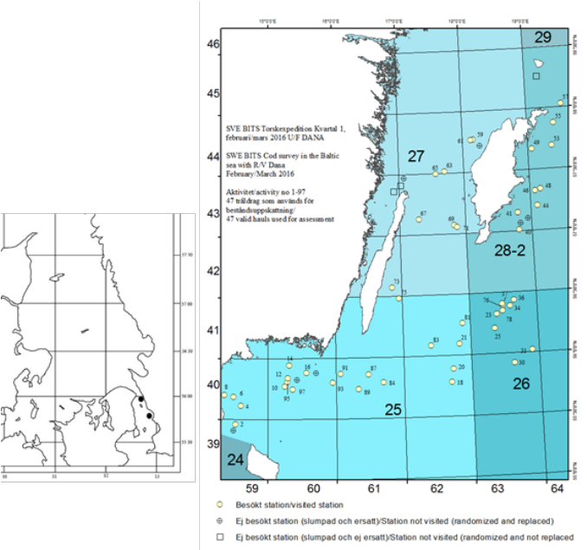
Map 1. BITS first quarter survey in 2016. Trawl stations conducted by R/V DANA is shown in the map to the right and two trawl stations (three hauls) conducted by Hålabben to the left

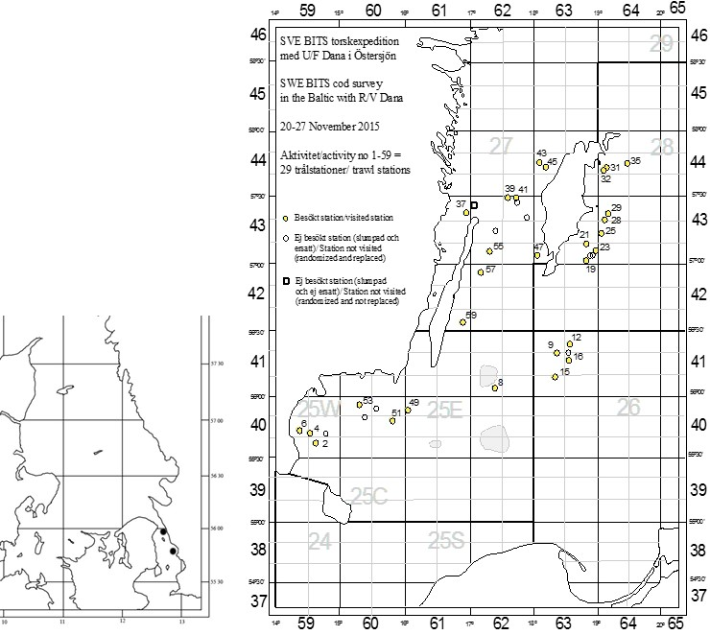
Map 2. BITS fourth quarter survey in 2015. Trawl stations conducted by R/V DANA is shown in the map to the right and two trawl stations (three hauls) conducted by Hålabben to the left.

- Coordination and participation
The Danish R/V DANA are chartered for the surveys in the Baltic and is complemented with R/V Hålabben in the Sound (SD23). Participating Member states in the surveys are: Denmark, Germany, Latvia, Poland, Lithuania and Sweden. The BITS survey is coordinated by the ICES Baltic International Fish Survey Working Group (WGBIFS) and the data are uploaded to the international ICES database DATRAS.

- International task-sharing (physical and/or financial) and the cost-sharing agreement used
Since 2011, Sweden has used the Danish vessel R/V DANA in the BITS surveys and a cooperation agreement between Sweden and Denmark has been established were all the practical details (price, payment, staff etc) for smooth cooperation are described. Latest agreement signed is valid until 31 Dec 2017.

- Explain where thresholds apply
No threshold applies to the BITS surveys

- Graphical representation (map) of the realized samples

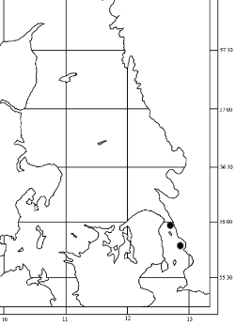

Map 1. BITS first quarter survey in 2018. Trawl stations conducted by R/V DANA is shown in the map to the right and two trawl stations (three hauls) conducted by Hålabben to the left

Map 2. BITS fourth quarter survey in 2018 Trawl stations conducted by R/V DANA is shown in the map to the right. The map to the left shows the six trawl stations conducted by Hålabben in the sound.

- Link to the latest meeting report of the coordination group

Report WGBIFS

- Main use of the results of the survey
Abundance estimates WGBFAS, Data compilation WS, benchmark WS.
Marine litter is uploaded to DATRAS and used for estimation of one of the indicators in MSFD.
The information of stomach content is used in several projects and ICES groups, e.g. WGIAB, WGCOMEDA.

- Extended comments (Tables 1G and 1H)
No extended comments to be explained.

BIAS – Baltic International Acoustic Survey

- Objectives of the survey
The aim of the survey is to provide abundance estimates of herring, sprat and pelagic cod in the Baltic Sea.

- Description of the methods used in the survey
The survey is using a SIMRAD EK60 echo sounder with the 38kHz transducer (ES38b) mounted on a towed body for the acoustic transect data collection and a pelagic trawl, Fotö trawl for collecting biological information. Approximately, 2 hauls are made in each ICES rectangle. For each haul, all species are length measured onboard and parameters such as age, weight, and sex are analyzed on herring and sprat and cod, the gonadal maturity is also analysed on herring. Sweden is responsible to cover area subdivision (SD) 27 and parts of SD 25, 26, 28 and 29. The acoustic data together with the biological information is used in the assessment models. Additional sampling on stomach content on cod is undertaken.
The Manual is available at http://www.ices.dk/community/groups/Pages/WGBIFS.aspx

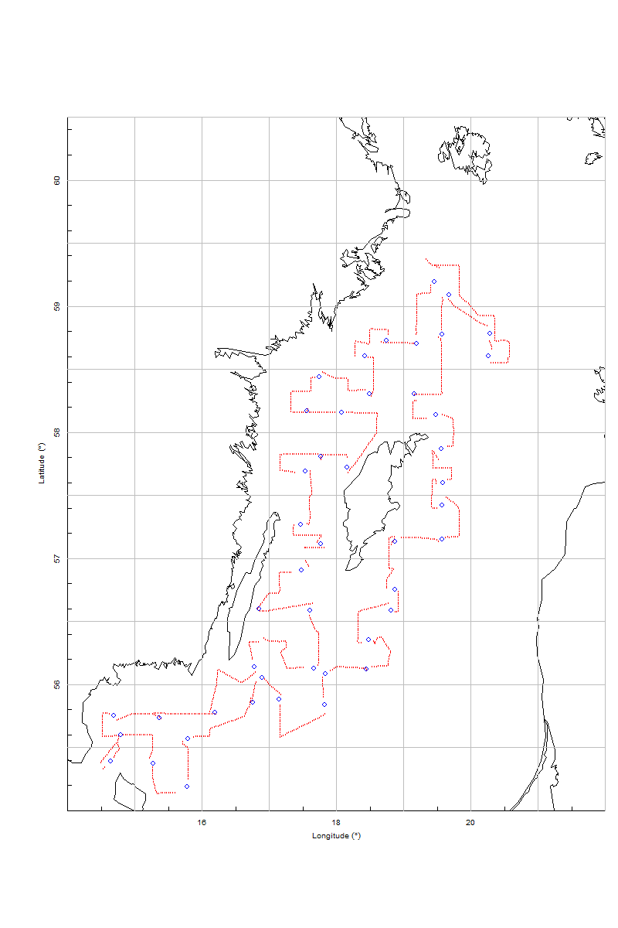
Map 3. Survey grid and trawl positions of R/V Dana during BIAS survey 2018.

- Coordination and participation
The BIAS survey is coordinated by the ICES Baltic International Fish Survey Working Group (WGBIFS) and the data are uploaded to the international data storage, IBAS database. Participating countries in the survey are Estonia, Finland, Germany, Latvia, Lithuania, Poland, Denmark and Sweden.

- International task-sharing (physical and/or financial) and the cost-sharing agreement used
Since 2011, Sweden has used the Danish vessel R/V DANA in the BIAS survey and a cooperation agreement between Sweden and Denmark has been established were all the practical details (price, payment, staff etc) for smooth cooperation are described. Latest agreement signed is valid until 31 Dec 2018.
Sweden has also an agreement with Finland regarding the parts run by Finland in SD 30. Sweden is sending two staff for participation during the survey.

- Explain where thresholds apply
No threshold applies to the BIAS survey.
- Graphical representation (map) of the realized samples

Map 3. Survey grid and trawl positions of R/V Dana during BIAS survey 2018

- Link to the latest meeting report of the coordination group
The latest meeting report can be found following this link.
Report WGBIFS

- Main use of the results of the survey
The main objective of BIAS is to assess herring and sprat resources in the Baltic Sea, and produce indices. The survey will provide data to the ICES Baltic Fisheries Assessment Working Group (WGBFAS). Data compilation WS, benchmark WS.
Additionally, the data is used in a number of scientific publications and has been used for producing a LF Indicator trough HELCOM. The information of stomach content is used in several projects and ICES groups, e.g. WGIAB, WGCOMEDA.

- Extended comments (Tables 1G and 1H)
Not applicable for this survey.

NORTH SEA AND EASTERN ARCTIC
IBTS Q1 and Q3 – The International Bottom trawl survey

- Objectives of the survey
The main aim of the survey is to estimate abundance of recruitment of the target species cod, haddock, whiting, Norway pout, herring, sprat, saithe, plaice, mackerel and also non-commercial fish. Moreover, the otoliths of the commercial species are collected and subsequently analysed in order to assess abundance by age class, in particular for the recruiting year classes in the Skagerrak and Kattegat.

- Description of the methods used in the survey
This survey is conducted twice annually, in quarters 1 and 3. The French bottom trawl GOV is used for sampling demersal species in both quarters while in Q1 only, a MIK (Midwater ring net) trawl is used at night for sampling fish larvae. Sweden is assigned 46 hauls for the first quarter survey and 45 randomly selected hauls for the third quarter survey. For both surveys hydrographical data are collected with a CTD in connection to the trawl hauls. Each haul are sorted and all species are recorded, length measured and weighed. For target species biological parameters are collected on fish length, age, weight, sex and gonadal maturity. In case of large catches subsampling is performed. Marine litter is registered from each haul.
Further details are explained in the International Bottom Trawl Survey (IBTS) manual:
IBTS manual
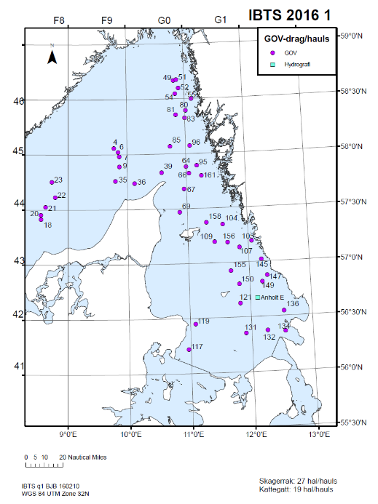
Map 4. Hauls with GOV demersal trawl IBTS first quarter survey 2016.
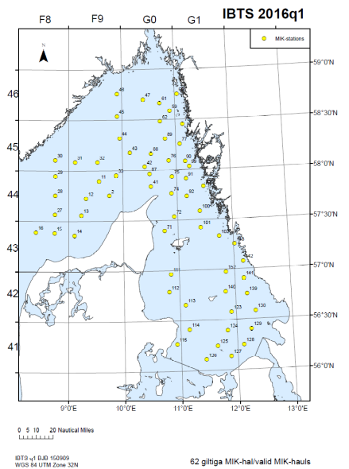

Map 5. Hauls with MIK larvae trawl during IBTS first quarter survey 2016.
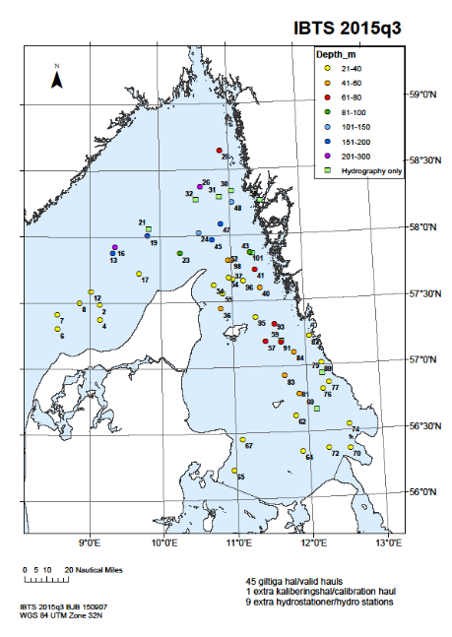
Map 6. Hauls with GOV demersal trawl IBTS third quarter survey 2015.

- Coordination and participation
The Danish R/V DANA is chartered for the surveys in the Kattegat and Skagerrak. Participating Member states in the surveys are: Sweden, Denmark, Germany, England, Scotland. The IBTS survey is coordinated by the International Bottom Trawl Survey Working Group (IBTSWG) and the data are uploaded to the international ICES database DATRAS. Data on marine litter is reported to the ICES marine litter database

- International task-sharing (physical and/or financial) and the cost-sharing agreement used
Since 2011, Sweden has used the Danish vessel R/V DANA in the IBTS surveys and a cooperation agreement between Sweden and Denmark has been established were all the practical details (price, payment, staff etc) for smooth cooperation are described. Latest agreement signed is valid until 31 Dec 2017.

- Explain where thresholds apply
No threshold applies to the IBTS surveys.
- Graphical representation (map) of the realized samples

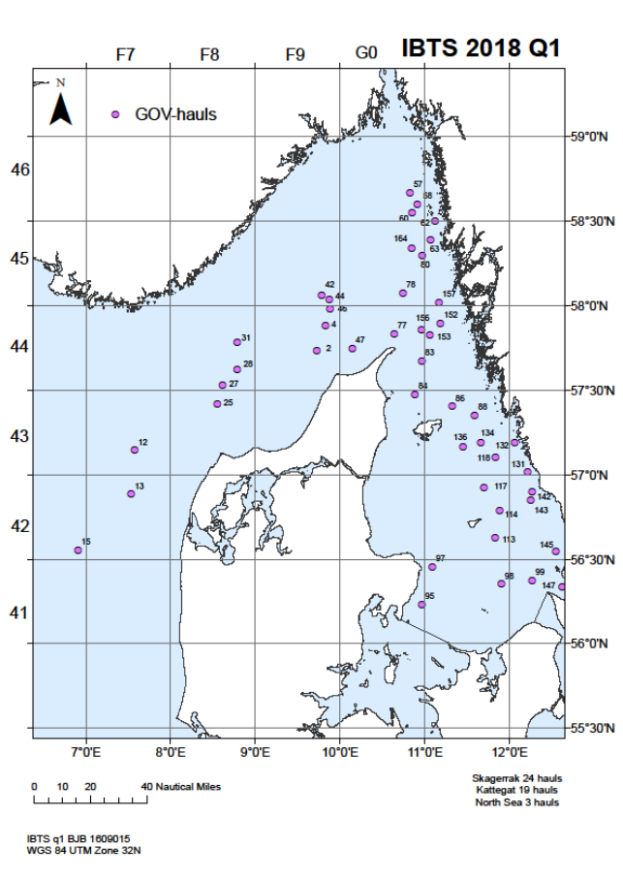
Map 4. Hauls with GOV demersal trawl IBTS first quarter survey 2018

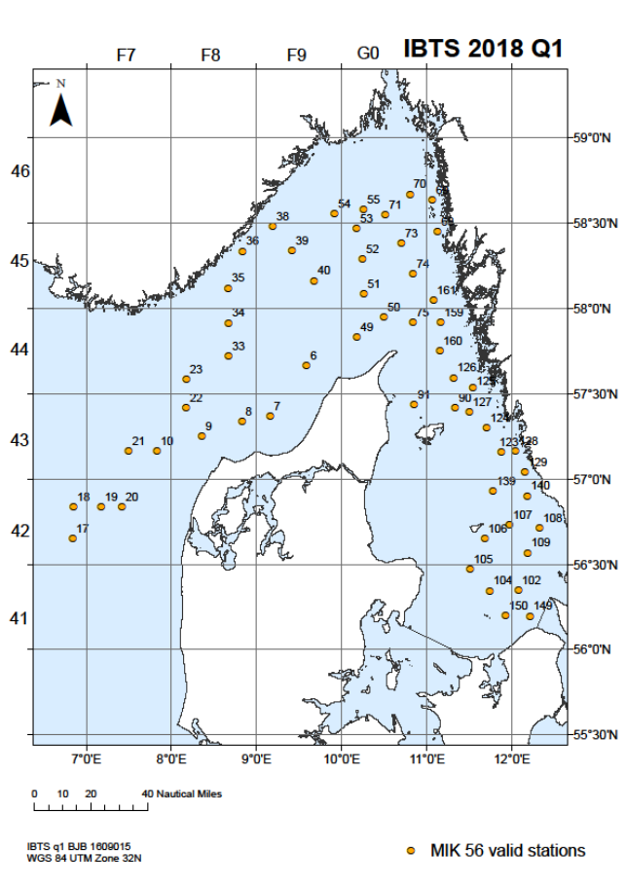
Map 5. Hauls with MIK larvae trawl during IBTS first quarter survey 2018.

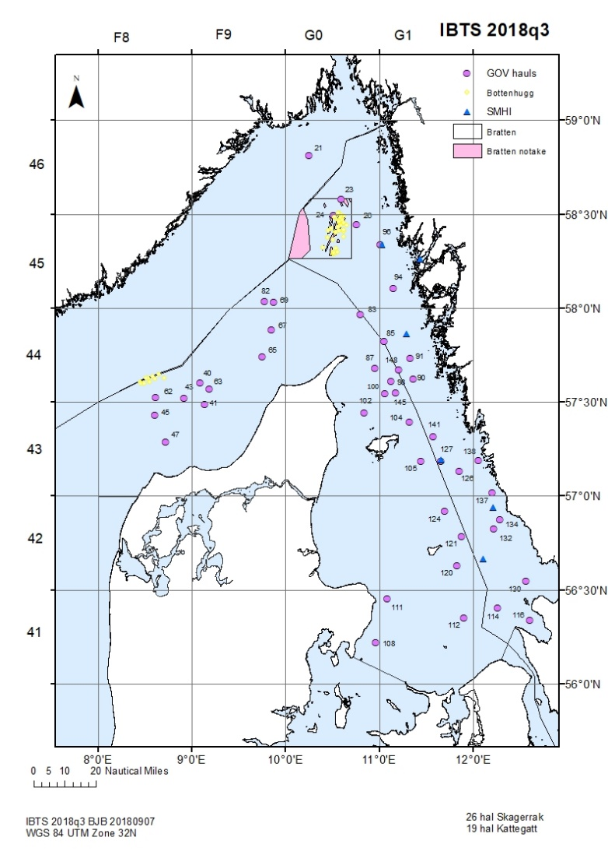
Map 6. Hauls with GOV demersal trawl IBTS third quarter survey 2018.

- Link to the latest meeting report of the coordination group
Report IBTSWG

- Main use of the results of the survey
Indices for ICES assessment groups HAWG, WGBFAS, WGNSSK.
Litter is a MFSD-descriptor and used by OSPAR.

- Extended comments (Tables 1G and 1H)
No additional comments.

NTV 3&4 – Nephrops TV SUrvey in functional Unit 3 & 4

- Objectives of the survey
The main objective of the survey is to provide abundance estimates for mud-burrowing animals like Nephrops.

- Description of the methods used in the survey
The fishery independent Underwater TV survey (UWTV) is performed by having a video camera mounted on a sledge that is towed slowly (0.5-0.8 knot) on the bottom while recording the bottom substrate. The video recording is analysed and Nephrops burrows are counted and converted into densities using information on the width of the view of the camera and length of the tow. Dead removals (landings and dead discards) together with mean weight from biological samplings are used to estimate stock biomass.

- Coordination and participation
The survey is a joint survey with Denmark. The survey has so far been run on a Swedish vessel and Danish vessel for the Swedish part and a Danish vessel for the Danish part. The aim was to use the Danish vessel for the whole area in 2017, and that Swedish scientific staff should be onboard covering the Swedish share of the survey. The Danish vessel did not get permission to all applied stations (for military reasons) so we had to use the Swedish vessel Asterix in the most coastal areas.

- International task-sharing (physical and/or financial) and the cost-sharing agreement used
The future agreement we are aiming for, will also cover sharing of equipment, payment and staff.

- Explain where thresholds apply
No thresholds apply to the survey.

- Graphical representation (map) of the realized samples

Map 7. Sledge UWTV stations for Denmark and Sweden for the survey in 2018 in the defined sub areas of the Nephrops stock in IIIa.
Not all stations could be visit due to bad weather, too low visibility, rocky bottoms or too many creels.

- Link to the latest meeting report of the coordination group
The survey is coordinated by the ICES working group on Nephrops surveys (WGNEPS).
The manual for the survey can be found at final report of the Working Group on Nephrops Surveys (WGNEPS). report WGNEPS

The latest Nephrops assessment results can be found at the final report of the on the North Sea, Skagerrak and Kattegat Working Group (WGNSSK).

- Main use of the results of the survey
The results are used to quantify the abundance of Norway lobster (Nephrops norwegicus) in the Skagerrak and Kattegat as an ICES recommended method for stock assessment of Nephrops, which is taken place in ICES WGNSSK.

- Extended comments (Tables 1G and 1H)
No additional comments.

ASH – Atlanto Scandian Herring survey

- Objectives of the survey
The aim is to investigate distribution and migrations of the Atlanto-Scandian herring,
blue whiting and other pelagic fish and to produce a biomass index for herring and a recruitment index for blue whiting. Furthermore, hydrographic conditions and plankton abundance in the Norwegian Sea and adjacent waters are monitored in order to investigate distribution and migration of herring and other pelagic fishes are influenced by environmental conditions.

- Description of the methods used in the survey
The survey is collecting acoustic data, biological data like species composition and length measurements. For the target species herring and blue whiting data are collected on length, weight, sex, maturity and age (from scales of herring and otoliths of blue whiting). In addition zooplankton hauls are made using a WP2 net and hydrographical data are collected using a CTD.

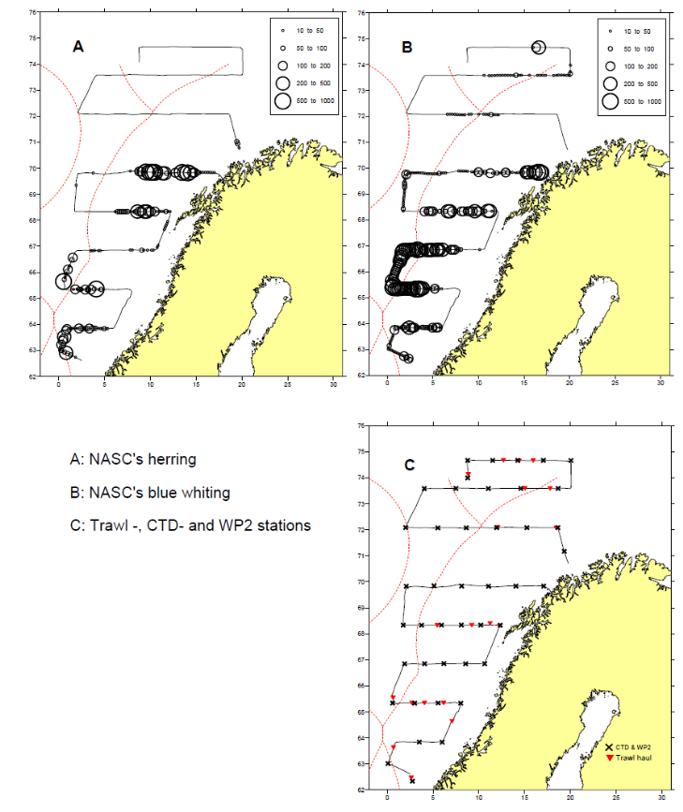
Map 8. Example from ASH 2013; Dana survey track, pelagic trawl, CTD and WP2 stations.

- Coordination and participation
The survey is carried out as a joint EU survey using the Danish vessel R7V DANA with participation of UK, Ireland, Netherlands, Germany, Sweden and Denmark. The survey is coordinated by the ICES Working Group of International Pelagic Surveys, WGIPS.

- International task sharing (physical and/or financial) and the cost sharing agreement used
Sweden is contributing by sending two staff participating in the survey as well as a cost-sharing model based on the share of TAC is applied according to an agreement. Denmark is responsible country for reporting of the results from the survey to the relevant ICES working group.

- Explain where thresholds apply
No thresholds apply to the survey.
- Graphical representation (map) of the realized samples
For details see Annual Report Denmark.

- Link to the latest meeting report of the coordination group.
For details see Annual Report Denmark.

- Main use of the results of the survey
For details see Annual Report Denmark.

- Extended comments (Tables 1G and 1H)
For details see Annual Report Denmark.

Blue whiting survey (IBWSS) is not a part of Swedish WP 2018 but should be included in our AR 2018 since Sweden is paying a part for this survey accoding to the established and signed agreement on cost sharing of this survey.
IBWSS – Blue whiting survey
The IBWSS is carried out annually in March/April in the North Sea. The Netherlands participates with RV Tridens (approx. 18 days). The survey is listed in (EU) 2016/1251 Table 10. The continuity of the previous survey design is guaranteed by participation in the coordinating survey group (WGIPS).

- Objectives of the survey
The survey aims to determine the distribution and abundance at age and length of the Northeast Atlantic blue whiting stock during the spawning season to the west of Britain and Ireland (Map 9).

- Description of the methods used in the survey
During the survey transect-wise acoustic echosounder measurements are made. In addition, trawl hauls are made to identify the species composition of the acoustic recordings. Hydrographical data are collected on regular intervals. The complete sampling procedure is defined in the ICES Manual for International Pelagic Surveys (IPS) chapter 2.1.1. The area to be covered is presented in the NLD WP 2017-2019 (Map 9). The acoustic transects are presented by lines, blue spots indicate hydrography stations.

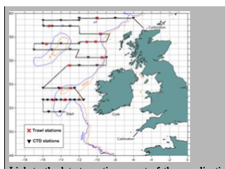

Map 9. Example from IBWSS 2018; Hydroacoustic transects, trawl stations and CTD. For map in better resolution, see Annual Report Netherlands.

- Coordination and participation
The survey is coordinated by the ICES Working Group on International Pelagic Surveys (WGIPS) and performed in collaboration with research vessels from Ireland, Faroe Islands, Russia, and Norway. The disaggregated survey data (hydrographic, biological, & acoustic) are stored in the PGNAPES database hosted by the Faroe Marine Research Institute. By executing SQL queries through the Application Express web-interface (http://oracle.frs.fo/apex), the user can extract data. Usernames and passwords are given to every nation participating in the survey. The blue whiting spawning stock estimate is used as a tuning index by ICES WGWIDE to determine the size of the population.

- International task sharing (physical and/or financial) and the cost sharing agreement used
Task sharing applies. The IBWSS is carried out by two EU MSs, and three non EU MSs, each contributing with its own vessel. Furthermore, scientists from Denmark, Germany and UK participate in the survey on board of the Dutch vessel. Cost sharing applies: the operational costs of the vessels are shared by EU MSs applying an allocation key proportional to national share of the EU TAC.

- Explain where thresholds apply
Not applicable.

- Graphical representation (map) of the realized samples
For details see Annual Report Netherlands.

- Link to the latest meeting report of the coordination group
For details see Annual Report Netherlands.

- Main use of the results of the survey
For details see Annual Report Netherlands.

- Extended comments (Tables 1G and 1H)
For details see Annual Report Netherlands.

Section 2: Fishing Activity Data

Text Box 2A: Fishing activity variables data collection strategy
General comment: This box fulfills paragraph 4 of Chapter III of the multiannual Union programme and Article 2, Article 4 paragraph (2) point (b) and Article 5 paragraph (2) of the Decision (EU) 2016/1701. It is intended to describe the method used to derive estimates on representative samples where data are not to be recorded under Regulation (EU) No 1224/2009 or where data collected under Regulation (EU) No 1224/2009 are not at the right aggregation level for the intended scientific use.
General comment: This box is applicable to the Annual Report. This box should provide information on the implementation of the data collection of fishing activity variables of Member States.
1. Description of methodologies used to cross-validate the different sources of data
Logbook data are automatically checked when filled in regarding completeness and also regarding logic. In
addition, random checks are performed later on catches landed compared to those sold and also given
geographic positions compared to VMS data. The port inspection also checks and verifies logbook data for the specific trip when an inspection is performed. Finally there are also computerized routinely performed checks of the complete logbook data to find abnormal and exorbitant values for all trips.

Journal data are automatically checked when filled in regarding completeness and also regarding logic. Since
the data is on monthly bases no further checks can be done on administrational or field bases. There are
computerized routinely performed checks of the complete journal data to find abnormal and exorbitant values for all trips.

2. Description of methodologies used to estimate the value of landings
Value by vessel and trip is concluded by estimating average prices per year, month, subdivision, and gear (if
available). The system is dynamic in the sense that if a price does not exist on a certain level, e.g. price per
gear, price per subdivision is used instead. If a price for the subdivision is not available price per month is used instead.
3. Description of methodologies used to estimate the average price (it is recommended to use weighted averages, trip by trip)
Averages prices is calculated from tripdata by values (see 2.). Meaning that they are weighted on the amount
caught.

4. Description of methodologies used to plan collection of the complementary data (sample plan methodology, type of data collected, frequency of collection etc)
A complementary data collection is in place for vessels below 10 meters. The sample plan is census based and they report in a so called fishing journal instead of the standardized logbook. The journal is filled in once every month with a finite number of fishing trips per journal. If a fishermen have many fishing trips he/she have to fill in several journals each month to cover all of the fishing trips. Type of data collected are almost the same as the logbook, which means number of days, type of gear, catch, spatial allocation etc. The data is not as detailed as the logbook data but it is sufficient for analysis and control purposes.

5. Deviations from Work Plan methodology used to cross-validate the different sources of data
No deviation.
6. Deviations from Work Plan methodology used to estimate the value of landings.
No deviation.
7. Deviations from Work Plan methodology used to estimate the average price.
No deviation.
8. Deviations from Work Plan methodology used to plan collection of the complementary data
In WP 2018-2019 Sweden reported no complementary data under point 4. Sweden has a complementary data collection which is described under point 4 above in Text Box 2A. There is no deviation regarding the collection of the complementary data.

Section 3: Economic and Social Data

Text Box 3A: Population segments for collection of economic and social data for fisheries
General comment: This box fulfils paragraph 5 points (a) and (b) of Chapter III of the multiannual Union programme and Article 2, Article 4 paragraphs (1), (2) and (5) and Article 5 paragraph (2) of the Decision (EU) 2016/1701. It is intended to specify data to be collected under Tables 5(A) and 6 of the multiannual Union programme.
General comment: This box is applicable to the Annual Report. This box should provide information on the implementation of the fleet socio-economic data collection of Member States.
1. Description of methodologies used to choose the different sources of data
There is no specific methodology when choosing the source of data. Economic data are available via balance sheets for each company. The balance sheet data is complemented by a postal census survey for all fishermen with a license. The survey is mandatory to fill in. Via the survey we obtain data on cost and capital variables as well as socio-economic data.

2. Description of methodologies used to choose the different types of data collection
All variables for economic and social data for fisheries will be collected in census. Data in registers at SwAM are available and used, and excess data needed, like some costs variables and capital values will be obtained in a census mail-survey to all fishermen with a license. Furthermore, social variables will be collected every third year, starting 2018, through a census mail-survey. It is mandatory to reply. The survey will be send by tradtional mail because it is the simplest and cheapest way. No e-mail addresses exist for the complete fleet and collection by phone is too expensive. Data on subsidies is included in the economic survey but also for cross-checking gathered from the databases on the EMFF at the Swedish Board of Agriculture. Other income, capital values, wages and salaries of crew as well as financial position is also gathered in census from the income tax declarations register of all vessel owners. This data is compiled by Statistics Sweden (SCB).
The inactive fleet will not be covered by the collection since they by definition doesn’t have any costs related to fisheries. However, data is gathered on vessel characteristics, effort, which by definition is zero, and capacity (fleet indicators). By experience, the capital value and capital cost of the inactive vessels is similar to capital value and capital cost of active vessels. Therefore, capital costs and capital value is estimated from data of active vessels with the same main gear type as the inactive vessels used when they were last active and fishing.
3. Description of methodologies used to choose sampling frame and allocation scheme
All variables for economic and social data for fisheries will be collected in census.
4. Description of methodologies used for estimation procedures
The Swedish fishing fleet are rather small. Clustering is needed due to confidentiality reasons and therefore all estimations are done on clustered segment. Since the survey is done on all vessels, in census, re-clustering for analytical reasons can be done easily.
Missing data, due to vessels sold, vessel owners that passed away etc., will be taken care of by weighting and calculating weighted averages using days at sea.
An allocation key to allocate the total variable cost to the different cost variables is estimated through the questionnaire (census letter-survey). The concerned cost variables are energy costs, repair and maintenance costs, variable costs and non-variable costs. Total costs from tax declarations are used to calibrate the results at the correct total level of costs to be used for the allocation key.
5. Description of methodologies used on data quality
Logbook data are automatically checked when filled in regarding completeness and also regarding logic. In addition, random checks are performed later on catches landed compared to those sold and also given geographic positions compared to VMS data. The fishery control also checks and verifies logbook data for the specific trip when a control is performed. Finally, there are also computerized routinely performed checks of the complete logbook data to find abnormal and exorbitant values for all trips.
Journal data are automatically checked when filled in regarding completeness and logic. Since the data is on monthly basis no further checks can be done on administrational or field bases. There are computerized routinely performed checks of the complete journal data to find abnormal and exorbitant values for all trips.
Survey data is checked by computerized routines for finding abnormal and exorbitant values. Tax register data are checked in numerous ways at the tax authority.

6. Deviations from Work Plan methodology for selection of data source
No deviation.
7. Deviations from Work Plan methodology to choose type of data collection
The economic data compiled by Statistics Sweden (SCB) has been slightly changed. Previously, this data has been presented in approximately 30 segments due to secrecy. Data is now available as micro data, which gives more accurate and reliable results on vessel level. Aggregated results does not differ significantly, due to the change from segment data to micro data.
8. Deviations from Work Plan methodology regarding sampling frame and allocation scheme
No deviation.
9. Deviations from Work Plan methodology used for estimation procedures
The estimation process regarding economic and social variables has been under development during 2018. The model and underlying estimation framework is the same. The estimation method is taking into account more variables that can have an effect on the estimated variable. A regression method with predicted values are used.
10. Quality assurance
10.1 Sound methodology
The data collection regarding economic and social data follow best practices and guidelines decided by expert groups, e.g. PIM-methodology regarding splitting of capital costs. Methodologies used are documented.
10.2. Accuracy and reliability
Throughout the whole data management process data checks are done frequently. Raw data are being processed before compiled to intermediate results. When intermediate results are produced, several extensive data checks are in place to assess and validate the data. Every error and correction/imputation is well documented and dealt with according to guidelines and best practices.
10.3. Accessibility and Clarity
Are methodological documents publicly available?
Yes

Are data stored in databases?
Yes

Where can methodological and other documentation be found?
https://www.havochvatten.se/en/swam/eu--international/international-cooperation/data-collection-framework-dcf/national-programs-and-annual-reports.html

Section 3: Economic and Social Data

Pilot Study 3: Data on employment by education level and nationality
General comment: This box fulfills paragraph 5 point (b) and paragraph 6 point (b) of Chapter III of the multiannual Union programme and Article 2 and Article 3 paragraph (3) point (c) of the Decision (EU) 2016/1701.It is intended to specify data to be collected under Table 6 of the multiannual Union programme.
General comment: This box is applicable to the Annual Report. This box is intended to provide information on the results obtained from the implementation of the pilot study (including deviations from planned and justifications as to why if this was not the case).
Fisheries
The pilot study regarding fisheries is not applicable anymore due to the addition of the full scale socioeconomic questionnaire with a census approach. See section 3A:2 for more details.

Aquaculture
1. Aim of pilot study
The aim of the pilot study is to specify methodology to undertake collection of data on employment by educational level and nationality.

2. Duration of pilot study
Autumn 2016 – spring 2018

3. Methodology and expected outcomes of pilot study
Pilot study will be conducted in cooperation with Statistics Sweden. Expected outcome is that data on educational level is possible to attain by existing register, and will be collected in order to examine usuability. As a preliminary outcome from discussions with Statistical Sweden there are no register for nationality linked to employment in Sweden. Further examination and discussion on the subject will be a major part of the pilot study. Data will likely be collected through questionnaries (see Q2 in text box 3B).

Fisheries
4. Achievement of the original expected outcomes of pilot study and justification if this was not the case.

Collection of social data was collected on a full scale together with cost data, using the same methodology.
5. Incorporation of results from pilot study into regular sampling by the Member State.
Already incorporated in the regular sampling. Data will be collected every third year.

Aquaculture
4. Achievement of the original expected outcomes of pilot study and justification if this was not the case.
Data on both educational level and nationality is incorporated in the annual production questionnaire.

5. Incorporation of results from pilot study into regular sampling by the Member State.
Data on both educational level and nationality is incorporated in the annual production questionnaire.

Section 3: Economic and Social Data

Text Box 3B: Population segments for collection of economic and social data for aquaculture
General comment: This box fulfills paragraph 6 points (a) and (b) of Chapter III of the multiannual Union programme and Article 2, Article 4 paragraphs (1) and (5) and Article 5 paragraph (2) of the Decision (EU) 2016/1701.It is intended to specify data to be collected under Tables 6 and 7 of the multiannual Union programme.

General comment: This box is applicable to the Annual Report. This box should provide information on the implementation of the socio-economic data collection for aquaculture of Member States.

1. Description of methodologies used to choose the different sources of data
Data will be collected by Statistics Sweden and Swedish board of Agriculture in four ways.
- Statistics Sweden: Income tax declarations from every enterprise whose main source of income (more than 50 %) comes from aquaculture will be compiled.
- Statistic Sweden: A questionnaire (Q1) about farming techniques, investments, production value and volume will be sent to all aquaculture farms. The questionnaire will give additional information that makes it possible to cluster farming units to enterprises in cases when several farming units are equal to one fiscal enterprise. It will also make it possible to compare information on value of aquaculture production with declared income from income tax declarations. These comparisons are needed to be able to classify the aquaculture farming as main acitivity of the enterprise or not.
- Statistics Sweden in cooperation with Swedish board of Agriculture: A second questionnaire (Q2) will be sent to all of the aquaculture enterprises in order to create a cost allocation key for costs that are not specified in the income tax declaration.
- Q2 will also include a separate section concerning questions about social and environmental variables that are not possible to collect through official databases.
- Swedish board of Agriculture: Data on subsidies will be collected from the Swedish board of Agriculture existing systems, the managing authority of the European Maritime and Fisheries Fund (EMFF), and will be compiled by Swedish board of Agriculture.
2. Description of methodologies used to choose the different types of data collection
Sweden has a production of over 1% of EU’s total production but below 2,5% which gives us the possibility to collect social and economic data with a simplified methodology such as pilot studies with a view to extrapolate the data. Environmental data does not need to be collected according to current thresholds but we consider this information important and has decided to collect and report this data.
The reference data is Sweden’s latest submission under Regulation (EC) No 762/2008 of the European Parliament and of the Council, and corresponding data published by Eurostat.
Data is collected, estimated and checked by Statistics Sweden which ensures the consistency of final data. Quality of the data collected by Swedish board of Agriculture is secured by using existing system for disbursement.

3. Description of methodologies used to choose sampling frame and allocation scheme
Data is collected, estimated and checked by Statistics Sweden which ensures the consistency of final data. Data on variables of production and data on the economic variables not included in the financial accounts (imputed value of unpaid labour, energy cost, livestock volume and cost, feed volume and cost, repair and maintenance, other operational cost, extraordinary cost) will be collected from answers from questionnaires conducted by Statistics Sweden which ensures the consistency of final data. Data on subsidies will be compiled from existing system of disbursement, whereafter an allocation will be made to distribute subsidies to appropiate segment.
Considering the segmentation in table 9 (Commission implementing decision (EU) 2016/1251 adopting a multiannual Union programme for the collection, management and use of data in the fisheries and aquaculture sectors for the period 2017-2019) Statistics Sweden is evaluating which segments will be possible to report. Sweden has a small aquaculture industry and need to group species together. As a preliminary plan we will try to report salmon and trout together under Hatcheries and nurseries (1:8). Other freshwater fish will be reported under Ponds (8:1), Recirculation systems (8:4), Cages (8:6), Polyculture (8:7) and Hatcheries and nurseries (8:8). Mussels and Oysters will be reported together under Other (10:4) and Crustaceans will be reported under Other (13:4)
4. Description of methodologies used for estimation procedures
A questionnaire (Q1) about farming techniques, investments, production value and volume will be sent to all aquaculture farms. The questionnaire will give additional information that makes it possible to cluster farming units to enterprises in cases when several farming units are equal to one fiscal enterprise. It will also make it possible to compare information on value of aquaculture production with declared income from income tax declarations. These comparisons are needed to be able to classify the aquaculture farming as main acitivity of the enterprise or not. Questionnaire 2 is used for make estimations on costs and social and environmental variables not included in tax declaration or other official databases. Respondents result will be assigned to proper segment by Statistical Sweden for producing a cost allocation key by using means from each segments.

5. Description of methodologies used on data quality
Data is collected, estimated and checked by Statistics Sweden which ensures the consistency and quality of final data. Questionnaire Q1 is evaluated by Statistics Sweden. They conduct telephone interviews with aquaculture enterprises when there are incomplete answers, unreasonable answers or non-responses. Due to experience there will not be necessary to assess the likely impact of non-response bias on survey estimates since the response rate on these types of questionnaires is nearly 100 % due to legislative reasons. Questionnaire Q2 is conducted and evaluated by Statistics Sweden in cooperation with Swedish board of Agriculture every third year to create an updated cost allocation key as well as an estimate of the social variables. Statstic Sweden conduct this questionnaire by sending out questionnaires with several reminders. Response rate is around 60 percent. The quality of data on subsidies is evaluated by Swedish board of Agriculture by comparison with previous years disbursements and programme budget.

6. Deviations from Work Plan methodology for selection of data source
A low response rate in Q2.
Actions to avoid deviations
The environmental variables that was supposed to be incorporated into Q2 (1.d) has instead been incorporated into Q1 starting 2019.

7. Deviations from Work Plan methodology to choose type of data collection
No deviations
8. Deviations from Work Plan methodology regarding sampling frame and allocation scheme
See below (Actions to avoid deviations).

Actions to avoid deviations
The segments that we planned to report are changed, segment Other freshwater fish polyculture 8.7 has been excluded and segment Other freshwater fish Tanks and raceways 8.2 has been added. 8.2 has also been aggregated with 8.4 Other freshwater fish Recirculation systems for variables due to confidentiality.

9. Deviations from Work Plan methodology used for estimation procedures
No deviations.
Actions to avoid deviations
However due to a low response rate on Q2 and a bias towards more smaller companies responding (53% of the enterprises but 21% of the production), our allocation key and the results are also biased. This is something that we are currently working with to eliminate or at least minimize in the upcoming data collection. The two questionnaires will become one and it will be web based. Also, instead of sending Q1 to all aquaculture sites the combined Q1 and Q2 will be sent to the enterprises. We hope that this will lessen the burden on the enterprises and generate a higher responserate.

10. Quality assurance
10.1 Sound methodology
For questionnaire Q1 there is a quality report publicly available which describes methodology and quality assurance. Questionnaire Q2 has no such description publicly available, but all data collection follows agreed practices in expert groups.

10.2. Accuracy and reliability
Response rate and Achieved sample rate are provided in Table 3B.
For Q1 data checks are done according to check lists following agreed routines for quality assurance within Statistics Sweden. Corresponding checks are done for Q2, by Statistics Sweden and Swedish Board of Agriculture in cooperation.

10.3. Accessibility and Clarity

Are methodological documents publicly available?
Yes for Q1 a quality report is publicly available.

Are data stored in databases?
Yes

Where can methodological and other documentation be found?
www.scb.se

Provide the web link, if documentation is publicly available
https://www.scb.se/en/finding-statistics/statistics-by-subject-area/agriculture-forestry-and-fishery/aquaculture/aquaculture-in-sweden/

Section 3: Economic and Social Data

Pilot Study 4: Environmental data on aquaculture
General comment: This box fulfills paragraph 6 point (c) of Chapter III of the multiannual Union programme and Article 2 and Article 4 paragraph (3) point (d) of the Decision (EU) 2016/1701. It is intended to specify data to be collected under Table 8 of the multiannual Union programme.
General comment: This box is applicable to the Annual Report. This box is intended to provide information on the results obtained from the implementation of the pilot study (including deviations from planned and justifications as to why if this was not the case).
1. Aim of pilot study
Aim of the pilot study is to explore the possibilities to collect environmental data on aquaculture by develop existing data collection on production.

2. Duration of pilot study
Autumn 2017 – spring 2018

3. Methodology and expected outcomes of pilot study
Development of existing data collection on aquaculture production to include enivironmental data there will be a reliable and easily attainable data source on the subject with well establish routines. Data collection on aquaculture production is an annual questionnaire to all enterprises in aquaculture sector. Data on treatments can probably be collected through official databases. Mortality needs to be included in the estimation questionnaire (Q2) see text box 3B.

4. Achievement of the original expected outcomes of pilot study and justification if this was not the case.

Data on mortality is incorporated in the annual production questionnaire.

5. Incorporation of results from pilot study into regular sampling by the Member State.

Data on mortality is incorporated in the annual production questionnaire.

Section 3: Economic and Social Data

Text Box 3C: Population segments for collection of economic and social data for the processing industry
General comment: This box fulfils footnote 6 of paragraph 1.1(d) of Chapter III of the multiannual Union programme, Article 2, Article 4 paragraphs (1) and (5) and Article 5 paragraph (2) of Decision (EU) 2016/1701. It is intended to specify data to be collected under Table 11 of the multiannual Union programme.
General comment: This box is applicable to the Annual Report. This box should provide information on the implementation of the socio-economic data collection for aquaculture of Member States.
1. Description of methodologies used to choose the different sources of data
The data presented comes mainly from official statistics that has been collected and processed by Statistics Sweden through the SRU register which is maintained by Statistics Sweden and consists of income tax declarations in Sweden. Part of the data will be collected from the Statistical Business Register which is a central register consisting of information on all registered enterprises in Sweden. It is also maintained by Statistics Sweden. Another part of the data will be collected from Labour market statistics, which is a central register that is maintained by Statistics Sweden.
2. Description of methodologies used to choose the different types of data collection
All data is collected, estimated and checked by Statistics Sweden which ensures the consistency of the final data.
3. Description of methodologies used to choose sampling frame and allocation scheme
All data is collected, estimated and checked by Statistics Sweden which ensures the consistency of the final data. Data on two variables (energy costs and subsidies) will be collected from answers from a questionnaire sent out by Statistics Sweden based on PPS-selection in the Statistical Business Register. The questionnaire is used as a base for estimating an allocation key for variables not included in the financial accounts. The sampling method for the variables collected with probability sample survey is Probability Proportional to Size (PPS sampling) where the sum of total income and total costs is used to select which enterprises that will be sampled. Data on one variable (unpaid labour) will be based on an expert evaluation made by the component authority Statistics Sweden. The reason for this is that there is not possible to use any regular data collection scheme for that variable.
4. Description of methodologies used for estimation procedures
All data is collected, estimated and checked by Statistics Sweden which ensures the consistency of the final data. Data on two variables (energy costs and subsidies) will be collected from answers from a questionnaire sent out by Statistics Sweden based on PPS-selection in the Statistical Business Register. The questionnaire is used as a base for estimating the variables (including energy costs and income from subsidies) not included in the financial account.
5. Description of methodologies used on data quality
All data is collected, estimated and checked by Statistics Sweden which ensures the consistency of the final data. The data quality evaluation is carried out by Statistics Sweden before delivering it to the Board of Agriculture, who conducts a macro evaluation upon delivery to ensure no abnormal or implausible changes have occurred by comparing the new data with previous years.
Sampled data is reviewed on a micro level by Statistics Sweden regarding summations, plausibility and relationships between variables. Outliers that may have a large effect on the estimation are checked and evaluated. Census data from the Swedish Tax Agency and the Statistical Business Register is evaluated by Statistics Sweden although not to such a large extent as sample data. The evaluation of census data mostly consists of reviewing suspiciously extreme values that may be small or large. After reviewing the data on a micro level the data is processed to correct for non-responses. After merging the census and sample data the aggregate is checked and evaluated at a macro level. In the last step no difference is made between sample and census data.
For variables, such as subsidies and energy costs, collected through the probability sample survey CV values are estimated to display the uncertainties due to sampling. A possible shortfall is that although data is collected, processed and ensured by Statistics Sweden, some variables are not available through financial accounts. The variables affected by this possible shortfall are subsidies and energy costs. The reason for this is that those variables were solely collected through questionnaires and there is a certain range of uncertainty of these variables and it is also difficult to control if they are correct. There are some shortfalls when it comes to subsidies, but it is not a good solution to obtain subsidies from the administrative records. The reason is that we are using Statistic Sweden’s standardized method to obtain the financial information for the processing industry and we do not see that we have any option to change this method.
6. Deviations from Work Plan methodology for selection of data source
There are no deviations from the methodology used to select data source compared to what was planned in the Work Plan.
In our Work Plan for 2018 Sweden stated that data on one variable (unpaid labour) would be based on an expert evaluation made by the component authority Statistics Sweden. The reason for this is that it is not possible to use any regular data collection scheme for that variable. This is also done.
According to the Work Plan for 2018 Sweden planned to report the total sum of subsidies as well as subsidies divided seperated by operating subsidies and subsidies on investments.
7. Deviations from Work Plan methodology to choose type of data collection
There are no deviations from the methodologies to choose type of data collecton scheme compared to what was planned in the Work Plan.
8. Deviations from Work Plan methodology regarding sampling frame and allocation scheme
There are no deviations from the methodologies used regarding sampling frame and allocation scheme compared to what was planned in the Work Plan.
9. Deviations from Work Plan methodology used for estimation procedures
There are no deviations from the methodologies used for estimation procedures compared to what was planned in the Work Plan.
10. Quality assurance
10.1 Sound methodology
The data collection follow methodologies, guidelines and best practices agreed in expert groups. All data is collected, estimated and checked by Statistics Sweden which ensures the consistency of the final data.
10.2. Accuracy and reliability
Response rate and Achieved sample rate are provided in Table 3C.
The achieved sample rate and respond rate is 100 % for variables collected through financial accounts by Statistics Sweden. For subsides obtained from questionnaires the corresponding achieved sample rate is 94 % and the response rate 94 %. Comprehensive validations were made during the compilation of the data and figures were cross checked with other data sources by Statistics Sweden, when possible.

10.3. Accessibility and Clarity
Are methodological documents publicly available? YES
Are data stored in databases? YES
Where can methodological and other documentation be found? YES
Provide the web link, if documentation is publicly available.
The weblink goes to Statistics Sweden and where the official data can be found.
https://www.scb.se/hitta-statistik/statistik-efter-amne/naringsverksamhet/naringslivets-struktur/foretagens-ekonomi/

Section 4: Sampling Strategy for Biological Data from Commercial Fisheries

Text Box 4A: Sampling plan description for biological data

General comment: This box fulfills Article 3, Article 4 paragraph (4) and Article 8 of the Decision (EU) 2016/1701 and forms the basis for the fulfilment of paragraph 2 point (a)(i) of Chapter III of the multiannual Union programme. This Table refers to data to be collected under Tables 1(A), 1(B) and 1(C) of the multiannual Union programme.
General comment: This box is applicable to the Annual Report. This box should provide information on the deviations from the planned sampling of Member States.
1. Description of the sampling plan according to Article 5 paragraph (3) of the Decision (EU) 2016/1701

Sweden is currently in the process of moving towards statistically sound sampling scheme (4S) in the commercial sampling. Preparation of detailed descriptions of the sampling design for the different sampling schemes is one important part in this process.
Evaluation, development and improvement of the remaining sampling schemes are underway and Sweden will continue to develop and implement 4S data collection in 2018.
This goal applies for all sampling with the exception of cases where end users may set other requirements. For example, eel sampling may have to be performed in a different way. This holds if the data needs are not possible to meet by commercial 4S sampling. This could be due to either fisheries management measures related to the Swedish national eel management plan or in case there are other objectives in the stock assessment that needs to be taken into account.

BALTIC SEA
Scheme: Baltic at-sea
Purpose: At-sea Observer Programme for length, age, weight data of landings and discards of demersal species in the Baltic Sea (Subdiv 22-32)
Main end-users: ICES WGBFAS; National fisheries management agency; Scientific research projects;
Design: Multi-stage
Main stratification: 1 fishery stratum (see details in Table 4A)
Temporal Stratification: Quarterly
Spatial Stratification: none

Stratum: SWE - Balt (at-sea) - Act - 24/25 – DemTrawl
 | Sampling frame | Sampling unit | Stratification | Selection Method | Sampling effort
1SU | List of vessels active in the Demersal trawl fishery in subdiv. 24 or 25 during previous year | Vessel | Quarterly | random draw from vessel list with unequal probability (probability proportional to number of trips) without replacement | 4 (per quarter)
2SU | Hypothetical list of trips from vessel | Fishing Trip | --- | ad-hoc (dependent on staff availability) | 1 (per vessel)
3SU | Hypothetical list of hauls in trip | Haul | --- | Census | Census
4SU | Hypothetical list of individuals caught in haul | Individuals | Species x Catch Fraction x Commercial Size Category  Biology: also 1cm length classes | Length: Census (random sample if too large)  Biology: Census (random sample if too large); sampling stops when trip goals are achieved | Length: all individuals  Biology:  COD discards: 5 otoliths and individual weights (per size class and trip)

Main limitations: Quota sampling for ages and weights may not ensure proper spatial coverage of the most abundant size classes;
Expected difficulties: There is risk for refusals related to landing obligation and other management measures; usage of random vessel lists in sampling the demersal trawl strata is statistically sound but may bring about low coverage in some subdivisions.
Expected coverage of target population (based on expected trips and 2013-2015 average number of trips per strata):
- SWE - Balt (at-sea) - Act - 24/25 – DemTrawl: 1.3%

Scheme: Baltic self-sampling
Purpose: Self-sampling programme for length, age, weight data of landings of demersal fisheries in the Baltic Sea (Subdiv 22-32)
Main end-users: ICES WGBFAS; National fisheries management agency; Scientific research projects;
Design: Multi-stage
Main stratification: 1 fishery stratum (see details in Table 4A)
Temporal Stratification: Quarterly
Spatial Stratification: None

Stratum: SWE - Balt (self) - Act - 22/32 - DemTrawl
 | Sampling frame | Sampling unit | Stratification | Selection Method | Sampling effort
1SU | List of weeks of the year | Week | Quarterly | random draw from week list without replacement | 8 (per quarter)
2SU | List of vessels active in the Demersal trawl fishery in all Baltic subdivisions previous year | Vessel | --- | Random selection from quarterly vessel list | 4 (per week) (*)
3SU | Hypothetical list of daily landings of cod from vessel in week | Daily landing of cod | --- | ad-hoc (performed by buyer) | 1 (per vessel)
4SU | All boxes of cod landed in fishing trip | Boxes of cod | Commercial Size Category | ad-hoc (performed by buyer) | 1 box (**)
5SU | All individuals in the box | Individuals  (individual length, weight and age) | None | Length: Census Biology: Random sample or census (depending on size category) | Length: all individuals in box  Biology:  Sizes 1-3: all otoliths and weights  Size 4: 20 otoliths and weights + 20 fish only weight  Sizes 5-7: 10 otoliths and weights + 10 fish only weight
(*) to ensure coverage of areas with less activity, buyers are also instructed to deliver full samples from additional landings from subdivision 24 whenever fleet activity occurs in that subdivision and vessels are not on the list;
(**) n=1 additional box is requested from sizes 1-3 from another vessel to ensure less frequent size classes are sampled.

Main limitations: Reduced control over the selection of box(es) within size category;
Expected difficulties: There is risk for refusals or reduced fleet activity related to landing obligation and other management measures (e.g., temporal closures); usage of random vessel lists in sampling the combined subdivisions (e.g., 22-32) is statistically sound but may yield low sample size in some of the subdivisions.
Expected coverage of target population (based on sampling targets and 2013-2015 average number of trips per strata):
- SWE - Balt (self) - Act - 24/25 – DemTrawl: 9.9%

Scheme: Baltic “at-sea or self-sampling”
Purpose: At-sea observer or self-sampling programme for length, age, weight data of landings and discards of demersal species in the Baltic Sea (Subdiv. 22-32),.
Main end-users: ICES WGBFAS; National fisheries management agency; Scientific research projects;

Design: Multi-stage
Main stratification: 6 fishery strata (see table 4A)
Temporal Stratification: Quarterly
Spatial Stratification: Subdivision

All strata (if at-sea)
 | Sampling frame | Sampling unit | Stratification |  | Selection Method |  | Sampling effort
1SU | List of vessels active in the gillnetter fisheries for demersal species in specific subdivisions during previous year | Vessel | Quarterly |  | Random sample from quarterly vessel list without replacement |  | Gillnets: 4 (per quarter)
2SU | Hypothetical list of weekly trips from vessel | Fishing Trip | --- |  | ad-hoc (dependent on staff availability) |  | 1 (per vessel)
3SU | Hypothetical list of hauls in trip | Haul | --- | Census |  | Census
4SU | Hypothetical list of individuals caught in haul | Individuals | Species x Catch Fraction x Commercial Size Category  Biology: also x 1cm length classes | Length: Census (random sample if too large)  Biology: Random sample or census (within length class) sampling stops when trip goals are achieved |  | Length: all individuals  Biology:  COD discards: 5 otoliths and individual weights (per size class and trip)

All strata (if self-sampling)
 | Sampling frame | Sampling unit | Stratification | Selection Method | Sampling effort
1SU | List of weeks of the year | Week | Quarterly | random sample from week list without replacement | Gillnets: 8 (per quarter)  Longlines: 6 (per quarter)
2SU | List of vessels active in the gillnetter or longlines fisheries for demersal species in specific subdivisions during 2016 | Vessel | --- | random sample from quarterly vessel list without replacement | 2 (per week) until 4 trips in quarter are achieved
3SU | Hypothetical list of weekly trips from vessel | Fishing trip | --- | ad-hoc (dependent on staff availability) | 1 (per vessel)
4SU | All boxes of catch kept during fishing trip | Boxes | Species x Catch fraction x Commercial Size Category | Census or “random” sample by observer | Cod Landings:  size (1-3): all boxes (or a sample of boxes)  size (4-7): 1 box  Other species landed and discarded: all boxes
5SU | All individuals in the box | Individuals  (individual length, weight and age) | None | Length: Census Biology: Random sample or census (depending on size category) | Length: all individuals in box  Biology (per size):  COD Sizes 1-3: all otoliths and weights  COD Sizes 4-5: 20 otoliths and weights + all remainder fish only weight  COD Sizes 6-7: 20 otoliths and weights + 20 fish only weight

Main limitations: lack of control over the sampling requires significant a posteriori checks for sampling biases; Quota sampling for ages and individual weight in at-sea sampling jeopardizes spatial coverage of the most abundant size classes
Expected difficulties: There is risk for refusals or reduced fleet activity related to landing obligation and other management measures (e.g., temporal closures); usage of random vessel lists in the sampling of combined subdivisions (e.g., 27-29) is statistically sound but may yield low sample size in some of the subdivisions.
Expected coverage of target population (based on expected trips and 2013-2015 average number of trips per strata):
- SWE - Balt (sea/self) - Pass - 23 – Nets: 0.6%
- SWE - Balt (sea/self) - Pass - 24 – Nets: 1.2%
- SWE - Balt (sea/self) - Pass - 25 – Nets: 0.5%
- SWE - Balt (sea/self) - Pass – 27-29 - Nets: 0.7%
- SWE - Balt (sea/self) - Pass - 24 - Longlines: 7.6%
- SWE - Balt (sea/self) - Pass - 25 - Longlines: 1.7%

Scheme: Baltic at-sea 2
Stratum KBWE2 and KBEE2/KBEE3
Scheme: Sampling is set up by contacting preselected fishermen. In connection with their silver eel pound net fishery, the fishermen sign up on a yearly basis for 1) a number of métier sampling trips and 2) collection of eel for stock sampling. Additionally, it is possible to sign up for recording effort and eel landings in a voluntary daily logbook. These data are a complement to the official landing statistics and may also include discards and seal- and bird-induced damage. Each fisherman can have several vessels. Observers choose which trip they visit the fishermen to perform the métier sampling. Preliminary 2018 set-up: 1 fisherman in SD 23, SD 25 and SD 27 respectively. In total, 8 métier sampling trips are planned.

Scheme: Baltic onshore sampling
Stratum KBN3
Scheme: Sampling is set up by contacting preselected vessels (fishermen). In connection with their herring trawl fishery, the fishermen sign up on a yearly basis for a number of métier sampling trips. The fishermen choose randomly (by themselves) which trip (haul) they collect samples from. These samples are later processed by staff at SLU Aqua. Depending on how many vessels that are trawling for herring in SD30 there can be 1 to 4 fishermen involved. Preliminary 2018 set-up: 1 trawler active. In total, 12 métier sampling trips are planned. A 4S approach will be implemented in 2018 and then this sampling scheme will be replaced.
Stratum KBN4
Scheme: Sampling set up by contacting preselected fishermen. In connection with their herring gill net fishery, the fishermen sign up on a yearly basis for 1) a number of métier sampling trips and 2) collection of herring for stock sampling. Each fisherman can have several vessels. The fishermen choose randomly (by themselves) which trip they collect samples from. These samples are later processed by staff at SLU Aqua. Preliminary 2018 set-up: 3 fishermen in SD 30 and in SD 31 respectively. In total, 12 métier sampling trips are planned.
Stratum KBN5
Scheme: Sampling from preselected vessel pairs (fishermen) assumed to be a good subsample of the total vendace fishing fleet. Fishing is not randomly distributed throughout the whole fishing ground. Instead, it takes place in different areas that are separated from each other and therefore, the sampling is stratified on 5 predefined local fishing areas. Trips are chosen haphazardly, where samples are collected in the beginning of the 1st, 3rd and 5th fishing week. Sampling is performed by sub-contractor County administrative board of Norrbotten. Preliminary 2018 set-up: In total, 15 vessel pairs participate in the sampling (the vessels that form pairs are always the same). Before going out sampling, 1 out of the 5 predefined fishing areas within the SD is chosen and then one of the preselected vessel pairs is contacted. The sampling staff will then collect samples in the harbour where the fish is landed. All trips are now included in the sampling program whereas only 4 métier samplings were included previously in the WP.

Scheme: Baltic other (market stock specific)
Purpose: Stock-specific programmes for length, length-weight relationship, age, maturity and stock composition of commercial landings from herring and sprat stocks in the Baltic
Design: Multi-stage
Main end-users: ICES HAWG, ICES WGBFAS; National fisheries management agency; Scientific research projects.

Herring
 | Sampling frame | Sampling unit | Stratification | Selection Method | Sampling effort
1SU | Hypothetical list of fishing trips with landings of herring or sprat from target subdivision during year | Fishing trip x species | Quarter and Subdivision (24-29S; 29N-31) | ad-hoc selection by first hand buyer; it is requested that samples are spread out in quarter | 8 to 10 Trips,
2SU | Individuals landed on fishing trip | Box | --- | ad-hoc selection by first hand buyer | 1 Box
3SU | Herring individuals in box | Biology of individuals  (individual length, weight, age, sex maturity, intestinal fat, nematodes ichthyophonus) | --- | Census or subsamples (50-150 per box when boxes are large and many boxes are available) until sampling targets are achieved | 400 individuals per Quarter and Subdivision  800 individuals per Quarter and Subdivision (29N-31)

Sprat
 | Sampling frame | Sampling unit | Stratification | Selection Method | Sampling effort
1SU | Hypothetical list of fishing trips with landings of herring or sprat from target subdivision during year | Fishing trip x species | Quarter and Subdivision (24-29S) | ad-hoc selection by first hand buyer | Variable
2SU | Individuals landed on fishing trip | Box | --- | ad-hoc selection by first hand buyer until sampling targets are attained | 1 Box
3SU | Herring individuals in box | Biology of individuals  (individual length, weight, age, sex maturity) | --- | Census or subsamples (50-150 per box when boxes are large and many boxes are available) until sampling targets are achieved | 500 individuals per Quarter and Subdivision

Herring/sprat landings of Danish vessels landing in Sweden
Danish vessels landing herring or sprat in Swedish ports are sampled whenever possible.

Main limitations: Lack of control of selection procedures
Expected difficulties: Weather conditions and number of boats fishing can affect sampling in Q1 and Q4
Expected coverage of target population (based on average number of samples obtained and average number of trips per strata in 2013-2015):
- SWE - Balt (stock spec) - Act - 24 – HerSpr: 20.9%
- SWE - Balt (stock spec) - Act - 25 – HerSpr: 3.4%
- SWE - Balt (stock spec)- Act - 26 – HerSpr: 7.0%
- SWE - Balt (stock spec)- Act - 27 – HerSpr: 3.1%
- SWE - Balt (stock spec)- Act - 28 – HerSpr: 4.2%
- SWE - Balt (stock spec)- Act - 29 – HerSpr: <0.1%

Data archiving: Secure SQL database and RDB
Quality assurance: Data entry checks and database internal validation, quarterly and annual checks using R-scripted routines and developments from FishPI WP4
Age reading: Otoliths are aged according to ICES guidelines.
Estimation: Estimates are carried out largely following ICES guidelines (e.g., WKDRP, WKPICS)

Quality: No bias has been identified so far; Data are routinely used by end-users
Future improvements: Most schemes were peer-reviewed by independent external experts in Nov/2016. A scheme-by-scheme work-plan for optimization and better approximating statistical sound sampling and estimation and end-user needs is currently being considered. Implementation of new designs is expected for 2019 onwards.

Scheme: logbooks & journals, freshwater
Purpose: biological sampling for weight, length, sex, maturity, age and endoparasite (Anguillicola crassus) from the commercial freshwater eel fishery.
In addition to the biological sampling the official fishery statistics of landings (numbers and total weight) of all commercial freshwater eel fisheries is collected by Swedish Agency for Marine and Water Management (SwAM) from all licensed fishermen. Numbers and weight of caught eel are used in ICES stock assessment models.

Design: Multi-stage
Main stratification: 1 Strata (see details in Table 4A)
Temporal Stratification: annual
Spatial Stratification: none

Strata: Freshwater, Eel-Fresh
 | Sampling frame | Sampling unit | Stratification | Selection Method | Sampling effort
1SU | Commercial eel fishery | fisherman X lake | NA | Representative eel fisherman in three lakes |  | 1 fisherman X lake
2SU | Landings | Individual fish | 1 cm length classes | Random sample | 125 fish per lake (375 fish in total) are sampled for weight, length, sex, maturity, age and endoparasite A. crassus.

Main limitations: The mandatory statistics data is the catch and the corresponding effort, however with different resolution and aggregation depending on the lakes concerned. EU logbooks made for daily reports are not used for freshwater fisheries, instead freshwater catches are reported on monthly or annually basis depending on lake. Eel rescued from induced mortalities in hydropower installation through a Trap and Transport program are reported to SwAM by each fisherman as well as the fisher’s organization on behalf of the industry.
Individual size, stage, sex, age and prevalence of an endoparasite (Anguillicola crassus), are collected from eels sampled from the commercial fishery in freshwater as described in Table 1C.
Expected difficulties: Unreporting or misreporting of catches occurs to an unknown extent. Since journal reliability is dependent on correct reporting by fishermen, there is potential bias in data.

Data archiving and quality assurance: Data archiving and quality assurance procedures for catch data are performed by the responsible authority, Swedish Agency for Marine and Water Management (SwAM). For data on biological variables archiving and quality assurance procedures are performed by SLU Aqua (Table 5A).
Quality: Data are routinely used by end-users (mainly ICES and SwAM).
By altering sampling between different lakes, fishermen and year, most “eel lakes” will be covered within a number of years concerning sampling of biological variables. Expected coverage of the commercial fishery statistics of target population by lake is close to 100% (based on the mandatory fishing journals conducted by licensed fishermen, meaning that all catch and/or landings have to be reported).
Future improvements: Reporting of effort should be mandatory. The reliability of the journal data could be improved by reducing unreported and misreported catches. SwAM is continuously working on improving data reliability.

NORTH SEA AND EASTERN ARCTIC
Scheme: Skagerrak/Kattegat at-sea
Purpose: Length, age, weight data of landings and discards of demersal species in Skagerrak (subdiv 20) and Kattegat (subdiv 21)
Main end-users: ICES WGBFAS, ICES WGNSSK, NAFO/ICES NIPAG; National fisheries management agency; scientific research projects
Design: Multi-stage
Main stratification: 7 fishery strata (see details in Table 4A)
Temporal and Spatial Stratification: Quarterly (all fisheries); Subdiv. (in some fisheries, see table 4A-B)

Per strata
 | Sampling frame | Sampling unit | Stratification | Selection Method | Sampling effort
1SU | List of vessels active in the fishery during previous year | Vessel | Quarterly | random draw from vessel list with unequal probability (probability proportional to number of trips; draw without replacement) | 3 (per quarter)
2SU | Hypothetical list of trips from vessel | Fishing Trip | --- | ad-hoc (dependent on staff availability) | 1 (per vessel)
3SU | Hypothetical list of hauls in trip | Haul | --- | Census | Census
4SU | Hypothetical list of individuals caught in haul | Individuals | Species x Catch Fraction x Commercial Size Category (*)  Biology: also 1cm length classes | Length: Census (random sample if too large)  Biology: Census (random sample if too large); sampling stops when trip goals are achieved | Length: all individuals  Biology:  WIT landings: Otoliths and individual weights from a subsample of 5-10 kg per trip  COD discards: 3 otoliths and individual weights (per size class and trip)  PLE discards: 3 otoliths and individual weights (per size class and trip)  WIT discards: 3 otoliths and individual weights (per size class and trip)
(*) in at-sea sampling of “SWE - SkaKat (at-sea) - Act - 20/21 – PanTrawlTun” and “SWE - SkaKat (at-sea) - Act - 20/21 – PanTrawlNoTun” reference samples from unsorted shrimps catches from the last haul are collected for validation purposes
Main limitations: Sampling frames used in some strata are defined in terms of both métiers and areas; Quota sampling for ages and weights may not ensure proper spatial coverage of the most abundant size classes;
Expected difficulties: There is risk for refusals related to landing obligation and other management measures; usage of random vessel lists in some strata is statistically sound but may bring about low coverage in some subdivisions.
Expected coverage of target population (based on expected trips and 2013-2015 average number of trips per strata):
- SWE - SkaKat (at-sea) - Act - 20/21 – PanTrawlTun: 1.7%
- SWE - SkaKat (at-sea) - Act - 20/21 – PanTrawlNoTun: 0.6%
- SWE - SkaKat (at-sea) - Act - 20 – NepTrawlGrid: 0.3%
- SWE - SkaKat (at-sea) - Act - 21 – NepTrawlGrid: 0.7%
- SWE - SkaKat (at-sea) - Act - 20 – MixTrawl: 0.9%
- SWE - SkaKat (at-sea) - Act - 21 – MixTrawl: 1.2%
- SWE - SkaKat (at-sea) - Pass - 20/21 – NepPots: 0.2%

Scheme: Skagerrak/Kattegat other (market stock specific)
Purpose: Stock-specific programmes for length, length-weight relationship, age, maturity and stock composition of commercial landings from herring, sprat and cod stocks in the Skagerrak and Kattegat
Main end-users: ICES HAWG, ICES WGBFAS, ICES WGNSSK, NAFO/ICES NIPAG; national fisheries management agency; scientific research projects;
Design: Multi-stage

Cod
 | Sampling frame | Sampling unit | Stratification | Selection Method | Sampling effort
1SU | Hypothetical list of fishing trips with landings of cod from target subdivision during year | Fishing trip x species | Quarter and Subdivision (20, 21) | ad-hoc selection by first hand buyer until sampling targets are achieved. It is requested that trips are spread in time. | Variable
2SU | List of size categories of cod in fishing trip | Size category | --- | ad-hoc selection by first hand buyer until sampling targets are achieved. It is requested that size categories are spread across trips (i.e., only 1-2 size categories are sampled per trip) | 1 size category
2SU | List of boxes in size category | Box | --- | ad-hoc selection by first hand buyer until sampling targets are achieved | 1 box (size 1 to 4)  ½ to 1 box (size 5)
3SU | Cod individuals in box | Biology of individuals  (individual length, weight and age) | --- | ad-hoc selection by first hand buyer until sampling targets are achieved | All fish are sampled for weight and otoliths until the following quarter*subdiv targets are achieved:  Size 1: 50 indiv.  Size 2: 50 indiv.  Size 3: 100 indiv.  Size 4: 100 indiv.  Size 5: 100 indiv.

Herring
 | Sampling frame | Sampling unit | Stratification | Selection Method | Sampling effort
1SU | Hypothetical list of fishing trips with landings of herring or sprat from target subdivision during year | Fishing trip x species | Quarter and Subdivision (20, 21) | ad-hoc selection by first hand buyer | Variable
2SU | Individuals landed on fishing trip | Box | --- | ad-hoc selection by first hand buyer | 1 Box
3SU | Herring individuals in box | Biology of individuals  (individual length, weight, age, maturity, nematodes) | --- | Census or subsamples (50-150 per box when boxes are large and many boxes are available) until sampling targets are achieved | 650 individuals per Quarter and Subdivision

Sprat
 | Sampling frame | Sampling unit | Stratification | Selection Method | Sampling effort
1SU | Hypothetical list of fishing trips with landings of herring or sprat from subdivision during year | Fishing trip x species | Quarter and Subdivision (20, 21) | ad-hoc selection by first hand buyer until sampling targets are achieved | Variable
2SU | Individuals landed on fishing trip | Box | --- | ad-hoc selection by first hand buyer until sampling targets are achieved | 1 Box
3SU | Herring individuals in box | Biology of individuals  (individual length, weight, age, maturity) | --- | Census or subsamples (50-150 per box when boxes are large and many boxes are available) until sampling targets are achieved | 400 individuals per Quarter and Subdivision

Danish landings of Pandalus shrimps
Danish vessels landing Pandalus borealis in Swedish ports are sampled whenever possible.

Main limitations: Lack of control over selection procedures
Expected difficulties: None (assuming first hand buyers continue to cooperate and significant landings take place)
Expected coverage of target population (based on average number of samples obtained and average number of trips per strata in 2013-2015):
- SWE - SkaKat (stock spec)- Act - 20 – HerSpr: 33.8%
- SWE - SkaKat (stock spec)- Act - 21 – HerSpr: 29.4%
- SWE - SkaKat (stock spec)- Act - 20 – Cod: 5.3%
- SWE - SkaKat (stock spec)- Act - 21 – Cod: 9.8%

All Schemes:
Data archiving: Secure SQL database and RDB
Quality assurance: Data entry checks and database internal validation, quarterly and annual checks using R-scripted routines and developments from FishPI WP4
Age reading: Otoliths are aged according to ICES guidelines.
Estimation: Estimates are carried out largely following ICES guidelines (e.g., WKDRP, WKPICS)
Quality: No significant biases have been identified so far; Data are routinely used by end-users
Future improvements: Most schemes were peer-reviewed by independent external experts in Nov/2016. A scheme-by-scheme work-plan for optimization and better approximating statistical sound sampling and estimation and end-user needs is currently being considered. Implementation of new designs is expected for 2019 onwards.
Deviation from the sampling plan according to Article 5 paragraph (3) of the Decision (EU) 2016/1701:
2. Deviations from the Work Plan
BALTIC SEA
The Swedish Baltic Sea cod fishery have deteriorated in recent years primarily due to the poor status of the Eastern Baltic cod. In 2018 only 29% of the quota was utilized and reductions of >50% cod in landings were observed relative to the reference period. The small scale coastal fishery is also deteriorating due to seal predation in the gears. The rapid decline in the fishery makes it difficult to predict fishing patterns. Such situation add significant difficulties to existing other more commonly felt sampling challenges (e.g., long coastline, very dispersed harbours and small-size of vessels). Constant prioritizing and adaptations to sampling are thus needed to be able to sample the Baltic fisheries at all and these naturally impact some performance indicators (% PSU achieved). Despite this, SWE keeps being able to sample an appreciable amount of trips from this region and provide fishery estimates that meet stake-holder expectations.

Scheme: Baltic “at-sea or self-sampling”
Most of the above mentioned challenges apply directly to the sampling of smaller-scale gillnet fisheries in Baltic coast. To sample them a complex combination of at-sea sampling (of landings and discards) and self-sampling (of landings and discards) is being used. In some subdivisions, sampling is further supplemented with results from pilot studies on by-catch (SD 23, 27, 28).
To meet reductions in landings experienced in the Baltic cod fisheries (>50% relative to reference period 2013-2015), sampling effort for 2018 was reduced to 5 weeks per quarter. An updated description of the sampling design table is provided below. This description simplifies the originally submitted section of Text Box 4A that included two tables with only slight differences between at-sea and self-sampling. It also updates the PSU considered to “week”, i..e, the same PSU was used for both at-sea and self-sampling which provides for a more consistent design.

All strata (at-sea or self-sampling)
 | Sampling frame | Sampling unit | Stratification |  | Selection Method |  | Sampling effort
1SU | List of weeks of the year | Week | Quarterly |  | random sample from week list without replacement |  | 5 weeks (per quarter)
2SU | List of vessels active in the gillnetter or longlines fisheries for demersal species in specific subdivisions during 2017 | Vessel | --- |  | Random sample from quarterly vessel list without replacement |  | SD23 only:  1-2 (per week)  Remainder SDs:  1-2 (per week) until 4 trips in quarter are achieved
3SU | Hypothetical list of weekly trips from vessel | Fishing Trip | --- |  | ad-hoc (dependent on staff availability) |  | 1 (per vessel)
4SU  (at- sea) | Hypothetical list of hauls in trip | Haul | --- | Census |  | Census
4SU  (self-samp) | All boxes of catch kept during fishing trip | Boxes | Species x Catch fraction x Commercial Size Category | Census or “random” sample by observer |  | Cod Landings:  size (1-3): all boxes (or a sample of boxes)  size (4-7): 1 box  Other species landed and discarded: all boxes
5SU  (at- sea) | Hypothetical list of individuals caught in haul | Individuals | Species x Catch Fraction x Commercial Size Category  Biology: also x 1cm length classes | Length: Census (random sample if too large)  Biology: Random sample or census (within length class) sampling stops when trip goals are achieved |  | Length: all individuals  Biology:  COD discards: 5 otoliths and individual weights (per size class and trip)
5SU  (self-samp) | All individuals in the box | Individuals  (individual length, weight and age) | None | Length: Census Biology: Random sample or census (depending on size category) |  | Length: all individuals in box  Biology (per size):  COD Sizes 1-3: all otoliths and weights  COD Sizes 4-5: 20 otoliths and weights + all remainder fish only weight  COD Sizes 6-7: 20 otoliths and weights + 20 fish only weight

Also strata “SWE - Balt (at-sea/self) - Pass - 24 – DemLonglines” and “SWE - Balt (at-sea/self) - Pass - 25 – DemLonglines” were merged into a single strata “SWE - Balt (at-sea/self) - Pass – 24/25 – DemLonglines”

Scheme: Baltic “at-sea”
During the elaboration of this Annual Report an error was noticed in the description on Scheme: SWE - Balt (at-sea) - Act - 24/25 – DemTrawl. This sampling scheme is better understood as SWE - Balt (at-sea) - Act – 24-26 – DemTrawl with the differences in its descriptive table:

 | Where it reads | ... | Should be read
 | Sampling frame | ... | Sampling frame
1SU | List of vessels active in the demersal trawl fishery in subdiv 24 or 25 during previous year | ... | List of vessels active in the demersal trawl fishery in subdiv 24 or 25 or 26 during previous year

Scheme: Baltic at-sea2
The deviation of the sampling KBEE2/KBEE3 (overachievement of 200%) was due to that four vessels were boarded because the fishermen used three different boats for the metier sampling. In order to get enough eel samples four vessels were boarded during the sampling in 2018.
The deviation of the sampling KBWE2 (underachievement of 0%) was due to the restrictions in the fishery in the SD 23.
Scheme: Baltic onshore sampling
The deviation of the sampling for KBN3 (overachievement of 200%) is due that two vessels that were active were identified in the strata later on and decided that it would be better to sample from two vessels instead of one that was initially planned. Thus in 2018 two vessels were sampled instead of initially planned one vessel.
Scheme: logbooks & Journals, freshwater: NA
Scheme: Baltic other (market stock specific):
No significant deviations in the overall sampling plan. Deviations did not affect end-usage.

NORTH SEA AND EASTERN ARCTIC
Note: during the elaboration of this Annual Report an error was noticed – NAFO/ICES NIPAG is not an end users of data collected under Scheme: Skagerrak/Kattegat other (market stock specific).
Scheme: Skagerrak/Kattegat at-sea:
Deviations in achieved PSU goals were generally minor and due to external factors, e.g., bad weather. Deviations did not significantly affect quality of data provided to end-users.
Scheme: Skagerrak/Kattegat other (market stock specific):
No significant deviations in the overall sampling plan. Deviations did not affect end-usage.

3. Action to avoid deviations
BALTIC SEA
Scheme: Baltic at-sea: NA
Scheme: Baltic self-sampling: NA
Scheme: Baltic “at-sea or self-sampling”: The self-sampling component received increasing emphasis in 2018. To account for reduction in catches/fishing activity sampling effort was reduced to five weeks and strata “SWE - Balt (at-sea/self) - Pass - 24 – DemLonglines” and “SWE - Balt (at-sea/self) - Pass - 25 – DemLonglines” were merged into a single strata “SWE - Balt (at-sea/self) - Pass – 24/25 – DemLonglines”. When fishing activity was low, sampling weeks were re-allocated to other strata and efforts were made to sample more trips each week. Systematic reviews of sampling scheme and plan have been considered as way to secure quarterly sampling design and intensity adapt to less predictable changes in the fishery.
Scheme: Baltic at-sea 2: NA
Scheme: Baltic onshore sampling: NA
Scheme: logbooks & journals, freshwater: NA
Scheme: Baltic other (market stock specific): NA

NORTH SEA AND EASTERN ARCTIC
Scheme: Skagerrak/Kattegat at-sea: NA
Scheme: Skagerrak/Kattegat other (market stock specific): NA

Section 5: data quality

Text Box 5A: Quality assurance framework for biological data

General comment: This box is applicable to the Annual Report. This box fulfills Article 5 paragraph (2) point (a) of the Decision (EU) 2016/1701. This box is intended to specify data to be collected under Tables 1(A), 1(B) and 1(C) of the multiannual Union programme.Use this box to provide additional information on Table 5A.
1. Evidence of data quality assurance
Data quality in all steps of the data collection has been under development for a number of years, in many international fora. The latest to mention would be; PGDATA, WGCATCH, WGBIOP, Standards, procedures and quality control in sampling are also under constant development on a national level. Comprehensive quality control work is in place for most sampling schemes and work has been going on during 2017-2018 to document these designs and processes. The aim is to compile, coordinate and make the protocols available in a structured and accessible through a public website in 2019. During 2018-2019, when more guidance is expected to be available from expert groups, also documentation of estimation methods and other aspects of data processing will continue.
Specific actions taken to improve the quality assurance framework during 2017 and 2018 in Sweden are the following:
- Sweden plays an active role in the RDB-SC (co-chairing the group) and is contributing heavily in the RDBES core team group. The RDBES will have huge impact on the development for MS to move towards statistical sound sampling, increase transparency in estimation of input values for stock assessment and therefore improve the overall data quality.
- Sweden has developed a number of r-scrips during 2017 and 2018 for screening the national data for errors. The scripts are systematically used for some sampling types and the plan is to implement the routine for all sampling types.
- Sweden started in 2018 a documentation project with the aim to structure the existing protocols already and to make them available. The structural work started in 2018. Sweden is also participating in the RCG intersessional group “Facilitate quality assurance of data and sampling programmes” started in 2018/19.
- A Swedish quality project is ongoing since many years at SLU (Swedish University of Agricultural Science) in which SLU Aqua is participating. The aim is to achieve quality standards on data collection, data storage, data handling and to make data available

2. Sampling design
- All sampling schemes other than eel and salmon are documented.
- Salmon: River sampling, counts of ascending individual salmon: Improvements has been made since AR 2017. Main constraints are that no single survey type exists for all rivers. External consultants collect this data. Documentation on the different data handling processes are now publically available from some of the consultants.
Sampling design has been documented for recreational river catches survey since AR 2017.
- Eel: Silver eel escapement, designated rivers: During 2018 the final planning and the installation work required for eel sampling progressed. In spring 2019 the actual sampling will commence. Silver eel escapement will be monitored in one to two rivers using fixed traps at weirs in combination with fish counters. Tagging/tracking will be done to verify the results. This approach and design is in line with similar studies in other member states in EU as discussed within ICES WGEEL and at RCG Diadromous-subgroup.

3. Sampling implementation
- Market stock specific sampling of cod, sprat and herring: There is no protocol for recording non-responses and refusals as the samples for cod are taken at a fish auction where any sample can be chosen. For the sprat and herring samples, a routine will be set up.
- Salmon: Recreational river catches survey: Main constraint is that most catches from rivers are estimated from voluntary reports. There is no registration of recreational fishermen in Sweden and therefore, the reporting of catches has to continue on voluntary basis.
- Silver eel escapement, designated rivers: Actual sampling is not yet implemented as the first river with all installations and arrangements required will be starting up during 2019.

4. Data capture
- Recreational River catches survey: Quality checks to validate detailed data are currently not documented but routines for this are under development. The current sampling schemes has been documented and potential weaknesses in data management and documentation has been identified.
- Salmon: River sampling, counts of ascending individual salmon: Improvements has been made since AR 2017. External consultants collect this data. Documentation on the different data handling processes are now publically available from some of the consultants.
- Silver eel escapement, designated rivers: As the use of designated rivers also for the assessment of silver eel escapement is a new concept to us, no traps were yet running in 2018 and therefore no data has been captured so far.

5. Data Storage
- Salmon: River sampling, counts of ascending individual salmon, Data collection of stocked amounts and sites and Recreational River catches survey: Data is currently not stored in any database but work with national database is in progress. No international databases exist but data is delivered to WGBAST.
- River sampling, salmon parr counts: No international database exist. Data is delivered to WGBAST and the national database SERS is publically available.
- River sampling, salmon smolt counts: Improvements have been made since AR 2017. Smolt counts are now in the national database Sötebasen, but database is not yet publically available. No international database exist but data is delivered to WGBAST.
- Recreational fisheries- postal questionnaire: This survey is managed by SwAM and stored in their data warehouse. No international database exist but data is delivered to WGBAST.
- Eel: Data on eel are stored in a new national database, “Sötebasen”. During 2018 a considerable part of our eel data were entered into “Sötebasen” and more will follow in coming years.

6. Data processing
- Processes to evaluate data accuracy and methods for editing and imputation are under development, partly through international cooperation. The processes are documented.
- Salmon: The processes to evaluate data accuracy for River sampling, counts of ascending individuals salmon, is documented by some of the external consultants conducting the surveys. This is an improvement made since AR 2017. The processes to evaluate data accuracy for recreational river catches survey are not currently documented but work is in progress within the SLU quality guide program.
The editing methods are currently not documented for recreational river catches survey, Fishermen logbooks, coastal (diadromous) and Fishermen catch reports, rivers (diadromous) but work is in progress within the SLU quality guide program. For River sampling, counts of ascending individual salmon improvements have been made since AR 2017 and editing methods are documented at some of the external consultants conducting the surveys.
- River sampling, salmon parr counts and River sampling, salmon smolt counts: Improvements have been made since AR 2017 and accuracy evaluation and editing methods are now documented.

Section 5: data quality

Text Box 5B: Quality assurance framework for socioeconomic data
General comment: This box fulfills Article 5 paragraph (2) point (b) of the Decision (EU) 2016/1701. This box is intended to specify data to be collected under Tables 5(A), 6 and 7 of the multiannual Union programme. Use this box to provide additional information on Table 5B.
1. Evidence of data quality assurance
Fishing fleet
During 2018 the data collection regarding economic variables were slightly changed. Instead of data on segment level SwAM now have access to data on micro level, which greatly increases the accuracy of the estimates. The same quality assurance framework is in place to assure that the data is correct and of desired quality.
The methodology used to assure the quality of the data is divided in sections, from initial data collection to final product for the end user. Data is checked in the initial stage on a daily and monthly basis depending on the form of the data (logbook or journal). Checks are performed automatically and manually within the control unit at SWaM. In the intermediate process where data is aggregated and compiled, a second data check is carried out with a time-series perspective, finding anomalies over time. Questionnaire data are cross-checked with transversal data for plausibility reasons. Data is checked when finalized, both with internal data assurance tools but also via DV-tool provided by (JRC/STECF). Furthermore, data issues are cross-checked by another MS at the first session writing Annual Economic Report. All data checks are performed with statistical programs such as Excel and Stata (hard checks) but also more soft checks done by an expert. No N is indicated in table 5B.

Aquaculture
Data is collected, estimated and checked by Statistics Sweden which ensures the consistency and quality of final data. For Q1 data checks are done according to check lists following agreed routines for quality assurance within Statistics Sweden. Corresponding checks are done for Q2, by Statistics Sweden and Swedish Board of Agriculture in cooperation. No N is indicated in table 5B.

Fish processing
All data is collected, estimated and checked by Statistics Sweden which ensures the consistency of the final data. The data quality evaluation is carried out by Statistics Sweden before delivering to the Board of Agriculture. The Board of Agriculture conducts a macro evaluation upon delivery to ensure no abnormal or implausible changes have occurred by comparing the new data with previous years. No N is indicated in table 5B.

2. Section P3 Impartiality and objectiveness
Not applicable.
3. Section P4 Confidentiality
Not applicable.
4. Section P5 Sound methodology
Not applicable.
5. Section P6 Appropriate statistical procedures

Fishing fleet
https://www.havochvatten.se/en/swam/eu--international/international-cooperation/data-collection-framework-dcf/national-programs-and-annual-reports.html
6. Section P7 Non-excessive burden on respondents
Not applicable.
7. Section P8 Cost effectiveness
Not applicable.
8. Section P9 Relevance
Not applicable.
9. Section P10 Accuracy and reliability
Not applicable.
10. Section P11 Timeliness and punctuality
Not applicable.
11. Section P12 coherence and comparability
Not applicable.
12. Section P13 Accessibility and Clarity
Not applicable.

The sampling scheme complements sampling carried out in schemes “Baltic self-sampling” and “Baltic at-sea or self-sampling” by extending data collection to additional stocks and discards of demersal trawlers
The sampling scheme complements sampling carried out in schemes “Baltic at-sea” and “Baltic at-sea or self-sampling” by supplementing data collection of trawl catches of cod stocks
In subdivision 23 priority will be given to at-sea data collection. Self-sampling being used if logistics, safety issues or refusals do not allow the implementation of at-sea sampling. Both landings and discards will be sampled. The remaining subdivisions will primarily be sampled through self-sampling. Sampling in 2016-2017 revealed a low percentage of discards in SD 24-29. In these areas cod below minimum landing size is usually landed. The landed BMS cod will be picked up by the self-sampling programme.
The sampling scheme complements sampling carried out in schemes “Baltic at-sea” and “Baltic self-sampling” by extending data collection to landings and discards of passive gears fishing demersal species.

