Swedish Agency for Marine and Water Management

Regulation (EU) 2017/1004 of the European Parliament and of the Council of 17 May 2017
on the establishment of a Union framework for the collection, management and use of data in the fisheries sector and support for scientific advice regarding the Common Fisheries Policy and repealing Council Regulation (EC) No 199/2008 (recast)

Commission Delegated Decision (EU) 2019/910 of 13 March 2019 establishing the multiannual Union programme for the collection and management of biological, environmental, technical and socioeconomic data in the fisheries and aquaculture sectors

Commission Implementing Decision (EU) 2019/909 of 18 February 2019
establishing the list of mandatory research surveys and thresholds for the purposes of the multiannual Union programme for the collection and management of data in the fisheries and aquaculture sectors.

Swedish Work Plan for data collection in the fisheries and aquaculture sectors
2020-2021
Version 1.0
Version 1.1

Gothenburg, Sweden 31/10/19, revised 06/11/19

CONTENTS

Section 1: Biological Data 3
Pilot Study 1: Relative share of catches of recreational fisheries compared to commercial fisheries 3
Section 1: Biological Data 5
Text Box 1E: Anadromous and catadromous species data collection in fresh water 5
Section 1: Biological Data 6
Pilot Study 2: Level of fishing and impact of fisheries on biological resources and marine ecosystem 6
Section 1: Biological Data 7
Text Box 1G: List of research surveys at sea 7
Section 2: Fishing Activity Data 21
Text Box 2A: Fishing activity variables data collection strategy 21
Section 3: Economic and Social Data 22
Text Box 3A: Population segments for collection of economic and social data for fisheries 22
Section 3: Economic and Social Data 24
Pilot Study 3: Data on employment by education level and nationality 24
Section 3: Economic and Social Data 25
Text Box 3B: Population segments for collection of economic and social data for aquaculture 25
Section 3: Economic and Social Data 27
Pilot Study 4: Environmental data on aquaculture 27
Section 3: Economic and Social Data 28
Text Box 3C: Population segments for collection of economic and social data for the processing industry 28
Section 4: Sampling Strategy for Biological Data from Commercial Fisheries 30
Text Box 4A: Sampling plan description for biological data 30

Section 1: Biological Data

Pilot Study 1: Relative share of catches of recreational fisheries compared to commercial fisheries

General comment: This Box fulfills paragraph 4 of Chapter V of the Delegated Decision on the multi-annual Union programme.
BALTIC SEA
A pilot study to quantify Swedish recreational catches of cod and associated by-catches was executed in ICES subdivision 23-24 during 2017-2019. The pilot study explored several survey techniques including aerial observations, hydrophone and camera sampling of activity patterns, snowball survey of questionnaire and on-site sampling methods. The study concluded that a separation of effort sampling, by passive counting (cameras), and on-site creel sampling of catch rates was most efficient to produce precise and accurate estimates of total catch and size and age composition of catches. The study further concluded that the major contribution of recreational catches of cod in the specified area was taken by the tourboats of the for-hire sector in subdivision 23. Hence it is proposed that the census of voluntary logbooks and on-board sampling of catches on the tourboats is continued and incorporated as a permanent contribution to the biological sampling of cod catches from the recreational sector.
1. Aim of study
Sampling in ICES subdivision 23 and 24 on catches and effort of recreational fisheries with focus on cod cought by the for-hire sector in the Western Baltic. The aim of the study is to get census data of catches and to collect size-based catch (including released fish) and effort information on cod but data on all species (including by-catch) will be collected.

2. Duration of study
The study on collecting diary information of catches from tourboats was initiated in subdivision 23 in 2010. During 2017-2019 it was included as one of the elements of the pilot study to collect catch information for the entire recreational fishing sector for cod in the Western Baltic. The diary and onboard sampling of tourboats in the Western Baltic will continue during 2020 - 2021 as a permanent contribution to the biological sampling of cod catches from the recreational sector. Estimates for subdivision 23 by quarter will be available for assessment needs on a yearly basis.

3. Methodology and expected outcomes of study
In the study, recreational fishery is defined as all fishing activities carried out by those without a commercial fishing license. The study will encompass two main components: a) the adjustment and extension of a yearly nation-wide postal questionnaire that presently is sent to approximately 22 000 randomly selected permanent residents in Sweden and b) the continuation of the current sampling of tourboats in Western Baltic. Questionnaires are often used for estimating total effort and socio-economic-related parameters. On-site data sampling can be used to validate and improve cost-efficiency of off-site data sampling but also vice versa. The on-board sampling provides estimates of catch rates and size (and age) composition of caught and released fish in Western Baltic.

- The postal questionnaire
A postal questionnaire will be sent to randomly selected permanent residents in Sweden, age 16-80 years. The minimum number of questionnaires that will be sent is 10 000. Statistical analyses will be carried out to analyse the impacts of increasing the number of questionnaires and adjusting their spatial coverage as this is necessary to attain higher precision in the estimates of catches from target stocks at subdivision level. The questionnaire will be sent at three occasions during the year with questions regarding fishing activities and targeted species in the most recent four months. The questionnaire does not target fishing carried out by visitors to Sweden but will give information on the recreational effort, catches gear use and expenditures of Swedish residents which comprise most of the population of fishers. In particular, the questionnaire will be evaluated as a means of cost-efficiently estimating catch and effort in regions not yet covered by on-site surveys (i.e. subdivisions 25 and 27).

- The tourboat sampling
The on-site pilot collecting data from recreational fishers acting from Swedish commercial fishing-tourism vessels in subdivision 23 and 24.
The study covers recreational fishing activity of both Swedish residents and visitors to Sweden. The on-board survey provides information about the persons practicing recreational fisheries alongside quarterly estimates of catch, effort and biological data on individual fish kept (weight, length etc.) and released (numbers and species) that are necessary for the application in stock assessment. Both weekdays and weekends/holiday-periods are covered in the scheme.

Section 1: Biological Data

Text Box 1E: Anadromous and catadromous species data collection in fresh water

General comment: This Box fulfills paragraph 2 points (b) and (c) of Chapter III of the Delegated Decision on the multi-annual Union programme
Baltic SEA AND IIIa
Method selected for collecting data
Salmon and sea trout
Data collection for salmon consists of annual electrofishing surveys of juveniles (parr), trapping of out-migrating smolts and counting of ascending spawners in fish ladders in designated rivers. These rivers are spread among assessment units to comply with end-user (ICES) needs. Electrofishing and smolt counting is also undertaken in additional rivers, according to stock assessment needs. Estimates of smolt and parr abundance are made through mark-recapture experiments and repeated sampling, by traps and electrofishing, respectively. For smolts, individual length and weight are collected for all individuals, and scale samples are taken from sub-samples stratified by time of capture for age determination. The number of electrofishing sites per river varies with size/length of river and with year for non-index rivers, to cover areas of salmon reproduction. The suggested number of sites fulfills the minimum requirement for an acceptable level of certainty for each river, with respect to smolt production estimates used for stock assessment.
For salmon, data from commercial (Table 2A) fisheries in freshwater are collected from fishing log-books. Total recreational (Table 1D) river catches of salmon (in 22-31 and IIIa) and sea trout (in 22-31) will be estimated annually (enquiries, interviews, catch reports from fishing right owners). Estimates of Baltic salmon trolling catches will be carried out every second year (site studies combined with effort estimates). Recreational fisheries with trap nets will be estimated every 4th year.

Eel
Recruitment of young eels into freshwater is estimated and sampled yearly by electrofishing and by eel counters in a number of rivers. Significant numbers of recruits are artificially stocked as young eels and data on numbers and release sites are annually added to a database. Introduced yellow eel populations are monitored and sampled using either fyke nets or outlet traps. Silver eels are sampled from selected commercial fisheries in three lakes yearly. The fishing mortality and escapement of migrating silver eels is estimated annually through mark-recapture studies at three different and altered sites along the Baltic coast. As a consequence of a reduced fishing efforts and an imposed three-month closure there is an urgent need for fishery-independent methods. Such data could be collected by increasing the current tagging program and by adding acoustic tagging. Acoustic tagging is currently being done as a first attempt within a test pilot program which might be continued in 2020 but this is all conducted outside of the DCF. A general ban of recreational fishing for eel was introduced in 2007. Exemptions to this ban are made in some inland areas where eel is not able to contribute to spawning migration due to downstream hydro power. A pilot study in 2017 indicated that recreational fishing for eel in exempted areas are limited. Thus, there is no need for a continued pilot study. Conditions for two designated rivers were evaluated in late 2017 and as a first step one river (Kävlingeån) was chosen and implemented in early 2019. A full life history study will be conducted from 2019 and onwards to assess the methodologies needed for data collection on recruits, standing stock and migrating individuals. To ensure that data will be appropriately collected from the designated river, some technical improvements are needed as a complement to the current installations.

Section 1: Biological Data

Pilot Study 2: Level of fishing and impact of fisheries on biological resources and marine ecosystem

General comment: This Box fulfills paragraph 3 point (c) of Chapter III of the Delegated Decision on the multi-annual Union programme
NORTH SEA AND EASTERN ARCTIC
1. Aim of pilot study
The aim of the pilot study is to obtain information on by-catches, primarely of birds and mammals, in the the gillnet fisheries in the Skagerrak (3aN). We will compare two methods (sea-going observers and simple camera systems) to obtain this data and discuss their strengths, weaknesses and limitations.
2. Duration of pilot study
The pilot study will be carried out during 2020-2021.
3. Methodology and expected outcomes of pilot study
Sweden did during 2017-2019 carry out a pilot study on by-caches in fisheries with gillnets and longlines in southern and central Baltic Sea and in the Kattegat. Results from this study show that by-catches of birds and mammals sometimes appear. Sea-sampling of gillnets in Öresund (SD 23) and Kattegat (3aS) have thereby been included in the WP 2020-2021. The Skagerrak (3aN), have not been monitored and is thereby the target of this pilot study.
Further, the pilot 2017-2019 showed that it was possible to monitor the gillnet fisheries with sea-going observers despite the small size of the vessels. The method is however labour intensive and not particularly effective as no by-catches were observed in most sampled trips. In order to also monitor the caught fish, two observers were needed as the hauling operation needed to be watched at all times. By-catches of harbour porpoises were rare but when they did occur the animal fell out of the net before reaching the boat in two thirds of the cases.
In 2020-2021 we intend to complement the sea-going observers with camera monitoring of the fisheries (as suggested by the fishPi2 project (MARE/2016/22). We intend to monitor the fishery in 4 different ways;
Two sea-going observers sampling randomly selected vessels in the same way as during the pilot study 2017-2019.
One sea-going observer and one portable gopro camera sampling randomly selected vessels in a similar way as during the pilot study 2017-2019.
Monitoring of randomly selected fishing trips with gopro cameras.
Monitoring of ad-hoc selected vessels (voluntarily basis) with gopro cameras.
The monitoring with cameras will be compared with the monitoring by observers and the strength, weaknesses and limitations of the methods will be discussed.
We intend to investigate:
- If it is possible to implement statistically sound designs when using cameras. The key question is if a sufficent amount of vessels are willing to carry cameras to allow for a random sampling design.
- If it is possible to identify species in the species groups (mammals, birds and fish) of intrest on the films obtained by the cameras.
- If it is possible to identify by-catches (e.g. slip outs of mammals) with the cameras that are not seen by the observers.
- If it is more effective to monitor by-catches of mammals, birds and fish with cameras and if/were there are trade-offs (e.g cameras more effective for some species but less effective for others).

Section 1: Biological Data

Text Box 1G: List of research surveys at sea

General Comment: This Box fulfills Chapter I of the Implementing Decision on the multi-annual Union programme. It is intended to specify which reseach surveys at sea set out in the Annex to the Implementing Decision on the multi-annual Union programme will be carried out. Member States shall specify whether the research survey is included in the Implementing Decision on the multi-annual Union programme or whether it is an additional survey.
BALTIC SEA
BITS Q1 and BITS Q4 – Baltic International Trawl Survey
1.Objectives of the survey
To estimate cod recruitment indices, cod abundance and to follow the development of flounder and other flatfish populations in the different Sub-Divisions in the Baltic. The survey is included in Table 10 in EU-MAP.
2. Description of the methods used in the survey
The survey is conducted using a TV3L demersal trawl at day-time. Sweden is assigned 50 randomly selected hauls for the first quarter survey and 30 randomly selected hauls for the fourth quarter survey. For both surveys hydrographical data are collected with a CTD in connection to the trawl hauls and acoustic data are continuously recorded. Each haul is sorted and all species are recorded, length measured and weighted. For target species biological parameters are collected on fish length, age, weight, sex and gonadal maturity. In case of large catches subsampling is performed. Additional sampling like stomach content on cod and flounder, sampling of parasites from cod liver is also undertaken and from each haul marine litter are registered. The data on marine litter is uploaded to the international ICES database.
Further details are explained in the Baltic International Trawl Survey (BITS) manual:
BITS manual

In the Sound, 11 stations with one haul in each station is trawled by a small Swedish vessel (Hålabben) using a down scaled TV3 930 trawl, to 30 % of original size. Except from the small trawl, the biological sampling is following the procedure described above.
Map 1. BITS first quarter survey (2019) illustrating the approximate spatial distribution of hauls for the surveys in 2020 and 2021 Trawl stations in SD 25.26.27.28 are conducted by the new Swedish vessel Svea and trawl stations in SD 23 by the smaller vessel Hålabben.

Map 2. BITS first quarter survey (2019) illustrating the approximate spatial distribution of hauls for the surveys in 2020 and 2021 Trawl stations in SD 25.26.27.28 are conducted by the new Swedish vessel Svea and trawl stations in SD 23 by the smaller vessel Hålabben

3. Coordination and participation
The new Swedish research vessel Svea will be used for the surveys in the Baltic and is complemented with R/V Hålabben in Öresund (SD23). R/V Svea will from autumn 2019 be the platform for all DCF surveys that are included in the WP. Participating Member states in the surveys are: Denmark, Germany, Latvia, Poland, Lithuania and Sweden. The BITS survey is coordinated by the ICES Baltic International Fish Survey Working Group (WGBIFS) and the data are uploaded to the international ICES database DATRAS.
4. Where applicable, describe the international task sharing (physical and/or financial) and the cost sharing agreement used
There is no cost sharing agreement for this survey.
5. Explain where thresholds apply
Share of Union TAC for target species is above 3%

BIAS – Baltic International Acoustic Survey
1. Objectives of the survey
The aim of the survey is to provide abundance estimates of herring, sprat and pelagic cod in the Baltic Sea. The survey is included in Table 10 in EU-MAP.

2. Description of the methods used in the survey
The survey is using a SIMRAD EK80 echo sounder with the 38kHz transducer (ES38-7) for the acoustic transect data collection and a pelagic trawl, Fotö trawl for collecting biological information. 2 hauls are made in each ICES rectangle. For each haul, all species are length measured on-board and parameters such as age, weight, and sex are analysed on herring, sprat and cod. The gonadal maturity is also analysed on herring. Sweden is responsible to cover area subdivision (SD) 27 and parts of SD 25, 26, 28 and 29. The acoustic data together with the biological information is used in the assessment models. Additional sampling on stomach content on cod is undertaken.
Further details are explained in the Baltic International Acoustic Survey (BIAS) manual:
The BIAS Manual

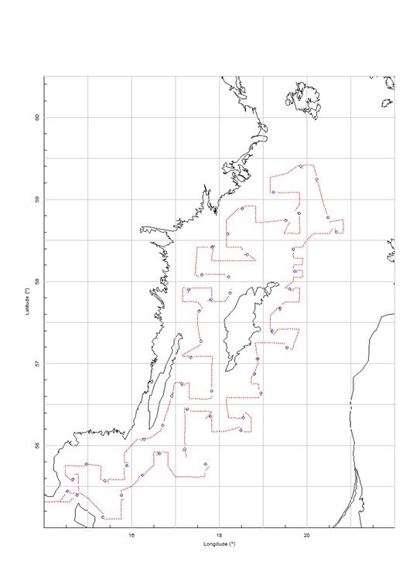
Map 3. Survey grid and trawl positions of for BIAS survey (2018), illustrating the approximate coverage of the survey in 2020 and 2021.

3. Coordination and participation
The new Swedish research vessel Svea will be used for conducting the survey The BIAS survey is coordinated by the ICES Baltic International Fish Survey Working Group (WGBIFS) and the data are uploaded to the international data storage, IBAS database. Participating countries in the survey are Estonia, Finland, Germany, Latvia, Lithuania, Poland and Sweden.
4. Where applicable, describe the international task sharing (physical and/or financial) and the cost sharing agreement used
There is an agreement between Finland and Sweden, where Sweden send two staff to the Finnish part of the BIAS survey conducted in SD30. For details, see table 7C.

5. Explain where thresholds apply
Share of Union TAC for target species is above 3%.

SPRAS – SPRAT ACOUSTIC SURVEY
The survey is also known as BASS – Baltic Acoustic Spring Survey. The survey is included in Table 10 in EU-MAP.
- Objectives of the survey
The aim of the SPRAS surveys is to estimate the stock indices of sprat (Sprattus sprattus) in the Baltic.
- Description of the methods used in the survey
The survey is using a SIMRAD EK80 echo sounder with the 38kHz transducer (ES38-7) for the acoustic transect data collection and a pelagic trawl, Fotö trawl for collecting biological information. Two hauls are made in each ICES rectangle. For each haul, all species are length measured on-board and parameters such as age, weight, and sex are analysed on sprat, herring and cod. Sweden is responsible to cover area subdivision (SD) 27 and parts of SD 29 and SD 25. The acoustic data together with the biological information is used in the assessment models.
Further details are explained in the Sprat Acoustic Survey (SPRAS) manual:
The SPRAS Manual
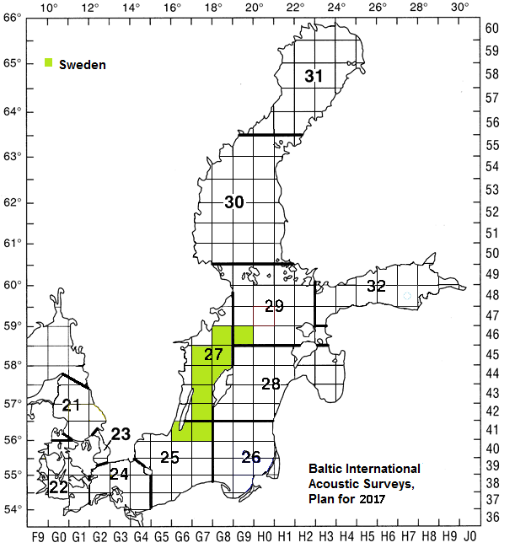
Map 4. Planned area to be covered by Sweden during the SPRAS survey 2020-2021.
- Coordination and participation
2020 will be the first year that Sweden is planning to conduct the survey and the new Swedish research vessel Svea will be used. The SPRAS survey is coordinated by the ICES Baltic International Fish Survey Working Group (WGBIFS) and the data are uploaded to the international data storage, IBAS database. MS participating SPRAS survey is Poland, Germany, Estonia, Lithuania, Latvia and from 2020 also Sweden.

- Where applicable, describe the international task sharing (physical and/or financial) and the cost sharing agreement used
Following recommendations of WGBIFS, each participating MS executes surveys primarily in their respective EEZs. No cost sharing is applied to this survey.

- Explain where thresholds apply
Share of Union TAC for target species is above 3%.
NORTH SEA AND EASTERN ARCTIC
IBTS Q1 and Q3 – The International Bottom trawl survey
1. Objectives of the surveys
The main aim of the survey is to estimate abundance of recruitment of the target species cod, haddock, whiting, Norway pout, herring, sprat, saithe, plaice, mackerel and also non-commercial fish. Moreover, the otoliths of the commercial species are collected and subsequently analysed in order to assess abundance by age class, in particular for the recruiting year classes in the Skagerrak, Kattegat and small parts of the North Sea. The survey is included in Table 10 in EU-MAP.

2. Description of the methods used in the survey
This survey is conducted twice annually, in quarters 1 and 3. The French bottom trawl GOV is used for sampling demersal species in both quarters while in Q1 only, a MIK (Midwater ring net) trawl is used at night for sampling fish larvae. Sweden is assigned 46 hauls for the first quarter survey of which three have been allocated to the North Sea, and 45 randomly selected hauls for the third quarter survey in the Skagerrak and Kattegat. In 2020, According to IBTSWG and recommendations from WKNSIMP, Sweden is requested to increase the overlapping of squares to conform more to the present design of the IBTS, now particularly important in the light of introducing a new vessel. For both surveys hydrographical data are collected with a CTD in connection to the trawl hauls. Each haul is sorted and all species are recorded, length measured and weighed. For target species biological parameters are collected on fish length, age, weight, sex and gonadal maturity. In case of large catches subsampling is performed. Marine litter is registered from each haul.
Further details are explained in the International Bottom Trawl Survey (IBTS) manual:
IBTS

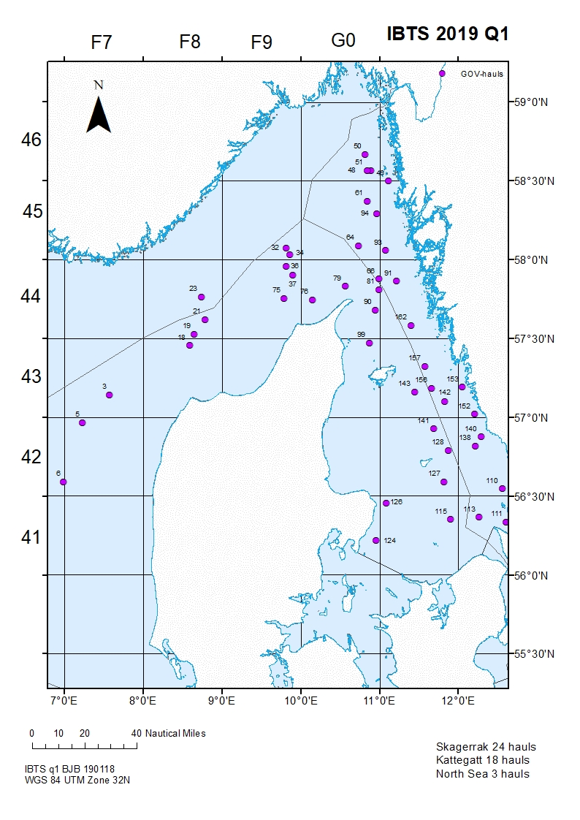
Map 5. IBTS first quarter survey 2019, illustrating the approximate spatial distribution of GOV demersal hauls for the survey in 2020 and 2021.
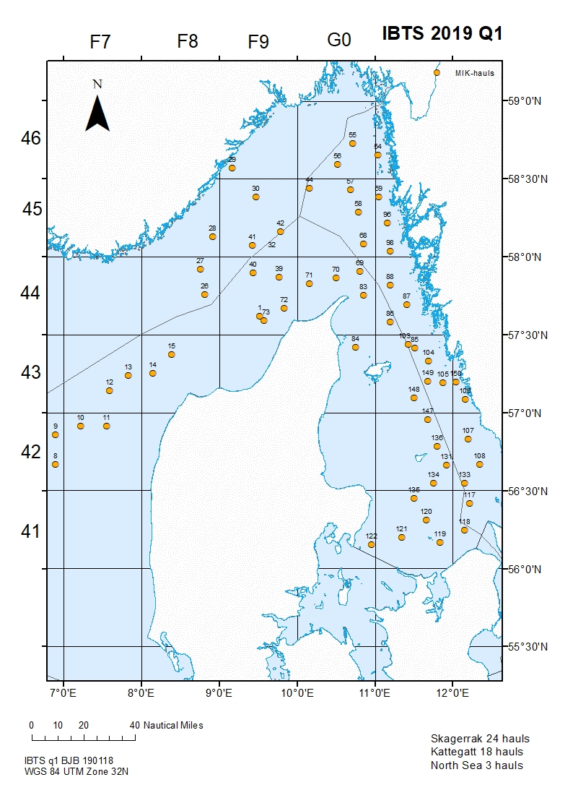
Map 6. Hauls with MIK larvae trawl during IBTS first quarter survey 2019 illustrating the approximate spatial distribution of hauls for 2020-2021.
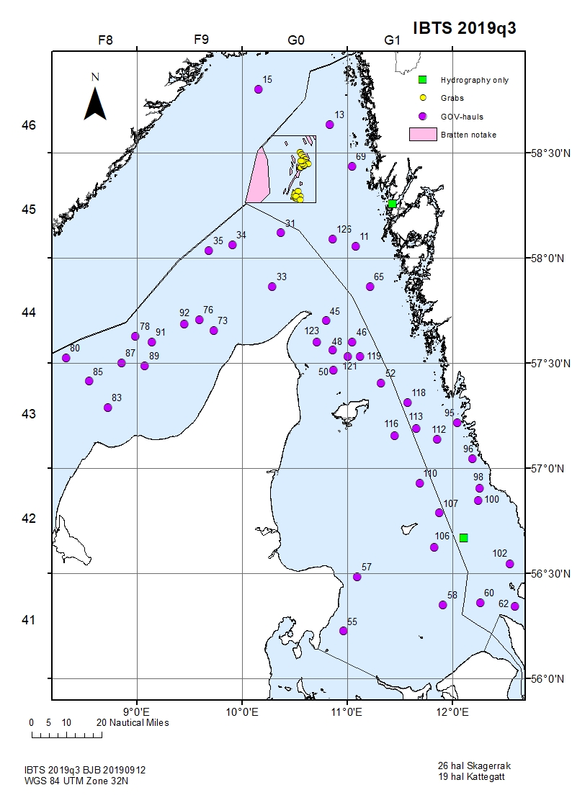
Map 7. IBTS third quarter survey 2019, illustrating the approximate spatial distribution of GOV demersal hauls for the survey in 2020-2021.

3. Coordination and participation
Participating Member states in the surveys are: Sweden, Denmark, Germany, England, Scotland. The IBTS survey is coordinated by the International Bottom Trawl Survey Working Group (IBTSWG) and the data are uploaded to the international ICES database DATRAS. Data on marine litter is reported to the ICES marine litter database.
In 2020 Sweden will run IBTS from the new research vessel Svea. The introduction of a new vessel to the present design of the survey has been discussed in the IBTSWG and the WG has requested Sweden to increase overlapping in a number of statistical squares. The intention is to overlap in approximately 14 squares in the North Sea and the Skagerrak with both Denmark and Norway. The coverage is not entirely decided yet but the work is in progress. Sweden is therefore planning for three extra days compared to previous years to cover the larger area including extra steaming time.

4. International task sharing (physical and/or financial) and the cost sharing agreement used
No cost sharing agreement is applied for this survey.
5. Explain where thresholds apply
Share of Union TAC for target species is above 3%

NTV 3&4 – Nephrops TV SUrvey in functional Unit 3 & 4
1. Objectives of the survey
The objective of the survey is to provide biomass estimates for mud-burrowing animals like Nephrops. The survey is included in Table 10 in EU-MAP.

2. Description of the methods used in the survey
The fishery independent Underwater TV survey is performed by having a video camera mounted on a sledge that is towed slowly (0.5-0.8 knot) on the bottom while recording the bottom surface. The video recording is analysed and Nephrops burrows are counted and converted into densities using information on the width of the view of the camera and length of the tow. Mean weight from biological samplings are used to estimate stock biomass. The manual for the survey, following the standard ICES survey protocol (SISP) can be found in final report of the Working Group on Nephrops Surveys (WGNEPS): WGNEPS
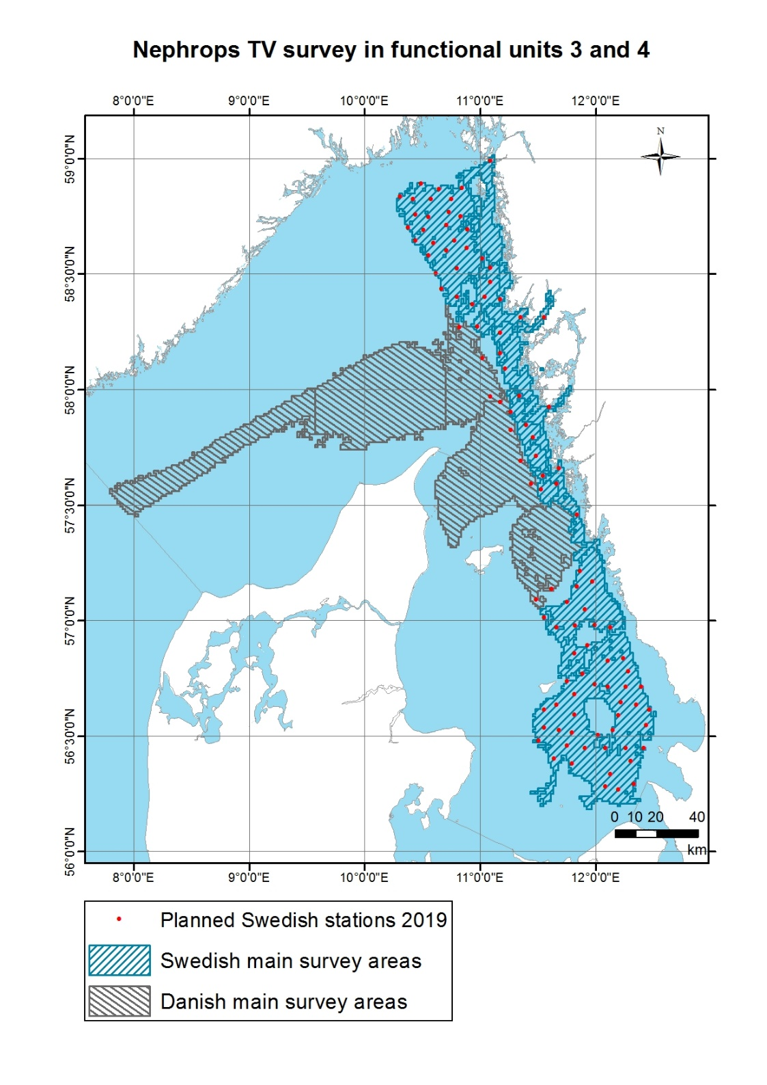
Map 8. Map showing the Nephrops tv (or under water tv UWTV) survey areas. Sweden and Denmark have divided the main responsibility for surveying in different parts or subareas (Danish main areas in grey, Swedish main areas in dark blue). The 2019 planned Swedish stations are shown in red to illustrate the spatial distribution of sampling stations and indicates the planned stations for 2020-2021.

3. Coordination and participation
The survey is a joint survey with Denmark. The survey area is divided into several subareas, where each country has the main responsibility for conducting sampling (see map 8. The future Swedish part of the survey is planned to be conducted using the new Swedish research vessel R/V Svea. The survey is coordinated by the ICES working group on Nephrops surveys (WGNEPS).

4. International task sharing (physical and/or financial) and the cost sharing agreement used
No cost sharing agreement is applied for this survey.
5. Explain where thresholds apply
Share of Union TAC for target species is above 3%

International Ecosystem Survey in the Nordic Seas (ASH; alternative abbr. IESSNS
- Objectives of the survey
This survey is carried out in order to investigate distribution and migrations of the Atlanto-Scandian herring, blue whiting and other pelagic fish and to produce a biomass index for herring and a recruitment index for blue whiting for the ICES Working Group on Widely Distributed stocks (ICES WGWIDE). Furthermore, hydrographic conditions and plankton abundance in the Norwegian Sea and adjacent waters are monitored in order to investigate distribution and migration of herring and other pelagic fishes are influenced by environmental conditions. The survey is included in Table 10 in EU-MAP.

- Description of the methods used in the survey.
The survey is collecting acoustic data, biological data like species composition and length measurements. For the target species herring and blue whiting data are collected on length, weight, sex, maturity and age (from scales of herring and otoliths of blue whiting). In addition, zooplankton hauls are made using a WP2 net and hydrographical data are collected using a CTD.

The sampling procedures are described in: ASH manual

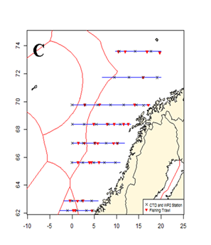

Map 9. Survey area covered in 2017 which indicate the area planned for 2020-2021.

- Coordination and participation
The survey is carried out as a joint EU survey using the Danish vessel R/V DANA with participation of UK, Ireland, Netherlands, Germany, Sweden and Denmark. The survey is coordinated by the ICES Working Group of International Pelagic Surveys, WGIPS.
Denmark is responsible for reporting the data from the survey.

- International task sharing (physical and/or financial) and the cost sharing agreement used
Cost share agreement is established for this survey, see table 7C for details.

- Explain where thresholds apply
Share of Union TAC for target species is above 3%.

Section 2: Fishing Activity Data

Text Box 2A: Fishing activity variables data collection strategy
General comment: This Box fulfills paragraph 4 of Chapter III of the Delegated Decision on the multi-annual Union programme. It is intended to describe the method used to derive estimates on representative samples where data are not to be recorded under Regulation (EU) No 1224/2009 or where data collected under Regulation (EU) No 1224/2009 are not at the right aggregation level for the intended scientific use.
1. Description of methodologies used to cross-validate the different sources of data
Logbook data are automatically checked when filled in regarding completeness and also regarding logic. In addition, random checks are performed later on catches landed compared to those sold and also given geographic positions compared to VMS data. The port inspection also checks and verifies logbook data for the specific trip when an inspection is performed. Finally there are also computerized routinely performed checks of the complete logbook data to find abnormal and exorbitant values for all trips.
Journal data are automatically checked when filled in regarding completeness and also regarding logic. Since the data is on monthly bases no further checks can be done on administrational or field bases. There are computerized routinely performed checks of the complete journal data to find abnormal and exorbitant values for all trips.
2. Description of methodologies used to estimate the value of landings
Value by vessel and trip is concluded by estimating average prices per year, month, subdivision, and gear (if available). The system is dynamic in the sense that if a price does not exist on a certain level, e.g. price per gear, price per subdivision is used instead. If a price for the subdivision is not available price per month is used instead.

3. Description of methodologies used to estimate the average price (it is recommended to use weighted averages, trip by trip)
Average prices is calculated from tripdata by values (see 2.). Meaning that they are weighted on the amount caught.
4. Description of methodologies used to plan collection of the complementary data (sample plan methodology, type of data collected, frequency of collection etc)
A complementary data collection is in place for vessels below 10 meters. The sample plan is census based and they report in a fishing journal instead of the standardized logbook. The journal is filled in once every month with a finite number of fishing trips per journal. If a fishermen have many fishing trips he/she will have to fill in several journals each month to cover all activity. Type of data collected are almost the same as the logbook, number of days, type of gear, catch, spatial allocation etc. The data is not as detailed as the logbook data but it is sufficient for analysis and control purposes.

Section 3: Economic and Social Data

Text Box 3A: Population segments for collection of economic and social data for fisheries

General comment: This Box fulfills paragraph 5 points (a) and (b) of Chapter III of the Delegated Decision on the multi-annual Union programme. It is intended to specify data to be collected under Tables 5(A) and 6 of the Delegated Decision on the multi-annual Union programme.
1. Description of methodologies used to choose the different sources of data
There is no specific methodology when choosing the source of data. Economic data are available via balance sheets for each company. The balance sheet data is complemented by a postal census survey for all fishermen with a license. The survey is mandatory to fill in. Via the survey we obtain data on cost and capital variables as well as socio-economic data.
2. Description of methodologies used to choose the different types of data collection
All variables for economic and social data for fisheries will be collected in census. Data in registers at SwAM are available and used, and excess data needed, like some costs variables and capital values will be obtained in a census mail-survey to all fishermen with a license. Furthermore, social variables will be collected every third year, starting 2018, through a census mail-survey. It is mandatory to reply. The survey will be send by letter-mail because it is the simplest and cheapest way. The respondents can either fill in it by hand or go to a website to fill it in online. No e-mail addresses exist for the complete fleet and collection by phone is too expensive. Data on subsidies is included in the economic survey but also for cross-checking gathered from the databases on the EMFF at the Swedish Board of Agriculture.
Other income, capital values, wages and salaries of crew as well as financial position is also gathered in census from the income tax declarations register of all vessel owners. The data is collected by Statistics Sweden (SCB).
The inactive fleet will not be covered by the collection since they by definition doesn’t have any costs related to fisheries. However, data is gathered on vessel characteristics, effort, which by definition is zero, and capacity (fleet indicators). By experience, the capital value and capital cost of the inactive vessels is similar to capital value and capital cost of active vessels. Therefore, capital costs and capital value is estimated from data of active vessels with the same main gear type as the inactive vessels used when they were last active and fishing.
3. Description of methodologies used to choose sampling frame and allocation scheme
All variables for economic and social data for fisheries will be collected in census.
4. Description of methodologies used for estimation procedures
Estimation is done with a regression method (OLS) for all different economic indicator. The estimation equation is somewhat equal for all indicator. Even though data is collected in census there is still missing data due to non-response from fishermen. Due to the non-responses, an estimation method (OLS) is needed to raise the data to full scale.
Missing data, due to vessels sold, vessel owners that passed away etc., will be taken care of by weighting and calculating weighted averages using days at sea.
An allocation key to allocate the total variable cost to the different cost variables is estimated through the questionnaire (census letter-survey). The concerned cost variables are energy costs, repair and maintenance costs, variable costs and non-variable costs. Total costs from tax declarations are used to calibrate the results at the correct total level of costs to be used for the allocation key.
5. Description of methodologies used on data quality
Logbook data are automatically checked when filled in regarding completeness and also regarding logic. In addition, random checks are performed later on catches landed compared to those sold and also given geographic positions compared to VMS data. The fishery control also checks and verifies logbook data for the specific trip when a control is performed. Finally, there are also computerized routinely performed checks of the complete logbook data to find abnormal and exorbitant values for all trips.
Journal data are automatically checked when filled in regarding completeness and logic. Since the data is on monthly basis no further checks can be done on administrational or field bases. There are computerized routinely performed checks of the complete journal data to find abnormal and exorbitant values for all trips.
Survey data is checked by computerized routines for finding abnormal and exorbitant values. Tax register data are checked in numerous ways at the tax authority.

Section 3: Economic and Social Data

Pilot Study 3: Data on employment by education level and nationality

General comment: This Box fulfills paragraph 5 point (b) and paragraph 6 point (b) of Chapter III of the Delegated Decision on the multi-annual Union programme. It is intended to specify data to be collected under Table 6 of the Delegated Decision on the multi-annual Union programme.
Fisheries
The pilot study regarding fisheries is not applicable anymore due to the addition of the full scale socio-economic questionnaire with a census approach.
Aquaculture
Pilot study regarding aquaculture is not applicable anymore due to an addition of the full scale socio-economic questions in the already existing questionnaire, with a census approach. See section 3B for more details.

Section 3: Economic and Social Data

Text Box 3B: Population segments for collection of economic and social data for aquaculture

General comment: This Box fulfills paragraph 6 points (a) and (b) of Chapter III of the Delegated Decision on the multi-annual Union programme. It is intended to specify data to be collected under Tables 6 and 7 of the Delegated Decision on the multi-annual Union programme.
1. Description of methodologies used to choose the different sources of data
Data will be collected by Statistics Sweden and Swedish board of Agriculture in three ways.
- Statistics Sweden: Income tax declarations from every enterprise whose main source of income (more than 50 %) comes from aquaculture will be compiled from official registers.
- Statistics Sweden: A questionnaire (Q1) about farming techniques, investments, production value and volume, costs that are not specified in the income tax declaration, social vaiables and mortality will be sent to all aquaculture enterprises.
- Swedish board of Agriculture: Data on subsidies will be collected from the Swedish board of Agriculture existing systems, the managing authority of the European Maritime and Fisheries Fund (EMFF), and will be compiled by Swedish board of Agriculture.
2. Description of methodologies used to choose the different types of data collection
Sweden has a production of over 1% of EU’s total production but below 2,5% which gives us the possibility to collect social and economic data with a simplified methodology such as pilot studies with a view to extrapolate the data. Environmental data does not need to be collected according to current thresholds but we consider this information important and has decided to collect and report this data.
The reference data is Sweden’s latest submission under Regulation (EC) No 762/2008 of the European Parliament and of the Council, and corresponding data published by Eurostat.
Data is collected, estimated and checked by Statistics Sweden which ensures the consistency of final data. Quality of the data collected by Swedish board of Agriculture is secured by using existing system for disbursement.
3. Description of methodologies used to choose sampling frame and allocation scheme
Data is collected, estimated and checked by Statistics Sweden which ensures the consistency of final data. Data on variables of production and data on the economic variables not included in the financial accounts (imputed value of unpaid labour, energy cost, livestock volume and cost, feed volume and cost, repair and maintenance, other operational cost, extraordinary cost) will be collected from answers from a questionnaire conducted by Statistics Sweden which ensures the consistency of final data. Data on subsidies will be compiled from existing system of disbursement.
Data is segmented according to table 9 (Commission implementing decision (EU) 2016/1251 adopting a multiannual Union programme for the collection, management and use of data in the fisheries and aquaculture sectors for the period 2017-2019). However, Sweden has a small aquaculture industry and need to group species and techniques together due to confidentiality. With a reference to previously reported production the reported segmentation will be:
- Salmon, trout and other freshwater fish together under Hatcheries and nurseries (8:8).
- Other freshwater fish will be reported under
  - Ponds (8:1),
  - Tanks and raceways (8:2),
  - Recirculation systems (8:4) and
  - Cages (8:6).
- Mussels and Oysters will be reported together under Other (10:12) and
- Crustaceans will be reported under Other (13:12).
4. Description of methodologies used for estimation procedures
A questionnaire (Q1) about farming techniques, investments, production value and volume, costs that are not specified in the income tax declaration, social vaiables and mortality will be sent to all aquaculture enterprises. The questionnaire will make it possible to compare information on value of aquaculture production with declared income from income tax declarations. These comparisons are needed to be able to classify the aquaculture farming as main acitivity of the enterprise or not. Respondents result will be assigned to proper segment by Statistics Sweden.
5. Description of methodologies used on data quality
Data is collected, estimated and checked by Statistics Sweden which ensures the consistency and quality of final data. Questionnaire is evaluated by Statistics Sweden. They conduct telephone interviews with aquaculture enterprises when there are incomplete answers, unreasonable answers or non-responses. Results are checked for bias. We intend to decrease previously biased results from questionnaires by our new methodolgy with just one questionnaire instead of two that is distributed on an enterprise level instead of facility. The quality of data on subsidies is evaluated by Swedish board of Agriculture by comparison with previous years disbursements and programme budget.

Section 3: Economic and Social Data

Pilot Study 4: Environmental data on aquaculture

General comment: This Box fulfills paragraph 6 point (c) of Chapter III of the Delegated Decision on the multi-annual Union programme. It is intended to specify data to be collected under Table 8 of the Delegated Decision on the multi-annual Union programme.
Pilot study regarding environmental data on aquaculture is not applicable anymore due to an addition of the variable mortality to already existing questionnaire, with a census approach. See section 3B for more details. Data on treatments are collected through official records.

Section 3: Economic and Social Data

Text Box 3C: Population segments for collection of economic and social data for the processing industry

General comment: This Box fulfills paragraph 1.1(d) of Chapter III and Table 10 of the Delegated Decision on the multi-annual Union programme. It is intended to specify data to be collected under Table 10 of the Delegated Decision on the multi-annual Union programme.
1. Description of methodologies used to choose the different sources of data
The data presented comes mainly from official statistics that has been collected and processed by Statistics Sweden through the SRU register which is maintained by Statistics Sweden and consists of income tax declarations in Sweden. Part of the data will be collected from the Statistical Business Register which is a central register consisting of information on all registered enterprises in Sweden. It is also maintained by Statistics Sweden. Another part of the data will be collected from Labour market statistics, which is a central register that is maintained by Statistics Sweden.
2. Description of methodologies used to choose the different types of data collection
All data is collected, estimated and checked by Statistics Sweden which ensures the consistency of the final data.
3. Description of methodologies used to choose sampling frame and allocation scheme
All data is collected, estimated and checked by Statistics Sweden which ensures the consistency of the final data. Data on two variables (energy costs and subsidies) will be collected from answers from a questionnaire sent out by Statistics Sweden based on PPS-selection in the Statistical Business Register. The questionnaire is used as a base for estimating an allocation key for variables not included in the financial accounts. The sampling method for the variables collected with probability sample survey is Probability Proportional to Size (PPS sampling) where the sum of total income and total costs is used to select which enterprises that will be sampled. Data on one variable (unpaid labour) will be based on an expert evaluation made by the component authority Statistics Sweden. The reason for this is that there is not possible to use any regular data collection scheme for that variable.
4. Description of methodologies used for estimation procedures
All data is collected, estimated and checked by Statistics Sweden which ensures the consistency of the final data. Data on two variables (energy costs and subsidies) will be collected from answers from a questionnaire sent out by Statistics Sweden based on PPS-selection in the Statistical Business Register. The questionnaire is used as a base for estimating the variables (including energy costs and income from subsidies) not included in the financial account.
5. Description of methodologies used on data quality
All data is collected, estimated and checked by Statistics Sweden which ensures the consistency of the final data. The data quality evaluation is carried out by Statistics Sweden before delivering it to the Board of Agriculture, who conducts a macro evaluation upon delivery to ensure no abnormal or implausible changes have occurred by comparing the new data with previous years.
Sampled data is reviewed on a micro level by Statistics Sweden regarding summations, plausibility and relationships between variables. Outliers that may have a large effect on the estimation are checked and evaluated. Census data from the Swedish Tax Agency and the Statistical Business Register is evaluated by Statistics Sweden although not to such a large extent as sample data. The evaluation of census data mostly consists of reviewing suspiciously extreme values that may be small or large. After reviewing the data on a micro level the data is processed to correct for non-responses. After merging the census and sample data the aggregate is checked and evaluated at a macro level. In the last step no difference is made between sample and census data.
For variables, such as subsidies and energy costs, collected through the probability sample survey CV values are estimated to display the uncertainties due to sampling. A possible shortfall is that, although data is collected, processed and ensured by Statistics Sweden, some variables are not available through financial accounts. The variables affected by this possible shortfall are subsidies and energy costs. The reason for this is that those variables were solely collected through questionnaires and there is a certain range of uncertainty of these variables and it is also difficult to control if they are correct. There are some shortfalls when it comes to subsidies, but it is not a good solution to obtain subsidies from the administrative records. The reason is that we are using Statistics Sweden’s standardized method to obtain the financial information for the processing industry and we do not see that we have any option to change this method.

Section 4: Sampling Strategy for Biological Data from Commercial Fisheries

Text Box 4A: Sampling plan description for biological data

General Comment: This Box forms the basis for the fulfilment of paragraph 2 point (a)(i) of Chapter III of the Delegated Decision on the multi-annual Union programme. This Table refers to data to be collected under Tables 1(A), 1(B) and 1(C) of the Delegated Decision on the multi-annual Union programme.
Sweden is moving towards statistically sound sampling scheme (4S) in the commercial sampling. Preparation of detailed descriptions of the sampling design for the different sampling schemes is one important part in this process.
Evaluation, development and improvement of the remaining sampling schemes are underway and Sweden will continue to develop and implement 4S data collection in 2020 and 2021.
This goal applies to all sampling with the exception of cases where end users may set other requirements. For example, eel sampling may have to be performed in a different way if the data needs are not possible to meet by commercial 4S sampling. This could be due to either fisheries management measures related to the Swedish national eel management plan or in case there are other objectives in the stock assessment that needs to be taken into account (cf. Council Regulation (EC) No 1100/2007 and Joint EIFAAC/ICES/GFCM Working Group on Eels (WGEEL).
Specific uncertainties with regards to 2020/2021:
Baltic Sea demersal fisheries: at present there are temporary emergency measures in place (EU 2019/1248) to protect the eastern Baltic cod stock. These measures will have significant impact on the Swedish cod fisheries in subdivision 27.3.d.24-26 during Quarter 3 and Quarter 4 of 2019. At present (10/2019) it is not yet known to what extent those measures will continue throughout 2020 and 2021. The plan described below assumes situation for 2020 and 2021 will be similar to that registered in the first half of 2019 both in terms of management and industry response. The sampling plan will therefore need to be adapted if, e.g., emergency measures are maintained, altered and/or the industry changes its response to the situation (e.g., by re-directing fishing effort to other species or fishing areas).
Sampling of pelagic stocks: Adequate sampling of pelagic stocks is strongly dependent on the collaboration of the industry and other countries (e.g., to sample foreign landings). Sweden is presently revising its commercial sampling of small pelagics to better meet the requirement of 4S sampling. The aim is to achieve a regional sampling plan, supported by the fishing industry and other Member States, that allows for the random sampling of vessels and/or trips and improves coverage to both national and foreign landings. At present landings of Danish vessels in Swedish ports are sampled whenever possible and the landings of Swedish vessels in Danish ports are covered by a bilateral agreement.

BALTIC SEA
Scheme: Baltic at-sea
Purpose: At-sea Observer Programme for length, age, weight data of landings and discards of demersal species in the Baltic Sea (Subdiv 22-32)
Main end-users: ICES WGBFAS; National fisheries management agency; Scientific research projects;
Design: Multi-stage
Main stratification: 2 fishery stratum (see details in Table 4A)
Temporal Stratification: Quarterly
Spatial Stratification: none (DemTrawlers in 22/29); 1 spatial stratum (DemNets in 23)

Stratum: SWE - Balt (at-sea) - Act – 22/29 – DemTrawl
 | Sampling frame | Sampling unit | Stratification | Selection Method | Sampling effort
1SU | List of vessels active in the Demersal trawl fishery in subdiv. 22 to 29 during previous year | Vessel | Quarterly | random draw from vessel list with unequal probability (probability proportional to number of trips) without replacement | 4 (per quarter)
2SU | Hypothetical list of trips from vessel | Fishing Trip | --- | ad-hoc (dependent on staff availability) | 1 (per vessel)
3SU | Hypothetical list of hauls in trip | Haul | --- | Census | Census
4SU | Hypothetical list of individuals caught in haul | Individuals | Species x Catch Fraction x Commercial Size Category  Biology: also 1cm length classes | Length: Census (random sample if too large)  Biology: Census (random sample if too large); sampling stops when trip goals are achieved | Length: all individuals  Biology:  COD BMS and discards: 5 otoliths and individual weights (per size class and trip)

Stratum: SWE - Balt (at-sea) - Pass – 23 - DemNets
 | Sampling frame | Sampling unit | Stratification | Selection Method | Sampling effort
1SU | List of weeks of the year | Week | Quarterly | random sample from week list without replacement | Gillnets: 5 (per quarter)
2SU | List of vessels active in the gillnetter or longlines fisheries for demersal species in specific subdivisions during 2016 | Vessel | --- | random sample from quarterly vessel list without replacement | 1 (per week)
3SU | Hypothetical list of weekly trips from vessel | Fishing trip | --- | ad-hoc (dependent on staff availability) | 1 (per vessel)
4SU | All boxes of catch kept during fishing trip | Boxes | Species x Catch fraction x Commercial Size Category | Census or “random” sample by observer | Cod Landings:  size (1-3): all boxes (or a sample of boxes)  size (4-7): 1 box  Other species landed and discarded: all boxes
5SU | All individuals in the box | Individuals  (individual length, weight and age) | None | Length: Census Biology: Random sample or census (depending on size category) | Length: all individuals in box  Biology (per size):  COD Sizes 1-3: all otoliths and weights  COD Sizes 4-5: 20 otoliths and weights + all remainder fish only weight  COD Sizes 6, BMS and discards: 20 otoliths and weights + 20 fish only weight

Main limitations: Sampling per trip for ages and weights may not ensure proper spatial coverage of the most abundant size classes;
Expected difficulties: There is risk for refusals and changes in fleet activity related to landing obligation, emergency management measures on the baltic cod fishery, and other management measures; usage of random vessel lists in sampling the demersal trawl strata is statistically sound but may bring about low coverage in some subdivisions.
Expected coverage of target population (based on sampling targets and 2016-2018 average number of trips per strata):
- SWE - Balt (at-sea) - Act – 22/29 – DemTrawl: 2.2% (n=16)
- SWE - Balt (at-sea) - Pass – 23 – DemNets: 1.2% (n=20)

Scheme: Baltic self-sampling
Purpose: Self-sampling programme for length, age, weight data of landings of demersal fisheries and catches of pelagic fisheries, including vendace, in the Baltic Sea (Subdiv 22-32)
Main end-users: ICES WGBFAS; National fisheries management agency; Scientific research projects;
Design: Multi-stage
Main stratification: 13 fishery stratum (see details in Table 4A)
Temporal Stratification: Quarterly
Spatial Stratification: by subdivision (in passive gears) or set of subdivisions (in active gears)

Stratum: SWE - Balt (self) - Act - 22/29 - DemTrawl
 | Sampling frame | Sampling unit | Stratification | Selection Method | Sampling effort
1SU | List of weeks of the year | Week | Quarterly | random draw from week list without replacement | 6 (per quarter)
2SU | List of vessels active in the Demersal trawl fishery in all Baltic subdivisions previous year | Vessel | --- | Random selection from quarterly vessel list | 4 (per week) (*)
3SU | Hypothetical list of daily landings of cod from vessel in week | Daily landing of cod | --- | ad-hoc (performed by buyer) | 1 (per vessel)
4SU | All boxes of cod landed in fishing trip | Boxes of cod | Commercial Size Category | ad-hoc (performed by buyer) | 1 box (**)
5SU | All individuals in the box | Individuals  (individual length, weight and age) | None | Length: Census Biology: Random sample or census (depending on size category) | Length: all individuals in box  Biology:  Sizes 1-3: all otoliths and weights  Size 4: 20 otoliths and weights + 20 fish only weight  Sizes 5-7: 10 otoliths and weights + 10 fish only weight
(*) to ensure coverage of areas with less activity, buyers are also instructed to deliver full samples from additional landings from rarer subdivisions, e.g., subdivision 24 whenever fleet activity occurs in that subdivision and vessels are not on the list;
(**) n=1 additional box is requested from sizes 1-3 from another vessel to ensure less frequent size classes are sampled.
Passive gear strata under SWE - Balt (self) – Pass – 23/25
 | Sampling frame | Sampling unit | Stratification | Selection Method | Sampling effort
1SU | List of weeks of the year | Week | Quarterly | random sample from week list without replacement | Gillnets and Longlines: 5 (per quarter)
2SU | List of vessels active in the gillnetter or longlines fisheries for demersal species in specific subdivisions during 2016 | Vessel | --- | random sample from quarterly vessel list without replacement | 2 (per week)
3SU | Hypothetical list of weekly trips from vessel | Fishing trip | --- | ad-hoc (dependent on staff availability) | 1 (per vessel)
4SU | All boxes of catch kept during fishing trip | Boxes | Species x Catch fraction x Commercial Size Category | Census or “random” sample by observer at the landing site | Cod Landings:  size (1-3): all boxes (or a sample of boxes)  size (4-6 and BMS): 1 box  Other species landed and discarded: all boxes
5SU | All individuals in the box | Individuals  (individual length, weight and age) | None | Length: Census Biology: Random sample or census (depending on size category) | Length: all individuals in box  Biology (per size):  COD Sizes 1-3: all otoliths and weights  COD Sizes 4-5: 20 otoliths and weights + all remainder fish only weight  COD Sizes 6 and BMS and discards: 20 otoliths and weights + 20 fish only weight

Stratum: SWE - Balt (self) - Act - 30 - DemTrawl
 | Sampling frame | Sampling unit | Stratification | Selection Method | Sampling effort
1SU | Hypothetical list of vessel*weeks from vessels active in the fishery | Vessel*Week | Quarter | Systematic (every fourth week, randomly select the first week); vessels selected without replacement | 3
2SU | Hypothetical list of trips | Trip | --- | Ad-hoc | 1 Trip
3SU | Hypothetical list of hauls in trip | Haul | --- | Ad-hoc (selected by the fishermen) | 1 haul
4SU | Hypothetical list of boxes | Box | --- | 20-25 kg unsorted | 1 box
5SU | Individuals in the box | Individual | Species | Census (length of all species) | ---

Stratum: “SWE - Balt (self) – Pass – 30” and “SWE - Balt (self) – Pass – 31”
 | Sampling frame | Sampling unit | Stratification |  | Selection Method |  | Sampling effort
1SU | List of vessels active in the gillnetter fisheries | Vessel*Month | Quarter |  | Ad-hoc |  | 3
2SU | List of trips from fishermen | Trip | --- |  | Ad-hoc |  | 1 (month)  In total 6 trips in one year
3SU | Catch of the trip | Box | Landings (20kg) and discards (5kg) | Ad-hoc (random) |  | 1
4SU | Individuals in the sample (box) | Individuals | Species  Biology (only Herring): Length stratified (half cm) | Census (all lengths measured)  Biology: Random sampling within length class until quarterly goals are achieved |  | Length: all ind.  Biology: 20 ind (otoliths, length (mm), weights, maturity, sex) per size class and quarter

Strata under “SWE - Balt (self) - Act - 31 – Pair trawlers targeting vendace”
 | Sampling frame | Sampling unit | Stratification |  | Selection Method |  | Sampling effort
1SU | List of weeks of the year  (Sept-Oct  5 weeks) | Week |  |  | Systematic (1st, 3rd and 5th week samples) |  | 3 weeks
2SU | List of vessels (fishing in the area) | Vessels | Five fishing areas within subdivision 31 |  | “Random” selection from vessel list |  | 1 vessel pairs  (per week/per area)
3SU | Hypothetical list of trips (from that vessel) | Trip landing |  | Ad-hoc (convenience) |  | 1 (per vessel)
4SU | Hypothetical list of bins of the landed fish | Bin | Species  Biology (only Herring): Length stratified (half cm) | From the middle of the landing |  | 1 bin
5SU | Hypothetical list of 10 L bucket in the bin | Bucket 10 L | --- | Ad-hoc |  | 1 bucket
6SU | All individuals in the bucket | Individual (species, individual length, weight and sex) | All length and recorded 0.5 cm groups | Census |  | Length: all individuals in bucket
7SU | Vendace in the bucket | Individual (Weight of gonads, maturity, age) |  | Ad-hoc |  | 65-70 in the bucket
Main limitations: lack of control over the sampling in self-sampling programmes requires significant a posteriori checks for sampling biases; In trawlers, the usage of random vessel lists in sampling of combined subdivisions (e.g., 22-29) is statistically sound but may yield low sample size in some of the subdivisions; Passive gears in subdivision 27-29 (where only minor cod landings occur) are not covered in the sampling.
Expected difficulties: There is risk for refusals or changes in fleet activity related to landing obligation, emergency management measures on the baltic cod fishery, and other management measures (e.g., temporal closures); Longline fisheries and gillnet fisheries in subdivision 24 are relatively limited making the sampling of this domain quite uncertain;
Expected coverage of target population (based on expected trips and 2016-2018 average number of trips per strata):
- SWE - Balt (self) - Act - 22/29 – DemTrawl: 13.0% (n=96)
- SWE - Balt (self) - Pass - 23 – Nets: 1.8% (n=40)
- SWE - Balt (self) - Pass - 24 – Longlines and Nets: 3.0% (n=40)
- SWE - Balt (self) - Pass - 25 – Nets: 1.8% (n=40)
- SWE - Balt (/self) - Pass - 25 - Longlines: 10.2% (n=40)
- SWE - Balt (self) - Act - 30 - DemTrawl: 5.4% (n=12)
- SWE - Balt (self) – Passive – 30 – Herring Nets: 0.7% (n=6)
- SWE - Balt (self) – Passive – 31 – Herring Nets: 2.6% (n=6)
- SWE - Balt (self) - Act - 31 – Vendace Pair trawlers: 2.6% (n=15)

Scheme: Baltic at-sea 2
Stratum KBWE2 and KBEE2/KBEE3
Scheme: Sampling is set up by contacting preselected fishermen. In connection with their silver eel pound net fishery, the fishermen sign up on a yearly basis for 1) a number of métier sampling trips and 2) collection of eel for stock sampling. Additionally, it is possible to sign up for recording effort and eel landings in a voluntary daily logbook. These data are a complement to the official landing statistics and may also include discards and seal- and bird-induced damage. Each fisherman can have several vessels. Observers choose which trip they visit the fishermen to perform the métier sampling. Set-up: 1 fisherman in SD 23, SD 25 and SD 27 respectively. In total, 8 métier sampling trips are planned.

Scheme: Baltic other (market stock specific)
Purpose: Stock-specific programmes for length, length-weight relationship, age, maturity and stock composition of commercial landings from herring and sprat stocks in the Baltic
Design: Multi-stage
Main end-users: ICES HAWG, ICES WGBFAS; National fisheries management agency; Scientific research projects.

Herring
 | Sampling frame | Sampling unit | Stratification | Selection Method | Sampling effort
1SU | Hypothetical list of fishing trips with landings of herring or sprat from target subdivision during year | Fishing trip x species | Quarter and Subdivision (24-29S; 29N-31) | ad-hoc selection by first hand buyer; it is requested that samples are spread out in quarter | 8 to 10 Trips
2SU | Individuals landed on fishing trip | Box | --- | ad-hoc selection by first hand buyer | 1 Box
3SU | Herring individuals in box | Biology of individuals  (individual length, weight, age, sex maturity, intestinal fat, nematodes ichthyophonus) | --- | Census or subsamples (50-150 per box when boxes are large and many boxes are available) until sampling targets are achieved | 400 individuals per Quarter and Subdivision (24-29S)  800 individuals per Quarter and Subdivision (29N-31)

Sprat
 | Sampling frame | Sampling unit | Stratification | Selection Method | Sampling effort
1SU | Hypothetical list of fishing trips with landings of herring or sprat from target subdivision during year | Fishing trip x species | Quarter and Subdivision (24-29S) | ad-hoc selection by first hand buyer | Variable
2SU | Individuals landed on fishing trip | Box | --- | ad-hoc selection by first hand buyer until sampling targets are attained | 1 Box
3SU | Herring individuals in box | Biology of individuals  (individual length, weight, age, sex maturity) | --- | Census or subsamples (50-150 per box when boxes are large and many boxes are available) until sampling targets are achieved | 500 individuals per Quarter and Subdivision

Main limitations: Lack of control of selection procedures
Expected difficulties: Weather conditions and number of boats fishing can affect sampling in Q1 and Q4
Expected coverage of target population (based on average number of samples obtained in 2016-2018 and average number of trips per strata in 2016-2018):
- SWE - Balt (stock spec) - Act - 24 – HerSpr: 31.4%
- SWE - Balt (stock spec) - Act - 25 – HerSpr: 5.2%
- SWE - Balt (stock spec)- Act - 26 – HerSpr: 14.0%
- SWE - Balt (stock spec)- Act - 27 – HerSpr: 2.5%
- SWE - Balt (stock spec)- Act - 28 – HerSpr: 3.4%
- SWE - Balt (stock spec)- Act - 29 – HerSpr: 4.5%

Scheme: logbooks & journals, freshwater
Purpose: biological sampling for weight, length, sex, maturity, age and endoparasite (Anguillicola crassus) from the commercial freshwater eel fishery.
In addition to the biological sampling the official fishery statistics of landings (numbers and total weight) of all commercial freshwater eel fisheries is collected by Swedish Agency for Marine and Water Management (SwAM) from all licensed fishermen. Numbers and weight of caught eel are used in ICES stock assessment models.

Design: Multi-stage
Main stratification: 1 Strata (see details in Table 4A)
Temporal Stratification: annual
Spatial Stratification: none

Strata: Freshwater, Eel-Fresh
 | Sampling frame | Sampling unit | Stratification | Selection Method | Sampling effort
1SU | Commercial eel fishery | fisherman X lake | NA | Representative eel fisherman in three varying lakes |  | 1 fisherman X lake
2SU | Landings | Individual fish | 1 cm length classes | Random sample | 125 fish per lake (375 fish in total) are sampled for weight, length, sex, maturity, age and endoparasite A. crassus.

Main limitations: The mandatory statistics data is the catch and the corresponding effort, however with different resolution and aggregation depending on the lakes concerned. EU logbooks made for daily reports are not used for freshwater fisheries, instead freshwater catches are reported on monthly or annually basis depending on lake. Eel rescued from induced mortalities in hydropower installation through a Trap and Transport program are reported to SwAM by each fisherman as well as by the fisher’s organization on behalf of the industry.
Individual size, stage, sex, age and prevalence of an endoparasite (Anguillicola crassus), are collected from eels sampled from the commercial fishery in freshwater as described in Table 1C.
Expected difficulties: Unreporting or misreporting of catches occurs to an unknown extent. Since journal reliability is dependent on correct reporting by fishermen, there is potential bias in data. Landings for commercial purposes and catch for Trap & Transport purposes have been mixed up, but must be separated for the assessment.

Expected coverage of target population: By altering sampling between different lakes, fishermen and year, most “eel lakes” will be covered within a number of years concerning sampling of biological variables. Expected coverage of the commercial fishery statistics of target population by lake is close to 100% (based on the mandatory fishing journals conducted by licensed fishermen, meaning that all catch and/or landings have to be reported).

NORTH SEA AND EASTERN ARCTIC
Scheme: NorthSea&EasternArtic at-sea or self-sampling
Purpose: Length, age, weight data of landings and discards of demersal species in Skagerrak (subdiv 20) and Kattegat (subdiv 21)
Main end-users: ICES WGBFAS, ICES WGNSSK, NAFO/ICES NIPAG; National fisheries management agency; scientific research projects
Design: Multi-stage
Main stratification: 8 fishery strata (see details in Table 4A)
Temporal and Spatial Stratification: Quarterly (all fisheries); Subdiv. (in some fisheries, see table 4A-B)

Per strata
 | Sampling frame | Sampling unit | Stratification | Selection Method | Sampling effort
1SU | List of vessels active in the fishery during previous year | Vessel | Quarterly | random draw from vessel list with unequal probability (probability proportional to number of trips; draw without replacement) | 3-5 (per quarter dependent on stratum)
2SU | Hypothetical list of trips from vessel | Fishing Trip | --- | ad-hoc (dependent on staff availability) | 1 (per vessel)
3SU | Hypothetical list of hauls in trip | Haul | --- | Census | Census
4SU | Hypothetical list of individuals caught in haul | Individuals | Species x Catch Fraction x Commercial Size Category (*)  Biology: also 1cm length classes | Length: Census (random sample if too large)  Biology: Census (random sample if too large); sampling stops when trip goals are achieved | Length: all individuals  Biology:  WIT landings: Otoliths and individual weights from a subsample of 5-10 kg per trip  COD discards: 3 otoliths and individual weights (per size class and trip)  PLE discards: 3 otoliths and individual weights (per size class and trip)  WIT discards: 3 otoliths and individual weights (per size class and trip)
(*) in at-sea sampling of “SWE - SkaKat (at-sea) - Act - 20/21 – PanTrawlTun” and “SWE - SkaKat (at-sea) - Act - 20/21 – PanTrawlNoTun” reference samples from unsorted shrimps catches from the last haul are collected for validation purposes
Main limitations: Sampling frames used in some strata are defined in terms of both métiers and areas; Sampling for ages and weights may not ensure proper spatial coverage of the most abundant size classes;
Expected difficulties: There is risk for refusals related to landing obligation and other management measures; usage of random vessel lists in some strata is statistically sound but may bring about low coverage in some subdivisions.
Expected coverage of target population (based on expected trips and 2016-2018 average number of trips per strata):
- SWE - NorthSea&EasternArtic (at-sea) - Act - 20/21, IVa-c – PanTrawlTun: 1.7% (n=12)
- SWE - NorthSea&EasternArtic (self) - Act - 20/21, IVa-c – PanTrawlNoTun: 0.8% (n=12)
- SWE - NorthSea&EasternArtic (at-sea) - Act - 20 – NepTrawlGrid: 0.4% (n=12)
- SWE - NorthSea&EasternArtic (at-sea) - Act - 21 – NepTrawlGrid: 0.9% (n=12)
- SWE - NorthSea&EasternArtic (at-sea) - Act - 20 – MixTrawl: 1.2% (n=20)
- SWE - NorthSea&EasternArtic (at-sea) - Act - 21 – MixTrawl: 1.1% (n=16)
- SWE - NorthSea&EasternArtic (at-sea) - Pass - 20/21 – NepPots: 0.3% (n=12)
- SWE - NorthSea&EasternArtic (at-sea) - Pass - 21 – DemNets: 0.8% (n=20)

Scheme: NorthSea&EasternArtic other (market stock specific)
Purpose: Stock-specific programmes for length, length-weight relationship, age, maturity and stock composition of commercial landings from herring, sprat, cod and witch flounder stocks in the Skagerrak and Kattegat
Main end-users: ICES HAWG, ICES WGBFAS, ICES WGNSSK, NAFO/ICES NIPAG; national fisheries management agency; scientific research projects;
Design: Multi-stage

Cod
 | Sampling frame | Sampling unit | Stratification | Selection Method | Sampling effort
1SU | Hypothetical list of fishing trips with landings of cod from target subdivision during year | Fishing trip x species | Quarter and Subdivision (20, 21) | ad-hoc selection by first hand buyer until sampling targets are achieved. It is requested that trips are spread in time. | Variable
2SU | List of size categories of cod in fishing trip | Size category | --- | ad-hoc selection by first hand buyer until sampling targets are achieved. It is requested that size categories are spread across trips (i.e., only 1-2 size categories are sampled per trip) | 1 size category
2SU | List of boxes in size category | Box | --- | ad-hoc selection by first hand buyer until sampling targets are achieved | 1 box (size 1 to 4)  ½ to 1 box (size 5)
3SU | Cod individuals in box | Biology of individuals  (individual length, weight and age) | --- | ad-hoc selection by first hand buyer until sampling targets are achieved | All fish are sampled for weight and otoliths until the following quarter*subdiv targets are achieved:  Size 1: 50 indiv.  Size 2: 50 indiv.  Size 3: 100 indiv.  Size 4: 100 indiv.  Size 5: 100 indiv.

Herring
 | Sampling frame | Sampling unit | Stratification | Selection Method | Sampling effort
1SU | Hypothetical list of fishing trips with landings of herring or sprat from target subdivision during year | Fishing trip x species | Quarter and Subdivision (20, 21) | ad-hoc selection by first hand buyer | Variable
2SU | Individuals landed on fishing trip | Box | --- | ad-hoc selection by first hand buyer | 1 Box
3SU | Herring individuals in box | Biology of individuals  (individual length, weight, age, maturity, nematodes) | --- | Census or subsamples (50-150 per box when boxes are large and many boxes are available) until sampling targets are achieved | 650 individuals per Quarter and Subdivision

Sprat
 | Sampling frame | Sampling unit | Stratification | Selection Method | Sampling effort
1SU | Hypothetical list of fishing trips with landings of herring or sprat from subdivision during year | Fishing trip x species | Quarter and Subdivision (20, 21) | ad-hoc selection by first hand buyer until sampling targets are achieved | Variable
2SU | Individuals landed on fishing trip | Box | --- | ad-hoc selection by first hand buyer until sampling targets are achieved | 1 Box
3SU | Herring individuals in box | Biology of individuals  (individual length, weight, age, maturity) | --- | Census or subsamples (50-150 per box when boxes are large and many boxes are available) until sampling targets are achieved | 400 individuals per Quarter and Subdivision

Witch flounder
 | Sampling frame | Sampling unit | Stratification | Selection Method | Sampling effort
1SU | Hypothetical list of fishing trips observed at-sea with landings of witch flounder | Fishing trip x species | Quarter and Subdivision (20) | ad-hoc selection by observers until sampling targets are achieved | Variable
2SU | Individuals landed on fishing trip | Box | --- | ad-hoc selection from unsorted landings | 1 Box
3SU | Witch flounder individuals in box | Biology of individuals  (individual length, weight, age, maturity) | --- | Census or subsamples | 100 individuals per Quarter and Subdivision

Main limitations: Lack of control over selection procedures
Expected difficulties: None
Expected coverage of target population (based on average number of samples obtained in 2016-2018 and average number of trips per strata in 2016-2018):
- SWE - NorthSea&EasternArtic (stock spec) - Act - 20 – HerSpr: 33.8%
- SWE - NorthSea&EasternArtic (stock spec) - Act - 21 – HerSpr: 22.4%
- SWE - NorthSea&EasternArtic (stock spec) - Act - 20 – Cod: 2.7%
- SWE - NorthSea&EasternArtic (stock spec) - Act - 21 – Cod: 6.7%
- SWE - NorthSea&EasternArtic (stock spec) - Act - 21 – Witch: 0.7%

All Schemes:
Data archiving: Secure SQL database and RDB.
Quality assurance: Checks are made on data entry by means of database internal validation and quarterly/annual checks using R-scripted routines and developments from fishPi WP4 (see also Table 5A); Data archiving and quality assurance procedures for catch data are performed by the responsible authority, Swedish Agency for Marine and Water Management (SwAM).
Age reading: Otoliths are aged according to ICES guidelines.
Estimation: Estimates are carried out largely following ICES guidelines (e.g., WKDRP, WKPICS, WGCATCH)
Quality: Data entry checks and database internal validation, quarterly and annual checks using R-scripted routines and developments from fishPi projects; No significant biases have been identified to date; Data are routinely accepted and used by end-users (namely ICES, STECF and SwAM).
Future improvements: Most sampling schemes were peer-reviewed by external experts between Nov/2016 and Nov/2018 resulting in the improvement of the statistical properties of some of the sampling schemes carried out in 2017-2019. A scheme-by-scheme work-plan for optimization and better approximating statistical sound sampling and estimation and end-user needs is currently being developed. When implementing changes priority will be given to the current stock-based sampling of small pelagics for which implementation of new designs and regional sampling is expected for 2021 onwards. With regards to eel sampling, reporting of effort should be mandatory. The reliability of the journal data could be improved by reducing unreported and misreported catches. SwAM is continuously working on improving data reliability.

The sampling scheme complements sampling carried out in schemes “Baltic self-sampling” by extending data collection to additional stocks and discards of demersal trawlers and gillnets in subdivision 23
In most strata self-sampling is restricted to the selection of the samples with observers carrying out the identification of the catch, measurements and biological sampling
The sampling scheme complements sampling carried out in schemes “Baltic at-sea” by, e.g., supplementing data collection of trawl catches of cod stocks
In subdivisions 26 to 29 the gillnet and longline fisheries are very reduced in so no strata have been defined.
Danish vessels landing Pandalus borealis in Swedish ports are sampled whenever possible.

