Ministry of Agriculture Forestry and Food of the Republic of Slovenia
and
Fisheries Research Institute of Slovenia

Regulation (EU) 2017/1004 of 17 may 2017
on the establishment of a Union framework for the collection, management and use of data in the fisheries sector and support for scientific advice regarding the common fisheries policy and repealing Council Regulation (EC) No 199/2008 (recast)

Commission Regulation (EC) No 665/2008 of 14 July 2008
laying down detailed rules for the application of Council Regulation (EC) No 199/2008

Commission delegated decision (EU) 2019/910 of 13 March 2019 establishing the multiannual Union programme for the collection and management of biological, environmental, technical and socioeconomic data in the fisheries and aquaculture sectors
Commission implementing decision (EU) 2019/909 of 18 February 2019 establishing the list of mandatory research surveys and thresholds for the purposes of the multiannual Union programme for the collection and management of data in the fisheries and aquaculture sectors

Slovenia Work Plan for data collection in the fisheries and aquaculture sectors
2020-2021

(Our Ref. No.: 342-6/2016/291)

CONTENTS
Section 1: Biological Data 2
Pilot Study 1: Relative share of catches of recreational fisheries compared to commercial fisheries 2
Section 1: Biological Data 2
Text Box 1E: Anadromous and catadromous species data collection in fresh water 2
Section 1: Biological Data 2
Pilot Study 2: Level of fishing and impact of fisheries on biological resources and marine ecosystem 2
Section 1: Biological Data 2
Text Box 1G: List of research surveys at sea 2
Section 2: Fishing Activity Data 2
Text Box 2A: Fishing activity variables data collection strategy 2
Text Box 3A: Population segments for collection of economic and social data for fisheries 2
Section 3: Economic and Social Data 2
Pilot Study 3: Data on employment by education level and nationality 2
Section 3: Economic and Social Data 2
Text Box 3B: Population segments for collection of economic and social data for aquaculture 2
Section 3: Economic and Social Data 2
Pilot Study 4: Environmental data on aquaculture 2
Section 3: Economic and Social Data 2
Text Box 3C: Population segments for collection of economic and social data for the processing industry 2
Section 4: Sampling Strategy for Biological Data from Commercial Fisheries 2
Text Box 4A: Sampling plan description for biological data 2

Section 1: Biological Data

Pilot Study 1: Relative share of catches of recreational fisheries compared to commercial fisheries

General comment: This Box fulfills paragraph 4 of Chapter V of the multi-annual Union programme and Article 2 and Article 4 paragraph (3) point (a) of this Decision.
1. Aim of pilot study
No pilot study is planned.
Since 2017 a statistical methodology for etimating catch data from recreational fisheries was developed in cooperation between Statistical Office of the Republic of Slovenia and Ministry of Agriculture, Forestry and Food. Sources for the recrational fisheries data are 1. Data received on the basis of annual licenses for sport fishing; 2. Data received on the basis of an annual licenses for the recreational fishing with spear gun; 3. Data received on the basis of daily and weekly licenses for recreational fisheries; 4. Data received from the organised sport competitions.
Based on this data and data from loogbook for commercila fisheries (all vessels have to fulfill the logbooks) a relative share catches of recreational fisheries compared to commercial fisheries can be easily done.
2. Duration of pilot study
/
3. Methodology and expected outcomes of pilot study
/
(max 900 words)

Section 1: Biological Data

Text Box 1E: Anadromous and catadromous species data collection in fresh water
General comment: This Box fulfills paragraph 2 points (b) and (c) of Chapter III of the multi-annual Union programme and Article 2 of this Decision.
Method selected for collecting data.
Anadromous and catadromous species data collection in fresh water will not be performed due to following reasos:
- Anguilla anguilla is protected species in Slovenia and it is not fished.
In Slovenia eel (Anguilla Anguilla) is protected species by the Decree on protected wild animal species, OJ 46/2004 and other amendments. With this Decree listed animals in Annex 1 are protected and habitats of animals listed in Annex 2 are also protected. Decree establish the protection of endangered species of wild fauna and flora, prescribes code of conduct, special protection arrangements and measures for protection and preservation of habitats of animal species with the intention to maintain favourable level of conservation of the species. It is prohibited to intentionally damage, kill, take from nature, catch, take and retain or agitate eels. It is also prohibited to have ells in captivity, to transport, to sell or trade eels taken from the nature.
In Slovenia eel is present in Adriatic hydrographic basin (west part of Slovenia indicated with blue and purple colour). In a part of catchment area of 2 very small rivers of Rižana and Dragonja that are located in south west part of Slovenia and in a part of catchment area of river Soča (purple colour that flows in Adriatic sea through Italy).
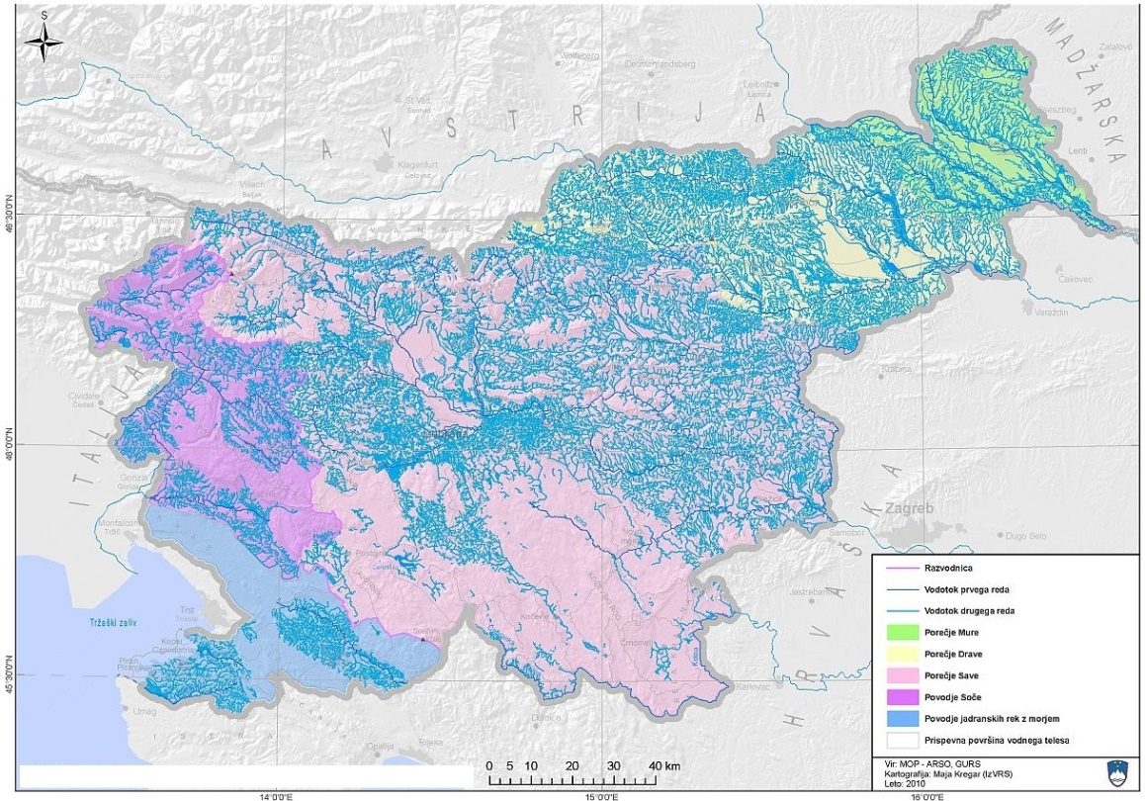
Figure 1: Rivers catchment areas of Slovenia. (Map source: Ministry of the Environment and Spatial Planning).

Therefore eel is not fished neither by commercial neither by recreational fisheman.
In year 2008 and 2019 Slovenia informed the European Commission that European eel (Anguilla anguilla) has been protected on the national level since 2004 via the Decree on protected wild animal species (Official Journal of the RS, No 46/2004). On the basis of this Decree, the fishing of eels in Slovenia is completely prohibited; it is also prohibited to intentionally harm, poison, kill, take from nature, hunt, catch or disturb the specimens of European eel.
These letters have been submitted to the Commission to exempt Slovenia from the obligation to submit an eel management plan in accordance with Regulation (EC) No 1100/2007. The Commission has responded favourably to the information and justifications provided by Slovenia.
Because of this Slovenia can not colect data on eel as specified in EU MAP III.2.c. In cases of incidental catch of eel in freshwater or marine fisheries, the data on number and wight are regularly recorded. Incidental catches are very rare and all are recorded in Biological database of the Fisheries research Institute of Slovenia – BioS Web (http://www.biosweb.org/index.php?task=map&tid=144).

- Salmo salar is not present in Slovenian waters.

- Salmo trutta in Slovenia is represented by subspecies Salmo trutta fario, which is landlocked in Slovenian rivers and not anadromous.

Based on the above mentioned facts Slovenia clearly presented basis for the exemption from the anadromous and catadromous species data collection in fresh waters. Besed on the Tabel 1E of the commission delegated decision (EU) 2019/910 of 13 March 2019 establishing the multiannual Union programme for the collection and management of biological, environmental, technical and socioeconomic data in the fisheries and aquaculture sectors. For European ell Slovenia was exempted from the obligation to submit an eel management plan in accordance with Regulation (EC) No 1100/2007 and there are no management units defined. For Salmon and Sea trout they are not present in Slovenian waters and Slovenia is outside areas of natural distribution of Salmon and Sea trout and no inlad watrers of Slovenia are exiting in the Baltic Sea.

(max 250 words per Area)

Section 1: Biological Data

Pilot Study 2: Level of fishing and impact of fisheries on biological resources and marine ecosystem
General comment: This Box fulfills paragraph 3 point (c) of Chapter III of the multi-annual Union programme and Article 2 and Article 4 paragraph (3) point (b) of this Decision.
Following the 2016 Recommendation of RCM Med&BS-LP on pilot studies for the assessment of incidental catches of birds, mammals, reptiles and fish and the 2017 Recommendation of the RCG Med&BS on pilot studies on incidental catch of vulnerable species, the RCG Med&BS 2017 has agreed to carry out the following pilot studies:
- 2018: Pilot study for assessing incidental catches of vulnerable species from bottom trawlers
- 2019: Pilot study for assessing incidental catches of vulnerable species from longlines
- 2020: Pilot study for assessing incidental catches of vulnerable species from set nets (gillnets).
The proposed metiers and year of sampling are in agreement with the GFCM planned incidental catch sampling programme which will be performed in the period 2018-2020 (Mid-term strategy (2017–2020) towards the sustainability of Mediterranean and Black Sea fisheries ).
1. Aim of pilot study
The aim of the pilot studies is to assess the impact of main fisheries on the vulnerable species and to collect accurate information on these species in terms of quantities, gears, temporal and spatial areas.

2. Duration of pilot study
Each pilot study related to selected metier will have a duration of one year.
3. Methodology and expected outcomes of pilot study
In overall, the methodology that will be followed for collecting data on incidenatl catch includes the collection of data from:
• Observer programmes for the identified fleet
• Logbook completion by fishers
• Interviews with fishers.

The guidelines for monitoring incidental catch of vulnerable species and processing the collected data, will be based both on the outputs of the EU MARE/2014/19 project for the Med&BS, and the GFCM guidelines on incidental catch (under preparation). Data to be collected will include: identification of species, number and weight (when possible) of individuals, gear specifications, location and timing of catches.

Expected outcomes

With the implementation of the planned pilot studies, it is expected that accurate information will be collected on the species incidentally caught, as well as their quantities, locations and the timing of such catches. This information will increase the knowledge on incidental catch in the region. Based on the results, systematic monitoring programme may be proposed for certain metiers/areas.
The knowledge gained under the pilot study and possible future systematic sampling will be very useful for the formulation of possible management measures for minimising incidental catch of vulnerable species in the region.
(max 900 words)

Section 1: Biological Data

Text Box 1G: List of research surveys at sea
General Comment: This Box fulfills Chapter IV of the multi-annual Union programme and Article 2 and Article 7 paragraph (3) of this Decision. It is intended to specify which reseach surveys at sea set out in Table 10 of the multi-annual Union programme will be carried out. Member States shall specify whether the research survey is included in Table 10 of the multi-annual Union programme or whether it is an additional survey.
International bottom trawl survey in the Mediterranean - MEDITS
1. Objectives of the survey
Objective of International bottom trawl survey in the Mediterranean (MEDITS) is to produce biological data on the demersal resources in the Mediterranean Sea.
The aim of the survey is to monitor demersal species (spatial and temporal distribution, abundance indices) in the sea fishing area of the Republic of Slovenia following the MEDITS Instruction Manual.

2. Description of the methods used in the survey. For mandatory surveys, link to the manuals. Include a graphical representation (map)
The survey is performed in one day with the MEDITS bottom trawl net, performing two samplings in sea fishing area of the Republic of Slovenia.
All captured fish that are not target species are counted and weighed altogether, MEDITS survey target species are taken to our laboratory, weighed, measured, and their sex and sexual maturity are determined. Therefore ecosystem indicators 4 are collected. The data are stored in the national database.
Manual and map: https://www.sibm.it/MEDITS%202011/principale%20project.htm
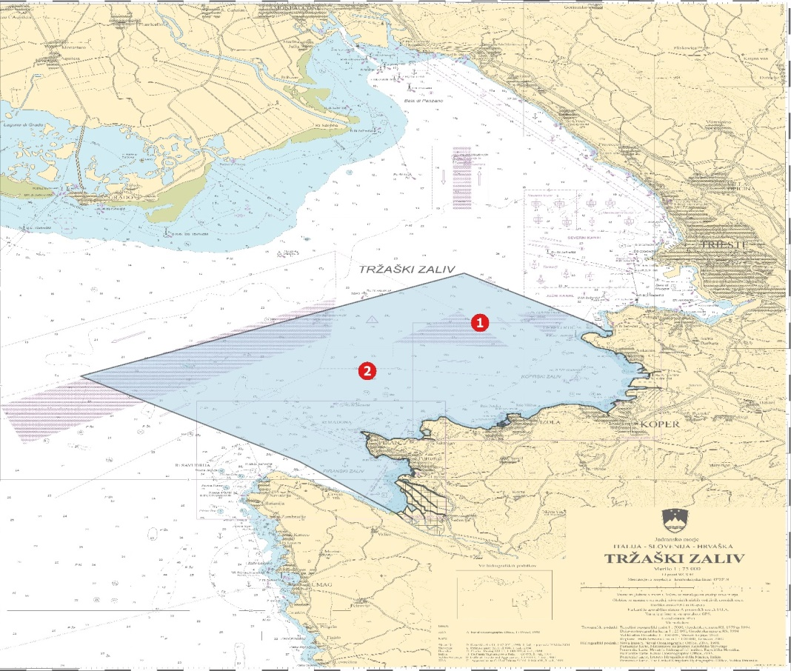
Figure 2: Slovenian MEDITS Survey. (Source: Fisheries Resarch Institute of Slovenia)
Land and maritime border between the Republic of Slovenia and the Republic of Croatia is determined based on the final and binding arbitration award of 29th June 2017 (in accordance with the Arbitration agreement between the government of the Republic of Slovenia and the Government of the Republic of Croatia signed on 4 November 2009). On 29 June 2017 the Arbitral Tribunal rendered its final Award determining the territorial and maritime border between Slovenia and Croatia which is binding, in accordance with the Arbitration Agreement and with general principles of international law.
The award determined the maritime border with exact coordinates. This allows it to be immediately enforced and depicted on maps. Slovenia expects that this maritime border (determined by the valid and binding award) is depicted on all maps in the framework of the European Data Collection Framework where maritime borders are to be depicted.

3. For internationally coordinated surveys, describe the participating Member States/vessels and the relevant international group in charge of planning the survey
The survey is performed in one day. Slovenian scientists are present during entire survey on the vessel, all specimens are taken and analysed by Slovenian scientist. For details see manual.

4. Where applicable, describe the international task sharing (physical and/or financial) and the cost sharing agreement used
MEDITS is conducted in less than 1 day. Samples are taken and analysed by Slovenia. Costs of the vessel, vessel crew, scientist and data analysis, storage, handling, processing and reporting are paid by Slovenian data collection programme.

5. Explain where thresholds apply
NA
(max 450 words per survey)

General Comment: This Box fulfills Chapter IV of the multi-annual Union programme and Article 2 and Article 7 paragraph (3) of this Decision. It is intended to specify which reseach surveys at sea set out in Table 10 of the multi-annual Union programme will be carried out. Member States shall specify whether the research survey is included in Table 10 of the multi-annual Union programme or whether it is an additional survey.
MEDiterranean International Acoustic Survey - MEDIAS
1. Objectives of the survey
Mediterranean International Acoustic Survey (MEDIAS). The aim of the echo-survey is to monitor small pelagic species (spatial and temporal distribution, abundance indices) in the sea fishing area of the Republic of Slovenia following the MEDIAS protocol.

2. Description of the methods used in the survey. For mandatory surveys, link to the manuals. Include a graphical representation (map)
All captured fish that are not target species are determined, counted and weighted altogether, following the MEDIAS protocol. MEDIAS survey target species are counted and weighted, measured, their sex is determined, their sexual maturity is determined and up to 10 specimens from each length class are prepared for otolith reading in the laboratory in Ancona.
Data (echo-track) is stored in the Italian database for the joint survey of northern Adriatic Echo-survey, and the results of two samples of fish caught in Slovenian waters are (besides Italian) also stored in the Slovenian database.
Manual and maps: http://www.medias-project.eu/medias/website/handbooks-menu.html.
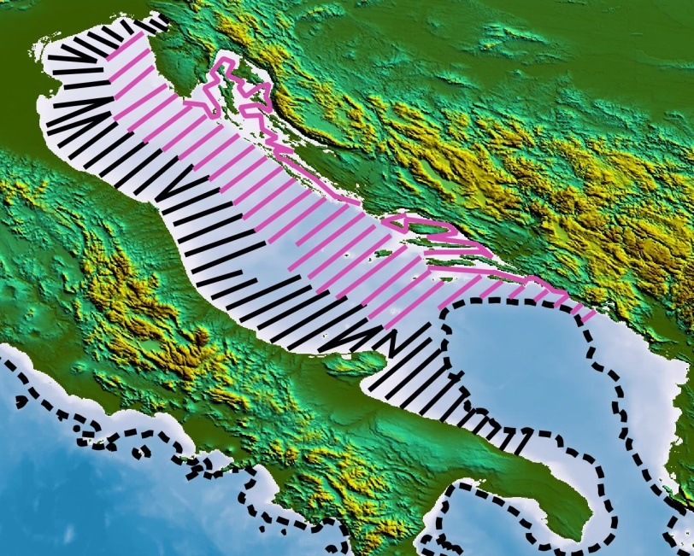
Figure 3: MEDIAS Survey in Adriatic Sea. (Source: http://www.medias-project.eu/medias/website/maps.html)

Land and maritime border between the Republic of Slovenia and the Republic of Croatia is determined based on the final and binding arbitration award of 29th June 2017 (in accordance with the Arbitration agreement between the government of the Republic of Slovenia and the Government of the Republic of Croatia signed on 4 November 2009). On 29 June 2017 the Arbitral Tribunal rendered its final Award determining the territorial and maritime border between Slovenia and Croatia which is binding, in accordance with the Arbitration Agreement and with general principles of international law.
The award determined the maritime border with exact coordinates. This allows it to be immediately enforced and depicted on maps. Slovenia expects that this maritime border (determined by the valid and binding award) is depicted on all maps in the framework of the European Data Collection Framework where maritime borders are to be depicted.

3. For internationally coordinated surveys, describe the participating Member States/vessels and the relevant international group in charge of planning the survey
The survey is performed in one day by echo-sounding the track of the protocol for Northern Adriatic including two samplings with MEDIAS pelagic trawl net in sea fishing area of the Republic of Slovenia.
MEDIAS is covered by Mediterranean EU Member States (Spain, France, Italy, Malta, Slovenia, Croatia and Greece).

4. Where applicable, describe the international task sharing (physical and/or financial) and the cost sharing agreement used
MEDIAS is conducted in less than 1 day. Costs of the vessel, vessel crew, scientist and data analysis, storage, handling, processing and reporting are paid by Slovenian data collection programme. Italy takes in charge analysis and reporting of the data of all the samples collected. Costs of Slovenian scientist participating in the survey are paid by Slovenia.

5. Explain where thresholds apply
NA

(max 450 words per survey)

General Comment: This Box fulfills Chapter IV of the multi-annual Union programme and Article 2 and Article 7 paragraph (3) of this Decision. It is intended to specify which reseach surveys at sea set out in Table 10 of the multi-annual Union programme will be carried out. Member States shall specify whether the research survey is included in Table 10 of the multi-annual Union programme or whether it is an additional survey.
Adriatic Rapido Trawl Survey - SOLEMON
1. Objectives of the survey
SOLEMON, rapido trawl survey in the Northern Adriatic Sea (SoleMon). The aim of the survey is to monitor benthic species (spatial and temporal distribution, abundance indices) in the sea fishing area of the Republic of Slovenia following the SoleMon protocol.

2. Description of the methods used in the survey. For mandatory surveys, link to the manuals. Include a graphical representation (map)
The catches of the two gears towed simultaneously are analysed separately for “RAPIDO A” and “RAPIDO D”. The whole catch of each gear is weighted and sorted for all finfish species, rays, sharks, cephalopods and commercially important shellfish and crustaceans, total weight by species is collected. A sub sample for the epibenthos/benthos species and debris (shells, litter, wood, etc.) is analysed fresh on board, weight and number is recorded for each of the individuals identified to the lowest taxonomic level possible.
Manual and map: SoleMon - Rapido trawl survey in the Northern Adriatic Sea; Instruction manual; Version 3; November 2017.
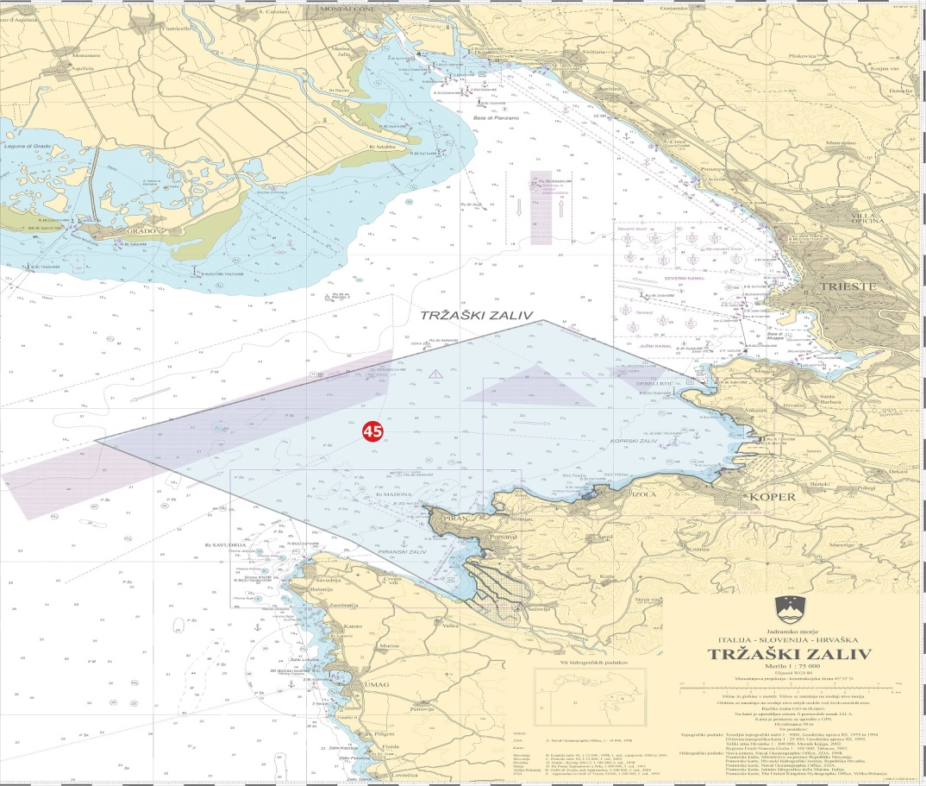
Figure 4: Slovenian SOLEMON Survey. (Source: Fisheries Resarch Institute of Slovenia)

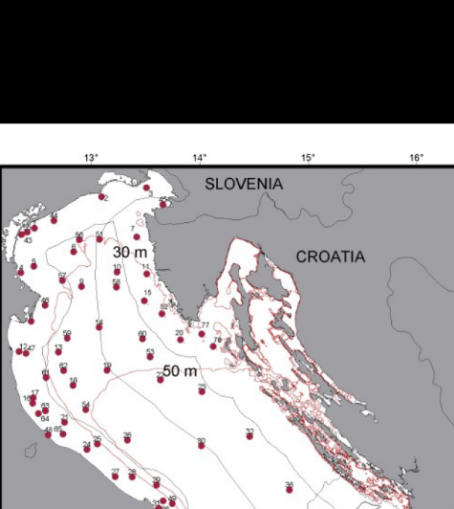
Figure 5: SoleMon hauls positons in GSA 17, (Source: SoleMon - Rapido trawl survey in the Northern Adriatic Sea; Instruction manual; Version 3; November 2017

Land and maritime border between the Republic of Slovenia and the Republic of Croatia is determined based on the final and binding arbitration award of 29th June 2017 (in accordance with the Arbitration agreement between the government of the Republic of Slovenia and the Government of the Republic of Croatia signed on 4 November 2009). On 29 June 2017 the Arbitral Tribunal rendered its final Award determining the territorial and maritime border between Slovenia and Croatia which is binding, in accordance with the Arbitration Agreement and with general principles of international law.
The award determined the maritime border with exact coordinates. This allows it to be immediately enforced and depicted on maps. Slovenia expects that this maritime border (determined by the valid and binding award) is depicted on all maps in the framework of the European Data Collection Framework where maritime borders are to be depicted.

3. For internationally coordinated surveys, describe the participating Member States/vessels and the relevant international group in charge of planning the survey
The survey is performed in one day by rapido trawl in sea fishing area of the Republic of Slovenia.
SoleMon is covered by Mediterranean EU Member States (Italy, Slovenia and Croatia).
4. Where applicable, describe the international task sharing (physical and/or financial) and the cost sharing agreement used
SoleMon is conducted in less than 1 day. Costs of the vessel, vessel crew, scientist and data analysis, storage, handling, processing and reporting are paid by Slovenian data collection programme. Italy takes in charge analysis and reporting of the data of all the samples collected. Costs of Slovenian scientist participating in the survey are paid by Slovenia. Slovenian data on SOLOMON survey are merged, analysed and reported together with the Italian data by Italy.

5. Explain where thresholds apply
NA

(max 450 words per survey)

General Comment: This Box fulfills Chapter IV of the multi-annual Union programme and Article 2 and Article 7 paragraph (3) of this Decision. It is intended to specify which reseach surveys at sea set out in Table 10 of the multi-annual Union programme will be carried out. Member States shall specify whether the research survey is included in Table 10 of the multi-annual Union programme or whether it is an additional survey.
Monitoring of fisheries resources with otter bottom trawl in the fishing sea of the Republic of Slovenia -OTBSLO.
1. Objectives of the survey
The aim of the survey is to monitor exploitation of demersal species in Slovenian waters independent and irrespective of data available on commercial fisheries. This data serve as the basis of monitoring of the state of demersal stock and ensuring of sustainable fish stock exploitation in the sea fishing area of the Republic of Slovenia

2. Description of the methods used in the survey. For mandatory surveys, link to the manuals. Include a graphical representation (map)
Sampling is performed by Fisheries Research Institute of Slovenia and conducted with hired fishing vessel 4-times per year at the three systematically pointed places in Slovenian waters (in total 12 hauls). All catches are sorted on board. Organisms of all categories are counted, weighted and identified to the lowest taxonomic level possible. Fishes, cephalopods and crustaceans are taken in the laboratory, where individual specimen are measured for: body length, weight, sex and sexual maturity.
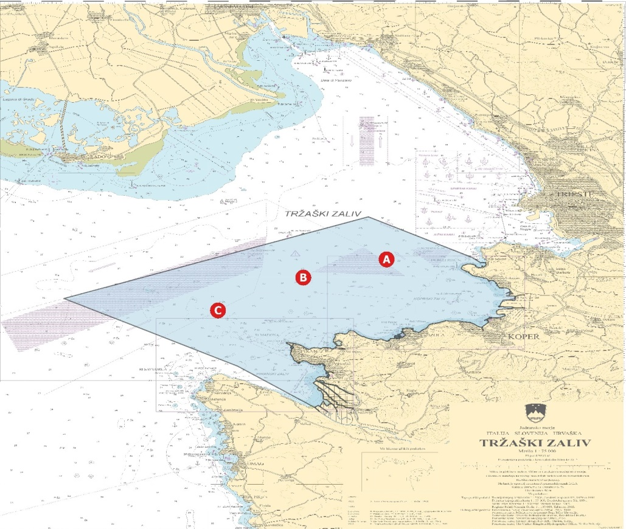
Figure 6: Slovenian monitoring of fisheries resources with otter bottom trawl in the fishing sea of the Republic of Slovenia – OTBSLO Survey. (Source: Fisheries Resarch Institute of Slovenia)
Land and maritime border between the Republic of Slovenia and the Republic of Croatia is determined based on the final and binding arbitration award of 29th June 2017 (in accordance with the Arbitration agreement between the government of the Republic of Slovenia and the Government of the Republic of Croatia signed on 4 November 2009). On 29 June 2017 the Arbitral Tribunal rendered its final Award determining the territorial and maritime border between Slovenia and Croatia which is binding, in accordance with the Arbitration Agreement and with general principles of international law.
The award determined the maritime border with exact coordinates. This allows it to be immediately enforced and depicted on maps. Slovenia expects that this maritime border (determined by the valid and binding award) is depicted on all maps in the framework of the European Data Collection Framework where maritime borders are to be depicted.

3. For internationally coordinated surveys, describe the participating Member States/vessels and the relevant international group in charge of planning the survey
The survey is performed in every quarter of the year by otter bottom trawl in the fishing sea of the Republic of Slovenia.

4. Where applicable, describe the international task sharing (physical and/or financial) and the cost sharing agreement used
NA

5. Explain where thresholds apply
NA

(max 450 words per survey)

General Comment: This Box fulfills Chapter IV of the multi-annual Union programme and Article 2 and Article 7 paragraph (3) of this Decision. It is intended to specify which reseach surveys at sea set out in Table 10 of the multi-annual Union programme will be carried out. Member States shall specify whether the research survey is included in Table 10 of the multi-annual Union programme or whether it is an additional survey.
Monitoring of catch composition with otter bottom trawl (type "volantina") in the specific stretch between 1.5 and 3 nautical miles from the coast in Slovenian waters – OTB_VOL
1. Objectives of the survey
The aim of the survey is to monitor catch composition of demersal species in in the specific stretch between 1.5 and 3 nautical miles from the coast in Slovenian waters with focus on species from Annex III of Council Regulation (EC) No 1967/2006 and cephalopods. This data serve for monitoring of derogation in terms of the minimum distance from the coast and the minimum sea depth for "volantina" trawlers fishing in the territorial waters of Slovenia demonstrating the share of catches of species from Annex III of Council Regulation (EC) No 1967/2006 and cephalopods.

2. Description of the methods used in the survey. For mandatory surveys, link to the manuals. Include a graphical representation (map)
Sampling is performed by Fisheries Research Institute of Slovenia and conducted with hired fishing vessel once every two months (6 days per year) with two hauls (in total 12 hauls per year) in the stretch between 1.5 and 3 nautical miles from the coast in Slovenian waters. All catches are sorted on board aiming to provide data on: catch composition, data on retained/ discarded length composition by species and share and composition of juvenile organisms of bottom trawler mainly fishing in the zone between 1,5 and 3 NM.
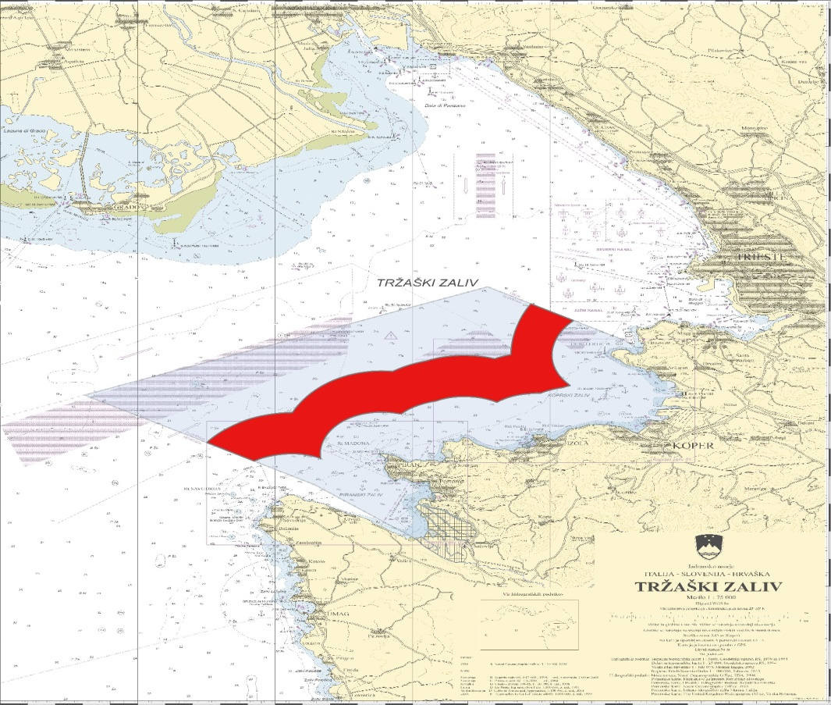
Figure 7: Slovenian monitoring of catch composition with otter bottom trawl (type "volantina") in the specific stretch between 1.5 and 3 nautical miles from the coast in Slovenian waters – OTB_VOL Survey. (Source: Fisheries Resarch Institute of Slovenia)
Land and maritime border between the Republic of Slovenia and the Republic of Croatia is determined based on the final and binding arbitration award of 29th June 2017 (in accordance with the Arbitration agreement between the government of the Republic of Slovenia and the Government of the Republic of Croatia signed on 4 November 2009). On 29 June 2017 the Arbitral Tribunal rendered its final Award determining the territorial and maritime border between Slovenia and Croatia which is binding, in accordance with the Arbitration Agreement and with general principles of international law.
The award determined the maritime border with exact coordinates. This allows it to be immediately enforced and depicted on maps. Slovenia expects that this maritime border (determined by the valid and binding award) is depicted on all maps in the framework of the European Data Collection Framework where maritime borders are to be depicted.

3. For internationally coordinated surveys, describe the participating Member States/vessels and the relevant international group in charge of planning the survey
The survey is performed in every two months per year with two hauls (in total 12 hauls per year) by demersal otter trawls in the stretch between 1.5 and 3 nautical miles from the coast in Slovenian waters.

4. Where applicable, describe the international task sharing (physical and/or financial) and the cost sharing agreement used
NA
5. Explain where thresholds apply
NA

(max 450 words per survey)

Section 2: Fishing Activity Data

Text Box 2A: Fishing activity variables data collection strategy
General comment: This Box fulfills paragraph 4 of Chapter III of the multi-annual Union programme and Article 2, Article 4 paragraph (2) point (b) and Article 5 paragraph (2) of this Decision. It is intended to describe the method used to derive estimates on representative samples where data are not to be recorded under Regulation (EU) No 1224/2009 or where data collected under Regulation (EU) No 1224/2009 are not at the right aggregation level for the intended scientific use.
1. Description of methodologies used to cross-validate the different sources of data.
Fishing activity data (Capacity, effort and landings data) are collected for all vessels active at any point in time of the year. Capacity data are collected for vessels registered on 31. December of reference year. Data are collected under Control Regulation (EU) No. 1224/2009.
Fishing capacity data are part of the Fleet Vessel Register Module of the information system InfoRib. The Fleet Register data will be integrated with other sources of data in order to obtain data at the level of fleet segments and at the level of métiers. In order to obtain the data according to Table 4 of the multi-annual Union programme two data sources will be used: Fleet Vessel Register data and Logbook data.
Effort data will be collected for all vessels active at any point in time of the reference year. The data will be collected from the logbooks. All Slovenian vessels, also those under 10 meters, are obligated to submit the logbooks. For vessels that are equiped with the VMS also VMS data will be used.
The target populations for the landing data will be all vessels from the Slovenian Fleet (also those under 10 meters). The data will be collected and crosschecked from 3 sources; the logbooks, sales notes and questionnaires – census survey.
The quality of the data is ensured since all vessels are taken into account. As a type of data collection Slovenia will use census. All parameters will be gathered with the help of more sources which guarantees the cross-checking of data.
The prices of fish will be collected through questionnaires and sales notes. For cross-checking purposes the data from AJPES (Agency of the Republic of Slovenia for Public Legal Records and Related Services ) – income and quantity of catch acquired from logbooks will be used (total income / total catch = price per kg).

2. Description of methodologies used to estimate the value of landings.
The data on the quantity of landings will be collected from the logbooks, while the price of the fish will be collected from the sales notes and through the use of a survey questionnaire.
On the basis of both kinds of data the value of all landings in Euros per species will be calculated and namely for the métiers as well as for fleet segments.
There was no specific action taken for vessels under 10 meters. Because we are collecting all data in same way regardless of the vessel length.

3. Description of methodologies used to estimate the average price (it is recommended to use weighted averages, trip by trip)
Average price per species – prices in Euros per kilo live weight without the VAT; the data will be collected from sales notes and through the use of a survey questionnaire. Slovenia will use weighted average prices.

4. Description of methodologies used to plan collection of the complementary data (sample plan methodology, type of data collected, frequency of collection etc)
Slovenia collecting complete sets of data for all of the fishing vessels (also for vessels under 10 meters) so no other metodologies for collecting the complementary data are not planned.
(max 900 words per Region)
Section 3: Economic and Social Data

Text Box 3A: Population segments for collection of economic and social data for fisheries
General comment: This Box fulfills paragraph 5 points (a) and (b) of Chapter III of the multi-annual Union programme and Article 2, Article 4 paragraphs (1), (2) and (5) and Article 5 paragraph (2) of this Decision. It is intended to specify data to be collected under Tables 5(A) and 6 of the multi-annual Union programme.
1. Description of methodologies used to choose the different sources of data
Bases for the collection of the economic and social variables are Table 5A and 6 of the multi-annual Union programme. Collection of this variables combines use of the information from three main resources:
- Questionnaire information returned on a voluntary basis,
- The Slovenian data base InfoRib,
- The annual accounts of business enterprises.
The data collected from all sources are combined in such a way that a complete set of accounting items is compared for each business enterprise. Most of the data will be cross-checked, e.g. value of landings from InfoRib will be checked with Income from annual accounts, landings from log book will be checked with sales in kg from sales notes, all costs from questionnaires will be checked with the costs from annual accounts etc. For checking the data will also be used databases from other public services such as Statistical Office of the Republic of Slovenia, Chamber of Commerce and Industry of Slovenia etc.
The economic and social variables will be collected for all vessels regardless of their activity (also for vessels under 10 meters). All economic variables will be collected for active vessels. For inactive vessels only capacity indicators and capital value and costs will be collected

2. Description of methodologies used to choose the different types of data collection
As a type of data collection Slovenia will use census. In the case of a census with non-responses, Slovenia will estimate variables using method of extrapolation. Extrapolation is based on the assumption that trends in the observations will continue outside the rang for which data are known. Slovenia will extrapolate data for each segment separately, so that there will be no errors due to different values in different segments.

3. Description of methodologies used to choose sampling frame and allocation scheme
Because of the census used, the whole population is covered.

4. Description of methodologies used for estimation procedures
As a type of data collection Slovenia will use census. In the case of a census with non-responses, Slovenia will estimate variables using the method of extrapolation. Extrapolation is based on the assumption that trends in the observations will continue outside the range for which data are known.

5. Description of methodologies used on data quality
The data collected from all sources are combined in such a way that a complete set of accounting items is compared for each business enterprise.
The target population is entire fishing sector in Slovenia. A survey (questionnaire) will be carried out on an annual basis. All enterprises will be given questionnaire, developed by group of experts. Questionare will cover the entire population (census).
With the combination of the data from census questionares and official registers we expect to obtain good and reliable quality data.
Regarding data quality some accuracy indicators will be calculated;
- Response rate; achieved number of respondents who supplied data / frame population number
- Coverage rate; total value of production of the respondent units / total value of production of the frame population
- Coefficient of Variation (CV); only in case of response rate <70%
(max 900 words per Region)

Section 3: Economic and Social Data

Pilot Study 3: Data on employment by education level and nationality
General comment: This Box fulfills paragraph 5 point (b) and paragraph 6 point (b) of Chapter III of the multi-annual Union programme and Article 2 and Article 3 paragraph (3) point (c) of this Decision. It is intended to specify data to be collected under Table 6 of the multi-annual Union programme.
1. Aim of pilot study
No pilot study is planned

2. Duration of pilot study
/

3. Methodology and expected outcomes of pilot study
/

(max 900 words)

Section 3: Economic and Social Data

Text Box 3B: Population segments for collection of economic and social data for aquaculture
General comment: This Box fulfills paragraph 6 points (a) and (b) of Chapter III of the multi-annual Union programme and Article 2, Article 4 paragraphs (1) and (5) and Article 5 paragraph (2) of this Decision. It is intended to specify data to be collected under Tables 6 and 7 of the multi-annual Union programme.
1. Description of methodologies used to choose the different sources of data
Bases for the collection of the economic and social variables are Table 6 and 7 of the multi-annual Union programme. The target population is entire marine aquaculture sector in Slovenia. Collection of this variables combines use of the information from three main resources:
- Questionnaire information returned from the aquaculture sector on a voluntary basis,
- Data base: ‘Central register of aquaculture and commercial fish pond infrastructure’ from MAFF (Ministry of Agriculture, Forestry and Food),
- The annual accounts of business enterprises.
The data collected from all sources are combined in such a way that a complete set of accounting items is compared for each business enterprise. Most of the data will be cross-checked, e.g. all costs from questionnaires will be checked with the costs from annual accounts, income from questionnaire will be checked with the income from annual accounts, etc. For checking the data also databases from other public services such as Statistical Office of the Republic of Slovenia, Chamber of Commerce and Industry of Slovenia etc. will be used.

2. Description of methodologies used to choose the different types of data collection
As a type of data collection Slovenia will use census.

3. Description of methodologies used to choose sampling frame and allocation scheme
Because of the census used, the whole population is covered.

4. Description of methodologies used for estimation procedures
As a type of data collection Slovenia will use census. In the case of a census with non-responses, Slovenia will estimate variables using method of extrapolation. Extrapolation is based on the assumption that trends in the observations will continue outside the rang for which data are known. Slovenia will extrapolate data for each segment separately, so that there will be no errors due to different values in different segments.

5. Description of methodologies used on data quality
The data collected from all sources are combined in such a way that a complete set of accounting items is compared for each business enterprise. The target population is all marine aquaculture sector in Slovenia. A survey (questionnaire) will be carried out on an annual basis to provide data on all the parameters. All enterprises will be given lengthy questionnaire, which will be developed by experts. Data will be collected on the whole population so we do not expect any problems in achieving good quality of the data.
With the combination of the data from census questionares and official registers we expect to obtain good and reliable quality data.
Regarding data quality some accuracy indicators will be calculated:
- Response rate; achieved number of respondents who supplied data / frame population number
- Coverage rate; total value of production of the respondent units / total value of production of the frame population
- Coefficient of Variation (CV); only in case of response rate <70%
(max 1000 words)

Section 3: Economic and Social Data

Pilot Study 4: Environmental data on aquaculture
General comment: This Box fulfills paragraph 6 point (c) of Chapter III of the multi-annual Union programme and Article 2 and Article 4 paragraph (3) point (d) of this Decision. It is intended to specify data to be collected under Table 8 of the multi-annual Union programme.
1. Aim of pilot study
No pilot study is planned.

2. Duration of pilot study
/

3. Methodology and expected outcomes of pilot study
/

(max 900 words)

Section 3: Economic and Social Data

Text Box 3C: Population segments for collection of economic and social data for the processing industry
General comment: This Box fulfills footnote 6 of paragraph 1.1(d) of Chapter III of the multi-annual Union programme, Article 2, Article 4 paragraphs (1) and (5) and Article 5 paragraph (2) of this Decision. It is intended to specify data to be collected under Table 11 of the multi-annual Union programme.
1. Description of methodologies used to choose the different sources of data
Basis for the collection of economic and social data on processing industry is Table 11 of the multi-annual Union programme. The target population will be entire fish processing companies in Slovenia. Data will be collected on the whole population of processing enterprises. The national program for collection of economic data for the processing industry combines information from three main resources:
- Questionnaire information returned from processing companies on a voluntary basis,
- The data from Veterinary Administration of the Republic of Slovenia (VARS),
- The annual accounts of business enterprises.
The data collected from all sources are combined in such a way that a complete set of accounting items is compared for each business enterprise. Most of the data will be cross-checked, e.g. all costs from questionnaires will be checked with the costs from annual accounts, income from questionnaire will be checked with the income from annual accounts, etc. For checking the data will also be used databases from other public services such as Statistical Office of the Republic of Slovenia, Chamber of Commerce and Industry of Slovenia etc.

2. Description of methodologies used to choose the different types of data collection
As a type of data collection Slovenia will use census.

3. Description of methodologies used to choose sampling frame and allocation scheme
Because of the census used, the whole population is covered.

4. Description of methodologies used for estimation procedures
As a type of data collection Slovenia will use census. In the case of a census with non-responses, Slovenia will estimate variables using method of extrapolation. Extrapolation is based on the assumption that trends in the observations will continue outside the rang for which data are known. Slovenia will extrapolate data for each segment separately, so that there will be no errors due to different values in different segments.

5. Description of methodologies used on data quality
The data collected from all sources are combined in such a way that a complete set of accounting items is compared for each business enterprise. The target population is all fish-processing sector in Slovenia. A survey (questionnaire, with personal contact) will be carried out on an annual basis to provide data on all the parameters. All enterprises will be given lengthy questionnaire, which will be developed by the experts.
With the combination of the data from census questionares and official registers we expect to obtain good and reliable quality data.
Regarding data quality some accuracy indicators will be calculated;
- Response rate; achieved number of respondents who supplied data / frame population number
- Coverage rate; total value of production of the respondent units / total value of production of the frame population
- Coefficient of Variation (CV); only in case of response rate <70%

(max 1000 words)

Section 4: Sampling Strategy for Biological Data from Commercial Fisheries

Text Box 4A: Sampling plan description for biological data
General Comment: This Box fulfills Article 3, Article 4 paragraph (4) and Article 8 of this Decision and forms the basis for the fulfilment of paragraph 2 point (a)(i) of Chapter III of the multi-annual Union programme. This Table refers to data to be collected under Tables 1(A), 1(B) and 1(C) of the multi-annual Union programme.
From 2020 Slovenia will no longer sample landings of Engraulis encrasicolus and Sardina pilchardus, since the fishery targeting small pelagics is not operating.
Slovenia will not continue with samplings of Engraulis encrasicolus and Sardina pilchardus due to inactivity of the PS fleet in last two years and very low activity in last seven years. There are also no other species with average landings above 200 tonnes.
Thresholds in accordance with the Commission Implementing Decision (EU) 2019/909, Annex; Chapter II; point (2)(c); applies.

(max 900 words per Region)

