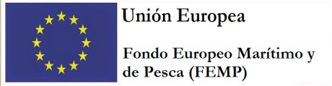

Ministerio de Agricultura, Pesca y Alimentación

Secretaría General de Pesca

Regulation (EU) 2017/1004 of the European Parliament and of the Council of 17 May 2017 on the establishment of a Union framework for the collection, management and use of data in the fisheries sector and support for scientific advice regarding the common fisheries policy and repealing Council Regulation (EC) No 199/2008 (recast)

Commission Implementing Decision (EU) 2016/1251 of 12 July 2016 adopting a multiannual Union programme for the collection, management and use of data in the fisheries and aquaculture sectors for the period 2017-2019.

Commission Implementing Decision (EU) 2016/1701 laying down rules on the format for the submission of work plans for data collection in the fisheries and aquaculture sectors

SPAIN Annual Report for data collection in the fisheries and aquaculture sectors
2018
Version 1

Madrid, 30-05-2019

CONTENTS

Section 1: Biological Data 5
Text Box 1C: Sampling intensity for biological variables 5
North Sea (ICES IIIa, IV and VIId areas) and Eastern Arctic (ICES areas I, II) 5
Section 1: Biological Data 6
Text Box 1C: Sampling intensity for biological variables 6
North Atlantic 6
Section 1: Biological Data 9
Text Box 1C: Sampling intensity for biological variables 9
Medierranean and Black Sea 9
Section 1: Biological Data 10
Text Box 1C: Sampling intensity for biological variables 10
CECAF 10
Section 1: Biological Data 11
Text Box 1C: Sampling intensity for biological variables 11
ICCAT, IOTC, IATTC, WCPFC 11
Section 1: Biological Data 13
Text Box 1D: Recreational fisheries 13
Section 1: Biological Data 14
Pilot Study 1: Relative share of catches of recreational fisheries compared to commercial fisheries 14
Section 1: Biological Data 16
Text Box 1E: Anadromous and catadromous species data collection in fresh water 16
Section 1: Biological Data 20
Text Box 1F: Incidental by-catch of birds, mammals, reptiles and fish 20
North Sea (ICES IIIa, IV and VIId areas) and Eastern Arctic (ICES areas I, II) 20
Section 1: Biological Data 21
Text Box 1F: Incidental by-catch of birds, mammals, reptiles and fish 21
North Atlantic 21
Section 1: Biological Data 23
Text Box 1F: Incidental by-catch of birds, mammals, reptiles and fish 23
Medierranean and Black Sea 23
Section 1: Biological Data 24
Text Box 1F: Incidental by-catch of birds, mammals, reptiles and fish 24
CECAF 24
Section 1: Biological Data 25
Text Box 1F: Incidental by-catch of birds, mammals, reptiles and fish 25
ICCAT, IOTC, IATTC, WCPFC 25
Section 1: Biological Data 27
Pilot Study 2: Level of fishing and impact of fisheries on biological resources and marine ecosystem 27
Section 1: Biological Data 31
Text Box 1G: List of research surveys at sea 31
FLEMISH CAP GROUNDFISH SURVEY 31
Text Box 1G: List of research surveys at sea 35
3LNO GROUNDFISH SURVEY 35
Text Box 1G: List of research surveys at sea- 40
IBTS 4th. Quarter(VIIIc y IXa north) 40
Text Box 1G: List of research surveys at sea 44
IBTS 4th. Quarter (IXa sur) 44
Text Box 1G: List of research surveys at sea 48
IBTS 4th. Quarter Porcupine groundfish survey 48
Text Box 1G: List of research surveys at sea 51
MACKEREL / H. MACKEREL EGGS SURVEY 51
Text Box 1G: List of research surveys at sea 53
MACKEREL / H. MACKEREL EGGS SURVEY 53
Text Box 1G: List of research surveys at sea 55
MACKEREL / H. MACKEREL EGGS SURVEY 55
Text Box 1G: List of research surveys at sea 57
SARDINE, ANCHOVY, H. MACKEREL ACOUSTIC SURVEY 57
Text Box 1G: List of research surveys at sea 61
Sardine DEPM 61
Text Box 1G: List of research surveys at sea 63
BIOMAN 63
Text Box 1G: List of research surveys at sea 69
MEDITS 69
Text Box 1G: List of research surveys at sea 74
MEDIAS 74
Text Box 1G: List of research surveys at sea 78
Anchovy DEPM-BOCADEVA 78
Text Box 1G: List of research surveys at sea 80
ECOCADIZ 80
Text Box 1G: List of research surveys at sea 85
ECOCADIZ-RECLUTAS 85
Text Box 1G: List of research surveys at sea 89
IBTS 1st. Quarter 89
Text Box 1G: List of research surveys at sea 93
JUVENA 93
Text Box 1G: List of research surveys at sea 101
PALPRO 101
Text Box 1G: List of research surveys at sea 104
BFT index 104
Text Box 1G: List of research surveys at sea 108
ISUNEPCA_TV Survey 108
Text Box 1G: List of research surveys at sea 111
BLUE WHITING SURVEY (IBWSS) 111
Section 2: Fishing Activity Data 115
Text Box 2A: Fishing activity variables data collection strategy 115
Section 3: Economic and Social Data 118
Text Box 3A: Population segments for collection of economic and social data for fisheries 118
Section 3: Economic and Social Data 122
Pilot Study 3: Data on employment by education level and nationality 122
Section 3: Economic and Social Data 124
Text Box 3B: Population segments for collection of economic and social data for aquaculture 124
Section 3: Economic and Social Data 128
Pilot Study 4: Environmental data on aquaculture 128
Section 3: Economic and Social Data 129
Text Box 3C: Population segments for collection of economic and social data for the processing industry 129
Section 4: Sampling Strategy for Biological Data from Commercial Fisheries 133
Text Box 4A: Sampling plan description for biological data 133
North Sea (ICES IIIa, IV and VIId areas) and Eastern Arctic (ICES areas I, II) 133
Section 4: Sampling Strategy for Biological Data from Commercial Fisheries 135
Text Box 4A: Sampling plan description for biological data 135
North Atlantic 135
Section 4: Sampling Strategy for Biological Data from Commercial Fisheries 138
Text Box 4A: Sampling plan description for biological data 138
Medierranean and Black Sea 138
Section 4: Sampling Strategy for Biological Data from Commercial Fisheries 141
Text Box 4A: Sampling plan description for biological data 141
CECAF 141
Section 4: Sampling Strategy for Biological Data from Commercial Fisheries 143
Text Box 4A: Sampling plan description for biological data 143
ICCAT, IOTC, IATTC, WCPFC 143
Section 5: Data quality 146
Text Box 5A: Quality assurance framework for biological data 146
North Sea (ICES IIIa, IV and VIId areas) and Eastern Arctic (ICES areas I, II) 146
Section 5: Data quality 148
Text Box 5A: Quality assurance framework for biological data 148
North Atlantic 148
Section 5: Data quality 151
Text Box 5A: Quality assurance framework for biological data 151
Medierranean and Black Sea 151
Section 5: Data quality 153
Text Box 5A: Quality assurance framework for biological data 153
CECAF 153
Section 5: Data quality 155
Text Box 5A: Quality assurance framework for biological data 155
ICCAT, IOTC, IATTC, WCPFC 155
Section 5: Data quality 157
Text Box 5B: Quality assurance for socioeconomic data 157

Section 1: Biological Data

Text Box 1C: Sampling intensity for biological variables

North Sea (ICES IIIa, IV and VIId areas) and Eastern Arctic (ICES areas I, II)
General comment: This box fulfils paragraph 2 point (a)(i)(ii)(iii) of Chapter III, Chapter IV of the multiannual Union programme and Article 2, Article 4 paragraph 1 and Article 8 of the Decision (EU) 2016/1701. This box is applicable to the Annual Report.
Spain has fisheries only in Eastern Acrtic (ICES areas I and II)
1.Evidence of data quality assurance
See Text box 5A-North Sea&Eastern Arctic.
2.Deviations from the Work Plan
Undersampling: (see AR comments in Table 1C)
The number of sampled individuals is less than planned due to the short lasting of one of the two observed trips. The main reason for that is there were no enough hauls targeted to this species and carried out on board in sampled trips to achieve planned sampling. When the trips last less than expected, like in these cases, it causes a lower number of individuals (vs. planned) sampled by the observer on board.
Oversampling: (see AR comments in Table 1C)
The reason for sampling more than planned is that we cannot predict in advance the lasting of the trips in these fisheries, because they vary depending on the owner decisions. When the trips last more than expected, like in these cases, it causes a higher number of individuals (vs. planned) sampled by the observer on board.
The sampling design is established to ensure the sampling quality and to ensure a minimum number of individuals by sampling for subsequent use in the assessment. To get this target, the observer is training to intensify as much as possible the length sampling since the beginning of the trip. (sometimes this produces an oversampling of length while undersampling other variables).
Sampling was carried out by scientific observers who remain on board throughout the period of the fishing trip until the vessel's arrival to port, so the whole trip is sampled. Because of this reason, sampling more than planned does not mean additional costs.
3.Actions to avoid deviations
The main cause of the deviation is the lasting of the trips in these fisheries due to the decisions taken by vessels' owners which are independent of sampling planned, so that no specific measures are proposed for this deviation.
Although the behavior of the fleet is impossible to change, the Institutes involved in sampling will continue in improving coordination with the sectors involved: owners and administration authorities.
Deviations caused by the data collection and sampling by the scientific observers on board can be improved widely through a better training and monitoring of the observers’ tasks. In addition, place experienced observers on board whenever possible will be tried to.

(max. 1000 words per Region/RFMO/RFO/IO)

Section 1: Biological Data

Text Box 1C: Sampling intensity for biological variables

North Atlantic
General comment: This box fulfils paragraph 2 point (a)(i)(ii)(iii) of Chapter III, Chapter IV of the multiannual Union programme and Article 2, Article 4 paragraph 1 and Article 8 of the Decision (EU) 2016/1701. This box is applicable to the Annual Report.
North Atlantic ICES areas XII, XIV and NAFO areas
1.Evidence of data quality assurance
See Text box 5A-North Atlantic- NAFO and ICES areas XII, XIV
2.Deviations from the Work Plan
Subsampling (see AR comments by stock in Table 1C)
The number of sampled individuals is less than planned. The main reason for that is there were no enough hauls targeted to this species and carried out on board in sampled trips to achieve planned sampling. When the trips last less than expected, like in these cases, it causes a lower number of individuals (vs. planned) sampled by the observer on board.
Oversampling (see AR comments by stock in Table 1C)
The reason for sampling more than planned is that we cannot predict in advance the lasting of the trips in these fisheries, because they vary depending on the owner decisions. When the trips last more than expected, like in these cases, it causes a higher number of individuals (vs. planned) sampled by the observer on board.
The sampling design is established to ensure the sampling quality and to ensure a minimum number of individuals by sampling for subsequent use in the assessment. To get this target, the observer is training to intensify as much as possible the length sampling (also used to get the sex ratio) since the beginning of the trip.
Sampling was carried out by scientific observers who remain on board throughout the period of the fishing trip until the vessel's arrival to port, so the whole trip is sampled. Because of this reason, sampling more than planned does not mean additional costs.
3.Actions to avoid deviations
The main cause of the deviations is the lasting of the trips in these fisheries due to the decisions taken by vessels' owners which are independent of sampling planned, so that no specific measures are proposed for these deviations.
Although the behavior of the fleet is impossible to change, the Institutes involved in sampling will continue in improving coordination with the sectors involved: owners and administration authorities.
Deviations caused by the data collection and sampling by the scientific observers on board can be improved widely through a better training and monitoring of the observers’ tasks. In addition, place experienced observers on board whenever possible will be tried to.

North Atlantic ICES VI, VII (excl. VIId), VIII, IX
1.Evidence of data quality assurance
See Text box 5A-ICES VI, VII (excl. VIId), VIII, IX
2.Deviations from the Work Plan
LENGHT:
As several working groups have highlighted planning for length sampling is not based in the number of individuals. As the column “Planned minimum no of individuals to be measured at the national level” was nevertheless requested, we fulfilled it according to last sampling results at the moment WP was done.
This list includes some stocks that are contiguous to those where the stock is more intensively present and sampled. We included those stocks in this sort of planning list to ensure that those species are selected, any changes in distribution are registered and information is taken by the sampling teams. This explains the low numbers of some “expected number of individuals” (e.g. Beryx spp. in “IXa and X”, or Loligo vulgaris in “All areas excluding VIIIc-IXa”). With so low numbers it is easy to understand that any changes have had a great impact in the % of achievement.
In this AR, the column “Achieved number of individuals measured at the national level” incorporates market sampling plus all on board sampling (retained plus discards). Large majority of the results are quite larger than numbers originally written under the so called “Planned minimum no of individuals”, probably affected because 2015 sampling results used to fulfil this numbers didn’t include retained catches. In any case we highlight planning is not based in terms of number of individuals.
Additional information has been added in the “AR Comments” column for those few cases where there was a low % of achievement (most relevant Lophius piscatorius VIIb-k, VIIIabd). In any case we highlight planning is not based in terms of number of individuals.
AGE, WEIGHT, SEX-RATIO, MATURITY, FECUNDITY:
Sampling at a higher level than planned (> 150%) is usually because:
- the sampling design is not focused on the total number of individuals sampled by year, but in the distribution of several samplings throughout the year, reaching a minimum number of fishes in each sampling to ensure the quality for each of them.
- a large number of samplings are needed to cover adequately all strata, because there are a large number of fisheries (target species vs. gears) in the ICES area and the sampling design is random stratified. The samplings needed by ICES assessment groups to carry out the relevant assessments require sampling an important part of the fisheries affecting the target species.
- some parameters like age@length needs a larger number of samples for obtaining representative age-length keys of the target stocks. This increase in the sample number do not involve additional cost, since work plan in laboratories is carried out according to the requirements of the working groups to which data must be provided.
- sometimes observers on board of the commercial fishing fleet, obtains a large number of samples as part of their sampling routine, without additional cost.
- when the initially planned sample size was not enough to ensure the quality of data, the sample size was increased when it was possible, to improve quality levels.
The samplings of some parameters were lower than planned (<90%) in some cases.
Although the methodology used to collect the data from landing samples is designed for achieved a representative sample of each of the commercial categories of the target species, (random sampling of unequally probable elements without replacement, being the stratum = length class), the individuals from the commercial landings have been often gutted, making it impossible to carry out a complete sampling (weight or even sex or maturity data).
In certain periods, is the bad weather, does not allow the commercial fleet to operate and prevents the purchase of the necessary samples.
The variable “weight” is not reliable when the individuals are small, due to the lack of precision of scales used to weight on board
3.Actions to avoid deviations
LENGTH:
For length sampling no problems detected in terms of number of individuals sampled.
AGE, WEIGHT, SEX-RATIO, MATURITY, FECUNDITY:
One of the biggest difficulties is the inability to cover the whole range of length properly. In most cases, this is due to the spatial distribution of the species itself in the areas where the samples came from and to the inability of the fishery to access the tails of the length distribution.
Another difficulty is the absence of validation of growth for some species (Trisopterus luscus, Molva molva, Conger conger, Helicolenus dactylopterus, Pollachius pollachius, Mullus surmuletus, Zeus faber,)
To remedy these deficits several actions are being implemented and the quality of the results for some species has improved in recent years.
- Optimization of the processing techniques of bony parts for better interpretation of them.
- Improving standardization of common criteria, both technical and interpretation.
-.The new SmartDots platform (an open source solution originally developed by ILVO) will be used for the exchange and calibration of otolith images readers. A set of software tools supports the user in managing all data of ICES age reading workshops and exchanges. All source code is publicly accessible. The development of SmartDots within ICES is guided by the WGBIOP.
- Continued participation in international forums such as “EARF”, Exchanges and Workshops of age and maturity determination.
(max. 1000 words per Region/RFMO/RFO/IO)

Section 1: Biological Data

Text Box 1C: Sampling intensity for biological variables

Medierranean and Black Sea
General comment: This box fulfils paragraph 2 point (a)(i)(ii)(iii) of Chapter III, Chapter IV of the multiannual Union programme and Article 2, Article 4 paragraph 1 and Article 8 of the Decision (EU) 2016/1701. This box is applicable to the Annual Report.
Spain has fisheries only in Mediterranean Sea
1.Evidence of data quality assurance
See Text box 5A-Mediterranean&BS
2.Deviations from the Work Plan
LENGTH:
The sampling design of length (biological variable related to fisheries) which is focused on the métier and not on the species, makes difficult to fit the number of individuals sampled to the number of individuals planned. For this reason, most of the species (59 species/area) have been sampled above or below the threshold <90 % - > 150 %.
AGE, WEIGHT, SEX-RATIO, MATURITY:
Reagarding these variables related to the population the number of individuals achieved for some of them is out of the threshold:
In the GSA01, small pelagics (Sardina pilchardus and Engraulis encrasicolus), were undersampled (see AR comments in Table 1C). On the other hand, Nephrops norvegicus was oversampled (see AR comments in Table 1C).
In the GSA05, Merluccius merluccius, Mullus surmuletus and Nephrops norvegicus were oversampled (see AR comments in Table 1C).
In the GSA06, the sexual maturity of Nephrops norvegicus was undersampled, while age of Engraulis encrasicholus and sex ratio of N. norvegicus were oversampled (see AR comments in Table 1C).
As planned, the estimation of the biological parameters and their uncertainties has been carried out using the tool INBIO 2.0 (“Estimation of biological parameters and their uncertainties through simulation techniques”), developed in R environment by the IEO.
3.Actions to avoid deviations
Oversampled of length cannot be avoided due to sampling method (concurrent sampling based on the métiers, not on the species). In the species with biological parameters undersampled, deviations could be avoided by increasing the number of individuals in each sampling/trip. However, this point depends on the availability of catches for these species, which has been the main drawbacks for the sampling in 2018.

(max. 1000 words per Region/RFMO/RFO/IO)

Section 1: Biological Data

Text Box 1C: Sampling intensity for biological variables

CECAF
General comment: This box fulfils paragraph 2 point (a)(i)(ii)(iii) of Chapter III, Chapter IV of the multiannual Union programme and Article 2, Article 4 paragraph 1 and Article 8 of the Decision (EU) 2016/1701. This box is applicable to the Annual Report.
1.Evidence of data quality assurance
See Text box 5A-CECAF.
2.Deviations from the Work Plan
Fishing ground “From Morocco to Guinea Bissau”:
The achieved number of individuals for some biological variables of Engraulis encrasicolus is lower than planned (<90%) because the last Sustainable Fisheries Partnership Agreement (SFPA) between the EU and Morocco expired on 14th July of 2018 and the last protocol of the SFPA between the EU and Guinea-Bissau expired in November 2017 and no fisheries have been conducted since then. For Parapenaeus longirostris, the % achieved is >150% due to the difficulty in predicting number to be measured at sea, very dependent on the species catches.
Fishing ground “Canary”:
The achieved number of individuals for all biological variables (including length) is higher than planned (>200%) because the planned numbers could not be updated in october 2017 by the submission of NWP 2018. Additionally, the achieved number of individuals measured (length) was higher than planned because it is difficult to predict number of individuals to be measured at sea.
3.Actions to avoid deviations
Fishing ground “From Morocco to Guinea Bissau”:
It is difficult to establish actions to avoid desviations, as these are attributable to different reasons than the sampling intensity, methods used for collecting data or metghods used for estimating the parameters. The deviations are due to the fishing activity (limited to half a year in Morocco) and/or to the variabilty in catches of the target species from one year to the another.
Fishing ground “Canary”:
Planned minimum number of individuals was accordingly updated in october 2018 when submmitted the NWP 2019 to avoid the current deviations from planned numbers in all the biological variables and species. The newly planned numbers will be applicable in AR 2019.

(max. 1000 words per Region/RFMO/RFO/IO)

Section 1: Biological Data

Text Box 1C: Sampling intensity for biological variables

ICCAT, IOTC, IATTC, WCPFC
General comment: This box fulfils paragraph 2 point (a)(i)(ii)(iii) of Chapter III, Chapter IV of the multiannual Union programme and Article 2, Article 4 paragraph 1 and Article 8 of the Decision (EU) 2016/1701. This box is applicable to the Annual Report.
1.Evidence of data quality assurance
See Text box 5A- ICCAT, IOTC, IATTC, WCPFC
2.Deviations from the Work Plan
ICCAT: Atlantic Ocean and adjacent seas
We have deviations on sampling intensity for five species:
Mediterranean Swordfish (Xiphias gladius): we have achieved the planned sampling on length but have undersampled for sexual maturity (71%), age (72%), sex-ratio (71%) and length-weight (67%). The main reasons for deviations are related to the landing and commercial strategies for the species. The swordfish are commercialized whole without eviscerating, so data on sexual maturity or sex ratio only can be recorded from damaged exemplars on board. In the same way tissue samples only can be taken opportunistically from damage swordfish on board. Regarding length–weight data, the landings of this species go directly to tracks so only weight or size data can be taken on ports, only in some exemplars can be measured by the two required variables (length and weight).
Bluefin tuna (Thunnus thynnus), bullet tuna (Auxis rochei), and Atlantic little tunny (Euthynnus alletteratus): we have achieved the planned sampling intensity for all stock related variables, except for fecundity (46%, 52% and 62% respectivelly). The reason for this deviation is related to the difficulties to obtain gonad samples from adult females in the reproductive season.
Dolphinfish (Coryphaena hippurus): we have undersampled for fecundity and length. These deviations are due to dolphinfish is caught as bycatch in longline fisheries, so the catches and availability of samples is hightly variable. In this season, we have obtained only 2% of adult females in order to estimate fecundity and the deviation in length is higher than 87%.
The number of fish measured for bluefin tuna, albacore, Mediterranean swordfish, bullet tuna and Atlantic bonito was greater than the number of fish planned. This is produced because the number of fish planned to be measured at national level within the National Program represents a minimum number of fish to be measured.
The number of length measurements for two species of tropical tuna (Thunnus albacares and Thunnus obesus) was lower than the number of lengths measurements planned because the Spanish tropical purse seine fleet stopped its activity from 14th November owing to the Bigeye fisheries closure. These almost two months represent nearly a 20% of the number of length samplings.
The biological sampling (sex-ratio, sexual maturity and weight) of Yellowfin tuna (Thunnus albacares) was lower than planned because the biological sampling depends on the availability and length of the individuals in the factories. For Bigeye (Thunnus obesus) it was higher than expected for the same reason.
The quantities of bycatch recorded by scientific observers on board in Atlantic, Indian and Pacific oceans have been included as additional lines highlighted in grey for the species not included in the Table 1D of the Commission Implementation Decision (EU) 2016/1251.

IOTC:
The sampling of Yellowfin tuna (Thunnus albacares) and Bigeye tuna (Thunnus obesus) has not reached the threshold of 90% due to two different circumstances:
a) The Seychelles Fishing Authority (SFA), through an agreement with the Spanish Institute of Oceanography (IEO), carries out the sampling in Seychelles. During the 2018, SFA exposed their difficulties, inherent to the lack of staff at port, which could not be resolved. It is not clear at this stage whether the undersampling can be related to administrative issues or not.
b) During 2018 some vessels of the Spanish purse seine fleet stopped the fishing activity individually since it had reached its catch quota for the Yellowfin tuna ("Order APM/17/2018, Spanish Ministry of Agriculture and Fisheries, Food, and Environment).
The quantities of bycatch recorded by scientific observers on board in Atlantic, Indian and Pacific oceans have been included as additional lines highlighted in grey for the species not included in the Table 1D of the Commission Implementation Decision (EU) 2016/1251.
3.Actions to avoid deviations
Deviations are due to problems inherent to the large pelagic fisheries. The objectives are considered achieved. Some additional measures proposed:
ICCAT:
Mediterranean Swordfish (Xiphias gladius): it is difficult to put in practice any action to avoid these sampling deviations due to their commercial nature. The unique possibility could be increase the onboard intensity in the next years.
Sampling for fecundity in Bluefin tuna (Thunnus thynnus), bullet tuna (Auxis rochei), Atlantic little tunny (Euthynnus alletteratus) we have considered increasing the sampling intensity on the mature fraction of the population in the reproductive season and areas.
Dolphinfish (Coryphaena hippurus): the deviations are due to dolphinfish is caught as bycatch in longline fisheries, so the catches and availability of samples is highly variable. it is difficult to put in practice any action to avoid these sampling deviations except increasing the onboard effort intensity in the next years.
IOTC:
Under the current sampling scheme, deviations would be expected to increase due to administrative issues in the subcontracting of the sampling activity to local institutions. Hence, efforts are being made to ensure the implementation of the original sampling design.

(max. 1000 words per Region/RFMO/RFO/IO)

Section 1: Biological Data

Text Box 1D: Recreational fisheries
General comment: This box fulfills paragraph 2 point (a) (iv) of Chapter III of the multiannual Union programme and Article 2, Article 3 and Article 4 paragraph 1 of the Decision (EU) 2016/1701. This box is applicable to the Annual Report. This box is intended to provide information on the design, implementation and analysis of all components of sampling schemes/ surveys that are listed in Table 1D.
1. Description of the target population
The target population consist of fishermen with licence to carry on recreational fishing techniques: on shore, boat, chartered boat and spearfishing.
2. Type of survey
Depending on species the type of survey can be questionnaires (e-mail and, phone), census like in the case of salmon wich data collection is exhaustive because of the obligation to issue a traffic guide for all specimens caugh.
Regarding highly migratory species the catch composition and the effort per day are collected exhaustively ("census") based on the statement of anglers.
3. Data Quality
Some of the survey metodology has been evaluated by WGRFS.
Collected data were transmitted to different end users like the ICES/EIFAC/GCFM, eel group (WGEEL) in the case of eel recreational fishery.
Data on catches obtained from tuna recreational ficheries area submitted to the relevant RFMO, (ICCAT).
4. Data Analysis and processing
A cleaning and depuration of survey data has been improved and automatized in order to make use consistent criteria along the years.

(max. 900 words per survey)

Section 1: Biological Data

Pilot Study 1: Relative share of catches of recreational fisheries compared to commercial fisheries
General comment: This box fulfils paragraph 4 of Chapter V of the multiannual Union programme and Article 2 and Article 4 paragraph (3) point (a) of the Decision (EU) 2016/1701.
General comment: This box is applicable to the Annual Report. This box is intended to provide information on the results obtained from the implementation of the pilot study.
1. Aim of pilot study
- To estimate the catch made by recreational fisheries. Priority will be given to the species listed in table 3 of the EU-MAP, excepting diadromous species (eel and salmon) which will be addressed separately. However, impact on other species identified as target by this fishery in Spain (both Atlantic and Mediterranean region) will be analyzed. This will allow to calculate the relative share of catches of recreational fisheries compared to commercial fisheries.
- To characterize the marine recreational fishing in Spain
- To set up a sampling plan designed to fulfil the requirements of the EUMAP
2. Duration of pilot study
Two years (2018-2019)
3. Methodology and expected outcomes of pilot study
In Spain, the management of recreational fishing, and therefore the sampling, is responsibility of the Spanish Autonomous Regions for inshore areas and by the Ministry of Fisheries for offshore areas. A fishing licence is mandatory for recreational fishers and is issued by the administrations of the Autonomous Regions.
There has been studies of recreational fisheries on several regions of the Spanish coast (Zarauz et al.,2015). However, this is the first study with an overall national approach, and with an objective of continuity, in terms of setting up a routinary sampling of these fisheriesThe recreational fisheries in Spain differ considerably between the Atlantic and the Mediterranean, and therefore, the sampling will need to be adapted to the specifities of each of the two regions. The methodological approach will be the following:
- Two regions are defined (Atlantic and the Mediterranean)
- In each region the sampling will be coordinated by a scientific partner (experts in recreational fisheries surveys). The execution of the sampling will be done by the different Autonomous Regions.
- The scientific partner will provide guidance for the sampling design, implementation and analysis according to international best practices guidelines (i.e. WGRFS). All components of the survey programme will be documented to have accurate and complete documentation. Quality assessment tools will be considered to analyses the robustness of the survey. Training will be given to the people in charge for the sampling in the Autonomous Regions
- The scientific partner will also ensure the coordination between the Atlantic and Mediterranean sampling and the consistency of the sampling and estimation methodologies.
- The sampling will include all types of recreational fishing: from boat, from the shore and spear fishing
- The sampling will consist on off-shore surveys.
- When possible, the license list will be used as a sampling frame and the people to be interviewed will be selected randomly. This design, however, will need to be adapted to the data available in each Autonomous Region.
The sampling of recreational fishing of anadromous and catadromous species (eel and salmon) needs a different approach and will not be covered in this study.
The main expected outcomes are the following:
- Catch estimates for, at least, the marine species listed in table 3. If other species are identified as relevant for this fishery, estimates will be also provived, but this depend on the results obtained.
- Characterization of the recreational fisheries in Spain.
- The development of a routinary sampling plan for recreational fisheries in Spain.
References:
Zarauz, L., Ruiz, J., Urtizberea, A., Andonegi, E., Mugerza, E., & Artetxe, I. (2015). Comparing different survey methods to estimate European sea bass recreational catches in the Basque Country. ICES Journal of Marine Science, 72 (49, pp. 1181-1191.
(max 900 words)
Brief description of the results obtained (including deviations from planned and justifications as to why if this was not the case).
Althoug it was planned the pilot study at national level, it is noteworthy that the domestic legislation moves the competency to the Regional Authorities.
Without prejudice to the exclusive competence of the Central Administratio in the matter of maritime fishing in outer waters, whether professional or recreational, at a same time, it can not be ignored that the Autonomous Regions regulate the practice of this activity in their respective internal waters, which makes it advisable to adapt the recreational practice in its set to the regime of finding the best way to manage it.
Therefore, it was decided, in this way, following the competencial framework, that it is the coastal Autonomous Regions that grant the better management of the activity to the recreational vessels always bearing in mind the general exercise conditions that guarantee the sustainability of the fishing resources established.
With this brief depiction of the legal status in mind, the situation remains as follows; there are 10 coastal Regions in Spain with competencies in recreational fisheries. In all of them, it is mandatory to exercise the activity upon the issueing of a licence. Thus, there are registers of number of licences. In most of them, there are pilot proyects ongoing which will allow a better understanding of the activity and the share of catches compared to those coming from professional activity.
Below was described the development of a pilot, from the point of view of a common approach. However, as explained above, there are several pilots that follows these procedures.
Having said that, and once the first results are provided, the role of the Central Government will be to coordinate and collaborate in any issue that the Regional Authorities may need.
Finally, it is important to evince the difficulty that this entails. The importance of the fishery industry, either professional or recreational, have a very important impact the coastal areas; this means high variability, and enormous complexity that may cause delays in offering the results, mostly compared to other areas where there is more uniformity in the fisheries.
For this reason, it is entrusted that given the extension of current Decision, it would be granted more time to those Member States with this variability.

4. Achievement of the original expected outcomes of pilot study and justification if this was not the case.
As previously expressed above, the several ongoing proyects are still to be finalised. Therefore, no results have been offered yet.
5. Incorporation of results from pilot study into regular sampling by the Member State.
Once all pilot and its results are presented, it will be studied the best way to incorporate them into regular sampling.
(max 900 words)

Section 1: Biological Data

Text Box 1E: Anadromous and catadromous species data collection in fresh water
General comment: This box fulfills paragraph 2 points (b) and (c) of Chapter III of the multiannual Union programme and Article 2 of the Decision (EU) 2016/1701.
General comment: This box is applicable to the Annual Report.
Method selected for collecting data.
Anguilla anguilla
In Spain, each autonomous region constitutes an eel management unit. In some of the regions sampling for the determination of the required parameters are already taking place; but not in others. For these EMUs where sampling design needs to be developed it is not possible to give much detail about the sampling design. However, training courses and national coordination are planned for 2017 in order to put in place eel sampling in all the EMUs.
ES-Basque Country (ES-Bas)
- The abundance of recruits will be estimated by:
  - Monthly samplings of the glass eel entrance in the estuary using sieve trawling during the maximum recruitment period (October-March)
  - Using the glass eel fishery catch and effort data compiled in the daily catches report.
  - Sampling daily the eel entrance in a fish trap located in the tidal limit of the Oria River during the migration period (May-October)
- The abundance of the standing stock (yellow eel); will be determined by electrofishing surveys in 25 sampling points.
- The number or weight and sex ratio of emigrating silver eels will be determined applying Durif et al. (2003; 2005) to the eels obtained in the electrofishing surveys.
EMU_ES_Navarra (EMU_ES_Nava)
Eel has disappeared in most of this EMU; and the population is restricted to the lower part of the Bidasoa River. In addition, the estuary of the Bidasoa is located between the Basque Country and France. Therefore it is considered that the EMU of Navarra does not have to sample this River.
EMU_ES_Asturias (EMU_ES_Astu)
- The abundance of recruits will be estimated using the glass eel fishery catch and effort data
- The abundance of the standing stock (yellow eel); will be determined by electrofishing surveys.
- The number or weight and sex ratio of emigrating silver eels will be determined applying Durif et al. (2003; 2005) to the eels obtained in the electrofishing surveys.
EMU_ES_Galicia (EMU_ES_Gali)
- The abundance of recruits will be estimated using a fish trap capturing elvers and yellow eel.
- The abundance of the standing stock (yellow eel); will be determined by electrofishing surveys.
- The number or weight and sex ratio of emigrating silver eels will be determined using a fish trap applying Durif et al. (2003; 2005) to the eels obtained in the electrofishing surveys.
EMU_ES_Murcía (EMU_ES_Murc)
Murcia envisages to determine recruitment in the Mar Menor, but as this is the first time in wich they will implement the survey they cannot provide further detail at the present stage. The abundance of recruits, standing stock (yellow eel); and the number or weight and sex ratio of emigrating silver eels will be determined by sampling the Mar Menor fishery catches.
EMU_ES_Castilla la Mancha (EMU_ES_Cast)
Although historically eel was present in this EMU; nowadays it has disappear from the area. Thus, it is not possible to sample.
EMU_ES_Valencia (EMU_ES_Vale)
- The abundance of recruits will be estimated using the glass eel fishery catch and effort data
- The abundance of the standing stock (yellow eel); will be determined by electrofishing surveys.
- The number or weight and sex ratio of emigrating silver eels will be determined applying Durif et al. (2003; 2005) to the eels obtained in the electrofishing surveys.
EMU_ES_Cantabria(EMU_ES_Cant)
As eel has not been sampled untill now, it is not possible to decide at this stage which River basin will be sampled. Anyway, the required parameters will be sampled as follows once the River basin is selected.
- The abundance of recruits will be estimated using the glass eel fishery catch and effort data and if possible using fishery independent methods once an appropriate sampling design is defined
- The abundance of the standing stock (yellow eel); will be determined by electrofishing surveys.
- The number or weight and sex ratio of emigrating silver eels will be determined applying Durif et al. (2003; 2005) to the eels obtained in the electrofishing surveys.
EMU_ES_Cataluña (EMU_ES_Cata)
- The abundance of recruits will be estimated by:
  - Monthly samplings of the glass eel entrance in the estuary using fyke nets with fine mesh during the maximum recruitment period (October-March)
  - Using the glass eel fishery catch and effort data compiled in the daily catches report.
- The abundance of the standing stock (yellow eel); will be determined by electrofishing surveys in 25 sampling points.
- Age and sex will be determined from a sampling of individuals obtained by means of electrofishing surveys
The number or weight and sex ratio of emigrating silver eels will be determined applying Durif et al. (2003; 2005) to the eels obtained in the electrofishing surveys.
EMU_ES_Baleares (EMU_ES_Bale)
Balearic island is not able to provide any information at this stage.
EMU_ES_Navarra (EMU_ES_Nava)
Eel has disappeared in most of this EMU; and the population is restricted to the lower part of the Bidasoa River.
- The abundance of recruits won´t be estimated since Bidasoa River estuary is located below the limits of Navarra territory (between the Basque Country and France)
- The abundance of the standing stock (yellow eel); will be determined by electrofishing surveys.
- The number or weight and sex ratio of emigrating silver eels will be determined using a fish trap applying Durif et al. (2003; 2005) to the eels obtained in the electrofishing surveys
EMU_ES_Inner basins (EMU_ES_Inne)
Although historically eel was present in this EMU; nowadays it has disappear from the area. Thus, it is not possible to sample.
Salmo salar
There is no professional fishing targeting Salmo salar (only recreational)
(max 250 words per Area)

Were the Planned Number achieved?
In Column R of Table 1. E the specific reasons for each of the basins not meeting the foreseen numbers are explained and some correction actions are proposed. Foreseen training courses to harmonize eel sampling in the different EMUs have not being held so far, as in this first step an evaluation of the gaps and needs for the different Autonomous Regions has been taken on board.
In the case of Survey ID, Column S, in some cases it has not been possible to indicate the fishing gear because it was not included within the fishing gears listed by FAO. In these cases, “NA” has been set and the fishing gear has been indicated in the comments (column U). In these cases where data have been collected from sources independent of the fishery, “NA”, has been used as the sampling methods were not related to fishing gear. In these cases, the sampling method was indicated in the column “K” and/or “U”.
Anguilla anguilla.
Sampling for eel has generally been carried out as planned. In almost all cases, 100% of the target has been met and in some of them the objective has even been exceeded. In a few cases it has not been possible to comply for external reasons (river flow) and in a few cases for budgetary and methodological reasons. Non-external problems are expected to be resolved next season.
In any case, it is considered that the information provided is sufficient for the assessment of the stock to be carried out correctly.
Some additional comments are provided by EMU:
EMU_ES_Anda
In the Guadalquivir it was foreseen it was foreseen to measures 700 eels. This refees to an estimate of the number of individuals that were intended to be sampled annually when the Junta de Andalucía had Collaboration Agreements in place with aquaculture facilities in which a percentage of the individuals were released into the natural environment. During 2018, in the absence of these collaboration agreements, the methodology was modified and 16 samples of eels were taken in the Guadalquivir UGA (10 in the Guadaira river and 6 in the Guadiamar river) in which measurements were taken (length, weight, etc.) of all the eels captured (43 eels).
EMU_ES_Basq
Although it was foreseen to sample recruitment monthly in the Oria River between October and March; a review of the past data showed that abundances in March were too low. Thus, taking into account the cost and the benefices of sampling in March, the March sampling was discarded and in the future 5 samplings will be performed.
EMU_ES_Cant
The basins in which they were to be sampled were not defined in the proposal.
Finally, in the case of recruitment, catch and effort data have been collected in all the Cantabrian basins and 5 fishery independent samplings have been carried out in the Deva basin. Since this is the first time that the surveys have been carried out, there have been numerous methodological problems that are expected to be solved in the future.
Likewise, in the case of the yellow and silver eel samples, all Cantabrian basins have been sampled. The following number of points per basin has been sampled for both stages:
 | Yellow eel | Silver eel
Deva | 8 | 8
Nansa | 3 | 3
Saja | 5 | 5
Pas | 6 | 6
Miera | 3 | 3
Asón | 6 | 6
Agüera | 3 | 3
TOTAL | 34 | 34

EMU_ES_Cata
For recruitment in the Ter, two sampling seasons were planned: autumn and spring. In autumn, heavy rains generated large flows in the river and it was impossible to place the fyke nets. For that reason only half of the samplings have been carried out.
For yellow an silver eel, as stated in the previous year report, It is considered that 10 points are enough, so samplings will be restricted to 10/year. Those ten samples have been surpassed. In addition, the heavy autumn rains generated very high river flows, which made it impossible to carry out electrical sampling during that season.
EMU_ES_Vale
Although it was foreseen to sample glass eels in the Albufera from commercial catches; finally the sampling authority had no means of catching glass eels.
Although it was foreseen to sample yellow and silver eel in10 point in the Turia River, It was not possible to sample at all points due to too high a flow rate.
Salmo salar
Sampling for salmon has generally been carried out as planned. In almost all cases, 100% of the target has been met. In most cases it has not been possible to comply for external reasons (river flow or drought). In any case, it is considered that the information collected is sufficient to allow a correct stock assessment to be carried out, since the proposal includes the collection of information on salmon in all the basins where salmon are currently present in Spain. Therefore, the planned sampling coverage was so wide that, although during 2018 some of the parameters were not collected in some of the basins as planned, the coverage is still very wide and allows for a correct evaluation of the species in Spain.
Some additional comments are provided by region.
Galicia
Samples have been taken in all Galician rivers except those where the population is very low. In Ulla, Umia and Lérez electrofishing surveys have not been carried out due to lack of personnel.
País Vasco
It was foreseen to estimate the juvenile density in 4 points of the Oiartzun river; however, only two points have been sampled because the other two missing stations were from the quality network of the rivers of Gipuzkoa. This network was discontinued in 2018.
It was not possible to record information from the Mayor and Lea Rivers
In general terms, all the Basque Rivers are covered by the sampling, so the sampling coverture is considered to be enough for assessment purposes.
(max 500 words per Area)

Section 1: Biological Data

Text Box 1F: Incidental by-catch of birds, mammals, reptiles and fish

North Sea (ICES IIIa, IV and VIId areas) and Eastern Arctic (ICES areas I, II)
General Comment: This box fulfils paragraph 3 point (a) of Chapter III of the multiannual Union programme and Article 2 of the Decision (EU) 2016/1701. This box is applicable to the Annual Report. This box is applicable only for those sections where Member States have reported that they have been carrying out regular sampling. Results and deviations for Pilot studies should be reported under Pilot Study 2.
Spain has fisheries only in Eastern Acrtic (ICES areas I and II)
1.Results
Stratum ID code L2: the observer on board recorded 0 occurrence of by catch.
2.Deviations from Work Plan
No deviations were recorded.
3. Data Quality
Stratum ID code: L1-L2-L3-L4: Observers on board have instructions for collecting data on incidental by-catch species. Specific forms designed for recording data of by-catch (fish, marine mammals, reptiles, birds and other species) including measurements, photographs, physical condition of the carcass and geographic location are included in the observers manual. Observations of marine mammals and seabirds are also collected by observers opportunistically.
However the onboard observer instructions do not indicate the need to record if the codend is (or not) checked for every haul or if and wich percentage of the sorting process has been checked.
The bycatch data are stored in a national data base and submitted to end users when data are required. In 2018, data of bycatch collected in 2017 in this area were sent to WGBYC.
It must be noted that Spanish onboard observer Programm was not originally designed for the recording of incidental by-catch of PETs, but to monitor and record data of retained catches and discards and to collect sampled in order to estimate discards and to calculate biological variables/parameters of commercial species.
(max 900 words)

Section 1: Biological Data

Text Box 1F: Incidental by-catch of birds, mammals, reptiles and fish

North Atlantic
General Comment: This box fulfils paragraph 3 point (a) of Chapter III of the multiannual Union programme and Article 2 of the Decision (EU) 2016/1701. This box is applicable to the Annual Report. This box is applicable only for those sections where Member States have reported that they have been carrying out regular sampling. Results and deviations for Pilot studies should be reported under Pilot Study 2.
North Atlantic ICES XII-XIV and NAFO areas
1.Results
Stratum ID code L3, L4: Some fish (bony and cartilaginous) species from Table 1D of the Commission Implementing Decision (EU) 2016/1251 were recorded as by catch.
2.Deviations from Work Plan
No deviations were recorded.
3. Data Quality
Stratum ID code: L1-L2-L3-L4: Observers on board have instructions for collecting data on incidental by-catch species. Specific forms designed for recording data of by-catch (fish, marine mammals, reptiles, birds and other species) including measurements, photographs, physical condition of the carcass and geographic location are included in the observers manual. Observations of marine mammals and seabirds are also collected by observers opportunistically.
However the onboard observer instructions do not indicate the need to record if the codend is (or not) checked for every haul or if and wich percentage of the sorting process has been checked.
The bycatch data are stored in a national data base and submitted to end users when data are required. In 2018, data of bycatch collected in 2017 in this area were sent to WGBYC.
It must be noted that Spanish onboard observer Programm was not originally designed for the recording of incidental by-catch of PETs, but to monitor and record data of retained catches and discards and to collect sampled in order to estimate discards and to calculate biological variables/parameters of commercial species.
North Atlantic ICES VI, VII (excl. VIId), VIII, IX
1.Results
For the AZTI institute, during the trips sampled on-board in the strata AZTI_S_OTB, AZTI_S_PTB_8abd (bottom otter trawlers and pair bottom trawlers), and AZTI_S_PS_8abd (Purse seiners observers had instructions to register all the by-catch of marine mammals, birds, elasmobrach and other fishes considered as PETS. All the bycatches, if any, were registered.
Concerning the IEO all by-catch is registered and stored in the IEO database. All the by-catch is submitted to ICES WGBYC.
2.Deviations from Work Plan
Deviations are explained in Table 4A and Text box 4A.
3. Data Quality
For AZTI:
The onboard observer instructions ask observers to check for rare (marine mammals, birds, elasmobrach and fother fishes considered as PETS) specimens in the catch at opening of the codend. All hauls are checked. In the sampled trips, no by catch mitigation devices were used.
The sampling design and protocols for onboard observers are being developed to include the proposed recommendations from the relevant expert groups. 2017 was the first year this sampling was implemented and therefore the process still needs improvement.
Data are stored in an excel file (not a database) since at present there are avery few data and no quality checks have been implemented yet. Work is in progress to include the data into the data base that holds the remaining sampling data, and to implement quality checking procedures.
For the IEO:
Several of the recommendations from groups such as ICES WGCATCH or ICES WGBYC are included in the protocol such as instructions to record catch of other species than fish and the reporting of specific devices in the gear. Nevertheless, some other issues need to be developed to ensure e.g. how much of the hauling process has been observed for incidental bycatches.
Data stored in different modules of the IEO data base SIRENO. All data sent to WGBYC
It must be noted that Spanish onboard observer Programm was not originally designed for the recording of incidental by-catch of PETs, but to monitor and record data of retained catches and discards and to collect samples in order to estimate discards and to calculate biological variables/parameters of commercial species.

(max 900 words)

Section 1: Biological Data

Text Box 1F: Incidental by-catch of birds, mammals, reptiles and fish

Medierranean and Black Sea
General Comment: This box fulfils paragraph 3 point (a) of Chapter III of the multiannual Union programme and Article 2 of the Decision (EU) 2016/1701. This box is applicable to the Annual Report. This box is applicable only for those sections where Member States have reported that they have been carrying out regular sampling. Results and deviations for Pilot studies should be reported under Pilot Study 2.
Spain has fisheries only in Mediterranean Sea
1.Results
Only the main métier in each GSA were selected to sampling, as recommended by RCMMed&BS 2010 and, following the discard sampling program, the observers onboard would collect information on discards and bycatch for trawlers in Spanish waters (National Program 2017-2019). Despite this, a series of pilot studies to explore the incidental by-catch in the Mediterranean and Black Sea started in 2018. The sampling plan follows the recommendation of the GFCM to develop some pilot studies from 2018 to 2020, in order to obtain information of the by-catch of the following fisheries:
-2018: Bottom trawl fishery
-2019: set longline
-2020: set gillnet
The results of the 2018 pilot study confirm the previous observations in the bottom trawl fishery: in general, the by catch is composed by some fish (bony and cartilaginous) species of the Table 1D of the Decision 2016/1251. In adittion to this, one record of Caretta caretta and some records of invertebrates ocurred. The observers did not report any ocurrence of marine mammals or birds bycaught in trawlers.
Also, in the sampling at market of other métiers (trammel nets, purse seiners or set gillnets), some fish species of the Table 1D of the Decision 2016/1251 have been recorded.
2.Deviations from Work Plan
No deviations
3. Data Quality
In the Mediterranean, the duration of trawlers trips is normally one day, with no large catches. Onboard observers are instructed to check the rare or unusual specimens, but the ability to identify the species/taxon depends on observer experience. Observers always indicate if the codend was not checked in a haul.
The pilot studies that are carried out over the three years 2018-2020 should follow the GFCM planned bycatch sampling program for the period 2018-2020. The methodology collected in the Handbook for monitoring incidental by catch and processing the collected data, produced under the MARE/2014/19 project, will be followed.

(max 900 words)

Section 1: Biological Data

Text Box 1F: Incidental by-catch of birds, mammals, reptiles and fish

CECAF
General Comment: This box fulfils paragraph 3 point (a) of Chapter III of the multiannual Union programme and Article 2 of the Decision (EU) 2016/1701. This box is applicable to the Annual Report. This box is applicable only for those sections where Member States have reported that they have been carrying out regular sampling. Results and deviations for Pilot studies should be reported under Pilot Study 2.
1.Results
Fishing ground: “From Morocco to Guinea-Bissau”:
Stratum ID code “C2” “C3-S”: Only some fish (bony and cartilaginous) species from Table 1 D were recorded as by catch.
Fishing ground: “Canary”:
There was observation effort for by catch in C6-S and C7-S, however incidental by catch is very rare and no species from Table 1 D has been recorded as by catch.
2.Deviations from Work Plan
Fishing ground: “Canary”:
A new sampling program at sea for small pelagic species in this Fishing ground (metier PS_SPF_10_0_0) has been included in Table 1F (code C6-S) because it was also included for monitoring at sea in table 4A and onboard observers note incidental bycatch. It was accordingly updated in october 2018 when submmitted the NWP 2019 and will be applicable in AR 2019.
3. Data Quality
Stratum ID codes C2, C3-S, C6-S, C7-S: Onboard observers are instructed to collect data on by-catch species. A specific datasheet is designed to collect information on turtles, including measurements, physical state and geographic position. Moreover, if other rare specimens (marine mammals and birds) would appear the observer on board is required to identify and record their catch.
Though no mitigation devices are used in the trawler fleets (C2, C3), no marine mammals or birds have been caught, the onboard observer instructions do not indicate the need to record if the codend is (or not) checked for every haul or if and wich percentage of the sorting process has been checked.
It must be noted that Spanish onboard observer programm in the trawler fleets was not originally designed for the recording of incidental by-catch of PETS, but to monitor and record data of retained catches and discards and to collect sampled in order to estimate discards and to calculate biological variables/parameters of commercial species.

(max 900 words)

Section 1: Biological Data

Text Box 1F: Incidental by-catch of birds, mammals, reptiles and fish

ICCAT, IOTC, IATTC, WCPFC
General Comment: This box fulfils paragraph 3 point (a) of Chapter III of the multiannual Union programme and Article 2 of the Decision (EU) 2016/1701. This box is applicable to the Annual Report. This box is applicable only for those sections where Member States have reported that they have been carrying out regular sampling. Results and deviations for Pilot studies should be reported under Pilot Study 2.
1.Results
Stratum ID code T1: The onboard observer program in longliners in the Western Mediterranean Sea have observed as incidental bycatch in 2018: sharks, bony fish, marine turtles, seabirds and marine mammals.
Stratum ID code T2. In the Mediterranean tuna traps the main incidental bycatch species in the catches were bony fish. There were also interactions with marine turtles in 2018.
Stratum ID code T5: The onboard observer program in longliners in the Atlantic, Indian and Pacific Oceans have observed as incidental bycatch in 2018: sharks, marine turtles and seabirds.
Stratum ID code T6: The onboard observer program in purse seiners in the Atlantic and Indian Oceans have observed as incidental bycacth in 2018: marine turtles.
Stratum ID code T7: The onboard observer program in purse seiners in the Pacific Ocean have observed as incidental bycath in 2018: marine turtles.
2.Deviations from Work Plan
The only deviation from the work plan was the number of onboard PSU sampled in the Mediterranean longlines. This deviation was due to problems with fleet collaboration derived from the implementation of the recovery plan for Mediterranean swordfish.
The sampling intensity increased in some fisheries due to the ICCAT requirements for species under recovery plans.
3. Data Quality
The observers on board longliners have protocols for collecting data on incidental bycatch species when occurred.
Specific training and forms are designed for recording bycatch. In addition, the onboard observer protocol instructs observers to report on the use of mitigation devices.
The sampling design and protocol follow the recommendations of tuna-RFMO sampling manuals, by ICCAT Subcommittee on Ecosystems and by the t-RFMOs Working Groups on ecosystems and bycatch.
Data are electronically stored in national and/or international databases and samples are stored and analyzed in the laboratory.
For tropical purse seiners, the scientific observers on board are instructed to check all the specimens contained in the codend. The scientific observers determine and register the use of Floating Objects (FOBs), registering their characteristics (non-entangling FADs, biodegradable FADs, natural and artificial logs, and others.
The observer databases are carefully reviewed by the IEO staff before storing them. Furthermore, the database itself avoids the outlier inputs. General quality indicators are used only for observer’s data coming from the Pacific Ocean. These data are also closely reviewed using an edition application which shows the outlier inputs.
Observer’s data obtained from the Atlantic and Indian oceans are stored in a database called ObServe which has been developed by IRD and is used by IRD, AZTI and IEO.
Observer’s data obtained in the Pacific Ocean are stored in national database.
The sampling methodology at market and on board is annually reviewed by a group of experts from IRD, AZTI, IEO, SFA and CRODT for the Atlantic and Indian Oceans region, and from IATTC and IEO for the Pacific Ocean region for the national observer program.
(max 900 words)

Section 1: Biological Data

Pilot Study 2: Level of fishing and impact of fisheries on biological resources and marine ecosystem
General comment: This Box fulfills paragraph 3 point (c) of Chapter III of the multiannual Union programme and Article 2 and Article 4 paragraph (3) point (b) of the Decision (EU) 2016/1701.
General comment: This box is applicable to the Annual Report. This box is intended to provide information on the results obtained from the implementation of the pilot study.
Mediterranean Sea
Following the 2016 Recommendation of RCM Med&BS-LP on pilot studies for the assessment of incidental bycatches of birds, mammals, reptiles and fish, the RCG Med&BS-LP 2017 has agreed to carry out the following pilot studies:
    - 2018: Pilot study for assessing incidental bycatches from bottom trawlers
    - 2019: Pilot study for assessing incidental bycatches from longlines
    - 2020: Pilot study for assessing incidental bycatches from set nets (trammel nets).
The proposed metiers and year of sampling are in agreement with the GFCM planned bycatch sampling programme which will be performed in the period 2018-2020.
1. Aim of pilot study
Collect accurate information on the species, quantities, sizes, locations and timing of bycatches of vulnerable species.
2. Duration of pilot study
Each pilot study related to each selected metier will have a duration of one year.
3. Methodology and expected outcomes of pilot study
In overall, the methodology that will be followed for collecting data on bycatches includes the collection of data from:
- Observer programmes
- Logbook completion by fishers
- Interviews with fishers.
The Handbook with guidelines for monitoring incidental by catch and processing the collected data, delivered under MARE/2014/19 project Med&BS, will be followed.
Data to be collected will include: identification of species, number and weight of individuals, size measurements, location and timing of bycatches.
Expected outcomes
With the implementation of the planned pilot studies, it is expected that accurate information will be collected on the species incidentally caught, as well as their quantities, sizes, locations and the timing of such bycatches. This information will increase the knowledge on bycatch in the region. Based on the results, systematic bycatch sampling may be proposed for certain metiers/areas.
The knowledge gained under the pilot study and possible future systematic sampling will be very useful for the formulation of possible management measures for minimising bycatch of vulnerable species in the region.
. (max 900 words)
Mediterranean Sea
1. Achievement of the original expected outcomes of pilot study and justification if this was not the case
During RCM Med&BS 2017 a list of métiers important for incidental catches were be prepared and agreed. The proposed metiers and year of sampling are in agreement with the GFCM planned bycatch sampling programme which will be performed in the period 2018-2020. Based on this list and end user needs, starting from 2018, MS are carrying out three pilot studies on a yearly basis:
-2018: Pilot study for assessing incidental bycatches from bottom trawlers
-2019: Pilot study for assessing incidental bycatches from longlines
-2020: Pilot study for assessing incidental bycatches from set nets.
The results of the 2018 pilot study confirm the previous observations in the bottom trawl fishery: in general, the by catch is composed by some fish (bony and cartilaginous) species of the Table 1D of the Decision 2016/1251. In adittion to this, one record of Caretta caretta and some records of invertebrates ocurred. The observers did not report any ocurrence of marine mammals or birds bycaught in trawlers.
2. Incorporation of results from pilot study into regular sampling by the MS
Te recording of incidental bycatch is already implemented in Observers on board Program.
(max 900 words)
Atlantic
IMPACT OF SMALL SCALE FISHERIES ON NON-COMMERCIAL AND PETS SPECIES
1. Aim of pilot study
Estimate the small scale fisheries impact on non-commercial and some PETS species (shark,skates, rays and Sea birds) in coastal habitats.
2. Duration of pilot study
One-year pilot study (2017)
3. Methodology and expected outcomes of pilot study
Data will be collected from the small scale fleet based in the Basque Country. The details of the sampling are explained below.
- Rays, sharks and other non-commercial bycatch species
Landings of this fleet will be sampled in a probability based sampling design. The sampling scheme for the small scale fleet is based on a multistage cluster sampling with monthly stratification (Table 1), with harbor*day as primary sampling unite (PSU) and trips as secondary sampling unit (SSU).
Table 1. Sampling scheme for the Basque artisanal fleet.
Sampling scheme | Artisanal fleet (fixed list of vessels)
Frame | Matrix port*day
Stratification 1st SU | Month
1st SU | Day*Port
Selection 1st SU | Systematic simple random
Stratification 2nd SU | -
2nd SU | Vessel landing event
Selection 2nd SU | Random
Stratification 3rd SU | Commercial species & Commercial size category
3rd SU | Box
Selection 3rd SU | First box in the tower
Stratification 4th SU | -
4th SU | Fish (length)
Selection 4th SU | Representative sample

The selection of the harbor*day is random with systematic weekly coverage, based on a matrix of ports and days. The matrix consists of 6 ports, representing the 90% of the landings. In the case that landings do not occur for one harbor*day, the matrix determine the following harbor to choose. The selection of the trip is a bit trickier. A methodology based on the selection of the first vessel landing very 20 min is proposed. If this methodology is not possible, with a view to get a representative sample and to minimize biases related to the selection of the vessels, any possible standard methodology will be applied.
Discards data will be collected using a self-sampling methodology in a reference fleet. Crew from the selected vessels will be trained for this specific task. High bycatch risk metiers will be selected taking into account previous studies and expert knowlegde. This reference fleet will be representative (taking into account gears, ports, vessel technical characteristics etc.), from the whole small scale fleet.
When possible, other on-site sampling methods as observers will be used to validate the data collected.
A good characterization of the small scale fleet will be possible. The impact of this fleet on commercial and non-commercial species will be analised. Possible impacts on some coastal PETS (specially rays, skates and sharks) species will be analysed too.
- PETS (Sea birds)
Indirect observation methodology will be used. Specifically, the methodology to obtain this information will be based on interviews (surveys conducted with fishermen). These surveys can serve as a first approach to gain an impression of the scale of bycatch impact on these PETS species by the small scale fleet.
Specific surveys will be designed with this aim. Trained interviewers will be the responsible to conduct these interviews. All landing sites will be covered and the number of interviews will be proportional to the number of vessels registered by each landing site.
Quality issues will be addressed too. Non response will be recorded. When possible, other on-site sampling methods as observers will be used to validate the data collected from the interviews.
Interactions between small scale fleets, especially for some metiers (gillnets and longlines), and Sea birds is expected. The impact of these metiers on these species will be analysed..
(max 900 words)
Atlantic
1.Achievement of the original expected outcomes of pilot study and justification if this was not the case
The pilot study was carried out in 2017.
2.Incorporation of results from pilot study into regular sampling by the MS
The sampling scheme implemented for the SSF by this pilot study has been incorporated under the routinely sampling programme in 2018, SSF data is considered scarce and low-quality data, also for transversal official information (logbooks, sale notes etc.). The results obtained from this pilot contributes to improve the knowledge of this fleet and the quality of the data, both transversal (effort, catches) and biological (length data, bycatch information etc.). Same occurs with the methodology used to estimate these catches and effort data.
(max 900 words)

Section 1: Biological Data

Text Box 1G: List of research surveys at sea

FLEMISH CAP GROUNDFISH SURVEY
General comment: This box fulfills Chapter IV of the multiannual Union programme and Article 2 and Article 7 paragraph (3) of the Decision (EU) 2016/1701. It is intended to specify which reseach surveys at sea set out in Table 10 of the multiannual Union programme will be carried out. Member States shall specify whether the research survey is included in Table 10 of the multiannual Union programme or whether it is an additional survey.
General comment: This box is applicable to the Annual Report. This box should provide complementary information on the performance of the surveys, the results and their main use.

FLEMISH CAP GROUNDFISH SURVEY
1. Objectives of the survey
The main objectives of the survey were the estimation of abundance and biomass index of the target species, as well as the knowledge of their population demographic structure and the oceanographic conditions on the Flemish Cap Bank (NAFO Division 3M). To this end the following tasks were implemented.
- Detailed length distribution and biological sampling of the catch for each target species, recording length, weight, sex, and the collection of otoliths and gonads. For other species only length and length-weight sampling were performed.
- Observation of the oceanographic conditions on the Bank. The collection of oceanographic data (temperature and salinity) was carried out mainly through the CTD profiling; with a grid-pattern design, placing CTD stations separated 15 nautical miles, both in latitude and longitude, with the aim of covering the whole Bank.
- Feeding analysis of most abundant species, to be done every two years.
- Sampling of invertebrates, with special attention to corals and sponges, to allow identification of potentially vulnerable marine ecosystems.
Target species: Cod, Roughhead grenadier, Redfish, American plaice, Greenland halibut and Northern shrimp.
2. Description of the methods used in the survey. For mandatory surveys, link to the manuals. Include a graphical representation (map)
Manual: http://archive.nafo.int/open/studies/s46/S46.pdf
Bottom trawl fishing hauls that lasting for 30 minutes and are distributed using a stratified random sampling scheme The trawling gear used is the Lofoten (NAFO 1990). Temperature and salinity profiles are taken with a CTD according to a predefined square grid. The survey starts in the second half of June, and needs 35 days at sea.
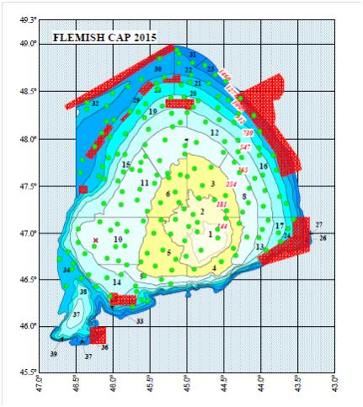Figure 1
3. For internationally coordinated surveys, describe the participating Member States/vessels and the relevant international group in charge of planning the survey
Spain+ Portugal Vizconde de Eza
Relevant international planning group: Portuguese-Spanish surveys in Flemish Cap - coordination meeting for the survey
4. Where applicable, describe the international task sharing (physical and/or financial) and the cost sharing agreement used
Spain contributes with vessel, staff and samples analysis in laboratory and Portugal contributes with staff and samples analysis in laboratory.
There is not signed agreement about task sharing.
5. Explain where thresholds apply
Not applicable
(max 450 words per survey)

FLEMISH CAP GROUNDFISH SURVEY
1.Graphical representation (map) showing the positions (locations) of the realized samples
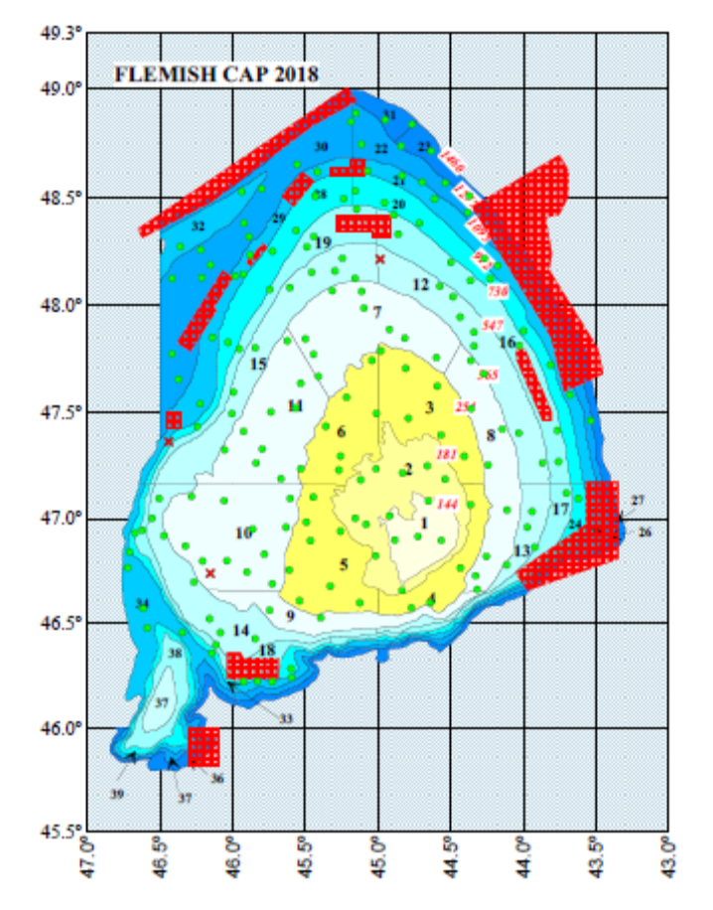Fig.1.a: Location of the hauls performed (valids in green and nulls in red) during the FLEMISH CAP GROUNDFISH SURVEY–2018 in Flemish Cap Bank (NAFO Div. 3M)
2.For internationally coordinated surveys, provide a link to the latest meeting report of the coordination group
Summary Report of the FLEMISH CAP International Survey COORDINATION MEETING (FCCM) 2018. http://www.repositorio.ieo.es
At this moment there is not proper access to IEO repository due technical problems
3.List the main use of the results of the survey (e.g. indices, abundance estimates, environmental indicators).
Survey results, including abundance indices of the main commercial species and age distributions for cod, redfish, American plaice, roughhead grenadier and Greenland halibut, provide independent information about the stock status of commercial fisheries.
The results are provided regularly to the NAFO Scientific Council, and they are also the base for many later studies.
These results are used by the NAFO SC to make an assessment on the state of the resources, which is the key tool for the NAFO Fisheries Commission to take the appropriate management measures. Results are used in the following stocks:
Cod (Div. 3M), American plaice (Div. 3M), Redfish (Div. 3M), Northern shrimp (Div. 3M), Greenland halibut (SA2 and Div, 3KLMNO) together with Canadian surveys, Roughhead grenadier (SA2+3) together with Canadian surveys. Samples for histological assessment of sexual maturity of cod, redfish, Greenland halibut and roughhead grenadier were taken. Oceanography studies continued to take place.
Furthermore, results have contributed to the preliminary identification of vulnerable marine ecosystem.
The oceanographic data collected in the NAFO surveys are available in the IEO Data Center (cedo@ieo.es), in Madrid. The IEO Data Center is integrated into other databases:
- International Data Networks: IODE (International Data Exchange and Oceanographic Information, http://www.iode.org).
- European Data Networks:
SeaDataNet: Pan-European infrastructure for Ocean & Marine Data Management, http://www.seadatanet.org
European Marine Observation and Data Network: EMODnet, http://www.emodnet.eu)
Annually, and through CEDO, CTD data of the NAFO surveys are sent to ISDM, the Regional Environmental Data Center for NAFO, previously to the NAFO Scientific Council Meeting.
Since 2018 the Summary Surveys Report are available in several databases and websites as SeaDataNet, POGO: the Partnership for Observation of the Global Ocean , EuroFleets, etc.
4.Extended comments
The final reports is not yet available. The preliminary surveys reports are provisional. Once these reports are finalized, they will be updated to IEO repository: http://www.repositorio.ieo.es
At this moment there is not proper access to IEO repository due technical problems
(max 450 words per survey)

Text Box 1G: List of research surveys at sea

3LNO GROUNDFISH SURVEY
General comment: This box fulfills Chapter IV of the multiannual Union programme and Article 2 and Article 7 paragraph (3) of the Decision (EU) 2016/1701. It is intended to specify which reseach surveys at sea set out in Table 10 of the multiannual Union programme will be carried out. Member States shall specify whether the research survey is included in Table 10 of the multiannual Union programme or whether it is an additional survey.
General comment: This box is applicable to the Annual Report. This box should provide complementary information on the performance of the surveys, the results and their main use.

3LNO GROUNDFISH SURVEY
1. Objectives of the survey
The main objectives of the survey were the estimation of abundance and biomass index of the target species, as well as the knowledge of their population demographic structure and the oceanographic conditions on the Grand Bank (NAFO Division 3NO and Division 3L). To this end the following tasks were implemented.
- Detailed length distribution and biological sampling of the catch for each target species, recording length, weight, sex, and the collection of otoliths and gonads. For other species only length and length-weight sampling were performed.
- Collection of oceanographic data data from the area using a CTD at the end of each fishing-haul.
- Collection of catch data (weight and number) of invertebrates in the most accurate way and continuing in the line of a higher taxonomic identification.
- Sampling of stomach contents of the main species to continue the study of their trophic relationships.
Target species: Cod, Roughhead grenadier, Redfish, Thorny skate, American plaice, Witch flounder, Greenland halibut, Yellow flounder, Black dogfish and Northern shrimp.
2. Description of the methods used in the survey. For mandatory surveys, link to the manuals. Include a graphical representation (map)
Manual:http://www.repositorio.ieo.es/e-ieo/bitstream/handle/10508/632/PROTOCOLO%20CAMPA%C3%91A%203LNO%20GROUNDFISH%20SURVEY_v2-revisi%C3%B3n%20enero%202013%20(2).pdf?sequence=9
Stratified random sampling scheme, diurnal Bottom trawl fishing hauls from 6 am to 9.30 pm with an average hauling time of 30 minutes. The trawling gear used is the ‘Campelen 1800’. Hydrographic profiles by haul are taken with a CTD. In NAFO Division 3NO there are planned 35 days at sea including sailing days. In NAFO division 3L there are planned 26 days at sea including sailing days

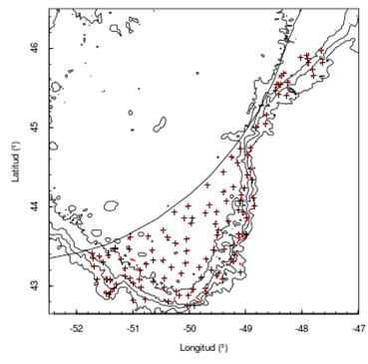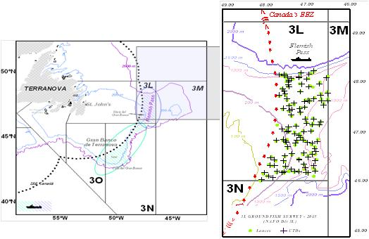Figure 2
NAFO 3NO NAFO 3L
3. For internationally coordinated surveys, describe the participating Member States/vessels and the relevant international group in charge of planning the survey
Not applicable. Spain is the only participant. The vessel is Miguel Oliver.
4. Where applicable, describe the international task sharing (physical and/or financial) and the cost sharing agreement used
Not applicable
5. Explain where thresholds apply
Not applicable
(max 450 words per survey)

3LNO GROUNDFISH SURVEY
1.Graphical representation (map) showing the positions (locations) of the realized samples
FIRST PART (Divisions 3NO)
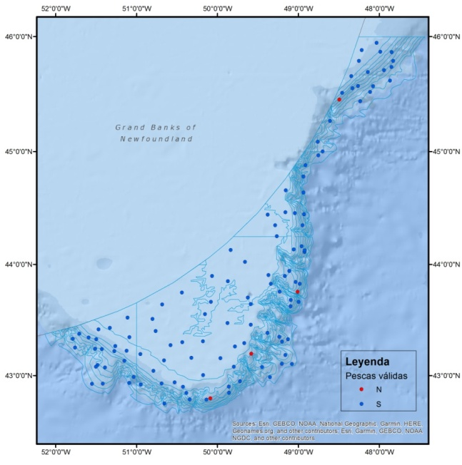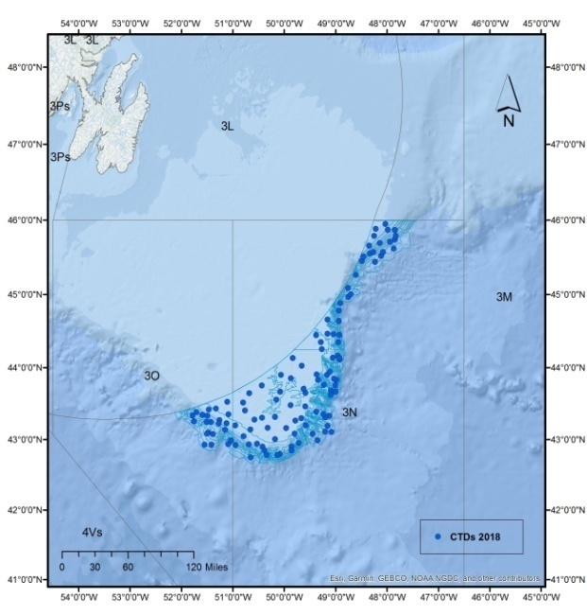
Fig.2.a: Location of the 114 valid hauls (blue) and 4 null hauls (red) [left] and CTD casts (blue) [right] obtained during the 1st part of “3LNO GROUNDFISH SURVEY – 2018” in the Grand Bank (NAFO Div. 3NO).

SECOND PART (Division 3L)
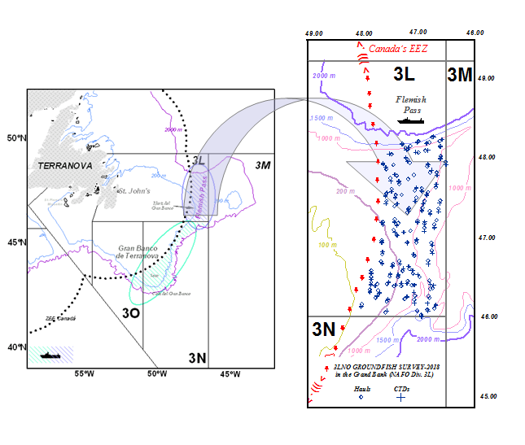
Fig.2.b: Location of the 100 valid hauls (green squares) and CTD casts (green crosses) obtained during the 2nd part of “3LNO GROUNDFISH SURVEY–2018” in the Grand Bank (NAFO Div. 3L)
2.For internationally coordinated surveys, provide a link to the latest meeting report of the coordination group
Not applicable. Spain is the only participant.
3.List the main use of the results of the survey (e.g. indices, abundance estimates, environmental indicators)
The results of these surveys, including biomass indices with their errors and length distributions, as well as the calculated biomass based on conversion of length frequencies for Northern shrimp, Greenland halibut, American plaice, Atlantic cod, Yellowtail flounder, Redfish, Witch flounder, Roughhead grenadier, Thorny skate and White hake are presented and used by the stock evaluators to NAFO Scientific Council Research Documents. In addition, age distributions are presented for Greenland halibut and Atlantic cod. Also, results contribute to the preliminary identification of VME.
The oceanographic data collected in the NAFO surveys are available in the IEO Data Center (cedo@ieo.es), in Madrid. The IEO Data Center is integrated into other databases:
- International Data Networks: IODE (International Data Exchange and Oceanographic Information, http://www.iode.org).
- European Data Networks:
SeaDataNet: Pan-European infrastructure for Ocean & Marine Data Management, http://www.seadatanet.org
European Marine Observation and Data Network: EMODnet, http://www.emodnet.eu)
Annually, and through CEDO, CTD data of the NAFO surveys are sent to ISDM, the Regional Environmental Data Center for NAFO, previously to the NAFO Scientific Council Meeting.
Since 2018 the Summary Surveys Report are available in several databases and websites as SeaDataNet, POGO: the Partnership for Observation of the Global Ocean , EuroFleets, etc.
4.Extended comments.
The final reports is not yet available. The preliminary surveys reports are provisional. Once these reports are finalized, they will be updated to IEO repository: http://www.repositorio.ieo.es
At this moment there is not proper access to IEO repository due technical problems
There is a mistake in WP about the number of days and vessel name.
The vessel is Vizconde de Eza and the number of days planned to carry out the two parts of the survey is 58 including sailing days.
(max 450 words per survey)

Text Box 1G: List of research surveys at sea-

IBTS 4th. Quarter(VIIIc y IXa north)
General comment: This box fulfills Chapter IV of the multiannual Union programme and Article 2 and Article 7 paragraph (3) of the Decision (EU) 2016/1701. It is intended to specify which reseach surveys at sea set out in Table 10 of the multiannual Union programme will be carried out. Member States shall specify whether the research survey is included in Table 10 of the multiannual Union programme or whether it is an additional survey.
General comment: This box is applicable to the Annual Report. This box should provide complementary information on the performance of the surveys, the results and their main use.

IBTS 4th. Quarter (VIIIc y IXa north)
1. Objectives of the survey
- Estimation of abundance indices by age of megrim (Lepidorhombus boscii and L. whiffiagonis), blue whiting, horse mackerel and mackerel, as well as indices by size class of hake and monkfish (Lophius budegassa and L. piscatorius),
- Estimation of the recruitment strength of the species mentioned, mainly hake, monkfish and megrims.
- Estimation of abundance indices (number and biomass) of other demersal species of fishing interest (Norway lobster, sparids, etc), as well as the fauna associated to them.
- Determination of geographical and bathymetric distribution of the different species.
- Obtaining the length distributions of all species of fish, Norway lobster and main cephalopods in the catches.
- Collecting biological data of the main commercial species: maturity stages, sex ratio, etc...
- Getting oceanographic data.
2. Description of the methods used in the survey. For mandatory surveys, link to the manuals. Include a graphical representation (map)
Stratified random sampling based on 30 minutes bottom trawl hauls during day light, getting abundance indices stratified by haul. Sampling for abundance indices covers the depths between 70 and 500 m and is stratified random, the hauls are allocated in 15 strata determined by combining 3 depth strata (>70-120m, 121-200 m and 201-500m) and five geographical sectors. Hauls allocation is proportional to the area of each stratum.
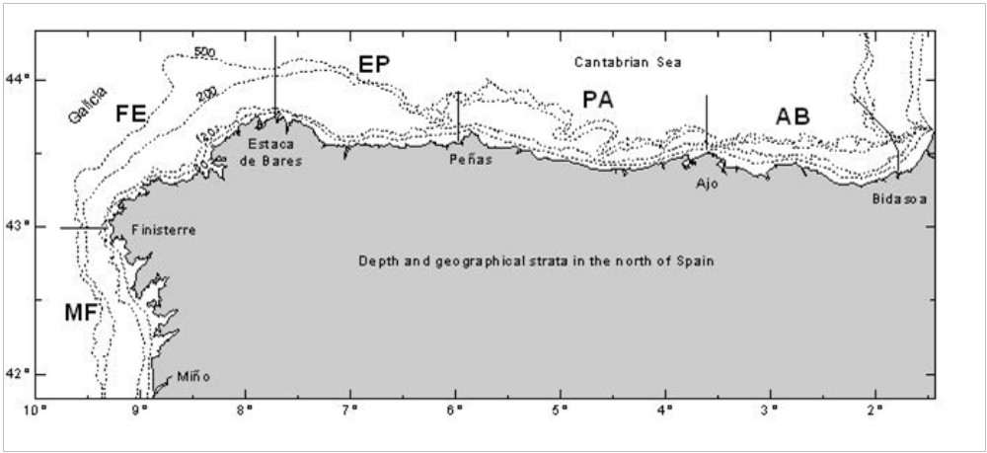Figure 3
3. For internationally coordinated surveys, describe the participating Member States/vessels and the relevant international group in charge of planning the survey
UK-Scotland/Scotia; UK-North Ireland/Corystes; Ireland/Celtic Explorer; France/Thalassa; Spain/Viconde de Eza, Miguel Oliver; Portugal/Noruega
Relevant international planning group: IBTSWG-International Bottom Trawl survey Working Group of ICES
4. Where applicable, describe the international task sharing (physical and/or financial) and the cost sharing agreement used
Individual tasks to the survey participants are allocated by the responsible ICES survey planning group. Each participating country is responsible for the activities conducted on its national part of the international survey. There is no particular cost sharing agreement in place for this survey.
5. Explain where thresholds apply
Not applicable
(max 450 words per survey)

IBTS 4th. Quarter (VIIIc y IXa north)
1.Graphical representation (map) showing the positions (locations) of the realized samples
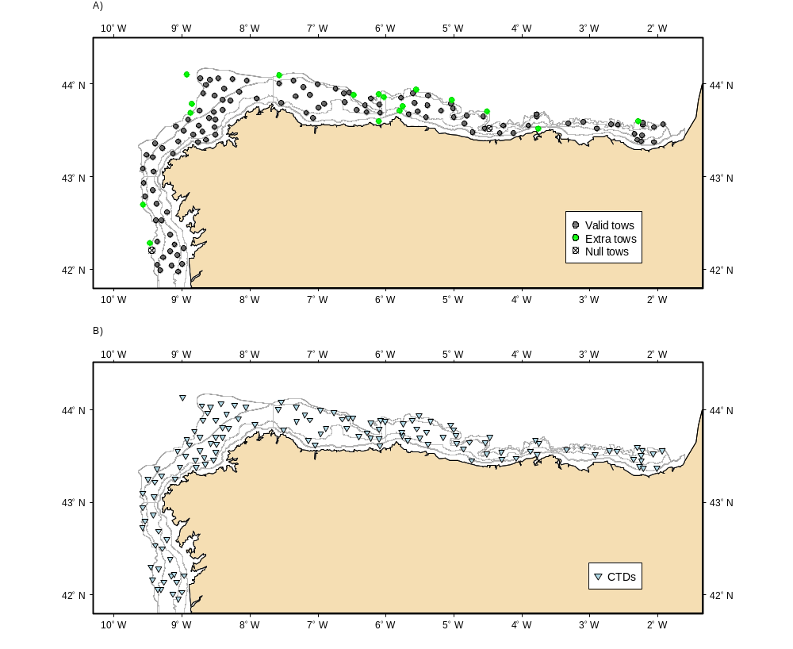Fig.3.a: Map of the hauls of sampling carried out during the survey IBTS 8c 9a 2018 (North Spanish shelf) and CTD stations performed).
2.For internationally coordinated surveys, provide a link to the latest meeting report of the coordination group
ICES. 2018. Report of the International Bottom Trawl Survey Working Group (IBTSWG), 19 - 23 March 2018, Oranmore, Ireland. ICES CM 2018/EOSG:01. 233 pp.
3.List the main use of the results of the survey (e.g. indices, abundance estimates, environmental indicators).
Data obtained are used for calibration of assessment models of groundfish on the South Platform within the ICES WGBIE, especially the southern stock of hake (Merluccius merluccius), megrims (Lepidorhombus whiffiagonis y L. boscii), anglers (Lophius budeggassa, and L. piscatorius), and Norway lobster (Nephrops norvegicus) on the Iberian continental shelf. Moreover, survey data are provided to WGDEEP of assessment of deep species (Phycis blennoides, Molva macrhophthalma, Helicolenus dactylopterus and Pagellus bogaraveo), to WGEF of assessment of elasmobranch species (Galeus melastomus, Scyliorhinus canicula, Etmopterus spinax, rays…) and to WGWIDE to provide information for the assessment of blue whiting (Micromessistius poutassou), North Eastern Atlantic mackerel (Scomber scombrus), horse mackerel (Trachurus trachurus) and boarfish (Capros aper). They are also used in the calibration of assessments of the southern stocks of horse mackerel on 9a (Trachurus spp.), anchovy (Engraulis encrasicholus) and mackerel (Scomber spp.) to WGHANSA.
These surveys are coordinated at IBTSWG group and all that group's recommendations are followed.
4.Extended comments.
There were no deviations from the Proposal.
(max 450 words per survey)

Text Box 1G: List of research surveys at sea

IBTS 4th. Quarter (IXa sur)
General comment: This box fulfills Chapter IV of the multiannual Union programme and Article 2 and Article 7 paragraph (3) of the Decision (EU) 2016/1701. It is intended to specify which reseach surveys at sea set out in Table 10 of the multiannual Union programme will be carried out. Member States shall specify whether the research survey is included in Table 10 of the multiannual Union programme or whether it is an additional survey.
General comment: This box is applicable to the Annual Report. This box should provide complementary information on the performance of the surveys, the results and their main use.

IBTS 4th. Quarter (IXa sur)
1. Objectives of the survey
- -Estimate distribution and relative abundance the main commercial species and provide recruitment indices.
- -Monitor changes in the stocks of commercial fish species independently of commercial fisheries data.
- -Monitor the distribution and relative abundance of all fish and invertebrates species.
- -Collecting data for the determination of biological parameters for selected species;
- -Collecting hydrographical and environmental information.
2. Description of the methods used in the survey. For mandatory surveys, link to the manuals. Include a graphical representation (map)
The whole area (7224 km2) has been separated into five depth strata (15-30, 31-100, 101-200, 201-500 and 501-800 m). The sampling design is random stratified with proportional allocation with a total of 42 fishing stations and swept-area method.
Length distribution of all fish and main species of crustacean and cephalopods are collected and biological parameters are obtained in the most important commercial species
Temperature and salinity are collected during each tow with a CTD attached to the gear. A CTD by haul will be carried out in the survey area.
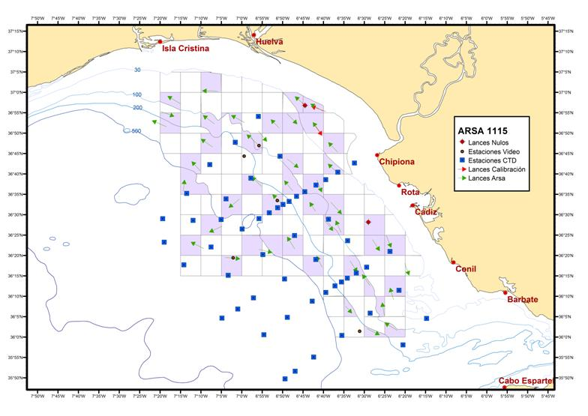Figure 4
3. For internationally coordinated surveys, describe the participating Member States/vessels and the relevant international group in charge of planning the survey
UK-Scotland/Scotia; UK-North Ireland/Corystes; Ireland/Celtic Explorer; France/Thalassa; Spain/Viconde de Eza, Miguel Oliver; Portugal/Noruega
Relevant international planning group: IBTSWG-International Bottom Trawl survey Working Group of ICES
4. Where applicable, describe the international task sharing (physical and/or financial) and the cost sharing agreement used
Individual tasks to the survey participants are allocated by the responsible ICES survey planning group. Each participating country is responsible for the activities conducted on its national part of the international survey. There is no particular cost sharing agreement in place for this survey.
5. Explain where thresholds apply
Not applicable
(max 450 words per survey)

IBTS 4th. Quarter (IXa sur)
1.Graphical representation (map) showing the positions (locations) of the realized samples
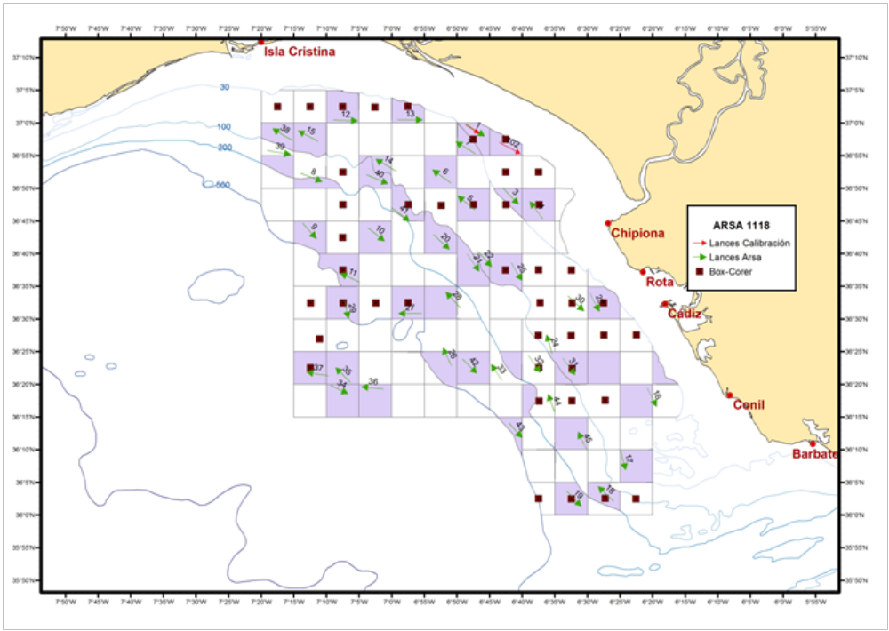
Fig.4.a: Map presenting the spatial distribution of the main sampling types obtained during the Southern Spanish Groundfish Survey on the Gulf of Cadiz (SP-GCGFS) (30 October– 12 November 2018).
The whole area (7224 km2) has been separated into five depth strata (15-30, 31-100, 101-200, 201-500 and 501-800 m). The sampling design is random stratified with proportional allocation. Total fishing stations selected are shading in the map (red and green arrows). Temperature and salinity data were also collected during each tow with a CTD attached to the gear (CTD stations represented as blue squares).
2.For internationally coordinated surveys, provide a link to the latest meeting report of the coordination group
Recommendations given by the Expert Group for the planning of these surveys (ICES IBTSWG) are adopted in the survey protocols. Hyperlink to the meeting report from the body, which coordinate the survey is:
http://www.ices.dk/sites/pub/Publication%20Reports/Expert%20Group%20Report/EOSG/2018/IBTSWG/IBTSWG%20Report%202018.pdf
3.List the main use of the results of the survey (e.g. indices, abundance estimates, environmental indicators).
The number of valid hauls was 45 valid (no deviations), 162 species of fish, 58 of crustacean and 57 of mollusca were recorded during the survey. Length distribution of all fish and main species of crustacean and cephalopods were recorder. Biological samples were studied for the most important species. 92 CTD casts were carried out in the survey area.
Data obtained are used for assessment models of groundfish on the South Platform within the ICES WGBIE, especially the southern stock of hake (Merluccius merluccius), and Norway lobster (Nephrops norvegicus) on the Iberian continental shelf. Moreover, survey data are provided to WGCEPH of cephalopods species like octopus (Octopus vulgaris), cuttlefish (Sepia officinalis and squid (Loligo vulgaris and Loligo forbesii), to WGEF of assessment of elasmobranch species (Galeus melastomus, Scyliorhinus canicula, Etmopterus spinax, rays…) and to WGWIDE to provide information for the assessment of blue whiting (Micromessistius poutassou), North Eastern Atlantic mackerel (Scomber scombrus), horse mackerel (Trachurus trachurus) and boarfish (Capros aper). They are also used in the calibration of assessments of the southern stocks of horse mackerel on 9a (Trachurus spp.), anchovy (Engraulis encrasicholus) and mackerel (Scomber spp.) to WGHANSA.
4.Extended comments.

(max 450 words per survey)

Text Box 1G: List of research surveys at sea

IBTS 4th. Quarter Porcupine groundfish survey
General comment: This box fulfills Chapter IV of the multiannual Union programme and Article 2 and Article 7 paragraph (3) of the Decision (EU) 2016/1701. It is intended to specify which reseach surveys at sea set out in Table 10 of the multiannual Union programme will be carried out. Member States shall specify whether the research survey is included in Table 10 of the multiannual Union programme or whether it is an additional survey.
General comment: This box is applicable to the Annual Report. This box should provide complementary information on the performance of the surveys, the results and their main use.

IBTS 4th. Quarter. Porcupine groundfish survey
1. Objectives of the survey
- To estimate stratified abundances indices by age of hake, megrims (L. whiffiagonis, L boscii), and monkfishes (Lophius budegassa y L. piscatorius) and other fish species.
- To estimate recruitment indices and spatial trends of younger ages of hake, megrims and monkfishes.
- To estimate stratified abundances indices of commercial fish species (Nephrops norvergicus, Phycis blennoides, Helicolenus dactylopterus, Molva molva, Conger conger)
- To describe the spatial distribution patterns of demersal and benthic species on Porcupine Bank.
- To collect otoliths and biological parameters of the main commercial fish species
- To collect data for the determination of biological parameters for the demersal species selected by DCF.
- To collect hydrographic data.
2. Description of the methods used in the survey. For mandatory surveys, link to the manuals. Include a graphical representation (map)
The sampling design was random stratified with two geographical sectors (Northern and Southern) and three depth strata (> 300 m, 300 – 450 m and 450 - 800 m). Hauls allocation is proportional to the strata area following a buffered random sampling procedure).
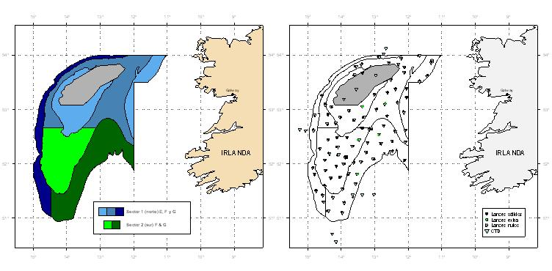Figure 5
3. For internationally coordinated surveys, describe the participating Member States/vessels and the relevant international group in charge of planning the survey
UK-Scotland/Scotia; UK-North Ireland/Corystes; Ireland/Celtic Explorer; France/Thalassa; Spain/Viconde de Eza, Miguel Oliver; Portugal/Noruega
Relevant international planning group: IBTSWG-International Bottom Trawl survey Working Group of ICES
4. Where applicable, describe the international task sharing (physical and/or financial) and the cost sharing agreement used
Individual tasks to the survey participants are allocated by the responsible ICES survey planning group. Each participating country is responsible for the activities conducted on its national part of the international survey. There is no particular cost sharing agreement in place for this survey.
5. Explain where thresholds apply
Not applicable
(max 450 words per survey)

IBTS 4th. Quarter. Porcupine groundfish survey
1.Graphical representation (map) showing the positions (locations) of the realized samples
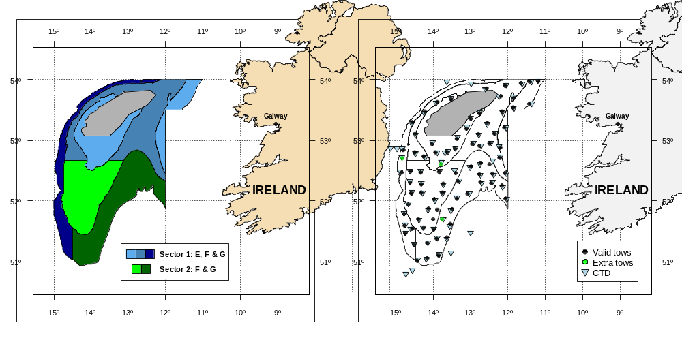
Fig.5.a. Geographic sectors used in the survey and hauls carried out in Porcupine Spanish ground fish survey in 2018.

2.For internationally coordinated surveys, provide a link to the latest meeting report of the coordination group
ICES. 2018. Report of the International Bottom Trawl Survey Working Group (IBTSWG), 19 - 23 March 2018, Oranmore, Ireland. ICES CM 2018/EOSG:01. 233 pp.
3.List the main use of the results of the survey (e.g. indices, abundance estimates, environmental indicators).
Data obtained are used to calibrate the assessment models of groundfish stocks on the ICES areas 7c-k in the working group WGBIE, hake, megrims and anglers. Moreover, data of the survey are provided to working group WGCSE for the assessment of the Norway lobster (Nephrops norvegicus), haddock (Melanogrammus aeglefinus), whiting (Merlangius merlangius) and cod (Gadus morhua), to working group WGDEEP of assessment of deep species (Phycis blennoides, Argentina sp., Molva macrhophthalma, M. molva and Helicolenus dactylopterus), to working group WGEF of assessment of elasmobranch species (Galeus melastomus, Deania calcea, Scyliorhinus canicula, Scymnodon ringens…) and to the working group WGWIDE to provide information for the assessment of blue whiting (Micromessistius poutassou) and boarfish (Capros aper), WGCEPH squids (Loligo forbesi, Todarodes sagitatus, illex coindetii).
4.Extended comments.
There were no deviations from the Proposal.
(max 450 words per survey)

Text Box 1G: List of research surveys at sea

MACKEREL / H. MACKEREL EGGS SURVEY
General comment: This box fulfills Chapter IV of the multiannual Union programme and Article 2 and Article 7 paragraph (3) of the Decision (EU) 2016/1701. It is intended to specify which reseach surveys at sea set out in Table 10 of the multiannual Union programme will be carried out. Member States shall specify whether the research survey is included in Table 10 of the multiannual Union programme or whether it is an additional survey.
General comment: This box is applicable to the Annual Report. This box should provide complementary information on the performance of the surveys, the results and their main use.

MACKEREL / H. MACKEREL EGGS SURVEY (trienal)-CAREVA
1. Objectives of the survey
- This survey (CAREVA) provides indices for the strength of the SSB and a relative abundance index of Atlantic mackerel (Scomber scombrus) spawning stock.
- Egg production and spawning area estimation for both mackerel and horse mackerel.
- Fecundity estimation
- Determine the egg distribution area and density of other commercial species (hake, sardine, etc.)
- Characterise the main oceanographic conditions of the surveyed area
2. Description of the methods used in the survey. For mandatory surveys, link to the manuals. Include a graphical representation (map)
WGMEGS Manual for the Mackerel and Horse Mackerel Egg Surveys (ICES, 2016a).

- In most of the western area plankton samplers are deployed at the centre of half standard ICES rectangles, which are 0.5° latitude, by 0.5° longitude. To the north of Spain (Cantabrian Sea) three sampler deployments are undertaken (in an east-west direction) in each 0.25° latitude by 1.0° longitude rectangle because of the proximity of the shelf edge to the coast.
- The standard plankton samplers used in the survey are Bongo 40 (oblique tows). All of these samplers generally have temperature, salinity and depth probes (Seabird 37 CTD) attached to the frames and they are also fitted with either mechanical flowmeters to enable the volume of water filtered on each deployment to be calculated.
- CTD profiles with Seabird 25 are also obtained in each BONGO station.
- Adult fish samples are obtained by pelagic trawls.
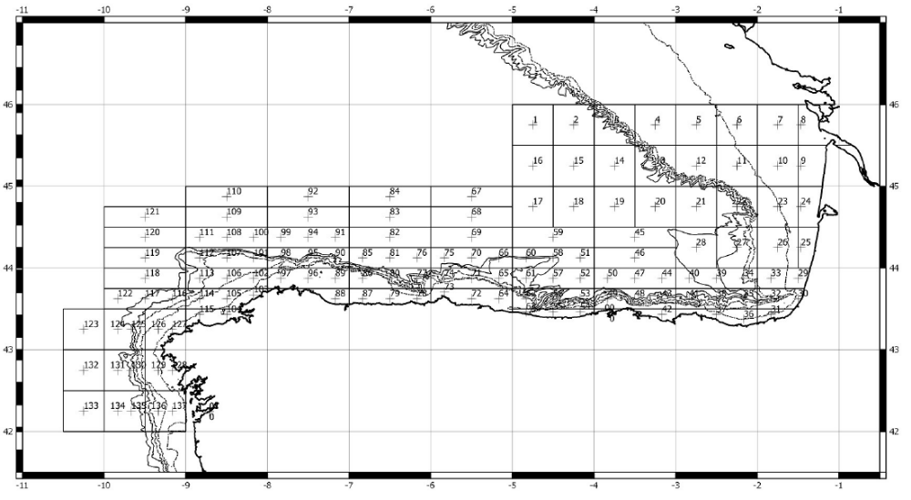Figure 6
3. For internationally coordinated surveys, describe the participating Member States/vessels and the relevant international group in charge of planning the survey
Spain /Vizconde de Eza, Ramon Margalef, Enma Bardan; Portugal/; Denmark/; UK-Scotland/; Ireland/; Germany/; The Netherlands/; Faroe Islands/;
Relevant international planning group: WGMEGS: Working Group on Mackerel and Horse Mackerel Egg Surveys
WGMEGS: Working Group on Mackerel and Horse Mackerel Egg Surveys
4. Where applicable, describe the international task sharing (physical and/or financial) and the cost sharing agreement used
Individual tasks to the survey participants (e.g. coverage of certain areas in a certain time frame) are allocated by the responsible ICES survey planning group. Each participating country is responsible for the activities conducted on its national part of the international survey. There is no particular cost sharing agreement in place for this survey.
5. Explain where thresholds apply
Not applicable
(max 450 words per survey)

MACKEREL / H. MACKEREL EGGS SURVEY (trienal)-CAREVA
This survey is triennial. Last survey was carried out in 2016 and the next survey will be carried out in 2019.
1.Graphical representation (map) showing the positions (locations) of the realized samples
2.For internationally coordinated surveys, provide a link to the latest meeting report of the coordination group
3.List the main use of the results of the survey (e.g. indices, abundance estimates, environmental indicators).
4.Extended comments.
(max 450 words per survey)

Text Box 1G: List of research surveys at sea

MACKEREL / H. MACKEREL EGGS SURVEY
General comment: This box fulfills Chapter IV of the multiannual Union programme and Article 2 and Article 7 paragraph (3) of the Decision (EU) 2016/1701. It is intended to specify which reseach surveys at sea set out in Table 10 of the multiannual Union programme will be carried out. Member States shall specify whether the research survey is included in Table 10 of the multiannual Union programme or whether it is an additional survey.
General comment: This box is applicable to the Annual Report. This box should provide complementary information on the performance of the surveys, the results and their main use.

MACKEREL / H. MACKEREL EGGS SURVEY (trienal)-JUREVA
1. Objectives of the survey
- This survey (JUREVA) provides indices for the strength of the SSB and a relative abundance index of horse mackerel (Trachurus trachurus) spawning stock.
- Egg production and spawning area estimation for both mackerel and horse mackerel.
- Fecundity estimation
- Determine the egg distribution area and density of other commercial species (hake, sardine, etc.)
- Characterise the main oceanographic conditions of the surveyed area
2. Description of the methods used in the survey. For mandatory surveys, link to the manuals. Include a graphical representation (map)
WGMEGS Manual for the Mackerel and Horse Mackerel Egg Surveys (ICES, 2016a).

- In most of the western area plankton samplers are deployed at the centre of half standard ICES rectangles, which are 0.5° latitude, by 0.5° longitude. To the north of Spain (Cantabrian Sea) three sampler deployments are undertaken (in an east-west direction) in each 0.25° latitude by 1.0° longitude rectangle because of the proximity of the shelf edge to the coast.
- The standard plankton samplers used in the survey are Bongo 40 (oblique tows). All of these samplers generally have temperature, salinity and depth probes (Seabird 37 CTD) attached to the frames and they are also fitted with either mechanical flowmeters to enable the volume of water filtered on each deployment to be calculated.
- CTD profiles with Seabird 25 are also obtained in each BONGO station.
- Adult fish samples are obtained by pelagic trawls.
Figure 7
3. For internationally coordinated surveys, describe the participating Member States/vessels and the relevant international group in charge of planning the survey
Spain /Vizconde de Eza, Ramon Margalef, Enma Bardan; Portugal/; Denmark/; UK-Scotland/; Ireland/; Germany/; The Netherlands/; Faroe Islands/;
Relevant international planning group: WGMEGS: Working Group on Mackerel and Horse Mackerel Egg Surveys
4. Where applicable, describe the international task sharing (physical and/or financial) and the cost sharing agreement used
Individual tasks to the survey participants (e.g. coverage of certain areas in a certain time frame) are allocated by the responsible ICES survey planning group. Each participating country is responsible for the activities conducted on its national part of the international survey. There is no particular cost sharing agreement in place for this survey.
5. Explain where thresholds apply
Not applicable
(max 450 words per survey)

MACKEREL / H. MACKEREL EGGS SURVEY (trienal)-JUREVA
This survey is triennial. Last survey was carried out in 2016 and the next survey will be carried out in 2019.
1.Graphical representation (map) showing the positions (locations) of the realized samples
2.For internationally coordinated surveys, provide a link to the latest meeting report of the coordination group
3.List the main use of the results of the survey (e.g. indices, abundance estimates, environmental indicators).
4.Extended comments.
(max 450 words per survey)

Text Box 1G: List of research surveys at sea

MACKEREL / H. MACKEREL EGGS SURVEY
General comment: This box fulfills Chapter IV of the multiannual Union programme and Article 2 and Article 7 paragraph (3) of the Decision (EU) 2016/1701. It is intended to specify which reseach surveys at sea set out in Table 10 of the multiannual Union programme will be carried out. Member States shall specify whether the research survey is included in Table 10 of the multiannual Union programme or whether it is an additional survey.
General comment: This box is applicable to the Annual Report. This box should provide complementary information on the performance of the surveys, the results and their main use.

MACKEREL / H. MACKEREL EGGS SURVEY (trienal)-AZTI
1. Objectives of the survey
The main objective of Mackerel and Horse Mackerel Egg Survey (AZTI) is to relate the number of freshly spawned eggs found in the water column to the number of females having spawned these eggs. With the estimated fecundity of the females, this provides an estimate of the spawning-stock biomass.
2. Description of the methods used in the survey. For mandatory surveys, link to the manuals. Include a graphical representation (map)
Details of methods used during the survey can be consulted at: Manual of the mackerel and horse mackerel egg surveys (MEGS): sampling at sea. Version 1.3. The working group on Mackerel and horse mackerel egg surveys. SISP 6-MEGS V1.3.62 pp.
http://www.ices.dk/sites/pub/Publication%20Reports/ICES%20Survey%20Protocols%20(SISP)/SISP%206%20-%20MEGS%20V1.3.pdf

The standard plankton net used in the ICES triennial egg surveys by AZTI is the Bongo 40. The procedures used in these surveys are described in detail the manual of surveys (see below). On completion of the hauls, plankton was preserved in a 4% buffered formaldehyde solution. At sea, fish eggs from plankton samples are sorted out- Once at lab, eggs are identified (Mackerel and horse mackerel species) and staged.
Adult samples of mackerel are captured using pelagic trawls at those areas where the presence of eggs is positive.

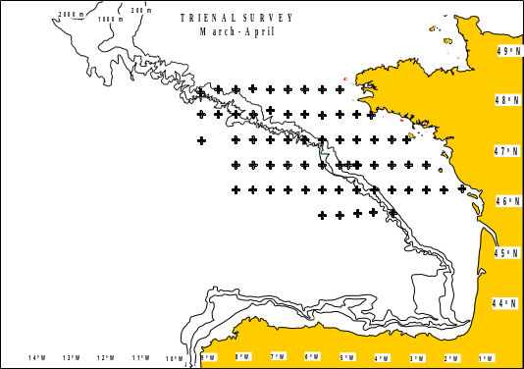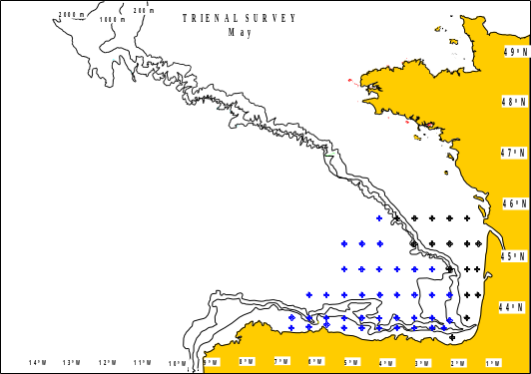Figure 8
3. For internationally coordinated surveys, describe the participating Member States/vessels and the relevant international group in charge of planning the survey
Spain /Vizconde de Eza, Ramon Margalef, Enma Bardan; Portugal/; Denmark/; UK-Scotland/; Ireland/; Germany/; The Netherlands/; Faroe Islands/;
Relevant international planning group: WGMEGS: Working Group on Mackerel and Horse Mackerel Egg Surveys
4. Where applicable, describe the international task sharing (physical and/or financial) and the cost sharing agreement used
Individual tasks to the survey participants (e.g. coverage of certain areas in a certain time frame) are allocated by the responsible ICES survey planning group. Each participating country is responsible for the activities conducted on its national part of the international survey. There is no particular cost sharing agreement in place for this survey.
AZTI participates covering the Cantabrian sea and Bay of Biscay areas in 2 periods, period 3 (March-April) and period 5 (May). During the last years, the surveys were executed on board the B/O Ramon Margalef and B/O Enma Bardan. The survey coordinator for survey will be Brendan O’ Hea, MI, Galway, Ireland
5. Explain where thresholds apply
Not applicable
(max 450 words per survey)

MACKEREL / H. MACKEREL EGGS SURVEY (trienal)-AZTI
This survey is triennial. Last survey was carried out in 2016 and the next survey will be carried out in 2019.
1.Graphical representation (map) showing the positions (locations) of the realized samples
2.For internationally coordinated surveys, provide a link to the latest meeting report of the coordination group
3.List the main use of the results of the survey (e.g. indices, abundance estimates, environmental indicators).
4.Extended comments.
(max 450 words per survey)

Text Box 1G: List of research surveys at sea

SARDINE, ANCHOVY, H. MACKEREL ACOUSTIC SURVEY
General comment: This box fulfills Chapter IV of the multiannual Union programme and Article 2 and Article 7 paragraph (3) of the Decision (EU) 2016/1701. It is intended to specify which reseach surveys at sea set out in Table 10 of the multiannual Union programme will be carried out. Member States shall specify whether the research survey is included in Table 10 of the multiannual Union programme or whether it is an additional survey.
General comment: This box is applicable to the Annual Report. This box should provide complementary information on the performance of the surveys, the results and their main use.

SARDINE, ANCHOVY, H. MACKEREL ACOUSTIC SURVEY (PELACUS)
1. Objectives of the survey
- The main objective of this survey was to achieve a biomass’ estimation by echointegration of the main pelagic fish distributed in the Spanish Cantabrian and NW waters (sardine, anchovy, horse mackerel, mackerel, blue whiting, bogue, boar fish, and chub mackerel). Together with this, the following objectives were also foreseen:
- Determine the distribution area and density of the main fish species
- Determine the main biological characteristics (length, sex, maturity stage and age) of the main fish species
- Estimate the relative abundance and distribution area of sardine and anchovy eggs by means of CUFES
- Estimate the adults parameters needed to apply the Daily Egg Production Method to sardine.
- Characterise the main oceanographic conditions of the surveyed area
- Determine the distribution pattern, taxonomic diversity and dry biomass by size classes of the plankton population presented in the surveyed area.
- Determine the natural abundance of N15 in sardine, anchovy and mackerel and their trophic position.
- Determine the distribution area and density of apical predators
- Determine the distribution area and density of marine microplastics litter
2. Description of the methods used in the survey. For mandatory surveys, link to the manuals. Include a graphical representation (map)
Acoustic, Systematic track with parallel transects evenly distribute each 8 nmi. Backscattering energy attributed to fish species after scrutinisation of the echograms. Biomass estimates using echointegration method. Pelagic fishing stations for echo-trace allocation and biological characterisation. CUFES for mapping egg (anchovy and sardine) distribution area. Trained observers recorded marine mammal, seabird, floating litter and vessel presence and abundance. Data on the hydrography and hydrodynamics of the water masses are collected via the deployment of rosettes and conductivity, temperature and depth sensors. Information on the composition, distribution and biomass of phytoplankton and zooplankton is derived from the analyses of samples taken by plankton nets.
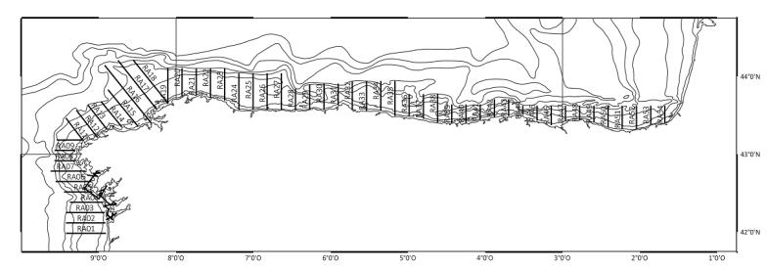Figure 9
3. For internationally coordinated surveys, describe the participating Member States/vessels and the relevant international group in charge of planning the survey
Spain/Miguel Oliver; Portugal/; France/
Relevant international planning group: WGACEGG: Working Group on Acoustic and Egg Surveys for Sardine and Anchovy in ICES Areas VII, VIII and IX
4. Where applicable, describe the international task sharing (physical and/or financial) and the cost sharing agreement used
Individual tasks to the survey participants are allocated by the responsible ICES survey planning group. Each participating country is responsible for the activities conducted on its national part of the international survey. There is no particular cost sharing agreement in place for this survey.
5. Explain where thresholds apply
Not applicable
(max 450 words per survey)

SARDINE, ANCHOVY, H. MACKEREL ACOUSTIC SURVEY (PELACUS)
1.Graphical representation (map) showing the positions (locations) of the realized samples
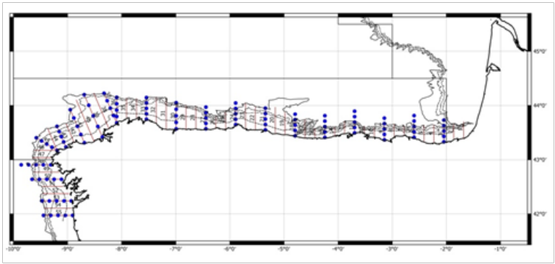Fig. 9 a: Acoustic tracks PELACUS 0318
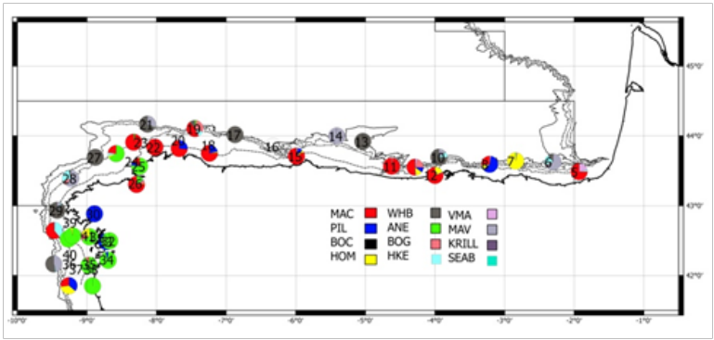Fig. 9 b: Fishing stations PELACUS 0318
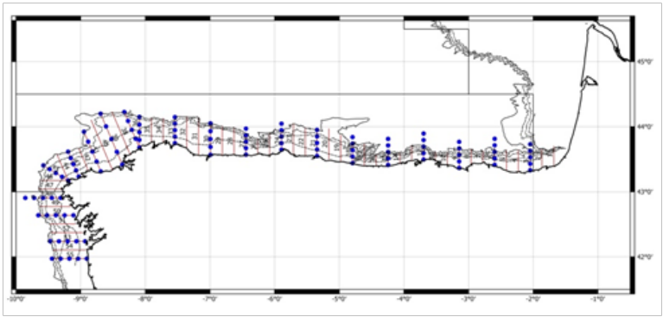Fig. 9 c: Combined Bongo+CTD stations PELACUS

2.For internationally coordinated surveys, provide a link to the latest meeting report of the coordination group
The Working Group on Acoustic and Egg Surveys for Sardine and Anchovy in ICES Areas 7, 8 and 9 (WGACEGG) coordinates this survey. The hyperlink to the latest meeting report is:
http://bit.ly/2DdQ6GT
3.List the main use of the results of the survey (e.g. indices, abundance estimates, environmental indicators).
This suvey is providing a series of both quantitative and qualitative indices for several fish species.
Acoustic estimates of sardine in 8c and 9a is using as independent fishery index at the assessment model, while that for anchovy in 9a is using as survey index at the qualitative trends analysis for assessment purposes. For horse makerel, abundance estimates in 8c is used as survey index for the Western Stock assessment model
Information obtained from sardine, anchovy and mackerel egg underway distribution is used as a proxy of the potential spawning area. The survey is also achieving relevant information for blue whiting, mackerel and boarfish (acoustic estimates and distribution) for the ICES WGWIDE in 9a and 8c ICES Divisions.
4.Extended comments.
There were no deviations from the Proposal.
(max 450 words per survey)

Text Box 1G: List of research surveys at sea

Sardine DEPM
General comment: This box fulfills Chapter IV of the multiannual Union programme and Article 2 and Article 7 paragraph (3) of the Decision (EU) 2016/1701. It is intended to specify which reseach surveys at sea set out in Table 10 of the multiannual Union programme will be carried out. Member States shall specify whether the research survey is included in Table 10 of the multiannual Union programme or whether it is an additional survey.
General comment: This box is applicable to the Annual Report. This box should provide complementary information on the performance of the surveys, the results and their main use.

Sardine DEPM (SAREVA)
1. Objectives of the survey
- The main objective of SAREVA survey is the estimation of the spawning stock biomass of sardine (Sardina pilchardus) based on the application Method of Daily Egg Production (DEPM).
- Sardine Spawning area estimation.
- Esti Daily egg production estimation of sardine.
- Determine the egg distribution area and density of other commercial species (hake, mackerel, horse mackerel, etc.
- Characterise the main oceanographic conditions of the surveyed area.
2. Description of the methods used in the survey. For mandatory surveys, link to the manuals. Include a graphical representation (map)
Survey methodology is fully described in ICES. 2004.The DEPM Estimation of Spawning-Stock Biomass for Sardine and Anchovy. ICES Cooperative Research Report, No. 268. 91 pp.
Survey consists of:
- Ichthyoplankton sampling on fixed stations (CalVET, 150µm mesh size, from 100 m depth to surface every 3 nm) and underway stations (CUFES), to delimit sardine spawning grounds.
- CTD profiles are obtained in each CalVET station (Seabird 25 and 37).
- Adult fish samples are obtained by pelagic trawls.Planktonic net hauls (CalVET) at 3 miles intervals. CUFES complementary samplings, lasting for 10 minutes, one mile and a half before and one mile and a half after each CalVET.
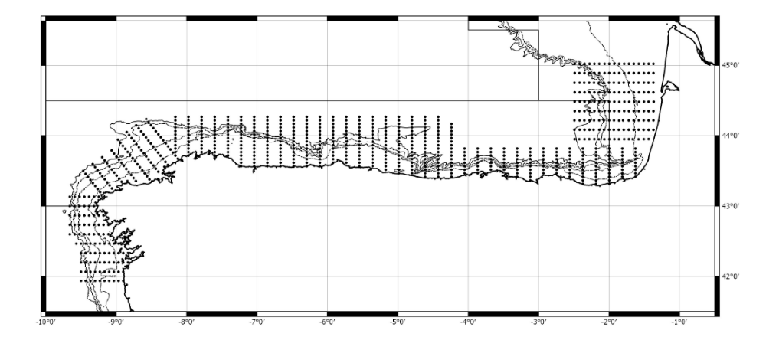Figure 10
3. For internationally coordinated surveys, describe the participating Member States/vessels and the relevant international group in charge of planning the survey
Spain/Viconde de Eza, Ramon Margalef; Portugal/Noruega
Relevant international planning group: WGACEGG: Working Group on Acoustic and Egg Surveys for Sardine and Anchovy in ICES Areas VII, VIII and IX
4. Where applicable, describe the international task sharing (physical and/or financial) and the cost sharing agreement used
Not applicable
5. Explain where thresholds apply
Not applicable
(max 450 words per survey)

Sardine DEPM (SAREVA)
This survey is triennial. Last survey was carried out in 2017 and the next survey will be carried out in 2020.
1.Graphical representation (map) showing the positions (locations) of the realized samples
2.For internationally coordinated surveys, provide a link to the latest meeting report of the coordination group
3.List the main use of the results of the survey (e.g. indices, abundance estimates, environmental indicators).
4.Extended comments.
(max 450 words per survey)

Text Box 1G: List of research surveys at sea

BIOMAN
General comment: This box fulfills Chapter IV of the multiannual Union programme and Article 2 and Article 7 paragraph (3) of the Decision (EU) 2016/1701. It is intended to specify which reseach surveys at sea set out in Table 10 of the multiannual Union programme will be carried out. Member States shall specify whether the research survey is included in Table 10 of the multiannual Union programme or whether it is an additional survey.
General comment: This box is applicable to the Annual Report. This box should provide complementary information on the performance of the surveys, the results and their main use.

BIOMAN
1. Objectives of the survey
- To estimate annually the total biomass of anchovy in the Bay of Biscay applying the DEPM, the age structure of the population (numbers, percentage, weight and length by age) and the spatial distribution of the specie.
- These estimates are used for the assessment and posterior management of this stock.
- To obtain triennially (2017) the sardine spawning stock biomass in 8ab (45ºN to 48ºN) applying the DEPM, to contribute to the triennial estimates.
- To obtain the total egg abundance indices for sardine in VIIIab. These estimates are used for the survey trends-based assessment of this stock.
- Biological characterization of the species, spawning area delimitation of anchovy and sardine in the Bay of Biscay.
- Hydrological conditions of the prospected area
2. Description of the methods used in the survey. For mandatory surveys, link to the manuals. Include a graphical representation (map)
The DEPM is applying following the protocol accorded at WGACEGG. In (ICES -Cooperative Research Report 332).
The area to cover is the southeast of the Bay of Biscay which corresponds to the main spawning area and spawning season of anchovy. The sampling strategy is adaptive. The survey will start from the West, looking for the western limit of the spawning. Then, the survey continue to the north to find the Northern limit of the spawning. Stations are located at intervals of 3 nmi along 15 nmi apart transects, perpendicular to the coast. At each station a vertical plankton haul is performed using a PairoVET net. Immediately after each haul samples are fixed in formaldehyde 4%.
The Continuous Underway Fish Egg Sampler (CUFES, Checkley et al., 1997) is used to delimit the spawning area of the species.
Sample depth, temperature, salinity and fluorescence profiles are obtained at each sampling station using a CTD coupled to the PairoVET.
The adult samples are obtained on board a pelagic trawler, during day and night, coinciding in space and time with the plankton sampling. When the plankton vessel encounters areas with anchovy or sardine eggs, the pelagic trawler is directed to those areas to fish. In each haul, immediately after fishing, anchovy and/or sardine are sorted from the bulk of the catch and a sample of two kg is selected at random. 100 individuals of each species are measured and a biological sampling is conducted for anchovy and/or sardine with 60 minimum or 120 maximum, number of individuals in each haul. Length, weight, sex maturity and extraction of otolith are measured for each individual within the haul.
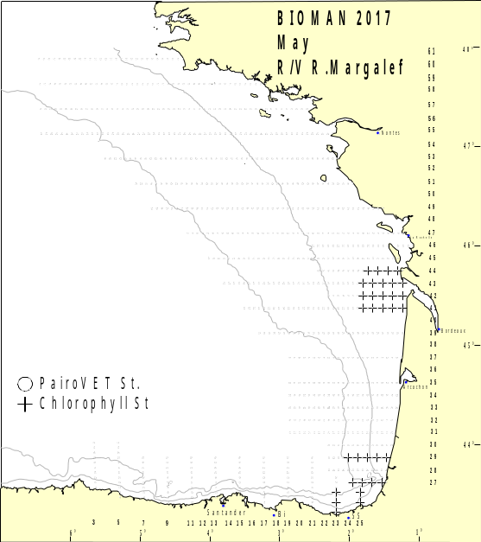Figure 11
3. For internationally coordinated surveys, describe the participating Member States/vessels and the relevant international group in charge of planning the survey
Spain/Viconde de Eza, Ramon Margalef; Portugal/Noruega
Relevant international planning group WGACEGG: Working Group on Acoustic and Egg Surveys for Sardine and Anchovy in ICES Areas VII, VIII and IX
4. Where applicable, describe the international task sharing (physical and/or financial) and the cost sharing agreement used
Not applicable
5. Explain where thresholds apply
Not applicable
(max 450 words per survey)

BIOMAN
1.Graphical representation (map) showing the positions (locations) of the realized samples
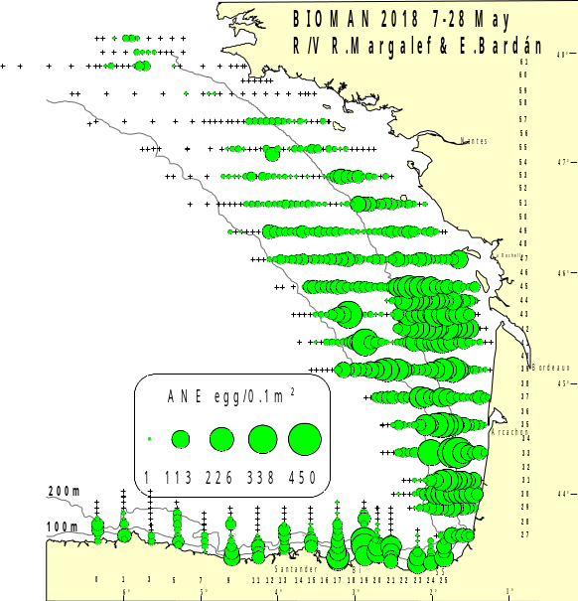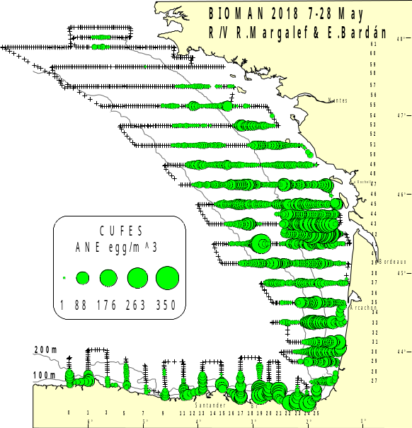
Fig.11.a: Distribution of anchovy egg abundances (eggs per 0.1m2) obtained with PairoVET (left) and CUFES (right) (eggs per m3) from the DEPM survey BIOMAN2018. A CTD is performance with each vertical plankton haul.

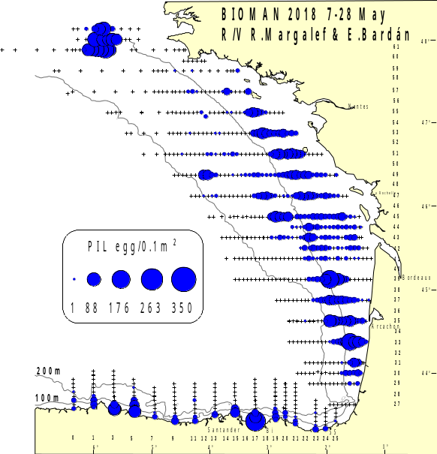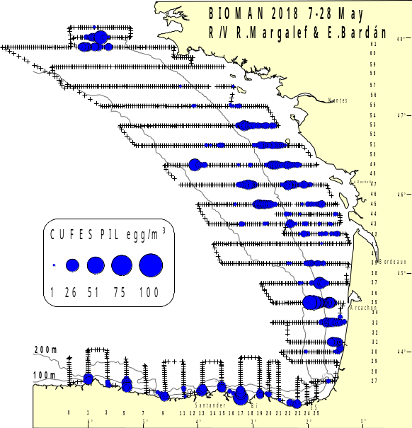
Fig.11.b: Distribution of sardine egg abundances (eggs per 0.1m2) obtained with PairoVET (left) and CUFES (right) (eggs per m3) from the DEPM survey BIOMAN2018. A CTD is performance with each vertical plankton haul.
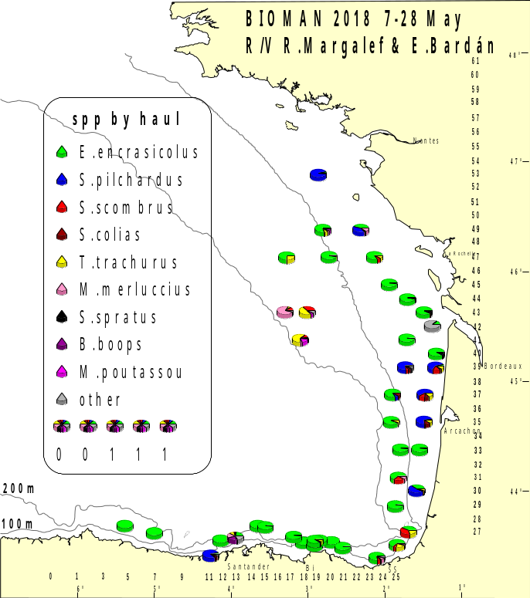Fig.11.c: Positive fishing during BIOMAN 2018 survey on board R/V Emma Bardán and hauls from purse seines.
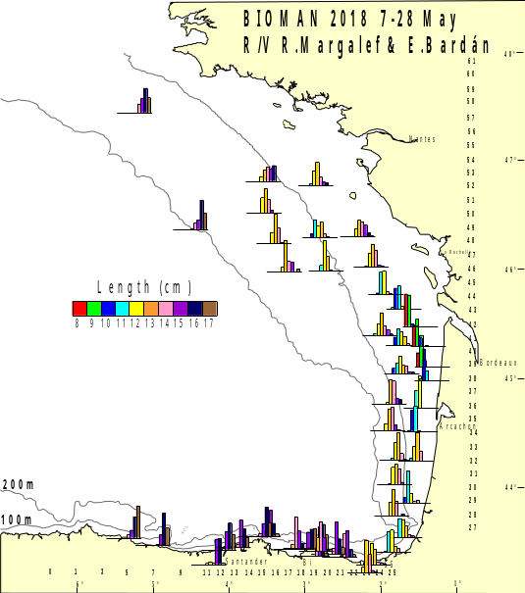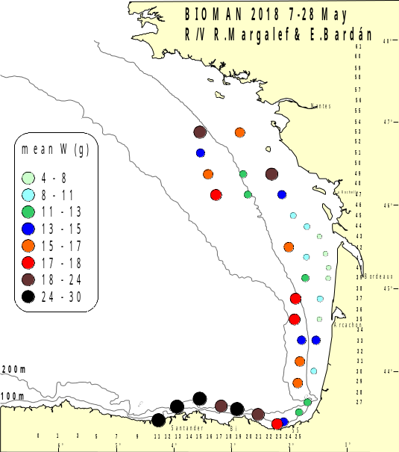
Fig.11.d: Anchovy size (left) and weight (right) per haul 2018
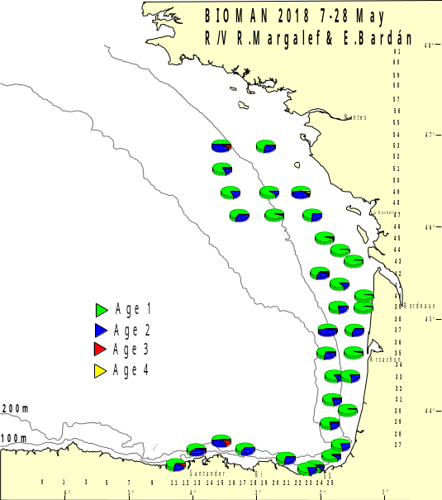
Fig.11.e: Anchovy spatial age composition by haul 2018.

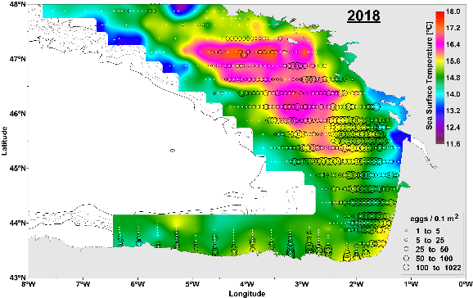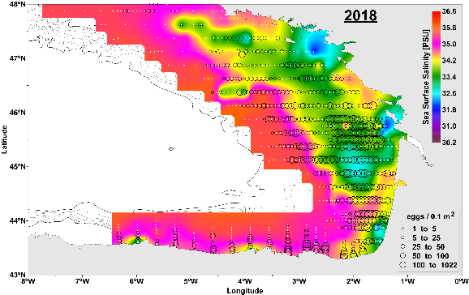
Fig.11.f: SST and SSS maps (left and right) overlapped with anchovy egg distribution 2018.
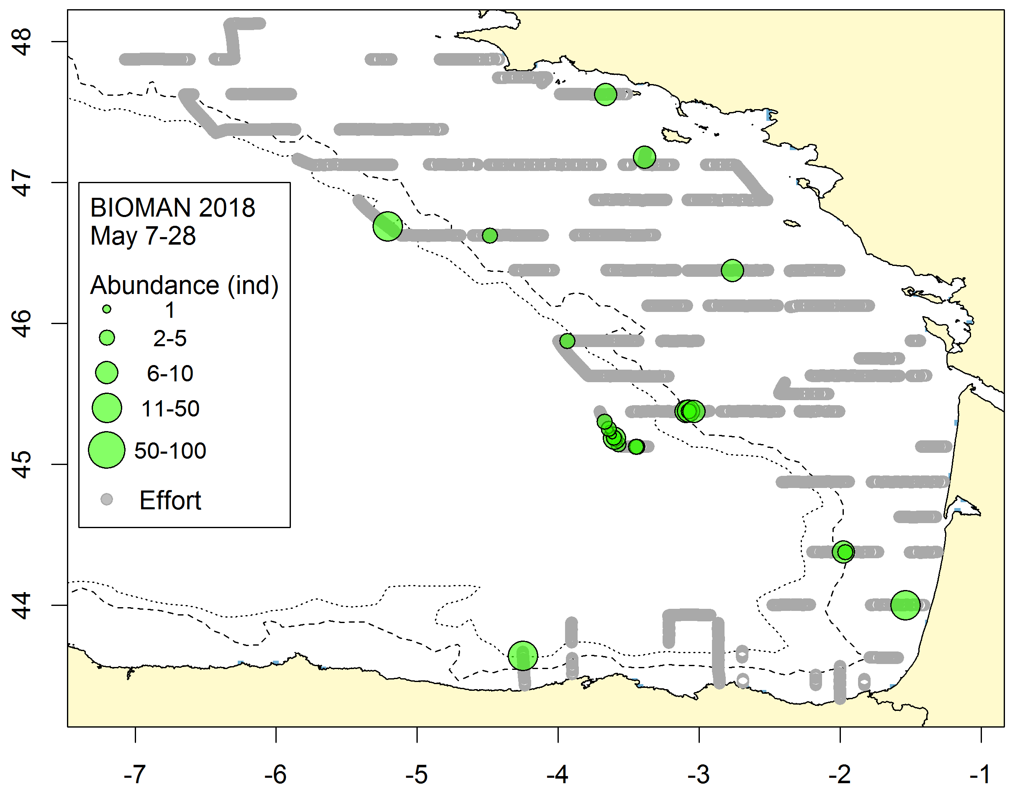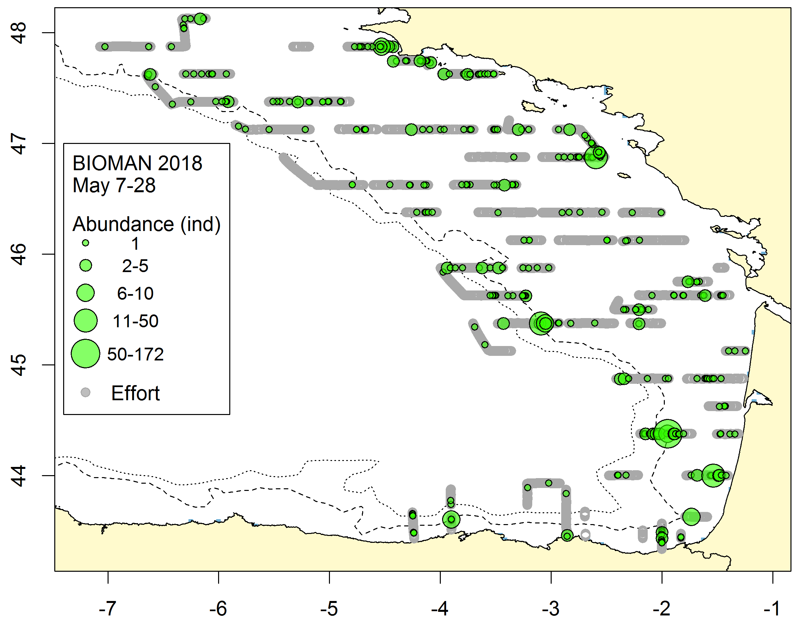
Fig.11.g: Distribution and abundance of common dolphins (left) and northern gannets (right) 2018. Grey points represent the effort while the size of the green circles is proportional to observed abundances. Blue background values represent the bathymetry. Abundance of other marine mammals and sea birds are showed in the report of the survey (in the link below)
2.For internationally coordinated surveys, provide a link to the latest meeting report of the coordination group
Relevant international planning group WGACEGG: Working Group on Acoustic and Egg Surveys for Sardine and Anchovy in ICES Areas 7, 8 and 9. Link to de last meeting report: https://bit.ly/2FZhGYL
3.List the main use of the results of the survey (e.g. indices, abundance estimates, environmental indicators).
This survey provides input to the assessment working group on horse mackerel, anchovy and sardine (WGHANSA):
- Anchovy spawning biomass (this equals total stock biomass since all anchovies are mature in spring) and population-at-age estimates in ICES 8 that is use yearly in the assessment of anchovy for the international catch advice in ICES 8abcd
- Sardine egg abundance estimated that is used yearly for the trends-based assessment for the international advice in ICES 8abd
Moreover:
- Size of all the species catched on the trawl hauls as an environmental indicator
- The CTD profiles are send to an international database
4.Extended comments.
Tables 1G and 1H: Other objectives were added to the survey since 2016: to obtain other indicators of the MSFD as microplastic abundances, marine mammals and sea bird abundances, human activities and marine litter abundances. eDNA to identify marine mammals and fish. This objetive was not in the planification in the original national plan (2017).
(max 450 words per survey)

Text Box 1G: List of research surveys at sea

MEDITS
General comment: This box fulfills Chapter IV of the multiannual Union programme and Article 2 and Article 7 paragraph (3) of the Decision (EU) 2016/1701. It is intended to specify which reseach surveys at sea set out in Table 10 of the multiannual Union programme will be carried out. Member States shall specify whether the research survey is included in Table 10 of the multiannual Union programme or whether it is an additional survey.
General comment: This box is applicable to the Annual Report. This box should provide complementary information on the performance of the surveys, the results and their main use.

MEDITS (Mediterranean International bottom trawl survey)
1. Objectives of the survey
Since the article 12 of the Council Regulation (EC) Nº 199/2008, of 25 February 2008, concerning the establishment of a Community framework for the collection, management and use of data in the fisheries sector and support for scientific advice regarding the Common Fisheries Policy, the main objective of the research surveys at sea is to evaluate the abundance and distribution of stocks, independently of the data provided by commercial fisheries, and to assess the impact of the fishing activity on the environment. The specific objectives of MEDITS surveys are:
- To get standardized indices of abundance and biomass of demersal species distributed in the circalittoral and batial soft bottoms of the Mediterranean
- To know the geographic and bathymetric distribution of these species.
- To describe the demographic structure of their populations.
- To collect biological data of the target species for fisheries.
- To get physical-chemical parameters (e.g. temperature and salinity) of the water masses where communities and demersal resources are distributed.
2. Description of the methods used in the survey. For mandatory surveys, link to the manuals. Include a graphical representation (map)
The MEDITS survey is carried out along the Spanish Mediterranean coast: Geographical sub-areas GSA01 (Northern Alboran Sea), GSA02 (Alboran Island), GSA05 (Balearic Islands) and GSA06 (Northern Spain) of the General Fisheries Commission for the Mediterranean (GFCM). See map below.
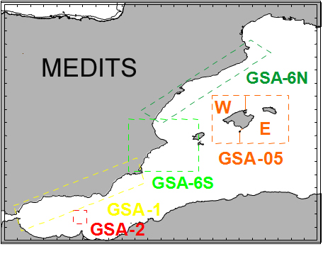Figure 12
According to MEDITS protocol, the hauls are positioned applying a stratified sampling scheme with random drawing of the positions within each stratum. The stratification parameter adopted is the depth with the following bathymetric limits: 10, 50, 100, 200, 500 and 800 m. The duration of the hauls is fixed to 30 minutes on depth less than 200 m and 60 minutes on more than 200 m. The hauls are performed only during daylight.
The survey is carried out in April-June (around 55 days), on board the research vessel "Miguel Oliver" (70 meters long, 14 meters wide, 2495 TRB and 2000 KW). The gear (GOC-73) is a bottom trawl designed for experimental fishing, with a cod-end mesh size of 20 mm. A SCANMAR system is used to monitor the arrival and departure of the net from the seabed and to estimate its horizontal and vertical openings. The bottom water temperature and salinity is recorded with the use of a CTD SBE-37 coupled to the flotsam of the net.
The data are stored in the IEO database SIRENO. Five file types are defined in order to store and exchange the data:
- Type A: Characteristics of haul. This file includes the data on bottom temperature and stratification
- Type B: Catches by haul
- Type C: Length, sex, and maturity at aggregated level
- Type E: Age weight and maturity by length at individual level
- Type L: Collection of marine litter data. According to the current common protocol, the collection of these data is voluntary.
The national coordinator of the MEDITS survey is Enric Massutí (IEO Baleares). The regional coordinators are Cristina García (IEO Málaga) for GSA01 and GSA02, Antonio Esteban (IEO Murcia) for GSA06 and Antoni Quetglas (IEO Baleares) for GSA05.
3. For internationally coordinated surveys, describe the participating Member States/vessels and the relevant international group in charge of planning the survey
Participating Member States: Albania, Cyprus, Spain, France, Greece, Croatia, Italy, Malta, Montenegro and Slovenia. For the list of vessels, see Annex I of the Medits Handbook_v8: www.sibm.it/MEDITS%202011/principaleprogramme.htm
The international coordination of the survey is carried out during the annual “MEDITS coordination meeting”.
4. Where applicable, describe the international task sharing (physical and/or financial) and the cost sharing agreement used
Each participating country is responsible for the activities conducted on its national part of the international survey. There is no particular cost sharing agreement in place for this survey.
5. Explain where thresholds apply
Not applicable
(max 450 words per survey)

MEDITS (Mediterranean International bottom trawl survey)
1.Graphical representation (map) showing the positions (locations) of the realized samples
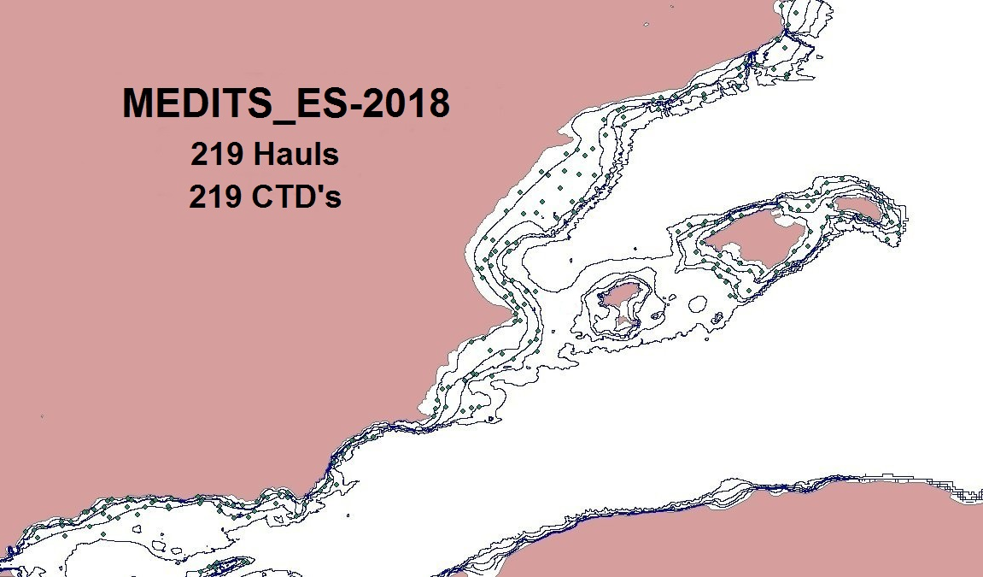
Fig.12.a : Map with the sampling positions during the MEDITS_survey 2018

2.For internationally coordinated surveys, provide a link to the latest meeting report of the coordination group
http://www.sibm.it/MEDITS%202011/principalemedits.htm
3.List the main use of the results of the survey (e.g. indices, abundance estimates, environmental indicators).
Standardised data obtained has been used for tuning assessments models XSA (Extended Survivors Analysis) and a4a (Statistical cath at age) developed by IEO within the framework of GFCM for the most important species exploited by the bottom trawl fishery along the Iberian Peninsula (mainly GSA 6) and the Balearic Islands (GSA 5). MEDITS data are also used for scientific papers, PhDs and Master Theses, as well as in several project funded at national and European level.
Number and weight of all species or taxons captured during the survey and mean yields of most abundant species were estimated. Sheets including mean standardized abundance and biomass and length frequency distribution during 2018 survey were also prepared, including a summary of historical data series for density and size indicators. It is included in national reports:
- García-Ruiz C. & E. López Díaz.- 2018. Informe campaña MEDITS_ES_0518: GSAs 1-2. IEO.
- Guijarro B., N. González, V. Rubio, M. Valls & F. Ordines.- 2018. Informe campaña MEDITS_ES_0518: GSA 5. IEO.
- Esteban A.- 2018. Informe campaña MEDITS_ES_0518: GSA 6. IEO.
4.Extended comments.
During 2018, the Spanish MEDITS survey was carried out from April 26th to June 24th (60 days), on board R/V Miguel Oliver (70x14.4 m, 2495 GT and 2x1000 kW), between 30 and 800 m depth, covering four geographic sub-areas (GSAs) of the General Fisheries Commission for the Mediterranean (GFCM): 1 (Northern Alboran Sea), 2 (Alboran Island), 5 (Balearic Islands) and 6 (Northern Spain). Sampling stations followed a depth stratified scheme: 30-50, 51-100, 101-200, 201-500 and 501-800 m. A total of 219 bottom trawls (GSA1: 59, GSA2: 7, GSA5: 51: GSA6: 102) were performed by IEO, following the MEDITS protocol. A total of 689 species or taxa (221 fishes, 108 crustaceans, 134 molluscs and 226 other invertebrates and algae) were identified, counted and weighted. A CTD SBE 37 attached to the flotsam of the net was used in all hauls to collect data on temperature, conductivity and depth. The total number of individuals captured was 1.660.080 and the length of 153.908 individuals was measured. Biological sampling of 28.358 individuals was made and 2.713 samples of hard structures for age estimations in Merluccius merluccius, Mullus barbatus, M. surmuletus, Lophius budegassa and L. piscatorius were taken.
(max 450 words per survey)

Text Box 1G: List of research surveys at sea

MEDIAS
General comment: This box fulfills Chapter IV of the multiannual Union programme and Article 2 and Article 7 paragraph (3) of the Decision (EU) 2016/1701. It is intended to specify which reseach surveys at sea set out in Table 10 of the multiannual Union programme will be carried out. Member States shall specify whether the research survey is included in Table 10 of the multiannual Union programme or whether it is an additional survey.
General comment: This box is applicable to the Annual Report. This box should provide complementary information on the performance of the surveys, the results and their main use.

MEDIAS (Mediterranean International Acoustic Survey)
1. Objectives of the survey
The MEDIAS project started in 2009 within the cooperation of seven research Institutes from six Mediterranean Member States of the European Union. The target was to harmonize and standardize the five ongoing acoustic surveys in the Mediterranean: Gulf of Lions (IFREMER), Iberian Coast (IEO), Sicilian Channel (IAMC/MCFS), Adriatic Sea (ISMAR), and North Aegean Sea (HCMR). The general aim is to produce information on small pelagic species for management decisions and provide input to assessment for stocks which are managed internationally, principally, anchovy (Engraulis encrasicolus) and sardine (Sardina pilchardus). Surveys take place during summer, during the anchovy peak of spawning.
2. Description of the methods used in the survey. For mandatory surveys, link to the manuals. Include a graphical representation (map)
The MEDIAS survey design covers the Spanish Mediterranean continental shelf (20 to 200 m depth) from the French border to Punta Europa (Strait of Gibraltar). Transects run perpendicular to the coastline/bathymetry. The inter-transect is 4 or 8 nautical miles in order to achieve the minimization of the coefficient of variation of the acoustic estimates for the target species taking into account the topography of each area. Survey is performed during the day.
A calibrated EK60 (Simrad) scientific echosounder is used, equiped with five frequencies (18, 38, 70, 120 and 200 kHz), for the collection of acoustic data. The frequency for assessment is 38 kHz, while the 18, 70, 120 and 200 kHz operate as complementary frequencies. The elementary distance sampling unit (EDSU) is 1 nautical mile. The fish density values are obtained as NASC (Nautical Acoustic Scattering Coefficient) (m2/mn2) values.
Opportunistic pelagic hauls are carried out in order to ground truth the fish echotraces detected by the echosounder. Target species of the MEDIAS surveys are anchovy and sardine, for wich abundance (nº individuals), biomass (tons) are estimated by length, sex and age but biological data for all species in the pelagic community regarding length frequency distribution and length-weight relationships are also acquired. Hidrological variables are collected by CTD’s.
MEDIAS survey is carried out on board R/V MIGUEL OLIVER, 70 m long, 14 m wide, 2480 TRB and 2000 KW.
National coordinator of the survey is Magdalena Iglesias (IEO-C.O. de Baleares).
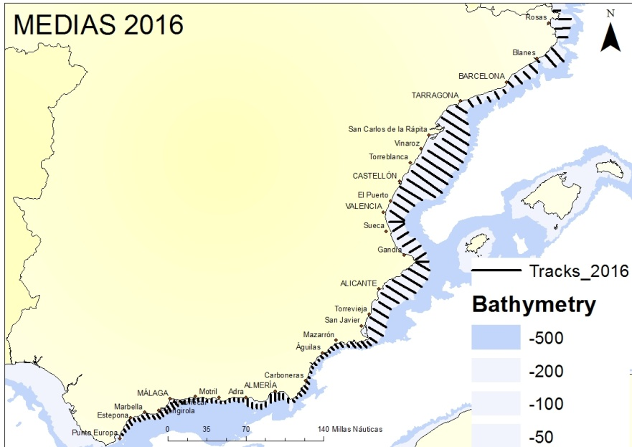Figure 13
3. For internationally coordinated surveys, describe the participating Member States/vessels and the relevant international group in charge of planning the survey
Participating Member States: France, Italy, Greece, Slovenia, Malta, Croatia and Spain.
The international coordination of the survey is carried out in the “MEDIAS coordination meeting”.
http://www.medias-project.eu/medias/website/
4. Where applicable, describe the international task sharing (physical and/or financial) and the cost sharing agreement used
Each participating country is responsible for the activities conducted on its national part of the international survey. There is no particular cost sharing agreement in place for this survey.
5. Explain where thresholds apply
Not applicable
(max 450 words per survey)

MEDIAS (Mediterranean International Acoustic Survey)
1.Graphical representation (map) showing the positions (locations) of the realized samples
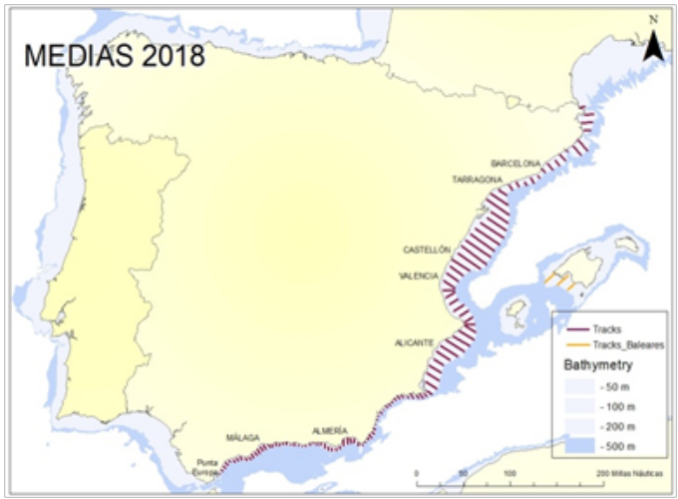Fig.13.a: Tracks (111) carried out during MEDIAS 2018
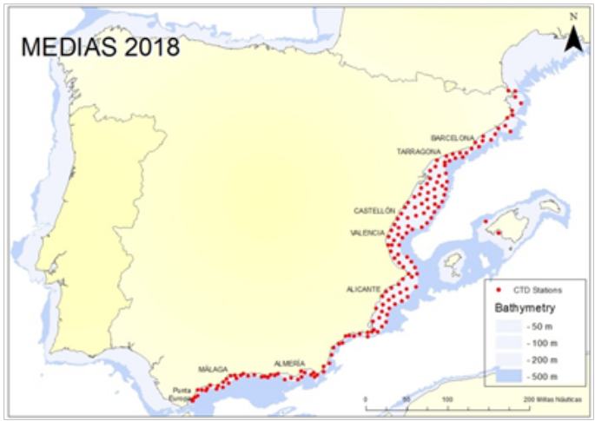Fig.13.b: CTD stations(165) carried out during MEDIAS 2018
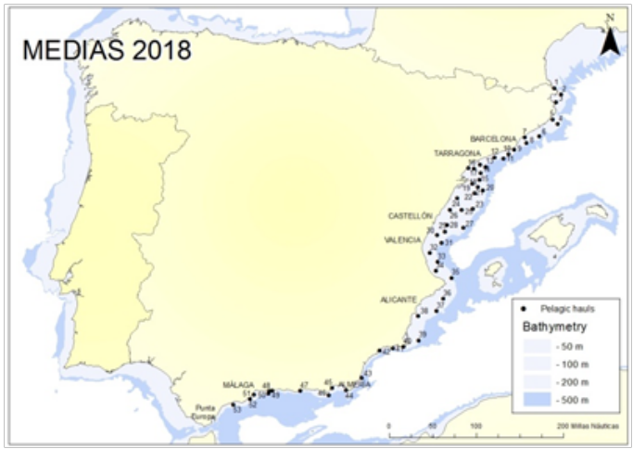Fig.13.c: Pelagic trawls (53) carried out during MEDIAS 2018
2.For internationally coordinated surveys, provide a link to the latest meeting report of the coordination group
http://www.medias-project.eu/medias/website/

3.List the main use of the results of the survey (e.g. indices, abundance estimates, environmental indicators).
Standardised data obtained has been used for tuning assessments models developed by IEO within the framework of GFCM for the most important species exploited by the purse seine fishery along the Iberian Peninsula (GSAs 1 and 6). MEDIAS data are also used for scientific papers and PhD and Master Theses.
Number and weight of all species or taxons captured during the survey and mean yields of most abundant species were estimated. Sheets including mean standardized abundance and biomass and length frequency distribution during 2018 survey were also prepared, including a summary of historical data series for density and size indicators. Its is included in the national report.
4.Extended comments.
During 2018, the Spanish MEDIAS survey was carried out from June 26th to July 28th (33 days), on board R/V Miguel Oliver (70x14.4 m, 2495 GT and 2x1000 kW). The survey prospected continental shelf of the Spanish Mediterranean (20 to 200 m depth) by means of a scientific echosounder EK60 (Simrad), equipped with 5 frequencies (18, 38, 70, 120 and 200 kHz), from the French border to Strait of Gibraltar that corresponds to GFCM Geographical Sub-Area covered are the GSA 06 (Northern Spain) and 01 (Northern Alboran Sea), between 20 and 200 m depth.
The methodology followed is the prospection of the continental shelf (20 to 200 m depth) by means of a scientific echosounder EK60 (Simrad), equipped with 5 frequencies (18, 38, 70, 120 and 200 kHz). Acoustic data are recorded continuously at a constant ship speed of 10 knots from sunrise to sunset, along parallel equidistant transects lying perpendicular to the bathymetry. The echosounder is calibrated before each survey following standard techniques (Demer et al., 2015).
Midwater pelagic trawls (53) were deployed to determine the species proportions present in the area. Acoustic data are processed using Echoview (Miryax Ltd.) software and PESMA (VisualBasic) software. Echo trace classification is based on echogram visual scrutinisation; usually the allocation is on account of a representative fishing station and very few times on direct allocation. Results of biomass (tons) and abundance (nº individuals) are presented by species, length and age.
Moreover, 165 CTD’s stations were performed to characterize the area prospected: temperature, salinity and chlorophyll a.

(max 450 words per survey)

Text Box 1G: List of research surveys at sea

Anchovy DEPM-BOCADEVA
General comment: This box fulfills Chapter IV of the multiannual Union programme and Article 2 and Article 7 paragraph (3) of the Decision (EU) 2016/1701. It is intended to specify which reseach surveys at sea set out in Table 10 of the multiannual Union programme will be carried out. Member States shall specify whether the research survey is included in Table 10 of the multiannual Union programme or whether it is an additional survey.
General comment: This box is applicable to the Annual Report. This box should provide complementary information on the performance of the surveys, the results and their main use.

Anchovy DEPM-BOCADEVA
1. Objectives of the survey
- The main objective of BOCADEVA survey is the estimation of spawning stock biomass (SSB) of Anchovy (Engraulis encrasicolus), based on the application of the Daily Egg Production Method (DEPM)
- To estimate the extension of Anchovy Spawning area in the Gulf of Cadiz.
- To estimate the Daily egg production (Po) and total production (Ptotal) of Anchovy in the Gulf of Cadiz.
- To determine the egg distribution area and density of other commercial species
- The survey objectives also included to characterize oceanographic and meteorological conditions in the study area during the survey
2. Description of the methods used in the survey. For mandatory surveys, link to the manuals. Include a graphical representation (map)
Vertical sampling (PairoVET)
The sampling grid was established on the continental shelf following a systematic sampling scheme, with the transects being perpendicular to the coast and equally spaced 8 nm. Egg samples were always taken every 3 nm in the inner shelf, up to 100 m depth (ICES, 2003). The inshore limit of transects was determined by bottom depth (as close to the shore as possible), while the offshore extension was decided adaptively depending on the results of the most recent CUFES sample.
Vertical hauls of plankton were carried out with a PairoVET sampler equipped with nets of 150 μm of mesh size. Hauls were carried out up to a maximum depth of 100 m or of 5 m above the bottom in shallower depths, with a speed of about 1 m/s. Sampling depth and temperature of the water column were recorded using a mini CTD Valeport fitted to the net. Flowmeters were used to calculate the volume of filtered water during each haul. Egg samples were analysed onboard. A preliminary identification and counting of anchovy eggs and larvae, as well as other commercial species were carried out. Samples were sorted, counted and preserved in a 4 % buffered formaldehyde solution. In the laboratory, anchovy eggs were classified in 11 developmental stages, according to the key proposed by Moser and Ahlstrom (1985).
Continuous sampling (CUFES)
During the CUFES sampling (Checkley et al., 2000) the volume of filtered water (600 l/min, approximately) was also integrated each 3 nm (at a fixed depth of 5 m). The CUFES collector was arranged with a 335 µm net. Anchovy eggs were classified in three stages: No-Embryo (I-III), Early Embryo (IV-VI) and Late Embryo (VII-XI).
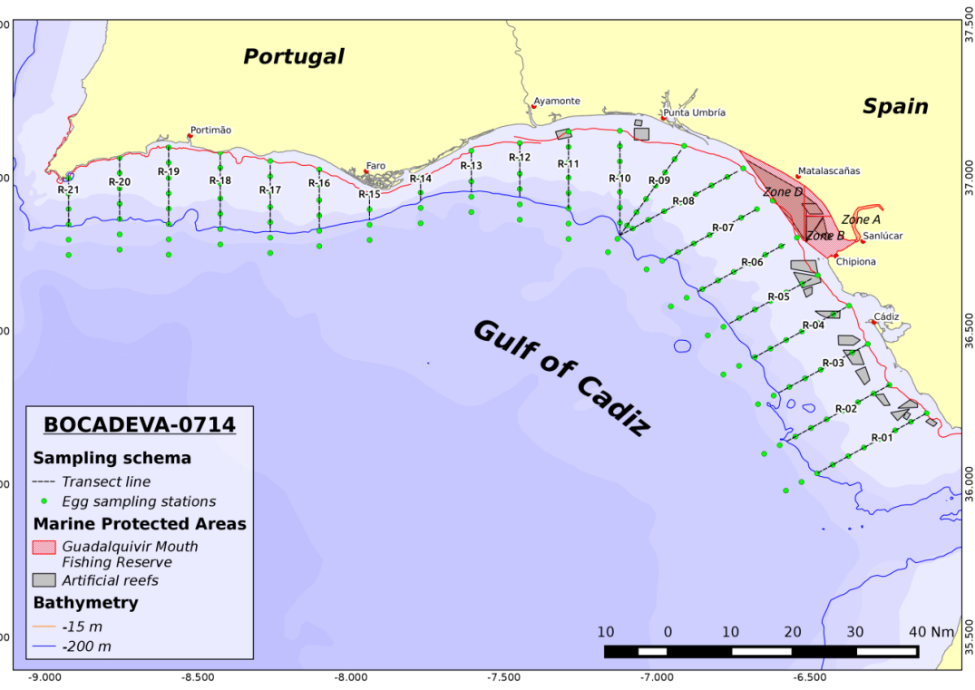Figure 14
3. For internationally coordinated surveys, describe the participating Member States/vessels and the relevant international group in charge of planning the survey
Spain/Vizconde de Eza, Ramon Margalef; Portugal/Noruega
WGACEGG: Working Group on Acoustic and Egg Surveys for Sardine and Anchovy in ICES Areas VII, VIII and IX
4. Where applicable, describe the international task sharing (physical and/or financial) and the cost sharing agreement used
Not applicable
5. Explain where thresholds apply
Not applicable
(max 450 words per survey)

Anchovy DEPM-BOCADEVA
This survey is triennial. Last survey was carried out in 2017 and the next survey will be carried out in 2020.
1.Graphical representation (map) showing the positions (locations) of the realized samples
2.For internationally coordinated surveys, provide a link to the latest meeting report of the coordination group
3.List the main use of the results of the survey (e.g. indices, abundance estimates, environmental indicators).
4.Extended comments.
(max 450 words per survey)

Text Box 1G: List of research surveys at sea

ECOCADIZ
General comment: This box fulfills Chapter IV of the multiannual Union programme and Article 2 and Article 7 paragraph (3) of the Decision (EU) 2016/1701. It is intended to specify which reseach surveys at sea set out in Table 10 of the multiannual Union programme will be carried out. Member States shall specify whether the research survey is included in Table 10 of the multiannual Union programme or whether it is an additional survey.
General comment: This box is applicable to the Annual Report. This box should provide complementary information on the performance of the surveys, the results and their main use.

ECOCADIZ
1. Objectives of the survey
- To estimate by hydroacoustics (echo-integration) and map the abundance and biomass of the main neritic pelagic species inhabiting the Gulf of Cadiz shelf waters, especially the Gulf of Cadiz anchovy spawning stock
- To characterize the biology of the above species in relation to their main habitats, especially according to the size composition and/or age structure, and to the maturity repletion and condition status.
- To map the distribution and abundance of the apical predators within the surveyed pelagic community their relation to oceanographic and biological factors.
- To oceanographically characterize the surveyed area: thermo-haline properties, patterns of distribution and circulation of the water masses; weather conditions
- To map the abundance and biomass of floating macro-litter.
2. Description of the methods used in the survey. For mandatory surveys, link to the manuals. Include a graphical representation (map)
Estimation of the abundance and biomass of the survey target species by vertical echo-integration, during daylight, along to a systematic grid composed by (21) transects, between 20 – 200 m isobaths, 8 nm-equally spaced and normal to the shoreline, with a Simrad™ EK-60 scientific echo-sounder working in a multi-frequency fashion (18, 38, 120 and 200 kHz). The echo-traces identification and determination of the size and age composition and other biological aspects of the assessed species is carried out from the results from opportunistic ground-truthing fishing hauls. Hydrographic characterization of the surveyed area is carried out by night through the sampling of a systematic grid of discrete CTD (with coupled multisensors)-LADCP casts (coupled to an oceanographic rosette) and along-transect sub-superficial continuous sampling with VMADCP and ThermoSal-F. The climatic characterization of the surveyed area is obtained from the analysis of continuous records of weather variables by an Aanderaa weather station. The ichthyoplankton (anchovy eggs) distribution and sub-superficial density is recorded by a Continuous Underway Fish Egg Sampler (CUFES™) along transects during the acoustic sampling. Anchovy larvae are collected with a Bongo 90 net at dusk in opportunistic stations located in waters close to the Guadiana and Guadalquivir river mouths. Information on the distribution and abundance of apical predators is collated by direct observation (census techniques) by an observer during the acoustic sampling.
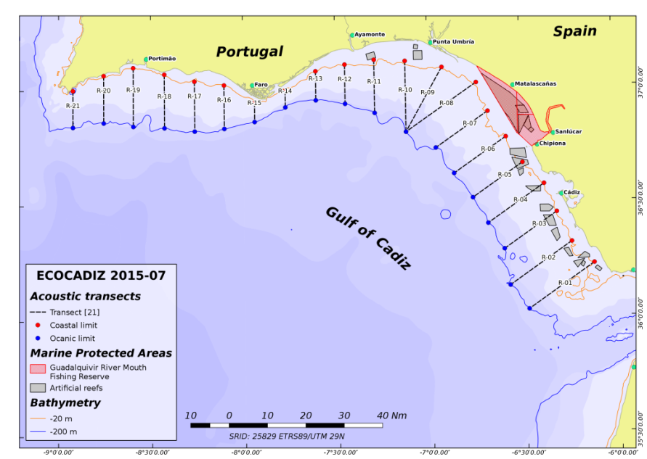Figure 15
3. For internationally coordinated surveys, describe the participating Member States/vessels and the relevant international group in charge of planning the survey
Spain/Miguel Oliver;
WGACEGG: Working Group on Acoustic and Egg Surveys for Sardine and Anchovy in ICES Areas VII, VIII and IX
4. Where applicable, describe the international task sharing (physical and/or financial) and the cost sharing agreement used
Not applicable
5. Explain where thresholds apply
Not applicable
(max 450 words per survey)

ECOCADIZ
1.Graphical representation (map) showing the positions (locations) of the realized samples
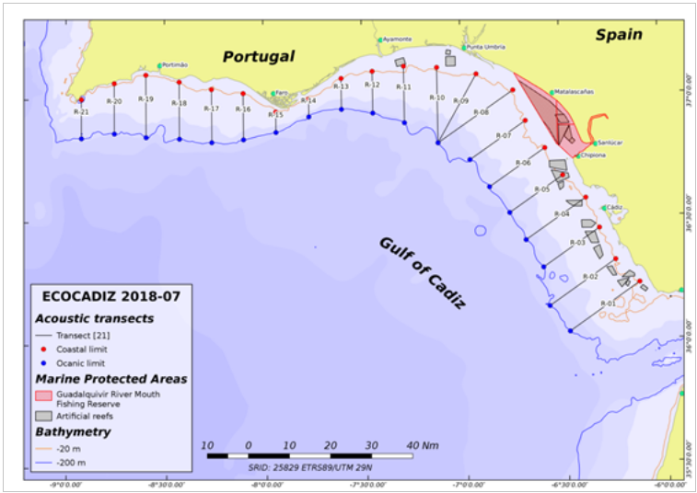Fig. 15.a: Acoustic transects sampled during the survey, also used for the census of marine top predators.
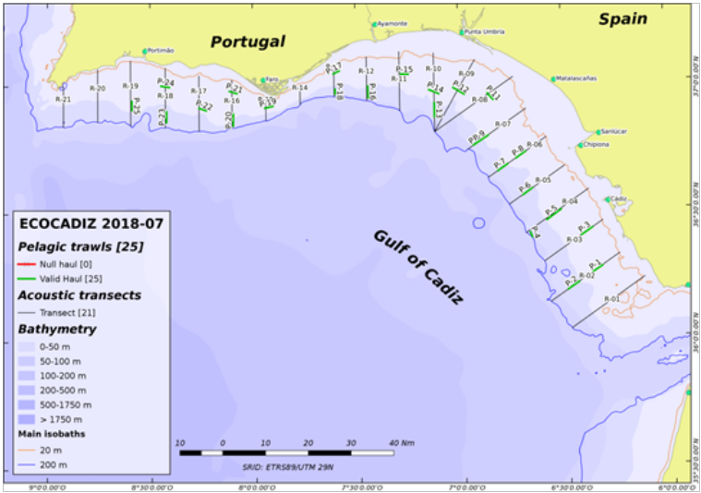Fig.15.b: Ground-truthing fishing hauls.
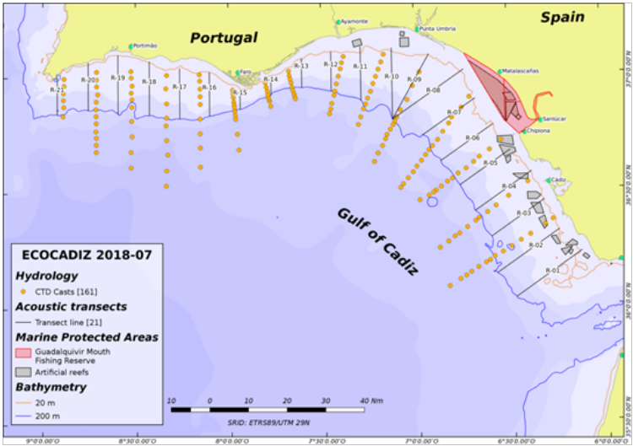Fig.15.c: CTD-LADCP stations
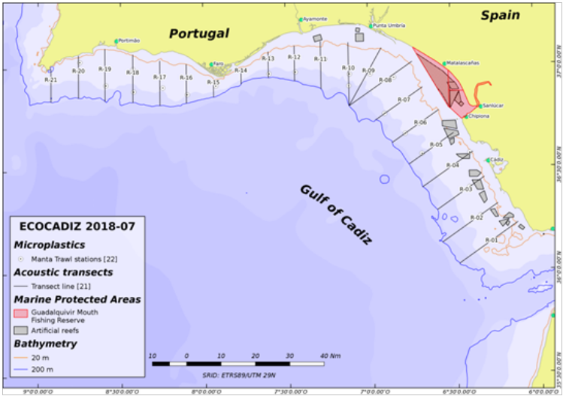Fig.15.4: Manta trawl hauls (micro-plastics).
2.For internationally coordinated surveys, provide a link to the latest meeting report of the coordination group
This survey is internationally coordinated and standardized in the ICES WGACEGG, and follows the standardized protocols of the acoustic surveys coordinated within the above WG.
https://community.ices.dk/ExpertGroups/wgacegg/2018%20Meeting%20Docs/03.%20Report%202018/WGACEGG2018report_19_12_2018_final.docx
3.List the main use of the results of the survey (e.g. indices, abundance estimates, environmental indicators).
Survey’s data and estimates are utilized in the ICES expert groups of both stock assessment of pelagic fish species (WGHANSA, WGWIDE) and acoustic and egg surveys for anchovy and sardine in ICES areas 7, 8 and 9 (WGACEGG). The latter expert group revises the results and establishes standardized protocols to properly conduct both this survey and other ones of similar methodology in the above ICES areas. The acoustic estimates from this series are of a special importance for the anchovy stock in Division 9a, specially for its southern component, since its assessment is based on a Gadget model which includes this survey as one of the survey indices (the Portuguese PELAGO acoustic survey is the other survey included in the model).
4.Extended comments.
Note 0: No duplication with other surveys. The Portuguese survey PELAGO also covers the same area than ECOCADIZ, but takes place in a different season (April-May). Since 2014, ECOCADIZ coincides every three years with the BOCADEVA DEPM survey, with ECOCADIZ supplying the adult samples to the DEPM survey. Following this approach two different anchovy population estimates are obtained by two different methods.
Note 1: At present there is no a relevant international database to upload the survey series data. Detailed and aggregated data are available to scientific community. Estimates are provided to WGACEGG, WGHANSA and WGWIDE, both graphically and in a tabulated way, in their reports. Additional working documents containing more detailed information are also presented in these WGs. WGACEEG is generating a common database from surveys under its scope (IFREMER, IPMA, AZTI and IEO). At a national scale, survey data are stored in the SIRENO database.
(max 450 words per survey)

Text Box 1G: List of research surveys at sea

ECOCADIZ-RECLUTAS
General comment: This box fulfills Chapter IV of the multiannual Union programme and Article 2 and Article 7 paragraph (3) of the Decision (EU) 2016/1701. It is intended to specify which reseach surveys at sea set out in Table 10 of the multiannual Union programme will be carried out. Member States shall specify whether the research survey is included in Table 10 of the multiannual Union programme or whether it is an additional survey.
General comment: This box is applicable to the Annual Report. This box should provide complementary information on the performance of the surveys, the results and their main use.

ECOCADIZ-RECLUTAS
1. Objectives of the survey
- To estimate by hydroacoustics (echo-integration) and map the abundance and biomass of the main neritic pelagic species inhabiting the Gulf of Cadiz shelf waters, especially in those waters considered according to previous studies as recruitment areas of the Gulf of Cadiz anchovy and sardine.
- To characterize the biology of the above species in relation to their main habitats (especially according to the size composition and/or age structure, and to the maturity, repletion and condition status.
- To detect, identify and capture those echo-traces corresponding to anchovy (and sardine) recruits in the insonified water column.
- To delimit the extension of anchovy (and sardine) recruitment area in the surveyed area from the spatial distribution of this population fraction.
- To identify those environmental and biological factors regulating the recruitment process of the small pelagic fish species in the recruitment areas from the oceanographic and environmental characterization of the surveyed area: thermo-haline properties, dissolved oxygen, fluorescence and transmissivity of the shelf waters by continuous (surface layer) and discrete (vertical casts) sampling; patterns of distribution and circulation of the water masses; weather conditions
2. Description of the methods used in the survey. For mandatory surveys, link to the manuals. Include a graphical representation (map)
Estimation of the abundance and biomass of the survey target species by vertical echo-integration, during daylight, along to a systematic grid composed by (21) transects, between 20 – 200 m isobaths, 8 nm-equally spaced and normal to the shoreline, with a Simrad™ EK-60 scientific echo-sounder working in a multi-frequency fashion (18, 38, 70, 120, 200 and 333 kHz). The echo-traces identification and determination of the size and age composition and other biological aspects of the assessed species was carried out from the results from opportunistic ground-truthing fishing hauls. Hydrographic characterization of the surveyed area was carried out by night through the sampling of a systematic grid of discrete CTD (with coupled multisensors)-LADCP casts (coupled to an oceanographic rosette) and along-transect sub-superficial continuous sampling with VMADCP and TSG-F. The climatic characterization of the surveyed area was obtained from the analysis of continuous records of weather variables by an Aanderaa weather station.
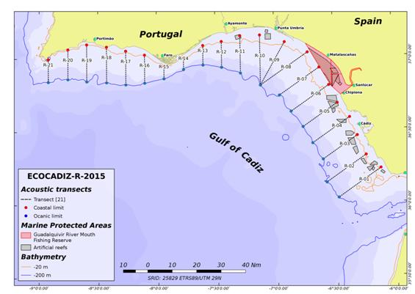Figure 16
3. For internationally coordinated surveys, describe the participating Member States/vessels and the relevant international group in charge of planning the survey
Spain Ramon Margalef,
WGACEGG: Working Group on Acoustic and Egg Surveys for Sardine and Anchovy in ICES Areas VII, VIII and IX
4. Where applicable, describe the international task sharing (physical and/or financial) and the cost sharing agreement used
Not applicable
5. Explain where thresholds apply
Not applicable
(max 450 words per survey)

ECOCADIZ-RECLUTAS
1.Graphical representation (map) showing the positions (locations) of the realized samples
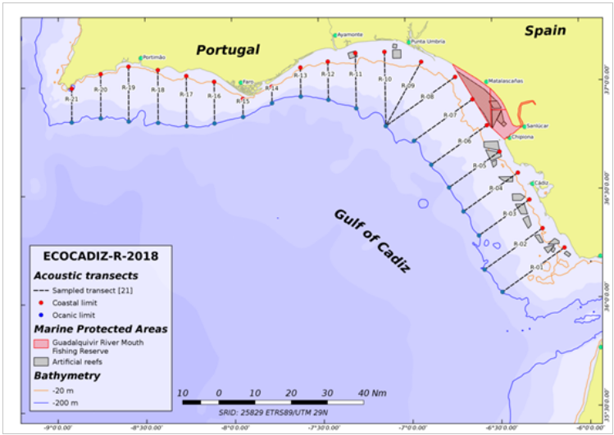Fig.16.a: Acoustic transects sampled
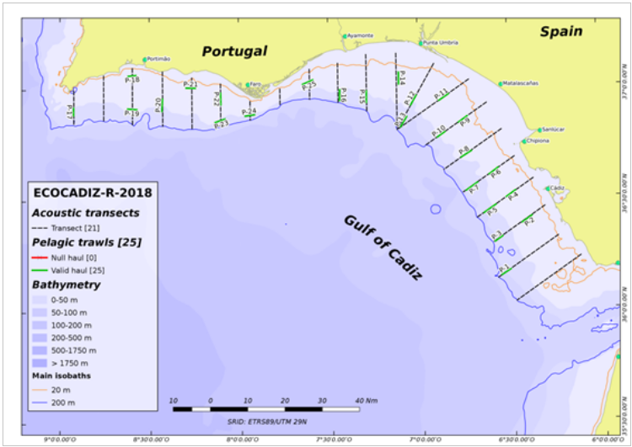Fig.16.b: Ground-truthing fishing hauls.
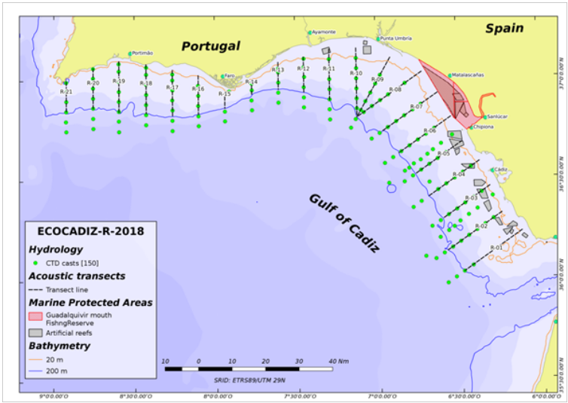Fig.16.c. CTD-LADCP stations.
2.For internationally coordinated surveys, provide a link to the latest meeting report of the coordination group
This survey is internationally coordinated and standardized in the ICES WGACEGG, and follows the standardized protocols of the acoustic surveys coordinated within the above WG. Such protocols are also discussed and updated in the WGACEEG groups.
Latest meeting Report:
https://community.ices.dk/ExpertGroups/wgacegg/2018%20Meeting%20Docs/03.%20Report%202018/WGACEGG2018report_19_12_2018_final.docx
3.List the main use of the results of the survey (e.g. indices, abundance estimates, environmental indicators).
Survey’s data and estimates are utilized in the ICES expert groups of both stock assessment of pelagic fish species (WGHANSA, WGWIDE) and acoustic and egg surveys for anchovy and sardine in ICES areas 7, 8 and 9 (WGACEGG). The latter group revises the results and establishes standardized protocols to properly conduct both this survey and other ones of similar methodology in the above ICES areas. The acoustic estimates from this series are of a special importance for anchovy in Division 9a and sardine in 8c-9a stocks, since they provide a direct estimate of the recruitment (age-0 fish) of these species in one of their main recruitment areas. Although the series is still short is expected that in a few years may be included in the respective stock assessments.
4.Extended comments.
Note 0: No duplication with other surveys.
Note 1: At present there is no a relevant international database to upload the survey series data. Detailed and aggregated data are available to scientific community. Estimates are provided to WGACEGG, WGHANSA and WGWIDE, both graphically and in a tabulated way, in their reports. Additional working documents containing more detailed information are also presented in these WGs. WGACEEG is generating a common database from surveys under its scope (IFREMER, IPMA, AZTI and IEO). At a national scale, survey data are stored in the SIRENO database.
Note 2: The initially planned target (in Table 1G) of CTD-LADCP stations (170 casts) was based on extremely intensive sampling schemes performed in the 2014 and 2015 surveys (176 and 170 stations respectively). Since then,the usual number of CTD casts is about 160 stations. In any case, very bad weather conditions (caused by the hurricane Leslie) during some days in the 2018 survey prevented from the conduction of several foreseen casts yielding a final number of 150 casts.
(max 450 words per survey)

Text Box 1G: List of research surveys at sea

IBTS 1st. Quarter
General comment: This box fulfills Chapter IV of the multiannual Union programme and Article 2 and Article 7 paragraph (3) of the Decision (EU) 2016/1701. It is intended to specify which reseach surveys at sea set out in Table 10 of the multiannual Union programme will be carried out. Member States shall specify whether the research survey is included in Table 10 of the multiannual Union programme or whether it is an additional survey.
General comment: This box is applicable to the Annual Report. This box should provide complementary information on the performance of the surveys, the results and their main use.

IBTS 1th. Quarter (IXa sur)
1. Objectives of the survey
- Estimate distribution and relative abundance of the main commercial species and provide recruitment indices
- - Estimate changes in the stocks of commercial fish species independently of commercial fisheries data
- - Monitoring of distribution and relative abundance of all fish and invertebrates species
- - Collect data for the determination of biological parameters for selected species
- - Collect hydrographical and environmental information.
2. Description of the methods used in the survey. For mandatory surveys, link to the manuals. Include a graphical representation (map)
The whole area (7224 km2) has been separated into five depth strata (15-30, 31-100, 101-200, 201-500 and 501-800 m). The sampling design is random stratified with proportional allocation with a total of 45 fishing stations and swept-area method.
Length distribution of all fish and main species of crustacean and cephalopods are collected and biological parameters are obtained in the most important commercial species
Temperature and salinity are collected during each tow with a CTD attached to the gear. A CTD by haul will be carried out in the survey area.
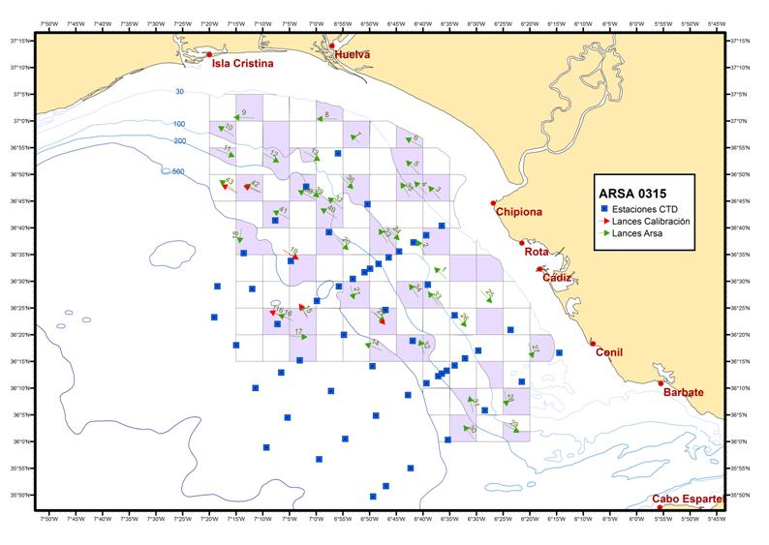Figure 17
3. For internationally coordinated surveys, describe the participating Member States/vessels and the relevant international group in charge of planning the survey
UK-Scotland/Scotia; UK-North Ireland/Corystes; Ireland/Celtic Explorer; France/Thalassa; Spain/Viconde de Eza, Miguel Oliver; Portugal/Noruega
Relevant international planning group: IBTSWG-International Bottom Trawl survey Working Group of ICES
4. Where applicable, describe the international task sharing (physical and/or financial) and the cost sharing agreement used
Not applicable
5. Explain where thresholds apply
Not applicable
(max 450 words per survey)

IBTS 1th. Quarter (IXa sur)
1.Graphical representation (map) showing the positions (locations) of the realized samples
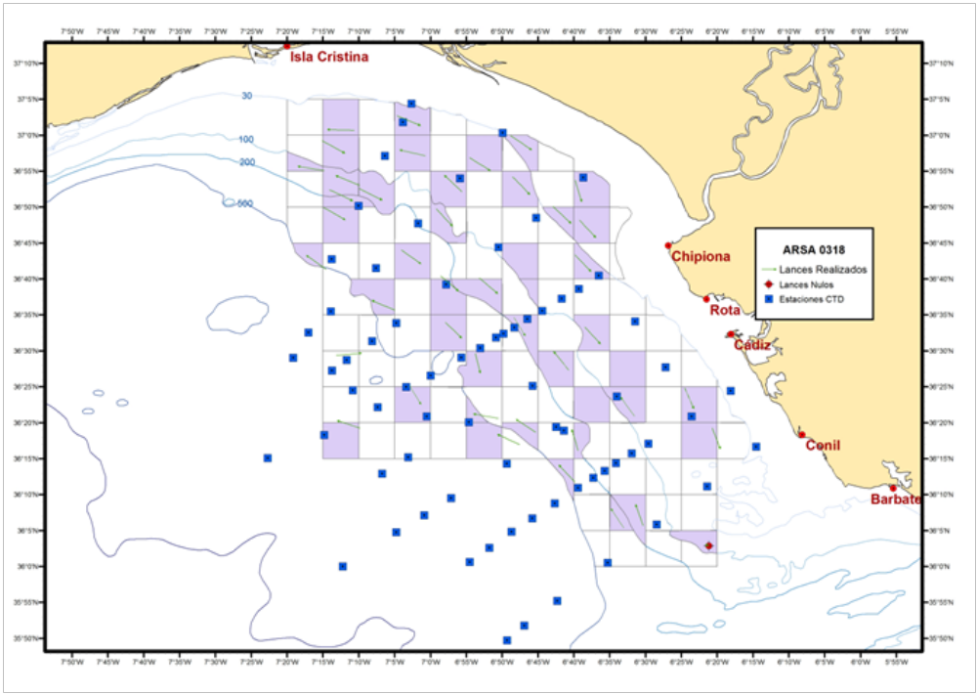
Fig.17.a: Map presenting the spatial distribution of the main sampling types obtained during the survey (21 February– 03 March 2018).
The whole area (7224 km2) has been separated into five depth strata (15-30, 31-100, 101-200, 201-500 and 501-800 m). The sampling design is random stratified with proportional allocation. Total fishing stations selected are shading in the map (red and green arrows) Temperature and salinity data were also collected during each tow with a CTD attached to the gear (CTD stations represented as blue squares).
2.For internationally coordinated surveys, provide a link to the latest meeting report of the coordination group
Recommendations given by the Expert Group for the planning of these surveys (ICES IBTSWG) are adopted in the survey protocols. Hyperlink to the meeting report from the body, which coordinate the survey is:
http://www.ices.dk/sites/pub/Publication%20Reports/Expert%20Group%20Report/EOSG/2018/IBTSWG/IBTSWG%20Report%202018.pdf
3.List the main use of the results of the survey (e.g. indices, abundance estimates, environmental indicators).
The number of valid hauls was 45 (41 valid). 143 species of fish, 53 of crustacean and 53 of mollusca were recorded during the survey.. Length distribution of all fish and main species of crustacean and cephalopods were recorder. Biological samples were studied for the most important species and CTD casts were carried out in the survey area.
Data obtained are used for assessment models of groundfish on the South Platform within the ICES WGBIE, especially the southern stock of hake (Merluccius merluccius), and Norway lobster (Nephrops norvegicus) on the Iberian continental shelf. Moreover, survey data are provided to WGCEPH of cephalopods species like octopus (Octopus vulgaris), cuttlefish (Sepia officinalis and squid (Loligo vulgaris and Loligo forbesii), to WGEF of assessment of elasmobranch species (Galeus melastomus, Scyliorhinus canicula, Etmopterus spinax, rays…) and to WGWIDE to provide information for the assessment of blue whiting (Micromessistius poutassou), North Eastern Atlantic mackerel (Scomber scombrus), horse mackerel (Trachurus trachurus) and boarfish (Capros aper). They are also used in the calibration of assessments of the southern stocks of horse mackerel on 9a (Trachurus spp.), anchovy (Engraulis encrasicholus) and mackerel (Scomber spp.) to WGHANSA.
4.Extended comments.

(max 450 words per survey)

Text Box 1G: List of research surveys at sea

JUVENA
General comment: This box fulfills Chapter IV of the multiannual Union programme and Article 2 and Article 7 paragraph (3) of the Decision (EU) 2016/1701. It is intended to specify which reseach surveys at sea set out in Table 10 of the multiannual Union programme will be carried out. Member States shall specify whether the research survey is included in Table 10 of the multiannual Union programme or whether it is an additional survey.
General comment: This box is applicable to the Annual Report. This box should provide complementary information on the performance of the surveys, the results and their main use.

JUVENA
1. Objectives of the survey
- The main objective of the project is estimating the abundance of juvenile anchovy in the Bay of Biscay in Autumn, as a tool for predicting the recruitment of anchovy. Secondary objectives include:
- Studying the biological condition of juvenile anchovy and its influence on the recruitment process.
- Caracterizing the hydrographic conditions and the abundance and distribution of the components of the pelagic ecosystem relevants to understand the dynamics of the recruitment.
- Studying the interactions between top predators and their preys in the Bay of Biscay, as well as inter-specific interactions between marine birds and sub-superficial predators.
- Acoustic identification and vertical distribution of mesopelagic species in the Bay of Biscay.
2. Description of the methods used in the survey. For mandatory surveys, link to the manuals. Include a graphical representation (map)
The methodology used to estimate the abundance of juvenile anchovy is the acoustic-trawl methodology. Acoustic data processing is performed by layer echo-integration. The identification and sizing is obtained by pelagic fishing hauls. The hauls are grouped by strata of homogeneous species and size composition. Inside each of these homogeneous strata, the echo-integrated acoustic backscattering is assigned to species according to the composition of the hauls. Afterwards, the energy corresponding to each specie-size is converted to biomass using their corresponding conversion factor. Details of the methodology of the JUVENA surveys were described by Boyra et al (2013).
References: Boyra, G., Martınez, U., Cotano, U., Santos, M., Irigoien, X., and Uriarte, A. 2013. Acoustic surveys for juvenile anchovy in the Bay of Biscay: abundance estimate as an indicator of the next year’s recruitment and spatial distribution patterns. ICES Journal of Marine Science, 70: 1354–1368.

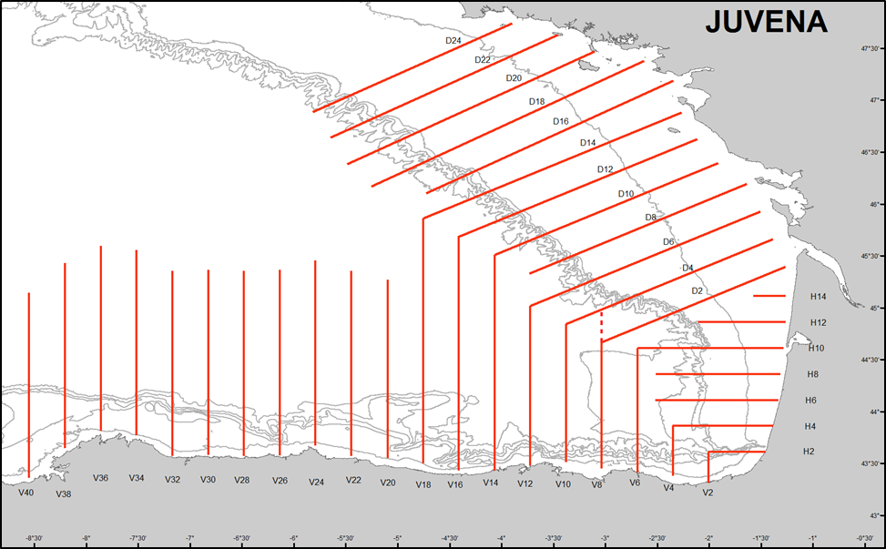 Figure 18
3. For internationally coordinated surveys, describe the participating Member States/vessels and the relevant international group in charge of planning the survey
Spain/Ramon Margalef, Enma Bardan
WGACEGG: Working Group on Acoustic and Egg Surveys for Sardine and Anchovy in ICES Areas VII, VIII and IX
4. Where applicable, describe the international task sharing (physical and/or financial) and the cost sharing agreement used
Not applicable
5. Explain where thresholds apply
Not applicable
(max 450 words per survey)

JUVENA
1.Graphical representation (map) showing the positions (locations) of the realized samples
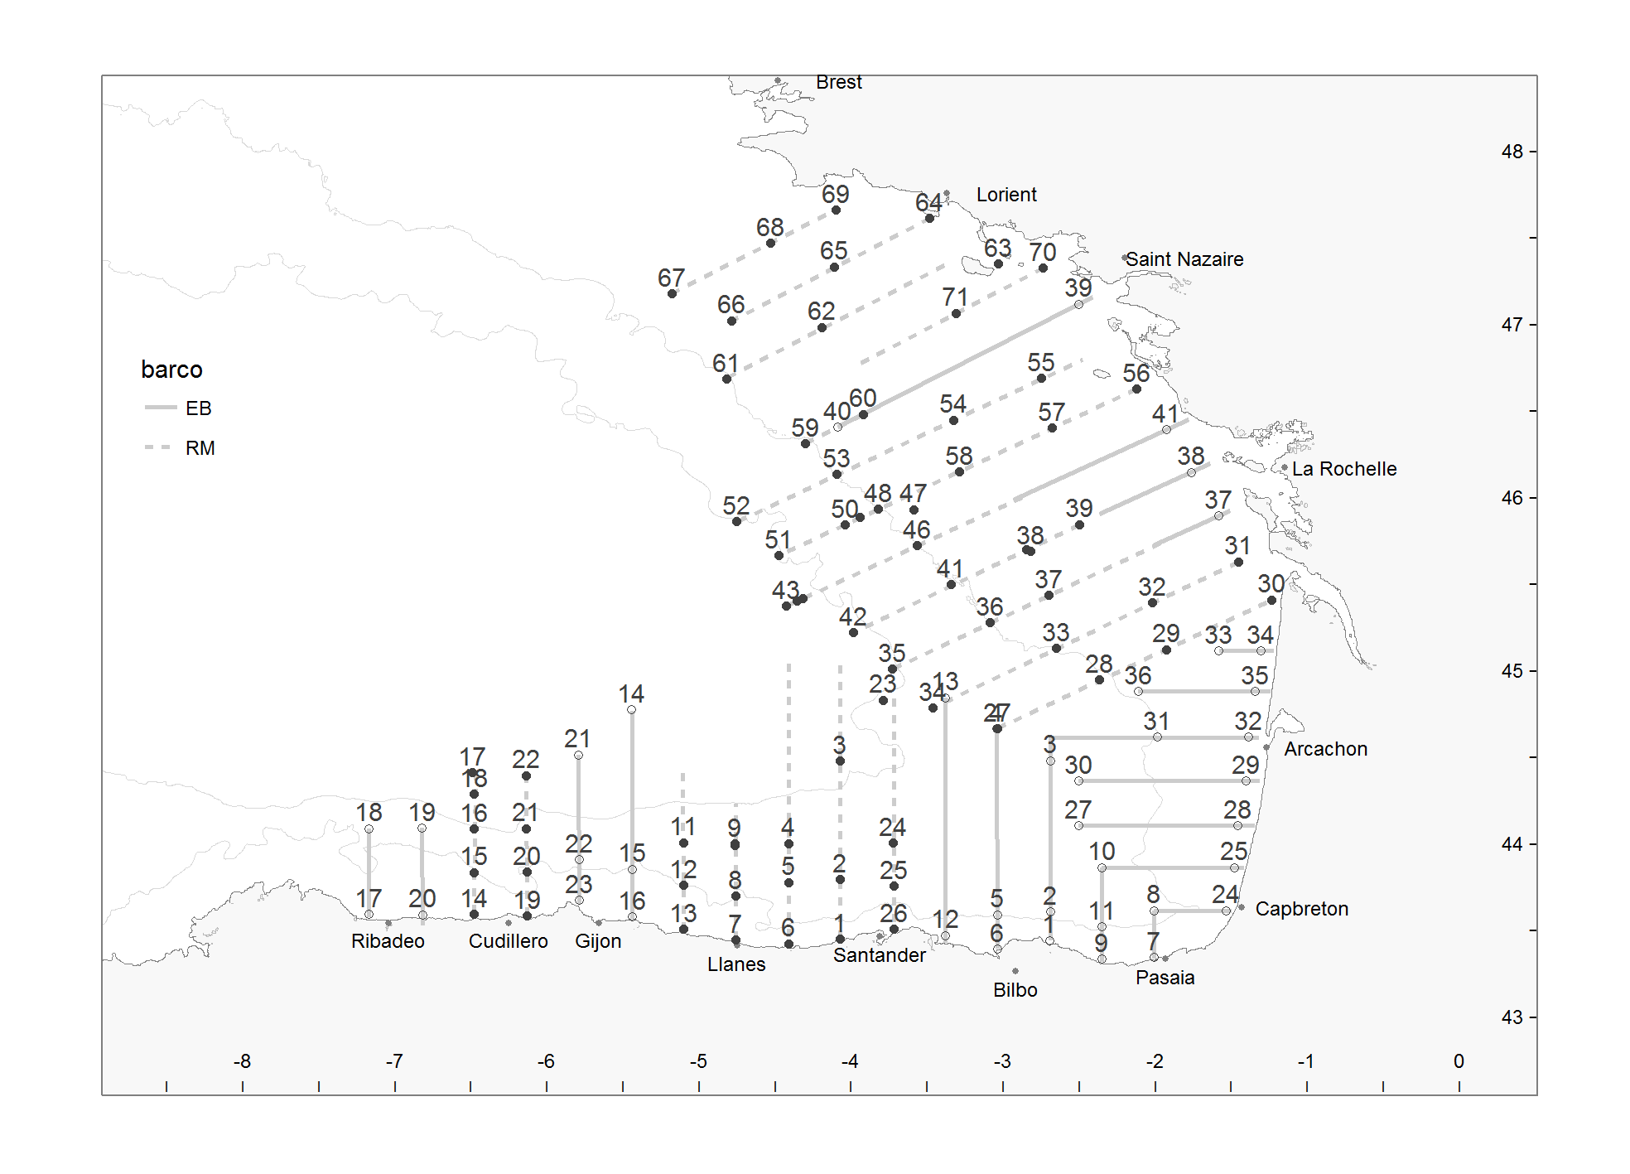 Fig.18.a: Visited transects and stations of hydrography / plankton by the R/V Ramon Margalef and R/V Enma Bardán (solid line for the RM and dashed line for the EB).
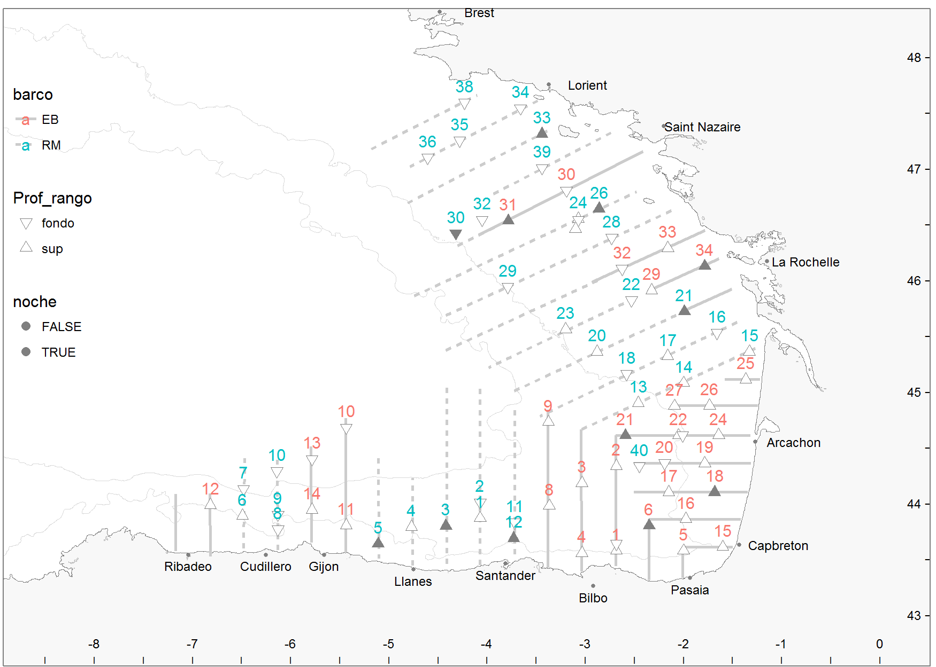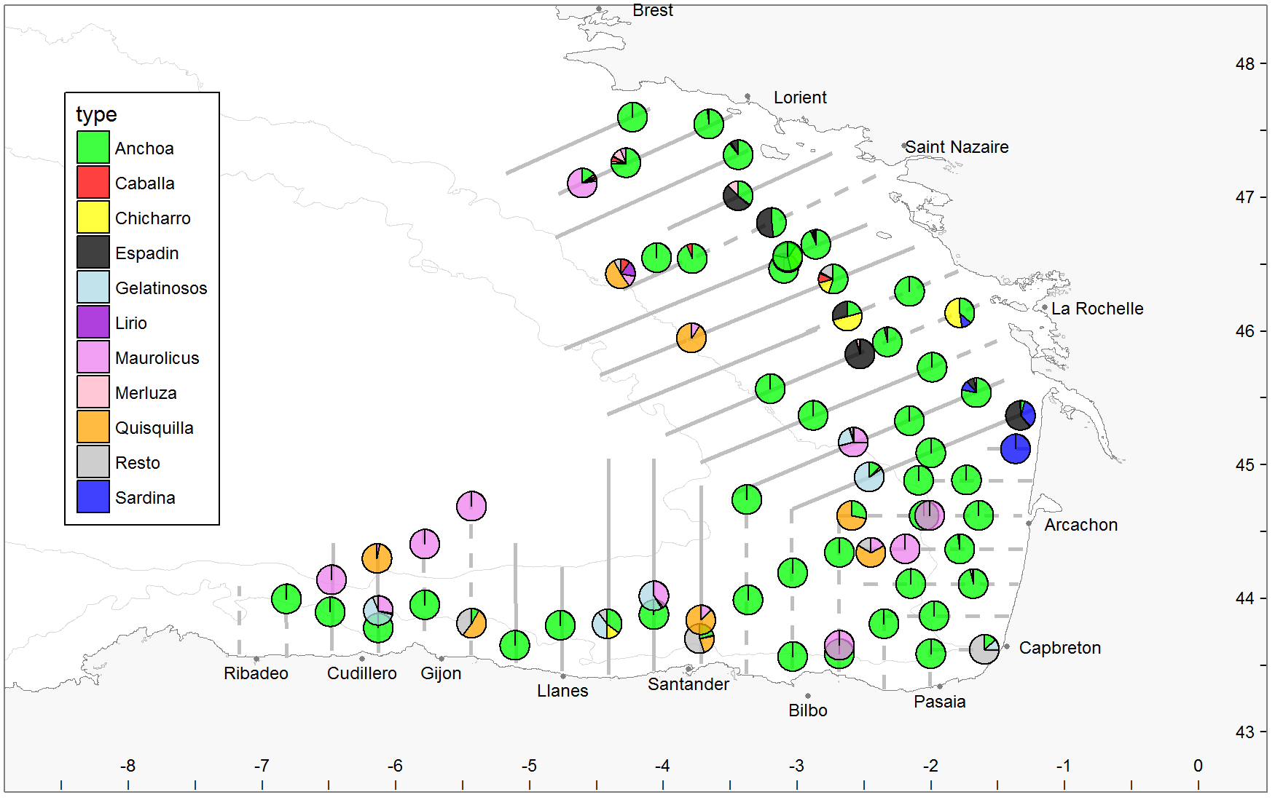
Fig.18.b: Left panel: position of the fishing stations. Right panel: Species composition of the hauls (by descending order: anchovy, mackerel, horse mackerel, spratt, gelatinous, blue whiting, Mueller’s pearlside, hake, krill, others and sardine.

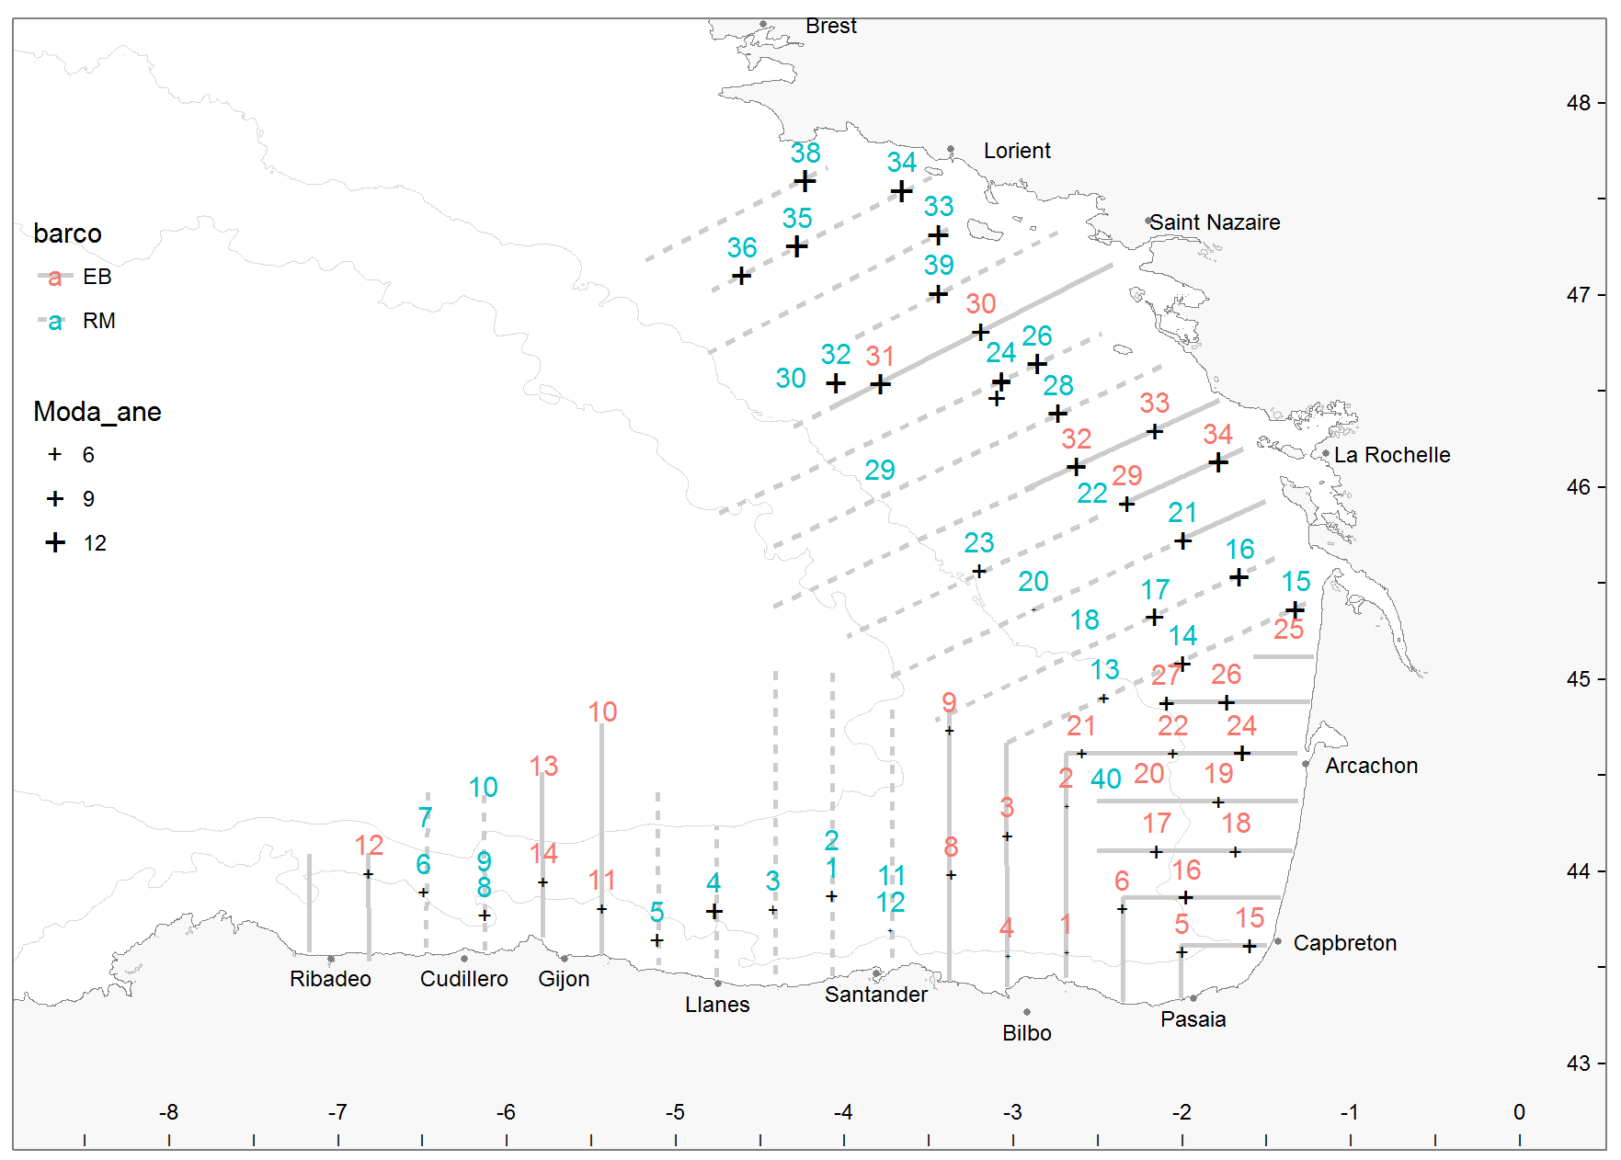 Fig.18.c: Size of anchovy in the positive anchovy hauls. The length of the crosses is proportional to the mode of the size (Standard length) of the captured anchovy.

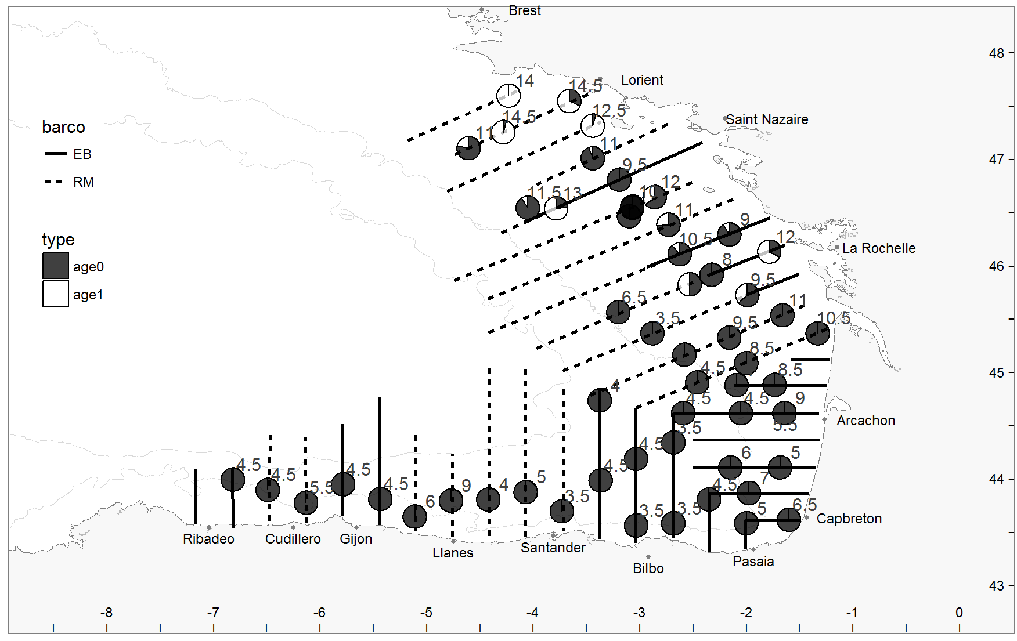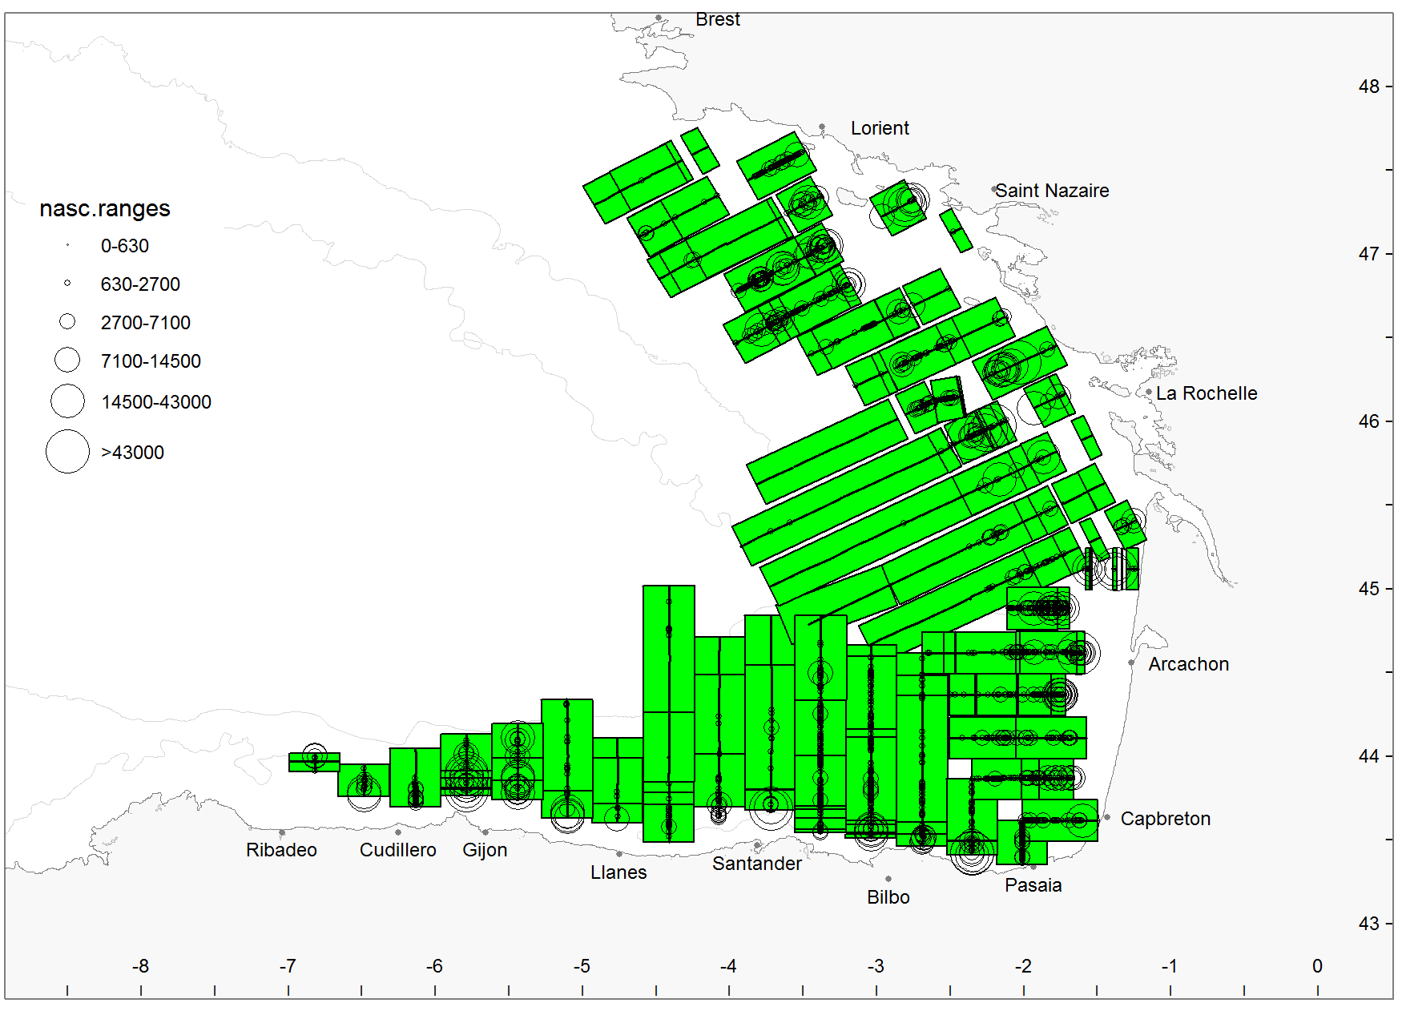
Fig.18.d: Left panel: positive area of distribution of anchovy. The pie charts show the percentage of juveniles (black) and adults (white) in the fishing hauls. Right panel: total acoustic energy (NASC) of all the identified species.
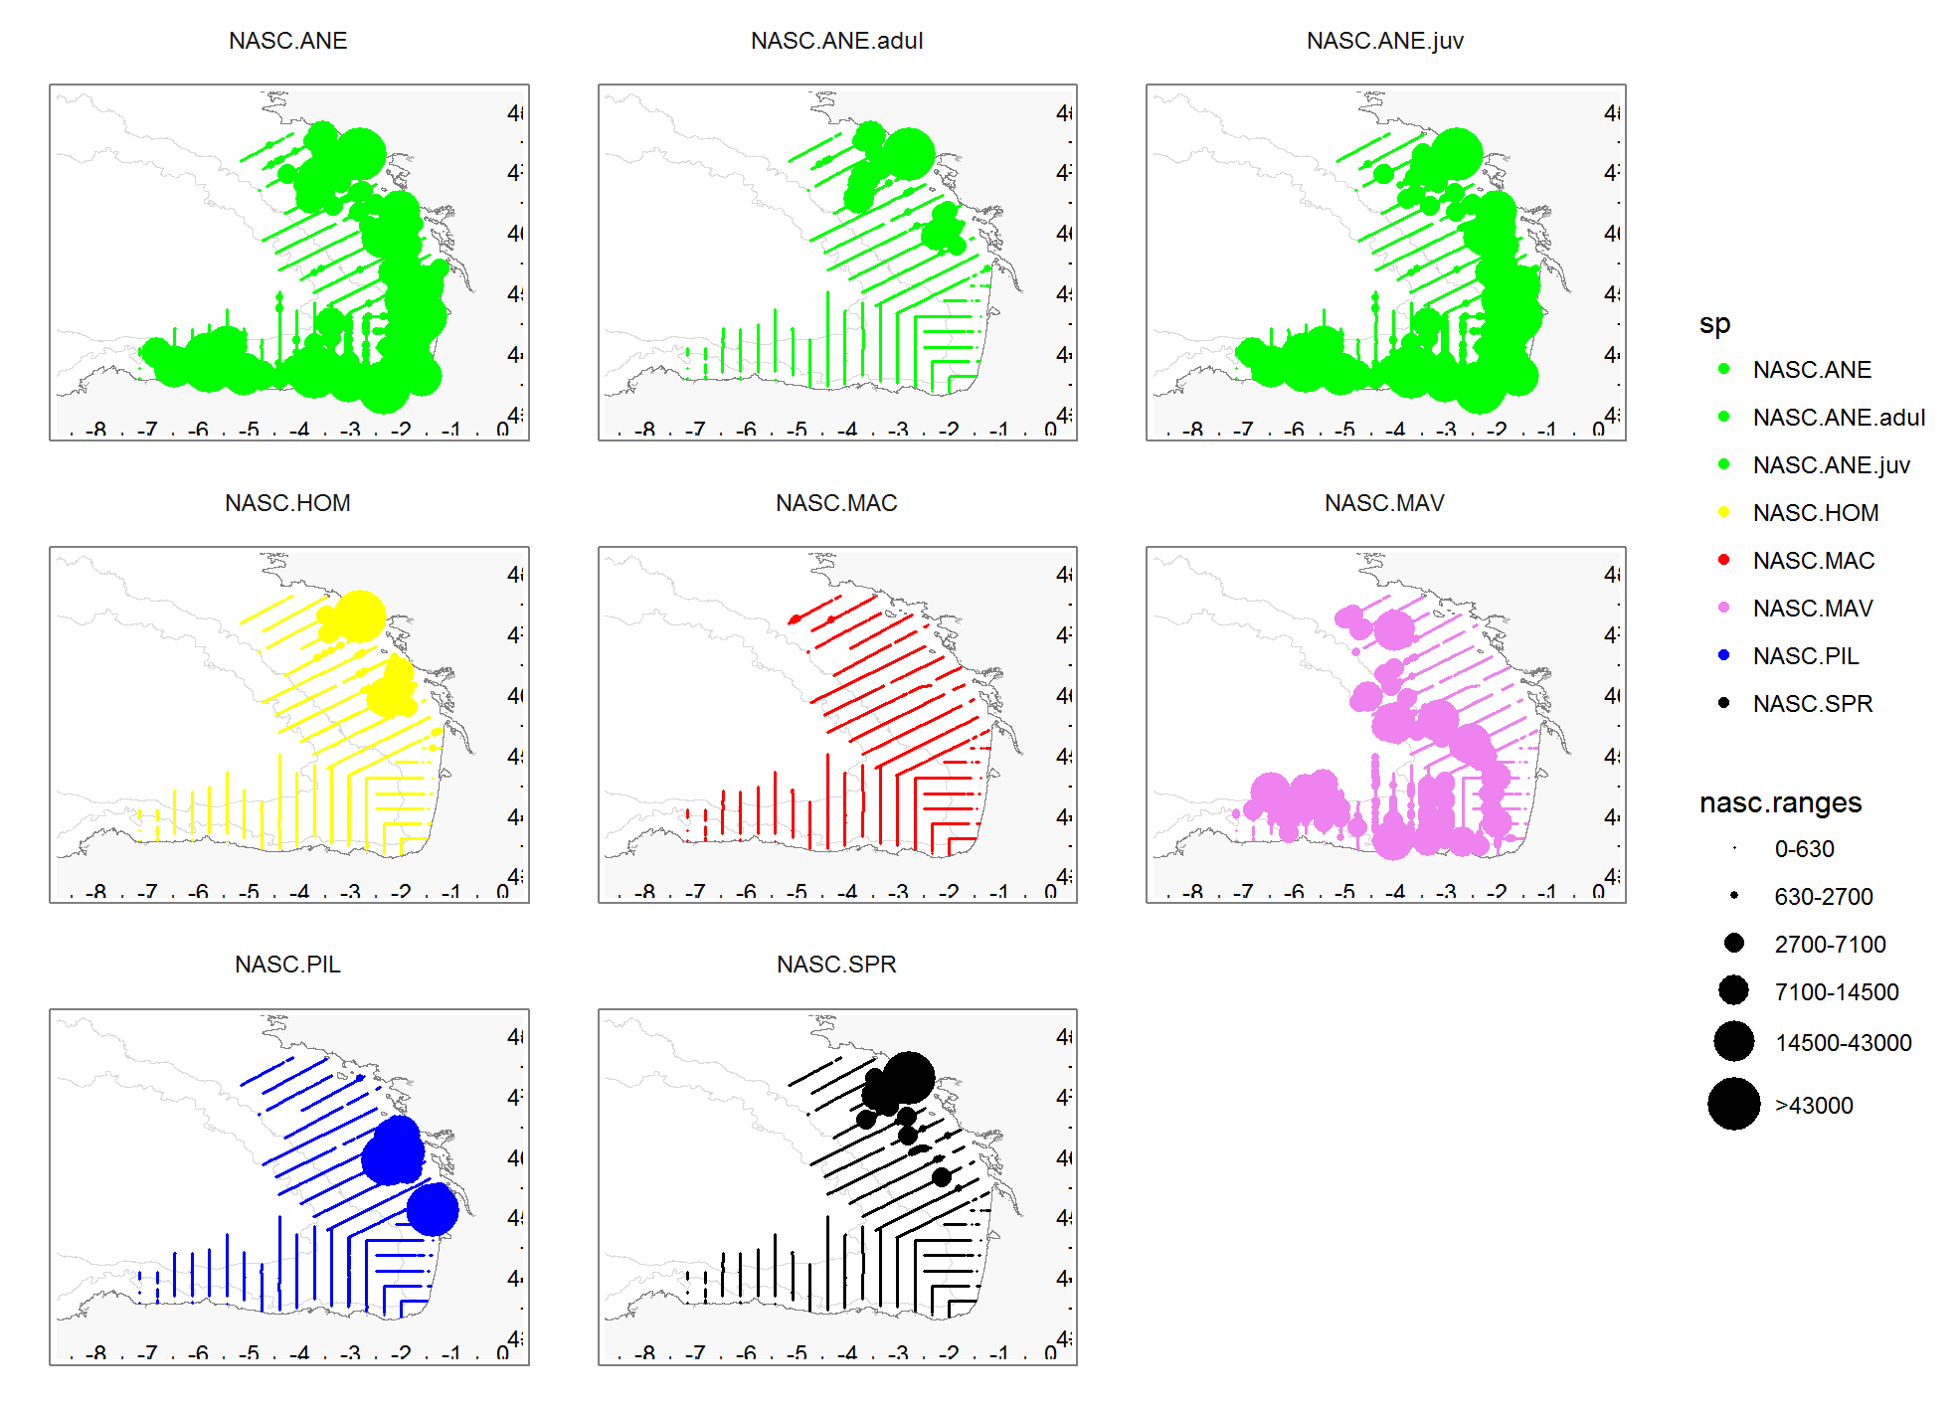
Fig.18.e: Spatial distribution of pelagic species assessed during JUVENA 2018.
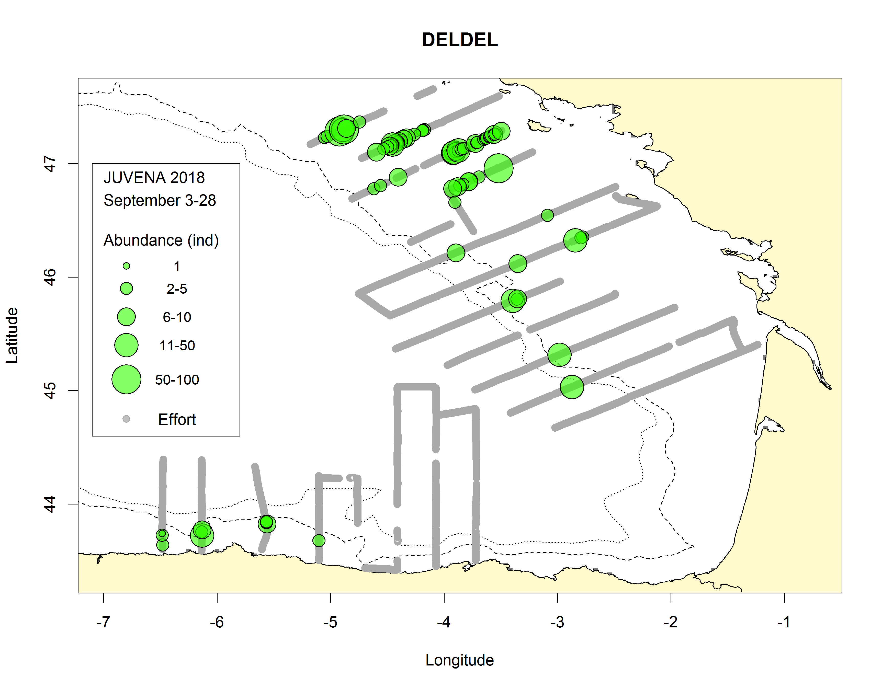a) 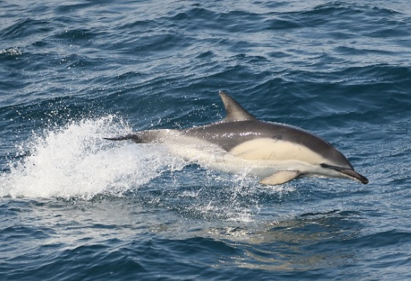b)
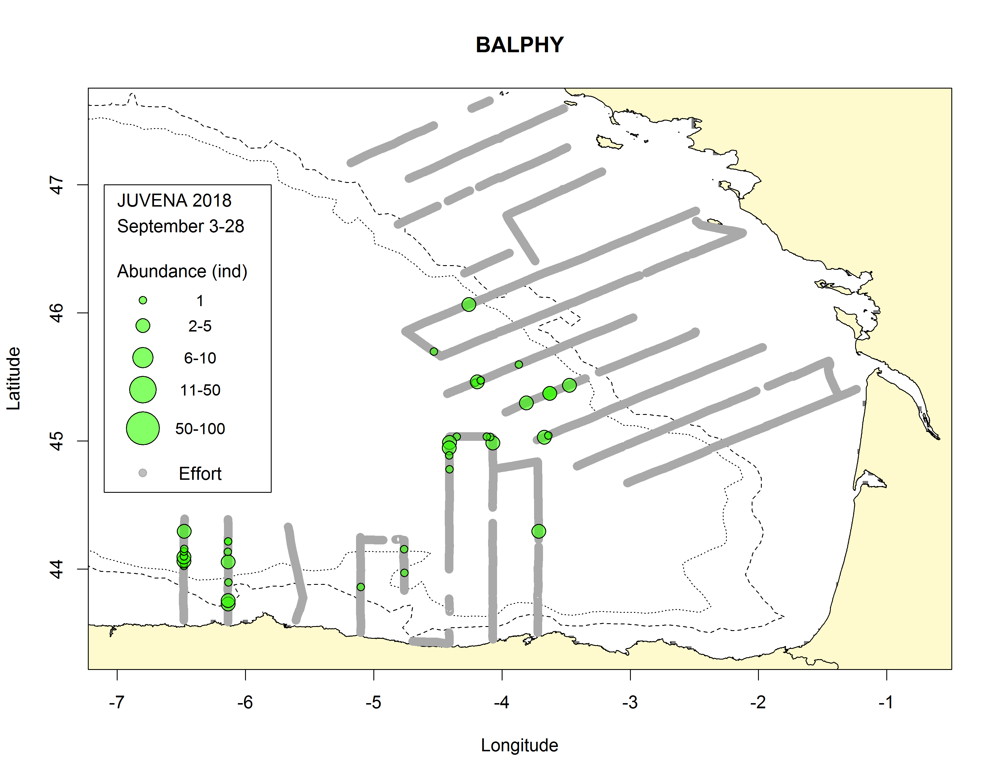c) 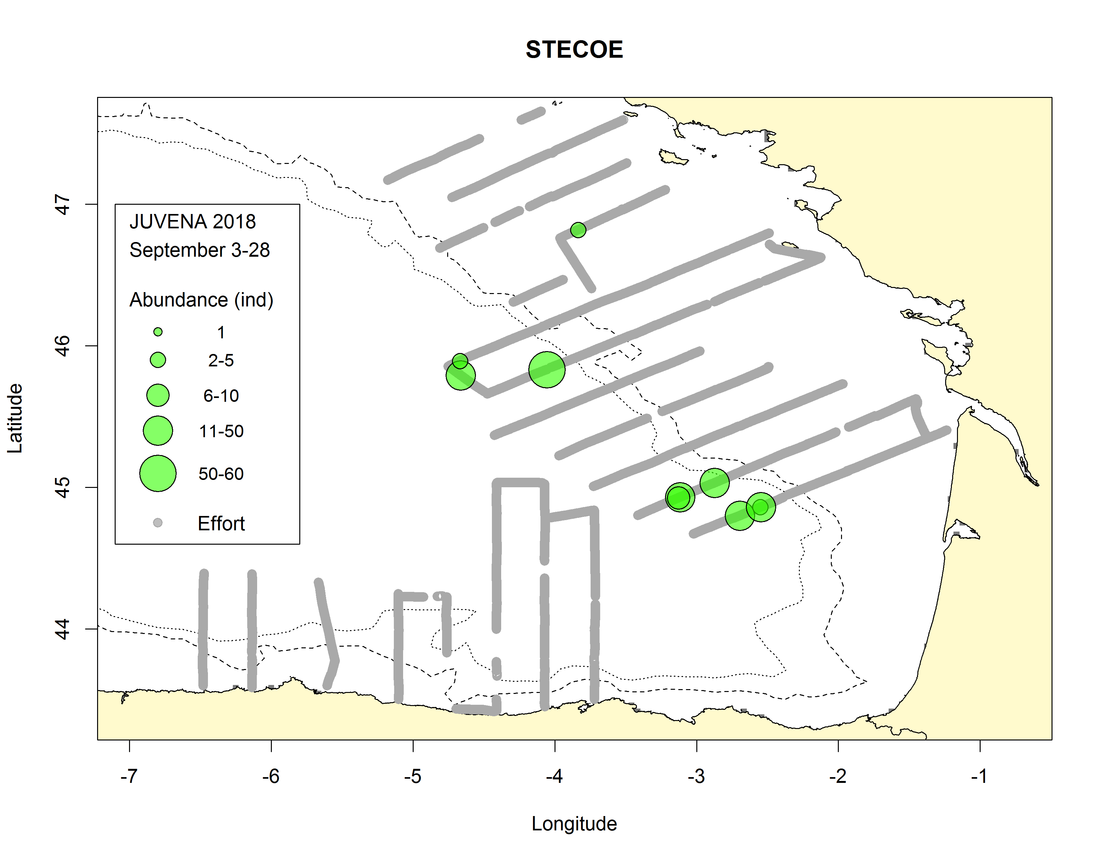d)
Fig.18.f: Distribution of the most abundant marine mammal species during JUVENA 2018, (a,b) common dolphins, (c) fin whales and (d) striped dolphins. Grey points represent the effort while the size of the green circles is proportional to observed abundances. The dotted and solid lines represent the isobaths of 200 m and 1000 m, respectively. See Table 2 for acronyms.
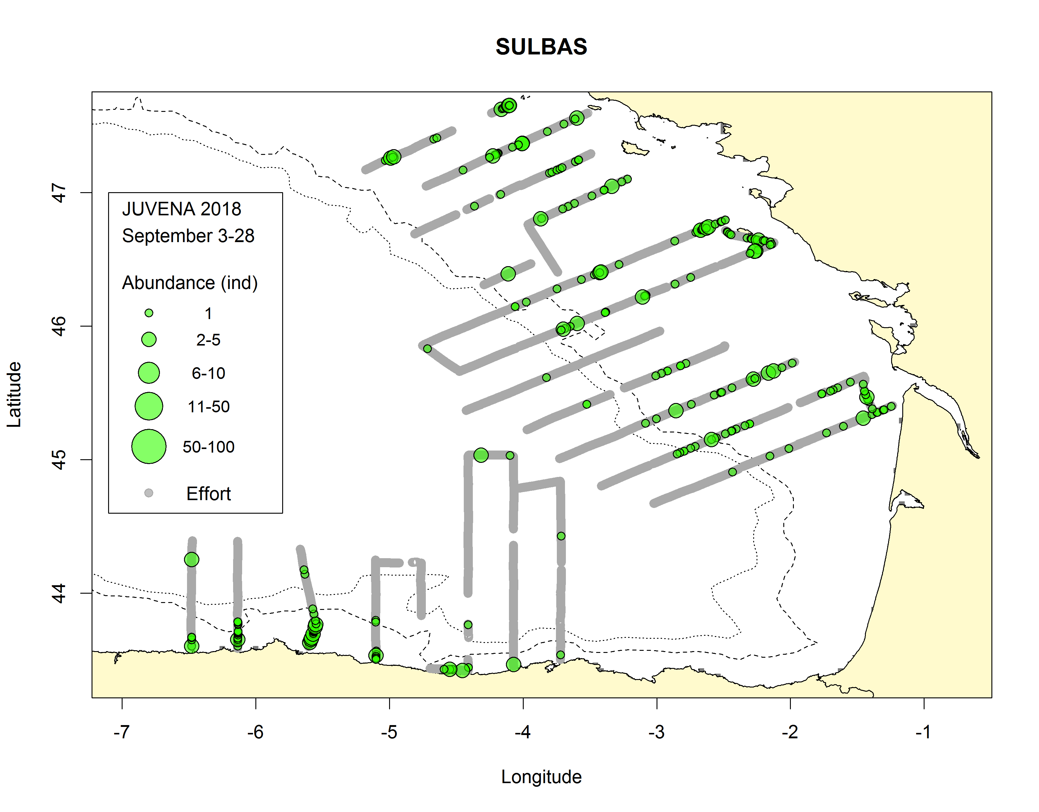a) 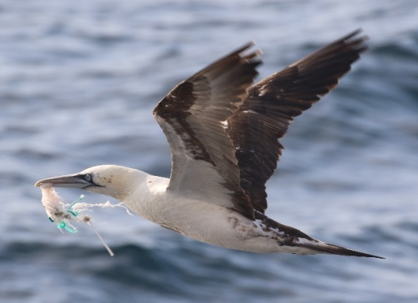b)
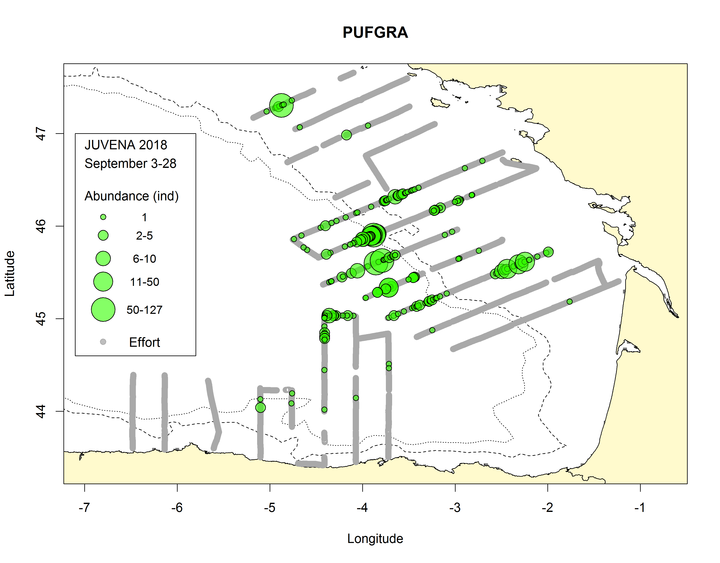c) 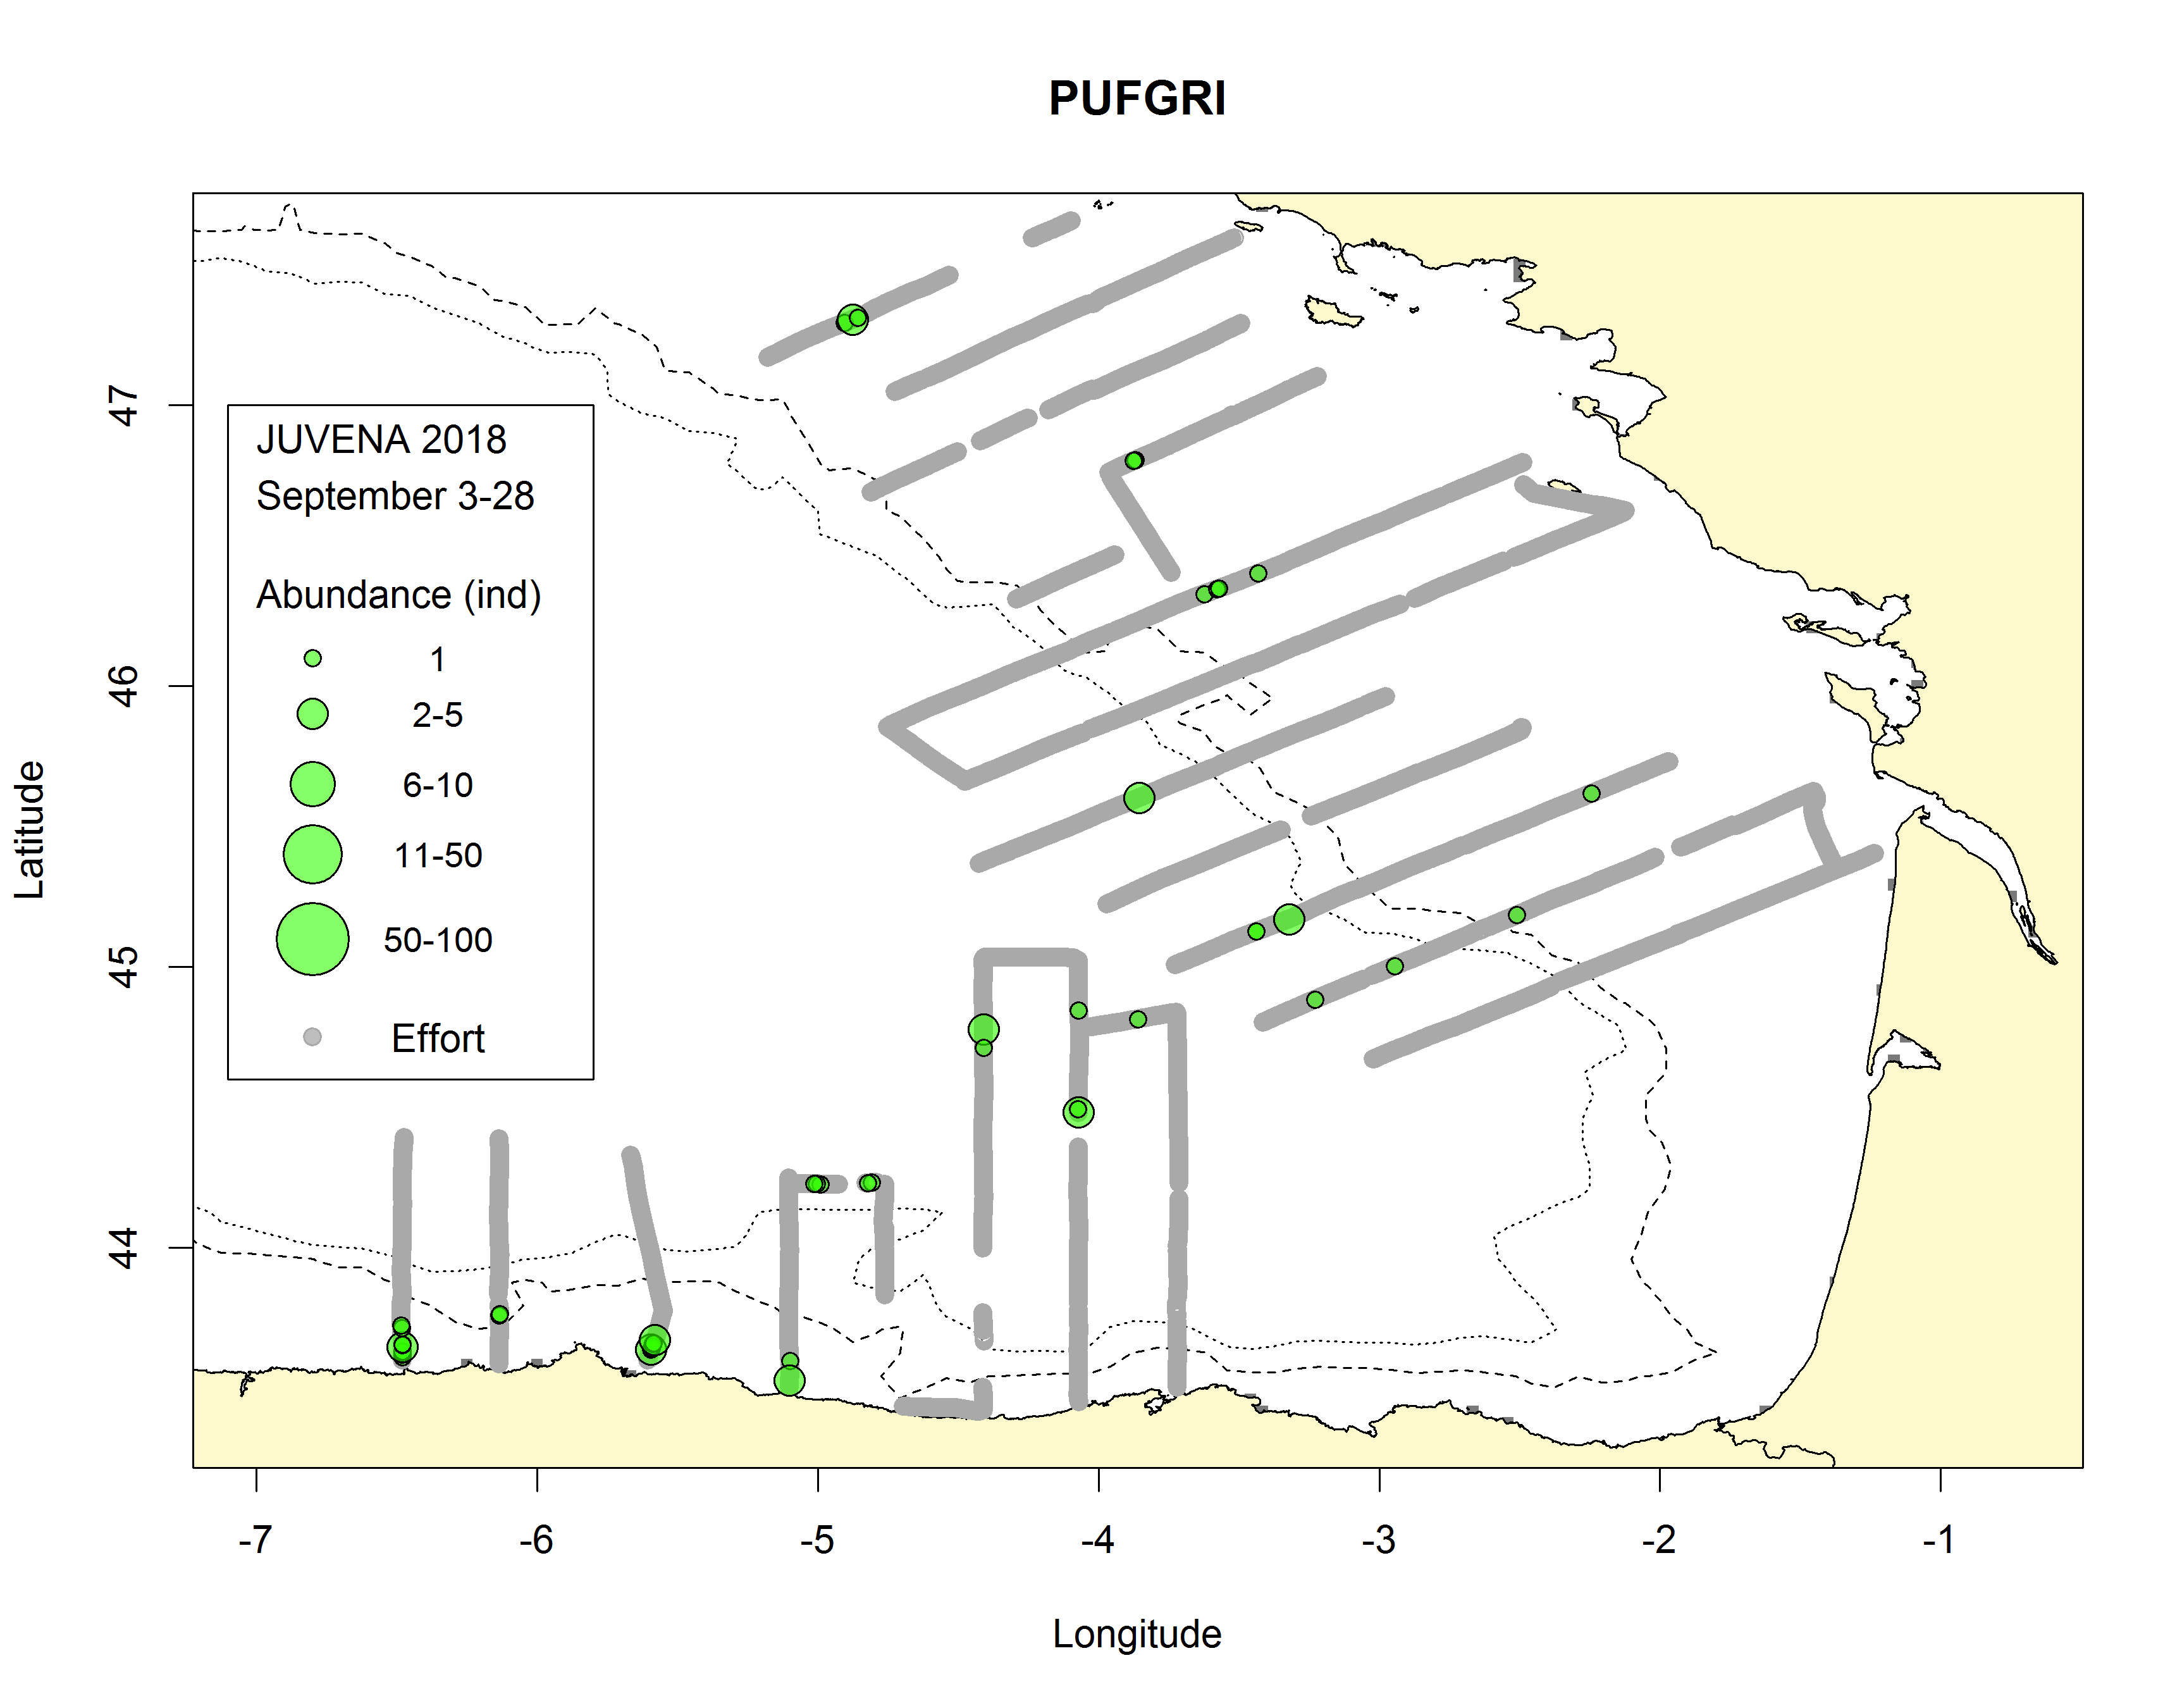d)
Fig.18.g: Distribution of the most abundant seabird species during JUVENA 2018 such as (a,b) northern gannets, (c) great shearwaters and (d) sooty shearwaters. Grey points represent the effort while the size of the green circles is proportional to observed abundances. The dotted and solid lines represent the isobaths of 200 m and 1000 m, respectively. See Table 2 for acronyms.
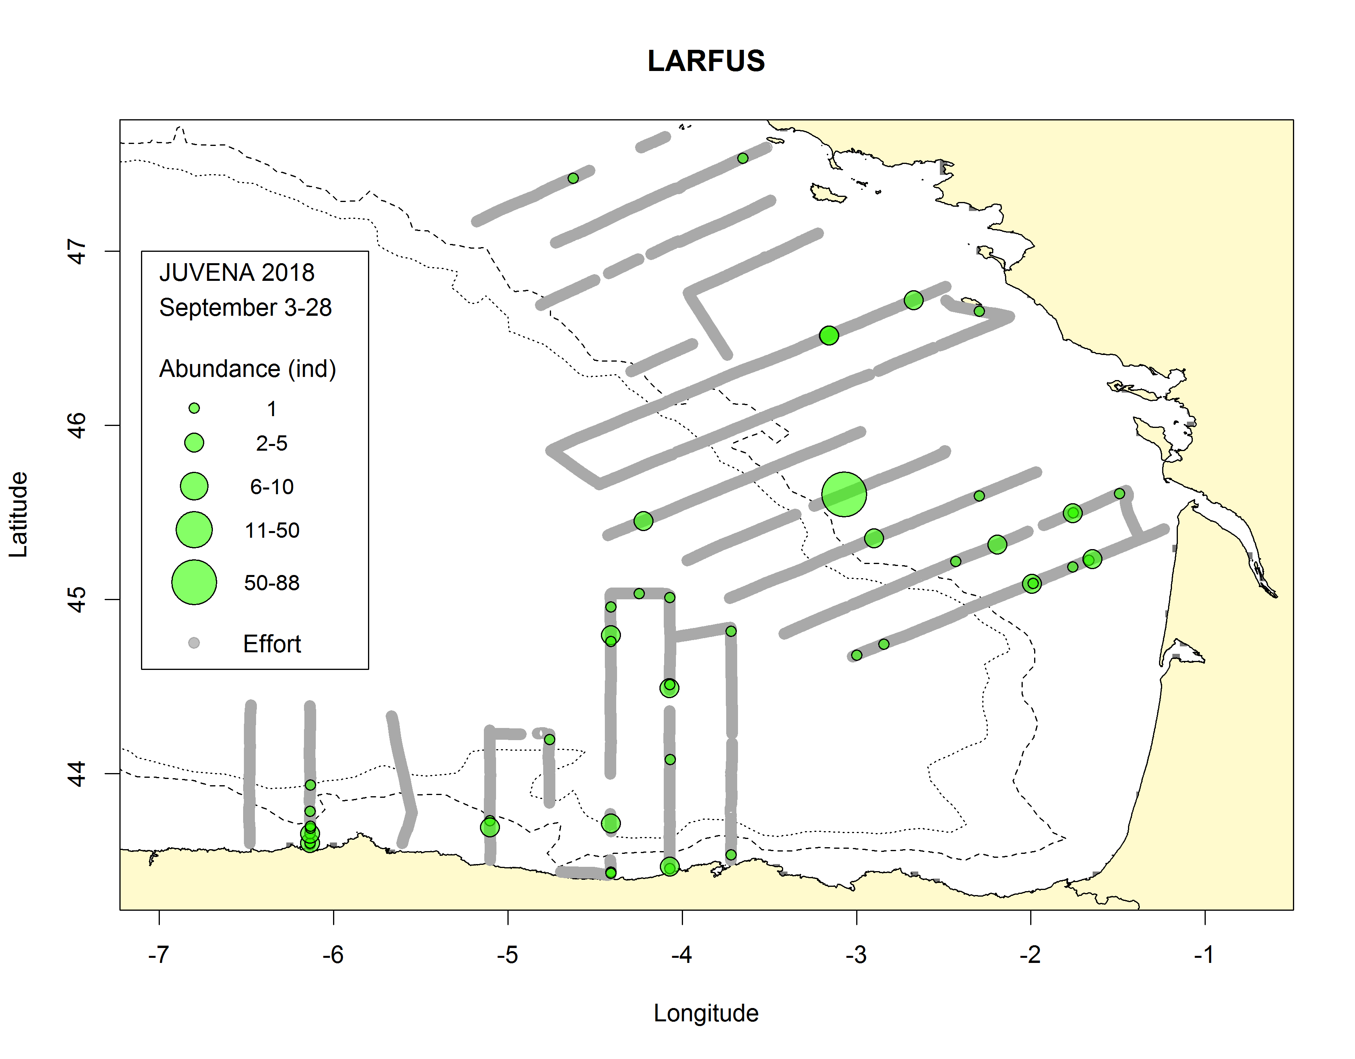a) 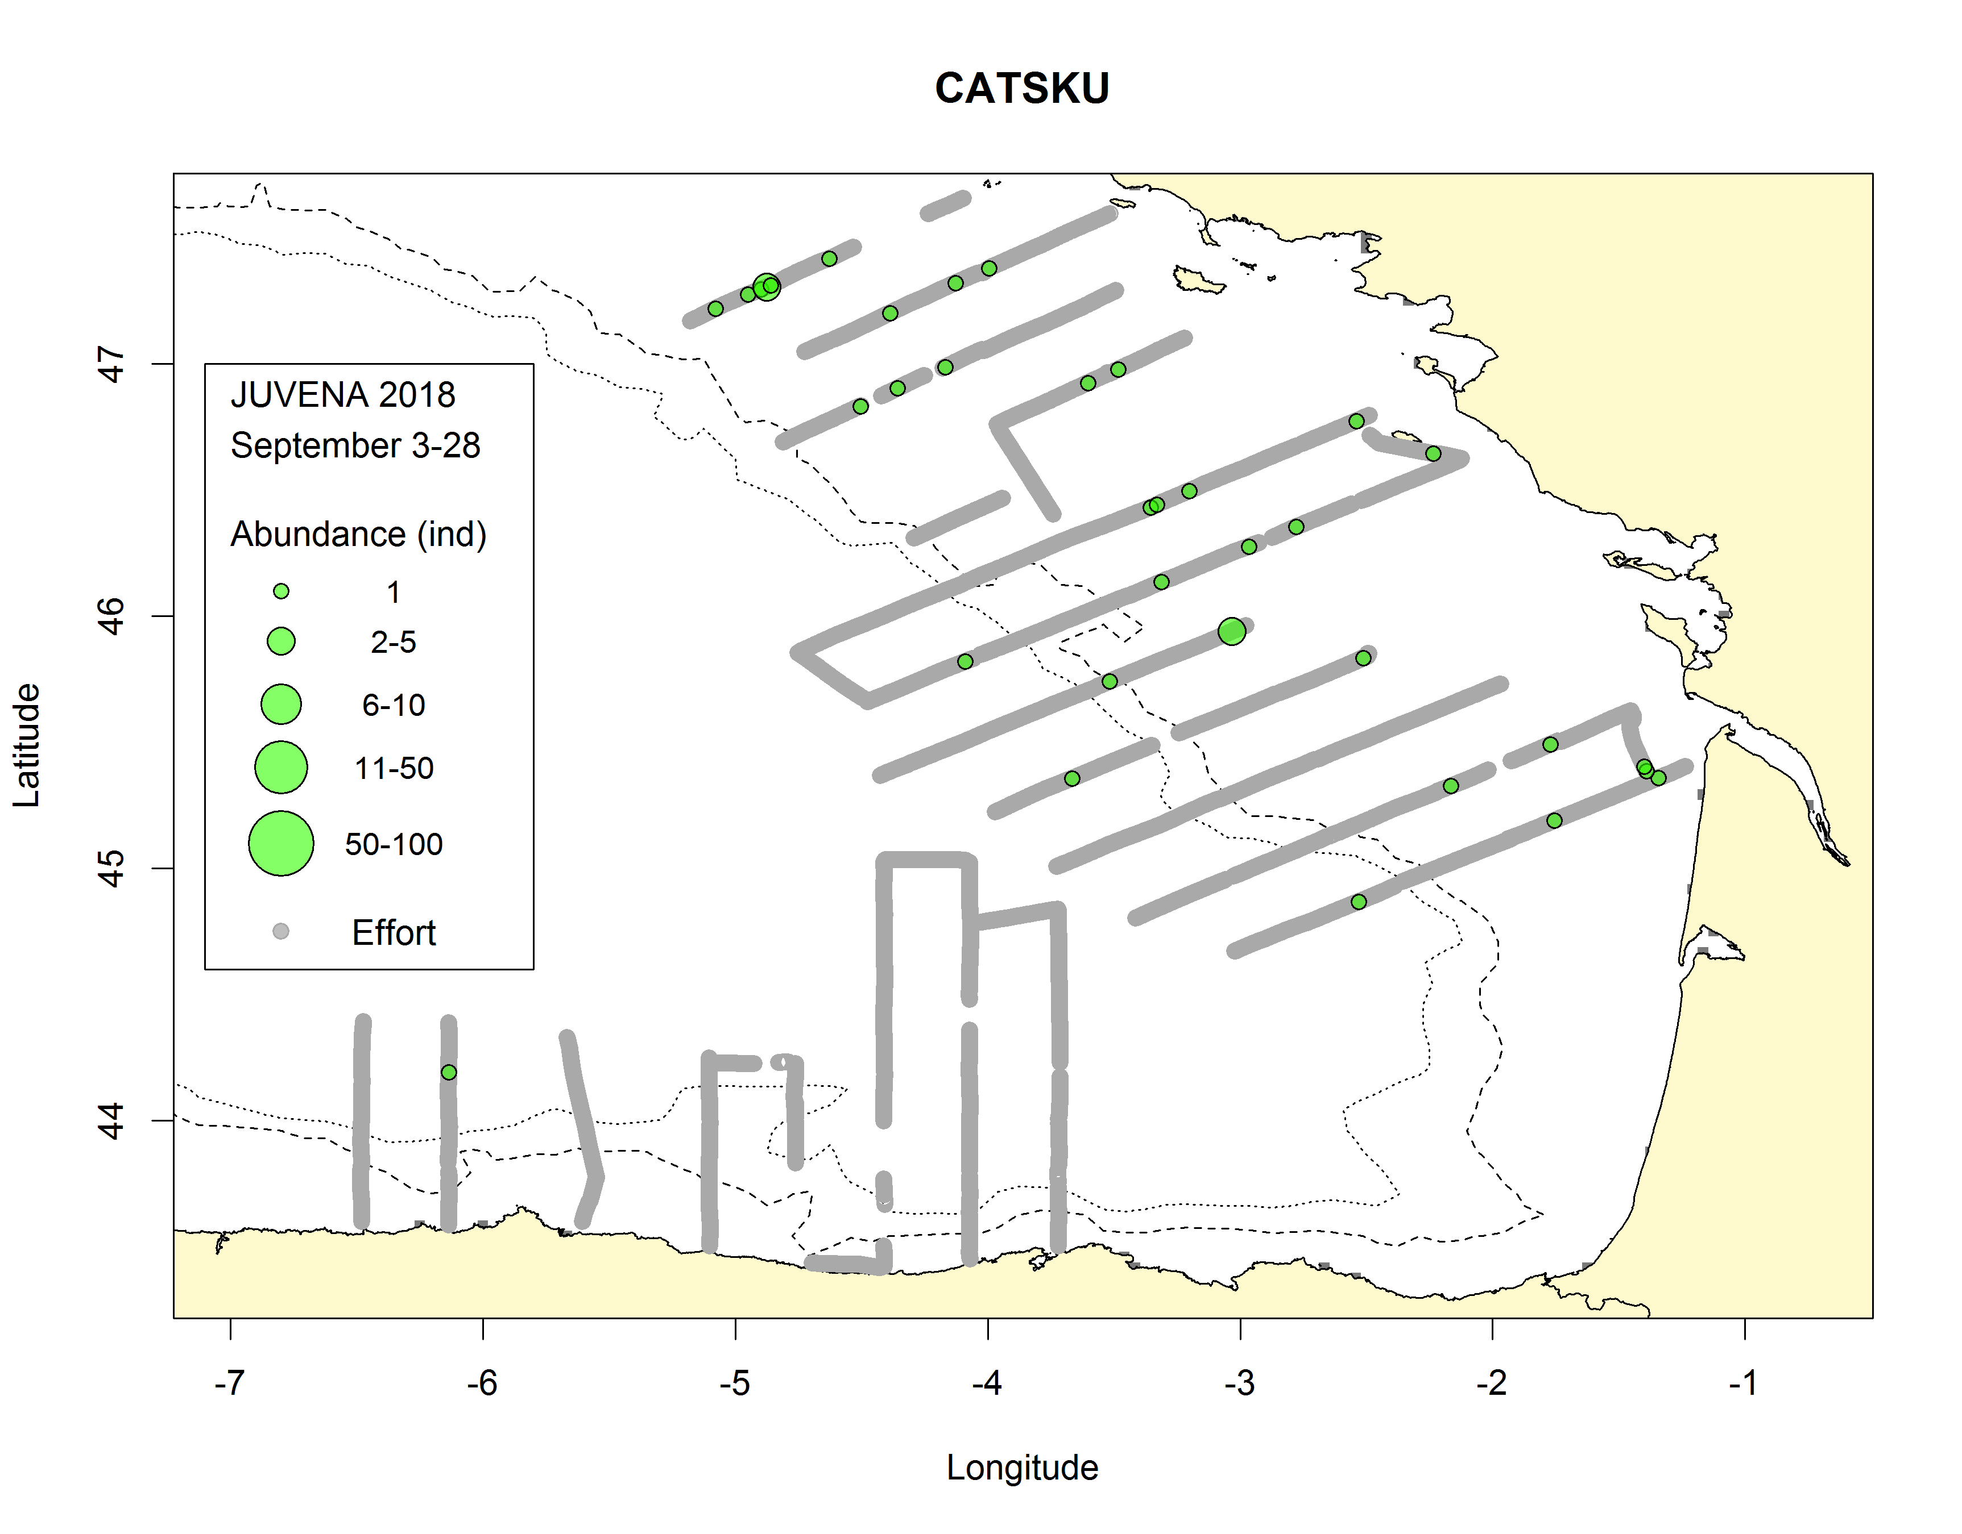b)
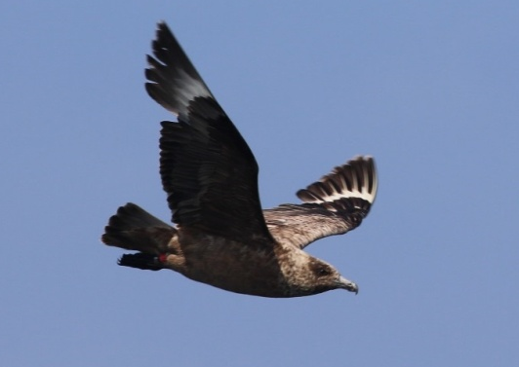c) 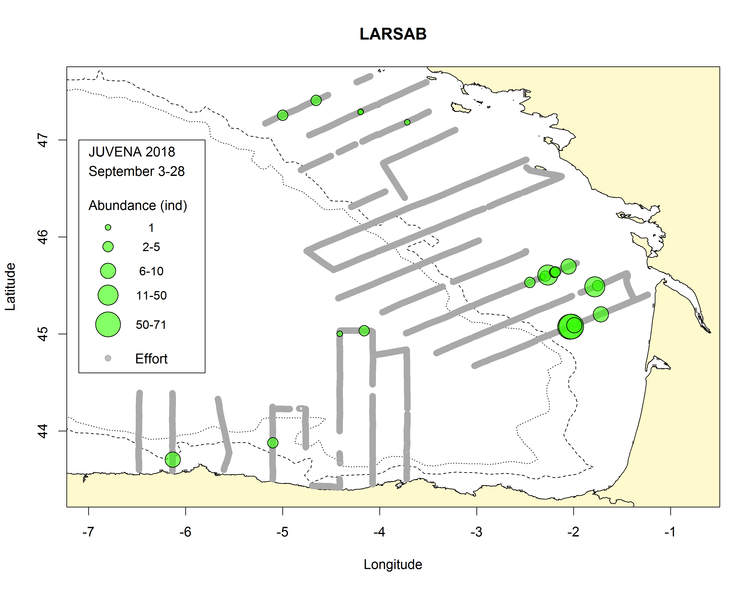d)
Fig.18.h: Distribution of the most abundant seabird species during JUVENA 2018 such as (a) lesser black-backed gulls, (b,c) great skuas and (d) Sabine’s gulls. Grey points represent the effort while the size of the green circles is proportional to observed abundances. The dotted and solid lines represent the isobaths of 200 m and 1000 m, respectively. See Table 2 for acronyms.
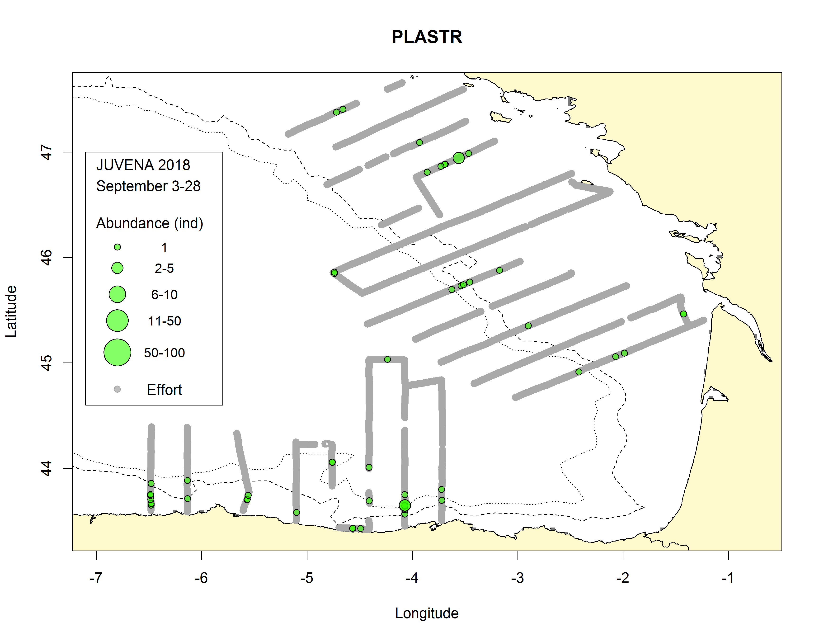a) 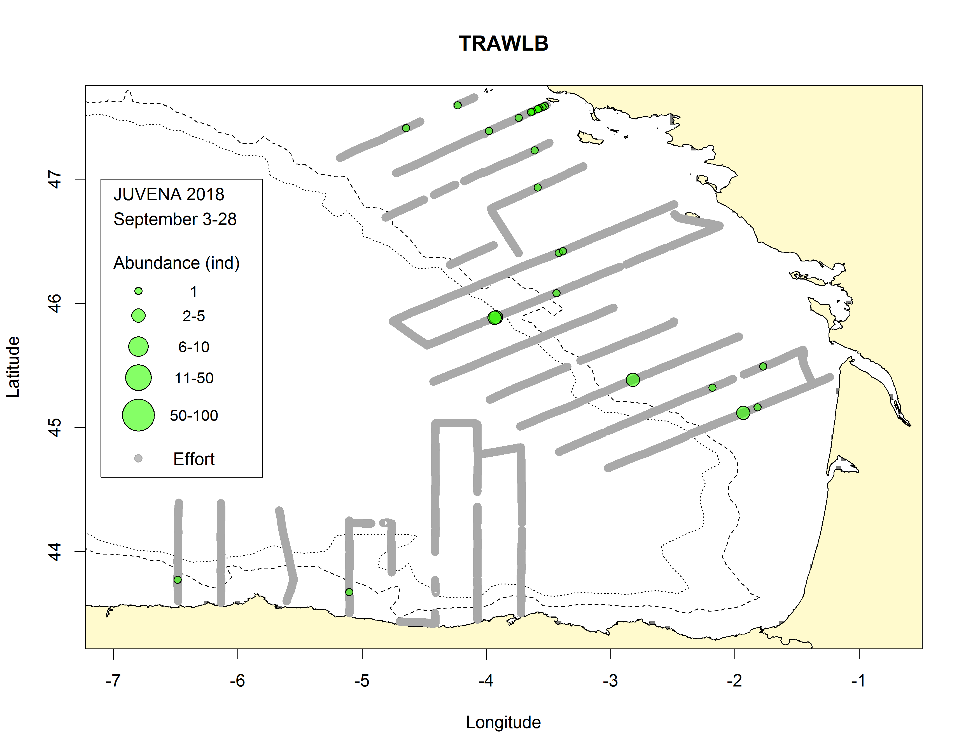b)
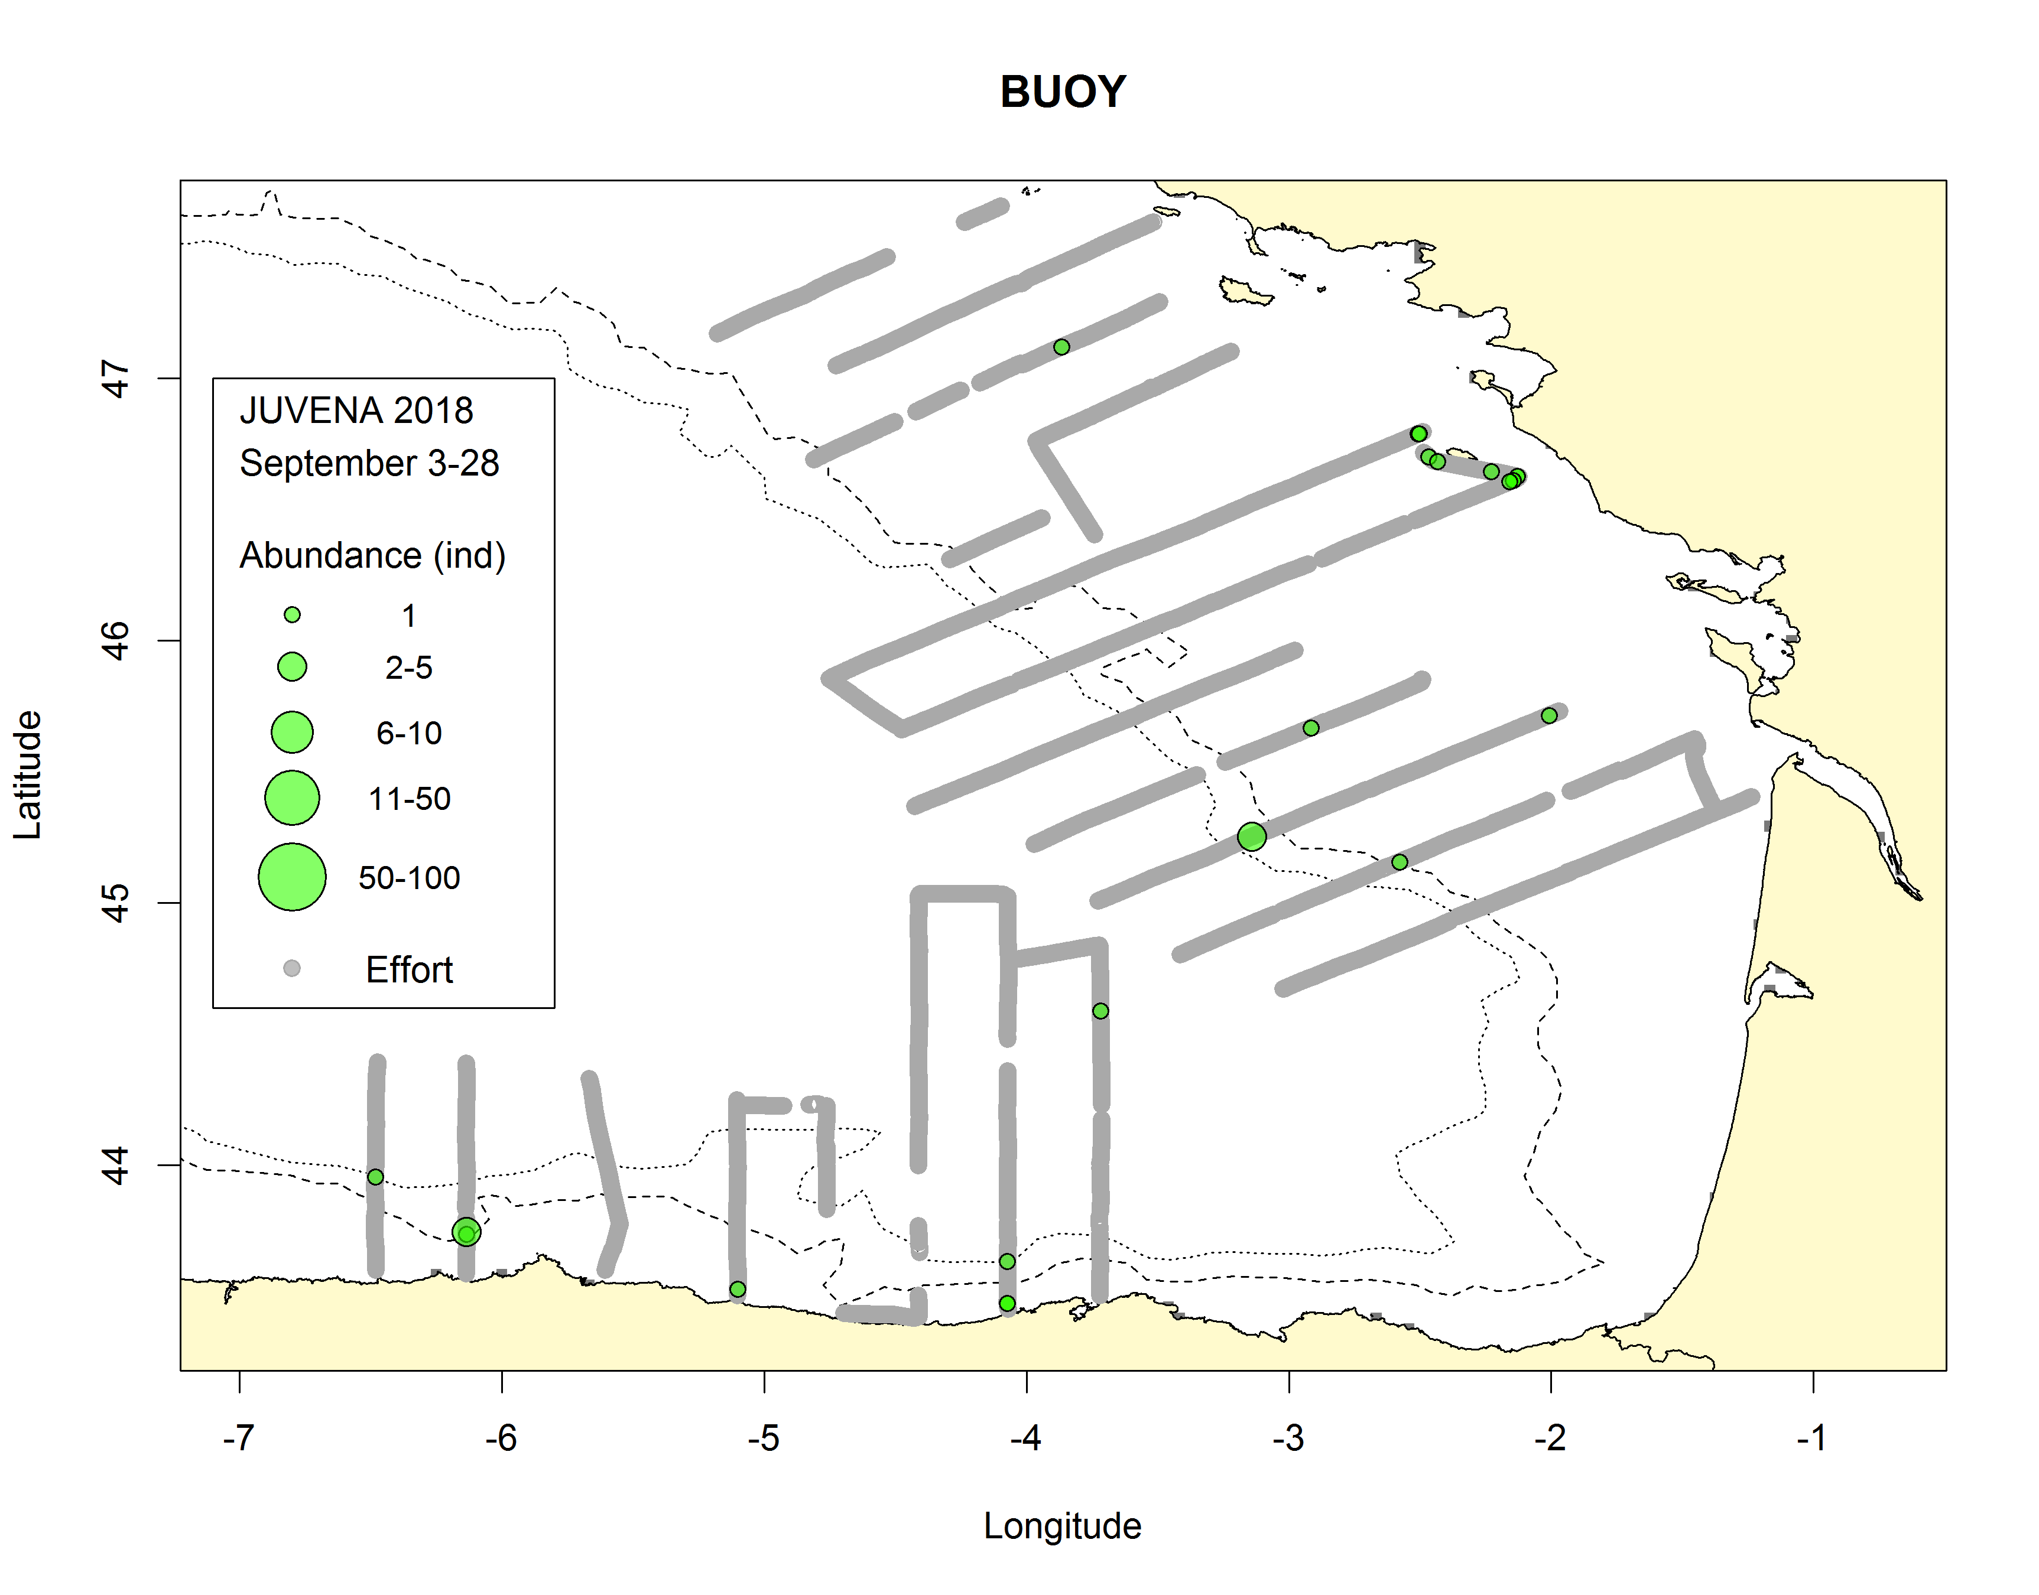c) 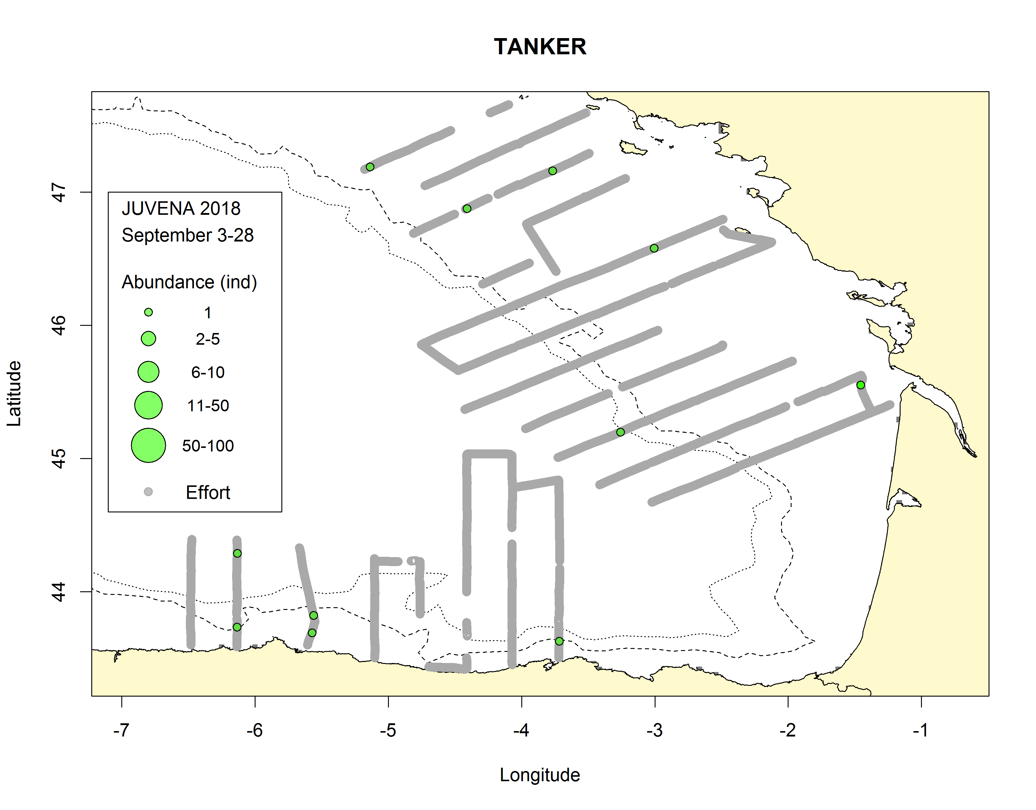d)
Fig.18.i: Distribution of the most abundant human activities during JUVENA 2018 such as (a) plastic trash, (b) fishing buoys, (c) merchant ships and (d) longliners. Grey points represent the effort while the size of the green circles is proportional to observed abundances. The dotted and solid lines represent the isobaths of 200 m and 1000 m, respectively.
2.For internationally coordinated surveys, provide a link to the latest meeting report of the coordination group
http://www.ices.dk/sites/pub/Publication%20Reports/Expert%20Group%20Report/SSGIEOM/2017/WGACEGG/WGACEGG.pdf
3.List the main use of the results of the survey (e.g. indices, abundance estimates, environmental indicators).
The main use of the results of the surveys is to provide assessment advice for anchovy stock in the Bay of Biscay. In particular the JUVENA survey provides assessment information on the recruitment level of anchovy in the Bay of Biscay. These results are reported to ICES WGACEGG, where the validity of the results is checked, and to ICES WGHANSA, where the results are used as input for the ICES CBBM assessment model for anchovy in the Bay of Biscay along with information on anchovy abundance provided by Bioman and PELGAS surveys, as well as the anchovy catches from the fleet.
4.Extended comments.
Tables 1G and 1H: In relation to the Acoustic records, Table 1G, the coverage area was expanded to the North (in coordination wiht CEFAS PELTIC survey) to obtain a combined coverage of anchovy and sardine from the Bay of Biscay to the Celtic Sea.
(max 450 words per survey)

Text Box 1G: List of research surveys at sea

PALPRO
General comment: This box fulfills Chapter IV of the multiannual Union programme and Article 2 and Article 7 paragraph (3) of the Decision (EU) 2016/1701. It is intended to specify which reseach surveys at sea set out in Table 10 of the multiannual Union programme will be carried out. Member States shall specify whether the research survey is included in Table 10 of the multiannual Union programme or whether it is an additional survey.
General comment: This box is applicable to the Annual Report. This box should provide complementary information on the performance of the surveys, the results and their main use.

PALPRO
1. Objectives of the survey
- To obtain data on biodiversity and biomass estimates.
- To obtain biological samples (tissues) of the most deep-water representative species.
- To test the suitability of the commercial longline fishing gear (for deep-water sharks) modified for scientific surveys.
- To test depth, salinity and temperature sensors adapted to deep for monitoring the fishing gear.
2. Description of the methods used in the survey. For mandatory surveys, link to the manuals. Include a graphical representation (map)
A modified commercial deep-water fishing gear adapted was used for the survey. The fishing gear is a two equal horizontal line sections of 1750 m +1750 m, each with 150 hooks (300 in total). Each hook was baited with 1/3 of mackerel.
The horizontal line was attached to the bottom with 1.5 kg stone each five hooks. To improve the catch efficiency of species that feed above the bottom, the stones of the horizontal line were removed in two “floating” sections of 75 + 75 hooks allowing these sections to get more buoyancy. The fishing gear was linked to the surface by two vertical lines and two buoys placed at the beginning and end of the horizontal line.
For the continuous recording of depth, temperature and salinity the long line was monitored with five small sensors DST centi and DST CTD able to withstand 2500 m depth. The survey areas was 10.5 km north of the Cape Matxitxako (VIIIc east) in a narrow canyon of about 28 km length that decreases progressively in depth from 500 to 2.500 m .
The average duration of the haul was 7:30 hours. For the calculation of the fishing effort several categories of the hook status were recorded.
Null (N) Lost of bait during the hauling
Entire (E) Hook with bait
Eaten (C) with bait partially eaten
Broken (R) Tangled-broken hook
Empty (V) Empty (no catch, no bait)
With catch (P) with catch
The specimens were identified, measured (cm), weighted (g) and sexed on board.
For the analysis of effort and CPUEs hauls’ catches were grouped in four depth strata: 650-1050 m, 1051-1450 m, 1451-1850 m and 1851-2250 m.
Catch per Unit Effort (CPUE1) was standardized to soak time (min) and to 300 hooks.
CPUE 1 = kg (in 300 hooks)/min
A second CPUE 2 was calculated removing the Null, Tangled and Emptied hooks (FC).
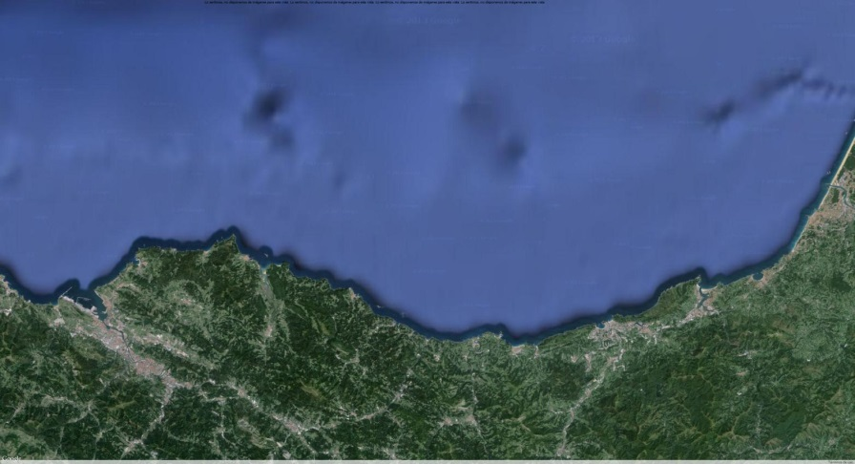
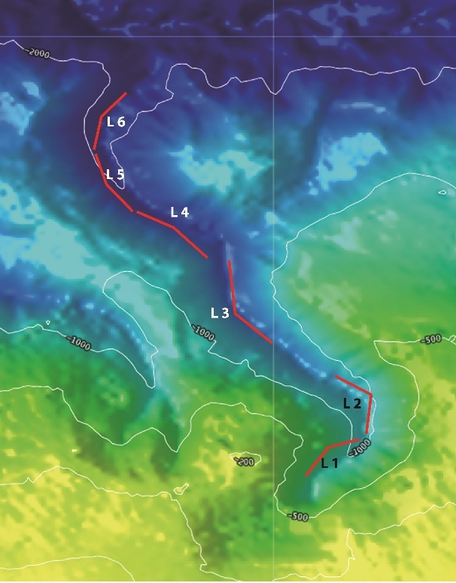
CPUE 2 = CPUE 1 x FC*
*FC =(300-(R+N+V)/300

Figure 19
3. For internationally coordinated surveys, describe the participating Member States/vessels and the relevant international group in charge of planning the survey
It is not an International coordinated survey
4. Where applicable, describe the international task sharing (physical and/or financial) and the cost sharing agreement used
Not applicable
5. Explain where thresholds apply
Not applicable
(max 450 words per survey)

PALPRO
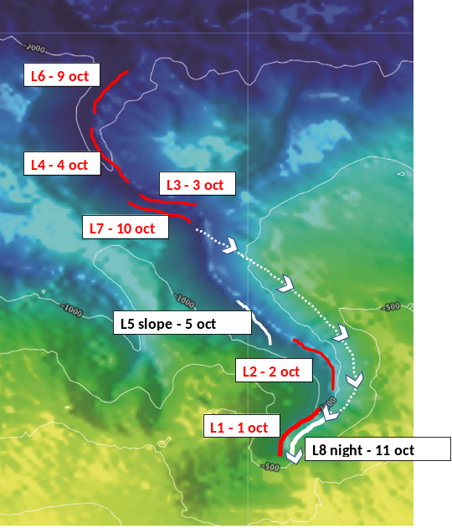
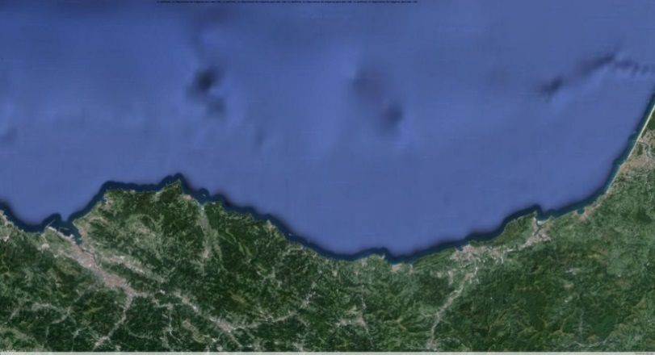
1.Graphical representation (map) showing the positions (locations) of the realized samples

Fig 19 a
2.For internationally coordinated surveys, provide a link to the latest meeting report of the coordination group
Results of the surveys are available through of the annual report:
G. Díez, L. A. Errazkin ,M. Basterretxea, l Oyarzabal, E. Cuendes,A. Maceira, A. Abaroa,. 2018. Campaña piloto de palangre de profundidad para la estima de abundancia de tiburones y otras especies en la 8c (PALPROF 2018). Informe Interno de AZTI para Dirección de Pesca y Acuicultura, Dpto. de Desarrollo Económico y Competitividad, Eusko Jaurlaritza – Gobierno Vasco., 77 pp.
3.List the main use of the results of the survey (e.g. indices, abundance estimates, environmental indicators).
Results of abundance and biomass index (kg (in 300 hooks)/min) as well as biodiversity information by depth strata have been used for a characterization of the deep-water fish fauna in the Basque Country continental slope.
These data have been presented for first time in the Working Document for the ICES WGDEEP. The construction of a robust series of data during a consistent period of time are useful tools for the assessment of the recovery of deep-water populations in the Bay of Biscay, in which are included deep-watersharks currently under UE regulation (TAC 0) and several teleost species present in the area of study.
*Diez. G., Arregi, L., Basterretxea, M., Onandia I., and Mugerza. 2016. Longline deep-water pilot survey for the estimated abundance of sharks and teleost species in the Bay of Biscay (ICES Division VIIIc). Working Document for the ICES Working Group on the Biology and Assessment of Deep-Sea Fisheries Resources, Copenhagen (Denmark), 20-27 April 2016, .9 pp.
http://www.ices.dk/sites/pub/Publication%20Reports/Expert%20Group%20Report/acom/2016/WGDEEP/01%20WGDEEP%20Report.pdf

4.Extended comments.
(max 450 words per survey)

Text Box 1G: List of research surveys at sea

BFT index
General comment: This box fulfills Chapter IV of the multiannual Union programme and Article 2 and Article 7 paragraph (3) of the Decision (EU) 2016/1701. It is intended to specify which reseach surveys at sea set out in Table 10 of the multiannual Union programme will be carried out. Member States shall specify whether the research survey is included in Table 10 of the multiannual Union programme or whether it is an additional survey.
General comment: This box is applicable to the Annual Report. This box should provide complementary information on the performance of the surveys, the results and their main use.

BFT index
1. Objectives of the survey
Main objective: developing a fishery-independent abundance index for juvenile bluefin tuna in the Bay of Biscay.
- Secondary objectives include:
- Analysing the geographical distribution of bluefin tuna schools in the Bay of Biscay,
- Assessing the size distributions in each tuna school detected in the Bay of Biscay,
- Identifying differential geographical distribution of tunas of different size classes in the Bay of Biscay,
- Studying the interactions between bluefin tunas and their main prey (anchovy) in the Bay of Biscay, as well as inter-specific interactions between marine birds and sub-superficial predators.
- Acoustic identification of bluefin tuna behavior within schools in the Bay of Biscay.
2. Description of the methods used in the survey. For mandatory surveys, link to the manuals. Include a graphical representation (map)
The methodology used to estimate the abundance of juvenile bluefin tuna is an acoustic survey following systematic transects, using long-range omnidirectional sonar as a detection tool and an EK60 echosounder to measure school dimensions and estimate biomass.
The identification and sizing of tunas is obtained by pole-and-line fishing and release and by a stereoscopic camera. Acoustic data processing is performed by both layer echo-integration, for schools observed during sampling fishing events, and school echo-integration for schools observed during transects without stopping the vessel. In the first case, the data are post-processed so as to keep only pings containing acoustic backscattering corresponding to tuna aggregations, by keeping only non-zero echointegration pings. This produces an along-track compacted echogram from which we obtain the mean density of the school calculated as the mean of the volume backscattering coefficient (sv; Maclennan et al 2002) of the non-zero pings. The shape of the schools is assumed to be a revolution ellipsoid with horizontal isotropy, i.e., with circular horizontal cross section. Details of the methodology of the surveys were described by Goñi et al. (2016).
References:
Goñi N, Onandia I, Lopez J,Arregui I, Uranga J, Melvin G D, Boyra G, Arrizabalaga H, Santiago J, 2016. Acoustic-based fishery-independent abundance index of juvenile bluefin tunas in the bay of biscay: 2015 and 2016 surveys. SCRS/2016/137, 15 p.
MacLennan, D.N., Fernandes, P.G., Dalen, J., 2002. A consistent approach to definitions and symbols in fisheries acoustics, ICES J. Mar. Sci. 59, 365-369.

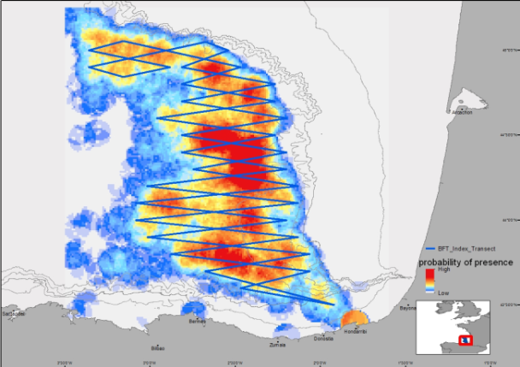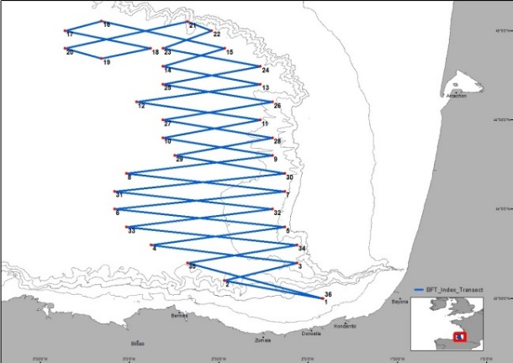 Figure 20
3. For internationally coordinated surveys, describe the participating Member States/vessels and the relevant international group in charge of planning the survey
The survey is coordinated by AZTI. A scientists from DFO Canada took part in the 2016 survey, and scientists from Ifremer, France, will be invited to participate in the survey every year. The possibility of organizing a parallel survey for juvenile bluefin tunas in the Gulf of Lions is being discussed with Ifremer scientists.
4. Where applicable, describe the international task sharing (physical and/or financial) and the cost sharing agreement used
Not applicable
5. Explain where thresholds apply
Not applicable
(max 450 words per survey)

BFT index
1.Graphical representation (map) showing the positions (locations) of the realized samples
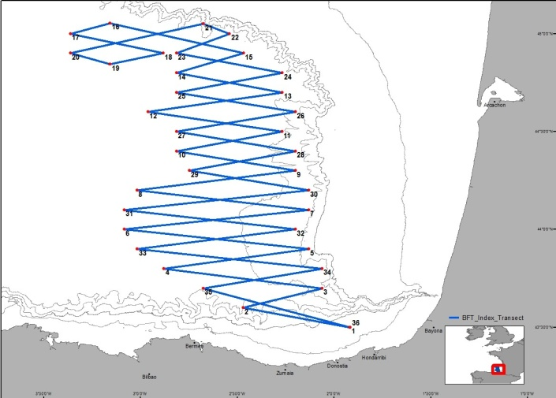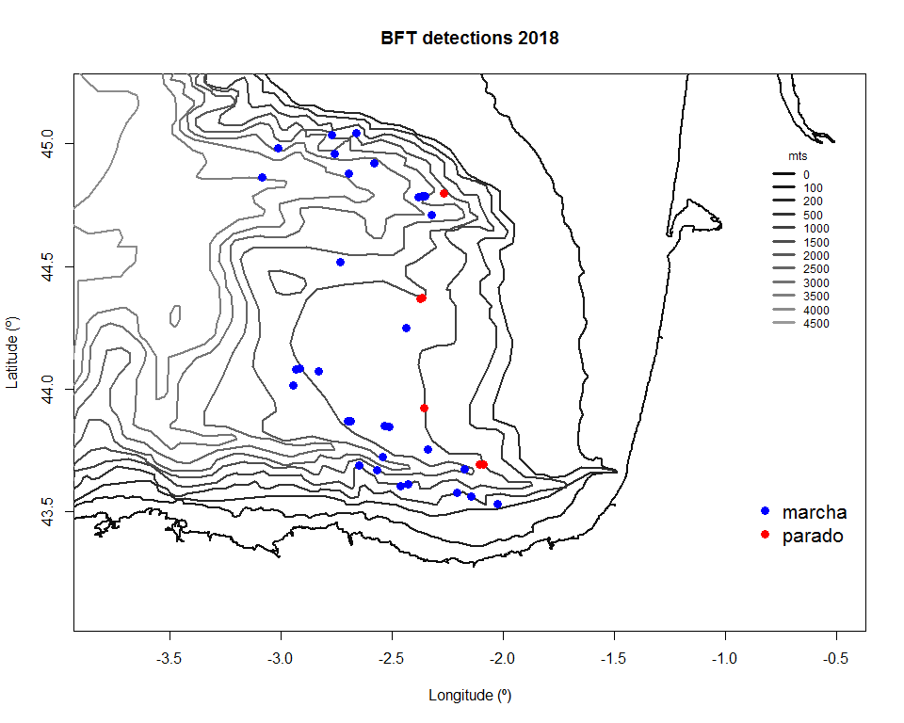
Fig.20.a:
Left Panel: visited transects during the survey in 2015 to 2018.
Right Panel: detections of bluefin tuna schools during the 2018 survey. Red dots: detections with vessel stopped. Blue dots: detections along the tracks of the vessel 8
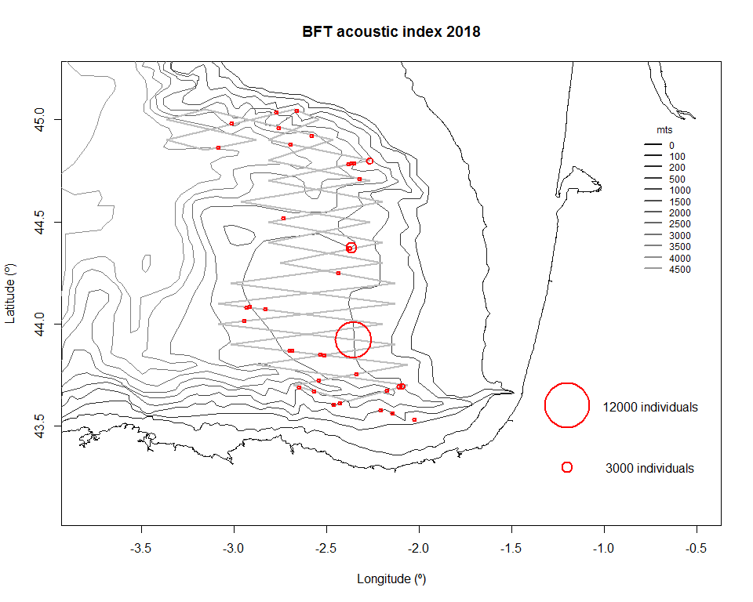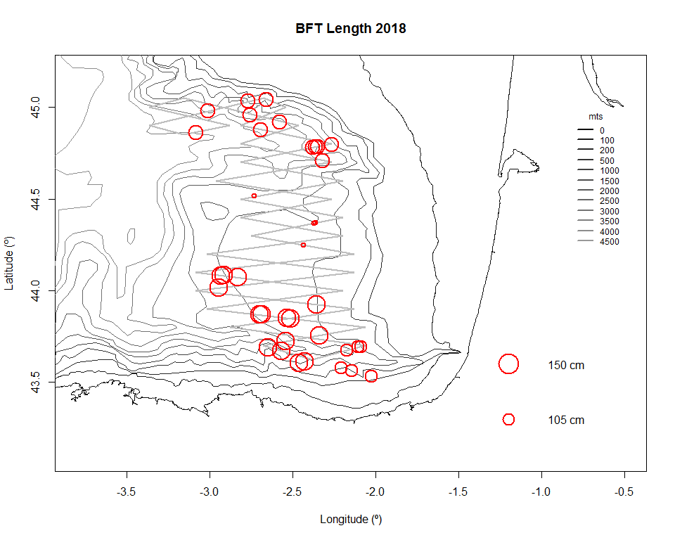
Fig.20.b:
Left Panel: estimated abundance of the bluefin tuna schools detected during the 2018 survey.
Right Panel: average length of the individuals in each bluefin tuna school detected in 2018.

2.For internationally coordinated surveys, provide a link to the latest meeting report of the coordination group
Goñi N, Uranga J, Martinez U, Rico I, Boyra G, Arregui I, Onandia I, Santiago J (2019) Índice acústico de juveniles de atún rojo en el Golfo de Bizkaia (BFTindex) 2018. Informe Final para GOBIERNO VASCO, Departamento de Desarrollo Económico y Competitividad, Vice. de Agricultura, Pesca y Politicas Alimentarias, Dirección de Pesca y Acuicultura.

3.List the main use of the results of the survey (e.g. indices, abundance estimates, environmental indicators).
The main use of the results of the survey is to build an acoustic-based, fishery-independent index to be used in the assessment of the Eastern Atlantic and Mediterranean bluefin tuna stock by ICCAT. The need for fishery-independent abundance indices is growing, in a context of highly altered fishing strategies following TAC reductions, and as in this region the only juvenile abundance index for bluefin tuna so far is based in baitboat catches, i.e. sensitive to tuna vertical distribution and feeding behavior. After gathering 5 to 6 years of survey (started in 2015) we hope to provide an abundance index for the stock assessment.

The results were presented in the bluefin species group of the SCRS species groups meetings in 2015, in the bluefin species group intersessional meeting in 2016, and in the bluefin species group of the SCRS species groups meetings in 2018:
https://www.iccat.int/Documents/CVSP/CV073_2017/n_6/CV073062044.pdf
https://www.iccat.int/Documents/CVSP/CV072_2016/n_7/CV07201862.pdf
https://www.iccat.int/Documents/CVSP/CV075_2018/n_6/CV075061399.pdf
4.Extended comments.
The summer 2018 was characterized by an unusual scarcity of bluefin tunas in the area, although with a presence of age-1 individuals, which were absent in previous surveys. Size measurement were made through the multibeam M3 sonar and the stereoscopic camera, to complete sampling by fishing.
(max 450 words per survey)

Text Box 1G: List of research surveys at sea

ISUNEPCA_TV Survey
General comment: This box fulfills Chapter IV of the multiannual Union programme and Article 2 and Article 7 paragraph (3) of the Decision (EU) 2016/1701. It is intended to specify which reseach surveys at sea set out in Table 10 of the multiannual Union programme will be carried out. Member States shall specify whether the research survey is included in Table 10 of the multiannual Union programme or whether it is an additional survey.
General comment: This box is applicable to the Annual Report. This box should provide complementary information on the performance of the surveys, the results and their main use.

ISUNEPCA_TV Survey (Nephrops FU 30, Gulf of Cadiz, ICES IXa)
Introduction
Currently, ICES considers UWTV methodology as the most appropriate to estimate of Norway lobster abundances, and suggests that, the so-called UWTV surveys can be used in order to obtain an absolute estimate of the biomass of Norway lobster and it can be use as the basis of the scientific advice according WKNEPH 2009 (ICES, 2009). Beside, these UWTV surveys are an excellent platform for obtain information on the benthic habitats and the monitoring of benthic macro fauna of the sedimentary areas in the circa littoral zone deep, such as the communities of pennatulaceans mega fauna and the burrowers fauna that have been included in the OSPAR List (OSPAR, 2010), on the impact of fishing activity on the bottom, as well as information of environmental variables.
ICES WKNEPS (Working Group on Nephrops Surveys) recommended in 2012 that TV survey coverage should be extended to other important fished grounds such the Gulf of Cadiz (FU 30) among others (ICES, 2012). In this sense, the Spanish Oceanographic Institute (IEO) carried out an exploratory Nephrops UWTV survey on the Gulf of Cadiz fishing grounds in 2014 within the framework of a project supported by Biodiversity Foundation (Spanish Ministry of Agriculture, Food and Environment) and European Fisheries Funds (EFF). Nowadays, IEO is funding a yearly UWTV survey in the Gulf of Cadiz (FU 30) since 2015.
In October 2016, ICES WKNEP (Benchmark Workshop on Nephrops Stocks) agreed that UWTV survey in FU 30 (ISUNEPCA TV survey) is appropriate for providing scientific advice on the abundance of this stock. Thus, Nephrops in FU 30 was upgraded to category 1 since this date, and the assessment is based on UWTV survey approach outliner in WKNEP 2016 and using parameters in the stock annex (ICES 2016).
1. Objectives of the survey
- To obtain estimates of Nephrops burrows densities in the Gulf of Cádiz from a randomized isometric grid of UWTV stations spacing 4 nautical miles using the underwater images.
- To define the Nephrops distribution in the Gulf of Cadiz
- To obtain density estimates of bentho-demersal macrofauna species and the occurrence of trawl marks on the sea bed
- To calibrate bentho-demersal macrofauna observed in the underwater videos and those obtained in the beam trawl.
- To measure oceanographic variables using a sledge mounted CTD
2. Description of the methods used in the survey. For mandatory surveys, link to the manuals. Include a graphical representation (map)
The UWTV design follows a randomized isometric grid of stations at 4 nm spacing. The stations ranged from 130-650 m depth with an average depth around 410 m. Additionally, stations located on the shallower edge of the study area are considered in order to verify the boundary of the Nephrops distribution. The sledge, once stable on the seabed, is towed at between 0.6-0.7 knots in order to obtain the best possible conditions for counting burrows and 10 good minutes are recorded. This time corresponds to 200 m swept, approximately. HiPAP transponder on the sledge is used to obtain the sledge position. The distance over ground estimate (DOG) is calculated using the sledge position and the field of view of the video footages is 75 cm (FOV), which was confirmed using lasers.
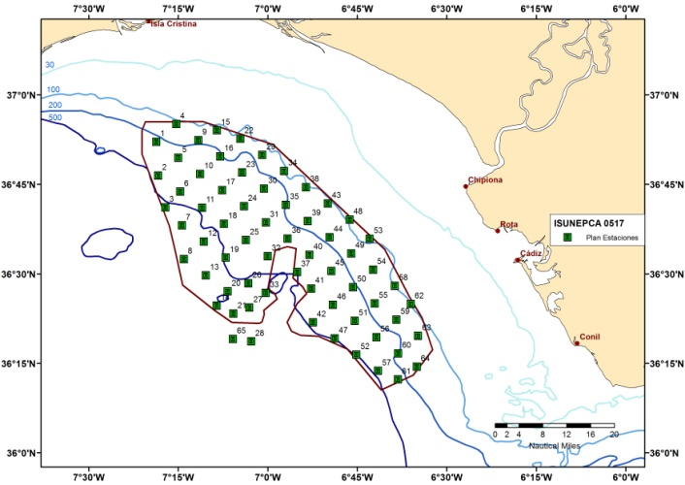 Figure 21
3. For internationally coordinated surveys, describe the participating Member States/vessels and the relevant international group in charge of planning the survey
UK-Scotland/Scotia; UK/Endeavour; AFBI/Corystes; Ireland/Celtic Explorer, Celtic Voyager; France/Celtic Voyager; Denmark/Havfisken; Sweden/Asterix; Spain/Ángeles Alvariño, Ramón Margalef
Relevant international planning group: WGNEPS_ICES Working Group of Nephrops Surveys.
4. Where applicable, describe the international task sharing (physical and/or financial) and the cost sharing agreement used
Individual tasks to the survey participants are allocated by the responsible ICES survey planning group. Each participating country is responsible for the activities conducted on its national part of the international survey. There is no particular cost sharing agreement in place for this survey.
5. Explain where thresholds apply
Not applicable
(max 450 words per survey)

ISUNEPCA_TV Survey (Nephrops FU 30, Gulf of Cadiz, ICES IXa)
1.Graphical representation (map) showing the positions (locations) of the realized samples
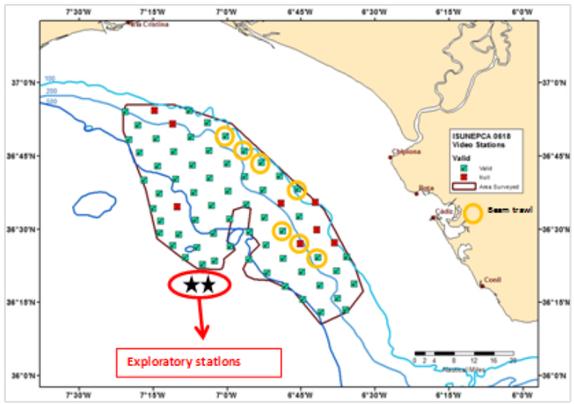Fig.21.a representing the spatial distribution of the TV and CTD stations carried out during the survey. Oceanographic data was obtained using a sledge mounted CTD.
2.For internationally coordinated surveys, provide a link to the latest meeting report of the coordination group
UWTV surveys design and methodologies have been developed and standardized by the Expert Group on Nephrops surveys (WGNEPS) which have been adopted in ISUNEPCA TV survey.
http://ices.dk/sites/pub/Publication%20Reports/Expert%20Group%20Report/SSGIEOM/2017/WGNEPS/WGNEPS%20Report%202017.pdf aun no está colgado en ICES el report 2018
3.List the main use of the results of the survey (e.g. indices, abundance estimates, environmental indicators).
The Nephrops abundance estimates obtained in ISUNEPCA TV survey are used by ICES Working Group for the Bay of Biscay and Iberian waters Ecoregion (WGBIE) to provide a fishery independent estimate of the stock size, exploitation status and catch advice for Nephrops in FU 30 (ICES Division 9a, Gulf of Cadiz). Beam trawl results were used to know the presence of other burrowing megafauna which co-occurring with Nephrops and that could be source of confusion in the identification of Nephrops burrows. Results are also presented in the Working Group on Nephrops surveys (WKNEPS) that is the coordination group for Nephrops UWTV and trawl surveys within ICES and has a quality assurance and development role.
4.Extended comments.
There was an error in the planned number of trawl hauls in the working plan tables. They should have been 10 instead of 20. In any case, only 7 trawl hauls were made due to lack of time because it appeared technical problems with the sledge, the main objective of this survey. However, 7 trawl hauls were enough to achieve the objectives of the survey.
(max 450 words per survey)

Text Box 1G: List of research surveys at sea

BLUE WHITING SURVEY (IBWSS)
General comment: This box fulfills Chapter IV of the multiannual Union programme and Article 2 and Article 7 paragraph (3) of the Decision (EU) 2016/1701. It is intended to specify which reseach surveys at sea set out in Table 10 of the multiannual Union programme will be carried out. Member States shall specify whether the research survey is included in Table 10 of the multiannual Union programme or whether it is an additional survey.
General comment: This box is applicable to the Annual Report. This box should provide complementary information on the performance of the surveys, the results and their main use.
For first time Spain (IEO) has joined the International Blue Whiting Spring Survey in 2018. Survey plan and area to be covered by the Spanish R/V Miguel Oliver, was agreed at the WGIPS meeting held in Den Hjelder (Holland) in January 2018.
So this survey was not in the 2018 WP submitted in October 2017. Nevertheless it was considered pertinent to include the survey in this AR as it was carried on in 2018.

BLUE WHITING SURVEY (IBWSS)
1. Objectives of the survey
- The main objective of this survey was to achieve a biomass’ estimation by echointegration of blue whiting, and other fish species present in the surveyed area. Together with this, the following objectives were also foreseen:
- Determine the distribution area and density of the main fish species
- To study the reproductive ecology of blue whiting
- Characterise the main oceanographic conditions of the surveyed area
- Determine the distribution area and density of apical predators
2. Description of the methods used in the survey. For mandatory surveys, link to the manuals. Include a graphical representation (map)
Systematic grid with random start, tracks 30 nmi apart in the southern part, 20nmi in the northern part, from self-break in the eastern limit to 13°W in the western limit, following the methodology defined in the “ICES Manual for International Pelagic Surveys (IPS) chapter 2.1.1”
Acoustic echosounder EK-60 at 18-38-70-120-200 kHZ. Day/night observation.
CUFES, Intake at 5 m. depth, 600 l min-1. 3 nmi/sample.
Pelagic fishing stations to identify the species composition of the acoustic recordings.
Marine mammals and birds observations (apical observer).
Manta trawl hauls (microplastics) done at the same time as the fishing tows.
Hydrological characterisation (CTD with plankton nets).
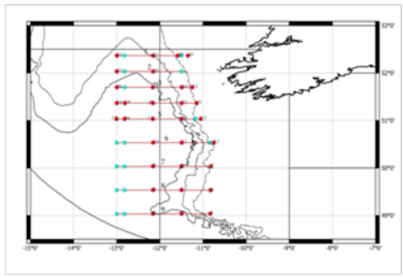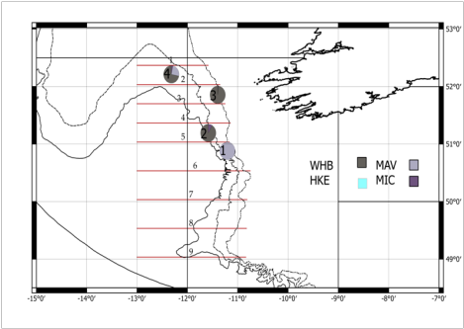Figure 22
3. For internationally coordinated surveys, describe the participating Member States/vessels and the relevant international group in charge of planning the survey
The survey is coordinated by the ICES Working Group on International Pelagic Surveys (WGIPS) and performed in collaboration with research vessels from Ireland, Faroe Islands, Russia, and Norway
The blue whiting spawning stock estimate is used as a tuning index by ICES WGWIDE to determine the size of the population. The survey data (hydrographic, biological, & acoustic) are stored in the PGNAPES database.
4. Where applicable, describe the international task sharing (physical and/or financial) and the cost sharing agreement used
The IBWSS is carried out by three EU MSs (Ireland, Netherland and Spain), and three non EU MSs, each contributing with its own vessel.
Cost sharing: the operational costs of the vessels are shared by EU MSs applying an allocation key proportional to national share of the EU TAC.
5. Explain where thresholds apply
Not applicable
(max 450 words per survey)

BLUE WHITING SURVEY (IBWSS)
1.Graphical representation (map) showing the positions (locations) of the realized samples
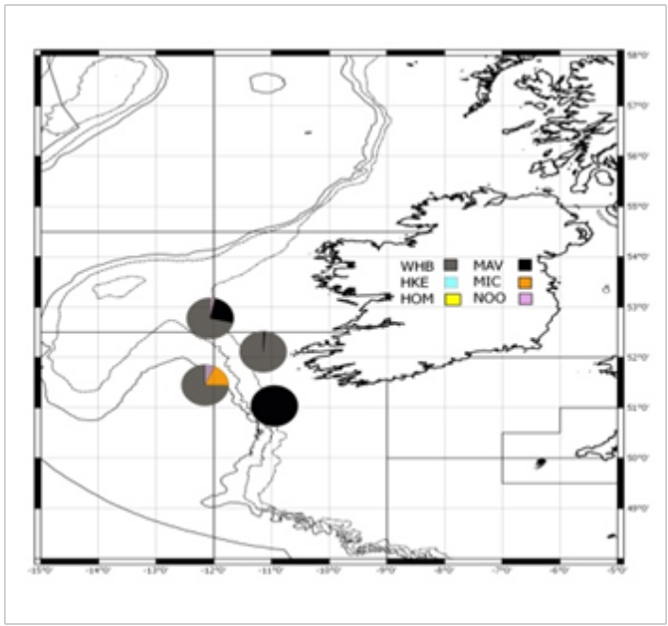Fig.22.1 Fishing stations IBWSS-PELACUS0318.
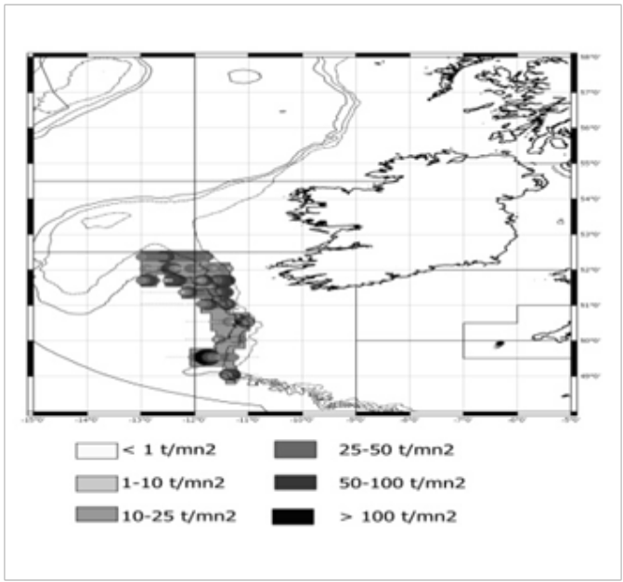Fig.22.2 Blue whiting distribution IBWSS-PELACUS0318. 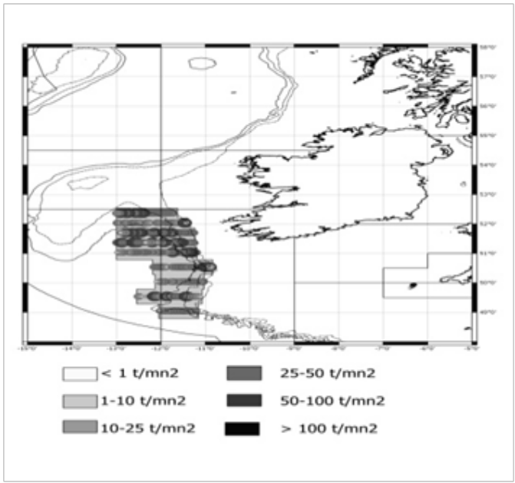Fig.22.3 Pearlside distribution IBWSS-PELACUS0318.

2.For internationally coordinated surveys, provide a link to the latest meeting report of the coordination group
The Working Group on International Pelagic Surveys (WGIPS) coordinates this survey. The hyperlink to the latest meeting report is:
http://www.ices.dk/sites/pub/Publication%20Reports/Expert%20Group%20Report/EOSG/2018/WGIPS/WGIPS%20report%202018.pdf
3.List the main use of the results of the survey (e.g. indices, abundance estimates, environmental indicators).
Although integrated at the IBWSS with R/V Magnus Heinason, Tridens, Celtic Explorer and M/S Kings Bay, the results would not be used for assessment purposes as long as the agreed covered area by R/V Miguel Oliver is located out of the core spawning area of blue whiting.
For the time being, this suvey is giving a quantitative index off-core blue whiting spawning area. Yet, the index is not used for assessment purposes, but providing useful information about stock structure, spawning activity and stock size off the main spawning area, already covered by the rest of the vessels participants in the survey.
Next year, together with the coverage of the Porcupine Seabigh, another two strata in 8abd will be covered for comparison purposes.
4.Extended comments.
For first time Spain (IEO) has joined the International Blue Whiting Spring Survey in 2018. Survey plan and area to be covered by the Spanish R/V Miguel Oliver, was agreed at the WGIPS meeting held in Den Hjelder (Holland) in January 2018.
So this survey was not in the 2018 WP submitted in October 2017. Nevertheless it was considered pertinent to include the survey in this AR as it was carried on in 2018.
(max 450 words per survey)

Section 2: Fishing Activity Data

Text Box 2A: Fishing activity variables data collection strategy

General comment: This box fulfills paragraph 4 of Chapter III of the multiannual Union programme and Article 2, Article 4 paragraph (2) point (b) and Article 5 paragraph (2) of the Decision (EU) 2016/1701. It is intended to describe the method used to derive estimates on representative samples where data are not to be recorded under Regulation (EU) No 1224/2009 or where data collected under Regulation (EU) No 1224/2009 are not at the right aggregation level for the intended scientific use.
General comment: This box is applicable to the Annual Report. This box should provide information on the implementation of the data collection of fishing activity variables of Member States.
1. Description of methodologies used to cross-validate the different sources of data.
Fishing activity variables are collected under control regulation. The sources of data are: Fleet register, logboook, sales notes and VMS. All this information is integrated into the centralized database of the SGP and can be found with precision levels settled by the regulation.
Improvements are being made in the centralized database in order to develop consistency filters and query with data matching in order to detect errors or inconsistencies as established by Community law and as approved by the European Commission.
Capacity: The data regarding capacity are obtained from Operating Spanish Fleet Register which is part of Community vessel Register, in which all vessels included.
From a software application, the parameters of the vessels according to the disaggregation level required by the Regulations can be checked. In this sense, regarding gear data, they are obtained from national census where vessels are included or, alternatively, from data of fishing licences issued.
Automatic filters are being implemented in the database to check possible inconsistencies.
These census are updated any time a change occurs, so that the annual update of the data is guaranteed. This gives a total coverage of Spanish fleet vessels, including those less than 10 m.
Effort:
- for vessels of more than 10 meters, data come from Fleet Register, logbooks and positions provided by the VMS data (vessels exceeding 15 m.)
- for vessels of up to 10 and 15m data are obtained from the logbooks.
- For vessels less than 10 meters, the data for fleet segments and fishing gear are obtained from Fleet register and those derived from sale notes given that each note corresponds to a day of fishing in the fishing ground to which the vessel´s been operating.
The fleet census is updated any time a change occurs, so that the yearly update of the data is guaranteed. This gives a total coverage of the Spanish fleet vessels, including those less than 10 m length.
Sales notes are collected daily on all auctions by the autonomous regions authorities that process and integrate them into their databases so that there is a full coverage. Whith established frequency, the sales notes are forwarded to the SGP that incorporate the information into its central database, which guarantee the full coverage in all national territory.
Improvements are being made in the centralized database in order to develop consistency filters and query with data matching in order to detect errors or inconsistencies, as established by Community law and as approved by the European Commission.
Landing: Information on landings by vessels over 10 meters comes from the landing declarations.
In 2012 it began the gradual implementation of the system of "electronic logbook". With this system, incorporating data on catches and landing declarations to the database is immediate, thus speeding up the incorporoation of information. This system has been a major advance over manual recording of data done in ports. This manual recording has been relegated to those vessels that are not required to have this electronic logbook, although a logbook in paper format is mandatory.
These recordings represent just 5% of the total catches of the Spanish fleet.
For vessels less than 10 meters, these data are collected from sales notes.
The latter information, if necessary, can be obtained through the crossings of sales notes against the tables of fleet census where the fishing mode is recorded for each vessel.
The precision and disaggregation levels under the Regulation have been reached, however, the information of disaggregation level required by the regulations concerning the value of species landed obtained from surveys to collect economic data. These surveys are processed in the year following their collection and also the data obtained are not yet integrated into the SGP central database, so it cannot be done automatically with a cross-checking like other parameters required for this module.
2. Description of methodologies used to estimate the value of landings.
As explained above.
3. Description of methodologies used to estimate the average price (it is recommended to use weighted averages, trip by trip)
Sales notes provide this data.
4. Description of methodologies used to plan collection of the complementary data (sample plan methodology, type of data collected, frequency of collection etc)
Not applicable. All variables are covered by the methodology as explained.

(max 900 words per Region)
1.Deviations from WP methodology used to cross-validate the different sources of data
No deviations from the WP in 2017.

Actions to avoid deviations
Not applicable

2. Deviations from WP methodologies used to estimate the value of landings
No deviations from the WP in 2017.

Actions to avoid deviations
Not applicable

3.Deviations from WP methodology used to estimate the average price (it is recommended to use weighted averages, trip by trip.
No deviations from the WP in 2017.

Actions to avoid deviations
Not applicable

4.Deviations from WP methodology used to plan collection of the complementary da
No complementary data is collected.

Actions to avoid deviations
Not applicable
(max 900 words per Region)

Section 3: Economic and Social Data

Text Box 3A: Population segments for collection of economic and social data for fisheries

General comment: This box fulfils paragraph 5 points (a) and (b) of Chapter III of the multiannual Union programme and Article 2, Article 4 paragraphs (1), (2) and (5) and Article 5 paragraph (2) of the Decision (EU) 2016/1701. It is intended to specify data to be collected under Tables 5(A) and 6 of the multiannual Union programme.
General comment: This box is applicable to the Annual Report. This box should provide information on the implementation of the fleet socio-economic data collection of Member States.
1. Description of methodologies used to choose the different sources of data
The statistic operation Marine Fisheries Economic Survey includes pollsters who gather information directly in questionnaires designed ad hoc.
Due to the considerable population size, performing an annual census would be too expensive and is not considered appropriate. Therefore, stratified random sampling will be performed, using economic profitability of the statistical unit as main variable, and size (measured by GT) as auxiliary variable.
The statistical unit or observation unit is each of the vessels included in the CFP (Operative Fishing Fleet Census, in Spanish), which can perform marine fishing, classified in group 03.11 of the National Activities Classification (CNAE-2009).
The reporting unit is the vessel’s owner.
The sampling unit is each CFP vessel with activity during the referred year.
The analysis unit, or economic activity unit is the vessel, therefore, it coincides with the observation unit.
2. Description of methodologies used to choose the different types of data collection
The data collection method is based on a stratified random sampling through a representative sample of the total population.
Data are collected by personal direct interview to the informers, including:
- daily contact between provincial and general coordinators
- training agents in their province
- preparation of materials
- designing surveying routes
- receiving filled-in questionnaires
- inspection
- submitting weekly to central offices all interviews conducted
The different phases of the work are listed below:
- Sending covering letter
- Location of phone numbers to make the first contact
- First contact with companies
- Conducting interviews
- Detection of incidents
The survey questionnaire contains the following:
- Identification of vessel’s owner - name, address, etc.
- Detailed information of the vessel’s owner to set the economic and financial situation ashore of companies in the sector.
- Vessel information.
- Vessel’s Income Statement Account.
3. Description of methodologies used to choose sampling frame and allocation scheme
Stratified random sampling. The main variable of this survey is the economic profitability of the ship, and the auxiliary variable to be used to stratify is the GT, a variable of which the population distribution is known.
Stratification: Survey population was divided into strata, according to the auxiliary variable GT, with the aim of obtaining groups on vessels as homogeneous as possible within stratum GT and with the greatest possible heterogeneity among the different strata, in relation to the profitability of the vessels.
Strata were defined according to statistic, biological (similarity in the fishing grounds’ characteristics), and technical (type of fishing methods utilised and vessel length).
In addition to the above mentioned criteria, stratification of the population has to meet the levels of disaggregation required by Community rules, resulting from Regulation 199/2008, of the Council.
Strata cannot contain less than 10 elements: strata not meeting this condition are grouped with others.
Sample size: with optimum allocation. Total sample size is determined aiming to estimate the median GT of the population with an expected error of 5%, that is, a 95% level of confidence.
Sample selection: In the population database, vessel data will appear together with the vessel’s owner data. By selecting the statistical units, reporting units of the survey are perfectly demarcated.
The various ships in the population are grouped according to the stratum to which they belong, and in each of these groups, membership or not of each of the vessels to the stratum will be randomly allocated. The result is a set of random and mutually independent subsamples.
The size of each of these subsamples will be previously determined by the (previously set) expected error level.
4. Description of methodologies used for estimation procedures
Target variables will be estimated using the stratified random sampling method. From data included in questionnaires, variables with those population values which may be of interest will be built.
5. Description of methodologies used on data quality
Refer to table 5B for a detailed description of these methodologies.
If a survey unit is considered “Impossible to include in the survey”, the reason for not having that information available will be noted in order to improve the design phase of future surveys, and they will affect the frame of this survey in the corresponding percentage.
(max 900 words per Region)
1. Deviations from WP methodology for selection of data source
Previously, stratified random sampling was carried out, using the economic profitability of the statistical unit as the main variable and the size (measured by GT) as an auxiliary variable.
Currently, stratified random sampling is carried out, using the economic profitability of the statistical unit as the main variable and for the calculation of the sample size, a combined or double-allocation method is used, between the minimum variance allocation of the GTs (75%) and the proportional allocation. (25%).
This type of sampling has been carried out because after analyzing the correlation of the results with the selected samples, it is better adjusted using a double allocation method than a simple allocation method.
Actions to avoid deviations

2. Deviations from WP methodology to choose type of data collection
No deviations.

Actions to avoid deviations
Not applicable
3.Deviations from WP methodology to choose sampling frame and allocation scheme
Stratified random sampling. The main variable of this survey is the economic profitability of the vessel, and the variables used for the stratification are the Supra-region, the fishing technique and the length.
Stratification: the surveyed population was divided into strata, according to the Supra-region variables, the fishing technique and the length, with the aim of obtaining groups of vessels as homogeneous as possible within the stratum and with the greatest possible heterogeneity among the different strata, in relation to the profitability of the vessels.
In addition to the above mentioned criteria, stratification of the population has to meet the levels of disaggregation required by Community rules, resulting from Regulation 199/2008, of the Council.
Strata cannot contain less than 10 elements: strata not meeting this condition are grouped with others.
Sample size: for the calculation of the sample size, a combined or double allocation method is used, between the minimum variance allocation of the GT (75%) and the proportional allocation (25%), with an expected error of less than 5 %, that is, and for a 95% confidence level.
Sample selection: In the population database, vessel data will appear together with the vessel’s owner data. By selecting the statistical units, reporting units of the survey are perfectly demarcated.
The various vessels in the population are grouped according to the stratum to which they belong, and in each of these groups, membership or not of each of the vessels to the stratum will be randomly allocated. The result is a set of random and mutually independent subsamples.
The size of each of these subsamples will be previously determined by the (previously set) expected error level.
Actions to avoid deviations

4. Deviations from WP methodology used for estimation procedures
No deviations
Actions to avoid deviations
Not applicable
5.Quality assurance
5.1 Sound methodology
Quality guarantee
The statistics of the Ministry are governed by principles that seek to ensure the quality and credibility of the data. These principles are included in the Code of Good Practice of European Statistics (CBP) and refer, among other aspects, to professional independence, protection of confidentiality, reliability of results, accuracy, timeliness, accessibility, clarity, comparability and coherence.
In this work, both in the process of collecting information and in the subsequent processes of data processing, there are established quality controls in continuous improvement.
There are several procedures to ensure the quality of the data transmitted.
• Controls made during the data loading process
• Controls carried out after the loading procedure
5.2. Accuracy and reliability
Response rate and Achieved sample rate are provided in Table 3A.
Quality evaluation
The different processes executed are aimed at eliminating or reducing as much as possible the errors, both in the information collection phase and in the processing phase.
The processing of survey information coincides temporarily with field work and it is developed in parallel with the collection of information. Due to this coincidence in the time, a first cleaning of the information is carried out when analyzing the possible errors committed at the time of collection, which are corrected immediately so that they do not affect the rest of data collected.
Subsequently, after the recording of the information, a second cleaning of the information by establishing a series of control standards to guarantee a quality level of the data collected and recorded.
Before the tabulation of the results, the joint results and the consistency of them are analyzed.
The collected data is debugged by correcting possible inconsistencies of the same, once they are received and after having recorded them, it is again observed whether there are possible deviations from values at a global level and inconsistencies are corrected.
During the final debugging process, the detection and debugging of inconsistencies is carried out in the identification variables of the units, as well as the detection of content errors.
Taking into account the type of variables, in some cases, procedures are carried out data imputation to correct errors
5.3. Accessibility and Clarity
Indicate Yes or No
• Are methodological documents publicly available? __Yes___
• Are data stored in databases? __Yes___
• Where can methodological and other documentation be found? ____
http://www.mapa.gob.es/es/estadistica/temas/estadisticas-pesqueras/pesca-maritima/encuesta-economica-pesca-maritima/default.aspx
(max 1000 words)

Section 3: Economic and Social Data

Pilot Study 3: Data on employment by education level and nationality

General comment: This box fulfills paragraph 5 point (b) and paragraph 6 point (b) of Chapter III of the multiannual Union programme and Article 2 and Article 3 paragraph (3) point (c) of the Decision (EU) 2016/1701.It is intended to specify data to be collected under Table 6 of the multiannual Union programme.
General comment: This box is applicable to the Annual Report. This box is intended to provide information on the results obtained from the implementation of the pilot study (including deviations from planned and justifications as to why if this was not the case).
1. Aim of pilot study
The aim of this pilot study is to measure the responsiveness and acceptance of questions made on social variables in such a complicated sector as fisheries and aquaculture. It will also serve to determine and specify questions to be included in questionnaires.
2. Duration of pilot study
The pilot study will be carried out during two periods. Pilot studies will begin on the collection to be carried out in 2017 on socio-economic information for 2016 and from this collection will be conducted pilot studies for two periods.
3. Methodology and expected outcomes of pilot study
Several social variables listed in Table 6 of the Decision, including employment by sex, EJC sex, unpaid labor by sex and EJC national, have been collected for years and do not need to be included in the pilot study.
Variables to be included in the pilot study on social information are: Employment by age, employment by level of education, employment by nationality and Employment by employment status.
• Employment by age: Since there is no clear definition of age intervals, the following intervals are considered:
- 16-29
- 30-44
- 45-64
- > 64
• Employment by level of education: the following categories will be considered:
- S.E. Uneducated
- E.P. Primary studies
- ES y U Secondary Education and University
• Employment by nationality: catregorías the following will be considered:
- NAC. National
- R.UE Rest of the EU
- F.UE Outside the EU
• Employment by employment situation: Because there is no clear definition, the following intervals are considered:
- employed: Person working on salary, wages, commissions or any other remuneration type.
- Employers: Employers or entrepreneurs with salaried staff.
- Self-employed: Professional (or not) self-employed person who does not employ personnel.
- Family assistance: a person who works in a company belonging to a relative, not receiving wages or fixed salary, either cash or kind.
- Members of a cooperative.

(max 900 words)
1. Achievement of the original expected outcomes of pilot study and justification if this was not the case
The information on the social variables has been collected for two years and no significant problems have been observed in the response of the respondents.
In future exercises, once defined the intervals of the different categories, it is assumed that the same lack of problems will continue.
Regarding the methodology of the pilot study, it has been adapted to what was indicated by the different interlocutors, in relation to:
- Employment by age:The age ranges have been adjusted to those indicated in the EU- MAP guidelines, the following intervals are considered:
  - < 15
  - 15-24
  - 25-39
  - 40-64
  - > 64
  - Unknown
- Employment by level of education: the following categories will be considered:
- 1.Low (Level 0-2)
- Medium (Level 3-4)
- High (Level 5-8)
- Unknown
- Employment by nationality: the following categories will be considered:
  - NAC
  - EU
  - EEA
  - Non-EU-EEA
  - Unknown
- Employment by employment situation: the following intervals will be considered:
- 1.Owner
- Employer
- Unknown

2. Incorporation of results from pilot study into regular sampling by the MS
The data from the pilot study are collected together with the rest of the economic variables following the same sampling methodology.
(max 900 words)

Section 3: Economic and Social Data

Text Box 3B: Population segments for collection of economic and social data for aquaculture

General comment: This box fulfills paragraph 6 points (a) and (b) of Chapter III of the multiannual Union programme and Article 2, Article 4 paragraphs (1) and (5) and Article 5 paragraph (2) of the Decision (EU) 2016/1701.It is intended to specify data to be collected under Tables 6 and 7 of the multiannual Union programme.
General comment: This box is applicable to the Annual Report. This box should provide information on the implementation of the socio-economic data collection for aquaculture of Member States.
1. Description of methodologies used to choose the different sources of data
The statistic operation Aquaculture Economic Survey includes pollers gathering information directly in questionnaires designed ad hoc.
The statistical unit or observation unit is each of the establishments authorised to perform aquaculture activities, as described in group 03.2 of CNAE-2009.
The reporting unit is the person who, owning the company to which the establishment belongs, or having the power and ability to respond, can be asked the questions contained in the corresponding questionnaire, related to the observation unit.
Sample units are the establishments performing aquaculture activities which in the reference year were authorised to do so.
The analysis unit, or economic activity unit is the establishment. It is the part of the company which undertakes its activity in a given geographical situation. Hence, in most cases it coincides with the observation unit.
When a company of the same owner and the same main activity has several establishments of aquaculture and data collected in the questionnaire are not disaggregated by each of the establishment, an proportional estimation of the corresponding fraction for each establishment is made.
2. Description of methodologies used to choose the different types of data collection
The methodology used for data collection is mixed. One part of the population is surveyed exhaustively (with a census) and the other part is surveyed with stratified random sampling.
Data are collected by direct personal interview to informers, by:
- daily contact between provincial and general coordinators
- training agents in their province
- preparation of materials
- designing surveying routes
- receiving filled-in questionnaires
- inspection
• submitting weekly to central offices all interviews conducted
The different phases of the work are listed below:
- Sending covering letter
- Location of phone numbers to make the first contact
- First contact with companies
- Conducting interviews
- Detection of incidents
The survey questionnaire contains the following:
- Identification of the legal form of the establishment’s owner and the number of establishments under his ownership.
- Description of the establishments
- Income Statement Account of the establishments
3. Description of methodologies used to choose sampling frame and allocation scheme
Stratified random sampling. The main variable of this survey is the result before taxes. However, the main variable will be determined at the end of the survey. This is why, in order to determine the simple size, it is necessary to have an auxiliary variable that is both previously known and correlated to the main variable. The effectively used capacity of the establishment will be the auxiliary variable, referred to as the size of the existing facilities in the establishment used to accommodate the species during the different phases or processes of aquaculture, which are effectively being used to this end.
The population to be sampled has been divided into strata, aiming to obtain groups of establishments with characteristics as homogeneous as possible within the stratum and with the greatest possible heterogeneity among the different strata.
Another criterion when defining the strata has been to obtain a number of them which can be handled, ensuring that each either includes a significant number of establishments or it represents a given species or zone.
In addition to the above mentioned criteria, stratification of the population has to meet the levels of disaggregation required by Community rules, resulting from Regulation 199/2008, of the Council.
Stratification was made based on the establishments’ characteristics: type of aquaculture according to water origin, type of aquaculture facilities (ground, in natural spaces. Horizontal culture, cages), and main species raised.
Strata have been surveyed by census or by sampling according to the following criteria:
- Strata including less than 20 establishments for each main species cultivated: exhaustive survey.
- Strata including 20 or more establishments and homogeneous characteristics: sampled and then extrapolated to obtain data for the population.
In this second group we must consider that sample size is calculated according to the auxiliary variable, the capacity effectively used by the establishment, and that, when variability within the stratum is high, it may be the case that sample size is the same as the population size for a particular stratum.
Sample size: with optimum allocation. Total sample size is determined aiming to estimate the economics results of the population with an expected error of 5%, that is, a 95% level of confidence.
Sample selection: In the population database, data from the aquaculture establishments will appear together with the corresponding owner data, for both the exhaustive survey and sampling. By selecting the statistical units, reporting units of the survey are perfectly demarcated.
In the exhaustive survey, each statistical unit will represent one unit in the population as a whole.
In sampling, the units will represent the corresponding population. Therefore, it will be necessary to select sampling units randomly.
For sampling, the population of different groups will be grouped according to the stratum to which they belong, and in each of these groups sampling will be made randomly obtaining as many random and mutually independent subsamples as there are strata.
The size of each of these subsamples will be previously determined by the (previously set) expected error level.
4. Description of methodologies used for estimation procedures
In the exhaustive survey there is an imputation method for those cases in which mandatory questions do not get a response within partially completed questionnaires.
5. Description of methodologies used on data quality
Refer to table 5B for a detailed description of these methodologies.

(max 1000 words)
1. Deviations from WP methodology for selection of data source
No deviations
Actions to avoid deviations
Not applicable
2. Deviations from WP methodology to choose type of data collection
No deviations
Actions to avoid deviations
Not applicable
3.Deviations from WP methodology to choose sampling frame and allocation scheme
No deviations
Actions to avoid deviations
Not applicable
4. Deviations from WP methodology used for estimation procedures
No deviations
Actions to avoid deviations
Not applicable
5.Quality assurance
51. Sound methodology
Quality guarantee
The statistics of the Ministry are governed by principles that seek to ensure the quality and credibility of the data. These principles are included in the Code of Good Practice of European Statistics (CBP) and refer, among other aspects, to professional independence, protection of confidentiality, reliability of results, accuracy, timeliness, timeliness, accessibility , clarity, comparability and coherence.
In this work, both in the process of collecting information and in the subsequent processes of data processing, there are established quality controls in continuous improvement.
There are several procedures to ensure the quality of the data transmitted.
• Controls made during the data loading process
• Controls carried out after the loading procedure.
5.2. Accuracy and reliability
Quality evaluation
The different processes executed are aimed at eliminating or reducing as much as possible the errors, both in the information collection phase and in the processing phase.
The processing of survey information coincides temporarily with field work and it is developed in parallel with the collection of information. Due to this coincidence in the time, a first cleaning of the information is carried out when analyzing the possible errors committed at the time of collection, which are corrected immediately so that they do not affect the rest of data collected.
Subsequently, after the recording of the information, a second cleaning of the information by establishing a series of control standards to guarantee a quality level of the data collected and recorded.
Before the tabulation of the results, the joint results and the consistency of them are analyzed.
The collected data is debugged by correcting possible inconsistencies of the same, once they are received and after having recorded them, it is again observed whether there are posible deviations from values at a global level and inconsistencies are corrected.
During the final debugging process, the detection and debugging of inconsistencies is carried out in the identification variables of the units, as well as the detection of content errors.
Taking into account the type of variables, in some cases, procedures are carried out data imputation to correct errors.
5.3. Accessibility and Clarity
Indicate Yes or No
• Are methodological documents publicly available? __Yes___
• Are data stored in databases? __Yes___
• Where can methodological and other documentation be found? ___
https://www.mapa.gob.es/es/estadistica/temas/estadisticas-pesqueras/acuicultura/encuesta-economica-acuicultura/default.aspx
(max 1000 words)

Section 3: Economic and Social Data

Pilot Study 4: Environmental data on aquaculture

General comment: This box fulfills paragraph 6 point (c) of Chapter III of the multiannual Union programme and Article 2 and Article 4 paragraph (3) point (d) of the Decision (EU) 2016/1701. It is intended to specify data to be collected under Table 8 of the multiannual Union programme.
General comment: This box is applicable to the Annual Report. This box is intended to provide information on the results obtained from the implementation of the pilot study (including deviations from planned and justifications as to why if this was not the case).
1. Aim of pilot study
2. Duration of pilot study
3. Methodology and expected outcomes of pilot study
(max 900 words)
1. 4. Achievement of the original expected outcomes of pilot study and justification if this was not the case.
No pilot Study was planned for 2018.
5. Incorporation of results from pilot study into regular sampling by the Member State.
The collection of this data is made by the competent authorities in the subject, which in the case of Spain are the Regional Authorities since it deals with Animal and Public Health. Besides, it is considered that no pilot should be carried out,. It is mandatory to collect them by the legislation on the matters mentioned, and therefore, since it falls on domains which exceed the competence of the CFP, no specific recommendations from the Fisheries authorities should be made. Also, it is worthy to remind that one the legislative body is a Directive, which entails to the Member States the best possible way to incorporate to its own legislative corp.
(max 900 words)

Section 3: Economic and Social Data

Text Box 3C: Population segments for collection of economic and social data for the processing industry

General comment: This box fulfils footnote 6 of paragraph 1.1(d) of Chapter III of the multiannual Union programme, Article 2, Article 4 paragraphs (1) and (5) and Article 5 paragraph (2) of Decision (EU) 2016/1701. It is intended to specify data to be collected under Table 11 of the multiannual Union programme.
General comment: This box is applicable to the Annual Report. This box should provide information on the implementation of the socio-economic data collection for aquaculture of Member States.
1. Description of methodologies used to choose the different sources of data
Accomodation to EU legislation.
Two main aspects must be highlighted:
- The survey is vertebrated following a multiple units model, in which, and according to EU legislation, the companies assume the main role.
- With the purpose to adapt to European nomenclature of economic activities (NACE rev.2), the “Industrial Companies Survey” is articulated referring to sectorization, stratification and statistical infraestructe on the basis of the “National Clasification of Economic Activities 2009”
Approach to obtain the primary data.
The primary data are oriented to the informing unit, trying to compile the features or variables they may provide, either because they know them or because they are accessible in their documentation.
All of the above aim to:
- Adapt the main variables of the questionnaire to the criteria and guidelines of the new “General Account Plan”.
- Utilisation of the different models of questionnaires depending on the size of the company and the different types of economic-finantial operations… all of them aspects that may hinder the homogeneous treatment of these units from the statistical point of view. To adjust the requested data (and according to its level of especification) to the intrinsic characteristics of each unit, different models of questionnaires have been designed depending on the features of each reporting company.
Units of the survey
The basic survey unit is the industrial company. The company may perform one or more activities in one or more places.
In the scheme of the survey, the company assumes at the same time, the roles of informing unit and observation unit.
However, although the company is the main unit of the survey, given the numerous objectives to be reached with this investigation, there are units that complement the information system, such as the industrial establishment (as observation unit) and the economic activity unit at local level (as analysis unit).
Population scope
The population under sampling is comprised by the companies whose main activity is included in the CNAE-2009 following sections:
- Section B: harvesting industries
- Section C: manufacture industry
- Section D: air conditioning, steam, gas and electric provider
- Section E: water provider, sanitation activities, waste management and decontamination.
2. Description of methodologies used to choose the different types of data collection
Collecting of information
The collection of information is carried out annually by the “Collection Units” of INE, responsible also for answering telephones to clear up doubts of the informers and for recording and filtering questionnaires.
The process of this collection of reference year “t” is carried out from the second trimester of the year “t+1”, with an aproximate duration of 4 months.
It will be assumed that the company has been surveyed if its main activity is one of those included in the population scope of the survey; also, if the questionnaire has been obtained duly fullfilled and the data comply with the consistency and completeness as established.
Besides, during the collection of all the information, some incidences may arise that dont allow to obtain the questionnaire: definite closure of the bussines, temporary closure o inactive company, mistakenly included in the survey, not in the scope, duplicated or impossible to locate, negative or not responding.
Models of questionnaires
Four models of questionnaires have been designed with the purpose of adequating the requested information to the specific features of the companies:
- Companies with less than 10 employees.
- Companies between 10-49 employees.
- Companies with 50 or more employees and whose activity is included in sections B and C of CNAE-2009.
- Companies with 50 or more employees and whose activity is included in sections D and E of CNAE-2009.
3. Description of methodologies used to choose sampling frame and allocation scheme
Sampling and design
Population framework: Companies Central Directory (“DIRCE”) which contains the information on the companies identification, as well as its main economic activity, location and size.
Type of sampling. Estratification
The population under study has been divided in different strata, according to the following variables:
- Company main activity, at 4 digit level (class), according to CNAE-2009.
- Autonomous region
- Company size interval, depending on the number of employees:
- Up to 3 employees
- From 4 to 9
- From 10 to 19
- From 20 to 49
- 50 or more employees
- Characteristics of the subsidiary company ( if it is subsidiary of a foreign company or not)
It has been thoroughly investigated those companies with 50 or more employees, as well as all companies included in the “Foreing subsidiary companies” record in Spain. Also, all companies that, although with a small size in terms of employees, have an important facturation volume, have been exhaustively surveyed.
The rest of the companies have been sampled. Each stratum, which has been determined by the crossing of the above mentioned variables, has conformed an independent population, in terms of the sampling.
Size sampling. Affixation.
Within each stratum, it has been calculated the size sample by optimum affixation or Neyman´s affixation, by fixing in advance the relative sampling error for the variable “number of employees”, at national level of 1%, and at regional level of 5%.
The size sampling has been increased, if necessary, to a minimum of two companies by stratum. On the other hand, and with the purpose of reaching more precise aggregated results, it has been determined by statistical criteria, within each strata, the outlier companies (in terms of facturation volume and employees) with the objective of including them in the thorough part of the sample.
By size intervals, sampling fraction have been as follows:

Strata by size Sampling fraction
Up to 3 employees | 10%
From 4 to 9 employees | 29%
From 10 to 19 employees | 42%
From 20 to 49 employees | 69%
50 or more | 100%
TOTAL | 21%
Size selection: by means of the assigning aleatory number, which allows the coordination of the sample with other surveys.
The selection process is independent from one year to another: the probability of a company being selected in year “t” is independent from the fact that this company has been selected the previous year (t-1).
4. Description of methodologies used for estimation procedures
Unbiased expansion estimators have been utilised in the stratified sample.
5. Description of methodologies used on data quality
IT processing of the sample file: carried out by IT application that ensures the organization, continuous collection supervision, filtering and efficient control of the process since the beginning of the survery, with the detection of systematic mistakes of fullfillement and interpretation of the questionnaries during the initial phase, making it easier to correct them afterwards.
Information processing
Carried out in a paralell to data collection itself; focusing on the continuous update process; refinement of the questionnaire content, integrated in the recording and treatment of the inter provincial management of the company (in particular, for companies located in different provinces).
(max 1000 words)
1. Deviations from WP methodology for selection of data source
No deviations
Actions to avoid deviations
Not applicable
2. Deviations from WP methodology to choose type of data collection
No deviations
Actions to avoid deviations
Not applicable
3.Deviations from WP methodology to choose sampling frame and allocation scheme
No deviations
Actions to avoid deviations
Not applicable
4. Deviations from WP methodology used for estimation procedures
No deviations
Actions to avoid deviations
Not applicable
5.Quality assurance
51. Sound methodology
The methodology of the Industrial survey can be found on the INE website.
The methodology published on the MAPA website is standardized with the different data sources in which the standards and good practice guidelines are documented.
The quality assurance framework for INE statistics is based on the ESSCoP, the Code of Good Practice of EUROSTAT European Statistics. The ESSCoP consists of 15 principles, grouped into three areas: Institutional Environment, Processes and Products. Each principle has associated a series of indicators that allow its measurement. To assess quality, different tools provided by EUROSTAT are used: the indicators already mentioned, the Self-assessment inspired by the DESAP model, the Peer Review, the user satisfaction surveys, and other evaluation procedures.
The methodology follows EU standards in relation to industrial surveys.
Based on the regulations 275/2010 of the Commission and 295/2008 of the European Parliament and the Council, the European Commission (EUROSTAT) assesses the quality of the data transmitted and publishes reports on the quality of European statistics.
5.2. Accuracy and reliability
The sample design tries to minimize the sampling errors and the different processes of the survey are aimed at eliminating or reducing as much as possible the errors of the same, both in the collection phase (response rate and debugging control) and in the subsequent editing and imputation.
The collection procedure, coverage control, debugging of errors and imputation of the lack of response allows obtaining a high degree of reliability of the statistics.
Sampling errors of the main variables are calculated.
5.3. Accessibility and Clarity
Indicate Yes or No
• Are methodological documents publicly available? __Yes___
• Are data stored in databases? __yes___
• Where can methodological and other documentation be found? _______________________________
http://www.ine.es/dyngs/INEbase/es/operacion.htm?c=Estadistica_C&cid=1254736143952&menu=ultiDatos&idp=1254735576715

(max 1000 words)

Section 4: Sampling Strategy for Biological Data from Commercial Fisheries

Text Box 4A: Sampling plan description for biological data

North Sea (ICES IIIa, IV and VIId areas) and Eastern Arctic (ICES areas I, II)
General comment: This box fulfills Article 3, Article 4 paragraph (4) and Article 8 of the Decision (EU) 2016/1701 and forms the basis for the fulfilment of paragraph 2 point (a)(i) of Chapter III of the multiannual Union programme. This Table refers to data to be collected under Tables 1(A), 1(B) and 1(C) of the multiannual Union programme.
General comment: This box is applicable to the Annual Report. This box should provide information on the deviations from the planned sampling of Member States.
North Sea and Eastern Arctic
Spain has only fisheries in Eastern Acrtic. All the sampling will be performed on commercial unsorted catches at sea by observers on board of fishing vessels that operate in international waters.
1.Sampling design
There are two types of fisheries and the target population is stratified into two fleets:bottom trawlers targeted Cod (OTB_DEF_> = 120_0_0) and midwater trawlers targeted redfish (OTM_DEF_100-119_0_0).
Target population: is the total number of trips in a year carried out by the Spanish fleet targeting the stocks selected for sampling. The trips lasted from few days to 3 months and all vessels are over 40 m.
Sampling frame: is the list of vessels with license to fish in each fishery.
Primary Sampling Units (PSUs): are the individual fishing trip in a fishery. In a single trip one vessel can cover two o more fisheries and even different Areas and/or Regions.
Method of PSU selection: is a systematic non-random sampling (rotation) from a list of vessels ranked by the effort of observation on board in previous years by fishery and updated every year. The selection is made by the fisheries authority which granted the license. The refusal rate in the last years is zero because the license is linked to the acceptance of scientific observer on board.
Sampling effort: is allocated according to the scientific experience gained from the study of fisheries in the area. The number of fishing trips and the number of individuals planned to be sampled were calculated based on data from previous years in order to keep the coverage from previous years and to cpmply the requirements of the end users.
Sampling procedures: the method to collect the length data from commercial fisheries is the concurrent sampling on board carried out by observers at-sea who remain on board throughout the period of the whole fishing trip (1-3 months). Observers on board collect data on unsorted catches and discards by species, efforts and positions The biological parameters (Weight, Age, Maturity) come from a sampling design stratified by length class. The Sex-ratio index is achieved at the same time of sampling of length which are randomly collected and not stratified.
2. Estimation procedures
Estimation of discards and catches structure are carried out from data collected by observers on board. The data consist on length data by sex and length-weight relationship collected by trip sampled. Raisings are done for each species by month and division. Finally, a raising is made to the total catch of the fishery.
The calculation to achieve other biological parameters will be estimated based on bootstrap procedures and fitting models with the tool INBIO 2.0 (“Estimation of biological parameters and their uncertainties through simulation techniques”) developed in R environment by the IEO..
3. Data quality evaluation
Data of each trip, collected and recorded on board, are checked during and after the trip (in the laboratory) in order to detect errors and inconsistencies (outliers, trends, range of variables, dispersion).
After the trip, the observer debugs all data, haul by haul and sampling by sampling. Finally, a random check of about 15% of the data is carried out to validate the quality of the results. Annually all sets of data for each fishery are checked previously to be used for assessment and other scientific tasks.
Quality controls like the following are performed:
- Implementation of sampling protocols for each species where the methodologies of sampling, processing and storage of samples are described.
- Processing, debugging and periodic checking of data.
- Standardization of the common criteria in assigning maturity and age of each species, in order to improve the accuracy.
- Attendance to workshops and/or exchanges between different scientific teams.
Data storage: Sampling data are stored into own and SIRENO database: (Seguimiento Informático de los Recursos Naturales Oceánicos) which is managed by the IEO.
The documentation required of the sampling design, implementation and data processing will be available in the period 2017-2019.
(max 900 words per region)
1. Deviations from Work Plan
ID code: L2, (67%): The main cause of the deviation is the lasting of the trips in these fisheries and the unpredictability of the permanence of observers in fishing areas due to the decisions taken by vessels' owners in the way of moving vessels among areas. In this case there was very low effort in 2018 for the metier: OTM_DEF_100-129_0_0.
2. Action to avoid deviations
ID code: L2. Although the behavior of the fleet is impossible to change, IEO will continue in improving coordination with the sectors involved: owners and administration authorities.
(max. 1000 words per region OR fishing ground)

Section 4: Sampling Strategy for Biological Data from Commercial Fisheries

Text Box 4A: Sampling plan description for biological data

North Atlantic
General comment: This box fulfills Article 3, Article 4 paragraph (4) and Article 8 of the Decision (EU) 2016/1701 and forms the basis for the fulfilment of paragraph 2 point (a)(i) of Chapter III of the multiannual Union programme. This Table refers to data to be collected under Tables 1(A), 1(B) and 1(C) of the multiannual Union programme.
General comment: This box is applicable to the Annual Report. This box should provide information on the deviations from the planned sampling of Member States.
North Atlantic (ICES areas XII, XIV and NAFO areas)
All the sampling will be performed on commercial unsorted catches at sea by observers on board of fishing vessels that operate in international waters.
1. Sampling design
In ICES Subareas XII, XIV there are two types of fisheries and the target population is stratified into two fleets: Bottom trawlers targeting deep-sea species in ICES Division XIIb and VIb-Hatton Bank (OTB_DWS_100-129_0_0) and Midwater trawlers targeting Redfish and Grenadiers in ICES Subareas XII and XIV-Irminger Sea-(OTM_DEF_100-119_0_0)
In NAFO Regulatory Area (NRA), Spanish fleet carry out different fisheries characterized by different mesh size, target species, depth and fishing area:
- Botton trawlers targeting Greenland halibut in Div 3LMNO (OTB_MDD_130-219_0_0).
- Botton trawlers targeting Skates in Div 3LNO (OTB_MDD_>=220_0_0).
- Botton trawlers targeting Northern Shrimp in Div 3LMNO (OTB_CRU_40-59). currently closed.
- Midwater trawlers targeting Alfonsino in Div 6G (OTM_DEF_130-135_0_0).
Target population, Sampling frame, Primary sampling units (PSUs), Method of PSU selection, Sampling effort, Sampling procedures (see NS&EA)
2. Estimation procedures (see NS&EA)
3. Data quality evaluation (see NS&EA)
North Atlantic (ICES areas VI-IX)
Sampling onshore (at market)
Purpose: Estimate landings at length for all stocks
Target population: All fish landed in Spain by the Spanish fleet. This target population is divided in two subpopulation:
- IEO is in charge of all the landings performed in Spain excepting the Basque Country
- AZTI is in charge of all the landings performed in the Basque Country
Stratification: The target population is stratified into 24 strata which are defined by mutually exclusive list of vessels (Table 4B). The temporal strata is the quarter, although equal monthly coverage is aimed.
Sampling frame, Primary sampling units (PSUs), Secondary sampling units (SSU), terciary sampling units (TSU) and protocol for the selection of samplesis explained in table 4A for each strata
Distribution of sampling effort: Sampling effort is allocated according to information on fishing effort and catches in the previous year.
Implementation:
-Refusals are recorded
-Expected difficulties: each strata has its own particularities. In general: refusals, incomplete trips (due to landings sent to a processing industry, where the sampling is not possible), getting in advance information about whether landings will take place in the selected port (for small vessels), randomization of the vessel selection
Sampling onboard
Target population: All fish discarded by Spanish fleet. This target population is divided in two subpopulation:
- IEO is in chagre of all the discards performed by Spanish vessels excepting the Basque Country
- AZTI is in chagre of all the discards performed by Basque vessels
Stratification: The target population is stratified into 13 strata which are defined by mutually exclusive list of vessels (Table 4B). The temporal strata is the quarter, although equal monthly coverage is aimed.
Sampling frame, Primary sampling units (PSUs), Secondary sampling units (SSU), and protocol for the selection of samples: explained in table 4A for each strata
Distribution of sampling effort: Sampling effort is allocated according to information on fishing effort and catches in the previous year.
Implementation:
-Refusals are recorded
-Expected difficulties: Refusal rate in PTB.
General
All data are stored in the IEO data base (SIRENO) and AZTI database.
Quality Assurance: Refusals are recorded. Automatic quality checks are applied when entering the data in the DataBase. Outliers are checked.
Documentation of raising/weighting procedure for national estimates: Sampling data is extrapolated to the whole population in each domain (usually stock*metier*quarter).
-For length distributions of the landings, the landed weight is used as raising factor and empty cells are filled using the nearest neibourgh criteria
-For catch (retained and discarded) estimates , the total effort by metiers is used as raising factor.
Sampling of eel
Eel has not been sampled until now in Spain. Taking into account the existing competences in Spain, each Autonomous Region is in charge of eel fisheries management and therefore sampling; in fact, each Autonomous region constitutes an eel management unit. As this is the first year for eel sampling, the sampling design needs to be developped and adapted to the particularities of each Autonomous Region. Training courses and national coordination is planned for 2017 in order to put in place eel sampling at a national level.
(max 900 words per region)
1. Deviations from Work Plan
North Atlantic (ICES areas XII, XIV and NAFO areas)
No deviations in North Atlantic (ICES areas XII, XIV) and NAFO areas.
North Atlantic ICES VI, VII (excl. VIId), VIII, IX
IEO_S_BT_CN: stratum with none PSUs sampled during 2018. As explained in the table 4A, this stratum (which had the smallest sampling effort allocation of the WP, only 4 PSUs in the year) was removed from the sampling plan due to systematic problems to go on board: it's a small scale fishery and usually problems of space. This fleet is covered and sampled under the on-shore program (Stratum ID code: IEO_M_BT_CN). This decision was taken and the end of 2017 and could not been included in the modification proposal for 2018. It was included and accepted as a modification of the original WP in the update Submitted NWP for 2019.
IEO_M_SB_GC: this is the only sampling result with low % of achievement. In this case this results is completely affected by an important fail of the fishery in 2018 that only reached 30% of the fishing trips accounted during the reference years.
AZTI_M_PTB_8abd (22% achievement, 2 PSU sampled, out of 9 planned) & AZTI_S_PTB_8abd (63% achievement, PSU sampled, out of 8 planned). This fleet has been reduced in 2018. During quarters 1,2 & 3 there was just one operative vessel, and during quarter 4, two vessels. Target could not be achieved because of logistic problems (limited space available on board) and refusals. Sampling effort was partially redistibuted and dedicated to AZTI_S_PTB_8c.

2. Action to avoid deviations
It’s not clear how to avoid some deviations, specially when they are related to changes in the dynamic of the fishery.
When unexpected problems appear (fishing closures, etc) sampling team redistribute that effort within the specific temporal-technical stratification. Only when that is not possible, sampling team redirect that sampling effort to another strata to avoid the lost of resources allocated for sampling. These actions, which are understood as a positive action under the quality assurance framework in place, avoid a perfect match of final results with original planning.
Work is in progress since a long time to try to minimize refusals, but for some fleets it is hard to achieve improvements. At the moment refusals are recorded to assess bias.
Limited space available on board in some fleets it is also a recurrent issue with a difficult solution. We try to cover the vessels where there is enough place for the observer on board. In extreme cases, as mentioned small scale fleet IEO_S_TB_CN, we were obliged to abandon the on-board programme thus relying on the on-shore programme for data collection purposes.
For some fleets it difficult to know in advance the date of arrival and this makes the implementation of the sampling plan more difficult. Work is in progress to optimize the sampling plan in these fleets
(max. 1000 words per region OR fishing ground)

Section 4: Sampling Strategy for Biological Data from Commercial Fisheries

Text Box 4A: Sampling plan description for biological data

Medierranean and Black Sea
General comment: This box fulfills Article 3, Article 4 paragraph (4) and Article 8 of the Decision (EU) 2016/1701 and forms the basis for the fulfilment of paragraph 2 point (a)(i) of Chapter III of the multiannual Union programme. This Table refers to data to be collected under Tables 1(A), 1(B) and 1(C) of the multiannual Union programme.
General comment: This box is applicable to the Annual Report. This box should provide information on the deviations from the planned sampling of Member States.
Mediterranean and Black Sea
Spain has no fisheries in Black Sea
The length of the coast of the Spanish Mediterranean, including Majorca and Menorca (Balearic Islands) is about 2200 km. There are 2578 vessels distributed in 71 ports. Most of them (60 ports) have regular auctions. Sampling staff are dispersed at several locations around the coast to reduce travelling time. In general the different fisheries (otter trawls, purse seines, artisanal fleet...) are widely distributed along the coast. There is a complete vessel registry and census data for landings, effort, gear, etc. as required by EU logbooks and sales notes.
The sampling design in the Spanish Mediterranean is done at the métier level (level 5), for those métiers selected by the ranking system, as state in the GFCM-DCRF Regulation. This ranking system is performed for each Geographical Sub-Area. The design has been done taking into account the representativeness of the data to collect with relation to the population (catches from the commercial fleet), considering that these data should be obtained cost-effectively and the information obtained can be used to estimate the population characteristics of interest precisely (low variability) and accurately (unbiased). For the proposed sampling schemes, it is possible to calculate estimates of the precision of the estimators of the population parameters.
Both for at-sea sampling and on-shore sampling, four different strata area considered: GSA, metier, selected ports and time frame. For each GSA, metiers are non-probabilistic selected, based on the rules of the regional RFMO (GFCM). For each combination of GSA-metier, the ports to sample have previously been selected according to previous knowledge which include their importance for each métiers (both in terms of biomass landed and effort as number of vessels) as well as their availability to carry out the sampling (both predisposition and adequate facilities) . Finally, the time frame (quarter or month) is set to force the sampling to cover the entire year.
The new survey design has the following features:
For at-sea sampling:
- The sampling frame is the list of vessel for each GSA, métier and selected ports, with vessel as primary sampling unit (PSU).
- The sampling effort (number of trips to sample) is distributed across strata (GSA, métier and ports) based on the fishing effort in the previous years (days at sea = trips).
- The list of vessel which operated in each GSA, métier and ports in the previous year would be available.
- The list of vessels will be randomly ordered in each sampling period (month/quarter) and vessels will be contacted in order as they appear in the list. Every unit is equally likely to be in the sample.
- Results of the contact (no answer, refusal and reasons for refusals) will be tracked.
- All catches will be concurrently sampled.
On shore sampling:
a-. GSAs 1, 6 and 7. For these GSAs, the primary sampling unit (PSU) is the combination port*vessel:
- The sampling effort (number of trips to sample) is distributed across strata (GSA, métier and selected ports) based on the fishing effort in the previous years (days at sea = trips).
- For those métiers selected in each GSA to sample, in each selected ports, a list of vessel-port which operated in that métier in the previous year would be available.
- The list of port-vessels will be randomly ordered in each sampling period (month) and vessels will be contacted in order as they appear in the list.
- Results of the contact (no answer, refusal and reasons for refusals) will be tracked.
- All catches landed will be concurrently sampled.
b-.GSA 5. For this GSA, the PSU is vessel:
In Mallorca, catches from all ports are sent to a unique market in the capital (Palma de Mallorca). The sampling frame is the list of vessels from the island which worked in the selected métier during that fishing trip. No refusals are expected in this case. If necessary, samples can be post-stratified.
For the collection of individual information in order to estimate age, maturity, sex ratio and weigth of the main species will be selected a number of individuals by length class every period (month, quarter or year).
The estimation of the biological parameters and their uncertainties will be carried out using the tool INBIO 2.0 (“Estimation of biological parameters and their uncertainties through simulation techniques”), developed in R environment by the IEO. INBIO makes possible to fit the most usual models and to estimate the coefficient of variation for parameters by using the non-parametric bootstrap methodology.
Update of “Sampedro, P., Sainza, M. and Trujillo, V., 2005.A simple tool to calculate biological parameters’uncertainty. Working Document, In: Workshop on Sampling Desing for Fisheries Data (WKSDFD), Pasajes, Spain
(max 900 words per region)
1. Deviations from Work Plan
In some cases there are big differences between the “Average number of PSU during the reference years” and the “Total number of PSU in the sampling year”. These are due to a change in the calculation method. In the WP the number of PSU was calculated having on account the sampling ports. In the AR we have calculated the number of PSU using all ports of the area.
Results under planning:
In some cases, it was not possible to reach the number of trips planned to sample during 2018 due to the following reasons:
ID codes M3-C, M6-C, M9-C, M11-C, M12-C, M12-S, M16-C, M17-C, M21-S, M23-S and M25-C (see AR comments in Table 4A).
Results over planning:
There are an incidental overplanning in two métiers, ID code M14-C and ID code M18-C (see AR comments in Table 4A)
Finally, more samplings than planned were performed in some métiers with the purpose of achieving higher quality in the calculation of length distributions of the main species, ID codes M4-C, M5-C, M14-S, M19-S and M22-S.
The improving of length data will be used in the assessment of small pelagic species of GSA01 and 06, and M. merluccius of GSA06.
2. Action to avoid deviations
When unexpected problems appear (temporal fishing closures, fisherman’s decisions, bad weather, etc.) sampling team redistribute the sampling effort.
Also the effort is redisributed to increase the sampling when the quality of length distributions is considered not as good as it should be.
Work is in progress to try to minimize refusals, but for sometimes it is hard to achieve colaboration. Limited space available on board in some fleets it is also an issue with a difficult solution.

(max. 1000 words per region OR fishing ground)

Section 4: Sampling Strategy for Biological Data from Commercial Fisheries

Text Box 4A: Sampling plan description for biological data

CECAF
General comment: This box fulfills Article 3, Article 4 paragraph (4) and Article 8 of the Decision (EU) 2016/1701 and forms the basis for the fulfilment of paragraph 2 point (a)(i) of Chapter III of the multiannual Union programme. This Table refers to data to be collected under Tables 1(A), 1(B) and 1(C) of the multiannual Union programme.
General comment: This box is applicable to the Annual Report. This box should provide information on the deviations from the planned sampling of Member States.
Fishing ground: Canary (EU waters)
- PS_SPF_10_0_0: Artisanal purse seiners targeting small pelagics. Daily fishing trips at night. Monthly samplings at markets are carried out in the main landing ports in Tenerife, where landings account for around 44% of the total in the Canaries. Primary sampling units or PSUs (vessel x trip) are selected ad-hoc from the boats that agreed to cooperate (around 45% of the total target population in Tenerife), covering representative boats (see Table 4B): Sampling frame code C6-M for concurrent at markets in Tenerife and C6-ss for stock specific in the Canary Islands carried out at markets for the four small pelagics target species.
- MIS_DES_0_0_0: Artisanal polyvalent and multi-specific fleet targeting demersal species with small gears (traps, hooks, nets). Daily fishing trips. Ports in Tenerife represent 11% of landings but cover around 30% in number of boats and 27% in effort. Samplings are carried out on a monthly basis, at sea (code C7-S), in Tenerife and at markets in the Canaries (code C7-ss) for stock specific samplings of Sparisoma cretense (main target species). PSUs at sea were selected ad-hoc covering representative “type vessels” operating in the island from those that agreed to cooperate (46% of the total target population in Tenerife), the rest being identified as refusals. Main difficulties are related to the high number of vessels, landing places, gears and target species of this fleet. Random selection of PSU from the collaborative boats are planned to be considered in the upcoming years.
Fishing ground: From Morocco to Guinea-Bissau (non EU waters in West Africa)
Sampling coverage in these areas highly depends on the varying circumstances of the Protocols of the SFPAs between the EU and coastal States. These can involve changes in the fisheries conditions and accessibility or even the closure of certain fisheries or the introduction of new fisheries to be sampled. As a consequence, some of the planned objectives for 2017-2019 would not be adequately achieved or some new métiers to be sampled could be added in the future.
In all cases, in sampling at sea schemes, difficulties might be expected, related to the collaboration of the fishing sector to have observers onboard. The degree of collaboration has been varying in the past, depending on the type of fleet and their specific circumstances (limited space onboard, uncertainty of the fishing activity in response of changing protocol measures, etc.).
All data (Canarian and NW African fishing grounds), are stored in the IEO data base SIRENO (Table 5A), processed and analyzed by the IEO scientists to be used in the CECAF assessment WGs and/or Joint Scientific Committees of SFPAs, following the requirements of these data by end-users.
Sampling schemes are different from one métier to another and are designed to collect the best data and information need for the assessment purposes required by CECAF:
- PS_SPF_0_0_0: Artisanal purse seiners targeting small pelagics in North Morocco (SFPA UE-Morocco). Mainly daily fishing trips. Samplings are carried out in the only Spanish fishing port where landings take place (Barbate), and thus covering 100% of the landing ports (Table 4B). Sampling frame code C1-M is used for monthly concurrent samplings and code C1-ss for biweekly stock specific sampling of Engraulis encrasicolus, (traditionally the target species). PSUs (vessels per trip) for both types of samplings are selected randomly. Main difficulties are related to the discontinuous activity of this fleet in Morocco, that also operates in the Spanish waters of the Gulf of Cadiz. Circumstances related to the Protocol regulations, management measures in the Spanish fishing ground (closed seasons, TACs) or the abundance of the stocks in one fishing ground or another may affect the activity of the fleet in Morocco.
- OTB_CRU_>=40_0_0: Bottom shrimper trawlers operating in NW Africa under SFPAs. Fishing trips of 1-3 months duration. Sampling is carried out at sea (code C-2). A Observers on board’s programme has been implemented since 2010, allowing to sample retained catch, discards and incidental by-catch. PSU (vessel per fishing trip) are selected by the shipowners association, trying to follow a rotation system (one vessel per fishing trip), allowing 100% coverage of the target population.
- OTB_DEF_>=70_0_0: Bottom trawlers targeting black hake in NW Africa under SPFAs. Weekly fishing trips landing in ports of the coastal States. All landings are transported by trucks to the Cadiz (Spain) fish market, where they are commercialized. Two sampling schemes are followed: a) samplings at sea (code C3-S), planned on an annual basis and considering commercial and discarded species. PSU (vessel x trip) are selected opportunistically, depending on the fishing sector cooperation and boat habitability; b) market stock specific sampling of the target species (Merluccius spp.) (code C3-ss), conducted on a monthly basis in the Port of Cádiz (100% of sampling coverage). PSU (vessel x trip) are selected randomly, all vessels collaborating.
- OTB_MCF_>=70_0_0: Industrial fleet of freezer trawlers targeting mix cephalopods and finfish in West Africa, under SFPAs (currently Guinea-Bissau), conducting fishing trips of around one month. Sampling is carried out at sea (code C4). The sampled PSU are assigned by the shipowners association, trying to cover all vessels. Main difficulties are related to the options of random selection of PSU.
- OTM_SPF_>=40_0_0: Non Spanish flagged EU industrial fleet of pelagic trawlers targeting small pelagics in West Africa. This fleet is currently subject to landing obligations in coastal States, this involving a great decrease of the landing frequency in the Canaries. Availability of samples from these landings depends on the fleet cooperation.
(max 900 words per region)
1. Deviations from Work Plan
Fishing ground “Canary”
Sampling frame C6-S for concurrent at sea is replacing to C6-M at market was launched in 2017 to avoid deviations in previous years. (see AR comments in Table 4A.
ID code C7-ss: >300 % of achivement (see AR comments in Table 4A).
Fishing ground “From Morocco to Guinea Bissau”:
ID codes C1, code C1-ss and C4: deviations due to early end of activity or no activity of the fleet (see AR comments in Table 4A)
2. Action to avoid deviations
Fishing ground “Canary”
The stratum C6-M was deleted and replaced by C6-S in NWP 2019 onwards and will be applicable in AR 2019.
ID code C7-ss: To avoid high deviations of the % of achivement, the planned minimum number of PSUs was updated in NWP 2019 (submmitted in october 2018) and will be applicable in AR 2019.
Fishing ground “From Morocco to Guinea Bissau”:
The desviations are due to SFPAs, which are reasons that cannot be attributed to sampling intensity or methods used for collecting data and for estimating the parameters, therefore it is not feasible to establish actions to avoid desviations.
(max. 1000 words per region OR fishing ground)

Section 4: Sampling Strategy for Biological Data from Commercial Fisheries

Text Box 4A: Sampling plan description for biological data

ICCAT, IOTC, IATTC, WCPFC
General comment: This box fulfills Article 3, Article 4 paragraph (4) and Article 8 of the Decision (EU) 2016/1701 and forms the basis for the fulfilment of paragraph 2 point (a)(i) of Chapter III of the multiannual Union programme. This Table refers to data to be collected under Tables 1(A), 1(B) and 1(C) of the multiannual Union programme.
General comment: This box is applicable to the Annual Report. This box should provide information on the deviations from the planned sampling of Member States.
Large pelagic fisheries
The sampling designs of the different types of large pelagic fisheries are described in the tuna RFMOs manuals. All large pelagic metiers are selected for sampling at level 7 (identifying the target species).
There are two types of sampling scheme:
1.- Sampling on shore.
In this scheme the following fisheries are involved:
- longlines (LLD_LPF_0_0_0 (ALB), LLD_LPF_0_0_0 (BFT), LLD_LPF_0_0_0 (SWO)) purse seine (PS_LPF_14_0_0) and trap (FPN_LPF_0_0_0) fisheries in the Mediterranean Sea.
- baitboats (LHP_LPF_0_0_0 (ALB), LHP_LPF_0_0_0 (BFT), LHP_LPF_0_0_0 (MSP), LHP_LPF_0_0_0 (TROP)), hand lines (LHM_LPF_0_0_0 (BFT)), longline (LLD_LPF_0_0_0 (SWO)), purse seines (PS_LPF_0_0_0 (TROP)), traps (FPN_LPF_0_0_0 (BFT)) and trolling lines LTL_LPF_0_0_0 (ALB)) fisheries in the Atlantic ocean.
- purse seine (PS_LPF_0_0_0 (TROP)) fisheries in the Indian ocean.
Sampling frame: is the list of vessels with license to fish for each fishery.
Landing locations: the vessels of the strata T2, T3 and T4 (see table 4B) land in the main Mediterranean ports of Spain; the vessels of the strata T8, T9, T10, T11, T12, T13, T14 and T15 land in the main Spanish Atlantic and Bay of Biscay fishing ports; Port of Dakar (Senegal) for the vessels of the stratum T16; ports of Abidjan (Ivory Coast) and Dakar (Senegal) for the vessels of the stratum T17; and the vessels of the stratum T18 landing in the port of Victoria (Seychelles).
The primary sampling units (PSU) is the fishing trip and the number of trips planned to be sampled at national level are randomly selected according to spatial and temporal strata. In the baitboat metiers (T15 and T16) and on purse seines fisheries (T17 and T18) the data collected suppose nearly a 100% of the total catches landed.
Sampling effort: the number of trips to be sampled by metier, time, area, and port. The number of individuals planned to be measured at national level were calculated based on the fishing effort of the previous years.
The methodology for collecting length data and other biological variables (age, maturity, sex ratio and weight) follows the RFMOs manuals. In the case of strata T16, T17 and T18 the sampling procedure is the selection of wells considering zone, quarter and type of banc. Sampling follows a two-steps (time of landing) simple random scheme focusing on those wells holding less strata variability. In the case of T16 stratum, the whole capture is considered as a unique well.
Execution difficulties:
- Sampling accessibility: in some cases the landing ports are variable and distant from each other, so it would be really difficult to establish sampling staff in each port. In many cases, it was necessary the purchase of specimens to carry out the sampling.
- In the case of baitboat fisheries (LHP_LPF_0_0_0 (TROP)) the tracking of ‘faux-poisson’ weight in the port of Dakar (Senegal) (multiple transport media and absence of control).
The data are stored into specific databases designed according to different strata of fleet and into SIRENO database which is managed by the IEO.
The biological parameters will be estimated based on bootstrap procedures and fitting models with the tool INBIO 2.0 (“Estimation of biological parameters and their uncertainties through simulation techniques”) developed in R environment by the IEO.
2.- Sampling at sea.
In this scheme the following fisheries are involved:
- longlines (LLD_LPF_0_0_0 (ALB), LLD_LPF_0_0_0 (BFT), LLD_LPF_0_0_0 (SWO)) fisheries in the Mediterranean Sea.
- longline (LLD_LPF_0_0_0 (SWO)), purse seine (PS_LPF_0_0_0 (TROP)) fisheries in the Atlantic, Indian and Pacific oceans.
Sampling frame: is the list of vessels with license to fish for each fishery.
The primary sampling unit (PSU) is the trip and the number of trips planned to be sampled at national level are randomly selected. Purse seine fisheries comprise a coverage of 10% of the total trips for both Atlantic and Indian Oceans uniformly distributed along the year. For the IATTC Area the coverage of purse seine fisheries is 100% of annual primary sampling units (50% by IATTC observers and 50% by national observers).
The observers on board collect data of catches (target and bycatch species) and also biological variables (length, sex, maturity and weight) from commercial fisheries. In the case of tropical purse seines, the observers on board collects the bycatch and the discard data for all fishing set.
Sampling effort: the number of fishing trips and the number of individuals planned to be measured at national level were calculated based on data from previous years in order to keep the coverage from previous experience.
Execution difficulties:
- It is challenging to cover trips in specific areas in specific time periods and selection depends on a combination of factors such as vessel access, and other logistics factors.
- In some cases refusal to embark observers.
- Priortity to ‘good practices’ when releasing bycatch species in Atlantic ocean's purse seine fisheries and Indian ocean's purse seine fisheries.
The observers on board data are stored into specific databases designed according to different strata of fleet and into SIRENO database which is managed by the IEO.
The biological parameters will be estimated based on bootstrap procedures and fitting models with the tool INBIO 2.0 (“Estimation of biological parameters and their uncertainties through simulation techniques”) developed in R environment by the IEO.
(max 900 words per region)
1. Deviations from Work Plan
ID code T1: Drifting longlines Mediterranean Sea (at sea): This deviation was due to problems with fleet collaboration derived from the implementation of the recovery plan for Mediterranean swordfish.
ID code T7: Purse seine In Pacific ocean: The National Observer Program covers the 50% of the total trips, the rest is covered by the IATTC staff.
ID code T15: Baitboat Canarias (at port): The achieved sampling is slightly under the planned owing to the annual variations in the number of active vessels and their landing ports.
code T17: Purse seine in the Atlantic Ocean (at port): the sampling has not reached the 90% of achievements, due to o the Bigeye fisheries closure on 14th November 2018. These almost two months represent nearly a 20% of the number of length samplings.
ID code T4, T10, T11: sampling intensity was increased due to the ICCAT requirements for species under recovery plans

2. Action to avoid deviations
Deviations from the work plan in the Mediterranean longline were due to problems with fleet colaboration in an average sampling year the ongoing working plan will be enough to achieve the planned sampling intensity.
(max. 1000 words per region OR fishing ground)

Section 5: Data quality

Text Box 5A: Quality assurance framework for biological data

North Sea (ICES IIIa, IV and VIId areas) and Eastern Arctic (ICES areas I, II)
General comment: This box is applicable to the Annual Report. This box fulfills Article 5 paragraph (2) point (a) of the Decision (EU) 2016/1701. This box is intended to specify data to be collected under Tables 1(A), 1(B) and 1(C) of the multiannual Union programme.Use this box to provide additional information on Table 5A.
Spain has fisheries only in Eastern Acrtic (ICES areas I and II)
1. Evidence of data quality assurance
For all sampling schemes, documentation process is still ongoing (not yet finalized) and it will be available in the period 2017-2019. When the documentation is ready it will be sent to the WGCATCH. No changes have been made during the sampling year.
Quality controls like the following are performed:
- Implementation of sampling protocols for each species where the methodologies of sampling, processing and storage of samples are described.
- Processing, debugging and periodic checking of data.
- Standardization of the common criteria in assigning maturity and age of each species, in order to improve the accuracy.
- Attendance to workshops and/or exchanges between different scientific teams.
2. Sampling design
Target population, Sampling frame, PSUs, Method of PSU selection are described in the Working Plan.
https://datacollection.jrc.ec.europa.eu/documents/10213/994679/WP_Spain_2017-2019.pdf
The sampling effort is allocated according to the scientific experience gained from the study of fisheries in the area. The number of fishing trips and the number of individuals planned to be sampled were calculated based on data from previous years in order to keep the coverage from previous years and to comply the requirements of the end users.
3. Sampling implementation
The method to collect the length data from commercial fisheries is the concurrent sampling on board carried out by observers at-sea who remain on board throughout the period of the whole fishing trip (1-3 months). Observers on board collect data on unsorted catches and discards by species, efforts and positions.
The biological parameters (Weight, Age, Maturity) come from a sampling design stratified by length class. The Sex-ratio index is achieved at the same time of length sampling which are randomly collected and not stratified.
More details about sampling protocol in IEO Observer´s Manual:http://www.repositorio.ieo.es/e-ieo/bitstream/handle/10508/528/MANUAL%20DEL%20OBSERVADOR%20repositorioIEO%20sep%202012.pdf?sequence=7
The data for the estimation of discards and catches structure consist on length data by sex and length-weight relationship collected by trip sampled. Raisings are done for each species by month and division. Finally, a raising is made to the total catch of the fishery.
The calculation to achieve other biological parameters will be estimated based on bootstrap procedures and fitting models with the tool INBIO 2.0* (“Estimation of biological parameters and their uncertainties through simulation techniques”) developed in R environment by the IEO.
*Update of “Sampedro, P., Sainza, M. and Trujillo, V., 2005. A simple tool to calculate biological parameters’uncertainty. Working Document, In: Workshop on Sampling Desing for Fisheries Data (WKSDFD), Pasajes, Spain.
4. Data capture
Data of each trip, collected and recorded on board, are checked during and after the trip (in the laboratory) in order to detect errors and inconsistencies (outliers, trends, range of variables, dispersion).
After the trip, the observer debugs all data, haul by haul and sampling by sampling. Finally, a random check of about 15% of the data is carried out to validate the quality of the results. Annually all sets of data for each fishery are checked previously to be used for assessment and other scientific tasks.
5. Data Storage
Sampling data are stored into own and SIRENO database: (Seguimiento Informático de los Recursos Naturales Oceánicos) which is managed by the IEO.
6. Data processing
Data sets, are explored and checked by IEO scientific staff. Quality checking’s for data processing includes:
- Outliers detection.
- Elaboration of internal QA reports which are reviewed by the institute before delivering the data
- Review of the number of samples against commercial landings and effort by strata.
(max. 900 words per Region/RFMO/RFO/IO OR sampling scheme)

Section 5: Data quality

Text Box 5A: Quality assurance framework for biological data

North Atlantic
General comment: This box is applicable to the Annual Report. This box fulfills Article 5 paragraph (2) point (a) of the Decision (EU) 2016/1701. This box is intended to specify data to be collected under Tables 1(A), 1(B) and 1(C) of the multiannual Union programme.Use this box to provide additional information on Table 5A.
North Atlantic ICES XII-XIV and NAFO areas
See North Sea (ICES IIIa, IV and VIId areas) and Eastern Arctic (ICES areas I, II).
The fleet, the fisheries, target species, gears are very similar to the ones used in Eastern Arctic as is the same Spanish fleet that operates in both areas.
Also the team of IEO that monitor the fisheries are the same which means that same sampling methodologies, implementation and data processing are performed, so the information related with the quality in NAFO areas and ICES areas XII and XIV was already described under the section of North Sea and Eastern Arctic.

ICES areas VI, VII (excl. VIId), VIII, IX
1. Evidence of data quality assurance
AGE, WEIGHT, SEX-RATIO, MATURITY, FECUNDITY:
The tool INBIO 2.0* developed by the IEO in R has been used to check the quality of biological parameters. Models and fit adopted are:
- Growth (vs. Length&Weight): von Bertalanffy. Non-linear estimation w. minimum least squares (Gauss-Newton estimation).
- Maturity (Length&Age): GLM. Logistic function. Binomial errors w. maximum log-likelihood fit.
- Length–Weight Relationship: Standard. Non-linear estimation w. minimum least squares (Gauss-Newton estimation).
- Sex-ratio (Length&Age): No Model. Percentage by length and age. Cubic spline to plot
*Update of “Sampedro, P., Sainza, M. and Trujillo, V., 2005. A simple tool to calculate biological parameters’uncertainty. Working Document, In: Workshop on Sampling Desing for Fisheries Data (WKSDFD), Pasajes, Spain.

In addition, several quality controls are performed.
- Applying a sampling protocol for each species where the methodologies used are described (sampling, storage and processing of data, processing and observation of skeletal parts (EP) for age allocation). (http://www.repositorio.ieo.es/e-ieo/handle/10508/1755; http://www.repositorio.ieo.es/e-ieo/handle/10508/10536; http://www.repositorio.ieo.es/e-ieo/handle/10508/9859)
- Standardization of the common criteria in assigning age of each species, in order to improve the accuracy in readings. (http://www.repositorio.ieo.es/e-ieo/handle/10508/10162; http://www.repositorio.ieo.es/e-ieo/handle/10508/11122; http://www.repositorio.ieo.es/e-ieo/handle/10508/10176; http://www.repositorio.ieo.es/e-ieo/handle/10508/10177; http://www.repositorio.ieo.es/e-ieo/handle/10508/10163; http://www.repositorio.ieo.es/e-ieo/handle/10508/10178))
- In the particular case of Conger conger, the age readings are performed on two different bony parts (both otoliths and vertebrae), for a greater assurance in the age assignations.
- As established by WKNARC in 2011, some actions are being performing: accuracy analysis of readings inter and intra readers; measure the distances from each annual ring to the core; identification of the edge of each bony part observed; development of annual collections of images that help the correct interpretation of the bony parts; use of a numerical scale to estimate the degree of confidence that the reader assigned to each one of their readings.
- The institutes responsible for data collection are part of the "The European Age Readers Forum" (EARF) (http://groupnet.ices.dk/AgeForum/default.aspx) whose purpose is to establish a "one-stop shop" or "single window" for all teams who are involved in the interpretation of age. The EARF provides a resource for training new readers (ie, collection of reference images) as well as the opportunity to share and discuss current allocation protocols ages, establish standard operating procedures and standardize methods of preparation and interpretation of bony parts.
- Participation in International Exchanges and Workshop of age determination like: Anchovy Exchange; Exhange and Workshop of mackerel; Exchange and Workshop of Trachurus sp. (See ICES WGBIOP, WKARMAC2, WKARHOM3 reports). Megrim (Lepidorhombus whiffiagonis), otolith exchange in Div. 4.a, 6.a)
LENGTH:
For both IEO and AZTI quality assurance framework in place is being continuously improved during the last years. Current quality assurance framework includes complete data monitoring from the moment data is taken. For market sampling this framework includes weekly communication and monthly visits to samplers in ports and monthly reports to allow a better reaction in case fishery or ports dynamics affects the sampling. Data base checking’s have been enlarged with R checking scripts to ensure monitoring of quality data. This is incorporating format control and outliers detection. COST package is used for validation of length distributions both for market and for on board length distributions also. Cross-checking of sampled trips with logbook data allows a better assignation of spatial fishing distribution.
Documentation of the quality assurance framework is in progress and this year a first release will be done. This will be, necessarily, incomplete in a first step, as more and more elements around the data collection in fisheries are being susceptible to be included in a quality assurance framework. Main actions performed in the quality assurance are detailed below.
2. Sampling design
The sampling implementation of last year was analyzed and minor changes were incorporated to the sampling design in order to improve some deviations. Changes follow the best practices recommended for statistically sound sampling designs, making them compatible with practical issues (samplers contract, economic limitations, port or fleets dynamics, etc).
Quite well documented along the NP 2017-2019. Table 4B has been used to accommodate extra information concerning the design that can help end users to understand the sampling design and the coverage of the fisheries. Also work compiled trough WGCATCH during the last years.
3. Sampling implementation
Fully register of non-responses and refusals.
4. Data capture
Data are captured by the observers using recording forms with unambiguous data fields. Forms are also revised by the researchers to identify potential bias due to misinterpretation by the observer.
The data base used by IEO and AZTI have some build-in quality checkings, such as:
- Compulsory fields ensuring that no crucial data is missing
- Indication of whether sampling weigths are estimated or measured
- Limited list of values for ports, metiers, species, vessels, areas, etc
After uploaded, quality process entails review of the data uploloaded previous to final consolidation of the sampling information. This includes data base’s own tools or R scripts to check for outliers, lengths ranges, correct dates, etc.
Validation of lengths distributions done through COST package (Delta measure, Vigneau and Mahevas, 2007)
Difficulty to communicate in a single document which aspects of the quality checks are done and how are done.
5. Data Storage
All data stored in database.
6. Data processing
Lack of clear guidelines to understand what kind of documentation is needed. A kind of “checking list” would be very useful.
Quality checking’s for data processing includes:
- Outliers detection.
- Validation of length distributions using COST package.
- Elaboration of internal QA reports which are reviewed by the institute before delivering the data
- Cross-checking of sampled trips with logbook/sales notes: analysis of bias in trips sampled.
- Cross-checking of logbooks and first sales notes.
- Review of the number of samples against commercial landings and effort by strata.
(max. 900 words per Region/RFMO/RFO/IO OR sampling scheme)

Section 5: Data quality

Text Box 5A: Quality assurance framework for biological data

Medierranean and Black Sea
General comment: This box is applicable to the Annual Report. This box fulfills Article 5 paragraph (2) point (a) of the Decision (EU) 2016/1701. This box is intended to specify data to be collected under Tables 1(A), 1(B) and 1(C) of the multiannual Union programme.Use this box to provide additional information on Table 5A.
Spain has fisheries only in Mediterranean Sea
1. Evidence of data quality assurance
LENGTH
Following the GFCM-DCRF manual, length is collected for the especies of the groups 1, 2 and 3 in a concurrent way. The species are sampled until the mode is obtained.
AGE, WEIGHT, SEX-RATIO, MATURITY, FECUNDITY:
For the collection of individual information in order to estimate age, maturity, sex ratio and weigth of the main species, a number of individuals by length class every period (month, quarter or year) are selected.
The tool INBIO 2.0* developed by the IEO in R has been used to check the quality of biological parameters. Models and fit adopted are:
- Growth (vs. Length&Weight): von Bertalanffy. Non-linear estimation w. minimum least squares (Gauss-Newton estimation).
- Maturity (Length&Age): GLM. Logistic function. Binomial errors w. maximum log-likelihood fit.
- Length–Weight Relationship: Standard. Non-linear estimation w. minimum least squares (Gauss-Newton estimation).
- Sex-ratio (Length&Age): No Model. Percentage by length and age. Cubic spline to plot
*Update of “Sampedro, P., Sainza, M. and Trujillo, V., 2005. A simple tool to calculate biological parameters’uncertainty. Working Document, In: Workshop on Sampling Desing for Fisheries Data (WKSDFD), Pasajes, Spain.
2. Sampling design
The sampling design and protocols followed the outcomes of GFCM_DCRF rules and recommendations, and the agreements carried out in the RCGMed&BS.
In the RCGMed& BS, the Mediterranean countries have reached the following agreements:
- 1.Maintenance the list of metiers for the Mediterranean and Black Sea done in 2009.
- 2.The sampling of the length distribution of species in the catches (both landings and discards) and the volume of the discards will be carried out by métier.
- 3.Member States have to follow the discard sampling program as recommended by RCMMed&BS 2010, and strictly follow the outputs of the proposed table in order to sample métier for discards.
- 4.The selection of metier to sample will be done through a ranking system.
- 5.The LIST of STOCKS to be sampled would be a combination of species included for sampling by the DC-MAP (refer to Tables 1A, 1B and 1C of Commission Implementing Decision (EU) 2016/1251) plus species required for sampling by GFCM.
- 6.The Planned Sampling for biological variables will be based in the GFCM-DCRF: The species will be classified in Group 1, 2 and 3 as in the adopted GFCM-Data Collection Reference Framework, 2016. For the species in Group 1 the biological parameters length, sex, age, maturity and weight should be reported every year. For the species in Group 2 the biological parameters should be reported every three years. And for the species in Group 3 only length should be reported every three years.
- 7.For the Sampling Intensity for biological variables, MS are encouraged to calculate the number of individuals to be sampled for biological data using a tool developed by the MARE/2014/19 Med&BS project.
The tool developed by the MARE/2014/19 Med&BS project allows to calculate an “optimal” number of individuals to sample disaggregated over strata (like quarters and metiers). The methodology used to search the optimal number of samples is the calculation of the CV curves through the resampling method (bootstrap approach). The procedure is based in the availability of large datasets. STREAM project has continued the development of this tool.
On the other hand, the Spanish experts follow the recommendations of the different ICES and STECF workshops on standardization of otholits reading and maturity stages.
3. Sampling implementation
Two methodologies have been applied to collect the biological variables:
- -For the biological variables related to fisheries, that should be delivered at métier level (length and volume of discards), a concurrent sampling has been carried out, on board commercial vessels or at the market.
- -The biological variables related to the population, that should be delivered at stock level (age, sex-ratio, maturity, individual weight), have been obtained from biological sampling from commercial vessels (from market samples or on board samples) and/or scientific surveys. The sampling is directed, and a fixed number of individuals by length class are sampled every month, quarter or year.
4. Data capture
The data base used by IEO named SIRENO have some build-in quality checkings, such as:
- Compulsory fields ensuring that no crucial data is missing
- Indication of whether sampling weigths are estimated or measured
- Limited list of values for ports, metiers, species, vessels, areas, etc
5. Data Storage
All data stored in database.
6. Data processing
Quality checking’s for data processing includes:
- Outliers detection.
- Cross-checking of sampled trips with logbook/sales notes: analysis of bias in trips sampled.
- Review of the number of samples against commercial landings and effort by strata.
(max. 900 words per Region/RFMO/RFO/IO OR sampling scheme)

Section 5: Data quality

Text Box 5A: Quality assurance framework for biological data

CECAF
General comment: This box is applicable to the Annual Report. This box fulfills Article 5 paragraph (2) point (a) of the Decision (EU) 2016/1701. This box is intended to specify data to be collected under Tables 1(A), 1(B) and 1(C) of the multiannual Union programme.Use this box to provide additional information on Table 5A.
1. Evidence of data quality assurance
Quality assurance framework in CECAF includes data monitoring from sampling to end-users in assorted métiers. Sampling schemes are different from one métier to another and are designed to collect the best data and information needed for assessment.
Biological data are collected from commercial vessels at sea and onshore, and are checked at the laboratory in order to detect errors and inconsistencies (outliers, trends, range of variables, dispersion) and eventually recorded in data bases ad hoc. In market sampling this framework includes several year visits to samplers in ports and monthly information to allow a better reaction in case fishery or ports dynamics affects the sampling.
Target species length data are collected at markets when fresh fleets land in Spanish ports. Freezer fleets length sampling should be achieved onboard before processing.
Biological data are always collected onboard, due to the processing (evisceration or freezing) of the target species, as well as retained and discarded species length data.
Sampling levels and data quality are considered adequate, based on experience and DCRF requirements, following quality levels (CV in previous technichal reports), and the agreements achieved in the RCM meetings. Documentation of the quality assurance framework is in progress and not available yet.
2. Sampling design
Not fully documented. Sampling coverage in these areas highly depends on the varying circumstances of the Protocols of the SFPAs between EU and coastal States. These can involve changes in the fisheries conditions and accessibility or even the closure of certain fisheries or the introduction of new fisheries to be sampled. In this respect, is important to emphasise that the last SFPA between the EU and Morocco expired on 14th July of 2018 and the last protocol of the SFPA between the EU and Guinea-Bissau expired in November 2017 and no fisheries have been conducted since then. As a consequence, some of the planed objectives for 2017-2019 would not be adequately achieved or some new métiers to be sampled could be added in the future.
Regarding the SSF of Canary Islands the sampling design is still improving to cover as much as possible the high variety of vessels, landing ports, gears and target species.
3. Sampling implementation
In all cases, in sampling at sea schemes, difficulties might be expected, related to the collaboration of the fishing sector to have observers onboard. The degree of collaboration has been unstable in the past, depending on the type of fleet and their specific circumstances, namely limited space onboard.
Generally, fleets have positively collaborated, allowing observers on-board regularly throughout 2017, with an increasing number of trips than in past years.
4. Data capture
All data from samplings, at sea and at market, are recorded at the moment in custom-made sheets and adapted data bases.
5. Data Storage
All information from Canarian and NW African fishing grounds is eventually uploaded in SIRENO, the institutional IEO data base, which includes quality routines, specific processes and reports. Sampling data are stored into own and SIRENO database: (Seguimiento Informático de los Recursos Naturales Oceánicos) which are managed by the IEO.
6. Data processing
Data sets, apart from SIRENO storage and processing, are also explored and checked by IEO scientific staff. Indeed, aside analyses help improving SIRENO routines.
Annually, for each fishery, these data sets are used for other scientific tasks and for assessment purposes. Data are also used at the Joint Scientific Committees between the EU and the coastal States (Morocco, Mauritania, Senegal and Guinea Bissau). In addition, they are used for assessment in the FAO/CECAF assessment Working Groups.
(max. 900 words per Region/RFMO/RFO/IO OR sampling scheme)

Section 5: Data quality

Text Box 5A: Quality assurance framework for biological data

ICCAT, IOTC, IATTC, WCPFC
General comment: This box is applicable to the Annual Report. This box fulfills Article 5 paragraph (2) point (a) of the Decision (EU) 2016/1701. This box is intended to specify data to be collected under Tables 1(A), 1(B) and 1(C) of the multiannual Union programme.Use this box to provide additional information on Table 5A.
1. Evidence of data quality assurance
In general, to check the quality and to carry out the estimation of the biological parameters and their uncertainties, the tool INBIO 2.0* (“Estimation of biological parameters and their uncertainties through simulation techniques”), developed in R environment by the IEO, was used. INBIO makes possible to fit the most usual models and to estimate the coefficient of variation for parameters by using the non-parametric bootstrap methodology.
Models and fit adopted were:
- Growth at age (vs. Length & Weight): von Bertalanffy. Non-linear estimation w. minimum least squares (Gauss-Newton estimation).
- Maturity (Length & Age): GLM. Logistic function. Binomial errors w. maximum log-likelihood fit.
- Length – Weight Relationship: Standard. Non-linear estimation w. minimum least squares (Gauss-Newton estimation).
- Sex-ratio (Length & Age): No Model. Percentage by length and age. Cubic spline to plot
*Update of “Sampedro, P., Sainza, M. and Trujillo, V., 2005. A simple tool to calculate biological parameters’uncertainty. Working Document, In: Workshop on Sampling Desing for Fisheries Data (WKSDFD), Pasajes, Spain.
2. Sampling design
The sampling design and protocols follow the RFMOs guidelines of sampling. Outliers and anomalous registrations have been detected using statistical techniques and routinely applications which avoid their input.
3. Sampling implementation
In the Atlantic and Indian Oceans purse seine sampling by scientific observers follows a specific and common methodology edited in a manual used by IRD, AZTI and IEO. Both samplings at market and at sea are analyzed in joint workshops with other scientific institutes using the same methodology (e.g., IRD, AZTI, CRODT, etc.). On ICCAT and IOTC, the samplig follows the methodology described in in https://www.iccat.int/en/ICCATManual.html.
4. Data capture
The main problems in large pelagic fisheries are the wide range of length distributions and the huge weight range of the individuals. There are trips with landings of kg. and trips with landings of tons. The data quality of sampling is considered satisfactory.
For most of the species, the number of individuals is difficult to plan in advance. It will depend on the access to the samples. In the case of by-catch species (usually low prevalence), the number of individuals sampled at national level cannot be planned in advance.
5. Data Storage
In Pacific Ocean (IATTC and WCPFC) the data from the observation on board EU purse seiners are stored in an IATTC_IEO common database. The sampling by scientific observers follows a specific methodology that can be consulted in http://www.iattc.org/Downloads.htm. Data from all the member states are centralized at the IATTC Secretariat, where they are subject to routinely verification and validation protocols.
6. Data processing
For purse seiners an annual comparison between declared logbooks and estimated catches is made in order to correct species composition and catch based on T3 treatment, taking into account data from sampling at port. This methodology is common to IRD and IEO.
(max. 900 words per Region/RFMO/RFO/IO OR sampling scheme)

Section 5: Data quality

Text Box 5B: Quality assurance for socioeconomic data
General comment: This box fulfills Article 5 paragraph (2) point (b) of the Decision (EU) 2016/1701. This box is intended to specify data to be collected under Tables 5(A), 6 and 7 of the multiannual Union programme. Use this box to provide additional information on Table 5B.
1. Evidence of data quality assurance
No change since WP was adopted.
2. Section P3 Impartiality and objectiveness
Fishing
The data source is the owners of the fishing vessels and the data is collected through an individualized personal survey for each of the selected vessels in the sample
The data is checked and modified in case of error. Periodic error checks are made during collection, during and after recording and after obtaining results and publication.
Aquaculture
The source of data is the establishments with authorization and cultivation, which in the reference period are authorized to develop the aquaculture activity.
The data is checked and modified in case of error. Periodic error checks are made during collection, during and after recording and after obtaining results and publication.
Processing
This is a structural survey aimed at companies whose main activity is industrial, carried out by sampling and in whose questionnaires the data are collected in four fundamental sections: income, expenses, investment and information related to the industrial establishments that the companies own.
The data is checked and modified in case of error.
During the micro depuration process, the detection and debugging of errors and inconsistencies in the identification variables of each record are carried out, as well as the debugging of content errors. Likewise, the systematic errors detected in the studies and previous analyses made on the recorded data are corrected.
After the micro depuration phase, the calculation of the elevation factors is carried out to determine the estimations of the different variables. The last stage, before the tabulation and dissemination of the results, is the obtaining of analysis tables for, through macro depuration techniques.
3. Section P4 Confidentiality
Fishing and Aquaculture
The necessary logical, physical and administrative measures are adopted so that the protection of confidential data is effective both from the data collection and until its publication, and in its storage.
The protocols are the same for any end user as for the DCF partners.
Law 12/1989 of the Public Statistical Function establishes that the MAPA establishes confidentiality protocols.
Processing
The INE (National Institute of Statistics) adopts the logical, physical and administrative measures necessary for the protection of confidential data to be effective, from the collection of data to its publication.
In the phases of information processing, the data that allows direct identification are only kept while they are strictly necessary to guarantee the quality of the processes.
In the publication of the results tables, the detail of the information is analysed to avoid that confidential data can be deduced from the statistical units. In cases where microdata files are disseminated, they are always anonymous.
In the tabulation plan, levels of disaggregation have been designed that are not affected by confidential data. In the customized requests, cell suppression is used to preserve statistical secrecy.
The protocols are the same for any end user as for the DCF partners.
Law 12/1989 of the Public Statistical Function establishes that the INE cannot disseminate, or make available in any way, individual or aggregated data that could lead to the identification of previously unknown data for a person or entity.
4. Section P5 Sound methodology
Fishing and Aquaculture
The methodologies followed for the statistical operations sources of these works are published on the MAPA website.
The MAPA statistics are governed by principles that seek to ensure the quality and credibility of the data. These principles are included in the Code of Good Practice of European Statistics (CBP) and refer, among other aspects, to professional independence, protection of confidentiality, reliability of results, accuracy, timeliness, timeliness, accessibility , clarity, comparability and coherence.
Processing
The methodology of the Industrial survey can be found on the INE website.
The methodology follows EU standards in relation to industrial surveys.
Based on the regulations 275/2010 of the Commission and 295/2008 of the European Parliament and the Council, the European Commission (Eurostat) assesses the quality of the data transmitted and publishes reports on the quality of European statistics.
5. Section P6 Appropriate statistical procedures
Fishing and Aquaculture
There is consistency between the administrative data and the statistical data since the population under study is determined from the administrative data of the Fleet Census as well as the administrative data of the activity of the vessels.
Both in the information collection process and in the subsequent data processing processes, there are established quality controls in continuous improvement.
No imputations are made, to ensure compliance with the statistical standards we opt for the increase of the samples.
There are documented reviews of the results.
Processing
There is consistency between the administrative data and the statistical data.
Regulation 275/2010 of the Commission establishes the procedures for evaluating the data sent by the different member states for the statistics of Annexes I to IX of the SBS Regulation (EC) No. 295/2008, based on the quality criteria listed in Article 12, paragraph 1, of Regulation (EC) No 223/2009 of the European Parliament and of the Council, namely: relevance, accuracy, timeliness, timeliness, accessibility, clarity, comparability and coherence.
Both in the information collection process and in the subsequent data processing processes, there are established quality controls in continuous improvement.
Automated imputations are made for the correction of errors found after data debugging.
There are documented reviews of the results
6. Section P7 Non-excessive burden on respondents
Fishing and Aquaculture
According to the Public Statistical Function Law, the state and regional statistical services establish cooperation formulas that at any time may be more suitable to make the most of the available information. The statistical services of the State Administration and of the Autonomous Communities may enter into agreements relating to the development of statistical operations when it is convenient for their improvement and efficiency or to avoid duplicities and expenses.
Processing
In order to significantly reduce the load of reporting units, simplified questionnaire models have been designed for small businesses and the design and selection of the sample has been coordinated with other surveys, in order to reduce overload as much as possible of certain reporting units.
Cooperative formulas are established to make the most of available information and avoid unnecessary duplication of statistical operations. The size of the samples and the amplitude of the questionnaires are reduced to the minimum necessary. As for the collection of data, the completion of the Internet is enhanced as an agile and safe method for the informants, and which allows achieving better levels of information quality. In any case, the informants have other possible response channels available (questionnaire in paper by mail, fax, and electronic questionnaire)
7. Section P8 Cost effectiveness
Fishing and Aquaculture
There are only automatic techniques for the validation of information. The collection and coding of it is done in a personalized way, there are no automatic collection techniques.
Processing
The data collection is done by maximizing the completion of the online questionnaire, which exceeds 80% of the total number of questionnaires collected. In any case, the informants have other response channels available (postal mail, fax, telephone or electronic questionnaires).
8. Section P9 Relevance
T Fishing and Aquaculture
Among the final users, it is worth mentioning: Public Organizations such as the General Fisheries Secretariat of the MAPA that uses the information gathered for its management function of the fishing sector, European Commission bodies such as DG MARE, Eurostat and JRC (Joint Research Center) that require data for the study of the fishing sector of Spain as a member of the EU, economic agents of the fishing sector such as fishing companies and associations, researchers and academic and scientific world such as Universities and Spanish Oceanographic Institute, media and individuals.
Processing
Within the INE, the main users of the information provided by this statistical operation are the National Accounts, Statistics of the ICT Sector, Statistics of Subsidiaries of Foreign Companies in Spain and the statistics of industrial conjuncture.
Among the external users of the survey are:
- Ministries and other public bodies.
- Territorial administrations (autonomous communities, town halls ...)
9. Section P10 Accuracy and reliability
Fishing and Aquaculture
The data collected from the different sources is purified by correcting possible inconsistencies of the same, once they are received and after having recorded them, it is again observed if there are possible deviations of global values and the inconsistencies are corrected.
The calculation of the coefficients of variation of the study variables is carried out and documented in the Final Report of the statistical operation.
Processing
The sample design tries to minimize the sampling errors and the different processes of the survey are aimed at eliminating or reducing as much as possible the errors of the same, both in the collection phase (response rate and debugging control) and in the subsequent editing and imputation.
The collection procedure, coverage control, debugging of errors and imputation of the lack of response allows obtaining a high degree of reliability of the statistics.
Sampling errors of the main variables are calculated.
10.Section P11 Timeliness and punctuality
Fishing and Aquaculture
There is a publication calendar of the different statistical operations visible on the MAPA website, which guarantees the execution of the work deadline
Processing
The dissemination of the data is done in accordance with the calendar of availability of the structural statistics that the INE produces and publishes for each year.
11.Section P12 coherence and comparability
Fishing and Aquaculture
The use of the same national classification of economic activities makes it possible to contrast the information with other economic statistics on common variables, for example, of the National Accounts.
The internal coherence of statistics is a consequence of the application of the same methodological criteria and the same calculation method.
The data are comparable over the years, since the same variables are collected for a homogeneous stratification.
Processing
The use of the same national classification of economic activities allows the possibility of comparing the information of the survey with other economic statistics, such as industrial conjuncture surveys, and with the Central Directory of Companies (DIRCE).
It is comparable at the international level, covers the information needs demanded by the various users of statistics and is a useful tool for National Accounting.
The continuity in the methodology applied since the implementation of the survey allows its comparability over time.
12. Section P13 Accessibility and Clarity
Fishing and Aquaculture
The methodology of the Economic Survey (main source of data) is published on the MAPA website.
The data is stored in databases, which are being worked on to make them public, always complying with the confidentiality precepts of the informants.
Processing
The methodology is available on the web page of the survey, the data is stored in Databases
(max. 900 words per Region/RFMO/RFO/IO/NSB OR sector)

