Annual Report of Spanish Program for the collection, management and use of data in the fisheries sector

Year 2016

Madrid, 30th May 2017

Index
Jose Ortega y Gasset,57
28006 - MADRID
TEL: 91 3476035
FAX: 91 3476037
Index 1
I. General framework 4
II. National data collection organisation 4
II. A. National correspondent and participating institutes 4
II. B. Regional and International coordination. 6
II. B1 Attendance of international meetings 6
II. B2 Follow-up of regional and international recommendations. 6
III. Module of the evaluation of the fishing sector 6
III. A. General description of the fishing sector 6
III. B. Economic variables 6
All Supra Regions. 6
III.B.1 Achievements: Results and deviation from NP proposal. 6
III.B.2 Data quality: Results and deviation from NP proposal. 9
III.B.3 Actions to avoid shortfalls. 10
III. C. Métier-related variables. 11
Baltic Sea (ICES areas III b-d). 11
North Sea (areas ICES IIIa, IV y VIId) y Eastern Arctic (areas ICES I y II) 11
III.C.1 Achievements: Results and deviation from NP proposal. 11
III.C.2 Data quality issues. 12
III.C.3 Actions to avoid deviations. 12
North Atlantic (ICES areas V-XIV and NAFO areas). 12
ICES VI, VII (excl. VIId), VIII, IX 12
III.C.1 Achievements: Results and deviation from NP proposal. 12
III.C.2 Data quality issues. 15
III.C.3 Actions to avoid deviations. 16
NAFO and ICES XII, XIV 16
III.C.1 Achievements: Results and deviation from NP proposal. 16
III.C.2 Data quality issues. 18
III.C.3 Actions to avoid deviations. 18
Mediterranean and Black Sea. 18
GFCM (Fisheries targeting small pelagics, demersal, crustaceans and cephalopods) 18
III.C.1 Achievements: Results and deviation from NP proposal. 18
III.C.2 Data quality issues. 21
III.C.3 Actions to avoid deviations. 22
ICCAT (Fisheries targeting large pelagics) 22
III.C.1 Achievements: Results and deviation from NP proposal. 22
III.C.2 Data quality issues. 23
III.C.3 Actions to avoid deviations. 23
Other Regions where fisheries are operated by EU vessels and managed by RFMO’s to which the Community is contracting party or observer. 23
CECAF 23
III.C.1 Achievements: Results and deviation from NP proposal. 23
III.C.2 Data quality issues. 25
III.C.3 Actions to avoid deviations. 25
ICCAT (Atlantic), IOTC, IATTC, WCPFC, etc. (Fisheries targeting large pelagics) 25
III.C.1 Achievements: Results and deviation from NP proposal. 25
III.C.2 Data quality issues. 27
III.C.3 Actions to avoid deviations. 27
III. D.Recreational fisheries 27
Baltic Sea (ICES áreas III b-d). 27
North Sea (areas ICES IIIa, IV y VIId) y Eastern Arctic (areas ICES I y II) 27
North Atlantic (areas ICES V-XIV y areas NAFO). 27
III.D.1 Achievements: Results and deviation from NP proposal. 28
III.D.2 Data quality issues. 30
III.D.3 Actions to avoid deviations. 31
Mediterranean and Black Sea. 31
III.D.1 Achievements: Results and deviation from NP proposal. 32
III.D.2 Data quality issues. 32
III.D.3 Actions to avoid deviations. 32
Other Regions where fisheries are operated by EU vessels and managed by RFMO’s to which the Community is contracting party or observer. 32
III. E. Stock related variables. 32
Baltic Sea (ICES áreas III b-d). 32
North Sea (areas ICES IIIa, IV y VIId) y Eastern Arctic (areas ICES I y II) 32
III.E.1 Achievements: Results and deviation from NP proposal. 33
III.E.2 Data quality issues. 33
III.E.3 Actions to avoid deviations. 34
North Atlantic (ICES areas V-XIV and NAFO areas). 34
ICES VI, VII (excl. VIId), VIII, IX 34
III.E.1 Achievements: Results and deviation from NP proposal. 34
III.E.2 Data quality issues. 38
III.E.3 Actions to avoid deviations. 39
NAFO and ICES XII, XIV 40
III.E.1 Achievements: Results and deviation from NP proposal. 40
III.E.2 Data quality issues. 41
III.E.3 Actions to avoid deviations. 42
Mediterranean and Black Sea. 42
GFCM (Fisheries targeting small pelagics, demersal, crustaceans and cephalopods) 42
III.E.1 Achievements: Results and deviation from NP proposal. 42
III.E.2 Data quality issues. 43
III.E.3 Actions to avoid deviations. 43
ICCAT (Fisheries targeting large pelagics) 43
III.E.1 Achievements: Results and deviation from NP proposal. 43
III.E.2 Data quality issues. 44
III.E.3 Actions to avoid deviations. 44
Other Regions where fisheries are operated by EU vessels and managed by RFMO’s to which the Community is contracting party or observer. 45
CECAF 45
III.E.1 Achievements: Results and deviation from NP proposal. 45
III.E.2 Data quality issues. 46
III.E.3 Actions to avoid deviations. 46
ICCAT (Atlantic), IOTC, IATTC, WCPFC, etc. (Fisheries targeting large pelagics) 47
III.E.1 Achievements: Results and deviation from NP proposal. 47
III.E.2 Data quality issues. 48
III.E.3 Actions to avoid deviations. 48
III. F Transversal Variables 49
III.F.1 Capacity 49
III.F.2 Effort 49
III.F.3 Landings 49
III. G Research surveys at Sea 50
IBTS 4th. Quarter (VIIIc y IXa north) 51
IBTS 4th. Quarter (IXa sur) 54
IBTS 4th. Quarter. Porcupine groundfish survey 56
Sardine DEPM (SAREVA) 59
MACKEREL / H. MACKEREL EGGS SURVEY (triennial) 59
SARDINE, ANCHOVY, H. MACKEREL ACOUSTIC SURVEY (PELACUS) 63
BIOMAN 69
FLEMISH CAP GROUNDFISH SURVEY 75
3LNO GROUNDFISH SURVEY 77
MEDITS (Mediterranean International bottom trawl survey) 81
MEDIAS (Pan-Mediterranean pelagic survey) 84
BLUE WHITING and REDNOR 86
IV. Module of the evaluation of the economic situation of the aquaculture and processing industry 86
IV.A Collection of data concerning the aquaculture 86
IV.A.1 Achievements: Results and deviation from NP proposal 86
IV.A.2 Data quality: Results and deviation from NP proposal 87
IV.A.3 Actions to avoid deviations 89
IV.B. Collection of data concerning the processing industry 89
IV.B.1 Achievements: Results and deviation from NP proposal 89
IV.B.2 Data quality: Results and deviation from NP proposal 90
IV.B.3 Actions to avoid deviations 91
V. Module of evaluation of the effects of the fishing sector on the marine ecosystem 91
V.1 Achievements: Results and deviation from NP proposal. 91
IV.2 Actions to avoid deviations. 91
VI. Module for management and use of the data 92
VI.1 Achievements: Results and deviation from NP proposal. 92
VI.2 Actions to avoid deviations. 92
VII. List of acronyms and abbreviations 93
IX. Comments, suggestions and reflections 94
X. References 95
XI. Anexes 95
ANEX I: Papers submitted to different RFMO and fora 95
ANEX II: Agreements 103
ANEX III 104
BOCADEVA 104
ECOCADIZ 104
ECOCADIZ-RECLUTAS 110
IBTS 1th. Quarter (IXa sur) 115
JUVENA 117
PALPROF 121
BFT index 125

I. General framework
This document describes the Annual Report of the Spanish Program for the collection, management and use of data in the fisheries sector. It has been developed as laid down in Council Regulation (EC) No 199/2008, Commission Regulation (EC) No 665/2008 and Commission Decision No 93/2010/EC (hereinafter Commission Decision).
Similarly, Article 5 of Commission Regulation (EC) No. 665/2008 of the sets the deadlines for submission of the Annual Report of the National Multi-annual Program for Member States that wish to receive a Community financial assistance which, from 1-1-2014 onwards, will be granted through the European Maritime and Fisheries Fund (EMFF).
The program is structured following the guidelines given by the Commission "Guidance for the submission of Annual Reports ... ... Version for Annual Reports 2015 (January 2016)” and is submitted in two documents:
"Spain_Annual Report 2016_text_30_May-2017
"Spain_Annual Report 2016_tables_30_May-2017
These documents have included activities in the field of fisheries research, aquaculture and collection of economic data and processing indutry in 2016, the objectives achieved and the difficulties in reaching some of them.

II. National data collection organisation
This technical report details the targets achieved and difficulties found during 2016.
In 2016 there was a national coordination meeting on October, 25th, in General Secretariat of Fisheries headquarters in Madrid. The main target of this meeting was to exchange experience gained during the year and advance the planning of data collection for the following year. The topics discussed were, among others: performing of the program in the year 2016 (problems with data requirements, data calls, etc.), planning the implementation of the 2016 report (set up deadlines to compile the different parts of the report), specific changes and modifications in 2017 with the enter into force of new Decision EU 1251/2016, review of the actions arising from the implementation of the new regulation (monitoring and recording of by catch species, changes in sampling desing to face the new Working Plan, adaptation to the future to cope with new situations caming from landing obligation, etc.), and the way on how all changes will affect the Working Plan in the near future, the adaptation of the IEO database (SIRENO) to the new system, possible problems with collecting data of transversal variables, with collecting data for the development of biological indicators, with data collection of recreational fisheries and possible solutions to solve them.

II. A. National correspondent and participating institutes
The National Authority responsible for implementing the Data Collection National Program is the GENERAL SECRETARIAT OF FISHERIES, (hereinafter SGP) from the Ministry of Agriculture and Fisheries, Food and Envionment (hereinafter MAPAMA), who acts as National Correspondant for the exchange of information between the Commission and the Kingdom of Spain.
It is based in Madrid, C/Velázquez, 144. 28006. Tel. 91 3476110/6057 Fax. 91 3476037.
E-mail: sgprotec@mapama.es
Pursuant to Article 8 of Commission Regulation (EC) No 665/2008, Spain has a central website as established by Council Regulation (EC) No 199/2008, where general information about data collection framework is stored.
http://www.mapama.gob.es/es/pesca/temas/proteccion-recursos-pesqueros/programa-nacional-datos-basicos/documentos-clave/
The tranversal variables data that are integrated into the database coming from internal administrative sources (administrative data, management, control and inspection data) and external sources from national and international organisms, are collected by the SGP, who also collects information on Recreational Fishing.
Economic figures in the fisheries sector are collected by the MAPAMA in the Economic Survey of Marine Fisheries, statistical operation that is included in the National Statistical Plan.
Aquaculture data are collected by the MAPAMA through the Economic Survey of Aquaculture, statistical operation that is included in the National Statistical Plan.
The data from processing industry are collected by the National Statistics Institute of Spain (INE), the Survey of Industrial Companies.
Biological métier-related data and biological stock-related data are collected by different Research Institutes and compiled at the Spanish Institute of Oceanography (hereinafter IEO), who processed and made them available to the responsible national body, the SGP.
The SGP colaborates with these Research Institutes related below, providing the oceanographic research vessels R/V Miguel Oliver, R/V Vizconde de Eza y R/V Emma Bardán.
The participants Institutes are:
Spanish Institute of Oceanography (IEO):
From the Ministry of Economy, Industry and Competitiveness with headquarters in Corazón de María, 8, 28002 Madrid; Tel: +34 91 342 11 00, (www.ieo.es). It performs the collection of fisheries data from the different areas, length sampling and biological sampling, on shore (market) and on board, and scientific analysis for the assessement of the Spanish fisheries. It carries out most of the research surveys at sea (9 annual y 4 triennal) and the subsequent analysis of the data associated with them. In these tasks are involved the 9 coastal centers that IEO has along the Spanish coast.
E mail: jap@vi.ieo.es
Instituto Tecnológico, Pesquero y Alimentario (Fundación AZTI - Tecnalia):
Txatxarramendi Ugartea z/g, 48 395 Sukarrieta-Bizcaia (Spain): Tel: +34 94 602 94 00, Herrera Kaia - Portu aldea, z/g, 20110 Pasaia (Gipuzkoa) Tel: +34 943 00 48 00), (www.azti.es). AZTi is in charge of the collection of fisheries data, biological sampling and assessment of the fisheries in which the fleet based in the Basque Country are involved. It carries out the BIOMAN and JUVENA survey in Bay of Biscay and performs one of the Mackerel / horse mackerel egg survey (MHMGS) triennial surveys.
E mail: eoleaga@azti.es
Marine Research Institute (IIM-CSIC) of VIGO:
Eduardo Cabello 6, 36 280-Vigo (Spain) Tel: +34 986 23 19 30), (www.iim.csic.es). It collaborates in the implementation of the Flemish Cap Groundfish Survey and subsequent scientific analysis for the assessment of Spanish fisheries in the NAFO area.
E mail: fran@iim.csic.es

II. B. Regional and International coordination.

II. B1 Attendance of international meetings
Coordination meetings and international scientific meetings attended by Spain are shown in table II_B_1.

II. B2 Follow-up of regional and international recommendations.
The follow-up of regional and international recommendations are listed in table II_B_2.

III. Module of the evaluation of the fishing sector

III. A. General description of the fishing sector
A summary of the Spanish fisheries is presented in Table III_A_1. For more detailed information see Annex I of the Spanish data collection Program “España_Propuesta PN 2016 en_2014-2016_Texto_30-octubre-2015". Description is not repited here, in order to reduce pages and because this information was given previously and already available in NP Proposal.
In recent years, one vessel has been fishing in the International Barents Sea area (ICES Div. Ia) using pots targeting the snow crab. The métier considered is FPO_CRU_0_0_0.
In 2016 days of observation-at-sea were planned for sampling this fishery. However, the uncertainty about the fishing rights of this species (considered sedentary and therefore with exclusive exploitation of the bordering countries up to 300 miles), does not advise its monitoring. In addition, as there is only one vessel in the fishery, the information collected would have to be considered as confidential. Due to these problems, no observation-at-sea in 2016 was conducted.
No other major changes in Spanish fiseries since those described in last year’s report.

III. B. Economic variables

All Supra Regions.

III.B.1 Achievements: Results and deviation from NP proposal.
During the year 2016 the Economic Survey on Maritime Fisheries was carried out in order to know the results of the reference period of 2015. The first step of this survey was made during the first quarter of 2016 and it consisted in reaching the knowledge of the population to investigate.
From 2012 onwards, the criteria to elaborate the initial population for the Survey were changed. The new framework to be utilized will contain a vessel list with activity during the reference year of the survey. Non active vessels will comprise a list of vessels that still being operative in the vessel register didn’t have any activity during the reference year.
Over the abovementioned population framework, the strata were built as defined in Appendix III of UE Decision 2010/93. Once the vessel population was stratified following those instructions, the sample size was calculated, according to the following statistical procedures:
Total sample size with an expected error of 4% at 95% confidence level. This was calculated under the assumption that the population has a normal type distribution. The formula utilized to calculate the sample size (n) was the following.
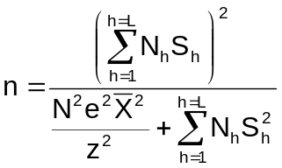 (1)
Where h is the number of strata (from 1 to L), Nh the strata size, N the population size, Sh the standard deviation for h strata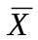 the average GT of the population, e the error of the estimated and z, the typified variable for the confidence level chosen.
The total sample was shared among the strata according to Neyman´s affixation (assignation according to the dispersion) by applying the following formula:
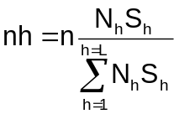 (2)
Where n, h, Nh and Sh are the same statistical variables than in (1)
The use of the formulas previously described doesn’t assure that with the sample size obtained for each stratum, we will have enough representatives in the population contained in each stratum, once we have had proceed to the collection. For this reason, Spain has applied additional criteria that produce a bigger sample size for some strata. For year 2016, over data of 2015 (and as it was for previous year), samples under 2% of its population were increased until they reached the 2%. The total sample size improves the requisite of an expected error of 4% at 95% confidence level.
After applying the considerations and formula already explained, the simple size to investigate in 2016, over the 2015 data, it was of 916 vessels.
For the field work in 2016, 916 vessels ship owners or representatives were visited. Out of these, 165 didn’t give a reply to the survey (negative) and 751 gave a satisfactory reply.
Over the total population comprised by a total of 8.501 vessels, the statistical inference was applied.
Regarding the population size having into account what was initially planned and what finally occurred at the moment of the studio performance, there were no variation, since it was successfully included within the population all the vessels with activity during the reference year. The relationship between what was planned and what was actually done in the size of the survey, there are no significant differences in relation to what was planned.
As for the strata aggregation (clusters), it was considered that in all cases the aggregated clusters are of medium importance, meaning that these are similar strata to what was aggregated. In all the cases, the grouping was among strata belonging to the same supra region.
The groups are as indicated in table III_B_2 of the attached document and all of them are justified by the necessity to preserve the statistical confidentiality in those vessel groups in which there are less than 10 units.
The aggregation followed the principle of most possible similarity; this is, it was grouped the strata with same features.
Capital value and cost value
Capital value and cost value variables are catalogued according to legislation (Decision 93/2010) as economic variables, not transversal. For this same reason, these are considered in this part III.B.1, and in table III.B.3 but not in III.F.1 as set in the foot note on the spread sheet.
Spain calculates the capital value as requested in (EC) Regulation n 199/2008 of the Council following the permanent inventory method proposed in the capital valuation report num. FISH/2005/03 and adapting as far as possible to the spread sheet of the mentioned report.
The original data source of the Spanish fleet is the Operative Fishing Vessel Register of the Ministry of Agriculture and Fisheries, Food and Environment that contains information of the 8693 Spanish fishing vessels that are part the population for the period 2014. It is possible to obtain from this record the data concerning to age and technical features of the vessels. This very same population is what is being used to obtain population data of capital value and cost value.
With these initial data, the data series as planned in the spread sheet is calculated, distributing the vessel number that are part of the Spanish fleet according to their age and put in by segments. For the capacity unit price calculation, the GT is the unit selected for the vessel capacity.
The requested parameters for the calculation are established as follows:
- Depreciation types. To apply the descendent amortization method, original spread sheet types are used (the general assumptions): hull 7%, engine 25%, electronics 50%, other equipment 35%. To apply the lineal amortization method, Spanish legislation types are used. Specifically, it has been consulted amortization coefficient tables of article 12 of Law 27/2014, of November 27, on Corporate Income Tax.
GROUPING 03. FISHERIES
Group 031. Maritime fisheries with vessels and traps
 | Maximun lineal coeficient % | Maximun period (years)
1. VESSELS, AIRCRAFT (Fishing vessels) | 10 | 20
2. MACHINERY (Engine) | 12 | 18
3. ELECTRONIC EQUIPMENT (Electronic Equipment) | 20 | 10
4. TOOLS (Fishing gears) | 25 | 8
(Hull 10%, engine 12%, electronics 20% y other equipment 25%. Valor residual hull 2,5%)
- Use life of each active It has been used also the maximum period proposed for the different actives in the above mentioned Regulation. (Unlimited hull, engine 18, electronics 12, and other equipment 8).
- Sharing of the capital components in the total value. The following percentages are considered:
- Hull 51%
- Engine 22%
- Electronics (electronic equipment) 10%
- Other equipment (fishing gears and other equipment) 17%
This information is obtained from the data collected in the Economic Survey of Maritime Fishing questionnaires, carried out by the Ministry of Agriculture and Fisheries, Food and Environment in the framework of valuation of every active type.
Estimation of capacity unit prices (CUP):
The starting point is the estimation of the capital value. From all the indicators presented, Spain chooses the vessel historical value. By means of the Economic Survey for Maritime Fisheries, it is obtained this information: vessel value (addition of the acquisition price plus repairing and significant transformations that this vessel has suffered since the day of acquisition and that may have modified its value). The vessel gross value is questioned and this must include the significant investments on it during its activity
Therefore, it is used the accounting information provided by the ship owner in the successive collecting data surveys. Since the vessels are stratified by vessel type and length and since the age is known, it can be inferred for vessels with the same features, the value obtained within each stratum and for a certain age. With these estimations, it is established a data base which contains most of the Spanish fleet vessels with a gross value and age. The fleet total value so calculated is used to estimate the price per unit of capacity.
In the “MACRO” approach, which considers the replacement of actives, the price per capacity unit is constant in the whole series of vessel data in the spread sheet. Once the replacement values are calculated, the path established in the spread sheet is used to obtain the depreciation values for the vessels, using the formula as corresponds according to the depreciation method used, decreasing or lineal. In the first method, to calculate the capital opportunity costs, it is used the data of the interest rates as in the Treasure bonds (1.54% in 2015 for 10 year-bonds).
In the “MICRO” approach, which considers the historical active value, the price per capacity unit obtained as explained before, is deflated to the previous years using the Industrial Price Index (IPI), published by the INE (for the division 30. “Manufacture of other transport material”. CNAE-2009, included in the group 3011, “Vessel construction and floating structures”).
On the other side, within this same approach are also used other Industrial Price Indexes to calculate in a non aggregated fashion the engines gross values, on board equipments and fishing gears that comprises the Spanish fishing fleet (“division 28: Manufacture of machinery and equipment n.c.o.o. 26: manufacture of IT, electronic, optic devices and 25: manufacturing of metallic, but machinery and equipment, respectively.
To obtain depreciated vessel values from historical gross data, classified by segments, the procedure is the established in the spread sheet, both as for the decreasing method and the lineal one, as it is also done in the MACRO approach.
In the MICRO approach, for the calculation of interest costs, it is used the interest rate of loans for more than 5 years (5.74% in 2015). Also, it is applied a ratio which measures the indebtedness of the fisheries sector and which is obtained from the values in the Economic Survey of Maritime Fisheries, linking the debts of ship owners with their capital value (14.03% in 2015).
The valuation of the amortized or net capital is requested in Commission Decision, both from the reposition value and historical capital value. In the spread sheet both variables are obtained as the capital costs (annual amortization), also requested in the Regulation. The amortization method is not specified, therefore Spain uses the lineal method and takes, by applying this method the replacement of amortized capital value and historical amortized value as a result of this spread sheet.
Nevertheless, for the Capital Cost (annual amortization) is preferred to consider the resulting value of the Economic Survey instead of taking the data obtained with the spread sheet (PIM), which doesn’t provide with the information with the stratification as requested in the legislation.
On the other side, the ratio that measures the financial situation, also requested by the Regulation, is obtained from the gross replacement value according to PIM method.

III.B.2 Data quality: Results and deviation from NP proposal.
Following the instructions given for the completion of the attached tables, in table III.B.3, it is requested as precision index, the response rate and not the CV, as in previous years
In any case, for our study, each strata of the population was assigned with a sample. The variables obtained in the sample are analyzed measuring its variability. To do so, it is calculated the variation coefficient (CV) of each of the variables measures on each strata. This CV is presented in one unit, adding four decimal ciphers to the CV.
The CV obtained shows us, in general terms, small variations in the measured variables. This means that the results are representative in each stratum.
There are variables that have no information of CV. We can differentiate the following situations:
- NA “Not Applicable”, non applicable variable to the strata and therefore, CV is not applicable.
- “CV in blank” there´s no information, no response for that variable.
- .- CV=0” referring to one of the following cases:
.- No variability = there is value for this variable but values are unique or the same for each of the units.
.- All the values of the strata are= 0.
Amongst the variables under study a few of them are derivative indexes, meaning that they come from another variable in the study and of constant value. Therefore, when it comes to the CV calculation, it is made by the variable CV.
In our case, this happens in national and harmonized EDP variables, which are obtained from the variable “number of hours of work for the crew”, divided by a fixed value of 1.800 for the national EDP and by 2.000 for harmonized EDP.
Therefore, CV values calculated for these variables are the same for CV of the variable “number of hours of work for the crew”.
The variable “Income from the value of quota and other fishing rights” it is considered as NA variable (non applicable) in certain stratum due to the fact that fishing rights cannot be sold or rented, except the trawlers in North Atlantic.
Calculation of the “Value of Non- paid work”
Spain calculated the non paid hours according to the average value of paid hours. For this, the procedure was as follows:
- Difference was made between the paid and non paid worker, being the last one the ship owners and members of his/her family involved in the exploitation of the vessel, for the case of individual companies, with no legal entity.
- After this, working hours have been calculated of the two types of workers, paid and unpaid.
- On the other hand, having the value of the incomes of paid staff, data known from the survey and which is reflected in the variable “salaries and incomes of the crew.
- Lastly, it is calculated the average value of per paid worker hour and it is multiplied by the number of unpaid work:
(Crew salaries and incomes / Paid workers hours) * hours worked by unpaid
This calculation is made from data obtained in the Economic Survey of Maritime Fisheries, referred to the sample vessels by segments and, applying to them the elevation coefficient we get its population value.

III.B.3 Actions to avoid shortfalls.
The entry into force of EU Regulation 199/2008 and Decision of 5th November of 2008, established new framework regarding the Regulations 1543/2000, 1639/2001 and 1581/2004. During 2014, the project of modification of Economic Survey continued. The schedule of collecting and presentation of results finishes its deadlines before ends of year n+1, being n the year of reference which the data belongs to.

III. C. Métier-related variables.

Baltic Sea (ICES areas III b-d).
Spain has no fisheries in this area.

North Sea (areas ICES IIIa, IV y VIId) y Eastern Arctic (areas ICES I y II)
Spain has only fisheries in the ICES Subareas I and II.

III.C.1 Achievements: Results and deviation from NP proposal.
Table III.C.1 shows the identified métiers for sampling according to the ranking system procedures established in Commission Decision. The ranking of the métiers was done using, as reference, the logbook data from 2013 and 2014.
In this area operated two métiers: OTB_DEF_> = 120_0_0 targeting Cod and OTM_DEF_100-119_0_0 targeting Redfish. Sampling is carried out by observers who remain on board throughout the period of the fishing trip. In 2016 trips lasted from few days to 3 months.
Table III.C.4 shows the number of trips planned for sampling during 2016 according to the national sampling scheme.
Table III.C.3 shows the details of the number of sampled trips by métier in 2016.
The commercial fleet performed 13 trips in the Cod fishery carried out by 5 trawlers. Currently the fleet continues landing mostly in Norwegian and German ports. For this reason the average number of days at sea by trip has decreased but the final number of trips has increased.
3 vessels have carried out 3 trips in the Redfish fishery.
Deviations between tables III.C.4 and III.C.3
The métier FPO_CRU_0_0_0 (code L4) was not sampled due confidential data and fishing rights problems. In 2016 days of observation-at-sea were planned for sampling this fishery. However, the uncertainty about the fishing rights of this species (considered sedentary and therefore with exclusive exploitation of the bordering countries up to 300 miles), does not advise its monitoring. In addition, as there is only one vessel in the fishery, the information collected would have to be considered as confidential. Due to these problems, no observation-at-sea in 2016 was conducted.
Table III.C.6 shows the number of individuals sampled for length on the total catch and discards during 2016 for all species in each métier
The data obtained from length sampling, refers to the total catch (unsorted catches) and in some cases from the retained catch.
Discards:
Discards estimation in these fisheries was obtained from sampling performed by observers on board. Such estimates are mainly carried out by quantification and weighing of samples and its extrapolation haul by haul.
Discard is forbidden in some areas. Besides, the fisheries are monospecific therefore the discards level is very low.

III.C.2 Data quality issues.
The data collected by observers on board are checked later on, at the laboratory. Data have been used for carrying out the assessment at AFWG. Both, sampling levels and data quality, are considered adequate.
Data of each trip are collected and recorded on board. Data are checked during and after the trip in order to detect errors and inconsistencies (outliers, trends, range of variables, dispersion).
After the trip, the observer debugs all data, haul by haul and sampling by sampling. Finally, a random check of about 15% of the data is carried out to validate the quality of the results. Annually, and for each fishery, all sets of data are checked previously to be used for assessment and other scientific tasks.

III.C.3 Actions to avoid deviations.
The main cause of the deviation is the lasting of the trips in these fisheries and the unpredictability of the permanence of observers in fishing areas due to the decisions taken by vessels' owners in the way of moving vessels among areas. Although the behavior of the fleet is impossible to change, the Institutes involved in sampling will continue in improving coordination with the sectors involved: owners and administration authorities.

North Atlantic (ICES areas V-XIV and NAFO areas).

ICES VI, VII (excl. VIId), VIII, IX

III.C.1 Achievements: Results and deviation from NP proposal.
Table III.C.1 shows the identified métiers for sampling according to the ranking system procedures established in Commission Decision. The ranking of the métiers was done based in logbook and sales notes data from 2013 and 2014.
Table III.C.4 shows the number of trips planned for sampling during 2016 according to the national sampling scheme.
Table III.C.3 shows the details of the number of sampled trips by métier and fishing ground in 2016.
Deviations between tables III.C.4 and III.C.3
In general, the majority of the planned sampling targets (III.C.4) were achieved.
Differences are mainly the result of the fleet activity and adjustments in the sampling program of both scientific institutions involved, IEO and AZTI, to integrate the guidelines and recommendations of expert groups to move towards a sampling scheme more statistically robust.
AZTI is moving towards a Statistically Sound Sampling Scheme (4S) design and implementation for its on-shore and at-sea sampling programmes. As part of this movement, in 2015 the artisanal fleet started to be sampled on-shore through a dedicated sampling scheme. The sampling has carried out in 2016. Although the sampling of the métiers GNS_DEF_>=100_0_0, GNS_DEF_60-79_0_0, GTR_DEF_60-79_0_0, and LLS_DEF_0_0_0 was not planned in the AZTI design, their sampling results are reported in the present Annual Report.
IEO is sampling according to a fleet stratification to be consistent with last years work and ensure the provision of data to end-users. Recommendations from expert groups such as WKPICS and WGCATCH are being integrated step by step to improve current sampling scheme and allow a better transition towards a fully statistically sound approach. As part of this work a revision of the sampling scheme to incorporate some of these changes led to some modifications in the sampling trips’ planification for 2016 in some activities.
1-Market sampling
1.1-Iberian fishing ground
a) Results achieved below to what was planned
FPO_MOL_0_0_0 (code I31): 47 sampling trips were achieved in 2016. The revision of the sampling design of this métier in 2014 showed that all the effort was being concentrated on landings from Division IXa. One sampling location was changed in order to cover the activity in Division VIIIc and a slight reduction of the sampling effort was established. According to this new design only one trip is missing in 2016, a good sampling coverage which improve 2015 results.
GNS_DEF_>=80-99_0_0 (code I33): 62 out of the 72 planned were completed due mainly to occasional problems to get this metier in Finisterre. Instead of getting this métier, the sampling team got a better coverage of GNS_DEF_60-79_0_0 due to its major landing frequence and importance in the port (1353 trips GNS_DEF_60-79_0_0 compared to 353 trips of GNS_DEF_>=80-99_0_0). These results would be, in fact, much more similar to a random 4S scenario in this port.
GNS_DEF_>=100_0_0 (code I34): A reduction was established by IEO in this métier for 2015 setting the final target in 60 trips. As explained last year, this was done to allow an increase of the sampling effort in other métiers. A target of 60 is in line with historical data provision, proves to provide a well coverage of the activity and no impact in the data provision is expected. This métier operates along the northern Spanish coast and their landings are very distributed among several ports. The sampling of this activity covers the most relevant ports (Cedeira, San Vicente de la Barquera and Santoña) with the addition of Bermeo (Basque Country) since 2015 due to changes of the sampling scheme by AZTI. 53 sampling trips out of the 60 originally planned 88% compliance) were completed in 2016.
LHM_DWS_0_0_0 (code I36): There is not any problem concerning the sampling of this métier. As explained every year, this is the only case in the Spanish Sampling Program where the numbers in table III.C.4 refers to number of events instead of number of trips. The daily landing of all boats is gathered in port and classified by commercial categories of sea bream (P. bogaraveo), so trips can not be differentiated when the biological sampling is performed.
LHM_SPF_0_0_0 (code I37): 55 out of 81 trips originally planned. Fishing effort kept constant but changes in the fleet behaviour led to a decrease of the trips landed in Basque ports. This reduced the probability of selecting those trips in a random procedure within the artisanal stratum (which is accounting for a high variability of fishing gears along the year). The reduction is understood as a consequence of the new probability based sampling design, the same way that other artisanal activities were more sampled. Anyway, the sampling design will be revised in order to cover those changes in fleet behavior.
OTB_DEF_>=55_0_0 and OTB_MPD_>=55_0_0 (code I41): Only IEO samples this fleet. A reduction was established in 2016, setting the final target in 180 trips instead vof 216 originally planned, out of which 176 were made.
b) Results achieved above to what was planned
Changes in the IEO and AZTI sampling design during last two years led to a clear surpass of the original trips planned in 2015. Specially, this is the case for some artisanal fleet which AZTI started to sample through a dedicated sampling scheme in 2015 due to its move towards a Statistically Sound Sampling Scheme. This sampling, not originally planned, is reported in the present Annual Report:
In the GNS_DEF_60-79_0_0 fishery (code I32), IEO surpassed the original planification, so adding the new AZTI contribution led to a 184% compliance. This fishery represents one of the most relevant activities with 24422 fishing trips in 2016.
Same situation arrived to LLS_DEF_0_0_0 (code I38), where the 122 sampled trips overcome the 84 originally planned.
For the GTR_DEF_60-79_0_0 (code I35), which was not planified in the original programme, the move towards a statistically sound sampling scheme led to obtain 55 fishing trips, improving the results of the serie started in 2015.
PS_SPF_0_0_0 (code I42) was already included in both institutes sampling programmes. 529 trips were achieved out of the 424 originally planned. Explanation about the deviation in the sampling of this metier is provided in the next section (1.2 Bay of Biscay fishing ground).
1.2 Bay of Biscay fishing ground
a) Results achieved below to what was planned: small differences in bottom trawlers (code I45 and I47). IEO reduced the coverage for 2016 according to the reduced effort deployed by the fleet in this area.
b) Results achieved above to what was planned
LLS_DEF_0_0_0 (code I44): 36 ‘concurrent at the market’ samplings were achieved out of the 24 planned, thus achieving a 196% of compliance. The already mentioned changes in AZTI’s sampling program led to sample 11 trips not originally planned in Bay of Biscay, increasing the percentage of compliance.
GNS_DEF_60-79_0_0 (code I55): 3 trips were accomplished. This métier showed no activity in Bay of Biscay before 2015 and very scarce afterwards. It appeared within the sampled trips due to the changes in AZTI to move towards a more statistically sound sampling program following WKPICKS and WGCATH guidelines. It is convenient to take into account that this metier is typical of the North-western Spanish coast, which is extended mostly along the ICES Division 8c. However, Basque Country also has jurisdictional waters in Division 8b, where that métier can operate.
PS_SPF_0_0_0 (code I46): 209 trips were sampled, although only 30 were planned. Equally to last two years, this deviation is explained mainly through the monitoring AZTI did on the anchovy fishery. Basque purse-seiners operate in area VIIIc and VIIIb depending on the availability of the resource. It is difficult to plan the exact number of trips to sample in each area. Besides, this métier has increased its effort in this area after the recovery of the anchovy stock and, thus, the number of trips sampled from both VIIIb and VIIIc has increased.
The most appropriate sampling frame both for AZTI and IEO should include purse-seiner trips for both areas (VIIIc and VIIIb) to solve this problem. The number of planned trips needs also to be increased. The plannification was changed for the NP 2017-2019 (EU-MAP).
1.3 West of Ireland and West of Scotland fishing grounds
a) Results achieved below to what was planned
LLS_DEF_0_0_0 (code I49): 32 ‘concurrent at the market’ samplings were achieved out of the 36 planned. Two of them in Celtic Sea (VIIh) and one in the West of Scotland, which are adjacent Divisions (it is not possible for the samplers at port determine in which exact ICES Division the boat operated).
OTB_DEF_70-99_0_0 (code I50): 23 ‘concurrent at the market’ samplings out of the 36 planned originally could be accomplished. This result is in line with 2015 achievements and is due to a steady decrease of the Spanish fleet. As stated in the 2015 national programme report, we modified our sampling effort to 24 trips in 2016. Therefore sampling objectives are fulfilled.
OTB_DEF_100-119_0_0 (code I51, I52): 23 trips accomplished. The high reduction in the effort of this métier during last years explains these results. This fleet only made 100 trips in 2016 from which 23 were sampled. This show the sampling effort deployed and the difficulties to maintain these levels. This situation seems to be permanent; therefore the sampling objectives (established in 34 trips) should be reduced.
b) Results achieved above to what was planned: there were no results above to what was planned in this fishing ground.
2. On board sampling for discards
In the on board sampling results go on with the 2015 achievements showing a general improvement compared to previous years.
a) Results achieved below to what was planned:
OTB_DEF_70-99_0_0 and OTB_DEF_100-119_0_0 (code I50, I51 and I52): 15 trips out of 17 were sampled. This is considered a good result considering the mentioned sharp reduction in the effort of the second métier in recent years.
OTB_MCD_>=55_0_0 (code I40): 53 trips achieved. IEO have improved the sampling protocol of this metier during to 2016, applying a random selection of vessels and recording the refusals. Besides, retained and discarded fractions ar now sampled in all trips, not alternately as in previous years, because it led to differences in the sampling coverage of landings and discards.Under this scheme it was needed a reduction of the trips observed while the information provided was in line with previous years (in terms of trips sampled for discards and for the landing fraction). Once proved during 2016, samping of this fleet will move around this total numbers (trips as PSUs) in the EUMAP and following years.
b) Results achieved above to what was planned
GNS_DEF_60-79_0_0, GNS_DEF_80-99_0_0 and GNS_DEF_>=100_0_0 (codes I32, I33 and I34) were surpassed (in line with good results obtained in 2015).
PS_SPF_0_0_0 (code I42): 44 on board trips were sampled in Iberian fishing ground. This is mainly the effect of a complete change of sampling strategy in the Division IXa (Gulf of Cadiz). On-shore concurrent sampling was changed to on-board sampling scheme in 2014. This modificationmade surpass the on-board sampling trips initially planned in the Spanish Sampling Program.
Results were slightly surpassed in other activities as the PTB_MPD_>=55_0_0 (code I43) and OTB_DEF_>=70_0_0 and OTB_MCF_>=70_0_0 (code I45) due to an improvement in the random selection of vessels.

Table III.C.6 shows the number of individuals sampled for length on the total catch and discards during 2016 for all species in each métier.

III.C.2 Data quality issues.
Sampling levels and quality of the data obtained are, in general, considered adequate.
The provision of length distributions of the main species subject to regulation remains in line with the data provision to groups assessed by ICES for the last years.
The quality of the length distributions, sampled on-shore has been tested through a joint exploration of all lengths by species and by métier for the detection of outliers. In the IEO this analysis was conducted through tools from the COST package. This methodology takes into account the sampling design and the different stratifications (geographic and temporal). This quality process was satisfactory for selected species, invalidating only a few samples whose distributions were considered not suitable in the statistical analysis. In AZTI, length distributions were analyzed and checked by stock coordinators to detect outliers and anomalous registers.
The actions undertaken to strengthen the quality of the data also covered the changes in the database and the cross-checking of the sampled trips with logbooks and sales notes provided by the national authorities. This allowed, following recommendations of RCM NA, an analysis of the landings profiles available from the different sources thus allowing a reduction of errors. During this process a revision of the métier assigned to each trip is also made. The exact geographical allocation of the trip is also provided by this cross-checking process which implies a greater capacity for analysis of the spatial coverage of the sampling.
In the IEO and AZTI on-board programme, a random selection procedure of the trips based on a list was implemented following the recommendation of sampling experts groups (SGPIDS, WGCATCH). The result is a general improvement in the quality and, surprinsingly, in the sampling coverage. The register of the refusals have led to obtain positive answers in some components of the fleet that were highly reluctant to be sampled in the past. Protocol is still being developed in light of the analysis of 2016 data to ensure this positive trend can be fully exploited.

III.C.3 Actions to avoid deviations.
At market, deviations from the planning correspond to two factors: a) the variability of fishing activities and b) the new sampling procedures established to be aligned with a more statistical sound sampling approach.
A complete new planification has been established for 2017 considering the statistical approach and starting a fully documentation of the procedures. In this sense, it’s expected an improvement between new planification and future results.
Nevertheless the variability of the fishing activities will remain always as a factor that affects the expected results and have to be considered.
Other factors could affect the results. In the case of IEO, changes in the planification are not possible immediately as the sampling work is carried out by a sub-contracted firm. This contract lasts for more than one year (two or more) so any modifications of the planned sampling established in the contract cannot be done immediately.
And finally, difficulties to access the fish persist. This is a relevant factor especially for on board sampling. The degree of cooperation with the fisheries sector is variable among fleets and among ports, but it should improve. To overcome these difficulties a continuous effort from the sampling teams to achieve the objectives is needed and we are not yet sure about how it will evolve with the “landing obligation” during next years.

NAFO and ICES XII, XIV

III.C.1 Achievements: Results and deviation from NP proposal.
Table III.C.1 shows the identified métiers for sampling according to the ranking system procedures established in Commission Decision. The ranking of the métiers was done using, as reference, the following:
- In ICES Subareas XII, XIV, data obtained from 2013 and 2014 logbooks.
- In NAFO Regulatory Area, data from NAFO observers (100 % mandatory on board commercial fleet) for 2013 and 2014.
In ICES Subareas XII, XIV two métiers operated in 2016:
OTB_DWS_100-129_0_0 (Hatton Bank): trawlers targeting deep-sea species in ICES Division XIIb and VIb.
OTM_DEF_100-129_0_0: trawlers targeting Redfish (Sebastes mentella) and, since 2010, targeting also Roundnose grenadier (Coryphaenoides rupestris). Both are monospecific fisheries located in ICES Subareas XII and XIV (Irminger Sea). The effort is shared between the two fisheries using pelagic trawls.
In NAFO Regulatory Area, 3 métiers operated in 2016:
OTB_MDD_130-219_0_0: Greenland halibut fisheries- (Reinhardtius hippoglossoides)
OTB_MDD_>=220_0_0: Thorny skate fisheries- (Raja radiata)
OTM_DEF_130-135_0_0: Alfonsino fishery (Beryx splendens). In 2014, NAFO SC requested to carry out the monitoring of Alfonsino stock. For this reason sampling on board was planned for a new métier named OTM_DEF_130-135_0_0 from 2014 onwards. It is a very marginal métier because there is a single fishing vessel targeting Alfonsino for only a few days a year.
In both, ICES Subareas XII and XIV and NAFO Regulatory Area, sampling is carried out by scientific observers in all métiers. The observers remain on board the whole trip, which can last about 2-3 months or even a few days; depending on fishing strategies and the owners’ decisions.
Table III.C.4 shows the number of trips planned for sampling during 2016 according to the national sampling scheme.
Table III.C.3 shows the details of the number of sampled trips by métier and fishing ground in 2016.
Deviations between tables III.C.4 and III.C.3
Sampling frame code L3
In 2016 there has been a higher number of observer trips than those initially planned due to the fleet tendency to shorten the trips which means a greatest number of observed trips although this not means an increase in the number of observation days at sea per year.
Usually vessels operating in this area have licences to use several fishing gears in the same voyage, thus, they can operate in several métiers. Observers are allocated to vessels when they leave the port in Spain and there is no accurate information about the vessel activity plan for the months that the trip lasts (fishing gear to use, fishing areas to fish,…). Thus, it is difficult to predict in advance which métiers are going to be sampled during a same voyage. Therefore, each time the vessel operates with different métier; it is considered that it is a different observed trip.
9 voyages with scientific observers on board were carried out. These 9 observers collected data from 15 different observed trips obtaining the following coverage by métier.
-OTB_DWS_100-129_0_0: These observers collected data from 1 observed trip in this métier.
-OTB_MDD_130-219_0_0: These observers collected data from 7 observed trips in this métier targeting R. hippoglossoides
-OTB_MDD _> = 220_0_0: These observers collected data from 6 observed trips in this métier targeting Raja radiata
-OTM_DEF_130-135_0_0 targeting Alfonsino in NRA Division 6G: Only one vessel operated with few days of effort in one trip and 1 observer collected data form it.
Table III.C.6 shows the number of individuals sampled for length on the total catch and discards during 2016 for all species in each métier.
As it was explained before, observers in these areas, remain on board the vessels for the whole trip and the vessels can operate with several fishing gears and in different areas within the same trip. Fishing gears and fishing areas depend on the decisions taken by the owners and captains, so it is difficult to achieve the planned sampling.
In NAFO regulatory area, species as American plaice (Hippoglossoides platessoides), Witch flounder (Glyptocephalus cynoglossus), Cod (Gadus morhua) stock 3NO and stock 3L, and Yellowtail flounder (Limanda ferruginea) have TAC = 0. Therefore the number of individuals sampled at the national level was not planned a priori.
The Shrimp fishery (Pandalus borealis) in NAFO Regulatory Area Division 3M and 3L are under moratorium.
In these cases, the individuals sampled are by-catch, that makes its sampling very difficult, however, scientific observers carry out length sampling of unsorted catches and discards of several of these species whenever possible.
The data obtained from length sampling, refers to the total catch (unsorted catches) and NOT to the retained catch.
Discards:
Discards estimation in these fisheries was obtained from sampling performed by observers on board. Such estimates are mainly carried out by quantification and weighing of samples and its extrapolation haul by haul.
The length samplings are carried out on samples of the total catch taken randomly before being sorting out by the crew. In addition length distributions of discards in most of the target species were also obtained.
In the NAFO Regulatory Area, the fishery trend is to reduce discards and the sampling possibilities are also reduced, so there are few hauls with significant quantities discarded where sampling can be performed.

III.C.2 Data quality issues.
The data collected by observers on board are checked later on, at the laboratory. Data have been used for carrying out the assessment at ICES-WGDEEP and ICES-NWWG and at NAFO Scientific Council. Both, sampling levels and data quality are considered adequate.
Data of each trip are collected and recorded on board. Data are checked during and after the trip in order to detect errors and inconsistencies (outliers, trends, range of variables, dispersion).
After the trip, the observer debugs all data, haul by haul and sampling by sampling. Finally, a random check of about 15% of the data is carried out to validate the quality of the results. Annually, for each fishery, all sets of data are checked previously to be used for assessment and other scientific tasks.

III.C.3 Actions to avoid deviations.
The main cause of the deviation is the lasting of the trips in these fisheries and the unpredictability of the permanence of observers in fishing areas due to the decisions taken by vessels' owners in the way of moving vessels among areas. Although the behavior of the fleet is impossible to change, IEO will continue in improving coordination with the sectors involved: owners and administration authorities.
In NAFO Regulatory Area, some species are under moratorium, and this causes deviations in sampling that are impossible to avoid. However, we are trying to increase the number of samplings of these species and the samplings of discards through a better training and a monitoring of the observers’ tasks. In addition, we prioritize the placement of experienced observers whenever possible.

Mediterranean and Black Sea.
Spain has no fisheries in the Black Sea.
As in tables, text explanations are divided by RFMO.

GFCM (Fisheries targeting small pelagics, demersal, crustaceans and cephalopods)

III.C.1 Achievements: Results and deviation from NP proposal.
The collection and analysis of métier related variables has been performed at Geographical Sub Area (GSA) level. The Spanish Mediterranean comprises 5 GSAs.
-GSA01, Northern Alboran Sea
-GSA02, Alboran Island
-GSA05, Balearic Islands
-GSA06, Northern Mediterranean
-GSA07, Gulf of Lion
The main métiers were selected in each GSA following the Ranking System rules. The sampling strategy to carry out the concurrent sampling depends on the fishery and the market. Length sampling in trawlers and trammel nets is performed by observers on board in all GSAs, while length sampling in purse seiners, set longliners, pots and lampara nets is performed at the market. The selected sampling scheme was the scheme 1: comprehensive sampling of all species.
The total number of species sampled was 91 species in the GSA01, 35 species in the GSA02, 75 species in the GSA05, 110 species in the GSA06 and 68 species in the GSA07.
Although in most of the areas there are not problems to access the vessels, the rate of refusals is occasionally high, which causes failures of sampling coverage. Additionally, the bad weather conditions limit the presence of observers on board in many cases, due to safety restraints. The enforcement on temporary/seasonal biological closures, decided at national or regional level on a short-term basis, often prevent a correct planning one year ahead. Finally, as all the sampling work is carried out by a sub-contracted firm, whose contract lasts for more than one year (two or more), any modifications of the planned sampling established in the contract cannot be done immediately.
Table III.C.1 reflects the métier identified in each GSA: the highlighted métiers are the métiers selected to sampling following the Ranking System described in the Commission Decision. To perform the ranking, the most recent sale notes have been taken into account (years 2013 and 2014).
Table III.C.4 shows the sampling design at national level and the number of trips planned for 2016.
Table III.C.3 shows the number of fishing days/trips sampled by métier and GSA.
Deviations between tables III.C.4 and III.C.3
In both tables (III.C.4 and III.C.3), some new métiers selected for the first time when performing the ranking with the most recent data (2013 and 2014), were added.
Among the new métiers selected for sampling, DRB_MOL_0_0_0 appears in the GSA01. The target species of hydraulic dredges (Callista chione, Chamaelea gallina, Donax trunculus y Acantocardia tuberculata) are not considered important to be sampled in the western Mediterranean because these species do not appear in Appendix VII of the Commission Decision where sampling obligations are established. We therefore ask for exemption of sampling this métier.
Results achieved below to what was planned:
In some cases, it was not possible to reach the number of trips planned to sample during 2016 due to the following reasons:
GSA01
- OTB_DEF_>=40_0_0, concurrent at sea (code M1C). Observers experienced problems in finding vessels to sample, being the main reasons of refusals to access to vessels, the safety measures or the high number of people already on board.
- GTR_DEF_>=16_0_0, concurrent on shore (code M3C). The artisanal fleet has not fished in this métier in three months along 2016. In addition, the scientific personal has difficulties to find vessels to sample, due to the low collaboration of the fishermen.
- OTB_DWS_>=40_0_0, market stock specific sampling of Aristeus antennatus (code M5S). The number of planned samplings was completed adding the samplings carried out in the landings of A. antennatus from the GSA02. In Almería is landed Aristeus antennatus from the GSA01 and the GSA02.
GSA05
- GTR_DEF_>=16_0_0, market stock specific sampling of Mullus surmuletus (code M7S). This is a seasonal fishery and thus the sampling scheme cannot cover all the year long.
- LA_SLP_14_0_0, concurrent at sea (code M10C). The fishery of Coryphaena hippurus in Mallorca is a seasonal fishery. During the season there were some technical problems that made difficult the full sampling.
GSA06
- GNS_DEF_>=16_0_0, concurrent at sea (code M15C). We cannot carry out all planned sampling in the months which the fishery is active. In addition, the scientific staff has difficulties to find vessels to sample, due to the low collaboration of the fishermen.
- OTB_DWS_>=40_0_0, concurrent at sea (code M17C). Part of the sampling has been done in OTB_DEF because the fishermen decided to change the target species once the observer was already on board.
GSA07
- OTB_DEF_>=40_0_0, concurrent at sea (code M19C). Part of the sampling has been done in OTB_DWS because the fishermen decided to change the target species once the observer was already on board.
Results achieved above to what was planned:
They were performed more samplings than planned in two métiers OTB_DEF_>=40_0_0, concurrent sampling in the GSA06 (code M12C), and OTB_DWS_>=40_0_0, concurrent sampling in the GSA07 (code 21C). The trips that were not done in OTB_DWS_>=40_0_0 of the GSA06 and OTB_DEF_>=40_0_0 of the GSA07 were done in these métiers.
When the observers had problems to sample the métier GNS_DEF_>=16_0_0 in the GSA06 or the métier LA_SLP_14_0_0 in the GSA05, they changed to métier GTR_DEF_>=16_0_0 and OTB_DWS_>=40_0_0 respectively. For this reason the number of samples of GTR_DEF_>=16_0_0 of the GSA06 (code M13C) and OTB_DWS_>=40_0_0 of the GSA05 (code M9C) are so high. So it was achieved a higher quality in the calculation of length distribution of main species, and they will be used in the assessment of Mullus spp of the GSA06 and Aristeus antennatus of the GSA05.
Finally, they were performed more samplings than planned in some métiers (PS_SPF_>=14_0_0, concurrent sampling in the GSA06 (code M14C), LLS_DEF_>=0_0_0, concurrent sampling in the GSA06 (code M18C), and LLS_DEF_0_0_0, stock specific sampling in the GSA07 (code M20S) with the purpose of achieving a higher quality in the calculation of length distributions of main species. The improving of length data will be used in the assessment of small pelagic of GSA06, and Merluccius merluccius of GSA06 and GSA07, respectively.
Table III.C.6 shows the sampling level (number of individuals sampled by species) in 2016. The number of individuals sampled is presented by métier for all species.
Discards
Discards have been sampling in the OTB métiers, following the exception rules of Commission Decision and the Regional Coordination Meeting of the Mediterranean and Black Sea 2009 (Table 3.3.4 – Priorities for sampling effort for discards).
In general, the volume of discards in the area 1.1 (Spanish Mediterranean) does not exceed a 10% in weight or 15% in number, so length sampling of the discarded fraction was not carried out. This estimate is based on pilot experiences in different ports. The discards of the target species in 2016 have not exceeded the 10% of the weight of the catch, except the discard of Octopus vulgaris in the GSA01 and GSA05, Merluccius merluccius in the GSA01, and Lophius piscatorius, Micromesistius poutassou and Nephrops norvegicus in the GSA05. These percentages are variable from one year to another.
% % Discards in the GSAs of the Spanish Mediterranean (2016)
Species | GSA1 | GSA2 | GSA5 | GSA6 | GSA7
A.antennatus | 0.03 | 0.57 | 0.34 | 0.05 | 0.20
E. encrasicholus | - | - | - | - | -
L. budegassa | 5.23 | 0.00 | 1.23 | 6.40 | 0.00
L. piscatorius | 10.00 | 0.00 | 22.62 | 0.28 | 1.85
M. merluccius | 13.30 | 0.00 | 0.84 | 3.15 | 1.64
M. poutassou | 6.42 | 0.00 | 40.52 | 1.27 | 1.35
M. barbatus | 2.38 | - | 0.00 | 3.61 | 3.65
M. surmuletus | 0.17 | - | 0.63 | 2.74 | 0.00
N. norvegicus | 0.00 | 0.00 | 14.34 | 1.94 | 1.45
O. vulgaris | 14.51 | - | 17.52 | 9.48 | 0.00
P. longirostris | 1.76 | - | 1.44 | 1.74 | 1.44
S. pilchardus | - | - | - | - | -
S. colias | - | - | - | - | -
S. scomber | - | - | - | - | -
T. mediterraneus | - | - | - | - | -
T. trachurus | - | - | - | - | -

III.C.2 Data quality issues.
Length data are collected by cm, ½ cm or mm, according to species. Detailed length classes are:
Specie | Length measure | Length class range (cm or g)
Aristeus antennatus | Caparace length | 0.2
Engraulis encrasicholus | Total length | 0.5
Lophius budegassa | Total length | 2.0
Merluccius merluccius | Total length | 1.0
Micromesistius poutassou | Total length | 1.0
Mullus barbatus | Total length | 1.0
Mullus surmuletus | Total length | 1.0
Nephrops norvegicus | Caparace length | 0.1
Octopus vulgaris | Weight | 100
Parapenaeus longirostris | Caparace length | 0.1
Sardina pilchardus | Total length | 0.5
Scomber colias | Total length | 1.0
Trachurus mediterraneus | Total length | 1.0
Trachurus trachurus | Total length | 1.0

In general, although some métiers suffered from under-sampling in some areas, the sampling level of the main stocks can be considered successful and these data is the basis of the annual assessments to be presented in the framework of the different stock assessment working groups (WGSADEM and WGSASP of the GFCM).
Discards.
Quarterly estimate of the length distribution of discards is not compulsory when discards represent, on an annual basis, less than 10% of the total catches by weight or less than 15% of the catches in numbers for the Group 1 and Group 2 species (Decision of the Commission).

III.C.3 Actions to avoid deviations.
It is necessary to note that unexpected events can alter the planning and these events (refusals, bad weather conditions, unexpected biological closures) can not be avoided or envisaged. However, big efforts are put every year in order to avoid deviations not dependent of unpredictable things.

ICCAT (Fisheries targeting large pelagics)

III.C.1 Achievements: Results and deviation from NP proposal.
Table III.C.1 shows the Métiers identified to be sampled following the ranking system established by Commission Decision. The ranking system was made using public data of ICCAT database and information of SGP (electronic fishing logbooks and sales notes) for the period 2013-2014.
Table III.C.4 shows the number of trips planned to be sampled at national level in 2016 and table III.C.3 shows the number of fishing trips sampled during 2016.
Deviations between tables III.C.4 and III.C.3
Drifting longlines (codes T1): The number of fishing trips along 2016 was under the expected one due mainly to problems with the fleet availability. This sampling below the planning affects mainly to trips targeting swordfish.
Purse Seine Cartagena and Tarragona (code T3): Length data from this métier are not currently available. All the catches of purse seines in 2016 went to fattening cages; as a consequence, the length sampling from purse seine will take place later, after slaughtering. This data are annually submitted to ICCAT with a delay of one year, for this reason data on this métier are not included in Table III.C.3. The fishing operations and subsequent caging operations of Bluefin tuna are monitored by Spanish observers from SGP, and also by ICCAT independent observers.
Table III.C.6 summarizes the length sampling of catches, landings and discards with the number of fish measured by species, fishing ground and Métier during 2015. The sampling scheme used was the concurrent sampling (Scheme 1) as defined in Commission Decision. The methodology for collecting data and the data type is made according to the ICCAT manual.
(http://www.iccat.int/en/ICCATManual.htm).
Deviations of table III_C_6
The number of fish measured was greater than the number of fish planned due to the fact that the number of fish planned to be measured at national level in the National Program is a minimum. The aim is to reaching the precision level established by Commission Decision.

III.C.2 Data quality issues.
The main problems in large pelagic fisheries are the wide range of length distributions and the huge weight range of the individuals. There are trips with landings of kg. and trips with landings of tons. The data quality of sampling is considered satisfactory.

III.C.3 Actions to avoid deviations.
Deviations are due to problems inherent to the large pelagic fisheries. The objectives are considered achieved and no additional measures are proposed.

Other Regions where fisheries are operated by EU vessels and managed by RFMO’s to which the Community is contracting party or observer.

CECAF
Three fishing grounds are considered for CECAF: “Madeira”, “Canary” (both being in EU waters) and “From Morocco to Guinea Bissau” (waters outside the EU) (RCM-LDF, Cádiz, Spain, June 2015). The Spanish fisheries in the CECAF area are developed both in national waters (in the Canary Islands) and in external waters of West Africa.
The fishery targeting cephalopods and finfish, which was called “OTB_CEP_>=70_0_0” in previous reports, is renamed to métier “OTB_MCF_>=70_0_0 in the current one, following the RCM_LDF_2015.

III.C.1 Achievements: Results and deviation from NP proposal.
Table III.C.1 includes the métiers selected for sampling by using the ranking system established by Commission Decision, in this case based of landings (or catch) and effort data. Different sources were used to compile this fishery information: sale notes in the landing ports, logbooks from the SGP, data from the IEO Information and Sampling Network, and information provided by the National Association of Crustacean Freezer Shipowners (ANAMAR). The reference year period considered was 2011-2013, instead of 2013-2014 (preferred for other fisheries), as it better reflects the most regular situation of the fisheries carried out in the West African fishing grounds of CECAF. Economic ranking could not be performed as economic data are not available for all métiers. Some of the planned objectives for 2016 could not be completely accomplished due to different reason explained below.
Table III.C.4 shows the number of planned trips to be sampled during 2016, as established by sampling schemes at national level. Table III.C.3 shows the number of sampled trips during 2016.
Deviations between tables III.C.4 and III.C.3
Fishing Ground- From Morocco to Guinea-Bissau:
Achieved below planned
-.PS_SPF_0_0_0. (targeting anchovy). (code C1): Fleet of artisanal purse seiners from Barbate (South Iberian Peninsula) operating in North Morocco and conducting daily trips. It was not possible to accomplish the planned objectives due to the discontinuous activity of this fleet during 2015 and 2016, the first two years of the current protocol. Only 3 fishing trips (one of them with no landings) were sampled at sea vs. the number of 9 fishing trips planned. It should be noted that samplings onboard this fleet were planned in order to estimate discards produced by this fleet in case it would reach levels that involve its regular sampling under the DCF, although in principle this is not expected for purse seine fisheries due to its highly selective character. On the other hand, 7 fishing trips on shore (Market stock-specific sampling-anchovy- code C1-ss) were achieved in relation to the total number planned (30).
-.OTB_DEF_>=70_0_0 (targeting black hake) (code C3): During 2016, 7 trawlers (3 fresh and 4 freezer) targeting black hake operated from Morocco to Senegal. Observations onboard were carried out in 11 fishing trips, 7 in Mauritania and 4 in Morocco.4 out of the 48 planned trips to sample on shore and 1 at sea (vs. 12 planned) were not achieved due logistic problems in relation to the beginning of the annual activity of the observers and samplers network.
- OTB_CEP_>=70_0_0 (targeting cephalopods) (code C4): Industrial fleet of freezer trawlers targeting cephalopods and finfish operating in Guinea Bissau in 2016. Only one trip from the four planned was not achieved due to the unavailability of vessels for hosting an observer onboard.
- OTM_SPF_>=40_0_0 (targeting small pelagics) (code C5): The current Protocol of the FPA forces the European fleet to land in the coastal States: 25% of the catches per trip (in the FPA EU-Morocco) and all catches except those from the last trip preceding the vessel's departure from Mauritanian fishing zones for a period lasting not less than three months (in the FPA EU-Mauritania). In the last case, the last trip could be landed in the Canary Islands (usually in Puerto de La Luz, Gran Canaria Island). However, no samples of the vessel landing in Las Palmas could be obtained by the IEO in 2016, mainly due to the important decrease of the landing frequency in this port. (Only one fishing trip of a EU pelagic trawler was known to land in Las Palmas)
Achieved above planned
- OTB CRU>=40_0_0 (targeting shrimps) (code C2): One sampling trip more than planned has been carried out (5 vs 4), trying to adapt the observers boarding to the vessels best convenience of hosting them. In addition, fishing trips in 2016 have been shorter and the total effort covered has not change very much from previous years
Fishing Ground-Canary:
Achieved below planned
- PS_SPF_10_0_0 (targeting small pelagics) (code C6): Fleet of purse seiners operating in the Canary Islands and conducting daily trips at night. Landings are spread in several ports, depending on the weather conditions and the resources location. In 2016, the number of concurrent samplings (5) was less than planned because more than one fishing trip by effort unit (fishing day) were performed sometimes and the on-shore sampling did not cover both trips. Regarding the stock specific sampling on-shore (code C6-ss) 3 out of the 48 planned trips were not covered due to logistic problems in relation to the beginning of the annual activity of the observers and samplers network.
Achieved above planned
- MIS_DES_0_0_0 (artisanal targeting demersal species) (code C7): Polyvalent and multi-species artisanal fleet fishing demersal species with small gears (traps, hooks, nets) and conducting daily trips in the Canary Islands. The number of sampled trips at sea (28) exceeded the planned sampling (12) for a better coverage of the variety of fishing gears used in this artisanal fishery.

Table III.C.6 shows the number of individuals measured from total catch and discards, by species and by métier in 2016.
Discards:
From Morocco to Guinea-Bissau:
As previously explained, discard samplings on board vessels from the métier PS_SPF_0_0_0 could not be carried out successfully for 2016, due to their irregular fishing activity in the Moroccan fishing ground during this year.
Discards have been analyzed in the métier OTB_DEF_> = 70_0_0, due to the possibility of having observers onboard demersal trawlers after four years without samplings at sea, The conditions of habitability and safety have been improved in some vessels, allowing regular samplings from a scientific observer on-board throughout 2016.
Canary:
Although discard samplings of the métier MIS_DES_0_0_0 are not planned (multispecific fishery where many species are commercialized), the observations onboard this fleet, allowed collecting information on the discards produced by this fleet.

III.C.2 Data quality issues.
The data collected by observers on board are recorded in data bases ad hoc and subsequently checked at the laboratory, in order to detect errors and inconsistencies (outliers, trends, range of variables, dispersion). Annually, for each fishery, all data sets are checked before being used for assessment and other scientific tasks.
Data are used for different purposes at the Joint Scientific Committees between the EU and Guinea Bissau, Mauritania, Morocco.
In addition, they are used for assessment in the FAO/CECAF assessment Working Groups.
Both, sampling levels and data quality are considered adequate.

III.C.3 Actions to avoid deviations.
The reasons preventing to reaching 100% of the planned objectives for 2016 were mainly related to changes in the fishing strategy or to logistic reasons that prevent the start of the annual activity of the observers and samplers network at the beginning of the year. These reasons, detailed throughout the report and unrelated to the sampling plan, prevented the successful execution of many of the planned targets.
It should be noted that new programs, especially those in foreign waters as sampling frame C4 (which started in second half of 2015), usually requires more than one year until the complete fulfillment of the planned objectives. To avoid deviations in sampling frame C6, a new program of observers on board has been launched from January 2017. In sampling frame C7, two trips (PSU) by month have been planed from 2017 in order to reduce deviations above the planned sampling. Moreover, discards of this métier have been included in the sampling plan description from 2017 as this fraction of catch was not previously planned.

ICCAT (Atlantic), IOTC, IATTC, WCPFC, etc. (Fisheries targeting large pelagics)

III.C.1 Achievements: Results and deviation from NP proposal.
Table III.C.1 shows the Métiers identified to be sampled following the ranking system established by Commission Decision. The ranking system was made using public data of ICCAT database and information of SGP (electronic fishing logbooks and sales notes) for the period 2013-2014.
Table III.C.4 shows the number of trips planned to be sampled at national level in 2016 and table III.C.3 shows the number of fishing trips sampled during 2016.
Deviations between tables III.C.4 and III.C.3
Purse Seine (codes T7, T17 and T18): during 2016 the number of trip sampled was less than the number of trips planned to be sampled at port in National Program. In the Atlantic and Indian Ocean (T17, T18) the sampling depends on sampling accessibility and it is difficult to plan a figure in advance. It is considered that the objectives have been achieved.
In the case of Pacific Ocean (T7) the number of trips planned was not reached due to fact that the number of vessels dropped to a half during 2016.
Stationary uncovered pound nets Atlantic (code T8): The fishing strategy has changed in the Atlantic traps. The fishing trips do not depend on the catches in the trap, but depend on commercial strategies. So we carried out the sampling of more trips than planned but with few fishes by trip.
Baitboat Cantabrian Sea targeting BFT (code T9): The baitboat fleet of Bay of Biscay started again the fishing activity after several years where the fishing opportunities had been transmitted to Atlantic Trap and Mediterranean Purse seine fisheries.
Baitboat targeting BFT (code T10): The baitboat is mono-speciphic fishery, and their landing take place in the same port that the handline fishery does it. We have carried out a census of the catches of these fleets so the assignation of trips to métier could be adequately done.
Handline targeting BFT (code T11): The handline is mono-speciphic fishery, and their landing take place in the same port that the baitboat fishery does it. We have carried out a census of the catches of these fleets so the assignation of trips to métier could be adequately done.
Table III.C.6 summarizes the length sampling of catches, landings and discards with the number of fish measured by species, fishing ground and métier during 2016. The sampling scheme used was the concurrent sampling as defined in Commission Decision. The methodology for collecting data and the data type is made according to the RFMOs manuals.
The landing samplings of purse seine fleets targeting tropical tuna in the Atlantic and Indian Oceans are collected directly in port following a stratified and multispecies sampling scheme. Both, proportions of species in the catch and length distributions (by type of boat or association) are obtained jointly in the same sampling. Length measures of catches are carried out by sampling staff hired to collect and handle these data and they were supervised by the Spanish expert in the area in cooperation with processing industries in landing countries. Since 2013 there is no Spanish Fisheries Office in Dakar and, since 2012, nor in Mahé although data have been collected since then in cooperation with IRD, CRO, CRODT and SFA and the procedures to reestablish this important position are being processed. Length sampling of discards and bycatch is carried out by the observers on board.
Concerning to the western Pacific Ocean, length sampling of species caught by purse seiners in the waters of the WCPFC is required in order to achieve the statistical requirements of this RFMO. Currently, in the western Pacific the type of sampling in port required (multispecies) could not be carried out by Spanish staff, considering that, on one hand the landing ports of this fleet are not always the same and there are no Spanish Fisheries Offices in the area, and on the other hand, the number of vessels is very small (two at present) and they are not operating in this area throughout the whole year, so there is no economic compensation in sustaining a Spanish Fisheries Office. Moreover, landing ports are variable and distant from each other, so it would be really difficult to establish sampling staff in each port. Due to this, there are no length samplings of catches carried out on purse seiners in the western central Pacific. In any case, it is supposed that observers on board from the Regional Observer Program of the WCPFC (100% of coverage) collect these data, but up to now, this information it is not accessible to European scientists.
In the eastern Pacific Ocean area, managed by the IATTC, length data of target species are registered in port, when landings take place by IATTC staff. This type of sampling (multispecies and stratified) is common to all purse seine fleets operating in the area. The ports where IATTC staff perform sampling are: Manta and Las Playas (Ecuador), Mazatlan and Manzanillo (Mexico), Panama City (Panama) and Cumana (Venezuela), ports on which the IATTC has regional offices.
Regarding bycatch, mostly discarded, length data are taken by observers on board. The coverage of this fleet, under the rules of AIDCP, is 100%, the observers on 50% of the trips are covered by IATTC and the other 50% are covered by National observers (PNOT-National Program of Tuna Observers) that follow the AIDCP protocols. All data are available annually for both entities through a data exchange process.
When the vessel works in the WCPFC area and has on board observers from IATTC or PNOT, observers collected the same information. If the purse seiner exclusively labours in WCPFC waters, an observer of the Regional Observer Program of this Commission that collects this information must be on board although this information is not accessible to European scientists, as in the case of length data.
Deviations of table III_C_6
Atlantic Ocean:
Katsuwonus pelamis, Thunnus albacares and Thunnus obesus: the number of fish sampled did not reach the planned number of fish to be measured at national level due to the inherent characteristics of purse seine fisheries with a stratified and multispecies sampling scheme. The objective of this type of sampling is not only obtaining the length distribution of the catch, but also determines its specific composition.
Thunnus alalunga and Thunnus thynnus: the number of fish measured was greater than the number of fish planned due to the number of fish planned to be measured at national level in the National Program is a minimum
Indian Ocean:
Thunnus albacares, Thunnus obesus: the number of fish sampled did not reach the planned number of fish to be measured at national level due to the inherent characteristics of purse seine fisheries with a stratified and multispecies sampling scheme. The objective of this type of sampling is not only obtaining the length distribution of the catch, but also determines its specific composition.

III.C.2 Data quality issues.
The main problems in large pelagic fisheries are the wide range of length distributions and the huge weight range of the individuals. There are trips with landings of kg and trips with landings of tons. The data quality of sampling is considered satisfactory.

III.C.3 Actions to avoid deviations.
Deviations are due to problems inherent to the large pelagic fisheries. The objectives are considered achieved and no additional measures are proposed.

III. D.Recreational fisheries

Baltic Sea (ICES áreas III b-d).
Spain has no fisheries in this area.

North Sea (areas ICES IIIa, IV y VIId) y Eastern Arctic (areas ICES I y II)
Spain has no recreational fisheries in this area.

North Atlantic (areas ICES V-XIV y areas NAFO).
Eel: Both, the management of recreational fishing and commercial fishing for eel in inner waters (inner rivers and inner maritime waters) fall under the jurisdiction of the Autonomous Regions. In outer waters, the competence fall under the SGP (Central Government), although in these waters there is no specific fishing directed to eel.
With the implementation of management plans of eel specific for each Autonomous Region, pursuant to Council Regulation (EC) 1100/2007 establishing measures for the recovery of the European eel, fishing effort mitigation measures have been proposed, in many cases involving the prohibition of recreational fishing of this species, both in the phase of glass eel (under 12 cm) and adult eel.
The Spanish SGP presented the eel management plan (CE nº 1100/2007 regulation) to the European Commission on December 2008, and this plan was approved on October 2010. Similarly, following the regulation requirements, the evaluation of the plan implementation was presented to the Commission on July 2012, and it was also elaborated in 2015 and discussed in ICES WG on Eels.
The only autonomous region in the Atlantic side where recreational fishing for eels is currently allowed is the Basque Country (only glass eel, with maximum quotas and only in inner waters up to the tidal limit). In the rest of the regions of the Atlantic side, recreational eel fishing is prohibited, including the international section of the River Miño (border with Portugal). The Basque Country is one of the Spanish eel Management units of the Spanish eel management plan.
Cantabria was the other Autonomous Community in the Area where recreational fishing was allowed, but since 2015 eel fishery has been banned for recreational purposes by the regional authorities. So the Basque Country remains the only Autonomous Community with this type of fishing authorized.
Regarding the other species for which we must provide data from the Atlantic side (salmon, sea bass and sharks) also indicates that outer waters fall under the competence of SGP, while fishing in inner and continental waters is competence of the autonomous regions, which, in addition, are in charge of issuing licenses for recreational fishing. As a rule, and for species not subject to special protection measures regulated by national legislation, there is a maximum capture in outer maritime waters established in 5 kg per person per day.
Salmon: Recreational fishing for salmon only takes place in inland waters (rivers and lakes), so its regulation corresponds to the autonomous regions. In Galicia and Asturias salmon fishing in marine waters is prohibited by law. The status of the species is of general decrease in all distribution area, keeping a highly regulated and limited exploitation with management measures such as extraction quotas by river, seasonal closures and areas closed.
Sea bass: The sampling of European Sea bass started in 2011 and 2012, when a “Pilot study to estimate sea bass catches made by the recreational fishery in the Basque Country“ took place. During 2013, AZTI carried out a sampling to estimate the catches of the main species targeted by the recreational fishers in the basque Country. After these two studies, it was decided to incorporate the sampling to the national program on a routinary basis.
Sharks: Both autonomous regions as well as recreational fishing associations consulted said the catch of sharks is "sporadic and anecdotal ", which usually are released in case of accidental catch as they are not a target species of recreational fishermen and commonly the fishing techniques used do not attract these species.
The species affected, if any, correspond to a few coastal species such as dogfish, spotted dogfish, etc. In Spain the fishery of all species from Alopiidae and Sphyrnidae families (thresher and hammer sharks respectively) is prohibited by Order ARM 2689/2009, and RD 347/2011 of 11 March, that regulates the recreational marine fishing in outer waters, this decree allows only recreational fishing of four Elasmobranchii species (Galeorhinus galeus, Isurus spp, spp Mustelus and Prionace glauca). On the other hand, data collection is performed on the authorized fishing contests. As a rule, there are no records of shark catches in these contests.

III.D.1 Achievements: Results and deviation from NP proposal.
Eel:
Basque County: According to the Basque glass eel fishery regulation, there must be only one license per person and fishing basin and it is mandatory to fill in a Daily Catches report. Every fishing night, fishermen must fill in information regarding fishing modality, fishing starting and finishing hour, sieve diameter, fishing area and catches data. In this way, it is possible to determine total catches, Catches per Unit Effort (CPUE) in the different fishing modalities and river basins. After the Management plan was implemented, the fishing season was shortened. Nowadays it starts on the 15 of November and finishes on the 31 of January and there is a quota of 2 kg per fishermen and night.
875 glass eel fishing licenses were issued in the 2015-2016 fishing season and most of them (834) for land fishing. The number of licenses issued has meaningfully decreased in relation to the previous fishing season as well as the weight of the catch. During the 2015-2016 fishing season there was a catch of 1,730 kg, and 49.4% of the catches belonged to the Oria River. Although total catches have been lower than those of the previous season (2,319 kg) together with the decrease in the number of licenses, the CPUE has been similar. This indicates that a possible under declaration of catches during the 2015-2016 fishing season.
Salmon
Annual statistical series are available and there is also an obligation to issue a traffic guide for all specimens caught. Also various biological data are obtained as well as the weight of the specimens. Thus, the data of recent years shows the amount of 9058 kg in 2008, 1931 kg in 2009, 1592 kg in 2010, 6555 kg in 2011, 7524 kg in 2012, 5115 kg in 2013, 6907 kg in 2014 and 7276.08 kg in 2015.
In 2016 the catches of salmon from recreational fisheries were 5845.33 kg broken down as follows:
-Navarra (Bidasoa river): 188.1 kg
-Cantabria: 521.235 kg
-Asturias (including Eo river): 4689 kg
-Galicia (except Eo river): 447 kg
Sea bass:
The sampling was designed to estimate the catches of sea bass for the recreational fishers in the Basque Country. Apart from sea bass, which is mandatory in the actual DCF, other species which were highligthed as relevant species by the studies menctioned above, were included. The cost of making a survey for one or some species was the same, and the WGRFS recomends that when possible, recreational fisheries surveys should get an overview of the main species in the area. For sea bass, catch and release was recorded. Species included in the survey depended on the type of recreational fishing, as it is shown in Table 1:
 | Species
Shore fishing | Sea bass (both caught and released) and squids
Boat fishing | Sea bass (both caught and released), squids and albacore
Spear fishing | Sea bass
Table 1: Species for which data were collected

Two different off-site methods were used: e-mail and phone. Data collection was done during January and July 2016. In January, information about the fishing performed from June to December 2015 was gathered (only email). In July, information about the fishing performed from January to June 2016 was gathered (email and phone). Information related to the second semester of 2016 will be gathered in January 2017.
A company was subcontracted to carry out the telephone surveys. The e-mail surveys were directly done by AZTI using SurveyMonkey (www.surveymonkey.com). All surveys fall in the category of recall surveys, in which interviewers are asked about an event performed in the past. To minimize the non-response during the survey, 300€ were raffled among all participants. Questionnaires were exactly the same among survey methods (e-mail and, phone,) and fishing techniques (fishers from shore, boat, and spearfishing).
Sampling frames were constructed with the contact information found in the corresponding license census. The surface licence census was used to interview shore and boat fishers and the spearfishing license census was used to build the sampling frame for spearfish. The sampling frames for the surveys were constructed with the available contact information in the census, which was not complete. When no phone answer was obtained in a household, several attempts were done at different times of the day before considering that sample as a non-response. In email surveys, no follow-up contacts were performed. Table 2 and Table 3 summarize the available number of surveys sent and the number of surveys completed for each type of recreational fishing and sampling method.
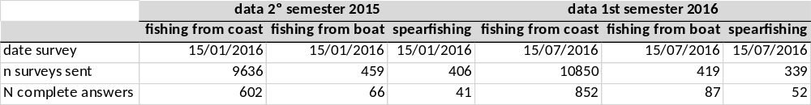
Table 2: Number of surveys sent and number of surveys completed by email

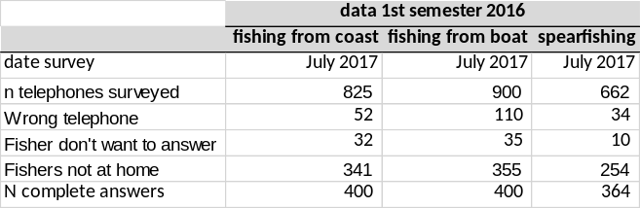
Table 3: Number of surveys sent and number of surveys completed by telephone

Deviations: As explained before, this sampling was incorporated to the national sampling program after the “Pilot study to estimate sea bass catches made by the recreational fishery in the Basque Country“. Therefore, the sampling was not planned in the National Plan presented for 2011-2013 and following roll-overs.
The telephone surveys to collect data from the secod semestrer of 2015 were not performed in January 2016. This was a plannification problem and it has been solved for the forthcoming survyes. In 2017, both telephone and email surveys are being done in January and July.

III.D.2 Data quality issues.
Eel: Collected data were transmitted to the ICES/EIFAC/GCFM eel group (WGEEL) 2016 to the Departamento de Medio Ambiente, Planificación Territorial, Agricultura y Pesca of the Basque Government, and to the Spanish Governments’ SGP.
Data from the data base for fishery do not come from an ad hoc biological survey but from a census.
Among the 875 fishermen with license in the 2015-2016 fishing season, 94% (826) of them sent the catches report. This percentage is similar to that of the previous season (93%). However, the percentage of correctly filled reports decreased from 82% to 75% during present fishing season. This decrease is probably caused still by the lack of habitude to fill in the report for those fishermen with a new license compared to those that have owned one before. Anyway, it is considered that the volume of data is enough for a proper data analysis.
Salmon: Data collection is exhaustive because of the obligation to issue a traffic guide for all specimens caught.
Sea bass: Some of the recommendations pointed out in the pilot study have been followed, such as the performance of several survey methods simultaneously (email and phone were carried out). Probably the main drawback of this study is that the sampling frames are not complete for email and telephone contact information. Post information was complete, but post surveys were not performed due to the low answer rate observed in previous studies. We are trying to solve this issue in collaboration with the competent Regional Administration, but progress is slow.
During 2016, the analysis of 2015 data has been performed. The cleaning and depuration of survey data has been improved and automatized in order to make use consistent criteria along the years. Once the data related to the second semester of 2016 is collected, they will be cleaned and analysed.

III.D.3 Actions to avoid deviations.
Eel: The Basque eel management plan foresees that only those fishermen that have submitted the catches report in time and correctly filled would be allowed to ask for a new license. Also, there is an annual meeting with glass eel fishermen to make them aware of the importance of fill in the catches report to permit a correct assessment and management of the eel population.
Sea bass: Sampling of recreational fisheries is not included in the 2015 National Plan, as it was a roll-over of the previous 2011-2013 national Plan. However, this sampling will be included in the National Plan which will be planed and presented when the EU-MAP enters into force.
In relation with the undercoverage of the sampling frames, steps have been made done in collaboration with the competent Regional Administration, in order to obtain better contact information. However, progress is slow.
It has to be taken into account that this is a new sampling and the methodology is still under development. Results will be presented at the WGRFS 2017 to get some feedback and improve the sampling if possible.

Mediterranean and Black Sea.
Spain has no fisheries in the Black Sea.
Eel: Both, the management of recreational fishing and commercial fishing for eel in inner waters (inner rivers and inner maritime waters) fall under the jurisdiction of the Autonomous Regions. In outer waters, the competence fall under the SGP (Central Government), although in these waters there is no specific fishing directed to eel.
With the implementation of management plans of eel, specific for each Autonomous Region, pursuant to Council Regulation (EC) 1100/2007 establishing measures for the recovery of the European eel, fishing effort mitigation measures have been proposed, in many cases involving the prohibition of recreational fishing of this species, both in the phase of glass eel (under 12 cm) and adult eel.
In the Mediterranean Basin, recreational fishing of adult eel is authorized only in Valencia and the Balearic Islands (in this with low incidence). In Valencia, in the framework of management plan, a reduction in effort by defining maximum fishing quotas has been chosen. In Catalonia the only authorized fishing modality is catch and release alive, of eel greater than 35 cm. and it is considered a little bit rooted and widespread activity among anglers.
Thunnus thynnus: Current regulations on recreational fisheries only permit Bluefin tuna fishing under a “catch and released” scheme. In the case of incidental catch of a dead Bluefin tuna in recreational fishery, only one fish by trip is allowed to be landed, and this catch has to be communicated to the SGP to the end of the quota.
Sharks: are only sporadically caught in recreational fisheries, and usually are released alive. The main contests of sport fisheries do not allow the landing of sharks. The Spanish legislation (order ARM 2689/2009), prohibited the landing of species of families Alopiidae and Sphyrnidae (thresher shark and hammerhead shark). In adition, the RD 347/2011, only permit to catch four species of sharks: (Galeorhinus galeus, Isurus spp, Mustelus spp y Prionace glauca) in recreational fisheries.

III.D.1 Achievements: Results and deviation from NP proposal.
Eel: As explained, recreational fishing catches of eel in the Balearic Islands are considered scarce; for the season 2016-2017, 14 Kg were reported. In Valencia catch data from sports associations, are recorded in numbers caught, but estimated weight in kilos is calculated (average of 150/200 gr per eel); on this regard, estimated catches for 2015 were 165 Kg, and for the year 2016, although the final report is not yet available, it is estimated a similar value.
Thunnus thynnus: As mentioned above, the capture is under a “catch and released” scheme and, in the case of accidental catches of some dead tuna (maximum one per trip) is mandatory to submit a catch declaration to the SGP. There are also campaigns of cooperation between the Spanish Federation of Responsible Recreational Fishing with various organisms (IEO, WWF) for to carry out studies by observers on board and electronic tuna tagging in order to improve knowledge of this species and their migration patterns.
Sharks: once the "pilot study to evaluate the recreational fishing pressure in the Balearic Islands" carried out in 2013 had finished, captures of elasmobranchs are estimated to be anecdotical.

III.D.2 Data quality issues.
Eel: In the Autonomous Community of Valencia, as noted, catch records are recorded in numbers caught, not in kilograms and an estimation of weight is done. The estimation for 2016 is in progress.
Also in the Balearic Islands, 14 kg of recreational catch have been declared in 2016.
Thunnus thynnus: The catch composition and the effort per day are collected exhaustively ("census") based on the catch declarations (regulated by RD 347/2011). In 2016 the catch was 3394 kg.
Sharks: once the "pilot study to evaluate the recreational fishing pressure in the Balearic Islands" in 2013, budget constraints make it difficult to increase the sampling effort. Catchability of these species is very low so the results of the sampling should be studied in parallel with data on catches by other fleets.

III.D.3 Actions to avoid deviations.
No additional measures are proposed.

Other Regions where fisheries are operated by EU vessels and managed by RFMO’s to which the Community is contracting party or observer.
Spain has no recreational fisheries in this area targeting the species required in apendix IV of Commission Decision 93/2010.

III. E. Stock related variables.

Baltic Sea (ICES áreas III b-d).
Spain has no fisheries in this area.

North Sea (areas ICES IIIa, IV y VIId) y Eastern Arctic (areas ICES I y II)
Spain has only fisheries in the ICES Subareas I and II.

III.E.1 Achievements: Results and deviation from NP proposal.
Table III.E.1 and table III.E.2 has been kept from the last update of 2016 National Program Proposal (“España_Propuesta PN 2016 en_2014-2016_Tablas_30-octubre-2015”).
Table III.E.3 shows the number of samples taken for each of the variables. Sampling requirements were established as set by the Commission Decision.
Biological parameters of Weight, Age and Maturity come from a sampling design stratified by length class. Data came from the biological samplings carried out by observers on board. The Sex-ratio index is achieved at the same time of sampling the length distributions that are randomly collected and not stratified by length class.
Deviations table III.E.3:
Sampling more than planned
The reason for sampling more than planned is that we can not predict in advance the lasting of the trips in these fisheries, because they varies depending on the owner decisions. When the trips last more than expected, like in this cases, it causes a higher number of individuals sampled by the observer on board.
The sampling design is established to ensure the sampling quality and to ensure a minimum number of individuals by sampling for subsequent use in the assessment. To get this target, the observer is training to intensify as much as possible the length sampling (also used to get the sex ratio) since the beginning of the trip.
Sampling was carried out by scientific observers who remain on board throughout the period of the fishing trip until the vessel's arrival to port, so the whole trip is sampled.
Because of this reason, sampling more than planned does not mean adittional costs.

III.E.2 Data quality issues.
The data collected by observers on board are checked later on, at the laboratory. Data have been used for carrying out the assessment at AFWG. Both, sampling levels and data quality, are considered adequate.
In general, to check the quality of the biological parameters, the tool INBIO 2.0 (“Estimation of biological parameters and their uncertainties through simulation techniques”), developed in R environment by the IEO, was used. In this tool the following methodologies are applied:
- Growth at age (vs. Length & Weight): von Bertalanffy. Non-linear estimation w. minimum least squares (Gauss-Newton estimation).
- Maturity (Length & Age): GLM. Logistic function. Binomial errors w. maximum log-likelihood fit.
- Length – Weight Relationship: Standard. Non-linear estimation w. minimum least squares (Gauss-Newton estimation).
- Sex-ratio (Length & Age): No Model. Percentage of females by length.
In addition, quality controls are also performed:
-Implementation of sampling protocols for each species where the methodologies of sampling, processing and storage of samples are described.
-Processing, debugging and periodic checking of data.
-Standardization of the common criteria in assigning maturity and age of each species, in order to improve the accuracy
-Attendance to workshops and/or exchanges between different scientific teams
Data of each trip are collected and recorded on board. Data are checked during and after the trip in order to detect errors and inconsistencies (outliers, trends, range of variables, dispersion).
After the trip, the observer debugs all data, haul by haul and sampling by sampling. Finally, a random check of about 15% of the data is carried out to validate the quality of the results. Annually all sets of data for each fishery are checked previously to be used for assessment and other scientific tasks.
In recent years an important effort is carried out to follow the recommendations of Planning Group on Data Needs for Assessment and Advice (PGDATA), Working Group on Commercial Catches (WGCATCH) and Working Group on Biological Parameters (WGBIOP).

III.E.3 Actions to avoid deviations.
The main cause of the deviation is the lasting of the trips in these fisheries due to the decisions taken by vessels' owners which are independent of sampling planned, so that no specific measures are proposed for this deviation.
Although the behavior of the fleet is impossible to change, the Institutes involved in sampling will continue in improving coordination with the sectors involved: owners and administration authorities.
Deviations caused by the data collection and sampling by the scientific observers on board can be improved widely through a better training and monitoring of the observers’ tasks. In addition, place experienced observers on board whenever possible will be tried to.

North Atlantic (ICES areas V-XIV and NAFO areas).

ICES VI, VII (excl. VIId), VIII, IX

III.E.1 Achievements: Results and deviation from NP proposal.
Table III.E.1 and table III.E.2 has been kept from the last update of 2016 National Program Proposal (“España_Propuesta PN 2016 en_2014-2016_Tablas_30-octubre-2015”).
Table III.E.3 shows the number of samples taken for each of the variables. Sampling requirements were established as set by the Decision Commission.
The biological samplings of the species listed in these ICES areas were carried out in 2016 to obtain the data to calculate the parameters of growth, length-weight relationships, maturity and sex-ratio, as indicated by the regulations in force. These biological samples were carried out, using samplings from the commercial catches and from research surveys.
Fecundity: (fecundity@length)
Denmark, Germany, Ireland, Netherlands, Scotland, Portugal, Spain (IEO), Spain/Basque Country (AZTI), Iceland and the Faroe Islands have participated in the mackerel and horse mackerel egg surveys in the western and southern area in 2016. IEO have covered The Biscay & Cantabrian Sea areas from 7th March to the 1st of March. Extra samples from commercial vessels and market were taken in January and February.
At the WGMEGS meeting April 2015 (ICES 2015) it was decided that during the 2016 survey, potential fecundity and atresia samples of mackerel will be collected during the whole survey as was also done in previous surveys. In the periods of expected spawning peak (February & March) enhanced sampling effort will be directed at collecting mackerel samples to estimate DEPM adult parameters. And for horse mackerel adult samples will be collected during the expected spawning peak periods (June & July).
As IEO surveys starts in January and finalize at the end of April, no horse mackerel were sampled. However, IEO was responsible for analyzing both, mackerel and horse-mackerel samples. Mackerel samples were used for fecundity estimations using both, AEPM and DEPM methods, while horse-mackerel fecundity was estimated following the DEPM method.
The number of fish sampled by IEO for biological analysis, the number of ovary samples for histology and the different analyses performed for each species following AEPM and DEPM methods are shown in the next paragraph.
Note that samples taken in each survey are distributed to all laboratories involved on histology and analysis.
Scomber scombrus
• Number of sampled fish at sea with biological analysis: 1386
• Sampled ovaries for histology: 451.
• Number of samples processed for histology (screening analysis): 311 (AEPM analysis)
• Number of samples analyzed for fecundity estimations_15 samples
• Number of samples analyzed for atresia estimations_9 samples (DEPM analysis)
• Number of samples analyzed for batch fecundity estimations _48
• Number of samples analyzed for POFs ageing to estimate spawning fraction _311
Trachurus trachurus
• Number of sampled fish at sea with biological analysis: 183
• Number of samples processed for histology (screening analysis): 45 (DEPM analysis)
• Number of samples analyzed for batch fecundity estimations _5
• Number of samples analyzed for POFs ageing to estimate spawning fraction _45
Ref. ICES, 2015. First Interim Report of the Working Group on Mackerel and Horse Mackerel Egg Surveys (WGMEGS). 20–24 April 2015, Copenhagen, Denmark. ICES CM 2015/SSGIEOM:09, 66 pp
Merluccius merluccius (both stocks): special case of age
Since 2011 the age of hake is not interpreted, however, otoliths continue to be collected in order to build the annual collections and to interpret their age in the future. In the WKAEH held in 2009 it was concluded that the interpretation of the hake growth based on the criterion applied until 2008, was not accurate or precise (based on the analysis of the readings performed during the WK and on the information obtained from the surveys on tagging and recapture carried out by IFREMER and IEO). Therefore, following the BENCHMARK that took place in February 2010, the ICES working group responsible for the assessment of hake (WGHMM) decided the application of models that do not require age-length keys (ALK) until a new criterion of interpretation of age (standardized and validated, that fits the reality of the growth of this species) will be available.

Deviations table III.E.3:
Sampling more than planned
A large number of species / stocks had been sampled at a higher level than planned (exceeding 150% of planned). This is because the design of sampling is not focused on the total number of individuals to be sampled in a year, but in the distribution of several samplings throughout the year, reaching a minimum number of fishes in each sampling to ensure the quality for each of them.
It must carry out a large number of samplings to cover adequately all strata, because there are a large number of fisheries (target species vs. gears) in the ICES area and the sampling design is random stratified. This sampling strategy does not correspond to the one developed in the Regulations, which establishes a minimum number of specimens sampled per landed ton, where National Program Proposal is based on. However, the samplings needed by ICES assessment groups to carry out the relevant assessments require sampling an important part of the fisheries affecting the target species.
Some parameters such as length@age need a larger number of samples for obtaining the age-length keys, to be representative of the target stocks. This increase in the sample number do not involve additional cost, since planning work in laboratories is carried out according to the requirements of the working groups to which data must be provided.
In most of the cases, part of the samples come from scientific research surveys at sea that, added to those coming from biological sampling in the laboratory, made that the required number of samples were exceeded, but this increase in the number of samples do not represent an additional cost.
Moreover, sometimes there are observers working on board of the commercial fishing fleet, from whose activity a large number of samples can be obtained without additional cost.
In other cases, when the initially planned sample size was not enough to ensure the quality of data, the sample size was increased when it was possible, to improve quality levels.
Sampling less than planned
The number of samples was lower than planned in the following cases:
Aspitrigla cuculus all areas: maturity @ length the number of individuals was less than planned, because it has not been possible to establish a degree of maturity for individuals of indeterminate sex.
Lepidorhombus boscii VIIIc, IXa: weight @ length the number of sampled individuals was less than planned, because individuals from surveys were not weighed on board, due to the lack of precision found for the variable weight in these species. Also, in the samples from the commercial landings, most of the individuals are landed gutted and we don´t have the live weight. In the "Achieved No of Individuals at a national level" column appears the number of individuals whose live weight has been recorded.
Molva molva all areas: The individuals of M. molva from commercial fishing are landed gutted, so the most of the biological samples are collected during the scientific surveys. Despite having sampled 100% of the catch of the survey, this amount has not been enough to reach the planned number for 2016. In any case, this is a triennial species for wich the total number of collected samples for the period 2014-2016 does conform to the total number planned (Table 4).
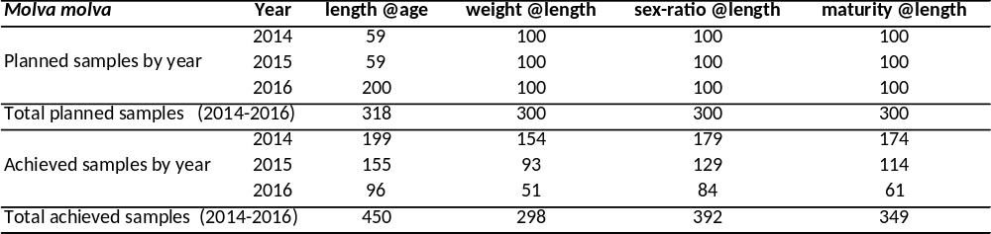
Table 4: Planned and achieved number of individuals of Molva molva by variable for the period 2014-2016

Nephrops norvegicus (only Cádiz): All data of N. norvegicus were obtained on board research surveys at sea. The distribution of quotas by vessel made impossible to obtain biological samples to be weighted in laboratory. For this reason, weights were zero. On board was impossible to obtain individual weights with sufficient accuracy. Regarding the number variable maturity@length, only maturity for females of the species was sampled.
Parapenaeus longirostris (IXa): weight&length. It was impossible to obtain individual weights with sufficient accuracy on board. For this reason, weights were 800 instead of 1300 individuals.
Pollachius pollachius (IX,X): This species is not present in the catches of scientific surveys, and samples from commercial fishing are difficult to obtain. In addition, the individuals from commercial landings are often landed gutted, making it impossible to take total weight data, sex or maturity variables. This is the reason because the number of samples for these parameters has not been enough to reach the planned number in 2016. In any case, this is a triennial species, and the number of collected samples for the period 2014-2016 does conform to the total number planned.
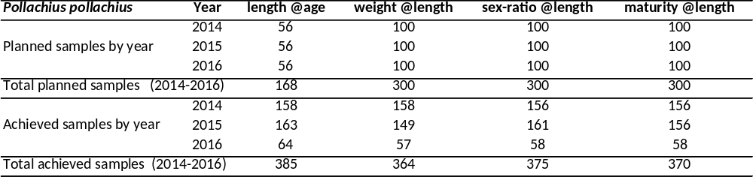
Table 5: Planned and achieved number of individuals of Pollachius pollachius by variable in IX ICES Division for the period 2014-2016.
Trachurus trachurus: VIIIabde: Although the number of individuals achieved is less than planned in all variables, the reality is that the two horse mackerel stocks have been adequately sampled (see Table 6)
The discrepancy comes from the fact that the number of individuals are planned based on the allocation of stocks of the species according to Commission Decision, and this does not match with the number of individuals obtained which is based on the actual definition of these stocks according to the Working Group on Widely Distributed Stocks (WGWIDE).
It is necessary to specify that the stock divisions of horse mackerel (Atlantic horse mackerel) which appears in the National Program (VIIIc- IXa on one side and IIa, IVa, Vb, VIa, VIIa-c, ek, VIIIabde / X on the other) does not correspond with the stock divisions used in the WGWIDE since 2004 (ICES 2005), defined as Southern stock = division IXa and Western stock = Divisions IIa, IVa, Vb, VIa , VIIa-c, ek, VIIIabcde / X
Until these stock level allocations are not corrected, we can not establish appropriate sampling level adjustments and therefore appear that there is a mismatch between the number of planned and obtained individuals.
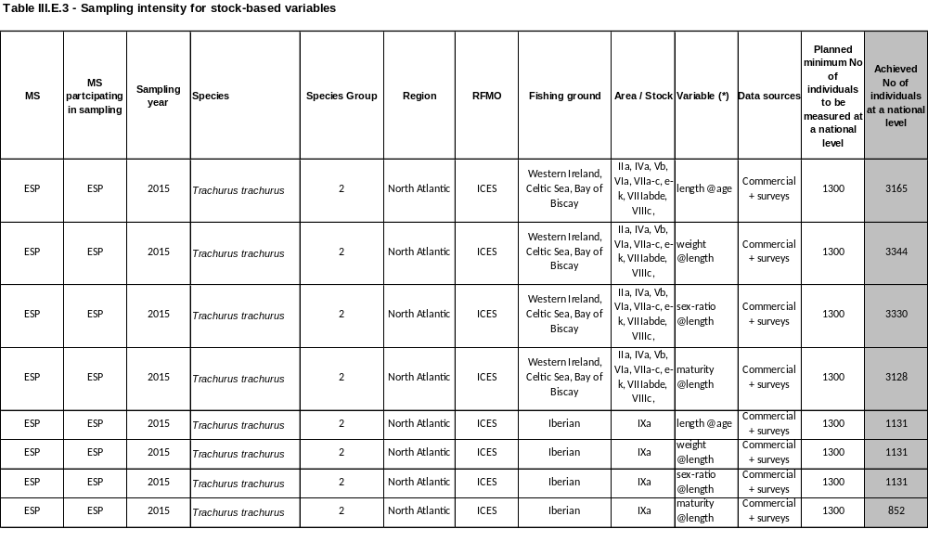
Table 6: Number of achieved individuals according to the division of stocks / area for horse mackerel (Trachurus trachurus) as is applied in the assessment working group of the species since 2004 (ICES 2005)
Zeus faber VIIIc, IXa: The number of individuals achieved in 2016 is less than planned for all variables. Given the triennial nature of the requirement for this species, the number of planned samples is going to be completed adding the samples collected in previous years (2014- 2015) (Table 7)
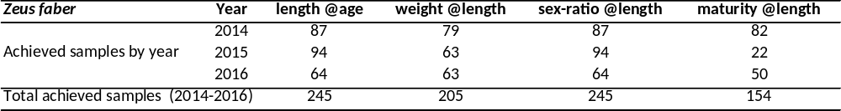
Table 7: Achieved number of individuals of John Dory (Zeus faber) by variable in VIIIc, IXa ICES Divisions for the period 2014-2016. The sampling planned number 156 for all variables.

III.E.2 Data quality issues.
The reached number of samples for obtaining biological parameters is widely covered in most species. The cases where the number of individuals obtained is less than the planned have been explained in the previous section.
In general, to check the quality of biological parameters, a tool INBIO 2.0 (Estimation of biological parameters and their uncertainties by simulation techniques) developed by the IEO in R has been used. In this tool the following methodologies are used:
- Growth at age: von Bertalanffy, least squares nonlinear estimation (Gauss-Newton algorithm).
- Maturity (length and age): Generalized linear model (GLM) with binomial errors and logistic link function. Maximum log-likelihood.
- Lenght / weight relationship: least squares nonlinear estimation (Gauss-Newton algorithm).
- Sex ratio: No model.Estimation of the global sex-ratio as percentage of females by length.
In adition, several quality controls are performed.
- Applying a sampling protocol for each species where the methodologies used in sampling, the storage and processing of data, and the processing and observation of skeletal parts (EP) for the allocation of age are described. (http://www.repositorio.ieo.es/e-ieo/handle/10508/1755, , http://www.repositorio.ieo.es/e-ieo/handle/10508/10536)
- Standardization of the common criteria in assigning age of each species, in order to improve the accuracy in readings.
- In the particular case of Conger conger, the age readings are performed on two different bony parts (both otoliths and vertebrae), for a greater assurance in the age assignations.
- As established by the Workshop of National Age Readings Coordinators (WKNARC) in 2011, some actions are being performing, such as the accuracy analysis of readings inter and intra readers; measure the distances from each annual ring to the core; identification of the edge of each bony part observed; development of annual collections of images that help the correct interpretation of the bony parts; and the use of a numerical scale to estimate the degree of confidence that the reader assigned to each one of their readings. To carry out these tasks, it is using the WebGR (http://webgr.azti.es/ce/search/myce/), tool that facilitates the exchange and analysis of results of bony parts readings using calibrated images.
- The institutes responsible for data collection are part of the "The European Age Readers Forum" (EARF) (http://groupnet.ices.dk/AgeForum/default.aspx). The purpose of the EARF is to establish a "one-stop shop" or "single window" for all teams who are involved in the interpretation of age. The EARF provides a resource for training new readers as well as the opportunity to share and discuss current allocation protocols ages, establish standard operating procedures and standardize methods of preparation and interpretation of bony parts.

III.E.3 Actions to avoid deviations.
One of the biggest difficulties for many of these species has been the inability to cover the whole range of length properly. In most cases, this difficulty is due to the spatial distribution of the species itself in the areas where the samples came from and to the inability of the fishery to access the tails of the length distribution.
Another difficulty found in the process of obtaining biological parameters is the absence of validation of growth for some species (Trisopterus luscus, Molva molva, Conger conger, Helicolenus dactylopterus, Pollachius pollachius, Mullus surmuletus, Zeus faber, Aspitrigla cuculus)
To remedy these deficits several actions are being implemented.
- Updating and improving sampling protocols
- Optimization of the processing techniques of bony parts for better interpretation of them.
- Improving standardization of common criteria, both technical and interpretation.
- Maintenance and improvement of the WebGR (http://webgr.azti.es/ce/search/myce/) tool that facilitates the exchange and analysis of results.
- Continued participation in international forums such as “The European Age Readers Forum” (EARF) (http://groupnet.ices.dk/AgeForum/default.aspx).

NAFO and ICES XII, XIV

III.E.1 Achievements: Results and deviation from NP proposal.
Table III.E.1 and table III.E.2 has been kept from the last update of 2016 National Program Proposal (“España_Propuesta PN 2016 en_2014-2016_Tablas_30-octubre-2015”).
Table III.E.3 shows the number of samples taken for each of the variables. Sampling requirements were established as set by the Commission Decision.
Biological parameters of Weight, Age and Maturity come from a sampling design stratified by length class. Data came from the biological samplings carried out both by on board observers and on surveys. The Sex-ratio index is achieved at the same time of sampling the length distributions that are randomly collected and not stratified by length class.
In NAFO regulatory area, species like American plaice (Hippoglossoides platessoides), Witch flounder (Glyptocephalus cynoglossus), Cod (Gadus morhua) 3NO, 3L and Yellowtail flounder (Limanda ferruginea) have TAC=0. Therefore the number of individuals sampled at the national level was not calculated a priori.
Northern Shrimp (Pandalus borealis) 3M and 3L stocks are under moratorium and sampling could not be performed.
Deviations table III.E.3:
Sampling more than planned
Sampling more than planned is mainly due to two different causes depending on the data source.
Data from research surveys at sea: Length sampling is carried out systematically by haul with the purpose of covering all depth strata. Biological sampling is carried out in most hauls, following a sampling methodology stratified by sex and length throughout the survey. Both methodological issues can lead to sampling more than planned.
Data from scientific observers at sea: The reason for sampling more than planned is that we can not predict in advance the lasting of the trips in these fisheries, because they vary depending on the owner decisions. When the trips last more than expected, like in this cases, it causes a higher number of individuals (vs. planned) sampled by the observer on board.
The sampling design is established to ensure the sampling quality and to ensure a minimum number of individuals by sampling for subsequent use in the assesment. To get this target, the observer is training to intensify as much as possible the length sampling (also used to get the Sex ratio) since the beginning of the trip.
Sampling was carried out by scientific observers who remain on board throughout the period of the fishing trip until the vessel's arrival to port, so the whole trip is sampled.
Because of these reasons, sampling more than planned does not mean adittional costs.
Sampling less tan planned
Alepocephalus bairdii and Sebastes mentella: the number of sampled individuals is less than planned due a deficient quality of data.
All data are collected by scientific observers at sea: The reason for sampling less than planned is that we can not predict in advance the lasting of the trips in these fisheries, because they vary depending on the owner decisions. When the trips last less than expected, like in these cases, it causes a lower number of individuals (vs. planned) sampled by the observer on board.

III.E.2 Data quality issues.
The data collected by observers on board and surveys are checked later on, at the laboratory. Data have been used for carrying out the assessment at ICES WGDEEP and ICES NWWG and NAFO SC. Both, sampling levels and data quality, are considered adequate
In general, to check the quality of the biological parameters, the tool INBIO 2.0 (“Estimation of biological parameters and their uncertainties through simulation techniques”), developed in R environment by the IEO, was used. In this tool the following methodologies are applied:
- Growth at age (vs. Length & Weight): von Bertalanffy. Non-linear estimation w. minimum least squares (Gauss-Newton estimation).
- Maturity (Length & Age): GLM. Logistic function. Binomial errors w. maximum log-likelihood fit.
- Length – Weight Relationship: Standard. Non-linear estimation w. minimum least squares (Gauss-Newton estimation).
- Sex-ratio (Length & Age): No Model. Percentage of females by length.
In addition, quality controls are also performed:
-Implementation of sampling protocols for each species where the methodologies of sampling, processing and storage of samples are described.
-Processing, debugging and periodic checking of data.
-Standardization of the common criteria in assigning maturity and age of each species, in order to improve the accuracy
-Attendance to workshops and/or exchanges between different scientific teams
Data of each trip are collected and recorded on board. Data are checked during and after the trip in order to detect errors and inconsistencies (outliers, trends, range of variables, dispersion).
After the trip, the observer debugs all data, haul by haul and sampling by sampling. Finally, a random check of about 15% of the data is carried out to validate the quality of the results. Annually all sets of data for each fishery are checked previously to be used for assessment and other scientific tasks.
The quality indicator of Maturity was calculated only with female data and macroscopic Maturity data are used for all species. In addition histological Maturity data of the following species are also obtained: Gadus morhua, Hippoglossoides platessoides, Macrourus berglax, Reindhardtius hippoglossoides and the three species of Sebastes in DIvision 3M. These data help to contrast the quality of macroscopic data obtained from this variable.
In recent years an important effort is carried out to follow the recommendations of Planning Group on Data Needs for Assessment and Advice (PGDATA) Working Group on Commercial Catches (WGCATCH), Working Group on Biological Parameters (WGBIOP) and NAFO SC.

III.E.3 Actions to avoid deviations.
The main cause of the deviation is the lasting of the trips in these fisheries due to the decisions taken by vessels' owners which are independent of sampling planned, so that no specific measures are proposed for this deviation.
Although the behavior of the fleet is impossible to change, the IEO will continue in improving coordination with the sectors involved: owners and administration authorities.
Another cause of deviations is due to the methodology used in research surveys that it must be kept uniform along the time series. The data collected in surveys can lead to oversampling. However, these data are needed for other purposes such as stock assessment and to measure environmental indicators. The adaptation of the surveys protocols to cover both targets will be tried as far as possible.
Deviations caused by the data collection and the sampling by the scientific observers on board can be improved widely through a better training and monitoring of the observers’ tasks. In addition, the placement of experienced observers on board will be tried to, whenever possible.

Mediterranean and Black Sea.
Spain has no fisheries in the Black Sea.
As in tables, text explanations are divided by RFMO.

GFCM (Fisheries targeting small pelagics, demersal, crustaceans and cephalopods)

III.E.1 Achievements: Results and deviation from NP proposal.
Table III.E.1 and table III.E.2 has been kept from the last update of 2016 National Program Proposal (“España_Propuesta PN 2016 en_2014-2016_Tablas_30-octubre-2015”).
Table III.E.3 shows the number of individuals sampled in order to obtain the biological variables (individual information on age, length, weight, sex and maturity) of the main species in 2016. At the end of the table, data collected from the new species selected in 2015 are shown.
Deviations in the table III.E.3
Scomber spp.: Sampling less than planned in all variables (length-at-age, weight-at-length, maturity-at-length, sex-ratio-at-length). Last years the landings of Scomber spp., and particularly of Scomber colias, are decreasing. In 2016, it was not possible to sample all the individuals of Scomber colias planned.
Some especies (Lophius budegassa, Mullus surmuletus, Nephrops norvegicus, Octopus vulgaris, Parapenaeus longirostris, Sardina pilchardus and Trachurus mediterraneus) have been over sampled to achieve a better quality in the calculation of biological parameters.

III.E.2 Data quality issues.
The estimatation of the biological parameters and their uncertainties has been carried out using the tool INBIO 2.0 (“Estimation of biological parameters and their uncertainties through simulation techniques”), developed in R environment by the IEO. INBIO makes possible to fit the most usual models and to estimate the coefficient of variation for parameters by using the non-parametric bootstrap methodology.
Models and fit adopted were:
- Growth at age (vs. Length & Weight): von Bertalanffy. Non-linear estimation w. minimum least squares (Gauss-Newton estimation).
- Maturity (Length & Age): GLM. Logistic function. Binomial errors w. maximum log-likelihood fit.
- Length – Weight Relationship: Standard. Non-linear estimation w. minimum least squares (Gauss-Newton estimation).
- Sex-ratio (Length & Age): No Model. Percentage by length and age. Cubic spline to plot
On the other hand, participation in workshops and exchanges of standardization criteria of maturity and age of different target species improves accuracy and allows the comparison of results with other European countries.

III.E.3 Actions to avoid deviations.
The deviations could be avoided by increasing the number of individuals in the sampling of Lophius piscatorius and Scomber colias in 2017. However, this point depends on the availability of catches for these species. The biological parameters of these G2 species could be calculated every three years, therefore this under sampling could be corrected.

ICCAT (Fisheries targeting large pelagics)

III.E.1 Achievements: Results and deviation from NP proposal.
Table III.E.1 and table III.E.2 has been kept from the last update of 2016 National Program Proposal (“España_Propuesta PN 2016 en_2014-2016_Tablas_30-octubre-2015”).
Table III.E.3 shows the number of fish planned and measured at national level during 2016. On commercial fleets whose landings takes place in national ports, the biological variables data are collected from market samples as well as from observers on board. In many cases, it was necessary the purchase of specimens to carry out the sampling.
Deviations in the table III.E.3
The number of fish measured was greater than the number of fish planned to reaching the precision level established by Commission Decision. In the case of some stock-related variables of swordfish and Bluefin tuna, the number of fish measured was less than number of fish planned due to changes in the commercialization patterns of these species.
Thunnus thynnus. The number of individuals measured came from the BFT-E stock (Eastern Atlantic and Mediterranean Sea). Depending on the availability of individuals, these are measured and weighted at the market, so it is not always possible to fit the planned minimum number of fish to be measured at national level.

III.E.2 Data quality issues.
In most of the species, the number of individuals is difficult to plan in advance. It will depend on access to the samples. In the case of by-catch species (usually low prevalence), the number of individuals sampled at national level cannot be planned in advance.
In general, to check the quality and to carry out the estimation of the biological parameters and their uncertainties, the tool INBIO 2.0 (“Estimation of biological parameters and their uncertainties through simulation techniques”), developed in R environment by the IEO, was used. INBIO makes possible to fit the most usual models and to estimate the coefficient of variation for parameters by using the non-parametric bootstrap methodology.
Models and fit adopted were:
- Growth at age (vs. Length & Weight): von Bertalanffy. Non-linear estimation w. minimum least squares (Gauss-Newton estimation).
- Maturity (Length & Age): GLM. Logistic function. Binomial errors w. maximum log-likelihood fit.
- Length – Weight Relationship: Standard. Non-linear estimation w. minimum least squares (Gauss-Newton estimation).
- Sex-ratio (Length & Age): No Model. Percentage by length and age. Cubic spline to plot

III.E.3 Actions to avoid deviations.
Deviations are due to problems inherent to the large pelagic fisheries. The objectives are considered achieved and no additional measures are proposed.

Other Regions where fisheries are operated by EU vessels and managed by RFMO’s to which the Community is contracting party or observer.

CECAF

III.E.1 Achievements: Results and deviation from NP proposal.
Table III.E.1 and table III.E.2 has been kept from the last update of 2016 National Program Proposal (“España_Propuesta PN 2016 en_2014-2016_Tablas_30-octubre-2015”).
It should be noted that although Spanish catches are by far the most important European demersal fisheries in the area, the total share in the EU landings may be in some cases lower than the 100% indicated. This is due to the fact that some other member States also conducting demersal fisheries in the area did not report their landings to the RCM.
Oppositely, although the small pelagic fisheries are mainly carried out by fleets of small pelagic trawlers from other EU countries, the share of the Spanish fisheries in the EU countries, although very limited, is not exactly "None" as some small pelagic species can be fished as bycatch of some fisheries targeting demersal species. It is the case of Trachurus spp., for which catches has been reported by the cephalopod-finfish trawlers operating in Guinea-Bissau.
Table III.E.3 shows the numbers of sampled fish to estimate the biological parameters length-weight, sex-ratio and sexual maturity, for 2016.
Deviation from Table III.E.3
Parapenaeus longirostris and Penaeus notialis (Farfantepenaeus notialis) (from métier OTB_CRU_>=40_0_0): the measured individuals in the case of P. longirostris for maturity and sex-ratio variables were considerably higher than the number planned: 6029 for maturity vs 2700 (223% achievement) and 11103 vs 2700 (411% achievement). These deviations from the planned sampling are related to the fishing strategy followed by the fleet. In 2016, most sampled fishing trawls targeted P. longirostris. For both species, the sex-ratio parameter included data from biological sampling and length sampling because the sex identification can be easily made by external characters and therefore, length samplings are made by sex. It is not possible to give the values of the weight parameter (0 vs 2700). This is due to the fact that the small size of individuals of P. longirostris requires that weight measurement are made with a precision balance, which cannot be used onboard due to the instability of this kind of vessels
Merluccius polli and M. senegalensis: both black hake species are marketed together as Merluccius spp and commercialized by size categories. As individuals are gutted in some of the commercial categories, biological samplings on shore are not possible. These species are targeted by the métiers OTB_DEF_>=70_0_0 and OTB_MCF_>=70_0_0 (previously named as OTB_CEP_>=70_0_0), where individuals are processed and frozen onboard. Accordingly, the biological information has been obtained from onboard observations of both métiers. Merluccius polli is the main hake species from Morocco (Western Sahara) to Senegal, where both métiers operated in 2016. The number of sampled individuals has been higher than planned (both hake species together) for sex-ratio and maturity (163% of achievement) due to the uncertainty when planning numbers of sampled individuals in métiers with high variability of their activity. The number of sampled individual weights has been slightly lower than expected (87% of achievement), due to the mentioned difficulties of having observers onboard during all the planed fishing trips.
Octopus vulgaris, Loligo vulgaris, Sepia hierredda and S. officinalis (from métier OTB_CEP_>=70_0_0 (renamed as OTB_MCF_>=70_0_0): Number of sampled individuals for weight, maturity and sex-ratio variables is lower than planned for L. vulgaris, S. officinalis (0 vs 500, 0% of achievement for both species) and also for S. hierredda (25 vs 400, 6% of achievement) because sampled fishing trips targeted finfish in deep waters, where the presence of these cephalopod species is less common. L. vulgaris and S. officinalis are highly unusual species in Guinea Bissau waters, where the métier operated in 2016.
Small pelagic species from West African fishing grounds (from Morocco to Guinea Bissau) of métier OTM_SPF_>=40_0_0 (Sardina pilchardus, Sardinella aurita, Sardinella maderensis and Trachurus spp.) were not sampled due to the lack of landings of EU pelagic trawlers on Spanish ports.
Regarding small pelagic species from Canary fishing ground of métier PS_SPF_10_0_0 (Sardina pilchardus, Sardinella aurita, Scomber colias and Trachurus spp.), the sampling intensity for all of them was higher than planned (>180% of achievement), because the samples are taken on a monthly basis (not according to the number of individuals) and a minimum number of individuals is analyzed to ensure quality, as well as the coverage of the reproductive cycle and temporary biological variations of these species.

III.E.2 Data quality issues.
Not all species have been sampled as expected for reasons previously explained and related to changes in the fleet activities or to logistic problems of the observers and samplers programs at the beginning of the year. Nonetheless, the data quality of the sampled species was the best possible under these circumstances throughout 2016 and the achieved information is considered satisfactory enough to be supplied to the relevant CECAF assessment working groups and Joint Scientific Committees of SFPAs.
In general to check the quality and to carry out the estimation of the biological parameters and their uncertainties, the tool INBIO 2.0 (“Estimation of biological parameters and their uncertainties through simulation techniques”), developed in R environment by the IEO, was used. INBIO makes possible to fit the most usual models and to estimate the coefficient of variation for parameters by using the non-parametric bootstrap methodology.
Models and fit adopted were:
- Growth at age (vs. Length & Weight): von Bertalanffy. Non-linear estimation w. minimum least squares (Gauss-Newton estimation).
- Maturity (Length & Age): GLM. Logistic function. Binomial errors w. maximum log-likelihood fit.
- Length – Weight Relationship: Standard. Non-linear estimation w. minimum least squares (Gauss-Newton estimation).
- Sex-ratio (Length & Age): No Model. Percentage by length and age. Cubic spline to plot

III.E.3 Actions to avoid deviations.
In other cases, deviations are related to changes in the resources’ abundance what involves changes in the strategy followed by the fleet (i.e: targeting one species or another). These are all external circumstances related to the fishing activity and no actions can be taken by us to avoid deviation.
Deviations related to sampling more than planned are due to ensure good quality and enough coverage. The objectives are considered achieved and no measures are proposed.

ICCAT (Atlantic), IOTC, IATTC, WCPFC, etc. (Fisheries targeting large pelagics)

III.E.1 Achievements: Results and deviation from NP proposal.
Table III.E.1 and table III.E.2 has been kept from the last update of 2016 National Program Proposal (“España_Propuesta PN 2016 en_2014-2016_Tablas_30-octubre-2015”).
Table III.E.3 shows the number of fish planned and measured at national level during 2016. On commercial fleets whose landings are in national ports, the biological variables data are collected from market samples and observers on board. In many cases, it was necessary the purchase of specimens to carry out the sampling.
Thunnus albacares, Thunnus obesus y Katsuwonus pelamis, in the Atlantic ocean, several reasons make the access to biological samplings very difficult, highlighting the remoteness of the landing ports, the freezing of the fish on board, the difficulties in handling the fish (big individuals), mechanization of handling, etc. The sampling by observers on board is very difficult due to the handling of fish, because the fishes are frozen entirely and they are not processed on board. The purchase of individuals for biological sampling is complex and requires a very high financing due to the high weight and the high economic value of the species.
In the Indian Ocean, due to the closure of the Spanish Fishery Office in Victoria (Seychelles), the sampling data depends on third parts managed by the Seychelles Fishing Authority (SFA) and the Institut de Recherche pour le Developpment (IRD). Biological sampling of weight-length, sex-ratio and maturity is based in the cannery placed outside the port of Victoria and requires additional funds to be supported. In recent years, biological information was transferred by IRD sampling team to IEO.
In the Pacific Ocean it is impossible to carry out the biological sampling of the target species, owing to the lack of a Spanish Fisheries Office, or staff in the area for its performance. The number of vessels is very small and they are not operating in the area throughout the year, so there is no economic compensation in supporting forementioned office or staff. It is necessary to add that the landing ports are variable and very far one from another and it would not be possible to have samplers in each port. It must also be noted that there are sampling programs and biological studies coordinated by the RFMOs Secretariats (IATTC and WCPFC) in this ocean.
Thunnus thynnus, in the Atlantic Ocean, the Spanish fisheries act on the spawning fraction (over six years) and on the juvenile fraction of the stock. This circumstance makes that several length classes are outside the geographical area where the Spanish fisheries work and cannot be covered, so studies of sex ratio and maturity are not conducted.
Thunnus alalunga, in the Atlantic Ocean, trolling and baitboats fisheries catch in a high percentage, the immature fraction of the population (<90 cm FL) and, in a lower percentage, the adult fraction of Albacore tuna (> 90 cm FL). The adults are captured in the resting phase, because the spawning area is located in tropical waters of the western Atlantic. Thus, it is unlikely take samples from spawners in northeast Atlantic to perform sex ratio and maturity studies.
In the Indian Ocean all the Thunnus alalunga capture is bycatch in other fisheries. The size of individuals and the fact that catches are very distant in space and time implies difficulties in conducting biological sampling.
Deviations in the table III.E.3
Atlantic Ocean:
Katsuwonus pelamis, Thunnus albacares and Thunnus obesus: In the Atlantic Ocean, there has not been biological sampling, owing inherent difficulties in specimens’ availability. Not only there is a lack of a Spanish Fisheries Office at any of the main landing ports since 2013, but also it has not been possible to get the administrative permissions needed to access the tuna canneries.
Thunnus alalunga: there is not weight sampling, since there are not recommendation by ICCAT to analyze length-weight relationship for the northern Albacore stock.
Thunnus thynnus: the number of individuals measured came from the BFT-E stock (Eastern Atlantic and Mediterranean). Depending on the availability of individuals, these are measured and weighted at the market, so it is not always possible to fit with the planned minimum number of fish to be measured at national level
Indian Ocean:
Katsuwonus pelamis, Thunnus albacares and Thunnus obesus: due to the closure of the Spanish Fishery Office in Victoria (Seychelles), the sampling data depends on third parts managed by the Seychelles Fishing Authority (SFA) and the Institut de Recherche pour le Developpment (IRD). Biological sampling of weight-length, sex-ratio and maturity is based in the cannery placed outside the port of Victoria and requires additional funds to be supported. In recent years, biological information was transferred by IRD sampling team to IEO.

III.E.2 Data quality issues.
In most of the species, the number of individuals is difficult to plan in advance. It will depend on access to the samples. In the case of bycatch species (usually low prevalence), the number of individuals sampled at national level cannot be planned in advance.
In general, to check the quality and to carry out the estimation of the biological parameters and their uncertainties, the tool INBIO 2.0 (“Estimation of biological parameters and their uncertainties through simulation techniques”), developed in R environment by the IEO, was used. INBIO makes possible to fit the most usual models and to estimate the coefficient of variation for parameters by using the non-parametric bootstrap methodology.
Models and fit adopted were:
- Growth at age (vs. Length & Weight): von Bertalanffy. Non-linear estimation w. minimum least squares (Gauss-Newton estimation).
- Maturity (Length & Age): GLM. Logistic function. Binomial errors w. maximum log-likelihood fit.
- Length – Weight Relationship: Standard. Non-linear estimation w. minimum least squares (Gauss-Newton estimation).
- Sex-ratio (Length & Age): No Model. Percentage by length and age. Cubic spline to plot

III.E.3 Actions to avoid deviations.
Deviations are due to problems inherent to the large pelagic fisheries. The objectives are considered achieved and no additional measures are proposed.

III. F Transversal Variables

III.F.1 Capacity

III.F.1.1 Achievements: Results and deviation from NP proposal.
The data regarding capacity are obtained from operating Spanish fleet Register which is part of Community vessel Register, in which all vessels are registered and is registered in the database of the SGP.
From a software application, the parameters of the vessels according to the disaggregation level required by the Regulations can be checked. In this sense, regarding gear data, they are obtained from national censuses where vessels are included or, alternatively, from data of issued fishing licences.

III.F.1.2 Data quality: Results and deviation from NP proposal.
These censuses are updated whenever a change occurs, so that the annual update of the data is guaranteed. This gives a total coverage of Spanish fleet vessels, including those less than 10 m.

III.F.1.3 Actions to avoid deviations.
Automatic filters are being implemented in the database to check possible inconsistencies.

III.F.2 Effort

III.F.2.1 Achievements: Results and deviation from NP proposal.
For vessels of more than 10 meters, data relating to fleet segments and fishing gear are obtained from Fleet register, data of stocks of particular interest are obtained from the logbooks and data of fishing areas are obtained from positions provided by the VMS data (vessels exceeding 15 m.) and from the logbooks (vessels between 10 and 15 m.). All this information is integrated into the centralized database of the SGP and can be found with precision levels settled by the regulation.
For vessels less than 10 meters, the data for fleet segments and fishing gear are obtained from Fleet register and data related to populations of special interest and fishing areas are derived from sale notes given that each note corresponds to a day of fishing in the fishing ground to which the vessel is attached.
The parameter on fuel consumption is taken up within the module of economic data.

III.F.2.2 Data quality: Results and deviation from NP proposal.
The fleet census is updated whenever a change occurs, so that the annual update of the data is guaranteed. This gives a total coverage of the Spanish fleet vessels, including those less than 10 m length.
Sales notes are collected daily on all auctions by the autonomous regions authorities that process and integrate them into their databases so that there is a full coverage. Whith established frequency, the sales notes are forwarded to the SGP that incorporate the information into its central database, which guarantee the full coverage in all national territory.

III.F.2.3 Actions to avoid deviations.
Improvements are being made in the centralized database in order to develop consistency filters and query with data matching in order to detect errors or inconsistencies, as established by Community law and as approved by the European Commission.

III.F.3 Landings

III.F.3.1 Achievements: Results and deviation from NP proposal.
Information on landings by vessels over 10 meters comes from the landing declarations.
In 2012 it began the gradual implementation of the system of "electronic logbook". With this system, incorporating data on catches and landing declarations to the database is immediate, thus speeding up the incorporoation of information. This system has been a major advance over manual recording of data done in ports. This manual recording has been relegated to those vessels that are not required to have this electronic logbook, although a logbook in paper format is mandatory.
In the latter cases, the data are received and entered into the database by personnel specifically hired by the SGP through entrustment management with the public company TRAGSATEC, and are responsible to receive and record information from more than 300 ports the Spanish coast.
These recordings represent just 5% of the total catches of the Spanish fleet.
For vessels less than 10 meters, these data are collected from sales notes which are collected by the regional authorities (autonomous communities) based on their skills and forwarded to the SGP, which are also integrated into the centralized database. In the sales notes the specific composition of the catch of each vessel and the geographical area is detailed, but not the gear used.
The latter information, if necessary, can be obtained through the crossings of sales notes against the tables of fleet census where the fishing mode is recorded for each vessel.

III.F.3.2 Data quality: Results and deviation from NP proposal.
The precision and disaggregation levels under the Regulation have been reached; however, the information of disaggregation level required by the regulations concerning the value of species landed is obtained from surveys to collect economic data. These surveys are processed in the year following their collection and also the data obtained are not yet integrated into the SGP central database, so it cannot be done automatically with a cross-checking like other parameters required for this module.

III.F.3.3 Actions to avoid deviations.
Improvements are being made every year in the centralized database in order to develop consistency filters and query with data matching in order to detect errors or inconsistencies as established by Community law and as approved by the European Commission.

III. G Research surveys at Sea
From 2014 (include), the activities undertaken within the EMFF are selected by the Member State, provided they meet the criteria set out in EMFF itself and contribute to the better implementation of the Common Fisheries Policy (CFP).
The activities to be undertaken were clearly defined by the COM Decisions, so there was no room in the NP Proposal for activities that were not mentioned in the Decision, although these activities were used for the evaluation of fisheries resources. For this reason, there are a number of research surveys at sea that, although used in assessment, could not be included before in the NP.
So, Annex III shows the outcomes of a number of research surveys at sea that Spain had been conducting at national expenses, which are coordinated internationally, and are used for the assessment of fishery resources in the working groups of the area ICES and thus they contribute to the better implementation of the CFP.
The information about these surveys was also included at the end of the table III.G.1.
Currently, the abundance indices by age in research surveys are not obtained for Merluccius spp. or Lophius spp. because the age interpretation using otoliths or illicia is not possible due to the existing problems in the reading criteria for both species.

IBTS 4th. Quarter (VIIIc y IXa north)

III.G.1 Achievements: Results and deviation from NP proposal.
Objectives:
- Estimation of abundance indices by age of megrim (Lepidorhombus boscii and L. whiffiagonis), blue whiting, horse mackerel and mackerel, as well as indices by size class of hake and monkfish (Lophius budegassa y L. piscatorius),
- Estimation of the recruitment strength of the species mentioned, mainly hake, monkfish and megrims.
- Estimation of abundance indices (number and biomass) of other demersal species of fishing interest (Norway lobster, sparids, etc), as well as the fauna associated to them.
- Determination of geographical and bathymetric distribution of the different species.
- Obtaining the length distributions of all species of fish, Norway lobster and main cephalopods in the catches.
- Collecting biological data of the main commercial species: maturity stages, sex ratio, etc...
- Getting oceanographic data.
- Perform hauls in the buffer zone of the Marine Protected Area Cachucho (Proyecto 4ESMAREC)
Sampling area: ICES Areas VIIIc and IXa North: continental shelf and continental slope of north Spanish coast (Figure 1), sampling the bottom at depths between 70 y 500 m, with additional hauls for depths under 70 m and over 500 m.
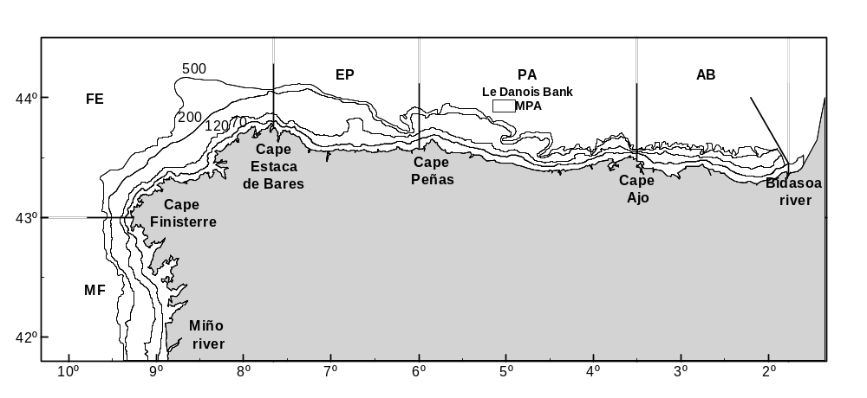
Figure 1: Map of stratification used in the survey IBTSVIIIcIXa 2015 (North Spanish coast)

Dates: From September 17th to October 23th, 2016.
Duration: The survey lasted for 37 days.
Methodology: random stratified sampling based on 30 minutes bottom trawl hauls during day light, getting abundance indices stratified by haul. Sampling for abundance indices covers the depths between 70 and 500 m and is stratified random, the hauls are allocated in 15 strata determined by combining 3 depth strata (>70-120m, 121-200 m and 201-500m) and five geographical sectors. Hauls allocation is proportional to the area of each strata.
Research Vessel: R/V Miguel Oliver, otter trawler 70 meters length, 14.40 m. breadth, 2495 GT and 2 * 1000kW.
Equipment and Sampling gear: Baca trawl 44/60 (60.3 m ground rope with single coat y 43.8 m float rope) with 20 mm mesh size in the codend.
Number of hauls: 134 valid fishing:
114 standard hauls
20 special hauls:
- 3 hauls in shallow areas, at 30-70 m depth, not covered by the stratification of the survey as there were not enough trawlable areas at these depths, but carried out yearly to monitor the resources and the ecosystem at these depths.
- 15 hauls deeper than 500 m, between 500-800 m, performed annually to track the status of resources and ecosystem in the area.
- 2 hauls near 800 m depth in the buffer area of "El Cachucho" Marine Protected Area.
Sampling:
Hydrographic sampling: 135 CTD stations were performed (CTD Seabird-25), covering most of the fishing stations in the survey whenever the weather permited. (Figure 2)
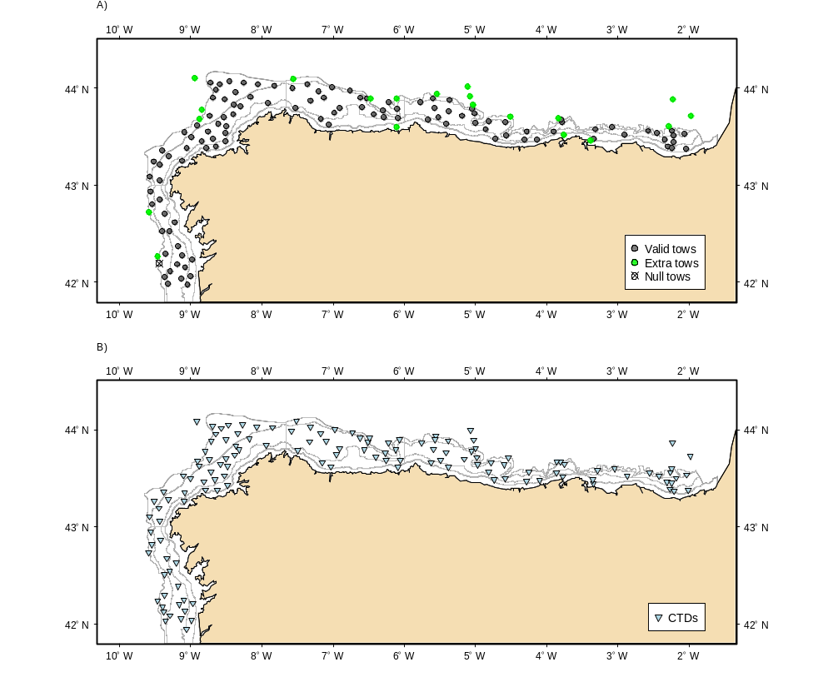
Figure 2: Map of the hauls of sampling carried out during the survey IBTS VIIIc IXa 2016 (North Spanish shelf) and map of the CTD stations performed.

Faunistic lists: They were a total of 264 species: 91 fish, 54 crustaceans, 48 molluscs, 36 echinoderms and also 35 species of other invertebrate groups.
Specimens sampled: Length distributions of all fish and Norway lobster were obtained. The number of specimens sampled for the main species are shown in the following tables.

Scientific name | Total
Merluccius merluccius | 11713
Lepidorhombus whiffiagonis | 4811
L. boscii | 8579
Lophius budegassa | 56
L. piscatorius | 41
Micromesistius poutassou | 8585
Phycis blennoides | 467
Helicolenus dactylopterus | 1811
Trisopterus luscus | 1185
Conger conger | 2017
Zeus faber | 89
Trachurus trachurus | 5976
Scomber scombrus | 525
Nephrops norvegicus | 120
Mullus sumuletus | 185
Chelidonichthys cuculus | 2213

Otholits and illicia:

Species | Otholits/illicia
Merluccius merluccius (stock N) | 9
Merluccius merluccius (stock S) | 883
Lepidorhombus whiffiagonis | 447
Lepidorhombus boscii | 510
Lophius budegassa | 57
Lophius piscatorius | 40
Micromesistius poutassou | 1007
Phycis blennoides | 153
Helicolenus dactylopterus | 169
Trisopterus luscus | 219
Conger conger | 170
Zeus faber | 64
Trachurus trachurus | 642
Scomber scombrus | 361
Scomber colias | 66
Engraulis encrasicolus | 140
Sardina pilchardus | 172

Data storage: survey data are stored by the IEO in its ad-hoc fishery data base SIRENO and also in DATRAS from 2001 onwards.
Environmental indicators:
In the survey “IBTS 4th. Quarter (VIIIc y IXa north)”-IBTS SP-NGFS- data are collected to calculate indicators 1 to 3, although no data on individual weights are taken as weather conditions should make results less reliable than using length-weight regressions to estimate the indicators to be calculated by weight, specifically indicator 2 "Proportion of large fish by weight".
Regarding indicator 4 on the "size of maturation of exploited species", this is an indicator that has to be calculated during the spawning season of the species, as advised in the workshops on fertility and maturity of various commercial species. The time when the survey is carried out, between the third and fourth quarter, it is not within the spawning season for most species, since it is in fact a survey to estimate recruitment strength.
Deviations: There were no deviations from the Proposal.

III.G.2 Data quality: Results and deviation from NP proposal.
Data obtained are used for calibration models of groundfish assessment of the South Platform ICES evaluated within the framework of WGBIE, especially the southern stock of hake (M. merluccius) and megrims (L. whiffiagonis y L. boscii), anglers (L. budegqassa, and L. piscatorius), and Norway lobster (N. norvegicus) in the Iberian continental shelf. They are also used in the calibration of assessments of the southern stock of horse mackerel (Trachurus spp.), and annual results for blue whiting (M. poutassou) are reported to WGWIDE and those of mackerel (Scomber spp.) to WGHANSA.
These surveys are coordinated at IBTSWG group and all that group's recommendations are followed.
Deviations: There were no deviations from the Proposal.

III.G.3 Actions to avoid deviations.
Not applicable.

IBTS 4th. Quarter (IXa sur)

III.G.1 Achievements: Results and deviation from NP proposal.
Objectives:
- -Estimate distribution and relative abundance the main commercial species and provide recruitment indices.
- -Estimate changes in the stocks of commercial fish species independently of commercial fisheries data.
- -Monitor the distribution and relative abundance of all fish and invertebrates species.
- -Collecting data for the determination of biological parameters for selected species;
- -Collecting hydrographical and environmental information.
Sampling area: The Southern Spanish Groundfish Survey on the Gulf of Cadiz (SP-GCGFS) is conducted in the southern part of ICES Division IXa, the Gulf of Cádiz. The covered area extends from 15 m to 800 m depth, during spring (March) and autumn (November) (Figure 3).
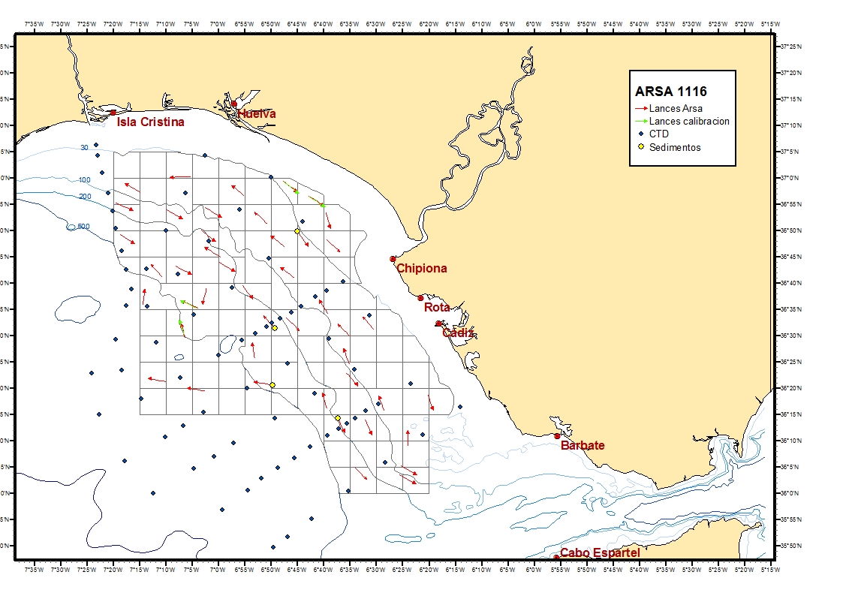
Figure 3: Sampling area and haul and CTD stations carry out during a survey IBTS IXa South in 4th Quarter. (ARSA 1116).

Dates: 30th October – 12th November 2016.
Duration: 14 days.
Methodology: The whole area (7224 km2) has been separated into five depth strata (15-30, 31-100, 101-200, 201-500 and 501-800 m). The sampling design is random stratified with proportional allocation with a total of 42 fishing stations and swept-area method.
Research Vessel: R/V Miguel Oliver, otter trawler 70 meters length, 14.40 m. breadth, 2495 GT and 2 * 1000kW.
Equipment and Sampling gear: Baka trawl 44/60 with a 43.6 m footrope and a 60.1 m headline.
Number of hauls: 45 valid haul.
Sampling:
Hydrographical Sampling: Temperature and salinity data were also collected during each tow with a CTD attached to the gear. Additionally 76 CTD casts were carried out in the survey area.
Biological sampling: A total of 372 species were captured, 156 fish species, 59 crustaceans, 64 molluscs, 24 echinoderms and 59 other invertebrates.
Number of biological samples: Length distribution of all fish and main species of crustacean and cephalopods.
Scientific name | Number of biological samples( maturity and age material, *maturity only)
Merluccius merluccius | 371 (otolith)
Merluccius merluccius* | 937*
Parapenaus longirostris* | 640*
Nephrops norvegicus* | 360*
Octopus vulgaris* | 255*
Loligo vulgaris* | 109*
Sepia officialis* | 552*
Ilex coindetii | 44
Todaropsis eblanae | 37
Loligo forbesii | 183

Data storage: survey data are stored by the IEO in its ad-hoc fishery data base SIRENO (Seguimiento Informático de los Recursos Naturales Oceánicos).
Deviations: There were no deviations from the Proposal.

III.G.2 Data quality: Results and deviation from NP proposal.
The data obtained are used for calibrating assessment models of demersal species in the ICES Southern area within the group WGBIE (formerly WGHMM).
Recommendations given by the Expert Group for the planning of these surveys (ICES IBTSWG) are adopted in the survey protocols.
Deviations: There were no deviations from the Proposal.

III.G.3 Actions to avoid deviations.
Not applicable.

IBTS 4th. Quarter. Porcupine groundfish survey

III.G.1 Achievements: Results and deviation from NP proposal.
Objectives:
- To estimate stratified abundances indices by age of hake, megrims (L. whiffiagonis, L boscii), and monkfishes (Lophius budegassa y L. piscatorius) and other fish species.
- To estimate recruitment indices and spatial trends of younger ages of hake, megrims and monkfishes.
- To estimate stratified abundances indices of commercial fish species (Nephrops norvergicus, Phycis blennoides, Helicolenus dactylopterus, Molva molva, Conger conger)
- To describe the spatial distribution patterns of demersal and benthic species on Porcupine Bank.
- To collect otoliths and biological parameters of the main commercial fish species
- To collect data for the determination of biological parameters for the demersal species selected by DCF.
- To collect hydrographic data.
Sampling area: VIIb-k ICES Division: Porcupine area extends from longitude 11° W to 15° W and from latitude 51° N to 54° N, from 185 to 800 m. (Figure 4)
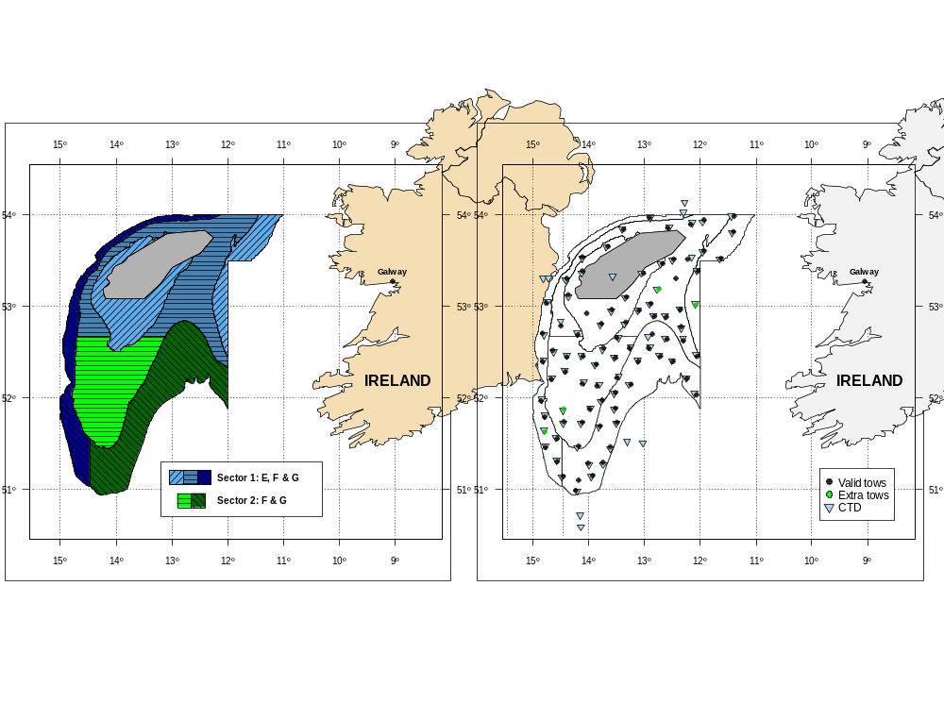
Figure 4: Geographic sectors used in the survey and hauls carried out in Porcupine Spanish ground fish survey in 2016.

Dates: 10th of September - 11th of October of 2016.
Duration: The surveys lasted for 32 days.
Methodology: The sampling design was random stratified with two geographical sectors (Northern and Southern) and three depth strata (> 300 m, 300 – 450 m and 450 - 800 m). Hauls allocation is proportional to the strata area following a buffered random sampling procedure).
Research vessel: R/V Vizconde de Eza.
Equipment and Sampling gear: Porcupine Baca – GAV 39/52 (52 m ground rope double coat, 39 m float rope), 20 mm mesh size in the codend. CTD SeaBird 25.
Number of hauls: 81 standard hauls, 4 additional hauls. There were no null hauls.
Sampling:
Hydrographic sampling: 91 hydrographic stations carried out using a CTD SeaBird 25 At the end or the beginning of each haul. Moreover, to complete the area coverage, some CTD casts will be performed in the central mound not trawlable (the shallowest part of the bank), and four radials, southwards, west and north to the bank, in order to get information about hydrographic conditions around the area.
Species list: A total of 213 species were found: 94 fish species, 40 crustaceans, 30 mollusks, 26 echinoderms and 23 of other invertebrates.
Lenght sampling: All fish species and Norway lobster (Nephrops norvegicus) were measured. The number of the main species sampled are shown in the following table.

Species | Total
Merluccius merluccius | 3255
Lepidorhombus whiffiagonis | 6667
L. boscii | 5125
Lophius budegassa | 43
L. piscatorius | 292
Micromesistius poutassou | 18076
Phycis blennoides | 1469
Trachurus trachurus | 943
Molva macrophtalma | 403
Molva molva | 52
Glyptocephalus cynoglossus | 1154
Melanogrammus aeglefinus | 471
Merlangius merlangus | 5
Helicolenus dactylopterus | 3997
Conger conger | 23
Nephrops norvegicus | 3653

Otholits and illicia:

Species | Otholit/ illicia | Species | Otholit/ illicia
Merluccius merluccius | 1072 | Phycis blennoides | 234
Lepidorhombus whiffiagonis | 784 | Conger conger | 23
Lepidorhombus boscii | 300 | Helicolenus dactylopterus | 180
Lophius budegassa | 36 | Molva molva | 52
Lophius piscatorius | 177 | Nephrops norvegicus* | 431
* Only sex, maturity and fecundity data (209 males, 222 females).

Data storage: survey data are stored by the IEO in its ad-hoc fishery data base SIRENO and also in DATRAS from 2001 onwards.
Environmental indicators:
Data of the survey are used to estimate index 1 and 3. However, length-weight regressions are used to estimate weight data specifically to get index 2, because that is more reliable than individual weight data obtained in the surveys which oscillate with meteorological conditions.
Regarding estimation of index 4 (maturity size of exploted species), the data of the surveys are not used because the Porcupine survey is carried out to estimate the recruitment (in the third and forth trimester of the year), but it is not conducted in the spawning season.
Deviations: There were no deviations from the Proposal.

III.G.2 Data quality: Results and deviation from NP proposal.
Data obtained are used to calibrate the demersal stocks assessment models of the ICES areas VII c-k in the working group WGBIE. Moreover, data of the survey are provided to working group WGCSE for assessment of the Norway lobster (Nephrops norvegicus), to working group WGDEEP for assessment of deep species (Phycis blennoides, Argentina sp., Molva macrhophthalma and H. dactylopterus), to working group WGEF for assessment of elasmobranch species (Galeus melastomus, Deania calcea, Scyliorhinus canicula, Scymnodon ringens…) and to the working group WGWIDE to provide information for the assessment of blue whiting (M. poutassou).
These surveys are coordinated at IBTSWG group and all that group's recommendations are followed.
Deviations: There were no deviations from the Proposal.

III.G.3 Actions to avoid deviations.
Not applicable.

Sardine DEPM (SAREVA)
This triennial survey was unplanned for 2016. The last one was carried out in 2014 and the next one is planned for 2017.

MACKEREL / H. MACKEREL EGGS SURVEY (triennial)
This is a triennial survey.The last one was carried out in 2013. The triennial survey in 2016 is made up of two surveys carried out by IEO (CAREVA and JUREVA) and another survey carried out by AZTI in two periods (period 3: March-April and period 5: May).

III.G.1 Achievements: Results and deviation from NP proposal.

CAREVA and JUREVA (IEO)
Objectives:
The main purpose of these surveys is the prospecting of eggs and adults of mackerel (Scomber scombrus) and horse mackerel (Trachurus trachurus) used for the joint international assessment of spawning biomass through the Annual Egg Production Method (AEPM) of the North Atlantic mackerel stock and egg production and fecundity of horse mackerel Western stock. For this purpose, the following objectives are defined:
- Estimation of daily and total production of mackerel (S. scombrus) eggs for application of the Annual Egg Production Method (AEPM).
- Estimation of daily and total production of horse mackerel (T. trachurus) eggs.
- Estimation of mackerel (S. scombrus) and horse mackerel (T. trachurus) spawning area.
- Study of oceanographic conditions and environmental variables.
- Estimation of potential fecundity values of target species.
- Spatial distribution of other species of commercial interest present in the area at the same time: mainly sardine .Surveyed area: Southern Biscay (until 46ºN), Cantabrian Sea and Galicia Atlantic coast.
Sampling area: Continental shelf and slope of the NW-N of the Iberian Peninsula and west of France (from the mouth of the Miño river to the parallel 46º N in CAREVA and to the parallel 45.25ºN in JUREVA) covering ICES areas IXa N, and VIIIbc. (Figure 5 & Figure 6)
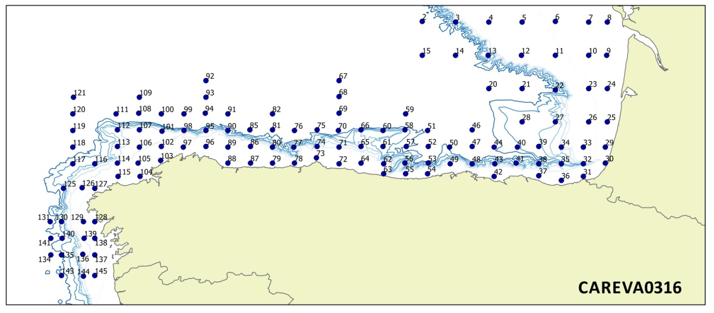
Figure 5: Sampling stations during CAREVA0316.
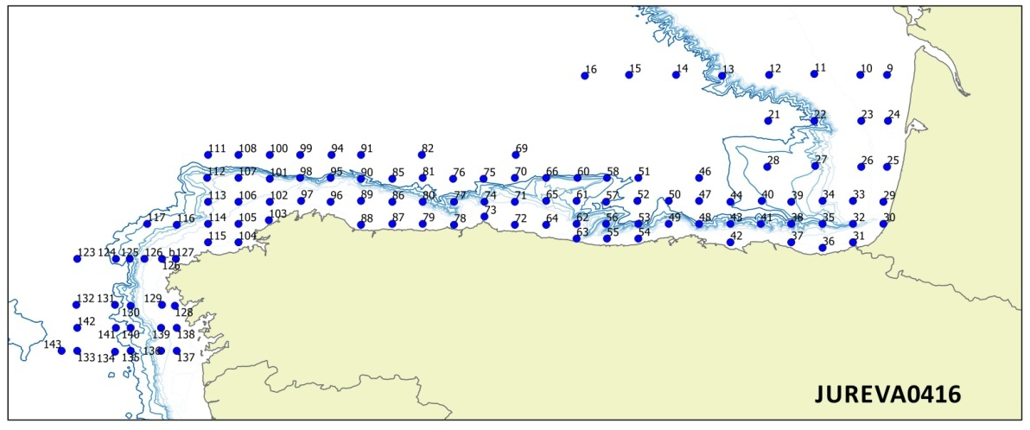
Figure 6: Sampling stations during JUREVA0416.
Dates: CAREVA from 6th to 31st March 2016, JUREVA from 8th April to 1st May 2016
Duration: CAREVA lasted for 26 days, JUREVA lasted for 25 days
Methodology: The standard plankton sampler for use on this survey is BONGO 40, with a nylon mesh aperture of 250 microns (oblique tow), a Seabird37 (CTD) attached to the frame and mechanical flowmeters to enable the volume of water filtered on each deployment to be calculated. Maximum sampling depth was 200m, or to within 5m of the bottom where the bottom is less than 200m.
Preliminar egg sorting was made on board two hours after fixation in formaldehyde. In the laboratory, a full check of the samples was completed thereafter.
Adult samples were obtained from pelagic fishing hauls (and completed with the pelagic fishing hauls performed onboard Miguel Oliver during PELACUS survey).
Research Vessel: R/V Vizconde de Eza.
Equipment and Sampling gear: Bongo 40 Net for planKton. CTD Seabird 37. Pelagic fishing gear.
Sampling:
CAREVA:-Ichthyoplankton tows: 130, -CTD stations: 126, -Adult fish operations: 3
JUREVA: -Ichthyoplankton tows: 117, -CTD stations: 111, -Adult fish operations: 14
Data storage: survey data are stored by the IEO in its ad-hoc fishery data base SIRENO.
Environmental indicators: During theese surveys collected data are available to calculate indicators 1, 2 and 3 for all the fish species caught. Besides, for indicator 4, data are also available for mackerel and horse mackerel.
Deviations: During JUREVA survey carried out in April, some planned ichthyoplankton transects could not be performed due to bad weather conditions. Because of the same reason, associated CTD data were not taken either.

TRIENAL (AZTI)
Sampling area:
Period 3: ICES Area VIIIabd. From 45 to 48.30 ºN and from French coast to 10ºW.
Period 5: ICES Area VIII bcd. From the Spanish and French coasts, south of 46 ° N up to the 7º W.

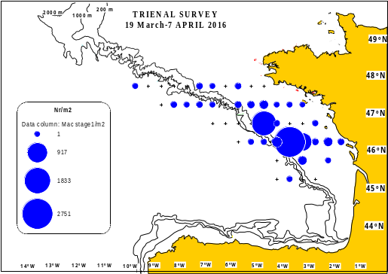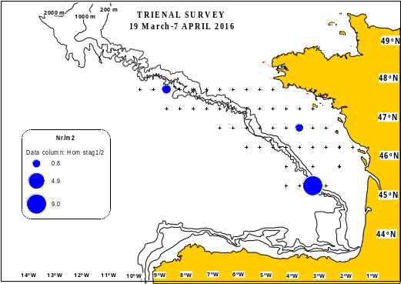
Figure 7: Ichthyoplankton stations from the survey. Abundance (eggs stage 1/m²) and distribution of mackerel (left) and horse mackerel (right) eggs obtained in 2016 with the BONGO net, on board the R/V Ramón Margalef in period 3.
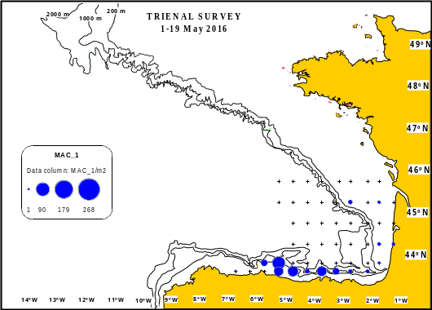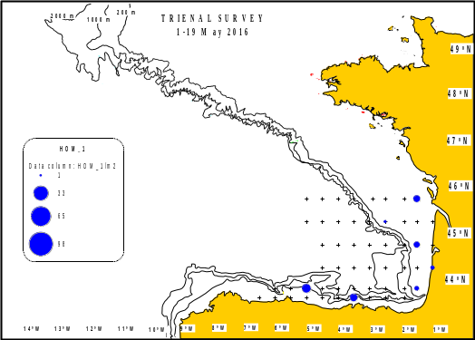
Figure 8: Ichthyoplankton stations from the survey. Abundance (eggs stage 1/m²) and distribution of mackerel (left) and horse mackerel (right) eggs obtained in 2016 with the BONGO net, on board the R/V Ramón Margalef in period 5.
Dates: Period 3: from 19th of March to 7th of April. Period 5: 30th April to 5th of May.
Duration: Period 3 lasted for 20 days, Period 5 lasted for 6 days. Total (Period 3 + Period 5) = 26 days
Methodology: Sampling design consists of a grid of stations located at the mid-point of 0.5 ° lat * 0.5 ° long rectangle in western area and 0.2 ° lat * 0.5 ° long in southern area one. Ichthyoplankton samples were collected using BONGO nets, 40 cm mouth diameter and equipped with 250 um mesh size and CTD. BONGO nets were towed to a nominal depth of 200 or 5 m above the bottom in shallower waters, and then retrieved back obliquely to the surface. The net was deployed at a speed of 50 m/min and retrieved at 20 m/min with the boat steaming at approximately 2 knots. Ancillary hydrographical data, namely, temperature and salinity were recorded at each haul using a CTD.
Pelagic trawls were carried out to obtain mackerel and horse mackerel adult samples. This sampling was, as much as possible, in line what was agreed in the WGMEGS and coincided with areas of high presence of eggs.
Research Vessel: Period 3: R/V Ramón Margalef for Ichthyoplankton and adult samplings. Period 5: R/V Ramón Margalef for Ichthyoplankton and R/V Emma Bardan for adults.
Equipment and Sampling gear: Bongo 40 nets for ichthyoplankton. Pelagic trawls of 15 m of vertical opening for adult.
Sampling:
Plankton sampling: 102 samples of plankton (Bongos) were collected, 49 stations in period 3 y 53 stations in period 5 (Figure 7 & Figure 8).
Biological sampling: 49 pelagic trawls for adult samples were performed.
Period 3: 5 hauls of adults (Figure 3 left) were carried out. 429 mackerels were caught and the length and weight were recorded. Additionally, for 274 females the following parameters were obtained: Length, gutted weight, gonad weight, sex, maturity and age.
Period 5: 44 hauls of adults (Figure 3 right) were completed. 758 mackerels were caught and the length and weight of 157 were registered. Also, for 62 females the following parameters were wrote down: Length, gutted weight, gonad weight, sex, maturity and age
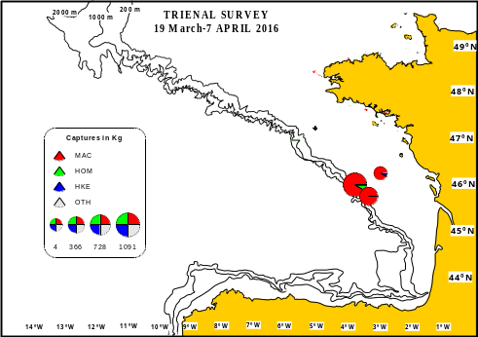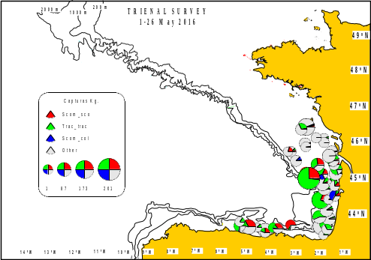
Figure 9: Spatial distribution and species composition of adult samples obtained during TRIENAL 2016 on board the pelagic trawler R/V Ramon Margalef (Period 3, left panel) and R/V Emma Bardán (Period 5, right panel).
Additionally, other species present in the hauls were measured: Trachurus trachurus: 126, Zeus faber: 1, Merluccius merluccius: 4, Capros aper: 2.
Hydrographic sampling: A systematic sampling was conducted at each ichtyoplankton station. It consisted in recording i) surface temperature and salinity manually using thermal and salinity sensors and ii) Vertical profile of temperature, salinity and chlorophyll in the water column from surface up to 200 m depth using a CTD RBR XR420. At each station temperature and salinity at bottom, 100, 50, 20 m depth and surface were recorded. This information was added to the standardized egg template.
Data storage: All data is stored in the AZTI data base. Additionally, data of eggs and other variables recording during the surveys were sent stored in Abeerden at the Marine Laboratory. Adults’ data were compiled by Norway (IMR) for mackerel and in Ijmuiden (IMARES) for horse mackerel. All this information is also gathered in the ICES data base portal.
Environmental indicators: During the survey TRIENAL 2016 data were collected to calculate indicators 1, 2 and 3 for the following species Engraulis encrasicolus, Sardina pilchardus, Scomber scombrus, Scomber colias, Trachurus trachurus, Merluccius merluccius, Spratus spratus and Myctofidae spp. Likewise, data were collected to calculate the indicator 4 for mackerel.
Deviations: The final number of plankton samples was 68% of the initial stations planned. This difference in the total number was consequence of:
1.Triennial surveys are adaptive surveys with the objective of delimitating the spawning area of the target species. It means the number of stations to do that will depend on the spatial distribution of eggs. When the spawning is very spread out, the number of stations needed to delimitate the area will be higher than when it is more concentrated. In 2016, we were able to achieve this objective with a lower number of stations because the spawning resulted be aggregate.
2.One transect was no completed due to bad weather conditions and technical problems. This was communicated to surveys coordinator to ensure that neighboring transect was completed to interpolate the missing stations. This kind of issues ae common during the surveys and we acted according to the protocol agreed in the WGMWEGS.

III.G.2 Data quality: Results and deviation from NP proposal.
Recommendations given by the Expert Group for the planning of these surveys (ICES WGMEGS) are adopted in the survey protocols.
The corresponding data of the samples has been sent according to the following scheme:
1) Egg production data to Brendan O’Head as surveys coordinator (MI, Ireland) and Finlay Burns as co-chair of WGMEGS.
2) Potential fecundity data for mackerel and atresia to Anders Thorsen and Merete Fonn respectively (IMR, Bergen) as coordinator of data and Paula Alvarez (AZTI) as person in charge of analysis.
3)Batch fecundity and spawning fraction data of mackerel to Cindy Van Damme (IMARES, The Netherlands) as coordinator and co-chair of WGMEGS and Dolores Garabana (IEO, Spain) as person in charge of analysis.
4) Batch fecundity and spawning fraction data of Horse mackerel to Cindy Van Damme (IMARES, The Netherlands) as coordinator and co-chair of WGMEGS and Maria Korta (AZTI, Spain) as person in charge of analysis
Analysis of reproductive parameters: In line what was agreed during the WKFATHOM in November 2016, the gonad processing followed this sequence: a first histological study of the reproductive status of all samples collected both mackerel and horse mackerel. This process split the samples into different groups of analysis according to the presence or absence of specific spawning markers. The groups were: i) samples for potential fecundity; ii) samples for atresia; iii) samples for batch fecundity and iv) samples for spawning frequency (POFs analysis). Finally, samples were distributed to the institutes/countries for completing the analysis. The allocation of samples (number per institute and type of analysis) was agreed during the WKFATHOM in 2016.
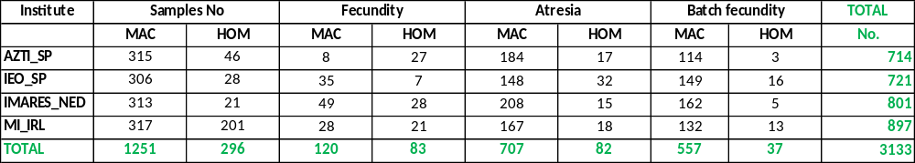
The data obtained are used for obtaining estimates of egg production for the western and southern component of mackerel, estimates of biomass applying the annual egg production method and estimates of potential fecundity.
Deviations: There were no deviations from the Proposal.

III.G.3 Actions to avoid deviations.
Not applicable.

SARDINE, ANCHOVY, H. MACKEREL ACOUSTIC SURVEY (PELACUS)

III.G.1 Achievements: Results and deviation from NP proposal.
Objectives:
- The main objective of this survey was to achieve a biomass’ estimation by echointegration of the main pelagic fish distributed in the Spanish Cantabrian and NW waters (sardine, anchovy, horse mackerel, mackerel, blue whiting, bogue, boar fish, and chub mackerel). Together with this, the following objectives were also foreseen:
- Determine the distribution area and density of the main fish species
- Determine the main biological characteristics (length, sex, maturity stage and age) of the main fish species
- Estimate the relative abundance and distribution area of sardine and anchovy eggs by means of CUFES
- Estimate the adults parameters needed to apply the Daily Egg Production Method to to estimate the spawning stock biomass of both mackerel and horse mackerel.
- Characterise the main oceanographic conditions of the surveyed area
- Determine the distribution pattern, taxonomic diversity and dry biomass by size classes of the plankton population presented in the surveyed area.
- Determine the natural abundance of N15 in sardine, anchovy and mackerel and their trophic position.
- Determine the distribution area and density of apical predators
- Determine the distribution area and density of marine microplastics litter
Sampling area: ICES Divisions 8c and 9a along the Spanish coast and Spanish part of the Bay of Biscay(Figure 10)
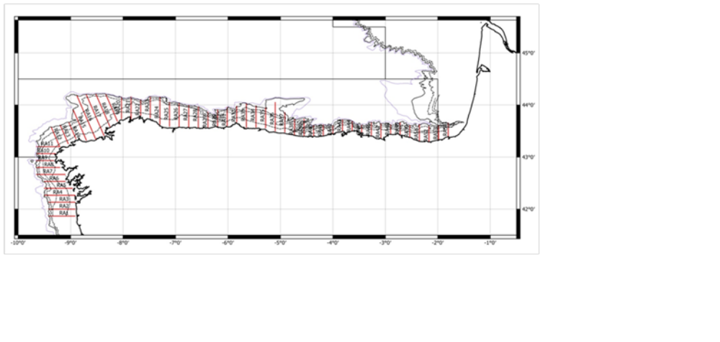
Figure 10: Acoustic sampling grid carried out by the R/V “Miguel Oliver” during the survey PELACUS 0316 (North-West Spanish coast).

Dates: 13th march 2016 - 16th April 2016.
Duration: The survey lasted for 33 days.
Methodology: Acoustic, Systematic track with parallel transects evenly distribute each 8 nmi. Backscattering energy attributed to fish species after scrutinisation of the echograms. Biomass estimates using echointegration method. Pelagic fishing stations for echo-trace allocation and biological characterisation. CUFES (Continuous Underway Fish Egg Sampler) for mapping egg (anchovy and sardine) distribution area. Trained observers recorded marine mammal, seabird, floating litter and vessel presence and abundance. Data on the hydrography and hydrodynamics of the water masses are collected via the deployment of rosettes and conductivity, temperature and depth sensors. Information on the composition, distribution and biomass of phytoplankton and zooplankton is derived from the analyses of samples taken by plankton nets.
Research Vessel: R/V Miguel Oliver, otter trawler 70 meters length, 14.40 m. breadth, 2495 GT and 2 * 1000kW.
Equipment and Sampling gear: An adaptation of a “grandes mailles”, with a vertical opening of about 20 m and horizontal one around 30 m. A. set of 4 m2 Apollo polyice doors (Thyborøn). Acoustic equipment consisted on a Simrad EK-60 scientific echo-sounder, operating at 18, 38, 70, 120 and 200 kHz. SeaBird Thermosalinograph coupled with a Turner Flourometer. Nets: Bongo, WP2 and CalVet. CTD+bottle rosette carousel.
Number of nautical miles prospected for acoustic purposes: 1248 nmi. Only day time
Number of CUFES stations: Intake at 5 m depth, 600 l min-1. 3 nmi/sample, 215 samples (sardine and anchovy eggs)
Marine mammals and birds observations: 144 legs (115.4 hours
Hydrological characterisation: 70 stations (45 CTD with rosette and 27 plankton nets)
Number of hauls: 49 (Figure 11).
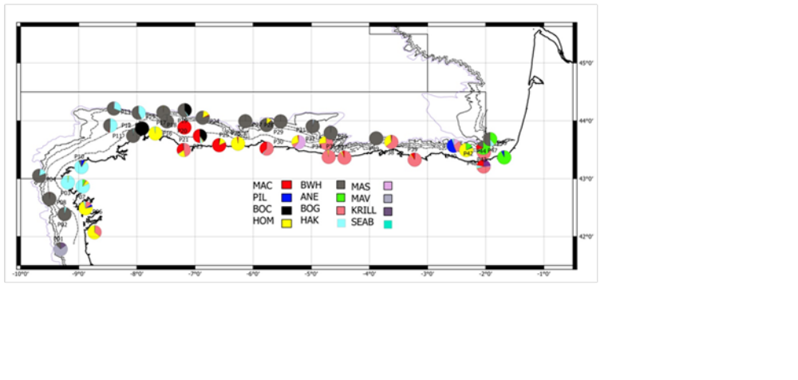
Figure 11: Backscattering energy proportion allocated to each species at each fishing station. (MAC-mackerel; PIL-sardine; BOC-boarfish; HOM- horse mackerel; WHB-blue whiting; ANE- anchovy; BOG-bogue; HAK-hake; MAS-chub mackerel; MAV-M. Muelleri KRILL -M. norvegica; SEAB- Sea breams).
Sampling
Acoustic sampling: Acoustic equipment consisted on a Simrad EK-60 scientific echosounder, operating at 18, 38, 70, 120 and 200 kHz. All frequencies were calibrated according to the standard procedures (Foote et al 1987). The elementary distance sampling unit (EDSU) was fixed at 1 nm. Acoustic data were obtained only during daytime at a survey speed of 8-10 knots. Data were stored in raw format and post-processed using SonarData Echoview software (Myriax Ltd.) (Higginbottom et al, 2000). All echograms were first scrutinized and also background noise was removed according to De Robertis and Higginbottom (2007). Fish abundance was calculated with the 38 kHz frequency as recommended at the PGAAM (ICES 2002), although echograms from 18, 70, 120 and 200 kHz frequencies were used to visually discriminate between fish and other scatter-producing objects such as plankton or bubbles, and to distinguish different fish species according to the strength of their echo at each frequency. The 18, 70, 120 and 200 kHz frequencies have been also used to create a mask allowing a better discrimination between fish species and plankton. The threshold used to scrutinize the echograms was –70 dB. The integration values were expressed as nautical area scattering coefficient (NASC) units or sA values (m2 nm -2) (MacLennan et al., 2002).
Main echosounder settings are shown in Table 8
Transducer power | 2000/2000/1000/200/90 W for 18/38/70/120/200 kHz
Pulse duration | 1.024 ms
Ping rate | Maximum, in case of ghost echo-bottom, change to time interval starting at 0.30 ms
Range (echograms, files) | 200 m in shallower area (i.e. depth<100m); 400 when depth is between 100-200m; and 1000 when depth is>400m
Table 8: Main echosounder settings

Acoustic tracks were steamed at 10 knots.
Two pelagic gears have been used to identify the species and size classes responsible for the acoustic energy detected and to provide samples. Choice of net was also dependant on the availability of enough unobstructed ground for the net to be deployed and recovered and for effective fishing to occur. Haul duration is variable and ultimately depends on the number of fish that enters the net and the conditions where fishing takes place although a minimum duration of 20 minutes is always attempted. The quality of the hauls for ground-truthing of the acoustic data was classified on account of weather condition, haul performance and the catch composition in numbers and the length distribution of the fish caught as follows:
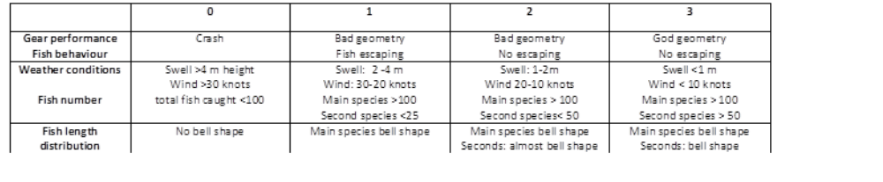
Hauls considered as the best representation of the fish community for a specific area were used to allocate NASC of each EDSU within this area when no direct allocation is feasible. This process involved the application of the Nakken and Dommasnes (1975, 1977) method for multiple species, but instead of using the mean backscattering cross section, the full length class distribution (1 cm length classes) has been used.
When possible, direct allocation was also done, accounting for the shape of the schools and also the relative frequency response (Korneliussen and Ona, 2003, De Robertis et al, 2010). Due to the aggregation pattern found in the surveyed area, fish schools were extracted using the following settings (Table 9)
Sv threshold | -60 dB for all frequencies
Minimum total school length | 2 m
Min. total school height | 1 m
Min. candidate length | 1 m
Min. candidate height | 0.5 m
Maximum vertical linking distance | 2.5 m
Max. horizontal linking distance | 10 m
Distance mode | Vessel log
Main frequency for extraction | 120 kHz
Table 9: Main morphological and backscattering energy characteristics used for schools detection

For all school candidates, several of variables were extracted, among them the NASC (s_{A}, m²/nmi²) together with the proportioned region to cell (ESDU, 1 nmi) NASC and the s_{V} mean and s_{V} max and geographic position and time. PRC_NASC values were summed for each ESDU and distances were referenced to a single starting point for each transect. Results for 38 and 120 kHz were compared. Besides, the frequency response for each valid school (i.e. those with length and s_{V} which allows them be properly measured) was calculated as the ratio s_{A(fi)} /s_{A(38)}, being fi the sAvalues for 18, 120 and 200 kHz
Once backscattering energy was allocated to fish species, the spatial distribution for each species was analysed taking into account both the NASC values and the length frequency distributions (LFD) to provide homogeneous assessment polygons. These are calculated as follows: an empty track determine the along-coast limit of the polygon, whilst three consecutive empty ESDU determine a gap or the across-coast limit. Within each polygon, the LDF is analysed.
LFD were obtained for all positive hauls for a particular species (either from the total catch or from a representative random sample of 100-200 fish). For the purpose of acoustic assessment, only those LFD which were based on a minimum of 30 individuals were considered. Differences in probability density functions (PDF) were tested using Kolmogorov-Smirnov test. PDF distributions without significant differences were joined, providing a homogeneous PDF strata. Spatial distribution was then analysed within each stratum and finally mean sA value and surface (square nautical miles) were calculated using a GIS based system (Q-gis). These values, together with the length distributions, are used to calculate the fish abundance in number as described in Nakken and Dommasnes (1975) (see previous section for further details). Estimatesfor each species was carried out on each strata (polygon) using the arithmetic mean of the backscattering energy (NASC, sA) attributed to each fish species and the surface expressed in square nautical miles.
Numbers were converted into biomass using the length weight relationships derived from the fish measured on board. For purposes of comparison, results are given by ICES Sub-Divisions (9aN, 8cW, 8cEw , 8cEe and 8b)
Otoliths are taken from anchovy, sardine, horse mackerel, blue whiting, mackerel and hake (Merluccius merluccius) in order to determine age and to obtain the age-length key (ALK) for each species and area.
Summary of the trawl haul and catches by species is shown in Table 10
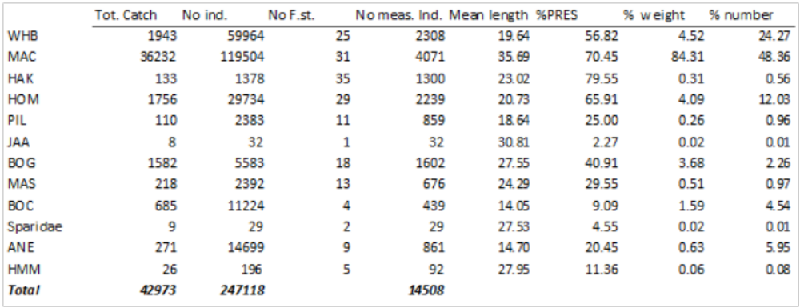
Table 10: Summary of the trawl haul and catches by species, indicating total catch in weight and number, the number of fishing station a particular species has been caught, the total weight and number of measured fish by specie, the overall mean length, the % of presence (number of fishing station with presence/total trawl hauls) and % in weight and number from the total catch in weight and number

CUFES system uses an internal pumping system with the intake located at 5 m depth. The sea water goes first to a tank of about 1m3 before to be pumped towards the concentrator. Samples from CUFES were collected every three nmi while acoustically prospecting the transects (Figure 12). Once the sample is taken it is fixed in a buffered 4% formaldehyde solution. Anchovy and sardine eggs are sorted out and counted before being preserved in the same solution. The remaining ichthyoplankton (other eggs and larvae) are also preserved in the same way. Information on horse mackerel and mackerel (qualitative) was also recorded.
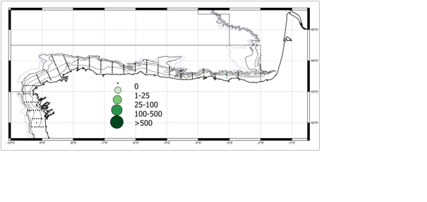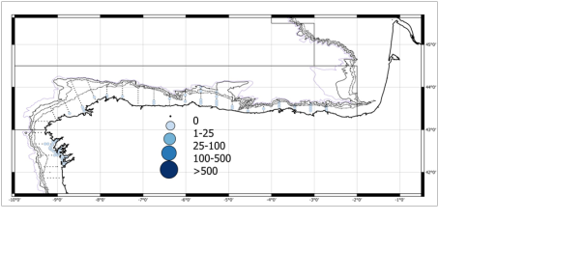Figure 12: Sardine and anchovy egg spatial distribution

Continuous records of SSS, SST and flourometry are taken using a SeaBird Thermosalinograph coupled with a Turner Flourometer. Plankton and CTD and bottle rosette for water samples casts are performed at night (Figure 13). Five stations are placed over the transects, which are those of the acoustic prospection but that are extended onto open waters until the 1000-2000 m isobaths. The stations are evenly distributed over the surveyed area at a distance of 16-24 nmi. Plankton was sampled using several nets (Bongo, WP2 and CalVet). Fractionated dried biomass at 53-200, 200-500, 500-1000 and >2000 µm fractions was calculated together with species composition and groups at fixed strata from samples collected at the CTD+bottle rosette carousel (pico and nanoplankton, microplankton and mesozooplankton). For this purpose, FlowCAM, LOPC and Zoo-Image techniques were used. Water samples were stored at -20°C for further dissolved nutrients analysis (NO3, NO2, P, NH4+, SiO4)
Three observers placed above the bridge of the vessel at a height of 16 m above sea level work in turns of two prospecting an area of 180° (each observer cover a field of 90°). Observations are carried out with the naked eye although binoculars are used (7x50) to confirm species identification and determine predator behaviour. Observations are carried out during daylight while the vessel prospects the transects and while it covers the distance between transects at an average speed of 10 knots. Observers recorded species, number of individuals, behaviour, distance to the vessel and angle to the trackline and observation conditions (wind speed and direction, sea state, visibility, etc.). Observers also recorded presence, number and type of boats and type, size and number of floating litter. The same methodology is used on the PELGAS surveys and both observer teams shared a common database.
A “manta net neuston sampler” was used. This trawl device has a collector of 350μm. Tows were performed for 15 min at 4 knots speed. The samples were evenly distributed along the surveyed area.
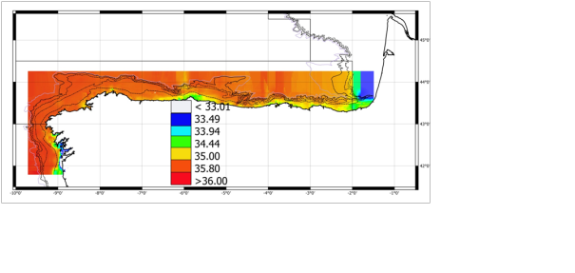
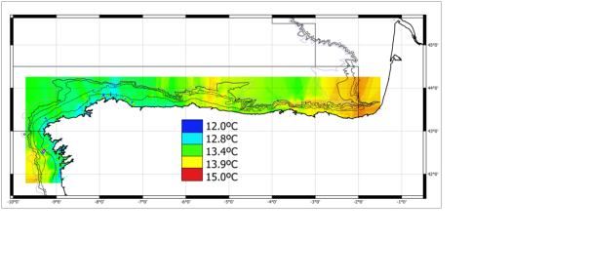
Figure 13: Horizontal profiles of temperature and salinity at 5 m depth from CT continuous records obtained at the acoustic transects normal to the coastline along the surveyed area.

Data storage: survey data are stored by the IEO in its ad-hoc fishery data base SIRENO.
Environmental indicators: During PELACUS-0315 survey collected data are available to calculate indicators 1, 2 and 3 for all the fish species caught. Besides, for indicator 4, data are also available for hake, sardine, mackerel, horse mackerel and blue whiting.
Deviations: During PELACUS survey in April, some planned acoustic transects could not be performed due to bad weather conditions.

III.G.2 Data quality: Results and deviation from NP proposal.
Data are available for the following ICES working groups: WGACEGG; WGWIDE; WGHANSA
Deviations: There were no deviations from the Proposal.

III.G.3 Actions to avoid deviations.
Noy applicable

BIOMAN

III.G.1 Achievements: Results and deviation from NP proposal.
Objectives
Estimate the 2016 anchovy biomass in the Bay of Biscay in spring applying the daily egg production method (DEPM).
Obtain the numbers at age, percentage at age, length at age, weight at age and biomass at age of the anchovy population.
Continuous sampling of anchovy and sardine eggs with CUFES.
Biological characterization of the species: determine the spawning area of anchovy in the Bay of Biscay for this year, age and size structure, length / weight ratio from data from the biological sampling of the survey. Sex ratio, batch fecundity and spawning frequency of the population
Study of the hydrological conditions of the survey area: 1) Measure the vertical profiles of temperature, salinity and chlorophyle at each plankton station; 2) Continuous data acquisition at 3 meters depth (temperature, salinity and chlorophyle).
Sampling area: ICES área VIII a, b, c and d. Between the Spanish and French coasts, south of 48 ° N and until 6ºW.
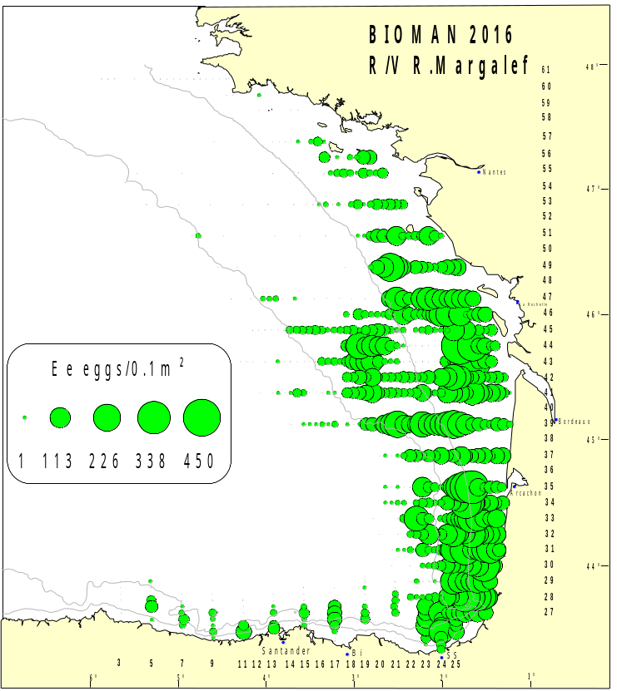
Figure 14: Ichthyoplankton stations from the survey. Abundance (eggs/0.1m²) and distribution of anchovy eggs obtained in 2016 with the PairoVET net, on board the R/V Ramón Margalef.
Dates:
R/V Emma Bardán: From 7th to 27th of May 2016 to obtain adult samples.
R/V Ramón Margalef: from 7th to 26rd May 2016 to obtain plankton samples.
Duration:
R/V Emma Bardán: 18 effective days working at sea + 3 days on harbor due to rough seas.
R/V Ramón Margalef: 20 effective days working at sea
Methodology:
The area covered was the southeast of the Bay of Biscay (Figure 14), which corresponds to the main spawning area and spawning season of anchovy. The sampling strategy was adaptive. The survey started from the West (transect 7, at 5º W), but as there were found anchovy eggs in this transect two more transects were prospected to the west until 5º 40’W looking for the western limit of the spawning area The Cantabric Coast and covered eastwards up to Pasajes (transect 25, approx. 1º50’W) (Figure 14). Unfortunately the west limit was not found totally but the abundances in the last transect were low. Then, the survey continued to the North, in order to find the Northern limit of the spawning area. When the egg abundances found were relatively high, additional transects separated by 7.5 nm were completed. This occurred in the eastern part of the Cantabric coast and in the area of the Adour and Garonne rivers.
The strategy of egg sampling was identical to that used in previous years, i.e. a systematic central sampling scheme with random origin and sampling intensity depending on the egg abundance found (Motos, 1994). Stations were situated at intervals of 3 nm along 15 nm apart transects perpendicular to the Cantabric and French coast.
At each station a vertical plankton haul was performed using a PairoVET net (Pair of Vertical Egg Tow, Smith et al., 1985 in Lasker, 1985) with a net mesh size of 150 µm for a total retention of the anchovy eggs under all likely conditions. The net was lowered to a maximum depth of 100 m or 5 m above the bottom in shallower waters. After allowing 10 seconds at the maximum depth for stabilization, the net was retrieved to the surface at a speed of 1 m s-1. A 45 kg depressor was used to allow for correctly deploying the net. "G.O. 2030" flowmeters were used to detect sequential clogging of the net during a series of tows.
Immediately after the haul, the nets were washed and the samples obtained were fixed in formaldehyde 4% buffered with sodium tetra borate in sea water, mixing the samples obtained in each of the nets that compound the PairoVET frame. After six hours of fixing, anchovy, sardine and other eggs species were identified, sorted out and counted on board (Figure 15).
The Continuous Underway Fish Egg Sampler (CUFES, Checkley et al., 1997) was used to record the eggs found at 3m depth with a net mesh size of 350µm not to lose eggs. The samples obtained were immediately checked under the microscope so that the presence/absence of anchovy eggs was detected in real time. When anchovy eggs were not found in six consecutive CUFES samples in the oceanic area transect was abandoned.
Adult samples were obtained on board R/V Emma Bardán (pelagic trawler) from the 7th to the 27th May coinciding in space and time with the plankton sampling. When the plankton vessel encountered areas with anchovy eggs, the R/V Emma Bardán was directed to those areas to fish. In each haul, immediately after fishing, anchovy were sorted from the bulk of the catch and a sample of two kg was selected at random. A minimum of one kg or 60 anchovies were weighted, measured and sexed and from the mature females the gonads of 25 non-hydrated females (NHF) were preserved. If the target of 25 NHF was not completed 10 more anchovies were taken at random and processed in the same manner. Sampling was stopped when 120 anchovies had to be sexed to achieve the target of 25 NHF. Otoliths from all individuals were extracted on-board and read in the laboratory to obtain the age composition per sample. In each haul 100 individuals of each species were measured.
This year 2 additional anchovy adult samples were obtained from the commercial Basque purse seine fleet when the egg sampling was crossing the area of Cape Breton where the purse seiners were operating. The spatial distribution of the adult anchovy samples is shown in Figure 16.

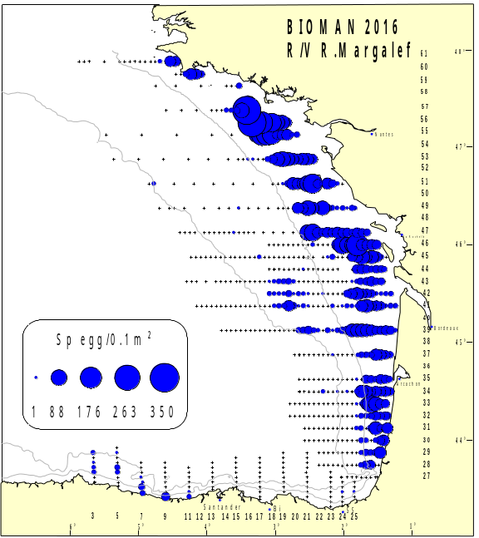
Figure 15: Ichthyoplankton stations from the survey. Abundance (eggs/0.1m²) and distribution of sardine eggs obtained in 2016 with the PairoVET net, on board the R/V Ramón Margalef
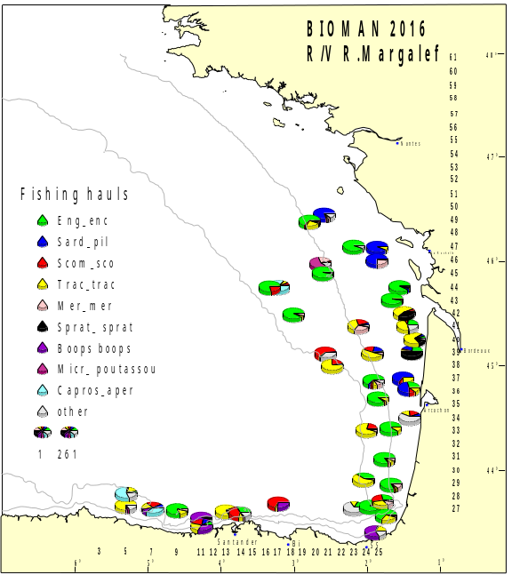
Figure 16: Spatial distribution and species composition of adult samples obtained during BIOMAN 2016 on board the pelagic trawler R/V Emma Bardán

Vessels:
R/V Ramón Margalef to obtain plankton samples
R/V Emma Bardán to obtain adult samples
Equipment and Sampling gear:
To collect plankton samples: a PairoVET net (Pair of Vertical Egg Tow, Smith et al., 1985 in Lasker, 1985) with a net mesh size of 150 µm with a flowmeter (G.O. 2030)and a couple CTDRBR-XR420.
The Continuous Underway Fish Egg Sampler (CUFES, Checkley et al., 1997) at 3m depth with a mesh size of 335 µm and a CTD to record simultaneously temperature and salinity at 3 m depth, a flowmeter to measure the volume of the filtered water, a fluorimeter and a GPS (Geographical Position System) to provide sampling position and time.
For the fishing hauls: pelagic trawler with a 15 m of vertical aperture was used.
Number of hauls:
Plankton stations: 680PairoVET and 1,649 CUFES
Adult samples: 44 pelagic trawls, from those 34 with anchovy and 29 were used for the analysis of the adult parameters. Moreover 2 hauls were obtained from the purse seine fleet. In total 31 samples for analysis.
Sampling
Hydrographic Sampling:
-Sample depth, temperature, salinity and fluorescence profiles were obtained at each sampling station using a CTD RBR-XR420 coupled to the PairoVET.
-At some points determinate before the survey, water was filtered from the surface to obtain chlorophyll samples to calibrate the data from the fluorimeter.
-The CUFES system had a CTD to record simultaneously temperature and salinity at 3 m depth, a flowmeter to measure the volume of the filtered water, a fluorimeter and a GPS (Geographical Position System) to provide sampling position and time. All these data were registered at real time using the integrated EDAS (Environmental Data Acquisition System) with custom software
Biological sampling:
-680 plankton samples (69% with anchovy eggs and 39% with sardine eggs) from those, anchovy eggs (25,564) and sardine eggs (7,684) were sorted and anchovy eggs were classified by stages (Figure 14 and Figure 15)
-44 pelagic trawls were performed, from those 34 with anchovy and 29 were used for the analysis of the adult parameters. Moreover 2 hauls were obtained from the purse seine fleet.
-In total 31 hauls were used for the analysis (2247 anchovies). A complete biological sampling was completed (size, weight, age –read otoliths from 2127 anchovies-, sex, and sexual maturity). From those anchovies 960 ovaries were analyzed with histology to estimate the spawning frequency of each female and finally of the population. The regression to calculate the batch fecundity was done with 83 hydrated females. Afterwards the batch fecundity of each female sampled and the batch fecundity of the population were estimated.
-Additionally, other species present in the hauls were measured:

Scientific name | Number
Sardina pilchardus | 962
Sprattus spratus | 259
Trachurus trachurus | 1933
Trachurus mediterraneus | 1
Scomber scombrus | 758
Somber japonicus | 89
Boops boops | 113
Micromesistius poutassou | 326
Merluccius merluccius | 274
Capros aper | 210
Trisopterus luscus | 3228
Dicentrachus labrax | 25

Data storage: The data are stored in the database SIRENO (IEO). And it is considering moving to a global database, comprising other surveys, oceanographic variables, biological, etc.
Environmental indicators: data were collected to calculate indicators 1, 2 and 3 for the following species: Engraulis encrasicolus, Sardina pilchardus, Sprattus spratus, Trachurus trachurus, Trachurus mediterraneus, Scomber scombrus, Somber japonicus, Boops boops, Micromesistius poutassou, Trisopterus luscus, Merluccius merluccius, Capros aper, Spp Myctofidas. Likewise, data were collected to calculate the indicator 4 of anchovy in the Bay of Biscay in spring
Deviations: The difference between the number of fishing hauls planned and performed is due to sampling is adaptive, i.e., the number of samples depends on the abundance of anchovy within each year. It is difficult to predict in advanced the precise number of samples.

III.G.2 Data quality: Results and deviation from NP proposal.
Data analysis: The total area surveyed was 98,866 km² and the anchovy spawning area was 55,092 Km (Figure 14).
The final biomass obtained applying the DEPM was 152,049 tonnes with a CV of 12%. A unique stratum was considered to estimate the total biomass and for the numbers at age 6 strata were considered.
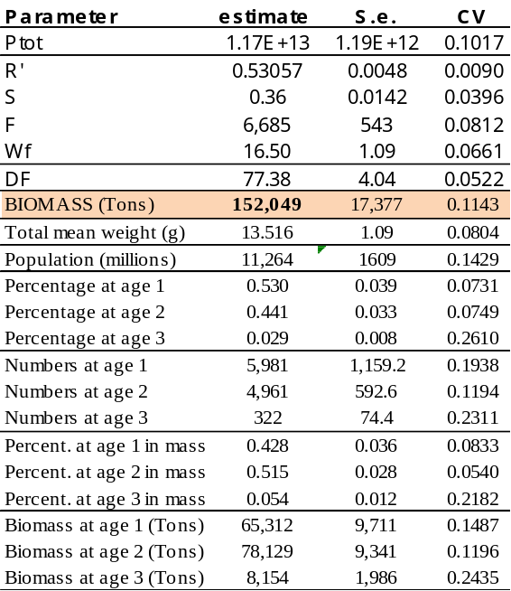
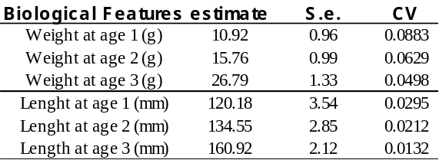
Tabla 11: Egg and adult parameters, total biomass and percentage at age, numbers at age, biomass at age, and weight and length at age for anchovy population derived from BIOMAN 2016 survey.

Ecosystem indicators: During the survey BIOMAN 2016 data were collected to calculate indicators 1, 2 and 3 for the following species: Engraulis encrasicolus, Sardina pilchardus, Sprattus spratus, Trachurus trachurus, Trachurus mediterraneus, Scomber scombrus, Somber japonicus, Boops boops, Micromesistius poutassou, Trisopterus luscus, Merluccius merluccius, Capros aper, Spp Myctofidas. Likewise, data were collected to calculate the indicator 4 for anchovy.
Desviations: There were no deviations from the Proposal.

III.G.3 Actions to avoid deviations.
Not applicable.

FLEMISH CAP GROUNDFISH SURVEY

III.G.1 Achievements: Results and deviation from NP proposal.
Objectives: The main objectives of the survey were the estimation of abundance and biomass index of the target species, as well as the knowledge of their population demographic structure and the oceanographic conditions on the Flemish Cap Bank (NAFO Division 3M). To this end the following tasks were implemented.
- Detailed length distribution and biological sampling of the catch for each target species, recording length, weight, sex, and the collection of otoliths and gonads. For other species only length and length-weight sampling were performed.
- Observation of the oceanographic conditions on the Bank. The collection of oceanographic data (temperature and salinity) was carried out mainly through the CTD profiling; with a grid-pattern design, placing CTD stations separated 15 nautical miles, both in latitude and longitude, with the aim of covering the whole Bank.
Target species: Cod (Gadus morhua), Redfish. (Sebastes marinus, S. mentella and S. fasciatus), American plaice (Hippoglossoides platessoides), Greenland halibut (Reinhardtius hippoglossoides), Roughead grenadier (Macrourus berglax) and Northern shrimp (Pandalus borealis).
Sampling area: Flemish Cap area (NAFO Division 3M) up to depths of 1460 m.
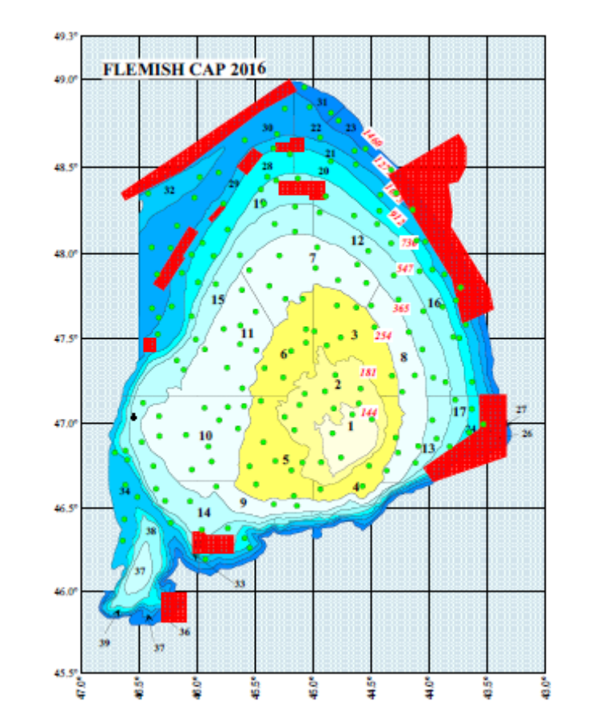
Figure 17: Map of the Flemish Cap Bank (NAFO Division 3M) with hauls performed (valids in green and nulls in red) on “FLEMISH CAP GROUNDFISH SURVEY — 2016”.
Dates:
20/06/2016: Departure from Spain (Scientific IEO&IIM staff).
22/06/2016: Departure to fishing ground.
23/06/2016: Arrival to fishing ground and starting fish hauls.
22/07/2016: End of fishing and departure to St. John´s.
23/07/2016: Arrival to St. John´s and end of Flemish Cap survey.
27/07/2016: Departure from St. John´s to Spain (Scientific staff)
28/07/2016: Arrival to Spain.
Duration: The survey lasted for 32 days at sea, out of which, 30 were effective fishing days and 2 days were used for sailing.
Methodology: Fishing hauls are distributed using a stratified random sampling scheme.
Research Vessel: R/V Vizconde de Eza.
Equipment and Sampling gear: The trawling gear used is the Lofoten (NAFO 1990). CTD SBE-25 SEALOGGER CTD.
Number of hauls: 182 hauls (181 valids and 1 null).
Sampling:
Hydrographic sampling: 68 hydrographic stations using a Seabird CTD system-25.
Length and biological sampling: length sampling of the most fish species of the catch were made and Reindhardtius hippoglossoides, Gadus morhua, Hippoglossoides platessoides, Macrourus berglax, as well as three species of Sebastes otholits were collected. Gonad samples of the same species for subsequent histological analysis in the laboratory were also collected.
The following table shows the numbers of fish measured, otoliths and gonads collected of the main commercial species:

SPECIES | Length sampling  (Nº Indiv) | Weight sampling  (Nº Indiv.) | Collected samples
SPECIES | Length sampling  (Nº Indiv) | Weight sampling  (Nº Indiv.) | Otoliths | Gonads
Gadus morhua | 6583 | 1411 | 1411 | 353
Hippoglossoides platessoides | 899 | 946 | 946 | 174
Sebastes norvegicus | 3532 | 1039 | 1039 | 308
Sebastes mentella | 6076 | 779 | 778 | 213
Sebastes fasciatus | 5875 | 742 | 741 | 204
Sebastes (juveniles) | 2037 | 185 | 184 | 0
Reinhardtius hippoglossoides | 3565 | 670 | 668 | 0
Macrourus berglax | 884 | 689 | 687 | 88
Pandalus borealis | 9919 | 3

This year we also put special attention to the identification and sampling of benthic invertebrates present in the catches.
Data storage: Survey data are stored into SIRENO database: (Seguimiento Informático de los Recursos Naturales Oceánicos) which is managed by the IEO.
Environmental indicators: During Flemish Cap Groundfish Survey, data about species, lengths and abundances for the calculation of environmental indicators 1, 2 and 3 were collected. Furthermore, individual measurements (age, length, sex and maturity) were done for the calculation of the indicator number 4 on the main target species.
This survey is coordinated at regional level in an international meeting attended by Spain and Portugal representatives and it is held annually in Vigo. The 2016 report is available at http://www.repositorio.ieo.es/e-ieo/handle/10508/10800
Deviations: Lack of time prevented to carry out all planned CTD stations.

III.G.2 Data quality: Results and deviation from NP proposal.
All quality objectives were achieved. As in previous years, several papers were submitted to the NAFO Scientific Council in 2016-2017 with the main results of the survey. (See Annex I)

III.G.3 Actions to avoid deviations.
It will seek to improve the time management along the survey to achieve the target of the CTD stations planned; although the priority is to reach the number of fish hauls planned.

3LNO GROUNDFISH SURVEY

III.G.1 Achievements: Results and deviation from NP proposal.

FIRST PART (Divisions 3NO)
Objectives: The main objectives of the survey were the estimation of abundance and biomass index of the target species, as well as the knowledge of their population demographic structure and the oceanographic conditions on the Grand Bank (NAFO Division 3NO). To this end the following tasks were implemented.
- Detailed length distribution and biological sampling of the catch for each target species, recording length, weight, sex, and the collection of otoliths and gonads. For other species only length and length-weight sampling were performed.
- Collection of oceanographic data area using a CTD at the end of each fishing-haul.
- Collection of catch data (weight and number) of invertebrates in the most accurate way and continuing in the line of a higher taxonomic identification.
Target species: Cod (Gadus morhua), Roughead grenadier (Macrourus berglax), Redfish (Sebastes spp.), Skates (Amblyraja radiata), American plaice (Hippoglossoides. platessoides), Witch flounder (Glyptocephalus cynoglossus), Greenland halibut (Reinhardtius hippoglossoides), Black dogfish (Centroscyllium fabricii), Yellowtail flounder (Limanda ferruginea) and Northern Shrimp (Pandalus borealis).
Sampling area: Grand Bank of Newfoundland on NAFO Regulation Area (Div. 3NO), out of the Canadian EEZ, covering a depth range from 40 up to 1450 m.
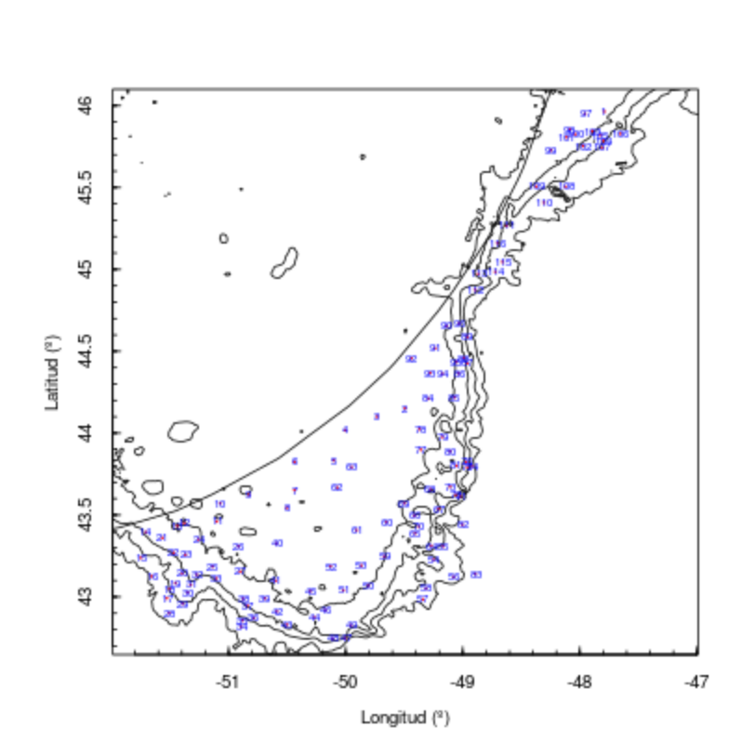
Figure 18: Map of the Grand Bank (NAFO Div. 3NO). Location of the 115 valid hauls obtained during the 1st part of “3LNO GROUNDFISH SURVEY – 2016”.
Dates:
23/05/2016: Departure from Vigo (Spain) on board R/V “Vizconde de Eza”.
30/05/2016: Arrival to fishing ground and starting fish hauls.
18/06/2016: End of fishing and departure from fishing ground to St. John´s (Canadá).
21/06/2016: Arrival to St. John´s and departure from St. John´s to Spain (scientific staff).
22/06/2016: Arrival to Spain and end of the survey.
Duration: The survey lasted for 31 days, out of which 30 days at sea. From these 30 days, 20 were effective fishing days and 10 days were used for sailing.
Methodology: Stratified random sampling scheme, diurnal fish hauls from 6 am to 9.30 pm with an average hauling time of 30 minutes.
Research vessel: R/V Vizconde de Eza.
Equipment and sampling gear: The trawling gear used is the Campelen 1800. CTD SBE-25 SEALOGGER.
Number of hauls: 116 fish hauls (115 valids and 1 null) were carried out.
Sampling:
Hydrographic sampling: 68 hydrographic profiles using a Seabird CTD system-25 were carried out.
Length and biological sampling: 1220 length samplings from 59 species with a total of 39940 individuals sampled. 820 biological samplings and length-weigth samplings were also carried out on 50 species; achieving in both samplings 10057 individuals sampled. 1222 pairs of otoliths and 429 gonads were collected for a posterior histological analysis at the lab.
The following table shows the sampling data of the main commercial species at the 1st part of the survey.
ESPECIES | Length sampling |  | Biological sampling |  | Collected samples
ESPECIES | Nº Samp. | Nº Indv. | Nº Samp. | Nº Indv. | Otoliths | Gonads
Amblyraja radiata | 58 | 738 | 59 | 506
Centroscyllium fabricii | 38 | 883 | 38 | 612
Gadus morhua | 49 | 2255 | 50 | 1376 | 610 | 313
Glyptocephalus cynoglossus | 50 | 851 | 50 | 584
Hippoglossoides platessoides | 67 | 6585 | 67 | 1374 | 267 | 116
Limanda ferruginea | 34 | 4062 | 29 | 756
Macrourus berglax | 56 | 1374 | 56 | 947
Pandalus borealis | 10 | 51 | 10 | 51
Reinhardtius hippoglossoides | 80 | 1527 | 81 | 1094 | 345
Sebastes spp. | 49 | 3744 | 40 | 751

As in the last year, we also put special attention to the identification and sampling of benthic invertebrates present in the catches; samples were collected for a posterior analysis in the laboratory.
Data storage: Survey data are stored into SIRENO (Seguimiento Informático de los Recursos Naturales Oceánicos) database which is managed by the IEO.
Environmental indicators:
During this part of the survey, (NAFO Division. 3NO) data about species, lengths and abundances for the calculation of environmental indicators 1, 2 and 3 were collected. Furthermore, individual measurements (age, length, sex and maturity) were carried out for the calculation of the indicator number 4 on the main target species.
Deviations: There were no deviations from the Proposal.

SECOND PART (Division 3L)
The 2nd part of the 3LNO Groundfish Survey (named in IEO as "Fletán Negro 3L" for internal organisation) has as main target, the exploration of the Division 3L in the NAFO Regulatory Area. This is an area of special interest for the Spanish Greenland halibut fishery where their maximum yields are recorded.
The partial exploration of this area began in 2003 and continued in 2004. From 2006 onwards the whole Division 3L has been prospected on board the R/V "Vizconde de Eza.
Objectives:
- Estimation of abundance indices, biomass and population structure of Greenland halibut and main commercial species.
- Obtention of biological information of target species.
- Collection of oceanographic data from the area using a CTD at the end of each fishing-haul.
Target species: Cod (Gadus morhua), Roughead grenadier (Macrourus berglax), Redfish (Sebastes spp.), Skates (Amblyraja radiata), American plaice (Hippoglossoides. platessoides), Witch flounder (Glyptocephalus cynoglossus), Greenland halibut (Reinhardtius hippoglossoides), Black dogfish (Centroscyllium fabricii) and Northern Shrimp (Pandalus borealis).
Sampling area: Flemish Pass (Div. 3L), out of the Canadian EEZ.
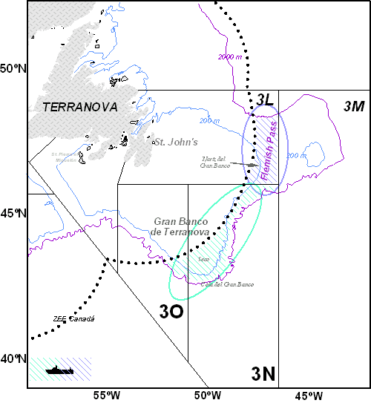
Figure 19: Map of Flemish Pass (NAFO Dividion. 3L). Location of depth isobaths, 200-mile boundary, hauls and CTD stations carried out on the 2nd part of the “3LNO GROUNDFISH SURVEY. 2016.
Dates:
25/07/2016: Departure from Vigo (Spain) (IEO staff).
27/07/2016: Departure from St. John´s (Canadá) to fishing ground.
28/07/2016: Arrival to fishing ground and starting fish hauls.
17/08/2016: End of fishing and departure from fishing ground to Spain.
24/08/2016: Arrival to Vigo (Spain).
Duration: The survey lasted for 29 days at sea out of which 21 were effective fishing days.
Methodology: Stratified random sampling scheme, diurnal fish hauls from 6 am to 9.30 pm with an average hauling time of 30 minutes.
Research vessel: R/V Vizconde de Eza.
Equipment and sampling gear: The trawling gear used is the Campelen 1800. CTD SBE-25 SEALOGGER.
Number of hauls: 105 fishing hauls (98 valids and 7 nulls) were carried out. All strata were sampled with at least two fishing hauls each.
Sampling:
Hydrographic sampling: 98 hydrographic stations using a Seabird CTD system-25 were carried out in a range from 108 to 1430 m. Bottom temperature values varied from -1.3021 to 3.8258 ºC and salinity from 33.1562 to 34.9156 USP.
Length and biological sampling: 1206 length samplings from 49 species with a total of 49655 individuals sampled. 1070 biological samplings and length-weigth were also carried out from 47 species; achieving in both samplings 15465 individuals sampled.
1158 pairs of otoliths and 313 gonads were collected for a posterior histological analysis at the lab.
The following table shows the sampling data of the main commercial species at the 2nd part of the survey.

ESPECIES | Length sampling |  | Biological sampling |  | Collected samples
ESPECIES | Nº Samp. | Nº Indv. | Nº Samp. | Nº Indv. | Otoliths | Gonads
Amblyraja radiata | 54 | 797 | 50 | 496
Centroscyllium fabricii | 37 | 410 | 37 | 350
Gadus morhua | 39 | 1207 | 38 | 590 | 287 | 139
Glyptocephalus cynoglossus | 34 | 309 | 32 | 277
Hippoglossoides platessoides | 38 | 4948 | 34 | 1095 | 247 | 105
Macrourus berglax | 79 | 4046 | 73 | 1525 | 233 | 65
Pandalus borealis | 40 | 5077 | 22 | 2263
Reinhardtius hippoglossoides | 96 | 3201 | 93 | 1623 | 381 | 4
Sebastes spp. | 50 | 6564 | 42 | 908

As in the last year, we also put special attention to the identification and sampling of benthic invertebrates present in the catches; samples were collected for a posterior analysis in the laboratory. Also, 3291 stomach contents from 24 deep-sea species were analyzed on board.
Data storage: Survey data are stored into SIRENO (Seguimiento Informático de los Recursos Naturales Oceánicos) database which is managed by the IEO.
Environmental indicators: During this part of the survey, (Div.3L) data about species, lengths and abundances for the calculation of environmental indicators 1, 2 and 3 were collected. Furthermore, individual measurements (age, length, sex and maturity) were carried out for the calculation of the indicator number 4 on the main target species

III.G.2 Data quality: Results and deviation from NP proposal.
All quality objectives were achieved. As in previous years, several papers were submitted to the NAFO Scientific Council in 2016-2017 with the main results of the survey. (See Annex I)
Deviations: Number of CTD profiles planned in the first part was not achieved. The reason about it was because this year it was implemented a grid for the hydrographic profiles, with sampling points at 15 nautical miles intervals on the shallower area and radials on the slope, instead of casting the data logger in each fishing station as usually. This system however did not work quite well for this survey, as it requires additional sailing time that we cannot afford in terms of working hours.

III.G.3 Actions to avoid deviations.
It is recommended to return to the system as in previous years using a CTD at the end of each fishing-haul.

MEDITS (Mediterranean International bottom trawl survey)

III.G.1 Achievements: Results and deviation from NP proposal.
Objectives:
- Evaluation of the abundance and distribution of stocks, independently of the data provided by commercial fisheries, and to assess the impact of the fishing activity on the environment. The survey is carried out between 30 m to 800 m depth
- Recording of abundance and biomass of all the catches,
- Recording of lenght structure and biological information of the main target species of the fishery, including the collection of hard structures for age determination.
- Recording of oceanographic data (temperature and salinity) close to the bottom during each sampling station is also recorded
Sampling area: División 1.1 (GFCM Geographical Subareas: Northern Alboran Sea, Alboran Island, Northern Spain and Balearic Islands)
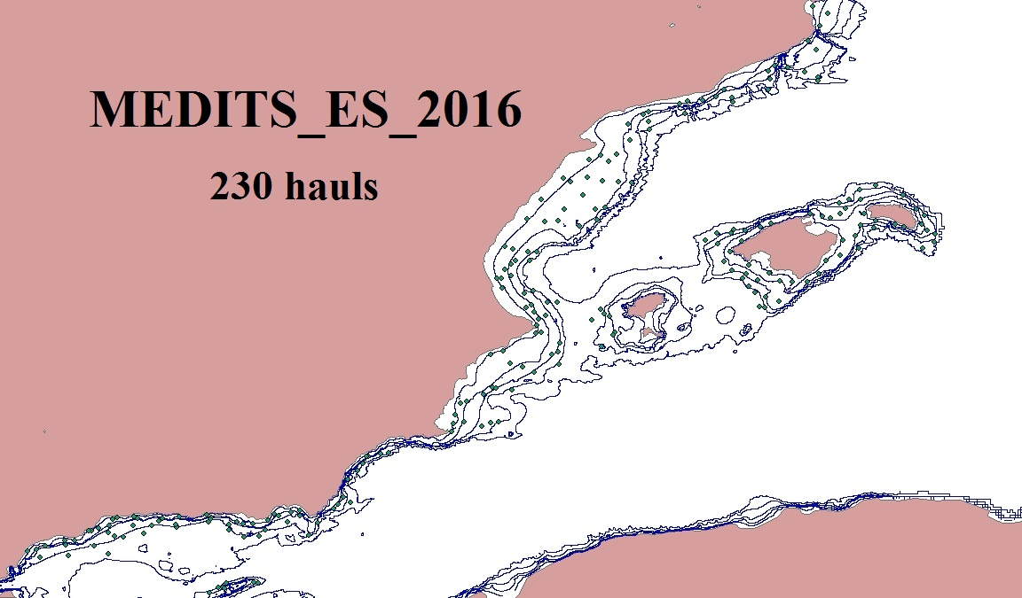
Figure 20: Map with the sampling positions during the MEDITS_ survey 2016.

Dates: From April 23rd to June 21st 2016.
Duration: The survey lasted for 60 days.
Methodology: The sampling stations are positioned following a depth stratified simple sampling scheme with random drawing of the positions within each stratum. The number of positions in each stratum is proportional to the surface of these strata. The whole area was stratified by depth range up to: 30, 50, 100, 200, 500 and 800 meters. Hauls were of 30 minutes for those at depth lower than 200 m and 1 hour for those deeper than 200 m. Catch per Km² is used as relative abundance and biomass indices.
Research Vessel: R/V Miguel Oliver, otter trawler of 70 m long, 14.40m wide, 2495 GT and 2 * 1000kW.
Equipment and Sampling gear: GOC 73 is an experimental bottom trawl gear with a vertical opening of 2.4-2.6 m and between 16 and 22 m of horizontal opening. Its dimensions are weighting chain of 40 m long, floats headline of 32.2 m long and 20 mm mesh size in the cod-end.
Number of hauls: A total of 230 hauls were carried out
Sampling:
Hydrographic sampling: simultaneously to the fishing hauls oceanographic data were registered by means of a CTD SBE-37(conductivity, temperature and depth) attached to the floats head-line.
Faunal list: The species identified were 212 of fish, 115 of crustaceans, 118 of molluscs, and 221 species of invertebrates belonging to different taxonomic categories. All fishes and commercial invertebrates were measured. A summary of the biological sampling carried out is shown in the following table.
Species | Number |  | Species | Number
Dalatias licha | 7 |  | Merluccius merluccius | 3549
Dipturus oxyrhinchus | 29 |  | Mullus barbatus | 2255
Etmopterus spinax | 565 |  | Mullus surmuletus | 1085
Galeorhinus galeus | 0
Galeus melastomus | 3116
Leucoraja naevus | 144 |  | Aristeomorpha foliacea | 63
Raja asterias | 43 |  | Aristeus antennatus | 1750
Raja clavata | 211 |  | Nephrops norvegicus | 1439
Raja miraletus | 72 |  | Parapenaeus longirostris | 2548
Raja montagui | 3
Raja spp | 256
Scyliorhinus canicula | 4682 |  | Ilex coindetti | 2110
Torpedo marmorata | 29 |  | Loligo vulgaris | 81

Otoliths/Ilicios:
Especies | Otolitos/ilicios
Merluccius merluccius | 781
Mullus barbatus | 705
Mullus surmuletus | 643
Lophius budegassa | 386
Lophius piscatorius | 57

Data storage: Biomass and abundance of each species, biological sampling of the species in the reference list and all the rest of the data collected, were computerized during the survey in a database specifically designed for it and stored in the fishery data base SIRENO (Seguimiento Informático de los Recursos Naturales Oceánicos). Data check up and calculations of abundance indices and length distributions were done after the survey using the tools created for it in SIRENO. Four types of files for storage and exchange format are defined.
Type 1. Characteristics of each haul.
Type 2. Catch of each haul in weight, number and number by sex.
Type 3. Biological parameters for the species in the reference list (length, sex, maturity).
Type 4. Temperature data
Environmental indicators: Data collected during the MEDITS 2016 survey can be used to calculate indicators 1, 2 and 3, for most of the species caught. Length measurements were collected for all the fish species in the catch. Collected otoliths of the species Merluccius merluccius, Mullus barbatus and Mullus surmuletus are useful for indicator 4. For some species, the low number of individuals caught will prevent the calculation of indicators 2 and 3.
Deviations: There were no deviations from the Proposal.

III.G.2 Data quality: Results and deviation from NP proposal.
The data obtained are used for calibrating assessment models in GFCM Working groups.
Recommendations given by the Expert Group for the planning of these surveys are adopted in the survey protocols.
Deviations: There were no deviations from the Proposal.

III.G.3 Actions to avoid deviations.
Not applicable.

MEDIAS (Pan-Mediterranean pelagic survey)

III.G.1 Achievements: Results and deviation from NP proposal.
Objectives:
The objective of MEDIAS survey is to obtain the abundance indices of the main small pelagic species in the Spanish Mediterranean coast: anchovy (Engraulis encrasicolus) and sardine (Sardina pilchardus). The survey prospected the continental shelf (20 to 200 m depth) by means of a scientific echosounder EK60 (Simrad), equipped with 5 frequencies (18, 38, 70, 120 and 200 kHz).
Sampling area: Continental shelf of the Spanish Mediterranean, from the French border to Strait of Gibraltar that corresponds to GFCM Geographical Sub-Area covered are the GSA 06 (Northern Spain) and 01 (Northern Alboran Sea), between 20 and 200 m depth.
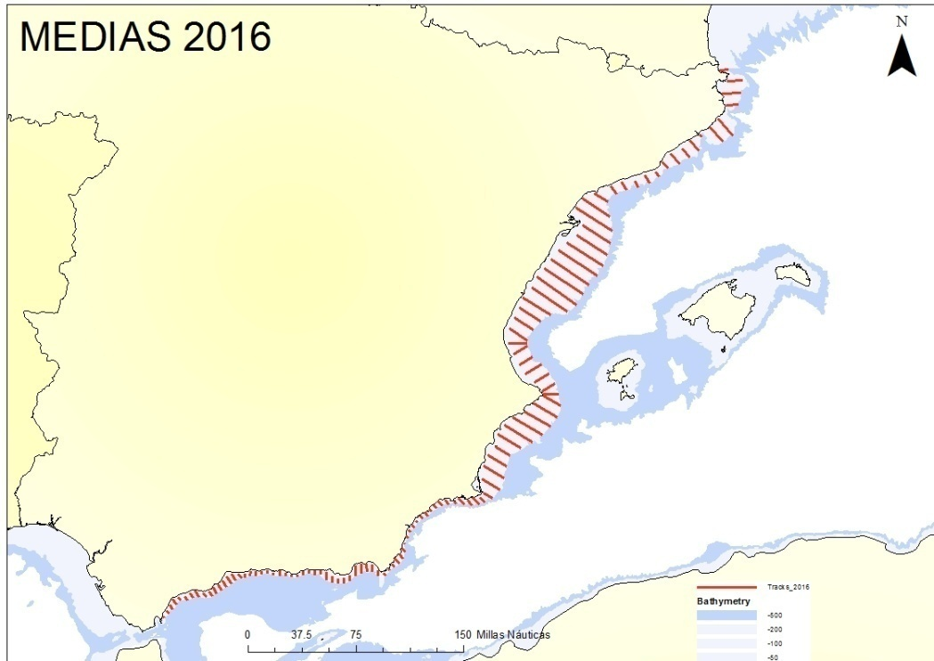
Figure 21: Situation of transects (111) done to recorded the acoustic data in the MEDIAS survey 2016.
Dates: From June 24rd to July 25th.
Duration: The survey lasted for 32 days.
Methodology: Prospection of the continental shelf (20 to 200 m depth) by means of a scientific echosounder EK60 (Simrad), equipped with 5 frequencies (18, 38, 70, 120 and 200 kHz). Acoustic data are recorded continuously at a constant ship speed of 10 knots from sunrise to sunset, along parallel equidistant transects lying perpendicular to the bathymetry. The echosounder is calibrated before each survey following standard techniques (Foote et al., 1987).
Midwater pelagic trawls were deployed to determine the species proportions present in the area. Acoustic data are processed using Echoview (Miryax Ltd.) software and PESMA (VisualBasic) software. Echo trace classification is based on echogram visual scrutinisation; usually the allocation is on account of a representative fishing station and very few times on direct allocation. Results of biomass (tons) and abundance (nº individuals) are presented by species, length and age.
Research vessel: R/V Miguel Oliver, of 70 m long, 14.40m wide, 2495 GT and 2 * 1000kW.
Equipment and Sampling gear: Scientific echosounder EK60, 3 midwater pelagic trawls of 16, 14 and 10 m of vertical opening
Number of hauls: 48 fishing hauls.
Sampling
MEDIAS 0715 | Nº
Acoustic transects | 111
Echo Nautical miles | 1129
Fishing hauls wiht midwater pelagic trawl | 48
Hydrographic sampling: number of CTD stations (CTD Seabird 19 plus) | 125

Faunistic list: They were identified 48 species.
Individuals sampled. All pelagic fishes were measured. A summary of biological sampling carried out is shown in the next table:

Specie | Individuals measured | Reproductive sampling | Otholits obtained
Engraulis encrasicolus | 3555 | 867 | 867
Sardina pilchardus | 4389 | 1134 | 1133
Sardinella aurita | 486 | 182 | -
Trachurus mediterraneus | 2241 | 733 | -
Trachurus trachurus | 1917 | 526 | -
Trachurus picturatus | 777 | 328 | -
Boops boops | 1266 | 321 | -
Scomber colias | 2783 | 469 | -
Spratus spratus | 553 | 113 | -

Data storage: the species found, weight and number of each species, biological sampling of the main species and all the data are stored in fishery data base SIRENO (Seguimiento Informático de los Recursos Naturales Oceánicos).
Environmental indicators: During MEDIAS 2016 survey were collected data with the aim of calculate indicators 1, 2 and 3, out the major part of fish species in the catch. They were measured individuals of all the species of fish in the catch. Of some species will not calculate the indicators 2 and 3 due the scarce number of individuals. For indicator 4 calculation were collected the necessary data of the species Engraulis encrasicholus y Sardina pilchardus.
Deviations: Survey design was changed in GSA06 in order to improve the precision of the abundance estimates (coefficient of variation). The inter-transect distance is now 8 nmi for the entire GSA06.

III.G.2 Data quality: Results and deviation from NP proposal.
Recommendations given by the Expert Group for the planning of these surveys are adopted in the survey protocols.
Deviations: This year 48 pelagic trawls were carried out to assess the prospected area instead of 70 planned. Mid-water pelagic trawls were deployed to determine the species proportions present in the area and the number of hauls is adaptative so it is variable between surveys and years. This number would not affect the accuracy of the results.

III.G.3 Actions to avoid deviations.
Not applicable.

BLUE WHITING and REDNOR
There was any Spanish participant in these surveys in 2016.

IV. Module of the evaluation of the economic situation of the aquaculture and processing industry

IV.A Collection of data concerning the aquaculture

IV.A.1 Achievements: Results and deviation from NP proposal
In Spain two surveys referred to aquaculture sector are carried out:
- Aquaculture Economic Survey, which collects the main economic data and means the main source of economic data as set out in EU Regulation 199/2008 of the Council.
- The Aquaculture Facilities Survey which collects technical and activity data. It is the source of data on productivity, in economics and physical terms, and employment, established in the REG 199/2008 of the Council. However, the main reason for this survey is to provide with information to comply with EU Regulation 762/2008 of the Parliament and the Council, on the aquaculture statistics presentation of the Member States.
Both surveys utilize the same frame population, and have as statistic unit the facility. Informers on both surveys are the companies, but the information is not always in a share point. The facilities survey is completed by the technicians responsible of the farming, who normally are in the farming facilities, and the economic survey is answered at the accounting facilities of the company.
The Aquaculture Facilities Survey is thoroughly investigated, with the exception of mussel rafts and farming parks for scallops located in Galicia.
The Aquaculture Economic Survey stratifies the population according to Appendix IX of EU Decision 93/2010.
Field work for both surveys is planned and implemented with a common working schedule to create economies of scale and use the synergies, as far as possible.
By the end of 2015, the results of surveys carried out for the period of 2014 were presented. The resulting target population, over which the inference was carried out, was the framework population for surveys in 2016, over 2015 data. The number of facilities of this framework was of 5,296, belonging to 3,067 companies. During the first three months of 2015, the stratification of this population was carried out, following instructions of Appendix XI previously cited, and the sample size was determined.
In the Economic Aquaculture Survey, those strata with less than 20 facilities were exhaustively investigated (according to census) and those of 20 and more were investigated under the sampling methodology. In these stratums, the sample size was calculated over the auxiliary variable “capacity of facilities”, as requested in EU Regulation 762/2008 of the Parliament and the Council, on the submission by Member States of statistics on aquaculture. The information that has been used was:
Total sample size with expected error of 5% on 96% of confidence was calculated under the assumption of the population has a normal type distribution. The formula to calculate the sample size (n) was the following:
(1)
Being: h, the number of strata (from 1 to L), Nh the h strata size, N the population size, Sh the standard deviation for h strata, average GT, e the error of estimated and z the typified variable for the confidence level chosen.
The total sample was split among the strata by means of Neyman´s affixation, applying the following formula:
(2)
Being: n, h, Nh and Sh, same statistical indicators that in (1).
The sample size obtained, by applying the previous formula was of 396 facilities belonging to 336 companies. When calculating the sample size, some of the strata offered a size that covers all its population, reason why belonging to B type are investigated exhaustively, as if they were type A.
When in field work, 290 companies replied satisfactorily all questionnaires and 46 didn’t provide with the economics information requested. The information obtained confirmed that the target population in 2016, over 2015 data, was the same that the one in the framework population, 5,296 facilities belonging to 3,067 companies. Besides, this population became the survey framework population for 2017, regarding 2016 data.

IV.A.2 Data quality: Results and deviation from NP proposal
Data belonging to each of the variables have been collected using the census or by sample, depending the strata to which they belong, as shown in table IV.A.2.
The variability index included in this table is the CV, calculated for all the strata, both the ones that were collected by sampling method or by the census.
The coefficients of variation obtained show that in general terms, small variations in the variables considered. This means that the results obtained are representatives for each of the strata.
There are variables with no CV information. We can differentiate the following cases:
- NA “Not Applicable”, non applicable variable to the strata and therefore, CV is not applicable.
- “CV blank” there is no information, with no response for that variable.
- .- CV=0” referring to one of the following cases:
.- No variability = there is value for this variable but values are unique or the same for each of the units.
- All the values of the strata are= 0.
Unpaid work valuation
Spain chose to measure the total hours of unpaid work with the average value of hour of paid work. The procedure was as follows:
- Differentiation between the paid and the unpaid worker, being the last one the owner of the facility and the family members involved in the exploitation, for cases of individual companies with no legal entity.
- Following to this, it is needed the value of paid and unpaid workers remuneration.
- On the other hand, hours of work for both workers were calculated data already known from surveys and reflected in the variable “salaries and incomes”.
- Lastly, we calculate the average value for worked hour for the paid and unpaid, multiplying it by the unpaid worked hours:
(Paid workers salaries and incomes/Paid workers hours) * unpaid worked hours
This calculation has been made from data obtained in the Economic Aquaculture Survey and Facilities Aquaculture Survey.
Conversion factors
The following conversion factors were used to transform the species used, in kilograms and per harvesting phase.
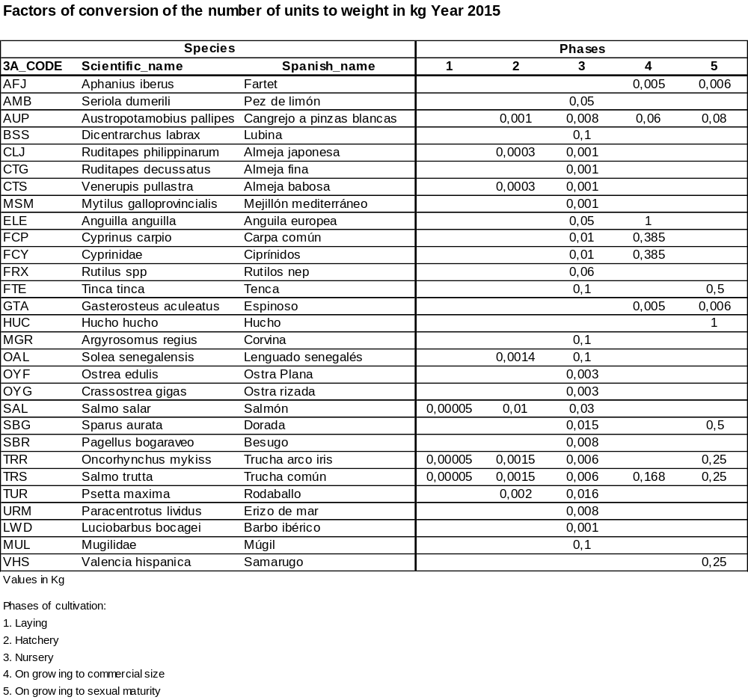

IV.A.3 Actions to avoid deviations
The Economic Aquaculture Survey has been put in place recently. In the near future, the analysis of the results and the field work to get the information will be used to introduce improvements in the survey.
The harvest of crustacean and algae is already comprised in table IV.A.1 within the mollusk group. Spain has a production of both, and in the classification shown in Appendix XI there is no specific space to include them, so it was decided its inclusion within this group, although it is a mistake such a consideration (as mollusk).

IV.B. Collection of data concerning the processing industry

IV.B.1 Achievements: Results and deviation from NP proposal
The source of information is the Industries Companies Survey which develops the Spanish National Statistical Institute (“INE”). The reference period for the work in 2016 is the year 2015.
During the year 2009, some changes were undertaken in the National Activities Classification (“CNAE”), as foreseen in the community legislation. The fisheries products under point 15.2 of NACE rev1 were redefined moving to group 10.2 of NACE-2009.
The results of data collection didn’t have representative variations.
The source of information doesn’t collect data on the following variables:
- Capital amortization.
- Total active value.
- Indebtedness
From year 2013, data on the number of employed persons are calculated disaggregating by sex from another source (Active Population Survey, “EPA”).
From this source were obtained percentages by sex, and worked hours.
Another variable that could be calculated from this same source was the unpaid work value, since they have data of worked hours for both the paid and unpaid.

IV.B.2 Data quality: Results and deviation from NP proposal
The methodology applied to the research had modifications that had effect from 2009. Until the year 2008, over 2007 data and before, the investigation was exhaustively for companies of 20 employees or more, and by sampling for those with less than 20. From the 2009 survey, over 2008 data, the limit of 20 employees became 50. All the companies with less than 50 employees are investigated by sampling. Companies with 50 o more employees are exhaustively investigated.
The companies’ directory for the field work comprised 668 companies, 372 with less or equal to 10, 217 with 11-49, 70 with 50-249 and 9 with more than 250 employees. When performing the field work over the final population, over which it is needed to infer was of 258 with less or equal to 10, 201 with 11-49 74 with 50-249 and 9 with more than 250.
From all the strata covered by sampling, the INE produces CV only for two variables: turnover and number of people employed. The rest of variables are not calculated.
Unpaid work valuation
Spain chose to measure the total hours of unpaid work with the average value of hour of paid work. The procedure was as follows:
- Differentiation between the paid and the unpaid worker, being the last one the owner of the facility and the family members involved in the exploitation, for cases of individual companies with no legal entity.
- Following to this, it is needed the value of paid and unpaid workers remuneration.
- On the other hand, hours of work for both workers were calculated data already known from surveys and reflected in the variable “salaries and incomes”.
- Lastly, we calculate the average value for worked hour for the paid and unpaid, multiplying it by the unpaid worked hours:
(Paid workers salaries and incomes/Paid workers hours) * unpaid worked hours
This calculation has been made from data obtained in the Industrial Companies Survey and the Active Population Survey, “EPA

IV.B.3 Actions to avoid deviations
Enterprises comprised in 10.2 of NACE-2009, included in the Industries Enterprises Survey that the INE carries out in Spain will continue as the source of information for this section of the DCP. Eurostat and DGMARE launched several collaborative procedures in the field of structural statistics in order to establish common procedures that don’t duplicate the collection of information. We believe that the information deficiencies should been solved in this collaboration framework and not independently in every country.
During the year 2015, data to produce the employment by sex and FTE by sex were achieved. And also the data needed to produce the variable “Value of unpaid work attributed”.
There are still some variables missing, “total active value”, and “capital amortization” waiting for the procedures of collaboration between EUROSTAT and DGMARE. Nevertheless, we are working on the possibility of gathering the information from the Commercial Register, where are compiled the economic accountancy of the enterprises.

V. Module of evaluation of the effects of the fishing sector on the marine ecosystem

V.1 Achievements: Results and deviation from NP proposal.
The data needed to calculate these indicators have been collected.
Indicators 1 - 4: Conservation status of fish species, Proportion of large fish, Mean maximum length of fishes and Size at maturation of the exploited fish species.
Data to calculate indicators 1, 2, 3 and 4 have been collected during the surveys.
Indicators 5, 6, y 7:
The VMS data needed to calculate these indicators are collected regularly on all vessels over 15 meters. These data are available within two months of receipt. Data are collected in each haul and it is possible to link the classification of métiers level 6 according to Appendix IV of the Commission Decision.
Indicator 8: Discarding rates of commercially exploited species
The percentage of discards of commercial species is used to assess the selectivity degree of a gear and its impact on the ecosystem. Data obtained by sampling discards have allowed the calculation of this indicator.
Indicator 9: Fuel efficiency of fish capture
The calculation of energy efficiency by species was made by dividing the income by species by fuel costs. The cost of fuel is one of the most important items within fleet operating costs, factor increased by continued growth in the price of oil. Their calculation provides a relevant indicator for comparing both the different energy efficiencies of different species (catches), and the various gears to compare the same species.

IV.2 Actions to avoid deviations.
No deviations have been detected.

VI. Module for management and use of the data

VI.1 Achievements: Results and deviation from NP proposal.
The entry into force of the sampling scheme based on métiers and concurrent sampling obligue us to make a series of adaptations in the databases, such as introducing the concept of métier in the trip, adaptation of the processes of extrapolation and calculation of the length distributions, identification of the species that are landed mixed, extension of the processes of distribution of species, etc.
The actions undertaken to strengthen the data quality, also covered the database modifications and the cross-checking of the trips sampled with the electronic logbooks and sales notes.
In the first case, the process has involved the addition of a field to confirm the checking of sampling and the limitation of allocable vessels in the database according to their status in the Spanish Census of Operational Fishing Fleet.
In the second case, we proceeded to the identification of the sampled trips in the logbooks and the analysis of catch profiles available to reduce error sources. This latter process allows checking assignments of trips to métier and corrects any erroneous assignments, mainly in the allocation of the geographical area.
During 2016, the special effort made to adapt these databases to the international formats for regional cooperation continues. In particular, the ICES Fisheries data base has been developed to generate FishFrame and InterCatch files.
Also the Tropical Tuna data base has been adapted to the OBSTUNA format, in order to improve regional cooperation with IEO and IRD. Althoug all these tasks are already advanced, it is necesary to continue working on them in the future. To facilitate the regional cooperation IEO-IRD, the format of tuna data bases is been constantly monitored, chequed and implemented.
Extensive work has also been done during this year to improve the integration of offcial data (logbooks and salesnotes) with sampling data.
Due to the large volume of information stored in our databases, the complexity of it (landings, biological sampling, lengths, research surveys, etc), and the behavior variability of the fleet from one year to another, a continuous effort of adaptation and improvement is necessary, which allows us to maintain a data management effective and appropriate to latest international recommendations.
Use of data:
Table III.E.3 presents the number of individuals collected for each variable and stock and Table III.C.6 shows the number of individuals measured. The data collected are depurated and used to estimate fishing parameters, such as catch per unit effort, length distributions, age-length keys and catch estimates by age. Studies of biological parameters such as growth, maturity, fecundity, stock-recruitment relationships to study the dynamics of populations, etc. are also conducted.
These ones allow the data analysis and the generation of assessment documents, as well as the testing of alternative assessment methods, presented in scientific advisory groups attended by Spanish repreesntatives in different RFMOs or International Organisations (NEAFC, NAFO, ICCAT, IOTC, GFCM, IATTC, WCPFC, ICES and STECF).
Table II.B.1 shows the coordination meetings, working groups and scientific assessement groups with attendance of Spanish representatives.
Table VI.1 shows the details of data that were transmitted to each group of scientific advice.

VI.2 Actions to avoid deviations.
No major shortfalls.

VII. List of acronyms and abbreviations
AFWG: Arctic Fisheries Working Group.
ANACEF (O.P.): Asociación Nacional de Armadores de Buques Congeladores de Cefalópodos (Organización de Productores Pesqueros)
AIDCP: Agreement on the International Dolphin Conservation
AZTI: Instituto Tecnológico, Pesquero y Alimentario
CECAF: Committee for Eastern Central Atlantic Fisheries.
COST: Common Open Source Tool for raising and estimating properties of statistical estimates derived from the Data Collection Regulation.
CPUE: Catch per Unit Effort.
CRODT: Centre de Recherches Océanographiques de Dakar-Thiaroye.
CSIC: Consejo Superior de Investigaciones Científicas.
IATTC: Inter-American Tropical Tuna Commission.
IBTSWG: International Bottom Trawl Survey Working Group.
ICCAT: International Commission for the Conservation of Atlantic Tunas
ICES: International Council for the Exploration of the Sea
IEO: Instituto Español de Oceanografía.
IFREMER: Institut français de recherche pour l'exploitation de la mer.
IIM: Instituto de Investigaciones Marinas.
IOTC: Indian Ocean Tuna Commission.
IRD: Institut de Recherche pour le Développement.
MAPAMA: Ministerio de Agricultura, Alimentación y Medio Ambiente
MEDITS: Campañas de arrastre en el Mediterráneo.
NEAFC: North East Atlantic Fisheries Commission
NAFO: Northwest Atlantic Fisheries Organization.
NAFO-SC: Northwest Atlantic Fisheries Organization-Scientific Council.
NAFO-SF: Northwest Atlantic Fisheries Organization-Fisheries Council.
NWWG: North-Western Working Group.
RFMO: Regional Fisheries Management Organization
PGDATA: Planning Group on Data Needs for Assesment and Advice
PNDB: National Data Collection Programme.
PNOT: Plan Nacional de Observadores de Túnidos.
RCM: Regional Coordination Meeting.
SCRS: Standing Committee on Research and Statistics.
SCSA-GFCM: Subcommittee Stock Assessment – General Fisheries Commission for the Mediterranean.
SFA: Seychelles Fishing Authority.
SGP: Secretaría General de Pesca (Ministerio de Agricultura y Pesca, Alimentación y Medio Ambiente)
SWO: Swordfish (Xiphias gladius)
TR: Troll.
USTA: Unidad Estadística Atunera de Antisarana.
VME: Vulnerable Marine Ecosystems.
WCPFC: Western Central Pacific Fisheries Commission.
WG Bay of Biscay: Working Group of Bay of Biscay.
WGACEGGS: Working Group on Acoustic and Egg Surveys for Sardine and Anchovy in ICES Areas VIII and IX.
WGBIOP: Working Group on Biological Parameters.
WGCATCH: Working Group on Commercial Catches.
WGCEPH: Working Group on Cephalopod Fisheries and Life History.
WGDEC: ICES/NAFO Joint Working group on Deep.water Ecology.
WGDEEP: Working Group on the Biology and Assessment of Deep Sea Fisheries Resources.
WGEF: Working Group on Elasmobranch Fishes.
WGFE: Working Group on Fish Ecology.
WGFMS-CPRS: Working Group of Fishery Managers and Scientists on Conservation Plans and Rebuilding Strategies (Fisheries Council NAFO).
WGFMS-VME: Working Group of Fishery Managers and Scientists on Vulnerable Marine Ecosystems (Fisheries Council NAFO)
WGHMM: Working Group on the Assessment of Southern Shelf Stocks of Hake, Monk and Megrim.
WGMEGS: Working Group on Mackerel and Horse Mackerel Egg Surveys.
WGMHSA: Working Group on the Assessment of Mackerel, Horse Mackerel, Sardine and Anchovy.
WGMSE: Working Group on Greenland Halibut Management Strategy Evaluation (Fisheries Council NAFO).
WGNEPH: Workshop on Nephrops Stocks.
WGNEW: Working Group on Assessment of New MoU Species.
WGNPBW: Northern Pelagic and Blue Whiting Fisheries Working Group.
WGNSSK: Working Group on the Assessment of Demersal Stocks in the North Sea and Skagerrak.
SGSBSA: Study Group on the Estimation of Spawning Stock Biomass of Sardine and Anchovy.
WHB: Blue whiting.
WIT: Witch flounder.

IX. Comments, suggestions and reflections
None.

X. References
ICCAT. 2006-2016. ICCAT Manual. International Commission for the Conservation of Atlantic Tuna. In: ICCAT Publications [on-line]. Updated 2016. [Cited 01/27/]. http://www.iccat.int/en/ICCATManual.asp, ISBN (Electronic Edition): 978-92-990055-0-7.
Report of the 12th Liaison Meeting. Brussels, Belgium, 08-09/10/2015.
Report of the Regional Co-ordination Meeting for the North Sea and Eastern Arctic (RCM NS&EA) 2015. Den Haag, The Netherlands. 31 August – 4 September, 2015.
Report of the 11th Regional Coordination Meeting for the Mediterranean and Black Sea and Large Pelagics Fisheries. Rome, Italy. 09/09/2015 - 11/09/2015
Report of the Regional Co-ordination Meeting for the Long Distance Fisheries (RCM LDF), 2015. Thünen Institute [TI]), Hamburg, Germany, 21/04/2015 – 22/04/2015 and Instituto Español de Oceanografía (IEO), Centro Oceanográfico de Cádiz, Cádiz, Spain, 9/06/2015 - 12/06/2015. 49 pp.
Report of the Regional Co-ordination Meeting for the North Atlantic (RCM NA) 2015. Hamburg, Germany. 14 – 18 September 2015
Update of “Sampedro, P., Sainza, M. and Trujillo, V., 2005.A simple tool to calculate biological parameters’uncertainty. Working Document, In: Workshop on Sampling Desing for Fisheries Data (WKSDFD), Pasajes, Spain
Vigneau, J., and Mahevas, S. 2007. Detecting sampling outliers and sampling heterogeneity when catch-at-length is estimated using the ratio estimator. – ICES Journal of Marine Science, 64: 1028–1032.
EU DATA COLLECTION FRAMEWORK (DCF), REG. 199/2008, 665/2008 and DECISION 2010/93/EU
ICES, 2015. First Interim Report of the Working Group on Mackerel and Horse Mackerel Egg Surveys (WGMEGS). 20–24 April 2015, Copenhagen, Denmark. ICES CM 2015/SSGIEOM:09, 66 pp

XI. Anexes

ANEX I: Papers submitted to different RFMO and fora

Papers submitted to NAFO
Scientific Council Summary (SCS):
González-Costas, F.; G. Ramilo-Rivero, E. Román-Marcote, A. Gago-Fernández, J. M. Casas- Sánchez, M. Sacau-Cuadrado, E. Guijarro-García, D. González-Troncoso, and J. Lorenzo-González. 2016. Spanish Research Report for 2015. NAFO SCS Doc. 16/05 Serial No. N6539.
González-Costas, F.; González-Troncoso, D; Sacau-Cuadrado, M.M. 2016. Report of the Scientific Council, 3-16 June 2016. NAFO SCS Doc. 16/14 Serial No. N6587
González-Costas, F.; González-Troncoso, D; Sacau-Cuadrado, M.M. 2016. Report of the Scientific Council, 19 - 23 Sept 2016. NAFO SCS Doc. 16/19 Serial No. N6640
Scientific Council Research (SCR):
González-Costas, F. 2016. A method to estimate the NAFO Subarea 2+3KLMNO GHL catches based on survey information. NAFO SCR Doc. 16/09 Serial No. N6545.
González-Troncoso, D., A. Gago, A. Nogueira-Gassent, and E. Román. 2016. Results for Greenland halibut, American plaice and Atlantic cod of the Spanish survey in NAFO Div. 3NO for the period 1997-2015. NAFO SCR Doc. 16/10, Serial No. N6546.
González-Troncoso, D.; Nogueira, A.; Gago-Fernández, A. 2016. Yellowtail flounder, redfish (Sebastes spp.) and witch flounder indices from the Spanish Survey conducted in Divisions 3NO of the NAFO Regulatory Area. NAFO SCR Doc. 16/11, Serial No. N6547.
González-Troncoso, D.; Gago-Fernández, A.; Nogueira, A.2016. Biomass and length distribution for roughhead grenadier, thorny skate and white hake from the surveys conducted by Spain in NAFO 3NO. NAFO SCR Doc. 16/12, Serial No. N6548.
González-Troncoso, D.; Nogueira, A. 2016. Results for capelin from the surveys conducted by Spain in the NAFO Regulatory Area of Div. 3NO, 1995-2015. NAFO SCR Doc. 16/13, Serial No. N6550.
Román, E., C. González-Iglesias, D. González-Troncoso, and M. S. Alvarez. 2016. Results for the Spanish Survey in the NAFO Regulatory Area of Division 3L for the period 2003-2015. NAFO SCR Doc. 16/15. Serial No. N6556.
Román, E., A. Armesto, D. González-Troncoso, and C. González-Iglesias. 2016. Results for the Atlantic cod, roughhead grenadier, redfish, thorny skate and black dogfish of the Spanish Survey in the NAFO Div. 3L for the period 2003-2015. NAFO SCR Doc. 16/16. Serial No. N6557.
Garabana D., P. Sampedro, R. Dominguez-Petit, C. González-Iglesias, A. Villaverde, M. Alvarez, C. Gonzalez-Tarrio, and M. Hermida. 2016. A review of NAFO 3LMN roughhead grenadier (Macrourus berglax Lacepède, 1801) reproductive biology including the evaluation of maturity ogive estimates. NAFO SCR Doc. 16/22. Serial No. N6565.
González-Costas, F., D. González-Troncoso, M. Mandado. 2016. Full benchmark review of the 3M cod assessment. NAFO SCR Doc. 16/23. Serial No. N6566.
González-Costas, F. 2016. An assessment of NAFO roughhead grenadier Subarea 2 and 3 stock. NAFO SCR Doc. 16/26 Serial No. N6569.
Ávila de Melo, A.; Brites, N.; Alpoim, R.; González-Troncoso, D.; González-Costas, F.; Fomin, K. 2016. A Revised Update of the 2014 ASPIC Assessment of Redfish (S. mentella and S. fasciatus) in Divisions 3LN. NAFO SCR Doc. 16/33 Serial No. N6576.
Pérez-Rodríguez, A.; Howell, D.; Casas-Sánchez, J.M.; Saborido-Rey, F.; Avila de Melo, A.; González-Costas, F.; González-Troncoso, D. 2016. GadCap: A GADGET multispecies model for the Flemish Cap cod, redfish and shrimp. NAFO SCR Doc. 16/35 Serial No. N6578.
González-Troncoso, D.; Nogueira, A.; Alpoim, R. 2016. Effect in mean catch and biomass index of removing stations in the closed Coral, Sponge and Seapen Protection Areas in the design of the EU Flemish Cap survey. NAFO SCR Doc. 16/40 Serial No. N6586.
Casas, J.M. 2016. Northern Shrimp (Pandalus borealis) on Flemish Cap Surveys 2016. NAFO SCR Doc. 16/51 Serial No. N6602.
Casas, J.M., E. Román, and M. S. Alvarez. 2016. Northern Shrimp (Pandalus borealis, Krøyer) from EU-Spain Bottom Trawl Survey 2016 in NAFO Div. 3LNO. NAFO SCR Doc. 16/52 Serial No. N6603.
2016 Scientific Council Summary (SCS) and Scientific Council Research (SCR) documenets available at:
https://www.nafo.int/Library/Science/SC-Documents.
Journal of Northwest Atlantic Fishery Science:
González-Costas, F.; González-Troncoso, D.; Morgan, M.J.; Murua, H.; Garcia, D. 2016. The impact of different assumptions about reproductive potential and recruitment on a Management Strategy Evaluation for the Greenland halibut stock in NAFO Subarea 2 and Division 3KLMNO. Journal of Northwest Atlantic Fishery Science, 48. 2016: 1-20
Document available at:
http://journal.nafo.int/Portals/0/Vol48-2016/J48-2016-BOOK-web.pdf

Papers submitted to ICES
Casas-Sánchez, J.M. 2016. The Spanish NE Arctic Cod Fishery in 2015. ICES AFWG 2016, WD-08.
Casas-Sánchez, J.M. 2016. The Spanish Pelagic Redfish Fishery in 2015. ICES AFWG 2016, WD-09.
Costa, A.M., Villamor, B., Silva, C., Nunes, C., Pinto, D., Perez, J.R., Inácio, M., Abreu, P. 2016. Southern horse mackerel, Trachurus trachurus Life-history: Reproduction. WD to Workshop on data evaluation for Southern Horse mackerel (WKSHOM), Lisbon, Portugal, 21 – 23 Nov 2016
Dueñas- Liaño, C., Hernandez, C., Antolínez, A., and Villamor, B. 2016. Problems identification in ageing of otoliths of Anchovy (Engraulis encrasicolus) from Divisions VIIIcb and IXa North. IEO. Presentation to WKARA2, Pasaia, Guipuzcoa (Spain), 28 Nov-2 Dec, 2016.
Guijarro-García, E.; Gil, J. 2016. Report of the Working Group on Biology and Assessment of Deep-sea Fisheries Resources. ICES WGDEEP REPORT 2016.
Hernández, C., Villamor, B., Landa, J. Use of simple morphometric condition indices in North Atlantic fisheries: the example of anchovy, mackerel, white and black anglerfish. Presentation to Workshop on Fish Condition (WKFICON). Girona, Spain, 17-18 Nov 2016.
Hernández, C., B. Villamor and J. Landa. 2016. Description of the BIOPEL and BIOBENTON projects of the IEO. Presentation to Workshop on Fish Condition (WKFICON). Girona, Spain, 17-18 Nov 2016.
Hernandez, C., Dueñas-Liaño, C., Antolinez, A. and Villamor, B. Criteria for age determination of anchovy otoliths in Sub-division IXa North: analysis of the rings biometric measures. 2016. IEO. Presentation to WKARA2, Pasaia, Guipuzcoa (Spain), 28 Nov-2 Dec, 2016.
ICES. 2016. Report of the Workshop on Growth-increment Chronologies in Marine Fish: climate-ecosystem interactions in the North Atlantic (WKGIC-2), 18-22 April 2016. Esporles, Mallorca (Spain). ICES CM 2016/SSGIEOM: 18. 18 pp.
Landa, J.; Antolínez, A.; Castro-Loehmann, B.; Hernández, C. Black anglerfish (Lophius budegassa): weight-length relationships, weight conversion factors and condition factor trends from a decade of two stocks, in ICES Div. VIIIc-IXa (northern Iberian Atlantic waters) and in Div. VIIb,c,h,j,k (Celtic Sea, south-western Ireland and Porcupine Bank) . WD to ICES Working Group for the Bay of Biscay and the Iberian waters Ecoregion (WGBIE) 2016. In repository IEO http://hdl.handle.net/10508/10317
Villamor, B., A. Uriarte, G. Basilone. 2016. Review information on anchovy age estimations, otolith exchanges, workshops and validation work done so far. IEO, AZTI, IAMC-CNR. Presentation to WKARA2, Pasaia, Guipuzcoa (Spain), 28 Nov-2 Dec, 2016.
Villamor, B., A. Uriarte, G. Basilone. Problems identification in ageing of otoliths of Anchovy (Engraulis encrasicolus) from 2014 Exchange. 2016. IEO, AZTI, IAMC-CNR. Presentation to WKARA2, Pasaia, Guipuzcoa (Spain), 28 Nov-2 Dec, 2016.
Uriarte A., Rico I. , Villamor B. , Duhamel E. , Dueñas C. , Aldanondo N. , Cotano, N. Validation of age determination from Otoliths for Bay of Biscay anchovy. 2016. AZTI, IEO, IFREMER. Presentation to WKARA2, Pasaia, Guipuzcoa (Spain), 28 Nov-2 Dec, 2016.

Papers submitted to GFCM
Working Group on Stock Assessment of Demersal species (WGSAD)
Pérez Gil, J.L. González, M., García, C., Meléndez, M., Esteban, A., Serna, J.M. and Ciércoles, C., 2016. Assessment of the blue and red shrimp Aristeus antennatus off the GSA 1 (Northern Alboran Sea).
Pérez Gil, J.L., González, M., Esteban, A., García, E., Serna, J.M., Meléndez, M., Vivas, M. and Herrera, E., 2016. Assessment of the european hake Merlucius merluccius off the GSA 6 (Northern Spain).
Settih, J., Benchoucha, S., Pérez Gil, J.L., Elouamari, N., Benzian, M., Hernández, P., Ligas, A., Colloca, F., García, C., Meléndez, M., Serna, J.M. and Acosta, J., 2016. Assessment of the european hake Merlucius merluccius from the trawl fishery off the GSA 1 – 3 (Northern Alboran Sea and Southern Alboran Sea).
García-Rodríguez, E., Vivas, M., Herrera, E., Esteban, A., Pérez-Gil, J.L., 2016. Stock assessment of Mullus barbatus from the trawl fishery off the GSA 6 (Northern Spain).
Esteban, A., Pérez-Gil, J.L., García-Rodríguez, E., Vivas, M., Herrera, E. and Farouk, R., 2016. Stock assessment of red shrimp Aristeus antennatus in the GSA6 (Northern Spain).
Carbonell, A., Guijarro, B., Gazá, M. and Ordines, F., 2016. Stock assessment of Aristeus antennatus from GSA05 (Balearic Islands).
Guijarro, B., Rubio, V., González, N., Ordines, F. and Massutí, E., 2016. Stock assessment of Merluccius merluccius from GSA 05 (Balearic Islands).
Guijarro, B., González, N., Rubio, V., Ordines, F. and Quetglas, A., 2016. Stock assessment of Mullus surmuletus from GSA05 (Balearic Islands).
Jadaud, A., Guijarro, B. and Massuti, E., 2016. Stock assessment of Merluccius merluccius from GSA 07 (Gulf of Lions).
Jadaud, A., Guijarro, B. and Massuti, E., 2016. Stock assessment of Mullus barbatus from GSA 07 (Gulf of Lions).
Working Group on Stock Assessment of Small Pelagic species (WGSASP)
Giráldez A., Torres, P., Iglesias, M., González, Meléndez, M.J. and Ventero, A., 2016. Assessment of the anchovy Engraulis encrasicholus from the purse seine fishery off the GSA Northern Alboran Sea – 1.
Giráldez A., Torres, P., Iglesias, M., González, M., Meléndez, M.J. and Ventero, A., 2016. Assessment of the anchovy Engraulis encrasicholus from the purse seine fishery off the GSA Northern Spain – 6.
Torres, P., Giráldez, A., Iglesias, M., González, M., Meléndez, M.J. and Ventero, A., 2016. Assessment of the sardine Sardina pilchardus from the purse seine fishery off the GSA Northern Alboran Sea – 1.
Torres, P., Giráldez, A., Iglesias, M., González, M., Meléndez, M.J. and Ventero, A., 2016. Assessment of the sardine Sardina pilchardus from the purse seine fishery off the GSA Northern Spain – 6.

Papers submitted to FAO/CECAF
Jurado-Ruzafa, A., M.T.G. Santamaría and S. Jiménez. 2016. Artisanal Fisheries of the Canary Islands. Case of Small Pelagics. FAO Working Group on the Assessment of Small Pelagic Fish off Northwest Africa. Dakar (Senegal), 23-28 May 2016. Oral presentation.
FAO, 2016. Report of the FAO Working Group on the Assessment of Small pelagic Fish off Northwest Africa. Dakar, Senegal, 23-28 May 2016. FAO Fisheries and Aquaculture Report. FAO. Rome (in edition).

Papers submitted to Joint Scientific Committees of Sustainable Fisheries Partnership Agreements (SFPAs
Bouzouma M., Corte, A., Daniel, P., 2016. Rapport de la Réunion annuelle du Comité Scientifique Conjoint relatif à l'Accord de pêche signé entre la République islamique de Mauritanie et l'Union européenne. Nouakchott, Mauritanie, 05 au 07 septembre 2016. Rapports des Comités Scientifiques Conjoints. Bruxelles, 72 p. + Annexes.
Fall M., Balguerias E., Daniel, P., Sano B.-S., Diédhiou A., 2016. Rapport de la réunion annuelle du Comité Scientifique Conjoint relatif à l'Accord de pêche signé entre la République du Sénégal et l'Union européenne. Dakar, Sénégal, 29 février, 01 et 02 mars 2016. Rapports des Comités Scientifiques Conjoints. Bruxelles, 62 p. + Annexes.
García-Isarch, E., Fernández-Peralta, L. and Martín-Sosa, P., 2016. Spanish Deep-Sea Fisheries in the CECAF area. FAO /CECAF Technical Workshop on deep-sea fisheries and vulnerable marine ecosystems in the high seas areas of the Eastern Central Atlantic. Dakar, Senegal, 8-10 November 2016. Oral presentation.
García-Isarch, E., Romero, Z., Expósito, P. and de Santos, D. 2016. Información biológica sobre las especies de crustáceos capturadas por la flota marisquera española en la ZEE de Guinea-Bissau. Anexo V, en: Sobrino I., Nahada V., Rodríguez S., 2016. Relatório da reunião anual do Comité Científico Conjunto sobre o acordo de pesca entre a República da Guiné-Bissau e União Europeia: 89-104.
García-Isarch, E., Romero, Z., Expósito, P. and de Santos, D. 2016. Pesquerías españolas de marisco en la ZEE de Guinea-Bissau: análisis de la actividad pesquera, capturas y descartes a partir de observaciones científicas a bordo (año 2011). Anexo IV, en: Sobrino I., Nahada V., Rodríguez S., 2016. Relatório da reunião anual do Comité Científico Conjunto sobre o acordo de pesca entre a República da Guiné-Bissau e União Europeia: 77-88.
Nahada V., Sobrino I., Rodríguez S., 2016. Extraordinary Joint Scientific Committee Meeting Report Guinea-Bissau – EU. Bissau, 17 pages + 4 Annexes.
Sobrino I., Nahada V., Rodríguez S., 2016. Relatório da reunião anual do Comité Científico Conjunto sobre o acordo de pesca entre a República da Guiné-Bissau e União Europeia. Cadiz, 71 paginas + 5 Anexos

Papers submitted to ICCAT
Cort J.L., and Estruch V.D. (2017) Analysis of the length–weight relationships for the Atlantic bluefin tuna, Thunnus thynnus (L.). Collect. Vol. Sci. Pap. ICCAT in Press SCRS/2016/154
Delgado de Molina, R. (2017) Datos estadísticos de la pesquería de túnidos de las Islas Canarias durante el periodo 1975 a 2015. Collect. Vol. Sci. Pap. ICCAT in Press SCRS/2016/126
Goñi N., Onandia I., Lopez J., Arregui I., Uranga J., Melvin G.D., Boyra G., Arrizabalaga H., and Santiago J. (2017) Acoustic-based fishery-independent abundance index of juvenile bluefin tunas in the Bay of Biscay: 2015 and 2016 surveys. Collect. Vol. Sci. Pap. ICCAT in Press SCRS/2016/137
Ortiz de Zárate V., and Perez B. (2017) The Spanish albacore (Thunnus alalunga) surface fishery activity in the north eastern Atlantic in 2015. Collect. Vol. Sci. Pap. ICCAT in Press SCRS/2016/157
Ortiz de Zárate V., Ortiz M., and Pérez B. (2017) Standardized North Atlantic albacore (Thunnus alalunga) CPUEs from the Spanish baitboat fleet, period: 1981-2014. Collect. Vol. Sci. Pap. ICCAT in Press SCRS/2016/073
Ortiz de Zárate V., Ortiz M., and Pérez B. (2017) Standardized North Atlantic albacore (Thunnus alalunga) CPUEs from the Spanish troll fleet, period: 1981-2014. Collect. Vol. Sci. Pap. ICCAT in Press SCRS/2016/074
Pascual-Alayón P., Amatcha H., N’ Sow F., Ramos M.L., and Abascal F.J. (2017) Estadística de las pesquerías españolas atuneras, en el océano Atlántico tropical, período 1990 a 2015. Collect. Vol. Sci. Pap. ICCAT in Press SCRS/2016/178
Pascual-Alayón P., Floch L., Dewals P., Irié D., Amatcha A.H., Amandè M.J., and Chassot E. (2017) Statistics of the European and associated purse seine fishing fleet in the Atlantic Ocean (1991-2015). Collect. Vol. Sci. Pap. ICCAT in Press SCRS/2016/177
Quelle P., Rodriguez-Marin E., Ruiz M., and Gatt M. (2017) Age-length keys availability for Atlantic bluefin tuna captured in the eastern management area. Collect. Vol. Sci. Pap. ICCAT in Press SCRS/2016/133
Tserpes G, Ortiz de Urbina J., Abid N., Ceyhan T., and Di Natale A. (2017) On the length-weight relationships of the Mediterranean swordfish. Collect. Vol. Sci. Pap. ICCAT in Press SCRS/2016/112.

Others:
García-Isarch, E., Gascuel, D., Guijarro, E., Gaertner, D., Merino, G., Coelho, R., Rosa, D., Murua, H., Wakeford, R., Jouffre, D., Figueiredo, I., and Abaunza, P. 2016. Scientific advice on the estimation of surplus for Sustainable Fisheries Partnership Agreements. Specific Contract No. 10 under Framework Contract No. MARE/2012/21. Final Report. April 2016. 133 pp. ISBN 978-92-9202-193-1. doi:10.2826/972172. European Union, 2016
García-Isarch, E., Romero, Z., Duque-Nogal, V., Expósito, P. and J.A. Sebastián. 2016. Información biológica y pesquera obtenida en las campañas de observación científica a bordo de la flota marisquera española en aguas de la ZEE de Mauritania (año 2014). Biological and fishery information obtained from the scientific surveys on board the Spanish shrimper fleet in the Mauritanian EEZ (year 2014). Instituto Español de Oceanografía Report, addressed to the National Association of Shipowners of Freezer Shrimper Vessels (ANAMAR). September 2016. 94 pp.
González-Lorenzo, G., B. Sotillo-de Olano, A. Jurado-Ruzafa, S. Jiménez y C. Perales-Raya. 2016. Informe ejecutivo de la campaña de observación científica realizada a bordo del buque Santo do Mar (septiembre-octubre 2016) en Guinea Bissau. Informe solicitado por la Asociación Nacional de Armadores de buques Cefalopoderos (ANACEF): 6 pp. Difusión restringida.
ICES. 2016. Interim Report of the Working Group on Cephalopod Fisheries and Life History (WGCEPH), 8–11 June 2015, Tenerife, Spain. ICES CM 2015/SSGEPD:02. 127 pp.
ICES. 2016. Report of the Workshop on Age Reading of Chub mackerel (Scomber colias) (WKARCM), 2–6 November 2015, Lisbon, Portugal. ICES CM 2015/SSGEIOM:11. 81 pp.
ICES. 2016. Report of the Workshop on Age Reading of horse mackerel (Trachurus trachurus), Mediterranean horse mackerel (Trachurus mediterraneus) and blue jack mackerel (Trachurus picturatus) (WKARHOM), 23-27 April 2012, Lisbon, Portugal. ICES CM 2012/ACOM:54. 83 pp.
Jurado-Ruzafa, A., A. Bartolomé, M.N. Carrasco and V. Duque. 2016. Length–weight relationships of the most catched small pelagic fish from the Canary Islands (CE Atlantic, Spain). Vieraea. Vol. 44: 107-116.
Jurado-Ruzafa, A., M.T.G. Santamaría, A. Bartolomé and E. Hernández. 2016. The artisanal purse-seine fishery in the Canary Islands. TBTI Symposium on European Small-Scale Fisheries and Global Linkages. Santa Cruz de Tenerife (Spain), 29 June – 1 July 2016.
Jurado-Ruzafa, A., C. Perales-Raya, S. Jiménez-Navarro, M. González-Porto, J. González-Jiménez and N. Villegas. 2016. The demersal artisanal fishery of Canary Islands in the EU’s Data Collection Framework. TBTI Symposium on European Small-Scale Fisheries and Global Linkages. Santa Cruz de Tenerife (Spain), 29 June – 1 July 2016.
Rey, J., Fernández-Peralta, L., García, A., Nava, E., Clemente, M.C., Otero, P., Villar, E.I., and C.G. Piñeiro, 2016. Otolith microstructure analysis reveals differentiated growth histories in sympatric black hakes (Merluccius polli and Merluccius senegalensis). Fisheries Research, 179: 280-290.
Verónica Duque-Nogal, Eva García-Isarch, Zeneida romero and Pablo Expósito. 2016. Discard and by-catch of the shrimper fleet in a West African fishing ground: towards an Ecosystem Approach to Fisheries Management. Poster presented in the I Congreso de Biodiversidad y Conservación de la Naturaleza. Divulgación y transferencia del conocimiento entre los distintos sectores de la sociedad.
Almería, Spain 29 and 30 september 2016. Book of abstracts (pp. 72). https://conserbio.files.wordpress.com/2016/03/libro-de-abstracts.pdf.
Fernández-Zapico, O.; Punzón, A.; Serrano, A. ; Landa, J. ; Ruiz-Pico, S. ; Velasco, F. Trends on the ontogeny of the dominant flatfish species on the southern Bay of Biscay. Ecology and distribution patterns. XV International Symposium on Oceanography of the Bay of Biscay (ISOBAY 15). Bilbao, 22-24 June, 2016. In repository IEO http://hdl.handle.net/10508/10318
Hernandez, C., Landa, J. y Villamor, B. 2016. Annual Report of Spanish Program for the collection, management and use of data in the fisheries sector. BIOBENTON-3 and BIOPEL-3 Projects. ICES Program. Information of the biological variables sampled (size, weight, sex, maturity and age) annually, send to: Directorate General for Maritime Affaires and Fisheries (DGMARE) of the European Comission. 14 April 2016.
Villamor, B.; Landa, J.; Antolínez, A.; Barrado-Fernández, J.; Dueñas-Liaño, C.; Hernández, C.; Meijide-Cameselle, M.; Navarro, M.R.; Riveiro, I. Manual de determinación de la edad de especies pelágicas y bentónicas en el área del ICES. In repository IEO http://hdl.handle.net/10508/10536
Landa, J.; Cañás, L. Spraguea lophii (Microsporidia) parasitizing in black anglerfish (Lophius budegassa) in European Atlantic waters. XIX Iberian Symposium on Marine Biology Studies (SIEBM XIX). Porto, Portugal, 5-9 September 2016. In repository IEO http://hdl.handle.net/10508/10323
Landa, J.; Antolínez, A.; Castro-Loehmann, B.; Autón-Díaz, U.R.; Hernández, C.; Dueñas-Liaño, C.; Navarro, M.R.; Gutiérrez-Martín, L.Ó.; Villamor, B. White anglerfish (Lophius piscatorius) in northern Iberian waters and northernmost Atlantic areas: weight-length relationships and other population parameters from a decade of research. XIX Iberian Symposium on Marine Biology Studies (SIEBM XIX). Porto, Portugal, 5-9 September 2016. In repository IEO http://hdl.handle.net/10508/10322
Landa, J.; Antolínez, A.; Castro-Loehmann, B.; Autón-Díaz, U.R. Prevalence of the microsporidian parasite Spraguea lophii in white anglerfish (Lophius piscatorius) in the Bay of Biscay and in other Atlantic areas. XV International Symposium on Oceanography of the Bay of Biscay (ISOBAY 15). Bilbao, 22-24 June, 2016 In repository IEO http://hdl.handle.net/10508/10321
Landa, J.; Antolínez, A.; Castro-Loehmann, B.; Autón-Díaz, U.R.; Hernández, C.; Dueñas-Liaño, C.; Navarro, M.R.; Villamor, B. Weight-length relationships, weight conversion factors and condition factor trends for two stocks of black anglerfish (Lophius budegassa) in southern Bay of Biscay, Galician waters and northern Atlantic areas from a decade. XV International Symposium on Oceanography of the Bay of Biscay (ISOBAY 15). Bilbao, 22-24 June, 2016. In repository IEO http://hdl.handle.net/10508/10320
Landa, J.; Rodriguez-Marin, E. Response to the letter critical of a recent Fisheries Research publication. Fisheries Research 185 (2017) 200. In repository IEO http://hdl.handle.net/10508/10313
Landa, J. and Fontenla, J. 2016. Age and growth of four spot megrim (Lepidorhombus boscii) in northern Iberian waters corroborated by cohort tracking. Estuarine, Coastal and Shelf Science, 179: 181-188. In repository IEO http://hdl.handle.net/10508/10311
Rodriguez-Marin, E.; Quelle, P.; Landa, J.; Villamor, B.; Hernández, C.; Navarro, M.R.; Dueñas-Liaño, C.; Ruiz, M.; Antolínez, A. Determinando la edad de los peces. In repository IEO http://hdl.handle.net/10508/10548
Villamor, B.; Riveiro, I.; Loureiro-Caride, M.I.; Sánchez-Barba, M.J. Criterios de Interpretación de la Edad en los Otolitos de la Sardina (Sardina pilchardus) Atlántica Europea. In repository IEO http://hdl.handle.net/10508/10178
Villamor, B.; López-Díaz, E.; Dueñas-Liaño, C.; Antolínez, A. Criterios de Interpretación de la Edad en los Otolitos del Jurel blanco (Trachurus mediterraneus) del Atlántico Nordeste. In repository IEO http://hdl.handle.net/10508/10177
Villamor, B.; Dueñas-Liaño, C.; López-Díaz, E. (Eduardo); Antolínez, A. Criterios de Interpretación de la Edad en los Otolitos del Jurel negro (Trachurus trachurus) del Atlántico Nordeste. In repository IEO http://hdl.handle.net/10508/10176
Villamor, B.; Otero-Pinzas, R.; Antolínez, A.; Riveiro, I. Criterios de Interpretación de la Edad en los Otolitos del Lirio o Bacaladilla (Micromesistius poutassou) del Atlántico Nordeste. In repository IEO http://hdl.handle.net/10508/10163
Villamor, B.; Navarro, M.R.; Dueñas-Liaño, C.; Antolínez, A. Criterios de Interpretación de la Edad en los Otolitos de la Caballa (Scomber scombrus) del Atlántico Nordeste. In repository IEO http://hdl.handle.net/10508/10162
Uriarte, A.; Rico, I.; Villamor, B. ; Duhamel, E.; Dueñas-Liaño, C. ; Aldanondo, N.; Cotano, U. Validation of age determination using otoliths of the European anchovy (Engraulis encrasicolus L.) in the Bay of Biscay. Marine and Freshwater Research 67(7) 951-966 http://dx.doi.org/10.1071/MF15092

ANEX II: Agreements

MoU IEO Dakar
See attached pdf. file.

MoU IEO IRD
See attached pdf. file.

MoU IEO Seychelles
See attached pdf. file.

ANEX III
From 1 January 2014 the activities carried out under the Spanish program of collection, management and use of data in the fisheries sector are funded by the EU through the European Maritime and Fisheries Fund (EMFF).
The Spanish National Program for the period 2014-2016 is an extension of the previous 2011-2013 Program, developed in 2010 based on the Commission Decision 949/2008, and subsequent minor amendments based on Commission Decision 93/2010.
In both COM Decisions, the areas and the activities to be undertaken were clearly defined, so there was no room for activities that were not mentioned in them, although these activities were used for the evaluation of fisheries resources.
However from 2014 (inclusive), the activities undertaken within the EMFF are selected by the Member State, provided they meet the criteria set out in EMFF itself and contribute to the better implementation of the Common Fisheries Policy (CFP). These activities were included in Spanish Operational Programme.
Therefore, we reflect below a number of activities which were not foreseen in that Spanish Program because of the immobility of the lists in Annex IX of Commission Decision.
This is the case of a number of research surveys at sea that Spain had been conducting at national expenses, which are coordinated internationally, and are used for the assessment of fishery resources in the working groups of the area ICES and thus they contribute to the better implementation of the CFP.
These research surveys at sea are:

BOCADEVA
This triennial survey was unplanned for 2016. The last one was carried out in 2014 and the next one is planned for 2017.

ECOCADIZ

III.G.1 Achievements: Results and deviation from NP proposal
Objectives:
Main:
- -To estimate by hydroacoustics (echo-integration) and map the abundance and biomass of the main neritic pelagic species inhabiting the Gulf of Cadiz shelf waters, especially the Gulf of Cadiz anchovy spawning stock (MSFD Descriptor 1, Indicators 1.1.1, 1.1.2, 1.2.1, 1.4.1, 1.5.1, 1.6.1, 1.6.2, 1.7.1; MSFD Descriptor 3, Indicators 3.1.2, 3.2.2; MSFD Descriptor 4, Indicators 4.3.1).
- -To characterize the biology of the above species in relation to their main habitats (either feeding, spawning, nursery or recruitment habitat depending on the species), especially according to the size composition and/or age structure, and to the maturity (including the mapping of anchovy egg distribution and density as sub-superficially sampled by CUFES), repletion and condition status (MSFD Descriptor 1, Indicators 1.3.1, 1.6.1, 1.7.1; MSFD Descriptor 3, Indicators 3.3.1, 3.3.2, 3.3.3, 3.3.4; MSFD Descriptor 4, Indicators 4.2.1).
- -To map the distribution and abundance of the apical predators within the surveyed pelagic community (cetaceans, sea turtles and sea birds) and their relation to oceanographic and biological factors (e.g. potential prey species). To study the importance and utilization of discards by scavenger sea birds (MSFD Descriptor 1, Indicators 1.1.1, 1.1.2, 1.2.1, 1.3.1, 1.4.1, 1.5.1, 1.6.1, 1.6.2, 1.7.1; MSFD Descriptor 4, Indicators 4.2.1, 4.3.1).
- -To oceanographically characterize the surveyed area: thermo-haline properties, dissolved oxygen, fluorescence and transmissivity of the shelf waters by continuous (surface layer) and discrete (vertical casts) sampling; patterns of distribution and circulation of the water masses; weather conditions (MSFD Descriptor 1, Indicators 1.6.3; MSDF Descriptor 5, Indicators 5.2.1, 5.2.2, 5.3.2; MSFD Descriptor 7, Indicators 7.1.1, 7.2.1, 7.2.2).
- -To map the abundance and biomass of floating macro-litter (MSFD Descriptor 10, Indicator 10.1.2).
secondary:
- -To describe the diurnal component of the nictemeral behavior of the small and mid-size pelagic fish species in relation to their respective aggregation and schooling patterns.
- -To collect additional biological samples (anchovy larvae) to satisfy specific requirements from different research projects related to the survey’s species.
Sampled Area: Portuguese and Spanish waters off the Gulf of Cadiz (Cape Trafalgar-Cape San Vicente). ICES Subdivision IXa South.
Dates: 30th July – 12th August 2016
Duration: total duration of 14 days, with 12 effective days of survey (working at sea) and 2 days for embarkment/disembarkment of equipment and personnel
Methodology: estimation of the abundance and biomass of the survey target species by vertical echo-integration, during daylight, along to a systematic grid composed by (21) transects, between 20 – 200 m isobaths, 8 nm-equally spaced and normal to the shoreline, with a Simrad™ EK-60 scientific echo-sounder working in a multi-frequency fashion (18, 38, 120 and 200 kHz). The echo-traces identification and determination of the size and age composition and other biological aspects of the assessed species was carried out from the results from opportunistic ground-truthing fishing hauls. Hydrographic characterization of the surveyed area was carried out by night through the sampling of a systematic grid of discrete CTD (with coupled multisensors)-LADCP casts (coupled to an oceanographic rosette) and along-transect sub-superficial continuous sampling with VMADCP and ThermoSal-F. The climatic characterization of the surveyed area was obtained from the analysis of continuous records of weather variables by an Aanderaa weather station. The ichthyoplankton (anchovy eggs) distribution and sub-superficial density was recorded by a Continuous Underway Fish Egg Sampler (CUFES™) along transects during the acoustic sampling. Anchovy larvae were collected with a Bongo 90 net at dusk in opportunistic stations located in waters close to the Guadiana and Guadalquivir river mouths. Information on the distribution and abundance of apical predators was collated by direct observation (census techniques) by an observer during the acoustic sampling.
Research vessel: R/V Miguel Oliver, 70 meters length, 14.40 m. breadth, 2495 GT and 2 * 1000kW.
Equipment and Sampling gears: “Tuneado” pelagic gear (formerly onboard B/O Cornide de Saavedra). EK-60 scientific echo-sounder. CTD (with coupled multisensors)-LADCP casts (coupled to an oceanographic rosette). VMADCP and ThermoSal-F. Aanderaa weather station. Continuous Underway Fish Egg Sampler. Bongo 90 net.
Number of hauls: opportunistic. Not based on a sampling scheme previously designed.
Samplings
Acoustics: the acoustic sampling was carried out by day, at an approximate speed of 10 knots, over a sampling grid based on a systematic sampling design composed by 21 parallel transects, normal to the shoreline, 8 nm equally-spaced, which extend between the 20 and 200 m isobaths (Figure 22). The whole 21-transect sampling grid was sampled.
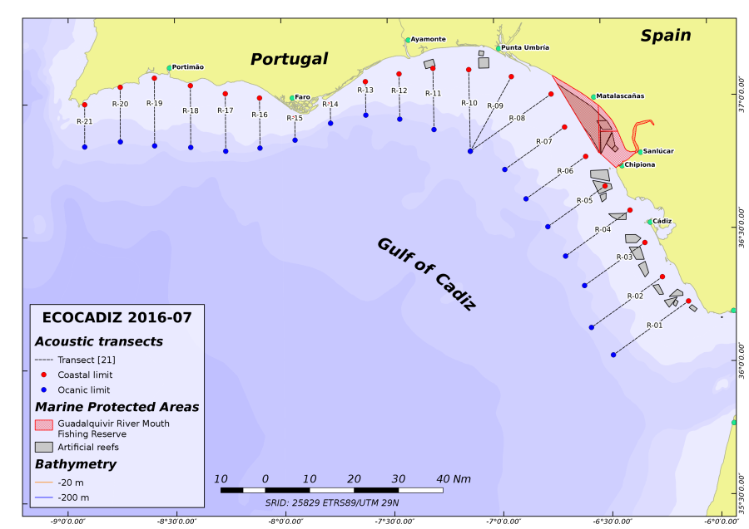
Figure 22: ECOCADIZ 2016-07 survey. Location of the acoustic transects sampled during the survey.

Groundtruthing hauls: groundtruthing hauls were carried out by day at a speed of 4 knots with a double objective: 1) to enable the echo-trace identification and further allocation of the total backscattering energy to species and sizes; 2) to provide the required samples for biologically characterizing the assessed species (anchovy, sardine, horse mackerel, Mediterranean horse mackerel, Blue jack mackerel, mackerel, chub mackerel and bogue). Location and number of these hauls was therefore opportunistic, although they are attempted to be carried out all over the sampled bathymetric range in order to obtain a better characterization of the pelagic fish assemblage. Performance and behaviour of the gear during the haul was monitored with a Simrad™ FS 20/25 trawl sonar system. The number of valid hauls was of 26 from a total of 26 (Figure 23 and Figure 23)

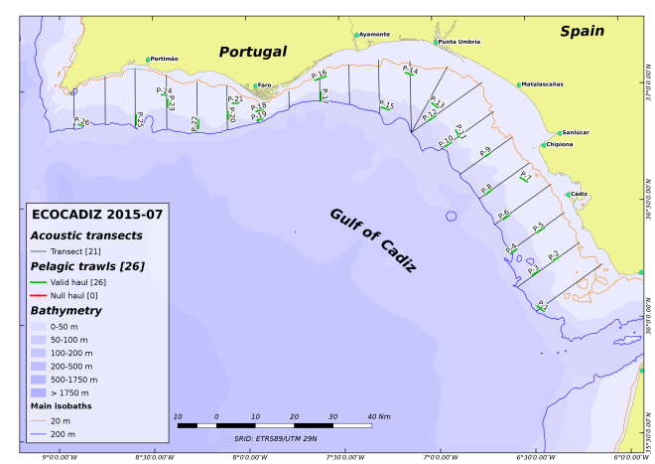
Figure 23: ECOCADIZ 2016-07. Location of ground-truthing fishing hauls. Null hauls in red.
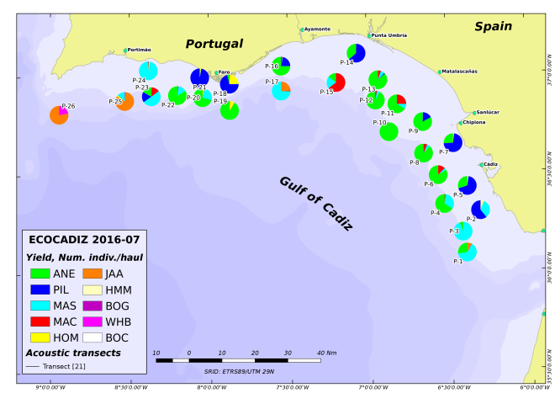
Figure 24: ECOCADIZ 2016-07. . Species composition (percentages in number) in fishing hauls.

Ichthyoplankton sampling:
CUFES™ sampling was carried by day during the acoustic tracking to continuously monitor the anchovy egg abundance. The minimum number of stations is about 120, but the final number of sampled stations may vary according to the extension of the anchovy spawning area each year. A total of 136 CUFES™ stations were finally sampled (Figure 25). Four (4) Bongo 90 coastal stations were also carried out at sunset in the surroundings of the Guadiana (2 stations) and Guadalquivir (1 station) river mouths to collect anchovy larvae for genetics studies (Figure 26). Twenty three (23) Manta trawl hauls were also carried out to characterize the distribution pattern of micro-plastics over the shelf (Figure 26).
Census of top predators: information on presence and abundance of sea birds, turtles and cetaceans was also recorded during the acoustic sampling by one onboard observer.
Sampling of Oceanographic and Climatic variables: The sampling grids sampled in summer and autumn acoustic surveys are different according to the respective surveys' objectives. The final number of sampled stations is adaptatively defined each survey according to the observed processes in real time. 157 stations are considered as a achieved target for the oceanographic characterization of the surveyed area in this survey. A Sea-bird Electronics™ SBE 21 SEACAT thermosalinograph and a Turner™ 10 AU 005 CE Field fluorometer were used during the acoustic tracking to continuously collect some hydrographical variables (sub-surface sea temperature, salinity, and in vivo fluorescence). Vertical profiles of hydrographical variables were also recorded by night from 157 CTDO2-LADCP casts distributed into 12 transects by using Sea-bird Electronics™ SBE 911+ SEACAT (with coupled Datasonics™ altimeter, SBE 43 oximeter, WetLabs™ ECO-FL-NTU fluorimeter and WetLabs™ C-Star 25 cm transmissometer sensors) and LADCP T-RDI™ WHS 300 kHz profilers coupled to a oceanographic rosette without bottles (Figure 24). The maximum sampling depth was 1446 m. VMADCP RDI™ 150 kHz records were also continuously recorded by night between CTD stations. Weather variables were also continuously recorded by an Aanderaa™ weather station.

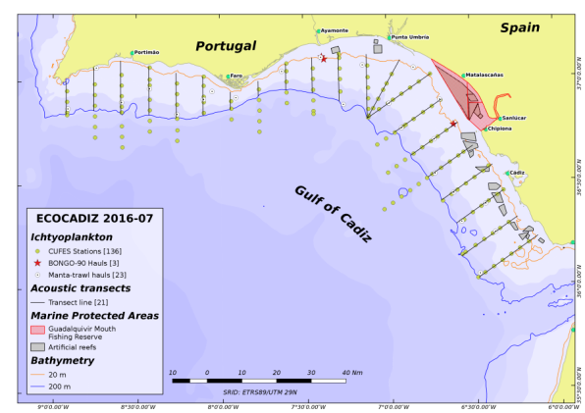
Figure 25: ECOCADIZ 2015-07. Location of CUFES and Bongo-90 and Manta trawl sampling stations.
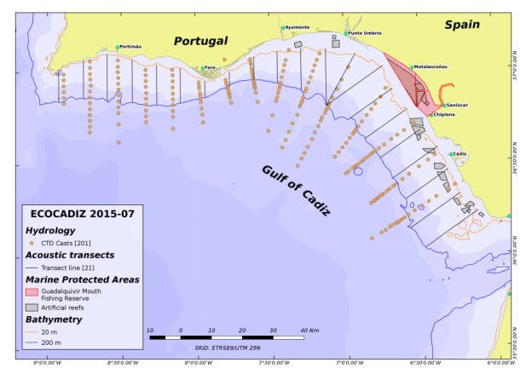
Figure 26: ECOCADIZ 2015-07. Location of CTD-LADCP stations.

Species:
The occurrence frequency, total weight and number of the most frequent captured species during the survey as well as the number of otoliths collected are described in the following text tables below (assessed species in bold)
Species | # of fishing stations | Occurrence (%) | Total weight (kg) | Total number
Scomber colias | 26 | 100 | 4479,004 | 68094
Merluccius merluccius | 22 | 85 | 126,583 | 983
Loligo media | 22 | 85 | 7,767 | 856
Engraulis encrasicolus | 22 | 85 | 2972,308 | 270738
Scomber scombrus | 22 | 85 | 839,369 | 25217
Trachurus trachurus | 17 | 65 | 518,1998 | 4269
Boops boops | 16 | 62 | 70,846 | 554
Sardina pilchardus | 15 | 58 | 1282,094 | 116193
Trachurus picturatus | 12 | 46 | 714,365 | 9892
Diplodus vulgaris | 7 | 27 | 122,202 | 628
Trachurus mediterraneus | 7 | 27 | 260,885 | 1217
Pagellus erythrinus | 7 | 27 | 37,411 | 189
Diplodus annularis | 6 | 23 | 2,648 | 46
Diplodus bellottii | 6 | 2 | 2,638 | 40
Illex Coindetii | 4 | 15 | 0,486 | 4
Alosa fallax | 4 | 15 | 1,319 | 7
Chelidonichthys lucerna | 4 | 15 | 2,284 | 9
Pagellus acarne | 4 | 15 | 21,32 | 77
Spicara flesuosa | 4 | 15 | 2,461 | 43
Macroramphosus scolopax | 3 | 12 | 0,254 | 7
Micromesistius poutassou | 3 | 12 | 0,476 | 5
Loligo vulgaris | 3 | 12 | 1,837 | 19
Pagellus bellotii bellotii | 3 | 12 | 5,521 | 39
Scorpaena notata | 3 | 12 | 0,278 | 3
Parastichopus regalis | 2 | 8 | 5,433 | 22
Sardinella aurita | 2 | 8 | 0,435 | 2
Capros aper | 2 | 8 | 14,092 | 805

Species | # otoliths
Engraulis encrasicolus | 1071
Sardina pilchardus | 371

Data storage: survey data are stored by the IEO in its ad-hoc fishery data base SIRENO (Seguimiento Informático de los Recursos Naturales Oceánicos).
Deviations:
In general terms, no departure from the Proposal is noteworthy. Regarding acoustic sampling all the foreseen objectives were achieved. The number of valid ground-truthing hauls (26) was considered sufficient and representative for the purposes of acoustic assessment and biological characterization of the assessed species. Nevertheless, problems still persist with the conduction of fishing hauls in waters comprised between the 20 and 35-40 m isobaths because of the size of the fishing gear, but mainly by the fact that this coastal fringe is usually full of fixed artisanal gears (octopus pots, hooks, nets, etc.), from the Guadalquivir river mouth area to Cape San Vicente, a problem which makes very difficult the pelagic/bottom trawl fishing. Furthermore, in the western Algarve, fishing hauls are even harder to be conducted because the occurrence of very hard and irregular bottoms, which threaten the integrity of the fishing gear, since this gear must be working in contact with the bottom in most cases. Presence and abundance of micro-plastics over the surveyed area has been sampled for the first time during the present survey. All the foreseen objectives of the ichthyoplankton and micro-plastics (CUFES, Bongo and Manta Trawl), as well as those ones of the census of apical predators, were achieved. The sampling intensity in the collection of oceanographic variables was also very high (201 casts plus continuous TSG-F records), which has had a positive effect in the achievement of the foreseen objectives and the quality of the gathered information.

III.G.2 Data quality: Results and deviation from NP proposal.
Survey’s data and estimates are utilized in the ICES expert groups of both stock assessment of pelagic fish species (WGHANSA, WGWIDE) and acoustic and egg surveys for anchovy and sardine in ICES areas VII, VIII and IX (WGACEGG). The latter expert group revises the results and establishes standardized protocols to properly conduct both this survey and other ones of similar methodology in the above ICES areas. The acoustic estimates from this series are of a special importance for the anchovy stock in Division IXa since the assessment is at present a qualitative one, based on the observed trends exhibited by the indices derived from both this survey series and from their counterparts conducted by other institutions in the same Division.
Recommendations given by the Expert Group for the planning of these surveys (ICES WGACEGG) are adopted in the survey protocols.
Desviaciones: No departure from the Proposal is noteworthy.

III.G.3 Actions to avoid deviations.
Not applicable.

ECOCADIZ-RECLUTAS

III.G.1 Achievements: Results and deviation from NP proposal
Objectives:
Main:
- -To estimate by hydroacoustics (echo-integration) and map the abundance and biomass of the main neritic pelagic species inhabiting the Gulf of Cadiz shelf waters, especially in those waters considered according to previous studies as recruitment areas of the Gulf of Cadiz anchovy and sardine (MSFD Descriptor 1, Indicators 1.1.1, 1.1.2, 1.2.1, 1.4.1, 1.5.1, 1.6.1, 1.6.2, 1.7.1; MSFD Descriptor 3, Indicators 3.1.2, 3.2.2; MSFD Descriptor 4, Indicators 4.3.1).
- -To characterize the biology of the above species in relation to their main habitats (either feeding, spawning, nursery or recruitment habitat depending on the species), especially according to the size composition and/or age structure, and to the maturity, repletion and condition status (MSFD Descriptor 1, Indicators 1.3.1, 1.6.1, 1.7.1; MSFD Descriptor 3, Indicators 3.3.1, 3.3.2, 3.3.3, 3.3.4; MSFD Descriptor 4, Indicators 4.2.1).
- -To detect, identify and capture those echo-traces corresponding to anchovy (and sardine) recruits in the insonified water column.
- -To delimit the extension of anchovy (and sardine) recruitment area in the surveyed area from the spatial distribution of this population fraction.
- -To identify those environmental and biological factors regulating the recruitment process of the small pelagic fish species in the recruitment areas from the oceanographic and environmental characterization of the surveyed area: thermo-haline properties, dissolved oxygen, fluorescence and transmissivity of the shelf waters by continuous (surface layer) and discrete (vertical casts) sampling; patterns of distribution and circulation of the water masses; weather conditions (MSFD Descriptor 1, Indicators 1.6.3; MSDF Descriptor 5, Indicators 5.2.1, 5.2.2, 5.3.2; MSFD Descriptor 7, Indicators 7.1.1, 7.2.1, 7.2.2).
Secondary:
- -To describe differential patterns by age group in the diurnal component of the nictemeral behavior of anchovy and sardine in relation to their respective aggregation and schooling patterns.
- -To map the abundance and biomass of floating macro-litter (MSFD Descriptor 10, Indicator 10.1.2).
Sampled area: Portuguese and Spanish waters off the Gulf of Cadiz (Cape Trafalgar-Cape San Vicente). ICES Subdivision IXa South
Dates: 16th October– 3rd November 2016.
Duration: total duration of 19 days, with 17 effective days of survey (working at sea), 2 days for embarkment/disembarkment of equipment and personnel, 1 day for refuelling and provisioning.
Methodology: estimation of the abundance and biomass of the survey target species by vertical echo-integration, during daylight, along to a systematic grid composed by (21) transects, between 20 – 200 m isobaths, 8 nm-equally spaced and normal to the shoreline, with a Simrad™ EK-60 scientific echo-sounder working in a multi-frequency fashion (18, 38, 70, 120, 200 and 333 kHz). The echo-traces identification, determination of the lenght and age composition and other biological aspects of the assessed species was carried out from the results from opportunistic ground-truthing fishing hauls. Hydrographic characterization of the surveyed area was carried out by night through the sampling of a systematic grid of discrete CTD (with coupled multisensors)-LADCP casts (coupled to an oceanographic rosette) and along-transect sub-superficial continuous sampling with VMADCP and TSG-F. The climatic characterization of the surveyed area was obtained from the analysis of continuous records of weather variables by an Aanderaa weather station.
Research vessel: R/V Ramón Margalef.
Equipment and Sampling gears: Gloria HOD 352 pelagic trawl gear. EK-60 scientific echo-sounder. CTD (with coupled multisensors)-LADCP casts (coupled to an oceanographic rosette). VMADCP and ThermoSal-F. Aanderaa weather station.
Number of hauls: opportunistic. Not based on a sampling scheme previously designed.
Number of transects: 21. (Figure 27).
Samplings
Acoustics: the acoustic sampling was carried out by day, at an approximate speed of 10 knots, over a sampling grid based on a systematic sampling design composed by 21 parallel transects, normal to the shoreline, 8 nm equally-spaced, which extend between the 20 and 200 m isobaths. The complete grid of acoustic sampling (21 transects) was not possible to be sampled because of the realization of joint NATO naval exercises in the spanish waters during a great part of the survey.(Figure 27).
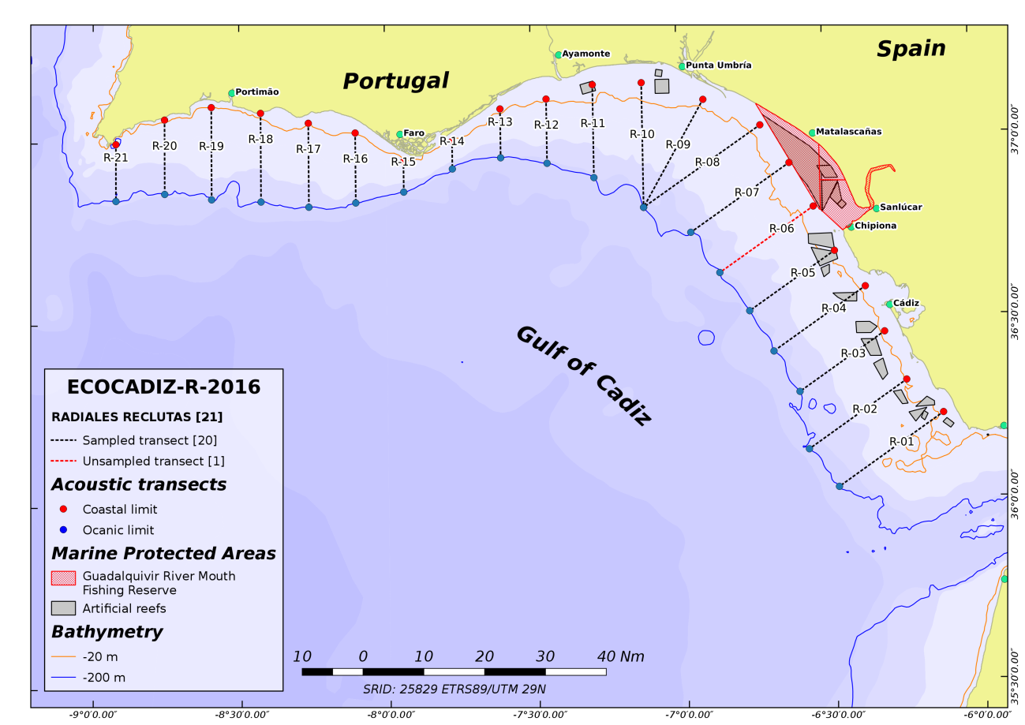
Figure 27: ECOCADIZ-RECLUTAS 2016-10. Location of the acoustic transects sampled during the survey. Transect R-06 was not sampled.
Groundtruthing hauls: groundtruthing hauls were carried out by day at a mean speed of 4 knots with a double objective: 1) to enable the echo-trace identification and further allocation of the total backscattering energy to species and sizes; 2) to provide the required samples for biologically characterizing the assessed species (anchovy, sardine, horse mackerel, Mediterranean horse mackerel, Blue jack mackerel, mackerel, chub mackerel and bogue). Location and number of these hauls was therefore opportunistic, although they were attempted to be carried out all over the sampled bathymetric range in order to obtain a better characterization of the pelagic fish assemblage. Performance and behaviour of the gear during the haul was monitored with a Simrad™ FS 20/25 trawl sonar system. The conduction of groundtruthing fishing hauls is opportunistic and not subject to a predefined sampling scheme. 20 hauls is considered as an acceptable goal to be achieved in each survey. During the survey were performed a total of 16 fishing hauls, 15 hauls were valid (Figure 28 and Figure 29). Four additional test hauls were carried out before the effective start of the survey to properly adjust the fishing gear, doors and sensors.

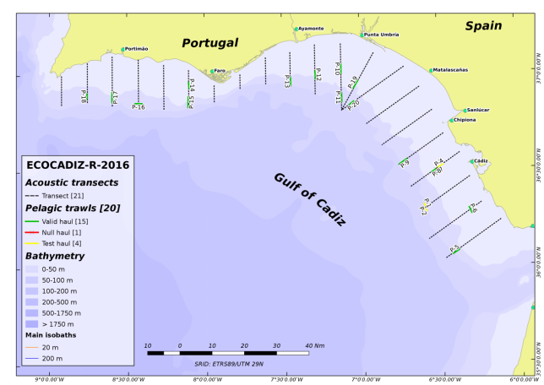
Figure 28: ECOCADIZ-RECLUTAS 2016-10. Location of ground-truthing fishing hauls. Null hauls in red. Test hauls in orange.
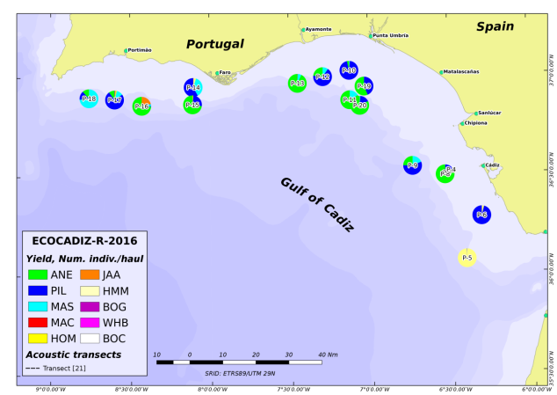
Figure 29: ECOCADIZ-RECLUTAS 2016-10. Species composition (percentages in number) in fishing hauls.

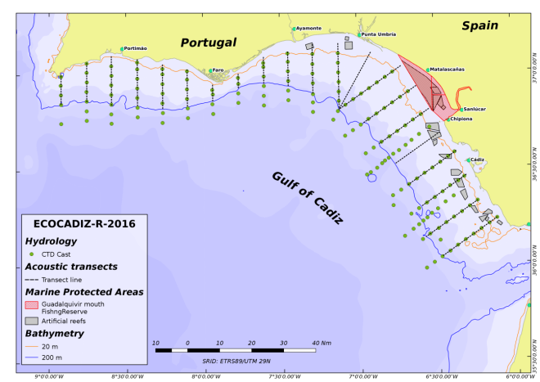
Figure 30: ECOCADIZ-RECLUTAS 2016-10. Location of CTD-LADCP stations

Ichthyoplankton sampling: given the dates and objectives of the survey no CUFES sampling was planned to be carried out.
Census of top predators: information on presence and abundance of sea birds, turtles and cetaceans was not recorded during the present survey because of the R/V’s reduced accommodation capacity.
Sampling of Oceanographic and Climatic variables: The sampling grids sampled in summer and autumn acoustic surveys are different according to the respective surveys' objectives. The final number of sampled stations is adaptatively defined each survey according to the observed processes in real item. 171 stations are considered as a achieved target for the oceanographic characterization of the surveyed area in this survey. A Sea-bird Electronics™ SBE 21 SEACAT thermosalinograph and a Turner™ 10 AU 005 CE Field fluorometer were used during the acoustic tracking to continuously collect some hydrographical variables (sub-surface sea temperature, salinity, and in vivo fluorescence). Vertical profiles of hydrographical variables were also recorded by night from 154 CTDO2-LADCP casts distributed into 21 transects by using Sea-bird Electronics™ SBE 911+ SEACAT (with coupled Datasonics™ altimeter, SBE 43 oximeter, WetLabs™ ECO-FL-NTU fluorimeter and WetLabs™ C-Star 25 cm transmissometer sensors) coupled to a oceanographic rosette without bottles. The usual LADCP T-RDI™ WHS 300 kHz profilers coupled to the abovementioned sampling system was not available for the present survey (Figure 30). The maximum sampling depth was 745 m. VMADCP RDI™ 150 kHz records were also continuously recorded by night between CTD stations. Weather variables were also continuously recorded by an Aanderaa™ weather station. 17 stations were impossible to be sampled due to consecutive Spanish/NATO Navy exercises.
Species:
The occurrence frequency, total weight and number of the most frequent captured species during the survey as well as the number of otoliths collected are described in the following text tables below:
Species | # of fishing stations | Occurrence (%) | Total weight (kg) | Total number
Sardina pilchardus | 14 | 82 | 1500,935 | 59169
Scomber colias | 12 | 71 | 2011,670 | 61749
Engraulis encrasicolus | 12 | 71 | 1035,366 | 82072
Merluccius merluccius | 11 | 65 | 6,055 | 48
Mola mola | 10 | 59 | 170,944 | 60
Scomber scombrus | 9 | 53 | 22,931 | 105
Trachurus trachurus | 7 | 41 | 57,848 | 573
Trachurus mediterraneus | 6 | 35 | 101,157 | 593
Boops boops | 5 | 29 | 29,275 | 270
Trachurus picturatus | 5 | 29 | 123,889 | 1770
Spondyliosoma cantharus | 4 | 24 | 9,797 | 62
Spicara flexuosa | 3 | 18 | 0,318 | 4
Pagellus erythrinus | 3 | 18 | 2,739 | 16
Loligo media | 3 | 18 | 0,883 | 172
Loligo vulgaris | 3 | 18 | 1,027 | 13
Diplodus annularis | 2 | 12 | 0,148 | 2
Sarda sarda | 2 | 12 | 4,060 | 7
Lepidopus caudatus | 2 | 12 | 0,022 | 2
Pomatomus saltatrix | 2 | 12 | 7,973 | 23
Pagellus bellottii bellottii | 1 | 6 | 0,330 | 2
Diplodus vulgaris | 1 | 6 | 0,091 | 1
Pteromylaeus bovinus | 1 | 6 | 41,32 | 1
Zeus faber | 1 | 6 | 0,853 | 1
Diplodus bellottii | 1 | 6 | 0,112 | 2
Maurolicus muelleri | 1 | 6 | 0,001 | 1
Rhizostoma pulmo | 1 | 6 | 5,610 | 2
Capros aper | 1 | 6 | 0,007 | 1
Stromateus fiatola | 1 | 6 | 0,630 | 1

Species | # otoliths
Engraulis encrasicolus | 634
Sardina pilchardus | 576

Data storage: survey data are stored by the IEO in its ad-hoc fishery data base SIRENO (Seguimiento Informático de los Recursos Naturales Oceánicos).
Deviations: the complete grid of acoustic sampling (21 transects) was not possible to be sampled. Transect RA06 was not acoustically sampled for the following reasons. The sampling scheme followed to accomplish this grid was highly conditioned by the realization of joint NATO naval exercises in the Spanish waters during a great part of the survey. The consecutive implementation of different naval exercises’ polygons conditioned the order of realization of the acoustic transects during the survey’s first and second legs. Thus, the acoustic sampling started by the coastal end of the transect R01 on 22nd October and proceeded westward up to the R05 on 24th. The acoustic sampling stopped on 24th-25th October in order to satisfy the R/V’s refueling and provisioning needs. The second leg proceeded between 26th and 30th October by acoustically sampling the R10 to R21 transects in the usual E-W direction. On 1st November the acoustic sampling came back again to the Spanish waters to sample the remaining transects R09 to R06. These transects were sampled in the W-E direction but, again, the execution of new naval exercises finally prevented from sampling the R06 transect.
Given the hardness and irregular nature of the Portuguese shelf bottoms and the relative fragility of the fishing gear used, a great part of the hauls conducted in those waters were carried out after a previous exploration of the bottom nature. The above-mentioned limitations imposed by the Navy exercises also resulted in a lower number of fishing hauls and CTD profiles than expected (2 CTD transects were not sampled and fishing hauls in transects RA06 and RA07 were not possible to be performed).
CUFES sampling to characterize the Gulf of Cadiz anchovy spawning area was not planned to be carried out in the present survey because of the survey dates.
Reduced accommodation capacities of the R/V prevented from the embarkment of an observer onboard for the census of top predators.

III.G.2 Data quality: Results and deviation from NP proposal.
Survey’s data and estimates are utilized in the ICES expert groups of both stock assessment of pelagic fish species (WGHANSA, WGWIDE) and acoustic and egg surveys for anchovy and sardine in ICES areas VII, VIII and IX (WGACEGG). The latter expert group revises the results and establishes standardized protocols to properly conduct both this survey and other ones of similar methodology in the above ICES areas. The acoustic estimates from this series are of a special importance for the anchovy stock in Division IXa since the assessment is at present a qualitative one, based on the observed trends exhibited by the indices derived from both this survey series and from their counterparts conducted by other institutions in the same Division.
Recommendations given by the Expert Group for the planning of these surveys (ICES WGACEGG) are adopted in the survey protocols.
Deviations: No departure from the Proposal is noteworthy.

III.G.4 Actions to avoid deviations.
Not applicable.

IBTS 1th. Quarter (IXa sur)

III.G.1 Achievements: Results and deviation from NP proposal
Objectives:
- Estimate distribution and relative abundance of the main commercial species and provide recruitment indices
- Estimate changes in the stocks of commercial fish species independently of commercial fisheries data
- Monitoring of distribution and relative abundance of all fish and invertebrates species
- Collect data for the determination of biological parameters for selected species
- Collect hydrographical and environmental information.
Sampling area: The Southern Spanish Groundfish Survey on the Gulf of Cadiz (SP-GCGFS) is conducted in the southern part of ICES Division IXa, the Gulf of Cádiz. The covered area extends from 15 m to 800 m depth, during spring (March) and autumn (November). (Figure 31).
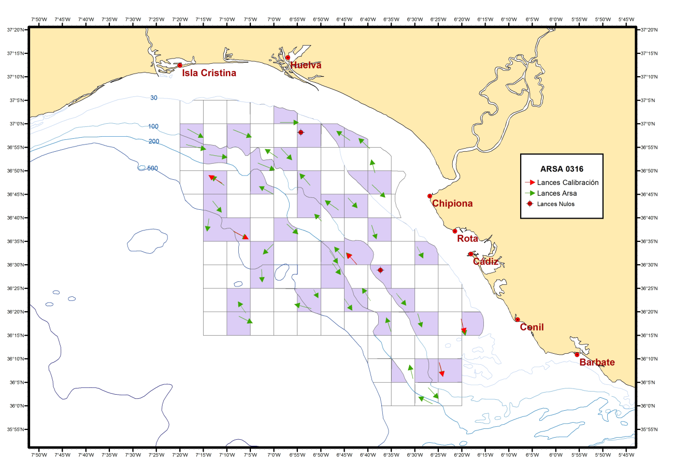
Figure 31: Sampling area with haul and CTD station carry out during a survey IBTS IXa South in 1th Quarter. (ARSA 0316.
Dates: 21th February -06th March 2016.
Duration: 14 days.
Methodology: The whole area (7224 km2) has been separated into five depth strata (15-30, 31-100, 101-200, 201-500 and 501-800 m). The sampling design is random stratified with proportional allocation with a total of 42 fishing stations and swept-area method.
Research Vessel: R/V Miguel Oliver, otter trawler 70 meters length, 14.40 m. breadth, 2495 GT and 2 * 1000kW
Equipment and Sampling gears: Baka trawl 44/60 with a 43,6 m footrope and a 60,1 m headline. CTD Seabird-37.
Number of Hauls: 45 valid haul.
Samplings
Hydrographical Sampling: Temperature and salinity data were also collected during each tow with a CTD attached to the gear.
Biological sampling: A total of 325 species were captured, 128 fish species, 53 crustaceans, 65 molluscs, 26 echinoderms and 53 other invertebrates.
Number of biological samples: Length distribution of all Fish and main species of crustacean and cephalopods.
Scientific name | Number of biological samples( maturity and age material, *maturity only)
Merluccius merluccius | 315 (otolith)
Merluccius merluccius* | 1199*
Parapenaus longirostris* | 1564*
Nephrops norvegicus* | 529*
Octopus vulgaris* | 153*
Sepia officialis* | 239*
Illex coindeti | 201
Todaropsis eblanea | 309

Data storage: survey data are stored by the IEO in its ad-hoc fishery data base SIRENO (Seguimiento Informático de los Recursos Naturales Oceánicos).
Deviations: There were no deviations.

III.G.2 Data quality: Results and deviation from NP proposal.
The data obtained are used for calibrating assessment models of demersal species in the ICES Southern area within the group of WGBIE (formerly WGHMM).
Recommendations given by the Expert Group for the planning of these surveys (ICES IBTSWG) are adopted in the survey protocols.
Deviations: There were no deviations.

III.G.3 Actions to avoid deviations.
Not applicable.

JUVENA

III.G.1 Achievements: Results and deviation from NP proposal
Objectives:
Obtaining an index abundance of juvenile anchovy to predict the recruitment of anchovy (Engraulis encrasicolus) in the Bay of Biscay.
The specific objectives of the survey are:
- The estimation of abundance of juvenile anchovy in autumn in the Bay of Biscay based of acoustic-trawl methodology. Use the biomass of juvenile anchovy as a prediction of next year recruitmentStudy of the biological status of juvenile anchovy and their behavior to the extent that they may affect the recruitment process.
- Characterization of the hidrography and abundance and distribution of the components of the pelagic ecosystem,relevants to understand the dynamics of the recruitment process.
- Study of the trophic interactions between large sub-surface predators (cetaceans and tunas) and their preys in the Bay of Biscay as well as the inter-specific interactions between marine birds and sub-surface predators.
- Acoustic identification and vertical distribution of mesopelagic species in the Bay of Biscay.
Sampling area: The sampling area covered the waters of the Bay of Biscay in ICES VIII zone (being 8º40’ W and 47º30’ N the limits.
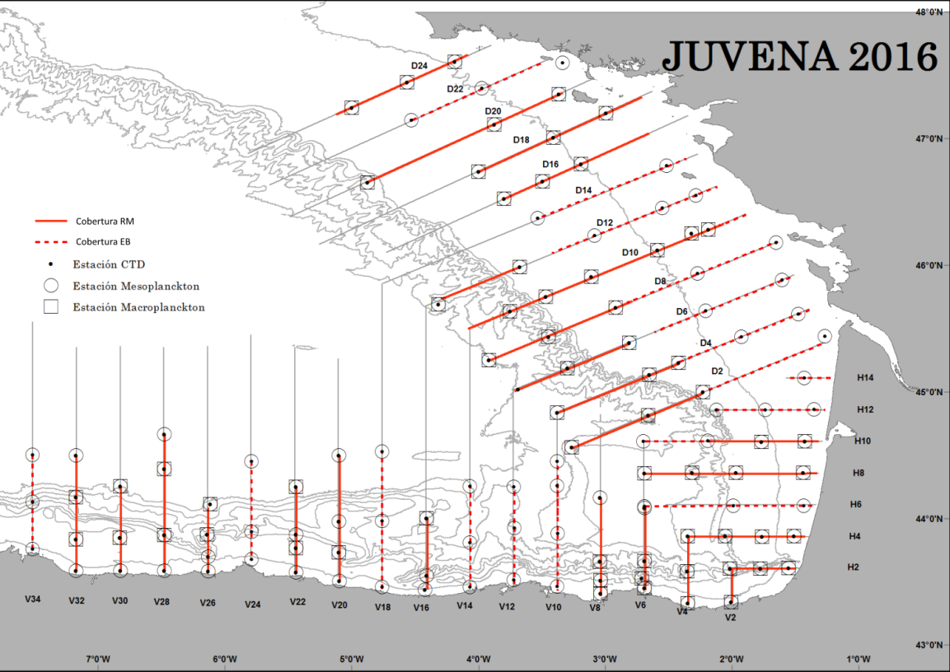
Figure 32: Plankton and hydrography stations done along the survey.

Dates: 1st-30th September 2016.
Duration: 30 days.
Methodology:
The vessels the chartered are both equipped with scientific echosounders calibrated using Standard procedures (Foote et al. 1987). For acoustic data processing the IFREMER Movies+ software was used.
The water column was sampled to depths of 200 m. Acoustic back-scattered energy by surface unit (SA, MacLennan et al. 2002) was recorded for each geo-referenced ESDU (Echointegration Sampling Distance Unit) of 0.1 nautical mile (185.2 m). Fish identity and population size structure was obtained from fishing hauls and echotrace characteristic using a pelagic trawl. Acoustic data, thresholded to -60 dB, was processed using Movies+ software (Ifremer) for biomass estimation and the processed data was represented in maps using ArcGIS. Hydrographic recording was made with CTD casts.
The sampling area covered the waters of the Bay of Biscay (being 8º40’ W and 47º30’ N the limits, Figure 32). Sampling was started from the Southern part of the sampling area, the Cantabrian Sea, moving gradually to the North to cover the waters in front of the French Coast. The acoustic sampling was performed during the daytime, when the juveniles are supposed to aggregate in schools (Uriarte 2002 FAIR CT 97-3374) and can be distinguished from plankton structures (Figura 33).
The vessels followed parallel transects, spaced 15 n.mi., perpendicular to the coast along the sampling area, taking into account the expected spatial distribution of anchovy juveniles for these dates, that is, crossing the continental shelf in their way to the coast from offshore waters (Uriarte et al. 2001).
During the summer, information from the commercial live bait tuna fishery was collected, in order to have knowledge about the spatial distribution and relative abundance of anchovy previous to the beginning of the survey.
In order to characterize the hydrography and plankton distributions, CTDs and WP2 vertical plankton hauls (40 cm diameter of mouth opening and 200 µm of mesh size) are carried out in both vessels. The stations are done in altern transects distanced around 12 nautical miles yielding around 5 stations per transect. Some of the stations will include also Bongo oblique hauls of 80 cm of mouth opening and 500 µm of mesh size to characterize the community of macro-zooplankton.
Onboard R/V Ramon Margalef, along the acoustic samping transects it is obtained also standardized observational information about abundance of large top predators (birds and marine mammals).
Research vessel:
R/V Ramón Margalef: acoustics-trawling, plankton-hidrography, top predators.
R/V Emma Bardán: acoustics-trawling, plankton-hidrography.
Equipment and Sampling gear: Both vessels are equipped with scientific echosounders. The acoustic equipment included three split beam echo sounders Simrad EK60 (Kongsberg Simrad AS, Kongsberg, Norway; Table 1) calibrated using Standard procedures (Foote et al. 1987). In the Ramon Margalef, the 38 kHz, 120 kHz and 200Khz transducers were installed looking vertically downwards, 3 m deep, at the end of a tube attached to the side of the boat, where as at the R/V Emma Bardan the same transducers were installed at the hull.
For Pelagic trawls, a Hampidjan Gloria 15 m vertical opening with Apollo doors of 350 kg was used.
For Plankton: WP2 (40 cm mouth diameter and 200 µm mesh size).

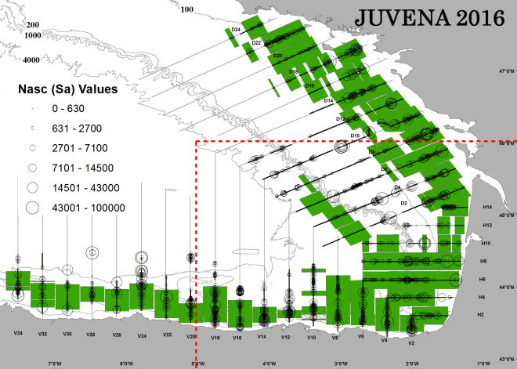
Figura 33: Distribution of acoustic backscattering echointegrated during the JUVENA 2105 survey. The green rectangles represent the positive area strata of anchovy Top: near-surface strata. Bottom: Deep strata. The diameter of the circumferences represents the index of acoustic abundance of all the identified species
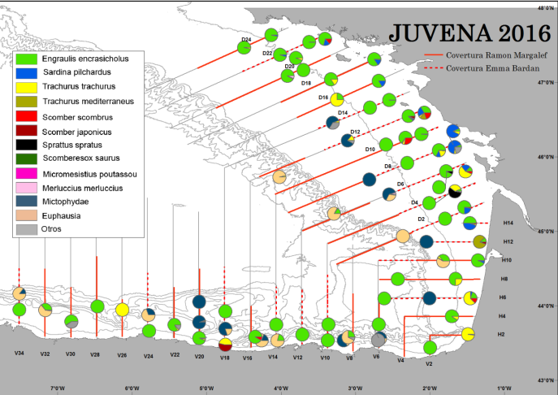
Figura 34: Distribution Spatial location and species composition of the pelagic trawl hauls

Number of hauls:
Plankton stations: 128 stations (Figure 32)
Hydrography: 128 stations (Figure 32)
Pelagic trawls: 78 trawls, 58 positive of anchovy (Figura 34)

Sampling
Hydrographic sampling. A systematic sampling was done in each plankton station
-CTD cast to obtain temperature, salinity and cholophile in the wáter column down to 200 m depth.
-Water samples for the calibation of the fluorimeter in several pre-defined stations.
-In addition, there was a continuous recording of near surface temperature, salinity, conductivity and fluorescence onboard R/V Ramón Margalef
Biological sampling:
-Each fishing haul was classified to species level and a random sample of each species was measured to produce lenght frequencies of the communities under study. A complete biological sampling of the anchovy juveniles collected was performed in order to analyze biological parameters of the anchovy juvenile population, as the age, lenght or lenght-weight ratio. Using these and other environmental parameters we will try to obtain, in a long term, indexes of the state of condition of the juvenile population, in order to be able to improve the prediction of the recruitment strengthness.
-Biological sampling was performed on the species described in the following table:
Species | N ind | Type of sampling
Engraulis encrasicolus | 3647 | Length, weight, gutted weigth, age
Engraulis encrasicolus | 7044 | Length
Sardina pilchardus | 1557 | Length
Sprattu spratus | 176 | Length
Trachurus trachurus | 1841 | Length
Trachurus mediterraneus | 135 | Length
Scomber scombrus | 626 | Length
Somber colias | 135 | Length
Sarda Sarda | 6 | Length
Micromesistius poutassou | 5 | Length
Merluccius merluccius | 140 | Length
Capros aper | 19 | Length
Dicentrarchus labrax | 2 | Length
Maurolicus muelleri | 1231 | Length
Loligo Vulgaris | 99 | Length
Tabla 12: Number of individuals sampled by species in JUVENA.

Plankton sampling:
-Plankton samples are analyzed using semi-automatic methods (FlowCAM, ZooScan and ZooHD) and image analysis techniques.
Data storage: The data are stored in AZTI –Tecnalia. We are considering the feasibility of allowing transference of the data to a global database containing data from other surveys and oceanographic and biologic variables.
Ecosystem indicators: During the survey JUVENA 2016 data were collected to calculate indicators 1, 2 and 3 for the following species: Engraulis encrasicolus, Sardina pilchardus, Scomber scombrus, Scomeber japónicus, Trachurus trachurus, Merluccius merluccius, Spratus spratus.
Deviations: There were no deviations.

III.G.2 Data quality: Results and deviation from NP proposal.
Survey’s data and estimates are used in the ICES expert groups of both stock assessment of pelagic fish species (WGHANSA) and ICES expert group of acoustic and egg surveys for anchovy in ICES areas VII, VIII and IX (WGACEGG).
Deviations: There were no deviations.

III.G.3 Actions to avoid deviations.
Not applicable.

PALPROF

III.G.1 Achievements: Results and deviation from NP proposal
Objectives:
- To update the sampling methodology tested in the 2015 survey, specially modifications in the longline fishing gear and soaking time to get suitable CPUEs by haul.
- To obtain preliminary data on biodiversity and biomass estimates.
- To obtain biological samples (tissues) of the most representative species
Sampling area: ICES area 8c. inshore and offshore waters of the Spanish National in eastern Biscay (Division 8c east, off the coast of Bermeo, from 400 m to 2500 m deep). Sampling began at a point located 10.5 km north of Cape Matxitxako (43º 33.86 'N, 2 ° 44.19' W) and followed a path of successive hauls northwards following the bottom of the canyon until the 43º43'N and between the latitudes 2º42'W and 2º50'W.
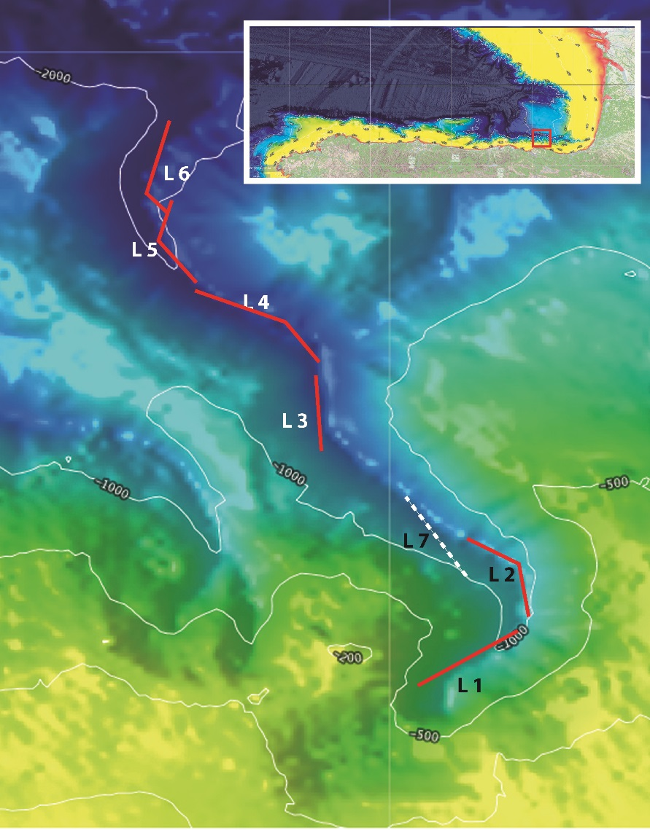
Figure 35: Area covered in the Survey Palprof.

Dates: From September 19 to 28 (2016). During these dates, the survey was carried out in 8 non-consecutive days of effective work at sea.
Duration: 8 non-consecutive days of effective work at sea.
Methodology:
It was used a modified commercial deep-water fishing gear adapted for the survey. Several modifications of the fishing gear were tried during the survey, and finally it was selected a double gear divided into two equal horizontal line sections of 1750 m +1750 m, each with 150 hooks (300 in total). Each hook was baited with1/3 of mackerel (Scomber scombrus).
The horizontal line was attached to the bottom by means of 1.5 kg stone each five hooks. In order to improve the catch efficiency of species that feed above the bottom, the stones of the horizontal line were removed in two “floating” sections of 75 + 75 hooks allowing these sections to get more buoyancy. The fishing gear was linked to the surface by two vertical lines (without hooks) and two buoys placed at the beginning and end of the horizontal line.
For the continuous recording of depth, temperature and salinity the long line was monitored with five small sensors DST centi and DST CTD (www.star-oddi.com) able to withstand 2500 m depth. The five DST sensors were attached in the beginning, mid-point and end of the main rope, and also in the center/top of each “floating” section.
The survey area was 10.5 km north of the Cape Matxitxako in a narrow canyon of about 28 km length that decreases progressively in depth from 500 to 2.500 m.
The survey lasted for eight days, in September from the 19th to 28th. One haul per day was accomplished; the vessel left the port at 8:00 a.m. and came back the same day after recovering the fishing gear. The gear was hauled soon in the morning and recovered 2 hours (soak time/effective fishing time) after the deployment of the boy in the end of the line. In order to compare the horizontal line speed to reach the bottom, the fishing gear was deployed in all the six valid hauls in zig-zag and with two vertical lines.
The average duration of the haul (from the start of the deployment until the last hook recovery) was 7:26 hours. One, out of the eight hauls, failed when the horizontal line got caught to the bottom, and the eighth (and last) one was tried in a different procedure, deploying the fishing gear in lateral trajectory in the mountainside of the valley between the positions of the 2 and 3 hauls. The survey started the first day at 650 m. of depth until the whole length of the line was deployed over the bottom, and annotating the final position that coincided with the starting position for the next day haul.
For the calculation of the fishing effort several categories of the hook status were recorded, both during the deployment and the recovering of the long line:
Null (N)-Lost of bait during the hauling
In the recovering of the line
Entire (E)-Hook with bait
Eaten (C)-Hook with bait partially eaten
Broken (R)-Tangled-broken hook
Empty (V)-Empty hook (no catch, no bait)
With catch (P)-Hook with catch
The specimens were identified individually on board, measured (cm), weighted (g), sexed and the condition (dead or alive) annotated.
Catch per Unit Effort (CPUE1) was standardized to soak time (min) and to 300 hooks.
CPUE 1 = kg (in 300 hooks)/min
A second CPUE (CPUE 2) was calculated removing from the 300 hooks the Null, Tangled and emptied hooks (FC).
CPUE 2 = CPUE 1 x FC*
*FC =(300-(R+N+V)/300:

Vessel: Commercial vessel ITOITZ 3-BI 4-1-02 (bottom longliner: code: 25490):
Equipment and Sampling gear:
It was used a modified commercial deep-water fishing gear adapted for the survey. Several modifications of the fishing gear were tried during the survey, and finally it was selected a double gear divided into two equal horizontal line sections of 1750 m +1750 m, with 300 hooks in total. The horizontal line was attached to the bottom by means of 1.5 kg stone each five hooks. In order to improve the catch efficiency of species that feed above the bottom, the stones of the horizontal line were removed in two “floating” sections of 75 + 75 hooks allowing these sections to get more buoyancy (see figure 1).The fishing gear was linked to the surface by two vertical lines (without hooks) and two buoys placed at the beginning and end of the horizontal line.
Number of hauls:
8 hauls: 1 not valid haul+1 test (lateral) haul + 6 valid hauls (Figure 35)
Sampling
-The 6 six valid haul deployed a total of 1800 hooks (average de 300 hooks/haul), with a total length of 21.486 m of the horizontal line over the bottom. The range of depths was from 685 m to 2.236 m.
The number of specimens measured (cm), weighted (g), sexed on board is shown in the following table.
Species | N indiv
Centroscymnus coelolepis | 43
Mora moro | 72
Etmopterus princeps | 33
Deania calcea | 38
Galeus melastomus | 8
Antimora rostrata | 9
Aphanopus carbo | 24
Centrophorus squamosus | 11
Hydrolagus pallidus | 2
Synaphobranchus kaupii | 1
Centroscymnus crepidater | 7
Conger conger | 1
Hydrolagus affinis | 1
Lophius piscatorius
Prionace glauca | 1
Etmopterus pusillus | 5
Etmopterus spp | 1
Tabla 13: N of individuals measured, weighted and sexed, by species in PALPROF survey.

Data storage: The data are stored in the database of AZTI Tecnalia, and is considering moving to a global database, comprising other surveys, oceanographic variables, biological, etc
Ecosystem indicators: During PALPROF 2016 survey, data have been collected to estimate indicators 1 to 3 for the following species: Centroscymnus coelolepis, Mora moro, Etmopterus princeps, Deania calcea, Galeus melastomus, Antimora rostrata, Aphanopus carbo, Centrophorus squamosus, Hydrolagus pallidus, Synaphobranchus kaupii, Centroscymnus crepidater, Conger conger, Hydrolagus affinis, Lophius piscatorius, Prionace glauca, Etmopterus pusillus, Etmopterus spp
Deviations: There were no deviations from the Proposal.

III.G.2 Data quality: Results and deviation from NP proposal.
The total length sampled in the 6 valid hauls was 21.486 m + 3.175 m of the lateral haul not counted in the analysis
For the analysis of effort and CPUEs hauls’ catches were grouped in four depth strata: 650-1050 m, 1051-1450 m, 1451-1850 m and 1851-2250 m
Deviations: There were no deviations.

III.G.3 Actions to avoid deviations.
Not applicable.

BFT index

III.G.1 Achievements: Results and deviation from NP proposal
Objectives:
Developing a fishery-independent abundance index for juvenile bluefin tuna in the Bay of Biscay. The specific objectives of the survey are:
- Estimating the abundance of juvenile bluefin tunas in their summer feeding grounds of the southeastern Bay of Biscay
- Analysing the geographical distribution of bluefin tuna schools in the Bay of Biscay,
- Assessing the size distributions in each tuna school detected in the Bay of Biscay,
- Identifying differential geographical distribution of tunas of different size classes in the Bay of Biscay,
- Studying the interactions between bluefin tunas and their main prey (anchovy) in the Bay of Biscay, as well as inter-specific interactions between marine birds and sub-superficial predators.
- Acoustic identification of bluefin tuna behavior within schools in the Bay of Biscay.
Sampling area:
The sampling area covered the waters of the Bay of Biscay in ICES VIIIb and VIIIc zones, east from 3º30’ W and south from 45º05’ N (Figure 36).
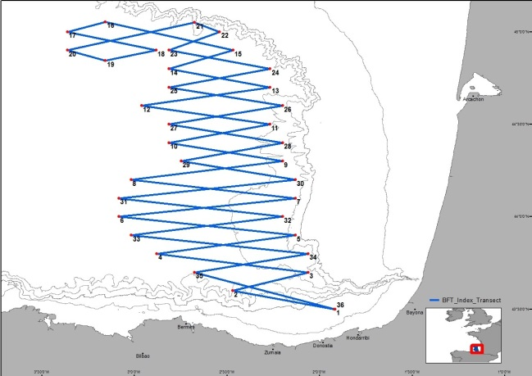
Figure 36: spatial definition of transects followed during the BFT Index Survey.
We based our survey design on the distribution of bluefin tuna catch locations by Basque baitboat vessels during the years 2002-2011 (Figure 37), considering that the distribution of catches is representative of bluefin tuna distribution in the area (Figure 38). A zig-zag design was chosen, starting and ending near the base port. The zig-zag design was preferred to parallel transects because it optimizes the time spent cruising, i.e. no inter-transect time needs to be used. The choice of starting and ending near the base port also allowed dedicating almost all cruising time to the acoustic survey, i.e. the traveling time to start point and back from end point could be reduced. Moreover, with this design the survey as a whole has no trended displacement, which avoids any bias that could derive from the interaction between vessel displacement and tuna displacement.

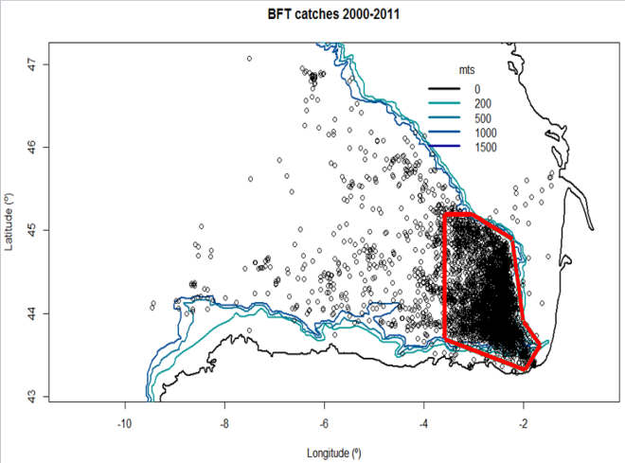
Figure 37: Spatial distribution of bluefin tuna catches by the baitboat fleet in the Bay of Biscay in the years 2000-2011 and spatial definition of the zone of highest catches (84.5% of fishing events and 85.5% of catch weight), delimited by red line
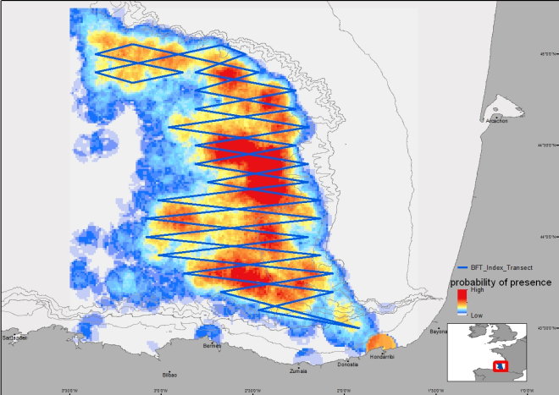
Figure 38: Probability of bluefin tuna presence according to the Basque baitboat catch data for the period 2000-2011, and spatial definition of the transects followed during the survey

Dates: From 8th to 18th July 2016
Duration: 11 days
Methodology:
Data registered on board and preliminary analyses: Along the transects, all bluefin tuna detections by sonar or echosounder or visual detection were registered, and no-kill fishing events were done in order to identify the species and to sample the sizes of the individuals present in each aggregation. When fishing was not possible (i.e. tunas not interested in the live bait), the identification of the species was made visually by observing fish jumping at the surface, and a size-category was estimated. When tunas were observed only by sonar, the skipper’s knowledge as well as Wesmar 165 sonars was used to discriminate tunas from other fish aggregations (e.g. anchovy) and to discriminate bluefin tuna from albacore when the latter was present. The unidirectional Wesmar 165 sonar (part of the vessel’s equipment) was also used to discriminate bluefin tuna from albacore.
In order to avoid double counts of the same aggregation, observations were skipped in two situations:
- after direction changes at the beginning of each transect, when a school encountered at the end of the previous transect could potentially be encountered again-after fishing events, when the vessel stays enough time at reduced speed to allow a tuna school to be detected a second time if encountered again. In these situations, each sonar detection was removed when the time and straight distance from a previous detection were sufficient for a displacement of the tunas, based on swimming speeds observed by Brill et al. (2002). During all the survey, two trolling lines were also fishing at the stern of the boat.
Processing of sonar screenshots: To analyze sonar screen dumps, we use a semi-automatic image processing method through which tuna schools are morphologically classified. First, the sonar screenshots of detected schools are pre-processed and segmented, and the characteristics of the regions obtained through the segmentation are extracted. Through this extraction, we obtain 20 morphologic characteristics of the regions. The morphological characteristics of regions corresponding to tuna schools will be used to calculate their dimensions and area. In a second step, in order to cross-check the detections registered by scientists on board, a tuna labelling classification model is validated based on a semi-automatic image processing tool. For this, these morphologic characteristics are grouped in a database that is based on an equivalent number of cases of bluefin tuna presence and absence. The 20 morphologic characteristics are analyzed through a comparative study of supervised classification, using classifiers of different families. To assess the efficiency and effectiveness of the different classification methods, the average values of different indices were calculated (see Goñi et al., 2016). The results of the experiments are analyzed based on the minimum, maximum, mean and standard deviation of these indices.
Furthermore, an OCR application (Optical Character Recognition) developed using the software R (R development core team, 2015) will be used to extract data relevant for tuna detections, and Kalman filter based temporal study for tracks detection will be used. Through Kalman filters the current position of an object is estimated (in our case the object is one of the regions extracted from the preprocessing of images), based on non-precise measurements and on the position in anterior states. Combining the potential of the tuna classification model, tuna detection from OCR applications, and Kalman filters, automatic counting and sizing tuna schools is feasible. In particular, the estimation of the school diameter from sonar screen dumps allows us to cross-validate the diameter estimated from the 200 kHz echosounder (see section 2.5).
Processing of echosounder data: The echosounder recordings are used to determine the dimensions, volume, and number of individuals in each bluefin tuna aggregation observed. The combined use of a vertically oriented and a laterally oriented transducer provides us with the vertical dimension and one of the horizontal dimensions of the tuna schools, together with the school diameter measured from sonar screenshots. Due to the reduced speed of the vessel during fishing events (or when the vessel was approaching the school even when no fishing was possible) the second horizontal dimension of the school could not be directly observed and will therefore be estimated assuming a horizontal isotropy of the tuna schools. It will also be cross-validated with the horizontal dimension derived from sonar image analyses.
First, all tuna schools are identified on the echograms, based on real time information recorded during detection on board the fishing vessel. In the records corresponding to the vertically oriented echosounder (i.e. 38 kHz), an echointegration by layer of each ping is done, with a -55dB threshold. After the echointegration, the data are post-processed so as to keep only pings containing acoustic backscattering corresponding to tuna aggregations, by keeping only non-zero echointegration pings. This produces an along-track compacted echogram from which we obtain the mean density of the school calculated as the mean of the volume backscattering coefficient (sv; Maclennan et al 2002) of the non-zero pings. The shape of the schools is assumed to be a revolution ellipsoid with horizontal isotropy, i.e., with circular horizontal cross section. The estimated volume of each detected school is calculated as:
Volume = (4.π/3).(Y_{max}/2)². (Z_{max}/2)
Where, Z_{max} is the vertical diameter of the school, and where Y_{max} is the horizontal diameter.
The density, number of tunas per unit volume by school is calculated from the 38 kHz echogram with the formula:
N/V =s_{v}/ <σ_{bs}>
Where, V is the volume of the tuna school, s_{v} the mean volume backscattering coefficient of the school (MacLennan et al.,2002) given by the echointegration at the 38 kHz echogram, and <σ_{bs}> the backscattering cross section, i.e., the fraction of energy backscattered by a single individual, which is function of the species and size of the individuals. To calculate < σ_{bs} >, we use bluefin tuna TS data (target strength, TS=10log10(σ_{bs}) , Maclennan et al., 2002) from Sainz-Pardo Martí (2010) and the equation:
TS = 20 log FL + b₂₀
Where, TS is the individual target strength, FL the fork length of the fish and b₂₀ is a constant parameter known as the reduced target strength (Simmonds and MacLennan, 2005). The b₂₀ value was -65.75 dB. Finally, an abundance index is calculated for each school, multiplying the density times the school volume.
The echointegration of schools for which no sampling could be done was also performed. For these schools the vessel speed during detection was 8 knots, so a simple echointegration by layer was performed. These results were combined with data from echointegrations of sampled schools (at low speed).
Vessel: a local baitboat vessel equipped with a MAQ long-range sonar (from which screen dumps were recorded with a time interval of one second), hired each year. Nuevo Horizonte Abierto was used in 2015 and Txingudi in 2016.
Number of school detected:
After removing the possible double-counts, 106 bluefin tuna schools could be detected by sonar during the 2015 survey and 34 during the 2016 survey. The spatial distribution of tuna detections was heterogeneous (Figure 39), combining long distances without detections and zones of high density of presence of bluefin tuna (particularly in 2015) in which numerous consecutive schools were detected in relatively short distance ranges. This variability also appears on a temporal level in 2015: we could observe a relatively low number of tuna schools detections in the first half of the survey and a higher number during the second half (Figure 39,Tabla 11) while cruising in the same zone. This heterogeneity of the distribution is a typical feature of this species.
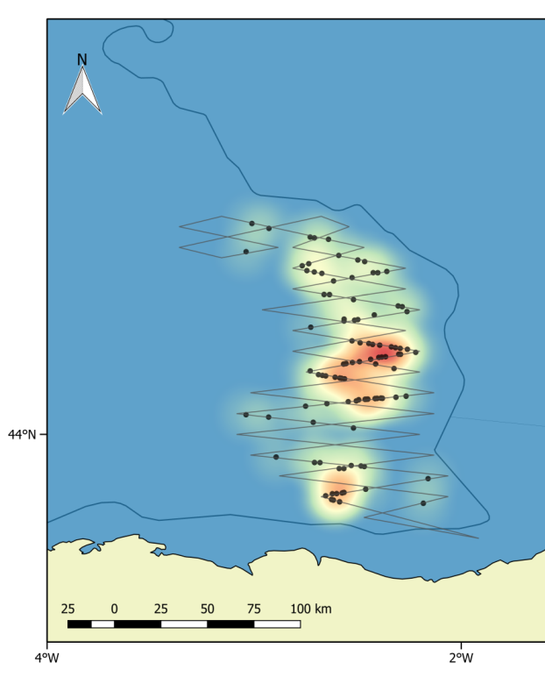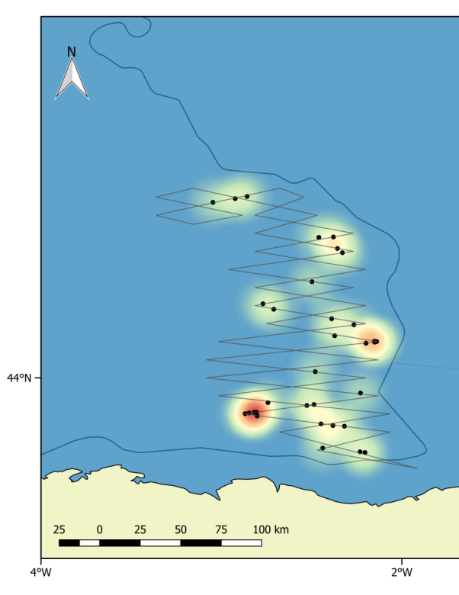
Figure 39: Detections and spatial density of the tuna schools observed during the survey in 2015 (left panel) and 2016 (right panel).

In an important part of the tuna schools detected, fishing was not possible. The tunas were not reactive to the live bait. This is a clear illustration of the variability of tuna catchability related to their biotic environment and feeding behavior. This confirms the need to develop fishery-independent abundance indices for bluefin tuna in this area
Transect start point | longitude | latitude | Distance to next point (n.m.) | Detections on transect distance (2015) | Detections by nautical mile (2015) | Detections on transect distance (2016) | Detections by nautical mile (2016)
1 | -1.91668 | 43.50000 | 24.7 | 0 | 0 | 0 | 0
2 | -2.47039 | 43.60000 | 18.72 | 1 | 0.053 | 1 | 0.053
3 | -2.06300 | 43.70000 | 35.98 | 0 | 0 | 5 | 0.139
4 | -2.87940 | 43.80000 | 33.01 | 4 | 0.121 | 6 | 0.182
5 | -2.13100 | 43.90000 | 41.75 | 0 | 0 | 1 | 0.024
6 | -3.08500 | 44.00000 | 41.69 | 0 | 0 | 0 | 0
7 | -2.13080 | 44.10000 | 38.78 | 0 | 0 | 0 | 0
8 | -3.01800 | 44.20000 | 35.77 | 0 | 0 | 1 | 0.028
9 | -2.20000 | 44.30000 | 27.12 | 2 | 0.074 | 2 | 0.074
10 | -2.81500 | 44.40000 | 24.23 | 0 | 0 | 1 | 0.041
11 | -2.26800 | 44.50000 | 30.32 | 0 | 0 | 1 | 0.033
12 | -2.96188 | 44.60000 | 30.29 | 0 | 0 | 1 | 0.033
13 | -2.26800 | 44.70000 | 24.13 | 3 | 0.124 | 1 | 0.041
14 | -2.81500 | 44.80000 | 15.97 | 2 | 0.125 | 0 | 0
15 | -2.46804 | 44.90000 | 30.75 | 5 | 0.163 | 0 | 0
16 | -3.15755 | 45.05000 | 9.3 | 0 | 0 | 0 | 0
17 | -3.36300 | 45.00000 | 21.27 | 0 | 0 | 0 | 0
18 | -2.88359 | 44.90000 | 12.16 | 2 | 0.164 | 0 | 0
19 | -3.15755 | 44.85000 | 9.39 | 1 | 0.106 | 0 | 0
20 | -3.36300 | 44.90000 | 30.58 | 0 | 0 | 3 | 0.098
21 | -2.67618 | 45.05000 | 6.47 | 0 | 0 | 0 | 0
22 | -2.54114 | 45.00000 | 13.11 | 0 | 0 | 0 | 0
23 | -2.81500 | 44.90000 | 24.08 | 0 | 0 | 0 | 0
24 | -2.26800 | 44.80000 | 24.12 | 3 | 0.124 | 2 | 0.083
25 | -2.81500 | 44.70000 | 27 | 5 | 0.185 | 0 | 0
26 | -2.20000 | 44.60000 | 27.04 | 7 | 0.259 | 0 | 0
27 | -2.81500 | 44.50000 | 27.08 | 9 | 0.332 | 0 | 0
28 | -2.20000 | 44.40000 | 24.31 | 13 | 0.535 | 0 | 0
29 | -2.75000 | 44.30000 | 27.24 | 6 | 0.220 | 3 | 0.110
30 | -2.13109 | 44.20000 | 41.62 | 14 | 0.336 | 2 | 0.048
31 | -3.08500 | 44.10000 | 38.74 | 4 | 0.103 | 1 | 0.026
32 | -2.20000 | 44.00000 | 35.93 | 0 | 0 | 0 | 0
33 | -3.01800 | 43.90000 | 41.83 | 5 | 0.120 | 1 | 0.024
34 | -2.06300 | 43.80000 | 27.37 | 8 | 0.292 | 0 | 0
35 | -2.67766 | 43.70000 | 35.25 | 3 | 0.085 | 2 | 0.057
Table 14: Summary of bluefin tuna detections made by sonar during both surveys.

Further steps
The echointegration of 2016 echosounder data was done, and the volume and number of individuals of each school will also be calculated. By visual inspection during echointegration, the volume of the schools seemed more important in 2016 than in 2015, which suggests a more aggregated distribution of the bluefin tunas in 2016 versus 2015. After post-processing, we expect the volume data to confirm this visual guess.
Fish size distribution of both years will also be compared, as well as the spatial density of tunas.
The spatial heterogeneity of the school detections is the most striking feature of these surveys, especially in the 2015 survey, in which the number of schools detected in the second half of the survey was one order of magnitude higher than in the first half. To address this issue, resampling can be used in order to assess the precision of the spatial distribution of the estimated tuna biomass. Universal kriging (Doray et al., 2008) can also be used to model the spatio-temporal variability in the estimated biomass of tuna aggregations recorded during the survey. Further than giving an abundance index, these tools would allow us to interpolate and map the estimated biomass of bluefin tunas detected in their core area in the Bay of Biscay
Data storage: The data are stored in AZTI –Tecnalia. We are considering the feasibility of allowing transference of the data to a global database containing data from other surveys and oceanographic and biologic variables.
Ecosystem indicators: During BFT 2015 and 2016 survey, data have been collected to estimate indicators 1 to 3 for Thunnus thynnus.
Deviations: There were no relevant deviations.

III.G.2 Data quality: Results and deviation from NP proposal.
When we reach a sufficient number of years of survey so as to provide a relevant abundance index survey’s data and estimates are proposed to be used in the ICCAT expert groups of bluefin tuna stock assessment.
Deviations: There were no deviations.

III.G.3 Actions to avoid deviations.
Not applicable.

Update of “Sampedro, P., Sainza, M. and Trujillo, V., 2005.A simple tool to calculate biological parameters’uncertainty. Working Document, In: Workshop on Sampling Desing for Fisheries Data (WKSDFD), Pasajes, Spain
Update of “Sampedro, P., Sainza, M. and Trujillo, V., 2005.A simple tool to calculate biological parameters’uncertainty. Working Document, In: Workshop on Sampling Desing for Fisheries Data (WKSDFD), Pasajes, Spain
Update of “Sampedro, P., Sainza, M. and Trujillo, V., 2005.A simple tool to calculate biological parameters’uncertainty. Working Document, In: Workshop on Sampling Desing for Fisheries Data (WKSDFD), Pasajes, Spain
Update of “Sampedro, P., Sainza, M. and Trujillo, V., 2005.A simple tool to calculate biological parameters’uncertainty. Working Document, In: Workshop on Sampling Desing for Fisheries Data (WKSDFD), Pasajes, Spain
Update of “Sampedro, P., Sainza, M. and Trujillo, V., 2005.A simple tool to calculate biological parameters’uncertainty. Working Document, In: Workshop on Sampling Desing for Fisheries Data (WKSDFD), Pasajes, Spain
Update of “Sampedro, P., Sainza, M. and Trujillo, V., 2005.A simple tool to calculate biological parameters’uncertainty. Working Document, In: Workshop on Sampling Desing for Fisheries Data (WKSDFD), Pasajes, Spain

