

MINISTRY OF AGRICULTURE AND RURAL DEVELOPMENT
NATIONAL AGENCY FOR FISHERIES AND AQUACULTURE

Regulation (EU) 2017/1004 of 17 May 2017of the European Parliament and the Council
on the establishment of a Union framework for the collection, management and use of data in the fisheries sector and support for scientific advice regarding the common fisheries policy and repealing Council Regulation (EC) No 199/2008

Commission Implementing Decision (EU) 2019/909 of 18 February 2019 establishing the list of mandatory research surveys and thresholds for the purposes of the multiannual Union programme for the collection and management of data in the fisheries and aquaculture sectors

Commission Delegated Decision (EU) 2019/910 of 13 March 2019 establishing the multiannual Union programme for the collection and management of biological, environmental, technical and socioeconomic data in the fisheries and aquaculture sectors

Commission Implementing Decision (EU) 2016/1701 of 19 August 2016laying down rules on the format for the submission of work plans for data collection in the fisheries and aquaculture sectors.

Commission Implementing Decision (EU) 2018/1283 of 24 August 2018 laying down rules on the format and timetables for the submission of annual data collection reports in the fisheries and aquaculture sectors.

[MS] Annual Report for data collection in the fisheries and aquaculture sectors
2021

Version [2] – [2022]
Bucharest, 20 June 2022

NATIONAL DATA COLLECTION ORGANIZATION

The Data Collection Programme is co-ordinated by the National Agency for Fisheries and Aquaculture, Ministry of Agriculture and Rural Development, national correspondent Constantin STROIE, with following contact details are:

Marian AVRAM - President NAFA
Constantin STROIE – national correspondent, NAFA
Street: Sf. Vineri, nr.29, sector 3, Bucuresti, Romania;
tel: (40) 0374.466.140, (40) 0374.466.139; fax: (40) 0374 466 138;
e-mail: secretariat@anpa.ro; anpa@anpa.ro; constantin.stroie@anpa.ro; alexandru.gheorghe@anpa.ro

The contact details of the participating institutes are:

National Institute for Marine Research and Development” Grigore Antipa„(NIMRD) - Co-ordinator

dr. Valeria ABAZA - Director General of NIMRD;
dr. Valodia MAXIMOV - co-ordinating program;
Mamaia Blvd, no. 300, 900581, Constanta, Romania
Tel. (40)0241 543 288, (40) 0241 540 870; Fax: (40)0241 831 274;
e-mail: office@alpha.rmri.ro; vmaximov@alpha.rmri.ro; http://www.rmri.ro

Institute for Research - Development for Aquatic Ecology, Fisheries and Aquaculture (IRDAEFA),

dr. Maricel Floricel DIMA - Director of IRDAEFA;
dr. Magdalena TENCIU – scientific responsible;
Portului street, no. 54, 800211, Galați, Romania
Tel.: (40)0236-416914, Fax: (40)0236-414270
e-mail: icdeapa.galati@asas.ro; magdatenciu@yahoo.com; http://www.icdeapa.ro

Research and Development Station for Fisheries (RDSF)

dr. Mioara COSTACHE - Director of RDSF
dr. Silvia RADU – scientific responsible;
Principală street, nr. 549, Nucet, jud. Dămbovița, Romania
tel/fax: 0245-267003, tel.0245-267009,
e-mail: SCDP.Nucet@asas.ro, scp_nucet@yahoo.com, viostef06@yahoo.com

CONTENTS

Section 1: Biological Data 4
Text Box 1C: Sampling intensity for biological variables 4
Section 1: Biological Data 6
Text Box 1D - Recreational fisheries 6
Section 1: Biological Data 7
Pilot Study 1: Relative share of catches of recreational fisheries compared to commercial fisheries 7
Section 1: Biological Data 10
Text Box 1E: Anadromous and catadromous species data collection in fresh water 10
Section 1: Biological Data 11
Text box 1F: Incidental by-catch of birds, mammals, reptiles and fish 11
Section 1: Biological Data 15
Pilot Study 2: Level of fishing and impact of fisheries on biological resources and marine ecosystem 15
Section 1: Biological Data 22
Text Box 1G: List of research surveys at sea 22
Section 2: Fishing Activity Data 36
Text Box 2A: Fishing activity variables data collection strategy 36
Section 3: Economic and Social Data 37
Text Box 3A: Population segments for collection of economic and social data for
fisheries 37
Section 3: Economic and Social Data 40
Pilot Study 3: Data on employment by education level and nationality 40
Section 3: Economic and Social Data 48
Text Box 3B: Population segments for collection of economic and social data for
aquaculture 48
Section 3: Economic and Social Data 51
Pilot Study 4: Environmental data on aquaculture 51
Section 3: Economic and Social Data 55
Text Box 3C: Population segments for collection of economic and social data for the
processing industry 55
Section 4: Sampling Strategy for Biological Data from Commercial Fisheries 59
Text Box 4A: Sampling plan description for biological data 59
Section 5: data quality 62
Text Box 5A: Quality assurance framework for biological data…………………………..62
Section 5: data quality 63
Text Box 5B: Quality assurance framework for socioeconomic data ……….…………………63

Section 1: Biological Data

Text Box 1C: Sampling intensity for biological variables

General comment: This box fulfils paragraph 2-point (a)(i)(ii)(iii) of Chapter III, of the Annex of the Delegated Decision (EU) 2019/910 and Chapter I of the Implementing Decision (EU) 2019/909 on the multiannual Union programme; and Article 2, Article 4 paragraph 1 and Article 8 of the Implementing Decision (EU) 2016/1701 on the format of the WP. This box is applicable to the Annual Report.
Member State should provide by Region/RFMO/RFO/IO:

1. Evidence of data quality assurance

Quality evaluation can only be carried out if the information coming from Table 5A in the Work Plan is available. If this is not the case, Member State shall provide an overview by giving information on the methodology used to assure the quality of the data collected.

Information on the methodology used to assure the quality of the data collected:

1. http://www.rmri.ro/Home/Publications.Other.ANPA.html?lang=en - under Materials and Methods section.
2. Biometric measurements, data checks & analysis
3. Descriptive statistics
4. ODV 5. Outliers Check values
6. L-W relationships
7. RoME software, developed with R language, RoME represents a common tool to perform data checks
8. BioIndex
9. Usage of appropriate exploratory statistical techniques to detect outliers and anomalous registers.

Romanien institutes use common standard protocols for processing of data agreed with Bulgaria institute.

According to the approved program, in 2021 the following biological parameters were collected: length, weight, age, sex ratio, sexual maturity and fecundity (table 1B), for the species: sprat (Sprattus sprattus); turbot (Scophthalmus maeoticus/Psetta maxima maeotica); horse mackerel (Trachurus mediterraneus): european anchovy (Engraulis encrasicolus); red mullet (Mullus barbatus); picked dogfish (Squalus acanthias); whiting (Merlangius merlangus); rapana (Rapana venosa); thornback ray (Raja clavata) and common stingray (Dasyatis pastinaca)(see AR comments in Table 1C). The species Atlantic horse mackerel / Trachurus trachurus is not present on the Romanian coast of the Black Sea, so that is not included in the sampling program because is not present in the catches.

2. Deviations from the Work Plan
There are no deviations from the planned methodology regarding sampling of the species.
No deviations from:
• sampling intensity,
• methods used for collecting data.
• methods used for estimating the parameters.

The sampling was performed by the institute's researchers (NIRMD), on board the vessel, recording and collecting data for all fishing activities carried out (the data obtained reflect the entire voyage) or in the port (in the catch landing area). The sampling scheme is established to ensure both the quality of sampling and to ensure a minimum number of individuals by sampling for later use in the evaluation.

Length and weight: the length sampling scheme (biological variable related to fishing), focused on the species and metier, generally corresponds to the number of planned individuals, was within the allowed limits [sprat -130.95 % (landings+surveys); European anchovy - 104.83 % (landings); turbot - 130.0 % (landings+surveys), picked dogfish - 116.0 % (surveys); horse mackerel - 131.3 % (landings+surveys); red mullet - 101.1 % (landings); rapa whelk - 129.64 % (landings); whiting - 132.45 % (surveys); thornback ray - 130.0 % (landings) and common stingray - 115.0 % (landings)(Table 1C)]. The high percentage of samples did not lead to any financial modification of the contract.
Age and sex ratio: the number of individuals analysed corresponds to the planned number, with small exceedances, but which were within the allowed limits [sprat -134.3 % (landings+surveys); European anchovy - 124.93 % (landings); turbot - 138.46% (landings+surveys); horse mackerel - 116.8 % (landings+surveys); red mullet - 114.8 % (landings); picked dogfish -116.0 % (surveys); rapa whelk – 118.6 % (landings), whiting – 108.9 % (surveys). Only sex ratio for species: thornback ray - 100.0 % (landings) and common stingray - 100.0 % (landings)(Table 1C)]. The high percentage of samples did not lead to any financial modification of the contract.
Sexual maturity and fecundity: the sexual maturity and fecundity sampling scheme, focused on the species, generally corresponds to the number of planned individuals: [sprat -111.8 % (landings+surveys); European anchovy - 108.14 % (landings); turbot - 100.0% (surveys); horse mackerel - 102.2 % (landings+surveys), red mullet - 122.8 % (landings) and whiting - 100.0 % (surveys)].

The number of people measured is between 90-150%, although sometimes it is higher than the planned minimum, because Romanian scientists have decided to investigate more fish in order to obtain a higher level of significance of
biological parameters of the species. The oversampling did not lead to any financial burdens.

Methods used for collecting data

The length composition of the catch is available by stock and metier from the metier sampling (Table 1C). Samples for biological parameters were derived from unsorted catch, retained catch and at-sea surveys. For this purpose, the staff of the research institute (NIRMD) they were on board vessels, fishing points along the coast and in fishing ports and participated in sea surveys with demersal and pelagic trawling. The methodology used to define the numbers of individuals, that will be sampled is based on the consultation with the Romanian research institute and the Bulgarian research institutes. The total length was measured from the tip of the snout to the tip of the longer lobe of the caudal fin, with the lobes compressed along the midline. The measurement precision is one millimetre. Weighing was done when most of the liquid drained off and measurement precision was 0.1 gram. For small pelagic and demersal species, the representative sampling for size-at-age structure was collected and stratified by length groups. For a number of 3-5 samples for length frequency, one sample for age frequency was extracted; calculated by the stratified method, that is providing for each length-class of a constant number of age material (otoliths or scales) - about 10 individuals (if is possible, 5 females and 5 males). Age compositions of the catch (unsorted catches, landings) were derived by applying “Age-Length-Keys” to the length composition of the catch. Sex was defined macroscopically during dissection following three categories: male, female, and undetermined (impossible to determine). Age was determined by macrostructural-level otolith (sagitta) reading. The reading is carried out with a stereomicroscope under reflected light. Counting of bands or rings is always carried out from the central zone to the marginal zone. Both otoliths of an individual were read and the readings were carried out by at least two separate readers
(http://www.rmri.ro/Home/Downloads/Publications.Other/NAFA_COLLECTION%20METHODOLOGIES.pdf)

Methods used for estimating the parameters

The data needed to calculate the parameters were obtained from specimens collected from a variety of sources, such as markets, surveys and sampling on board the vessel or in port when landing the catch. Biological sampling was carried out by specialists of the National Institute for Marine Research and Development” Grigore Antipa” Constanta (NIRMD)
(http://www.rmri.ro/Home/Downloads/Publications.Other/NAFA_Material%20and%20methods%20for%20survey%20in%20the%20Romanian%20Black%20Sea%20area.pdf)

3. Actions to avoid deviations.

According to the scientists from the research institutes in Romania, the collection of more samples and the measurement of biological parameters of more individuals than the minimum planned in the work plan (when this is possible and does not cost additional funds) contribute to more reliable and detailed results to be used for stock assessments.

The main cause of the deviation is the lasting of the trips in these fisheries due to the decisions taken by vessels' owners which are independent of sampling planned, so that no specific measures are proposed for this deviation. Although the behaviour of the fleet is impossible to change, the Institutes involved in sampling will continue in improving coordination with the sectors involved: owners and administration authorities.

Deviations caused by the data collection and sampling by the scientific observers on board can be improved widely through a better training and monitoring of the observers’ tasks. In addition, place experienced observers on board whenever possible will be tried to. Oversampled of length cannot be avoided due to sampling method (concurrent sampling based on the metiers, not on the species). However, in the species with under sampling, deviations could be avoided by increasing the number of individuals in each sampling/trip. However, this point depends on the availability of catches for these species, which have been the main drawbacks for the sampling in 2021.

Section 1: Biological Data

Text Box 1D - Recreational fisheries

General comment: This box fulfills paragraph 2 point (a) (iv) of Chapter III of the Annex of the Delegated Decision (EU) 2019/910 on the multiannual Union programme; and Article 2, Article 3 and Article 4 paragraph 1 of the Implementing Decision (EU) 2016/1701 on the format of the WP. This box is applicable to the Annual Report. This box is intended to provide information on the design, implementation and analysis of all components of sampling schemes/ surveys that are listed in Table 1D.
1. Description of the target population

There are no relevant achievements due to the absence of the target species (Bluefin tuna and Eels) in the area, as per listed species in Table 1D. Romanian Black Sea recreational fisheries are totally insignificant in total catches due to the lack of valuable and attractive species. This type of fishing is performed mainly from the coast and is connecting only with the species from Gobies (Neogobius melanostomus / black spotted goby and Mesogobius batracephalus / flat-head goby), Mediterranean horse mackerel (Trachurus mediterraneus ponticus), bluefish (Pomatomus saltatrix) and sometimes for grey mullet (Mugilidae). In Romania there are fishermen using recreational fisheries mainly in the touristic season – summer time. Due to the absence of the listed species (Bluefin tuna and Eels) in the area, Romania has no obligation to carry out biological sampling. Squalus acanthias, Raja clavata and Dasyatis Pastinaca, species present on the Romanian Black Sea coast, are not reported in recreational fishery, and appear only as by-catch in commercial fishery. The other species listed in Table 3 (Decision (EU) 2019/910) are not present in the Black Sea area (Table 1D), as highly migratory ICCAT species, i.e. tonidae spp. The target population consist of fishermen with licence to carry on recreational fishing techniques: on shore and boat.

2. Type of survey

Depending on species the type of survey can be questionnaires (e-mail and, phone), census like in the case of gobies and horse mackerel which data collection is exhaustive. Regarding the other species the catch composition and the effort per day are collected exhaustively ("census") based on the statement of anglers.

3. Data Quality

Not applicable

Information about non-responses and refusals is found in the Work Plan, Table 5A. Are non-responses and refusals recorded in Table 5A?
If the answer is No: information on recordings of non-responses and refusals should be included in this section of the Annual Report.

4. Data Analysis and processing
Not applicable
Information about data processing is found in the Work Plan, Table 5A. Are the editing and imputation methods documented and identified?
If the answer is No: information on estimation procedures should be included in this section of the Annual Report, following the questions below:
Does the estimation procedure follow the survey design?
Has the precision of the estimates been calculated and documented?

Section 1: Biological Data
Pilot Study 1: Relative share of catches of recreational fisheries compared to commercial fisheries

General comment: This box fulfils paragraph 4 of Chapter II of the Annex of the Implementing Decision (EU) 2019/909 on the multiannual Union programme and Article 2 and Article 4 paragraph (3) point (a) of the Implementing Decision (EU) 2016/1701 on the format of the WP.
General comment: This box is applicable to the Annual Report. This box is intended to provide information on the results obtained from the implementation of the pilot study.
1. Aim of pilot study

In accordance with Article 2 and Article 4 (paragraph 3), point (a) of the Decision no. 1251/2016 and Table 3, in the Mediterranean and Black Sea supra-region there is the need to collect information from recreational fisheries catches on a quarterly basis for: eel, bluefin tuna and sharks. In the Black Sea region, in the Romanian coastal area, the species eel and bluefin tuna do not exist, only elasmobranchs species, such as picked dogfish (Squalus acanthias), thornback ray (Raya clavata) and common stingray (Dasyatis pastinaca). Picked dogfish inhabiting the Romanian marine waters is a migratory species, with long life cycle, whose stock is strongly influenced by the environmental conditions and fishing effort size. Thornback ray and common stingray, demersal fishes, are leading more sedentary lives and are found half buried in sand at depths of over 70 m. In Romanian fisheries, picked dogfish, thornback ray and common stingray occur mainly as by-catch in the trawler catches, and landings in recent years are only of the order of several tonnes for picked dogfish, and very often as isolated specimens for the other two species.
Recreational fishing activities at the seaside are an integral part of the life and coastal communities of the Black Sea. It is of particular cultural importance in the region and represents an important economic component of coastal tourism, which is one of the main maritime sectors in terms of gross added value and employment. However, despite the socio-economic benefits, the lack of reliable estimates of catches has led to the exclusion of recreational fisheries (RF) from stock assessment. This can be difficult to assess stocks that are over-exploited by commercial fisheries and for which the RF could be an additional component of fishing mortality. This lack of data also undermines our ability to manage the sustainability of fish stocks (Hyder et al., 2014). Considering that the main objective is to ensure the conservation and sustainable use of living marine resources at the biological, social, economic and environmental level, as well as the sustainable development of aquaculture in the Black Sea, the activity of the RF must be properly considered. Therefore, catches mortality should include all reported or estimated commercial fishing landings, plus landings from RF and subsistence fisheries. These data have a wide range of existing or potential end-users, including national governments, the scientific community, as well as the GFCM, respectively the European Commission. In addition, in some countries, the need to collect this data is also determined by the European Commission (EU, 2013) and the Framework Directive on the Strategy for the Marine Environment (EU, 2008). Improved information on this sector will contribute to the development of effective and enforceable control measures and will support the development of regional long-term management plans and marine spatial planning. These are important issues that should be addressed urgently to promote better management of fishery resources in the Black Sea.

2. Duration of pilot study

Two years. Start in 2020, January 1st, and end on 31st December 2021. As the recreational fishing activity in Romania is seasonal, it usually starts at the beginning of the second quarter and ends at the middle of the fourth quarter, being largely conditioned by the hydroclimatic state and the migration of the fish species that reach the Romanian coast for feeding and reproduction, situation that requires the temporary use of certain categories of gears and suitable fishing techniques, we consider that the time required for the operation of the pilot study should be two calendar years (2020-2021), and the results will be available in 2022. It must be taken into account that for each new information people become suspicious, difficult to convince and involve many field surveys both at sea and on land, therefore, a lot of clarification work.

3. The methodology and expected results of the pilot study

The recreational fishing in the Black Sea has started to grow from year to year, with more and more followers, the tendency being of continuous growth. Recreational fishing on the Romanian coast of the Black Sea can be done both from the shore, dams and from the boat, and the baits used can be natural (shells, frames, fish or poultry) or artificial (fish forms made of metal, or artificial flies). The permits are issued free of charge, online, by NAFA and for sea fishing, being the border area, it is necessary to obtain the Coast Guard's approval based on the permit issued by NAFA.
The main species of fish that are the object of RF are: fam. Gobiidae, Carangidae, Mugilidae, Belonidae, Mullidae, Pomatomidae and sometimes Clupeidae and Dasyatidae. In Romania, most fishermen use recreational fishing for food purposes as subsistence fishing. The main target species in recreational fishing are: Neogobius melanostomus - round goby; Mesogobius batrachocephalus - knout goby; Trachurus mediterraneus ponticus - mediterranean horse mackerel; Pomatomus saltatrix - blue fish and Liza aurata - golden grey mullet, Dasyatis pastinaca - common stingray, Alosa pontica - pontic shad, Alosa tanaica - Black Sea shad, Belone belone euxini - garfish, Mullus barbatus ponticus - red mullet.
The fishing gear used is the hand lines provided with hooks, such as: handlines with 2 hooks for fishing goby from the boat; handlines with 10 hooks for fishing horse mackerel, blue fish, pontic shad and Black Sea shad from boat or from the docks; pole lines with 2 hooks for golden grey mullet fishing on the shore/docks; handlines with 2 hooks for fishing gobies, mackerel and red mullet on the docks; pole lines with artificial fish for fishing blue fish on the boat or on the docks and fly fishing for garfish on the docks.

Boats used are in classes of lengths 0-6 m and 6-12 m and made of engineered wood, fiberglass or sheet metal or on frames. The fishing is done from sunrise to sunset and the total catch should not exceed 5 kg per person/day, all detained fish must be within the legal limit length - minimum conservation side.
According to the legislation in force (OU 23/2008) recreational fishing is carried out from sunrise to sunset and during recreational fishing it is allowed to use a maximum number of 2 gear. The maximum number of fish that can be retained during a fishing day, according to the legislation in force, is 5 kg. Also, during the fishing day, only individuals with legal dimensions will be retained (Order 342/2008).
The recreational fishing at sea has a seasonal character, practically the activity starts from the end of March when the water temperature reaches values higher than 7°C, the first fish that appear in the catches are the species of gobies, and ends towards the end of November with the decrease temperatures.
The catches made during the period of March - are still relatively small, with the exception of the gobies catch. As the water temperature rises above 12-13̊C, from the second decade of May, timid catches of mackerel begin to be recorded (a period of about 2 weeks when a first migration of the mackerel occurs on the Romanian Black Sea coast) at handlines. Also, in May, small catches also begin to be recorded for the species of fish that can be caught with both the pole lines and the handlines from the docks, respectively the harbour enclosure.
From experience, more representative catches for recreational fishing are obtained from the second half of September at gobies, horse mackerel, golden grey mullet and bluefish. If the water temperature is maintained at the level of 13-15̊ C, catches can be obtained until near the end of November, especially at golden grey mullet which is grouped for wintering (forming compact banks), respectively gobies that can be captured until the water temperature drops below 7°C.

The structure of the data to be collected

In order to obtain the information regarding the situation of RF capacities and effort, of the total catch, respectively retained and thrown, respectively the structure of the persons practicing recreational fishing, it is necessary to collect the following transversal variables: number of vessels; fishing area; fishing days; hours of fishing; number of fishing trips; number of fishing gears; weight of total catch and species; weight of total catch retained by species; weight of total catches thrown by species and number of fishermen, by sex, professional status, educational level, etc.

Sources of data collection

The main sources of data collection mentioned above are the following documents: the questionnaire sent by each fisherman online, periodic field surveys and interviews with fishermen having fishing permits.
a. The questionnaire is the source where information is found regarding all the data needed to carry out an assessment (number of vessels, no fishing months, no fishing days, no fishing hours, no tools used and fishing technique, fishing area, total catch by species, respectively retained and discarded, etc.). The elaboration of the content of the questionnaire is carried out by the research staff of the NIMRD "Grigore Antipa" in collaboration with the NAFA staff, with strict compliance with all the requirements regarding the complexity of the data regarding the recreational fishing. After completing the final form of the questionnaire, it is transmitted online to the NAFA headquarters by each fisherman and subsequently by NAFA to the NIMRD for data centralization and processing.
b. Fishing permits are an indication of the total number of fishermen. Periodic field surveys (interviews with field fishermen regarding catches by species, tools and techniques used, no. of fishing average, number of fishermen, by sex, professional status, educational level, etc.).

The way of data collection

The data is collected annually, with the support of NAFA staff, from all fishermen, from the sources mentioned above. In addition, data and information are also obtained through regular field surveys through the network of collectors, respectively, interviews with fishermen. Basic and periodic checks are carried out during the fishing operations on all types of tools and techniques used. In both individual and group interviews, the role of the interviewer is to moderate the discussion and to create a framework in which participants are encouraged to participate in the discussion.
In accordance with the obligations regarding different data that should be reported to the EC bodies, namely GFCM (the annual methodological report on data collection and management statistics on national recreational fisheries), the exhaustive method covering 100% of the fishermen who applied permits for recreational fishing.

Quality of data collected

After completing the questionnaires by each fisherman, they are taken online with NAFA support by NIMRD "Grigore Antipa" who after a thorough verification of the data (cross-comparing the data from the questionnaire with those from other sources of collection / information such as periodic surveys, interviews with fishermen in the field) is passed to the next stage of analysis / processing with strict observance of the correlation of the data obtained from various sources. In the event that there are any uncertainties regarding fishing data, the data providers are contacted for clarifications or corrections if necessary. After a thorough verification, the data is centralized and processed according to the requirements of the external users and uploaded on their platforms, in the requested formats, according to the schedules.

Brief description of the results obtained (including deviations from planned and justifications as to why if this was not the case).
Recreational fishing is carried out in accordance with MARD Order no. 252/2019, for the amendment of the MADR Order no. 60/2017, regarding the access to the living aquatic resources from the public domain of the state in order to practice recreational fishing in natural fish habitats, with the exception of the "Danube Delta" Biosphere Reserve. In accordance with art. 1 - the allocation of the right to recreational fishing in natural fish habitats in Romania, with the exception of the Danube Delta Biosphere Reserve, is made by the National Agency for Fisheries and Aquaculture (ANPA), as administrator of living aquatic resources, based on a permit nominal issued by ANPA, without the collection of taxes and fees. According to art. 3:
* the recreational fishing permit is issued annually, through a computer software, online (for sea fishing, being the border area, it is necessary to obtain the approval of the Coast Guard);
* recreational fishermen have the obligation to report to ANPA, annually, the situation of catches made through recreational fishing;
* the reporting to ANPA of the catches made by recreational fishing is made by drawing up the catch sheet, an integral part of the recreational fishing permit, completed and submitted by February 28 of the current year, for the previous year.

Recreational fishing at sea has a seasonal character, practically the activity starts from the end of March when the water temperature reaches values higher than 7⁰ C, the first fish that appear in the catches are goby species and ends late of November, with the decrease temperatures. Catches made during March to May are still relatively small, except for goby. As the water temperature rises above 12-13⁰ C, from the second decade of May, begin the catches of horse mackerel with hand lines. Also in May, small catches begin to be recorded for mullet species caught with the remote rod and fishing line from the dikes, respectively inside the port. More representative catches in recreational fishing are obtained from the second half of September for goby, horse mackerel, red mullet and bluefish.
The fishing gear used are hand lines with hooks, such as: hand lines with 2 hooks for goby fishing; hand lines with 10 hooks for fishing horse mackerel, bluefish, Danube shad and Black Sea shad; hand line with 2 hooks
for horse mackerel fishing; fishing line with 2 hooks for fishing goby, grey mullet, red mullet; fishing rod for bluefish fishing with artificial baits; and fishing rod for garfish fishing with midge.

The main groups of fish that are the object of fishing: fam. Gobiidae, Carangidae, Mugilidae, Belonidae, Mullidae, Pomatomidae, Clupeidae and Dasyatidae. In Romania, most fishermen use recreational fishing for food as subsistence fishing. Target species are: knout goby (Mesogobius batracephalus); round goby (Neogobius melanostomus); horse mackerel (Trachurus mediterraneus ponticus); bluefish (Pomatomus saltatrix); flathead grey mullet (Mugil cephalus); gray mullet (Mugil cephalus); bonito (Sarda sarda) Danube shad (Alosa immaculata); garfish (Belone belone euxini); stingray (Dasyatis pastinaca); Black Sea shad (Alosa tanaica), Caspian shad (Alosa tanaica), red mullet (Mullus barbatus ponticus); big-scale sand smelt (Atherina boyeri) and shore rockling (Gaidropsarus mediterraneus).

According to the database of the National Agency for Recreational Fisheries, in the period 2020 - 2021 were released a number of 28.216 fishing permits on the Black Sea in 2020, respectively 25.957 permits in 2021.

Structure of fishing permits by sex

As can be seen in Figs. 1.1, the number of people who opted for a recreational fishing permit in the period 2020-2021 was dominated by men, both in 2020 (92,90 %) and in 2021 (92,99 %), of the total number of permits released. The number of fishing permits released for women was around 7,0 % (7,10 % in 2020 and 7,01 % in 2021, respectively).

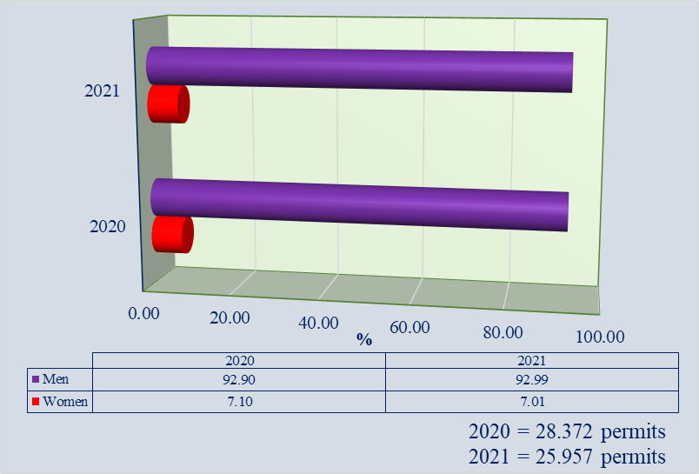
Fig. 1.1 Number of permits issued by ANPA, by sex in 2020-2021
Structure of fishing permits, by age levels

From Fig. 1.2 shows that between 2020 and 2021, they predominated fishing permits released for ages 40 to 64 (58,44 % / 2020 and 60,48 % / 2021) and 25-39 years (25,48 % / 2020 respectively 21,77 % / 2021) and 65-79 years (11,37 % / 2020 and 13,36 % / 2021) (Fig. 1.2 and Fig. 1.3).

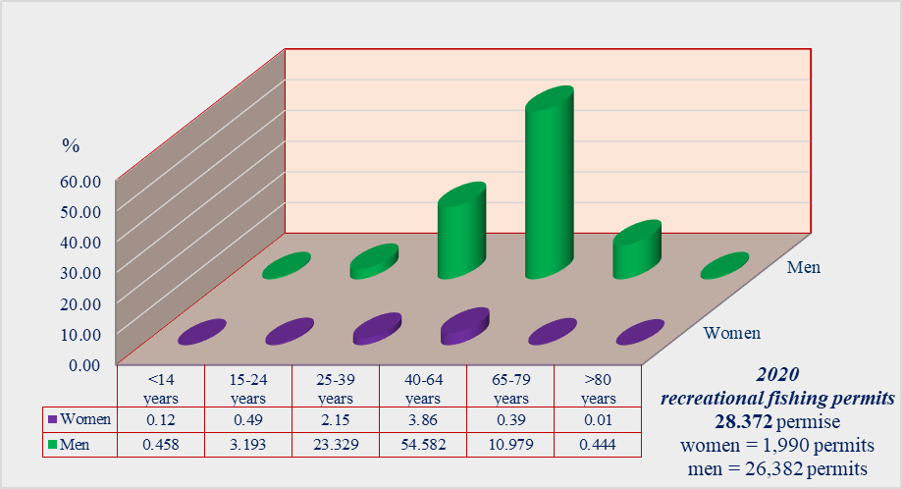

Fig. 1.2 Number of permits issued by ANPA, by age and sex, in 2020

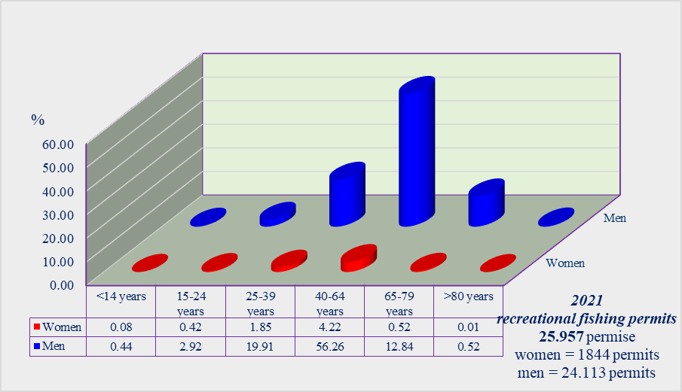

Fig. 1.3 Number of permits issued by ANPA, by age and sex, in 2021

Catch structure by fish species
According to art. 17 (1), from the MADR Order no. 252/2019, the fishermen who obtained a recreational fishing permit, have the obligation to present to NAFA, the centralized situation of the catches made by its members until February 28 of the current year, for the previous year. Unfortunately, given the national epidemiological situation created by the coronavirus SARS_COV-2, in order to reduce the exposure and transmission of respiratory viruses in the period 2020-2021, although almost 30,000 annual premises have been released, recreational fishing activity of was very low, many license holders could not practice this type of fishing. For this reason, approximately 9,052 registered reports (approximately 30%, of the total permits issued, many with 0 kg reports) could be taken over and analysed in the two years. For the same reasons, the collection of biological data has been very low, given the weak participation in the practice of this type of fishing, in pandemic period.
Thus, in 2020, the 8,003 reports received were processed and analysed, which achieved a number of 3,036 days at sea / trips and a catch of 7999,12 kg. The species of fish caught were: black spotted goby - 45,6 %; horse mackerel - 31,9 %; knout goby - 5.6 %; grey mullet - 12,2 %; red mullet 0.3 %; whiting - 0,1 %; garfish 0,5 %; common stingray - 2.1 %; goby spp. - 0.4 %; sand smelt - 0,01 %; bluefish 0.2 %; bonito - 0,01 %; flathead grey mullet – 0.9 % and Danube shad - 0.3 % (Fig. 1.4). The average productivity achieved was 2.635 kg per days at sea and 0.999 kg per fishing permit released. Compared to those mentioned above, we extrapolated data obtained, and that of the total permits released, about 20% report activity and catches, respectively 5.700 reports, which would make a total catch in the Black Sea, about 30,000 kg, in about 6,000 – 6,500 days of fishing

In 2021, only 1,049 reports were processed and analysed, which achieved a number of 636 days at sea/ trips and a catch of 1,547 kg. The species of fish caught were: gobies - 37,8 %; horse mackerel - 23,6 %; knout goby - 0.9 %; grey mullet - 23,5 %; red mullet - 0,2 %; whiting - 0,8 %; garfish - 1,3 %; common stingray - 2,1 %; goby spp. - 1.5 %; sand smelt - 0.1 %; bluefish - 5,4 %; bonito - 0,1 %; flathead grey mullet - 0.1 %; European anchovy - 0,07 %; Danube shad - 2,1 % and Caspian shad - 0,2 % (Fig. 1.4). The average productivity achieved was 2,56 kg per days at sea and 1,47 kg per reported fishing permit. Compared to those mentioned above, we extrapolated data obtained, and that of the total permits released, about 20% report activity and catches, respectively 5.500 reports, which would make a total catch in the Black Sea, about 25.000 kg, in about 5,000 – 5,500 days of fishing

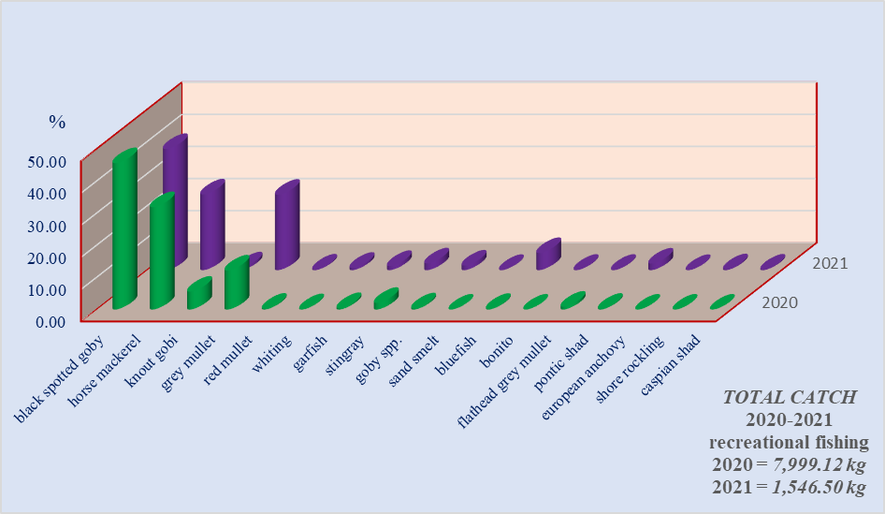
Fig. 1.4 The share of fish species caught in recreational fishing in the Black Sea in the period 2020 - 2021

4. Achievement of the original expected outcomes of pilot study and justification if this was not the case.

After completing the questionnaires by each fisherman, they are taken over with the support of NAFA, by NIMRD "Grigore Antipa" specialists who, after an announced verification of the data (cross-comparison of questionnaire data with those from other sources of collection / information such as periodic surveys, interviews with fishermen in the field), process the data, in strict compliance with the correlation of data obtained from various sources. In the event of uncertainty regarding fishing data, the data providers are contacted for clarification or corrections if necessary. After an announced verification, the processed data is centralized and the requirements of the external users and uploads on their platforms, in the required formats, according to the plans.

The lack of a register and / or fishing licenses, combined with the tightening of the legal framework for the acquisition of
personal data, makes it difficult to identify amateur fishermen, thus restricting their cooperation with research institutes. This is especially noticeable in the location of fishermen and results in very few records of this fishing method. Equally difficult is the reduction to the total number of tourists during the summer.
Efforts should be made to achieve a culture of collaboration between the fishing community and to increase the rate of their voluntary participation in such research during periodic sampling.

5. Incorporation of results from pilot study into regular sampling by the Member State.

For the next period, the study will continue with the aim to incorporate in the sampling frame a greater number of areas to be sampled in order to strengthen the representativeness of the sample and therefore the accuracy of the results, but also to advertise in a direct way the effort of monitoring and at the same time to strengthen the culture of participation in recreational fisheries community the country.
Grati, F., Carlson, A., Carpentieri, P. & Cerri, J. 2021, Handbook for data collection on recreational fisheries in the Mediterranean and the Black Sea. FAO Fisheries and Aquaculture Technical Paper No 669. Rome, FAO

Section 1: Biological Data
Text Box 1E: Anadromous and catadromous species data collection in fresh water

General comment: This box fulfills paragraph 2 points (b) and (c) of Chapter III of the Annex of the Delegated Decision (EU) 2019/910 on the multiannual Union programme; and Article 2 of the Implementing Decision (EU) 2016/1701 on the format of the WP.
General comment: This box is applicable to the Annual Report.
1. Method selected for collecting data.

Not applicable.
2. Were the planned number achieved? Yes/ No

Not applicable.

Anadromous and catadromous species data collection in fresh water is not foreseen. The reasons are that eel (Anguilla anguilla), Atlantic salmon de (Salmo salar) and Brown trout (Salmo trutta) are not present in Romanian fresh water. The other species than these mentioned above, as per approved Romanian working program for 2020-2021, we are state the following: sturgeons – commercial fishery is banned; the alosa species spp., are included in Text Box 1F.

Section 1: Biological Data

Text box 1F: Incidental by-catch of birds, mammals, reptiles and fish

General Comment: This box fulfils paragraph 3-point (a) of Chapter III of the Annex of the Delegated Decision (EU) 2019/910, on the multiannual Union programme; and Article 2 of the Implementing Decision (EU) 2016/1701 on the format of the WP. This box is applicable to the Annual Report. This box is applicable only for those sections where Member States have reported that they have been carrying out regular sampling. Results and deviations for Pilot studies should be reported under Pilot Study 2.
1. Results

In 2021 expeditions were made at sea on the board of commercial fishing vessels, as follows: 62 PSU sampling using pelagic trawler, 162 PSU from beam trawler, 78 PSU using pound nets and 18 PSU with gillnets, for the identification and monitoring of fish, mammals, birds, molluscs and crustaceans by-catches (Table 1F). Similar to the previous year, in 2021, on board observers did not record adequate data on marine mammals, birds and reptiles like by-catch in fishing gears. Only some fish species (bony and cartilaginous) and some invertebrates were recorded as by-catch, see Table 1 F.

The by-catches in the year 2021 were identified and monitored as follows:

Fishing pelagic trawl (SCT_OTM_1-1 and SCT_OTM_1-2): in 2021, 15 vessels practiced this type of fishing (6 vessel of 18-24 m, 6 vessels of 12-18 m and 3 boat of 6-12 m).

Fleet  LOA (m) | Number of vessels | Total annual effort |  |  | Estimated annual effort (fishing days) by single vessel | Catch (kg)
Fleet  LOA (m) | Number of vessels | Day | number of fishing trips | hours | Estimated annual effort (fishing days) by single vessel | Catch (kg)
6 – 12 m | 6 | 42 | 294 | 300 | 7 | 7,426
12 – 18 m | 6 | 164 | 1,079 | 1190 | 27 | 82,954
18 – 24 m | 6 | 26 | 117 | 8 | 8 | 4,668
TOTAL | 15 | 232 | 1,490 | 1,626 | 42 | 95,048
Sampling
Sampling trips*
Minimum coverage (26.72 %) |  |  | 62
Optimal coverage (32.33-43.10 %) |  |  | 75 - 100

In commercial pelagic trawling, 23 expeditions were made (11 at sea and 12 at the landing points) and a number of 62 observation sheets were drawn up. In addition to the target specie (sprat) in pelagic trawling, in 2021, species (catch and individuals estimated in number) have been identified: sprat (39,773 kg/9228074 individuals); red mullet (32,574 kg/2160080 ind.); horse mackerel (13,036 kg/926562 ind.), bluefish (7,988 kg/137393 ind.); european anchovy (150 kg/19330 ind.); common stingray (1,278 kg/173 ind.); round goby (138 kg/7877 ind.), Caspian shad (75 kg/1548 ind.) and picked dogfish (26 kg/4 ind.). Very rarely, sporadic and very small numbers, species: sea mouse (Callionymus pusillus); greater weever (Trachinus draco), flounder (Platichthys flesus flesus); common sole (Pegusa lascaris), stargazer (Uranoscopus scaber), black scorpionfish (Scorpaena porcus), shore rockling (Gaidropsarus mediterraneus); brown meagre (Sciaena umbra) and crab (Crangon spp). A total of 18 species have been identified, of which the following vulnerable species are included in the list of vulnerable species (according to Table 1D, EU Decision no. 910/2019): red mullet (202 exp.), bluefish (37 exp.), Caspian shad (56 exp), round goby (33 exp); common stingray (2 exp.), and crabs (88 exp.). Variables needed for estimation of total number of vulnerable specimens caught:

a. the bycatch rate (T), per species: red mullet - 3,25; bluefish – 0.59; Caspian shad - 0.90; round goby - 0.53, common stingray - 0,032 and crabs - 1.41;

b. the estimate of the individuals caught by the fleet was calculated (I/232): red mullet – 754; bluefish – 136.88; Caspian shad – 208.8.76; round goby – 122.96, common stingray – 7.42 and crabs – 327.12;

During the period analysed, the observers on board the vessels did not record any specimen from the group of marine mammals, birds or reptiles, caught in the pelagic trawl, and in the official statistics there are no catches discharged into the sea. However, during the expeditions have been reported around the fishing gear, of dolphins the species: common dolphin (Delphinus delphis ponticus); marsuin (Phocoena phocoena) and rough-toothed dolphin (Tursiops truncatus ponticus) and also birds: great cormorant (Phalacrocorax carbo), Black-headed gull (Larus ridibundu) and Caspian gull (Larus canhinnans).

Fishing of beam trawl (SCT_TBB_2-1 and SCT_TBB_2-2): the main fishing technique on the Romanian coast (about 76.25 % of the total fishing). In 2021, a number of vessels (6-12 m / 8 vessels; 12-18 m 14 vessels; 18-24 m / 3 vessel and > 24 m / 1 vessels) were activated in specialized fishing for rapa whelk. In commercial vessels 126 expeditions were made (66 at sea and 60 at the landing points) and a number of 126 observation sheets were drawn up.
In 2021, a number of 30 species were identified, of which 16 species of fish, 7 species of molluscs, 3 species of crustaceans
Fleet  LOA (m) | Number of vessels | Total annual effort |  |  | Estimated annual effort (fishing days) by single vessel | Catch (kg)
Fleet  LOA (m) | Number of vessels | Day | number of fishing trips | hours | Estimated annual effort (fishing days) by single vessel | Catch (kg)
6 – 12 m | 8 | 207 | 1.840 | 1.900 | 26 | 440.476
12 – 18 m | 14 | 487 | 4.651 | 4.774 | 35 | 1493.354
18 – 24 m | 3 | 97 | 867 | 948 | 32 | 343.691
> 24 m | 1 | 37 | 357 | 411 | 37 | 106.942
TOTAL | 26 | 828 | 7.715 | 8.033 | 176 | 2.384.566
Sampling
Sampling trips*
Minimum coverage (15.21 %) |  |  | 126
Optimal coverage (24.15.12-36.23 %) |  |  | 200 - 300

3 jellyfish and 1 species of ascenidae: Callionymus pussillus (sailfin dragonet/20 individuals), Uranoscopus scaber (stargazer/1 ind.), Hippocampus hippocampus (short snouted seahorse/11 ind.), Scopthalmus maximus (turbot/11 ind.), Merlangius merlangus euxinus (whiting/53 ind.); Gobius niger (black goby/6 ind.); Gobius paganellus (rock goby/10 ind.); Neogobius melanostomus (round goby/4 ind.); Mullus barbatus (red mullet/5 ind.); Scorphaena porcus (black scorpionfish/4 ind.); Nerophis ophidion (straightnose pipefish/2 ind.); Parablennius sanguinolentus (rusty blanny/3 ind.); Squalus acanthias (picked dogfish/5 ind.); Platichthys flesus felsus (European flounder/5 ind.); Pegusa lascaris (sand sole/8 ind.); Dasyatis pastinaca (common stingray/4 ind.); Mytilus galloprovincialis (mussel/485.091 ind.), Chamelea gallina (striped venus clam/10 ind.), Scapharca inaequivalvis (scapharca/10 ind.), Mya arenaria (sand gaper/22,138 kg), Anadara inaequivalvis (anadara), Flexopecten glaber (scallop/5 ind.); Parvicardium exiguum /4 ind.); Liocarcinus navigator (crab/180 ind.), Liocarcinus holsatus (crab/88 ind.;) Diogenes pugilator (hermit crabs/1 ind.); Ascidiella aspersa /2,237 individuals and Aurelia aurita (common jellyfish/62.262 kg; Rhizostoma pulmo (commonly known/33.05 kg).

In 2021, a number of 126 sheets for bony and cartilaginous fish species were made, in which a total number of 30 species were identified, of which the following vulnerable species are included in the List of vulnerable species: turbot (11 ind.); red mulet (25 ind.); short snouted seahorse (11 ind.); mussels (881 ind.); striped venus (48 ind.); picked dogfish (5 ind.); whiting (53 ind.); common stingray (4 ind.); black goby (6 ind.); round goby (2 ind.); and crabs (269 ind.). Variables needed for estimation of total number of vulnerable specimens caught:

a. the bycatch rate (T), per species: turbot - 0,087; red mullet - 0,198; short snouted seahorse - 0.087; mussels - 6.69; striped venus - 0.38; picked dogfish - 0.039; whiting - 0,420, common stingray - 0.031; black goby - 0,016; round goby - 0.011 and crabs - 2.135;

b. the estimate of the individuals caught by the fleet was calculated (I/828): turbot - 72,03; red mullet - 164.28; short snouted seahorse - 72.28; mussels - 5789.42; striped venus - 315.42; picked dogfish - 32.86; whiting - 348.28, common stingray - 25.66; black goby - 39.43; round goby - 13.143 and crabs - 1767.71;

During the period analysed, the observers on board the vessels did not record any specimen from the group of marine mammals, birds or reptiles, caught in the pelagic trawl, and in the official statistics there are no catches discharged into the sea. However, in this period of time, have been reported the presence around the fishing gear, of dolphins, the species: common dolphin (Delphinus delphis ponticus); marsuin (Phocoena phocoena) and rough-toothed dolphin (Tursiops truncatus ponticus) and birds: great cormorant (Phalacrocorax carbo); pygmy cormorant (Phalacrocorax pygmaeus), eurasian coot (Fulica atra), Black-headed gull (Larus ridibundu) and Caspian gull (Larus canhinnans).

Pound net fishing (SCT_FPN_3-2 and SCT_FPN_3-1): in 2021, they practiced this type of fishing, a number of 2 boats smaller than 6 m and 28 boats of 6-12 m.

Fleet  LOA (m) | Number of vessels | Total annual effort |  | Estimated annual effort (fishing days) by single vessel | Catch (kg)
Fleet  LOA (m) | Number of vessels | day | hours | Estimated annual effort (fishing days) by single vessel | Catch (kg)
< 6 m | 2 | 21 | 32 | 11 | 711
6 – 12 m | 28 | 608 | 745 | 22 | 70,407
TOTAL | 30 | 686 | 733 | 25 | 71,118
 |  |  | Sampling Sampling
 |  |  | Sampling trips* Sam8484pling trips*
Minimum coverage (11.37 %) |  |  | 78
Optimal coverage (17.5-21.86 %) |  |  | 120 - 150

In 2021, in the pound net fishing, a very large number of fish species (33 species) were monitored and identified, in addition to the target species (catch and individuals estimated in number), respectively: European anchovy (38,679 kg/ 5721745 individual); horse mackerel (12,781 kg/907,741 ind.); sprat (7,789 kg/1807193 ind.); bluefish (807 kg/13,880 ind.); whiting (2,940 kg/161,361 ind.) red mullet (1,738 kg/115,252); big scale sand smelt (1,564 kg/414854 ind.); round goby (1,161 kg/ 66,267 ind.); common stingray (845 kg/115 ind.); Danube shad (705 kg/2,830 ind.); knout goby (418 kg / 6,531 ind.); garfish (695 kg/3,500 ind.); Caspian shad (110 kg/2,271 ind.); common sole (56 kg/510 ind.), turbot (78 kg/35 ind.) and European seabass (88 kg). With which in small numbers or in the form of isolated specimens: long-snouted seahorse (Hippocampus guttulatus); greater weever (Trachinus draco); stargazer (Uranoscopus scaber); shore rockling (Gaidropsarus mediterraneus); black goby (Gobius niger); flounder (Platichthys flesus flesus); kilka (Clupeonella cultriventris); black scorpionfish (Scorpaena porcus); sailfin dragonet (Callionymus pusillus); picarel (Spicara smaris); sea needle (Syngnathus spp.); straightnose pipefish (Nerophis ophidion); rusty blanny (Parablennius sanguinolentus); loach (Noemacheilus barbatulus barbatulus); ski drum (Umbrina cirrosa); weatherfish (Ophidion rochei); brown meagre (Sciaena umbra) and comber (Serranus cabrilla).

In 2021, a number of 78 fish species sheets were made, in which a number of 11 vulnerable species were identified (according to Table 1D, EU Decision no. 910/2019), respective: whiting (66 ind.); turbot (4 ind.); common stingray (7 ind.); big scale sand smelt (98 ind); round goby (11 exp.); knout goby (3 exp.); red mullet (203 exp); Caspian shad (17 ind.); Danube shad (8 ind.); garfish (5 ind.), long-snouted seahorse (19 ind.). Variables needed for estimation of total number of vulnerable specimens caught:

a. the bycatch rate (T), per species: whiting - 0.85; turbot - 0.051; common stingray - 0.09; big scale sand smelt - 1.25; round goby - 0.14; knout goby - 0.038; red mullet - 2.60; Caspian shad - 0.218; Danube shad - 0.10; garfish - 0.06; long-snouted seahorse – 0.24

b. the estimate of the individuals caught by the fleet was calculated (I/686): whiting - 583.1; turbot - 34.98; common stingray - 61.56; big scale sand smelt - 861.89; round goby - 96.74; knout goby - 26.38; red mullet - 1785.35; Caspian shad - 149.51; Danube shad - 70.35; garfish - 43.97; long-snouted seahorse – 167.10.

Observers at the landing points located along the Romanian coast, during the analysed period, did not report any specimens from the group of marine mammals, birds or reptiles, caught in net pounds and in the official statistics there are no catches discharged into the sea. Regarding their presence in the area of the pound nets activity, were reported singular or flocked presences of dolphins (3-5 specimens), in constant motion in search of food, specimens of mammals approaching the fishing tool, belonging to the species: marsuin (Phocoena phocoena) and common dolphin (Delphinus delphis ponticus). The presence of specimen from different group of birds were signalled around the pound nets: great cormorant (Phalacrocorax carbo), pygmy cormorant (Phalacrocorax pygmeus) and Caspian gull (Larus canhinnans). The behaviour of these species was highlighted by looking for food resources or a place to rest (aspect observed in migratory species).

Gill nets fishing (SCT_GSN_4-2 and SCT_GSN_4-2): in 2021, they practiced this type of fishing, a number of 5 boats smaller than 6 m, 59 boats of 6-12 m, 14 vessels of 12-18 m, 2 vessels of 18-24 m and 2 vessels of > 24 m.

Fleet  LOA (m) | Number of vessels | Total annual effort |  | Estimated annual effort (fishing days) by single vessel | Catch (kg)
Fleet  LOA (m) | Number of vessels | day | hours | Estimated annual effort (fishing days) by single vessel | Catch (kg)
< 6 m | 5 | 12 | 51 | 2 | 1,050
6 – 12 m | 59 | 398 | 1,722 | 7 | 44,992
12 – 18 m | 14 | 130 | 766 | 9 | 33,836
18 – 24 m | 2 | 12 | 74 | 6 | 3,558
> 24 m | 2 | 6 | 31 | 3 | 1,528
TOTAL | 80 | 552 | 2,613 | 24 | 83,436
 |  |  | Sampling Sampling
 |  |  | Sampling trips* Sam8484pling trips*
Minimum coverage (3.2 %) |  |  | 18
Optimal coverage (9.1-18.11 %) |  |  | 50 - 100

The monitoring of the complementary catches obtained in the gill nets fishery was carried out every month in the fishing landing points located along the Romanian Black Sea coast. A first observation is that for the small boats (generally under 6 m), that are used for fishing, did not allow the access on board during fishing, of the observers, therefore, most of the data and information collected were based on interviews or fishermen's statements. In 2021, in the pound net fishing, a very large number of fish species (19 species) were monitored and identified, in addition to the target species (catch and individuals estimated in number), respectively, demersal species: turbot - (74,500 kg/30,500 individuals); common stingray - (1,364 kg/185 ind.); thornblack ray (511 kg/180 ind.); goby spp - (527 kg/32,800 ind.); knout goby – (167 kg/1,720 ind.); picked dogfish - 274 kg/50 ind.); whiting - (30 kg/986 ind.); red mullet - (183 kg/12120 ind.) and pelagic species: Danube shad - (2606 kg/10,444 ind.); Caspian shad - (131 kg/2,703 ind.); horse mackerel - (1,102 kg/75,156 ind.); golden grey mullet - (1,225 kg/21,563 ind.); bluefish - (557 kg/9,856 ind.); European anchovy - (167 kg/17,587 ind.). Other species: sprat, whiting, rapa whelk, garfish and Atlantico bonito.
In 2021, a number of 18 observation sheets were prepared for fish species in which a number of 8 vulnerable species were identified (according to Table 1D, EU Decision no. 910/2019), respectively: common stingray (Dasyatis pastinaca), thornblack ray (Raja clavata), picked dogfish (Squalus acanthias), Pontic shad (Alosa immaculata), Caspian shad (Alosa tanaica), bluefish (Pomatomus saltatrix), whiting (Merlangius merlangus euxinus), red mullet (Mullus barbatus) golden gray mullet (Liza aurata) and round goby (Neogobius melanostomus). Protected demersal species observed: common stingray - 3 individuals; thornback ray - 1 ind.; picked dogfish - 1 ind.; red mullet - 33 ind.; round goby - 66 ind.; whiting - 95 ind. In the fishing with fixed pelagic nets were observant species: Danube shad - 98 individuals; Caspian shad - 143 ind.); golden gray mullet - 17 ind. Variables needed for estimation of total number of vulnerable specimens caught:
a. the bycatch rate (T), per species: common stingray - 0.166; thornback ray - 0.055; picked dogfish - 0.055; round goby - 3.66; red mullet - 1.83; whiting – 5.44; Danube shad - 30.00; Caspian shad - 7.94; golden gray mullet - 1.00

b. the estimate of the individuals caught by the fleet was calculated (I/552): common stingray - 91.63; thornback ray – 30.36; picked dogfish - 0.055; round goby – 2030.32; red mullet - 1010.16; whiting – 3002.88; Danube shad - 16560.0; Caspian shad – 4382.88; golden gray mullet - 552.00.

The observations at the landing points located along the Romanian coast, during the analysed period, and the interviews with fishermen pointed out that no species from the group of marine mammals, birds or reptiles, was caught in gill nets and in the official statistics there are no catches and discharged into the sea. However, in the sampling of other metiers (pound net and set gillnets), some fish species of the Table 1D of the Decision 2019/910 have been recorded.

Fishing activities carried out with LHP_LHM / rods, rods, longlines and Misc / divers, are selective (no by-catch is obtained). At the same time, it uses small boats, which do not allow the presence of other people on board.

Follow-up of the study (by-catch):

* Monitoring catches fleet segments, highlighted a major impact only fishing with beam trawl;

* The bycatch rate in rapa whelk beam trawl fishery is 0.10 - 0.12 % from total catches on average in June, increases up to 0.24 % total catches in July and diminishes to 0.02-0.05 % in the autumn. The turbot bycatch rate is 0.11 % total catches in the spring period, while in the autumn it is between 0-0.10% total catches per fishing day with an average level of 0.01% annual total catches;

* Finding measures are to increase the selectivity of fishing gear. For beam trawl is necessary to increase the mesh size;

* Obligation for fishermen to fill in the fishing logbook, if there are incidental by-catches of fishes, birds, mammals or reptiles occurred;

* Continued monitoring of catches per fleet segment and to estimate the level of fishing and the impact of fishing activities on marine biological resources and marine ecosystems, that will be continued in the coming years.

2. Deviations from Work Plan

There were no deviations from what was planned in the WP

3. Data quality

The observers on board long liners have protocols for collecting data on incidental bycatch species when occurred. Specific training and forms are designed for recording bycatch. In addition, the onboard observer protocol instructs observers to report on the use of mitigation devices.

Questions to be addressed are listed below:
- Does the onboard observer protocol contain a check for rare specimens in the catch at opening of the coded? If YES is the observer instructed to indicate if the coded was NOT checked in a haul?

- YES

- In gill nets - and hook-and-line fisheries: does the onboard observer protocol instruct the observer to indicate how much of the hauling process has been observed for (large) incidental bycatches which never came on board (because they fall out of the net)? In large catches: does the protocol instruct to check for rare specimens during sorting of the catch (i.e., at conveyor belt)? Is the observer instructed to indicate what percentage of the sorting or hauling process has been checked at “haul level”?

- YES

- Does the onboard observer protocol instruct to report on the use of mitigation (i.e. Escape Devices or Acoustic Deterrent Devices)?

- YES

- Does the sampling design and protocol follow the recommendations from relevant expert groups? Provide appropriate references. If there are no relevant expert groups, the design and protocol have to be explained in the text. - The sampling design and protocol uses recommendation in Monitoring discards in Mediterranean and Black Sea fisheries: methodology for data collection, Edited draft, VI. 2018, FAO, 76 pp and in. Monitoring the incidental catch of vulnerable species in Mediterranean and Black Sea fisheries: Methodology for data collection. FAO Fisheries and Aquaculture Technical Paper No. 640. Rome, FAO.Monitoring the incidental catch of vulnerable species in the Mediterranean and the Black Sea: methodology for data collection, (2019), FAO Fisheries and Aquaculture Technical Paper No. 640. Rome, FAO, 106 pp.

- Are data quality issues taken into account?
- YES

- How are data (and samples) stored - In xls. files and protocols.
Section 1: Biological Data
Pilot Study 2: Level of fishing and impact of fisheries on biological resources
and marine ecosystem

General comment: This Box fulfills paragraph 3 point (c) of Chapter III of the Annex of the Delegated Decision (EU) 2019/910 on the multiannual Union programme; and Article 2 and Article 4 paragraph (3) point (b) of the Implementing Decision (EU) 2016/1701 on the format of the WP.
General comment: This box is applicable to the Annual Report. This box is intended to provide information on the results obtained from the implementation of the pilot study.
1. Aim of pilot study

Member States shall establish, as part of the work plans drawn up in accordance with Article 21 of Regulation (EU) No. 508/2014, the data to be collected amongst the following sets as specified in art. 4 of Decision (EU) 2019/910. Data to assess the impact of Union fisheries on marine ecosystems in Union waters and outside Union waters. Those data shall consist of the following:

a. For all types of fisheries, incidental by-catch, including the species listed in Table 1D;
b. Data to assist in the assessment of the impact of fisheries;
c. data for estimating the level of fishing and the impact of fishing activities on marine biological resources and on marine ecosystems

2. Duration of pilot study

Two years. Start in 2020, January 1st, and end on 31st December 2021.

3. Methodology and expected outcomes of pilot study

The methodology and techniques that were used for the collection, verification, processing and analysis of data and for the assessment of fish stocks are those generally accepted for the Black Sea basin and in accordance with international methodology. Data were collected in accordance with the GFCM instructions (Monitoring the incidental catch of vulnerable species in the Mediterranean and the Black Sea: methodology for data collection). The study is based on the data collected in 2020, to assess the effect of beam trawling on the juvenile stages of the turbot (Scopthalmus maximus) and picked dogfish (Squalus acanthias). Also, the study includes data about the species composition of the by-catch in rapa whelk fisheries: spatial distribution of the target species, abundance and length-weight structure. The study covers the following activities: sampling with beam trawl; determination of the qualitative and quantitative structure of the by-catch; determination of the absolute and standard length and individual weight of the turbot and picked dogfish, collected as by-catch; collection of data for gender and life stages.
The method used was that of area investigation using the beam trawl for the sampling procedure. Data collection was carried out on board vessels using standard fishing gear used - beam trawl. Biological data for the pilot project on evaluation of by-catch in the Rapa whelk fishery: geographic coordinates (start and end points), water depth (m), duration of trawling activities, mean trawling speed (Knt/h), total Rapa whelk catch/trawl, structure on species, species composition of by catch, absolute and standard length, individual weight of target species, determination of age (for turbot ≤ 45cm); sex and maturity (for turbot ≤ 45 cm).

Laboratory analyses: the age of the species was analysed in the laboratory. Otolith samples were analyses with the use of a binocular microscope. The average, minimum and maximum length of the individuals were measured and based on this data the percentage distributions of the size classes was calculated.

Statistical methods: the percentage of the turbot that was discharged into the sea, in the fishing of Rapa whelk from the Romanian coast, was estimated and covered in two different ways: the average of daily trawls and the average obtained per trawl. Monthly averages of the length and weight of turbot were estimated. General statistics on catches of turbot, weight and length data were presented. The XLSTAT software was used to present the histogram of the structure of the length and weight of the turbot discharged into the sea, as well as the capture obtained for Rapa whelk. Statistics on histogram classes were presented, including lower- and upper-class limit, frequency, relative frequency and density.

Sampling plan: coordinates of sampled stations and sampling depths, in the two expeditions organized in 2021. The study covers the time between 07 - 15 July and 12 - 27 October 2021, in the sector between Sulina - Mangalia, being performed a number of 51 trawls per expedition, in 20 fishing days, the distribution of the sampled stations being presented in Fig. 2.3, between the isobaths of 05 - 30 m. The investigations regarding the Rapa welk fishing were carried out on board the research vessel "Steaua de Mare 1" (year of construction / 1981, ROU–P–040254 CT), belonging to the National Institute for Marine Development Research "Grigore Antipa" Constanța, having the following characteristics: type - B-410; total length - 25.71 m; maximum width - 7.22 m; maximum draft - 2.91 m; engine power - 420 kw (570 HP); maxim tonnage - 134 t; net tonnage - 40 t; speed - 7-10 Nd; boarding staff - 7 persons and researcher team - 6 persons.
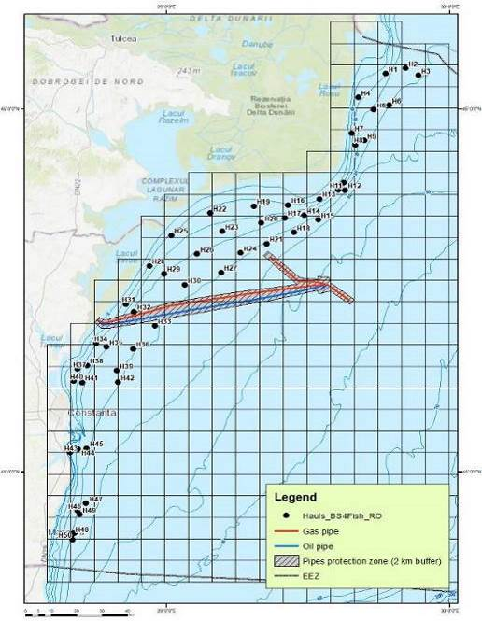
Fig. 2.3 Distribution of sampling station, 2021

The research vessel Steaua de Mare 1, is equipped with: vertical acoustic research probe; mesh probe; winch probe; trawl winches; manoeuvring winches; wading / 500 m on the drum; pelagic and demersal spacing panels; pelagic and demersal trawl reinforcement elements.
Brief description of the results obtained (including deviations from planned and justifications as to why if this was not the case).

4. Achievement of the original expected outcomes of pilot study and justification if this was not the case
According National Work Plans approved for 2021, Romania must carry out the pilot study for assessing incidental catches of vulnerable species. Given the fact in net fishing, due to selective gears use the by-catches are very small and these have no major impact on the marine ecosystem and fish species resources. Based on this argument and the needs of end users, Romania continued to conduct pilot studies starting in 2017, on the assessment of by-catches in beam trawlers fishery because it is more relevant, as per total catches reported.

5. Incorporation of results from pilot study into regular sampling by the MS
The current state of specialized fishing for Rapa welk, in the marine area of Romania

Harvesting the Rapa whelk (Rapana venosa), in Romanian Black Sea coast area, is done by three methods:

● manual harvesting, in the southern part of the Romanian Black Sea coast, between Constanța and Mangalia, between 5 - 25 m, on a surface of approximately 200 km²;
● traps / cages, in the southern area between Eforie Sud and Mangalia, between 5 - 12 m;
● beam trawl, legalized since July 2013, in the northern part of the coast, between Baia Mamaia and Sf. Gheorghe, between 17-30 m, a surface of approximately 1,400 km²;
The first two methods are environmentally friendly, allowing high selectivity of catches, protection of habitats and access to rocky places. The big disadvantage is the high operating costs, mainly due to the high load of divers and the price of cages. The use of beam trawls is a practical method that allows to increase the catches, but limited to uncoded areas.

The catch: in the last 8 years, the specialized fishing for rapa whelk in Romania, has acquired a significant importance, becoming the main species in commercial fishing. Rapa whelk catches have increased from one year to another, ranging between 1,761 tons in 2009, to 9,211.247 tons in 2017 (Fig. 2.4).

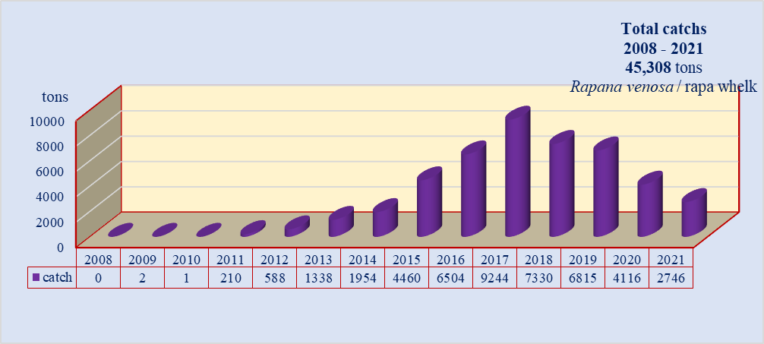
Fig. 2.4 Dynamics of Rapa whelk catch (kg) in the Romanian coast, during 2008 – 2021

Qualitative composition and distribution of by-catch

The main area of activity is between the isobaths of 05-30 m. At the Romanian Black Sea coast, in specialized fishing for Rapa whelk were identified, a varied number of complementary species, which differs from one year to another. Thus, in 2021, 30 species, of which 16 species of fish, 7 species of molluscs, 3 species of crustaceans, 3 jellyfish and 1 species of ascenidae: Fish: Callionymus pussillus (sailfin dragonet) - 20 individuals (8 ind. july/12 ind. october), Uranoscopus scaber (stargazer) - 1 ind. (1/0), Hippocampus hippocampus (short snouted seahorse) - 11 ind. (10/1), Scopthalmus maximus (turbot) - 11 ind. (6/5), Merlangius merlangus euxinus (whiting) - 53 ind. (23/30); Gobius niger (black goby) - 6 ind. (6/0); Gobius paganellus (rock goby) - 10 ind. (5/5); Neogobius melanostomus (round goby) - 4 ind.(2/2); Mullus barbatus (red mullet) - 5 ind. (3/2); Scorphaena porcus (black scorpionfish) - 4 ind. (4/0); Nerophis ophidion (straightnose pipefish) - 2 ind. (1/1); Parablennius sanguinolentus (rusty blanny) - 3 ind. (0/3); Squalus acanthias (picked dogfish) - 5 exp. (5/0); Platichthys flesus felsus (European flounder) - 5 ind. (0/5); Pegusa lascaris (sand sole) - 8 ind. (3/5); Dasyatis pastinaca (common stingray) - 4 ind. (4/0); Mollusca: Mytilus galloprovincialis (mussel) - 485.091 ind., Chamelea gallina (striped venus clam) – 10 ind. (7/3), Scapharca inaequivalvis (scapharca) – 10 ind. (10/0), Mya arenaria (sand gaper) – 22,138 kg, Anadara inaequivalvis (anadara), Flexopecten glaber (scallop) - 5 ind.; Parvicardium exiguum - 4 ind. (4/0); Crustacee: Liocarcinus navigator (crab) – 180 ind. (121/59), Liocarcinus holsatus (crab) - 88 ind. (65/23); Diogenes pugilator (hermit crabs) - 1 ind. (1/0); Ascenidae: Ascidiella aspersa 2,237 individuals and Aurelia aurita (common jellyfish) - 62.262 / 0,359 kg; Rhizostoma pulmo (commonly known) - 33.05 / 0 kg.

Regarding the distribution of by-catch species, they were distributed over the entire investigated area; from the group of gobies, the most common, was the goby species, species gobies spp. (Gobies spp) and sea horse (Hippocampus hippocampus) and (Fig. 2.5). Also, other frequently identified species were along with: sand sole (Pegusa lascaris/Solea lascaris), common stingray (Dasyatis pastinaca) (Fig. 2.6) and (whiting) (Merlangius merlangus euxinus), European flounder (Platichthys flesus flesus) and red mullet (Mullus barbatus) (Fig. 2.7).

a.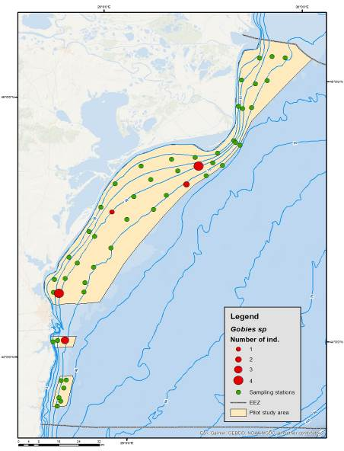 b.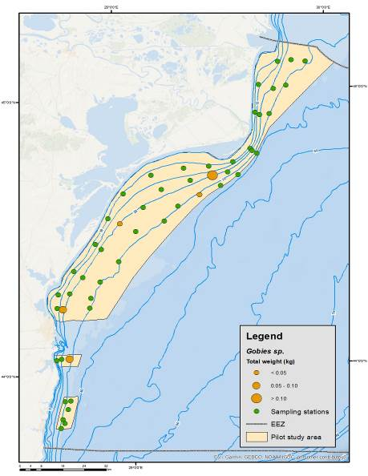 c.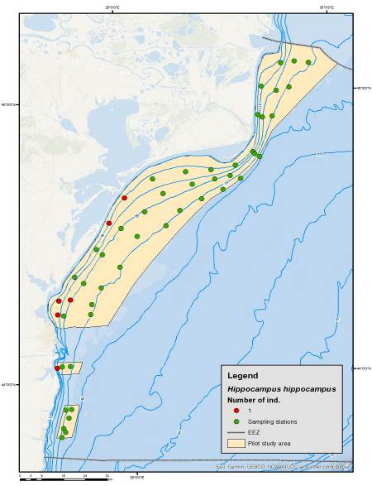 d.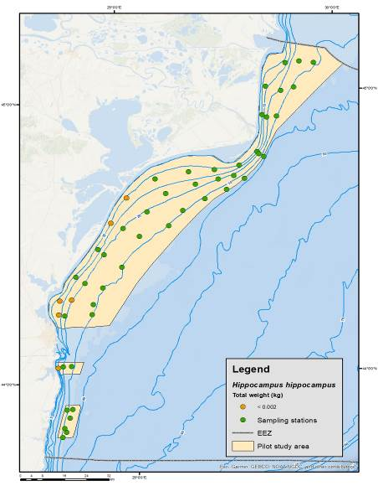
Fig. 2.5 Distribution of by-catch species gobies spp. (a/ind./trawl and b/kg/trawl) and Hippocampus hippocampus (c/ind./trawl and d/kg/trawl), in rapa whelk beam-trawl fishing, during 2021

a.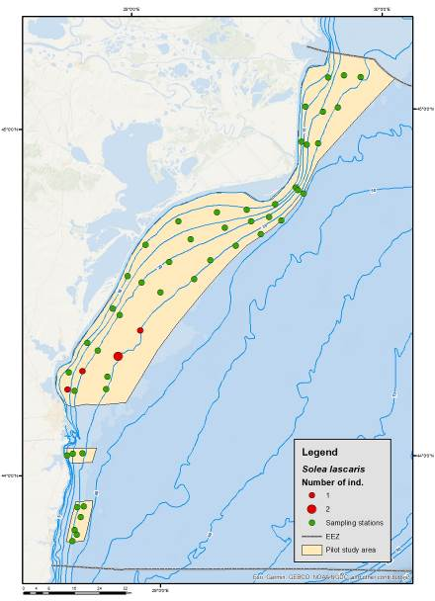 b.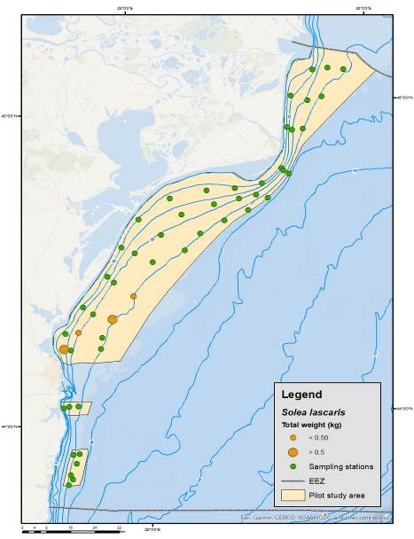 c.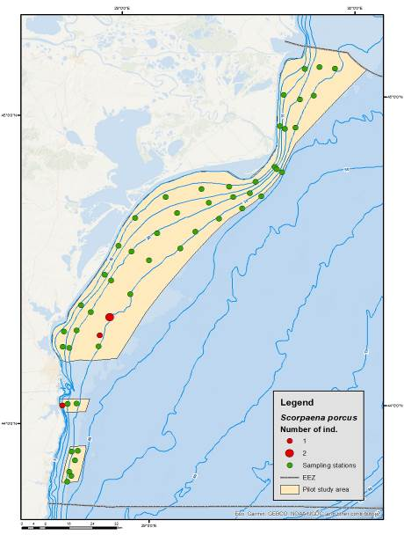 d.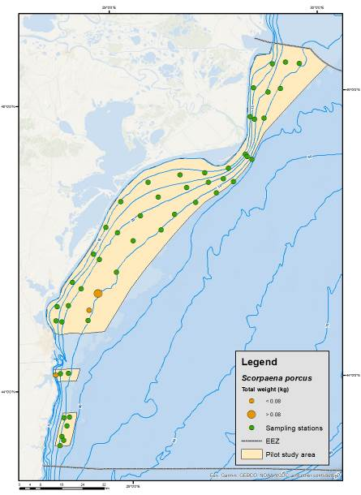

Fig. 2.6 Distribution of by-catch species Pegusa lascaris/Solea lascaris (a/ind./trawl and b/kg/trawl) and Scorpaena porcus (c/ind./trawl and d/kg/trawl), in rapa whelk beam-trawl fishing, during 2021

At the same time, other species have been identified, in isolated specimens, such as: common stingray (Dasyatis pastinaca) and picked dogfish (Squalus acanthias) (Fig. 2.8).

a.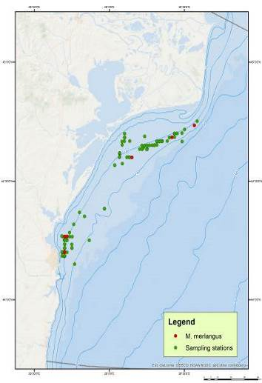 b.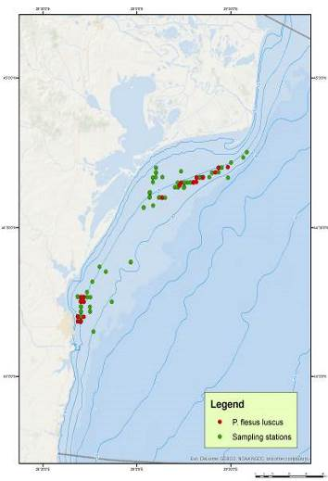 c. 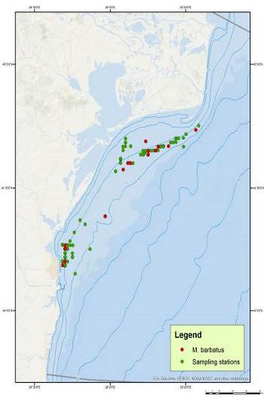
Fig. 2.7 Distribution of by-catch species: Merlangius merlangus euxinus (a), Platichthys flesus flesus (b) și Mullus barbatus (c), in rapa whelk beam-trawl fishing, during 2021

a.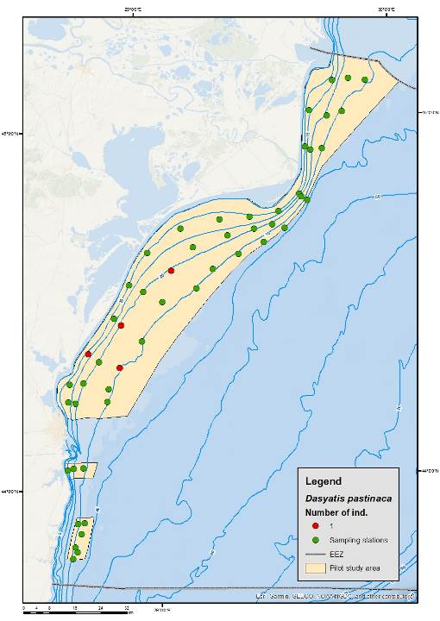 b.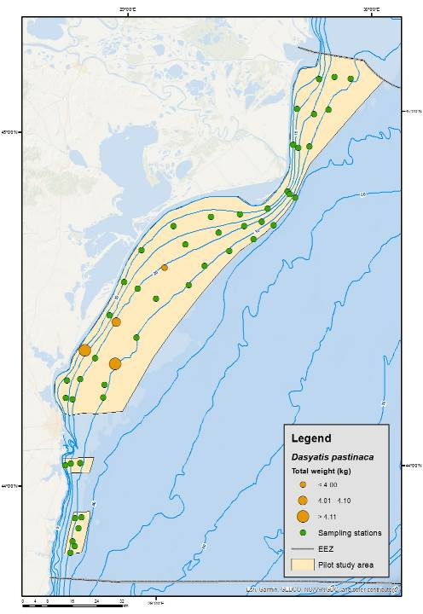 c.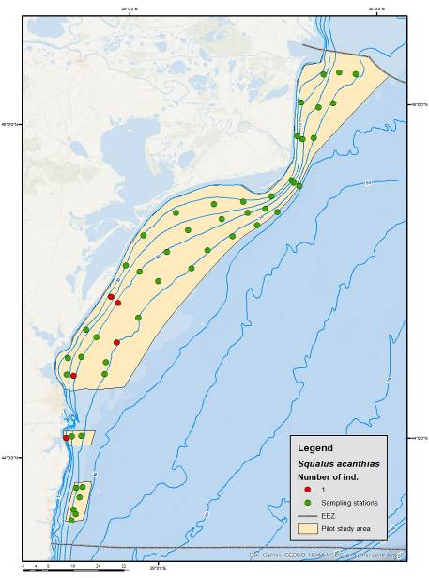 d.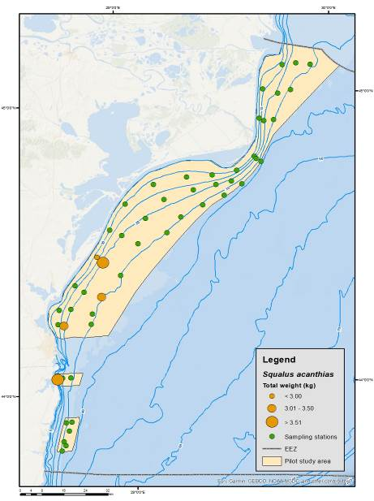
Fig. 2.8 Distribution of by-catch species Dasyatis pastinaca (a/ind./trawl and b/kg/trawl) and Squalus achantias (c/ind./trawl and d/kg/trawl), in rapa whelk beam-trawl fishing, during 2021

Spatial dynamics of turbot by-catches, total weight, percentage distribution

In 2021, significant catches per trawl were estimated at no more than 0-1 ind./day of fishing. The specimens were found along the coast, the northern area, between Chituc and Periboina (Fig. 2.9). The percentage ratio of bycatch was 0.11%, as an average of the data per day of trawling, with a maximum daily quota of 0.03% (Table 2.1).

Table 2.1 Average weight of turbot (kg / trawl) and percentage of total catch obtained in specialized fishing for rapa whelk on the Romanian coast, during 2021

Nr. crt. | Total catch rapa whelk (kg) | Turbot catches (kg) | Turbot  (ind./trawl) | Average weight of turbot | % from total rapa whelk
July 2021 | 399,623 | 7,881 | 6 | 0.154 | 1,972
October 2021 | 770.189 | 6,568 | 5 | 0.128 | 0.852

a. 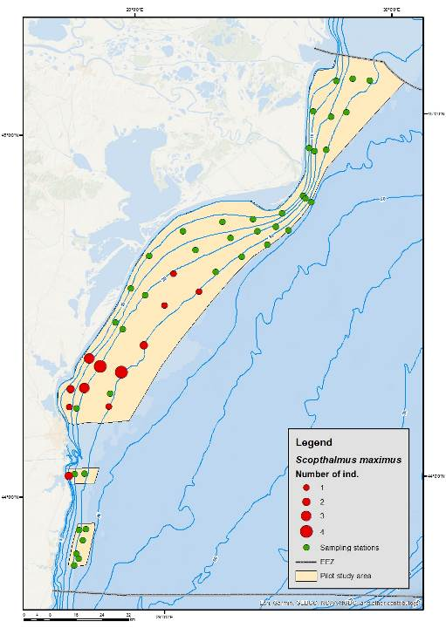 b. 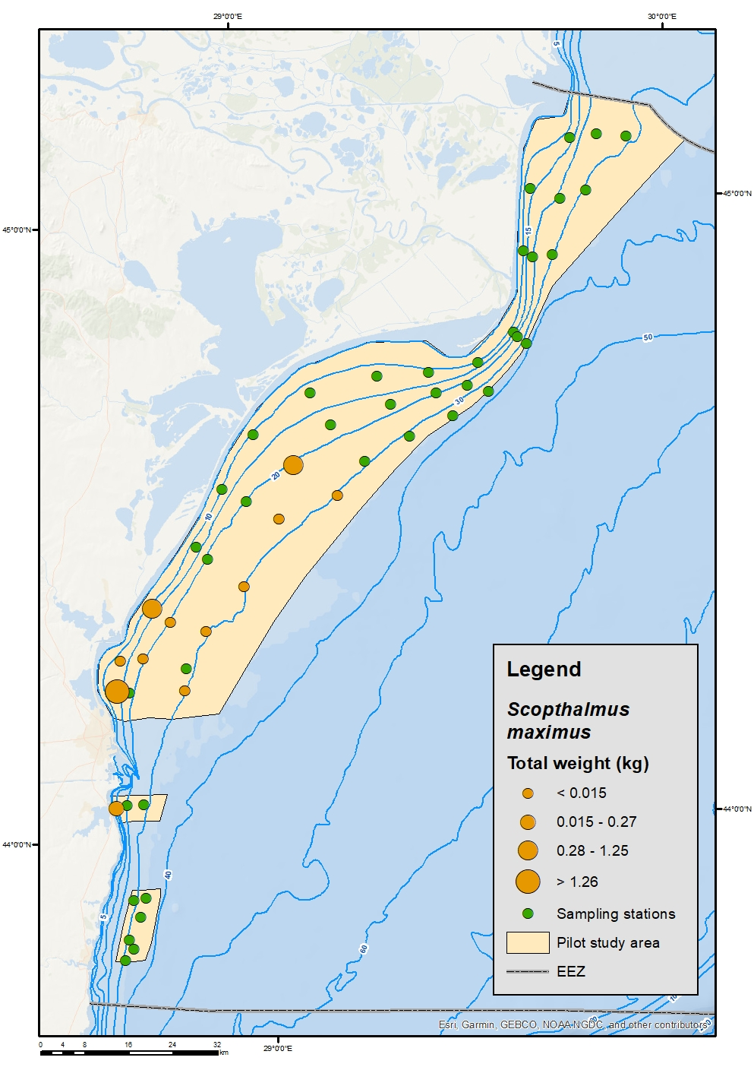

Fig. 2.9 Turbot abundance (a/ind./trawl and b/kg/trawl), in rapa whelk beam-trawl fishing, during 2021
Thus, in 2021, the turbot individuals (11 specimens) were analysed, being observed the length classes between 14-55 cm and the weight classes between 42.0-2,99 g predominated (Fig. 2.10, Table 2.2 and Fig. 2.11). 4 juvenile specimens were identified.
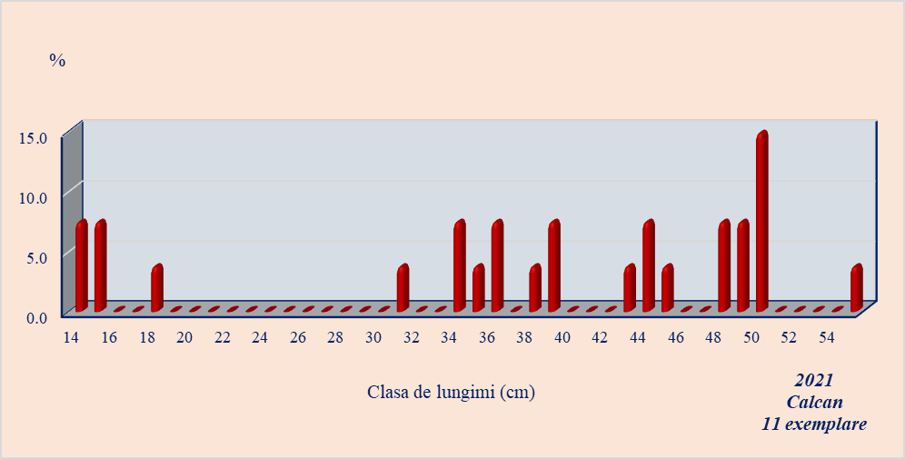
Fig. 2.10 Structure by length classes turbot (%) like by-catch in rapa whelk beam-trawl fishing, during 2021

Table 2.2 Statistical data for the structure of turbot length classes (cm) and weight classes (g), during 2021

Lower bound | Upper bound | 2021
Lower bound | Upper bound | Lemgth (cm |  |  | Lower bound | Upper bound | Weight (g)
Lower bound | Upper bound | Frequency | Relative frequency | Density | Lower bound | Upper bound | Frequency | Relative frequency | Density
13.50 | 18.20 | 2 | 0.200 | 0.043 | 0.042 | 0.310 | 4 | 0.200 | 0.746
31.00 | 39.30 | 3 | 0.280 | 0.034 | 0.400 | 1.130 | 3 | 0.320 | 0.438
40.00 | 45.20 | 2 | 0.160 | 0.031 | 1.550 | 1.850 | 2 | 0.160 | 0.533
47.00 | 49.00 | 3 | 0.200 | 0.100 | 1.900 | 2.300 | 1 | 0.160 | 0.400
50.00 | 55.00 | 1 | 0.160 | 0.032 | 2.400 | 2.990 | 1 | 0.160 | 0.271

a.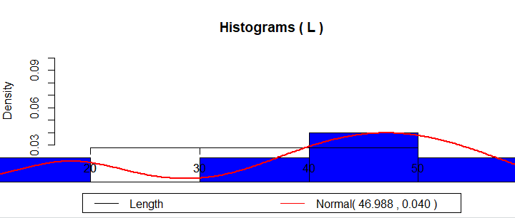 b.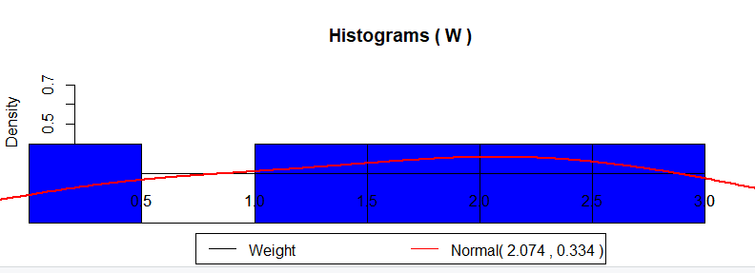

Fig. 2.11 Histograms on turbot length (a) and weight (b) classes catch in rapa whelk beam-trawl fishing, during 2021

Total catch of rapa whelk and % of turbot species as by catch

In 2021, the total weight of the rapeseed catches in the two expeditions made was 1,169.812 kg (399.623 kg / spring survey and 770.189 kg / autumn survey) and the average weight of the catches was 7.84 kg / trawl / spring survey and 15.10 kg / trawl / autumn, ranging from 0.0-88.50 kg / trawl / spring season to 0.0–107,291 kg / trawl / autumn season (Table 2.3).

Table 2.3 Statistical data on the distribution of Rapa Whelk (kg/trawl) by weight classes,

Lower bound | Upper bound | July survey |  |  | October survey
Lower bound | Upper bound | Frequency | Relative frequency | Density | Frequency | Relative frequency | Density
0.000 | 9.999 | 43 | 0.843 | 0.084 | 35 | 0.686 | 0.069
10.000 | 19.999 | 2 | 0.039 | 0.004 | 6 | 0.118 | 0.012
20.000 | 29.000 | 1 | 0.020 | 0.002 | 3 | 0.059 | 0.006
30.000 | 39.000 | 3 | 0.059 | 0.006 | 1 | 0.020 | 0.002
40.000 | 49.999 | 0 | 0.000 | 0.000 | 1 | 0.020 | 0.002
50.000 | 59.999 | 1 | 0.020 | 0.002 | 2 | 0.039 | 0.004
60.000 | 69.999 | 0 | 0.000 | 0.000 | 0 | 0.000 | 0.000
70.000 | 79.999 | 0 | 0.000 | 0.000 | 0 | 0.000 | 0.000
80.000 | 89.999 | 1 | 0.020 | 0.002 | 0 | 0.000 | 0.000
90.000 | 99.999 | 0 | 0.000 | 0.000 | 2 | 0.039 | 0.004
100.000 | 109.999 | 0 | 0.000 | 0.000 | 1 | 0.020 | 0.002
Regarding the of biometrics aspects, the individuals of rapa whelk analysed were distributed by weight and length classes. In 2021, the analysed rapa whelk specimens had a spectrum of lengths between 2.5 cm and 10.0 cm, dominated by the length classes between 5.0-7.0 cm and the weight classes between 13.0-152.4 g (Fig. 2.12). Regarding the distribution by sex, 52.57% males and 47.43% females were identified.

a. 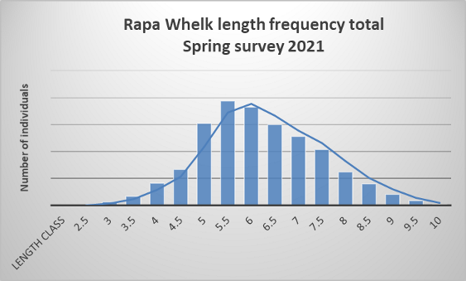 b.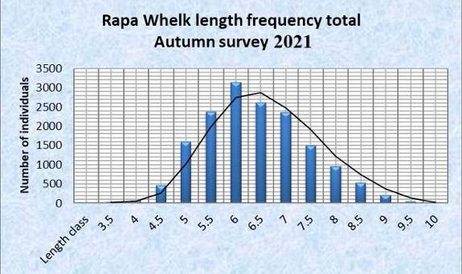
Fig. 2.12 Structure on length classes of rapa whelk (no. individuals), during 2020

Table 2.6 Statistical data for the structure of rapa whelk length classes (cm) and weight classes (g), during 2021

Lower bound | Upper bound | 2021
Lower bound | Upper bound | Length (cm) |  |  | Lower bound | Upper bound | Weight (g)
Lower bound | Upper bound | Frequency | Relative frequency | Density | Lower bound | Upper bound | Frequency | Relative frequency | Density
40.00 | 49.00 | 277 | 0.587 | 0.065 | 15.00 | 50.00 | 619 | 0.158 | 0.005
50.00 | 59.00 | 1503 | 0.548 | 0.061 | 51.00 | 70.00 | 1254 | 0.320 | 0.017
60.00 | 69.00 | 1494 | 0.472 | 0.052 | 71.00 | 80.00 | 1107 | 0.282 | 0.031
70.00 | 79.00 | 349 | 0.620 | 0.069 | 81.00 | 90.00 | 505 | 0.129 | 0.014
80.00 | 89.00 | 235 | 0.760 | 0.084 | 91.00 | 100.00 | 234 | 0.060 | 0.007
90.00 | 99.00 | 63 | 0.000 | 0.000 | 101.00 | 155.00 | 202 | 0.052 | 0.001
Analysing the histograms, it is observed that the groups with a weight between 70 and 90 g and with a length between 6 and 10 cm, predominated (Fig. 2.13).

a.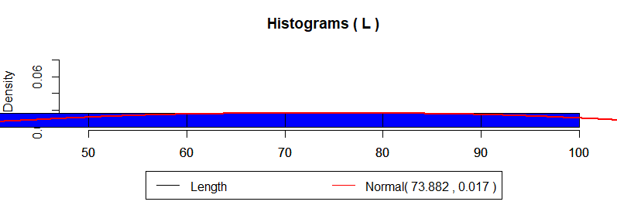 b. 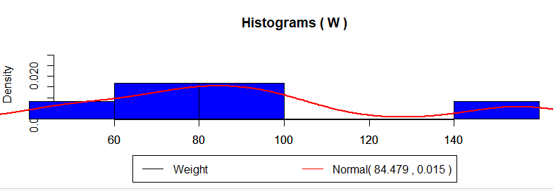
Fig. 2.13 Histograms of distribution by length (a) and weight (b) classes, for rapa whelk, during 2021

a. 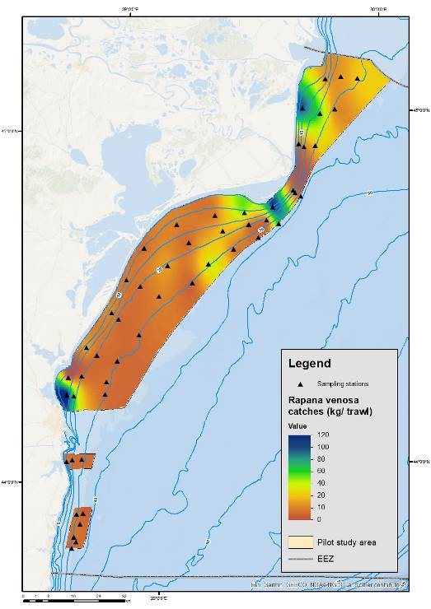 b. 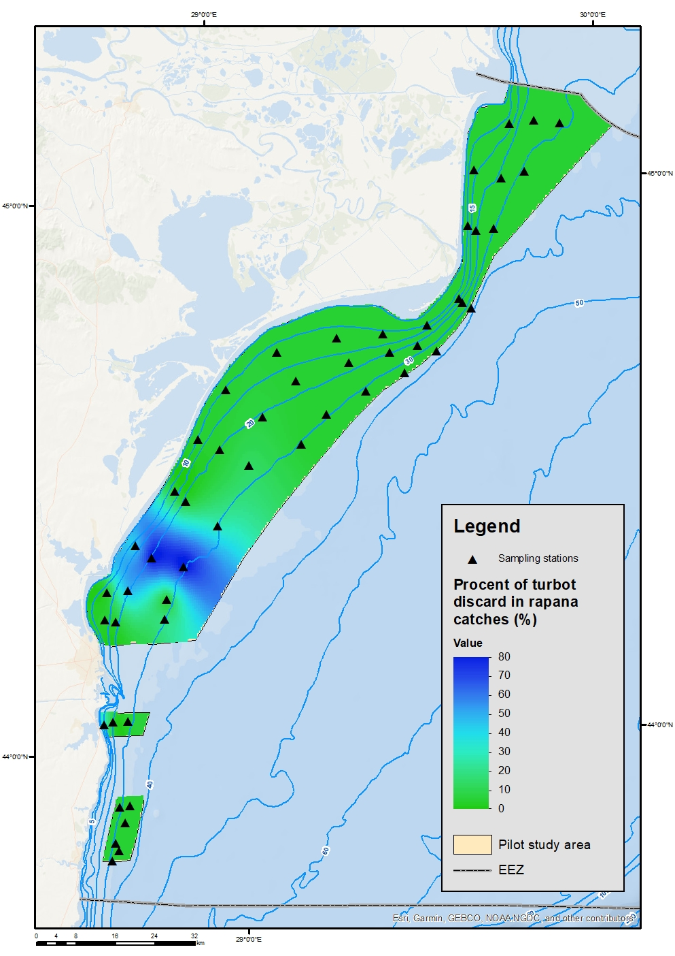
Fig. 2.14 Rapa whelk total catch (kg/trawl) and turbot % discard from beam trawl, in 2020
Below, in Fig. 2.14 is shown the percentage of catches of turbot obtained in specialized fishing for rapa whelk, with beam trawl (% of catches of rapa whelk), during 2021, where it is observed that the highest percentage is found along the northern coast, in the perimeter of Cape Midia - Periboina and where the catches are low, but the juvenile turbot, can appear more often as being discharged back into the sea.

CONCLUSIONS

The study conducted in 2021, included two expeditions (July and October) being carried out a number of 51 trawls per expedition, with beam trawl. The main conclusions are:

a. Common species in accidental capture are: mussels, crab, seahorse, sea mouse, goby, whiting and turbot. Rare species are red mullet, black scorpionfish, tub gurnard, common sole, stargazer. These were found mainly in two sectors: Baia Mamaia – Chituc and Gura Portita;

b. In the by-catches from 2021, a number of 423.536 specimens were identified, belonging to 30 species (16 species of fish, 7 species of molluscs, 3 species of crustaceans, 3 jellyfish and 1 species of ascedidae): Callionymus pussillus, Uranoscopus scaber, Hippocampus hippocampus, Scopthalmus maximus, Pegusa lascaris, Dasyatis pastinaca, Platichthy sflesus flesus, Merlangius merlangus euxinus, Gobius niger, Neogobius melanostomus, Gobius paganellus, Squalus acanthias, Mullus barbatus, Trachinus draco, Scorphaena porcus, Nerophis ophidion, Parablennius sanguinolentus; Mytilus galloprovincialis, Chamelea gallina, Scapharca inaequivalvis, Mya arenaria, Anadara inaequivalvis, Flexopecten glaber ponticus; Parvicardium exiguum, Liocarcinus navigator, Liocarcinus holsatus, Diogenes pugilator, Aurelia aurita, Rhizostoma pulmo and Ascidiella aspersa;

c. Total number of 11 turbot specimens were identified, having a total weight of 14,449 kg; The most significant catches of turbot 0-1 ind./day of fishing were observed in the area of Chituc - Periboina;

d. The average weight of bycatch in the year 2021 ranged from 0.172 kg / day to 1.453 kg/trawl, with a maximum of 2,980 kg/day and a minimum of 0 kg/day. The percentage ratio of bycatch is 0.03 %, as an average of the data per day of trawling, with a maximum daily quota of 0.13 %;

e. The average lengths of the turbot individuals, ranged from 10.0 to 54.0 cm, with weights between 0.13 and 2.980 kg. Juvenile forms are predominant, the only mature specimen with a weight of 2.98 kg and a length of 54.0 cm. The most significant percentage parts of the total abundance size group 31.5-39.3 cm (52.34%);

f. The total weight of rape catches was 339.623 kg/spring and 770.189 kg/autumn. The average weight was 6.15.10 kg / trawl/spring and 15.10 kg/trawl/autumn, ranging from 0.0–107.291 kg/trawl. The dominant group (70.59%) weighs 0.0-8.89 kg/trawl, followed by the weight group 10.0-19.99 kg/trawl (9.8%), while the catches are low, 30.00-39.99 kg/trawl and 40.0-49.99 kg/trawl, were recorded with 1.96% each, of the total catch;

g. The percentage ratio of bycatch had an average value of 0.0219% and 0.35306%, as an average of data per day of trawling, with a maximum daily quota of 0.17% and 0.89%.

Section 1: Biological Data
Text Box 1G: List of research surveys at sea

General comment: This box fulfills Chapter I of the Annex of the Implementing Decision (EU) 2019/909, on the list of mandatory surveys and thresholds, of the multiannual Union programme; and Article 2 and Article 7 paragraph (3) of the Decision (EU) 2016/1701 on the format of the WP. It is intended to specify which reseach surveys at sea set out in the multiannual Union programme will be carried out. Member States shall specify whether the research survey is included in Chapter I of the Annex of the implementing decision of the multiannual Union programme or whether it is an additional survey.
General comment: This box is applicable to the Annual Report. This box should provide complementary information on the performance of the surveys, the results and their main use.
PELAGIC TRAWL SURVEY IN BLACK SEA

1. Objectives of the survey

The aim of the pelagic trawl survey in the Black Sea is the assessment of the stock biomass of sprat (Sprattus sprattus). Furthermore, an analysis of the distribution and abundance of the other species caught as by-catch will be presented. Main objectives:

* Estimates of abundance (by number and biomass) of the main demersal and pelagic species of commercial interest distributed at a depth between 10 m and 100 m;

* Description of the demographic structure of commercial species, along with spatial distribution patterns;

* Detailed length distribution and biological sampling of the catch for each target species, recording length, weight, sex, and the collection of otoliths and gonads. For other species only length and length-weight sampling were performed;

* Observation of the oceanographic conditions on the Bank. The collection of oceanographic data (temperature and salinity) was carried out mainly through the CTD profiling;

* Assessing the environmental impact of fishing.

2. Description of the methods used in the survey. For mandatory surveys, link to the manuals. Include a graphical representation (map)

Pelagic Trawl survey will be accomplished in spring and autumn quarters each year. The study will be held in the area enclosed between Vama Veche (43.7378 N/28.5857ºE)45’ N and Sulina (45.1807º N//29.7574ºE) with a total length of the coastline of 245 km. During each survey 30 random hauls will be carried out in the Romanian area (60 trawls per year). The survey undergoes during the day and the following types of data were collected:
* Coordinates and duration of each trawl
* Sprat total catch weight
* Separation of the by-catch by species
To establish the abundance of the reference species in front of the Romanian coast a standard methodology for stratified sampling was employed (Gulland, 1966). To address the research objectives the region was divided into three strata according to depth – Stratum 1 (15-35 m) Stratum 2 (35–50 m) and Stratum 3 (50–75 m).
a. 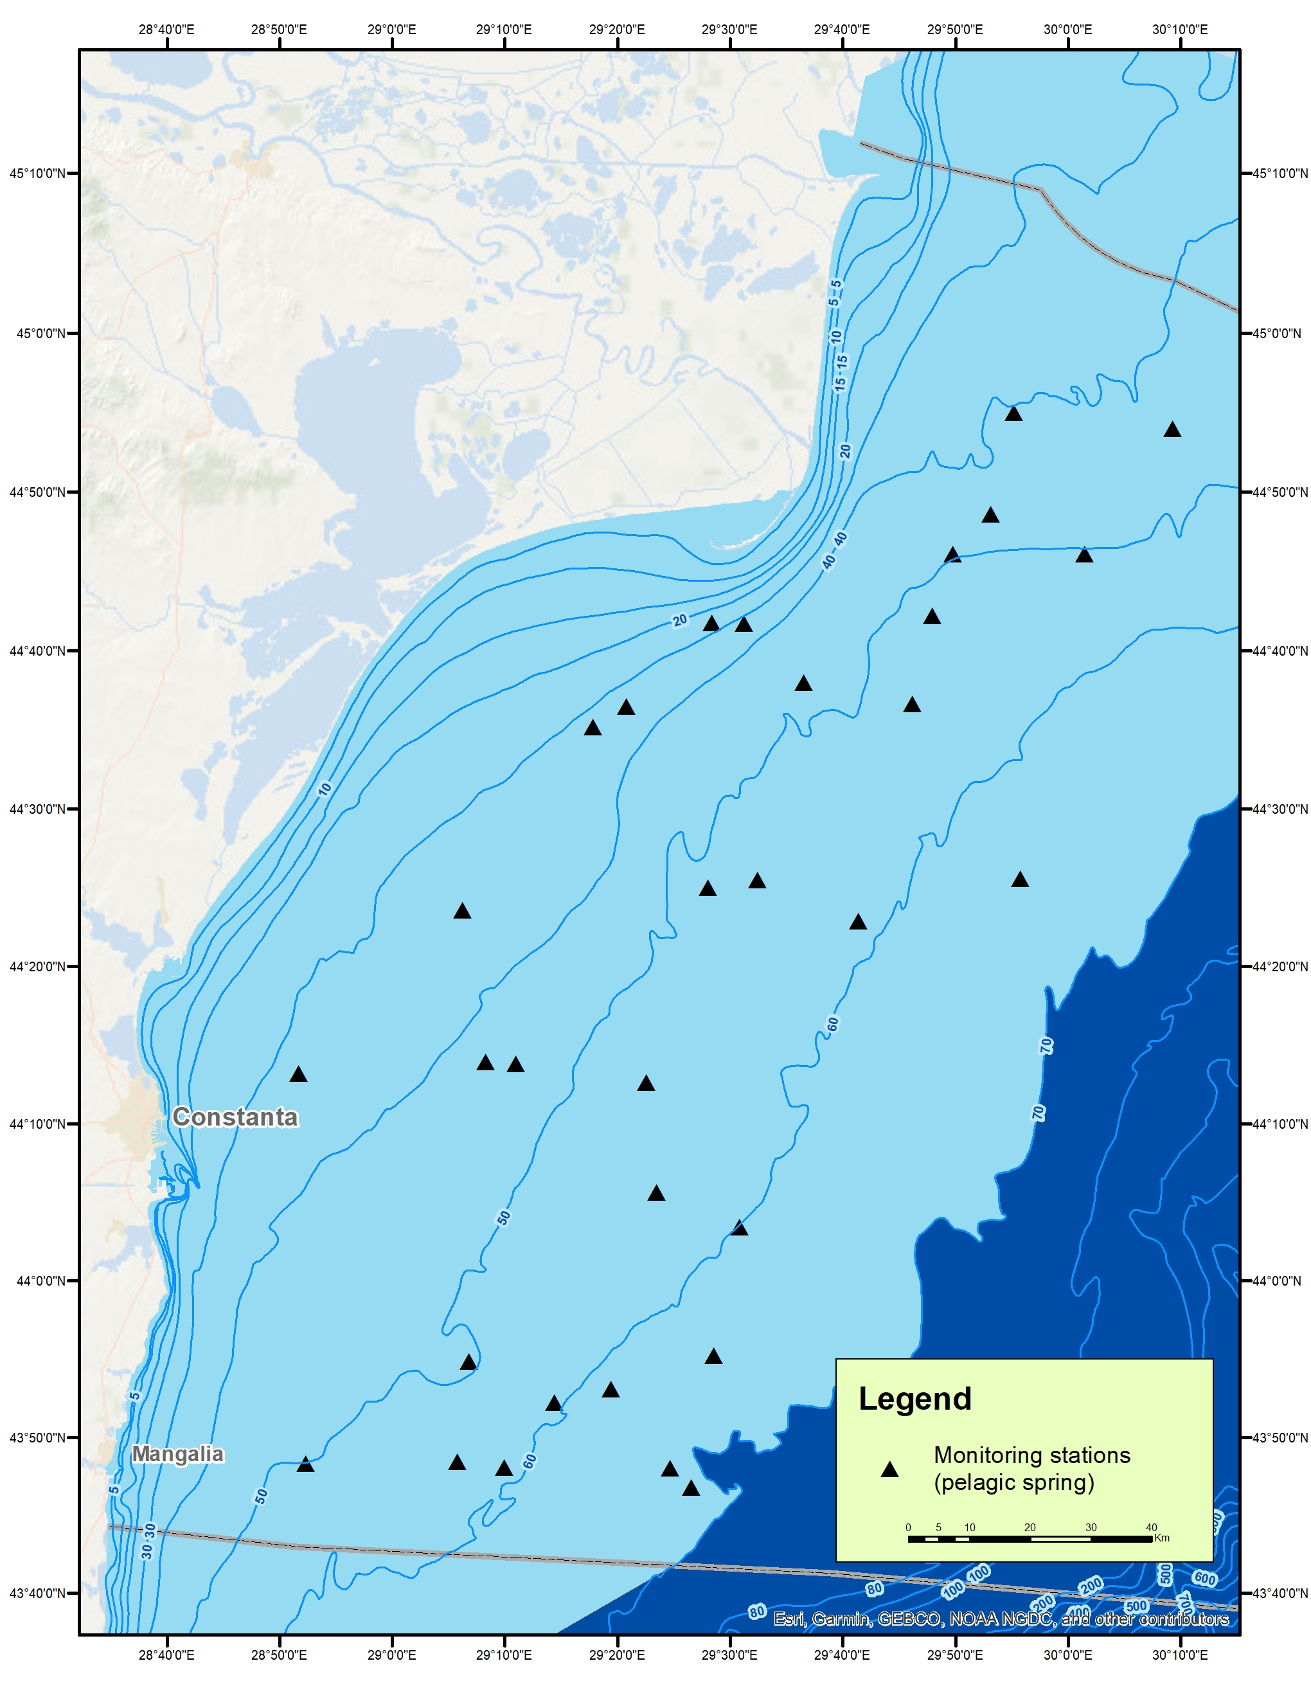 b. 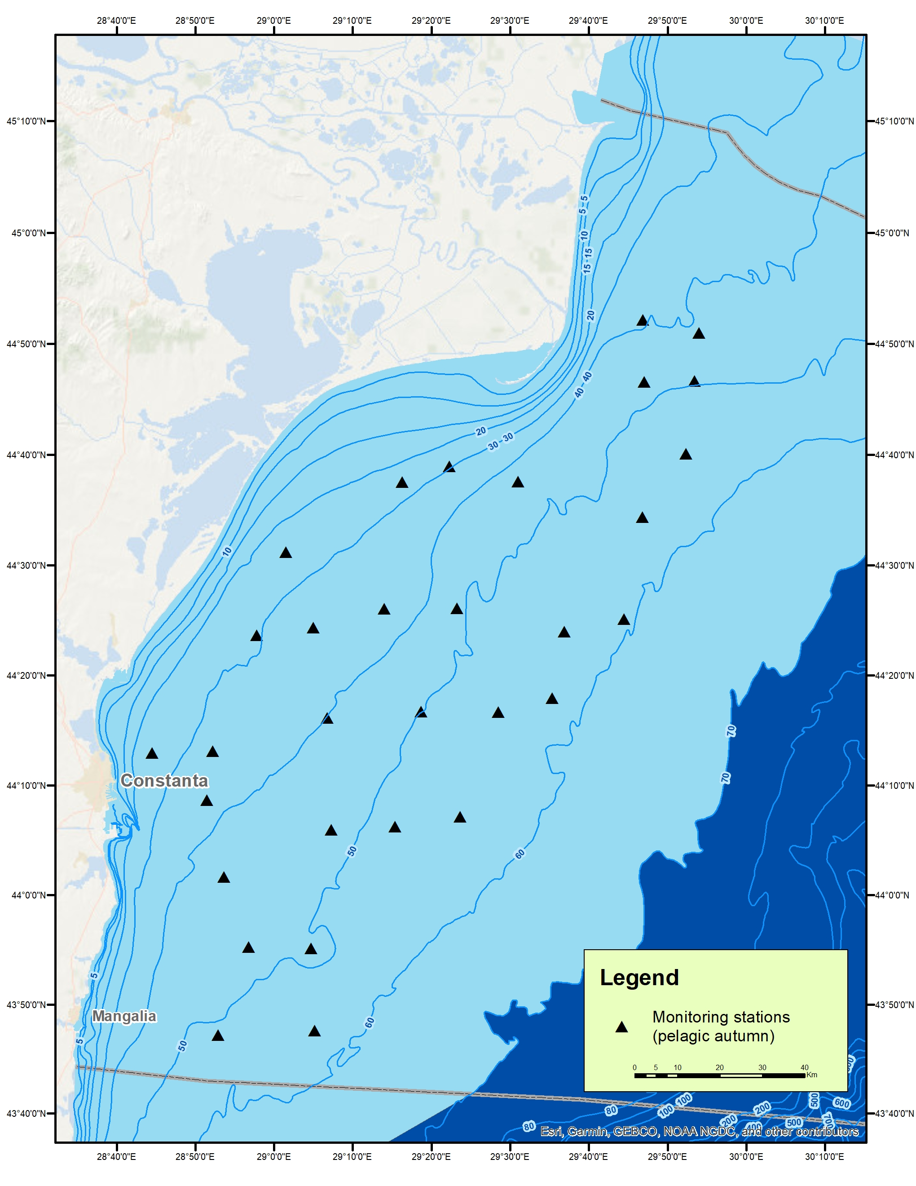
Fig. 1G1 Planned distribution stations pelagic trawl, in spring (a) and autumn season (b), in 2021
The methodology and techniques that were used for the collection, verification, processing and analysis of data and for the assessment of fish stocks are generally accepted for the Black Sea basin and in accordance with international methodology (http://www.rmri.ro/Home/Downloads/Publications.Other/NAFA_Material%20and%20methods%20for%20survey%20in%
20the%20Romanian%20Black%20Sea%20area.pdf). For estimating the sprat crowd’s biomass, the holistic method of
probe trawling was used and the pelagic trawl was used for sampling.

3. For internationally coordinated surveys, describe the participating Member States/ vessels and the relevant international group in charge of planning the survey
Romania and Bulgaria undertake annually research surveys in their territorial waters and EEZ under their jurisdiction, following common methodology, harmonization of biological data sampling and analysis and harmonization of stock assessment methods. Both countries will follow the methodology already adopted by other EU countries (MEDIAS). The agreement between Romania and Bulgaria is available on the following link:
(http://www.rmri.ro/Home/Publications.Other.ANPA.html?lang=en).

4. Where applicable, describe the international task-sharing (physical and/or financial) and the cost-sharing agreement used
Pursuant to the Collaboration Agreement concluded between NAFA Romania and NAFA Bulgaria (Table 7C: Bi- and multilateral agreements), the parties are committed to providing financial resources for scientific surveys and work meetings. Each party will cover their own surveys costs for their own research vessels in national waters and the cost of the research team’s participation on board the other vessels during surveys.

5. Explain where thresholds apply
No thresholds will be applied, as specified in Chapter V of Implementing Implementation (EU) 2019/909.
6. Graphical representation (map) showing the positions (locations) of the realized samples.

Pelagic trawl spring surveys: in 2021, the calculated biomasses for the main pelagic fish species at the Romanian coast were: sprat (44,169.59 t / Fig. 1G2a) and whiting (569.80 t /Fig. 1G3a). In the spring season, agglomerations biomass of sprat was lower by about 24.57% compared with the previous year. Due to the very small catches and the small number of specimens of picked dogfish caught, both in the spring season, the evaluation of the species in pelagic trawls was not performed.
a. 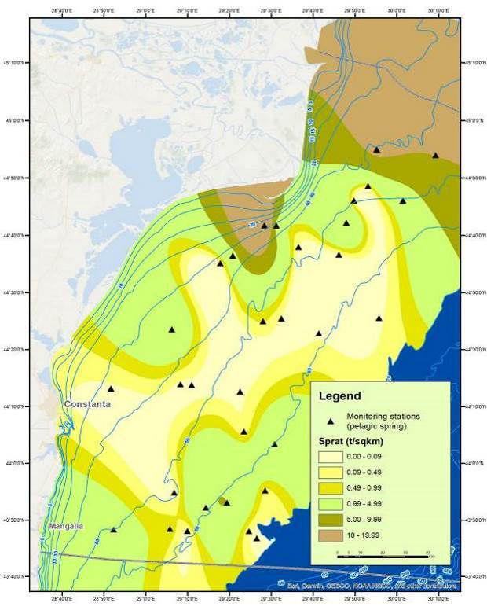 b. 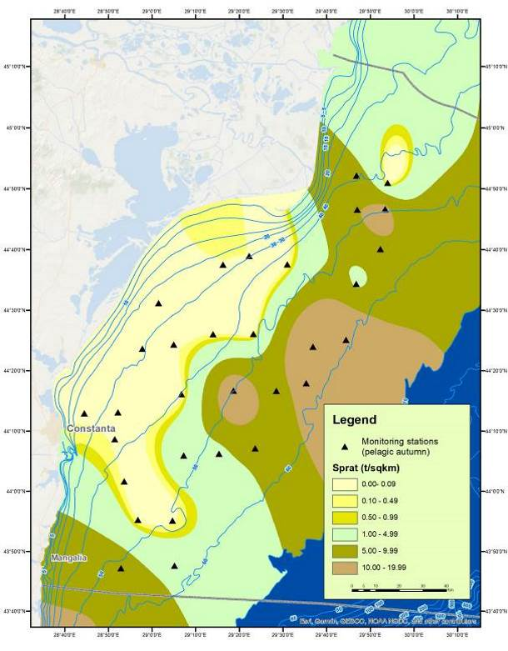
Fig. 1G2 Distribution of sprat agglomerations in the spring (a) and autumn season (b), pelagic trawl survey, in 2021

a.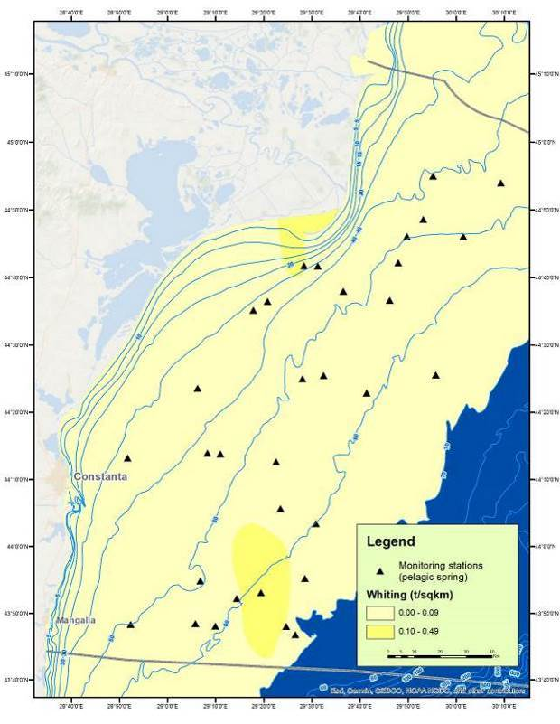 b 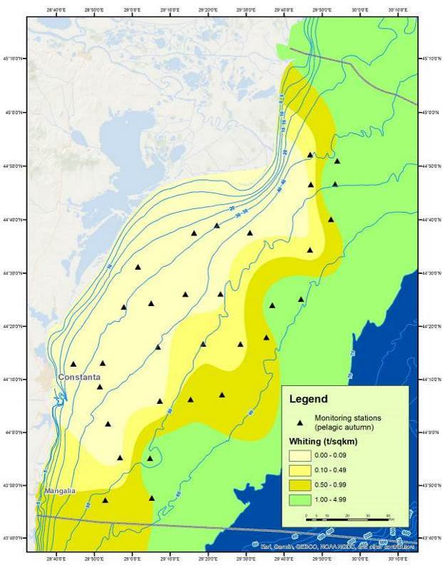
Fig. 1G3 Distribution of whiting agglomerations in the spring (a) and autumn season (b), pelagic trawl survey, in 2021

Pelagic trawl autumn surveys: in 2021, the calculated biomasses for the main pelagic fish species at the Romanian coast were: sprat (93,677.68 t / Fig. 1G2b) and whiting (8,943.41 t /Fig. 1G3b). In the autumn season of 2021, the biomass of sprat agglomerations were approximately equal to the previous year. Due to the catches and the small number of captured dogfish specimens caught, in the autumn season, the assessment of the species in pelagic trawls was not performed.

7. For internationally coordinated surveys, provide a link to the latest meeting report of the coordination group

The surveys with Romanian demersal and pelagic trawls are coordinated with Bulgaria. Romanian representatives attended, were represented at the MEDIAS meeting: http://www.medias-project.eu/medias/website; DG-Mare-JRC
(https:// datacollection.jrc.ec.europa.eu/dcf) and GFCM.

8. List the main use of the results of the survey (e.g., indices, abundance estimates, environmental indicators).
Pelagic sprint survey
Evaluation of sprat agglomerations in the pelagic trawl expedition, in the spring season of 2021
Sprat / June 2021
Depth range (m) | 0–30 m | 30–50 m | 50-70 m | Total
Investigated area (Km²) | 600 | 3,800 | 3,100 | 7,500
Variation of the catches (t/Km²) | 0.012-19.202 | 0.005-11.712 | 0.004-4.936 | 0.004-19.202
Average catch (t/ Km²) | 4.493 | 2.207 | 1.225 | 2.642
Biomass of the fishing agglomerations (t) | 11021.0 | 10887.71 | 9077.85 | 13182.43
Biomass extrapolated the Romanian shelf (t) |  |  |  | 44.169,59

Biomass (tons) and abundance (individuals) of sprat

a. 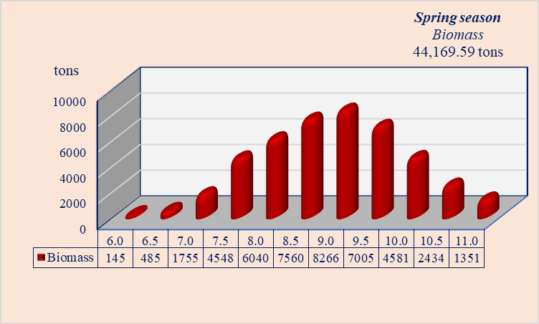 b. 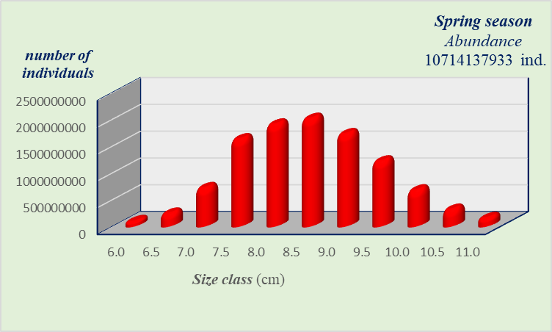
Fig. 1G4 Structure by lengths of biomass (a) and abundance (b) of sprat during spring pelagic survey

Structure of biomass and abundance by age distribution
a. 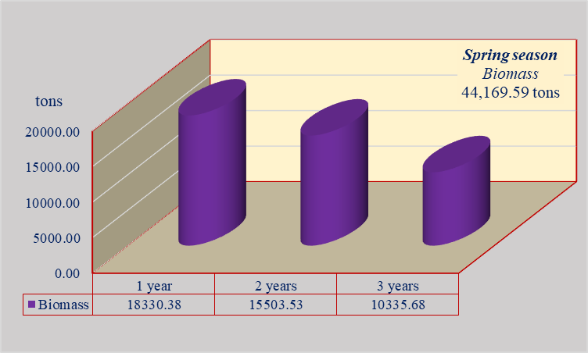 b. 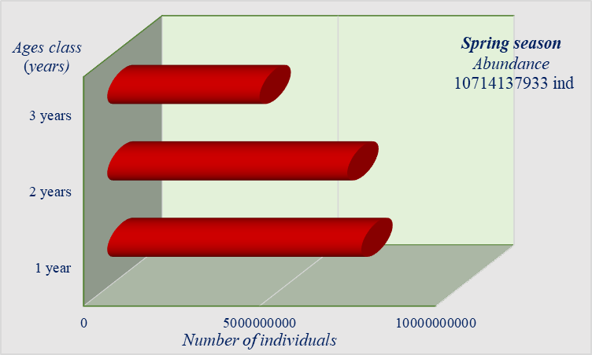
Fig. 1G5 Structure by ages of biomass (a) and abundance (b) of sprat during spring survey

Evaluation of whiting agglomerations in the pelagic trawl expedition, in the spring season of 2021
Whiting / June 2021

Depth range (m) | 0–30 m | 30–50 m | 50-70 m | Total
Investigated area (Km²) | 600 | 3,800 | 3,100 | 7,500
Variation of the catches (t/Km²) | 0.000-0.105 | 0.000-0.080 | 0.000-0.290 | 0.000-0.290
Average catch (t/ Km²) | 0.017 | 0.012 | 0.046 | 0.025
Biomass of the fishing agglomerations (t) | 42.90 | 57.18 | 344.11 | 444.19
Biomass extrapolated the Romanian shelf (t) |  |  |  | 569.801
Biomass (tons) and abundance (individuals) of whiting

a. 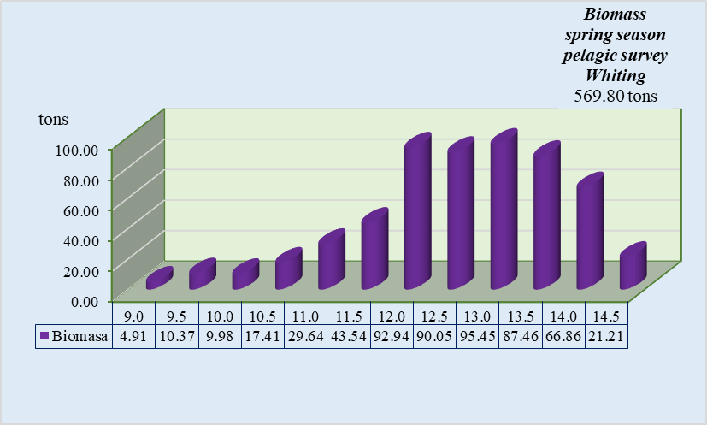 b. 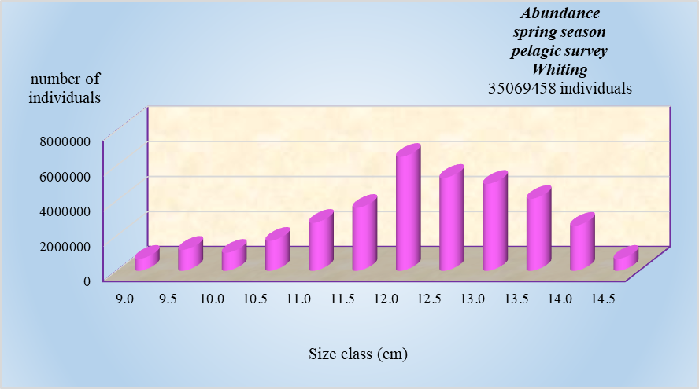
Fig. 1G6 Structure by lengths of biomass (a) and abundance (b) of whiting during spring pelagic survey
Structure of biomass and abundance by age distribution

a. 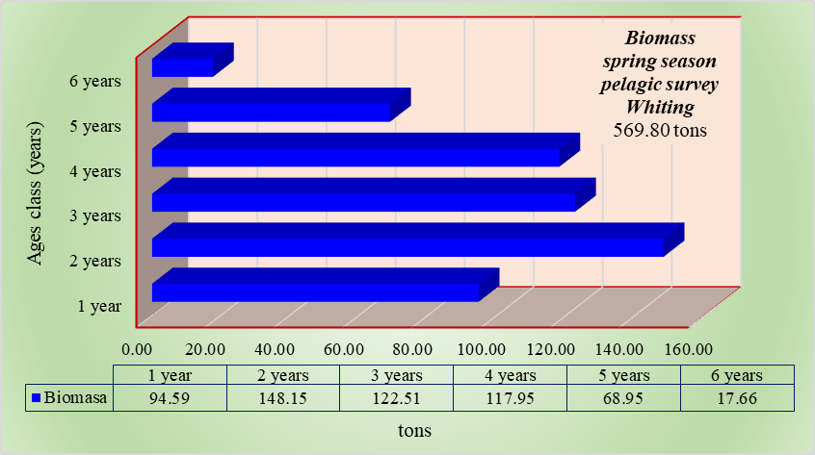 b. 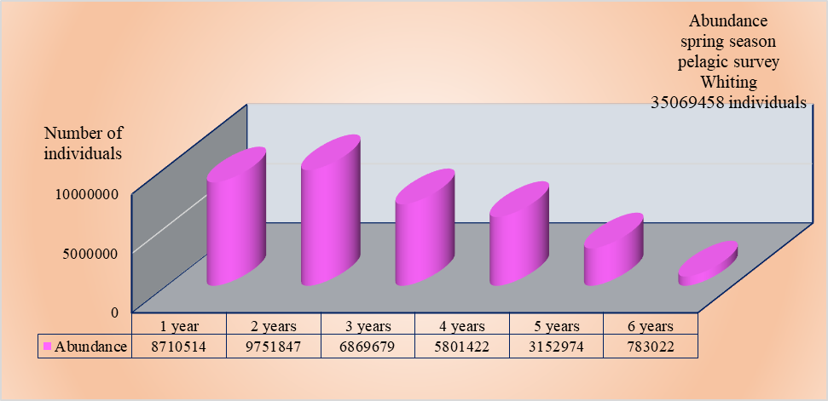
Fig. 1G7 Structure by ages of biomass (a) and abundance (b) of whiting during spring survey

Pelagic autumn survey
Evaluation of sprat agglomerations in the pelagic trawl expedition, in the autumn season of 2021
Sprat / November 2021
Depth range (m) | 0–30 m | 30–50 m | 50-70 m | Total
Investigated area (Km²) | 0 | 4,100 | 6,150 | 10,250
Variation of the catches (t/Km²) | 0.000 | 0.000-11.440 | 3.430-19.570 | 0.000-19.570
Average catch (t/ Km²) | 0.000 | 2.039 | 8.842 | 3.627
Biomass of the fishing agglomerations (t) | 0.000 | 10059.45 | 65519.16 | 75578.16
Biomass extrapolated the Romanian shelf (t) |  |  |  | 93.677,68

Biomass (tons) and abundance (individuals) of sprat
a. 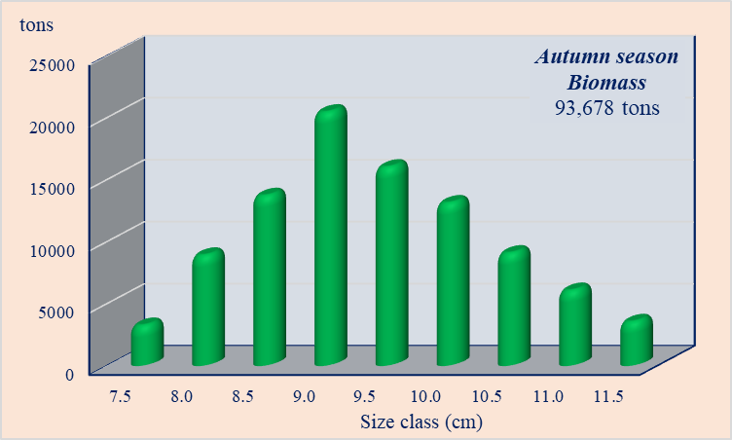 b. 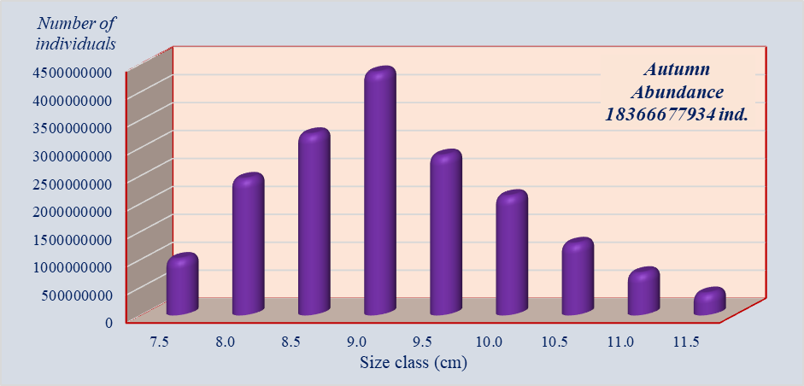

Fig. 1G8 Structure by lengths of biomass (a) and abundance (b) of sprat during autumn pelagic survey
Structure of biomass and abundance by age distribution
a. 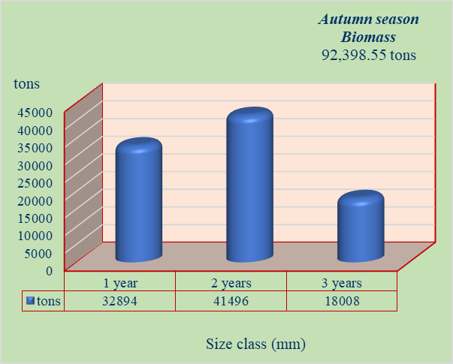 b. 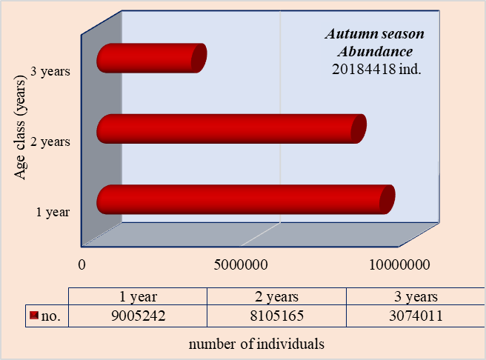
Fig. 1G9 Structure by ages of biomass (a) and abundance (b) of sprat during autumn survey

Evaluation of whiting agglomerations in the pelagic trawl expedition, in the autumn season of 2021
Whiting / November 2021

Depth range (m) | 0–30 m | 30–50 m | 50-70 m | Total
Investigated area (Km²) | 0 | 4,100 | 6,150 | 10,250
Variation of the catches (t/Km²) | 0.000 | 0.000-2.158 | 0.224-1.554 | 0.000-2.158
Average catch (t/ Km²) | 0.000 | 0.360 | 0.724 | 0.361
Biomass of the fishing agglomerations (t) | 0.000 | 1774.61 | 5365.93 | 7140.54
Biomass extrapolated the Romanian shelf (t) |  |  |  | 8,943.41
Biomass (tons) and abundance (individuals) of whiting
a. 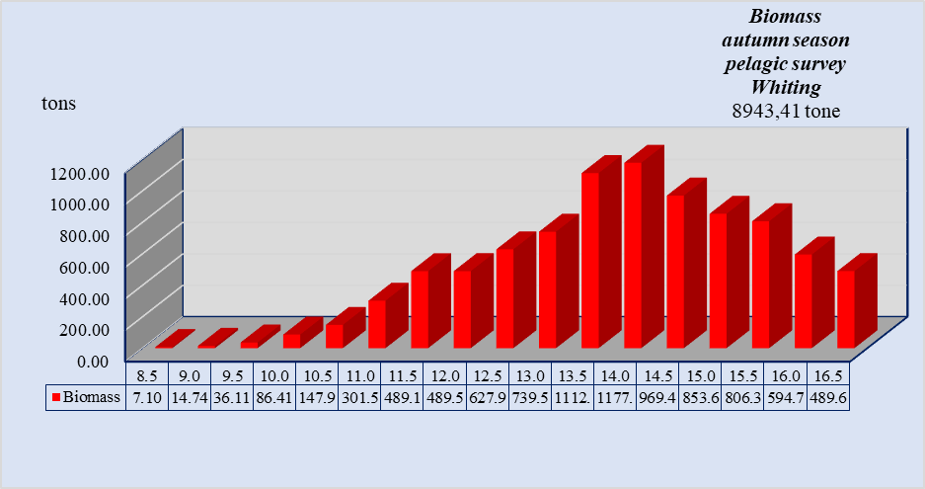b. 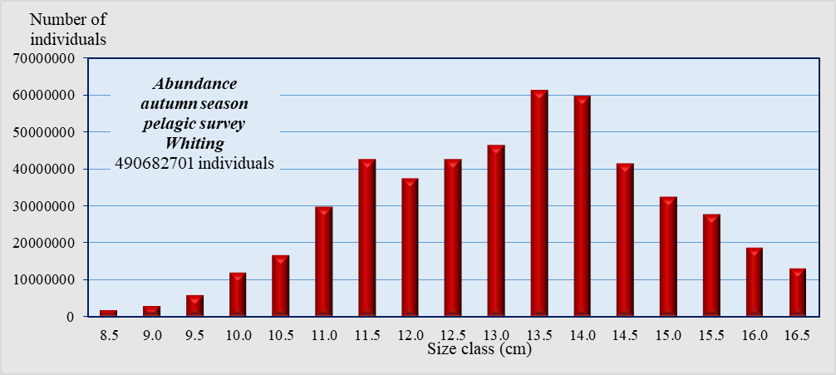
Fig. 1G10 Structure by lengths of biomass (a) and abundance (b) of whiting during spring pelagic survey
Structure of biomass and abundance by age distribution
a. 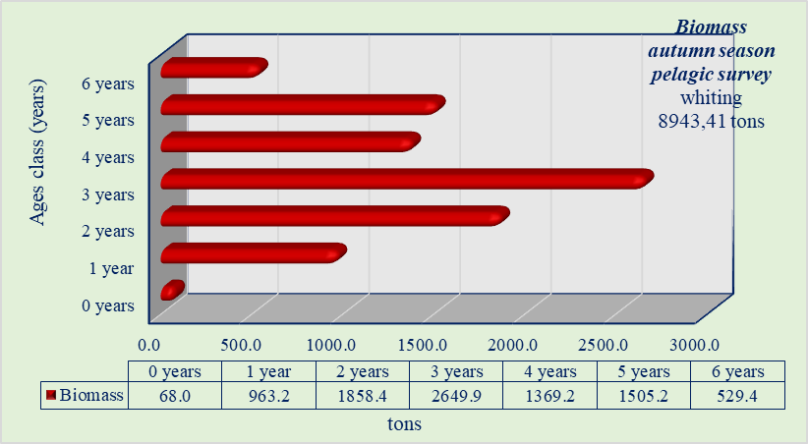 b. 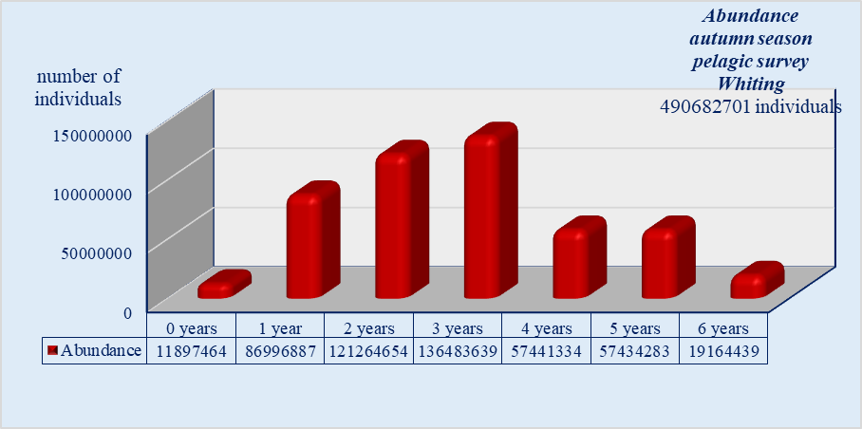
Fig. 1G11 Structure by ages of biomass (a) and abundance (b) of whiting during spring survey

a.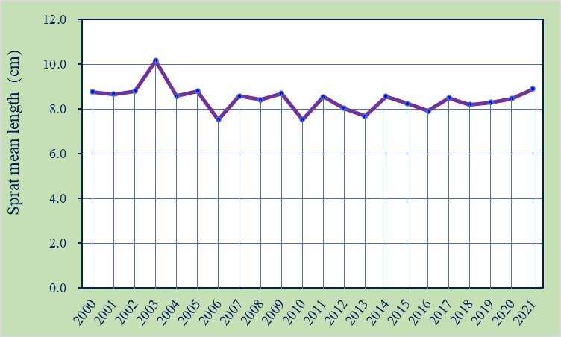 b. 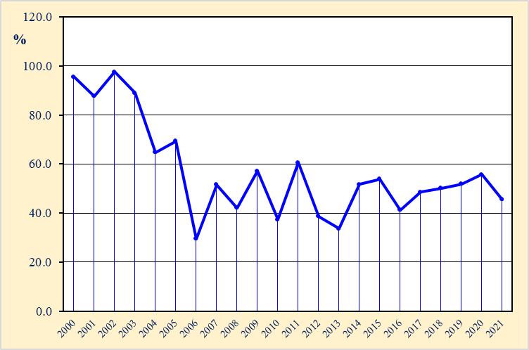
Fig. 1G12 The average length (a) and percentage (b) of sprat specimens larger than the average size at first sexual maturation in the period 2000 – 2021
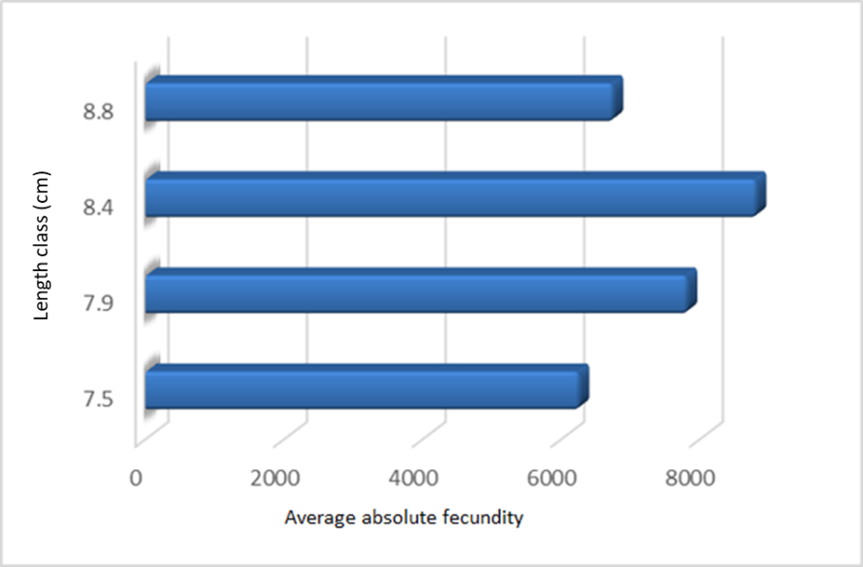
Fig. 1G13 The average values of absolute fecundity determined by sprat in 2021

a.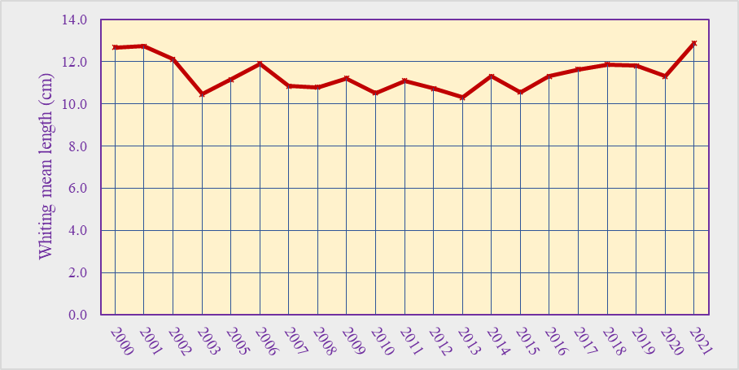 b.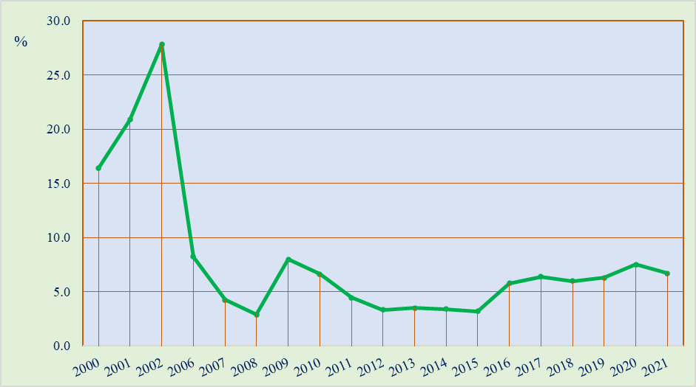
Fig. 1G14 The average length (a) and percentage (b) of whiting specimens larger than the average size at first sexual maturation in the period 2000 – 2021

9. Extended comments (Tables 1G and 1H)

If the Member State has extended AR Comments, these can be placed under this section. If this is the case, a reference to this text box should be provided in the corresponding tables. During the surveys at sea and at the fishing points along the Romanian Black Sea coast, in accordance with the activities provided in the National Program, information on incidental by-catch of birds, mammals, reptiles and fish were collected. Species striped red mullet / Mullus surmuletus, not present in Romanian area. Also, data on the presence of mammals in the area of the stationary and the active fishing gears and the presence of marine litter, both on land and at sea, were collected. All the collected data have been reported to the international bodies to which Romania has adhered or participated as a partner in the ongoing international projects. Thus, mammalian data were reported annually to ACCOBAMS (http://www. accobams.org/) and data on marine litter were uploaded to the EMOD-NET platform (https://www.emodnet-chemistry.eu/).
BOTTOM TRAWL SURVEY IN BLACK SEA

1. Objectives of the survey
The main goal is the assessment of the stock biomass of turbot (Scophthalmus maximus) along the Romanian Black Sea coast, estimation of the biomass and abundance of the reference species by depth strata and study of size/age and sex structure, food composition, by-catch, distribution of the stock.

2. Description of the methods used in the survey. For mandatory surveys, link to the manuals. Include a graphical representation (map)

The bottom trawl survey for turbot stock assessment will be conducted in May and October each year. To establish abundance and biomass of turbot, a standard methodology for stratified sampling (Gulland, 1966; Sparre, Venema, 1998;) will be applied. To address the research objectives the region was divided into three strata according to depth – Stratum 1 (15-35 m) Stratum 2 (35–50 m) and Stratum 3 (50–75 m). During each survey 40 random hauls will be carried out in the Romanian area (80 trawls per year). The survey undergoes during the day and the following types of data were collected:
* Coordinates and duration of each trawl
* Sprat total catch weight
* Separation of the by-catch by species
The indicative zones, where trawling will be performed, are presented in Fig. 1G15.

a. 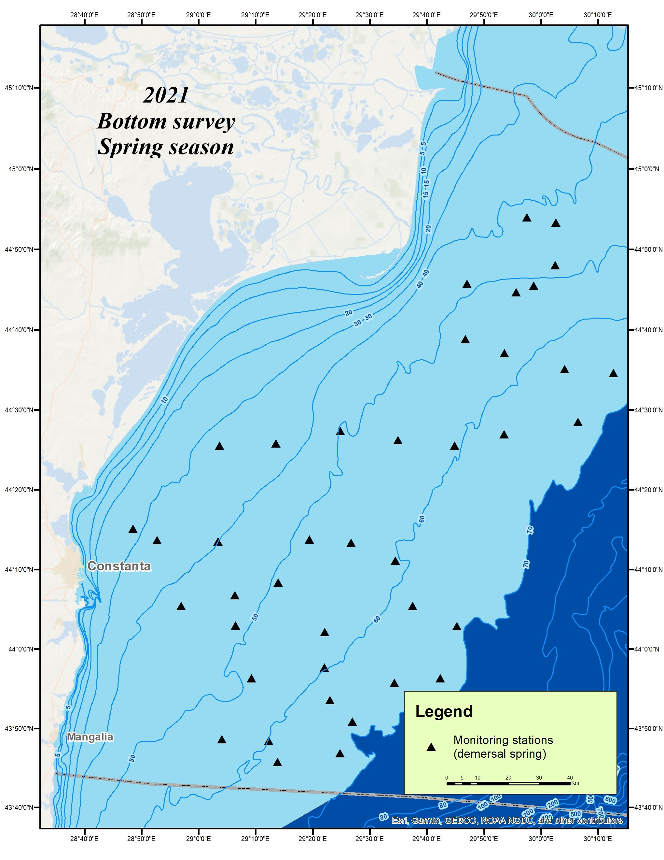 b. 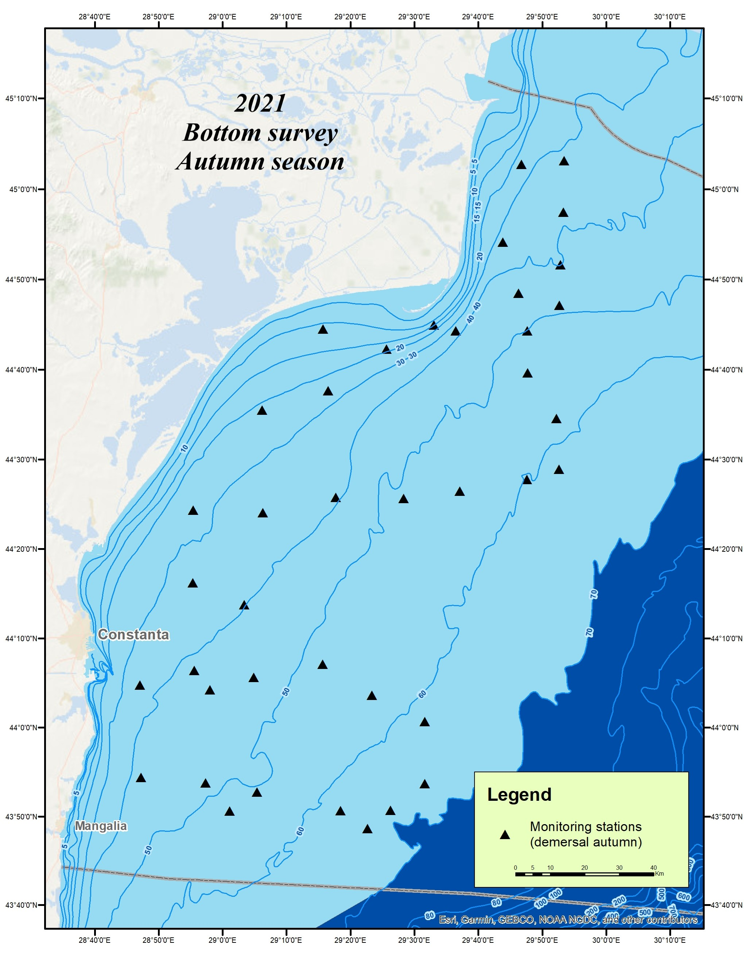
Fig. 1G15 Planned distribution stations bottom trawl, in spring (a) / autumn season (b), in 2021
The methodology and techniques that were used for the collection, verification, processing and analysis of data and for the assessment of fish stocks are generally accepted for the Black Sea basin and in accordance with international methodology (http://www.rmri.ro/Home/Downloads/Publications.Other/NAFA_Material%20and%20methods%20for%20survey%20in%
20the%20Romanian%20Black%20Sea%20area.pdf). For estimating the sprat crowd’s biomass, the holistic method of probe trawling was used and the pelagic trawl was used for sampling.

3. For internationally coordinated surveys, describe the participating Member States / vessels and the relevant international group in charge of planning the survey
Romania and Bulgaria undertake annually research surveys in their territorial waters and EEZ under their jurisdiction, following common methodology, harmonization of biological data sampling and analysis and harmonization of stock assessment methods. Both countries will follow the methodology already adopted by other EU countries (MEDIAS). The agreement between Romania and Bulgaria is available on the following link:
(http://www.rmri.ro/Home/Publications.Other.ANPA.html?lang=en).

4. Where applicable, describe the international task-sharing (physical / financial) and the cost-sharing agreement used
Pursuant to the Collaboration Agreement concluded between NAFA Romania and NAFA Bulgaria (Table 7C: Bi- and multilateral agreements), the parties are committed to providing financial resources for scientific surveys and work meetings. Each party will cover their own surveys costs for their own research vessels in national waters and the cost of the research team’s participation on board the other vessels during surveys.

5. Explain where thresholds apply
No thresholds will be applied, as specified in Chapter V of Implementing Implementation (EU) 2019/909.

6. Graphical representation (map) showing the positions (locations) of the realized samples.

Bottom trawl spring surveys: in 2021, the calculated biomasses for the main demersal fish species at the Romanian coast were: turbot (3,290.48 t /Fig. 1G16, 1G17, 1G18, 1G19 and 1G20); picked dogfish (4,135.44 t /Fig. 1G21, 1G22 and 1G23) and whiting (1,899.99 t / Fig. 1G24a). In 2021, the biomass of turbot agglomerations registered values close to those achieved in 2020, and that of shark an increase of 46.1%. For whiting biomass, the calculated biomass was close to the values of previous years.

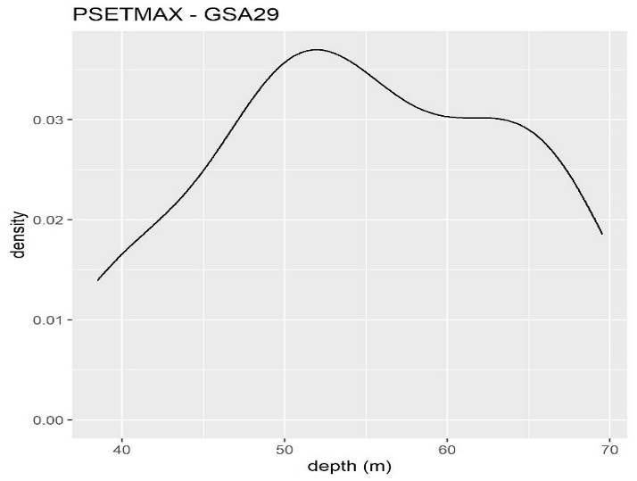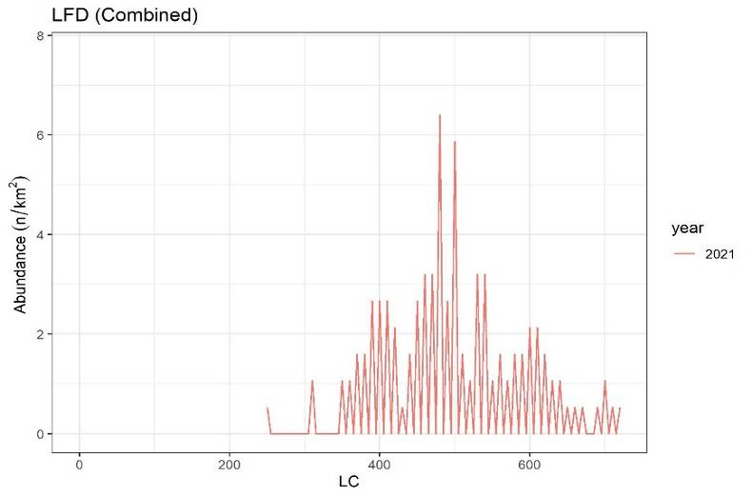
Fig. 1G16 Density of turbot specimens as a function of depth (m), Fig. 1G17 Length frequency distribution of combined turbot
in spring season, in 2021 in spring season, in 2021
a.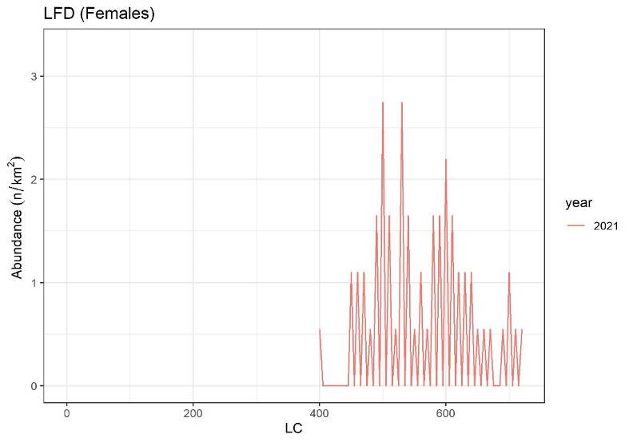 b.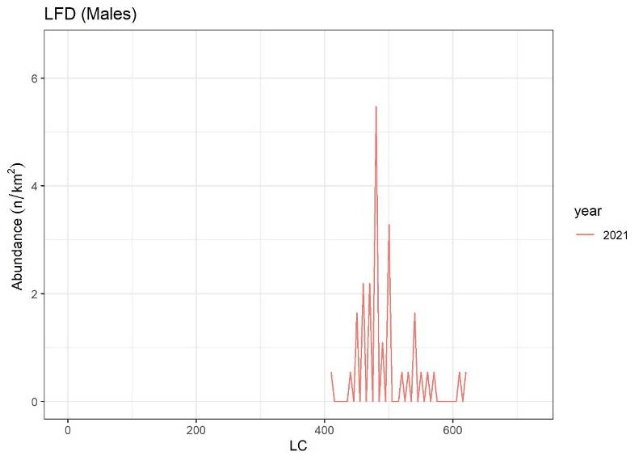
Fig. 1G18 Length frequency distribution of female’s (a) and male’s (b) turbot, in spring season, in 2021

a. 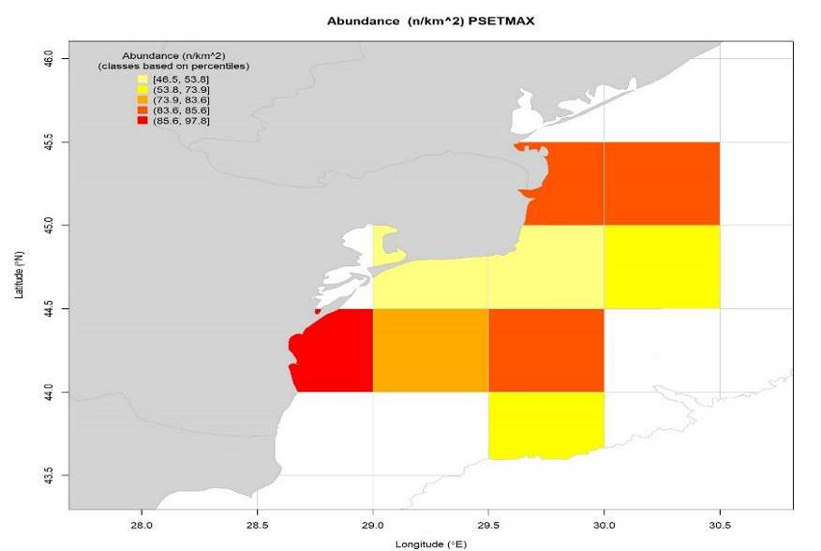 b. 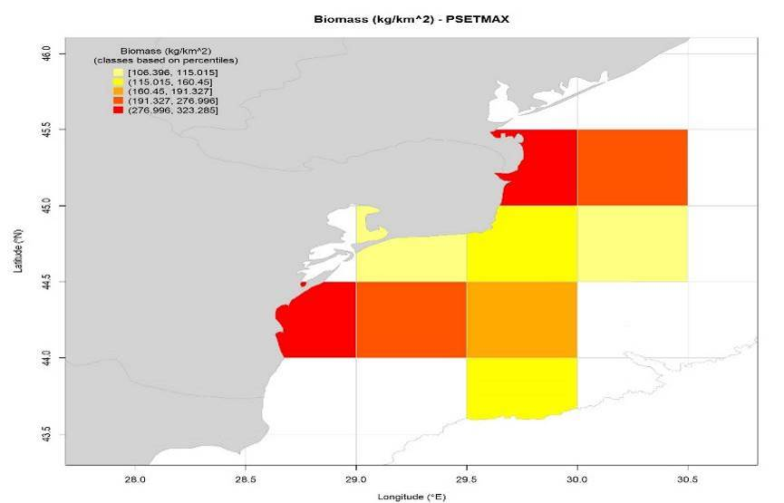

Fig. 1G19 Spatial distribution of abundance (a/n/Km²) and biomass (b/kg/Km²) indices in the turbot, in spring season 2021

a. 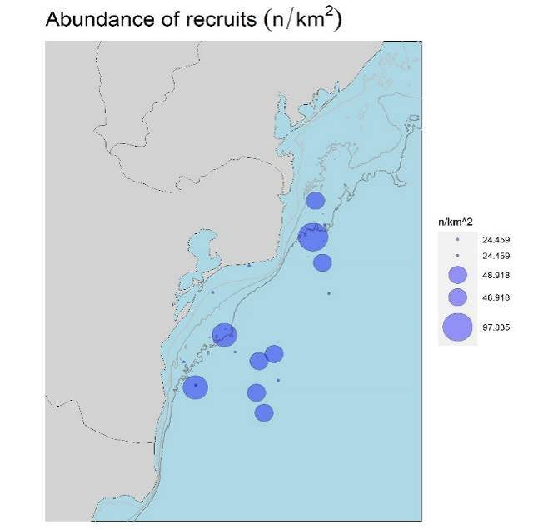 b. 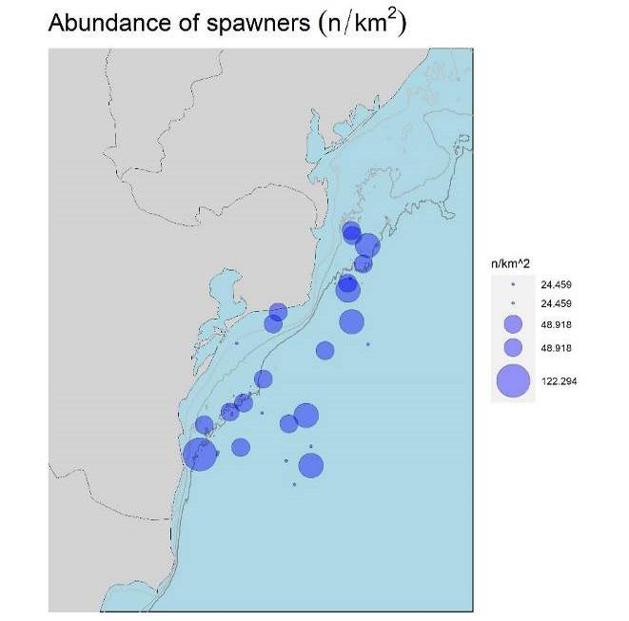
Fig. 1G.20 Abundance of recruits (a; n/Km²) and spawners (b; n/Km²), in the turbot, in spring season in 2021

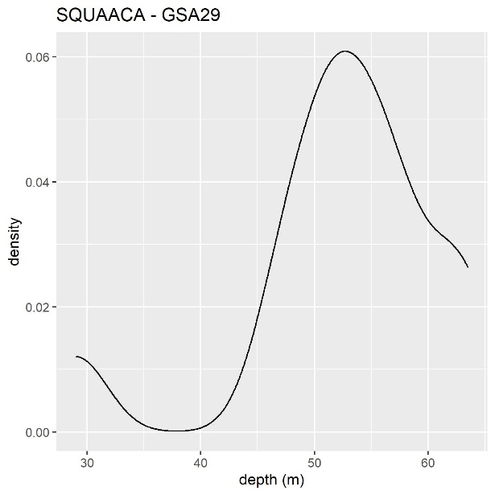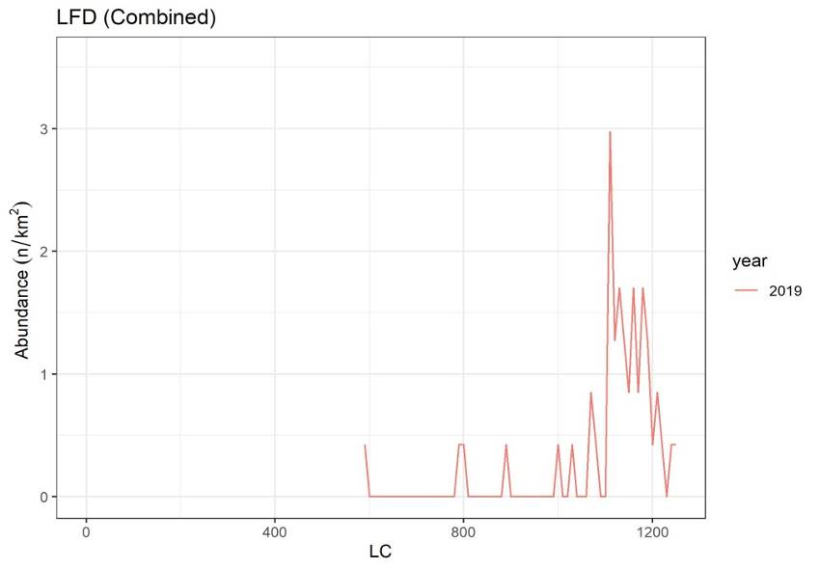

Fig. 1G21 Density of piked dogfish specimens as a function Fig. 1G22 Length frequency distribution of combined
of depth (m), in spring season, in 2021 picked dogfish, in spring season, in 2021
a. 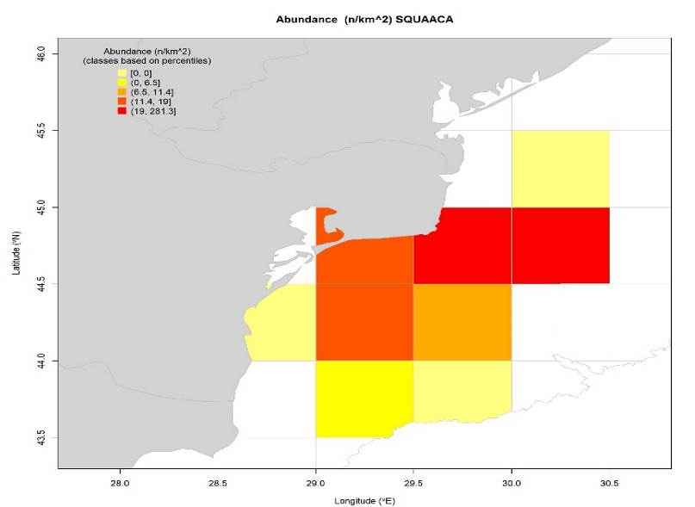 b. 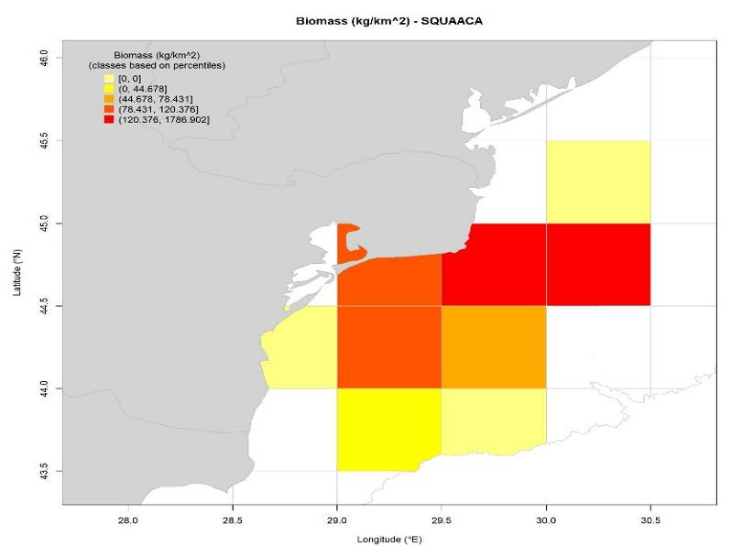

Fig. 1G23 Spatial distribution of abundance (a) and biomass (b) indices in the picked dogfish species, in spring season 2021

a. 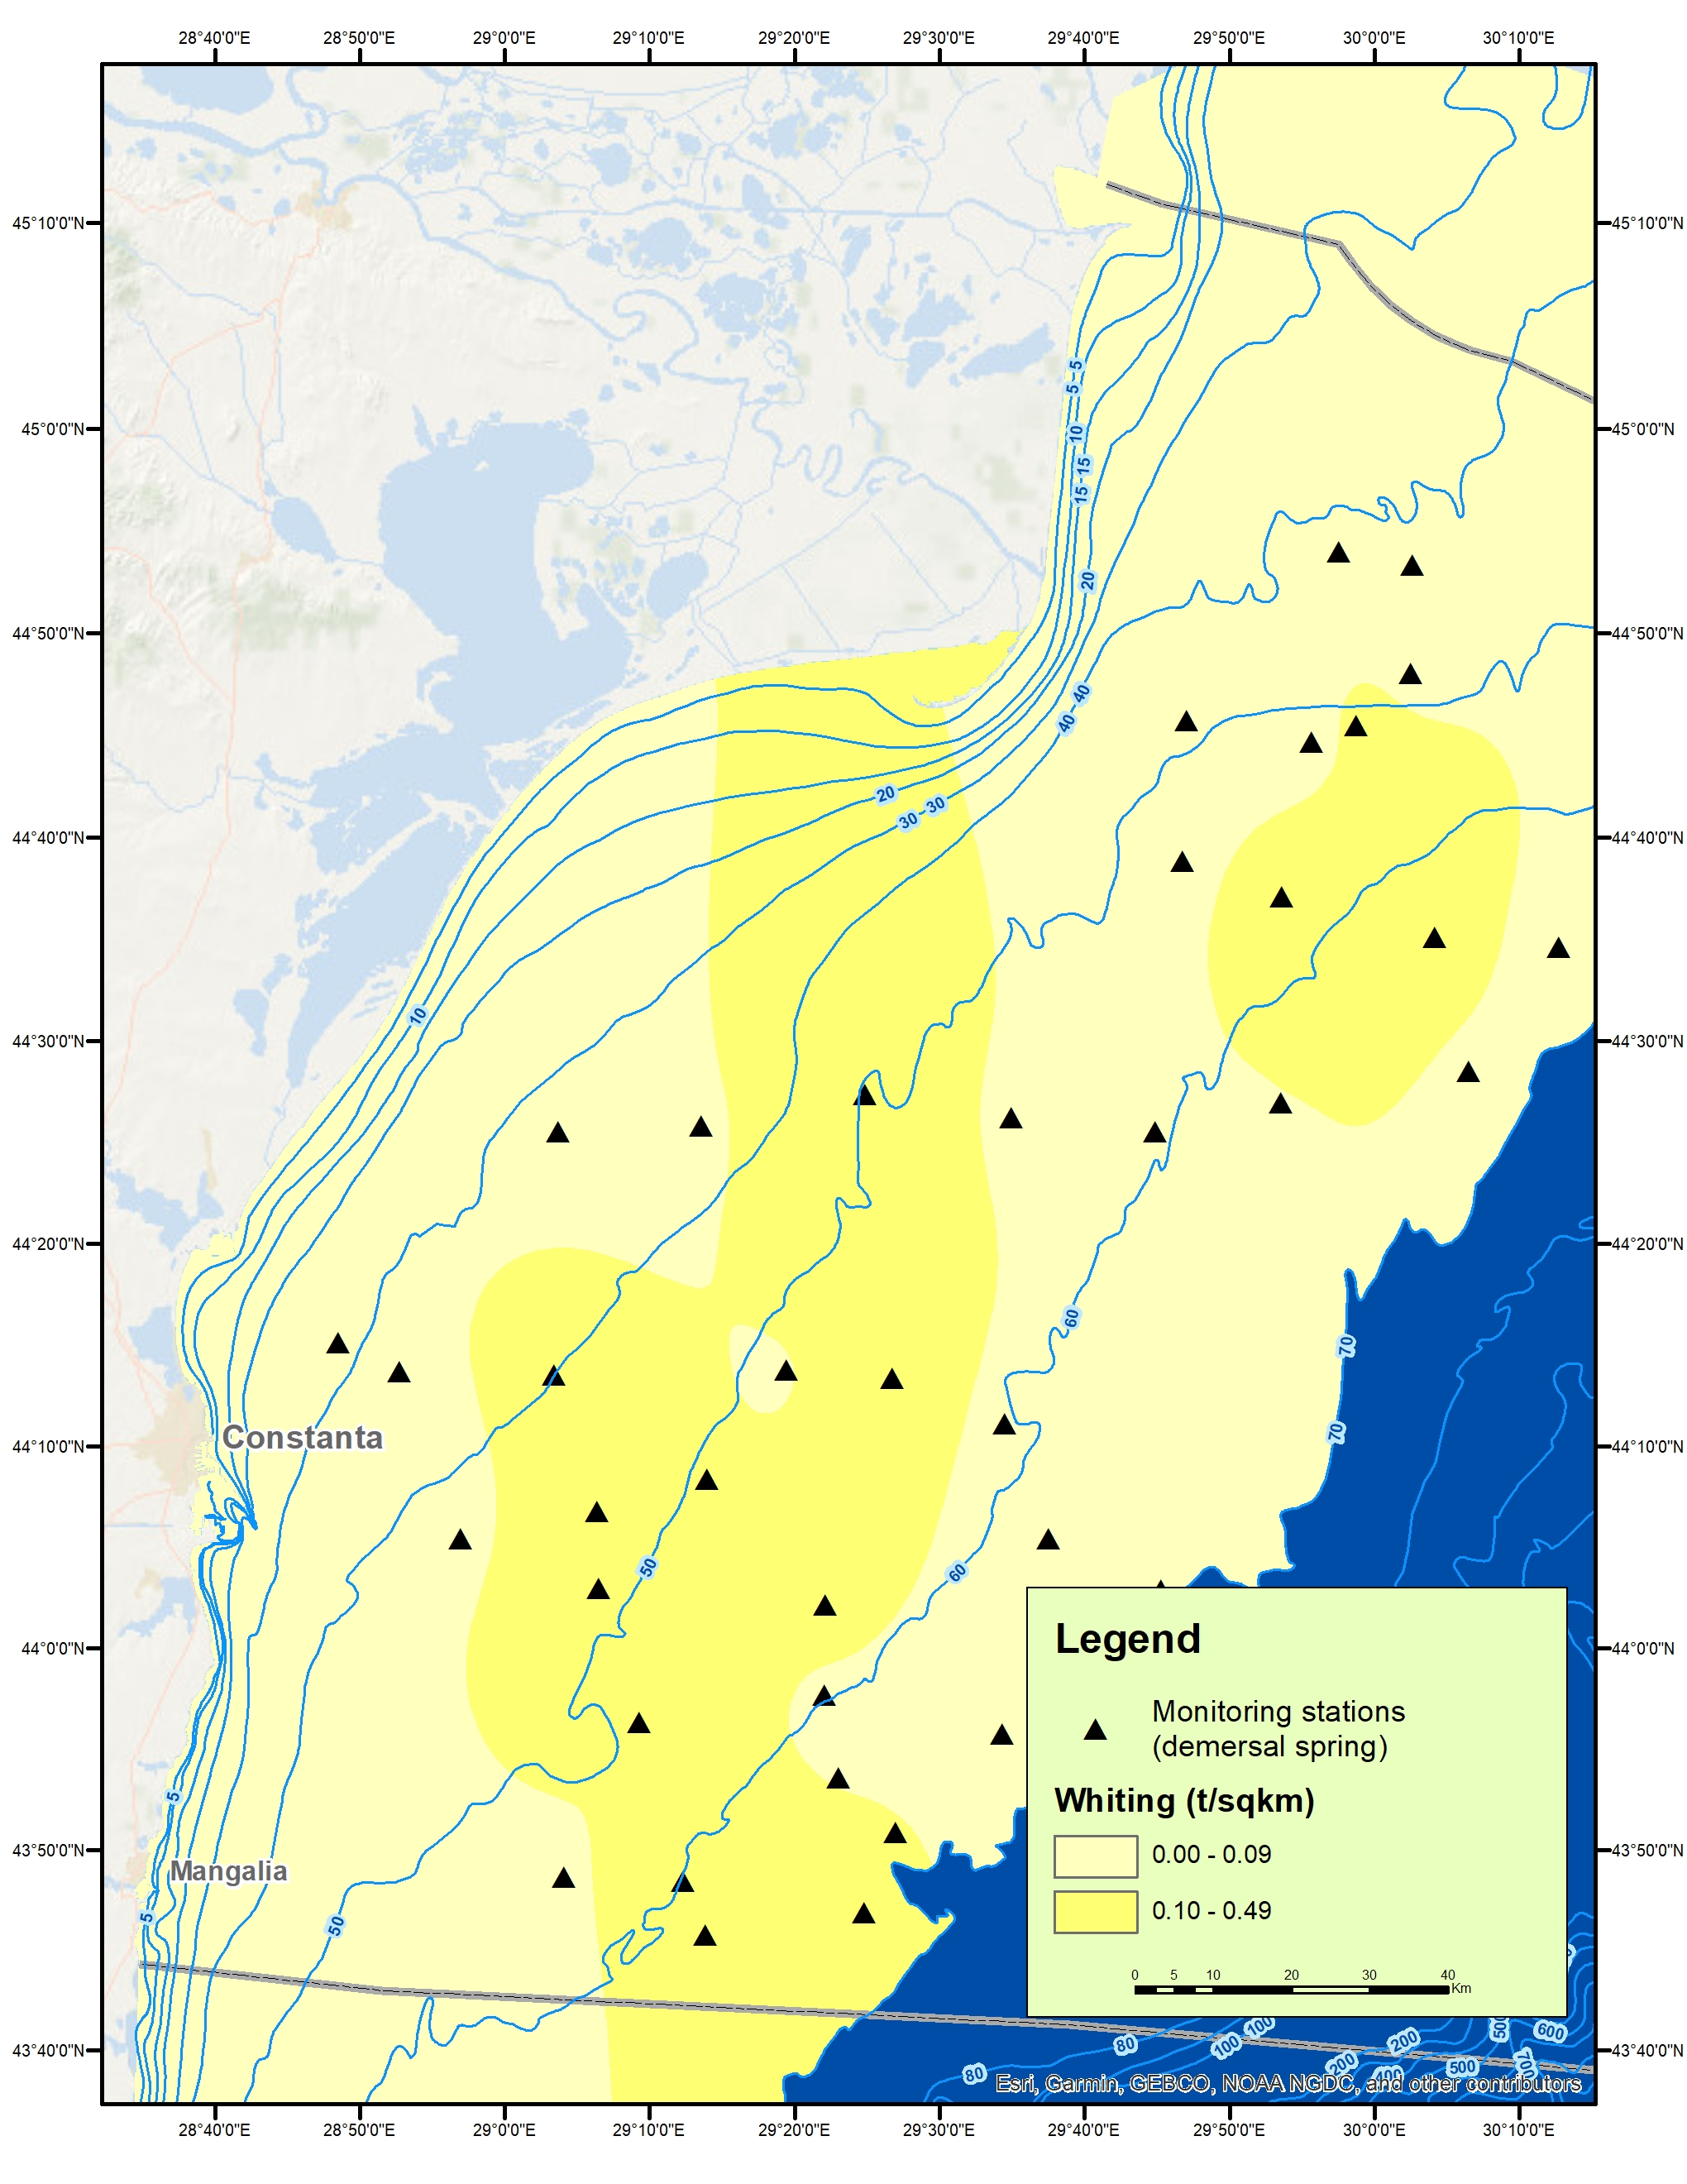 b 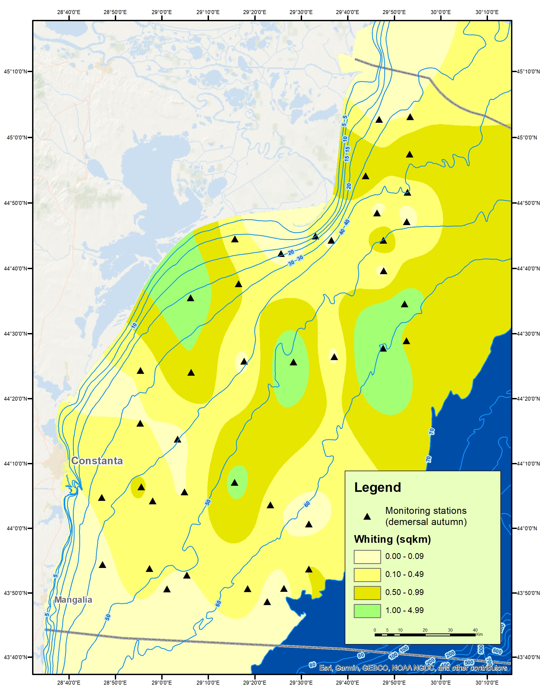
Fig. 1G24 Distribution of whiting agglomerations in the spring (a) and autumn season (b), bottom trawl survey, in 2021

Bottom trawl autumn surveys: in 2021, the calculated biomasses for the main demersal fish species at the Romanian coast were: turbot 3,441.22 t /Fig. 1G15b, Fig. 1G25, 1G26, 1G26, 1G27, 1G28 and Fig. 1G29); picked dogfish (1,945.78 t / 1G30 and 1G31) and whiting (8,123.68 t / Fig. 1G23b). In 2021, the biomass of turbot agglomerations recorded values close to those obtained in the autumn season of 2020.

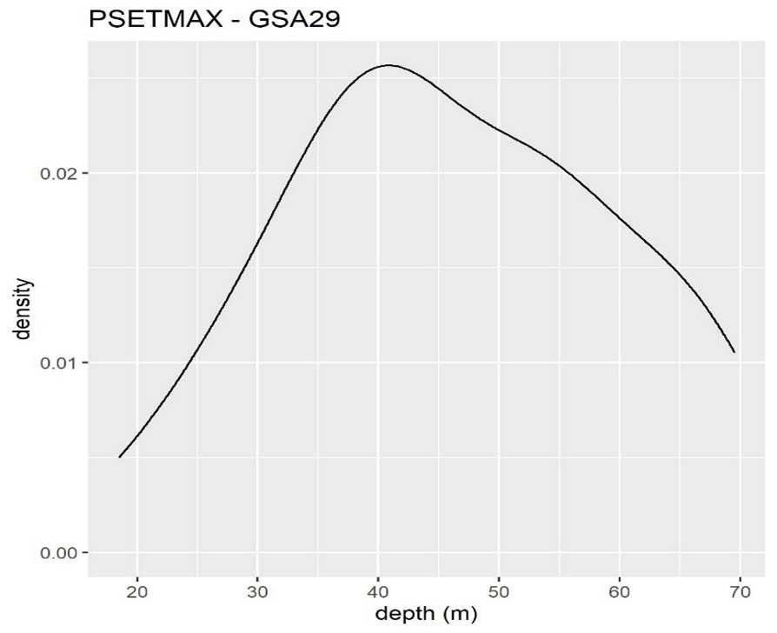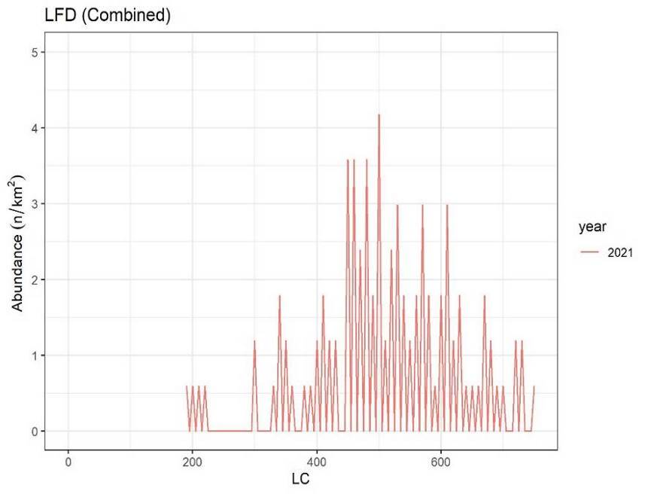
Fig. 1G25 Density of turbot specimens as a function of depth (m), Fig. 1G26 Length frequency distribution of combined turbot
in autumn season, in 2021 in autumn season, in 2021
a. 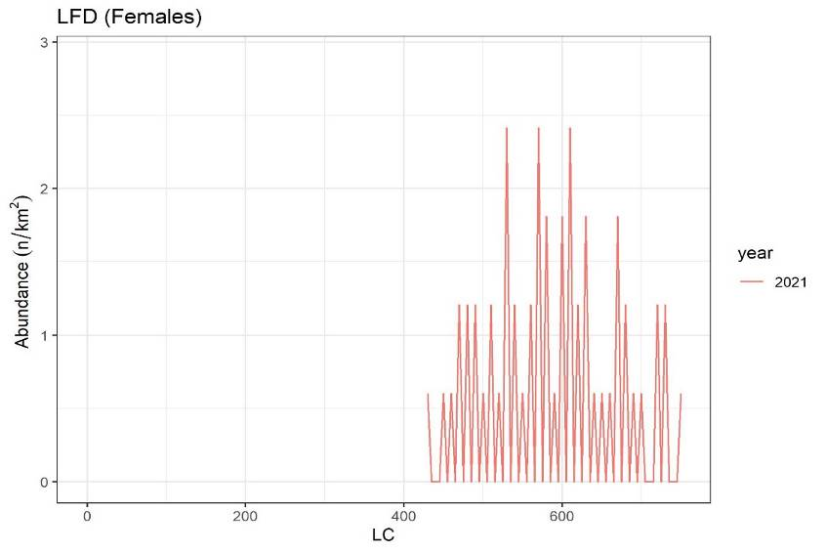 b. 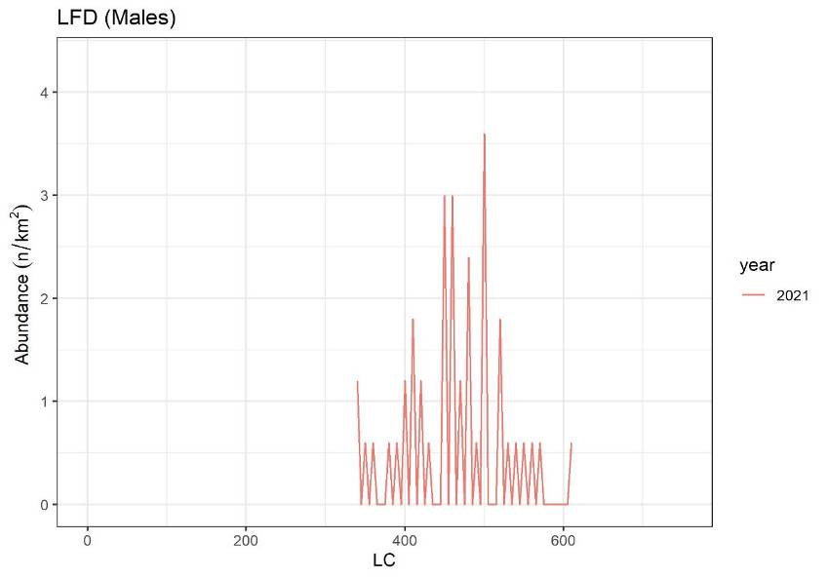

Fig. 1G27 Length frequency distribution of female’s (a) and male’s (b) turbot, in autumn season, in 2021

a. b.

Fig. 1G28 Spatial distribution of abundance (a/n/Km²) and biomass (b/kg/Km²) indices in the turbot, in autumn season 2021

a. b.
Fig. 1G29 Abundance of recruits (a; n/Km²) and spawners (b; n/Km²), in the turbot, in autumn season in 2021
. 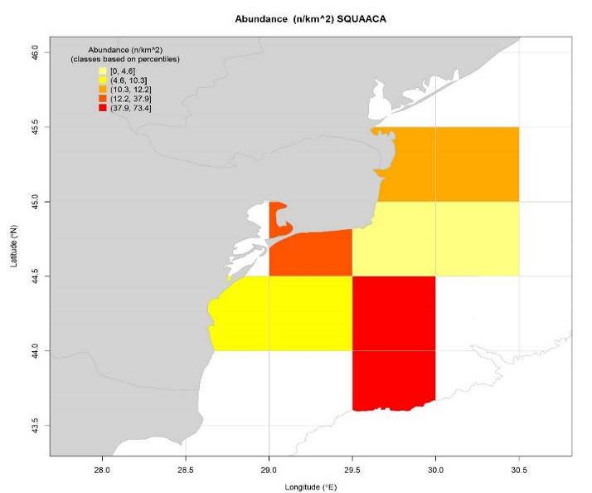 b. 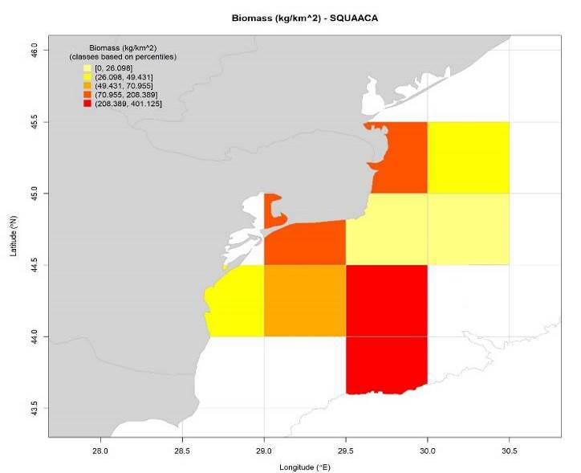

Fig. 1G30 Spatial distribution of abundance (a) and biomass (b) indices in the picked dogfish species, in autumn season 2021

7. For internationally coordinated surveys, provide a link to the latest meeting report of the coordination group

The surveys with Romanian demersal and pelagic trawls are coordinated with Bulgaria. Romanian representatives attended, were represented at the MEDITS; DG-Mare – JRC (https://datacollection.jrc.ec.europa.eu/dcf) and GFCM.

8. List the main use of the results of the survey (e.g. indices, abundance estimates, environmental indicators).

SPRING SEASON
Bottom Survey
Assessment of turbot agglomerations in spring season, demersal trawl survey, in Romanian area.
turbot / May 2021
Depth range (m) | 0–30 m | 30–50 m | 50-70 m | Total
Investigated area (Km²) | 200 | 2,900 | 6,200 | 9,300
Variation of the catches (t/Km²) | 0,000 | 0,044-0,642 | 0,053-0,425 | 0,044-0,642
Average catch (t/ Km²) | 0,000 | 0,238 | 0,190 | 0,143
Biomass of the fishing agglomerations (t) | 0,000 | 1172,72 | 1406,64 | 2579.36
Biomass extrapolated the Romanian shelf (t) |  |  |  | 3,290.48

Biomass (tons) and abundance (individuals) of turbot

a. 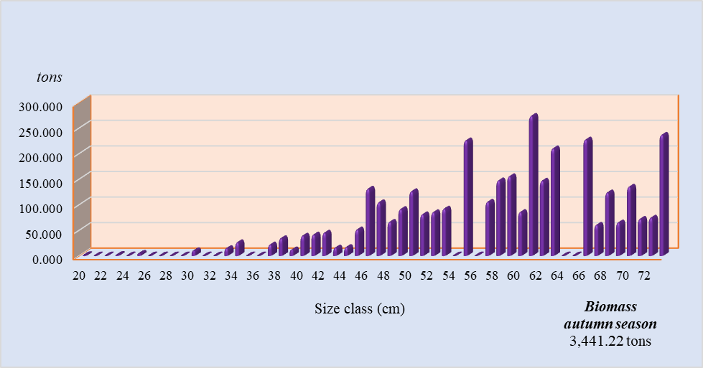 b. 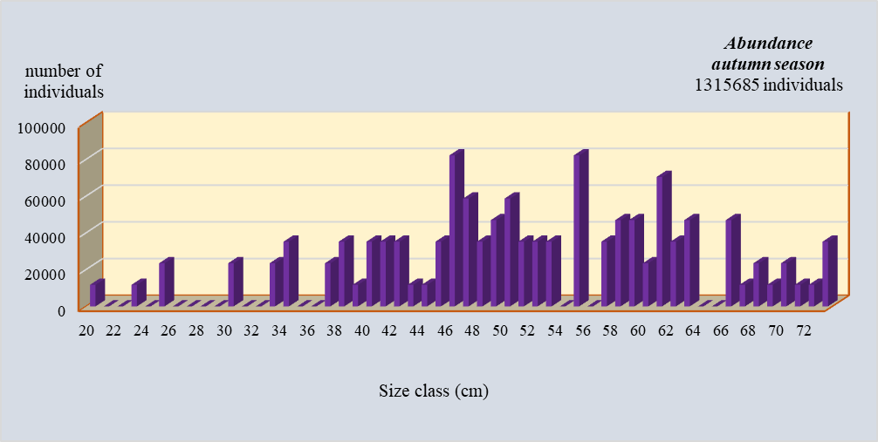

Fig. 1G31 Structure by lengths of biomass (a) and abundance (b) of turbot during spring survey

Structure of biomass and abundance by age distribution

a. 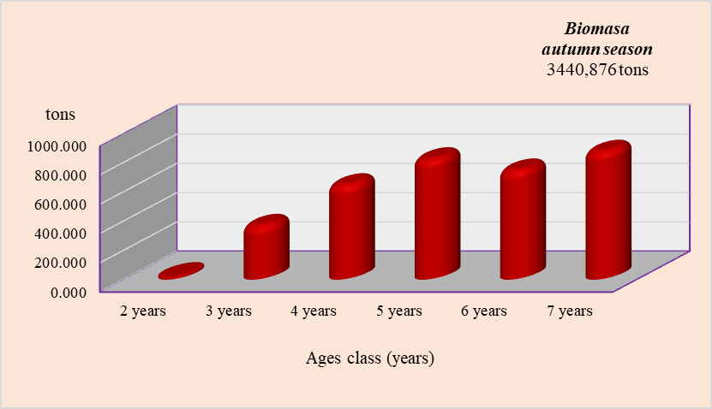 b. 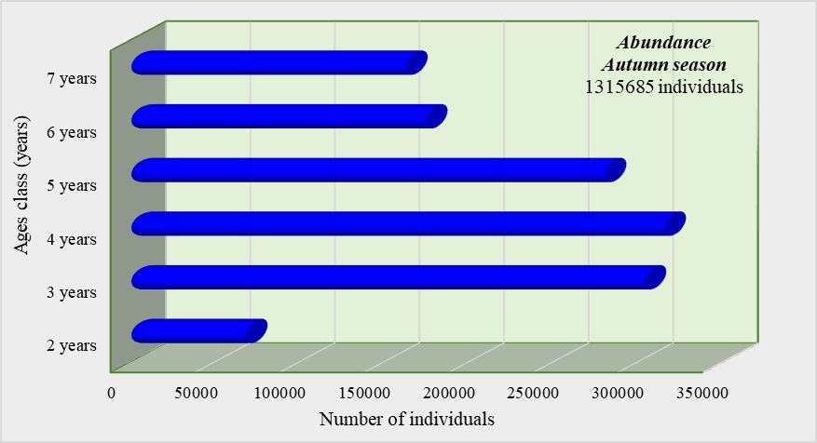

Fig. 1G32 Structure by ages of biomass (a) and abundance (b) of turbot during spring survey

a. 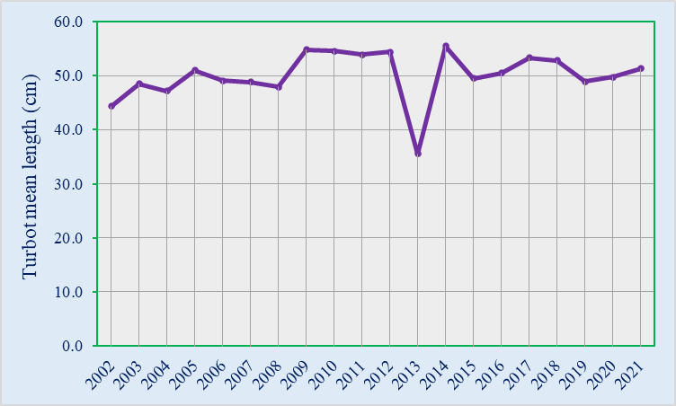 b. 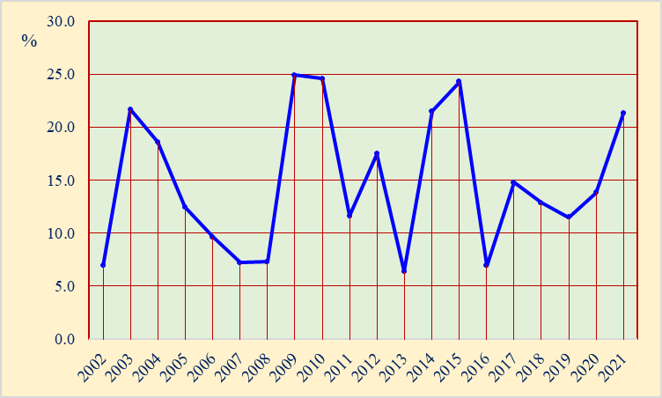
Fig. 1G33 The average length (a) and percentage (b) of turbot specimens larger than the average size at first sexual maturation in the period 2000 – 2021

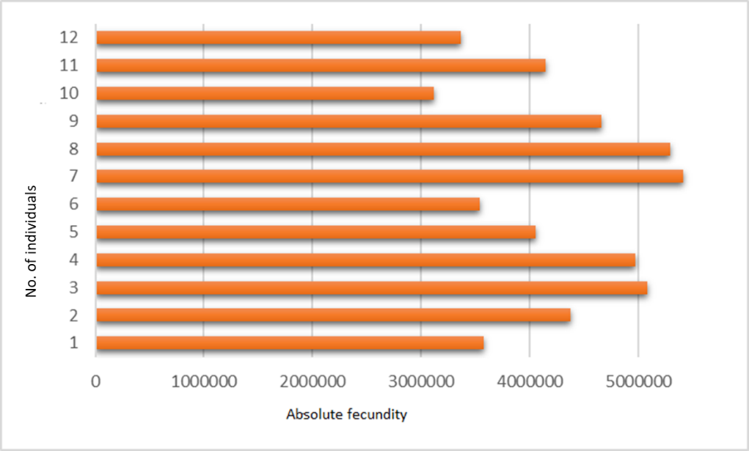

Fig. 1G34 The average values of absolute fecundity determined by turbot in 2021

Assessment of piked dogfish agglomerations in the demersal trawl expedition, in the spring season of 2021
Picked dogfish / May 2021
Depth range (m) | 0–30 m | 30–50 m | 50-70 m | Total
Investigated area (Km²) | 200 | 2,900 | 6,200 | 9,300
Variation of the catches (t/Km²) | 0.000-0.166 | 0.000-0.951 | 0.144-6.981 | 0.000-6.981
Average catch (t/ Km²) | 0.083 | 0.087 | 0.355 | 0.175
Biomass of the fishing agglomerations (t) | 203.99 | 430.65 | 2,627.47 | 3,262.11
Biomass extrapolated the Romanian shelf (t) |  |  |  | 4,135.44

Biomass (tons) and abundance (thousands of individuals) of picked dogfish

a. 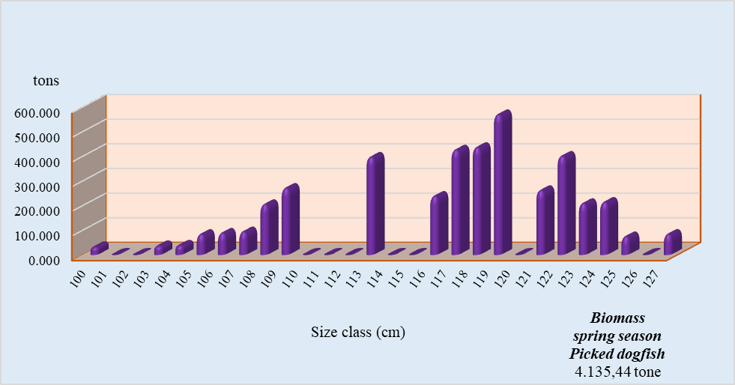 b. 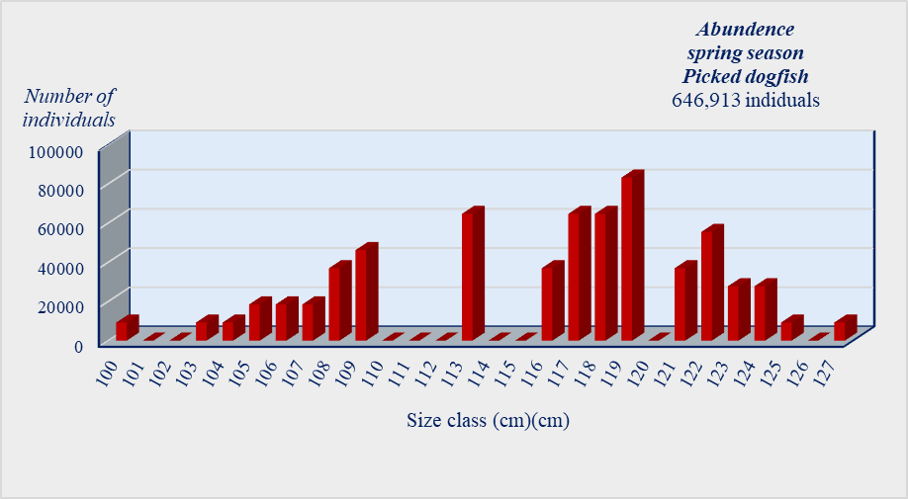
Fig. 1G.35 Structure by lengths of biomass (a) and abundance (b) of picked dogfish during spring demersal survey

Structure of biomass and abundance by age distribution

a. 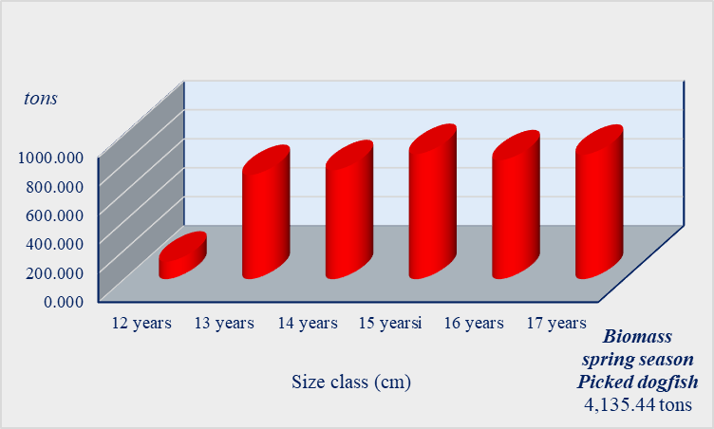 b. 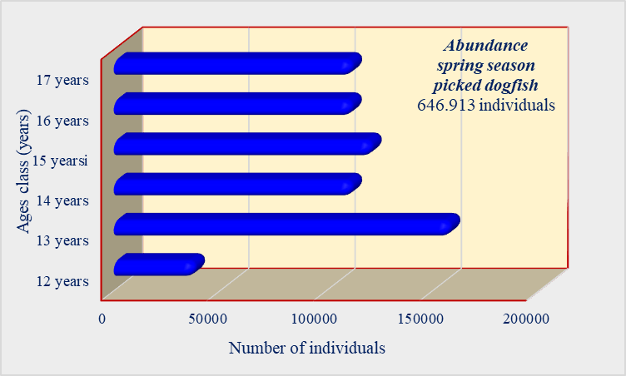
Fig. 1G.36 Structure by ages of biomass (a) and abundance (b) of picked dogfish during spring survey
Evaluation of whiting agglomerations in the demersal trawl expedition, in the spring season of 2021
Whiting / May 2021
Depth range (m) | 0–30 m | 30–50 m | 50-70 m | Total
Investigated area (Km²) | 200 | 2,900 | 6,200 | 9,300
Variation of the catches (t/Km²) | 0.002-0.062 | 0.002-0.477 | 0.011-0.249 | 0.002-0.477
Average catch (t/ Km²) | 0.032 | 0.134 | 0.097 | 0.088
Biomass of the fishing agglomerations (t) | 78.91 | 660.79 | 721.92 | 1461.62
Biomass extrapolated the Romanian shelf (t) |  |  |  | 1,899.99
Biomass (tons) and abundance (individuals) of whiting

a. 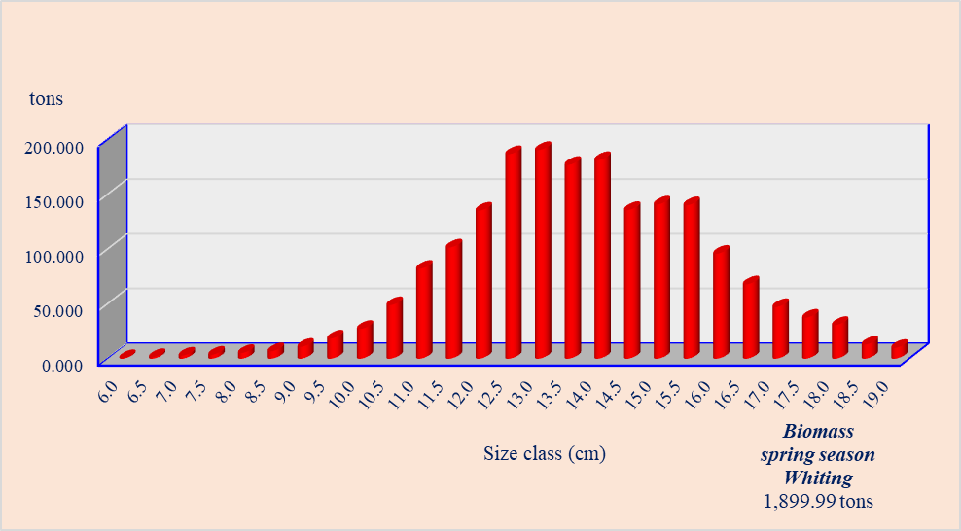 b. 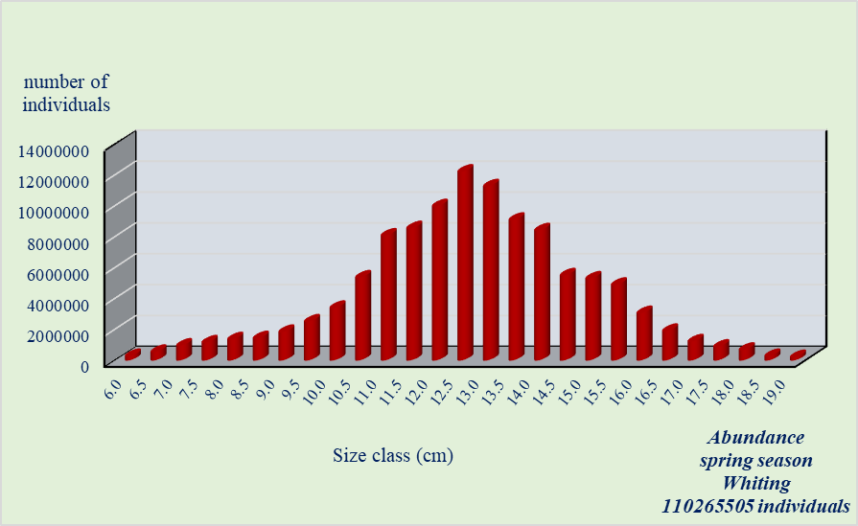
Fig. 1G37 Structure by lengths of biomass (a) and abundance (b) of whiting during spring demersal survey

Structure of biomass and abundance by age distribution

a. 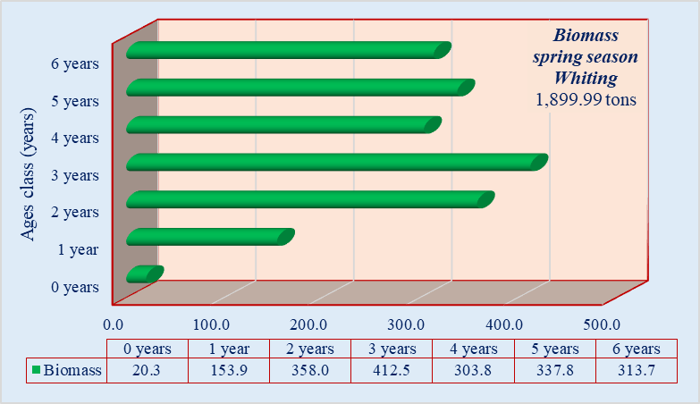 b. 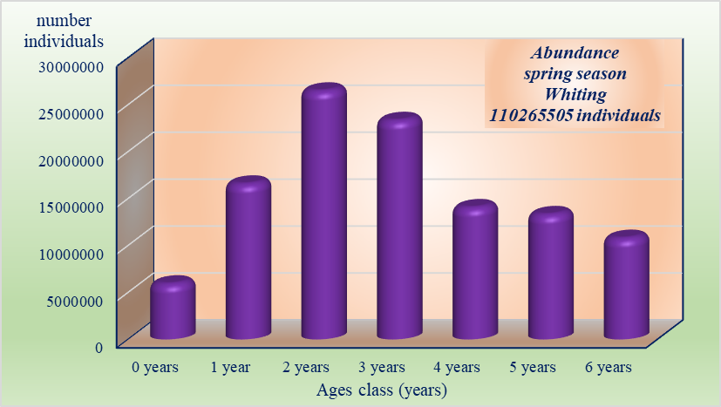
Fig. 1G38 Structure by ages of biomass (a) and abundance (b) of whiting during spring demersal survey

a. b.
Fig. 1G39 The average length (a) and percentage (b) of whiting specimens larger than the average size at first sexual maturation in the period 2000 – 2021

AUTUMN SEASON
Demersal survey
Evaluation of turbot agglomerations in the demersal trawl expedition, in the autumn season of 2020
Turbot / October 2021

Depth range (m) | 0–30 m | 30–50 m | 50-70 m | Total
Investigated area (Km²) | 1,600 | 3,900 | 5,200 | 10,700
Variation of the catches (t/Km²) | 0.136-0.256 | 0.088-0.482 | 0.116-0.350 | 0.088-0.482
Average catch (t/ Km²) | 0.151 | 0.208 | 0.160 | 0.173
Biomass of the fishing agglomerations (t) | 370.42 | 1024.79 | 1183.60 | 2578.81
Biomass extrapolated the Romanian shelf (t) |  |  |  | 3,441.22

Biomass (tons) and abundance (individuals) of turbot

a. b.

Fig. 1G37 Structure by lengths of biomass (a) and abundance (b) of turbot during autumn survey
Structure of biomass and abundance by age distribution
a. b.

Fig. 1G40 Structure by ages of biomass (a) and abundance (b) of turbot during autumn survey

Evaluation of picked dogfish agglomerations in the demersal trawl expedition, in the autumn season of 2020
Picked dogfish / October 2021

Depth range (m) | 0–30 m | 30–50 m | 50-70 m | Total
Investigated area (Km²) | 1,600 | 3,900 | 5,200 | 10,700
Variation of the catches (t/Km²) | 0.000-0.324 | 0.000-0.136 | 0.144-0.498 | 0.000-0.498
Average catch (t/ Km²) | 0.094 | 0.016 | 0.160 | 0.090
Biomass of the fishing agglomerations (t) | 230.99 | 80.13 | 1185.01 | 1496.13
Biomass extrapolated the Romanian shelf (t) |  |  |  | 1,945.78

Biomass (tons) and abundance (individuals) of picked dogfish
a. 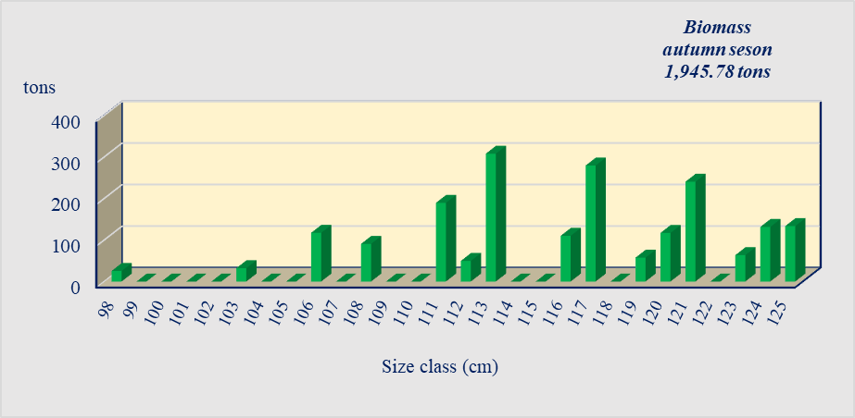 b. 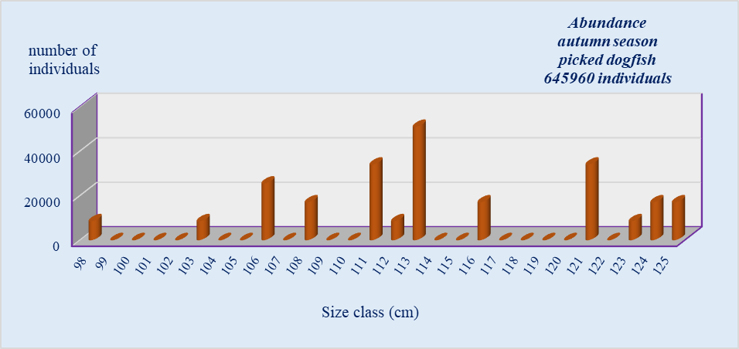
Fig. 1G41 Structure by lengths of biomass (a) and abundance (b) of picked dogfish during autumn survey

Structure of biomass and abundance by age distribution
a. 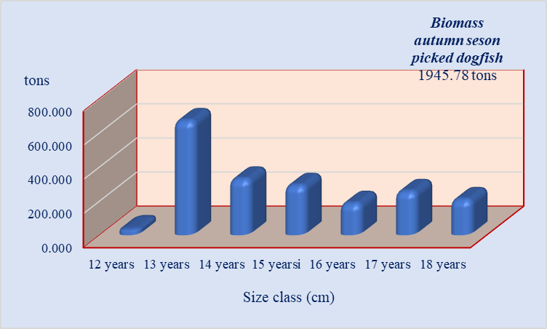 b. 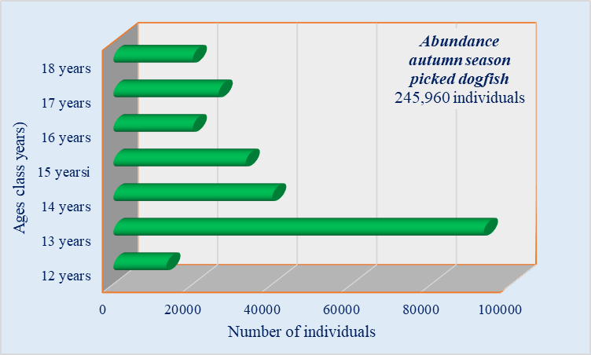

Fig. 1G.42 Structure by ages of biomass (a) and abundance (b) of picked dogfish during autumn survey

a.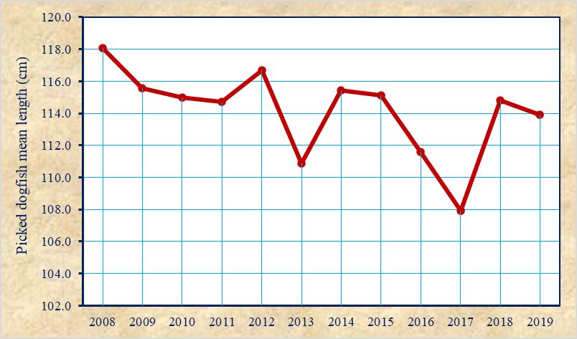 b. 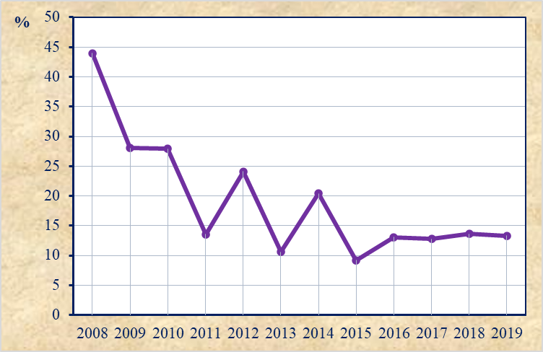
Fig. 1G43 The average length (a) and percentage (b) of picked dogfish specimens larger than the average size at first sexual maturation in the period 2008 – 2021

Evaluation of whiting agglomerations in the demersal trawl expedition, in the autumn season of 2020
Whiting / October 2021

Depth range (m) | 0–30 m | 30–50 m | 50-70 m | Total
Investigated area (Km²) | 1,600 | 3,900 | 5,200 | 10,700
Variation of the catches (t/Km²) | 0.000-1.308 | 0.000-0.934 | 0.085-1.619 | 0.000-1.619
Average catch (t/ Km²) | 0.411 | 0.286 | 0.501 | 0.399
Biomass of the fishing agglomerations (t) | 1008.03 | 1409.98 | 3713.21 | 6131.22
Biomass extrapolated the Romanian shelf (t) |  |  |  | 8,123.68

Biomass (tons) and abundance (individuals) of whiting
a. 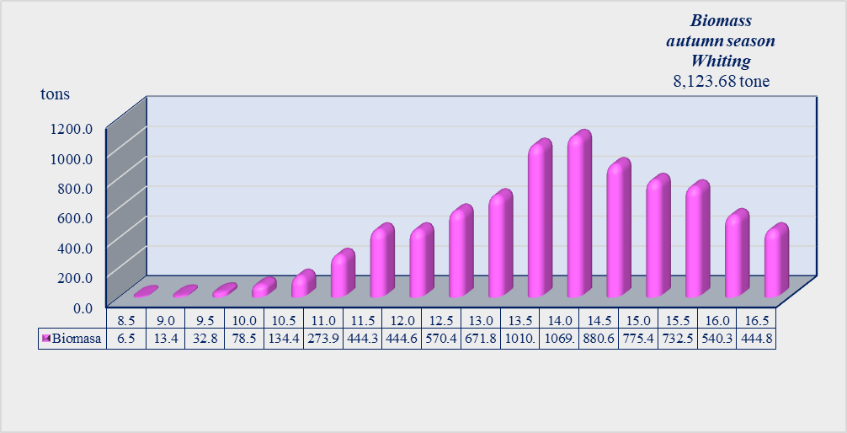 b. 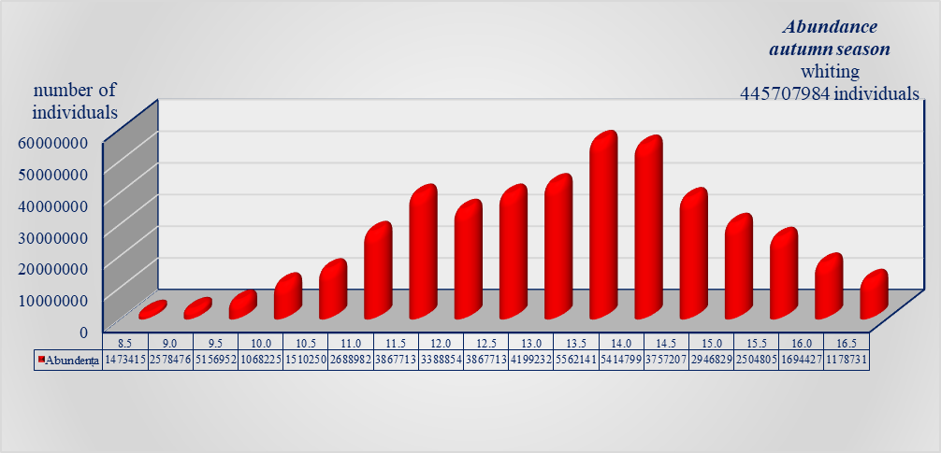
Fig. 1G44 Structure by lengths of biomass (a) and abundance (b) of whiting during autumn survey

Structure of biomass and abundance by age distribution
a. 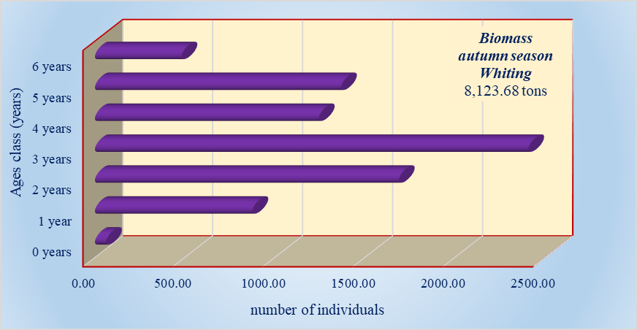 b. 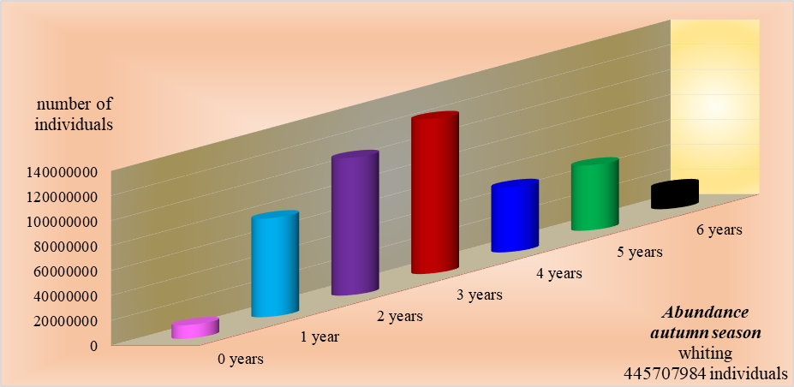
Fig. 1G45 Structure by ages of biomass (a) and abundance (b) of whiting during autumn survey

9. Extended comments (Tables 1G and 1H)
If the Member State has extended AR Comments, these can be placed under this section. If this is the case, a reference to this text box should be provided in the corresponding tables.

During the surveys at sea and at the fishing points along the Romanian Black Sea coast, in accordance with the activities provided in the National Program, information on incidental by-catch of birds, mammals, reptiles and fish were collected. Species striped red mullet / Mullus surmuletus, not present in Romanian area. Also, data on the presence of mammals in the area of the stationary and the active fishing gears and the presence of marine litter, both on land and at sea, were collected. All the collected data have been reported to the international bodies to which Romania has adhered or participated as a partner in the ongoing international projects. Thus, mammalian data were reported annually to ACCOBAMS (http://www.accobams.org/) and data on marine litter were uploaded to the EMOD-NET platform (https://www.emodnet-chemistry.eu/).

Section 2: Fishing Activity Data
Text Box 2A: Fishing activity variables data collection strategy

General comment: This box fulfills paragraph 4 of Chapter III of the Annex of the Delegated Decision (EU) 2019/910 on the multiannual Union programme; and Article 2, Article 4 paragraph (2) point (b) and Article 5 paragraph (2) of the Implementing Decision (EU) 2016/1701 on the format of the WP. It is intended to describe the method used to derive estimates on representative samples where data are not to be recorded under Regulation (EU) No 1224/2009 or where data collected under Regulation (EU) No 1224/2009 are not at the right aggregation level for the intended scientific use.
General comment: This box is applicable to the Annual Report. This box should provide information on the implementation of the data collection of fishing activity variables of Member States.
1. Description of methodologies used to cross-validate the different sources of data.

For verifying the accuracy of capacity and effort there is the possibility of cross validation with data of capacity and effort that are mentioned in the questionnaire completed by each economic agent in accordance with the provisions of provenance and results of the activities carried out.
To verify the accuracy of data on landings situation there is the possibility to cross-validate data log sheets with the sales notes and transport notes.

2. Description of methodologies used to estimate the value of landings.

The data corresponding to the variable of landings (total amount of landings per species, the total weight of landings per species and prices of each species) is achieved by exhaustive method, a coating method that ensures 100% of the population and the maximum level of quality. Data collection is performed monthly from the following sources: log sheets, sales notes and transport notes filled out by each economic agent subsequently transmitted by NAFA fishery inspectors to NIMRD.

3. Description of methodologies used to estimate the average price (it is recommended to use weighted averages, trip by trip)

Estimating the average price for each commercial species is achieved by weighted average.

4. Description of methodologies used to plan collection of the complementary data (sample plan methodology, type of data collected, frequency of collection etc)

The data collected corresponding to the variables for capacity, effort will be simultaneously drawn from sources such as journals, fishing fleet registers, sale notes and questionnaires by the exhaustive method. The operation of collecting data will be done monthly from the sources mentioned above, provided by fishery inspectors, by regularly checking fisheries landing points and first sales centers, respectively. This method ensures 100% coverage of the population and the highest level of quality.
Data regarding capacity is available in the fleet register, where you find the following information: vessel length, gross tonnage, maximum power of the main engine and age of the ship.
Data on effort (days at sea, fishing days, no. of trips, no. of fishing operations, name and number of fishing gear, etc.) are available in the logbooks for vessels over 12 meters and in the coastal logbooks for boats smaller than 12 m.

No thresholds will be applied, specified in Chapter V of Commission Implementing Decision (EU) 2016/1251.
5. Deviations from Work Plan methodology used to cross-validate the different sources of data

No thresholds will be applied, as specified in Chapter V of Implementing Decision (EU) 2019/910.

6. Deviations from Work Plan methodology used to estimate the value of landings.

There are no deviations from the methodology used to estimate the value of landings.

7. Deviations from Work Plan methodology used to estimate the average price.

There are no deviations from the methodology used to estimate the average price.

8. Deviations from Work Plan methodology used to plan collection of the complementary data.

There are no deviations from Work Plan methodology used to plan collection of the complementary data.

Section 3: Economic and Social Data
Text Box 3A: Population segments for collection of economic and social data for fisheries

General comment: This box fulfils paragraph 5 points (a) and (b) of Chapter III of the Annex of the Delegated Decision (EU) 2019/910 on the multiannual Union programme; and Article 2, Article 4 paragraphs (1), (2) and (5) and Article 5 paragraph (2) of the Implementing Decision (EU) 2016/1701 on the format of the WP. It is intended to specify data to be collected under Tables 5(A) and 6 of the delegated decision on the multiannual Union programme.
General comment: This box is applicable to the Annual Report. This box should provide information on the implementation of the fleet socio-economic data collection of Member States.
1. Description of methodologies used to choose the different sources of data

The variables collected for this section are listed in Table 5A of the multiannual program of the EU. The reported data were collected according to the level of the requirements set out in Tables 3, 5B and 5C of the EU-MAP. The main sources of economic and social data collection are based on the following documents: the questionnaires, fishing log-books at the Black Sea and coastal fishing log-books. Those correspond to the national fleet register, sale notes and transport notes.
a. The questionnaires are the source of for economic and social data as requested in table 5 A of EU-MAP.
b. The logbook is the document in which, besides data on fishing effort and catches, are included data requested in table 5A of EU-MAP.
c. The fleet register is a document that contains information for technical characteristics of all fishing vessels, as per data requested in table 5A of EU-MAP.
d. Sale notes contain data requested in table 5A of EU-MAP.

2. Description of methodologies used to choose the different types of data collection

The main holders of economic and social data are the economic operators engaged in fishing on the Romanian coast of the Black Sea. In the orders issued by the Ministry of Agriculture and Rural Development they have an obligation to complete these data in fishing journals of the Black Sea and the coastline, sale notes, transport notes and questionnaire All these documents, except the questionnaire, are taken monthly from every economic operator by NAFA inspectors, after a preliminary verification and available to the research staff of the NIMRD to be centrally processed and transmitted to end-user format requested by them. Documents such as fishing logbooks, landing declarations in ports/landing sites should be handed-over/delivered to NAFA inspectors by the captains/deputy of the vessels.
The data collection in the landing sites, nominated by NAFA, among the Black Sea coast, will be done by NAFA staff. For the conformity of fishery data, inspectors confront fishing journals with the sale notes and transport notes. If these data are not in correlation, the necessary corrections are performed.
Elaboration of the Questionnaire content is conducted by research staff of NIMRD in collaboration with NAFA staff with strict compliance of the notice of all economic and social data requested in Decision (EU) 1251/2016 and 910/2019. After completion of the final form of the questionnaire, it is distributed by NAFA inspectors to each economic agent that has the obligation to complete all available data depending on the complexity of the activities performed, after drawing up the balance. Finally, NAFA inspectors give these questionnaires to the research team of NIMRD, who verify the data and they contact the NAFA inspectors and the economic operators when there are certain ambiguities in order to correct them.

3. Description of methodologies used to choose sampling frame and allocation scheme
The data collection method which will be applied is stratified random. As per the obligations related to various data that should be reported to other organisms of EC, e.g. Eurostat (the annual methodological report for collection and management data on statistics of national fisheries and aquaculture), the exhaustive method will be applied, covering 100 % the active vessels registered in FFR, for all segments of the fleet. The following procedures/means will be used:
1. NAFA staff:
- headquarters of NAFA: 2 persons centralising and compiling data, issuing the requested forms for transmission to relevant bodies national and international;
- regional branch of NAFA in Constanta, responsible for the activities in their competence area; one person is collecting data from the in-charge inspectors of NAFA and the operators in the field.
2. Technical equipment: PCs, laptops, electronic mail - basically, for the links between central offices and regional branches. The collected data useful for the scientists, as a base for their works, are transmitted to them (NAFA to NIMRD).

4. Description of methodologies used for estimation procedures
The calculation of these variables, for the active vessels, will respect the instructions indicated in the Table 5A of the multiannual program of the Union [Decision (EU) 2016/1251] and will be based on the figures obtained through questionnaire and other sources, showed above mentioned, from the owners of the fishing units by the inspectors of NAFA and the provisions of the national fishing legislation.
The data will be collected from all economic operators. In such a case, the data collection method is exhaustive and the resulting assessment will by a census.
As per national legislation, the captain has the obligation to fulfil the coastal logbook for each fishing operation, including the no. of hours, no. and type of gears, the fishing area and the catches per species, live weight and prices of sales (sales notes).
These obligations are similar to the requested legal obligations as for the vessels less than 12 m. These vessels are obliged to complete the Coastal Fishing Logbook, having the same obligations as above mentioned for the vessels bigger 12 m.
Information is obtained by NAFA local branch personnel, weekly/ monthly, by taking over from the authorized operators/ license owners the records regarding: species/ products accomplished quantity (kg live weight) and the average price for sale in order to inform the national authorities responsible in the field and international fora.
For data collection regarding all the activities mentioned above, there are no other legal regulatory acts issued by other national authorities, including the national statistics one, beside those issued by the Ministry of Agriculture. The figures are verified with those registered in sales notes, as per domestic legislation and internal procedure rowels of NAFA. Romanian fishing vessels operate only in one supra-region/region, according to Table 5C of the multiannual program of the Union [Decision (EU) 2016/1251] - supra-region Mediterranean Sea and Black Sea, subregion Black Sea.

5. Description of methodologies used on data quality
The method described for collecting the data using the legal documents requested by internal legislation and local NAFA staff activity will provide for a 100% accuracy for all fishing vessels. In order to collect data, the records in the above-mentioned documents will be used. This information is submitted by all active vessels to the regional branch of NAFA, where they are taken over by staff appointed to process the legal documents, in line with our national regulations.
Weekly, for fishing activities, the staff in regional branches centralizes data to be recorded: total production, raw material sales, final destination of own products, total value of each catch produced.
Data reliability/control verification by comparing data with other sources, as a statistical rule, is made by cross-checking the documents requested at branch level by local inspector and the person specialized in centralizing data. The second stage takes place in NIMRD - the figures are verified by staff processing data (a cross-check of all data provided by economic operators, NAFA and the Ministry of Finance), who is responsible with submitting the information to the centralized database - NDCP Romania. The methodology used cannot be publicly accessed because the site NAFA is not yet operational. The program database is stored separately on a secured server in NIMRD.
No thresholds will be applied, specified in Chapter V of Commission Implementing Decision (EU) 2016/1251.

6. Deviations from Work Plan methodology for selection of data source

There are no deviations from the methodology used to select the data source.

7. Deviations from Work Plan methodology to choose type of data collection

There are no deviations from Work Plan methodology to choose type of data collection.

8. Deviations from Work Plan methodology regarding sampling frame and allocation scheme

There are no deviations from the Work Plan methodology regarding sampling frame and allocation scheme.

9. Deviations from Work Plan methodology used for estimation procedures

The economic and social data collected from fishing units are included in Table 3A. There are no deviations from Work Plan methodology used for estimation procedures.
The difference in the number of rows between the accepted WP and the current AR is due to the fact that in the accepted WP the fishing techniques are passed on length classes that are supposed to be sampled in the period 2020-2021, and in the current AR the reference is made to the fishing techniques on length classes that were existing and sampled in 2021.

10. Quality assurance

10.1. Sound methodology

The collection of fishing data complies with the methodologies agreed within the group of experts. Methodologies are documented and not made public.

10.2. Accuracy and reliability

The response rate and sampling rate are provided in Table 3A - "Segmentation of population for the collection of economic and social data for fishing" (as required by EU Decisions 2019/910 and 2016/1701).

The response rate is expressed as a percentage.

Validation and evaluation of raw data, intermediate and final results was carried out in a first step by crosschecking both by NAFA and by NIMRD (the gross delete) and data recorded in all the documents provided by the economic operators.

In the second stage, the staff specialized in the centralization of the data from NAFA and NIMRD carried out a re-verification of centralizations in case documents were found that were not sent in time or in which minor modifications and subsequent amendments were made by certain economic operators. In the last stage, NIMRD research staff, following a reassessment of the integrity and accuracy of data from centralized situations, switched to data processing, as well as a regular check of the interim and final results respectively

10.3 Accessibility and clarity

Are methodological documents available publicly?

YES

Are the data stored in databases?

YES

Where can one find methodological documents and other documents?

The web page is under construction.

The program database is stored separately on a secured server of National Institute for Marine Research and Development Grigore Antipa Romania (NIMRD) – http://cdp.rmri.ro/pncd/index.html

Section 3: Economic and Social Data
Pilot Study 3: Data on employment by education level and nationality

General comment: This box fulfills paragraph 5 point (b) and paragraph 6 point (b) of Chapter III of the Annex Delegated Decision (EU) 2019/910 on the multiannual Union programme; and Article 2 and Article 4 paragraph (3) point (c) of the Implementing Decision (EU) 2016/1701 on the format of the WP. It is intended to specify data to be collected under Table 6 of the delegated decision on the multiannual Union programme.
General comment: This box is applicable to the Annual Report. This box is intended to provide information on the results obtained from the implementation of the pilot study (including deviations from planned and justifications as to why if this was not the case).
1. Aim of pilot study

The aim of the pilot study is to establish a methodology to facilitate the collection of data on the employment situation in the fisheries depending on the level of education and nationality. The aim of the pilot study is to develop and test the most effective tools / ways of investigating social component in the fisheries sector. The data planned to obtain aimed at defining / characterization employees in the sectors of fisheries, aquaculture and processing industry based on the level of education, age, gender and nationality.

2. Duration of pilot study

Since the Romanian coastal fishing activities are seasonal, a situation that leads to temporary use of certain categories of vessels, fishing gear and personnel involved with different levels of training and nationalities, we believe that the duration required for the operation of the pilot study should be of calendar two years (2020-2021) and the results will be available in 2022. It must be taken in consideration that for every new information, people become apprehensive, hard to convince and that involves performing several field trips and, consequently, much work to be clarified.

3. Methodology and expected outcomes of pilot study

3.1 Methodology

Data collection aimed at the education level and nationality personnel working in the marine fisheries sector will be based on the questionnaire, where each economic operator will record the data for each employee under his company. Questionnaires will be developed by the research staff of NIMRD “Grigore Antipa” and will be shared with NAFA inspectors to a small group of economic operators that must conduct fishing activities that include all segments of the vessels and fishing gear used in different sectors of the Romanian seaside. The questionnaires will be collected by NAFA inspectors from the economic agents and made available to research staff of NIMRD “Grigore Antipa”, who will analyse and process data from the questionnaires. Also, the research staff of NIMRD will use various documents and data stored by NAFA on the courses carried out by authorized personnel for fishing activities. It also for data validation will intervene directly undertakings.
The methodology established by the pilot study will open the way to the statistical evaluation of the level of studies and nationalities of all personnel operating in the field of fishing. This way one can determine the level of training / experience of staff performing marine fishing.

Pilot studies will be based on quantitative and qualitative methods. The qualitative method will involve the focus group / round table with experts and professional organizations to establish the questionnaire. Determining sample, distribution and collection of questionnaires, will involve the quantitative method of the pilot study. The last phase of the pilot study will be: analysis and interpretation of the collected data, testing the efficacy of research instruments and protocols and estimation of statistical parameters for later analysis. Expected outcomes of the study will be to know the education level, age, gender and nationality of employees and to identify the best method to collect these data in the future.

3.2 Expected outcomes of pilot study

Setting-up the componence of the education level and nationality of personnel performing along the Romanian coast, by vessel segments, gear and fishing sectors of the Romanian Black Sea coast.
Also, if from the study’s results that the level of training of staff that conducts fishing activities is mediocre, action should be taken, by achieving professional development in this kind of activities they perform in this domain.

No thresholds will be applied, specified in Chapter V of Commission Implementing Decision (EU) 2016/1251.

4. Achievement of the original expected outcomes of pilot study and justification if this was not the case.

a. Fisheries: the purpose of the study was to assess the social circumstances based on the main indicators: the structure of the workforce divided by gender, age, level of education, nationality and professional status, unpaid labour by gender, equivalent to full-time (FTE) by gender and national level. The results of the study were materialized in a database on the social structure of fishing personnel such as quantitative and qualitative contribution broken down by sex, age, nationality, level of education, level of training, implicitly, structure of the days and hours worked. In order to determine an overview of fishermen's communities fishing in the Romanian Black Sea sector and to ensure the overall objectives of the study, the data was initially collected from official sources, which were subsequently supplemented from the social analysis of these. Finally, the overall picture is complex, starting from the general analysis of communities and identifying social issues.
The data and information collected they highlighted the level of social progress and were provide the opportunity to take appropriate social policy measures to improve the social conditions for fishing communities by linking and optimizing existing reports among the main social indicators. We can say that the study has facilitated the assessment of the existing social situation in the fisheries sector.

The analysis of the social situation of the personnel who carried out fishing activities in the coastal and marine areas of the Romanian Black Sea sector
The structure of the personnel who worked in the period 2020 - 2021 in the marine fishery sector, by the state of employment

In 2020, a total of 131 vessels were active, the personnel engaged in sea fishing activities being 416 individuals and in 2021 for a total of 130 active vessels, the number of personnel was 439 individuals. The average number of people employed per ship was 3 persons / ship. The structure of the active vessels on segments of length classes and fishing techniques was as follows:
* 2020 (4 PMP vessels 24-40 m, 1 PMP vessel 18-24 m, 21 PMP vessels 12-18 m, 93 ships 06-12 m (of which 68 PG and 25 PMP), 12 vessels 00-06 m PG
* 2021 (1 PMP vessels 24-40 m, 3 PMP vessel 18-24 m, 18 PMP vessels 12-18 m, 99 ships 06-12 m (of which 69 PG and 30 PMP), 9 vessels 00-06 m PG (Fig. 3.1).
The situation with the total number of fishermen by sex recorded on each segment of fishing vessel and fishing technique is shown in Fig. 3.2.
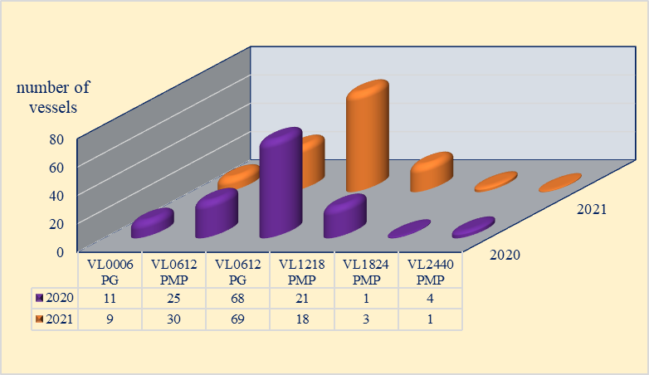

Fig. 3.1 The situation of active vessels, structured by length classes and fishing techniques in period the 2020 - 2021

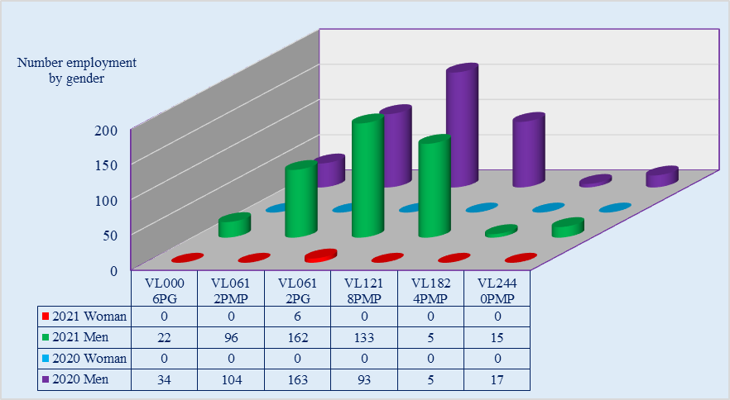

Fig. 3.2 The employment situation by sex in period the 2020 - 2021

The employment situation on ship segments, fishing techniques and employee status is shown in Fig. 3.3. As you can see, the staff employed as an employee was numerically dominant. The number of landlords ranged from 1 to 3 to the VL2440PMP, VL1824PMP and VL0006PG segments and 5 to 10 to the VL1218PMP, VL0612PMP and VL0612PG segment while the other segments of the vessels did not have fishermen on such a statute. Percentage of persons with ownership status accounted for 6.7 % / 2020 and 13.6%/2021 and the employee employed 93.3 %/ 2020 and 86.4 % /2021, of the total number of 416 persons / 2020 and 439 persons / 2021 occupiers. In general, shipowners participate with the crew in fishing activities and have the status of an employee. In general, shipowners participate with the crew in fishing activities and have the status of an employee.

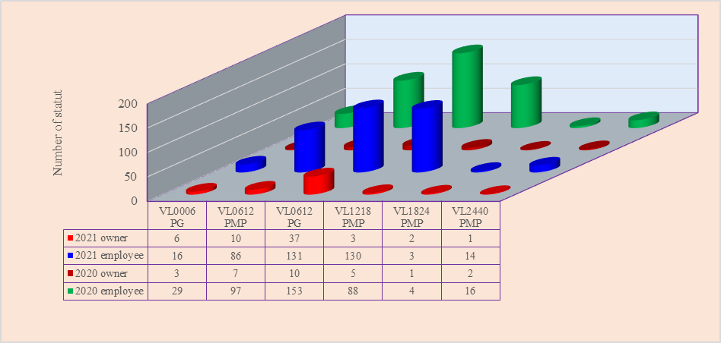
Fig. 3.3 The situation of active personnel on vessel segments and fishing techniques with employee and owner status

Employment structure by age
Figure 3.4 shows that all segments of the ship predominated between the ages of 25-39 years and 40-64 years respectively, because these fishing activities by their complexity require fishermen with knowledge / experience in the field, generally the most many young people up to the age of 24, after completing high school studies, are moving to other areas of activity, perspective and more substantial salaries.

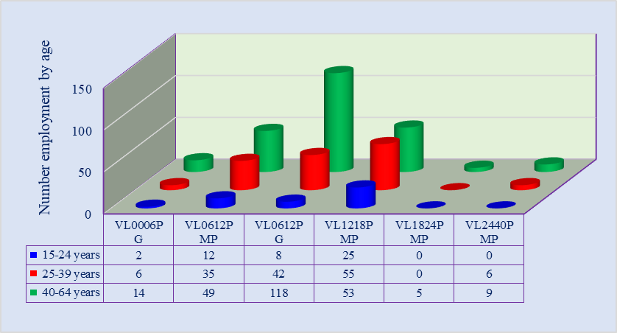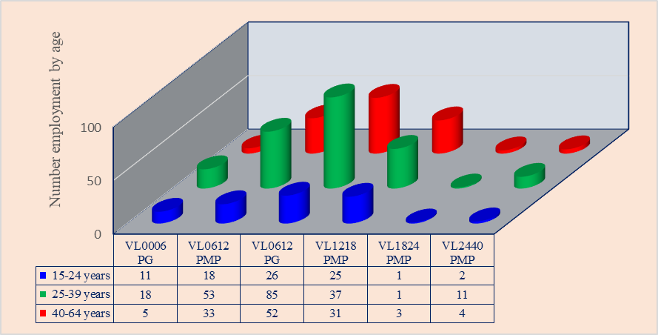
Fig. 3.4 The employment situation at age levels in the period 2020 - 2021
Structure of employment by educational level.
As can also be seen from Fig. 3.5, in most ship segments, the educational level of the employees is low to medium, especially in the segments VL0612PG, where the low educational level is predominant (predominantly staff with a compulsory national level at which they have acquired general knowledge). Qualification and obtaining an attestation for the fishermen's profession can be done within specialized institutions for the professional training of staff who wish to work in this field. In fact, due to the lack of institutions with such qualifications, the training of the personnel wishing to carry out fishing activities (fishing operations, installation of tools, clothing / repairs, etc.) takes place directly at the workplace under the guidance and supervision of the staff qualified on board vessels, who has experience in successfully carrying out fishing activities.

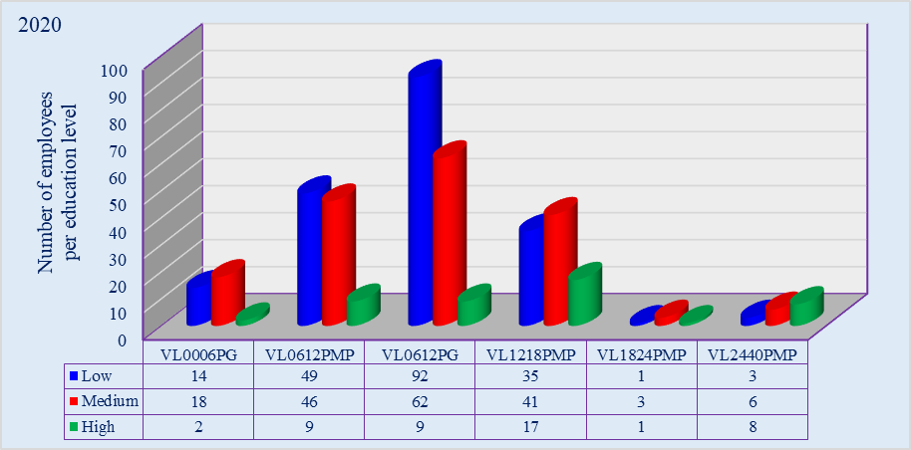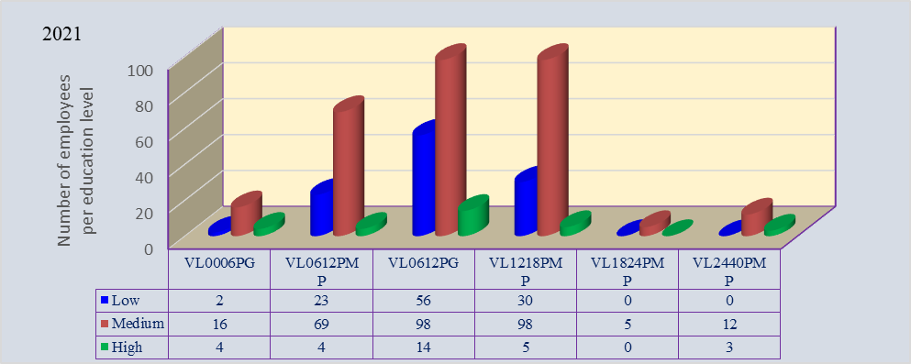

Fig. 3.5 The employment situation at education level in the period 2020 - 2021

Since fishing activities are seasonal in nature, with more special working conditions, young people tend to focus on other areas of activity that can provide them with a high financial support (eg economics and engineering, medicine, electronics and automatization, etc.). In order to have a higher number of middle and or higher-qualified individuals in the fisheries sector, specialized training institutions should be promoted in the fisheries sector, but financial support must be ensured.

Structure of employment by nationality
The total number of staff engaged in fishing activities was 416 people in 2020 and 439 people in 2021. As can be seen in Fig. 3.6, most of the employees were of Romanian nationality (94%), while those of other nationalities such as Bulgarian and Turkish were representative, with 2% and 4% respectively. Persons of other nationalities found themselves employed on segments of vessels using PMP fishing techniques (eg: VL2440PMP, VL1218PMP and VL0612PMP).

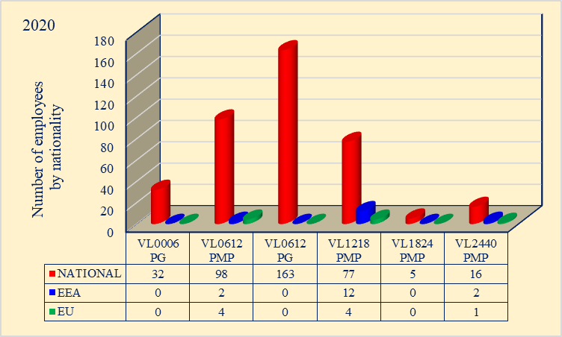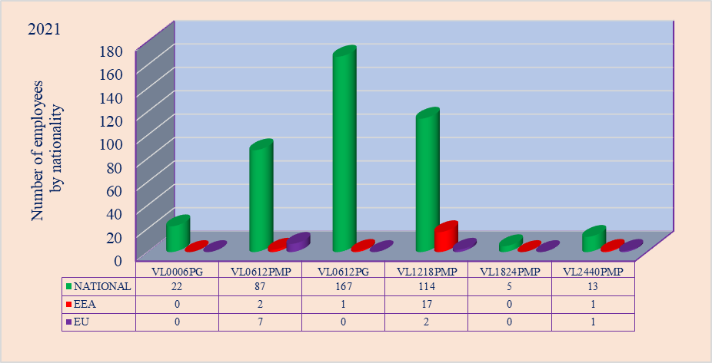
Fig. 3.6 The employment situation by nationality in period the 2020-2021

Structure of unpaid labour by gender
As it can be seen in Fig.3.7, the number of staff who opted in the period 2020-2021, for the unpaid work option varied from one ship segment to another. Most options for this variant were registered in the length class VL0612 where, by the way, the employed staff was dominant (67% of the total number of employees). In conclusion, it can be said that the major option of the employed staff was for the salary payment option.

Structure of FTE National

The values of FTE National were presented, in the period 2020-2021, at a low level (Fig. 3.8), compared to previous years, with large differences from one segment of the vessel / fishing technique to another.

The main cause of an objective nature was the pandemic years which reduced the activity (fishing days) due to the decrease in orders, mainly of molluscs (Rapana venosa and Mitylus galloprovincialis), requested by restaurants, processing factories and export requirements. Thus, compared to 2019, the demand on the rapa whelk market was 40% lower in 2020 and by mussels by 26%.

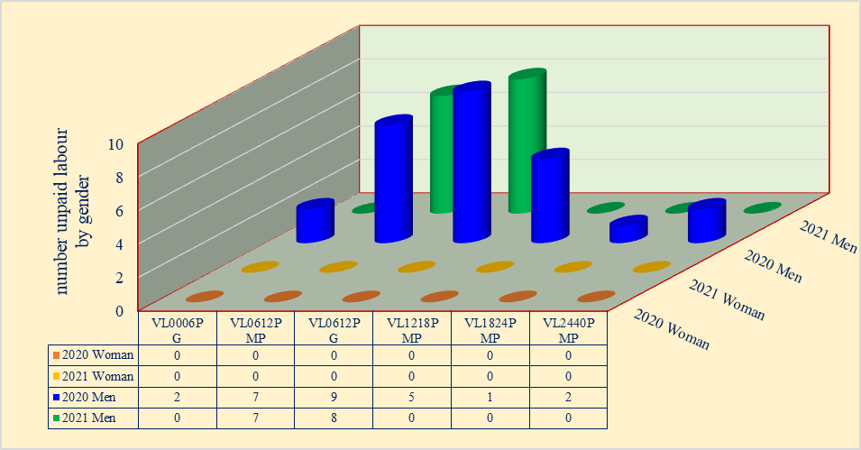
Fig.3.7 Structure of unpaid labour by gender in 2020

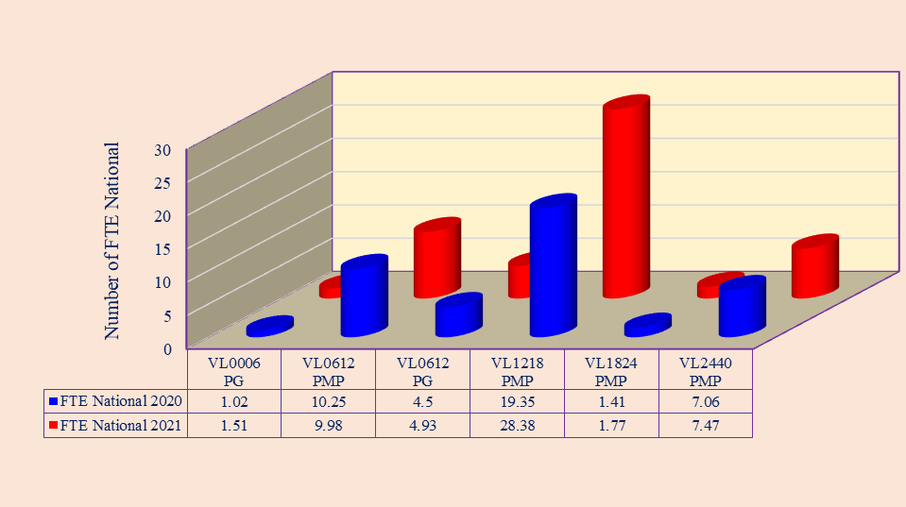

Fig.3.8 Structure of FTE National in the period 2020 - 2021

We also remind you that the number of fishing days is also affected by:
* Unfavourable hydro-climatic conditions (small number of days favourable to fishing activities and implicitly to fishing hours);
* Aged fishing fleet (51% of the total number of vessels in the Fleet Register are 100% depreciated, which is why technical and functional problems often occur in the fishing process);
* The fishing activity is of a seasonal nature, the number of trips at sea being dependent on the presence of migratory fish species at different times of the year with great variations from one year to another.
equivalent to full-time (FTE) by gender and national level, as it follows
b. Aquaculture: for the aquaculture sector, social data were collected from all 490 units. From the analysis of the data for conducting the pilot study 3, the following can be concluded: the aquaculture staff is 79.10 % men 20.90 % women.
Staff | Total number of employees
Staff | Total, of which: | Employed women | Employed men
Number of employees | 2,315 | 484 | 1,831
Percentage | - | 20.90 | 79.10

* The structure of the staff, depending on the age, is dominated by the age segment 40-60 years in a percentage of 63.54%, followed by the segment over 25-39 years with 23.97% (Fig. 3.9);

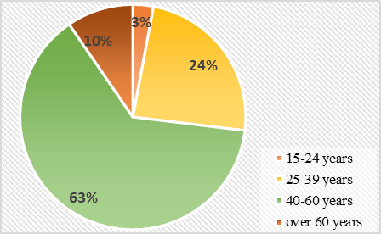

Fig. 3.9 Share of age classes of aquaculture employees

* The ratio between male and female employees according to age, is higher in favor of men regardless of age (Fig. 3.10). The lowest number of employees is registered in the age category between 15-24 years.
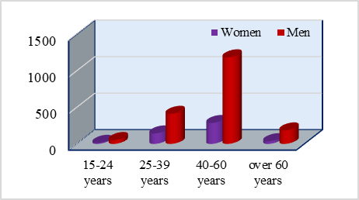

Fig. 3.10 The ratio of male and female employees by age

* Depending on the level of education, the staff with high school, post-high school and professional studies predominates (56.95 %), the staff with university studies is in proportion of 21 %, and the one with primary and secondary education is in proportion of 22 % (Fig. 3.11);

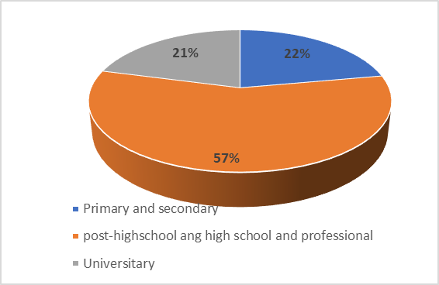

Fig. 3.11 Aquaculture workforce broken down by level of education

* Depending on the nationality, the employees of the surveyed units are 97.36% from Romania and 2.64% from outside the EU (Turks, Nepalese, Chinese, Macedonians and Sri Lankans, etc.).

c. Processing sector: social data were collected from all 18 companies with main activity. Data were collected by segments according to the number of employees. The structure of employees in the processing sector by gender is as follows:

* At the level of the entire sector, women predominate with a percentage of 56 % compared to men with a percentage of 44 % (Fig. 3. 12).

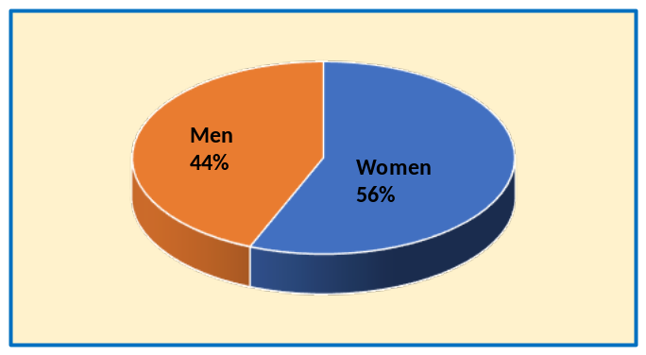
Fig. 3.12 Gender structure of employees in the fish processing sector

* In the first segment (≤10) men predominate, with a percentage of 53%, compared to the segments (11-49 and 50-250), where the percentage of women was higher (65% and 55%, respectively) than men (35% and 45%, respectively) (Fig. 3.13).

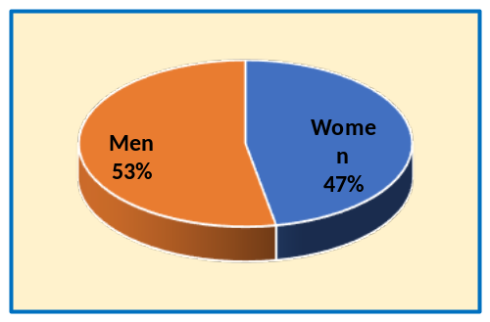 | 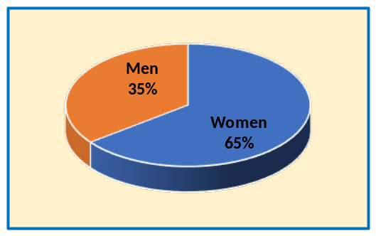
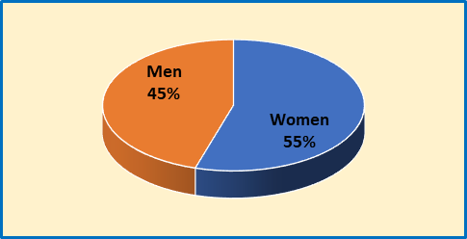

Fig. 3.13 Gender structure of employees in the fish processing sector - by segments

* On all segments (≤10, 11-50, 50-250), 10 % of employees are between 15-25 years old, 26.31 % of employees are between 25-39 years old and 55.41 % employees are between 40-64 years old. In 2021, 8 % of employees were over 65, unlike the previous year, when there were no employees over 65 (Fig. 3.14).

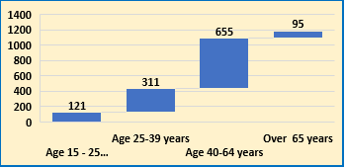
Fig. 3.14 The structure according to the age of the employees in the fish processing sector

* In all segments (≤10, 11-50, 50-250), the predominant level of education is Primary, Secondary, Vocational Education (52 %), followed by high school and post-secondary education (37 %). A percentage of 11 % of employees is represented by those with higher education (university)(Fig. 3.15).

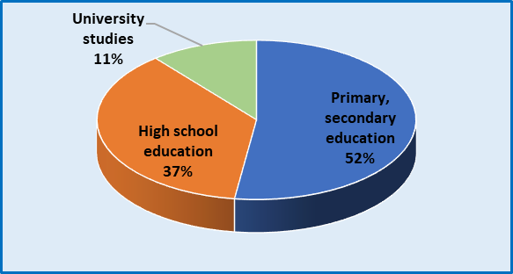

Fig. 3.15 The structure according to the level of education of the employees in the fish processing sector

Out of the total employees in processing sector, 93% are Romanians, and a percentage of 7% are from outside the EU (Fig. 3.16).

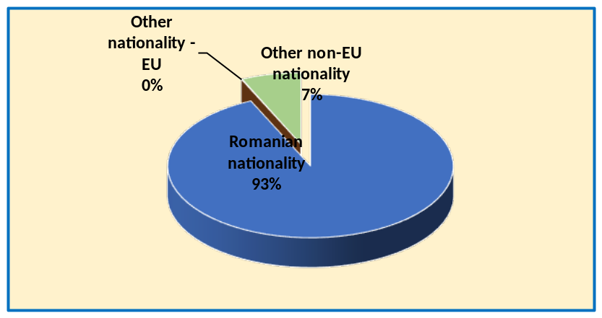
Fig. 3.16 The structure according to the nationality of the employees in the fish processing sector

5. Incorporation of results from pilot study into regular sampling by the Member State.

Social indicators are instruments that measure social performance in order to understand the knowledge of the social phenomena and processes quantitative and qualitative, making it possible to compare in time with reference to the concept of quality. Every year, Romania, within the Annual Report, shall provide data on the situation of all social indicators identified in the marine fishing activity, as required in Table 6 of the multiannual Union Programme (Decision EU 910/2019).

Section 3: Economic and Social Data
Text Box 3B: Population segments for collection of economic and social data for aquaculture

General comment: This box fulfills paragraph 6 points (a) and (b) of Chapter III of the Annex of the Delegated Decision (EU) 2019/910 on the multiannual Union programme; and Article 2, Article 4 paragraphs (1) and (5) and Article 5 paragraph (2) of the Implementing Decision (EU) 2016/1701 on the format of the WP. It is intended to specify data to be collected under Tables 6 and 7 of the delegated decision on the multiannual Union programme.
General comment: This box is applicable to the Annual Report. This box should provide information on the implementation of the socio-economic data collection for aquaculture of Member States.
1. Description of methodologies used to choose the different sources of data

First of all, there will be analysed the Aquaculture Units Register (AUR), that will provide general information about the aquaculture units and economic operators in the field, which are officially registered. Each year, with the help of NAFA inspectors (National Agency for Fisheries and Aquaculture) information will be gathered, regarding the active farms from those officially registered. For those active farms, questionnaires will be sent. Where appropriate, data will be collected through interviews, by the phone or in the field. For gross sales per species also financial accounts will be utilized, where appropriate. Some of variables will be collected by accessing and using the database of economic statistics indicators of the Ministry of Finance.

2. Description of methodologies used to choose the different types of data collection

The collected data will have economic, social and technological nature. The specificity of the aquaculture sector is: species and farming techniques. The questionnaire will be structured by:
Section I - Data unit identification.
Section II - Technical data unit, related to: surface, category unit (hatchery and/or nursery, on growing, combined), age biological material (embryonated eggs, brood summer I, brood summer II, fish consumption, breeding) breeding type applied (natural or artificial), type of rearing system, farming techniques.
Section III - Economic data (economic variables under table 7 of the multi-annual Union programme).
3. Description of methodologies used to choose sampling frame and allocation scheme

The data collection method of the aquaculture sector will be exhaustive, namely census. Questionnaires will be sent to all active farms from registered units. Thus, the frame population will be the same with the total population.

4. Description of methodologies used for estimation procedures

The calculation of these variables, for aquaculture, will respect the instructions given in:
Table 6 - Social variables for the fishing and aquaculture sectors;
Table 7 - Economic variables for the aquaculture sector,
from the multiannual Union program [Decision (EU) 2016/1251] and will based on questionnaire and other sources indicated above, owners of aquaculture units by NAFA inspectors and national fisheries legislation.
The data will be collected from all economic operators. In such a case, the data collection method is exhaustive and the resulting assessment will by a census.
The estimation of some variables will be necessary during data validation (e.g. livestock costs with quantity; feed costs with quantity, etc). The methodology will involve setting an average price per unit, collected from other farms with same characteristics, and then estimation of missing variable. Also, if data from some variables will not be provided by units, an estimation will be made for each variable in part. The estimation value will be the average of values of that variable, corresponding to same species, farm size and volume of production.

5. Description of methodologies used on data quality

Data quality analysis will involve the calculation of response rate for all segments of the population or for each segment in part under table 7 of the multi-annual Union programme.

No thresholds will be applied, specified in Chapter V of Commission Implementing Decision (EU) 2016/1251.

6. Deviations from Work Plan methodology for selection of data source
There are no deviations from the methodology, of the plan work to collect aquaculture data, used to select the data source.

7. Deviations from Work Plan methodology to choose type of data collection

Data collection was performed by regions and based on the number of employees for each unit. There are no deviations in the work plan regarding the sample framework and the allocation scheme.

8. Deviations from Work Plan methodology regarding sampling frame and allocation scheme

Data collection was performed by region and function of the crop species and the breeding system.
Data collection was performed by regions and based on the number of employees for each unit. There are no deviations in the work plan regarding the sample framework and the allocation scheme.

9. Deviations from Work Plan methodology used for estimation procedures

Data collection was performed by region and function of the crop species and the breeding system.
The economic and social data collected from the aquaculture units, included in table 3B: Segmentation of the population for the collection of economic and social variables for aquaculture, which are not reported by the units, are estimated as the corresponding data average for the respondent processing units from the respective employee segment, according to the methodology https://asas-icdeapa.ro/proj/Procedura-Manual-EN.pdf .

10. Quality assurance
10.1 Sound methodology

The methodologies are documented and made public by accessing the link:
https://asas-icdeapa.ro/proj/Procedura-Manual-EN.pdf
and
http://www.rmri.ro/Home/Publications.Other.ANPA.html?lang=en

10.2. Accuracy and reliability
The rate of response and the sampling rate achieved, are presented in table 3B: Segmentation of the population for the collection of economic and social variables for aquaculture. (Decision UE 2016/1701).
Data quality was calculated using the recommended formula: the number of respondents who provided data in response to the census/ total population of the framework.
The rate of response is presented as percentage %.
Data quality was evaluated using the guidelines of the Guide for the Annual Reports Submission of the Data Collection National Programs.
The methodologies are documented and made public by accessing the link
https://asas-icdeapa.ro/proj/Procedura-Manual-EN.pdf and http://www.rmri.ro/Home/Publications.Other.ANPA.html?lang=en.
The quality of the data has been assessed using the recommended for Guidance for the submission and evaluation of Annual Reports under Regulation (EU) 2017/1004, Commission Implementing Decision (EU) 2016/1701, Commission Implementing Decision (EU) 2016/1251, Commission Implementing Decision (EU) 2018/1283 (Version for Annual Reports 2017-2019).

10.3. Accessibility and Clarity

YES.
The methodologies are documented and made public by accessing the link
https://asas-icdeapa.ro/proj/Procedura-Manual-EN.pdf and http://www.rmri.ro/Home/Publications.Other.ANPA.html?lang=en.

Are methodological documents publicly available?

YES
Are data stored in databases?

YES

Where can methodological and other documentation be found?
The web page is under construction. After public auction conclusion, NAFA signed the contract in January 2020 for integrated data base with contractor, having deadline 2023. The program database is stored separately on a secured server of National Institute for Marine Research and Development Grigore Antipa Romania (NIMRD) - http://www.rmri.ro/Home/Publications.Other.html

Section 3: Economic and Social Data
Pilot Study 4: Environmental data on aquaculture

General comment: This box fulfills paragraph 6 point (c) of Chapter III of the Annex of the Delegated Decision (EU) 2019/910 on the multiannual Union programme; and Article 2 and Article 4 paragraph (3) point (d) of the Implementing Decision (EU) 2016/1701 on the format of the WP. It is intended to specify data to be collected under Table 8 of the delegated decision on the multiannual Union programme.
General comment: This box is applicable to the Annual Report. This box is intended to provide information on the results obtained from the implementation of the pilot study (including deviations from planned and justifications as to why if this was not the case).
1. Aim of pilot study

The aim of the pilot study is to analyse the environmental data for aquaculture, regarding the type and quantity of medicines or treatments administered for diseases prevention and control, from the romanian aquaculture sector and the mortalities registered in aquaculture units.

2. Duration of pilot study
The pilot study will be done in 2020 – 2021 period and the results will be available in 2022.

3. Methodology and expected outcomes of pilot study

The Pilot study was elaborated based on quantitative and qualitative methods.
The qualitative method involves the interviews conducted in order to establish the form of questionnaire. The quantitative method is represented by sample determination, distribution and collection of the questionnaires. The last phase of the pilot study consisted of the analysis and interpretation of collected data, testing the efficacy of research instruments and protocols and estimation of statistical parameters for later analysis. The main participants in the research are the aquaculture units, the Research and Development Institute for Aquatic Ecology, Fisheries and Aquaculture Galati (IRDAEFA), the Research and Development Station for Fisheries Nucet (RDSFC Nucet) and the National Agency for Fisheries and Aquaculture (NAFA). Pilot study includes data regarding administrated substances and treatments in romanian aquaculture units and it was performed as it follows:
1. Elaboration of the questionnaire structure, according to Table 8 of the multi-annual Union programme, following a work group sesion with NAFA agents, in cooperation with researchers from IRDAEFA Galati and RDSFC Nucet.
2. Sample size and the number of aquaculture units taken into study, was established by considering specific criteria such as sector segmentation and development regions.
3. Data collection was conducted according to the general data protection regulation (EU 2016/679) and by content writting the questionnaire, accompanied with punctual interviews, with the purpose of obtaining coherent and comparable information, regarding the environmental variables that are to be collected subsequent to the pilot study.

No thresholds will be applied, specified in Chapter V of Commission Implementing Decision (EU) 2016/1251.

4. Achievement of the original expected outcomes of pilot study and justification if this was not the case.
The analysis of the collected samples revealed that:
In the section "Preventive treatments applied to the prevention of fish diseases", the data collected showed that the preventive treatments applied differ according to the specifics of the breeding unit, so that: in cyprinid breeding units, the substances applied for prophylactic purposes are mainly represented by: lime, sodium chloride (salt), lime chloride, oxytetracycline and potassium permanganate (KMnO4); in the case of salmonic units, the treatments were: sodium chloride (salt), formaldehyde, methyl blue, potassium permanganate, peracetic acid, chloramine T, biosol, peridox, bisulfim and antibiotics such as oxytetracycline, floron and flumechin. Thus, it can be appreciated that, in cyprinid breeding units, the application of treatments and substances is carried out for prophylactic purposes, due to the low chances of disease among the fish population. This is often due to the low storage densities of animal biomass and the high volume of water. In the case of nursery salmon units, the administered substances were applied for curative purposes.
In the section “Disinfection treatments and actions for the prevention of diseases carried out in pools / growing enclosures / facilities” the data collected showed that: - in concrete basins, specific to salmon farming units, the treatments applied consist in the administration of substances such as: Chloramine T, quicklime, Lime chloride, Peracetic acid, Peral S, Formaldehyde, Copper sulphate, floron and Chloride sodium (salt); - in soil basins, specific in most cases to cyprinid breeding units, disinfection treatments for disease prevention consisted of the application of substances such as: lime chloride, quicklime, copper sulphate.
In the section “Amendments and management fertilizers” it can be said that, for this chapter, data were completed from the breeding units of cyprinids, where the breeding of fish is done in land basins. As amendment and administered fertilizer are used: manure, lime and ammonium nitrate.
Section “Treatment for diseases manifested in the fish farm”. Data from salmonid breeding units have been completed for this section. The drugs administered were: copper sulphate, sodium chloride (salt), peracetic acid, oxytetracycline, florfenicol, floredan, enroden, chloramine T.
Preventive treatments for the prevention of fish diseases

Species | Year | Type of chemical substance administered | The amount of substance administered (grams) | Period of administration  (From m/d/y  to m/d/y) | Purpose
Autochthonous cyprinides  and cyprinids of South East Asia | All ages | NaCl | 1% | Spring | Prevention
Autochthonous cyprinides  and cyprinids of South East Asia | All ages | chalk | 400.000 g/ha | Spring | Prevention
Autochthonous cyprinides  and cyprinids of South East Asia | All ages | Calcium chloride | 7.000 -20.000 g / ha | Spring | Prevention
Autochthonous cyprinides  and cyprinids of South  East Asia | First year summer fish | Vitamin B complex | 21.000 g/ha | Spring | Prevention
Autochthonous cyprinides  and cyprinids of South East Asia | First year summer fish, Second year summer fish II | KmnO4 | 0,01 g/l | Spring | Prevention
Carp | 2 years old | Calcium chloride | 150.000 g/ha | 2 weeks | Prevention
Carp | All ages | Enteroguard | 12.000 g | Spring | Prevention
Carp | First year summer fish | oxytetracycline | 30 g/100 kg fish | Spring | Prevention
Trout | All ages | NaCl | 1 %/mc | Spring, Autumn | Prevention
Trout | All ages | oxytetracycline | 60 g – 100 g /100 mc | Spring, Autumn | Prevention
Trout | All ages | Floredon | 3-4 g/mc | Spring | Prevention
Trout | One month | Floron | 5 g/100 kg fish | Spring | Prevention
Trout | Six months | Enrofloxacină | 12 g/100 kg fish | Autumn | Prevention
Trout | First year summer fish | Divosan forte | 50 g/150 mc | Spring, summer | Prevention
Trout | One years old | Flurenicol | 10 g/100 kg fish | Summer | Prevention
Trout | All ages | chloramine T | 10-15 g/mc | Spring, Autumn | Prevention
Trout | 1-2 years old | Florfenidem | 5-10 g/100 kg fish | Spring, Autumn | Prevention
Trout | One years old | Peridox | 20 g/mc | Spring, Autumn | Prevention
Trout | All ages | Peracetic acid | 100 g/pond | Monthly | Prevention
Trout | 1-2 years old | Peral S | 4-10 g/mc | August -September | Prevention
Trout | All ages | Formaldehyde | 1.500.000 g | Periodic | Prevention
Trout | First year summer fish | Flumechin | 3 g/kg fish | 10 days/year | Prevention
Trout | One month | Biosol | 13000 g/25 mp | a date / year | Prevention
Trout | First year summer fish | KmnO4 | 1.000 g/pond | Spring | Prevention
Trout | All ages | Bisufilm | 30 gr | 10 days/year | Prevention

Disinfection treatments and actions to prevent diseases in the pond/Growth space/ Equipments
The type of pond/Growth space/ Equipments | Type of chemical substance administered | The amount of substance administered (grams) | Period of administration  (from m/d/y to m/d/y) | Purpose
Concrete ponds | Chloramine T | 4-10 g/mc | All year round | Disinfection
Concrete ponds | Calcium oxide | 250-500 g/mp | All year round | Disinfection
Concrete ponds | Salt | 3-5 % | Twice a month | Prevention
Concrete ponds | Calcium oxide | 0,01 g/mc | All year round | Disinfection
Concrete ponds | Peracetic acid | 5-10 g/mc | Summer | Disinfection
Concrete ponds | Divosan forte | 70 g/mc | Summer | Disinfection
Concrete ponds | Peral S | 500-1000 g/100 mc | All year round | Disinfection
Concrete ponds | Formaldehyde | 33 g /3 p | All year round | Disinfection
Concrete ponds | Copper sulphate | 40 g/pond | 4 times / year | Disinfection
Concrete ponds | Floron | 7 g/mc | 7-14 days | Disinfection
Rearing ponds | Calcium oxide | 100.000-200.000 g / ha | All year round | Disinfection
Rearing ponds | Calcium oxide |  | All year round | Disinfection
Rearing ponds | Triplafavin | 14800 g/ha | April | Prevention
Incubators | Formaldehyde | 350 g/500 l | April – May | Disinfection
Circular basin | Peridox | 40 g/mc | Once every 20 days | Disinfection
Circular basin | Ecocid | 3 g/mp | One day | Disinfection
Basin with concrete edges and earth bottom | Peracetic acid | 0,5-1 g/mp | All year round | Disinfection
Container | Wofasteril | 3 g/mc | 7-14 days | Disinfection

Amendments and fertilizers administered

Amendment / fertilizer administered | Amount of Amendment / Fertilizer administered  (kg) | Period of administration  (from m/d/y to m/d/y) | Purpose
Calcium hydroxide | 200-500 kg/ha | summer | Disinfection and amelioration
Manure | 900-2,000 kg/ha | summer | Natural food stimulation and improvement, combating algal blooms

Curative treatments: Treatment for diseases manifested in the fish unit
Disease | The species for which the treatment was applied | Age | Type of drug administered | Amount administered (grams) | Period of administration  (from m/d/y to m/d/y) | Disease
Ichthyophthiriasis | Trout | 2 years old | Copper sulphate | 2g / m³ water | 15 days | Microscopic examination
Ichthyophthiriasis | Trout | > 2 years old | Sodium chloride | 2000 g/500 l water | 7 days | Visual observation
Ichthyophthiriasis | Trout | 2-5 months | Oxytetracycline | 6 g/100 kg | 6-7 days | Laboratory analysis
Ichthyophthiriasis | Trout | 1-2 years old | Enroden | 21.500 g | 20.08- 30.08 | Inflamed gills
Saprolegniasis | Trout | 0-6 months | Formaldehyde | 1g/500 l water | Spring-autumn season | Visual observation
Saprolegniasis | Trout | 1 year old | Peracetic acid | 1800 g | 07.09-15.09 | White spots on the abdomen
Enteric redmouth disease (ERM) | Trout | 1-2 years old | Bisulfite | 30 g/100 kg | 01.04-30.09 | Bleeding, skin discoloration, swimming in agony
Furunculosis | Trout | 2-7 months | Florfenicol | 2 g/100 kg | 7 days | Visual observation
Branhiomycosis | Trout | 1-2 years old | Chloramine T | 1—15 g m³ water | 30 days (Spring-autumn season) | Visual observation
Mycobacteriosis | Trout | All ages | Chloramine T | 30.000 g | 01.01-31.12 | Laboratory analysis
Mycobacteriosis | Trout | All ages | Oxytetracycline | 4-6 g /100 kg fish/day | 6-8 consecutive days | Laboratory analysis
Mycobacteriosis | Trout | 2-11 months | Flonidan | 40 g /100 kg fish | 10 consecutive days | Laboratory analysis

Mortality caused by diseases recorded in aquaculture units

Mortalities % | Species | Age
5,4 | Rainbow trout | 1-24 months
40 | Rainbow trout | 0-6 months
5 | Rainbow trout | 2 years old
60 | Rainbow trout | Fingerlings
5 | Rainbow trout | First year summer fish
1 | Rainbow trout | Second year summer fish
5 | Brook trout | Second year summer fish
35 | Rainbow trout | 0-7 months
10 | Rainbow trout | 1 year old
2 | Rainbow trout | 2 years old
10 | Rainbow trout | 6-7 months
10 | Rainbow trout | 1 year old
10 | Rainbow trout | Fingerlings
5 | Rainbow trout | First year summer fish
30 | Rainbow trout | 1 luna-1,6 ani
1 | Brook trout | First year summer fish
1 | Brook trout | First year summer fish
1 | Brook trout | 2 years old
0,52 | Rainbow trout | 1 year old
5,6 | Rainbow trout | 1-12 months
20 | Rainbow trout | 1-5 months
5 | Trout | 2 years old
4 | Trout | 1 year old
3 | Brook trout | icre embrionate
8,8 | Rainbow trout | 1-2 years old
1 | Rainbow trout | 10-18 months
0,51% | Carp | First year summer fish
0,05 | Carp | One year old
0,3 | Carp | First year summer fish
15 | Carp | All ages
15 | Bighead | All ages
15 | Silver carp | All ages
15 | Grass carp | All ages
58,30 | Russian sturgeon | 4 years old
26,60 | Pike | 3 years old

In conclusion, it can be stated that in the case of salmonic units, the application of treatments and substances is carried out for curative purposes, due to the high storage densities of fish biomass. This creates a high risk of disease among the fish population.
“Mortality from diseases in aquaculture establishments” In this section the mortality reports within the salmonid units were higher (1-40%) compared to the mortality reports within the cyprinid units (1-20%), and in the sturionic units’ mortality of up to 58% is registered. Romania is ready to report environmental data on aquaculture, once every two (2) years to the European Union, starting with the collection of data from 2019, from all responding units.

No thresholds will be applied, specified in Chapter V of Commission Implementing Decision (EU) 2016/1251.

Section 3: Economic and Social Data
Text Box 3C: Population segments for collection of economic and social data for the processing industry

General comment: This box fulfils footnote 6 of paragraph 1.1(d) of Chapter III of the Annex of the Delegated Decision (EU) 2019/910 on the multiannual Union programme; and Article 2, Article 4 paragraphs (1) and (5) and Article 5 paragraph (2) of the Implementing Decision (EU) 2016/1701 on the format of the WP. It is intended to specify data to be collected under Table 10 of the delegated decision on the multiannual Union programme.
General comment: This box is applicable to the Annual Report. This box should provide information on the implementation of the socio-economic data collection for aquaculture of Member States.
1. Description of methodologies used to choose the different sources of data
Identification of units which have as object of activity (main and secondary activity) NACE 1020 is done by consulting the Register processing units (RPU) developed by National Agency for Fisheries and Aquaculture, Bucharest (NAFA), reports and records from National Agency for Fiscal Administration and the Trade Register and authorizations veterinary released by the National Sanitary Veterinary and Food Safety for the units preparing fish and fishery products.
Economic and social data source according to COMMISSION IMPLEMENTING DECISION (EU) 2016/1251 Table 11 – the collected data (economic and social variables) for the processing industry sector is questionnaire, interview and information site specializing in National Agency for Fiscal Administration

2. Description of methodologies used to choose the different types of data collection
Data are collected by specialists from the Institute of Research - Development for Aquatic Ecology, Fisheries and Aquaculture/Galati and NAFA inspectors. Data are centralized and processed questionnaires received directly from respondents or collected by the inspectors of National Agency for Fisheries and Aquaculture. The questionnaires cover all the economic variables listed in Table 11 COMMISSION IMPLEMENTING DECISION (EU) 2016/1251. The processed data are included in Table 3C: Population segments for collection of economic and social time for the processing industry.
Ordering data will be made depending on region development and the number of employees of the unit.
The questionnaires are structured in three sections:
Section I - Data unit identification (name of the unit, NACE code, ownership, unit address, contact person).
Section II - Data processing unit (raw materials, types, quantity, value)
Section III - Economic data (revenues, expenses, number of employees, financial statement) and social data according to Table 11 - COMMISSION IMPLEMENTING DECISION (EU) 2016/1251.
3. Description of methodologies used to choose sampling frame and allocation scheme
Data will be collected from all fish processing units (census) motivated by the small number of processing units operating at the time of writing data collection program. Data collection will be from units with 1020 Caen code - main activity and secondary activity.

4. Description of methodologies used for estimation procedures
The calculation of these variables, for processing industry, will respect the instructions given in:
Table1-11 - Economic and social variables for the processing industry sector that may be collected on a voluntary basis, from the multiannual Union program [Decision (EU) 2019/910] and will based on questionnaire and other sources indicated above, owners of processing units, by NAFA inspectors and national legislation.
The data will be collected from all economic operators. In such a case, the data collection method is exhaustive and the resulting assessment will by a census.
Economic and social data included in Table 3C: Population segments for collection of economic and social time for the processing industry, which are not reported units will be estimated as the average of data units responding.

5. Description of methodologies used on data quality
Data quality will be calculated using formulas recommended.
• Response rate; achieved number of respondents who supplied data / frame population number.
• Coverage rate; total value of production of the respondent units / total value of production of the frame population. Coefficient of Variation (CV); only in case of response rate <70%

No thresholds will be applied, specified in Chapter V of Commission Implementing Decision (EU) 2016/1251.
6. Deviations from Work Plan methodology for selection of data source

There are no deviations from the methodology of the work plan for data collection in processing 2020-2021 used to select the data source.

7. Deviations from Work Plan methodology to choose type of data collection

There are no deviations from the methodology of the work plan for data collection in processing 2020-2021, used to select the data source.

8. Deviations from Work Plan methodology regarding sampling frame and allocation scheme

Data collection was performed by regions and based on the number of employees for each unit. There are no deviations in the work plan regarding the sample framework and the allocation scheme.

9. Deviations from Work Plan methodology used for estimation procedures

The economic and social data collected from the processing units with main activity, included in table 3C: Population segments for collection of economic and social data for the processing industry.
There are no deviations from Work Plan methodology used for estimation procedures.
The economic and social data collected from the processing units with main activity, included in table 3C: Population segments for collection of economic and social data for the processing industry. There are no deviations from Work Plan methodology used for estimation procedures.
If an economic, social or production variable has not been reported by a unit, it will be estimated by calculating the results from unit reports of the same type (from the same segment) and size. The type of error is biased, and the statistical calculation will be performed in accordance with the methodological provisions suggested by STECF - SGECA 10-03, namely the calculation of the response rate (RR%)

The methodologies are documented and made public by accessing the link:
https://asas-icdeapa.ro/proj/Procedura-Manual-EN.pdf
and
http://www.rmri.ro/Home/Publications.Other.ANPA.html?lang=en

10.1 Sound methodology

Data collection from the processing industry follows the established methodologies by a group of experts. The methodologies are documented and made public by accessing the link:
https://asas-icdeapa.ro/proj/Procedura-Manual-EN.pdf
and
http://www.rmri.ro/Home/Publications.Other.ANPA.html?lang=en

10.2. Accuracy and reliability

The rate of response and the sampling rate achieved, are presented in table 3C: Population segments for collection of economic and social data for the processing industry. (Decision UE 2016/1701).
Data quality was calculated using the recommended formula: the number of respondents who provided data in response to the census/ total population of the framework. The rate of response is presented as percentage %.
Data quality was evaluated using the guidelines of the Guide for the Annual Reports Submission of the Data Collection National Programs. The methodologies are documented and made public by accessing the link:
https://asas-icdeapa.ro/proj/Procedura-Manual-EN.pdf
and
http://www.rmri.ro/Home/Publications.Other.ANPA.html?lang=en

10.3. Accessibility and Clarity
Are methodological documents publicly available?
Yes.
The methodologies are documented and made public by accessing the link:
https://asas-icdeapa.ro/proj/Procedura-Manual-EN.pdf
and
http://www.rmri.ro/Home/Publications.Other.ANPA.html?lang=en

Are data stored in databases?
YES

Where can methodological and other documentation be found?
The program database is stored separately on a secured server of National Institute for Marine Research and Development Grigore Antipa Romania (NIMRD) - http://www.rmri.ro/Home/Publications.Other.ANPA.html?lang=en

Section 4: Sampling Strategy for Biological Data from Commercial Fisheries
Text Box 4A: Sampling plan description for biological data

General comment: This box fulfills Article 3, Article 4 paragraph (4) and Article 8 of the Implementing Decision (EU) 2016/1701 on the format of the WP and forms the basis for the fulfilment of paragraph 2 point (a)(i) of Chapter III of the Annex of the Delegated Decision (EU) 2019/910 on the multiannual Union programme. This Table refers to data to be collected under Tables 1(A), 1(B) and 1(C) of the delegated decision on the multiannual Union programme.
General comment: This box is applicable to the Annual Report. This box should provide information on the deviations from the planned sampling of Member States.
The sampling programme is realised in view to obtain the monthly distribution of length on species from catches of landings (number and weight). The data will be collected by metiers, species presented in Tables 1(A), 1(B) and 1(C) of the multi-annual Union programmes and according to the relevant GFCM criteria, three different groups have been established, by which the species are listed at subregional level (GFCM subregions):
* the first group refers to the frequency of evaluations (i.e. the species that are evaluated regularly);
* the second refers to the importance of fishing (e.g. landings, catches and / or economic value);
* the third group is based on conservation criteria (i.e. endangered species) or the impact of their presence on the ecosystem (i.e. non-indigenous species).
For the period 2020-2021, biological studies included:
group 1: sprat / Sprattus sprattus; European anchovy / Engraulis encrasicolus; turbot / Psetta maxima maeotica; Mediterranean horse mackerel / Trachurus mediterraneus ponticus and picked dogfish / Squalus acanthias;

group 2: whiting / Merlangius merlangus euxinus; rapa whelk / Rapana venosa;

group 3: thornback ray / Raya clavata; common stingray / Dasyatis pastinaca; red mullet / Mullus barbatus ponticus.

Species small-spotted catshark / Scyliorhinus canila, is not present on the Romanian coast of the Black Sea.
The data needed to calculate the parameters will be obtained from specimens collected from a variety of sources, such as markets, surveys and on-board sampling. Biological sampling will be carried out by the National Institute for Marine Research and Development Grigore Antipa Constanta (NIRMD).
The total length will be measured from the tip of the snout to the tip of the longer lobe of the caudal fin with the lobes compressed along the midline. The measurement precision is one millimetre. Weighing is done when most of the liquid drains off and measurement precision is 0,1 gram. The sex is defined macroscopically during dissection following three categories: male, female, and undetermined (impossible to determine). Age is determined by macrostructural-level otolith (sagitta) reading. The reading is carried out with a stereomicroscope under reflected light. Counting of bands or rings is always carried out from the central zone to the marginal zone. Both otoliths of an individual are read and the readings are carried out by at least two separate readers (Maximov V and all, 2019, Reference Manual for Fishery data Collection, NIMRD, Constanta, România, p. 66, http://www.rmri.ro/Home/Publications.Other.html

Following the procedure described in the guidelines for the implementation of the National Programme, Romania determines metiers to sample in table 2A. For the collection of the data will be used data sources as logbooks, declarations of first sale, Vessels Monitoring System data. All details for the selected metiers are described in the standard tables.
The metiers are the following:
- pelagic trawl fishery;
- beam trawl;
- pound net fishery;
- set gillnet fishery;
- long lines and hand lines fishery
- other types (various) / manual harvesting (by divers).

The target fish species in pelagic trawl fishery is sprat with by-catch of whiting, turbot, anchovy and horse mackerel. In the pound net fishery, the main species in the catches have a seasonal character, the sprat being the target species in spring period and the beginning of the summer and anchovy and horse mackerel in the summer and autumn period. The by-catch in the pound net fishery is composed of whiting, turbot, red mullet and others demersal species.
In set gillnet fishery, the bottom species with commercial importance is turbot with by-catch of thornback ray, common stingray, spiny dogfish and cetaceans.
Long lines and hand lines are representative for artisanal fishery. The main species in the catches are gobies and horse mackerel.
The sampling resources are allocated to at-sea sampling and shore-based sampling.
The sampling distribution is made depending on the seasonal character of the target species. We must have in view the fact that all marine fishing vessels operate with one day - few days fishing trip, but don’t exceed a week. The collection of the random samples from unsorted catches and landings will take place in fishing harbours, fishery points and at sea on vessel board.
The samples are extracted from the catch of trawler fishery, pound net fishery, gillnet fishery and long lines and hand lines fishery. The sampling schemes will be organized in a way that sampling effort is distributed proportionally to the fishing effort. Relatively larger landings during the year imply higher sampling effort and vice versa. This will ensure that the biological data correspond directly to the national landing statistics.

The sampling scheme, strategies and effort will be the following:

a. Pelagic trawler fishery, in three fishing harbours:

● Mangalia and Cape Midia harbours - 2 times/month in the fishing season (April -November);
● Sulina harbour - 1 time / year, in the fishing season (April - November);
● On board of vessel, one fishing trip / month.

The fish species target of the sampling will be mainly sprat and by-catches (whiting, turbot, anchovy and horse mackerel, picked dogfish).

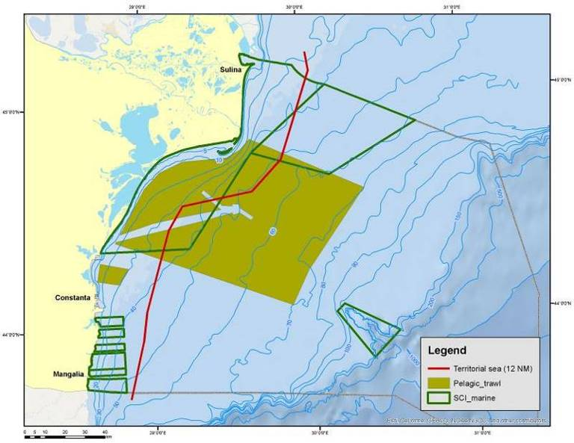

Pelagic trawl activity area, Romanian Black Sea coast

b. Beam trawler fishery
● Mangalia and Cape Midia harbours - 2 times/month in the fishing season (April-November);
● On board of vessel, one fishing trip / month.
The target species will be rapa whelk.

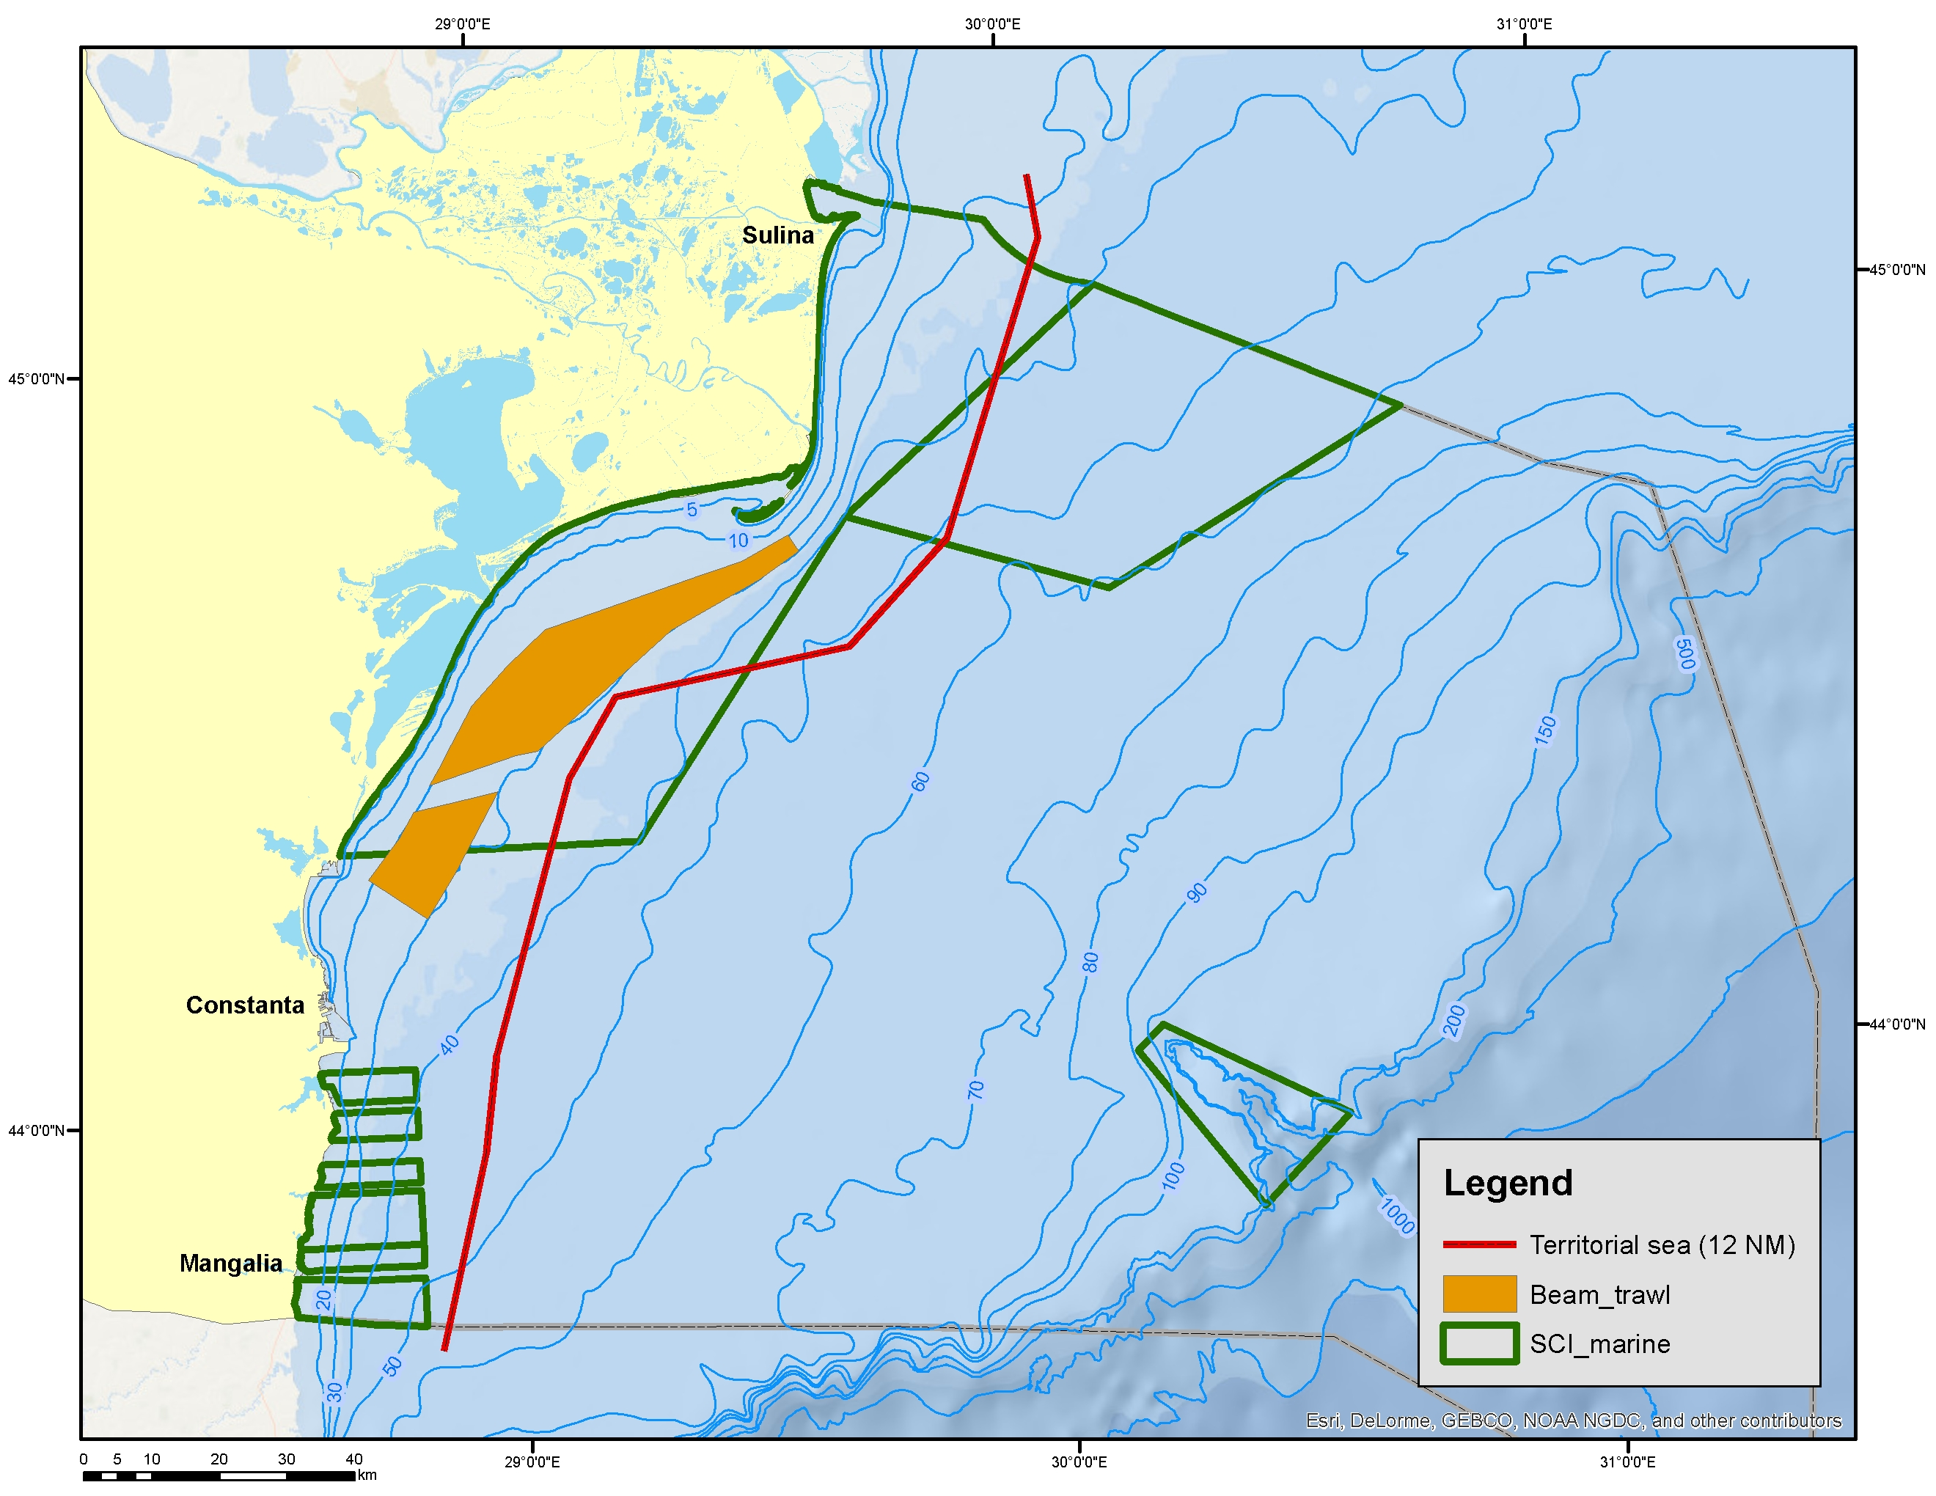

Beam trawl activity area, Romanian Black Sea coast

c. Pound net fishery, at least in two locations:

● from fishery points in the southern part of the Romanian coast (Vama Veche - Agigea area) – 2 times/month in the fishing season (April – September);
● from fishery points in the northern part of the Romanian littoral (Constanta – Chituc area) – 2 times/month in the fishing season (April – September);
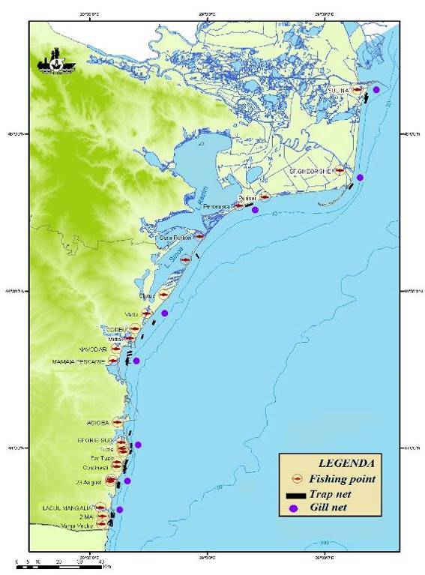
The fish species object of the sampling will be: sprat in spring and early summer, anchovy and horse mackerel in summer and autumn. The same sampling of unsorted and retained catches was included, sampling of discarded species for which stock variables are collected in Table 1A and 1D species. The species of fish sampled were sprat, anchovy, red mullet and horse mackerel, and the secondary catches (by-catch) were: Pontic shad, Azov shad, red mullet, turbot, big-scale sand smelt, garfish, gobies, picked dogfish, common stingray, thornback ray, sea sole.
d. Gillnet fishery:

● from fishery points in the southern part of the Romanian coast (Vama Veche - Agigea area) - 2 times/month in the fishing season;

● from fishery points in the northern part of the Romanian littoral (Constanta - Periboina area) - 2 times/month in the fishing season;

Distribution area for passive fishing gears
● in fishing harbours:
♦ Cape Midia harbour - 2 times/month in the fishing season;
♦ Sulina harbour - 1 time/month in the fishing season.

● On board of vessel, one fishing trip/month.

The sampling scheme for fixed gillnet fisheries targeted demersal and pelagic species in a small-scale coastal fishery, including the similar sampling of captured catches and the collection of total catch data, effort (quantities, days at sea), catch composition, mesh size and fishing depth. Sampling was done on shore (landing points) based on probability samples. Polyvalent activity is a common practice of small coastal craft, which means they are involved in different metiers, and, during daily exits at sea, they can fish on multiple metiers.
The demersal species object of the sampling is turbot and also by-catches of thornback ray, common stingray, picked dogfish and red mullet. The pelagic species object of the sampling is Pontic shad and Caspian shad,

e. Long lines and hand lines fishery

Long-haul and hook-fishing is representative for artisanal fishing (vessels <10 m), the collection of samples will be made from fishing points along the Romanian coast. The collected biological data will be reported by fleet segments, gear type, mesh size and target species. Target species in catches were mainly gobies and sometimes mackerel.

f. Manual harvesting of Rapa whelk (Rapa venosa).

Once a month from fishing points along the Romanian Black Sea coast.
This sampling scheme covers all fishing metiers and fleet segments used at the Romanian coast.
For all kind of fishery will be used the appropriate methods covering the metiers as specified in Table 4A, including the listed species, and as per sampling frame description mentioned in Table 4B.

No thresholds will be applied, specified in Chapter V of Commission Implementing Decision (EU) 2016/1251.

Deviation from the sampling plan according to Article 5 paragraph (3) of the Implementing Decision (EU) 2016/1701:
2. Deviations from the Work Plan

The deviations from the planned activities are related to the oversampling of commercial catches due to random collection from significant number of catches in terms of numbers, as the data collection did not imply additional costs and efforts of the technical team performed the sampling.

3. Action to avoid deviations

Not applicable

Section 5: data quality

Text Box 5A: Quality assurance framework for biological data

General comment: This box is applicable to the Annual Report. This box fulfills Article 5 paragraph (2) point (a) of the Implementing Decision (EU) 2016/1701 on the format of the WP. This box is intended to specify data to be collected under Tables 1(A), 1(B) and 1(C) of the Annex of the Delegated Decision (EU) 2019/910 on the multiannual Union programme. Use this box to provide additional information on Table 5A of the Annual Report.
1. Evidence of data quality assurance

The sampling design is documented in protocols, available in the responsible research institutes and in the annual report for the implementation of the Work Plan and in the reports for each survey. The reports from the research surveys and information about the methodologies are available at
(http://www.rmri.ro/Home/Publications.Other.ANPA.html?lang=en).

Sampling schemes are different from one metier to another and are designed to collect the best data and information needed for assessment. Biological data are collected from commercial vessels at sea and onshore, and are checked at the laboratory in order to detect errors and inconsistencies and eventually recorded in data bases ad hoc. In market sampling this framework includes several year visits to samplers in ports and monthly information to allow a better reaction in case fishery or ports dynamics affects the sampling. Biological data are always collected onboard, due to the processing of the target species, as well as retained species length data. Sampling levels and data quality are considered adequate, based on experience and DCRF requirements, following quality levels, and the agreements achieved in the RCM meetings.

There are rules for Data Quality Control (DQC) and Data Quality Assurance (DQA), including all steps of marine data collection and analysis - from sea expedition to final reporting. For example, all data, collected in the sea, are included in protocols and checked by two different persons for mistakes (scientist and expedition leader) and all samples are numbered and identified by given rules. If any corrections are needed, they are presented in separate protocols, controlled by two scientists. Scientific data are kept in databases and in xls files.
Specific technical reports are prepared every six months and on yearly basis, regarding evolution of the main parameters of the stock, biomass assessments, catch projections, size, age composition, maturity, physical condition etc. and are kept on two different computers, with copies on CD and flash memories.

2. Sampling design

Not applicable.

3. Sampling implementation

Not applicable.

4. Data capture

Not applicable.

5. Data Storage

Not applicable.

6. Data processing

Not applicable.

Section 5: data quality

Text Box 5B: Quality assurance framework for socioeconomic data

General comment: This box fulfills Article 5 paragraph (2) point (b) of the Implementing Decision (EU) 2016/1701 on the format of the WP. This box is intended to specify data to be collected under Tables 5(A), 6 and 7 of the Annex of the Delegated Decision (EU) 2019/910 on the multiannual Union programme. Use this box to provide additional information on Table 5B of the Annual Report.
1. Evidence of data quality assurance

There were no changes in the type of data collection scheme or the data sources in the sampling year. The same quality assurance framework is applied to all sectors and all data collection schemes, since each sector (Fishing fleet, Aquaculture, Fish processing) are with census data collection scheme. The methodology for data collection of transversal and socio-economic variables for the fleet, aquaculture and processing is available at the following link:
http://www.rmri.ro/Home/Publications.Other.ANPA.html?lang=en under Materials and Methods section – the file name is ‘Description of the methodology used for data collection in Romania.

In accordance with the obligations regarding different data that should be reported to other bodies in the EC, e.g., Eurostat (the annual methodological report on data collection and management of statistics on national fisheries), the exhaustive method was applied covering 100% of the vessels registered in the FRF for all segments of the fleet. The questionnaires completed with the requested economic data are analysed by the NIMRD specialists, by groups of variables, reporting from a percentage point of view the expenses at the level of the income obtained by each economic agent, respectively their comparative reporting at the level of the expense / income ratio obtained in the previous years with the strict observance of the correlation of the economic variables in table 5A EU-MAP by ship segments and fishing techniques, fishing effort, etc. Thus, the process of controlling the primary data consist of the following stages: identification of the extreme values from the absolute values; identification of extreme values from average values; cost structure evaluation and comparison with baseline data.

The primary economic data provided by the economic operators through questionnaires can be cross-checked with other sources of activity-related data, VMS, balance sheet data or balance sheet data submitted by them on the website of the Ministry of Public Finance.

In the event that there are any uncertainties regarding the value of some economic indicators, the data providers (accountants or administrators of the economic agents) are contacted in order to make clarifications or corrections if necessary.
Regarding the verification of the accuracy of the data regarding the landing situations, there is the possibility to re-validate the data sheets with the sales notes and the transport notes. The estimation of the average price for each commercial species is made by calculating the weighted average based on the prices recorded in the sales notes issued by the first sale centres for each landing made by the economic agents.

After a thorough verification, the data is centralized and processed according to the requirements of the external users and uploaded on their platforms, in the requested formats, according to the schedules. The same procedure will be applied also for the social variables, so after completing the questionnaires with all social indicators according to table 6 EU-MAP by each economic operator, they are taken over with the support of NAFA by NIMRD "Grigore Antipa" who after a thorough verification of the data [cross-comparison of the data from the questionnaire with those from other sources of collection / information such as the logs of coastal and marine fisheries, fishing authorizations, interviews with fishermen on the ground (fishing points or in fishing areas), respectively the comparative reporting of the level of size, compared to the level of data collected in previous years , proceed to the next stage of analysis / processing with strict observance of the correlation of each social variable by segment of vessel and fishing techniques.

The same procedure is applied in the aquaculture and processing sector where, after completing the questionnaires with all socio-economic indicators according to tables 6, 7 and 11 EU-MAP, by each economic operator, they are taken with the support of NAFA by the IRDFAEFA specialists (Research and Development Institute for Aquatic Ecology, Fisheries and Aquaculture) which after a thorough verification of data [cross-comparing questionnaire data with those from other sources of collection / information such as: operating authorizations, register of aquaculture processing units registry, reports and records from National Agency for Fiscal Administration and the Trade Registry, interviews with personnel engaged in aquaculture and processing activities, respectively a comparison with data reported in previous years], proceeds to the next stage of analysis / processing. The control of the primary data will consist as in the previous case when identifying the extreme values from the absolute values, identifying the extreme values from the average values, evaluating the cost structure and comparing with the reference data.

2. Section P3 Impartiality and objectiveness

It's not necessary

3. Section P4 Confidentiality

It's not necessary

4. Section P5 Sound methodology

It's not necessary

5. Section P6 Appropriate statistical procedures

The contract for the implementation of NAFA's integrated database is currently in the process of being installed.

6. Section P7 Non-excessive burden on respondents

It's not necessary

7. Section P8 Cost effectiveness

We are mentioning that the public acquisition for the conclusion of the contract on integrated database, as legal procedure, is ongoing, actually

8. Section P9 Relevance

It's not necessary

9. Section P10 Accuracy and reliability

It's not necessary

10. Section P11 Timeliness and punctuality

It's not necessary

11. Section P12 coherence and comparability

It's not necessary

12. Section P13 Accessibility and Clarity

The program database is stored separately on a secured server of National Institute for Marine Research and Development Grigore Antipa Romania (NIMRD) - http://cdp.rmri.ro/pncd/index.html

