[Responsible National Body/ies for implementation of Annual Report]

Regulation (EU) 2017/1004 of 17 May 2017of the European Parliament and the Council
on the establishment of a Union framework for the collection, management and use of data in the fisheries sector and support for scientific advice regarding the common fisheries policy and repealing Council Regulation (EC) No 199/2008

Commission Implementing Decision (EU) 2019/909 of 18 February 2019 establishing the list of mandatory research surveys and thresholds for the purposes of the multiannual Union programme for the collection and management of data in the fisheries and aquaculture sectors

Commission Delegated Decision (EU) 2019/910 of 13 March 2019 establishing the multiannual Union programme for the collection and management of biological, environmental, technical and socioeconomic data in the fisheries and aquaculture sectors

Commission Implementing Decision (EU) 2016/1701 of 19 August 2016 laying down rules on the format for the submission of work plans for data collection in the fisheries and aquaculture sectors.

Commission Implementing Decision (EU) 2018/1283 of 24 August 2018 laying down rules on the format and timetables for the submission of annual data collection reports in the fisheries and aquaculture sectors.

POLAND Annual Report for data collection in the fisheries and aquaculture sectors
2021
Version [1.0]
[Gdynia, 30 May 2022]

CONTENTS
Section 1: Biological Data 3
Text Box 1C: Sampling intensity for biological variables 3
Section 1: Biological Data 7
Text Box 1D - Recreational fisheries 7
Section 1: Biological Data 11
Pilot Study 1: Relative share of catches of recreational fisheries compared to commercial fisheries 11
Section 1: Biological Data 12
Text Box 1E: Anadromous and catadromous species data collection in fresh water 12
Section 1: Biological Data 14
Text box 1F: Incidental by-catch of birds, mammals, reptiles and fish 14
Section 1: Biological Data 16
Pilot Study 2: Level of fishing and impact of fisheries on biological resources and marine ecosystem 16
Section 1: Biological Data 17
Text Box 1G: List of research surveys at sea 17
Section 2: Fishing Activity Data 25
Text Box 2A: Fishing activity variables data collection strategy 25
Section 3: Economic and Social Data 27
Text Box 3A: Population segments for collection of economic and social data for fisheries 27
Section 3: Economic and Social Data 34
Pilot Study 3: Data on employment by education level and nationality 34
Section 3: Economic and Social Data 35
Text Box 3B: Population segments for collection of economic and social data for aquaculture 35
Section 3: Economic and Social Data 38
Pilot Study 4: Environmental data on aquaculture 38
Section 3: Economic and Social Data 39
Text Box 3C: Population segments for collection of economic and social data for the processing industry 39
Section 4: Sampling Strategy for Biological Data from Commercial Fisheries 42
Text Box 4A: Sampling plan description for biological data 42
Section 5: data quality 49
Text Box 5A: Quality assurance framework for biological data 49
Section 5: data quality 51
Text Box 5B: Quality assurance framework for socioeconomic data 51

Section 1: Biological Data

Text Box 1C: Sampling intensity for biological variables

General comment: This box fulfils paragraph 2 point (a)(i)(ii)(iii) of Chapter III, of the Annex of the Delegated Decision (EU) 2019/910 and Chapter I of the Implementing Decision (EU) 2019/909 on the multiannual Union programme; and Article 2, Article 4 paragraph 1 and Article 8 of the Implementing Decision (EU) 2016/1701 on the format of the WP. This box is applicable to the Annual Report.
Member State should provide by Region/RFMO/RFO/IO:
- Evidence of data quality assurance
Quality evaluation can only be carried out if the information coming from Table 5A in the Work Plan is available. If this is not the case, Member State shall provide an overview by giving information on the methodology used to assure the quality of the data collected.
e.g.:
The sampling design and protocols follow the outcomes of sampling expert groups.
Use of common standard criteria agreed with other countries/groups.
Use of special packages or tools (e.g. COST …) for calculations.
Use of sampling protocol for storage of data.
Use of sampling protocol for processing of data.
Use appropriate exploratory statistical techniques to detect outliers and anomalous registers.

All Region/RFMO/RFO/IO
For the overview of the quality assurance methodology used, see Table 5A and Text Box 5A

- Deviations from the Work Plan
MS to list the deviations (if any) in the achieved data collection compared to what was planned in the Work Plan and explain the reasons for the deviations. The threshold for deviation follow those set in the former AR: <90 % and >150 %.
Explain any deviation from the proposed:
- sampling intensity,
- methods used for collecting data.
- methods used for estimating the parameters.
General reasons for deviations from the Work Plan in terms of planned vs. achieved should be summarised in this section, while detailed comments on deviations on particular species/stocks should be included in the AR Comments column in Table 1C.
In case of Member State adding new species not included in the WP, this should be clearly explained and justified.
Sampling Design described in the WP, does not provide for planned minimum of individuals to be measured expressed in absolute numbers but explains the sampling protocol applied. The level of achievements (%) were calculated as a ratio of achieved number of individuals measured at the national level and the number of individuals that should be measured on the basis of sampling protocol and the number of samples obtained.
Baltic Sea
No deviations from sampling methods used. Undersampling for some species explained in Table 1C. Oversampling of salmon (Salmo salar) for biological variables (158%), except length, was caused by the fact that with the significant reduction of landings of this species in 2021 observers selected more individuals for detailed analysis than required by the sampling protocol in order to secure more biological data.
Like in 2020, there were three main factors negatively affecting the implementation of the WP in 2021 in terms of low number of samples collected (in particular from at-sea sampling of commercial fisheries):
- COVID-19
The implementation of the WP in 2021, with some exceptions, was strongly affected by the COVID-19 pandemic and the restrictions introduced at the national and international level to combat and reduce the effects of the pandemic.
Surveys
Due to the implementation of a strict sanitary regime in relation to the crew of the research vessel and the research team, none of the planned surveys was affected by the COVID-19 pandemic. This regime included i.a. a two-week preventive quarantine before the survey and tests for the presence of the SARS-CoV-2 virus the day before the survey.
Sampling of commercial fishery:
All DCF sampling at sea on board commercial fishing vessels longer than 12 m were suspended in 2021 due to COVID-19 pandemic. Scientific observers were allowed to board and collect samples at sea on fishing vessels of LOA below 12 m in the Baltic, but fishing activity in general was very limited.
Additionally, two-week preventive quarantine before surveys had an additional negative impact on the number of observers available to collect the samples onshore from landings from commercial fishery.
- Fisheries ban in the Baltic Sea
Fishery targeting Cod (Gadus morhua) in SD 24 and 25-32 was prohibited in 2021 – only small amount of bycatch was allowed. Cod recreational fisheries was also prohibited.
With the suspension of at sea sampling on vessels with LOA >12m, data collection in 2021 was concentrated on sampling onshore. However, port based sampling was significantly reduced due to the reduction of fishing fleet activity.
In general, in 2021 the fishing effort expressed in total number of days at sea for all fleet segments was reduced by 30% as compared to the reference period. The effort of fleet using GNS and OTB targeting demersal species was reduced by almost 30% and 70% respectively.
As compared to year 2019, the year before the COVID pandemic, fishing effort in 2021 expressed in total number of days at sea for all fleet segments was reduced by 32% which is illustrated on a monthly basis in the graph below.
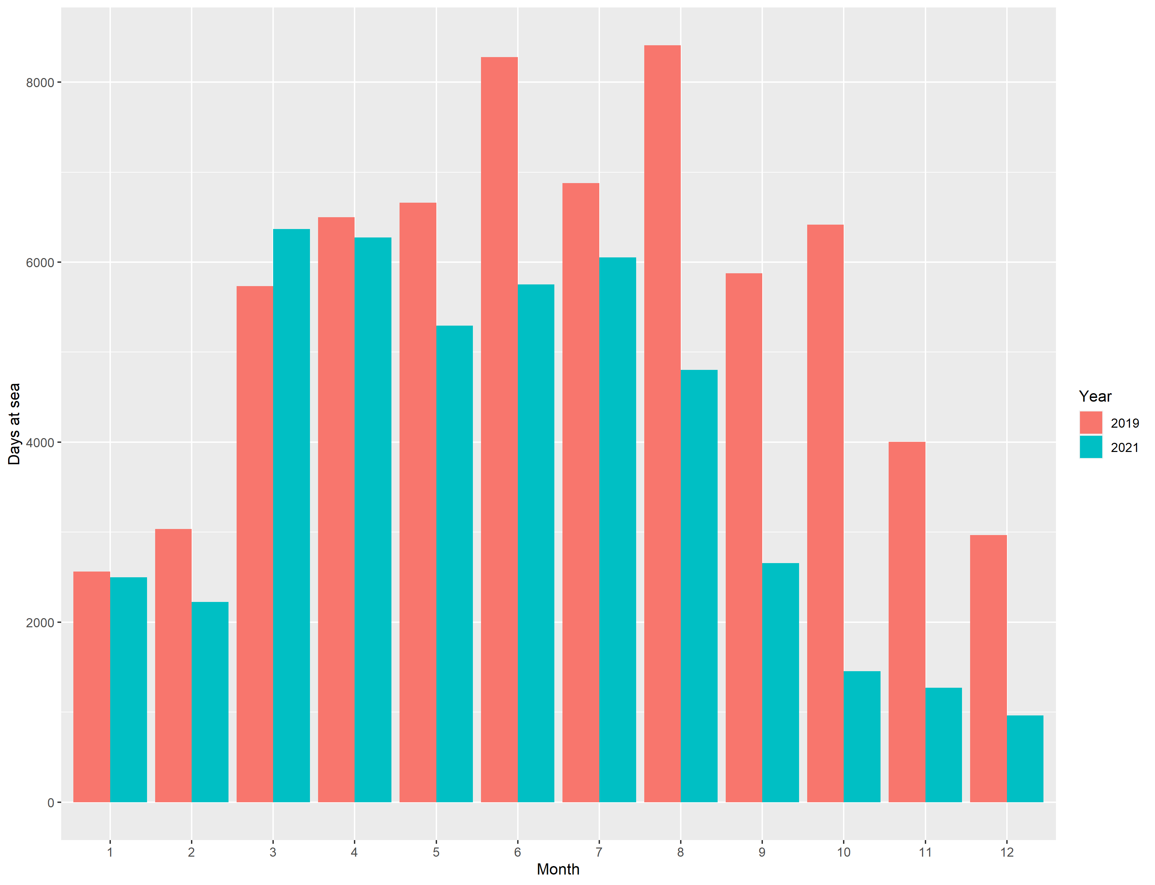

- High refusal rate
In 2021 the refusal rates varied from 32% to 79.63%. across different strata. This was mainly related to Baltic fisheries closures and also COVID-19 pandemic situation. See Text Box 4A for detailed analysis.

Other Regions - North Sea and Eastern Arctic
No sampling performed in 2021. There was only one vessel operating in this area and targeting demersal species, operating from outside of Poland. Due to the COVID restriction and uncertainties in Europe the fishing trip with an observer, originally planned in the first quarter, was postponed. When the vessel was ready to take observer onboard in the second quarter, no long distance fishery’s observer was available. Ultimately, this vessel was withdrawn from Polish fleet in the second half of 2021 and the chance to sample fishery in this region was lost.
Other Regions – CECAF
Based on a multilateral agreement between DEU-LTU-LVA-NLD-POL, from 2018 Poland is coordinating joint sampling program for biological data collection on board EU fishing vessels engaged in the fishery for small pelagic fish in the CECAF area (Central-East Atlantic).
No sampling performed in 2021 due to both COVID-19 (restrictions in people movement, safety issues) and lack of space for observer on board the vessels.
Other Regions – SPRFMO
Based on a multilateral agreement between DEU-LTU-NLD-POL, from 2017 Poland is coordinating joint sampling program for biological data collection on board EU fishing vessels engaged in the fishery for small pelagic fish in the SPRFMO area (South-East Pacific).
Biological sampling in this Region in 2021 was conducted in line with the SPRFMO Data Standards (CMM 02-2021) and the requirements of the SPRFMO Conservation and Management Measure for Trachurus murphyi (CMM 01-2021). (see Table 7C for more info).

- Actions to avoid deviations.
Member State to describe the actions that will be considered / have been taken to avoid the deviations in the future and when these actions are expected to produce effect. If there are no deviations, then this section is not applicable.
Baltic Sea
Regarding high level of non-responses and refusals to take observers onboard as one of three main reason for deviations in sampling intensity, actions to avoid or mitigate deviations were already taken in previous years. Based on the sampling design applied, a dedicated web application was developed to support sampling process management (see Text Box 4A for more details).No action possible to avoid deviations caused by COVID related restrictions (safety issues) or ban on some fisheries.

Other Regions – NS&EA, CECAF and SPRFMO
No action needed.

(max. 1000 words per Region/RFMO/RFO/IO)

Section 1: Biological Data

Text Box 1D - Recreational fisheries

General comment: This box fulfills paragraph 2 point (a) (iv) of Chapter III of the Annex of the Delegated Decision (EU) 2019/910 on the multiannual Union programme; and Article 2, Article 3 and Article 4 paragraph 1 of the Implementing Decision (EU) 2016/1701 on the format of the WP. This box is applicable to the Annual Report. This box is intended to provide information on the design, implementation and analysis of all components of sampling schemes/ surveys that are listed in Table 1D.
1. Description of the target population
The target population and the elements of this target population accessibility, need to be defined and described in this section. In the case of Recreational Fisheries, the target population could be whole population of resident anglers, charter boats etc. This will permit to evaluate if all sectors contributing to the total catch, are included in the survey.
Cod recreational fishery
In Poland there is a dedicated fleet segment of private boats and registered charter boats adapted to cod recreational fishery – angling with fishing rods (LHP). For the purpose of sampling this segment under DCF, the Primary Sampling Unit is vessel/trip and the target population was defined as the total number of recreational sea-going trips targetting cod. Annual increase of this activity was observed in the period 2007-2014. In the period 2015-2019 a gradual decrease was observed from uer to year and a sharp decline of cod sea-going trips was observed in 2020 due to implementation of EU ban on cod recreational fisheries in the Eastern Baltic (27.3.d.25-32) and also due to limiting cod fishery in 27.3.d.24 to only 6 NM zone from the coastline. Total number of cod angling trips in 2014 was 11217, in 2015 was 10158, in 2016 was 9373, in 2017 was 7343, in 2018 was 7909, in 2019 was 5912, and in 2020 only 71 (data for 2021 are under processing and final figures are not availabe yet).

Recreational fisheries for diadromous species
From 2020 sampling of marine recreational fisheries for diadromous species was converted from Pilot Study to routine sampling. The report from this Pilot Study was published on the publicly available website - https://dcf.mir.gdynia.pl/?page_id=367
Marine recreational fisheries targeting sea trout and eel in Polish Maritime Waters is performed using rod fishing from the sea shore (LHP) whereas recreational fisheries targeting salmon (and to a lesser extent sea trout) is conducted with the use of trolling technique (LDL). The fishing for sea trout and salmon is conducted in late autumn, winter and early spring and take place both from the shore and offshore. The trolling fleet consist mainly of private boats, taking occasionally on board recreational fishermen holding individual fishing permits. The number of active trolling boats differed between months and there is an observed increasing trend through the fishing season, with a peak in April. The 111, 118, 133, 125 and 138 different trolling boats were inventoried in 2017, 2018, 2019, 2020 and 2021, respectively. The target population consists of a total number of trolling operations (boat-days) per year. The CPUE for trolling fishing is expressed as a number of fish per boat per day. In 2021 the mean CPUE was similar to 2019-2020 and was around 2. The four-years median value of CPUE was 1.84 salmon per trolling trip. In case of sea trout and eel fishing from the coast the target population is a total number of fishing days (angler-days) per year. The CPUE for this type of angling activity is expressed as a number of fish per angler per day.

Monthly changes of mean catch per unit effort (N fish per trip) of salmon during trolling trip in Polish EEZ in 2018-2021, based on on-site questionaires survey data.

Yearly changes of mean catch per unit effort (N fish per trip) of salmon during trolling trip in Polish EEZ in 2018-2021, based on on-site questionaires survey data. Solid line indicate median value for 2018-2021.

Sea trout is an important fishing target in the rivers of northern Poland. Most of the rivers in this region are managed by the Polish Angling Association. Currently, the only source of information of fishing catches is the catch register. Unfortunately, the data obtained from the registers are incomplete. This is due to the different levels of registries submission in individual districts, the lack of information on the catches of visiting anglers and the problem of credibility of data entered into the registers (overestimation and underestimation).
For the purpose of sampling this segment, the Primary Sampling Unit is individual river and the target population was the whole population of resident anglers.

2. Type of survey
In Table 1D, the methodology or type of survey used must be included, but any information about the design is missing.
Table 5A in the Work Plan allows to identify if the sampling design is documented and where it can be found. Are the surveys identified correctly in Table 5A and information about sampling design provided under this table?
If the answer is No: information on the design should be included in this section of the Annual Report (e.g.: stratification, selection of PSU, is sampling probability base etc.).
YES – sampling design is documented and relevant link provided in Table 5A
None of the planned observer trips was realized in 2021 due to ban on cod recreational fishery in ICES Subdivisions 24-32, excluding from the regulation recreational catches in Subdivision 24 within six nautical miles, measured from the baselines. Additional reason for not complying with the plan was very limited number of Polish recreational trips in SD 24 (data under elaboration) within six nautical miles and also limitations in personnel relocation as a consequence of COVID-19 restrictions.
For salmon trolling fishing a five on-board observations have been realized in 2021 in combination with on-site survey and trolling boats counting. Furthermore, a remote CCTV cameras have been applied for monitoring of recreational salmon trolling fishery effort. The analysis of an off-site survey questionaires for 2021 (annual web-based survey) is currently conducted.
Monitoring of sea trout and eel fishing from the sea shore have been conducted with on-site survey questionaires. The analysis of an off-site survey questionaires for 2021 (annual web-based survey) is currently conducted.
Data for diadromous species were collected for seven rivers: Ina, Rega, Parsęta, Słupia, Łeba, Reda and Drwęca. For this purpose, fishing registers were analyzed. The average value of 50% for all rivers was adopted as the percentage of returns, and the share of foreign anglers as 10%, because this is the average obtained during the survey. The exception is Parsęta, where, due to the permit collection system, the percentage of returns is higher and amounts to 80% and this was used for the calculations. The data obtained in this way indicate that in 2019, 3,029 sea trout were caught in the seven analyzed rivers, which, assuming an average weight of 3 kg of sea trout, gives slightly over 9 tons.
The combination of the two methods allowed to estimate the amount of sea trout catch. No salmon catch was observed.
3. Data Quality
Information about non-responses and refusals is found in the Work Plan, Table 5A. Are non-responses and refusals recorded in Table 5A?
If the answer is No: information on recordings of non-responses and refusals should be included in this section of the Annual Report.
YES - non-responses and refusals are recorded and indicated in Table 5A. For recreational fishery targeting Baltic cod (Gadus morhua) non-responses and refusals are recorded for questionnaires' survey. At-sea biological sampling is not fully randomized but based on vessels' availability (drawing from the vessel list). In order to reduce the potential bias regarding data quality, the monitoring of the Gadus morhua recreational fisheries was extended by supplementary questionnaires’ survey and recreational catch data from charter boats’ daily reports.
For recreational fishery targeting salmon, sea trout and eel non-responses and refusal rate are recorded for questionnaires' survey (on-site). To reduce the potential bias two sources of information (on-site and off-site surveys) are used.

The mean five-year (2017-2021) refusal rate was a 19.3%, 9.0% and 3.4%, for salmon, eel and sea trout fishing, respectively.

Mean refusal rate of different type of fishing from on-site questionaires survey conducted in 2017-2021.

4. Data Analysis and processing
Information about data processing is found in the Work Plan, Table 5A. Are the editing and imputation methods documented and identified?
If the answer is No: information on estimation procedures should be included in this section of the Annual Report, following the questions below:
Does the estimation procedure follow the survey design? YES
Has the precision of the estimates been calculated and documented?
Neither editing and imputation methods nor the precision of the estimates are documented yet. Imputation is not performed at national level. Hence, no documentation on imputation methods.
The estimation procedure follow the survey design.

(max. 900 words per survey)

Section 1: Biological Data

Pilot Study 1: Relative share of catches of recreational fisheries compared to commercial fisheries

General comment: This box fulfils paragraph 4 of Chapter II of the Annex of the Implementing Decision (EU) 2019/909 on the multiannual Union programme and Article 2 and Article 4 paragraph (3) point (a) of the Implementing Decision (EU) 2016/1701 on the format of the WP.
General comment: This box is applicable to the Annual Report. This box is intended to provide information on the results obtained from the implementation of the pilot study.
- Aim of pilot study

- Duration of pilot study

- Methodology and expected outcomes of pilot study

No Pilot Study planned for 2020-2021.
Based on the achievemnts of the Pilot Study conducted in 2017-2019, sampling programme will be implemented (see table 1D of the WP).

(max 900 words)
Brief description of the results obtained (including deviations from planned and justifications as to why if this was not the case).
4. Achievement of the original expected outcomes of pilot study and justification if this was not the case.

5. Incorporation of results from pilot study into regular sampling by the Member State.

(max 900 words)

Section 1: Biological Data

Text Box 1E: Anadromous and catadromous species data collection in fresh water

General comment: This box fulfills paragraph 2 points (b) and (c) of Chapter III of the Annex of the Delegated Decision (EU) 2019/910 on the multiannual Union programme; and Article 2 of the Implementing Decision (EU) 2016/1701 on the format of the WP.
General comment: This box is applicable to the Annual Report.
1. Method selected for collecting data.
European Eel
Already since 2010 WGEEL has been indicating the need of an assessment of biomass and mortality indicators in management as well as scientific reference points to ultimately result in a scientific advice framework that works in line with the ICES precautionary approach. The sampling design will provide relevant data for biomass assessment to WGEEL to perform the approach for international stock assessment.
As required by DECISION (EU) 2016/1251 data collection for two Polish EMU`s (Oder and Vistula) will consist of:
- catch quantities derived from inland commercial fisheries (official statistical questionnaires)
- biological variables – age, length, weight, sex and life stage.
- the abundance of recruits – catch data obtained from eel ladders set in Pomeranian rivers, data on stocking from statistical questionnaires and resellers.
- the abundance of the standing stock – calculated by mathematical modelling, supplemented by data from scientific non selective fyke nets set in lagoons and lakes.
- the number of emigrating silver eels will be calculated by mathematical modelling.
- the stock dynamics of eel for both EMU’s is estimated using a version of CAGEAN model (Deriso et al., 1985), described in the Polish Eel Management Plan. Data will be delivered to WGEEL annually.

Salmon and sea trout
Data about volume of commercial catches will be obtained from special questionnaires (inland waters).
Stock related variables will be collected during monitoring of commercial catches and landings.

Information on abundance of salmon smolt and parr and number of ascending individuals is not relevant. There are no wild salmon rivers in Poland. At the moment the estimation of stock status is made by executing the assessment model for 17 wild salmon stocks and by expert evaluation in 25 wild salmon rivers. Accidental catch of salmon parr will be noted during sea trout electrofishing survey.

The present EU MAP regulation does not recognize the need of sea trout parr density data that is obtained by electrofishing surveys in rivers. By now, these surveys are in many countries conducted outside the EU data collection. However, as these data gives the basis for the ICES advice, a solid foundation for the relevant river surveys should be established in the EU MAP in order to guarantee the continuation of parr density data series at least in a minimum scale in each assessment unit (RCM 2016). Poland will perform standard electrofishing surveys in 40 sites on 14 river systems/. Data will be delivered to WGBAST annually.

(max 250 words per Area)
2. Were the planned number achieved? Yes/ No
If answer is No, Member State shall explain why not, and what measures were taken to avoid non-conformity.

European eel
Yes – the planned number was achieved
Regarding fishery dependent data (biological variables), some oversampling occurred for yellow an silver eels in ODER and VISTULA EMUs
Reason for non-conformity
A larger number of individuals is associated with large catches in the autumn. The entire catch of the day was analyzed. The number indicated refers to variables such as length, mass, sex, silvering index. For age determination 200 individuals of eels were analised, which was sufficient for stock assesment.

Salmon and sea trout
Yes – the planned number was achieved

(max 500 words per Area)

Section 1: Biological Data

Text box 1F: Incidental by-catch of birds, mammals, reptiles and fish

General Comment: This box fulfils paragraph 3 point (a) of Chapter III of the Annex of the Delegated Decision (EU) 2019/910, on the multiannual Union programme; and Article 2 of the Implementing Decision (EU) 2016/1701 on the format of the WP. This box is applicable to the Annual Report. This box is applicable only for those sections where Member States have reported that they have been carrying out regular sampling. Results and deviations for Pilot studies should be reported under Pilot Study 2.
1. Results
Member States shall fill in Table 1F and provide additional information, if available, in this text box. For example, species (or family) identification, number of samples, and the state of the animals incidentally by-caught (i.e. were they released alive, dead, or collected for sampling).
Observers have been instructed to look for incidental by-catch of birds, mammals and fish during at sea sampling only.
For all sampling and observation activity of commercial fishery in 2021, the total of 21 individuals of Alosa fallax was incidentally by-caught in ICES SD 26:
- 4 individuals in May in the stratum ‘Baltic vessels under 10 meters in length’ using FPO (dead),
- 7 individuals in September in the stratum ‘Baltic vessels under 10 meters in length’ using FPO (dead),
- 6 individuals in October in the stratum ‘Baltic vessels under 10 meters in length’ using FPO (dead),
- 2 individuals in September in the stratum ‘Baltic vessels between 18 and 24 meters in length’ using OTM (dead),
- 2 individuals in October in the stratum ‘Baltic vessels between 24 and 40 meters in length’ using OTM (dead)
During BITS Q1 research survey in February 2021, 12 individuals of Alosa fallax were by-caught in control hauls in ICES SD 26 (collected for sampling).
During BITS Q4 research survey in November 2021, the following fish were incidentally by-caught in control hauls: 3 individuals of Alosa fallax in ICES SD 25 (collected for sampling), 233 individuals of Alosa fallax in ICES SD 26 (collected for sampling), 2 individuals of Lampetra fluviatilis in ICES SD 26 (collected for sampling)
During BIAS research survey in September 2021, one individual of Lampetra fluviatilis was by-caught in control haul in ICES SD 26 (released alive).

2. Deviations from Work Plan
Member States shall list the deviations (if any) in the achieved data collection compared to what was planned in the WP and explain the reasons for the deviations.
Explain any deviations from the proposed:
- sampling intensity
- methods used for collecting data

NA

3. Data quality
Member States shall provide information on sampling protocols and sampling design for incidental by-catch data collection.
Questions to be addressed are listed below:
- Does the onboard observer protocol contain a check for rare specimens in the catch at opening of the codend? If YES is the observer instructed to indicate if the codend was NOT checked in a haul?
YES – observers are instructed and obliged to record results of observation of the incidental by-catch of protected species from all observed hauls (in longer fishing trips with many hauls, observer must record the number of hauls observed and not observed).

- In gill nets - and hook-and-line fisheries: does the onboard observer protocol instruct the observer to indicate how much of the hauling process has been observed for (large) incidental bycatches which never came on board (because they fall out of the net)? In large catches: does the protocol instruct to check for rare specimens during sorting of the catch (i.e. at conveyor belt)? Is the observer instructed to indicate what percentage of the sorting or hauling process has been checked at “haul level”?
Standard procedure is that observer is obliged to observe whole hauling-in and sorting processes and to record all by-catch, including by-catch of protected species, and to determine both the main catch and by-catch composition (with length measurement). Additionally, observer is specifically requested to document (including taking photos) by-catch of protected species.

-Does the onboard observer protocol instruct to report on the use of mitigation (i.e. Escape Devices or Acoustic Deterrent Devices)?
YES - in some but not all sampling schemes observer protocol includes specific requirement to report the use of mitigation device. Apart from the procedures described in sampling protocols, before each at sea observer trip the observers are provided with written instructions detailing data collection requirements, including requirement to record any mitigation device applied.

- Does the sampling design and protocol follow the recommendations from relevant expert groups? Provide appropriate references. If there are no relevant expert groups, the design and protocol have to be explained in the text.
There are no recommendations from the relevant expert groups on sampling design regarding by-catch observations yet. The ICES WGBYC started discussion on that issue but it is still not finalized.
Before each at-sea trip, observers are provided with written instruction specifying sampling requirements adapted to the type of fishing activity she/he is going to observe.

- Are data quality issues taken into account?
YES
- How are data (and samples) stored
In national database (NPZDRpl)

(max 900 words)

Section 1: Biological Data

Pilot Study 2: Level of fishing and impact of fisheries on biological resources and marine ecosystem

General comment: This Box fulfills paragraph 3 point (c) of Chapter III of the Annex of the Delegated Decision (EU) 2019/910 on the multiannual Union programme; and Article 2 and Article 4 paragraph (3) point (b) of the Implementing Decision (EU) 2016/1701 on the format of the WP.
General comment: This box is applicable to the Annual Report. This box is intended to provide information on the results obtained from the implementation of the pilot study.
1. Aim of pilot study

2. Duration of pilot study

3. Methodology and expected outcomes of pilot study

No Pilot Study planned.

(max 900 words)
Brief description of the results obtained (including deviations from planned and justifications as to why if this was not the case).

4. Achievement of the original expected outcomes of pilot study and justification if this was not the case

5. Incorporation of results from pilot study into regular sampling by the MS

(max 900 words)

Section 1: Biological Data

Text Box 1G: List of research surveys at sea
General comment: This box fulfills Chapter I of the Annex of the Implementing Decision (EU) 2019/909, on the list of mandatory surveys and thresholds, of the multiannual Union programme; and Article 2 and Article 7 paragraph (3) of the Decision (EU) 2016/1701 on the format of the WP. It is intended to specify which reseach surveys at sea set out in the multiannual Union programme will be carried out. Member States shall specify whether the research survey is included in Chapter I of the Annex of the implementing decision of the multiannual Union programme or whether it is an additional survey.
General comment: This box is applicable to the Annual Report. This box should provide complementary information on the performance of the surveys, the results and their main use.
- Objectives of the survey
Baltic International Trawl Surveys – BITS Q1 and BITS Q4
The aim of the surveys is an evaluation of Gadus morhua and Platichthys flesus and, to some extent, Sprattus sprattus and Clupea harengus recruiting year classes strength (abundance index) and analysis of their distribution during winter (BITS Q1) and autumn (BITS Q4) in the bottom zone of the Southern Baltic.

- Description of the methods used in the survey. For mandatory surveys, link to the manuals. Include a graphical representation (map)
A set of control hauls (with the use of a standard bottom trawl) and hydrological parameters measurements at randomly selected stations.

ICES Manual for BITS surveys : ICES. ADDENDUM 1: SERIES OF ICES SURVEY PROTOCOLS;
SISP manual for the Baltic International Trawl Surveys (BITS); March 2014; Gdynia, Poland
( http://dcf.mir.gdynia.pl/?page_id=367 ).

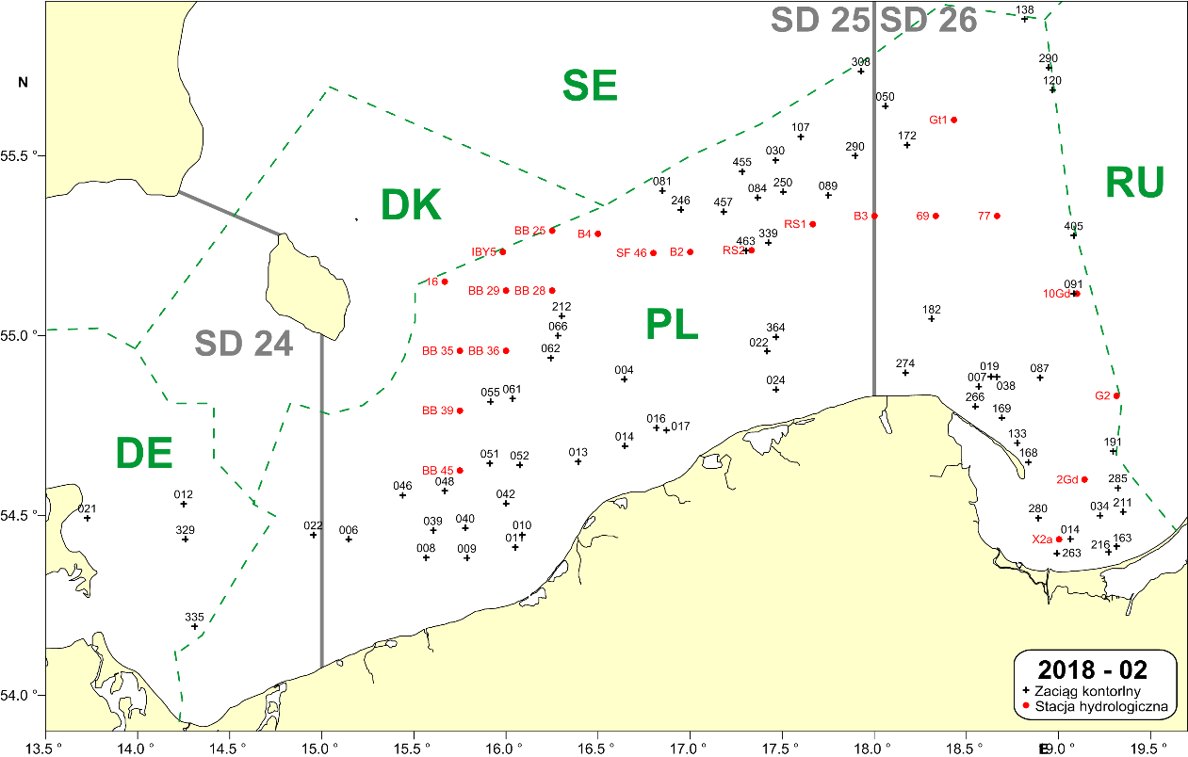

Fig. 1.1. Example location of the bottom control trawl hauls and the hydrological standard stations to be performed by the “Baltica” during the BITS Q1 survey in the Polish part of the Southern Baltic (black crosses = control hauls; red dots = hydrological stations).

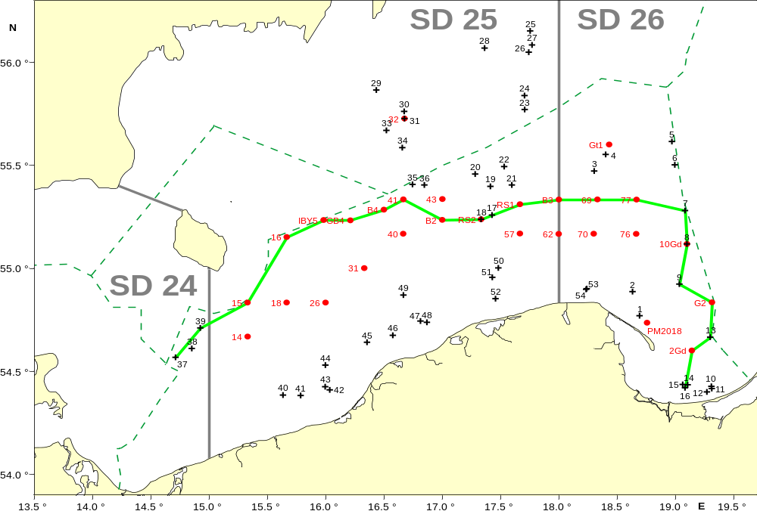

Fig. 1.2. Example location of the bottom trawl hauls and the hydrological standard stations to be performed by the r.v. “Baltica” during the BITS Q4 survey in the Polish part of the southern Baltic (black crosses = control hauls; red dots = hydrological stations).

- For internationally coordinated surveys, describe the participating Member States/ vessels and the relevant international group in charge of planning the survey
BITS surveys are coordinated by the ICES Working Group on Baltic International Fish Survey (WGBIFS).
MS participating in BITS Q1 surveys: DEU; DNK; LTU; LVA; SWE
MS participating in BITS Q4 surveys: DEU; DNK; EST; LTU; LVA; SWE

- Where applicable, describe the international task-sharing (physical and/or financial) and the cost-sharing agreement used
Following recommendations of WGBIFS, each participating MS executes surveys primarily in their respective EEZs. No cost sharing agreements in place yet.

- Explain where thresholds apply
NA

Baltic Acoustic Surveys – SPRAS and BIAS
The description below refers to two Baltic acoustic surveys of similar scope and methodology: SPRAS - Sprat Acoustic Survey (known also as BASS – Baltic Acoustic Spring Survey) and BIAS - Baltic International Acoustic Survey.

- Objectives of the survey
The aim of the SPRAS surveys is an estimation of the stock indices of Sprattus sprattus in May, whereas the aim of the BIAS surveys is an estimation of Clupea harengus, Sprattus sprattus and, to some extent, Gadus morhua stocks resources (biomass and abundance) and analysis of their spatial distribution in the pelagic zone of the southern Baltic during autumn season.

- Description of the methods used in the survey. For mandatory surveys, link to the manuals. Include a graphical representation (map)
In case of both types of surveys, a set of control hauls (fish catch-stations) with the use of herring small-meshed pelagic trawl is performed as well as echo-integration records (S_{A} = NASCs; Nautical Area Scattering (Strength) Coefficient) are collected along the pre-selected acoustic transects on the distance of about 830 NM.

BIAS & BASS Surveys Manual: ICES. ADDENDUM 2: SERIES OF ICES SURVEY PROTOCOLS, VERSION 1.02; SISP MANUAL OF INTERNATIONAL BALTIC ACOUSTIC SURVEYS (IBAS);
28-03-2014, GDYNIA, POLAND ( http://dcf.mir.gdynia.pl/?page_id=367 ).

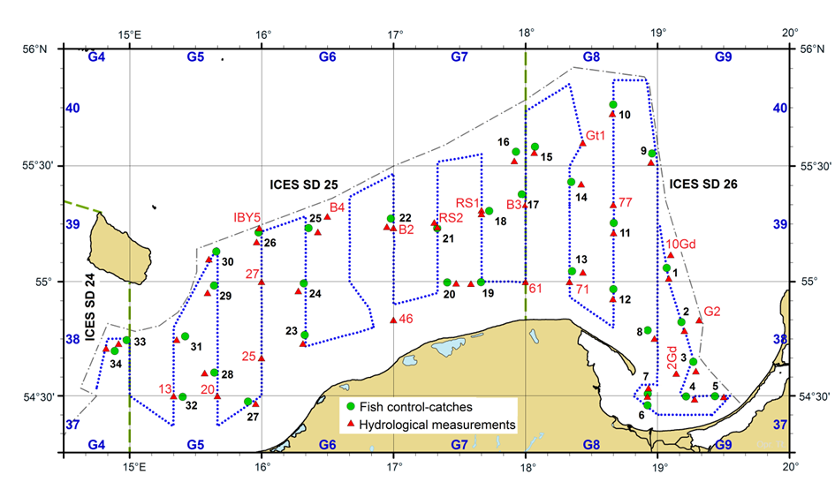
Fig. 1.3. Example location of the echointegration track (blue dotted line), pelagic control hauls(green dots) and hydrological stations (red triangles) during the SPRAS (May) and BIAS (autumn) surveys in the Polish Exclusive Economic Zone on board r/v Baltica.

- For internationally coordinated surveys, describe the participating Member States/ vessels and the relevant international group in charge of planning the survey
SPRAS and BIAS surveys are coordinated by the ICES Working Group on Baltic International Fish Survey (WGBIFS).
MS participating SPRAS surveys: DEU; EST; LTU; LVA.
MS participating in BIAS surveys: DEU; DNK; EST; FIN; LTU; LVA; SWE

- Where applicable, describe the international task-sharing (physical and/or financial) and the cost-sharing agreement used
Following recommendations of WGBIFS, each participating MS executes surveys primarily in their respective EEZs. No cost sharing agreements in place yet.

- Explain where thresholds apply
NA

(max. 450 words per survey)

Like in 2020, due to the implementation of a strict sanitary regime in relation to the crew of the research vessel and the research team, none of the planned cruises was affected by the COVID-19 pandemic in 2021. This regime included i.a. a two-week preventive quarantine before the survey and tests for the presence of the SARS-CoV-2 virus the day before the survey.
Baltic International Trawl Surveys – BITS Q1

- Graphical representation (map) showing the positions (locations) of the realized samples.

Member State shall provide maps presenting the spatial distribution of the main sampling types obtained during the survey.

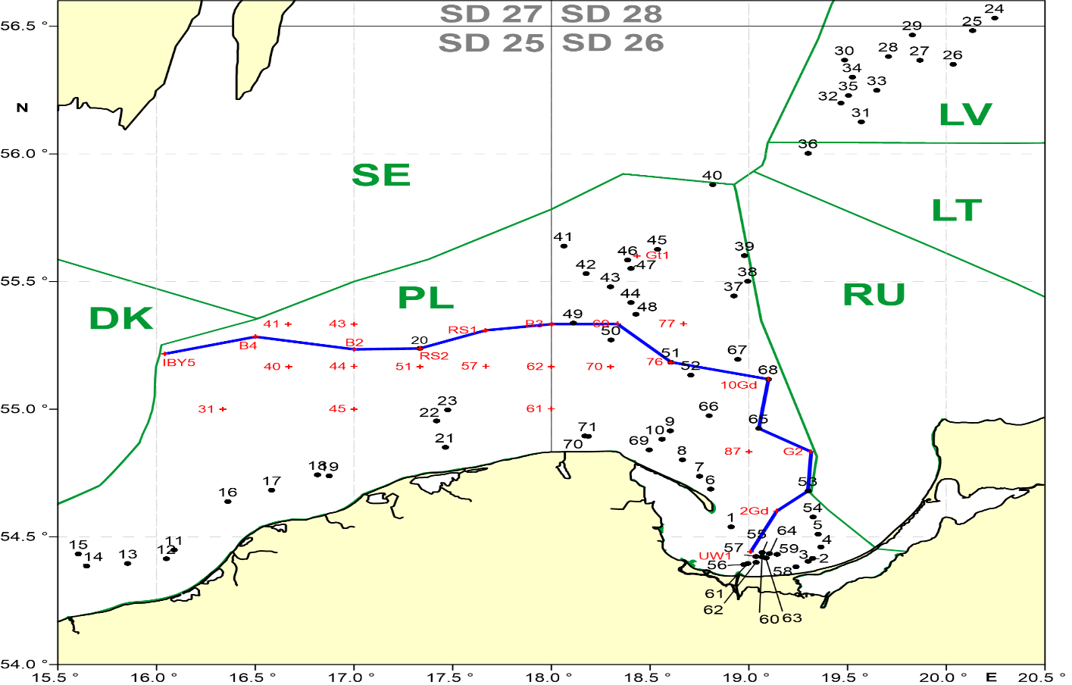

Fig. 1.4. Location of the bottom trawl hauls and the hydrological standard stations performed during the r.v. “Baltica” BITS-Q1 2021 survey in the southern Baltic (black crosses – fish control hauls, red dots – hydrological standard stations, blue line – hydrological profile).

- For internationally coordinated surveys, provide a link to the latest meeting report of the coordination group.
Member State shall provide a hyperlink to the meeting report from the body coordinating the survey (ICES, MEDITS coordination group, MEDIAS coordination group etc.). For non-international coordinated surveys, Member State shall refer to any status report (e.g. Cruise report).
https://ices-library.figshare.com/articles/report/Baltic_International_Fish_Survey_Working_Group_WGBIFS_/18618341

- List the main use of the results of the survey (e.g. indices, abundance estimates, environmental indicators).
Member State shall specify in which context the results are used (on routine basis), both on an international as well as on a national context.

Survey results are primarily used for stock assessment purposes:
- indices of year-classes abundance of cod and flounder,
- biomass indices of cod (CPUE from BITS surveys).

At national level, survey results are also used as a basis for scientific opinions and description of the actual situation and long term developments in fish stocks status and hydrological conditions in the Baltic – at the request of national fisheries administration agencies.

9. Extended comments (Tables 1G and 1H)
If the Member State has extended AR Comments, these can be placed under this section. If this is the case, a reference to this text box should be provided in the corresponding tables.

NA

Baltic International Trawl Surveys – BITS Q4

- Graphical representation (map) showing the positions (locations) of the realized samples.

Member State shall provide maps presenting the spatial distribution of the main sampling types obtained during the survey.

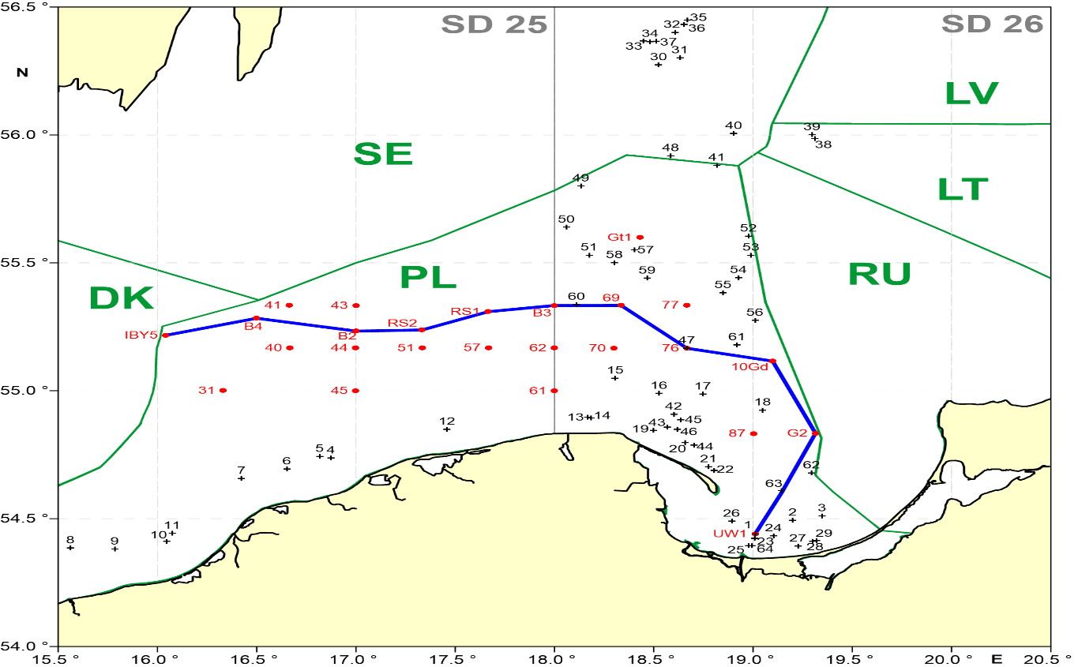

Fig. 1.5. Location of the bottom trawl hauls and the hydrological standard stations performed during the r.v. “Baltica” BITS-Q4 2021 survey in the the southern Baltic (black crosses – fish control hauls, red dots – hydrological standard stations, blue line – hydrological profile).

- For internationally coordinated surveys, provide a link to the latest meeting report of the coordination group.
Member State shall provide a hyperlink to the meeting report from the body coordinating the survey (ICES, MEDITS coordination group, MEDIAS coordination group etc.). For non-international coordinated surveys, Member State shall refer to any status report (e.g. Cruise report).
https://ices-library.figshare.com/articles/report/Baltic_International_Fish_Survey_Working_Group_WGBIFS_/18618341
- List the main use of the results of the survey (e.g. indices, abundance estimates, environmental indicators).
Member State shall specify in which context the results are used (on routine basis), both on an international as well as on a national context.

Survey results are primarily used for stock assessment purposes:
- indices of year-classes abundance of cod and flounder,
- biomass indices of cod (CPUE from BITS surveys).

At national level, survey results are also used as a basis for scientific opinions and description of the actual situation and long term developments in fish stocks status and hydrological conditions in the Baltic – at the request of national fisheries administration agencies.

9. Extended comments (Tables 1G and 1H)
If the Member State has extended AR Comments, these can be placed under this section. If this is the case, a reference to this text box should be provided in the corresponding tables.

NA

Baltic Acoustic Surveys – SPRAS

- Graphical representation (map) showing the positions (locations) of the realized samples.

Member State shall provide maps presenting the spatial distribution of the main sampling types obtained during the survey.

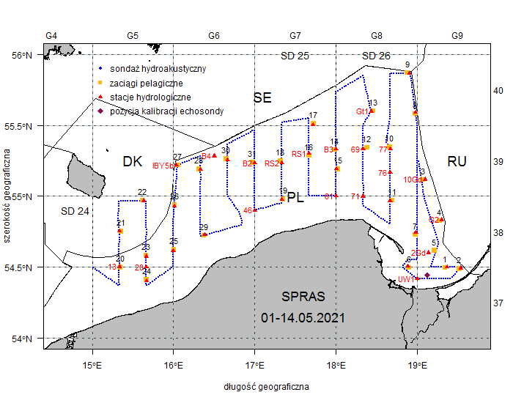

Fig. 1.6. Location of the echointegration track, pelagic control hauls and hydrologic stations during the SPRAS (May 2021) survey in the Polish Exclusive Economic Zone on board r/v Baltica (yellow dots – pelagic control hauls; red triangles – hydrologic stations; blue dotted line – echointegration track).

- For internationally coordinated surveys, provide a link to the latest meeting report of the coordination group.
Member State shall provide a hyperlink to the meeting report from the body coordinating the survey (ICES, MEDITS coordination group, MEDIAS coordination group etc.). For non-international coordinated surveys, Member State shall refer to any status report (e.g. Cruise report).
https://ices-library.figshare.com/articles/report/Baltic_International_Fish_Survey_Working_Group_WGBIFS_/18618341

- List the main use of the results of the survey (e.g. indices, abundance estimates, environmental indicators).
Member State shall specify in which context the results are used (on routine basis), both on an international as well as on a national context.

Acoustic surveys results are primarily used for stock assessment purposes:
- indices of year-classes abundance of sprat and herring,
- biomass estimates of herring, sprat and cod.

At national level, survey results are also used as a basis for scientific opinions and description of the actual situation and long term developments in fish stocks status and hydrological conditions in the Baltic – at the request of national fisheries administration agencies.

9. Extended comments (Tables 1G and 1H)
If the Member State has extended AR Comments, these can be placed under this section. If this is the case, a reference to this text box should be provided in the corresponding tables.

NA

Baltic Acoustic Surveys – BIAS

- Graphical representation (map) showing the positions (locations) of the realized samples.

Member State shall provide maps presenting the spatial distribution of the main sampling types obtained during the survey.

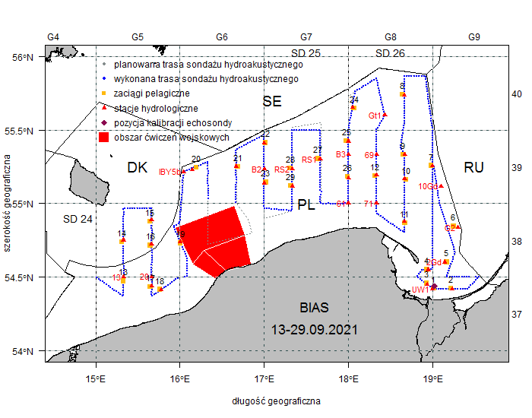

Fig. 1.7. Location of the echointegration track, pelagic control hauls and hydrologic stations during the BIAS (September 2021) survey in the Polish Exclusive Economic Zone on board r/v Baltica (yellow squares – pelagic control hauls; red triangles – hydrologic stations; blue dotted line – echointegration track; red area -military exercise area).

- For internationally coordinated surveys, provide a link to the latest meeting report of the coordination group.
Member State shall provide a hyperlink to the meeting report from the body coordinating the survey (ICES, MEDITS coordination group, MEDIAS coordination group etc.). For non-international coordinated surveys, Member State shall refer to any status report (e.g. Cruise report).
https://ices-library.figshare.com/articles/report/Baltic_International_Fish_Survey_Working_Group_WGBIFS_/18618341

- List the main use of the results of the survey (e.g. indices, abundance estimates, environmental indicators).
Member State shall specify in which context the results are used (on routine basis), both on an international as well as on a national context.

Acoustic surveys results are primarily used for stock assessment purposes:
- indices of year-classes abundance of sprat and herring,
- biomass estimates of herring, sprat and cod.

At national level, survey results are also used as a basis for scientific opinions and description of the actual situation and long term developments in fish stocks status and hydrological conditions in the Baltic – at the request of national fisheries administration agencies.

9. Extended comments (Tables 1G and 1H)
If the Member State has extended AR Comments, these can be placed under this section. If this is the case, a reference to this text box should be provided in the corresponding tables.

NA

Section 2: Fishing Activity Data

Text Box 2A: Fishing activity variables data collection strategy
General comment: This box fulfills paragraph 4 of Chapter III of the Annex of the Delegated Decision (EU) 2019/910 on the multiannual Union programme; and Article 2, Article 4 paragraph (2) point (b) and Article 5 paragraph (2) of the Implementing Decision (EU) 2016/1701 on the format of the WP. It is intended to describe the method used to derive estimates on representative samples where data are not to be recorded under Regulation (EU) No 1224/2009 or where data collected under Regulation (EU) No 1224/2009 are not at the right aggregation level for the intended scientific use.
General comment: This box is applicable to the Annual Report. This box should provide information on the implementation of the data collection of fishing activity variables of Member States.
- Description of methodologies used to cross-validate the different sources of data

Catch data are compared with the landings data on a trip level in the range of catch composition and catch/landing weight. Fishing locations registered in logbooks are checked with the VMS data.

2. Description of methodologies used to estimate the value of landings

The value of landings for each species is estimated for the whole year by multiplying the total landings weight by average price per kg. The average annual exchange rate is used to calculate the value in EUR

3. Description of methodologies used to estimate the average price (it is recommended to use weighted averages, trip by trip)

Average price is obtained from the sales notes data. It is estimated for the whole year for each species by dividing the total value by total weight.

4. Description of methodologies used to plan collection of the complementary data (sample plan methodology, type of data collected, frequency of collection etc)

Not applicable

(max 900 words per Region)
5. Deviations from Work Plan methodology used to cross-validate the different sources of data
List the deviations (if any) and explain the reasons for the deviations.
Actions to avoid deviations.
Briefly describe the actions that will be considered / have been taken to avoid the deviations in the future and when these actions are expected to produce effect. If there are no deviations, then this section can be skipped.
NA

6. Deviations from Work Plan methodology used to estimate the value of landings.
List the deviations (if any) and explain the reasons for the deviations.
Actions to avoid deviations
Briefly describe the actions that will be considered / have been taken to avoid the deviations in the future and when these actions are expected to produce effect. If there are no deviations, then this section can be skipped.
Sales notes from vessels of length less than 10 meters are stored by the fisheries authorities in a paper form. Due to a limited access to these documents an annual average price is used to estimate the value of landings. Information on landings weight and value from questionnaires used for economic and social data collection are also used.

7. Deviations from Work Plan methodology used to estimate the average price.
List the deviations (if any) and explain the reasons for the deviations.
Actions to avoid deviations.
Briefly describe the actions that will be considered / have been taken to avoid the deviations in the future and when these actions are expected to produce effect. If there are no deviations, then this section can be skipped.
NA

8. Deviations from Work Plan methodology used to plan collection of the complementary data
List the deviations (if any) and explain the reasons for the deviations.
Actions to avoid deviations
Briefly describe the actions that will be considered / have been taken to avoid the deviations in the future and when these actions are expected to produce effect. If there are no deviations, then this section can be skipped.
NA

(max 900 words per Region)

Section 3: Economic and Social Data

Text Box 3A: Population segments for collection of economic and social data for fisheries

General comment: This box fulfils paragraph 5 points (a) and (b) of Chapter III of the Annex of the Delegated Decision (EU) 2019/910 on the multiannual Union programme; and Article 2, Article 4 paragraphs (1), (2) and (5) and Article 5 paragraph (2) of the Implementing Decision (EU) 2016/1701 on the format of the WP. It is intended to specify data to be collected under Tables 5(A) and 6 of the delegated decision on the multiannual Union programme.
General comment: This box is applicable to the Annual Report. This box should provide information on the implementation of the fleet socio-economic data collection of Member States.
1. Description of methodologies used to choose the different sources of data
Economic and social data regarding the fishing fleet is obtained from administrative documents (fishing logs, landing declarations, first sale documents, fishing fleet register) and statistical questionnaires obligatory filled out by fishing vessel owners.

2. Description of methodologies used to choose the different types of data collection
Requests with questionnaires for economic and social variables are sent to all active vessels owners (census data). Transversal data is acquired from administrative ERS (Electronic Reporting System) using online connection.

3. Description of methodologies used to choose sampling frame and allocation scheme
All data were intended to be collected for a whole population on the basis of census data.

4. Description of methodologies used for estimation procedures
In case of non-responses in census, estimation based on averages for vessels that provided data and information known for a whole population for individual vessels i.e. volume of catches, fishing days, number of vessels within given segment. If there was a lack of information from the whole population (100%), the data are estimated based on the average values of the sample calculated taking into account number of fishing vessels, number of fishing days, number of personnel or catch size (variables known for a whole population).

5. Description of methodologies used on data quality
The data are intended to be complete i.e. include information from the whole population. If any fishing vessel owners fail in their obligation to return the statistical questionnaires, the values of the missing parameters for the missing population was estimated based on averaged data from the questionnaires received. Defined as the ratio of number units for which data for at least same variables have been collected to the total number of units designed for data collection. CV and representativity analysis are performed. According to article 38 of the Law issued on 29 June 1995 on official statistics it shall not be allowed to publish or disseminate statistical information obtained in statistical surveys of official statistics which can be linked or can identify natural persons or individual data characterizing business entities, especially if the aggregated data consist of less than three entities or the share of one entity in the compilation is higher than the three-fourths of the total (statistical confidentiality).

(max 900 words per Region)
6. Deviations from Work Plan methodology for selection of data source
List the deviations (if any) from the methodology used to select data source compared to what was planned in the Work Plan, and explain the reasons for the deviations.
Actions to avoid deviations
Briefly describe the actions that will be considered / have been taken to avoid the deviations in the future and when these actions are expected to produce effect. If there are no deviations, then this section can be skipped.
No deviation compared to WP.
7. Deviations from Work Plan methodology to choose type of data collection
List the deviations (if any) from the methodologies to choose type of data collecton scheme compared to what was planned in the Work Plan, and explain the reasons for the deviations.
Actions to avoid deviations
Briefly describe the actions that will be considered / have been taken to avoid the deviations in the future and when these actions are expected to produce effect. If there are no deviations, then this section can be skipped.
No deviation compared to WP.

8. Deviations from Work Plan methodology regarding sampling frame and allocation scheme
List the deviations (if any) from the methodologies used regarding sampling frame and allocation scheme compared to what was planned in the Work Plan, and explain the reasons for the deviations.
Actions to avoid deviations
Briefly describe the actions that will be considered / have been taken to avoid the deviations in the future and when these actions are expected to produce effect. If there are no deviations, then this section can be skipped.
No deviation compared to WP.

9. Deviations from Work Plan methodology used for estimation procedures
List the deviations (if any) from the methodologies used for estimation procedures compared to what was planned in the Work Plan, and explain the reasons for the deviations.
Actions to avoid deviations
Briefly describe the actions that will be considered / have been taken to avoid the deviations in the future and when these actions are expected to produce effect. If there are no deviations, then this section can be skipped.
No deviation compared to WP.

10. Quality assurance
10.1 Sound methodology
Briefly describe if the data collection follow methodologies, guidelines and best practices agreed in expert groups and whether methodologies are documented and are made publicly available.
In accordance with national regulations, each vessel’s owner is legally bound to fill out a questionnaire regarding the economic results of the fishing vessel. In order to ensure the maximum number of questionnaires is received, similarly to previous years reminders of the obligation to file them were sent by registered mail and phone calls were made to execute the obligation. Recommendations of the Lisbon DCF workshop on “statistical issues related to the collection of economic data within the DCF” (i.e. closer cooperation with PO) were taken into account to deal with the non-response problem. As the number of returned questionnaires did not reach a plan of respond rate, calculations were made, based on the questionnaires received. Economic data received does not usually exceed 70% of respond rate. However all responses were of random character (probability sample), which should ensure the representativeness of the sample. Response rates are provided in an Excel table. Description of methodologies are documented and are made publicly available on the website (https://dcf.mir.gdynia.pl/?page_id=367).

10.2. Accuracy and reliability
Response rate and Achieved sample rate are provided in Table 3A.
For additional information, briefly describe how raw data inputs, intermediate results and outputs are regularly assessed and validated and how errors are identified, documented and dealt with.
Representativeness

There is no standard approach implemented on how the representativeness of the data can be evaluated. An analysis of the frequency distribution of two variables: volume of catches (in tonnes) and effort (in days at sea) was performed to check similarity between the sample and the total population. The results presented on graphs below show that the sample, in general, represents correctly total population. Species composition of catches by segment confirms also good similarity.
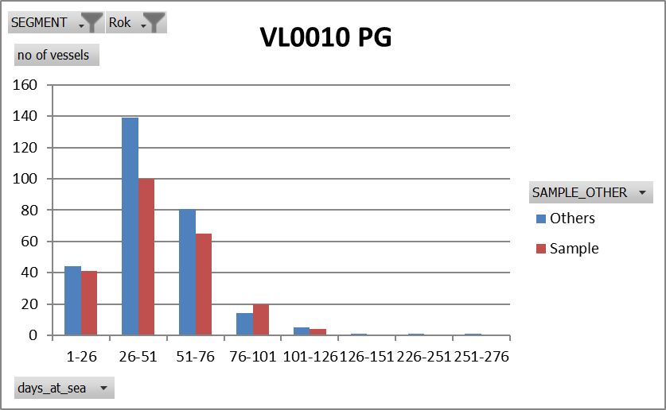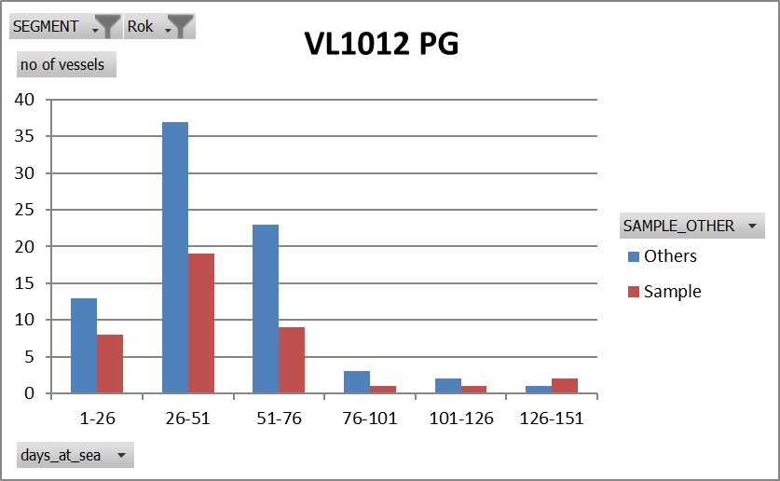
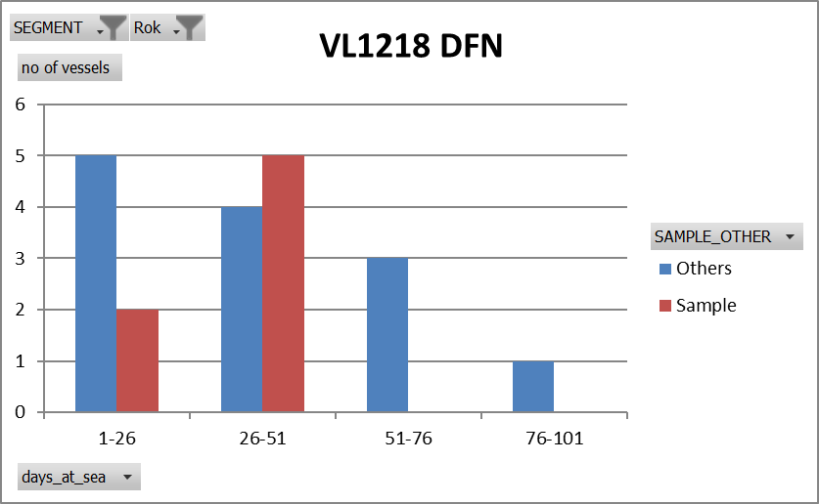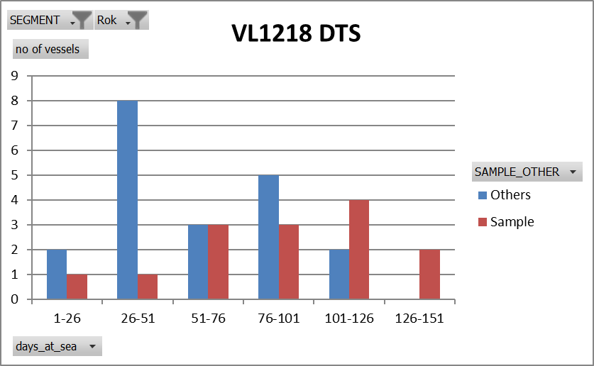
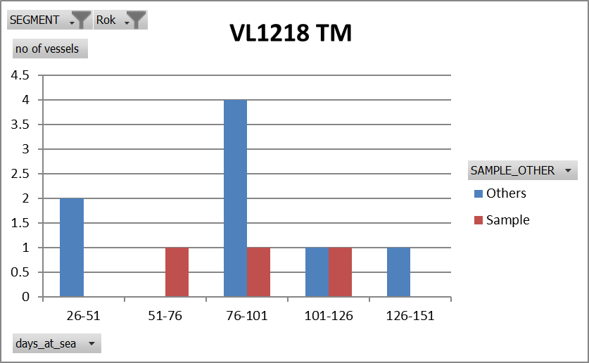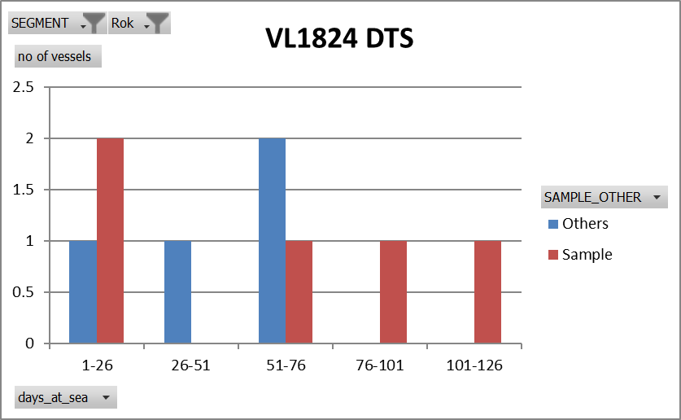
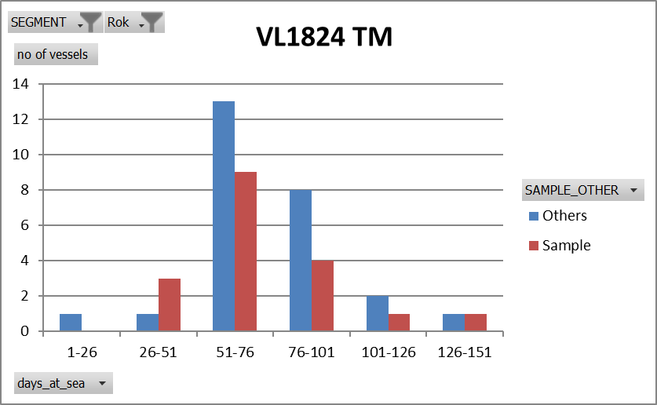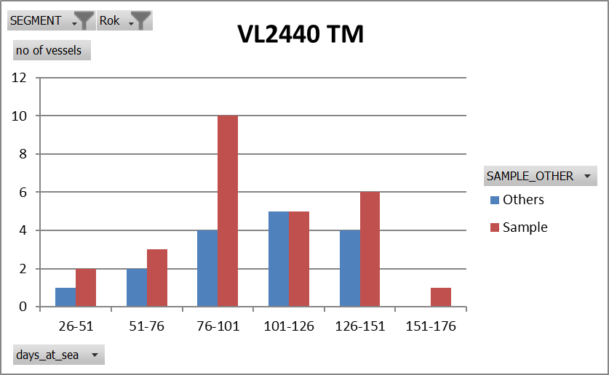
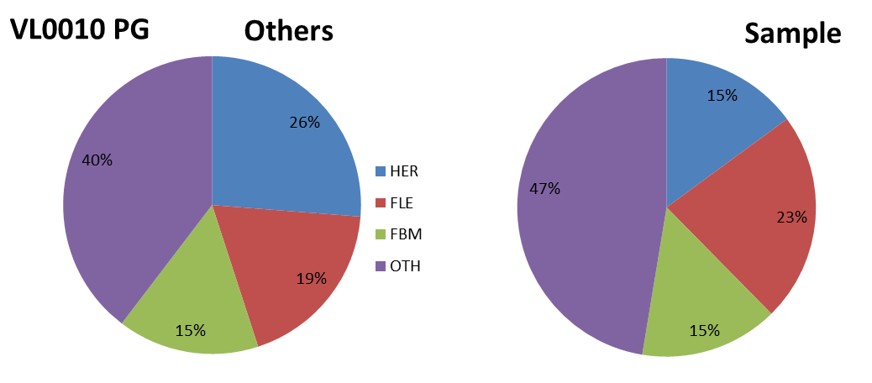
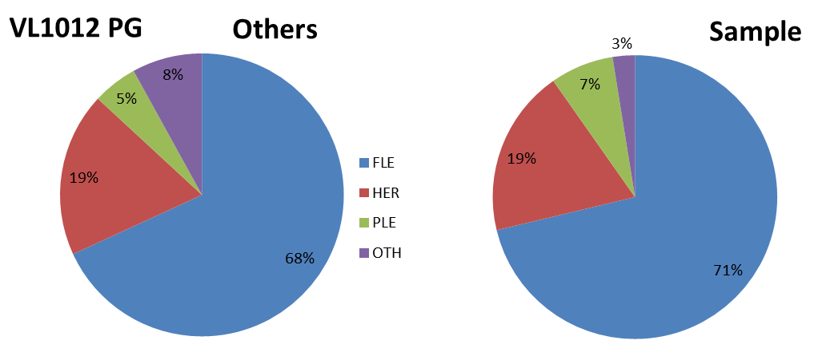
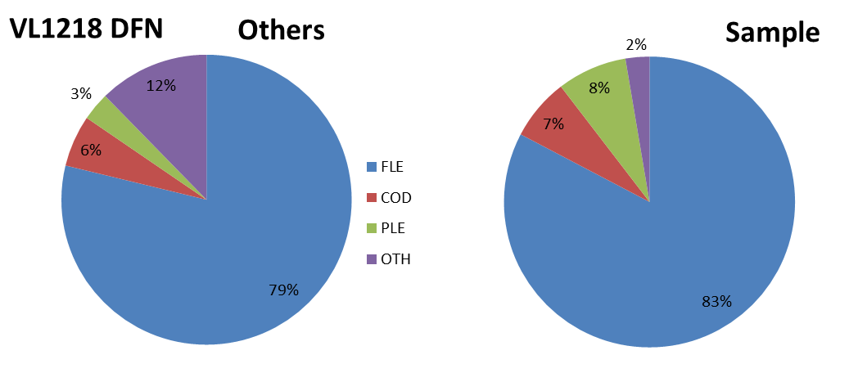
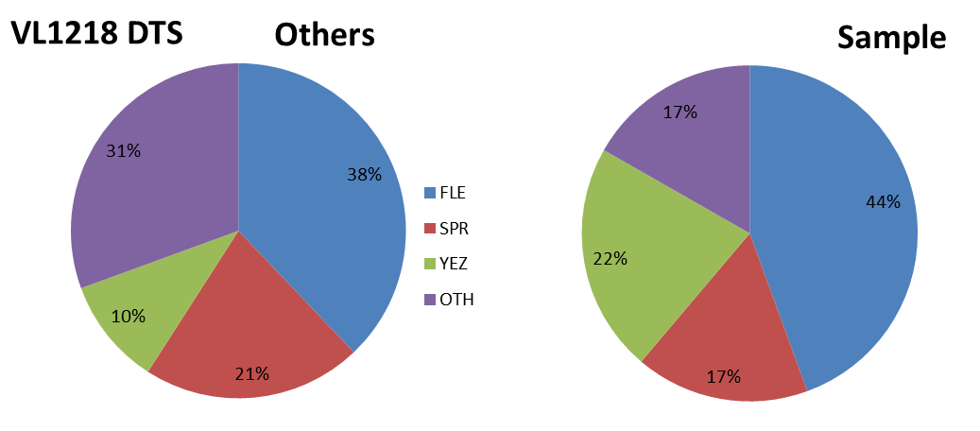
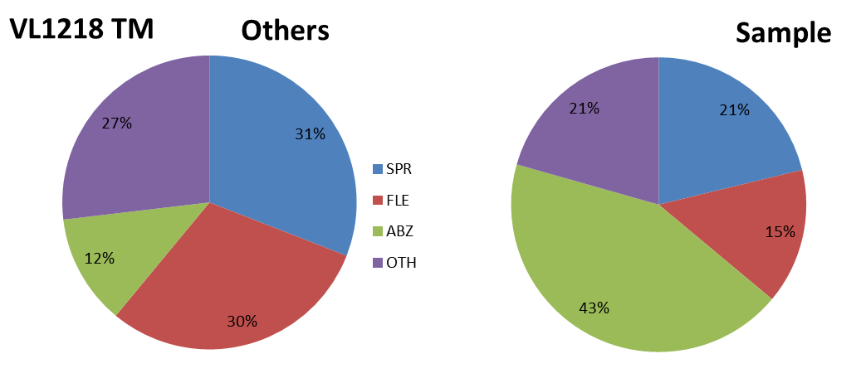
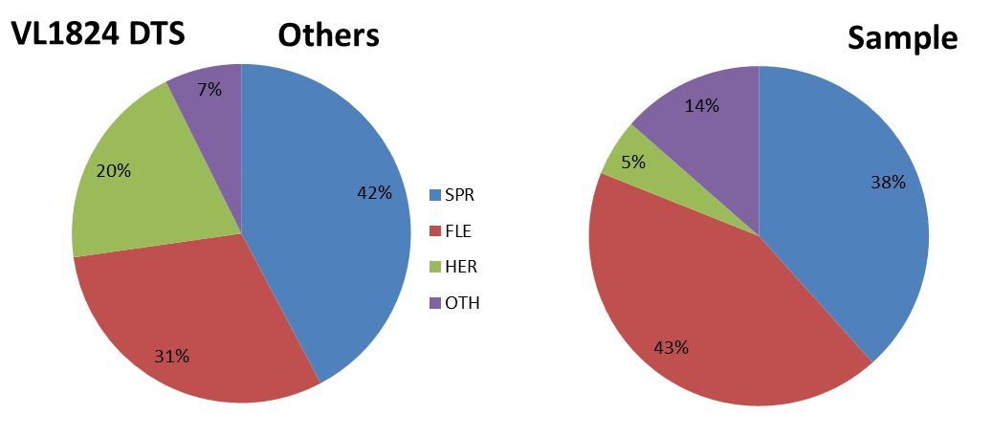
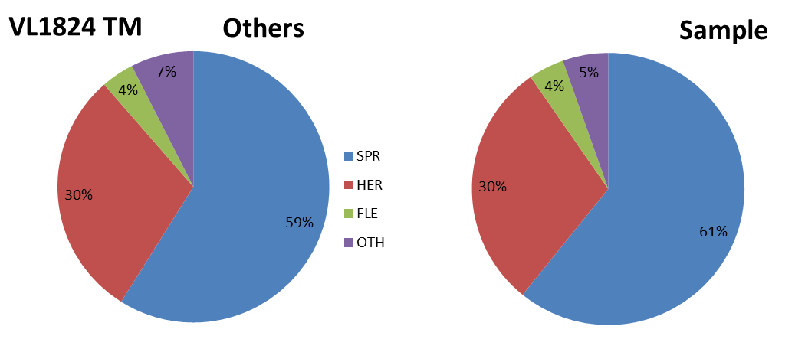
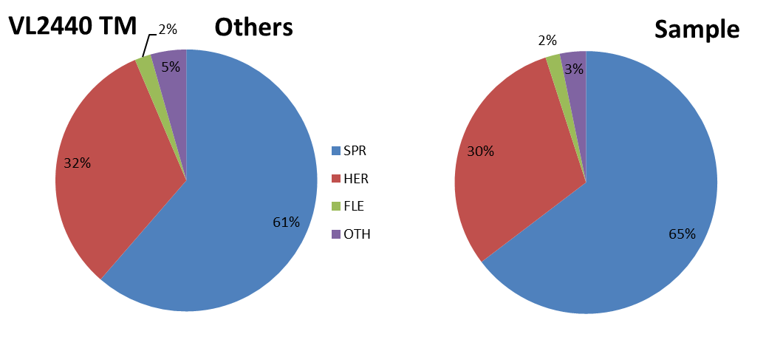
Distant-water fleet
Followed previous years, due to confidentiality reasons deep sea vessels (fishing outside of Baltic Sea) were excluded from economic analysis (data were collected but could not be reported). In 2021 this segment consisted of one pelagic and one demersal characteristic trawler over 40 m in length and one vessel fishing with traps, belonging to 24-40 m length class. Considering this it was impossible to report data without identifying them and infringe the law on data confidence nor combine them with other vessel’s segments.

10.3. Accessibility and Clarity
Indicate with Yes or No
Are methodological documents publicly available?
YES
Are data stored in databases?
YES
Where can methodological and other documentation be found?
Provide the web link, if documentation is publicly available
https://dcf.mir.gdynia.pl/?page_id=367
https://datacollection.jrc.ec.europa.eu/wps
https://datacollection.jrc.ec.europa.eu/documents-links

(max 1000 words)

Section 3: Economic and Social Data

Pilot Study 3: Data on employment by education level and nationality

General comment: This box fulfills paragraph 5 point (b) and paragraph 6 point (b) of Chapter III of the Annex Delegated Decision (EU) 2019/910 on the multiannual Union programme; and Article 2 and Article 4 paragraph (3) point (c) of the Implementing Decision (EU) 2016/1701 on the format of the WP. It is intended to specify data to be collected under Table 6 of the delegated decision on the multiannual Union programme.
General comment: This box is applicable to the Annual Report. This box is intended to provide information on the results obtained from the implementation of the pilot study (including deviations from planned and justifications as to why if this was not the case).
Fisheries
In 2021 in order to be fully in line with the EU-MAP (Commission Delegated Decision 2019/910) the annual economic questionnaire (which is used to collect economic and social data for fisheries) was ammended to include additional missing nationality and unpaid labour information. All other data required has already been collected: employment by gender, FTE by gender, employment by age, employment by education level, employment by employment status, FTE National. All the variables are collected on annual basis.

Aquaculture
There is no marine aquaculture in Poland.

(max 900 words)
4. Achievement of the original expected outcomes of pilot study and justification if this was not the case.

NA – no Pilot Study needed

5. Incorporation of results from pilot study into regular sampling by the Member State.

NA – no Pilot Study needed

(max 900 words)

Section 3: Economic and Social Data

Text Box 3B: Population segments for collection of economic and social data for aquaculture

General comment: This box fulfills paragraph 6 points (a) and (b) of Chapter III of the Annex of the Delegated Decision (EU) 2019/910 on the multiannual Union programme; and Article 2, Article 4 paragraphs (1) and (5) and Article 5 paragraph (2) of the Implementing Decision (EU) 2016/1701 on the format of the WP. It is intended to specify data to be collected under Tables 6 and 7 of the delegated decision on the multiannual Union programme.

General comment: This box is applicable to the Annual Report. This box should provide information on the implementation of the socio-economic data collection for aquaculture of Member States.

1. Description of methodologies used to choose the different sources of data

According to classification of aquaculture activities by Eurostat statistics, Poland has no marine aquaculture sector. Hence, no sampling is planned.

2. Description of methodologies used to choose the different types of data collection
According to classification of aquaculture activities by Eurostat statistics, Poland has no marine aquaculture sector. Hence, no sampling is planned.

3. Description of methodologies used to choose sampling frame and allocation scheme
According to classification of aquaculture activities by Eurostat statistics, Poland has no marine aquaculture sector. Hence, no sampling is planned.

4. Description of methodologies used for estimation procedures
According to classification of aquaculture activities by Eurostat statistics, Poland has no marine aquaculture sector. Hence, no sampling is planned.

5. Description of methodologies used on data quality
According to classification of aquaculture activities by Eurostat statistics, Poland has no marine aquaculture sector. Hence, no sampling is planned.

(max 1000 words)
6. Deviations from Work Plan methodology for selection of data source
List the deviations (if any) from the methodology used to select data source compared to what was planned in the Work Plan, and explain the reasons for the deviations.
Actions to avoid deviations
Briefly describe the actions that will be considered / have been taken to avoid the deviations in the future and when these actions are expected to produce effect. If there are no deviations, then this section can be skipped.

7. Deviations from Work Plan methodology to choose type of data collection
List the deviations (if any) from the methodologies to choose type of data collecton scheme compared to what was planned in the Work Plan, and explain the reasons for the deviations.
Actions to avoid deviations
Briefly describe the actions that will be considered / have been taken to avoid the deviations in the future and when these actions are expected to produce effect. If there are no deviations, then this section can be skipped.

8. Deviations from Work Plan methodology regarding sampling frame and allocation scheme
List the deviations (if any) from the methodologies used regarding sampling frame and allocation scheme compared to what was planned in the Work Plan, and explain the reasons for the deviations.
Actions to avoid deviations
Briefly describe the actions that will be considered / have been taken to avoid the deviations in the future and when these actions are expected to produce effect. If there are no deviations, then this section can be skipped.

9. Deviations from Work Plan methodology used for estimation procedures
List the deviations (if any) from the methodologies used for estimation procedures compared to what was planned in the Work Plan, and explain the reasons for the deviations.
Actions to avoid deviations
Briefly describe the actions that will be considered / have been taken to avoid the deviations in the future and when these actions are expected to produce effect. If there are no deviations, then this section can be skipped.

10. Quality assurance
10.1 Sound methodology
Briefly describe if the data collection follow methodologies, guidelines and best practices agreed in expert groups and whether methodologies are documented and are made publicly available.
10.2. Accuracy and reliability
Response rate and Achieved sample rate are provided in Table 3B.
For additional information, briefly describe how raw data inputs, intermediate results and outputs are regularly assessed and validated and how errors are identified, documented and dealt with.
10.3. Accessibility and Clarity
Indicate with Yes or No
Are methodological documents publicly available?
Are data stored in databases?
Where can methodological and other documentation be found?
Provide the web link, if documentation is publicly available

(max 1000 words)

Section 3: Economic and Social Data

Pilot Study 4: Environmental data on aquaculture

General comment: This box fulfills paragraph 6 point (c) of Chapter III of the Annex of the Delegated Decision (EU) 2019/910 on the multiannual Union programme; and Article 2 and Article 4 paragraph (3) point (d) of the Implementing Decision (EU) 2016/1701 on the format of the WP. It is intended to specify data to be collected under Table 8 of the delegated decision on the multiannual Union programme.
General comment: This box is applicable to the Annual Report. This box is intended to provide information on the results obtained from the implementation of the pilot study (including deviations from planned and justifications as to why if this was not the case).
1. Aim of pilot study
According to classification of aquaculture activities by Eurostat statistics, Poland has no marine aquaculture sector. Hence, no sampling is planned.

2. Duration of pilot study
According to classification of aquaculture activities by Eurostat statistics, Poland has no marine aquaculture sector. Hence, no sampling is planned.

3. Methodology and expected outcomes of pilot study

According to classification of aquaculture activities by Eurostat statistics, Poland has no marine aquaculture sector. Hence, no sampling is planned.

(max 900 words)
4. Achievement of the original expected outcomes of pilot study and justification if this was not the case.

5. Incorporation of results from pilot study into regular sampling by the Member State.

(max 900 words)

Section 3: Economic and Social Data

Text Box 3C: Population segments for collection of economic and social data for the processing industry

General comment: This box fulfils footnote 6 of paragraph 1.1(d) of Chapter III of the Annex of the Delegated Decision (EU) 2019/910 on the multiannual Union programme; and Article 2, Article 4 paragraphs (1) and (5) and Article 5 paragraph (2) of the Implementing Decision (EU) 2016/1701 on the format of the WP. It is intended to specify data to be collected under Table 10 of the delegated decision on the multiannual Union programme.
General comment: This box is applicable to the Annual Report. This box should provide information on the implementation of the socio-economic data collection for aquaculture of Member States.
1. Description of methodologies used to choose the different sources of data
A questionnaire will be used to collect all data.

2. Description of methodologies used to choose the different types of data collection
The data are census. A request for economic and social variables (questionnaires) will be sent to all processing companies. There is a legal obligation to deliver these data annually to National Marine Fisheries Research Institute in Poland (according to the regulation of June 29, 1995 on public statistics - Journal of Laws 2016 No. 0, pos. 1068).

3. Description of methodologies used to choose sampling frame and allocation scheme
Population include all legal business entities, including legal personalities and organizational units without legal personality and individuals operating fish and other aquatic animal processing facilities that are listed as meeting the standards of Council Regulation (EC) no. 853/2004 of April 29, 2004, which sets forth detailed requirements regarding hygiene in foodstuffs of animal origin, Appendix IIII Section VIII Fisheries Products. The data collection will also cover fish processing plants authorized by administrative decision pursuant to art. 21a section 1 and 3 of the Act of 16 December 2005 on products of animal origin (Journal of Laws of 2017, item 242, as amended) for the production of fishery products on third country markets.
The population cover enterprises whose main activity is defined according to the EUROSTAT definition under NACE Code 10.20: ‘products’. ”Processing and preserving of fish, crustaceans and mollusks ” and also enterprises that carry out fish processing but not as main activity.
4. Description of methodologies used for estimation procedures
It is assumed that all processing facilities obliged to return completed questionnaires will comply.
5. Description of methodologies used on data quality
Unit response rate will be used as indicator of accuracy. Defined as the ratio of number units for which data for at least same variables have been collected to the total number of units designed for data collection.
According to article 38 Law issued on 29 June 1995 on official statistics it shall not be allowed to publish or disseminate obtained in statistical surveys of official statistics statistical information which can be linked or can identify natural persons or individual data characterizing business entities, especially if the aggregated data consist of less than three entities or the share of one entity in the compilation is higher than the three-fourths of the total.

(max 1000 words)
6. Deviations from Work Plan methodology for selection of data source
List the deviations (if any) from the methodology used to select data source compared to what was planned in the Work Plan, and explain the reasons for the deviations.
Actions to avoid deviations
Briefly describe the actions that will be considered / have been taken to avoid the deviations in the future and when these actions are expected to produce effect. If there are no deviations, then this section can be skipped.

7. Deviations from Work Plan methodology to choose type of data collection
List the deviations (if any) from the methodologies to choose type of data collecton scheme compared to what was planned in the Work Plan, and explain the reasons for the deviations.
Actions to avoid deviations
Briefly describe the actions that will be considered / have been taken to avoid the deviations in the future and when these actions are expected to produce effect. If there are no deviations, then this section can be skipped.
8. Deviations from Work Plan methodology regarding sampling frame and allocation scheme
List the deviations (if any) from the methodologies used regarding sampling frame and allocation scheme compared to what was planned in the Work Plan, and explain the reasons for the deviations.
Actions to avoid deviations
Briefly describe the actions that will be considered / have been taken to avoid the deviations in the future and when these actions are expected to produce effect. If there are no deviations, then this section can be skipped.

9. Deviations from Work Plan methodology used for estimation procedures
List the deviations (if any) from the methodologies used for estimation procedures compared to what was planned in the Work Plan, and explain the reasons for the deviations.
Actions to avoid deviations
Briefly describe the actions that will be considered / have been taken to avoid the deviations in the future and when these actions are expected to produce effect. If there are no deviations, then this section can be skipped.

10. Quality assurance
10.1 Sound methodology
Briefly describe if the data collection follow methodologies, guidelines and best practices agreed in expert groups and whether methodologies are documented and are made publicly available.
In accordance with national regulations, economic and some social data were collected obligatory for the entire population. In order to ensure the maximum number of questionnaires is received, similarly to previous years reminders of the obligation to file them were sent by emails and registered mail to execute the obligation. For missing questionnaires calculations of the missing variables for the missing population were made, based on average data from the questionnaires received.

10.2. Accuracy and reliability
Response rate and Achieved sample rate are provided in Table 3C.
For additional information, briefly describe how raw data inputs, intermediate results and outputs are regularly assessed and validated and how errors are identified, documented and dealt with.
Each questionnaire received from a fish processing plant is registered in the address database and subjected to formal, substantive and accounting control. Detected errors are corrected by direct phone contact or email with the person resposible for filling in the questionnaire. Then the form is entered into the database in the "Primary Forms" tab. When approving the form for transfer to the "Approved Forms" tab, the system performs automatic data validation. Detected errors must be corrected before approval.

10.3. Accessibility and Clarity
Indicate with Yes or No:
Are methodological documents publicly available? YES
Are data stored in databases? YES
Where can methodological and other documentation be found?
Provide the web link, if documentation is publicly available.
https://dcf.mir.gdynia.pl/?page_id=367
https://datacollection.jrc.ec.europa.eu/wps
https://datacollection.jrc.ec.europa.eu/documents-links

(max 1000 words)

Section 4: Sampling Strategy for Biological Data from Commercial Fisheries

Text Box 4A: Sampling plan description for biological data

General comment: This box fulfills Article 3, Article 4 paragraph (4) and Article 8 of the Implementing Decision (EU) 2016/1701 on the format of the WP and forms the basis for the fulfilment of paragraph 2 point (a)(i) of Chapter III of the Annex of the Delegated Decision (EU) 2019/910 on the multiannual Union programme. This Table refers to data to be collected under Tables 1(A), 1(B) and 1(C) of the delegated decision on the multiannual Union programme.
General comment: This box is applicable to the Annual Report. This box should provide information on the deviations from the planned sampling of Member States.
1. Description of the sampling plan according to Article 5 paragraph (3) of the Implementing Decision (EU) 2016/1701 on the format of the WP.

In 2017 Poland has implemented a new sampling design plan, moving gradually from metier based and purely opportunistic sampling towards the plan based on statistics. After a 3 year implementation, it is now possible to improve the design, eliminating the identified shortcomings.
The following approach was applied to a new sampling plan:

Scheme – determination of the sampling scheme was based on the fishing areas. For the Baltic Sea sampling, the combination of ‘at-sea and on-shore’ scheme was used, whereas in regions outside Baltic Sea only ‘at-sea’ scheme was chosen as the only one practically possible. The defined sampling schemes are: „Baltic at sea and on shore”, „North Sea and Eastern Arctic at sea”, „Other fishing regions at sea”. A separate scheme was set for at-sea sampling of biological data, catch per unit effort and catch composition from recreational fishery for Baltic cod, defined as „At sea cod recreational fishery”.

Stratifications – there were some modifications introduced in comparison to the previous sampling design for Baltic fishery, where the stratification was formerly based on the type of vessels’ fishing technique exploiting given fish stock. This approach had some meaningful defects, where the main one was the fact that one vessel could use multiple fishing techniques so could be assigned to more than one strata, what is statistically wrong. The previous sampling design resulted in high refusal rate, casued among others by the fact that being selected, a vessel was not sampled because it changed gear or target species so was no longer compliant with the PSU group it was initially assigned to. To avoid such a situation in the future, a change was introduced in the way of defining strata, which are now based on the vessels’ length category.

Sampling frame – all vessels that were active (at least one fishing trip) in 2018 make a list that is a proxy for selecting the PSUs. According to WKPICS 2013:
“At-sea sampling with trips as primary sampling units. When trips can be selected randomly from a fleet of vessels, at least approximately, it is often reasonable to treat vessel-trips as the primary sampling units. In such cases, the list of all trips (obtained at the end of the year) makes up the sampling frame. This is a virtual frame that cannot be used in stage 1 to select the trips. The actual selection is typically based on a frame with a vessel list crossed with time.“.

Coverage – assuming the target population consists of all vessels that were active in 2018, the coverage of target population equals 100%.

Primary Sampling Unit (PSU) is „vessel trip”

Sampling intensity – in order to maintain the continuity of the sampling intensity compared to the previous years, the annual number of samples to be collected during 2020-2021 period is at the same level as during the previous multiannual programs (2014-2019). Both at sea and on shore sampling will be continued. In order to obtain independent, scientific data on discards, at sea sampling will be conducted as the first choice, if not possible then on-shore sampling will be conducted.
Sampling of the Baltic Sea fisheries is based on a quarterly basis. To define the sampling intensity per each stratum per quarter, the half of the total annual number of samples was distributed proportionally to the quarterly distribution of landings and the second half of the total number of samples was distributed proportionally to the total number of trips. It was decided to include both paramateres in order to distribute the sampling effort reflecting the different segments of the fishing fleet. So to take into consideration vessels that have the bigger share in total catches (i.e. larger vessels) as well as vessels that have much more fishing trips but small catches (i.e. smaller vessels, active mainly in a coastal fishery).
In case of sampling fisheries outside the Baltic Sea, fishing trips to sample are not selected randomly but depend on practical or regional considerations (see comments in Table 4A of the WP).

Reference years – in case of the Baltic Sea fisheries only 2018 data were used as the reference year, treating it as a most reliable period. Basing on this, we get the sampling frame that is more up to date than it would be if the last 3 years were used. With this approach, it will be possible to reduce the refusal rate eliminating the refusals like ‘vessel withdrawn’, ‘vessel under renovation’ etc. For fisheries outside the Baltic Sea, the three years period of 2016-2018 was applied as a reference years.

Sample selection – in case of the Baltic Sea fisheries sampling, for each quarter and for each stratum a list of vessels will be randomly selected with replacement from a sampling frame. The number of vessels selected will be overrated, to take into account potential refusals and to avoid additional draws. The number of extra vessels to be drawn, has been estimated based on refusal rate from the period 2017-2019. In case, the selected number of vessels will not be enough (more refusals than expected, e.g. lack of contact with the vessel, refusal to take observer on board or provide landed fish for sampling on shore), the supplementary drawing will be performed to maintain the desired number of vessels trips to sample. The concrete vessel trip will be chosen depending on the observer availability. List of vessels selected for sampling will be recorded in a register. This register will contain information on date of selection, date the vessel was contacted to arrange sampling, information if contact with the vessel was successful or not, vessel’s owner acceptance or refusal to be sampled (as well as reasons in case of refusal).

Data archiving and quality checks – Data entered to the national database are verified in the two-stage validation process supported by a number of completeness, data type and range checks. Export procedures which prepare data sets for external databases (like RDB FishFrame or InterCatch) also perform basic checks. Additionally, a number of quality reports were developed to improve the completeness and reliability of the data.

Coverage of fish stocks – as the stratification is based on vessel length and does not put any restirictions on stock sampling, simulations were carried out in order to investigate the potential coverage of stocks fished and metiers used. Using the official 2018 data, the test drawing for all strata was carried out. The average number of samples per fishing stock and metier was calculated after 100 iterations made to check the coverage. The result of these simulations showed that planned sampling design described above provides good coverage of fish stocks.

Until 2016, sampling programme was based on an opportunistic approach. Due to the confidentiality of personal data, the Institute executing the DCF had no full register of the fishing vessels’ owners with contact details. Sampling was based on the cooperation with the owners of over 100 vessels (c.a. 12% of all Polish vessels), built over the years on the basis of trust. During last three years efforts were being made to gain access to the full register of vessels’ owners. The list of contact details to vessels’ owners systematically expands but the process is extended in time. Therefore, the main expected difficulties in execution of the sampling programme is potentially high level of non-response and/or refusals.

Deviation from the sampling plan according to Article 5 paragraph (3) of the Implementing Decision (EU) 2016/1701:
2. Deviations from the Work Plan
Member State shall list the deviations (if any) in the achieved data collection, compared to what was planned in the Work Plan and explain the reasons for the deviations.

The improvements of the sampling design implemented in 2020, which followed the suggestions from WGCATCH, were also applied in 2021, as they proved to have a positive impact on data collection. The major change was to simplify sampling stratification. Definition of PSU groups is no longer dependent on target assemblage or fishing technique, which led to reduction of refusals related to the change of vessel’s metier. The list of contacts to vessel owners is constantly updated and as a result there were only few cases in 2021 when contact details to selected vessels were missing. Despite the above mentioned improvements, still some obstacles in collecting the samples were encountered in 2021.
The achieved number of PSUs collected in all strata was being monitored quarterly throughout the whole year. If execution of the plan in a given quarter was poor, then opportunistic selection of missing PSUs (expert’s selection) was carried out in the second half of that quarter.
According to the sampling design, all contacts with the owners of vessels selected for sampling fishing trips in each stratum, as well as refusals and reasons for refusals were recorded in a dedicated register. The refusal rates in 2021 decreased in most of sampling strata in comparison to 2020 and ranged from 32% to 79.63%.
The methodology used to determine the refusal rate was based on the one used by the ICES Study Group on Practical Implementation of Discard Sampling Plans (SGPIDS). With a slight modification of including also ‘Not available’ status, as in 2021 this was the main reason for not achieving the planned number of samples.
“As defined during SGPIDS 2 (ICES 2012a) the refusal rate in the fisheries context is the proportion of skippers who, having been successfully contacted ultimately failed to allow the observer to go onboard to obtain the sample. This refusal rate is calculated as the number of industry refusals divided by the number of sequential selections or approaches where contact was successfully made. This refusal rate provides an indication of the industry reaction to the observer programme and is a useful measure of their cooperation.” (ICES. 2013. Report of the Study Group on Practical Implementation of Discard Sampling Plans (SGPIDS), 24 June – 28 June 2013, Lysekil, Sweden. ICES CM 2013/ACOM:56. 142pp. –
http://www.ices.dk/sites/pub/Publication%20Reports/Expert%20Group%20Report/acom/2013/SGPIDS/SGPIDS13.1.pdf )
The table below presents, for each stratum, the list of fishing trips selected for sampling and successfully contacted, number of refusals, number of trips selected opportunistically by experts, number of trips actually executed and refusal rate.
Stratum ID | Drawn / contacted | Refusal | Expert selection | Executed | Refusal Rate (%)
<10 | 69 | 35 | 39 | 73 | 50.72
10-<12 | 15 | 11 | 11 | 15 | 73.33
12-<18 | 18 | 11 | 8 | 15 | 61.11
18-<24 | 54 | 43 | 1 | 12 | 79.63
24-<40 | 101 | 75 | 2 | 28 | 74.26
Pelagics_pilot | 25 | 8 | 0 | 17 | 32.00

The refusal rate for vessels under 10 meters in length (<10) and those between 10 and 12 meters in length (10-<12) was high mainly because lack of vessels activity caused by Covid-19. Moreover, bad weather conditions were another significant obstacle to sampling of small scale fleet. In case of strata 12-<18, 18-<24 and 24-<40 , so the vessels between 12 and 40 meters, the most frequent reason of refusals was inactivity related to temporal closures of major fisheries in the Baltic Sea.
The main reasons for refusals varied between the different strata. Four main groups of refusals’ reasons were chosen for refusal analysis purposes:
1) inactive vessels (including vessels actually inactive, in repair, unavailable or withdrawn from fishery);
2) no fishing limit;
3) reluctance to cooperate;
4) bad weather conditions;
5) no space for observer;
The figures below present the frequency of different reasons for refusal for each stratum:
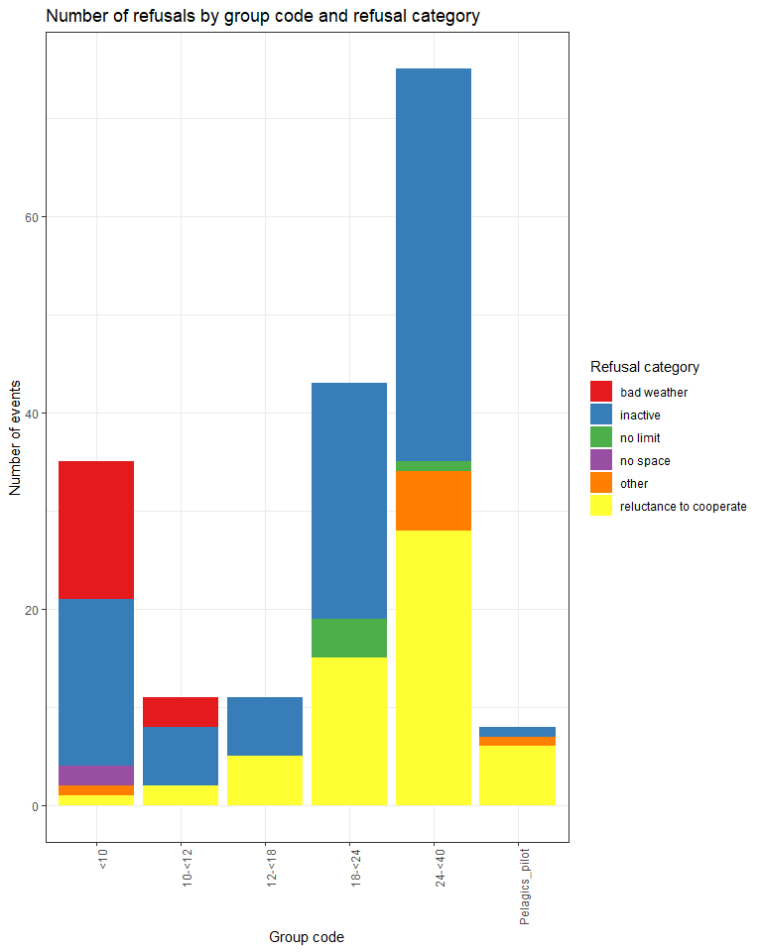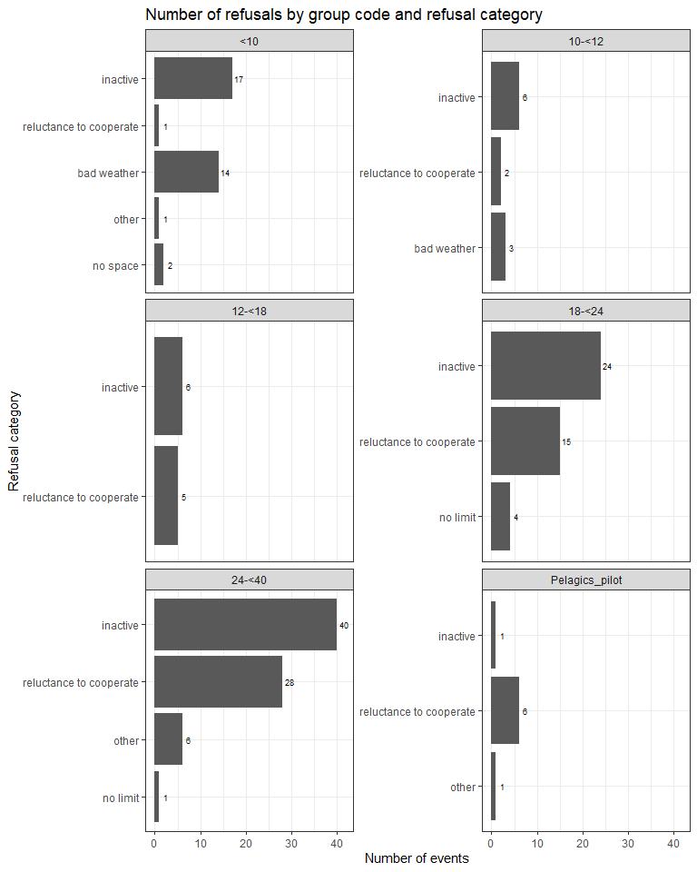

In general, two main reasons for refusals among vessels/trips selected for sampling were either inactive vessels (51%) or reluctance to cooperate (31%). These two reasons together constituted 82% of refusal cases. Lack of quota accounted for 3% of refusals, whereas bad weather conditions accounted for 9%.
Additionally, in 2021 the samples were obtained from one strata not included in any of the sampling frames defined in the Work Plan. The samples were collected as a part of the Intersessional Subgroup ‘Case study of fisheries for small pelagic’s in the Baltic’. The data were collected in the three months period January-March 2021, with the random method of PSU selection. The sampling frame included 56 vessels which met the following criteria: were active at least once in the period January-March 2020, were using OTM, had total landings 10t minimum, were targeting sprat or herring (over 95%) and have length above 17.5m.

3. Action to avoid deviations
Member State shall describe the actions that will be considered / have been taken to avoid the deviations in the future and when these actions are expected to produce effect. If there are no deviations, then this section is not applicable.
Based on the sampling design applied, a dedicated web application was used to support sampling process management. The application provides three types of user roles:
1) Administrator – management of PSUs groups, vessels and trips. Access to fishery statistics, drawing of vessels, assigning coordinators to groups.
2) Coordinator – partial permission for trips’ management within the assigned groups. Assigning observers to trips.
3) Observer – restricted access to trips with a possibility to view assigned trips.
4) Visitor - possibility to view assigned trips but no permission to modify
A module for contact’s details management was successfully implemented by the end of 2017.
Other regions - North Sea and Eastern Arctic / CECAF
2. Deviations from the Work Plan
Member State shall list the deviations (if any) in the achieved data collection, compared to what was planned in the Work Plan and explain the reasons for the deviations.
No sampling performed in 2021 in the North Sea and Eastern Arctic. There was only one vessel operating in this area and targeting demersal species, operating from outside of Poland. Due to the COVID restriction and uncertainties in Europe the fishing trip with an observer, originally planned in the first quarter, was postponed. When the vessel was ready to take observer onboard in the second quarter, no long distance fishery’s observer was available. Ultimately, this vessel was withdrawn from Polish fleet in the second half of 2021 and the chance to sample fishery in this region was lost.
No fishing activity of the Polish fleet in CECAF areas in 2021.

3. Action to avoid deviations
Member State shall describe the actions that will be considered / have been taken to avoid the deviations in the future and when these actions are expected to produce effect. If there are no deviations, then this section is not applicable.
No measures could be taken to mitigate encountered problems.
Other regions - SPRFMO
2. Deviations from the Work Plan
Member State shall list the deviations (if any) in the achieved data collection, compared to what was planned in the Work Plan and explain the reasons for the deviations.
No deviations.
3. Action to avoid deviations
Member State shall describe the actions that will be considered / have been taken to avoid the deviations in the future and when these actions are expected to produce effect. If there are no deviations, then this section is not applicable.
No actions needed.

(max. 1000 words per region OR fishing ground)

Section 5: data quality

Text Box 5A: Quality assurance framework for biological data
General comment: This box is applicable to the Annual Report. This box fulfills Article 5 paragraph (2) point (a) of the Implementing Decision (EU) 2016/1701 on the format of the WP. This box is intended to specify data to be collected under Tables 1(A), 1(B) and 1(C) of the Annex of the Delegated Decision (EU) 2019/910 on the multiannual Union programme. Use this box to provide additional information on Table 5A of the Annual Report.
Applies to all Region/RFMO/RFO/IO OR sampling schemes
1. Evidence of data quality assurance
Within this section Member State shall provide information on the methodology used to assure the quality of the data collected, highlighting those aspects where changes have been made during the sampling year. Information shall be provided by each sampling scheme for which data was collected. In the case where the same quality assurance framework is applied to all data collection schemes, information can be provided at general level with the indication “all sampling schemes”.
In those sections of Table 5A where “N” is indicated, Member States shall explain the main constrains and/ or the steps taken to fulfil this obligation. In the cases where a reference documents is requested, Member States shall provide a web link.
In cases where documents are not publicly available, due to institutions internal policy, confidentiality or other reasons, this shall be indicated by the Member State.
Polish quality assurance framework is a multi-stage process. At first, data entered to the national database are verified in the two-stage validation process supported by a number of completeness, data type and range checks. Export procedures which prepare data sets for external databases (like RDB FishFrame or InterCatch) also perform basic checks.
Additionally, three validation applications were developed, all written in Shiny (R package) and available only via the institute’s intranet:
- Data Quality Check application - the following visual and quantitative quality analyses of the data stored in the database, are available:
- outliers identification for Weight at Length relationship and Length at Age – a user can inspect the data visually on the scatter plots and mark suspicious points for further checking, or make use of the automatic outliers identification based on the Bonferroni outlier test,
- inconsistency between sample and catch weight,
- biological analyses with missing age – a table with detailed data, as well as a histogram of the number of gaps for all species, are available,
- inconsistency between number of individuals in the length classes and in the biological analyses,
- dates misreporting.
A user can screen the data in the fully interactive mode or download a quality report in HTML/PDF format. Another type of data quality check was identified and described in 2019 and further developed in 2020 and 2021. The purpose of this new check is to find potential duplicates in the sampling data registered in the national database. The implementation of it is in progress.
- Data Accuracy Check application - the model and assumptions of the data accuracy checks software have been specified in 2019 and in 2020 it was adjusted to the new sampling design. The new features are still being developed and the information about possible accuracy checks is currently being collected from the available literature. Over the last year, the outcomes of WKBIOPTIM have been analysed and will be implemented in the nearest future. Currently the observer effect analysis is available for users of the web application. A user can display all VMS signals of a chosen vessel and highlight points from trips with on-board observers. The methodology used was based on the ICES WKACCU Report 2008, whereas the example of such analysis applied to the Polish data was performed during RCM Baltic 2016. A script for refusal reasons analysis developed as a standalone document in 2019 enables the calculation of refusal rates, categorisation of refusal reasons and identification of unusual refusal reasons. The script produces a set of graphs that gives an overview of the results of contact attempts. The script was significantly updated in 2020, because of the new sampling design and further tested in 2021. This script was included in the data accuracy check web application in 2021. Moreover the following types of check were further developed: spatial and temporal coverage of sampling, random trips vs expert judgement trips. To enhance tools for data accuracy checks, an option of switching the application from “R” to “Python” were analysed in 2021 and will be further discussed.

- Sampling plan achievement monitoring application – this application was created in 2020 as a manager tool with the purpose of supplying an easy way to monitor the achievement of the sampling plan. What is already developed is the set of analysis displaying number of trips, samples, specimens measured for age and length for a species and year selected by a user. Basing on this app, the managers are making decisions whether there should be some extra sampling carried out – not probabilistic, basing on the expert knowledge, to supply the sufficient number of samples. In 2021 the current achievement summary was included in the app. It include number of samples, refusals and the most frequent reasons of refusals. This whole effort is being made to make sure that the best quality of sampling is carried out.

2. Sampling design
Explain main constraints and/ or steps taken, if ‘N’ (no) was indicated in Table 5A.
NA
Documentation data quality assurance regarding data collected from EU fishery in the SPRFMO area as well as documentation of sampling design for two recreational fisheries sampling schemes (marine recreational fisheries for Diadromous species and inland waters recreational fisheries for Diadromous species) were revised already in 2020 and are accessible publicly at:
https://dcf.mir.gdynia.pl/?page_id=367.

3. Sampling implementation
Explain main constraints and/or steps taken, if ‘N’ (no) was indicated in Table 5A.
Recording of non-responses and refusals is not applicable in the long distance fishery (pelagic trawlers fishing in NS&EA, CECAF and SPRFMO areas). There are limited number of vessels available in these sampling strata and, unless for objective reasons, there are no substantial problems with placing observer on board the vessels – based on written agreements with vessels owners concerned.
4. Data capture
Explain main constraints and/ or steps taken, if ‘N’ (no) was indicated in Table 5A.
NA
5. Data Storage
Explain main constraints and/ or steps taken, if ‘N’ (no) was indicated in Table 5A. Please provide a link if the documented revisions are available and not confidential.
NA
6. Data processing
Explain main constraints and/ or steps taken, if ‘N’ (no) was indicated in Table 5A.
Imputation is not performed at national level but at Stock Data Coordination level. Data are provided to end user "as-is" (as collected, validated and recorded in national database)

(max. 900 words per Region/RFMO/RFO/IO OR sampling scheme)

Section 5: data quality

Text Box 5B: Quality assurance framework for socioeconomic data

General comment: This box fulfills Article 5 paragraph (2) point (b) of the Implementing Decision (EU) 2016/1701 on the format of the WP. This box is intended to specify data to be collected under Tables 5(A), 6 and 7 of the Annex of the Delegated Decision (EU) 2019/910 on the multiannual Union programme. Use this box to provide additional information on Table 5B of the Annual Report.
1. Evidence of data quality assurance
Within this section MS shall provide information on the methodology used to assure the quality of the data collected, highlighting those aspects where changes have been made during the sampling year. Information shall be provided by each sector (Fishing fleet, Aquaculture, Fish processing) for which data was collected and by each data collection scheme. In the case where the same quality assurance framework is applied to all sectors or/and all data collection schemes, information can be provided at general level with the indication “all sectors” or “all data collection schemes”.
In those sections of Table 5B where “N” is indicated, Member States shall explain the main constrains and/ or the steps taken to fulfil this obligation. In the cases where a reference documents is requested, Member States shall provide a web link.
In cases where documents are not publicly available, due to institutions internal policy, confidentiality or other reasons, this shall be indicated by the Member State.
Fleet
In accordance with national regulations, each vessel’s owner is legally bound to fill out a questionnaire regarding the economic results of the fishing vessel. In order to ensure the maximum number of questionnaires is received, similarly to previous years reminders of the obligation to file them were sent by registered mail and phone calls were made to execute the obligation. Recommendations of the Lisbon DCF workshop on “statistical issues related to the collection of economic data within the DCF” (i.e. closer cooperation with PO) were taken into account to deal with the non-response problem. As the number of returned questionnaires did not reach a plan of respond rate, calculations were made, based on the questionnaires received. Economic data received does not usually exceed 70% of respond rate. However all responses were of random character (probability sample), which should ensure the representativeness of the sample. Response rates are provided in an Excel table.

Aquaculture
Data are not collected in Poland.

Processing
In accordance with national regulations, economic and some social data were collected obligatory for the entire population. In order to ensure the maximum number of questionnaires is received, similarly to previous years reminders of the obligation to file them were sent by registered mail and phone calls were made to execute the obligation. Recommendations of the Lisbon DCF workshop on “statistical issues related to the collection of economic data within the DCF” were taken into account to deal with the non-response problem. For missing questionnaires calculations of the missing variables for the missing population were made, based on average data from the questionnaires received.

2. Section P3 Impartiality and objectiveness
Explain main constraints and/ or steps taken, if ‘N’ (no) was indicated in Table 5B
NA
3. Section P4 Confidentiality
Explain main constraints and/ or steps taken, if ‘N’ (no) was indicated in Table 5B
NA
4. Section P5 Sound methodology
Explain main constraints and/ or steps taken, if ‘N’ (no) was indicated in Table 5B
Information on this principle should be briefly explained in Text boxes 3A, 3B and 3C. Description of methodologies used on data quality.
NA
5. Section P6 Appropriate statistical procedures
Explain main constraints and/ or steps taken, if ‘N’ (no) was indicated in Table 5B. Please provide a link if the documented revisions are available and not confidential.
NA
6. Section P7 Non-excessive burden on respondents
Explain main constraints and/ or steps taken, if ‘N’ (no) was indicated in Table 5B
NA
7. Section P8 Cost effectiveness
Explain main constraints and/ or steps taken, if ‘N’ (no) was indicated in Table 5B
Some fish processing and fisheries data is duplicated with the Central Statistical Office (CSO) data collection programme. It is however unavoidable since the data reported needs to be aggregated in requested data call way based on individual units (which are unavailable to get from CSO due to confidentiality reasons).
8. Section P9 Relevance
Explain main constraints and/ or steps taken, if ‘N’ (no) was indicated in Table 5B
NA
9. Section P10 Accuracy and reliability
Explain main constraints and/ or steps taken, if ‘N’ (no) was indicated in Table 5B. Information on this principle should be briefly explained in Text boxes 3A, 3B and 3C. Description of methodologies used on data quality.
NA– there is few end users interested only.

10. Section P11 Timeliness and punctuality
Explain main constraints and/ or steps taken, if ‘N’ (no) was indicated in Table 5B
There is no need to have errors documented, all detected issues are corrected.

11. Section P12 coherence and comparability
Explain main constraints and/ or steps taken, if ‘N’ (no) was indicated in Table 5B
NA
12. Section P13 Accessibility and Clarity
Explain main constraints and/ or steps taken, if ‘N’ (no) was indicated in Table 5B. Information and links to documentation on this principle should be briefly explained in Text boxes 3A, 3B and 3C. Description of methodologies used on data quality.

NA

(max. 900 words per Region/RFMO/RFO/IO/NSB OR sector)

