National Marine Fisheries Research InstituteNational

Commission Implementing Decision (EU) 2016/1701
on the establishment of a Union framework for the collection, management and use of data in the fisheries sector and support for scientific advice regarding the common fisheries policy and repealing Council Regulation (EC) No 199/2008 (recast).
Commission Implementing Decision (EU) 2016/1251 of 12 July 2016 adopting a multiannual Union programme for the collection, management and use of data in the fisheries and aquaculture sectors for the period 2017-2019.
Commission Implementing Decision (EU) 2016/1701
laying down rules on the format for the submission of work plans for data collection in the fisheries and aquaculture sectors.
Commission Implementing Decision (EU) ****/*****

POLAND
Annual Report for data collection in the fisheries and aquaculture sectors
2018

Version 1

[Gdynia, 29 May 2019]
CONTENTS
Section 1: Biological Data 3
Text Box 1C: Sampling intensity for biological variables 3
Section 1: Biological Data 7
Text Box 1D - Recreational fisheries 7
Section 1: Biological Data 9
Pilot Study 1: Relative share of catches of recreational fisheries compared to commercial fisheries 9
Section 1: Biological Data 13
Text Box 1E: Anadromous and catadromous species data collection in fresh water 13
Section 1: Biological Data 15
Text box 1F: Incidental by-catch of birds, mammals, reptiles and fish 15
Section 1: Biological Data 17
Pilot Study 2: Level of fishing and impact of fisheries on biological resources and marine ecosystem 17
Section 1: Biological Data 18
Text Box 1G: List of research surveys at sea 18
Section 2: Fishing Activity Data 25
Text Box 2A: Fishing activity variables data collection strategy 25
Section 3: Economic and Social Data 26
Text Box 3A: Population segments for collection of economic and social data for fisheries 26
Section 3: Economic and Social Data 32
Pilot Study 3: Data on employment by education level and nationality 32
Section 3: Economic and Social Data 33
Text Box 3B: Population segments for collection of economic and social data for aquaculture 33
Section 3: Economic and Social Data 35
Pilot Study 4: Environmental data on aquaculture 35
Section 3: Economic and Social Data 36
Text Box 3C: Population segments for collection of economic and social data for the processing industry 36
Section 4: Sampling Strategy for Biological Data from Commercial Fisheries 40
Text Box 4A: Sampling plan description for biological data 40
Section 5: data quality 46
Text Box 5A: Quality assurance framework for biological data 46
Section 5: data quality 48
Text Box 5B: Quality assurance framework for socioeconomic data 48

Section 1: Biological Data

Text Box 1C: Sampling intensity for biological variables

General comment: This box fulfils paragraph 2 point (a)(i)(ii)(iii) of Chapter III, Chapter IV of the multiannual Union programme and Article 2, Article 4 paragraph 1 and Article 8 of the Decision (EU) 2016/1701. This box is applicable to the Annual Report.
Member State should provide by Region/RFMO/RFO/IO:
- Evidence of data quality assurance
Quality evaluation can only be carried out if the information coming from Table 5A is available. If this is not the case, Member State shall provide an overview by giving information on the methodology used to assure the quality of the data collected.
e.g.:
The sampling design and protocols follow the outcomes of sampling expert groups.
Use of common standard criteria agreed with other countries/groups.
Use of special packages or tools (e.g. COST …) for calculations.
Use of sampling protocol for storage of data.
Use of sampling protocol for processing of data.
Use appropriate exploratory statistical techniques to detect outliers and anomalous registers.

All Region/RFMO/RFO/IO
For the overview of the quality assurance methodology used, see Table 5A and Text Box 5A

- Deviations from the Work Plan
MS to list the deviations (if any) in the achieved data collection compared to what was planned in the Work Plan and explain the reasons for the deviations. The threshold for deviation follow those set in the former AR: <90 % and >150 %.
Explain any deviation from the proposed:
- sampling intensity,
- methods used for collecting data.
- methods used for estimating the parameters.
General reasons for deviations from the Work Plan in terms of planned vs. achieved should be summarised in this section, while detailed comments on deviations on particular species/stocks should be included in the AR Comments column in Table 1C.
In case of Member State adding new species not included in the WP, this should be clearly explained and justified.

Sampling Design described in the WP, does not provide for planned minimum of individuals to be measured expressed in absolute numbers but explains the methodology of sampling. In order to compare the achieved number of individuals measured at the national level with the planned number according to WP, the “AR Comments” column in Table 1C contains method of calculation of what the planned number should be.

Baltic Sea
No deviations from sampling methods used. Only deviations in sampling intensity were encountered.

Oversampling:
Perch (Perca fluviatilis) was oversampled for biological parameters. This fishery is important for local communities of small scale fishery and decline in this fishery was observed in 2018 (overall landings reduced by 34%). Therefore more biological samples were taken (with negligible financial consequences) in order to have wider scope of biological data for this stock.
Both Herring 25-29 (Clupea harengus) and Sprat 22-32 (Sprattus sprattus) were oversampled for length in commercial fishery by. This oversampling is mainly caused by the intensive sampling at sea. When the measurements are taken by an observer during the trip at sea, the reason for over-sampling is often that all fish chosen randomly as a subsample have to be measured in order to calculate the retained and discarded portion of the whole catch.
Sprat was also slightly oversampled in case of biological data during surveys mainly due to the fact that higher number of individuals per 0,5 cm length class from the range 5-10 were taken for sampling.

Undersampling:
Although European eel (Anguilla Anguilla) was undersampled for biological parameters, but it does not affect the results of the stock dynamics model as the total number of sampled eels is sufficient for modeling purposes.
Herring (Clupea harengus) in SD 22-24 was slightly undersampled for biological parameters during surveys due to very low abundance of this species in BITS surveys (which are not dedicated to pelagic stocks).
Herring (Clupea harengus) in SD 25-29 from commercial fishery was also slightly undersampled for biological parameters due to high rate of refusal to take observers on board (89,7%). (for more comments on refusal rate analysis see Text Box 4A)
Both Cod stocks (Gadus morhua), 22-24 and 25-32, in commercial fishery sampled at sea were undersampled due to insufficient number of sampling trips, caused by dramatic decline, in terms of fishing trips in 2018 as compared to the reference period, in GNS cod fishery in SD 25-32 (by 49%) and in SD 22-24 (by 74%). The trawl fishery for cod 25-32 also decreased by 43% in 2018. The Polish quota for cod 25-32 in 2018 was utilized at the level of 53% only. Additionally, with the very low fishing quota for the fishery for cod 22-24 (786 t), this fishery was closed already by mid-July 2018, making impossible to collect all samples planned.
Flounder (Platichthys flesus) was undersampled in commercial fishery for biological parameters due to low number of sampling trips, caused by high level of non-responses and refusals to take observers onboard.
Plaice (Pleuronectes platessa) is marked as undersampled for biological parameters during surveys due to low range of length classess observed and as a result of the methodology applied to calculate planned number according to WP (see the “AR Comments” column in Table 1C).
Turbot (Psetta maxima) was undersampled due to the fact that it is a by-catch species and often limited number of fish for length measurement is available and it was not possible to purchase the fish for biological sampling. In total, only 79 t of turbot were landed in Poland in 2018.
Salmon (Salmo salar) was practically not sampled in 2018 due to 100% refusal rate for both accepting observer on board for at sea sampling and for onshore sampling. Additionally, sampling was not possible from mid-September due to introduction of the closure of this fishery in Poland. Only four individuals, being a by-catch in other fisheries, were measured for length. (for more comments on refusal rate analysis see Text Box 4A)
Sea trout (Salmo trutta) was undersampled due to the fact that it was not possible to obtain sufficient number of fish, both from self-sampling or from the market, to achieve the target.
Indication for undersampling of Perch (Perca fluviatilis) for length is a result of the methodology applied to calculate planned number according to WP (see the “AR Comments” column in Table 1C). This methodology assumes equal weight of boxes with fish purchased for sampling (25 kg), However, in reality the on shore samples are purchased from fishermen by weight and are presented in boxes, with unknown number and size/weight of individual fish in a box and unknown weight of boxes. All fish from purchased boxes are measured but very often, especially in case of low catch, boxes are not filled to full 25 kg capacity.
Pike perch (Sander lucioperca) was significantly undersampled because of dramatic decline in fishery (by 57%). Like in the case of Perca fluviatilis above, the on shore samples are purchased from fishermen by weight and are presented in boxes, with unknown number and size/weight of individual fish in a box and unknown weight of boxes. All fish from purchased boxes are measured but very often, especially in case of low catch, boxes are not filled to full 25 kg capacity.

Other Regions - North Sea and Eastern Arctic
There were no deviation in sampling for cod stock I-II (Gadus morhua). The reason for not sampling Melanogrammus aeglefinus and Pollachius virens in 2018 was that those are by-catch species in cod fishery and during one observed fishing trip in that region there were practically no by-catch of those two species.

Other Regions – CECAF
Based on a new multilateral agreement between DEU-LTU-LVA-NLD-POL, from 2018 Poland is coordinating joint sampling program for biological data collection on board EU fishing vessels engaged in the fishery for small pelagic fish in the CECAF area (Central-East Atlantic).
Biological sampling in this in 2018 was conducted in line with "Biological Data Collection of pelagic fisheries in CECAF waters - Manual for scientific observers on board EU pelagic trawlers in CECAF area". (see Table 7C for more info)

Other Regions – SPRFMO
Based on a new multilateral agreement between DEU-LTU-NLD-POL, from 2017 Poland is coordinating joint sampling program for biological data collection on board EU fishing vessels engaged in the fishery for small pelagic fish in the SPRFMO area (South-East Pacific).
Biological sampling in this Region in 2018 was conducted in line with the SPRFMO Data Standards (CMM 02-2018) and the requirements of the SPRFMO Conservation and Management Measure for Trachurus murphyi (CMM 01-2018). (see Table 7C for more info)

- Actions to avoid deviations.
Member State to describe the actions that will be considered / have been taken to avoid the deviations in the future and when these actions are expected to produce effect. If there are no deviations, then this section is not applicable.

Baltic Sea
The main reason for deviations in sampling intensity was high level of non-responses and refusals to take observers onboard. Actions to avoid or mitigate deviations were already taken and 2017 and during the sampling year.
A dedicated web application was created in 2017 and further developed in 2018 to support sampling process management. The application provides three types of user roles:
- Administrator – management of PSUs groups, vessels and trips. Access to fishery statistics, drawing of vessels, assigning coordinators to groups.
- Coordinator – partial permission for trips’ management within the assigned groups. Assigning observers to trips.
- Observer – restricted access to trips with a possibility to view assigned trips.

In November 2017 a module for contact’s details management was successfully implemented and applied in 2018. Contact details to vessel owners were intensively collected from many sources.
The new sampling design and the application mentioned above were presented during the WGCATCH meeting in November 2017.
Following the WGCATCH recommendation:
- in 2018 it was decided to have one list of PSUs instead of two separate lists for at-sea and on-shore sampling, with higher priority assigned to at-sea sampling than on-shore sampling,

- the stratification of the sampling program was re-examined in 2018 with the aim to reduce number of groups of PSUs in order to avoid having stratums with small number of samples.
An option to have one annual list of randomly selected PSUs instead of four quarterly lists is also considered for inclusion in the new WP.
Taking into account the feedback from WGCATCH further modifications will be considered and included in the proposal for new Work Plan developed in 2019 for a period of 2020 onwards. In order to identify the modifications needed in the sampling programme, a preliminary work has been done in 2018. The main focus was on the analysis of the most recent official fisheries data which showed the relationships between currently used groups of PSUs. This type of analysis will be continued in 2019 and will be a basis for developing new Work Plan.

Other Regions – NS&EA, CECAF and SPRFMO
No action needed.

(max. 1000 words per Region/RFMO/RFO/IO)

Section 1: Biological Data

Text Box 1D - Recreational fisheries

General comment: This box fulfills paragraph 2 point (a) (iv) of Chapter III of the multiannual Union programme and Article 2, Article 3 and Article 4 paragraph 1 of the Decision (EU) 2016/1701. This box is applicable to the Annual Report. This box is intended to provide information on the design, implementation and analysis of all components of sampling schemes/ surveys that are listed in Table 1D.
1. Description of the target population
The target population and the elements of this target population accessibility, need to be defined and described in this section. In the case of Recreational Fisheries, the target population could be whole population of resident anglers, charter boats etc. This will permit to evaluate if all sectors contributing to the total catch, are included in the survey.

In Poland there is a dedicated fleet segment of charter boats adapted to cod recreational fishery – angling with fishing rods (LHP). For the purpose of sampling this segment under DCF, the Primary Sampling Unit is vessel/trip and the target population was defined as the total number of recreational sea-going trips targetting cod. The size of this target population varies between years with decreasing trend over the last years. Total number of cod angling trips in 2014 was 11217, in 2015 was 10158, in 2016 was 9373 and in 2017 was 7343 (data for 2018 are under processing and final figures are not availabe yet).

2. Type of survey
In Table 1D, the methodology or type of survey used must be included, but any information about the design is missing.
Table 5A in the Work Plan allows to identify if the sampling design is documented and where it can be found. Are the surveys identified correctly in table 5A and information about sampling design provided under this table?
If the answer is No: information on the design should be included in this section of the Annual Report (e.g.: stratification, selection of PSU, is sampling probability base etc.).
The recreational fishery for cod (Gadus morhua) in Poland is monitored using effort information (number of angling trips in sampling frames - ICES Subdivision and quarter) provided by Harbour Master Offices and mean weight of cod per trip in the given sampling frame calculated from on-board observed trips.
Four types of data were collected in order to monitor the development of Gadus morhua recreational fisheries and to estimate the catch level.
- Data on the number of recreational sea-going trips and the number of anglers participating at those trips were collected from Harbour Master Offices’ registers.
- Data on total weight of fish caught and biological data (length, weight, sex, maturity and age) were collected and processed from angling trips with observers on-board.
- Daily reports of recreational catch delivered to regional inspectorates of marine fisheries by owners of charter boats (mandatory catch reporting since March of 2015).
- Interviews with anglers (questionnaires’ survey) during on-board observer trips.
Data on number of recreational sea-going trips and the number of anglers participating at those trips collected from Harbour Master Offices’ registers are the comprehensive data source on marine recreational fisheries status. Each angling vessel’s departure, including number of anglers on-board, is recorded in Harbour Master Offices’ documents. However, data on number of recreational fishing trips in the whole 2018 can be collected from Harbour Master Offices in 2019. At the time of preparation of this AR, data on total number of these trips in 2018 were incomplete.
Main purpose of on-board observed trips was to measure the length and weight of each fish caught in order to determine catch composition and the whole catch of fish during given trip (part of the catch was also sampled for other biological data - sex and age). This allows for estimating the total catch applying raising method by number of trips recorded by Harbour Master Offices. In order to obtain uniform coverage of biological data sampling over the year and ICES Subdivision, the number of planned and executed observed sea-going trips in 2017 and 2018 were increased to 24 (as compared to 12 in 2016), with the aim of having 6 observed trips in each quarter (2 observed trips per month).

3. Data Quality
Information about non-responses and refusals is found in the Work Plan, Table 5A. Are non-responses and refusals recorded in table 5A?
If the answer is No: information on recordings of non-responses and refusals should be included in this section of the Annual Report.
Non-responses and refusals are recorded for questionnaires' survey. At-sea biological sampling is not fully randomized but based on vessels' availability (drawing from the vessel list).
In order to reduce the potential bias regarding data quality, the monitoring of the Gadus morhua recreational fisheries was extended by supplementary questionnaires’ survey and recreational catch data from charter boats’ daily reports.

4. Data Analysis and processing
Information about data processing is found in the Work Plan, Table 5A. Are the editing and imputation methods documented and identified?
If the answer is No: information on estimation procedures should be included in this section of the Annual Report, following the questions below:
Does the estimation procedure follow the survey design?
Has the precision of the estimates been calculated and documented?

Neither editing and imputation methods nor the precision of the estimates are documented yet. Imputation is not performed at national level. Hence, no documentation on imputation methods.
The estimation procedure follow the survey design. By raising sample mean weight of the anglers catch from observed trips in a given stratum by the known number of trips at the population level, the total recreational catch of Gadus morhua is obtained.

(max. 900 words per survey)

Section 1: Biological Data

Pilot Study 1: Relative share of catches of recreational fisheries compared to commercial fisheries

General comment: This box fulfils paragraph 4 of Chapter V of the multiannual Union programme and Article 2 and Article 4 paragraph (3) point (a) of the Decision (EU) 2016/1701.
General comment: This box is applicable to the Annual Report. This box is intended to provide information on the results obtained from the implementation of the pilot study.
Aim of pilot study 1 - coastal and marine waters

Development of a map of the Polish Exclusive Economic Zone with spatial and temporal distribution of salmon, seatrout and eel recreational fisheries by species and fishing techniques. This should allow to determine areas and time with highest recreational fisheries activities (hot spots) which, in turn, will serve to design a appropriate monitoring and sampling programme enabling estimates of fishing effort as well as catch volume and composition for recreational fisheries for salmon, seatrout and eel.

Duration of pilot study
Based on the recent observations, depending on the target species and fishing techniques used in recreational fisheries in the Polish maritime waters, the pilot study should cover period from late winter to late autumn.
It is planned to conduct pilot study in 2017 and it is anticipated that it will last 10-11 months. In case the results of a survey are unsatisfactory, i.e. planned goal is not achieved, it is anticipated that a new or modified pilot study, based on the experience gained in 2017, will be conducted for another 10-11 months in 2018.

Methodology and expected outcomes of pilot study
Due to the differences in time and techniques of recreational fisheries targeting salmon, seatrout and eel, study is divided into two main modules.
Module 1
This module is dedicated to monitoring of recreational fisheries of salmon and trout conducted at sea with the use of trolling technique (trolling boats), over the periods from late winter to early spring and in the autumn.
There are two basic categories of trolling boats active in this fisheries:
Commercial boats, for which the recreational fishery is an official commercial activity. Such boats take on board up to 4-6 recreational fishermen who are fishing under the interim or full-year permit/license purchased by the boats’ owners,
Other boats, taking occasionally on board recreational fishermen holding individual fishing permits
Three main methods will be applied to monitor the composition of the fleet engaged in the recreational fishery and fishing effort:
- remote CCTV cameras installed in ports known as the most important for salmon and seatrout recreational fishery (Gdynia, Hel, Jastarnia) and at least small harbour equipped with facilities for launching boats and pontoons;
- on-site and off-site questionnaire interviews
- entering into contracts with trolling boats’ skippers/owners for filling an annual fishing logbooks.
Preliminary results of the study on the use of remote CCTV cameras for monitoring of recreational salmon trolling fishery effort (presented at the 2016 ICES Annual Science Conference) revealed that remote cameras proved to be a cost-efficient method providing accurate fishing effort estimates helping to reduce bias in recreational catch estimates.
In order to determine catch composition and to collect basic biological data, observers from National Marine Fisheries Research Institute (NMFRI) will participate in trolling cruises targeting salmon and seatrout.
Onboard observations at sea, on-site interviews and data collected through the CCTV cameras will serve to verify the reliability/accuracy of the catch volumes estimates based on the off-site questionnaire interviews.
Fisheries Inspectorates along the Polish coast will be contacted and/or visited in order to collect data on the number of recreational fishing permits/licenses issued and on structure of those permits/licenses (interim or full-year).

Module 2
This module is dedicated to monitoring of coastal (from the shore) recreational fisheries of eel and seatrout from the shore with the use of fishing rods, over the periods from late winter and early spring to late summer.
The main methods applied to monitor this segment of the recreational fishery will be on-site and off-site questionnaire interviews and field observations by the observers from NMFRI. Estimated catch size declared in the off-site questionnaire interviews will be verified by the direct field observations.
Expected outcomes of the Pilot Study include:
- identification of categories of the Polish recreational fisheries,
- estimates of the catch volume and composition and catch per unit effort,
- spatial and temporal distribution of the salmon, seatrout and eel recreational fisheries,
- size and composition of the recreational fishery fleet (the share of the commercial trolling boats in the total number of trolling boats),
- number and structure of the recreational fishing permits issued annually,
- socio-economic information on recreational fishery,
- development of methods for effective monitoring of recreational fisheries, taking into account local conditions,

Aim of pilot study 1 - inland waters

Sea trout is an important angling goal in the coastal rivers. The majority of rivers of this area are located within the Polish Angling Assosiation (PAA) usage range. Currently, the only source of information on the level of angling catches is catch registers maintained by particular PAA districts. Unfortunately, the data obtained from the records are incomplete. This is due to the different level of recovered records in particular districts, the lack of information on catches of visiting anglers and the problem of reliability of data entered into registers. The aim of this pilot study is to implement a set of actions enabling gathering and development of reliable data on angling catches of sea trout and salmon in the selected rivers of the northern Poland.
Duration of pilot study

The pilot study should cover all year period execept closed season.
It is planned to conduct pilot study in 2017 and it is anticipated that it will last 9 months. In case the results of a survey are unsatisfactory, i.e. planned goal is not achieved, it is anticipated that a new or modified pilot study, based on the experience gained in 2017, will be conducted for another 9 months in 2018

Methodology and expected outcomes of pilot study

Three rivers of different size have been selected for a pilot study, i.e. Słupia and Rega which are the Pomeranian rivers (SD 25), and the Ina river that belongs to the Oder catchment area (SD 24). They are all mixed sea trout rivers, where sea trout is also the main object of angling catches. The protection period for sea trout lasts from 1 October to 31 December. The sea trout angling in Poland is focused mainly on catching kelts (January–March). Apart from this period, the months of increased pressure are September and the turn of June and July. The methodology of estimating the angling catches will be based on the following elements:
- Analysis of catch records from the PAA districts of the analyzed rivers. Since the access to data is shifted in time, the time of processing results falls for the next year.
- Involvement of local anglers, one for each of the rivers. Their task will be to collect information about the caught individuals through the so-called angling exchange and direct surveys by the water. During the peak season, a series of questionnaires at the most popular sections of the rivers is expected.
- Analysis of the two most popular angling online forums dedicated to salmonids. Preparation of a questionnaire.
- Confrontation of angling data with information obtained from automated meters (Słupia and Ina - Riverwatcher) and data from the catch points (Rega and Słupia).

Effect/Results of pilot study
- Development of methods for data collection and verification of angling catches on the basis of direct angling surveys and through online queries.
- Calibration of a method based on data from meters and river fish catches.
- Study on the possibility of extending activities to further sea trout rivers in Poland.

References
ICES 2015. Report of the Working Group on Recreational Fisheries Surveys (WGRFS), 1–5 June 2015, Sukarrieta, Spain. ICES CM 2015\SSGIEOM:10. 111 pp.
Weltersbach M.S. 2013. Recreational fishery on salmon and sea trout. Planned research activities in Germany. WGBAST. Tallinn, 06.04.2013.
Weltersbach M.S., Kaiser F., Strehlow H.V. 2016. Surveying 2.0 - Using remote cameras to monitor a highly specialized recreational fishery in the Baltic Sea. Oral presentation. ICES Annual Science Conference, organized in Riga (Latvia), 19-23 September 2016.
Wołos A. 2008. Register of angling catches with the need for rational fisheries management on the example of selected districts of Polish Angling Association (PAA). Fisheries User – A new reality. PAA: 102-119.
Brief description of the results obtained (including deviations from planned and justifications as to why if this was not the case).
4. Achievement of the original expected outcomes of pilot study and justification if this was not the case.
Pilot study – marine waters
In 2018, off-site (web-based) questionnaire survey has been developed. A sub-page of NMFRI home page, dedicated to survey mentioned above has been created. Sub-page included background information concerning pilot study with a link to the electronic questionnaire. In addition, the information about web-based survey has been distributed among Regional Maritime Fisheries Inspectorates webpages and also Polish popular fishing platforms, such as internet angling communities as well as the well known angling magazine “Wędkarski Świat” (“Angling World”).
On-site questionnaire survey targeting sea trout salmon and eel, started in 2017 has been continued in areas having an importance in recreational fisheries (hot spots).
Trolling boat counting started in April 2017 has been continued in selected marinas/harbors.
In 2018 CCTV monitoring survey in two harbors (Hel and Gdańsk-Górki Zachodnie) has been conducted for providing accurate fishing effort estimates helping to reduce bias in recreational catch estimates. This work covered winter, spring and autumn seasons of 2018.
Distribution of dedicated fishing logbook (diaries) among trolling boat skippers has been continued. Trolling boat skippers were invited to fill-in an annual fishing logbooks on a voluntary basis. This work is neccesarry for monitoring the activity of trolling fishing and for estimation of a potential catch per unit effort defined as a catch per day per boat.
In addition, dring the period from November 2017 to April 2018, a direct on-board observations of trolling catches have been conducted to verify estimated catch size declared in the off-site questionnaire interviews. This action leads to better understanding the specifics of trolling fishery and anglers society as well as delivers biological data of fish being caught during salmon trolling cruises (biological sampling).
Main achievement
- identification of categories of the Polish recreational fisheries – High;
- estimates of the catch volume and composition and catch per unit effort – Moderate (the issue concerns shore fishing – seatrout and eel, due to wide distribution of fishing areas along Polish coast – lack of concentration);
- spatial and temporal distribution of the salmon, seatrout and eel recreational fisheries – Moderate (the issue concerns shore fishing – seatrout and eel, due to wide distribution of fishing areas along Polish coast – lack of concentration);
- size and composition of the recreational fishery fleet (the share of the commercial trolling boats in the total number of trolling boats) – High;
- number and structure of the recreational fishing permits issued annually – Moderate (formal procedure of data collection is being analised);
- socio-economic information on recreational fishery – High;
- development of methods for effective monitoring of recreational fisheries, taking into account local conditions – High:
- off-site (web-based) questionnaire survey – low response rate, recommended to repeat every 5 years,
- on-site questionnaire survey – high response rate (good coverage for salmon, moderate coverage for seatrout and eel due to wide spatial distribution of fishing areas),
- trolling boat counting - once per month counting frequency provides good quality data, counting bias refers to trolling boats visiting particular harbors within short period of time,
- CCTV monitoring tested in two harbors (Hel and Gdańsk-Górki Zachodnie) delivers good quality data. This preliminary results leads to the consideration of extending coverage with CCTV monitoring to the Marinas being important in terms of trolling boats concentration (i.e. Gdynia and Kołobrzeg harbors). However, analysis of the CCTV monitoring data collected appeared to be time and effort consumming,
- Distribution of dedicated fishing logbook (diaries) provides data of good quality, however meets rather low interest of trolling boat skippers,
- Onboard observations – it is considered to participate in minimum one trolling cruise per month in a salmon trolling season, considering spatial season intensity (verification of logbook data, catch size declared in the off-site questionnaire interviews as well as biological data collection of fish being caught).

5. Incorporation of results from pilot study into regular sampling by the Member State.
Not applicable in 2018. Data from 2018 are still collected in 2019 (e.g. dedicated fishing logbook distributed among trolling boat skippers will be collected after the end of salmon trolling season in 2019, i.e. in June-July).

4. Achievement of the original expected outcomes of pilot study and justification if this was not the case.
Pilot study – inland waters
According to the Work Plan, in 2018 a monitoring of recreational fishery targeting sea trout and salmon was conducted on three rivers: Słupia, Rega and Ina. Compared to 2017, pilot study has been extended on the Parsęta River. During this work a catch reports from the Polish Angling Association districts were analyzed for Rega R. and Ina R. (years 2013-2016), for Słupia R. (years 2003-2016) and for Parsęta R. (available data only for 2018). Furthermore, on-site interviews were conducted in 2018 using standardized questionaires. As a complementary method, catch data from two most popular angling online forums dedicated to salmonids were analysed. Data from automatic fish couters (Słupia and Parsęta - Riverwatcher) and data from the catch points (Rega, Słupia and Parsęta) were collected.
Main achievement
  - Development of methods for data collection and verification of angling catches on the basis of direct angling surveys and through online queries – High (on-site questionnaire survey – recommended for further monitoring);
  - Calibration of a method based on data from fish counters and river fish catches (both, angling and spawners collection) – Moderate (calculated regressions shows high efficiency of used calibration method. However, long time data series are needed to calculate more precise corelations between catch data and fish counters);
  - Study on the possibility of extending activities to further sea trout rivers in Poland – High (fourth river – Parsęta – included in the pilot study, in 2018)

5. Incorporation of results from pilot study into regular sampling by the Member State.
Not applicable in 2018.
(max 900 words)

Section 1: Biological Data

Text Box 1E: Anadromous and catadromous species data collection in fresh water

General comment: This box fulfills paragraph 2 points (b) and (c) of Chapter III of the multiannual Union programme and Article 2 of the Decision (EU) 2016/1701.
General comment: This box is applicable to the Annual Report.
1. Method selected for collecting data.
European eel
Already since 2010 WGEEL has been indicating the need of an assessment of biomass and mortality indicators in management as well as scientific reference points to ultimately result in a scientific advice framework that works in line with the ICES precautionary approach (RCM Baltic 2016). The sampling design will provide relevant data for biomass assessment to WGEEL to perform the approach for international stock assessment.
As required by DECISION (EU) 2016/1251 data collection for two Polish EMU`s (Oder and Vistula) will consist of:
- catch quantities derived from inland and marine commercial fisheries (logbooks and official statistical questionnaires)
- biological variables – age, length, weight, sex and life stage.
- the abundance of recruits – catch data obtained from eel ladders set in Pomeranian rivers, data on stocking from statistical questionnaires and resellers.
- the abundance of the standing stock – calculated by mathematical modelling, supplemented by data from scientific non selective fyke nets set in lagoons and electrofishing in lakes.
- the number of emigrating silver eels will be calculated by mathematical modelling.
- the stock dynamics of eel for both EMU’s is estimated using a version of CAGEAN model (Deriso et al., 1985),

Salmon and sea trout
Data about volume of commercial catches will be obtained from logbooks (marine waters) and special questionnaires (inland waters).
Stock related variables will be collected during at-sea monitoring of commercial catches and landings in marine and inland waters.
Information on abundance of salmon smolt and parr and number of ascending individuals is not relevant. There are no wild salmon rivers in Poland. At the moment the estimation of stock status is made by executing the assessment model for 17 wild salmon stocks and by expert evaluation in 25 wild salmon rivers. Accidental catch of salmon parr will be noted during sea trout electrofishing survey.
The present EU MAP regulation does not recognize the need of sea trout parr density data that is obtained by electrofishing surveys in rivers. By now, these surveys are in many countries conducted outside the EU data collection. However, as these data gives the basis for the ICES advice, a solid foundation for the relevant river surveys should be established in the EU MAP in order to guarantee the continuation of parr density data series at least in a minimum scale in each assessment unit (RCM 2016). Poland will perform standard electrofishing surveys in 30 sites on 13 rivers. Data will be delivered to WGBAST annually.
(max 250 words per Area)
- Were the planned number achieved? Yes/ No

European eel
Regarding fishery dependent data (biological variables), planned number was not achieved and varied beetween 61% to 72%..
Reason for non-conformity
Eels were purchased from commercial fishery, targeting both stages (yellow and silver) with the use of fyke nets. For analysis, individuals were chosen after visual observation (based on the coloration), simultaneously measuring all the parameters necessary to determine classification based on Durif et al. 2005.
After calculating the Durif index, some individuals were re-classified to a different stage than that resulting from visual observation. However, this does not affect the results of the stock dynamics model, which does not require separation of stages. Total number of sampled eels is lower than last year but sufficient for modeling purposes.
Reference: DurifC. DufourS. ElieP., 2005. The silvering process of Anguilla anguilla: a new classification from the yellow resident to the silver migrating stage. J. Fish Biol. 66:1025-1043.

Regarding fishery independent data (abundance of recruits), the number of traps were limited to 6 out of 9 planned.
Reason for non-conformity
In previous years, no fish were caught on 3 sites. Because of the fluctuations in the water level, the traps were also destroyed. It was decided to set traps only on sites where the quality of the data would be satisfactory.

Regarding fishery independent data (electrofishing), Low eel density requires more sampling sites, therefore the number of electrofishing sites in inland lakes and in Pomeranian rivers were increased
Reason for non-conformity
The number of electrofishing sites increased as compared to the numbers originally planned in order to evaluate the “quality” of potential sites and to determine the most representative sites for future sampling. Very low eel density was recorded in previous years, hence so more sites are reqiured.
Regarding fishery independent data (yellow eel abundance) no sampling of Oder EMU trap were conducted.
Reason for non-conformity
A sufficient number of eels for stock assessment were obtained from commercial catches. Sampling postponned to 2019. There is no need to conduct trap sampling every year. In the next submission of WP sampling programme will be adjusted.
Salmon and sea trout
Yes – the planned number was achieved, however some oversampling occurred. Additional sampling of spawners were conducted. More length classes were noted. Also more sites were electrofished due the national and WGBAST data needs.
The number of electrofishing sites increased from 30 to 40 in 2018 in order to adjust sampling to the national assessment needs.
If answer is No, Member State shall explain why not, and what measures were taken to avoid non-conformity.
(max 500 words per Area)

Section 1: Biological Data

Text box 1F: Incidental by-catch of birds, mammals, reptiles and fish

General Comment: This box fulfils paragraph 3 point (a) of Chapter III of the multiannual Union programme and Article 2 of the Decision (EU) 2016/1701. This box is applicable to the Annual Report. This box is applicable only for those sections where Member States have reported that they have been carrying out regular sampling. Results and deviations for Pilot studies should be reported under Pilot Study 2.
1. Results
Member States shall fill in Table 1F and provide additional information, if available, in this text box. For example, species (or family) identification, number of samples, and the state of the animals incidentally by-caught (i.e. were they released alive, dead, or collected for sampling).
For all sampling and observation activity of commercial fishery in 2018 the following fish were incidentally by-caught:
- Alosa fallax – one individual, recorded in January, in ICES SD 25 in the stratum “Baltic demersal trawlers targeting eastern cod” using OTB,
- Nerophis ophidion – one individual, recorded in September, in ICES SD 24 in the stratum “Baltic boats targeting freshwater species of SD 22-24” using GNS
During BITS research survey in February 2018, the following fish were incidentally by-caught in control hauls:
- in ICES SD 25 – one individual of Pomatoschistus minutus (released)
- in ICES SD 26 – six individuals of Alosa fallax (retained)
During BITS research survey in November 2018, the following marine organisms were by-caught in control hauls:
- in ICES SD 25 – one individual of Alosa fallax
- in ICES SD 26 – sixteen individuals of Alosa fallax (released), four individuals of Lampetra fluviatilis (retained) and one individual of Pomatoschistus minutes (released).
During BIAS research in September 2018, three individuals of Lampetra fluviatilis (retained) and one individual of Nerophis ophidion (released)were by-caught in control hauls in ICES SD 26.

2. Deviations from Work Plan
NA

3. Data quality
Member States shall provide information on sampling protocols and sampling design for incidental by-catch data collection.
Questions to be addressed are listed below:
- Does the onboard observer protocol contain a check for rare specimens in the catch at opening of the codend? If YES is the observer instructed to indicate if the codend was NOT checked in a haul?
YES – observers are instructed and obliged to record results of observation of the incidental by-catch of protected species from all observed hauls (in longer fishing trips with many hauls, observer must record the number of hauls observed and not observed).

- In gill nets - and hook-and-line fisheries: does the onboard observer protocol instruct the observer to indicate how much of the hauling process has been observed for (large) incidental bycatches which never came on board (because they fall out of the net)? In large catches: does the protocol instruct to check for rare specimens during sorting of the catch (i.e. at conveyor belt)? Is the observer instructed to indicate what percentage of the sorting or hauling process has been checked at “haul level”?
Standard procedure is that observer is obliged to observe whole hauling-in and sorting processes and to record all by-catch, including by-catch of protected species, and to determine both the main catch and by-catch composition (with length measurement). Additionally, observer is specifically requested to document (including taking photos) by-catch of protected species.

-Does the onboard observer protocol instruct to report on the use of mitigation (i.e. Escape Devices or Acoustic Deterrent Devices)?
In some but not all sampling schemes observer protocol includes requirement to report the use of mitigation device. Observer protocols for all sampling schemes is under revision to include this requirement.

- Does the sampling design and protocol follow the recommendations from relevant expert groups? Provide appropriate references. If there are no relevant expert groups, the design and protocol have to be explained in the text.
There are no recommendations from the relevant expert groups on sampling design regarding by-catch observations yet. The ICES WGBYC started discussion on that issue but it is still at the initial stage.
Before each at-sea trip, observers are provided with written instruction specifying sampling requirements adapted to the type of fishing activity she/he is going to observe.

- Are data quality issues taken into account?
YES

- How are data (and samples) stored
In national database (NPZDRpl)

(max 900 words)

Section 1: Biological Data

Pilot Study 2: Level of fishing and impact of fisheries on biological resources and marine ecosystem

General comment: This Box fulfills paragraph 3 point (c) of Chapter III of the multiannual Union programme and Article 2 and Article 4 paragraph (3) point (b) of the Decision (EU) 2016/1701.
General comment: This box is applicable to the Annual Report. This box is intended to provide information on the results obtained from the implementation of the pilot study.
1. Aim of pilot study
NA
2. Duration of pilot study
NA
3. Methodology and expected outcomes of pilot study
NA

(max 900 words)
Brief description of the results obtained (including deviations from planned and justifications as to why if this was not the case).

4. Achievement of the original expected outcomes of pilot study and justification if this was not the case

NA

5. Incorporation of results from pilot study into regular sampling by the MS

Not applicable – no Pilot Study 2 planned in WP

(max 900 words)

Section 1: Biological Data

Text Box 1G: List of research surveys at sea

General comment: This box fulfills Chapter IV of the multiannual Union programme and Article 2 and Article 7 paragraph (3) of the Decision (EU) 2016/1701. It is intended to specify which reseach surveys at sea set out in Table 10 of the multiannual Union programme will be carried out. Member States shall specify whether the research survey is included in Table 10 of the multiannual Union programme or whether it is an additional survey.
General comment: This box is applicable to the Annual Report. This box should provide complementary information on the performance of the surveys, the results and their main use.
Baltic International Trawl Surveys – BITS-1Q and BITS-4Q
The research surveys are included in Table 10 of the multiannual Union programme.

- Objectives of the survey
An evaluation of Gadus morhua and Platichthys flesus and, to some extent, Sprattus sprattus and Clupea harengus recruiting year classes strength (abundance index) and analysis of their distribution during winter (BITS-1Q) and autumn (BITS-4Q) in the bottom zone of the southern Baltic.

- Description of the methods used in the survey. For mandatory surveys, link to the manuals. Include a graphical representation (map)
A set of control hauls (with the use of a standard bottom trawl) and hydrological parameters measurements at randomly selected stations.
ICES Manual for BITS surveys : ICES. ADDENDUM 1: SERIES OF ICES SURVEY PROTOCOLS;
SISP manual for the Baltic International Trawl Surveys (BITS); March 2014; Gdynia, Poland
( http://dcf.mir.gdynia.pl/?page_id=367 )

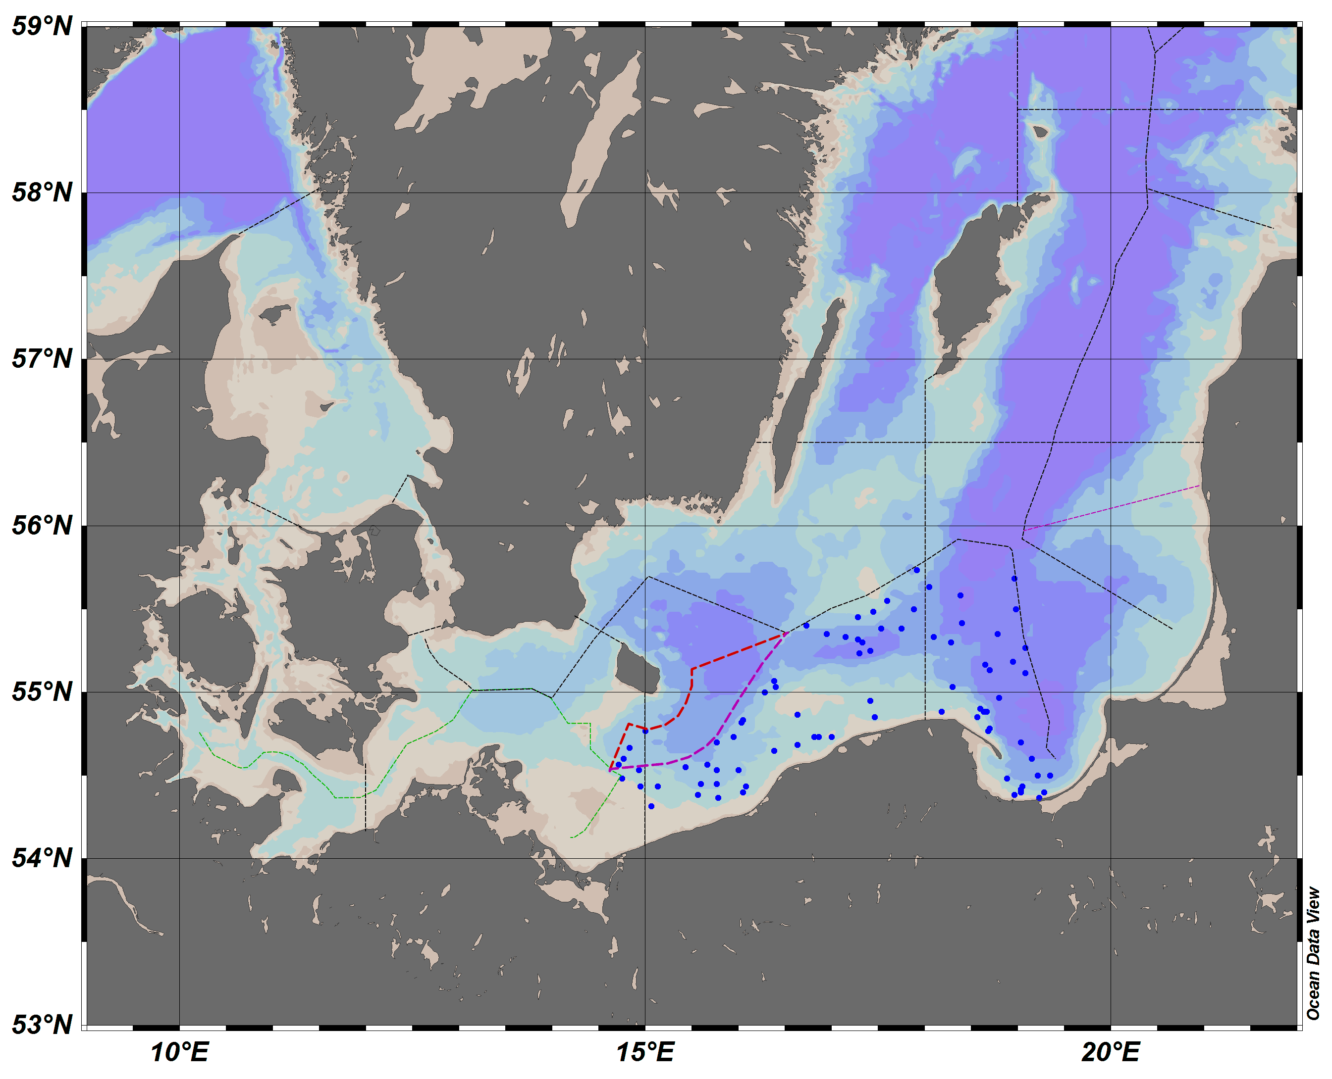

Fig. 1.1. Location of the bottom trawl hauls and the hydrological standard stations to be performed by the r.v. “Baltica” during the BITS-1Q survey in the Polish part of the southern Baltic.

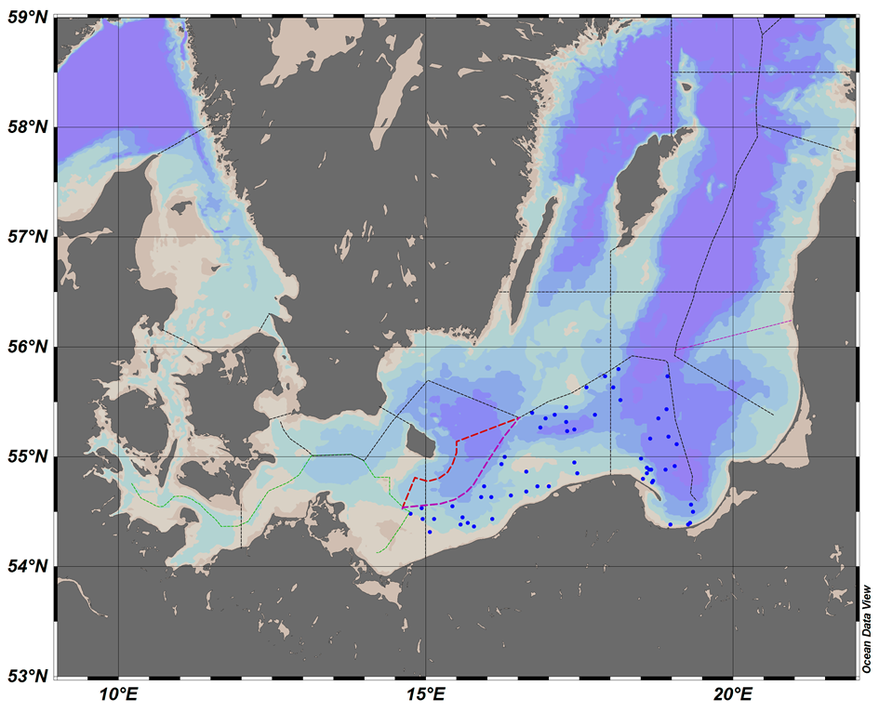

Fig. 1.2. Location of the bottom trawl hauls and the hydrological standard stations to be performed by the r.v. “Baltica” during the BITS-4Q survey in the Polish part of the southern Baltic.

- For internationally coordinated surveys, describe the participating Member States/ vessels and the relevant international group in charge of planning the survey

BITS surveys are coordinated by the ICES Working Group on Baltic International Fish Survey (WGBIFS).
MS participating in BITS-1Q surveys: DEU; DNK; LTU; LVA; SWE
MS participating in BITS-4Q surveys: DEU; DNK; EST; LTU; LVA; SWE

- Where applicable, describe the international task-sharing (physical and/or financial) and the cost-sharing agreement used
Following recommendations of WGBIFS, each participating MS executes surveys primarily in their respective EEZs. No cost sharing agreements in place yet.

- Explain where thresholds apply
N.A.

(max. 450 words per survey)
- Graphical representation (map) showing the positions (locations) of the realized samples.
Member State shall provide maps presenting the spatial distribution of the main sampling types obtained during the survey.

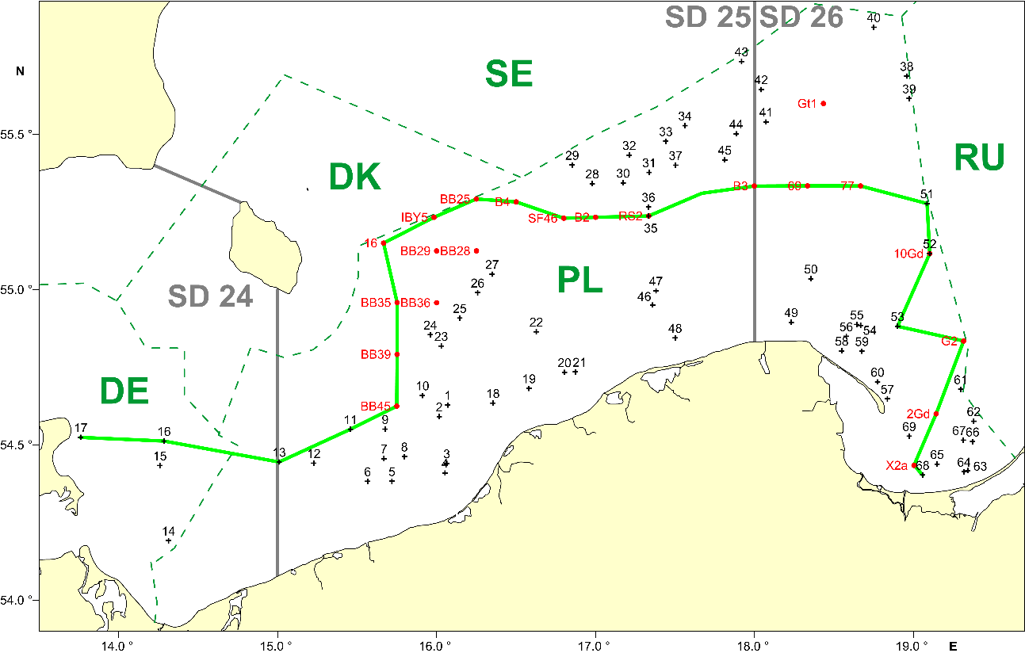

Fig. 1.4. Location of the bottom trawl hauls and the hydrological standard stations performed during the r.v. “Baltica” BITS-Q1 2018 survey in the southern Baltic (black crosses – fish control hauls, red dots – hydrological standard stations, green line – hydrological profile).

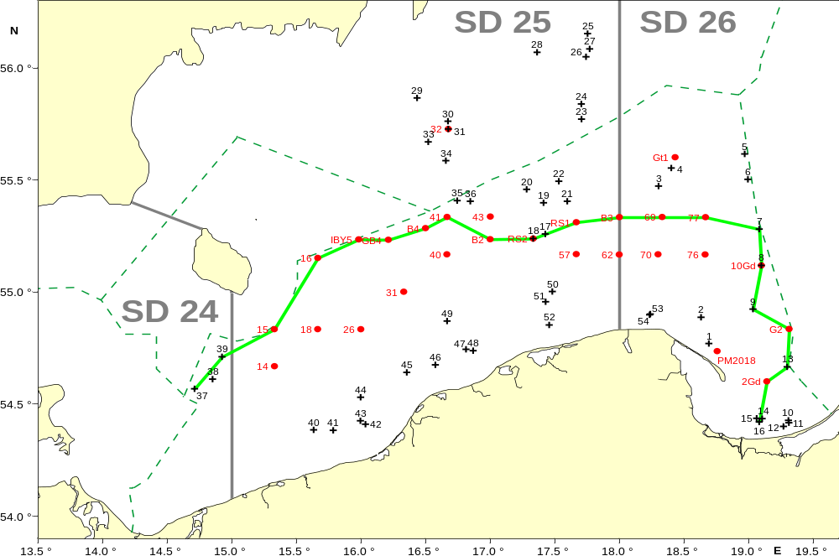

Fig. 1.5. Location of the bottom trawl hauls and the hydrological standard stations performed during the r.v. “Baltica” BITS-Q4 2018 survey in the the southern Baltic (black crosses – fish control hauls, red dots – hydrological standard stations, green line – hydrological profile).

- For internationally coordinated surveys, provide a link to the latest meeting report of the coordination group.
Member State shall provide a hyperlink to the meeting report from the body coordinating the survey (ICES, MEDITS coordination group, MEDIAS coordination group etc.). For non-international coordinated surveys, Member State shall refer to any status report (e.g. Cruise report).

http://ices.dk/sites/pub/Publication%20Reports/Expert%20Group%20Report/EOSG/2018/WGBIFS/WGBIFS%20report%202018.pdf

- List the main use of the results of the survey (e.g. indices, abundance estimates, environmental indicators).
Member State shall specify in which context the results are used (on routine basis), both on an international as well as on a national context.

Survey results are primarily used for stock assessment purposes:
- indices of year-classes abundance of cod and flounder,
- biomass indices of cod (CPUE from BITS surveys).

At national level, survey results are also used as a basis for scientific opinions and description of the actual situation and long term developments in fish stocks status and hydrological conditions in the Baltic – at the request of national fisheries administration agencies.

9. Extended comments (Tables 1G and 1H)
If the Member State has extended AR Comments, these can be placed under this section. If this is the case, a reference to this text box should be provided in the corresponding tables.

NA

(max 450 words per survey)

Baltic Acoustic Surveys – SPRAS and BIAS
The research surveys are included in Table 10 of the multiannual Union programme.

The description below refers to two Baltic acoustic surveys of similar scope and methodology: SPRAS - Sprat Acoustic Survey (known also as BASS – Baltic Acoustic Spring Survey) and BIAS - Baltic International Acoustic Survey.

- Objectives of the survey
The aim of the SPRAS surveys an estimation of the stock indices of Sprattus sprattus in May, whereas the aim of the BIAS surveys is an estimation of Clupea harengus, Sprattus sprattus and, to some extent, Gadus morhua stocks resources (biomass and abundance) and analysis of their spatial distribution in the pelagic zone of the southern Baltic during autumn season.

- Description of the methods used in the survey. For mandatory surveys, link to the manuals. Include a graphical representation (map)
In case of both types of surveys, a set of control hauls (fish catch-stations) with the use of herring small-meshed pelagic trawl is performed as well as echo-integration records (S_{A} = NASCs; Nautical Area Scattering (Strength) Coefficient) are collected along the pre-selected acoustic transects on the distance of about 830 NM.

BIAS & BASS Surveys Manual: ICES. ADDENDUM 2: SERIES OF ICES SURVEY PROTOCOLS, VERSION 1.02; SISP MANUAL OF INTERNATIONAL BALTIC ACOUSTIC SURVEYS (IBAS);
28-03-2014, GDYNIA, POLAND ( http://dcf.mir.gdynia.pl/?page_id=367 )

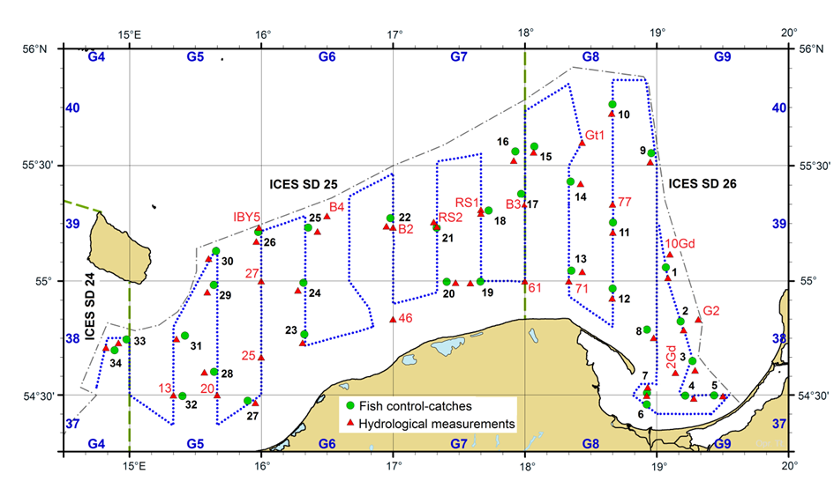
Fig. 1.3. Location of the echointegration track, pelagic control haul and hydrologic stations during the SPRAS (May) and BIAS (autumn) surveys in the Polish Exclusive Economic Zone on board r/v Baltica.

- For internationally coordinated surveys, describe the participating Member States/ vessels and the relevant international group in charge of planning the survey
SPRAS and BIAS surveys are coordinated by the ICES Working Group on Baltic International Fish Survey (WGBIFS).
MS participating SPRAS surveys: DEU; EST; LTU; LVA.
MS participating in BIAS surveys: DEU; DNK; EST; FIN; LTU; LVA; SWE

- Where applicable, describe the international task-sharing (physical and/or financial) and the cost-sharing agreement used
Following recommendations of WGBIFS, each participating MS executes surveys primarily in their respective EEZs. No cost sharing agreements in place yet.

- Explain where thresholds apply
N.A.

(max. 450 words per survey)
- Graphical representation (map) showing the positions (locations) of the realized samples.
Member State shall provide maps presenting the spatial distribution of the main sampling types obtained during the survey.

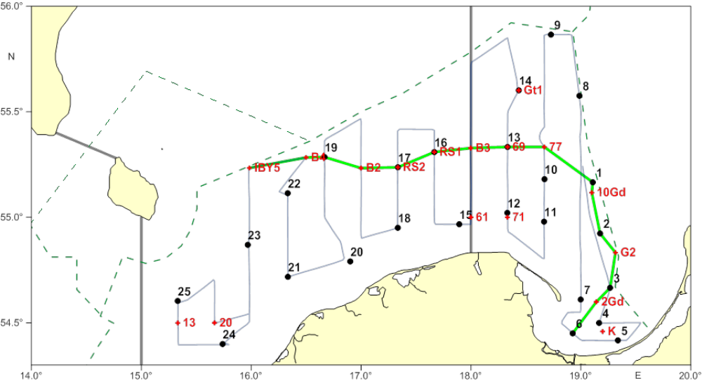
Fig. 1.3. Location of the echointegration track, pelagic control hauls and hydrologic stations during the SPRAS (May 2018) survey in the Polish Exclusive Economic Zone on board r/v Baltica (green dots – pelagic control hauls, red triangles – hydrologic stations, yellow square – turning points of the transects).

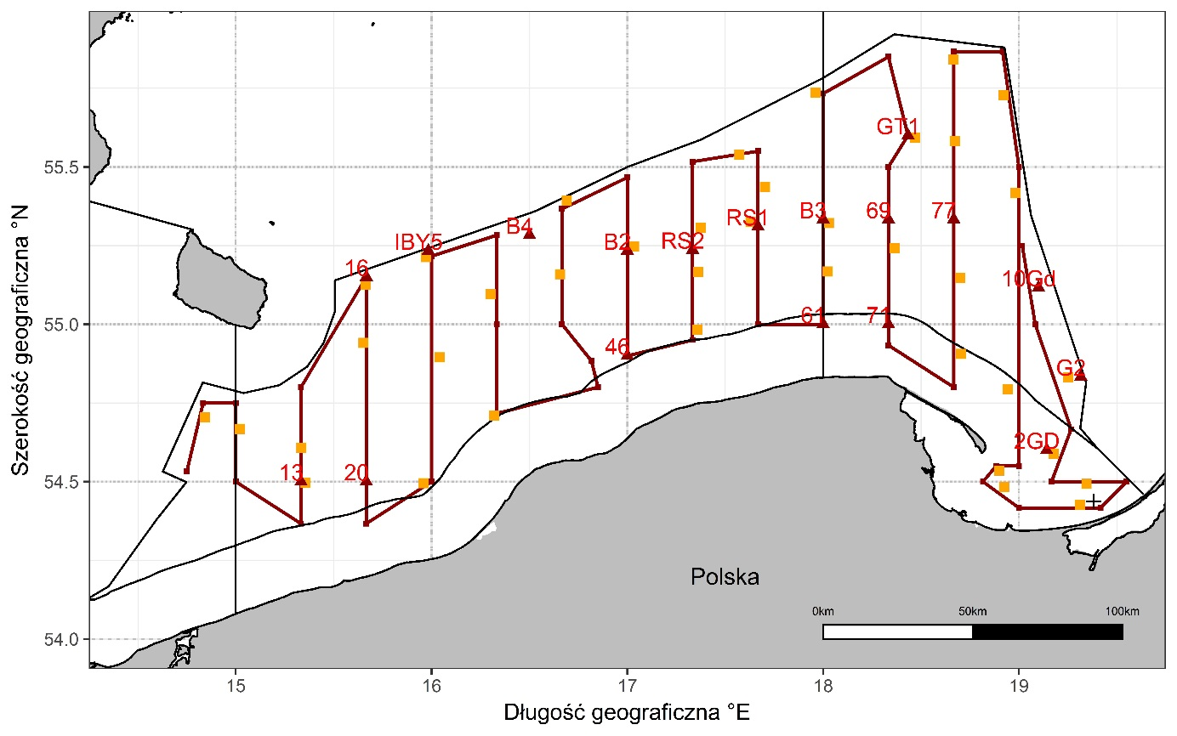
Fig. 1.3. Location of the echointegration track, pelagic control hauls and hydrologic stations during the BIAS (September 2018) survey in the Polish Exclusive Economic Zone on board r/v Baltica (yellow squares – pelagic control hauls, red triangles – hydrologic stations).

- For internationally coordinated surveys, provide a link to the latest meeting report of the coordination group.
Member State shall provide a hyperlink to the meeting report from the body coordinating the survey (ICES, MEDITS coordination group, MEDIAS coordination group etc.). For non-international coordinated surveys, Member State shall refer to any status report (e.g. Cruise report).
http://ices.dk/sites/pub/Publication%20Reports/Expert%20Group%20Report/EOSG/2018/WGBIFS/WGBIFS%20report%202018.pdf

- List the main use of the results of the survey (e.g. indices, abundance estimates, environmental indicators).
Member State shall specify in which context the results are used (on routine basis), both on an international as well as on a national context.

Acoustic surveys results are primarily used for stock assessment purposes:
- indices of year-classes abundance of sprat and herring,
- biomass estimates of herring, sprat and cod.

At national level, survey results are also used as a basis for scientific opinions and description of the actual situation and long term developments in fish stocks status and hydrological conditions in the Baltic – at the request of national fisheries administration agencies.

9. Extended comments (Tables 1G and 1H)
If the Member State has extended AR Comments, these can be placed under this section. If this is the case, a reference to this text box should be provided in the corresponding tables.

NA

(max 450 words per survey)

Section 2: Fishing Activity Data

Text Box 2A: Fishing activity variables data collection strategy

General comment: This box fulfills paragraph 4 of Chapter III of the multiannual Union programme and Article 2, Article 4 paragraph (2) point (b) and Article 5 paragraph (2) of the Decision (EU) 2016/1701. It is intended to describe the method used to derive estimates on representative samples where data are not to be recorded under Regulation (EU) No 1224/2009 or where data collected under Regulation (EU) No 1224/2009 are not at the right aggregation level for the intended scientific use.
General comment: This box is applicable to the Annual Report. This box should provide information on the implementation of the data collection of fishing activity variables of Member States.
1. Description of methodologies used to cross-validate the different sources of data

Catch data are compared with the landings data on a trip level in the range of catch composition and catch/landing weight. Fishing locations registered in logbooks are checked with the VMS data.

2. Description of methodologies used to estimate the value of landings

The value of landings for each species is estimated for the whole year by multiplying the total landings weight by average price per kg. The average annual exchange rate is used to calculate the value in EUR.

3. Description of methodologies used to estimate the average price (it is recommended to use weighted averages, trip by trip)

Average price is obtained from the sales notes data. It is estimated for the whole year for each species by dividing the total value by total weight.

- Description of methodologies used to plan collection of the complementary data (sample plan methodology, type of data collected, frequency of collection etc)

Not applicable.
(max 900 words per Region)
5. Deviations from Work Plan methodology used to cross-validate the different sources of data
NA
6. Deviations from Work Plan methodology used to estimate the value of landings.
Sales notes from vessels of length less than 10 meters are stored by the fisheries authorities in a paper form. Due to a limited access to these documents an annual average price is used to estimate the value of landings. Information on landings weight and value from questionnaires used for economic and social data collection are also used.
7. Deviations from Work Plan methodology used to estimate the average price.
NA
8. Deviations from Work Plan methodology used to plan collection of the complementary data
NA
(max 900 words per Region)

Section 3: Economic and Social Data

Text Box 3A: Population segments for collection of economic and social data for fisheries

General comment: This box fulfils paragraph 5 points (a) and (b) of Chapter III of the multiannual Union programme and Article 2, Article 4 paragraphs (1), (2) and (5) and Article 5 paragraph (2) of the Decision (EU) 2016/1701. It is intended to specify data to be collected under Tables 5(A) and 6 of the multiannual Union programme.
General comment: This box is applicable to the Annual Report. This box should provide information on the implementation of the fleet socio-economic data collection of Member States.
1. Description of methodologies used to choose the different sources of data
Economic and social data regarding the fishing fleet will come from administrative documents (fishing logs, landing declarations, first sale documents, Fishing Fleet Register) and statistical questionnaires filled out by fishing vessel owners.

2. Description of methodologies used to choose the different types of data collection
The study will be census and questionnaire with economic and social variables will be sent to all active vessels owners. For social variables there will be non-probability survey.

3. Description of methodologies used to choose sampling frame and allocation scheme
All data are intend to be collected for a whole population on the basis of census data.

4. Description of methodologies used for estimation procedures
In case of non-responses in census, estimation will be made based on averages for vessels that provided data and information known for a whole population for individual vessels i.e. volume of catches, fishing days, number of vessels within given segment. If there is a lack of information from the whole population (100%), the data are estimated based on the average values of the sample calculated taking into account number of fishing vessels, number of fishing days, number of personnel or catch size (variables known for a whole population).

5. Description of methodologies used on data quality
These data are intend to be complete as they will include information from the whole population. If any fishing vessel owners fail in their obligation to return the statistical questionnaires, the values of the missing parameters for the missing population will be determined based on averaged data from the questionnaires received. Defined as the ratio of number units for which data for at least same variables have been collected to the total number of units designed for data collection.

(max 900 words per Region)
6. Deviations from Work Plan methodology for selection of data source
List the deviations (if any) from the methodology used to select data source compared to what was planned in the Work Plan, and explain the reasons for the deviations.
Actions to avoid deviations
Briefly describe the actions that will be considered / have been taken to avoid the deviations in the future and when these actions are expected to produce effect. If there are no deviations, then this section can be skipped.
No deviation compared to NP proposal took place.
7. Deviations from Work Plan methodology to choose type of data collection
List the deviations (if any) from the methodologies to choose type of data collecton scheme compared to what was planned in the Work Plan, and explain the reasons for the deviations.
Actions to avoid deviations
Briefly describe the actions that will be considered / have been taken to avoid the deviations in the future and when these actions are expected to produce effect. If there are no deviations, then this section can be skipped.
No deviation compared to NP proposal took place.
8. Deviations from Work Plan methodology regarding sampling frame and allocation scheme
List the deviations (if any) from the methodologies used regarding sampling frame and allocation scheme compared to what was planned in the Work Plan, and explain the reasons for the deviations.
Actions to avoid deviations
Briefly describe the actions that will be considered / have been taken to avoid the deviations in the future and when these actions are expected to produce effect. If there are no deviations, then this section can be skipped.
No deviation compared to NP proposal took place.

9. Deviations from Work Plan methodology used for estimation procedures
List the deviations (if any) from the methodologies used for estimation procedures compared to what was planned in the Work Plan, and explain the reasons for the deviations.
Actions to avoid deviations
Briefly describe the actions that will be considered / have been taken to avoid the deviations in the future and when these actions are expected to produce effect. If there are no deviations, then this section can be skipped.
No deviation compared to NP proposal took place.

10. Quality assurance
10.1 Sound methodology
Briefly describe if the data collection follow methodologies, guidelines and best practices agreed in expert groups and whether methodologies are documented and are made publicly available.
In accordance with national regulations, each vessel’s owner is legally bound to fill out a questionnaire regarding the economic results of the fishing vessel. In order to ensure the maximum number of questionnaires is received, similarly to previous years reminders of the obligation to file them were sent by registered mail and phone calls were made to execute the obligation. Recommendations of the Lisbon DCF workshop on “statistical issues related to the collection of economic data within the DCF” (i.e. closer cooperation with PO) were taken into account to deal with the non-response problem. As the number of returned questionnaires did not reach a plan of respond rate, calculations were made, based on the questionnaires received. Economic data received does not usually exceed 70% of respond rate. However all responses were of random character (probability sample), which should ensure the representativeness of the sample. Response rates are provided in an Excel table.

10.2. Accuracy and reliability
Response rate and Achieved sample rate are provided in Table 3A.
For additional information, briefly describe how raw data inputs, intermediate results and outputs are regularly assessed and validated and how errors are identified, documented and dealt with.
Representativeness

There is no standard approach implemented on how the representativeness of the data can be evaluated. An analysis of the frequency distribution of two variables: volume of catches (in tonnes) and effort (in days at sea) was performed to check similarity between the sample and the total population. The results presented on graphs below show that there is a little difference between sampled group of vessels and the total population. Species composition of catches by segment confirms also good similarity.

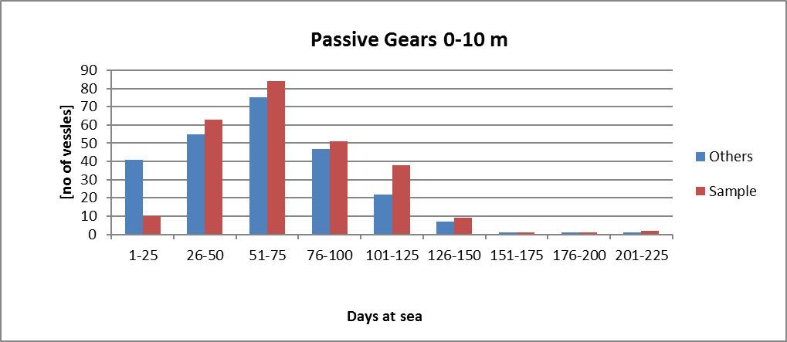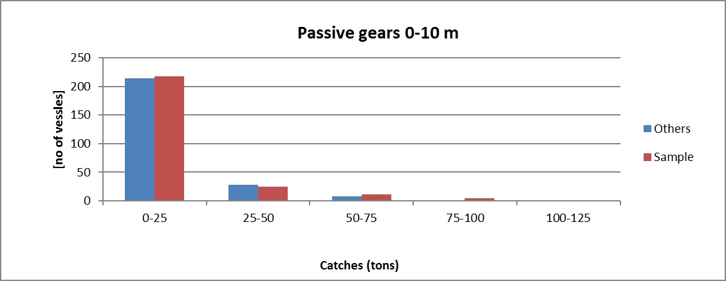
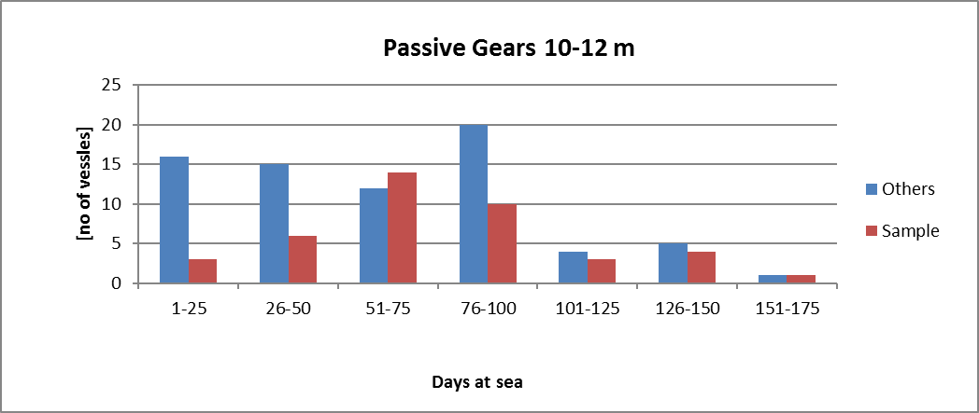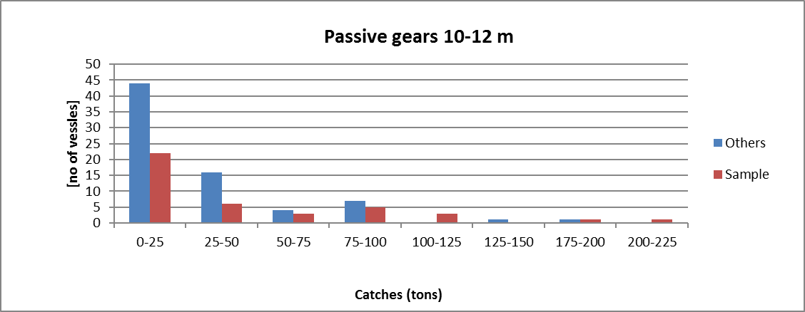
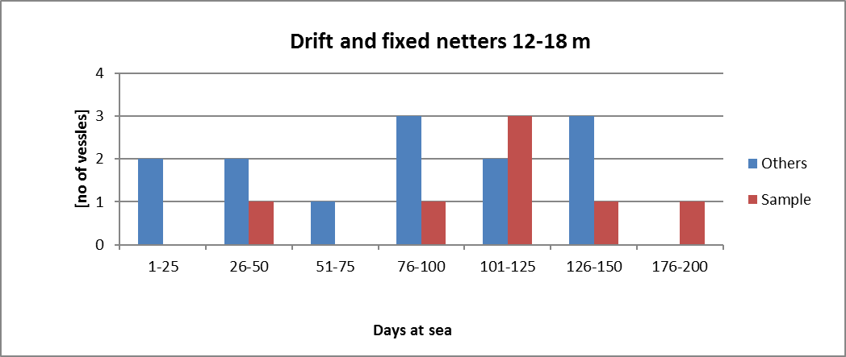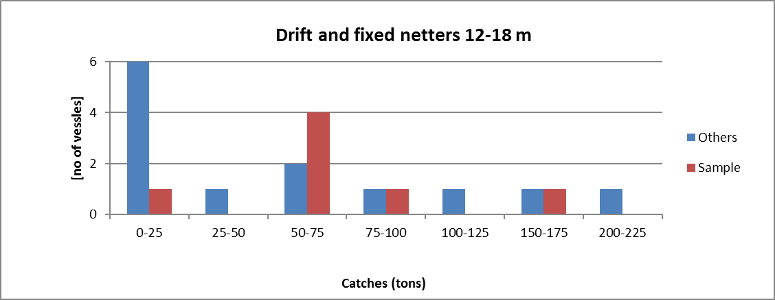
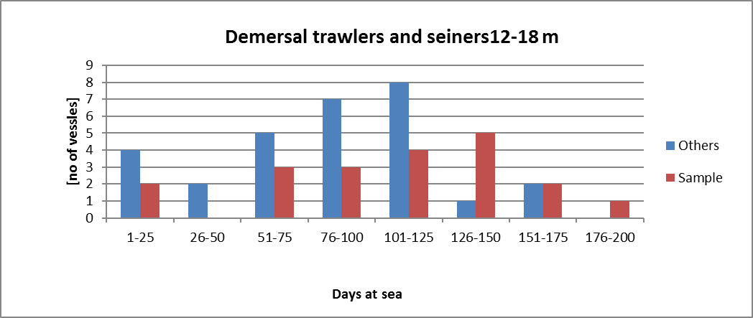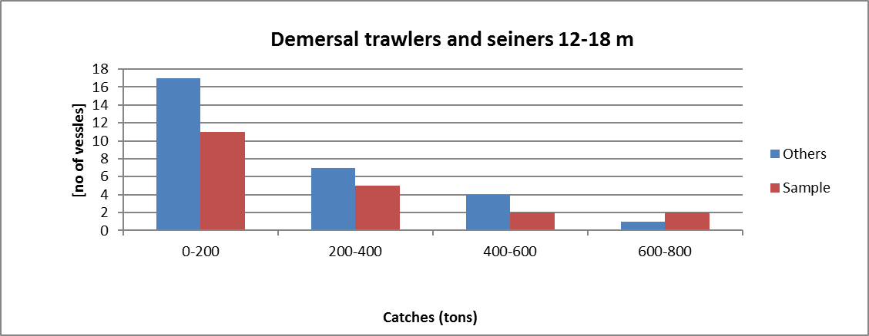
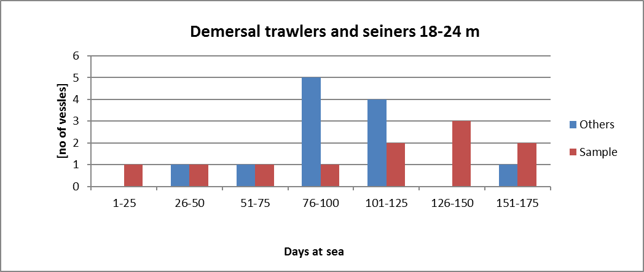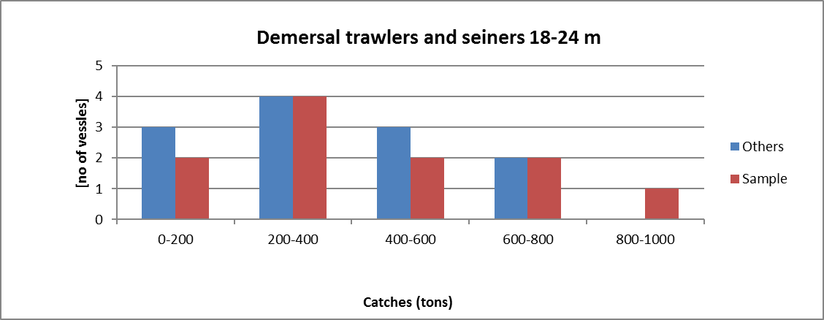
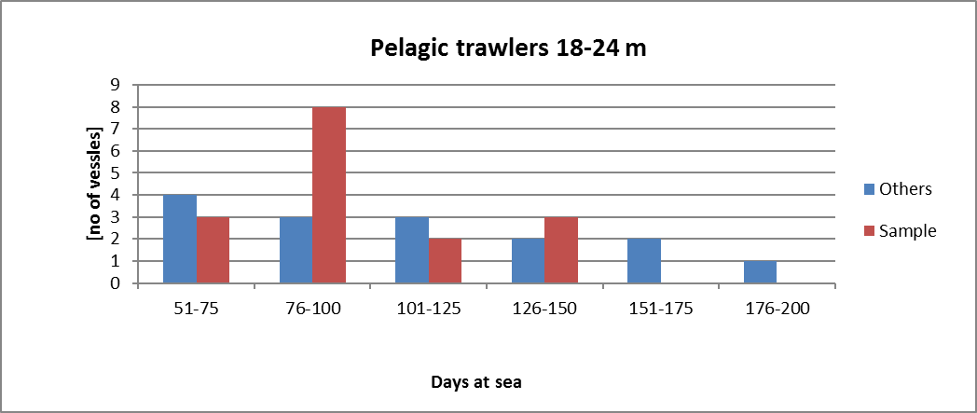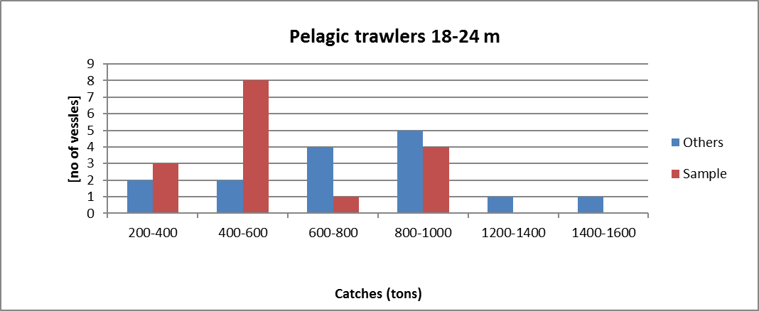
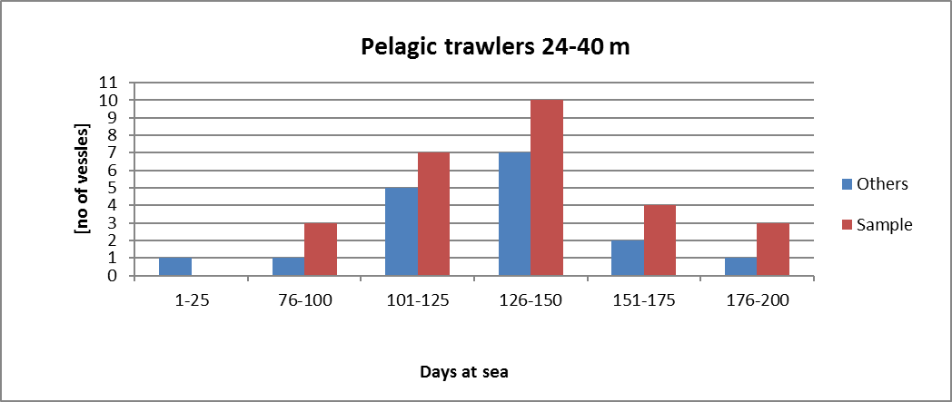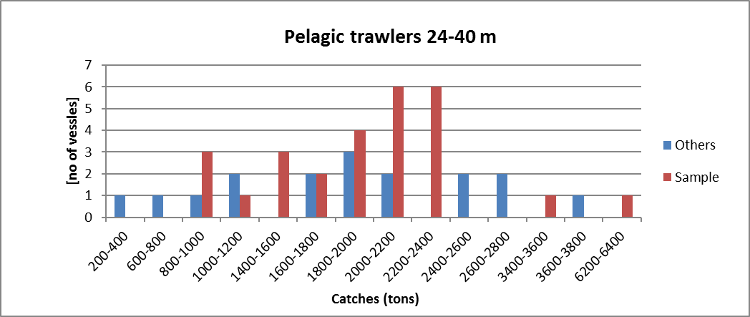

Passive gears 0-10m
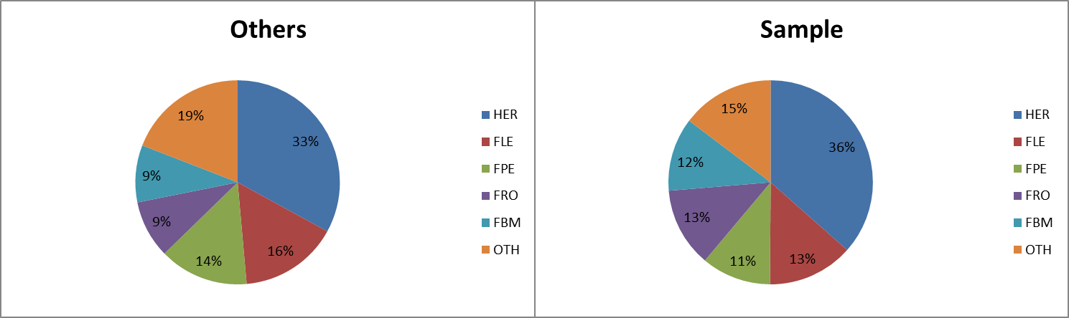

Passive gears 10-12m
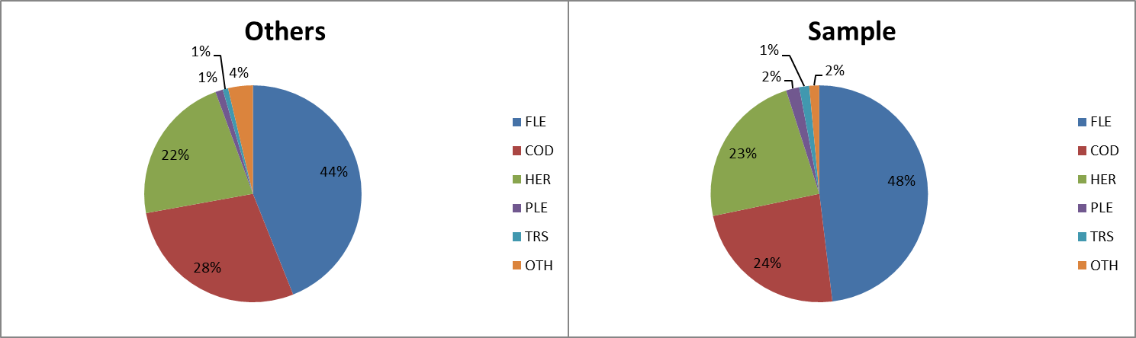

Drift and fixed netters 12-<18 m
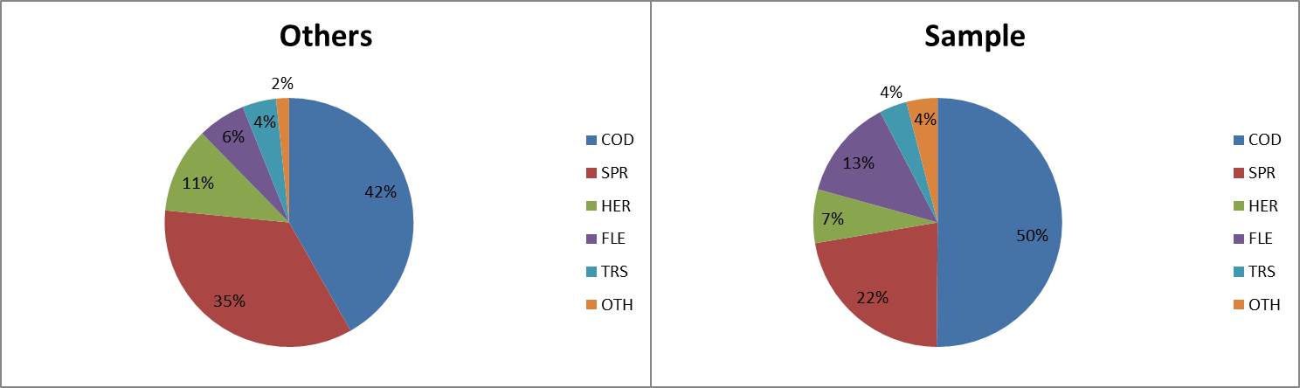

Demersal trawlers and seiners 12-< 18 m
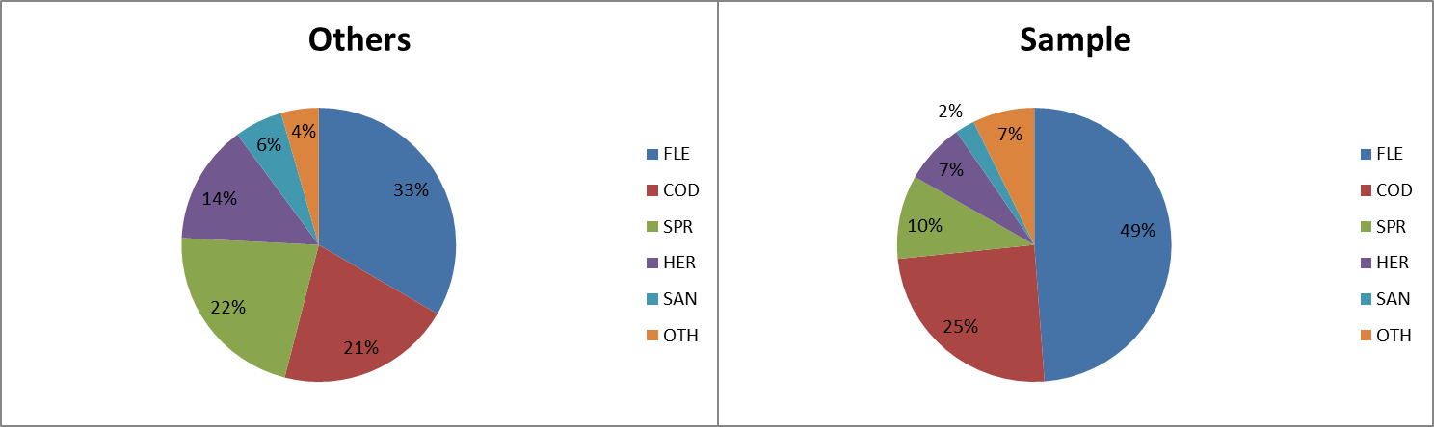

Demersal trawlers and seiners 18-< 24 m
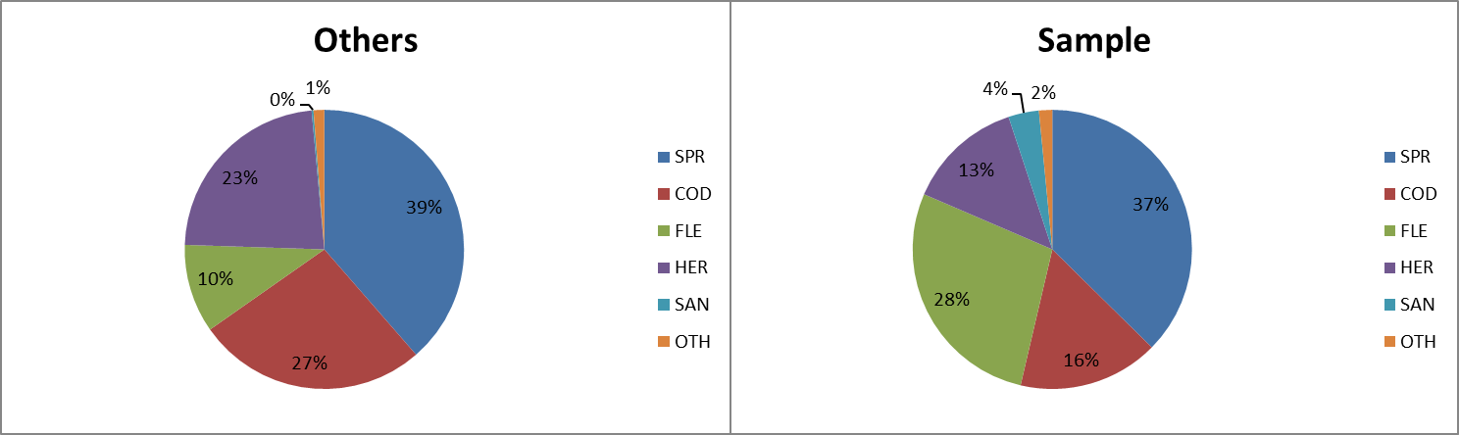

Pelagic trawlers 18-24 m
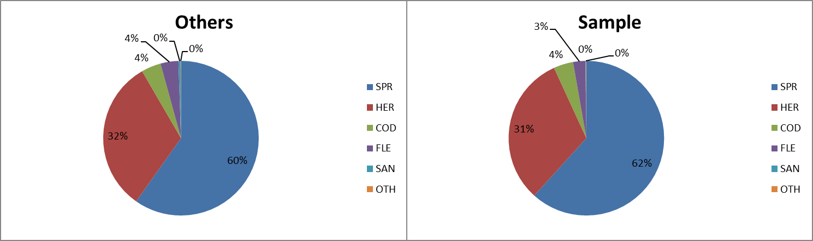

Pelagic trawlers 24-40 m
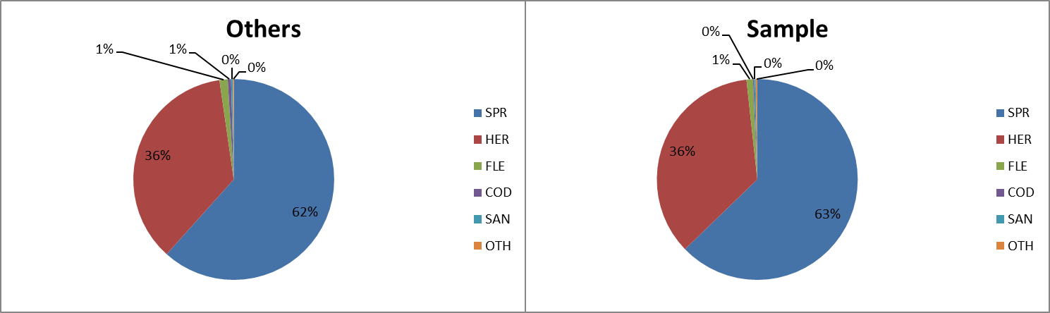

Distant-water fleet
Followed previous years, due to confidentiality reasons deep sea trawlers segment (distant-water fleet) were excluded from economic analysis (data were collected but could not be reported). In 2017 this segment of pelagic vessels over 40 m in length consisted of 3 very characteristic vessel, what makes impossible to report data without identifying them and infringe the law on data confidence nor combine them with other vessel’s segments. Complete data were collected but cannot be reported.
10.3. Accessibility and Clarity
Indicate with Yes or No
Are methodological documents publicly available?
YES
Are data stored in databases?
YES
Where can methodological and other documentation be found?
Provide the web link, if documentation is publicly available
https://datacollection.jrc.ec.europa.eu/wps
https://datacollection.jrc.ec.europa.eu/documents-links

(max 1000 words)

Section 3: Economic and Social Data

Pilot Study 3: Data on employment by education level and nationality

General comment: This box fulfills paragraph 5 point (b) and paragraph 6 point (b) of Chapter III of the multiannual Union programme and Article 2 and Article 3 paragraph (3) point (c) of the Decision (EU) 2016/1701.It is intended to specify data to be collected under Table 6 of the multiannual Union programme.
General comment: This box is applicable to the Annual Report. This box is intended to provide information on the results obtained from the implementation of the pilot study (including deviations from planned and justifications as to why if this was not the case).
Data collection on employement by eduaction level and nationality has been collected and will be continued in the next period.

(max 900 words)
4. Achievement of the original expected outcomes of pilot study and justification if this was not the case.

NA – no Pilot Study needed

5. Incorporation of results from pilot study into regular sampling by the Member State.

NA – no Pilot Study needed

(max 900 words)

Section 3: Economic and Social Data

Text Box 3B: Population segments for collection of economic and social data for aquaculture

General comment: This box fulfills paragraph 6 points (a) and (b) of Chapter III of the multiannual Union programme and Article 2, Article 4 paragraphs (1) and (5) and Article 5 paragraph (2) of the Decision (EU) 2016/1701.It is intended to specify data to be collected under Tables 6 and 7 of the multiannual Union programme.

General comment: This box is applicable to the Annual Report. This box should provide information on the implementation of the socio-economic data collection for aquaculture of Member States.

Based on the data until 2015, according to classification of aquaculture activities by Eurostat statistics, Poland has no marine aquaculture sector. Hence, no sampling is planned.

(max 1000 words)
6. Deviations from Work Plan methodology for selection of data source
List the deviations (if any) from the methodology used to select data source compared to what was planned in the Work Plan, and explain the reasons for the deviations.
Actions to avoid deviations
Briefly describe the actions that will be considered / have been taken to avoid the deviations in the future and when these actions are expected to produce effect. If there are no deviations, then this section can be skipped.
NA
7. Deviations from Work Plan methodology to choose type of data collection
List the deviations (if any) from the methodologies to choose type of data collecton scheme compared to what was planned in the Work Plan, and explain the reasons for the deviations.
Actions to avoid deviations
Briefly describe the actions that will be considered / have been taken to avoid the deviations in the future and when these actions are expected to produce effect. If there are no deviations, then this section can be skipped.
NA
8. Deviations from Work Plan methodology regarding sampling frame and allocation scheme
List the deviations (if any) from the methodologies used regarding sampling frame and allocation scheme compared to what was planned in the Work Plan, and explain the reasons for the deviations.
Actions to avoid deviations
Briefly describe the actions that will be considered / have been taken to avoid the deviations in the future and when these actions are expected to produce effect. If there are no deviations, then this section can be skipped.
NA

9. Deviations from Work Plan methodology used for estimation procedures
List the deviations (if any) from the methodologies used for estimation procedures compared to what was planned in the Work Plan, and explain the reasons for the deviations.
Actions to avoid deviations
Briefly describe the actions that will be considered / have been taken to avoid the deviations in the future and when these actions are expected to produce effect. If there are no deviations, then this section can be skipped.
NA

10. Quality assurance - NA
10.1 Sound methodology
Briefly describe if the data collection follow methodologies, guidelines and best practices agreed in expert groups and whether methodologies are documented and are made publicly available.
10.2. Accuracy and reliability
Response rate and Achieved sample rate are provided in Table 3B.
For additional information, briefly describe how raw data inputs, intermediate results and outputs are regularly assessed and validated and how errors are identified, documented and dealt with.
10.3. Accessibility and Clarity
Indicate with Yes or No
Are methodological documents publicly available?
Are data stored in databases?
Where can methodological and other documentation be found?
Provide the web link, if documentation is publicly available

(max 1000 words)

Section 3: Economic and Social Data

Pilot Study 4: Environmental data on aquaculture

General comment: This box fulfills paragraph 6 point (c) of Chapter III of the multiannual Union programme and Article 2 and Article 4 paragraph (3) point (d) of the Decision (EU) 2016/1701. It is intended to specify data to be collected under Table 8 of the multiannual Union programme.
General comment: This box is applicable to the Annual Report. This box is intended to provide information on the results obtained from the implementation of the pilot study (including deviations from planned and justifications as to why if this was not the case).
Based on the data until 2017, according to classification of aquaculture activities by Eurostat statistics, Poland has no marine aquaculture sector. Hence, no sampling is planned.

(max 900 words)
4. Achievement of the original expected outcomes of pilot study and justification if this was not the case.

NA

5. Incorporation of results from pilot study into regular sampling by the Member State.

NA

(max 900 words)

Section 3: Economic and Social Data

Text Box 3C: Population segments for collection of economic and social data for the processing industry

General comment: This box fulfils footnote 6 of paragraph 1.1(d) of Chapter III of the multiannual Union programme, Article 2, Article 4 paragraphs (1) and (5) and Article 5 paragraph (2) of Decision (EU) 2016/1701. It is intended to specify data to be collected under Table 11 of the multiannual Union programme.
General comment: This box is applicable to the Annual Report. This box should provide information on the implementation of the socio-economic data collection for aquaculture of Member States.
1. Description of methodologies used to choose the different sources of data
A questionnaire will be used to collect all data.

2. Description of methodologies used to choose the different types of data collection
The study will be census and questionnaire with economic variables will be sent to all processing firm. For social variables there will be non-probability survey.

3. Description of methodologies used to choose sampling frame and allocation scheme
The study will include all legal business entities, including legal personalities and organizational units without legal personality and individuals operating fish and other aquatic animal processing facilities that are listed as meeting the standards of Council Regulation (EC) no. 853/2004 of April 29, 2004, which sets forth detailed requirements regarding hygiene in foodstuffs of animal origin, Appendix IIII Section VIII Fisheries Products. Also included will be entities listed as qualified to make direct sales in accordance with the regulation of the Minister of Agriculture and Rural Development of December 29, 2006 regarding veterinarian requirements during the production of products of animal origin for direct sale (Journal of Laws of 2015 No. 0 pos. 1703). Participation in the study is obligatory for all fish processing facilities according to the regulation of June 29, 1995 on public statistics (Journal of Laws 2016 No. 0, pos. 1068).
The population cover enterprises whose main activity is defined according to the Eurostat definition under NACE Code 10.20: ‘products’. ”Processing and preserving of fish, crustaceans and mollusks ” and also enterprises that carry out fish processing but not as a main activity.

4. Description of methodologies used for estimation procedures
It is assumed that all processing facilities obliged to return completed questionnaires will comply.

5. Description of methodologies used on data quality
Unit response rate will be used as indicator of accuracy. Defined as the ratio of number units for which data for at least same variables have been collected to the total number of units designed for data collection.
According to article 38 Law issued on 29 June 1995 on official statistics it shall not be allowed to publish or disseminate obtained in statistical surveys of official statistics statistical information which can be linked or can identify natural persons or individual data characterizing business entities, especially if the aggregated data consist of less than three entities or the share of one entity in the compilation is higher than the three-fourths of the total.

(max 1000 words)
6. Deviations from Work Plan methodology for selection of data source
List the deviations (if any) from the methodology used to select data source compared to what was planned in the Work Plan, and explain the reasons for the deviations.
Actions to avoid deviations
Briefly describe the actions that will be considered / have been taken to avoid the deviations in the future and when these actions are expected to produce effect. If there are no deviations, then this section can be skipped.
Social variables
Additional voluntary questionnaires with social variables (employment by education level and nationality) were sent to all fish processing plants to ensure a high respond rate but owners were not willing to fill out them. Due to high refusal rate for social variables, POL will collect this data every year and put this variables into obligatory economic questionnaire (starting from 2020). There will be reminders of the obligation sent by registered mail and phone calls.

7. Deviations from Work Plan methodology to choose type of data collection
No deviation compared to WP methodology to choose type of data collection took place.
List the deviations (if any) from the methodologies to choose type of data collecton scheme compared to what was planned in the Work Plan, and explain the reasons for the deviations.
Actions to avoid deviations
Briefly describe the actions that will be considered / have been taken to avoid the deviations in the future and when these actions are expected to produce effect. If there are no deviations, then this section can be skipped.
8. Deviations from Work Plan methodology regarding sampling frame and allocation scheme
No deviation compared to WP methodology took place
List the deviations (if any) from the methodologies used regarding sampling frame and allocation scheme compared to what was planned in the Work Plan, and explain the reasons for the deviations.
Actions to avoid deviations
Briefly describe the actions that will be considered / have been taken to avoid the deviations in the future and when these actions are expected to produce effect. If there are no deviations, then this section can be skipped.

9. Deviations from Work Plan methodology used for estimation procedures
No deviation compared to WP methodology took place.

List the deviations (if any) from the methodologies used for estimation procedures compared to what was planned in the Work Plan, and explain the reasons for the deviations.
Actions to avoid deviations
Briefly describe the actions that will be considered / have been taken to avoid the deviations in the future and when these actions are expected to produce effect. If there are no deviations, then this section can be skipped.

10. Quality assurance
10.1 Sound methodology
Briefly describe if the data collection follow methodologies, guidelines and best practices agreed in expert groups and whether methodologies are documented and are made publicly available.

In accordance with national regulations, economic and some social data were collected obligatory for the entire population. In order to ensure the maximum number of questionnaires is received, similarly to previous years reminders of the obligation to file them were sent by registered mail and phone calls were made to execute the obligation. Recommendations of the Lisbon DCF workshop on “statistical issues related to the collection of economic data within the DCF” were taken into account to deal with the non-response problem. For missing questionnaires calculations of the missing variables for the missing population were made, based on average data from the questionnaires received.

10.2. Accuracy and reliability
Response rate and Achieved sample rate are provided in Table 3C.
For additional information, briefly describe how raw data inputs, intermediate results and outputs are regularly assessed and validated and how errors are identified, documented and dealt with.
Response rate and Achieved sample rate are provided in Table 3C.
An 74,2% response rate was achieved for segment “Companies <= 10”, 80,6% for segment “Companies 11-49”, 83% for segment “Companies 50-250” and 100% for segment “Companies > 250”.
For additional information, briefly describe how raw data inputs, intermediate results and outputs are regularly assessed and validated and how errors are identified, documented and dealt with.

Each questionnaire coming from a fish processing plant is registered in the address database and subjected to formal, substantive and accounting control. Detected errors are corrected by direct telephone contact or e-mail with the person filling in the questionnaire. Then the form is entered into the database in the "Primary Forms" tab. When approving the form for transfer to the "Approved Forms" tab, the system performs automatic data validation. Detected errors must be corrected before approval.

10.3. Accessibility and Clarity
Indicate with Yes or No:
Are methodological documents publicly available? YES
Are data stored in databases? YES
Where can methodological and other documentation be found?
Provide the web link, if documentation is publicly available.
https://datacollection.jrc.ec.europa.eu/wps
https://datacollection.jrc.ec.europa.eu/documents-links
(max 1000 words)

Section 4: Sampling Strategy for Biological Data from Commercial Fisheries

Text Box 4A: Sampling plan description for biological data

General comment: This box fulfills Article 3, Article 4 paragraph (4) and Article 8 of the Decision (EU) 2016/1701 and forms the basis for the fulfilment of paragraph 2 point (a)(i) of Chapter III of the multiannual Union programme. This Table refers to data to be collected under Tables 1(A), 1(B) and 1(C) of the multiannual Union programme.
General comment: This box is applicable to the Annual Report. This box should provide information on the deviations from the planned sampling of Member States.
- Description of the sampling plan according to Article 5 paragraph (3) of the Decision (EU) 2016/1701

A new sampling plan will be implemented by Poland, starting from 2017, in order to move gradually from metier based and purely opportunistic sampling towards the plan based on statistics, with the aim to reach statistically sound sampling scheme (4S) in two-three years time.
The following approach was applied to new sampling plan:

Scheme - determination of the sampling schemes for Baltic Sea region was based on the main types of fisheries exploiting fish stocks subject to sampling requirements, with the use of a combination of at-sea and on-shore schemes, e.g. “Demersal at sea and on shore”, “Pelagic at sea and on shore”, etc. For sampling biological data from recreational fishery for Baltic cod, as well as for fisheries in regions outside Baltic Sea, the “at sea” sampling scheme was chosen, as the only one practically possible.

Stratifications - as the main purpose is to collect biological data in support of different fish stocks assessment, stratification is based on the type of vessels (fishing technique) exploiting given fish stock, e.g. “Baltic demersal trawlers targeting western cod” or “Balctic gillnetters targeting western cod”.

Sampling frame – as the first step to define a sampling frame, a list of all ports where landings from given stock and by the type of vessel (demersal or pelagic trawlers, gilnetters, longliners, etc.) was created and, as a second step, those ports were ranked by the total volume of landings from that given stock. As a result of ranking only those ports were selected for sampling for given stock and given type of vessels where minimum 90% of landings took place (average over the reference period). Thus Sampling Frame is defined as a total number of vessels of a given type (trawlers, gilnetters, etc.) which, over the reference period, ever landed fish from a given stock in one of the port from the selected group of ports representing 90% of landings from that stock and by that type of vessel.

Coverage – assuming that the target population consists of all vessels exploiting given fish stock (irrespective of the fishing technique and port of landings), through the stratification and sampling frames design described above, the combined coverage of target populations by the sampling frames associated with that populations, (i.e.“targeting” given stock) varies between 61 and 97%.

Primary Sampling Unit (PSU) is “vessel trip”.

Sampling intensity –in order to maintain the continuity of the sampling intensity compared to the previous years, the annual number of samples to be collected during 2017-2019 period is at the same level as during the previous multiannual program (2014-2016). Both at sea and on shore sampling will be continued. In order to obtain independent, scientific data on discards and in order to maintain the practice of previous years, about 40-50% of sampling activity will be conducted through at sea observers trips.

Time stratification – for those stocks for which biological data are required on a quarterly basis, the total annual number of samples for that stocks will be distributed proportionally to the quarterly distribution of landings from that stock.

Sample selection – for each quarter and for each sampling frame a vessel trip will be randomly selected from a survey population. After each drawing of a particular vessel, this vessel will be returned to a drawing list before next drawing is performed. This procedure will be applied until the desired number of vessels to sample is reached. List of vessels selected for sampling will be recorded in a register. This register will contain information on date of selection, date the vessel was contacted to arrange sampling, information if contact with the vessel was successful or not, vessel’s owner acceptance or refusal to be sampled (as well as reasons in case of refusal). In case of lack of contact with the vessel or refusal to take observer on board or provide landed fish for sampling on shore, the supplementary drawing will be performed to maintain the desired number of vessels trips to sample.

Data archiving and quality checks - Data entered to the national database are verified in the two-stage validation process supported by a number of completeness, data type and range checks. Export procedures which prepare data sets for external databases (like RDB FishFrame or InterCatch) also perform basic checks. Additionally, a number of quality reports were developed to improve the completeness and reliability of the data.

Until 2016, sampling programme was based on an opportunistic approach. Due to the confidentiality of personal data, the Institute executing the DCF had no full register of the fishing vessels’ owners with contact details. Sampling was based on the cooperation with the owners of over 100 vessels (c.a. 12% of all Polish vessels), built over the years on the basis of trust. Efforts are being made for access to the full register of vessels’ owners. The list of contact details to vessels’ owners systematically expands but the process is extended in time. Therefore, the main expected difficulties in execution of the sampling programme is high level of non-response and/or refusals.

(max 900 words per region)
Deviation from the sampling plan according to Article 5 paragraph (3) of the Decision (EU) 2016/1701:
2. Deviations from the Work Plan
Member State shall list the deviations (if any) in the achieved data collection, compared to what was planned in the Work Plan and explain the reasons for the deviations.

Since the totally new sampling scheme was implemented in 2017 without any transitional period, some obstacles were encountered both in 2017 and in 2018 sampling. Due to high refusal rates or lack of contacts to vessel owners, supplementary drawings were performed in order to reach the planned number of sampled trips quarterly. If the planned number of trips was still not achieved in a given quarter, then two weeks before the end of the quarter opportunistic selection of missing PSUs was carried out. Additionally, some vessels were not sampled because they changed gear or target species and were no longer compliant with the PSU group they were initially assigned to.
According to sampling design, all contacts with the owners of vessels selected for sampling fishing trips in each stratum, as well as refusals and reasons for refusals were recorded in a dedicated register.
The refusal rates varied from 46% to 100% across different strata.
The methodology used to determine the refusal rate was that used by the ICES Study Group on Practical Implementation of Discard Sampling Plans (SGPIDS):
“As defined during SGPIDS 2 (ICES 2012a) the refusal rate in the fisheries context is the proportion of skippers who, having been successfully contacted ultimately failed to allow the observer to go onboard to obtain the sample. This refusal rate is calculated as the number of industry refusals divided by the number of sequential selections or approaches where contact was successfully made. This refusal rate provides an indication of the industry reaction to the observer programme and is a useful measure of their cooperation.”
(ICES. 2013. Report of the Study Group on Practical Implementation of Discard Sampling Plans (SGPIDS), 24 June – 28 June 2013, Lysekil, Sweden. ICES CM 2013/ACOM:56. 142pp. - http://www.ices.dk/sites/pub/Publication%20Reports/Expert%20Group%20Report/acom/2013/SGPIDS/SGPIDS13.1.pdf )

The table below presents, for each stratum, the list of fishing trips selected for sampling and successfully contacted, number of refusals, number of trips selected opportunistically by experts, number of trips actually executed and refusal rate.
Stratum ID | Drawn / contacted | Refusal | Expert selection | Executed | Refusal Rate (%)
POL BFWS1 | 14 | 11 | 7 | 10 | 78.6
POL BFWS2 | 13 | 6 | 2 | 9 | 46.2
POL BH1 | 3 | 2 | 0 | 1 | 66.7
POL BH2 | 1 | 0 | 0 | 1 | 0.00
POL DCT2 | 32 | 26 | 4 | 10 | 81.3
POL DTF | 59 | 57 | 3 | 5 | 96.6
POL GNSC1 | 8 | 8 | 0 | 0 | 100
POL GNSC2 | 13 | 12 | 0 | 1 | 92.3
POL GNSF | 4 | 2 | 1 | 3 | 50.0
POL GNSSAL | 14 | 14 | 2 | 2 | 100
POL LLDSAL | 22 | 22 | 0 | 0 | 100
POL PHT1 | 11 | 9 | 0 | 2 | 81.8
POL PHT2 | 39 | 35 | 1 | 5 | 89.7
POL PST | 59 | 41 | 9 | 27 | 69.5
POL DCT1 | 0 | 0 | 1 | 1 | NaN

It was not possible to calculate the refusal rate for stratum DCT1 (Baltic demersal trawlers targeting western cod) because there were no contacts with owners of the vessels drawn to sample fishing trips. Additionally, with the very low fishing quota in 2018 for the fishery for cod 22-24 (786 t), this fishery was closed already by mid-July 2018, making impossible to collect all samples planned. Many attempts were made to take samples from other vessels in this stratum based on the expert choice, but only one trip to sample was successful.
100% refusal rates were recorded for strata: Baltic gillnetters targeting western cod (GNSC1), Baltic onshore boats targeting salmonids (GNSSAL) and Baltic offshore longliners targeting salmon (LLDSAL).
In case of stratum GNSC1 – the reasons for refusals were either lack of space on board the fishing boat, or selected vessels were inactive or vessels changed the target species. Additionally, this fishery was closed already by mid-July 2018, making impossible to collect all samples planned.
In case of stratum GNSSAL – the main reason for refusals was change of the target species. Other reasons were that the selected vessels were inactive or the owner was reluctant to cooperate. Only two fishing trips were sampled, based on the non-random expert selection.
In case of stratum LLDSAL – the main reason for refusals was also change of the target species. Other reasons were that there were no space on board for observer, bad weather conditions, the selected vessels were inactive or the owners was reluctant to cooperate. All attempts made to collect samples from other vessels engaged in this fishery failed.
The main reasons for refusals varied between the different strata. Six main groups of refusals’ reasons were chosen for refusal analysis purposes:
- change of target assemblage: (including actual change of target assemblage no fishing limit, fishing ban, low fishing efficiency);
- inactive vessels (including vessels actually inactive, in repair, unavailable or withdrawn from fishery);
- no space on board for observers;
- reluctance to cooperate;
- bad weather conditions;
- other (e.g. no reason given)

The figures below present the frequency of different reasons for refusal for each stratum:
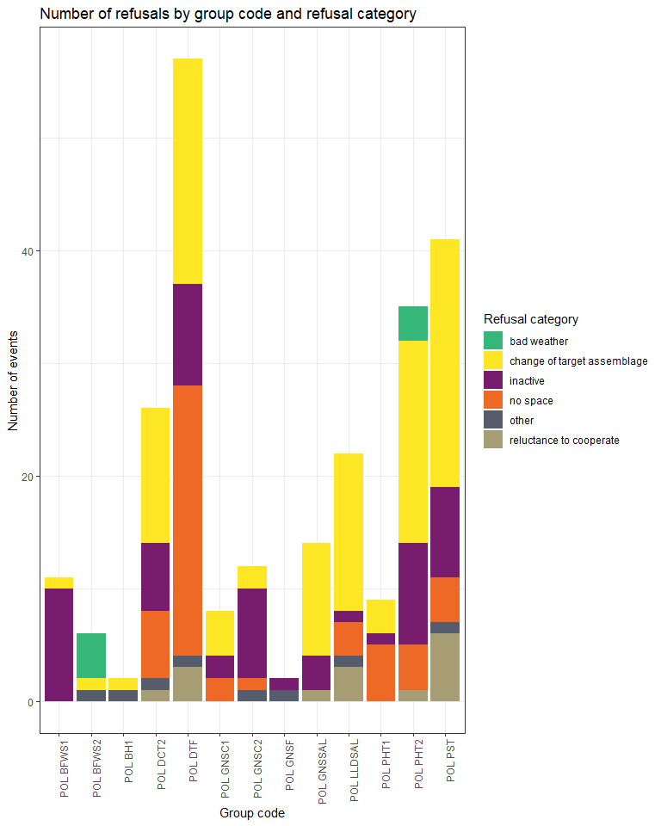
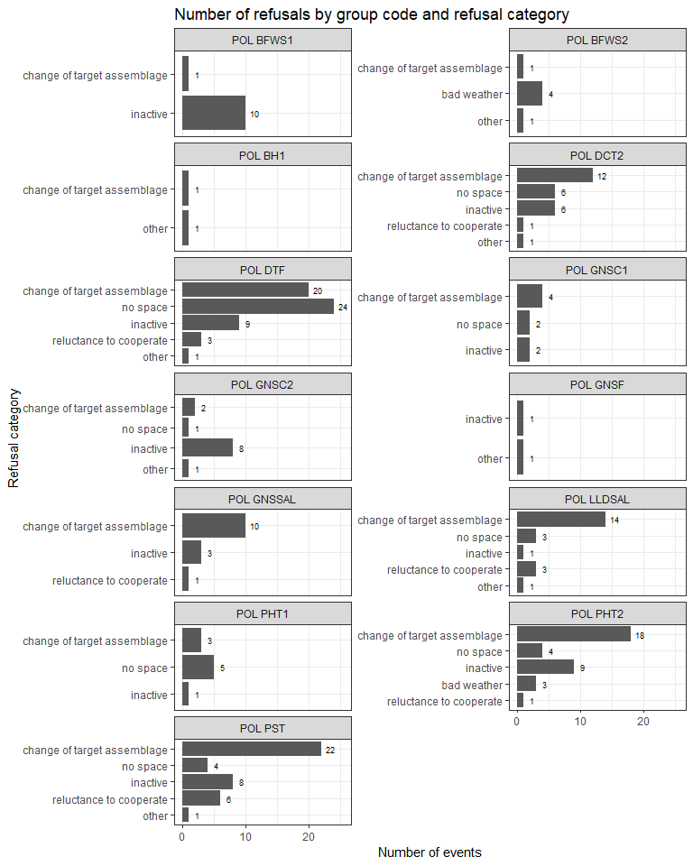

In general, three main reasons for refusals among those vessels/trips selected for sampling were either change of target species (44%) inactive vessels (23%) or lack of space on board (21%). These three reasons together constituted 88% of refusal cases. Reluctance to cooperate accounted for 6% refusal cases whereas bad weather conditions and other reasons accounted for 3% cases each.
The above situation occurred despite the fact that in each quarter of the year, in case of lack of contact with the vessel or refusal to take observer on board or provide landed fish for sampling on shore, the supplementary drawing was performed to maintain the desired number of vessels trips to sample.

3. Action to avoid deviations
Member State shall describe the actions that will be considered / have been taken to avoid the deviations in the future and when these actions are expected to produce effect. If there are no deviations, then this section is not applicable.

Baltic
Based on the sampling design applied, a dedicated web application was developed to support sampling process management. The application provides three types of user roles:
- Administrator – management of PSUs groups, vessels and trips. Access to fishery statistics, drawing of vessels, assigning coordinators to groups.
- Coordinator – partial permission for trips’ management within the assigned groups. Assigning observers to trips.
- Observer – restricted access to trips with a possibility to view assigned trips.

A module for contact’s details management was successfully implemented by the end of 2017.
As far as sampling policy itself is concerned, the new sampling design and the application mentioned above were presented at the WGCATCH meeting in 2017. The WGCATCH recommended to examine the stratification of the sampling program and to consider reduction of a number of groups of PSUs in order to avoid having strata with small number of samples. Another suggestion was to set one annual list of randomly selected PSUs instead of four quarterly lists. In 2018 it was decided to have one group of PSUs instead of two separate groups for at-sea and on-shore sampling. It was also agreed that at-sea samples have higher priority than on-shore samples. Taking into account the feedback from WGCATCH further modifications will be considered and included in the proposal for new Work Plan developed in 2019 for a period of 2020 onwards. In order to identify the modifications needed in the sampling programme, a preliminary work has been done in 2018. The main focus was on the analysis of the most recent official fisheries data which showed the relationships between currently used groups of PSUs. This type of analysis will be continued in 2019 and will be a basis for developing new Work Plan.
Planned simplification of the sampling design (e.g. reduction of number of sampling strata) for a new WP should result in the reduction of refusal. Additionally, more frequent contacts with owners of the vessels selected for sampling fishing trips is planned in order to allow a faster response if the high level of refusals persists. Refusal rates from the period 2017-2019 will be taken into account when creating initial lists of PSUs for 2020. A surplus of PSUs will be included in the list which will reduce the number of additional draws done to compensate for the planned number of samples.

Other regions
Based on a multilateral agreement between DEU-LTU-NLD-POL, from 2017 Poland is coordinating joint sampling program for biological data collection on board EU fishing vessels engaged in the fishery for small pelagic fish in the SPRFMO area (South-East Pacific).
Based on a new multilateral agreement between DEU-LTU-LVA-NLD-POL, from 2018 Poland is coordinating joint sampling program for biological data collection on board EU fishing vessels engaged in the fishery for small pelagic fish in the CECAF area (Central-East Atlantic).
No other deviation from WP.

(max. 1000 words per region OR fishing ground)

Section 5: data quality

Text Box 5A: Quality assurance framework for biological data

General comment: This box is applicable to the Annual Report. This box fulfills Article 5 paragraph (2) point (a) of the Decision (EU) 2016/1701. This box is intended to specify data to be collected under Tables 1(A), 1(B) and 1(C) of the multiannual Union programme.Use this box to provide additional information on Table 5A.
Applies to all Region/RFMO/RFO/IO OR sampling schemes

1. Evidence of data quality assurance
Within this section Member State shall provide information on the methodology used to assure the quality of the data collected, highlighting those aspects where changes have been made during the sampling year. Information shall be provided by each sampling scheme for which data was collected. In the case where the same quality assurance framework is applied to all data collection schemes, information can be provided at general level with the indication “all sampling schemes”.
In those sections of Table 5A where “N” is indicated, Member States shall explain the main constrains and/ or the steps taken to fulfil this obligation. In the cases where a reference documents is requested, Member States shall provide a web link.
In cases where documents are not publicly available, due to institutions internal policy, confidentiality or other reasons, this shall be indicated by the Member State.
Polish quality assurance framework is a multi-stage process. At first, data entered to the national database are verified in the two-stage validation process supported by a number of completeness, data type and range checks. Export procedures which prepare data sets for external databases (like RDB FishFrame or InterCatch) also perform basic checks.
Additionally, two validation applications were developed, both written in Shiny (R package) and available only via the institute’s intranet:
1. Data Quality Check application - at present, the following visual and quantitative quality analyses of the data stored in the database, are available:
- outliers identification for Weight at Length relationship and Length at Age – a user can inspect the data visually on the scatter plots and mark suspicious points for further checking, or make use of the automatic outliers identification based on the Bonferroni outlier test,
- inconsistency between sample and catch weight,
- biological analyses with missing age – a table with detailed data, as well as a histogram of the number of gaps for all species, are available,
- inconsistency between number of individuals in the length classes and in the biological analyses,
- dates misreporting.
A user can screen the data in the fully interactive mode or download a quality report in HTML/PDF format.
2. Data Accuracy Check application - at present only observer effect analysis is available. A user can display all VMS signals of a chosen vessel and highlight points from trips with on-board observers. The methodology used was based on the ICES WKACCU Report 2008, whereas the example of such analysis applied to the Polish data was performed during RCM Baltic 2016.
Both applications mentioned above are under constant development. National database and applications are accessible only within internal Institute’s network.
In comparison to the WP, a substantial progress was made during the sampling year. Sampling design documentation were prepared for all sampling schemes as well as data evaluation tools for majority of them. During the sampling year a number of issues, both conceptual and technical, were identified in the sampling programme. They will be taken into account when updating the documentation of the sampling design.
In 2018, the software for data quality checks was successfully deployed as a web application in the Institute’s internal network. It is accessible for specialists responsible for species / stocks data analysis. The application was improved by adding another type of analysis which shows mean weights of fish in a sample and allows to find errors in a sample weight.
The application for data accuracy checks is still under development. Apart from the observer effect analysis which is already available, the following other types of checks were identified and are planned to be further developed and implemented in the near future:
- refusal reasons analysis,
- spatial and temporal coverage of sampling,
- incomplete sampling frame effects,
- random trips vs. expert judgement trips.

2. Sampling design
Explain main constraints and/ or steps taken, if ‘N’ (no) was indicated in Table 5A.
NA
3. Sampling implementation
Explain main constraints and/or steps taken, if ‘N’ (no) was indicated in Table 5A.
Recording of non-responses and refusals is not applicable in the long distance fishery (pelagic trawlers fishing in NS&EA, CECAF and SPRFMO areas). There are limited number of vessels available in these sampling strata and, unless for objective reasons, there are no substantial problems with placing observer on board the vessels – based on written agreements with vessels owners concerned.
4. Data capture
Explain main constraints and/ or steps taken, if ‘N’ (no) was indicated in Table 5A.
NA
5. Data Storage
Explain main constraints and/ or steps taken, if ‘N’ (no) was indicated in Table 5A. Please provide a link if the documented revisions are available and not confidential.
NA
6. Data processing
Explain main constraints and/ or steps taken, if ‘N’ (no) was indicated in Table 5A.
Imputation is not performed at national level but at Stock Data Coordination level. Data are provided to end user "as-is" (as collected, validated and recorded in national database)

(max. 900 words per Region/RFMO/RFO/IO OR sampling scheme)

Section 5: data quality

Text Box 5B: Quality assurance framework for socioeconomic data

General comment: This box fulfills Article 5 paragraph (2) point (b) of the Decision (EU) 2016/1701. This box is intended to specify data to be collected under Tables 5(A), 6 and 7 of the multiannual Union programme. Use this box to provide additional information on Table 5B.
1. Evidence of data quality assurance
Within this section MS shall provide information on the methodology used to assure the quality of the data collected, highlighting those aspects where changes have been made during the sampling year. Information shall be provided by each sector (Fishing fleet, Aquaculture, Fish processing) for which data was collected and by each data collection scheme. In the case where the same quality assurance framework is applied to all sectors or/and all data collection schemes, information can be provided at general level with the indication “all sectors” or “all data collection schemes”.
Fleet
In accordance with national regulations, each vessel’s owner is legally bound to fill out a questionnaire regarding the economic results of the fishing vessel. In order to ensure the maximum number of questionnaires is received, similarly to previous years reminders of the obligation to file them were sent by registered mail and phone calls were made to execute the obligation. Recommendations of the Lisbon DCF workshop on “statistical issues related to the collection of economic data within the DCF” (i.e. closer cooperation with PO) were taken into account to deal with the non-response problem. As the number of returned questionnaires did not reach a plan of respond rate, calculations were made, based on the questionnaires received. Economic data received does not usually exceed 70% of respond rate. However all responses were of random character (probability sample), which should ensure the representativeness of the sample. Response rates are provided in an Excel table.

Aquaculture
Data are not collected in Poland.

Processing
In accordance with national regulations, economic and some social data were collected obligatory for the entire population. In order to ensure the maximum number of questionnaires is received, similarly to previous years reminders of the obligation to file them were sent by registered mail and phone calls were made to execute the obligation. Recommendations of the Lisbon DCF workshop on “statistical issues related to the collection of economic data within the DCF” were taken into account to deal with the non-response problem. For missing questionnaires calculations of the missing variables for the missing population were made, based on average data from the questionnaires received.

In those sections of Table 5B where “N” is indicated, Member States shall explain the main constrains and/ or the steps taken to fulfil this obligation. In the cases where a reference documents is requested, Member States shall provide a web link.
In cases where documents are not publicly available, due to institutions internal policy, confidentiality or other reasons, this shall be indicated by the Member State.

2. Section P3 Impartiality and objectiveness
Explain main constraints and/ or steps taken, if ‘N’ (no) was indicated in Table 5B
NA
3. Section P4 Confidentiality
Explain main constraints and/ or steps taken, if ‘N’ (no) was indicated in Table 5B
NA
4. Section P5 Sound methodology
Explain main constraints and/ or steps taken, if ‘N’ (no) was indicated in Table 5B
Information on this principle should be briefly explained in Text boxes 3A, 3B and 3C. Description of methodologies used on data quality.
NA
5. Section P6 Appropriate statistical procedures
Explain main constraints and/ or steps taken, if ‘N’ (no) was indicated in Table 5B. Please provide a link if the documented revisions are available and not confidential.
NA
6. Section P7 Non-excessive burden on respondents
Explain main constraints and/ or steps taken, if ‘N’ (no) was indicated in Table 5B
NA
7. Section P8 Cost effectiveness
Explain main constraints and/ or steps taken, if ‘N’ (no) was indicated in Table 5B
NA
8. Section P9 Relevance
Explain main constraints and/ or steps taken, if ‘N’ (no) was indicated in Table 5B
NA
9. Section P10 Accuracy and reliability
Explain main constraints and/ or steps taken, if ‘N’ (no) was indicated in Table 5B. Information on this principle should be briefly explained in Text boxes 3A, 3B and 3C. Description of methodologies used on data quality.
NA
10. Section P11 Timeliness and punctuality
Explain main constraints and/ or steps taken, if ‘N’ (no) was indicated in Table 5B
NA
11. Section P12 coherence and comparability
Explain main constraints and/ or steps taken, if ‘N’ (no) was indicated in Table 5B
NA
12. Section P13 Accessibility and Clarity
Explain main constraints and/ or steps taken, if ‘N’ (no) was indicated in Table 5B. Information and links to documentation on this principle should be briefly explained in Text boxes 3A, 3B and 3C. Description of methodologies used on data quality.
NA
(max. 900 words per Region/RFMO/RFO/IO/NSB OR sector)

