Ministry of Maritime Economy and Inland Waterways
National Marine Fisheries Research Institute

Regulation (EU) 2017/1004 of the European Parliament and of the Council
of 17 May 2017
on the establishment of a Union framework for the collection, management and use of data in the fisheries sector and support for scientific advice regarding the common fisheries policy and repealing Council Regulation (EC) No 199/2008

Commission Delegated Decision (EU) 2019/910 of 13 March 2019
establishing the multiannual Union programme for the collection and management of biological, environmental, technical and socioeconomic data in the fisheries and aquaculture sectors.
Commission Implementing Decision (EU) 2019/909 of 18 February 2019 establishing the list of mandatory research surveys and thresholds for the purposes of the multiannual union programme for the collection and management of data in the fisheries and aquaculture sectors.

Polish Work Plan for data collection in the fisheries sector
2020-2021
Version [1]

Gdynia, 31.10.2019

CONTENTS

Section 1: Biological Data 3
Pilot Study 1: Relative share of catches of recreational fisheries compared to commercial fisheries 3
Section 1: Biological Data 4
Text Box 1E: Anadromous and catadromous species data collection in fresh water 4
Section 1: Biological Data 5
Pilot Study 2: Level of fishing and impact of fisheries on biological resources and marine ecosystem 5
Section 1: Biological Data 6
Text Box 1G: List of research surveys at sea 6
Section 2: Fishing Activity Data 9
Text Box 2A: Fishing activity variables data collection strategy 9
Section 3: Economic and Social Data 10
Text Box 3A: Population segments for collection of economic and social data for fisheries 10
Section 3: Economic and Social Data 11
Pilot Study 3: Data on employment by education level and nationality 11
Section 3: Economic and Social Data 12
Text Box 3B: Population segments for collection of economic and social data for aquaculture 12
Section 3: Economic and Social Data 13
Pilot Study 4: Environmental data on aquaculture 13
Section 3: Economic and Social Data 14
Text Box 3C: Population segments for collection of economic and social data for the processing industry 14
Section 4: Sampling Strategy for Biological Data from Commercial Fisheries 15
Text Box 4A: Sampling plan description for biological data 15

Section 1: Biological Data

Pilot Study 1: Relative share of catches of recreational fisheries compared to commercial fisheries

General comment: This Box fulfills point 4 of Chapter II of the Decision 2019/909 and Article 2 and Article 4 paragraph (3) point (a) of this Decision.
No Pilot Study planned for 2020-2021.
Based on the achievemnts of the Pilot Study conducted in 2017-2019, sampling programme will be implemented (see table 1D of the WP).

Section 1: Biological Data

Text Box 1E: Anadromous and catadromous species data collection in fresh water

General comment: This Box fulfills paragraph 2 points (b) and (c) of Chapter III of the multi-annual Union programme and Article 2 of this Decision.
European Eel
Already since 2010 WGEEL has been indicating the need of an assessment of biomass and mortality indicators in management as well as scientific reference points to ultimately result in a scientific advice framework that works in line with the ICES precautionary approach. The sampling design will provide relevant data for biomass assessment to WGEEL to perform the approach for international stock assessment.
As required by DECISION (EU) 2016/1251 data collection for two Polish EMU`s (Oder and Vistula) will consist of:
- catch quantities derived from inland commercial fisheries (official statistical questionnaires)
- biological variables – age, length, weight, sex and life stage.
- the abundance of recruits – catch data obtained from eel ladders set in Pomeranian rivers, data on stocking from statistical questionnaires and resellers.
- the abundance of the standing stock – calculated by mathematical modelling, supplemented by data from scientific non selective fyke nets set in lagoons and lakes.
- the number of emigrating silver eels will be calculated by mathematical modelling.
- the stock dynamics of eel for both EMU’s is estimated using a version of CAGEAN model (Deriso et al., 1985), described in the Polish Eel Management Plan. Data will be delivered to WGEEL annually.

Salmon and sea trout
Data about volume of commercial catches will be obtained from special questionnaires (inland waters).
Stock related variables will be collected during monitoring of commercial catches and landings.

Information on abundance of salmon smolt and parr and number of ascending individuals is not relevant. There are no wild salmon rivers in Poland. At the moment the estimation of stock status is made by executing the assessment model for 17 wild salmon stocks and by expert evaluation in 25 wild salmon rivers. Accidental catch of salmon parr will be noted during sea trout electrofishing survey.

The present EU MAP regulation does not recognize the need of sea trout parr density data that is obtained by electrofishing surveys in rivers. By now, these surveys are in many countries conducted outside the EU data collection. However, as these data gives the basis for the ICES advice, a solid foundation for the relevant river surveys should be established in the EU MAP in order to guarantee the continuation of parr density data series at least in a minimum scale in each assessment unit (RCM 2016). Poland will perform standard electrofishing surveys in 40 sites on 14 river systems/. Data will be delivered to WGBAST annually.

Section 1: Biological Data

Pilot Study 2: Level of fishing and impact of fisheries on biological resources and marine ecosystem

General comment: This Box fulfills paragraph 3 point (c) of Chapter III of the multi-annual Union programme and Article 2 and Article 4 paragraph (3) point (b) of this Decision.
No Pilot Study planned.

Section 1: Biological Data

Text Box 1G: List of research surveys at sea

General Comment: This Box fulfills Chapter I of the multi-annual Union programme and Article 2 and Article 7 paragraph (3) of this Decision. It is intended to specify which reseach surveys at sea set out in an Annex to the Decision 2019/909 will be carried out. Member States shall specify whether the research survey is included in an Annex to the Decision 2019/909.
Baltic International Trawl Surveys – BITS Q1 and BITS Q4
Objectives of the survey
The aim of the surveys is an evaluation of Gadus morhua and Platichthys flesus and, to some extent, Sprattus sprattus and Clupea harengus recruiting year classes strength (abundance index) and analysis of their distribution during winter (BITS Q1) and autumn (BITS Q4) in the bottom zone of the Southern Baltic.

Description of the methods used in the survey. For mandatory surveys, link to the manuals. Include a graphical representation (map)
A set of control hauls (with the use of a standard bottom trawl) and hydrological parameters measurements at randomly selected stations.

ICES Manual for BITS surveys : ICES. ADDENDUM 1: SERIES OF ICES SURVEY PROTOCOLS;
SISP manual for the Baltic International Trawl Surveys (BITS); March 2014; Gdynia, Poland
( http://dcf.mir.gdynia.pl/?page_id=367 ).

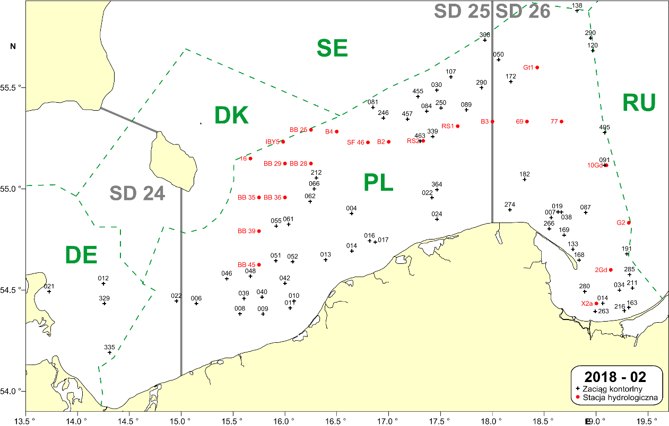

Fig. 1.1. Example location of the bottom control trawl hauls and the hydrological standard stations to be performed by the “Baltica” during the BITS Q1 survey in the Polish part of the Southern Baltic (black crosses = control hauls; red dots = hydrological stations).

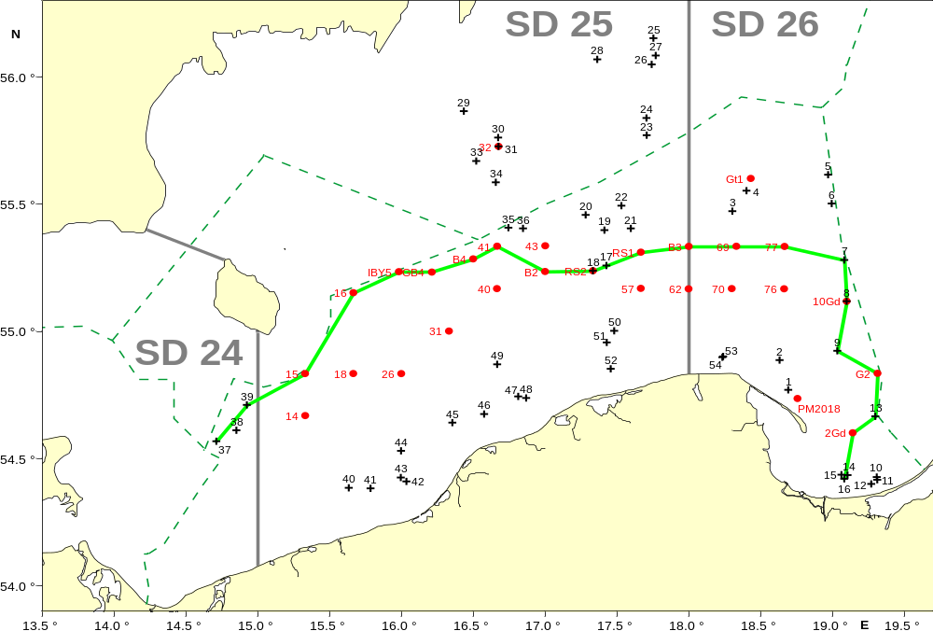

Fig. 1.2. Example location of the bottom trawl hauls and the hydrological standard stations to be performed by the r.v. “Baltica” during the BITS Q4 survey in the Polish part of the southern Baltic (black crosses = control hauls; red dots = hydrological stations).

For internationally coordinated surveys, describe the participating Member States/vessels and the relevant international group in charge of planning the survey
BITS surveys are coordinated by the ICES Working Group on Baltic International Fish Survey (WGBIFS).
MS participating in BITS Q1 surveys: DEU; DNK; LTU; LVA; SWE
MS participating in BITS Q4 surveys: DEU; DNK; EST; LTU; LVA; SWE

Where applicable, describe the international task sharing (physical and/or financial) and the cost sharing agreement used

Following recommendations of WGBIFS, each participating MS executes surveys primarily in their respective EEZs. No cost sharing agreements in place yet.

Explain where thresholds apply
N.A.

Baltic Acoustic Surveys – SPRAS and BIAS
The description below refers to two Baltic acoustic surveys of similar scope and methodology: SPRAS - Sprat Acoustic Survey (known also as BASS – Baltic Acoustic Spring Survey) and BIAS - Baltic International Acoustic Survey.
Objectives of the surveys
The aim of the SPRAS surveys is an estimation of the stock indices of Sprattus sprattus in May, whereas the aim of the BIAS surveys is an estimation of Clupea harengus, Sprattus sprattus and, to some extent, Gadus morhua stocks resources (biomass and abundance) and analysis of their spatial distribution in the pelagic zone of the southern Baltic during autumn season.
Description of the methods used in the survey. For mandatory surveys, link to the manuals. Include a graphical representation (map)
In case of both types of surveys, a set of control hauls (fish catch-stations) with the use of herring small-meshed pelagic trawl is performed as well as echo-integration records (S_{A} = NASCs; Nautical Area Scattering (Strength) Coefficient) are collected along the pre-selected acoustic transects on the distance of about 830 NM.

BIAS & BASS Surveys Manual: ICES. ADDENDUM 2: SERIES OF ICES SURVEY PROTOCOLS, VERSION 1.02; SISP MANUAL OF INTERNATIONAL BALTIC ACOUSTIC SURVEYS (IBAS);
28-03-2014, GDYNIA, POLAND ( http://dcf.mir.gdynia.pl/?page_id=367 ).
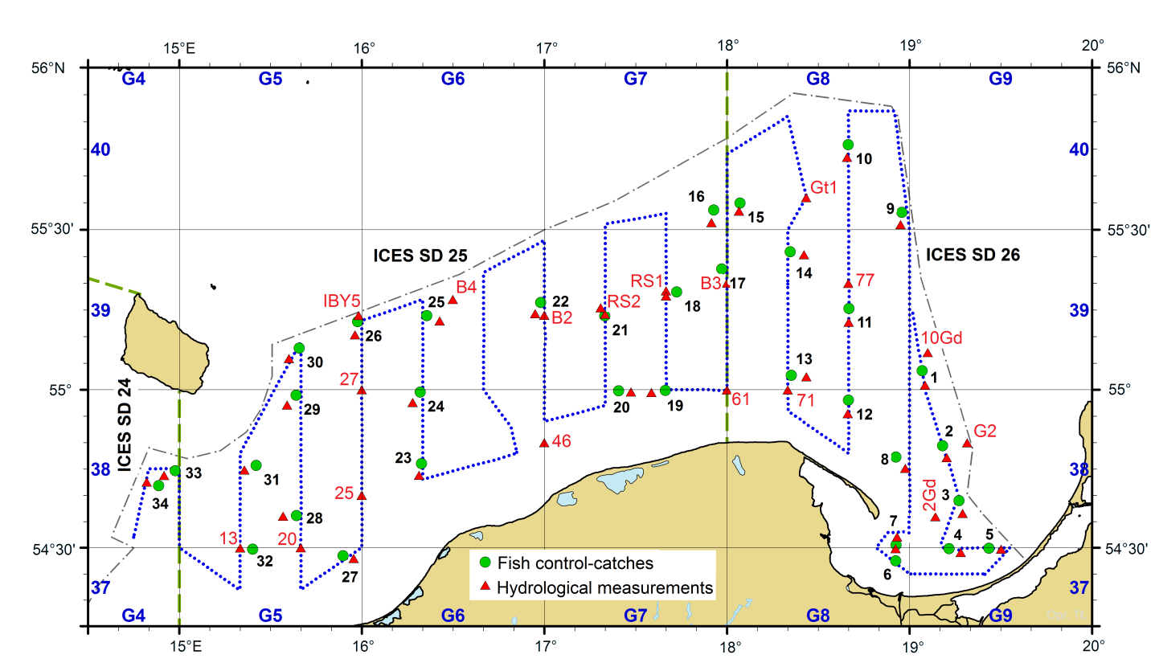
Fig. 1.3. Example location of the echointegration track (blue dotted line), pelagic control hauls(green dots) and hydrological stations (red triangles) during the SPRAS (May) and BIAS (autumn) surveys in the Polish Exclusive Economic Zone on board r/v Baltica.

For internationally coordinated surveys, describe the participating Member States/vessels and the relevant international group in charge of planning the survey
SPRAS and BIAS surveys are coordinated by the ICES Working Group on Baltic International Fish Survey (WGBIFS).
MS participating SPRAS surveys: DEU; EST; LTU; LVA.
MS participating in BIAS surveys: DEU; DNK; EST; FIN; LTU; LVA; SWE

Where applicable, describe the international task sharing (physical and/or financial) and the cost sharing agreement used
Following recommendations of WGBIFS, each participating MS executes surveys primarily in their respective EEZs. No cost sharing agreements in place yet.

Explain where thresholds apply
N.A.

Section 2: Fishing Activity Data

Text Box 2A: Fishing activity variables data collection strategy

General comment: This Box fulfills paragraph 4 of Chapter III of the multi-annual Union programme and Article 2, Article 4 paragraph (2) point (b) and Article 5 paragraph (2) of this Decision. It is intended to describe the method used to derive estimates on representative samples where data are not to be recorded under Regulation (EU) No 1224/2009 or where data collected under Regulation (EU) No 1224/2009 are not at the right aggregation level for the intended scientific use.
1. Description of methodologies used to cross-validate the different sources of data.
Catch data are compared with the landings data on a trip level in the range of catch composition and catch/landing weight. Fishing locations registered in logbooks are checked with the VMS data.

2. Description of methodologies used to estimate the value of landings.
The value of landings for each species is estimated for the whole year by multiplying the total landings weight by average price per kg. The average annual exchange rate is used to calculate the value in EUR.

3. Description of methodologies used to estimate the average price.
Average price is obtained from the sales notes data. It is estimated for the whole year for each species by dividing the total value by total weight.

4. Description of methodologies used to plan collection of the complementary data.
Not applicable.

Section 3: Economic and Social Data

Text Box 3A: Population segments for collection of economic and social data for fisheries

General comment: This Box fulfills paragraph 5 points (a) and (b) of Chapter III of the multi-annual Union programme and Article 2, Article 4 paragraphs (1), (2) and (5) and Article 5 paragraph (2) of this Decision. It is intended to specify data to be collected under Tables 5(A) and 6 of the multi-annual Union programme.
1. Description of methodologies used to choose the different sources of data
Economic and social data regarding the fishing fleet will come from administrative documents (fishing logs, landing declarations, first sale documents, Fishing Fleet Register) and statistical questionnaires filled out by fishing vessel owners.

2. Description of methodologies used to choose the different types of data collection
Requests with questionnaires for economic and social variables will be sent to all active vessels owners (census data).

3. Description of methodologies used to choose sampling frame and allocation scheme
All data are intend to be collected for a whole population on the basis of census data.

4. Description of methodologies used for estimation procedures
In case of non-responses in census, estimation will be made based on averages for vessels that provided data and information known for a whole population for individual vessels i.e. volume of catches, fishing days, number of vessels within given segment. If there is a lack of information from the whole population (100%), the data are estimated based on the average values of the sample calculated taking into account number of fishing vessels, number of fishing days, number of personnel or catch size (variables known for a whole population).

5. Description of methodologies used on data quality
These data are intend to be complete as they will include information from the whole population. If any fishing vessel owners fail in their obligation to return the statistical questionnaires, the values of the missing parameters for the missing population will be determined based on averaged data from the questionnaires received. Defined as the ratio of number units for which data for at least same variables have been collected to the total number of units designed for data collection. CV and representativity analysis will be performed. According to article 38 of the Law issued on 29 June 1995 on official statistics it shall not be allowed to publish or disseminate statistical information obtained in statistical surveys of official statistics which can be linked or can identify natural persons or individual data characterizing business entities, especially if the aggregated data consist of less than three entities or the share of one entity in the compilation is higher than the three-fourths of the total (statistical confidentiality).

Section 3: Economic and Social Data

Pilot Study 3: Data on employment by education level and nationality

General comment: This Box fulfills paragraph 5 point (b) and paragraph 6 point (b) of Chapter III of the multi-annual Union programme and Article 2 and Article 3 paragraph (3) point (c) of this Decision. It is intended to specify data to be collected under Table 6 of the multi-annual Union programme.
Fisheries
In order to be fully in line with the EU-MAP (Commission Delegated Decision 2019/910) the annual economic questionnaire (which is used to collect economic and social data for fisheries) will be ammended to include additional missing information about employment by nationality and unpaid labour in 2021 (untill that these data will be requested on a voluntary basis). All other data required has already been collected: Employment by gender, FTE by gender, Employment by age, Employment by education level, Employment by employment status, FTE National. All the variables are collected on annual basis.

Aquaculture
There is no marine aquaculture in Poland.

Section 3: Economic and Social Data

Text Box 3B: Population segments for collection of economic and social data for aquaculture

General comment: This Box fulfills paragraph 6 points (a) and (b) of Chapter III of the multi-annual Union programme and Article 2, Article 4 paragraphs (1) and (5) and Article 5 paragraph (2) of this Decision. It is intended to specify data to be collected under Tables 6 and 7 of the multi-annual Union programme.
Based on the data until 2017, according to classification of aquaculture activities by Eurostat statistics, Poland has no marine aquaculture sector. Hence, no sampling is planned.

Section 3: Economic and Social Data

Pilot Study 4: Environmental data on aquaculture

General comment: This Box fulfills paragraph 6 point (c) of Chapter III of the multi-annual Union programme and Article 2 and Article 4 paragraph (3) point (d) of this Decision. It is intended to specify data to be collected under Table 8 of the multi-annual Union programme.
Based on the data until 2017, according to classification of aquaculture activities by Eurostat statistics, Poland has no marine aquaculture sector. Hence, no sampling is planned.

Section 3: Economic and Social Data

Text Box 3C: Population segments for collection of economic and social data for the processing industry

General comment: This Box fulfills footnote 7 of paragraph 1.1(d) of Chapter III of the multi-annual Union programme, Article 2, Article 4 paragraphs (1) and (5) and Article 5 paragraph (2) of this Decision. It is intended to specify data to be collected under Table 10 of the multi-annual Union programme.
1. Description of methodologies used to choose the different sources of data
A questionnaire will be used to collect all data.

2. Description of methodologies used to choose the different types of data collection
The data are census. A request for economic and social variables (questionnaires) will be sent to all processing companies. There is a legal obligation to deliver these data annually to National Marine Fisheries Research Institute in Poland (according to the regulation of June 29, 1995 on public statistics - Journal of Laws 2016 No. 0, pos. 1068).

3. Description of methodologies used to choose sampling frame and allocation scheme
Population include all legal business entities, including legal personalities and organizational units without legal personality and individuals operating fish and other aquatic animal processing facilities that are listed as meeting the standards of Council Regulation (EC) no. 853/2004 of April 29, 2004, which sets forth detailed requirements regarding hygiene in foodstuffs of animal origin, Appendix IIII Section VIII Fisheries Products. The data collection will also cover fish processing plants authorized by administrative decision pursuant to art. 21a section 1 and 3 of the Act of 16 December 2005 on products of animal origin (Journal of Laws of 2017, item 242, as amended) for the production of fishery products on third country markets.

The population cover enterprises whose main activity is defined according to the Eurostat definition under NACE Code 10.20: ‘products’. ”Processing and preserving of fish, crustaceans and mollusks ” and also enterprises that carry out fish processing but not as a main activity.

4. Description of methodologies used for estimation procedures
It is assumed that all processing facilities obliged to return completed questionnaires will comply.

5. Description of methodologies used on data quality
Unit response rate will be used as indicator of accuracy. Defined as the ratio of number units for which data for at least same variables have been collected to the total number of units designed for data collection.
According to article 38 Law issued on 29 June 1995 on official statistics it shall not be allowed to publish or disseminate obtained in statistical surveys of official statistics statistical information which can be linked or can identify natural persons or individual data characterizing business entities, especially if the aggregated data consist of less than three entities or the share of one entity in the compilation is higher than the three-fourths of the total.

Section 4: Sampling Strategy for Biological Data from Commercial Fisheries

Text Box 4A: Sampling plan description for biological data

General Comment: This Box fulfills Article 3, Article 4 paragraph (4) and Article 8 of this Decision and forms the basis for the fulfilment of paragraph 2 point (a)(i) of Chapter III of the multi-annual Union programme. This Table refers to data to be collected under Tables 1(A), 1(B) and 1(C) of the multi-annual Union programme.
In 2017 Poland has implemented a new sampling design plan, moving gradually from metier based and purely opportunistic sampling towards the plan based on statistics. After a 3 year implementation, it is now possible to improve the design, eliminating the identified shortcomings.
The following approach was applied to a new sampling plan:

Scheme – determination of the sampling scheme was based on the fishing areas. For the Baltic Sea sampling, the combination of ‘at-sea and on-shore’ scheme was used, whereas in regions outside Baltic Sea only ‘at-sea’ scheme was chosen as the only one practically possible. The defined sampling schemes are: „Baltic at sea and on shore”, „North Sea and Eastern Arctic at sea”, „Other fishing regions at sea”. A separate scheme was set for at-sea sampling of biological data, catch per unit effort and catch composition from recreational fishery for Baltic cod, defined as „At sea cod recreational fishery”.

Stratifications – there were some modifications introduced in comparison to the previous sampling design for Baltic fishery, where the stratification was formerly based on the type of vessels’ fishing technique exploiting given fish stock. This approach had some meaningful defects, where the main one was the fact that one vessel could use multiple fishing techniques so could be assigned to more than one strata, what is statistically wrong. The previous sampling design resulted in high refusal rate, casued among others by the fact that being selected, a vessel was not sampled because it changed gear or target species so was no longer compliant with the PSU group it was initially assigned to. To avoid such a situation in the future, a change was introduced in the way of defining strata, which are now based on the vessels’ length category.

Sampling frame – all vessels that were active (at least one fishing trip) in 2018 make a list that is a proxy for selecting the PSUs. According to WKPICS 2013:
“At-sea sampling with trips as primary sampling units. When trips can be selected randomly from a fleet of vessels, at least approximately, it is often reasonable to treat vessel-trips as the primary sampling units. In such cases, the list of all trips (obtained at the end of the year) makes up the sampling frame. This is a virtual frame that cannot be used in stage 1 to select the trips. The actual selection is typically based on a frame with a vessel list crossed with time.“.

Coverage – assuming the target population consists of all vessels that were active in 2018, the coverage of target population equals 100%.

Primary Sampling Unit (PSU) is „vessel trip”

Sampling intensity – in order to maintain the continuity of the sampling intensity compared to the previous years, the annual number of samples to be collected during 2020-2021 period is at the same level as during the previous multiannual programs (2014-2019). Both at sea and on shore sampling will be continued. In order to obtain independent, scientific data on discards, at sea sampling will be conducted as the first choice, if not possible then on-shore sampling will be conducted.
Sampling of the Baltic Sea fisheries is based on a quarterly basis. To define the sampling intensity per each stratum per quarter, the half of the total annual number of samples was distributed proportionally to the quarterly distribution of landings and the second half of the total number of samples was distributed proportionally to the total number of trips. It was decided to include both paramateres in order to distribute the sampling effort reflecting the different segments of the fishing fleet. So to take into consideration vessels that have the bigger share in total catches (i.e. larger vessels) as well as vessels that have much more fishing trips but small catches (i.e. smaller vessels, active mainly in a coastal fishery).
In case of sampling fisheries outside the Baltic Sea, fishing trips to sample are not selected randomly but depend on practical or regional considerations (see comments in Table 4A of the WP).

Reference years – in case of the Baltic Sea fisheries only 2018 data were used as the reference year, treating it as a most reliable period. Basing on this, we get the sampling frame that is more up to date than it would be if the last 3 years were used. With this approach, it will be possible to reduce the refusal rate eliminating the refusals like ‘vessel withdrawn’, ‘vessel under renovation’ etc. For fisheries outside the Baltic Sea, the three years period of 2016-2018 was applied as a reference years.

Sample selection – in case of the Baltic Sea fisheries sampling, for each quarter and for each stratum a list of vessels will be randomly selected with replacement from a sampling frame. The number of vessels selected will be overrated, to take into account potential refusals and to avoid additional draws. The number of extra vessels to be drawn, has been estimated based on refusal rate from the period 2017-2019. In case, the selected number of vessels will not be enough (more refusals than expected, e.g. lack of contact with the vessel, refusal to take observer on board or provide landed fish for sampling on shore), the supplementary drawing will be performed to maintain the desired number of vessels trips to sample. The concrete vessel trip will be chosen depending on the observer availability. List of vessels selected for sampling will be recorded in a register. This register will contain information on date of selection, date the vessel was contacted to arrange sampling, information if contact with the vessel was successful or not, vessel’s owner acceptance or refusal to be sampled (as well as reasons in case of refusal).

Data archiving and quality checks – Data entered to the national database are verified in the two-stage validation process supported by a number of completeness, data type and range checks. Export procedures which prepare data sets for external databases (like RDB FishFrame or InterCatch) also perform basic checks. Additionally, a number of quality reports were developed to improve the completeness and reliability of the data.

Coverage of fish stocks – as the stratification is based on vessel length and does not put any restirictions on stock sampling, simulations were carried out in order to investigate the potential coverage of stocks fished and metiers used. Using the official 2018 data, the test drawing for all strata was carried out. The average number of samples per fishing stock and metier was calculated after 100 iterations made to check the coverage. The result of these simulations showed that planned sampling design described above provides good coverage of fish stocks.

Until 2016, sampling programme was based on an opportunistic approach. Due to the confidentiality of personal data, the Institute executing the DCF had no full register of the fishing vessels’ owners with contact details. Sampling was based on the cooperation with the owners of over 100 vessels (c.a. 12% of all Polish vessels), built over the years on the basis of trust. During last three years efforts were being made to gain access to the full register of vessels’ owners. The list of contact details to vessels’ owners systematically expands but the process is extended in time. Therefore, the main expected difficulties in execution of the sampling programme is potentially high level of non-response and/or refusals.

