Ministry of Agriculture, Nature and Food Quality of The Netherlands,
The Hague
Wageningen Marine Research, IJmuiden
Wageningen Economic Research, The Hague

REGULATION (EU) 2017/1004 OF THE EUROPEAN PARLIAMENT AND OF THE COUNCIL of 17 May 2017
on the establishment of a Union framework for the collection, management and use of data in the fisheries sector and support for scientific advice regarding the common fisheries policy and repealing Council Regulation (EC) No 199/2008
COMMISSION IMPLEMENTING DECISION (EU) 2016/1701 of 19 August 2016
laying down rules on the format for the submission of work plans for data collection in the fisheries and aquaculture sectors
COMMISSION DELEGATED DECISION (EU) 2019/910 of 13 March 2019
establishing the multiannual Union programme for the collection and management of biological, environmental, technical and socioeconomic data in the fisheries and aquaculture sectors
COMMISSION IMPLEMENTING DECISION (EU) 2019/909 of 18 February 2019
establishing the list of mandatory research surveys and thresholds for the purposes of the multiannual Union programme for the collection and management of data in the fisheries and aquaculture sectors

The Netherlands - Work Plan for data collection in the fisheries and aquaculture sectors
2020-2021
Version 1

The Hague
October 31, 2019

Contents
Section 1: BIOLOGICAL DATA 3
1D Recreational fisheries 3
Pilot Study 1: Relative share of catches of recreational fisheries compared to commercial fisheries 3
1E Anadromous and catadromous species data collection in fresh water 3
Fishing impact 4
Pilot Study 2: Level of fishing and impact of fisheries on biological resources and marine ecosystem 4
1G Research surveys at sea 5
Region: North Sea and Eastern Arctic 5
Region: North Atlantic 18
Section 2: Fishing Activity Data 21
2A Fishing activity variables data collection strategy 21
Region: Baltic Sea; North Sea; Eastern Arctic; NAFO; Extended North-Western waters (Ices areas V, VI and VII) and Southern Western waters 21
Region: Other regions 21
Section 3: Economic and Social Data 23
3A Population segments for collection of economic and social data for fisheries 23
Region: Baltic Sea; North Sea; Eastern Arctic; NAFO; Extended North- Western waters (Ices areas V, VI and VII) and Southern Western waters 23
Region: Other regions 25
Pilot Study 3: Data on employment by education level and nationality 26
3B Population segments for collection of economic and social data for aquaculture 27
Pilot Study 4: Environmental data on aquaculture 29
3C Population segments for collection of economic and social data for the processing industry 30
Section 4: Sampling Strategy for Biological Data from Commercial Fisheries 31
4A Sampling plan description for biological data 31
Region: North Sea 31
Region: North-Western waters 32
Region: Other regions 33

Section 1: BIOLOGICAL DATA

1D Recreational fisheries

Pilot Study 1: Relative share of catches of recreational fisheries compared to commercial fisheries
General comment: This Box fulfils paragraph 4 of Chapter V of the Delegated Decision on the multi-annual Union programme.
Aim of pilot study
Not applicable as since 2009 a national recreational survey has been in place in the Netherlands, covering all the requirements of EU-MAP.
Duration of pilot study
Not applicable
Methodology and expected outcomes of pilot study
Not applicable

1E Anadromous and catadromous species data collection in fresh water
General comment: This Box fulfils paragraph 2 points (b) and (c) of Chapter III of the Delegated Decision on the multi-annual Union programme
Method selected for collecting data
In the Netherlands, eel (Anguilla anguilla) is the only diadromous fish species that is fished commercially in freshwater. In 2010 the Ministry of Economic Affairs introduced an obligatory online catch registration for all freshwater waterbodies. In 2012 effort data (type and number of fishing gears) was added to the registration system. In the catch & effort registration system, yellow eel and silver eel catches are not separated. The existing market sampling programme consists of 36 samples collected between May and August. In each sample length measurements of 150 (max. 200) eels are taken from the unsorted catches. Silver eel and yellow eel are registered separately. In addition to collecting length data, eels are collected for biological sampling (life stage, length, weight, sex, age). Annually several hundred eels are dissected for biological samples (4 eels per 10cm class until 50 cm and 2 eels per 10 cm class for eel >50cm). From these eel, a subset of 50 eels are selected for ageing.
In addition to the fisheries data, fisheries independent surveys take place.
- a glass eel survey takes place every year with a lift net at 8 locations. Glass eel indices are calculated and used by ICES for a European glass eel index. Since 2019 glass eel detectors area also used, which are able to monitor continuously. 9 glass eel detectors are stationed at 5 locations.
- A selection of ditches that do not belong to the WFD (Water frame work Directive) sampling programme are surveyed every year
- Every year Lake IJsselmeer and Markermeer are sampled with an electric beam trawl.

Fishing impact

Pilot Study 2: Level of fishing and impact of fisheries on biological resources and marine ecosystem
General comment: This Box fulfils paragraph 3 point (c) of Chapter III of the Delegated Decision on the multi-annual Union programme
Aim of pilot study
To collect samples of fish species that occur as incidental bycatch in the pelagic fishery. The data collected will provide information on the effect of pelagic fisheries on non–commercial species. It is expected that this project will lead to better cooperation with crews in the sampling of protected species in general (including birds and mammals). The pilot will also provide information on the feasibility of future, large scale data collection programmes for by catch.
Duration of pilot study
2020 and 2021 (2 years)
Methodology and expected outcomes of pilot study
The crew of one trawler is asked to collect once a week all non-marketable fish species from the sorting belt during a pre-set period (e.g. one hour) up to a maximum of one fish standard tray (40-50 kg). In addition, the crew is asked to collect rare non-marketable species in hauls where the occur in extreme numbers. This part of the catch is frozen in standard carton boxes of 20-25 kg and labelled with date, haul number and geographical position. The frozen boxes are landed and collected for analysis at Wageningen Marine Research. Individual fish are identified to species and length- measured to the cm below. Results are back reported to the crew. Data is stored in the database at Wageningen Marine Research. The results may be shared with relevant end-user groups like WGBYC.
The sampling may be extended later in the year to two trawlers.

1G Research surveys at sea
General Comment: The Boxes fulfill Chapter I of the Implementing Decision on the multi-annual Union programme. It is intended to specify which reseach surveys at sea set out in the Annex to the Implementing Decision on the multi-annual Union programme will be carried out. Member States shall specify whether the research survey is included in the Implementing Decision on the multi-annual Union programme or whether it is an additional survey.

Region: North Sea and Eastern Arctic
Survey: International Bottom Trawl Survey (IBTS)
The IBTS is carried out twice a year, one survey is conducted in the first quarter and a second survey in the third quarter. The Netherlands participates only in the first quarter (Q1) survey with RV Tridens (25 days at sea). The survey is listed in 2016/1251 Table 10. The continuity of the previous survey design is guaranteed by participation in the coordinating survey group (IBTSWG).
Objectives of the survey
The ICES SISP Manual for the International Bottom Trawl Surveys (revision IX) describes the current objectives:
- To determine the distribution and relative abundance of pre‐recruits of the main commercial species with a view of deriving recruitment indices;
- To monitor changes in the stocks of commercial fish species independently of commercial fisheries data;
- To monitor the distribution and relative abundance of all fish species and selected invertebrates;
- To collect data for the determination of biological parameters for selected species;
- To collect hydrographical and environmental information;
- To determine the abundance and distribution of late herring larvae (February North Sea survey).
Description of the methods used in the survey
During daytime, GOV trawl hauls are conducted. At night time, a Method Isaac Kidd (MIK) plankton trawl is deployed. Hydrographical data is collected with a CTD (downcast) at every trawl station. Since 2011, litter from the trawl catch is being sorted and registered. The complete sampling procedure and the level of precision are defined in the ICES SISP Manual for the International Bottom Trawl Surveys (revision IX) and the Manual for the Midwater Ring Net sampling during IBTS Q1 (version 3).
The ICES IBTS Working Group (IBTSWG) decides annually on the sampling areas for the contributing MSs. The area to be covered by the Netherlands in 2019 is presented in Figure 1. Slight changes based on IBTSWG decisions may occur for 2020 and 2021, but no major changes are to be expected.
Coordination and participation
The survey is coordinated by the ICES IBTS Working Group (IBTSWG) and performed in collaboration with research vessels from France, Germany, Denmark, Sweden, UK and Norway.

The data of the survey are uploaded in the ICES Database of Trawl Surveys (DATRAS). The internationally combined recruit indices of various species are used by ICES groups WGNSSK and HAWG, elasmobranch information is used by ICES WGEF, and mackerel information incidentally by WGWIDE. The IBTS data are also being used in the OSPAR MSFD assessment.
International task sharing (physical and/or financial) and the cost sharing agreement used
Task sharing applies.
The IBTS Q1 survey is carried out by a number of EU MSs and non-EU countries, each contributing with its own vessel.
No cost sharing applies.
Explain where thresholds apply
Not applicable

Survey: North Sea Beam Trawl Survey (BTS)
The BTS is carried out annually in August/September. The Netherlands participates with RV Isis (25 days at sea) and RV Tridens (20 days at sea), both with a different spatial coverage. The survey is listed in 2016/1251 Table 10. The continuity of the previous survey design is guaranteed by participation in the coordinating survey group (WGBEAM).
Objectives of the survey
The ICES Manual for the Offshore Beam Trawl Surveys (SISP14, April 2019) describes the current objectives:
- Create fisheries-independent abundance indices by age group (1 year olds and older) for a number of fish species (i.a. plaice, sole, dab, lemon sole, flounder, turbot, brill, monk fish) for the sampled area
- Collection of biological data on all fish species including elasmobranch species for ecosystem analysis purposes, including length measurements
- Collection of data on at least a selection of epibenthos species for ecosystem analysis purposes
- Collection of marine litter data
Description of the methods used in the survey
During daytime, 30 minute beam trawl hauls are conducted. Hydrographical data is collected with a CTD (downcast) at every trawl station. Since 2011, litter from the trawl catch is sorted and registered on board Tridens. The complete sampling procedure is defined in the ICES Manual for the Offshore Beam Trawl Surveys (SISP14, April 2019).
The area to be covered by the Netherlands is presented in Figure 2a and 2b.
Coordination and participation
The survey is coordinated by the ICES Working Group on Beam Trawl Surveys (WGBEAM). Other MSs carrying out beam trawl surveys in the region are Belgium, Germany and UK.

The data of the survey are uploaded in the ICES Database of Trawl Surveys (DATRAS). The Dutch beam trawl survey in the North Sea data is being used by ICES WGNSSK in the fish stock assessments (sole Solea solea, plaice Pleuronectes platessa, dab Limanda limanda, brill Scophthalmus rhombus and turbot Scophthalmus maximus/Psetta maxima).
BTS data are being used in the OSPAR MSFD assessment.
International task sharing (physical and/or financial) and the cost sharing agreement used
Task sharing applies. The survey is carried out by four EU MSs, each contributing with its own vessel.
No cost sharing applies.
Explain where thresholds apply
Not applicable

Survey: Demersal Young Fish Survey (DYFS)
The DYFS is carried out annually from end of August-early November. The Netherlands participates with RV Isis (25 days at sea), RV Luctor (15 days at sea), RV Stern (25 days at sea) covering different near shore areas and estuaries. The survey is listed in 2016/1251 Table 10. The continuity of the previous survey design is guaranteed by participation in the coordinating survey group (WGBEAM).
Objectives of the survey
The ICES Manual for the Inshore Beam Trawl Surveys (in prep.) describes the current objectives:
- Create a fisheries‐independent stock estimate for brown shrimp and for 0- and 1-year old plaice, sole and dab
- Collection of data on all fish species and epibenthos species for ecosystem purposes
Description of the methods used in the survey
During daytime, 15 minute beam trawl hauls are conducted. Hydrographical data is collected with a datalog CTD attached to the net. The complete sampling procedure is defined in the ICES Manual for the Inshore Beam Trawl Surveys.
The area to be covered by the Netherlands is presented in Figure 3.
Coordination and participation
The survey is coordinated by the ICES Working Group on Beam Trawl Surveys (WGBEAM). Other MSs carrying out DYFS are Belgium and Germany.

The data of the survey are uploaded in the ICES Database of Trawl Surveys (DATRAS).
The internationally combined recruit indices for plaice, sole and dab are used by ICES WGNSSK.
The internationally combined abundance indices for brown shrimp are used by ICES WGCRAN.
International task sharing (physical and/or financial) and the cost sharing agreement used
The DYFS is carried out by three EU MSs, each contributing with its own vessel.
No cost sharing applies.
Explain where thresholds apply
Not applicable

Survey: Sole Net Survey (SNS)
The SNS is carried out annually in September. The Netherlands participates with RV Isis (10 days at sea) in the Dutch, German and Danish coastal zone. The survey is listed in 2016/1251 Table 10. The continuity of the previous survey design is guaranteed by participation in the coordinating survey group (WGBEAM).
Objectives of the survey
The ICES Manual for the Inshore Beam Trawl Surveys (in prep.) describes the current objectives:
- Create a fisheries‐independent stock estimate for 1- to 4-year old plaice and sole
- Collection of data on all fish species and epibenthos species for ecosystem purposes
As the manual is under revision, other data use is not yet mentioned: SNS data is currently also used for a fisheries-independent stock estimate in the assessment of turbot (Scophthalmus maximus).
Description of the methods used in the survey
During daytime, 15 minute beam trawl hauls are conducted. Hydrographical data is collected with a datalog CTD attached to the net. The complete sampling procedure is defined in the ICES Manual for the Inshore Beam Trawl Surveys.
The area to be covered by the Netherlands is presented in Figure 4.
Coordination and participation
The survey is coordinated by the ICES Working Group on Beam Trawl Surveys (WGBEAM). The Netherlands is the only MS conducting this survey.

The ICES Database of Trawl Surveys (DATRAS) is under development to have the SNS data stored.
The plaice, sole and turbot indices are used by ICES WGNSSK.
International task sharing (physical and/or financial) and the cost sharing agreement used
No task sharing applies (NLD only MS carrying out this survey).
No cost sharing applies.
Explain where thresholds apply
Not applicable

Survey: International Ecosystem Survey in the Nordic Seas (ASH) –see for full description Workplan Denmark
The ASH is carried out annually in the May/June and is carried out by RV Dana (Denmark). The survey is listed in 2016/1251 Table 10. The continuity of the previous survey design is guaranteed by participation in the coordinating survey group (WGIPS).
Objectives of the survey
The ICES Manual for International Pelagic Surveys (IPS) (version 1.00) describes the current objectives:
- Carry out a predetermined survey cruise track
- Determine an age stratified estimate of relative abundance of herring within the survey area
- Determine an age stratified estimate of relative abundance of blue whiting within the survey area
- Collect biological samples from directed trawling on insonified fish echotraces to determine age structure and maturity state of the herring stock
- Collect physical oceanography data from vertical profiles (CTD).
- Plankton sampling (WP2 and Dyedi)
Description of the methods used in the survey
During the survey acoustic echosounder measurements are done. In addition, trawl hauls are made to identify the species composition of the acoustic recordings. Also hydrographical and plankton data are collected. The complete sampling procedure is defined in the ICES Manual for International Pelagic Surveys (IPS) chapter 2.1.2.
The area to be covered in the survey is presented in Figure 5.
Coordination and participation
The survey is coordinated by the ICES Working Group on International Pelagic Surveys (WGIPS). The Netherlands participates in the ASH as part of a consortium of EU MSs and let two scientists join the survey on-board RV Dana.

Data storage and data use: see work plan Denmark.
International task sharing (physical and/or financial) and the cost sharing agreement used
Task sharing (personnel) applies: the survey is carried out by RV Dana and the Netherlands let two scientists join the survey.
Cost sharing applies: the operational costs of the vessels are shared by EU MSs applying an allocation key proportional to national share of the EU TAC.
Explain where thresholds apply
Not applicable

Survey: Mackerel egg Survey (NSMEGS; Triennial)
The mackerel egg survey in the North Sea is an extension of the international mackerel and horse mackerel egg survey in western waters. The NSMEGS is carried out triennially in May/June (first survey planned in 2020). The Netherlands participates with RV Tridens (amount of days depending on contribution by other countries), covering the North Sea. The survey is listed in 2016/1251 Table 10. The continuity of the previous survey design is guaranteed by participation in the coordinating survey group (WGMEGS).
Objectives of the survey
The aim of the survey is to provide abundance estimates of the North Sea component of Atlantic mackerel by measuring the egg abundance. In combination with measurements of fecundity and atresia, which will be collected in the same year, the egg abundance can be converted into estimates of the spawning stock.
Description of the methods used in the survey
The main sampling type are plankton hauls using a Gulf VII plankton sampler, following a fixed station design. The survey is split up into four periods, and in each period the area is fully covered. In addition to the plankton hauls, fish hauls (with a pelagic trawl) are carried out for the collection of adult mackerel biological parameters. Hydrographical data are collected with a Seabird CTD attached to the plankton sampler. The complete sampling procedure is defined in the SISP Manual for the mackerel and horse mackerel egg surveys (MEGS): sampling at sea (version 2.2 2019). The methodology for atresia and fecundity estimates is defined in the SISP Manual for the mackerel and horse mackerel egg surveys (MEGS): SISP 5 - WGMEGS V12 Manual for AEPM and DEPM fecundity.
The area to be covered by the Netherlands is presented in Figure 6.
Coordination and participation
The survey is coordinated by the ICES Working Group on Mackerel and Horse Mackerel Egg Surveys (WGMEGS). The Netherlands and Denmark are conducting this survey.

The survey data is currently stored in the WMR database (Frisbe). Egg and fecundity data are made available to WGMEGS before the WGWIDE meeting in 2020.
The survey index, fecundity estimate and mackerel biological data is being used by ICES WGWIDE.
International task sharing (physical and/or financial) and the cost sharing agreement used
Task sharing applies: the survey is carried out by DNK and NLD.
No cost sharing applies.
Explain where thresholds apply
Not applicable

Survey: Herring Larvae Survey (IHLS)
The herring larvae survey in the North Sea is annually carried out in September (two weeks) and December (one week). The Netherlands participates with RV Tridens (total 15 days), covering the North Sea. The survey is listed in 2016/1251 Table 10. The continuity of the previous survey design is guaranteed by participation in the coordinating survey group (WGSINS).
Till 2017 the survey was also carried out in January (one week), but this week has been replaced by a survey in April focussing on the Downs recruitment, see below (IHLS-DRS).
Objectives of the survey
The aim of the survey is to estimate the adult population of autumn spawning herring based on the abundance of newly hatched herring larvae as this is a reliable index for spawning stock abundance. In particular, the survey gives information on the abundance of different spawning components.. The Netherlands covers Buchan, central North Sea, southern North Sea and English Channel.
Description of the methods used in the survey
The main sampling type are plankton hauls using a Gulf VII plankton sampler, following a fixed station design. In addition to the plankton hauls, fish hauls (with a pelagic trawl) may be carried out for the collection of adult biological parameters. Hydrographical data are collected with a Seabird CTD attached to the plankton sampler. During the herring larvae surveys a standard grid is sampled. In each ICES rectangle 9 stations are sampled (0°30 N x 1°E/W; ca. 30 x 30 NM). The complete sampling procedure is defined in the ICES Manual for the International herring larvae surveys south of 62° North (Annex 7, January 2010).
The area to be covered by the Netherlands is presented in Figures 7b, c.
Coordination and participation
The survey is coordinated by the ICES Working Group on Surveys on Ichthyoplankton in the North Sea and adjacent Seas (WGSINS). Other MS carrying out IHLS is Germany.
The IHLS time-series is part of the eggs and larvae database at the ICES Data Centre.
The internationally combined indices are used by ICES HAWG for the assessment of the North Sea herring spawning stock biomass.
International task sharing (physical and/or financial) and the cost sharing agreement used
Task sharing applies. The IHLS is carried out by two EU MSs, each contributing with its own vessel.
No cost sharing applies.
Explain where thresholds apply
Not applicable

Survey: Downs recruitment survey
The Downs recruitment survey in the North Sea is since 2018 annually carried out in April (one week). The Netherlands participates with RV Tridens (total 5 days), covering the relevant area in the North Sea (sampling area based on larval drift modelling). The survey not is listed in 2016/1251 Table 10. The continuity of the survey design is guaranteed by participation in the coordinating survey group (WGSINS).
Objectives of the survey
The aim of the DRS is to provide an recruitment index for the winter spawning herring population in the Southern North Sea and English Channel. The advice of HAWG is to continue the survey for at least another three years to be able to derive proper indices that can be used for the stock assessment.
Description of the methods used in the survey
The main sampling type are plankton hauls using a Gulf VII plankton sampler, following a fixed station design. Hydrographical data are collected with a Seabird CTD attached to the plankton sampler. During the DRS a standard grid is sampled. In each ICES rectangle 9 stations are sampled (0°30 N x 1°E/W; ca. 30 x 30 NM). The complete sampling procedure is not yet described in an international manual, but the methodology largely follows those used in IHLS (defined in the ICES Manual for the International herring larvae surveys south of 62° North (Annex 7, January 2010)).
The area to be covered by the Netherlands is presented in Figures 7a.
Coordination and participation
The survey is coordinated by the ICES Working Group on Surveys on Ichthyoplankton in the North Sea and adjacent Seas (WGSINS). Currently no MS participates in this survey.
The DRS data is stored in the eggs and larvae database at the ICES Data Centre.
The advice of HAWG is to continue the survey for at least another three years to be able to derive proper indices that can be used for the stock assessment.
International task sharing (physical and/or financial) and the cost sharing agreement used
Task sharing does not apply.
No cost sharing applies.
Explain where thresholds apply
Not applicable

Survey: NS Herring Acoustic Survey (NHAS)
The NHAS is carried out annually in June/July in the North Sea. The Netherlands participates with RV Tridens (total 20 days). The survey is listed in 2016/1251 Table 10. The continuity of the previous survey design is guaranteed by participation in the coordinating survey group (WGIPS).
Objectives of the survey
The survey aims to provide an annual estimate of the distribution, abundance and population structure to inform the assessment of the following herring and sprat stocks: Western Baltic Spring-spawning herring (in ICES Divisions IV and IIIa), North Sea Autumn Spawning herring (in IV and IIIa), West of Scotland herring (in VIaN), Malin Shelf herring (west of Scotland/Ireland in VIaN-S and VIIb,c), North Sea sprat (in IV) and Sprat in IIIa (western Baltic).
Description of the methods used in the survey
During the survey acoustic echosounder measurements are done, preferably in transects perpendicular to the coast. In addition, trawl hauls are made to identify the species composition of the acoustic recordings. Hydrographical data are collected on regular intervals. The complete sampling procedure is defined in the ICES Manual for International Pelagic Surveys (IPS) chapter 2.1.5.
The area to be covered by the Netherlands is presented in Figure 8. The ICES Working Group on International Pelagic Surveys (WGIPS) redistributed the sampling areas during the 2016 meeting, so the figure presented differs from the coverage presented in the current version of the manual.
Coordination and participation
The survey is coordinated by WGIPS and performed in collaboration with research vessels from Denmark, Germany, UK, Ireland and Norway.

The raw acoustic survey data are stored within individual national institutes. Since 2003 until 2014 aggregated survey data were stored in the FishFrame Acoustics database (http://dmz-web08.dfu.min.dk/NorthSea/FishFrame/). However, the platform and maintenance of that database has been discontinued and from 2015 onwards, data are stored in the ICES acoustic database (https://ices.dk/marine-data/data-portals/Pages/acoustic.aspx).
The derived estimates and age structure of herring and sprat are used as tuning indices in the respective assessments and are submitted annually to ICES HAWG.
International task sharing (physical and/or financial) and the cost sharing agreement used
Task sharing applies. The NHAS is carried out by five EU MSs and one non EU country, each contributing with its own vessel.
No cost sharing applies.
Explain where thresholds apply
Not applicable

Survey: Dutch shellfish surveys (Additional survey)
The Dutch shellfish surveys are carried out annually between February and October covering the Dutch coast and estuaries (Wadden Sea, Oosterschelde, Westerschelde, and since 2017 Veerse Meer and Grevelingen). The surveys together form the basis for the national shellfish advice. The survey is not listed in 2016/1251 Table 10. The sampling design has been evaluated in 2015 and is a continuation of the previous design.
Objectives of the survey
The survey aims to provide an annual estimate of:
- the abundance of Ensis sp., Spisula subtruncata, Mytilus edulis, Cerastoderma edule and Lutraria lutraria in the Dutch coastal zone
- the abundance of Cerastoderma edule, Mytilus edulis and Crassostrea gigas in the Wadden Sea and Oosterschelde and Westerschelde estuary
- the abundance of non-commercial shellfish and infauna species in the Dutch coastal zone, Wadden Sea and Ooster- and Westerschelde estuary
Description of the methods used in the survey
The survey samples a number of commercial shellfish species in the littoral and sublittoral areas in the Dutch coastal zone and estuaries. All sub-surveys are stratified. The sampling device depends on the sampling location and target species. A summary is given in Table 1G and 1H. The complete sampling procedure is defined in the Dutch manual ‘Handboek schelpdierbestandsopnames’ (available on request).
The area to be covered is presented in Figure 9.
Coordination and participation
Not applicable
International task sharing (physical and/or financial) and the cost sharing agreement used
Not applicable, national survey
Explain where thresholds apply
Not applicable

Survey: Lakes IJsselmeer and Markermeer (Additional survey)
The Dutch survey on the lakes IJsselmeer and Markermeer is carried out annually in October and November, covering both lakes. The survey delivers data to the international advice on eel as well as to national advice on smelt, bream, roach, perch, pikeperch. The survey is not listed in 2016/1251 Table 10.
Objectives of the survey
The survey aims to provide an annual estimate of:
- the abundance of eel, smelt, bream, roach, perch and pikeperch in lakes IJsselmeer and Markermeer
- age composition of eel, bream, roach, perch and pikeperch in both lakes
- the abundance of non-commercial fish species in both lakes
Description of the methods used in the survey
The survey is carried out with an electric beam trawl for eel and with a 4 meter beam trawl for the other species, and standardised since 1989. The survey has a fixed sampling design. A summary for the eel sampling is given in Table 1G and 1H. The complete sampling procedure is defined in the Dutch manual https://wur.on.worldcat.org/oclc/1105167443.
The area to be covered is presented in Figure 11.
Coordination and participation
Not applicable
International task sharing (physical and/or financial) and the cost sharing agreement used
Not applicable, national survey
Explain where thresholds apply
Not applicable

Survey maps North Sea and Eastern Arctic
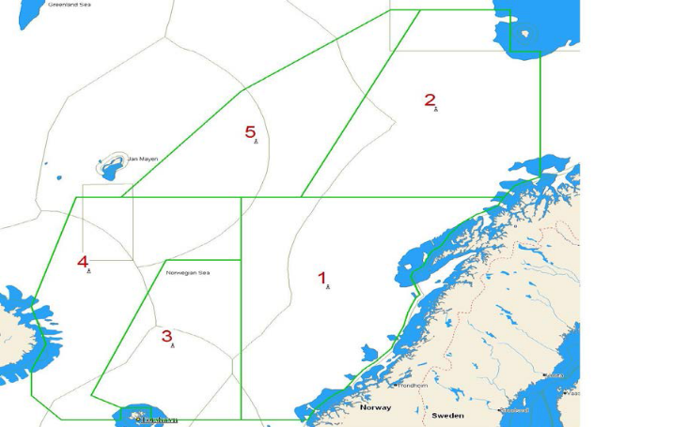
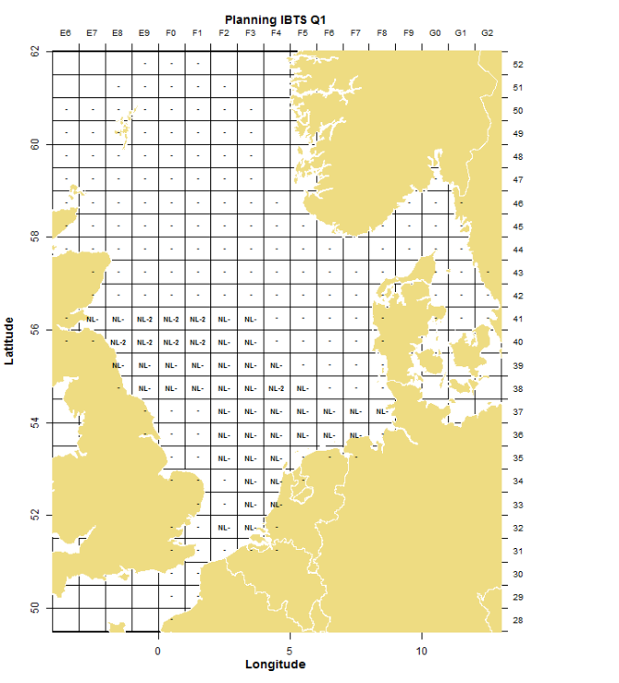
Figure 5. Planning ASH, RV Dana (DNK).
Figure 1. Planning NS-IBTS Netherlands Q1 2019; NL-=1GOV, 2MIK; NL-2=2GOV, 4 MIK hauls in rectangle

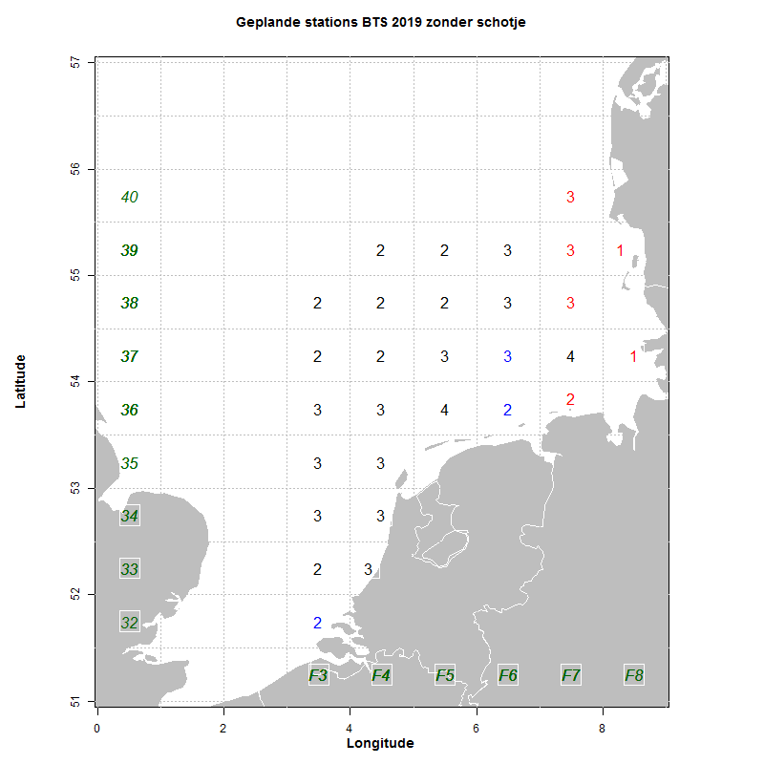
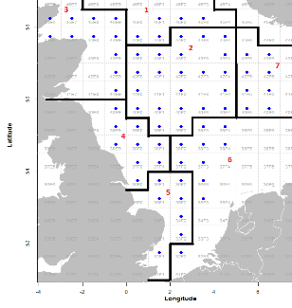
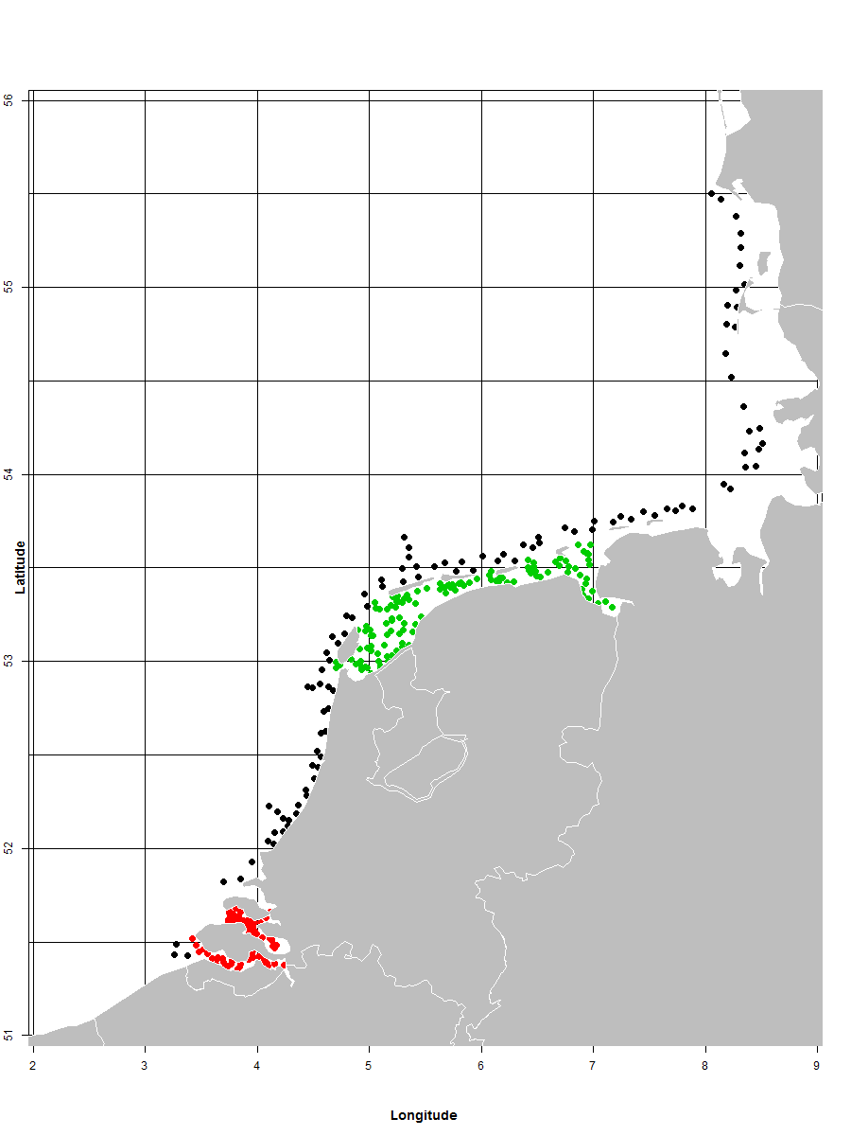
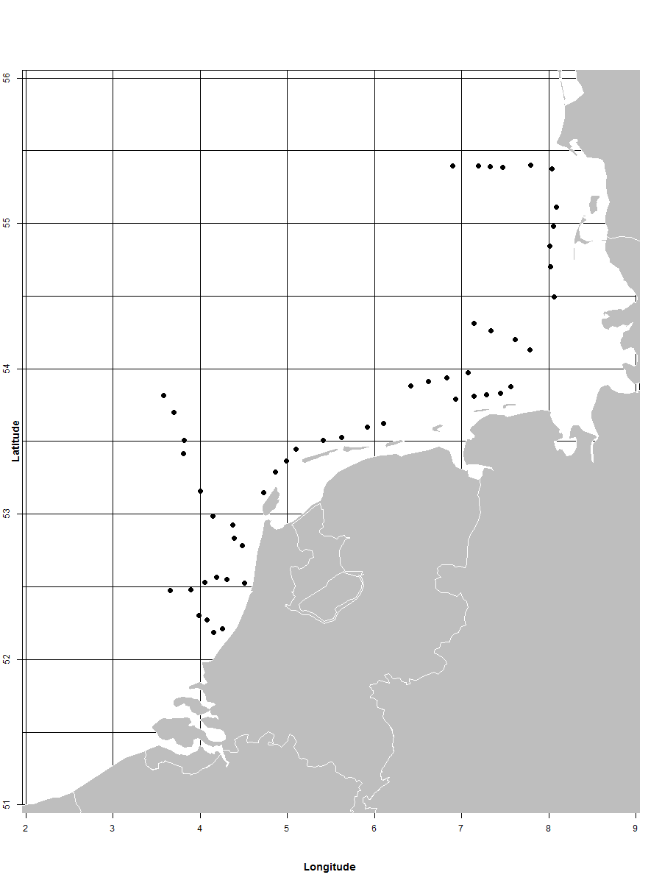
Figure 2a. Planning BTS Netherlands, RV Tridens in the southeastern North Sea. Numbers represent the number of hauls, Red numbers: tows of 15 minutes; blue: locations to be alert on extremely large catches.
Figure 2b. Planning BTS Netherlands, RV Tridens, central and western North Sea. Blue dots represent one haul, red numbers define areas for biological data collection (within the bold lines).
represent areas for biological data collection.

Figure 3. Planning DYFS Netherlands, RV Isis (black), RV Luctor (red), RV Stern (green).
Figure 4. Planning SNS Netherlands, RV Isis (black).

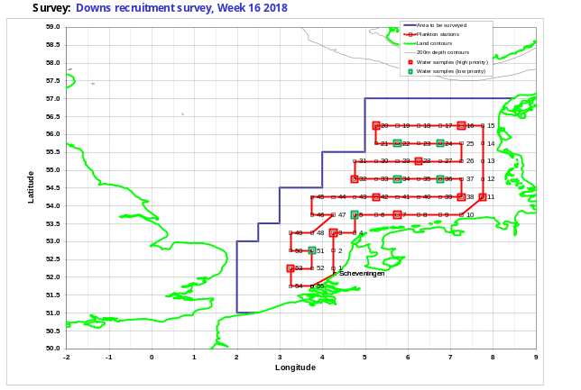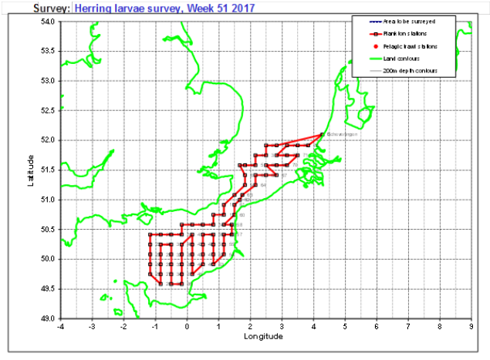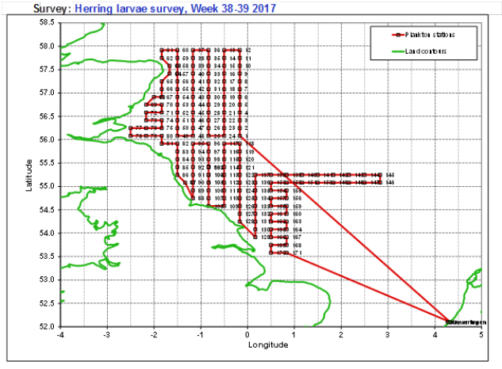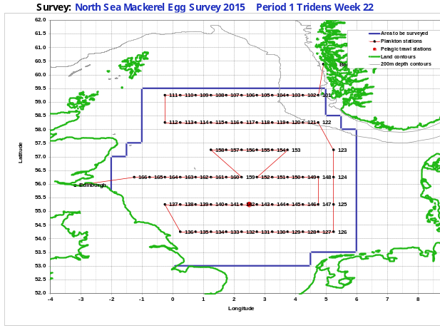
Figure 7c. Planning IHLS December, RV Tridens (NLD).
Figure 7b. Planning IHLS September, RV Tridens (NLD).
Figure 7a. Planning IHLS April (DRS), RV Tridens (NLD)
Figure 6. Global planning NSMEGS, RV Tridens (NLD).
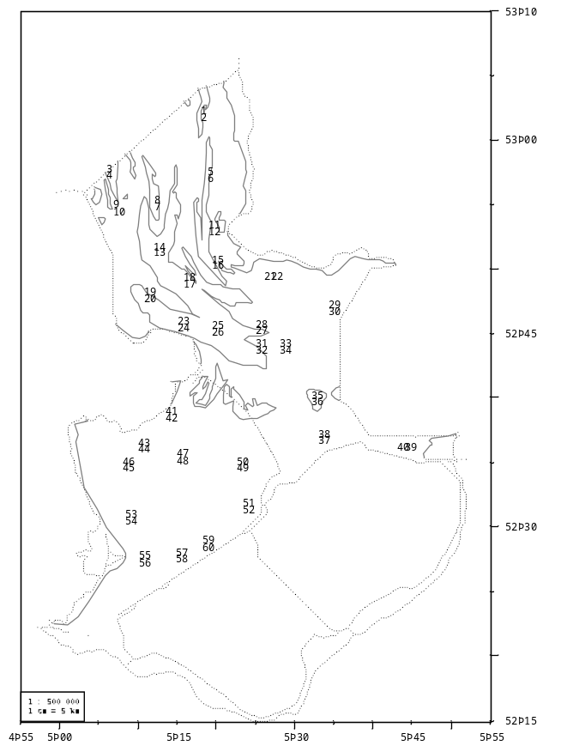
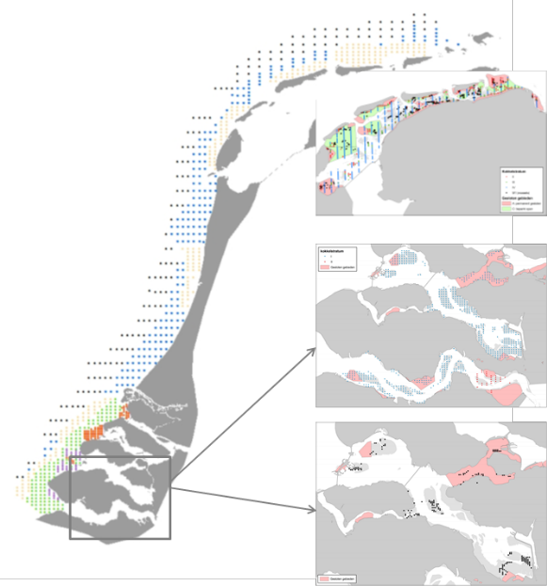
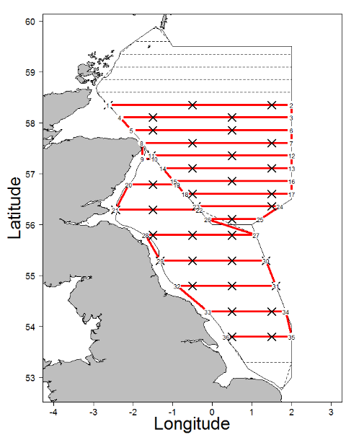
Figure 11. Planning survey on lakes IJsselmeer and Markermeer, RV Stern (NLD). Numbers indicate the station number.

Figure 9. Planning Dutch shellfish survey.

Figure 8. Planning NHAS, RV Tridens (NLD). Red line representing acoustic transects, black crosses indicating hydrography stations.

Region: North Atlantic
Survey: Blue whiting survey (IBWSS)
The IBWSS is carried out annually in March/April in the North Sea. The Netherlands participates with RV Tridens (approx. 18 days). The survey is listed in 2016/1251 Table 10. The continuity of the previous survey design is guaranteed by participation in the coordinating survey group (WGIPS).
Objectives of the survey
The survey aims to determine the distribution and abundance at age and length of the Northeast Atlantic blue whiting stock during the spawning season to the west of Britain and Ireland (Figure 10).
Description of the methods used in the survey
During the survey transect-wise acoustic echosounder measurements are done. In addition, trawl hauls are made to identify the species composition of the acoustic recordings. Hydrographical data are collected on regular intervals. The complete sampling procedure is defined in the ICES Manual for International Pelagic Surveys (IPS) chapter 2.1.1.
The area to be covered is presented in Figure 10. The acoustic transects are presented by lines, blue spots indicate hydrography stations.
Coordination and participation
The survey is coordinated by the ICES Working Group on International Pelagic Surveys (WGIPS) and performed in collaboration with research vessels from Ireland, Faroe Islands, Russia, and Norway.

The disaggregated survey data (hydrographic, biological, & acoustic) are stored in the ICES acoustic database (https://ices.dk/marine-data/data-portals/Pages/acoustic.aspx)
The blue whiting spawning stock estimate is used as a tuning index by ICES WGWIDE to determine the size of the population.
International task sharing (physical and/or financial) and the cost sharing agreement used
Task sharing applies. The IBWSS is carried out by two EU MSs, and three non EU MSs, each contributing with its own vessel. Furthermore, scientists from Denmark, Germany and UK participate in the survey on board of the Dutch vessel.
Cost sharing applies: the operational costs of the vessels are shared by EU MSs applying an allocation key proportional to national share of the EU TAC.
Explain where thresholds apply
Not applicable

Survey: International Mackerel and Horse Mackerel Egg Survey (MEGS; Triennial –NO SURVEY IN WP PERIOD)
The MEGS is carried out triennially from January until July (first survey planned in 2022). The Netherlands participates with RV Tridens (approx. 30 days). The survey is listed in 2016/1251 Table 10. The continuity of the previous survey design is guaranteed by participation in the coordinating survey group (WGMEGS).
Objectives of the survey
The aim of the survey is to provide abundance estimates of the western and southern component of Atlantic mackerel and horse mackerel by measuring the egg abundance. In combination with measurements of fecundity and atresia, which will be collected in the same year, the egg abundance can be converted into estimates of the spawning stock.
Description of the methods used in the survey
The main sampling type are plankton hauls using a Gulf VII plankton sampler, following a fixed station design. The survey is split up into 6or 7 periods, and in each period the spawning area is fully covered. In addition to the plankton hauls, fish hauls (with a pelagic trawl) are carried out for the collection of adult mackerel and horse mackerel biological parameters. Also hydrographical data are collected with a Seabird CTD attached to the plankton sampler. The complete sampling procedure is defined in the SISP Manual for the mackerel and horse mackerel egg surveys (MEGS): sampling at sea (version 2.2 2019). The methodology for atresia and fecundity estimates is defined in the SISP Manual for the mackerel and horse mackerel egg surveys (MEGS): SISP 5 - WGMEGS V12 Manual for AEPM and DEPM fecundity.
The survey area is presented in Figure 11. ICES Working Group on Mackerel and Horse Mackerel Egg Surveys (WGMEGS) decides on the detailed planning in the meeting the year prior to the survey (for 2019 survey: 2018 WGMEGS meeting).
Coordination and participation
The survey is coordinated by ICES WGMEGS (WGMEGS). Germany, Ireland, Netherlands, UK, Portugal, Spain, Iceland and the Faroe Islands participate in the survey.
The survey data is stored in the ICES eggs and larvae database. Fecundity and atresia data are currently stored at IMR, Norway for mackerel and WMR for horse mackerel. An ICES database for fecundity and atresia data is currently being developed.
The survey index, fecundity estimate and adult biological data is being used by ICES WGWIDE.
International task sharing (physical and/or financial) and the cost sharing agreement used
Task sharing applies. The MEGS is carried out by six EU MSs and two non EU countries, each contributing with its own vessel. Fecundity and atresia samples are divided among the four analysing EU countries (Ireland, Netherlands, UK, Spain) and Norway.
No cost sharing applies.
Explain where thresholds apply
Not applicable

Survey maps North Atlantic
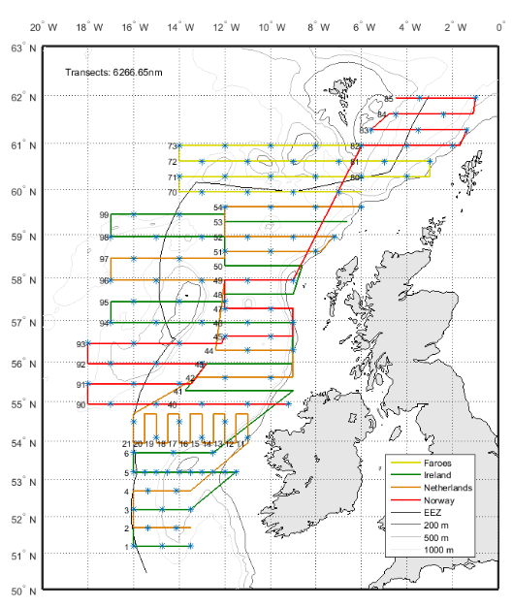
Figure 10. Planning IBWSS, RV Tridens (NLD) transects indicated by orange line.

Section 2: Fishing Activity Data

2A Fishing activity variables data collection strategy

Region: Baltic Sea; North Sea; Eastern Arctic; NAFO; Extended North-Western waters (Ices areas V, VI and VII) and Southern Western waters
General comment: This Box fulfils paragraph 4 of Chapter III of the Delegated Decision on the multi-annual Union programme. It is intended to describe the method used to derive estimates on representative samples where data are not to be recorded under Regulation (EU) No 1224/2009 or where data collected under Regulation (EU) No 1224/2009 are not at the right aggregation level for the intended scientific use.
Description of methodologies used to cross-validate the different sources of data.
Price data is collected from sales notes and cross-validated with data from accounts from the collection scheme on Economic data cutters.
Description of methodologies used to estimate the value of landings.
Information on fish prices is available from sales notes (from auctions) for most segments, except for some shellfish species (for dredgers) and for the species caught by the large pelagic trawlers. For the pelagic trawlers the prices are obtained from the accounts of the trawler companies during the collection scheme on Economic data pelagic trawlers. For the dredgers price information is obtained by questionnaires within the frame of the collection scheme on Economic data small coastal fisheries.
Description of methodologies used to estimate the average price (it is recommended to use weighted averages, trip by trip)
Average prices are calculated by weighted averages on trip level.
Description of methodologies used to plan collection of the complementary data (sample plan methodology, type of data collected, frequency of collection etc.)
For the shellfish caught by dredgers and for the pelagic trawlers complementary price data will be gathered based on the accounts (pelagic trawlers) and questionnaire data (dredgers). Data will be collected in combination with the other economic information as described in box 3A.

Region: Other regions
General comment: This Box fulfils paragraph 4 of Chapter III of the Delegated Decision on the multi-annual Union programme. It is intended to describe the method used to derive estimates on representative samples where data are not to be recorded under Regulation (EU) No 1224/2009 or where data collected under Regulation (EU) No 1224/2009 are not at the right aggregation level for the intended scientific use.
Description of methodologies used to cross-validate the different sources of data.
A small number of large pelagic vessel spends (part of) its time outside in other regions. Details on the data collection in the description of the data collection for the supra region Baltic Sea; North Sea; Eastern Arctic; NAFO; Extended North-Western waters (Ices areas V, VI and VII) and Southern Western waters.
Description of methodologies used to estimate the value of landings.
Information on fish prices is available from sales notes (from auctions) for the species caught by the large pelagic trawlers. For the pelagic trawlers the prices are obtained from the accounts of the trawler companies during the collection scheme on Economic data pelagic trawlers.
Description of methodologies used to estimate the average price (it is recommended to use weighted averages, trip by trip)
Average prices are calculated by weighted averages on trip level.
Description of methodologies used to plan collection of the complementary data (sample plan methodology, type of data collected, frequency of collection etc.)
For the pelagic trawlers complementary price data will be gathered based on the accounts . Data will be collected in combination with the other economic information as described in box 3A.

Section 3: Economic and Social Data

3A Population segments for collection of economic and social data for fisheries

Region: Baltic Sea; North Sea; Eastern Arctic; NAFO; Extended North- Western waters (Ices areas V, VI and VII) and Southern Western waters
General comment: This Box fulfils paragraph 5 points (a) and (b) of Chapter III of the Delegated Decision on the multi-annual Union programme. It is intended to specify data to be collected under Tables 5(A) and 6 of the Delegated Decision on the multi-annual Union programme.
Description of methodologies used to choose the different sources of data
The Dutch fishing fleet encompasses a large variety of vessels and fishing techniques. In the economic data collection, three groups of vessels are distinguished:
- Pelagic trawlers targetting small pelagics for human consumption (approx. 30% of the total value of the Dutch fleet).
- Active cutters using demersal active gears on a commercial basis add more than 95% of the remaining commercial catches.
- Vessels in the small coastal fisheries are either vessels that participate occasionally or never in the sea fishery or vessels that use passive gears or dredges.
In order to distinguish between the active cutters and the small coastal fisheries the main gear and lower threshold of 50,000 Euro on gross revenue is used for the active cutter fleet. Ultimo 2015 the Dutch fleet encompassed 8 pelagic trawlers, 279 cutters and 241 vessels classified in the small coastal fisheries. Ultimo 2018 the Dutch fleet consists of 8 pelagic trawlers, 289 cutters and 225 vessels classified in the small coastal fisheries (ultimo 2018, www.visserijincijfers.nl).
The data sources used for the collection of economic data for the groups vary:
- Economic data for the pelagic trawlers and the active cutters is obtained from company accounts and balance sheets through the LEI survey. Accounts are copied each quarter on a vessel level and all detailed transactions are stored in a database. In addition the balance sheets of the fishing firm are copied.
- Economic data for the small coastal fisheries is collected by means of questionaires (both telephone and paper).
Landings are obtained from both official logbooks, accounts and questionnaires.
Value of landings (sales notes, accounts and questionnaires): detailed sales notes are available for all Dutch auctions, but do not provide a complete picture of fish sales as some fish (e.g. shrimp and fish caught by the large pelagic trawlers) are sold directly. Therefore, value of landings information is also obtained from accounts and questionnaires. During aggregation procedures data from logbooks, accounts and questionnaires is combined to deliver most accurate estimates.
Effort (logbooks and questionnaires): for some small-scale fisheries reported effort in the questionnaires has been higher than in the logbooks. For some vessels that were assumed to be non-active the logbooks stated that they were going to sea for some (limited) time. Because of this, all vessel owners are contacted (either by telephone, mail or e-mail), including the owners of those vessels that have no recorded fishing time in the logbook and data are combined.
Data on investments and financial position of the cutter sector are gathered from financial accounts, and have a time lag of one year. Therefore, these data only becomes available two years after the reference year.
Description of methodologies used to choose the different types of data collection
The data from the active cutters is collected through the LEI panel. This panel has an annual turnover of approx. 4% and is assumed to be a probability sample survey. Economic data from the pelagic trawlers is collected by census, because of the small number of companies involved. The data collection from the small coastal vessels is also done by census because of the low response rate. In recent years this response rate has been increased by using a combination of a telephone questionnaire and a paper questionnaire.
Description of methodologies used to choose sampling frame and allocation scheme
The sampling frame of the economic data covers the complete Dutch marine fishing fleet as registered in the EU vessel register. Inland and aquaculture fishing vessels are excluded from data collection. All pelagic trawlers and small coastal vessels are covered by the economic surveys. The allocation of sampling in the active cutter sector is based on an annual assessment of the representativeness and resulting data quality of the panel data. Further information is available from the Methodological report that will be published early 2020.
Description of methodologies used for estimation procedures
For the pelagic trawlers no estimation of economic results is needed as all information is available.
Costs and earnings from the active cutters are estimated through regression analysis of detailed costs and earnings information from the cutters in the pannel and information on thechnical characteristics, effort and landings from all vessels in the population from the logbooks and the vessel register.
Capital value and depreciation are calculated based on digressive depreciation in accordance with the method followed in the templates published on the DCF website.
Sales note information covers more than 80% of the total value of landings of the demersal species. The missing information (mainly from the pelagic sector and shrimp landings) is estimated using regression models including information from logbooks and accounts.
Economic information from the small-scale fleet is estimated using the questionnaire data and the total number of vessels in each EU fishing fleet. As many of the EU segments consist of less than 10 fishing vessels, these segments are clustered. The clustering procedures are based on technical data and catch composition and follow the procedure described in SCEGA 09-02. Further information is available from the Methodological report that will be published early 2020.
Description of methodologies used on data quality
Wageningen Economic Research (formerly LEI) is ISO9001 Certified. Methods for data collection have mostly been described in detail in internal manuals. General discriptions of the followed procedures will be made publicly available in the coming years.
Information on landings, landings value and effort are obtained from different sources (questionnaires, logbooks and accounts) and are cross-checked. Inconsistencies in data mainly consists for the small coastal fisheries. There, information on landings and effort from questionnaires are used whenever data are not consistent. Furthermore, the fleet segmentation might be adjusted based on the outcome of the questionnaires. Further information on quality aspects is available from the Methodological Report that will be published early 2020.

Region: Other regions
General comment: This Box fulfils paragraph 5 points (a) and (b) of Chapter III of the Delegated Decision on the multi-annual Union programme. It is intended to specify data to be collected under Tables 5(A) and 6 of the Delegated Decision on the multi-annual Union programme.
Description of methodologies used to choose the different sources of data
A small number of large pelagic vessel spends (part of) its time outside EU waters in other regions such as CECAF and SPRFMO area. Complete economic information is collected from all vessels in this segment. Details on the data collection for this segment are given in the description of the data collection for the supra region Baltic Sea; North Sea; Eastern Arctic; NAFO; Extended North- Western waters (Ices areas V, VI and VII) and Southern Western waters.
Description of methodologies used to choose the different types of data collection
See description of the data collection for the supra region of Baltic Sea; North Sea; Eastern Arctic; NAFO; Extended North- Western waters (Ices areas V, VI and VII) and Southern Western waters.
Description of methodologies used to choose sampling frame and allocation scheme
See description of the data collection for the supra region of Baltic Sea; North Sea; Eastern Arctic; NAFO; Extended North- Western waters (Ices areas V, VI and VII) and Southern Western waters.
Description of methodologies used for estimation procedures
See description of the data collection for the supra region of Baltic Sea; North Sea; Eastern Arctic; NAFO; Extended North- Western waters (Ices areas V, VI and VII) and Southern Western waters.
Description of methodologies used on data quality
See description of the data collection for the supra region of Baltic Sea; North Sea; Eastern Arctic; NAFO; Extended North- Western waters (Ices areas V, VI and VII) and Southern Western waters.
General comment: This Box fulfils paragraph 5 points (a) and (b) of Chapter III of the multi-annual Union programme and Article 2, Article 4 paragraphs (1), (2) and (5) and Article 5 paragraph (2) of this Decision. It is intended to specify data to be collected under Tables 5(A) and 6 of the multi-annual Union programme.

Section 3: Economic and Social Data

Pilot Study 3: Data on employment by education level and nationality
General comment: This Box fulfils paragraph 5 point (b) and paragraph 6 point (b) of Chapter III of the Delegated Decision on the multi-annual Union programme. It is intended to specify data to be collected under Table 6 of the Delegated Decision on the multi-annual Union programme.
Aim of pilot study
The pilot study will be split up in two parts, aiming to provide more detailed information on the employment by (1) education level and (2) nationality in the fishing sector and the aquaculture sector, in addition to the information gathered on age and gender.
Duration of pilot study
No activities will take place in 2020. In 2021 the data on employment by education level and nationality of all segments in the fisheries and aquaculture will be collected in the census survey in which all other social data will be collected as well.
Methodology and expected outcomes of pilot study
The census survey will be carried out by means of a combined paper and digital questionnaire to all owners of fishing and aquaculture vessels, asking for the education level and nationality of the crew members. The resulting information will be analysed for statistical patterns based on fleet characteristics and regional patterns in order to facilitate optimal estimation of sector totals.

Section 3: Economic and Social Data

3B Population segments for collection of economic and social data for aquaculture

The Dutch target population covers part of the enterprises under NACE Code 05.02: Fish farming. The Netherlands does not collect economic data from freshwater aquaculture and land-based aquaculture of marine finfish species. Data collection on freshwater aquaculture is voluntary and land-based aquaculture of finfish species (turbot and sole) falls below the 10% threshold (total 0.7% weight and 2.4% value over the period 2008-2014). The remaining two sub sectors are the mussel and oyster culture.

General comment: This Table fulfils paragraph 6 points (a) and (b) of Chapter III of the Delegated Decision on the multi-annual Union programme and Chapter II of the Implementing Decision on the multi-annual Union programme. This Table is intended to specify data to be collected under Tables 6 and 7 of the Delegated Decision on the multi-annual Union programme. Use this Table to give an overview of the collection of economic and social data of the aquaculture sector.
Description of methodologies used to choose the different sources of data
Economic data for the mussel and oyster sector are available from nationals auctions, national statistics and the company accounts. Total volume of landings and value of landings for the mussel sector is obtained from the mussel auction, covering 100% of the mussel landings. For the oyster sector no such landings statistics are available, so all data is gathered from the oyster farmers directly. Economic data of both sub-sectors are gathered from annual financial accounts. Because these reports become available only 16 months after the reference year, data collection is delayed by one year, therefore data is available two years after the reference year. Further information is available from the Methodological report that will be published early 2020.
Description of methodologies used to choose the different types of data collection
Production data from the oyster sector is gathered by means of a telephone questionnaire involving all oyster companies (census). Data on costs and earnings and employment is gathered from a panel of companies that provide accounts on a voluntary basis. This panel is assumed to be a representative sample. Annual turnover rate of the sample is low (< 10%), but because of earlier experiences of low response rates in random sampling, this is thought to be the most suitable type of data collection. Further information is available from the Methodological report that will be published early 2020.
Description of methodologies used to choose sampling frame and allocation scheme
Data from these sectors are obtained by means of a panel covering between 16 and 22% of the total number of companies.
Description of methodologies used for estimation procedures
As there is no stratification within the segments, the averages of the obtained panel data will be assumed to be good estimates for the population averages. The total values of the economic variables will be estimated through different aggregation procedures for each of these sectors:
- Mussel segment: total value of the production for the segment is available, all variable cost items and earning items (turnover, subsidies, other income, wages and salaries, energy costs, livestock costs, repair and maintenance, other operational costs) will be aggregated based on this. Fixed cost items (depreciation of capital, financial costs, extraordinary costs) as well as other economic indicators (total value of assets, net investments, debt, number of persons employed, FTE) will be aggregated according the number of enterprises.
- Oyster segment: In principle all variables will be aggregated based on the number of companies. In case total production figures are available, these will be used to correct the estimated production and the costs from the panel data. Herewith, it will be assumed that the cost structure to produce one kg of oysters is constant.
Because the data on costs and earnings are only available two years after the reference year, the econmic data of the last year is estimated using the cost structure of the reference year and the total production volume of the following year. E.g. on 01-01-2020 economic data will be available for 2017 and the economic performance for 2018 will be estimated based on the production volume for 2018. Further information is available from the Methodological report that will be published early 2020.
Description of methodologies used on data quality
Wageningen Economic Research (formerly LEI) is ISO9001 Certified. Methods for data collection have mostly been described in detail in internal manuals. General discriptions of the followed procedures will be made publicly available in the coming years.
The procedures to estimate totals have been described above. The evaluation of bias will be based on the total production and production value of the sector and companies in the panel. Whenever possible, data will be collected on the total production and total value of sectors to evaluate whether the panel data are biased and to correct for this bias. For the mussel sector, such data are available by means of total production value and volume, and for the oyster sector data on the number of oysters produced will also be used for this purpose. Further information on the quality assurance available from the Methodological report that will be published early 2020.

Section 3: Economic and Social Data

Pilot Study 4: Environmental data on aquaculture
General comment: This Box fulfils paragraph 6 point (c) of Chapter III of the Delegated Decision on the multi-annual Union programme. It is intended to specify data to be collected under Table 8 of the Delegated Decision on the multi-annual Union programme.
Aim of pilot study
The Netherlands will collect aquaculture data for shellfish bottom culture only. As drugs are not used in this type of aquaculture and information about mortality is not known, no pilot study on environmental data on aquaculture planned yet.
Duration of pilot study
Not (yet) applicable
Methodology and expected outcomes of pilot study
Not (yet) applicable

Section 3: Economic and Social Data

3C Population segments for collection of economic and social data for the processing industry
General comment: This Box fulfils paragraph 1.1(d) of Chapter III and Table 10 of the Delegated Decision on the multi-annual Union programme. It is intended to specify data to be collected under Table 10 of the Delegated Decision on the multi-annual Union programme.
Description of methodologies used to choose the different sources of data
Data collection from the processing sector is voluntary. No data collections is carried out by the Netherlands.
Description of methodologies used to choose the different types of data collection
Not applicable
Description of methodologies used to choose sampling frame and allocation scheme
Not applicable
Description of methodologies used for estimation procedures
Not applicable
Description of methodologies used on data quality
Not applicable

Section 4: Sampling Strategy for Biological Data from Commercial Fisheries

4A Sampling plan description for biological data

Region: North Sea
General Comment: This Box forms the basis for the fulfilment of paragraph 2 point (a)(i) of Chapter III of the Delegated Decision on the multi-annual Union programme. This Table refers to data to be collected under Tables 1(A), 1(B) and 1(C) of the Delegated Decision on the multi-annual Union programme.
At-sea sampling
The on-board sampling plan for commercial fisheries in the North Sea and Eastern Artic areas is a random sampling scheme from, in principle, four predefined sampling populations: passive demersal gears (DEMPAS), shrimpers (SHRIMP), active demersal gears (DEMACT) and pelagic gears (PEL1, see section 4A North-Western waters). The sampling populations are defined through vessel lists made available through the VISSTAT data base (national catch and effort registration database). Given the low sampling coverage of SHRIMP, 0.1% or less, of total days at sea and the large variation between the sampled hauls, collected data in 2017-2018 cannot be raised to fleet level. As a significant increase in the sampling coverage will result in disproportionate costs in comparison to the experienced use by end-users (e.g. not used in assessments) in 2017-2018, the on-board sampling of shrimpers is excluded from the sampling survey from 2019 onwards.

The sampling plan for passive demersal gears is working towards a random vessel*trip section scheme, with a sampling intensity of 2 to 3 trips per quarter. Ideally, a vessel is selected randomly from the sampling population, i.e. the complete list of vessels operating passive gear (in case of DEMPAS). After the selection, contact is established and the request to observe the first following fishing event (trip) is put forward. To be able to evaluate and estimated possible sampling bias, responses or non-response are recorded accordingly. In practice, random selection may be hampered due to the highly variability of fishing activity throughout the year and the seasonal and weather dependent character of the fisheries.
During the fishing event all catch components, landings, discards and landed fish below biological minimum reference size (BMS) are sampled. Information on fishing activity, catch composition, catch volumes and individual lengths are measured an recorded by an observer from Wageningen Marine Research.

The sampling plan on active demersal gears is based on a reference fleet scheme. A representative selection of 20-25 vessels from the sampling population, all vessels operating active demersal gear, collects discard samples (self-sampling) following a pre-defined annual sampling schedule. This schedule is produced at the beginning of the year through a random selection of 160 vessel*week combinations. According to this schedule a selected vessel takes a representative discard sample, including BMS, for two hauls, during the selected week. The collected samples are landed by the vessel at port where they are collected by Wageningen Marine Research and returned back to the laboratory for analysis. During the selected week fishermen record information on the volume of the catches and composition of the landings for every haul.
The vessel crew conducts this self-sampling of the catches, after a training by Wageningen Marine Research. To check for sampling bias, the self-sampling programme is validated by a separate discard programme by observers at sea. This programme is limited to 10 trips per year on board vessels of the reference fleet.
No length measurements of landings are collected during the self-sampling trips as this fraction is sufficiently covered by the on-shore sampling programme (AUCTION, see below).
On-shore sampling demersal fisheries
The on-shore sampling plan (AUCTION-DEM) for demersal fisheries is based on auction sampling of landings from random fishing trips. All landing locations are split into 2 categories based on previous experiences, main locations (in practice auctions) covering over 80% of the total national demersal landings are identified, while the remaining locations cover less than 20%. These remaining locations are very scattered over the country and very diverse, mainly ports without auction (landed fish goes to auctions by lorry or sold virtually and transported directly to buyers), sometimes shipyards or others sites, only very few landings occur. Auction samples are randomized over the first group of auctions. The latter group is not sampled. The sampling strategy is working towards a random auction*trip selection. In principle, a cold storage (containing all landings from a vessel’s trip) is selected, based on a randomized numbered list, for sampling of biological variables of selected species (secondary unit). As the time window is very narrow, in general only one or two species can be sampled before the fish is auctioned. In case of non-response, i.e. not allowed to sample the fish, this refusal will be recorded. Length measurements usually take place at the auction, while sampling for other variables takes place at the laboratory on purchased samples, also selected as described above.

The species selection is based on the species list specified in Table 1A of EU-MAP. Table 1A of the Dutch Work Plan lists all the species selected for sampling, based on the selection criteria as specified in EU-MAP.
On-shore sampling of shrimp fisheries
The on-shore sampling plan (AUCTION-SHRIMP) for shrimp (Crangon) fisheries is relative similar to the sampling plan for demersal fisheries. Main auctions (often dedicated to shrimp landings) covering over 80% of the landings are identified and sampled. Batches (representing a landing from a vessel) are selected randomly during the sorting process at the auction. Non-responses, if any, are registered.
Pelagic fisheries
The sampling plans for pelagic fisheries are described in section 4A North Atlantic as North Sea and North Atlantic pelagic fisheries are covered under the same sampling plans.
Data quality check
All data is stored in a national database after standardised quality checking.
Wageningen Marine Research is ISO9001:2015 Certified. Methods for data collection have mostly been described in detail in internal manuals.
Execution of programme
Given the well-established experience and the, in general, good cooperation, with the fishermen, no problems are to be expected in the execution of this programme.

Region: North-Western waters
General Comment: This Box forms the basis for the fulfilment of paragraph 2 point (a)(i) of Chapter III of the Delegated Decision on the multi-annual Union programme. This Table refers to data to be collected under Tables 1(A), 1(B) and 1(C) of the Delegated Decision on the multi-annual Union programme.
At-sea sampling (PEL1)
The sampling plan for pelagic trawlers (PEL1) is a random vessel*trip section scheme, with a sampling intensity of 1 trip per month. After the selection, contact is established with the fleet manager of the ship owners and the request to observe the first following fishing event (trip) is put forward. To be able to evaluate and estimated possible sampling bias, responses or non-response are recorded accordingly. During the fishing event all catch components, landings, discards and landed below biological minimum reference size (BMS) are sampled. Information on fishing activity, catch composition, catch volumes and individual lengths are measured an recorded by an observer from Wageningen Marine Research.
Pelagic fisheries self-sampling (PEL2)
The pelagic self-sampling scheme is based on a census approach (all trips) for a selected number of vessels. The pool of pelagic vessels simultaneously operating in European waters is very small (<10) and a few vessels known (expected) to remain in European waters throughout a year and known to be capable of taking good quality samples are selected for sampling. These vessels deliver samples, based on instructions by the responsible institute, for each species*week*area combination during the year for each trip. Samples are taken after species selection at the vessel, but prior to size sorting, thus ensuring to span the full length range of the catch. Since the fisheries are highly seasonal in general, all vessels are usually engaged in similar fisheries and the selected vessels are expected to be representative for the entire fleet engaged in the fishery at that same time. Based on previous sampling and analysis experiences, the spatial and temporal coverage of the sampling is sufficient and of sufficient quality.
Data quality check
All data is stored in a national database after standardised quality checking.
Wageningen Marine Research is ISO9001:2015 Certified. Methods for data collection have mostly been described in detail in internal manuals.
Execution of programme
Having a few vessels available has so far not led to data deficiencies, however, given current movements towards more remote areas to fish, as well as constant trading of and changes to vessels and fishing plans, it might become problematic to have continuous sources delivering samples. The good cooperation with the vessel operators is expected to circumvent major problems, so no insurmountable problems are expected to arise.

Region: Other regions
General Comment: This Box forms the basis for the fulfilment of paragraph 2 point (a)(i) of Chapter III of the Delegated Decision on the multi-annual Union programme. This Table refers to data to be collected under Tables 1(A), 1(B) and 1(C) of the Delegated Decision on the multi-annual Union programme.
The Dutch fisheries in ‘Other regions’ is limited to the area of competence of CECAF and SPRFMO. For both areas, multilateral agreements are established with other MS operating similar fisheries in the areas. The Dutch fisheries involved are fisheries for small pelagic species only, conducted by a limited number of pelagic freezer trawlers. Vessels are selected based on the availability to host observers as this is a limiting factor to be accepted on board. This limitation stems from regional agreements in CECAF area and practical (remote and outside easy reach from the shore) aspects in SPRFMO area.
CECAF
Based on a multi-lateral agreement for 2020 between The Netherlands, Germany, Poland, Latvia and Lithuania, Poland is responsible for sampling pelagic fisheries for these MS involved in CECAF area. The Netherlands supports Poland with organisational aspects where needed. All data is quality checked and stored in a national database by Poland. All data will be delivered to the relevant working group. Sampling methodology and data storage is further described in the Polish WP.

For 2021, a renewed agreement needs to be settled. It is expected that this will be done at the 2020 RCG LDF.
SPRFMO
Based on a multi-lateral agreement for 2020 between The Netherlands, Germany, Poland and Lithuania, Poland is responsible for sampling pelagic fisheries for these MS involved in SPRFMO area. The Netherlands supports Poland with organisational aspects where needed. The sampling protocol is based on requirements as laid down by SPRFMO Scientific Committee and strives to cover the entire fishing season accordingly.

For 2021, a renewed agreement needs to be settled. It is anticipated that this will be done at the 2020 RCG LDF.

All data is quality checked and stored in a national database by Poland. All data will be delivered to the relevant working group.

