National Programme 2011-2013 – THE NETHERLANDS

(the drawing-up of the programme of the Data Collection Framework)

by

Ministry of Economic Affairs, Agriculture and Innovation Netherlands (Directorate of Agriculture, Fisheries, and Agribusiness.)
IMARES (Institute for Marine Resources & Ecosystem Studies)
LEI (Institute of Agricultural Economics)
Version information
Version 3b is the original version of the NP and was submitted at 31 March 2010. The tables and finforms matching to this NP have the same version codes.
A revised set of tables (version 3c) was produced after the 1st meeting of the RCM NA in Oostende. In this version only corrections were made in the names of the parameters.
Version 4 is the revised version of the NP submitted to SGRN including actions from the RCM NS&EA and RCM NA. Changes have been made to the text and tables. The major change is the introduction of sampling frames for the GNS and OTB in the area IV,VIId rather than the individual metiers applying this gear. Furthermore, the results of the bilateral agreements with DK and Fr are taken into account.
Version 5 is the revised version taking into account the comments made by the Commission in MARE-C3/ VV/HR/VD/Ares(2010). The major changes are the update of the budget forcast, the requested inclusion of information in sections IIIE1 North Sea and North Atlantic both for the biological as the economical part.
After approval by the Commission on December 7, 2010, version 5 was finalized as the Final Plan incl the FinForms.
On February 4, 2011 the Commision issued the final approval for the Dutch NP. On February 14, the final version of the NP (incl tables and finforms) was sent to the Commission. Compared to version 5, all changes in the text were accepted and, as requested, an annex (Annex 6) was added to include the overview of indicative costs of the programme. In addition to this, the additional information for the derogation request in section III.C.6 (North Atlantic) as provided to and accepted by the Commision was included. Also, spelling mistakes and formatting errors were corrected.
Version 6 is the agreed version for 2011. This version is same as version 5 with the track changes accepted
Version 7 is a draft version proposed with the modifications for 2012 made to the programme (back up 19-10)
Version 8 is a draft version proposed with the modifications for 2012 made to the programme (back up 20-10)
Version 9 is a draft version proposed with the modifications for 2012 made to the programme (back up 25-10)
Version 10 is the final version proposed with the modifications for 2012 made to the programme and submitted to the Commission on October 31, 2011.
Table of contents
I. General framework 6
II. Organisation of the National Programme 7
II.A. National organisation and coordination 7
II.B. International coordination and international scientific meetings 8
II.C. Regional coordination 9
III. Module of evaluation of the fishing sector 10
III.A. General description of the fishing sector 10
III.B. Economic variables (Supra region ICES and NAFO areas) 12
III.B.1 Data acquisition 12
III.B.2 Estimation 15
III.B.3 Data quality evaluation 16
III.B.4 Data presentation 16
III.B.5 Regional coordination 16
III.B.6 Derogations and non conformities 18
III.B. Economic variables (Other regions) 19
III.B.1 Data acquisition 19
III.B.2 Estimation 19
III.B.3 Data quality evaluation 19
III.B.4 Data presentation 19
III.B.5 Regional coordination 19
III.B.6 Derogations and non conformities 20
III.C. Biological - metier-related variables (North Sea) 21
III.C.1. Data acquisition 21
III.C.2. Estimation procedures 25
III.C.3. Data quality evaluation 26
III.C.4. Data presentation 27
III.C.5. Regional coordination 27
III.C.6. Derogations and non-conformities 28
III.C. Biological - metier-related variables (North Atlantic) 30
III.C.1. Data acquisition 30
III.C.2. Estimation procedures 32
III.C.3. Data quality evaluation 33
III.C.4. Data presentation 33
III.C.5. Regional coordination 33
III.C.6. Derogations and non-conformities 34
III.C. Biological - metier-related variables (Other regions) 36
III.C.1. Data acquisition 36
III.C.2. Estimation procedures 37
III.C.3. Data quality evaluation 37
III.C.4. Data presentation 37
III.C.5. Regional coordination 38
III.C.6. Derogations and non-conformities 39
III.D. Biological - Recreational fisheries (North Sea) 40
III.D.1. Data acquisition 40
III.D.2. Estimation procedures 41
III.D.3. Data quality evaluation 41
III.D.4. Data presentation 42
III.D.5. Regional coordination 42
III.D.6. Derogation and non conformities 42
III.E. Biological - stock-related variables (North Sea) 43
III.E.1. Data acquisition 43
III.E.2. Estimation procedures 44
III.E.3. Data quality evaluation 44
III.E.4. Data presentation 44
III.E.5. Regional coordination 44
III.E.6. Derogations and non-conformities 45
III.E. Biological - stock-related variables (North Atlantic) 46
III.E.1. Data acquisition 46
III.E.2. Estimation procedures 46
III.E.3. Data quality evaluation 47
III.E.4. Data presentation 47
III.E.5. Regional coordination 47
III.E.6. Derogations and non-conformities 47
III.E. Biological - stock-related variables (Other Regions) 48
III.E.1. Data acquisition 48
III.E.2. Estimation procedures 48
III.E.3. Data quality evaluation 48
III.E.4. Data presentation 48
III.E.5. Regional coordination 49
III.E.6. Derogations and non-conformities 49
III.F. Transversal variables 50
III.F.1. Capacity 50
III.F.2 Effort 50
III.F.3 Landings 52
III.G Research surveys at sea 53
III.G.1 Planned surveys 53
III.G.2. Modifications in the surveys 56
III.G.3. Data presentation 56
III.G.4. Regional coordination 57
III.G.5. Derogations and non conformities 57
IV Module of the evaluation of the economic situation of the aquaculture and processing industry 58
IV.A. Collection of economic data for the aquaculture 58
IV.A.1 General description of the aquaculture sector 58
IV.A.2 Data acquisition 59
IV.A.3 Estimation 59
IV.A.4 Data quality evaluation 60
IV.A.5 Data presentation 60
IV.A.6 Regional coordination 60
IV.A.7 Derogations and non-conformities 60
IV.B. Collection of data concerning the processing industry 61
IV.B.1 Data acquisition 61
IV.B.1 (a) Definition of variables 61
IV.B.1 (b) Type of data collection 61
IV.B.1 (c) Target and frame population 61
IV.B.1 (d) Data sources 61
IV.B.1 (e) Sampling stratification and allocation scheme 62
IV.B.2 Estimation 62
IV.B.3 Data quality evaluation 63
IV.B.4 Data presentation 63
IV.B.5 Regional coordination 63
IV.B.6 Derogations and non-conformities 63
V. Module of evaluation of the effects of the fishing sector on the marine ecosystem 64
VI. Module for management and use of the data 65
VI.A. Management of the data 65
VI.B. Use of the data 68
VII Follow-up of STECF recommendations 70
VIII List of derogations 73
IX. List of acronyms and abbreviations 74
X. Comments, suggestions and reflections 77
XI. References 79
XII Annexes 81
Annex 1 Set of survey maps 82
Annex 2 Agreements 91
Annex 3 Costs and Earnings items taken into account in the different parameters as set out in appendix VI of the DCF in the LEI survey of accounts of the cutter fleet. 101
Annex 4 Description of selected metiers 104
Annex 5 Vergoeding discards 131
Annex 6 Indicative costs 133
Annex 7 Biological Data Collection of pelagic fisheries in CECAF waters in compliance with the DCF 134

General framework
This document contains the proposal for the Dutch National Programme (NP) for the collection of biological and economic data from the national fisheries sector in for the years 2011-2013. The programme has been developed in accordance with the rules laid down in a number of EC Council and Commission Regulations and Decisions, hereafter referred to as the Data Collection Framework or DCF. The data are collected for the purpose of supporting the Common Fisheries Policy (CFP). Similar data are also collected by other EU Member States (MS). The DCF contains qualitative and quantitative criteria, on which and how much data has to be collected by the MS and the quality to be aimed at. The NP complies as much as possible with these criteria.
Furthermore, the EC has established provisions to facilitate the cooperation between MS with the regard to the collection of data. These are Regional Coordination Meetings (RCM), formal (bilateral) agreements with other MS and in the future regional databases. As far as relevant the conclusions and agreements of the meetings are included in the NP.
In addition to this report a budget the programme has been prepared following guidelines DCF. The planning of the costs is presented in separate spread sheets in formats as provided by the Commission.
The NP is structured in a number of modules. In the following chapters a report is given of the activities that will be carried out by the Netherlands related to the DCF. The format of this report is structured following the most recent instructions from the Commission.
The present proposal contains a provisional multi-annual work programme for the years 2009 and 2010 to be carried out by the Netherlands and differs substantial from the previous programmes following a revision of the legislation it is based on. The main changes, compared to previous years, are a related to a change in sampling strategy from stock based to fisheries based. Also, activities related to international coordination of the programme and the provision of advice through international bodies are now included. A number of activities will be co-ordinated by the Regional Coordination Meetings (RCM).
The NP for 2011 has been approved in February 2011. The present version is an updated programme with minor modifications to be implemented in 2012.

II. Organisation of the National Programme

II.A. National organisation and coordination
The work in the Netherlands will be carried out by three partners:
- The Dutch Directorate of Agriculture, Fisheries, and Agribusiness (EL&I-AKV). This is a section in the Ministry of Economic Affairs, Agriculture and Innovation and performs control at the commercial fisheries and recreational and game fisheries. This partner also acts as coordinator of the NP. Mr Kees Verbogt from this Directorate acts as National Correspondent;
- LEI (Institute of Agricultural Economics). This institute is a private research institution, part of the Wageningen University and Research Centre. The LEI is responsible for collection of agricultural and fisheries economics statistics in The Netherlands;
- IMARES (Institute for Marine Resources & Ecosystem Studies). This institute is established in 2006 and consists of the former Netherlands Institute for Fisheries Research (RIVO) and parts of Alterra Texel and TNO Ecological Risk Studies. The research focuses on a wide variety of issues including sustainable fisheries, marine ecosystems, development of Marine Protected Areas, environmental risk assessment and development of new forms of aquaculture. The institute is part of the Wageningen University and Research Centre and provides knowledge and expertise to the needs of policy makers, nature conservation agencies and the fishing industry.

Ministry of Economic Affairs, Agriculture and Innovation | Netherlands Institute for Agricultural Economics (LEI) | Institute for Marine Resources & Ecosystem Studies (IMARES)
Prins Clauslaan 8  Post-box 20401  2500 EK The Hague Netherlands  Phone: +31 70 3793911  Fax: + 31 70 3786153  web: www.minlnv.nl | Alexanderveld 5  Post-box 29703  2502 LS The Hague Netherlands  Phone: +31 70 3358330  Fax: +31 70 3615624  web: www.lei.nl | Haringkade 1  Post-box 68  1970 AB IJmuiden Netherlands  Phone: +31 317 480900  Fax: +31 317 487362  web: www.imares.nl
Contact: Kees Verbogt  Phone: + 31 646064914  E-mail: k.verbogt@minlnv.nl | Contact: Hans van Oostenbrugge  Phone: + 31 70 3358239  E-mail: hans.vanoostenbrugge@wur.nl | Contact: Sieto Verver  Phone: + 31 317 487045  E-mail: sieto.verver@wur.nl

The NP is supported by a national steering group responsible for national coordination of the programme. The steering group consists of the contact persons of the organisations participating in the NP or their substitutes and meets 1-3 times a year. Also additional experts can be invited. The main tasks of the steering group are to monitor progress of the implementation of the programme during the year, planning the national contribution to the RCMs, planning of the production of the NP and the Annual Report (AR) and implementing new recommendations from RCMs or STECF.

II.B. International coordination and international scientific meetings
International coordination of data collection and quality issues takes place at several levels. Coordination takes place on the contents of the NP between MS at a regional level in the Regional Coordination Meetings. Further, elements in the NP which also concern other MS, in particular related to sampling, will be dealt with by bilateral coordination with the other MS. All surveys are coordinated internationally by ICES planning groups.
The survey planning groups, which are relevant to the Netherlands are IBTSWG, WGIPS, WGMEGS, WGRFS and WGBEAM. These ICES working groups coordinate the surveys carried out in Dutch NP. These groups will meet annually and will be attended by the MS.
Further, the ICES Planning Group on Commercial Catches, Discards and Biological Sampling (PGCCDBS) remains responsible for coordination of the quality aspects of sampling of catches (landings and discards) and biological parameters. PGCCDBS meets annually and the meetings of this planning group will be attended. One of the activities of PGCCDBS is to initiate workshops dealing with standardisation of methods and quality of data sampling between different institutes. The workshops are eligible under the DCF and MS intents to participate in all workshops relevant to the NP.
Coordination of economic data collection takes place in RCMs.
According to Article 10(2) of Council Reg. 665/2008, the Commission shall provide the MS with a list of meetings which are eligible for Community financial support for the expert participation in the following year. The list will be made available by the Commission around mid December. Table II.B.1 provides a preliminary list of meetings that will likely be attended by national experts in 2012. The list includes international coordination meetings, workshops and meetings for scientific advice. At the end of each year, a final list of meetings will be provided updating intended participation in next year’s meetings

II.C. Regional coordination
The regional coordination and cooperation between MS within the same marine region have been developed during the former period of the DCR and is now fully integrated in the general framework (Article 5 of Reg. 199/2008). As part of this objective, RCMs are established to improve the overall quality of the data collected in support of the CFP, through task and cost sharing, data pooling and, in general, all bilateral, regional and pan-European initiatives that can help to increase the accuracy, effectiveness and cost efficiency of data collection.
The elements of regional coordination are given in the relevant NP Proposal sections. The Netherlands and other MS and actions initiated by RCM are to be included in updates of the present proposal,
The Netherlands will participate in the following Regional Coordination Meetings:
MS | Baltic Sea | North Sea &East Arctic | North Atlantic | Mediterranean & Black Sea | Long Distance Fisheries
Netherlands |  | X | X |  | X

The following RCM recommendations apply:
source | Recommendation | Responsive actions
Med&BS( 2009) | The RCM Med recommends the participation of the National Correspondents of the MS in the future RCMs,  for achieving better internal organisation.  For ensuring the link between the two forums, it is recommended that the chairman of the PGMed participates to the RCM Med.  The RCM Med encourages the participation of one economist from each MS to the future RCMs. | The National Correspondent or his representative will participate in the RCM meetings indicated in the table above.
NS&EA  Baltic, NA,  Med&BS ( 2009) | In the NP proposals, a short description of all metiers selected by the 90% ranking procedure should be provided. Such a table would enable RCM to identify whether a metier with the same name covers the same or different fisheries in different NPs.  Moreover, the RCM-NA recommends MS to investigate on the mesh size ranges actually used in their fisheries and describes more precisely the metiers operating with bottom trawls with the objectives of defining possible common metiers at the national level (level 7).  Moreover, the RCM-Med&BS recommends MS to investigate on the mesh size or gear sizes ranges actually used in their fisheries, especially for nets and hooks, and to provide information during the next PGMed meeting, for a possible agreement of size ranges at level 6. | MS has provided short description of the metiers in Annex 4, using the standard template.
Med&BS  (2009 | The RCM-NA recommends that all MS should follow strictly the naming conventions for reporting the sampling and statistics information. To that aim, MS are invited to investigate closely on the mesh size range actually used. The SGRN Guidelines for NP proposals should be revised in order to ensure unambiguous coding of the metiers and fishing grounds and to stress the importance to adhere to these rules. Careful attention to the naming of the metiers | The proposed naming convention has been applied in this NP
NS&EA (2009) | RCM NS&EA recommends MS to use the average landing figures over the years 2007-2008 as the basis for ranking metiers within the NP 2011-2013 | This recommendation was followed in this NP

III. Module of evaluation of the fishing sector

III.A. General description of the fishing sector
The Dutch fishing sector in marine waters can be split up in three major sectors: the demersal fishery in the North Sea, the pelagic fishery in European and international waters and coastal fisheries for bivalves. Table III.A.1 gives an overview of the areas where Dutch fisheries are active.
Composition of Dutch fleet (31-12-2008)
Fishing fleet | No. of vessels | No. of vessels  31-12-2009
Demersal fisheries | 308 | 308
Pelagic fisheries | 14 | 14
Other sea fisheries | 217 | 193
Aquaculture | 76 | 75
Non active | 177 | 177
Total Dutch fleet | 792 | 767
source: Visserij in cijfers 2010
Demersal fisheries
The major demersal fishery in the Netherlands is the beam trawl fishery directed to flatfish in the North Sea. These fisheries are mixed fisheries taking also non target species and discards and operate all year round. Three metiers can be distinguished within the beam trawl fleet: beam trawlers <300 HP and beam trawlers >300 HP. The first group exist of relative small vessels, operating in coastal areas which are by regulation not accessible to the larger beam trawlers. Within the second group, two metiers can be distinguished, those fishing with a minimum mesh size of 80-99 mm for a mixture of plaice and sole, mainly fishing in Division IVc and part of Division IVb and those fishing for plaice with 100 mm mesh size and larger in Division IVb. The number of vessels and effort of the beam trawl fleet has decreased considerable in recent years due to decommissioning schemes. Also, a gradual switch towards other fishing methods can be observed in recent years, such as twin trawling and shrimping.
Small fleet segments, which have recently developed in the Netherlands are twin trawlers, fishing in the southern North Sea for a mixture of plaice, roundfish and non-quota species such as mullets and gurnards. Also a fishery directed to Norway lobster, mainly with twin trawls and beam trawls has developed in recent years.
The fishery for brown shrimp (Crangon crangon) is carried out within the 6 mile zone along the continental coast extending from Sylt to the Dutch-Belgian border, including the Wadden Sea and other estuaries. This fishery is regulated by licenses
The Netherlands have some small quota for demersal species in the Gulf of Biscay (VIIIc) and the Irish Sea (VIIa). Traditionally these quotas are exchanged with other countries and no fishing of Dutch vessels is assumed to take place in these areas in 2012.
Pelagic fisheries
Dutch pelagic trawlers fish for pelagic species using pelagic or semi-pelagic trawls in North East Atlantic, North African and Pacific waters. The fishing operations of the pelagic fisheries are by nature directed to single species which are taken with relative few discards. Major target species in Atlantic waters are herring, mackerel, horse mackerel and blue whiting. In African waters the target species are sardinella and horse mackerel and west of Chile and Peru the target is jack mackerel (Trachurus murphyi). The landings from African and Pacific waters are mainly landed abroad, partly outside the EU. The fisheries for the various pelagic species occur in different seasons and are generally not of a mixed nature. All fish is landed frozen and used for human consumption.
Other Sea fisheries including inactive vessels
This part of the Dutch fleet (370 vessels) comprises vessels involved in gill net fishing and various other high sea fishing as well as non-active vessels. In total, 193 vessels are considered active and 177 vessels are inactive. Of the active small scale fishery fleet, 66 vessels took part in gill net fishing and 133 vessels took part in other high seas fishery such as shellfish fishing on the North Sea, fishing with static vessels for lobster and eel in the coastal and delta zone, and smelt fishing with seines. The non-active fleet consisted of vessels which had not made any (registered) fishing trip.
Coastal fisheries for bivalves
In the Wadden Sea and Easter Scheldt Estuary, mussels are cultured by a fleet mainly operating from Yerseke. Small (wild) mussels are collected and transported to locations where better conditions for growth are expected and harvested 1-2 years later. The fishery for mussels is in fact a form of aquaculture and is regulated by extensive national regulations.
The fishery for cockles is carried out by hand in the Wadden Sea and Scheldt Estuary. A major mechanical cockle fishery in coastal waters has been terminated in 2005.
In the Scheldt Estuary native (Ostrea edulus) and Pacific Crassostrea gigas) oysters are cultured. Only a few companies are involved in the oyster culture.
On a smaller scale, a fishery for shellfish (molluscs) takes place in coastal waters. The fishery is directed to either spisula (Spisula subtruncata, Spisula solida) or to American jackknife clams (Ensis americanus). The latter species is an alien species which has expanded considerable in recent years. The fishery is regulated by licenses.

III.B. Economic variables (Supra region ICES and NAFO areas)
Supra Region Baltic Sea (ICES area II b-d), North Sea (ICES areas IIIa, IV and VIId) and Eastern Arctic (ICES areas I and II), and North Atlantic (ICES areas V-XIV) and NAFO areas.

III.B.1 Data acquisition
The DCF requires that detailed economic information is collected from a representative sample of the fleet as registered in the official vessel register.

III.B.1 (a) Definition of variables
In the LEI survey more than 200 highly detailed costs and income categories are defined. Appendix 3 gives an overview of these costs and incomes categories and how they are used to calculate the parameters given in Appendix VI of the DCF. Besides these, information on the income from fisheries is gathered by species and all purchases of tangible assets are registered, classified in more than 50 different categories. All economic data are available electronically at this very detailed level, so that changes in the DCF can be easily applied on current and formerly collected data.
In the paper questionnaire used for the data collection of the commercially less active fleet segments, variables and variable definitions are used from the DCF.
Capital value and depreciation are calculated based on digressive depreciation in accordance to the method followed in the templates published on the DCF website. FTE is calculated in accordance with the study FISH/2005/14.
Fuel efficiency of fish capture is calculated as the ratio between value of landings and the cost of fuel. For the vessels included in the LEI survey value of landings and cost of fuel are collected on metier level. Not all segments are represented in the LEI survey. For those segments not represented in the LEI-survey, see III.B.1 for further explanation of the target population, data is collection on annual level. Based on effort data found in the official logbook an estimation of landings and cost of fuel per metier will be made.

III.B.1 (b) Type of data collection
Two types of data collection schemes are used: census, and probability sample survey. The larger segments, in terms of expected turnover are sampled by a probability sample survey (LEI survey). The smaller segments, in terms of turnover, are sampled by a census data collection scheme, by sending out paper questionnaires. Table II.B.3 gives an overview which type of data collection scheme is used per segment for 2011.

III.B.1 (c) Target and frame population
In the Dutch fishing fleet two large groups of vessels can be distinguished besides the fleet segmentation of the DCF; commercially active and less active vessels (including those which are non-active). These two groups of vessels differ in cost structure and income and thus are considered separated target populations. Commercially active vessels carry out the fishery on a commercial basis add more than 95% to the commercial catches. The less active vessels participate occasionally or never in the sea fishery. A large part of these vessels merely exist because of administrative reasons (e.g. to store licences, capacity, sea days, ITQ). In order to distinguish between economically less active and active vessels we use a lower threshold for economic active vessels of 50,000 Euro on gross revenue. Based on this threshold, the active fleet, the population for the detailed economic data gathering included 308 cutters and 14 industrial vessels in 2008. The commercially less active fleet consisted of 217 vessels is 2008. The data collection for these two groups is organised in different ways:
The commercially active vessels are concentrated in the following segments:
- Beam trawl:12-18 m
- Beam trawl:18-24 m
- Beam trawl: 24-40 m
- Beam trawl : 40- m
- Demersal trawls and seiners :18-24 m
- Demersal trawls and seiners : 24-40 m
- Pelagic trawls and seiners : 40- m
- Polyvalent gears : 24-40 m
The commercially less-active vessels are mainly concentrated in the following segments
- Passive gear: 0-10 m
- Demersal trawls 0-10 m
- Polyvalent gear 12-18 m
As many of the segments consist of less than 10 vessels clustering will be needed in order to publish data. The clustering procedures will be based on technical data and catch composition and will follow the procedure described in SCEGA 09-02. The results of the clustering procedure are shown in Table III.B.1

III.B.1 (d) Data sources
Data collection of the economic variables will be based on several different data sources:
* LEI survey of the Dutch cutter fleet.
* Paper questionnaires commercially less active vessels
* Company accounts cutter fleet and pelagic fleet
* Official logbook database
To gather the information the three full-time accountants of LEI obtain economic information from the fishing sector. For the commercially active vessels, economic data are collected directly from fishermen’s accounts and balance sheets through the LEI survey. They copy the financial accounts of the fishermen each quarter and copy all transactions in the LEI database. This is done on the basis of the vessel. In addition to the financial accounts the balance sheets of the fishing firm are also copied.
From commercially less active vessels, data are collected by means of paper questionnaires.
Data collection from the inactive vessels is done through the same paper questionnaire as is used to collect the data from less-active vessels. Owners of inactive vessels are asked for the capital value of the vessel and the financial position as well as investments.
In the new version of the MP and the tables, these will be checked for consistency.
The following variables will be gathered from different sources and consistency will be checked.
Landings (logbooks, accounts and questionnaires). Not all landings are recorded in logbooks, because fishermen are simply not obliged to register catches below 50 kg per trip per species. Therefore, landings data from accounts and questionnaires will be used whenever data are not consistent.
Value of landings (sales notes, accounts and questionnaires). Auction statistics do not provide a complete picture of fish sales as some fish (e.g. shrimp) are sold directly to trade companies. Therefore, value of landings data from accounts and questionnaires will be used whenever data are not consistent.
Effort (logbooks and questionnaires). For some small scale fisheries reported effort in the questionnaires has been higher than in the logbooks. Even some vessels that were assumed to be non-active from the logbooks stated that they were going to sea for some (limited) time. Because of this complete questionnaires will be send to all vessel owners, including the owners of those vessels that have no recorded fishing time in the logbook. Effort data from questionnaires will be used for these segments whenever data are not consistent Also, based on the outcome of the questionnaires, the fleet segmentation might be adjusted.

III.B.1 (e) Sampling stratification and allocation scheme
The sampling strategy depends on the target population. For the commercially active vessels a non- random sampling procedure is used, for the commercially less active vessels a census is used.
Sampling stratification commercially active vessels
For the commercially active vessels, the Dutch programme is implemented through the on-going LEI survey of the Dutch cutter fleet. The results will be further cross-checked with the data from the Directorate of Fisheries (Fleet Register and Logbook Database).
As there is no obligation for the fishermen to provide economic data and as many fishermen are reluctant to provide data, gathering data by means of questionnaires would probably lead to a high non-response. This is confirmed by the results of the questionnaires send to the owners of the less active vessels (non-response > 70%). The use of a panel in which data are collected from fishermen for a longer time period takes care of this problem of non-response. This way of data sampling might lead to bias in the sampled data.
Last year the representativeness and the reliability of the sample was extensively tested using 2008 data. The research showed that the current fleet sample is reliable and representative when stratification is made in both fishing gear and vessel length.
The 2008 panel that was used consisted of 87 vessels (29% of the total commercially cutter fleet). The vessel length groups are defined as: 12-18 meters, 18-24 meters, 24-40 meters and >40 meters. The fishing gear groups after rearranging (groups with less than 10 vessels in it were combined) were: Beam trawl and Demersal trawl and Seiners.
The reliability of the sample was tested using the standard error. The relative standard error of most of the target variables is less than 10 %.
For the representativeness the mean of the population was compared with the mean of the panel and p-values were given. In all cases no significance difference (p<0.05) was found between the fleet population and the sample.
The same calculations were done for an adjusted classification. Because the beam trawl boats 24-40 meters is a heterogenic group this segment was further stratified. The old group 24-40 meters is split in a 24-30 meters group and a 30-40 meters group. The quality of the new setup is compared with the original setup and showed that it was even more representative and reliable. More information from the research can be found in Turenhout et al (forthcoming)
New panel members are selected at random from the population to deal with a natural turnover of about 10%. This natural turnover of 10% is expected to be constant in the period 2011-2013.
The sample size of each segment is about 30% of the whole segment, with the restriction that the sample size should at least consist of 10 vessels.
The segment of pelagic trawlers over 40 m is special with respect to the low number of companies involved. Because of privacy reasons, complete economic and catch information has been gathered for this segment instead of taking a sample. Data collection of this fleet segment is similar to the data collection through the LEI panel.
Sampling stratification commercially less active vessels
For the commercially less active vessels, the Dutch programme is implemented through a yearly survey send out to all vessels which registered landings less than 50,000 euro. In order to attain economic information from the other fleet segments including the non-active vessels, The Netherlands will prolong the surveys with paper questionnaires as carried out in previous years.
Because of the high variability in economic parameters found in the 2005-2008 data and the high non-response, questionnaires will be send out to all owners of the less commercially active and inactive vessels. Coverage targets are set at 30% of the total population. The questionnaires will have all economic variables in with a description of the cost items which should be available for the DCF. Besides, questionnaires will also include questions on effort, gear use, catches and fuel consumption. The methodology is similar to that used in previous year and a detailed description is given in Bartelings and Van Oostenbrugge, 2006.

III.B.2 Estimation
Specific calculation procedures are used for the following variables:
- The gross value of landings is based on sales information obtained directly from fish auctions. This information is checked with and when needed (in case of direct sells to private parties in e.g. shrimp fishery) complemented with information from company accounts.
- Imputed value of unpaid labour is calculated on a trip by trip basis. For each trip the owner joins the vessel, he/she gets the same share as a crew member. Whether the owner has joined the trip is deduced from the total share of paid wages in the net income (gross value of landing – landing costs and fuel costs). When the share is lower than normal (around 40%) it means that the owner has also joined the trip.
- Leasing of equipment is highly uncommon in the Dutch fishing fleet. Over the last years none of the panel members leased any equipment. Therefore, the invested capital of leased equipment is not applicable to this fleet.
- Annual depreciation is calculated the total of the depreciation of the hull, engine and other assets based on the PIM and the investments collected as described under investments. The engine and the hull of the vessel are written down exponentially, whereas all other assets are written down linearly. This methodology is consistent with the PIM.
- Investments are valuated, based on the actual purchase price whenever possible. In case this is not possible insurance value is used as a proxy of the replacement value, or the value of the investment is estimated based on the technical characteristics and standards costs per unit of capacity like is done in the PIM.
- The dept-asset ratio is calculated based on information from the balance sheet on debts and the estimated capital value.
- The number of full time employees is estimated per vessel based detailed information on the time on board of each individual crewmember. Per crew member the total number of hours at sea is registered. Using a constant this amount is corrected for the hours rest on board and the amount of labour on shore. The constants will be fleet specific. The resulting hours worked will be used to estimate total FTE.
- All other costs items are calculated directly from the financial accounts.
- Information on catches and effort are retrieved from the official catch database (VIRIS). For the vessel in the panel, this information is cross-checked against available accounting information and information from the fish auction databases.
- Technical information on vessel size, engine power etc. is retrieved from the official vessel register (NRV).
The total values of the economic variables will be estimated based on the number of vessels in the panel and the number of vessels in the population. Because of the representativeness of the panel over the last years it is expected that this simple aggregation will do. And thus there will be no need for more complicated estimators. As the vessels participating in the LEI survey are expected to be slightly more successful in economic terms (slightly higher cost and earning) the total values of economic variables will be adjusted to represent the entire population. Research has shown that on average the vessels participating in the LEI panel have 5% higher landings then vessels not participating in the LEI panel.
The data collection through the LEI panel allows for the direct calculation fuel costs per quarter and metier for these segments. Estimation of the total costs for fuel in each metier will be based on total effort (from logbooks) and fuel costs per sea day (from panel data).
The total values of the economic variables for the non-commercial fleet will be estimated based on the number of vessels in the panel and the average values calculated on the basis of the questionnaires of vessels in the population. Where needed, based on the results of the questionnaires, adjustments in the fleet segmentation will be made.
As discussed in the SGECA meeting (SGECA 09-02) it is appropriate to use a model to calculate costs and revenues in the case of large non-response. In case of the commercially less active vessels the expected non response is high.
To improve the low quality of the data collection for the paper questionnaire, it was tested whether a model could be used to calculate the total cost and income in these fleet segments. Based on 2008 and 2009 data two models were developed. One model estimates the economic variables of these fleet segments based on results of similar vessels in the LEI survey. The second model estimates the economic results based on logbook data combined with averages from the questionnaire results. This year both models will be tested with further questionnaire results to see which one is most suitable to estimate the economic results of these fleet segments.

III.B.3 Data quality evaluation
Research has shown that there are some differences between landings calculated based on sales notes and landings calculated based on the official logbook database. For a large part the differences between these data sources can be explained to fish processing on board of the vessel. As logbook data will now be used to calculate effort and landings on metier level it is important to determine prices of live weight, whereas sales notes only provide prices of processed fish. As of 2011 the two datasets will be combined to determine prices of live weight and these prices will be used to determine the value of landings per metier level.
Table III.B.3 gives further details on the sampling methods used and on the methods used to assure the quality of the collected data.
As discussed in SCEGA 09-02, the panel selection meets the requirements of a Probability Sample Survey as the participants of the panel has been selected randomly and replacements of participants dropping out of the panel are also selected randomly. The ESS handbook for quality reports shows that for random sampling, it is reasonable to apply standard error estimators
In case of the paper questionnaire which is used for the non-commercial fisheries, the expected non-response rate is high. In accordance to The ESS handbook for quality reports , to calculate the non-response error several steps will be taken: Non-response rates according to the most relevant definitions for the whole survey and for important sub-domains will be determined, Item non-response rates for key variables will be calculated and a breakdown of non-respondents according to cause for non-response will be made, and finally a qualitative statement on the bias risks associated with the non-response will be assessed.

III.B.4 Data presentation
Annual economic data will only become available in the year after the reference year. Therefore the 2011-13 programme will cover 2010 to 2012 data and final validated data will only become available 10 months after the reference year.
Segments smaller than 10 vessels will be clustered together with similar segments to ensure data confidentiality. To ensure complete confidentiality, individual economic data will not be delivered together with capacity indicators, as the inclusion of capacity indicators would make it fairly simple to identify individual vessels.

III.B.5 Regional coordination
With regard to regional coordination of the economic data collection of the fishing fleet the following recommendations apply:
Economic variables: sampling strategy for the collection of economic variables
RCM NS&EA 2009 Recommendation | The RCM NS &EA recommends the following:  - the inclusion of a methodology report, as proposed by SGECA, would provide significant benefits  - there would be merit in reviewing the SGRN guidelines as proposed by SGECA
Follow-up actions needed | On 1: Inclusion of a methodology report in NPs  On 2: Review of the SGRN guidelines
Responsible persons for follow-up actions | - Commission and MS  - SGECA Working Group, i.e. SGECA/DCF
Time frame  (Deadline) | - March 2010  - June 2010
LM comment | LM notes that SGRN 09-03 has taken care of this recommendation by including a methodology report in the new DCF guidelines.
MS comment | MS supports recommendation and has included methodology report in the Annual Report 2010

Economic variables: common methods to ensure consistency and comparability of all economic variables
RCM NS&EA 2009 Recommendation | The RCM NS &EA recommends that MS perform checks on the quality of their data and that further work be undertaken to help RCMs prepare for the recommended comparability checks within regions.
Follow-up actions needed | Guidance to be issued to RCMs on the comparability checks that they would be expected to undertake
Responsible persons for follow-up actions | RCM Liaison Group and SGECA Working Group, i.e. SGECA/DCF
Time frame  (Deadline) | December 2009
LM comment | SGRN/ECA meeting on evaluation of TR2009 to check inconsistencies
MS comment | MS fully supports this and incorporates checks in current procedures

Economic variables: European Database for economic data
RCM Med&BS and RCM-LDF 2011 Recommendation | The Group supports the creation of regional database for economic data and recommends to further investigate this proposal in order to review different implementing procedures. A steering Committee should be established to decide who will administrate the database, what data should be included and access rules.
Follow-up actions  needed | Other RCMs should consider above-mentioned proposal.
Responsible persons for follow-up actions | RCM; LIAISON; DG MARE
LM comment
MS comment | MS supports this recommendation

Economic variables: Planning Group for economic issues
RCM Med&BS and RCM LDF 2011 Recommendation | The RCMMed&BS recommends establishing a planning group (PGECON) to discuss methodological and coordination issues related to the economic modules of the DCF. In this way, participation of economists in the RCM would be facilitated because the planning group would ensure the presentation of appropriate TORs. It is noted that in the SGECA meetings, participants are independent experts and not experts who are directly involved in the implementation of National Programs  Through the PGECON, proposals for workshops and/or studies could be transmitted to the RCM for endorsement
Follow-up actions needed | Other RCMs should consider abovementioned proposal.  TORs for PGECON to be defined by the different RCMs and coordinated by the Liaison Meeting
Responsible persons for follow-up actions | RCM; LIAISON; DG MARE
MS comment | MS supports this recommendation

III.B.6 Derogations and non conformities
The collection of the data in the Dutch fishing fleet, described above, allows full compliance with the requirements of the regulation.

III.B. Economic variables (Other regions)
In general, only one large pelagic vessel spends the majority of its time at sea outside the supra region of ICES and NAFO areas (in African waters). In the coming years this number might change, but it is certain that only vessels of this segment will be operating in other supra regions. As complete economic information is collected from all vessels in this segment this will pose no problems on the data collection program. Details on the data collection for this segment are given in the description of the data collection for the supra region of ICES and NAFO areas.

III.B.1 Data acquisition
See description of the data collection for the supra region of ICES and NAFO areas.

III.B.1 (a) Definition of variables
See description of the data collection for the supra region of ICES and NAFO areas.

III.B.1 (b) Type of data collection
See description of the data collection for the supra region of ICES and NAFO areas.

III.B.1 (c) Target and frame population
Data of large pelagic vessels is collected

III.B.1 (d) Data sources
See description of the data collection for the supra region of ICES and NAFO areas.

III.B.1 (e) Sampling stratification and allocation scheme
See description of the data collection for the supra region of ICES and NAFO areas.

III.B.2 Estimation
See description of the data collection for the supra region of ICES and NAFO areas.

III.B.3 Data quality evaluation
See description of the data collection for the supra region of ICES and NAFO areas.

III.B.4 Data presentation
See description of the data collection for the supra region of ICES and NAFO areas.

III.B.5 Regional coordination
Under current circumstances publication of the data will not be possible unless economic results are combined with results of other countries. This will be discussed in the regional coordination meeting.
The following recommendations apply
Economic variables: Clustering of fishing fleet
RCM Med&BS 2011 Recommendation | The RCM-Med&BS recommends that all MS in the Supra-region follow the methodology to cluster only length classes in order to compare economic variables, and so doing, give justification on the basis of statistical analysis, as required by the regulation
Follow-up actions needed | Updating of 2009 NP, at last implementation of the 2010 NP
Responsible persons for follow-up actions | MS, SGRN
Time frame (Deadline)
LM comment
MS comment | MS recommends to follow the guidelines as discussed in SGECA 09-02 and base clustering on particular characteristics of the fleet.

III.B.6 Derogations and non conformities
The collection of the data in the Dutch fishing fleet, described above, allows full compliance with the requirements of the regulation.

III.C. Biological - metier-related variables (North Sea)
North Sea (ICES areas IIIa, IV and VIId) and eastern Arctic (ICES areas I and II)

III.C.1. Data acquisition

III.C.1 (a) Codification and naming convention
The metiers selected in the Dutch fleets are identified at level 6 as indicated in Commission Decision 2008/949/EC Appendix IV (1-5).
The metiers are labelled according the rules laid out in the guidelines (version 2009):
Gear type_Target assemblage_Mesh size (range)_Selective device_Mesh size (range) in the selective device (Example: TBB_DEF_70-99_0_0).
To determine the metiers in the Dutch fishery, official logbook and sales data have been used for the year 2007 and 2008. Following the recommendations by the 6th Liaison Meeting and the RCM’s in 2009, the data is averaged over these two years. Based on this logbook data, the total effort, landings and revenue for a trip are determined and trips are allocated to fishing grounds. In case a trip covers more than one fishing ground the effort is distributed over the fishing grounds relative to the revenue raised in this fishing ground during that trip. This distribution is in general only relevant for large pelagic trawlers covering a large area during a trip. Other vessels tend to stay in the same fishing ground during a trip.
In general, gear type and mesh size are known for a given trip. No information is available on the use of selection devices nor on the mesh size of the selection device, as a result these values are set to “0”. The target assemblage (level 5 of the metier matrix) was determined in 2 ways. In Dutch fisheries, the gear in combination with the mesh size can easily be used as a proxy for determining the target assemblage. As a result, for the majority of the gears, the target assemblage for a trip was set based on the gear used during a trip, e.g. demersal fish when a beam trawl was used.
Only for gear type OTB and OTT, the target assemblage is not obvious, vessels operating these gears might target crustaceans (Nephrops), demersal fish or a mixture of crustaceans and demersal fish. Analysis of the landing profiles of these gear types showed that a 100% crustacean fishery is virtually absent, but a large proportion of the trips showed mixed landings. Based on this analysis and personal information, it was decided to allocate the trips landing 30% or more of Nephrops (in weight) to “Mixed Crustaceans and Demersal Fish” and trips landing less than 30% to “Demersal fish”.
The fishing grounds remained unchanged compared to the NP 2009-2011 and are defined in SGRN-08-01. These fishing grounds are a mixture of the areas defined in level 1 and 2 in Appendix I of the Commission Decision.
For mesh size ranges the classification agreed by the Liaison (February 2009) has been used
 | Fishing grounds | Mesh size ranges (in mm)
Towed gear | Skagerrak and Kattegat | <16 | 16-31 | 32-69 | 70-89 | 90-119 | >=120
Towed gear | Estern Arctic, North Sea and Eastern Channel | <16 | 16-31 | 32-69 | 70-99 | 100-119 | >=120
Fixed gear | Entire Region | 10-30 | 50-70 | 90-99 | 100-119 | 120-219 | >=220

III.C.1 (b) Selection of metiers to sample
The selection of metiers is based on analyses of the effort, landings and species composition by Dutch fishing vessels as recorded in the Dutch logbooks in the reference years 2007 and 2008. Fishing trips of these vessels have been grouped into metiers according a stratification indicated at level 6 in Appendix IV of the Commission Decision.
The selection criteria for the metiers are based on the average annual landings, effort (days at sea) and value of the landings. For each ‘fishing ground’ and each selection criterion, the metiers were ranked according their share in the total. The shares then were cumulated until the cut-off level of 90% was achieved for each selection criterion. The selected metiers, based on the 90% coverage of selection criteria are given in Table III.C.1. The metiers not selected for sampling has been shaded in this table. Some of the selected metiers have unknown area or gear because the information was missing in the log books. These metiers have not been considered further.
Pelagic fisheries for herring en horse mackerel are carried out in IV and VIId by large freezer trawlers using midwater otter trawl (OTM_SPF_32_69) or midwater pair trawler (PTM_SPF_32_69). For data acquisition purposes these are combined (OTM_SPF_32_69). A justification for combing these metiers can be found in the section data acquisition for the Atlantic. The information on which metiers have been merged can be found in Table III.C.2.
At the national level, the metier TBB_DEF_70-99_0_0 in the North Sea is split into vessels >300 HP and vessels <300 HP. The latter group (so called Euro cutters) are vessels predominantly fishing in coastal areas and are subject to different legislation. Also the composition of the catch (landings and discards) differs from the first group.
The TBB metiers in IIIa were operate only a few weeks each year in this area. These were selected by the 90% selection gate mainly because of the absence of other fisheries on this fishing ground.
A separate metier is the inland fishery for eel (FYK_>CAT_0_0_0). This metier cannot qualify using the standard selection criteria because catch and effort statistics of inland fisheries is not included in the logbook data. This metier is included in Appendix IV and sampling is included in the NP in relation to recovery and monitoring measures to be taken by the MS through COUNCIL REGULATION (EC) No 1100/2007
Table III.C.3 lists all defined metiers which will be sampled. A brief description of the metiers selected by the ranking system is given in Annex 4. The

III.C.1 (c) Type of data collection
The Dutch harbour sampling scheme is a non-probability sample survey, stratified by year, area, harbour, quarter, species and size grade. Information on quantity of each species landed is recorded in the VISSTAT database, where data on catch area, size grades, value and vessel identity are compiled. There are at least two to five samples per stratum.
Concurrent samplings of Dutch fisheries are conducted during at sea sampling where both the discarded and the retained part of the catch are measured.
Data acquisition demersal fisheries (landings)
For the demersal fisheries in this area, separate sampling programmes will be established for landings and discards. A full ‘concurrent sampling programme’ at sea has been considered to be inefficient and also too expensive. The landings will be sampled in the fish auctions. No concurrent sampling programme will be applied for sampling the landings. Such a procedure would be difficult to implement for the following reasons:
- The fish in the auctions is only available for a short time. The time window is on average an hour, which is too short to measure all the landings of all species unless a large team of samplers is available. This would make the sampling very expensive;
- In some occasions the fish of one trip is landed in several auctions and can therefore not measured as a whole;
- In the absence of information, which metiers will be available at the landing site, it is difficult to make a metier specific planning for measuring the landings.
Instead, the following sampling system will be implemented. In order to obtain the requested length distributions of the landings in the various metiers, two different kind of information is needed:
- measurements of the length distribution of the landings by size grade, irrespectively of their metier and;
- information on the species composition and the quantity of landings by size grade for each metier.
Length compositions of the landings will be measured for all qualified species in the fish market. For some fragile species, such as Nephrops and shrimps, samples will have to be bought to make measurements possible. The stratification of the measurements will be by size grade and quarter. No distinction will be made between metiers at this stage. The proposed sampling strategy is given in Table III.C.3.
The information on the composition of the landings and size grades by metier is available from logbook information and the auction slips.
The length composition of the landings can then be obtained by raising the measured samples to the total landings. The stratification used in the raising procedure is metier, size grade and quarter.
A similar stratified sampling system has been applied by the Netherlands in the past for sampling the age distribution of the landings. The applied sampling intensity did result in the required precision for age for most species. It is envisaged that a similar stratified system applied to sampling for length would also be able to achieve the required precision. Because the composition of the landings comprises far more length groups than age groups, more measurements have to be taken to achieve the same precision. The planned sampling intensity for each species is given in Table III.C.4.
The length measurements in metier FYK_CAT_>0_0_0 were included in the sampling programme for the first time in 2009 as a pilot study. The pilot study aimed to estimate optimal sampling strategy delivering the required precision. Due to problems with the sampling in 2009 the pilot was extended to 2010. Based on the evaluation of the results of the pilot study a revised sampling plan will be provided later in 2010.
Data acquisition demersal fisheries (discards)
A discard sampling system based on self-sampling by the fishing sector has been introduced by NLD in 2009 for demersal fisheries. The main reason for implementing this system was the increased demand of information by the DCF. Collecting this information with an observer at sea programme, as has been done before 2009, would have led to extraordinary high financial costs. There would also be logistic problems in recruiting sufficient number of observers to carry out a sampling at sea programme.
The main features of the new system are:
- Involvement of the industry in collection of data by introducing a selfsampling programme;
- The introduction of a reference fleet within each metiers which is subject to discard sampling. The reference fleet should be representative for the activity of the metier;
- The vessels in this reference fleet will record information on the volume of the catches and the composition of the landings by haul;
- On request, vessels of the reference fleet will bring two unsorted samples of the discarded catch ashore (two hauls will be sampled by trip). These will be collected by IMARES staff. The samples will be sorted by or under supervision of IMARES staff and length distribution of all species will be measured;
- There are no length measurements of landings in the selfsampling trips;
- Training for the crews of the vessels in the reference fleet will be provided by scientific staff. Once training has been provided, vessels will be able to conduct self-sampling of the catches;
- To ensure that data being collected by the metiers are not biased, the data will be validated by a separate discard programme by observers at sea. This programme will be limited to 10 trips for those metiers for which the selfsampling system is applied;
In order to comply with international legislation, the Ministry of EL&I has given the vessels, participating in the reference fleet, derogation (permit) for landing undersized fish for scientific purposes. The samples are collected at the end of the trip by IMARES staff and processed locally or brought to the fish lab for further processing. For each sampling trip a financial compensation of 600€ for the extra costs has been agreed between the Ministry and the industry (see Annex 5). The EC has confirmed to the National Correspondent that such costs are eligible.
A manual has been produced to describe detailed procedures for sampling, data management and data processing. A separate manual has been produced with clear instructions for the sampling on board. The proposed sampling intensity for each metier is given in Table III.C.3.
Data acquisition pelagic fisheries (landings and discards)
There is one pelagic metier active in this region (OTM_SPF_32-69_0_0). The sampling system is concurrent by observers on board of the vessel. A description of the sampling systems for landings and discards for the pelagic metier is given in section III.C.2 for the North Atlantic.
The main region where the pelagic fleet operates is in the North East Atlantic. In general, several fishing ground are visited during one fishing trip. The main target species of this metier in the North Sea are herring, horse mackerel and some mackerel. The sampling of these stocks is included in the programme for the North East Atlantic. Since it is difficult to predict in advance how many observer trips will cover the North Sea. Additional sampling is required to meet the precision requirements. Therefore extra samples of the unsorted catch of these species will be collected by a sampling fleet and processed at IMARES. The proposed sampling intensity in this area is given in Table III.C.4.

III.C.1 (d) Target and frame population
For the sampling programme in the fish auctions, the target populations are the total annual landings by species. The sampling frame consists of the landings into the major auctions in The Netherlands. Smaller auctions are not included in the sampling programme.
For the sea-sampling programme (concurrent sampling at sea) the target population is all the trips. The sampling frames consist of lists of trips by vessel and sampling strata (metier, temporal stratification). The assumption is made that the level of effort of the previous year can be used to predict the activity for the sampling year. By making this assumption we can randomly select trips for sampling, provided that the master allows observers on board and the vessel holds capacity to carry observers. Trip is then the primary sampling unit.
At the RCM NS&EA 2010 it was recommended to use GNS (all mesh sizes) as the sampling frame rather that the separate GNS metiers as identified in this region. This was implemented in the present version of the NP. The same applies to the OTB. This gear code is used in a number of different fisheries which cannot be identified on the metier level. Also a variety of gears, including new developed gear, are reported as OTB in log books.

III.C.1 (e) Sampling stratification and allocation scheme
For the sampling programme in the fish auctions, the sampling is stratified temporally (either quarterly or monthly depending on the species). For several species, the landings are sorted into size-classes (market categories) before sampling. For these species, the market categories are used for stratification.
For the sea-sampling program, the metiers identified by the selection procedure for length and volume measurements of landings and discards are listed in the text table below.
Metier LVL6 | National metier | Target species | Space strata | Time strata | Comments
OTM_SPF_32_69_0_0 | OTM_SPF_32_69_0_0 | herring  mackerel  horse-mackerel | I, II, IV, VIId | Quarterly estimates | TAC regulated  Quota restriction
PTM_SPF_32_69_0_0
TBB_DEF_70_99_0_0 | TBB_DEF_70_99_0_0  > 300 HP | plaice sole turbot brill cod | IV | Quarterly estimates | TAC regulated  Quota restriction
TBB_DEF_70_99_0_0 | TBB_DEF_70_99_0_0  < 300 HP | plaice sole turbot brill cod | IV | Quarterly estimates | TAC regulated  Quota restriction  Eurocutters
TBB_CRU_16_31_0_0 | TBS_Crangon | Crangon | IVc,b | Quarterly estimates | License regulated
OTB_DEF_70_99_0_0 | OTB_MCD_70_99_0_0 | demersal and Nephrops | IV FU5 | Quarterly estimates | TAC regulated  Quota restriction
OTB_MCD_70_99_0_0
FYK_CAT_>0_0_0 | - FYK_CAT_>0_0_0 | eel | IV | Monthly estimates | National effort regulation  derogation for discards
MIS_UND_0_0_0 | MIS_UND_0_0_0 | unknown | IV, VIId | none | derogation for all
GNS_DEF_100_119_0_0 | GNS_DEF_0_0_0 | cod/sole | IV | Quarterly estimates | TAC regulated  Quota restriction
LH_FIF_0_0_0 | LH_FIF_0_0_0 | sea bass | IV | Quarterly estimates | Non quota species  derogation for discards
SSC_DEF_70_99_0_0 | SSC_DEF_70_99_0_0 | red mullet gurnards squids various | IV, VIId | Quarterly estimates | Non quota species
TBB_DEF_90_119_0_0 | TBB_DEF_90_119_0_0 | plaice | IIIa | none | derogation for landings and discards
TBB_DEF>=120_0_0 | TBB_DEF>=120_0_0 | plaice | IIIa | none | derogation for landings and discards
All unshaded metiers will be subject to sampling of landing and discards by NLD. The metier sampling strategy for each metier is given in table III.C.4. For the shaded metiers derogation will be asked (see relevant section) for part of the sampling or will be sampled by another MS through a bilateral agreement.
In 2011 NLD started a pilot camera project on the GNS metier. The project is still in an immature state and needs to be developed with input from managers and stakeholders. The preliminary result seems promising for cod and turbot. However, species identification for other (flatfish) species is difficult or impossible. The major sampling of this metier is still carried out by observers.

III.C.2. Estimation procedures
The sampling strategy indicated in Table III.C.3 indicates for most metiers ‘other’. This requires further specification. In the text table below the specification is given of the different sampling strategies.

Target Assemblage LVL5 | Metier LVL6 | Sampling strategy
Small Pelagics | OTM_SPF_32_69_0_0 | Concurrent sampling at sea
Crangon | TBB_CRU_16_31_0_0 | Concurrent sampling at sea
Demersal fish | TBB_DEF_70_99_0_0 | Concurrent sampling at sea
Demersal fish/Nephrops | OTB_MCD_70_99_0_0 | ‘Other’ refers to discard self sampling programme
Demersal fish | SSC_DEF_70_99_0_0 | ‘Other’ refers to discard self sampling programme
Demersal fish | GNS_DEF_0_0_0 | Concurrent sampling at sea
Small Pelagics | OTM_SPF_32_69 | ‘Other’ refers to the additional samples of measurements of the landings. The number of sampling trips should be interpretated as number of sampling events.
Demersal fish | all | ‘Other’ refers to the sampling schedule of landings by size grade for all species in the fish market. The number of sampling trips should be interpretated as number of sampling events.
Catadromous | FYK_CAT_>0_0_0 | ‘Other’ refers to the length sampling at fresh water
Information of volume of discards is available from selfsampling schemes or observer schemes. Volumes of discards are estimated by raising the observed volumes by effort stratified by quarter. In most cases the effort parameter “fishing hours” is used as the raising parameter. In the case of the OTM_SPF_ 32-69_0_0 metier the raising parameter used is “fishing trip” as the use of this parameter gives the most robust estimate.
Length and age structures of the landings for all species are raised by weight on a quarterly basis. Pending on the species, the raising procedure may be stratified by size grade.
Length and age structures of the discards are raise by effort. The same parameters are used as for obtaining the volume of the discards.

III.C.3. Data quality evaluation
The estimation of volumes and size grades of landings by metier is based on exhausted information and the precision of these will be dependent on the quality of the logbook information. In principle these parameters will have a high precision but this cannot be measured. As the logbook information is based on exhaustive information which is checked and approved by the Dutch fisheries control authorities, it is expected that this data contains a very low level of bias.
The planned sampling intensity of the size structure of the catch intends to aim for achieving the required precision. However, it is unlikely that this precision will be achieved for all species. For a number of species catches and landings are low and it is unlikely that the number of fish needed to achieve the precision will not be accessible.
Data quality checks will be performed at two stages. Firstly the input software designed for entering data for market sampling, discard data and surveys is integrated and operates off-line from the data bases. The programme contains data quality checks of the entrees before the data is accepted. Secondly the data is submitted to the national data base (FRISBE) which performs quality checks on the formats.
Further relevant workshop will be attended to maintain and develop expertise and bring/maintain measurements to international standards.
The sampling intensity for discards in TBB_DEF_70-99_0_0 is based on preliminary analyses of the age composition of plaice discards in this fleet in discard trips in the period 2000-2007. For this analysis, discard information was available on a haul by haul basis. The results of the analyses indicate that 17-22 quarterly observations would be required to estimate discards of ages 1-4 with the required precision. Each observation in the analyses consists of 2 samples (hauls). In order to achieve the same precision for ages >4 the amount of required observations increases sharp to 60-70. Since most of the discards are immature juveniles, the sampling programme will exist of 20 quarterly measurements. Plaice is one of the most abundant species in this fishery. It is unlikely that the required precision is met for all species, in particular for those which are much less abundant in the catches and in the samples.
For the discards, a possible source of bias could be the self-sampling activities by the fishermen. Bias might occur if the fishermen take the samples based on own perception rather than the predefined haul to take a sample from. Also, the way a discard sample is taken, e.g. at the beginning of processing the fish on board or at the end of the process might cause bias in the results. In 2011, a study was undertaken to identify possible source of discards and to evaluate the quality of the data collected within the self-sampling project. Also, parallel to the selfsampling programme a limited observer programme is carried out. The study did not indicate that bias from selfsampling occurred.
A second source of bias comes from changes in the metier composition which are not reflected in the reference sampling fleet. The metier TBB_DEF_70-99_0_0 originally consisted of beam trawlers using traditional beams and tickler chains. However in recent years, new developments such as the beam being replaced by a more aerodynamic sum wing and tickler chains by electric stimulation, have been introduced. The introduced changes aim for economic optimisation of the fishery, reducing discards and reducing the impact of the gear on the bottom. It is very likely that the newly introduced gears have different selectivity characteristics. However, a major problem is that these new gears and their catch and effort statistics are still classified as beam trawls. So they cannot be identified. In 2011, a mismatch was identified between the gear composition used in this metier and the reference sampling fleet. In 2012 the sampling fleet will be adjusted to take account for the gear composition in this metier.
A third source of bias may occur from the raising procedure for discards if the (spatial) distribution of the observations and the effort of the fleet differ. This bias can be circumvented when the data are spatially stratified. Ways to stratify the samples and effort will be investigated in 2012.
The TBB_DEF_70-99_0_0 is by far the largest metier fleet operating in the Netherlands. The effort and landings in the other metiers are much smaller. The sampling intensities for the other metiers are estimated, taking into account the proportional smaller size of these metiers and a requirement for a minimum number of samples.
As far as possible methodology developed under the COST programme will be used to measure precision. Methodology to measure precision in selfsampling programmes is still in development.

III.C.4. Data presentation
Data on the volume (weight) of the catches and the age- and length structure of landings and discards will be made available in the year after the year they have been collected for the production of stock assessments and corresponding scientific analyses. On the metier level, the data sets will in most cases be restricted to the metiers identified in the NP.
For those metiers, which are not sampled for discard, no estimates of discards can be provided.

III.C.5. Regional coordination
At the meeting of the RCM NS&EA in May 2010, the metiers were ranked on a regional basis using the same criteria as was used on the national basis. It was decided to merge a number of metiers within the qualified range. For the NP of the NLD this had the following consequences.
- The OTB metiers with a mesh size 70-99 mm in IV, VIId were merged. These were 3 separate metiers including one non qualifying metier.
- The GNS metiers with different mesh sizes in IV, VIId were merged. These were 3 separate metiers including 2 non qualifying metiers.
Table III.C.2 has been adjusted accordingly after the RCM
Annex 2 gives a complete overview of the (bilateral) agreements with other MS applying to the DCF in the period 2011-2013. The bilateral agreement with France and Denmark were adjusted, Based on the bilateral agreements, France takes over the responsibility to sample Mullus surmuletus in the North Sea to cover the collection of biological parameters for The Netherlands (4 samples). On the other hand, The Netherlands takes 2 extra samples of plaice and 2 extra samples of sole to cover the Danish landings of these species in the North Sea.
The following recommendations apply:
source | Recommendation | Responsive actions
NS&EA  (2007) | The RCM NS&EA recommends that if an area is covered by one dedicated trip per year only, the effort put into this single trip could better be allocated to other fleet segments ensuring better coverage of these segments. | MS support the philosophy behind this recommendation. This was also an argument to allocate the restricted resources available for sampling discards to the most important segments of the fleets
NS&EA  (2008) | The RCM recommends that France and the Netherlands should formalise a bilateral agreement for sampling the landings, as the majority of French catches is taken by Dutch crews operating on French flag vessels and landing in the Netherlands | MS has done this
NS&EA  (2008) | The RCM recommends that intersessional work be carried out in order to address the issue of coordination of the sampling of smalle pelagic fisheries as there are operating in different fishing grounds during the same trip | ongoing work
NS&EA (2009) | The RCM NS&EA recommends MS to refer to the table in Annex 5 of this report (RCM report) for elaborating maturity sampling programmes, when drafting their National Programme proposals 2011-2013 | The table was produced intersessionally and needs to be reviewed. A regional coordinated sampling plan is needed
NS&EA (2010) | RCM NS&EA considers that given the fact that most likely, almost all Member States involved in the DCF will use COST for computing their precision levels for 2009 and prepare assessment working groups, resulting in a positive attitude of the EC towards the implementation of COST, a follow up of the COST project – COST 2- is required.  The framework for the continuation of the project has several objectives:  - avoiding the development of national versions of the tool  - creating a functional help mailing list and expanding/enhancing the examples (taking into account the simulation outcomes).  - correcting the possible bugs, improving the code, adapting to new versions of exporting (InterCatch)  - Progressing on benchmarking the methods and simulating different sampling schemes and levels with COSTsim  - Make the tool user friendly | MS does not use COST tool directly. The methodology developed by COST is implemented in national software.
RCM NS&EA and NA (2010) identified the following stocks for The Netherlands as below 10% of the EU share, based on EUROSTAT, but to be above 25% for all MS combined: Gadus morhua (North Sea) and Scombrus scombrus (all areas). The RCMs recommended The Netherlands to analyse the distribution of its landings for these stocks and to analyse whether these stocks are already adequately sampled by other MS.
The Netherlands is however already sampling its landings of these stocks, so no further action has to be taken.

III.C.6. Derogations and non-conformities
There are no non-conformities with the DCF.
Hindsight experience gained by analyses of data in ICES workshops WKMERGE and WKFLAT indicates that it is most likely that none of the MS would be able to comply precision requirements of the DCF at the proposed levels of sampling at sea. This was noted at the RCM NS&EA in 2010. The RCM will bring this problem to the attention of the Commission and ask for guidelines on how to deal with the situation
For a few metiers selected by the standard procedure derogation will be asked for sampling discards. These metiers are listed in the table below. The reason for the derogation is listed in the table.
Derogations for sampling will be asked for the following metiers which were selected by the prescribed procedure:
Metier | Fishing ground | derogation | reason
MIS_UND_0_0_0 | IV, VIId | for landings and discards | this metier was created by unidentified log book records
FYK_CAT_>0_0_0 | IV (fresh water) | for sampling discards | all discards (if there are any) survive
LH_FIF_0_0_0 | IV | for sampling discards | this is a fishery by anglers for sea bass. There is no access to the fishery.
TBB_DEF_90_119_0_0 | IIIa | for sampling landings and discards | no access to the catches and vessels by NLD;  total effort is about 4 fishing weeks
TBB_DEF>=120_0_0 | IIIa | for sampling landings and discards | no access to the catches and vessels by NLD; discarding assumed to be very low; total effort is about 1 fishing week
For the two beam trawl metiers selected by NLD in IIIa, regional coordination has been considered with DK. The catch of these metiers is predominantly landed in DK and transported by lorry to NLD. The landings from this metier are small and difficult to sample since it is not known in advance where and when they will be landed. It will be just by coincidence if they are available for the sampling teams during their visits to the fish auctions.
In 2011 NLD obtained a derogation for sampling these metiers.

III.C. Biological - metier-related variables (North Atlantic)
North Atlantic (ICES areas V-XIV and NAFO areas)

III.C.1. Data acquisition

III.C.1 (a) Codification and naming convention
For a description of the codification and naming convention used in identifying the metiers see chapter III.C.1 for the North Sea (ICES areas IIIa, IV and VIId) and eastern Arctic (ICES areas I and II).
For mesh size ranges the classification agreed by the Liaison (February 2009) has been used
 | Fishing grounds | Mesh size ranges (in mm)
Towed gear | VI, VI &VII | <16 | 16-31 | 32-69 | 70-99 | 90-119 | >=120
Towed gear | VIII & IXb |  | 16-31 | 32-54 | 55-69 | >=70
Towed gear | Area IXa |  |  | 40-54 | >=55
Towed gear | Area X |  | 20-39 | 40-64 | >=65
Towed gear | NAFO | 40 | 60 | 90 | 100 | 130 | 280
Fixed gear | VI, VI &VII | 10-30 | 50-70 | 90-99 | 100-119 | 120-219 | >=220
Fixed gear | VIII & IXb | <40 | 40-49 | 50-59 | 60-79 | 80-99 | >=100
Fixed gear | Area IXa | <40 | 40-49 | 50-59 | 60-79 | 80-99 | >=100
As in the North Sea, to determine the metiers in the Dutch fishery, official logbook and sales data have been used for the year 2007 and 2008. Following the recommendations by the 6th Liaison Meeting and the RCM’s in 2009, the data is averaged over these two years. Based on this logbook data, the total effort, landings and revenue for a trip are determined and trips are allocated to fishing grounds. In case a trip covers more than one fishing ground the effort is distributed over the fishing grounds relative to the revenue raised in this fishing ground during that trip. This distribution is in general only relevant for large pelagic trawlers covering a large area during a trip. Other vessels tend to stay in the same fishing ground during a trip.
In general, gear type and mesh size are known for a given trip. No information is available on the use of selection devices nor on the mesh size of the selection device, as a result these values are set to “0”. The target assemblage (level 5 of the metier matrix) was determined in 2 ways. In Dutch fisheries, the gear in combination with the mesh size can easily be used as a proxy for determining the target assemblage. As a result, for the majority of the gears, the target assemblage for a trip was set based on the gear used during a trip, e.g. molluscs when a dredge was used.
For gear type OTB and OTT, the target assemblage is not obvious, vessels operating these gears might target crustaceans (Nephrops), demersal fish or a mixture of crustaceans and demersal fish. Analysis of the landing profiles of these gear types showed that a 100% crustacean fishery is virtually absent, but a large proportion of the trips showed mixed landings. Based on this analysis and personal information, it was decided to allocate the trips landing 30% or more of Nephrops (in weight) to “Mixed Crustaceans and Demersal Fish” and trips landing less than 30% to “Demersal fish”. In the North Atlantic area, these metiers are however absent.

III.C.1 (b) Selection of metiers to sample
The selection of metiers is based on analyses of the effort, landings and species composition by Dutch fishing vessels as recorded in the Dutch logbooks in the reference years 2007 and 2008. Fishing trips of these vessels have been grouped into metiers according a stratification indicated at level 6 in Appendix IV of the Commission Decision.
The selection criteria for the metiers are based on the average annual landings, effort (days at sea) and value of the landings. For each ‘fishing ground’ and each selection criterion, the metiers were ranked according their share in the total. The shares then were cumulated until the cut-off level of 90% was achieved for each selection criterion. The selected metiers, based on the 90% coverage of selection criteria are given in Table III.C.1. The metiers not selected for sampling has been shaded in this table. Some of the selected metiers have unknown area or gear because the information was missing in the log books. These metiers have not been considered further.
The major activity of Dutch vessels in this Region is the pelagic fisheries with freezer trawlers for small pelagics using midwater otter trawl or midwater pair trawls. Several metiers are identified through the stratification by fishing ground. Since these metiers consist of the same vessels and are targeting the same species assemblages and stocks which are distributed over several fishing grounds in this region, these metiers has been merged. Biological justification for the merging is that the species assemblages mainly consist of widely migrating stocks (mackerel, horse mackerel, blue whiting and herring) which are occurring in most fishing grounds in this region. The merged metiers considered for sampling are given in Table III.C.2.
Exceptions were made for the fishery on herring fishing ground IIa and VIa, since this areas contain herring populations which are assessed by ICES as separate stocks. In these areas extra national metiers will be maintained only for the sampling of herring.
Table III.C.3 lists all defined metiers which will be sampled. A brief description of the metiers selected by the ranking system is given in Annex 4.

III.C.1 (c) Type of data collection
Dutch sampling scheme is carried out on board of pelagic freezer trawlers. The type of data collection is a probability sample survey with no stratification. Information on quantity of each species landed is recorded in the VISSTAT database, where data on catch area, size grades, value and vessel identity are compiled. There are at least two to five samples per stratum.
Fishing trips of the pelagic fishery are relatively long with a duration between 4 to 6 weeks. During one trip several fishing grounds are visited. Landings may be landed in Dutch harbours or harbours abroad, but never appear in fish auctions. For this region, NLD will apply the concurrent sampling system by observers at sea. Length measurements will be taken for all species in the catch for each fishing ground which is visited during the trip. In addition stock related variables will be collected for the relevant stocks listed in Appendix VII of the Decision. Distinction will be made between landings and discards. In addition of the length measurements, the volume of all discarded species will be measured.
The fishing grounds visited by the vessels are generally decided by the skipper during the trip. This means that it is not possible to define a priori sampling targets by fishing ground. It is therefore possible that a situation occurs that some fishing grounds will be not or insufficiently covered by biological sampling. Therefore, additional samples of the unsorted catch of target species will be taken by the crews of selected vessels (sampling fleet) to take account for those fishing grounds which are not or not sufficiently covered by the observer trips. The crews of the selected vessels have been trained by staff of IMARES. The samples will be collected after the trip and processed on shore.
In general, discarding in this metier is low and often below the limit which oblige to sampling these. However, in some years, discarding has been observed significant, mostly because of over quota reasons (mackerel). In all occasions discarding information (volume, length sampling and stock related variables) will be sampled.
Table III.C.3 summarises the sampling strategies and sampling effort that have been adopted for metier-related variables. Table III.C.4 shows the national and regional length measurement targets and requirements.

III.C.1 (d) Target and frame population
For the sea-sampling programme (concurrent sampling at sea) the target population of the concurrent sampling programme is the annual number of trips by metier. Frame population is the number of observer trip with measurements of the composition of the catch.
In addition a self-sampling programme is run providing additional samples of length measurements by stock and biological parameters.

III.C.1 (e) Sampling stratification and allocation scheme
Strictly spoken, there is no a priori stratification possible since the fishing grounds visited, by the vessels, are generally decided by the skipper or the company during the trip. Pending on the results of the fishery, demand of the market or quota availability, vessels may change fishing ground during the trip several times. Therefore, sampling will be carried out by a fixed number of trips evenly spread out over the year.
However, in practice sampling stratification is not completely random. Taken into account the knowledge of the seasonality of the fisheries, the probability of sampling a particular fishery may be influenced by the choice of timing the sampling.
NLD has applied the proposed sampling scheme in the NP 2009-2010 and in previous years where it gave representative sampling of the catches of the metier.
The metiers identified by the selection procedure for length and volume measurements of landings and discards are listed in the text table below.
Metier LVL6 | National metier | Target species | Space strata | Time strata | Comments
OTM_SPF_32_69_0_0 | OTM_small pelagics | blue whiting herring  mackerel  horse-mackerel | I II IV V VI VII VIII | Quarterly estimates | TAC regulated  Quota restriction
DRB_MOL_0_0_0 | DRB mollucs | scallop | VIIa | Quarterly estimates | Agreement with Uk
DRB_MOL_0_0_0 | DRB mollucs | scallop | VIIe | Quarterly estimates | Agreement with Uk
DRB_MOL_0_0_0 | DRB mollucs | scallop | VIIfgh | Quarterly estimates | Agreement with Uk
SSC_DEF_70-99_0_0 | Scottish seine | mixed | VIIe | none | derogation for landing and discards
All unshaded metiers will be subject to sampling of landing and discards by NLD. The metier sampling strategy for each metier is given in table III.C.4. For the shaded metiers derogation will be asked (see relevant section) for part of the sampling or will be sampled by another MS through a bilateral agreement.

III.C.2. Estimation procedures
The information of volume of discards by haul and trip is available from an observer programme. Volumes of discards are stratified by quarter and estimated by raising the observed discard volumes by an effort raising parameter. “Fishing trip” is used as the raising parameter, as analyses of data obtained in previous years indicate that the use of this parameter gives the most robust estimate.
Length and age structures of the catches for all species are raised by weight on a quarterly or monthly basis.

III.C.3. Data quality evaluation
In the NP period, twelve observer trips are planned in this metier each year. Together with the additional samples from the selfsampling programme, it is expected that the required precision (level 2) for the length composition for the major species will be met. In the past, sampling schemes of the same magnitude in this fishery have achieved this precision for the age composition of the catch.
The manuals describing the sampling procedures for landings and discards have been updated in 2011. These manuals will also describe the procedures for quality checking and storage of data in national databases. The quality procedures will include data management (checking for outliers and a standard production of conversion from detailed data to primary data). Also the estimation of precision will be included in the quality check. The methods for estimating precision are provided by the COST project.

III.C.4. Data presentation
Data on the volume (weight) of the catches and the age- and length structure of landings and discards will be made available in the year after the year they have been collected for the production of stock assessments and corresponding scientific analyses. On the metier level, the availability of data sets will in most cases be restricted to the metiers identified in the NP.

III.C.5. Regional coordination
Annex 2 gives a complete overview of the (bilateral) agreements with other MS applying to the DCF in the period 2011-2013.
For the metiers selected by NLD in the North Atlantic, regional coordination was required with UK for three dredge metiers fishing for scallops in several fishing ground in Division VII. The fishing activities in each area comprised only a few days per year, but in the absence of other activities by NLD on these fishing grounds, the metiers were selected. The catch of these metiers was predominantly landed in the UK. The sampling of the landings of this metier was dealt with in a bilateral agreement between NLD and UK. None of these metiers qualified for biological sampling. Since 2011, dredges are no longer exploited by Dutch vessels in this region, thus the need to coordinate has disappeared.
Metier LVL6 | National metier | Target species | Space strata | need agreement with | Comments
DRB_MOL_0_0_0 | DRB mollucs | scallop | VIIa | UK | catches are landed in UK
DRB_MOL_0_0_0 | DRB mollucs | scallop | VIIe | UK | catches are landed in UK
DRB_MOL_0_0_0 | DRB mollucs | scallop | VIIfgh | UK | catches are landed in UK
RCM NS&EA and NA (2010) identified the following stocks for The Netherlands as below 10% of the EU share, based on EUROSTAT, but to be above 25% for all MS combined: Gadus morhua (North Sea) and Scombrus scombrus (all areas). The RCMs recommended The Netherlands to analyse the distribution of its landings for these stocks and to analyse whether these stocks are already adequately sampled by other MS.
The Netherlands is however already sampling its landings of these stocks, so no further action has to be taken.
With regard to the sampling of the pelagic freezer trawler bilateral agreements between the Netherlands with France and Germany apply.
The following recommendations apply:
source | Recommendation | Responsive actions
NS&EA 2007 | The RCM North Sea and East Arctic recommends that if an area is covered by one dedicated trip per year only, the effort put into this single trip could better be allocated to other fleet segments ensuring better coverage of these segments. | MS support the philosophy behind this recommendation. This was also an argument to allocate the restricted resources available for sampling discards to the most important segments of the fleets
NS&EA 2008 | The RCM recommends that intersessional work be carried out in order to address the issue of coordination of the sampling of smalle pelagic fisheries as there are operating in different fishing grounds during the same trip | is ongoing
NS&EA 2009 | OTM_SPF_32-69_0_0 & PTM_SPF_32-69_0_0: The RCM NS&EA recommends that France and The Netherlands should formalise a bilateral agreement for sampling the landings, as the majority of French catches is taken by Dutch crews operating on French flag vessels and landing in The Netherlands. | This agreement has been settled.
RCM NA 2010 | Western Channel (ICES area VIIe): OTM_SPF_16-31_0_0 : Metier description to be provided by France and the Netherlands, and sampling to be planned. | Must be a mistake. This metier is not ranked in for The Netherlands. No further action needed.
RCM NA 2010 | Faeroe (ICES Divisions Vb): OTM_SPF_32-69_0_0 :. The Netherlands fishery relates to blue whiting and expected number of trips sampled in this fishing ground should be provided | The total expected number trips to be sampled is given at the level of metier. Not specified by species in a certain fishing ground. The sampling for blue whiting in area Vb is part of the 10 sampling trips and 36 self-sampling trips scheduled for this metier.
RCM NA 2010 | West of Scotland (ICES Sub-area VI): OTM_SPF_32-69_0_0 : Expected number of samples falling in this fishing ground should be provided by Germany and The Netherlands. | The total expected number trips to be sampled is given at the level of metier. Not specified by species in a certain fishing ground. The sampling in this area is part of the 10 sampling trips and 36 self-sampling trips scheduled for this metier.
RCM NA 2010 | West of Ireland (ICES Divisions VIIb, VIIc, VIIj and VIIk): OTM_SPF_32-69_0_0 : Metier description to be provided by France, Ireland, the Netherlands and UK. | The metier description was provided within the NP in Annex 4, template 15.
RCM NA 2010 | Stock variables: Studies on shared international age-length keys. The Netherlands is requested to provide data for this study | The Netherlands will provide data upon request for this study.
RCM NA 2011 | recommends MS to check in their NP proposal 2012 that sufficient coverage of deep-water fisheries on-board sampling is planned, in order to meet the EWG needs. MS to check and consider increasing the sampling coverage of deepwater fisheries in their amendment of 2012 NP proposal. | Except for argentine, NLD has no deep-water fisheries. Catches of this species are sampled for metier and stock paramenters
RCM NA and NS&EA 2011 | recommends MS to update metier descriptions already compiled by RCM NA 2010 and using the standard template complete descriptions for any new regionally ranked metiers identified. Updated and new files to be uploaded by Fishing Ground co-ordinators. | All metier description are included in the the NP in Annex 4

III.C.6. Derogations and non-conformities
There are no non-conformities with the DCF
For one metier selected by the standard procedure a derogation will be asked for sampling landings and discards. This metiers is listed in the table below. The reason for the derogation is listed in the table.
Derogations for sampling will be asked for the following metiers which were selected by the prescribed procedure:
Metier | Fishing ground | derogation | reason
SSC_DEF_70-99_0_0 | VIIe | for sampling landings and discards | no access to the catches and vessels by NLD
The Netherlands asks for derogation for sampling the Dutch metier SSC_DEF_70-99 in fishing ground VIIe. This metier is mainly operating from ports outside NLD and is landing its catch in foreign auctions (mainly in France and some in the UK). NLD has no direct access to the vessels and catches. Based on the exemption rule in Article 5, chapter B1 of Commission Decision 2010/93/EU, The Netherlands requests derogation for sampling SSC_DEM_70_99 in fishing ground VIIe because of the excessive costs involved in sampling this metier to meet the obligations with regard to the precision levels involved.
In 2009, this metier encompassed 10 vessels covering a total of 95 trips with 119 days at sea (mainly day trips). The metier was ranked in for sampling in 2011-2013. The ranking for effort is due to the low total effort in this area for the Netherlands. The fishery is opportunistic and the main target species is red mullet. The high position in the ranking for value is due to the high prized target species for this metier. Next to red mullet some poor cod, squid and whiting are caught.
The obligation for sampling the landed catch is in those countries where the catch is landed: mainly in France and some in the UK. However, this metier is either not identified or ranked in the list of national metiers of France and UK. Informally, France informed The Netherlands that France will carry out some sampling of SSC metiers in VIIe under the French NP although there is no obligation to do so. At least some information will be collected, both from the metier as well as from the main species involved. Given the sporadic events of landings by Dutch vessels in French harbours, sampling events of Dutch vessels is however unlikely. Also The Netherlands is aware that French vessels might operate the same gear as the Dutch vessels, but not necessarily the same mesh-range and the same target species.
No information on discarding is available for this metier, although in 2011 NLD will start a discard sampling programme of a similar (identical) metier in area IV and VIId for the first time. The obligation to sample the discarded catch is by the MS of the flag vessel (The Netherlands). To fulfil this obligation about 20 sampling events are required to meet precision targets. However, relative high costs are involved to enable sampling of this metier due to poor access to the vessels of this metier.
In 2011 NLD obtained a derogation for sampling this metier.

III.C. Biological - metier-related variables (Other regions)
Other regions where fisheries are operated by EU vessel and managed by RFMO’s to which the Community is contracting party of observer (e.g. ICCAT, IOTC, CECAF…)

III.C.1. Data acquisition
NLD and a few other MS (Lithuania, Latvia, Poland and Germany) have long distance pelagic fisheries in the CECAF waters and in the Pacific. The catches from the CECAF waters are mostly landed in Spain (Canary Islands) or outside the EU. The sampling of the landings of these catches is included in the Spanish NP. Also the Mauritanian Fisheries Research Institute (IMROP) carries out a sampling programme. So far, no regular sampling programme exists for EU catches in the Pacific waters, although some MS have send observers in some years. In March 2010, the RCM LDF met for the first time and discussed the need to establish sampling programmes in these areas by the MS.
For CECAF waters, the RCM LDF concluded that the DCF requires that an additional sampling programme for discards should be established by the MS operating in this area. The RCM has agreed on a procedure and time frame to develop such a programme during 2010 between the MS concerned. In the RCM LDF in 2011 the MS mentioned above agreed to implement a common sampling programme in this area in 2012 and 2013. The sampling is carried out by observers from IMROP and is coordinated by Corten Marine Research (CRM) which is contracted for this purpose. A key to share the cost is agreed by the MS. The agreement is included in the bilateral agreements between NLD and the other MS. NLD will include the full costs in the its NP and claim the national contribution from the other MS. NLD is responsible for reporting in the NP and AR.
For the Pacific Ocean, the RCM LDF concluded in 2010 that there are no obligations for MS to undertake biological sampling in Pacific Ocean in the DCF at present. At the time of establishing the DCF no SPRFMO initiative was on going. This is the reason why no species in Pacific Ocean area are currently defined in the DCF legislation for biological sampling.
It is likely that in the near future the Convention of the South Pacific Regional Fisheries Management Organisation will be implemented by EU and other contracting Parties. The implementation of this Convention will require a revision of the DCF and accordingly an introduction of new fishing areas and target fisheries in the relevant Commission Decision. Accordingly the NP will be adjusted when data collection becomes obligatory.

III.C.1 (a) Codification and naming convention
For a description of the codification and naming convention used in identifying the metiers see chapter III.C.1 for the North Sea (ICES areas IIIa, IV and VIId) and Eastern Arctic (ICES areas I and II).
For mesh size ranges in the CECAF area the classification agreed by RCM LDF (March 2010) has been used
Minimum Authorised  Mesh Size | Fisheries Partnership  Agreement between EC and MAURITANIA | Fisheries Partnership  Agreement between EC and GUINEA -BISSAU | Fisheries Partnership  Agreement between EC and MOROCCO
Demersal Trawl Fishery | 70 mm. | 70 mm. | 70 mm.
Cephalopods Trawl Fishery | 70 mm. | 70 mm.
Crustaceans Trawl Fishery | 50 mm | 40 mm
Small Pelagic Trawl Fishery | 40 mm |  | 40 mm
Current Legal Framework | DO L343 of 8 December 2006 | DO L 342 of 27.12.2007 | DO L141 of 29 May 2006
For the Pacific area no naming convention for mesh size has been presented. The RCM LDF in 2011 stated that there is no minimum mesh size defined. The fishery is probably carried out with mesh sizes between 45 and 65 mm.

III.C.1 (b) Selection of metiers to sample
In 2007 and 2008 Dutch pelagic freezer trawlers were active in Mauritanian waters and in Pacific water near Chile.
The selection of metiers is based on the landings by Dutch fishing vessels as recorded in the Dutch logbook database in the years 2007 and 2008. Trips of these vessels have been grouped in metiers according level 6 in Appendix IV of the Decision and the fishing grounds defined in SGRN-08-01. These fishing grounds are a mixture of the areas defined in level 1 and 2 in Appendix I of the Decision. From these metiers total landings, effort (days at sea) and value of the catch (average of 2007 and 2008) were ranked for each fishing ground according their share in the total. The shares then were cumulated until the cut-off level of 90% was achieved for each selection criterion. The selected metiers, based on the 90% coverage of landings, effort and value are given in Table III.C.1.
The procedure selected two metiers, OTM_SPF_>=40_0_0 in CECAF 34 and OTM_SPF_UND-0_0 in the Pacific targeting Small Pelagic species. These are also the only metiers active in these areas. The fish caught by these metiers are almost all landed abroad and partly outside the EU.

III.C.1 (c) Type of data collection
The type of data collection is concurrent sampling for all species in the catch. The sampling will be carried out by Mauritanian observers on board of European pelagic trawlers all fishing in the metier OTM_SPF_>=40_0_0.
The sampling population are the trips of the EU vessels fishing in this metier. Because there is no access to all vessels, sampling procedure is a non-probability sampling survey, in which data are collected from non randomly selected units of the population (trips).
Table III.C.3 summarises the sampling strategies and sampling effort that have been adopted for metier-related variables. Table III.C.4 shows the regional length measurement targets and requirements.

III.C.1 (d) Target and frame population
The target population of the concurrent sampling programme is the annual number of trips by metier. The sampling frame population is the number of observer trips with measurements of the composition of the catch.

III.C.1 (e) Sampling stratification and allocation scheme
There is only one sampling frame. The sampling has a quarterly stratification. In total 12 trips will be sampled (3 each quarter). There is no further stratification.

III.C.2. Estimation procedures
The data collected will be used in assessments of the stocks by the Pelagic Working Group of CECAF. Data will be processed as in previous years, accommodating for the formats used by the working group. Presently there is no description of the methods that will be used for estimating the discards volumes and the length and age structure of the catches available.

III.C.3. Data quality evaluation
The trips in metier OTM_SPF_>=40_0_0 are directed to one or more pelagic species in the area. Some trips are directed to sardinella species. Other trips are directed to horse mackerels. A potential source of bias could occur when the distribution of sampling effort differs from the distribution of effort in the targeted fisheries.
It should be kept in mind that the samples are taken from a non randomly selected units from the population which may cause bias. The main reason for applying non random sampling is that in the recent past observers have been refused to board frequently. MS involved in the agreement have been asked to take provisions to allow observers on all trips.

III.C.4. Data presentation
Data on the volume (weight) of the catches and the age- and length structure of landings and discards will be made available in the year after the year they have been collected for the production of stock assessments and corresponding scientific analyses. On the metier level, the availability of data sets will in most cases be restricted to the metiers identified in the NP.

III.C.5. Regional coordination
In the RCM Long Distance Fisheries in 2010 and 2011 a regional approach of data collection in these areas was discussed.
Mauritanian waters
The pelagic fishery in CECAF is carried out by EU fleets from the Netherlands, Poland, Latvia, Lithuania and Germany. The catches of the Dutch trawlers are partly landed in Las Palmas (Spain). Until 2012, no coordination is being implemented for sampling activities in the CECAF fisheries, although Spain is monitoring the catch, effort, length and biological data for other EU fleets targeting small pelagic species and landing in Las Palmas. In this context the RCM LDF recommended in 2010 that all MS involved in the pelagic fishery ensure adequate sampling coverage for landings and discards. NLD promised to take the initiative with regard to this recommendation before the forthcoming RCM in 2011.
In the meeting of the RCM LDF in 2011, the MS concerned agreed to adopt a common sampling programme for the fisheries on small pelagics based on sampling carried out by IMROP (the Mauritanian Fisheries Research Institute). IMROP has been sampling these fisheries for a number of years and have supplied data to the Pelagic Working Group of CECAF. The common sampling programme has been developed based on the sampling requirements as been defined in the DCF and would also meet the requirements of the CECAF working group. The coordination of the sampling in the CECAF area is subcontracted to CMR, who has extensive experience with sampling fisheries in this long distance fisheries and also maintains close contacts to IMROP.
The sampling programme to be carried out is given in Appendix 7 and is agreed by the MS concerned. An agreement on the cost sharing is documented in the bilateral agreements between NLD and the other countries (Appendix 2).
The following recommendations apply
source | Recommendation | Responsive actions
RCM LDF 2010 | All MS involved in industrial small pelagic fishery in “From Morocco to Guinea Bissau” fishing ground to ensure adequate sampling coverage for the landings and discards.  All MS involved in fishery to draft one agreement to share tasks. | National Correspondants from all MS involved in fishery, and EC. The Netherlands will take initiative. Before the next RCM, to be approved and signed at that RCM
RCM LDF 2011 | To implement a joint observer program in the fishery of small pelagic in the CECAF area during the years 2012 and 2013. Negotiation are required of financial aspects between the concerned MS and if agreement is reached modification of their NP Members State involved: Netherlands, Latvia, Lithuania, Poland and Germany. Deadline before the 31 of October 2011. | The MS involved have reached agreement on the financial aspects and the joint observer program will be implemented in their NP in 2012 and 2013.
Pacific Ocean
The pelagic fishery in Pacific is carried out by EU fleets from the Netherlands, Poland, Germany and Lithuania. Currently no sampling is being implemented in the Pacific. Also the DCF does not define what to sample. According to the envisaged convention of SPRFMO, a new logbook has to be implemented for EU fisheries, the DCF has to be adjusted and MS, participating in the fishery, are subsequently to develop and implement sampling programmes to attain a number of objectives specified by the meeting of the RCM LDF in 2010.
Since all EU vessels (Poland, Lithuania, Germany, and the Netherlands) are operating in the same fishery with the same gear, the RCM has suggested setting up a common EU sampling strategy. One possible sampling strategy could take the form of an EU observer programme covering 10% of the EU effort (an EU-obligation under the Convention), ensuring that the sampling protocol adheres to data requirements specified by SPRFMO. The common observer programme is anticipated to be more cost efficient than separate national observer programmes. Such a programme was discussed between the MS concerned at the meeting of the RCM LDF in 2011. It was concluded that it was too premature to establish a common sampling programme at this moment because it was likely that the fishery in this area would not be continued in the coming years because of announced severe reductions in the allowed catches which makes this long distance fishery unprofitable. If fisheries would be conducted by EU vessels in 2012, each MS would create its provisions for sampling.
Germany and the Netherlands have already established a short term bilateral agreement on a pilot-basis to collect biological data in the SPRFMO area. RCM now suggests evaluating and preferably extending this bilateral agreement by Polish and Lithuanian participation, which then could be transferred into the common EU observer programme for the Pacific as suggested in the paragraph above. In a case of other MS joining in this fishery it is strongly recommended that these MS will have to join in the research and monitoring (observer-schemes) obligations/activities/programme as well.

III.C.6. Derogations and non-conformities
Derogations for sampling will be asked for the following metiers which were selected by the prescribed procedure:
Metier | Fishing ground | derogation | reason
OTM_SPF_UND_0_0 | CECAF | for sampling discards | no access to the catches and vessels by NLD (applies to 2011)
OTM_SPF_UND_0_0 | SPRFMO | for sampling catches | no access to the catches and vessels by NLD and probably no fishery (applies to 2012)
A derogation for sampling catches in the CECAF area was granted in previous years but will not be continued in 2012 and 2013.
Although there is no obligation for collecting biological stock variables in the SPRFMO area, there is an obligation to sample the structure of the catches in the metier in this area. The main motivation for asking derogation for sampling the catches in the SPRFMO area is that it is likely that no fishing activity is expected in that area in 2012. In principle, a limited fishery is possible on a TAC. Sampling this fishery would lead to excessive high costs.

III.D. Biological - Recreational fisheries (North Sea)
North Sea (ICES areas IIIa, IV and VIId) and eastern Arctic ICES areas I and II)

III.D.1. Data acquisition
The Netherlands has recreational fisheries only in the North Sea, national estuaries and inland waters. Chapter III.B.B1.3.(3) of the Decision requires a quarterly evaluation of the weight of the recreational catches listed in Appendix IV. These are cod (Gadus morhua), eel (Anguilla anguilla) and all shark species. The first two species are caught in Dutch recreational fisheries.
No licences are required for recreational fisheries in the Dutch coastal waters. This complicates to estimate the activity of the population in recreational fisheries. From 2011 onwards, recreational cod catches can only be taken by anglers operating from the shore or from boats. All other types of recreational fisheries (e.g. fyke nets, gill net, long line) in marine waters will be forbidden.
In 2005 and 2006, a pilot survey was carried out under the DCR to estimate the catches of cod by anglers in the Netherlands (van Keeken et al., 2007). The annual catches in the years of the study were estimated between 456-1765 tonnes and landings were estimated between 264-1037. However, the estimates were considered very uncertain. An earlier study (Smit et al, 2004) estimated annual catches between 186-408. In comparison the commercial landings of cod in the Netherlands in 2005 and 2006 was about 1600 tonnes in each of those years. The different results in both studies can be mostly attributed to the different methodological approaches and assumptions.
Eel is mostly taken in inland waters by anglers and some by snigglers. In coastal waters and estuaries eels are also caught with fyke nets but in much lower quantities, however, the use of fyke nets for recreational fishers will be forbidden from 1 January 2011 onwards . Rough estimates of annual recreational catches of eel fluctuate between 200 (Dekker et al 2008) and 200-400 tonnes (Vriese et al., 2008). Annual catches of commercial fisheries for eel are estimated to be around 1000 tonnes (Dekker et al, 2008). In the summer of 2008, the prime organization of recreational fishers (Sportvisserij Nederland) has implemented a voluntary ban on eel landing from 2009 onwards. According to this decision, no eel should be taken, though catch-and-return will remain allowed. This is a voluntary restriction, not translated into law.

III.D.1. (a) Type of data collection
The type of data collection is a Probability Sample Survey, in which data are collected from a sample of population members randomly selected.

III.D.1. (b) Target and frame population
The target population for which inferences are made are all Dutch households. The frame population is a subsample of the target population. Importantly, the demographics of the frame population does not deviate from the demographics of the whole Dutch population as determined by the Central Bureau of Statistics. The frame population of 52 thousand households, randomly selected, has been approached in December 2009 and questioned on their participation in recreational fishery as part of the screening survey. In a second step, a subset of the frame population (about 2000) which are active in recreational fisheries will be selected for a 12 month logbook survey.

III.D.1. (c) Data sources
Data on the participation of the Dutch population in recreational fishing will be obtained through a online screening survey of 52 thousand households. The first screening survey has already been carried out in 2009. Future screening surveys are planned for December 2011 and 2013. The survey will allow to estimate the participation in the various recreational fisheries. Information on catch, species, length, ratio kept-released, location, CPUE, motivation and satisfaction and spending patterns will be obtained by a 12 month logbook survey of 2000 freshwater and/or marine recreational fishers in the period March 2010 – March 2011 and March 2012-March 2013.

III.D.1. (d) Sampling stratification and allocation scheme
The parameters which will be estimated are effort en CPUE for each recreational type of fishery. In addition information will become available on the size distribution of the catch and the ratio between retained and discarded catch.
In principle the programme will cover all types of recreational fishery in the Netherlands and the information describe above will become available for all species caught in recreational fisheries in fresh and marine waters. For eel, also information will become available on the ration caught in marine and fresh water.
Screening surveys (2009, 2011, etc.) and 12 month logbook surveys (2010, 2012 etc.) are planned every other year. In 2011, priority will be given to the estimation of recreational catches of North Sea cod. In principle, new estimates of cod, eel and shark catches will be available in 2011, 2013 and so on.

III.D.2. Estimation procedures
In principle, the effort and species specific CPUE data, obtained from the frame population can be raised to the total population by type of fishery and provides estimates of the total quarterly catch by the Netherlands by species.

III.D.3. Data quality evaluation
The sampled population is an unbiased sample of the total population. Since the introduction of a ban on all other recreational fisheries in marine coastal waters, apart from angling, the number of ‘metiers’ in the population is limited.
Biases Screening Survey
Biases in the screening survey are negligible due to careful design of the survey. The demographics of the frame population (52,000 households) is selected and maintained by one of the largest commercial marketing companies in the Netherlands to ensure its frame population does not deviate from the demographics of the whole Dutch population as determined by the Central Bureau of Statistics. The recreational fishing participation survey was offered ‘blind’ to the 52.000 households. Every month the commercial marketing company sends a questionnaire about a range of diverse topics (social, politics, products) to the households in its database. The households do not know what the topics are when they start filling in the online questionnaire and they are not allowed to skip topics or pick and choose topics. Furthermore the households are offered a financial incentive to fill in the monthly online questionnaire which results in high 90-95% response rates.
Logbook Survey
During the screening survey, people were not only asked if they had participated in freshwater and/or marine recreational fisheries and if they wanted to participate in a 12 month logbook survey but also to indicate roughly how often they had fished in the past 12 months to determine the level of fishing ‘avidity’ (1-5, 5-10, 10-25, 25-50, >50 annual fishing trips). As expected the level of avidity was higher among the people that indicated to be willing to participate in the 12 month logbook program compared to the avidity of all the people in the screening survey. To avoid this type of bias (overestimation of the catch because the participants of the logbook survey are more fanatic than the average recreational fisher), the demographics (including avidity) of the 2000 people selected for the logbook program is similar to the demographics on the recreational fishers in the screening survey.
Eel is mostly exploited is fresh waters and recreational landings are presently forbidden. Therefore, in principle, estimates will apply to catches only. Additional information (yet to be defined) may need to be collected to estimate the compliance with the ban on eel landings.
Presently, no procedures have been developed to estimate the precision of the estimates provided by the proposed sampling framework. These will be developed in the period covered by this NP.

III.D.4. Data presentation
The data collected will be stored in a national database and be made available for cooperative analyses with other MS. The results of the study will be published in a number of reports aiming at a deadline of 6 months after the start of a new calendar year.

III.D.5. Regional coordination
There is no (not yet) regional coordination, since the recreational fisheries differ considerable between MS. Also the national legislation on recreational fisheries differs between MS. Hence, there is a variety of approaches in MS to sample recreational fisheries in the different countries. The programme in the Netherlands is a continuation of the programme started in 2009/2010 and takes guidance from international coordination meetings on sampling methodology organised by ICES.
In 2009, ICES has established a Working Group for Recreational Surveys (WGRFS). NLD will participate in this group and will use the expertise of the group in organising its surveys. In particular, NLD will seek for cooperation in developing precision methodology designated to recreational fisheries.
In the Netherlands, the Recreational Fisheries Programme is managed and designed by IMARES Wageningen UR in close co-operation with the Royal Dutch Anglers Association ‘Sportvisserij Nederland ‘. The current design of the Recreational Fisheries Survey will not only collect information on catch and effort but also on motivation and satisfaction of recreational fishers and spending patterns (lures, bait etc.). Especially the last two items are of interest to the Royal Dutch Anglers Association to develop their strategies and policies to improve the quality of recreational fishing.
The following recommendations apply:
source | Recommendation | Responsive actions
SGRN-07-02 | recommends that a standard methodology should be developed before any new pilot or routine data collection programmes are set up on recreational fisheries. Any such standard methodology should not be restricted to particular species, but should address recreational fishing activities in general. The process of developing such a standard methodology should be initiated by PGCCDBS and PGMed. | MS agrees with SGRN
NS&EA (2009) | The RCM NS&EA is presently not in the position to give advice on the sampling of recreational eel catches in fresh water systems. However, the RCM identified a discrepancy in the sampling of eel between fresh waters and marine waters. The sampling in marine waters is covered under the DCF, but as the majority of the recreational fisheries takes place in inland waters, coordination should also be done with the sampling of the inland waters, therefore RCM NS&EA recommends MS to provide an overview of their inland sampling of the recreational fishery on eel | This has been done and was presented to RCM 2010
NA (2011) | recommends MS to include recommendations and outcomes of PGRFS in the adjustment of their 2012 NP, if relevant.. | At the deadline of submission of the NP, the report of PGRFS was not available.

III.D.6. Derogation and non conformities
There are no non conformities. No derogations are requested.

III.E. Biological - stock-related variables (North Sea)
North Sea (ICES areas IIIa, IV and VIId) and eastern Arctic ICES areas I and II)

III.E.1. Data acquisition

III.E.1. (a) Selection of stocks to sample
Biological- stock-related variables are required for all stocks listed in Appendix VII of the Commission Decision. Exempted from sampling are those stocks of which the national quota is less than 10% of the Community share of the TAC or less that 200 tonnes during the previous 3 years. However, if the sum of the relevant quota of MS, whose allocation is less than 10%, is more than 25% of the Community share of the TAC, a co-operative sampling has to be set up. For non-quota species a similar criteria exist based on the national share in the Community landings. For the preparation of the NP, data of Community landings were made available to the MS. However, in a number of cases (for instance rays and skates by species) the provided landings for NLD deviated considerable from our own data base. In most cases the sampling criterion for non TAC species has therefore been based on the 200 tonnes limit. Stocks listed in Appendix VII with landings less 200 tonnes were excluded from biological sampling.
Table III.E.1 lists the stocks corresponding to Appendix VII. The average national catches taken in 2007-2008 and the TAC shares for each stocks are listed. All stocks with a TAC share of more than 10% are highlighted and qualify for sampling of stock related variables. In addition to those two other stocks in this Region are highlighted. These are Nephrops norvegicus in IIIa, IVa East/IVa/IV and Anguilla anguilla in IV and VIId.
The sampling of Norwegian lobster concerns Functional Unit 5. NLD takes the majority of the landings in this functional unit. The biological parameter ’age’ for Anguilla anguilla has be sampled in national inland fresh waters from the same fish as the other biological parameters are measured. So far, ageing of eel has been very difficult and imprecise. Therefore eel assessments are carried out with length based models. However, for the estimate of the growth parameter used in these models an estimate of growth at age is required but not every year. Only small selections (by subarea) of the otoliths collected are planned to be aged as soon as reliable techniques are avaialble.

III.E.1. (b) Type of data collection
For all species listed in table III E.2 biological parameters are collected from the landings through the routine sampling programmes in the fish auctions or self-sampling programmes. These are complemented with measurements from discard programmes and research vessel surveys. This type of data collection can probably be described as type C: Non-Probability Sample survey, in which data are collected from non-randomly selected units of population.
The major source of maturation data for North Sea herring (pre-spawning), Atlanto-scandian herring (post-spawning) and blue whiting (spawning) are the acoustic surveys on these stocks. Fecundity estimates are only obtained for mackerel in the North Sea in the years that the egg surveys are carried out.

III.E.1. (c) Target and frame population
The frame and target population are considered to be equal given the direct sampling procedures in place. This population consists of all species selected for sampling, based on appendix VII of the Commission Decision and its exemption rules.
Where appropriate, in the future The Netherlands will take into account the outcomes of the workshops on accuracy, precision and sampling design (WKACCU, WKPRECISE, WKMERGE) to further refine the implementations of target and frame population.

III.E.1. (d) Sampling stratification and allocation scheme
Table III E.2 gives an overview of the long-term sampling strategy with respect to 'Stock related variables'.
Table III E.3 gives an overview of the planned sampling for age, weight, sex ratio, maturity and fecundity in the NP years.

III.E.2. Estimation procedures
All biological measurements are collected routinely during the surveys at sea and market- and discard sampling programmes. Fecundity estimates of mackerel are taken from samples taken during or before the egg survey is carried out and are analysed using histological techniques and image analyses. For mackerel as fecundity as well as artresia is measured.
Most of biological measurements, made by the individual MS, are only representative for part of the stock and represent only measurements of biological characteristics of individual fish. Stock representative variables can only be calculated when sampling covers the whole stock in a representative way. This is often not the case and stock representative estimates of biological parameters can only be obtained in combination with measurements from other countries. Also additional information from other sources may be required to estimate the stock related variables. In practice the estimation of the biological stock-related variables is carried out by international planning or expert groups.

III.E.3. Data quality evaluation
No a priori analysis has been carried out in order to estimate the number of measurements needed to achieve the required precision for the stock related parameters. Such an analyses is stock and parameter specific and will require access to other information which is not available or can be made available by MS to an international expert group. The sampled targets are based on historical guidelines applied in previous NP.
The actual measurements are being screened by standard procedures (range checks) before they are stored in a computerised database.

III.E.4. Data presentation
The data collected will be stored in a national database and be made available for cooperative analyses with other MS. The results of the data collection will be published in a number of reports aiming at a deadline of 6 months after the start of a new calendar year for the availability to end-users.
For the purpose of providing scientific advice to fisheries management, aggregation of data will be prepared and presented to the relevant working groups.

III.E.5. Regional coordination
The text in this section will be updated after the RCM where the international coordination is carried out. Annex 2 gives a complete overview of the (bilateral) agreements with other MS applying to the DCF in the period 2011-2013.
With regard to the triennial fecundity estimates of mackerel in the North Sea in the years that the egg survey is carried out, coordination takes place by WGMEGS.
For the stocks selected by NLD in the North Sea and Eastern Arctic, regional coordination is required for a few stocks which are not accessible to NLD because they are not landed in NLD or covered by the surveys carried out by NLD. The sampling of the biological parameters of these stocks is dealt with in a bilateral agreements.
stock | Fishing ground | NLD with | Comments
Pecten maximus | VIId | UK | catches are landed in UK
Pleuronectes platessa | IIIa | Denmark | catches are landed in DK
The following recommendations apply:
source | Recommendation | Responsive actions
NS&EA  (2008) | The collection of stock-based variables for sea bass (Dicentrarchus labrax) is required on a triennial basis and data quality is expected to improve when international sampling is carried out in the same year. The RCM NS&EA recommends that the NP proposals for The Netherlands and the UK be amended to sample sea bass for the first time in 2010, which is in line with the scheduled sampling by France in 2010. | NLD has started sampling on a triannual basis in 2010.

III.E.6. Derogations and non-conformities
No derogations are required

III.E. Biological - stock-related variables (North Atlantic)
North Atlantic (ICES areas V-XIV and NAFO areas)

III.E.1. Data acquisition

III.E.1. (a) Selection of stocks to sample
Biological- stock-related variables are required for all stocks listed in Appendix VII of the Commission Decision. Exempted from sampling are those stocks of which the national quota is less than 10% of the Community share of the TAC or less that 200 tonnes during the previous 3 years. However, if the sum of the relevant quota of MS, whose allocation is less than 10%, is more than 25% of the Community share of the TAC, a co-operative sampling has to be set up. For non-quota species a similar criteria exist based on the national share in the Community landings. For the preparation of the NP, data of Community landings were made available to the MS. However, in a number of cases (for instance rays and skates by species) the provided landings for NLD deviated considerable from our own data base. In most cases the sampling criterion for non TAC species has therefore been based on the 200 tonnes limit. Stocks listed in Appendix VII with landings less 200 tonnes were excluded from biological sampling.
Table III.E.1 lists the stocks corresponding to Appendix VII. The average national catches taken in 2007-2008 and the TAC shares for each stocks are listed. All stocks with a TAC share of more than 10% are highlighted and qualify for sampling of stock related variables.

III.E.1. (b) Type of data collection
For all species listed in table III E.2 biological parameters are collected from the catches through the routine sampling programmes based on self-sampling on board pelagic trawlers. These are complemented with measurements from discard programmes and research vessel surveys where appropriate. This type of data collection can probably be described as type C: Non-Probability Sample survey, in which data are collected from non-randomly selected units of population.

III.E.1. (c) Target and frame population
The frame and target population are considered to be equal given the direct sampling procedures in place. This population consists of all species selected for sampling, based on appendix VII of the Commission Decision and its exemption rules.
Where appropiate, in the future The Netherlands will take into account the outcomes of the workshops on accuracy, precision and sampling design (WKACCU, WKPRECISE, WKMERGE) to further refine the implementations of target and frame population

III.E.1. (d) Sampling stratification and allocation scheme
Table III E.2 gives an overview of the long-term sampling strategy with respect to 'Stock related variables'.
Table III E.3 gives an overview of the planned sampling for age, weight, sex ratio, maturity and fecundity in the NP years.
In 2012 additional biological samples of mackerel in the North Sea will be taken by Norway to estimate fecundity (100) and atresia (50). Normally these samples are only taken in years when the mackerel egg survey is carried out. In the estimation of the SSB from the egg survey, the egg density and fecundity estimates are equally important. However, it seems to be very difficult to obtain mackerel in a suitable condition to measure fecundity and atresia. Recent obtained annual estimates of fecundity show large variation and are based on few samples. Therefore it has been decided to try to obtain extra observation in the years intermediate between the surveys. The samples will be processed by NLD and Norway.

III.E.2. Estimation procedures
All biological measurement are collected routinely during the surveys at sea and market- and discard sampling programmes. Fecundity estimates of mackerel and horse mackerel are taken from samples taken during or before the egg survey is carried out and are analysed using histological techniques and image analyses. For mackerel as fecundity as well as artresia is measured. For horse mackerel only fecundity is measured
Most of biological measurements, made by the individual MS, are only representative for part of the stock and represent only measurements of biological characteristics of individual fish. Stock representative variables can only be calculated when sampling covers the whole stock in a representative way. This is often not the case and stock representative estimates of biological parameters can only be obtained in combination with measurements from other countries. Also additional information from other sources may be required to estimate the stock related variables. In practice the estimation of the biological stock-related variables is carried out by international planning or expert groups.

III.E.3. Data quality evaluation
No a priori analysis has been carried out in order to estimate the number of measurements needed to achieve the required precision for the stock related parameters. Such an analyses is stock and parameter specific and will require access to other information which is not available or can be made available by MS to an international expert group. The sampled targets are based on historical guidelines applied in previous NP.
The actual measurements are being screened by standard procedures (range checks) before they are stored in a computerised database.

III.E.4. Data presentation
The data collected will be stored in a national database and be made available for cooperative analyses with other MS. The results of the data collection will be published in a number of reports aiming at a deadline of 6 months after the start of a new calendar year for the availability to end-users.
For the purpose of providing scientific advice to fisheries management, aggregation of data will be prepared and presented to the relevant working groups.

III.E.5. Regional coordination
With regard to the triennial fecundity estimates of mackerel and horse mackerel in the western waters in the years that the egg survey is carried out, coordination takes place by WGMEGS
The following recommendations apply
source | Recommendation | Responsive actions
NA (2009) | Considering i) the low landings levels for some small stocks registered in Appendix VII of the EC Decision 2008/949/EC and ii) that the cost of obtaining data of sufficient quantity to undertake a meaningful assessment, particularly if based on age data, would be prohibitive, the RCM-NA recommends that these species be well documented then reviewed and given if justified Group 3 status. | MS support this recommendation
Baltic (2009) | Member states are recommended to seek for task sharing when starting ageing new species | MS agrees and will act accordingly
NA (2011) | recommends MS to complete properly the tables III.E.1 and III.E.2 | As far as know, MS has filled in the tables according the guidelines
NA (2011) | RCM NA recommends all MS to have a careful look at the tables in annex VII, in order to identify stocks for which a bilateral agreement would improve the sampling scheme. MS to identify bilateral agreement, contact NC and propose such agreement in their NP proposal for 2012 | MS has done so

III.E.6. Derogations and non-conformities
No derogations are required

III.E. Biological - stock-related variables (Other Regions)
Other regions where fisheries are operated by EU vessel and managed by RFMO’s to which the Community is contracting party of observer (e.g. ICCAT, IOTC, CECAF…)

III.E.1. Data acquisition

III.E.1. (a) Selection of stocks to sample
Biological- stock-related variables are required for CECAF stocks listed in Appendix VII of the Commission Decision. For the preparation of the NP, data of Community landings were made available to the MS. Exempted from sampling are those stocks of which the national quota is less than 10% of the Community share of the TAC or less that 200 tonnes during the previous 3 years is not applied here.
Table III.E.1 lists the stocks corresponding to Appendix VII with the average national catches taken in 2007-2008. These stocks are not subject to TAC management. For all stocks listed in Appendix VII stock related variables will be collected from the catches.

III.E.1. (b) Type of data collection
For all species listed in table III E.2 biological parameters are collected from the catches through the subcontracted sampling programme by observers on board pelagic trawlers of NLD, GER, POL, LIT and LAT. This type of data collection can probably be described as type C: Non-Probability Sample survey, in which data are collected from non-randomly selected units of population.

III.E.1. (c) Target and frame population
The frame and target population are considered to be equal given the direct sampling procedures in place. This population consists of all species selected for sampling, based on Appendix VII of the Commission Decision and its exemption rules.

III.E.1. (d) Sampling stratification and allocation scheme
Table III E.2 gives an overview of the long-term sampling strategy with respect to 'Stock related variables'.
Table III E.3 gives an overview of the planned sampling for age, weight, sex ratio, maturity and fecundity in the NP years.

III.E.2. Estimation procedures
All biological measurement are collected routinely through the observer sampling programme of IMROP. No surveys are carried out in this area which allow additional sampling of stock parameters.
There will be no further processing of the primary data by the MS.

III.E.3. Data quality evaluation
No a priori analysis has been carried out in order to estimate the number of measurements needed to achieve the required precision for the stock related parameters. Such an analyses is stock and parameter specific and will require access to other information which is not available or can be made available by other nations to an international CECAF expert group. The sampled targets are based on financial constraints.
The actual measurements are being screened by standard procedures (range checks) before they are stored in a computerised database.

III.E.4. Data presentation
A copy of the data collected will be stored in the national database of the Netherlands and be made available for cooperative analyses to other MS. The results of the data will be submitted to the Pelagic Working Group of CECAF for the purpose of stock assessment. Formats are given in the agreed programme given in Annex 7..
For the purpose of providing scientific advice to fisheries management, aggregation of data will be prepared and presented to the relevant working groups.

III.E.5. Regional coordination
The common sampling programme has been initiated by the RCM LDF in 2010 and developed and agreed by the RCM LDF in 2011 by all MS fishing in the CECAF area. These are; Germany, the Netherlands, Lithuania, Poland and Latvia. The programme applies to 2012 and 2013.
The following recommendation applies:
source | Recommendation | Responsive actions
RCM-LDF 2011 | recommends that in the absence of a maturity scale for CECAF stocks, the RCM-LDF recommends for the time being to use the maturity scale established in the ICES WKSPMAT 2008 Workshop and to joint this methodology to the Sampling Observer Program | The Netherlands accepts the recommendation by RCM LDF and will seek opportunities to incorporate the maturity scale established in ICES WKSPMAT 2008 in the Sampling Programme in the CECAF Region. However, The Netherlands wishes to stress that it is not clear whether the proposed maturity scale is applicable to the CECAF stocks. Moreover, given that CECAF is the end-user of the data, it is unknown whether CECAF accepts the proposed scale and considers the ICES scale usable or not.
For the stocks selected by NL in other regions, regional coordination is required for stocks which are not accessible to NL because they are not landed in NL or are not covered by the surveys carried out by NL This concens in this area only catches of Sarda sarda. Sampling of biological stock parameters of these catches is included in the Spanish NP. It is not clear whether sampling of the biological parameters of this stock requires a bilateral agreement.
stock | Fishing ground | sampled by | Comments
Sarda sarda | CECAF | ESP | catches are landed in Spain

III.E.6. Derogations and non-conformities
No derogations are required

III.F. Transversal variables
Data on capacity are available from the fleet register and will be obtained from this data source.

III.F.1. Capacity

III.F.1 1 Data acquisition
Full information on capacity indicators is available through the fleet register. Therefore only this information source will be used.

III.F.1 2 Data quality evaluation
Data is based on exhaustive information and comes from one source.

III.F.2 Effort

III.F.2 1 Data acquisition
Effort data are available through the VIRIS logbook database. In addition to the EC regulation on logbooks, all vessels below 10m have to register all fishing trips and landings (also <50 kg) in their logbooks. Therefore the VIRIS logbook database covers the complete Dutch fleet. The following effort variables are however not available as these are not mentioned on the logbook:
- Number of rigs
- Number of nets and length
- Number of hooks and number of lines
- Number of traps
- Soaking time.
In 2010 The Netherlands will introduce the electronic logbook, which will also include these variables. The authorities will stimulate the use by all vessels over 15 m. in addition to the EC regulation for vessels over 24 m. Therefore, this information will be available for most vessels after 2010. Work is being done to make this data available and this will be done for 2012. For small vessels, however, these variables will be attained in combination with the economic data collection programme and thus will not be available on a trip by trip basis for the whole fleet.
Data about fuel consumption is collected on trip level from the economic more important fleet segments through the LEI-survey. This data will be directly used to estimate fuel consumption on metier level. The total value of the fuel consumption will be estimated by calculating an average fuel consumption per unit of effort per metier for the vessels in the LEI survey and multiplying this with the total amount of effort in the metier. For those segments not represented in the LEI-survey data is collection on annual level. Based on effort data found in the official logbook an estimation of landings and cost of fuel per metier will be made.

III.F.2 2 Data quality evaluation
Effort data is based on exhaustive information and quality checks on the data are done by the General Inspection Service.
Mess data is known to be inconsistent in some cases. The consistency will be checked given the catch composition.
Data may be missing for part of the vessels <15m. Aggregated totals on metier level will checked for consistency on national level In case of inconsistencies, effort will be taken to estimate the missing data on metier level.
The representativeness of the LEI panel on metier level will be checked.

III.F.2 3 Data presentation
Annual effort data will only become available in the year after the reference year. Therefore the 2011-13 program will cover 2010 and 2012 data and final validated data will only become available 10 months after the reference year.

III.F.2 4 Regional coordination
The following recommendation apply:
source | Recommendation | Responsive actions
NS&EA  (2009) | RCM NS&EA recommends that consideration be given to making submission of the following Transversal Variables optional:  - number of trips  - number of rigs  - number of fishing operations  - number of nets/length  - number of hooks/number of lines  - number of pots, traps  - soaking time | MS supports this recommendation

Transversal variables
RCM NS&EA 2011 recommendation | As some of the transversal variables to be collected according to the DCF are collected according to the Control Regulation N0. 404/2011 and these variables the not always are defined equally according to the two regulations the RCM NS&EA 2011 recommends:  Variables Hours fished and soaking time should be added to Control Regulation 404/2011 (CR) and be included in the logbook as mandatory variables.  The variable Fishing time might be excluded as this information is not used unless fishing authorities need this information.  Variables Number of hooks and lines, Number of pots and traps, number of rigs should be defined more clearly in Control Regulation and for the purpose of the DCF reference to the CR could just be made.  Concerning Number and height of nets, a more comprehensive approach is available in Control Regulation namely length, height and mesh size of the nets. This should be included in DCF by a reference to Control Regulation  Use of selective devices should be mandatory reported in the logbook.  Number of fishing operations should be included for all active gears in DCF (now only purse seine)
Follow-up actions needed | Logbooks should be further developed and updated in order making it possible for the fishers to record information needed for both the CR and the DCF. In the short term some of improvements may be reached nationally, as member states may change the optional fields of logbook as mandatory. Updating of DCF is also needed. In midterm, legislative updates are needed
Responsible persons for follow-up actions | In short term: NCs are requested to report back to the national control authorities on this issue and report back to the RCM NS&EA meeting in 2012  For the legislation process: Liaison meeting > STECF > the EU Commission
Time frame (Deadline) | ASAP
MS comment | MS supports this recommendation

III.F.2 5 Derogations and non-conformities
Some effort variables (number of nets and length, number of hooks and number of lines, number of traps, and soaking time) from vessels under 15 m will not be available from logbook information in the years to come as these vessels will not be using the electronic logbook system. Therefore, it is impossible to get this type of data from small vessels at the trip level. The Netherlands will collect this information in combination with the economic data collection. However this information is gathered annually through a paper survey and it is on a vessel basis. Therefore it will be impossible to get information on the metier level.

III.F.3 Landings

III.F.3 1 Data acquisition
Landings data are available at the trip level through the VIRIS logbook database. In addition to the EC regulation on logbooks, all vessels below 10m have to register all fishing trips and landings (also <50 kg) in their logbooks. Therefore the VIRIS logbook database covers the complete Dutch fleet.
Price and value data are available at a trip level from sales notes for almost all fishing trips. In case complete data on landings are available from logbooks, the total value of the landings is simply calculated by adding up the landings for all trips in one metier and for one fleet segment. In case price and value data of a specific metier/segment combination is not available for all trips, total value of landings will be estimated based on the total landings and the average price per species and month in this metier/segment combination. Thus it will be assumed that the average price of the fish is the same for trips with and without price information
Average annual prices will be based on weighted averages of all landings.
Conversion factors are given in table III.F.3 and will be updated in case of modifications.

III.F.3 2 Data quality evaluation
The data on landings are checked in the VIRIS data system. Data on prices are obtained directly from fish auctions and will be checked with company accounts. Research has shown that there are some differences between landings calculated based on sales notes and landings calculated based on the official logbook database. For a large part the differences between these data sources can be explained to fish processing on board of the vessel. As logbook data will now be used to calculate effort and landings on metier level it is important to determine prices of live weight, whereas sales notes only provide prices of processed fish. As of 2011 the two datasets will be combined to determine prices of live weight and these prices will be used to determine the value of landings per metier level.

III.F.3 3 Data presentation
Annual landing data will only become available in the year after the reference year. Therefore the 2011-13 program will cover 2010 and 2012 data and final validated data will only become available 10 months after the reference year.

III.F.3 4 Regional coordination
No initiatives have been taken to coordinate the national programme with other MS.

III.F.3 5 Derogations and non-conformities
There are no non-conformities with the DCF.

III.G Research surveys at sea

III.G.1 Planned surveys
All MS are obliged to undertake scientific research at sea to evaluate the abundance and distribution of fish stocks independently of the data obtained from the commercial fisheries. The research surveys qualifying for the NP are listed in Appendix IX of the Commission Decision. The Netherlands participate in 10 of these surveys including 2 surveys which are carried once every 3 years. A short description of these survey is given in the paragraphs below. All surveys described in this programme are internationally co-ordinated.
The surveys, carried out by the Netherlands under the NP, are listed in Table III.G.1

III.G.1.1 International Bottom Trawl Survey (IBTS)
The IBTS is carried out twice a year, one survey is conducted in the first quarter and a second survey in the third quarter. The Netherlands participates only in the first quarter survey with the Tridens (25 days at sea). The survey is co-ordinated by the IBTSWG and performed in collaboration with research vessels from France, Norway, UK, Germany, Denmark and Sweden. The area to be fished by the Netherlands is been decided annually by the IBTSWG and is given in Figure 1.
The survey is carried out as a bottom trawl survey deploying a GOV trawl during daylight hours as a standard aboard all research vessels involved. In addition to the trawl-surveys, a Method Isaac Kidd (MIK) plankton trawl is deployed during night hours to estimate the abundance of fish larvae, in particular herring- and sprat larvae. Hydrographical data is collected with a CTD. The sampling procedure and the level of precision are defined in the Manual for the International Bottom Trawl Surveys.
The trawl survey provides stock abundance indices and recruit estimates for herring, sprat, roundfish and Norway pout stocks in the North Sea, the Skagerrak and the Kattegat. Also a recruitment index for herring is provided by a larvae index which is collected by this survey using a plankton net during the night. In addition length compositions are obtained for all non-commercial fish species and volume/number estimates are collected for all other species.
Data for the BTS is stored in the DATRAS database kept at ICES. A copy of the national data is held at IMARES.
The data are used by the ICES Assessment Working Groups WGNSSK and HAWG for stock assessment. The data are suitable for the calculation of environmental indicators 1-4 listed in Appendix XIII of the Commission Decision.

III.G.1.2 Beam Trawl Survey (BTS)
The BTS is carried out in the 3rd quarter with the R/V Tridens and R/V Isis in the southern and central North Sea. The survey is co-ordinated by the WGBEAM and performed in collaboration with beam trawl surveys carried out in Belgium, France, England, Germany and Denmark deploying different type of beam trawls in different areas.
The primary purpose of the survey is to obtain indices of stock abundance for plaice and sole in the North Sea for calibrating the assessments of these stocks by WGNSSK. In addition information of abundance and the distribution of all other demersal species are obtained.
Both vessels use a standard 8 meter beam trawl. The station grids are fixed to a selection of rectangles in which each 2-4 random hauls are done. The survey is carried out during daylight hours. The sampling procedure and the level of precision is described in a national survey manual. The station grid of the survey is given in Figure 2. An international manual for beam trawl surveys has been prepared by WGBEAM.
Data for the BTS is stored in the DATRAS database kept at ICES. A copy of the national data is held at IMARES.
The results of the survey are used by WGNSSK. The data are suitable for the calculation of environmental indicators 1-4 listed in Appendix XIII of the Commission Decision.

III.G.1.3 Demersal Young Fish Survey (DYFS)
The DYFS is carried out in the 3rd quarter in the nurseries of juvenile flatfish and young shrimps in the southern North Sea. The survey is co-ordinated by the WGBEAM and performed in collaboration Belgium, Germany and England.
The main purpose of DYFS is to provide abundance estimates of juvenile plaice and sole (0-group and 1-group) for catch and stock forecasts and brown shrimps (Crangon crangon). In addition the survey provides information of changes in the abundance of other species in the areas where the surveys are carried out. These are the Wadden Sea, Scheldt Estuary and continental coastline along the coast of the Netherlands, Germany and Denmark
Three different vessels participate in this survey covering the various nursery areas of plaice and sole. The survey is using a 6 meter shrimp trawl in the North Sea coastal area and a 3 meter shrimp trawl in the estuaries. The station grid of the survey is given in Figure 3.
Data is stored in a database kept at IMARES and is used by WGNSSK and WGCRAN. The data are suitable for the calculation of environmental indicators 1 listed in Appendix XIII of the Commission Decision.

III.G.1.4 Sole Net Survey (SNS)
The SNS is carried out in August/September by R.V. Isis in the North Sea. The survey is co-ordinated by WGBEAM. The time series of the survey starts in 1969.
The purpose of the survey is to obtain recruitment estimates for 1- and 2- group plaice and sole. In addition length compositions are obtained for all non-commercial fish species and volume/number estimates are collected for all other species.
They survey is carried out with a small meshed 6 meter beam trawl. The fixed station grid (Figure 4) consists of 10 lines of stations (4-9) perpendicular or parallel to the continental coastline. At least 4 stations per line will be fished. The sampling procedure is defined in a national survey manual.
Data is stored in a database kept at IMARES.
The results of the survey are used by WGNSSK. The data are suitable for the calculation of environmental indicators 1-4 listed in Appendix XIII of the Commission Decision.

III.G.1.5 International Ecosystem survey in the Nordic Sea (ASH)
The Netherlands participates in the ASH as part of an consortium of EU Member States consisting of Denmark, Germany, United Kingdom, Ireland, Sweden and the Netherlands. The other non-EU partners in the survey are Norway, Iceland, Faeroes and Russia. The survey is done in the 2nd quarter by the Danish research vessel DANA and consists of a calibration part and acoustic measurements of the abundance of Atlanto-scandian herring and blue whiting in the Norwegian Sea. The operational costs of the vessels are shared by the members of the consortium applying an allocation key proportional to national share of the EU TAC. The survey is co-ordinated by WGIPS (previously PGNAPES and WGNAPES).
The aim of the survey is to quantify the amounts and map the distributions of Atlanto-scandian herring and juvenile blue whiting in the Norwegian Sea by means of acoustic measurements, made with a Simrad EK500 echosounder. In addition, trawl hauls are made to identify the species composition of the acoustic recordings. The herring and blue whiting are length measured and weighted aboard and biological characteristics are collected such as sex, maturity, age, and spawning type. Also hydrographical and plankton data will be collected. The survey operates under the same manual as for the acoustic herring surveys in the North Sea.
Data is stored in a database kept at Faroese Fisheries Laboratory (Faroe Islands)
The data is used by WGWIDE in the assessments of Atlanto-scandian herring and blue whiting. The data are suitable for the calculation of environmental indicators 1-4 listed in Appendix XIII of the Commission Decision.

III.G.1.6 Herring Larvae Survey (IHLS)
The survey will be carried out in two periods of the year by R.V. Tridens: around week 39-40 in the North Sea and in week 4 and 51 in the English Channel (Downs herring). The stations grid is given in figure 5. The larvae surveys are done in collaboration between Norway, Germany and the Netherlands and are co-ordinated by WGIPS (previously PGIPS and PGHERS).
The aim of the survey is to estimate the adult population of autumn spawning herring in the southern North Sea and English Channel. The abundance of young herring larvae is a reliable index for spawning stock abundance and used by the HAWG for the assessment of North Sea herring. In particular, the survey gives information on the abundance of different spawning components.
Herring larvae are collected using a Gulf VII plankton sampler. The larvae are staged according an agreed procedure. The sampling procedure and the level of precision are defined in the Manual for the Herring Hydro Acoustic Surveys. Hydrographical data is collected using a CTD. An international manual for these surveys has been prepared by PGHERS. The usual station grid is given in Figure 5.
Data is stored in a database held by Institut für Seefischerei in Hamburg.
The data is used by HAWG. The data are not suitable for the calculation of environmental indicators listed in Appendix XIII of the Commission Decision.

III.G.1.7 North Sea Herring Acoustic survey (NHAS)
The survey is carried out in the 2nd and 3rd quarter by the Netherlands on R.V. Tridens in collaboration with Denmark, Norway, Scotland and Germany. The survey is co-ordinated by the PGHERS. The Dutch contribution to the survey consists of a calibration part (2 days at sea) and acoustic measurements of the abundance of herring stocks (18 days at sea) in the North Sea and VIa. The area to be covered by the Netherlands will be decided by the WGIPS (previously PGIPS and PGHERS) and is given in Figure 6.
The purpose of this international survey is to provide acoustic abundance estimates of herring and sprat in the North Sea. In addition biological parameters are collected on the maturity and (stock) weight at age used in the stock assessment of this species.
The acoustic measurements are made with a Simrad EK500 echosounder. In addition, trawl hauls are made to identify the species composition of the acoustic recordings. The herring are length measured and weighted aboard and sent to the laboratory in IJmuiden for further examinations such as sex, maturity, age, and spawning type. Hydrographical data is collected using a CTD. The sampling procedure and the level of precision are defined in the Manual for the Herring Hydro Acoustic Surveys.
Data is stored in a FishFrame database kept by DTU-Aqua (Denmark).
The results of the survey are used by the HAWG. The data are not suitable for the calculation of environmental indicators 2-4 listed in Appendix XIII of the Commission Decision.

III.G.1.8 Blue Whiting Survey
The survey is carried out in March by Norway, Russia, Faroer and the EU on the spawning grounds of blue whiting west of Ireland and consists of a calibration part and acoustic measurements of the abundance of blue whiting. The EU is represented in this survey by vessels of Ireland (R.V. Celtic Explorer) and the Netherlands (R.V. Tridens). The operational costs of the EU vessels are shared by the members of a consortium of the following MS: UK, Germany, Ireland, Netherlands, Denmark and Spain, applying an allocation key proportional to their national landings in the period 2000-2004. The consortium members will also provide the scientific staff on the vessels. The survey is co-ordinated by WGIPS (previously PGNAPES and WGNAPES).
The purpose of this international survey is to provide acoustic abundance estimates of the spawning stock of blue whiting for use in the assessments of this stock.
The survey is carried out using a Simrad EK500 echosounder. In addition, trawl hauls are made to identify the species and size composition of the acoustic recordings. Length and weight are measured on board and biological characteristics are collected such as sex, maturity, age, and spawning type. Hydrographical data is collected using a CTD. Almost immediately after the survey has been completed, a meeting is held between the countries participating in the survey, to process the data to a format that can be used by WGWIDE for assessment purposes.
Data is stored in a database kept at Faroese Fisheries Laboratory (Faroe Islands)
The data is used by WGWIDE in the assessment of blue whiting. The data are not suitable for the calculation of environmental indicators listed in Appendix XIII of the Commission Decision.

III.G.1.9 International Mackerel and Horse Mackerel Egg Survey (MEGS)
The MEGS is carried out in western waters in the 2nd quarter once every three years (Gulf of Biscay, West of Ireland and Scotland). The next survey will be carried out in 2013. The surveys are carried out through collaboration between England, Scotland, Norway, Germany, Spain, Portugal, Ireland and the Netherlands, which will participate with R.V. Tridens. In total there are 6 survey periods. NLD is expected to participate in period 4 and 5 (Figure 8). The survey is coordinated by the WGMEGS. The area to be covered by the Netherlands will be decided by the WGMEGS.
The aim of the survey is to provide abundance estimates of the western and southern spawning stock components of mackerel and horse mackerel by measuring the egg abundance of both species. In combination with measurements of fecundity and atresia, which will be taken in the same year, the egg abundance can be converted into estimates of the spawning stock.
In addition to the plankton hauls (using GULF VII plankton sampler), fish hauls (with a 2000 mesh pelagic trawl) are carried out for the collection of biological parameters (length, weight, maturity, sex ratio and fecundity. Also hydrographical data are collected. The sampling procedure and the level of precision are defined in the reports of WGMEGS.
Data for the western and northern areas are stored in a database kept by FRS Aberdeen. Data for the southern area a kept in a database hold by IEO Madrid
The results of the survey are used by WGWIDE. The data are not suitable for the calculation of environmental indicators as listed in Appendix XIII of the Commission Decision.

III.G.1.10 Mackerel Egg Survey (NSMEGS)
The international mackerel and horse mackerel egg survey in western waters is carried out in the 2nd quarter once every three years (Gulf of Biscay, West of Ireland and Scotland). The mackerel egg survey in the North Sea is an extension of this survey. The triennial survey is carried in the same period as the international survey but one year later. This is done to avoid competition for ship time with the international survey. The next survey is in 2011. The survey is carried out by the Netherlands and Norway. The survey grid is presented in figure 9.
The aim of the survey is to provide abundance estimates of North Sea component of Atlantic mackerel by measuring the egg abundance. In combination with measurements of fecundity and atresia, which will be taken in the same year, the egg abundance can be converted into estimates of the spawning stock. In addition to the plankton hauls (using GULF VII plankton sampler), fish hauls (with a 2000 mesh pelagic trawl) are carried out for the collection of biological parameters. Also hydrographical data are collected.
The survey is co-ordinated by the WGMEGS. The results of the survey are used by WGWIDE.
The results of the survey are used by WGWIDE. The data are not suitable for the calculation of environmental indicators as listed in Appendix XIII of the Commission Decision.

III.G.2. Modifications in the surveys
As far as known, no modification are planned to the standard procedures, survey coverage, timing of the surveys and participating vessels. Sampling protocols may be updated by the regional coordination groups during the period covering the NP

III.G.3. Data presentation
The results of the surveys will be made available to the relevant ICES experts groups. Since the timing of the experts groups has shifted to the first half of the calendar year, many of survey data will become available after the annual meeting of the expert group and the data will be used for the first time in the year after the survey. Exceptions are the results of the IBTS, ASH, MEGS, NSMEGS and the blue whiting survey.

III.G.4. Regional coordination
All surveys are coordinated by ICES planning groups. The flatfish surveys are coordinated by WGBEAM, the mackerel and horse mackerel surveys by WGMEGS, herring surveys of stock south of 62° N by WGIPS, the IBTS by the IBTSWG and blue whiting and Atlanto-scandian herring by WGNAPES. As far as published, survey manuals can be found at the ICES survey website.
In order to exchange expertise and enhance standardisation between MS, a limited exchange of staff will take place between scientists and technicians boarding the vessels in the period covering the NP
The following recommendations apply
source | Recommendation | Responsive actions
NA (2007) | RCM NA recommends that all fishing operations sampled on-board research vessels be flagged when the sorting process does not operate on the complete catch (subsampling from total catch for species distinction). | Subsample factor applied to measuring the catch have always been routinely recorded in the national database.

III.G.5. Derogations and non conformities
The collection of the survey data, described above, fully complying with the requirements of the regulation.

IV Module of the evaluation of the economic situation of the aquaculture and processing industry

IV.A. Collection of economic data for the aquaculture

IV.A.1 General description of the aquaculture sector
The aquaculture sector in the Netherlands (for consumption fish) is small compared to the fisheries sector. Total gross output from the Dutch aquaculture sector in 2005 was 108.4 million Euro, and the total volume was 71,900 ton. The aquaculture sector consisted of about 160 companies. In recent years the number of companies has reduced rapidly and now there are no more than 100 companies active.
The main sectors within aquaculture are:
- Mussel culture: Concentrated in Zeeland and the Wadden area this is the biggest sector within Dutch aquaculture. Around 50 companies are actively involved, producing around 50 million kg of mussels annually during the last years. However, the production of mussels (in tonnes) has declined quite a lot since 1996. In 1996 92,000 tons of mussels were produced. In 2008 the production was only 37,000 tons, a decline of almost 60%. One of the reasons is a shortage of spat due to environmental restrictions on the catch of wild spat and a natural shortage of spat in the areas where catches are still allowed. The mussels are grown predominantly in bottom culture. Around 25 entrepreneurs are experimenting with alternative methods of spat collection.
- The culture of Pacific oysters and Flat oysters is closely connected to mussel culture. About a quarter of the 28 companies that produce oysters also produce mussels. Like mussels oysters are also grown in bottom culture. The production of oysters has been relatively stable over the years (29 million pieces in 1999 versus 33 million pieces in 2007). However in 2008 the production declined to 21 million pieces. Production of Flat oysters has
- European eel is the most important fresh-water aquaculture species. About 20 companies are producing European eel in 2010. This is a decline of over 60% compared with 2005. In 2005 the total production volume of European eel was equal to 5,000 ton with a total value of about 42 million Euro.
- The second most important aquaculture species is catfish (North African catfish and Claresse) with a volume of 4,500 ton and a value of about €4 million in 2006. 27 firms were producing catfish in 2008 including 2 hatcheries and 1 integrated firm. By 2010 the number of catfish farms had decreased to around 13 (North African catfish and Claresse).
- Pikeperch culture is carried out by 3 companies.
- There is also a large group of companies that stock ponds with trout but these companies have no hatcheries and do not grow the trout their selves but import adult trout for sport fishing. These companies are excluded from the data collection.
Other species produced in the Netherlands in 2009 were tilapia, turbot, sole and yellowtail but the number of firms are very limited (maximum up to 2). Sole is only produced by one company at the moment, although the company has been trying to produce sole for some years, 2005 was the first year it produced sole commercially. Most of the Dutch fish farms are just producing one species.
Several other initiatives are or have been taking place in this sector:
- Mussel and oyster spat production in a hatchery/nursery instead of capturing it in the wild
- Common cockle production in the Ooster- and Westerschelde (some in combination with the production of rag-worms)
- Sole farming in recirculation systems and ponds (some in combination with the production of rag-worms and sea-vegetables)
- Production of tilapia within two horticulture companies
These initiatives are also developed by a small number of companies and are therefore not taken into account in the current data collection.
Besides aquaculture for consumption approximately 40 companies are involved in farming of ornamental fish.

IV.A.2 Data acquisition

IV.A.2 (a) Definition of variables
All economic variables stated in the regulation are collected from the financial accounts of the firms.
Capital costs are defined as the total of the depreciation costs and financial costs. Both costs items are taken from the financial accounts of the enterprises.

IV.A.2 (b) Type of data collection
Data will be collected through a voluntary panel.

IV.A.2 (c) Target and frame population
The Dutch target population covers all enterprises under NACE Code 05.02: Fish farming. As some of the segments are very small and include freshwater species, no economic data is gathered from these. Besides, ornamental fish farming companies (not in NACE Code 05.02) 40 are not included.

IV.A.2 (d) Data sources
Data sources used are:
Eurostat : Data on total production of land based aquaculture for part of the aquaculture fish farms
LEI panel: financial accounts
Data published by PO mussel, PO oyster, Dutch Association of Aquaculturists NEVEVI, Dutch Fish Product Board

IV.A.2 (e) Sampling stratification and allocation scheme
In order to attain economic information from the aquaculture sector LEI makes use of a panel of companies from which the annual financial accounts are analysed. This is mainly because of high non-response of previous questionnaires in this sector. Especially land based aquaculture in the Netherlands is an competitive and economically difficult sector, and therefore firms are reluctant to provide data on their economic position As some of the segments consist of very few firms the target of the data collection is to obtain full coverage of these segments. In the larger segments data coverage of 35% will be aimed for.

IV.A.3 Estimation
In each of the segments (mussel culture, oyster culture, land based aquaculture; eel, catfish and others) data on the different economic variables will be obtained from company accounts. As there is no stratification within the segments, the averages of the obtained panel data will be assumed to be good estimates for the population averages. For some of the subsectors (such as the mussel sector) this can be checked (see also IV A 4) with sector data, but for other sectors this information is not available. Therefore the estimation procedure for the sector totals is to be fairly simple. The total values of the economic variables will be estimated through different aggregation procedures for each of these sectors:
- Mussel segment: total value of the production for the segment is available, all variable cost items and earning items (turnover, subsidies, other income, wages and salaries, energy costs, livestock costs, repair and maintenance, other operational costs) will be aggregated based on this. Fixed cost items (depreciation of capital, financial costs, extraordinary costs) as well as other economic indicators (total value of assets, net Investments, debt, number of persons employed, FTE) will be aggregated according the number of enterprises..
- Other segments. In principle all variables will be aggregated based on the number of companies. In case total production figures are available, these will be used to correct the estimated production and the costs from the panel data. Herewith, it will be assumed that the cost structure to produce one kg of fish is constant.

IV.A.4 Data quality evaluation
The procedures to estimate totals have been described above. The evaluation of bias will be based on the total production and production value of the sector and companies in the panel. Whenever possible, data will be collected on the total production and total value of sectors to evaluate whether the panel data are biased and to correct for this bias. For the mussel sector, such data are available by means of total production value and volume, and for the oyster sector data on the number of oysters produced will also be used for this purpose. For the smaller sectors with full data coverage this is no problem since there is no bias, but for other sectors, attaining data on this might be problematic because of data deficiencies and lack of cooperation from enterprises. In some cases this can be solved by using information from the Chamber of Commerce in combination with expert knowledge on the sector to estimate the total production, but for some sectors it might be impossible. In these cases it might be impossible to evaluate the bias.

IV.A.5 Data presentation
Because the data are based on financial accounts, data collection is delayed by almost a year. Therefore the 20011-13 program will cover 2009 to 2011 data and final validated data will only become available 18 months after the reference year. The shellfish sector is a special case because the financial year covers the period from July –June. As the majority of the production (> 80%) takes place from July-December, the economic results of the 2009-2010 season will be presented as the 2009 data.

IV.A.6 Regional coordination
No recommendations were done at the North sea RCM with regard to the economic data collection of the fishing fleet. No initiatives have been taken to coordinate the national programme with other MS.

IV.A.7 Derogations and non-conformities
The collection of the data in the Dutch fishing fleet, described above, allows full compliance with the requirements of the regulation. Only one small scale long line mussel company is not taken into consideration in the data collection.

IV.B. Collection of data concerning the processing industry

IV.B.1 Data acquisition

IV.B.1 (a) Definition of variables
Income (Turnover):
Turnover comprises the totals invoiced by units in the sector during the reference period, and this corresponds to market sales of goods or services supplied to third parties.
Turnover includes all duties and taxes on the goods or services invoiced with the exception of the VAT invoiced by the unit vis-à-vis its customer and other similar deductible taxes directly linked to turnover.
Production costs include:
- Personnel costs: defined as the total remuneration, in cash or in kind, payable by an employer to an employee (regular and temporary employees as well as home workers) in return for work done by the latter during the reference period. Personnel costs also include taxes and employees' social security contributions retained by processing units as well as the employer's compulsory and voluntary social contributions.
- Purchases of goods and services include the value of all goods and services purchased during the accounting period for resale or consumption in the production process. This includes:
  - Raw materials (including purchases for resale, changes of stocks)
  - Energy
  - Packaging
- Other running costs include:
  - Payments for agency workers
  - Costs of selling
  - Other operating costs: e.g.: postal and telecom, consultancy payments.
- Fixed costs include operating costs linked to buildings and equipment (payments for maintenance and repair, leasing payments).
- Employment (number of persons employed and FTEs)
- The capital costs are calculated as the sum of depreciation and financial cost. Both variables are available within the Statistics Netherlands’s database.

IV.B.1 (b) Type of data collection
Using data from secondary sources

IV.B.1 (c) Target and frame population
As has been indicated in the Technical Report of previous years, using data from secondary sources is considered to be the only realistic way to collect data of the processing sector. This means that the result depend on the quality of secondary sources. Nevertheless, most but not all of the indicators as set out in Appendix X can be submitted. The sample rate depends on the secondary sources.

IV.B.1 (d) Data sources
Economic data on fish processing and wholesaling businesses is available in a structural business statistics database kept by the national statistical office Statistic Netherlands for all companies (SN) and a business register of the Chamber of Commerce for companies with more than 50 employees.
The SN database contains, most of the data as set out in Appendix X:
- Income (Turnover):
- Personnel costs
- Purchases of goods and services
- Other running costs
- Subsidies
- Employment
The SN data base does not provide information on
- Fixed costs.
- Capital Value (total value of assets)
- Net investments
- Debt
- Employment by gender
The Chamber of Commerce provides a Register of individual business. The register includes data on costs and earnings and the financial position (share of own capital) and investment (asset), for businesses having over 50 employees.
For business having less than 50 employees, the register provides only general data on employment and the financial position. This database provides data on:
- Capital Value (total value of assets)
- Debt
CC does not include Net investments, but this could be calculated from the change of Capital Value over years.
The CC data do not provided information on subsidies and employment by gender.

IV.B.1 (e) Sampling stratification and allocation scheme
A target population of fish processors which correspond to NACE Rev. 1 classes 15.2 (fish processing) was extracted from a data base kept by National Statistics.
The register of business approved by National authorities to process fish and shellfish (under Council Regulations (EC) No 852/2004, (EC) No 852/2004 and (EC) No 852/2004 on the hygiene of food stuffs, includes many more companies because the register also includes also a relatively large number of mixed processors/wholesalers engaged in processing and trade of fresh fish and shellfish (NACE class 1.38.2 (fish wholesaling)).
Sample rate and precision achieved vary by the company size and depend on the secondary source. A stratification strategy by size is proposed:
- The 20% sample rate for companies having less than 50 employees.
- Census for over 50 employee business (5% of the population).

IV.B.2 Estimation
The economic data are collected through the data collection of Statistics Netherlands. Within their data collection programme distinction is made between companies under and over 50 employees. The population of companies above 50 employees is covered completely and the population under 50 employees is covered by a random sample of 20% of the companies. Statistics Netherlands carries out the survey by sending paper questionnaires to the selected companies. Statistics Netherlands also enters and processes the data and also provides the multipliers for the data aggregation. LEI has access to the detailed datasets at Statistics Netherlands to analyse the data and provide the aggregation.
Estimation of the data is done by the Central Bureau of Statistics Netherlands. The methodology used is published in CBS (2008).
The fixed cost will be calculated by counting up the cost of depreciation and the financial cost. Financial cost are collected by the Dutch Statistical Office, while depreciation is estimated by a sample of data of Dutch processing companies from the Dutch Chamber of Commerce. The sampling strategies for depreciation and financial costs are included in table IV_B_2

IV.B.3 Data quality evaluation
Data checks are provided by the Central Bureau of Statistics Netherlands. To ensure data quality figures used are also checked with official published data on Statline. Because of the full coverage of the larger companies no variability estimation is needed in this stratum. As fully detailed information is available on the individual company level on the different economic parameters, and the sample coverage of companies with less than 50 employees, estimation of the variability of the estimate is possible, using the variability in sample results and the sample coverage.

IV.B.4 Data presentation
Data from both sources are available with a time lag of approximately 1,5 or 2 years. E.g. for the NP year 2011 data will be available over the reference year 2009. Since data is available with such a large time lag a simulation model will be developed to estimate the cost and earnings of current year. The model will be developed in 2010 and will be tested with 2011 data. If results are satisfactory the model will be used from 2012 onwards. Because of structural adjustments in the data collection process at CBS in 2011, the availability of the data for 2009 has been delayed for some months. Therefore we have not been able to develop the simulation model. It is expected that in 2012 no delay regarding the availability of the data for 2010 will occur. The development of the model is also planned for 2012.

IV.B.5 Regional coordination
No recommendations were done at the North sea RCM with regard to the economic data collection of the fishing fleet. No initiatives have been taken to coordinate the national programme with other MS.

IV.B.6 Derogations and non-conformities
Following from above indicated data availability, The Netherlands will ask for derogation to deliver data on employment by gender.

V. Module of evaluation of the effects of the fishing sector on the marine ecosystem
Data requirements needed for the calculation of the ecosystem indicators are specified in Appendix XIII of Commission Decision 2008/949/EC.
The first three indicators listed in Appendix XIII of the CR require data on species abundance and length distribution by species from fishery independent research surveys. Such information is collected routinely in established trawl surveys such as IBTS and BTS. The information is available for part of the marine region defined by the survey area on a haul by haul basis. The surveys which contribute to the collection of data for the calculation of these ecosystem indicators are specified in section III.G.1.
Indicator 4 requires extended information on age, length, sex and maturity from fishery independent research surveys. Since 2009, this information has been collected for the target species in the surveys listed in Table III.G.1.
Indicators 4-7 require position registration data based on VMS. VMS data will be made available for research purpose under certain conditions, safeguarding the confidentiality of the identity of the vessel. The data are available in a resolution of one record every 2 hours and are stored in the central database VISSTAT. This database also contains logbook and selling slips data. The different data sources can be linked.
The data collection through the LEI panel allows for the direct calculation fuel costs per quarter and metier for some segments (see also section III.B.1). Estimation of the total costs for fuel in these metier will be based on total effort (from logbooks) and fuel costs per day at sea (from panel data). For all other fleet segments, fuel costs per metier and quarter will be estimated, based on the quarterly effort by metier and the total fuel costs for the fleet segment. Herewith the fuel costs per sea day are considered to be equal in different metiers and quarters. Based on these estimates of fuel costs per metier and the value of ladings as collected under section III.F.3 the fuel efficiency will be estimated.

VI. Module for management and use of the data

VI.A. Management of the data
Data bases
Four databases are maintained for storing fishery related data, VISSTAT, FRISBE, ARTIS and EcoEU. VISSTAT and FRISBE are ORACLE databases (v. 9.1) based at IMARES and running on a server under a SOLARIS (v. 9) operating system. ARTIS is a relational database data base operated at LEI. EcoEU is an internet database operated at LEI
In practice, management of fishery data can be split up in three basic activities: data base management, management of the data, and developing software around the data base.
The management of the data base includes the operational aspects of the data base including upgrading data base software, backups, protection of the data, managing the access to the database and providing meta information on the contents of the data base. This task is delegated to a team of data base managers.
Management of the data includes validating and quality check of the data, before they are entered in the data base. The data to be managed may originate from different sources. They are either collected by one of the partners in the DCF or provided from elsewhere. Each data domain has a specific data manager responsible for the input and quality of the data. For example, each research vessel survey is considered as a separate data domain.
The software development includes the production of applications to enter ‘primary data’ offline and produce exchange files. Wherever possible, first quality checks are built in these applications to prevent entering obvious mistakes. Other applications are developed to check the exchange format and cross check data before they are submitted to the database. Also application have been developed to extract data from the database and to produce aggregations and views on the contents of the data base.
Primary data.
VISSTAT contains information from the fishery. These are basically all primary data subject to access restrictions for most users. Other users may extract detailed data sets from this data base for further analyses. Data in this database are originating from various sources and are not collected through the DCF. More specific VISSTAT contains sub selections of logbook data, VMS data and sales slip information from fish auctions. Most data in this database are exhaustive:
- Landing data: reported landings in the Netherlands and of Dutch vessels landing abroad;
- Trip information such as dates, geographical fishing position, effort data, gear and mesh size for the same trips where landing data is available;
- Vessel data: a historical list of fishing vessels with their characteristics such as length and power;
- Sales slip data from the fish auctions with information on size grades and prices;
- VMS data: these are the number of geographical positions where fishing vessels were located at a specified time in history.
FRISBE contains biological data from research vessels surveys, biological sampling from discard trips and market sampling. In recent years the collection of these data was carried out in the DCF framework. The data in this data base are stored in a detailed data format. The following data are maintained:
- Trawl survey data for all trawl survey carried out by the Netherlands. Data are recorded at the lowest level of aggregation and consists of trip information, haul information and individual measurements on all species recorded. Hydrographical measurements are stored at the haul level.
- Discard data contain individual measurements of discards and landings from observer trips (including those carried out in the past). The lowest level of aggregation is haul-based.
- Biological measurements on landings consisting of measurements of length frequencies of the landings and biological parameters age, length, weight, sex and maturity, measured on individual fish.
- The database is capable of storing the following data but currently no operational data is stored.
- Egg survey and larvae data.
- Stomach content data.
- Historical tagging data
- Acoustic survey data
ARTIS is a central object orientated database and contains all economic data of active fishing vessels and the shellfish aquaculture sector. ARTIS is held at LEI and was developed for the collection and analysis of all its economic data. Data aggregation up to the vessel level (detailed data) is automated in Artis. Data for the less active and inactive vessels as well as data from the land based aquaculture are stored in SPSS data files and Excel data files. Data from the following years will be added routinely to ARTIS.
Aggregated data
No aggregated data are stored in the data bases. When needed, data are extracted ad hoc from the databases and then processed by some peer reviewed computer programs using SQL queries. SAS analytical software is used to produce results at the requested aggregation level. For a number of queries that occur more often a web application is under construction to produce a view on the aggregated data. Similar procedures for the aggregation of economic data are used at LEI. Data are aggregated using SPSS and GAMs programs. These aggregated data are made available on an access database.
EcoEU is an internet database storing all economic data that has been summited under the DCR/DCF. Upon request, this data can be accessed by external parties.
Meta data.
The information about the data stored in VISSTAT and FRISBE is presently on line available on the intranet of IMARES. Here one can also find a summary about the actual data stored in FRISBE which is refreshed every working day by an automated process. In 2010 a national website will be launched (delayed in 2009) which makes the information publicly available on the internet. Meta data on the economic data will be made available in 2009 through the national website
Data collection.
VISSTAT data are collected by a separate governmental fishery inspection agency (AID) and sent to IMARES on a monthly basis. AID is responsible for the correctness and completeness of the data. During import these data are tested for inconsistencies and corrected when needed. If corrections are made by the AID to their data set at a later stage, IMARES will update the data in VISSTAT as well.
FRISBE data are collected off line using a dedicated data entry program that applies a number of rules to prevent entering wrong data for as much as possible. The program generates exchange files which are used for import into the database. However, before import, these files are analysed by some SAS programs to find any data that might be erroneous. If errors are encountered, they will be corrected and then this action is repeated. To be able to reconstruct previous versions of these files, they are part of a revision control system.
ARTIS data are entered directly in the ARTIS database. Several quality checks are built in the database to prevent wrong data entry. In the aggregation process individual data are also checked again for errors.
Data protection.
The servers at IMARES running the VISSTAT and FRISBE databases and the server at LEI running the ARTIS database are located in a climate controlled room where only “need to be there” employees can enter. The room has a dedicated fire detection and fire extinguishing system.
Every working day a backup of the data is made on magnetic tapes. When not needed directly, these tapes are stored at a secure location outside the building. The backup method gives the possibility to recover older versions of data sets that might have been corrupted or were lost. The versions to choose from are the ones 1, 2, 4 days old, 1, 2, 4 weeks old, 1, 2, 3 months old and 1 or more years old.
Only users at IMARES and LEI, for whom this is necessary, can log on to the servers after having been provided with a secure username/password combination.
The data in VISSTAT and FRISBE can only be accessed, modified or deleted on a ‘need to be able’ basis for a select group of trusted users. To monitor this, an administration is kept up to date with information about which persons had what permissions during some period.
In ARTIS only the accountants who enter the data can modify or delete the data. The models and aggregation programs are maintained by a special unit within LEI.
All researchers at IMARES and LEI can be granted a read access to the FRISBE data. For VISSTAT and ARTIS researchers can only obtain read access to the data after approval and after signing a document in which the user states that he/she will not use the data in any way that might interfere with the Netherlands privacy regulations.
Data delivery
Data is partly on line available on some aggregated level (see Aggregation data). Other data from FRISBE and VISSTAT for end users can be produced on an ad hoc basis by dedicated SAS programs that extract the data from the database and then generate information at the requested aggregation level. Economic data can also be produced on an ad hoc basis by dedicated SPSS programs that extract the data from the databases and generate the information needed. The results are screened by experts before sending them to the end users.
Regional Data Bases
In 2010 a Regional Data Base (RDB) was established in the North Sea and Eastern Arctic and the North Atlantic. The RDB is powered by FishFrame. FishFrame was developed as a RDB and is already operating in the Baltic Region for a number of years. The Netherlands is supporting the RDB because this would improve cost efficient data sampling and management of the data. Also common tools developed around the RDB would facilitate to analyse the quality of the data and allow more efficient data transfers and response to data calls.
The Netherlands will follow the initiatives taken by the RCMS. In 2011 and 2012, NLD is member of the steering committee which give guidance in the further deveopment of the RDB.
source | Recommendation | Responsive actions
RCM NA 2011 | recommends that  - MS should make sure that their landings abroad are included in the Regional Database upload allowing the RCM to analyse the possible needs for bilateral agreements.  - The RCMs should perform an annual analysis on landings in foreign countries and conclude where bilateral agreements need to be made. MS should set up agreements, fixing the details of sampling, compilation and submission of data in each case when it is indicated by the RCM that a bilateral agreement is needed. Standard output algorithms to enable analysis of compiled data should be included in RDB. | MS includes landings abroad in RDB and consider those in relation to agreements with other MS.
RCM NA 2011 | recommends that all MS investigate data loaded to RDB under metier 'No_logbook' and replace with the agreed code given in section 3.1 and request the RDB steering group to endorse these as the only permitted entries within the fields defined. | MS will resubmit data with correct codes awaiting for final agreed guidelines
RCM NA 2011 | RCM NA recommended the use of the standard code MIS_MIS_0_0_0 to replace 'No_Matrix' for fisheries not specified in Annex IV of the Commission Decision. Resubmit data into the regional database after correction | MS will resubmit data with correct codes awaiting for final agreed guidelines

VI.B. Use of the data
biological data
The primary users of the data collected in the DCF are ICES and STECF. The data are used in the working groups of these institutions in combination with similar data from other MS for analyses and to provide a basis for advice to fisheries management.
Aggregated data will be produced in the required format for these working groups. Usually these aggregate data will comprise of several of the following elements:
- quarterly data on volume of the landings
- quarterly estimates on the volume of discards (for Group 1 and 2 species)
- quarterly age- or length composition of the (landings and discards)
- biological parameters such as weight and maturity
- quarterly information on the spatial and temporal distribution of fishing effort and landings
- From 2010 onwards, the information listed above can also be provided by metier (discard information can only be provided if the metier is included in the discard sampling programme.
- precision estimates of the elements described above
- Survey indices (produced in cooperation with other nations participating in the surveys) consistent of international agreed standard aggregation of data
- description of activity of relevant fleet segments
The fleet based data will allow to carry out analyses on a fleet or metier basis.
Experts from the Netherlands are close involved in the analyses of the data collected in the DCF for the provision of advice. After the rescheduling of the ICES advisory framework in 2008, much of the analyses (stock assessments) will now be carried out in the national laboratories before it is considered in a working group. National experts are involved in the assessment of demersal fish stocks in the North Sea. These also include Norway lobster (Nephrops norvegicus) and shrimps (Crangon crangon). For pelagic stocks, national experts are involved in herring (North Sea, VIa, Atlanto-scandian), mackerel (North Sea, western), horse mackerel (North Sea, western) and blue whiting. Further, data and expertise are provided to assessment working groups dealing with Elasmobranches, and new MoU species and ecosystem effects of fishing activities. Further experts are involved in assessments in other regions managed by CECAF (Sardinella aurita) and the SPRFMO (Trachurus murphyi).
Environmental indicators to measure the effects on the marine ecosystem cannot be calculated from national data only. The provision of these indicators has to be delegated to expert groups meeting under the ICES of STECF umbrella. The data collected for the calculation of these indicators and expertise to analyse these data will be provided to these groups.
Table VI.B.1, provides a preliminary list of meetings under the ICES umbrella that will likely be attended by national experts for supporting the scientific advice in 2009. In addition to these ICES meetings, scientific support and data will be submitted to STECF working groups such as SGECA, SGRN, SGBRE, SGRST, SGMOS and SGFEN.
economic data
The primary user of the economic data collected in the DCF is STECF. The data are used in the working groups of these institutions in combination with similar data from other MS for analyses and to provide a basis for advice to fisheries management.
Aggregated data will be produced in the required format for these working groups. Usually these aggregate data will comprise of several of the following elements:
- quarterly data on volume of the landings
- monthly price statistics
- annual data on the economic performance of the different sectors
- description of activity of relevant fleet segments
The main use of the data is for the compilation of the AER, but data are also used in other STECF working groups such as SGECA and SGRN.

VII Follow-up of STECF recommendations
SGRN has requested this section in the NP Proposals, which summarises the follow-up given to SGRN's recommendations.
source | Recommendation | Responsive actions
SGRN 08-02 | SGRN has repeatedly recommended every MS to estimate the precision of the data obtained by sampling in order to assess the quality of the associated estimates. In SGRN opinion, the best way to explore data is to evaluate the precision with the aim of optimising the sampling design (see Section 7.2 in SGRN-06-03 report, Anon. 2006). More than the exact quantification of the level of uncertainty, the objective of calculating precision levels should be to improve the quality of the data that is collected. In parallel, SGRN has supported the idea of developing a common tool for assessing the accuracy and precision of the biological parameters estimated through sampling programmes. Such a tool has been granted financial support by the Commission through the Call for Service Contracts FISH/2006/15. […] SGRN will continue to request all MS to assess the quality of the estimates even if the different methodologies used prevent the direct comparisons of the results between MS. | MS has contributed in the development of methods to estimate precision and applied these to data collected through the DCR. In a number of cases the results were used to optimise sampling effort. MS intents to use the common tool as soon as it is available
SGRN 08-02 | All MS are requested to collect calcified structures for stocks listed in Appendix XV whether they have the facilities to read them or not. The non-reading possibilities could result in accumulation of large quantities of un-aged calcified structures residing in institutes. It is strongly recommended that, in cases like this MS should continue the collection and  seek agreement, in the relevant RCM, with another MS who has the expertise and willingness to accept to age them or  consider having a staff member trained in assessing the otoliths.  The fact that age reading is not currently used in analytical stock assessment, should not be an excuse for not collecting the calcified structures. The modifications of the DCR requirements can only be done following STECF approval. | MS collects otoliths of all stocks listed in Appendix VII of the CD in the new DCF which also qualify the the sampling conditions. Expertise is available in the MS to read the age information of the common species. For other species otoliths are sometines read by experts from abroad or the otholiths are archived without interpretation. The latter is only the case when there is no demand for the interpreation results
SGRN 09-01 | Large differences in the amount of capital invested are likely to exist between MS, in particular between those MS who have tradable markets in quota and licences and those who do not. A recent EU wide study1 focussed on defining a common methodology for the calculation of capital invested in tangible assets and capital costs (Perpetual Inventory Method (PIM)), and it is recommended that this methodology is followed by MS when producing ROI estimates. | MS complies with this recommendation
SGRN 09-01 | Reviewers of the NP neither found that while MS listed their bi-lateral agreements in the annexes, they did nor refer to them in the report text (Section III B). SGRN recommends MS to address this in future NP submissions. | The bilateral agreements are referred to in the sections Regional Coordination and included in this NP in Annex 2.
SGRN 09-02 | SGRN recommends that species recorded under mixed categories should be reported at species level and this requirement should be enforced. | MS supports this recommendation
SGRN 09-02 | The need for regional data bases has been discussed in the past and endorsed by both STECF and the Commission, but little progress has been made on the issue. SGRN recommends that the various RCM meetings in September and October (2009) deal with the issue of regional data bases. SGRN recommends that lead MS are identified to progress the issue of regional data bases in partnership with other MS. This will ensure a shared ownership of the regional database. SGRN recommends that RCM’s agree a FISHFRAME compatible data base for the regional data bases. SGRN recommends that the work programme for developing the regional database should be included in the NP for 2011 – 2013 under the data base development. | MS supports this recommendation
SGRN 09-03 | STECF recommends that at least Cyprus, France, Germany, Greece, Italy, Lithuania, Malta, The Netherlands, Portugal and Spain should participate in the RCM on Long-Distant Fisheries, considering their fisheries in the CECAF area, South Pacific, Indian Ocean and 'other regions where fisheries are operated by EU vessels and managed by RFMOs | NLD has participated in the RCM Long Distant Fisheries in 2010.
SGRN 10-02 | SGRN recommends the relevant MS to attend the RCM LDF in future if the corresponding MS has a long-distance fishery in "Other regions" and to be equipped with the necessary data, background information and mandate to take decisions. | NLD has participated in all meetings
SGRN 10-02 | SGRN recommends using the term 'retained catches' instead of 'landings' throughout. | NLD asks SGRN to refrain from recommendations like this one. SGRN and STECF also frequently continue the use of the word landings and the word is also used in other formal documents.
EWG 11-02 | SGRN recommends including in the new DCF, commitments for Member States to set up at national or regional level, a system to encourage cooperation between control authorities and the National Programmes of the DCF. The cooperation system should address all issues of relevance for the collection and processing of data to be collected under the Control Regulation and the DCF | MS notes that the objectives of the Control Regulation and DCF differ. Possibilities for cooperation or harmonisation will be investigated at a national coordination meeting
EWG 11-02 | The Control Regulation includes commitments for Member States to develop and implement sampling plans for vessels not subject to logbook requirements and landing declarations. SGRN recommends that when Member States develop the sampling plans due notice is taken to the data requirements under the DCF. This could be done by actively involve at national level the DCF experts in the development of the sampling plans. | MS notes that the objectives of the Control Regulation and DCF differ. Possibilities for cooperation or harmonisation will be investigated at a national coordination meeting
EWG 11-08 | EWG 11-08 recommends. Information and description on the method/software used for calculation of CV’s should be included (or referred to)in the AR if not provided in NP . | Documentation or references of the methods used for the calculation of CV will be included in the AR for 2011
EWG 11-08 | EWG 11-08 recommends MS are obliged (by DCF regulation) to set-up a website on their data collection. No MS mentioned or referenced such websites. To be taken into account in guidelines for 2011 – 2013 as was not mentioned in present guidelines. MS publicise web address (e.g. GER and DEN website) . MS could be linked to EU DCF website | The articles in the Commission Regulation on this subject can be intepreted in different way. NLD has asked the Commission how to interpret the articles but did not get a conclusive answer yet.
EWG 11-08 | EWG 11-08 recommends CVs and biologial parameters should be calculated for shared stocks at a regional level due to the fact that many MS do not hit targets at national level; national CVs could still be provided but not evaluated. Commission to consider. | NLD agrees with the proposal as these parameters can only be calculated at the regional (stock) level

VIII List of derogations
Short title of derogation | NP Proposal section | Derogation approved or rejected¹ | Year of approval or rejection of past requests for derogations
Number of rigs, Number of nets and length, Number of hooks and number of lines, Number of traps and Soaking time from all vessels in 2009 | III.F.2.4 | a | 2009
Number of rigs, Number of nets and length, Number of hooks and number of lines, Number of traps and Soaking time from all vessels in 2009 | III.F.2.4 | a | 2009
Sampling long line mussel culture | IV.A.5 | a | 2009
Data on employment by gender | IV.B.4 | a | 2009
Sampling of discards in metier LHPSPF000 in IV, VIId | III.C.5 | a | 2009
Sampling of discards in metier GNSDEM000 in IV, VIId | III.C.5 | a | 2009
Sampling of metier related variables in TBBDEM080 in IIIa | III.C.5 | a | 2009
Sampling of metier related variables in TBBDEM100 in IIIa | III.C.5 | a | 2009
Sampling of discards in metier SCCDEM000 in IV, VIId | III.C.5 | a | 2009
Sampling of metier related variables in DRBMOL000 in VIIa | III.C.5 | a | 2009
Sampling of metier related variables in DRBMOL000 in VIIe | III.C.5 | a | 2009
Sampling of metier related variables in DRBMOL000 in VIIfghj | III.C.5 | a | 2009
Sampling of metier related variables in SSCDEML000 in VIIe | III.C.5 | a | 2009
Sampling of metier related variables in GNSDEM000 in VIIfghj | III.C.5 | a | 2009
Sampling of metier OTMSPF000 in Pacific | III.C.5 | a | 2009
Sampling of metier OTMSPF000 in the CECAF area | III.C.5 | a | 2009
Sampling of recreational catches | III.D.4 | r | 2009
Sampling of biological – stock related variables in the CECAF area | III.E.5 | a | 2009
Sampling of biological – stock related variables in the CECAF area | III.E.5 | a | 2009
Number of rigs, Number of nets and length, Number of hooks and number of lines, Number of traps and Soaking time from all vessels in 2009 | III.F.2.4 | a | 2009
Number of rigs, Number of nets and length, Number of hooks and number of lines, Number of traps and Soaking time from all vessels in 2009 | III.F.2.4 | a | 2009
Sampling of biological – stock related variables in the CECAF area | III.E.5 | a | 2009
Sampling long line mussel culture | IV.A.5 | a | 2009
Data on employment by gender | IV.B.4 | a | 2009
Sampling of metier MIS_UND_0_0_0 in IV, VIId | III.C.6 | a | 2010
Sampling for discards in metier FYK_CAT_0_0_0 in IV in fresh water | III.C.6 | a | 2010
Sampling for discards in metier LH_FIF_0_0_0 in IV | III.C.6 | a | 2010
Sampling of metier TBB_DEF_90_119_0_0 in IIIa | III.C.6 | a | 2010
Sampling for of metier TBB_DEM>=120_0_0 in IIIa | III.C.6 | a | 2010
Sampling of metier OTM_SPF_UND_0_0 in the CECAF area | III.C.6 | a | 2010
Sampling of landings and discards in metier SCCDEM000 in IV, VIId | III.C.6 | a | 2010
Sampling of biological – stock related variables in the CECAF area | III.E.6 | a | 2010
Number of rigs, Number of nets and length, Number of hooks and number of lines, Number of traps and Soaking time vessels <15m | III.F.2.4 | a | 2010
Sampling long line mussel culture | IV.A.5 | a | 2010
Sampling of metier SCC_DEF_70-99_0_0 in VIIe | III.C.6 | a | 2011
¹ Insert ‘a’ for approved or ‘r’ for rejected

IX. List of acronyms and abbreviations

shortcut | abbreviation of
ACCESS | Database type
AID | Governmental fishery inspection agency
ALK | Age Length Key
ARTIS | Database with economic data maintained by LEI
AR | Annual Report of Activities (previously Technical Report)
ASC | Annual Science Conference of ICES
ASH | International Ecosystem survey in the Nordic Sea
BTS | Beam Trawl Survey
CC | Capital Cost
CD | Commission Decision (reference)
CECAF | Committee for the Eastern Central Atlantic Fisheries
CEFAS | Centre for Environment, Fisheries & Aquaculture Science (Lowestoft UK)
CFP | Common Fishery Policy
CMR | Corten Marine Research
COST | Common Open Source Tool
CR | Council Regulation or Commission Regulation
CTD | instrument to measure water characteristics like salinity, temperature, pressure, depth and density
CV | Coefficient of variation
DATRAS | ICES Database with survey data
DCR | Data Collection Regulation
DCF | Data Collection Framework (successor of DCR from 2009 onwards)
DRB | Gear code: Dredges
DTU Aqua | Danish National Institute of Aquatic Resources at the Technical University of Denmark (DTU). (previously: DIFRES Danish Institute for Fisheries Research)
DYFS | Demersal Young Fish Survey
EC | European Commission
EL&I | Ministry of Economic Affairs, Agriculture and Innovation (previously Ministry of LNV)
ESP | Spain
ESS handbook
EU | European Union
EUROSTAT | European Statistical Office
FRA | France
FRISBE | Database with biological data maintained by IMARES
FRS Aberdeen | Federal Research Services (Scottish Fishery Research Institute)
FTE | Full Time Equivalent
FYK | Gear code: Fyke
GOV | Fishing net used for IBTS
GER | Germany
GNS | Gear code: Gill net
HAWG | Herring Assessment Working Group for the Area South of 62ºN
HP | engine power expressed in horse power
IBTS | International Bottom Trawl Survey
IBTSWG | International Bottom Trawl Survey Working Group
ICCAT | International Commission for the Conservation of Atlantic Tunas
ICES | International Council for Exploration of the Sea
IEO | Instituto Español de Oceanografía
IHLS | International Herring Larvae Survey in the North Sea
IMARES | Institute for Marine Resources & Ecosystem Studies, Wageningen UR
IMROP | Institut Mauritanien de Recherches Océanographiques et des Pêches
IOTC | Indian Ocean Tuna Commission
IRL | Ireland
ITQ | Individual Transferable Quota
JRC | Joint Research Centre
LEI | Institute of Agricultural Economics
LH | Gear code: Anglers
LNV | Ministry of Agriculture, Nature and Food Quality
LNV-DVIS | Former Dutch Directorate of Fisheries situated at LNV
LNV-AKV | Dutch Directorate of Agriculture, Fisheries and Agribusiness
LTU | Lithuania
MEGS | International Mackerel and Horse Mackerel Egg Survey
MIK | herring plankton sampling net operated during IBTS
MS | Member State of the European Union
NAFO | Northwest Atlantic Fisheries Organisation
NCM | National Coordination Meeting
NEVEVI | Dutch Association of Aquaculturists
NA | North Atlantic
NHAS | North Sea Herring Acoustic survey
NLD | The Netherlands
NP | National Data Collection Programme
NSMEGS | North Sea Mackerel Egg Survey
ORACLE | Relational Database computer software
OTB | Gear code: Otter Trawl Bottom
OTM | Gear code: Otter Trawl Midwater
OTT | Gear code: Otter Trawl Twin
PGCCDBS | ICES Planning Group on Commercial Catch, Discards and Biological Sampling
PGMED | Planning Group for the Mediterranean
PGRFS | Planning Group for Recreational Surveys
PIM | Perpetual Inventory Method
PO | Producers Organization
PTB | Gear code: Pair Trawl Bottom
RCM | Regional Coordination Meeting
RCM LDF | RCM Long distance Fisheries
RCM NA | RCM North Atlantic
RCM NS&EA | RCM North Sea and Eastern Arctic
RCM Med&BS | RCM Mediterranean and Black Sea
RDB | Regional Data Base
RIVO | Netherlands Institute for Fisheries Research
RFMO | Regional Fisheries Management Organization
ROI | Return on Investment
SAS | Statistical software package
SGECA | STECF Sub-group on Economic Affairs (subgroup from STECF)
SGBRE | Sub-group on Balance Between the Resources and their Exploitation (subgroup from STECF)
SGRST | Subgroup on Review of Stocks (subgroup from STECF)
SGMOS | Sub-group on Management Objectives (subgroup from STECF)
SGFEN | Sub-group on Fisheries and Environment (subgroup from STECF)
SGRN | Subgroup on Research Needs and Data Collection (subgroup from STECF)
SNS | Sole Net Survey
SOLARIS | computer operating system
SPRFMO | South Pacific Regional Fisheries Management Organization
SSC | Gear code: Scottish Seine
STECF | Scientific, Technical and Economic Committee for Fisheries
SQL | Structured Query Language
TAC | Total Allowable Catch
TBB | Twin Beam Trawl
TBS | Gear code: Beam Trawl Shrimp
TNO | Netherlands Organization for Applied Scientific Research TNO
TR | Technical Report of activities (now Annual Report……)
UK | United Kingdom
VAT | Value Added Tax
VIRIS | Visserij Registratie en Informatie Systeem (Database with logbook entries in the Netherlands, maintained by DV)
VISSTAT | Dutch data base with (non biological) data on fisheries
VMS | Satellite based Vessel Monitoring System
vTI | Johann Heinrich von Thünen-institute, Germany
WKMHMSE | Workshop on Mackerel and Horse mackerel egg staging and identification
WGBEAM | Working Group on Beam Trawl Surveys
WGCRAN | Working Group on Crangon Fisheries and Life History
WGIPS | Working Group for International Pelagic Surveys; previously PGIPS; previously PGHERS
WGMEGS | Working Group on Mackerel and Horse Mackerel Egg Surveys
WGWIDE | Working Group on Widely distributed Stocks
WGNSSK | Working Group on the Assessment of Demersal Stock in the North Sea and Skagerrak
WKMHMES | Workshop on Mackerel and Horse Mackerel Egg Surveys

X. Comments, suggestions and reflections
- There is a problem with the identification of metiers which must be sampled, if only the selection procedure is in the guidelines is used. The selection procedure of the metiers is based on the landings, value of landings and activity of vessels flying the MS flag. The Commission Decision, however, dictates that the MS is responsible for sampling of all landings landed in the MS. In a number of cases, significant amount of landings are landed by foreign flags which are not identified using the described selection procedure. These metiers, and the requirement for sampling, can only be identified by notification of the responsible MS or by non-standard methods. It demonstrated that it is required to co-ordinate with other MS before the submission of the NP.
- There is a gap in the mesh size matrix in the NA which is used to identify the metiers. This may lead to a situation where identified metiers cannot be classified. Fortunately this did not appear in the data used for 2007 and 2008
- The different ways which defines whether metiers have to be sampled and when biological parameters need to sampled can lead to inconsistencies. It may be that a metier is selected for sampling but that there is no requirement for sampling biological parameters for the stocks caught by the metier. Also in some cases in occurs that the amount of landings qualify a stock qualify for sampling biological parameters but the metiers in which it is caught do not qualify. This leads to incomplete sampling, data not be used and a waste of resources.
- The requirement of achieving a certain precision and the requirement of proportional sampling are in contradiction. The number of samples needed to achieve a certain precision depend on the variability between the samples and the number of classes in the sample which have to be distinguished. This may mean that a small catch may require as many samples as a large catch.
- At the time of submission of the NP 2011-2012, the report of the 6th Liaison meeting in Hamburg was not released. MS has picked up recommendations from a draft version (version 1) of this report. Also the SGRN-09-04 report of the meeting in Hamburg was not released. No draft copy of this report was available and no account could be taken of the recommendations in this report.
- The Netherlands favours the establishment of a RDB with disaggregated data and the same system for the different regions. The Netherlands will follow the initiatives taken by the RCMS. The relevant section of the NP will be updated pending the decisions been taken in the RCM during 2010.
- No costs are budgeted for data collection of transversal variables as these data are directly calculated from logbook data. Costs are budgeted for handling of data to calculate the transversal variables. This is included in the total costs for data management and data use.
- The labour pay rates used in the budget calculation for the NP in 2011 are based on the salary components of the official rates to be used by DLO in 2010. They are calculated on an hourly basis assuming 210 productive days of 7.2 hours per day. An inflation of 3.0% was assumed for 2011. For the calculation of the indicative budgets for 2012 and 2013 the pay rates used for 2011 were applied unchanged. In the cost statement, the pay rates will be based on the actual salary costs of the labour carried out in DCF activities.
- The labour pay rates used in the budget calculation for the NP in 2012 are based on the salary components of the official rates agreed between the Ministry of EL&I and DLO for 2012. They are recalculated on an hourly basis assuming 210 productive days of 7.2 hours per day. For the calculation of the indicative budgets for 2013 the pay rates used for 2012 were applied unchanged. In the cost statement of the AR, the pay rates will be based on the actual salary costs of the labour carried out in DCF activities. The indicative budgets of the NP are given in Annex 6.
- Based on the outcomes of the first part of the RCM NA meeting in April 2010, DG Mare requested MS to respect the naming conventions for the standard tables III_C and III_E of the NP (REF MARE REG/C3(2010)D/4674). The Netherlands respected this request and provided amended tables to DG Mare before the RCMs. However, the reference table provided with the request differed from the original guidelines and in some occasions from the regulation. The reference tables provided were used and the naming conventions were implemented.
- Table III_E_1 should refer to Appendix VII of the regulation, but the amended version does not respect Appendix VII in full detail as e.g. stock areas combined in Appendix VII are now split, e.g. the areas for Clupea harengus in the North Atlantic.
- The mismatch between fishing grounds and stock area became again evident while modifying the tables according to the above mentioned reference tables.
- In some cases information by fishing trip is incomplete which makes it impossible to classify a trip into a metier. This missing information could be on the gear used, the mesh size used or the target species assemblage. The present metier coding procedure do no deal with this situation. However, NLD considers it important that all catches are considered when considering a NP. Therefore NLD recommends to implement codes in the metier naming convention dealing with these trips. In its NP, NLD has used the code MSC for unknown gears and UND for unknown mesh sizes.
- The updates in the text of this report made for 2012 are given in track changes. An exception is made for tables in this report which are only reformated, updated figures with survey station grids and bilateral agreements. The changeds made in the standard tables provided in Excell are not in track change mode. The track change mode will eventually be removed when the programme. is agreed.
- Recommendations are updated. Consideration has been given to the recommendations from SGRN in 2010 and 2011. Since no Liaison report was available from 2011, relevant recommandations in the draft reports of the RCM LDF, RCM NA and RCM NS&EA have been considered.

References
COUNCIL REGULATION (EC) No 861/2006 of 22 May 2006 establishing Community financial measures for the implementation of the Common Fisheries Policy and in the area of the Law of the Sea
COUNCIL REGULATION (EC) No 199/2008 of 25 February 2008 concerning the establishment of a Community framework for the collection, management and use of data in the fisheries sector and support for scientific advice regarding the Common Fisheries Policy
COMMISSION REGULATION (EC) No 665/2008 of 14 July 2008 laying down detailed rules for the application of Council Regulation (EC) No 199/2008 concerning the establishment of a Community framework for the collection, management and use of data in the fisheries sector and support for scientific advice regarding the Common Fisheries Policy
COMMISSION DECISION (2008/949/EC) adopting a multi annual Community programme pursuant to Council Regulation (EC) No 199/2008 establishing a Community framework for the collection, management and use of data in the fisheries sector and support for scientific advice regarding the Common Fisheries Policy
COMMISSION REGULATION (EC) No 1078/2008 of 3 November 2008 laying down detailed rules for the implementation of Council Regulation (EC) No 861/2006 as regards to the expenditure incurred by Member States for the Collection and management of the basic fisheries data
COUNCIL REGULATION (EC) No 1100/2007 of 18 September 2007 establishing measures for the recovery of the stock of European eel
Anon 2006. Report of the 2nd Liaison Meeting between the Chairs of the RCMs, the Chair of SGRN and the European Commission. Brussels, 6-7 February 2006.
Anon 2006. Report of the 3rd Liaison Meeting between the Chairs of the RCMs, the Chair of SGRN and the European Commission. Brussels, 14-15 November 2006.
Anon 2008. Report of the 4th Liaison Meeting between the Chairs of the RCMs, the chair of ICES PGCCDBS, the chair of PGMED, the ICES representative, the Chair of SGRN and the European Commission. Brussels, 20-22 February 2008.
Anon 2009. Report of the 5th Liaison Meeting between the Chairs of the RCMs, the chair of ICES PGCCDBS, the chair of PGMED, the ICES representative, the Chair of SGRN and the European Commission. Brussels, 26-27 February 2009
Anon 2009. Report of the 6th Liaison Meeting between the Chairs of the RCMs, the chair of ICES PGCCDBS, the chair of PGMED, the ICES representative, the Chair of SGRN and the European Commission. Hamburg, 7-8 December 2009 (draft 1)
Anon 2009. Guidelines for the submission of National Programme Proposals on the National Data Collection Programmes under Council Regulation (EC) 199/2008 Commission Regulation (EC) 665/2008 and Commission Decision 2008/949/EC (version 2009). Annex to SGRN 2009 report
Anon 2010. Report of the 7th Liaison Meeting between the Chairs of the RCMs, the chair of ICES PGCCDBS, the chair of PGMED, the ICES representative, the Chair of SGRN and the European Commission. Oostend, 3-4 June 2010 (draft)
Anon 2011. Report of the Second Regional Coordination Meeting on Long Distance Fisheries Ljubljana (Slovenia) 10-13 May 2011
Anon 2011. Report of the Regional Co-ordination Meeting for the North Atlantic (RCM NA) 2011 La Rochelle, France 12 – 15 September 2011
Anon 2011. Report of the Regional Co-ordination Meeting for the North Sea and Eastern Arctic (RCM NS&EA) 2011. Johan Heinrich von Thunen Institute (vTI) Hamburg, Germany26/09/2011 – 30/09/201
Borges, L., O.A. van Keeken, A.T.M. van Helmond, B. Couperus and M. Dickey-Collas. 2008. What do pelagic freezer-trawlers discard? ICES Journal of Marine Science. Journal of Marine Science, 65: 605-611.
Dekker W., Deerenberg C. & Jansen H. 2008 Duurzaam beheer van de aal in Nederland: Onderbouwing van een beheersplan. [Sustainable management of the eel in the Netherlands, support for the development of a management plan] IMARES report C041/08, 99 pp.
Helmond, A.T.M., van A.S. Couperus, S.S. Uhlmann, R.A. Bol and R.R. Nijman. 2011. Handboek discardbemonstering en bijvangst registratie. CVO rapport 11.009
Helmond, A.T.M., S.S. Uhlmann, H.M.J. van Overzee, S.M. Bierman, R.A. Bol and R.R. Nijman. 2010. Discard sampling of Dutch bottom-trawl fisheries in 2009 and 2010. CVO report 11.008
Helmond, A.T.M. van and H.M.J. van Overzee. 2011. Discard sampling of the Dutch pelagic freezer fishery in 2010. CVO Report 11.010
Helmond, A.T.M. van and H.J.M. van Overzee 2010. Discard sampling of the Dutch pelagic freezer fishery in 2008 and 2009. CVO report 10.008
Helmond, A.T.M. van, and H.M.J. van Overzee. 2009. Discard sampling of the Dutch pelagic freezer fishery in 2003-2007. CVO report 09.001
Keeken, O.A. van, A. Dijkman Dulkes and P. Groot. 2006. Pilot study: Catches of the North Sea cod by recreational fishermen in the Netherlands. CVO report nr. 07.002
Verver, S.W. Handboek Marktbemonstering zeevisserij 2011, CVO 10.011 (in Dutch)
Vriese, F.T., J.P.G. Klein Breteler, M.J. Kroes & I.L.Y. Spierts, 2007. Duurzaam beheer van de aal in Nederland - Bouwstenen voor een beheerplan [Sustainable management of the eel in the Netherlands, building blocks for a management plan]. VisAdvies BV, Utrecht. Projectnummer VA2007_01, 174 pagina’s en bijlagen. (in press)

XII Annexes

Annex 1 Set of survey maps
Figure 1 IBTS station grid planned for 2012 and 2013
(the station grid may be subject to changes agreed by the IBTSWG)
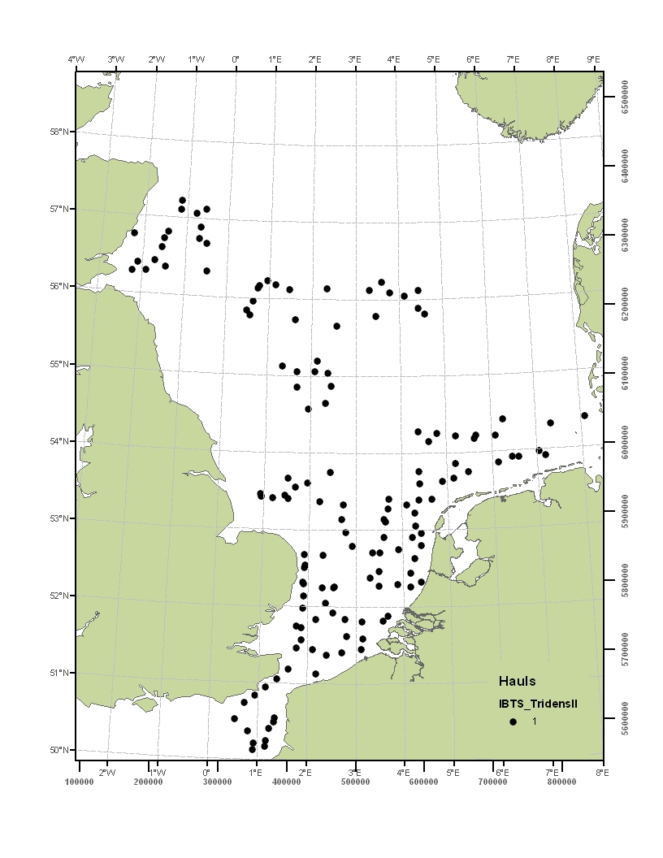

Figure 2 BTS Station grid fished by R.V. Tridens and R.V. Isis
(the station grid may be subject to changes agreed by WGBEAM)

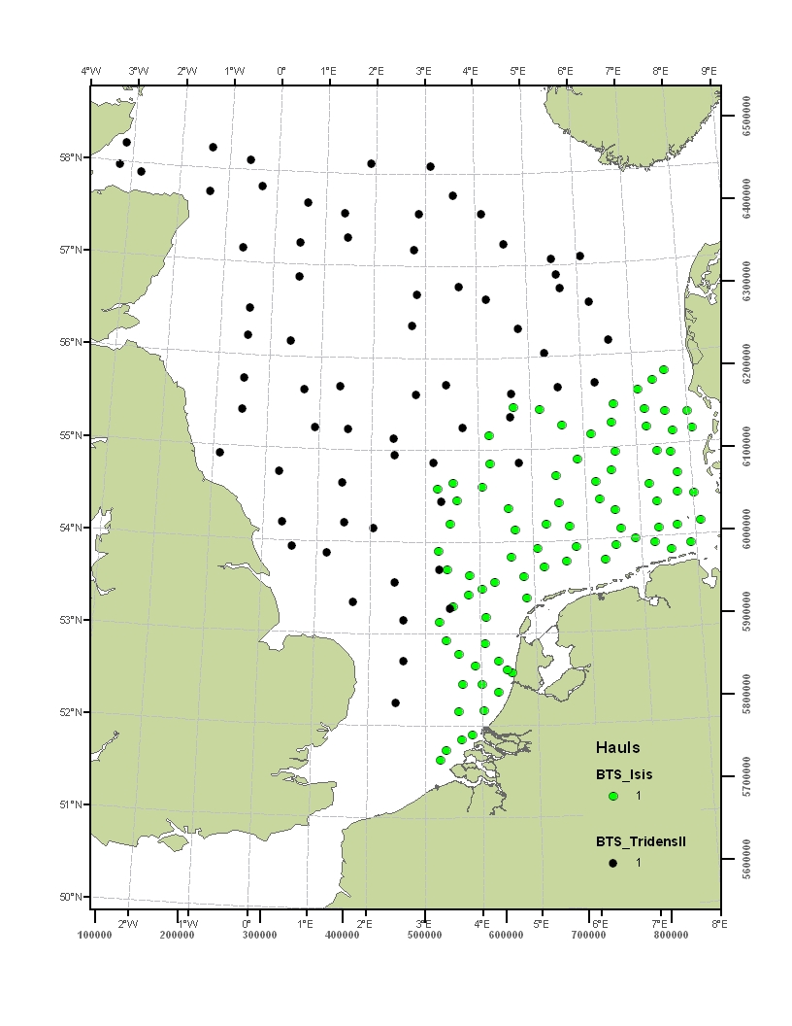

Figure 3. Demersal Young Fish Survey. Station grid for R.V. Stern (Wadden Sea), R.V. Schollevaar (Scheldt Estuary) and R.V. Isis (coastal zone)
(the station grid may be subject to changes agreed by WGBEAM)

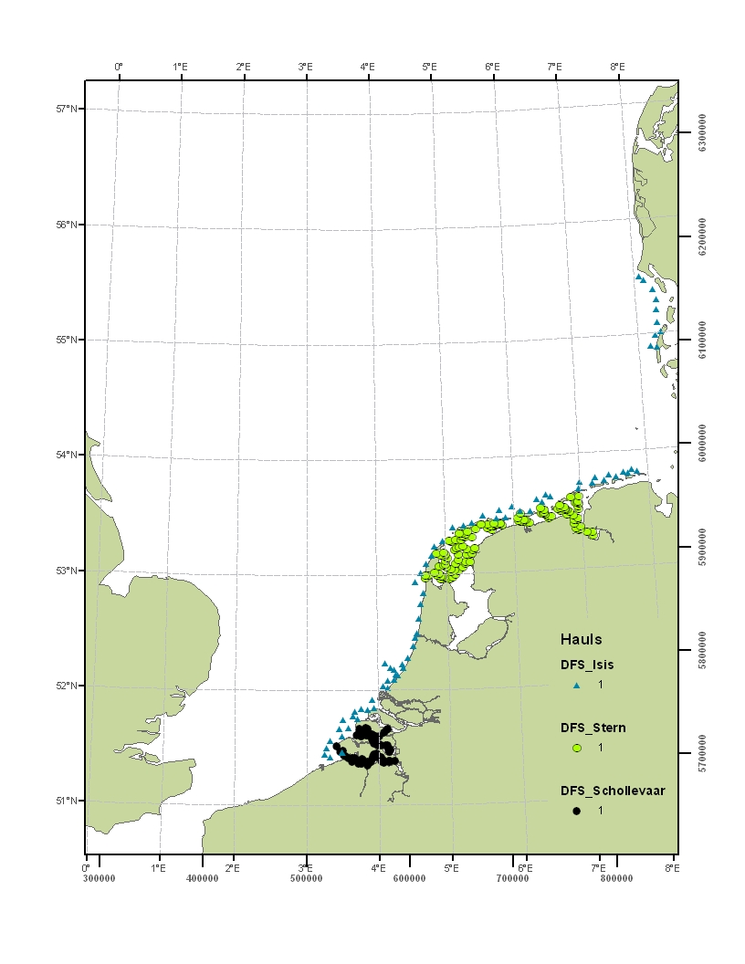
Figure 4 Sole Net Survey. Station grid for R.V. Isis
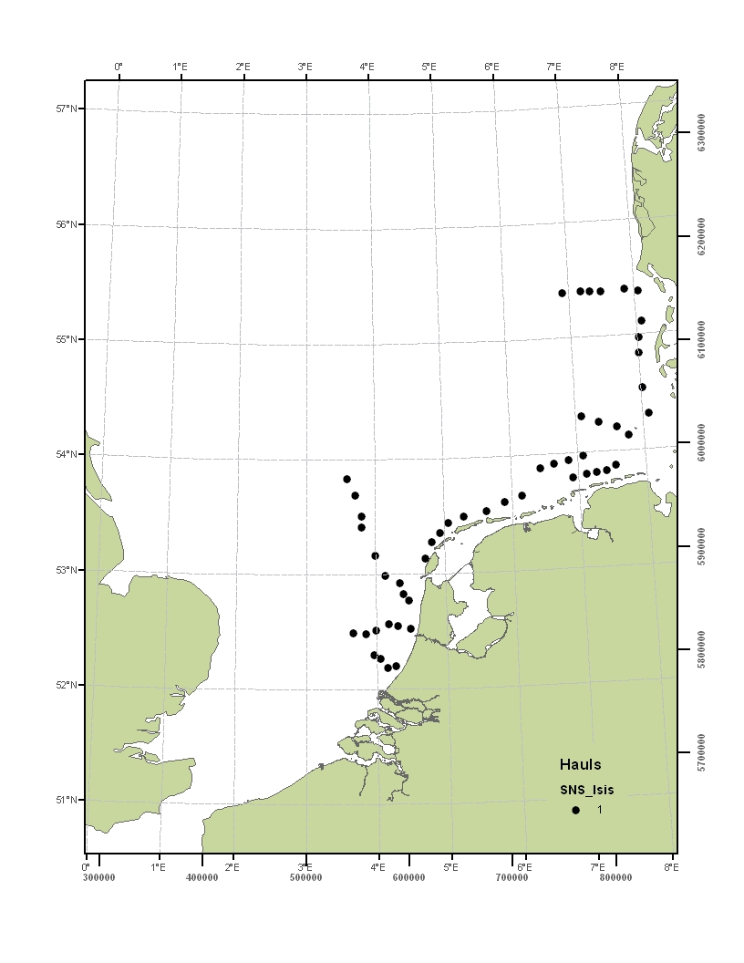
Figure 5 Herring Larvae survey station grid. The northern stations, covering the Banks and Buchan components, are fished in September. The southern stations, covering the Downs component, are fished in December.
(the station grid may be subject to changes agreed by WGIPS)

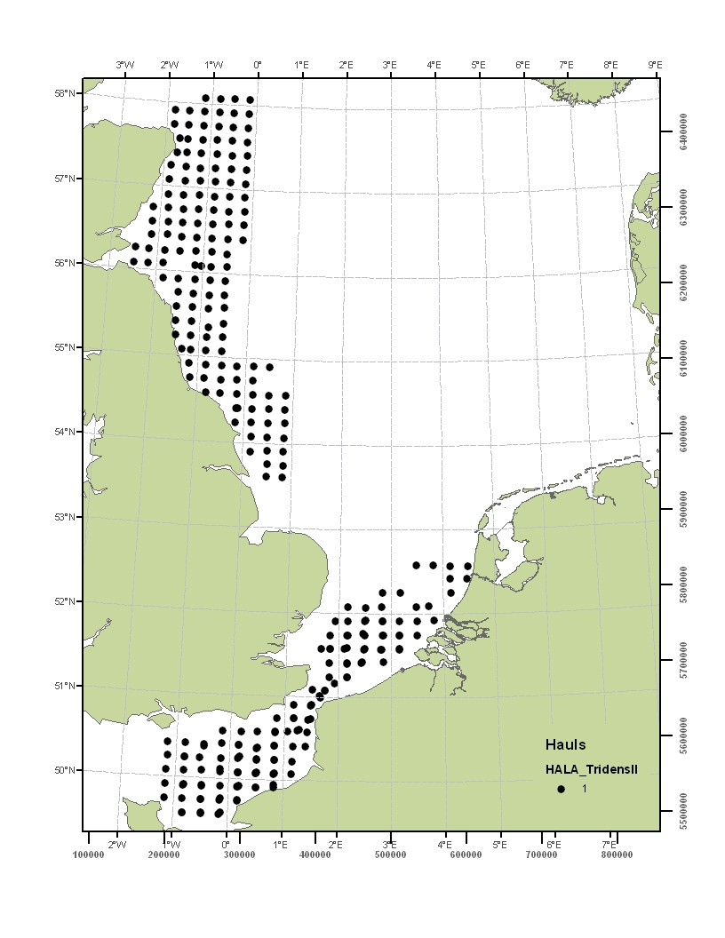
Figure 6 North Sea Herring Acoustic Survey. International station grid
(the station grid may be subject to changes agreed by WGIPS)

Survey direction: north south.
Blue line = Tridens
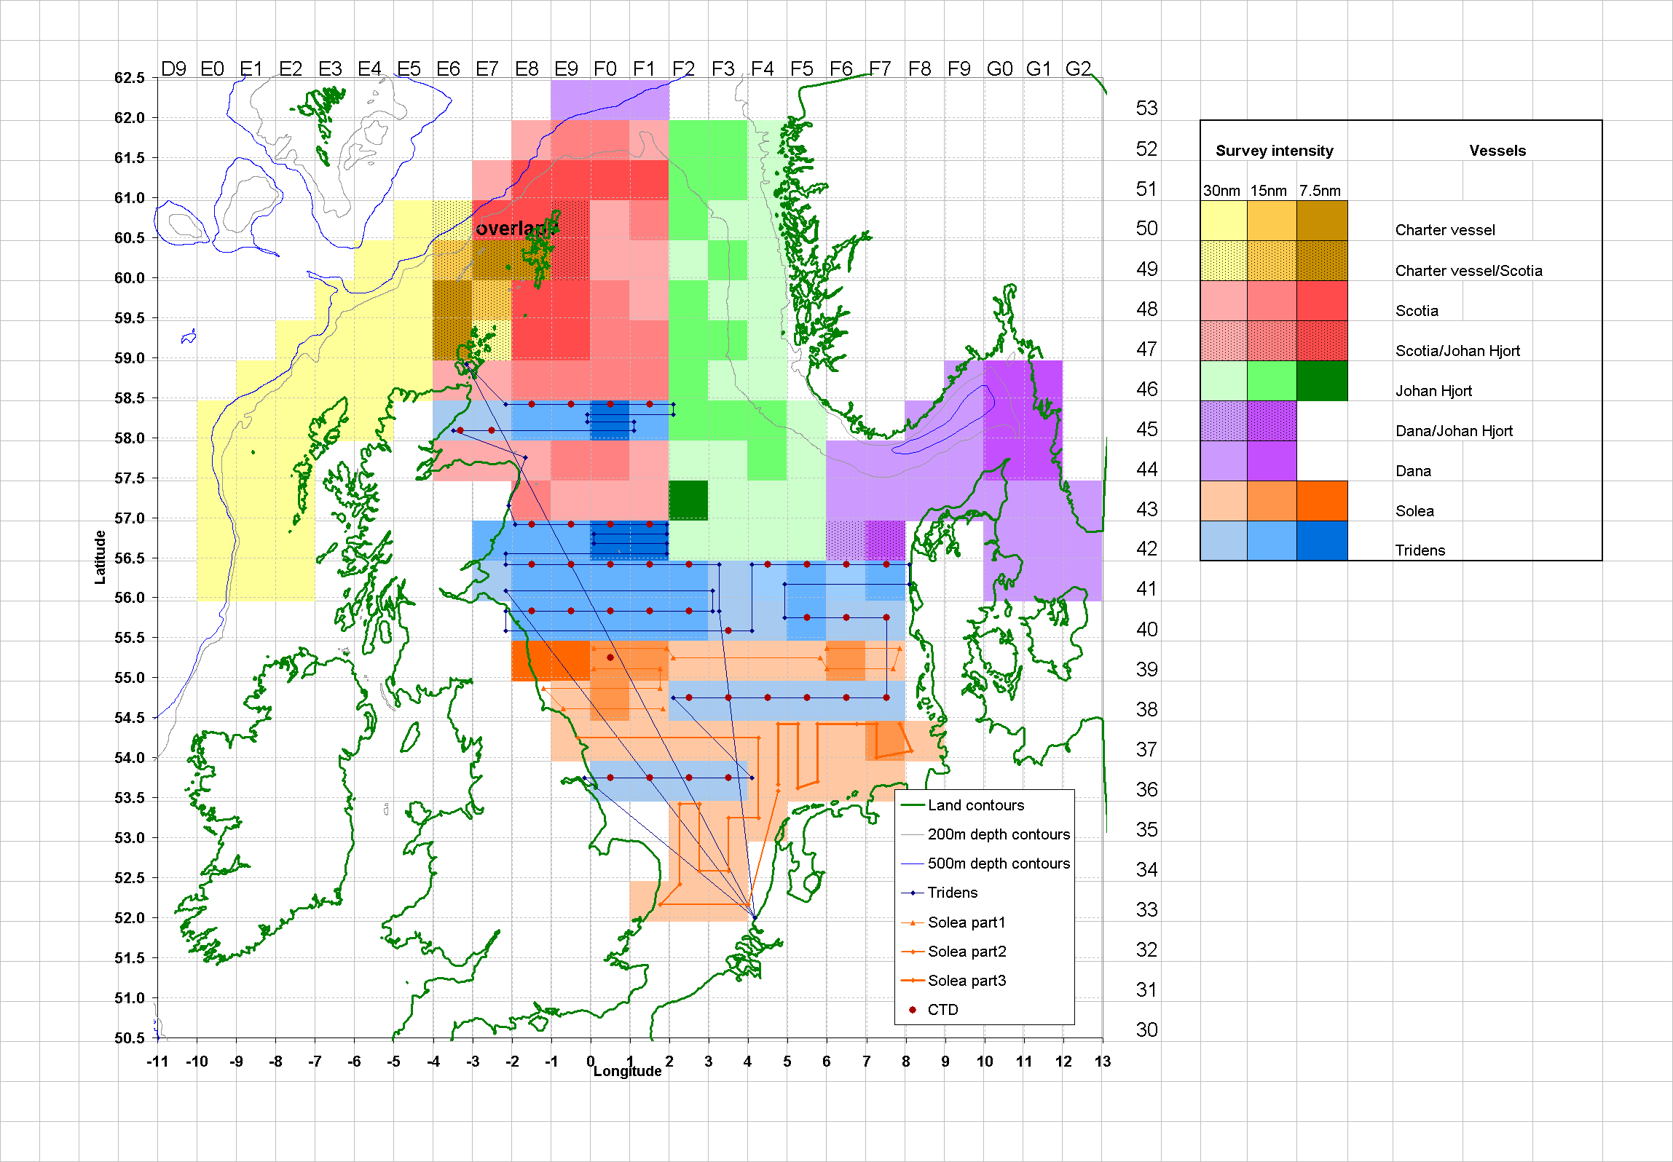
Red dots = CTD stations for Tridens.
Figure 7 Blue whiting survey. Preliminary survey tracks for the International blue whiting spawning stock survey in 2012 agreed by WGNAPES in 2011.

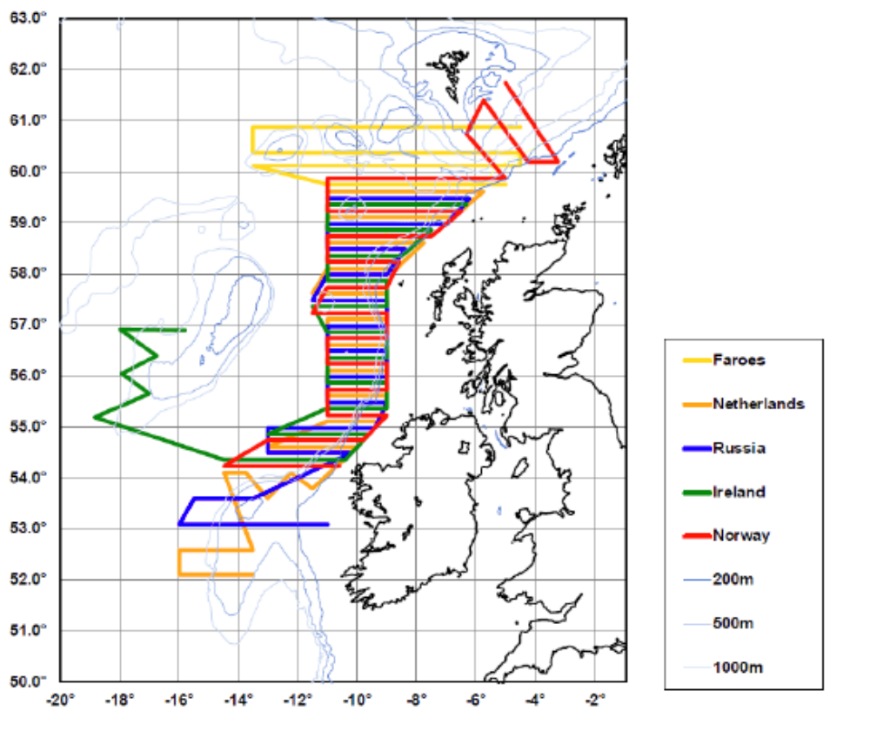

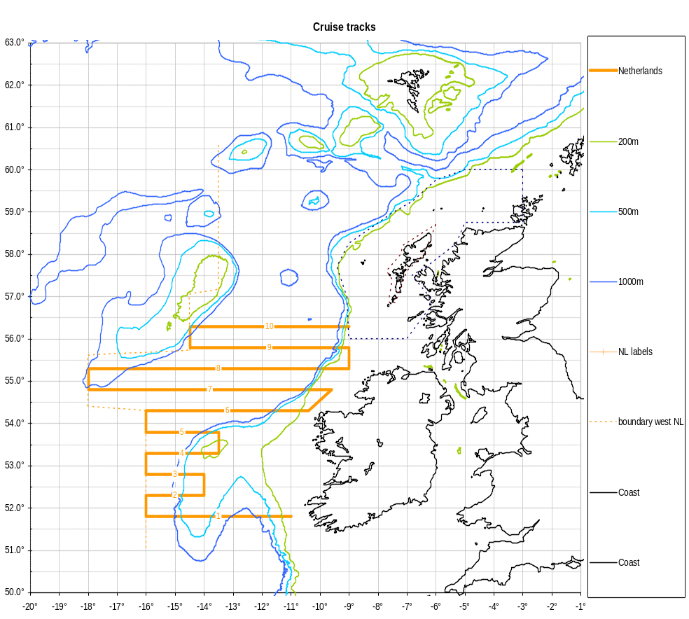
Figure 8 International Mackerel and Horse Mackerel Egg survey. Survey area expected to be covered by RV TRIDENS in 2013. The survey tracks may be changed by WGMEGS

Figure 9 North Sea mackerel egg survey. Survey area expected to be covered by RV TRIDENS in 2011. The survey tracks may be changed by WGMEGS
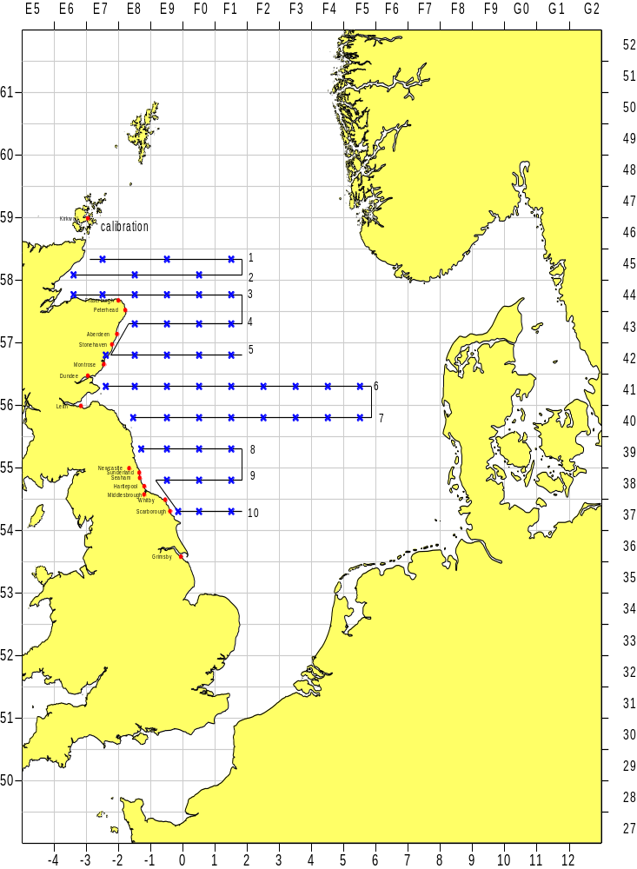

Annex 2 Agreements

Bilateral Agreement between The Netherlands (Centre for Fisheries Research) and Germany (Johann Heinrich von Thünen Institute, vTI) for the collection of length and age samples in accordance with EC Regulation 665/2008, laying down detailed rules for the application of Council Regulation (EC) 199/2008, and its Commission Decision 2010/93/EU
Agreement:
Pelagic freezer trawlers fishing on herring, blue whiting, mackerel and horse mackerel, and beam trawlers fishing on plaice and sole under the German register, which land for first sale into The Netherlands, will be sampled as part of the German National Programme under the requirements of the EC Data Collection Framework (199/2008). The eventual additional sampling costs will be covered within the German National Sampling Programme 2011-2013.
Description of sampling:
The sampling will be for length and age of discards and landings, sampling will be carried out in accordance with the German National Sampling Programme.
Sampling intensity:
Levels and coverage of sampling will be as agreed at the annual meeting of RCM North Sea & Eastern Arctic.
Data responsibility:
Germany is responsible for submitting the data to the relevant ICES Expert Groups, and to the EC under the requirements of its Data Collection Framework. Germany will provide the required data for the species that are requested by the relevant ICES Expert Groups, and the data for the additional species to The Netherlands as and when requested.
Contact persons:
In The Netherlands (CVO): Sieto Verver: sieto.verver@wur.nl
In Germany (vTI-SF): Jens Ulleweit: jens.ulleweit@vti.bund.de

Signatures:
For The Netherlands (CVO) For Germany (vTI)
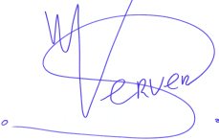
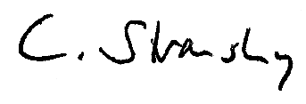
Sieto Verver Dr. Christoph Stransky
Dpt. Head Centre for Fisheries Research German National Correspondent

Date: 24 March 2010

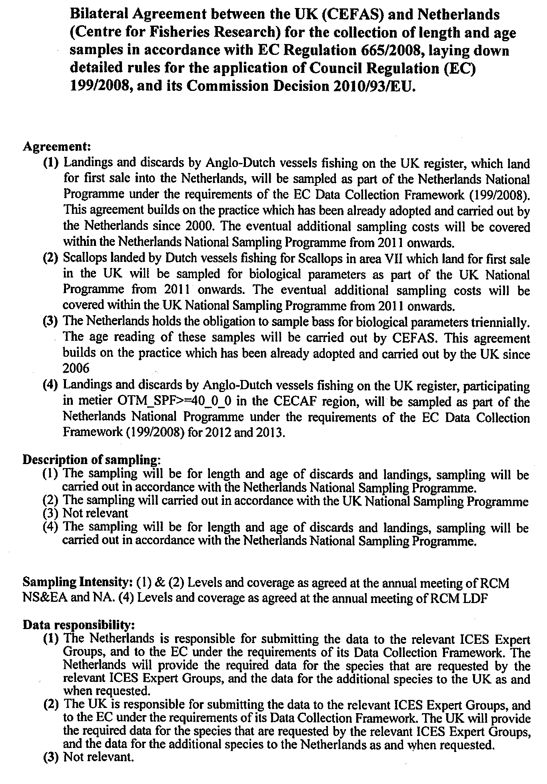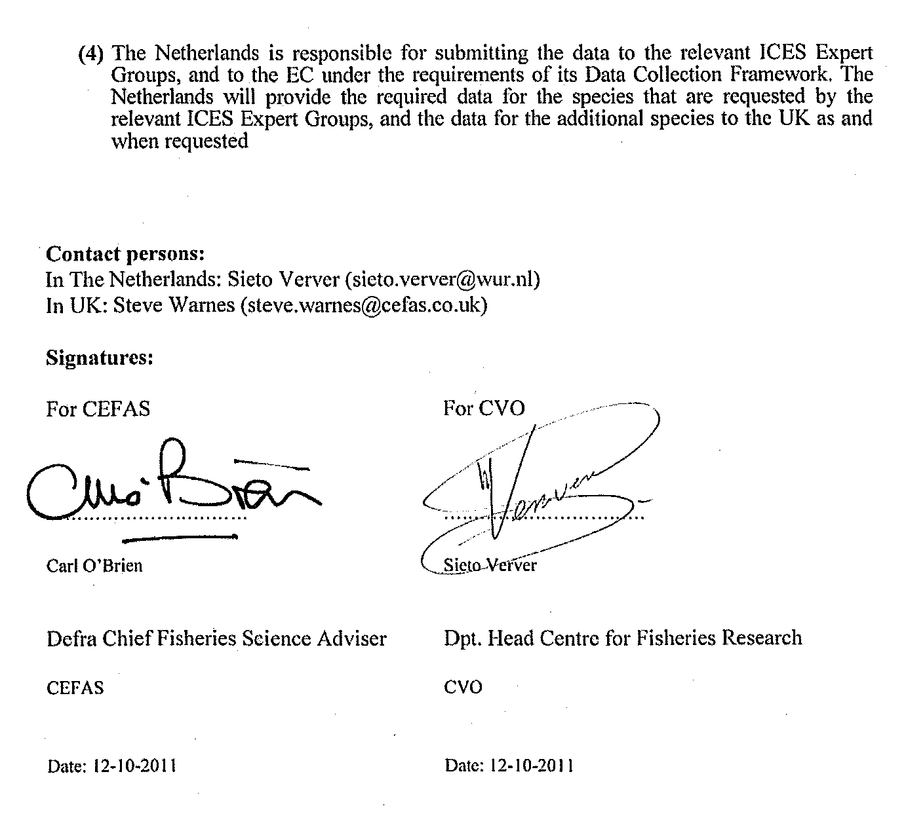

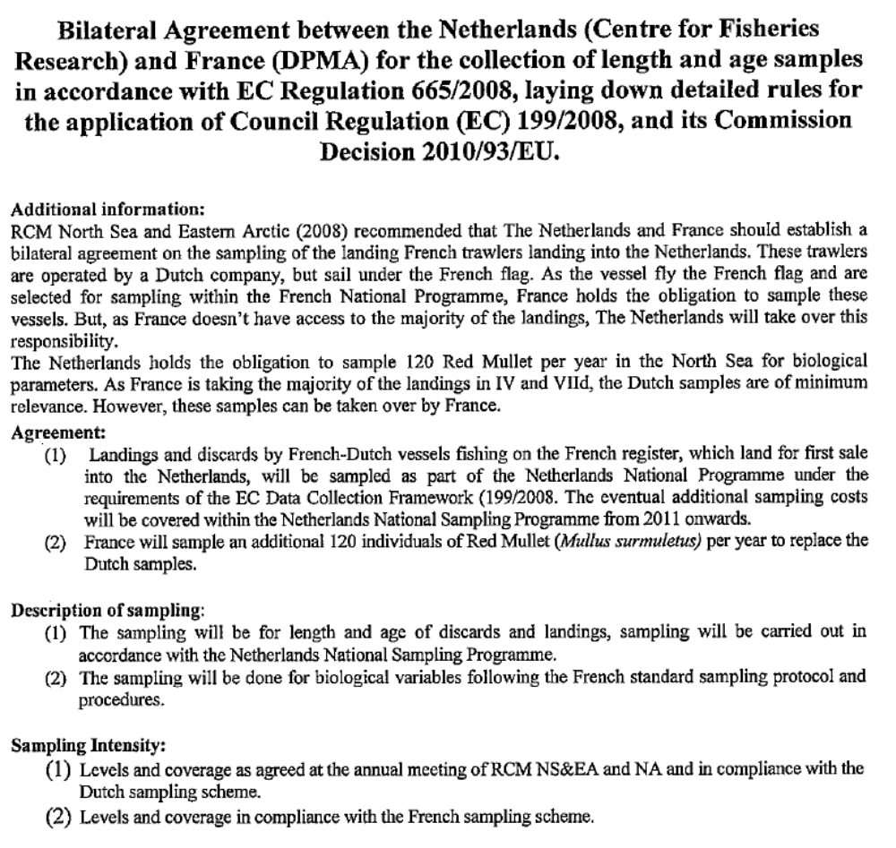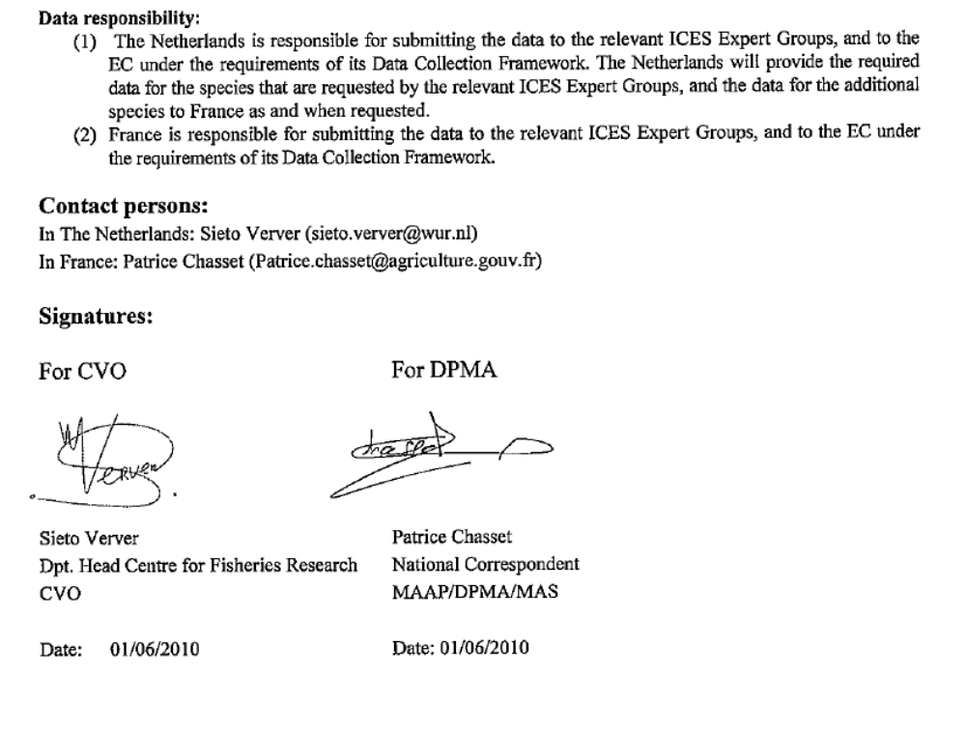
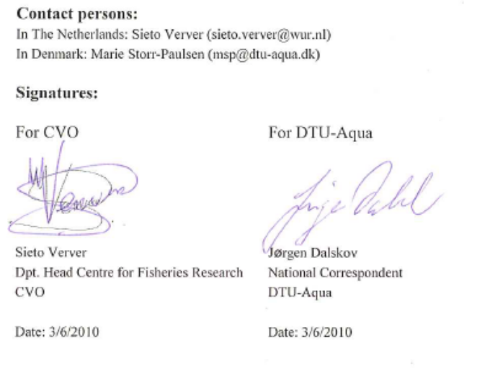
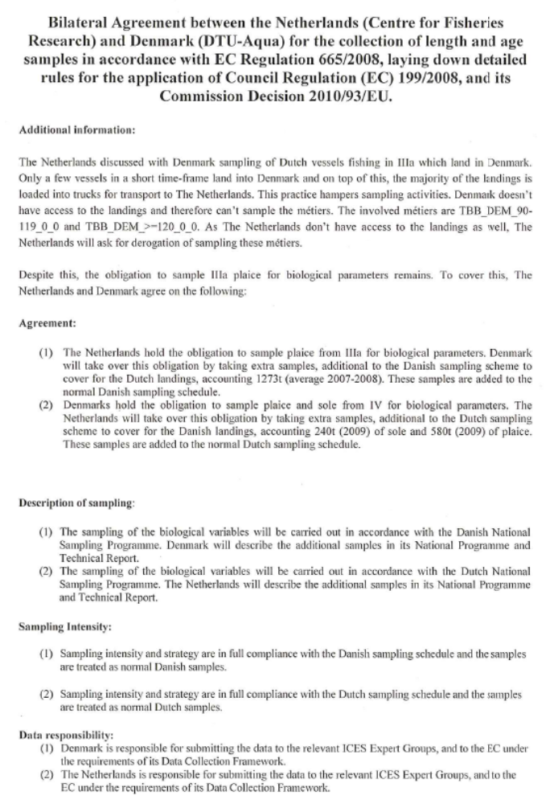
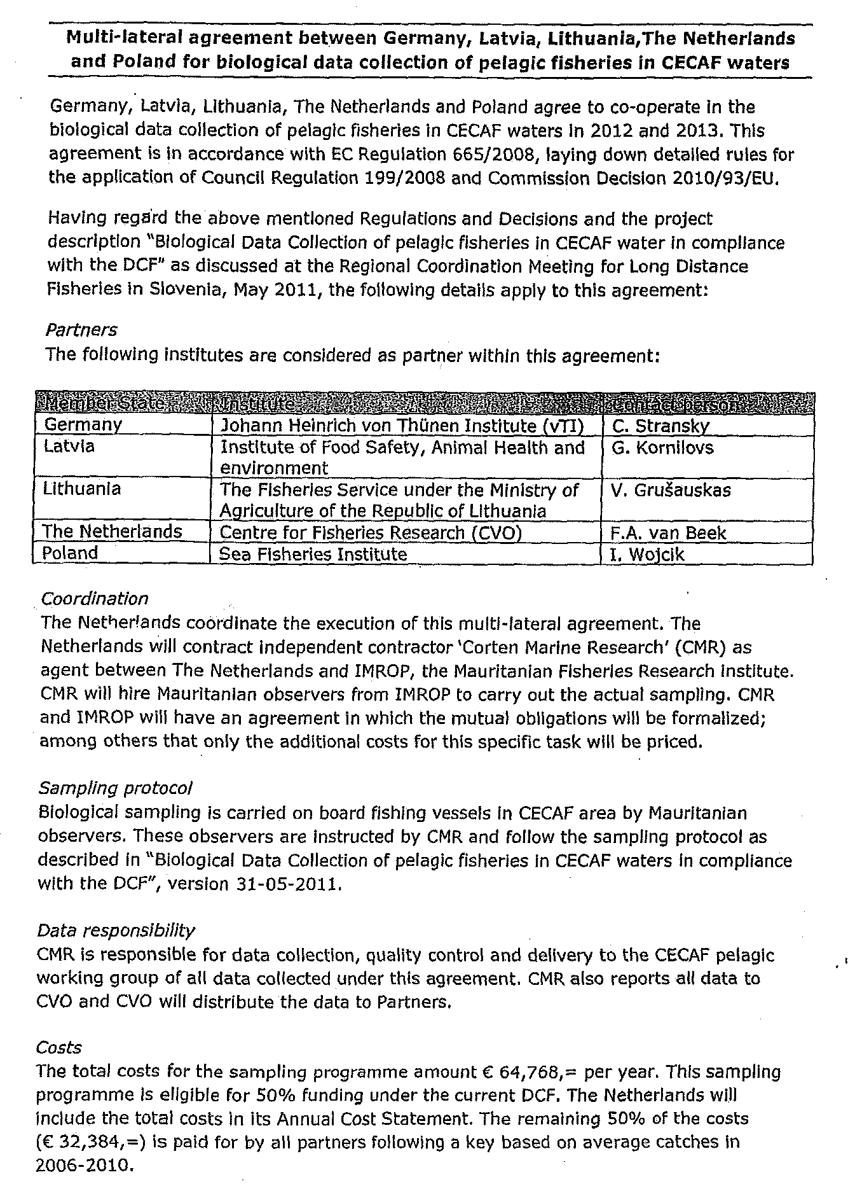

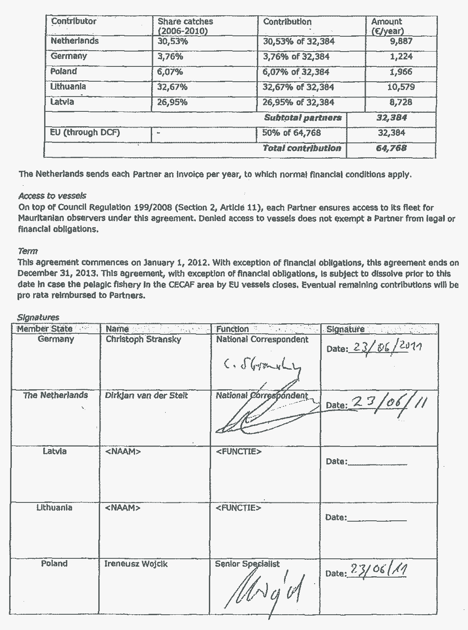
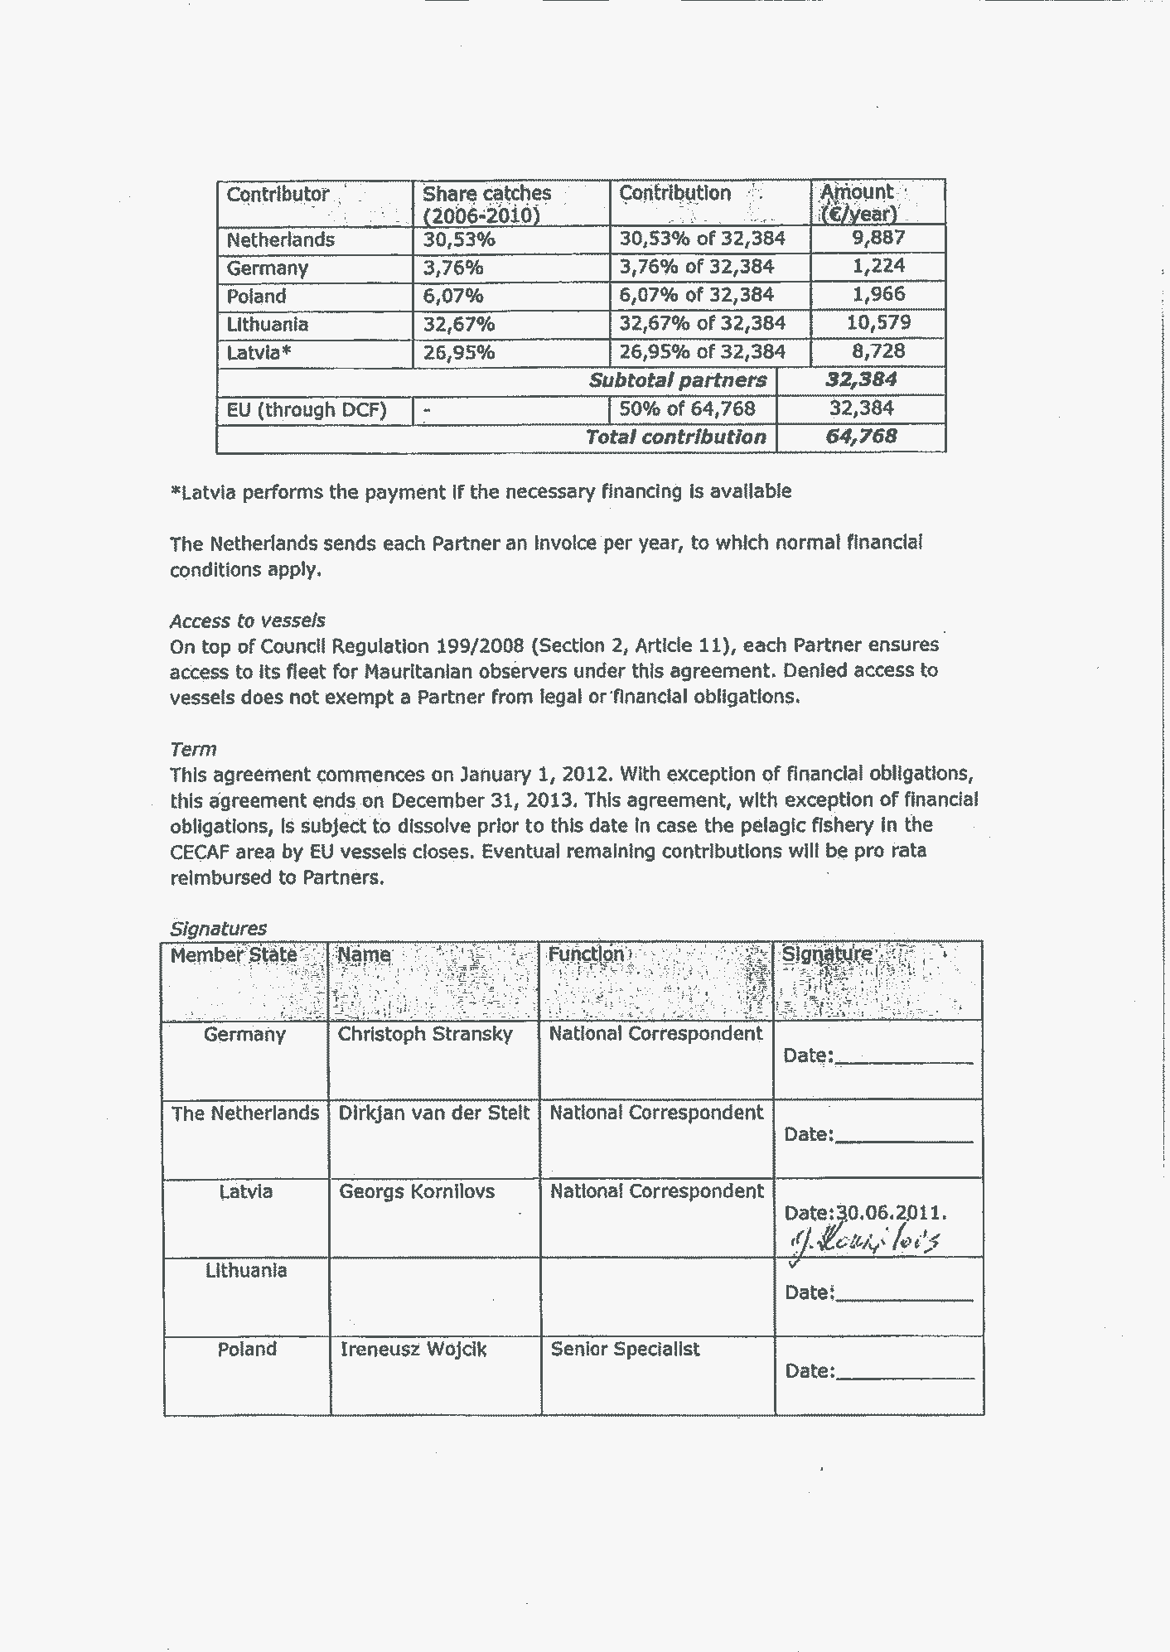
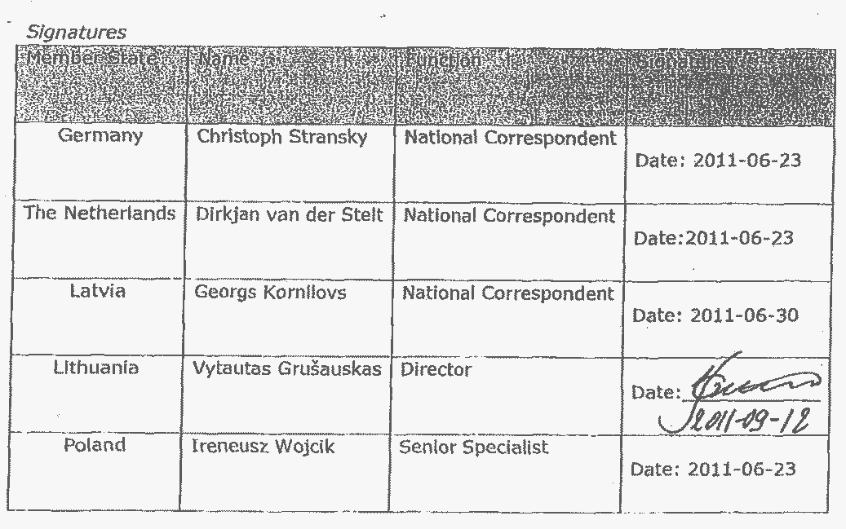

Annex 3 Costs and Earnings items taken into account in the different parameters as set out in appendix VI of the DCF in the LEI survey of accounts of the cutter fleet.

Parameter | Costs/Income included
Gross value of landings | Income per species and market category
Income from leasing out quota or other fishing rights | Rent quota cod  Rent quota mackerel  Rent quota plaice  Rent quota sole  Rent quota whiting
Direct subsidies | Compensation on contribution for auction in case of closed areas  Compensation for voluntary stop of fishing during certain part of the year
Other income | Income from charter vessel by research  Income from towing other vessels  Settlement of income from fisheries in case of co-operation with other vessels  Insurance payments
Wages and salaries of crew | Part of the income from research activities that is paid to the crew  Part of the subsidy that is paid as wage to the crew  Wage for the crew for maintenance of the vessel  Wage for the crew from income from fishing  Wage for the crew from income from towing other vessels  Holiday pay  Social security payments
Imputed value of unpaid labour | Imputed value for owners own labour on board
Energy costs | Kerosene
Repair and maintenance. | Maintenance catch processing equipment  Maintenance engine  Maintenance hull  Maintenance Ice machine, freezing equipment  Maintenance navigation equipment  Maintenance shrimp processing equipment  Fishing gear (netting)
Variable operational costs | Auction levy  Clothing crew  Contribution fisheries association  Electricity  Food costs for crew  Harbour fee  Ice  Levy on landed fish for compensation for fish that was taken out of the market  Lubrication oil  Pay for landing armament  Plastic bags  Rent fish boxes  Salt  Service costs auctions  Small tools  Sorting/unloading  Subscription fisheries association  Subscription fisheries Product Organisation  Tax on waste production  Transport costs fish  Travel expenses crew  Wage for safeguarding  Water
Non-variable operational costs | Insurance  Costs of company car  Costs of company office  Costs of setting up the business  Costs agent in harbour  Bookkeeping  Fines  Other general expenses  Telephone
Lease/rental payments for quota or other fishing rights | Production rights (licences etc.)
Annual depreciation | Depreciation
Value of physical capital: depreciated replacement value | Depreciated replacement value of hull, engine, catch processing equipment, Ice machine, freezing equipment,  navigation equipment and shrimp processing equipment
Value of physical capital: depreciated historical value | Depreciated historical value of hull, engine, catch processing equipment, Ice machine, freezing equipment,  navigation equipment and shrimp processing equipment
Value of quota and other fishing rights
Investments in physical capital | Investments in hull, engine, catch processing equipment, Ice machine, freezing equipment,  navigation equipment and shrimp processing equipment
Debt/asset ratio | Financial position of fishing firm
Engaged crew | Total number of crew members
FTE National | FTE based on national standard
FTE harmonised | FTE based on 2000 hours per FTE
Number | Number of vessels (from vessel register)
Mean LOA | Mean length of vessels (from vessel register)
Mean vessel's tonnage | Mean tonnage of vessels (from vessel register)
Mean vessel's power | Mean engine power of vessels (from vessel register)
Mean age | Mean age of vessels (from vessel register)
Days at sea | Total effort (from logbook)
Energy consumption | Total Number of vessels (from vessel register)
Number of fishing enterprises/units | Number of fishing firms (from vessel register)

Annex 4 Description of selected metiers

Metier description template 1
RCM | North Sea and Eastern Atlantic
Fishing ground | IV- VIId
Name of metier: | TBB_DEF_70-99_0_0
Flag country: | Netherlands
Date of update: | 24-10-2011
Description of the metier
Spatial distribution of the fishing activity of the metier | Mainly in IVb,c
Seasonal pattern of the fishing activity of the metier | Fishing all year round
Number of vessels involved in metier by LOA group: | <18: 8 vessels - 18-24: 46 vessels - 24-40: 40 vessels - >40: 80 vessels
Detailed gear types and selectivity devices used in metier | 12 meter beam trawl using tickler chains or chain mats. Mesh sizes of the cod end are close to 80 mm,
Main target and by-catch species for the metier | Target species are sole and plaice with bycatches of other flatfish and roundfish species
Indicate level of discard of major species (mostly subset of G1 or G2 species):  (Text. e.g. Significant, Insignificant, Occasional high) | Species | Level of discarding
 | plaice | high
 | sole | low
 | dab | high
 | roundfish | mediate
Is significant part of the catches landed in foreign countries? | Landing country |  | Sampling agreement (y/n) ref. to table
 | NLD |  | not relevant
Sampling of the metier
Indicate if this Metier is merged with other metiers for sampling | not merged
Justification for merging: | not relevant
Sampling scheme | Type of sampling |  |  | Sampling frame and primary sampling unit for data collection | Data collected (retained catch; discarded catch; unsorted catch) and sampling method (concurrent, other)
Sampling scheme | Observers at sea |  |  | Yes, by trip | Landings and discards (concurrent)
Sampling scheme | Self sampling |  |  | Yes, by trip | Discards
Sampling scheme | Sampling landings on shore |  |  | Yes, by trip, stratified by category | Landings
Indicate if the Metier is associated with particular sampling problems: | not relevant
Additional remarks (historical and others): | The number of vessels has been reduced considerable in recent years.

Metier description template 2
RCM | North Sea and Eastern Atlantic
Fishing ground | IV- VIId
Name of metier: | TBB_CRU_16-31_0_0
Flag country: | Netherlands
Date of update: | 24-10-2011
Description of the metier
Spatial distribution of the fishing activity of the metier | Relatively close to the continental coast and within the 12 miles zone in area IVb,c including Wadden Sea and Scheldt estuaries. Average trip duration is 1 or 2 days.
Seasonal pattern of the fishing activity of the metier | Fishing for brown shrimp all year round with peak landings in spring and autumn
Number of vessels involved in metier by LOA group: | <18: 10 vessels - 18-24: 130 vessels - 24-40: 50 vessels - >40: 2 vessels
Detailed gear types and selectivity devices used in metier | Beam trawl with a beam length of 5 meter, using small size cod end and bobbins in the ground rope. Some vessel may use separation panels.
Main target and by-catch species for the metier | Target species is brown shrimp with some bycatches of flatfish (small grades)
Indicate level of discard of major species (mostly subset of G1 or G2 species):  (Text. e.g. Significant, Insignificant, Occasional high) | Species | Level of discarding
 | crangon | variable, sometimes high
 | plaice | variable, sometimes high, mostly 0-group
 | sole | variable, sometimes high, mostly 0-group
 | general | amounts variable, percentage high because bycatches consist mostly of juvenile fish
Is significant part of the catches landed in foreign countries? | Landing country |  | Sampling agreement (y/n) ref. to table
 | NLD |  | not relevant
Sampling of the metier
Indicate if this Metier is merged with other metiers for sampling | not merged
Justification for merging: | not relevant
Sampling scheme | Type of sampling |  |  | Sampling frame and primary sampling unit for data collection | Data collected (retained catch; discarded catch; unsorted catch) and sampling method (concurrent, other)
Sampling scheme | Observers at sea |  |  | Yes | Landings and discards (concurrent)
Sampling scheme | Self sampling |  |  | No
Sampling scheme | Sampling landings on shore |  |  | Yes | landings
Indicate if the Metier is associated with particular sampling problems: | Due to the logistics on board, sampling has to be carried out by two observers and is therefore relative expensive. For the same reason, self sampling is not possible.
Additional remarks (historical and others): | Many vessels in this metier are also operating in other metiers, such as beam trawling for flatfish.

Metier description template 3
RCM | North Sea and Eastern Atlantic
Fishing ground | IV- VIId
Name of metier: | OTB_DEF_70-99_0_0
Flag country: | Netherlands
Date of update: | 26-02-2010
Description of the metier
Spatial distribution of the fishing activity of the metier | Mainly in IVb,c
Seasonal pattern of the fishing activity of the metier | Fishing all year round
Number of vessels involved in metier by LOA group: | <18: 5 vessels - 18-24: 19 vessels - 24-40: 22 vessels - >40: 5 vessels
Detailed gear types and selectivity devices used in metier | A number of different gears is using this metier description. There are no traditional otter trawls used anymore. Most gears are twin trawls or multiple trawls.
Main target and by-catch species for the metier
Indicate level of discard of major species (mostly subset of G1 or G2 species):  (Text. e.g. Significant, Insignificant, Occasional high) | Species | Level of discarding
 | plaice | high
 | sole | low
 | dab | high
 | roundfish | mediate
Is significant part of the catches landed in foreign countries? | Landing country |  | Sampling agreement (y/n) ref. to table
 | NLD |  | not relevant
Sampling of the metier
Indicate if this Metier is merged with other metiers for sampling | not merged
Justification for merging: | not relevant
Sampling scheme | Type of sampling |  |  | Sampling frame and primary sampling unit for data collection | Data collected (retained catch; discarded catch; unsorted catch) and sampling method (concurrent, other)
Sampling scheme | Observers at sea
Sampling scheme | Self sampling
Sampling scheme | Sampling landings on shore |  |  | Yes, stratified by category | landings
Indicate if the Metier is associated with particular sampling problems: | not relevant
Additional remarks (historical and others):

Metier description template 4
RCM | North Sea and Eastern Atlantic
Fishing ground | IV-VIId
Name of metier: | OTB_MCD_70-99_0_0
Flag country: | Netherlands
Date of update: | 26-02-2010
Description of the metier
Spatial distribution of the fishing activity of the metier | Mainly in IVb,c
Seasonal pattern of the fishing activity of the metier | Fishing all year round with peak in quarters 2 and 3
Number of vessels involved in metier by LOA group: | 18-24: 7 vessels - 24-40: 12 vessels - >40: 3 vessels
Detailed gear types and selectivity devices used in metier | A number of different gears is using this metier description. There are no traditional otter trawls used anymore. Most gears are twin trawls or multiple trawls
Main target and by-catch species for the metier | Target species are Nephrops and plaice with bycatches of other flatfish and roundfish species
Indicate level of discard of major species (mostly subset of G1 or G2 species):  (Text. e.g. Significant, Insignificant, Occasional high) | Species | Level of discarding
 | Nephrops | high
 | plaice | high
 | dab | high
Is significant part of the catches landed in foreign countries? | Landing country |  | Sampling agreement (y/n) ref. to table
 | NLD |  | not relevant
Sampling of the metier
Indicate if this Metier is merged with other metiers for sampling | not merged
Justification for merging: | not relevant
Sampling scheme | Type of sampling |  |  | Sampling frame and primary sampling unit for data collection | Data collected (retained catch; discarded catch; unsorted catch) and sampling method (concurrent, other)
Sampling scheme | Observers at sea
Sampling scheme | Self sampling |  |  | Yes | Discards
Sampling scheme | Sampling landings on shore |  |  | Yes | Landings
Indicate if the Metier is associated with particular sampling problems: | not relevant
Additional remarks (historical and others): | The metier is selected using a 10% (volume) selection gate for Nephrops.

Metier description template 5
RCM | North Sea and Eastern Atlantic
Fishing ground | IV- VIId
Name of metier: | MIS_UND_0-0_0_0
Flag country: | Netherlands
Date of update: | 26-02-2010
Description of the metier
Spatial distribution of the fishing activity of the metier | unknown
Seasonal pattern of the fishing activity of the metier | unknown
Number of vessels involved in metier by LOA group: | unknown
Detailed gear types and selectivity devices used in metier | unknown
Main target and by-catch species for the metier | various
Indicate level of discard of major species (mostly subset of G1 or G2 species):  (Text. e.g. Significant, Insignificant, Occasional high) | Species | Level of discarding
Is significant part of the catches landed in foreign countries? | Landing country |  | Sampling agreement (y/n) ref. to table
 | NLD |  | not relevant
Sampling of the metier
Indicate if this Metier is merged with other metiers for sampling | not merged
Justification for merging: | not relevant
Sampling scheme | Type of sampling |  |  | Sampling frame and primary sampling unit for data collection | Data collected (retained catch; discarded catch; unsorted catch) and sampling method (concurrent, other)
Sampling scheme | Observers at sea
Sampling scheme | Self sampling
Sampling scheme | Sampling landings on shore
Indicate if the Metier is associated with particular sampling problems: | not relevant
Additional remarks (historical and others): | The metier is selected from vessels with no gear specification in the log-book.

Metier description template 6
RCM | North Sea and Eastern Atlantic
Fishing ground | IV- VIId
Name of metier: | GNS_DEF_100-119_0_0
Flag country: | Netherlands
Date of update: | 26-02-2010
Description of the metier
Spatial distribution of the fishing activity of the metier | Dutch coastal area
Seasonal pattern of the fishing activity of the metier | April-September in general, December-February for Cod
Number of vessels involved in metier by LOA group: | <10: 43 vessels – 10-12: 12 vessels – 12-18: 5 vessels - 18-24: 6 vessels - 24-40: 6 vessels - >40: 1 vessels
Detailed gear types and selectivity devices used in metier | Standing gillnets with floats, can be up to 1500m long.
Main target and by-catch species for the metier | Cod, sole, bass, flounder, dab and mullet
Indicate level of discard of major species (mostly subset of G1 or G2 species):  (Text. e.g. Significant, Insignificant, Occasional high) | Species | Level of discarding
 | Whiting | Occasionally high
Is significant part of the catches landed in foreign countries? | Landing country |  | Sampling agreement (y/n) ref. to table
 | NLD |  | not relevant
Sampling of the metier
Indicate if this Metier is merged with other metiers for sampling | not merged
Justification for merging: | not relevant
Sampling scheme | Type of sampling |  |  | Sampling frame and primary sampling unit for data collection | Data collected (retained catch; discarded catch; unsorted catch) and sampling method (concurrent, other)
Sampling scheme | Observers at sea
Sampling scheme | Self sampling |  |  | Will start in 2011
Sampling scheme | Sampling landings on shore
Indicate if the Metier is associated with particular sampling problems:
Additional remarks (historical and others):

Metier description template 7
RCM | North Sea and Eastern Atlantic
Fishing ground | IV- VIId
Name of metier: | LH_FIF_0-0_0_0
Flag country: | Netherlands
Date of update: | 26-02-2010
Description of the metier
Spatial distribution of the fishing activity of the metier | Mainly IVc-VIId
Seasonal pattern of the fishing activity of the metier | Mainly spring and autumn
Number of vessels involved in metier by LOA group: | <10: 51 vessels – 10-12: 3 vessels – 12-18: 5 vessels - 24-40: 1 vessels
Detailed gear types and selectivity devices used in metier | Simple angling gear except for 1 vessel fishing for squid. This vessel is equipped with lamps and automated lines.
Main target and by-catch species for the metier | Target species are Bass and Cod, with by catch of Pollack and Mullets. 1 vessel directs its effort towards squids.
Indicate level of discard of major species (mostly subset of G1 or G2 species):  (Text. e.g. Significant, Insignificant, Occasional high) | Species | Level of discarding
 | All | Unknown, but expected to be low
Is significant part of the catches landed in foreign countries? | Landing country |  | Sampling agreement (y/n) ref. to table
 | NLD |  | not relevant
Sampling of the metier
Indicate if this Metier is merged with other metiers for sampling | not merged
Justification for merging: | not relevant
Sampling scheme | Type of sampling |  |  | Sampling frame and primary sampling unit for data collection | Data collected (retained catch; discarded catch; unsorted catch) and sampling method (concurrent, other)
Sampling scheme | Observers at sea
Sampling scheme | Self sampling
Sampling scheme | Sampling landings on shore
Indicate if the Metier is associated with particular sampling problems:
Additional remarks (historical and others): | This metier is selected for effort only

Metier description template 8
RCM | North Sea and Eastern Atlantic
Fishing ground | IV- VIId
Name of metier: | SSC_DEF_70-99_0_0
Flag country: | Netherlands
Date of update: | 28-02-2010
Description of the metier
Spatial distribution of the fishing activity of the metier | Mainly in IVb,c ,VIId
Seasonal pattern of the fishing activity of the metier | October-February for VIId. Summertime in area IVb,c
Number of vessels involved in metier by LOA group: | 24-40: 10 vessels
Detailed gear types and selectivity devices used in metier | no details
Main target and by-catch species for the metier | Target species are red mullet (Mullus surmuletus) and tub gurnard (Trigla lucerna). Other target species in this fishery are dab (Limanda limanda), whiting (Merlangius merlangus), plaice (Pleuronectes platessa) in IVc), common cuttlefish (Sepia officinalis) in VIId and squids (Loliginidae) in IVc and VIId
Indicate level of discard of major species (mostly subset of G1 or G2 species):  (Text. e.g. Significant, Insignificant, Occasional high) | Species | Level of discarding
 | plaice, dab | high
 | other | unknown
Is significant part of the catches landed in foreign countries? | Landing country |  | Sampling agreement (y/n) ref. to table
 | FR |  | landings from VIId. No agreement with France
Sampling of the metier
Indicate if this Metier is merged with other metiers for sampling | not merged
Justification for merging: | not relevant
Sampling scheme | Type of sampling |  |  | Sampling frame and primary sampling unit for data collection | Data collected (retained catch; discarded catch; unsorted catch) and sampling method (concurrent, other)
Sampling scheme | Observers at sea
Sampling scheme | Self sampling
Sampling scheme | Sampling landings on shore
Indicate if the Metier is associated with particular sampling problems: | not relevant
Additional remarks (historical and others): | also operating in VIIe

Metier description template 9
RCM | North Sea and Eastern Atlantic
Fishing ground | IV- VIId
Name of metier: | OTM_SPF_32-69_0_0
Flag country: | Netherlands
Date of update: | 24-10-2011
Description of the metier
Spatial distribution of the fishing activity of the metier | IV for most of the species.
Seasonal pattern of the fishing activity of the metier | North Sea herring in June-August
Number of vessels involved in metier by LOA group: | >40m: 10 vessels
Detailed gear types and selectivity devices used in metier | pelagic midwater trawl
Main target and by-catch species for the metier | Target species are herring (Clupea harengus), mackerel (Scomber scombrus), horse mackerel (Trachurus spp) and sardine (Sardina pilchardus) in IVc and VIId
Indicate level of discard of major species (mostly subset of G1 or G2 species):  (Text. e.g. Significant, Insignificant, Occasional high) | Species | Level of discarding
 | mackerel | mediate
 | other target | low
 | other | low numbers, high percentages
Is significant part of the catches landed in foreign countries? | Landing country |  | Sampling agreement (y/n) ref. to table
 | NLD |  | not relevant
Sampling of the metier
Indicate if this Metier is merged with other metiers for sampling | merged with PTM_SPF_32-69_0_0 and OTM_SPF_32-69_0_0 and PTM_SPF_32-69_0_0 in adjacent areas
Justification for merging: | With the exception of North Sea herring and North Sea horse mackerel, the fishery is targeting widely migrating stocks distributed over several fishing grounds. No fishing ground designed sampling is possible. The PTM vessels (1 pair) target the same stocks with a similar gear
Sampling scheme | Type of sampling |  |  | Sampling frame and primary sampling unit for data collection | Data collected (retained catch; discarded catch; unsorted catch) and sampling method (concurrent, other)
Sampling scheme | Observers at sea |  |  | Yes, trips | Unsorted catch (concurrent)
Sampling scheme | Self sampling |  |  | Yes, trips | Unsorted catch
Sampling scheme | Sampling landings on shore |  |  | No
Indicate if the Metier is associated with particular sampling problems: | Blue whiting, mackerel and horse mackerel are widely distributed stocks distributed over several fishing grounds. The vessels operating in this metiers are also fishing on other fishing grounds during the same trip on target species: mackerel, horse mackerel, blue whiting and herring. The sampling programme is therefore not directed to metiers (defined by fishing ground) but to the fleet.
Additional remarks (historical and others):

Metier description template 10
RCM | North Sea and Eastern Atlantic
Fishing ground | IV- VIId
Name of metier: | PTM_SPF_32-69_0_0
Flag country: | Netherlands
Date of update: | 24-10-2011
Description of the metier
Spatial distribution of the fishing activity of the metier | IV and VIId
Seasonal pattern of the fishing activity of the metier | IVa for herring in June-August, IVc-VIId for Horse Mackerel from October-February
Number of vessels involved in metier by LOA group: | There is only one pair trawl combination operating, also in adjacent areas.
Detailed gear types and selectivity devices used in metier | midwater pair trawl
Main target and by-catch species for the metier | Target species are herring (Clupea harengus), mackerel (Scomber scombrus), horse mackerel (Trachurus spp) and sardine (Clupea pilchardus) in IVc
Indicate level of discard of major species (mostly subset of G1 or G2 species):  (Text. e.g. Significant, Insignificant, Occasional high) | Species | Level of discarding
 | mackerel | mediate
 | other target | low
 | other | low numbers, high percentages
Is significant part of the catches landed in foreign countries? | Landing country |  | Sampling agreement (y/n) ref. to table
 | NLD |  | not relevant
Sampling of the metier
Indicate if this Metier is merged with other metiers for sampling | merged with OTM_SPF_32-69_0_0 in adjacent areas
Justification for merging: | With the exception of North Sea herring and North Sea horse mackerel, the fishery is targeting widely migrating stocks distributed over several fishing grounds. No fishing ground designed sampling is possible. The OTM vessels target the same stocks with a similar gear
Sampling scheme | Type of sampling |  |  | Sampling frame and primary sampling unit for data collection | Data collected (retained catch; discarded catch; unsorted catch) and sampling method (concurrent, other)
Sampling scheme | Observers at sea |  |  | Yes, trips | Unsorted catch (concurrent)
Sampling scheme | Self sampling |  |  | Yes, Trips | Unsorted catch
Sampling scheme | Sampling landings on shore
Indicate if the Metier is associated with particular sampling problems: | Mackerel and horse mackerel are widely distributed stocks distributed over several fishing grounds. The vessels operating in this metiers are also fishing on other fishing grounds during the same trip on target species: mackerel, horse mackerel and herring. The sampling programme is therefore not directed to metiers (defined by fishing ground) but to the fleet.
Additional remarks (historical and others):

Metier description template 11
RCM | North Atlantic
Fishing ground | VI
Name of metier: | OTM_SPF_32-69_0_0
Flag country: | Netherlands
Date of update: | 24-10-2011
Description of the metier
Spatial distribution of the fishing activity of the metier | VIa and VI b
Seasonal pattern of the fishing activity of the metier | Mainly April and May and winter season
Number of vessels involved in metier by LOA group: | >40m: 10 vessels
Detailed gear types and selectivity devices used in metier | Freezer trawlers using pelagic midwater trawl
Main target and by-catch species for the metier | VIa: blue whiting (Micromesistius poutassou), herring (Clupea harengus), mackerel (Scomber scombrus), horse mackerel (Trachurus spp.) and argentines (Argentina spp.)  VIb: blue whiting (Micromesistius poutassou)
Indicate level of discard of major species (mostly subset of G1 or G2 species):  (Text. e.g. Significant, Insignificant, Occasional high) | Species | Level of discarding
 | mackerel | mediate
 | other target | low
 | other | low numbers, high percentages
Is significant part of the catches landed in foreign countries? | Landing country |  | Sampling agreement (y/n) ref. to table
 | NLD |  | not relevant
Sampling of the metier
Indicate if this Metier is merged with other metiers for sampling | merged with PTM_SPF_32-69_0_0 and OTM_SPF_32-69_0_0 and PTM_SPF_32-69_0_0 in adjacent areas
Justification for merging: | The fishery is targeting widely migrating stocks distributed over several fishing grounds.
Sampling scheme | Type of sampling |  |  | Sampling frame and primary sampling unit for data collection | Data collected (retained catch; discarded catch; unsorted catch) and sampling method (concurrent, other)
Sampling scheme | Observers at sea |  |  | Yes, trips | Unsorted catch (concurrent)
Sampling scheme | Self sampling |  |  | Yes, Trips | Unsorted catch
Sampling scheme | Sampling landings on shore
Indicate if the Metier is associated with particular sampling problems: | not relevant
Additional remarks (historical and others): | The herring in VIa is considered to be a separate stock and will be subject to specific sampling. The other stocks are distributed over a large area.

Metier description template 12
RCM | North Atlantic
Fishing ground | VIIIabde
Name of metier: | OTM_SPF_32-54_0_0
Flag country: | Netherlands
Date of update: | 24-10-2011
Description of the metier
Spatial distribution of the fishing activity of the metier | only in VIIIb
Seasonal pattern of the fishing activity of the metier | April and June
Number of vessels involved in metier by LOA group: | >40m: 10 vessels
Detailed gear types and selectivity devices used in metier | Freezer trawlers using pelagic midwater trawl
Main target and by-catch species for the metier | horse mackerel and mackerel
Indicate level of discard of major species (mostly subset of G1 or G2 species):  (Text. e.g. Significant, Insignificant, Occasional high) | Species | Level of discarding
 | mackerel | mediate
 | horse mackerel | low
 | other | low numbers, high percentages
Is significant part of the catches landed in foreign countries? | Landing country |  | Sampling agreement (y/n) ref. to table
 | NLD |  | not relevant
Sampling of the metier
Indicate if this Metier is merged with other metiers for sampling | merged with PTM_SPF_32-69_0_0 and OTM_SPF_32-69_0_0 and PTM_SPF_32-69_0_0 in adjacent areas
Justification for merging: | not relevant
Sampling scheme | Type of sampling |  |  | Sampling frame and primary sampling unit for data collection | Data collected (retained catch; discarded catch; unsorted catch) and sampling method (concurrent, other)
Sampling scheme | Observers at sea |  |  | Yes, trips | Unsorted catch (concurrent)
Sampling scheme | Self sampling |  |  | Yes, Trips | Unsorted catch
Sampling scheme | Sampling landings on shore
Indicate if the Metier is associated with particular sampling problems:
Additional remarks (historical and others):

Metier description template 13
RCM | North Atlantic
Fishing ground | VIIIabde
Name of metier: | PTM_SPF_32-54_0_0
Flag country: | Netherlands
Date of update: | 24-10-2011
Description of the metier
Spatial distribution of the fishing activity of the metier | only in VIIIb
Seasonal pattern of the fishing activity of the metier | April
Number of vessels involved in metier by LOA group: | one pair trawl with one annual trip
Detailed gear types and selectivity devices used in metier | pelagic midwater trawl
Main target and by-catch species for the metier | horse mackerel and mackerel
Indicate level of discard of major species (mostly subset of G1 or G2 species):  (Text. e.g. Significant, Insignificant, Occasional high) | Species | Level of discarding
 | mackerel | mediate
 | horse mackerel | low
 | other | low numbers, high percentages
Is significant part of the catches landed in foreign countries? | Landing country |  | Sampling agreement (y/n) ref. to table
 | NLD |  | not relevant
Sampling of the metier
Indicate if this Metier is merged with other metiers for sampling | merged with OTM_SPF_32-69_0_0 and OTM_SPF_32-69_0_0 and PTM_SPF_32-69_0_0 in adjacent areas
Justification for merging: | Similarity in fishing pattern, discards and selectivity.
Sampling scheme | Type of sampling |  |  | Sampling frame and primary sampling unit for data collection | Data collected (retained catch; discarded catch; unsorted catch) and sampling method (concurrent, other)
Sampling scheme | Observers at sea |  |  | Yes, trips | Unsorted catch (concurrent)
Sampling scheme | Self sampling |  |  | Yes, Trips | Unsorted catch
Sampling scheme | Sampling landings on shore
Indicate if the Metier is associated with particular sampling problems: | not relevant
Additional remarks (historical and others): | small metier with 12 days effort per year

Metier description template 14
RCM | North Atlantic
Fishing ground | VIIa
Name of metier: | DRB_MOL_0-0_0
Flag country: | Netherlands
Date of update: | 28-02-2010
Description of the metier
Spatial distribution of the fishing activity of the metier | Irish Sea
Seasonal pattern of the fishing activity of the metier | Fishing all year round
Number of vessels involved in metier by LOA group: | 1
Detailed gear types and selectivity devices used in metier | unknown
Main target and by-catch species for the metier | Target species is scallop
Indicate level of discard of major species (mostly subset of G1 or G2 species):  (Text. e.g. Significant, Insignificant, Occasional high) | Species | Level of discarding
 | scallop | unknown
 | unknown | unknown
Is significant part of the catches landed in foreign countries? | Landing country |  | Sampling agreement (y/n) ref. to table
 | UK |  | yes
Sampling of the metier
Indicate if this Metier is merged with other metiers for sampling | not merged
Justification for merging: | not relevant
Sampling scheme | Type of sampling |  |  | Sampling frame and primary sampling unit for data collection | Data collected (retained catch; discarded catch; unsorted catch) and sampling method (concurrent, other)
Sampling scheme | Observers at sea
Sampling scheme | Self sampling
Sampling scheme | Sampling landings on shore
Indicate if the Metier is associated with particular sampling problems: | not accessible to NLD
Additional remarks (historical and others): | The vessel is also operating in neighbouring fishing grounds.

Metier description template 15
RCM | North Atlantic
Fishing ground | VIIbjck
Name of metier: | OTB_SPF_32-69_0_0
Flag country: | Netherlands
Date of update: | 28-02-2010
Description of the metier
Spatial distribution of the fishing activity of the metier | All fishing grounds
Seasonal pattern of the fishing activity of the metier | December-March
Number of vessels involved in metier by LOA group: | >40m: 10 vessels
Detailed gear types and selectivity devices used in metier | Pelagic midwater trawl operated by freezer trawlers
Main target and by-catch species for the metier | VIIb,j: mackerel and horse mackerel  VIIc,k: blue whiting
Indicate level of discard of major species (mostly subset of G1 or G2 species):  (Text. e.g. Significant, Insignificant, Occasional high) | Species | Level of discarding
 | mackerel | mediate
 | other target | low
 | other | low numbers high percentage
Is significant part of the catches landed in foreign countries? | Landing country |  | Sampling agreement (y/n) ref. to table
 | NLD |  | not relevant
Sampling of the metier
Indicate if this Metier is merged with other metiers for sampling | merged with PTM_SPF_32-69_0_0 and OTM_SPF_32-69_0_0 and PTM_SPF_32-69_0_0 in adjacent areas
Justification for merging: | The fishery is targeting widely migrating stocks distributed over several fishing grounds.
Sampling scheme | Type of sampling |  |  | Sampling frame and primary sampling unit for data collection | Data collected (retained catch; discarded catch; unsorted catch) and sampling method (concurrent, other)
Sampling scheme | Observers at sea |  |  | Yes, trips | Unsorted catch
Sampling scheme | Self sampling |  |  | Yes, Trips | Unsorted catch
Sampling scheme | Sampling landings on shore
Indicate if the Metier is associated with particular sampling problems: | not relevant
Additional remarks (historical and others):

Metier description template 16
RCM | North Atlantic
Fishing ground | VIIe
Name of metier: | SSC_DEF_70-99_0_0
Flag country: | Netherlands
Date of update: | 28-02-2010
Description of the metier
Spatial distribution of the fishing activity of the metier | unknown
Seasonal pattern of the fishing activity of the metier | Fishing activity takes place mainly in January and February
Number of vessels involved in metier by LOA group: | 24-40m: 5 vessels
Detailed gear types and selectivity devices used in metier | unknown
Main target and by-catch species for the metier | Target species are red mullet (Mullus surmelatus) which is about 50% of the total landings. Other target species in this fishery are whiting (Merlangius merlangus), bib (Trisopterus luscus), tub gurnard (Trigla lucerna), common cuttlefish (Sepia officinalis) and red seabream (Pagellus bogaraveo)
Indicate level of discard of major species (mostly subset of G1 or G2 species):  (Text. e.g. Significant, Insignificant, Occasional high) | Species | Level of discarding
 | all | unknown
Is significant part of the catches landed in foreign countries? | Landing country |  | Sampling agreement (y/n) ref. to table
 | NLD |  | not relevant
Sampling of the metier
Indicate if this Metier is merged with other metiers for sampling | not merged
Justification for merging: | not relevant
Sampling scheme | Type of sampling |  |  | Sampling frame and primary sampling unit for data collection | Data collected (retained catch; discarded catch; unsorted catch) and sampling method (concurrent, other)
Sampling scheme | Observers at sea
Sampling scheme | Self sampling
Sampling scheme | Sampling landings on shore
Indicate if the Metier is associated with particular sampling problems: | not relevant
Additional remarks (historical and others):

Metier description template 17
RCM | North Atlantic
Fishing ground | VIIe
Name of metier: | OTM_SPF_32-69_0_0
Flag country: | Netherlands
Date of update: | 28-02-2010
Description of the metier
Spatial distribution of the fishing activity of the metier
Seasonal pattern of the fishing activity of the metier | Main fishing activity takes place in October and November
Number of vessels involved in metier by LOA group: | >40m: max 10 vessels
Detailed gear types and selectivity devices used in metier | Pelagic midwater trawl operated by freezer trawlers
Main target and by-catch species for the metier | Target species are horse mackerel, pilchard and herring
Indicate level of discard of major species (mostly subset of G1 or G2 species):  (Text. e.g. Significant, Insignificant, Occasional high) | Species | Level of discarding
 | horse mackerel | low
 | herring | low
 | pilchard | low
 | other | low (numbers) high (percentages)
Is significant part of the catches landed in foreign countries? | Landing country |  | Sampling agreement (y/n) ref. to table
 | NLD |  | not relevant
Sampling of the metier
Indicate if this Metier is merged with other metiers for sampling | merged with PTM_SPF_32-69_0_0 and OTM_SPF_32-69_0_0 and PTM_SPF_32-69_0_0 in adjacent areas
Justification for merging: | The fishery is targeting widely migrating stocks distributed over several fishing grounds.
Sampling scheme | Type of sampling |  |  | Sampling frame and primary sampling unit for data collection | Data collected (retained catch; discarded catch; unsorted catch) and sampling method (concurrent, other)
Sampling scheme | Observers at sea |  |  | Yes, by trip | Unsorted catch (concurrent)
Sampling scheme | Self sampling |  |  | Yes, by trip | Unsorted catch
Sampling scheme | Sampling landings on shore
Indicate if the Metier is associated with particular sampling problems: | not relevant
Additional remarks (historical and others):

Metier description template 18
RCM | North Atlantic
Fishing ground | IV- VIId
Name of metier: | DRB_MOL_0_0_0
Flag country: | Netherlands
Date of update: | 28-02-2010
Description of the metier
Spatial distribution of the fishing activity of the metier | Mainly in IVb and VIId
Seasonal pattern of the fishing activity of the metier | unknown
Number of vessels involved in metier by LOA group: | 24-40m: 1 vessel
Detailed gear types and selectivity devices used in metier | dredge, no details available
Main target and by-catch species for the metier | Pecten maximus (common scallop)
Indicate level of discard of major species (mostly subset of G1 or G2 species):  (Text. e.g. Significant, Insignificant, Occasional high) | Species | Level of discarding
 | all | unknown
Is significant part of the catches landed in foreign countries? | Landing country |  | Sampling agreement (y/n) ref. to table
 | UK |  | yes
Sampling of the metier
Indicate if this Metier is merged with other metiers for sampling | not merged
Justification for merging: | not relevant
Sampling scheme | Type of sampling |  |  | Sampling frame and primary sampling unit for data collection | Data collected (retained catch; discarded catch; unsorted catch) and sampling method (concurrent, other)
Sampling scheme | Observers at sea
Sampling scheme | Self sampling
Sampling scheme | Sampling landings on shore
Indicate if the Metier is associated with particular sampling problems: | not accessible to NLD
Additional remarks (historical and others):

Metier description template 19
RCM | North Atlantic
Fishing ground | VIIe
Name of metier: | PTM_SPF_32-69_0_0
Flag country: | Netherlands
Date of update: | 28-02-2010
Description of the metier
Spatial distribution of the fishing activity of the metier | VIIe
Seasonal pattern of the fishing activity of the metier | August-October and January-March
Number of vessels involved in metier by LOA group: | 1 pair trawl
Detailed gear types and selectivity devices used in metier | Pelagic midwater pair trawl
Main target and by-catch species for the metier | Target species are horse mackerel and sardine
Indicate level of discard of major species (mostly subset of G1 or G2 species):  (Text. e.g. Significant, Insignificant, Occasional high) | Species | Level of discarding
 | mackerel | mediate
 | other target | low
 | other | low (quantities) high (percentage)
Is significant part of the catches landed in foreign countries? | Landing country |  | Sampling agreement (y/n) ref. to table
 | NLD |  | not relevant
Sampling of the metier
Indicate if this Metier is merged with other metiers for sampling | merged with PTM_SPF_32-69_0_0 and OTM_SPF_32-69_0_0 and PTM_SPF_32-69_0_0 in adjacent areas
Justification for merging: | The fishery is targeting widely migrating stocks distributed over several fishing grounds.
Sampling scheme | Type of sampling |  |  | Sampling frame and primary sampling unit for data collection | Data collected (retained catch; discarded catch; unsorted catch) and sampling method (concurrent, other)
Sampling scheme | Observers at sea
Sampling scheme | Self sampling
Sampling scheme | Sampling landings on shore
Indicate if the Metier is associated with particular sampling problems: | not relevant
Additional remarks (historical and others):

Metier description template 20
RCM | North Atlantic
Fishing ground | VIIfgh
Name of metier: | DRB_MOL_0_0_0
Flag country: | Netherlands
Date of update: | 28-02-2010
Description of the metier
Spatial distribution of the fishing activity of the metier | Mainly in VIIf
Seasonal pattern of the fishing activity of the metier | March-April and Summer months
Number of vessels involved in metier by LOA group: | 24-40m: 1 vessel
Detailed gear types and selectivity devices used in metier | dredge, no details available
Main target and by-catch species for the metier | Target species Pecten maximus (common scallop)
Indicate level of discard of major species (mostly subset of G1 or G2 species):  (Text. e.g. Significant, Insignificant, Occasional high) | Species | Level of discarding
 | all | unknown
Is significant part of the catches landed in foreign countries? | Landing country |  | Sampling agreement (y/n) ref. to table
 | UK |  | agreement in preparation
Sampling of the metier
Indicate if this Metier is merged with other metiers for sampling | not merged
Justification for merging: | not relevant
Sampling scheme | Type of sampling |  |  | Sampling frame and primary sampling unit for data collection | Data collected (retained catch; discarded catch; unsorted catch) and sampling method (concurrent, other)
Sampling scheme | Observers at sea
Sampling scheme | Self sampling
Sampling scheme | Sampling landings on shore
Indicate if the Metier is associated with particular sampling problems: | not accessible to NLD
Additional remarks (historical and others):

Metier description template 21
RCM | North Atlantic
Fishing ground | VIIfgh
Name of metier: | OTM_SPF_32-69_0_0
Flag country: | Netherlands
Date of update: | 24-10-2011
Description of the metier
Spatial distribution of the fishing activity of the metier | Unknown
Seasonal pattern of the fishing activity of the metier | December-February
Number of vessels involved in metier by LOA group: | >40m: max 10 vessels
Detailed gear types and selectivity devices used in metier | Pelagic fishery by freezer trawlers with midwater trawls.
Main target and by-catch species for the metier | Target species are horse mackerel, herring, mackerel
Indicate level of discard of major species (mostly subset of G1 or G2 species):  (Text. e.g. Significant, Insignificant, Occasional high) | Species | Level of discarding
 | mackerel | mediate
 | other target | low
 | other | low (quantities) high (percentage)
Is significant part of the catches landed in foreign countries? | Landing country |  | Sampling agreement (y/n) ref. to table
 | NLD |  | not relevant
Sampling of the metier
Indicate if this Metier is merged with other metiers for sampling | merged with PTM_SPF_32-69_0_0 and OTM_SPF_32-69_0_0 and PTM_SPF_32-69_0_0 in adjacent areas
Justification for merging: | The fishery is targeting widely migrating stocks distributed over several fishing grounds.
Sampling scheme | Type of sampling |  |  | Sampling frame and primary sampling unit for data collection | Data collected (retained catch; discarded catch; unsorted catch) and sampling method (concurrent, other)
Sampling scheme | Observers at sea |  |  | Yes, by trip | Unsorted catch (concurrent)
Sampling scheme | Self sampling |  |  | Yes, by trip | Unsorted catch
Sampling scheme | Sampling landings on shore
Indicate if the Metier is associated with particular sampling problems: | not relevant
Additional remarks (historical and others): | total annual effort is about 13 days

Metier description template 22
RCM | North Atlantic
Fishing ground | Vb
Name of metier: | OTM_SPF_32-69_0_0
Flag country: | Netherlands
Date of update: | 24-10-2011
Description of the metier
Spatial distribution of the fishing activity of the metier | Vb
Seasonal pattern of the fishing activity of the metier | May
Number of vessels involved in metier by LOA group: | >40m: max 10 vessels, but in general 4 or 5.
Detailed gear types and selectivity devices used in metier | Pelagic fishery by freezer trawlers with midwater trawls.
Main target and by-catch species for the metier | Pelagic fishery exclusively directed to blue whiting.
Indicate level of discard of major species (mostly subset of G1 or G2 species):  (Text. e.g. Significant, Insignificant, Occasional high) | Species | Level of discarding
 | blue whiting | low
Is significant part of the catches landed in foreign countries? | Landing country |  | Sampling agreement (y/n) ref. to table
 | NLD |  | not relevant
Sampling of the metier
Indicate if this Metier is merged with other metiers for sampling | merged with OTM_SPF_32-69_0_0 in adjacent areas
Justification for merging: | The fishery is targeting widely migrating stocks distributed over several fishing grounds.
Sampling scheme | Type of sampling |  |  | Sampling frame and primary sampling unit for data collection | Data collected (retained catch; discarded catch; unsorted catch) and sampling method (concurrent, other)
Sampling scheme | Observers at sea |  |  | Yes, by trip | Unsorted catch (concurrent)
Sampling scheme | Self sampling |  |  | Yes, by trip | Unsorted catch
Sampling scheme | Sampling landings on shore
Indicate if the Metier is associated with particular sampling problems: | not relevant
Additional remarks (historical and others): | total annual effort 9 days

Metier description template 23
RCM | North Sea and Eastern Atlantic
Fishing ground | I-II
Name of metier: | OTM_SPF_32-69_0_0
Flag country: | Netherlands
Date of update: | 24-10-2011
Description of the metier
Spatial distribution of the fishing activity of the metier | Mainly in IIa
Seasonal pattern of the fishing activity of the metier | July and August
Number of vessels involved in metier by LOA group: | >40m: max 10 vessels, but in general 2 or 3 involved in this metier.
Detailed gear types and selectivity devices used in metier | OTM
Main target and by-catch species for the metier | Norwegian spring spawning herring with almost no bycatch of other species
Indicate level of discard of major species (mostly subset of G1 or G2 species):  (Text. e.g. Significant, Insignificant, Occasional high) | Species | Level of discarding
 | herring | very low
 | other | almost absent
Is significant part of the catches landed in foreign countries? | Landing country |  | Sampling agreement (y/n) ref. to table
 | NLD |  | not relevant
Sampling of the metier
Indicate if this Metier is merged with other metiers for sampling | merged with OTM_SPF_32-69_0_0 and PTM_SPF_32-69_0_0 in adjacent areas
Justification for merging: | The fishery is targeting widely migrating stocks distributed over several fishing grounds.
Sampling scheme | Type of sampling |  |  | Sampling frame and primary sampling unit for data collection | Data collected (retained catch; discarded catch; unsorted catch) and sampling method (concurrent, other)
Sampling scheme | Observers at sea |  |  | Yes | unsorted catch (concurrent)
Sampling scheme | Self sampling |  |  | Yes | Yes
Sampling scheme | Sampling landings on shore
Indicate if the Metier is associated with particular sampling problems: | In some years, it is hard to get access to the vessels and its landings.
Additional remarks (historical and others): | The number of vessels have been reduced considerable in recent years. In some years the fishery is absent.

Metier description template 24
RCM | North Sea and Eastern Atlantic
Fishing ground | IIIa
Name of metier: | TBB_DEF_90-119_0_0
Flag country: | Netherlands
Date of update: | 28-02-2010
Description of the metier
Spatial distribution of the fishing activity of the metier | unknown
Seasonal pattern of the fishing activity of the metier | May-July
Number of vessels involved in metier by LOA group: | In general max 5 vessels (>40m)
Detailed gear types and selectivity devices used in metier | Beam trawl using tickler chains. Mesh sizes of the cod-end larger than 90 mm,
Main target and by-catch species for the metier | Target species is plaice
Indicate level of discard of major species (mostly subset of G1 or G2 species):  (Text. e.g. Significant, Insignificant, Occasional high) | Species | Level of discarding
 | plaice | unknown
 | other mainly dab and cod | unknown
Is significant part of the catches landed in foreign countries? | Landing country |  | Sampling agreement (y/n) ref. to table
 | DK 60% |  | needed
Sampling of the metier
Indicate if this Metier is merged with other metiers for sampling | not merged
Justification for merging: | not relevant
Sampling scheme | Type of sampling |  |  | Sampling frame and primary sampling unit for data collection | Data collected (retained catch; discarded catch; unsorted catch) and sampling method (concurrent, other)
Sampling scheme | Observers at sea
Sampling scheme | Self sampling
Sampling scheme | Sampling landings on shore
Indicate if the Metier is associated with particular sampling problems: | Not accessible for measurement in the Netherlands, also virtually impossible for Denmark to get hold of samples.
Additional remarks (historical and others): | The Netherlands can land appx 1500t of Plaice from IIIa. In some years, this amount (or part of it) is traded for Sole (IV) with another country. When this is the case, the fishery doesn’t take place.

Metier description template 25
RCM | North Sea and Eastern Atlantic
Fishing ground | IIIa
Name of metier: | TBB_DEF_>=120_0_0
Flag country: | Netherlands
Date of update: | 28-02-2010
Description of the metier
Spatial distribution of the fishing activity of the metier | Skagerrak
Seasonal pattern of the fishing activity of the metier | no pattern
Number of vessels involved in metier by LOA group: | a few (only 55 fishing days per year)
Detailed gear types and selectivity devices used in metier | twin beam trawl with large mesh size
Main target and by-catch species for the metier | target species is plaice
Indicate level of discard of major species (mostly subset of G1 or G2 species): | Species | Level of discarding
 | plaice | insignificant
 | other species | insignificant (very large mesh size)
Is significant part of the catches landed in foreign countries? | Landing country |  | Sampling agreement (y/n) ref. to table
 | unknown
Sampling of the metier
Indicate if this Metier is merged with other metiers for sampling | (list which other metiers are included in the sampling metier)
Justification for merging:
Sampling scheme | Type of sampling |  |  | Sampling frame and primary sampling unit for data collection | Data collected (retained catch; discarded catch; unsorted catch) and sampling method (concurrent, other)
Sampling scheme | Observers at sea |  |  | No
Sampling scheme | Self sampling |  |  | No
Sampling scheme | Sampling landings on shore |  |  | No
Indicate if the Metier is associated with particular sampling problems: | No access to metier. There are only 55 fishing days per year
Additional remarks (historical and others): | The Netherlands can land appx 1500t of Plaice from IIIa. In some years, this amount (or part of it) is traded for Sole (IV) with another country. When this is the case, the fishery doesn’t take place. Total effort of this metier is about 55 days

Metier description template 26
RCM | Other Regions
Fishing ground | CECAF
Name of metier: | OTM_SPF_40_0_0
Flag country: | Netherlands
Date of update: | 24-10-2011
Description of the metier
Spatial distribution of the fishing activity of the metier | The fishery takes place within the 200 miles zone of Mauritania
Seasonal pattern of the fishing activity of the metier | The fishery takes place all year round. In this fishery, the main activity is from May to October directed to Sardinella aurita. During the rest of the year, there is a limited fishery on other species (sardines and horse mackerels).
Number of vessels involved in metier by LOA group: | 4 vessels >40m (in fact >100m) also differ by year
Detailed gear types and selectivity devices used in metier | Pelagic trawls operated by large freezer trawlers
Main target and by-catch species for the metier | Main target is Sardinella aurita with less catches of Sardinella maderensis, horse mackerel (Trachurus sp), chub mackerel (Scomber colias) and sardine (S. Pilchardus). Not all species are reported by name.. There are also catches of bonito (Sarda sarda)
Indicate level of discard of major species (mostly subset of G1 or G2 species): | Species | Level of discarding
 | total | insignificant (< 10%)
 | by species | sometimes exceeding 10%
Is significant part of the catches landed in foreign countries? | Landing country |  | Sampling agreement (y/n) ref. to table
 | Spain |  | in national programme of Spain
 | Mauritania |  | yes
Sampling of the metier
Indicate if this Metier is merged with other metiers for sampling | Not merged with other metiers.
Justification for merging:
Sampling scheme | Type of sampling |  |  | Sampling frame and primary sampling unit for data collection | Data collected (retained catch; discarded catch; unsorted catch) and sampling method (concurrent, other)
Sampling scheme | Observers at sea |  |  | Yes | unsorted catch (concurrent)
Sampling scheme | Self sampling |  |  | No
Sampling scheme | Sampling landings on shore |  |  | Yes | by Spain
Indicate if the Metier is associated with particular sampling problems: | No access of MS to catches and landings. Almost all catches are landing in Spain (Canary Islands) or outside EU. Spain has included the sampling of the landings in its NP (by obligation).
Additional remarks (historical and others): | A sampling programme (observers) is carried out by IMROP (Mauritania).  This sampling programme is adjusted to the requirements of the DCF and adopted by all EU MS fishing in these waters (NL, GER, POL, LAT LIT)

Metier description template 27
RCM | Other Regions
Fishing ground | Pacific
Name of metier: | OTM-SPF_0_0_0
Flag country: | NLD
Date of update: | 24-10-2011
Description of the metier
Spatial distribution of the fishing activity of the metier | Div. 3.2 and 2.6 of 87 FAO area; outside 200 miles zone of the coast of South America (Chilli, Peru)
Seasonal pattern of the fishing activity of the metier | The main fishery is between March and September
Number of vessels involved in metier by LOA group: | varies considerable by year and is depending on catch opporunities  NLD: 2; LIT: 2: GER: 3; POL: 2-3
Detailed gear types and selectivity devices used in metier | Pelagic midwater trawls operated by large (>100m) pelagic trawlers
Main target and by-catch species for the metier | Trachurus murphyi (Chilean jack mackerel) with some bycatch of chub mackerel
Indicate level of discard of major species (mostly subset of G1 or G2 species): | Species | Level of discarding
 | jack mackerel | low (source pilot study NLD)
 | other | low (5-10%) (source pilot study NLD)
Is significant part of the catches landed in foreign countries? | Landing country |  | Sampling agreement (y/n) ref. to table
 | transhipment at sea 55% |  | no
 | Germany |  | no
Sampling of the metier
Indicate if this Metier is merged with other metiers for sampling | No other metiers are included in the sampling metier
Justification for merging: | not relevant
Sampling scheme | Type of sampling |  |  | Sampling frame and primary sampling unit for data collection | Data collected (retained catch; discarded catch; unsorted catch) and sampling method (concurrent, other)
Sampling scheme | Observers at sea
Sampling scheme | Self sampling
Sampling scheme | Sampling landings on shore
Indicate if the Metier is associated with particular sampling problems: | The metier is not sampled
Additional remarks (historical and others): | - Required minimum mesh size is unknown.  - The EU fishery has developed in the last 10 years. Four EU Member States are active in the pelagic fishery in the South Pacific: the Netherlands, Germany, Poland and Lithuania with about 10 vessels all operating in the same metier.

Annex 5 Vergoeding discards
Voor schippereigenaren die participeren in discard reizen wordt onderstaande vergoeding overeengekomen:
Een vergoeding per visserijtak (metier) ligt ingewikkeld. Daarom is gekozen voor een vergoeding die zodanig opgebouwd is dat deze gemiddeld voor alle visserijtakken kan worden toegepast.
Er wordt uitgegaan van een reguliere weekreis. Een discardsmonster per visreis bestaat uit twee bemonsterde trekken per visreis.
Van deze twee bemonsterde trekken (A en B genoemd) worden twee kisten ongesorteerde discards verzameld (alles minus maatse vis), opgeslagen en aan de wal gebracht.
Van de bemonsterde trekken wordt bijgehouden:
- de datum
- de tijd van uitzetten en halen
- volume van de totale vangst
- positie van de trek
- aantal kisten per soort
Van de gehele visreis wordt voor dit doel separaat bijgehouden:
- totaal effectieve visuren
- totaal aanlandingen per soort
Dit geheel wordt hieronder als ‘administratie’ aangemerkt.
Uitgangspunt
Een weekreis bestaat uit gemiddeld 5 dagen. Hierbij wordt uitgegaan dat er in totaal 1 dag wordt gestoomd van en naar de visgebieden. Ook de tijd die tijdens de weekreis wordt besteed aan stomen voor het verplaatsen van de visserij is hierin meegenomen. Effectief blijven er gemiddeld 4 visdagen over. Per visdag (24 uur) worden er gemiddeld 8 trekken gedaan. Bij de boomkorvisserij ligt dat gemiddelde iets hoger en bij andere visserijen iets lager.
Algemeen kan gesteld worden dat onderstaande berekening voor het gemiddelde van de verschillende metiers kan worden gehanteerd.
Berekening
Voor het verwerken van de discards (sorteren, opslaan, etc.) wordt gerekend op gemiddeld twee uur per man in totaal (1 uur per man per trek). De benodigde personele inzet per bemonsteringstrek bedraagt gemiddeld 2 man in totaal. Eén uur in totaal per reis wordt besteed voor het vastleggen van de gegevens (de administratie). Op basis hiervan is de volgende berekening tot stand gekomen:

2 trekken bemonstering (2 man x 1 uur x 2 trekken) € 160
1 uur administratie € 40
Bijkomende kosten:
Kosten koeling, opslag, kistenhuur etc. € 200
Onvoorzien € 50
Kosten per week per discardsreis € 450
Bonus
De sector vindt het uitermate belangrijk dat discardsonderzoek goed gebeurt.
Het is daarom van belang om na afloop van het project een bonus toe te kennen aan die schepen die serieus aan het project hebben meegewerkt. Om dit te bewerkstelligen stellen wij voor om achteraf een bonus toe te passen van € 150 per discardsvisreis voor die vaartuigen die dit goed hebben gedaan.
Wij verwachten dat de bonus een extra stimulans is om het project goed uit te voeren. Het productschap bepaalt in overleg met Imares en sector wie voor een bonus in aanmerking komen. De bonus zal iedere 4 maanden worden toegekend (3 x per jaar).
De totale kosten voor een discardreis bedragen hiermee in totaal € 600,-
Totale kosten voor het gehele project
Het totaal aantal discardsreizen en kosten bedragen op basis van de bemonsteringsvoorstellen:

TBB_DEF_70_99_0_0 80 reizen
TBB_DEF_70_99_0_0_euro 20 reizen
OTB_DEF_70_99_0_0 20 reizen
OTB_CRU_70_99_0_0 20 reizen
SSC_DEF_70_99_0_0 20 reizen
Totaal 160 reizen € 96.000,-

Annex 6 Indicative costs
Overview of the indicative costs of the Dutch multi-annual national programme 2011-2013. This table is taken over from the FinForms Part I: NP indicative costs and updated for 2012

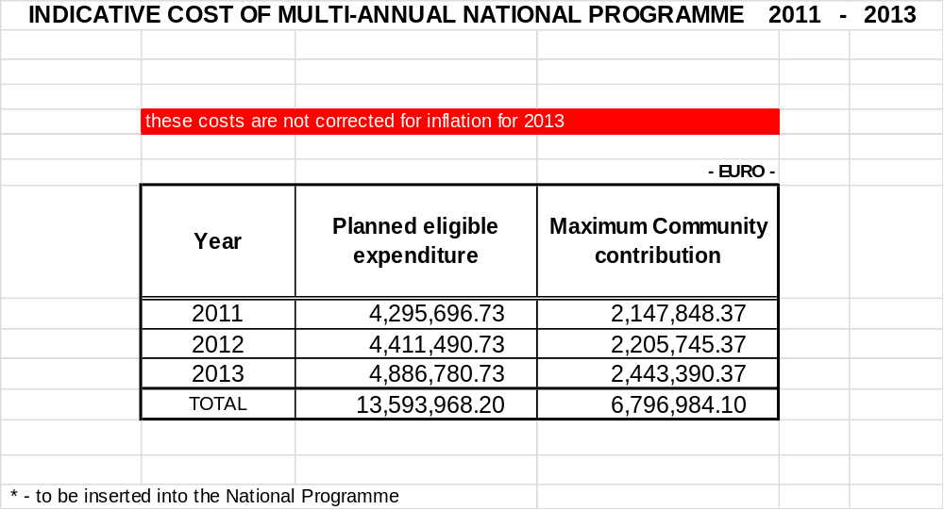

Annex 7 Biological Data Collection of pelagic fisheries in CECAF waters in compliance with the DCF

Version 2 24-10-2011

Version control:
Version 2 is the final project description for 2012-2013. The changes compares to the project proposal of May 31, 2011 are:
- Change from project proposal to project description
- Inclusion of contact details for Lithuania and Latvia. Corrections in contact details The Netherlands
- Correction of the number of observer days (table, chapter 9) 360 instead of 480. No implications for the programme as 360 was scheduled already. 480 was just a miscalculation in the table.

1 Introduction

In most marine waters in the world, management of fisheries is based on information of the fisheries and information of the fish stocks. Information is needed on the amount of vessels, the size of the vessels, the amount of fishing and the composition of the catch. Managers need that information to regulate the fishing activity. Scientists also need the information in order to be able to give advice to the managers on the potential exploitation of the fish stock and what the likely consequences of different management scenarios are.

Information is made available from the fishery by log-books and documents from fish auctions. This information is used to compile statistics on the catch composition and fishing activity of the vessel. It also identifies the gear which was used in the fishing operation. In addition sometimes information on the fishing area of the vessels is available by satellite monitoring (VMS).

Biological information of the catches and the fish stocks is collected by scientists by sampling programmes of the catch (landings and discards). This information is used to assess the dynamics of the stocks and its response to the fishery. Also surveys can provide information of the dynamics of the stock. The information from the surveys is fishery independent and is often used together with the information from the fishery in an assessment of the historical dynamics of the stock.

In 2002 the European Union (EU) introduced legislation which obliges EU Member States (MS) to collect data from the fisheries by EU fleets and the fish stocks they are fishing. This legislation consists of a set of Data Collection Regulations also called the DCR. The DCR was split in a Minimum Programme (MP) and an Extensive Programme (EP). The collection of data in the MP was mandatory and the collection of data in the EP was optional. The sampling of the stocks and fishery in Mauritanian waters was part of the optional programme. Therefore the EU MS (with the exception of Spain) fishing in CECAF waters had not included the biological sampling of the catches in this area in their national sampling programme.

Since 2009, the EU legislation has been revised. In the new set of Regulation and Decisions (also called the DCF) the focus has changes to sampling metiers rather than fish stocks. A metier is a group of vessels fishing with a similar gear on the same target species in the same area. Also the optional programme has disappeared. This means that sampling of catches in non EU waters (including Moroccan and Mauritanian) has become mandatory. Although the European Commission (EC) has given derogations for sampling this fishery in 2009-2011 to some countries, it has announced it will expect MS to start a sampling programme in 2012. Since a large part of the catch is landed in non EU countries, the access of MS to the sample the catch is limited. Therefore cooperation is sought with the countries which have access to the catches.

This document describes what kind and how much biological information is required from the pelagic fishery by EU vessels fishing in relevant waters based on the DCF. A summary is given of the relevant chapters in the Commission Decision which apply to sampling of the fishery in CECAF waters. In addition, Regional Fisheries Management Organisation may define data needs which of which the collection is also mandatory.

In this document, the relevant elements for the sampling of the pelagic stocks in CECAF waters are extracted from the DCF, and a common sampling programme is proposed which defines the sampling needs on a regional basis supported by all EU MS operating a pelagic fishery in this area.

1.1 Member States fishing in CECAF waters (except of Madeira fishing ground)

The fishery in Mauritanian, Moroccan and Guinea-Bissau waters is regulated through agreements between those countries and other parties including the EU. The first agreement with the EU dates from 1996. The recent fishery agreements contain conditions regarding logbooks and (scientific) observers.

Scientific advice is provided through CECAF, which is a regional science organisation like ICES with no management responsibility but supporting assessment WG.

The pelagic fishery takes place all year round, within the 200 miles zones the fisheries carried out by The Netherlands, Germany and France target the same species composition and can be considered as one metier. In this fishery, the main activity is from May to October directed to Sardinella aurita. During the rest of the year, there is a limited fishery on other species (sardines and horse mackerels). Part of the catch is landed into the EU in Las Palmas (Spain).

Other EU MS conducting pelagic fisheries in this area are Poland, Lithuania and Latvia. The fisheries of these (East European) countries is mainly directed to horse mackerel species and can be considered as a different métier in future, after obtaining more reliable data from observers programme described in this document.

The catches of metier are listed in the table below (source:RCM participants data)
metier OTM_SPF_>40_0_0
Member State | 2006 | 2007 | 2008 | 2009 | 2010 | average  2006-2010
Netherlands | 75 330 | 75 666 | 83 360 | 68 108 | 92 908 | 79 074
Germany | 15 407 | 13 198 | 0 | 0 | 20 395 | 9 800
France | 0 | 0 | 1 610 | 5 546 | 0 | 1 431
Poland | 0 | 0 | 17 708 | 46 287 | 14 605 | 15 720
Lithuania | 55 497 | 35 793 | 120 100 | 124 480 | 87 237 | 84 621
Latvia | 21 913 | 62 015 | 68 410 | 81 282 | 115 420 | 69 808
TOTAL | 168 147 | 186 672 | 291 188 | 325 703 | 330 565 | 260 455

The data in this table is incomplete and in the absence of reported information based on data provided by RCM participants. In 2008 and 2009, an Irish vessel was operating in Mauritania which does not show up in the logbook data base. The same applies for a UK vessel. German trawlers are all run by a Dutch company and are normally active in Mauritania occasionally (recently only in 2006 and 2007) and with one vessel in Morocco in 2010. Now (April 2011) they are back in Mauritania. Poland has started to fish in the 2008 and continues till now (by 2 vessels. There are 2 fishing companies from Lithuania that operates in CECAF area with total of 8 vessels.

There are 3 Latvian fishing companies - 7 vessels - operated in CECAF region. The main species in landings are horse mackerel, mackerel, pilchard, sardinella and anchovy. Catches are conducted for whole year.

Based on information from the NP2011 – 2013, tables below presents lists of countries which are obliged to sample. This ranking includes France, UK and Ireland, which have not included the area in theirs NP`s.

Selected metiers for sampling following DCF criteria are based on average of 2007-2008 data (Poland 2008 – 2009) (E: selected by effort, L: selected by landings, V selected by value
Region_REC | CECAF
FG REC draft | From Morocco to Guinea-Bissau
METIERS listed | ESP ** | POL** | GER | LAT | LIT | NLD | FRA, IRL, UK*
OTM_SPF_>=40_0_0 | *** | E,L,- | E,L,V | E,L,V | E,L,V | E,L,V | -
Effort listed in NP
Region_REC | CECAF
FG REC draft | From Morocco to Guinea-Bissau
METIERS listed | POL** | GER | LAT | LIT | NLD | FRA, IRL, UK*
OTM_SPF_>=40_0_0 | 150 | 33 | 962 | 1,452 | 597 | -

Landings listed in NP
Region_REC | CECAF
FG REC draft | From Morocco to Guinea-Bissau
METIERS listed | POL | GER | LAT | LIT | NLD | FRA, IRL, UK*
OTM_SPF_>=40_0_0 | 31,998 | 13,198 | 62,231 | 77,974 | 79,643 | -
* area not listed in NP
** no data for value
*** selected by volume of landings and because the first sale takes place in its territory

1.2 Present sampling activities in pelagic fisheries in CECAF waters

Spain

Spain (IEO) has included the sampling of the landings of the pelagic EU metiers in the CECAF/Mauritanian EEZ in their NP 2011-2013. The NP also includes the collection of biological parameters. Spain has been carrying out the sampling from 2004 till now, and the results of the monitoring are being presented to the relevant assessment WG.
Mauritania

After the termination of the RIVO-IMROP observer programme in 2005, a new observer programme has been set up by IMROP at present. This programme is financed entirely by the Mauritanian government. The Netherlands provided technical assistance through a small project (€50,000/yr in 2009 and 2010) financed by the Dutch ship owners association PFA and the Dutch Ministry of Agriculture, Nature and Food Quality. Corten Marine Research (CMR) is responsible for the Dutch technical cooperation project. The IMROP programme employs about 25-30 Mauritanian scientific observers which are to carry out an extensive sampling programme on board all industrial fishing vessels. This sampling also includes registration of discards and by-catches. The results of the monitoring are to be presented to the assessment WG for the CECAF area and used in the assessment.

Poland

Poland has started sampling programme in CECAF area in 2011. PL NP`s 2011 – 2013 include metiers and biological variables sampling during one trip per year which are carried out by the Sea Fisheries Institute observers.

Lithuania

In 2010 Fishery Service under the Ministry of Agriculture of Lithuania contracted 1 fishing company in for data collection. In 2011 a new contract was signed. Lithuania has neither scientists nor any other experts available for biological data collection in distant waters. Instead, fishing companies are obliged to commit one of the crew members to do such job (usually, they are fish technicians). In 2010 4th quarter in Morocco and Mauritania waters Lithuania sampled 6 different species in 9 trips, collected 16 samples and measured and weighed 4259 individuals.

Latvia

Research institute BIOR (Latvia) has signed agreement with one fishing company for data collection in 2011 in CECAF region.

Accordingly this agreement one technician provides fishing observation and collection of biological data due all fishing season from 1 vessel. The collection of biological data includes catch composition, discard data and length measurement.

The technician’s tasks in 2011 are:

- 1 length measurement of dominant fish species pro week (>=200 individuals in measurement);
- 1 by-catch length measurement 1 time pro 10 hauls;
- 1 discard length measurement 1 time pro 10 hauls.

2 Data Collection Framework (DCF)

The data collection framework consists of regulations adopted by the Council of Ministers of EU MS and regulations and decisions implemented by the European Commission (EC). The DCF consists of the following regulations and decisions (in force in 2011.)

2.1 COMMISSION DECISIONS

Commission Decision of 18 December 2009 (2010/93/EU): Adopting a multiannual Community programme for the collection, management and use of data in the fisheries sector for the period 2011-2013 (notified under document C (2009) 10121).

2.2 COMMISSION REGULATIONS

Commission Regulation (EC) No 665/2008 of 14 July 2008: Laying down detailed rules for the application of Council Regulation (EC) No 199/2008 concerning the establishment of a Community framework for the collection, management and use of data in the fisheries sector and support for scientific advice regarding the Common Fisheries Policy.

Commission Regulation (EC) No 1078/2008 of 3 November 2008: Laying down detailed rules for the implementation of Council Regulation (EC) No 861/2006 as regards the expenditure incurred by Member States for the collection and management of the basic fisheries data.

2.3 COUNCIL REGULATIONS

Council Regulation (EC) No 2347/2002 of 16 December 2002: establishing specific access requirements and associated conditions applicable to fishing for deep sea stocks.

Council Regulation (EC) No 861/2006 of 22 May 2006: Establishing Community financial measures for the implementation of the common fisheries policy and in the area of the Law of the Sea.

Council Regulation (EC) No 199/2008 of 25 February 2008: Concerning the establishment of a Community framework for the collection, management and use of data in the fisheries sector and support for scientific advice regarding the Common Fisheries Policy.

Corrigendum to Council Regulation (EC) No 199/2008 of 25 February 2008 concerning the establishment of a Community framework for the collection, management and use of data in the fisheries sector and support for scientific advice regarding the common fisheries policy.

2.4 The contents of the DCF

The table below has been taken over from the JRC website and provides a lay out of the data to be collected for the DCF. In addition, the DCF gives direction on the management, storage, protection and access to data, management of the National Programmes and coordination of data collection between MS. Also, instructions are given on the eligibility of costs which can be declared by the MS to the EC for co-financing.

The area of data collection described in this document is indicated by a colour in the table below and applies only to the pelagic fishery in CECAF waters.

 | DCF
 | Fishing |  |  |  |  | Aquaculture and Processing |  | Marine
 |  |  |  |  |  | Industry |  | Ecosystem
 | Econ Data | Bio Data |  | Transv Data | Research surveys at sea | Aquaculture: | Processing:
 | Econ Data | Metier | Stock | Transv Data | Research surveys at sea | Econ Data | Econ Data
 | Econ Data | related | related | Transv Data | Research surveys at sea
appendices | II , III , VI , VIII | I , II , IV , VII | VII | V , VIII | IX | X , XI | XII | II , XIII
variables
variables | Enterprises | Discards |  | Capacity | MEDITS |  | Income
(requested) | Employment | Effort |  | Effort | Small Pelagic |  | Personal c.
 | Income | Growth |  | Landings | Bottom trawl |  | Energy c.
 | Expenditure | Landings |  |  | Pelagic trawl |  | Raw Mat. c.
 | Capital Value | Maturity ogive |  |  |  |  | otherOper .
 |  | Sex ratio |  |  |  |  | Capital c.
 |  |  |  |  |  |  | Extraord. c.
 |  |  |  |  |  |  | CapitalValue
 |  |  |  |  |  |  | Net Investm.
 |  |  |  |  |  |  | Debt
 |  |  |  |  |  |  | Employment
 |  |  |  |  |  |  | Enterprises
disaggregation levels
sampling strategy
precision levels
exemption rules

3 Precision levels

In many cases it is required to report on the precision of the collected data. The DCF indicates what level of precision is required for certain data. The required precision affects the sampling strategy and the number of samples to be taken. The achieved precision can only be calculated afterwards and will be presented in the annual Report of Activities (former technical report) by each member state involved in sampling.

The required precision applies to the sampling of the national catches or regional catches.

Where reference is made to precision/confidence level the following distinction shall apply:

Level 0: |  | Precision of parameter is less than for 'level 1' i.e. parameter cannot be estimated within precision of plus or minus 40 % for a 95 % confidence interval and the coefficient of variation (CV) is higher than 20 %
Level 1: |  | Level making it possible to estimate a parameter either with a precision of plus or minus 40 % for a 95 % confidence level or a coefficient of variation (CV) of 20 % used as an approximation;
Level 2: |  | Level making it possible to estimate a parameter either with a precision of plus or minus 25 % for a 95 % confidence level or a coefficient of variation (CV) of 12,5 % used as an approximation;
Level 3: |  | Level making it possible to estimate a parameter either with a precision of plus or minus 5 % for a 95 % confidence level or a coefficient of variation (CV) of 2,5 % used as an approximation.
Level 4: |  | Level making: exhaustive data collection.
NR |  | Not Relevant. It is not possible to provide a meaningful calculation of the precision - e.g. because the variance is too large.
NA |  | Not Applicable. There is no obligation to estimate precision for this parameter.

4 Metier related variables

4.1 Pelagic metiers in Mauritanian waters operated by EU vessels

According to the metier classification rules in the Commission Decision there is one pelagic metier: OTM_SPF_>40_0_0. The code of the metier is given in the table below:

metier code | description
OTM_SPF_>40_0_0 | Pelagic trawls fishing for small pelagic fish with a mesh size greater than 40mm.

4.2 Variables

- quarterly length distribution of catches
- quarterly volume of discards

on a metier level and for the stocks listed in Appendix VII of the Commission Decision (Annex 5).

4.3 Disaggregation level

- by metier as defined by level 6 in appendix IV in the Commission Decision (mesh size)
- merging of metiers is allowed provided statistical evidence is provided regarded homogeneity of the combined metiers.
- spatial unit to be defined by Regional Fisheries Management Organisation

4.4 Sampling strategy

4.4.1 for the landings

- There are several sampling strategies proposed in the Commission Decision to sample the length distribution of the landings. For the pelagic fishery in CECAF waters we aim for scheme 1: comprehensive sampling of all species by observers on board of the vessels.
- description of sampling protocol required

4.4.2 for the discards

- The quarterly volume of discards must be estimated where discards in a given metier are estimated to exceed 10% of the total volume of the catches. If the volume of discards is less than 10% derogation for not sampling can be obtained if this can be demonstrated by recent pilot studies.
- quarterly length distribution of discards by species if discards are more than 10% of the species catch in weight or 15% of the species catch in numbers. These percentages do not apply to an individual haul or trip but to the metier.
- Minimum number of fishing trips to be sampled is 2 trips per quarter
- description of the sampling protocol required

4.5 Precision levels

- for the length distribution of the landings precision level 2
- for the length distribution of the discards precision level 1
- for the discard volume estimates by species precision level 1

5 Stock related variables

5.1 Variables

For those species indicated in Appendix VII biological information must be sampled to determine:

- weight at length
- sex ratio by length
- maturity at length by sex

This information has to be provided on a triennial basis. In principle, this sampling starts in 2012 and is repeated in 2015. For continuity purposes, annual sampling has to be considered by the MS involved.

5.2 Precision levels

The precision levels required are given below. The DCF gives guidelines on the range of observation to which the precision levels have to be estimated. The estimation of the precision levels is part of the analyses of the data and is not directly of relevance to the data collection in the field.

- level 2 for weight at length
- level 3 for sex ratio
- level 3 for maturity
6 Sampling programme data requirements

In principle, sampling of the catches encompasses both landings and discards, but when sorting takes place the length distribution of discards might differ due to the sorting practice. If only undersized fish is discarded, the length composition of the catch provides information on the length distribution of the discarded fraction. However, if discarding takes place due to other reasons, e.g. quality issues or species sorting, separate length distributions have to be determined, both for the discarded fraction as well as for the landings.

6.1 Metier related variables

In principle, this sampling programme aims for comprehensive sampling of all catches during a trip. This implies that during a trip, all hauls have to be sampled for length distribution of landings and discards for all species, as well as estimates of the proportion of discards have to be made.
For each trip the following parameters have to be registered:

- Name and registration number of the vessel
- Name and address details of the skipper
- Vessel power (in kW)
- Harbour and date/time of departure
- Harbour and date/time of arrival
- Target species of the trip
- Type of gear
- Mesh size of the cod-end
- Other special remarks

On haul level, a trawl list has to be used to register haul specific parameters:

- Haul number
- Date
- Time (UTM)
- Haul position (deg.min)
- Haul duration (hours, minutes)
- Estimated catch by species

6.1.1. Length distribution of landings

For each haul, the length distribution of the landings has to be determined by species. A representative sample of 25kg is taken from the retained catch. This sample is then sorted by species and for each species, the number of fish per cm-class (total length head-to-tip of the tail, cm-below except for sardine which is measured to 0.5cm-below is registered as well as the total weight of the sampled fish per species.

6.1.2 Length distribution of discards

As for landings, the length distribution of the discarded fraction has to be determined by species. A representative sample of 25kg is taken from the discarded catch. This sample is then sorted by species and for each species, the number of fish per cm-class (total length head-to-tip of the tail, cm-below except for sardine which is measured to 0.5 cm-below) is registered as well as the total weight of the sampled fish per species.

Incidental catches of less frequent or rare species (e.g. sharks, swordfish, tuna etc.) are collected and measured from a larger part of the catch or the whole catch. A multiplier for these measurements must be estimated and provided in order to raise the measurements to the total catch.

6.1.3 Estimation of proportion of volume of discards of the total catch

Proportion of discards has to be estimated on a haul level for all species combined based on the proportion of the weight discarded in relation to the catch. Distinguish between discarding and slipping. Slipping is the part of the catch which is released directly from the net and does not come on board. Also it is possible that part of the catch is kept on board in a tank and released in sea afterwards. Therefore no catch composition or length measurements are available from this part of the catch. It is acknowledged that estimates of slipping and tank releases are less precise that discard estimates.

In most cases the percentage discards in volume can be estimated from the information provided in sections 6.1, 6.1.1 and 6.1.2

6.1.4 Estimation of proportion of discards in weight and numbers by species listed in Appendix VII

For the species listed in Appendix VII, the proportion of discards in weight and in number has to be provided. These can be estimated from the information described above.

6.2 Stock related variables

Unlike the metier related variables, stock related variables have to be sampled for selected species only and with a lower frequency, once every three years. However, for continuity and assessment purposes, these data are to be collected every year. The species for which sampling of stock variables apply are specified in Appendix VII (Annex 5). For all species and each parameter, the sampling target is 100 measurements by quarter. The measurements will be carried out by the observers on board on the vessel.

On the sample level, the trip number, haul number and date has to record in order to enable trace back position of the samples.

The following parameters have to be collected for each individual fish:
- Length: total length to the millimeter (head to tip of the tail)
- Weight: ungutted weight in grams
- Sex: male, female, undetermined
- Maturity: scale as defined and used in the RFMO region. Maturity determination must be performed using relevant workshop results, following up Spanish experience and methodology.

7 Data formats, transfer and reporting

7.1 Aggregation of data

Chapter 6 describes the parameters needed to address the requests as laid down in the DCF. Data must be available in a database at the sampling level. This means that no aggregation must be applied for data stored in the database.

For the purpose of analyses e.g. in working groups data must be made available in aggregated in a format as is required by the data user.

7.2 Data formats for exchange

As sampling activities are carried out for several MS, no national data exchange format can be used. To facilitate easy data exchange in an international context, standardized Excel-spread sheet for non-aggregated data must be used for data exchange towards the MS. Each MS converts and transfers the information into its own national database. By means of bilateral agreements between MS, a different arrangement can be agreed.

Data will be provided by Microsoft Excel spread sheets. Examples of the data format are given in section 8.

7.3 Data storage

Pending alternative arrangements between MS, each MS holds its own responsibility towards the EU to collect data and to store this data in a national centralized database. Data collected within this sampling programme has to be stored in this database as well. Alternative arrangements can be made between MS and included in bilateral agreements between MS.

7.4. Data use

Data will be used to

- mandatory reporting on achieved sampling in AR
- to calculate precision levels by MS or RCM
- made available to end users in aggregated format as defined by the end user

7.5 Deadlines data transfer

- The deadline for reporting the achieved sampling in the Annual Report of Activities is 31 May of the year following the year where the data have been collected. This is also the date where data must be made available on request. This means that the data needs to be available for analyses in an accessible database before 31 May.
- The deadline for data transfer to the MS is April 1st in the year after the year where the data have been collected. This deadline is required in order to transfer the data to the national database, analyse the precision of the data and report the data in the AR.
- Data may need to be available earlier if they are used by a working group which is meeting in the first half of the year.
- Data will be send to contact persons listed in Annex 7.

7.6 Information required for reporting of planning and progress

MS of the EU are responsible for submitting a National Programme which describes the annual sampling programme and lists in detail the planned numbers of samples and measurements. The Annual Report of Activities reports on the achieved sampling in the previous years. All MS have to use the same format for reporting and the quantitative planning and reporting of achievements has to be done in a standard Microsoft Excel tables provided by the EC.

For planning and reporting, the same tables are used and a justification has to be given if the achieved sampling deviates from the planning. In addition the AR must report on achieved precision levels achieve by the sampling. This requires some analyses of the sampling data prior to reporting.

To fill these tables the following information of the sampling and the metiers has to be provided on yearly basis:

For the NP (planning)

- For metier (Table III_C_3):
  - Total number of trips planned in the area
  - Number of trips to be sampled on board
  - Number of trips to be sampled on shore

metier code | year | Total number of trips per year | Number of trips to be sampled on board per year | Number of trips to be sampled on shore | stratification
OTM_SPF_>40_0_0 | 2012 | 12 | 12 | 0 | quarter
OTM_SPF_>40_0_0 | 2013 | 12 | 12 | 0 | quarter

- For metiers combined by species (Table III_C_5):
  - Planned minimum number of fish measured at the regional level
  - precision level aimed for
  - time stratification of sampling (monthly)
species | year | Planned total minimum number of fish measured | precision level aimed for | stratification | Achieved total number of fish measured
Fanfantepenaeus notialis | 2012 |  | Level 2 (12.5%) | quarter
Lepidopus caudatus | 2012 |  | Level 2 (12.5%) | quarter
Sepia hierredda | 2012 |  | Level 2 (12.5%) | quarter
Sepia officinalis | 2012 |  | Level 2 (12.5%) | quarter
Loligo vulgaris | 2012 |  | Level 2 (12.5%) | quarter
Merluccius spp. | 2012 |  | Level 2 (12.5%) | quarter
Octopus vulgaris | 2012 |  | Level 2 (12.5%) | quarter
Parapenaeus longirostris | 2012 |  | Level 2 (12.5%) | quarter
Pristis pectinata | 2012 |  | Level 2 (12.5%) | quarter
Pristis pristis | 2012 |  | Level 2 (12.5%) | quarter
Pteroplatytrygon violacea | 2012 |  | Level 2 (12.5%) | quarter
Rajidae (d) | 2012 |  | Level 2 (12.5%) | quarter
Rhinobatos cemiculus | 2012 |  | Level 2 (12.5%) | quarter
Rhinobatos rhinobatos | 2012 |  | Level 2 (12.5%) | quarter
Sardina pilchardus | 2012 | 2000 | Level 2 (12.5%) | quarter
Sardinella aurita | 2012 | 2000 | Level 2 (12.5%) | quarter
Sardinella maderensis | 2012 | 500 | Level 2 (12.5%) | quarter
Scomber japonicus | 2012 | 500 | Level 2 (12.5%) | quarter
Shark-like Selachii | 2012 |  | Level 2 (12.5%) | quarter
Squatina aculeata | 2012 |  | Level 2 (12.5%) | quarter
Squatina aculeata | 2012 |  | Level 2 (12.5%) | quarter
Squatina squatina | 2012 |  | Level 2 (12.5%) | quarter
Trachurus spp. | 2012 | 2000 | Level 2 (12.5%) | quarter
Fanfantepenaeus notialis | 2013 |  | Level 2 (12.5%) | quarter
Lepidopus caudatus | 2013 |  | Level 2 (12.5%) | quarter
Sepia hierredda | 2013 |  | Level 2 (12.5%) | quarter
Sepia officinalis | 2013 |  | Level 2 (12.5%) | quarter
Loligo vulgaris | 2013 |  | Level 2 (12.5%) | quarter
Merluccius spp. | 2013 |  | Level 2 (12.5%) | quarter
Octopus vulgaris | 2013 |  | Level 2 (12.5%) | quarter
Parapenaeus longirostris | 2013 |  | Level 2 (12.5%) | quarter
Pristis pectinata | 2013 |  | Level 2 (12.5%) | quarter
Pristis pristis | 2013 |  | Level 2 (12.5%) | quarter
Pteroplatytrygon violacea | 2013 |  | Level 2 (12.5%) | quarter
Rajidae (d) | 2013 |  | Level 2 (12.5%) | quarter
Rhinobatos cemiculus | 2013 |  | Level 2 (12.5%) | quarter
Rhinobatos rhinobatos | 2013 |  | Level 2 (12.5%) | quarter
Sardina pilchardus | 2013 |  | Level 2 (12.5%) | quarter
Sardinella aurita | 2013 | 2000 | Level 2 (12.5%) | quarter
Sardinella maderensis | 2013 | 2000 | Level 2 (12.5%) | quarter
Scomber japonicus | 2013 | 500 | Level 2 (12.5%) | quarter
Scomber japonicus | 2013 | 500 | Level 2 (12.5%) | quarter
Shark-like Selachii | 2013 |  | Level 2 (12.5%) | quarter
Squatina aculeata | 2013 |  | Level 2 (12.5%) | quarter
Squatina aculeata | 2013 |  | Level 2 (12.5%) | quarter
Squatina squatina | 2013 |  | Level 2 (12.5%) | quarter
Trachurus spp. | 2013 | 2000 | Level 2 (12.5%) | quarter

- For the stock related variables by stock (Table III_E_3)
  - Planned number of fish measured for weight & length,
  - Planned number of fish investigated for maturity & length and
  - Planned number of fish investigated for sex-ratio & length

species | by year | data source | precision required | Planned minimum No of individuals to be measured at a national level
 |  |  |  | weight & length | maturity & length | sex-ratio & length
Fanfantepenaeus notialis | 2012-2013 | commercial | 0.025
Lepidopus caudatus | 2012-2013 | commercial | 0.025
Sepia hierredda | 2012-2013 | commercial | 0.025
Sepia officinalis | 2012-2013 | commercial | 0.025
Loligo vulgaris | 2012-2013 | commercial | 0.025
Merluccius spp. | 2012-2013 | commercial | 0.025
Octopus vulgaris | 2012-2013 | commercial | 0.025
Parapenaeus longirostris | 2012-2013 | commercial | 0.025
Pristis pectinata | 2012-2013 | commercial | 0.025
Pristis pristis | 2012-2013 | commercial | 0.025
Pteroplatytrygon violacea | 2012-2013 | commercial | 0.025
Rajidae (d) | 2012-2013 | commercial | 0.025
Rhinobatos cemiculus | 2012-2013 | commercial | 0.025
Rhinobatos rhinobatos | 2012-2013 | commercial | 0.025
Sardina pilchardus | 2012-2013 | commercial | 0.025 | 400 | 400 | 400
Sardinella aurita | 2012-2013 | commercial | 0.025 | 400 | 400 | 400
Sardinella maderensis | 2012-2013 | commercial | 0.025 | 400 | 400 | 400
Scomber japonicus | 2012-2013 | commercial | 0.025 | 400 | 400 | 400
Shark-like Selachii | 2012-2013 | commercial | 0.025
Squatina aculeata | 2012-2013 | commercial | 0.025
Squatina aculeata | 2012-2013 | commercial | 0.025
Squatina squatina | 2012-2013 | commercial | 0.025
Trachurus spp. | 2012-2013 | commercial | 0.025 | 400 | 400 | 400

For the AR (reporting)
- For each metier (Table III_C_3):
  - Total number of trips carried out by the metier
  - Total achieved number of sampling trips
  - Achieved number of trips carried out on board
  - Achieved number of trips carried on shore

metier code | year | Total number of trips achieved in the area | Number of trips to be sampled on board | Number of trips to be sampled on shore
OTM_SPF_>40_0_0_I | 2012 | 12 | 12
OTM_SPF_>40_0_0_I | 2013 | 12 | 12

- For metiers combined by species(Table III_C_5):
  - There is a problem with this table (specification will follow later)

- For the stock related variables by stock (Table III_E_3)
  - Achieved number of fish measured for weight & length,
  - Achieved number of fish investigated for maturity & length and
  - Achieved number of fish investigated for sex-ratio & length

species | by year | data source | Achieved No of individuals measured at a regional level |  |  | precision achieved
 |  |  | weight & length | maturity & length | sex-ratio & length | weight & length | maturity & length | sex-ratio & length
Fanfantepenaeus notialis | 2012-2013 | com
Lepidopus caudatus | 2012-2013 | com
Sepia hierredda | 2012-2013 | com
Sepia officinalis | 2012-2013 | com
Loligo vulgaris | 2012-2013 | com
Merluccius spp. | 2012-2013 | com
Octopus vulgaris | 2012-2013 | com
Parapenaeus longirostris | 2012-2013 | com
Pristis pectinata | 2012-2013 | com
Pristis pristis | 2012-2013 | com
Pteroplatytrygon violacea | 2012-2013 | com
Rajidae (d) | 2012-2013 | com
Rhinobatos cemiculus | 2012-2013 | com
Rhinobatos rhinobatos | 2012-2013 | com
Sardina pilchardus | 2012-2013 | com | 400 | 400 | 400 | Level 2 | Level 2 | Level 2
Sardinella aurita | 2012-2013 | com | 400 | 400 | 400 | Level 2 | Level 2 | Level 2
Sardinella maderensis | 2012-2013 | com | 400 | 400 | 400 | Level 2 | Level 2 | Level 2
Scomber japonicus | 2012-2013 | com | 400 | 400 | 400 | Level 2 | Level 2 | Level 2
Shark-like Selachii | 2012-2013 | com
Squatina aculeata | 2012-2013 | com
Squatina aculeata | 2012-2013 | com
Squatina squatina | 2012-2013 | com
Trachurus spp. | 2012-2013 | com | 400 | 400 | 400 | Level 2 | Level 2 | Level 2

Next to the technical information in the tables, the sampling methodology has to be described as well as a description of sampling problems encountered during the year. The information has to be ordered following the strict guidelines as laid down by the EU.

Reporting to the EC

The Netherlands will include the planning and reporting of the monitoring activities of the pelagic fisheries in CECAF waters in its NP and AR. The other MS, which are included in the co-ordinated programme will refer in their NP and AR to the programme of the Netherlands. The delegation of the sampling responsibities between MS will be adressed in their bilateral agreements.
8 Data exchange formats

The IMROP observers presently use Excel spreadsheets for reporting their data to IMROP. These sheets can also be used for the DCF programme. The main formats are:

(a) Trawl station list (caractéristiques des stations). An example of this is given in annex 1.

(b) Trip summary (fiche de synthèse).This format allows a rapid analysis of data on catch composition and length data, without the need of first entering them in a relational data base. An example is given in annex 2.

(c). Biological data form (fiche données biologiques). This form contains one line per fish, with data on catching time and position, length, weight, sex, maturity and fat content. An example is given in Annex 3.

9 Budget

To comply with the DCF requirements, a minimum of three observer trips will be made per type of fishery (metier) and per quarter of the year.

The sampling will be conducted by IMROP observers that normally also work on other industrial fishing vessels in Mauritania. In order to fulfil the requirements of the DCF, additional trips will have to be scheduled on board EU vessels.

The data entry and quality control will be done by IMROP observers, under the supervision of CMR (Corten Marine Research). The final responsibility of data quality and transmission of data to the European Commission rests with CMR.

When sampling catches on board large pelagic trawlers, IMROP observers normally work in pairs. This facilitates the sampling in the factory, and it also allows one observer to monitor by-catches of protected species on the fishing deck while the other continues the sampling in the factory. For all trips to be made, two observers have been budgeted. The minimum duration of a trip on board a pelagic trawler is 15 days.

The project will use the existing facilities of CMR at the IMROP institute in Nouadhibou (office space, car etc.) at no extra costs. Part of the work by CMR will be done in the framework of the existing cooperation project between the Netherlands and Mauritania. This work is financed by the Dutch Pelagic Freezer trawler Association (PFA) and the Ministry of Economic Affairs, Agriculture and Innovation (ELI). Only the addition costs (including labour) made by CMR will be charged to the Commission.

For EU vessels that operate from the port of Las Palmas, the observers will have to embark or disembark in this port. For this purpose, a budget for air tickets has been included.

Estimated costs of the data collection in Mauritania for the DCF per year (in Euro)

IMROP observer per day (Euro) | 120
observer days per year = 12 x 15 x 2 | 360
total costs IMROP observers per year |  | 43200
material (balance, working clothes, etc.) per year |  | 4000
travel costs IMROP observers per year* |  | 4800
CMR fee for 12 working days (incl. VAT) per year |  | 8568
CMR additional travel costs (2 trips to Nouadhibou) per year |  | 4000
CMR bank fees per year |  | 200
total estimated costs per year |  | 64768

*) 12 tickets of 400 Euro
Annex 1 Format for exchange of trawl station data

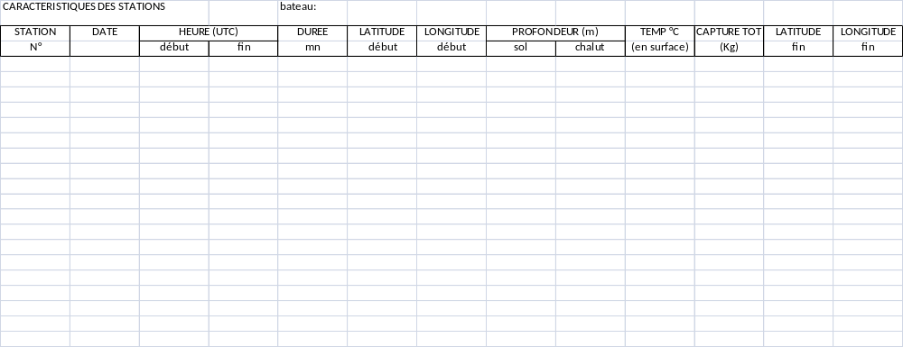

Annex 2 Format for exchange of catch composition and length data

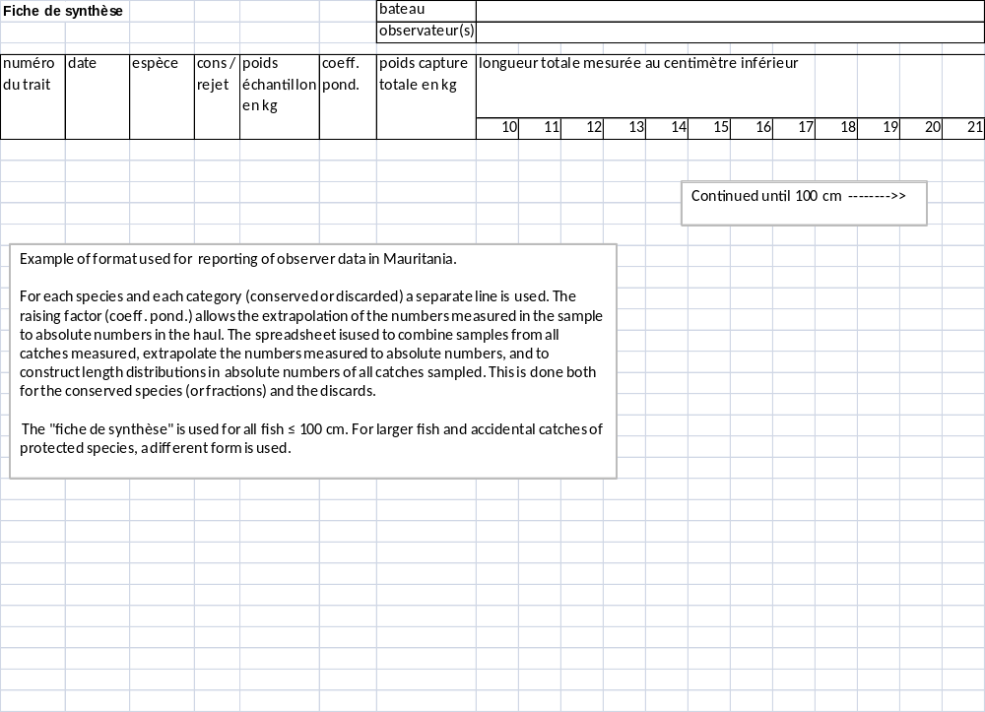

Annex 3 Format for exchange of biological data

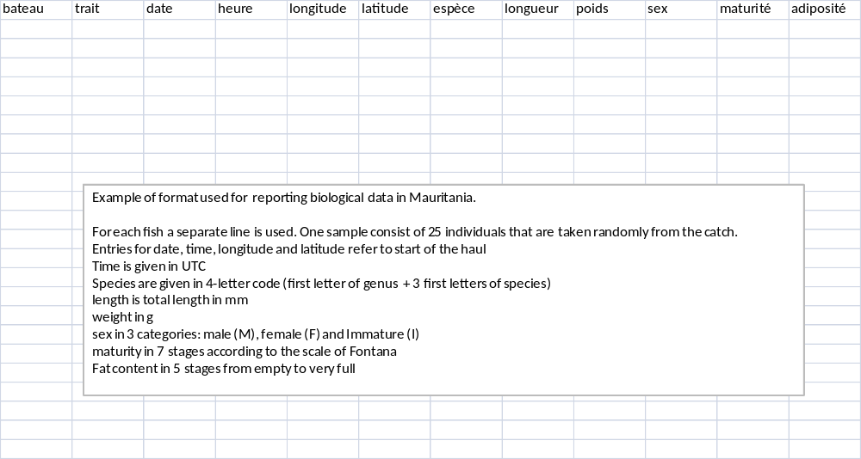

Annex 4 Extract from Appendix IV from the Commission Decision of 18.12.2009

Extraction from Appendix IV from the Commission Decision of 18.12.2009 adopting a multiannual Community programme for the collection, management and use of data in the fisheries sector for the period 2011-2013. C(2009)10121 final
- Other regions where fisheries are operated by EU vessels and managed by RFMO's to which the Community is contracting party or observer (e.g. ICCAT, IOTC, CECAF…)

Level 1 | Level 2 | Level 3 | Level 4 | Level 5 | Level 6 | LOA classes (m)
Activity | Gear classes | Gear groups | Gear type | Target assemblage (b) | Mesh size and  other selective  devices | < 10 | 10-<12 | 12-<18 | 18-<24 | 24-<40 | 40 & +
Fishing activity | Trawls | Bottom trawls | Bottom otter trawl [OTB] | Crustaceans | (a)
 |  |  |  | Demersal fish | (a)
 |  |  |  | Mixed cephalopods and demersal fish | (a)
Fishing activity | Trawls | Bottom trawls | Multi-rig otter trawl [OTT] | Crustaceans | (a)
Fishing activity | Trawls | Pelagic trawls | Midwater otter trawl [OTM] | Small pelagic fish | (a)
Fishing activity | Hooks and Lines | Rods and Lines | Hand and Pole lines [LHP] [LHM] | Large pelagic fish | (a)
 |  |  |  | Demersal fish | (a)
Fishing activity | Hooks and Lines | Longlines | Drifting longlines [LLD] | Large pelagic fish | (a)
Fishing activity | Hooks and Lines | Longlines | Set longlines [LLS] | Demersal fish | (a)
Fishing activity | Traps | Traps | Pots and Traps [FPO] | Crustaceans | (a)
 |  |  |  | Finfish | (a)
Fishing activity | Nets | Nets | Trammel net [GTR] | Demersal fish | (a)
Fishing activity | Nets | Nets | Set gillnet [GNS] | Demersal fish | (a)
Fishing activity | Nets | Nets | Driftnet [GND] | Demersal fish | (a)
Fishing activity | Seines | Surrounding nets | Purse seine [PS] | Small pelagic fish | (a)
 |  |  |  | Large pelagic fish | (a)
Fishing activity | Misc. (Specify) | Misc. (Specify) |  |  | (a)
Other activity than fishing |  |  |  | Other activity than fishing
Inactive |  |  |  | Inactive

Footnote:
(a) As defined in Regulations (EC) No 600/2004, 830/2004, 115/2006, 563/2006, 764/2006, 805/2006, 1562/2006, 1563/2006, 1801/2006, 2027/2006, 450/2007, 753/2007, 893/2007, 894/2007, 1386/2007, 1446/2007, 31/2008, 241/2008 and 242/2008
(b) The retained part of the catch should be classified by target assemblage (crustaceans, cephalopods, demersal fish, etc.) at a trip level or at a fishing operation level where possible, and sorted by weight or by total value in the case of valuable species (e.g. Nephrops, Tunas). The target assemblage that comes up at the first position should be considered as the target assemblage to be reported in the matrix.

Annex 5 Extract from Appendix VII from the Commission Decision of 18.12.2009
Extraction from Appendix VII from the Commission Decision of 18.12.2009 adopting a multiannual Community programme for the collection, management and use of data in the fisheries sector for the period 2011-2013. C(2009)10121 final

List of Biological variables with species sampling specification
(Y= Yearly; T= every three years)

CECAF FAO 34
Species (Engl.) | Species (Latin) | Area/Stock | Species group(a) | Age  no/1000t | Weight | Sex | Maturity | Fecundity
Black scabbardfish | Aphanopus carbo | Madeira | G1 |  | T | T | T
Anchovy | Engraulis encrasicolus | Morocco | G1 |  | T | T | T
Southern pink shrimp | Fanfantepenaeus notialis | all areas | G1 |  | T | T | T
Silver scabbardfish | Lepidopus caudatus | Mauritania | G2
Common squid | Loligo vulgaris | all areas | G2 |  | T | T | T
Hake | Merluccius spp. | all areas | G1 |  | T | T | T
Common octopus | Octopus vulgaris | all areas | G1 |  | T | T | T
Deepwater rose shrimp | Parapenaeus longirostris | all areas | G1 |  | T | T | T
Smalltooth sawfish | Pristis pectinata | all areas | G1
Common sawfish | Pristis pristis | all areas | G1
Blue stingray | Pteroplatytrygon violacea | all areas | G1
Other rays and skates | Rajidae (d) | all areas | G1
Blackchin guitarfish | Rhinobatos cemiculus | all areas | G1
Common guitarfish | Rhinobatos rhinobatos | all areas | G1
Sardine | Sardina pilchardus | all areas | G1 |  | T | T | T
Round sardinella | Sardinella aurita | all areas | G1 |  | T | T | T
Short-body sardinella | Sardinella maderensis | all areas | G1 |  | T | T | T
Chub mackerel | Scomber japonicus | Madeira | G1
Chub mackerel | Scomber japonicus | all areas except Madeira | G1 |  | T | T | T
Cuttlefish | Sepia hierredda | all areas | G1 |  | T | T | T
Cuttlefish | Sepia officinalis | all areas | G1 |  | T | T | T
Sharks | Shark-like Selachii | all areas | G1
Sawback aculeata | Squatina aculeata | all areas | G1
Smoothback angelshark | Squatina aculeata | all areas | G1
Angelshark | Squatina squatina | all areas | G1
Horse mackerel | Trachurus spp. | all areas | G1 |  | T | T | T

Annex 6 Abbreviations used in this document

AR | Annual Report of Activities (previously Technical Report). This is a report to be submitted by the MS every year to report on the achieved data collection in the previous year
CMR | Corten Marine Research
CV | Coefficient of variation
EC | European Commission
EU | European Union
DCF | Data Collection Framework. A set of Regulations and Decisions by the European Council and European Commission which describes the data collection
DCR | Data Collection programme before the DCF
EEZ | Exclusive Economic Zone
IEO | Instituto Español de Oceanografia
IMARES | Institute for Marine Resources and Ecosystem Studies in the Netherlands
IMROP | Mauritanian Institute for Oceanographic Research and Fisheries
MS | Member States of the European Union
PFA | Pelagic Freezer-Trawler Association
RIVO | now included in IMARES

Annex 7. Contacts

Dirk Jan van der Stelt (National Correspondent Netherlands)
Ministry of Economic Affairs, Agriculture and Innovation
Prins Clauslaan 8
Post-box 20401
2500 EK Den Haag
Netherlands
E-mail: d.j.van.der.stelt@minlnv.nl
Phone: +31 70 3793911

Frans van Beek (biologist Netherlands)
Centre for Fisheries Research (CVO)
Haringkade 1
Post-box 68
1970 AB IJmuiden
Netherlands
E-mail: frans.vanbeek@wur.nl
Phone: +31 317 487044

Ad Corten (biologist Netherlands)
Corten Marine Research BV
De Waterdief 52
1911 JT Uitgeest
Netherlands
E-mail: adcorten@yahoo.co.uk
Phone +31 251 313280

Dr. Christoph Stransky (National Correspondent Germany)
Johann Heinrich von Thünen Institute [vTI]
Institute of Sea Fisheries
Palmaille 9, 22767 Hamburg
Germany
E-mail: christoph.stransky@vti.bund.de
Phone: +49 40 38905-228

Zbigniew Karnicki (National Correspondent, Poland)
The Sea Fisheries Institute in Gdynia
Kollataja 1, 81-332 Gdynia, Poland
karnicki@mir.gdynia.pl

Ireneusz Wójcik (senior specialist Poland)
The Sea Fisheries Institute in Gdynia
Kollataja 1, 81-332 Gdynia, Poland
iwojcik@mir.gdynia.pl

Jerzy Janusz (biologist, Poland)
The Sea Fisheries Institute in Gdynia
Kollataja 1, 81-332 Gdynia, Poland
jjanusz@mir.gdynia.pl

Georgs Kornilovs (National Correspondent, Latvia)
Latvian Fish Resources Agency
Daugavgrivas Street 8
LV-1048 Riga, Latvia
Georgs.kornilovs@bior.gov.lv

Vytautas Grusauskas (Director, Lithuania)
Ministry of Agriculture of the Republic of Lithuania
J. Lelevelio Street 6
01103 Vilnius, Lithuania
Contact: Brigita Kukonenko (chief specialist) Brigita.Kukonenko@zum.lt

COUNCIL REGULATION (EC) No 861/2006 of 22 May 2006 establishing Community financial measures for the implementation of the Common Fisheries Policy and in the area of the Law of the Sea COUNCIL REGULATION (EC) No 199/2008 of 25 February 2008 concerning the establishment of a Community framework for the collection, management and use of data in the fisheries sector and support for scientific advice regarding the Common Fisheries Policy COMMISSION REGULATION (EC) No 665/2008 of 14 July 2008 laying down detailed rules for the application of Council Regulation (EC) No 199/2008 concerning the establishment of a Community framework for the collection, management and use of data in the fisheries sector and support for scientific advice regarding the Common Fisheries Policy COMMISSION DECISION (2008/949/EC) adopting a multi annual Community programme pursuant to Council Regulation (EC) No 199/2008 establishing a Community framework for the collection, management and use of data in the fisheries sector and support for scientific advice regarding the Common Fisheries Policy COMMISSION REGULATION (EC) No 1078/2008 of 3 November 2008 laying down detailed rules for the implementation of Council Regulation (EC) No 861/2006 as regards to the expenditure incurred by Member States for the Collection and management of the basic fisheries data
Guidelines for the submission of National Programme Proposals on the National Data Collection Programmes under Council Regulation (EC) 199/2008, Commission Regulation (EC) 665/2008 and Commission Decision 2008/949/EC Version 2009
fishing in the 12 miles coastal zone and plaice box
COUNCIL REGULATION (EC) No 1100/2007 of 18 September 2007 establishing measures for the recovery of the stock of European eel
Verver, S.W. Handboek Marktbemonstering zeevisserij 2011, CVO 10.011 (in Dutch)
Helmond, A.T.M., van A.S. Couperus, S.S. Uhlmann, R.A. Bol and R.R. Nijman. 2011. Handboek discardbemonstering en bijvangst registratie. CVO rapport 11.009.
The sampling fleet consists of a few selected vessels. On these vessels, the crew takes samples of the catch, which will be processed on shore. The crew is trained by IMARES staff.
Borges, L., O.A. van Keeken, A.T.M. van Helmond, B. Couperus & M. Dickey-Collas. 2008. What do pelagic freezer-trawlers discard? Journal of Marine Science, 65: 605-611.
Helmond, A.T.M., S.S. Uhlmann, H.M.J. van Overzee, S.M. Bierman, R.A. Bol and R.R. Nijman. 2010. Discard sampling of Dutch bottom-trawl fisheries in 2009 and 2010. CVO report 11.008
Helmond, A.T.M. van and H.M.J. van Overzee. 2011. Discard sampling of the Dutch pelagic freezer fishery in 2010. CVO Report 11.010 Helmond, A.T.M. van and H.J.M. van Overzee 2010. Discard sampling of the Dutch pelagic freezer fishery in 2008 and 2009. CVO report 10.008 Helmond, A.T.M. van, and H.M.J. van Overzee. 2009. Discard sampling of the Dutch pelagic freezer fishery in 2003-2007. CVO report 09.001
Borges, L., O.A. van Keeken, A.T.M. van Helmond, B. Couperus and M. Dickey-Collas. 2008. What do pelagic freezer-trawlers discard? ICES Journal of Marine Science Advance Journal of Marine Science, 65: 605-611.
Helmond, A.T.M., van A.S. Couperus, S.S. Uhlmann, R.A. Bol and R.R. Nijman. 2010. Handboek discardbemonstering en bijvangst registratie. CVO rapport 11.009.

