Dutch Ministry of Agriculture, Nature and Food Quality, The Hague
Wageningen Marine Research, IJmuiden
Wageningen Economic Research, The Hague

Commission Implementing Decision (EU) 2017/1004
on the establishment of a Union framework for the collection, management and use of data in the fisheries sector and support for scientific advice regarding the common fisheries policy and repealing Council Regulation (EC) No 199/2008 (recast).
Commission Implementing Decision (EU) 2016/1251 of 12 July 2016 adopting a multiannual Union programme for the collection, management and use of data in the fisheries and aquaculture sectors for the period 2017-2019.
Commission Implementing Decision (EU) 2016/1701
laying down rules on the format for the submission of work plans for data collection in the fisheries and aquaculture sectors.
Commission Implementing Decision (EU) 2018/1283
laying down rules on the format and timetables for the submission of annual data collection reports in the fisheries and aquaculture sectors.

Netherlands Annual Report for data collection in the fisheries and aquaculture sectors
2018
Version [1]

[The Hague, May 23, 2019]
CONTENTS
Section 1: Biological data 3
Text Box 1C: Sampling intensity for biological variables 3
Text Box 1D - Recreational fisheries 5
Pilot Study 1: Relative share of catches of recreational fisheries compared to commercial fisheries 5
Text Box 1E: Anadromous and catadromous species data collection in fresh water 7
Text box 1F: Incidental by-catch of birds, mammals, reptiles and fish 8
Pilot Study 2: Level of fishing and impact of fisheries on biological resources and marine ecosystem 9
Text Box 1G: List of research surveys at sea 10
Region: North Sea and Eastern Arctic 10
Region: North Atlantic 24
Section 2: Fishing Activity Data 27
Text Box 2A: Fishing activity variables data collection strategy 27
Section 3: Economic and Social Data 29
Text Box 3A: Population segments for collection of economic and social data for fisheries 29
Pilot Study 3: Data on employment by education level and nationality 32
Text Box 3B: Population segments for collection of economic and social data for aquaculture 33
Pilot Study 4: Environmental data on aquaculture 35
Text Box 3C: Population segments for collection of economic and social data for the processing industry 35
Section 4: Sampling Strategy for Biological Data from Commercial Fisheries 37
Text Box 4A: Sampling plan description for biological data 37
Section 5: Data quality 38
Text Box 5A: Quality assurance framework for biological data 38
Text Box 5B: Quality assurance framework for socioeconomic data 39

Section 1: Biological data

Text Box 1C: Sampling intensity for biological variables
General comment: This box fulfils paragraph 2 point (a)(i)(ii)(iii) of Chapter III, Chapter IV of the multiannual Union programme and Article 2, Article 4 paragraph 1 and Article 8 of the Decision (EU) 2016/1701. This box is applicable to the Annual Report.
- Evidence of data quality assurance
- For area 87: Data collection is carried out by Poland under a Multilateral agreement. Quality assurance is based on end-user (SPFRMO) needs and specifications.
- For area 34: Data collection is carried out by Poland under a Multilateral agreement. The sampling protocol is based on end-user (CECAF) needs and provided with the Multi-lateral agreement in the Workplan.
- For area 27:
  - On-shore sampling: As described in the accepted workplan, sampling of demersal vessels is based on random selection of vessels visiting the main auctions in The Netherlands. Both national and foreign vessels are sampled. Pelagic fish is not auctioned, catch samples are collected on board of a fixed (depends on activities in EU Waters) selection of trawlers, including foreign vessels landing into the Netherlands.
  - At-sea sampling: As described in the accepted Workplan, at-sea sampling occurs on board four pre-defined sampling populations: passive demersal gears (DEMPAS), shrimpers (SHRIMP), active demersal gears (DEMACT) and pelagic gears (PEL1). The Netherlands is currently working towards improved random sampling of the sampling populations. The sampling plan for DEMACT is based on a reference fleet scheme. A representative selection of 20-25 vessels from the sampling population collects discard samples (self-sampling) following a random sampling schedule. For DEMPAS it has been tried to apply random sampling, but in practice it has proven to be extremely difficult to implement random sampling since the activity of vessels within this sampling population is highly variable and this fishery has a strong seasonal and weather dependent character.
Routine data quality checks and data validation exercises of both on-shore and at-sea sampling are executed during data entry (standardized data entry software) and prior to and during data import (standardized checking routines and data import procedures). Standardized raising procedures including quality control are used for data preparation prior to data transmission to end-users.
- Deviations from the Work Plan
- For area 87: See AR Poland.
- For area 34: See AR Poland as from 2018 onwards, Poland coordinates and executes the sampling programme in Area 34 under a multilateral agreement with Germany, Latvia, Lithuania and the Netherlands.
- For area 27:
  - On-shore sampling: The deviations between planned and achieved numbers of individuals mainly stem from discrepancies in the planned number for the various variables. E.g. for on-shore sampling the planned number of length measurements is in general an underestimation as this number originated from length@age numbers, rather than length measurements only. This has been corrected in the 2019 update of the NLD Workplan. For Scomber scombrus the total number of achieved samples over all regions is (more than) sufficiently covered. By design, the pelagic sampling follows the fishery, hence activity shifts between regions are reflected in sampling achievements. As a consequence, this may lead to apparent over- or undersampling for a specific region. On species level however, the planned numbers are all met in those cases. Rays and seabass are subject to specific landing restrictions, limiting the possibilities to sample these species. As a result, these species are undersampled. In some cases, e.g. for Nephrops norvegicus, additional commercial categories were added by the industry, resulting in additional categories to sample and thus an increased number of individuals that may be mistaken for oversampling.
  - At-sea sampling: While for a number of species the achieved numbers deviate from the planned numbers, the planned trips were reached for nearly all stratum_codes (Table 4A). The deviations between planned and achieved numbers of individuals for a few species stem from discrepancies in the planned number for the various variables E.g. the planned number of length measurements is in general an underestimation as this number originated from length@age numbers, rather than length measurements only. This has been corrected in the 2019 update of the NLD Workplan. In 2018, for a few species the achieved numbers deviate from the planned numbers. Over- or undersampling for these species is caused by the fact that sampling follows the fishery. This fact will continue to have an impact in future years, eventhough the planned numeber have been tuned to previous achievementsFurthermore, for a number of species, e.g. Raja Brachyura, the achieved number deviates from the planned number as the planned number is a theoretical number.
- Actions to avoid deviations.
- For area 27:
  - On-shore sampling: Limited possibilities exist to achieve higher numbers of individuals for rays and seabass. Any sampling event is however seen as an opportunity to collect samples for these species, whenever these species are available for sampling.
  - Incorrect planned numbers have been corrected in the approved 2019 NLD Workplan

Section 1: Biological Data

Text Box 1D - Recreational fisheries
General comment: This box fulfills paragraph 2 point (a) (iv) of Chapter III of the multiannual Union programme and Article 2, Article 3 and Article 4 paragraph 1 of the Decision (EU) 2016/1701. This box is applicable to the Annual Report. This box is intended to provide information on the design, implementation and analysis of all components of sampling schemes/ surveys that are listed in Table 1D.
1. Description of the target population
The target population is the whole population of resident recreational fishers fishing in The Netherlands. Recreational fishers are mainly anglers.
A small group are marine gillnet fishermen. The group of gillnet fishers is decreasing because of the recent prohibition to retain seabass and because of the old age of this group. Gillnet recreational fishery is analysed separately.
2. Type of survey
The Netherlands carries out a multiannual sampling programme covering all recreational fisheries in fresh and marine waters. The surveys are directed to cod and eel but also provide information on other species such as sharks. As there is no licence system in the Netherlands from which recreational fishermen can be identified, the programme consists of screening survey covering about 50.000 randomly selected households. These households are questioned on their participation in recreational fishery as part of a screening survey. Based on the results of this screening survey about 2000-2500 recreational fishermen have been selected to provide information on their recreational catches in a diary survey.
Information on the design can be found in Table 5A.
3. Data Quality
Non-responses and refusals are recorded in table 5A. Documentation on data quality can be found in the link in table 5A (van der Hammen et al., 2015)
4. Data Analysis and processing
Information about data processing is found in the Work Plan, Table 5A.
Section 1: Biological Data

Pilot Study 1: Relative share of catches of recreational fisheries compared to commercial fisheries
General comment: This box fulfils paragraph 4 of Chapter V of the multiannual Union programme and Article 2 and Article 4 paragraph (3) point (a) of the Decision (EU) 2016/1701.
General comment: This box is applicable to the Annual Report. This box is intended to provide information on the results obtained from the implementation of the pilot study.
- Aim of pilot study
- Duration of pilot study
- Methodology and expected outcomes of pilot study
not applicable (no pilot study)

Section 1: Biological Data

Text Box 1E: Anadromous and catadromous species data collection in fresh water
General comment: This box fulfills paragraph 2 points (b) and (c) of Chapter III of the multiannual Union programme and Article 2 of the Decision (EU) 2016/1701.
General comment: This box is applicable to the Annual Report.
1. Method selected for collecting data.
In the Netherlands, eel (Anguilla anguilla) is the only diadromous fish species that is fished commercially in freshwater. In 2010 the Ministry of Economic Affairs (currently Ministry of Agriculture, Nature and Food Quality) introduced an obligatory online catch registration for all inland waters. In 2012 effort data (type and number of fishing gears) was added to the registration system. In the catch & effort registration system, yellow eel and silver eel catches are not separated. Since 2010 the existing market sampling programme that in Lake IJsselmeer/Lake Markermeer has been implemented in the whole country. Roughly one sample represents 10 tonnes of catch. A sample consists of length measurements of max. 200 eels. In addition to collecting data on the length frequency of the catch, eels are collected for biological sampling (life stage, length, weight, sex, age). Annually several hundred eels are dissected for biological samples and a subset of 50-100 eels are selected for ageing.
2. Were the planned numbers achieved?
In general, the planned numbers were achieved or planned numbers were exceeded (see Table 1E). The only non-conformity is explained in Table 1E and below:
Glass eel sampling was carried out on 9 instead of 11 locations in 2018. This is due to the set-up of the programme, which relies on volunteers on most of the locations. Some of the planned locations could not be manned, but the data used by WGEEL (ICES), the long-term series at Den Oever, is not sampled by volunteers and has been continued.

Actions to avoid deviations: a new methodology is being developed to depend less on volunteers. Glass eel will be sampled with glass eel traps, starting on a number of locations in 2019 and expanding in the years after.

Section 1: Biological Data

Text box 1F: Incidental by-catch of birds, mammals, reptiles and fish
General Comment: This box fulfils paragraph 3 point (a) of Chapter III of the multiannual Union programme and Article 2 of the Decision (EU) 2016/1701. This box is applicable to the Annual Report. This box is applicable only for those sections where Member States have reported that they have been carrying out regular sampling. Results and deviations for Pilot studies should be reported under Pilot Study 2.
1. Results
During all observer trips on board commercial vessels (i.e. 1117 hauls) the scientific observers have recorded incidental bycatches (this also includes zero bycatch) and corresponding observation effort on a haul level. The observed incidentally by-caught species were generally released dead.
2. Deviations from Work Plan
none
3. Data quality
The onboard observer protocol states that (i) the observer registers whether the cod-end was checked in a haul for incidental bycatches, (ii) in gillnet and hook-and-line fisheries the observer registers how much of the hauling process has been observed for incidental bycatches which never came on board, (iii) in active fisheries the observer indicates what percentage of the sorting or hauling process has been checked at haul level, and (iv) the observer should report the use of mitigation devices. The sampling protocol follows recommendations from ICES Working Group on Bycatch of Protected Species (WGBYC).
Routine data quality checks and data validation exercises are executed during data entry (standardized data entry software) and prior to and during data import (standardized checking routines and data import procedures). Data is stored in the WMR database (Frisbe).

Section 1: Biological Data

Pilot Study 2: Level of fishing and impact of fisheries on biological resources and marine ecosystem
General comment: This Box fulfills paragraph 3 point (c) of Chapter III of the multiannual Union programme and Article 2 and Article 4 paragraph (3) point (b) of the Decision (EU) 2016/1701.
General comment: This box is applicable to the Annual Report. This box is intended to provide information on the results obtained from the implementation of the pilot study.
No pilot study planned for 2018, pending discussion at regional level with main end-users on needs (variables to deliver, spatio-temporal distribution etc.).
Not applicable

Section 1: Biological Data

Text Box 1G: List of research surveys at sea

Region: North Sea and Eastern Arctic
Survey: International Bottom Trawl Survey (IBTS)
The IBTS is carried out twice a year, one survey is conducted in the first quarter and a second survey in the third quarter. The Netherlands participates only in the first quarter (Q1) survey with RV Tridens (25 days at sea). The survey is listed in 2016/1251 Table 10. The continuity of the previous survey design is guaranteed by participation in the coordinating survey group (IBTSWG).
Objectives of the survey
The ICES SISP Manual for the International Bottom Trawl Surveys (revision IX) describes the current objectives:
- To determine the distribution and relative abundance of pre‐recruits of the main commercial species with a view of deriving recruitment indices;
- To monitor changes in the stocks of commercial fish species independently of commercial fisheries data;
- To monitor the distribution and relative abundance of all fish species and selected invertebrates;
- To collect data for the determination of biological parameters for selected species;
- To collect hydrographical and environmental information;
- To determine the abundance and distribution of late herring larvae (February North Sea survey).
Description of the methods used in the survey
During daytime, GOV trawl hauls are conducted. At night time, a Method Isaac Kidd (MIK) plankton trawl is deployed. Hydrographical data is collected with a CTD (downcast) at every trawl station. Since 2011, litter from the trawl catch is being sorted and registered. The complete sampling procedure and the level of precision are defined in the ICES SISP Manual for the International Bottom Trawl Surveys (revision IX) and the Manual for the Midwater Ring Net sampling during IBTS Q1 (revision 2).
The ICES IBTS Working Group (IBTSWG) decides annually on the sampling areas for the contributing MSs. The area to be covered by the Netherlands in 2017 is presented in Figure 1 in the NLD WP 2017-2019. The sampling areas were re-distributed during IBTSWG 2016, and may be changed for 2018 and 2019 by the group.
Coordination and participation
The survey is coordinated by the ICES IBTS Working Group (IBTSWG) and performed in collaboration with research vessels from France, Germany, Denmark, Sweden, UK and Norway.
The data of the survey are uploaded in the ICES Database of Trawl Surveys (DATRAS). The internationally combined recruit indices of various species are used by ICES groups WGNSSK and HAWG, elasmobranch information is used by ICES WGEF, and mackerel information incidentally by WGWIDE. The IBTS data are also being used in the 2016 OSPAR MSFD assessment.
International task sharing (physical and/or financial) and the cost sharing agreement used
Task sharing applies. The IBTS Q1 survey is carried out by a number of EU MSs and non-EU countries, each contributing with its own vessel.
No cost sharing applies.
Explain where thresholds apply: Not applicable
Graphical representation (map) showing the positions (locations) of the realized samples during NLD IBTS 2018. Red dots=MIK samples, Black dots=GOV
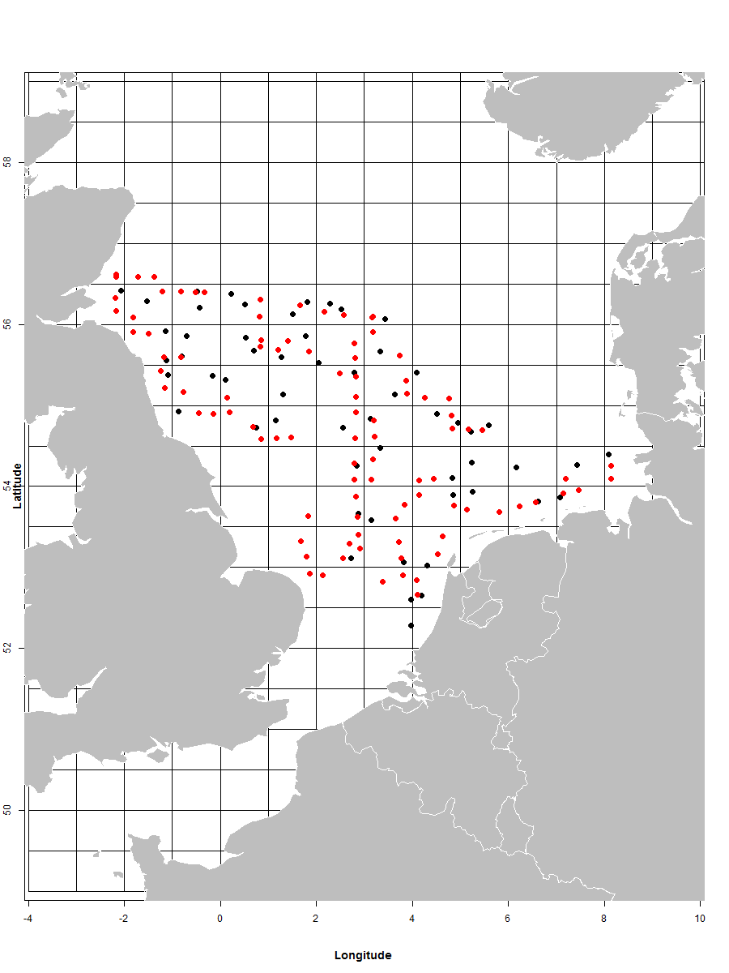
Link to the latest meeting report of the coordination group: available via ICES IBTSWG, for the MIK sampling also via ICES WGEGGS2. From 2019 onwards, the MIK sampling will be scientifically discussed in ICES WGSINS.
Main use of the results of the survey
The internationally combined recruit indices of various species are used by ICES groups WGNSSK and HAWG, elasmobranch information is used by ICES WGEF, and mackerel information incidentally by WGWIDE. The IBTS data are also being used in the OSPAR MSFD assessment.
MIK data are used by HAWG.
Extended comments (Tables 1G and 1H)
No additional comments

Survey: North Sea Beam Trawl Survey (BTS)
The BTS is carried out annually in August/September. The Netherlands participates with RV Isis (25 days at sea) and RV Tridens (20 days at sea), both with a different spatial coverage. The survey is listed in 2016/1251 Table 10. The continuity of the previous survey design is guaranteed by participation in the coordinating survey group (WGBEAM).
Objectives of the survey
The ICES Manual for the Offshore Beam Trawl Surveys (version 1.0, June 2009) describes the current objectives:
- Create a fisheries‐independent stock estimate for plaice and sole
- Collection of data on all fish species and epibenthos species for ecosystem purposes
Description of the methods used in the survey
During daytime, 30 minute beam trawl hauls are conducted. Hydrographical data is collected with a CTD (downcast) at every trawl station. Since 2011, litter from the trawl catch is sorted and registered on board Tridens. The complete sampling procedure is defined in the ICES Manual for the Offshore Beam Trawl Surveys.
The area to be covered by the Netherlands is presented in Figure 2a and 2b in the NLD WP 2017-2019.
Coordination and participation
The survey is coordinated by the ICES Working Group on Beam Trawl Surveys (WGBEAM). Other MSs carrying out beam trawl surveys in the region are Belgium, Germany and UK.
The data of the survey are uploaded in the ICES Database of Trawl Surveys (DATRAS). Up to 2016, only the information from the Dutch beam trawl survey in the North Sea is being used by ICES WGNSSK in the fish stock assessments (sole Solea solea, plaice Pleuronectes platessa, dab Limanda limanda). BTS (RV Isis) data is used in the assessment of brill (Scophthalmus rhombus) and turbot (Scophthalmus maximus).
BTS data (RV Isis and RV Tridens) are being used in the 2016 OSPAR MSFD assessment.
International task sharing (physical and/or financial) and the cost sharing agreement used
Task sharing applies. The survey is carried out by four EU MSs, each contributing with its own vessel. No cost sharing applies.
Explain where thresholds apply: Not applicable
Graphical representation (map) showing the positions (locations) of the realised samples during NLD BTS 2018.
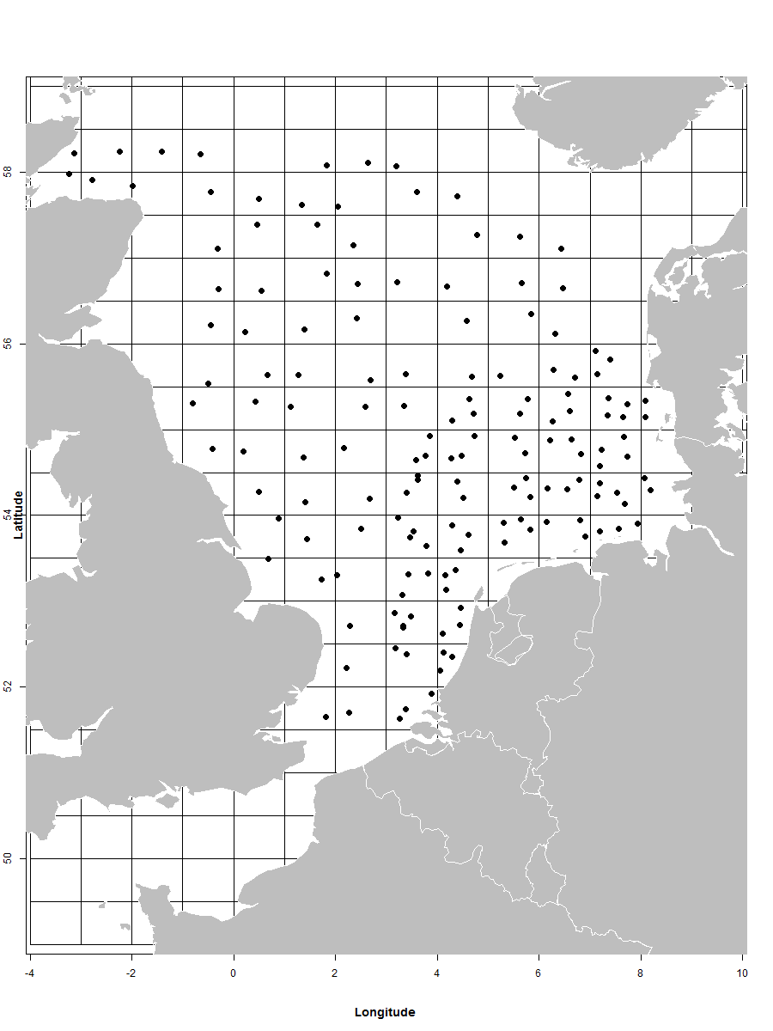
Link to the latest meeting report of the coordination group: available via ICES WGBEAM
Main use of the results of the survey
The information from the Dutch beam trawl survey in the North Sea is being used by ICES WGNSSK in the fish stock assessments (sole Solea solea, plaice Pleuronectes platessa, dab Limanda limanda), brill (Scophthalmus rhombus) and turbot (Scophthalmus maximus).
BTS data are being used in the OSPAR MSFD assessment.
Extended comments (Tables 1G and 1H)
No additional comments

Survey: Demersal Young Fish Survey (DYFS)
The DYFS is carried out annually from end of August-early November. The Netherlands participates with RV Isis (25 days at sea), RV Luctor (15 days at sea), RV Stern (25 days at sea) covering different near shore areas and estuaries. The survey is listed in 2016/1251 Table 10. The continuity of the previous survey design is guaranteed by participation in the coordinating survey group (WGBEAM).
Objectives of the survey
The ICES Manual for the Inshore Beam Trawl Surveys (in prep.) describes the current objectives:
- Create a fisheries‐independent stock estimate for brown shrimp and for 0- and 1-year old plaice, sole and dab
- Collection of data on all fish species and epibenthos species for ecosystem purposes
Description of the methods used in the survey
During daytime, 15 minute beam trawl hauls are conducted. Hydrographical data is collected with a datalog CTD attached to the net. The complete sampling procedure is defined in the ICES Manual for the Inshore Beam Trawl Surveys.
The area to be covered by the Netherlands is presented in Figure 3 in the NLD WP 2017-2019.
Coordination and participation
The survey is coordinated by the ICES Working Group on Beam Trawl Surveys (WGBEAM). Other MSs carrying out DYFS are Belgium and Germany.
The data of the survey are uploaded in the ICES Database of Trawl Surveys (DATRAS).
The internationally combined recruit indices for plaice, sole and dab are used by ICES WGNSSK.
The internationally combined abundance indices for brown shrimp are used by ICES WGCRAN.
International task sharing (physical and/or financial) and the cost sharing agreement used
The DYFS is carried out by three EU MSs, each contributing with its own vessel. No cost sharing applies.
Explain where thresholds apply: Not applicable
Graphical representation (map) showing the positions (locations) of the realised samples during NLD DYFS 2018. Red=Luctor, Green=Stern, Black=Isis.
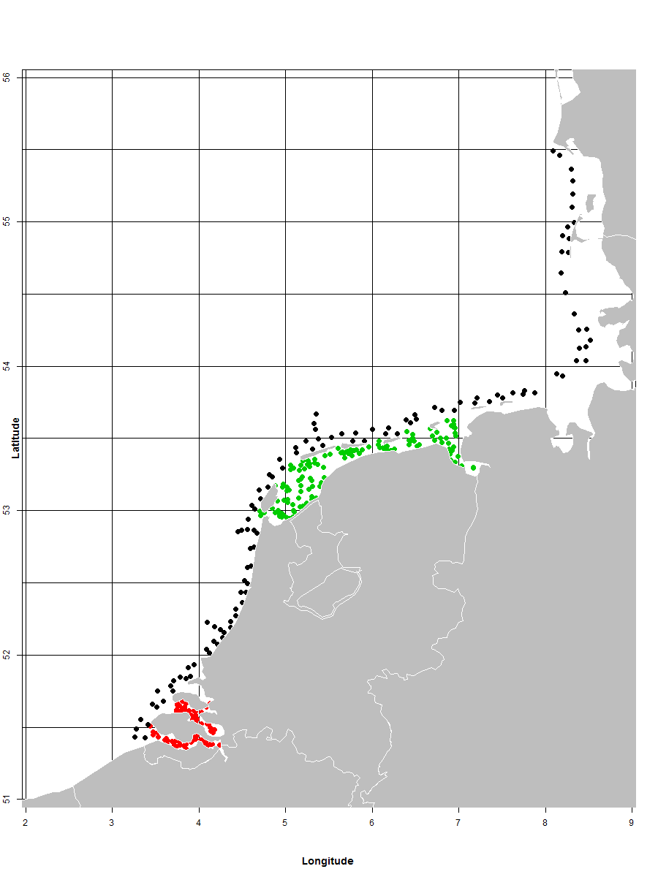
Latest meeting report of the coordination group: available via ICES WGBEAM
Main use of the results of the survey (e.g. indices, abundance estimates, environmental indicators)
- The internationally combined recruit indices for plaice, sole and dab are used by ICES WGNSSK
- The internationally combined abundance indices for brown shrimp are used by ICES WGCRAN
- The DYFS data collected in the Wadden Sea are also used in TMAP (Trilateral Monitoring and Assessment Programme in the Wadden Sea
- The DYFS data collected in the ‘Voordelta’ and Western Scheldt are delivered to MONEOS (Dutch-Flemish monitoring programme in the Scheldt area)
- Historical DYFS data in the Wadden Sea have been delivered to WaLTER (Data portal Wadden Sea monitoring)
Extended comments (Tables 1G and 1H)
Since 2017, fish for biological data collection has been weighed on board Luctor and Stern. This results in higher numbers length at weight in Table 1C than originally planned. On board RV Isis fish always has been weighed.
The survey in the coastal zone was slightly hampered by bad weather. Over-all the survey coverage is sufficient, but choices had to be made to get the spatial coverage as good as possible, resulting is a slightly lower amount of samples than planned.

Survey: Sole Net Survey (SNS)
The SNS is carried out annually in September. The Netherlands participates with RV Isis (10 days at sea) in the Dutch, German and Danish coastal zone. The survey is listed in 2016/1251 Table 10. The continuity of the previous survey design is guaranteed by participation in the coordinating survey group (WGBEAM).
Objectives of the survey
The ICES Manual for the Inshore Beam Trawl Surveys (in prep.) describes the current objectives:
- Create a fisheries‐independent stock estimate for 1- to 4-year old plaice and sole
- Collection of data on all fish species and epibenthos species for ecosystem purposes
As the manual is under revision, other data use is not yet mentioned: SNS data is currently also used for a fisheries-independent stock estimate in the assessment of turbot (Scophthalmus maximus).
Description of the methods used in the survey
During daytime, 15 minute beam trawl hauls are conducted. Hydrographical data is collected with a datalog CTD attached to the net. The complete sampling procedure is defined in the ICES Manual for the Inshore Beam Trawl Surveys.
The area to be covered by the Netherlands is presented in Figure 4 in the NLD WP 2017-2019.
Coordination and participation
The survey is coordinated by the ICES Working Group on Beam Trawl Surveys (WGBEAM). The Netherlands is the only MS conducting this survey.
The ICES Database of Trawl Surveys (DATRAS) is under development to have the SNS data stored.
The plaice, sole and turbot indices are used by ICES WGNSSK.
International task sharing (physical and/or financial) and the cost sharing agreement used
No task sharing applies (NLD only MS carrying out this survey). No cost sharing applies.
Explain where thresholds apply: Not applicable
Graphical representation (map) showing the positions (locations) of the realized samples during NLD SNS 2018:
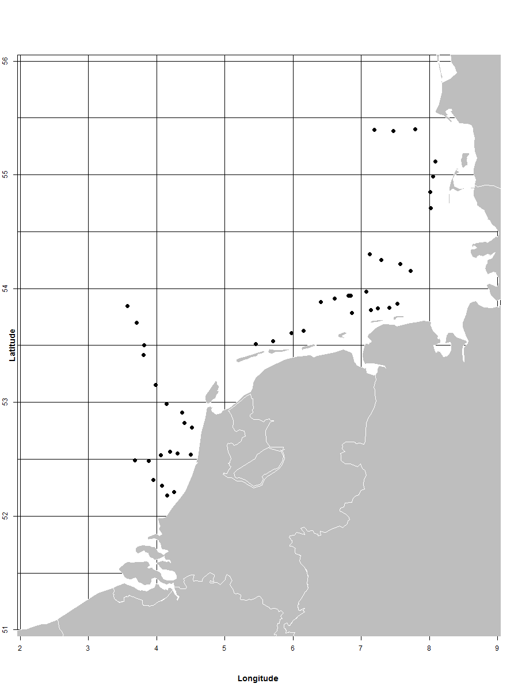
Link to the latest meeting report of the coordination group: available via ICES WGBEAM
Main use of the results of the survey: the plaice, sole and turbot indices are used by ICES WGNSSK.
Extended comments (Tables 1G and 1H)
During the first week limited sampling could be carried out. The survey was completed in two weeks, but some days later than originally planned. No effect is to be expected on the indices.

Survey: International Ecosystem Survey in the Nordic Seas (ASH) –see for full description Workplan Denmark
The ASH is carried out annually in the May/June and is carried out by RV Dana (Denmark). The survey is listed in 2016/1251 Table 10. The continuity of the previous survey design is guaranteed by participation in the coordinating survey group (WGIPS).
Objectives of the survey
The ICES Manual for International Pelagic Surveys (IPS) (version 1.00) describes the current objectives:
- Carry out a predetermined survey cruise track
- Determine an age stratified estimate of relative abundance of herring within the survey area
- Determine an age stratified estimate of relative abundance of blue whiting within the survey area
- Collect biological samples from directed trawling on insonified fish echotraces to determine age structure and maturity state of the herring stock
- Collect physical oceanography data from vertical profiles (CTD).
- Plankton sampling (WP2 and Dyedi)
Description of the methods used in the survey
During the survey acoustic echosounder measurements are done. In addition, trawl hauls are made to identify the species composition of the acoustic recordings. Also hydrographical and plankton data are collected. The complete sampling procedure is defined in the ICES Manual for International Pelagic Surveys (IPS) chapter 2.1.2.
The area to be covered in the survey is presented in Figure 5 in the NLD WP 2017-2019.
Coordination and participation
The survey is coordinated by the ICES Working Group on International Pelagic Surveys (WGIPS). The Netherlands participates in the ASH as part of a consortium of EU MSs and let two scientists join the survey on-board RV Dana.
Data storage and data use: see work plan Denmark.
International task sharing (physical and/or financial) and the cost sharing agreement used
Task sharing (personnel) applies: the survey is carried out by RV Dana and the Netherlands let two scientists join the survey.
Cost sharing applies: the operational costs of the vessels are shared by EU MSs applying an allocation key proportional to national share of the EU TAC.
Explain where thresholds apply: Not applicable
Graphical representation (map) showing the positions (locations) of the realized samples during ASH 2018: see AR Denmark.
Link to the latest meeting report of the coordination group: available via available via ICES WGIPS
Main use of the results of the survey: see AR Denmark
Extended comments (Tables 1G and 1H): see AR Denmark

Survey: Mackerel egg Survey (NSMEGS; Triennial)
The mackerel egg survey in the North Sea is an extension of the international mackerel and horse mackerel egg survey in western waters. The NSMEGS is carried out triennially in May/June (first survey planned in 2017). The Netherlands participates with RV Tridens (amount of days depending on contribution by other countries), covering the North Sea. The survey is listed in 2016/1251 Table 10. The continuity of the previous survey design is guaranteed by participation in the coordinating survey group (WGMEGS).
Objectives of the survey
The aim of the survey is to provide abundance estimates of the North Sea component of Atlantic mackerel by measuring the egg abundance. In combination with measurements of fecundity and atresia, which will be collected in the same year, the egg abundance can be converted into estimates of the spawning stock.
Description of the methods used in the survey
The main sampling type are plankton hauls using a Gulf VII plankton sampler, following a fixed station design. The survey is split up into four periods, and in each period the area is fully covered. In addition to the plankton hauls, fish hauls (with a pelagic trawl) are carried out for the collection of adult mackerel biological parameters. Hydrographical data are collected with a Seabird CTD attached to the plankton sampler. The complete sampling procedure is defined in the SISP Manual for the mackerel and horse mackerel egg surveys (MEGS): sampling at sea (version 1.3; new version to be published soon). The methodology for atresia and fecundity estimates is defined in the SISP Manual for the mackerel and horse mackerel egg surveys (MEGS): SISP 5 - WGMEGS V11 Manual for AEPM and DEPM fecundity.
The area to be covered by the Netherlands is presented in Figure 6 in the NLD WP 2017-2019.
Coordination and participation
The survey is coordinated by the ICES Working Group on Mackerel and Horse Mackerel Egg Surveys (WGMEGS). The Netherlands is the only MS conducting this survey.
The survey data is currently stored in the IMARES database (Frisbe). Egg and fecundity data are made available to WGMEGS before the WGWIDE meeting in 2017.
The survey index, fecundity estimate and mackerel biological data is being used by ICES WGWIDE.
International task sharing (physical and/or financial) and the cost sharing agreement used
No task sharing applies (NLD is the only MS carrying out this survey). No cost sharing applies.
Explain where thresholds apply: Not applicable
Graphical representation (map)
No survey in 2018 (triennial survey, next survey in 2020)
Link to the latest meeting report of the coordination group: available via ICES WGMEGS
Main use of the results of the survey: the survey index, fecundity estimate and mackerel biological data is being used by ICES WGWIDE.
Extended comments (Tables 1G and 1H)

Survey: Herring Larvae Survey (IHLS)
The herring larvae survey in the North Sea is annually carried out in January (one week), September (two weeks) and December (one week). The Netherlands participates with RV Tridens (total 20 days), covering the North Sea. The survey is listed in 2016/1251 Table 10. The continuity of the previous survey design is guaranteed by participation in the coordinating survey group (WGIPS).
Objectives of the survey
The aim of the survey is to estimate the adult population of autumn spawning herring based on the abundance of newly hatched herring larvae as this is a reliable index for spawning stock abundance. In particular, the survey gives information on the abundance of different spawning components.. The Netherlands covers Buchan, central North Sea, southern North Sea and English Channel.
Description of the methods used in the survey
The main sampling type are plankton hauls using a Gulf VII plankton sampler, following a fixed station design. In addition to the plankton hauls, fish hauls (with a pelagic trawl) may be carried out for the collection of adult biological parameters. Hydrographical data are collected with a Seabird CTD attached to the plankton sampler. During the herring larvae surveys a standard grid is sampled. In each ICES rectangle 9 stations are sampled (0°30 N x 1°E/W; ca. 30 x 30 NM). The complete sampling procedure is defined in the ICES Manual for the International herring larvae surveys south of 62° North (Annex 7, January 2010).
The area to be covered by the Netherlands is presented in Figures 7a, b, c in the NLD WP 2017-2019.
Coordination and participation
The survey is coordinated by the ICES Working Group on International Pelagic Surveys (WGIPS). Other MS carrying out IHLS is Germany.
The IHLS time-series is part of the eggs and larvae database at the ICES Data Centre.
The internationally combined indices are used by ICES HAWG for the assessment of the North Sea herring spawning stock biomass.
International task sharing (physical and/or financial) and the cost sharing agreement used
Task sharing applies. The IHLS is carried out by two EU MSs, each contributing with its own vessel. No cost sharing applies.

Explain where thresholds apply: Not applicable

Graphical representation (map) showing the positions (locations) of the realized samples during NLD IHLS 2018 (black=September survey by RV Tridens, red=December survey by RV Zirfaea):
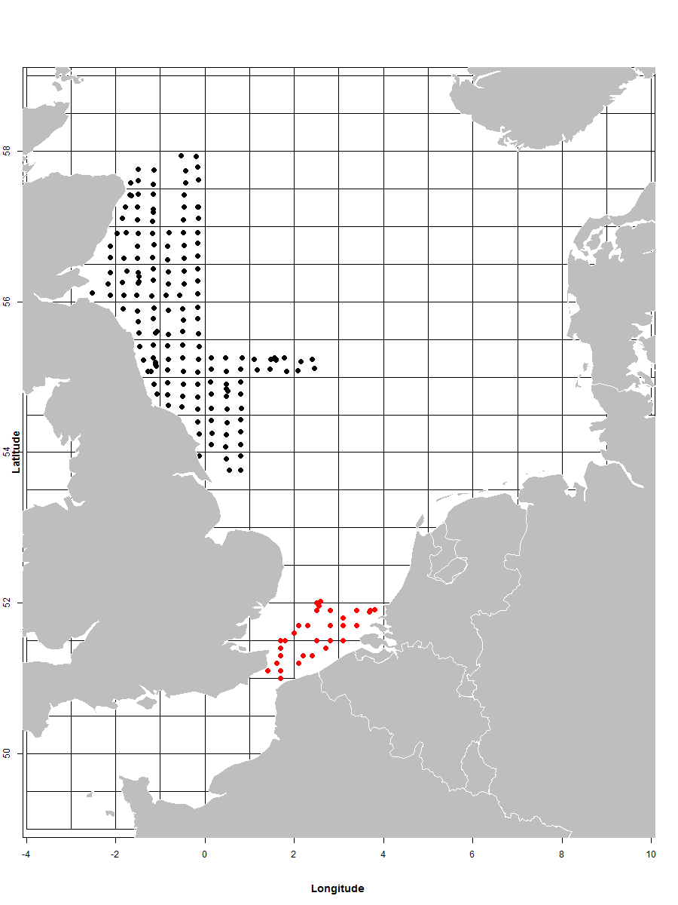
Link to the latest meeting report of the coordination group: available via ICES WGEGGS2 and ICES WGIPS. From 2019 onwards, the survey will be coordinated by ICES WGSINS.
Main use of the results of the survey: the internationally combined indices are used by ICES HAWG for the assessment of the North Sea herring spawning stock biomass.
Extended comments (Tables 1G and 1H):
The January IHLS survey has been replaced by a dedicated survey on Downs herring recruitment (DRS; added as additional box). This was agreed by the coordinating ICES group as well as the ICES HAWG where the data are used for the assessment.
The survey in December 2018 had to be carried out on a different vessel than originally planned. This vessel is more vulnerable to bad weather conditions. This lead to non-sampling in the Channel area.
As in autumn 2018 and winter 2019 also the German surveys suffered from technical and/or weather problems, only a good coverage was gained in the Buchan and Central North Sea spawning areas (the Dutch September survey). Because of the bad coverage in the Orkney/Shetland and Downs spawning areas, these data were rejected by the Herring Assessment Working Group (HAWG). The contribution of the different spawning components was therefore calculated from the assessment model, including the survey data for the Buchan and Central North Sea

Survey: NS Herring Acoustic Survey (NHAS)
The NHAS is carried out annually in June/July in the North Sea. The Netherlands participates with RV Tridens (total 20 days). The survey is listed in 2016/1251 Table 10. The continuity of the previous survey design is guaranteed by participation in the coordinating survey group (WGIPS).
Objectives of the survey
The survey aims to provide an annual estimate of the distribution, abundance and population structure to inform the assessment of the following herring and sprat stocks: Western Baltic Spring-spawning herring (in ICES Divisions IV and IIIa), North Sea Autumn Spawning herring (in IV and IIIa), West of Scotland herring (in VIaN), Malin Shelf herring (west of Scotland/Ireland in VIaN-S and VIIb,c), North Sea sprat (in IV) and Sprat in IIIa (western Baltic).
Description of the methods used in the survey
During the survey acoustic echosounder measurements are done, preferably in transects perpendicular to the coast. In addition, trawl hauls are made to identify the species composition of the acoustic recordings. Hydrographical data are collected on regular intervals. The complete sampling procedure is defined in the ICES Manual for International Pelagic Surveys (IPS) chapter 2.1.5.
The area to be covered by the Netherlands is presented in Figure 8 in the NLD WP 2017-2019. The ICES Working Group on International Pelagic Surveys (WGIPS) redistributed the sampling areas during the 2016 meeting, so the figure presented differs from the coverage presented in the current version of the manual.
Coordination and participation
The survey is coordinated by WGIPS and performed in collaboration with research vessels from Denmark, Germany, UK, Ireland and Norway.
The raw acoustic survey data are stored within individual national institutes. Since 2003 until 2014 aggregated survey data were stored in the FishFrame Acoustics database (http://dmz-web08.dfu.min.dk/NorthSea/FishFrame/). However, the platform and maintenance of that database has been discontinued and from 2015 onwards, data are stored in the (developing) ICES acoustic database.
The derived estimates and age structure of herring and sprat are used as tuning indices in the respective assessments and are submitted annually to ICES HAWG.
International task sharing (physical and/or financial) and the cost sharing agreement used
Task sharing applies. The NHAS is carried out by five EU MSs and one non EU country, each contributing with its own vessel. No cost sharing applies.
Explain where thresholds apply: Not applicable
Graphical representation (map) showing the positions (locations) of the realized samples during NLD NHAS 2018:
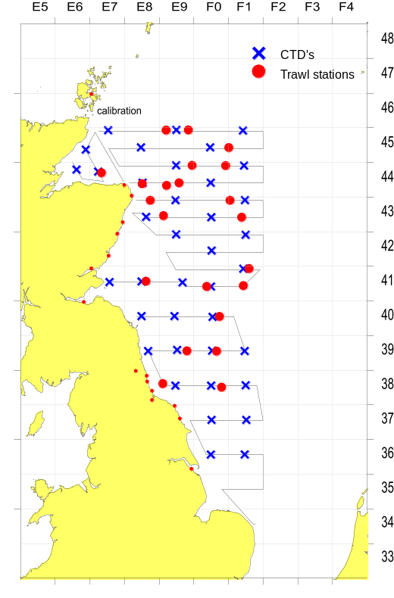
Link to the latest meeting report of the coordination group: available via ICES WGIPS
Main use of the results of the survey: the derived estimates and age structure of herring and sprat are used as tuning indices in the respective assessments and are submitted annually to ICES HAWG.
Extended comments (Tables 1G and 1H): no additional comments.

Survey: Dutch shellfish surveys (Additional survey)
The Dutch shellfish surveys are carried out annually between February and October covering the Dutch coast and estuaries (Wadden Sea, Oosterschelde and Westerschelde estuary). The surveys together form the basis for the national shellfish advice. The survey is not listed in 2016/1251 Table 10. The sampling design has been evaluated in 2015 and is a continuation of the previous design.
Objectives of the survey
The survey aims to provide an annual estimate of:
- the abundance of Ensis sp., Spisula subtruncata, Mytilus edulis, Cerastoderma edule and Lutraria lutraria in the Dutch coastal zone
- the abundance of Cerastoderma edule, Mytilus edulis and Crassostrea gigas in the Wadden Sea and Oosterschelde and Westerschelde estuary
- the abundance of non-commercial shellfish and infauna species in the Dutch coastal zone, Wadden Sea and Ooster- and Westerschelde estuary
Description of the methods used in the survey
The survey samples a number of commercial shellfish species in the littoral and sublittoral areas in the Dutch coastal zone and estuaries. All sub-surveys are stratified. The sampling device depends on the sampling location and target species. A summary is given in Table 1G and 1H. The complete sampling procedure is defined in the Dutch manual ‘Handboek schelpdierbestandsopnames’ (available on request).
The area to be covered is presented in Figure 9 in the NLD WP 2017-2019.
Coordination and participation: Not applicable
International task sharing (physical and/or financial) and the cost sharing agreement used
Not applicable, national survey
Explain where thresholds apply: Not applicable
Graphical representation (map) showing the positions (locations) of the realized samples during NLD shellfish surveys 2018:
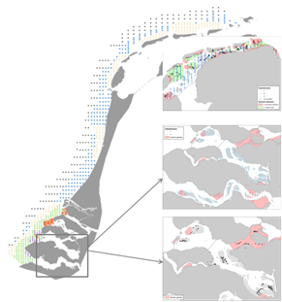
Link to the latest meeting report of the coordination group: not applicable, national survey
Main use of the results of the survey
- the survey is primarily used for stock estimation of shellfish stocks in Dutch waters, to provide national advice on shellfish fisheries.
- The data collected in the Wadden Sea are also used in TMAP (Trilateral Monitoring and Assessment Programme in the Wadden Sea)
- The data collected in the ‘Voordelta’ and Western Scheldt are delivered to MONEOS (Dutch-Flemish monitoring programme in the Scheldt area).
- Historical data in the Wadden Sea have been delivered to WaLTER (Data portal Wadden Sea monitoring)
Extended comments (Tables 1G and 1H)
Due to major summer cockle mortality re-sampling has taken place in the Wadden Sea and Eastern Scheldt. The data have been used to provide a new stock estimate for 2018.

Survey: Downs recruitment survey—NOT IN WP 2018; agreed upon in NLD Workplan 2019
The Downs recruitment survey in the North Sea is since 2018 annually carried out in April (one week). The Netherlands participates with RV Tridens (total 5 days), covering the relevant area in the North Sea (sampling area based on larval drift modelling). The survey not is listed in 2016/1251 Table 10. The continuity of the survey design is guaranteed by participation in the coordinating survey group (WGIPS).
Objectives of the survey
The aim of the DRS is to provide an recruitment index for the winter spawning herring population in the Southern North Sea and English Channel. After the survey in 2019 it will be decided if this new survey will be continued and used for the assessment by HAWG.
Description of the methods used in the survey
The main sampling type are plankton hauls using a Gulf VII plankton sampler, following a fixed station design. Hydrographical data are collected with a Seabird CTD attached to the plankton sampler. During the DRS a standard grid is sampled. In each ICES rectangle 9 stations are sampled (0°30 N x 1°E/W; ca. 30 x 30 NM). The complete sampling procedure is not yet described in an international manual, but the methodology largely follows those used in IHLS (defined in the ICES Manual for the International herring larvae surveys south of 62° North (Annex 7, January 2010)).
The area to be covered by the Netherlands is presented in Figures 7a.
Coordination and participation
The survey is coordinated by the ICES Working Group on Egg Surveys (ICES WGEGGS2). From 2019 onwards, the survey will be coordinated by ICES WGSINS. Currently no MS participates in this survey.
The DRS data is stored in the eggs and larvae database at the ICES Data Centre.
After the survey in 2019 it will be decided if this new survey will be continued and used for the assessment by HAWG.
International task sharing (physical and/or financial) and the cost sharing agreement used
Task sharing does not apply.
No cost sharing applies.
Explain where thresholds apply
Not applicable
Graphical representation (map) showing the positions (locations) of the realized samples during NLD DRS 2018:
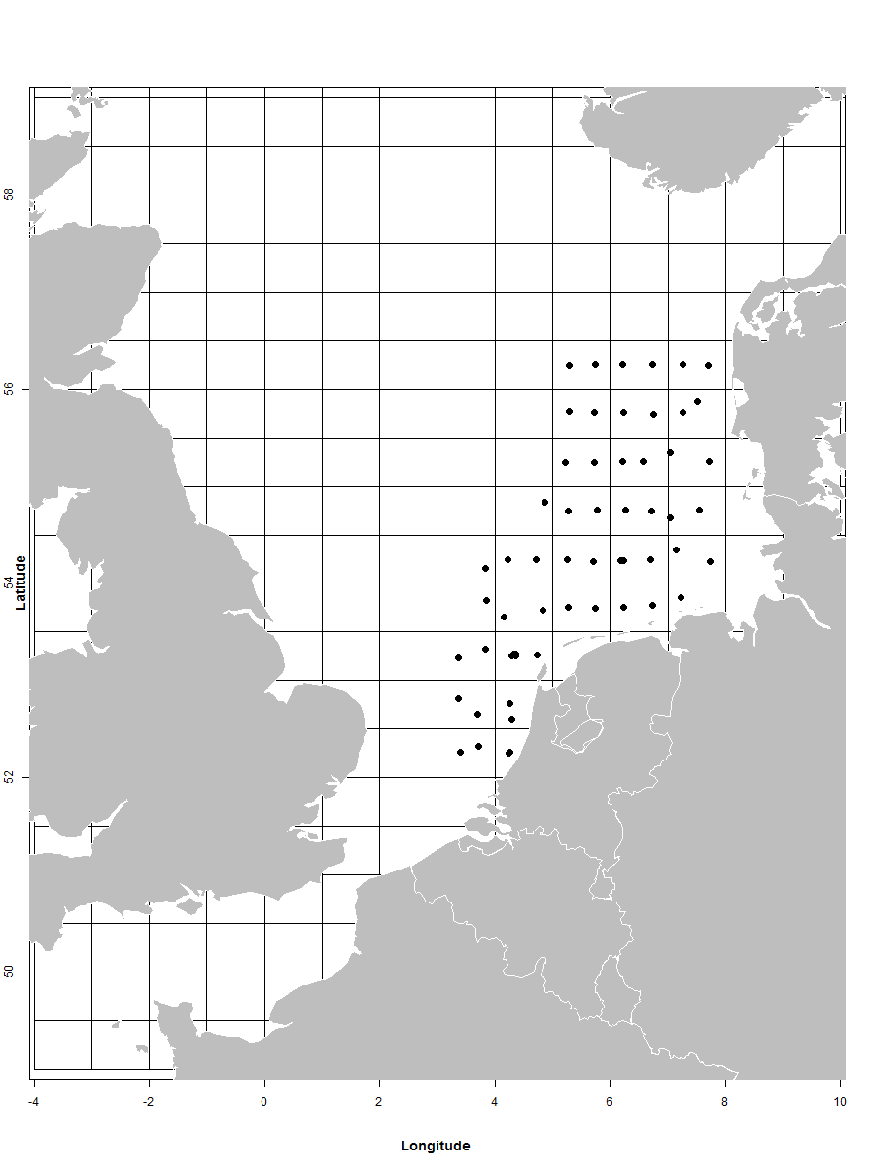
Link to the latest meeting report of the coordination group: available via ICES WGEGGS2. From 2019 onwards, the survey will be coordinated by ICES WGSINS.

Main use of the results of the survey: the data will be used by ICES HAWG for the assessment of the North Sea herring spawning stock biomass.

Extended comments (Tables 1G and 1H): no additional comments

Region: North Atlantic
Survey: Blue whiting survey (IBWSS)
The IBWSS is carried out annually in March/April in the North Sea. The Netherlands participates with RV Tridens (approx. 18 days). The survey is listed in 2016/1251 Table 10. The continuity of the previous survey design is guaranteed by participation in the coordinating survey group (WGIPS).
Objectives of the survey
The survey aims to determine the distribution and abundance at age and length of the Northeast Atlantic blue whiting stock during the spawning season to the west of Britain and Ireland (Figure 10).
Description of the methods used in the survey
During the survey transect-wise acoustic echosounder measurements are done. In addition, trawl hauls are made to identify the species composition of the acoustic recordings. Hydrographical data are collected on regular intervals. The complete sampling procedure is defined in the ICES Manual for International Pelagic Surveys (IPS) chapter 2.1.1.
The area to be covered is presented in Figure 10 in the NLD WP 2017-2019. The acoustic transects are presented by lines, blue spots indicate hydrography stations.
Coordination and participation
The survey is coordinated by the ICES Working Group on International Pelagic Surveys (WGIPS) and performed in collaboration with research vessels from Ireland, Faroe Islands, Russia, and Norway.
The disaggregated survey data (hydrographic, biological, & acoustic) are stored in the PGNAPES database hosted by the Faroe Marine Research Institute. By executing SQL queries through the Application Express web-interface (http://oracle.frs.fo/apex), the user can extract data. Usernames and passwords are given to every nation participating in the survey.
The blue whiting spawning stock estimate is used as a tuning index by ICES WGWIDE to determine the size of the population.
International task sharing (physical and/or financial) and the cost sharing agreement used
Task sharing applies. The IBWSS is carried out by two EU MSs, and three non EU MSs, each contributing with its own vessel. Furthermore, scientists from Denmark, Germany and UK participate in the survey on board of the Dutch vessel.
Cost sharing applies: the operational costs of the vessels are shared by EU MSs applying an allocation key proportional to national share of the EU TAC. This has not been fully effectuated yet, moreover reaching agreements between sharing MS is posing problems for years already. As a result no full cost sharing is executed, at the expense of operating MS.
Explain where thresholds apply: not applicable
Graphical representation (map) showing the positions (locations) of the realized samples during NLD IBWSS 2018:
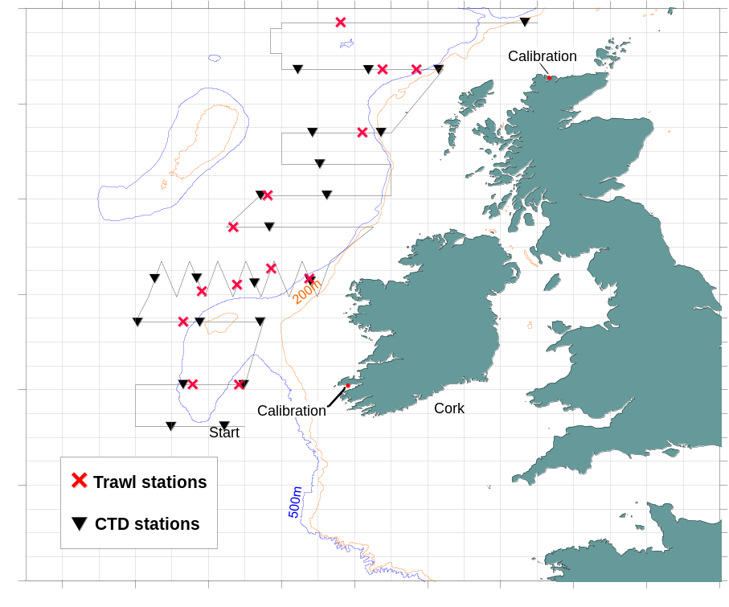

Link to the latest meeting report of the coordination group: available via ICES WGIPS
Main use of the results of the survey: the blue whiting spawning stock estimate is used as a tuning index by ICES WGWIDE to determine the size of the population.
Extended comments (Tables 1G and 1H): no additional comments.

Survey: International Mackerel and Horse Mackerel Egg Survey (MEGS; Triennial)
The MEGS is carried out triennially from January until July (first survey planned in 2019). The Netherlands participates with RV Tridens (approx. 30 days). The survey is listed in 2016/1251 Table 10. The continuity of the previous survey design is guaranteed by participation in the coordinating survey group (WGMEGS).
Objectives of the survey
The aim of the survey is to provide abundance estimates of the western and southern component of Atlantic mackerel and horse mackerel by measuring the egg abundance. In combination with measurements of fecundity and atresia, which will be collected in the same year, the egg abundance can be converted into estimates of the spawning stock.
Description of the methods used in the survey
The main sampling type are plankton hauls using a Gulf VII plankton sampler, following a fixed station design. The survey is split up into 6or 7 periods, and in each period the spawning area is fully covered. In addition to the plankton hauls, fish hauls (with a pelagic trawl) are carried out for the collection of adult mackerel and horse mackerel biological parameters. Also hydrographical data are collected with a Seabird CTD attached to the plankton sampler. The complete sampling procedure is defined in the SISP Manual for the mackerel and horse mackerel egg surveys (MEGS): sampling at sea (version 1.3). The methodology for atresia and fecundity estimates is defined in the SISP Manual for the mackerel and horse mackerel egg surveys (MEGS): SISP 5 - WGMEGS V11 Manual for AEPM and DEPM fecundity.
The survey area is presented in Figure 11 in the NLD WP 2017-2019. ICES Working Group on Mackerel and Horse Mackerel Egg Surveys (WGMEGS) decides on the detailed planning in the meeting the year prior to the survey (for 2019 survey: 2018 WGMEGS meeting).
Coordination and participation The survey is coordinated by ICES WGMEGS (WGMEGS). Germany, Ireland, Netherlands, UK, Portugal, Spain, Iceland and the Faroe Islands participate in the survey.
The survey data is stored in the ICES eggs and larvae database. Fecundity and atresia data are currently stored at IMR, Norway for mackerel and WMR for horse mackerel. An ICES database for fecundity and atresia data is currently being developed.
The survey index, fecundity estimate and adult biological data is being used by ICES WGWIDE.
International task sharing (physical and/or financial) and the cost sharing agreement used
Task sharing applies. The MEGS is carried out by six EU MSs and two non EU countries, each contributing with its own vessel. Fecundity and atresia samples are divided among the four analysing EU countries (Ireland, Netherlands, UK, Spain) and Norway. No cost sharing applies.
Explain where thresholds apply: not applicable
Graphical representation (map) showing the positions (locations) of the realized samples: no survey in 2018 (first and only survey in this WP period will take place in 2019).
Link to the latest meeting report of the coordination group: available via ICES WGMEGS
Main use of the results of the survey: no survey in 2018 (first and only survey in this WP period will take place in 2019).
Extended comments (Tables 1G and 1H): no additional comments

Section 2: Fishing Activity Data

Text Box 2A: Fishing activity variables data collection strategy
General comment: This box fulfills paragraph 4 of Chapter III of the multiannual Union programme and Article 2, Article 4 paragraph (2) point (b) and Article 5 paragraph (2) of the Decision (EU) 2016/1701. It is intended to describe the method used to derive estimates on representative samples where data are not to be recorded under Regulation (EU) No 1224/2009 or where data collected under Regulation (EU) No 1224/2009 are not at the right aggregation level for the intended scientific use.
General comment: This box is applicable to the Annual Report. This box should provide information on the implementation of the data collection of fishing activity variables of Member States.
1. Description of methodologies used to cross-validate the different sources of data
Price data was collected from sales notes and cross-validated with data from accounts from the collection scheme on Economic data cutters. Landings data were obtained from both official landings information (sales notes and landing declarations) and fishermen’s estimation (middle part of the logbook for landings per area) and were checked for inconsistencies. Whenever inconsistencies were found the information on landings per area was adjusted to the landing declarations. As from 1-1-2018 owners of vessels smaller than 10 meters were no longer obliged to keep paper logbooks any longer and register their fishing activities through the E-lite system. This system only registers official landings information. Therefore, the fishermen’s estimation does not exist for these vessels any longer.
2. Description of methodologies used to estimate the value of landings
Information on fish prices was available from sales notes (from auctions) for most segments, except for some shellfish species (for dredgers) and for the species caught by the large pelagic trawlers. For the pelagic trawlers the prices were obtained from the accounts of the trawler companies during the collection scheme on Economic data pelagic trawlers. Data covered all fishing activities in both the supra region Baltic Sea; North Sea; Eastern Arctic; NAFO; Extended North-Western waters (Ices areas V, VI and VII) and Southern Western waters and supra region Other regions. For the dredgers price information was obtained by questionnaires within the frame of the collection scheme on Economic data small coastal fisheries.
3. Description of methodologies used to estimate the average price (it is recommended to use weighted averages, trip by trip)
Average prices were calculated by weighted averages on trip level.
4. Description of methodologies used to plan collection of the complementary data (sample plan methodology, type of data collected, frequency of collection etc.)
For the shellfish caught by dredgers and for the pelagic trawlers complementary price data was gathered based on the accounts (pelagic trawlers) and questionnaire data (dredgers). Data was collected in combination with the other economic information as described in box 3A.
5. Deviations from Work Plan methodology used to cross-validate the different sources of data
As from 1-1-2018 owners of vessels smaller than 10 meters were no longer obliged to keep paper logbooks any longer and register their fishing activities through the E-lite system. This system only registers official landings information. Therefore, the fishermen’s estimation does not exist for these vessels any longer.
6. Deviations from Work Plan methodology used to estimate the value of landings.
Because of the non-response for the economic data for the dredgers, no price information for the shellfish species could be estimated based on the questionnaires. As an alternative, prices were obtained through a number of telephone interviews with sector experts.
7. Deviations from Work Plan methodology used to estimate the average price.
See point 6.
8. Deviations from Work Plan methodology used to plan collection of the complementary data
See point 6.
Actions to avoid deviations.

Section 3: Economic and Social Data

Text Box 3A: Population segments for collection of economic and social data for fisheries
General comment: This box fulfils paragraph 5 points (a) and (b) of Chapter III of the multiannual Union programme and Article 2, Article 4 paragraphs (1), (2) and (5) and Article 5 paragraph (2) of the Decision (EU) 2016/1701. It is intended to specify data to be collected under Tables 5(A) and 6 of the multiannual Union programme.
General comment: This box is applicable to the Annual Report. This box should provide information on the implementation of the fleet socio-economic data collection of Member States.
1. Description of methodologies used to choose the different sources of data
The Dutch fishing fleet encompasses a large variety of vessels and fishing techniques. In the economic data collection, three groups of vessels are distinguished:
- Pelagic trawlers targeting small pelagics for human consumption (approx. 30% of the total value of the Dutch fleet).
- Active cutters using demersal active gears on a commercial basis add more than 95% of the remaining commercial catches.
- Vessels in the small coastal fisheries are either vessels that participate occasionally or never in the sea fishery or vessels that use passive gears or dredges.
In order to distinguish between the active cutters and the small coastal fisheries the main gear and lower threshold of 50,000 Euro on gross revenue was used for the active cutter fleet. The Dutch fleet includes 8 pelagic trawlers, 279 cutters and 241 vessels classified in the small coastal fisheries (ultimo 2015). In 2018 the Dutch fleet included 8 pelagic trawlers, 289 cutters and 225 vessels classified in the small coastal fisheries.
The data sources used for the collection of economic data for the groups varied:
- Economic data for the pelagic trawlers and the active cutters was obtained from company accounts and balance sheets through the survey of Wageningen Economic Research. Accounts were copied each quarter on a vessel level and all detailed transactions were stored in a database. In addition the balance sheets of the fishing firm were copied.
- Economic data for the small coastal fisheries was collected by means of questionnaires (both telephone and paper).
Landings and effort were obtained from both official logbooks, accounts and questionnaires.
Value of landings (sales notes, accounts and questionnaires): detailed sales notes were available for all Dutch auctions, but do not provide a complete picture of fish sales as some fish (e.g. shellfish and fish caught by the large pelagic trawlers) are sold directly. Therefore, value of landings information was also obtained from accounts and questionnaires. During aggregation procedures data from logbooks, accounts and questionnaires was combined to deliver most accurate estimates.
Data on investments and financial position of the cutter sector are gathered from financial accounts, and have a time lag of one year. Therefore, these data only becomes available two years after the reference year.
2. Description of methodologies used to choose the different types of data collection
The data from the active cutters was collected through the panel of Wageningen Economic Research. This panel has an annual turnover of approx. 4% and is assumed to be a probability sample survey. Economic data from the pelagic trawlers was collected by census, because of the small number of companies involved. The data collection from the small coastal vessels was also done by census because of the low response rate. Over the last years this response rate had been increased by using a combination of a telephone questionnaire and a paper questionnaire.
3. Description of methodologies used to choose sampling frame and allocation scheme
The sampling frame of the economic data covered the complete Dutch marine fishing fleet as registered in the EU vessel register. Inland and aquaculture fishing vessels were excluded from data collection. All pelagic trawlers and small coastal vessels were covered by the economic surveys. The allocation of sampling in the active cutter sector was based on an annual assessment of the representativeness and resulting data quality of the panel data.
4. Description of methodologies used for estimation procedures
For the pelagic trawlers no estimation of economic results was needed as all information was available.
Costs and earnings from the active cutters were estimated through analysis of detailed costs and earnings information from the cutters in the panel and information on technical characteristics, effort and landings from all vessels in the population from the logbooks and the vessel register.
Capital value and depreciation were calculated based on digressive depreciation in accordance with the method followed in the templates published on the DCF website.
Sales note information covered more than 80% of the total value of landings of the demersal species. The missing information (mainly from the pelagic sector and shrimp landings) was estimated using information from logbooks and accounts.
Economic information from the small-scale fleet was estimated using the questionnaire data and the total number of vessels in each EU fishing fleet. As many of the EU segments consisted of less than 10 fishing vessels, these segments were clustered. The clustering procedures were based on technical data and catch composition and follow the procedure described in SCEGA 09-02.
5. Description of methodologies used on data quality
Wageningen Economic Research (formerly LEI) is ISO9001 Certified. Methods for data collection have mostly been described in detail in internal manuals. General descriptions of the followed procedures will be made publicly available in the coming years.
Information on landings, landings value and effort are obtained from different sources (questionnaires, logbooks and accounts) and are cross-checked. Inconsistencies in data mainly consists for the small coastal fisheries. There, information on landings and effort from questionnaires are used whenever data are not consistent. Furthermore, the fleet segmentation might be adjusted based on the outcome of the questionnaires.
6. Deviations from Work Plan methodology for selection of data source
Social data for all sectors were obtained by means of questionnaires. For the pelagic trawlers and the active cutters specific questionnaires were send out to the owners of the vessels concerning all social variables. For the small coastal fisheries, the questions concerning the social data were included in questionnaire on economic data.
7. Deviations from Work Plan methodology to choose type of data collection
No deviations
In contrast to what was planned the social data were gathered by means of a specific questionnaire send out to all vessel owners of the cutter sector and the large pelagic trawlers. For the small coastal fisheries the questions on the social variables were included in the annual questionnaire on the economic information. In both cases questionnaires were sent out to all vessel owners. The main reason behind this deviation from the work plan was the assumption that the response rate on the questionnaires would be small.
8. Deviations from Work Plan methodology regarding sampling frame and allocation scheme
No deviations
9. Deviations from Work Plan methodology used for estimation procedures
In 2019 extra effort has been made to increase sample rates for the collection of economic data for all fisheries sectors. For the cutter sector, this has resulted in an increase of the overall achieved sample rate/planned sample rate from 74% for 2017 data to 88% for 2018 data. As for the small coastal fisheries and inactive vessels, 100% of the vessel owners were included in the sampling scheme as specified in the National program. In the small coastal fisheries the response rate increased but the response rate was still relatively low (20%). The response rate for inactive vessels has been quite good, because of the telephone questionnaires (37% in 2018).
In some smaller strata the low response rate caused problems, because no information was available for certain clusters. To overcome this problem the following clusters have been combined in order to estimate the economic variables (income, expenditures, employment and capital):
- Demersal trawlers and/or demersal seiners 0-< 10 m, cluster Beam trawlers 0-< 10 m and cluster Beam trawlers 12-< 18 m
- Cluster Dredgers 24-< 40 m and cluster Drift and/or fixed netters 12-< 18 m
The economic importance of these segments is of minor importance for the Dutch fleet. In 2019 increased cooperation will be sought with fishermen’s organisations to discuss this issue and increase effort to enlarge the response rate for the small coastal fisheries.
For consistency reasons with the National Plan all possible segments were included in the National plan from 2018 onwards. This means that for many segments without any vessels in 2017 the records from the NP were included in the table, but naturally, no information on these segments was collected.
Also for the active cutter sector the achieved sample rate was lower than planned in the NP. However, the response rate wat increased substantially from 74% for 2016 to 88% for 2017 data. During 2019. the remaining issues will be solved.
Because of the decrease in vessel numbers in the segment Demersal trawlers and/or demersal seiners 18-< 24 m (8 vessels), only one account was available for this specific segment. In order to keep the time series consistent, the segment was not clustered with another segment, but the economic results of these vessels were estimated from the segment Demersal trawlers and/or demersal seiners 24-< 40 m. The vessels in this use the same fishing gears and many of these are between 24 and 30 meters in length, whereas all vessel in the segment 18-< 24 m are between 22 and 24 meters. Therefore these vessels are most comparable to the ones in the segment Demersal trawlers and/or demersal seiners 24-< 40 m.
In case of the social data collection, response rates were good for the active cutter sector. For the small coastal fisheries, the response rate was low, despite the effort and reminders send. Because of capacity issues, data delivery for the large trawlers was delayed and data were not available before the data call. These data will become available in 2019.
10. Quality assurance
10.1 Sound methodology
The methodologies used are in line with those developed in the PGEcon WGs.
10.2. Accuracy and reliability
In all data collections schemes for economic data quality checks are built in the databases and part of the aggregation procedures. For the Cutter data these checks for internal consistency of the data are automated within the ARTIS database in which the data are stored. In case of the data from the large trawler fleet and the small-scale fleet consistency checks and analysis of outliers are performed before the aggregation process. In case of inconsistencies, contact is sought with the provider of the data in order to assess whether the data is wrong or not and the information is corrected.
10.3. Accessibility and Clarity
- Are methodological documents publicly available? No
- Are data stored in databases? Yes
- Where can methodological and other documentation be found? Not applicable.
- Provide the web link, if documentation is publicly available. Not applicable.
Section 3: Economic and Social Data

Pilot Study 3: Data on employment by education level and nationality
General comment: This box fulfills paragraph 5 point (b) and paragraph 6 point (b) of Chapter III of the multiannual Union programme and Article 2 and Article 3 paragraph (3) point (c) of the Decision (EU) 2016/1701.It is intended to specify data to be collected under Table 6 of the multiannual Union programme.
General comment: This box is applicable to the Annual Report. This box is intended to provide information on the results obtained from the implementation of the pilot study (including deviations from planned and justifications as to why if this was not the case).
1. Aim of pilot study
The pilot study will be split up in two parts, aiming to provide more detailed information on the employment by (1) education level and (2) nationality in the fishing sector and the aquaculture sector, in addition to the information gathered on age and gender
2. Duration of pilot study
The pilot study shall start in 2017 in preparation for the actual data collection in 2018, parallel to the data collection on social variables.
3. Methodology and expected outcomes of pilot study
Data will be gathered by means of questionnaires, sent to fishing vessel owners. The cutter fleet and the pelagic trawler fleet will be used as frame population for the pilot study. Questionnaires will be send to the vessel owners participating in the cutter panel and will be followed up by phone calls to ensure maximum response levels. Results will be analysed using analyses of variance to check for significant differences in crew characteristics between various fleet segments. If needed data will be aggregated using post stratification. If possible consistency checks with other data sources will be done, but it is not clear yet which sources can be used for this.
4. Achievement of the original expected outcomes of pilot study and justification if this was not the case.
During 2018, various data sources were checked as source of data that could be used for these data but it became clear that because of the needed link with the vessel, no existing data sources could be used. Because of this the data was collected by means of questionnaires send to the owners of the vessels. In contrast to what was planned the frame population was extended to the whole population and the questionnaires were sent to all owners of fishing vessels.
In order to lower the administrative burden of the fishermen, these questionnaires were combined with the those of the other social variables in the regular sampling programme. For the small coastal fisheries the collection of social variables was combined with the collection of economic information for the same reason. The questionnaire for the cutter sector resulted in quite good response rates (almost 30%). Response rates for the small coastal fisheries were much lower (approx. 13%). Because of capacity issues, data delivery was delayed for the large trawlers and data were not available before the data call. These data will become available in 2019. Analysis of the available data did not result in significantly different demographic profiles within segments, so the aggregation procedures were based on the aggregation methods for the economic data.
5. Incorporation of results from pilot study into regular sampling by the Member State.
Results from the pilot study were used in the regular sampling of the social data in the national programme using census data collection by questionnaires and aggregation procedures in accordance with the economic data collection.

Section 3: Economic and Social Data

Text Box 3B: Population segments for collection of economic and social data for aquaculture
General comment: This box fulfills paragraph 6 points (a) and (b) of Chapter III of the multiannual Union programme and Article 2, Article 4 paragraphs (1) and (5) and Article 5 paragraph (2) of the Decision (EU) 2016/1701.It is intended to specify data to be collected under Tables 6 and 7 of the multiannual Union programme.

General comment: This box is applicable to the Annual Report. This box should provide information on the implementation of the socio-economic data collection for aquaculture of Member States.

1. Description of methodologies used to choose the different sources of data
Economic data for the mussel and oyster sector were obtained from nationals auctions, national statistics and the company accounts in accordance with the National plan. Total volume of landings and value of landings for the mussel sector was obtained from the mussel auction. During the last years an increasing amount of mussels is not auctioned. However, all of the sales are to be administered by the auction, and therefore the auction statistics cover 100% of the Dutch mussel production. For the oyster sector no such landings statistics were available, so all data were gathered from the oyster farmers directly. Economic data of both sub-sectors were gathered from annual financial accounts. Because these reports become available only 16 months after the reference year, data collection was delayed by one year as stated in the National Programme. Therefore economic data on 2016 was collected in 2018.
2. Description of methodologies used to choose the different types of data collection
Production data from the oyster sector were gathered by means of a telephone questionnaire involving all oyster companies (census). Data on costs and earnings and employment from both mussel and oyster sector were gathered from a panel of companies that provide accounts on a voluntary basis. This panel is assumed to be a representative sample. An analysis in 2017 of the mussel panel confirmed this assumption based on the size of the companies. Annual turnover rate of the sample is low (< 10%), but because of earlier experiences of low response rates in random sampling, this is thought to be the most suitable type of data collection.
3. Description of methodologies used to choose sampling frame and allocation scheme
Data from these sectors are obtained by means of a panel covering between 22 and 27% of the total number of companies.
4. Description of methodologies used for estimation procedures
As there is no stratification within the segments, the averages of the obtained panel data were assumed to be good estimates for the population averages. The total values of the economic variables were estimated through different aggregation procedures for each of these sectors:
- Mussel segment: total value of the production for the segment was available, all variable cost items and earning items (turnover, subsidies, other income, wages and salaries, energy costs, livestock costs, repair and maintenance, other operational costs) were aggregated based on this. Fixed cost items (depreciation of capital, financial costs, extraordinary costs) as well as other economic indicators (total value of assets, net investments, debt, number of persons employed, FTE) were aggregated according the number of active vessels.
- Oyster segment: In principle all variables will be aggregated based on the number of enterprises. In case total production figures are available, these will be used to correct the estimated production and the costs from the panel data. Herewith, it will be assumed that the cost structure to produce one kg of oysters is constant.
Because the most recent data on costs and earnings were from the year 2015 (two years before the reference year), the economic results of 2016 were estimated using the cost structure of 2015 and the total production volume of 2016.
5. Description of methodologies used on data quality
Wageningen Economic Research (formerly LEI) is ISO9001 Certified. Methods for data collection have mostly been described in detail in internal manuals. General descriptions of the followed procedures will be made publicly available in the coming years.
The procedures to estimate totals have been described above. The evaluation of bias will be based on the total production and production value of the sector and companies in the panel. Whenever possible, data will be collected on the total production and total value of sectors to evaluate whether the panel data are biased and to correct for this bias. For the mussel sector, such data are available by means of total production value and volume, and for the oyster sector data on the number of oysters produced will also be used for this purpose.
6. Deviations from Work Plan methodology for selection of data source
No deviations
7. Deviations from Work Plan methodology to choose type of data collection
For the collection of social data, data collection by means of a paper questionnaire was chosen as low response rates were anticipated.
8. Deviations from Work Plan methodology regarding sampling frame and allocation scheme
Social data collected covered between 29 and 50% of the total number of companies.
9. Deviations from Work Plan methodology used for estimation procedures
In order to aggregate the social data no further disaggregation within the two (Mussel and Oyster) segments was made and responses were assumed to be representative of the whole sector.
10. Quality assurance
10.1 Sound methodology
The data collection in the mussel and oyster sector resembles a panel data collection. As stated above and in the national program, this data collection scheme was chosen because of the positive effects on long lasting relationships with vessel owners on response rates and data quality. For both sectors the representatively has been checked regularly (mussel sector in the last year).
10.2. Accuracy and reliability
- Response rate and Achieved sample rate are provided in Table 3C. From recent analysis of the data it is clear that the cost structure of the oyster companies is highly variable and that the current sample of 5 companies is not enough to provide a good insight in the costs and earnings of this sector. In 2018 various attempts have been made to increase involvement of the sector through the PO, but these have so far not resulted in an increased number of panel members. In 2019 extra effort will be made to increase the number of participants.
- Raw data are taken from the accounts and entered in the Wageningen Economic Research accounts database. This database includes automated validity and consistency checks. Besides the processed data are checked by our trained administrative staff per enterprise and the aggregated data are checked by research staff.
10.3. Accessibility and Clarity
Indicate with Yes or No:
- Are methodological documents publicly available? No, not yet
- Are data stored in databases? Yes
- Where can methodological and other documentation be found? (Internal) documents are available at Wageningen Economic Research and Ministry of Economic Affairs.
- Provide the web link, if documentation is publicly available. Not yet available.
Section 3: Economic and Social Data

Pilot Study 4: Environmental data on aquaculture
General comment: This box fulfills paragraph 6 point (c) of Chapter III of the multiannual Union programme and Article 2 and Article 4 paragraph (3) point (d) of the Decision (EU) 2016/1701. It is intended to specify data to be collected under Table 8 of the multiannual Union programme.
General comment: This box is applicable to the Annual Report. This box is intended to provide information on the results obtained from the implementation of the pilot study (including deviations from planned and justifications as to why if this was not the case).
1. Aim of pilot study
The Netherlands will collect aquaculture data for shellfish bottom culture only. As drugs are not used in this type of aquaculture and information about mortality is not known, no pilot study on environmental data on aquaculture is planned yet.
2. Duration of pilot study
Not (yet) applicable
3. Methodology and expected outcomes of pilot study
Not (yet) applicable
4. Achievement of the original expected outcomes of pilot study and justification if this was not the case.
Not applicable as no pilot study has been carried out
5. Incorporation of results from pilot study into regular sampling by the Member State.
Not applicable as no pilot study has been carried out
Section 3: Economic and Social Data

Text Box 3C: Population segments for collection of economic and social data for the processing industry
General comment: This box fulfils footnote 6 of paragraph 1.1(d) of Chapter III of the multiannual Union programme, Article 2, Article 4 paragraphs (1) and (5) and Article 5 paragraph (2) of Decision (EU) 2016/1701. It is intended to specify data to be collected under Table 11 of the multiannual Union programme.
General comment: This box is applicable to the Annual Report. This box should provide information on the implementation of the socio-economic data collection for aquaculture of Member States.
1. Description of methodologies used to choose the different sources of data
Data collection from the processing sector is voluntary. No data collection is carried out by the Netherlands.
2. Description of methodologies used to choose the different types of data collection
Not applicable
3. Description of methodologies used to choose sampling frame and allocation scheme
Not applicable
4. Description of methodologies used for estimation procedures
Not applicable
5. Description of methodologies used on data quality
Not applicable

Section 4: Sampling Strategy for Biological Data from Commercial Fisheries

Text Box 4A: Sampling plan description for biological data
General comment: This box fulfills Article 3, Article 4 paragraph (4) and Article 8 of the Decision (EU) 2016/1701 and forms the basis for the fulfilment of paragraph 2 point (a)(i) of Chapter III of the multiannual Union programme. This Table refers to data to be collected under Tables 1(A), 1(B) and 1(C) of the multiannual Union programme.
General comment: This box is applicable to the Annual Report. This box should provide information on the deviations from the planned sampling of Member States.
1. Description of the sampling plan according to Article 5 paragraph (3) of the Decision (EU) 2016/1701
The description of the sampling plan does not deviate from the sampling plan as described in section 4 of the approved WP 2017-2019 for The Netherlands.
Deviation from the sampling plan according to Article 5 paragraph (3) of the Decision (EU) 2016/1701:
2. Deviations from the Work Plan
- For area 87 (SPRFMO): if any deviation: see AR Poland
- For area 34 (CECAF): if any deviation: see AR Poland
- For North Sea and North Western waters:
  - For stratum_code AUCTION_DEM, the achieved number of PSU exceeds the planned number by 100%. The planned number was however too low as sampling of multiple trips during one sampling event was not taken into account. This number needs to be updated in a future revision of the plan.
  - For stratum_code DEMPAS, the planned number of PSU (i.e. 20 trips) in the NLD 2018 Workplan was wrongly attributed to only at-sea sampling DEMPAS. It should have been equally divided over at-sea sampling DEMPAS and at-sea sampling DEMACT. This has been corrected in the 2019 Dutch Workplan. Consequently, 2018 did not follow the NLD 2018 Workplan; 10 trips at-sea sampling DEMPAS were executed and 10 trips at-sea sampling DEMACT were executed. Results of DEMACT at-sea sampling trips are provided together with DEMACT self-sampling.
3. Action to avoid deviations
- For area 34 (CECAF): Various issues regarding accessibility have been discussed in the past (RCG LDF). From 2018 onwards, Poland has taken over sampling in this region. The cooperation with the vessel owners has been renewed and agreed upon, it is expected that this will ensure improved accessibility, capacity and cooperation in the region.
- 2019 accepted NLD Workplan includes a separate stratum for at-sea DEMACT.

Section 5: Data quality

Text Box 5A: Quality assurance framework for biological data
General comment: This box is applicable to the Annual Report. This box fulfills Article 5 paragraph (2) point (a) of the Decision (EU) 2016/1701. This box is intended to specify data to be collected under Tables 1(A), 1(B) and 1(C) of the multiannual Union programme. Use this box to provide additional information on Table 5A.
1. Evidence of data quality assurance
All sampling schemes other than eel and recreational fisheries: Limited documentation of processes to evaluate data accuracy has been made, in 2018 a dedicated project is initiated to redesign and streamline sampling procedures, quality assurance and reporting. All data undergoes routine validity and completeness checks before import into the standard database. The database import procedures contain additional quality checks on data integrity and consistency.
Where applicable, the actual handbooks, codes, scripts etc. are considered as intellectual property of the research institute. As a result, these documents are not considered suitable for publication in the public domain. Wageningen Marine Research (previously: IMARES) is ISO9001:2015 certified.
2. Sampling design
- EEL: A national working plan for Anguilla anguilla market sampling is available, however this is not officially documented in a report.
- All sampling schemes other than eel: as described in the accepted NLD Workplan, all designs are documented.
3. Sampling implementation
- EEL: Refusals of Anguilla anguilla market sampling are known, but are not officially documented. Refusals are currently rare. It is not to be expected that non-recording of the refusal rate is of influence on the quality of data.
4. Data capture
- EEL: Logbook information is currently obtained by the ministry.
- All sampling schemes other than eel: as described in the accepted NLD Workplan, all scripts for quality checks are documented.
5. Data Storage
- EEL: freshwater eel data is currently not yet stored in the national database. The adjustment of the database is planned in 2019-2020.
- All sampling schemes: as described in the accepted NLD Workplan, all data is stored in (inter)national databases when available. If no database is available, data is safely stored.
6. Data processing
- EEL: For eel logbook data, no editing or imputation is done
- Recreational fisheries: see van der Hammen et al., 2015
- All sampling schemes other than eel and recreational fisheries: as described above, limited documentation on the processes to evaluate data accuracy has been made as part of the routine scripts.

Section 5: Data quality

Text Box 5B: Quality assurance framework for socioeconomic data
General comment: This box fulfills Article 5 paragraph (2) point (b) of the Decision (EU) 2016/1701. This box is intended to specify data to be collected under Tables 5(A), 6 and 7 of the multiannual Union programme. Use this box to provide additional information on Table 5B.
Fisheries sector
1. Evidence of data quality assurance
Wageningen Economic Research (formerly LEI) is ISO9001 Certified. Methods for data collection have mostly been described in detail in internal manuals and project plans. General descriptions of the followed procedures will be made publicly available in the coming years.
2. Section P3 Impartiality and objectiveness
Explain main constraints and/ or steps taken, if ‘N’ (no) was indicated in Table 5B
3. Section P4 Confidentiality
Explain main constraints and/ or steps taken, if ‘N’ (no) was indicated in Table 5B
4. Section P5 Sound methodology
Explain main constraints and/ or steps taken, if ‘N’ (no) was indicated in Table 5B
Information on this principle should be briefly explained in Text boxes 3A, 3B and 3C. Description of methodologies used on data quality.
5. Section P6 Appropriate statistical procedures
Explain main constraints and/ or steps taken, if ‘N’ (no) was indicated in Table 5B. Please provide a link if the documented revisions are available and not confidential.
6. Section P7 Non-excessive burden on respondents
Explain main constraints and/ or steps taken, if ‘N’ (no) was indicated in Table 5B
7. Section P8 Cost effectiveness
Data on income and auction fees and costs from the active cutter sector is obtained from auctions and fed into the data base automated. Part of the questionnaires for the small scale sector is filled in through a web based questionnaire, although a large part of the small scale fishermen prefers to fill in a paper questionnaire. As stated in the relevant parts of the AR most of the checks for internal consistency of the data are automated.
8. Section P9 Relevance
End users of the economic data are limited to the Ministry of Agriculture, Nature and Food Quality and the European Commission and its associated bodies (e.g. STECF). National data are published through www.visserijincijfers.nl. Visit statistics from this website are collected.
9. Section P10 Accuracy and reliability
Data errors for the small scale sector and for the logbook information have been documented and the reasons for adjustments of data is stored in databases.
10. Section P11 Timeliness and punctuality
Explain main constraints and/ or steps taken, if ‘N’ (no) was indicated in Table 5B
11. Section P12 coherence and comparability
Explain main constraints and/ or steps taken, if ‘N’ (no) was indicated in Table 5B
12. Section P13 Accessibility and Clarity
Detailed documentation is available in internal working documents and documentation of analysis scripts. Progress has been made with an overall methodological document which will be made public in 2019.

Aquaculture sector
1. Evidence of data quality assurance
Wageningen Economic Research (formerly LEI) is ISO9001 Certified. Methods for data collection have mostly been described in detail in internal manuals and project plans. General descriptions of the followed procedures will be made publicly available in the coming years.
2. Section P3 Impartiality and objectiveness
No additional information
3. Section P4 Confidentiality
No additional information
4. Section P5 Sound methodology
No additional information
5. Section P6 Appropriate statistical procedures
No additional information
6. Section P7 Non-excessive burden on respondents
No additional information
7. Section P8 Cost effectiveness
Production statistics of Mussels and Oysters are obtained from National administration and the Producers organisations. These data are relative simple data sets that are retrieved by e-mail.
8. Section P9 Relevance
End users of the economic data are limited to the Ministry of Agriculture, Nature and Food Quality and the European Commission and its associated bodies (e.g. STECF). National data are published through www.visserijincijfers.nl. Visit statistics from this website are collected.
9. Section P10 Accuracy and reliability
No progress was made on this point for aquaculture data yet. In the coming years, data aggregation and checking procedures will be further automated.
10. Section P11 Timeliness and punctuality
No additional information
11. Section P12 coherence and comparability
No additional information
12. Section P13 Accessibility and Clarity
Internal coherence of the production statistics is evaluated based on the time series of the production data.
Detailed documentation is available in internal working documents and documentation of analysis scripts. Progress has been made with an overall methodological document which will be made public in 2019.

