Annual Report 2012 – THE NETHERLANDS

(Detailing the state of completion of the aims set at the time of the drawing-up the National programme for the Data Collection Framework)

by

Ministry of Economic Affairs
IMARES (Institute for Marine Resources & Ecosystem Studies)
LEI (Institute of Agricultural Economics)

Version control
Version: f1
Submitted May 31, 2013
Files:
- Annual_Report_2012_NL_f1.docx containing the Annual Report text
- Annual_Report_2012_NL_StandardTables_f1.xlsx containing the Annual Report Standard Tables.
- Annual_Report_2012_NL_CostStatement_f1.xlsx containing the Annual Report Cost Statement. (PDF also provided)
Version: f2
Submitted April 18, 2014
Files:
- Annual_Report_2012_NL_f2.docx containing the adapted Annual Report text. Additions highlighted in red and stem from the response by The Netherlands to questions raised at the evaluation of the Annual Report. These responses were already approved by the Commission, but had to be included in the final Annual Report.
- Annual_Report_2012_NL_StandardTables_f3.xlsx containing the Annual Report Standard Tables, including the updated table as requested.
Version: final
Approved version, similar to f2
Submitted for publication, April 30, 2014.

Table of contents
I. General framework 9
II. Organisation of the National Programme 10
II.A. National correspondent and participating institutes 10
II.B. Regional and International coordination 12
II B 1 Attendance of International meetings 12
II B 2 Follow-up of regional and international recommendations 12
III. Module of evaluation of the fishing sector 13
III.A. General Description of the fishing sector 13
III.B. Economic variables (Supra region ICES and NAFO areas) 15
III.B.1 Achieved Sampling: results and deviation from NP proposal 15
III.B.2 Data quality: results and deviation from NP proposal 16
III.B.3 Follow-up of Regional and international recommendations 19
III.B.4 Actions to avoid shortfalls 19
III.B. Economic variables (Other regions) 20
III.B.1 Achievements: results and deviation from NP proposal 20
III.B.2 Data quality: results and deviation from NP proposal 20
III.B.3 Follow-up of Regional and international recommendations 20
III.B.4 Actions to avoid shortfalls 20
III.C. Biological - métier-related variables (North Sea) 21
III.C.1. Achievements: results and deviation from NP proposal 21
III.C.2 Data quality: results and deviation from NP proposal 22
III.C.3 Follow-up of Regional and international recommendations 23
III.C.4 Actions to avoid shortfalls 23
III.C. Biological - métier-related variables (North Atlantic) 24
III.C.1. Achievements: results and deviation from NP proposal 24
III.C.2 Data quality: results and deviation from NP proposal 24
III.C.3 Follow-up of Regional and international recommendations 24
III.C.4 Actions to avoid shortfalls 25
III.C. Biological - métier-related variables (Other regions) 26
III.C.1. Achievements: results and deviation from NP proposal 26
III.C.2 Data quality: results and deviation from NP proposal 26
III.C.3 Follow-up of Regional and international recommendations 26
III.C.4 Actions to avoid shortfalls 26
III.D. Biological - Recreational fisheries (North Sea) 27
III.D.1. Achievements: results and deviation from NP proposal 27
III.D.2. Data quality: results and deviation from NP proposal 28
III.D.3. Follow-up of Regional and international recommendations 28
III.D.4. Actions to avoid shortfalls 29
III.E. Biological - stock-related variables (North Sea) 30
III.E.1. Achievements: results and deviation from NP proposal 30
III.E.2. Data quality: results and deviation from NP proposal 31
III.E.3. Follow-up of Regional and international recommendations 31
III.E.4. Actions to avoid shortfall 31
III.E. Biological - stock-related variables (North Atlantic) 33
III.E.1. Achievements: results and deviation from NP proposal 33
III.E.2. Data quality: results and deviation from NP proposal 33
III.E.3. Follow-up of Regional and international recommendations 33
III.E.4. Actions to avoid shortfalls 33
III.E. Biological - stock-related variables (Other Regions) 34
III.E.1. Achievements: results and deviation from NP proposal 34
III.E.2. Data quality: results and deviation from NP proposal 34
III.E.3. Follow-up of Regional and international recommendations 34
III.E.4. Actions to avoid shortfalls 34
III.F. Transversal variables 35
III.F.1. Capacity 35
III.F.2 Effort 35
III.F.3 Landings 35
III.G Research surveys at sea 37
III.G.1 Achievements: results and deviation from NP proposal 37
III.G.2 Data quality: results and deviation from NP proposal 40
III.G.3 Follow-up of Regional and international recommendations 40
III.G.4 Actions to avoid shortfalls 40
IV Module of the evaluation of the economic situation of the aquaculture and processing industry 41
IV.A. Collection of economic data for the aquaculture 41
IV.A.1 Achievements: results and deviation from NP proposal 41
IV.A.2 Data quality: results and deviation from NP proposal 42
IV.A.3 Follow-up of Regional and international recommendations 42
IV.A.4 Actions to avoid shortfalls 42
IV.B. Collection of data concerning the processing industry 43
IV.B.1 Achievements: results and deviation from NP proposal 43
IV.B.2 Data quality: results and deviation from NP proposal 44
IV.B.3 Follow-up of Regional and international recommendations 44
V. Module of evaluation of the effects of the fishing sector on the marine ecosystem 45
V.1. Achievements: results and deviation from NP proposal 45
V.2. Actions to avoid shortfalls 45
VI. Module for management and use of the data 46
VI.1. Achievements: results and deviation from NP proposal 46
VI.2. Actions to avoid shortfalls 47
VIIa Follow-up of STECF recommendations 48
STECF EWG in 2010 48
STECF EWG in 2011 51
STECF EWG in 2012 59
VIIb Follow-up of recommendations from the Liaison Committee 63
Liaison Committee in 2010 63
Liaison Committee in 2011 74
Liaison Committee in 2012 84
VIII. List of acronyms and abbreviations 90
IX. Comments, suggestions and reflections 93
Comments to the cost statement: 93
Comments to the report: 93
Comments to the tables: 93
Reflections on data use 94
X. References 95
XI Annexes 97
Annex 1 Set of survey maps 98
Annex 2 Bilateral Agreements 99
Annex 3 Subcontracts 107
Annex 4 Methodology for estimating the precision of estimates based on biological market sampling data 108
Annex 5 Minutes of National Coordination Meetings 109

General framework
In 2010, the Netherlands submitted a proposal for a multi-annual National Programme for the years 2011-2013 for the collection of biological and economic data of the fishing sector and commercial exploited fish stocks. In this report, this national data collection programme will be further referred to as the National Programme (NP). This programme covers the second period of the revised regulations introduced by the European Commission (EC) for the collection of biological and economic data in the period 2009-2013. These regulations oblige Member States (MS) to collect data, needed to support the Common Fishery Policy (CFP). This Framework of Data Collection Regulations (DCF) contains procedures, guidelines, and both qualitative as well as quantitative criteria, on which and how much data has to be collected. Further, the EC has established provisions to facilitate the cooperation between MS in carrying out their NP.
A revised programme for the year 2012 was submitted in 2011 by the Netherlands, taking into account the agreements with other MS to implement a common sampling programme for catches in long distance fisheries.
This report is an Annual Report of Activity (AR) of the work which was carried out in 2012 in the Netherlands with reference to the aims described in the proposal and the requirements listed in the DCF. The lay out of the report follows the revised guidance template submitted by the Commission to the MS for this purpose in 2013. Most of the required information is given in the tables (grey fields) which are distributed separately in an Excel document.

II. Organisation of the National Programme

II.A. National correspondent and participating institutes
The Dutch National Correspondent in 2012 was drs. C.J.M Verbogt (Kees), employed by the Dutch Ministry of Economic Affairs, section “Directie Agroketens en Dierenwelzijn” (DAD) (Animal Supply Chain and Animal Welfare Department).
The NP in the Netherlands was carried out by 3 partners in 2012:
- The Animal Supply Chain and Animal Welfare Department (EZ-DAD) is a section in the Ministry of Economic Affairs and performs control and authority exercises at the commercial fisheries and the recreational and game fisheries. This partner also acted as coordinator for the execution of the National Programme in 2011;
- LEI (Institute of Agricultural Economics). This institute is a private research institution, part of Wageningen University and Research Centre. LEI is responsible for collection of agricultural and fisheries economics statistics in The Netherlands; Within the programme, LEI is responsible for the evaluation of the fishing sector; transversal variables; the evaluation of the economic situation of the aquaculture and the collection of data concerning the processing industry.
- IMARES (Institute for Marine Resources & Ecosystem Studies). This institution is a private research institution, as part of Wageningen University and Research Centre. IMARES is responsible for the biological part of the data collection programme, including stock- and metier related variables; recreational fisheries and research surveys at sea.

Ministry of Economic Affairs (EZ) | Netherlands Institute for Agricultural Economics (LEI) | Institute for Marine Resources & Ecosystem Studies (IMARES)
Bezuidenhoutseweg 73  2594 AC The Hague Netherlands  Post-box 20401  2500 EK The Hague Netherlands  Phone: +31 70 3786868  http://www.rijksoverheid.nl/ministeries/ez | Alexanderveld 5  Post-box 29703  2502 LS The Hague Netherlands  Phone: +31 70 3358330  Fax: +31 70 3615624  www.lei.nl | Haringkade 1  Post-box 68  1970 AB IJmuiden Netherlands  Phone: +31 317 480900  Fax: +31 317 487362  www.imares.nl
Contact: Kees Verbogt  Phone: + 31 70 3784891  c.j.m.verbogt@minez.nl | Contact: Hans van Oostenbrugge  Phone: + 31 70 3358239  hans.vanoostenbrugge@wur.nl | Contact: Sieto Verver  Phone: + 31 317 487045  sieto.verver@wur.nl

A Steering Group has been established with members from the three partners. The main objective of the Steering Group is to coordinate the work to be carried out according to the DCF. National coordination between the involved partners has been undertaken regularly, mostly through electronic communication techniques.

In 2012, one physical coordination meetings was organized to evaluate the work carried out in The Netherlands. The main subjects were:
- strategy data collection in 2014 under DC-MAP;
- evaluation of the financial audit by the Commission;
- Operational Programme 2014-2020;
- monitoring shell fish;
- Fish gear codes.
The meeting was held in December. The minutes are included in Annex 5.

The following table provides an overview of derogations applicable to 2012:
Short title of derogation | NP proposal section | Type of data - variables | Region | Derogation approved or rejected | Year of approval / rejection | Reason/ justification for derogation
Derogation for sampling metier MIS_UND_0_0_0 | III.C.6 (North Sea) | Biological and metier related variables; landings and discards | IV, VIId | approved | 2011 | this metier was created by unidentified log book records
Derogation for sampling metier FYK_CAT_>0_0_0 | III.C.6 (North Sea) | Biological and metier related variables; discards | IV (fresh water) | approved | 2011 | all discards (if there are any) survive
Derogation for sampling metier LH_FIF_0_0_0 | III.C.6 (North Sea) | Biological and metier related variables;discards | IV | approved | 2011 | this is a fishery by anglers for sea bass. There is no access to the fishery.
Derogation for sampling metier  TBB_DEF_90-119_0_0 | III.C.6 (North Sea) | Biological and metier related variables;landinsg and discards | IIIa | approved | 2011 | no access to the catches and vessels by NLD;  total effort is about 4 fishing weeks
Derogation for sampling metier  TBB_DEF_DEF>=120_0_0 | III.C.6 (North Sea) | Biological and metier related variables;landings and discards | IIIa | approved | 2011 | no access to the catches and vessels by NLD; discarding assumed to be very low; total effort is about 1 fishing week
Derogation for sampling metier  SSC_DEF_70-99_0_0 | III.C.6 (North Atlantic) | Biological and metier related variables;landings and discards | VIIe | approved | 2011 | no access to the catches and vessels by NLD
Derogations for sampling metier OTM_SPF_UND_0_0 | III.C.6 (Other regions) | Sampling catches | SPRFMO | approved | 2012 | no access to the catches and vessels by NLD and probably no fishery at all
Employment by gender | IV.B.6 | Data on employment by gender | All areas | approved | 2012 | Data not available due to time lag of 2 years.

II.B. Regional and International coordination

II B 1 Attendance of International meetings
Table II.B.1 list the meetings which have been attended by the MS in 2012.
This list includes all the coordination meetings. In 2012, NLD participated in the RCM NS&EA, RCM NA and RCM LDF. In 2012, Sieto Verver (NLD) chaired the RCM NA meeting. Frans van Beek (NLD) was elected as the new chair of the RCM NS&EA for the period 2013-2014.
MS participated in one of the three training workshops of the RDB. MS also participated in the SC of the RDB. In 2012, three meetings were held which is which is one more than planned.
MS participated in almost all ICES meetings which were planned in the NP. Due to a reorganisation of the ICES planning groups, two meetings of WGIPS were held, one in January and the other one in December. Both meetings were attended by the Netherlands. No meeting of this group is planned in 2013. Also an extra meeting of WKLIFE was held in 2012 to establish advice procedures for data limited stocks. Both WKLIFE meetings were attended by the Netherlands. The meetings of WKBWHCR, WKWHMMP and SGCal in 2012 were canceled. The meetings of WKMSGAD, WKARHOM, WKFREQ and WKESDCF were not attended by NL. The first two workshops dealt with expertise in areas or stock where NL has no expertise needs. The latter two because of agenda problems.
In 2012 NLD has provided chairs for the following ICES expert groups: SGPIDS, SGELECTRA, WGEVO, WGWIDE, WGNEW, WKPELA, AGDMM, WGDIM, WKMSSPDF2, WGBYC, WKMSTB, WKMSPA, WGMEGS, SGSIPS, WKVHES, IBPNEW and WKFATHOM.
For the economic data collection, MS attended PGECON and the WS on disaggregating the economic data to the metier level. The chair of PGECON 2013 (Heleen Bartelings) attended the liaison meeting.

II B 2 Follow-up of regional and international recommendations
The chapter of recommendations has been update with the new recommendations made in 2012 by the LM and STECF. All relevant recommendations are listed in section VII, including those from previous years. The following recommendations are applicable to this chapter: EWG 11-08 no 4, Liaison 2010 no 18 and Liaison 2011 no 25, 27,

III. Module of evaluation of the fishing sector

III.A. General Description of the fishing sector
The Dutch fishing sector in marine waters can be split up in three major sectors: the demersal fishery in the North Sea, the pelagic fishery in European and international waters and coastal fisheries for bivalves. Table III.A.1 gives an overview of the areas where Dutch fisheries are active.
A major change in the fishery is a reduction of the active vessels using small scale gears from 248 vessels in 2011 to 209 vessels in 2012. No major changes have taken place in the Dutch fishing fleet in 2011.
Composition of Dutch fleet (at the end of the year)
Fishing fleet | No. of vessels  2010 | No. of vessels  2011 | No. of vessels  2012
Demersal fisheries | 308 | 310 | 318
Pelagic fisheries | 14 | 14 | 12
Other sea fisheries | 258 | 248 | 209
Aquaculture | 75 | 75 | 75
Non active | 145 | 168 | 203
Total Dutch fleet | 800 | 815 | 817
source: Vessel Register
Demersal fisheries
The major demersal fishery in the Netherlands is the beam trawl fishery directed to flatfish in the North Sea and some in VIId. These fisheries are mixed fisheries taking also non target species and discards and operate all year round. Three metiers have been distinguished within the beam trawl fleet: beam trawlers <300 HP and two metiers of beam trawlers >300 HP. The first group exist of relative small vessels, also operating in coastal areas which are by regulation not accessible to the larger beam trawlers. Within the second group, two metiers can be distinguished, those fishing with a minimum mesh size of 80-99 mm for a mixture of plaice and sole, mainly fishing in Division IVc and part of Division IVb and those fishing for plaice with 100 mm mesh size and larger in Division IVb. Because of regulations, aiming at protecting cod in the North Sea, the beam trawl activities fishing with 100 mm mesh size and larger have almost stopped in recent years. The number of vessels and effort of the total beam trawl fleet has decreased considerable in recent years due to decommissioning schemes.
Due to new regulations aiming at reducing bycatch and disturbing the sea bottom and economic incentives (reduce fuel costs), the beam trawl fleet shows developments into new fishing methods. In the most recent years beam trawl methods using pulse stimulation instead of tickler chains have developed fast. Also alternatives for the beam itself, such as a fly wings have been introduced. The catch composition with these “new gears” is different from the traditional beam trawl. However, in the logbooks fishing operations using the new gear cannot be distinguished from traditional beam trawling. Also, a gradual switch towards other fishing methods can be observed in recent years, such as twin trawling, fly shouting, seine and shrimping.
Small fleet segments, which have recently developed in the Netherlands, are twin trawlers, fishing in the southern North Sea for a mixture of plaice, roundfish and non-quota species such as mullets and gurnards. Also a fishery directed to Norway lobster, mainly with twin trawls and beam trawls has developed in the past decades.
The fishery for brown shrimp (Crangon crangon) is carried out within the 6 mile zone along the continental coast extending from Sylt to the Dutch-Belgian border, including the Wadden Sea and other estuaries. This fishery is regulated by licenses.
The Netherlands have some small quota for demersal species in the Gulf of Biscay (VIIIc) and the Irish Sea (VIIa). Traditionally these quotas are exchanged with other countries and no fishing of Dutch vessels has taken place in these areas in 2012.
Pelagic fisheries
Dutch pelagic trawlers fish for pelagic species using pelagic or semi-pelagic trawls in North East Atlantic, North African and Pacific waters. The fishing operations of the pelagic fisheries are by nature directed to single species which are taken with relative few discards. Major target species in Atlantic waters are herring, mackerel, horse mackerel and blue whiting. In African waters the target species are sardinella and horse mackerel and west of Chile and Peru the target is jack mackerel (Trachurus murphyi). The landings from African and Pacific waters are mainly landed abroad, partly outside the EU. The fisheries for the various pelagic species occur in different seasons and are generally not of a mixed nature. All fish is landed frozen and used for human consumption. Due to quota restriction in the Pacific, no fishery has taken place in 2012. The fishery in African waters had stopped in April 2012 following the expiration of the Agreement between the EU and Mauritania.
Other Sea fisheries including inactive vessels
This part of the Dutch fleet (412 vessels in 2012) comprises vessels involved in gill net fishing and various other sea fishing as well as non-active vessels. In total, 209 vessels are considered active and 203 vessels are inactive. Of the active small scale fishery fleet, around 50 vessels took part in gill net fishing. The other vessels took part in other seas fishery such as shellfish fishing on the North Sea, fishing with static vessels for lobster and eel in the coastal and delta zone, and smelt fishing with seines. The non-active fleet consisted of vessels which had not made any (registered) fishing trip.
Aquaculture and coastal fisheries for bivalves
In the Wadden Sea and Easter Scheldt Estuary, mussels are cultured by a fleet mainly operating from Yerseke. Small (wild) mussels are collected and transported to locations where better conditions for growth are expected and harvested 1-2 years later. The fishery for mussels is a form of aquaculture and is regulated by extensive national regulations.
The fishery for cockles is carried out by hand in the Wadden Sea and Scheldt Estuary. A major mechanical cockle fishery in coastal waters has been terminated in 2005.
In the Scheldt Estuary native (Ostrea edulus) and Pacific Crassostrea gigas) oysters are cultured. Only a few companies, operating from Yerseke, are involved in the oyster culture.
On a smaller scale, a fishery for shellfish (molluscs) takes place in coastal waters. The fishery is directed to either spisula (Spisula subtruncata, Spisula solida) or to American jackknife clams (Ensis americanus). The latter species is an alien species which has expanded considerable in recent years. The fishery is regulated by licenses.

III.B. Economic variables (Supra region ICES and NAFO areas)
Supra Region Baltic Sea (ICES area II b-d), North Sea (ICES areas IIIa, IV and VIId) and Eastern Arctic (ICES areas I and II), and North Atlantic (ICES areas V-XIV) and NAFO areas.

III.B.1 Achieved Sampling: results and deviation from NP proposal
In the Dutch fishing fleet two large groups of vessels can be distinguished besides the fleet segmentation of the DCF; commercially active and less active vessels (including those which are non-active). These two groups of vessels differ in cost structure and income and thus are considered separated target populations. Commercially active vessels carry out the fishery on a commercial basis add more than 95% to the commercial catches. The less active vessels participate occasionally or never in the sea fishery. A large part of these vessels merely exist because of administrative reasons (e.g. to store licences, capacity, sea days, ITQ). In order to distinguish between economically less active and active vessels we use a lower threshold for economic active vessels of 50,000 Euro on gross revenue.
The commercially active vessels are concentrated in the following segments:
- Beam trawl: 12-18 m
- Beam trawl: 18-24 m
- Beam trawl: 24-40 m
- Beam trawl : 40- m
- Demersal trawls and seiners : 18-24 m
- Demersal trawls and seiners : 24-40 m
- Pelagic trawls and seiners : 40- m
Data from commercially active vessels was gathered directly by copying fishermen’s accounts by three full time accountants who have access to the full accounting of the firms (all individual bills and invoices. The data of individual vessels is elaborated by week (trip) and fishery. This data was collected during the reference year. So data from 2011 has been collected during 2011. Final validated data will only become available 10 months after the reference year.
The commercially less-active vessels are mainly concentrated in the following segments
- Passive gear: 0-10 m
- Demersal trawls: 0-10 m
- Polyvalent gear: 12-18 m
- Dredges 0-10 m
Data from commercially less-active vessels has been collected indirectly by means of a paper questionnaire
Annual economic data for the small scale fisheries has been collected by a survey send out one year after the reference year, so data from 2011 for the small scale fisheries has been collected in 2012 and final validated data for these segments was available end-2012, one year after the reference year.
LEI panel: target population
Detailed economic data have been collected in 2012 from 83 cutters and 14 industrial vessels, as specified in the national programme (Netherlands Directorate of Fisheries, 2002). A special segment is the fleet segment of pelagic trawlers over 40m, covering the Dutch pelagic trawler fleet. As this segment consists of only 3 companies, complete economic and catch information has been gathered.
The current panel consists of 83 vessels (approximately 30% of the total commercially active cutter fleet) and is stratified according to gear type and length. As discussed in SGEGA 09-02, the panel selection meets the requirements of a Probability Sample Survey as the participants of the panel has been selected randomly and replacements of participants dropping out of the panel are also selected randomly. For each of the vessels economic data are collected on effort, catches, revenues, variable and fixed costs and financial position. The revenues and costs are collected for nine types of fishery in which the vessels can be involved. These types of fishery are: (1) pair trawling for herring, (2) otter trawl, (3) beam trawl, (4) pair trawl for demersal round fish, (5) shrimp trawl, (6) fishery for Nephrops, (7) gill net, (8) Danish seine, (9) twin rig and (10) others. In last year’s AR it was shown that the panel stratification is representative for the Dutch fleet.
The segment of beam trawl vessel between 24 and 40 metres is highly heterogeneous, both in technical characteristics as well as in economic and fishing performance. This is mainly because 22 vessels longer than 24 metres are in fact euro cutters and thus hardly comparable to the other vessels in this segment. Therefore variability in this segment is large and the segment is stratified further based on the engine power as specified in the extended program, according to appendix IV of the EC regulation. The number of vessels in each of the two sub segments and the number of vessels included in the panel are given in the table below.
Number of commercially active vessels in the beam trawl segment from 24-40 from which economic information is gathered, together with population numbers
Length (m) | Fishing technique | Hp | Population | Panel
24-40 | Beam trawl | <301 | 9 | 3
24-40 | Beam trawl | >300 | 14 | 3
There were no deviations from the planned sample rate for the commercially active fleet.
Paper Questionnaire: target population
Information of the vessels that are not included in the population for the LEI panel (both less important fisheries and vessels which earn less than 50.000 euro per year) is gathered by sending out a questionnaire.
The results of the questionnaire showed that within the group of vessels categorised as less active or inactive, 203 vessels were non-active. The other vessels could be categorised in 4 segments, of which the small vessels using passive gears was by far the most important. The number of small pelagic vessels was too small to report on and grouped with the demersal vessels as their cost structure is far more comparable with demersal vessels than with the larger pelagic trawlers.
Table III.A.1 shows that in 8 of the total of 10 identified segments coverage of the active vessels in the sample is > 20%. In case of the other segments, dredges and Demersal trawls and seines 0-10m data coverage is poor.
As planned the questionnaire was send out to all less active and inactive vessels. Thus there were no deviations from the planned sample rated. As the questionnaire is voluntary the response rate is still not as high as optimal. Therefor a model to better estimate the economic results of this segment is further developed and tested.
Remark on fleet register
As a general remark, it is highlighthed that the fleet register indicates 846 active vessels on January 1st, 2011, while the this annual report lists 741 in total. This difference originates from the inclusion of aquaculture and inland vessels in the register, while these are not taken into account for datacollection.

III.B.2 Data quality: results and deviation from NP proposal
Different variables are collected from different sources and the data quality checks differed per source. For all variables the coefficient of variation was calculated following the standard formula:
CV = standard deviation of the variable / estimated value of the variable
The standard deviation of the variable was estimated using the statistical software program SPSS.
Information on catches and effort were retrieved from the official catch database (VIRIS). In order to obtain detailed data on landings according to market category, contact has been made with the different auctions and they have agreed to deliver detailed data on landings and prices per market category. Detailed data are available per market category from 2004 onwards.
Technical information on vessel size, engine power etc. was retrieved from the official vessel register. This is a complete census of the Dutch fleet and thus no estimations are necessary for the capacity indicators.
The price per capacity unit is calculated based on a fixed amount per gross tonnage of the vessel and kWs of the engine. This amount is every year adjusted by an heavy machinery index. Two PCUs are calculated, one for vessels over 70bt and one for vessels below 70 bt. 65% of the calculated capital value is attributed to value of the hull and 25% of the calculated capital value is attributed to the value of the engine. The PCU has been estimated with a linear regression model based on real sales prices. The hull is depreciated in 20 years, the engine in 10 years. In fisheries segments that make less extensive use of their equipment (shrimp fisheries, gillnetters etc.) the economic lifecycle is extended to 25 years for the hull and 15 years for the engine. These depreciation time frames are chosen based on expert knowledge of the fisheries segments.
The number of FTE’s are calculated based on the average number of crewmembers. It is assumed that annual number of working hours is 2000.
Like stated before, economic data is collected either directly from the fishermen’s accounts or by paper questionnaires. The data quality differs between these two collection methods. As the fishing area of the Dutch vessels exceeds the borders of the regions specified in the EU regulation (level 3), even within one trip, data on the economic variables (income from subsidies, production costs, fixed costs, interest and the number of vessels) are not available on this aggregation level. Information on effort and catches is available on this aggregation level. Thus, the values of the required economic variables are estimated, based on the total value in the group and the relative amount of effort in each of the regions for both the commercially active and the commercially less active vessels.
LEI panel: data collected
From the vessels within the LEI panel information of over 200 highly detailed costs and income categories is collected. The table below gives an overview of these costs and incomes categories and shows how they are used to calculate the parameters defined in appendix XVIII of the DCF. Besides these, information on income from fisheries is gathered by species and all purchases of tangible assets are registered, classified in more than 50 different categories. All economic data are available electronically at this highly detailed level, so that changes in the DCF can be easily applied on both current and formerly collected data.
Investments are valuated, based on the actual purchase price whenever possible. In case the purchase price is not known insurance value is used as a proxy of the replacement value. If the insurance value is also unavailable, the value of the investment is estimated based on standards or expert knowledge. This last possibility, however, is only seldom used.
Leasing of equipment is highly uncommon in the Dutch fishing fleet. Over the last years none of the panel members leased any equipment. Therefore, the invested capital of leased equipment is not applicable to this fleet.
The engine and the hull of the vessel are written down exponentially, whereas all other assets are written down linearly. Based on this, depreciation is calculated.
For the calculation of the employment, full time employees are defined as employees who are normally joining the fishing operation (>70% of the fishing trips). In some instances the number of crew members is larger than the number of people working on board the vessel at any given trip, so that crewmembers get some days of. All of these crew members are defined as full-time employees.
Results representativeness sample
In 2011 the representativeness and the reliability of the sample was extensively tested using 2009 data. The research showed that the current fleet sample is reliable and representative when stratification is made in both fishing gear and vessel length.
The 2008 panel that was used consisted of 87 vessels (29% of the total commercially cutter fleet). The vessel length groups are defined as: 12-18 meters, 18-24 meters, 24-40 meters and >40 meters. The fishing gear groups after rearranging (groups with less than 10 vessels in it were combined) were: Beam trawl and Demersal trawl and Seiners.
The reliability of the sample was tested using the standard error. The relative standard error of most of the target variables is less than 10 %.
For the representativeness the mean of the population was compared with the mean of the panel and p-values were given. In all cases no significance difference (p<0.05) was found between the fleet population and the sample.
The same calculations were done for an adjusted classification. Because the beam trawl boats 24-40 meters is a heterogenic group this segment was further stratified. The old group 24-40 meters is split in a 24-30 meters group and a 30-40 meters group. The quality of the new setup is compared with the original setup and showed that it was even more representative and reliable. More information from the research can be found in Turenhout et al (2011).
The representativeness and reliability of the panel will be tested every 5 years.
There was no deviation of the national program for the data gathered by the panel in 2012, either in sampling or in the variables collected. The precision levels of the variables were good to acceptable in all cases.
Paper Questionnaire: data collected
For the vessels not included in the population for the LEI panel information was gathered by means of paper questionnaires. As the information could only be gathered after the end of the year, data were gathered from 2011. These data were available for the data requests by the commission in spring 2013.
Data gathered with the paper questionnaires is less extensive than data gathered through the LEI panel. Variables gathered included various costs (energy cost repairment cost, fixed cost, employment cost, other variable cost and fishing right cost) and income, investment and effort.
Because previous years resulted in a high level of non-response, questionnaires were sent out to the owners of all commercially less active vessels (in total approx. 360).
In general the overall response to the questionnaire was good (around 30%) and for all segments defined economic parameters could be estimated. However the targeted precision levels could not be attained. This had mainly two reasons:
- response was low for some of the specific requested parameters.
- due to the high variability in the answers, (mainly caused by high variability within the segments), the targeted precision levels could not be attained even in cases where coverage was more than 50%.
Because the variability within the segments for this part of the fleet is very high, higher precision levels were tried to be obtained by increasing the stratification level of the largest segment: passive gear 0-10m, This segment passive gear was further stratified in vessels fishing with gillnets and vessels fishing with other passive gear. The assumption was that the vessels fishing with gillnets would be active for a larger part of the year and thus provide a more homogenous group. These vessel owners were specifically targeted and send a specific questionnaire, furthermore the producers group of gillnet fishermen was involved to motivate members to return the questionnaire. The response rate in this specific group was about 35%, much higher than the year before. The variability in this segment however was still quite high. Effort varied between 3 days at sea per vessel to over 100 days at sea per vessel, making it impossible to attain the target precision levels even with this increased stratification.
To improve the low quality of the data collection for the paper questionnaire MS is working on a model to assess the passive gear fisheries business results. One of these models assesses the business results using the 2008 and 2009 mean questionnaire variables per day at sea. A weighted mean is found and can be multiplied with the logbook days at sea data in the following year. External factors are not included in this model, because this model is based on historical data. The future external factors should be integrated to optimize the assessed business results. The second model assesses the business results using the stratification group horsepower class 1 of the commercially active fisheries group. The cost variables per day at sea in the group of coming year multiplied with a measured factor gives a good estimation about the passive gear cost variables in that same year. In this case external factors are included, because these factors are integrated in the used commercial fisheries data.
Because the models so far are only based on the 2008 and 2009 questionnaire data it’s not very reliable. Both models will be tested with survey results from 2010 and 2011. The results will be published in a LEI report (forthcoming 2013).
Clustering scheme
The clustering in the TR is consistent with the clustering that was used for the data upload in spring 2013. During the data analysis clusters were aggregated differently than in the NP to enhance coherence within clusters. The change in clustering had a positive impact on the resulting quality of the estimates. However, some small clusters were defined with less than 10 vessels, which were combined with other segments. In the coming year the original clustering will be applied.

III.B.3 Follow-up of Regional and international recommendations
No recommendations apply.

III.B.4 Actions to avoid shortfalls
The low precision levels of data collected by questionnaires will be addressed by using a model to estimate the total economic results for the fleet segments in question.
Two models have been developed to assess the passive gear fisheries business results. One of these models assesses the business results using the 2008 and 2009 mean questionnaire variables per day at sea. A weighted mean is found and can be multiplied with the logbook days at sea data in the following year. External factors are not included in this model, because this model is based on historical data. The future external factors should be integrated to optimize the assessed business results. The second model assesses the business results using the stratification group horsepower class 1 of the commercially active fisheries group. The cost variables per day at sea in the group of coming year multiplied with a measured factor gives a good estimation about the passive gear cost variables in that same year. In this case external factors are included, because these factors are integrated in the used commercial fisheries data.
Because the models so far are only based on the 2008 and 2009 questionnaire data it’s not very reliable. Both models will be tested with survey results from 2010 and 2011. The results will be published in a LEI report (forthcoming 2013).

III.B. Economic variables (Other regions)
In 2011 six large pelagic vessel spent the majority of their time at sea outside the supra region of ICES and NAFO areas (in African and south American waters), and four other vessels spend part of their time fishing in these waters. Due to the small number of vessels fishing in the supra region ‘Other Regions’ it is not possible to report on any economic results for this region due to confidentiality agreements. In accordance with the NP,, no data has been collected in 2012.

III.B.1 Achievements: results and deviation from NP proposal
Data from all pelagic vessels was collected including the vessels fishing in other regions. Results are however attributed to the North Sea supra-region due to confidentiality agreements. This is in accordance with the NP.

III.B.2 Data quality: results and deviation from NP proposal
See description of the data quality for the supra region of ICES and NAFO areas.

III.B.3 Follow-up of Regional and international recommendations
Under current circumstances publication of the data will not be possible unless economic results are combined with results of other countries.
No recommendations apply.

III.B.4 Actions to avoid shortfalls
There are no actions planned

III.C. Biological - métier-related variables (North Sea)
North Sea (ICES areas IIIa, IV and VIId) and eastern Arctic (ICES areas I and II)

III.C.1. Achievements: results and deviation from NP proposal
Tables III.C.3, III.C.4, III.C.5 and III.C.6 provide the sampling plan for the metier related variables and the realised results in 2012.
Several sampling systems are used in NL to obtain length and age compositions of the catches. The length sampling of the landings of demersal species is based on measurements in the fish auctions by species and size grades. These measurements can be used for all metiers with landings of these species and size grades for which information of the landings is available from auction sale slips. In addition discards programmes with observers and self-sampling programmes are used to estimate discards for a number of metiers.
The planned number of trips to be sampled in the auction was overshot by 6% (117 vs 110 planned, the planned number of 60 in the NP was not correct, the number should have read 110). Sampling more trips doesn’t imply more trips to the auction. During the same visit, several vessels are sampled, thus overshooting the number of trips doesn’t result in higher costs, but does result in a somewhat wider spread over the sampling frame.
The self-sampling programme for discards has been introduced in 2009 and was continued since then. The self-sampling programme covers several metiers. In this programme, samples of the discard fraction of the catch are taken by the crew of vessels operating in the commercial fishery using a sampling protocol provided by IMARES. The samples are processed ashore by IMARES. The sampling at sea is carried out by reference fleets which are representative to metiers as defined in the DCF. The vessels participating in the reference fleet get a financial compensation for the samples they bring ashore
The experiences with the discard self-sampling programme are positive. The industry is cooperating well and the programme provides much better information on the spatial distribution in discarding. In addition to the self-sampling programme, 10 observer trips have been carried out in 2012, to enable to detect possible bias in the self-sampling. The number of observer trips is in accordance with the planning. In 2012 an evaluation of the self-sampling programme was carried out through comparison of observations from self-sampling with the observer observations collected in 2009, 2010 and 2011. The evaluation concluded that the self-sampling observations provide a representative estimate of discarding.
The metier TBB_CRU_16-31_0_0 is the shrimp fishery for Crangon. Discards in this metier are estimate through an observer programme. In this metier 5 of the 8 planned observer trips were carried out in 2012. However, the total number of sampling days (10 days) in this metier was higher than planned. The original sampling programme assumes 8 sampling trips of 1 day. In practice, the fishery is changing to longer trips. As a consequence more observer days are needed to cover 8 trips and, ultimately, the budget was not sufficient to cover these extra observer days.
The sampling of the beam trawl metier (TBB_DEF_70-99_0_0) is carried out through self-sampling and was directed to two components, the so called Euro-cutters which mostly operate in coastal waters and the larger trawlers operating off shore. The proposed sampling was almost realised. 97 of the 100 planned self-samples were realised.
The mixed fishery for Nephrops and demersal fish is carried out in metier OTB_MCD_70_99_0_0 which is a sampling frame containing also the other OTB activities. In total 40 trips of this metier were planned in 2012 to be sampled through self-sampling of which 37 trips were realised.
The metier GN_DEF_100_119_0_0 refers to the Dutch cod fishery with gillnet (passive stationary nets). A poor cod fishery gave only a very narrow time window (3-4 weeks) to conduct all planned trips, this in combination with refusal of fishers to cooperate, eventually resulted in no observations for this metier in 2012.
From the Scottish Seine SSC_DEF_70_99_0_0 only 8 of the planned 20 self-samples were obtained in 2012. A large part of the catches are landed abroad creating logistical problems for the monitoring programme..
Eels were sampled at fresh water landing sites in different parts of the country. The sampling was severely hampered by a general closure of the fishery during part of the year as part of the Dutch implementation of the Eel Recovery plan. In addition, in some areas, a permanent closure of the eel fishery has been introduced because of a too high dioxin level in eels. These closures handicap the data collection from fishery dependent sources. Several fishermen seized fishing earlier than planned and some of the gears in IJsselmeer/Markermeer were barely being used. Consequently, sampling targets, set earlier, have not been met. From the 72 samples planned in 2012, 68 have been realised. It is expected that the closures will be maintained in future years. At a national level, this has led to shift from fishery dependent to fishery independent data collection for eel.
The number of trips for eel metier FYK_CAT_0_0_0 are unknown. This also applies to the sampling trips of this metier. When measuring fish at (fresh water) landing sites, the samples mostly consists of a fish originating from mixture of trips. So, in principle one measurement is representative for several trips.
The pelagic fishery is carried out with large freezer vessel operating in several areas during one trip. The description of the sampling of the pelagic metier is included in the section North Atlantic.

III.C.2 Data quality: results and deviation from NP proposal
The fast development and changes in fishing techniques, in combination with slow anticipation of the data collection and the (control) regulations, negatively influences data quality and may have introduced bias in the discard estimates in the TBB metier. The TBB_DEF_70-99_0_0 is the largest metier operated by NLD in the North Sea. Recent developments in this metier are the introduction of electric stimulation and hydro-dynamic beams (sum wings) replacing the traditional beam. These innovations have led to a reduction in fuel (costs) and also intend to reduce the impact on the bottom structure and fauna. However also the catch composition (species and length composition) may differ from the traditional beam trawl. Also the level of discarding may be different (assumed to be lower). This will not affect the estimation of landings and its size composition since these estimates are based on exhaustive information from logbooks and auction slips. However the estimates of discard for the TBB fleet as a whole will be affected. Despite the fact that the (self)sampling fleet includes a number of vessels operating these new gears it is not possible account for the potential differences between these and traditional beam trawlers . This is due to there not being a unique registration code of the ‘new gears’, as they are all registered as TBB and the composition of the different types gear operating in the TBB fleet is unknown. This may lead to bias in the total catch composition.
Sampling of eels has been reduced because of closures of the fishery. This will not affect the quality of the data but the data will become less useful in applications to estimate eel abundance. Instead, fishery independent data collection has been intensified to cover the data gap. This data collections falls outside the scope of the DCF.
National software, developed for this purpose, has been used to calculate precision estimates using methodology developed in COST. A short summary of the method is given in Annex 4.
Despite the unclear variables in Table III.C.5, the precision provided refers to length sampling on stock area basis. In earlier years, NLD has provided comments on this table which are repeated in section IX, which have not been addressed so far by the Commission. However, after evaluation, based on requests by the Commission, MS has updated and provided the missing CVs. New methodology has been developed to estimate the CV's for the missing species, where feasible. Due to the nature of sampling (not targeting CV but e.g. good coverage over the stock over various categories through stratified sampling) in some case it is not possible to estimate CVs properly. This methodology again shows that CV's on their own are not suitable to be used as a single indicator due to the high sensitivity to sampling design in itself. This has been indicated by various Expert Groups, like the groups working on the new DC-MAP. In some cases, the number of individuals is too low to estimate the CV or the number of samples is too low to estimate the CV. Also, updates have been made to the databases after renewed quality checking procedures. In some cases this led to adaption of the number s of fish compared to the status in May 2013. Where applicable, these changes have been reflected in the table
The following derogations apply for sampling of the following métiers:
MIS_UND_0_0_0 (IV, VIId), FYK_CAT_0_0_0 (IV, fresh water), LH_FIF_0_0_0 (IV), TBB_DEF_90-119_0_0 (IIIa), TBB_DEF_>=120_0_0 (IIIa). These derogations were approved based on the National Program version 2011.

III.C.3 Follow-up of Regional and international recommendations
The following recommendations apply: RCM NA2010 no 8, 10, LM 2011 no 23 and 24 (in section VII)

III.C.4 Actions to avoid shortfalls
In order to solve the bias in the discard estimates of the metier TBB_DEF_70_99_0_0 an inventory was carried out in 2011 to estimate the frequency of the several types of gears used in this metier. In 2012, the sampling fleet has been adjusted to be representative for the gear composition of the TBB fleet. Also in the future, it will be necessary to make adjustments in the sampling fleet.
To be able to monitor longer trips on shrimpers a new sampling programme will be developed with only one observer on board. Limiting our personal resources on board creates the ability to cover extra monitoring days within the same budget.
To be able to monitor the GN_DEF_100_119_0-0 metier, a good working relationship should be re-established. Also, to limit the possibility of running out of observer opportunities because of a poor fishing season, the focus of gillnet monitoring should change to a wider scope of gillnet metiers including other target species (and therefore a wider range of mesh sizes), and other fishing seasons.
A bilateral agreement with France, UK and Denmark would be beneficial for monitoring Scottish Seine SSC_DEF_70_99_0_0. During a large part of the year Dutch seiner fish and land in the countries mentioned above.
Sampling of eels has been reduced because of closures of the fishery. This will not affect the quality of the data but the data will become less useful in applications to estimate eel abundance. Instead, fishery independent data collection has been intensified to cover the data gap. This data collection falls outside the scope of the DCF.
The SSC metier is relatively new in the Netherlands and is mostly operating in Division
VIId. It is difficult to obtain samples as a large part of the catch is landed in foreign harbours. NLD will evaluate the situation and will try to obtain extra samples or seek a solution through a bilateral agreement with the countries concerned in the next RCM.

III.C. Biological - métier-related variables (North Atlantic)
North Atlantic (ICES areas V-XIV and NAFO areas)

III.C.1. Achievements: results and deviation from NP proposal
Tables III.C.3, III.C.4, III.C.5 and III.C.6 provide the sampling plan for the metier related variables and the realised results in 2012.
The sampling programme in the North Atlantic exists of an observer programme at sea on board of pelagic freezer trawlers fishing in European waters and a self-sampling programme carried out by this fleet. The Dutch fishing activity in this region is entirely directed to a restricted number of pelagic species: mackerel, horse mackerel, blue whiting and herring which are caught in large quantities. Also a small amount of argentines (deep sea) is caught by this fleet. The fishing trips of this fleet are not restricted to a specific region or fishing ground but are following the distribution of the stocks covering several regions and fishing grounds including those in the North Sea and the Eastern English Channel.
During the trips covered by observers, concurrent samples of landings and discards for all species are taken on each fishing ground. Further, by-catches of cetaceans are recorded routinely during the trips in order to comply with EU legislation.
In addition a self-sampling programme is providing frozen samples of the unsorted catch from different fishing grounds. The samples are collected and processed by IMARES. The self-sampling programme includes (Dutch owned) vessels with the German and UK flag and from 2010 onwards also with the French flag.
Note that the fleet is targeting species which are widely distributed over a number of fishing grounds. Therefore the sampling frame chosen for sampling is not the metiers as ranked by fishing ground but a combination of metiers. In fact the sampling frame is the fleet of freezer trawlers. The fleet is including 1 pair trawl combination, fishing for the same species in the same areas with similar gear characteristics as the midwater otter trawl. Therefore the pair trawl metiers have been merged with the midwater otter trawl.
The programme proposed in the NP of 2012 was fully realised. The total number of observer trips planned in 2012 is 12. Table III-C-3 indicates 10 observer trips but this is not correct. In 2012, In total 12 observer trips were carried out including two trips on a French vessel and two trips on a German vessel.
In addition 88 trips were sampled by self-sampling. Each self-sampling trip contains samples of several species and often also from different fishing grounds. The planned number of self-sampling trips was 36.
NL has a small quota for Atlanto-Scandian herring. The quota is taken in a few trips, mainly in the 3th quarter of the year. Samples are usually obtained by self-sampling. Unfortunately, the quota in 2012 was taken by vessels which are not part of the self-sampling fleet and no access to other catches was possible. Therefore, no samples were obtained from the Atlanto-Scandian herring fishery.

III.C.2 Data quality: results and deviation from NP proposal
The data quality is considered to be good. The observed discard proportions are relatively low (<5%) and do not affect the quality of the data.
Only one derogation applies for this area, the approved derogation for sampling SSC_DEF_70-99_0_0 in area VIIe, due to high costs and no access to fish.
As for The North Sea: Despite the unclear variables in Table III.C.5, the precision provided refers to length sampling on stock area basis. In earlier years, NLD has provided comments on this table which are repeated in section IX, which have not been addressed so far by the Commission. However, after evaluation, based on requests by the Commission, MS has updated and provided the missing CVs. New methodology has been developed to estimate the CV's for the missing species, where feasible. Due to the nature of sampling (not targeting CV but e.g. good coverage over the stock over various categories through stratified sampling) in some case it is not possible to estimate CVs properly. This methodology again shows that CV's on their own are not suitable to be used as a single indicator due to the high sensitivity to sampling design in itself. This has been indicated by various Expert Groups, like the groups working on the new DC-MAP. In some cases, the number of individuals is too low to estimate the CV or the number of samples is too low to estimate the CV. Also, updates have been made to the databases after renewed quality checking procedures. In some cases this led to adaption of the number s of fish compared to the status in May 2013. Where applicable, these changes have been reflected in the table

III.C.3 Follow-up of Regional and international recommendations
The following recommendations apply: STECF EWG 11-08 no 17

III.C.4 Actions to avoid shortfalls
No actions required for 2012.

III.C. Biological - métier-related variables (Other regions)
Outside North Atlantic and North Sea waters, the Dutch National programme encompasses sampling in CECAF waters under “Other regions”.
Following the bilateral agreements between The Netherlands, Poland, Germany, Latvia, and Lithuania, a common sampling programme was implemented in the CECAF waters for the pelagic fleet.
The type of data collection is concurrent sampling for length composition of all species in the catch. The sampling has been carried out by Mauritanian observers on board of European pelagic trawlers all fishing in the metier OTM_SPF_>=40_0_0. A description of the sampling programme is given in Annex 7 of the National Programme resubmitted for 2012.
The sampling was carried out by the Mauritanian institute IMROP and coordinated by subcontractor Corten Marine research (CMR)

III.C.1. Achievements: results and deviation from NP proposal
Tables III.C.3, III.C.4, III.C.5 and III.C.6 provide the sampling plan for the metier related variables and the realised results in 2012. The information in these tables is also relevant to Poland, Germany, Latvia, and Lithuania. These countries may refer in their Annual Reports to the Annual Report of the Netherlands for their achievements.
Due to termination of the Agreement between the EU and Mauritania on the fishing access to this area, the fishery closed prematurely in April. No further fishery has been conducted in 2012 in this area by the pelagic fleets of the countries mentioned above. The original planning was to carry out 12 concurrent sampling trips during the year. Because of the early closure, only 5 trips were realised, mostly covering the period February-April. Therefore most sampling targets have not been met.

III.C.2 Data quality: results and deviation from NP proposal
The data quality is not determined and has not been evaluated yet.
Given the low number of samples compared to the number of individuals and mainly due to mixed sampling strategies. No single CV can be estimated. No end-user is requesting the data. However, efforts shall be made to correct the sampling strategies in order to be able to estimate CVs properly.

III.C.3 Follow-up of Regional and international recommendations
The following recommendation applies RCM LDF 2010 no 15

III.C.4 Actions to avoid shortfalls
The present bilateral agreement between NLD and the other countries covers both 2012 and 2013. Sampling was discontinued mid 2012 due to the absence of a fishery but will be continued in 2013 as soon as a substantial new fishery will start again in this period and providing that access will be granted to the observers. For 2014 and further years, new agreements have to be made between the countries involved in this fishery.
It should be kept in mind that the samples are taken from a non randomly selected units from the population which may cause bias. The main reason for applying non random sampling is that in the recent past observers have been refused to board frequently. MS involved in the agreement have been asked to take provisions to allow observers on all trips.

III.D. Biological - Recreational fisheries (North Sea)
North Sea (ICES areas IIIa, IV and VIId) and eastern Arctic ICES areas I and II)

III.D.1. Achievements: results and deviation from NP proposal
NL has set up a multiannual sampling programme covering all recreational angler fisheries in fresh and marine waters. The surveys are directed to cod and eel but may also provide information on other species. As there is no licence system from which recreational fishermen can be identified, the programme consists of screening survey covering about 50.000 randomly selected households. The screening surveys were held in December 2009 and 2011. These households were questioned on their participation in recreational fishery as part of a screening survey. This survey was subcontracted to TNS NIPO. Based on the results of this screening survey about 2000-2500 recreational fishermen have been selected to provide information on their recreational catches, motivation and spending in a diary survey. These diary surveys ran between March 2010-2011 and March 2012-2013 and make use of logbooks.
The data collected in the first period have been analysed and published. The results from the screening survey indicate that in 2009 1.7 million recreational fishermen in The Netherlands were active. This is 10.9 % of the Dutch population (6.8% in fresh water only, 1.2% in coastal waters only and 2.9% in both fresh and coastal waters). In 2011 the number of recreational fishermen decreased to around 1.4 million participants.
The estimates of recreational catches of eel and cod from the first diary survey are presented in the table below. The estimates from the second diary survey March 2012-2013 have not been analysed yet.
The preliminary estimates of recreational catches of eel and cod are presented in the table below. Surprising is the high tonnage of landed eel because it is forbidden to retain eel as a recreational fisher since 2009. The recreation catch for both species is significant (10-30) in relation to the commercial catch. In comparison, the recreational catch of sole is <0.01% of the commercial catch.
Overview of recreational catches in the Netherlands in 2010. Note that these are preliminary estimates (uncorrected data; these data should not be reproduced without consultation with IMARES).
Species | Caught (t) | Retained (t) | Release Rate (%) | % Commercial Catch
Eel (Anguilla anguilla): MARINE | 43-60 | 17-36 | 40-60%
Eel (Anguilla anguilla) FRESHWATER | 187-215 | 37-78 | 64-80%
Eel (Anguilla anguilla): MARINE + FRESHWATER | 231-276 | 55-115* | 58-76% | 15-30%*
Cod (Gadus morhua) | 382 | 360 | 6% | ~10%
Catch and release mortality has not been included in these calculations.
The sampling programme, as it has been set up now, may also provide estimates of the recreational catch of other species in marine waters and fresh water.
Regarding sharks: In general, given the limited distribution of sharks along the Dutch coast and Dutch waters, sharks are not considered as a target species for the recreational (nor commercial) fisheries. However, while sampling recreational fisheries, sharks are included in the questionnaires. The data will analyzed and published at the end of 2014 at the latest.

III.D.2. Data quality: results and deviation from NP proposal
The methodology used to obtain the estimates is quite unique and tailored to the Dutch situation where no public information on the activity of recreational fishery is available. The estimates show large confidence intervals but are in line with results in previous pilot studies. Reducing the confidence intervals would lead to disproportional increase of sampling costs and is therefore not considered.
A closer look at the lengths of the fish recorded by the logbook holders seemed to show that many logbook holders might not actually measure the fish accurately. The lengths recorded were strongly biased towards 0s and 5s (e.g. 30, 35, 40 etc.). More importantly, comparison with onsite data suggests some overestimation of the sizes of retained fish. Little difference was found between recorded lengths in the logbooks of released fish in comparison with onsite data. For cod the size of retained fish were overestimated by a factor of 1.4 and therefore the length frequency data of the onsite survey was used when calculating biomass from numbers. For eel it was not possible to use length frequency data from the onsite sampling as only two eels were encountered in the field program. To obtain onsite length data for retained eel will be difficult as in almost all waters retaining eel is forbidden. In other words most of the eel has been illegally retained. Furthermore, eel fishermen are widely scattered over the Dutch inland and coastal waters and are difficult to intercept during a onsite program. These factors make it difficult to collect onsite length frequency data for eel. To calculate biomass from numbers we used the length frequency from the logbooks (uncorrected estimate) but also calculated a biomass estimate (corrected estimate) using a correction factor based on the overestimation calculated for cod and dab. Parallel to the second diary survey in 2012-2013 a more elaborate onsite programme was conducted to improve the collection of length frequency data of retained fish.
Taking account of international recommendations of PGRFS the survey design in the Netherlands need to address the following potential bias issues:
- Determine if the TNS-NIPO database is representative for the general population in the Netherlands. It will have to conduct a screening survey using random digit dialling (phone) parallel to the online screening survey. This parallel survey is planned for December 2013.
- Improve the onsite surveys to obtain better length frequency data. Good quality length frequency data are detrimental for a reliable biomass estimation. The programme was elaborated in 2012 and will be implemented again during the next diary survey in 2014.
Until so far the recreational data collection was restricted to the angling population because legislation was in force which forbids recreation fishing with set nets. However, a recreational fishery with passive gears (gill nets) has been allowed again along certain parts of the Dutch coast. The catches of this type of recreational fishery will have to be included in the 2014 survey.

III.D.3. Follow-up of Regional and international recommendations
Based on discussions within the WGRFS it was recommended that during the next Diary Survey in 2012-2013 information on both fishing trips in the Netherlands as fishing trips abroad will be recorded. In the current Diary Survey (2011-2012), recreational fishermen can record both national and international fishing trips. An additional Screening Survey will need to be conducted to determine the number of fishing trips abroad. Also a survey to determine the catches of recreational fishermen using passive gears (gill nets) may have to be developed in the near future.
In 2012, NL participated in the ICES Working Group on Recreational Fishery Surveys (WGRFS). This is a new working group, presently mainly dealing with exchanging expertise between different countries but also aims to harmonize the methodology used in the different countries (WGRFS 2012).
The following recommendation apply: LM 2010 no 7, LM 2011 no 7 and no 30,

III.D.4. Actions to avoid shortfalls
NLD has increased the number of onsite samplings in 2012 in order to obtain better estimates of the length composition of the catch.
NLD will include the sampling of recreational fisheries with set nets in its NP after 2012 in the case this fishery will be permitted in NLD.
Because of financial restriction in the national research budget, the Netherlands cannot immediately implement all relevant international recommendations. Recommendations to estimate methodological bias in the sampling and to estimate number of fishing trips abroad will be addressed if financial resources become available.

III.E. Biological - stock-related variables (North Sea)
North Sea (ICES areas IIIa, IV and VIId) and eastern Arctic ICES areas I and II)

III.E.1. Achievements: results and deviation from NP proposal
The sampling targets and achievements of the biological stock related variables are presented in table III.E.3. The columns in this table, reflecting achievements on regional level, are not relevant, since achievements of other MS are unknown at the time of reporting.
In the NP, the number of planned biological observations by species was based on the samples obtained from fish market or self-sampling. These were listed in the NP for 2012. In addition biological observation is obtained during surveys and discard trips. The number of observations from these sources is difficult to plan and was not included in the NP. However, these observations are sometimes more relevant and supplementary to those obtained in the fish market.
In general, the sampling targets set in the NP proposal of the Netherlands were met. However, in some cases, under or oversampling occurred. As sampling for length, weight, sex & maturity at age usually is performed on the same individual, the mentioned deviations are applicable to all these parameters, except if stated otherwise.
The target set for Clupea harengus in area I, II, V was not met. No samples were obtained from Atlanto-Scandian herring in this area. This is explained in the sections III.C.1. The achieved sampling for Clupea harengus in area IV, VIId, IIIa was overshot by 28%. These deviations are due to the nature of the pelagic fisheries sampling as sampling of this metier completely relies on samples taken during on-board sampling, since auction sampling is impossible. The sampling therefore automatically follows the fishery, resulting in a shift of sampling effort from one area to the other compared to the scheduled sampling scheme. However, if the targets for the Region (I, II, V and IV, VIId, IIIa) are combined, the target on the number of individuals is exactly met..
The targets set for Psetta maxima and Scopthalmus rhombus were overshot by 23% and 7% respectively, due to extra fish taken per sample to ensure good sampling coverage of the different size categories available at the auction. Due to changes in sorting behaviour at the auctions, these species are often sorted into sub-categories, thus requiring additional samples to ensure coverage of all relevant categories
The target set for Nephrops norvegicus was not met as sampling reached 49% completion. As for the last years, due to changes in processing of Nephrops on board fishing vessels, one market category was not landed during a large part of the year. Despite this change, the number of individuals sampled per category remained unchanged, resulting in a lower number of individuals per sample, ultimately resulting in the virtual shortfall in numbers of individuals sampled.
The target set for Gadus morhua, was almost met by 96% coverage..
Both the targets for Pleuronectus platessa and Solea solea were virtually overshot by 3%.However, this is due to the fact that the planned number of individuals doesn’t take the additional samples for Denmark (bilateral agreement) into account. Should these number be taken into account, the coverage for both species would be 100%.
The targets set for Platichthus flesus and Limanda limanda were overshot by 100%, while Microstomus kitt was overshot by 110%. Due to changes in sorting behaviour over the recent years the targets are overshot. These species are landed in 2 categories and the sampling intensity follows these categories to ensure complete coverage of the length range landed at the auction.
For the determination of length, maturity, gender, weight and age of Anguilla anguilla, fish samples are obtained aiming to meet the planned numbers in table III.E.3. However, not all samples will be further processed. Only a small part of the otoliths will be aged as soon as validated methodology has become available.
Eel samples were collected between May and August 2012. Roughly 1 sample per 5 t was sampled. Samples were spatially distributed based on their contribution to the total eel landings in 2011. In 2012 68 eels samples from the following geographical areas: IJsselmeer (18 samples, 4 gear types), Markermeer (12 samples, 2 gear types), Friesland (8 samples), Hollands Noorderkwartier (8 samples), Gevelingenmeer (3 samples), IJssel Plus, Stichtse Rijnlanden and Veluwe Randmeren (4 samples), Lauwersmeer and Hunze en Aa’s (2 samples) and 1 sample at Veerse Meer. A sample consisted of measuring the length of 150-200 specimens and collecting 2-4 eels per 10 cm size class for further analysis in the laboratory (length, weight, sex, parasites, growth).
The target of 1500 fish (otoliths) set in the NP for age sampling is not realistic since no age-based assessment is possible. About one hundred otoliths from three locations Zuid Holland (15) and Hollands Noorderkwartier (85) were selected for aging to study spatial differences in growth.

III.E.2. Data quality: results and deviation from NP proposal
Table III.E.3 also list some values of the accuracy indicators for the following biological parameters as estimated from auction samples: weight at age, length at age, sex-ratio and maturity at age. A coefficient of Variation (CV; the standard error divided by the mean) has been computed for each of the biological parameters as the average over the most abundant age groups. As sampling for most species has not covered the entire stock, the parameters are more representative to the national catch. In general, precision appears to increase rapidly with increasing sample size up to approximately 1000 fish. Lengths-at-age are generally estimated with much higher precision than weights-at-age. The precision estimates of maturity-at-age are difficult to interpret and are poorly defined, since for most species 100% of all sampled individuals of older ages are mature. For the estimated mean length-at-age and sex-ratio-at-age, the precision targets have been met for all species. For the estimated mean weights-at-age, the precision targets have been met for 4 intensively sampled species (Solea solea, pleuronectus platessa, Micromesistius poutassou, Limanda limanda).
It must be noted that the precision requirements are set arbitrarily and are set the same for all species. In general it is difficult to obtain unbiased precision estimates for biological parameters which are representative to the stock. Mostly the problem is insufficient coverage of the population by sampling. In many cases, the catches from where the samples are taken cannot be assumed to give a representative sample of the entire population, Some of these problems could be overcome by a regional coordination of sampling. Others can only be solved by specific, sometimes expensive sampling programmes.
Further, in order to be able to calculate biological parameters, there is often also external information needed which is not included in the sampling. For instance ratios of abundance in different areas to weight the observations. This information is often not available or available from other sources. The calculation of the precision will then have to take account of the quality of the external information.
The data sources mentioned in the NP table III_E_3 were based on commercial and survey estimates together. However, in the AR, these data sources are split to facilitate precision calculation based on commercial data only. Both the sources surveys and discards are mentioned separately.

III.E.3. Follow-up of Regional and international recommendations
No specific recommendation apply.

III.E.4. Actions to avoid shortfall
For Clupea harengus, sampling completely relies on samples brought ashore by the trawlers. The sampling follows the main activities of the fleet and as a result, sampling intensity may shift from area to area without adhering to the proposed sampling area. The most import issue is however to cover the actual fishing areas, which is done through this strategy. As in 2011 and 2012, during 2013, additional effort will be made to collect samples from area IIa by special requests to vessel owners. Although not perfect, this approach resulted in some samples in 2011, avoiding complete non-sampling in the area, unfortunately, this didn’t work out in 2012.
For Nephrops, no changes will be made to the sampling strategy, as current procedures cover the remaining categories sufficiently.
As described in this Annual Report (Section III.E.2) and repeatedly approved by numerous Workshops, if CV’s are to be set, CV’s should be set specifically for species and variables. It must be noted that the precision requirements are set arbitrarily and are set the same for all species. In general it is difficult to obtain unbiased precision estimates for biological parameters which are representative to the stock. Mostly the problem is insufficient coverage of the population by sampling. In many cases, the catches from where the samples are taken cannot be assumed to give a representative sample of the entire population, Some of these problems could be overcome by a regional coordination of sampling. Others can only be solved by specific, sometimes expensive sampling programmes.

III.E. Biological - stock-related variables (North Atlantic)
North Atlantic (ICES areas V-XIV and NAFO areas)

III.E.1. Achievements: results and deviation from NP proposal
In general, the sampling targets set in the NP proposal were met except for the target set for Clupea harengus in area VIa, as no samples could be obtained from that area. As for the North Sea this deviation is due to the nature of the pelagic fisheries. Sampling of this metier is completely relies on samples taken during on-board sampling and as the samples cannot be obtained from auctions. The sampling therefore follows the fishery, resulting in a shift of effort from one area to the other, or even from region to region, compared to the scheduled sampling scheme.
However, as described in section III.E.1 (North Sea) when the targets for area I, II, V and IV, VIId, IIIa and VIa are combined, the sampling is completed at exactly 100%. The shift in areas had no financial implications.
As in 2011, due to a poor fishery and the resulting problematic access to samples, the sampling achievement for Argentina spp reached 67%..
The overall targets (areas combined) for Scomber scombrus, Micromesistius poutassou and Trachurus trachurus were exactly met, despite a different distribution over the areas. As sampling follows the fishery, no data implications arise from this.

III.E.2. Data quality: results and deviation from NP proposal
The sampling targets and achievements of the biological stock related variables are presented in table III.E.3. The columns in this table, which reflect to achievements on regional level, are not relevant, since there has been no regional coordination of the sampling of biological parameters. Also achievements of other MS are unknown at the time of this reporting.
In general, the sampling targets set in the NP proposal of the Netherlands were met within the boundaries around 100%.
For some of the parameters, precision estimates (CV) have been calculated. Comments given in section III.E.2 of the Region North Sea and Eastern Atlantic are also valid for this region.

III.E.3. Follow-up of Regional and international recommendations
No specific recommendation applies to this section of the report.

III.E.4. Actions to avoid shortfalls
As for the North Sea region, sampling of pelagic species like Clupea harengus , Scomber scombrus, Micromesistius poutassou, Trachurus trachurus and Argentina spp completely relies on samples brought ashore by the trawlers. The sampling follows the main activities of the fleet and as a result, sampling intensity may shift from area to area without adhering to the proposed sampling area. The most import issue is however to cover the actual fishing areas, which is done through this strategy.
Comments given in section III.E.4 of the Region North Sea and Eastern Atlantic regarding CV’s and coverage are also valid for this region.

III.E. Biological - stock-related variables (Other Regions)
CECAF (all areas).
Following a bilateral agreements between the Netherlands and Poland, Germany, Latvia, and Lithuania, a common sampling programme was implemented in the CECAF waters for the pelagic fleet.
The type of data collection is concurrent sampling for length composition of all species in the catch. The sampling has been carried out by Mauritanian observers on board of European pelagic trawlers all fishing in the metier OTM_SPF_>=40_0_0. A description of the sampling programme is given in Annex 7 of the National Programme resubmitted for 2012.
The sampling was carried out by the Mauritanian institute IMROP and coordinated by subcontractor Corten Marine research (CMR)

III.E.1. Achievements: results and deviation from NP proposal
The sampling targets and achievements of the biological stock related variables are presented in table III.E.3. Only the columns in this table reflecting achievements on regional level are relevant.
The sampling target was based on the assumption of monitoring the fishery during the entire year. However, the fishery stopped in April 2012. Therefore most sampling targets have not been met.

III.E.2. Data quality: results and deviation from NP proposal
Data have become available from the 1st quarter in 2012 only for the first time. No evaluation of the data quality has been carried out. The evaluation is not part of the bilateral agreement.

III.E.3. Follow-up of Regional and international recommendations
No new recommendations are relevant. The former recommendation SGRN 10-02 no 1 was relevant and is implemented

III.E.4. Actions to avoid shortfalls
No actions are required for 2013. Sampling will be continued when vessel from countries under the bilateral agreement will reopen a fishery in this area. For 2014 and later the bilateral agreement has to be renewed.
The evaluation of the quality of the data should be discussed in the RCM-LDF 2013. Task sharing of the evaluation should be included in the bilateral agreement.

III.F. Transversal variables

III.F.1. Capacity

III.F.1 Achievements: results and deviation from NP proposal
Data on capacity was available from the fleet register and has been solely obtained from this data source. Data was available for the entire Dutch fleet so no estimation was required. Data collection was according to the national program and there were no deviation from the national programme.

III.F.1 Data quality: results and deviation from NP proposal
Full information on capacity indicators was available through the fleet register. Therefore only this information source has been used. The fleet registry covered the entire fleet. There were no deviations from the national program.

III.F.1 Actions to avoid shortfalls
There are no shortfalls

III.F.2 Effort

III.F.2 Achievements: results and deviation from NP proposal
Effort data are available through the VIRIS logbook database. In addition to the EC regulation on logbooks, all vessels below 10m have to register all fishing trips and landings (also <50 kg) in their logbooks. Therefore the VIRIS logbook database covers the complete Dutch fleet and effort does not need to be estimated.
The following effort variables were however not available as these are not mentioned on the logbook:
- Number of rigs
- Number of nets and length
- Number of hooks and number of lines
- Number of traps
- Soaking time
For the commercial fleet these variables were not collected. For the non-commercial fleet some questions where added to the paper questionnaire about these variables. The results however were not representative for the entire sector and therefore not reported on. This however was not a deviation from the NP as derogation was requested and granted for these variables.

III.F.2 Data quality: results and deviation from NP proposal
Effort data is based on exhaustive information and quality checks on the data were done by the General Inspection Service. There were no deviations from the NP.

III.F.2 Follow-up of Regional and international recommendations
No initiatives have been taken to coordinate the national programme with other MS.

III.F.2 Actions to avoid shortfalls
There were no shortfalls

III.F.3 Landings

III.F.3 Achievements: results and deviation from NP proposal
Landings data are available at the trip level through the VIRIS logbook database. In addition to the EC regulation on logbooks, all vessels below 10m have to register all fishing trips and landings (also <50 kg) in their logbooks. Therefore the VIRIS logbook database covers the complete Dutch fleet.
The data on landings are checked in the VIRIS data system. Data on prices are obtained directly from fish auctions and are checked with company accounts.

III.F.3 Data quality: results and deviation from NP proposal
Price and value data are available at a trip level from sales notes for almost all fishing trips. In case complete data on landings are available from logbooks, the total value of the landings is simply calculated by adding up the landings for all trips in one metier and for one fleet segment. In case price and value data of a specific metier/segment combination is not available for all trips, total value of landings will be estimated based on the total landings and the average price per species and month in this metier/segment combination. Thus it will be assumed that the average price of the fish is the same for trips with and without price information.
Average annual prices will be based on weighted averages of all landings.
Conversion factors are given in table III.F.3.2 and will be updated in case of modifications.

III.F.3 Follow-up of Regional and international recommendations
No initiatives have been taken to coordinate the national programme with other MS.

III.F.3 Actions to avoid shortfalls
There were no shortfalls.

III.G Research surveys at sea

III.G.1 Achievements: results and deviation from NP proposal
The technical achievements of the research surveys at sea are given in table III.G.1 and III.E.3. All surveys listed in the NP were carried out. Most surveys planned in 2012 have been carried without major problems. The station grids (figures 1-8) are presented in Annex 1.
The number of trawl hauls carried out by Tridens during the acoustic herring survey in the North Sea was 14. The planned number of trawl hauls was 25. The number of hauls is related to the distribution of herring as indicated by the acoustic equipment and the mixing of herring with other species in the water column. The hauls are taken for biological samples of herring and to verify the species composition associated with the acoustic signals. The planned number of trawl hauls is therefore indicative. The number of 14 hauls was considered sufficient for these purposes.
For the IBTS survey, the number of days at sea was reduced by 5 days due to extremely good weather conditions during the survey. This resulted in an 80% achievement on days at sea, however a 98% and 128% coverage was achieved on the number of planned fish hauls and plankton hauls respectively. As also other countries encountered good weather conditions, no additional sampling was required. Because of this, the costs of carrying out this survey in 2012 were lower than forecasted.

Due to severe technical problems at RV Isis, the Sole Net Survey (SNS) was completed by RV Tridens, and started two weeks later than scheduled. Almost the complete survey grid has been covered successfully by Tridens. Due to the vessel change, the vessel costs for this survey are higher than forecasted for 2012.

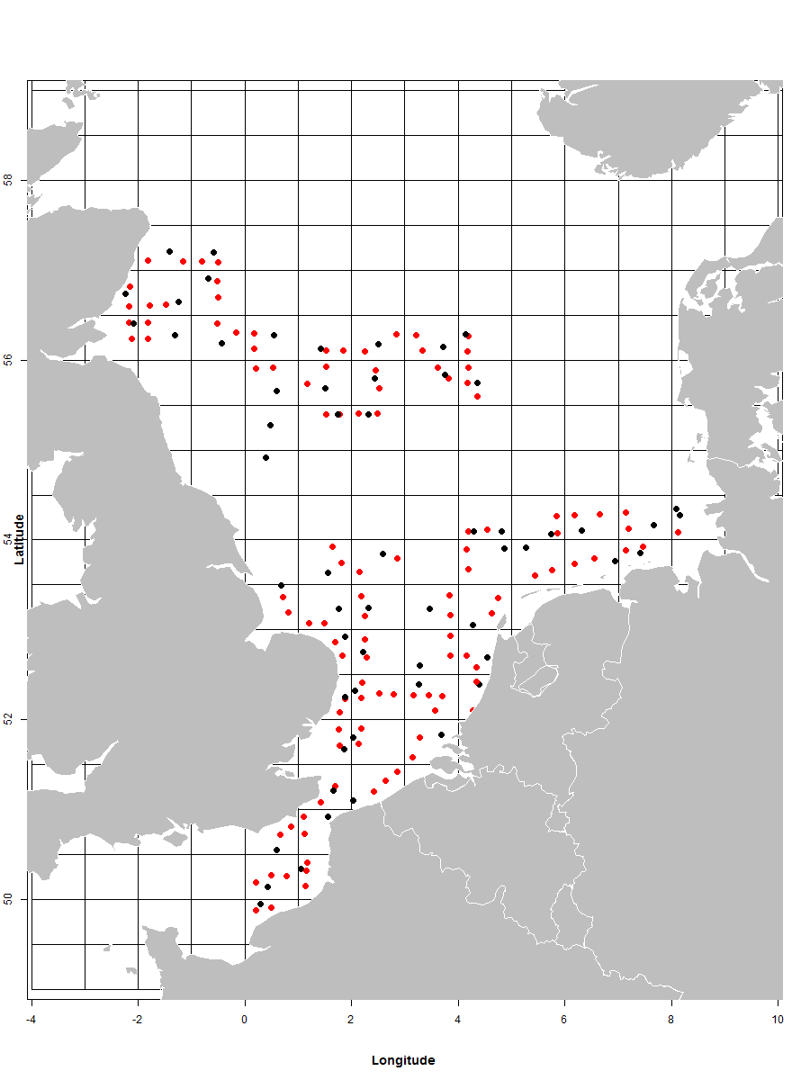
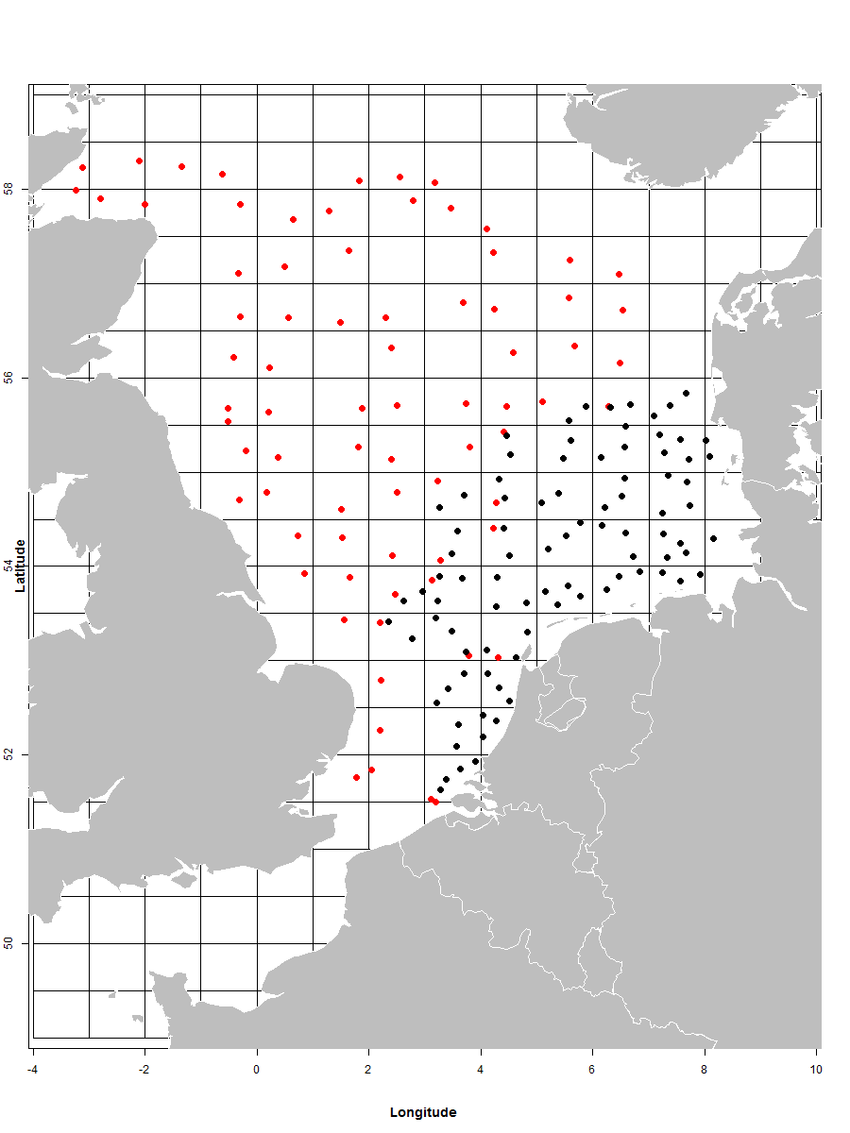
Maps

Fig 1. Sampling grid Dutch International Bottom Trawl Survey 2012. Red: MIK (plankton) hauls; Black: GOV (fish) hauls
Fig 2. Sampling grid Dutch Beam Trawl Survey 2012. Red: RV Tridens; Black: RV Isis

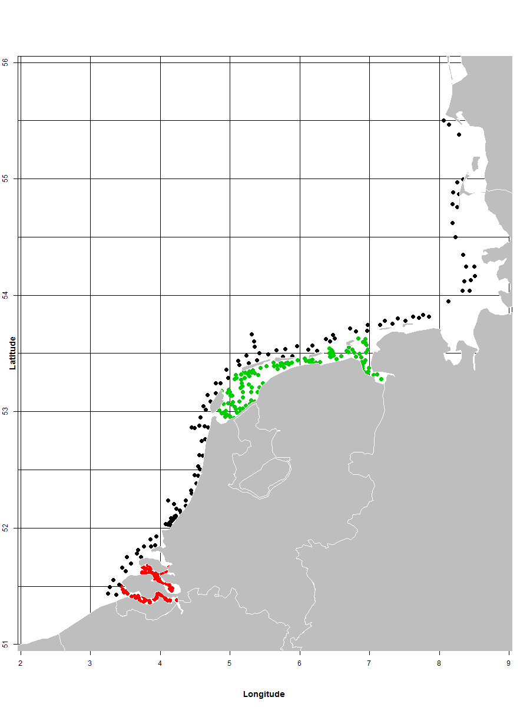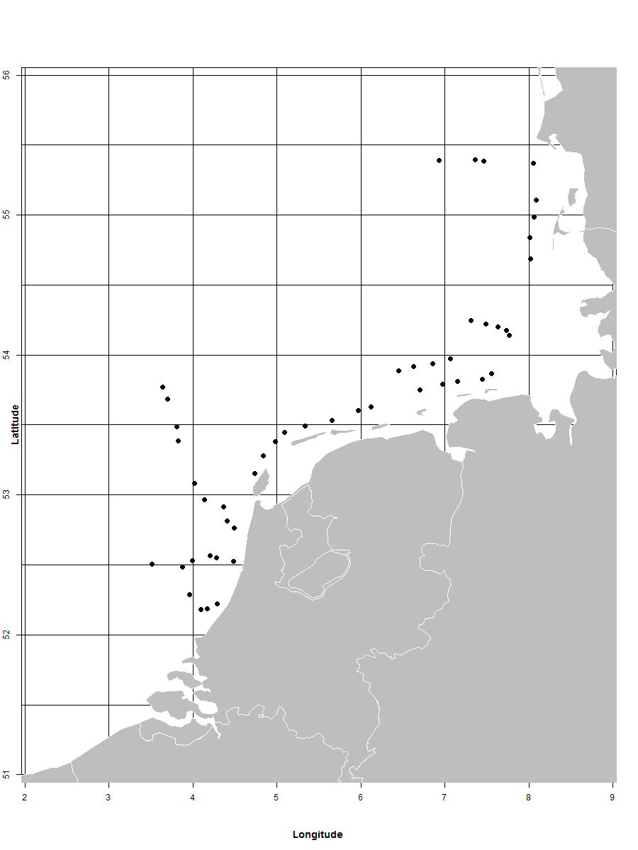

Fig 3. Sampling grid Demersal Young Fish Survey 2012. Red: RV Schollevaar; Black: RV Isis; Green: RV Stern
Fig 4. Sampling grid Sole Net Survey 2012.

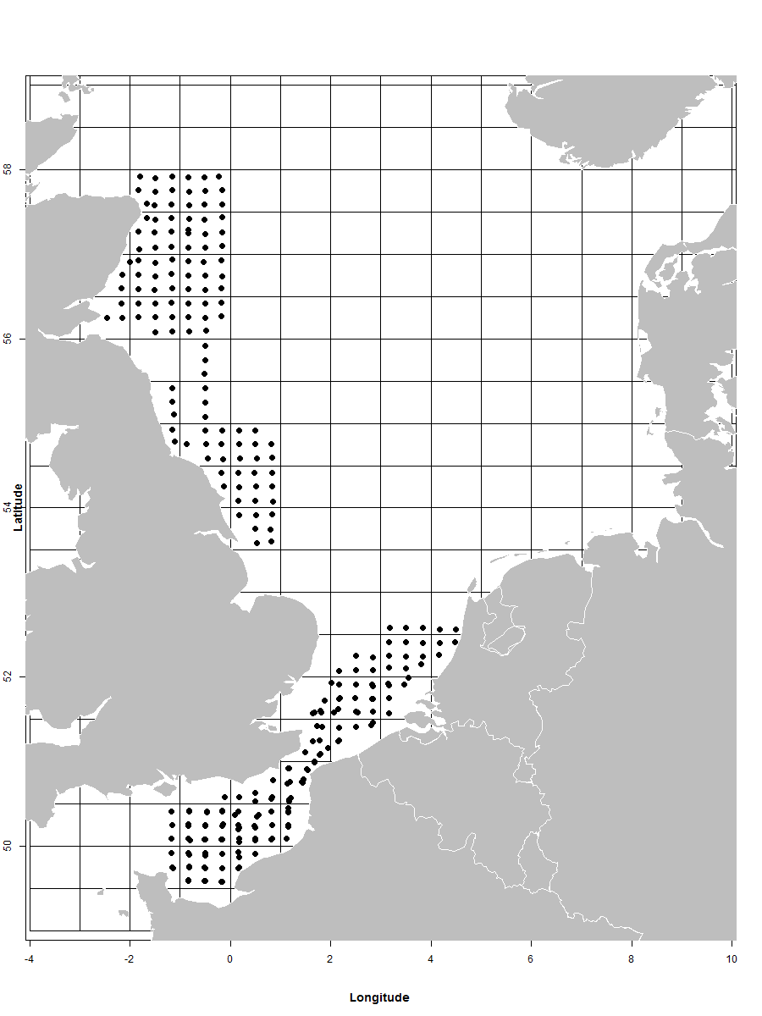
Fig 5. Sampling grid Herring Larvae Survey 2012.
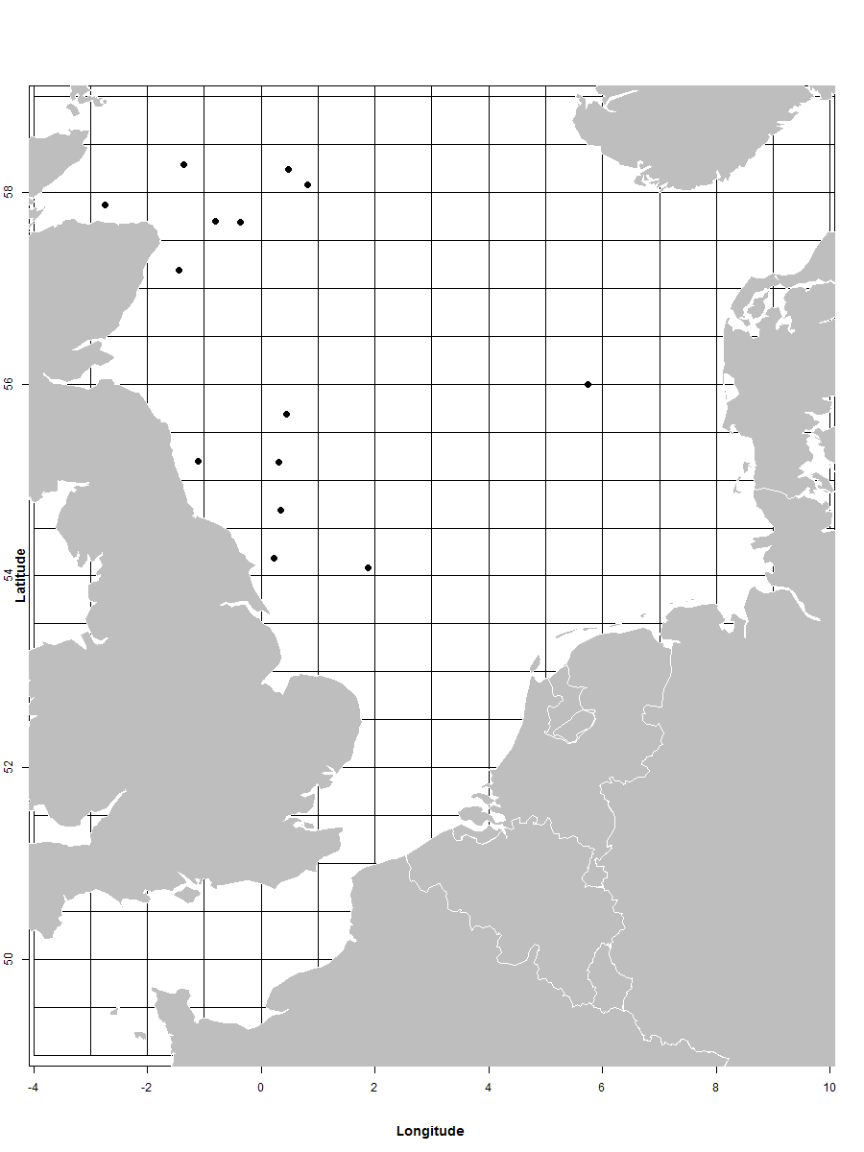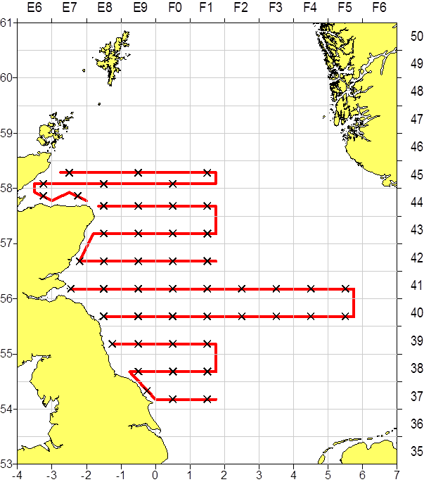

Fig 6a. Sampling grid NS Herring Acoustic Survey 2012. Acoustic transects (red line) and hydrography stations (black X).
Fig 6b. Sampling grid NS Herring Acoustic Survey 2012. Fish hauls.

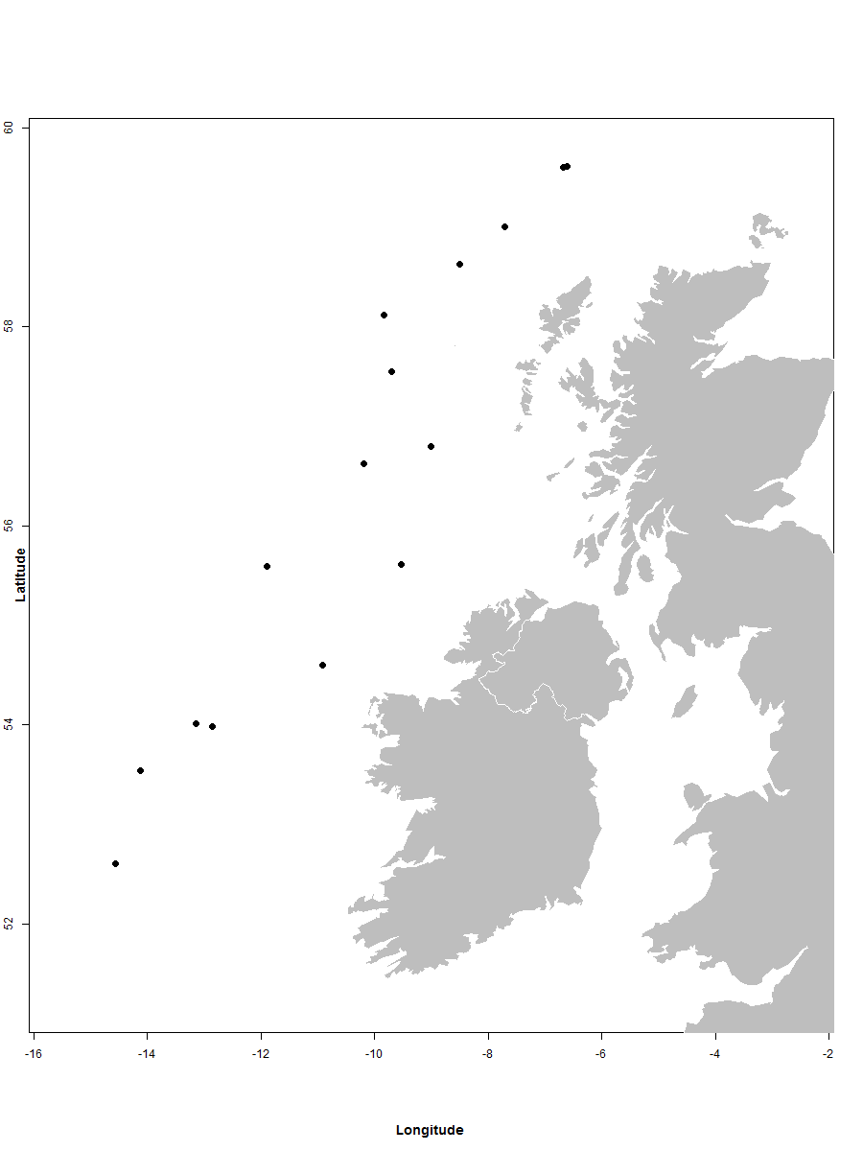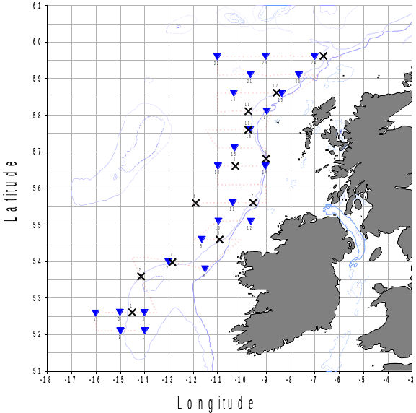

Fig 7a. Sampling grid Blue Whiting Survey 2012. Acoustic transects (red dotted line) and hydrography stations (blue triangles).
Fig 7b. Sampling grid Blue Whiting Survey 2012. Fish hauls

Fig 8.: International Mackerel and Horse Mackerel egg survey: no survey in 2012 (according to schedule, next survey planned for 2013)
Fig 9.: Mackerel egg survey: no survey in 2012 (according to schedule, next survey planned for 2014)

III.G.2 Data quality: results and deviation from NP proposal
The deviation of the planned programme had minor to no influence on the quality of the survey indices of 2012 is expected. See also III.G.1-Achievements.

III.G.3 Follow-up of Regional and international recommendations
The following recommendation applies: STECF EWG 11-08 no 11

III.G.4 Actions to avoid shortfalls
Dealing with weather conditions is part of research at sea. The planning of the sampling is always based on an ‘average’ year. During ‘good’ years it is important to communicate (inter)nationally if other ships need extra sampling to cover their programme. In ‘bad’ years it is highly recommended to communicate as soon as possible on the potential shortfalls that will occur. Since on all Dutch vessels internet is available, communication is easy.
The international acoustic survey on blue whiting is carried out in an area and in a period when poor weather conditions can be expected. In order to reduce the risk that areas may not be surveys, in 2010 the survey design has been adjusted by WGNAPES, resulting in a better coverage in the following years. In 2012, the Dutch survey coordinator stayed ashore and coordinated the locations of the survey on a daily basis. Combined with extremely good weather conditions, this resulted in a good spatial and temporal coverage.
Further actions are not necessary

IV Module of the evaluation of the economic situation of the aquaculture and processing industry

IV.A. Collection of economic data for the aquaculture

IV.A.1 Achievements: results and deviation from NP proposal
The aquaculture sector in the Netherlands consists of three main components:
- The mussel sector
- The oyster sector
- The land based aquaculture sector.
For each of these sectors economic data is collected.
For the mussel and oyster sector data is collected through a panel which covers about 25% of all the firms in the sector. There were no deviations from the NP proposal for these sectors. The collection of data for the land-based aquaculture was more problematic.
In contrary to the fisheries sector, the aquaculture sector is relatively data poor. Only for the mussel culture, reliable data exists on the total production from the mussel auction in Yerseke. Data on the total production of land based aquaculture is available from Eurostat, based on figures provided by Statistics Netherlands and the Ministry of Agriculture Nature conservation and Food safety. However these data show quite some inconsistencies. From this comparison it seems that the Eurostat definition under NACE Code 05.02: “Fish Farming” does not include all aquaculture firms. Thus the data collection of these sectors solely depends on data collection from firms. LEI started to collect data about the aquaculture sector in the year 2005. Through contacts within this relatively small sector and its product organisations (PO mussel culture, Dutch Oyster Association, Dutch Fish Farmers Association NEVEVI, Dutch Fish Product Board), since that time LEI knows fairly accurately how many firms are operating in the sector.
In order to attain economic information from the aquaculture sector LEI makes use of a panel of companies from which the annual financial accounts are analysed. This is mainly because of high non-response of previous questionnaires in this sector. Especially land based aquaculture in the Netherlands is a relatively small, fragmented, highly competitive and dynamic sector. As a result firms are reluctant to provide data on their economic position. All economic variables stated in the regulation can be obtained from the financial accounts of the firms.
As the majority of the segments of the land based aquaculture sector consist of very few firms (i.e. 1-3 firms) the target of the data collection is to obtain full coverage of these segments. However participation in the data collection is voluntary and despite numerous attempts to get new firms to join the panel response continues to be low. Combined with the fact that in 2011 the decrease in production from 2009 proceeded it proved impossible to get a representative sample for the land based aquaculture sector in 2011. Remaining land based trout farms only produced trout for recreational fisheries and are thus no longer included in the data collection.
In 2010 LEI has set up an additional collection program for macro data. This includes the number of companies (by species), production and annual revenue. Contact information of fish farms was gathered from official sources (Statistics Netherlands, Dutch Fish Product Board) and complemented with expert knowledge and a web-scrapping exercise. All known fish farmers were contacted and approached for a telephone questionnaire. Non-response however is still a concern. Many respondents are reluctant to provide information because this is a small economic sector and they are concerned about anonymity. This is particularly the case when the firm specializes in breeding a for the Netherlands relatively new species.
Nevertheless, the survey does provide some valuable insights in the development of the sector. The most important species are eel and catfish where we see concentration of production capacity with fewer but larger producers remaining. Smaller entrepreneur focus more and more on direct sales of (smoked) products.
Because the data are based on financial accounts, data collection is delayed by almost a year. Therefore the 2011-12 program will cover 2010 and 2020 data and final validated data will only become available 18 months after the reference year. The shellfish sector is a special case because the financial year covers the period from July –June. As the majority of the production (> 80%) takes place from July-December, the economic results of the 2010-2011 season will be presented as the 2010 data.

IV.A.2 Data quality: results and deviation from NP proposal
The total value of the economic variables is estimated through different aggregation procedures for each of these sectors:
- Mussel segment: as the total production is available here gross value of production and variable production costs are aggregated according to the production. Fixed costs are aggregated based on the number of vessels.
- Oyster segment: as opposed to the mussel segment there does not exist a statutory duty of sale by auction for oysters. However the Fish Marketing Board request the oyster producers to submit an annual statement of supplied oysters. Furthermore LEI makes use of a panel of oyster companies from which the annual financial accounts are analysed
- Land based fish farming segment: LEI makes use of a panel of fish farming companies from which annual accounts are analysed. In principle all variables would be aggregated by species based on the number of companies, but also production data gathered during the telephone interviews will be used. However since all panels in the sub-segment exist of too few firms it proved impossible to reliably aggregate the results for the entire segment.
- The current number of Dutch oyster companies is 27. Throughout the years LEI has had a panel of oyster companies to estimate the overall economic situation of the oyster sector. Last year, due to several companies unexpectedly leaving the panel, we only had 5 companies remaining. Due to this low number of companies present in the panel the reliability of the estimates for the total oyster sector is considered to be insufficient. Next year our aim is to increase the number of companies taking part in the panel with at least 2; this should ensure statistically robust numbers.

IV.A.3 Follow-up of Regional and international recommendations
No recommendations were done at the North Sea RCM with regard to the economic data collection of the fishing fleet. No initiatives have been taken to coordinate the national programme with other MS.

IV.A.4 Actions to avoid shortfalls
The number of firms presented in the oyster panel will be increased next year.

IV.B. Collection of data concerning the processing industry
Data on fish processing was compiled by LEI from a number of sources. The European Commission requested data from only fish processing and no data collection on fish wholesaling.

IV.B.1 Achievements: results and deviation from NP proposal
LEI Collects data from several resources: LEI survey, SN business statistics, Business statistics collected by Chamber of Commerce, landings statistics, statistics of international trade. The financial account provided by the Chamber of Commerce and the SN database have been directly used to estimate the variables. Other data sources have been used to cross check the results.
LEI collects data on employment and economic performance of the processing sector and fish wholesaling by means of a 5-annual survey (questionnaire). This survey was conducted in 2010.
There were no deviations from the national programme.
SN Business statistics
Economic data on fish processing and wholesaling businesses is available in a structural business statistics database kept by the national statistical office Statistic Netherlands (SN). The database is updated annually. Definitions of variables comply broadly with Commission Regulation (EC) No 2700/98. LEI has access to a set of anonymous micro-data. The SN database contains, among others, data on the following variables:
Income (Turnover):
Turnover comprises the totals invoiced by units in the sector during the reference period, and this corresponds to market sales of goods or services supplied to third parties. Turnover includes all duties and taxes on the goods or services invoiced with the exception of the VAT invoiced by the unit vis-à-vis its customer and other similar deductible taxes directly linked to turnover.
Production costs include:
- Wages and salaries of staff: defined as the total remuneration, in cash or in kind, payable by an employer to an employee (regular and temporary employees as well as home workers) in return for work done by the latter during the reference period. Personnel costs also include taxes and employees' social security contributions retained by processing units as well as the employer's compulsory and voluntary social contributions.
- Purchases of goods and services include the value of all goods and services purchased during the accounting period for resale or consumption in the production process. This includes:
  - Raw materials (including purchases for resale, changes of stocks)
  - Energy costs
- Other operational costs include:
  - Packaging
  - Payments for agency workers
  - Costs of selling
  - Other operating costs: e.g.: postal and telecom, consultancy payments.
- Fixed costs include costs linked to the depreciation of buildings and equipment (payments for maintenance and repair, leasing payments), and financial costs.
- Employment (number of persons employed and FTEs)
Business statistics collected by Chamber of Commerce
The Chamber of Commerce provides a Register of individual business. The register includes data on financial position (share of own capital) and investment (asset), for all businesses. The financial data are obtained from this source.
Landing statistics
Data of landings at national auctions (by vessel, trip, and market category) is collected and kept in a database kept by LEI. The database can be updated at a monthly basis, is based on sales notes and covers all recorded landings at all national auctions. The data set provides data on volume, value and prices of raw materials purchased from all domestic landings of fresh fish. Data on landings and landings value of sea frozen fish is collected by LEI from vessel owners.
Statistics of international trade
Data on international trade (volume, value and prices) of raw materials and final products is provided by SN and Eurostat. LEI has access to a dataset at Standard International Trade Classification (SITC) rev.3 8-digit level. This dataset allows e.g. estimation of volume of raw materials imported and of prices of final products produced from TAC related species.
All indicators as set out in Appendix XIX of the DCR can be submitted but with one year delay as micro-data of SN are not sooner made available.
Sample rate and precision achieved vary by indicator and depend on the secondary source. The sample rate of all indicators collected from business statistics database of SN amounts to 25%.

IV.B.2 Data quality: results and deviation from NP proposal
Data checks were done internally by the Central Bureau of Statistics Netherlands. To ensure data quality figures used were also checked with official published data on Statline..

IV.B.3 Follow-up of Regional and international recommendations
No initiatives have been taken to coordinate the national programme with other MS.

IV.B.4 Actions to avoid shortfalls
No shortfalls.

V. Module of evaluation of the effects of the fishing sector on the marine ecosystem

V.1. Achievements: results and deviation from NP proposal
No specific additional activities have been carried out in the DCF directed to this module. The data required are collected in other modules or are available from other sources. The indicators 1, 2 and 3 listed in Commission Decision 2008/949/EC Appendix XIII of the Commission Decision require data on species abundance and length distribution by species from fishery independent research surveys. These data has been collected through the annual surveys carried out by the Netherlands. Table V.1 lists the information collected during the sampling year.
VMS positions (indicators 4-7) are available for all vessels which are subject to the obligation of having VMS equipment on board. With regard to the confidentiality of the VMS data there still is a conflict between national legislation and DCF legislation. VMS data has been made available by IMARES for research purpose under certain conditions.
Catch composition (indicator 8) of the landings are available for all metiers. Discard data are available for all metiers which are subject to discard sampling. These include all major metiers operating under the flag of the Netherlands.
The data collection through the LEI panel allows for the direct calculation fuel costs (Indicator 9) per quarter and metier. Estimation of the total costs for fuel in each metier are based on total effort (from logbooks) and fuel costs per sea day (from panel data).
Numerous activities, regarding the analyses of data collected under the DCF, have been carried out in 2012. One of the major activities is the implementation of the Marine Strategy Framework Directive (MSFD) and the development of indicators of Good Environmental Status (GES). However, these activities have not been carried out under tee DCF and are not eligible.

V.2. Actions to avoid shortfalls
There are no shortfalls. Action has been taken to streamline national legislation and DCF legislation.

VI. Module for management and use of the data

VI.1. Achievements: results and deviation from NP proposal
Management of the data
Databases
Three relational databases are maintained for storing fishery related data, VISSTAT, FRISBE and ARTIS. VISSTAT and FRISBE are based at IMARES. ARTIS is operated at LEI. The data bases contain only primary data. No aggregated data are kept in these databases, but aggregations can be made from this primary data.
The standard procedures for operating these databases have been maintained in 2012. These procedures are described in the NP 2009-2010. There were no major technical problems with the data bases
VISSTAT contains information of the fishery, mainly obtained from external sources (log-books, sale slips, VMS etc.). Data in this database have been regularly supplemented with actual information for the year 2012. There is often a few months delay between the collection of the data and the submission to VISSTAT. The database is relatively new (a few years). Action has been continued to build up a historical time series by including data from earlier years.
FRISBE contains biological information from the metier sampling, biological parameters, and survey and discard data. Data from 2012 sampling activities have been collected and entered off line using standardised input software. Updated versions of this software “Billie Turf’” have been developed in order to be able to cope with new data requirements, format revisions and bugs. All data is quality checked before date is submitted to FRISBE.
The biological data base is fed with data though two data entry applications. The standard data entry application (named Billie Turf) runs on a PC environment and is used in the laboratory and on board of research and commercial vessels. A “light” version of the standard data entry program Billie (named Libbie) runs on a tablet and is used in the auction.
All economic data are held in databases at LEI. The data of the active vessels are stored in a central object orientated database (ARTIS). ARTIS was developed at LEI for the collection and analysis of all its economic data. Data for the less active and inactive vessels are stored in SPSS data files. Data from the following years will be added routinely to ARTIS. All aggregated data for the DRC are stored in an ACCESS database which is accessible for the commission by means of a system of web services.
Data requests by end-users are administrated in a separate database “FIDAREQ”..
Regional Data Bases
In 2012, limited progress was made by implementing the Regional Data Bases (RDB) in the North Sea and East Atlantic and the North Atlantic Region. Support was given to all the three meeting of the Steering Committee. All meetings were held in Copenhagen. In 2012, NLD co-operated in the call from the RCM chairs to submit data from 2010 and 2011 to the RDB for the purpose of coordination of data collection.
Use of the data
Table VI.1 gives a summary of the information transmitted to major data users in 2012 (ICES and STECF working and study groups). It mostly concerns fisheries and fish stock data from data collection in 2011 and survey data from 2011 and 2012.
This table is incomplete as it does not include data transmission from secondary sources such as ICES InterCatch and DATRAS to other users. Most of the data has been aggregated and exchanged in the format defined by the user.
Survey data are also kept in RDBs together with the survey data from other countries hosted at ICES or various national institutes. In some cases these RDBs hold primary data. In other cases they contain aggregated data. Data for all surveys, for which an international database exist, have been transmitted to these RDBs. The routine transmission of survey data to RDB are is included in the table VI-1.
Relevant recommendations
The following recommendations apply: STECF SGRN 10-02 nos 3, 4, 5, 6 and 7, STECF EWG 11-08 nos 10, LM 2011 no 42, 43 and 48

VI.2. Actions to avoid shortfalls
A few shortfalls have been identified which are dealt with as follows:
- The conflict between EU and national legislation on the confidentially of VMS data still persist. In the past the approach was taken that VMS data will be made available prevailing EU law above national law. However, in 2011, the EU introduced a new control regulation. The control regulation conflicts with the DCF in the area of confidentiality of certain data, in particular VMS data.

VIIa Follow-up of STECF recommendations
The recommendations, dealt with in this section, are addressed to the MS by the STECF EWG in 2010 and 2011. The recommendations for 2012 originate from the STECF reviews (in the STECF plenary reports) of the EWG held in 2012.

STECF EWG in 2010
The following recommendations were selected from the SGRN 10-02 and SGRN 10-03. The selection contains the recommendation which are considered relevant to the Netherlands or the MS in general.
No final SGRN 10-01 report is available (also not on the JRC website). In a draft report, provided by a participant of the meeting, no recommendations are highlighted.
The numbering of recommendations of SGRN 10-02 is applied by the MS. In the report of SGRN 10-03, no recommendations addressed to the MS were found.

1 Topic: Long-Distance Fisheries sampling |  | III-E3
STECF SGRN 10-02  Recommendation | SGRN recommends the relevant MS to attend the RCM LDF in future if the corresponding MS has a long-distance fishery in "Other regions" and to be equipped with the necessary data, background information and mandate to take decisions.
Follow-up actions needed | Relevant MS to attend the RCM LDF.
Responsible persons for follow-up actions
Time frame (Deadline)
MS response | MS has attended RCM LDF meetings in 2010 and 2011

2 Topic: Reporting of landings vs. retained catches
STECF SGRN 10-02  Recommendation | SGRN recommends using the term 'retained catches' instead of 'landings' throughout.
Follow-up actions needed | European Commission, MS, SGRN.
Responsible persons for follow-up actions
Time frame (Deadline)
MS response | MS considers this recommendation redundant

3 Topic: Data calls |  | VI-1
STECF SGRN 10-02  Recommendation | SGRN recommends MS to report technical problems with the upload of data in detail to JRC and DG MARE. The consistency of data with the DCF and Data Call lies in the responsibility of the Member States.
Follow-up actions needed | Member States to report technical uploading problems to JRC and DGMARE.  Member States to ensure consistency of the data with the DCF and Data Calls
Responsible persons for follow-up actions
Time frame (Deadline)
MS response | MS reports possible problems to JRC when applicable. MS strives for consistency of the data throughout all data calls.

4 Topic: Data calls |  | VI-1
STECF SGRN 10-02  Recommendation | SGRN recommends that all MS to thoroughly check the data quality before submitting them and to use the electronic upload procedure and eventual built-in automatic quality checks.  SGRN strongly recommends that all MS to submit data in the given time frame.
Follow-up actions needed | Member States to respect these recommendations
Responsible persons for follow-up actions
Time frame (Deadline)
MS response | MS respects these recommendations.

5 Topic: Data calls |  | VI-1
STECF SGRN 10-02  Recommendation | SGRN recommends MS to report problems with the upload of data in detail to JRC and DG MARE
Follow-up actions needed | Member States to report uploading problems to JRC and DG MARE.
Responsible persons for follow-up actions
Time frame (Deadline)
MS response | see topic 3

6 Topic: Transversal variables |  | VI-1
STECF SGRN 10-02  Recommendation | SGRN recommends that all MS to thoroughly check the data quality before submitting them and to use the electronic upload procedure and eventual built-in automatic quality checks.
Follow-up actions needed | Member States to respect these recommendations.
Responsible persons for follow-up actions
Time frame (Deadline)
MS response | MS agrees with this recommendation and does already perform internal quality checks of the data.

7 Topic: Fish processing industry |  | VI-1  IV-B3
STECF SGRN 10-02  Recommendation | SGRN recommends that MS should consult with the national statistical offices in order to improve efficiency and guarantee consistency in the data collection process. Efficiency can be improved because national statistical offices could already have information required to be collected under the DCF. Data consistency will be met if the same definitions are applied.  SGRN recommends that MS to follow the specification stated in the DCF and fully comply with future data calls on economic data related to the fish processing sector.
Follow-up actions needed | Member States to respect these recommendations.
Responsible persons for follow-up actions
Time frame (Deadline)
MS response | Member State already consults with national statistical office about the data collection of the processing industry

STECF EWG in 2011
The following recommendations were selected from STECF EWG 11-02, EWG 11-08 and EWG 11-19. The selection contains the recommendation which are considered relevant to the Netherlands or the MS in general. The numbering of recommendations of EWG11-02 is applied by the MS. The numbering of the recommendations of the other EWG corresponds with those in their reports.

1 Topic: STECF, RCM and LM recommendations
STECF EWG 11-02  Recommendation | EWG 11-02 recommended that all relevant recommendations issued by RCMs, LM, STECF and its sub-groups should be compiled,
Follow-up actions needed | Compile the Information – Circulate to NC
Responsible persons for follow-up actions | Frans van Beek volunteered to do a list of STECF 2009 recommendations (see Annex 4) Recommendations are compiled in RCM report.
Time frame (Deadline) | By end April 2011
MS response | Frans van Beek has produced and distributed the list

2 Topic: Co-operation between Control Authorities and the NP of the DCF
STECF EWG 11-02  Recommendation | EWG 11-02 recommends including in the new DCF, commitments for Member States to set up at national or regional level, a system to encourage cooperation between control authorities and the National Programmes of the DCF. The cooperation system should address all issues of relevance for the collection and processing of data to be collected under the CR and the DCF Follow Up Action Needed : Scope out requirements for such
Follow-up actions needed | Scope out requirements for such a co-operation
Responsible persons for follow-up actions | MS  DG MARE
Time frame (Deadline) | 2011 et seq.
MS response | MS agrees with this recommendation and will strive to implement such a system when needed.

3 Topic: Control Regulation and Sampling Plans for Vessels not Subject to Logbooks
STECF EWG 11-02  Recommendation | The CR includes commitments for MS to develop and implement sampling plans for vessels not subject to logbook requirements and landing declarations. EWG 11-02 recommends that when MS develop the sampling plans due notice is taken to the data requirements under the DCF. This could be done by actively involving at national level the DCF experts in the development of the sampling plans.
Follow-up actions needed | MS to Identify Sampling Plans under CR
Responsible persons for follow-up actions | MS Control Authority and DCF Personnel  DG MARES
Time frame (Deadline) | 2011 et seq.
MS response | MS is also using questionnaires for small scale fisheries, but the results resemble the information in the logbooks as there is no National exemption from the logbook regulation in the Netherlands

3 Topic: Calculation of CV |  | III-B3
STECF EWG 11-08  Recommendation | EWG 11-08 recommends that information and description on the method/software used for calculation of CV’s should be included (or referred to) in the AR if not provided in NP.
Follow-up actions needed | Await review by STECF Plenary in July
Responsible persons for follow-up actions | DG MARE  MEMBER STATES
Time frame (Deadline) | After STECF July Plenary  Address in 2012
MS response | Annex 6 of this report contains a short description on the method/software used for calculation of CV’s including references. A paper with a description of the methods is in preparation  For Economic variables, MS has followed the suggested calculation of CV as provided in the definitions on the JRC website.

4 Topic: List of Meetings Attended |  | II-B2
STECF EWG 11-08  Recommendation | EWG 11-08 recommends for the AR tables, Table II.B.1 (list of eligible meetings) that is provided by the Commission should be used and all meetings and not only the meetings attended should be provided.
Follow-up actions needed | Await review by STECF Plenary in July
Responsible persons for follow-up actions | DG MARE, Member States
Time frame (Deadline) | After STECF July Plenary. Action in 2012
MS response | MS has followed this approach in the AR

5 Topic: Recommendations from LM, STECF
STECF EWG 11-08  Recommendation | EWG 11-08 recommends that STECF compiles the filtered LIST of recommendations by region (from the previous year) for use by Member States in compiling AR and NP. This list should be available on the DCF website.  MS put in a filtered list of Recommendations and show what actions that have been taken to follow up recs.  Amend the current guidelines to say only previous year recs. should be followed. (EWG 11-08 would point out that a recurring recommendation should be a guideline).
Follow-up actions needed | Await review by STECF Plenary in July
Responsible persons for follow-up actions | DG MARE, STECF, Member States
Time frame (Deadline) | After STECF July Plenary, Address in 2012
MS response | STECF has not taken this action. The approach of NL with dealing of regulation is explained in this report.

6 Topic: Derogations Table
STECF EWG 11-08  Recommendation | EWG 11-08 recommends that a table including derogations asked for and if granted or rejected to be included in the AR tables. Adjust Guidelines for AR to include this.
Follow-up actions needed | Await review by STECF Plenary in July
Responsible persons for follow-up actions | DG MARE, Member States
Time frame (Deadline) | After STECF July Plenary, Address in 2012
MS response | The guidelines to the 2012 AR have not been adjusted to this request. NLD has provided a table with derogations in its NP.

7 Topic: Tables from NP included in AR
STECF EWG 11-08  Recommendation | EWG 11-08 recommends that. Table III.C.1 and III.C.2 III E 1 should not to be deleted from the AR. Maintaining the tables is what is expected. This should be included in the revision of the AR guidelines.
Follow-up actions needed | Await review by STECF Plenary in July
Responsible persons for follow-up actions | DG MARE, Member States
Time frame (Deadline) | After STECF July Plenary, Address in 2012
MS response | MS has not deleted any table from the AR

10 Topic: MS Website |  | VI-1
STECF EWG 11-08  Recommendation | EWG 11-08 recommends that MS set-up a website on their data collection. They are obliged (by DCF regulation) to do so. No MS mentioned or referenced in the AR to such websites.
Follow-up actions needed | Await review by STECF Plenary in July
Responsible persons for follow-up actions | DG MARE, Member States
Time frame (Deadline) | After STECF July Plenary. Address in 2012
MS response | MS has set up a DCF section in the CVO website: http://www.cvo.wur.nl/default.asp?ZNT=S0T2O489

11 Topic: MS unable to conduct a Survey |  | III-G3
STECF EWG 11-08  Recommendation | EWG 11-08 recommends that in cases that a research vessels is not available for carrying out a contribution to a DCF survey, that MS in question should demonstrate that it made all necessary efforts to carry out the survey. MS must make provisions so that such problems do not happen e.g. seek assistance from other MS or charter a vessel.
Follow-up actions needed | Await review by STECF Plenary in July
Responsible persons for follow-up actions | DG MARE, Member States
Time frame (Deadline) | After STECF July Plenary, Address in 2012
MS response | MS agrees with the recommendation. In the past, in such situation MS has managed to find replacing vessel capacity.

14 Topic: Capital Value Calculation |  | III-B3
STECF EWG 11-08  Recommendation | EWG 11-08 recommends that for the calculation of Capital value, all MS shall use PIM (Perpetual Inventory Method) in the future. A Workshop has already explained the method (DCF Workshop on Capital Valuation, Naples June 2011). MS should use this report in next AR. Also explore the need for a Training Workshop. This Report should be made available on the on DCF WEB site.
Follow-up actions needed | Await review by STECF Plenary in July
Responsible persons for follow-up actions | DG MARE, Member States
Time frame (Deadline) | After STECF July Plenary  Address in 2012
MS response | MS has calculated the capital value following the PIM method

16 Topic: AR TEMPLATE
STECF EWG 11-08  Recommendation | EWG 11-08 recommends that files with filters, hidden cells, track changes, coloured cells etc. should not be submitted in AR
Follow-up actions needed | Await review by STECF Plenary in July
Responsible persons for follow-up actions | DG MARE, Member States
Time frame (Deadline) | After STECF July Plenary, Address in 2012
MS response | Yes, MS agrees and applies

17 Topic: Guide Line Review |  | III-C3
STECF EWG 11-08  Recommendation | EWG 11-08 recommends that non conformities in the tables of the AR needs to be explained in the text.
Follow-up actions needed | Await review by STECF Plenary in July
Responsible persons for follow-up actions | DG MARE, Member States
Time frame (Deadline) | After STECF July Plenary, Address in 2012
MS response | Yes, MS will do so.

1 Topic: Annual Reports 2013 – Reporting of Adjustments to NP
STECF EWG 11-19  Recommendation | EWG 11-19 recommends that for Annual Report 2013, all the adjustments carried out by MSs must be clearly reported to illustrate the activities implemented in the reference year. This rule has to be applied to all kind of adjustments (minor, major, substantial etc etc) even in case MS have submitted or not a revised version of the National Program. All these “adjustments” should then appear in the relevant tables of the Annual Report Changes in AR tables with respect to the NP tables should be tracked in red.
Follow-up actions needed | Await review by STECF Plenary in April 2012
Responsible persons for follow-up actions | DG MARE , STECF, Member States, Data End Users
Time frame (Deadline) | During early 2012 after STECF Plenary April 2012
MS response | This recommendation is unclear. Also, if this is relevant, it should be dealt with in the guidelines.

2 Topic: Metier Ranking System
STECF EWG 11-19  Recommendation | According to Commission Decision 93/2010, all MS performing the ranking system should use the average values of the 2 previous years. EWG 11-19 recommends that MS (even if they submitted or not a revised version of the National Program) use the most update set of values (i.e. landing values, tons, fishing days) in order to select the metiers to be sampled.
Follow-up actions needed | Await review by STECF Plenary in April 2012
Responsible persons for follow-up actions | DG MARE , STECF, Member States, Data End Users
Time frame (Deadline) | During early 2012 after STECF Plenary April 2012
MS response | NLD does not agree with this recommendation because the NP is a multi-annual programme defined for a period of 3 years based on the average values of the 2 previous years. The follow-up of recommendation would require that all MS resubmit their 2012 NP after the April Plenary in 2012. This would complicate the process for a number of reasons. It would be undesirable to change on-gong sampling programmes as this would lead to incomplete information. There would also to time for harmonisation with other MS. Also, many unmodified NPs or NPs with minor modification have already been approved by the Commission before the proposed deadline for resubmission. If annual update of the NP based on a reanalysis of the ranking system is desirable, this should be requested in the guidelines taking into account the possibility for RCM to allow harmonisation. In that case there is also no need to establish a multi-annual programme.

5 Topic: On the revision of the National Programmes within a Programme Period
STECF EWG 11-19  Recommendation | EWG 11-19 recommends that revisions in the text of the NP proposals within the programme period should be done in a way allowing the reader to follow the development in the MS. This means that all information valid for the first years of the triennial programme should be kept and not deleted. For example, if a pilot study was carried out in 2011 and the NP for 2012 was revised in accordance with the result from the pilot study, information about the pilot study should be kept in the text of the NP, specifying that this was the situation in 2011, and description of the related modifications should be added, specifying that this was the revised situation for 2012.
Follow-up actions needed | Await review by STECF Plenary in April 2012
Responsible persons for follow-up actions | DG MARE , STECF, Member States
Time frame (Deadline) | During early 2012 after STECF Plenary April 2012
MS response | MS does not agree with the recommendation. The NP for a specific year should contain the intended actions and not the history of the actions done in the past. These can be found in NP’s of previous years.

14 Topic: Issues identified from a Brainstorm of the DCF
STECF EWG 11-19  Recommendation | EWG 11-19 recommends that the issues raised during the DCF brainstorm session (list of 46) should be used to inform the debate on the new DCF. The focus should be on addressing these issues rather than identifying new issues.
Follow-up actions needed | Await review by STECF Plenary in April 2012
Responsible persons for follow-up actions | DG MARE , STECF, Member States, Data End Users
Time frame (Deadline) | During early 2012 after STECF Plenary April 2012
MS response | This recommendation is incorrectly addressed to the MS

15 Topic: Updated SWOT on DCF
STECF EWG 11-19  Recommendation | EWG 11-19 recommends that the updated SWOT analyses (Table 3.2) should be used to inform the debate on the new DCF. The focus should be on addressing the issues in the SWOT rather than identifying new issues.
Follow-up actions needed | Await review by STECF Plenary in April 2012
Responsible persons for follow-up actions | DG MARE , STECF, Member States, Data End Users
Time frame (Deadline) | During early 2012 after STECF Plenary April 2012
MS response | This recommendation is incorrectly addressed to MS

16 Topic: STECF Comments and Recommendations on new DCF
STECF EWG 11-19  Recommendation | EWG 11-19 recommends that the 18 issues outlined in the Table 4.1 of this report are included in the discussion on a new DCF during the early part of 2012.
Follow-up actions needed | Await review by STECF Plenary in April 2012
Responsible persons for follow-up actions | DG MARE , STECF, Member States, Data End Users
Time frame (Deadline) | During early 2012 after STECF Plenary April 2012
MS response | This recommendation is incorrectly addressed to MS

17 Topic: Concurrent Sampling
STECF EWG 11-19  Recommendation | EWG 11-19 recommends that for on-shore sampling, MS should continue to sample the metiers and make sure to cover all the species/stocks where a demand is formulated by an end-user (or listed in Appendix VII of the Comm. Dec.), but the methodology used to achieve the goals remains at the discretion of the MS, provided that it is fully documented and approved within their NP proposal.
Follow-up actions needed | Await review by STECF Plenary in April 2012
Responsible persons for follow-up actions | DG MARE , STECF, Member States, Data End Users
Time frame (Deadline) | During early 2012 After STECF Plenary April 2012
MS response | MS agrees with the recommendation and proposes to apply the concept in the revision of the DCF.

STECF EWG in 2012
The following recommendations were selected from STECF PLEN-01, PLEN 12-02 and PLEN 12-03. In its second meeting in 2012 STECF stated that conclusions and recommendations from EWG reports are NOT the opinion of the STECF before review and adoption by the committee. Therefore, recommendations were collected not from the EWG reports but from STECF. This section presents a selection of recommendation which apply to data collection and which are considered relevant to the Netherlands or the MS in general. The numbering of the selected recommendations is applied by the MS.

1 Topic: National Progamme and Annual Report
STECF PLEN 12-01  Recommendation | In order to facilitate enhancements in the NPs, STECF recommends that the Commission should:  - include in the guidelines definitions of minor, major, or substantial changes (e.g. methodological issues, sampling design, changing in the surveys, derogations etc etc).  - request all MS to include a summary page giving a brief overview of the main revision made to the NP.  - publish the list of all relevant recommendations from STECF, RCM, Liaison meetings in the data collection web site.  STECF recommends that the Commission provide to the NP review group, the original text and the proposed NP revisions for ease of comparison. The final version of the approved NP is what should appear on the DCF website. This website is currently not up to date.
Follow-up actions needed
Responsible persons for follow-up actions | Commission
Time frame (Deadline)
MS response | MS endorses the recommendation and regrets that no list of relevant recommendations of STECF has been provided so far.

2 Topic: Overview of selectivity of gears used in EU fisheries
STECF PLEN 12-01  Recommendation | STECF recommends that a more detailed analysis of discard data gathered under the Data Collection Framework should be undertaken to provide a quantitative rather than a qualitative assessment and this analysis be used to identify the level of discards for the aggregated fleets.
Follow-up actions needed
Responsible persons for follow-up actions
Time frame (Deadline)
MS response | MS strongly supports this recommendation. The Netherlands has started a quantitative analyses in 2013 and urges other MS also to do so. The information is relevant to for the implementation of the landing obligation under the new CFP. The Netherlands also would support an initiative to coordinate this internationally.

3 Topic: International dimension
STECF PLEN 12-02  Recommendation | STECF recommends that FPAs be based on management plans, which should include management objectives, harvest control rules, TAC or effort allocation keys and should be supported by data collection programs, scientific advice and monitoring.
Follow-up actions needed
Responsible persons for follow-up actions
Time frame (Deadline)
MS response | MS supports this recommendation. Future legislation on data collection should accommodate for this.

4 Topic: fishing effort data call
STECF PLEN 12-02  Recommendation | STECF would like to reiterate its recommendation from STECF PLEN-11-03 that data collected under different EU programs and DCF have to be compatible if bioeconomic modeling should be further developed and improved. In particular, there is an urgent need to harmonize gear and area descriptors between economic and biological data calls, as well as to improve the consistency of transversal data such as effort and landings by fleet and métier across these data calls. At present, economic data are only available for aggregated groups of vessels assigned to a single majority activity (to preserve confidentiality) without detailed information on their actual fishing activities, while biological data are collected at the scale of fishing activities =(or métiers) without insights of how individuals select different combinations of activities, making the two data sets largely irreconcilable as they are currently requested under Data Calls. In practice, it might be possible to link the two through allocation to fleets and métiers of logbooks data crossed with fleet register. STECF emphasizes that the DCF needs to explicitly improve this link.
Follow-up actions needed
Responsible persons for follow-up actions
Time frame (Deadline)
MS response | MS agrees, but it is unclear what kind of action has to be taken by who.

5 Topic: STECF advice from July 2012 on tuna fisheries where sharks are associated species
STECF PLEN 12-03  Recommendation | To facilitate data collection and accurate documentation and reporting of catches, STECF recommends that any sharks caught in FPA fisheries should be retained and landed whole (with fins wholly or partly attached to their respective carcass).
Follow-up actions needed
Responsible persons for follow-up actions
Time frame (Deadline)
MS response | The recommendation does not apply to the Netherlands

VIIb Follow-up of recommendations from the Liaison Committee

Liaison Committee in 2010
Selection of recommendations from the Liaison Committee Meeting in 2010 which require actions in 2011 from the MS in general or the Netherlands in particular. The numbering of the 2010 LM recommendations is applied by MS.
LM 2010-1 Topic: Data call (quality issue transmission of the data)
RCM Med&BS 2010  Recommendation | Participants recommend the following improvements in the context of data calls: respect legal provisions to deliver data calls (1 month); provide clearer indications on variables; standardize formats of the request with agreed common formats at Regional Level (see RCM Med&BS 2009 report); respect DCF format and do not change format from one year to another; develop an upload system that clearly detail the errors occurred. Participants are also concerned about the extremely restrictive filter of the data calls that make upload of the data extremely difficulties.
Follow-up actions needed
Responsible persons for follow-up actions | MS, SGRN, JRC, SGMED, DG MARE
Time frame (Deadline)
LM comment | LM notes that data end-users should use the codifications of the DCF Decisions 2008/949/EC and 2010/93/EU. As a basis for developing a standard data exchange format and common codification to be used when exchanging DCF data, the specifications given in the ICES Coop.Res.Rep. 296 (2009) and RCM/LM codifications should be taken into consideration.
MS response | NLD considers that this recommendation is not directed to the MS.

LM 2010-2 Topic : Metier and stock related variables: III.C, III.E, Data quality control and validation of data in NP proposals
RCM Med&BS 2010  Recommendation | Following the analysis carried out during the meeting (analysis on the paragraph III.C and III.E related to data quality and validation), RCM Med&BS recommends MS to revise their NPs in order to achieve all requirements listed in the NP Guidelines for the submission of National Program Proposals, or to explain why it is not done.
Follow-up actions needed | Member States to review their National Programs; SGRN
Responsible persons for follow-up actions | MS; Liaison, SGRN
Time frame (Deadline) | Before NP evaluation by SGRN (June 2010)
LM comment | LM considers that SGRN 10-01 pays particular attention to those NPs where information on data quality control and validation of data is missing.
MS response | NLD has reviewed its NP and no action was considered required.

LM 2010-3 Topic : DCF requirements: Reference landings by country
RCM Med&BS 2010  Recommendation | RCM NA recommends MS to upload the landings in EUROSTAT by ICES division and by genus and species, and avoid as much as possible the use of the generic code “spp”. It is reminded that STECF (2007) recommended the use of EUROSTAT as the reference for landings by country and area, and that all effort should be done to secure the quality of information provided to EUROSTAT.  RCM NA recommends EUROSTAT to disseminate its transmission procedure for this kind of data, to all MS.
Follow-up actions needed | All MS, EUROSTAT for dissemination of transmission procedure
Responsible persons for follow-up actions | National Correspondents
Time frame (Deadline) | before end of 2010
LM comment | LM recommend that MS populate EUROSTAT
MS response | MS considers that requested action is outside the mandate of the DCF

LM 2010-4 Topic : COST tool
RCM Med&BS 2010  Recommendation | The Group discussed the outputs of the WS on Cost. The Group recognize that the tools generated by the COST project could improve noticeably the quality of DCF data collection schemes. But before to address the final request of the WS (a second Cost project), RCM Med&BS recommends to further progress testing the tool and to clearly screen the applicability and functionality. The Group recommend also waiting feedback from users (National laboratories and JRC) to assess and identify issues and need for improvement of the software.
Follow-up actions needed
Responsible persons for follow-up actions | MS, Liaison Meeting, JRC, DGMARE
Time frame (Deadline)
LM comment | LM recommend MS to use COST tools and encourage MS to report on the implementation of these tools in analysing their data.
MS response | NLD considers that the recommendation is not addressed to the MS

LM 2010-5 Topic : COST 2
RCM Med&BS 2010  Recommendation | RCM NS&EA considers that given the fact that most likely, almost all Member States involved in the DCF will use COST for computing their precision levels for 2009 and prepare assessment working groups, resulting in a positive attitude of the EC towards the implementation of COST, a follow up of the COST project – COST 2- is required. The framework for the continuation of the project has several objectives:  -avoiding the development of national versions of the tool  -creating a functional help mailing list and expanding/ enhancing the examples (taking into account the simulation outcomes).  -correcting the possible bugs, improving the code, adapting to new versions of exporting (InterCatch)  -progressing on benchmarking the methods and simulating different sampling schemes and levels with COSTsim  -make the tool user friendly
Follow-up actions needed | MS to start to implement COST
Responsible persons for follow-up actions | MS to be prepared to use COST
Time frame (Deadline) | results to reported to EC and RCM NS&EA in 2011
LM comment | LM recommend MS to use COST tools and encourage MS to report on the implementation of these tools in analyzing their data.
MS response | This recommendation is not adressed to the MS

LM 2010-6 Topic : COST tools hands-on workshop
RCM Med&BS 2010  Recommendation | The Group discussed the outputs of the WS on Cost. The Group recognize that the tools generated by the COST project could improve noticeably the quality of DCF data collection schemes. But before to address the final request of the WS (a second Cost project), RCM Med&BS recommends to further progress testing the tool and to clearly screen the applicability and functionality. The Group recommend also waiting feedback from users (National laboratories and JRC) to assess and identify issues and need for improvement of the software.
Follow-up actions needed
Responsible persons for follow-up actions | MS, Liaison Meeting, JRC, DGMARE
Time frame (Deadline) | Before NP evaluation by SGRN (June 2010)
LM comment | LM recommend MS to use COST tools and encourage MS to report on the implementation of these tools in analyzing their data.
MS response | No follow up actions are specified. Also, this recommendation is not addressed at the MS

LM 2010-7 Topic : Recreational fisheries : Best practise |  | III-D3
RCM NA 2010  Recommendation | RCM NA recommends MS not to wait for the outcomes of the PGRFS to revise current (when relevant) and prepare future NP Proposal on recreational fisheries, but base their planning on the DCF requirements and their own knowledge of the fisheries. RCM NA also recommends to consider the recommendations of WKSMRF, WGEEL, and the future recommendations of PGRFS.
Follow-up actions needed | Revising MS NP proposals 2011-2013 and drafting new NP’s
Responsible persons for follow-up actions | All MS.
Time frame (Deadline) | October 2011
LM comment | LM recommends that SGRN 10-01 takes this recommendation and the RCM-NA 2009 recommendation (which was not taken into consideration) into account when evaluating MS plans for recreational fisheries sampling
MS response | MS disagrees with approach of considering future unseen recommendations. MS has taken all available recommendation into account in the drafting and revising of the sampling proposal for recreational fisheries.

LM 2010-8 Topic : Metier variables: description of nationally ranked metiers |  | III-C3
RCM NA 2010  Recommendation | RCM 2010 recommends that MS use the template provided by RCM NA 2009 to update old metier descriptions (when needed) and describe new ranking métiers identified at this RCM, and strictly respect the agreed naming conventions of fishing ground and métiers as well as the deadline for submission of the information. Appointed persons are responsible for requesting the data and compiling it on a regional level.
Follow-up actions needed | Preparation of metier descriptions/exchange data for task-sharing.
Responsible persons for follow-up actions | All MS.
Time frame (Deadline) | Every year before RCM meetings
LM comment | LM endorses this recommendation
MS response | NLD provides its metier description in an Annex to the NP. They are yearly updated.

LM 2010-7 Topic : Recreational fisheries : Best practise |  | III-C3
RCM NA 2010  Recommendation | RCM 2010 provides a template for summarizing national information on the actions undertaken by MS to include concurrent sampling in their sampling programmes, and recommends that MS use this template to document their activities regarding this topic.
RCM NA 2010  Recommendation | RCM 2010 recommends SGRN to review the actions undertaken by MS regarding concurrent sampling, and give feedback to RCM for the 2011 meeting.
Follow-up actions needed | Preparation of national descriptions on concurrent sampling
Responsible persons for follow-up actions | RCM participants and MS without delegates in RCM NA 2010
Time frame (Deadline) | Before RCM 2011
LM comment | LM regards this as an issue for SGRN, by reviewing the experiences of MS with concurrent sampling under the DCF.
MS response | MS has given feed back on its concurrent sampling to the chair of RCM NA

LM 2010-8 Topic : Metier variables: description of nationally ranked metiers |  | III-C3
RCM NA 2010  Recommendation | RCM 2010 recommends that MS use the template provided by RCM NA 2009 to update old metier descriptions (when needed) and describe new ranking métiers identified at this RCM, and strictly respect the agreed naming conventions of fishing ground and métiers as well as the deadline for submission of the information. Appointed persons are responsible for requesting the data and compiling it on a regional level.
Follow-up actions needed | Preparation of metier descriptions/exchange data for task-sharing.
Responsible persons for follow-up actions | All MS.
Time frame (Deadline) | Every year before RCM meetings
LM comment | LM endorses this recommendation
MS response | NLD provides its metier description in an Annex to the NP. They are yearly updated.

LM 2010-10 Topic : Metier variables: Concurrent sampling |  | III-C3
RCM NA 2010  Recommendation | RCM 2010 provides a template for summarizing national information on the actions undertaken by MS to include concurrent sampling in their sampling programmes, and recommends that MS use this template to document their activities regarding this topic.
RCM NA 2010  Recommendation | RCM 2010 recommends SGRN to review the actions undertaken by MS regarding concurrent sampling, and give feedback to RCM for the 2011 meeting.
Follow-up actions needed | Preparation of national descriptions on concurrent sampling
Responsible persons for follow-up actions | RCM participants and MS without delegates in RCM NA 2010
Time frame (Deadline) | Before RCM 2011
LM comment | LM regards this as an issue for SGRN, by reviewing the experiences of MS with concurrent sampling under the DCF.
MS response | MS has given feed back on its concurrent sampling to the chair of RCM NA

LM 2010-11 Topic : Metier variables: Inclusion of bilateral and RCM agreements in NP
RCM NA2010  Recommendation | Revised National Programmes to include appropriate reference to RCM NA report in relation to sampling agreement at metier level. National Programmes to include in annex formal bilateral agreements, using the template in annex 9.
Follow-up actions needed | National Correspondents to ensure that National Programme includes appropriate reference to RCM and bilateral agreements in relation to sampling activities as referred to in the RCM NA report. Programs; SGRN
Responsible persons for follow-up actions | National Correspondents
Time frame (Deadline) | Before NP evaluation by SGRN (June 2010)
LM comment | LM considers that the overviews on bilateral agreements produced by RCMs should serve as basis for SGRN to highlight further needs. LM notes that this overview should be produced for the Baltic by the next RCM.
MS response | The recommendation should be to ask the Commission to change the guidelines for the production of the NP. The sampling agreements made at the RCM are translated in bilateral agreements. NLD has included these in its NP using the standard and agreed template.

LM 2010-12 Topic : Metier variables: Sampling coordination
RCM NA2010  Recommendation | RCM NA 2010 recommends MS to review precisely all statements made by RCM NA in the section describing the fishing and sampling activities per fishing grounds, and propose actions. RCM NA recommends SGRN to use the tables proposed by RCM NA in its evaluation of NP proposals 2011-2013 in June 2010.
Follow-up actions needed | Propose actions in line with RCM NA recommendations
Responsible persons for follow-up actions | All MS, SGRN
Time frame (Deadline) | June 2010, Revision of the NP proposals after SGRN evaluation
LM comment | LM endorses this recommendation
MS response | The recommendation is unclear and the reference should be more specific

LM 2010-13 Topic : Metier variables: Tasks prior to the RCM Baltic 2011
RCM Baltic 2010  Recommendation | Development of a report in FishFrame which calculate the top 90% ranking of metiers for each MS as well as on regional level. The data should be based on data from the two previous years.
Follow-up actions needed | Landing -, effort – and landing value statistics should be uploaded in FishFrame.
Responsible persons for follow-up actions | RCM participants and FishFrame designers and developers
Time frame (Deadline) | Prior to RCM in 2011
LM comment | LM endorses these recommendations and would like to widen the scope to all regions by recommending that before the RCMs in 2011. MS should look at their transversal data (landings, effort, value), review their metier ranking, and in the in case of significant changes, bring these to the attention of RCMs. As the RCMs had noted that some MS had used the reference years 2008-2009, instead of the reference years 2007-2008 agreed at the 2009 RCMs, the consistent use of the same reference years among MS can be critical in this respect.
MS response | NLD has supported this recommendation and provided the required data in the requested format to the RCM NA and RCM NS&EA in 2011

LM 2010-14 Topic : Metier variables: Tasks prior to the RCM Baltic 2011
RCM Baltic 2010  Recommendation | For the purposes of regional understanding of sampling activities, national information on sampling should be compiled regionally in advance of the next meeting.
Follow-up actions needed | Preparation of exchange data for task-sharing.
Responsible persons for follow-up actions | RCM chair and RCM participants
Time frame (Deadline) | Prior to RCM in 2011.
LM comment | see recommendation nr 13
MS response | This recommendation is unclear. What is meant with ‘national information on sampling’? Sampling activities have been described in the Dutch NP. It is not clear what is more required.

LM 2010-15 Topic : CECAF area: Fishing activities and sampling coverage |  | III-C3
RCM LDF 2010  Recommendation | All MS involved in industrial small pelagic fishery in “From Morocco to Guinea Bissau” fishing ground to ensure adequate sampling coverage for the landings and discards.
Follow-up actions needed | All MS involved in fishery to draft one agreement to share tasks.
Responsible persons for follow-up actions | National Correspondents from all MS involved in fishery. The Netherlands will take initiative.
Time frame (Deadline) | Before the next RCM LDF, to be approved and signed at that RCM.
LM comment | LM endorses this recommendation.
MS response | All MS involved in small pelagic fishery in the CECAF area have agreed to implement a shared sampling programme in these waters in 2012 and included it in their NP.

LM 2010-16 Topic : Stock variables: Studies on shared international age-length keys
RCM NA 2010  Recommendation | The RCM NA recommends that a case study for deriving regional stock based age-length keys be carried out for mackerel (Scomber scombrus) in the North East Atlantic and Western Channel. This information is required to evaluate if it is appropriate to introduce task sharing, at stock level, with regard to sampling for ageing of fish.
Follow-up actions needed | Coordinating country (Ireland) to contact Spain, United Kingdom, Portugal and The Netherlands for supply of data and support in analyzing the data.
Responsible persons for follow-up actions | Andy Campbell, Marine Institute, Ireland, to coordinate and produce working document. Spain, United Kingdom, Portugal and The Netherlands should send the sampling data to Andy Campbell (andy.Campbell@marine.ie) on request. ICES
Time frame (Deadline) | RCM NA 2011
LM comment | LM endorses these recommendations. See also section on the 'Role of the RCM', where the general approach of internationally coordinated sampling efforts is supported by LM.
MS response | NLD has provided data for this exercise to the co-ordinating MS.

LM 2010-17 Topic : Regional sampling of stocks with national quota shares of <10%:
RCM NS&EA 2010  Recommendation | The RCM NS&EA recommends that relevant countries investigate the distribution of their landings from the named stocks in Table IV-4 in relation to the overall distribution across the stock area. Where they have no sampling plans for catches, they should consider if their component of the stock is adequately sampled, spatially and temporally by other MS.
Follow-up actions needed | Check if MS has catches in this RCM area and if MS has no sampling plans for catches, ensure that its component of the catch is adequately covered elsewhere. MS to report back to RCM NS&EA 2011.
Responsible persons for follow-up actions | Belgium, Denmark, Germany, France, The Netherlands, Sweden, Portugal and Spain
Time frame (Deadline) | 10 June 2010 for NP Revision
LM comment | LM endorses the recommendation.
MS response | The MS has dealt with this recommendation in the RCMs in 2011

LM 2010-18 Topic : Member States participation to DCF meetings |  | II-B2
RCM Med&BS 2010  Recommendation | Because of the necessity to coordinate tasks sharing in both fishing grounds Black sea and Mediterranean region, RCM Med&BS addressed the problem of effective regional coordination with the absence of several member states (in this particular case the Group refers to Greece, Malta and Cyprus). The non-attendance to the DCF meetings (i.e. RCM Med, PGMed, Surveys working groups) may affect negatively also the work of all the other MS. RCM Med&BS recall the importance of the DCF Meetings at Regional level (especially the RCM Med&BS) and stresses the participation in the future meetings of all MS.
Follow-up actions needed
Responsible persons for follow-up actions | MS; SGRN; DG MARE
Time frame (Deadline)
LM comment | LM would like to recall that MS participation in the relevant RCMs is mandatory. Furthermore, LM considers that RCMs should continue their efforts in inviting third countries with fisheries in the relevant regions.
MS response | NLD agrees with LM. NLD has participated in all meetings of all relevant RCMs.

Liaison Committee in 2011
Selection of recommendations from the Liaison Committee Meeting in 2011 which require actions in 2011 from the MS in general or the Netherlands. The recommendations are numbered following the numbering in the Liaison report.

LM 2011-3 - Topic : Sampling of Metier related variables including foreign landings : Requirement of on-line information on fleet behaviour
RCM Baltic 2011  Recommendation | To ensure possibilities for adequate sampling of biological and metier related data including landings in foreign MS, national institutes need to have online access to national logbook data and national VMS data.
Follow-up actions needed | National institutes to get access to online logbook and VMS data
Responsible persons for follow-up actions | MS administrations
Time frame (Deadline) | As soon as possible
LM comment | LM notes that this recommendation is common to the NS&EA and NA regions as well. LM supports this recommendation strongly, as access to VMS and logbook data is critical.
MS response | Dutch national institutes have attempted to obtain online access to national logbook data and national VMS data but the access has been refused by the control authorities.

LM 2011-4 - Topic : Metier related variables: Routines for establishing bilateral agreements
RCM Baltic 2011  Recommendation | 1) MS should upload all landing data into the Regional Data Base allowing the RCM to analyse the possible needs for bilateral agreements.  2) The RCMs should each year perform an analysis on landings in foreign countries and conclude were bilateral agreements needed to be made. MS should set up agreements, fixing the details of sampling, compilation and submission of data in each case when it is indicated by the RCM that a bilateral agreement is needed. To include the agreed analysis in FishFrame would be very convenient and time saving.  3) MS should set up agreements, fixing the details of sampling, compilation and submission of data in each case it is concluded by the RCM that a bilateral agreement is needed.
Follow-up actions needed | 1. MS to upload data into FishFrame  2. RCMs to check for the need for agreements and ICES/FishFrame respectively  3. MS to set up bilateral agreements
Responsible persons for follow-up actions | 1. MS  2. RCM 2012  3. MS
Time frame (Deadline) | 1. Annually. Deadline 1st of July 2012  2. Annually  3. Annually. Before deadline for compilation /amendment of NP
LM comment | LM notes that this recommendation is common to the NS&EA and NA regions as well. LM supports a formal data call (in collaboration with the Commission), noting that MS legally are not obliged to respond within 1 month.
MS response | 1) MS uploaded the requested data.  3) and updated the bilateral agreements in 2011 and will do so in 2012 as well

LM 2011-7 Topic : Metier related variables: Recreational fisheries |  | III-D3
RCM Baltic 2011  Recommendation | 1. MS is requested to submit the recreational fishery available data (total removals, any biological data) to the next meeting of WGBFAS, WGBAST and WGEEL in 2012.  ICES WGBFAS, WGBAST and WGEEL are asked to consider the usefulness of inclusion the recreational fishery data into the stock assessment. If it is useful for certain stock WG should provide the list of necessary data needed from recreational fishery in the Baltic.
Follow-up actions needed | 1. MS responsible scientists  Decide during corresponding ICES WG how to proceed
Responsible persons for follow-up actions | 1. MS national correspondent for recreational fisheries  WGBFAS, WGBAST and WGEEL stock assessment coordinators
Time frame (Deadline) | 1. Before corresponding ICES WG meetings (March 2012 – WGBAST, April 2012 - WGBFAS, September 2012 - WGEEL)  March-September 2012
LM comment | LM supports this recommendation.
MS response | 1. MS will make requested data available to all relevant ICES WG in 2012

LM 2011-9 - Topic : Stock related variables: data quality and deficiencies.
RCM Baltic 2011  Recommendation | MS to look into discard sampling program according to WKACCU 2008 guidelines (12 aspects).
Follow-up actions needed | The Chair RCM and all the MS
Responsible persons for follow-up actions | The Chair RCM and all the MS
Time frame (Deadline) | RCM Baltic 2012
LM comment
MS response | It is unclear what kind of action is required from the MS

LM 2011-19 - Topic : DCF Requirements
RCM NA 2011  Recommendation | RCM NA recommends that the collection of otoliths of John Dory is continued but not proceed with age readings until an agreed standardized method is developed.
Follow-up actions needed | All MS having catches of John Dory to collect otoliths
Responsible persons for follow-up actions | All MS
Time frame (Deadline) | None
LM comment | LM supports this recommendation and regards it relevant for the NS&EA region as well.  LM recommends that PGCCDBS provides guidance on
MS response | This recommendation does not apply to NLD

LM 2011-20 - Topic : Feedback from assessment working groups
RCM NA 2011  Recommendation | RCM NA recommends MS to describe in detail the methodology on the separation of the catches of the 2 Lophius species. This information should be available to the 2012 benchmark assessment.
Follow-up actions needed | Prepare a document to be forwarded to the WGHMM Lophius stock coordinators.
Responsible persons for follow-up actions | All MS having catches of Lophius in the Atlantic and having not provided this information to the ICES assessment Working group in 2011.
Time frame (Deadline) | End of 2011
LM comment | LM recommends that the National Correspondents make this information available well before the Benchmark Workshop (WKFLAT) 2012, ideally during November 2011.
MS response | Catches of Lophius by NL flag vessels are very low and not sampled.

LM 2011-22 Topic: Metier variables: Increase sampling in deep-water fisheries
RCM NA 2011  Recommendation | RCM NA recommends MS to check in their NP proposal 2012 that sufficient coverage of deep-water fisheries on-board sampling is planned, in order to meet the EWG needs.
Follow-up actions needed | MS to check and consider increasing the sampling coverage of deep-water fisheries in their amendment of 2012 NP proposal.
Responsible persons for follow-up actions | MS
Time frame (Deadline) | October 2011
LM comment | LM supports this recommendation.
MS response | In the absence of deep-water fisheries in NLD, this recommendation does not apply to MS.

LM 2011-23 - Topic : Métier variables : Métier descriptions |  | III-C3
RCM NA 2011  Recommendation | MS to update metier descriptions already compiled by RCM NA 2010 and using the standard template complete descriptions for any new regionally ranked metiers identified. Updated and new files to be uploaded by Fishing Ground co-ordinators.
Follow-up actions needed | MS to complete metier descriptions
Responsible persons for follow-up actions | All MS
Time frame (Deadline) | RCM NA 2012
LM comment | LM supports this recommendation and notes that it applies to all regions.
MS response | All nationally ranked metier descriptions are yearly updated and provided as an annex to the NP. See also RCM NA 2010 no 8.

LM 2011-24 - Topic : Metier and stock variables : Concurrent sampling |  | III-C3
RCM NA 2011  Recommendation | MS to fill in template on concurrent sampling and provide it to the chair of RCM NA for compilation and sending to the chair of STECF EWG 11-19 in advance of the December meeting
Follow-up actions needed | MS to fill the template  Chair of RCM NA to compile all questionnaires and sent them to the chair of STECF EWG 11-19
Responsible persons for follow-up actions | All MS, chair of RCM NA
Time frame (Deadline) | November 31 2011
LM comment | LM supports this recommendation and notes that the deadline for submission of questionnaires should be 15 November 2011 in order to allow compilation of information before STECF EWG 11-19.
MS response | NLD has done so. See also RCM NA 2010 no 10.

LM 2011-25 - Topic : Metier variables : Merging metier |  | II-B2
RCM NA 2011  Recommendation | RCM NA recommends RCM participants to contact relevant staff within their institute to attend the ICES WKPICS1 meeting on practical implementation of statistical sound catch sampling programmes
Follow-up actions needed | Identify experts for attending WKPICS1
Responsible persons for follow-up actions | RCM NA participants
Time frame (Deadline) | November 2011
LM comment
MS response | MS has identified expert to attend the ICES WKPICS1 meeting. However, he was not able to attend the meeting.

LM 2011-27 - Topic : Metier related variables: Routines for establishing bilateral agreements |  | II-B2
RCM NA 2011  Recommendation | MS should make sure that their landings abroad are included in the RDB upload allowing the RCM to analyse the possible needs for bilateral agreements.  The RCMs should perform an annual analysis on landings in foreign countries and conclude where bilateral agreements need to be made. MS should set up agreements, fixing the details of sampling, compilation and submission of data in each case when it is indicated by the RCM that a bilateral agreement is needed. Standard output algorithms to enable analysis of compiled data should be included in the RDB.
Follow-up actions needed | MS to make sure landings abroad data are included into the RDB
Responsible persons for follow-up actions | MS
Time frame (Deadline) | Annually. Deadline 1st of July 2012.
LM comment | See RCM Baltic
MS response | See response on LM 4

LM 2011-30 - Topic : Recreational fisheries: Best practice |  | III-D3
RCM NA 2011  Recommendation | RCM NA recommends MS to include recommendations and outcomes of PGRFS in the adjustment of their 2012 NP, if relevant..
Follow-up actions needed | Revising MS NP proposals 2012.
Responsible persons for follow-up actions | All MS.
Time frame (Deadline) | October 2011
LM comment | LM supports this recommendation
MS response | This recommendation is a repetition of a previous recommendation in 2011. See RCM NA 2010 no 7

LM 2011-33 - Topic : Stock variables : Quality issues
RCM NA 2011  Recommendation | RCM NA recommends MS to complete properly the tables III.E.1 and III.E.2
Follow-up actions needed | MS to review their tables of the NP Proposal 2011-2013
Responsible persons for follow-up actions | MS
Time frame (Deadline) | October 2011
LM comment | LM supports this recommendation.
MS response | The tables in the NP Proposal 2011-2013 of NLD have been reviewed and are correct. From the recommendation it is not clear why this request does not apply to all tables.

LM 2011-38 - Topic : Stock variables : Regional collection
RCM NA 2011  Recommendation | RCM NA recommends all MS to have a careful look at the tables in annex VII, in order to identify stocks for which a bilateral agreement would improve the sampling scheme.
Follow-up actions needed | MS to identify bilateral agreement, contact NC and propose such agreement in their NP proposal for 2012
Responsible persons for follow-up actions | All MS
Time frame (Deadline) | October 2011
LM comment
MS response | This action has been carried out by the MS in the various RCMS.

LM 2011-42 - Topic : Metier variables : Regional ranking / RDB |  | VI-1
RCM NA 2011  Recommendation | RCM NA recommends that all MS investigate data loaded to RDB under metier 'No_logbook' and replace with the agreed code given in section 3.1 and request the RDB steering group to endorse these as the only permitted entries within the fields defined.
Follow-up actions needed | Resubmit data into the regional database after correction
Responsible persons for follow-up actions | All MS
Time frame (Deadline) | July 2012
LM comment | See RCM Baltic recommendation
MS response | Resubmitted and new data from NLD to the RDB will take account for this recommendation. In order to prevent non agreed codes in a RDB, NLD is of the opinion that it is important that the RDB software should check all input data and only accepts agreed data codes.

LM 2011-43 - Topic : Metier variables : Regional ranking/ RDB |  | VI-1
RCM NA 2011  Recommendation | RCM NA recommended the use of the standard code MIS_MIS_0_0_0 to replace 'No_Matrix' for fisheries not specified in Annex IV of the Commission Decision.
Follow-up actions needed | Resubmit data into the regional database after correction
Responsible persons for follow-up actions | All MS
Time frame (Deadline) | July 2012
LM comment | See RCM Baltic recommendation
MS response | Resubmitted and new data from NLD to the RDB will take account for this recommendation. NLD is of the opinion that it is important that the RDB should check input data and only accepts agreed data codes.

LM 2011-48 - Topic : Quality issues: use of FishFrame as regional database |  | VI-1
RCM NS&EA 2011  Recommendation | The RCM NS&EA recommends that that all MS respond to the data call in 2012 from the chair of RCM NS&EA and load their data to FishFrame or make it available in the FishFrame format. This data call will include Commercial Landings, Commercial Effort and Commercial Samples records for 2010 and 2011.
Follow-up actions needed | MS to have responded to the data call. If issues persist then ICES to inform the chair of RCM NS&EA
Responsible persons for follow-up actions | All MS and chair of RCM NS&EA
Time frame (Deadline) | Data call in February 2012 and then deadline 4 months later
LM comment | See RCM Baltic recommendations.
MS response | see response to LM 4

LM 2011-50 - Topic : Stock Variables: Studies on shared international age–length keys
RCM NS&EA 2011  Recommendation | Sampling for ages and the construction of ALK should follow sound statistical sampling practices set out according to WKPRECISE. Greater emphasis should be placed on the collection of age samples for species subject to age based stock assessments as the collection of length frequency data not linked to age samples may be of limited benefit in improving bias and precision estimates for numbers at age.  Databases structures should allow storage of linked age and length samples.  Collection regulations should not encourage the collection of length only data at the expense of age sampling for species subject to age based assessments.
Follow-up actions needed | MS to review their sampling for ages and construction of ALKs (if used).  Commission to frame collection regulations so as to encourage best statistical practice.
Responsible persons for follow-up actions | MS, Commission
Time frame (Deadline) | To be considered for the new DCF
LM comment | LM notes that this issue will be discussed further in the light of a revised DCF.
MS response | MS agrees but not relevant at this moment

Liaison Committee in 2012
Selection of recommendations from the Liaison Committee Meeting in 2012 which require actions in 2012 from the MS in general or the Netherlands. The recommendations are numbered following the numbering in the Liaison report.
1 Topic : Stock Variables: Potential bilateral agreements on sampling of landings abroad
RCM NS&EA 2012  Recommendation | Where it was identified that bilateral agreement is required, according to the rules agreed upon at the RCM NS&EA 2011 and endorsed by the LM8 and STECF 11-19, MS are requested to establish or update a bilateral agreement on sampling of landings abroad
Follow-up actions needed | MS to evaluate the need for such an agreement based on the overview provided by the RCM NS&EA (Annex No ??)
Responsible persons for follow-up actions | MS
Time frame (Deadline) | Annually. Before deadline for compilation/amendment of NP
LM comment | LM supports this recommendation.
MS response | MS agrees and has already adopted this procedure for a number of years.

2 Topic : Regional Database: Review of the Data Policy Document
RCM NS&EA 2012 and RCM NA  Recommendation | In respect of the development of the RDB and the protection of the data and the ownership of the data, a draft Data Policy Document has been established. The data policy document is based on the current situation but need to reviewed in all its aspects in order to be satisfactory for all MS. The data policy document is a “flexible” document and must be updated as the needs and the development of the RDB are changing. For example, a new data policy document will be prepared if there are changes to the exchange format (update is needed).
Follow-up actions needed | The National Correspondents (NC) from all MS are requested to read through the document, and sent all remarks and/or suggestions for improvements to the chair of the relevant RCM and to the RDB Steering Group (RDB-SG). Even if the NC has no specific remarks or suggestions, it is recommended to send a notification that the document has been read. Based on the input from the NCs, an updated version will be presented at the next NC Coordination meeting organized by the EC.
Responsible persons for follow-up actions | Chair RCM & RDB-SG, National Correspondents of all MS, EC
Time frame (Deadline) | Before the 15th of November 2012
LM comment | LM agrees with this recommendation and recommends the Commission to forward the request to the NC’s..
MS response | The Netherlands has considered the document and supports it.

3 Topic : Métier related variables: Routines for establishing bilatereal agreements
RCM Baltic 2012  Recommendation | - MS should upload all landing data into the Regional Data Base allowing the RCM to analyse the possible needs for bilateral agreements.  - The RCMs should each year perform an analysis on landings in foreign countries and conclude where bilateral agreements need to be made. MS should set up agreements, fixing the details of sampling, compilation and submission of data in each case when it is indicated by the RCM that a bilateral agreement is needed. To include the agreed analysis in FishFrame would be very convenient and time saving.  - MS should set up agreements, fixing the details of sampling, compilation and submission of data in each case it is concluded by the RCM that a bilateral agreement is needed.
Follow-up actions needed | - MS to upload data into FishFrame  - RCMs to check for the need for agreements and ICES/FishFrame respectively  - MS to set up bilateral agreements
Responsible persons for follow-up actions | - MS  - RCM 2013  - MS
Time frame (Deadline) | - Annually. Deadline 15th March 2013  - Annually  - Annually. Before deadline for compilation /amendment of NP
LM comment | LM endorses the recommendation while noting that the development of the agreed analysis has to be taken up by the RDB-SC.
MS response | NL has uploaded the requested data in the RDB and, where required, considered the sampling details in its bilateral agreements with other MS.

4 Topic : Sampling of Métier related variables in foreign landings : Requirement for sampling of foreign landings
RCM Baltic 2012  Recommendation | The RCM Baltic 2012 recommends that landings should not be sampled abroad by landings countries as these data cannot be used but should be compensated by the flag countries by a higher sampling level in the flag country.
Follow-up actions needed | MS should ensure bilateral agreements are made.
Responsible persons for follow-up actions | Chair to present in the LM
Time frame (Deadline) | LM 2012
LM comment | LM supports the recommendation for 2013 under the conditions that:  1 The data needs of the end-users are sufficiently covered under the current standards.  2 MS involved specify the approach through a derogation or a bilateral agreement in the 2013 National Programs and seek approval through the evaluation process currently in place.
MS response | The Netherlands does not not agree with this recommendation. Also this recommendation is in contradiction with recommendation 1 and 7 by RCM NS&EA and RCM NA. MS notes that LM supported these contradictory recommendations.

5 Topic : Sampling of Métier related variables including foreign landings : Requirement of on-line information on fleet behaviour
RCM Baltic 2012  Recommendation | To ensure possibilities for adequate sampling of biological and métier related data including landings in foreign MS, it is recommended that the national authorities give ensure that national institutes have online access to national logbook data and national VMS data as this is needed for carrying out cost efficient DCF obligations.
Follow-up actions needed | National institutes to get access to online logbook and VMS data
Responsible persons for follow-up actions | MS administrations
Time frame (Deadline) | As soon as possible
LM comment | LM endorses the recommendation and notes that access to this information, preferably online and in real-time, is crucial for adequate sampling. This recommendation should be forwarded to the NC’s by the Commission.
MS response | National Institutes in the Netherlands do not have online access to national logbook data and national VMS data. Access to the data for carrying out DCF obligations is guaranteed through a copy of the data in a database maintained by IMARES.

6 Topic : Métier variables: Metier Descriptions
RCM NA 2012  Recommendation | RCM NA 2012 recommends that the metier descriptions for fishing grounds under the remit of the RCM be updated by each MS in as much detail as possible. These descriptions to be used as a tool, in conjunction with outputs from the RDB, to identify metiers that could be combined for regionally coordinated sampling plans.
Follow-up actions needed | MS to update Metier descriptions
Responsible persons for follow-up actions | MS participating in fisheries under the remit of RCM NA
Time frame (Deadline) | June 2013
LM comment | LM endorses this recommendation.
MS response | The metier descriptions are submitted in the NP and are updated in the resubmissions of the NP.

7 Topic : Stock related variables: Setting up of Bilateral agreements
RCM NA 2012  Recommendation | RCM NA recommends MS put in place bilateral agreements for sampling of landings abroad where applicable.
Follow-up actions needed | Include bilaterals in the revised NP proposals
Responsible persons for follow-up actions | MS
Time frame (Deadline) | 31 Oct 2012
LM comment | LM endorses this recommendation
MS response | MS agrees and has already adopted this procedure for a number of years.

8 Topic : Stock related variables: Setting up of Pilot programmes for sampling of Boar fish (Capros aper)
RCM NA 2012  Recommendation | RCM NA recommends MS involved and that have obligations in the Boar fish fishery to set up a pilot program for sampling.
Follow-up actions needed | Include pilot study in the revised NP proposals
Responsible persons for follow-up actions | MS fishing Boar fish
Time frame (Deadline) | 31 Oct 2012
LM comment | LM endorses this recommendation.
MS response | Netherlands does not conduct a fishery directed to Boar fish. These species is caught as a by-catch and is sampled in the discard monitoring programme

VIII. List of acronyms and abbreviations

shortcut | abbreviation of
ACCESS | Microsoft database
AGDMM | ICES Ad hoc Group on the Distribution and Migration of Northeast Atlantic Mackerel
AR | Annual Report
ARTIS | Database with economic data maintained by LEI
BTS | Beam Trawl Survey
CBS | Statistics Netherlands
CECAF | Committee for the Eastern Central Atlantic Fisheries
CEFAS | Centre for Environment, Fisheries & Aquaculture Science (Lowestoft UK)
CFP | Common Fishery Policy
COST | Common Open Source Tool
CR | Commission Regulation
CRM | Corten Research Management
CTD | instrument to measure water characteristics like salinity, temperature, pressure, depth and density
CV | Coefficient of variation
CVO | Centre for Fisheries Research (Netherlands)
DATRAS | ICES Database with survey data
DCR | Data Collection Regulation
DCF | Data Collection Framework (successor of DCR from 2009 onwards)
DG MARE | Directorate-General for Maritime Affairs and Fisheries of the European Commission
DPMA | Direction des pêches maritimes et de l’aquaculture
DTU-Aqua | National Institute of Aquatic Resources of the Technical University of Denmark
EC | European Commission
EL&I | Dutch Ministry of Economics, Agriculture and Innovation
EL&I-DAD | Animal Supply Chain and Animal Welfare Department of EL&I
EU | European Union
EUROSTAT | European Statistical Office
EWG | Expert Working Group
EZ | Dutch Ministry of Economic Affairs
FIDAREQ | Database administrating data requests
FRISBE | Database with biological data maintained by IMARES
FYK | gear code for Fyke net
GER | Germany
GNS | Gear code: Gill net
HAWG | ICES Herring Assessment Working Group for the Area South of 62ºN
HP | engine power expressed in horse power
IBTS | International Bottom Trawl Survey
ICCAT | International Commission for the Conservation of Atlantic Tunas
ICES | International Council for Exploration of the Sea
IBTS | International Bottom Trawl Survey
IMARES | Institute for Marine Resources & Ecosystem Studies, Wageningen UR
IOTC | Indian Ocean Tuna Commission
ITQ | Individual Transferable Quota
JRC | Joint Research Centre
LEI | Institute of Agricultural Economics
LM | Liaison Meeting
MS | Member State of the European Union
MCD | Mixed crustacean and Demersal fish target composition
MFSD | Marine Framework Strategy Directive
NACE | Nomenclature statistique des activités économiques dans la Communauté européenne (General Industrial Classification of Economic Activities within the European Communities)
NAFO | Northwest Atlantic Fisheries Organization
NA | North Atlantic
NLD | The Netherlands
NP | National Data Collection Programme
OTB | gear code for otter trawl
PCU | price per Capacity Unit
PGCCDBS | ICES Planning Group on Commercial Catch, Discards and Biological Sampling
PGMED | Planning Group for the Mediterranean
PIM | Perpetual Inventory Method
RCM | Regional Coordination Meeting
RCM LDF | RCM Long distance Fisheries
RCM NA | RCM North Atlantic
RCM NS&EA | RCM North Sea and Eastern Arctic
RCM Med&BS | RCM Mediterranean and Black Sea
RCM Baltic | RCM Baltic Sea
RDB | Regional Data Base
RFMO | Regional Fisheries Management Organization
SGECA | STECF Sub-group on Economic Affairs (subgroup from STECF)
SGELECTRA | ICES Study Group on Electrical Trawling
SGIMC | ICES Study Group in Integrated Monitoring of Contaminants and Biological Effects
SGPIDS | ICES Study Group on Practical Implementation of Discard Sampling Plans
SGRN | Subgroup on Research Needs and Data Collection (subgroup from STECF)
SITC | Standard International Trade Classification
SN | national statistical office Statistic Netherlands
SPSS | Software package for statistical analyses
SSC | gear code for Scottish Seine
STECF | Scientific, Technical and Economic Committee for Fisheries
TAC | Total Allowable Catch
TBB | Gear code: Twin Beam Trawl
TBS | Gear code: Beam Trawl Shrimp
TNS NIPO | Dutch research organization specialized in market research
UK | United Kingdom
VAT | Value Added Tax
VIRIS | Visserij Registratie en Informatie Systeem (Database with logbook entries in the Netherlands, maintained by EL&I)
VISSTAT | Dutch data base with (non-biological) data on fisheries
VMS | Satellite based Vessel Monitoring System
vTI | Johann Heinrich von Thünen-institute, Germany
WKACCU
WKFLAT | Benchmark Workshop on Flatfish
WKFRAME2 | ICES Second Workshop on Implementing the ICES FMSY Framework
WKIDFL | ICES Workshop on the identification of clupeoid, flatfish, gadoids and other fish larvae
WKISS | ICES Workshop on the Implications of Stock Structure
WKMSFD11 D3+ | ICES Workshop of the Marine Strategy Framework Directive2-Descriptor 3
WKPELA | ICES Benchmark Workshop on Pelagic Stocks
WKPRECISE
WKSMRF | ICES Workshop on Sampling Methods for Recreational Fisheries
WGBAST | ICES Working Group on Baltic Salmon and Trout
WGBFAS | ICES Baltic Fisheries Assessment Working Group
WGCRAN | ICES Working Group on Crangon Fisheries and Life History
WGEEL | ICES/EIFAAC Working Group on Eels
WGEGGS | ICES Working Group on North Sea Cod and Plaice Egg Surveys in the North Sea
WGDIM | ICES Working Group on Data and Information Management
WGEVO | ICES Working Group on Fisheries-Induced Evolution
WGRFS | ICES Planning Group on Recreational Fishery Surveys (previously PGFRS)
WKHERMP | ICES Workshop on the evaluation of the long-term management plan for North Sea herring
WGMASC | ICES Working Group on Marine Shellfish Culture
WGMEGS | ICES Working Group on Mackerel and Horse Mackerel Egg Surveys
WGNAPES | ICES Working Group on Northeast Atlantic Ecosystem Surveys; previously PGNAPES
WGNEW | ICES Working Group on new MoU species
WGOOFE | ICES Working Group on Operational oceanographic products for fisheries and environment
WGRFS | ICES Working Group on Recreational Fishery Surveys
WGWIDE | ICES Working Group on Widely Distributed Stocks (consists of parts of former WGNPBW and WGMHSA)

IX. Comments, suggestions and reflections

Comments to the cost statement:
- The format used for the cost statement is the same as the one used for the calculation of the budget proposal for the NP 2011-2013. These formats were provided by the Commission as Excel worksheets.
- The labour rates in the cost statement are calculated for each employee separately based on the eligible labour costs and a productivity of 210 days (1512 hours) for full time employees. For employees with a productivity higher than 1512 hours, the labour rates were reduced. For employees which were not fully employed in 2011 a proportionally reduced productivity was used.
- In order to be able to deal with the reporting of time by activity, as requested in the financial format, activity categories have been introduced in the national time declaration reporting systems. However, the activity descriptions do not always exactly match with those in the financial form. The labour time listed in the financial forms is taken from the national time declaring system. However, in some cases the stratification over activities is partly based on expert judgement.
- The daily rates of the research vessels have been recalculated based on the actual costs in 2012.
- Due to changes in the survey programme of the IBTS and SNS (see chapter III.G), the days at sea and the vessel in the cost statement differ from the budget proposal.
- The Demersal Young Fish survey is carried out with three vessels. The vessel costs are specified in separate sheets. The labour and other costs cannot easily been separated and are included combined in the sheet of RV “Isis”.

Comments to the report:
- All recommendations by STECF DCF expert groups in 2010 and 2011 and the Liaison Committee meetings in 2010, 2011 and 2012 are collected in section VII. The recommendations from STECF expert groups in 2012, endorsed by STECF, are taken from the STECF plenary reports. The recommendations are a selection of only those addressed to the MS or specifically directed to NLD. These recommendations are numbered. As far as possible the original number has been applied. In the case there was no original numbering, a numbering has been applied by the MS for this report. In the relevant sections in the report dealing with ‘follow-up of recommendations’, we refer to the relevant recommendation with numbering as applied in section VII.
- For a large number of recommendations there appears to be no appropriate place in the report template for response. Also, some recommendations would be more appropriate to deal with in the NP. A large number of recommendations is unclear or are wrongly addressed to the MS.

Comments to the tables:
- NL has repeatedly commented on Table III.C.5. The table is internally inconsistent and also inconsistent with the requirement from the Decision. The white cells in the table require information on the sampling intensity for length compositions of the metiers combined. However the grey cells require the information by metier. So the planning (white) and reporting (grey) information does not match. Also, the variables to be entered “number of fish measured/aged” is unclear since the table supposed to deals with length compositions only. It is not clear from the reported data in the table which species are measured by age and which one by length. Also the associated achieved precision would differ for age and length. Further there is only one column in which the required precision can be indicated, while precision requirements for discards and landings are different. The column “Precision (CV) achieved on volume of discards” does not belong in this table since this table deals with length measurements. Also it is not clear whether the volume is should be given by metier or metiers combined.
- The mismatch between the NP and AR part of Table III.C.5 was mentioned in previous year’s Technical Reports and brought to the attention of the Commission. However, no changes in tables and guidelines have been provided. This table is a big mess and unhelpful.
- The format of table VI_1 is not suitable to report transfer of data sampled under foreign flag or under a bilateral agreement.

Reflections on data use
- For the meetings listed in Table II_B_1, eligible travel costs are limited to two persons per meeting. NLD considers that this limitation is not always justified. In order to reduce the number of working groups, ICES has merged a number of groups and meetings but the tasks have been unchanged. This applies as well to survey planning groups (SGIPS + PGNAPES = WGIPS) as for working groups analysing data for the purpose of providing advise (WGNPBW + WGHMSA = WGWIDE). Although the number of meetings is reduced, the number of participants is not. NLD requests the Commission to reconsider the strict application of the limited to two persons per meeting.

X. References
Anon 2010. National Programme 2011-2013 – The Netherlands – (the drawing up of the programme of the Data Collection Framework). Revised version (12) submitted April, 2012
Anon 2010. Report of the 7th Liaison Meeting between the Chairs of the RCMs, the chair of ICES PGCCDBS, the chair of PGMED, the ICES representative, the Chair of SGRN and the European Commission. ILVO Institute, Ostend, Belgium, 3rd and 4th June 2010
Anon 2011. Report of the 8th Liaison Meeting between the Chairs of the RCMs, the chair of ICES PGCCDBS, the chair of PGMED, the ICES representative, the Chairs of STECF DCF ESG’s and the European Commission. ILVO Institute, Ostend, Belgium, 4th and 5th October 2011
Anon 2012. Report of the 9th Liaison Meeting between the Chairs of the RCMs, the chair of ICES PGCCDBS, the chair of PGMED, the ICES representative, the Chairs of STECF DCF EWG’s, PGECON and the European Commission. DGMARE, Brussels, Belgium, 24 - 26 September 2012
Anon 2013. Guidelines for the submission of Annual Report on the National Data Collection Programmes under Council Regulation (EC) 199/2008, Commission Regulation (EC) 665/2008 and Commission Decision 2010/93/EU (Version 2013). Annex II in Scientific, Technical and Economic Committee for Fisheries (STECF) DCF- update of MS Annual Report Guidelines, review amended LIT NP and Croatian NP for 2013 (STECF-13-07) Edited by EskildKirkegaard & FabrizioNatale Report EUR XXXXX EN
EC-RCM 2010. Final report of the Regional Coordination Meeting for the North Atlantic (RCM NA) 2010. Ostend, Belgium. 19 – 21 April 2010 and 31 May – 2 June 2010.
EC-RCM 2010. First Regional Coordination Meeting on Long Distance Fisheries (RCM LDF). Madrid 3-5 maart 2010.
EC-RCM 2010. Report of the Regional Coordination Meeting for the North Sea and Eastern Arctic (RCM NS&EA) 2010. FINAL VERSION. DTU-Aqua Charlottenlund, Denmark17,21 May 2010.
EC-2010. Scientific, Technical and Economic Committee for Fisheries (STECF). Evaluation of 2011-2013 National Programmes linked to the Data Collection Framework. Report of the Subgroup on Research Needs (SGRN 10-01) 14-19 June 2010, Ispra, Italy. Edited by Paul Connolly and Jarno Virtanen EUR 24723 EN
EC 2010. Scientific, Technical and Economic Committee for Fisheries (STECF). Evaluation of 2009 Annual Reports related to the Data Collection Framework. Report of the Subgroup on Research Needs (SGRN 10-02). 5-10 JULY 2010, HAMBURG. Edited by Christoph Stransky & Hendrik Doerner EUR 24535 EN
EC-2010. Scientific, Technical and Economic Committee for Fisheries. Report of the Sub-Group on Research Needs. SGRN-10-03 Review of needs related to surveys. Authors: Alpoim, R., Brodie, W., Daskalov, G., Degel, H., Fiorentino, F., Korsbrekke, K., Morgado, M.C., O'Brien, C., Reid, D., Sampson, D., Somarakis, S., Stransky, C., and Uriarte, A. EUR – Scientific and Technical Research series – EUR 24634 EN
EC-RCM 2011. Report of the Second Regional Coordination Meeting on Long Distance Fisheries (RCM-LDF). Ljubljana (Slovenia). 10-13 May 2011
EC-RCM 2011. Final report of the Regional Coordination Meeting for the North Atlantic (RCM NA) 2011, La Rochelle, France, 12–15 September 2011
EC-RCM 2011. Report of the Regional Coordination Meeting for the North Sea and Eastern Arctic (RCM NS&EA) 2011. Johan Heinrich von Thunen Institute (vTI), Hamburg, Germany. 26/09/2011 – 30/09/2
EC 2011. Scientific, Technical and Economic Committee for Fisheries (STECF) Expert Working Group (EWG) 11-02. Reflections on the Present and Future Requirements of the DCF. Borchette Centre, Brussels; 21st to 25th March 2011 EUR 24896 EN
EC 2011. Scientific, Technical and Economic Committee for Fisheries (STECF) Expert Working Group (EWG) 11-8. Evaluation of 2010 annual reports related to the Data Collection Framework. Helsinki; 27th June 2011 - 1st July 2011 EUR 25250 EN
EC-RCM 2012. Report of the Third Regional Coordination Meeting on Long Distance Fisheries (RCM-LDF). Madrid (Spain). 9-13 July 2012
EC-RCM 2012. Final report of the Regional Coordination Meeting for the North Atlantic (RCM NA) 2012, Irish Marine Institute Galway, Ireland, 10–14 September 2012
EC-RCM 2012. Report of the Regional Coordination Meeting for the North Sea and Eastern Arctic (RCM NS&EA) 2012. Institute for Agricultural and Fisheries Research (ILVO), Oostende, Belgium. 3-7 September 2012
EC 2012. Scientific, Technical and Economic Committee for Fisheries (STECF) Expert Working Group (EWG 11-19). Review of the Revised 2012 National Programmes and the Future of the DCF. Borchette Centre, Brussels; 28th November to 1st December 2011 EUR 25308 EN
EC 2012. 39th Plenary Meeting Report of the Scientific, Techinal and Economic Committee for Fisheries (PLEN-12-01). Plenary meeting 16-20 April 2012, Brussels. Edited by John Casey & Hendrik Doerner. Report EUR 25303 EN
EC 2012. 40th Plenary Meeting Report of the Scientific, Techinal and Economic Committee for Fisheries (PLEN-12-02). Plenary meeting 9-13 July 2012, Copenhagen. Edited by John Casey & Hendrik Doerner. Report EUR 25411EN
EC 2012. 41th Plenary Meeting Report of the Scientific, Techinal and Economic Committee for Fisheries (PLEN-12-03). Plenary meeting 5-9 November 2012, Brussels. Edited by John Casey & Hendrik Doerner. Report EUR 25579EN
EC 2012. Scientific, Technical and Economic Committee for Fisheries (STECF). Expert Working Group on Evaluation of MS Annual Reports for 2011 of the DCF (EWG-12-08). Hamburg, Germany, 25-29 June 2012. Edited by Michael W. Ebeling, Nikolaos Mitrakis & Hendrik Doerner. EUR 25450 EN
EC 2013. Scientific, Technical and Economic Committee for Fisheries (STECF). DCF - Assessment of NP Changes (STECF-13-02; EWG-12-08). Brussels, Belgium, 10-14 December 2012. Edited by Michael W. Ebeling, Nikolaos Mitrakis & Hendrik Doerner. EUR 25827 EN
Hammen, T., and Martin de Graaf. 2012. Recreational fishery: catch estimate of cod (Gadus morhua) and eel (Anguilla anguilla). Report number C014/12
Helmond, A.T.M., S.S. Uhlmann, H.M.J. van Overzee, S.M. Bierman, R.A. Bol and R.R. Nijman. 2011. Discard sampling of Dutch bottom-trawl fisheries in 2009 and 2010. CVO report 11.008
Helmond, A.T.M. van, S.S. Uhlmann, R.A. Bol, R.R. Nijman and A. Coers. 2012. Discard sampling of Dutch bottom-trawl and seine fisheries in 2011. CVO report: 12.010
Turenhout, M., H. Bartelings, J.A.E. van Oostenbrugge, Evaluation sample fisheries, Agricultural Economics Research Institute (LEI), The Hague, 2011.

XI Annexes

Annex 1 Set of survey maps
Upon request by the Commission, the set of survey maps has been moved into the section III.G.1.: Research surveys at sea

Annex 2 Bilateral Agreements
Bilateral Agreement between The Netherlands (Centre for Fisheries Research) and Germany (Johann Heinrich von Thünen Institute, vTI) for the collection of length and age samples in accordance with EC Regulation 665/2008, laying down detailed rules for the application of Council Regulation (EC) 199/2008, and its Commission Decision 2010/93/EU
Agreement:
Pelagic freezer trawlers fishing on herring, blue whiting, mackerel and horse mackerel, and beam trawlers fishing on plaice and sole under the German register, which land for first sale into The Netherlands, will be sampled as part of the German National Programme under the requirements of the EC Data Collection Framework (199/2008). The eventual additional sampling costs will be covered within the German National Sampling Programme 2011-2013.
Description of sampling:
The sampling will be for length and age of discards and landings, sampling will be carried out in accordance with the German National Sampling Programme.
Sampling intensity:
Levels and coverage of sampling will be as agreed at the annual meeting of RCM North Sea & Eastern Arctic.
Data responsibility:
Germany is responsible for submitting the data to the relevant ICES Expert Groups, and to the EC under the requirements of its Data Collection Framework. Germany will provide the required data for the species that are requested by the relevant ICES Expert Groups, and the data for the additional species to The Netherlands as and when requested.
Contact persons:
In The Netherlands (CVO): Sieto Verver: sieto.verver@wur.nl
In Germany (vTI-SF): Jens Ulleweit: jens.ulleweit@vti.bund.de
Signatures:
For The Netherlands (CVO) For Germany (vTI)
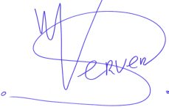
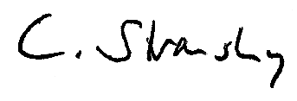
Sieto Verver Dr. Christoph Stransky
Dpt. Head Centre for Fisheries Research German National Correspondent

Date: 24 March 2010

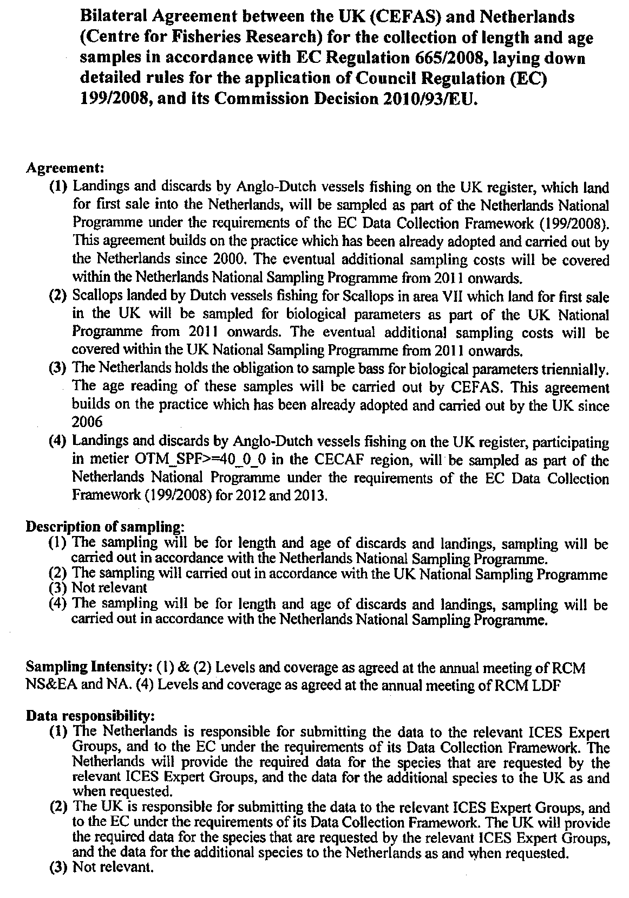
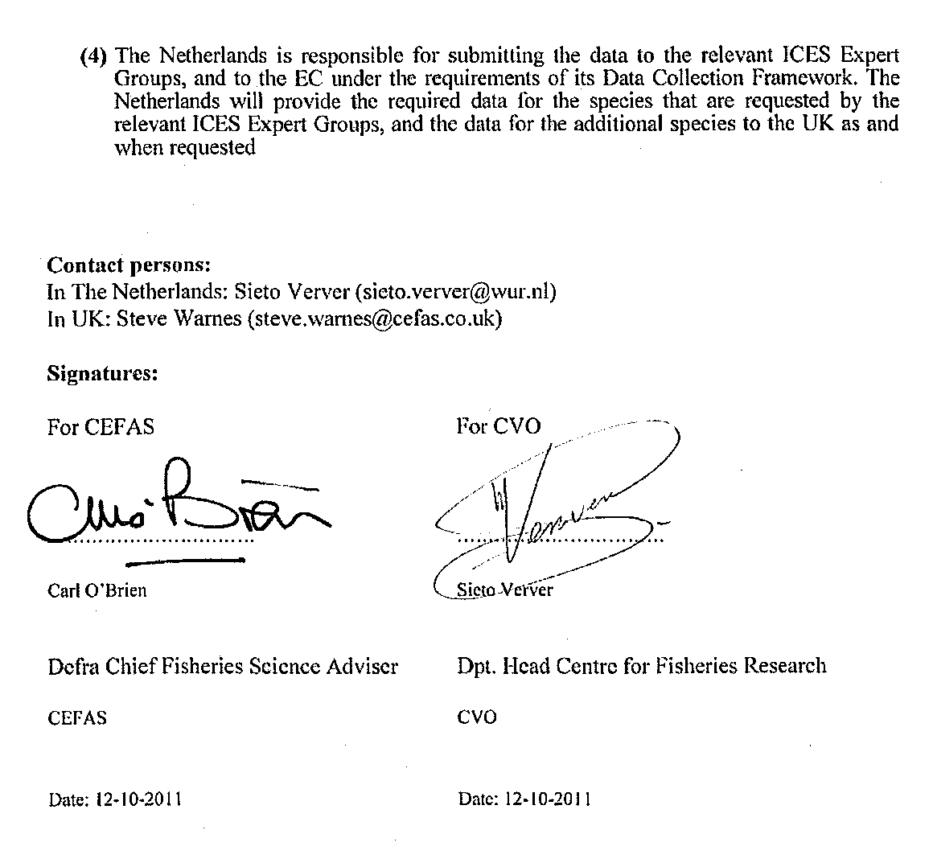
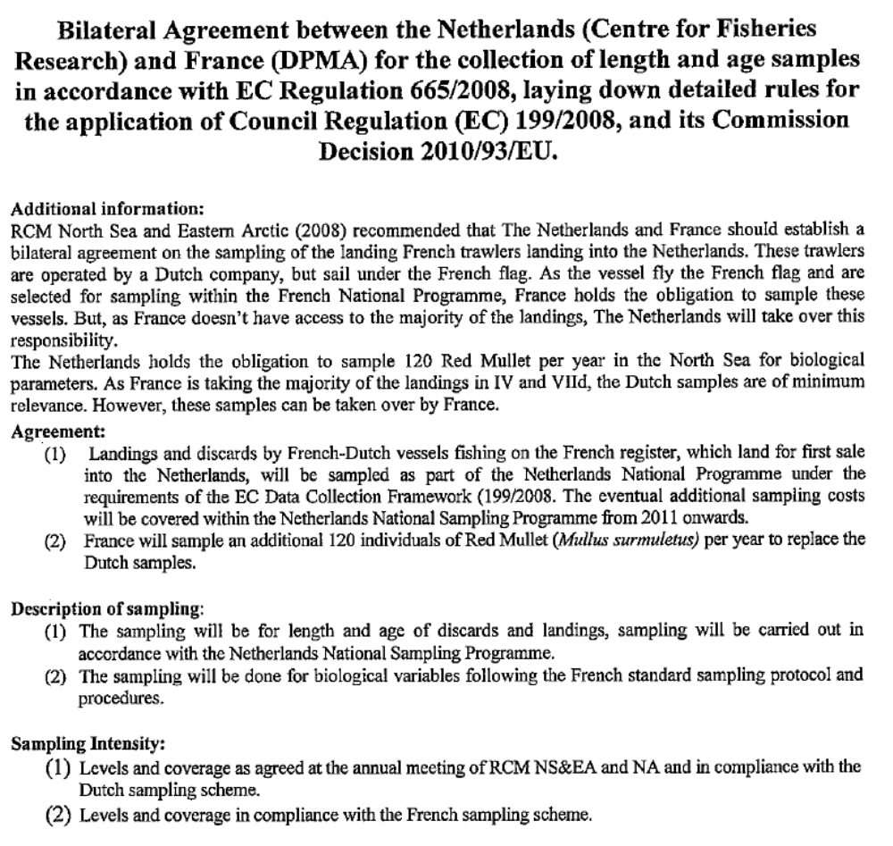

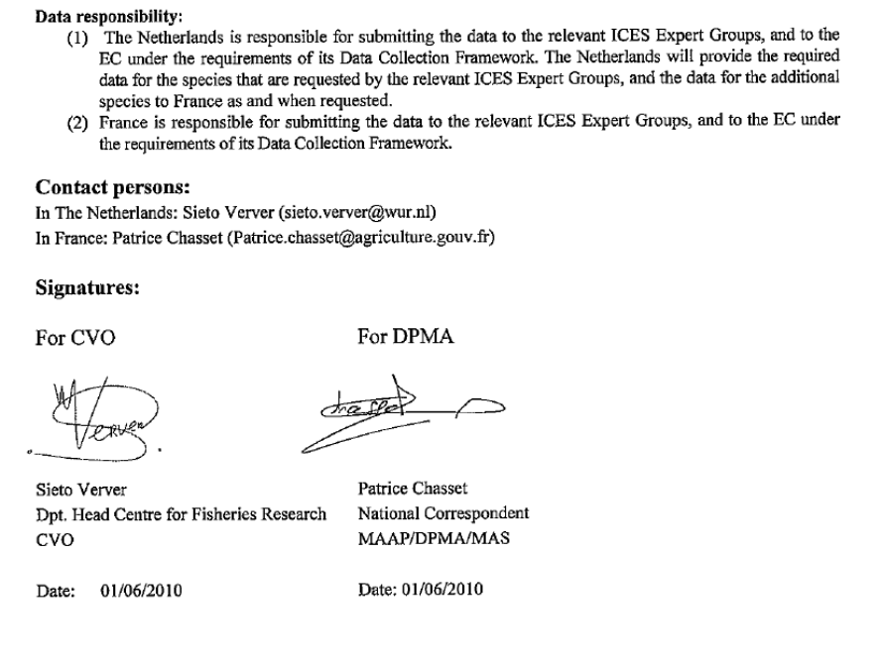
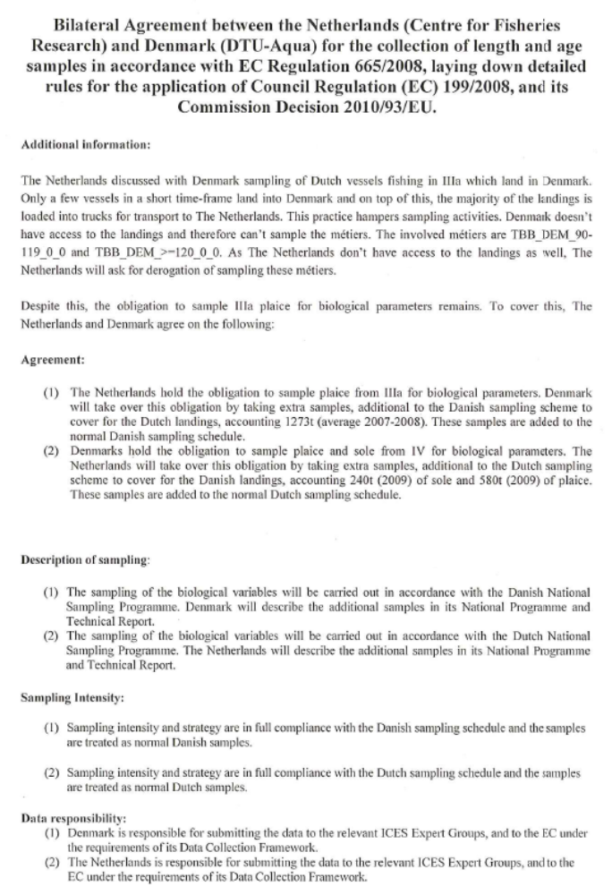
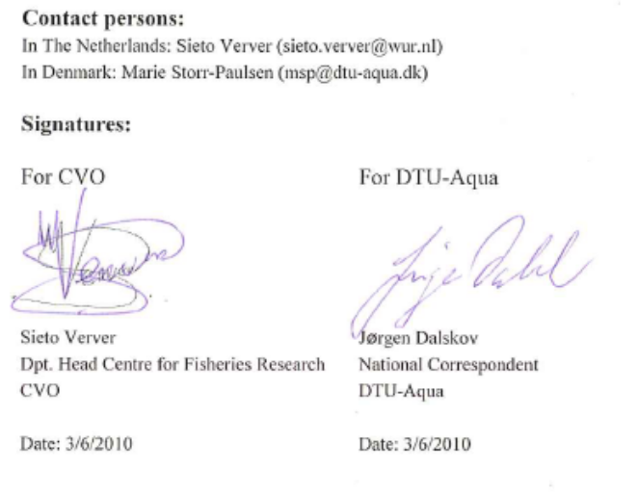

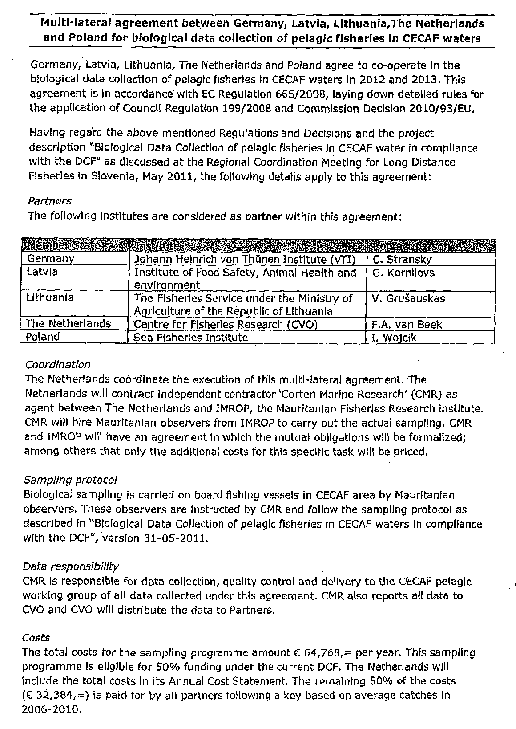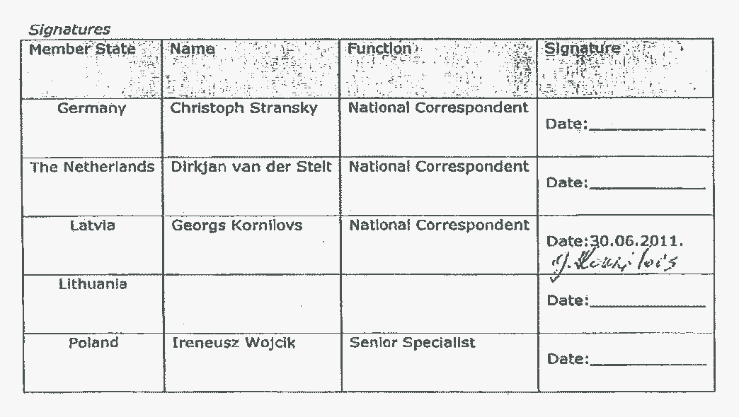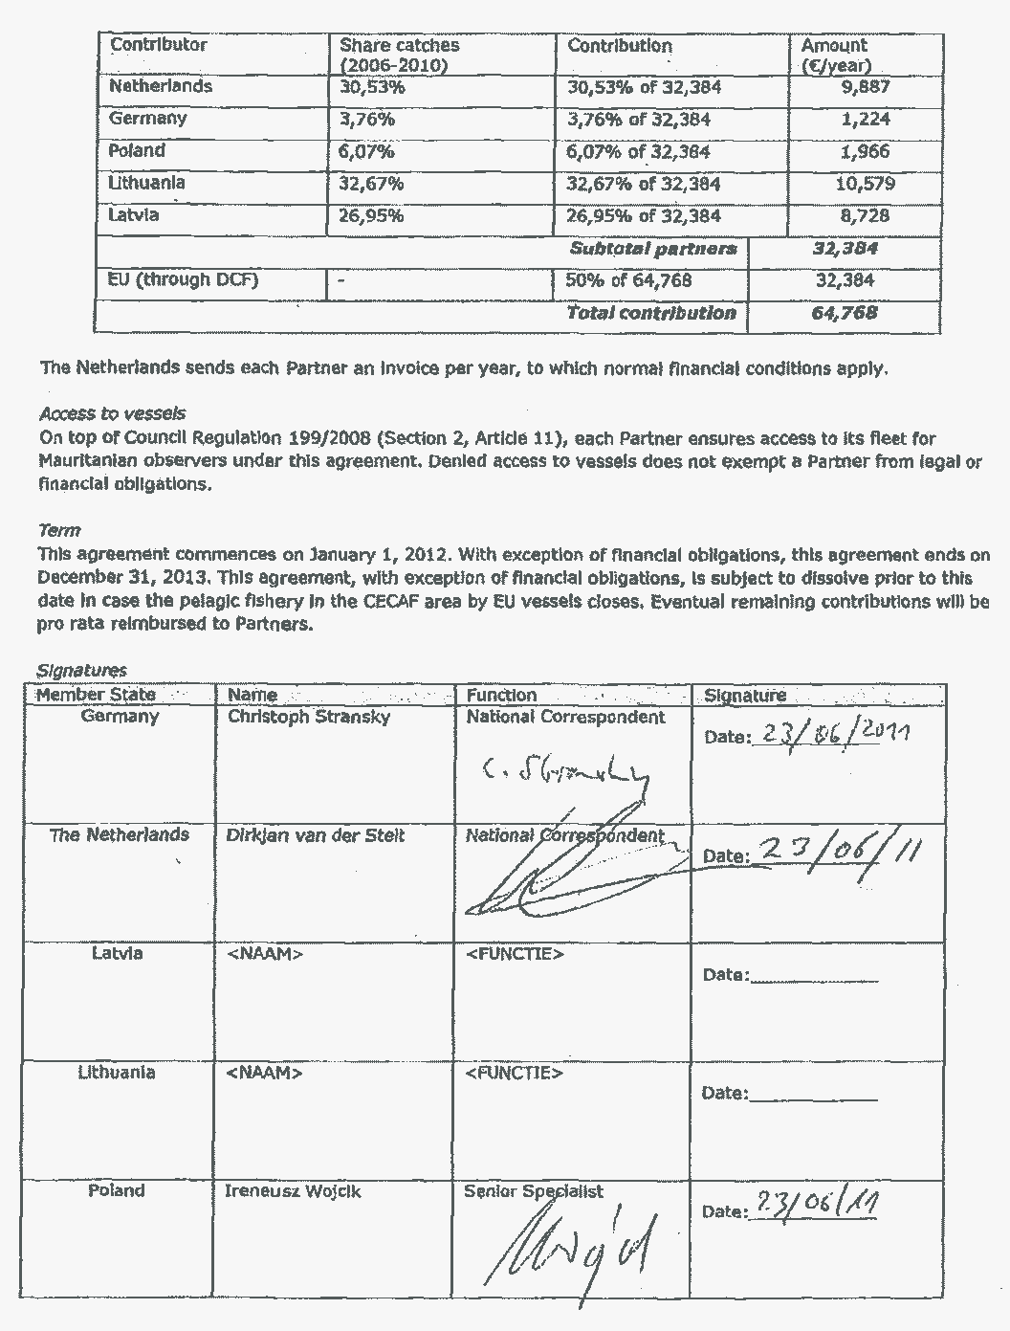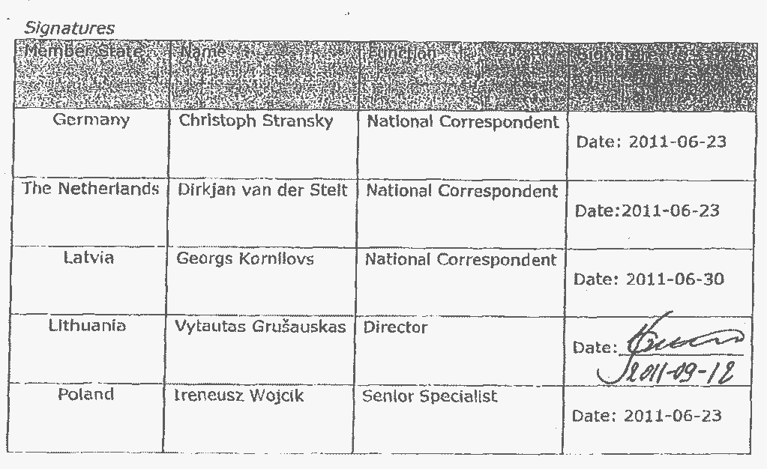

Annex 3 Subcontracts
Copies of the subcontracts between IMARES and its subcontractors are available in the Certificate of Expenditure.

Annex 4 Methodology for estimating the precision of estimates based on biological market sampling data
Methodology for estimating the precision of estimates based on market sampling data
At IMARES a number of statistical procedures have been implemented to estimate the precision of estimates of key biological parameters (weights-at-age, lengths-at-age, maturity-at-age and numbers-at-length) in the landings, based on market sampling data as required under the DCF. The statistical procedures that are used depend upon the sampling methodology (Cochran 1977) and are described in the manuals of the EU funded COST project and as documented in the reports from the ICES workshops WKPRECISE and WKACCU (ICES 2008, 2009).

For each species, a description has been made of the sampling design, the target population and the sampling frame (sampling frames have not yet been fully evaluated for all species) (ICES 2008). A combination of design-based and model-based methods are used to compute the precision estimates (ICES 2009). These methods have been implemented in a number of custom made computing scripts in the statistical programming language R (http://www.r-project.org/). The procedures are essentially similar to the procedures as used in the COST package but are written in such a way that they communicate directly with the VISSTAT and FRISBE databases at IMARES which contain data on fisheries statistics and biological market sampling.

For the species which are sampled primarily at market, a bootstrap is used in the raising procedure, with resampling (with replacement) of trips from which fish have been sampled. Thus, for these species, the fishing ‘trip’ is the primary sampling unit. For the (mostly pelagic) species which are sampled at sea with several samples per trip, the primary unit which is used in the bootstrap procedures is the sample. For the precision estimation, the number of primary units that are used in the bootstrap in each stratum is equal to the number of units in this stratum minus one as a correction factor for too overoptimistic variance estimates due to small sample sizes per stratum (Lahiri 2003, Efron 1987).

In addition to the bootstrap procedure, an analytical variance estimator based on the delta method has been derived to estimate the precision of numbers-at-age (not required under the DCF). This analytical method is only used for species which are sampled in commercial size categories.

Cochran, W.G. (1977). Sampling techniques. Wiley series in probability and mathematical statistics-applied.. J.W.a.sons. 413 pp
ICES WKPRECISE REPORT 2009. Report of the Workshop on methods to evaluate and estimate the precision of fisheries data used. ICES CM 2009/ACOM:40
ICES WKACCU REPORT 2008. Report of the Workshop on Methods to Evaluate and Estimate the Accuracy of Fisheries Data used for Assessment (WKACCU). ICES CM 2008\ACOM:32
Lahiri, P. 2003. On the impact of bootstrap in survey sampling and small area estimation. Statistical Science , Vol. 18, No. 2
EFRON, B. (1987). Better bootstrap confidence intervals (with discussion). J. Amer Statist. Assoc. 82 171-200.

Annex 5 Minutes of National Coordination Meetings
Verslag DCF Coördinatie Meeting Nederland
Den Haag, 17 December 2012
Aanwezig: Kees Verbogt (NC, Min EZ, DAD), Dirk-Jan van der Stelt (Min EZ, DAD, Heleen Bartelings (CEI), Frans van Beek (CVO), Sieto Verver (CVO, verslag)
Uitgenodigd: Bas Drukker (DG MARE), Christopher Priebe (DG MARE), Hans van Oostenbrugge (afgemeld, CEI), John Nam Wong Ching (afgemeld, Min EZ, DAD)
- Planning komend jaar
Indien in 2013 de nieuwe DCMAP verordening tijdig gereed komt en in 2014 van kracht wordt, moet het concept Nationaal Plan van Nederland met andere MS gecommuniceerd worden incl. afstemming eindgebruikers. Er zullen prioriteiten gesteld moeten worden binnen de verdeling van taken tussen landen. Het proces hoe dit moet gaan lopen is nog niet geregeld. Hopelijk geeft de nieuwe DCMAP daar guidance over. De verwachting is nu dat er op z’n vroegst in januari een concept verordening is, deze niet op tijd klaar is voor implementatie.
Hoe gaat het verder als nieuw DCMAP niet klaar is? De verwachting is dat EMFF en CFP pas in december 2013 goedgekeurd gaan worden. De onderhangende wetgeving zoals DCMAP lopen daarmee vertraging op.
De lopende DCF verordening zal dan waarschijnlijk een jaar verlengd worden. Als het zo loopt, dan is het voorstel is dan om huidige nationaal plan te verlengen. Niet updaten, tenzij de Cie andere guidelines geeft.
De toevoeging van zeezoogdieren in DCMAP heeft waarschijnlijk weinig implicaties omdat we dit al doen onder het huidige discardsprogramma. Huidige 812/2004 geeft geen aanleiding voor onze bruinvis monitoring, want uit de tijd van 812 hadden wij geen bruinvissen voor de kust, bovendien telden onze typen visserij niet mee. Als 812 aangepast wordt, dan hoogstwaarschijnlijk wel impact op onze monitoring, in lijn met nationale ontwikkelingen m.b.t. het plaatsen van camera’s op staandwant schepen.
Strategie bepaling vanuit NL belangrijk i.s.m. met andere MS, zodat we er maximaal uithalen wat we nodig hebben.
RCMs gepland voor 2 meetings in 2013, afhankelijk van planning DCMAP. Aan de RCM Long Distance nemen we waarschijnlijk 1x deel. Waarschijnlijk hebben we geen long distance verplichtingen. Hooguit dat we een intentieverklaring opnemen dat we de activiteiten blijven monitoren en actie ondernemen waar nodig. De vraag is dan hoe we dat gaan doen dan.
- Afgelopen jaar
Geen wijzigingen NP 2013 ingediend, alleen financiële aanpassingen.
De 2011 TR is goed verlopen, althans dat bleek uit de STECF-EWG, evengoed een lange lijst met vragen. Inhoudelijk nog geen reactie van de Commissie gekregen. Financieel oordeel gevraagd aan te houden, hangende de uitkomsten van de audit.
- Evaluatie van de financiële audit
Het enige probleem uit de 2006 audit was de berekening van de tarieven. De berekening is daarop aangepast en volgt nu de richtlijnen aangegeven in de verordening. De verwachting is dat we dat dit jaar n.a.v. de audit weer dit probleem hebben. De auditors constateerden dat bij overschrijding van de productiviteitsnorm de werkelijke kosten worden overschat. Het is niet duidelijk hoe het in andere landen geregeld is. DK houdt een maximum aan, rekent dan alleen werkelijke kosten.
Het IMARES deel van de audit verliep goed. Alles was op orde. Er werden een paar kleine foutjes gevonden. Het LEI deel bracht een foutje in de tarieven aan het licht, in ons voordeel. Naar verwachting kan dit nog gecorrigeerd worden.
De audit van de kosten van de onderzoeksvaartuigen leverde de grootste problemen op. De Rijksrederij had zich niet goed voorbereid. Het audit team zal in 2013 terugkomen om de onderzoeksvaartuigen te auditen. Sieto heeft daarna veel tijd geïnvesteerd bij de rederij om de deze kosten boven water te krijgen, evenals de vaardagen.
De vraag is hoe de financiering van de rederij functioneert, met name het afrekenen met EZ, als er op basis van geschatte bedragen wordt afgerekend met EZ.
- NC meeting
Verschoven van december naar januari aangezien er geen concept DCMAP beschikbaar is.
- Organisatie van reacties op DCMAP voorstel
De organisatie van de reactie bepalen we zodra er een voorstel is.
- concept bijdrage aan Operationeel Programma 2014-2020
Hoe de financiële structuur binnen NL moet gaan lopen is nog niet duidelijk.
Het operationeel plan kan m.b.t. Datacollectie kort zijn, waarin de ambitie staat om de datacollectie uit te voeren. Aandacht wordt gevraagd voor vernieuwing en samenwerking (met stakeholders). Het operationeel plan wordt gebaseerd op politieke keuzes waarbij prioriteiten gesteld moeten worden. Waarschuwing om deze niet door de NGO’s te laten domineren.
- Monitoring IJsselmeer en Scheldierbemonstering
Het is nog niet duidelijk of de schelpdierbemonstering onderdeel van de EMFF kan zijn. Mogelijk wel de aquacultuursoorten (mossel, oesters), maar niet de wilde bestanden als ensis en spisula.
M.b.t. IJsselmeer, bijvangsten van beschermde vogels in bepaalde types. Waar vogel en habitatrichtlijnen elkaar bijten, ontstaan verplichtingen uit EMFF en datacollectie verordening. Nog onduidelijk of dit via DCMAP of EMFF wordt geregeld.
- Codering tuigtypes
Huidige codes van vistuigen zoals zij in de logboeken worden genoteerd zijn te breed geworden. Als we met ingang van 2014 uitbreiding van bv pulskor mogelijk wordt, wordt het probleem steeds groter. Het is een nationaal probleem. We willen nogmaals in Brussel aankaarten omdat we dit niet alleen nationaal op willen lossen omdat het een EU probleem is.
We zoeken uit of het mogelijk is om de extra coderingen in VIRIS op te nemen en of wij daar toegang toe kunnen krijgen. (Actie: Sieto)

COUNCIL REGULATION (EC) No 861/2006 of 22 May 2006 establishing Community financial measures for the implementation of the Common Fisheries Policy and in the area of the Law of the Sea COUNCIL REGULATION (EC) No 199/2008 of 25 February 2008 concerning the establishment of a Community framework for the collection, management and use of data in the fisheries sector and support for scientific advice regarding the Common Fisheries Policy COMMISSION REGULATION (EC) No 665/2008 of 14 July 2008 laying down detailed rules for the application of Council Regulation (EC) No 199/2008 concerning the establishment of a Community framework for the collection, management and use of data in the fisheries sector and support for scientific advice regarding the Common Fisheries Policy COMMISSION DECISION (2008/949/EC) adopting a multi annual Community programme pursuant to Council Regulation (EC) No 199/2008 establishing a Community framework for the collection, management and use of data in the fisheries sector and support for scientific advice regarding the Common Fisheries Policy COMMISSION REGULATION (EC) No 1078/2008 of 3 November 2008 laying down detailed rules for the implementation of Council Regulation (EC) No 861/2006 as regards to the expenditure incurred by Member States for the Collection and management of the basic fisheries data
Guidelines for the submission of Annual Report on the National Data Collection Programmes under Council Regulation (EC) 199/2008, Commission Regulation (EC) 665/2008 and Commission Decision 2010/93/EU (Version 2013)
In 2012 the name of the Ministry of Economics, Agriculture and Innovation (EL&I) has been changed into the Ministry of Economic Affairs (EZ).
fishing in the 12 miles coastal zone and plaice box
COUNCIL REGULATION (EC) No 812/2004 of 26 April 2004 laying down measures concerning incidental catches of cetaceans in fisheries and amending Regulation (EC) No 88/98.
Hammen, T., and Martin de Graaf. 2012. Recreational fishery: catch estimate of cod (Gadus morhua) and eel (Anguilla anguilla). Report number C014/12

