Ministry of Agriculture of the Republic of Lithuania
Fisheries Service under the Ministry of Agriculture of the Republic of Lithuania
Agricultural Information and Rural Business Centre
Klaipedos university

Commission Implementing Decision (EU) 2016/1701 of 19 August 2016
laying down rules on the format for the submission of work plans for data collection in the fisheries and aquaculture sectors
Commission Implementing Decision (EU) 2019/909 of 18 February 2019
establishing the list of mandatory research surveys and thresholds for the purposes of the multiannual union programme for the collection and management of data in the fisheries and aquaculture sectors
Commission Delegated Decision (EU) 2019/910 of 13 March 2019
establishing the multiannual Union programme for the collection and management of biological, environmental, technical and socioeconomic data in the fisheries and aquaculture sectors

Lithuanian Work Plan for data collection in the fisheries and aquaculture sectors
2020-2021

Vilnius
2019
CONTENTS

Section 1: Biological Data 3
Pilot Study 1: Relative share of catches of recreational fisheries compared to commercial fisheries 3
Section 1: Biological Data 4
Text Box 1E: Anadromous and catadromous species data collection in fresh water 4
Section 1: Biological Data 5
Pilot Study 2: Level of fishing and impact of fisheries on biological resources and marine ecosystem 5
Section 1: Biological Data 6
Text Box 1G: List of research surveys at sea 6
Section 2: Fishing Activity Data 11
Text Box 2A: Fishing activity variables data collection strategy 11
Section 3: Economic and Social Data ……..122
Text Box 3A: Population segments for collection of economic and social data for fisheries 122
Section 3: Economic and Social Data 15
Pilot Study 3: Data on employment by education level and nationality 15
Section 3: Economic and Social Data 16
Text Box 3B: Population segments for collection of economic and social data for aquaculture 16
Section 3: Economic and Social Data 16
Pilot Study 4: Environmental data on aquaculture 16
Section 3: Economic and Social Data 17
Text Box 3C: Population segments for collection of economic and social data for the processing industry 17
Section 4: Sampling Strategy for Biological Data from Commercial Fisheries 11
Text Box 4A: Sampling plan description for biological data 19

Section 1: Biological Data

Pilot Study 1: Relative share of catches of recreational fisheries compared to commercial fisheries

General comment: This Box fulfils paragraph 4 of Chapter V of the multi-annual Union programme and Article 2 and Article 4 paragraph (3) point (a) of this Decision.
Pilot study is not foreseen for 2020-2021

Section 1: Biological Data

Text Box 1E: Anadromous and catadromous species data collection in fresh water
General comment: This Box fulfils paragraph 2 points (b) and (c) of Chapter III of the multi-annual Union programme and Article 2 of this Decision.
Method selected for collecting data.
For salmon and sea trout having in the mind it is very important fresh water stage in the life cycle. The data on parr densities in the rivers will be collected by electrofishing – 100 monitoring sites covering all rivers suitable for salmonids including index rivers. The smolt number will be estimated from electrofishing data and smolt traps for salmon and sea trout smolts (2 smolt traps for salmon smolts and 1 for the sea trout smolts). The number of adults migrating to the rivers will be estimated from commercial by catches in Curonian lagoon till spawners counters in the rivers Žeimena, Minija and Jūra will be established (Table 1E). Samples for biological analyses (minimum 50 salmons and 50 sea trout’s, Table 1C) from commercial bycatch in Curonian lagoon and commercial catches at the sea will be collected.
Eel
A minimum of 100 individuals shall be analysed per management unit as specified in Regulation (EC) No 1100/2007 for yellow and silver eels separately. Samples for biological analysis (100 units in Inland and 100 units in Curonian Lagoon) will be obtained on shore (Table 1C, 1F, 5A).
In Inland 2 monitoring places (2 river trap nets) will be used to estimated eel migratory intensity, CPUE, biological data. Data indicated in Tables 1B, 1C, 1F, 4A, 4B will be collected. 9 trip days per season (April –May) is planned to visit monitoring places (Table 4A).
Yellow eel standing stock will be estimated from fyknets and river trap nets catches.

Section 1: Biological Data

Pilot Study 2: Level of fishing and impact of fisheries on biological resources and marine ecosystem

General comment: This Box fulfils paragraph 3-point (c) of Chapter III of the multi-annual Union programme and Article 2 and Article 4 paragraph (3) point (b) of this Decision.
The pilot study has been foreseen in the 2-nd version of Working Plan for 2017 – 2019 and revised in the 3-d version of WP.
According to the 3-d version of WP the study will be finalised in the beginning of 2020. However, taking in account preliminary results some sampling schemes for 2020 – 2021 was already updated for sampling of fishes listed in the Table 1D of Delegated Decision (EU)No 2019/910. See tables 4A and 4B and section 4A.

Section 1: Biological Data

Text Box 1G: List of research surveys at sea
General Comment: This Box fulfils Chapter IV of the multi-annual Union programme and Article 2 and Article 7 paragraph (3) of this Decision. It is intended to specify which research surveys at sea set out in Table 10 of the multi-annual Union programme will be carried out. Member States shall specify whether the research survey is included in Table 10 of the multi-annual Union programme or whether it is an additional survey.
Baltic International Trawl Survey – BITS Q1.
1. Objectives of the survey
The main aim of the BITS surveys is to estimate cod and other demersal species recruitment indices and abundance in ICES Subdivision Iniid.
2. Description of the methods used in the survey. For mandatory surveys, link to the manuals. Include a graphical representation (map)
The surveys have been conducting within period of February-March in the Lithuanian Exclusive Economic Zone (LEEZ) according to the BITS manual (ICES, 2014. Manual for the Baltic International Trawl Surveys (BITS). Series of ICES Survey Protocols SISP 7 - BITS. 71 pp.)
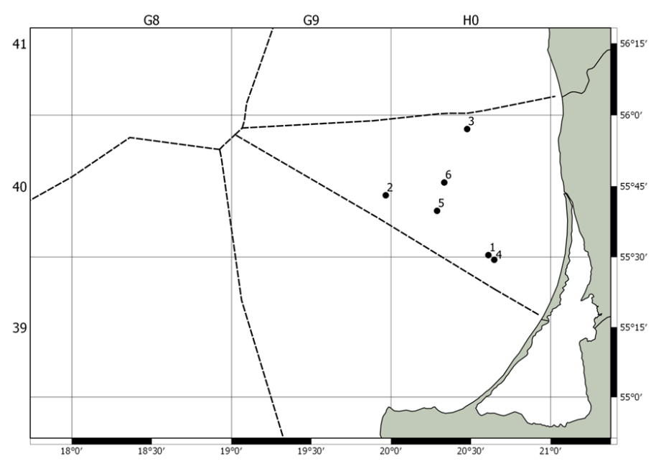
Figure 1. Allocation of stations defined in the LEEZ for BITS Q1 survey in 2019
3. For internationally coordinated surveys, describe the participating Member States/vessels and the relevant international group in charge of planning the survey
Survey is coordinated by Baltic International Fish Survey Working Group (WGBIFS). All Baltic countries, including Russia, are participating in this survey. Countries and vessels involved into BITS survey are mentioned in the manual mentioned above.
4. Where applicable, describe the international task sharing (physical and/or financial) and the cost sharing agreement used:
Not relevant
5. Explain where thresholds apply
Not relevant

Baltic International Trawl Survey – BITS Q4
1. Objectives of the survey
The main aim of the BITS surveys is to estimate cod and other demersal species recruitment indices and abundance in ICES Subdivision IIId.
2. Description of the methods used in the survey. For mandatory surveys, link to the manuals. Include a graphical representation (map)
The surveys have been conducting within period of November – December in the Lithuanian Exclusive Economic Zone (LEEZ) according to the BITS manual (ICES, 2014. Manual for the Baltic International Trawl Surveys (BITS). Series of ICES Survey Protocols SISP 7 - BITS. 71 pp.)
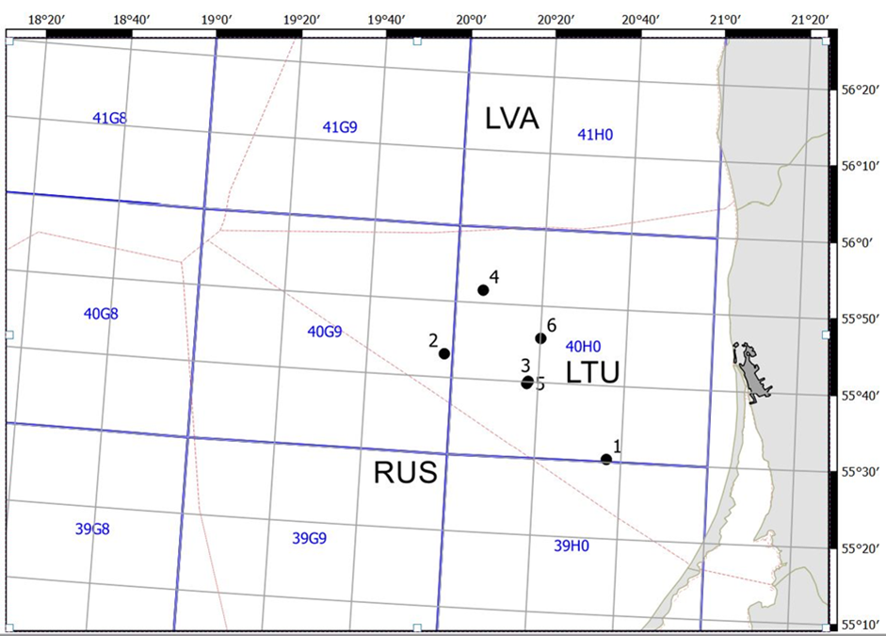
Figure 2. Allocation of stations defined in the LEEZ for BITS Q4 survey in 2019

3. For internationally coordinated surveys, describe the participating Member States/vessels and the relevant international group in charge of planning the survey
Survey is coordinated by Baltic International Fish Survey Working Group (WGBIFS). All Baltic countries, including Russia, are participating in this survey. Countries and vessels involved into BITS survey are mentioned in the manual mentioned above.
4. Where applicable, describe the international task sharing (physical and/or financial) and the cost sharing agreement used
Not relevant
5. Explain where thresholds apply
Not relevant
Sprat Acoustic Survey – SPRAS.
1. Objectives of the survey
The main aim of the SPRAS surveys is to assess abundance of sprat and herring resources in ICES Subdivision IIId.
2. Description of the methods used in the survey. For mandatory surveys, link to the manuals. Include a graphical representation (map)
The surveys have been conducting within May in the Lithuanian Exclusive Economic Zone (LEEZ) according to the IBAS manual (ICES. 2014. Manual of International Baltic Acoustic Surveys (IBAS). Series of ICES Survey Protocols SISP 8 - IBAS. 24 pp.)
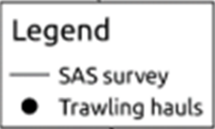
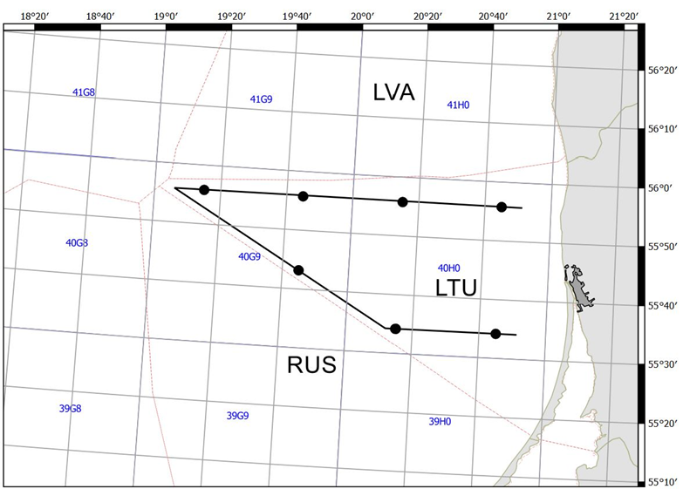
Figure 3. Cruise track design and hauls of SPRAS in LEEZ in 2019
3. For internationally coordinated surveys, describe the participating Member States/vessels and the relevant international group in charge of planning the survey
Survey is coordinated by Baltic International Fish Survey Working Group (WGBIFS). All Baltic countries, including Russia, are participating in this survey. Countries and vessels involved into SPRAS survey are mentioned in the BITS manual mentioned above.
4. Where applicable, describe the international task sharing (physical and/or financial) and the cost sharing agreement used
Not relevant
5. Explain where thresholds apply
Not relevant
Baltic International Acoustic Survey (Autumn) – BIAS
1. Objectives of the survey
The main aim of the BIAS surveys is to assess abundance of herring and sprat resources in ICES Subdivision IIId.
2. Description of the methods used in the survey. For mandatory surveys, link to the manuals. Include a graphical representation (map)
The surveys have been conducting within period of September – October in the Lithuanian Exclusive Economic Zone (LEEZ) according to the IBAS manual (ICES. 2014. Manual of International Baltic Acoustic Surveys (IBAS). Series of ICES Survey Protocols SISP 8 - IBAS. 24 pp.)
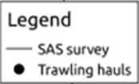
Figure 4. Cruise track design and hauls of BIAS in LEEZ in 2019

3. For internationally coordinated surveys, describe the participating Member States/vessels and the relevant international group in charge of planning the survey
Survey is coordinated by Baltic International Fish Survey Working Group (WGBIFS). All Baltic countries, including Russia, are participating in this survey. Countries and vessels involved into BIAS survey are mentioned in the BITS manual mentioned above.
4. Where applicable, describe the international task sharing (physical and/or financial) and the cost sharing agreement used
Not relevant
5. Explain where thresholds apply
Not relevant
Survey of fishes in the Lithuanian coastal waters of the Baltic sea - CFS.
1. Objectives of the survey
The Lithuanian coastal zone in the Baltic Sea is very rich and diverse community of hydro biotic organisms. It consists of lot ecological niches and fish nursery grounds important for commercial and non-commercial fishes (especially important juveniles). Lithuanian coastal waters are highly affected by on-land anthropogenic activities, that makes significant impact on eutrophication, distribution of waist and toxic substances. Spread of invasive species as gobies (Gobiidae) highly affects behavior of local fish population, including cod. Therefore, constant monitoring of fishes and fishing activities in the Lithuanian coastal waters may provide information important for early detection of negative tendencies in the development of populations of commercial fishes.
2. Description of the methods used in the survey. For mandatory surveys, link to the manuals. Include a graphical representation (map)
The survey consists from two parts:
Juveniles survey: The objective of this survey is to determine the abundancy and biomass dynamics of all juvenile fishes in the coastal areas. The survey is performed in 14 sites alongside the Lithuania’s coastal zone (figure 5) during August - September. From each station 3 samples are taken using two different fishing technics: a dragnet is used mainly for sprat, smelt and sand eel, but all other species that are caught are analyzed as well; a beach seine specially designed for flatfish and turbot juveniles and shrimp. Hydrological parameters are recorded during each sampling as well.
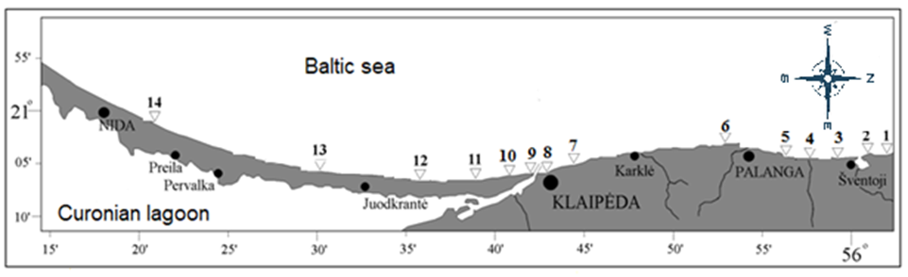
Figure 5. The sites of juvenile survey in Lithuanian coastal zone
Gillnet monitoring: The objective of this survey is to monitor the biological conditions and migration patterns of the fishes. The multi mesh-sized gillnets (from 14mm to 70 mm) are casted in four monitoring stations alongside the Lithuania’s coastal zone: two close to the southern and northern edges of Lithuanian coastal zone (Nida and Šventoji) and another two close to the mouth of Curonian lagoon, the most important source of fresh water (Smiltynė and Melnragė). The survey fishing is made once a month in each of the stations. Biological, hydrological and fisheries activity parameters are recorded according to the methodology of the HELCOM.
3. For internationally coordinated surveys, describe the participating Member States/vessels and the relevant international group in charge of planning the survey
This is not an internationally coordinated survey however it is planned to use the results of the survey in the assessment of flounder and turbot in the Central Baltic, the survey is performed by methodology of the HELCOM and it is performed also in other countries of the Baltic Sea.
4. Where applicable, describe the international task sharing (physical and/or financial) and the cost sharing agreement used
Not relevant
5. Explain where thresholds apply
Not relevant

SECTION 2: FISHING ACTIVITY DATA

Text Box 2A: Fishing activity variables data collection strategy

General comment: This Box fulfills paragraph 4 of Chapter III of the multi-annual Union programme and Article 2, Article 4 paragraph (2) point (b) and Article 5 paragraph (2) of this Decision. It is intended to describe the method used to derive estimates on representative samples where data are not to be recorded under Regulation (EU) No 1224/2009 or where data collected under Regulation (EU) No 1224/2009 are not at the right aggregation level for the intended scientific use.
- For all fleet segments by regions the transversal variables is deriving from database system FDIS, which contains the data referred to Commission Regulation (EC) No 26/2004 of 30 December 2003 on the Community fishing fleet register in Annex I and Council Implementing Regulation (EC) No 404/2011 in Annex X. As well FDIS contains an obligatory by National legislation national logbook, for vessels of less than 8 m length overall which is operating exusevly in the Baltic Sea. Community fishing vessels from 8 to 12 metres’ length overall are obliged to keep a fishing logbook and submit landing and transhipment declarations. Fishing vessels of 18 metres’ length overall or more, the fishing logbook is in electronic form and the landing declarations are submitting electronically. The Lithuanian fleet does not consist of any vessels with the length class of 12 to 18 metres in length. Active and inactive vessels are included in the vessel register. The maintenance and continuous updates are up to dates. Using a conversion factor established in accordance with the Council Regulation (EC) No 404/2011 ANNEXES XIII-XV, FDIS includes a built in function that converts processed fish weight into live fish weight. Lithuania has performed cross-checking, analyses and verifications through automated computerised algorithms and mechanisms on vessel monitoring systems, catch, effort and sales notes data and data related to the Community fishing fleet register as well as the verification of licences and fishing authorisations. Data is available in the form of primary data to the all national institutions implementing the workplans.
- Data on landings for vessels less than 8 m length overall, which is not covered under Control Regulation, are derived from the national logbooks which have been cross-checked with sales notes. These provide the key details on the species, presentation, location of landings, weight and value of fish being landed that is entered into computer system. For all fleet segments value is estimating based on prices derived from sales notes multiplying by weight from landing declarations.
- Based on sales notes the average price by species, presentation and region is computing by dividing the total value of fish available for sale by the total weight available for sale during the period. Each sale note is related to the vessel trip or monthly report, which allow computing the average price on base of vessel trips or monthly report.
- To approach reliable and high quality of data Lithuania uses a “census” type of logbooks for vessel, which is not recordered data under the Regulation (EU) No 1224/2009. National logbooks are completing by a company engaged in commercial fishing in the Baltic Sea coastal area. List of vessels is approved by national legislation and covers the whole segment population. The landings and metier based effort variables are
provided by abovementioned logbooks. The logbooks information shall be transmitted to the authority 2 times per month. When classifying a data transmission failures regarding timeliness or completeness the company is notified and report is re/submitted. The logbooks landing information are cross-checking with sales notes.
(max 900 words per Region)

Section 3: Economic and Social Data

Text Box 3A: Population segments for collection of economic and social data for fisheries
General comment: This Box fulfills paragraph 5 points (a) and (b) of Chapter III of the multi-annual Union programme and Article 2, Article 4 paragraphs (1), (2) and (5) and Article 5 paragraph (2) of this Decision. It is intended to specify data to be collected under Tables 5(A) and 6 of the multi-annual Union programme.
1. Description of methodologies used to choose the different sources of data
The total population for fleet economic and social variables is all active and inactive vessels registered in the Union Fishing Fleet Register on 31 December of the reporting year and vessels that do not appear on the Register at that date but have fished at least one day during the reporting year.
Collection of economic variables of the Lithuanian fleet will be based on following major data sources:
- Lithuanian Agricultural and Food Product Market Information System (LAFPMIS) administered by State enterprise Agricultural Information and Rural Business Center (AIRBC);
- Fishery Data Informational System (FDIS) administered by Fisheries Service;
- Fleet register.
Economic variables for the variable groups as Income, Labour costs, Energy costs, Repair and maintenance costs, Other operating costs, Subsidies, Capital costs, Capital value, Investments, Financial position, Employment and Energy consumption are obtained from LAFPMIS (census survey DR-1), whereas Economic variables for the Effort (except Energy consumption), Number of fishing enterprises/units and Production value per species are obtained from FDIS. Data for variable group Fleet is available from Fleet Register.
Social data as Employment by gender, FTE by gender, Unpaid labour by gender, Employment by age, Employment by employment status and FTE National will be collected on annual basis and available from data source LAFPMIS (census survey DR-1). Social variables as Employment by education level and Employment by nationality will be collected each three years (started in 2018) by specialized census survey and available from data source LAFPMIS.
Variable gross value of landings is available from two data sources, FDIS (estimated gross value of landings) and LAFPMIS questionnaires (income from landings, census survey DR-1). Two values will serve for crosschecking purposes and in the case of non-response to DR-1. For the reporting Gross value of landings, LAFPMIS information will be used as it is obtained from the same data source (accounting documents of enterprise) as other economic variables and relates to expenditures, capital related variables, employment and social indicators. In the case of non-responses, estimated gross value of landings from FDIS will be used.
2. Description of methodologies used to choose the different types of data collection
For all economic and social variables census data collection scheme will be applied for total fleet. Data are collected by Statistical questionnaires (code DR-1) approved by the order of the Minister of Agriculture No 3D-707 on 4-th August of 2010. IFDIS and Fleet Register possess census data as well. Variables as Value of unpaid labour, Consumption of fixed capital, Value of physical capital, Value of landings per species, FTE by gender and FTE National in WP excel table are indicated as collected from indirect survey. These variables are estimated from the primary data, collected by census surveys (LAFPMIS and FDIS). Estimation procedure is provided in paragraph 4.
3. Description of methodologies used to choose sampling frame and allocation scheme
Data collection is based at enterprise level. If enterprise operates two vessels or more, belonging to different fleet segments, it is asked to provide separate questionnaires for individual segments, if all vessels belongs to one segment, only one questionnaire for all vessels in segment is provided. Before starting annual census survey DR-1 for economic and social variables, composition of fleet segments are checked from the fleet activity information (effort data from FDIS). Logbook based data on effort for each active population vessel is extracted from FDIS and taking into account vessel length, fishing area and activity by gear, fleet segments are formed. Fleet economic data is collected at fleet segment level, whereas social data will be available at the fishing region level as recommended by PGECON 2017: “Small scale fleet”, “Large scale fleet” and “Long distance fleet”. Aggregation groups of social variables are used from PGECON 2017 3-9 recommendations.
4. Description of methodologies used for estimation procedures
Value of unpaid labour.
Imputed value of unpaid labour is calculated as the number of unpaid family members (variable from DR-1) involved in production, or number of their working hours (if provided) multiplied by average annual wage (variable from DR-1) calculated for “paid labour” at particular segment level.
FTE by gender and FTE National
In census survey, working hours of employees in fisheries is collected at gender level. Therefore, FTE by gender as well as National FTE is calculated from annual working hours (variable from DR-1) divided from annual number of hours for 1 full time employee indicated in national law.
Consumption of fixed capital, Value of physical capital
Value of physical capital and consumption of fixed capital will be estimated using Perpetual Inventory Method (PIM) using the linear depreciation scheme based on capital values estimated using replacement values (STECF 11-19, page 6) and included in the template model developed by EC study No. FISH/2005/03 and modified by 2017 pilot study conducted in Lithuania on “Capital value calculation using only book values and compared results with capital value calculation using Perpetual inventory method (PIM)”. The modified PIM uses tailored input data (real life depreciation rates, renewal age, vessel structure and residual values of capital of Lithuania fishing vessels by segments) for calculating capital value and depreciation costs by directly inputting initial vessel values (combination of purchasing values (historical book values at current prices) and modeled values (calculated for unknown values of vessels from price per capacity unit (PCU)) into PIM. Pilot study results are available in the report of PGECON 2018. The methodology for calculating capital value and depreciation costs is published in AIRBC website.
Non-responses
In the case, when response rate is less than 100% of population, missing variables are estimated from the independent variables from FDIS effort and landing data.
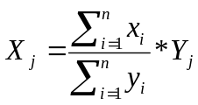
where:
X_{j} – missing variable information about the vessel;
x_{i}– collected variable of the sample;
n – sample size;
Y_{j} – FDIS independent variable of the vessel;
y_{i}– FDIS independent variable of the sample.
For the missing variables as Labour costs and Other operating costs FDIS independent variable Value of landings is used. For the missing variables as Energy costs, Repair and maintenance costs, Energy consumption, Total hours worked and FTE, FDIS independent variable Days at sea is used. For missing Number of employees, the Social security administrative data is used. Missing financial position is estimated based on Value of physical capital data from PIM calculations.
Missing population for social data is used from administrative employment data from Social security service. Values of social indicators are estimated applying percentage ratios from collected social variables to the missing population.
5. Description of methodologies used on data quality
Fleet economic and social data collection is included in the annual Official Statistic data collection Program and therefore quality is ensured by application of principles of European Code of Practice. The data collection processes in AIRBC complies the ISO 9001 requirements for data quality and ISO 27001 requirements for data security. AIRBC has carried out a self-assessment of the compliance with the European Statistics Code of Practice, which can be considered as a best practice in the European Statistical System. The self-assessment reviews the institutional environment (professional independence, mandate for data collection, adequacy of resources, commitment to quality and statistical confidentiality, impartiality and objectivity) as well as the statistical processes and the quality of its outputs.
For data quality assurance, LAFPMIS Interactive Data Input System contains:
- logical verification and data validation at different data processing stages;
- automatic data aggregation during data input process;
- for external users, especially data providers, system ensure easy accessibility of methodologies;
- system is flexible in terms of development according requirements from end users and external users;
- update and storage of exhaustive administrative data.
In addition, primary data, intermediate results and statistical outputs are regularly assessed by the expertise of personnel, data are checked for inconsistencies, completeness, and timeliness. Any detected errors are registered in non-compliance register. Based on records from this register data audition unit of AIRBC periodically visit fishing companies and perform primary data quality and accuracy audition by checking questionnaire data with companies accounting documents.
For quality measurements, response rate (separately at respondent/vessel and reported item levels) and coverage rate (taking into account value of landings) are calculated.
In FDIS has been performed cross-checking, analyses and verifications through automated computerised algorithms and mechanisms on vessel monitoring systems, catch, effort and sales notes data and data related to the Community fishing fleet register as well as the verification of licences and fishing authorisations that ensure Fleet, Effort (exclude Energy consumption), Number of fishing enterprises/ units and Production value per species variables quality.
(max 900 words per Region)

Section 3: Economic and Social Data

Pilot Study 3: Data on employment by education level and nationality
General comment: This Box fulfills paragraph 5 point (b) and paragraph 6 point (b) of Chapter III of the multi-annual Union programme and Article 2 and Article 3 paragraph (3) point (c) of this Decision. It is intended to specify data to be collected under Table 6 of the multi-annual Union programme.
1. Aim of pilot study
Pilot study was carried out in 2018. From 2021 census survey for data collection of social variables will be applied.
2. Duration of pilot study
Employment by gender, FTE by gender, Unpaid labour by gender, Employment by age, Employment by employment status and FTE National will be collected on annual basis by census survey (DR-1 forms), whereas Employment by education level and Employment by nationality will be collected each three years (starting started in 2018) by specialized triannual census survey.
3. Methodology and expected outcomes of pilot study
Methodology and aggregation levels of social variables is taken from PGECON 2017 recommendations 3-9.
(max 900 words)

Section 3: Economic and Social Data

Text Box 3B: Population segments for collection of economic and social data for aquaculture
General comment: This Box fulfills paragraph 6 points (a) and (b) of Chapter III of the multi-annual Union programme and Article 2, Article 4 paragraphs (1) and (5) and Article 5 paragraph (2) of this Decision. It is intended to specify data to be collected under Tables 6 and 7 of the multi-annual Union programme.
Lithuanian aquaculture sector consists only from freshwater aquaculture activities, therefore as data collection for this type of aquaculture is optional, it is not foreseen.
1. Description of methodologies used to choose the different sources of data
Not relevant
2. Description of methodologies used to choose the different types of data collection
Not relevant
3. Description of methodologies used to choose sampling frame and allocation scheme
Not relevant
4. Description of methodologies used for estimation procedures
Not relevant
5. Description of methodologies used on data quality
Not relevant
(max 1000 words)

Section 3: Economic and Social Data

Pilot Study 4: Environmental data on aquaculture
General comment: This Box fulfills paragraph 6 point (c) of Chapter III of the multi-annual Union programme and Article 2 and Article 4 paragraph (3) point (d) of this Decision. It is intended to specify data to be collected under Table 8 of the multi-annual Union programme.
1. Aim of pilot study
Not relevant (see text box 3B)
2. Duration of pilot study
Not relevant
3. Methodology and expected outcomes of pilot study
Not relevant
(max 900 words)

Section 3: Economic and Social Data

Text Box 3C: Population segments for collection of economic and social data for the processing industry
General comment: This Box fulfills footnote 6 of paragraph 1.1(d) of Chapter III of the multi-annual Union programme, Article 2, Article 4 paragraphs (1) and (5) and Article 5 paragraph (2) of this Decision. It is intended to specify data to be collected under Table 11 of the multi-annual Union programme.
1. Description of methodologies used to choose the different sources of data
Economics and social data variables concerning fish processing industry will be based on 3 data sources:
• Lithuanian Agricultural and Food Product Market Information System (LAFPMIS) administered by State enterprise Agricultural Information and Rural Business Center (AIRBC), annual census survey (ŽF-1) for economic data collection.
• LAFPMIS semiannual census survey (ŽP-1) for employment variables and annually collected social variables.
• Number of enterprises is obtained from Lithuanian State Food and Veterinary Service (SFVS) the list of animal food handling entities holding veterinary approval number.
Employment data is crosschecked with information from State Social Insurance Fund (SSIF). Also data on classifications by activity status of fish processing companies is cross checked with data from National Statistical Department.
Economic and social data is gathered from all fish processing industry companies by statistical forms ŽF-1 and ŽP-1 approved by the Minister of agriculture and included in the official statistics work programmes (OSWP) which is regulated by Lithuanian Law on Statistics and is mandatory for all type of economical entities. The data is more detailed than that of the National Statistical Department and covers all of the fish processing companies’ population and is used to meet the need for national administrative purposes. Therefore, data from statistical forms ŽF-1 and ŽP-1 will be the main source for economics and part of social data. Social variables as employment by nationality and by education level started to be collected through pilot study, launched in 2018 and will continue every three years by specialized triannual census survey. Social variables as employment by gender, age and national FTE will be collected by semiannual census survey (ŽP-1).
The population for economic and social variables will refer to enterprises whose main activity is defined according to the Eurostat definition under NACE Code 15.20: “Processing and preserving of fish, crustaceans and molluscs”. Also data will be collected from those enterprises that carry out fish processing but not as a main activity.
The list of all fish processing companies will be obtained from SFVS on a yearly basis, segments will be assigned according to data from (SSIF) and main activity will be determined according to (NSD).
2. Description of methodologies used to choose the different types of data collection
Census (A), which attempts to collect data from all members of a population, will be applied for each size categories. .
Value of unpaid labour - will be calculated for all the enterprises which will provide the data about the unpaid employees engaged in fish processing activities. The calculations will be based on the statistical forms ŽP-1 and ŽF-1. The number of unpaid workers involved in processing, or number of their working hours will be multiplied by average annual wage calculated for “paid labour” in particular segment.
For the calculation of national FTE, the number of hours worked during the year will be collected from the enterprises through the statistical forms (ŽP-1). This parameter will be divided by national annual full-time working hours, which is based on the law of the Minister of social security and labour. It confirms the number of average working hours per year annually.
3. Description of methodologies used to choose sampling frame and allocation scheme
Since data are to be collected through a Census (A) a description of the sampling frame is not relevant.
4. Description of methodologies used for estimation procedures
In the case, when response rate is less than 100% of the population for a specific variable, the missing information of a company will be derived in accordance to data on employment from SSIF. The missing data on a specific variable will be calculated by dividing the sample of that variable from a specific segment by the number of employees from the sample of a specific segment and multiplying by employees of the company in question. If a specific segment, to which a company with a missing variable is assigned, is deemed too small, sample from the whole processing industry will be used.
5. Description of methodologies used on data quality
The methodologies for quality of fish processing sector is a fraught and consistent process of data collection covering the checks of data completeness, quality and integrity of gathered data and post collection data checks by auditing individual enterprises. All the irregularities will be noted in the non-compliance register (NCR):
1. As the data collection scheme is Census (A), data on fish processing will be checked for completeness and timeliness through response rates. Non-response enterprises and related data entries will be included in the NCR.
2. Data quality will be ensured by checking data integrity and quality during the initial data entry through LAFPMIS Interactive Data Input System (IDIS), where input data will be automatically check for inconsistencies between coherent variables, data completeness, and other logical data coherences. Further data quality checks will be conducted by sector specialists, looking for inconsistencies in time data series, by cross checking data with other data sources, identifying extremities of separate variables, and other logical checks. All the irregularities will be included in the NCR.
3. In accordance with to the NCR, the validation of data will be checked by auditing companies with most irregularities by directly crosschecking statistical form`s data with that of the companies bookkeeping data. Any abnormalities and irregularities will be corrected.
Furthermore, in accordance to data NCR and audit outcomes, methodologies for data submitting and metadata will be reviewed and changed to enhance the quality of data gathering.
(max 1000 words)

Section 4: Sampling Strategy for Biological Data from Commercial Fisheries

Text Box 4A: Sampling plan description for biological data
General Comment: This Box fulfils Article 3, Article 4 paragraph (4) and Article 8 of this Decision and forms the basis for the fulfilment of paragraph 2 point (a)(i) of Chapter III of the multi-annual Union programme. This Table refers to data to be collected under Tables 1(A), 1(B) and 1(C) of the multi-annual Union programme.
Baltic Sea
Taking in account the results of pilot study, the scope of some sampling schemes was supplemented by elements of collection of some biological data on the fish species to be monitored under protection programmes (Table 1D of Delegated Decision (EU) 2019/910) and actively fished by local fishermen. Such amendments made the sampling schemes to be more efficient to contributing to the objectives of the common fisheries policy set out in Article 2 of Regulation (EU) No 1380/2013, including promotion of sustainable coastal fishing activities.
Sampling of coastal vessels under 8 meters. This is the segment containing the biggest number of fishing vessels (about 68% from operating the Baltic Sea) and contributing highest fishing activity (more than 66% of fishing days from the total in the Baltic Sea), however taking only about 3% of commercial catches in the Baltic Sea. Traditionally, these vessels are fishing with set gill nets, however catches taken by pound nets become very important.
Significant part of fishing grounds is covered by NATURA 2000 areas. Almost 80% of fishing effort resulted catch of fish to be monitored under protection programmes. Quantity of these fishes contributed almost the same share than commercial fishes listed in Table 1A. Therefore, estimation of biomass index of this species should be one of priorities of sampling schemes for coastal vessels. In addition to commercial fish species listed in Table 1A, smelt (Osmerus eperlanus) and vimba bream (Vimba vimba) were chosen for sampling of biological data, because these species are important for the sector and fishing of these species should be properly regulated.
Another special feature of Baltic Sea coastal fishery is strong links with Curonian Lagoon. Catches of European perch in Baltic Sea contributed only about 7% while rest 93% were caught in the Curonian lagoon; for pike perch, consequently 4 and 96 percent. The same situation is with fish species listed in Table 1D of Delegated Decision (EU) 2019/910.
To this background tow sampling schemes applied: on shore sampling including 2 sampling strata vessels fishing with passive gears in the Curonian lagoon (CR-L ) and vessels fishing with gillnets in the coastal zone of Baltic Sea (BC-GNS-L); self-sampling at sea - vessels fishing with pound nets in the coastal zone of Baltic Sea (BC-FIX-SS).
Data on fishing effort and catches are recorded in the national fisheries information system (FDIS) on monthly or daily basis. Therefore, PSU is a vessel landing x month. Secondary sampling unit (SSU) – landing x fishing trip. Tertiary sampling unit (TSU) – the fish box in the landing.
PSU will be selected randomly from the corresponding sampling frame (see table 4B), then landing per one fishing trip will be sampled (SSU).
For the sampling from pound nets, two PSU will be randomly selected twice per quarter (from February to June), the fishermen will be instructed to bring the TSU sample – box of unsorted fish.
Sampling of vessel above 8 meters. In average, 7 vessels are fishing with gillnets, 5 vessels with pelagic trawls. 16 vessels are fishing with fishing with OTB and OTM during the same year.
Onshore sampling: contains two strata: landings of demersal fishes from the vessels fishing with gill nets. (BS-GNS-L) and landings from vessels fishing with mixed trawls BS-TrawlPlus-L); landings of small pelagic fishes from vessels fishing with trawls (PEL-BS-TrawlPlus-L). PSU – vessel landing x day in Klaipeda port. One PSU per month shall be sampled. Due to small number of landings it is not possible to select PSU randomly, so it is done by preselected – opportunistic way. Each second week of a month is initially planned for sampling of landings. If landing from selected stratum takes place the sampling is carried out, if no from selected stratum landings were during planned week, sampling is postponed to the next week.
Sampling at sea: vessel fishing with gillnets (BS-GNS-S); mixed trawlers (BS-TrawlPlus-S); and pelagic trawlers (BS-O/PTM-S). PSU- vessel x trip; SSU- fishing effort; TSU – fish box.
Most of Lithuanian vessels fishing in the Baltic Sea are far from modern fishing vessels and requires big crew. Installed basic safety equipment on these vessels covers only number of persons equal to the number of crew. Embarking of additional person is possible only when vessel is operating with reduced crew. To overpass this limitation, especially for collection of discard samples, self-sampling will be applied. The crew of selected vessel will be instructed to bring the TSU – box of unsorted fishes subject to discard.
North Sea and Eastern Arctic
Two vessels were fishing for northern shrimp, and one vessel was fishing for redfish in average during 2016-2018. Two vessels were fished for snow crabs in 2016, but now it stopped.
At sea shrimp catches: PSU – vessel x trip, SSU – fishing effort. Deployment of observers on one trip per vessel per fishing season is planned. Observers will be instructed to record catches of all species caught and discarded during the sampled trip.
At sea redfish catches: Landings of Sebastes mentella were below the threshold estimated in the Implementing Decision (EU) 2019/909, however AFWG is requesting data, therefore to ensure continuity, at sea sampling of Sebastes mentella catches is planned for 2020 -2021. PSU – vessel x trip, SSU – fishing effort. Deployment of observer on one trip per vessel per fishing season is planned. Observer will be instructed to record catches of all species caught and discarded during the sampled trip.
North Wester Waters
The same one vessel is fishing for redfish (Sebastes mentella) in Eastern Arctic and North Western waters. It was noted in the STEFC EWG 19-09 report: “Lithuania should pay more attention to process of planning sampling of biological variables of fish stock in order to make it realistic and to avoid inclusion in the WP the variables for stock for which data collection is very difficult or not possible”, however WGWIDE is requested g data on Micromesistius poutassu and Scomber scombrus. Fishng of these species in the NWW region during 2016 -2018 was occasional and consisted for M. poutasssu only 1,5% from EU landings, for S. scombrus less than 1%. These species were listed in the Table 1B and 1C, however no separate schemes for these species are planned.
At sea catches of pelagic fishes: This sampling scheme is designated for sampling of redfish (S. mentella). PSU – vessel x trip, SSU – fishing effort. Deployment of observer on one trip per vessel per fishing season is planned. Observer will be instructed to record catches of all species caught and discarded during the sampled trip. If catches of M. poutassu and S. scombrus will occur, the scheme will be adjusted.
Other regions
Multilateral agreement for CECAF will be prolonged (Poland, Lithuania, Germany, Latvia and Netherlands), to ensure streamlined data collection. Agreement will be run by Netherlands
Multilateral agreement for SPRFMO was prepared (Poland, Lithuania, Germany, and Netherlands), to ensure streamlined data collection. Agreement will be run by Poland.

