Ministry of Agriculture of the Republic of Lithuania,
Fisheries Service under the Ministry of Agriculture of the Republic of Lithuania,
Agricultural Information and Rural Business Centre,
Marine Research Institute of Klaipeda University
Regulation (EU) 2017/1004 of 17 May 2017of the European Parliament and the Council
on the establishment of a Union framework for the collection, management and use of data in the fisheries sector and support for scientific advice regarding the common fisheries policy and repealing Council Regulation (EC) No 199/2008
Commission Implementing Decision (EU) 2019/909 of 18 February 2019 establishing the list of mandatory research surveys and thresholds for the purposes of the multiannual Union programme for the collection and management of data in the fisheries and aquaculture sectors
Commission Delegated Decision (EU) 2019/910 of 13 March 2019 establishing the multiannual Union programme for the collection and management of biological, environmental, technical and socioeconomic data in the fisheries and aquaculture sectors
Commission Implementing Decision (EU) 2016/1701 of 19 August 2016 laying down rules on the format for the submission of work plans for data collection in the fisheries and aquaculture sectors.
Commission Implementing Decision (EU) 2018/1283 of 24 August 2018 laying down rules on the format and timetables for the submission of annual data collection reports in the fisheries and aquaculture sectors.

Lithuanian Annual Report for data collection in the fisheries and aquaculture sectors
2021
Version I – 2021
Vilnius, 2022

CONTENTS

SECTION 1: BIOLOGICAL DATA 3
Text Box 1C: Sampling intensity for biological variables 3
Text Box 1D - Recreational fisheries 5
Section 1: Biological Data 7
Pilot Study 1: Relative share of catches of recreational fisheries compared to commercial fisheries 7
Section 1: Biological Data 8
Text Box 1E: Anadromous and catadromous species data collection in fresh water 8
Section 1: Biological Data 9
Text box 1F: Incidental by-catch of birds, mammals, reptiles and fish 9
Section 1: Biological Data 10
Pilot Study 2: Level of fishing and impact of fisheries on biological resources and marine ecosystem 10
Section 1: Biological Data 11
Text Box 1G: List of research surveys at sea 11
SECTION 2: FISHING ACTIVITY DATA 20
Text Box 2A: Fishing activity variables data collection strategy 20
SECTION 3: ECONOMIC AND SOCIAL DATA 22
Text Box 3A: Population segments for collection of economic and social data for fisheries 22
Pilot Study 3: Data on employment by education level and nationality 28
Text Box 3B: Population segments for collection of economic and social data for aquaculture 29
Pilot Study 4: Environmental data on aquaculture 31
Text Box 3C: Population segments for collection of economic and social data for the processing industry 32
SECTION 4: SAMPLING STRATEGY FOR BIOLOGICAL DATA FROM COMMERCIAL FISHERIES 37
Text Box 4A: Sampling plan description for biological data 37
SECTION 5: DATA QUALITY 42
Text Box 5A: Quality assurance framework for biological data 42
Section 5: data quality 43
Text Box 5B: Quality assurance framework for socioeconomic data 43

SECTION 1: BIOLOGICAL DATA

Text Box 1C: Sampling intensity for biological variables
General comment: This box fulfils paragraph 2 point (a)(i)(ii)(iii) of Chapter III, of the Annex of the Delegated Decision (EU) 2019/910 and Chapter I of the Implementing Decision (EU) 2019/909 on the multiannual Union programme; and Article 2, Article 4 paragraph 1 and Article 8 of the Implementing Decision (EU) 2016/1701 on the format of the WP. This box is applicable to the Annual Report.
Member State should provide by Region/RFMO/RFO/IO:
- Evidence of data quality assurance
Quality evaluation can only be carried out if the information coming from Table 5A in the Work Plan is available. If this is not the case, Member State shall provide an overview by giving information on the methodology used to assure the quality of the data collected.
e.g.:
The sampling design and protocols follow the outcomes of sampling expert groups.
Use of common standard criteria agreed with other countries/groups.
Use of special packages or tools (e.g. COST …) for calculations.
Use of sampling protocol for storage of data.
Use of sampling protocol for processing of data.
Use appropriate exploratory statistical techniques to detect outliers and anomalous registers.

The system of data quality assurance is described in the Table 5A and text box 5A.

- Deviations from the Work Plan
MS to list the deviations (if any) in the achieved data collection compared to what was planned in the Work Plan and explain the reasons for the deviations. The threshold for deviation follow those set in the former AR: <90 % and >150 %.
Explain any deviation from the proposed:
- sampling intensity,
- methods used for collecting data.
- methods used for estimating the parameters.
General reasons for deviations from the Work Plan in terms of planned vs. achieved should be summarised in this section, while detailed comments on deviations on particular species/stocks should be included in the AR Comments column in Table 1C.
In case of Member State adding new species not included in the WP, this should be clearly explained and justified.
Baltic Sea (ICES areas III b-d)
Restrictions for Eastern Baltic cod fisheries introduced from 2020 affected whole sampling schemes which were planned based on average fishing pattern in 2016 – 2018. Bottom trawlers shifted to the pelagic trawling; landings of demersal fishes decreased drastically, therefore sampling effort from demersal landings were available for pelagic landings (grah 1.1). It resulted oversampling of Clupea harengus and Spratus spratus. For Gadus morhua and Platyhthys flesus,these species were landed as by-catch only, therefore, difficult to plan fishing effort for these species and it caused significant deviations. See more in the text box 4A.
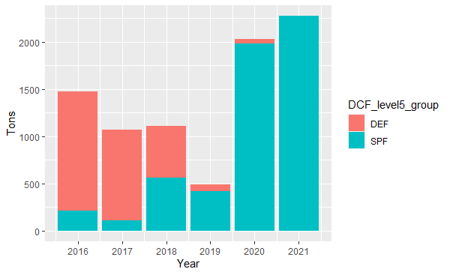
Graph1.1 landings of demersal (DEM) and small pelagic (SPF) fishes by Lithuanian trawlers in Lithuania during 2016-2021
Catches of Anguilla anguilla are extremely rare in the Baltic Sea (2 kg in 2021), therefore no samples from Baltic Sea were collected, only samples in fresh waters as subject of Table 1E
There is no direct fishing for Salmo salar and Salmo trutta, usually as by-catch by small scale coastal fleet. Only one vessel was fished for S.salar by longines, but it was very occasional (see graph 1.2). By-catch of S.trutta was less than 150 kg in 2021, so no samples from commercial fishing for S. salar and S. trutta in the Baltic Sea were collected, only samples from coastal fisheries survey (CFS) inland waters as subject to Table 1E
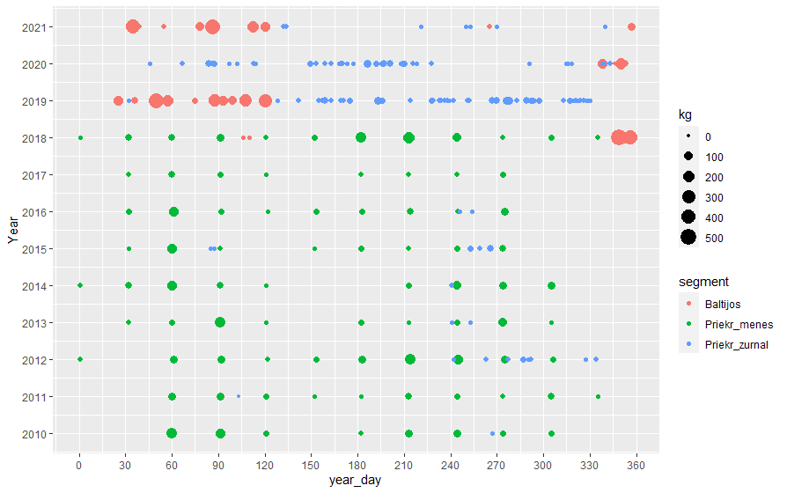
Graph1.2 landings of salmo salar by year day and segment during 2010 -2021:
segments: Baltijos – landings from LLD vessel, Prekr_menes and Priekr_zurnal – by-catch by coastal SSF
Eastern Arctic (ICES areas I and II)
Due to ban Sebastes mentella fishing in ICES area XIV more sampling effort were made in in the ICES areas I and II.
Panadalus borealis sampling intensity was high above than planned minimum, however, since there was no planned maximum, all quantities above minimum shall not be clarified as deviation from WP
Western waters (ICES areas Vb (only Union waters), VI and VII)
It was no fishing for S.mentella in ICES area XIV in 2021, therefore no data were collected. Lithuania has very small fishing opportunities in this region. Only one vessel is occasionally fishing for fishes other than S. mentella in this area if a fishing opportunities are acquired by ad hoc quota swap. Depending on situation this vessel is fishing in North Atlantic or CECAF and SPRFMO areas during the same year, so it is very difficult to organize sampling effort especially when COVID-19 restrictions were in force. Therefore no samples for M.poutassou and S.scombrus were collected in 2021.
Other regions (CECAF, SPRFMO)
According to multilateral agreement all information should be provided by Poland.

- Actions to avoid deviations.
Member State to describe the actions that will be considered / have been taken to avoid the deviations in the future and when these actions are expected to produce effect. If there are no deviations, then this section is not applicable.
Baltic Sea (ICES areas III b-d)
Recent restrictions of fishing for cod resulted shift of fishing effort, and consequently sampling effort different as it was planned. We will try to adjust sampling effort to the factual situation. However, due to high uncertainty deviations between planned and factual sampling effort remains quite likely.
Eastern Arctic (ICES areas I and II)
Sampling of individual length and weight of P. borealis was planned because landing quantities were above threshold set in Implementing Decision, however, the end user ICES work group NIPAG have not asked length distribution of P.borealis but only data on catches and effort. We would like to have clear opinion of the Commission how we should act if according to the article 2.1 a) of Delegated Decision (EU)2021/1167 “…data shall comprise catch quantities by species and biological data from individual specimens, to enable the estimation of volume and length frequency, as well as biological variables such as individual age, sex, weight, maturity and fecundity…”, but end user is not asking data on length frequency.
Western waters (ICES areas Vb (only Union waters), VI and VII)
Since one only one vessel is occasionally fishing for other fishes than S.mentella and P.borealis in this area the sampling method “observer at sea” is difficult therefore, the sampling method “self-sampling” is planned to implement. Training for crew is planned and will be carried when it will be suitable
M.poutassou and S.scomber were included into WP 2020-2021 based on end user ICES work group WGWIDE needs, even the landings of these species from Lithuanian vessels during reference period were much less than threshold (1.15% and 0.09%). The current situation shows that STEFC was right in 2018 when it was advised not to include into WP occasionally fished stocks. We follow this approach in WP for 2022-2024. However, taking in account possible end user needs we are going to implement self-sampling schemes on large vessels as it was described above.
Other regions (CECAF, SPRFMO)
According to multilateral agreement all information should provide Poland.

(max. 1000 words per Region/RFMO/RFO/IO)

SECTION 1: BIOLOGICAL DATA

Text Box 1D - Recreational fisheries

General comment: This box fulfills paragraph 2 point (a) (iv) of Chapter III of the Annex of the Delegated Decision (EU) 2019/910 on the multiannual Union programme; and Article 2, Article 3 and Article 4 paragraph 1 of the Implementing Decision (EU) 2016/1701 on the format of the WP. This box is applicable to the Annual Report. This box is intended to provide information on the design, implementation and analysis of all components of sampling schemes/ surveys that are listed in Table 1D.
1. Description of the target population
Lithuania has recreational fishery only in the Baltic Sea within coastal area of Lithuanian exclusive economic zone and internal waters (Curonian lagoon, rivers and lakes). Cod has been fished in the Baltic sea, salmon and sea trout are fished both in the Baltic sea and rivers, while eel is fished only in internal waters. Two types of surveys have been performed.
- Survey at sea targeting inspection of catch for salmon, sea trout and cod. During the inspection the target population is population of both resident anglers and charter boats operating at sea.
- Questionaires. The target population is residents of Lithuania and the proportion of anglers engaged in recreational fishery exclusively in inland waters of Lithuania.
2. Type of survey
- Surveys at sea have been performed on regular basis and focused on high season of cod and salmon/sea trout fishery. Since cod fishing was not available for commercial or recreational purposes from 1 January 2020 no data of cod catch were registered. Data collected during the surveys included number of boats observer during the day of inspection, number of anglers and total catch by species (in kg and individuals) as well as size of fish in cm. Some procedures have been conducted on landing sites if inspection was impossible at sea. Number and weight of released individuals were also recorded if such information is available from interviewing All data were recordered in relevant protocols.
- Questionaires. The study for evaluation of caught and/or released volumes of salmon, sea trout and eel have been conducted by interviewing residents of Lithuania engaged in recreation fishery in inland waters. Data also included the size of caught and/or released individuals. The study (in Lithuanian) is available: https://www.vic.lt/drp/
3. Data Quality
- Survey at sea. There were no cases of refusal recorded. All inspected elements of population were recorded with positive results.
- Questionaires. There were no records of refusal or non-response observed.
4. Data Analysis and processing
Information about data processing is found in the Work Plan, Table 5A. Are the editing and imputation methods documented and identified? If the answer is No: information on estimation procedures should be included in this section of the Annual Report, following the questions below:
Does the estimation procedure follow the survey design?
Yes. Collected data were raised to population level and total volume of catches were obtained.
Has the precision of the estimates been calculated and documented?
The precision of the estimates has been calculated and documented for the data from survey in internal waters, while precision estimates from surveys at sea has not been estimated. In later case analytical method has been used for catch estimation
- Survey at sea. For raising procedures data on number of charter boats registered during the fishing operations have been extracted from relevant databases. The estimation procedure follows the survey design.
Questionaires. All data have been analysed statistically and the results are presented in the relevant study mentioned above. Figures of total volume for both caught and released fish in kg and individuals were estimated by raising procedure.

Section 1: Biological Data

Pilot Study 1: Relative share of catches of recreational fisheries compared to commercial fisheries

General comment: This box fulfils paragraph 4 of Chapter II of the Annex of the Implementing Decision (EU) 2019/909 on the multiannual Union programme and Article 2 and Article 4 paragraph (3) point (a) of the Implementing Decision (EU) 2016/1701 on the format of the WP.
General comment: This box is applicable to the Annual Report. This box is intended to provide information on the results obtained from the implementation of the pilot study.
- Aim of pilot study

- Duration of pilot study

- Methodology and expected outcomes of pilot study

(max 900 words)
Brief description of the results obtained (including deviations from planned and justifications as to why if this was not the case).

4. Achievement of the original expected outcomes of pilot study and justification if this was not the case.

5. Incorporation of results from pilot study into regular sampling by the Member State.

(max 900 words)

Section 1: Biological Data

Text Box 1E: Anadromous and catadromous species data collection in fresh water
General comment: This box fulfills paragraph 2 points (b) and (c) of Chapter III of the Annex of the Delegated Decision (EU) 2019/910 on the multiannual Union programme; and Article 2 of the Implementing Decision (EU) 2016/1701 on the format of the WP.
General comment: This box is applicable to the Annual Report.
1. Method selected for collecting data.
For salmon and sea trout having in the mind it is very important fresh water stage in the life cycle. The data on parr densities in the rivers will be collected by electrofishing – 100 monitoring sites covering all rivers suitable for salmonids including index rivers. The smolt number will be estimated from electrofishing data and smolt traps for salmon and sea trout smolts (2 smolt traps for salmon smolts and 1 for the sea trout smolts). The number of adults migrating to the rivers will be estimated from commercial by catches in Curonian lagoon till spawners counters in the rivers Žeimena, Minija and Jūra will be established (Table 1E). Samples for biological analyses (minimum 50 salmons and 50 sea trout’s, Table 1C) from commercial bycatch in Curonian lagoon and commercial catches at the sea will be collected.
Eel
A minimum of 100 individuals shall be analysed per management unit as specified in Regulation (EC) No 1100/2007 for yellow and silver eels separately. Samples for biological analysis (100 units in Inland and 100 units in Curonian Lagoon) will be obtained on shore (Table 1C, 1F, 5A).
In Inland 2 monitoring places (2 river trap nets) will be used to estimated eel migratory intensity, CPUE, biological data. Data indicated in Tables 1B, 1C, 1F, 4A, 4B will be collected. 9 trip days per season (April – May) is planned to visit monitoring places.
Yellow eel standing stock will be estimated from fyknets and river trap nets catches.
(max 250 words per Area)
2. Were the planned number achieved? Yes/ No
If answer is No, Member State shall explain why not, and what measures were taken to avoid non-conformity.
2.1. Concerning eel, Fisheries service interviewed 350 recreational fishermen. 12% of them indicated catching eel during 2021. Using total quantity and weight of reported caught eels, average weight of eels was calculated. According to the data of the Ministry of Environment, 74436 anglers acquired annual fishing permits issued in Lithuania for recreational fisheries in 2021. Using this data total eel amount caught in recreational fishery was calculated using the approved methodology.
2.2. The monitoring of salmon and sea trout stocks biological variables and population characteristics (parr number) was carried out in 101 monitoring sites (Nemunas, Šventoji, Venta and Bartuva river catchments) according to electrofishing sampling protocol. The estimation of number of salmon and sea trout smolts was done compiling the electrofishing data with data from traps according of WGBAST recommendations.
Counting of adult specimens was unsuccessful, because of malfunction of equipment caused by factory defects. The negotiations with manufacturer on fixing of the defects is ongoing.

(max 500 words per Area)

Section 1: Biological Data

Text box 1F: Incidental by-catch of birds, mammals, reptiles and fish

General Comment: This box fulfils paragraph 3 point (a) of Chapter III of the Annex of the Delegated Decision (EU) 2019/910, on the multiannual Union programme; and Article 2 of the Implementing Decision (EU) 2016/1701 on the format of the WP. This box is applicable to the Annual Report. This box is applicable only for those sections where Member States have reported that they have been carrying out regular sampling. Results and deviations for Pilot studies should be reported under Pilot Study 2.
1. Results
All observers are instructed to register bycatch of any animal or single/rear species. If observers are not available onboard due to lack of space or safety requirements, masters are obliged to record this information in the logbooks.
2. Deviations from Work Plan
There are no deviations from WP as all possible data sources have been used for data collection (logbooks, observation trips, projects, surveys, etc.)
3. Data quality
Member States shall provide information on sampling protocols and sampling design for incidental by-catch data collection.
Questions to be addressed are listed below:
- Does the onboard observer protocol contain a check for rare specimens in the catch at opening of the codend? If YES is the observer instructed to indicate if the codend was NOT checked in a haul?
Answer: NO. In case of small catches observers have opportunity to check rare species in the codend. If catches are too large only subsample of catches might be taken for catch composition. There are no specific indications for checking haul are included in sampling protocol.
- In gill nets - and hook-and-line fisheries: does the onboard observer protocol instruct the observer to indicate how much of the hauling process has been observed for (large) incidental bycatches which never came on board (because they fall out of the net)? In large catches: does the protocol instruct to check for rare specimens during sorting of the catch (i.e. at conveyor belt)? Is the observer instructed to indicate what percentage of the sorting or hauling process has been checked at “haul level”?
Answer: On fishing trawlers operating in distant waters during the sorting procedure at conveyor belt observers are instructed to check rare specimens. During the sorting procedure observers are checking every haul and the results are reflected in their reports. If the percentage is required, it could be estimated from that report.
-Does the onboard observer protocol instruct to report on the use of mitigation (i.e. Escape Devices or Acoustic Deterrent Devices)?
Answer: No.
- Does the sampling design and protocol follow the recommendations from relevant expert groups? Provide appropriate references. If there are no relevant expert groups, the design and protocol have to be explained in the text.
Answer: Expert groups like WGBYC or WKPETSAMP did not provide any specific recommendations on sampling design. By-catch of any animals from freezer trawlers, which operate in distant waters, has been registered by master in the log-books. If observer is available on-board, this part of data collection is performed by observer. The check of incidental by-catch has been performed haul-by-haul. Small trawlers in the Baltic Sea are also obligated to record any incidental by-catch of animals in their log-books. Observation on such types of vessels is impossible due to lack of space on-board and safety reasons. Fishermen from coastal fishery of the Baltic Sea may also make records of incidental by-catch in the log-books.

- Are data quality issues taken into account?
Answer: Yes
- How are data (and samples) stored
Answer: All data related to data collection are stored in national database. Data related to registration of incidental catch have to be included into database, i. e. some modifications have to be done adding extra column in it.

Section 1: Biological Data

Pilot Study 2: Level of fishing and impact of fisheries on biological resources and marine ecosystem

General comment: This Box fulfills paragraph 3 point (c) of Chapter III of the Annex of the Delegated Decision (EU) 2019/910 on the multiannual Union programme; and Article 2 and Article 4 paragraph (3) point (b) of the Implementing Decision (EU) 2016/1701 on the format of the WP.
General comment: This box is applicable to the Annual Report. This box is intended to provide information on the results obtained from the implementation of the pilot study.
1. Aim of pilot study

2. Duration of pilot study

3. Methodology and expected outcomes of pilot study

(max 900 words)
Brief description of the results obtained (including deviations from planned and justifications as to why if this was not the case).
Summary is available on DFC website.

4. Achievement of the original expected outcomes of pilot study and justification if this was not the case

5. Incorporation of results from pilot study into regular sampling by the MS

(max 900 words)

Section 1: Biological Data

Text Box 1G: List of research surveys at sea
General comment: This box fulfills Chapter I of the Annex of the Implementing Decision (EU) 2019/909, on the list of mandatory surveys and thresholds, of the multiannual Union programme; and Article 2 and Article 7 paragraph (3) of the Decision (EU) 2016/1701 on the format of the WP. It is intended to specify which reseach surveys at sea set out in the multiannual Union programme will be carried out. Member States shall specify whether the research survey is included in Chapter I of the Annex of the implementing decision of the multiannual Union programme or whether it is an additional survey.
General comment: This box is applicable to the Annual Report. This box should provide complementary information on the performance of the surveys, the results and their main use.
Baltic International Trawl Survey – BITS Q1.
1. Objectives of the survey
The main aim of the BITS surveys is to estimate cod and other demersal species recruitment indices and abundance in ICES Subdivision Iniid.
2. Description of the methods used in the survey. For mandatory surveys, link to the manuals. Include a graphical representation (map)
The surveys have been conducting within period of February-March in the Lithuanian Exclusive Economic Zone (LEEZ) according to the BITS manual (ICES, 2014. Manual for the Baltic International Trawl Surveys (BITS). Series of ICES Survey Protocols SISP 7 - BITS. 71 pp.)
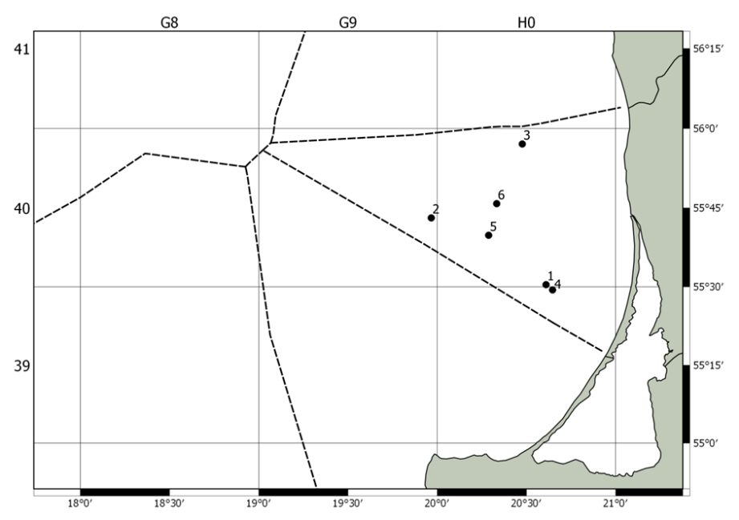
Figure 1. Allocation of stations defined in the LEEZ for BITS Q1 survey in 2019
3. For internationally coordinated surveys, describe the participating Member States/vessels and the relevant international group in charge of planning the survey
Survey is coordinated by Baltic International Fish Survey Working Group (WGBIFS). All Baltic countries, including Russia, are participating in this survey. Countries and vessels involved into BITS survey are mentioned in the manual mentioned above.
4. Where applicable, describe the international task sharing (physical and/or financial) and the cost sharing agreement used:
Not relevant
5. Explain where thresholds apply
Not relevant
- Graphical representation (map) showing the positions (locations) of the realized samples.
Member State shall provide maps presenting the spatial distribution of the main sampling types obtained during the survey.
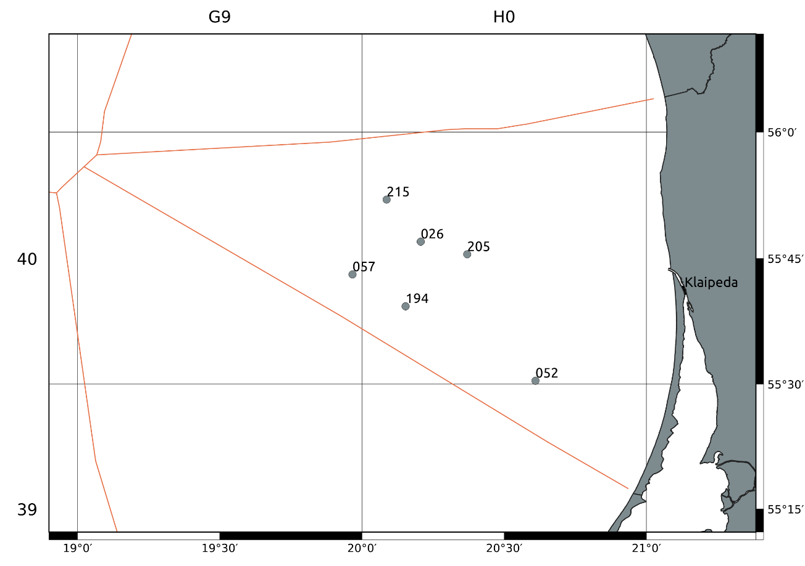
Figure 1a. Achieved survey stations to Lithuania for BITSQ1 survey in 2021
- For internationally coordinated surveys, provide a link to the latest meeting report of the coordination group.
http://www.ices.dk/community/groups/Pages/WGBIFS.aspx
- List the main use of the results of the survey (e.g. indices, abundance estimates, environmental indicators).
Target species are demersal fish species, mainly Baltic cod and flatfish species (mainly flounder, plaice and turbot). The main aim is to determine the year-class strength of the target species. Target data are abundances, weight and length distributions of all fishes and length-weight-age-sex-maturity data of cod and flatfish species as well as hydrographic data (temperature, salinity and oxygen). The collected data are saved in ICES DATRAS database.
- Extended comments (Tables 1G and 1H)
none
Baltic International Trawl Survey – BITS Q4
1. Objectives of the survey
The main aim of the BITS surveys is to estimate cod and other demersal species recruitment indices and abundance in ICES Subdivision IIId.
2. Description of the methods used in the survey. For mandatory surveys, link to the manuals. Include a graphical representation (map)
The surveys have been conducting within period of November – December in the Lithuanian Exclusive Economic Zone (LEEZ) according to the BITS manual (ICES, 2014. Manual for the Baltic International Trawl Surveys (BITS). Series of ICES Survey Protocols SISP 7 - BITS. 71 pp.)
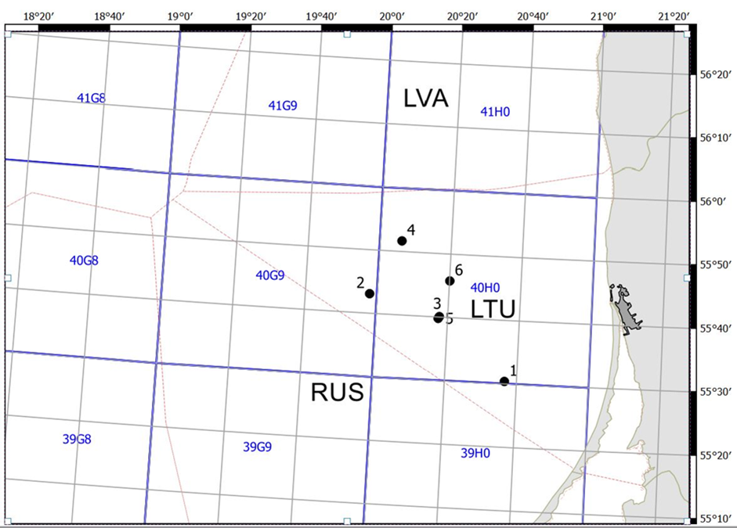
Figure 2. Allocation of stations defined in the LEEZ for BITS Q4 survey in 2019
3. For internationally coordinated surveys, describe the participating Member States/vessels and the relevant international group in charge of planning the survey
Survey is coordinated by Baltic International Fish Survey Working Group (WGBIFS). All Baltic countries, including Russia, are participating in this survey. Countries and vessels involved into BITS survey are mentioned in the manual mentioned above.
4. Where applicable, describe the international task sharing (physical and/or financial) and the cost sharing agreement used
Not relevant
5. Explain where thresholds apply
Not relevant
- Graphical representation (map) showing the positions (locations) of the realized samples.
Member State shall provide maps presenting the spatial distribution of the main sampling types obtained during the survey.
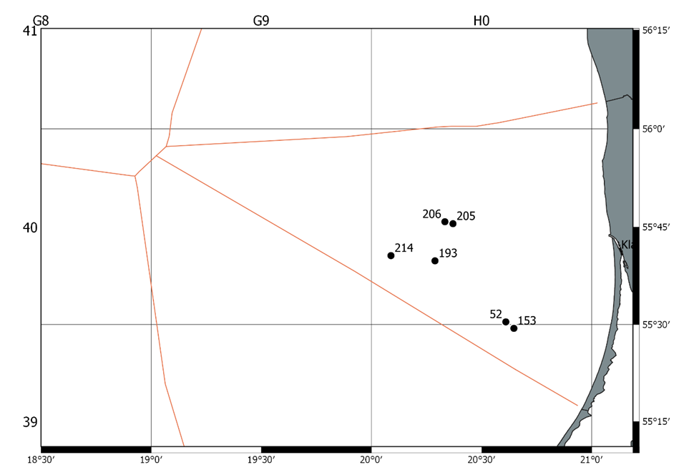
Figure 2a. Achieved survey stations to Lithuania for BITSQ4 survey in 2021
- For internationally coordinated surveys, provide a link to the latest meeting report of the coordination group.
http://www.ices.dk/community/groups/Pages/WGBIFS.aspx
- List the main use of the results of the survey (e.g. indices, abundance estimates, environmental indicators).
Target species are demersal fish species, mainly Baltic cod and flatfish species (mainly flounder, plaice and turbot). The main aim is to determine the year-class strength of the target species. Target data are abundances, weight and length distributions of all fishes and length-weight-age-sex-maturity data of cod and flatfish species as well as hydrographic data (temperature, salinity and oxygen). The collected data are saved in ICES DATRAS database.
9. Extended comments (Tables 1G and 1H)
none
Sprat Acoustic Survey – SPRAS.
1. Objectives of the survey
The main aim of the SPRAS surveys is to assess abundance of sprat and herring resources in ICES Subdivision IIId.
2. Description of the methods used in the survey. For mandatory surveys, link to the manuals. Include a graphical representation (map)
The surveys have been conducting within May in the Lithuanian Exclusive Economic Zone (LEEZ) according to the IBAS manual (ICES. 2014. Manual of International Baltic Acoustic Surveys (IBAS). Series of ICES Survey Protocols SISP 8 - IBAS. 24 pp.)
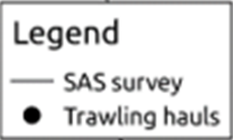
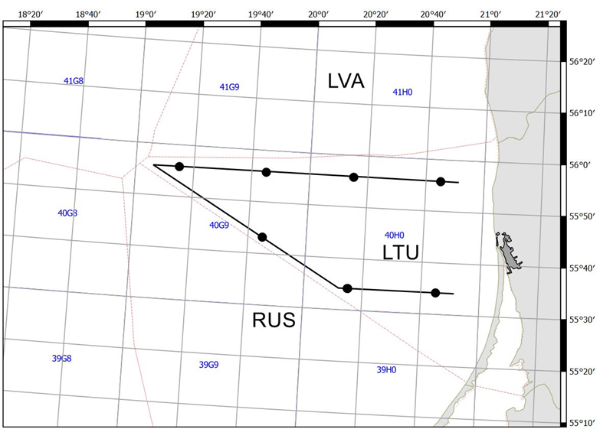
Figure 3. Cruise track design and hauls of SPRAS in LEEZ in 2019
3. For internationally coordinated surveys, describe the participating Member States/vessels and the relevant international group in charge of planning the survey
Survey is coordinated by Baltic International Fish Survey Working Group (WGBIFS). All Baltic countries, including Russia, are participating in this survey. Countries and vessels involved into SPRAS survey are mentioned in the BITS manual mentioned above.
4. Where applicable, describe the international task sharing (physical and/or financial) and the cost sharing agreement used
Not relevant
5. Explain where thresholds apply
Not relevant
- Graphical representation (map) showing the positions (locations) of the realized samples.Member State shall provide maps presenting the spatial distribution of the main sampling types obtained during the survey.
Not available
- For internationally coordinated surveys, provide a link to the latest meeting report of the coordination group.
Not available
- List the main use of the results of the survey (e.g. indices, abundance estimates, environmental indicators).
Not available
9. Extended comments (Tables 1G and 1H)
When acoustic equipment (SIMRAD EK60 38/120/200 KHZ SPLIT BEAM SYSTEM) was tested on shore before the trip the control indicators didn’t show any problems, however no signal was received during operations at sea. No official repairer of SIMRAD is in Lithuania. After approval by official dealer comprehensive testing was caried out in the local electronic repairing office. Some defects of transducer’s hermitization (hidroyzolation) was detected during this test. It was not possible to fix the equipment in short time period. Therefore, SPRAS survey was not carried out in 2021.
Baltic International Acoustic Survey (Autumn) – BIAS
1. Objectives of the survey
The main aim of the BIAS surveys is to assess abundance of herring and sprat resources in ICES Subdivision IIId.
2. Description of the methods used in the survey. For mandatory surveys, link to the manuals. Include a graphical representation (map)
The surveys have been conducting within period of September – October in the Lithuanian Exclusive Economic Zone (LEEZ) according to the IBAS manual (ICES. 2014. Manual of International Baltic Acoustic Surveys (IBAS). Series of ICES Survey Protocols SISP 8 - IBAS. 24 pp.)
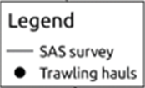
Figure 4. Cruise track design and hauls of BIAS in LEEZ in 2019

3. For internationally coordinated surveys, describe the participating Member States/vessels and the relevant international group in charge of planning the survey
Survey is coordinated by Baltic International Fish Survey Working Group (WGBIFS). All Baltic countries, including Russia, are participating in this survey. Countries and vessels involved into BIAS survey are mentioned in the BITS manual mentioned above.
4. Where applicable, describe the international task sharing (physical and/or financial) and the cost sharing agreement used
Not relevant
5. Explain where thresholds apply
Not relevant
- Graphical representation (map) showing the positions (locations) of the realized samples.
Member State shall provide maps presenting the spatial distribution of the main sampling types obtained during the survey.
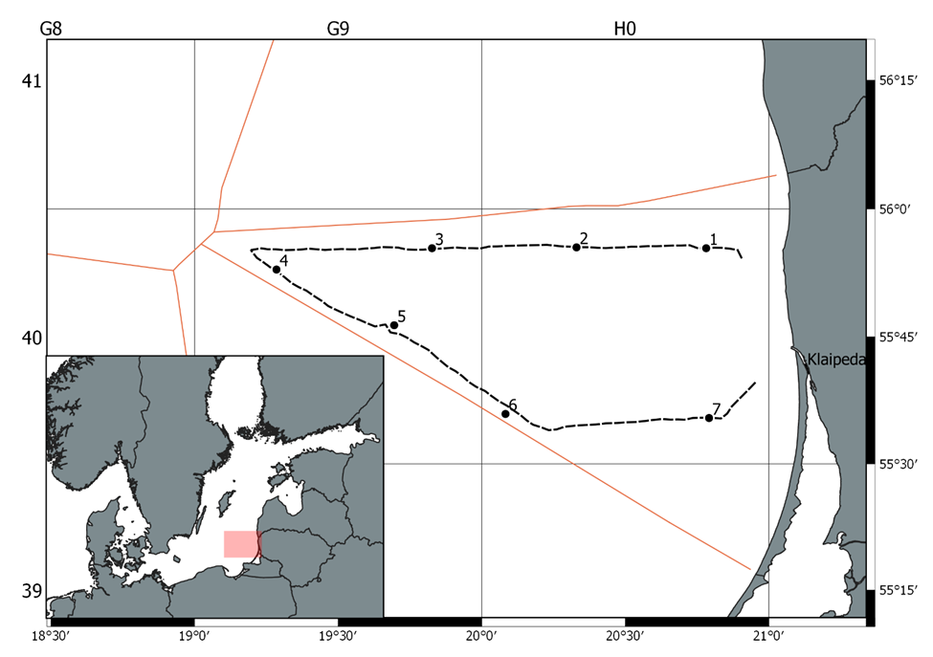
Figure 4a. Locations of the realized fish control hauls, hydrological stations performed during Lithuania BIAS survey in 2021
- For internationally coordinated surveys, provide a link to the latest meeting report of the coordination group.
http://www.ices.dk/community/groups/Pages/WGBIFS.aspx
- List the main use of the results of the survey (e.g. indices, abundance estimates, environmental indicators).
Target species are pelagic fish species, mainly herring and sprat. Target data are biomass, weight and length distributions and length-weight-age-sex-maturity of sprat and herring. Length distributions of all fishes as well as hydrographic data (temperature, salinity and oxygen). The data are used as an index for the stock assessment of herring and sprat. The collected data are saved in ICES Acoustic trawl surveys database.
9. Extended comments (Tables 1G and 1H)
none
Survey of fishes in the Lithuanian coastal waters of the Baltic sea - CFS.
1. Objectives of the survey
The Lithuanian coastal zone in the Baltic Sea is very rich and diverse community of hydro biotic organisms. It consists of lot ecological niches and fish nursery grounds important for commercial and non-commercial fishes (especially important juveniles). Lithuanian coastal waters are highly affected by on-land anthropogenic activities, that makes significant impact on eutrophication, distribution of waist and toxic substances. Spread of invasive species as gobies (Gobiidae) highly affects behavior of local fish population, including cod. Therefore, constant monitoring of fishes and fishing activities in the Lithuanian coastal waters may provide information important for early detection of negative tendencies in the development of populations of commercial fishes.
2. Description of the methods used in the survey. For mandatory surveys, link to the manuals. Include a graphical representation (map)
The survey consists from two parts:
Juveniles survey: The objective of this survey is to determine the abundancy and biomass dynamics of all juvenile fishes in the coastal areas. The survey is performed in 14 sites alongside the Lithuania’s coastal zone (figure 5) during August - September. From each station 3 samples are taken using two different fishing technics: a dragnet is used mainly for sprat, smelt and sand eel, but all other species that are caught are analyzed as well; a beach seine specially designed for flatfish and turbot juveniles and shrimp. Hydrological parameters are recorded during each sampling as well.
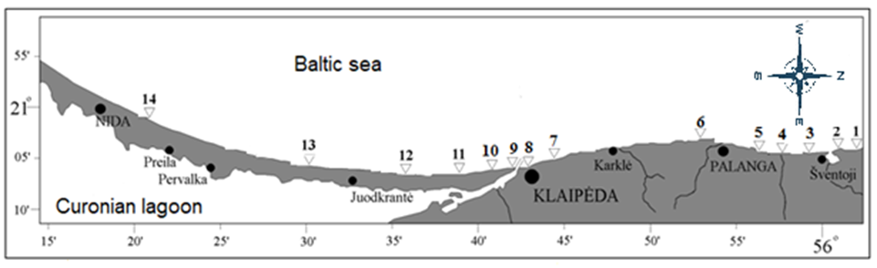
Figure 5. The sites of juvenile survey in Lithuanian coastal zone
Gillnet monitoring: The objective of this survey is to monitor the biological conditions and migration patterns of the fishes. The multi mesh-sized gillnets (from 14mm to 70 mm) are casted in four monitoring stations alongside the Lithuania’s coastal zone: two close to the southern and northern edges of Lithuanian coastal zone (Nida and Šventoji) and another two close to the mouth of Curonian lagoon, the most important source of fresh water (Smiltynė and Melnragė). The survey fishing is made once a month in each of the stations. Biological, hydrological and fisheries activity parameters are recorded according to the methodology of the HELCOM.
3. For internationally coordinated surveys, describe the participating Member States/vessels and the relevant international group in charge of planning the survey
This is not an internationally coordinated survey however it is planned to use the results of the survey in the assessment of flounder and turbot in the Central Baltic, the survey is performed by methodology of the HELCOM and it is performed also in other countries of the Baltic Sea.
4. Where applicable, describe the international task sharing (physical and/or financial) and the cost sharing agreement used
Not relevant
5. Explain where thresholds apply
Not relevant
- Graphical representation (map) showing the positions (locations) of the realized samples.
Member State shall provide maps presenting the spatial distribution of the main sampling types obtained during the survey.
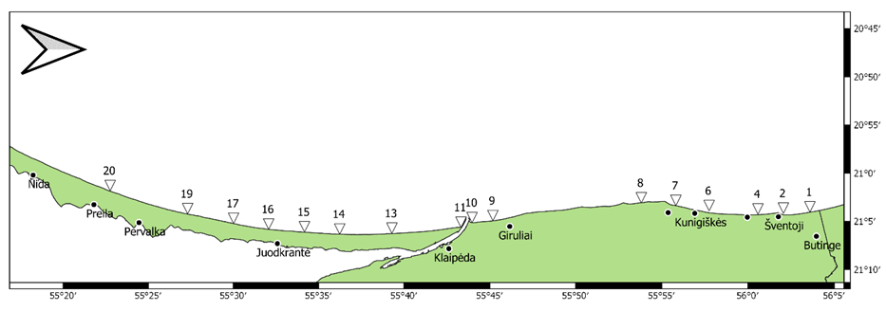
Figure 5a. Locations of the realized fish control hauls and hydrological stations performed during Lithuania juvenile survey in the period from 5th August to 15th September 2021

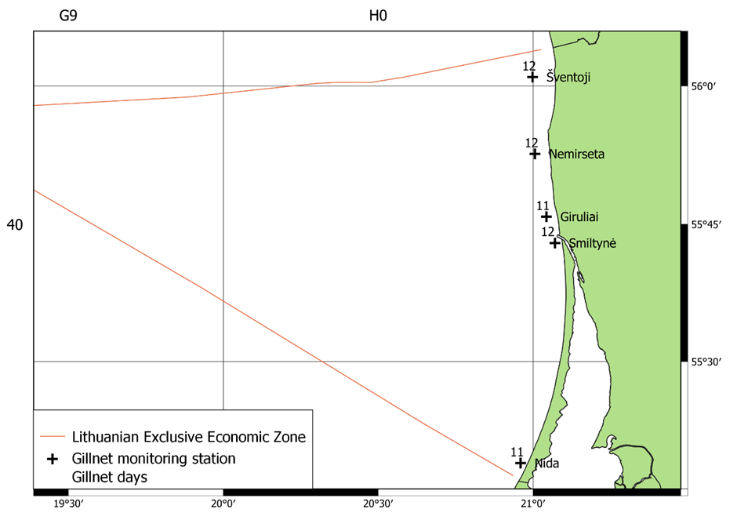
Figure 5b. Lithuania gillnet monitoring stations in the period February – December 2021. Number at the station indicates number of monitoring effort in gillnet*day
- For internationally coordinated surveys, provide a link to the latest meeting report of the coordination group.
The survey isn’t coordinated internationally. Results of survey are stored in KU SharePoint, summarized reports are provided to the institutions involved in the fisheries regulation in the Baltic Sea and Curonian lagoon.
- List the main use of the results of the survey (e.g. indices, abundance estimates, environmental indicators).
Gillnet monitoring survey provides information on the distribution and relative abundance of fish species in coastal zone, monitors changes in the stocks of commercial fish and supplies information on the distribution and relative abundance of all fish species including ones listed in the Table 1D of Decision 2016/1251
The main aim of the juveniles’ survey is obtaining abundance estimates of juveniles of flatfish (flounder and turbot), sprat and other species, as well as abundance of crustaceans. This information is periodically requested by some ICES work groups as WGBFAS, WKMixHER and HELCOM.

SECTION 2: FISHING ACTIVITY DATA

Text Box 2A: Fishing activity variables data collection strategy

General comment: This box fulfills paragraph 4 of Chapter III of the Annex of the Delegated Decision (EU) 2019/910 on the multiannual Union programme; and Article 2, Article 4 paragraph (2) point (b) and Article 5 paragraph (2) of the Implementing Decision (EU) 2016/1701 on the format of the WP. It is intended to describe the method used to derive estimates on representative samples where data are not to be recorded under Regulation (EU) No 1224/2009 or where data collected under Regulation (EU) No 1224/2009 are not at the right aggregation level for the intended scientific use.
General comment: This box is applicable to the Annual Report. This box should provide information on the implementation of the data collection of fishing activity variables of Member States.
1. Description of methodologies used to cross-validate the different sources of data
- For all fleet segments by regions the transversal variables is deriving from database system FDIS, which contains the data referred to Commission Regulation (EC) No 26/2004 of 30 December 2003 on the Community fishing fleet register in Annex I and Council Implementing Regulation (EC) No 404/2011 in Annex X. As well FDIS contains an obligatory by National legislation national logbook, for vessels of less than 8 m length overall which is operating exusevly in the Baltic Sea. Community fishing vessels from 8 to 12 metres’ length overall are obliged to keep a fishing logbook and submit landing and transhipment declarations. Fishing vessels of 18 metres’ length overall or more, the fishing logbook is in electronic form and the landing declarations are submitting electronically. The Lithuanian fleet does not consist of any vessels with the length class of 12 to 18 metres in length. Active and inactive vessels are included in the vessel register. The maintenance and continuous updates are up to dates. Using a conversion factor established in accordance with the Council Regulation (EC) No 404/2011 ANNEXES XIII-XV, FDIS includes a built in function that converts processed fish weight into live fish weight. Lithuania has performed cross-checking, analyses and verifications through automated computerised algorithms and mechanisms on vessel monitoring systems, catch, effort and sales notes data and data related to the Community fishing fleet register as well as the verification of licences and fishing authorisations. Data is available in the form of primary data to the all national institutions implementing the workplans.

2. Description of methodologies used to estimate the value of landings

Data on landings for vessels less than 8 m length overall, which is not covered under Control Regulation, are derived from the national logbooks which have been cross-checked with sales notes. These provide the key details on the species, presentation, location of landings, weight and value of fish being landed that is entered into computer system. For all fleet segments value is estimating based on prices derived from sales notes multiplying by weight from landing declarations.

3. Description of methodologies used to estimate the average price (it is recommended to use weighted averages, trip by trip)

Based on sales notes the average price by species, presentation and region is computing by dividing the total value of fish available for sale by the total weight available for sale during the period. Each sale note is related to the vessel trip or monthly report, which allow computing the average price on base of vessel trips or monthly report.

4. Description of methodologies used to plan collection of the complementary data (sample plan methodology, type of data collected, frequency of collection etc)

To approach reliable and high quality of data Lithuania uses a “census” type of logbooks for vessel, which is not recordered data under the Regulation (EU) No 1224/2009. National logbooks are completing by a company engaged in commercial fishing in the Baltic Sea coastal area. List of vessels is approved by national legislation and covers the whole segment population. The landings and metier based effort variables are
provided by abovementioned logbooks. The logbooks information shall be transmitted to the authority 2 times per month. When classifying a data transmission failures regarding timeliness or completeness the company is notified and report is re/submitted. The logbooks landing information are cross-checking with sales notes.

(max 900 words per Region)
5. Deviations from Work Plan methodology used to cross-validate the different sources of data
No deviations.
Actions to avoid deviations.
No actions needed.

6. Deviations from Work Plan methodology used to estimate the value of landings.
No deviations.
Actions to avoid deviations
No actions needed.

7. Deviations from Work Plan methodology used to estimate the average price.
No deviations.
Actions to avoid deviations.
No actions needed.
8. Deviations from Work Plan methodology used to plan collection of the complementary data
No deviations.
Actions to avoid deviations
No actions needed.

SECTION 3: ECONOMIC AND SOCIAL DATA

Text Box 3A: Population segments for collection of economic and social data for fisheries

General comment: This box fulfils paragraph 5 points (a) and (b) of Chapter III of the multiannual Union programme and Article 2, Article 4 paragraphs (1), (2) and (5) and Article 5 paragraph (2) of the Decision (EU) 2016/1701. It is intended to specify data to be collected under Tables 5(A) and 6 of the multiannual Union programme.
General comment: This box is applicable to the Annual Report. This box should provide information on the implementation of the fleet socio-economic data collection of Member States.
1. Description of methodologies used to choose the different sources of data
The total population for fleet economic and social variables is all active and inactive vessels registered in the Union Fishing Fleet Register on 31 December of the reporting year and vessels that do not appear on the Register at that date but have fished at least one day during the reporting year.
Collection of economic variables of the Lithuanian fleet will be based on following major data sources:
- Lithuanian Agricultural and Food Product Market Information System (LAFPMIS) administered by State enterprise Agricultural Information and Rural Business Center (AIRBC).
- Fishery Data Informational System (FDIS) administered by Fisheries Service.
- Fleet register.
- Perpetual Inventory Method (PIM)
- Modified Discounted Cash Flow Method (DCFM)
Economic variables for the variable groups as Income, Labour costs, Energy costs, Repair and maintenance costs, Other operating costs, Subsidies, Investments, Financial position, Employment and Energy consumption are obtained from LAFPMIS (census survey DR-1). Consumption of fixed capital and value of physical capital is estimated by the PIM, Value of quota and other fishing rights is estimated by DCFM. Economic variables for the Effort (except Energy consumption), Number of fishing enterprises/units and Production value per species are obtained from FDIS. Data for variable group Fleet is available from Fleet Register.
Social data as Employment by gender, FTE by gender, Unpaid labour by gender, Employment by age, Employment by employment status and FTE National will be collected on annual basis and available from data source LAFPMIS (census survey DR-1). Social variables as Employment by education level and Employment by nationality will be collected each three years (started in 2018) by specialized census survey and available from data source LAFPMIS.
Variable gross value of landings is available from two data sources, FDIS (estimated gross value of landings) and LAFPMIS questionnaires (income from landings, census survey DR-1). Two values will serve for crosschecking purposes and in the case of non-response to DR-1. For the reporting Gross value of landings, LAFPMIS information will be used as it is obtained from the same data source (accounting documents of enterprise) as other economic variables and relates to expenditures, capital related variables, employment and social indicators. In the case of non-responses, estimated gross value of landings from FDIS will be used.
2. Description of methodologies used to choose the different types of data collection
For all economic and social variables census and in some cases indirect survey data collection schemes will be applied for total fleet. Data are collected by Statistical questionnaires (code DR-1) approved by the order of the Minister of Agriculture No 3D-707 on 4-th August of 2010. FDIS and Fleet Register possess census data as well. Variables as Value of unpaid labour, Consumption of fixed capital, Value of physical capital, Value of quota and other fishing rights, Value of landings per species, FTE by gender and FTE National in WP excel table are indicated as collected from indirect survey. These variables are estimated from the primary data, collected by census surveys (LAFPMIS and FDIS). Estimation procedure is provided in paragraph 4.
3. Description of methodologies used to choose sampling frame and allocation scheme
Data collection is based at enterprise level. If enterprise operates two vessels or more, belonging to different fleet segments, it is asked to provide separate questionnaires for individual segments, if all vessels belongs to one segment, only one questionnaire for all vessels in segment is provided. Before starting annual census survey DR-1 for economic and social variables, composition of fleet segments are checked from the fleet activity information (effort data from FDIS). Logbook based data on effort for each active population vessel is extracted from FDIS and taking into account vessel length, fishing area and activity by gear, fleet segments are formed. Fleet economic data is collected at fleet segment level, whereas social data will be available at the fishing region level as recommended by PGECON 2017: “Small scale fleet”, “Large scale fleet” and “Long distance fleet”. Aggregation groups of social variables are used from PGECON 2017 3-9 recommendations.
4. Description of methodologies used for estimation procedures
Value of unpaid labour.
Imputed value of unpaid labour is calculated as the number of unpaid family members (variable from DR-1) involved in production, or number of their working hours (if provided) multiplied by average annual wage (variable from DR-1) calculated for “paid labour” at particular segment level.
FTE by gender and FTE National
In census survey, working hours of employees in fisheries is collected at gender level. Therefore, FTE by gender as well as National FTE is calculated from annual working hours (variable from DR-1) divided from annual number of hours for 1 full time employee indicated in national law.
Consumption of fixed capital, Value of physical capital
Value of physical capital and consumption of fixed capital will be estimated using Perpetual Inventory Method (PIM) using the linear depreciation scheme based on capital values estimated using replacement values (STECF 11-19, page 6) and included in the template model developed by EC study No. FISH/2005/03 and modified by 2017 pilot study conducted in Lithuania on “Capital value calculation using only book values and compared results with capital value calculation using Perpetual inventory method (PIM)”. The modified PIM uses tailored input data (real life depreciation rates, renewal age, vessel structure and residual values of capital of Lithuania fishing vessels by segments) for calculating capital value and depreciation costs by directly inputting initial vessel values (combination of purchasing values (historical book values at current prices) and modeled values (calculated for unknown values of vessels from price per capacity unit (PCU)) into PIM. Pilot study results are available in the report of PGECON 2018. The methodology for calculating capital value and depreciation costs is published in AIRBC website.
Value of quota and other fishing rights
From 2017 in Lithuania ITQ system was introduced as a quota management measures. In order to determine the value of fishing rights under ITQ system, methodology was established and adapted to national fleet. Preparation of methodology was based on the pilot study of application of different estimation methods to Lithuanian fishing fleet and comparison to the available ITQ market information. Guidelines were followed from the conclusions at PGECON 2019 where results from SECFISH WP4 were presented. Methodology proposes to use Modified discounted cash flow method adapted to different fleets. For Baltic Sea large scale fleet value of fishing rights is calculated separately for pelagic and demersal species. For coastal small-scale fleet value of fishing rights is estimated for the allocated number of gears expressed in units of net length in particular fishing area. For long distance fleet, due to confidentiality issues value of fishing rights are not calculated separately for each fleet segment (pelagic and demersal) but estimated for total long distance cluster considering small pelagic fisheries as dominant. Regional aspect was taken into account for discount rate estimation for all fleets.
Non-responses
In the case, when response rate is less than 100% of population, missing variables are estimated from the independent variables from FDIS effort and landing data.

where:
X_{j} – missing variable information about the vessel;
x_{i}– collected variable of the sample;
n – sample size;
Y_{j} – FDIS independent variable of the vessel;
y_{i}– FDIS independent variable of the sample.
For the missing variables as Labour costs and Other operating costs FDIS independent variable Value of landings is used. For the missing variables as Energy costs, Repair and maintenance costs, Energy consumption, Total hours worked and FTE, FDIS independent variable Days at sea is used. For missing Number of employees, the Social security administrative data is used. Missing financial position is estimated based on Value of physical capital data from PIM calculations.
Missing population for social data is used from administrative employment data from Social security service. Values of social indicators are estimated applying percentage ratios from collected social variables to the missing population.
5. Description of methodologies used on data quality
Fleet economic and social data collection is included in the annual Official Statistic data collection Program and therefore quality is ensured by application of principles of European Code of Practice. The data collection processes in AIRBC complies the ISO 9001 requirements for data quality and ISO 27001 requirements for data security. AIRBC has carried out a self-assessment of the compliance with the European Statistics Code of Practice, which can be considered as a best practice in the European Statistical System. The self-assessment reviews the institutional environment (professional independence, mandate for data collection, adequacy of resources, commitment to quality and statistical confidentiality, impartiality and objectivity) as well as the statistical processes and the quality of its outputs.
For data quality assurance, LAFPMIS Interactive Data Input System contains:
- logical verification and data validation at different data processing stages;
- automatic data aggregation during data input process;
- for external users, especially data providers, system ensure easy accessibility of methodologies;
- system is flexible in terms of development according requirements from end users and external users;
- update and storage of exhaustive administrative data.
In addition, primary data, intermediate results and statistical outputs are regularly assessed by the expertise of personnel, data are checked for inconsistencies, completeness, and timeliness. Any detected errors are registered in non-compliance register. Based on records from this register data audition unit of AIRBC periodically visit fishing companies and perform primary data quality and accuracy audition by checking questionnaire data with companies accounting documents.
For quality measurements, response rate (separately at respondent/vessel and reported item levels) and coverage rate (taking into account value of landings) are calculated.
In FDIS has been performed cross-checking, analyses and verifications through automated computerised algorithms and mechanisms on vessel monitoring systems, catch, effort and sales notes data and data related to the Community fishing fleet register as well as the verification of licences and fishing authorisations that ensure Fleet, Effort (exclude Energy consumption), Number of fishing enterprises/ units and Production value per species variables quality.
(max 900 words per Region)
6. Deviations from Work Plan methodology for selection of data source
No deviations from Work Plan.
Actions to avoid deviations
NA.
7. Deviations from Work Plan methodology to choose type of data collection
No deviations from Work Plan.
Actions to avoid deviations
NA.
8. Deviations from Work Plan methodology regarding sampling frame and allocation scheme
No deviations from Work Plan.
Actions to avoid deviations
NA
9. Deviations from Work Plan methodology used for estimation procedures
No deviations from Work Plan.
Actions to avoid deviations
NA.
10. Quality assurance
The quality of statistical information and its preparation is ensured in accordance with the provisions of the European Statistics Code of Practice. For quality assurance framework AIRBC adopted:
- 2017 March 15 Order No. 1V-54 of Director General of the AIRBC Regarding the provision, verification, processing, preparation of statistical information to the European Commission, Eurostat and National Authorities for the statistical information on the Lithuanian agricultural and food products market system and the approval of the publication procedure (internal document).
- 2016 September 22 Order No. 1V-141 of Director General of the AIRBC On Approval of Quality Policy of the State Enterprise of Agricultural Information and Rural Business Center (internal document).
In its activities, AIRBC follows the principles of the integrated management system, which includes elements of quality and information security management in accordance with the Lithuanian standard LST ISO / IEC 9001: 2015 and the Lithuanian standard LST ISO / IEC 27001: 2013.
10.1 Sound methodology
For socio-economic data collection census survey is applied using statistical form DR-1 approved in the annex 4 of Rules of fisheries data collection in Lithuania. Economic and social variables of fishing fleet are provided from enterprise accountancy, except capital value, consumption of fixed capital, value of quota and other fishing rights and imputed value of unpaid labour which are estimated using best practice and common methodologies agreed in DCF expert working groups. Compilation of all the methodologies recommended by PGECON reports and DCF workshops is available in “Methodologies for the socio-economic data described in EU MAP” Ref. Ares (2016)2440332 - 26/05/2016. (by Evelina Sabatella).
- Capital value and consumption of fixed capital for fishing fleet is estimated by Perpetual Inventory Method (PIM method) proposed in the study FISH/2005/03: ‘Irepa Onlus Coordinator, 2006’.
- Value of quota and other fishing rights are estimated by Modified discounted cash flow method adjusted to the fleet by different fishing areas. Methodology was prepared according to the results of pilot study on the application of different estimation methods to Lithuanian fishing fleet and comparison to the available ITQ market information. Guidelines were followed from the conclusions at PGECON 2019 where results from SECFISH WP4 were presented.
- Imputed value of unpaid labour is estimated using methodology suggested in “Methodologies for the socio-economic data described in EU MAP” Ref. Ares (2016)2440332 - 26/05/2016 (by Evelina Sabatella), FTE method (WS, Naples, 2009) that includes the following steps: estimation of paid and unpaid FTE-> determination of an average remuneration per paid FTE (average wage by fleet segment)-> calculation of imputed value of unpaid labour = unpaid FTE * (average remuneration per paid FTE).
10.2. Accuracy and reliability
Response rate and Achieved sample rate are provided in Table 3A.
Primary data inputs are controlled by validation tools in Interactive Data Input System (IDIS). Data quality meets the requirements in terms of accuracy, timeliness and punctuality, comparability and compatibility. Accuracy and reliability of primary data is ensured by data collectors, which carries out manual data revision in terms of completeness, integrity, comparability with time series, applying expert knowledge and methods to identify outliers. Identified errors are corrected and analyzed. AIRBC data inspection unit based on risk assessment analysis carries out data checks and comparison of primary statistical data with accountancy documents. Identified errors and deviations of reported questionnaires in comparison to accountancy documents are included in the inspection act and non-compliance form.
10.3. Accessibility and Clarity
Indicate with Yes or No
Are methodological documents publicly available? – Yes
Are data stored in databases? – Yes
Where can methodological and other documentation be found? Web links for methodology and other documentation:
- 10.3.1. Legal acts for data collection and methodology: 2010 October 4 Order of the Minister of Agriculture of the Republic of Lithuania 3D-707 "On Approval of Rules for the Provision of Fish Statistics". 2020 February 17 Order of the Minister of Agriculture of the Republic of Lithuania 3D-104 "On Approval of the Data Collection Program of the National Fisheries of Lithuania for 2020-2021".
Statistical survey described in the Methodology for the survey of production, sales, employment and economic activity indicators in aquaculture, marine fisheries and fish processing industries (only in Lithuanian).
- 10.3.2. Methodology for calculation of capital value and consumption of fixed capital (only in Lithuanian)
- 10.3.3. Methodology for calculation Value of quota and other fishing rights (only in Lithuanian)
- 10.3.4. Methodology of Risk assessment analysis for control of data reliability and accuracy (only in Lithuanian)
(max 1000 words)

Section 3: Economic and Social Data

Pilot Study 3: Data on employment by education level and nationality

General comment: This box fulfills paragraph 5 point (b) and paragraph 6 point (b) of Chapter III of the multiannual Union programme and Article 2 and Article 3 paragraph (3) point (c) of the Decision (EU) 2016/1701.It is intended to specify data to be collected under Table 6 of the multiannual Union programme.
General comment: This box is applicable to the Annual Report. This box is intended to provide information on the results obtained from the implementation of the pilot study (including deviations from planned and justifications as to why if this was not the case).
1. Aim of pilot study
Pilot study was carried out in 2018. From 2021 census survey for data collection of social variables will be applied.
2. Duration of pilot study
Employment by gender, FTE by gender, Unpaid labour by gender, Employment by age, Employment by employment status and FTE National will be collected on annual basis by census survey (DR-1 forms), whereas Employment by education level and Employment by nationality will be collected each three years (starting started in 2018) by specialized triannual census survey.
3. Methodology and expected outcomes of pilot study
Methodology and aggregation levels of social variables is taken from PGECON 2017 recommendations 3-9.
4. Achievement of the original expected outcomes of pilot study and justification if this was not the case.
Pilot study was not foreseen for 2021. As provided in Work Plan, from 2021 social data is collected by regular census data collection.
5. Incorporation of results from pilot study into regular sampling by the Member State.
NA
(max 900 words)

Section 3: Economic and Social Data

Text Box 3B: Population segments for collection of economic and social data for aquaculture

General comment: This box fulfills paragraph 6 points (a) and (b) of Chapter III of the multiannual Union programme and Article 2, Article 4 paragraphs (1) and (5) and Article 5 paragraph (2) of the Decision (EU) 2016/1701.It is intended to specify data to be collected under Tables 6 and 7 of the multiannual Union programme.

General comment: This box is applicable to the Annual Report. This box should provide information on the implementation of the socio-economic data collection for aquaculture of Member States.

Lithuanian aquaculture sector consists only from freshwater aquaculture activities, therefore as data collection for this type of aquaculture is optional, it is not foreseen.
1. Description of methodologies used to choose the different sources of data
Not relevant
2. Description of methodologies used to choose the different types of data collection
Not relevant
3. Description of methodologies used to choose sampling frame and allocation scheme
Not relevant
4. Description of methodologies used for estimation procedures
Not relevant
5. Description of methodologies used on data quality
Not relevant
Lithuanian aquaculture sector consists only from freshwater aquaculture activities, therefore as data collection for this type of aquaculture is optional, it is not foreseen for 2020-2021 Work Plan

6. Deviations from Work Plan methodology for selection of data source
NA.
Actions to avoid deviations
NA.
7. Deviations from Work Plan methodology to choose type of data collection
NA.
Actions to avoid deviations
NA.
8. Deviations from Work Plan methodology regarding sampling frame and allocation scheme
NA.
Actions to avoid deviations
NA
9. Deviations from Work Plan methodology used for estimation procedures
NA.
Actions to avoid deviations
NA.
10. Quality assurance
10.1 Sound methodology
NA.
10.2. Accuracy and reliability
NA.
10.3. Accessibility and Clarity
NA.
(max 1000 words)

Section 3: Economic and Social Data

Pilot Study 4: Environmental data on aquaculture

General comment: This box fulfills paragraph 6 point (c) of Chapter III of the multiannual Union programme and Article 2 and Article 4 paragraph (3) point (d) of the Decision (EU) 2016/1701. It is intended to specify data to be collected under Table 8 of the multiannual Union programme.
General comment: This box is applicable to the Annual Report. This box is intended to provide information on the results obtained from the implementation of the pilot study (including deviations from planned and justifications as to why if this was not the case).
1. Aim of pilot study
Not relevant (see text box 3B)
2. Duration of pilot study
Not relevant
3. Methodology and expected outcomes of pilot study
Not relevant
4. Achievement of the original expected outcomes of pilot study and justification if this was not the case.
Data collection of aquaculture sector is not foreseen in 2020-2021 WP.
5. Incorporation of results from pilot study into regular sampling by the Member State.
NA
(max 900 words)

Section 3: Economic and Social Data

Text Box 3C: Population segments for collection of economic and social data for the processing industry

General comment: This box fulfils footnote 6 of paragraph 1.1(d) of Chapter III of the multiannual Union programme, Article 2, Article 4 paragraphs (1) and (5) and Article 5 paragraph (2) of Decision (EU) 2016/1701. It is intended to specify data to be collected under Table 11 of the multiannual Union programme.
General comment: This box is applicable to the Annual Report. This box should provide information on the implementation of the socio-economic data collection for aquaculture of Member States.
1. Description of methodologies used to choose the different sources of data
Economics and social data variables concerning fish processing industry will be based on 3 data sources:
•Lithuanian Agricultural and Food Product Market Information System (LAFPMIS) administered by State enterprise Agricultural Information and Rural Business Center (AIRBC), annual census survey (ŽF-1) for economic data collection.
•LAFPMIS semiannual census survey (ŽP-1) for employment variables and annually collected social variables.
•Number of enterprises is obtained from Lithuanian State Food and Veterinary Service (SFVS) the list of animal food handling entities holding veterinary approval number.
Employment data is crosschecked with information from State Social Insurance Fund (SSIF). Also data on classifications by activity status of fish processing companies is cross checked with data from National Statistical Department.
Economic and social data is gathered from all fish processing industry companies by statistical forms ŽF-1 and ŽP-1 approved by the Minister of agriculture and included in the official statistics work programmes (OSWP) which is regulated by Lithuanian Law on Statistics and is mandatory for all type of economical entities. The data is more detailed than that of the National Statistical Department and covers all of the fish processing companies’ population and is used to meet the need for national administrative purposes. Therefore, data from statistical forms ŽF-1 and ŽP-1 will be the main source for economics and part of social data. Social variables as employment by nationality and by education level started to be collected through pilot study, launched in 2018 and will continue every three years by specialized triannual census survey. Social variables as employment by gender, age and national FTE will be collected by semiannual census survey (ŽP-1).
The population for economic and social variables will refer to enterprises whose main activity is defined according to the Eurostat definition under NACE Code 10.20: “Processing and preserving of fish, crustaceans and molluscs”. Also data will be collected from those enterprises that carry out fish processing but not as a main activity.
The list of all fish processing companies will be obtained from SFVS on a yearly basis, segments will be assigned according to data from (SSIF) and main activity will be determined according to (NSD).
2. Description of methodologies used to choose the different types of data collection
Census (A), which attempts to collect data from all members of a population, will be applied for each size categories.
Value of unpaid labour - will be calculated for all the enterprises which will provide the data about the unpaid employees engaged in fish processing activities. The calculations will be based on the statistical forms ŽP-1 and ŽF-1. The number of unpaid workers involved in processing, or number of their working hours will be multiplied by average annual wage calculated for “paid labour” in particular segment.
For the calculation of national FTE, the number of hours worked during the year will be collected from the enterprises through the statistical forms (ŽP-1). This parameter will be divided by national annual full-time working hours, which is based on the law of the Minister of social security and labour. It confirms the number of average working hours per year annually.
3. Description of methodologies used to choose sampling frame and allocation scheme
Since data are to be collected through a Census (A) a description of the sampling frame is not relevant.
4. Description of methodologies used for estimation procedures
In the case, when response rate is less than 100% of the population for a specific variable, the missing information of a company will be derived in accordance to data on employment from SSIF. The missing data on a specific variable will be calculated by dividing the sample of that variable from a specific segment by the number of employees from the sample of a specific segment and multiplying by employees of the company in question. If a specific segment, to which a company with a missing variable is assigned, is deemed too small, sample from the whole processing industry will be used.
5. Description of methodologies used on data quality
The methodologies for quality of fish processing sector are a fraught and consistent process of data collection covering the checks of data completeness, quality and integrity of gathered data and post collection data checks by auditing individual enterprises. All the irregularities will be noted in the non-compliance register (NCR):
1.As the data collection scheme is Census (A), data on fish processing will be checked for completeness and timeliness through response rates. Non-response enterprises and related data entries will be included in the NCR.
2.Data quality will be ensured by checking data integrity and quality during the initial data entry through LAFPMIS Interactive Data Input System (IDIS), where input data will be automatically check for inconsistencies between coherent variables, data completeness, and other logical data coherences. Further data quality checks will be conducted by sector specialists, looking for inconsistencies in time data series, by cross checking data with other data sources, identifying extremities of separate variables, and other logical checks. All the irregularities will be included in the NCR.
3.In accordance with to the NCR, the validation of data will be checked by auditing companies with most irregularities by directly crosschecking statistical form`s data with that of the companies bookkeeping data. Any abnormalities and irregularities will be corrected.
Furthermore, in accordance to data NCR and audit outcomes, methodologies for data submitting and metadata will be reviewed and changed to enhance the quality of data gathering.
(max 1000 words)
6. Deviations from Work Plan methodology for selection of data source
No deviations from Work Plan.
Actions to avoid deviations
NA.
7. Deviations from Work Plan methodology to choose type of data collection
No deviations from Work Plan.
Actions to avoid deviations
NA.
8. Deviations from Work Plan methodology regarding sampling frame and allocation scheme
No deviations from Work Plan.
Actions to avoid deviations
NA.
9. Deviations from Work Plan methodology used for estimation procedures
No deviations from Work Plan.
Actions to avoid deviations
NA.
10. Quality assurance
The quality of statistical information and its preparation is ensured in accordance with the provisions of the European Statistics Code of Practice. For quality assurance framework AIRBC adopted:
- 2017 March 15 Order No. 1V-54 of Director General of the AIRBC Regarding the provision, verification, processing, preparation of statistical information to the European Commission, Eurostat and National Authorities for the statistical information on the Lithuanian agricultural and food products market system and the approval of the publication procedure (internal document).
- 2016 September 22 Order No. 1V-141 of Director General of the AIRBC On Approval of Quality Policy of the State Enterprise of Agricultural Information and Rural Business Center (internal document).
In its activities, AIRBC follows the principles of the integrated management system, which includes elements of quality and information security management in accordance with the Lithuanian standard LST ISO / IEC 9001: 2015 and the Lithuanian standard LST ISO / IEC 27001: 2013.
10.1 Sound methodology
For data collection census socio-economic survey is applied using statistical form for fish processing industry ŽF-1, approved in the annex 3 of Rules of fisheries data collection in Lithuania. Economic and social variables are provided from enterprise accountancy except imputed value of unpaid labour which is estimated using methodology suggested in “Methodologies for the socio-economic data described in EU MAP” Ref. Ares (2016)2440332 - 26/05/2016 (by Evelina Sabatella). FTE method (WS, Naples, 2009) that includes the following steps: estimation of paid and unpaid FTE -> determination of an average remuneration per paid FTE (average wage by the size of fish processing company)-> calculation of imputed value of unpaid labour = unpaid FTE * (average remuneration per paid FTE).
Applied methodologies are publicly available.
10.2. Accuracy and reliability
Response rate and Achieved sample rate are provided in Table 3C.
Primary data inputs are controlled by validation tools in Interactive Data Input System (IDIS). Data quality meets the requirements in terms of accuracy, timeliness and punctuality, comparability and compatibility. Accuracy and reliability of primary data is ensured by data collectors, which carries out manual data revision in terms of completeness, integrity, comparability with time series, applying expert knowledge and methods to identify outliers. Identified errors are corrected and analyzed. AIRBC data inspection unit based on risk assessment analysis carries out data checks and comparison of primary statistical data with accountancy documents. Identified errors and deviations of reported questionnaires in comparison to accountancy documents are included in the inspection act and non-compliance form.
10.3. Accessibility and Clarity
Indicate with Yes or No
Are methodological documents publicly available? – Yes
Are data stored in databases? – Yes
Where can methodological and other documentation be found? Web links for methodology and other documentation
- 10.3.1. Legal acts for data collection and methodology: 2010 October 4 Order of the Minister of Agriculture of the Republic of Lithuania 3D-707 "On Approval of Rules for the Provision of Fish Statistics". 2020 February 17 Order of the Minister of Agriculture of the Republic of Lithuania 3D-104 "On Approval of the Data Collection Program of the National Fisheries of Lithuania for 2020-2021".
Statistical survey described in the Methodology for the survey of production, sales, employment and economic activity indicators in aquaculture, marine fisheries and fish processing industries (only in Lithuanian).
(max 1000 words)

SECTION 4: SAMPLING STRATEGY FOR BIOLOGICAL DATA FROM COMMERCIAL FISHERIES

Text Box 4A: Sampling plan description for biological data
General comment: This box fulfills Article 3, Article 4 paragraph (4) and Article 8 of the Implementing Decision (EU) 2016/1701 on the format of the WP and forms the basis for the fulfilment of paragraph 2 point (a)(i) of Chapter III of the Annex of the Delegated Decision (EU) 2019/910 on the multiannual Union programme. This Table refers to data to be collected under Tables 1(A), 1(B) and 1(C) of the delegated decision on the multiannual Union programme.
General comment: This box is applicable to the Annual Report. This box should provide information on the deviations from the planned sampling of Member States.
Baltic Sea
Taking in account the results of pilot study, the scope of some sampling schemes was supplemented by elements of collection of some biological data on the fish species to be monitored under protection programmes (Table 1D of Delegated Decision (EU) 2019/910) and actively fished by local fishermen. Such amendments made the sampling schemes to be more efficient to contributing to the objectives of the common fisheries policy set out in Article 2 of Regulation (EU) No 1380/2013, including promotion of sustainable coastal fishing activities.
Sampling of coastal vessels under 8 meters. This is the segment containing the biggest number of fishing vessels (about 68% from operating the Baltic Sea) and contributing highest fishing activity (more than 66% of fishing days from the total in the Baltic Sea), however taking only about 3% of commercial catches in the Baltic Sea. Traditionally, these vessels are fishing with set gill nets, however catches taken by pound nets become very important.
Significant part of fishing grounds is covered by NATURA 2000 areas. Almost 80% of fishing effort resulted catch of fish to be monitored under protection programmes. Quantity of these fishes contributed almost the same share than commercial fishes listed in Table 1A. Therefore, estimation of biomass index of this species should be one of priorities of sampling schemes for coastal vessels. In addition to commercial fish species listed in Table 1A, smelt (Osmerus eperlanus) and vimba bream (Vimba vimba) were chosen for sampling of biological data, because these species are important for the sector and fishing of these species should be properly regulated.
Another special feature of Baltic Sea coastal fishery is strong links with Curonian Lagoon. Catches of European perch in Baltic Sea contributed only about 7% while rest 93% were caught in the Curonian lagoon; for pike perch, consequently 4 and 96 percent. The same situation is with fish species listed in Table 1D of Delegated Decision (EU) 2019/910.
To this background tow sampling schemes applied: on shore sampling including 2 sampling strata vessels fishing with passive gears in the Curonian lagoon (CR-L ) and vessels fishing with gillnets in the coastal zone of Baltic Sea (BC-GNS-L); self-sampling at sea - vessels fishing with pound nets in the coastal zone of Baltic Sea (BC-FIX-SS).
Recording of data on fishing effort and catches on trip by trip basis have been started since 2019. Therefore, PSU was changed to vessel landing x day. Secondary sampling unit SSU) - the fish box in the landing.
PSU will be selected randomly from the corresponding sampling frame (see table 4B), then landing per one fishing trip will be sampled (SSU).
For the sampling from pound nets, two PSU will be randomly selected twice per quarter (from February to June), the fishermen will be instructed to bring the TSU sample – box of unsorted fish.
Sampling of vessel above 8 meters. In average, 7 vessels are fishing with gillnets, 5 vessels with pelagic trawls. 16 vessels are fishing with fishing with OTB and OTM during the same year.
Onshore sampling: contains two strata: landings of demersal fishes from the vessels fishing with gill nets. (BS-GNS-L) and landings from vessels fishing with mixed trawls BS-TrawlPlus-L); landings of small pelagic fishes from vessels fishing with trawls (PEL-BS-TrawlPlus-L). PSU – vessel landing x day in Klaipeda port. One PSU per month shall be sampled. Due to small number of landings it is not possible to select PSU randomly, so it is done by preselected – opportunistic way. Each second week of a month is initially planned for sampling of landings. If landing from selected stratum takes place the sampling is carried out, if no from selected stratum landings were during planned week, sampling is postponed to the next week.
Sampling at sea: vessel fishing with gillnets (BS-GNS-S); mixed trawlers (BS-TrawlPlus-S); and pelagic trawlers (BS-O/PTM-S). PSU- vessel x trip; SSU- fishing effort; TSU – fish box.
Most of Lithuanian vessels fishing in the Baltic Sea are far from modern fishing vessels and requires big crew. Installed basic safety equipment on these vessels covers only number of persons equal to the number of crew. Embarking of additional person is possible only when vessel is operating with reduced crew. To overpass this limitation, especially for collection of discard samples, self-sampling will be applied. The crew of selected vessel will be instructed to bring the TSU – box of unsorted fishes subject to discard.
North Sea and Eastern Arctic
Two vessels were fishing for northern shrimp, and one vessel was fishing for redfish in average during 2016-2018. Two vessels were fished for snow crabs in 2016, but now it stopped.
At sea shrimp catches: PSU – vessel x trip, SSU – fishing effort. Deployment of observers on one trip per vessel per fishing season is planned. Observers will be instructed to record catches of all species caught and discarded during the sampled trip.
At sea redfish catches: Landings of Sebastes mentella were below the threshold estimated in the Implementing Decision (EU) 2019/909, however AFWG is requesting data, therefore to ensure continuity, at sea sampling of Sebastes mentella catches is planned for 2020 -2021. PSU – vessel x trip, SSU – fishing effort. Deployment of observer on one trip per vessel per fishing season is planned. Observer will be instructed to record catches of all species caught and discarded during the sampled trip.
North Wester Waters
The same one vessel is fishing for redfish (Sebastes mentella) in Eastern Arctic and North Western waters. It was noted in the STEFC EWG 19-09 report: “Lithuania should pay more attention to process of planning sampling of biological variables of fish stock in order to make it realistic and to avoid inclusion in the WP the variables for stock for which data collection is very difficult or not possible”, however WGWIDE is requested g data on Micromesistius poutassu and Scomber scombrus. Fishng of these species in the NWW region during 2016 -2018 was occasional and consisted for M. poutasssu only 1,5% from EU landings, for S. scombrus less than 1%. These species were listed in the Table 1B and 1C, however no separate schemes for these species are planned.
At sea catches of pelagic fishes: This sampling scheme is designated for sampling of redfish (S. mentella). PSU – vessel x trip, SSU – fishing effort. Deployment of observer on one trip per vessel per fishing season is planned. Observer will be instructed to record catches of all species caught and discarded during the sampled trip. If catches of M. poutassu and S. scombrus will occur, the scheme will be adjusted.
Other regions
Multilateral agreement for CECAF will be prolonged (Poland, Lithuania, Germany, Latvia and Netherlands), to ensure streamlined data collection. Agreement will be run by Netherlands
Multilateral agreement for SPRFMO was prepared (Poland, Lithuania, Germany, and Netherlands), to ensure streamlined data collection. Agreement will be run by Poland.
Deviation from the sampling plan according to Article 5 paragraph (3) of the Implementing Decision (EU) 2016/1701:
2. Deviations from the Work Plan
Member State shall list the deviations (if any) in the achieved data collection, compared to what was planned in the Work Plan and explain the reasons for the deviations.
Baltic Sea
Stratum BC-FIX-SS
Due to restrictions described above, most majority of demersal species were landed from small scale coastal fishing vessels, especially fishing with fixed gears (graph 4.1). It resulted bigger sampling effort for SSF vessels fished with fixed gears.
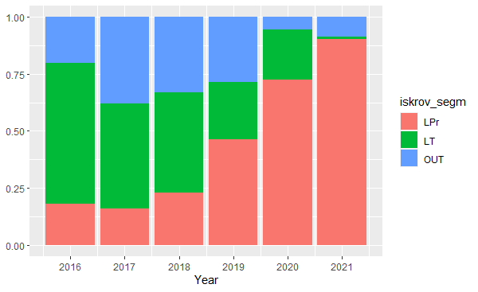
Graph 4.1 Share of landings of demersal fishes by coastal fleet (LPr), Baltic Sea trawlers in Lithuanian ports (LT) and trawlers foreign ports (OUT) during 2016-2021
Stratum BS-GNS-L and BS-GNS-S
Only one vessel was fished with gillnets in open sea. Other vessels fished close to coastal waters and targeted various species, therefore landings of species subject to sampling was drastically reduced, consequently it was difficult select randomly the landings suitable for sampling
Stratum BS-TrawlPlus-L; BS-TrawlPlus-S and BS-O/PTM-S
As it was described in text box 1C restrictions for Eastern Baltic cod fisheries introduced from 2020 affected whole sampling schemes which were planned based on average fishing pattern in 2016 – 2018. Sampling efforts were planned based on 2016-2018 reference period when most of the vessels fished with bottom trawls or bottom + midwater trawls, while in 2021 was no vessels fishing with bottom trawl (graph 4.2).
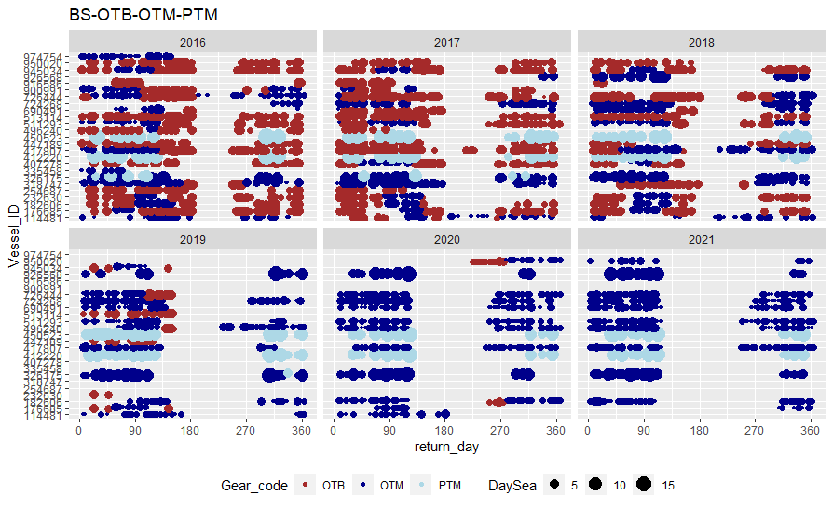
Graph 4.2 fishing activities of LTU Baltic Sea trawlers fleet in 2016 -2021
, 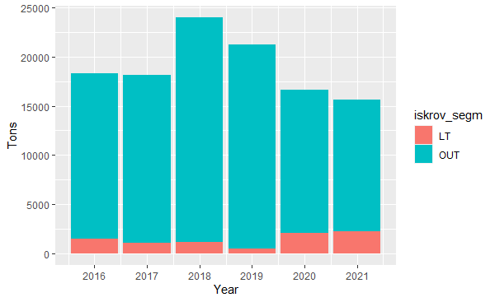
Graph 4.2 Landings from Lithuanian Baltic Sea trawlers in Lithuania (LT) and foreign ports (OUT) during 2016-2021
Despite to increased amount of landings from trawlers in Lithuanian ports, most majority of landings from trawlers are made abroad (graph 4.2). To cover landings abroad sampling at sea was planned for trawlers never landed in Lithuania. 8 of 13 (61%) trawlers have no landings in Lithuanian ports in 2021. However, no sampling of these vessel at sea was done in 2021 because of COVID 19 restrictions. Consequently, more fishing effort was dedicated for trawlers and gilnetters landed in Lithuania.
10 samples from the pelagic trawlers belonging to the stratum O\PTM-S were collected in Danish ports in the framework of case study “Small pelagic sampling in the Baltic”. So instead sampling at sea on-shore sampling was done. We think it is good practice and could be continued.
Due to restrictions described above, most majority of demersal species were landed from small scale coastal fishing vessels (graph 4.3). It resulted bigger sampling effort for SSF.
North-East Atlantic and Western Channel)
Only one vessel is occasionally fishing for fishes other than Sebastes mentella in this area if some fishing opportunities are acquired by ad hoc quota swap. Depending on situation this vessel is fishing in NWW or CECAF and SPRFMO areas during the same year (graph 4.4), so it is very difficult to organize sampling effort especially when COVID-19 restrictions were in force.
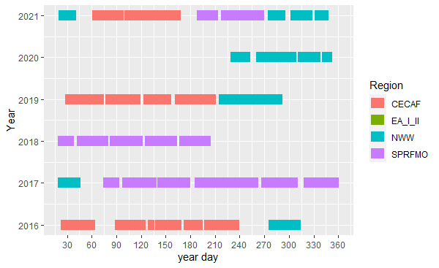
Graph 4.4 Fishing by regions by the vessel fishing for pelagic fishes in high seas during 2016-2021

3. Action to avoid deviations
Member State shall describe the actions that will be considered / have been taken to avoid the deviations in the future and when these actions are expected to produce effect. If there are no deviations, then this section is not applicable.
Baltic Sea
Significant changes in the Baltic Sea fisheries during 2019 -2020 years showed that rigid planning may cause the problems. We are revising sampling frames to be in line with hierarchies established in RDBES. For example: as number of trawlers landing their catches in LT is very small it is difficult to make probability-based vessel selections, therefore selection of landing event as hierarchy 8 in RDBES will be used in future.
Biggest part of landings is made abroad, so only at sea sampling can cover these landings. However, in practice it is difficult to deploy an observer from foreign port (requires more time and resources), other limitations as COVID-19 are possible as well. Thanks to Danish colleagues’ number of samples were collected by them in Danish ports and researcher from our institute was accepted to make necessary analyses. We think it was very good example of regional coordination and hope to continue this practice.
SSCF fleet is generating small amount of landings of EU regulated species, however composition of these landings is wide depending on migration of fish and other marine habitats. Sampling schemes for SSCFF are revising to adopt it for better implantation of objectives defined in EU Marine Strategy Framework Directive.
North-East Atlantic and Western Channel)
Vessels fishing in this region never land in Lithuanian ports, moreover they are conducting fishing trips depending on possibilities which are quiring ad hoc. It makes very difficult to plan and organise work of scientific observer therefore, to ensure adequate sample collection self- sampling schemes are implementing. These vessels are big factory vessels and usually there are some educated or skilled crew members knowing fish quite well (for example fish-masters, production technologists, etc). Some additional courses how to collect biological data periodically provided to these skilled crew members will allow to have on board persons available to collect samples during any fishing effort even unpredicted in advance
East Arctic, Norwegian Sea and Barents Sea
Sampling of individual length and weight of P. borealis was planned because landing quantities were above threshold set in Implementing Decision, however, the end user ICES work group NIPAG have not asked length distribution of P.borealis but only data on catches and effort. We would like to have clear opinion of the Commission how we should act if according to the article 2.1 a) of Delegated Decision (EU)2021/1167 “…data shall comprise catch quantities by species and biological data from individual specimens, to enable the estimation of volume and length frequency, as well as biological variables such as individual age, sex, weight, maturity and fecundity…”, but end user is not asking data on length frequency.

(max. 1000 words per region OR fishing ground)

SECTION 5: DATA QUALITY

Text Box 5A: Quality assurance framework for biological data
General comment: This box is applicable to the Annual Report. This box fulfills Article 5 paragraph (2) point (a) of the Implementing Decision (EU) 2016/1701 on the format of the WP. This box is intended to specify data to be collected under Tables 1(A), 1(B) and 1(C) of the Annex of the Delegated Decision (EU) 2019/910 on the multiannual Union programme. Use this box to provide additional information on Table 5A of the Annual Report.
1. Evidence of data quality assurance
Within this section Member State shall provide information on the methodology used to assure the quality of the data collected, highlighting those aspects where changes have been made during the sampling year. Information shall be provided by each sampling scheme for which data was collected. In the case where the same quality assurance framework is applied to all data collection schemes, information can be provided at general level with the indication “all sampling schemes”.
In those sections of Table 5A where “N” is indicated, Member States shall explain the main constrains and/ or the steps taken to fulfil this obligation. In the cases where a reference documents is requested, Member States shall provide a web link.
In cases where documents are not publicly available, due to institutions internal policy, confidentiality or other reasons, this shall be indicated by the Member State.
2. Sampling design
Explain main constraints and/ or steps taken, if ‘N’ (no) was indicated in Table 5A.
Baltic Sea (ICES areas III b-d)"
Documentation on sampling designed (methodology) is stored in KU Share Point. This methodology is not perfect and constantly revised based on obtained experience and changes in Lithuanian fishing patterns. This methodology contains some additional annexes, which may contain confidential information. Therefore, this documentation is password protected.
3. Sampling implementation
Baltic Sea (ICES areas III b-d)"
“NA” in the column J (Are non-responses and refusals recorded?).
Due to COVID-19 restrictions only onshore sampling in the Baltic Sea region and self-sampling methods in other regions was caried out in 2020-2021. Number of vessels per strata variated from 1 to 9 (except SCCF), there were no formal refusals during previous years as well (see AR2018 and AR2019), so development of special scheme of registering of refusals was not the priority. Nevertheless, we are adjusting our sampling design with codes to meet RDBES requirements on recording of non-responses and refusals.
4. Data capture
Explain main constraints and/ or steps taken, if ‘N’ (no) was indicated in Table 5A.
All areas and sampling schemes
Quality checks for data capture: The quantity of biological data recorded per year is not so big (hundreds of records per season per sampling scheme), so there is no need for sophisticated software. Quality checks are performed by some validation rules and formulas integrated in MS excel, and some basic r-scripts are made. The documentation is stored in KU Share Point.
Quality checks in 3 phases:
- Primary data validation. The excel workbooks for recording of primary measures of commercial fishing samples in the Baltic; for international surveys sample in the Baltic; for coastal monitoring survey samples (Baltic Sea); for shrimp samples (Eastern Arctic); for redfish in Eastern arctic and Northwestern waters. There are some validation rules in these workbooks: code lists for sex, age, maturity; as well conditional formatting for dates, numbers.
- Gaps. For at sea sampling special worksheet is integrated into data recording workbook. It allows on-time indication of length groups with no with no individual weight measurements, or no otoliths collected and therefore to collect missing data during the trip. For onshore landings this check is run when data are entered into special excel workbook (VERSLIN_SAMPL_IMPORT.xlsx.) designed to record all samples before they are imported into final data base.
- Final check. When data are entered into excel file VERSLIN_SAMPL_IMPORT.xlsx the r-script (matavim_import_check.R) is run. It checks some possible errors, e.g. missing values, intermix between individual measurements and group measurements and detection of possible typing errors which may have significant impact (externalities between length and weight). If r-script generates records with possible errors, manual checks with primary data sources is performed and corresponding corrections are made in excel work sheet.
5. Data Storage
Explain main constraints and/ or steps taken, if ‘N’ (no) was indicated in Table 5A. Please provide a link if the documented revisions are available and not confidential.
All areas and sampling schemes
Checked data are stored in protected KU SharePoint as RData and csv files.
6. Data processing
Explain main constraints and/ or steps taken, if ‘N’ (no) was indicated in Table 5A.
All areas and sampling schemes
R-scrips are developed to process the data suitable for InterCatch, RDB and RDBES (still in development phase).
Some evaluations are performing to access sample variation, precession (MWCV) and sample coverage. The results are available in the protected KU Share Point and are used to adjust the sampling methodology to the latest tendencies in Lithuania fisheries.

(max. 900 words per Region/RFMO/RFO/IO OR sampling scheme)

Section 5: data quality

Text Box 5B: Quality assurance framework for socioeconomic data

General comment: This box fulfills Article 5 paragraph (2) point (b) of the Implementing Decision (EU) 2016/1701 on the format of the WP. This box is intended to specify data to be collected under Tables 5(A), 6 and 7 of the Annex of the Delegated Decision (EU) 2019/910 on the multiannual Union programme. Use this box to provide additional information on Table 5B of the Annual Report.
Within this section MS shall provide information on the methodology used to assure the quality of the data collected, highlighting those aspects where changes have been made during the sampling year. Information shall be provided by each sector (Fishing fleet, Aquaculture, Fish processing) for which data was collected and by each data collection scheme. In the case where the same quality assurance framework is applied to all sectors or/and all data collection schemes, information can be provided at general level with the indication “all sectors” or “all data collection schemes”.
In those sections of Table 5B where “N” is indicated, Member States shall explain the main constrains and/ or the steps taken to fulfil this obligation. In the cases where a reference documents is requested, Member States shall provide a web link.
In cases where documents are not publicly available, due to institutions internal policy, confidentiality or other reasons, this shall be indicated by the Member State.

2. Section P3 Impartiality and objectiveness
Explain main constraints and/ or steps taken, if ‘N’ (no) was indicated in Table 5B
NA

3. Section P4 Confidentiality
Explain main constraints and/ or steps taken, if ‘N’ (no) was indicated in Table 5B
Concerning Variable groups „Fleet”, “Effort” and “Production value per species” The most part of data are collecting in the framework of control regulation and treating in accordance with rules on confidentiality established by that regulation. For complimentary data collection is adopted a national legal act containing confidentiality provisions. Whereas external users are not permitted to access to data sources, there is no need of protocols and documentation to enforce confidentiality with them.
Concerning the data collection, processing, analysis and dissemination of statistical information, AIRBC fully guarantees the confidentiality of data provided by respondents according to the Information Security Policy Guidelines of AIRBC. Guidelines of Security Policy is approved in 2014 August 27 by the Order No. 1V-124 of Director General of AIRBC on approval of the information security policy of the State Enterprise Agricultural Information and Rural Business Center (internal AIRBC document).
4. Section P5 Sound methodology
Explain main constraints and/ or steps taken, if ‘N’ (no) was indicated in Table 5B
Information on this principle should be briefly explained in Text boxes 3A, 3B and 3C. Description of methodologies used on data quality.
Information in Text boxes 3A, 3B and 3C

5. Section P6 Appropriate statistical procedures
Explain main constraints and/ or steps taken, if ‘N’ (no) was indicated in Table 5B. Please provide a link if the documented revisions are available and not confidential.
Concerning Variable groups „Fleet”, “Effort” and “Production value per species” due to confidentiality, the documented revisions are not available publicly
Final AIRBC data are published and are not subsequently revised. Exceptions are in cases when the internal revision of statistical data is carried out resulting in the identified significant errors. Data revision policy is approved in 2017 March 15 by the Order No. 1V-54 of Director General of AIRBC Regarding the provision, verification and processing of information for Lithuanian agricultural and food products market information system as well as preparation of statistical information to the European Commission, Eurostat and National Authorities and approval of the publication procedure (internal AIRBC document).
6. Section P7 Non-excessive burden on respondents
Explain main constraints and/ or steps taken, if ‘N’ (no) was indicated in Table 5B
NA

7. Section P8 Cost effectiveness
Explain main constraints and/ or steps taken, if ‘N’ (no) was indicated in Table 5B
Concerning Variable groups „Fleet”, “Effort” and “Production value per species”, due to regular changing of requested coding in data calls, an automatic techniques for data capture and data coding are always under development and available only partly.
For the rest of Variable groups - NA

8. Section P9 Relevance
Explain main constraints and/ or steps taken, if ‘N’ (no) was indicated in Table 5B
NA

9. Section P10 Accuracy and reliability
Explain main constraints and/ or steps taken, if ‘N’ (no) was indicated in Table 5B. Information on this principle should be briefly explained in Text boxes 3A, 3B and 3C. Description of methodologies used on data quality.
Concerning Variable groups „Fleet”, “Effort” and “Production value per species”, cross-checking, analyses and verifications through automated computerised algorithms and mechanisms on vessel monitoring systems, catch, effort and sales notes data and data related to the Community fishing fleet register as well as the verification of licences and fishing authorisations are developed in IFDIS instead of documentation.
For the rest of Variable groups look the information in Text boxes 3A, 3B and 3C

10. Section P11 Timeliness and punctuality
Explain main constraints and/ or steps taken, if ‘N’ (no) was indicated in Table 5B
NA

11. Section P12 coherence and comparability
Explain main constraints and/ or steps taken, if ‘N’ (no) was indicated in Table 5B
NA

12. Section P13 Accessibility and Clarity
Explain main constraints and/ or steps taken, if ‘N’ (no) was indicated in Table 5B. Information and links to documentation on this principle should be briefly explained in Text boxes 3A, 3B and 3C. Description of methodologies used on data quality.
Information in Text boxes 3A, 3B and 3C
FDIS contains primary data as recorded, reported and transmitted under Regulation (EC) No 1224/2009. cross-checking, analyses and verifications through automated computerised algorithms and mechanisms on vessel monitoring systems, catch, effort and sales notes data and data related to the Community fishing fleet register as well as the verification of licences and fishing authorisations are developed in IFDIS. Information on the methodology used to assure the quality of complimentary data collection publicly is available: https://www.vic.lt/drp/

