Ministry of Agriculture of the Republic of Lithuania, Fisheries Service under the Ministry of Agriculture of the Republic of Lithuania, Agricultural Information and Rural Business Centre, Marine Research Institute of Klaipeda University

Commission Implementing Decision (EU) 2016/1701
on the establishment of a Union framework for the collection, management and use of data in the fisheries sector and support for scientific advice regarding the common fisheries policy and repealing Council Regulation (EC) No 199/2008 (recast).
Commission Implementing Decision (EU) 2016/1251 of 12 July 2016 adopting a multiannual Union programme for the collection, management and use of data in the fisheries and aquaculture sectors for the period 2017-2019.
Commission Implementing Decision (EU) 2016/1701
laying down rules on the format for the submission of work plans for data collection in the fisheries and aquaculture sectors.

Commission Implementing Decision (EU) 2018/1283
laying down rules on the format and timetables for the submission of annual data collection reports in the fisheries and aquaculture sectors.

Lithuanian Annual Report for data collection in the fisheries and aquaculture sectors
2018
Version 2 – 2018

Vilnius, 2019
CONTENTS

Section 1: Biological Data 3
Text Box 1C: Sampling intensity for biological variables 3
Section 1: Biological Data 4
Text Box 1D - Recreational fisheries 4
Section 1: Biological Data 5
Pilot Study 1: Relative share of catches of recreational fisheries compared to commercial fisheries 5
Section 1: Biological Data 6
Text Box 1E: Anadromous and catadromous species data collection in fresh water 6
Section 1: Biological Data 7
Text box 1F: Incidental by-catch of birds, mammals, reptiles and fish 7
Section 1: Biological Data 8
Pilot Study 2: Level of fishing and impact of fisheries on biological resources and marine ecosystem 8
Section 1: Biological Data 9
Text Box 1G: List of research surveys at sea 9
Section 2: Fishing Activity Data 10
Text Box 2A: Fishing activity variables data collection strategy 10
Section 3: Economic and Social Data 12
Text Box 3A: Population segments for collection of economic and social data for fisheries 12
Section 3: Economic and Social Data 14
Pilot Study 3: Data on employment by education level and nationality 14
Section 3: Economic and Social Data 15
Text Box 3B: Population segments for collection of economic and social data for aquaculture 15
Section 3: Economic and Social Data 18
Pilot Study 4: Environmental data on aquaculture 18
Section 3: Economic and Social Data 19
Text Box 3C: Population segments for collection of economic and social data for the processing industry 19
Section 4: Sampling Strategy for Biological Data from Commercial Fisheries 21
Text Box 4A: Sampling plan description for biological data 21
Section 5: data quality 22
Text Box 5A: Quality assurance framework for biological data…………………………..22
Section 5: data quality 23
Text Box 5B: Quality assurance framework for socioeconomic data ……….…………………23

Section 1: Biological Data

Text Box 1C: Sampling intensity for biological variables

General comment: This box fulfils paragraph 2-point (a)(i)(ii)(iii) of Chapter III, Chapter IV of the multiannual Union programme and Article 2, Article 4 paragraph 1 and Article 8 of the Decision (EU) 2016/1701. This box is applicable to the Annual Report.
General remark:
For the period until 1-st of July 2018 biological data were collected by Fisheries Service under MoA (FS). Responsibility for collection of biological data was delegated to Klaipeda University from 1 July 2018. Marine Research Institute of Klaipeda University (MRI) is in charge for collection of biological variables. This reorganisation had some effect on intensity of collection of biological variables, because some formal procedures had been updated.
Baltic Sea
- Evidence of data quality assurance
Data quality assurance measures for sampling programme are given in Table 5A
- Deviations from the Work Plan
Five species was planned for sampling in commercial fisheries (Table 1C). Out of them for three species significant deviations from Work Plan were in 2018:
For ell (Anguilla Anguilla) – planned minimum 200 specimens to be sampled is difficult to implement, because there is no direct fishing for eel in the Baltic, just very small bycatch (12 kg in 2018).
For cod (Gadus morhua) in subdivissions 25-32. More than 15 specimens per 1 cm per quarter were sampled in average. More than 20 specimens were sampled per 1 cm per quarter for the length groups within percentile 5 < P < 95. However, landings of cod in 2018 were twice less than in 2017 and 2016, number of length groups observed in 2018 was only 42 (in 2016 – 2017 it was 52 length groups). Therefore, sampling according to the protocol hasn’t resulted planned quantity.
For sprat (Spratus spratus) – less than 1% from total landings were landed in Lithuanian harbours. About 77% landed in Denmark. According to voluntary agreement between FS and DTU Aqua sampling of sprat landings in Denmark was carried out by DTU Aqua.
- Actions to avoid deviations.
There were three main reasons for deviations which require different actions:
Planned sampling programme do not corresponded to the recent situation in the sector. Due to formal procedures of reorganisation the access to the national fisheries data information system was provided to MRI on 01.07.2018. MRI is carrying comprehensive analysis of fishing effort in the Baltic Sea together with coherent logistic and financial possibilities. Work Plan will be updated accordingly.
Significant decrease of landings of main commercial species in Lithuanian harbours. Measures to sample maximum number of landings in Lithuanian harbours are foreseen: cooperation with fishermen, adjusting of working time of MRI researchers to be available during nights or weekends. However, effect of these measures is very dependent on available financial resources.
Limited possibilities for deploying of observers. Most of Lithuanian vessels fishing in the Baltic Sea are far from modern fishing vessels and requires big crew. Installed basic safety equipment on these vessels covers only number of persons equal to the number of crew. Embarking of additional person is possible only when vessel is operating with reduced crew. It was signed agreement between MRI and Lithuanian Fisheries Producers’ Association, according this agreement financial benefit for the vessel owner is foreseen for the deployment of the observers on the vessels.
More information see text box 4A
Eastern Arctic and North Atlantic
- Evidence of data quality assurance
Data quality assurance measures for sampling programme are given in Table 5A
- Deviations from the Work Plan
Seven species was planned for sampling in commercial fisheries in these regions (Table 1C). Out of them for four species no sampling was carried at all, and for other three significant deviations from Work Plan were in the 2018.
For Clupea harrengus, Micromesisttius poutassu, Scomber scomber and Trachurus trachurus. There was never direct fishing for these stocks by Lithuanian vessels, no catches of these stocks were recorded during past two years. Therefore, no sampling was possible.
For Pandalus borealis in ICES areas I and II. Number of samples for length exceeded planned minimum more than 200%, however no maximum was planned, moreover it didn’t require any additional costs, so it has no negative impact on sampling results.
For Sebastes marinus in ICES areas I and II. Instead S. marinus S. mentella was sampled. According to Eurostat there were no catches of S. marinus form Lithuanian vessels from 2008 to 2017, only S. mentella and Sebastes spp. For the 2018 as well 85% was S.mentella and other 15% Sebastes spp.
For Sebastes mentella in ICES areas I, II and XIV. Sampled number of specimens for length has no negative results on sampling results.
- Actions to avoid deviations.
MRI is analysing fishing effort data and will not include the species for which fishing is just occasional in future Work Plan.
Requirement to take samples form every haul is redundant and may negatively affect sampling quality, therefore MRI updated sampling protocols requiring to take samples from randomly chosen hauls, but not less than 10 hauls per trip.
More information see text box 4A
Other regions CEFAC and SPRFMO areas
- Evidence of data quality assurance
Sampling and quality check has to be conducted under multilatteral aggreement by Netherlands from CECAF and by Poland from SPRFMO
- Deviations from the Work Plan
Not applicable
- Actions to avoid deviations.
Not applicable
(max. 1000 words per Region/RFMO/RFO/IO)

Section 1: Biological Data

Text Box 1D - Recreational fisheries

General comment: This box fulfills paragraph 2 point (a) (iv) of Chapter III of the multiannual Union programme and Article 2, Article 3 and Article 4 paragraph 1 of the Decision (EU) 2016/1701. This box is applicable to the Annual Report. This box is intended to provide information on the design, implementation and analysis of all components of sampling schemes/ surveys that are listed in Table 1D.
1. Description of the target population
1.1. Gadus morhua. Local chart boats engaged in marine fishery of cod were taken as target population. The vessels are of different size and can carry different number of anglers (from 2 to 15 people).
1.2. Salmo salar and Salmo truta. The same methodology have been used as for previous species. The diference is that as a target population vessels, which exclusivelly targetting salmon and sea trout by trolling method were included into investigation within limited period of fishery, i. e. January-February and November-December.
We started survey for salmon and sea trout in inland waters in 2018, but due to technical obstacles, we were unable to collect all the data properly, but we undertake to have updated data for the end users in the fourth quarter of 2019.
1.3. Anguilla anguilla. Target population of survey is anglers, that were interviewed near the lakes and other water bodies where eels were re-stocked.

2. Type of survey
2.1. Surveys at sea as well as on landing places (for cod and salmon/sea trout) have been conducted each month through the year. Information on number of anglers per vessel and catch volumes by species per vessel have been collected. Surveys included whole coastal area of Lithuanian exclusive economic zone and randomly selected vessels within area have been investigated. Same strategy of survey have been used in the places of landings and harbours, where numbers of anglers per vessel and total catch volumes per vessel have been recorded.
2.2. . The surveys in inland waters (for salmon/sea trout) we undertake to have updated for the end users in the fourth quarter of 2019.
2.3. Survey for eel. Face to face interviews on fishing sites and questionaires distributed via fishing equipment shops have been used to collect the data.
3. Data Quality
Information about non-responses and refusals was not recorded due to sufficiently high collaboration level of fishermen.
3.1. Survey for cod. 150 vessels have been investigated (3% achieved average sample rate).
3.2. Survey for salmon/sea trout. 87 vessels have been investigated (1-6% achieved average sample rate).
3.3. Survey for eel. In total 1170 individuals have been interviewed to achieve 95% confidence level.
4. Data Analysis and processing
Gadus morhua and Salmo salar & Salmo truta. We estimated an average catch per person per vessel on monthly basis. The number of vessels registered are available from the coast guard, which records the arrival and departure of all vessels. We know the number of vessels in the fleet, then the catch of the fleet can be estimated from:
(Catch of fleet in a month) = (Catch of one vessel in a month) x (Number of vessels in fleet)
At the end we summarize all months and produce total catch volumes per year.
The precision of the estimates has been calculated (see “Data quality”above) but not documented.

Section 1: Biological Data

Pilot Study 1: Relative share of catches of recreational fisheries compared to commercial fisheries

General comment: This box fulfils paragraph 4 of Chapter V of the multiannual Union programme and Article 2 and Article 4 paragraph (3) point (a) of the Decision (EU) 2016/1701.
General comment: This box is applicable to the Annual Report. This box is intended to provide information on the results obtained from the implementation of the pilot study.
No pilot study concerning the subject was planned in the WP
(max 900 words)
No pilot study concerning the subject was planned in the WP
(max 900 words)

Section 1: Biological Data

Text Box 1E: Anadromous and catadromous species data collection in fresh water

General comment: This box fulfils paragraph 2 points (b) and (c) of Chapter III of the multiannual Union programme and Article 2 of the Decision (EU) 2016/1701.
General comment: This box is applicable to the Annual Report.
1. Method selected for collecting data.
Eel.
Fisheries service interviewed 1170 fishermen of recreational fisheries and learned that last year they caught 7 percent of the eel. After finding out the quantity and weight of the eels, we calculated their average weight. According to the data of the Ministry of Environment, about 78000 fishermen buy annual fishing permits issued in Lithuania for recreational fisheries . The data is obtained after calculating the quantity of eels for 78000 fishermen by using the correction rate.
Salmon and sea trout
From 10 to 20 trips are planned to perform during the spring (January 1 – May 15) and 15-20 trips during the
autumn (August 15 – October 15) for sampling in 10 rivers that are indicated in the Table 1E.
During the trips interviewing of amateur fisheremen using face to face questionaires (ICES WGFRS recommendation) method will be performed, biological parameters such as total length and weight will be registered. Collection of scales and otoliths for age determination are also foreseen.

(max 250 words per Area)
2. Were the planned number achieved? Yes/ No
2.1.No for Eel. The number of traps purchased was lower than planned. In future Lithuania will plan sampling strategy more accurately.
2. 2. The monitoring of salmon and sea trout stocks biological variables and population characteristics was carried out in 110 monitoring sites (Nemunas, Šventoji, Venta and Bartuva river catchments) according to electrofishing sampling protocol. The salmon and sea trout smolts number estimation was done from traps compiling the electrofishing data according the recommendations of WGBAST. The number of adults was not estimated, the counters installation in Žeimena and Minija rivers is planned for the year 2020 only.
(max 500 words per Area)

Section 1: Biological Data

Text box 1F: Incidental by-catch of birds, mammals, reptiles and fish

General Comment: This box fulfils paragraph 3 point (a) of Chapter III of the multiannual Union programme and Article 2 of the Decision (EU) 2016/1701. This box is applicable to the Annual Report. This box is applicable only for those sections where Member States have reported that they have been carrying out regular sampling. Results and deviations for Pilot studies should be reported under Pilot Study 2.
1. Results
Survey EEL1. Due to absence of other than eel catches there were no records on bycatch.
Survey EEL2. Due to absence of other than eel catches there were no records on bycatch.
Survey BS1. There were no records in logbooks for demersal fishery on bycatch of rare fish species or animals.
Survey BS2. There were no records in logbooks for demersal fishery on bycatch of rare fish species or animals.
Survey BS3.
Survey BS4. Due to absence of other than cod and flounder catches there were no records on bycatch of other fish species.
Survey BS5. Due to absence of other than herring and sprat catches there were no records on bycatch of other fish species.
Survey NSEA1 includes 2 types of fishery, which are pelagic trawl fishery for redfish and demersal trawl fishery for shrimp. Due to strict rules in NEAFC area any kind of bycatch or discard is prohibited. Therefore, no bycatch has been recorded during the observations.
Survey NSEA2 includes only pelagic trawl fishery for redfish. Due to strict rules in NEAFC area any kind of bycatch or discard is prohibited. Therefore, no bycatch has been recorded during the observations.
Survey NA1. There was no fishery in 2018 in relevant areas.
Survey NA2. There was no fishery in 2018 in relevant areas.
Survey NA3. There was no fishery in 2018 in relevant areas.
Survey CE. Data collection have been conducted by Poland following multi-latteral agreement
Survey SP. Data collection have been conducted by Poland following multi-latteral agreement

2. Deviations from Work Plan
NA

3. Data quality
Member States shall provide information on sampling protocols and sampling design for incidental by-catch data collection.
Questions to be addressed are listed below:
- Onboard observer protocol do not contain a check for rare specimens in the catch at opening of the codend. If YES is the observer instructed to indicate if the codend was NOT checked in a haul?
Answer: NO
- In gill nets - and hook-and-line fisheries: does the onboard observer protocol instruct the observer to indicate how much of the hauling process has been observed for (large) incidental bycatches which never came on board (because they fall out of the net)? In large catches: does the protocol instruct to check for rare specimens during sorting of the catch (i.e. at conveyor belt)? Is the observer instructed to indicate what percentage of the sorting or hauling process has been checked at “haul level”?
Answer: NO
-Does the onboard observer protocol instruct to report on the use of mitigation (i.e. Escape Devices or Acoustic Deterrent Devices)?
Answer: NO, because all fishing gears have special requirements for construction and are not intended to make any modifications
- Does the sampling design and protocol follow the recommendations from relevant expert groups? Provide appropriate references. If there are no relevant expert groups, the design and protocol have to be explained in the text.
Answer: data on the results of effort observations have been submitted to WGBYC expert group. No recommendations from this group have been provided yet. During the observation trips at sea observers are instructed to record any bycatch by haul. In case of large catches sample (s) are taken to identify single or rare species. Same procedure is applied for sampling on shore at landing places.

- Are data quality issues taken into account?
Answer: NO

- How are data (and samples) stored
Answer: All records and data are stored in national databases following structure of forms for biological sampling

Section 1: Biological Data

Pilot Study 2: Level of fishing and impact of fisheries on biological resources and marine ecosystem

General comment: This Box fulfils paragraph 3 point (c) of Chapter III of the multiannual Union programme and Article 2 and Article 4 paragraph (3) point (b) of the Decision (EU) 2016/1701.
General comment: This box is applicable to the Annual Report. This box is intended to provide information on the results obtained from the implementation of the pilot study.
1. Aim of pilot study
Some impact on seabed by Lithuanian trawlers and by-catch of birds by coastal fishermen was recorded in some surveys (e.g.: J.Daunys,D 2015; Morkunas,J 2015 ) carried out during last decade.
The aim of this study will be estimation of the level of fishing of Lithuanian commercial fishing fleet in the Baltic Sea and the impact of fishing activities on marine biological resources and on marine ecosystems, including bycatch of non-commercial species listed in the table 1D of Commission decision (EU)2016/1251, and recommend an appropriate sampling scheme schemes.
2. Duration of pilot study
Pilot study is expected to be launched at the beginning of year 2019 and the results should be available at the beginning of 2020.
3. Methodology and expected outcomes of pilot study
1. Analysis of historical (2007-2017) data from commercial fishery, both coastal and large-scale fleet operating in the Baltic Sea recorded by fisheries control authorities. The outcomes of this analysis will be estimation the of activities and impact and its variability by fishing area; fishing gear; fishing season; fishing type, etc;
2. Analysis of recent surveys on impact of fishing activities carried out by Lithuanian fishing vessels on marine ecosystems, and bycatch of non-commercial species listed in the table 1D. The outcomes of this analysis will be comparison of level and variability of impact in comparison of the ones estimated by analysis of historical data from commercial fisheries;
3. Questionnaires distributed to the operators of coastal and large-scale vessels. The output of this questioners will be estimation of fishermen perceptions of their impact on marine ecosystem, as well as willingness and possibilities to record these data and participate in possible sampling schemes.
4. Sampling schemes for collecting data on impact of fishing activities to different components of marine ecosystem will be elaborated and tested. Depending on overall results it would be recommended to apply special sampling schemes or to upgrade existing ones.
----------------
Darius Daunys. 2015.Žvejybos dugniniais tralais intensyvumas ir poveikis Lietuvos Baltijos jūros dugno ekosistemai;
Julius Morkūnas. 2015. Jūrinių paukščių priegaudos mastai Lietuvos Baltijos jūroje
(max 900 words)
Brief description of the results obtained (including deviations from planned and justifications as to why if this was not the case).
Preliminary results of analysis of historical data suggests that existing sampling program for the small-scale fishing (SSF) fleet should be revised. Sampling of catches made by SSF vessels seems to be important for estimation of fisheries on Baltic Sea coastal ecosystem including impact on species listed in the Table 1D. Impact of bottom trawling for sea-bottom ecosystem in some areas of Lithuanian EEZ may be significant, therefore analysis of VMS data may be useful for control of impact to the bottom ecosystem.

4. Achievement of the original expected outcomes of pilot study and justification if this was not the case
Out of four planned outcomes two are already finishing to achieve, Question are is in preparation.

5. Incorporation of results from pilot study into regular sampling by the MS
Preliminary results already taken in account for preparation of sampling programme in the Baltic Sea for the 2020 and successive years.

(max 900 words)

Section 1: Biological Data

Text Box 1G: List of research surveys at sea
General comment: This box fulfills Chapter IV of the multiannual Union programme and Article 2 and Article 7 paragraph (3) of the Decision (EU) 2016/1701. It is intended to specify which reseach surveys at sea set out in Table 10 of the multiannual Union programme will be carried out. Member States shall specify whether the research survey is included in Table 10 of the multiannual Union programme or whether it is an additional survey.
General comment: This box is applicable to the Annual Report. This box should provide complementary information on the performance of the surveys, the results and their main use.
Baltic International Trawl Survey – BITS Q1.
1. Objectives of the survey
The main aim of the BITS surveys is to estimate cod and other demersal species recruitment indices and abundance in ICES Subdivision IIId.
2. Description of the methods used in the survey. For mandatory surveys, link to the manuals. Include a graphical representation (map)
The surveys have been conducting within period of February-March in the Lithuanian Exclusive Economic Zone (LEEZ) according to the BITS manual (ICES, 2014. Manual for the Baltic International Trawl Surveys (BITS). Series of ICES Survey Protocols SISP 7 - BITS. 71 pp.)
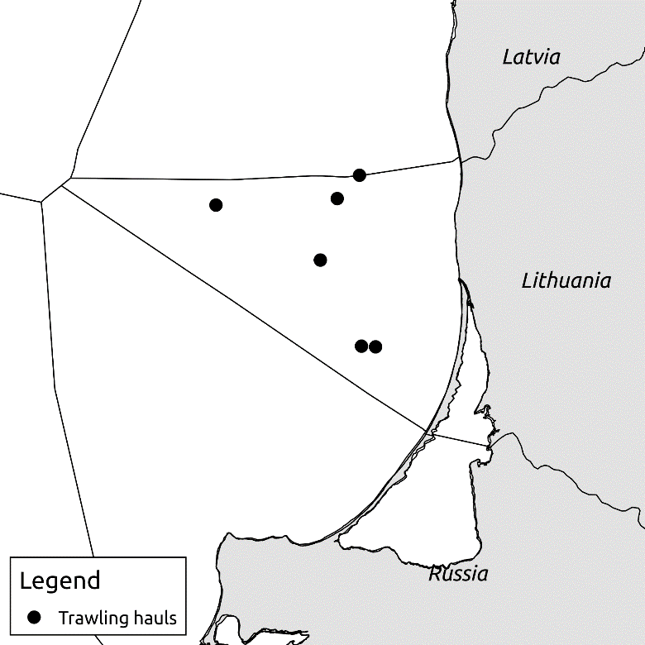
Figure 1. Allocation of stations defined in the LEEZ for BITS survey over 2013-2015 period
3. For internationally coordinated surveys, describe the participating Member States/vessels and the relevant international group in charge of planning the survey
Survey is coordinated by Baltic International Fish Survey Working Group (WGBIFS). All Baltic countries, including Russia, are participating in this survey. Countries and vessels, involved into BITS survey are mentioned in the manual mentioned above.
4. Where applicable, describe the international task sharing (physical and/or financial) and the cost sharing agreement used
Not relevant
5. Explain where thresholds apply
Not relevant
- Graphical representation (map) showing the positions (locations) of the realized samples.
Member State shall provide maps presenting the spatial distribution of the main sampling types obtained during the survey.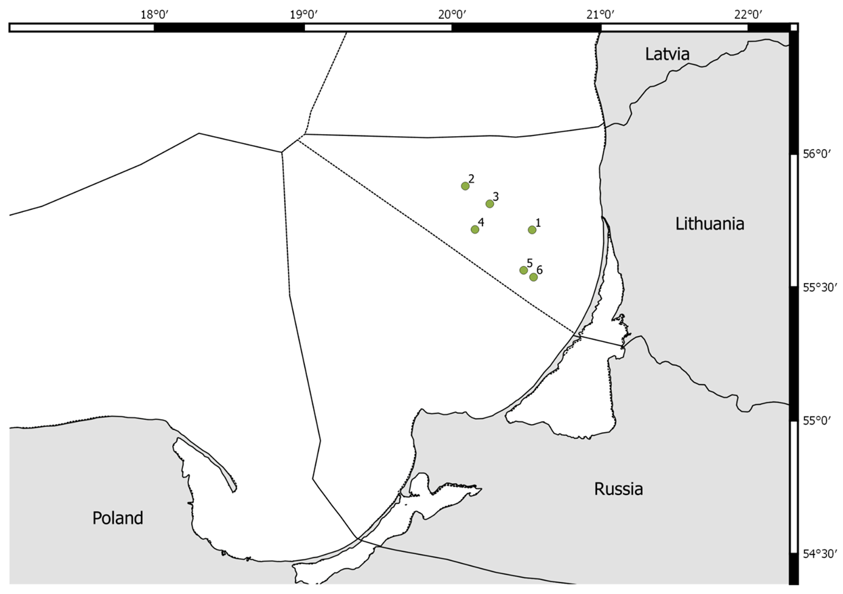
Figure 2. Allocation of stations assigned to Lithuania for BITSQ1 survey in 2018
- For internationally coordinated surveys, provide a link to the latest meeting report of the coordination group.

http://www.ices.dk/community/groups/Pages/WGBIFS.aspx
- List the main use of the results of the survey (e.g. indices, abundance estimates, environmental indicators).

Target species are demersal fish species, mainly Baltic cod and flatfish species (mainly flounder, plaice and turbot). The main aim is to determine the year-class strength of the target species. Target data are abundances, weight and length distributions of all fishes and length-weight-age-sex-maturity data of cod and flatfish species as well as hydrographic data (temperature, salinity and oxygen). The collected data are saved in ICES DATRAS database.
9. Extended comments (Tables 1G and 1H)
none
Baltic International Trawl Survey – BITS Q4.
1. Objectives of the survey:
The main aim of the BITS surveys is to estimate cod and other demersal species recruitment indices and abundance in ICES Subdivision IIId.
2. Description of the methods used in the survey. For mandatory surveys, link to the manuals. Include a graphical representation (map)
The surveys have been conducting within period of November – December in the Lithuanian Exclusive Economic Zone (LEEZ) according to the BITS manual (ICES, 2014. Manual for the Baltic International Trawl Surveys (BITS). Series of ICES Survey Protocols SISP 7 - BITS. 71 pp.)
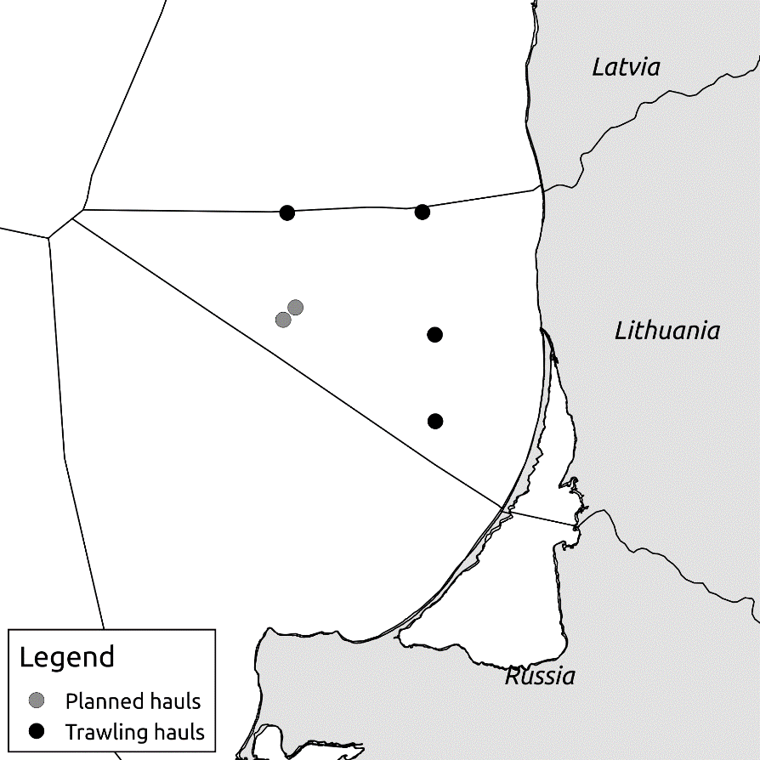
Figure 3. Allocation of stations defined in the LEEZ for BITS survey over 2013-2015 period

3. For internationally coordinated surveys, describe the participating Member States/vessels and the relevant international group in charge of planning the survey
Survey is coordinated by Baltic International Fish Survey Working Group (WGBIFS). All Baltic countries, including Russia, are participating in this survey. Countries and vessels, involved into BITS survey are mentioned in the manual mentioned above.
4. Where applicable, describe the international task sharing (physical and/or financial) and the cost sharing agreement used
Not relevant
5. Explain where thresholds apply
Not relevant
- Graphical representation (map) showing the positions (locations) of the realized samples.
Member State shall provide maps presenting the spatial distribution of the main sampling types obtained during the survey.
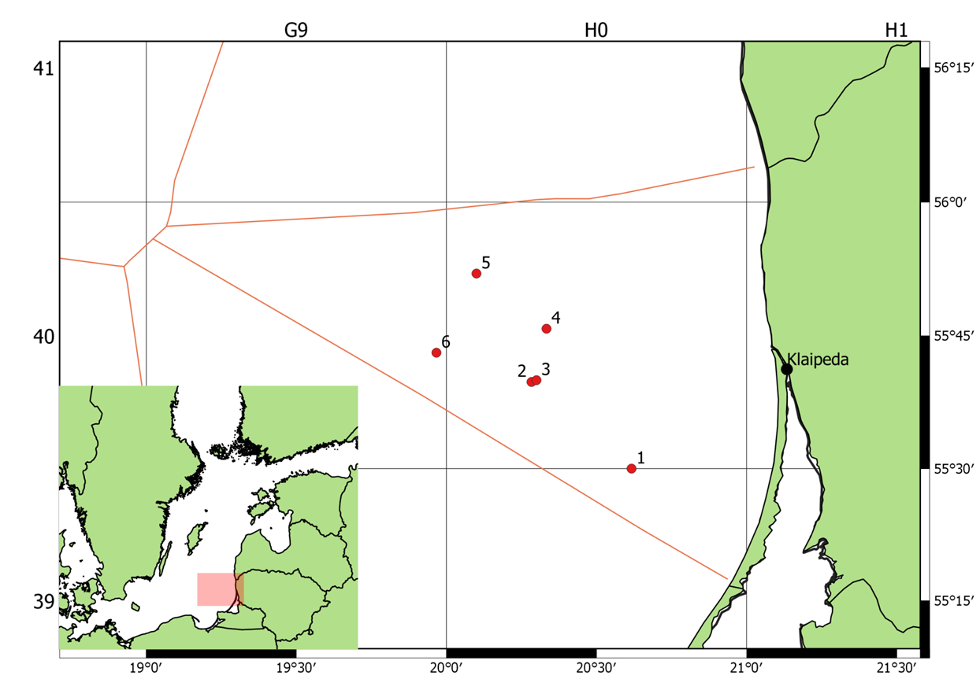
Figure 4. Allocation of stations assigned to Lithuania for BITSQ4 survey in 2018
- For internationally coordinated surveys, provide a link to the latest meeting report of the coordination group.

http://www.ices.dk/community/groups/Pages/WGBIFS.aspx
- List the main use of the results of the survey (e.g. indices, abundance estimates, environmental indicators).
Target species are demersal fish species, mainly Baltic cod and flatfish species (mainly flounder, plaice and turbot). The main aim is to determine the year-class strength of the target species. Target data are abundances, weight and length distributions of all fishes and length-weight-age-sex-maturity data of cod and flatfish species as well as hydrographic data (temperature, salinity and oxygen). The collected data are saved in ICES DATRAS database.
9. Extended comments (Tables 1G and 1H)
none
Baltic International Acoustic Survey (Autumn) – BIAS.
1. Objectives of the survey:
The main aim of the BIAS surveys is to assess abundance of herring and sprat resources in ICES Subdivision IIId.
2. Description of the methods used in the survey. For mandatory surveys, link to the manuals. Include a graphical representation (map)
The surveys have been conducting within period of September – October in the Lithuanian Exclusive Economic Zone (LEEZ) according to the IBAS manual (ICES. 2014. Manual of International Baltic Acoustic Surveys (IBAS). Series of ICES Survey Protocols SISP 8 - IBAS. 24 pp.)
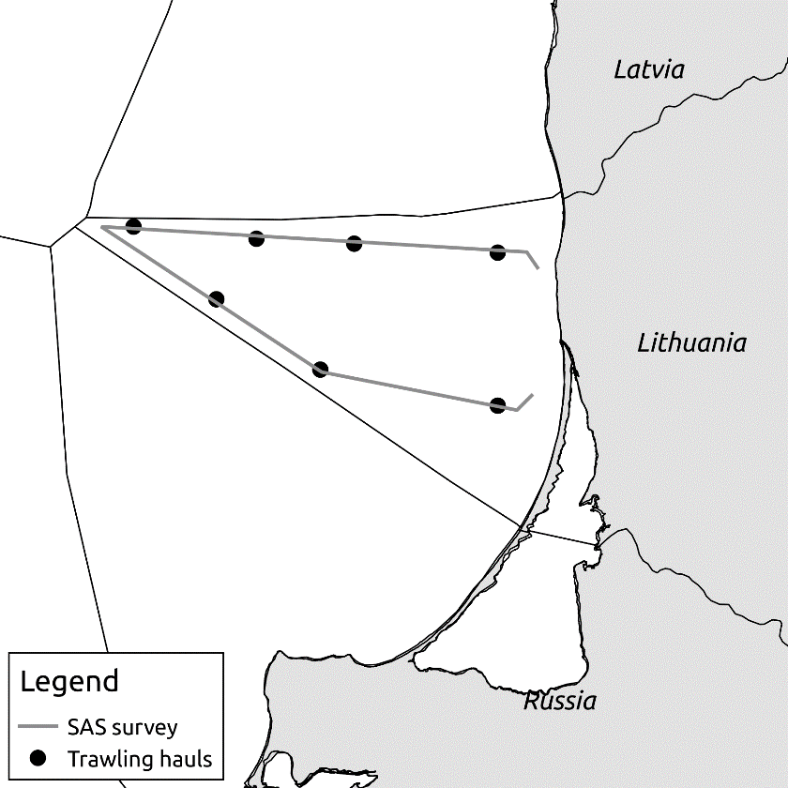
Figure 5. Cruise track design and hauls of BIAS in LEEZ
3. For internationally coordinated surveys, describe the participating Member States/vessels and the relevant international group in charge of planning the survey
Survey is coordinated by Baltic International Fish Survey Working Group (WGBIFS). All Baltic countries, including Russia, are participating in this survey. Countries and vessels, involved into BIAS survey are mentioned in the BITS manual mentioned above.
4. Where applicable, describe the international task sharing (physical and/or financial) and the cost sharing agreement used
Not relevant
5. Explain where thresholds apply
Not relevant
- Graphical representation (map) showing the positions (locations) of the realized samples.
Member State shall provide maps presenting the spatial distribution of the main sampling types obtained during the survey.
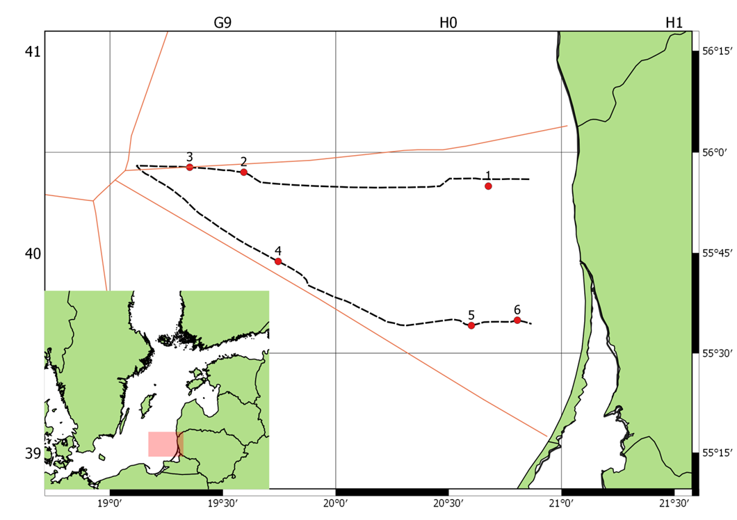
Figure 6. Locations of the realized fish control hauls, hydrological stations performed during Lithuania BIAS survey on the c/v "169"and c/v “Z55” in the period of 18-19.10.2018.

- For internationally coordinated surveys, provide a link to the latest meeting report of the coordination group.

http://www.ices.dk/community/groups/Pages/WGBIFS.aspx
- List the main use of the results of the survey (e.g. indices, abundance estimates, environmental indicators).

Target species are pelagic fish species, mainly herring and sprat. Target data are biomass, weight and length distributions and length-weight-age-sex-maturity of sprat and herring. Length distributions of all fishes as well as hydrographic data (temperature, salinity and oxygen). The data are used as an index for the stock assessment of herring and sprat. The collected data are saved in ICES Acoustic trawl surveys database.
9. Extended comments (Tables 1G and 1H)
none
Sprat Acoustic Survey – SPRAS.
1. Objectives of the survey
The main aim of the SPRAS surveys is to assess abundance of sprat and herring resources in ICES Subdivision IIId.
2. Description of the methods used in the survey. For mandatory surveys, link to the manuals. Include a graphical representation (map)
The surveys have been conducting within May in the Lithuanian Exclusive Economic Zone (LEEZ) according to the IBAS manual (ICES. 2014. Manual of International Baltic Acoustic Surveys (IBAS). Series of ICES Survey Protocols SISP 8 - IBAS. 24 pp.)
Figure 7. Cruise track design and hauls of SPRAS in LEEZ

3. For internationally coordinated surveys, describe the participating Member States/vessels and the relevant international group in charge of planning the survey
Survey is coordinated by Baltic International Fish Survey Working Group (WGBIFS). All Baltic countries, including Russia, are participating in this survey. Countries and vessels, involved into SPRAS survey are mentioned in the BITS manual mentioned above.
4. Where applicable, describe the international task sharing (physical and/or financial) and the cost sharing agreement used
Not relevant
5. Explain where thresholds apply
Not relevant
- Graphical representation (map) showing the positions (locations) of the realized samples.
Member State shall provide maps presenting the spatial distribution of the main sampling types obtained during the survey.
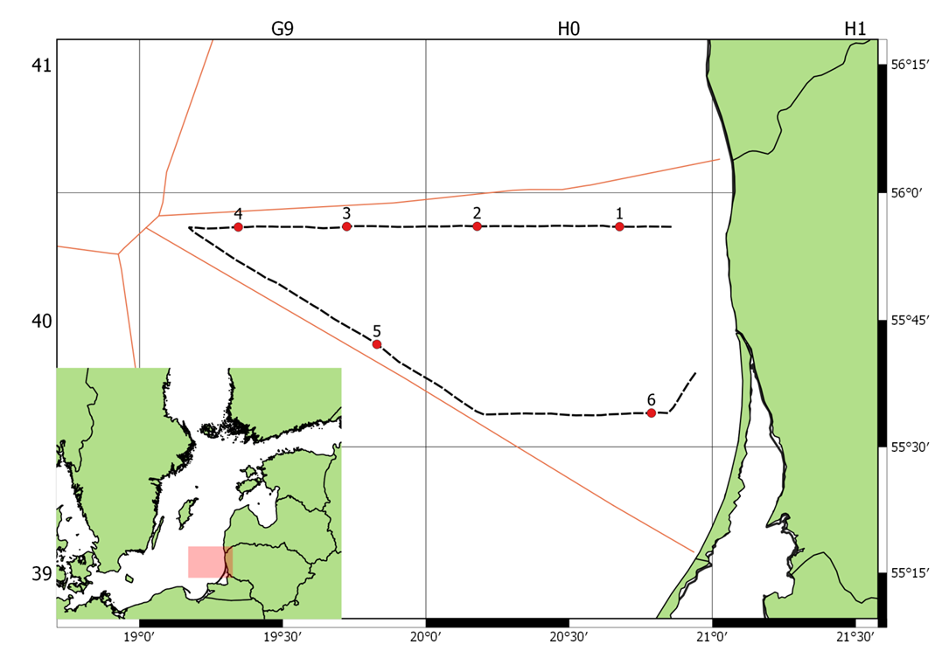
Figure 8. Locations of the realized fish control hauls, hydrological stations performed during Lithuania SPRAS survey on the r/v "Darius" in the period of 08 - 09.05.2018.
- For internationally coordinated surveys, provide a link to the latest meeting report of the coordination group.

http://www.ices.dk/community/groups/Pages/WGBIFS.aspx
- List the main use of the results of the survey (e.g. indices, abundance estimates, environmental indicators).

Target species are pelagic fish species, mainly herring and sprat. Target data are biomass, weight and length distributions and length-weight-age-sex-maturity of sprat and herring. Length distributions of all fishes as well as hydrographic data (temperature, salinity and oxygen). The data are used as an index for the stock assessment of sprat. The collected data are saved in ICES Acoustic trawl surveys database.
9. Extended comments (Tables 1G and 1H)
none
Survey of fishes in the Lithuanian coastal waters of the Baltic sea - CFS.
- Objectives of the survey
The Lithuanian coastal zone in the Baltic Sea is very rich and diverse community of hydro biotic organisms. It consists of lot ecological niches and fish nursery grounds important for commercial and non-commercial fishes (especially important juveniles). Lithuanian coastal waters are highly affected by on-land anthropogenic activities, that makes significant impact on eutrophication, distribution of waist and toxic substances. Spread of invasive species as gobies (Gobiidae) highly affects behavior of local fish population, including cod. Therefore, constant monitoring of fishes and fishing activities in the Lithuanian coastal waters may provide information important for early detection of negative tendencies in the development of populations of commercial fishes.
- Description of the methods used in the survey. For mandatory surveys, link to the manuals. Include a graphical representation (map)
The survey consists from two parts:
Juveniles survey: The objective of this survey is to determine the abundancy and biomass dynamics of all juvenile fishes in the coastal areas. The survey is performed in 14 sites alongside the Lithuania’s coastal zone (figure 5) during August - September. From each station 3 samples are taken using two different fishing technics: a dragnet is used mainly for sprat, smelt and sand eel, but all other species that are caught are analyzed as well; a beach seine specially designed for flatfish and turbot juveniles and shrimp. Hydrological parameters are recorded during each sampling as well.
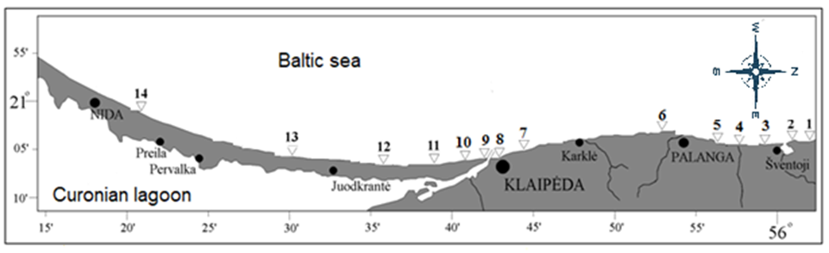
Figure 9. The sites of juvenile survey in Lithuanian coastal zone
Gillnet monitoring: The objective of this survey is to monitor the biological conditions and migration patterns of the fishes. The multi mesh-sized gillnets (from 14mm to 70 mm) are casted in four monitoring stations alongside the Lithuania’s coastal zone: two close to the southern and northern edges of Lithuanian coastal zone (Nida and Šventoji) and another two close to the mouth of Coronian lagoon, the most important source of fresh water (Smiltynė and Melnragė). The survey fishing is made once a month in each of the stations at least ten times per year. Depending on weather conditions it may start in January or February and finish in November or December. Biological, hydrological and fisheries activity parameters are recorded according to the methodology of the HELCOM.
3. For internationally coordinated surveys, describe the participating Member States/vessels and the relevant international group in charge of planning the survey
This is not an internationally coordinated survey however it is planned to use the results of the survey in the assessment of flounder and turbot in the Central Baltic, the survey is performed by methodology of the HELCOM and it is performed also in other countries of the Baltic Sea.
4. Where applicable, describe the international task sharing (physical and/or financial) and the cost sharing agreement used
Not relevant
5. Explain where thresholds apply
Not relevant
- Graphical representation (map) showing the positions (locations) of the realized samples.
Member State shall provide maps presenting the spatial distribution of the main sampling types obtained during the survey.
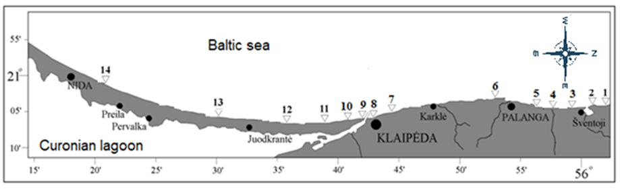
Figure 10. Locations of the realized fish control hauls and hydrological stations performed during Lithuania juvenile survey in the period of 03 - 06.09.2018
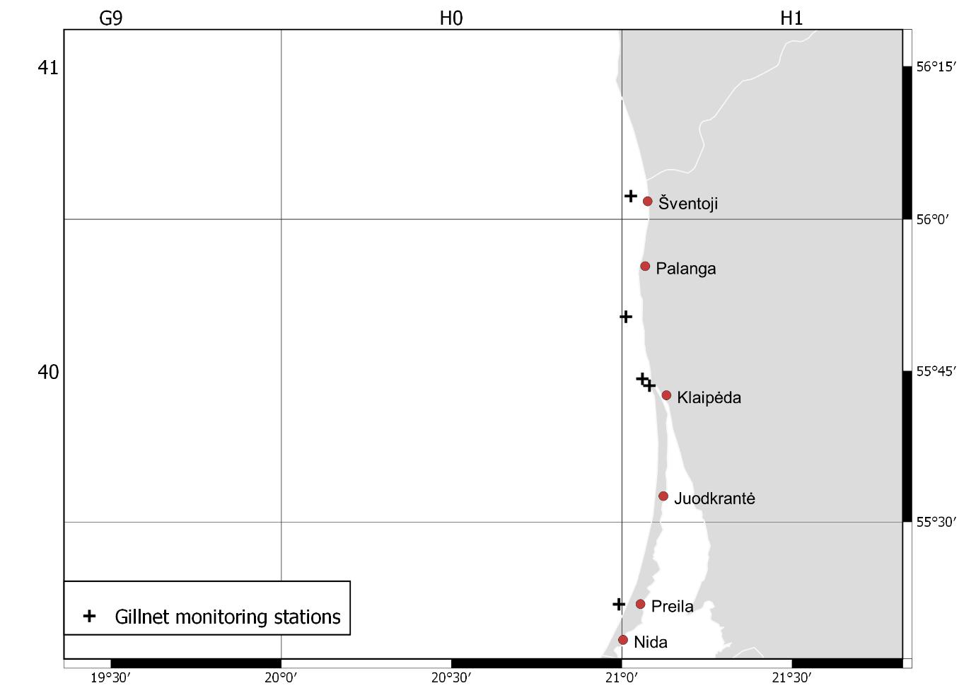
Figure 11. Lithuania gillnet monitoring stations.
- For internationally coordinated surveys, provide a link to the latest meeting report of the coordination group.

Result of fishes in the Lithuanian coastal waters of the Baltic sea survey is included in institute annual report
- List the main use of the results of the survey (e.g. indices, abundance estimates, environmental indicators).
Gillnet monitoring survey provides information on the distribution and relative abundance of fish species in coastal zone, monitors changes in the stocks of commercial fish and supplies information on the distribution and relative abundance of all fish species including ones listed in the Table 1D of Decision 2016/1251
The main aim of the juveniles survey is obtain abundance estimates of flatfish (flounder and turbot), smell and sprat juveniles. This information is periodically requested by some ICES work groups as WGBIFS, WKMixHER and etc.

Section 2: Fishing Activity Data

Text Box 2A: Fishing activity variables data collection strategy

General comment: This box fulfills paragraph 4 of Chapter III of the multiannual Union programme and Article 2, Article 4 paragraph (2) point (b) and Article 5 paragraph (2) of the Decision (EU) 2016/1701. It is intended to describe the method used to derive estimates on representative samples where data are not to be recorded under Regulation (EU) No 1224/2009 or where data collected under Regulation (EU) No 1224/2009 are not at the right aggregation level for the intended scientific use.
General comment: This box is applicable to the Annual Report. This box should provide information on the implementation of the data collection of fishing activity variables of Member States.
1. For all fleet segments by regions the transversal variables is deriving from database system IFDIS, which contains the data referred to Commission Regulation (EC) No 26/2004 of 30 December 2003 on the Community fishing fleet register in Annex I and Council Implementing Regulation (EC) No 404/2011 in Annex X. As well IFDIS contains an obligatory by National legislation monthly declarative forms, that derived from national logbook, for vessels of less than 8 m length overall which is operating in the Baltic Sea. Community fishing vessels from 8 to 12 metres’ length overall are obliged to keep a fishing logbook and submit landing and transhipment declarations. Fishing vessels of 18 metres’ length overall or more, the fishing logbook is in electronic form and the landing declarations are submitting electronically. The Lithuanian fleet does not consist of any vessels with the length class of 12 to 18 metres in length. Active and inactive vessels are included in the vessel register. The maintenance and continuous updates are up to dates. Using a conversion factor established in accordance with the Council Regulation (EC) No 404/2011 ANNEXES XIII-XV, IFDIS includes a built in function that converts processed fish weight into live fish weight. Lithuania has performed cross-checking, analyses and verifications through automated computerised algorithms and mechanisms on vessel monitoring systems, catch, effort and sales notes data and data related to the Community fishing fleet register as well as the verification of licences and fishing authorisations. Data is available in the form of primary data to the all national institutions implementing the workplans.
2. Data on landings for vessels less than 8 m length overall, which is not covered under Control Regulation, are derived from the combination of the monthly declarative forms which have been cross-checked with sales notes. These provide the key details on the species, presentation, location of landings, weight and value of fish being landed that is entered into computer system. For all fleet segments value is estimating based on prices derived from sales notes multiplying by weight from landing declarations.
3. Based on sales notes the average price by species, presentation and region is computing by dividing the total value of fish available for sale by the total weight available for sale during the period. Each sale note is related to the vessel trip or monthly report, which allow computing the average price on base of vessel trips or monthly report.
4. To approach reliable and high quality of data Lithuania uses a “census” type of declarative form for vessel, which is not recordered data under the Regulation (EU) No 1224/2009. Monthly declarative forms that derived from national logbook are completing by a company engaged in commercial fishing in the Baltic Sea coastal area. List of vessels is approved by national legislation and covers the whole segment population. The landings and metier based effort variables are provided by abovementioned forms. The forms shall be transmitted to the authority by the tenth day of the following month. When classifying a data transmission failures regarding timeliness or completeness the company is notified and report is re/submitted. The monthly declarative forms as well as landing declarations are cross-checking with sales notes.

5. Deviations from Work Plan methodology used to cross-validate the different sources of data
No deviations.
Actions to avoid deviations.
No actions needed.

6. Deviations from Work Plan methodology used to estimate the value of landings.
No deviations.
Actions to avoid deviations
No actions needed.

7. Deviations from Work Plan methodology used to estimate the average price.
No deviations.
Actions to avoid deviations.
No actions needed.

8. Deviations from Work Plan methodology used to plan collection of the complementary data
No deviations.
Actions to avoid deviations
No actions needed.

Section 3: Economic and Social Data

Text Box 3A: Population segments for collection of economic and social data for fisheries

General comment: This box fulfils paragraph 5 points (a) and (b) of Chapter III of the multiannual Union programme and Article 2, Article 4 paragraphs (1), (2) and (5) and Article 5 paragraph (2) of the Decision (EU) 2016/1701. It is intended to specify data to be collected under Tables 5(A) and 6 of the multiannual Union programme.
General comment: This box is applicable to the Annual Report. This box should provide information on the implementation of the fleet socio-economic data collection of Member States.
1. Description of methodologies used to choose the different sources of data
The total population for fleet economic and social variables are all active and inactive vessels registered in the Union Fishing Fleet Register on 31 December of the reporting year and vessels that do not appear on the Register at that date but have fished at least one day during the reporting year.
Collection of economic variables of the Lithuanian fleet will be based on following major data sources:
- Lithuanian Agricultural and Food Product Market Information System (LAFPMIS) administered by State enterprise Agricultural Information and Rural Business Center (AIRBC); - Integrated Fishery Data Informational System (FDIS) administered by Fisheries Service; - Fleet register.
Economic variables for the variable groups as Income, Labor costs, Energy costs, Repair and maintenance costs, Other operating costs, Subsidies, Capital costs, Capital value, Investments, Financial position, Employment and Energy consumption are obtained from LAFPMIS (DR-1), whereas Economic variables for the Effort (except Energy consumption), Number of fishing enterprises/units and Production value per species are obtained from FDIS. Data for variable group Fleet is available from Fleet Register.
Social data as Employment by gender, FTE by gender, Unpaid labor by gender, Employment by age, Employment by employment status and FTE National will be collected on annual basis and available from data source LAFPMIS (DR-1). Social variables as Employment by education level and Employment by nationality will be collected each three years (starting in 2018) by pilot study and available from data source LAFPMIS (DR-1).
Variable gross value of landings will be available from two data sources, FDIS (gross value of landings) and LAFPMIS questionnaires (income from landings). First of all, two values will serve for crosschecking purposes when data collected by questionnaires regarding production costs, capital value and employment firstly should correspond to the income from same data source and only after that to the gross value of landings from FDIS.
2. Description of methodologies used to choose the different types of data collection
For all economic and social (excluding Employment by education level and Employment by nationality) variables census data collection scheme will be applied for all regions and all fleet segments. Data are collected by Statistical questionnaires (code DR-1), approved by the law of the Minister of Agriculture No 3D-707 on 4th August of 2010 (last amended in 2016). FDIS and Fleet Register possess census data as well.

3. Description of methodologies used to choose sampling frame and allocation scheme
Data collection is based at enterprise level. If enterprise operates two vessels or more, belonging to different fleet segments, it is required to provide separate questionnaires for individual segment, if all vessels belongs to one segment, only one questionnaire for all vessels in segment is provided. Logbook based data on effort for each active population vessel is extracted from FDIS and depending on it overall length, fishing area and activity by gear, allocation to segments are performed. Criteria and primary data for segmentation of vessels, less than 10 m are also extracted from FDIS.

4. Description of methodologies used for estimation procedures
Imputed value of unpaid labor will be calculated for all the individual enterprise operating only in the coastal area which in DR-1 questionnaire provides number of unpaid family members engaged in fishery sector. The number of unpaid family members involved in production, or number of their working hours (if provided) will be multiplied by average annual wage calculated for “paid labor” at particular segment level.
Value of physical capital and consumption of fixed capital will be estimated using Perpetual Inventory Method (PIM) through a template model developed by EC study No. FISH/2005/03 proposes to determine the aggregate value of the physical capital in the current year by aggregation of active fleets by age or vintage classes. Methodology is provided in “Methodologies for the socio-economic data described in EU MAP (Ref. Ares(2016)2440332 – 26/05/2016.
In the case, when response rate is less than 100% of population, the missing variables are estimated from the sample, taking into the consideration the value of landings which has census on all active fleet (FDIS) of missing vessel and data from sample.
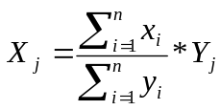
where:
X_{j} – missing variable information about the vessel;
x_{i}– collected variable of the sample;
n – sample size;
Y_{j} – FDIS independent variable of the vessel;
y_{i}– FDIS independent variable of the sample.

For fleet that logbook is obliged, the days at sea variable is estimating as defined in Chapter I of COMMISSION IMPLEMENTING DECISION (EU) 2016/1251. For vessels of less than 8 m length overall which is operating in the Baltic Sea only, the days at sea variable is derived from monthly declarative forms, that computed based on national logbook records on fishing activities.

5. Description of methodologies used on data quality
Fleet economic data collection is included in the annual Official Statistic data collection Program and therefore quality is ensured by application of principles of European Code of Practice. The data collection processes in AIRBC complies the ISO 9001 requirements for data quality and ISO 27001 requirements for data security. AIRBC has carried out a self-assessment of the compliance with the European Statistics Code of Practice, which can be considered as a best practice in the European Statistical System. The self-assessment reviews the institutional environment (professional independence, mandate for data collection, adequacy of resources, commitment to quality and statistical confidentiality, impartiality and objectivity) as well as the statistical processes and the quality of its outputs.
For data quality assurance, LAFPMIS Interactive Data Input System contains:
- logical verification and data validation at different data processing stages;
- automatic data aggregation during data input process;
- for external users, especially data providers, system ensure easy accessibility of methodologies;
- system is flexible in terms of development according requirements from end users and external users;
- update and storage of exhaustive administrative data.
In addition, primary data, intermediate results and statistical outputs are regularly assessed by the expertise of personnel, data are checked for inconsistencies, completeness, and timeliness. Any detected errors are registered in non-compliance register. Based on records from this register data audition unit of AIRBC periodically visit fishing companies and perform primary data quality and accuracy audition by checking questionnaire data with companies accounting documents.
For quality measurements, response rate (separately at respondent/vessel and reported item levels) and coverage rate (taking into account value of landings) are calculated.
In FDIS has been performed cross-checking, analyses and verifications through automated computerized algorithms and mechanisms on vessel monitoring systems, catch, effort and sales notes data and data related to the Community fishing fleet register as well as the verification of licenses and fishing authorizations that ensure Fleet, Effort (exclude Energy consumption), Number of fishing enterprises/ units and Production value per species variables quality.
6. Deviations from Work Plan methodology for selection of data source
No deviations from Work Plan.
Actions to avoid deviations
NA.
7. Deviations from Work Plan methodology to choose type of data collection
No deviations from Work Plan.
Actions to avoid deviations
NA
8. Deviations from Work Plan methodology regarding sampling frame and allocation scheme
No deviations from Work Plan.
Actions to avoid deviations
NA
9. Deviations from Work Plan methodology used for estimation procedures
No deviations from Work Plan.
Actions to avoid deviations
NA
10. Quality assurance
10.1 Sound methodology
For data collection, Lithuania use census survey (DR-1 form in legal act provided in 10.3.1. subparagraph) and vast majority of economic and social variables are provided from enterprice accountancy. However, variables as capital value, consumption of fixed capital, and imputed value of unpaid labour are estimated using best practice and common methodologies agreed in expert working groups. Compilation of all the methodologies already suggested in previous STECF reports, PGECON reports and in DCF workshops is available in DCF website, document “Methodologies for the socio-economic data described in EU MAP” Ref. Ares(2016)2440332 - 26/05/2016. (by Evelina Sabatella).
- Capital value and consumption of fixed capital for Lithuainan fleet is estimated by PIM method proposed in the study FISH/2005/03: ‘Irepa Onlus Coordinator, 2006’.
- Imputed value of unpaid labour is estimated using methodology suggested in “Methodologies for the socio-economic data described in EU MAP” Ref. Ares(2016)2440332 - 26/05/2016 (by Evelina Sabatella).
Value of unpaid labour can be estimated through the following methodology:
A. FTE method (WS, Naples, 2009), that includes the following steps:
• estimation of paid and unpaid FTE;
• definition of an average remuneration per paid FTE (e.g. average wage by fleet segment/company, national average wage, minimum national wage, etc…);
• calculation of imputed value of unpaid labour =: unpaid FTE * (average remuneration per paid FTE).
Applied methodologies are publically available : https://datacollection.jrc.ec.europa.eu/dc/fleet/guidance#_48_INSTANCE_pMomk7430Xoy_%3Dhttps%253A%252F%252Fdatacollection.jrc.ec.europa.eu%252Fdocuments%252F10213%252F1235778%252FEUMAP_guidance.pdf
10.2. Accuracy and reliability
Response rate and Achieved sample rate are provided in Table 3A.
Raw data imputs are controled by validation tools in Interactive Data Input Sustem (IDIS). Accuracy and reliability of primary data is ensured by data collectors, which carries out mannual data revision in terms of completeness, integrity and deviations based on expert knowledge. Then AIRBC data inspection unit personnel based on risk assessment analysis carries out data checks and comparison of provided data with accountancy documents by visiting fihing enterprises. Identified errors and deviations of reported questionnaires in comparison to accountancy documents are included in the inspection act and non-compliance form (can be found by web link 10.3.1.). Risk asessment analysis of reported data is based on the non-complinace records and size of enterprise as well as value of production in total production structure. Methodology of Risk assessment analysis can be found by web link 10.3.4.)
10.3. Accessibility and Clarity
Indicate with Yes or No
Are methodological documents publicly available? – Yes (https://www.vic.lt/zumpris/metodiniai-dokumentai/)
Are data stored in databases? – Yes (https://is.vic.lt/pls/vris/ris_start.wwwindex)
Where can methodological and other documentation be found? Web links for methodology and other documentation
- 10.3.1. Legal act for data collection and methodology:
https://www.e-tar.lt/portal/lt/legalAct/be557330e0ab11e7b3f0a470b0373cb2
- 10.3.2. Methodology for calculation of Imputed value of unpaid labour:
https://datacollection.jrc.ec.europa.eu/documents/10213/3f2194f5-b1a3-4f1f-96aa-02f3740cba6a (Table 1 Economic variables for the fleet)
- 10.3.3. Methodology for calculation of capital value and consumption of fixed capital:
http://www.vic.lt/zumpris/wp-content/uploads/sites/4/2018/05/KAPITALO-VERTES-SKAIC%C2%8CIAVIMO-metodikos-APRASAS.pdf
- 10.3.4. Methodology of Risk assessment analysis for control of data reliability and accuracy can be found by web link:
http://www.vic.lt/zumpris/wp-content/uploads/sites/4/2018/04/Oficialiosios-statistin%C4%97s-informacijos-rengimo-proces%C5%B3-rizikos-vertinimo-metodika.pdf
(max 1000 words)

Section 3: Economic and Social Data

Pilot Study 3: Data on employment by education level and nationality

General comment: This box fulfills paragraph 5 point (b) and paragraph 6 point (b) of Chapter III of the multiannual Union programme and Article 2 and Article 3 paragraph (3) point (c) of the Decision (EU) 2016/1701.It is intended to specify data to be collected under Table 6 of the multiannual Union programme.
General comment: This box is applicable to the Annual Report. This box is intended to provide information on the results obtained from the implementation of the pilot study (including deviations from planned and justifications as to why if this was not the case).
1. Aim of pilot study
In accordance with Commission Implementing Decision (EU) 2016/1251, adopting a multiannual Union programme for collection, management and use of data in the fisheries and aquaculture sectors for the period 2017-2019, social data shall be collected every three years and data on employments by education level and employment by nationality may be collected on the basis of pilot studies. The pilot study is foreseen for implementation of this legal act.
2. Duration of pilot study
Each pilot study is expected to be launched at the June of each three years starting in 2018 (2018 06) and results should be available after six months from starting date.
3. Methodology and expected outcomes of pilot study
Pilot study will be conducted for two variables (Employment by education level and Employment by nationality) every three years, starting from 2018. Each pilot study is planned to be performed together with annual economic fleet data collection of respective year as additional information, requested in statistical questionnaires (code DR-1), approved by the law of the Minister of Agriculture No 3D-707 on 4-th August of 2010 (last amended in 2016). Consequently, data collection scheme for pilot study will be census based in line with annual fleet economic data survey and annual fish processing economic data survey, coming with official cover letter indicating additional requirements for social data and referring to EU legislation. Based on PGECON 2017 recommendation, social data for fleet will be stratified by AER segment groups to “Small scale fleet”, “Large scale fleet” and “Long distance fleet”. For fish processing industry disaggregation will be at segment level based on number of employees. Furthermore, following disaggregation levels will be applied:
1. “Employment by nationality”:
- “National”;
- “EU”;
- “EEA (non EU)”;
- “Other” (Non-EU/EEA).
2. “Employment by education level”:
- “Low education” levels 0-2 (ISCED2011 and ISCED1997);
- “Medium education: levels 3-4 (ISCED2011 and ISCED1997);
- “High education” levels 5-8 (ISCED2011), levels 5-6 (ISCED1997).
4. Achievement of the original expected outcomes of pilot study and justification if this was not the case.
Aims of the study were successfully achieved. Pilot study of social variables in Lithuanian fishing fleet and fish processing industry was launched in 2018 as census survey. Structure of the questionnaire of survey was developed applying all PGECON 2017 recommendations for social variable data collection. Data was collected at the highest disaggregation level – one data line per employee, allowing linkage of all collected social variables among each other and comparability with other EU MS applying PGECON recommendations. Taking into account the vessel as statistical unit, response rate for social variables as education and nationality were 73.4% in small scale fleet with 95.8% coverage rate in terms of value of landings per vessel; for large scale fleet response rate – 72.7%, coverage rate – 93.8%; for long-distance fleet response rate – 83.3%, coverage rate – 96.3%. Social variables as employment and FTE by gender, unpaid labor by gender, employment by age, by status and FTE national in small scale fleet were collected with the response rate 92% and coverage rate – 99.7%, whereas for large scale and long-distance fleet response rate was 100% and coverage rate – 100%. In fish processing industry social variables were collected with 81% of response rate and 95% of coverage rate (in terms of production value) in 0-10 employees segment; in the segment of 10-50 employees achievements were 100%; for 50-250 employees segment – 91% response rate and 90% coverage rate; 250< employees segment response rate was 83% with 81% coverage rate. The survey in pilot study included additional social variables as qualification code, working position and duration of employment period per person. In general, all outcomes were in line with expectations, even with census survey, some missing responses from very small enterprises (seen from high coverage rate) were expected.
5. Incorporation of results from pilot study into regular sampling by the Member State.
As data were collected by each employee, incorporation of data is possible at any aggregation level.
(max 900 words)

Section 3: Economic and Social Data

Text Box 3B: Population segments for collection of economic and social data for aquaculture

General comment: This box fulfills paragraph 6 points (a) and (b) of Chapter III of the multiannual Union programme and Article 2, Article 4 paragraphs (1) and (5) and Article 5 paragraph (2) of the Decision (EU) 2016/1701.It is intended to specify data to be collected under Tables 6 and 7 of the multiannual Union programme.

General comment: This box is applicable to the Annual Report. This box should provide information on the implementation of the socio-economic data collection for aquaculture of Member States.

Lithuanian aquaculture sector consists only from freshwater aquaculture activities, therefore as data collection for this type of aquaculture is optional, it is not foreseen for 2017-2019.

1. Description of methodologies used to choose the different sources of data
Not relevant
2. Description of methodologies used to choose the different types of data collection
Not relevant
3. Description of methodologies used to choose sampling frame and allocation scheme
Not relevant
4. Description of methodologies used for estimation procedures
Not relevant
5. Description of methodologies used on data quality
Not relevant
Lithuanian aquaculture sector consists only from freshwater aquaculture activities, therefore as data collection for this type of aquaculture is optional, it is not foreseen for 2017-2019 Work Plan

6. Deviations from Work Plan methodology for selection of data source
NA.
Actions to avoid deviations
NA.
7. Deviations from Work Plan methodology to choose type of data collection
NA.
Actions to avoid deviations
NA.
8. Deviations from Work Plan methodology regarding sampling frame and allocation scheme
NA.
Actions to avoid deviations
NA
9. Deviations from Work Plan methodology used for estimation procedures
NA.
Actions to avoid deviations
NA.
10. Quality assurance
10.1 Sound methodology
NA.
10.2. Accuracy and reliability
NA.
10.3. Accessibility and Clarity
NA.
(max 1000 words)

Section 3: Economic and Social Data

Pilot Study 4: Environmental data on aquaculture

General comment: This box fulfills paragraph 6 point (c) of Chapter III of the multiannual Union programme and Article 2 and Article 4 paragraph (3) point (d) of the Decision (EU) 2016/1701. It is intended to specify data to be collected under Table 8 of the multiannual Union programme.
General comment: This box is applicable to the Annual Report. This box is intended to provide information on the results obtained from the implementation of the pilot study (including deviations from planned and justifications as to why if this was not the case).
Data collection for aquaculture is not foreseen for 2017-2019 as all sector in Lithuania consists of fresh water aquaculture activities
1. Aim of pilot study
Not relevant (see text box 3B)
2. Duration of pilot study
Not relevant
3. Methodology and expected outcomes of pilot study
Not relevant
4. Achievement of the original expected outcomes of pilot study and justification if this was not the case.
Data collection of aquaculture sector is not foreseen in 2017-2019 WP.

5. Incorporation of results from pilot study into regular sampling by the Member State.
NA

(max 900 words)

Section 3: Economic and Social Data

Text Box 3C: Population segments for collection of economic and social data for the processing industry

General comment: This box fulfils footnote 6 of paragraph 1.1(d) of Chapter III of the multiannual Union programme, Article 2, Article 4 paragraphs (1) and (5) and Article 5 paragraph (2) of Decision (EU) 2016/1701. It is intended to specify data to be collected under Table 11 of the multiannual Union programme.
General comment: This box is applicable to the Annual Report. This box should provide information on the implementation of the socio-economic data collection for aquaculture of Member States.
1. Description of methodologies used to choose the different sources of data
Economics and social data variables concerning fish processing industry to be collected under Table 11 of the multi-annual Union programme will be based on 3 data sources:
• Lithuanian Agricultural and Food Product Market Information System (LAFPMIS) administered by State enterprise Agricultural Information and Rural Business Center (AIRBC), annual survey (ŽF-1) for economic data collection.
• LAFPMIS semiannual survey (ŽP-1) for social data collection.
• The list of animal food handling entities holding veterinary approval number for the total number of fish processing companies, gathered by Lithuanian State Food and Veterinary Service (SFVS).
Moreover, Economics and social data variables concerning fish processing industry will be cross-checked with information collected by National Statistical Department (NSD) on economic data and with information collected by State Social Insurance Fund (SSIF) on social data. Also data on classifications by activity status of fish processing companies will be cross checked by Institutional sectors and subsectors data from National Statistical Department.
Economic and social data is gathered from all fish processing industry companies by statistical forms ŽF-1 and ŽP-1 approved by the Minister of agriculture and included in the official statistics work programmes (OSWP) which is regulated by Lithuanian Law on Statistics and is mandatory for all type of economical entities. The data is more detailed than that of the National Statistical Department and covers all of the fish processing companies’ population and is used to meet the need for national administrative purposes. Therefore, data from statistical forms ŽF-1 and ŽP-1 will be the main source for economics and part of social data. Social variables as employment by nationality and by education level will be collected through pilot study, launched in 2018 and repeated every three years. Social variables as employment by gender, age and national FTE will be collected by semiannual survey (ŽP-1).
The population will refer to enterprises whose main activity is defined according to the Eurostat definition under NACE Code 15.20: “Processing and preserving of fish, crustaceans and molluscs”. Also data will be collected from those enterprises that carry out fish processing but not as a main activity.
The list of all fish processing companies will be obtained from SFVS on a yearly basis, segments will be assigned according to data from (SSIF) and main activity will be determined according to (NSD).

2. Description of methodologies used to choose the different types of data collection
Census (A), which attempts to collect data from all members of a population, will be applied for each segment for most of the economic and social variable, except:
• Value of unpaid labour - will be calculated for all the enterprises which will provide the data about the unpaid employees engaged in fish processing activities. The calculations will be based on the statistical forms ŽP-1 and ŽF-1. The number of unpaid workers involved in processing, or number of their working hours will be multiplied by average annual wage calculated for “paid labour” in particular segment.
• For the calculation of national FTE, the number of hours worked during the year will be collected from the enterprises through the statistical forms (ŽP-1). This parameter will be divided by national annual full-time working hours, which is based on the law of the Minister of social security and labour. It confirms the number of average working hours per year annually.

3. Description of methodologies used to choose sampling frame and allocation scheme
Since data are to be collected through a Census (A) a description of the sampling frame is not relevant.

4. Description of methodologies used for estimation procedures
In the case, when response rate is less than 100% of the population for a specific variable, the missing information of a company will be derived in accordance to data on employment from SSIF. The missing data on a specific variable will be calculated by dividing the sample of that variable from a specific segment by the number of employees from the sample of a specific segment and multiplying by employees of the company in question. If a specific segment, to which a company with a missing variable is assigned, is deemed too small, sample from the whole processing industry will be used.

5. Description of methodologies used on data quality
The methodologies for quality of fish processing sector is a fraught and consistent process of data collection covering data collection fullness checks, quality and integrity of gathered data and post collection data checks by auditing individual enterprises. All the irregularities will be noted in the non-compliance register (NCR):
1. As the data collection scheme is Census (A), data on fish processing will be checked for completeness and timeliness through response rates. Non-response enterprises and related data entries will be included in the NCR.
2. Data quality will be ensured by checking data integrity and quality during the initial data entry through LAFPMIS Interactive Data Input System (IDIS), where input data will be automatically check for inconsistencies between coherent variables, data completeness, and other logical data coherences. Further data quality checks will be conducted by sector specialists, looking for inconsistencies in time data series, by cross checking data with other data sources, identifying extremities of separate variables, and other logical checks. All the irregularities will be included in the NCR.
3. In accordance with to the NCR, the validation of data will be checked by auditing companies with most irregularities by directly crosschecking statistical form`s data with that of the companies bookkeeping data. Any abnormalities and irregularities will be corrected.
Furthermore, in accordance to data NCR and audit outcomes, methodologies for data submitting and metadata will be reviewed and changed to enhance the quality of data gathering.
6. Deviations from Work Plan methodology for selection of data source
No deviations from Work Plan.
Actions to avoid deviations
NA.
7. Deviations from Work Plan methodology to choose type of data collection
No deviations from Work Plan.
Actions to avoid deviations
NA.
8. Deviations from Work Plan methodology regarding sampling frame and allocation scheme
In 2018 census survey data was collected for all economic and social variables, included in Table 11 of 2016/1251 Regulation and for all segments. However, as WP Table 3C includes only selected number of variables, AR Table 3C is accordingly filled to match WP table. This deviation should be considered as improvement reflecting complete coverage of socioeconomic data with high response rate and better comparability among all segments. Therefore in 2018 WP was amended and was approved containing the complete list of variables for all segments.
Actions to avoid deviations
NA.
9. Deviations from Work Plan methodology used for estimation procedures
No deviations from Work Plan.
Actions to avoid deviations
NA.
10. Quality assurance
10.1 Sound methodology
For data collection, Lithuania use census survey (ZF-1 form in legal act provided in 10.3.1. subparagraph) and vast majority of economic and social variables are provided from enterprise accountancy. However, variables as imputed value of unpaid labour are estimated using best practice and common methodologies agreed in expert working groups. Compilation of all the methodologies already suggested in previous STECF reports, PGECON reports and in DCF workshops is available in DCF website, document “Methodologies for the socio-economic data described in EU MAP” Ref. Ares(2016)2440332 - 26/05/2016. (by Evelina Sabatella).
- Imputed value of unpaid labour is estimated using methodology suggested in “Methodologies for the socio-economic data described in EU MAP” Ref. Ares(2016)2440332 - 26/05/2016 (by Evelina Sabatella).
Value of unpaid labour can be estimated through the following methodology:
A. FTE method (WS, Naples, 2009), that includes the following steps:
• estimation of paid and unpaid FTE;
• definition of an average remuneration per paid FTE (e.g. average wage by fleet segment/company, national average wage, minimum national wage, etc…);
• calculation of imputed value of unpaid labour =: unpaid FTE * (average remuneration per paid FTE).
Applied methodologies are publically available.
10.2. Accuracy and reliability
Response rate and Achieved sample rate are provided in Table 3C.
Raw data imputs are controled by validation tools in Interactive Data Input Sustem (IDIS). Accuracy and reliability of primary data is ensured by data collectors, which carries out mannual data revision in terms of completeness, integrity and deviations based on expert knowledge. Then AIRBC data inspection unit personnel based on risk assessment analysis carries out data checks and comparison of provided data with accountancy documents by visiting fish processing enterprises. Identified errors and deviations of reported questionnaires in comparison to accountancy documents are included in the inspection act and non-compliance form (can be found by web link 10.3.1.). Risk asessment analysis of reported data is based on the non-complinace records and size of enterprise as well as value of production in total production structure. Methodology of Risk assessment analysis can be found by web link 10.3.3.)
10.3. Accessibility and Clarity
Indicate with Yes or No
Are methodological documents publicly available? - Yes
Are data stored in databases? – Yes (https://is.vic.lt/pls/vris/ris_start.wwwindex)
Where can methodological and other documentation be found? Web links for methodology and other documentation
- 10.3.1. Legal act for data collection and methodology:
https://www.e-tar.lt/portal/lt/legalAct/be557330e0ab11e7b3f0a470b0373cb2
- 10.3.2. Methodology for calculation of Imputed value of unpaid labour:
https://datacollection.jrc.ec.europa.eu/documents/10213/3f2194f5-b1a3-4f1f-96aa-02f3740cba6a (Table 3 Economic variables for the fleet)
- 10.3.3. Methodology of Risk assessment analysis for control of data reliability and accuracy can be found by web link:
http://www.vic.lt/zumpris/wp-content/uploads/sites/4/2018/04/Oficialiosios-statistin%C4%97s-informacijos-rengimo-proces%C5%B3-rizikos-vertinimo-metodika.pdf
(max 1000 words)

Section 4: Sampling Strategy for Biological Data from Commercial Fisheries

Text Box 4A: Sampling plan description for biological data

General comment: This box fulfils Article 3, Article 4 paragraph (4) and Article 8 of the Decision (EU) 2016/1701 and forms the basis for the fulfilment of paragraph 2 point (a)(i) of Chapter III of the multiannual Union programme. This Table refers to data to be collected under Tables 1(A), 1(B) and 1(C) of the multiannual Union programme.
General comment: This box is applicable to the Annual Report. This box should provide information on the deviations from the planned sampling of Member States.
General remark:
For the period until 1-st of July 2018 biological data were collected by Fisheries Service under MoA (FS). Responsibility for collection of biological data was delegated to Klaipeda University from 1 July 2018. Marine Research Institute of Klaipeda University (MRI) is in charge for collection of biological variables in the Baltic Sea; North Sea and Eastern Arctic; and North Atlantic regions. Sampling programme for the CECAF and SPRFMO regions is carried out according to multilateral agreement (see Table 7C). The Nederland coordinate the programme for CECAF and Poland for SPRFMO. Fisheries unite of MoA is supervising implementation of these multilateral sampling programmes.
MRI initiated comprehensive analysis of fishing effort together with coherent logistic and financial possibilities in 2019 (when access to the data stored in Fisheries Data Information System (FDIS) was provided), therefore existing sampling programmes will be revised.
Baltic Sea
There are seven sampling strata planned (Table 4B), but two of them are for eel fisheries in inland waters (strata EEL1 and EEL2) and does not relate to commercial fisheries in the Baltic Sea. Almost all catch (99,9%) of Anguilla anguilla was taken in inland waters, so sampling for biological data for eel is completely covered in the Table 1E.
The stratum BS1 was designated for sampling at sea and covers list of vessels fishing demersal fish using otter trawls. 7vessels with overall length from 18 to 40 meters were in this stratum in 2018 and resulted about 80% from total landings of most important demersal species (cod and flounder). Fishing trip was selected as PSU. It was 229 fishing trips registered in 2018 and it was only about 60% from average in reference period (2013-2015). It was planned to sample one PSU per month. Selection of PSU was not fully probability based, because of small number of vessels and other reasons (see paragraph Deviation from Work Plan below). List of the vessels were kept in excel table and the ones for sampling was selected by RANDOM function each month. If selected vessel was not planned to make fishing trip or ceased due to technical problem another vessel was selected.
The stratum BS2 was designated for sampling at sea and covers list of vessels fishing demersal fishes using gill nets. Two vessels with LOA 24 -40 meters and 5 vessels with LOA 8-12 meters and resulted about 17% from total landings of cod and 1% of flounder. Fishing trip was selected as PSU. It was 298 fishing trips registered in 2018 and it was 6 times more than the number indicated for the reference period (2013-2015) in the Work Plan. The reasons of this deviations explained below (see paragraph Deviation from Work Plan).
The stratum BS3 was designated for sampling at sea covers list of the vessels fishing in coastal zone. 59 vessels with LOA up to 8 meters were in this stratum in 2018. These vessels were mostly fishing fresh water and semi-diadromous fishes. According to Work plan the PSU is fishing trip.
The stratum BS4 was designated for onshore sampling of landings of demersal fishes. There is only one harbour in Lithuania (Klaipeda) where vessels with LOA equal or more than 8 meters are landing fish. Out of total annual landings of cod 60% was landed in Klaipeda, for flounder it was about 70%. According to Work Plan PSU was port day. Selection of PSU was not fully probabilistic: each second week was chosen for sampling, and if actual landings in this week occurs the SSU - vessel x landing was sampled. Number of SSU was chosen depending on resources available (see paragraph Deviation from Work Plan).
The stratum BS5 was designated for onshore sampling of landings of small pelagic fish. According to Work Plan PSU was port day. Selection of PSU was not fully probabilistic: each second week was chosen for sampling, and if actual landings in this week occurs the SSU - vessel x landing was sampled. Number of SSU was chosen depending on resources available. However less than 10% from total landings of small pelagic fish was landed in Lithuanian harbour. Traditionally most of small pelagic fishes are landing in Denmark (in 2018 it was about 77% from total), therefore FS have signed agreement with Danish Technical University (DTU) for sampling of landings from Lithuanian vessels in Denmark.
Eastern Arctic
There are two sampling strata for this region
The stratum NSEA1 was designated for at sea sampling of shrimp trawlers. According to Work Plan PSU was trip covering whole season samples shall be collected by observer. According FDIS two fishing vessels made 17 fishing trips in 2018. The fishery was in the international waters of ICES areas I and II.
The stratum NESA2 was designated for at sea sampling of pelagic trawlers fishing for redfish. According to Work Plan PSU was trip covering whole season samples shall be collected by observer. According FDIS one fishing vessel made 3 fishing trips in 2018. The fishery was in the international waters of ICES areas I, II.
North Atlantic
The stratum NA1 was designed for at sea sampling of pelagic trawlers fishing in ICEs areas VI-VII. Fishing in these areas is very occasional, no fishing in 2018.
The stratum NA2 was designed for at sea sampling of pelagic trawlers fishing in ICEs areas I - XIV. According FDIS one fishing vessel made 4 fishing trips in 2018. The fishery was in the international waters of ICES area XIV.
The stratum NA3 was designed for at sea sampling of pelagic trawlers fishing Scombridae in ICEs areas II-VIII. No fishing for Scombridae in this area in 2018. Scombridae were fished during the fishing trips in CECAF region only in 2018.
CECAF and SPRFMO regions
Sampling in CECAF region is coordinated by the Nederland according to multilateral agreement (see table 7C), sampling in SPRFMO region is coordinated by Poland according to multilateral agreement.
Two Lithuanian vessels were operated in the CECAF division, one of them was operated both in CECAF and SPRFMO regions.
(max 900 words per region)
Deviation from the sampling plan according to Article 5 paragraph (3) of the Decision (EU) 2016/1701:
2. Deviations from the Work Plan
Baltic Sea
All of sampling strata were under sampled (see tables 1C and 4A).
For the strata BS1 and BS2 it was mainly because very limited possibilities to deploy observers on the vessels. Most of Lithuanian vessels fishing in the Baltic Sea are far from modern fishing vessels and requires big crew. Installed basic safety equipment on these vessels covers only number of persons equal to the number of crew. Embarking of additional person is possible only when vessel is operating with reduced crew.
Another reason limiting to select PSU may be called “metier issue”. Most of the vessels with LOA between 18 and 40 meters are fishing both for demersal and pelagic fishes. Out of 7 vessels in the stratum BS1 4 were switching between demersal and pelagic fisheries depending on availability of quota and demand in the market. Therefore, it was the cases when randomly selected vessel for sampling of demersal species was actually fishing with pelagic trawl, so another vessel had to be selected.
Third reason limiting deploying od observers is that quite big number of fishing trips had been started and finished outside Lithuania, it causes a lot of logistic and financial consequences. For example, out of 229 trips fished with otter bottom trawls 61 started (27%) and 63 (about 28%) finished outside Lithuania.
For the stratum BS3 under sampling was mainly because of mistakenly planning. Planned PSU – vessel trip – is impracticable. The effort and landing data for these vessels are aggregated monthly in FDIS, therefore, MRI was not able to analyse data trip by trip, so in fact PSU was vessel month, consequently secondary sampling unit (SSU) was vessel x day at sea. Notwithstanding big number of vessels in this stratum they are catching less than 5% of species selected for sampling. Very small landing per vessel, carried out in 29 places along whole coastline. Vessels are very small so to deploy observers is almost impossible. Preliminary results of pilot study Level of fishing and impact of fisheries on biological resources and marine ecosystem suggests that this stratum should be important for sampling of species listed in the table 1D rather than commercial landings.
For the stratum BS4 most reason for under sampling was dramatically reduced landings of cod in 2018 and length distribution (see text box 1C). Another reason caused by very strong dependency of Lithuanian fleet on weather conditions: vessels are far from modern, so the can fish only in limited weather conditions. Fishing trips weren’t scheduled on weekdays but run ad-hoc depending on weather conditions. It resulted that out of 158 landing days 57 (36%) were during weekend. Most of landings were carried out late night or early in the morning, so it caused some logistic problems.
For the stratum BS5 under sampling was resulted because unrealistic planning. Less than 10% of herring landings and less than 1% sprat landings were made in Lithuanian harbours. Unfortunately, we are not able to explain under sampling of landings in ports of Denmark.
Eastern Arctic
Oversampling for both strata NSEA1 and NSEA2 was because contracted observer was instructed to take length samples every haul. Number of hauls is not predictable in advance. However, no maximum number to be sampled was set, moreover it didn’t require additional financial resources, therefore it has no negative aspect on implementation of sampling programme.
North Atlantic
The same vessel was fished in stratum NSEA2 and NA2, reasons of oversampling the same as in Eastern Arctic region.
There were some mismatches in description of sampling frames in the WP 2018-2019, see table below.
Table 4A of WP |  |  |  |  | Table 4B of WP |  |  | NOTES
Region | RFMO/RFO/IO | Sub-area / Fishing ground | Scheme | Stratum ID code | Stratum ID number | Stratum | Sampling frame description | NOTES
North Sea and Eastern Arctic | ICES | ICES I-II | sampling at sea | NSEA1 | NSEA1 | Otter trawler fishing shrimps in ICES | 1 vessel active | -----
North Sea and Eastern Arctic | ICES | NEAFC XII-XIV | sampling at sea | NSEA2 | NSEA2 | Pelagic trawler operating in NEAFC | 1 vessel active | Shoild be defined as pelagic trawler operating in ICES I- II
North Atlantic | ICES | ICES VI-VII | sampling at sea | NA1 | NA1 | Pelagic trawler operating in ICES IV-VI | 1 vessel active | No fishing in this area
North Atlantic | ICES | ICES I-XIV | sampling at sea | NA2 | NA2 | Pelagic trawler operating in ICES VI-VII | 1 vessel active | Should be defined as Pelagic trawlwes operating in NEAFC areas XII and XIV.
North Atlantic | ICES | ICES II-VIII | sampling at sea | NA3 | NA3 | Pelagic trawler fishing scombridae | 1 vessel active | No fishing for scombridae

Since it was no fishing in ICES areas VI – VII the strata N1 and N3 were unsampled.
CECAF and SPRFMO regions
No information available because sampling in CECAF region is coordinated by the Nederland according to multilateral agreement (see table 7C), sampling in SPRFMO region is coordinated by Poland according to multilateral agreement.
3. Action to avoid deviations
Baltic Sea
Revision of sampling programme. Since MRI was granted with access to FDIS comprehensive analysis of fishing effort together with coherent logistic and financial possibilities. Most of landings of cod in Lithuania usually made in first six months of the year (60 -70 % from yearly landings), more sampling effort are planned for this period. The workload for MRI researchers is quite big during these months: data calls, annual reports, expert group meetings, etc it is difficult to cover enough fishing trips by observers. To solve this problem the method of self-sampling was introduced. MRI made agreement with Lithuanian Fisheries Producers’ Association to collect samples at sea and deliver to the Klaipeda port. According to the same agreement some financial benefit is foreseen for deploying observer on board of vessels.
Since vessels in the sampling stratum BS3 are catching less than 5% species regulated by TAC, sampling programme will be revised to adopt it for sampling of bycatch species listed in Table 1D.
For the pelagic fisheries the package of financing is revising as well to make possibilities for adequate number of sampling missions to foreign ports. Implementing of regional sampling programme for small pelagic fishes in the Baltic will allow to reach adequate sampling of Lithuanian landings in foreign ports, especially Denmark and Sweden. Sampling stratum for sampling at sea of vessels fishing small pelagic in the Baltic will be introduced in new Work plan.
Eastern Arctic
Selection for sampling a trip covering whole season for the strata NSEA1 and NSEA2 do not fit real situation, because in fact one vessel made more than 6 trips in 2018. Requirement for observer to sample every trip is redundant and it may negatively affect quality of sampling. Sampling protocol for observers deployed on the vessels fishing for shrimp and redfish was revised: observer was required randomly sample at least 10 hauls per trip. Oversampling for length data will be avoided, and more time will be available for sampling of by-catch.
North Atlantic
Lithuania has no fishing quotas in this region, fishing is very occasional if fishing possibilities are acquired by quota swaps. STECF noted to Lithuania on irrationality to include in Work Plan species fished occasionally. (notes to Lithuanian AR 2017). MRI get access to detailed data in the FDIS in beginning of 2019 only, so Work Plan for 2020 and onward will be made to STEFC notes and comprehensive analysis of detailed data for recent few years.
MRI is planning to initiate amendment of Lithuanian fisheries law, to ensure a possibility to collect biological data in case if vessel is fishing in other areas than traditional ones.
CECAF and SPRFMO regions

(max. 1000 words per region OR fishing ground)

Section 5: data quality

Text Box 5A: Quality assurance framework for biological data

General comment: This box is applicable to the Annual Report. This box fulfills Article 5 paragraph (2) point (a) of the Decision (EU) 2016/1701. This box is intended to specify data to be collected under Tables 1(A), 1(B) and 1(C) of the multiannual Union programme. Use this box to provide additional information on Table 5A.
1. Evidence of data quality assurance
Within this section Member State shall provide information on the methodology used to assure the quality of the data collected, highlighting those aspects where changes have been made during the sampling year. Information shall be provided by each sampling scheme for which data was collected. In the case where the same quality assurance framework is applied to all data collection schemes, information can be provided at general level with the indication “all sampling schemes”.
In those sections of Table 5A where “N” is indicated, Member States shall explain the main constrains and/ or the steps taken to fulfil this obligation. In the cases where a reference documents is requested, Member States shall provide a web link.
In cases where documents are not publicly available, due to institutions internal policy, confidentiality or other reasons, this shall be indicated by the Member State.

2. Sampling design
Substantial revision of sampling design is ongoing (see box 4A)

3. Sampling implementation
There were no refusals to take sample in ports. It was not possible to deploy observers on some trips in the Baltic Sea, however it was not because of refusal to take observer, but because safety reasons (see text box 1C and 4A)

4. Data capture
Data are recorded in special logbooks (in case of surveys or observer trips) and special forms (in case of onshore sampling). This is a primal data record. Data from paper format are manually entered to digital version of database (excel tables). Relevant data are submitted in to the international databases.
Quality checks are performing by data screening tools developed by ICES
5. Data Storage
New module for biological data in FDIS is in preparation, expected will be operational in July 2019

6. Data processing
There is no special documentation on evaluation of bias and precision. Data processing is performing according to ICES recommendations.

(max. 900 words per Region/RFMO/RFO/IO OR sampling scheme)

Section 5: data quality

Text Box 5B: Quality assurance framework for socioeconomic data

General comment: This box fulfills Article 5 paragraph (2) point (b) of the Decision (EU) 2016/1701. This box is intended to specify data to be collected under Tables 5(A), 6 and 7 of the multiannual Union programme. Use this box to provide additional information on Table 5B.
1. Evidence of data quality assurance
Within this section MS shall provide information on the methodology used to assure the quality of the data collected, highlighting those aspects where changes have been made during the sampling year. Information shall be provided by each sector (Fishing fleet, Aquaculture, Fish processing) for which data was collected and by each data collection scheme. In the case where the same quality assurance framework is applied to all sectors or/and all data collection schemes, information can be provided at general level with the indication “all sectors” or “all data collection schemes”.
In those sections of Table 5B where “N” is indicated, Member States shall explain the main constrains and/ or the steps taken to fulfil this obligation. In the cases where a reference documents is requested, Member States shall provide a web link.
In cases where documents are not publicly available, due to institutions internal policy, confidentiality or other reasons, this shall be indicated by the Member State.

Economic variables from EUMAP table 5A (except variable groups “Fleet”, “Effort”, “Production value per species”) and social variables from EUMAP Table 6 as well as fish processing industry is collected by SE Agricultural Information and Business Centre, which has implemented ISO 9001 quality standards for business operations including data collection and management. QAF is applied for taking into account all principles listed in table 5B. Apart from methodological information and legal acts legitimizing data collection which are publicly available, majority of documents on QAF implementation are internal AIRBC documents and due to institution internal policy are not publicly available.
Economic variables from variable groups „Fleet”, “Effort” and “Production value per species” from EUMAP table 5A are collected by Fishery Service under the Ministry of Agriculture of the Republic of Lithuania. Data obtained from IFDIS.

2. Section P3 Impartiality and objectiveness
Explain main constraints and/ or steps taken, if ‘N’ (no) was indicated in Table 5B
NA

3. Section P4 Confidentiality
Explain main constraints and/ or steps taken, if ‘N’ (no) was indicated in Table 5B
Concerning Variable groups „Fleet”, “Effort” and “Production value per species” The most part of data are collecting in the framework of control regulation and treating in accordance with rules on confidentiality established by that regulation. For complementary data collection is adopted a national legal act containing confidentiality provisions. Whereas external users are not permitted to access to data sources, there is no need of protocols and documentation to enforce confidentiality with them.
For the rest of Variable groups – NA

4. Section P5 Sound methodology
Explain main constraints and/ or steps taken, if ‘N’ (no) was indicated in Table 5B
Information on this principle should be briefly explained in Text boxes 3A, 3B and 3C. Description of methodologies used on data quality.
Information in Text boxes 3A, 3B and 3C

5. Section P6 Appropriate statistical procedures
Explain main constraints and/ or steps taken, if ‘N’ (no) was indicated in Table 5B. Please provide a link if the documented revisions are available and not confidential.
Concerning Variable groups „Fleet”, “Effort” and “Production value per species” due to confidentiality, the documented revisions are not available publicly
For the rest of Variable groups - NA

6. Section P7 Non-excessive burden on respondents
Explain main constraints and/ or steps taken, if ‘N’ (no) was indicated in Table 5B
NA

7. Section P8 Cost effectiveness
Explain main constraints and/ or steps taken, if ‘N’ (no) was indicated in Table 5B
Concerning Variable groups „Fleet”, “Effort” and “Production value per species”, due to regular changing of requested coding in data calls, an automatic techniques for data capture and data coding are always under development and available only partly.
For the rest of Variable groups – NA

8. Section P9 Relevance
Explain main constraints and/ or steps taken, if ‘N’ (no) was indicated in Table 5B
NA

9. Section P10 Accuracy and reliability
Explain main constraints and/ or steps taken, if ‘N’ (no) was indicated in Table 5B. Information on this principle should be briefly explained in Text boxes 3A, 3B and 3C. Description of methodologies used on data quality.
Concerning Variable groups „Fleet”, “Effort” and “Production value per species”, use of census approach based on adapted declarative forms to estimate SSF fishing activities (sometimes combined with sales notes data) rejects requirement on sampling errors or non-sampling errors measurement.
For the rest of Variable groups look the information in Text boxes 3A, 3B and 3C

10. Section P11 Timeliness and punctuality
Explain main constraints and/ or steps taken, if ‘N’ (no) was indicated in Table 5B
NA

11. Section P12 coherence and comparability
Explain main constraints and/ or steps taken, if ‘N’ (no) was indicated in Table 5B
NA

12. Section P13 Accessibility and Clarity
Explain main constraints and/ or steps taken, if ‘N’ (no) was indicated in Table 5B. Information and links to documentation on this principle should be briefly explained in Text boxes 3A, 3B and 3C. Description of methodologies used on data quality.
Information in Text boxes 3A, 3B and 3C
IFDIS contains primary data as recorded, reported and transmitted under Regulation (EC) No 1224/2009. cross-checking, analyses and verifications through automated computerised algorithms and mechanisms on vessel monitoring systems, catch, effort and sales notes data and data related to the Community fishing fleet register as well as the verification of licences and fishing authorisations are developed in IFDIS. Information on the methodology used to assure the quality of complementary data collection publicly is available: http://zum.lrv.lt/lt/veiklos-sritys/zuvininkyste/duomenu-rinkimo-programa

(max. 900 words per Region/RFMO/RFO/IO/NSB OR sector)

