Department of Agriculture Food and Marine
Sea Fisheries Unit, Clonakilty, Co. Cork, Ireland

Fisheries Ecosystems Advisory Services, The Marine Institute,
Rinville, Oranmore, Galway, Ireland

An Bord Iascaigh Mhara (Irish Sea Fisheries Board),
Crofton Road, Dun Laoghaire, Co Dublin, Ireland

EU Council Regulation 199/2008
Concerning the establishment of a community framework for the collection, management and use of data in the fisheries sector and support for scientific advice regarding the Common Fisheries Policy

Ireland National Programme 2011-2013
Revision for year 2013
( Version 7)

Revision 28th March 2013

I. General framework 6
II. Organisation of the National Programme 6
II.A National organisation and co-ordination 6
II.B International co-ordination 8
II.C Regional co-ordination 9
III. Module of evaluation of the fishing sector 9
III.A General description of the fishing sector 9
III.B Economic variables 9
III.B.1 Data acquisition 10
III.B.1 a Definition of variables 10
III.B.1 b Type of Data Collected 12
III.B.1 c Target and Frame Population 12
III.B.1 d Data Sources 13
III.B.1 e Sampling Stratification and Allocation schemes 14
III.B.2 Estimation 15
III.B.3 Data Quality Evaluation 16
III.B.4 Data Presentation 17
III.B.5 Regional Coordination 18
III.B.6 Derogations and Non Conformities 18
III.C Biological - metier-related variables 18
III.C.1 Data Acquisition 18
III.C.1.a Codification and naming convention 18
III.C.1.b Selection of metiers to sample 18
III.C.1.c Type of data collection 23
III.C.1.d Target and frame population 24
III.C.1.e Sampling Stratification and allocation scheme 25
III.C. 2 Estimation Procedures 25
III.C. 3 Data Quality Evaluation 25
III.C. 4 Data Presentation 26
III.C. 5 Regional Co-ordination 26
III.C. 6 Derogations and Non Conformities 27
III.D Biological - Recreational fisheries 29
III.D.1 Data acquisition 29
III.D.1.a Type of data collection 31
III.D.1.b Target Frame and Population 31
III.D.1.c Data Sources 31
III.D.1.d Sampling stratification and allocation scheme 31
III.D.2 Estimation Procedures 32
III.D.3 Data Quality Evaluation 32
III.D.4 Data Presentation 32
III.D.5 Regional Co-ordination 32
III.D.6 Derogations and Non conformities 33
III.E.1 Data Acquisition 34
III.E.1 a Selection of Stocks to sample 34
III.E.1 b Type of Data Collection 34
III.E.1 c Target and Frame Population 34
III.E.1 d Sampling Stratification and allocation schemes 35
III.E.2 Estimation Procedures 36
III.E.3 Data quality evaluation 36
III.E.4 Data Presentation 36
III.E.5 Regional co-ordination 36
III.E.6 Derogations and non-conformities 37
III.F Transversal variables 39
III.F.1 Capacity 39
III.F.1.1 Data acquisition 39
III.F.1.2 Data Quality 40
III.F.2 Effort 41
III.F.2.1 Data acquisition 41
III.F.2.2 Data quality evaluation 42
III.F.2.3 Data Presentation 42
III.F.2.4 Regional co-ordination 42
III.F.2.5 Derogations and non-conformities 42
III.F.3 Landings 43
III.F.3.1 Data acquisition 43
III.F.3.2 Data Quality 43
III.F.3.3 Data Presentation 43
III.F.3.4 Regional co-ordination 44
III.F.3.5 Derogations and non-conformities 44
III.G Research surveys at sea 45
111 G.1.1 Planned Surveys International Ecosystem Survey in the Nordic Sea 45
III.G.1.2 Modifications in the surveys 46
III.G.1.3 Data Presentation 46
III.G.1.4 Regional Co-ordination 46
III.G.1.5 Derogations and Non conformities 46
111.G.2.1 Planned Surveys Western IBTS Fourth Quarter Groundfish Survey 46
III.G.2.2 Modifications in the surveys 46
III.G.2.3 Data Presentation 46
III.G.2.4 Regional Co-ordination 47
III.G.2.5 Derogations and Non conformities 47
III.G.3.1 Planned surveys Blue Whiting Survey 47
III.G.3.2Modifications in the surveys 48
III.G.3.3 Data Presentation 48
III.G.3.4 Regional Co-ordination 48
III.G.3.5 Derogations and Non conformities 48
III.G.4.1 Planned surveys International Mackerel and Horse Mackerel Egg Survey 49
III.G.4.2 Modifications in the surveys 49
III.G.4.3 Data Presentation 49
III.G.4.4 Regional Co-ordination 49
III.G.4.5 Derogations and Non conformities 49
III.G.5.1 Planned surveys Spawning Herring Acoustic Survey 50
III.G.5.2 Modifications in the surveys 50
III.G.5.3 Data Presentation 50
III.G.5.4 Regional Co-ordination 51
III.G.5.5 Derogations and Non conformities 51
III.G.6. 1 Planned surveys Pre Spawning Herring Acoustic 51
III.G.6.2 Modifications in the surveys 51
III.G.6.3 Data Presentation 52
III.G.6.4 Regional Co-ordination 52
III.G.6.5 Derogations and Non conformities 52
III.G.7.1 Planned surveys Nephrops UWTV Irish Sea 52
III.G.7.2 Modifications in the surveys 53
III.G.7.3 Data Presentation 53
III.G.7.4 Regional Co-ordination 53
III.G.7.5 Derogations and Non conformities 53
III.G.8.1 Planned surveys Nephrops UWTV Aran Grounds 53
III.G.8.2 Modifications in the surveys 54
III.G.8.3 Data Presentation 54
III.G.8.4 Regional Co-ordination 54
III.G.8.5 Derogations and Non conformities 54
III.G.9.1 Planned surveys Nephrops UWTV Survey Celtic Sea 54
III.G.9.2 Modifications in the surveys 55
III.G.9.3 Data Presentation 55
III.G.9.4 Regional Co-ordination 55
III.G.9.5 Derogations and Non conformities 56
IV. Module of the evaluation of the economic situation of the aquaculture and processing industry 57
IV.A Collection of data concerning the aquaculture 57
IV.A.1 General description of the aquaculture sector 57
IV.A.2 Data Collection 58
IV.A.2.a Definition of variables 58
IV.A.2.b Type of data collection 59
IV.A.2.c Target and Frame Population 60
IV.A.2.d Data Sources 60
IV.A.2.e Sampling Stratification and allocation scheme 61
IV.A.3 Estimation 62
IV.A.4 Data Quality Evaluation 64
IV.A.5 Data Presentation 64
IV.A.6 Regional Coordination 64
IV.A.7 Derogations and Non Conformities 65
IV.B Collection of data concerning the processing industry 65
IV.B.1 Data Acquisition 65
IV.B.1.a Definition of variables 65
IV.B.1.b Type of data collection 66
IV.B.1.c Target and Frame Population 66
IV.B.1.d Data Sources 67
IV.B.1.e Sampling Stratification and allocation scheme 67
IV.B.2 Estimation 68
IV.B.3Data Quality Evaluation 68
IV.B.4 Data Presentation 69
IV.B.5 Regional Coordination 69
IV.B.6 Derogations and Non Conformities 69
V. Module of evaluation of the effects of the fishing sector on the marine ecosystem 70
VI. Module for management and use of the data 72
VI A Management 72
VII. Follow-up of STECF recommendations 76
VIII. List of derogations 90
IX. List of acronyms and abbreviations 92
X. Comments, suggestions and reflections 94
XI. References 95
XII. Annexes 96
Annex 1 Bi lateral Agreements 96
XIII. Figures 102

I. General framework
The Marine Institute has been delegated responsibility by its parent government department, Department of Agriculture Marine and Food (DAMF) to organise and co-ordinate Irelands obligations under the DCF and the MI has therefore compiled this document as the National Programme for Ireland 2011-2013. This programme addresses the following EU Commission Regulation (199/2008/EC) (adopting a multi annual community programme pursuant to Council regulation (EC) No 199/2008 establishing a community framework for the collection, management and use of data in the fisheries sector and support for scientific advice regarding the Common Fisheries Policy) and Commission Decision 2010/93/EU (adopting a multiannual Community programme for the collection, management and use of data in the fisheries sector for the period 2011-2013) The general framework follows that provided in previous years following the guidelines and uses the standard tables for submissions as provided by STECF in 2009.

This programme follows the regulation and outlines the procedures that are necessary including concurrent sampling, collection of data for the Aquaculture section and Ecosystem indicators. A detailed analysis was carried out in 2010 on the logbook data to select the metiers to sample. Ireland will continue to participate at the relevant Regional Co-ordination Meetings (RCM) where international co-ordination on sampling will be discussed and agreed amongst member states.

Proposed amendments to the program

- Update of the III.A general description of the fishing sector and the resulting changes in metiers. One metier falling out of the fishery and the inclusion of a new metier. Tables IIIC3 and 4 have been changed to reflect the changes and allocation of trips, however the overall number of trips have not changed.
- Changes in the collection of data in the economic sections from company accounts to questionnaire in III.B Economic variables (III.B.1 a Definition of variables).
- Minor changes to reference years and figures in the salmon fishery in Section III D 1.
- Three requests for derogations on the sampling of recreational Eel, Sharks and Sea Bass in Section III.D.6. These are based on the fact that the first two fisheries are on a catch and release basis and the other due to the low numbers of fish angled and the disperse nature of the fishery.
- Inclusion of a Boar fish Caprus aper pilot study for biological sampling, resulting tables IIIE 1.2.&3 have been updated
- Spatial changes to the three underwater TV surveys in Sections III.G.7 , III.G.8, III.G.9. These changes were supported by WGNEPHS

II. Organisation of the National Programme

II.A National organisation and co-ordination

National Correspondent
Dr Frank O Brien,
The Marine Institute,
Fisheries Ecosystems Advisory Services,
Rinville,
Oranmore, Galway,
IRELAND

Phone 00353 91 387200
Fax 00353 91 387201
E Mail frank.obrien@marine.ie

Contact Details of all other relevant Government Departments /Institutes.

- Department of Agriculture Food and Marine ( DAFM )
DAFM is the main governmental department with responsibility for sea fisheries policy and management.

The Dept. of Agriculture, Food and Marine ,
Sea Fisheries Unit,
Clonakilty,
Co. Cork.

Phone : 00353 23 59500
Fax. 00353 23 59508
info@agriculture.gov.ie
www.agriculture.gov.ie

- The Marine Institute (MI)
The MI is a semi state marine research organisation charged by DAMF with the collection of scientific data and the provision of scientific advice for the fisheries sector.

The Marine Institute
Rinville,
Oranmore.
Co. Galway
Phone: 00353 91387200
Fax : 00353 91387201
http://www.marine.ie/

- An Board Iascaigh Mhara (BIM – The Irish Sea Fisheries Board)
BIM is a semi state sea fisheries development agency charged by DAMF with the collection of economic data for the DCF on the fisheries, aquaculture and processing sector

PO Box 12
Crofton Road.
Dun Laoghaire
Co. Dublin.
Phone : +353 1 2144100
Fax : +353 1 2144119
www.bim.ie

- Department of Communications Energy and Natural Resources (DCENR)
DCENR is the main governmental department with responsibility for Natural Resources including Inland Fisheries which cover the areas relating to eels, salmon and recreational fishing.

The Dept. of Communications Energy and Natural Resources,
Natural Resources, Inland Fisheries Division29 – 31 Adelaide Road,
Dublin 2.
Phone : 00353 1 6782000
Fax : 00353 1 6782449
www.dcenr.gov.ie

- Sea Fisheries Protection Agency (SFPA)
SFPA have the responsibility for control and enforcement and the provision of VMS data (Module VI)
Clonakilty HQ
West Cork Technology Park,
Clonakilty, Co. Cork.
Phone: 353 23 59300
Fax: 353 23 59720
www.sfpa.ie

- Inland Fisheries Ireland
Inland Fisheries Ireland has responsibility for Recreational Fisheries (Section III.D.)
Inland Fisheries Ireland,
Swords Business Campus,
Swords, Co. Dublin,
IRELAND.
Phone: + 353 1 8842 600
Fax: + 353 1 8360 060
www.fisheriesireland.ie
National co-ordination meetings for the Data Collection Framework will be held between the main participating agencies (Marine Institute and Bord Iascaigh Mhara). The main aims will be to ensure that all of the relevant documentation is up to date; all submissions are on time and the programmes correctly implemented. These will occur once a year or more frequently if required.

II.B International co-ordination
During 2011-2013, Ireland will participate fully in the relevant ICES planning groups, study groups, working groups, regional co-ordination meetings and workshops which are directly related to data collection requirements under Commission Regulation (EC) 199/2008.
For the full list of meetings refer to Table II.B.1.

II.C Regional co-ordination

Ireland’s contribution to regional co-ordination is detailed under the relevant national programme proposal sections.

MS | Baltic Sea | North Sea &  East Arctic | North Atlantic | Mediterranean &  Black Sea | Other regions
Ireland |  | X | X |  | X

Module of evaluation of the fishing sector

III.A General description of the fishing sector
The Irish fishing fleet consists of a little over 1,400 vessels and is divided into 5 segments; polyvalent, pelagic trawl, specific bivalve, aquaculture and beam trawl. Inshore vessels (<10m) are also sampled under the DCF and are included in the polyvalent, specific bivalve and aquaculture segments. There are about 6,000 people working in the fishing fleet associated activities. The majority of Irish fishing, data collection and sampling activity is concentrated in the ICES Sub-areas around Ireland VI and VII where Irish vessels are engaged in demersal, pelagic, industrial, and tuna-like fisheries (Table III A 1). The pelagic fishery targeting mackerel and horse mackerel also operates in the II, IIIa, IV. Some pelagic landings in those fisheries are landed in the UK–Scotland, France, Denmark and Norway where scientists in those countries sample them. In recent years Ireland has one vessel fishing small pelagics off Mauritania which are landed into Spain. In the RCM long distance fisheries held in Vigo it was decided that sampling levels by Spain and the Netherlands cover this metier adequately. Ireland no longer has a deep water or eel fishery.

A new metier for sampling has emerged in area VIIa as a response to the Cod Management Plan (EC regulation 1342/2008). In 2010, three Irish vessels were exempted from effort restrictions associated with 1342/2008. These vessels use a selective grid to maintain cod catches below 1.5%, in accordance with article 11.3 of 1342/2008. These vessels are now considered as a separate metier for sampling purposes as their catch composition is different to other otter trawl vessels targeting Nephrops. Presently there are another 8 vessels using grids with the view to obtaining effort exemption. Since March 2012, it is mandatory for all OTB_CRU vessels operating in the Irish sea to use species selective gears (Swedish grid, separator or SELTRA gear). Those vessels opting to use grids can automatically avail of exemption from effort restrictions but are required (EU Regulation 237/2010) to be subject to an increased sampling programme. Given the shift towards more selective gears, it is necessary to treat these as discrete metiers from a catch sampling perspective. As a result the numbers of metiers targeting prawns is still two, however they are now divided into grid and other separator methods and this has been reflected in our sampling strategy.

III.B Economic variables
Baltic Sea (ICES areas III b-d), North Sea (ICES areas IIIa, IV and VIId) and Eastern Arctic (ICES areas I and II), and North Atlantic (ICES areas V-XIV and NAFO areas)

III.B.1 Data acquisition

III.B.1 a Definition of variables
The following economic parameters will be collected to fulfil the requirements of Appendix VI of Commission Decision (2008/949/EC).

Variable group | Variable | Economic Parameters  To be collected in 2011 to 2013 | Data source
Income | Gross value of landings | See Transversal section | Log-book  Sentinel inshore  Programme
Income | Income from leasing out quota or other fishing rights | n/a
Income | Direct subsidies | Direct subsidies. Includes direct payments | Bord Iascaigh Mhara Grant Aid
Income | Other income | Non fishing income | Questionnaire
Personnel costs | Wages and salaries of crew | Crew share out | Questionnaire
Personnel costs | Imputed value of unpaid labour | Estimated value of owners own labour / family members | Questionnaire
Energy costs | Energy costs | Fuel and oil (bulk) | Questionnaire
Repairs and maintenance costs | Repair and maintenance costs | Repairs and maintenance | Questionnaire
Other operational costs | Variable costs | Filters/gloves/lube oil  Provisions  Handling fees  Commission  Transport  Ice  Dues & levies  Other variable costs | Questionnaire
Other operational costs | Non-variable costs | Insurance  Loan Interest  Bank interest and charges  Accountancy and audit  Subs and donations  Motor and travel expenses  Legal fees  Telephone, postage & stationary  Other non-variable costs | Questionnaire
Other operational costs | Lease/rental payments for quota or other fishing rights | n/a
Capital costs | Annual depreciation | Estimated according to PIM | Questionnaire (PIM)
Capital value | Value of physical capital: depreciated replacement value | Book value of fixed assets (itemised)  Additions/disposals  Year of purchase | (PIM)  Questionnaire
Capital value | Value of physical capital: depreciated historical value | Initial cost of fixed assets  Year of purchase | (PIM)  Questionnaire
Capital value | Value of quota and other fishing rights | n/a
Investments | Investments in physical capital | Additional / Disposals of fixed assets in current year | (PIM)  Questionnaire
Financial position | Debt/Asset ratio | Debt(Short-term loans  Bank overdraft  Creditors and accruals  Other current liabilities  Long-term loans) / Capital value | (PIM)  Questionnaire
Employment | Engaged crew | Number of crew  Number of onshore personnel | Questionnaire  (FTE Report)
Employment | FTE National | FT, PT, Casual | Questionnaire  (FTE Report)
Employment | FTE harmonised | Hours spend on onshore admin  Hours spend loading/unloading  Hours spend “working” at sea | Questionnaire  (FTE Report)
Fleet | Number | See Transversal section | Log-book  Fleet Register  Expert knowledge
Fleet | Mean LOA | See Transversal section | See above
Fleet | Mean vessel’s tonnage | See Transversal section | See above
Fleet | Mean vessel’s power | See Transversal section | See above
Fleet | Mean age | See Transversal section | See above
Effort | Days at sea | See Transversal section | Log-book  Sentinel inshore Programme
Effort | Energy consumption | Estimated from fuel costs and average fuel prices | Fuel prices from suppliers  Questionnaires
Number of fishing enterprises/units | Number of fishing enterprises/units | Number of fishing enterprises/units | Fleet register
Production value per species | Value of landings per species | See Transversal section | Log-book  Sales Notes  Sentinel inshore Programme
Production value per species | Average price per species | See Transversal section | Log-book  Sales Notes  Sentinel inshore Programme

Fuel efficiency of fish capture

In accordance with indicator 9 of Appendix XIII of Commission Decision 2008/949/EC, the fuel efficiency of fish capture will be calculated as the ratio between the value of landings and the cost of fuel, by metier. The inshore components will be estimated from the following data collected on a daily basis under the sentinel vessel programme;

- Landings per species;
- Price per species;
- Fuel costs;
- Fuel prices.

These data, will be raised to the total active population of vessels <10 metres in length (LOA) and will be included in their respective national metier.

Fuel costs received from vessels >10 meters length (LOA), targeted in the annual economic survey, will be apportioned equally on an effort basis to their relevant metiers and quarters, and raised to the active population. Effort will be based on a log-book analysis that will apportion each fishing trip to a particular metier (see Section III.F for more details).

III.B.1 b Type of Data Collected
Given the constraints imposed by the voluntary nature of the current data collection regime, the data collection scheme for all economic variables from all segmentsis a non-probability sample survey (Table III.B.3)

In 2010, a Statutory Instrument (S.I. 132 of 2010) was introduced by the MS requiring all fishery sector operators to collect and maintain economic data as listed in Annex XII of the Commission Decision.

III.B.1 c Target and Frame Population
Non-probability sample survey design

Although the survey was originally designed as a probability sample survey, it is determined to be a non-probability survey on the basis of the annual failure to achieve the required numbers of voluntary returns. Sampling rates by fleet segment are determined using a stratified, random sampling methodology (Table III.B.1).

Target Population

The data sources for the national implementation for the fleet target population are:

- EU Fleet register;
- EU Log-book data.

The target population is the “commercial fishing fleet” as recorded in the EU Fleet Register on the first day of the reference year. Consequently, the annual data collection programme will collect economic data from fleet segments based on the EU register as it was on the 1st January of the reference year (e.g. the 2013 programme will be based on the fleet register on the January 1st 2012).

Fleet Segmentation: The segmentation of the fleet, contained in Appendix III of Commission Decision (2008/949/EC), is used to stratify the collection of all, non-transversal, economic parameters.

The following data sources will be used to segment the fleet:

- EU Fleet Register on the 1st January for the reference year.
- EU log-book activity records for vessels active in the reference year (>10 meters);
- Expert knowledge of fishing activities;
- Recorded fishing activity from previous economic surveys.

In accordance with Appendix III of Commission Decision (2008/949/EC), individual vessels are assigned to fleet segments by overall length (LOA) class and the main fishing method engaged in by the vessel, in the previous calendar year. The target population and planned sample numbers are provided in Table III.B.1 and Table III.B.2.

Clustering of fleet segments: A total of 23 fleet segments have been clustered with adjacent size classes, based on the fleet as it stands in 2012. There are a total of 7 clusters, as outlined in table III.B.2. The reason for this clustering is to protect the identities of individual vessels in small samples, and to ensure adequate coverage of all identified fleet segments, where compliance is not mandatory. In accordance with the National Programme guidelines, clustered segments take the same name as the segment contributing the greatest number of vessels.

Frame population

The source of information used to distinguish the sampling frame from the target population, will be based on EU logbook data as follows:

- Active Vessels: For vessels greater than 10 meters in overall length, only those with at least one entry in the EU log-book , in the reference year, will be deemed active. This analysis will take place once the log-book data are available for a particular reference year, which is approximately 3 months after the end of the calendar year;

- For vessels less than 10 meters in overall length, an estimate of inactivity will be conducted each year using all available sources, including: previous survey responses, the National, inshore, Sentinel programme (see Section III.F) for vessels less than 10 meters in overall length and expert knowledge.

III.B.1 d Data Sources
The data sources used to collect economic variables from fleet segments are:

- Sales notes data,
- End of year accountant’s reports,
- Voluntary questionnaire information returned by vessel owners targeted in the annual economic survey,
- Voluntary questionnaire information from face-to-face interviews with vessel owners,
- Mandatory questionnaire information returned by vessel owners applying for EU/National grant aid,
- Data from vessel owners from a national sentinel vessel programme (to collect both transversal and non-transversal economic data from vessels in the inshore sector where log-book declarations are not mandatory).

National Sentinel Vessel Programme (Vessels < 12 meters length - LOA)

The Member State will continue to collect transversal economic parameters, on a daily basis, from vessels < 12 meters in length (LOA) in a national, sentinel vessel programme. This is justified on the basis that it is not currently possible to define quantitative targets for a sampling programme for transversal parameters within metiers containing an inshore component; specifically for vessels <10 metres LOA and where official declarations of their landings are not required. In accordance with Article 11(4) of Council Regulation (EC) No 199/2008 – defining the eligibility of self-sampling aboard Community fishing vessels – vessel owners participating in the sentinel programme will record their daily landings, effort and price data in a ‘sentinel record book’, specifically designed to capture these data, for a full calendar year.

Additionally, and to enhance the cost-effectiveness of this programme;

- Non-transversal economic parameter will also be collected, again on a daily basis, by vessels < 12 meters (LOA) participating in the sentinel programme;
- Non-operational economic parameters will also be collected at the end of the reference year. These data will be collected using a survey and an exit interview from the sentinel programme;
- Biological (length composition) and discard information will be collected on a weekly basis by vessels participating in the sentinel programme to complement the data on biological variables in these metiers.

Those vessels accepted into the sentinel programme will be remunerated to the amount of €1000 per vessel per annum. Remuneration is based on an average of 180 days at sea per year, and an estimated 30 - 40 minutes to record the data in the supplied sentinel record book. When the additional time commitment required from each participating vessel owner for direct contact with survey personnel, to complete the exit interview required at the end of the data collection period and to provide non-operation data are included, the total commitment amounts to 115 hours per year. Using the national minimum wage in Ireland (currently €8.65 per hour for adults over the age of 18) the total annual cost of 115 hours at €8.65 per hour is €1,000. This remuneration is deemed the minimum necessary to attract eligible fishermen into the programme and to ensure accurate and reliable data are recorded.

III.B.1 e Sampling Stratification and Allocation schemes
Type of sampling strategy

The sampling strategy is of a stratified, random design (Tables III.B.1 and III.B.2). In the reference year, economic data will be collected from 15% of the total fleet. Data will be collected from 33% of vessels in fleet segments > 12 metres in length (LOA), and 10% of vessels in fleet segments < 12 metres in length (LOA).

Although no specific precision levels are proscribed (in the regulation) for economic variables, the sampling programme adopted by the Member State is constructed to achieve a precision of 25% at a 95% confidence level, in line with Level 2 of Commission Decision (2008/949/EC).

Further stratification within the fleet

Further stratification of the fleet in order to refine economic analyses, is theoretically possible but practically impossible to achieve. Such stratification and improvement of the sampling framework will, however, be addressed by DCF staff practised and dedicated in such work, in anticipation of legislative change.

Determination of sample size for each fleet segment

Required sampling intensities have been estimated by statistical analysis of historical survey data from the last four years of surveys . The method uses a random sampling formula (1) to determine how many samples (n) are required to obtain a pre-determined precision level on a parameter where σ2 is the sample variance, d (2) is the required precision of the estimate in the same units as the mean, and t is the t-value. As recommended in the SGRN guidelines for the National Programme, a more detailed explanation can be found in Appendix 1.

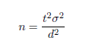(1)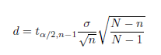 (2)

For vessels in fleet segments > 12 meters in length (LOA), a postal survey will be distributed to a random sample of vessels. A random, stratified sampling approach based on Gross Tonnage will be applied to ensure a representative sample is obtained from each fleet segment. Due to the voluntary nature of the survey, however, a representative sample from each stratum cannot be guaranteed.

Under the terms and conditions of EFF co-funded schemes contained in the National Seafood Development Operational Programme and implemented in the reference year, all vessel owners in receipt of grant-aid will be required to comply with the annual economic survey. Following advice and input from the industry, the timing of the annual survey is now scheduled to coincide with the final date for submission of statutory tax returns for the previous financial year. This is intended to encourage the active participation of fishermen and their accountant’s in providing the relevant data at a single and convenient time of the year. In 2011 IRL remedied the two year lag in the acquisition of economic data by conducting a survey in January 2011 requesting Economic data for 2009 followed by a second call in November 2011 requested Economic data for 2010. This resulted in a move from requesting two years data in the annual survey to just one year. The data call in 2012 requested data for 2011 and resulted in the removal of our two year lag, which we believe improves the NP.

Following advice and input from the industry, the timing of the annual survey is now scheduled to coincide with the final date for submission of statutory tax returns for the previous financial year. This is intended to encourage the active participation of fishermen and their accountant’s in providing the relevant data at a single and convenient time of the year.

Sample evolution over time, rotational groups

Appropriate application of sampling theory will direct the evolution of the sampling framework. Although the voluntary nature of the annual survey prevents the practical development of the sampling frame, the development of such innovation will represent a core function of the DCF staff group.

III.B.2 Estimation
Estimation methods from sample to population

Recognising the implications and influences imposed by the voluntary nature of the annual survey on the probability sample survey design, the Horvitz-Thompson estimator along with standard appropriate raising techniques will be used, to derive final estimates for each variable collected.

The Horvitz–Thompson (HT) estimate of the total is given by:

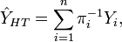

Where Yi is an independent sample from n of N ≥ n distinct strata with a common mean μ. Πi is the inclusion probability that a randomly sampled individual in a superpopulation belongs to the ith stratum.

Imputation of non-responses and non-response adjustments

Non- responses to the probability Sample survey design will be accounted for as follows:

- Substitutes will be selected randomly from the same fleet segment;
- Substituted units will match the characteristics defined by the fleet segment category.

Estimation of capital value and capital costs

In accordance with Appendix VI of Commission Decision (2008/199/EC), the Perpetual Inventory Method (PIM) will be applied to estimate capital value and costs for each of the fleet segments in Table III.B.1. The following input parameters (required by the STECF model) will be estimated;

- Selected capacity unit,
- Price per capacity unit,
- Share in total investment ,
- Government bonds,
- Market rate for loans.

Capacity indicators and capital value will be estimated for all vessels on the register, regardless of their activity. The following sources will be used to estimate the input parameters to the PIM model:

- Questions on fixed assets, investments, and depreciation from the annual economic survey,
- EU fleet register,
- EU log-book data
- Sentinel vessel programme,
- Central Statistics Office (CSO),

Estimation of Employment

In accordance with Appendix VI, a harmonised FTE will be estimated for each of the fleet segments in Table III.B.1. For vessels >10 meters in length (LOA), operational data from log-book submissions will be used in the estimation of fishing time on a trip-by-trip basis. In addition, there are several questions on the annual economic survey forms that deal specifically with hours worked, both at sea and on land-based activities associated with fishing.

III.B.3 Data Quality Evaluation
Sampling methods and measures of data quality, in terms of target precision or percentage coverage, are detailed in table III.B.3 for each of the parameters and the fleet segments. The sampling intensity is based on an analysis of the variance of historic, operational data, as these have proved to be the most uniform, with the aim of achieving a precision of 25% at a 95% confidence level, in line with Level 2 of Commission Decision (2008/199/EC). Variances within fixed costs have proved much higher than expected and, as such, quality will be measured at a coverage rate, commensurate with the target precision for the non-operational parameters. The Member State will seek further statistical advice on this aspect of the National Programme.

A general improvement in the quality of data received from vessel owners has been realised, consistent with the implementation of the following operational measures;

- Ensuring that a qualified accountant signs off on the financial aspects of the survey;
- Timing the survey to the coincide with the end-of-year submission of tax returns to ensure all figures are already checked for the Revenue Commissioner’s Office;
- Requesting full, end-of-year, accountant’s reports.

Data for the 2011/2013 National Programme will be submitted electronically via interactive PDF forms to a centralised database, with pre-validation necessary before the accountants can successfully submit the forms. A secondary validation process will be performed on the data once received, and any erroneous data will be queried directly with the vessel owners or their accountants, by survey personnel. Similarly, any erroneous data supplied by vessel owners, contracted under the sentinel vessel programme, will be queried and rectified by survey personnel, as and when it arises, or at the exit interview stage of the programme.

The template supplied on the DCF website for the calculation of capital value and depreciation will be used as recommended in the National Programme guidelines. The harmonised FTE of 2000 hours will also be used to ensure comparability between Member States datasets.

Under the Probability Sample Survey design, the CV will be used as an accuracy indicator for all variables collected, by segment.

Although error associated with bias and variability will effectively be introduced if observed returns do not match those expected, these descriptors will be reported where possible and with appropriate caveats.

The issue of consistency of data coming from different data sources is recognized as being of significant importance. The introduction of bias in this area, is under continual assessment and is currently being addressed by restricting acceptance of data to a small number of official data streams (i.e. data items consistent with fields in annual company returns (provided via accountants), EU logbook data and Sales notes data).

III.B.4 Data Presentation
For non-transversal variables collected through the annual economic survey, data for a particular reference year will be fully validated and available approximately 15 months from the end of the reference year: data for a particular reference year is collected at the start of November of the following year (to coincide with the final submission date for tax returns for the previous year). A three month period follows before all data is received from those targeted in the survey, with an additional two months for data procession, and validation before the data is ready for transmission.

Economic data from fleet segments < 12 metres, both transversal and non-transversal, will be collected daily and will be available approximately three months from the end of the reference year, allowing for data processing and validation.

III.B.5 Regional Coordination
The Member State will participate at the relevant Regional Coordination Meetings (RCM). However, as all fleets are covered in the National Programme in terms of economic parameters, there are no direct responsive actions required from the Member State from previous RCM recommendations.

III.B.6 Derogations and Non Conformities
None

III.C Biological - metier-related variables

North Atlantic ( ICES areas V-XIV and NAFO areas) and
North Sea ( ICES areas IIIa,IV and VIId and Eastern Arctic ( ICES I and II)

III.C.1 Data Acquisition

III.C.1.a Codification and naming convention
Irish metier groupings for the reference period 2008-2009 were aggregated according to level 6 of the Nantes matrix given in Commission Decision (2008/949/EC) Appendix IV (1-5). These metiers were defined by ranking percentages of landings species components consistent with level 5 target assemblages (i.e. crustacean, demersal, etc) on a trip by trip basis, assigning the largest species component within the trip as the target assemblage. This was carried out for all trips carried out by Irish vessels 10 meters or greater in overall length during the reference period.

III.C.1.b Selection of metiers to sample
Irish logbook, vessel register, and sales note data from 2008 and 2009 were used for the allocation of fishing trips to the matrix given in Commission Decision (2009/949/EC) Appendix IV (1-5), and their subsequent ranking according to landings, effort and first sale value. Data was taken from the Integrated Fisheries Information System (IFIS) database, supplied by the Department of Agriculture, Marine, and Food (DAMF)

Table III.C.1 contains all metiers where trips have been allocated to level 6 of the matrix (for both the North Atlantic, and the North Sea and Eastern Arctic). The two year average of each metier has been ranked in relation to landings, effort and value according to Commission Decision 2008/949/EC to identify the top 90% of each to be covered by the sampling program.

Many of the fishing grounds defined by the RCM segment continuous fisheries, such as highly migratory pelagic species, fisheries following the continental slope edge to the west of Ireland, and demersal fisheries within the Celtic Sea and southern Irish Sea.

Non-sampled metiers are highlighted in grey within Table III.C.1.

The table below are short summaries of the metiers identified as within the top 90% of effort, landings or value.
VI | Bottom Otter Trawl | Demersal Fish | Targeting hake, monkfish, megrim, haddock with by catches of whiting, Nephrops and cod
VI | Midwater Otter Trawl | Small Pelagic Fish | VIa herring, VIa part of wider fisheries for mackerel, scad, sprat, VI blue whiting part of the wider fishery  Boarfish fishery (outside DCF requirements)
VI | Midwater Pair Trawl | Small Pelagic Fish
VI | Pots and Traps | Crustaceans | VIa inshore fisheries for Pink shrimp, Brown crab, Brown crab and lobster, Lobster
VIIa | Beam Trawl | Demersal Fish | Targeting Sole or Rays with by-catches of plaice and other demersal species
VIIa | Boat Dredge | Molluscs | Fisheries for clam, cockle, scallop (with VIIfgh)
VIIa | Bottom Otter Trawl | Crustaceans | Nephrops fishery on the western Irish Sea
VIIa | Bottom Otter Trawl | Demersal Fish | Mixed whitefish fishery with VIIg
VIIa | Pots and Traps | Crustaceans | Inshore fisheries for Brown crab and lobster, Lobster, Velvet crab
VIIa | Pots and Traps | Molluscs | Irish Sea whelk inshore fishery
VIIbcjk | Bottom Otter Trawl | Crustaceans | Nephrops fisheries on the Aran grounds and Porcupine bank
VIIbcjk | Bottom Otter Trawl | Demersal Fish | Hake, monkfish and megrim slope based fisheries
VIIbcjk | Fly Shooting Seine | Small Pelagic Fish | Gear misspecification – PTM for blue whiting
VIIbcjk | Midwater Otter Trawl | Small Pelagic Fish | Part of wider blue whiting, mackerel, scad, sprat and herring fisheries  Boarfish fishery (outside DCF requirements Pilot Survey included for 2013 revision)
VIIbcjk | Midwater Pair Trawl | Small Pelagic Fish
VIIbcjk | Midwater Pair Trawl | Large Pelagic Fish | VIIj and VIIk Tuna fishery
VIIbcjk | Pots and Traps | Crustaceans | Inshore VIIb and VIIj fisheries for Pink shrimp, Brown crab and lobster, Lobster, Spider crab, Velvet crab
VIIbcjk | Set Gillnets | Demersal Fish | Targeting Hake
VIIfgh | Beam Trawl | Demersal Fish | Targeting megrim and anglerfish with by-catches of sole, plaice, rays and other demersal species.
VIIfgh | Boat Dredge | Molluscs | Scallop fishery in VIIg, part of a trans boundary fishery with VIIa. Also a clam fishery
VIIfgh | Bottom Otter Trawl | Crustaceans | Nephrops fishery on the Smalls ground
VIIfgh | Bottom Otter Trawl | Demersal Fish | Targeting haddock, whiting, hake and cod with by-catches of anglerfish, megrim and other demersal species
VIIfgh | Fly Shooting Seine | Demersal Fish | Targeting VIIg roundfish (haddock, whiting , cod and hake) fishery
VIIfgh | Midwater Otter Trawl | Small Pelagic Fish | Part of wider fisheries. VIIg fisheries for herring, sprat, VIIh fisheries for mackerel, scad  Boarfish fishery (outside DCF requirements Pilot Survey included for 2013 revision)
VIIfgh | Midwater Pair Trawl | Small Pelagic Fish
VIIfgh | Set Gillnets | Demersal Fish | Targeting mixed whitefish in VIIg, part of a trans boundary fishery with VIIa
I II | Midwater Pair Trawl | Small Pelagic Fish | Herring fishery
IV VIId | Midwater Otter Trawl | Small Pelagic Fish | Primarily IVa Mackerel fishery
IV VIId | Midwater Pair Trawl | Small Pelagic Fish | Primarily IVa Mackerel fishery
IV VIId | Pots and Traps | Crustaceans | Primarily IVb edible crab fishery

Merging
Within the North Atlantic and the North Sea and Eastern Arctic, the primarily analysis identified 129 individual metiers. For sampling purposes, these have been merged and are shown in (Table III.C.2).

Investigation into the length frequencies of each of the four main species targeted by Ireland with mid-water otter trawls and mid-water pair trawls, namely herring, mackerel, horse mackerel and blue whiting, show great similarity between the two gear types, supporting the merging of metiers with these two gear types for sampling.

- North Atlantic mid-water otter trawls and mid-water pair trawls for small pelagic fish.
The majority of Irish effort directed towards small pelagic fish within the North Atlantic is carried out by mid-water pair trawls, although both gear types occur within the top 90% of landings/effort/value.
- North Sea mid-water other trawls and mid-water pair trawls for small pelagic fish.
The majority of Irish effort directed towards small pelagic fish within the North Sea is carried out by mid-water pair trawls, only mid-water pair trawls are ranked within the top 90%.
- Small pelagic fish directed mid-water other trawls and mid-water pair trawls in areas I and II.
The majority of Irish effort directed towards small pelagic fish within the Eastern Arctic is carried out by mid-water pair trawls, only mid-water pair trawls are ranked within the top 90%.

Additionally, the multivariate metier analysis also highlights a number of distinct metiers that have strong similarities with others in terms of gears and target assemblage and fishing area, but may have relatively low effort making it difficult to identify and target for sampling purposes; the area of activity is spatially discrete but part of a wider area e.g. Celtic Sea. A number of demersal metiers have also been merged as they straddle two or more fishing areas as the fishery is continuous. Based on gear/area/target similarities and a priori knowledge of the fisheries, these metiers have been merged into existing metiers currently being sampled or collapsed to form a new metier for sampling purposes.

National metiers
Ireland has stratified three merged groups beyond the LVL6 metier level. This was done in order to achieve the required data quality whilst capturing temporal and spatial variation. These national metiers are very discrete in time and space. They are explained in the tables below.

In addition new metiers have been identified within the Irish fishery. Two of these are further dis-agregation of existing metiers and one new fishery

OTB_CRU_70-99_0_0 in VIIa has been further dis-aggregated in to OTB_CRU_70-99_0_0 and OTB_CRU_70-99_2_0. This is to reflect the fact that some of the vessels fishing Nephrops in the Irish sea are now using a grid to effect the release of fish. In 2013 this has now changed to OTB_CRU_70-99_1_0 for separator panels , and OTB_CRU_70-99_2_0 for those using grids, with no changes to the overall numbers of trips.

OTB_DEF_100-119_0_0 has also separated in to two national metiers, one targeting Hake Monkfish and Megrim which mainly work on the 200 m contour line and a more inshore component which target gadoids.

Metier LVL6 | National metier | Target species | Space strata | Time strata | Comments
OTB_CRU_70-99_0_0
OTB_CRU_70-99_0_0 | OTB_CRU_70-99_1_0 | Nephrops | VIIa | Yearly | Separator panel or SELTRA
 | OTB_CRU_70-99_2_0 | Nephrops | VIIa | Yearly | Grid
OTB_DEF_100-119_0_0 | OTB_DEF_100-119_0_0 | Hake Monkfish and Megrim | VIIbcjk | Yearly | Fishery on the 200m contour line
OTB_DEF_100-119_0_0 | OTB_DEF_100-119_0_0 | Gadoids | VIIbcjk | Yearly | More inshore and different target species

The PTM_SPF metier encompasses a number of species within the North Atlantic and North Sea and Eastern Arctic regions. These fisheries are largely single species discrete fisheries. This metier is therefore disaggregated to its component fisheries to increase precision of the biological data.

Metier LVL6 | National metier | Target species | Space strata | Time strata | Comments
PTM_SPF_>=32_0_0 | PTM_ASH | Clupea harengus | I II | Monthly estimates between Oct and Jan | Fishery only lasts about 3 weeks
PTM_SPF_>=32_0_0 | PTM_mack_north | Scomber scombrus | IVa | Monthly estimates between Oct and Jan | Fishery only lasts about 6 weeks
PTM_SPF_>=32_0_0 | PTM_mack_west | Scomber scombrus | VI, VII | Monthly estimates between Oct and March
PTM_SPF_>=32_0_0 | PTM_scad_west | Trachurs trachurus | VI, VII | Monthly estimates between Sep and March
PTM_SPF_>=32_0_0 | PTM_mack_biscay | Scomber scombrus | VIII | Monthly estimates between Oct and March
PTM_SPF_>=32_0_0 | PTM_bwg | Micromistius poutassou | IV, VI, VII | Monthly estimates between Jan and March
PTM_SPF_>=32_0_0 | PTM_Her_north | Clupea harengus | VIa | Monthly estimates between Oct and March
PTM_SPF_>=32_0_0 | PTM_Her_I sea | Clupea harengus | VIIaN | Monthly estimates between Aug and Oct | Fishery did not occur in 2008 &2009 and unlikely to occur in 2010
PTM_SPF_>=32_0_0 | PTM_Her_cs | Clupea harengus | VIIaS, VIIg,j | Monthly estimates between Aug and March
PTM_SPF_>=32_0_0 | PTM_spr | Sprattus sprattus | VI, VII | Yearly estimates between Oct and March | Fishery is spasmodic

The FPO_CRU metier discretely targets a number of species with different gears in Area VI and VII. These fisheries are largely single species discrete fisheries using fishery specific types of pots (FPO). This metier is therefore disaggregated to its component fisheries to increase precision of the biological data.

The DRB_MOL metier is further disaggregated into two gear types (Level 4 DRB and HMD) and their component fisheries which target single species. Although two different gears are used only boat dredge is reported within the logbooks. Each gear type targets two species; DRB_Scallop, DRB_SurfClam, HMD_Cockle and HMD_Razor clam.

Disaggregation of potting metier beyond LVL6. FPO type is disaggregated to 4 sub-types.
Metier LVL6 | National metier | Target species | Space strata | Time strata | Comments
FPO_CRU | FPO_ 1Shrimp | Pink shrimp (Palaemon) | VIa, VIIb,j,g,f | Monthly | Seasonal Aug-Mar
FPO_CRU | FPO_ 2Crab | Brown crab (Cancer) | VIa | Monthly
FPO_CRU | FPO_ 2CrabLobster | Brown crab (Cancer) and lobster (Homarus) | VIa, VIIa,b,j,g,f | Monthly
FPO_CRU | FPO_ 2Lobster | Lobster (Homarus) | VIa,  VIIa,b,j,g,f | Monthly
FPO_CRU | FPO_ 3Spider | Spider crab (Maja) | VIIj | Monthly | Seasonal fishery
FPO_CRU | FPO_ 4Velvet | Velvet crab (Necora) | VIIa,b,j | Monthly

Disaggregation of dredge Molluscs metier into component target species
Metier LVL6 | National metier | Target species | Space strata | Time strata | Comments
DRB_MOL | HMD_Cockle | Cockle (Cerastoderma) | VIIa | Monthly estimates | Fishery season varies annually
DRB_MOL | HMD_Razor | Razor clam (Ensis) | VIIa | Monthly estimates
DRB_MOL | DRB_SurfClam | Surf clam (Spisula) | VIIa | Monthly estimates | Fishery season varies annually
DRB_MOL | DRB_Scallop | King Scallop (Pecten) | VIIa,g,f | Monthly estimates

These national metiers were accepted RCM NA 2009

III.C.1.c Type of data collection
Selection of vessels for both on board sampling and for land based sampling is done on a random basis and therefore vessels may be > or < than 10m in length. In the pelagic, Nephrops and the white fish sector the majority of the vessels are >10 m. Relative few onboard samples are taken in the whitefish sector on vessels due to space considerations and vessel safety but these will be covered ashore during the concurrent sampling programme. In the potting and dredge metiers the majority of the vessels are <10m and there are plans to conduct up to 40 trips in this metier

All of the data collected is collected under scheme B) Probability Sample survey, in which data are collected from randomly selected units of a population

Sampling for length requires a greater precision from landings than discards. Therefore, there should be a greater effort directed towards landings sampling. The total numbers of at the market sampling events is more than the total number of at sea sampling events for Ireland.

Concurrent -at- sea:
All of Irelands fishing trips are less that two weeks in duration and will be sampled on a monthly basis, some adjustments have been made due to the seasonality of some fisheries, namely the OTB_CRU in VIIc, VIIfgh and VIIa, where there is greater effort in the summer months and the sampling effort has been reassigned to reflect this. OTB_DEF_in VIb operates for six months of the year and planned sampling levels reflect this seasonality, this metier is now combined with OTB-DEF in VIa. Sampling effort in metiers DRB and FPO (Table III.C.1) metiers targeting bivalves and crustaceans respectively and in the <10m vessels will be allocated mainly to the period March to October to reflect the seasonal pattern of activity. Sampling of the <10m sector will be conducted by MI staff and sub-contractors
Historically Ireland’s discard sampling programme has been metier based and complies with the metier based sampling rules within the new DCF.

Self sampling of Nephrops catch (landings and discards) has been occurring for Nephrops metiers in the Western Irish Sea, Aran and Celtic Sea stocks since the beginning of the data time series. This will be maintained.
BIM will continue to operate a Sentinel Vessel Programme (SVP) which will provide biological data (length composition of catch) for FPO and DRB metiers. This programme also samples transversal data and economic data. In 2010 the number of SVP trips (vessel days) for which fish length data was provided totalled 778. These data therefore support the MI concurrent at sea trips in these metiers and provide additional data at sub-metier level for different components of FPO and DRB metiers targeting and catching single species. In the case of DRB these target fisheries are cockle, surf clam and razor clam. In the case of FPO the target fisheries are brown crab, velvet crab, spider crab, lobster, shrimp and whelk.
In the FPO_MOL_0-0-0 metier targeting Whelks, trips from ICES division VI and Areas VIIbcjk and VIIfgh have been removed from the program, they are not selected in Table IIIC1 but had been included in previous years programs as we were in a position to sample them but now are unable.

Concurrent at the Market:
The residual number of sampling trips will be carried out ashore using MI staff. Concurrent sampling in the markets will be carried out to comply with concurrent sampling scheme 1. The use of Port Contract Samples in the Ports for collection of data from the scallop fishery will continue.

Other [Market stock specific sampling]
Additional measurements on species will be taken by MI personnel and Port Contract Samplers.

Approximately 58% of the annual sampling effort will be directed towards at sea sampling to concurrent sampling Scheme 1 for all metiers. For the PTM there is a greater effort allocated to concurrently sampling landings in the market.

III.C.1.d Target and frame population
A number of base sampling units (frames) have been identified to aid the planning and implementation of the more specific sampling programme. Due to its geographic location, Irish fisheries are conducted over several ICES divisions and general sea areas. The fisheries are conducted from key fishing ports in the North west (Greencastle); the West (Ros a Mhíl and Dingle); the South (Castletownbere, Union Hall, Dunmore East, Kilmore Quay) and the East Coast (Howth and Clogherhead). Within these geographic strata, three high level gear categories have been identified, towed demersal gears (encompassing OTB/SSC/TWR/TBB); towed pelagic gears (PTM/OTM) and static gears (GTN/GTR/LLN/DRG). The combined geographic location and gear type have then been used to codify the sampling frame e.g. S1; NW2 and E3 refers to towed gear in the Southern area; towed pelagic gears in the North West and static gears on the East coast respectively

A number of sampling frames had previously been defined with a seasonal component. These were subsections of categories defined with year round activity. During the first application of sampling frames over 2011, and the retrospective application and reporting for 2010, these subsections were found to be impractical. As a result the seasonal sampling frames have been recombined with the higher level, year round activity. The average trip numbers within the reference years and the planned number of trips for the remaining sampling frames have been updated to include trips from sub-frames based on 2009 and 2010 logbook information.

III.C.1.e Sampling Stratification and allocation scheme
Ireland allocated is sampling effort across the sampling frames according to the rules given in Commission Decision (2009/949/EC). Greater effort was placed into frames with greater variability based on an a priori knowledge of the fisheries as Ireland has been following a metier based sampling approach to its discard sampling programme since 1997.

See comments, suggestions and reflections for further comments on this section.

III.C. 2 Estimation Procedures
Historically Ireland’s discard sampling programme has been metier based and complies with the metier based sampling rules within the new DCF. Raising procedures are based on the number of trips are in accordance with WKDRP (2009). Metier level estimates of discards are obtained by raising the mean discard rate across sampled trips within the specific metier and raised based on the total number of trips performed by the metier as a whole, the total number of trips are based derived from EU logbooks.

III.C. 3 Data Quality Evaluation
Ireland has stratified its fishing metiers and intends to sample all metiers that satisfy the inclusion rules.

Ireland has stratified the pelagic metiers beyond the LVL6 level. This was done in order to achieve the required data quality whilst capturing temporal and spatial variation.

Accuracy: The WKACCU report (2008) provides an extensive list of potential sources of bias and means to mitigate them. Ireland will follow the WKACCU guidelines wherever practical.
Precision: The requirement for concurrent sampling restricts the number of trips that can be sampled due to the high demand on resources for this type of sampling. Therefore the precision levels are likely to be poorer since the introduction of concurrent sampling
Validation and QC: Ireland are using COST tools and a number of in-house tools for data validation and quality control.

At the data collection and the data input stage regular checks are made during collection and all data inputs are cross checked against raw data sheets. Voice report clients are used to check data entered onto the Discard database. At the data extraction stage all age length keys and length frequencies are checked for outliers.

The data are made available to the relevant stock assessment working groups (WGCSE; WGHMM; HAWG; WGWIDE) in the year after the data were collected. The working groups are presented with the model inputs as well as a description of the data and data quality.

III.C. 4 Data Presentation
Data is made available to ICES assessment working groups at least one month before the relevant assessment working group. It is not possible to provide data any sooner due to delivery of finalised catch and effort data from EU logbooks from the previous year. The data delivery time scale is in agreement with stock coordinators for the various stocks. National data is also uploaded into INTERCATCH annually and is made available for ad hoc data calls from the EC.
Ireland is currently undertaking an extensive review of its database structures in order to facilitate expedient data delivery.
Ireland currently supplies the required data to the following working groups,
HAWG, WGWIDE, CSECO, WGHMM, WGEF and WGCRAB

III.C. 5 Regional Co-ordination
‘The Member State on whose territory the first sale of fish landings takes place shall be responsible for ensuring that biological sampling occurs according to the standards defined in this Community Programme. If necessary, Member States shall co-operate with the authorities of non EU third countries to set up biological sampling programmes for the landings carried out by vessels flying the third country’s flag.’ Ireland will follow the recommendations of both SGRN and the North East Atlantic RCM which recommend that foreign landings be sampled in the country of first sale.

Ireland has setup Bi – Lateral agreements with the UK-Scotland, France and Denmark to better co – ordinate this sampling effort. An example of these is included in Annex 1. A request was sent to Spain to set up a bi lateral agreement but no response was received.

Most of these bi laterals are for the sampling of pelagic species. Ireland currently lands into the UK-Scotland, Denmark and France and appropriate sampling requirements are in place. UK-Scotland and Denmark land pelagic species into Ireland and these are also sampled under our routine sampling programme.
Demersal landings from Spain and UK ‘Flag Vessels’ are landed into Ireland but are then transhipped into Spain for first point of sale.

At the request of the RCM, Ireland and UK- Northern Ireland have looked at task sharing in sampling OTB_CRU_0_0_0 in the Celtic Sea. Ireland currently has 13 concurrent-at-sea trips planned for this metier. UK- Northern Ireland effort in this fishery is quite small and they both target the same population.

Recommendation | Responsive Action
MEMBER STATES start bilateral talks as soon as possible, with a view to establishing bilateral agreements on the issue of foreign flag vessel sampling.  RCM encourages MEMBER STATES to include copies of these agreements in their National Program submissions for the year 2006. | Ireland has established Bi-Lateral agreements with the following countries UK-Scotland, France and Denmark.
RCM NEA recommends a case study for gathering all information on discards data of cod, haddock and whiting in Area VI. | This project has been initiated and Ireland has provided all relevant information
RCM NA recommends that Ireland liaise with UK to ensure that the UK sampling coverage suitably covers the Irish metier. | The MS has liaised with UK Northern Ireland and it was assumed that the Irish sampling intensity of 13 trips for this metier would suffice.

Stock related variables: Setting up of Bilateral agreements
RCM NA 2012 Recommendation (RCMNA 4) | RCM NA recommends MS put in place bilateral agreements for sampling of landings abroad where applicable.
Follow-up actions needed | Include bilaterals in the revised NP proposals
Responsible persons for follow-up actions | MS
Time frame (Deadline) | 31 Oct 2012
Follow up by member state | Table completed by Member state

III.C. 6 Derogations and Non Conformities

In addition to the national metiers listed in Table III.C.2. the DRB_MOL metier also targets seed mussel (Mytilus) mainly in the Irish Sea (Area VIIa). These mussels are not landed however but relayed in other areas in Area VII licensed for aquaculture. The catch is composed of ‘seed mussel’ (age 0+) only and the targeted ‘populations’ are ephemeral in nature as they suffer catastrophic natural mortality during winter storms due to shear stress on the sea bed which washes out the seed mussel bed. There is, therefore, no scope to use size or age data of mussels from this metier in stock assessment or in management of the fishery. Stock biomass is assessed annually in a number of seed mussel beds using a combination of acoustic mapping and dredge sampling. These assessments do not require data on size composition other than that which is obtained during dredge sampling at the time of survey.

Ireland seeks derogations to sample discards from the fisheries detailed in the below table and highlighted grey in table III.C.1. Derogations are sought based on low effort levels (<20 days) within métiers and the inability to identify these trips in advance. With specific reference to bottom otter trawl deep-water species, prior to 2008-2009 Ireland had a productive deepwater fishery (of over 200 days per year), there is no longer a directed deepwater fishery (zero trips in 2009).

Those trips with the metier code MIS_DEF_0_0_0 are trips where no gear type was recorded within the logbooks.

Fishing Ground | Gear LVL4 | Target Assemblage  LVL5 | Métier LVL6 | Effort Days
VI | Hand and Pole Lines | Small Pelagic Fish | LHP_SPF_0_0_0 | 1
VIIa | Hand and Pole Lines | Demersal Fish | LHP_DEF_0_0_0 | 1
VIIa | Hand and Pole Lines | Small Pelagic Fish | LHP_SPF_0_0_0 | 3
VIIbcjk | Hand and Pole Lines | Large Pelagic Fish | LHP_LPF_0_0_0 | 8
VIIIabde | Hand and Pole Lines | Large Pelagic Fish | LHP_LPF_0_0_0 | 4
VIIa | Set Longlines | Demersal Fish | LLS_DEF_0_0_0 | 1
VIIbcjk | Set Longlines | Large Pelagic Fish | LLS_LPF_0_0_0 | 4
VIIbcjk | Set Longlines | Small Pelagic Fish | LLS_SPF_0_0_0 | 1
I II | Set Longlines | Demersal Fish | LLS_DEF_0_0_0 | 18
VIIbcjk | Drift Longlines | Demersal Fish | LLD_DEF_0_0_0 | 3
VIIbcjk | Drift Longlines | Large Pelagic Fish | LLD_LPF_0_0_0 | 3
VIIbcjk | Bottom Otter Trawl | Deep-water Species | OTB_DWS_0_0_0 | 18
VIIe | Dredge | Molluscs | DRB-MOL-0_0_0 | 2
VIIIabde | Bottom Otter Trawl | Demersal Fish | OTB_DEF_0_0_0 | 3
VIIe | Beam Trawl | Demersal Fish | TBB_DEF_0_0_0 | 4
VI | Miscellaneous | Demersal Fish | MIS_DEF_0_0_0 | 2
VIa | Miscellaneous | Demersal Fish | MIS_DEF_10_0_0 | 1
VIIbcjk | Miscellaneous | Demersal Fish | MIS_DEF_80_0_0 | 1
VIIbcjkfgh | Miscellaneous | Demersal Fish | MIS_DEF_0_0_0 | 2

III.D Biological - Recreational fisheries

North Atlantic ( ICES areas V-XIV and NAFO areas)

Recreational fisheries in Ireland occur in freshwater and at sea. In the marine environment shore based and sea-based angling targets a wide range of species including shark. Freshwater recreational fishing includes salmon.

III.D.1 Data acquisition
Sea Bass:

The unlicensed recreational bass angling catch is difficult to estimate accurately due to the remote and dispersed nature of the angling venues, and the angling focus for this species is largely conservation oriented with significant catch-and-release (74%) being practised.

Following the publication (2012) of the study carried out in 2011 on the extent of the Sea Bass recreational fishery it concludes that landings are estimated at 11,600 individuals and these anglers harvested 30t of bass in 2010 and 44tin 2011.
In 2013 length and weight will not be sampled due to the low levels of landings. See Formal derogation request.

Eel
Ireland does not have a commercial fishery for Eel. Eel is now protected in Ireland by legislation. Recreational eel fishing is now only carried out by a minority of rod anglers on a catch and release basis.. There are the two byelaws, one prohibiting the issuing of eel fishing licences and the other prohibiting the possession and sale of Irish caught eel: http://www.dcenr.gov.ie/Natural/Inland+Fisheries/Legislation/Bye+Laws/Bye-Laws+2009.htm

- Bye-Law No 858, 2009 prohibits the issue of eel fishing licences by the regional fisheries boards in any Fishery District.

- Bye-law No C.S. 303, 2009 prohibits fishing for eel, or possessing or selling eel caught in a Fishery District in the State until June 2012.

In response to advice from the International Council for the Exploration of the Sea (ICES) that the European eel (Anguilla anguilla L.) is endangered and that the fishery is unsustainable the EC regulation establishing measures for the recovery of the European eel (Council Regulation 11000/2007) was created. Details of MS plans to support this can be found in: http://www.fisheriesireland.ie/Projects/eel-monitoring-programme.html

Length and age composition of eels will not be sampled as there is no legitimate catch
See formal derogation request.

Salmon
There are approximately 140 salmon rivers in Ireland. Both recreational and commercial fisheries take place. Annual catch TACs are estimated for all 140 rivers and harvest of salmon is only allowed provided there is a surplus over the required conservation limit. This TAC is divided between the esturine commercial fisheries and the recreational fishing sector. The recreational catch in 2012 and recreational quota was 90,374salmon. Commercial draft and snap net fisheries operate in the estuaries of 20 rivers. The commercial catch and quota in 2012 were 13,900 salmon and 18,155 salmon respectively.

A drift net fishery which operated up to 2008 in Lough Foyle, a cross boarder fishery jointly managed between the Republic of Ireland and the UK was closed in 2010 and 2011 for conservation purposes.

Sharks
Under the DCF, the term sharks covers all Chondrichthyan fishes, thus sharks, rays, dogfish and Chimaeras. Recreational fisheries for rays are small and dispersed. There is no legal or voluntary declaration of catch. Length and age composition of the recreational catch of rays will not be sampled.
Recreational fisheries for sharks, including dogfish, is on a catch and release basis. Claims for specimen fish of tope and blue shark are now taken as length only, so as to ensure that the fish can be returned alive (http://www.irish-trophy-fish.com/notices/conservation.htm). Most commercial angling operators now take part in the IFI Marine Sport Fish Tagging Programme, where live sharks, skates and rays are tagged with the appropriate tag and released (http://www.fisheriesireland.ie/Tagging/marine-sport-fish-tagging-programme.html). Records are kept by Inland Fisheries Ireland.

Length and age composition of the recreational catch of sharks will not be sampled. See formal derogation request.

III.D.1.a Type of data collection
Salmon: Data is collected on a census basis where all fish are noted in a logbook. Catch data are collected by IFI and Marine Institute. The principal means of data acquisition is by mandatory logbook returns for all fisheries including rod and line. On receipt of a set number of plastic locking carcass tags, anglers also receive a logbook. Both anglers and commercial fishermen are obliged to record all details of their catch in their logbook immediately after killing and tagging the fish. At the end of each season fishermen are obliged to return their logbooks. Data are input to a national data base by IFI. Additional biological information may be taken from private fisheries who keep private records.

III.D.1.b Target Frame and Population
Salmon: The Target Population is every salmon producing river in Ireland of which there are approximately 140.
100% of commercial logbooks are returned while approximately 60 to 70% of angling logbooks are returned annually. Return of logbooks is mandatory.

III.D.1.c Data Sources
Salmon: Carcass tags and Logbooks – source of data anglers and commercial fishermen. Data are processed by IFI and Marine Institute. Samples of fish are measured by IFI and the Marine Institute .

Tagging and tag recovery information – Derived from specific sampling locations in commercial fish dealers premises or recreational fisheries where Binary Nose Coded Tagged salmon are released and subsequently recovered by the Marine Institute. Lengths and weights are recorded and scale samples may be taken.

III.D.1.d Sampling stratification and allocation scheme
Salmon: Sampling programmes are not carried out to estimate the total size of the salmon catch as there is nearly 100% return of commercial logbooks. Logbook return rates range from 60-70% from anglers). A raising factor is applied in the Estimation Procedure (see below) but is not based on sampling of the catch.
Sampling is carried out to estimate exploitation rates in commercial or recreational fisheries in individual rivers. Salmon fisheries data are not generally stratified according to weight but usually by age class. Therefore, commercial catches are reported a grilse (1 sea winter salmon) whereas recreational catches may be split into the two categories i.e. 1 sea winter salmon or multi sea winter (MSW) salmon. The national sampling programme for coded wire tagged salmon involves scanning of commercial catches and recreational catches in many locations around Ireland for the presence of tagged returning adult salmon. Information on lengths, weights and scale samples are taken from random samples during the tag recovery programme. Tag recovery data are raised to the total catch in each district (commercial catch) or rod fishery by multiplying the tag recovery by the ratio of the sampled catch to the total catch. A further raising factor is applied to account for Non-Catch Fishing Mortality (NCFM) in the fisheries i.e. fall outs from nets on haulback, predation by seals or other marine predators and illegal fishing. These are mainly based on reports of local fishery inspectors.

III.D.2 Estimation Procedures
Salmon: The methodology for estimating the recreational catch is to use mandatory returns in logbooks as the primary data source. A national database is available on catches for each individual rivers which are reported in each of the fishery districts based. The data returned in the recreational logbooks are raised to account for non-returned logbooks. A raising factor is applied in the Estimation Procedure (see below). This is estimated from angling returns in mandatory logbooks. A raising factor is applied to account for non-returned angling logbooks (Small, I. (1991) Exploring data provided by angling for salmonids in the British Isles. In: Catch Effort Sampling Strategies - their application in Freshwater Fisheries Management. I.G. Cowx, (Ed.), Blackwell Scientific Publications Ltd.)

III.D.3 Data Quality Evaluation
Salmon: For the purposes of producing an annual record of the catches, logbook returns are generally examined initially by the fishery inspectors inputting data into a national salmon catch database. Any subsequent inconsistencies will then be subject to scrutiny by the data managers in Inland Fisheries Ireland and corrected. A further quality check is undertaken by the National Standing Scientific Committee for Salmon who are responsible for estimating total returns to each river and advising on catch levels.

III.D.4 Data Presentation
Salmon: A full assessment of the status of Irish salmons stocks is carried out by the Standing Scientific Committee who present these results to the DCENR and Inland Fisheries Ireland annually in the form of a written annual report. This is freely available on the DCENR website.

III.D.5 Regional Co-ordination
Sea Bass: N/A
Eel: N/A
Shark: N/A

Salmon
The Wild Salmon and Sea Trout Tagging Scheme is administered by Inland Fisheries Ireland, Cross boarder collaboration with the Loughs Agency (an inter-government agency between Ireland and the UK) occurs in the case of the river Foyle, while inter-governmental collaboration also exists between the UK and Ireland in the case of the River Erne.

III.D.6 Derogations and Non conformities
Ireland formally requests a derogation from sampling the following species and these were presented to the RCM NA 2012

Sea Bass: Based on the results of the pilot survey presented at EWG 12 02. Domestic shore bass anglers are estimated at 11,600 individuals and these unlicensed anglers harvested 30t of bass in 2010 and 44t in 2011. The request for a derogation from this largely catch and release fishery is based on the fact that there are low levels of removals from this unlicensed recreational activity. This coupled with dispersed nature of the anglers would make it extremely difficult and expensive to conduct any meaningful sampling program.
RCM NA 2012 Comment: RCM NA supports the request given the outcomes of the study. Ireland should specify the request officially in the National Program 2013.

Eel-A derogation is requested based on the fact that recreational eel fishing is now only carried out by a minority of rod anglers on a catch and release basis, hence there are no removals from the fishery
RCM NA 2012 Comment: RCM NA supports the request under the assumption that the laws are respected.

Sharks A derogation is requested based on the fact that recreational fishing is small and dispersed and that species are fished on a catch and release basis and therefore there are no removals form the fishery.
RCM NA 2012 Comment: : Given the information provided by the tagging study as well as the assumption that recreational fishery takes place on a catch and release basis, RCM NA supports this request.

III.E Biological - stock-related variables

North Atlantic ( ICES areas V-XIV and NAFO areas) and
North Sea ( ICES areas IIIa,IV and VIId) and Eastern Arctic ( ICES I and II)

III.E.1 Data Acquisition

III.E.1 a Selection of Stocks to sample
Sampling will take place for stocks Table III.E.1. Stocks not sampled are highlighted in pale grey. International landings for 2009 are not available for most stocks, therefore the average EU landings for 2007-8 were used to estimate the share in EU landings for stocks that have no TAC. Landings for “shark-like Selachii”, under highly migratory species in appendix VII are not given because the landings data are not specific enough to distinguish highly migratory shark-like Selachii. However we are confident that Irish landings of these species are negligible.
Interpretation of stock definitions
Appendix VII of Commission Decision (2008/199/EC) lists the stocks for which biological samples are to be collected. Most entries in the table contain more than one ICES Division which might be separated by a comma, a forward slash or a separate row. Neither the Commission Regulation nor the SGRN guidelines offer guidance on the definition of stocks in the table, but it is interpreted as follows: Divisions that are separated by commas are interpreted as being part of the one stock. Divisions that are separated by a forward slash or a separate row of the table are interpreted as belonging to separate stocks. In Tables III.E.1, III.E.2 and III.E.3 each stock is presented in a separate row to avoid confusion.

Combined species
The landings of some species in Appendix VII are reported as groups of species (e.g. anglerfishes, megrims, rays & skates). Where it was not possible to apportion these landings to individual species, the combined landings are reported.

Region
The heading “Region” refers to the region given in Appendix VII. These regions do not correspond to those given in table III.A.1.

III.E.1 b Type of Data Collection
It is nearly impossible to collect data from strictly randomly selected units from the population. However, as far as is practical, all data are collected essentially at random (within practical constraints). Therefore the sampling scheme that most closely resembles the type of data collection used is the probability sample survey.

III.E.1 c Target and Frame Population
The target populations are the stocks defined in Appendix VII of Commission Decision 2008/949/EC. The regulation is not explicit on whether the target population consists of the biological population, the catches or the landings. It is our interpretation that the target population consists of the international landings of each stock (at least for age composition data).
The Frame population generally consists of the landings of the Member State and is therefore only the same as the target frame if all landings are taken by one MS or all MS have identical fisheries. In some cases, parameters are estimated from fishing surveys and in that case the frame population tends to resemble the biological population more closely.

III.E.1 d Sampling Stratification and allocation schemes
Long-term sampling strategy
An overview of the long-term sampling strategy is given in table III E.2. Most stocks will be sampled on an annual basis in order to obtain sufficient sample numbers for a tri-annual update of parameter estimates. From 2010 onwards, maturity and sex-ratio data will be collected on observer trips on an annual basis for most demersal stocks. Previously these data were collected on Q1 groundfish surveys.

Planned sample numbers
Planned sample numbers are given in table III E.3. It is not possible to fill in the field “Fishing ground” in table III E.3 using the fishing ground given in section III.C.1 as suggested in the STECF guidelines because the stocks in table III E.3 cannot be linked directly to the metiers from section III.C.1 (one stock may be fished by many metiers and one metier might target many stocks). For this reason, the field “Fishing ground” is left blank.

Planned minimum number of individuals to be measured at a national level for Homarus gammarus have been adjusted to reflect more reasonable sampling levels.

WKPRECISE (2008) states that “variances of key estimates are typically driven by the number of PSUs [Primary Sampling Units] sampled, and so the effective sample size is usually much smaller than the total number of individuals sampled”. For this reason it is not possible to aim for target precision levels based on the number of individuals sampled without taking into account the number of PSUs (samples, trips etc).

An analysis of the relationship between precision and sample numbers is given In the National Programme 2009-10 IRELAND, Annex 3 and 4. For age sampling it is not possible to achieve precision level 3 as specified without sampling excessively large numbers of fish, which would not be cost-effective. Annex 3 concludes that an annual sample size of 1000-2000 individuals per stock appears to be a reasonable target for estimating the age composition of the commercial catch. Annex 4 concludes that reasonable targets for estimating sex ratio and maturity would be in the order of 100 individuals per age class, so these targets vary from less than 400 for short-lived species to nearly 3000 for species with a large number of age classes in their population.

The national sampling targets that are specified in table III.E.3 are a compromise between the target precision levels, the relevance of the data for stock assessment, the cost and availability of samples. It is expected that precision level 2 (but not level 3) can be achieved for the majority of the stocks that are of significant commercial importance.

Sampling targets at the regional level will be provided by the relevant RCM in 2010.

Data sources
Data will be collected in the ports (landings) on observer trips (discards and landings) and on surveys (Irish Groundfish Survey, Herring Acoustic Surveys, Atlanto/Scandian Herring and Blue Whiting Acoustic Survey).
Age compositions, length and weight data will be mainly obtained from commercial sources (port sampling and observer trips). Data on sex ratio will be mainly be obtained from surveys except for species that are usually landed with their sexual organs intact. Maturity data will be collected from observer trips during quarter-1 and from surveys where appropriate (following guidelines from WKMOG, 2008). Fecundity data will be collected on the Mackerel and Horse Mackerel Egg Surveys on a tri-annual basis. This sampling is internationally coordinated.
Section III.E.2 of the National Programme 2009-10 IRELAND provides a species-specific overview of the data collection of stock related variables.

III.E.2 Estimation Procedures
Age: Age compositions are generally estimated from two-stage sampling where random length samples are taken and length-stratified age samples are used to construct an age-length-key. For herring, mackerel and horse mackerel, random age samples are taken.
Length: Length distributions are obtained from random samples.
Weight: Individual weights are recorded for all fish that are aged. A length-weight relationship is fitted to estimate weight-at-length and weight-at-age is estimated from this using an age-length-key
Sex: Sex-at-age is estimated using a sex-age-length-key
Maturity: Maturity-at-age is estimated using a maturity-age-length-key or, if appropriate, a sex-maturity-age-length-key.
Fecundity: Fecundity is estimated following methods described in WGMEGS (2009)

III.E.3 Data quality evaluation
See section III.E.1 d for an explanation of the planned sampling strategy in terms of the target precision. Recommendations from WKACCU (2008), WKPRECISE (2009) and WKMERGE (2010) have been taken into account for the planning of sampling in 2011-13. Tools developed under the COST project will be used to evaluate precision levels.

The ageing programme has many checks where most species read have two age readers and a percentage of all otoliths are read twice and % agreement and C.V are checked.

III.E.4 Data Presentation
The data are made available to the relevant stock assessment working groups (WGCSE; WGHMM; HAWG; WGWIDE) in the year after the data were collected. The working groups are presented with the model inputs as well as a description of the data and data quality.

III.E.5 Regional co-ordination
Sampling targets at the regional level will be provided by the relevant RCM in the future and are currently unavailable. Recommendations for sampling of Black Sole in 7a are in place.

Stock related variables: Maturity sampling

RCM NA 2009 Recommendation | The RCM NA recommends MS to refer to the table in Annex X of this report for elaborating maturity sampling programmes, when drafting their National Programs.
Follow-up actions needed | STECF/SGRN and the European Commission when evaluating the National Programme proposals 2011-2013.
Responsible persons for follow-up actions | Member states, STECF/SGRN, European Commission.
Time frame (Deadline) | Early 2010
Actions by Member State | Tables IIIE were updated accordingly with reference to Annex X

Stock related variables: Setting up of Pilot programmes for sampling of Boar fish Capros aper
RCM NA 2012 Recommendation (RCMNA 5) | RCM NA recommends MS involved and that have obligations in the Boar fish fishery to set up a pilot program for sampling.
Follow-up actions needed | Include pilot study in the revised NP proposals
Responsible persons for follow-up actions | MS fishing Boar fish
Time frame (Deadline) | 31 Oct 2012
Follow up by member state | Pilot study included in NP 2013 revision

Boar Fish Pilot study is included as Appendix which included the sampling of Boarfish as part of the Concurrent at Sea program and ashore for Length weight, age and maturity.

III.E.6 Derogations and non-conformities
The exemption rules listed under III.B2.5 of Commission Regulation 199/2008/EC have been applied to the stocks in Appendix VII of the Commission Regulation. Stocks exempted from sampling are highlighted in grey in table III E.1. Derogations are not requested for all stocks for which the exemption rules apply as sampling some of these stocks is considered of importance for stock assessment and management.

The table below lists the stocks that will be sampled even though the exemption rules apply.
Species | Stock | Landings | EU share
Lophius budegassa | IV, VI | 360 | 3%
Lophius budegassa | VIIb-k, VIIIabd | 2010 | 6%
Lophius piscatorious | IV, VI | 360 | 3%
Lophius piscatorious | VIIb-k, VIIIabd | 2010 | 6%
Merlangius merlangus | VIa | 80 | 30%
Merlangius merlangus | VIIa | 110 | 57%
Merluccius merluccius | IIIa, IV, VI, VII, VIIIab | 1320 | 3%
Pleuronectes platessa | VIIa | 120 | 65%
Pleuronectes platessa | VIIfg | 60 | 47%
Pleuronectes platessa | VIIbc | 30 | 80%
Pleuronectes platessa | VIIh-k | 70 | 69%
Raja brachyura | all areas | 1150 | 9%
Raja clavata | all areas | 1150 | 9%
Raja montagui | all areas | 1150 | 9%
Raja naevus | all areas | 1150 | 9%
Solea solea | VIIa | 70 | 16%
Solea solea | VIIfg | 30 | 3%
Solea solea | VIIbc | 40 | 80%
Solea solea | VIIhjk | 70 | 45%
Thunnus alalunga | NEA | 1370 | 8%

III.F Transversal variables

Baltic Sea (ICES areas III b-d), North Sea (ICES areas IIIa, IV and VIId) and Eastern Arctic (ICES areas I and II), and North Atlantic (ICES areas V-XIV and NAFO areas)

III.F.1 Capacity

III.F.1.1 Data acquisition
Fleet capacity data is collated on the Irish Register of Sea Fishing. The register is updated quarterly. Data include vessel length (LOA), KWS, GTs, age and segment to which the vessel is registered. In the case of vessels over 10m LOA gears deployed by each vessel will be obtained from logbook data.

Specific actions for vessels < 12m LOA

NOTE: Ireland does not have <12m vessels operating in Baltic Sea (ICES areas III b-d), North Sea (ICES areas IIIa, IV and VIId) and Eastern Arctic (ICES areas I and II

Fleet Segmentation
Appendix IV segmentation is used for collecting all transversal economic parameters. The following data sources have been used to segment the inshore fishing fleet (less than 12 meters in length - LOA) into their main fishing metier:

- EU Fleet Register (from 1 st of January of the reference year)
- Expert knowledge,
- Recorded fishing activity from previous economic surveys,
- National metier analysis.

This segmentation is common to sections III.F.2 (Effort) and III.F.3 (Landings).

Data Sources
The data sources that will be used to estimate capacity variables for the inshore fleet are:

- National Sentinel vessel programme,
- EU Fleet Registers (01/01/2011, 01/01/2012 and 01/01/2013),
- Expert knowledge of fishing activity.

These data sources are common to sections III.F.2 (Effort) and III.F.3 (Landings).

Sampling Strategy
Transversal variables will be collected from a total of 100 vessels under the sentinel vessel programme, using a stratified sampling strategy to target the major fisheries from each of the 5 required metiers. The following sample rates will be achieved:

Metier Targeted Fishery Sample Size Coverage

VII Crustaceans Potters Mixed Crab/Lobsters 15 c.7%
Lobster 16 c. 6%
Shrimps 13 c. 6%
Spider Crabs 3 c. 15%
SUB-TOTAL 47

VI Crustaceans Potters Crabs 5 c. 15%
Mixed Crab/Lobsters 10 c. 8%
Shrimps 4 c. 40%
SUB-TOTAL 19

VIIa Mollusc Potters Whelks 8 c. 20%

VIIa Mollusc Dredgers Razor Clams 6 c. 30%
Cockles 6 c. 15%
Surf clams 3 c. 60%
Scallops 3 c. 65%
SUB-TOTAL 18

VII f-k Gillnetters Demersal spp. 8 c. 25%

Total 100 c. 11%

Data will be collected from all vessels for the reference year(s). Each vessel owner will fill in a daily log-book with details of effort, landings, prices, costs, and biological length measurements where applicable.

This sampling strategy is common to sections III.F.2 (Effort) and III.F.3 (Landings).

III.F.1.2 Data Quality
Data are collected by census and are checked for consistency and duplicates.

Specific actions for vessels < 12 meters
A total of 11% of the active fleet will be sampled under the national sentinel vessel programme. An analysis of variance to calculate the precision of all transversal parameters in each of the metiers will be conducted at the end of the reference year, and the results will be used to assess the sampling requirements for the following year. The population coverage is deemed sufficient to cover all major fisheries within the required metiers.

A quality procedure will be followed for the collection, entry, storage, and validation of all sentinel data. This will include automated checks on economic parameters to ensure they are within acceptable limits, and random checks on data entered by personnel, employed specifically for this purpose. Data will be stored in a computerised system developed specifically for this programme, and the identities of participants and the primary data will be password protected. Only aggregated data will be used for reporting purposes.

Approximately 30% of vessels will be cross-checked by observers collecting biological variables at sea. Any erroneous data identified, will be followed up directly with the vessel owners by survey personnel. A final validation of data will be conducted at the end of year by means of an exit interview with all participants, and feedback on survey procedures will help assist with improving the survey for future years.

An activity profile for each target fishery will be produced, based on effort data collected from the 100 vessels. These profiles, in conjunction with expert knowledge, will be used to estimate the total number of vessels fishing in a particular metier for a given reference year.

Number of vessels
A vessel may fish in several metiers in a given reference year. If a vessel has at least one entry in the sentinel vessel log-book for a particular metier, it will be included in the vessel count for that metier. The total number of vessels active in a metier will be estimated by building up activity profiles of target fisheries within metiers and applying the results to non-sentinel vessels in the same fisheries. In the case of vessels <10m expert knowledge will be applied to the raising procedure from the sentinel vessel programme. In addition, certain vessels will be licensed to only fish within certain metiers, which will increase the accuracy of the final estimates. For example, polyvalent potting vessels will be confined to the potting metiers, and specific vessel will be confined to the dredging metier. These vessels represent 30% and 7% of the <12 meter fleet respectively.

GT, kW, Vessel Age
Fishing capacity data will be taken from the fleet registers as they are on the 1st of January of the reference year. Capacity indicators from inactive vessels will not be included when reporting at the metier level (B1), but will be reported as inactive at the fleet level, in accordance with Appendix III. Capacity indicators will be collected exhaustively from the fleet register.

III.F.2 Effort

III.F.2.1 Data acquisition
The following effort based transversal variables can be provided from the logbook at the appropriate stratification level and units for all Irish vessels >10m: Number of vessels, Days at sea, Hours fished, Fishing days, kW * Fishing Days, GT * Fishing days, Number of trips, Gear type, Number of fishing operations.

Specific actions for vessels under 10meters
The following transversal variables will be collected from pilot programme ‘sentinel vessels’ under 12m LOA, to fulfil the requirements of Appendix VIII of Commission Decision (2008/199/EC)

Variable | Gears | Transversal variables  2011-2013, <12mLOA | Data source
Days at sea | All | Fishing trip dates | Sentinel Log-book
Hours Fished | Dredges and Trawls | Daily fishing time (hrs)  Daily Steaming time (hrs) | Sentinel Log-book
Fishing days | All | Daily fishing records | Sentinel Log-book
kW * Fishing Days | Dredges and Trawls | Daily fishing records * kW of vessel | Sentinel Log-book  EU Fleet Register
GT * Fishing Days | Dredges and Trawls | Daily fishing records * GT of vessel | Sentinel Log-book  EU Fleet Register
Number of trips | All | Daily fishing records | Sentinel Log-book
Number of rigs | Multi rig (level 4) | n/a | n/a
Number of fishing operations | Purse Seine | n/a | n/a
Number of nets, Length | Nets | Lengths of nets in the water  Length of nets hauled today  Soak time of nets  Average length of a net (to estimate numbers) | Sentinel Log-book
Number of hooks/lines | Hooks and lines | n/a | n/a
Number of pots/traps | Traps | Number of pots in the water (daily)  Number of pots hauled (daily) | Sentinel Log-book
Soaking time | All passive gears | Soak time for all passive gears (daily) | Sentinel Log-book

The sampling strategy for the sentinel vessel programme is described in section III.F.1.1 All vessels shall submit completed log-books at the end of the reference year, containing all the relevant transversal variables in the above table. The log-books will be designed to allow entry of effort data from all the applicable gear types. Each trip will be assigned to a metier based on the effort data recorded. In this manner, an activity profile for targeted metiers will be built up that will be used to estimate fishing effort for the rest of the active inshore population.

III.F.2.2 Data quality evaluation
Logbook data for >10m are collected by census and are quality checked using a series of algorithms and integrated with VMS database.

III.F.2.3 Data Presentation
Transversal variables collected through the annual economic survey for a particular reference year will be fully validated and available approximately 15 months from the end of the reference year; data for a particular reference year is collected at the start of November of the following year (to coincide with the final submission date for tax returns for the previous year). A three month period follows before all data is received from those targeted in the survey, with an additional two months for data procession, and validation before the data is ready for transmission.

Transversal data from fleet segments < 12 metres, will be collected daily and will be available approximately three months from the end of the reference year, allowing for data processing and validation.

III.F.2.4 Regional co-ordination
Logbook information for Irish vessels landing in other MS is transmitted to Ireland and reciprocal arrangements are in place for foreign vessels landing in Ireland.

III.F.2.5 Derogations and non-conformities
The following effort based transversal variables cannot be provided from the logbook at the appropriate stratification level and units for all Irish vessels >10m: Number of rigs, Number of nets / Length, Number of hooks, Number of lines, Numbers of pots, traps and soaking time. This data are not collected routinely and are not mandatory for reporting in the logbooks. The only way these variables can be collected is by developing a sampling programme. Given the diversity of vessels and operations involved and the heterogeneity of activities in space and time the cost of such a programme would be prohibitive at this time. Therefore Ireland seeks a derogation for these variables for vessels over 10m but will cover some vessels in the 10-12m LOA category as these, with the vessels u10m LOA, comprise the shellfish metier.

The Member State understands that from 2011 onwards this information will be collected in the electronic log book and this will facilitate the member state in collecting the information.

III.F.3 Landings

III.F.3.1 Data acquisition
Landings data will be provided, at the appropriate stratification level and units for all Irish vessels >10m, from logbook data, sales notes data and national statistics on landings by port.
Specific actions for vessels < 10 meters.

The following economic parameters will be collected from all sentinel vessels, to fulfil the requirements of Appendix VIII of Commission Decision (2008/199/EC)).

Variable | Economic Parameters  To be collected in 2011-2013 | Data source
Value of landing | Boxes / Kg landed per species  Price achieved per species | Sentinel Log-book  Sales Notes data  National Statistics on landings by Port
Live Weight of landings | As above | As above
Prices by commercial species | As above | As above

The sentinel log-books will be designed to allow entry of landings by weight and value by species. The data collected will be used to raise the parameters in the above table to the metier level. This will be achieved by cross referencing the species assemblages landed by particular metiers in the sentinel programme, with national statistics on landings, at the fishing port level, in the inshore sector.

III.F.3.2 Data Quality
Specific actions for vessels under 10 meters; See section III.F.1.2

III.F.3.3 Data Presentation
Transversal variables collected through the annual economic survey for a particular reference year will be fully validated and available approximately 15 months from the end of the reference year; data for a particular reference year is collected at the start of November of the following year (to coincide with the final submission date for tax returns for the previous year). A three month period follows before all data is received from those targeted in the survey, with an additional two months for data procession, and validation before the data is ready for transmission.

Transversal data from fleet segments < 12 metres, will be collected daily and will be available approximately three months from the end of the reference year, allowing for data processing and validation.

III.F.3.4 Regional co-ordination
Logbook information for Irish vessels landing in other MS is transmitted to Ireland and reciprocal arrangements are in place for foreign vessels landing in Ireland.

III.F.3.5 Derogations and non-conformities
None

III.G Research surveys at sea

Ireland meets the criteria for research surveys as defined in Appendix IX of Commission Decision (2008/199/EC).

Ireland participates in several ICES expert groups that deal with the coordination and organisation of these surveys. These groups are as follows:

IBTS Working Group (International bottom trawl surveys)
WGIPS (Co-ordinates herring surveys)
PGNAPES (Co-ordinates blue whiting and Atlanto-Scandian herring surveys)
WGMEGS (Co-ordinates mackerel and horse mackerel egg surveys)
WGNEPHSURV (Co-ordinates Nephrops underwater television surveys)
PGNEACS (Co-ordinates North east Atlantic Continental Slope Survey)

In 2011-2013, the Irish Marine Institute plans to conduct or participate in the following surveys:

- International Ecosystem Survey in the Nordic Sea ( Participation only)
- Western IBTS Fourth Quarter Groundfish Survey
- International Blue Whiting Spawning Stock Survey
- International Mackerel and Horse Mackerel Egg Survey
- Spawning Herring Acoustic Survey in the Celtic Sea
- Pre Spawning Herring Acoustic Survey on the Malin Shelf
- Nephrops UWTV Survey Irish Sea
- Nephrops UWTV Survey Aran Grounds
- Nephrops UWTV Survey Celtic Sea

111 G.1.1 Planned Surveys International Ecosystem Survey in the Nordic Sea
Aim: The aim of the survey is to provide fishery independent indices of abundance on Atlanto-Scandian Herring (ASH) and Blue Whiting to the Northern Pelagic and Blue Whiting Fisheries Working Group (NPBWWG). It also provides ecosystem data on the Norwegian and Barents Seas to other working groups.

Data Collection: Spatial coverage extends from approximately 62° to 73° N and between 5° W and 10° W and includes extensive hydrographic data. Ireland receives a share of the TAC for both stocks and sends one Scientist on the southern leg of the survey.

Data Storage: The survey data is stored in the international ICES PGNAPES database for ASH and Blue Whiting.

Ecosystem indicators

The International Ecosystem Survey in the Nordic Sea satisfies the criteria listed in relation to ecosystem indicators 1, 2, 3 and 4.

Ireland plans to send one scientist to participate in this survey.

For survey map please refer to the Danish NP Proposal

III.G.1.2 Modifications in the surveys
See Danish NP

III.G.1.3 Data Presentation
See Danish NP

III.G.1.4 Regional Co-ordination
See Danish NP

III.G.1.5 Derogations and Non conformities
See Danish NP

111.G.2.1 Planned Surveys Western IBTS Fourth Quarter Groundfish Survey

Aim: The Western IBTS Fourth Quarter Groundfish Survey collects data on the distribution, relative abundance and biological parameters of commercial stocks in VIaS, VIIb, VIIgN & VIIjN After commissioning of a new research vessel in 2003 the current time series was initiated and built on two independent existing time series.

Sampling is carried according to a depth stratified semi-random design where 25% of stations are allocated randomly. Data acquired from the Irish seabed mapping programme as well information from commercial fisherman is then used to source suitable fishing location within 10nmi of these random locations. The remaining 75% of stations are selected at random from the survey database of clear tows, ensuring a minimum of 10nmi between stations.

Planned survey stations are shown in Figure 1

III.G.2.2 Modifications in the surveys
No changes or modification to the survey design are foreseen.

III.G.2.3 Data Presentation
The target species are sampled for length, sex ratio, weight, age and maturity. The currently utilised survey assessment indices are for cod haddock, whiting, plaice, sole and hake. There are a number of other species with adequate time series that could be used, and it is anticipated that the list of species will expand over time in accordance with the ICES benchmark system, which limits the addition of ‘new’ data until a given stock is subject to a benchmark assessment (approximately every 3 years). Data is also collected and provided for other demersal stocks (i.e. cod, white & black anglerfish, megrim, lemon sole, hake, saithe, ling, blue whiting and a number of elasmobranchs) as well as several pelagics (herring, horse mackerel and mackerel).

The survey data is captured directly into Microsoft Access with subsequent transfer to SQLServer. Following validation and quality checks the data is uploaded into the ICES DATRAS database and also presented annually through IBTSWG.

In addition to sampling of target species, the entire catch is sorted and quantified to as close to species level as is consistently possible, given the resources. This data has been utilised in a number of ecosystems as well and in biological and environmental impact studies. This Survey satisfies the criteria listed in relation to ecosystem indicators 1, 2, 3 and 4.

This Survey also continues to contribute data to a number of oceanographic datasets such as EUROGOOS as well as marine habitat classification programmes such as INFOMAR

III.G.2.4 Regional Co-ordination
Survey planning is presented at the International Bottom Trawl Working Group (IBTS) and sampling protocols adhere to the prescribed IBTS manual.

As with the other IBTS coordinated surveys in the Western Area, a narrow corridor of overlap is designed in to the survey area to facilitate ongoing comparison of survey trends between this survey and it’s neighbouring IBTS surveys. This survey is, however, the important and only link in coverage between the Scottish survey to the north, Spanish Porcupine survey to the west, UK to the east and south, as well as French survey in the central and southern Celtic Sea.

Three intercalibration exercises have taken place between the Spanish Porcupine Survey and this survey, as well as earlier calibration studies with the neighbouring French and Scottish groundfish surveys as part of the IPROSTS EU Study Contract 98-057.

III.G.2.5 Derogations and Non conformities
None exist at this time

III.G.3.1 Planned surveys Blue Whiting Survey
Survey Aims
The aim of the survey is to provide an estimate of relative abundance to the Working Group of Widely Distributed stocks (WGWIDE) and to compile a global time series of estimates that can be used to tune the assessment of this stock.
- Collect acoustic data on spawning and post spawning aggregations of blue whiting (Micromesistius poutassou) along the northern migration pathway from key spawning areas in target sub areas 1 and 2b and 2a (PGNAPES defined)
- Determine an age stratified estimate of relative abundance and biomass of blue whiting within the survey area
- Collect biological samples from directed trawling on insonified fish echotraces to determine age structure and maturity state of the standing stock
- Collect physical oceanography data as horizontal and vertical profiles from a deployed sensor array
- Provide biological and acoustic data to the PGNAPES database for the determination of blue whiting spawning stock biomass within the western spawning region
- Conduct a abundance and distribution survey of marine mammals and seabirds

Data collection:
Acoustic data is collected during the survey using a Simrad ER60 scientific echosounder operating over four frequencies (18, 38, 120 & 200kHz). All hydrographic data collected during vertical CTD casts is collected using a SeaBird 911 CTD unit. Biological data recording length, weight, sex, maturity and age data from target species collected during fishing operations is stored on an Access database and up loaded to a Sequel Server database at the Institute. All survey data is stored in raw and processed formats.

Data Storage
All survey data is stored both by the Marine Institute and in a web based International survey database for all survey participants. Within the Marine Institute all survey data are stored in 3 formats; electronically on a Sequel Server database platform and as two hard copies (DVD and High capacity storage discs). The international database contains data collected in all aspects of the survey (acoustic, biological and hydrographic). This database is coordinated and managed through ICES PGNAPES by the Faeroes. Access to the online database is via http://oracle.frs.fo/apex

Ecosystem indicators
The Blue Whiting survey satisfies the criteria listed in relation to ecosystem indicators 1, 2, 3 and 4.

The proposed acoustic cruise track for the 2013 survey is shown in Figure 2

III.G.3.2Modifications in the surveys
No major modification to the survey design is foreseen in the near future.

III.G.3.3 Data Presentation
Collated data on biomass and abundance for the International synoptic spawning stock survey (and component national survey reports are) presented annually in the WGNAPES report. The combined survey report is presented as a working document to WGWIDE. Aggregated and dis-aggregated survey data for all participant nations are available through a web based database portal managed by the Faroe Islands Institute of Fisheries.

III.G.3.4 Regional Co-ordination
The international blue whiting spawning stock survey is carried out by 5 participant nations (EU: Ireland and the Netherlands, Norway, Faroe Islands, Russian Federation). Coordination is carried out for the following year’s survey at the annual WGNAPES. Over the last 4 years Ireland has acted as International survey coordinator charged with maintaining communications between vessels at sea, instigating inter-calibration exercises, compiling the international report and data coordination. Survey information is collated, problems encountered are discussed and a survey report is produced at a post cruise meeting held at the end of the joint survey program.

III.G.3.5 Derogations and Non conformities
None exist at this time

III.G.4.1 Planned surveys International Mackerel and Horse Mackerel Egg Survey
The aim of the survey is to assess the spawning stock biomass of mackerel and horse mackerel in the Northeast Atlantic.

Mackerel and horse mackerel eggs are extracted from plankton samples collected using a GULF VII sampler. The numbers of stage 1 eggs are used to calculate annual egg production. Adult fish are collected for the analysis of fecundity and atresia. These egg production and fecundity estimates are subsequently used to calculate spawning stock biomass for the assessment working group, WGWIDE. All survey and sampling protocols have been developed by WGMEGS. The international survey programme covers the eastern Atlantic from Gibraltar to the north of Scotland between January and July. Sampling grid resolution is 0.5° latitude by 0.5° longitude. Participants are assigned a sampling area but the survey is adaptive. Survey transects are continued until two consecutive samples containing zero mackerel or horse mackerel eggs are encountered. Ireland conducts two surveys between 48°N and 60°N, one in March, the second in July.

The Irish mackerel egg survey data is stored in a series of Excel spreadsheets and is forwarded to the data coordinator in MSSML, Scotland, where it is held on the international egg survey database.

The mackerel and horse mackerel egg survey satisfies the criteria listed in relation to ecosystem indicators 1, 2, 3, and 4.

The proposed cruise track for the 2013 survey is shown in Figure 3

III.G.4.2 Modifications in the surveys
Any changes to survey coverage or protocols will be adopted at the WGMEGS planning meeting in 2012.

III.G.4.3 Data Presentation
Provisional data will be prepared for the WGWIDE meeting in 2013. Final data will be presented at WGMEGS 2014.

III.G.4.4 Regional Co-ordination
The International Mackerel and Horse Mackerel Egg survey is a tri-ennial survey coordinated between ten national laboratories in nine countries. Finlay Burns, from MSSML in Scotland, is survey coordinator.

III.G.4.5 Derogations and Non conformities
None exist at this time

III.G.5.1 Planned surveys Spawning Herring Acoustic Survey
Survey Aims
The aim of the survey is to provide an estimate of relative abundance to the WGHAWG and to compile a relative time series that can be used to tune the stock assessment.
- Collect acoustic data on pre-spawning and spawning aggregations of herring (Clupea harengus) within key spawning areas in the Celtic Sea.
- Determine an age stratified estimate of relative abundance of herring within the survey area (ICES Divisions VIIb, VIIj, VIIg and VIIaS)
- Collect biological samples from directed trawling on insonified fish echotraces to determine age structure and maturity state of the herring stock
- Collect ancillary information on secondary pelagic species such as sprat and pilchard to determine biomass and abundance within the survey area
- Collect physical oceanography data as horizontal and vertical profiles from a deployed sensor array.
- Survey by visual observations marine mammals and seabird abundance and distribution during the survey

Data collection:
Acoustic data is collected during the survey using a Simrad ER60 scientific echosounder operating over four frequencies (18, 38, 120 & 200kHz). All hydrographic data collected during vertical CTD casts is collected using a SeaBird 911 CTD unit. Biological data collected during the survey in the form of length, weight, sex, maturity and age data from target species collected during fishing operations is stored on an Access database and up loaded to a Sequel Server database at the Institute. All survey data is stored in raw and processed formats.

Data storage
All survey data is stored both by the Marine Institute and in a web based International survey database for all survey participants. Within the Marine Institute all survey data are stored in 3 formats; electronically on a Sequel Server database platform and as two hard copies (DVD and High capacity storage discs). A web based International survey database (FishFrame) is available for data submission by survey participants. This database contains data collected in all aspects of the survey (acoustic, biological and hydrographic). This database is coordinated and managed through ICES WGIPS. The online database is managed by the Danish and is available through http://dmz-web08.dfu.min.dk/NorthSea/FishFrame/

Ecosystem indicators
The spawning herring survey satisfies the criteria listed in relation to ecosystem indicators 1, 2, 3 and 4.

The proposed acoustic cruise track for the 2011-2013 surveys are shown in Figure 4.

III.G.5.2 Modifications in the surveys
No major modification to the survey design is foreseen in the near future.

III.G.5.3 Data Presentation
All survey data is collated and is submitted annually to HAWG for use in the stock assessment process. Aggregated and dis-aggregated survey is held on-site at the Institute and is available on request. Steps are being taken to have survey data included into the FishFrame database.

III.G.5.4 Regional Co-ordination
Ireland remains the only country with a long standing survey time series for this stock. Ireland is the only nation that has a targeted fishery for herring in this region in recent years. Due to the relative isolation of this stock solely in terms of linking in with other existing coordinated surveys this is difficult to achieve in the short term. Data from this survey program will continue to actively feed into expert groups such as SGHERWAY, WGIPS and HAWG.

III.G.5.5 Derogations and Non conformities
None exist at this time

III.G.6. 1 Planned surveys Pre Spawning Herring Acoustic
Survey Aims
The aim of the survey is to provide an estimate of relative abundance to the HAWG and to extend the tuning series used in the assessment.
- Collect acoustic data on pre-spawning and spawning aggregations of herring (Clupea harengus) within summer feeding areas to the west of Ireland and Scotland (53º30-57ºN).
- Determine an age stratified estimate of relative abundance of herring within the survey area (ICES Divisions VIaS and VIIb)
- Collect biological samples from directed trawling on insonified fish echotraces to determine age structure and maturity state of survey stock
- Collect physical oceanography data as horizontal and vertical profiles from a deployed sensor array.
- Sighting survey of marine mammals and seabirds encountered during the survey

Data collection:
Acoustic data is collected during the survey using a Simrad ER60 scientific echosounder operating over four frequencies (18, 38, 120 & 200kHz). All hydrographic data collected during vertical CTD casts is collected using a SeaBird 911 CTD unit. Biological data collected during the survey in the form of length, weight, sex, maturity and age data from target species collected during fishing operations is stored on an Access database and up loaded to a Sequel Server database at the Institute. All survey data is stored in raw and processed formats.

Data storage
All survey data is collected and stored both by the Marine Institute and in a web based International survey database (FishFrame) for all survey participants. This database contains data collected in all aspects of the survey (acoustic, biological and hydrographic). This database is coordinated and managed through ICES WGIPS. FishFrame is available at http://dmz-web08.dfu.min.dk/NorthSea/FishFrame/

Ecosystem indicators
The pre-spawning herring survey satisfies the criteria listed related to ecosystem indicators 1, 2, 3 and 4.

The proposed acoustic cruise track for the 2011-2013 surveys are shown in Figure 5.

III.G.6.2 Modifications in the surveys
Survey coverage was extended northwards in 2010 to 57ºN on recommendation of SGHERWAY to co-survey the area currently covered by the Scottish vessel. This area continues to produce a high degree of inter-annual variability in terms of herring biomass in the Malin shelf stock region. The use of two vessels synoptically covering the grounds will try to address this source of noise in the assessment.

III.G.6.3 Data Presentation
Collated data on biomass and abundance for the Malin shelf synoptic stock survey (and component national survey reports are) presented annually in the WGIPS report. A combined survey report is presented as a working document to WGHAWG. Aggregated and dis-aggregated survey data for participants are available through a web based database portal managed by the Danish Fisheries Institute and available at http://dmz-web08.dfu.min.dk/NorthSea/FishFrame/

III.G.6.4 Regional Co-ordination
Surveys of the Malin Shelf stock are coordinated through WGIPS for the following year’s survey. Area coverage and effort allocation are decided in advance. In 2010 a post cruise meeting will be established to collate survey data and produce a combined report. Ireland in 2010 have been nominated as survey coordinators for the Malin Shelf.

III.G.6.5 Derogations and Non conformities
Non exist at this time

III.G.7.1 Planned surveys Nephrops UWTV Irish Sea

The main aims of the survey are to collect Nephrops burrow density estimates from a randomised fixed (3.5 nmi) grid of stations in the Western Irish Sea. Typically this amounts to around 140 UWTV stations although this may vary slightly (+-5%) depending on the randomisation. At each site 10 minutes of geo-referenced and “field of view calibrated” video footage is collected. This footage is reviewed independently by two trained and “calibrated” Nephrops burrow counters to obtain quality assured average minute by minute burrow counts. These data are in turn used to estimate the abundance and spatial distribution of Nephrops burrows over the ground. The results feed into the stock assessment and scientific management advice for this stock. Ancillary information on Nephrops activity, behaviour and fishing impacts is also collected. Environmental conditions are also monitored using a sledge mounted CTD at each deployment location.

The survey design and protocols are described more fully in the WKNEPHTV 2007 report http://www.ices.dk/workinggroups/ViewWorkingGroup.aspx?ID=210. Calibration footage and training protocols follow the recommendations of WKNEPHBID 2008 http://www.ices.dk/workinggroups/ViewWorkingGroup.aspx?ID=262.

The data collected, validated and stored at sea in a specifically designed Access database. Following QA and QC procedures the data are uploaded to SQL database in the Marine Institute. The worked up results are transmitted to the relevant ICES Working Group (WGCSE).

This survey provides fishery independent information on the abundance of Nephrops. The results together with those collected in an associated AFBI trawl survey can be used to define the conservations status of that stock (indicator 1).

Planned survey stations are shown in Figure 6

III.G.7.2 Modifications in the surveys
In 2012 SGNEPS carried out an analysis which showed that sampling intensity on the Aran and in the Celtic Sea grounds could be reduced without significant loss in accuracy and with minimal reductions in precision. SGNEPS also recommended minimum precision levels (<20%RSE) for UWTV surveys and that sampling intensity of all surveys should be reviewed. SGNEPS 2012 further recommended that Survey coverage should be extended to other important grounds such as FU16, FU19, FU20-21, FU33 and FU30. With these recommendations in mind Ireland will review sampling intensity in the Western Irish Sea in collaboration with AFBI (UK-Northern Ireland). Following the results of this review there may well be grounds to reduce sampling intensity in the Irish Sea for the 2013 survey season. The sampling intensity will be modified such that it generates an abundance estimate with relative standard error or CV of around 10% which is below the 20% threshold recommended by SGNEPS 2012. Any ship time saved will be used to extend UWTV survey coverage to the other Nephrops grounds within Irish waters (FU16, FU19, FU20-21).

III.G.7.3 Data Presentation
The survey results are presented annually to the working group on the Celtic Sea ecoregion (WGCSE) as a working document. http://www.ices.dk/reports/ACOM/2009/WGCSE/01_General_2009.pdf
The results are used in the assessment and formulation of catch options.
http://www.ices.dk/reports/ACOM/2009/WGCSE/06.5_Nephrops_VIIa_FU15.pdf

III.G.7.4 Regional Co-ordination
Regional co-ordination is carried out through Study Group on Nephrops Surveys. http://www.ices.dk/workinggroups/ViewWorkingGroup.aspx?ID=338

III.G.7.5 Derogations and Non conformities
None exist at this time

III.G.8.1 Planned surveys Nephrops UWTV Aran Grounds
The main aims of the survey are to collect Nephrops burrow density estimates from a randomised fixed (2.25 nmi) grid of stations in the Aran Grounds. Typically this amounts to around 65 UWTV stations although this may vary slightly (+-5%) depending on the randomisation. Indicator stations are also surveyed at 9 sites in Galway Bay and off Slyne Head. At each site 10 minutes of geo-referenced and “field of view calibrated” video footage is collected. This footage is reviewed independently by two trained and “calibrated” Nephrops burrow counters to obtain quality assured average minute by minute burrow counts. These data are in turn used to estimate the abundance and spatial distribution of Nephrops burrows over the ground. The results feed into the stock assessment and scientific management advice for this stock. Ancillary information on Nephrops activity, behaviour and fishing impacts is also collected. In addition 5 beam trawls are carried out to provide Nephrops for length, weight, sex and maturity sampling. Environmental conditions are also monitored using a sledge mounted CTD at each deployment location.

The survey design and protocols are described more fully in the WKNEPHTV 2007 report http://www.ices.dk/workinggroups/ViewWorkingGroup.aspx?ID=210. Calibration footage and training protocols follow the recommendations of WKNEPHBID 2008 http://www.ices.dk/workinggroups/ViewWorkingGroup.aspx?ID=262.

The data collected, validated and stored at sea in a specifically designed Access database. Following QA and QC procedures the data are uploaded to SQL database in the Marine Institute.

Planned survey stations are shown in Figure 7

III.G.8.2 Modifications in the surveys
In 2012 SGNEPS carried out an analysis which showed that sampling intensity on the Aran grounds could be reduced without significant loss in accuracy and with minimal reductions in precision. SGNEPS also recommended minimum precision levels (<20%RSE) for UWTV surveys and that sampling intensity of all surveys should be reviewed. SGNEPS 2012 further recommended that Survey coverage should be extended to other important grounds such as FU16, FU19, FU20-21, FU33 and FU30. With these recommendations in mind Ireland proposed to modify the sampling intensity on the Aran grounds from a grid of 2.25 nmi to a grid of 4 nmi. The grid shape will also be modified from rectangular to triangular grid or isometric grid (e.g. Figure 8). This is expected to lead to a survey estimate with an RSE below 10% which is well below the SGNEPS recommended limit. The number of stations required reduces by around 50% and time required on the Aran grounds by approximately 40%.

Ireland intends to use the time saved here and on other UWTV surveys to extend survey coverage to other areas within Irish waters such as FU16, FU19, FU20-21. An example survey plan is for the Porcupine Bank with a 6 nmi isometric grid is shown in Figure 9. This survey would take approximately 5 days to complete with no weather or technical down time. A pilot survey on FU16 has been successfully carried out in 2012 in conjunction with the Aran UWTV survey. Extending UWTV survey coverage to previously un-surveyed areas within current resource constraints will result in a better basis for assessment and management of data limited Nephrops stocks.

III.G.8.3 Data Presentation
The survey results are presented annually to the working group on the Celtic Sea ecoregion (WGCSE) as a working document. http://www.ices.dk/reports/ACOM/2009/WGCSE/01_General_2009.pdf.The results are used in the assessment and formulation of catch options.
http://www.ices.dk/reports/ACOM/2009/WGCSE/07.5_Nephrops_VIIb_FU17.pdf

III.G.8.4 Regional Co-ordination
Regional co-ordination is carried out through Study Group on Nephrops Surveys. http://www.ices.dk/workinggroups/ViewWorkingGroup.aspx?ID=338

III.G.8.5 Derogations and Non conformities
None exist at this time

III.G.9.1 Planned surveys Nephrops UWTV Survey Celtic Sea
The main aims of the survey are to collect Nephrops burrow density estimates from a randomised fixed (3.5 nmi) grid of stations in the Celtic Sea deep area. Typically this amounts to around 100 UWTV stations although this may vary slightly (+-5%) depending on the randomisation. Indicator stations are also surveyed at 15 other sites in the Celtic Sea. At each site 10 minutes of geo-referenced and “field of view calibrated” video footage is collected. This footage is reviewed independently by two trained and “calibrated” Nephrops burrow counters to obtain quality assured average minute by minute burrow counts. These data are in turn used to estimate the abundance and spatial distribution of Nephrops burrows over the ground. The results feed into the stock assessment and scientific management advice for this stock. Ancillary information on Nephrops activity, behaviour and fishing impacts is also collected. In addition 7 beam trawls are carried out to provide Nephrops for length, weight, sex and maturity sampling. Environmental conditions are also monitored using a sledge mounted CTD at each deployment location.

The survey design and protocols are described more fully in the WKNEPHTV 2007 report http://www.ices.dk/workinggroups/ViewWorkingGroup.aspx?ID=210. Calibration footage and training protocols follow the recommendations of WKNEPHBID 2008 http://www.ices.dk/workinggroups/ViewWorkingGroup.aspx?ID=262.

The data collected, validated and stored at sea in a specifically designed Access database. Following QA and QC procedures the data are uploaded to SQL database in the Marine Institute.

Planned survey stations are shown in Figure 10

III.G.9.2 Modifications in the surveys
In 2012 SGNEPS carried out an analysis which showed that sampling intensity on the Smalls Nephrops grounds could be reduced without significant loss in accuracy and with minimal reductions in precision. SGNEPS also recommended minimum precision levels (<20%RSE) for UWTV surveys and that sampling intensity of all surveys should be reviewed. SGNEPS 2012 further recommended that Survey coverage should be extended to other important grounds such as FU16, FU19, FU20-21, FU33 and FU30. With these recommendations in mind Ireland proposed to modify the sampling intensity on the Smalls grounds from a grid of 3 nmi to a grid of 4.5 nmi. The grid shape will also be modified from rectangular to triangular grid or isometric grid (e.g. Figure 11). This is expected to lead to a survey estimate with an RSE below 10% which is well below the SGNEPS recommended limit. The number of stations required reduces by around 50% and time required on the Smalls grounds by approximately 40%.
Ireland intends to use the time saved here and on other UWTV surveys to extend survey coverage to other areas within Irish waters such as FU16, FU19, FU20-21. An example survey plan is for FU19 is shown in Figure 12.

III.G.9.3 Data Presentation
The survey results are presented annually to the working group on the Celtic Sea ecoregion (WGCSE) as a working document. http://www.ices.dk/reports/ACOM/2009/WGCSE/01_General_2009.pdf
The results are used in the assessment.
http://www.ices.dk/reports/ACOM/2009/WGCSE/07.7_Neph_FU20_22.pdf

III.G.9.4 Regional Co-ordination
Regional co-ordination is carried out through Study Group on Nephrops Surveys. http://www.ices.dk/workinggroups/ViewWorkingGroup.aspx?ID=338

III.G.9.5 Derogations and Non conformities
None exist at this time

Module of the evaluation of the economic situation of the aquaculture and processing industry

IV.A Collection of data concerning the aquaculture

IV.A.1 General description of the aquaculture sector
Ireland has a relatively diverse aquaculture sector operating across a number of different sub sectors. The main species produced in Ireland are blue mussel (Mytlus edulis), native oyster (Ostrea edulis), Pacific (gigas) oyster (Crassostrea gigas), salmon (Salmo salar) and rainbow trout (Oncorhynchus mykiss).

In Ireland, all aquaculture operations must be licensed under the Fisheries (Amendment) Act 1997 by the Minster for the Department of Agriculture, Marine and Food (DAMF). Licences are issued on a site-by-site basis, which means that one aquaculture producer may hold several licences.

In 2009, the total volume of the shellfish and finfish sectors was 47,408 tonnes, which was a 5.3 % increase on aquaculture data that was gathered in 2008. Harvest value also increased by 13.4 % to give a total aquaculture value of € 106.6 million in 2009.

Shellfish production volume and value has continued to decline since 2007 despite the overall upward trend in 2009 from 2008. Rope Mussel production has shown the sharpest decline, down from10,067 tonnes in 2008, to 8,981 tonnes in 2009 with a corresponding drop in unit price from €638 to €525 per tonne. Bottom mussel volume increased modestly but unit value declined sharply; from €1,018 in 2008 to €587 per tonne in 2009. Gigas Oyster production showed modest increases in production volume and unit value; 6,188 tonnes at €2,015 per tonne in 2008 to 6,488 tonnes at €2,109 per tonne in 2009.

Finfish production volume and value are responsible for the overall increase in aquaculture volume and value, due mainly to the recovery of salmon production, up from 9,218 tonnes to 12,210 tonnes and the growth of the organic salmon component to 68% of overall salmon production. Production in this sector is expected to grow farther.

There were a total of 1,952 people employed in the aquaculture industry in 2009, of which 614 were in full time employment, 418 were in part time employment and 920 were employed on a casual basis. Overall FTE in 2009 was 976, down 24% on the 2008 FTE of 1,281.

Comparison with the fisheries sector

In 2009, the fisheries sectors total production was 222,327 tonnes, which was virtually the same as the 2008 tonnage. The total value of production in the fisheries sector in 2009 was €204.5 million compared with €214.1 million in 2008, a 4.5% decrease in value. Therefore it can be seen that in 2009 the value of aquaculture production was worth just over 50% of the fisheries sector while the tonnage was just 21%. This means that the average value per tonne of aquaculture production was €2,236 whereas from fisheries this was only €919 per tonne.

IV.A.2 Data Collection

IV.A.2.a Definition of variables
The following economic parameters will be collected to fulfil the requirements of Appendix X of Commission Decision (2008/199/EC). The validated data will be available within 12 months of the end of the survey year, i.e. 2011 data will be completed by the end of 2012.

Variable group | Variable | Economic Parameters  To be collected in 2011 to 2013 | Data source
Turnover | Turnover | Total invoice value, excluding VAT, of sales made during the year (SBS 12 11 0) | Census
Turnover | Subsidies | operating subsidies, including grants | Questionnaire
Turnover | Other income | Other aquaculture income | Questionnaire
Personnel costs | Wages and salaries of staff | Total remuneration including Directors salaries) payable by an employer to an employee in return for work done by the later during the accounting period, including the value of any social contributions, income taxes etc. payable by the employee (SBS 13 32 0) | Questionnaire
Personnel costs | Imputed value of unpaid labour | Unpaid labour  - Hours per year  - Relationship to enterprise | Questionnaire
Energy costs | Energy costs | Light, heat and power used during the accounting period. | Questionnaire
Raw material costs | Livestock costs | Cost of raw material (seed, spat, ova , fry, smolts etc) | Questionnaire
Raw material costs | Feed costs | Cost of fish feed etc. | Census survey from 2011 on
Repairs and maintenance costs | Repairs and maintenance | Repairs and maintenance | Questionnaire
Other operational costs | Other operational costs | All other operating costs, such as marketing and distribution costs and administration costs. Excludes wages and salaries, light, heat & power, depreciation, purchases of raw materials. | Questionnaire
Capital costs | Depreciation of capital | Depreciation for year | Questionnaire
Capital costs | Financial costs, net | Financial costs, net Interest costs on Capital | Questionnaire
Extraordinary costs, net | Extraordinary costs, net | Extraordinary costs, net | Questionnaire
Capital value | Total value of assets | Fixed Assets  Tangible Assets  Financial Assets  Other  +  Current Assets: Stocks  Debtors  Cash in Bank/Hand  Other | Questionnaire
Net Investments | Net Investments | Net Investments | Questionnaire
Debt | Debt | Fixed Liabilities: Long Term Loans  Other  +  Current Liabilities: Creditors  Overdraft  Short Term Loans | Questionnaire
Raw material volume | Livestock | Volume of raw material (Input of seed, spat, ova, fry, smolts etc. in Tonnes or equivalent units,) | Questionnaire
Raw material volume | Fish Feed | Volume of fish feed in Tonnes or equivalent units etc. | Census survey from 2011 on
Volume of Sales | Volume of sales | Per species | Census
Employment | Number of persons employed | Total employed, broken down by gender | Census
Employment | FTE National | See * below. | Census
Number of Enterprises | By size Category  1 – 10  11 – 49  50 – 249  > 250 | Number employed per enterprise | Census
*(Full Time Staff: >30 hours / week throughout the year or > 40 weeks / year working 40 hours per week; Part Time Staff: between 10 & 30 hours / week throughout the year or between 13 & 39 weeks of working 40 hours / week; Casual Staff: < 10 hours / week throughout the year or < 13 weeks of working 40 hours / week.)

IV.A.2.b Type of data collection
The data source is from a single survey, encapsulated within a two-component survey form. The first component is the mandatory census on production and employment that is sent to all aquaculture licence operators. The second component is the ‘Costs and Financial’ Survey (C&F survey) which is a non-probability sample survey that is sent to 20% of the aquaculture operators. . This component comes within an extended version of the census form for the 20% of the frame population involved. The census survey form, whether in its strictly census or extended census plus C & F format is posted to all known aquaculture operators. If the form is not returned within a specified time frame, follow up phone calls are made or site visits are carried out in conjunction with other work in the area to complete the form. The sample base for the Costs and Financial Survey is made from the known client base so as to give as good as possible coverage of the scale and types of operations involved in aquaculture. . In the latter case, the frame population excludes non commercial enterprises such as state or semi-state and moribund licence holders

IV.A.2.c Target and Frame Population
Census survey design

The census survey design is species specific and relates to specific licensed sites. Several separate forms may be sent to an individual operator if they have several sites and facilities e.g. a hatchery and separate ongrowing site. Whereas the Costs and Financial Survey relates to the trading entity and can include operations at multiple sites and in certain cases several species.

Target Population

The target population for the census is all licensed fish farming enterprises operating in Ireland, as defined by NACE code 05.02 “Fish Farming”. For the Costs and Financial Survey a non- probability sample population of 20% of the commercially trading entities of the census survey population is selected. The 2011 programme will collect economic and production data on the sector from 2010, and likewise, the 2012 national programme will collect data pertaining to 2011. This is necessary, as the financial data will only be available from the company accounts in the following financial year.

Frame Population
The target frame populations for the Census survey and Costs and Financial Survey are outlined in Table IV.A.2a. and Table IV.A2b. respectively. The sampling strategy is detailed in Table IV.A.3.

IV.A.2.d Data Sources
The data sources for the national evaluation of the Aquaculture industry sector are:

- Annual mandatory census for production volumes, values, and employment.
- Annual mandatory non-probability sample survey for costs and financial variables.

Appendix XI segmentation is used for collecting all economic parameters on the aquaculture sector. The following data sources have been used for segmention.

In accordance with Appendix XI of Commission Decision (2008/199/EC) the segments are defined by the target species and farming techniques. The target population and planned sample numbers are provided in tables IV.A.2 and IV.A.3.

Copies of the survey forms for 2010 are included in the annex. Note audited company accounts or company operating statements of accounts are used to verify data for the cost and financial survey.

IV.A.2.e Sampling Stratification and allocation scheme
Type of sampling strategy

Total population sampling by census.

The sampling plan is detailed in Table IV.A.2 a and b and IV.A.3 under the headings “planned sample number”, “planned sample rate” and “sampling method”, for each of the segments. It should be noted that some of the aquaculture culture techniques indicated as occurring in Ireland are on such a minor level that segmentation to that level is both impractical and in breech of company confidentiality. Accordingly segmentation reflects the major activity of a given entity and several segments are populated by minor though similar entities by size and culture method.

The Member State will exhaustively collect the following economic parameters for all segments identified in table IV.A.1 in an annual census of the aquaculture sector:

- Turnover by species,
- Volume of sales by species,
- Employment,
- Number of enterprises.

Further stratification within the sector/segment

The Member State will survey all segments within the Aquaculture sector covering all species and fish farm culture techniques as given in Appendix XI fro the economic variables defined in Appendix X of Commission Decision (2008/199/EC). These are collected in the annual census described in Tables IV.A.2a&b above. A total of 305 commercial enterprises are currently active in all segments and represent over 90% of the total number of enterprises engaged in the aquaculture sector.

The remaining entities (State and University hatcheries and nurseries and other non commercially viable entities) producing a volume of shellfish or finfish by aquaculture practice are either classed as non commercial or unviable for economic survey and are excluded from the costs and financial survey. This position is reviewed annually. An overall sampling rate of 20% of the target population is deemed sufficient to get a representative sample of enterprises in the sector for the costs and financial survey.

Table IV.A.1 shows all Aquaculture activity, from the smallest to the largest while Table IV 2a shows which activities are large enough to make up segments. Mussel raft, for example, is indicated in the first table as an activity that occurs but as it contributes to a portion of the turnover of one small company, it can not be given a segment of its own and is aggregated with Mussel longline (see below). Mussel Raft is therefore, not mentioned as a segment in Table IV 2a.

Due to falling numbers of companies in segments of critically low populations and due to the diversity of species, unit type and culture techniques used by an overall low population, the MS is obliged to aggregate the smallest segments to maintain company confidentiality. As far as possible, the aggregated segments contain homogeneity of member characteristics.

The following segment aggregations were made:

Trout Ongrowing (Seg 2.2), population 4 and Trout Cages (Seg 2.4), population 2 were aggregated to Trout ongrowing (Seg 2.2). The production unit population was 6 for 2011 but expected to decrease further to 5 in 2012. Trout Ongrowing is the chosen Segment for the aggregation of all trout producing units as the main activity of all units of the population is ongrowing.

The segments ‘Other marine fish combined’ and ‘Marine Fish cages’ are removed due to total loss of population members by 2011.

Other freshwater Fish Combined (Seg 5.3) consists of two spps of similar culture/production type and a combined population of 5 units.

One small unit of raft cultured mussels is considered as part of mussel longline segment.

Six units comprise the segment ‘Other Shellfish’ and include abalone, urchins and “seaweed”. Seaweed should be considered as a separate segment in the future.

Non probability sample methodology is used for the costs and financial survey. Participants are chosen so as to cover all the main methodologies of culture for the various species as well as by entity size so that a good cross section of the overall production tonnage and value is achieved.

Determination of sample size

As stated for the census survey a 100% sample target is selected. For the costs and financial survey a target of 20% was selected so that there could be a certain amount of variation and rotation amongst the participants in order to avoid a data collection regime that would be too rigorous and invasive on particular individuals in the aquaculture sector.

Sample evolution over time, rotational group

A key component of the selection of the participants for the costs and financial survey is based on the detailed industry knowledge of the survey team. Such participants have been initially selected who are known to be efficient and willing to provide information in a detailed and timely fashion. It is envisaged that in the current reference period of 2011 to 2013 that this cohort will be rotated so that the detailed survey will be completed by a particular participant once ever two to three years.

IV.A.3 Estimation
Estimation methods from sample to population

In the case of non returns for the census survey, the most recent production and employment data for a given enterprise may be used, in consultation with the local Aquaculture Area Officer and other relevant sources, to make the best estimate for the enterprise. Approximately 15% or less of the entire population engaged in aquacultural practices have required such an assessment in the past. If a participant has a history of non returns over several years then a site visit is arranged to collect the information.

For the cost and financial survey for which a 20% sample return is targeted the 100% estimation of the variables is made on a species and sectoral basis. The specific variables are calculated based on what percentage of value of production the sub sample constitutes of the overall production as determined by the census and the variable is simply divided by that percentage and multiplied by 100 to bring it to the 100% population estimate for variable.

Estimation of unpaid labour
An estimation of unpaid labour, in any segment, by family members or others will be ascertained by comparing the expected value of wages and salaries per segment, based on expected wages and salaries per employee/director, multiplied by the segment FTE, with the actual value of the segment wages and salaries, derived from the survey This will then be extrapolated as described above.

Estimation of capital value
Capital value will be estimated from the value of the current fixed tangible assets as reported in the annual costs and financial survey. Net book value, additions, disposals and depreciation will be requested for each of the following asset category:

- Land and buildings,
- Production farms and machinery,
- Other farm machinery and inventory,
- Farms under construction,
- Other fixed assets.

In addition, details of value of stock and financial assets will be requested. Alternatively these details will be furnished from a copy of the relevant financial statement for the entity surveyed.

Estimation of capital costs

Capital costs will be estimated from the value of the current fixed tangible assets and the preferred method of depreciation for the different asset categories. This information will be requested on the annual costs and financial survey.

Imputation of non-responses and non-response adjustments

This issue of non responses was described in the estimation section above. As stated if there is no response over several years then a site visit will be undertaken to get the information from the particular farm.

IV.A.4 Data Quality Evaluation
There are no stated precision requirements for collecting data in the aquaculture sector. As such, the Member State is using percentage coverage of the segments as a measure of quality for parameters not collected exhaustively. The initial sample set is compiled from the current and up to date aquaculture licence data base held by BIM which is cross checked and updated with the DAMF applications and approvals as well as local site visits to farms by BIM personnel.

Farms selected for the costs and financial survey will be contacted in advance to inform them of the survey; this will be followed up by site visits to interview the owners and assist with filling out the survey questionnaire, if required.

Certain data collected via questionnaire and/or interview from companies will be validated, where possible, against their published end-of-year abridged accounts. Data collected shall be treated as confidential and shall not be disclosed in any format whereby the companies or individuals can be identified. All primary data shall by stored electronically in a secure database, and be protected under the terms of the Data Protection Acts.

IV.A.5 Data Presentation
For cost and financial variables collected through the annual survey, data for a particular reference year will be fully validated and available approximately 15 months from the end of the reference year. Data for a particular reference year is collected at the start of February of the following year. A three month period follows before all data is received from those targeted in the survey, with an additional two months for data procession, and validation before the data are ready for transmission.

Production and employment data will be available 8 months after the end of that calendar year: data for a particular reference year is collected at the start of January of the following year. A three to six month period follows before all census forms are received, with an additional 2 months for data processing, and validation before the data are ready for transmission.

IV.A.6 Regional Coordination
The Member State will participate at the relevant Regional Coordination Meetings (RCM). There are no direct responsive actions required from the Member State from previous RCM recommendations.

The Member State is aware of the low attendances of economists at RCM and the need for more participation at these meetings. As such, the Member State will endeavour to ensure Ireland is represented at future meetings.

IV.A.7 Derogations and Non Conformities
None

IV.B Collection of data concerning the processing industry

IV.B.1 Data Acquisition

IV.B.1.a Definition of variables
The following economic parameters will be collected to fulfil the requirements of Appendix XII of Commission Decision (2008/199/EC).

Variable group | Variable | Economic Parameters  To be collected in 2011 - 2013 | Data source
Turnover | Turnover | Total invoice value, excluding VAT, of sales made during the year (SBS 12 11 0) | Abridged Company Accounts  Questionnaire
Turnover | Subsidies | operating subsidies | Abridged Company Accounts  Questionnaire
Turnover | Other income | Total Financial income, extraordinary income | Abridged Company Accounts  Questionnaire
Personnel costs | Wages and salaries of staff | Total remuneration payable by an employer to an employee in return for work done by the later during the accounting period, including the value of any social contributions, income taxes etc. payable by the employee (SBS 13 32 0) | Abridged Company Accounts  Questionnaire
Personnel costs | Imputed value of unpaid labour | Unpaid labour  - Hours per week  - Relationship to enterprise | Abridged Company Accounts Questionnaire
Energy costs | Energy costs | Light, heat and power used during the accounting period. | Abridged Company Accounts  Questionnaire
Raw material costs | Purchase of fish and other new material for production | The value of primary and secondary material that is used to produce a product (fish bought in). | Abridged Company Accounts  Questionnaire
Other operational costs | Other operational costs | All other operating costs, such as marketing and distribution costs and administration costs. Excludes wages and salaries, light, heat & power, depreciation, purchases of raw materials. | Abridged Company Accounts  Questionnaire
Capital costs | Depreciation of capital | Depreciation for year | Abridged Company Accounts  Questionnaire
Capital costs | Financial costs, net | Interest costs of capital | Abridged Company Accounts  Questionnaire
Extraordinary costs, net | Extraordinary costs, net | Extraordinary costs, net | Abridged Company Accounts  Questionnaire
Capital value | Total value of assets | Fixed Assets  - Net Book Value  - Additions  - Disposals  - Depreciation | Abridged Company Accounts  Questionnaire
Net Investments | Net Investments | Fixed Assets  - Net Book Value  - Additions  - Disposals  - Depreciation | Abridged Company Accounts  Questionnaire
Debt | Debt | Short-term loans  Bank overdraft  Creditors and accruals  Other current liabilities  Long-term loans | Abridged Company Accounts  Questionnaire
Employment | Number of persons employed | Total employed | Questionnaire
Employment | FTE National | As per Study No Fish/2005/14 | Questionnaire
Number of Enterprises | By size Category  1 – 10  11 – 49  50 – 249  > 250 | Number employed per enterprise | Questionnaire

IV.B.1.b Type of data collection
The data collection scheme for all processing sector variables is a voluntary census.

In 2010 a Statutory Instrument was introduced in the MS requiring that all processor
operators of a fish processing plant shall maintain economic data as listed in Annex XII of the Commission Decision.

IV.B.1.c Target and Frame Population
Census survey design

Target Population

The data source for the national implementation for the target population is the:

National database of registered processing companies in the seafood sector.

The target population is all licensed fish processing companies operating in the Republic of Ireland, as defined by NACE code 15.20 “Processing and preserving of fish and fish products”. The annual programme will collect economic data on the sector from the reference year, i.e. the 2012 national programme will collect data pertaining to 2011. This is necessary as the financial data will only be available from the company accounts in the following financial year.

For enterprises that carry out fish processing, but not as a main activity, the total number of enterprises and their turnover attributed to fish processing will be collected.

IV.B.1.d Data Sources
The data sources for the national implementation for the economic variables of the processing industry sector are:

- Abridged Company accounts (available through www.cro.ie);
- Benchmarking Study;
- Questionnaire;
- Interviews with selected enterprises;
- Expert Industry Knowledge.

IV.B.1.e Sampling Stratification and allocation scheme
Type of sampling strategy

Total population sampling by census.

The sampling plan is detailed in Table IV.B.1 and IV.B.2 under the headings “planned sample no”, “planned sample rate” and “sampling method”, for each of the enterprise size categories. In January 2010, using total number employed, there were 101 companies in the “≤ 10” category size, 49 in the “11 – 49” category, and 13 in the “50 – 249” category, representing 26%, 49% and 25% of turnover in the sector respectively. A survey sampling rate of 15% in the “≤ 10” category, 25% in the “11 – 49” category, and 30% in the “50 – 249” category is deemed sufficient coverage to get a good representative sample of the sector. This represents a total of 31 companies, or 20% of the population. As all processing companies are limited liability (ltd) companies they are required to publish abridged accounts on an annual basis. The Member State will carry out an analysis of these audited accounts through the Companies Registration Office (CRO). Any parameters that cannot be estimated from these accounts will be collected via a questionnaire and/or fact-finding interview with enterprises selected in the sampling frame.

Further stratification within sector/segment

None

Determination of sample size

Total census

Sample evolution over time, rotational group

Appropriate application of sampling theory will direct the evolution of the sampling framework. Although the voluntary nature of the annual survey prevents the practical development of the sampling frame, the development of such innovation will represent a core function of the DCF staff group.

IV.B.2 Estimation
Estimation methods from sample to population

Recognising the implications and influences imposed by the voluntary nature of the annual survey on the census survey design, the Horvitz-Thompson estimator will be used, to derive final estimates for each variable collected.

Estimation of unpaid labour
An estimation of unpaid labour, in any, by family members/directors/company owners/employees or other will be ascertained by questionnaire and/or direct interview with the individual enterprises.

Estimation of employment
Employment will be collected in term of total engaged in the sector by enterprise, and a national FTE based on the average industrial working week of 40 hours with 20 days annual leave and 9 public holidays. This equates to 230 working days, or 1840 hours annually. This compares with 2000 hours as recommended for a harmonised EU FTE, as stated in Study No FISH/2005/14 “Calculation of labour including FTE (full-time equivalents) in fisheries.

Estimation of capital costs
Capital costs will be estimated from the value of the current fixed tangible assets and the preferred method of depreciation for different asset categories. In the first instance, the questionnaire will be examined to ascertain these parameters. In cases where the information is not provided then abridged company accounts available in the public domain, will be used to ascertain details on both capital value and costs.

IV.B.3Data Quality Evaluation
There are no stated precision requirements for collecting data in the processing industry sector. As such, the Member State is using the percentage coverage of the size categories as the measure of quality. For some parameters, a census will be conducted from publicly available sources.
Data collected via questionnaire and/or interview from companies will be validated, where possible, against their published end-of-year abridged accounts. The format of the abridged accounts of companies vary significantly in the detail supplied, necessitating the Member State to request information from those companies selected in the sampling frame via questionnaire.

Data collected shall be treated as confidential and shall not be disclosed in any format whereby the companies or individuals can be identified. All primary data shall by stored electronically in a secure database, and be protected under the terms of the Data Protection Acts.

IV.B.4 Data Presentation
Data for a particular reference year data shall be available 15 months after the end of that calendar year. This is necessary as the abridged accounts generally will not be available until after 31st October of the following year, to coincide with the final submission date for income tax returns for the previous financial year.

IV.B.5 Regional Coordination
The Member State shall participate at the relevant Regional Coordination Meetings (RCM). There are no direct responsive actions required from the Member State from previous RCM recommendations.

The Member State is aware of the low attendances of economists at RCM and that there is a need for more participation at these meetings. As such, the Member State will endeavour to ensure Ireland is represented at future meetings.

IV.B.6 Derogations and Non Conformities
None

Module of evaluation of the effects of the fishing sector on the marine ecosystem
Indicators 1, 2 and 3: Conservation status of fish species (1); Proportion of large fish (2), mean maximum length of fishes (3)

Data for the Indicators for this module will be collected by survey.
  - The Western IBTS Fourth Quarter Groundfish Survey will collect data for Indicators 1- 3 in waters up to 200m deep from Divisions VI and VII, with the exception of VIIa and VIIf. (Years available for analysis: 2003-Present , 1998 for VIIg)
  - The Spawning Herring Acoustic Survey will collect data for Indicators 1-3 from VIIb, VIIj, VIIg and VIIaS in Q4 each year ((Years available for analysis: 2004-Present)
  - The Pre-spawning Herring Acoustic survey will collect data for Indicators 1-3 in VIa and VIIb in Q2 annually ((Years available for analysis:2008-Present ).
  - The Blue Whiting Acoustic Survey will collect data for Indicators 1- 4 in VIa and VIb in March-April each year. (Years available for analysis: 2004-Present) ,This survey is co-ordinated by PGNAPES and the final survey area may change depending on other international involvement.
  - Mackerel and Horse mackerel egg survey will collect data for Indicators 1-3
  - Underwater TV surveys will collect information on Conservation Status of Fish Species (Indicator 1) in VIIb (Aran survey – Q2) , VIIa (Irish Sea survey – Q3), and VIIg (Celtic Sea Survey – Q3). (Years available for analysis:2008-Present)

Indicator 4: Size at maturation of exploited fish species (4)

Data for the Indicators for this module will be collected by survey.
  - The Western IBTS Fourth Quarter Groundfish Survey will collect data for Indicators 4 in waters up to 200m deep from Divisions VI and VII, with the exception of VIIa and VIIf. (Years available for analysis: 2003-Present , 1998 for VIIg)
  - The Spawning Herring Acoustic Survey will collect data for Indicators 4 from VIIb, VIIj, VIIg and VIIaS in Q4 each year ((Years available for analysis: 2004-Present)
  - The Pre-spawning Herring Acoustic survey will collect data for Indicators 4 in VIa and VIIb in Q2 annually ((Years available for analysis:2008-Present ).
  - The Blue Whiting Acoustic Survey will collect data for Indicators 4 in VIa and VIb in March-April each year. (Years available for analysis: 2004-Present) ,This survey is co-ordinated by PGNAPES and the final survey area may change depending on other international involvement.
  - Mackerel and Horse mackerel egg survey will collect data for Indicators 4
  - Underwater TV surveys will collect information on Conservation Status of Fish Species (Indicator 1) in VIIb (Aran survey – Q2) , VIIa (Irish Sea survey – Q3), and VIIg (Celtic Sea Survey – Q3). (Years 2002-Present)

Indicator 5,6,7: Distribution of fishing activities, Aggregation of fishing activities, Areas not impacted by mobile bottom gears

The Marine Institute will be granted access to VMS data by SFPA for the purposes of the DCF. Currently, vessel position data is collected hourly or every two hours for all Irish vessels over 15 m. It has already proven possible to link daily VMS positional data with logbook information for the Irish fleet thus allowing all positional data to be classified to level 6. The distribution of fishing activities, aggregation of fishing activities and areas not impacted by mobile bottom gears can be mapped and provided as required.

Indicator 8 Discarding rates of commercially exploited species

Metier based discard sampling is conducted as part of the concurrent sampling at sea programme. Details of this programme are described in III.C.2 with sampling effort by metier outlined in table III.C.3. and details on data collected by species shown in section III.E.2 of the national programme 2011 -2013. Trip specific discard rates by species measured in weight are raised to discard rates by quarter and metier using species landings data. The time series available for this analysis is 1993 to present. The geographical extent for the analysis is ICES divisions VIa, VIIa,b,c,j,g,h.

Indicator 9 Value of landings and cost of fuel.

The calculation of fuel efficiency is also described in section IIIb. Fuel efficiency of fish capture is defined in Appendix XIII of Commission Decision (2009/10121/EC).as the ratio between value of landings and cost of fuel, by metier. The inshore components will be estimated from the following data collected on a daily basis under the sentinel vessel programme;

- Landings per species,
- Price per species,
- Fuel costs,
- Fuel prices.

These data, will be raised to the total active population of vessels <10 metres in length (LOA) and will be included in their respective national metier.

Fuel costs received from vessels >10 meters length (LOA), targeted in the annual economic survey, will be apportioned equally on an effort basis to their relevant metiers, and raised to the active population. Effort will be based on a log-book analysis that will apportion each fishing trip to a particular metier (see Section III.F for more details).

The time series for the parameter is 2006 to present. The geographical extent of the data is dependent on the geographical extent of the returns received from vessels on the Irish register. Normally these would be confined to ICES areas but occasionally there may be data submitted by vessels operating on the high seas or in distant waters (e.g. the Pacific).

VI. Module for management and use of the data

VI A Management
Data from port sampling is warehoused in the STOCKMAN system, which is a client-server relational database in SQL2005 with a VB6 graphical user interface (GUI). This database also houses data on biological variables collected under Module IIIE. Since 2009 this information has been collected at the vessel trip level as required from the metier based sampling programme. Discard sampling, has been collected on a fleet basis and will continue to be collected as such. This data was housed an Access 2000 databases on the Marine Institute’s network, but has been integrated to the STOCKMAN database in 2010. Thus all of the commercial catch sampling carried out by Ireland is housed in a single relational database.

Transversal information is collected via Logbooks. The logbooks information is the responsibility of the SFPA (Sea Fisheries Protection Authority). Logbook information is stored in the IFIS system (Integrated Fisheries Information System) which is maintained by the IT section of DAMF (Department of Agriculture, Marine and Food). This Oracle database also hosts licensing and sales notes information, and is managed as part of the Irish government’s data warehouse. A view of this database is maintained on the Marine Institute’s network. VMS data is available to the MI through a special request mechanism channelled through DAMF. Irish VMS data is managed by the FMC (Fisheries monitoring and Control Centre) branch of the Irish Navy. The data is housed on a system called LIRGUARD, which is an Oracle database. Views of both the VMS and logbooks data are housed by the MI on separate secure SQL Server 2008 database.

Survey information is stored on individual databases. The IBTS groundfish survey and acoustic surveys are stored on SQL server databases, and these automatically generate output to internationally coordinated survey databases such as that used by PGNAPES, PGIPS (Fishframe) and the IBTSWG (Datras).

Socio-economic data are stored in a database, located on a secure server within the BIM network. Access to this database is strictly controlled and limited to personnel directly involved in the collection and management of these data. Development of the database schema will continue in 2011/2013 to maximise the efficiency of storage and retrieval of economic parameters collected in the 2011/2013 National Programme

All Aquaculture survey data are stored and managed on Access and Excel databases, located on a secure server within the BIM network. Aquaculture site details, including GIS and licensing details, production and employment data are entered, collated and maintained in the ALPS system, an Access/GIS based, relational database. Production and employment data are also backed up on an Excel Database which can be used for reconciliation purposes. Costs and financial data are currently entered and processed on Excel spreadsheets before transfer to Excel templates supplied by the JRC for data transfer to them.. Eventual Integration of data entry and management with the MI and /or department systems described above is anticipated.

The thrust of the data management programme is to consolidate data where possible, and centralise on more robust and secure enterprise-wide databases while continuing to enhance and further develop the suite of analysis and reporting tools available. Significant progress has been made over recent years to consolidate the range of databases and data management solutions for fisheries datasets. Data archiving is now formalised, and the integration of survey datasets is well underway. By 2011 the Discard and Stockman Databases will be merged, as these both contain biological information on landings. Development of the Socio-economic database will be ongoing over the 2011 to 2013 period to facilitate the generation of metadata, as required under article 13(b) of Council Regulation (EC) No. 199/2008. The objective of such development will be to constitute and implement a continuous improvement of the database reporting structure. The database currently contains all economic parameters as defined in Appendix XVII and XIX of Commission Regulation (EC) No. 1639/2001 and has been modified to include the changes to existing economic parameters in the fisheries and processing sectors, as defined in Appendix VI and XII of Commission Regulation (199/2008/EC) and tables to store economic parameters on the aquaculture industry.

Data exchange to the EU is currently via Excel templates as supplied by the JRC. The data is pre-validated prior to submission by the import procedures (described below), but undergo additional validation and quality checks. A feasibility study to supply data from the MI servers to JRC directly via Apache web services was conducted, and should the JRC require data via this route Ireland will be able to rapidly implement a solution. The key shortcoming to supplying data via this route currently (to meet the format of STECF requests for data) is the manual integration still required between the Logbooks and Stockman databases. Much of the database development work for Ireland over the period 2011-2013 will involve addressing this shortcoming.

Following article 9 of 655/2008 a database which to store the information relating to data requests will be created in 2010. Access to this database will be enabled through the website described above.

A table with a description of the major properties of the databases is shown below.

Quality control and validation procedures.

Data on biological variables from port sampling are collected according to documented SOP’s. These SOP’s cover areas such as data quality and checking and are follow closely PGCCDBS (2008) discussions regarding international best practice. At the database front end there are validation procedures ensuring the integrity of data entered from biological sampling events. The database itself has a dedicated DBA (data base administrator) who checks for inputs on a regular interval for range date and sum cross checks.

The data on transversal variables such as vessel level information on catch effort and landings is housed in the logbooks database. This data is gathered by the Sea Fisheries Protection Authority (SFPA) directly from vessel logsheets which have to be completed by law (for vessels greater than 10m). The data is entered to a government level database called IFIS (Irish Fisheries Information System), which is an Oracle database system. Views of this data required for the DCF are generated dynamically and downloaded periodically using a secure FTP service. This service uses a 1024-bit SSH2-RSA Secure FTP private key to securely download the data from a Department of Agriculture, Marine and Food (DAMF) server directly to a Marine Institute server. Downloads from IFIS are uploaded to the MI logbooks database using SQL server DTS packages. This allows for a further layer of validation and quality (range) checking of the data. The DBA also administers the logbooks database ensuring a consistent quality assured data resource.

Socio-economic data from the annual DCF economic survey may be submitted electronically, in XML format, via interactive PDF forms in addition to the standard paper format. Although electronic submission is preferred and promoted, data received on paper forms is accepted and entered into the XML format internally. Initial validation of the data occurs on submission of the form data. For example, if certain mandatory fields are not completed, or if balance sheet figures do not match, the user will not be allowed to submit the form electronically. Increasingly, data quality has been a key driver in deciding the format of the annual economic survey forms. To this end, two separate forms are submitted for each vessel; a financial form that mirrors an end-of-year accountant’s report, and a non-financial form, which contains data on fishing activity and crew structure. The financial form must be submitted and signed off by a qualified accountant. The survey is timed to coincide with the final submission date for mandatory self-assessment tax returns to the Office of the Revenue Commissioners, thus ensuring that the required financial data are both readily available, and validated and processed in advance by the vessel’s accountant. The vessel owner completes the non-financial form.

Following validation, the XML data are imported into the Socio-economic database using an in-house routine developed for the purpose.

Data supplied by aquaculture producers is currently verified using such documents as ‘The gatherers Document’ and other logbooks of the SFPA, fish movement certificates and financial statements for the year. Verification is also supplied by staff engaged in development or environmental monitoring schemes who regularly visit aquaculture sites and facilities. Data entry and analysis is verified by internal procedures where all input data is checked by a second person prior to it being downloaded into the ALPS database.

Following Article 8 of EC Reg 655/2008 Ireland has created a secure website where the relevant information relating to the DCF is shared between BIM and the MI. Currently this workspace contains all details and supporting documentation relating to the NP. From 2010 the workspace will be updated to contain all the relevant documentation relating to the data holdings in the two Institutes. This information is currently housed on separate servers which are not shared across the Institutes. Currently co-ordination between BIM and the MI is maintained through regular contact.

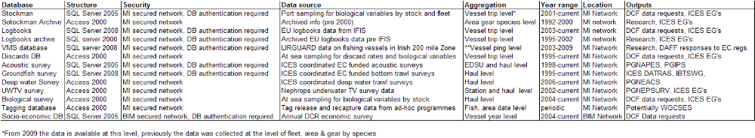

VII. Follow-up of STECF recommendations

Recommendations from SGRN for the 2006 NP | Actions Taken
Data on U10m:SGRN insists that the outcome of the pilot programme be used to set up routine sampling programmes under Module D for the fleet segment < 10 m from 2007 onwards | Ireland now has a comprehensive sampling programme and it is described in the 2009-2010 NP
Regarding Western IBTS, Ireland states that some new modifications in agreement with ICES IBTS Working Group has been applied to this survey, including 4 additional survey days for inter-calibration purposes. SRGN agreed with the approach | Ireland is continuing to comply with the recommendations of IBTS
Ireland affirms that it will continue with pilot surveys (National Funded) in 2006 year to assess the annual value of economic parameters specified in Appendix XIX. However, no details are offered with respect to the calculation of the parameters itself, and the time-disaggregation. | Details on the collection of economic parameters from the processing sector were provided in the National Programme and Technical Reports of subsequent years.
The sampling levels are based on the average of landing for the years 1999-2001, and not over the most recent three years. If Ireland is using the most recent data to increase the budget (third paragraph, page 20 of the NSP) is not easy to understand why these data is not used for sampling effort calculations. STECF recommended that an updated table be supplied | Ireland inserted the correct revised table
Vessel segmentation will not fully be done according to Appendix III of Regulation. The offshore fleet will be segmented based on the overall length, however, inshore fleet will be segmented based on the number of pots fished. | Ireland inserted the correct revised table

Recommendations from SGRN for 2007 NP | Actions taken
Regarding vessels of < 10 m, a pilot survey will be carried out for boats using passive gears in 2006. This survey will try to deliver data with the precision level of 2. However, it is not stated whether there is a pilot survey for boats <10 m using other gears. SGRN (STECF, 2006) informed us that Ireland is planning a pilot survey for the fishing fleet and that SGRN is insisting that this programme must include routinely sampling for boats < 10 m | SGRN was informed that for the 2007 NP the MS is carrying out the provisions of the Regulation by collecting data on boats < 10m using processor sales slips and fishing calendars
Regarding the Aran Nephrops Survey, no survey classified as Priority 2 is identified with such a name in Appendix XIV of Regulation 1639/2001 or in the amended revision (Regulation 1581/2004). Ireland states that this survey has been in operation since 2002 and now has an established time-series (5 years) and requests the inclusion as a Priority 2 survey from 2007 onwards. | Ireland removed this survey from the programme and sought to get it included in the list of new survey in the new regulation 199/2008
Pleuronectes platessa seems to be over-sampled in the EP. SGRN recommends MSs to use the precision analysis of previous year's sampling to establish their sampling plan in the NP proposal.  Incorrect species naming in regulation | I Ireland is now sampling to this recommendation and is sampling the correct species
SGRN reminds the MS that the coverage of data collection by segment should be as set out in Appendix III to the DCF. | The Irish fleet segmentation is clearly defined in Table 10.1 of the 2007 National Programme and conforms to the fleet segmentation of Appendix III of Regulation 1639/2001.
SGRN recommends that MS follows the provisions of the DCF. On the collection of economic data | The Member State is committed to following the all provisions of the DCF

Recommendations from SGRN for 2008 NP | Actions Taken
MS should provide the report to the Commission in view of the future work planned on this issue ( Pilot Study of Recreational Cod Fishing) | The pilot study will be submitted to the next SGRN meeting.
There are some inconsistencies between tables 9.1, 9.2 and 9.3 SGRM recommends that the table is amended | I Ireland re-submitted the table

Recommendations from SGRN for 2010 NP | Actions Taken
SGRN recommends MS to carry out necessary analysis to ensure that the quality of self sampling does not provide biased estimates | As of End of September only 2 self sampling data sets has been collected, this was due to delays in getting the programme started. Once further data sets arrive analysis will be carried out.  It has been decided to drop this self sampling programme due to quality issues, data will now be collected by MI personnel.
SGRN recommends that table IIIC4 be amended. | Amendments were sent to the commission
MS does not provide information on Ecosystem indicators 8 and 9 | Information provided in NP revision
MS does not provide information on Ecosystem indicators 8 and 9 | Information now provided

Follow up of RCM 2009 Recommendations

Feedback from ICES: WGDEEP
RCM NS&EA 2009 Recommendation | RCM NA urges onboard observers to sample maturity of blue ling.
Follow-up actions needed
Responsible persons for follow-up actions | MS fishing blue ling
Time frame  (Deadline) | 2010
Actions by Member State | MS does not have a Blue Ling fishery, however maturity data of specimens caught is taken on Surveys .

Feedback from ICES : Benchmark workshops
RCM NA 2009 Recommendation | RCM NA recommends stock coordinators investigate into bias and precision using ICES WKACCU outcomes and COST tool.
Follow-up actions needed | Data quality investigation
Responsible persons for follow-up actions | Stock coordinators of benchmarked stocks
Time frame  (Deadline) | Prior to benchmarks 2010
Actions by Member State | See text in section IIIE3 on Data Quality and use of COST tool

Feedback from ICES : Surveys
RCM NA 2009 Recommendation | RCM NA recommends any modifications / additions / stoppage of surveys should be forwarded to SGRN meeting for consideration.
Follow-up actions needed | STECF/SGRN review of changes on the list of eligible surveys.
Responsible persons for follow-up actions | Member States
Time frame  (Deadline) | 2010
Actions by Member State | Member state will be attending SGRN meeting and will provide all of the data necessary

Métier variables: Tasks prior to the RCM NA 2010
RCM NA 2009 Recommendation | For the purposes of ranking metiers to sample, National data on effort, landings and value by metier and fishing ground should be compiled regionally in advance of the next meeting. To enable this, participants from MS should strictly respect the agreed naming conventions of fishing ground, metiers and units of the variables as well as the deadline for submission of the national data. The Chair is responsible for compiling it on a regional level.  RCM NA recommends the use the average of the reference period 2007 – 2008 for the ranking.
Follow-up actions needed | Preparation of exchange data for task-sharing.
Responsible persons for follow-up actions | RCM participants to ensure that the Chair of RCM NA receives the relevant information. RCM Chair to arrange for compilation of regional ranking.
Time frame (Deadline) | Until April 2010
Actions by Member State | Noted for the NP 2011-2013 and the RCM 2010

Métier variables: Tasks prior to the RCM NA 2010
RCM NA 2009 Recommendation | For the purposes of understanding the heterogeneity of metiers and the consequences for task sharing and discard sampling, national descriptions of the regionally ranked metiers should be compiled using the metier description template Annex XI. To enable this, participants from the MS should strictly respect the agreed naming conventions of fishing ground and metiers as well as the deadline for submission of the information. Appointed persons are responsible for requesting the data and compiling it on a regional level
Follow-up actions needed | Preparation of exchange data for task-sharing.
Responsible persons for follow-up actions | Appointed persons (1 person per fishing ground) and RCM participants  (see table above)
Time frame (Deadline) | until April 2010
Actions by Member State | Noted for the NP 2011-2013 and the RCM 2010

Métier variables: Description of metiers to be sampled in National Programme
RCM NA 2009 Recommendation | In compiling the National Programmes 2011-2013, MS should ensure that the information provided in describing the metiers to be sampled relates directly to the information provided to the RCM NA in the metier section.
Follow-up actions needed | National Correspondent (or person completing fleet / metier descriptions) to liaise with RCM participants responsible for compiling metier description templates for the RCM NA.
Responsible persons for follow-up actions | National Correspondents and RCM participants.
Time frame (Deadline) | March 2010
Actions by Member State | Noted for the NP 2011-2013 and the RCM 2010

Métier variables: merging fleet segments and metiers for sampling and analysis
RCM NA 2009 Recommendation | To ensure that all Member States’ National Programmes for 2011-13 take account of the outcomes from WKMERGE, RCM NA 2009 recommends that all MS contribute to the workshop and ensure that their participants are able to carry out the required preparatory work.
Follow-up actions needed | Member States to identify appropriate participants who are involved in the statistical design of national fleet-based biological sampling programmes, and to advise the WKMERGE chairs of the names of participants in sufficient time to allow preparatory work. The chairs will also seek participation of people with particular skill sets. Participants will be asked to prepare the following material for the meeting:  - All Member States participants to provide a Working Document describing the basis for national metier definition and merging in 2009&2010;  - Identified participants to prepare European case studies for examining applications of metier-merging methods. The PGCCDBS will liaise with RCMs to identify suitable case studies. The data for these case studies are to be available at the Workshop in the COST format.
Responsible persons for follow-up actions | All Member States (RCM members and National Correspondents)
Time frame (Deadline) | MS National Correspondents to provide WKMERGE chairs with details of national participation no later than 20 November 2009.
Actions by Member State | MS was unable to send someone to the workshop but will be following the recommendations of the workshop when compiling the NP

Celtic Sea (ICES Divisions VIIf, VIIg, and VIIh)
- OTB_CRU_70-99_0_0 : France and Ireland are sampling for landings and discards. There is a spatial difference in the areas fished by both fleets. UK has limited fishery but to liaise with Ireland regarding task sharing for onboard sampling.

Métier variables: Fishing activities and sampling coverage
RCM NA 2009 Recommendation | RCM NA recommends that Ireland liaise with UK to ensure that the UK sampling coverage suitably covers the Irish metier.
Follow-up actions needed | Ireland to – liaise directly with UK to confirm that spatial and temporal aspects of fisheries in this area allow appropriate task sharing
Responsible persons for follow-up actions | Helen McCormick - Ireland  Steve Warnes – UK
Time frame (Deadline) | March 2010
Actions by Member State | Ireland has liaised with Northern Ireland with regards to task sharing, NI has a limited fishery in this area and as Ireland has 13 discard trips planned for this metier, it is assumed that this metier is adequately covered

Métier variables: Inclusion of bilateral and RCM agreements in NP
RCM NA 2009 Recommendation | National Programmes to include appropriate reference to RCM NA report in relation to sampling agreement at metier level.
Follow-up actions needed | National Correspondents to ensure that National Programme includes appropriate reference to RCM and bilateral agreements in relation to sampling activities as referred to in the RCM NA report
Responsible persons for follow-up actions | National Correspondents
Time frame (Deadline) | March 2010
Actions by Member State | MS has up Bi laterals using the templates provided with UK-Scotland, France and Denmark. A request was sent to Spain but at the time of submission no response was received.

Recreational fisheries : Best practise
RCM NA 2009 Recommendation | RCM NA recommends MS to prepare their NP Proposal 2011-2013 on recreational fisheries based on the DCF requirements, using their own knowledge of the fisheries, without waiting for the outcomes of the PGFRS.  RCM NA recommends also MS to consider the recommendations of the ICES WGEEL.
Follow-up actions needed | Drafting MS NP proposals 2011-2013
Responsible persons for follow-up actions | All MS
Time frame (Deadline) | March 2010
Actions by Member State | Noted in The 2010-2013 NP

Stock related variables: Landing figures
RCM NA 2009 Recommendation | The RCM NA recommends that landings of the most recent three years reported by MS for non-TAC stocks, listed in Appendix VII of the Commission Decision 2008/949/EC, should be made available to MS. This information is required to evaluate if sampling is an obligation or not.
Follow-up actions needed | List of landing figures by MS and area to be compiled by JRC and sent to MS.
Responsible persons for follow-up actions | STECF
Time frame (Deadline) | Prior to RCM 2010 (preferably prior to compilation of the NPs)
Actions by Member State | MS has used the recommended landings figures.

Stock related variables: increase of age sampling
RCM NA 2009 Recommendation | The RCM NA recommends that sampling for age should be increased in order to meet the required sampling levels for saithe (Vb), turbot (all areas) and John Dory (all areas).
Follow-up actions needed | Implementation of (increased) sampling for age by the relevant countries:  - saithe (Vb) :  - turbot (all areas) : BEL (VIIa,VIIfg, VIIIab)  - John Dory (all areas) :
Responsible persons for follow-up actions | MS to include in their NP proposal 2011-2013
Time frame (Deadline) | March 2010
Actions by Member State | MS has no requirement to sample these species as it is less that 10% of the community share

Stock related variables: blue whiting as a test case for international analysis in COST
RCM NA 2009 Recommendation | The RCM NA recommends that blue whiting should be used as a test case for international raising and further analysis in the COST-package.
Follow-up actions needed | Collect all available biological stock-related data on blue whiting and analyse these combined in COST. Working Document for PGCCDBS.
Responsible persons for follow-up actions | Stock-coordinators for data delivery. Joël Vigneau for data analysis.
Time frame (Deadline) | End of 2009 for data deliveries  March 2009 for the analysis and the Working Document.
Actions by Member State | MS will provide data to the stock co-ordinator

Stock variables: Follow-up STECF proposal to enlarge list of sharks

Follow-up actions needed | Correct area to “IV, VIId”
Responsible persons for follow-up actions | European Commission
Time frame (Deadline) | December 2009
RCM NA 2009 Recommendation | RCM NEA recommends SGRN to promote dedicated sampling of sharks
Follow-up actions needed | Amend the DCF sampling scheme
Responsible persons for follow-up actions | STECF/SGRN
Time frame (Deadline) | December 2009
Actions by Member State | MS will take note of enlarged list in NP 2011-2013

DCF Requirements
RCM NA 2011 recommendation | RCM NA recommends that the collection of otoliths of John Dory is continued but not proceed with age readings until an agreed standardized method is developed.
F Follow-up actions needed | All MS having catches of John Dory to collect otoliths
Responsible persons for follow-up actions | All MS
Time frame (Deadline) | None
Actions by Member State | ???

Feedback from assessment working groups
RCM NA 2011 recommendation | RCM NA recommends MS to describe in detail the methodology on the separation of the catches of the 2 Lophius species. This information should be available to the 2012 benchmark assessment.
Follow-up actions needed | Prepare a document to be forwarded to the WGHMM Lophius stock coordinators.
Responsible persons for follow-up actions | All MS having catches of Lophius in the Atlantic and having not provided this information to the ICES assessment Working group in 2011.
Time frame (Deadline) | End of 2011
Actions by Member State | Methodology already sent to the ICES assessment Working

Metier vairables : Increase sampling in deep-water fisheries
RCM NA 2011 recommendation | RCM NA recommends MS to check in their NP proposal 2012 that sufficient coverage of deep-water fisheries on-board sampling is planned, in order to meet the EWG needs.
Follow-up actions needed | MS to check and consider increasing the sampling coverage of deep-water fisheries in their amendment of 2012 NP proposal.
Responsible persons for follow-up actions | MS
Time frame (Deadline) | October 2011
Actions by Member State | Member state does not have a deep water fishery

Metier variables : Metier descriptions
RCM NA 2011 Recommendation | MS to update metier descriptions already compiled by RCM NA 2010 and using the standard template complete descriptions for any new regionally ranked metiers identified. Updated and new files to be uploaded by Fishing Ground co-ordinators.
Follow-up actions needed | MS to complete metier descriptions
Responsible persons for follow-up actions | All MS
Time frame (Deadline) | RCM NA 2012
Actions by Member State | All metier descriptions will be prepared in advance of the RCM 2012

Metier and stock variables : Concurrent sampling
RCM NA 2011 Recommendation | MS to fill in template on concurrent sampling and provide it to the chair of RCM NA for compilation and sending to the chair of STECF EWG 11-19 in advance of the December meeting
Follow-up actions needed | MS to fill the template  Chair of RCM NA to compile all questionnaires and sent them to the chair of STECF EWG 11-19
Responsible persons for follow-up actions | All MS, chair of RCM NA
Time frame (Deadline) | November 31 2011
Actions by Member State | Concurrent sampling questionnaire will be filled out by MS in advance of meeting

Metier variables : Merging metier
RCM NA 2011 Recommendation | RCM NA recommends RCM participants to contact relevant staff within their institute to attend the ICES WKPICS1 meeting on practical implementation of statistical sound catch sampling programmes
Follow-up actions needed | Identify experts for attending WKPICS1
Responsible persons for follow-up actions | RCM NA participants
Time frame (Deadline) | November 2011
Actions by Member State | MS is unable to send person but they will send working documents and attend via correspondence

Métier related variables: Routines for establishing bilateral agreements
RCM NA 2011 Recommendation | - MS should make sure that their landings abroad are included in the Regional Database upload allowing the RCM to analyse the possible needs for bilateral agreements.  - The RCMs should perform an annual analysis on landings in foreign countries and conclude where bilateral agreements need to be made. MS should set up agreements, fixing the details of sampling, compilation and submission of data in each case when it is indicated by the RCM that a bilateral agreement is needed. Standard output algorithms to enable analysis of compiled data should be included in the RDB.
Follow-up actions | MS to make sure landings abroad data are included into the RDB
Responsible persons for follow-up actions | MS
Time frame (Deadline) | Annually. Deadline 1st of July 2012.
Actions by Member State | MS will make sure landings abroad data are included into the RDB

Recreational fisheries: Best practice.
RCM NA 2011 Recommendation | RCM NA recommends MS to include recommendations and outcomes of PGRFS in the adjustment of their 2012 NP, if relevant..
Follow-up actions needed | Revising MS NP proposals 2012.
Responsible persons for follow-up actions | All MS.
Time frame (Deadline) | October 2011
Actions by Member State | MS will include recommendations from PG in NP

Stock variables : Quality issues
RCM NA 2011 Recommendation | RCM NA recommends MS to complete properly the tables III.E.1 and III.E.2
Follow-up actions needed | MS to review their tables of the NP Proposal 2011-2013
Responsible persons for follow-up actions | MS
Time frame (Deadline) | October 2011
Actions by Member State | Tables were reviewed

Stock variables : Regional collection
RCM NA 2011 Recommendation | RCM NA recommends all MS to have a careful look at the tables in annex VII, in order to identify stocks for which a bilateral agreement would improve the sampling scheme.
Follow-up actions needed | MS to identify bilateral agreement, contact NC and propose such agreement in their NP proposal for 2012
Responsible persons for follow-up actions | All MS
Time frame (Deadline) | October 2011
Actions by Member State | All relevant Bi-Lateral agreements have been put in place and are enclosed in submission

Metier variables : Regional ranking / RDB
RCM NA 2011 Recommendation | RCM NA recommends that all MS investigate data loaded to RDB under metier 'No_logbook' and replace with the agreed code given in section 3.1 and request the RDB steering group to endorse these as the only permitted entries within the fields defined.
Follow-up actions needed | Resubmit data into the regional database after correction
Responsible persons for follow-up actions | All MS
Time frame (Deadline) | July 2012
Actions by Member State | Member state will re submit data

Metier variables : Regional ranking/ RDB
RCM NA 2011 Recommendation | RCM NA recommended the use of the standard code MIS_MIS_0_0_0 to replace 'No_Matrix' for fisheries not specified in Annex IV of the Commission Decision.
Follow-up actions needed | Resubmit data into the regional database after correction
Responsible persons for follow-up actions | All MS
Time frame (Deadline) | July 2012
Actions by Member State | N/A

Métier variables: Metier Descriptions
RCM NA 2012 Recommendation (RCMNA 2) | RCM NA 2012 recommends that the metier descriptions for fishing grounds under the remit of the RCM be updated by each MS in as much detail as possible. These descriptions to be used as a tool, in conjunction with outputs from the RDB, to identify metiers that could be combined for regionally coordinated sampling plans.
Follow-up actions needed | MS to update Metier descriptions
Responsible persons for follow-up actions | MS participating in fisheries under the remit of RCM NA
Time frame (Deadline) | June 2013
Follow up by member state | Metier descriptions will be updated by Member state

Stock related variables: Setting up of Bilateral agreements
RCM NA 2012 Recommendation (RCMNA 4) | RCM NA recommends MS put in place bilateral agreements for sampling of landings abroad where applicable.
Follow-up actions needed | Include bilaterals in the revised NP proposals
Responsible persons for follow-up actions | MS
Time frame (Deadline) | 31 Oct 2012
Follow up by member state | Table completed by Member state

Stock related variables: Setting up of Pilot programmes for sampling of Boar fish Capros aper
RCM NA 2012 Recommendation (RCMNA 5) | RCM NA recommends MS involved and that have obligations in the Boar fish fishery to set up a pilot program for sampling.
Follow-up actions needed | Include pilot study in the revised NP proposals
Responsible persons for follow-up actions | MS fishing Boar fish
Time frame (Deadline) | 31 Oct 2012
Follow up by member state | Pilot study included in NP 2013 revision

VIII. List of derogations

List of requests for derogations:
Short title of derogation | NP Proposal section | Derogation approved or rejected¹ | Year of approval or rejection of past requests for derogations
Exemption to sample Orange Roughy and Portuguese Dogfish | 2006 NP Module I 9.2 | a | 2005
Exemption to sample Spanish Mackerel | 2007 NP Module I 9.2 | a | 2006
Exemption to sample the seed mussel fishery | III.C.5 | a | 2009
Exemption for some effort transversal variables NP 2009-2010 | III.F.2.4 |  | 2009
Exemption to sample discards from a number of metiers based on low effort | III.C.5 | a | 2009
Exemption to sample discards from a number of metiers based on low effort. See below list | III.C.1 |  | 2010
Exemption to sample recreational catches of Sea Bass | III.D.6
Exemption to sample recreational catches of Eel | III.D.6
Exemption to sample recreational catches of Shark | III.D.6
¹ Insert ‘a’ for approved or ‘r’ for rejected

List of metiers for which MS is looking for derogation based of low level of effort.

Fishing Ground | Gear LVL4 | Target Assemblage  LVL5 | Métier LVL6 | Effort Days
VI | Hand and Pole Lines | Small Pelagic Fish | LHP_SPF_0_0_0 | 1
VIIa | Hand and Pole Lines | Demersal Fish | LHP_DEF_0_0_0 | 1
VIIa | Hand and Pole Lines | Small Pelagic Fish | LHP_SPF_0_0_0 | 3
VIIbcjk | Hand and Pole Lines | Large Pelagic Fish | LHP_LPF_0_0_0 | 8
VIIIabde | Hand and Pole Lines | Large Pelagic Fish | LHP_LPF_0_0_0 | 4
VIIa | Set Longlines | Demersal Fish | LLS_DEF_0_0_0 | 1
VIIbcjk | Set Longlines | Large Pelagic Fish | LLS_LPF_0_0_0 | 4
VIIbcjk | Set Longlines | Small Pelagic Fish | LLS_SPF_0_0_0 | 1
I II | Set Longlines | Demersal Fish | LLS_DEF_0_0_0 | 18
VIIbcjk | Drift Longlines | Demersal Fish | LLD_DEF_0_0_0 | 3
VIIbcjk | Drift Longlines | Large Pelagic Fish | LLD_LPF_0_0_0 | 3
VIIbcjk | Bottom Otter Trawl | Deep-water Species | OTB_DWS_0_0_0 | 18
VIIe | Dredge | Molluscs | DRB-MOL-0_0_0 | 2
VIIIabde | Bottom Otter Trawl | Demersal Fish | OTB_DEF_0_0_0 | 3
VIIe | Beam Trawl | Demersal Fish | TBB_DEF_0_0_0 | 4
VI | Miscellaneous | Demersal Fish | MIS_DEF_0_0_0 | 2
VIa | Miscellaneous | Demersal Fish | MIS_DEF_10_0_0 | 1
VIIbcjk | Miscellaneous | Demersal Fish | MIS_DEF_80_0_0 | 1
VIIbcjkfgh | Miscellaneous | Demersal Fish | MIS_DEF_0_0_0 | 2

IX. List of acronyms and abbreviations

Acoustic surveys Acoustic surveys use sound waves emitted from a "transducer" to estimate the density of plankton and fish shoals. The transducer is attached to a drop keel on the survey vessel, which is linked to an echo sounder in the vessel which records the shoals of fish as "marks" on a screen or paper trace. The density of these marks is used to calculate total biomass of a stock.
Age The number of years of life completed, here indicated by an Arabic numeral, followed by a plus sign if there is any possibility of ambiguity (age 5, age 5+).
BIM An Bord Iascaigh Mhara, The Irish Sea Fisheries Board, charged with responsibility for development of the fishing and aquaculture industries in Ireland. (see www.bim.ie)
By-catch Refers to discarded catch (see Discards) plus incidental catch not purposely targeted by the fishermen.
CPUE /Catch Per Unit of Effort The catch of fish, in numbers or in weight, taken by a defined unit of fishing effort. Also called catch per effort, fishing success, or availability.
DAMF Department of Agriculture, Marine and Food (see www.daff.gov.ie)
DCENR Department of Communications Energy and Natural resources (see www.dcenr.gov.ie)
DCF / Data Collection Framework EU Council Regulations 1543/2000, 1639/2001, 199/2008 established a community framework for the collection and management of the data needed to conduct the common fisheries policy. Each member state must collect data on the biology of the fish stocks, on the fleets and their activities and on economic and social issues
Discard Discards are defined as that part of the catch returned to the sea as a result of economic, legal or other considerations.
Discard rate The percentage (or proportion) of the total catch which is discarded.
FAT Fisheries Assessment Technician – regionally-based sea-going staff employed by FSS.
Fishing Effort The total fishing gear in use for a specified period of time. When two or more kinds of gear are used, they must be adjusted to some standard type
Groundfish Species of demersal fish dwelling on, or close to the sea floor, as targeted in the annual Western IBTS 4th quarter survey around the Irish coast.
IBTS International Bottom Trawl Survey Working group
ICES International Council for the Exploration of the Seas –Ireland shares the Total Allowable Catches TACs for many stocks we exploit with our European Union partners. Because of this international dimension many stocks need to be assessed in international fora such as ICES.
ICCAT International Commission for the Conservation of Atlantic Tuna
Marine Institute The Marine Institute is Ireland's national agency with the following general functions: "to undertake, to co-ordinate, to promote and to assist in marine research and development and to provide such services related to marine research and development, that in the opinion of the Institute will promote economic development and create employment and protect the environment." Marine Institute Act, 1991 (see www.marine.ie)
IFI Inland Fisheries Ireland Recreational fisheries are included in their responsibilities.
IFIS Integrated Fisheries Information System .Database held by DAMF with landings, effort and first sale value of fish species
FSS / Fisheries Science Services – One of seven service areas of the Marine Institute, FSS’s mission is to assess, research and advise on the marine fisheries resource in Irish waters
HAWG Herring Assessment Working Group
LA Laboratory Analyst.
Latt Laboratory Attendant
MS Member State.
Nemesys Nephrops measuring system.
NP National Programme.
WGWIDE Working group on Widely distributed stocks
RCM Regional Co-ordination Meetings.
PGCCDBS, Planning group commercial catch discards and Biological sampling
WGCSE Celtic seas eco region working group
WGHMM Working group Hake Monk and Megrim
WGIPS ICES Working Group International Pelagic Surveys
WGNAPES ICES Working Group on North East Atlantic Pelagic Ecosystem Surveys
WGNEACS ICES Working Group on the North-east Atlantic Continental Slope Survey
Recovery Plan This is a multi-annual plan to recover seriously depleted stock. The plans generally involve agreed Harvest Control Rules, Technical Measures, Effort Controls and various control and enforcement measures.
Recruitment The amount of fish added to the exploitable stock each year due to growth and/or migration into the fishing area. For example, the number of fish that grow to become vulnerable to the fishing gear in one year would be the recruitment to the fishable population that year. This term is also used in referring to the number of fish from a year class reaching a certain age. For example, all fish reaching their second year would be age 2 recruits.
Sample A proportion or a segment of a fish stock which is removed for study, and is assumed to be representative of the whole. The greater the effort, in terms of both numbers and magnitude of the samples, the greater the confidence that the information obtained is a true reflection of the status of a stock (level of abundance in terms of numbers or weight, age composition, etc.)
SFPA Sea Fisheries Protection Agency
STECF The Scientific Technical and Economic Committee on Fisheries was established by the European Commission and comprises fisheries scientists and economists from the Member States. The role of STECF is to advise the European Commission on scientific, technical and economic issues related to the management of fisheries resources that are exploited worldwide by members of the European Union.
STO Scientific and Technical Officer
Stock A "stock" is a population of a species living in a defined geographical area with similar biological parameters (e.g. growth, size at maturity, fecundity etc.) and a shared mortality rate. A thorough understanding of the fisheries biology of any species is needed to define these biological parameters.
SSB / Spawning stock biomass The total weight of all sexually mature fish in the population. The size of SSB for a stock depends on abundance of year classes, the exploitation pattern, the rate of growth, fishing and natural mortality rates, the onset of sexual maturity and environmental conditions.
STOCKMAN A custom developed relational database which houses the Marine Institute Fisheries Science Services sampling data.
TAC / Total Allowable Catch is the total regulated catch from a stock in a given time period, usually a year.
TL Team Leader
WKDRP Workshop on Discard Raising Procedures
WGMEGS ICES Working Group on Mackerel and Horse Mackerel Egg Surveys (WGMEGS)

X. Comments, suggestions and reflections

Ireland notes a number of changes and modifications to the list of standard tables. While we welcome developments to the national programme that aid data transparency and compatibility between member states, Ireland notes that some of these changes (from the 2009-2010) submission lack justification and have resulted in a substantial increase in workload i.e. re-analysis of national sampling allocations that we consider unnecessary and without foundation. Table IIIC1 now explicitly specifies a list of ‘fishing’ grounds into which national metiers must be allocated. While this may be useful post hoc to ensure that there has been adequate sampling coverage across stocks, many Irish metiers are trans-boundary. We consider that the metier should be defined from its area of operation, and not constrained to a potentially artificial boundary. This constraint led to another layer of metier analysis that we consider unnecessary. While we acknowledge the benefit of using a sampling frame at a national level (table IIIC3), due to the highly mobile nature of Irish fisheries and their trans-boundary nature, the data frames are not always consistent with the activity of the various fleets and shifting the sampling target from ‘fishing ground’ to ‘sampling frame’ is not necessarily consistent with the activity that we wish to observe. Ireland notes that some of these changes are inconsistent with the historic national sampling strategy that has been developed over time and we felt best matches the activity of Irish fishing activity.

Financial Forms

XI. References

Gerritsen H, Lordan C (2006) Gutted to round-weight conversion factors for anglerfish (Lophius piscatorius) and (Lophius budegassa). Irish Fisheries Bulletin 26. 8pp. ISSN:1649 5055

ICES, 2007. Report of the herring assessment working group for the area south of 62oN. ICES CM 2008/ACOM:02. 601 pp.

STECF-SGRN, 2007. STECF Sub-group on Research Needs (SGRN). Review of list of surveys at sea (Appendix XIV of EU Commission Regulation N°1581/2004) with their priorities. Commission Staff Working Paper 2007:01. 25 pp.

WKMOG (2008) Report of the Workshop on Maturity Ogive Estimation for Stock Assessment (WKMOG). ICES CM2008/ACOM:33. 3-6 June 2008. Lisbon, Portugal.

Anon 1996 Manual for International Bottom Trawl Surveys (Revision V) Addendum to ICES CM 1996/H:1

ICES 2007. Report of the Workshop on the use of UWTV surveys for determining abundance in Nephrops stocks throughout European waters. ICES CM: 2007/ACFM: 14 Ref: LRC, PGCCDBS.

ICES 2008. Report of the Workshop and training course on Nephrops Burrow Identification (WKNEPHBID). ICES CM: 2008/LRC: 03 Ref: ACOM.

Minto, C. (1998) Precision level estimates: robust to small sample sizes of finite populations for the Data Collection Regulations.

(Small, I. (1991) Exploring data provided by angling for salmonids in the British Isles. In: Catch Effort Sampling Strategies - their application in Freshwater Fisheries Management. I.G. Cowx, (Ed.), Blackwell Scientific Publications Ltd.)

WKACCU, 2008. Workshop on Methods to Evaluate and Estimate the Accuracy of Fisheries Data used for Assessment. ICES CM 2008\ACOM:32, ICES, Copenhagen.

XII. Annexes

Annex 1: Bi lateral Agreements

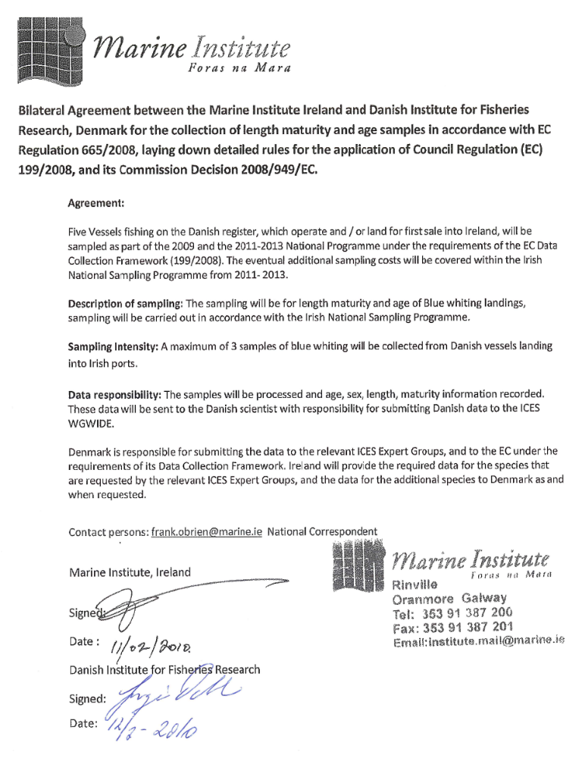
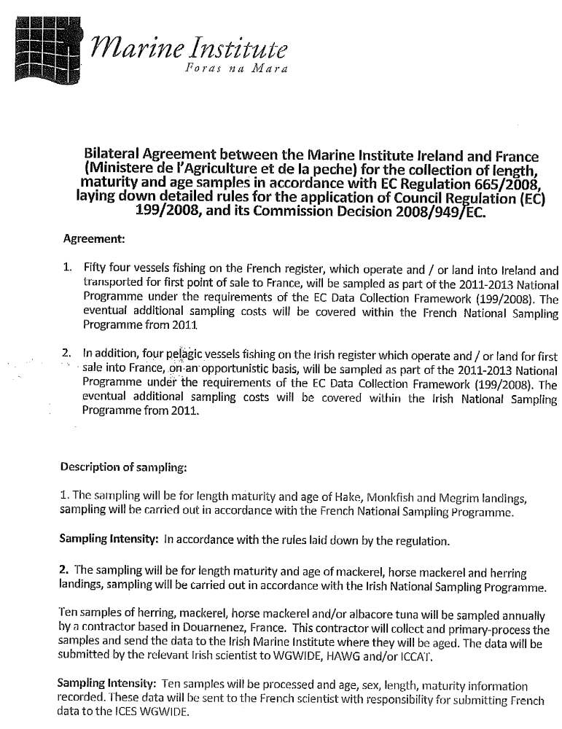

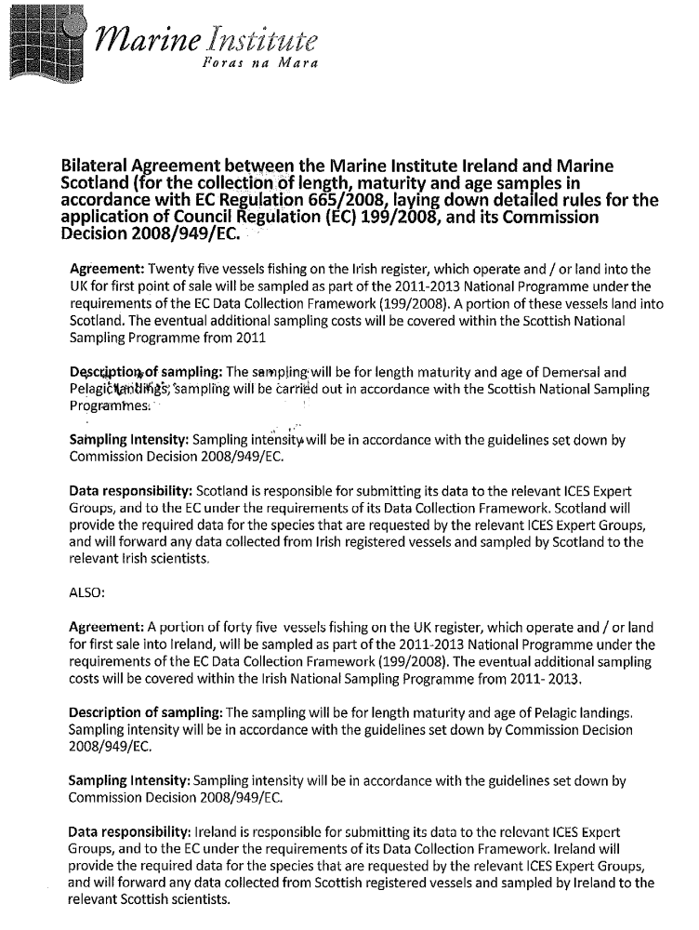

Annex 2:

EU Council Regulation 199/2008
Concerning the establishment of a community framework for the collection, management and use of data in the fisheries sector and support for scientific advice regarding the Common Fisheries Policy

Ireland National Programme 2011-2013
Proposal for Pilot study for the inclusion of Boarfish Capros Aper as a species for sampling

18st October 2012

Background
In 2012 the Pelagic RAC developed a long term management plan for Boarfish Capros aper. Currently Boarfish is not listed in Appendix VII but the MS wishes to sample boarfish as a species as this is a rapidly emerging fishery. In addition this is now a TAC species and resulting data is provided to WGWIDE.
The MS proposes to set up a pilot study for the collection of data for this species. The data will be collected from the concurrent at sea program and land based samples and will collect data on length, weight, maturity and age.

Biological - metier-related variables

A new metier PTM_SPF_32-69_0_0_ targeting Boarfish Capros aper has been identified by the analysis of the Irish logbook data. Landings of this rapidly developing fishery from Ireland are detailed below.2011 is the first year that there had been a TAC for this species and the Irish pelagic fleet has been targeting this species for a number of years.

Boarfish landings by Irish Vessels
2003 | 460
2004 | 675
2005 | 242
2006 | 2772
2007 | 17615
2008 | 21584
2009 | 68629
2010 | 88457
2011 | 20685

The Irish quota for 2012 is 56,666 tonnes and in 2013 is 77,000 tonnes.

Type of data collection
The MS proposes 4 at sea sampling trip, two in the first quarter and two in the last quarter on vessels chosen at random from those targeting boarfish. These at sea trips will collect data on landings, discards and associated positional and environmental data following the existing protocols for other pelagic species. Samples will also be collect ashore for length weight, maturity and age.

Target and frame population
The sampling frame will be all pelagic vessels fishing on the North, West and South coast.

Data Quality Evaluation
Data will be stored in the Pelagic discard data base and STOCKMAN database.
All sampling schemes are designed following WKACCU, validation of all data is done using COST and a number of in-house tools for data validation and quality control.
The data will made available to the relevant stock assessment working groups (WGWIDE) in the year after the data were collected. The working groups will be presented with the model inputs as well as a description of the data and data quality.

Biological - stock-related variables

Data Collection
Data for this species will be collected from landings from each vessel that is targeting this species. Each vessel has been asked to collect a sample of 50kg and deliver to the nearest port analyst. It is envisaged that 3850 otoliths will be collected and 7000 individuals measured,

Target and frame population
The sampling frame will be all pelagic vessels fishing on the North, West and South coast.

Data Quality Evaluation
Data will be stored in STOCKMAN and validation of all data is done using COST and a number of in-house tools for data validation and quality control.
The data will made available to the relevant stock assessment working group (WGWIDE) in the year after the data were collected. The working groups will be presented with the model inputs as well as a description of the data and data quality.

Regional Co-Ordination
No regional co-ordination has been set up as yet for this species.

Costs

The costs for this program for year 2013 are included in the financial forms.

XIII. Figures

Figure 1. IGFS map of proposed stations 2011-2013
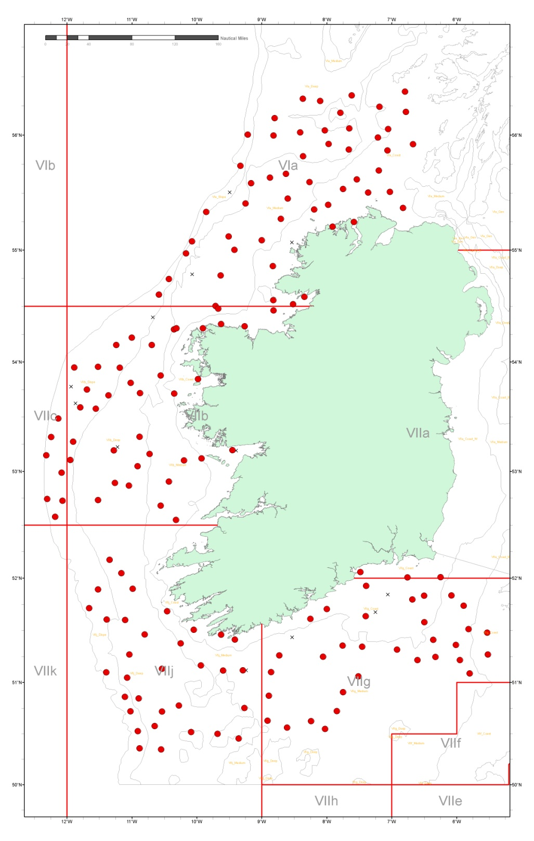

Figure 2. Acoustic cruise track (green). Blue whiting Spawning survey 2010-2013.

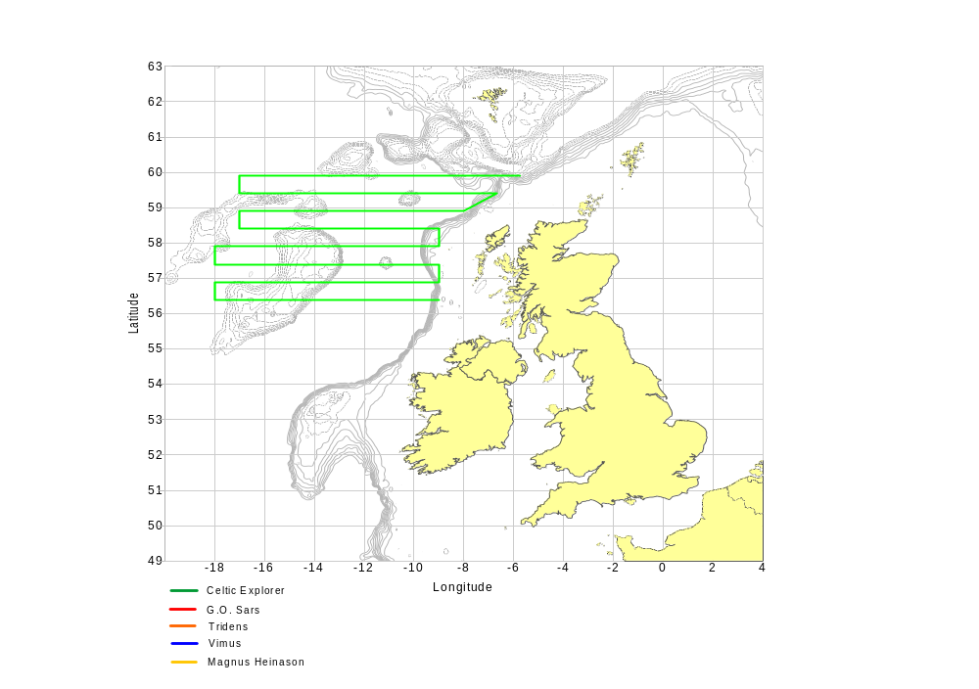

Fiqure 3. International Mackerel and Horse Mackerel Egg Survey 2013 ( Proposed stations for whole survey Irelands involvement will be decided at WGMEGS 2012)
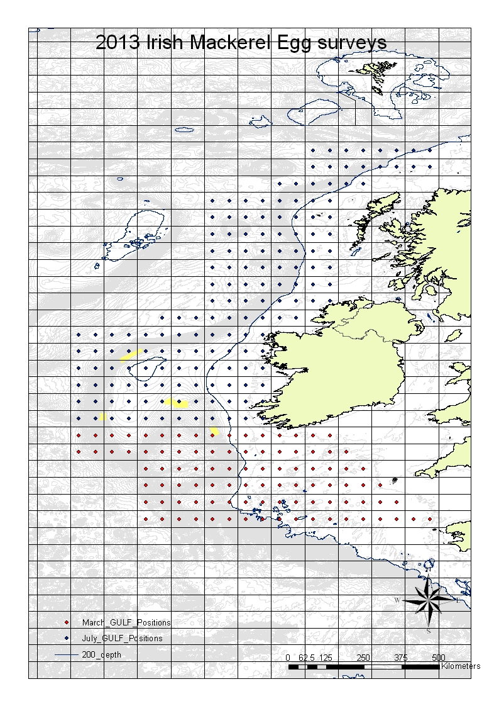
Figure 4 Acoustic cruise track (red). Herring Spawning Survey 2011-2013 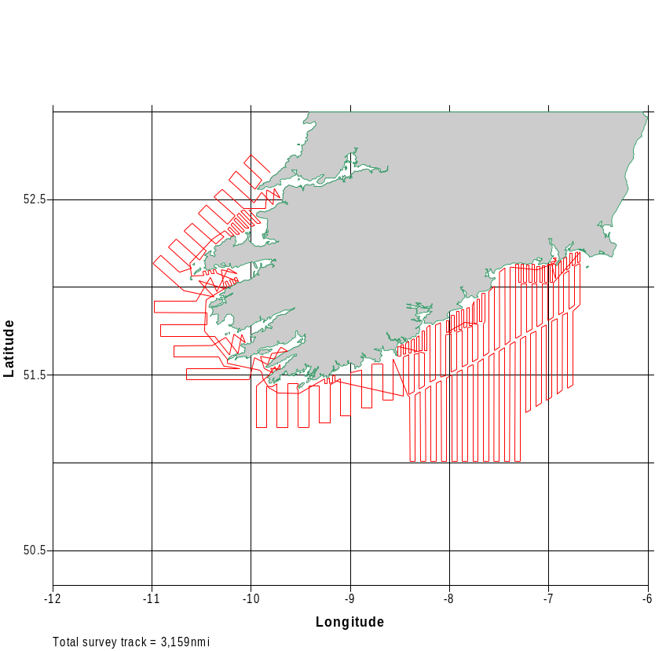

Figure 5 Acoustic cruise track (green). Pre Spawning Herring Survey 2011-2013

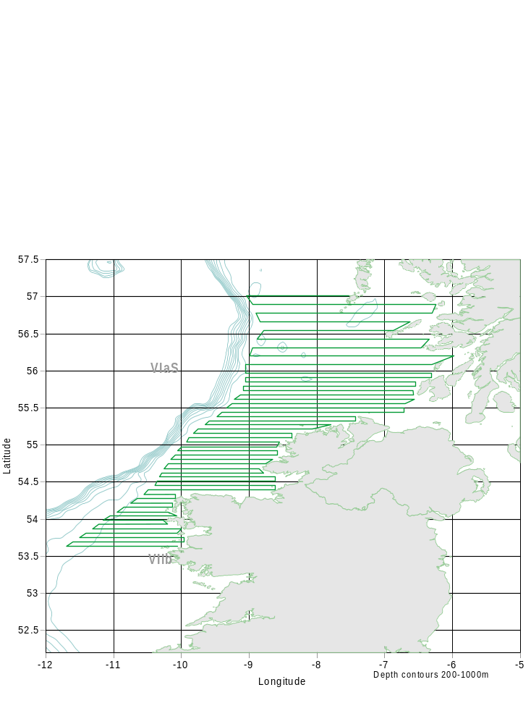

Figure 6 Nephrops UWTV Irish Sea . The black + indicate station positions and the red line are the known boundaries of Nephrops habitat.

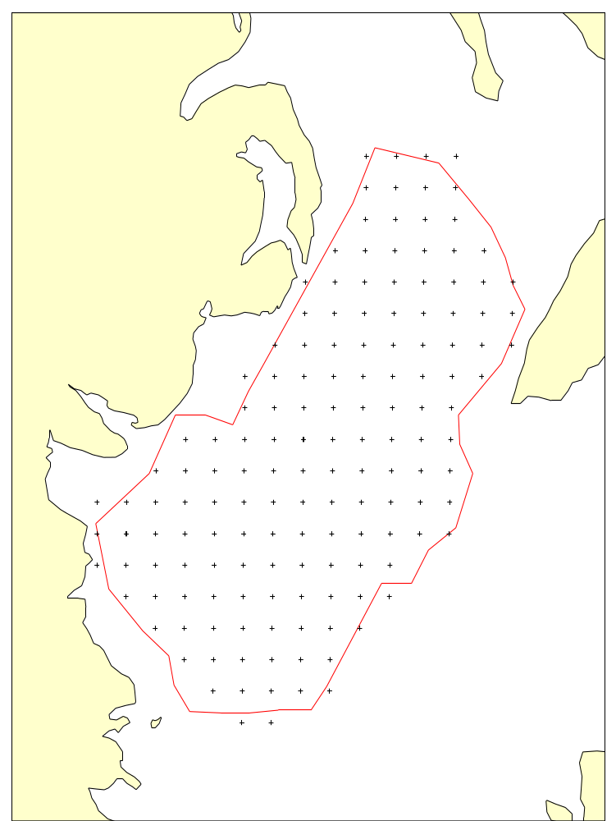

Figure 8. Proposed modification to Nephrops UWTV survey on the Aran Grounds. The blue + indicate station positions with a 4 nmi isometric grid.
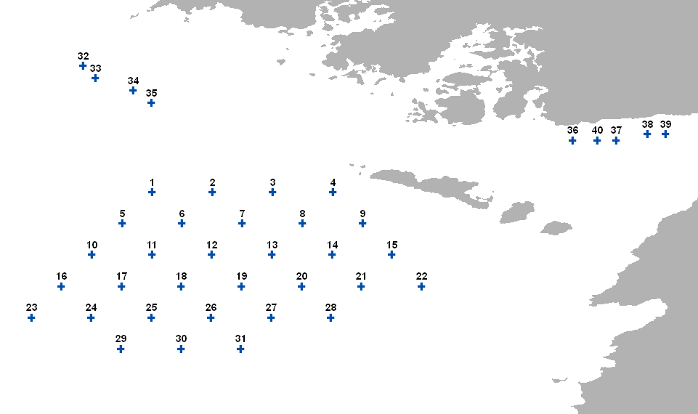

Figure 9. Proposed modification of the Aran UWTV to extend coverage to the Porcupine Bank. Example station positions (black dots) for a 6 nmi isometric grid taking approximately 5 days to complete without down time.
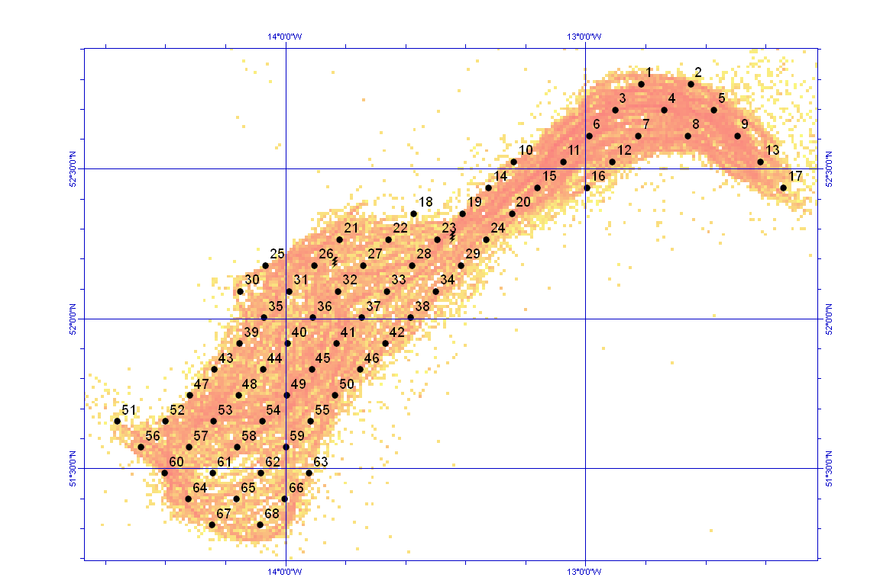

Figure 10 Nephrops UWTV Celtic Sea . The black + indicate station positions and the red line are the known boundaries of Nephrops habitat in the “Smalls” area other smaller patches are not shown.

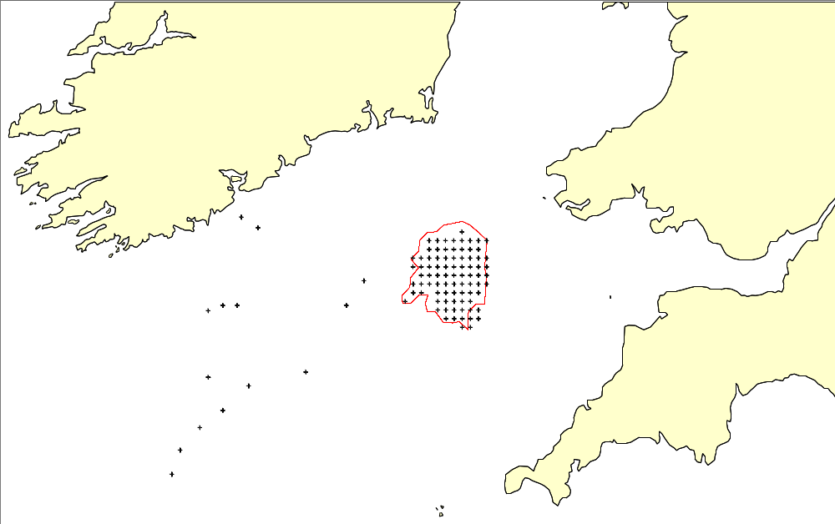

Figure 11. Proposed modification to the Celtic Sea Nephrops UWTV survey. The station intensity on the ‘Smalls’ would be increased from 3 nmi to a 4.5 nmi isometric grid (stations positions shown as black crosses).
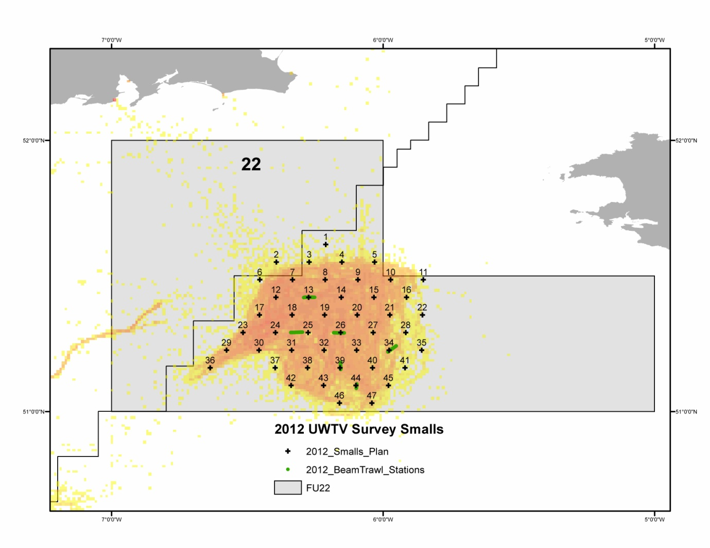

Figure 12. Proposed modification to the Celtic Sea Nephrops UWTV survey to extend survey coverage in FU19. The black + indicate station positions.
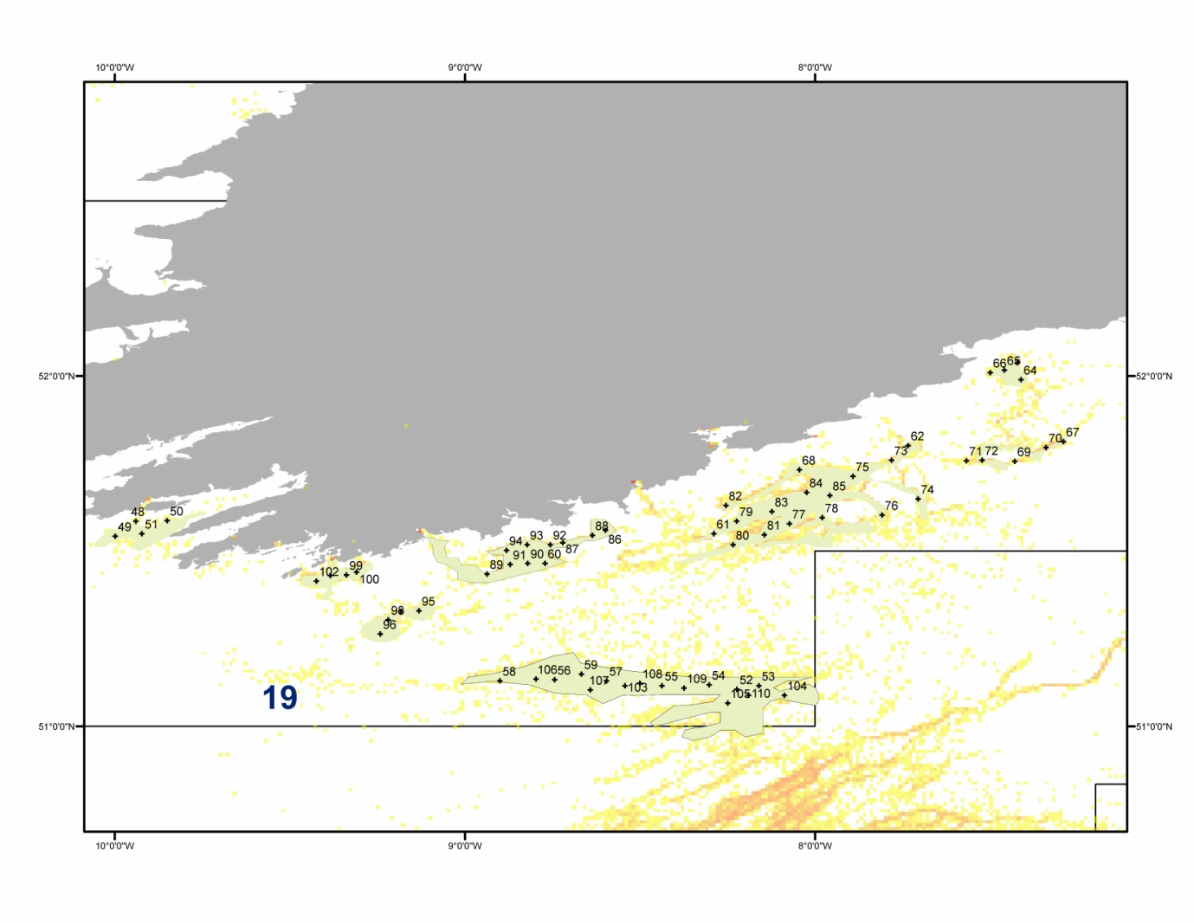

National programme for the collection, management and use of data in the fisheries sector for the period N - (N+2)
INDICATIVE COST OF MULTI-ANNUAL NATIONAL PROGRAMME 2011 - (2013) *
 |  |  | - EURO -
 | Year | Planned eligible expenditure | Maximum Community contribution
 | 2011 | 5,373,275.51 | 2,686,637.76
 | 2012 | 5,771,583.45 | 2,885,791.73
 | 2013 | 6,789,727.28 | 3,394,863.64
 | TOTAL | 17,934,586.24 | 8,967,293.12
* - to be inserted into the National Programme

Minto, C. (1998) Precision level estimates: robust to small sample sizes of finite populations for the Data Collection Regulations.

