
MINISTRY OF AGRICULTURE

Council Regulation (EC) No 2017/1004 of 17 May 2017
on the establishment of a Union framework for the collection, management and use of data in the fisheries sector and support for scientific advice regarding the common fisheries policy and repealing Council Regulation (EC) No 199/2008 (recast)

Commission Regulation (EC) No 665/2008 of 14 July 2008
laying down detailed rules for the application of Council Regulation (EC) No 199/2008
(amended by Commission Delegated Regulation (EU) 2015/1930 of 28 July 2015)

Commission Delegated Decision (EU) 2019/910 of 13 March 2019
establishing the multiannual Union programme for the collection and management of biological, environmental, technical and socioeconomic data in the fisheries and aquaculture sectors

Commission Implementing Decision (EU) 2019/909 of 18 February 2019
establishing the list of mandatory research surveys and thresholds for the purposes of the multiannual union programme for the collection and management of data in the fisheries and aquaculture sectors

Croatian Work Plan for data collection in the fisheries and aquaculture sectors
2020-2021
Version 1 – 2020

Zagreb, 31 October 2019

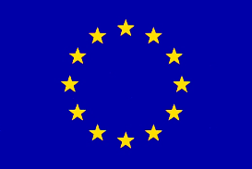
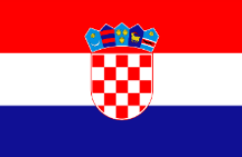
EUROPEAN UNION
CONTENTS

Section 1: Biological Data 2
Pilot Study 1: Relative share of catches of recreational fisheries compared to commercial fisheries 2
Section 1: Biological Data 3
Text Box 1E: Anadromous and catadromous species data collection in fresh water 3
Section 1: Biological Data 4
Pilot Study 2: Level of fishing and impact of fisheries on biological resources and marine ecosystem 4
Section 1: Biological Data 5
Text Box 1G: List of research surveys at sea 5
Section 2: Fishing Activity Data 10
Text Box 2A: Fishing activity variables data collection strategy 10
Section 3: Economic and Social Data 12
Text Box 3A: Population segments for collection of economic and social data for fisheries 12
Section 3: Economic and Social Data 15
Pilot Study 3: Data on employment by education level and nationality 15
Section 3: Economic and Social Data 16
Text Box 3B: Population segments for collection of economic and social data for aquaculture 16
Section 3: Economic and Social Data 18
Pilot Study 4: Environmental data on aquaculture 18
Section 3: Economic and Social Data 19
Text Box 3C: Population segments for collection of economic and social data for the processing industry 19
Section 4: Sampling Strategy for Biological Data from Commercial Fisheries 21
Text Box 4A: Sampling plan description for biological data 21

Section 1: Biological Data

Pilot Study 1: Relative share of catches of recreational fisheries compared to commercial fisheries

General comment: This Box fulfills paragraph 4 of Chapter V of the Delegated Decision on the multi-annual Union programme.
1. Aim of pilot study
The study is a continuation of the pilot study implemented according to the Work plan 2017-2019, encompassing the activites which were not realized in the estimated timeframe, as well as the additional acitivities on recreational fisheries. The aim of this pilot study is to assess the share of catches from recreational fisheries in relation to commercial catches and to obtain indicative data on fishing effort and the qualitative and quantitative composition of the catch particularly in relation to the species listed in Table 3 EUMAP (eel and elasmobranchs, while highly migratory ICCAT species are already included in on site sampling). In order to achieve this goal the annual catches by species in both weight and number shall be obtained. Also, the study will take into account the national activites planned in the reference year, regarding the regulation and additional projects on data collection in recreational fisheries.
2. Duration of pilot study
The anticipated duration of the project is one year, and will be performed by early 2020.
The results of the pilot study will be included in the Annual Report for 2019 by the end of May 2020.
3. Methodology and expected outcomes of pilot study
Considering the large number of participants in sport and recreational fisheries (in recent years, over 70,000 permits is being issued), and the problem of direct (on-board) data collection, the necessary data collection for recreational fisheries is planned through a simple questionnaire that will be distributed to fishermen when purchasing the fishing permit. Data would partly be collected by a prepaid post card survey (for those anglers who purchase their permit in the offices of the Directorate of Fisheries (in further text: DoF) and sports associations), and the other by an e-survey for those who buy an online permit. During the survey information on the types of fishing gears used will be gathered, as well as data on fishing effort, and qualitative and quantitative composition of the catch, with special reference to species listed in Table 3 of the EUMAP (eel and elasmobranchs).
The target population shall consist of all recreational fishing and shall include fishing activities carried out on shore (eg. angling, spearing and fish caught using harpoons) and onboard vessels.

Section 1: Biological Data

Text Box 1E: Anadromous and catadromous species data collection in fresh water

General comment: This Box fulfills paragraph 2 points (b) and (c) of Chapter III of the Delegated Decision on the multi-annual Union programme.
Method selected for collecting data.
The only species from the group of anadromous and catadromous species that has a commercial importance in Croatia is Anguilla anguilla, European eel. The annual catch of this species is very small (an average of about 400 kg) and is performed by commercial and sport and recreational fishing. This type of fisheries is primarily performed using two types of gears - a special type of pot to catch eel and fyke for eel. Fishing takes place throughout the year with different intensity, while the major area of ​​fishing is the mouth of the river Neretva.
Monitoring of eel in Croatia for the period 2017-2019 was planned as a pilot study. During the monitoring program there was no information about registered catch due to scarcity of catch of this species. The prolonged implementation of the pilot study is due to the onsultation of the fisheries sector and administration. Therefore the pilot study shall be continued in the period 2020-2021.
Within the pilot study sampling is planned to be carried out annually, as on-board sampling and sampling on the landing place. During sampling, data on the characteristics of the fishing gear will be collected (number and size of fish pots, mesh size), as well as data on fishing effort and the information on the qualitative and quantitative composition of catches (target species, by-catch and discard). For the target species eel data on length frequencies and biological data (length, individual weight, sex, maturity and age over otolith) will be collected.
All stages of eel (recruits – glass eel, standing stock – yellow eel and emigrating silver eel) will be subject to the pilot study as is planned in Table 1E and sampled for the determination of the required parameters (abundance of glass and yellow eel, and the number or weight and sex ratio of emigrating silver eels). The abundance will be estimated using the eel fishery catch and effort data if possible and using fishery independent methods once an appropriate sampling design is defined. By the end of 2019 the national management plan for eel is still not adopted, however according to scientific and fisheries data, River Neretva is determined as the sampling area for the pilot study.
The methodology for the monitoring, and the protocol will be designed for the purpose of reporting and evaluation refered to in Article 9 of Council Regulation (EC) No 1100/2007 of 18 September 2007 establishing measures for the recovery of the stock of European eel. Coordination of both administrative and methodological activities is needed in order to establish a monitoring programme for eel by the end of the period. In this regard, national coordination is planned for the beginning of 2020. The sampling methodology shall also be discussed within the Regional Coordination Group for the Mediterranean and Black sea in 2020.

Section 1: Biological Data

Pilot Study 2: Level of fishing and impact of fisheries on biological resources and marine ecosystem

General comment: This Box fulfills paragraph 3 point (c) of Chapter III of the Delegated Decision on the multi-annual Union programme.
1. Aim of pilot study
The aim of this study is to collect the data to assess the impact of Union fisheries on marine ecosystems in Union waters and outside Union waters. Data for estimating the level of fishing and the impact of fishing activities on marine biological resources and on marine ecosystems shall be collected based on end-user needs.
2. Duration of pilot study
From 2017 observers on-board are being used also to monitor incidental by-catch. Pilot study will be conducted in the period from 2018 to 2020.
3. Methodology and expected outcomes of pilot study
Incidental by-catch of all birds, mammals and reptiles and fish protected under Union legislation and international agreements, including the species listed in Table 1D, including absence in the catch, will be monitored during scientific observer trips on fishing vessels and by the fisherman themselves through logbooks.
Pilot study 2 shall be carried out according to RCG MED&BS 2017 Recommendation 5: Pilot studies on incidental catch of vulnerable species.
Following the 2016 Recommendation of the RCG Med&BS-LP on pilot studies for the assessment of incidental catches of birds, mammals, reptiles and fish, the planned monitoring programme of the GFCM on the incidental catch of vulnerable species, shall be followed carrying out the following pilot studies:
- 2018: Pilot study for assessing incidental catches of vulnerable species from bottom trawlers
- 2019: Pilot study for assessing incidental catches of vulnerable species from longlines
- 2020: Pilot study for assessing incidental catches of vulnerable species from set nets (gillnets).
The guidelines for monitoring incidental catch of vulnerable species and processing the collected data, will be based both on the outputs of the EU MARE/2014/19 project for the Med&BS, and the GFCM guidelines on incidental catch (under preparation). Data to be collected will include: identification of species, number and weight (when possible) of individuals, gear specifications, location and timing of catches.

Section 1: Biological Data

Text Box 1G: List of research surveys at sea

General Comment: This Box fulfills Chapter I of the Implementing Decision on the multi-annual Union programme. It is intended to specify which reseach surveys at sea set out in the Annex to the Implementing Decision on the multi-annual Union programme will be carried out. Member States shall specify whether the research survey is included in the Implementing Decision on the multi-annual Union programme or whether it is an additional survey.
Pan-Mediterranean Acoustic Survey (MEDIAS)
1. Objectives of the survey
Evaluate the abundance and spatial distribution of small pelagic fish resources by direct methods (acoustics), independently of the data provided by commercial fisheries; Target species are anchovy and sardine.
2. Description of the methods used in the survey.
Acoustic data for fish abundance estimation are collected by calibrated scientific echo sounder at 38kHz; Fish samples are collected by use of pelagic trawl net, with aim to provide information needed for echograms scrutinization, as well as for collection of fish biological data; Abiotic environmental data (measurements of temperature and salinity) collections are made by CTD vertical profiles, while additional biotic data in pelagic ecosystem are obtained by plankton sampling (acoustic at 120kHz and/or vertical hauls). Collection of navigational data ensures that all other collected data are geo-referenced (suitable for spatial analyses). Manual of the survey is available at http://www.medias-project.eu/medias/website/handbooks-menu.html, and it contains a graphical map of the surveys.
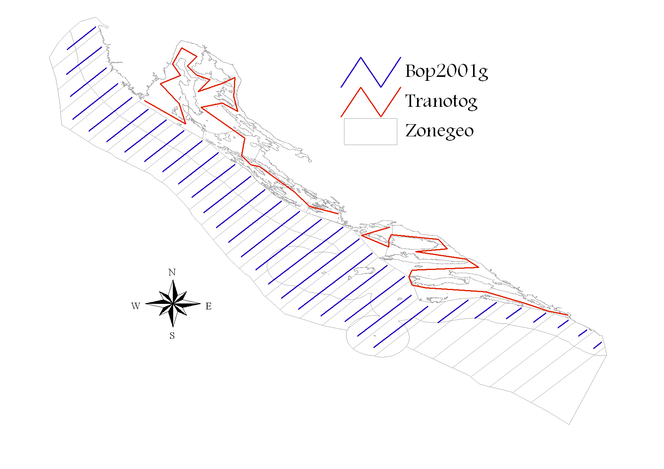
Figure 1. Map of acoustic survey in eastern part of GSA 17 during MEDIAS-DCF survey. Blue transects in open sea and red transects in inner sea.

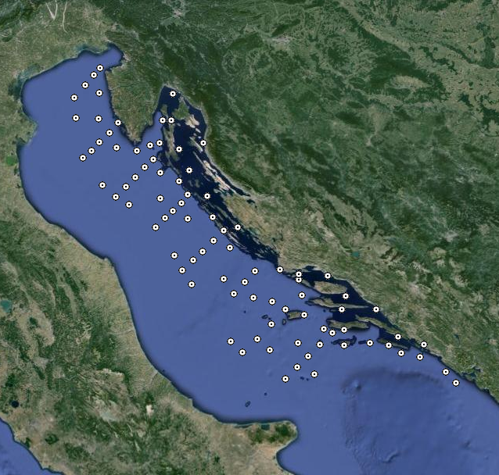
Figure 2. The spatial position of the CTD stations at which the measurements were made during the echo-monitoring DCF MEDIAS (September-October). Source: http://jadran.izor.hr/roscop/.
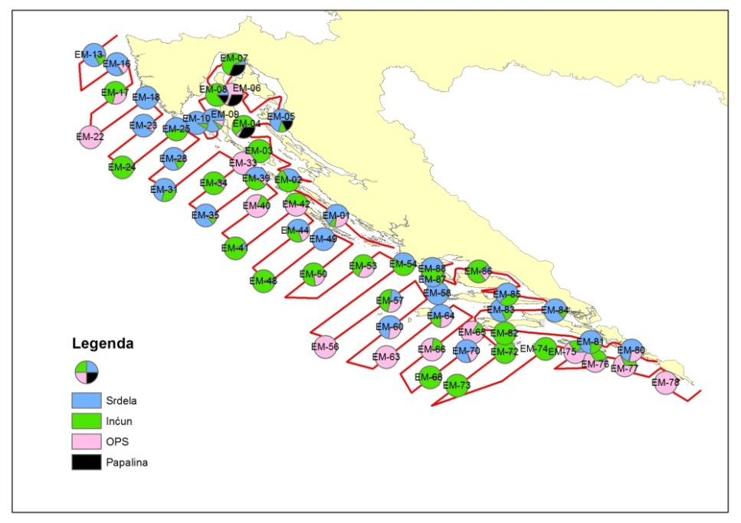

Figure 3. The spatial distribution of sampling and composition of catches achieved with the pelagic trawl along acoustic transects (green - anchovy, blue - sardine, black - sprat, and red - OPS) in September and October.
3. Participating Member States/vessels and the relevant international group in charge of planning the survey
Croatia is participating in MEDIAS by conducting an acoustic survey in the eastern part of GSA17 area (Adriatic Sea), covering an area of 13,578 Nm². International MEDIAS Steering Committee is in charge of surveys planning.
4. Where applicable, describe the international task sharing (physical and/or financial) and the cost sharing agreement used
Not applicable.
5. Explain where thresholds apply
Thresholds are applied only in acoustic data elaborations, as described in MEDIAS Handbook (see at http://www.medias-project.eu/medias/website/handbooks-menu.html).

International bottom trawl survey in the Mediterranean (MEDITS)
1. Objectives of the survey
The MEDITS survey programme intends to produce basic information on benthic and demersal species in term of population distribution as well as demographic structure, on the continental shelves and along the upper slopes at a global scale in the Mediterranean Sea, through systematic bottom trawl surveys.
2. Description of the methods used in the survey
The MEDITS is conducted in spring - summer period from Max to July based on MEDITS protocol using specially designed bottom trawl net GOC 73. Sampling stations are randomly distributed according to the depth strata (10-50; 50-100; 100-200; 200-500; 500-800 m) and the number of stations is proportional to the surface of each stratum (Figure 1). The duration of tow in the area shallower than 200 m is 30 min, while in the area deeper than 200 m is 60 min. On board the vessel, the catches are split into the categories and sub-categories as reported in Annex V and XV of the manual. For each species the total weight and number of individuals should be collected, excluding the taxonomic category V, G, H for which only the total weight should be collected. For taxonomic categories D and E the number of individuals is not mandatory. When the catch of a given species or a fraction of a given species (e.g. juveniles) is too abundant to be measured in extenso it is reasonable to take a representative sub-sample of the catch. This sub-sample should be not less than 100 individuals.
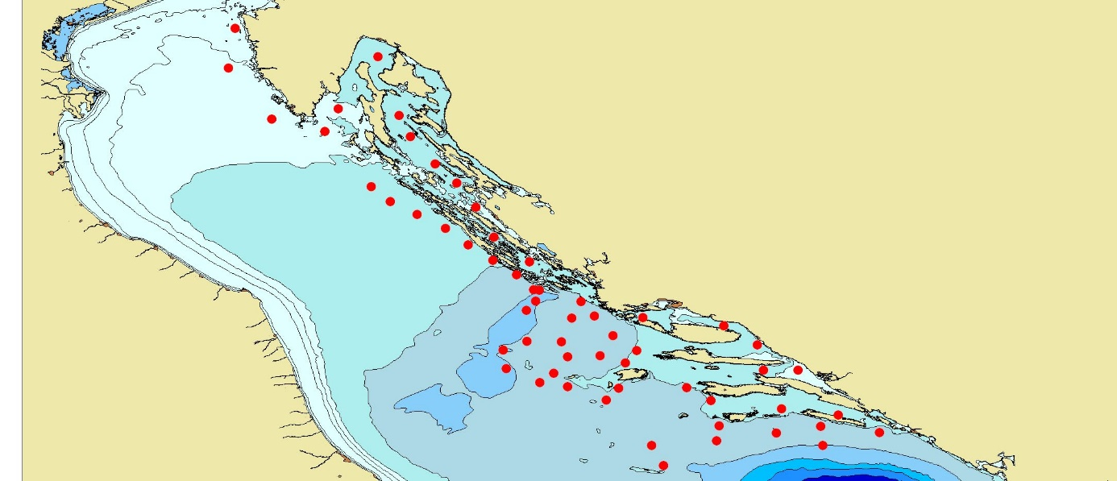
Figure 4. Map of sampling positions during the MEDITS survey in GSA 17 (Croatian territorial waters).
3. Participating Member States/vessels and the relevant international group in charge of planning the survey
Croatia is participating in MEDITS Surveys by conducting a bottom trawl survey in the eastern part of GSA17 area (Adriatic Sea), covering an area of 32000 Km2. MEDITS Working Group is in charge of survey planning.
4. Where applicable, describe the international task sharing (physical and/or financial) and the cost sharing agreement used
Not applicable.
5. Explain where thresholds apply
Not applicable.

Adriatic Rapido Trawl Survey (SoleMon)
1. Objectives of the survey
Solea solea is an important resource in the GFCM area. About 22% of the GFCM landings of soles come from the Adriatic Sea. In the GSA17 soles are targeted by “rapido” trawl and set nets by around 500 vessels, for a total of 1,600 fishermen and an annual value of landings of around 40 million Euros.
The main survey objectives are:
a) Assessing abundance, distribution in GSA17 of sole and other important demersal resources by surveys with “rapido” gears suitable to seize flatfish and other benthic animals.
b) Pursuing the studies on the ecosystem impact of the “rapido” trawl fishery.
c) Contribution to the setting of the GES and targets for the Adriatic Sea in the framework of an ecosystem approach, thus matching to the requirement of the implementation of the MSFD [DIRECTIVE 2008/56/EC].
2. Description of the methods used in the survey
The survey will cover sole presence within the GSA 17 that, according to the genetic information pertains as a single stock (Figure 5). All this holds also for benthic fish and shellfish of commercial interest, including rays and other selachians, since EU greatly focuses on such vulnerable resources. Since 2005 the same gear and protocol was used. The gear was a modified beam trawl named as “rapido” trawl. The gear was appositely planned to be fished on different types of bottom. The survey vessel utilizes two gears simultaneously; taking the characteristics of the gear and the rigging into account the warps should have a diameter of 14-16 mm. The length of warps to be shot is determined by the depth. The gear positioned in the right side of the vessel has 15 m of warp more than the other, in order to avoid possible interference between the two gears during the haul.
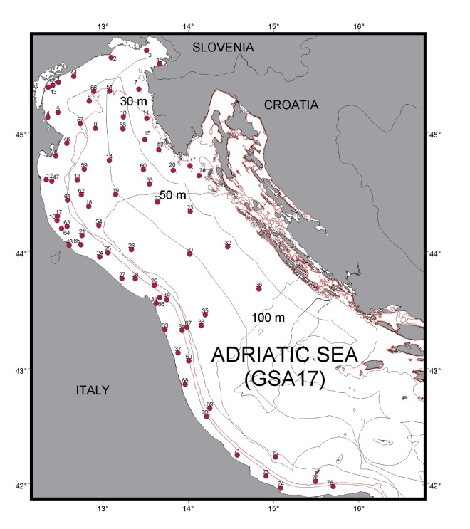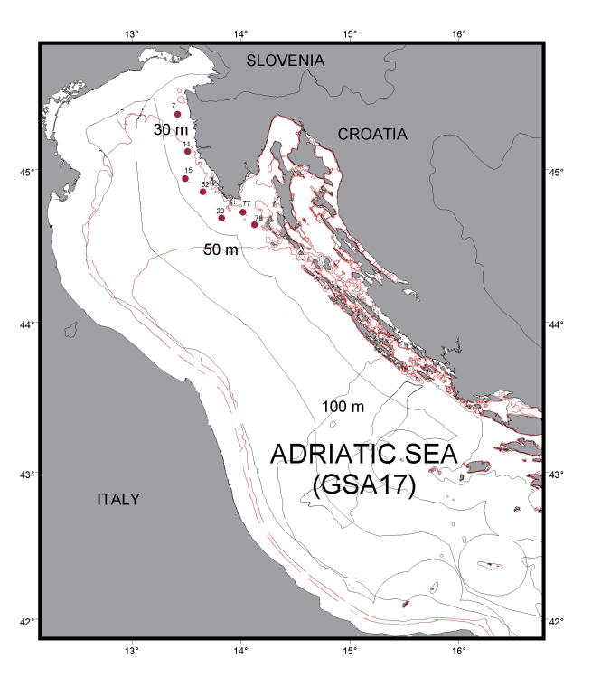
Figure 5. (left) Map of Solemon hauls in the Adriatic, GSA 17 (74 hauls). Borders between MS are indicative and without prejudice to territorial boundaries.
Figure 6. (right) Croatian hauls in the Adriatic Sea, GSA 17 (7 hauls).
3. Participating Member States/vessels and the relevant international group in charge of planning the survey
Data will be shared in working groups both at EU (STECF and ICES) and Mediterranean level (FAO-GFCM), and with all Member States of AdriaMed through common database AtrIS.
4. Where applicable, describe the international task sharing (physical and/or financial) and the cost sharing agreement used
Not applicable. The survey is performed by the Italian research vessel with no additional cost for Croatia while DSA for the Croatian scientists are financed through the AdriaMed project. Coordination is provided under framework of FAO AdriaMed project. Biological sampling is carried out on board scientific vessel "G. Dallaporta" in GSA 17 area by scientists from CNR, IOF and FRI. Sampling is based according to the Handbook on Solemon survey. CNR, IOF and FRI are responsible for data collection, quality control and delivery to the FAO AdriaMed working group for all data collected.
5. Explain where thresholds apply
Not applicable.

Section 2: Fishing Activity Data

Text Box 2A: Fishing activity variables data collection strategy

General comment: This Box fulfills paragraph 4 of Chapter III of the Delegated Decision on the multi-annual Union programme. It is intended to describe the method used to derive estimates on representative samples where data are not to be recorded under Regulation (EU) No 1224/2009 or where data collected under Regulation (EU) No 1224/2009 are not at the right aggregation level for the intended scientific use.
1. Description of methodologies used to cross-validate the different sources of data.
As part of the data collection preparation process, before retrieval of data, quality control procedures are performed to ensure the quality of collected data before its use. Such procedures include validation and verification of primary data from logbooks, fishing reports, sales notes, economic questionnaires etc. During 2015 Croatia started implementing the national validation and verification system under the National Plan for the Implementation of the Validation and Verification System in Republic of Croatia, approved by the European Commission. The so called “Valid” system includes automatic cross-checking procedures of Control data with the aim to validate and verify data comming from fishing declarations (including logbooks and fishing reports) and sales notes. Data on fishing activities is cross-checked with VMS data and relevant inspection procedures are applied when needed.
Although Control data is continuously validated during the year, separate quality reports are used to accomplish this task after data has been collected and stored in the data base. This process lasts around two months and is accomplished prior to the data-call announcement.

2. Description of methodologies used to estimate the value of landings.
Value of landings represents landings weight average prices. Amounts of first sales from sales notes and questionnaires are used to cross-check the resulting estimates. Total value for each species is the result of total weight landed multiplied by the average price.

3. Description of methodologies used to estimate the average price.
Average price is estimated using the recommended method, using weighted averages, trip by trip, obtained from sales notes, logbooks and fishing reports data. Average price is estimated using weighted mean of average price by the landing weight obtained by specie and trip.

4. Description of methodologies used to plan collection of the complementary data (sample plan methodology, type of data collected, frequency of collection etc).
Capacity, effort and landing information is fully covered by DoF and will be collected on the census basis. Complementary data collection is not applied as catch reporting requirements in Croatia are required for all vessels less than 10 m LoA by national legislation in force. The reporting is based on monthly catch reports that are particularly suited for passive gears. Additionally, small scale vessels for personal needs that were transferred to the commercial fleet in 2015 were included in the DCF population for 2015 and fall under the national requirement of catch reporting.

Section 3: Economic and Social Data

Text Box 3A: Population segments for collection of economic and social data for fisheries

General comment: This Box fulfills paragraph 5 points (a) and (b) of Chapter III of the Delegated Decision on the multi-annual Union programme. It is intended to specify data to be collected under Tables 5(A) and 6 of the Delegated Decision on the multi-annual Union programme.
1. Description of methodologies used to choose the different sources of data.
Collection of the economic variables of the fleet is based on two major data sources:
a) Fishery Information System administered by DoF (fishing activity variables, volume and value of blue diesel consumed per vessel; information on subsidies etc.); and
b) Questionnaires for economic data collection.
The consistency of information coming from questionnaires and administrative sources is assured by cross-checking information from the different data sources.

2. Description of methodologies used to choose the different types of data collection.
Economic variables will be collected by questionnaires; the type of data collection scheme is probability sample survey by stratified random sampling and in some cases a census survey. For the variables Consumption of fixed capital and Value of physical capital Indirect survey shall be applied.
All demersal trawl and purse seine segments regardless of the length class shall be sampled on a census basis, due to the importance of a higher response rate (these segments are under heavy management measures).

3. Description of methodologies used to choose sampling frame and allocation scheme.
Based on the basic data on the population and data on the use of fishing gears retrieved and stored, after data has been validated and verified, a segmentation of the fishing fleet is performed. In some cases fleet segments are clusered for sampling purposes or reporting purposes for confidentiality reasons. As clustering depends entirely on the activity of vessels, in cases where clustering is needed, vessel activity is reviewed on a vessel to vessel case. In cases where a vessel changes its activity from one year to another inconsistently, it is directly reflected in the clustering.
On the basis of determined fleet segments, the procedure for determining sample sizes is carried out.
In order to estimate the sample size for the collection of economic variables, the variability of GT and kW is calculated. Coefficient of GT variation is used as a basis to define the sample size of the total fleet.
The sample is distributed among the relevant strata with the principal objective of minimizing the sampling error to be obtained for the stratification variable. The optimum Neyman allocation, which guarantees a minimum variance for the variable used in the stratification, is used for this purpose.
The sample size for each stratum is adjusted in accordance with several minimum rules: not less than 10% of each stratum, not less than 5 observations per segment with <50 active vessels assuming the response rate of 50%. According to the distribution of the GT few segments need to be sampled on census basis.
Stratification on the basis of representative sub-sample per coastal county will be made which should result in a somewhat higher sample rate overall. This has to be done in order to try to reach a representative sample size for each coastal county for two reasons: 1) efficiently organize sampling among data collectors in seven DoF field units and 2) enable economic analysis at the level of smaller units for the purposes of evaluating FLAG strategies, different development plans at municipal level etc.

4. Description of methodologies used for estimation procedures
Estimation procedures are performed according to agreed methodologies published on the official DCF web site (https://datacollection.jrc.ec.europa.eu/docs-links/socio-eco-var).
National procedures and methodological documents will be made available by the end of 2019 on the new national web site (https://podaci.ribarstvo.hr).
In cases where response rate is inadequate to reach a statistically sound estimation, a simple regression is used to cross-check results or estimate totals. Low response rate is typically a problem of data collection for the small-scale fleet, for which questionnaire return rate is low, data in questionnaires inconsistent, unreliable and sometimes unreadable as in most cases there is no professional accounting. To tackle these issues, considerably more effort is placed into data collection for the fisherman involved in small scale fisheries, including direct contact, reviewing questionnaires, cross checking data to ensure a more complete data sets, higher quality and more reliable results.
The calculation of variables Consumption of fixed capital and Value of physical capital is based on data from questionnaires and financial accounts in accordance with the PIM methodology, proposed in the report of study No FISH/2005/03. The age data is available per each vessel in the Fleet register. The data on the value of physical capital (replacement, insurance and purchase is collected through the questionnaire by DoF). The proposed DCF Excel template for the calculation of the capital costs will be used.
Estimation of direct subsidies: DoF records on direct subsidies are used as well as questionnaires. In cases where enterprises have more than one vessel, the amount of subsidies is allocated to vessels based on GT, as subsidies are collected on an enterprise level. The estimations are cross-checked by allocating the total amount of subsidies paid to respective fleet segments using the share of landings value of the fleet segment. In the end, three sets of estimations are compared to reach a sound conclusion.
Estimation of energy consumption and energy costs: For the estimation of energy consumption and energy cost blue diesel records are used. The register of blue diesel is updated annually on the amount of fuel consumed per vessel. No estimation to determine totals is used, as data is collected on a census basis. Energy consumption and information on subsidies (as a second data source) was excluded from DoF questionnaires to avoid duplication of data collection. According to several years of cross-check, FINA and DoF records are proven to be sufficient and there is no need to keep two data sources. PGECON was consulted on the change of methodology in 2019.
Estimation of FTE: The number of hours worked during the year, collected from the enterprises through the economic questionnaire, is divided by national annual full-time working hours (based on the CBS methodology 2084 hours).
5. Description of methodologies used on data quality
To ensure the quality of data collected accuracy of the data that will be calculated. The data quality evaluation depends on the data collection scheme. In all cases (census and probability sampling) unit response rate (number of enterprises responded/total sample) and item response rate (response rate per each variable) is calculated as follows:
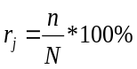
- Response rate (per item j);
N – Total number of vessels in the sample;
n – Number of vessels which provided the data (questionnaire/per each variable).
Coverage rate (number of responses/total population) is calculated in case of probability sampling survey.
It is planned that random samples be used and the sample size adjusted in accordance with the response rate during the implementation.

Section 3: Economic and Social Data

Pilot Study 3: Data on employment by education level and nationality

General comment: This Box fulfills paragraph 5 point (b) and paragraph 6 point (b) of Chapter III of the Delegated Decision on the multi-annual Union programme. It is intended to specify data to be collected under Table 6 of the Delegated Decision on the multi-annual Union programme.
The pilot study on employment by education level and nationality has been carried out in 2018 and the data on employment by education level and nationality shall be collected through the annual economic questionnaire. The questionnaire has been amended to include the additional information on employment by nationality, employment status and information on unpaid labour in 2019.

Section 3: Economic and Social Data

Text Box 3B: Population segments for collection of economic and social data for aquaculture

General comment: This Box fulfills paragraph 6 points (a) and (b) of Chapter III of the Delegated Decision on the multi-annual Union programme. It is intended to specify data to be collected under Tables 6 and 7 of the Delegated Decision on the multi-annual Union programme.
1. Description of methodologies used to choose the different sources of data
There are two main sources of data - some variables will be collected from DoF database and subsidies register while some will be taken from questionnaires. For cross-checking, data from the Croatian Financial Agency (FINA) will be used, which is mostly connected with the balance sheet, but only for companies who have to deliver their data due to their size category or net profit.
2. Description of methodologies used to choose the different types of data collection
Data collection for all techniquest and species groups shall be carried out on the basis of a census, except for Long line-Mussel which shall be sampled on the basis of a Probability Sample Survey.
Data collection will be conducted by phone contact with subjects, introducing them with the data collection, and sending questionnaires together with guidelines by post or email. To ensure data consistency for all segments, together with each variable defined in guidelines it will be given the link to accounting code in balance sheets. The subject will have time two weeks to prepare documentation for data collection and after that a data collector will arrange a visit to farm office or accounting office to check and collect the requested data. For some cases where it is not possible to ensure direct contact, the subjects answer the questionnaires with telephone consultation and send it to DoF by e-mail.
3. Description of methodologies used to choose sampling frame and allocation scheme
Segmentation will be based on species and technique. Since a large number of enterprises are producing more than one species, additional segmentation is based on the value of production attributed to one species. Collecting data shall be for all segments by a census, except shellfish farm, where collecting is based on probability sampling.
4. Description of methodologies used for estimation procedures
One of the main problems is low response and cooperation so estimation needs to be used. Missing variables can be estimated from the FINA database and from Croatian national statistics bureau. Also, additional attention will be made on collecting data, especially on small-scale companies in marine aquaculture, so as in freshwater aquaculture. Since in Croatia there are different levels of enterprises legal registration with different accounting methods, it came clear during data collecting that is necessary to adjust guidelines for each of them. Two different questionnaires with different approach shall be devised. The first one, for small-scale companies, tailored to their business activities and the way of leading accounting records. Other for larger companies where it is easier to respond to inquiries and requests submitted to them.
Since a large number of shellfish enterprises are producing more than one species with significantly different market value (with an increasing volume and value of oysters and decreasing quantities of mussels), in order to make the segmentation more precise, to the additional segmentation, based on the value of production attributed to one species, the third criteria shall be applied - the total area of production per species.

5. Description of methodologies used on data quality
Data collection will be performed through questioners created for this purpose. To ensure data consistency for all segments, together with definition of each variable in guidelines, link is made to accounting code in balance sheets. Some of variables also will be collected from the DoF subsidies register, since it is mandatory for all aquaculture producers in Croatia to report the production in volume and value each year at the farm level. Some of the variables will be taken from questionnaires. Some other variables, e.g. subsidies, will be collected through DoF register and questionnaires. For some segments with small-scale companies it will be necessary to put additional effort in future data collection since they have difficulties in recording financial documents.

Section 3: Economic and Social Data

Pilot Study 4: Environmental data on aquaculture

General comment: This Box fulfills paragraph 6 point (c) of Chapter III of the Delegated Decision on the multi-annual Union programme. It is intended to specify data to be collected under Table 8 of the Delegated Decision on the multi-annual Union programme.
According to available Eurostat aquaculture production data, Croatian aquaculture production, with 17,1 thousand tonnes in 2017 represents a share of 1,3% of the total EU-28 production. Taking into account the defined thresholds of the EU MAP (Implementing Decision 2016/1251, chapter V 6.), environmental data on aquaculture will not be collected.

Section 3: Economic and Social Data

Text Box 3C: Population segments for collection of economic and social data for the processing industry

General comment: This Box fulfills paragraph 1.1(d) of Chapter III and Table 10 of the Delegated Decision on the multi-annual Union programme. It is intended to specify data to be collected under Table 10 of the Delegated Decision on the multi-annual Union programme.
1. Description of methodologies used to choose the different sources of data
Most of the data and additional information will collected through DCF collection and some from FINA (Croatian Financial Agency). Balance sheets will be used for cross-checking of data from questionnaires. DCF data will be collected through the questionnaires sent to the companies accountants.
Balance sheets, coming from CBS (Central Business Statisics), will be complemented by the DoF questionnaire. In order to ensure the consistency of data coming from different data sources cross checking indicators will be used, e.g. volume and value of production collected by DoF and CBS. For enterprises with less than 10 employees, which are not covered by the CBS survey, all the data need to be collected through the DoF questionnaire.
2. Description of methodologies used to choose the different types of data collection
Data collection will be conducted by phone contact with subjects, introducing them with the data collection, and sending questionnaires (forms) together with guidelines by post or email. In the case of processing industry, it is not necessary to visit subjects since most companies have an accounting service and have much better data than some aquaculture segments or the small-scale fishing fleet. The exact size of the active population will be determined only after data collection (in 2015), since all companies that have fish processing as main or as part of their activities were contacted.
3. Description of methodologies used to choose sampling frame and allocation scheme
As data from the Business Register is not necessarily updated, data from the Register of approved establishments, maintained by Ministry of Agriculture, the Veterinary Directorate, will be taken into account when defining the population for reference years 2017-2019.
4. Description of methodologies used for estimation procedures
All questionnaires will be checked by DoF employees and all strange or unknown data reviewed. In some cases, respondents need to be asked to clarify some numbers or information they sent. In cases when data collection is not possible directly from a visit, questionnaires will be filled with telephone consultation and send to DoF by e-mail. Also, some data collection can be made through balance sheet and profit and loss accounts. Those financial reports are available for public at FINA.
5. Description of methodologies used on data quality
A new type of questionnaire should provide data that maximum correspond to the actual operation of enterprises in the fish processing industry. Many companies whose main activity is processing, have also many other activities, as well as aquaculture and fishing activties. In this manner, data placed in questionnaires are actually balanced. Data coming from CBS can however only be used in cross-checking procedures since DCF data call deadlines are usually well before the CBS data availability.

Section 4: Sampling Strategy for Biological Data from Commercial Fisheries

Text Box 4A: Sampling plan description for biological data

General Comment: This Box forms the basis for the fulfilment of paragraph 2 point (a)(i) of Chapter III of the Delegated Decision on the multi-annual Union programme. This Table refers to data to be collected under Tables 1(A), 1(B) and 1(C) of the Delegated Decision on the multi-annual Union programme.
Description of the sampling plan according to Article 5 paragraph (3) of this Decision
REGION: Mediterranean Sea and Black Sea
In order to ensure compatibility along the time series, Croatia will report data by metiers as recommended by RCMMed&BS-LP 2016 and 2017, and as defined by EU Decision 1251/2016 under Chapter III (data requirements), paragraph 2(a) requesting catch data at the aggregation level 6 (corresponding to mesh size). All the collection and analysis of data will be performed and reported at GSA level. Sampling will be performed in order to evaluate the quarterly (in some cases monthly) length distribution of species in the catches, and the quarterly volume of discards.
Only the major metiers will be considered for sampling purposes (following metiers sampled in the previous programming period for comparability purposes and time series). Official statistics (catch, discards, landings, effort and value data) have been used to apply the ranking system. Sampling strategy for each metiere is designed partly as concurrency-at-sea (sampling directly on board by observers and scientists) and concurrency-at-landing site (sampling directly on landing site, at market etc.), taking also into accoount the croatian fishing zones and their specificities. The target population for the reference year will be the number of fishing trips (fishing days) by metier of the previous years. The frame population is a subsample of the target population: it will be a selection of fishing trips, mainly on spatial (Croatian fishing zones and subzones) and time stratification basis (monthly or quarterly) with measurements of the composition of the catch in order to detect seasonal differences in the demographic structure and composition of the landings for different metiers. The sampling will be accomplished as stratified random sampling: the sampling unit belonging to the metier (primary unit) will be the fishing trip (secondary unit). The number of fishing days to be sampled has been defined proportionally to the effort (number of days at sea for each metier) and the landings.
Demersal trawls
Sampling by individual fishing zones is planned for the demersal trawl metier; in total 6 zones per year will be covered 25 times on-board and 60 times at landing places.
Dredges
Sampling is planned for the dredges metier in total 4 times on-board and 4 times at landing places per year.
Sampling of demersal trawl and dredges will be conducted seasonally in order to achieve optimum quarterly distribution of data.
Purse seine net “srdelara”
Sampling of purse seine net “srdelara” will be carried out by individual fishing zones seasonally 36 times on-board and 24 times on landing places.
Purse seine nets
Sampling for purse seines “oližnica”, “igličara”, “palamidara”, “ciplara” and “lokardara” will be carried out annually in total 6 times on board and 24 times on landing places. Namely, purse seines “oližnica” will be sampled 8 times overall; 2 on-board and 6 on landing, purse seines “igličara” will be sampled 4 times overall; all on landing, purse seines “palamidara” will be sampled 4 times overall; all on landing, purse seines “ciplara” will be sampled 8 times overall; 2 on-board and 6 on landing, and purse seines “lokardara” will be sampled 8 times overall; 4 on-board and 4 on landing.
Metier GTR
Trammel nets will be sampled depending on the season when the gear is allowed to be used. Sampling will be carried out 6 times on board and 18 times at landing places.
Metier GNS
Gillnets will be sampled during the entire year 35 times at landing places and 2 times on-board.
Metier FPO
Pots for crustaceans will be sampled in the summer season 15 times at landing places targeting catches of Norway lobster.
Metier SB-SV
Seine nets will be sampled 18 times at landing places and 10 times on-board during the entire year.
Metier LLS
Set longlines will be sampled during the entire year 12 times on landing places.
PS_LPF_>=14_0_0: Large purse seiners targeting bluefin tuna using individual quotas. The fishing season is restricted to one month per year. This BFT fishery is based on farming activities which means that BFT is not landed but transferred live into cages. Metier shall be covered by all relevant monitoring and data collection activities as per ICCAT Recommendation. Given that only a small percentage (less than 1%) of the fish is landed, a part of the measurement shall be based on stereoscopical camera to evaluate the length compositions of the fish. This metiere was selected due to the international obligations and not as per any of the predetermined parameters, and to follow ICCAT recommendation (ref. RCMMed&BS 2009 and 2010 agreement) in order to ensure regional coordination in the sampling of BFT PS.
LLD_LPF_0_0_0: Drifting longlines for large pelagic. Although this metier was not selected by the ranking system and it accounts for only 0,04 % of effort and 0,006 % of landings, it is selected for sampling following ICCAT recommendation in order to ensure regional coordination in the sampling of drifting longlines. The metier is thereafter disaggregated into two metiers:
- LLD_LPF_0_0_0 BFT: Drifting longlines for large pelagic targeting bluefin tuna; and
- LLD_LPF_0_0_0 SWO: Drifting longlines for large pelagic targeting swordfish.
LHP_LPF_0_0_0 (BFT): Sampling programme will encompass commercial catch that is part of the TAC used by a number of vessels that catch BFT by hand lines.
For all the above mentioned metiers minimal number of 600 length samples and 92 total samples (length, weight, age, sex, maturity) of BFT and minimum of 10 total samples of swordfish will be collected.
Recreational fishery and big game fishing competitions of large pelagic fish (BGF REC): Allocated TAC for recreational fishery and BGF will be covered for every held competition and all of the landed fish will be sampled.

