Johann Heinrich von Thünen Institute (TI)
Federal Research Institute for Rural Areas, Forestry and Fisheries,
Institutes of Sea Fisheries (SF), Baltic Sea Fisheries (OF) and Fisheries Ecology (FI)
(National Correspondent: Dr. C. Stransky, Tel. +49 471 94460-141,
E-mail: christoph.stransky@thuenen.de) http://www.thuenen.de
Regulation (EU) 2017/1004 of the European Parliament and of the Council of 17 May 2017
on the establishment of a Union framework for the collection, management and use of data in the fisheries sector and support for scientific advice regarding the common fisheries policy and repealing Council Regulation (EC) No 199/2008 (recast).
Commission Implementing Decision (EU) 2019/909 of 18 Feb 2019
establishing the list of mandatory research surveys and thresholds for the purposes of the multiannual Union programme for the collection and management of data in the fisheries and aquaculture sectors
Commission Delegated Decision (EU) 2019/910 of 13 March 2019
establishing the multiannual Union programme for the collection and management of biological, environmental, technical and socioeconomic data in the fisheries and aquaculture sectors
Commission Implementing Decision (EU) 2016/1701 of 19 August 2016
laying down rules on the format for the submission of work plans for data collection in the fisheries and aquaculture sectors.
Commission Implementing Decision (EU) 2018/1283 of 24 August 2018
laying down rules on the format and timetables for the submission of annual data collection reports in the fisheries and aquaculture sectors.

German Annual Report for data collection in the fisheries and aquaculture sectors
2021
Version 1.2 – June 2022
[Bremerhaven/Rostock, 22 June 2022]
CONTENTS
Section 1: Biological Data 3
Text Box 1C: Sampling intensity for biological variables 3
Section 1: Biological Data 7
Text Box 1D - Recreational fisheries 7
Section 1: Biological Data 10
Pilot Study 1: Relative share of catches of recreational fisheries compared to commercial fisheries 10
Section 1: Biological Data 14
Text Box 1E: Anadromous and catadromous species data collection in fresh water 14
Section 1: Biological Data 16
Text box 1F: Incidental by-catch of birds, mammals, reptiles and fish 16
Section 1: Biological Data 18
Pilot Study 2: Level of fishing and impact of fisheries on biological resources and marine ecosystem 18
Section 1: Biological Data 23
Text Box 1G: List of research surveys at sea 23
Section 2: Fishing Activity Data 62
Text Box 2A: Fishing activity variables data collection strategy 62
Section 3: Economic and Social Data 64
Text Box 3A: Population segments for collection of economic and social data for fisheries 64
Section 3: Economic and Social Data 69
Pilot Study 3: Data on employment by education level and nationality 69
Section 3: Economic and Social Data 70
Text Box 3B: Population segments for collection of economic and social data for aquaculture 70
Section 3: Economic and Social Data 74
Pilot Study 4: Environmental data on aquaculture 74
Section 3: Economic and Social Data 75
Text Box 3C: Population segments for collection of economic and social data for the processing industry 75
Section 4: Sampling Strategy for Biological Data from Commercial Fisheries 79
Text Box 4A: Sampling plan description for biological data 79
Germany, however, was participating in the MARE/2014/19 project “Strengthening regional cooperation in the area of fisheries data collection” (FishPi), where regional statistically sound sampling schemes were tested. We were also involved in the FishPi2 project, which develops practical recommendations for regional sampling plans. 83
Section 5: data quality 84
Section 5: data quality 85
Text Box 5B: Quality assurance framework for socioeconomic data 85

Annexes (separate documents) 87
Cruise reports of non-mandatory surveys

Section 1: Biological Data

Text Box 1C: Sampling intensity for biological variables
General comment: This box fulfils paragraph 2 point (a)(i)(ii)(iii) of Chapter III, Chapter IV of the multiannual Union programme and Article 2, Article 4 paragraph 1 and Article 8 of the Decision (EU) 2016/1701. This box is applicable to the Annual Report.
General remarks regarding all regions:
Several reasons imply that the collection of biological parameters from commercial fisheries is best handled by sampling-at-sea. This is due to
- the necessity to sample on board of freezer trawlers and trawlers with processing units. This is the case in the fishery for pelagic species, as these are landed in frozen packages. The same is true for landings of demersal species from waters off Norway and Greenland which are landed as partly processed products.
- monitoring discarding. It would be highly ineffective not to sample the landings and other biological data at the same time.
- providing the possibility to sample at the same time landings, discards and other catch fractions (related to the Landing Obligation) and to take otoliths and samples for sex and maturity.
- discards of species listed in Table 1D of Commission Decision 2016/1251 as by-catch in fisheries directed towards other species that can only be recorded on board.
- 73%, 69% and 76% of the landings in 2019, 2020 and 2021, respectively, having occurred in foreign countries.

Due to the reasons mentioned above, Germany prefers to sample catches at sea in the North Sea and North Atlantic. This is still the case with the Landing Obligation in force in parts of the fleet. In the Baltic Sea, there is at-sea, self-sampling and harbour sampling.

The status of a scientific observer on board of a German fishing vessel still is a guest status. Article 12.2 of Reg. 2017/1004 stipulates that “the masters of Union vessels shall accept on board scientific observers and cooperate with them”, which did however not improve this situation. The possibility for biological sampling depends on the hospitality of vessel owners and companies. Based on the present situation, random sampling of the fleet is difficult and might be not optimal in future (even if a new legal basis for on board sampling is in place), since some reluctance regarding observers will still remain for several fisheries.

Data are gathered in connection with sampling of commercial sources (observer trips, harbour and self-sampling) and on scientific surveys. Data are sampled on a yearly basis. Table 1C provides an overview on the species by region/fishing ground/area/stock that were sampled during 2021. Note that for some species (e.g. redfish and Greenland halibut), otoliths were only taken but not read due to lacking consensus on age reading methodology and validity. For Baltic flatfish, in accordance with the RCG Baltic 2019 decision to "terminate the age readings for dab, flounder, brill and turbot from the commercial fishery in the Baltic sea (SD 22-32).", otoliths are still sampled but not aged as they are currently not needed to conduct the stock assessment".

The indications of the planned minimum numbers of individuals to be measured for the different variables are based on experiences with the German sampling scheme and survey catches. Even with the possibilities to adjust the numbers within the updates for the programme, it is not always possible to predict accurately if these planned numbers are reachable and realistic. In the following, the most common reasons for over- and undersampling are listed:

Reasons for oversampling:
For most of the fish stocks and brown shrimp, the number of length and age measurements well exceeded the planned and requested minimum number of measurements. As most of the measurements are taken on observer trips, the reason for "oversampling" is often that all fish of a once randomly chosen subsample have to be measured in order to calculate the retained and discarded fraction of the whole catch. Another reason is that once an observer is onboard, the entire trip is being sampled (i.e. sampling does not stop after a few hauls or fishing days, but lasts until the end of that trip). The sometimes very high numbers for weight@length (=individual weights) are taken to obtain reliable weight-length relationships.

Reasons for undersampling:
In several cases, the planned sample sizes have not been achieved. In some cases, this is due to the general rule for observers to collect stock-based variables of 10-12 fish per length class and area. If only very few length classes occur during a fishing trip, this rule can lead to undersampling in terms of the planned numbers.

Although Germany was able to cover most of the stocks, the COVID-19 pandemic interfered with the sampling programmes in many ways. It was not always possible to place observers onboard because of missing hygiene standards or national regimentations prohibited the crossing of borders to bring staff into the harbours.

For surveys, no minimum numbers are given in Table 1C. Here, the survey manual stipulates the target of the survey in terms of fishing method, spatial and temporal coverage. Surveys are mostly not aiming to catch high numbers of a certain species but to get a standardized overview on the abundance and distribution of fish species.

In 2019, the German catch sampling schemes were evaluated externally. The results suggest that the current sampling efforts, given the constraints already explained above, cannot be improved to a large extent. One of the recommendations is to focus on regional coordination and adaptation towards sampling the main fisheries more intensely and release sampling effort by task-sharing with other countries.

Further explanations by region:

Baltic Sea:
- Evidence of data quality assurance
All data quality assurance measures for the commercial and the recreational fisheries sampling programme are given in Table 5A.

- Deviations from the Work Plan
The work plan for the Baltic Sea defines six stratum ID codes. In 2021, deviations occurred in three of these sampled strata.
Over-achievement:
Baltic passive 2224 (+725%): In recent years this stratum contributes increasing proportions to the total landings while the importance of active gear landings is decreasing, especially of Western Baltic cod (>30%) but also for flatfishes. Despite this increasing importance, there is a lack in biological data, not only regarding length and age distributions, but also in the discards. Thus, our sampling fills an important gap in the stock assessment input data. Moreover, this fleet involves a great proportion of the German fishing vessels in the Baltic Sea with considerable variations in species composition, gear settings, temporal and spatial extent, which was not fully recognised when the Work Plan was designed. In addition, potential bycatch issues exist (marine mammals and sea birds) and more intensive sampling was initiated to fulfil national and international requirements.
Finally, due to low cod quota and COVID-19, the proportion of passive gear trips increased (see comment below) and additional self-samples were purchased from the passive demersal fleet in 2021.

Baltic sprat (+800%): In 2012, a self-sampling cooperation was initiated with the two main trawlers targeting sprat and has been successfully continued since 2013. Improved work organisation in the lab enabled efficient work-up of samples without causing additional costs.

Under-achievement:
Baltic active 2224 (only 63% achieved): Quota and catch options for cod in the western Baltic remain historically low in 2021, so that the possibility to obtain trips and samples from the fishery was also reduced. Due to ongoing COVID-19-related restrictions, observers still could not enter the vessels in many cases; larger vessels, which require larger catches to be profitable, reduced the number of trips because larger catches were difficult to sell. The passive gear fisheries was less affected, as these usually have smaller catches, and their catch size can be adjusted more easily, and they are operated by one or two persons only and thus had fewer problems (e.g. with testing or quarantine measures).
Baltic herring active 2224 (only 60% achieved): The planned number of PSUs sampled per year has been updated in 2021 (from 30 to 10 PSU) and now reflects fishing activity and the respective decrease in fishing effort. The very low national quota shortened the fishing season and hence the number of samples that could be collected.

Baltic active 2532 (only 20% achieved): In 2021, Eastern Baltic cod could only be fished as a bycatch species with a bycatch quota and the total number of PSUs in the sampling year was historically low so that the sampling reflected the minor fishing activities; also COVID-19 restrictions further aggravated conducting observer trips.

- Actions to avoid deviations
Conservative planning leads to exceeding the sampling plan, which results in so-called ‘oversampling’. However, oversampling may not be the right term, as for statistical purposes, the sampling intensities in terms of trips are usually not too high. Given the relatively low coverage, any additional, statistically sound sampling data are useful and desirable, especially if they come with no additional costs – as in our case.
Since our sampling is proportional to the fishing activities, the under-achievement in the strata “Baltic active 2224” and “Baltic active 2532” just reflects the reduced number of fishing trips in 2021 and the decreased availability of sampling opportunities due to COVID-19 restrictions.
Given the very low cod quota of the commercial fisheries in the western Baltic Sea in 2021, we started collecting length-stratified samples of cod angled onboard of charter tour boat trips. In former years, biological data from the commercial samples had been regularly used to raise the length data from the recreational sampling; in 2021 for the first time biological data from the recreational samples were used to raise the length data from the commercial sampling. The samples involved whole specimens of both undersized cod (BMS) and market-size cod (>35 cm) for biological sampling.

North Sea and Eastern Arctic:
- Evidence of data quality assurance
See Table 5A. The sampling design and protocols follow the outcomes of sampling expert groups and/or the national standards. Sampling procedures and analysis are described and documented (see e.g. http://www.dcf-germany.de/fileadmin/sites/default/downloads/Beprobungsanleitung_2011-12.pdf). Data quality is checked by national routines. Germany is participating in relevant age reading and maturity workshops in order to ensure international agreement. Presently, we do not evaluate bias and precision of our data. A routine tool is still not available for such estimates on a national level. Furthermore, bias and precision should be evaluated on a regional level within the Regional Coordination Groups in order to assess the sampling levels on a broader coverage. Germany is participating actively in the Regional Coordination Group for the North Sea and Eastern Arctic, now combined with the North Atlantic (RCG NANSEA).
- Deviations from the Work Plan
Oversampling and undersampling of the planned minimum number of individuals of a certain species are explained in the general remarks at the beginning of this paragraph.
Specific explanations are given for zero measurements:
Scarce measurements of saithe in ICES 3a: Catches in the Skagerrak are belonging to the same saithe stock as in the northern North Sea, targeted by the same fishing metier. As fishing activities in the Skagerrak occur only irregularly, the stock is sampled mainly in the North Sea. Sampling possibilities were additionally restricted due to the COVID-19 pandemic.
- Actions to avoid deviations
Achieved sampling intensities higher than the planned values are explained above. For statistical reasons, the achieved sampling intensities cannot be considered too high. The occurrence of oversampling rather reflects conservative planning.
In 2021, again most of the deviations were caused by restrictions for placing observers onboard of fishing vessels due to the COVID-19 pandemic. These could be compensated in some fisheries e.g. beam trawlers targeting flatfish by increasing the number of self-samples. Overall, this led to a better coordination with the fisheries which hopefully will be of use in future to overcome sampling deficiencies especially for assessment purposes.
In the case of the saithe fisheries, additional sampling for the assessment could also obtained by sampling a commercial sample in the fish processing plant.

North Atlantic and NAFO:
- Evidence of data quality assurance
See Table 5A. The sampling design and protocols follow the outcomes of sampling expert groups and/or the national standards. Sampling procedures and analysis are described and documented (see e.g. http://www.dcf-germany.de/fileadmin/sites/default/downloads/Beprobungsanleitung_2011-12.pdf). Data quality is checked by national routines. Germany is participating in relevant age reading and maturity workshops in order to ensure international agreement. Presently, we do not evaluate bias and precision of our data. A routine tool is still not available for such estimates on a national level. Furthermore, bias and precision should be evaluated on a regional level within the Regional Coordination Groups in order to assess the sampling levels on a broader coverage. Germany is participating actively in the Regional Coordination Group for the North Atlantic, now merged with the North Sea and Eastern Arctic (RCG NANSEA).
- Deviations from the Work Plan
Oversampling and undersampling of the planned minimum number of individuals of a certain species are explained in the general remarks at the beginning of this paragraph.
Specific explanations are given for zero measurements:
Missed sampling of herring in ICES Div. 6a/6aN/6aS, 7bc/7a/7j: This herring is only bycatch in the pelagic fisheries targeting other species. In 2021, this was not the case, no landings were recorded. Therefore, no sampling could be conducted.
- Actions to avoid deviations
Achieved sampling intensities higher than the planned values are explained above. For statistical reasons, the achieved sampling intensities cannot be considered too high. The occurrence of oversampling rather reflects conservative planning.
Germany is always aiming to fulfil all its sampling obligations. However, in case of some fisheries with a very low number of trips and very long duration (e.g. up to 3 months), it is not always possible to place observers.
In 2021, again most of the deviations were caused by restrictions for placing observers onboard of fishing vessels due to the COVID-19 pandemic. These could be compensated in some fisheries e.g. freezer trawlers targeting small pelagics by increasing the number of self-samples. Overall, this led to a better coordination with the fisheries which hopefully will be of use in future to overcome sampling deficiencies especially for assessment purposes.

Other regions:
- Evidence of data quality assurance
A multilateral sampling agreement for the CECAF area exists since 2011. For the SPRFMO area, a similar agreement is in force since 2015. Table 7A provides details on these agreements, and the national portal website (dcf-germany.de) contains copies of the agreements. Sampling procedures are described in separate documents accompanying the multilateral agreements (https://www.dcf-germany.de/sampling). Germany is participating actively in the Regional Coordination Group on Long Distance Fisheries (RCG LDF).
- Deviations from the Work Plan
not applicable
- Actions to avoid deviations
The sampling is currently conducted by Poland and coordinated under the RCG LDF and within multilateral agreements. Any deviations and actions are discussed in these fora. For the SPRFMO region, plans are currently underway to establish an international pool of observers, complying with the new RFMO requirements from 2024/2025 onwards.

Section 1: Biological Data

Text Box 1D - Recreational fisheries
General comment: This box fulfills paragraph 2 point (a) (iv) of Chapter III of the Annex of the Delegated Decision (EU) 2019/910 on the multiannual Union programme; and Article 2, Article 3 and Article 4 paragraph 1 of the Implementing Decision (EU) 2016/1701 on the format of the WP. This box is applicable to the Annual Report. This box is intended to provide information on the design, implementation and analysis of all components of sampling schemes/ surveys that are listed in Table 1D.
i) Off-site telephone/diary survey (2020-ongoing):
Survey ID: Off-site survey
1. Description of the target population
All Persons ≥ 14 years of age in German households that have been recreationally angling (all fishing methods & species) in the past 12 months or plan to do so in the next 12 months in Germany. The population is stratified by municipality. Primary sampling units (PSUs) are German households the secondary sampling unit is the individual.
2. Type of survey
A nation-wide representative computer-assisted telephone interview (CATI) screening survey targeting 150,000 Germans has been carried out from October 2020 to April 2021 followed by a one-year diary survey. The off-site CATI survey was designed to identify anglers in the German population, to collect their socio-demographic parameters and information on angler heterogeneity, and to estimate fishing effort as well as to recruit participants for the subsequent diary survey. The CATI survey used a dual frame approach with 70% landline numbers and 30% mobile numbers. A mixture of random-digit dialling and number sampling from an official number registry (landline only) was used to derive telephone numbers and contact households, with selection probabilities being proportional to the number of households per municipality. However, a disproportional sampling approach was chosen to increase the number of marine anglers in the diary survey. Therefore, the probability of sampling telephone numbers originating from federal states that are more close to the German coasts was doubled. A total of 1,541,182 numbers were used to realize 150,232 interviews. Of these numbers, 683,135 (~44%) were mobile numbers and 858,047 (~56%) were land-line numbers. Up to ten attempts were made to contact a household. Thereafter, a telephone number was considered a quality-neutral failure. Household size and number of persons in a household being recreational anglers were determined. An angler was defined as a person who had fished at least once in Germany during the last 12 months preceeding the survey. Survey participants had to be older than 14 due to the German Youth Protection Act. All persons that had been fishing in Germany in the last 12 months, or who planned to go fishing there in the next 12 months were asked to participate in a one-year diary survey. This resulted in a total of 1,891 diarists. All diary participants were asked to report every single angling day in Germany over an observation period of 12 months starting from the day they received the diary. For every angling day, the date, time, fishing location, angling platform (boat, charter boat, shore), target species, and the number of fish caught, harvested and released per species had to be reported. In order to maintain the motivation to participate, to retrieve diary data, and to reduce panel attrition bias, the participants were contacted by telephone at quarterly intervals during the entire observation period. The diary data will be collected between October 2020 and May 2022. The survey and the analyses are still ongoing.
3. Data Quality
Data quality is checked externally for consistency and validity by the market research company who conducts the survey. Data quality is checked internally at different levels of the processing chain (e.g. completeness, consistency and validity checks of the Excel spreadsheets during data import to database / range and cross checks of the final database entry.
4. Data Analysis and processing
In order to obtain representative estimates of the size of the German angler population, the corresponding fishing effort and catches, harvests and releases for all species both the data of the CATI and the diary survey will be weighted and extrapolated in various ways following the data collection. The estimation procedure follows the survey design. All weigthing, extrapolation and imputation methods will be documented. Precision estimates (CIs) will be caluclated and documented, see Weltersbach et al. 2021 for example from a previous survey.
Reference:
Weltersbach, M. S., Riepe, C., Lewin, W.-C., & Strehlow, H. V. (2021). Ökologische, soziale und ökonomische Dimensionen des Meeresangelns in Deutschland. Braunschweig: Johann Heinrich von Thünen-Institut, 254 p, Thünen Rep 83, http://doi:10.3220/REP1611578297000

ii) On-site access point survey:
Survey ID: On-site survey
1. Description of the target population
Baltic marine anglers encountered at access points (harbours, piers, beaches etc.). Primary sampling units (PSUs) are access points and days the secondary sampling unit is the fishing trip.
2. Type of survey
The multispecies on-site access point survey includes random intercepts of marine anglers (shore, boat and charter boat anglers) at access points along the German Baltic Sea coast. It aims to collect catch rates and fishing characteristics of marine anglers for both sea-based and land-based catches for both the harvest and release component (in particular of western Baltic cod for stock assessment purposes). The sampling frame covers all access point (79) along the entire German coast in ICES SD22 & SD24. Data is used for extrapolation of German recreational catch data using effort data from the off-site telephone/diary survey. The coastline is divided into five strata, with harbours and beaches as access points and days as primary sampling units. Access points and days (27 days per month) are randomly selected within the strata. The interviews are conducted by five survey agents during peak activity times in the afternoon/evening when most anglers are expected to end their fishing day. The sampling effort is increased for sea-based fishing methods and for those days when anglers most frequently go fishing (weekends and public holidays). Observation time per access point is usually 3-5 hours. The fishing methods are grouped into shore fishing (surf angling and wading), boat fishing (including float tubes and kayaks), and charter vessel fishing. The following data are collected during the interviews: the number of caught and released fish per species, the sociodemographic factors gender, age, place of residence (postal code), avidity (measured as the reported number of fishing days in the German Baltic Sea in the past 12 months), weather conditions and the coastal state and specific location at which the interview took place. In 2021, 1,235 on-site angler intercepts were realized. In addition, onboard length samplings of recreational caught fish are conducted on charter boats in the German Baltic Sea. This aims in collecting recreational length distributions for sea-based catches for both the harvest and release component. The sampling frame covers the entire German charter boat fleet in SD22 & SD24. Primary sampling units (PSUs) are recreational charter vessel fishing trips the secondary sampling unit is the fish. The coastline is divided into five strata. Per month 5 assignments are carried out where a scientific observer carries out onboard length measurements. Sampling date and the individual charter vessel are randomly selected for each sampling day. For more details see Strehlow et al., 2012.
3. Data Quality
Data quality is permanently checked internally at different levels of the processing chain (e.g. daily/monthly completeness and validity checks of the Excel spreadsheets during the data input / completeness, consistency and validity checks during data import to database / range and cross checks of the final database entry. A documentation can be found in ICES, 2019 and Lewin et al., 2021.
4. Data Analysis and processing
Data is used for extrapolation of German recreational cod catch data, as well as for scaling Danish recreational catches in SD22 & SD24 for the ICES stock assessment. In the case of cod data, no annual precision estimates are calculated, as for assessment purposes, this is not a requirement. Recreational length data is used together with commercial length-weight data to determine catch in numbers at age (CANUM). Data analyses and processing has been documented in Strehlow et al., 2012 and ICES, 2019. The main R script used for analysis can be found in a gitgub repository (Haase et al. 2022).
References:
Strehlow HV, Schultz N, Zimmermann C, Hammer C (2012). Cod catches taken by the German recreational fishery in the Western Baltic Sea, 2005-2010: implications for stock assessment and management. ICES J Mar Sci 69(10):1769-1780.
ICES. 2019. Benchmark Workshop on Baltic Cod Stocks (WKBALTCOD2). ICES Scientific Reports. 1:9. 310 pp. http://doi.org/10.17895/ices.pub.4984
Lewin, W.-C., Weltersbach, M. S., Haase, K., Riepe, C., Skov, C., Gundelund, C., & Strehlow, H. V. (2021). Comparing on-site and off-site survey data to investigate survey biases in recreational fisheries data. ICES Journal of Marine Science. http://doi:10.1093/icesjms/fsab131
Haase, K., Weltersbach, M. S., Lewin, W.-C., Zimmermann, C., and Strehlow, H. V. 2022. Potential effects of management options on marine recreational fisheries – the example of the western Baltic cod fishery. ICES Journal of Marine Science, 79, 661–676, https://doi.org/10.1093/icesjms/fsac012

iii) Remote camera survey:
Survey ID: Camera survey
1. Description of the target population
Salmon trolling boats leaving harbours. Primary sampling units (PSUs) are access points (harbours) and days and secondary sampling units are salmon trolling boats.
2. Type of survey
Remote cameras are installed at three marinas (Glowe, Lohme, Wiek) that collectively provide access to > 60% of all trolling boats participating in the German salmon trolling fishery, to quantify launch based fishing effort departing from these marinas (Hartill et al., 2020). Each system consists of a network camera connected to a wireless network router. Images are stored on a 250 GB Solid-State Drive (SSD) connected to the router and data are manually retrieved every two months. Marina entrance choke points are monitored, providing coverage of all boats leaving the marinas. Recording is restricted to the salmon trolling season (December to May) and images are only taken between 5 am and 3 pm when trolling boats are known to leave the marinas to increase cost efficiency. Image analysis and boat counting is conducted via manual visual inspection of the images in time-lapse (30 frames viewed per second). Salmon trolling effort from marinas not monitored by cameras is extrapolated using regular instantaneous trolling boat counts (every two weeks at night or on storm days) covering all relevant marinas with salmon trolling boats and the proportions of trolling boats that went out for fishing derived from the marinas with camera monitoring (Hartill et al., 2020). The camera monitoring is complemented by random on-site interviews (10-12 assignments per month with replacement) of trolling anglers in four relevant marinas (including the marinas where the camera monitoring is conducted) to determine catch, harvest and release rates (each per boat) and to collect biological catch data and socio-economic information. In 2021, a total of 60 random on-site samplings were conducted and 251 trolling boats with 449 anglers targeting salmon were interviewed.
3. Data Quality
Data quality is permanently checked internally at different levels of the processing chain (e.g. daily/monthly completeness and validity checks of the Excel spreadsheets during the data input / completeness, consistency and validity checks during data import to database / range and cross checks of the final database entry.
4. Data Analysis and processing
Data is used for estimation of the German recreational salmon catches for the ICES stock assessment. The estimation procedure follows the survey design. Precision estimates (CIs) are caluclated and documented. Data analyses and processing has been documented in ICES, 2020.
References:
Hartill BW, Taylor SM, Keller K, Weltersbach MS (2020) Digital camera monitoring of recreational fishing effort: Applications and challenges. Fish Fisheries 21(1):204-215.
ICES. 2020. Baltic Salmon and Trout Assessment Working Group (WGBAST). ICES Scientific Reports. 2:22. 261 pp. http://doi.org/10.17895/ices.pub.5974

Section 1: Biological Data

Pilot Study 1: Relative share of catches of recreational fisheries compared to commercial fisheries
General comment: This box fulfils paragraph 4 of Chapter II of the Annex of the Implementing Decision (EU) 2019/909 on the multiannual Union programme and Article 2 and Article 4 paragraph (3) point (a) of the Implementing Decision (EU) 2016/1701 on the format of the WP.
General comment: This box is applicable to the Annual Report. This box is intended to provide information on the results obtained from the implementation of the pilot study.
Resume 2017-2019 and outlook
The pilot study was performed as planned by Germany within 2017-2019 and will be continued as regular
data collection.
The pilot study conducted during 2017-2019 revealed that for some areas and species, marine recreational
fisheries (MRF) catches represented a significant proportion of the total removals and thus should be
collected regularly to underpin European fisheries management. This was the case for cod, salmon and sea
trout in the Baltic Sea.
In the case of cod, the comaprison between the off-site 1-year-telephone-diary survey and the on-site
stratified random access-point-intercept survey revealed that a national population survey is required at
regular intervals (3-5 years) to quantify fishing effort and that an annual on-site intercept survey proves
valuable to detect rapid and quick changes in catch rates (CPUE). The onboard sampling during charter boat
trips was used to collect biological catch composition data (length measurements) for all caught and released
species during the sampled trips of this sector. This survey component is indispensable to obtain unbiased
length distriutions of caught and released MRF catch compositions. We will therfore continue with our
annual on-site access-point-intercept survey in 2020 and beyond, as well as regular onboard sampling of
MRF catches to obtain length distributions. As there have been substantial changes in MRF management
regulations in recent years (introduction of a bag limit for cod), which also affect anglers' behaviour and thus
exerted fishing effort, we are planning to conduct a large nationwide telephone survey in 2020/2021 to yield
updated data on fishing effort in recreational fisheries. This survey shall also cover freshwater/inland
fisheries to yield estimates on freshwater eel catches in Germany. Social indicators will be included to
correct for angler heterogeneity in data collection and stock assessment.
In the case of salmon, the 1-year-telephone-diary survey revealed that this survey does not adeqautely cover
the MRF for salmon in the Baltic Sea. We therefore invented a new dedicated salmon-camera survey to
obtain near-census effort estimates from relevant salmon harbours and in association with stratified random
angler-intercepts in those harbours to obatin catch rates and biological data (length distribution). MRF
salmon catches proved to have a large interannual variability suggesting to conduct this dedicated survey on
an annual basis. We will thus continue this remote camera survey with regular angler intercepts in 2020.
In the case of sea trout, the 1-year-telephone-diary survey could be used to obtain effort estimates for the
MRF sea trout fishery. This survey was however not sufficient to yield annual variability and length
distributions. Currently, the plan is to continue to use national population surveys for this specialized fishery
and use the same data for intermittent years. The planned nationwide telephone survey in 2020 will provide
updated data for sea trout catches in the Baltic Sea.
Altogether, the conducted pilot study (MRF surveys) was adequate to fullfill the DCF requirements and the
continuity of it will satisfy the following end-users of the MRF data: ICES WGRFS, WGBFAS and
WGBAST; DG MARE; EP; RCGs; PGECON; national governments and regional fisheries authorities,
international and national angling bodies, national and local businesses and journalists.

4. Brief description of the results obtained (including deviations from planned and justifications as to why if this was not the case).
The pilot studies were performed as planned by Germany within 2017-2021 and the final results have already been reported in detail in the 2020 annual report and the EMFF pilot study summary, which can be found here:
https://www.dcf-germany.de/documents
The main objective of the present pilot studies was the collection of representative data on the number, fishing effort, catch-per-unit-effort and total catches (harvest and releases) of German marine anglers in the North and Baltic Sea including the brackish lagoon waters (Bodden) of Mecklenburg-Western Pomerania considering all relevant species. Therefore, it was necessary to conduct pilot studies investigating the extent and impact of recreational fishing on marine and diadromous fish stocks in Germany in order to gain information on the share of recreational fisheries catches compared to commercial fisheries.
To achieve this goal three pilot studies have been conducted in the period 2017-2021:(i) Telephone diary survey (ii) Multiannual on-site access point survey (iii) Remote camera survey.
- Telephone diary survey: A representative telephone screening survey (CATI) of the general population in Germany was conducted from May to October 2014 to identify marine anglers in the German population. During the screening survey, sociodemographic parameters of the German marine angler population were collected and participants were recruited for a one-year diary study. The diary study aimed to provide detailed spatial-temporal data on recreational fishing effort and catches for all species over a twelve-month period. The diary survey ran between May 2014 and October 2015. The analyses and documentation of the results were conducted in the framework of the pilot study between April 2017 and January 2021. A main goal of the off-site survey was the collection of fishing effort data that can be used together with catch rate data from the on-site survey (pilot study 2) to calculate recreational harvest and releases for stock assessment purposes. Based on the experiences and lessons learned from the pilot study similar off-site surveys are planned every 5-7 years (due to cost constraints) to update recreational fishing data, in particular fishing effort. These surveys will also include all freshwater recreational fisheries in Germany to obtain also catches of diadromous species during their freshwater phase. However, with the exception of eel, freshwater catches for these species are expected to be negligible. A subsequent off-site telephone diary survey targeting German marine and freshwater anglers from all over Germany (screening of 150,000 German households) has been already initiated in 2020 and will run until 2022.
- Multiannual on-site access point survey: The second pilot study comprised a stratified random on-site access point intercept survey conducted between 2017 and 2020. The on-site survey follows a multi-annual survey design and collects information based on completed fishing days on socio-demographics of anglers, fishing characteristics, and catch rates for stock assessment purposes, in particular western Baltic cod (Gadus morhua), even though all species are considered. The survey is conducted annually and will continue in the future.
- Remote camera survey: The third pilot study comprised a remote camera survey supplemented with an on-site access point intercept survey to monitor the highly specialized recreational salmon (Salmo salar) trolling fishery in the Baltic Sea around the Island of Ruegen (ICES SD 24). The survey is conducted annually since 2017 and will continue in the future.
Results
i) Telephone diary survey: For the reference period 12 months prior to the interview (2013/2014), a total of around 197,000 German marine anglers could be estimated spending about 1.8 million fishing days in German coastal waters. In addition, the results showed that there were about 161,000 German Baltic Sea anglers, who spent about 1.3 million fishing days in the German Baltic Sea, about 49,000 Bodden anglers, who spent about 390,000 days fishing in the Bodden and about 32,000 German North Sea anglers, who spent about 232,000 fishing days in the German North Sea. In total, 586 persons participated in the one-year diary study. Depending on the species and stock, the importance of recreational fisheries harvest varied considerably compared to German commercial fisheries in the Baltic Sea (ICES subdivisions 22 and 24). For example, the relative contribution of German recreational fisheries to total German removals (sum of German commercial and recreational fishery removals in metric tons) of sea trout (≈ 91%) and cod (≈ 53%) was high, while their contribution to herring, eel (each ≈ 6%) and flounder (≈ 7%) was well below 10% of the total removals. In the North Sea, the most popular target species were sea bass (Dicentrarchus labrax), various flatfish species, cod and mackerel. Boat and charter vessel anglers mainly targeted mackerel and cod, and shore anglers mainly sea bass and flatfishes. In total, 13 different species were caught, with plaice, mackerel and cod being the most common. Release rates for cod, sea bass and eel were around 30%. In international comparison, catches by German marine anglers in the North Sea were relatively insignificant.
ii) Multiannual on-site access point survey: During 1,843 on-site sampling assignments, 8,762 anglers over 14 years of age were encountered and interviewed along the German coast between 2015 and 2019. The majority of anglers (92%) targeted cod, noticeable fewer herring (5%), salmon (2%), and sea trout (1%). Cod anglers caught a mean number of 4.6 (± 5.4 S.D.) cod per angler and day. On average, the cod anglers released 39.6% (± 34.5% S.D.) of the caught cod. The mean catch of herring anglers was 25.5 (± 32.2 S.D.) herrings per angler and day. Only 1.7% (8.3% S.D.) of caught herring was released. Salmon and sea trout anglers caught on average 1.2 (± 0.9 S.D.) salmon and 1.6 (± 1.0 S.D.) sea trout per angler and day, respectively. On average 5.4% (± 15.8%) of salmons and 11.4% (± 22.6 S.D) of seatrout were released. For all species, catch rates and release percentages varied between years and angling platforms. We concluded that the on-site survey is suitable to collect catch, harvest and release data that can be used for stock assessment purposes.
iii) Remote camera survey: Based on the camera monitoring and the corresponding extrapolations the total salmon trolling fishing effort in Germany ranged from about 2,000 to about 5,400 salmon boat fishing days per year between 2017-2020. A total of nearly 2,800 salmon anglers from 1,178 trolling boats were surveyed for this purpose after completing their fishing day in the period 2017-2020. The calculated harvest ranged between 1,093 and 5,525 and releases between 26 and 923 salmon per year. The results of this pilot study revealed that remote cameras proved to be a cost-efficient method providing accurate salmon trolling fishing effort estimates helping to reduce bias in recreational salmon trolling catch estimates.

5. Achievement of the original expected outcomes of pilot study and justification if this was not the case.
The pilot studies conducted within the remits of the German recreational catch sampling scheme have furthered our understanding of the marine recreational fisheries sector in Germany. Although mainly designed as multispecies surveys the results of the national telephone diary survey (pilot study 1) and the on-site access point intercept survey (pilot study 2) revealed an underrepresentation of highly specialized recreational fisheries as for example the German recreational salmon trolling fishery. This led to the development and application of novel survey methods, such as the remote camera survey (pilot study 3) targeting this fishery. Overall, the achievements matched the originally expected outcomes as harvest and releases for the DCF species listed in the North and Baltic Sea are available. Deviations from the planned achievements occurred only for recreational freshwater catches of diadromous species (eel, Baltic sea trout and Atlantic salmon). The reason for this lies mainly in the low incidence of anglers in Germany (≈ 4-5%). As a result, national population surveys covering the entire population of Germany are extremely elaborate and very expensive > 800,000. It is planned to conduct these national off-site telephone diary surveys every 5 to 7 years. Due to low participation rates in recreational fishing (preventing the use of representative population panel studies) in Germany and as there are no complete sampling frames (e.g. a license register) available, there are currently no alternatives to representative German-wide off-site screening surveys. The only other deviation lies in being able to provide recreational removals for Baltic sea trout only every other year and based on off-site surveys. This is unfavourable from a stock assessment point of view (although Baltic sea trout is not a quota species) – as similar to cod – the interannual variation of catch rates (CPUE) is variable and the strongest driver for total recreational harvest estimates. For the same reason, the on-site survey (pilot study 2) will be continued on an annual basis as it provides accurate CPUE estimates for cod that would not be available when relying on off-site survey conducted only every other year. However, sea trout angler behaviour is very different than that to cod anglers, which is why sea trout anglers are underrepresented in the on-site access point intercept survey preventing the calculation of precise CPUEs on an annual basis. Further, sea trout fishing effort is highly variable and largely driven by weather and sea state. Future surveys will therefore rely on a proxy to correct for real sea trout fishing effort and CPUEs between large-scale off-site surveys.

6. Incorporation of results from pilot study into regular sampling by the Member State.
Based on the pilot studies the following surveys will be continued as regular data collection:
- Multispecies off-site survey: A nation-wide representative computer-assisted telephone interview (CATI) screening survey combined with a one-year diary survey will be conducted every 5-7 years to provide national estimates of fishing effort, social indicators, catches, harvest and releases for all species in marine and freshwater environments. The last survey started in October 2020 and continues until 2022.
- Multispecies on-site survey: The multispecies on-site survey aims in collecting information on fishing characteristics and catch rates, in particular for western Baltic cod. The on-site survey is carried out annually along the outer German Baltic coastline and usesa stratified random sample of sampling days and access points selected without replacement. Biological data will be collected annually by scientific observers during monthly onboard samplings of charter boat trips along the German Baltic coast.
- Remote camera survey: Remote cameras are installed at three German marinas that collectively provide access to > 60% of all trolling boats participating in the German salmon trolling fishery, to quantify launch based fishing effort departing from these marinas. Salmon trolling effort from marinas not monitored by cameras is extrapolated using regular instantaneous trolling boat counts (every two weeks at night or on storm days) covering all relevant marinas with salmon trolling boats and the proportions of trolling boats that went out for fishing derived from the marinas with camera monitoring. The camera monitoring is complemented by random on-site interviews of trolling anglers in relevant marinas to determine catch, harvest and release rates (each per boat) and to collect biological catch data and socio-economic information.

Section 1: Biological Data

Text Box 1E: Anadromous and catadromous species data collection in fresh water

General comment: This Box fulfills paragraph 2 points (b) and (c) of Chapter III of the multi-annual Union programme and Article 2 of this Decision.
Eel (Anguilla anguilla)
As required by Decisions 2019/909 and 2019/910, the data collection in all German Eel Management Units (EMUs) will be organised as follows:
- Biological variables (age, length, sex, maturity)
  - Sampling of silver eels from commercial catches
  - Timing and frequency of sampling commercial fisheries potentially affects catch composition (i.e. length and/or age composition) and will thus introduce a bias to the collected data. To proceed towards a sound sampling scheme, multiple samplings over an extended time period will be conducted in one EMU (Ems) to analyse seasonal variations in the catch composition. It is thus necessary to conduct additional age readings in this EMU and therefore no further age readings will be conducted in other EMUs.
  - Spawner quality assessed in sub-samples (e.g. contamination status, fat content, parasite infestation)
- Annual catch quantities in EMUs as reported by fishers
- Recruitment
  - Natural recruitment: regional (non-DCF) glass eel monitoring /ICES time series
  - Stocking: number of glass eels and elvers, as reported in national stocking statistics
  - Larval surveys in the spawning area of the European eel
- Abundance of standing stock and silver eel escapement
  - calculated via German Eel Model III (Oeberst & Fladung, 2012)

Salmon (Salmo salar)
Based on the recent data collection, it was concluded in the German DCF Annual Report 2018 that German populations of Salmo salar do currently not contribute to the stock assessment by WGNAS and active data collection within the DCF framework is considered not feasible. However, available data and information from regional authorities will be collected annually and provided to relevant end-users in order to ensure regular updates on the state of German salmon populations.

References
Oeberst, R. & Fladung, E. 2012. German Eel Model (GEM II) for describing eel, Anguilla anguilla (L.), stock dynamics in the river Elbe system. Inf. Fish. Res. 59: 9-17. DOI: 10.3220/Infn59_09-17_2012
Were the planned numbers achieved?
Fully achieved regarding the multiple sampling of silver eels over an extended time period in the River Ems. Eel sampling took place between September 2020 and December 2021. In total, biological variables of 3,296 eels were assessed (2,370 in 2021) and age readings were made on a subsample of 155 otoliths. Restrictions of laboratory operations due to the COVID-19 pandemic caused a delay in age readings. However, the planned number of otoliths was sampled and age readings were finalized in time.
Partly achieved regarding the sampling of commercial catches. Planned numbers were fully achieved in EMUs Ems, Elbe, Warnow, and Schlei/Trave. In EMUs Eider, Rhein and Weser, however, sampling was not completed due to different reasons (low catches, temporal failure of fishing gear, unwillingness of fishermen to cooperate).
Partly achieved regarding the spawner quality assessment. In 2021, sampling for spawner quality analyses (contaminant load, fat content and Anguillicola crassus infestation) was completed. The analyses, however, could not be conducted as planned due to technical problems and will be made during the 2022-2024 WP period.
Fully achieved regarding salmon data collection. Available data from German inland waters were collected and provided to end-user (ICES WGNAS).
Data collection on eel catch quantities, eel recruitment and stocking are collected annually, but data from 2021 will be available only later in 2022. An annual update on these data is provided in the ICES data call on eel and available to end-users. Data on the silver eel escapement from EMUs and abundance of standing stock is reported in the Eel Management Plan progress reports on a three-year basis. In 2021, the latest progress report was published.
As already reported in the Annual Report 2020, two studies were conducted aiming 1) to assess the feasibility of environmental DNA analysis to quantify the abundance of migrating silver eels in rivers and 2) to investigate the contaminant burden of eels in German EMUs. Detailed information on progress, results and difficulties of these studies were provided in the Annual Report 2020 as separate study reports.
Implications of COVID-19 pandemic restrictions
Laboratory operations were hampered or temporarily stopped also in 2021 due to COVID-19 pandemic restrictions. This caused delays in sample processing and analysis (e.g. otolith age readings, morphometric measurements of samples from eel fisheries) and hampered the progress of spawner quality analyses. Due to travel restrictions, sampling of commercial eel fisheries was temporarily not possible because work-related travel was restricted or prohibited.

Section 1: Biological Data

Text box 1F: Incidental by-catch of birds, mammals, reptiles and fish

General Comment: This box fulfils paragraph 3 point (a) of Chapter III of the multiannual Union programme and Article 2 of the Decision (EU) 2016/1701. This box is applicable to the Annual Report. This box is applicable only for those sections where Member States have reported that they have been carrying out regular sampling. Results and deviations for Pilot studies should be reported under Pilot Study 2.
1. Results
In certain German fisheries, the by-catch of single specimens of vulnerable species was observed very occasionally (see Table 1F). In 2021, no by-catch of mammals and birds was observed in the North Sea and North Atlantic area. Occurring by-catch of listed fish species (e.g. Rajidae) was recorded. It was attempted to release the specimens alive when possible.
2. Deviations from Work Plan
No deviations. Our sampling covers all bird and marine mammal species (no reptiles occur in our fishing areas). If occurring species are identified to the lowest possible taxon (species level). Birds are usually dead and collected for sampling; the carcasses are provided to the Institute for Terrestrial and Aquatic Wildlife Research of the University of Veterinary Medicine Hannover (ITAW Büsum) in Germany. Cormorants are not collected.
3. Data quality
- Does the onboard observer protocol contain a check for rare specimens in the catch at opening of the codend? If YES is the observer instructed to indicate if the codend was NOT checked in a haul?
North Sea and North Atlantic: Yes, the observer is advised to give an indication to which amount he/she was able to check the fishing activities for accidental by-catch.
Baltic Sea: No, because rare species are already recorded in the standard protocol. Onboard of passive-gear vessels, the entire catch is sampled (concurrent sampling) and all species in the catch are recorded. On active-gear vessels, the observer is usually on deck when the codend comes onboard and sampling is concurrent.
- In gill nets - and hook-and-line fisheries: does the onboard observer protocol instruct the observer to indicate how much of the hauling process has been observed for (large) incidental bycatches which never came on board (because they fall out of the net)? In large catches: does the protocol instruct to check for rare specimens during sorting of the catch (i.e. at conveyor belt)? Is the observer instructed to indicate what percentage of the sorting or hauling process has been checked at “haul level”?
North Sea and North Atlantic: Gill nets are only used by very few vessels in the North Sea and north-western waters. Due to the negligible effort, these vessels are not included in the observer program.
Baltic Sea: No, but usually the observer is on deck and observes the hauling process unless the observer is processing the sample. In large catches, subsamples are taken and all species in the subsample are identified to species level. Observers are instructed to indicate the percentage of the haul they have sampled.
- Does the onboard observer protocol instruct to report on the use of mitigation (i.e. Escape Devices or Acoustic Deterrent Devices)?
Yes, but only in use in the German Baltic Sea fisheries.
- Does the sampling design and protocol follow the recommendations from relevant expert groups? Provide appropriate references. If there are no relevant expert groups, the design and protocol have to be explained in the text.
The question is unclear. We follow the current sampling guidelines of the DCF/EU-MAP and try to include suggested improvements of relevant working groups (e.g. WGCATCH, WGBIOP, WGBYC) whenever it is doable within our working routine. Our current sampling programme is concurrent sampling of landings, discards and unwanted by-catches, the latter involve all PETS but the sampling design is not directed to sample incidental bycatches or collect additional data on sea birds or marine mammals (e.g. counting flocks of birds or estimating the size of schools of marine mammals during the sampling).
- Are data quality issues taken into account?
The question is unclear. Sampling coverage follows the sampling obligations in accordance with the Commission Delegated Decision (EU) 2019/910. Observers are trained for species determinations.
- How are data (and samples) stored
The data are stored in a national database. Samples of incidental bycatch are only stored temporarily in a freezer and then provided to specialised research groups in Germany (e.g. ITAW Büsum, Deutsches Meeresmuseum).

Section 1: Biological Data

Pilot Study 2: Level of fishing and impact of fisheries on biological resources and marine ecosystem

General comment: This Box fulfills paragraph 3 point (c) of Chapter III of the multiannual Union programme and Article 2 and Article 4 paragraph (3) point (b) of the Decision (EU) 2016/1701.
General comment: This box is applicable to the Annual Report. This box is intended to provide information on the results obtained from the implementation of the pilot study.
1. Aim of pilot study (Stomach sampling and analysis)
Improve availability of data and tools for estimating the level of fishing and the impact of fishing activities on marine biological resources
2. Duration of pilot study
24 months (1 Jan 2020 – 31 Dec 2021 - continuation)
3. Methodology and expected outcomes of pilot study
Fundamental changes in the importance of natural vs. fishing-induced mortality are observed while moving towards MSY management target. The comprehensive reduction of fishing mortality and successive recovery of fish stocks, especially of the larger predatory species, led to an increasing natural mortality as opposed to fishing mortality. Consequently, estimates of natural mortality become more important for stock assessments and forecasts. A DG MARE tender (Contract MARE/2012/02-SI2.632887) pilot study on stomach sampling in the North Sea and Baltic Sea was able to prove, in cooperation with the ICES Working Group on Multispecies Assessment Methods (WGSAM), that cost-effective sampling of stomachs is possible during existing surveys. It was possible to analyse stomachs in a cost-effective manner with the help of national labs and/or external contractors. Results of the fishPi project (MARE/2014/19) conclude that opportunistic stomach sampling on existing DCF surveys is a promising way forward. However, missing regional coordination was identified a major problem by the project. The lack of coordination leads to unbalanced sampling effort resulting in a lack of statistically sound sampling of all key species needed for food web characterisation and finally does not allow moving towards the Ecosystem Approach to Fisheries (EAF). Based on the lessons learned from the DG MARE pilot study and the fishPi project, Germany will in this pilot study establish a regular sampling scheme for stomachs on its vessels during international and national surveys in close cooperation with WGSAM, survey planning groups, regional coordination groups and international partner labs. The sampling will be carried out based on the guidelines from WGSAM to ensure that data can be used for multi-species modelling, assessments and advice.
Currently, the Regional Coordination Group for the North Atlantic, North Sea & Eastern Arctic (RCG NANSEA 2019) is discussing ways to move forward to implementing a regional coordinated stomach sampling programme. For this purpose, an intersessional subgroup on stomach sampling has been established to work on this matter. The experience from the German stomach data sampling trial will be discussed further at the regional coordination meetings (RCGs), survey planning groups and WGSAM during 2019, 2020 and 2021. If other countries agree, the rolling scheme can be easily harmonized with other countries. The aim is to cover finally the whole North Sea. However, this depends on the willingness of other countries. In any case, Germany will deliver an overview on its sampling scheme, associated costs and uncertainties inherent in final data products. This will give guidance on which basis Germany will establish a regular sampling scheme.
For the Baltic Sea, stomach data of cod, flounder, plaice, dab and turbot, collected during 2017-2019 in the western Baltic, will be analysed in 2020 within the scope of BSc MSc and PhD theses.
References
RCG NANSEA 2019. Report of the Regional Coordination Group North Atlantic, North Sea & Eastern Artic. 3-6 June 2019, Ghent, Belgium, 114 pp.
Brief description of the results obtained (including deviations from planned and justifications as to why if this was not the case).
- Achievement of the original expected outcomes of pilot study and justification if this was not the case
A German Bight stomach sampling programme was introduced in 2018 for the first time. The German Bight is the main sampling area for Germany. The goal was the establishment of a rolling scheme with the plan to sample each year one or two of the most important fish predators in the German Bight (whiting, cod, mackerel, turbot, grey gurnard). The rolling scheme started in 2018 with whiting (Merlangius merlangus) and was continued with cod (Gadus morhua) and turbot (Scophthalmus maximus) in 2019 and 2021. Stomachs were sampled during various national and international surveys in the German Bight (IBTS, German Box survey (GSBTS), German EEZ survey (GAS EEZ), German young fish survey (DYFS) and a survey dedicated to sample brown shrimp and its predators four times a year). The sampling strategy is based on the guidelines from WGSAM (ICES 2010), i.e. the target is to sample two stomachs per 5 cm predator length class per station. As many stations as possible will be sampled. The analysis of the stomach contents follows the protocol from the last international stomach sampling study (MARE/2012/02-SI2.632887). In 2018, approximately 1600 whiting were sampled in the German Bight, while in 2019 and 2021 approximately 200 turbot and cod stomachs were sampled. The frozen samples were processed at the Thünen Institute of Sea Fisheries in Bremerhaven, Germany. A total of 1 285 whiting and 63 turbot were weighed, length measured, sex distinguished and the stomach content mass was weighed and the contents stored in ethanol. The analysis of the whiting and turbot stomach contents has been completed. The analysis showed that juvenile whiting predominantly feed on crustaceans, while the proportion of fish in the stomachs increased with increasing total length of whiting. The most abundant fish families found in the stomachs were Clupeidae, Gadidae, Ammodytidae and Gobiidae with identified species herring Clupea harengus, sprat Sprattus sprattus, lesser sandeel Ammodytes tobianus and whiting Merlangius merlangus. Turbot was almost entirely piscivorous, feeding mainly on Clupeidae (e.g. C. harengus) and Gadidae (e.g. M. merlangus). The intensity of the feeding impact of whiting and turbot on juveniles of commercially important fish species and of whiting on brown shrimp (Crangon crangon) is currently being analysed. Preliminary results indicate a strong predation pressure of age-0 to age-2 whiting on commercially important fish and brown shrimp close to the German coast.
In the Baltic Sea, cod stomachs are sampled on a regular basis since 2015. In addition, the contemporary feeding ecology of cod from the Belt Sea (SD22) were published in Funk et al. (2021). Cod stomach content data from the Arkona Basin (SD24; sampling years 2017, 2018) and the Bornholm Basin (SD25; sampling years: 2018, 2019) are presently being prepared for publication. Moreover, stomach contents of the major flatfish species from the Bornholm Basin (i.e. flounder, plaice) were sampled (sampling years: 2018, 2019) and analysed within the scope of Master theses. In 2020, a stomach sampling of whiting in the western Baltic Sea was initiated in response to requirements indicated by ICES WGSAM and the RCG ISSG stomach sampling.
- Incorporation of results from pilot study into regular sampling by the MS
The experience from the German stomach data sampling trial have been and will be discussed at regional meetings (RCGs), survey planning groups (e.g. IBTSWG) and WGSAM. If other countries agree, the rolling scheme can be easily harmonized with other countries. However, this depends on the willingness of other countries. In any case, Germany has presented the experience with and the results of its sampling trial during the intersessional subgroup work of the RCG and the main lessons learned have been incorporated to the case study on a regionally coordinated stomach sampling program of the North Sea. The aim is to initiate a regionally coordinated stomach sampling program for the North Sea, in which the German sampling activities will be incorporated. This aim has partly been realised, as a regionally coordinated stomach sampling program in the North Sea has started in the first quarter of 2022.
In the Baltic Sea, the sampling of cod stomachs has been implemented as part of the sampling routine since 2015.
References
Funk S, Frelat R, Möllmann C, Temming A, Krumme U (2021) The forgotten feeding ground: patterns in seasonal and depth-specific food intake of adult cod Gadus morhua in the western Baltic Sea. J Fish Biol 98, 707-722, DOI:10.1111/jfb.14615.

General comment: This box is applicable to the Annual Report. This box is intended to provide information on the results obtained from the implementation of the pilot study
1. Aim of pilot study (Impact of fishing activities on marine biological resources)
Improve availability of data and tools for estimating the level of fishing and the impact of fishing activities on marine biological resources and on marine ecosystems
2. Duration of pilot study
24 months (1 Jan 2020 – 31 Dec 2021- continuation)
3. Methodology and expected outcomes of pilot study
When it comes to assessing the impact of fishing on marine ecosystems, two aspects have to be considered: i) Bottom-contacting fishing gears potentially impact habitat quality and thus suitability and carrying capacity of marine ecosystems and ii) non-target species including rare and sensitive species are by-caught in the fishery potentially affecting ecosystem composition and functionality. Data on by-catch of the latter species in the different fisheries are still scarce. Incidental by-catch of elasmobranchs and marine mammals can only be quantified with large uncertainties. Germany will train observers to better distinguish between different shark, ray and skate species and will ensure that by-catch of non-commercial and sensitive species will be recorded during observer trips. Habitat degradation by fisheries needs to be assessed differently. First of all, the level of fishing by metier needs to be determined at highest geographical resolution, to assess the overlap of fishing and habitat. Secondly, the impact of different gear types on the specific habitat type needs to be classified to assess the impact of fishing on habitat quality. In this pilot study, Germany will adapt existing methodology as applied by ICES WGSFD and OSPAR to establish a routine monitoring of fishing impacts on marine habitats. Combining indices of fishing impact on habitats with by-catch information on rare and sensitive species will allow addressing the impact of fishing on marine ecosystems.
The information on biological as well as technical interactions (including by-catch of non-commercial and sensitive species and habitat impact) in mixed fisheries needs to be combined in integrated modelling approaches. Under the new CFP, management strategies need to the established that ensure the ecological, social and economic sustainability of fisheries. Management plans need to take into account the knowledge on biological and technical interactions in mixed fisheries to reach this goal. Based on the traditional (including economics) and new information from the DCF pilot study, Germany will help to develop and parameterise management strategy evaluation tools that account for ecosystem considerations for the North Sea together with institutes from other MS. This will allow an integrated impact assessment of management strategies and ensures that all available DCF data are utilised to provide the best possible advice.
In the first phase of this pilot study, international fishing effort data were analysed in the German Bight in order to quantify fishing pressure on the seafloor. For this, we followed a similar indicator and assessment framework as described in ICES (2017) and used the swept area ratio (SAR) as proxy for seafloor abrasion. However, some adaptations were necessary in order to obtain estimates that are temporally and spatially more precise for the southern North Sea. For example, based on data from 2012-2016, on average 45% of the German offshore areas and 62% of the coastal areas were fished with bottom-contacting gears with relatively little interannual variation. The completed small-scale SAR estimates can now be related to by-catch information on rare and sensitive species, helping to assess ecosystem effects of fisheries.
In 2018, Germany significantly contributed to the ICES WGSFD and WGFBIT, the latter developing models to determine the impact/status of the seabed. These models form the basis for the future advice in relation to fisheries impact on habitat quality, and the continuation of the Pilot Study helps to adapt them for a regional North Sea assessment and will ensure the incorporation of the results into a regular sampling by the MS.

References
ICES. 2017. Interim Report of the Working Group on Spatial Fisheries Data (WGSFD), 29 May – 2 June
2017, Hamburg, Germany. ICES CM 2017/SSGEPI: 16. 42 pp.
Brief description of the results obtained (including deviations from planned and justifications as to why if this was not the case).
- Achievement of the original expected outcomes of pilot study and justification if this was not the case
In this pilot study, international fishing effort data were analysed in the German Bight in order to quantify fishing pressure on the seafloor. For this, we followed a similar indicator and assessment framework as described in ICES (2017) and used the swept area ratio (SAR) as proxy for seafloor abrasion. However, some adaptations were necessary in order to obtain estimates that are temporally and spatially more precise for the southern North Sea. For example, based on data from 2012-2016, on average 45% of the German offshore areas and 62% of the coastal areas were fished with bottom-contacting gears with relatively little inter-annual variation. The completed small-scale SAR estimates can now be related to by-catch information on rare and sensitive species, helping to assess ecosystem effects of fisheries.
In 2021, Germany significantly contributed to the ICES WGSFD, WKTRADE3 and WGFBIT, the latter developing models to determine the impact/status of the seabed based on species traits as an extension of only using taxonomic identities. These models form the basis for the future advice in relation to fisheries impact on habitat quality. Moreover, Germany developed a machine-learning approach, using Gradient Forest, to determine which natural and human stressors, including fisheries, are important in structuring benthic and demersal fish distributions in the Southern North Sea, and at which threshold-values community changes occur. Finally, we studied the potential spatial conflict between offshore windfarms and fisheries (Stelzenmüller et al., 2022).
The mixed fishery FLBEIA model developed in the pilot project for the North Sea was adopted for ICES mixed fishery advice starting in 2022. This shift has several advantages over the previously used model, including increased detail in the defining fleet/métier selectivity patterns and the ability to conduct longer-term forecasts within a flexible management strategy evaluation (MSE) framework.
Recent work has also included the evaluation of socioeconomic outcomes under scenarios of climate change. In these scenarios, changes in fish and fuel prices are considered, as well as climate-driven effects to recruitment in several important demersal stocks. A machine learning methodology developed within the working group has been used to identify significant mediatory effects between environmental variables and stock recruitment relationships (SRRs). These SRRs have been subsequently incorporated within the FLBEIA model for use in forecasting future recruitment under scenarios of climate change. The results indicate strongest long-term changes for stocks whose recruitment is linked to temperature in the North Sea (cod and plaice), while stocks whose recruitment is primary driven by other environmental variables that lack clear long-term trends (e.g. currents) are less affected (whiting and saithe). The recruitment decreases for cod are predicted to continue to limit mixed fisheries effort in the future; however, compliance with catch limits associated with maximum sustainable yield (MSY) results in good stock status and improved profitability in the medium term. Longer-term management will need to continually update MSY reference points in response to changing stock dynamics under climate change. In combination with climate change impacts, additional work has focused on assessing the resilience of demersal mixed fisheries to cope with (unexpected) environmental shocks to recruitment. Again, MSY compliance was observed to allow stocks to quickly rebound back to safe biomass levels.
Ongoing work will continue to focus on improving the model conditioning for use in short- and long-term forecasting. One particular application will be in the evaluation of indicators related to the implementation Ecosystem Based Fisheries Management (EBFM). The use of the MSE framework will allow for the incorporation of several types of model uncertainty – process uncertainty (natural variability in demographic rates and processes) and observation uncertainty (imperfect observation of the true state of the ecosystem). By considering these sources of uncertainty, we aim optimize forecasting ability and improve the efficiency of management measures.
The sampling of sensitive bycatch is already incorporated in the regular sampling programme (cf. Table 1F and Text Box 1F).

References:
ICES. 2017. Interim Report of the Working Group on Spatial Fisheries Data (WGSFD), 29 May – 2 June 2017, Hamburg, Germany. ICES CM 2017/SSGEPI: 16. 42 pp.
Stelzenmüller, V., J. Letschert, A. Gimpel, C. Kraan, W.N. Probst, S. Degraer, and R. Döring. 2022. From plate to plug: the impact of offshore renewables on European fisheries and the role of marine spatial planning. Renewable and Sustainable Energy Reviews 158:112108.

Section 1: Biological Data

Text Box 1G: List of research surveys at sea

General comment: This box fulfills Chapter IV of the multiannual Union programme and Article 2 and Article 7 paragraph (3) of the Decision (EU) 2016/1701. It is intended to specify which reseach surveys at sea set out in Table 10 of the multiannual Union programme will be carried out. Member States shall specify whether the research survey is included in Table 10 of the multiannual Union programme or whether it is an additional survey.
General comment: This box is applicable to the Annual Report. This box should provide complementary information on the performance of the surveys, the results and their main use.

Mandatory surveys:
Baltic International Trawl Survey (BITS)
- Objectives of the survey
Target species are demersal fish species, mainly Baltic cod and flatfish species (flounder, plaice, dab, brill and turbot). The main aim is to determine the year-class strength of the target species. Target data are abundances, weight and length distributions of all fishes and length-weight-age-sex-maturity-feeding-parasitism data of commercially important species as well as hydrographic data (temperature, salinity and oxygen). The collected data are stored in a national SQL database and submitted to the ICES DATRAS database. In addition, stomachs and marine litter are sampled.
- Description of the methods used in the survey. For mandatory surveys, link to the manuals. Include a graphical representation (map)
See survey manual:
http://doi.org/10.17895/ices.pub.2883
- For internationally coordinated surveys, describe the participating Member States/vessels and the relevant international group in charge of planning the survey
Denmark (R/V DANA and R/V HAVFISKEN), Sweden (R/V SVEA), Germany (R/V SOLEA), Lithuania (F/V CLV*), Poland (R/V BALTICA), Latvia (R/V BALTICA) and Estonia (F/V CEV**) and Russia (R/V ATLANTIDA). ICES WGBIFS is coordinating the planning of this survey.
* BITS Code for: Commercial Lithuanian Vessel (Charter)
**BITS Code for: Commercial Estonian Vessel (Charter)
The relevant international group in charge of planning the survey is the ICES Working Group on Baltic International Fish Survey (WGBIFS).
- Where applicable, describe the international task sharing (physical and/or financial) and the cost sharing agreement used
The ICES survey planning group (WGBIFS) assigns the tasks to the survey participants (e.g. coverage of certain areas in a certain time frame). Each participating country is responsible for the activities conducted on its national part of the international survey.

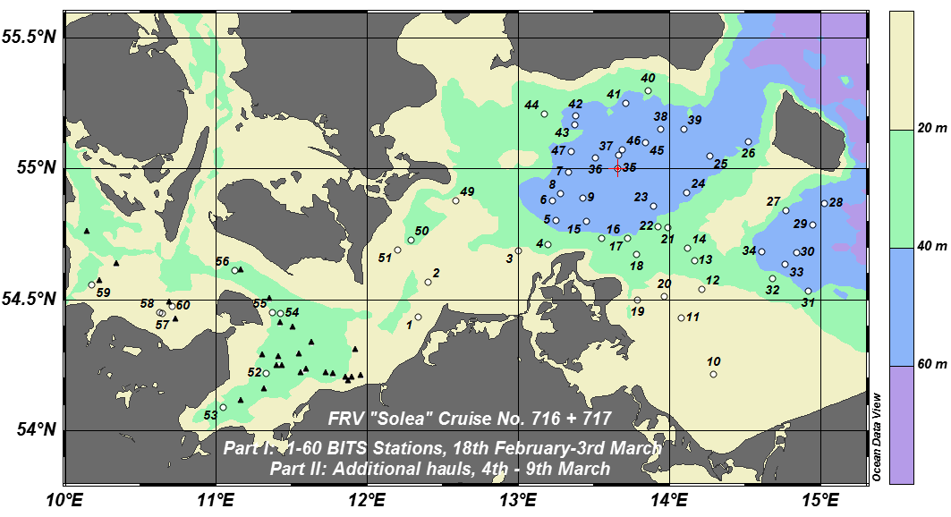

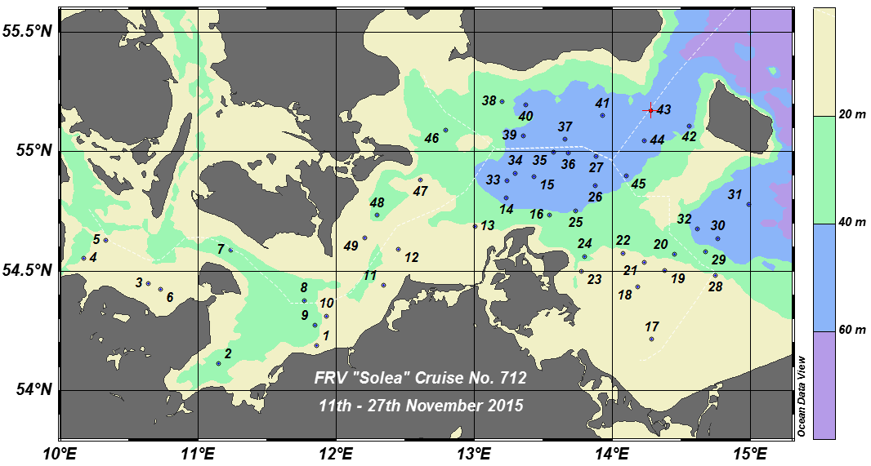
Map: Baltic International Trawl Survey (BITS): Example for trawling positions in the 1st quarter 2016 (upper panel) and in the 4th quarter 2015 (lower panel)

- Graphical representation (map) showing the positions (locations) of the realized samples.
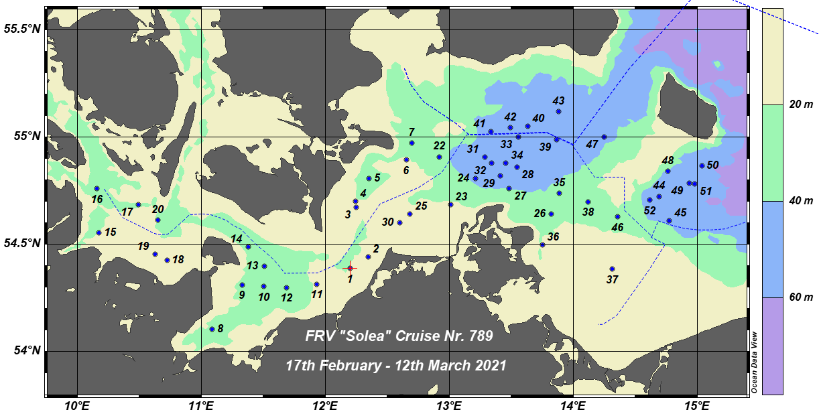
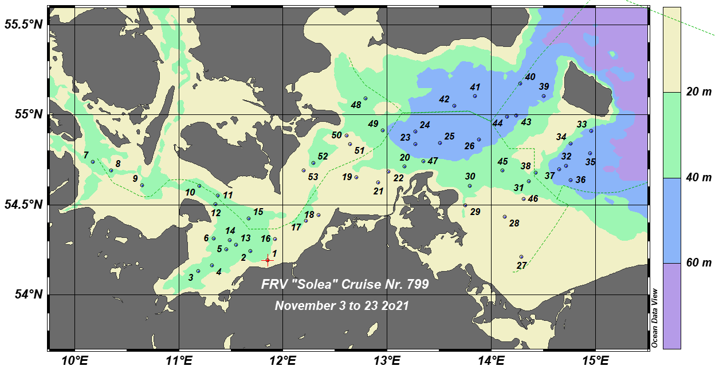
Map: Baltic International Trawl Survey (BITS): Distribution of the trawling positions in quarter 1 (upper panel) and 4 (lower panel) in 2021
- For internationally coordinated surveys, provide a link to the latest meeting report of the coordination group.
https://doi.org/10.17895/ices.pub.8248
- List the main use of the results of the survey (e.g. indices, abundance estimates, environmental indicators).
Target species are demersal fish species, mainly Baltic cod and flatfish species (flounder, plaice, dab, brill and turbot). The main aim is to determine the year-class strength of the target species. Target data are abundances, weight and length distributions of all fishes and length-weight-age-sex-maturity-feeding-parasitism data of commercially important species as well as hydrographic data (temperature, salinity and oxygen). The collected data are stored in a national SQL database and submitted to the ICES DATRAS database. In addition, stomachs and marine litter are sampled.
- Extended comments (Tables 1G and 1H)
None

Baltic International Acoustic Survey (BIAS, Autumn)
- Objectives of the survey
Target species are small pelagic fish species, mainly Baltic herring, sprat and additionally European anchovy and pilchard. The main aim is to provide information on stock parameters of small pelagics in the Baltic Sea. Target data are biomass, weight and length distributions and length-weight-age-sex-maturity of small pelagic target species in the Kattegat and western Baltic Sea including Belt Sea, Sound and Arkona Sea as well as hydrographic data (temperature, salinity and oxygen). The data are saved in a national SQL database and storage in the ICES Acoustic Trawl Database has been implemented.
- Description of the methods used in the survey. For mandatory surveys, link to the manuals. Include a graphical representation (map)
see survey manual:
https://www.ices.dk/sites/pub/Publication Reports/ICES Survey Protocols (SISP)/2017/SISP 8 IBAS 2017.pdf
- For internationally coordinated surveys, describe the participating Member States/vessels and the relevant international group in charge of planning the survey
Denmark (R/V DANA) and Sweden (R/V SVEA), Finland (R/V ARANDA), Germany (R/V SOLEA), Lithuania (R/V DARIUS), Latvia (R/V BALTICA), Poland (R/V BALTICA), Estonia (R/V ULRIKA) and Russia (R/V ATLANTNIRO). ICES WGBIFS/WGIPS are coordinating the planning of this survey.
- Where applicable, describe the international task sharing (physical and/or financial) and the cost sharing agreement used
The ICES survey planning group (WGBIFS) assigns the tasks to the survey participants (e.g. coverage of certain areas in a certain time frame). Each participating country is responsible for the activities conducted on its national part of the international survey. Cost sharing: There is no particular cost sharing agreement in place yet for this survey.

- Graphical representation (map) showing the positions (locations) of the realized samples.
Map: Baltic International Acoustic Survey (BIAS), October 2021: Cruise track/hydroacoustic transects (green lines) and realized trawl hauls (red diamonds).
- For internationally coordinated surveys, provide a link to the latest meeting report of the coordination group.
http://www.ices.dk/community/groups/Pages/WGIPS.aspx
http://www.ices.dk/community/groups/Pages/WGBIFS.aspx
Latest report submitted and currently being prepared for publication.
- List the main use of the results of the survey (e.g. indices, abundance estimates, environmental indicators).
Survey results are used for the assessment of WBSSH by the ICES Herring Assessment Working Group (HAWG) as fishery independent abundance indices.
- Extended comments (Tables 1G and 1H)
none
Sprat Acoustic Survey (SPRAS)
- Objectives of the survey
Target species is sprat. The main aim is to provide information on stock parameters of sprat in the Baltic Sea. Target data are biomass, weight and length distributions and length-weight-age-sex-maturity of sprat in the western Baltic Sea including Belt Sea, Sound, Arkona Sea and Bornholm Sea as well as hydrographic data (temperature, salinity and oxygen). The collected data are saved in an Access-database and the ICES international database.
- Description of the methods used in the survey. For mandatory surveys, link to the manuals. Include a graphical representation (map)
see survey manual: http://www.ices.dk/community/groups/Pages/WGBIFS.aspx
- For internationally coordinated surveys, describe the participating Member States/vessels and the relevant international group in charge of planning the survey
Sweden (R/V SVEA), Germany (R/V WALTER HERWIG), Lithuania (R/V DARIUS), Poland(R/V BALTICA), Latvia (R/V ULRICA), Estonia (R/V ULRICA) and Russia (R/V ATLANTNIRO). ICES WGBIFS is coordinating the planning of this survey.
- Where applicable, describe the international task sharing (physical and/or financial) and the cost sharing agreement used
The ICES survey planning group (WGBIFS) assigns the tasks to the survey participants (e.g. coverage of certain areas in a certain time frame). Each participating country is responsible for the activities conducted on its national part of the international survey. Cost sharing: There is no particular cost sharing agreement in place yet for this survey.

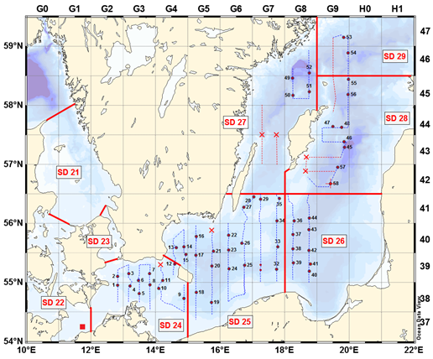
Map: Sprat Acoustic Survey (SPRAS), May 2015: Example of a cruise track

- Graphical representation (map) showing the positions (locations) of the realized samples.
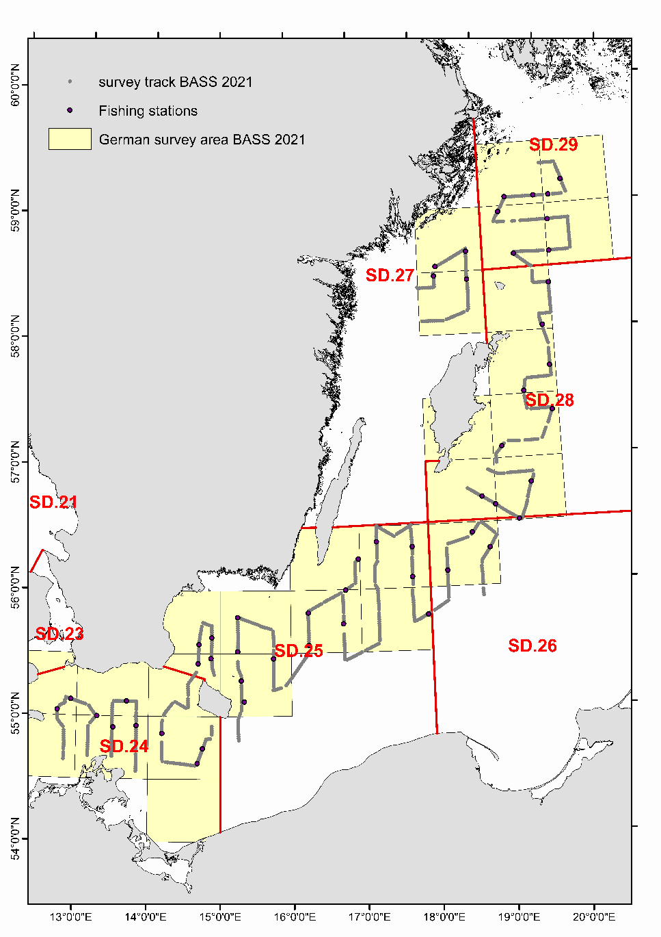
Map: Sprat Acoustic Survey (SPRAS), May 2020: Cruise track and realized trawl hauls
- For internationally coordinated surveys, provide a link to the latest meeting report of the coordination group.
http://www.ices.dk/community/groups/Pages/WGBIFS.aspx
- List the main use of the results of the survey (e.g. indices, abundance estimates, environmental indicators).
The data are used as an index for the stock assessment of Baltic sprat.
- Extended comments (Tables 1G and 1H)
Absence of licence delivery for all specific planned station within the Swedish EEZ forced significant track changes. This resulted in total hydroacoustic track lengths below 60 nautical miles in 24 of the 27 rectangles assigned as German investigation area.

Rügen Herring Larvae Survey (RHLS)
- Objectives of the survey
Target species is the western Baltic spring-spawning herring. The main aim is to monitor the spawning activity of the spring-spawning herring of the Western Baltic Sea in its main spawning area, the Greifswald Bay. Target data are high-resolution spatial and temporal records of the larval abundance during the entire spawning period as well as hydrographic data (temperature, salinity and oxygen). The collected data are stored nationally and in the ICES Fish Eggs and Larvae dataset.
- Description of the methods used in the survey. For mandatory surveys, link to the manuals. Include a graphical representation (map)
Manual is available on request.
- For internationally coordinated surveys, describe the participating Member States/vessels and the relevant international group in charge of planning the survey
National survey only.
- Where applicable, describe the international task sharing (physical and/or financial) and the cost sharing agreement used
National survey only.
- Graphical representation (map) showing the positions (locations) of the realized samples.

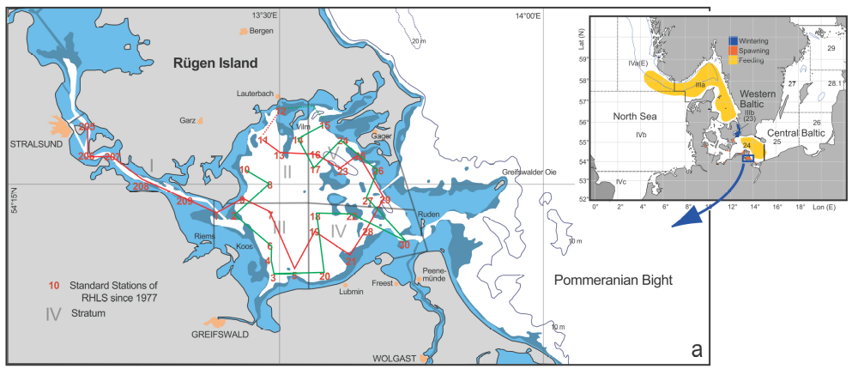
Map: Rügen Herring Larvae Survey (RHLS), Cruise track and station plan

- For internationally coordinated surveys, provide a link to the latest meeting report of the coordination group.
https://ices-library.figshare.com/articles/report/Herring_Assessment_Working_Group_for_the_area_South_of_62_N_HAWG_2021/18620597
https://www.ices.dk/community/groups/Pages/WGSINS.aspx
- List the main use of the results of the survey (e.g. indices, abundance estimates, environmental indicators).
Survey results (N20 index) are used for the assessment of Western Baltic Spring-Spawning Herring by the ICES Herring Assessment Working Group (HAWG) as fishery independent abundance indices.
- Extended comments (Tables 1G and 1H)
none

International Bottom Trawl Survey, Quarter 1 (IBTS Q1)
- Objectives of the survey
- • To determine the distribution and relative abundance of pre-recruits of the main commercial species with a view of deriving recruitment indices;
- To monitor changes in the stocks of commercial fish species independently of commercial fisheries data;
- To monitor the distribution and relative abundance of all fish species and selected invertebrates;
- To collect data for the determination of biological parameters for selected species;
- To collect hydrographical and environmental information;
- To determine the abundance and distribution of late herring larvae in order to provide the ICES Herring Assessment Working Group (HAWG) with a recruitment index for the North Sea herring stock.
- To collect fish eggs in conjunction with the MIK sampling to determine principal spawning grounds of winter spawning fish in the North Sea
- Description of the methods used in the survey. For mandatory surveys, link to the manuals. Include a graphical representation (map)
Bottom trawling with a standard GOV trawl; CTD casts; Plankton net haul with a MIK net and the attachment MIKeyM net;
Survey manuals
ICES 2015: Manual for the International Bottom Trawl Survey, Revision IX. SISP 10 http://www.ices.dk/sites/pub/Publication%20Reports/ICES%20Survey%20Protocols%20(SISP)/SISP%2010%20-%20Manual%20for%20the%20International%20Bottom%20Trawl%20Surveys%20-%20Revision%20IX.pdf
ICES 2017. Manual for the Midwater Ring Net sampling during IBTS Q1. Series of ICES Survey Protocols SISP 2. 25 pp. http://doi.org/10.17895/ices.pub.3434
ICES 2018. Manual for egg survey for winter spawning fish in the North Sea. Series of ICES Survey Protocols SISP 13. 19 pp. http://doi.org/10.17895/ices.pub.5225
- For internationally coordinated surveys, describe the participating Member States/vessels and the relevant international group in charge of planning the survey
France: RV Thalassa, The Netherlands: RV Tridens, Germany: RV Dana (charter in replacement of Walther Herwig III) , Denmark: RV Dana, Sweden: RV Svea, Norway: RV G.O. Sars, Scotland: RV Scotia
Coordinating body is the ICES International Bottom Trawl Survey Working Group (IBTSWG).
- Where applicable, describe the international task sharing (physical and/or financial) and the cost sharing agreement used
Individual tasks to the survey participants (e.g. coverage of certain areas in a certain time frame) are allocated by the IBTSWG. Each participating country is responsible for the activities conducted on its national part of the international survey. Cost sharing: There is no particular cost sharing agreement in place yet for this survey.

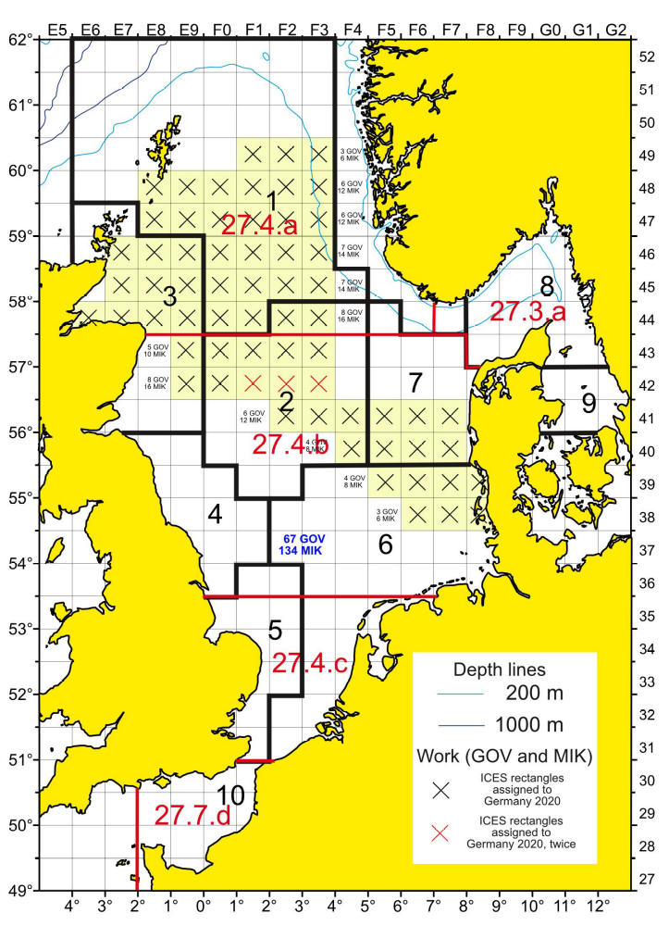
Map: International Bottom Trawl Survey (IBTS) in the North Sea: Planning map for German Coverage in 2021 (Q1).

- Graphical representation (map) showing the positions (locations) of the realized samples.

Map: GOV-hauls, CTD- and MIK-Stations of FRV Walther Herwig III, WH 443 (26/01 to 16/02/2021). Blue dots: combined CTD and GOV-trawl stations, Red dots: MIK stations. The black line indicates the travelled routes between stations.
- For internationally coordinated surveys, provide a link to the latest meeting report of the coordination group.

https://ices-library.figshare.com/articles/report/International_Bottom_Trawl_Survey_Working_Group_IBTSWG_/18618368

- List the main use of the results of the survey (e.g. indices, abundance estimates, environmental indicators).

Survey indices for commercial fish species are used in the assessment by ICES WGNSSK, HAWG and WGWIDE.
- Extended comments (Tables 1G and 1H)
None

International Bottom Trawl Survey, Quarter 3 (IBTS Q3)
- Objectives of the survey
The main objective of the IBTS Q3 is to provide abundance indices of the target species haddock, cod, saithe, whiting, Norway pout, herring, sprat, mackerel and plaice in the North Sea and the Skagerrak. Germany participates as one of six nations in the internationally coordinated Q3 survey. Apart from abundance indices, information is collected on individual length, weight and age for the target species. Additional age data are obtained for selected fish species to be evaluated for future use in assessments. Furthermore, abundance, weight and length data are collected for all fish species caught. This serves the second objective to obtain information on changes in the abundance and distribution of fish species not commercially targeted, and in the composition of regional groundfish assemblages.
- Description of the methods used in the survey. For mandatory surveys, link to the manuals. Include a graphical representation (map)
Types of data collected include biological data for the groundfish community, as well as additional data on the bycatch of benthic invertebrates. The German part of the survey includes a dedicated sampling programme of benthic epifauna and sediments. Further accompanying data recorded include information on stations and gear performance, hydrographic data, observations of weather and sea state. The data are stored locally in databases in the national institutes and submitted to public international databases at ICES. - A detailed description of the survey methods can be found in the corresponding survey manual: https://www.ices.dk/sites/pub/Publication%20Reports/ICES%20Survey%20Protocols%20(SISP)/SISP%2010%20%E2%80%93%20Revision%2011_Manual%20for%20the%20North%20Sea%20International%20Bottom%20Trawl%20Surveys.pdf
- For internationally coordinated surveys, describe the participating Member States/vessels and the relevant international group in charge of planning the survey
UK England: RV Endeavour, Germany: FRV Walther Herwig III, Denmark: RV Dana, Sweden: RV Svea, Norway: RV Kristine Bonnevie, UK Scotland: RV Scotia
Coordinating body is the ICES IBTSWG.
- Where applicable, describe the international task sharing (physical and/or financial) and the cost sharing agreement used
Individual tasks to the survey participants (e.g. coverage of certain areas in a certain time frame) are allocated by the IBTSWG. Each participating country is responsible for the activities conducted on its national part of the international survey. Cost sharing: There is no particular cost sharing agreement in place yet for this survey.

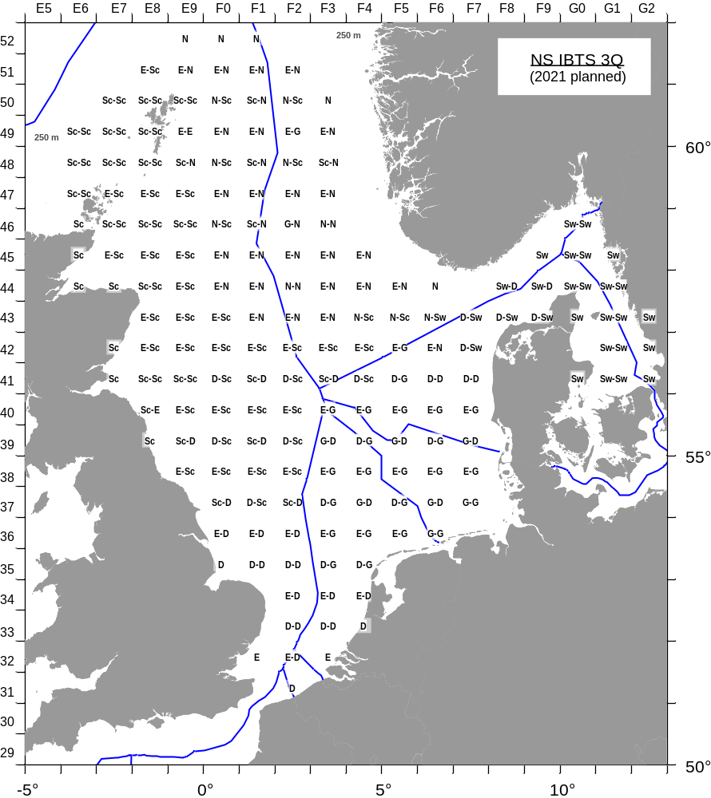
Map: International Bottom Trawl Survey (IBTS) in the North Sea (Q3): Survey Grid

- Graphical representation (map) showing the positions (locations) of the realized samples.
Map: International Bottom Trawl Survey (IBTS) in the North Sea (Q3); German contribution during cruise on the chartered Danish vessel “Dana”, from August 19- September 12, 2021: Position of the fishing stations in 2021, for both, German and Danish hauls. (No GSBTS on “Walther Herwig III” in 2021 due to ship failure.)
- For internationally coordinated surveys, provide a link to the latest meeting report of the coordination group.
IBTS: http://ices.dk/community/groups/Pages/IBTSWG.aspx
- List the main use of the results of the survey (e.g. indices, abundance estimates, environmental indicators).
Survey indices for commercial fish species are used in the assessment by ICES WGNSSK, HAWG, WGSAM and WGWIDE. Abundance estimates for cephalopods are used by WGCEPH.
- Extended comments (Tables 1G and 1H)
none

North Sea Beam Trawl Survey (BTS)
- Objectives of the survey
Target species of this survey are mainly sole and plaice but also associated species. The survey provides densities (abundance and biomass) indices for the target species as well as hydrographic data.
- Description of the methods used in the survey. For mandatory surveys, link to the manuals. Include a graphical representation (map)
All surveys coordinated by WGBEAM are carried out with a beam trawl. Depending on the local circumstances and the ship’s capacity, the width and rigging of the beam trawls varies. Germany uses a light 7.2 m beam trawl.
Manual:
https://ices-library.figshare.com/articles/report/SISP_14_-_Manual_for_the_Offshore_Beam_Trawl_Surveys_WGBEAM_/19051328
- For internationally coordinated surveys, describe the participating Member States/vessels and the relevant international group in charge of planning the survey
The Beam Trawl Survey in the North Sea and Eastern English Channel is carried out by Belgium, Germany, Netherlands and UK-Cefas.
The research vessels are BELGICA for Belgium, SOLEA for Germany, TRIDENS for The Netherlands and CEFAS ENDEAVOUR for the UK.
The survey planning group is the ICES WGBEAM.
- Where applicable, describe the international task sharing (physical and/or financial) and the cost sharing agreement used
Individual tasks to the survey participants (e.g. coverage of certain areas in a certain time frame) are allocated by the WGBEAM. Each participating country is responsible for the activities conducted on its national part of the international survey. Cost sharing: There is no particular cost sharing agreement in place yet for this survey.

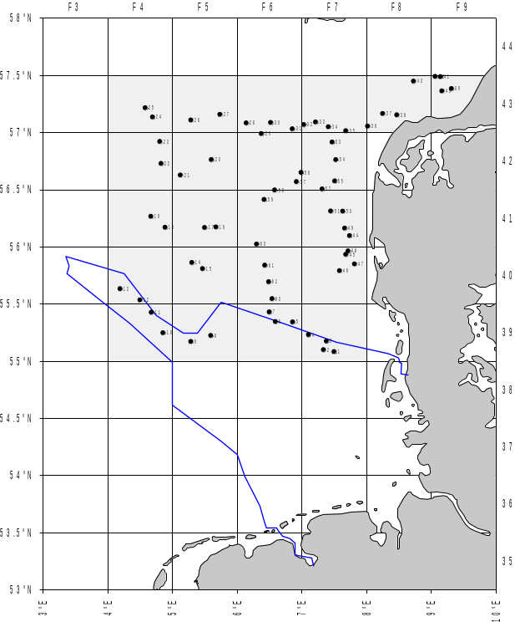
Map: North Sea Beam Trawl Survey (BTS): Example for station plan
- Graphical representation (map) showing the positions (locations) of the realized samples.
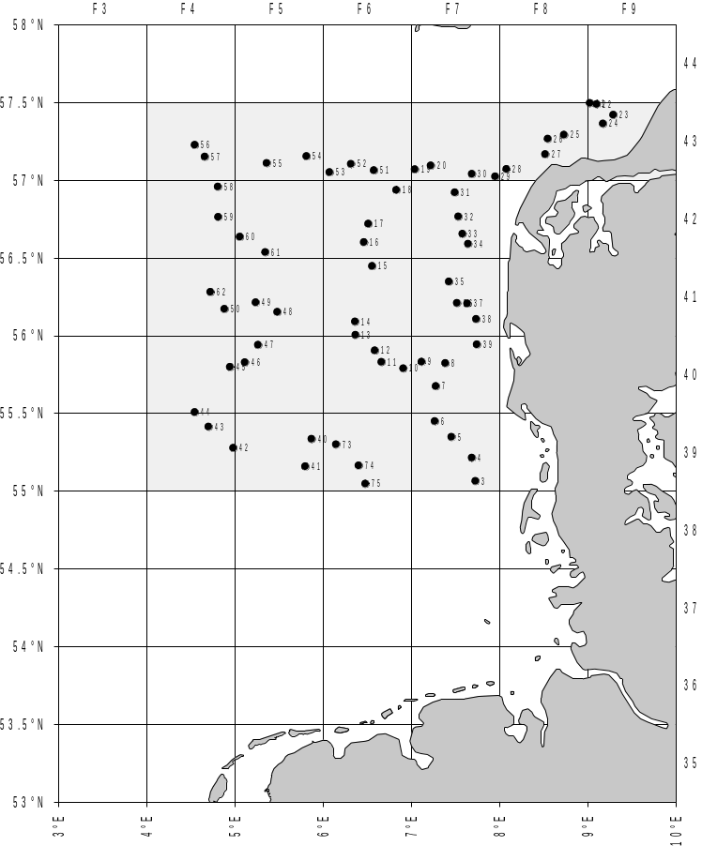
Map: North Sea Beam Trawl Survey (BTS): Realized fishing stations 2021
- For internationally coordinated surveys, provide a link to the latest meeting report of the coordination group.
http://ices.dk/community/groups/Pages/WGBEAM.aspx
- List the main use of the results of the survey (e.g. indices, abundance estimates, environmental indicators).
ICES WGNSSK: Limanda limanda, Pleuronectes platessa, Solea solea; indices by age group, age 1-10+
ICES WGEF: elasmobranch species; CPUE per species per haul
- Extended comments (Tables 1G and 1H)
none

Demersal Young Fish Survey (DYFS)
- Objectives of the survey
The aim of the survey is to provide abundance indices of sole, plaice, whiting and cod as well as of other demersal young fish and brown shrimp. The indices are part of a time series which started in the early 1970’s. The collected data are stored locally in a national data base and are submitted to the ICES DATRAS data base. Data are used by ICES WGNSSK, WGBEAM and WGCRAN and are relevant to the trilateral Wadden Sea Monitoring Programme (TMAP). Comparable investigations are conducted by NED and BEL. The German part of the survey consists of short trips on chartered commercial cutters and the RV Clupea yearly in September/October.
- Description of the methods used in the survey. For mandatory surveys, link to the manuals. Include a graphical representation (map)
Steel 3m-shrimp-beam trawl without tickler chain, 20mm codend. An electronic sensor for time, temperature, salinity and pressure (turbidity optional) is attached. The whole catch is weighted and sorted, unless for the exceptional case of a very large catch, when only a sub-sample is processed. Length distributions are recorded for all finfish species caught, measured to the cm below. Herring and sprat are measured to the 0.5 cm. Survey manual: http://www.ices.dk/sites/pub/Publication%20Reports/Expert%20Group%20Report/SSGIEOM/2015/01%20WGBEAM%20-%20Report%20of%20the%20Working%20Group%20on%20Beam%20Trawl%20Surveys%20%28WGBEAM%29.pdf
- For internationally coordinated surveys, describe the participating Member States/vessels and the relevant international group in charge of planning the survey
This survey is coordinated by the ICES Working Group on Beam Trawl Surveys (WGBEAM). Participating countries are The Netherlands, Germany and Belgium. The Netherlands cover the area from the Dutch to the Danish coast with the RV Isis. In the Dutch Wadden Sea area, the RVs Stern and Waddenzee are used and the Scheldt Estuary is covered by the RV Schollevaar. Germany operates with chartered commercial shrimp cutters in the German Wadden Sea and operates along the German coast with the RV Clupea. Belgium operates along the Belgium coast with the RV Broodwinner. For further details, see the WGBEAM reports, e.g.: http://www.ices.dk/sites/pub/Publication%20Reports/Expert%20Group%20Report/SSGIEOM/2015/01%20WGBEAM%20-%20Report%20of%20the%20Working%20Group%20on%20Beam%20Trawl%20Surveys%20%28WGBEAM%29.pdf ).
- Where applicable, describe the international task sharing (physical and/or financial) and the cost sharing agreement used
Individual tasks to the survey participants (e.g. coverage of certain areas in a certain time frame) are allocated by WGBEAM. Each participating country is responsible for the activities conducted on its national part of the international survey. Cost sharing: There is no particular cost sharing agreement in place yet for this survey.

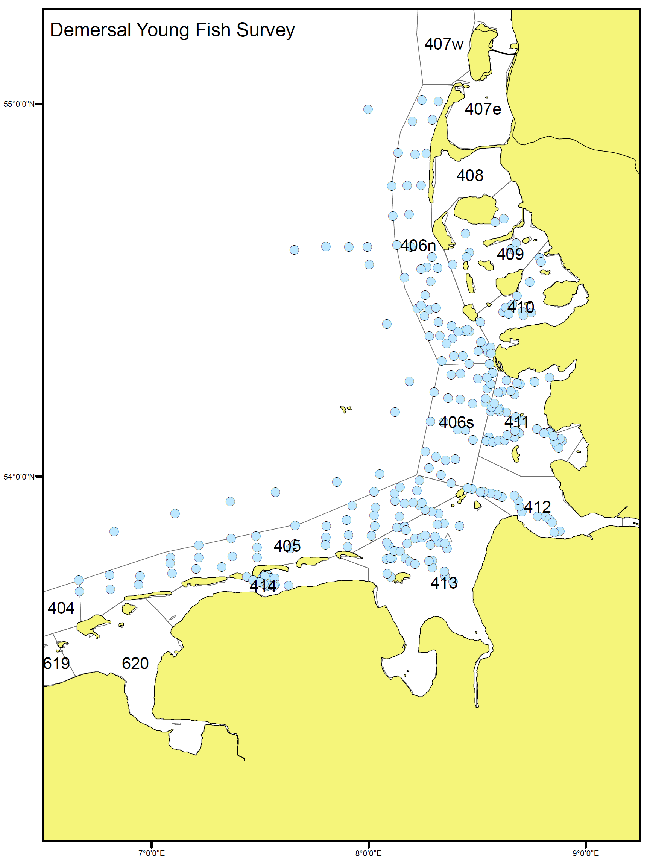
Map: Demersal Young Fish Survey (DYFS): Station grid

- Graphical representation (map) showing the positions (locations) of the realized samples.
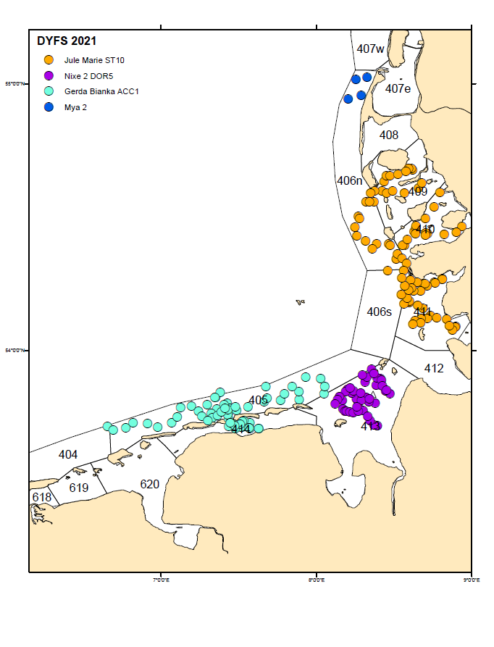
Map: Demersal Young Fish Survey (DYFS): Positions of fishing stations 2021
- For internationally coordinated surveys, provide a link to the latest meeting report of the coordination group.
https://www.ices.dk/community/groups/Pages/WGBEAM.aspx

- List the main use of the results of the survey (e.g. indices, abundance estimates, environmental indicators).

survey indices for plaice and sole, abundance estimates, biological data for brown shrimp and demersal fish in ICES sub-area 4, environmental status
- Extended comments (Tables 1G and 1H)
none

International Herring Larvae Surveys (IHLS)
- Objectives of the survey
The main objective of the survey is helping to assess the herring stocks in the North Sea. The results of the herring larvae surveys are used to calculate an overall biomass index of the SSB of North Sea autumn-spawning herring as well as the relative contribution of different stock components on the total herring reproduction. The surveys monitor the annual distribution and abundance of herring larvae at the main spawning locations, the length frequency of herring larvae, as well as ambient water temperature and salinity. All relevant herring larvae data are stored together with basic hydrographic information in the ICES eggs and larvae database. The surveys are conducted annually during autumn and winter.
- Description of the methods used in the survey. For mandatory surveys, link to the manuals. Include a graphical representation (map)
Herring larval abundance is surveyed at the major herring spawning grounds in the North Sea, e.g. in the Orkney/Shetland area, the Buchan region, the Central North Sea and the Southern North Sea. Standard gears are high-speed GULF samplers, deployed in a double oblique manner to near the sea bed and back to surface. Stations are located on a 10 by 10 nautical miles grid. This grid includes every square that is known to contain herring larvae less than 10 mm. Herring larvae are sorted from the samples and length-measured. The number of larvae per m² at each station is used to calculate mean numbers of larvae per m² for each ICES rectangle (consist of nine IHLS stations in total). These values are raised by the sea surface corresponding to the relevant rectangle and summed over the total area to obtain larvae abundance indices. The manual of the IHLS is available as Annex 7 to the ICES WGIPS Report 2010.
- For internationally coordinated surveys, describe the participating Member States/vessels and the relevant international group in charge of planning the survey
Germany and The Netherlands participate in the IHLS sampling. With regard to the prevailing weather conditions, they most frequently use larger research vessels, e.g. FRV "Walther Herwig III" and RV "Tridens". The parental committee for the IHLS is the ICES Working Group on Surveys on Ichthyoplankton in the North Sea (WGSINS).
- Where applicable, describe the international task sharing (physical and/or financial) and the cost sharing agreement used
Individual tasks to the survey participants (e.g. coverage of certain areas in a certain time frame) are allocated by WGSINS. Each participating country is responsible for the activities conducted on its national part of the international survey. Cost sharing: There is no particular cost sharing agreement in place yet for this survey.

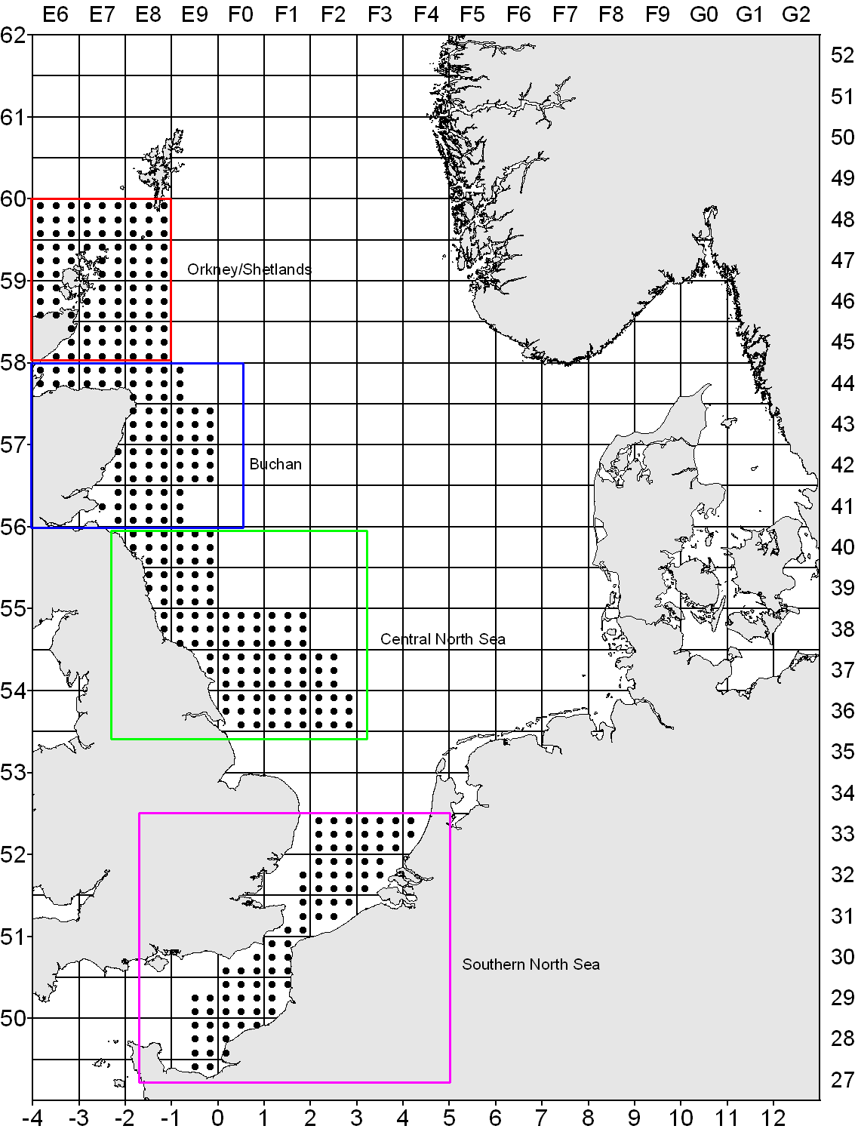
Map: Herring Larvae Survey (IHLS) in the North Sea: Station grid
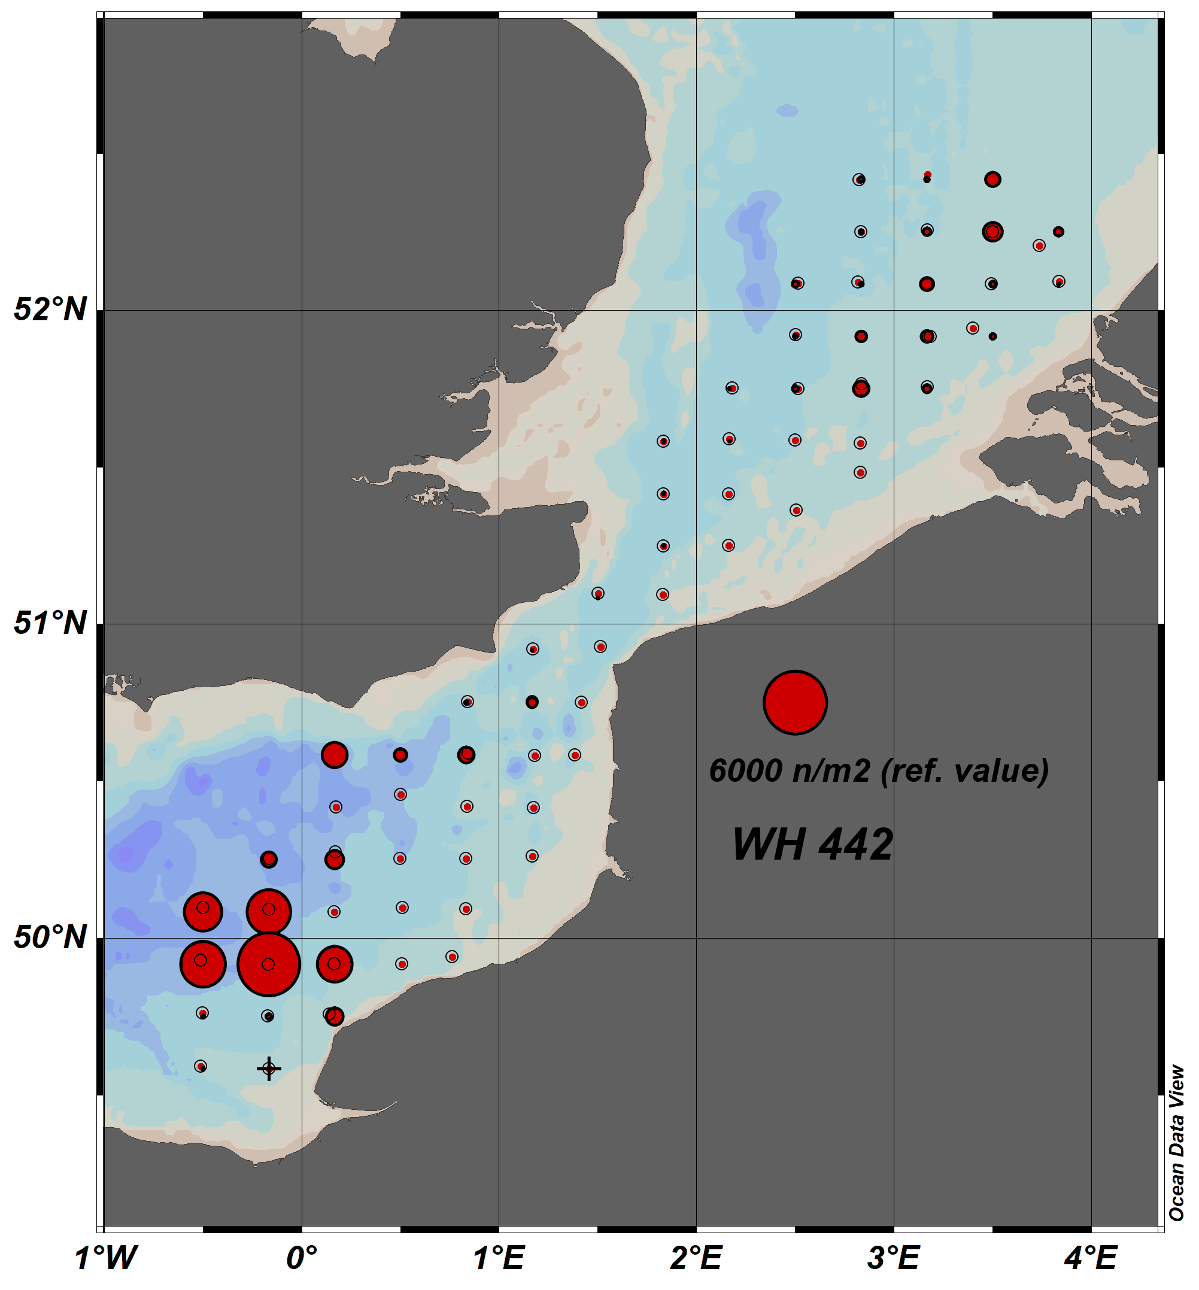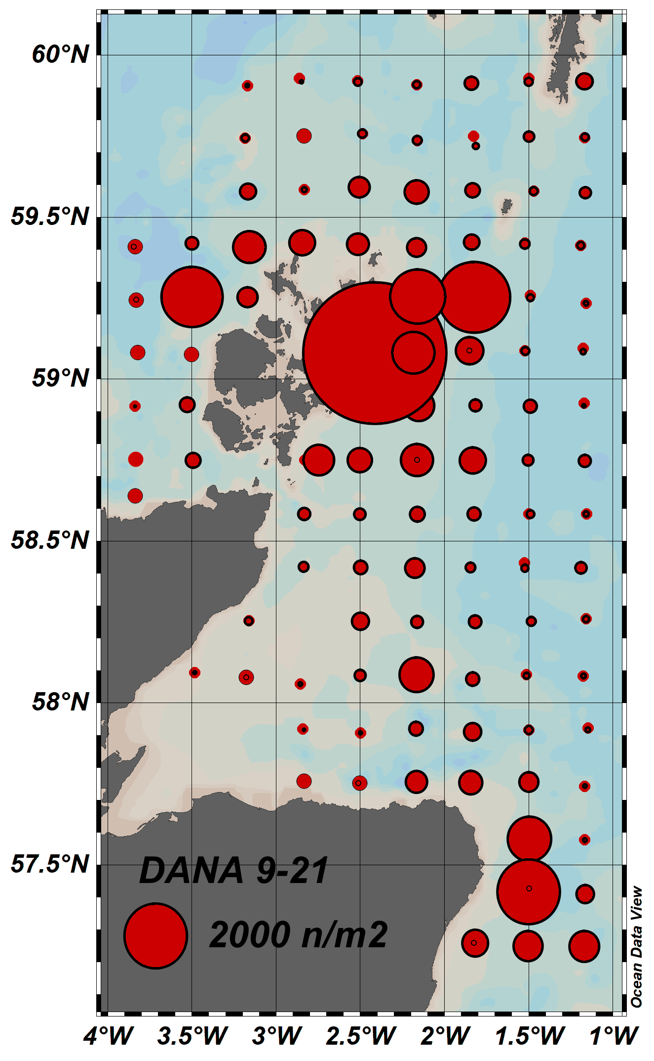
Map: Herring Larvae Survey (IHLS) in the North Sea: Realized plankton stations in January 2021 (left panel) and September 2021 (right panel).
- For internationally coordinated surveys, provide a link to the latest meeting report of the coordination group.
The parental committee WGSINS met in December 2021. The latest report is: ICES 2022. Working Group on Surveys on Ichthyoplankton in the North Sea and adjacent Seas (WGSINS; outputs from 2021 meeting). ICES Scientific Reports. 4:27. 47pp. http://doi.org/10.17895/ices.pub.19420232
- List the main use of the results of the survey (e.g. indices, abundance estimates, environmental indicators).
The survey provides SSB indices on herring spawning components and their dynamics in the North Sea. These data are used in the international ICES Herring Assessment Working Group. Information on fish eggs and larvae, e.g. taxa, abundance and distribution, is used on national basis.
- Extended comments (Tables 1G and 1H)
none

North Sea Herring Acoustic Survey (NHAS)
- Objectives of the survey
The survey aims to provide an annual estimate of the distribution, abundance and population structure to inform the assessment of the following herring and sprat stocks: Western Baltic spring-spawning herring (in ICES Divisions IV and IIIa), North Sea autumn-spawning herring (in IV, IIIa and VIId), West of Scotland herring (in VIaN), Malin Shelf herring (west of Scotland/Ireland in VIaN-S and VIIb,c), North Sea sprat (in IV) and sprat in IIIa (Skagerrak/Kattegat). The derived estimates and age structure of herring and sprat are used as tuning indices in the respective assessments and are submitted annually to the ICES Herring Assessment Working Group (HAWG).
- Description of the methods used in the survey. For mandatory surveys, link to the manuals. Include a graphical representation (map)
Types of data collected include 1nm NASCs for clupeid fish (acoustic data), age and length distribution for all clupeids in the investigation area, maturity at age. Survey manual:
https://www.ices.dk/sites/pub/Publication Reports/ICES Survey Protocols (SISP)/SISP 9 Manual for International Pelagic Surveys (IPS).pdf
- For internationally coordinated surveys, describe the participating Member States/vessels and the relevant international group in charge of planning the survey
Participants (countries/vessels) of this internationally coordinated survey include: IRL (RV "Celtic Explorer"), SCO (RV "Scotia"), NOR (RV "Johan Hjort"), DEN (RV "Dana"), NED (RV "Tridens"), GER (FRV "Solea"). The survey is planned, coordinated and evaluated by the ICES Working Group of International Pelagic Surveys (ICES WGIPS).
- Where applicable, describe the international task sharing (physical and/or financial) and the cost sharing agreement used
Individual tasks to the survey participants (e.g. coverage of certain areas in a certain time frame) are allocated by WGIPS. Each participating country is responsible for the activities conducted on its national part of the international survey. Cost sharing: There is no particular cost sharing agreement in place yet for this survey.
Map: North Sea Herring Acoustic Survey (NHAS) 2021: Cruise tracks (total survey coverage, color coding according to strata allocated to participant. German (FRV “Solea”) strata/cruise tracks in dark yellow.

- Graphical representation (map) showing the positions (locations) of the realized samples.
Map: North Sea Herring Acoustic Survey (NHAS): German strata covered with FRV “Solea” in 2021. Mean NASC values measured along the cruise track (5 nmi intervals) and allocated to clupeids are depicted as bubbles (empty intervals indicated as +). Red diamonds: Directed (pelagic) trawl hauls.
- For internationally coordinated surveys, provide a link to the latest meeting report of the coordination group.
- http://ices.dk/sites/pub/PublicationReports/ExpertGroupReport/EOSG/2020/WGIPSreport2020.pdf
- List the main use of the results of the survey (e.g. indices, abundance estimates, environmental indicators).
Survey results are used for the assessment of target species by the ICES Herring Assessment Working Group (HAWG) as fishery independent abundance indices.
- Extended comments (Tables 1G and 1H)
none

International Deep Pelagic Ecosystem Survey (IDEEPS) – formerly called International Redfish Trawl and Acoustic Survey (REDTAS)
- Objectives of the survey
This survey is part of a coordinated effort of ICES to undertake an International Deep Pelagic Ecosystem Survey in the Irminger Sea and adjacent waters in June/July, estimating the abundance and biomass of the pelagic beaked redfish (Sebastes mentella) stocks and conducting additional observations relevant to integrated ecosystem assessment in the area.
- Description of the methods used in the survey. For mandatory surveys, link to the manuals. Include a graphical representation (map)
The international trawl/acoustic survey on pelagic redfish in the Irminger Sea and adjacent waters in June/July is generally carried out by three vessels from Germany, Iceland and Russia (currently only Russia and Germany participate in the survey). In the depth zone that can be surveyed by hydroacoustic measurements, i.e. shallower than the deep-scattering layer (DSL; down to about 350 m), hydroacoustic measurements and identification trawls are carried out. Within and below the DSL (down to about 950 m), redfish abundance is estimated by trawls. Biological data are collected from the redfish caught in the pelagic trawls and hydrographical measurements are taken on regular stations on the survey tracks. For details, see: http://www.ices.dk/community/groups/Pages/WGIDEEPS.aspx
- For internationally coordinated surveys, describe the participating Member States/vessels and the relevant international group in charge of planning the survey
The survey takes place every three years and is scheduled to be a joint survey by Germany with the FRV “Walther Herwig III” and by Russia (RV “Vilnyus”) and usually Iceland. In November 2017, Iceland informed the responsible survey planning working group that they would not participate in the survey in 2018. No specific reason was given. The main objective of the survey and the international cooperation of the survey are planned by the “ICES Working Group on International Deep Pelagic Ecosystem Surveys (WGIDEEPS – former name: Working Group on Redfish Surveys)” which usually meets late January/early February of the survey year.
- Where applicable, describe the international task sharing (physical and/or financial) and the cost sharing agreement used
Individual tasks to the survey participants (e.g. coverage of certain areas in a certain time frame) are allocated by WGIDEEPS. Each participating country is responsible for the activities conducted on its national part of the international survey. Cost sharing: There is no particular cost sharing agreement in place yet for this survey.

Map: International Deep Pelagic Ecosystem Survey (IDEEPS): Survey tracks and stations in 2015

- Graphical representation (map) showing the positions (locations) of the realized samples.
NA (next survey year: 2024)
- For internationally coordinated surveys, provide a link to the latest meeting report of the coordination group.
https://www.ices.dk/sites/pub/Publication%20Reports/Forms/DispForm.aspx?ID=38667
- List the main use of the results of the survey (e.g. indices, abundance estimates, environmental indicators).
- Provide survey biomass indices for the North Western Working Group (NWWG) to support advice on pelagic beaked redfish stocks in the Irminger Sea and adjacent water;
- Estimate the geographical and depth distribution and relative abundance of pelagic beaked redfish stocks;
- Monitor changes in the stocks of pelagic beaked redfish independently of commercial fisheries data;
- Collect data for the determination of biological parameters for beaked redfish stocks;
- Collect hydrographical and environmental information;
- Collect additional observations relevant to integrated ecosystem assessment in the area.

- Extended comments (Tables 1G and 1H)
NA (next survey year: 2024)

Greenland Groundfish Survey (GGS)
- Objectives of the survey
The objective is to obtain data for the assessment of cod, demersal redfish and other demersal species in Greenland.
- Description of the methods used in the survey. For mandatory surveys, link to the manuals. Include a graphical representation (map)
Demersal trawling, plankton sampling and CTD casts for physical oceanographic measurements along standard transects are carried out. Manual available at www.thuenen.de. The German groundfish survey started in 1982 and was primarily designed for the assessment of cod, but covers the entire groundfish fauna down to 400 m depth. It is carried out annually during the 4th quarter and provides the only fishery-independent information about the abundance & biomass of groundfish off Greenland (ICES Div. XIVb and NAFO Div. 1B-1F). Designed as a stratified random survey, the hauls are allocated to 14 strata (7 geographic areas * 2 depth strata, 0-200m, 201-400m) off West and East Greenland. The fishing gear used is a standardised 140-feet bottom trawl. Biological data from the catches (length distributions for all species, individual weights, gonad and liver weights as well as sex and maturity for the commercial species) are collected, population data raised to the total surveyed area and submitted to the ICES North-Western Working Group (NWWG) and NAFO Scientific Council and used in the respective stock assessments. In addition, hydrographic (CTD) and weather data are collected. The survey is carried out every October/November on FRV “Walther Herwig III”.
- For internationally coordinated surveys, describe the participating Member States/vessels and the relevant international group in charge of planning the survey
The survey is regularly evaluated through ICES NWWG. DEU is the only EU Member State to undertake this survey. The current vessel used for the survey is FRV Walther Herwig III.
- Where applicable, describe the international task sharing (physical and/or financial) and the cost sharing agreement used
No task sharing with other countries for the autumn survey. Greenland conducts a parallel spring survey with its own vessel. Data from the two seasons are combined in assessment.
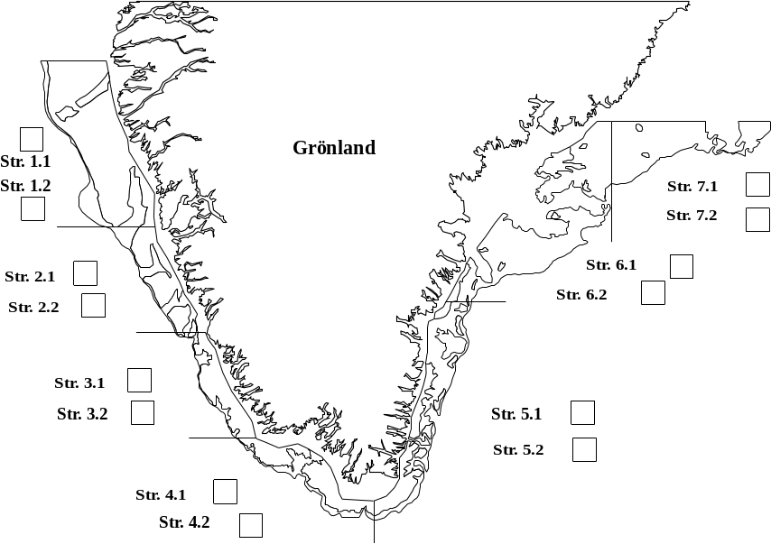
Map: Greenland Groundfish Survey (GGS): Sampling strata

- Graphical representation (map) showing the positions (locations) of the realized samples.
Due to technical problems with the ship and bad weather conditions in the investigation area, no sampling could be conducted in 2021.

- For internationally coordinated surveys, provide a link to the latest meeting report of the coordination group.
https://www.ices.dk/community/groups/Pages/NWWG.aspx
- List the main use of the results of the survey (e.g. indices, abundance estimates, environmental indicators).
Survey index for cod, survey index for redfish species for the assessment
- Extended comments (Tables 1G and 1H)
none

International Mackerel and Horse Mackerel Egg Survey (MEGS)
- Objectives of the survey
The main objective of this triennial survey is to produce both an index and a direct estimate of the biomass of the North East Atlantic mackerel stock and an egg production index of the southern and western horse mackerel stocks.
- Description of the methods used in the survey. For mandatory surveys, link to the manuals. Include a graphical representation (map)
The general method is to quantify the freshly spawned eggs in the water column on the spawning grounds and to determine the fecundity of the females. This is done by sampling sufficient numbers of gonads before during and after the spawning. These are then histologically analysed. In combination, the realised fecundity (potential fecundity minus atresia) of the females and the actual number of freshly spawned eggs in the water render an estimate of the spawning stock biomass.
Survey Manual: ICES 2014. Manual for the mackerel and horse mackerel egg surveys (MEGS): sampling at sea. Series of ICES Survey Protocols. SISP 6 - MEGS V1.3. 62 pp.
- For internationally coordinated surveys, describe the participating Member States/vessels and the relevant international group in charge of planning the survey
Portugal: RV Noruega, Spain: RV Vizconde de Eza + RV Ramon Margalef, The Netherlands: RV Tridens, Germany: FRV Walther Herwig III (in 2019 Danish RV Dana was chartered), Ireland: RV Celtic Explorer + RV Corystes (2019), Faroe Islands: RV Magnus Hendersson, Iceland: RV Bjarni Saemundsson; UK Scotland: RV "Scotia" plus chartered vessels, Norway: chartered vessel Brennholm (2019)
Coordinating body is the ICES Working Group on Mackerel and Horse Mackerel Egg Surveys (WGMEGS).
- Where applicable, describe the international task sharing (physical and/or financial) and the cost sharing agreement used
Individual tasks to the survey participants (e.g. coverage of certain areas in a certain time frame) are allocated by WGMEGS. Each participating country is responsible for the activities conducted on its national part of the international survey. Cost sharing: There is no particular cost sharing agreement in place yet for this survey.
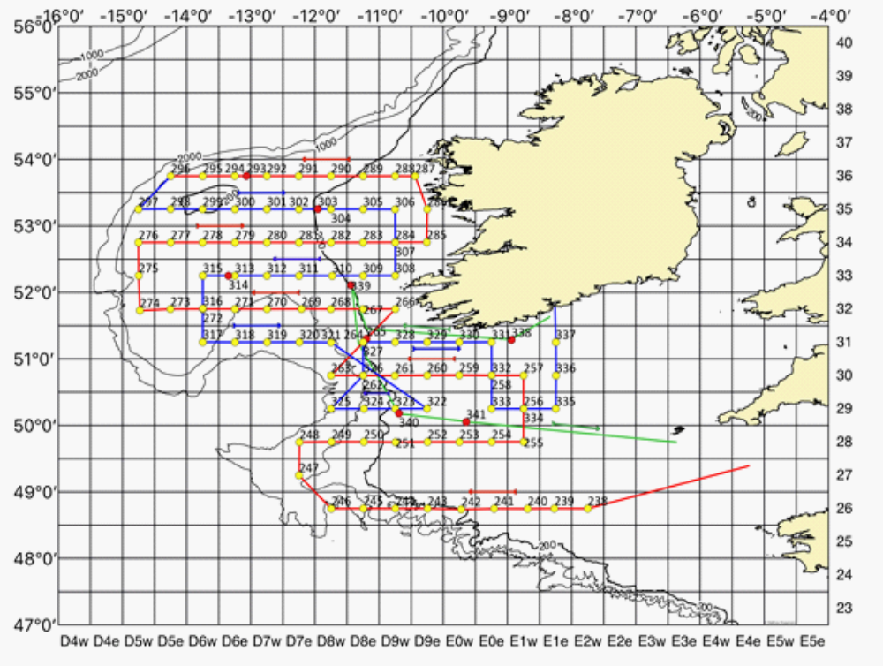
Map: International Mackerel and Horse Mackerel Egg Survey (MEGS): German Coverage 2016 (yellow circles = positions of plankton hauls; red = positions of fishing hauls)
- Graphical representation (map) showing the positions (locations) of the realized samples.

No survey in 2021, next survey is carried out in 2022.
- For internationally coordinated surveys, provide a link to the latest meeting report of the coordination group.
https://www.ices.dk/community/groups/Pages/WGMEGS.aspx
- List the main use of the results of the survey (e.g. indices, abundance estimates, environmental indicators).
An index and a direct estimate of the biomass of the North East Atlantic mackerel stock and an egg production index of the southern and western horse mackerel stocks used by ICES assessment group WGWIDE
- Extended comments (Tables 1G and 1H)
none

Non-mandatory surveys:
Fehmarn Juvenile Cod Survey (FEJUCS)
- Objectives of the survey
Target species is the western Baltic cod. The main aim is to monitor the cohort strengths of age-0 and age-1 cod during autumn in the Western Baltic Sea. Target data are length-frequency distributions of undersized cod caught in commercial pound nets located near Fehmarn (the centre of the main spawning area of western Baltic cod). The collected data are stored and processed nationally.
- Description of the methods used in the survey. For mandatory surveys, link to the manuals. Include a graphical representation (map)
The method is described in the Working Document Number 18, p. 293-310 of ICES 2019, Benchmark Workshop on Baltic Cod Stocks (WKBALTCOD2). ICES Scientific Reports. 1:9. 310 pp. http://doi.org/10.17895/ices.pub.4984.
- For internationally coordinated surveys, describe the participating Member States/vessels and the relevant international group in charge of planning the survey
National survey only.
- Where applicable, describe the international task sharing (physical and/or financial) and the cost sharing agreement used
National survey only.
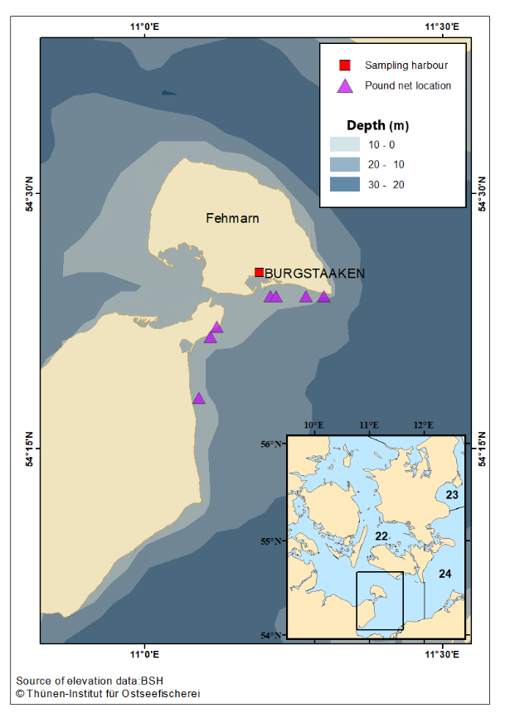
Map: Fehmarn Juvenile Cod Survey (FEJUCS). Location of pound nets along the coast of Fehmarn and the adjacent mainland, from which samples are collected between September and December each year.
- For internationally coordinated surveys, provide a link to the latest meeting report of the coordination group.
National survey only.
- List the main use of the results of the survey (e.g. indices, abundance estimates, environmental indicators).
The FEJUCS time series is used as a tuning fleet in the assessment of the western Baltic cod stock by the ICES Baltic Fisheries Assessment Working Group (WGBFAS) as a fishery-independent abundance index. Water temperature (and oxygen content) is sampled using a data logger. Data are stored in a national data base.
- Extended comments (Tables 1G and 1H)
None

Cod in the Baltic (CoBalt)
- Objectives of the survey
Target species is Baltic cod. The main aim is to monitor the reproductive activities of eastern Baltic cod. Target data are abundances, weight and length distributions of all fishes and length-weight-age-sex-maturity data of cod as well as hydrographic data (temperature, salinity and oxygen). The collected data are saved in a national SQL database. In addition, cod and flatfish stomachs are sampled occasionally.
- Description of the methods used in the survey. For mandatory surveys, link to the manuals. Include a graphical representation (map)
The used methods are standard BITS methods, which are described in the BITS survey manual: http://www.ices.dk/community/groups/Pages/WGBIFS.aspx
- For internationally coordinated surveys, describe the participating Member States/vessels and the relevant international group in charge of planning the survey
National survey only.
- Where applicable, describe the international task sharing (physical and/or financial) and the cost sharing agreement used
National survey only.
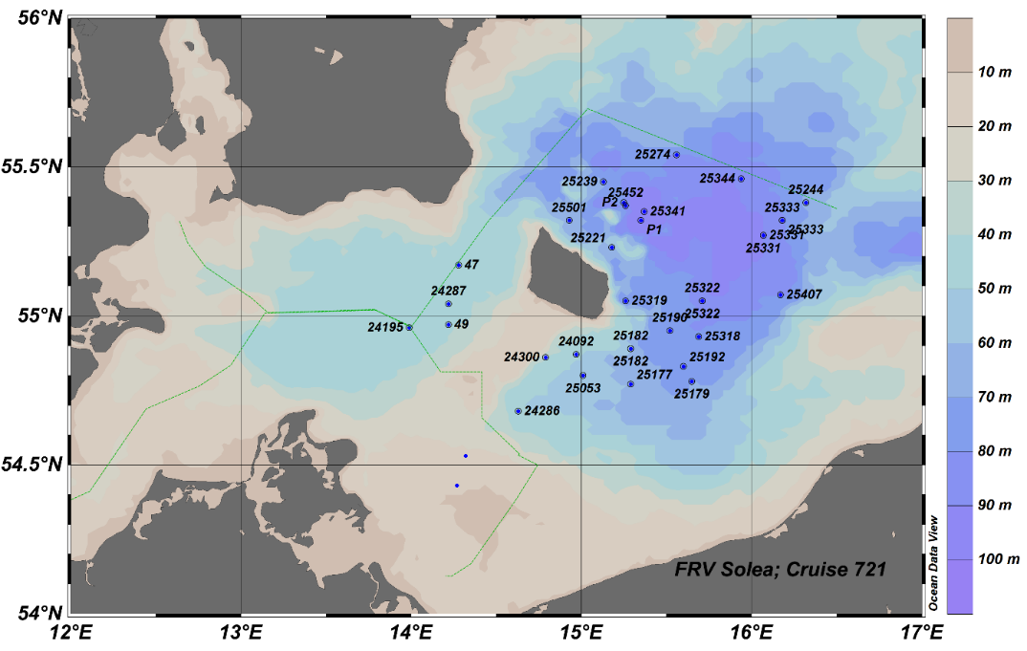
Map: Cod in the Baltic Survey (CoBalt): Positions of fishing hauls

- Graphical representation (map) showing the positions (locations) of the realized samples.
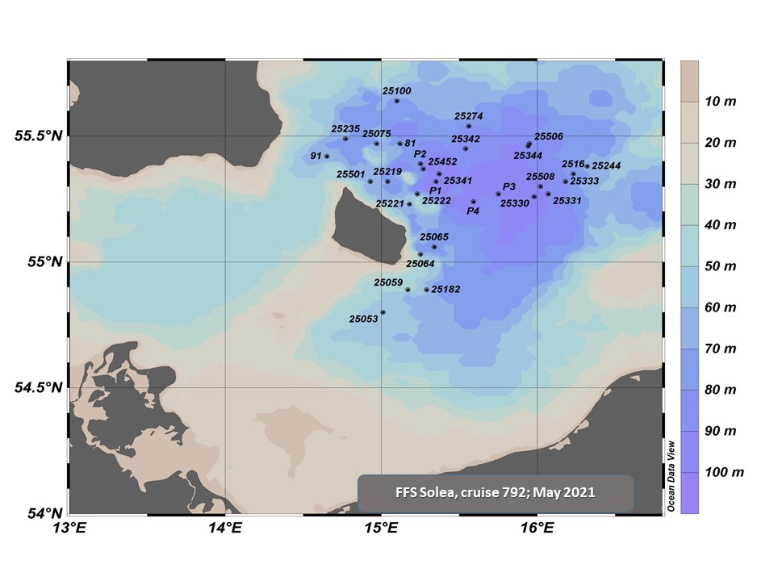
Map: Cod in the Baltic Survey (CoBalt): Positions of fishing hauls in 2021; survey Solea 792, 25 May – 7 June 2021
- For internationally coordinated surveys, provide a link to the latest meeting report of the coordination group.
https://www.bsh.de/DE/DATEN/Ozeanographisches_Datenzentrum/Durchgefuehrte_Forschungsfahrten/_Anlagen/Jahre/2018_node.html

- List the main use of the results of the survey (e.g. indices, abundance estimates, environmental indicators).
Target species are demersal fish species in the Baltic Sea, mainly cod. The aim of the survey is the sampling of data on maturation, condition and spawning activities of cod in relation to hydrography (salinity, temperature, oxygen) in the Bornholm Basin and the Arkona Sea.
- Extended comments (Tables 1G and 1H)
None

National Bottom Trawl Survey in the Baltic (BaltBox)
- Objectives of the survey
The purpose of this survey is the qualitative and quantitative recording of changes in distribution and composition of the demersal fish fauna in the German EEZ of the Baltic Sea. The sampling areas are located in ecologically characteristic areas ranging from Kiel Bay and Fehmarn Belt in the west via the deep Arkona Basin through to Adlerground and Oderbank in the east. Since 2018 only the most characteristic areas concerning spatio-temporal distribution of fish species are investigated: “West”, “Deep” and “East”. Target data are abundances, weight and length distributions of all fishes and length-weight-age-sex-maturity data of Baltic cod, flounder, plaice, dab, turbot and brill as well as hydrographic data (temperature, salinity and oxygen). The data are stored in a national SQL database. In addition, cod stomachs are sampled.
- Description of the methods used in the survey. For mandatory surveys, link to the manuals. Include a graphical representation (map)
The used methods are standard BITS methods, which are described in the BITS survey manual: http://www.ices.dk/community/groups/Pages/WGBIFS.aspx
- For internationally coordinated surveys, describe the participating Member States/vessels and the relevant international group in charge of planning the survey
National survey only.
- Where applicable, describe the international task sharing (physical and/or financial) and the cost sharing agreement used
National survey only.
- Graphical representation (map) showing the positions (locations) of the realized samples.

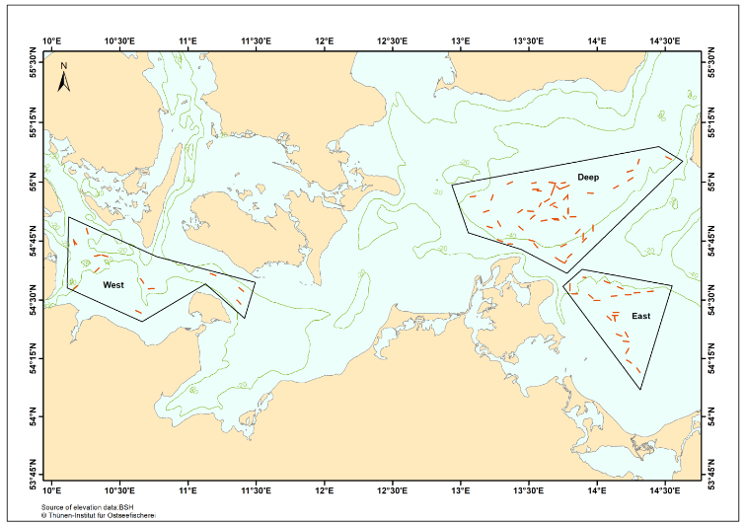
Map BaltBox survey. Location of fixed sampling areas for investigations of the demersal fish fauna in the German EEZ of the Baltic Sea.

- For internationally coordinated surveys, provide a link to the latest meeting report of the coordination group.
National survey only.
- List the main use of the results of the survey (e.g. indices, abundance estimates, environmental indicators).
The main objective is to characterize the demersal fish fauna and their changes over time. Therefore, biodiversity indices, abundances and environmental parameters (e.g. salinity, temperature, oxygen saturation) are estimated, recorded and analysed.
- Extended comments (Tables 1G and 1H)
The following publication resulted from the survey:
Rau A, Lewin W-C, Zettler ML, Gogina M, Dorrien C von (2019). Abiotic and biotic drivers of flatfish abundance within distinct demersal fish assemblages in a brackish ecosystem (western Baltic Sea). Estuar Coast Shelf Sci 220:38-47, DOI:10.1016/j.ecss.2019.02.035

German Autumn Survey in the Exclusive Economic Zone (GAS EEZ)
- Objectives of the survey
- To determine the distribution and relative abundance of demersal fish species;
- To monitor changes in the stocks of commercial fish species independently of commercial fisheries data;
- To monitor the distribution and relative abundance of all fish species and invertebrates
- To collect hydrographical data (temperature, salinity and oxygen);
- To collect data on marine litter.

- Description of the methods used in the survey. For mandatory surveys, link to the manuals. Include a graphical representation (map)
The survey takes place every year alternately with beam trawl (7 meter) and otter bottom trawl (cod hopper). A fixed station pattern has been fished since 2004. Sorting of the catch follows the standard IBTS methods, which are described in the IBTS survey manual (ICES 2020: Manual for the International Bottom Trawl Survey, Revision XI. SISP 10).
The data are so far stored locally in a national database.
- For internationally coordinated surveys, describe the participating Member States/vessels and the relevant international group in charge of planning the survey
National survey only
- Where applicable, describe the international task sharing (physical and/or financial) and the cost sharing agreement used
National survey only
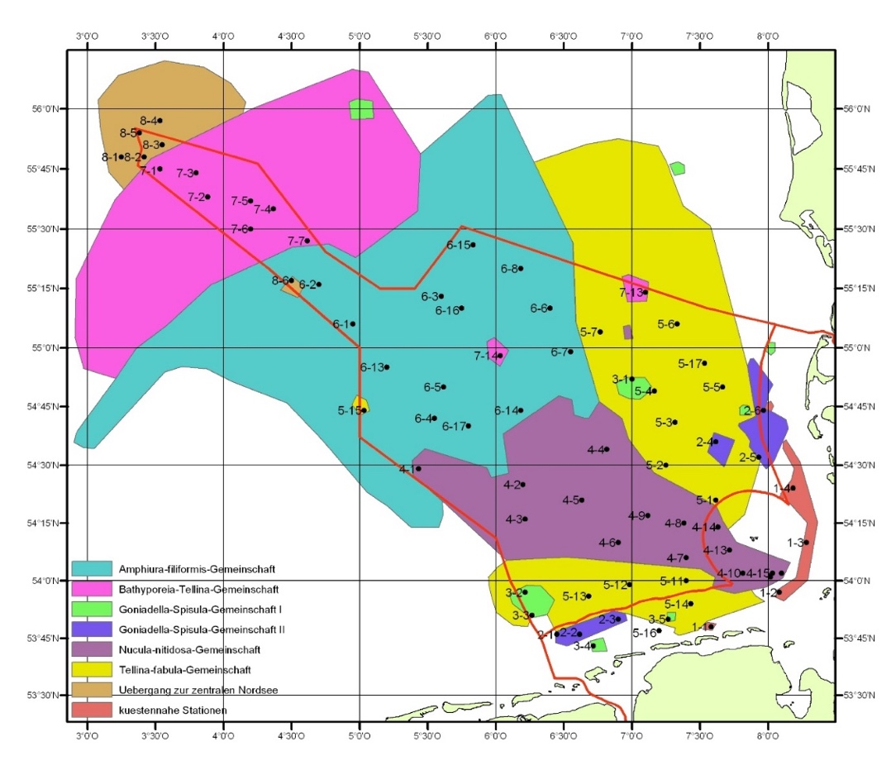
Map: German Autumn Trawl Survey (GAS EEZ) – Positions of hauls within different faunal zones
- Graphical representation (map) showing the positions (locations) of the realized samples.

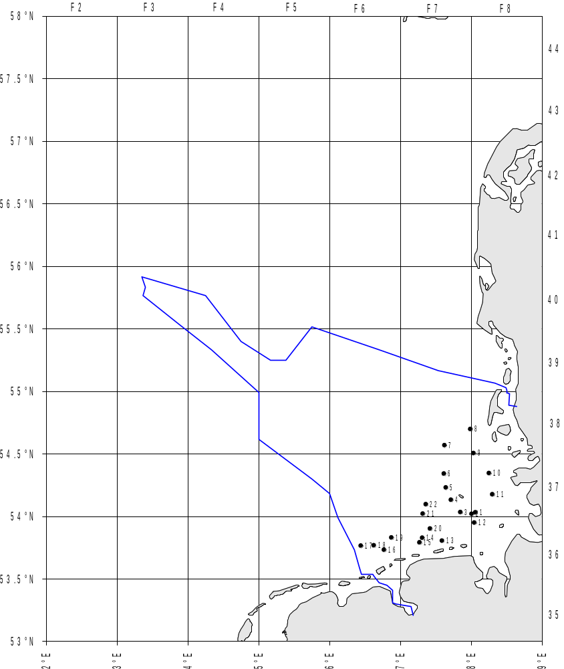
Map: German Autumn Trawl Survey (GAS EEZ) – Realized fishing hauls in 2021
- For internationally coordinated surveys, provide a link to the latest meeting report of the coordination group.
http://www.bsh.de/aktdat/dod/fahrtergebnis/2019/20190087.htm
see PDF annex
- List the main use of the results of the survey (e.g. indices, abundance estimates, environmental indicators).
The survey provides information on the distribution and relative abundance of demersal fish species, monitors changes in the stocks of commercial fish species independently of commercial fisheries data and supplies information on the distribution and relative abundance of all fish species and invertebrates
- Extended comments (Tables 1G and 1H)
none

Eel Larvae Survey
- Objectives of the survey
A) Regular and standardized monitoring of larval eel (Anguilla anguilla) abundance in the Sargasso Sea as a basis for the establishment of a stock-recruitment relationship and stock assessment.
B) Larval abundance and distribution in the Sargasso Sea in relation to glass eel recruitment and hydrographic conditions in order to evaluate the effect of climate change on larval survival, retention and drift.
Data on larval abundance in the spawning area are poor and the existence of a stock-recruitment-relationship is unproven. Until today, European eel stock assessment is largely based on fluctuations in glass eel recruitment along European coasts. However, the age of arriving glass eels is scientifically disputed with estimations reaching between 1 and 3 years. In addition, oceanic factors influencing larval survival until metamorphosis into glass eel stages are still debated as potential drivers for the eel stock decline. The regular monitoring of larval abundance in the Sargasso Sea is aiming to provide information that is required to evaluate whether management measures (e.g. increase of spawner escapement) increase the reproduction success of A. anguilla. By comparing larval abundances with glass eel recruitment of the following years, the surveys also provide insights into the effect of oceanic factors on eel stock development. It is investigated how climatic changes affect the survival and distribution of eel larvae and to what extent the drift towards European waters might be impeded by hydrographic conditions.
- Description of the methods used in the survey. For mandatory surveys, link to the manuals. Include a graphical representation (map)
The study area ranges from 31° - 22°N and 70° - 50°W. Inside this area, a core sampling area is defined in accordance with larval distribution. Sampling takes place with an Isaac Kidd Midwater Trawl (net opening 6.3 m², mesh size 500 µm) at approximately 50 stations along north-south transects. Species identification and length measurements of all leptocephalus larvae are done on board. Hydrographic conditions are monitored by CTD throughout the sampling area.
- For internationally coordinated surveys, describe the participating Member States/vessels and the relevant international group in charge of planning the survey
National survey only
- Where applicable, describe the international task sharing (physical and/or financial) and the cost sharing agreement used
National survey only

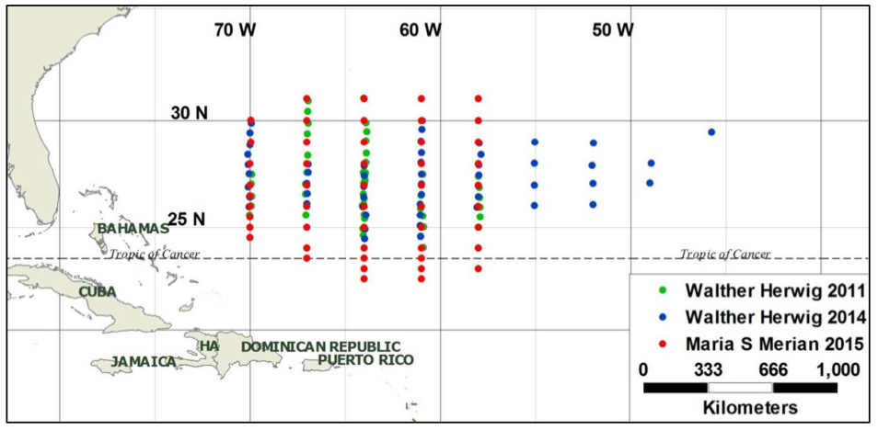
Map: Eel Larvae Survey, sampled transects in 2011, 2014 and 2015. In 2017 (FRV Walther Herwig III cruise WH404), the transects at 64°, 61° and 58°W were sampled (not shown).
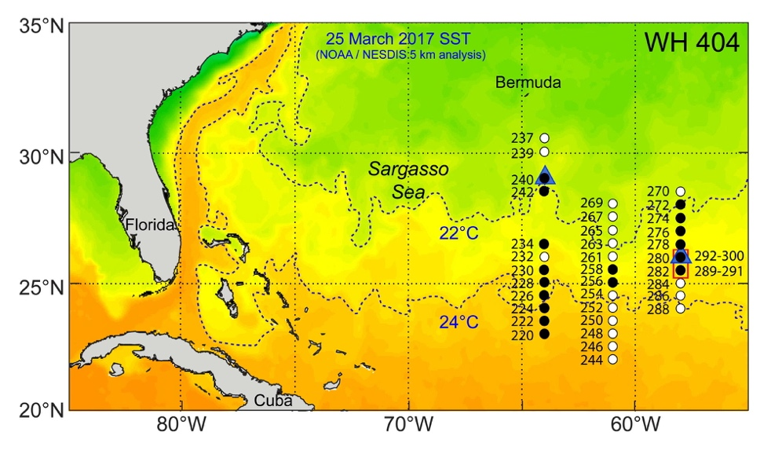
Map: Eel Larvae Survey, sampled transects in 2017
- Graphical representation (map) showing the positions (locations) of the realized samples.
No survey in 2021, next survey year is 2023
- For internationally coordinated surveys, provide a link to the latest meeting report of the coordination group.
http://www.bsh.de/aktdat/dod/fahrtergebnis/2017/20170155.htm,
Survey was completely cancelled in 2020 due to the Covid-19 pandemic. Next survey year is 2023
- List the main use of the results of the survey (e.g. indices, abundance estimates, environmental indicators).
During the EELS cruises, distribution and abundance of early life stages of eels (Anguilla anguilla and A. rostrata) are studied in the central Sargasso Sea. In the frame of a regular time series, the studies aim at enabling conclusions about the long-term effects of changing hydrographic conditions on distribution, abundance and survival of eel larvae in the Sargasso Sea. In the medium-term, the data shall offer relevant information for a successful and efficient management of this endangered fish species. Our catches of eel larvae, in combination with the oceanographic data obtained during the cruise, can also help to more precisely localize the spawning sites of European eel and to better understand the relevant abiotic factors in the spawning area.
In addition to the detailed work on eel larvae, we also investigate abundance and distribution of leptocephalus-larvae of other species, to detect potential changes in the leptocephalus community in the Sargasso Sea.
Beside the investigations of eel larvae, the behaviour of mature female eels in their presumed spawning area was investigated by using pop-up satellite tags in 2017. From this experiment, we expect data about the swimming behaviour of female eels short before spawning, including information about the spawning depth and hydrographic conditions at the spawning site.
The present research cruise is not understood as a stand-alone project. Instead, it represents a further step in our efforts to establish a continuous time-series of Sargasso Sea surveys, during which abundance and distribution of eel larvae as well as hydrographic conditions during the spawning period will be documented. By doing this, our studies provide a basis for a better understanding of the distribution of eel larvae and physical constraints for eels to spawn. By also conducting studies on related issues, e.g. trophic interactions, we further increase the knowledge about ecology of the youngest life stages of this fascinating, economically important but endangered species.
- Extended comments (Tables 1G and 1H)
none

Section 2: Fishing Activity Data

Text Box 2A: Fishing activity variables data collection strategy

General comment: This box fulfills paragraph 4 of Chapter III of the multiannual Union programme and Article 2, Article 4 paragraph (2) point (b) and Article 5 paragraph (2) of the Decision (EU) 2016/1701. It is intended to describe the method used to derive estimates on representative samples where data are not to be recorded under Regulation (EU) No 1224/2009 or where data collected under Regulation (EU) No 1224/2009 are not at the right aggregation level for the intended scientific use.
General comment: This box is applicable to the Annual Report. This box should provide information on the implementation of the data collection of fishing activity variables of Member States.
- Description of methodologies used to cross-validate the different sources of data

Depending on the variable, the source is either the logbook (for effort) or the sales notes (for value of landings). The logbooks are also used to determine the metier. There is, however, no duplicate provision of data from separate sources which would require cross-validation.

2. Description of methodologies used to estimate the value of landings

The value of landings is taken directly from sales notes. In the case of missing entries for the value, it is being estimated using prices achieved at the same time in the same region with the same gear at the same place. In the case of missing hits, the criteria of similarity (e.g. “same place”) are reduced until a hit is achieved.

3. Description of methodologies used to estimate the average price (it is recommended to use weighted averages, trip by trip)

Prices are estimated using figures from the sales notes. In order to get the price per kg, the revenue is divided by the mass sold. In the case of missing entries for revenue, it is estimated as described before.

4. Description of methodologies used to plan collection of the complementary data (sample plan methodology, type of data collected, frequency of collection etc)

For vessels without logbooks, effort variables are estimated on the basis of a questionnaire which is sent together with the survey on fleet economic variables (stratified random sampling). Gear size and days at sea are requested. These data are compared with the sales notes which always refer to a certain time period. The sum of these periods is related to the survey result. The ratio of both figures is used estimate the fleet segment total by multiplying it with the total of the time periods derived from the sales notes.
All other fishing activity data are collected according to the standards as provided by the Control Regulation (1224/2009).
5. Deviations from Work Plan methodology used to cross-validate the different sources of data
No deviations.
Actions to avoid deviations.
NA

6. Deviations from Work Plan methodology used to estimate the value of landings.
No deviations.

7. Deviations from Work Plan methodology used to estimate the average price.
No deviations.

8. Deviations from Work Plan methodology used to plan collection of the complementary data
The 2021 WP did not contain effort information by variable. For the 2021 AR, information is provided by variable (as for AR 2020). DEU performed an additional data collection on effort variables only for vessels without logbooks. According to COM Dec. 1251/2016, “number of fishing operations” is to be collected. However, this variable is only meaningful in context with purse seines (see COM Dec. 93/2010). This fishery is not performed by any German vessel, thus the variable is not relevant. Nonetheless, data can be estimated based on the survey (number of nets X fishing days).

Section 3: Economic and Social Data

Text Box 3A: Population segments for collection of economic and social data for fisheries

General comment: This box fulfils paragraph 5 points (a) and (b) of Chapter III of the multiannual Union programme and Article 2, Article 4 paragraphs (1), (2) and (5) and Article 5 paragraph (2) of the Decision (EU) 2016/1701. It is intended to specify data to be collected under Tables 5(A) and 6 of the multiannual Union programme.
General comment: This box is applicable to the Annual Report. This box should provide information on the implementation of the fleet socio-economic data collection of Member States.
- Description of methodologies used to choose the different sources of data
Data sources are chosen based upon availability and accessibility. Whenever data are available which are collected under a different legislation (transversal data), these are being used (fleet register, logbooks sales notes). Data which are not covered by the sources mentioned above, are collected through the following sources:
- an accountancy network which consists of about 160 vessels providing a comprehensive set of economic data annually (covering beam trawlers 12-24 m, demersal trawlers 12-24 m, and fixed netters between 8 and 18 m)
- a questionnaire which is sent by mail to owners of small-scale fisheries vessels < 10m (“probability proportional to size” sampling), requesting “socio-economic” data on an enterprise level, and
- a questionnaire for the segments “Beam trawlers: 10-12 m*and 24-40 m*”; “Demersal trawlers 24-40 m and >40 m” and “Pelagic trawlers > 40 m*” referring to individual vessels.
All surveys are carried out on a voluntary basis. The selection under (ii) is related to the vessel owner. Most fishermen own only one vessel. In case that an owner is selected for sampling and owns more than one vessel, questionnaires will be sent for each individual vessel. However, fishermen owning more than one smaller vessel do not file expenses and employment data separated by vessel. Therefore, this group will be sampled on an enterprise basis, and only effort and physical value data will be surveyed on a vessel basis.
2. Description of methodologies used to choose the different types of data collection
Methodologies are chosen by means of segment size and importance. Segments with few vessels, but high importance for certain fisheries or in terms of total landings, are sampled exhaustively. This applies to most segments >24m. Other segments are sampled on the basis of “probability proportional to size” sampling (“size” refers to the value of landings). The bigger the segment (in terms of no. of vessels), the smaller the sample rate.
3. Description of methodologies used to choose sampling frame and allocation scheme
The sampling frame is the target population. The target population is the fleet on 31st December plus all vessels having reported any activity (landings declaration) during the year. Vessels are allocated to a segment gear by using logbook information or, for vessels without logbooks, main gear in the fleet register.
As approved for previous periods, vessels targeting mainly blue mussels are excluded from the fishing fleet, as their activity is defined as aquaculture (using seed mussels) and their figures are reported in the aquaculture section.
4. Description of methodologies used for estimation procedures
A correlation analysis is being performed between data which are available exhaustively (capacity, landings, and in most cases effort) and those data from the surveys. The Pearson correlation coefficient is used as a first indicator of which factor has the most influence on the variable which has to be estimated. As a result of this analysis, a scheme is being developed, which includes not only correlation aspects, but also considerations of meaningfulness. For instance, energy costs are likely to be dependent upon both the vessel size and some effort parameter, but not so much on value of landings – even if the correlation analysis might indicate something else.
 | Basis for estimation
Variable type to be estimated | GT | kW | fishing days | days at sea | value of landings
Direct subsidies |  | X
Other income |  | X
Wages and salaries of crew | X |  | X |  | X
Imputed value of unpaid labour | X |  | X |  | X
Energy costs | X |  | X
Repair and maintenance costs | X |  |  |  | X
Variable costs | X |  | X
Non-variable costs | X | X
Investments in physical capital |  |  |  |  | X
Debt/asset ratio |  |  |  |  | X
Engaged crew |  |  |  | X
FTE National |  |  |  | X

Estimation for segments with sampling results
In a next step, the values are estimated for the segment for which sampled data are available. It has turned out that the fractions, which the sample represents within the considered segment, are in most cases quite similar, e.g. in TBB1218 the sample represents about 41% of the number of vessels, 41% of LoA, 44% of GT, 41% of kW, 52% of weight of landings, 49% of revenues and 45% of days at sea (example from 2008).
In other words, estimations are in most cases quite robust, no matter which factor is used for estimation. Nonetheless, the estimator is chosen with respect to the scheme above. In cases where more than one variable is indicated as basis for estimation, the average of the fraction will be applied.
Estimation for segments without sampling results
According to the experience in previous years, there is a chance that for a segment or a variable no responses are obtained. In this case, the basis for estimation will be a regression analysis of segments with the same fishing technique and an adjacent length class or with the same length class and a similar fishing technique, depending upon which version delivers the highest r². The final choice can be done only when the data are available.
5. Description of methodologies used on data quality
In accordance with the STECF report on quality aspects (SGECA 09-02), the coefficient of variation will be used as indicator of accuracy.
In addition, Germany is testing an alternative clustering approach to find a more suitable segmentation procedure, based on fishing pattern rather than on main gear class. The aim is to achieve segments with less variability.
6. Deviations from Work Plan methodology for selection of data source
List the deviations (if any) from the methodology used to select data source compared to what was planned in the Work Plan, and explain the reasons for the deviations.
No deviations. In addition to the sources mentioned, subsidies were comprehensively provided by the federal institutions resposible for approval and payment.
Actions to avoid deviations
NA
Briefly describe the actions that will be considered / have been taken to avoid the deviations in the future and when these actions are expected to produce effect. If there are no deviations, then this section can be skipped.
No deviations
7. Deviations from Work Plan methodology to choose type of data collection
List the deviations (if any) from the methodologies to choose type of data collecton scheme compared to what was planned in the Work Plan, and explain the reasons for the deviations.
No deviations
Actions to avoid deviations
Briefly describe the actions that will be considered / have been taken to avoid the deviations in the future and when these actions are expected to produce effect. If there are no deviations, then this section can be skipped.
NA
8. Deviations from Work Plan methodology regarding sampling frame and allocation scheme
List the deviations (if any) from the methodologies used regarding sampling frame and allocation scheme compared to what was planned in the Work Plan, and explain the reasons for the deviations.
No deviations
Actions to avoid deviations
Briefly describe the actions that will be considered / have been taken to avoid the deviations in the future and when these actions are expected to produce effect. If there are no deviations, then this section can be skipped.
NA

9. Deviations from Work Plan methodology used for estimation procedures
List the deviations (if any) from the methodologies used for estimation procedures compared to what was planned in the Work Plan, and explain the reasons for the deviations.
No deviations
Actions to avoid deviations
Briefly describe the actions that will be considered / have been taken to avoid the deviations in the future and when these actions are expected to produce effect. If there are no deviations, then this section can be skipped.
NA
10. Quality assurance
10.1 Sound methodology
Briefly describe if the data collection follow methodologies, guidelines and best practices agreed in expert groups and whether methodologies are documented and are made publicly available.
The methodologies applied are in line with expert group recommendations (e.g. SGECA 09-02). Sampling schemes used are census and probability sampling. The methodologes applied are documented and being made publicly available in the Work Plan, which is available e.g. under
https://www.dcf-germany.de/documents.
Specific information on the FADN-based data can be found at
https://www.bmel-statistik.de/landwirtschaft/testbetriebsnetz/testbetriebsnetz-fischerei-buchfuehrungsergebnisse/.
10.2. Accuracy and reliability
For additional information, briefly describe how raw data inputs, intermediate results and outputs are regularly assessed and validated and how errors are identified, documented and dealt with.
Response rate and achieved sample rate are provided in Table 3A.
FADN-based data are additionally checked through an IT-based plausibility routine, comprising a comparison of numerous figures:
https://www.bmel-statistik.de/landwirtschaft/testbetriebsnetz/testbetriebsnetz-landwirtschaft-buchfuehrungsergebnisse/plausibilitaetspruefung-landwirtschaft/
Figures from additional surveys comprise about 50 questionnaires. Those are assessed manually, following principles similar to the FADN plausibility routine, though being shorter (as the FADN contains many more variables than required for EU MAP). In principle, values are checked by the individual GVA – datasets are further scrutinised when the GVA is sensibly negative. In some cases, one-time expenses are an explanation (e.g. repair). If expenses substantially exceed a typical percentage of the value of landings, then the data will be cross-checked with the supplier, when regarded relevant.
10.3. Accessibility and Clarity
Indicate with Yes or No
Are methodological documents publicly available? Yes
Are data stored in databases? Yes
Where can methodological and other documentation be found?
Provide the web link, if documentation is publicly available
https://www.dcf-germany.de/documents
https://www.bmel-statistik.de/landwirtschaft/testbetriebsnetz/testbetriebsnetz-fischerei-buchfuehrungsergebnisse/
https://www.bmel-statistik.de/landwirtschaft/testbetriebsnetz/testbetriebsnetz-landwirtschaft-buchfuehrungsergebnisse/plausibilitaetspruefung-landwirtschaft/

Section 3: Economic and Social Data

Pilot Study 3: Data on employment by education level and nationality

General comment: This box fulfills paragraph 5 point (b) and paragraph 6 point (b) of Chapter III of the multiannual Union programme and Article 2 and Article 3 paragraph (3) point (c) of the Decision (EU) 2016/1701.It is intended to specify data to be collected under Table 6 of the multiannual Union programme.
General comment: This box is applicable to the Annual Report. This box is intended to provide information on the results obtained from the implementation of the pilot study (including deviations from planned and justifications as to why if this was not the case).
The pilot study was performed as planned by Germany within 2017-2019 and will be continued as regular data collection.
4. Achievement of the original expected outcomes of pilot study and justification if this was not the case.
Not relevant, the pilot study was executed in 2018.

5. Incorporation of results from pilot study into regular sampling by the Member State.
Not relevant

Section 3: Economic and Social Data

Text Box 3B: Population segments for collection of economic and social data for aquaculture

General comment: This box fulfills paragraph 6 points (a) and (b) of Chapter III of the multiannual Union programme and Article 2, Article 4 paragraphs (1) and (5) and Article 5 paragraph (2) of the Decision (EU) 2016/1701.It is intended to specify data to be collected under Tables 6 and 7 of the multiannual Union programme.

General comment: This box is applicable to the Annual Report. This box should provide information on the implementation of the socio-economic data collection for aquaculture of Member States.

Background: 2,584 German aquaculture farms produced more than 31,800 tons of fish, crustaceans, molluscs and other aquatic organisms in 2018 (Destatis 2019). The main species are rainbow trout, common carp and blue mussels. According to the last tentative assumed Eurostat aquaculture production data, this represents a share of 2.2 % of the total EU-28 production (STECF-18-19). Taking into account the defined thresholds of the EU MAP (Implementing Decision 2016/1251, chapter V 6.), social and economic data on aquaculture will be collected, while environmental data on aquaculture will not be collected.
1. Description of methodologies used to choose the different sources of data
The Federal Statistical Office in Germany (Destatis) coordinates an annual aquaculture census on production data (volume, species, number of farms, used fish farming technique per federal state). These data do not provide further economic facts on aquaculture. Notwithstanding, it can be seen as a starting point for a planned evaluation on economic and social performance of the sector. In case of the German on-bottom blue mussel cultures, the Federal Office for Agriculture and Food (Bundesanstalt für Landwirtschaft und Ernährung, BLE) collects data on landings, crew and other logbook entries. Further, the German Federal Employment Agency (Bundesagentur für Arbeit, BA) collects monthly data on employment; but not on non-paid labour, which plays an important role in freshwater aquaculture in particular. The BA data covers information about number of permanent employees, casual contracts, apprentices, gender and nationalities. Regarding the data situation and the requirements of DCF, there are two different data resources to analyse the economic and social performance of the sector: assembly of already existing secondary data (data on employment and production/landings) from diverse sources and a collection of primary data done by the Thünen-Institute.
2. Description of methodologies used to choose the different types of data collection
A triangulation (mixed-method-approach) is applied. First, data on production and employment is collected by third party agencies via census (Destatis, BA, BLE) and collated by the Thünen-Institute according to DCF requirements. Second, data on economics and social variables are collected via survey (standardised questionnaire). Third, it is planned to build up a network of representative farms (according to the typical farm approach, cf. PGECON 2019). The typical farms will be used as supplementary data source for farm economics and labour characteristics (social variables) to balance shortcomings of the survey (e.g. insufficient response behaviour in case of some variables).
3. Description of methodologies used to choose sampling frame and allocation scheme
While Destatis coordinates the census of production data in Germany, the data itself is collected by the 16 state offices of statistics in Germany. Due to the strict interpretation and application of data protection law, the responsible state authorities rejected to give Thünen-Institute access to the diverse fish farmer address bases. As described in Germany’s annual report for data collection in the fisheries and aquaculture sectors 2017-2019 from May, 2019 and approved through the letter of acceptance of annual report from EC MARE/C3 Joost Paardekooper from July 12th, 2018, the original planned two-stage sampling process including the planned threshold (cf. German Work Plan for data collection in the fisheries and aquaculture sectors 2017-2019) could not be applied, because the Thünen-Institute has no access to freshwater fish farmers’ addresses combined with information about cultured species and volume. Alternatively, an own database has been built up. Here are freshwater aquaculture enterprises listed, which addresses is available via public sources. After the undertaken survey 2018, new information from respondees lead to cleanse the established address database. Several entries were deleted, because the addresses were invalid or interviewees had objections according to data protection regulation (EU) 2016/679 of the European Parliament and the Council. This cleansing process is ongoing and will exclude part-time and hobby farms in future. At the end, only professional operations will be considered as fish farms “whose primary activity is [are] defined according to the European classification of economic activities” (Decision 2016/1251, Chapter III 6.a). At the time of this report, the address database considers 766 addresses. In 2018, the Thünen-Institute received 146 responses for freshwater aquaculture enterprises in 2018, which represent around 20 percent of the total German fresh water aquaculture production.
Due to cleansing process the exact sample frame is still variable, but will oscillate between 200 and 400 companies. For the current workplan, the assumed number of 300 cases is applied, whereof the main species trout and carp farms have an almost equal share. For the marine sector, all approx. 10 companies holding licenses are surveyed by questionnaire.
In addition, a small network of representative farms will be build up, which is chosen by purpose sampling (PGECON 2019).
4. Description of methodologies used for estimation procedures
For production and for some social variables, there is no estimation necessary (cf. point 1.), as the data are based on a census from Destatis, BA or BLE. In case of economic data gained via sample or the network of representative farms, standard statistic parameters will be applied within the true population to a certain degree of confidence. Main reference for estimation will be the total production per species, production system and farm size.
5. Description of methodologies used on data quality
The quality of available production, landing, logbook and employment data can be regarded as high due to the fact that Destatis, BA and BLE data are conducted via census. Destatis sets thresholds, which exclude fish farms with a scale <0.3 ha or with a volume <200 m³ (Destatis 2019). The same thresholds are applied for the address database used by Thünen-Institute. The planned sample for DCF economic data on freshwater aquaculture follows the common practices of statistics with linked sampling errors. The sampling errors will be expressed by standard error, coefficient of variation and confidence interval. Due to the experience of the Thünen-Institute regarding economic surveys for fisheries and (marine) aquaculture and an internal review process of the development of a well understandable questionnaire, measurement errors are not expected. Economic data collection is not mandatory for fish farmers in Germany and thus a low response rate is experienced. As a consequence, data collection activities include communication strategies (announcements in fish farmer magazines, personal introduction of the project to local research stations and fish farmer meetings) as well as mail reminders. Further, the planned network of representative farms will balance low response rates of the survey.
References
Bundesagentur für Arbeit (2018) Beschäftigte nach ausgewählten Wirtschaftsklassen nach Klassifizierung der Wirtschaftszweige (WZ 2008). German Federal Employment Agency, internal report, Nürnberg, July, 2016.
Destatis (2019) Land- und Forstwirtschaft, Fischerei. Erzeugung in Aquakulturbetrieben 2018. German Federal Statistical Office (Destatis), Fachserie 3 (4.6), Destatis, Wiesbaden.
Planning Group on Economic Issues (PGECON), PGECON 2019 Report, Slovenia, May 6th-10th, 2019, available at https://datacollection.jrc.ec.europa.eu/docs/pgecon
6. Deviations from Work Plan methodology for selection of data source
No deviations.
7. Deviations from Work Plan methodology to choose type of data collection
No deviations.
The variable financial income was part of the annual survey in earlier years, however the feedback led to the conclusion that this economic variable is not relevant for the (rather low-capital) German sector. Therefore, this variable was not included in the 2021 survey.
8. Deviations from Work Plan methodology regarding sampling frame and allocation scheme
No deviations.
As described above, the frame population consists of the total of publicly available addresses of German freshwater aquaculture enterprises, continously cleansed and updated on the basis of responses/new farms to be added. The current frame population corresponds to 430 salmonid and 314 carp producing operations. The total number of German aquaculture farms, collected within the census of the Federal Statistical Office (Destatis), corresponds to approx. 2500 (1626 salmonid and 1483 carp operations, partly producing both species) and their total production volume is the target size for extrapolation. The frame population for the variable “persons employed” was chosen according to the population frame of the National Labour Agency (BA) and corresponds to the number of registered employees (census). This decision was taken on the basis that the BA frame population does not neccessarily correspond to the frame population of aquaculture producing operations collected by Destatis.
9. Deviations from Work Plan methodology used for estimation procedures
No deviations.
10. Quality assurance
10.1 Sound methodology
The methodologies applied are in line with expert group recommendations (e.g. SGECA 09-02). Sampling schemes used are census, probability sampling and indirect survey. The methodologes applied are documented and being made publicly available in the Work Plan, available e.g. under https://www.dcf-germany.de/documents.
Regarding data on aquaculture production volume per species, production techniques (segments), number of farms, cf. Federal Statistical Agency (Destatis) “Qualitätsbericht. Erhebung über die Erzeugung in Aquakulturbetrieben“, 18. November 2020, Wiesbaden.
(https://www.destatis.de/DE/Methoden/Qualitaet/Qualitaetsberichte/Land-Forstwirtschaft-Fischerei/aquakulturbetriebe.pdf?__blob=publicationFile (access on 05/05/2022; only available in German))
Regarding data on permanent and casual employment, apprenticeships, gender and origins of employees cf. labour register of the National Employment Agency (Bundesagentur für Arbeit, November 2020).
(https://statistik.arbeitsagentur.de/DE/Statischer-Content/Grundlagen/Methodik-Qualitaet/Qualitaetsberichte/Generische-Publikationen/Qualitaetsbericht-Statistik-Beschaeftigung.html?__blob=publicationFile (access on 05/05/2022; only available in German))
10.2. Accuracy and reliability
For a continous synthesis of the freshwater aquaculture and marine aquaculture surveys, all questionnaires were sent at the beginning of November 2021 at once. Response rate and achieved sample rate per variable are provided in Table 3B.
10.3. Accessibility and Clarity
Indicate with Yes or No
Are methodological documents publicly available? Yes
Are data stored in databases? Yes
Where can methodological and other documentation be found?
https://www.dcf-germany.de/documents https://www.destatis.de/DE/Methoden/Qualitaet/Qualitaetsberichte/Land-Forstwirtschaft-Fischerei/einfuehrung.html (access on 05/05/2021; only available in German))
https://statistik.arbeitsagentur.de/DE/Statischer-Content/Grundlagen/Methodik-Qualitaet/Qualitaetsberichte/Generische-Publikationen/Qualitaetsbericht-Statistik-Beschaeftigung.html?__blob=publicationFile (access on 05/05/2022; only available in German)

Section 3: Economic and Social Data

Pilot Study 4: Environmental data on aquaculture

General comment: This box fulfills paragraph 6 point (c) of Chapter III of the multiannual Union programme and Article 2 and Article 4 paragraph (3) point (d) of the Decision (EU) 2016/1701. It is intended to specify data to be collected under Table 8 of the multiannual Union programme.
General comment: This box is applicable to the Annual Report. This box is intended to provide information on the results obtained from the implementation of the pilot study (including deviations from planned and justifications as to why if this was not the case).
1. No data collection planned due to threshold (see background text at the beginning of Text Box 3B).

4. Achievement of the original expected outcomes of pilot study and justification if this was not the case.
-
5. Incorporation of results from pilot study into regular sampling by the Member State.
-

Section 3: Economic and Social Data

Text Box 3C: Population segments for collection of economic and social data for the processing industry

General comment: This box fulfils footnote 6 of paragraph 1.1(d) of Chapter III of the multiannual Union programme, Article 2, Article 4 paragraphs (1) and (5) and Article 5 paragraph (2) of Decision (EU) 2016/1701. It is intended to specify data to be collected under Table 11 of the multiannual Union programme.
General comment: This box is applicable to the Annual Report. This box should provide information on the implementation of the socio-economic data collection for aquaculture of Member States.
1. Description of methodologies used to choose the different sources of data
In Germany, the fish processing sector is part of the industry. Almost 80-90% of employment and turnover belong to companies with 20 and more employees. Therefore, already existing data collection schemes with the emphasis on these larger companies are used. Additional data in particular for the social variables are gathered by the Federal Employment Agency. These data are almost all based on census. In order to avoid doubling data collection, these primary data are used for the purpose of the data collection in the processing sector. For some variables, data are not available via other administrative bodies. In these cases, the Institute of Sea Fisheries conducts an additional survey and will make also use of published financial statements of the companies.
The Federal Statistical Office in Germany (Destatis) holds a database with data on turnover, number of enterprises and employees belonging to the social security scheme. Destatis further collects data on Investment and sales on a census basis with a threshold of companies with 20 employees and conducts a probability sample survey on several cost items and employment data.
The Federal Employment Agency registers all persons employed in Germany. Additional characteristics like gender, age etc. are collected as well. If data on employment figures are not sufficient or - as in the case of unpaid labour – maybe not fully covered by the Employment Agency, additional data collection on a triennial basis for social data and annually for economic data will be executed by the Institute of Sea Fisheries.
For the raw material input by species and origin, some experience in data collection exists at the institute from former years. In order to enhance quality, a pilot study will be conducted. The aim is to make use of data already stored for traceability purposes in the sector. It is intended to check the quality and availability of these data and eventually conduct an own survey to obtain reliable pictures of the raw material input by species and origin. Meetings with industry representatives will form the starting point.
2. Description of methodologies used to choose the different types of data collection
The already existing data collections by the Federal Statistical Office and the Federal Employment Agency are well established and provide reliable and validated time series. Respective quality reports are available on request or already on the respective websites. A report about the overall description of the organisation of the survey, the various segments, and the quality aspects of both data types - primary and secondary data - will be provided. Given the experience from former years, data on variables that are not covered by other administrative bodies are more or less well achievable by questionnaire and eventual telephone recall, so this methodology will be maintained.
For the volume of raw material by species and origin, no such regular collection scheme is established, so a pilot study will be conducted.
3. Description of methodologies used to choose sampling frame and allocation scheme
In many cases, where data are already covered by regular data collection, decision on sampling frame and allocation scheme have been made already years ago, e.g. on the European level for Structural Business Statistics (SBS) data, or census is conducted.
For the data collection conducted by the Institute of Sea Fisheries, the principles are cost effectiveness and avoiding double data collection burden for the enterprises. On the other hand, the requirement is to obtain reliable data representing development and status quo of the sector. So a sampling frame concentrating on the large companies with 20 and more employees (representing 80-90% of the sectors turnover and employment) will be set up, and together with published financial statements, 20% sampling rate seems to be appropriate.
4. Description of methodologies used for estimation procedures
For some economic data and for some social variables, there is no estimation necessary because data are based on census and past experience shows no problems with non-response. In case of economic data gained via sample (cf. Table 3C), standard statistic parameters will be applied to calculate the range of values/volumes within the true population.
The pilot study conducted has shown a need for further collaboration with the industry and the industry organisation in order to provide a better basis to the use of the data and improve the procedure to gather them. Further contact is foreseen with firms that have shown interest, and subsequent approximations could be taken to others members of the industry. Therefore, to improve the success rate, non-probability sampling (purpose-sampling) could be employed in addition to probability sampling.
For the non-main activity sector, the population is unclear due to a lack a definition of the activity according to the EU-MAP in the official register of the ministry. The size of the population will be gradually estimated through the answers to the survey, which allows to distinguish among firms that have fish processing as their main activity, those who have it as a non-main activity and those who do not have it at all. Further efforts could be deployed to better define the population according to the EU-MAP, e.g. through exploring the possibility of using a different data source of administrative origin.
5. Description of methodologies used on data quality
The quality of available secondary data can be regarded as very high due to the fact that Destatis’ data on fish processing industry are collected under European SBS standards and ARGE’s data collection on employment is conducted via census. Destatis sets thresholds for specific cost data (20 and more employees, cf. Table 3C for details), but the stratified random sampling covering around 40% of the sectors larger companies allows high quality of the data. Due to the experience of the Thünen Institute regarding economic surveys for fisheries, (marine) aquaculture and fish processing, measurement errors are not expected. Some data are collected by the Institute of Sea Fisheries (cf. Table 3C), including the pilot study on raw material. As answering to this questionnaire is not mandatory for the companies, a low response rate is considered. As a consequence, a focus of data collection will include communication strategies in advance (announcements in fish sector magazines, personally introduction of the project to the association of fish processors) as well as mail reminder. Quality will be assessed by response rate and the sampling errors will be expressed by standard error and coefficient of variation.
References
ARGE (2018) Beschäftigte nach ausgewählten Wirtschaftsklassen der Wirtschaftszweige (WZ 2008). German Federal Employment Agency, internal report, Nürnberg, June, 2018.
Destatis (2017) Beschäftigte, Umsatz und Investitionen der Unternehmen und Betriebe des Verarbeitenden Gewerbes sowie des Bergbaus und der Gewinnung von Steinen und Erden, Fachserie 4 Reihe 4.2.1 - 2018 Destatis, Wiesbaden.
Destatis (2017) Kostenstruktur der Unternehmen des Verarbeitenden Gewerbes, Fachserie 4 Reihe 4.3 – 2019 Destatis, Wiesbaden.
6. Deviations from Work Plan methodology for selection of data source
Actions to avoid deviations
For the collection of raw material data, after the pilot study and the cooperation with the research project SECFISH were completed, a first attempt has been performed to include raw material in the institute´s survey.

7. Deviations from Work Plan methodology to choose type of data collection
Actions to avoid deviations
No deviations

8. Deviations from Work Plan methodology regarding sampling frame and allocation scheme
Actions to avoid deviations
For the raw material data, the experience from the pilot study and national research project was used to develop the survey.

9. Deviations from Work Plan methodology used for estimation procedures
Actions to avoid deviations
No deviations

10. Quality assurance
10.1 Sound methodology
The methodologies applied are in line with expert group recommendations (e.g. SGECA 09-02). The quality of available secondary data can be regarded as very high due to the fact that Destatis’ data on fish processing industry are collected under European SBS standards and the Federal Employment Agency´s (ARGE) data collection on employment is conducted via census. Sampling schemes used are census, probability and non-probability sampling. For the census and probability sampling to DESTATIS and ARGE the response rate is particularly good as delivery of data is compulsory for the firms.
The methodologies applied are documented and made publicly available in the National Work Plan, which is available e.g. under https://www.dcf-germany.de/documents.
For the pilot study, the methodology has been developed in cooperation with the SECFISH project. The specific documentation from the project can be accessed at: https://datacollection.jrc.ec.europa.eu/mare-2016-22-strengthening-regional-cooperation?p_p_id=110_INSTANCE_ye8qSc1W6ds3&p_p_lifecycle=0&p_p_state=normal&p_p_mode=view&p_p_col_id=column-2&p_p_col_count=1&_110_INSTANCE_ye8qSc1W6ds3_struts_action=%2Fdocument_library_display%2Fview_file_entry&_110_INSTANCE_ye8qSc1W6ds3_redirect=https%3A%2F%2Fdatacollection.jrc.ec.europa.eu%2Fmare-2016-22-strengthening-regional-cooperation%3Fp_p_id%3D110_INSTANCE_ye8qSc1W6ds3%26p_p_lifecycle%3D0%26p_p_state%3Dnormal%26p_p_mode%3Dview%26p_p_col_id%3Dcolumn-2%26p_p_col_count%3D1&_110_INSTANCE_ye8qSc1W6ds3_fileEntryId=1293879
Further extensions to the methodology have been performed using a case study, among others to reduce the burden on respondents.

Specific information on the already existing data collections by the Federal Statistical Office and the Federal Employment Agency data can be found at:

ARGE (2018) Sozialversicherungspflichtig Beschäftigte nach ausgewählten Wirtschaftszweigen der WZ
2008. German Federal Employment Agency, internal report, Nürnberg, August 2018.

Destatis (2020) Beschäftigte, Umsatz und Investitionen der Unternehmen und Betriebe des Verarbeitenden
Gewerbes sowie des Bergbaus und der Gewinnung von Steinen und Erden, Fachserie 4 Reihe 4.2.1 – 2020
Destatis, Wiesbaden.

Destatis (2019) Kostenstruktur der Unternehmen des Verarbeitenden Gewerbes, Fachserie 4 Reihe 4.3 –
2019 Destatis, Wiesbaden.

10.2. Accuracy and reliability
Response rate and achieved sample rate are provided in Table 3C. Since enterprises with 20 and more employees are responsible for more than 90% of the sector's sales and employment, low response rates in the segments with fewer employees do not affect the results in terms of representation of the sector eminently. The data collected represent between 80% and 100% of the sector's total sales. The exceptions are data for debt and net value of assets. Here, the willingness to provide data voluntarily differs distinctly. As in all former years, data for debt are calculated from the interest payment of the enterprises, taking market interest rates for enterprises. Then it is compared to the data from those enterprises that have provided data, to check if the amount is in an appropriate range and otherwise adapted to the values from the sample, as in the years before. Different company sizes are taken into account by a weighting factor, based on the sales volume.

Data from the German Federal Statistical Office (Destatis) on cost are available through the annual “Report on the cost structure of Processing Trade” which is released each June (year n) and which refers to year (n-2).
Thus in 2021, data on 2019 have been collected. This is in accordance with the STECF 14-24 report suggesting the rules for procedures under the EU MAP.

10.3. Accessibility and Clarity
Are methodological documents publicly available? Yes
Are data stored in databases? Yes
Where can methodological and other documentation be found?
Provide the web link, if documentation is publicly available.
https://www.dcf-germany.de/documents

https://www.destatis.de/DE/Themen/Branchen-Unternehmen/Industrie-Verarbeitendes-
Gewerbe/Publikationen/Downloads-Struktur/beschaeftigte-umsatz-investitionen-2040421197004.html

https://www.destatis.de/DE/Themen/Branchen-Unternehmen/Industrie-Verarbeitendes-
Gewerbe/Publikationen/Downloads-Struktur/kostenstruktur-2040430177004.html

https://www.destatis.de/DE/Methoden/Qualitaet/Qualitaetsberichte/Industrie-Verarbeitendes-
Gewerbe/kostenstruktur-verarbeitendes-gewerbe.html

https://www.unternehmensregister.de/ureg/result.html;jsessionid=026F2ADDE15882DF80064ECD45D055
E1.web02-1

https://datacollection.jrc.ec.europa.eu/mare-2016-22-strengthening-regional-cooperation?p_p_id=110_INSTANCE_ye8qSc1W6ds3&p_p_lifecycle=0&p_p_state=normal&p_p_mode=view&p_p_col_id=column-2&p_p_col_count=1&_110_INSTANCE_ye8qSc1W6ds3_struts_action=%2Fdocument_library_display%2Fview_file_entry&_110_INSTANCE_ye8qSc1W6ds3_redirect=https%3A%2F%2Fdatacollection.jrc.ec.europa.eu%2Fmare-2016-22-strengthening-regional-cooperation%3Fp_p_id%3D110_INSTANCE_ye8qSc1W6ds3%26p_p_lifecycle%3D0%26p_p_state%3Dnormal%26p_p_mode%3Dview%26p_p_col_id%3Dcolumn-2%26p_p_col_count%3D1&_110_INSTANCE_ye8qSc1W6ds3_fileEntryId=1293879

Section 4: Sampling Strategy for Biological Data from Commercial Fisheries

Text Box 4A: Sampling plan description for biological data

General comment: This box fulfills Article 3, Article 4 paragraph (4) and Article 8 of the Decision (EU) 2016/1701 and forms the basis for the fulfilment of paragraph 2 point (a)(i) of Chapter III of the multiannual Union programme. This Table refers to data to be collected under Tables 1(A), 1(B) and 1(C) of the multiannual Union programme.
General comment: This box is applicable to the Annual Report. This box should provide information on the deviations from the planned sampling of Member States.
1. General remark
Germany is conducting two approaches for the North Sea / North Atlantic (Institute of Sea Fisheries, Bremerhaven) and the Baltic Sea region (Institute for Baltic Sea Fisheries, Rostock) to account for the nature of the fisheries in the different regions.
- North Sea / North Atlantic regions:
Table 4C lists all fleet segments operating in the North Sea and North Atlantic regions with average landings >100t per year. Overall, approx. 220 vessels are operating in these regions, the majority belonging to the brown shrimp fleet. All other segments operating in the North Sea and North Atlantic consist of only a few vessels (on average 2 to 5 vessels). The same vessels can be listed in more than one segment. For instance, the same pelagic trawlers are targeting North Sea herring or blue whiting in ICES Div. 6b depending on the season.
The sampling frames for biological data are described in Table 4B. Vessels to sample are selected from a telephone list. However, the approach is an opportunistic randomised PSU selection and not fully probability-based due to the low number of vessels within one segment. The primary sampling unit is the vessel x trip, the secondary sampling unit is the haul, the tertiary sampling unit is the fish in the haul.
The only fleet segment with a greater number of vessels is the brown shrimp fishery, yet the target species is not assessed by ICES and there is no TAC. Some segments in the high-seas fisheries might consist only of one trip of a three-month duration by a huge vessel and high catch leading to a nearly exhaustive sampling of the segment.
Overall, the sampling frame is designed to fulfil the sampling obligations according to Table 1A and to understand the catch compositions of the important fisheries in these regions qualitatively and quantitatively as well as to enable and secure the data delivery to the assessment groups. Adaptations to the selected fisheries will be carried out after regional work plans and/or agreements have been established.
For the North Sea and North Atlantic, sampling is undertaken by at-sea-sampling only. This is because in the harbours of the German North Sea coast, there are hardly any auctions and direct fish sales. Landings are directly transferred from the vessel to different processing plants in Germany, but also to processing plants in foreign countries. Overall, 68%, 64% and 70% of the German landings occurred in foreign countries in 2013, 2014 and 2015, respectively. Therefore, it is virtually impossible to sample at harbours.
Sampling strata by regions:
- North Sea and Eastern Arctic
Fishing ground: Eastern Arctic (ICES Sub-areas I and II)
Arctic 1 – (Factory trawlers)
Target species: Saithe and cod. Peak season: 1st and 3rd quarter. Area: Northeast Arctic waters. Duration of trips: 4 weeks to 3 months.
Arctic 2 - (Pelagic freezer trawlers)
Target species: Atlanto-Scandian herring. Peak season: August to November. Area: Norwegian Sea. Duration of trips: 3 to 4 weeks.
Fishing ground: North Sea and Skagerrak (ICES Sub-area IV and Divisions IIIa and VIId)
North Sea 1 – (Small beam trawlers)
Target species: Brown shrimp. Peak season: March to October with peaks in the 2nd and 3rd quarter. Area: German North Sea coastal waters. Duration of trips: 1 to 3 days.
North Sea 2 – (Pelagic freezer trawlers)
Target species: Herring, mackerel. Peak season: Restricted fishing season for mackerel in the North Sea – January/February and 4th quarter; Herring – 3rd quarter/December. Area: North Sea and English Channel. Duration of trips: 3 to 4 weeks.
North Sea 3 – (Otter trawlers, pair trawlers and seine trawlers)
Target species: Saithe, cod, haddock. Peak season: All year round. Area: Northern North Sea and Skagerrak. Duration of trips: 1 to 2 weeks.
North Sea 4 – (Beam trawlers)
Target species: Sole and plaice. Peak season: All year round. Area: Southern North Sea. Duration of trips: 4 to 6 days.
North Sea 5 – (Otter trawlers)
Target species: Flatfish. Peak season: All year round. Area: Central and southern North Sea. Duration of trips: 5 to 8 days.
- North Atlantic and NAFO
Fishing ground: NAFO areas
North Atlantic 1 (Factory trawlers)
Target species: Greenland halibut and cod. Peak season: 3rd/4th quarter. Area: West Greenland (NAFO Div. 1D). Duration of trips: 6 weeks to 3 months.
Fishing grounds: Western waters (ICES Sub-areas VI-VIII, mainly West of Scotland and West of Ireland)
North Atlantic 2 (Pelagic freezer trawlers)
Target species: Mackerel, horse mackerel, blue whiting, herring. Peak season: March to June/October/November. Area: West British waters and Bay of Biscay. Duration of trips: 3 to 4 weeks.
Fishing ground: Iceland, Greenland and Irminger Sea (ICES Sub-areas XII and XIV and Division Va)
North Atlantic 3 (Factory trawlers)
Target species: Greenland halibut and cod. Peak season: 2nd/3rd quarter. Area: East Greenland (ICES Div. XIVb). Duration of trips: 4 weeks to 3 months.
North Atlantic 4 (Factory trawlers)
Target species: Redfish. Peak season: 2nd/3rd quarter. Area: Irminger/Labrador Sea (ICES Sub-areas XII and XIV, NAFO Sub-areas 1-2). Duration of trips: 4 weeks to 3 months.

- Baltic Sea:
The German fisheries in the Baltic Sea are separated into three fleet segments: 1) Demersal fish, 2) Sprat, 3) Herring.
The demersal fleet is further subdivided into 1a) passive SD2224, 1b) active SD2224, 1c) active SD2532. Each year, a list of vessels is produced using the landings data from the previous year (e.g. the lists for 2018 are compiled 2017 with data from 2016). The lists are sorted by total landings per vessel. The fleet segment lists of 1a, 1b and 1c include all vessels that contributed ~60%, ~90 and ~90% of the total landings, respectively. The list of vessels is then randomised by assigning a random number to each vessel on a list. The sequence of the random number determines the sequence of contacting the vessel. There is only one list for the entire year. If all vessels from a list have been contacted before the year ended, the same list is used again. Sampling is conducted all year-round and the effort is distributed according to fishing seasons. Each phone call with fishers is documented since 2010. This forms the basis for our recordings of success/non-response/rejection/refusal rates. In addition, we record if the sample is random or based on expert knowledge. Expert knowledge partly is used to ensure efficient sampling coverage of periods/strata with very low landings, e.g. demersal species in quarter 3. Cod, flounder, plaice and other flatfishes and fish species are sampled as part of the demersal sampling programme. However, if a vessel is selected, any fishing trip is sampled, except for trips targeting freshwater species, herring or sprat (see below).
An at-sea observer catch sampling programme (including concurrent sampling of landings, discards and unwanted by-catches) is conducted for the demersal fleet segments. In addition, a self-sampling programme with fishers is used to collect biological and catch data; unsorted commercial catch samples of usually 140-250 kg from the last or last but one haul are purchased. Diagnostics show that sampled trips are representative of the overall national population of vessels and their spatio-temporal dynamics. In addition, opportunistic sampling of landed discards (BMS cod under the landing obligation) may take place.
The primary sampling unit is the vessel x trip, the secondary sampling unit is the haul, the tertiary sampling unit is the fish in the haul.
The sprat catches mainly originate from two pelagic trawlers. Since 2013, we have a self-sampling programme where each vessel provides one frozen catch sample (5 kg) from each trip. This covers the ICES subdivisions 25-29. In addition, the minor sprat catches in SD22 and SD24 are sampled opportunistically upon expert knowledge and notification from the few fishers that are temporarily targeting sprat.
The fleet targeting herring is subdivided into 3a) passive SD2224, 3b) active SD24. For 3a, five major ports around the Greifswald Bay - the major fishing ground - are sampled using 30-50 kg unsorted catch samples from a vessel per port. Samples from the ports are taken from a known group of fishers, which are considered representative for the respective fleet given that similar mesh sizes are used. For 3b, a 30-50 kg unsorted catch sample is taken from an arbitrary (pair) trawler landing in the only German herring processing plant in Neu-Mukran, Rügen island. During the herring season (Nov-Apr), each week either 3a or 3b is sampled. The day of the week is selected according to wind and logistic considerations. In addition, to estimate the by-catches of cod (and other species) of the herring trawlers, the by-catch of 3b landed in Neu-Mukran is sampled once bi-weekly since 2014.
The assessment input data for small pelagics are prepared by quarter, gear (for herring: gillnet, trapnet, pelagic trawl; for sprat: pelagic trawl) and ICES Subdivision (for herring: 22 and 24; for sprat: 22, 24, 25-29). The landings are raised by the corresponding total length/age-length distributions of the commercial samples.
Deviation from the sampling plan according to Article 5 paragraph (3) of the Decision (EU) 2016/1701:
2. Deviations from the Work Plan
Baltic Sea:
The planned number of 30 PSU for “Baltic herring active 2224” given in the previous Work Plan was corrected to a realistic number of 10 PSU in 2021. A PSU of 30 must have been a wrong entry. A PSU of 30 is completely unrealistic because our national sampling scheme of the landings in the herring processing plant in Neu-Mukran usually does not exceed 14 samples in a year. The sampling scheme closely follows the fishery, which usually takes place between November and April. Given a bi-weekly sampling with 1 sample in a given week, we can expect 10-12 samples a year. Therefore, we changed the planned number of PSU to 10.
On 22 July 2019, the European Commission issued an immediate measure to protect the cod stock of the eastern Baltic Sea (EU 2019/1248). In 2021, Eastern Baltic cod could only be fished under a bycatch quota. This resulted in a massive decrease in fishing trips of German trawlers on Eastern Baltic cod in SD25.
In 2021, the strongly reduced quota for Western Baltic cod and the COVID-19 restrictions also affected the commercial fishery and the sampling effort. Fewer samples could be obtained in the active gear segments in all areas. This is mainly due to a reduced fishing effort, as trawlers require larger catch volumes to be profitable; this was impeded by small fishing opportunities and COVID-19-related marketing problems. In addition, many fishers referred to COVID-19 restrictions and rejected observers.
The reduced number of samples in the active fisheries was compensated by an increase of observer trips and self-samples from the passive gear segment. The passive gear segment was less affected by the COVID-19 restrictions, as these vessels are profitable at lower catch volumes and can more easily adjust to smaller catch volumes, and are usually operated by one or two persons.
Regarding other deviations from the Work Plan, please refer to Text Box 1C.

North Sea and Eastern Arctic:
Arctic 1 – (Factory trawlers)
Target species: Saithe and cod. Peak season: 1st and 3rd quarter. Area: Northeast Arctic waters. Duration of trips: 4 weeks to 3 months. Sampling effort: 2 observer trips were planned but only 1 trip was carried out. In 2021, it was not possible to place an observer onboard a fishing trip within the 3rd quarter due to restrictions caused by the COVID-19 pandemic.
North Sea 1 – (Small beam trawlers)
Target species: Brown shrimp. Peak season: March to October with peaks in the 2nd and 3rd quarter. Area: German North Sea coastal waters. Duration of trips: 1 to 3 days. Sampling effort: 8 observer trips were planned but only 3 trips were carried out. Due to the COVID-19 pandemic, the placement of observers was very restricted due to missing hygiene concepts onboard and therefore, only a few trips could be carried out. However, self-sampling within the EMFF pilot project “Estimating the catch composition in the brown shrimp fisheries as required for the exemption from the landing obligation” supplied additional 26 samples from fishing trips.
North Sea 3
Target species: Gadoids, mainly saithe, in ICES areas 4 and 3a. Peak season: All year around. Area: Northern North Sea. Duration of trips: 7 to 10 days. Sampling effort: 6 observer trips were planned, only 5 trips could be sampled. In the 1st and 2nd quarter it was not possible to place an observer on a vessel due to restrictions caused by the COVID-19 pandemic. However, for the 2nd quarter, saithe samples were obtained by a market sampling to obtain samples for length and age measurements.
North Sea 4
TBB Target species: Flatfish. Peak season: All year round. Area: Central and southern North Sea. Duration of trips: 5 to 8 days. Sampling effort: 4 observer trips were planned, due to the COVID-19 pandemic, this fishery could not be sampled by observers. However, 3 trips were sampled by self-sampling.
North Sea 5
OTB Target species: Flatfish. Peak season: All year round. Area: Central and southern North Sea. Duration of trips: 5 to 8 days. Sampling effort: 2 observer trips were planned, no trip could be carried out. It was not possible to place observers on vessels of this fishery due to the COVID-19 pandemic.
Fishing grounds: Western waters (ICES Sub-areas VI-VIII, mainly West of Scotland and West of Ireland)
North Atlantic 2 (Pelagic freezer trawlers)
Target species: Mackerel, horse mackerel, blue whiting, herring. Peak season: March to June/October/November. Area: West British waters and Bay of Biscay. Duration of trips: 3 to 4 weeks. Sampling effort: 3 observer trips were planned but only 1 trip was carried out and another was sampled by self-sampling. Due to restrictions caused by the COVID-19 pandemic, it was not possible to sample another trip.
Fishing ground: Iceland, Greenland and Irminger Sea (ICES Sub-areas XII and XIV and Division Va)
North Atlantic 3 (Factory trawlers)
Target species: Greenland halibut and cod. Peak season: 2nd/3rd quarter. Area: East Greenland (ICES Div. XIVb). Duration of trips: 4 weeks to 3 months. Sampling effort: 2 observer trips were planned but only 1 trip was carried out. It was not possible to place an observer onboard on another trip due to restrictions caused by the COVID-19 pandemic.
Regarding other deviations from the Work Plan, please refer to Text Box 1C.
3. Action to avoid deviations
Baltic Sea:
Given the very low cod quota of the commercial fisheries in the western Baltic Sea in 2021, we started collecting length-stratified samples of cod angled onboard of charter tour boat trips. In former years, biological data from the commercial samples had been regularly used to raise the length data from the recreational sampling; in 2021 for the first time biological data from the recreational samples were used to raise the length data from the commercial sampling. The samples involved whole specimens of both undersized cod (BMS) and market-size cod (>35 cm) for biological sampling.

North Sea and North Atlantic:

In 2021, again most of the deviations were caused by restrictions for placing observers onboard of fishing vessels due to the COVID-19 pandemic.
However, in general based on the list of fishing vessels supplied by the Federal Agency for Agriculture and Food (BLE), Germany is always aiming at reaching a wide participation of vessels in the observer programme and including vessels which have not been sampled by observers before. Although this is partially successful, there are always vessel owners, of smaller vessels in particular, who are not willing to allow observers onboard. In the high-seas fisheries, there are only a few vessels and the fishing trips have a duration of up to 3 months. Here, it is often logistically difficult to place an observer out of the available pool on board, simply because of holidays, sickness etc. Based on the present situation, random sampling of the fleet is not fully implemented. This leads somewhat to an opportunistic sampling strategy, taking sampling opportunities when they occur, irrespective if they are planned or not. Other deviations occurred because of short-notice changes in the fishing behaviour. When more or other than the planned trips were carried out, opportunities for samplings were taken which arose due to contacts with the fishing industry.

Although article 12(2) of Reg. 2017/1004 stipulates that “the masters of Union vessels shall accept on board scientific observers and cooperate with them” and the Federal fisheries research institutes hold a co-operation agreement with the German Fisheries Association, this situation remains to be difficult for some metiers.

Germany, however, was participating in the MARE/2014/19 project “Strengthening regional cooperation in the area of fisheries data collection” (FishPi), where regional statistically sound sampling schemes were tested. We were also involved in the FishPi2 project, which develops practical recommendations for regional sampling plans.
In 2019, the German catch sampling schemes were evaluated externally. The results suggest that the current sampling efforts, given the constraints already explained above, cannot be improved to a large extent. One of the recommendations is to focus on regional coordination and adaptation towards sampling the main fisheries more intensely and release sampling effort by task-sharing with other countries.

Section 5: data quality

Text Box 5A: Quality assurance framework for biological data

General comment: This box is applicable to the Annual Report. This box fulfills Article 5 paragraph (2) point (a) of the Decision (EU) 2016/1701. This box is intended to specify data to be collected under Tables 1(A), 1(B) and 1(C) of the multiannual Union programme. Use this box to provide additional information on Table 5A.
1. Evidence of data quality assurance
NA
2. Sampling design
NA
3. Sampling implementation
NA
4. Data capture
NA
5. Data Storage
NA
6. Data processing
Presently, we do not evaluate bias and precision of our data, since we are not aware of routine tools available for such estimates on a national level. However, data accuracy evaluation processes (bias and precision) are currently undergoing internal reviews, as the database holding the commercial sampling data is being updated and processes and routines are improved. Documentation will be given together with the new version of the database.

Section 5: data quality

Text Box 5B: Quality assurance framework for socioeconomic data

General comment: This box fulfills Article 5 paragraph (2) point (b) of the Decision (EU) 2016/1701. This box is intended to specify data to be collected under Tables 5(A), 6 and 7 of the multiannual Union programme. Use this box to provide additional information on Table 5B.
Within this section MS shall provide information on the methodology used to assure the quality of the data collected, highlighting those aspects where changes have been made during the sampling year. Information shall be provided by each sector (Fishing fleet, Aquaculture, Fish processing) for which data was collected and by each data collection scheme. In the case where the same quality assurance framework is applied to all sectors or/and all data collection schemes, information can be provided at general level with the indication “all sectors” or “all data collection schemes”.
In those sections of Table 5B where “N” is indicated, Member States shall explain the main constrains and/ or the steps taken to fulfil this obligation. In the cases where a reference documents is requested, Member States shall provide a web link.
In cases where documents are not publicly available, due to institutions internal policy, confidentiality or other reasons, this shall be indicated by the Member State.
1. Evidence of data quality assurance
NA

2. Section P3 Impartiality and objectiveness
Explain main constraints and/ or steps taken, if ‘N’ (no) was indicated in Table 5B
NA

3. Section P4 Confidentiality
Explain main constraints and/ or steps taken, if ‘N’ (no) was indicated in Table 5B
In case of data collection through questionnaires no other DCF partner is involved, i.e. the issue is not applicable. The same applies to external users. There are no constraints as consequence.

4. Section P5 Sound methodology
Explain main constraints and/ or steps taken, if ‘N’ (no) was indicated in Table 5B
Information on this principle should be briefly explained in Text boxes 3A, 3B and 3C. Description of methodologies used on data quality.
Sound methodology is now documented for the pilot study, in cooperation with the project SECFISH, and is available with the project documentation. See: MARE/2016/22 Socio-economic data collection for fisheries, aquaculture and the processing industry. Work Package 5: Deliverable 5.1: Feasibility study on the collecting of raw material data from the EU fish processing industry (https://datacollection.jrc.ec.europa.eu/mare-2016-22-strengthening-regional-cooperation?p_p_id=110_INSTANCE_ye8qSc1W6ds3&p_p_lifecycle=0&p_p_state=normal&p_p_mode=view
&p_p_col_id=column-2&p_p_col_count=1&_110_INSTANCE_ye8qSc1W6ds3_struts_action=%2Fdocument
_library_display%2Fview_file_entry&_110_INSTANCE_ye8qSc1W6ds3_redirect=https%3A%2F%2Fdatacolle
ction.jrc.ec.europa.eu%2Fmare-2016-22-strengthening-regional-cooperation%3Fp_p_id%3D110_INSTANCE
_ye8qSc1W6ds3%26p_p_lifecycle%3D0%26p_p_state%3Dnormal%26p_p_mode%3Dview%26p_p_col
_id%3Dcolumn-2%26p_p_col_count%3D1&_110_INSTANCE_ye8qSc1W6ds3_fileEntryId=1293879
5. Section P6 Appropriate statistical procedures
Explain main constraints and/ or steps taken, if ‘N’ (no) was indicated in Table 5B. Please provide a link if the documented revisions are available and not confidential.
NA

6. Section P7 Non-excessive burden on respondents
Explain main constraints and/ or steps taken, if ‘N’ (no) was indicated in Table 5B
NA

7. Section P8 Cost effectiveness
Explain main constraints and/ or steps taken, if ‘N’ (no) was indicated in Table 5B
NA

8. Section P9 Relevance
Explain main constraints and/ or steps taken, if ‘N’ (no) was indicated in Table 5B
The survey by questionnaire is aimed to fulfil EU MAP requirements in combination with the other “data collection schemes”. There are no specific end users of the survey by questionnaire other than the end users of EU MAP data. Therefore there are no constraints as consequence.

9. Section P10 Accuracy and reliability
Explain main constraints and/ or steps taken, if ‘N’ (no) was indicated in Table 5B. Information on this principle should be briefly explained in Text boxes 3A, 3B and 3C. Description of methodologies used on data quality.
NA

10. Section P11 Timeliness and punctuality
Explain main constraints and/ or steps taken, if ‘N’ (no) was indicated in Table 5B
For the pilot study information on timeliness and punctuality will be available as the pilot study is completed and the subsequent survey put in place

11. Section P12 coherence and comparability
Explain main constraints and/ or steps taken, if ‘N’ (no) was indicated in Table 5B
The internal coherence and time comparability of information on the origin of raw material have been further developed through a national project on the origin and dependence on biological raw materials.

12. Section P13 Accessibility and Clarity
Explain main constraints and/ or steps taken, if ‘N’ (no) was indicated in Table 5B. Information and links to documentation on this principle should be briefly explained in Text boxes 3A, 3B and 3C. Description of methodologies used on data quality.
NA

Annexes
- separate documents -
(Cruise reports of non-mandatory surveys)

