Marine Management Organisation, England
Agri-Food and Biosciences Institute, Northern Ireland
Marine Scotland, Marine Laboratory, Scotland
Centre for Environment, Fisheries & Aquaculture Science, England
Environment Agency, England
Natural Resources Wales
Welsh Government
Seafish
Commission Delegated Decision (EU) 2019/910 of 13 March 2019 establishing the multiannual Union programme for the collection and management of biological, environmental, technical and socioeconomic data in the fisheries and aquaculture sectors.

Commission Implementing Decision (EU) 2019/909 of 18 February 2019 establishing the list of mandatory research surveys and thresholds for the purposes of the multiannual union programme for the collection and management of data in the fisheries and aquaculture sectors.

United Kingdom Work Plan for data collection in the fisheries and aquaculture sectors
2020-2021
Version 1

York, 30 October 2019
CONTENTS

Section 1: Biological Data 3
Pilot Study 1: Relative share of catches of recreational fisheries compared to commercial fisheries 3
Section 1: Biological Data 4
Text Box 1E: Anadromous and catadromous species data collection in fresh water 4
Section 1: Biological Data 7
Pilot Study 2: Level of fishing and impact of fisheries on biological resources and marine ecosystem 7
Section 1: Biological Data 8
Text Box 1G: List of research surveys at sea 8
Text Box 1G: List of research surveys at sea 47
Text Box 1G: List of research surveys at sea 51
Section 2: Fishing Activity Data 67
Text Box 2A: Fishing activity variables data collection strategy 67
Section 3: Economic and Social Data 70
Text Box 3A: Population segments for collection of economic and social data for fisheries 70
Section 3: Economic and Social Data 73
Pilot Study 3: Data on employment by education level and nationality 73
Section 3: Economic and Social Data 74
Text Box 3B: Population segments for collection of economic and social data for aquaculture 74
Section 3: Economic and Social Data 77
Pilot Study 4: Environmental data on aquaculture 77
Section 3: Economic and Social Data 79
Text Box 3C: Population segments for collection of economic and social data for the processing industry 79
Section 4: Sampling Strategy for Biological Data from Commercial Fisheries 81
Text Box 4A: Sampling plan description for biological data 81

Section 1: Biological Data

Pilot Study 1: Relative share of catches of recreational fisheries compared to commercial fisheries

General comment: This Box fulfills paragraph 4 of Chapter V of the multi-annual Union programme and Article 2 and Article 4 paragraph (3) point (a) of this Decision.
The Sea Angling survey is one in a series of surveys starting in 2016 and using the same methods, to meet DCF requirements. Hence it is no longer a pilot study and will be providing catch estimates for use by ICES and other end users, including for comparison with commercial catches. The methodology is described previously in the UK DCF technical report for work completed in 2016.
Similarly, the national salmon surveys have been running for many years and the data are already used in salmon assessments.
Eels caught in the sea are covered by the marine recreational surveys, and in freshwater, all eels must be returned alive by recreational fishers.

(max 900 words)

Section 1: Biological Data

Text Box 1E: Anadromous and catadromous species data collection in fresh water

General comment: This Box fulfills paragraph 2 points (b) and (c) of Chapter III of the multi-annual Union programme and Article 2 of this Decision.
Data collection is managed through separate agencies in the four Devolved Authorities so there are variations between the methods.
Designation of waterbodies
Stock assessment methods designate the rivers monitored for salmon: 64 principle rivers across England and Wales; 16 across Northern Ireland; and, 168 water bodies, including Special Areas of Conservation (SACs), individual rivers and groups of between 2 and 6 rivers in Scotland.
There are 15 Eel Management Units (EMUs), including one shared with the Republic of Ireland. Most EMUs have been set at the River Basin District (RBD) level, as defined under the Water Framework Directive.
Temporal Frequency
ICES (2012) recommended eel fisheries and stock data be collected annually, except stock abundance should be collected once per EMP reporting period (presently every 3 years). ICES (2012) recommended salmon fisheries and stock data be collected annually, except fecundity and sex ratio of adults every 5 years.
Salmon
Commercial fisheries in England and Wales report mandatory catch returns (logbooks) submitted by licensed netsmen and all net-caught salmon must be tagged with a carcass tag. In Scotland, salmon fishery statistics (monthly numbers and total weights of salmon and grilse) are obtained from proprietors or occupiers of fisheries under legal provisions. There are no commercial salmon fisheries currently in Northern Ireland.
Recreational fisheries in England and Wales are monitored through obligatory catch returns. In Scotland, salmon fishery statistics (monthly numbers and total weights of salmon and grilse landed and released) are obtained from proprietors or occupiers of fisheries under legal provisions. In Northern Ireland any salmon landed must be carcass tagged and rod catch data are collected through a tag return scheme for landed and released fish.
Stock surveys on the abundance of parr use electrofishing surveys, and provide numbers per unit area, individual lengths and age distribution based on age reading scales from a sub-sample of catches and/or size frequency distributions. Survey programmes are annual, except for England and Wales that have an annual (‘temporal’) programme and a 6-year (‘spatial’) rolling programme.
Information on the abundance of smolts is collected using in-river traps, providing catch per unit effort (time), individual lengths and scale-based age reading from a subsample to update age-length keys. Smolt trapping occurs on the Welsh Dee, River Tamar (England), the Aberdeenshire Dee (Scotland), and the River Bush (Northern Ireland).
Information on the number of ascending adults is collected through fixed traps, electronic counters or extrapolated from rod catch reports and exploitation rates estimates (derived from trap and counter data), and individual lengths, weights and ages are collected from trapping a representative biological sample of the adult run on each river. Traps operate on the Dee (Wales), Tamar, Lune and Tyne (England) and on two upper tributaries of the Aberdeenshire Dee. Marine Scotland Science operates three salmon counters across Scotland, two on the North Esk and one on the river Helmsdale.
Eels
Commercial fisheries for eels (recruits, yellow and silver eels) in England and Wales are legally required to report catch quantities (weight), effort as days fished, the location and type of water fished. No data are collected on other biological characteristics: maturity and fecundity are not applicable as all exploited life stages are immature; other characteristics are not required for national stock assessments. Commercial fisheries in Lough Neagh (Northern Ireland) are reported to AFBI/DAERA by the Lough Neagh Fishermen’s Co-operative Society Ltd. Weekly sampling of 20 yellow eel over 20 weeks (May to September), and 10 silver eel over a 12 week period, provide age and length, weight, fat content, sex, age, stomach contents, and parasite load. Sex ratio of the silver eel population is estimated from size grading the catch into boxes of small (male) and large (female) eels. There are no commercial fisheries for eel in Scotland.
Recreational fisheries for eel in GBR are banned, and any eel that are caught by other recreational fisheries must be returned alive to the water.
The abundance of recruits is estimated from traps in five EMUs (Scotland, Anglian, Thames, North-west, South-west) yielding numbers or batch weights of glass eel/elvers and numbers and lengths of yellow eel; from a time-series of CPUE from the commercial fishery in England (Severn); from dragnet surveys twice monthly from March/April to July/August in Northern Ireland (River Bann; Strangford Lough) yielding numbers per kg and length frequencies from 50 juveniles per sample; and model-based hindcasting from yellow eel abundance estimates in other EMUs.
The abundance of standing stock is collected from electrofishing surveys in rivers across all 15 EMUs. Sites are fished every 1 to 3 years, depending on programme specification, and provide numbers per unit area, length frequency distribution and estimated individual weights.
Information on the numbers or weight, and sex ratio of silver eels, is collected annually from 3 EMUs using commercial catch sampling (Northern Ireland), downstream traps (Scotland) or electronic counters (England), and once in every EMP reporting period (as per the requirements of the EC Eel Regulation 1100/2007), for the remaining 12 EMUs using model-based estimates derived from yellow eel abundance surveys. The model-based methods are described in the 2015 EMP Progress Report to the EU, at: http://sciencesearch.defra.gov.uk/Document.aspx?Document=12571_UKEMP2015report.pdf

Section 1: Biological Data

Pilot Study 2: Level of fishing and impact of fisheries on biological resources and marine ecosystem

General comment: This Box fulfills paragraph 3 point (c) of Chapter III of the multi-annual Union programme and Article 2 and Article 4 paragraph (3) point (b) of this Decision.
Chapter III, paragraph 3 (c) of Commission Implementing Decision (EU) 2016/1251 of 12 July 2016 relates to data for estimating the level of fishing and the impact of fishing activities on marine biological resources and on marine ecosystems, such as effects on non-commercial species, predator-prey relationships and natural mortality of fish species in each marine region. The Decision requires an initial assessment of the data through pilot studies and dependent the subsequent outcomes of these studies are to determine future data collection specific for each marine region, which will be coordinated at marine region level and based on end-user needs. This was considered by both the Baltic and North Sea and Eastern Arctic RCMs who noted that no specific end-user needs had been notified.
Up until the the Work Plan for 2019, in the UK no pilot had been outlined pending clarification of objectives and requirements by the appropriate end-users. However at the request of the STECF Evaluation Meeting (EWG 17-17) (The EWG advises the MS to consider planning pilot studies on the level of fishing and impact of fisheries on biological resources and marine ecosystem to fullfill the requirements of EU MAP regulation 1251/2016 in the future WP) the UK included details of a pilot of a self-reporting scheme using Remote Electronic Monitoring to record fishery interactions with cetaceans and other large protected and endangered species. This work has not been included in the AWP for 2021 and no other pilot is planned in this period, again pending end-user clarification of objectives and requirements.
1. Aim of pilot study
NA
2. Duration of pilot study
NA
3. Methodology and expected outcomes of pilot study
NA
(max 900 words)

Section 1: Biological Data

Text Box 1G: List of research surveys at sea

North Sea (ICES areas IIIa, IV and VIId) and Eastern Arctic (ICES Areas I& II)

International Bottom Trawl Survey IBTS Q1; UK Scotland component IV

Included in Table 10

1. Objectives of the survey
A pre-recruit survey undertaken during Q1 in the North Sea as one component of the ICES International Bottom Trawl Survey (IBTS). The survey is targeted towards young (1-group) cod, haddock, whiting, saithe, Norway pout, herring and mackerel by utilising a GOV trawl fitted with an internal 20 mm liner. In addition pre-metamorphosing herring larvae are sampled at night by deploying a Methot mid-water net.

2. Description of the methods used in the survey. For mandatory surveys, link to the manuals. Include a graphical representation (map)
The survey will be undertaken by MRV Scotia. 51 pseudo-random stations will be surveyed for hydrographic information coupled with the deployment of a GOV trawl for 30 minutes. Numbers at length and age will be acquired for all target species with all other fish species being measured and counted. Additional biological data will be gathered for species listed in Table 1A of Commission Implementing Decision (EU) 2016/1251.

4
2
0
2
4
55
56
57
58
59
60
61
IBTS - Quarter 1 Survey

26/01
16/02
Trawl Positions
Methot Positions
MAP 1

Data will be stored electronically in the Marine Scotland Science FSS system and uploaded to the ICES DATRAS database. Plankton samples (from Methot net) will be stored in a dedicated building onsite.

3. For internationally coordinated surveys, describe the participating Member States/vessels and the relevant international group in charge of planning the survey
ICES International Bottom Trawl Survey Working Group IBTSWG

Data used by WGNSSK for assessments.

Dana (Sweden & Denmark); Scotia (UK-Scotland); Thalassa (France); CEFAS Endeavour (Netherlands); Walther Herwig III (Germany)

4. Where applicable, describe the international task sharing (physical and/or financial) and the cost sharing agreement used

5. Explain where thresholds apply

(max 450 words per survey)
North Sea (ICES areas IIIa, IV and VIId) and Eastern Arctic (ICES Areas I& II)

International Bottom Trawl Survey IBTS Q3; North Sea; UK Scotland component IV

Included in Table 10

1. Objectives of the survey
A pre-recruit survey undertaken during Q3 in the North Sea as one component of the ICES International Bottom Trawl Survey (IBTS). The survey is targeted towards young (0 and 1-group) cod, haddock, whiting, saithe, Norway pout, herring and mackerel by utilising a GOV trawl fitted with an internal 20 mm liner.

2. Description of the methods used in the survey. For mandatory surveys, link to the manuals. Include a graphical representation (map)
The survey will be undertaken by MRV Scotia. 86 pseudo-random stations will be surveyed for hydrographic information coupled with the deployment of a GOV trawl for 30 minutes. Numbers at length and age will be acquired for all target species with all other fish species being measured and counted. Additional biological data will be gathered for species listed in Table 1A of Commission Implementing Decision (EU) 2016/1251.

Quarter 3 - Groundfish Survey Track
52
51
50
49
48
47
46
45
44
43
42
41
40
39
38
37
36
35
E6
E7
E8
E9
F0
F1
F2
F3
F4
F5
F6
F7
F8
9/08
31/08
MAP 2

Data will be stored electronically in the Marine Scotland Science FSS system and uploaded to the ICES DATRAS database.

3. For internationally coordinated surveys, describe the participating Member States/vessels and the relevant international group in charge of planning the survey
ICES International Bottom Trawl Survey Working Group

Data used by WGNSSK for assessments.

Dana (Sweden & Denmark); Walther Herwig III (Germany); Johan Hjort (Norway); CEFAS Endeavour (UK-England); Scotia (UK-Scotland)

4. Where applicable, describe the international task sharing (physical and/or financial) and the cost sharing agreement used

5. Explain where thresholds apply

(max 450 words per survey)
North Sea (ICES areas IIIa, IV and VIId) and Eastern Arctic (ICES Areas I& II)

ICES Q2/3 Coordinated Acoustic Survey in the Skagerrak and Kattegat, the North Sea, West of Scotland and the Malin Shelf area; Areas III, IV, VIa, VIIb; North Sea Herring Acoustic survey. UK Scotland component IV

Included in Table 10

1. Objectives of the survey
To conduct an acoustic survey to estimate the abundance and distribution of herring in the north western North Sea. The results will be combined with those of Germany, Netherlands, Norway & Denmark to produce an age disaggregated abundance index for herring.

2. Description of the methods used in the survey. For mandatory surveys, link to the manuals. Include a graphical representation (map)
Scotia will undertake an extended acoustic survey by following a pattern of parallel transects running east to west. It is projected that in excess of 2300 nautical miles will be surveyed at four different frequencies (18, 38, 120 and 200 kHz). A pelagic trawl will be deployed approximately 38 times to ‘ground truth’ the acoustic data and provide biological samples of herring and sprat..This survey now extends into ICES area VIa, as indicated on the map.

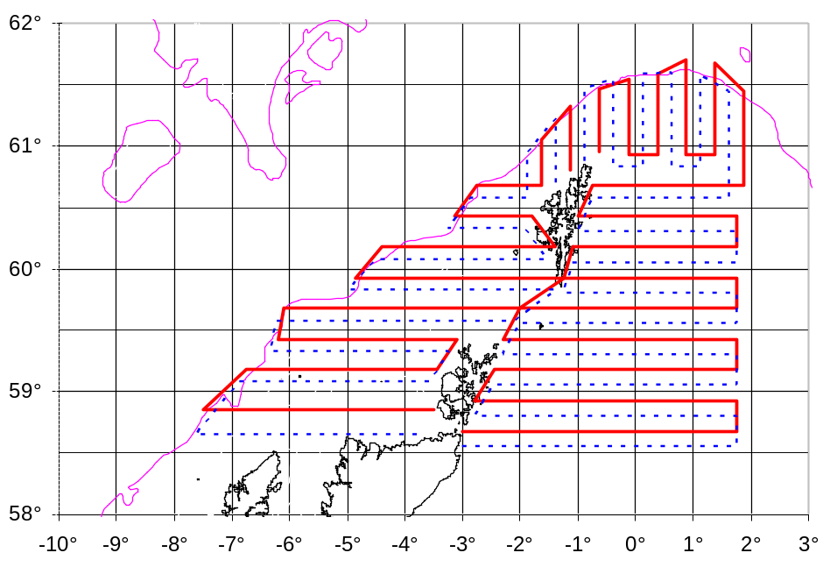
MAP 3 UK (Scotland) North Sea and North Atlantic herring acoustic survey transects

All acoustic data will be stored in data banks at MSS. Subsequent post survey analysis will be provided to the relevant ICES working groups.

3. For internationally coordinated surveys, describe the participating Member States/vessels and the relevant international group in charge of planning the survey
ICES Working Group on International Pelagic Surveys WGIPS

Data are used in stock assessments

Celtic Explorer (Ireland); Scotia (UK-Scotland); Johan Hjort (Norway); Tridens (Netherlands); Solea (Germany); Dana (Denmark)

4. Where applicable, describe the international task sharing (physical and/or financial) and the cost sharing agreement used
The coverage of the west of Scotland is shared by UK Scotland (MSS) and Ireland (Marine Institute)

5. Explain where thresholds apply

(max 450 words per survey)
North Sea (ICES areas IIIa, IV and VIId)

Nephrops UWTV survey, NTV7; UK Scotland, IVa FU7; Fladen Ground

Included in Table 10

1. Objectives of the survey
To obtain estimates of distribution and abundance of Nephrops in the Fladen Ground using underwater television. This survey will be conducted by Scotia undertaking one extensive survey that includes both FU7 (IVa) and FUs11-13 (VIa). To conform with the list of mandatory surveys under the Data Collection Framework in which separate surveys are listed for these functional units, the physical survey will be divided into two and reported separately by FU7 and FU11-13.

2. Description of the methods used in the survey. For mandatory surveys, link to the manuals. Include a graphical representation (map)
It is planned to complete 70 TV tracks and 2 fishing hauls. Additionally, information on size at maturity will be obtained.

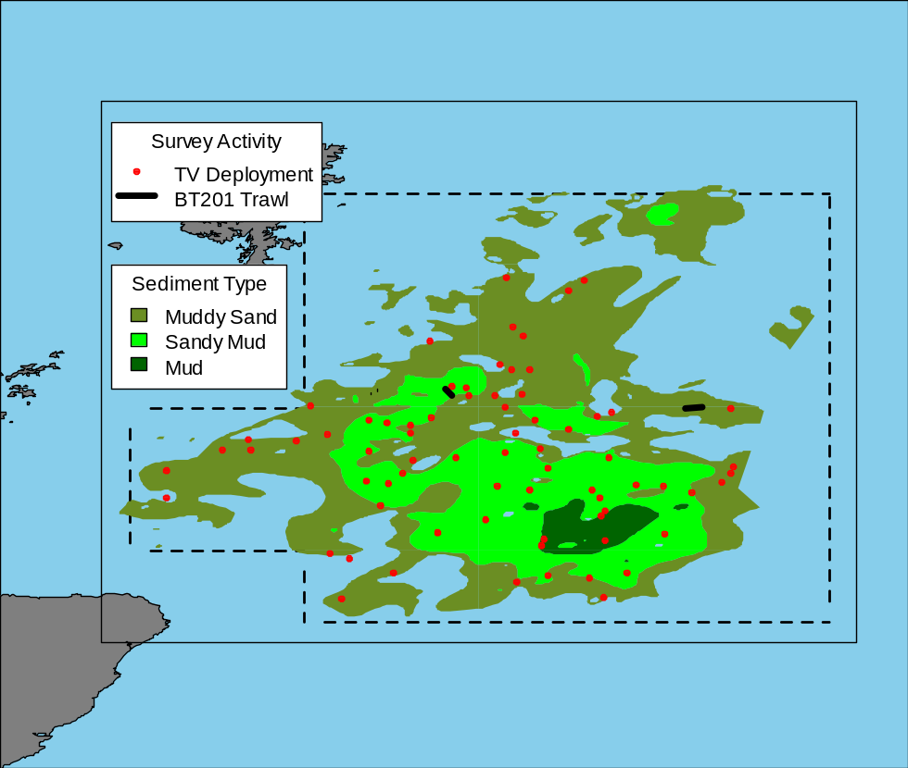
MAP 4
Video recordings are stored in DVD format and other data in an ACCESS database (WGNEPS is currently seeking to develop an international UWTV database and Scottish data will be transmitted to it when/if it is developed). Video recordings will be analysed and the results conveyed to the ICES Working Group on the Assessment of Demersal Stocks in the North Sea and Skagerrak (WGNSSK).

3. For internationally coordinated surveys, describe the participating Member States/vessels and the relevant international group in charge of planning the survey
ICES Working Group on Nephrops Surveys (WGNEPS)

Data are used in functional unit assessments

Although Nephrops UWTV surveys are coordinated via WGNEPS, the surveys are generally carried out by individual countries sampling Functional Units in their own ‘back yards’ rather than defining multi-vessel surveys across entire sea areas.

4. Where applicable, describe the international task sharing (physical and/or financial) and the cost sharing agreement used

5. Explain where thresholds apply

(max 450 words per survey)

North Sea (ICES areas IIIa, IV and VIId)

Nephrops UWTV survey, NTV8, NTV9; UK Scotland, IVa FU8&9; Moray Firth & Firth of Forth

Included in Table 10

1. Objectives of the survey
To obtain estimates of the distribution and abundance of Nephrops in the Firth of Forth, and the Moray Firth using underwater cameras.

2. Description of the methods used in the survey. For mandatory surveys, link to the manuals. Include a graphical representation (map)
It is planned to complete 50 TV tracks and 2 fishing hauls in each of FU8 and FU9 (total 100 tv and 4 hauls) on this combined survey. . Additionally, information on size at maturity will be obtained.

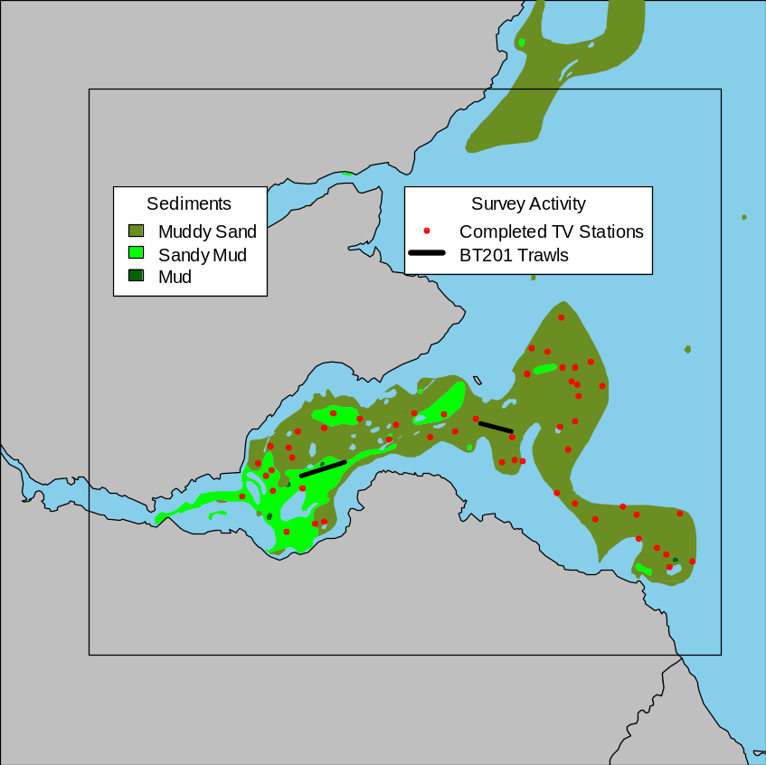
MAP 5

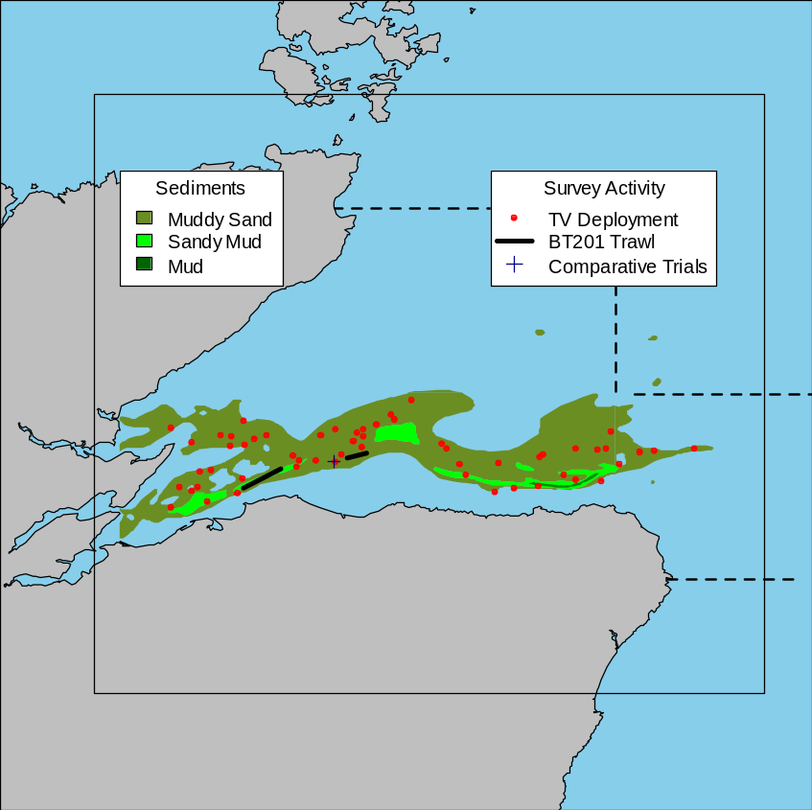
MAP 6

Video recordings are stored in DVD format and other data in an ACCESS database (WGNEPS is currently seeking to develop an international UWTV database and Scottish data will be transmitted to it when/if it is developed). Video recordings will be analysed and the results conveyed to the ICES Working Group on the Assessment of Demersal Stocks in the North Sea and Skagerrak (WGNSSK).

3. For internationally coordinated surveys, describe the participating Member States/vessels and the relevant international group in charge of planning the survey

ICES Working Group on Nephrops Surveys (WGNEPS)
Data are used in functional unit assessments
Although Nephrops UWTV surveys are coordinated via WGNEPS, the surveys are generally carried out by individual countries sampling Functional Units in their own ‘back yards’ rather than defining multi-vessel surveys across entire sea areas.

4. Where applicable, describe the international task sharing (physical and/or financial) and the cost sharing agreement used

5. Explain where thresholds apply

(max 450 words per survey)

North Sea (ICES areas IIIa, IV and VIId) and Eastern Arctic (ICES Areas I& II)

North Sea sandeel survey, NSSS; UK Scotland component Area IV (Firth of Forth & Turbot Bank)

In Table 10

- Objectives of the survey

To determine the abundance, length and age of sandeels (Ammodytes marinus) in the sediment in regions east of Scotland covering the Firth of Forth and Turbot bank areas. (ICES IVa).

The AWG splits the North Sea into 7 distinct management areas, 5 of which are commercially fished. Scotland samples SA 4.

2. Description of the methods used in the survey. For mandatory surveys, link to the manuals. Include a graphical representation (map)

MRV Alba na Mara will use a modified scallop dredge with 6” teeth, camera trolley with light source and DST logger (temperature and depth). The areas will be surveyed by camera and the dredge deployed 70-75 times to catch samples for biological parameters. Sediment is collected at each station.

TV data are stored in DVD format and other data are stored in data banks at Marine Scotland (MSS).
Subsequent post survey analysis and age data will be provided to ICES HAWG.
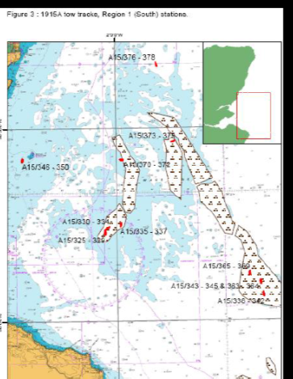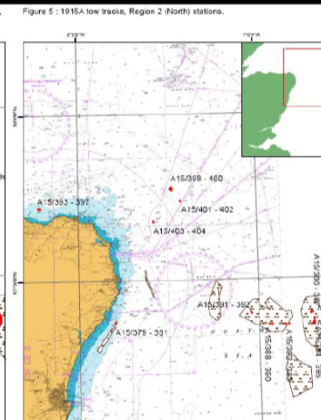
MAP 7 (2 maps)
3. For internationally coordinated surveys, describe the participating Member States/vessels and the relevant international group in charge of planning the survey

ICES Herring Assessment Working Group (HAWG).

UK (Scotland) data will be amalgamated with survey data provided by Denmark and Norway.

4. Where applicable, describe the international task sharing (physical and/or financial) and the cost sharing agreement used

5. Explain where thresholds apply

North Sea (ICES areas IIIa, IV and VIId) and Eastern Arctic (ICES Areas I& II)

International Bottom Trawl Survey IBTS 3 (ENG); UK England component IV

Included in Table 10

1. Objectives of the survey
The survey provides estimates of abundance of recruiting year classes and
CPUE-at-age series for cod, haddock, whiting, saithe and Norway pout to the North Sea and Skagerrak Demersal Working Group (WGNSSK). These are used for tuning
purposes.

2. Description of the methods used in the survey. For mandatory surveys, link to the manuals. Include a graphical representation (map)

A total of 76 prime stations over 30 days are planned in area IV between 51 to 62 deg. N, and between 4 deg. W to 8 deg. E. All fish caught will be identified to species and measured. Age samples and biological parameters will be taken from all target species and species listed in DCR Appendix VII. Benthic by-catch information is collected at each station. Hydrographic data will be collected at two stations per day. Any anthropogenic waste material will be recorded and weighed.

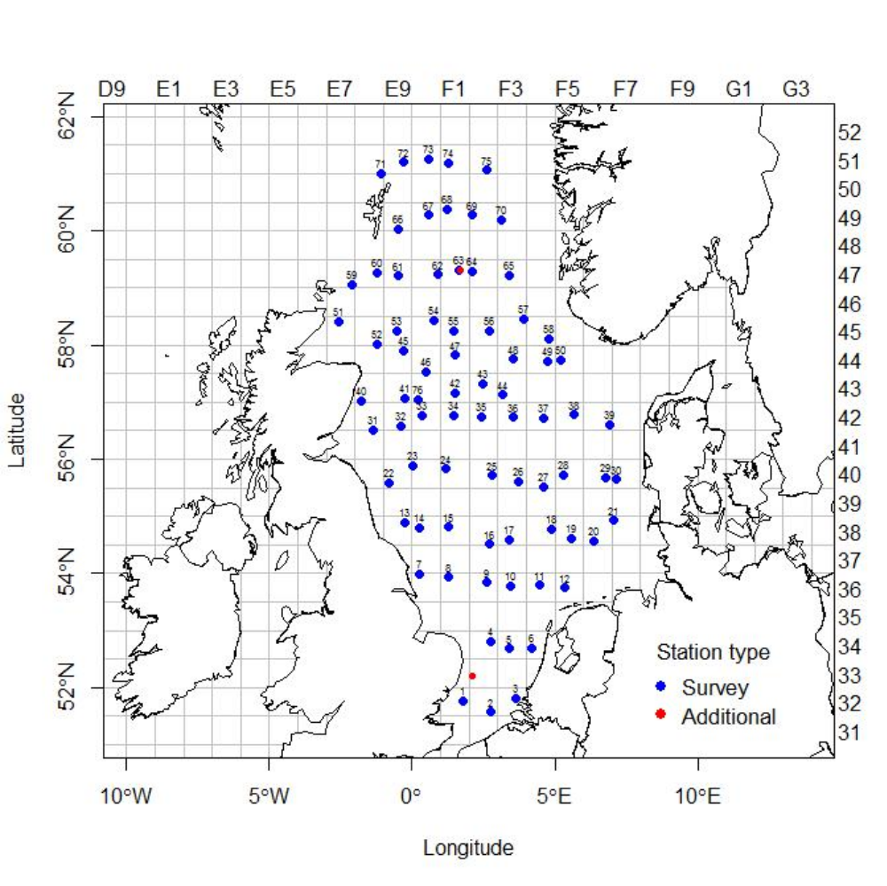
Map26 – International Bottom Trawl Survey England Q3

The resultant data will be input to a Cefas surveys database (FSS) using the Cefas Fisheries Electronic Data Capture (FEDC) System. All data will also be transmitted to ICES for input to the DATRAS database.

3. For internationally coordinated surveys, describe the participating Member States/vessels and the relevant international group in charge of planning the survey
ICES International Bottom Trawl Survey Working Group IBTSWG

Data used by WGNSSK for assessments.

Dana (Sweden & Denmark); Scotia (UK-Scotland); Thalassa (France); CEFAS Endeavour (Netherlands); Walther Herwig III (Germany)

4. Where applicable, describe the international task sharing (physical and/or financial) and the cost sharing agreement used

5. Explain where thresholds apply

North Sea (ICES areas IIIa, IV and VIId) and Eastern Arctic (ICES Areas I& II)

North Sea Beam Trawl Survey BTS Q3; North Sea; UK England component IV

Included in Table 10

1. Objectives of the survey
To provide estimates of abundance of recruiting year classes and CPUE-at-age series for plaice and sole to the North Sea and Skagerrak Demersal WG
(WGNSSK). These are used for tuning purposes.

2. Description of the methods used in the survey. For mandatory surveys, link to the manuals. Include a graphical representation (map)
A total of 85 prime stations over 14 days are planned, and all fish caught will be identified to species and measured. Age samples and biological parameters will be taken from all target species and species listed under Appendix VII of the DCR which are caught. Benthic by-catch information is collected at each station. Hydrographic data will be collected at a minimum of two stations per day. Any anthropogenic waste material will be recorded and weighed.

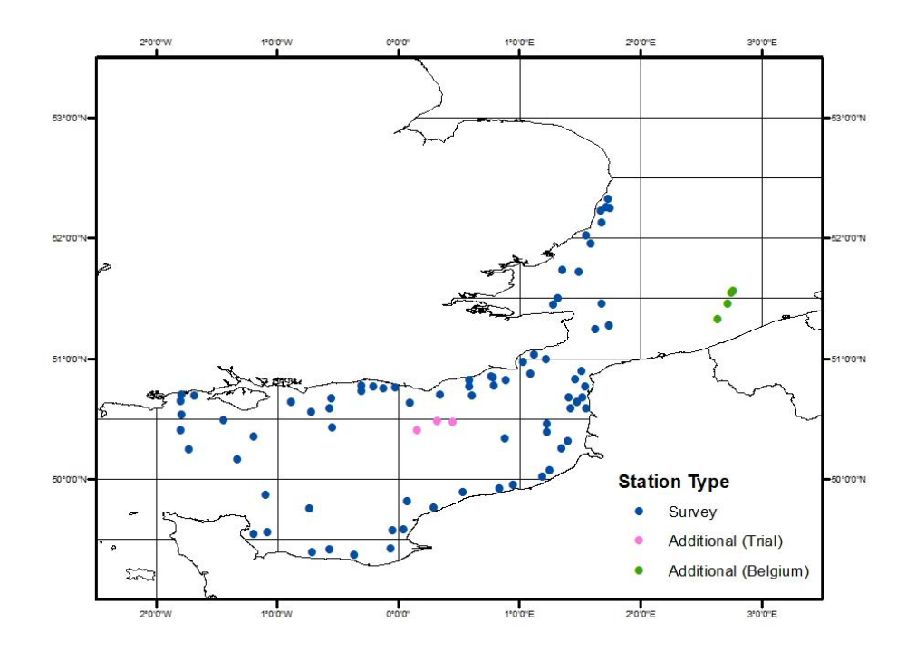

Map 27 North Sea Beam Trawl Survey BTS Q3; North Sea;

The resultant data will be input to a Cefas surveys database (FSS) using the Cefas Fisheries Electronic Data Capture (FEDC) System. All data will also be transmitted to ICES for input to the DATRAS database.

3. For internationally coordinated surveys, describe the participating Member States/vessels and the relevant international group in charge of planning the survey

Beam Trawl Working Group (WGBEAM).

Data used by WGNSSK for assessments.

4. Where applicable, describe the international task sharing (physical and/or financial) and the cost sharing agreement used

5. Explain where thresholds apply

(max 450 words per survey)
North Sea (ICES areas IIIa, IV and VIId) and Eastern Arctic (ICES Areas I& II)
Nephrops tv survey FU6 (Farne Deeps)

Nephrops UWTV survey, NTV6; UK England, FU6; Farne Deeps

Included in Table 10

1. Objectives of the survey
To obtain estimates of distribution and abundance of Nephrops in the Farne Ground using underwater television. This survey will be conducted by Rv Endeavour undertaking one extensive survey on the Farn Deep Grounds. To conform with the list of mandatory surveys under the Data Collection Framework in which separate surveys are listed for these functional units, the physical survey will be FU6.

2. Description of the methods used in the survey. For mandatory surveys, link to the manuals. Include a graphical representation (map)
It is planned to complete 110 TV Survey Stations. Additionally, information on swathe data and water samples was also collected.

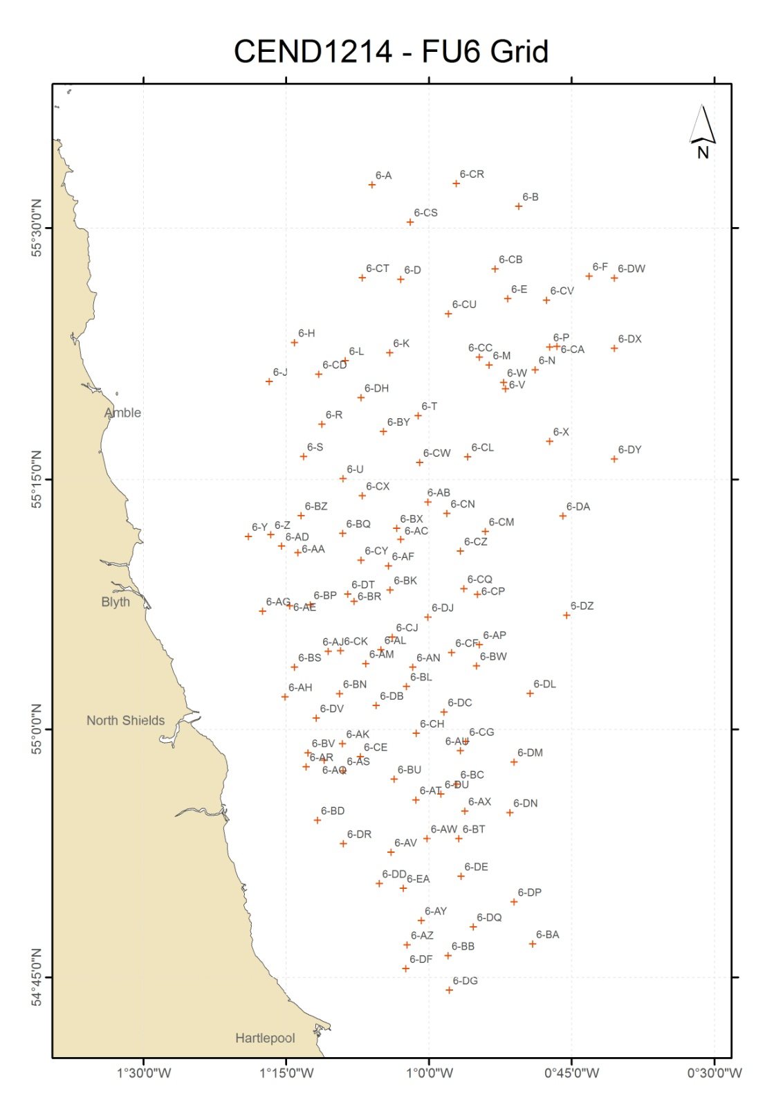
Map 29 showing the location of the surveyed area in the Function Unit 6 area (110 stations).

Video recordings are stored in DVD format and other data in an ACCESS database (WGNEPS is currently seeking to develop an international UWTV database and English data will be transmitted to it when/if it is developed). Video recordings will be analysed and the results conveyed to the ICES Working Group on the Assessment of Demersal Stocks in the North Sea and Skagerrak (WGNSSK).

3. For internationally coordinated surveys, describe the participating Member States/vessels and the relevant international group in charge of planning the survey
ICES Working Group on Nephrops Surveys (WGNEPS)

Data are used in functional unit assessments

Although Nephrops UWTV surveys are coordinated via WGNEPS, the surveys are generally carried out by individual countries sampling Functional Units in their own ‘back yards’ rather than defining multi-vessel surveys across entire sea areas.

4. Where applicable, describe the international task sharing (physical and/or financial) and the cost sharing agreement used

5. Explain where thresholds apply

(max 450 words per survey)
North Sea (ICES areas IIIa, IV and VIId) and Eastern Arctic (ICES Areas I& II)

International Ecosystem Survey in the Nordic Seas; ASH; Area IIa; May

The UK will contribute to this survey by providing funds and staff equivalent to 22% of the survey costs. This is a Danish Survey so they will supply the technical details.

Included in Table 10

1.Objectives of the survey

This is a Danish internationally coordinated Survey which is conducted by the Danish vessel Dana, so Denmark will supply the details. See WP for Denmark.

2. Description of the methods used in the survey. For mandatory surveys, link to the manuals. Include a graphical representation (map)

3. For internationally coordinated surveys, describe the participating Member States/vessels and the relevant international group in charge of planning the survey
Den, UK, Net, Ger, Ire

4. Where applicable, describe the international task sharing (physical and/or financial) and the cost sharing agreement used
A cost sharing agreement is in place amongst the participating MS equivalent to their % share of the quota.
The UK provides 22% of the funding plus staff on board the ship.

5. Explain where thresholds apply

(max 450 words per survey)
North Atlantic (ICES Areas V-XIV and NAFO areas)

Western IBTS Q1 survey; Western waters; UK Scotland component (VIa) (Scottish western IBTS)

Included in Table 10

1. Objectives of the survey
To survey ICES areas VIa and during quarter 1. The survey is almost identical to the corresponding survey in the North Sea and provides CPUE-at-age series for cod, haddock, whiting and saithe to WGCSE. These are used for tuning purposes. It also provides data for ages 1 & 2 mackerel to WGWIDE.

2. Description of the methods used in the survey. For mandatory surveys, link to the manuals. Include a graphical representation (map)
The survey will be undertaken by MRV Scotia. Approximately 56 to 60 semi-randomly selected stations will be surveyed for hydrographic information coupled with the deployment of a GOV trawl for 30 minutes. Numbers at length and age will be acquired for all target species with all other fish species being measured and counted. Additional biological data will be gathered for species listed in Table 1A of Commission Implementing Decision (EU) 2016/1251.

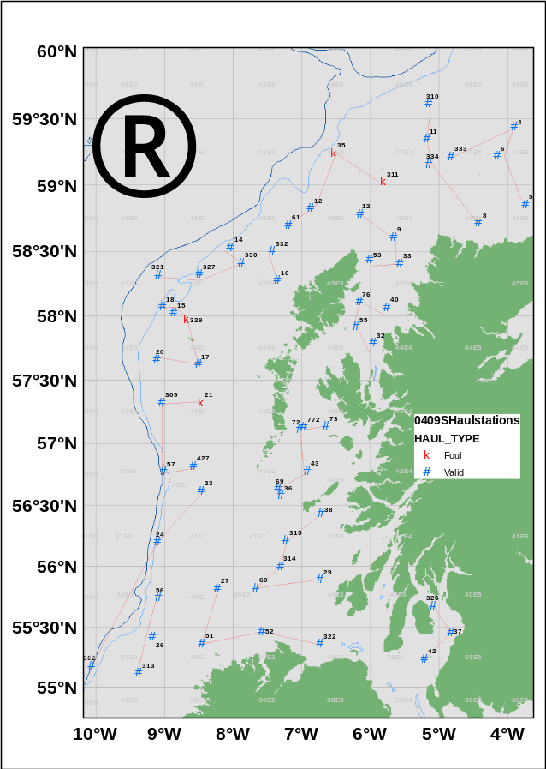
MAP 8

Data will be stored electronically in MS-S data banks with a copy sent to ICES for storage in the DATRAS database.

3. For internationally coordinated surveys, describe the participating Member States/vessels and the relevant international group in charge of planning the survey
ICES International Bottom Trawl Survey Working Group

Data used by WGCSE for assessments.

Scotia (UK-Scotland); Corystes (UK-Northern Ireland); Spain (Miguel Oliver)

4. Where applicable, describe the international task sharing (physical and/or financial) and the cost sharing agreement used

5. Explain where thresholds apply

(max 450 words per survey)

North Atlantic (ICES Areas V-XIV and NAFO areas)

Western IBTS Q4 survey; Western waters; UK Scotland component VIa, VIIb

Included in Table 10

1. Objectives of the survey
A young fish survey undertaken during Q4 as one component of the ICES western waters bottom trawl survey. The survey is targeted towards young (0 and 1-group) cod, haddock, whiting, saithe, Norway pout, herring and mackerel by utilising a GOV trawl fitted with an internal 20 mm liner.

2. Description of the methods used in the survey. For mandatory surveys, link to the manuals. Include a graphical representation (map)
The survey will be undertaken by MRV Scotia. Approximately 60 to 62 pseudo-random stations will be surveyed for hydrographic information coupled with the deployment of a GOV trawl for 30 minutes. Numbers at length and age will be acquired for all target species with all other fish species being measured and counted. Additional biological data will be gathered for species listed in Table 1A of Commission Implementing Decision (EU) 2016/1251.

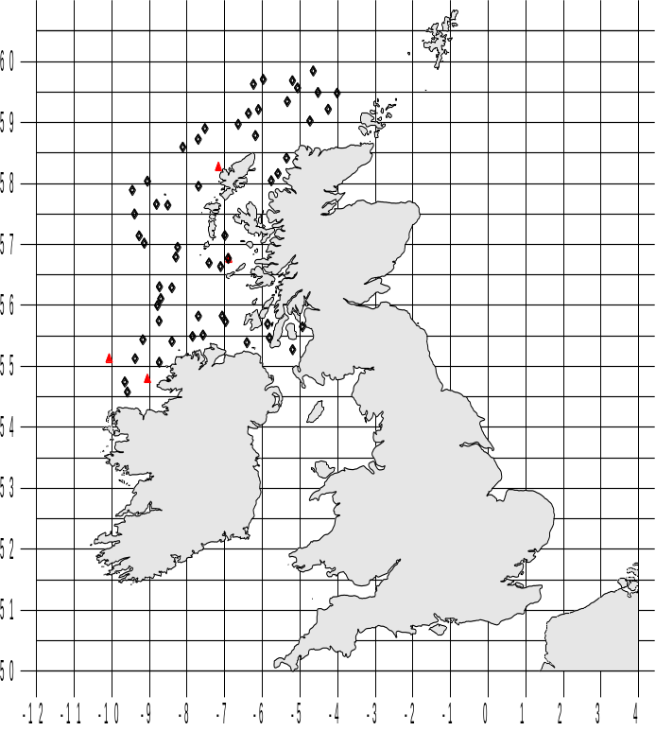

MAP 9

Data will be stored electronically in the Marine Scotland Science FSS system and uploaded to the ICES DATRAS database.

3. For internationally coordinated surveys, describe the participating Member States/vessels and the relevant international group in charge of planning the survey
ICES International Bottom Trawl Survey Working Group

Data used by WGCSE for assessments.

Scotia (UK-Scotland); Corystes (UK-Northern Ireland); Celtic Explorer (Ireland); Thalassa (France); Miguel Oliver (Spain); Noruega (Portugal)

4. Where applicable, describe the international task sharing (physical and/or financial) and the cost sharing agreement used

5. Explain where thresholds apply

(max 450 words per survey)

North Atlantic (ICES Areas V-XIV and NAFO areas)

Western IBTS Q3 Rockall survey, IBTS ROC Q3; Western waters; UK Scotland component Rockall (VIb)

Additional survey

1. Objectives of the survey
To carry out a bottom trawl survey of haddock on the Rockall Plateau to depths of 350m. Temperature and salinity profiles are collected at selected stations as well as biological samples (genetics and otoliths) of other key species for population studies (haddock, mackerel, whiting, cod, saithe, skates/rays)

2. Description of the methods used in the survey. For mandatory surveys, link to the manuals. Include a graphical representation (map)
The survey design is random-stratified with the survey divided into 4 depth strata bounded overall by the 350m depth contour. The survey excludes two areas that lie largely within this zone. Both of these are North East Atlantic Fisheries Commission (NEAFC) closures designed to protect vulnerable marine ecosystems (VMEs). Forty-five 30 minute trawl hauls are planned.

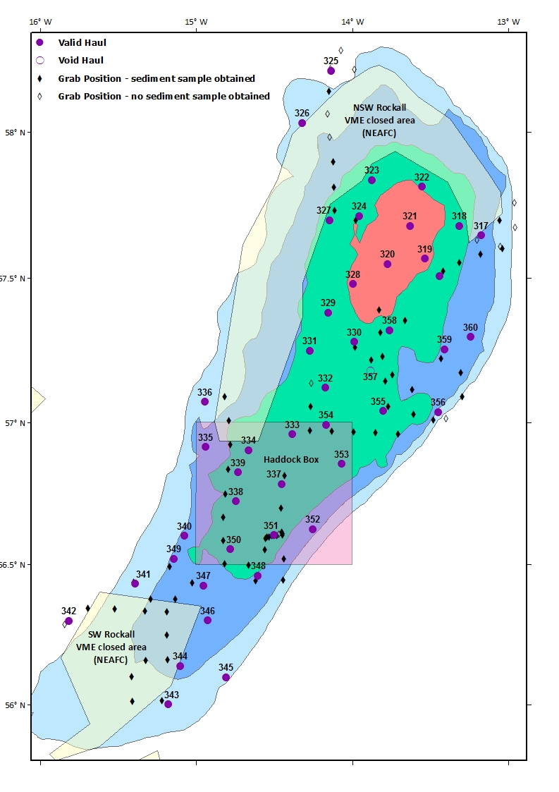
MAP 10

Data will be stored electronically in MS-S data banks with a copy sent to ICES for storage in the DATRAS database.

3. For internationally coordinated surveys, describe the participating Member States/vessels and the relevant international group in charge of planning the survey
ICES International Bottom Trawl Survey Working Group

Data sent to WGCSE and for assessments.

Scotia (UK-Scotland); Vizcondede Eza (Spain)

4. Where applicable, describe the international task sharing (physical and/or financial) and the cost sharing agreement used

5. Explain where thresholds apply

(max 450 words per survey)

North Sea (ICES areas IIIa, IV and VIId) and Eastern Arctic (ICES Areas I& II) and
North Atlantic (ICES Areas V-XIV and NAFO areas)

International Blue whiting spawning stock survey; Areas I, II, III, IV, V)

Included in Table 10

1. Objectives of the survey
An acoustic survey of blue whiting spawning biomass in the northeast Atlantic

2. Description of the methods used in the survey. For mandatory surveys, link to the manuals. Include a graphical representation (map)
See Dutch and Irish workplans.
No map, see WP for NET and IRE

3. For internationally coordinated surveys, describe the participating Member States/vessels and the relevant international group in charge of planning the survey
ICES Working Group on International Pelagic Surveys

Fritjof Nansen (Russia); Celtic Explorer (Ireland); Magnus Heinason (Faroe Islands); Tridens (Netherlands); G.O. Sars (Norway)

4. Where applicable, describe the international task sharing (physical and/or financial) and the cost sharing agreement used
The UK (Scotland) makes a financial contribution to the international blue whiting spawning stock survey, co-funding the Dutch and Irish parts of the survey (ie, the EU participants) and also provides one member of staff to participate in the survey. The cost sharing agreement is found in the 2014 report of the RCM meeting held in Lysekil, Sweden.

5. Explain where thresholds apply
RCM NS&EA 2014 agreed that the cost sharing model where those MS having a EU-TAC share >= 5% is sharing the survey cost according to their EU-TAC shares for the main species concerned: i) the International Ecosystem Survey in the Nordic (Atlanto-Scandian herring), ii) the Blue Whiting Survey (blue whiting). This model will be used for the International Ecosystem Survey in the Nordic Seas (IESNS) carried out by the Danish R/V Dana and the Blue Whiting Survey carried out by the Irish R/V Celtic Explorer and the Dutch R/V Tridens for years 2014 and 2015 or until a new data regulation is in place.

(max 450 words per survey)

North Atlantic (ICES Areas V-XIV and NAFO areas)

NS Herring Acoustic Survey (IV) conducted by UK Sco now extends into ICES area VIa, See map and description above.

Eastern Arctic (ICES Areas I& II) and North Atlantic (ICES Areas V-XIV and NAFO areas)

Nephrops UWTV survey, , UWTV (FU11-13); UK Scotland, VIa FU11-13; North Minch, South Minch, Clyde Sea, Stanton Bank

Included in Table 10

1. Objectives of the survey
To obtain estimates of distribution and abundance of Nephrops in in functional units to the west of Scotland using underwater television. This survey will be conducted by Scotia undertaking one extensive survey that includes both FUs11-13 (VIa) and FU7 (IVa). To conform with the list of mandatory surveys under the Data Collection Framework in which separate surveys are listed for these functional units, the physical survey will be divided into two and reported separately by FU11-13 and FU7.

2. Description of the methods used in the survey. For mandatory surveys, link to the manuals. Include a graphical representation (map)
It is planned to complete 112 TV tracks and 5 fishing hauls. Additionally, information on size at maturity will be obtained.

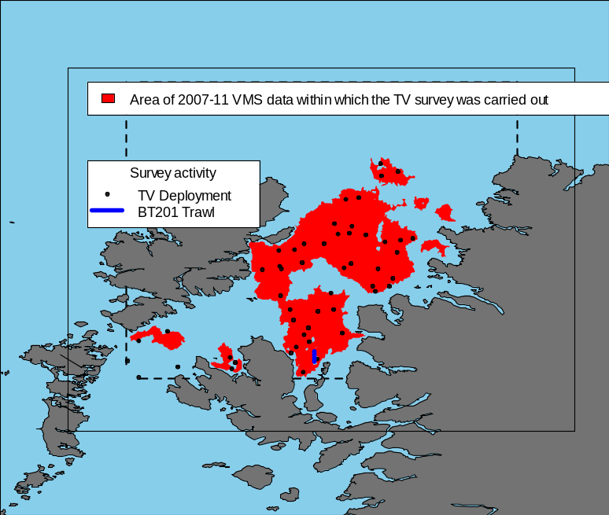
MAP 12
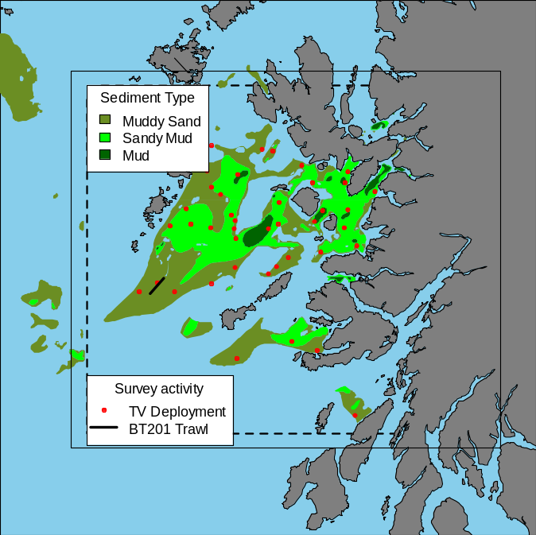
MAP 13
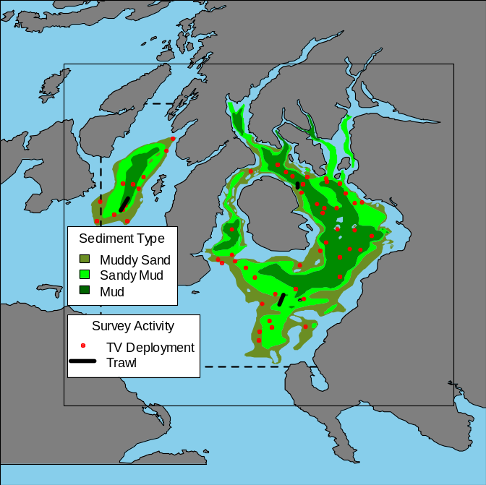
MAP 14

Video recordings are stored in DVD format and other data in an ACCESS database (WGNEPS is currently seeking to develop an international UWTV database and Scottish data will be transmitted to it when/if it is developed). Video recordings will be analysed and the results conveyed to the ICES Working Group on Celtic Seas Ecoregion (WGCSE).

3. For internationally coordinated surveys, describe the participating Member States/vessels and the relevant international group in charge of planning the survey
ICES Working Group on Nephrops Surveys (WGNEPS)

Data are used in functional unit assessments

Although Nephrops UWTV surveys are coordinated via WGNEPS, the surveys are generally carried out by individual countries sampling Functional Units in their own ‘back yards’ rather than defining multi-vessel surveys across entire sea areas.

4. Where applicable, describe the international task sharing (physical and/or financial) and the cost sharing agreement used

5. Explain where thresholds apply

(max 450 words per survey)

North Sea (ICES areas IIIa, IV and VIId) and Eastern Arctic (ICES Areas I& II) and North Atlantic (ICES Areas V-XIV and NAFO areas)

SIAMISS IVa and VIa /b surveys I, II and III : Anglerfish surveys; Scottish component IVa, VIa, VIb

Additional survey

1. Objectives of the survey
UK Scotland (MSS) will undertake three nationally co-ordinated concurrently-run anglerfish demersal trawling surveys.
- on the Rockall Plateau VIb (34 hauls) and to the west of the Hebrides VIa (15 hauls)
- to the west of Shetland and area VIa (29 hauls)
- in the northern North Sea IVa (29 hauls)

2. Description of the methods used in the survey. For mandatory surveys, link to the manuals. Include a graphical representation (map)
A minimum of 107 one hour trawl hauls is planned throughout the 3 surveys in all areas using a modified GOV net and ground gear. The net will be deployed down to a maximum 1000m in the Atlantic and 500m in the North Sea. From each haul full biological sampling will be recorded for all Lophius spp, Lepidorhombus spp, cod, blue ling and skate caught. All other species will be sub sampled.

Sampling protocols were agreed between MSS scientists and representatives from the fishing industry who specifically target Lophius but also follow the IBTS guidelines.
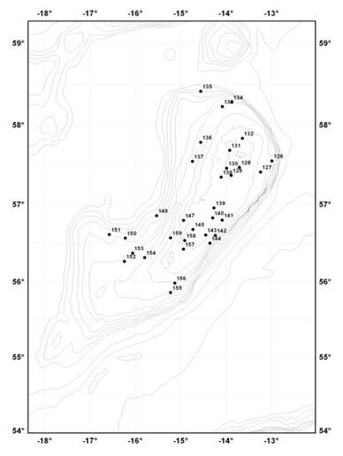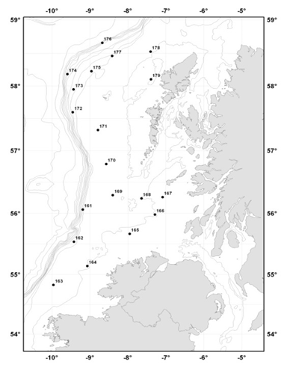
Rockall West of the Hebrides
MAP 15 (4 maps)

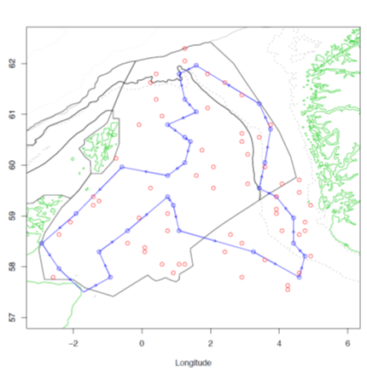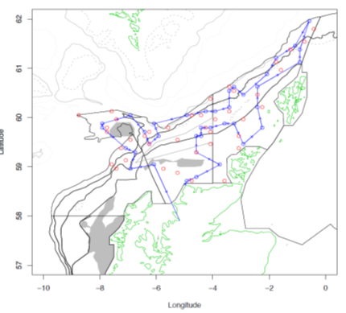
Northern North Sea West of Shetland
MAP 15 (4 maps)
3. For internationally coordinated surveys, describe the participating Member States/vessels and the relevant international group in charge of planning the survey.
Data are held in the Marine Scotland Science FSS database and sent to the ICES WGCSE where they are used extensively to assess anglerfish and megrim stocks.

4. Where applicable, describe the international task sharing (physical and/or financial) and the cost sharing agreement used

5. Explain where thresholds apply

(max 450 words per survey)

Eastern Arctic (ICES Areas I& II) and North Atlantic (ICES Areas V-XIV and NAFO areas)

West of Scotland Deepwater Survey; UK Scotland VIa; Deepwater slope west of the Hebrides and Rosemary Bank.

Additional survey

1. Objectives of the survey

To map the composition, distribution and abundance of continental slope species including invertebrates on the deepwater slope west of the Hebrides and Rosemary Bank to depths of 2000m. In addition samples (genetics and otoliths) will be collected for key species for population studies.

This is a biennial survey, with surveys taking place in odd-numbered years (ie, 2019, 2021)

2. Description of the methods used in the survey. For mandatory surveys, link to the manuals. Include a graphical representation (map)
Approximately 35 deepwater trawl hauls will be carried out at depths between 500m and. Catch rate and length-frequency distribution for all fish species are collected and adjusted to a standardised trawl-haul duration. Temperature at depth is collected to characterise the species' environment. Benthic invertebrates are sorted quantified and recorded from trawl hauls. Additional biological data will be gathered for deepwater species listed in Table 1A of Commission Implementing Decision (EU) 2016/1251.

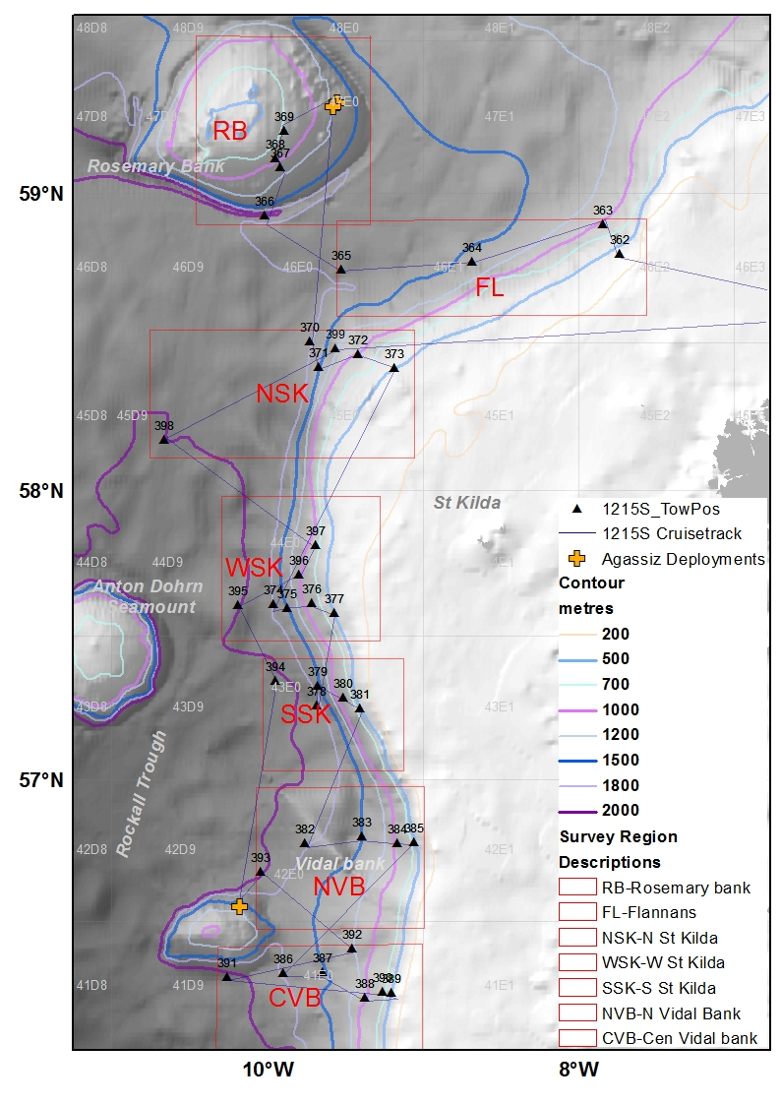
MAP 16

Data are held in the Marine Scotland FSS database system and reported to the ICES Deepwater Working Group (WGDEEP) where they are used as biomass indices for exploratory analyses.

3. For internationally coordinated surveys, describe the participating Member States/vessels and the relevant international group in charge of planning the survey

4. Where applicable, describe the international task sharing (physical and/or financial) and the cost sharing agreement used

5. Explain where thresholds apply

(max 450 words per survey)

Eastern Arctic (ICES Areas I& II) and North Atlantic (ICES Areas V-XIV and NAFO areas)

Triennial Mackerel/Horse Mackerel Egg Survey, MEGS; Areas VI to IX;

Included in Table 10

In 2019 UK Scotland undertook a 4th MEGS survey due to other countries not undertaking their allotted areas for this internationally coordinated set of surveys.. It is likely that in 2022 Scotland will do likewise.
Althiough these surveys will not take place in 2020 or 2021 the maps are shown below for completeness.

1. Objectives of the survey

To carry out mackerel and horse mackerel egg surveys (ICES Triennial Survey) within allocated sampling periods of the 2016 MEGS survey plan along the NE Atlantic shelf

To collect adult fish samples, by trawling, for atresia and fecundity analysis back at the laboratory.

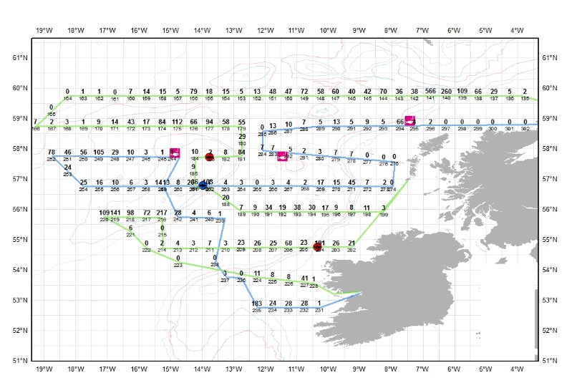
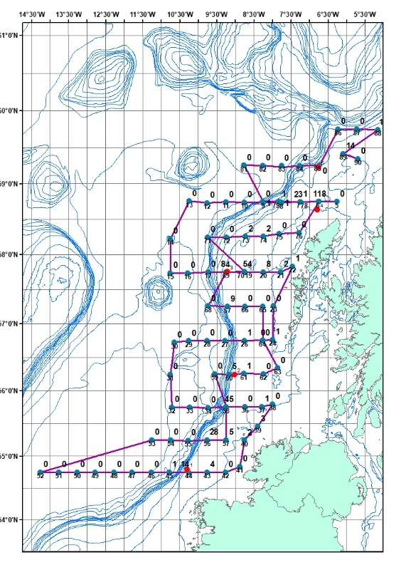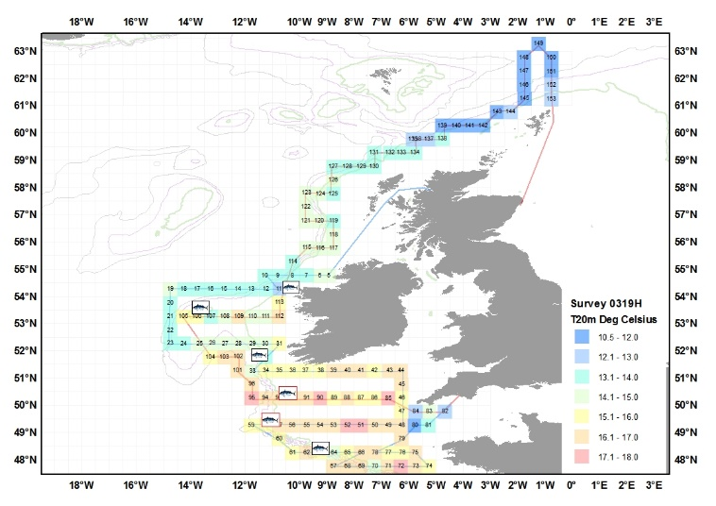

4. Where applicable, describe the international task sharing (physical and/or financial) and the cost sharing agreement used

5. Explain where thresholds apply

North Sea Q3 IBTS
Completed survey areas
(max 450 words per survey)
Maps Mackerel egg acoustic surveys

North Atlantic (ICES Areas V-XIV and NAFO areas)

Irish Sea and north of Ireland herring acoustic survey
Included in table 10
Spawning/Pre-spawning Herring VIa & VIIa
1. Objectives of the survey
The primary objective is to estimate the distribution, abundance and population structure of herring and sprat in the Irish Sea by echo-integration and targeted midwater trawling in the Irish Sea (VIIa) and west of Scotland (VIa). A secondary objective is to conduct visual Marine Mammal Observation (MMO) and when possible Passive Acoustic Monitoring (PAM) of cetacean species to obtain the data required to determine species occurrence, density estimates and identify important habitats
2. Description of the methods used in the survey. For mandatory surveys, link to the manuals. Include a graphical representation (map)
The survey will be carried out in two phases whereby phase one will occur in the North Channel, western Irish Sea, North Wales coast and eastern Irish Sea (VIIa) and phase 2 will occur Survey of Scottish (VIa) and Manx coastal waters. Sampling will be carried out on a systematic grid of stations covering the spawning grounds and surrounding regions in the NE and NW Irish Sea. A total of approximately 1200 nautical miles are planned to surveyed by eco-integration using a Simrad EK-60 echosounder (see below). Additional pelagic trawls (approx. 24) are to be carried out to obtain corresponding samples to validate estimates from acoustic data. Species compositions and length frequencies will be recorded from all trawl catches. Samples of up to 50 herring will be taken from each catch for recording of age and other biological parameters. Length-weight parameters will be estimated for fish species contributing significantly to the acoustic integrals. An additional intensified grid may be surveyed around the Isle of Man to investigate the effect of the timing of the spawning migration if timing allows.

Survey manual: http://www.ices.dk/sites/pub/Publication%20Reports/ICES%20Survey%20Protocols%20(SISP)/SISP%209%20Manual%20for%20International%20Pelagic%20Surveys%20(IPS).pdf
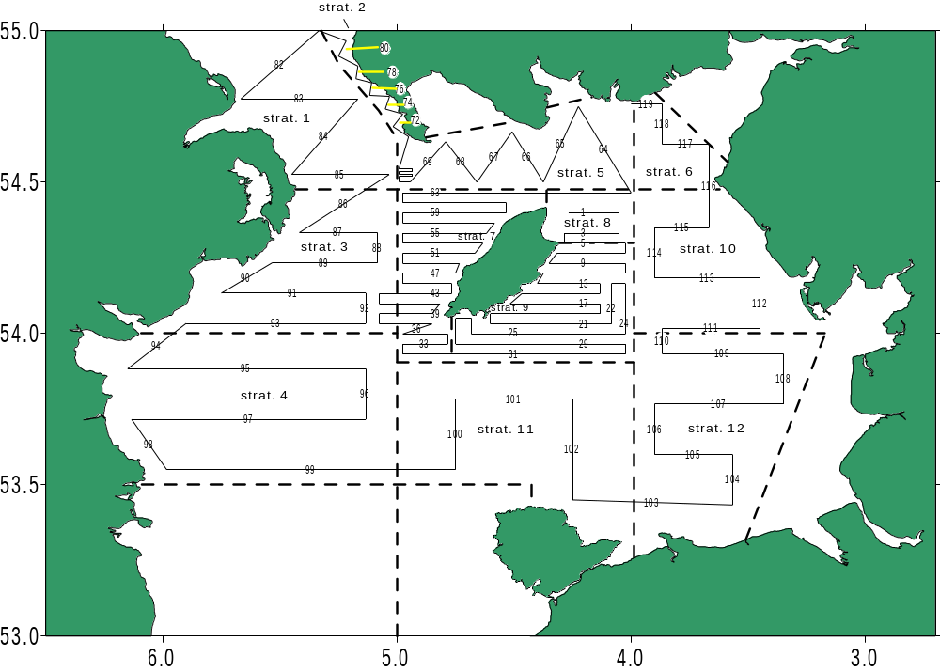
Figure 1: Transects and stratum boundaries for the Northern Irish Spawning/pre-spawning Herring Acoustic Survey MAP 17
3. For internationally coordinated surveys, describe the participating Member States/vessels and the relevant international group in charge of planning the survey
The survey is coordinated by ICES WGIPS. At present the survey is conducted onboard the RV Corystes.
4. Where applicable, describe the international task sharing (physical and/or financial) and the cost sharing agreement used
None.
5. Explain where thresholds apply
None.

North Atlantic (ICES Areas V-XIV and NAFO areas)
Quarter 1 Irish Sea Groundfish Survey (NIGFS Q1)
Additional survey
1. Objectives of the survey
The Northern Irish Groundfish Survey (NIGFS Q1) Irish Sea survey aims to collect data on the distribution and relative abundance, and biological information of commercial fish in VIIa. The primary species of interest are cod, haddock and whiting, herring and plaice.
2. Description of the methods used in the survey. For mandatory surveys, link to the manuals. Include a graphical representation (map)
The survey will be carried out in the Irish Sea (see below) and aims to depart at the start of March with a duration of 23 days (weather dependent). A target of 62 stations of fixed positions are towed using a rock-hopper otter trawl with a 17m footrope fitted with 250 mm non-rotating rubber discs. The survey is divided in strata defined by length and substratum. Scanmar sensors were fitted to gear and trawl parameters recorded. In addition temperature and salinity are recorded at each station. The species composition of each catch is to be recorded by total weight of species caught and length frequencies recorded for all species. Dependent of the number of individual fish caught all samples of cod, haddock, herring and whiting have length, weight, sex and maturity recorded and otoliths are to be obtained for aging. If the number of individual fish is large, an appropriate sub-sample should be taken. The biological samples of code and herring may be further analysed for parasite burden.

Survey manual: http://www.ices.dk/sites/pub/Publication%20Reports/ICES%20Survey%20Protocols%20(SISP)/SISP1-IBTSVIII.pdf
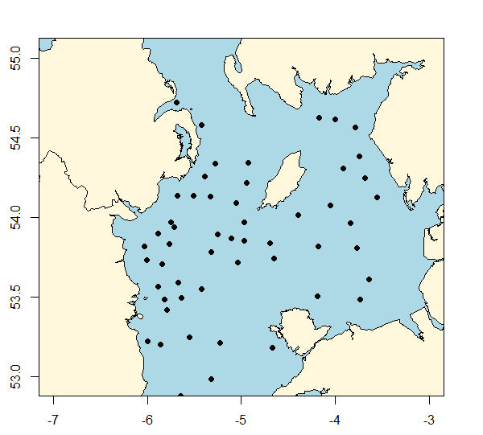
MAP 18

Figure 1: Location of trawl stations Northern Irish Groundfish Survey (NIGFS Q1)
3. For internationally coordinated surveys, describe the participating Member States/vessels and the relevant international group in charge of planning the survey
The survey is coordinated by ICES IBTSWG. At present the survey is conducted onboard the RV Corystes.
Scotia (UK-Scotland); Corystes (UK-Northern Ireland); Celtic Explorer (Ireland); Thalassa (France); Miguel Oliver (Spain); Noruega (Portugal)

4. Where applicable, describe the international task sharing (physical and/or financial) and the cost sharing agreement used
None.
5. Explain where thresholds apply
None.

Text Box 1G: List of research surveys at sea

North Atlantic (ICES Areas V-XIV and NAFO areas)
Quarter 4 Irish Sea Groundfish Survey (NIGFS Q4)
Additional survey
1. Objectives of the survey
The Northern Irish Groundfish Survey (NIGFS Q4) Irish Sea survey aims to collect data on the distribution and relative abundance, and biological information of commercial fish in VIIa. The primary species of interest are cod, haddock and whiting, herring and plaice.
2. Description of the methods used in the survey. For mandatory surveys, link to the manuals. Include a graphical representation (map)
The survey will be carried out in the Irish Sea (VIIa ;see below) and aims to depart at the start of March with a duration of 19 days (weather dependent). A target of 62 stations of fixed positions are to be towed using a rock-hopper otter trawl with a 17m footrope fitted with 250 mm non-rotating rubber discs. The survey will be divided in strata defined by length and substratum. Scanmar sensors will be fitted to gear and trawl parameters recorded. In addition temperature and salinity are to be recorded at each station. The species composition of each catch will be recorded by total weight of species caught and length frequencies recorded for all species. Dependent of the number of individual fish caught all samples of cod, haddock, herring and whiting will have length, weight, sex and maturity recorded and otoliths obtained for aging. If the number of individual fish is large, an appropriate sub-sample should be taken. The biological samples of cod and herring may be further analysed for parasite burden.

Survey manual: http://www.ices.dk/sites/pub/Publication%20Reports/ICES%20Survey%20Protocols%20(SISP)/SISP1-IBTSVIII.pdf
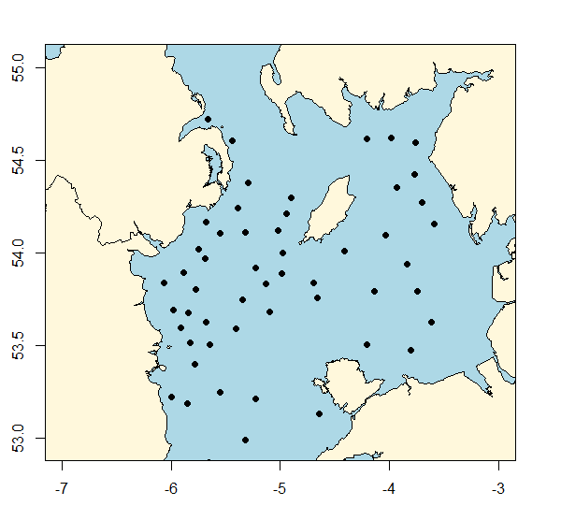
Figure 1: Location of trawl stations Northern Irish Groundfish Survey (NIGFS Q4)
MAP 19
3. For internationally coordinated surveys, describe the participating Member States/vessels and the relevant international group in charge of planning the survey
The survey is coordinated by ICES IBTSWG. At present the survey is conducted onboard the RV Corystes. Scotia (UK-Scotland); Corystes (UK-Northern Ireland); Celtic Explorer (Ireland); Thalassa (France); Miguel Oliver (Spain); Noruega (Portugal)

4. Where applicable, describe the international task sharing (physical and/or financial) and the cost sharing agreement used
None.
5. Explain where thresholds apply
None.

North Atlantic (ICES Areas V-XIV and NAFO areas)
Nephrops UWTV Irish Sea FU14, UWTV (FU14)

Additional survey
1. Objectives of the survey
To investigate the distribution, biology and population structure of Nephrops (Nephrops norvegicus) in the eastern Irish Sea, using underwater television.
2. Description of the methods used in the survey. For mandatory surveys, link to the manuals. Include a graphical representation (map)
The Nephrops UWTV (FU 14) will take place in the Eastern Irish Sea (see below) during the last week in July. The total duration of the cruise is planned to be 3 days. In FU 14 the aim is to complete 38 camera tracks. The camera tracks will be of 15 minutes duration whereby within each minute the number of Nephrops burrows will be counted by a minimum of two experienced surveyors.
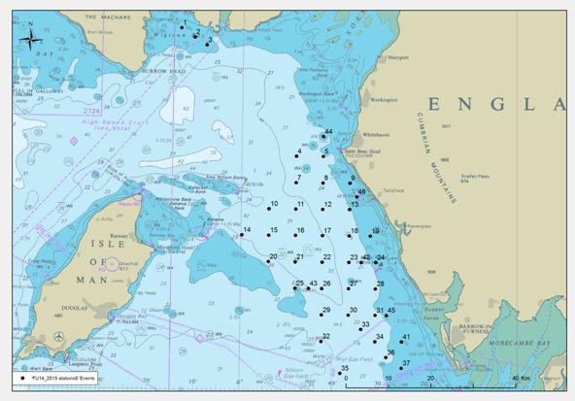
Figure 1: UWTV tow stations in FU 14 for the Nephrops UWTV Irish Sea Survey
MAP 20
3. For internationally coordinated surveys, describe the participating Member States/vessels and the relevant international group in charge of planning the survey
The survey is coordinated by ICES WGNEPS. At present the survey is conducted onboard the RV Corystes.
4. Where applicable, describe the international task sharing (physical and/or financial) and the cost sharing agreement used
Staff exchange occurs from the Irish Marine Institute and the Agri-food and Bioscience Institute. Staff from the Marine Institute provides technical and physical support during the UWTV stage of the survey.
5. Explain where thresholds apply
None.

Text Box 1G: List of research surveys at sea

North Atlantic (ICES Areas V-XIV and NAFO areas)
Nephrops UWTV survey Irish Sea, UWTV (FU15)
Listed in Table 10
1. Objectives of the survey
To investigate the distribution, biology and population structure of Nephrops (Nephrops norvegicus) in the eastern Irish Sea, using underwater television.
2. Description of the methods used in the survey. For mandatory surveys, link to the manuals. Include a graphical representation (map)
The Nephrops UWTV (FU 15) will occur in the Eastern Irish Sea (see below) during the last week in July. The UWTV phase of the survey is planned to last 7 days. In FU15 the aim is to complete 100 camera tracks. The camera tracks are planned for 15 minutes whereby within each minute the number of nephrops burrows are counted by a minimum of two experienced surveyors. A trawling phase of the survey is planned to last 5 days with 24 trawl stations to be sampled using a commercial Nephrops otter-trawl with 70mm mesh net and 45mm cod end for a 30-60 minute tows at fixed-position stations to investigate the distribution, biology and population structure of Nephrops in the eastern Irish Sea. The trawl catch will be sorted and quantified at the species level, and length compositions to be recorded for all species. Data on Nephrops is to be collected by sex and maturity stage. Additional data on epibenthos will be recorded using a small beam trawl.
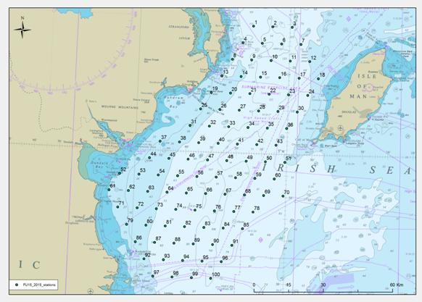
Figure 1: UWTV tow stations in FU 15 for the Nephrops UWTV Irish Sea Survey MAP 21 (2 maps)

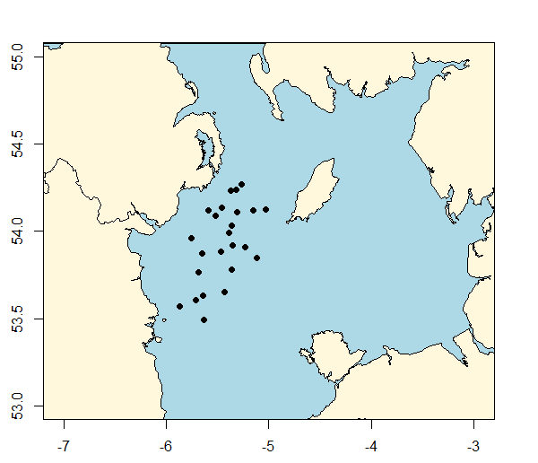
MAP 21 (2 maps)
Figure 2: :Location of the trawl stations in FU 15 for the Nephrops UWTV Irish Sea Survey.
3. The survey is coordinated by ICES WGNEPS. At present the survey is conducted onboard the RV Corystes.

4. Where applicable, describe the international task sharing (physical and/or financial) and the cost sharing agreement used
Staff exchange occurs from the Irish Marine Institute and the Agri-food and Bioscience Institute. Staff from the Marine Institute provides technical and physical support during the UWTV stage of the survey.
5. Explain where thresholds apply
None.

North Atlantic (ICES Areas V-XIV and NAFO areas)
Northern Irish MIK net survey NI-MIK
Additional survey
1. Objectives of the survey
The objectives of the NI-MIK survey are;
- To investigate the distribution and abundance of juvenile gadoids in management area VIIa(N).
- To collect zooplankton, fish larvae and environmental data using the GulfVII.
- To monitor jellyfish abundance in the Irish Sea survey area.
2. Description of the methods used in the survey. For mandatory surveys, link to the manuals. Include a graphical representation (map)
The survey will take place in the Irish Sea (VIIa) between May-June lasting approximately 19 days, split across two phases. A grid of approximately 122 stations will be sampled with the high speed plankton sampler (GulfVII) and 90 stations using the MIK net. MIK net sampling during the hours of darkness (sunset to sunrise). The nets are to be deployed to ~5m off the sea bed. The deployment of the MIK net will be controlled using the Scanmar catch control system and towed at approximately 3knots. The GulfVII being towed at between 3-4knts. A member of the scientific staff will monitor the deployment of the MIK net and will require communication with the winch man from the bridge (VHF).

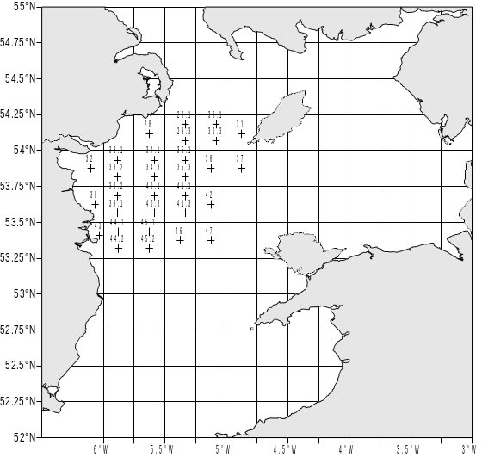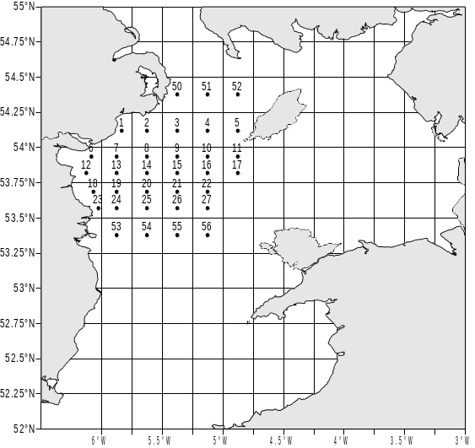
Figure 1. MIK net sampling stations NI-MIK phase i. Figure 2. GULFVII sampling stations NI-MIK phase i

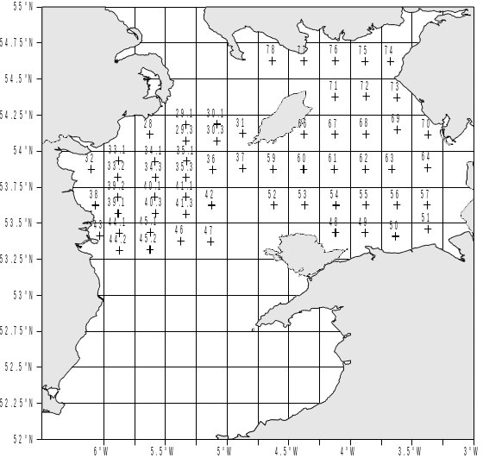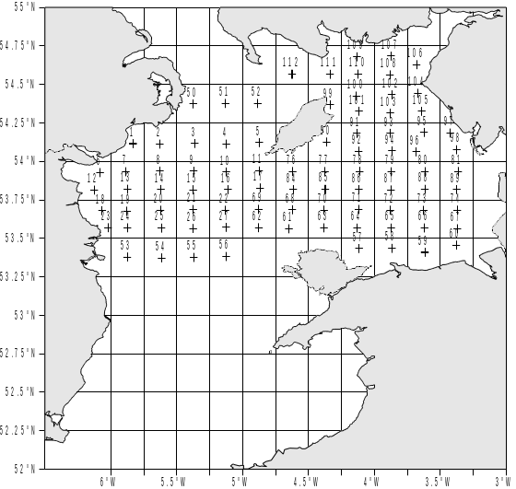
Figure 3. MIK sampling stations for NI-MIK phase ii. Figure 4. GulfVII sampling stations for NI-MIK phase ii
MAP 22 (4 maps)
3. For internationally coordinated surveys, describe the participating Member States/vessels and the relevant international group in charge of planning the survey
N/A
4. Where applicable, describe the international task sharing (physical and/or financial) and the cost sharing agreement used
None.
5. Explain where thresholds apply
None.

North Atlantic (ICES Areas V-XIV and NAFO areas)
Irish Sea queen scallop survey
Additional survey
1. Objectives of the survey
The objectives of the VIIa queen scallop survey are:
- To obtain information on spatial patterns of abundance of different size-classes of queen scallops in the Irish Sea and off the north coast;
- To collect biological information from queen scallops and scallops by area, including tissue samples;
- To collect information on by-catch species;
- To collect additional biological information on fish species.

2. Description of the methods used in the survey. For mandatory surveys, link to the manuals. Include a graphical representation (map)
The survey will occur at the end of June lasting approximately 4 days. A total of 30 stations will be selected at random from a fixed grid 0.03* 0.03 decimal degrees. The number of stations within strata selected will be from a function of historic queenie fishery within that strata and strata area. In addition it is planned that 7 tows will take place using four dredges towed abreast, the outer dredges were as used by the commercial vessels for targeting queen scallops (width = 725 mm). The inner dredges were as used to target king scallop (width = 745 mm). These dredges will be selected based expert judgement from the camera tows.
At all stations the camera and sledge will be deployed. Film data from 15-minute tows at each station will be stored on DVDs. A USBL system is also to be used to enable the course taken by the sledge during tows to be tracked. This information is an essential input to calculation of the area of seabed swept during each tow.
All catch will be processed separately from the each of the dredge types. Length frequencies of all queen scallops will be taken and two from each length class (0.5cm) retained for biological sampling - length, breadth, and abductor muscle and gonad weights. Length frequencies of all finfish bycatch and counts of benthos are also to be recorded.
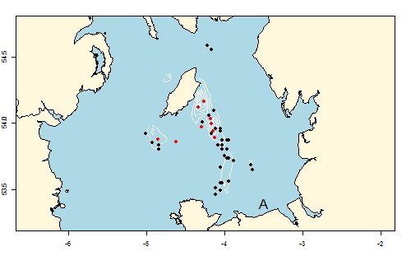
MAP 23 . Stations surveyed within the Irish Sea area of the VIIa queen scallop. Stations surveyed by UWTV, red - exploratory stations; black – core fishery area stations.

3. For internationally coordinated surveys, describe the participating Member States/vessels and the relevant international group in charge of planning the survey
N/A
4. Where applicable, describe the international task sharing (physical and/or financial) and the cost sharing agreement used
None.
5. Explain where thresholds apply
None.

North Atlantic (ICES Areas V-XIV and NAFO areas)
VIa queen scallop survey
Additional survey

1. Objectives of the survey
The objective of the VIa queen scallop survey are:
- To obtain information on spatial patterns of abundance of different size-classes of queen scallops;
- To collect biological information from queen scallops and scallops by area, including tissue samples;
- To collect information on by-catch species;
- To collect additional biological information on fish species.

2. Description of the methods used in the survey. For mandatory surveys, link to the manuals. Include a graphical representation (map)
The survey is planned for the start of July lasting approximately 6 days. A total of 40 stations are planned to be selected at random from a fixed grid 0.03* 0.03 decimal degrees. The number of stations within strata will be a function of historic queenie fishery within that strata and strata area. In addition it is planned that 10 tows will take place using four dredges towed abreast, the outer dredges were as used by the commercial vessels for targeting queen scallops (width = 725 mm). The inner dredges were as used to target king scallop (width = 745 mm). These dredges will be selected based expert judgement from the camera tows.
At all stations the camera and sledge will be deployed. Film data from 15-minute tows at each station to be stored on DVDs. A USBL system is to be used to enable the course taken by the sledge during tows to be tracked. This information is an essential input to calculation of the area of seabed swept during each tow.
All catch should be processed separately from the each of the dredge types. Length frequencies of all queen scallops are to be taken and two from each length class (0.5cm) retained for biological sampling - length, breadth, and abductor muscle and gonad weights. Length frequencies of all finfish bycatch and counts of benthos will be recorded.
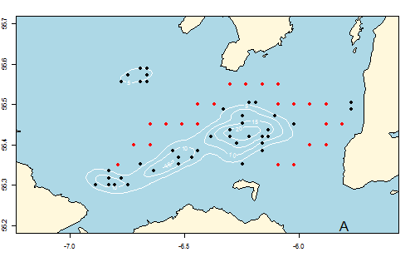
MAP 24 . Stations surveyed within the North Coast area of the VIa queen scallop survey. Stations surveyed by UWTV, red - exploratory stations; black – core fishery area stations.

3. For internationally coordinated surveys, describe the participating Member States/vessels and the relevant international group in charge of planning the survey
N/A
4. Where applicable, describe the international task sharing (physical and/or financial) and the cost sharing agreement used
None.
5. Explain where thresholds apply
None.

North Atlantic (ICES Areas V-XIV and NAFO areas)
VIa & VIIa Scallop survey
Additional survey

1. Objectives of the survey
The aim of the survey is to assess the scallop (Pecten maximus) grounds off the County Down coast and collect the following scallop data:
- catch per unit effort.
- scallop age composition
- weight, height and length of individual scallops.
- abductor muscle and gonad weights.
- scallop shell samples were retained for morphometric study.
Identify and quantify macrofauna associated with scallops.
Collect samples of scallop abductor muscle and gonad for contaminant analysis.
2. Description of the methods used in the survey. For mandatory surveys, link to the manuals. Include a graphical representation (map)
The scallop survey will occur in mid-February for duration of approx. 5 days (weather dependent). 35 stations of fixed position are to be dredged using a beam with four 2-foot dredges and from the starboard trawl winch on 24mm warp. A fine mesh (<10mm) liner will be attached to one dredge to retain small benthic fauna. Catches are to be sorted and the associated fauna identified and counted. Scallops are to be weighed and shell length and height measured. Meat yield will be determined by measurement of the abductor muscle and gonad weight. Shells are to be aged by examination of growth bands on the flat shell and flat shells are retained for microscopic examination of hinge ligament scars after the cruise.
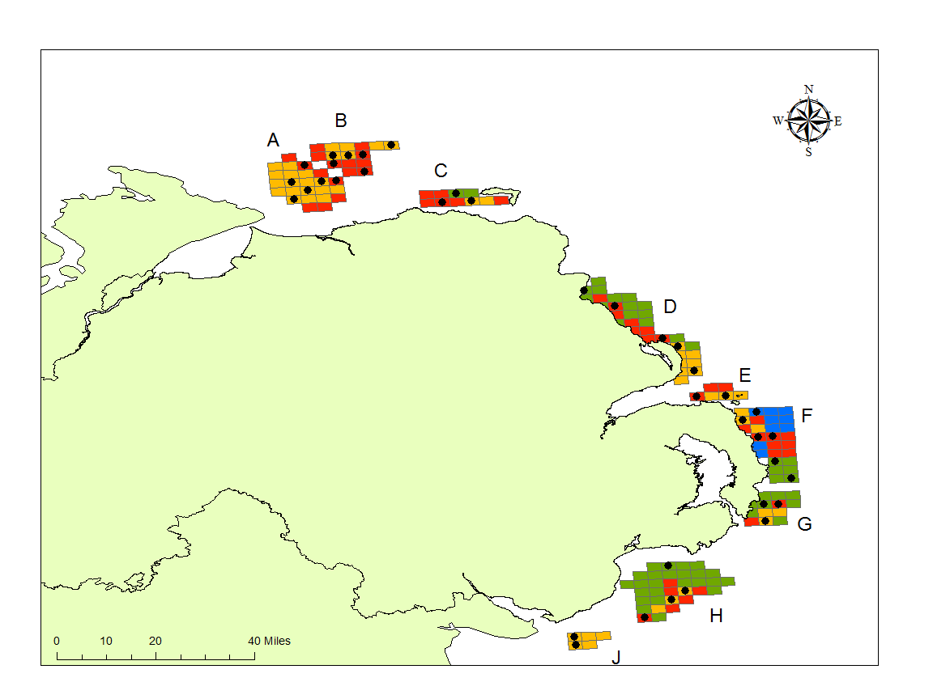
MAP 25 : Location of stations(black dots) for dredging in the VIa & VIIA king scallop survey. The different colours represent the different substrata types.
3. For internationally coordinated surveys, describe the participating Member States/vessels and the relevant international group in charge of planning the survey
N/A
4. Where applicable, describe the international task sharing (physical and/or financial) and the cost sharing agreement used
None.
5. Explain where thresholds apply
None.

North Atlantic (ICES Areas V-XIV and NAFO areas)

Irish Sea, Bristol Channel and Celtic Sea Beam Trawl Survey (ICES Areas VIIa,f,g)

ISBCBTS 3rd quarter (September); VIIa,f,g; (Irish Sea & Bristol Channel Beam Trawl
Survey) UK England component VII

Included in Table 10

1.Objectives of the survey
To provide estimates of abundance of recruiting year classes and CPUE-at-age series for plaice, sole, cod and haddock to the Celtic Seas Ecoregion Working Group (WGCSE). These are used for tuning purposes.

2. Description of the methods used in the survey. For mandatory surveys, link to the manuals. Include a graphical representation (map)
A total of 108 stations have been planned over 21 days. Age samples and biological parameters will be taken from all target species and all species listed under Appendix VII of the DCR which are caught. Benthic by-catch information is collected at each station. Hydrographic data will be collected at a minimum of two stations per day. Any anthropogenic waste material will be recorded and weighed.

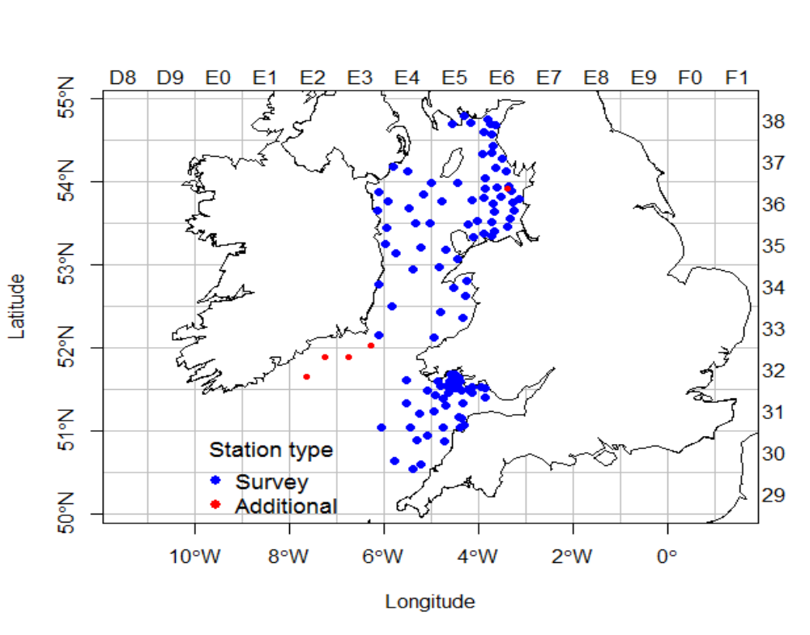
Map 28 Irish Sea, Bristol Channel and Celtic Sea Beam Trawl Survey (ICES Areas VIIa,f,g)

The resultant data will be input to a Cefas surveys database (FSS) using the Cefas Fisheries Electronic Data Capture (FEDC) System. All data will also be transmitted to ICES for input to the DATRAS database.

3. For internationally coordinated surveys, describe the participating Member States/vessels and the relevant international group in charge of planning the survey
Celtic Seas Ecoregion Working Group (WGCSE).

North Atlantic (ICES Areas V-XIV and NAFO areas)

SWECOS 1st quarter (March); VIIe,f,g,h,j Ecosystem beam trawl survey; Western Channel and Celtic Sea.

Included in Table 10

1. Objectives of the survey
To provide estimates of abundance of recruiting year classes and CPUE-at-age series for plaice and sole to the Celtic Seas Ecoregion Working Group (WGCSE). These are used for tuning purposes. As the Celtic Sea time series grows, further species tuning indices will be provided to assessment WGs. This is a random stratified survey design using two 4m beam trawls. In addition, grab samples, CTD profiles and SPI camera deployments will be conducted at each prime station.

2. Description of the methods used in the survey. For mandatory surveys, link to the manuals. Include a graphical representation (map)
A total of 131 stations have been planned over 30 days. Age samples and biological parameters will be taken from all target species and all species listed under Appendix VII of the DCR which are caught. Benthic by-catch information is collected at each station. Hydrographic and sea-bed samples will be collected at all prime stations. Any anthropogenic waste material will be recorded and weighed.

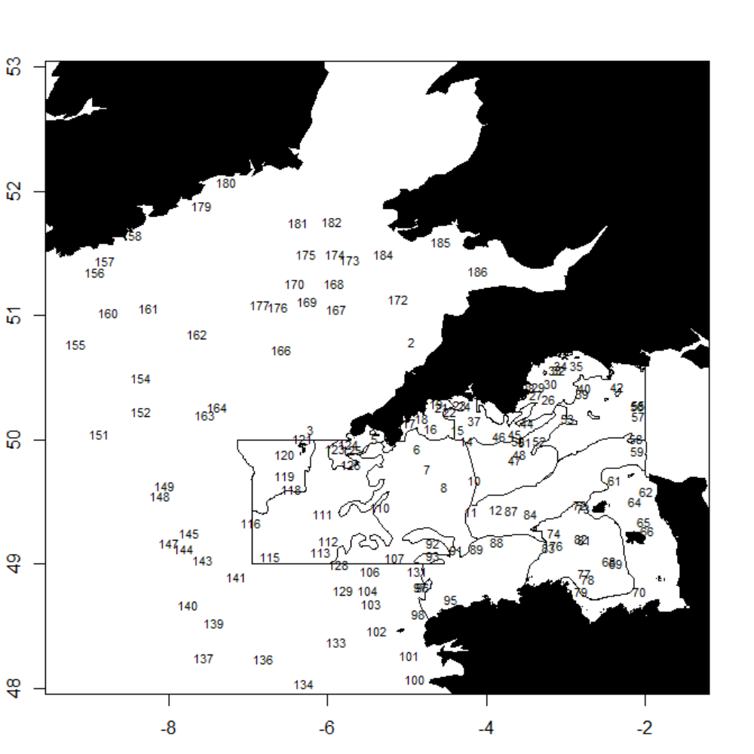

Map 30 SWECOS 1st quarter (March); VIIe,f,g,h,j Ecosystem beam trawl survey; Western Channel and Celtic Sea.

The resultant data will be input to a Cefas surveys database (FSS) using the Cefas Fisheries Electronic Data Capture (FEDC) System. All data will also be transmitted to ICES for input to the DATRAS database.

3. For internationally coordinated surveys, describe the participating Member States/vessels and the relevant international group in charge of planning the survey

Celtic Seas Ecoregion Working Group (WGCSE)

4. Where applicable, describe the international task sharing (physical and/or financial) and the cost sharing agreement used

5. Explain where thresholds apply

(max 450 words per survey)
North Atlantic (ICES Areas V-XIV and NAFO areas)

PELTIC, Pelagic Survey; Areas VIIe, VIIf, VIIg; 4th Quarter (English Integrated Pelagic Survey)

Additional survey

1. Objectives of the survey
To carry out an acoustic survey to estimate the abundance and distribution of the small pelagic fish community (sprat, sardine, anchovy, mackerel, horse, mackerel) in the western English Channel and eastern Celtic Sea (ICES area VIIe,f and g; the “Mackerel Box”). This survey provides the only fishery independent data for these species in the area. Estimates of the abundance of sprat are presented at HAWG to feed into the stock assessment of sprat in VIIde; age disaggregated sardine abundances, requested by ICES under WKSAR and are provided to WGHANSA and used in support fo the stock assessment of ICES area VII sardine; northern anchovy data will also be presented at WGHANSA although no stock assessment currently exists. Additional abundance data on mackerel, horse mackerel, boarfish and herring are calculated and may be used as (recruitment) indices.
To provide the associated environmental and ecological context for the estimates, other relevant sampling methodologies will be integrated to better understand the effect of such processes. These will inform not only on the development of future stock dynamics of the survey’s target species, but will also help to develop a better understanding how the pelagic processes affect particularly demersal species surveyed in the area by other DCF surveys.
The plan is to add an additional seven days to the survey to explore the northern-most boundary of key pelagic fish resources in the study area, specifically sardine.

- 2. Description of the methods used in the survey. For mandatory surveys, link to the manuals. Include a graphical representation (map)

Approximately 2200 nautical miles will be surveyed with ~40 ad hoc pelagic trawl operations to ground-truth acoustic data and collect biological samples. All fish and cephalopods caught will be identified to species and measured. Age samples and biological parameters will be taken from all target species (sprat, sardine, mackerel, anchovy, horse mackerel, herring, boar fish, blue whiting, garfish and saury pike) and species listed under Appendix VII of the DCR which are caught.

Sardine eggs and larvae from 90 plankton stations, will be counted, staged and aged and presented to WGACEGG to establish spawning areas and estimate sardine SBB. Meso zooplankton samples and vertical profiles of temperature and salinity are collected at the same 90 stations. Further discrete samples for phyto-and micro zooplankton, as well as oceanographic data (including chlorophyll and nutrients), will be collected at at a subset of 40 of those fixed primary stations, which, combined with continuous sub-surface oceanographic sampling, provide an ecological context of the observations. In addition, these environmental data are used to monitor the ecosystem health under OSPAR and MSFD descriptors. Seabirds and marine mammal observations are recorded along transects by observers.

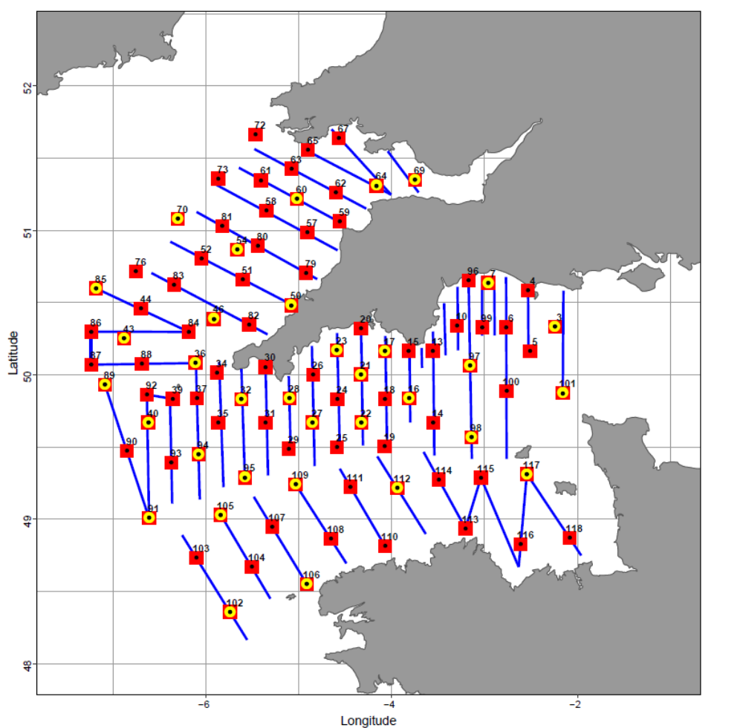
Map 31 Peltic, Pelagic Survey; Areas VIIe, VIIf, VIIg; 4th Quarter (English Integrated Pelagic Survey)
Accoustic transects (blue lines), zooplankton stations (redboxes) and Rosette stations (yellow)

Data will be held in a surveys database at CEFAS and provided in summarized form to WGACEGG and WGIPS. Fisheries acoustic data, partitioned by species and, where possible, age and length categories will be stored in formats coordinated by WGIPS and WGACEGG and made available to ICES through the respective working group databases. Pelagic trawl catch data will be recorded using the CEFAS Electronic Data Capture System. Oceanographic data and outcome of plankton samples analysis will be stored in the Cefas Data Repository, linked to the survey.
3. For internationally coordinated surveys, describe the participating Member States/vessels and the relevant international group in charge of planning the survey
WGACEGG: Working Group on Acoustic and Egg surveys for Sardine and Anchovy in ICES Areas VII, VIII and IX
WGIPS: Working Group on International Pelagic Surveys
4. Where applicable, describe the international task sharing (physical and/or financial) and the cost sharing agreement used

5. Explain where thresholds apply

(max 450 words per survey)

Section 2: Fishing Activity Data

Text Box 2A: Fishing activity variables data collection strategy

General comment: This Box fulfills paragraph 4 of Chapter III of the multi-annual Union programme and Article 2, Article 4 paragraph (2) point (b) and Article 5 paragraph (2) of this Decision. It is intended to describe the method used to derive estimates on representative samples where data are not to be recorded under Regulation (EU) No 1224/2009 or where data collected under Regulation (EU) No 1224/2009 are not at the right aggregation level for the intended scientific use.
1. Description of methodologies used to cross-validate the different sources of data.
UK fishing authorites in Scotland, NorthernIreland and Wales have a system of integrated databases which provide information on UK fishing vessel activity at sea, landings and sales of fish. These are known as IFISH (Integrated Fisheries System Holding data warehouse) and MCSS (Monitoring Control and Surveillance System) and are the main sources for the effort data required for the various fleet segments of the UK fleet. These systems sit within an overall system which carries out a number of cross checks of information between the various sources, including checks between activity data as reported in EU logbooks and that derived from satellite surveillance systems and other vessel monitoring inspection systems. This cross-check system highlights to administrations various apparent errors in reported data, with actions taken as necessary to resolve the errors.
2. Description of methodologies used to estimate the value of landings.
Data on landings by 10m and over vessels are derived from the combination of the community logbook, landing declarations and sales notes. These provide the key details on the species, presentation, weight and value of fish being landed that is entered onto computer systems at local port offices.
From 2005 the UK has operated a system requiring the registration of buyers and sellers of fish at the point of first sale, and an associated requirement for all such sales to have sales notes reported and provided to fisheries authorities within 48 hours of the sale. Data from these sales notes are captured as part of the UK integrated data systems, with data collected for sales related to all UK vessels, be they under or over 10 meters in length. After a period of assessment and quality assurance, UK fisheries adopted sales notes data as the key source of information on the activity of vessels 10 metres and under overall length. Thus the system in place in the UK is considered to be a census and thus more complete and reliable than a sampling approach.
From July 2019 a new catch recording service has been introduced which will see the owners and operators of under 10 metre vessels, who catch and land species subject to quotas, catch limits or effort restrictions, recording their catch via a mobile device (a smartphone or tablet) prior to the fish leaving the vessel.
Additionally, those involved in shellfish fishing activity are also required to report their activity in the form of monthly diaries of activity and landings.
Landed weights are used as the initial entered data, with live-weights calculated as the products of the landed weight and the appropriate conversion factors for that species and presentation of fish involved. The total landed weight of each species is taken from the landing declaration. Sales notes information give the details of the breakdown of the landed weight of each species in term of each presentation (and grade) sold. This proportionate breakdown is then applied to the total weight for each species so that the total live weight equivalent of the total landed weight is then allocated across the presentation types seen for the landing. Values of landings are derived from sales notes and in the case that sales notes are missing (eg sometimes in the case of landings made abroad) they are imputed from averages for the species (see below).
Commercial catches of anadromus and catadromous fish
Catches of salmon in England and Wales by nets and fixed engines are derived from data reported in the mandatory catch returns (logbooks) submitted by licensed netsmen. To help address concerns about the reliability of catch return data, and in response to international obligations to reduce the levels of illegal and unreported catch, a carcass tagging scheme was introduced in England and Wales in 2009. Under this scheme, all net-caught salmon and sea trout must be individually tagged with a carcass tag after capture and the details of all fish caught recorded, along with the tag number, in a logbook. These measures are expected to improve the reliability of declared catch data for net fisheries since each net-caught fish must be tagged and each tag must be accounted for. Since implementation, the carcass tagging and logbook scheme have been subject to minor changes to help improve operation, but are considered to have been a success in both reducing illegal catches and improving the reliability of catch data.
Catches of salmon in England and Wales by nets and fixed engines are derived from data reported in the mandatory catch returns (logbooks) submitted by licensed netsmen. To help address concerns about the reliability of catch return data, and in response to international obligations to reduce the levels of illegal and unreported catch, a carcass tagging scheme was introduced in England and Wales in 2009. Under this scheme, all net-caught salmon and sea trout must be individually tagged with a carcass tag after capture and the details of all fish caught recorded, along with the tag number, in a logbook. These measures are expected to improve the reliability of declared catch data for net fisheries since each net-caught fish must be tagged and each tag must be accounted for. Since implementation, the carcass tagging and logbook scheme have been subject to minor changes to help improve operation, but are considered to have been a success in both reducing illegal catches and improving the reliability of catch data.
In Scotland, salmon fishery statistics are obtained from returns made in response to an annual questionnaire sent to the proprietors or occupiers of fisheries under the provisions of section 64 of the Salmon and Freshwater Fisheries (Consolidation) (Scotland) Act 2003. Fisheries are required to report the monthly numbers and total weights of salmon and grilse taken.
There are no commercial fisheries for salmon in Northern Ireland.Commercial fisheries for eels in England and Wales are required to report catches as a duty of their authorisation to fish.
3. Description of methodologies used to estimate the average price (it is recommended to use weighted averages, trip by trip)
For the period to 2017 average prices for each species have been calculated on the basis of live-weight quantities for each landing. This effectively weights the overall price thus calculated to the most prevalent presentation used for landings each species and applies to both over 10m vessels and 10m and under vessels. From 2017 data processing will include an automatic process for the calculation of monetary values associated with and attribution of average prices to, the apportioned quantities of fish caught. These monetary values will be applied only after the landing and subsequent apportionment process have occurred. Average prices calculated for each species will be weighted by landing location and seasonailty.
4. Description of methodologies used to plan collection of the complementary data (sample plan methodology, type of data collected, frequency of collection etc)
NA.

Section 3: Economic and Social Data

Text Box 3A: Population segments for collection of economic and social data for fisheries

General comment: This Box fulfills paragraph 5 points (a) and (b) of Chapter III of the multi-annual Union programme and Article 2, Article 4 paragraphs (1), (2) and (5) and Article 5 paragraph (2) of this Decision. It is intended to specify data to be collected under Tables 5(A) and 6 of the multi-annual Union programme.
1. Description of methodologies used to choose the different sources of data
The UK has chosen to carry out an annual survey in order to collect much of the economic data required, however the response to the survey is entirely voluntary. A short questionnaire is carried out by field researchers and then followed up by request for vessel accounts from vessel owners. These accounts provide the main source of data for most of the economic variables.
Data from accounts is combined with data on transversal variables (also part of the data submitted to the commission) to ensure consistency between the different sets of data and to minimize the complexity of the economic survey.
The UK combines numerous sources of data collection in order to fulfil EUMAP obligations. Administrative sources (Fleet register, logbooks and sales notes as well as Individual Quota Allocation Register) are used in combination with face to face interviews carried out by field researchers and accounts collection at the end of financial year. Some data sources are used in combination (questionnaires / accounts and administrative methods) using calculation. For the list of data sources see Table 3A.
2. Description of methodologies used to choose the different types of data collection
For all UK administrative sources the information is available at Census level. For most of the economic variables and employment, Non-Probability Sample Survey is used. The survey is implemented in 2 steps: face-to-face interviews in ports followed by phone or e-mail contact at a later date in the year when accounts are available. Based on previous experience this approach is the most efficient method for collecting a sufficient sample size to generate estimates for every vessel on the UK Vessel Register. Collaboration between the MMO, Government and Industry bodies such as Seafish and POs enables the UK to achieve response rates at an acceptable level.
Flexibility is important during the survey as parts of the UK catching sector can occasionally be difficult to meet face-to-face due to the nature of the work and in some cases questionnaires are completed over the phone or by e-mail. Face-to-face interviews are preferable to ensure the quality, robustness and legibility of any data collected.
3. Description of methodologies used to choose sampling frame and allocation scheme
The sampling frame to be used will be the UK fishing fleet register on 31st December including all vessels active during the year. Involvement in the survey is voluntary. As such it involves a degree of self-selection and is not a true random sample of the fleet.
In order to ensure that adequate levels of involvement are achieved, a key aspect of the contact with fishermen is that as well as seeking permission to contact their accountants direct for the required information, agreement is also sought for such access to their financial data to be allowed for subsequent years. As such, the sample for each segment can include some elements of a cohort analysis. It is thought that the benefits of this approach in terms of both ensuring a good level of response for each segment and generating time series information on individuals offsets the introduction of a potential bias from the use of a non-random sampling approach.
The target for the economic data survey is to cover 10% of active fleet in a sample, however intensity of sampling depends on the fleet segment and number of vessels in the fleet, therefore in cases of small scale fishery with >500 vessels in the fleet the planned sample rate is 2% (3% is used for fleets with 200-500 vessels).
4. Description of methodologies used for estimation procedures

The estimation procedures are implemented on the level of a more precise variables list and national fleet segments, which are defined based on gear used, target species, area and engine power/vessel size. In total 21 costs items are extracted from the accounts and estimated for each vessel based on models, which combine administrative sources with segment sample. Estimation procedures for different variables and variable groups are presented below.

Costs and earnings:
Within defined ﬂeet segments (not DCF segments) individual costs and earnings items from the collected vessel financial accounts (the segment sample) are added together to create a ‘combined segment sample cost structure’. The sum of each cost item in the ‘combined segment sample cost structure’ is calculated for each vessel within a segment as a proportion of the sum of fishing income available for all vessels from the administrative sources.

Fuel costs and crew share costs are calculated differently from other costs. To calculate fuel costs, we use the capacity (VCUs) and fishing effort (days at sea) of each vessel to estimate its fuel consumption in litres, which is then combined with the average annual red diesel price (excluding duty) to calculate the fuel cost estimates for each vessel.
To calculate crew share costs, we allocate a minimum £100 per day in instances where the actual observed amount within the ‘combined segment sample cost structure’ is lower.

Following the calculation of fuel cost and crew share, we apply the proportions from all the other costs within the ‘combined segment sample cost structure’ to the official declared fishing income for each vessel within each ﬂeet segment. We estimate costs and earnings for all vessels involved in the fishery (with recorded landings/catches) during the year.

Engaged crew:
Estimation of engaged crew is based on the survey data collected from vessel owners during face to face interviews, combined with data collected by the Marine Management Organisation. This provides details on the number of engaged crew, both full-time and part-time. With this sample information we then estimate total engaged crew based on the physical characteristics of the individual vessel and the vessel’s level of activity. Once the total engaged crew is estimated for all types of vessel in the UK ﬂeet, we estimate Full Time Equivalent (FTE) jobs based on hours worked (an FTE is assumed to be 2,000 hours worked a year).

Value of physical capital:
The UK intends to follow the methods for calculation of the value of physical capital as given in the report of the study N° FISH/2005/03 on the evaluation of the capital value, investments and capital costs in the fisheries sector. Sample data from vessel accounts will provide a depreciated value for the sample fishing vessel. This sample data can then be applied at a DCF segment level to the entire fleet based on a value per vessel capacity unit to estimate physical capital values.

For new variables, which were not defined in the previous DCF framework, estimation procedures and definitions will be elaborated on during the first year of data collection in 2017 when possible sources of data collection and methods will be evaluated.
Subsidies on investment:
The data is directly obtained from Administrative sources, linked to vessel owners or their vessels and aggregated to the level required.

5. Description of methodologies used on data quality
The quality of estimates after application of data estimation procedures recorded and applied in STATA statistical software are then evaluated by set of quality checks developed by JRC and applied in UK. Data visualisation tool for Economic Data Quality assessment developed in R (Knitr/Sweave file) allows to visualise full set of economic data assessing data coverage, clustering scheme used for data submission, consistency and variability of economic estimates per fleet segment over years as well as other quality parameters (see more in the report Ribeiro C.C. & Motova A., R Quality checks for DCF data submission).
The majority of the economic data will be collected by a probability sample survey and estimated based on Value of landings using models as described above. For these data, bias will be assessed by calculation of coverage rate, response rate and variability in terms of CV.

Section 3: Economic and Social Data

Pilot Study 3: Data on employment by education level and nationality

General comment: This Box fulfills paragraph 5 point (b) and paragraph 6 point (b) of Chapter III of the multi-annual Union programme and Article 2 and Article 3 paragraph (3) point (c) of this Decision. It is intended to specify data to be collected under Table 6 of the multi-annual Union programme.
After 2017 pilot study implemented in 2017, the data collection of social indicators for fleet had been added to fleet survey as additional tables to the first phase of the data collection when interviews are performed in the ports. The data will be collected for the same reference year as when the questionnaire is used. The methodologies used to choose sampling frame and allocation scheme will be the same as for the economic fleet survey.
The total number of employees will be estimated based on the same method used before social variables were introduced to the data collection. These methods are outlined in textbox 3A.
As for the economic data call 2018, the UK will use the below formula to estimate from the sample to the population:
Y_(s,i)=A_(s,i)*P_s
Where Y_(s,i) – estimated number of persons with specific characteristics within each strata;
P_s – estimated population within strata (estimated during the 1st step)
A_(s,i) – relative share of specific characteristics (e.g. gender, age group, etc) i within sample in a specific strata s.
1. Aim of pilot study
NA

2. Duration of pilot study
NA
3. Methodology and expected outcomes of pilot study
NA

(max 900 words)

Section 3: Economic and Social Data

Text Box 3B: Population segments for collection of economic and social data for aquaculture

General comment: This Box fulfills paragraph 6 points (a) and (b) of Chapter III of the multi-annual Union programme and Article 2, Article 4 paragraphs (1) and (5) and Article 5 paragraph (2) of this Decision. It is intended to specify data to be collected under Tables 6 and 7 of the multi-annual Union programme.
1. Description of methodologies used to choose the different sources of data
Under UK Aquatic Animal Health regulations, Aquaculture Production Businesses (APBs) are required to register with (and be authorised by) the regional competent authorities:
• in England and Wales by The Centre for Environment, Fisheries and Aquaculture Science (Cefas)
• in Scotland by Marine Scotland Science (MSS)
• in Northern Ireland by the Department of Agriculture, Environment and Rural Affairs (DAERA)
The three registers of APBs represent the UK population of aquaculture enterprises which encompasses: Salmon, Trout, Carp, Other freshwater fish, Other marine fish, Mussel, Oyster, and Other mollusc segments.
In 2015 (as in 2014), the Salmon segment dominated UK aquaculture: 81% volume, 89% value. All other segments fall below the threshold of 10% of the MS’s production by volume and value.
Species segment | 2015 Volume |  | 2015 Value
Species segment | tonnes | % | GB£ | %
Salmon- Other methods | 172,146 | 81 | 639,390,303 | 88
Trout -Other methods | 15,199 | 7 | 44,832,572 | 6
Mussel - Other | 19,254 | 9 | 25,454,304 | 4
All other segments combined  (i.e. Carp+Other freshwater fish+Other marine fish+Oyster+Other molluscs) | 5,156 | 2 | 15,417,432 | 2
UK total | 211,756 | 100 | 725,094,611 | 100
2. Description of methodologies used to choose the different types of data collection
Volume and some employee data are routinely collected from all enterprises in long-standing annual censuses of all registered APBs (conducted by Cefas, MSS and DAERA) and will be available for all segments. Data on Weight of sales per species, Persons employed and Number of enterprises (by category on the number of persons employed) will be collated from the censuses. Gross sales per species will be calculated from Weight of sales and expert estimates of farm gate price (collated for EC Reg 762/2008) so will also be available for all segments.
The remaining Economic and Social variable data need to be collected by survey. The threshold criterion will be applied, so surveys will be limited to the Salmon-other methods segment (with possible extension for continuity to the Trout-other methods and Mussel-other segments as per 2015-2017 surveys).
The remaining Economic variables (Other income, Personnel costs, Value of unpaid labour, Energy costs, Livestock costs, Feed costs, Repair and maintenance, Other operating costs, Operating subsidies, Subsidies on investments, Consumption of fixed capital, Total value of assets, Financial income, Financial expenditures, Net investments, Debt, Livestock used, Fish feed used, Unpaid labour, Number of hours worked by employees and unpaid workers) not captured by the censuses will be collected by a non-probability sample survey undertaken by Cefas. The survey approach has been developed over the previous 5 years and was restricted to the Salmon, Trout and Mussel segments in 2015-2017.
Of the Social variables, those which were previously (<2017) classed as Economic variables (i.e. Employment by gender, FTE by gender, Unpaid labour by gender, FTE National) will be collected for the Salmon-other segment within the non-probability sample survey for Economic variables. For the novel Social variables (Employment by age, Employment by education level, Employment by nationality, Employment by employment status), a separate pilot non-probability sample survey of Salmon enterprises will be undertaken.
3. Description of methodologies used to choose sampling frame and allocation scheme
Census: Production volume (and value) and some employee data will be collected from all APBs on the three regional registers.
Economic Survey: All commercial salmon enterprises will be selected for survey. Data from trout and mussel enterprises (if sampled) will be selected on the basis of production volume to maximise returns: larger businesses are better able to respond and provide quality data.
Pilot Social Survey (in PY 2018): All commercial salmon enterprises in Scotland will be sent a questionnaire.
It is considered inappropriate to segment aquaculture enterprises by both species group and production technique because: individual enterprises often operate across techniques; the number of enterprises within a segment would be limited affecting confidentiality and data quality; obscure segment classification potentially results in inconsistency between years. Segments will therefore be restricted to one technique per species group. Segmentation has changed with Commission Implementing Decision 2016/1251; the segmentation proposed represents the best alignment to the previous UK segmentation to ensure continuity:
- Finfish: Salmon-other methods; Trout-other methods; Carp-other methods; Other freshwater fish-other methods; Other marine fish-other methods;
- Shellfish: Mussel-other; Oyster-bottom; Other molluscs-other.

4. Description of methodologies used for estimation procedures
Turnover (gross sales per species) is imputed from wet weight of sales (via census) and estimated average annual unit value (GB£/tonne). Expert opinion (trade associations, traders, individual operators for low volume species) is used to estimate average annual unit values which vary temporally and geographically; independent estimates are derived for the three UK regions (Scotland, Northern Ireland, England and Wales) which show consistency.
Employment data collected in the separate censuses differ between the three regions and are not completely aligned with requirements in terms of gender and FTE in Scotland and Northern Ireland. Estimates for each sector within these regions will be based upon data from England and Wales. Data from the three regions will be collated by Cefas to provide UK totals by segment.
Where survey responses for Weight (of Sales / Livestock used) are given by number and stage rather than weight, conversion indexes will be used:
- Egg weights: salmon = 0.16 g, rainbow trout = 0.1 g; brown/sea trout = 0.08 g
- “Fry” = 2 g, “Fingerling” = 25 g, “Smolt” = 80 g
Survey response data will be summed within a segment, and the UK segment total estimated by scaling-up using segment total derived from the censuses: financial variables by Gross sales and Raw material weight variables by Weight of Sales.
Financial values in GBP (Sterling) will be converted to € using the annual exchange rate published by Eurostat.
5. Description of methodologies used on data quality
Cefas, MSS and DAERA staff collect and collate regional census data. Cefas staff collect the survey data, collate the UK census and survey data, and format the worked-up data for submission. All staff involved in data collection, entry, collation and work-up:
- are trained, experienced, engaged and have a good knowledge of the aquaculture industry;
- undergo mandatory annual training in Information Protection;
- use appropriate software, with restricted access to maintain confidentiality of individual enterprises.
Census: Data (Weight of sales; employment) is manually checked for anomalies at data entry and collation stages by experienced operators with knowledge of individual enterprises and by comparison to previous years’ data.
Surveys: Customised questionnaires, pre-populated with census data and previous survey data for reference, will be posted by recorded delivery to the selected enterprises, with a covering letter and a pre-paid return envelope to encourage completion and return. Enterprises will also be given the option of returning a scan, or requesting an electronic document, via email. Businesses that do not respond, will be contacted to encourage replies. In 2016, the response rate from UK salmon enterprises was 61%, and these enterprises represented >70% of the segment Gross sales and Weight of sales. Reponse rates have, however, declined following the Brexit vote and in 2018 were 30%, representing ca 44% of the segment volume and value.
Survey response data will be checked for anomalous and missing values and queried with the enterprises.

Section 3: Economic and Social Data

Pilot Study 4: Environmental data on aquaculture

General comment: This Box fulfills paragraph 6 point (c) of Chapter III of the multi-annual Union programme and Article 2 and Article 4 paragraph (3) point (d) of this Decision. It is intended to specify data to be collected under Table 8 of the multi-annual Union programme.
PGECON 2016 agreed that further work was needed to define a common framework for data collection which could be employed for the required EUMAP pilot studies on aquaculture sustainability data covering mortalities and medicine use. A workshop was proposed in spring 2017 which would inform work to be undertaken in 2018. This workshop did not take place and data collection and collation was piloted in 2018 as described below. It is planned to continue this pilot data collection and collation into 2020, but methods will be refined using workshop advice (proposed by PGECON for 2020) and experience gained in 2018/19. 1. Aim of pilot study
Commission Implementing Decision 2016/1251 requires collection of environmental data every 2 years for: 1. Medicines or treatment administered, by type, in gram; 2. Mortalities, in %. The starting year is 2018 (as social data) for 2015 and 2016 data; data is needed for finfish but not shellfish (“totals relevant to the total volume of fish”; fish = finfish in Table 9). It must be recognised that although aquaculture producers are required (by the cited Regulation and Directive) to keep records of treatments and mortalities, there is no obligation for farmers to routinely collate or report these. Collection of the environmental variables, as specified in Decision, is therefore not as straightforward as may seem.
Mortality: MSS already publish (http://www.gov.scot/Resource/0050/00505162.pdf) annual census data on % survival (based on numbers input and output) for the Scottish salmon farming industry. It was initially planned to use this data to fulfil the requirement for mortality. However, mortality (by weight) is also already reported by each seawater net-pen farm in Scotland on a monthly basis to the Scottish Environment Protection Agency (SEPA) and published http://aquaculture.scotland.gov.uk/data/fish_farms_monthly_biomass_and_treatment_reports.aspx). Reported values will be collated by calendar year and expressed relative to Scottish seawater finfish production tonnage. Mortality based on weight is a better environmental indicator (than % based on numbers), weight better matches other DCF input variables (feed, livestock, medicines), and the source data (farm returns to SEPA) match the medicine statistics.
Medicines and treatments: There are numerous types of aquaculture medicine and treatment which fall into various categories:
I. Antibiotics, e.g. Amoxicillin, Oxytetracycline, Floramphenicol, Amoxicillin
II. Prescription only medicines (POMs), i.e. Antibiotics + steroids (methyl-testosterone)
III. Other treatments with Marketing Authorisations (MAs), i.e. vaccines, sea-lice in feed treatments (Slice, Calicide), sea-lice bath treatments (Azamethiphos, Cypermethrin, Deltamethrin, Emamectin benzoate, Teflubenzuron), antimicrobials (Pyceze = bronopol), antihelminthics (Praziquantel), anaesthetics
IV. Other generic treatments without MAs, e.g. Chloramine T, hydrogen peroxide, formaldehyde, other anaesthetics, methylene blue
V. Banned treatments, e.g. malachite green
There is currently no guidance specifying which of these treatments data are required. An EWG is awaited.
Following UK discussions between Cefas, MSS, DAERA, VMD (the UK’s Veterinary Medicines Directorate) and Defra, it has been decided to focus on:
- MA sea-lice treatments in the Scottish marine finfish sector due to concerns about environmental impact. The data is already available via existing farm self-reporting systems to SEPA. http://apps.sepa.org.uk/spripa/Search/ByPollutant/Criteria.aspx; (http://aquaculture.scotland.gov.uk/data/fish_farms_monthly_biomass_and_treatment_reports.aspx, .
- antibiotics in the salmon and trout segments - a priority due to increasing global concerns over antimicrobial resistance (AMR). Some data (Scottish marine finfish net-pens sites) already exists, having been collected by SEPA. Additional data for England and Wales will be collected via a pilot study.
2. Duration of pilot study
The Cefas Fish Health Inspectorate is collecting data during inspection visits to all salmonid farms in England and Wales throughout 2018. This additional census data (albeit within one region of the UK) will be available for collation and review in 2019.
3. Methodology and expected outcomes of pilot study
Mortality: See above.
Medicines: The pilot study will develop methods for data collection, storage and work-up. Predicted potential issues to overcome are accurate identification of time of use, and the type (product or active ingredient). Combination of the partial census data with the existig data for Scottish marine finfish net-pen use will enable comparisons against VMD sales data and the industry’s own estimates.
(max 900 words)

Section 3: Economic and Social Data

Text Box 3C: Population segments for collection of economic and social data for the processing industry

General comment: This Box fulfills footnote 6 of paragraph 1.1(d) of Chapter III of the multi-annual Union programme, Article 2, Article 4 paragraphs (1) and (5) and Article 5 paragraph (2) of this Decision. It is intended to specify data to be collected under Table 11 of the multi-annual Union programme.
1. Description of methodologies used to choose the different sources of data
There exist a number of data sources that include relevant data on UK seafood processing companies including the Food Standard Agency database. However, the definitions of what constitutes a processing enterprise contained in these sources differ from that of the DCF. These databases provide a starting point for a biennial census of all UK processing sites; this allows the UK seafood processing industry to be defined as per the requirements of the DCF.
The census provides a list of processing sites that derive more than 50% of turnover from processing activities. This list is used to create the list of companies who are contacted annually requesting financial data through a questionnaire or in the submission of financial accounts. These Accounts are seen as the most reliable data source for estimating the performance of the sector.
Data on number of persons employed, FTE National and number of enterprises is also collected during the biennial census. This is due to the fact that this data is not available in annual accounts and to carry out further data collection on an annual basis would not be cost effective.
2. Description of methodologies used to choose the different types of data collection
Due to the large number of potential processing sites identified, face to face interviews would be prohibitively expensive and time consuming. A telephone census is used to gather data on the types of activities taking place at different sites and total number of employees. On occasion, face to face interviews are carried out with the largest sites to confirm the accuracy of the data and to gather further data on what is driving trends.
Participation in the survey is entirely voluntary in the UK. In the event that we are able to contact a company but they will not provide data we will use previous survey data (if available) combined with our own expertise to create estimates. If we cannot contact a company which is reported to be trading but for which we have no previous survey response, we would estimate the FTEs for the reference year based on a combination of Seafish expertise and other available sources such as published accounts or data from a relevant trade association.
Financial data is collected via questionnaire or hard copies of accounts. For larger enterprises these accounts are publicly available guaranteeing a robust sample size.
3. Description of methodologies used to choose sampling frame and allocation scheme
For the census survey the Seafish processing database (containing data from all previous surveys) is used as a starting point. Further to this contact is made with all sites listed as processors in the Food Standards Agency database and any new sites identified by the experts in the Seafish economics team or Seafish regional teams.
The financial survey is a non-probability sample survey. Involvement in the survey is voluntary. As such it involves a degree of self-selection and is not a true random sample of the sector. A high percentage of the largest processing companies in terms of turnover are included in the sample due to the availability of data from published financial accounts.
4. Description of methodologies used for estimation procedures
The data collection phase of the project leads to the creation of a sample of completed financial survey questionnaires and published accounts. Where both survey and published accounts data are available for particular variables, the survey data supersede officially published figures. The merging of survey and published accounts is also supplemented by extensive checks to ensure compatibility in terms of variable definitions.

Once the financial datasets are merged, each of the individuals is estimated individually at the company level, for all companies in the population (aside from those in the sample), applying sample averages on a per-FTE basis, where company FTEs are calculated as the sum of the relevant site(s) FTEs, using site ownership data (for the relevant year).
5. Description of methodologies used on data quality
The quality of estimates after application of data estimation procedures recorded and applied in STATA statistical software are then evaluated by set of quality checks developed by JRC and applied in UK. Data visualisation tool for Economic Data Quality assessment developed in R (Knitr/Sweave file) allows to visualise full set of economic data assessing data coverage, consistency and variability of economic estimates per group within the industry over years as well as other quality parameters (see more in the report Ribeiro C.C. & Motova A., R Quality checks for DCF data submission).
For the data collected bias will be assessed by calculation of coverage rate, response rate and variability in terms of CV.

Section 4: Sampling Strategy for Biological Data from Commercial Fisheries

Text Box 4A: Sampling plan description for biological data

General Comment: This Box fulfills Article 3, Article 4 paragraph (4) and Article 8 of this Decision and forms the basis for the fulfilment of paragraph 2 point (a)(i) of Chapter III of the multi-annual Union programme. This Table refers to data to be collected under Tables 1(A), 1(B) and 1(C) of the multi-annual Union programme.
ALL REGIONS IV, VI, VII, VIII
Northern Ireland sampling schemes
“NIR - Market”
NIR-N1: Area frame of sampling main ports with > 90% of landings. Providing access to vessels using otter trawlers, seine netters and dredge. Sampling events identified at random on days ports are active.

NIR-N2: Area frame of peripheral locations with < 10% of landings, active for 45days a year each. Sampling of these is not currently undertaken.

“NIR - Self-sampling”

NIR-N3 : A reference fleet of vessels for Nephrops catch sampling through fisher self-sampling. Selected vessels are from main Northern Irish ports. The reference vessels selection is designed to be representative of the entire fleet with systematic rota sampling.

“NIR - Observer at sea”

NIR-N5:List frame of GBN - registered vessels operating out of Northern Irish ports, for use in selecting vessels for at sea sampling of the mid-water trawl fleet segment. Vessels must apply for permit from control authority for any trip. A condition of this permit is a requirement to be observed. Observations are systematically identified to ensure equal coverage.

NIR-N6: List frame of GBN registered vessels operating from Northern Irish ports, with targeted selection of vessels engaged in seasonal queen scallop fishery.

NIR-N9: Unsampled GBN registered restricted to infrequent small scale fisheries, poly-valet gears and those trips perusing pelagic mid-water fisheries landing into other EU countries.

NIR-N4; NIR-N7; NIR-N10; NIR-N11: List frame of GBN registered vessels operating from Northern Irish ports, with random selection of vessels.

“NIR – Processor”

NIR-N8: Samples taken at processors of herring, from identifiable landings

“Yellow eel sampling”
NIR-N12: Systematic survey - Yellow eel catches are sampled weekly over 20 week fishery season
“Silver eel sampling”
NIR-N13: Systematic survey - Silver eel catches sampled weekly over 12 week fishery season
Scotland : All regions Scottish at-sea sampling
“UK-SCT at-sea catch sampling scheme” code in table 4A

The at-sea sampling design collects biological data for the trawler fleets targeting demersal and shellfish. The catch components recorded are landed, unwanted catch and BMS fractions. The trawler fleets sampled account for approximately 91% of the demersal fish species landed and ~ 66% of the total demersal and shellfish landings from the Scottish fleet. The non-sampled components are mainly small, often single manned under 10m vessels operating pots and trap which account for ~ 25% of the landed shellfish in 2015. There are also a relatively few vessels using nets, lines and other gear which are not sampled.
The vessels are divided into 8 sampling strata, based on gross characteristics of the vessel, their main location and operating area: North Sea and West Coast demersal trawlers; and demersal inshore trawlers targeting Nephrops by their predominant Nephrops functional unit (Clyde, Firth of Forth, Moray Firth, North Minch, South Minch and Fladen) offshore trawlers targeting Nephrops.

At-sea observers are allocated a randomised vessel selection forms for each trip they are asked to undertake. This form consists of a uniquely randomised draw from the sampling frame for the strata. The observer contacts the vessels in a prioritised order, recording the outcome of the contact for each vessel, until a trip is arranged and conducted. Non-response and refusal rates are calculated from the vessel selections forms.
When at-sea, the observers sample the unwanted catch and BMS component of all hauls. A sample of the unwanted catch and BMS fraction is collected for each haul, usually two mixed species baskets, from which all individuals are identified to species and length measurements are taken. Length stratified collection of age structures is undertaken for predetermined species. The length frequencies are recorded from a sample of the landed component. For trawlers targeting Nephrops the sampling of Nephrops and fish is by alternate days. Incidental by-catch is recorded for each haul as encountered.
The Horvitz-Thompson estimator will be used to estimate landed numbers-at-age or length and bootstrapping will be used to estimate corresponding standard errors and confidence intervals for these estimates. This will take account of the sampling hierarchy and sampling probabilities correctly in the sample weights. The method has not yet been finalised but is likely to include a ratio estimator using landed weight. Data are stored in the national database and also in spreadsheet exported into R, creating a documented R package for analyses, at each stage, rigorous quality checking procedures are followed
On-shore market sampling
“UK-SCT on-shore market sampling” scheme code in table 4A

The on-shore market sampling design collects biological data for landings of demersal species for the provision of landings-at-age or -length. The six main Scottish fish markets provide the access points for these landings, which collectively account for 68% of the Scottish landings. Non sampled landings are largely non assessable; 15% (16.5 Kt in 2015) are from foreign vessels with point of first sale outwith Scotland (mainly in France and Spain) that are loaded into trucks at the landing port. A further 16% (17.9Kt in 2015) are sold direct to buyers and don’t appear at fish markets. Approximately 65 demersal species are landed into Scotland, of which 45 are sold at the markets. The remainder are mainly relatively small landings of deep water species from foreign vessels which are trucked to foreign markets. The 6 markets in Scotland are stratified into 4 mainland and 2 Shetland markets. Each stratum is sampled 36 weeks of the year, with one Shetland market and 3 randomly selected mainland market being sampled each week. Currently sampling effort at markets is allocated in order to maximise sample sizes in each of ICES SubAreas IV and VI. Once at the market vessels are selected at random using a vessel selection form, on which non-response and refusals are recorded. Vessels are not stratified. The species to sample are selected at random using a stratified species selection form, in which non-response and refusals are recorded. The species are stratified into the following categories – common, less common and rare, with 2 species being selected from the common category, one from the less common and all the rare species. This results in approximately 3 species being sampled per trip, which ensures larger sample sizes from the more commercially important species whilst reduces processing time for a trip, whilst maximising the samples of rare species. One box of fish is sampled from each sales category – these boxes are selected at the discretion of the sampler. The lengths of each fish in the box are recorded, and if otoliths are taken, the first otolith from each cm length class is selected. The Horvitz-Thompson estimator will be used to estimate landed numbers-at-age or length and bootstrapping will be used to estimate corresponding standard errors and confidence intervals for these estimates. This will take account of the sampling hierarchy and sampling probabilities correctly in the sample weights. The method has not yet been finalised but is likely to include a ratio estimator using landed weight. Data are stored in the national database and also in spreadsheet exported into R, creating a documented R package for analyses, at each stage, rigorous quality checking procedures are followed.
On-shore pelagic sampling
“UK-SCT pelagic on-shore” scheme code in table 4A

The on-shore pelagic sampling design collects biological data for landings of pelagic species from the pelagic fleet for the provision of landings-at-age or -length. Three Scottish processors provide the main access points for these landings. The main pelagic species are mackerel, herring and blue whiting, with some horse mackerel and sprat. The landings are stratified into mainland and Shetland landings. The landings of these pelagic species into non-processor locations (e.g. markets) amount to 0.38% of the total pelagic landings by weight.
Each stratum is sampled potentially 36 weeks of the year, with intercept sampling of the know vessels from the pelagic fleet being used according to the seasonal operation of the fisheries and the landing activities of the vessels. The random allocation of sampling days within week will ensure a probability based selection of the processor location, hence vessel, actually sampled.
One box of mixed unsorted catch is sampled from each landing – these boxes are a sample of the vessel’s tanks as they are pumped to the processor. All fish in the sample are identified and recorded for length. The first three individuals (of the target pelagic species) from each cm length class is selected for the collection of otoliths, and the recording of sex and maturity. The Horvitz-Thompson estimator will be used to estimate landed numbers-at-age or length and bootstrapping will be used to estimate corresponding standard errors and confidence intervals for these estimates. This will take account of the sampling hierarchy and sampling probabilities correctly in the sample weights. The method has not yet been finalised but is likely to include a ratio estimator using landed weight. Data are stored in the national database and also in spreadsheet exported into R, creating a documented R package for analyses, at each stage, rigorous quality checking procedures are followed.
Small pelagic fish (mainly line caught mackerel) landed through markets are a frequent but not a significant component of the pelagic landings, amounting to 0.38% of the total. These are not sampled through the probability based species selection methods for demersal species.
Shellfish on-shore sampling
“UK-SCT on-shore Shellfish sampling” scheme code in table 4A
The on-shore shellfish sampling schemes collects biological data on five shellfish species, Nephrops, Scallops, Lobster and two species of Crab (Edible and Velvet).
The design of the scheme makes a broad distinction between the Shetland Isles where data on the landings of 4 species are collected (there are no Nephrops landings into Shetland), and the mainland Scotland which is divided into 15 sampling strata, where any and all of the 5 shellfish species encountered will be sampled. The mainland sampling strata are based on the geographical region and contain landing ports and the local processors that receive shellfish landings from these ports. Collectively the scheme has the potential to cover ~78% of the shellfish landed into Scotland, the remaining 22% is typically by small, mainly under 10m, vessels landing infrequently into small and often remote ports. Visits to sampling strata are by designated sampling weeks with observer directed sampling to determine locations and opportunities for data collection. There are at present on probability based selection methods employed, sampling being ad hoc and opportunistic.
Shellfish sampling in Shetland is sub-contracted and the MOU governing its operation sets out target numbers by species of the data to be collected.
The scheme both on the mainland and in Shetland will be revised during 2017 with a review of the sampling strata and the introduction of probability based sampling.
Sampling hierarchy is generally by commercial categories within trip, for the particular species. Samples are selected sufficient to achieve a representative length frequency distribution. For all individuals the appropriate carapace/shell length measures are taken, for Nephrops sex and breeding condition is recorded, for scallops meat weight.
The Horvitz-Thompson estimator will be used to estimate landed numbers-at-age or length and bootstrapping will be used to estimate corresponding standard errors and confidence intervals for these estimates. This will take account of the sampling hierarchy and sampling probabilities correctly in the sample weights. The method has not yet been finalised but is likely to include a ratio estimator using landed weight. Data are stored in the national database and also in spreadsheet exported into R, creating a documented R package for analyses, at each stage, rigorous quality checking procedures are followed.
English and Welsh sampling schemes All regions
Schemes are run concurrently to collect size and age data from all categories of commercial catch
Offshore sampling scheme: UK-E+W Observer at sea
Access to the population is through a regularly updated list frame of fishing vessels, from which a stratified random selection is made for direct observation by Cefas observers. The sampling frame is a virtual frame of all fishing trips of the vessels in the list, which comprises all commercial fishing vessels [registered in E&W]. The list of active vessels is updated quarterly to capture the polyvalent and seasonal nature of regional fisheries.
The overall sampling effort is largely constrained by financial and staff resources – currently ~525 staff days are available for at-sea observer sampling.
The list of vessels in the sampling frame is stratified by Region; 2 strata in the North Sea and Eastern Artic and 3 in the North Atlantic and predominant fishing method (nets, trawls, lines, beam trawl and scallop dredge). In addition, some region / fishing method strata are further stratified by vessel LOA (<10m; 10m+). In most regions the nets, trawls and lines are combined into single strata but in some regions where gear specific fisheries are more distinct Nets and Trawl are seperated. Beam trawl and Scallop dredge vessels are also kept distinct but cover all regions - the North Sea and North East Atlantic to capture the nomadic nature of a lot of these vessels.
Some vessels are excluded from the sampling frame
- Vessels less than 7m, excluded for health & safety reasons
- Vessels considered unsafe to take observers for reasons other than size.
- Vessels specialising in fishing methods or target species for which a derogation has been granted:
  - Clam, oyster and cockle dredgers
  - Some pelagic vessels
  - Potting vessels
- Vessels fishing from foreign ports or outside England and Wales. Vessels subject to bilateral agreements to be sampled in another country, or where RCMs consider the metier is effectively sampled by another country.
Teams of regionally based observers work to quarterly targets and use shared drawlists of randomly ordered vessels. Each vessel in turn is approached and non response and refusals are recorded.
Onshore sampling schemes: UK-E+W Crustacean on shore; UK-E+W Demersal on shore; UK-E+W Pelagic on shore
Target population for DCF is all fish and shellfish species landed into England and Wales for which estimates of length and/or age composition for the landed component are required.
Access to the population is through a regularly updated list frame of fishing ports at which all or a defined proportion of the total landings are accessible at auctions, processors or other on-shore locations, and from which a stratified random selection of ports and days is made for sampling trips by Cefas staff. The overall sampling effort is largely constrained by the financial and staff resources made available for this work – currently ~ 1200 staff days are available for port sampling.
The PSU is a port (or harbour or processor) on a specific day when landed catch is available. Landings into many small ports are transported to neighbouring larger ports where they can be sold by auction. A PSU is therefore a port where landings are available and implicitly includes all satellite ports from which catch is transported. Ports with auctions vary widely in size, from Lowestoft which deals with irregular infrequent landings from a dispersed fleet of under 10m vessels to Brixham which deals with regular large landings from a large fleet of over 10m vessels and a large fleet of inshore vessels.
The sampling frame is a frame comprising auction ports and ports of sale in England and Wales, and days of the year. The frame excludes the following locations:
- Very small ports, harbours, or other landing sites including beaches, where fish are disposed of locally rather than at auction sites (with potentially large components in the <25kg exemption for reporting), and where considerable effort would be required to sample very small amounts.
- Ports where access has been denied may be excluded within the frame to capture non response rates and record the potential biases.
The Cefas port sampling programme currently targets four distinct types of fishery, each will have its own separate sampling programme. These are:
- Demersal onshore (including cephalopods and Nephrops)
- Crustacean onshore
- Pelagic
Whilst there is some overlap (many ports land finfish and shellfish), this does not represent overlapping PSUs as each of the three fishery groups is treated as an independent frame with an independent sampling scheme and the access points are often quite distinct.
The list of ports in each of the three sampling frames is stratified by:
- Quarter,
- Region (6 strata) Lists of ports that map closely to ICES divisions, stock boundaries and fleet activities - 1Northeast, 2East, 3Southeast…
- Port “size” based on the relative importance of that port within that region
- Gear group although only 1 or 2 groups may be specific to the frame.
E1 - Demersal trawlers, netters + liners
E3 - Pelagic trawlers and seiners
E4 - Shellfish pot & trap vessels
E5 - Beam trawlers
E6 - Scallop dredgers

On the given day at the auction site a sampler will use a unique randomised list of numbers to select the trip to sample and then a similar list to sample the species available. Non-response rates and refusals will be recorded. The vessel selection scheme works in large auctions but at merchants staff are often limited to sampling what arrives or is available at the time they are there. So the port and day selection process differ between regions.
Onshore self sampling schemes - UK-E+W Nephrops on shore; UK-E+W Pelagic self sampling; UK-E+W Scallop self sampling
Three species specific self sampling schemes run concurrently with the landings sampling schemes and have been adopted either as the only access to particular fisheries or other biological parameters not available on the market; to guarantee catch samples from domains within other onshore programmes. In the Nephrops scheme and Scallop the scheme the vessels are contacted whilst at sea or before heading to sea to bring back samples from particular hauls or areas where they are fishing and for the Thames herring fishery the local agent or reference vessels organises samples when the fishery is active. The scallop vessels are contacted by their agents if they are seen, on AIS, to be fishing in the required areas.

Addendum

Fully documented fisheries (Catch Quota Trials)

North Sea and Eastern Arctic and North Atlantic

The UK’s EMFF Operational programme makes provision for collection of data to monitor the effects of the landing obligation. This requirement will in part be met through the piloting of fully documented fisheries (catch quota trials). These have been included in the UK’s DCF National Programme since 2013 and will continue under the 2020 to 2021 programme.

In October 2009 a joint statement by UK, German and Danish Ministers agreed that further work on piloting fully documented catch quota systems using CCTV as a catch verification tool should be carried out. The rationale being that fully documented fisheries (FDF) has the potential to significantly reduce discards by making fishermen account for all catches against their quota. The catch quota system is based on placing an absolute cap on fishing mortality. All fish caught are accounted for and when fishermen reach their quota limit they have to stop fishing. It is anticipated that the fishing industry would adopt a greater sense of responsibility in ensuring sustainability of fishing opportunities under such a system.

A number of trials have been run by European Member States including the UK which have largely concentrated on North Sea cod. A scheme in England was included under the UK’s DCF programme from 2013. This additionally included Western Channel sole, plaice and anglerfish and mixed stocks and was conducted for a variety of fishing methods in the North Sea and Western Channel fisheries. Further information may be found at the UK’s DCF website at:
https://www.gov.uk/guidance/data-collection-framework

http://publications.jrc.ec.europa.eu/repository/bitstream/JRC97428/lbna27456enn.pdf
http://publications.jrc.ec.europa.eu/repository/bitstream/JRC97428/lbna27456enn.pdf

