Direction Générale des Affaires Maritimes, de la Pêche et de l’Aquaculture

Regulation (EU) 2017/1004 of 17 May 2017 of the European Parliament and the Council
on the establishment of a Union framework for the collection, management and use of data in the fisheries sector and support for scientific advice regarding the common fisheries policy and repealing Council Regulation (EC) No 199/2008
Commission Implementing Decision (EU) 2019/909 of 18 February 2019 establishing the list of mandatory research surveys and thresholds for the purposes of the multiannual Union programme for the collection and management of data in the fisheries and aquaculture sectors
Commission Delegated Decision (EU) 2019/910 of 13 March 2019 establishing the multiannual Union programme for the collection and management of biological, environmental, technical and socioeconomic data in the fisheries and aquaculture sectors
Commission Implementing Decision (EU) 2016/1701 of 19 August 2016 laying down rules on the format for the submission of work plans for data collection in the fisheries and aquaculture sectors.
Commission Implementing Decision (EU) 2018/1283 of 24 August 2018 laying down rules on the format and timetables for the submission of annual data collection reports in the fisheries and aquaculture sectors.

French Annual Report for data collection in the fisheries and aquaculture sectors
2021
Version 1
Paris, 31st may 2022

CONTENTS
Section 1: Biological Data 4
Text Box 1C: Sampling intensity for biological variables 4
Text Box 1D - Recreational fisheries 11
General comments 11
Mandatory reports on catch of salmon in freshwaters 11
Mandatory reports on catch of eel by recreative fishermen using gears and nets 12
Framing surveys, fishermen panels 12
Pilot Study 1: Relative share of catches of recreational fisheries compared to commercial fisheries 14
Text Box 1E: Anadromous and catadromous species data collection in fresh water 17
Text box 1F: Incidental by-catch of birds, mammals, reptiles and fish 21
Region : North Sea and Eastern Arctic 21
Region : North Atlantic 21
Region : Mediterranean Sea and Black sea 22
Region : Other regions 24
Pilot Study 2: Level of fishing and impact of fisheries on biological resources and marine ecosystem: By-catch of PETS in the North Atlantic - Supra region: North Atlantic region: ICES 26
Pilot Study 2 bis: Level of fishing and impact of fisheries on biological resources and marine ecosystem: assessment of by-catch mortality in the Indian Ocean - Region: Other Region – Indian Ocean (IOTC) 28
Text Box 1G: List of research surveys at sea 31

Section 2: Fishing Activity Data 55
Text Box 2A: Fishing activity variables data collection strategy 55
Supra-region : Baltic Sea; North Sea; Eastern Arctic; NAFO; Extended North-Western waters (Ices areas V, VI and VII) and Southern Western waters 56
Supra-region: Mediterranean Sea and Black Sea 59
Supra-region: Other regions 63
Supra Region: Others Regions, - 24-< 40 m, 40 m or larger Indian Ocean (IOTC) 67
Supra Region: Others Regions, - 24-< 40 m, 40 m or larger RFMO: ICCAT 68

Section 3: Economic and Social Data 71
Text Box 3A: Population segments for collection of economic and social data for fisheries 71
Supra regions Baltic Sea, North Sea and Eastern Arctic, and North Atlantic 71
Supra Region: Mediterranean Sea and Black Sea 73
Supra region Other Regions 76
Pilot Study 3: Data on employment by education level and nationality 78
Text Box 3B: Population segments for collection of economic and social data for aquaculture 80
Pilot Study 4: Environmental data on aquaculture 84
Text Box 3C: Population segments for collection of economic and social data for the processing industry 87

Section 4: Sampling Strategy for Biological Data from Commercial Fisheries 88
Text Box 4A: Sampling plan description for biological data 88
Region: North Sea and Eastern Arctic 88
Region: North Atlantic 91
Region: Mediterranean Sea and Black Sea 94
Region: Other region – Indian Ocean (IOTC and SWIOFC) 97
Region: South Eastern Atlantic (ICCAT) 100
Region: Central Western Atlantic (WECAFC and ICCAT) 101
Section 5: data quality 103
Text Box 5A: Quality assurance framework for biological data 103
General comments 103
Region: North Sea and Eastern Arctic 105
Region: North Atlantic 107
Region: Mediterranean Sea and Black Sea 110
Region: Other region – Indian Ocean (IOTC and SWIOFC) 112
Region: Other region – Western Central Atlantic (ICCAT and WECAFC) 113
Region: Other region – South Eastern Atlantic (ICCAT) 114
Region: All regions – Eel (Anguilla anguilla) 116
Region: All regions – Salmon (Salmo salar) 117
Region: North Sea and Eastern Arctic North Atlantic Mediterranean Sea and Black Sea - Recreative fisheries 119
Text Box 5B: Quality assurance framework for socioeconomic data 121
Fishing fleet 121
Aquaculture 122
Processing industry 124

Section 1: Biological Data

Text Box 1C: Sampling intensity for biological variables
General comments

General comment: This box fulfils paragraph 2 point (a)(i)(ii)(iii) of Chapter III, of the Annex of the Delegated Decision (EU) 2019/910 and Chapter I of the Implementing Decision (EU) 2019/909 on the multiannual Union programme; and Article 2, Article 4 paragraph 1 and Article 8 of the Implementing Decision (EU) 2016/1701 on the format of the WP. This box is applicable to the Annual Report.
- Evidence of data quality assurance
France implements several tools for the quality assurance of its data collection, ranging from a dedicated webtool for real-time monitoring of commercial and biological parameter sampling (WAO), dedicated tools for populating data in a central database (TUTTI for the surveys and ALLEGRO for the commercial sampling) and extensive use of COST library functions for data preparation for end-users. For more details, see table and textbox 5A.
NA was widely used in Table 1C and column J ‘Planned number of measurements’ since the following agreement was reached at STECF and well captured in EWG-21-17 : 'N/A' is not valid value in column ‘Number of individuals to sample’ as per the guidelines. 'N/A' (or 'NA') is to be used when it is not possible to plan precisely for a species the number of a specific variable to be collected (planned for age, sex, maturity etc. are dependent on the landing practice which may vary during the year / by port or are dependent on a research survey, etc.). Indeed, it remains to agree on how to evaluate under or over achievement in these cases. Some countries introduced the concept of ratio number of individuals measured during the year Y-1 vs mean number of measurements in years Y–2:Y-4; France did not calcultate such ratio but put the mean values for the years Y-2:Y-4 in the comment column of the NWP. If needed to report a realization rate, a long-term solution should be seeked at STECF.

- Deviations from the Work Plan
2021 was another Covid-19 pandemic year, but with more limited impact on data collection than 2020. Some auctions remained closed to sampling for a period of time, the observation at sea on the deep-sea fisheries was almost impossible to realize due to the need to travel abroad for embarking and travel restrictions were strict, notably for entering UK territory. In the remote islands of Martinique and Guadeloupe, demonstrations against the lockdown measures severely impacted during several months the realisation of on-shore sampling.
Moreover, 2021 was the first full year of implementation of the new on-shore (ObsVentes) and at-sea (ObsMer) programmes (see textbox 4A for details). These new programmes required some adjustments with the teams on the field, so that the second part of the year was far more successful and promising for the future than the beginning of the year.

- Actions to avoid deviations.
A new monitoring tool (Imagine) for real time monitoring of the data collection on biological parameters (both fisheries dependent and independent) has been developed and implemented from January 2022. This tool enables the monitoring of individual parameters (age, weight, sex-ratio, maturity) for all scientific surveys at sea and commercial sampling (ObsMer and ObsVentes).

(max. 1000 words per Region/RFMO/RFO/IO)

Region : North Sea and Eastern Arctic
- Evidence of data quality assurance
See general section and texbox 5A
More integration of sampling elasmobranch for length between the ObsVentes and EOS programmes were initiated in the region. This resulted in more auctions monitored and a better sharing of sampling effort between the two programmes. This initiative will be continued in 2022 in the Atlantic region.

- Deviations from the Work Plan
In addition to the deviations explained in the general comments, the 2021 sampling targets for the stock-based variables (ageing, maturity, sex ratio and individual weight) were met for all listed species (see Table 1C). Achievements not in accordance with the plan are detailed as follows:
- Mullus surmuletus from commercial (achievement = 0%). Purchase of fish was difficult with a limited seasonal fishery and staff transition at that time.
- Polliachius virens from ICES areas I & II (age from commercial, achievement = 0%). No fish was sampled because there was no landings in french fishing ports.
- Polliachius virens from ICES areas IV (age from commercial, achievement = 0%). No fish was sampled because there is no landings in french fishing ports. However, the number of individuals and samples collected from ICES area VI (same stock) was over sampled to compensate for the missing area IV.

- Actions to avoid deviations.
Dedicated sampling for length of Pollachius virens on-shore were added to compensate for the impossibility to sample the fleet targeting this species at-sea in 2021 due to Covid-19 travel restriction (sampling frame M0001, see textbox 4A).
For Mullus surmuletus, the staff issue is resolved the purchase of fish will resume in 2022.

(max. 1000 words per Region/RFMO/RFO/IO)

Region : North Atlantic
- Evidence of data quality assurance
See textbox 5A

- Deviations from the Work Plan
In addition to the deviations explained in the general comments, the 2021 sampling targets for the stock-based variables (ageing, maturity, sex ratio and individual weight) were met for all listed species (see Table 1C). Achievements not in accordance with the plan are detailed as follows:
- Aequipecten opercularis (length from commercial, achievement = 0%) – very specific seasonal metier not sampled because there is no demand for this data.
- Engraulis encrasicolus (age, weight, sex-ratio and maturity from commercial, achievement = 0%) suffered the strong decrease of catches of anchovy in France (94 tonnes in all for the French fleets, see Table 1A), making it impossible to sample.
- Gadus morhua (achievement = 85%), suffered the decrease of catches of cod in France, see Table 1A, it is difficult to achieve the targets.
- Lepidorhombus whiffiagonis (achievement = 201%), Oversampling is mainly due to the integration of samples from a specific french research project (MATO “MATurité Objective des poissons par l'histologique quantitative”) focused on this species.
- Lophius piscatorius VIIb-k, VIIIabd (sex-ratio, weight, maturity, achievement = 0%) – These variables should not have been listed in the NWP since, like L. Budegassa, there is no plan to collect this information from commercial sources.
- Merlangius merlangus (sex-ratio, weight and maturity from commercial, achievement = 0%) - These variables should not have been listed in the NWP since, like for the Lophius, there is no plan to collect this information from commercial sources.
- Nephrops norvegicus FU19 (length and sex-ratio from commercial, achievement = 0%) – No fishing in this functional unit in 2021, see also revised landing figure in Table 1A.
- Sardina pilchardus (achievement = 220%), Oversampling (commercial sex ratio, sampling maturity,weight) is mainly due to the integration of samples from a specific french research project outside EU-MAP funding (DEFIPEL “DEveloppement d’une approche de gestion intégrée de la FIlière petits PELagiques française” – fundings ) focused on this species.

- Actions to avoid deviations.
The specific research project which led to an oversampling of Sardina pilchardus which will end in 2023 years and sampling will be reduced to the planned minimum number of individuals thereafter.

(max. 1000 words per Region/RFMO/RFO/IO)

Region : Mediterranean Sea and Black Sea
- Evidence of data quality assurance
See textbox 5A

- Deviations from the Work Plan
In addition to the deviations explained in the general comments, the 2021 sampling targets for the stock-based variables (ageing, maturity, sex ratio and individual weight) were met for all listed species (see Table 1C). Achievements not in accordance with the plan are detailed as follows:
- Engraulis encrasicolus from commercial (achievement = 73%) suffered the decrease of catches of anchovy in France (see Table 1A) and with the landings being scattered all along the coastline, it is difficult to achieve the targets.
- Trisopterus minutus from commercial (achievement = 0%) – This species is only counted not measured in the at-sea sampling protocol. Either it is an error in the NWP where this species should not have been listed as covered with length sampling or an omission in the sampling protocol; either way France will investigate the needs and how to address this issue at best.

- Actions to avoid deviations.
Sampling protocol for at-sea sampling has been updated to include measures of Trisopterus minutus.

(max. 1000 words per Region/RFMO/RFO/IO)

Region : Other region – Indian Ocean (IOTC) and SWIOFC
- Evidence of data quality assurance
See textbox 5A
The sampling protocol for length of target species for the purse seine fishery is implemented in order to optimize the accuracy of estimates of tuna catches per species for the two-fishing mode: the free school and the fishing aggregation device (FAD).
For the longline fishery, observers are collecting length data for the target species (swordfish and tunas) in order to increase the coverage of their respective length frequency distributions.
All large pelagics sampling are aggregated from different sources monitoring the fisheries in La Réunion and Mayotte and in foreign harbours, namely Large pelagics at sea and on-shore, large pelagics sizes on foreign shores and ObsVentes programmes.

- Deviations from the Work Plan
The deviation from the Work Plan is related to the absence of biological data collection for some species due to their absence in landings or in discards followed by observers. Moreover since 2018, there is a discard ban for the tuna species. Achievements not in accordance with the plan are detailed as follows:
- All species discarded Other regions (length achievement near 0%) - The number of samples achieved is low compared to the average for the reference period because there is a discard ban since 2018 and sampling is dependent on these discards.
- Carcharhinus falciformis and Carcharhinus longimanus – The sampling is opportunistic and is fishing dependent.
Regarding Mayotte :
- at beginning of 2021, COVID impact linked to lockdown
- regarding longline fisheries, change in fleet, only one longliner boat remains. New vessels integrated the fleet but no observation onboard is possible, due to the size of the vessel and no place onboard.
- Scomberomorus commerson and Serranidae sampling have been added as extra lines in table 1C since they were included in the on-shore sampling programme but were forgotten in NWP.

- Actions to avoid deviations.
A new programme financed outside EMFF and EU-MAP (ACCOBIOM – not under EMFF fundings) was initiated in 2021 in La Reunion to increase data collection for biological parameters of the main stocks. This project will eventually reassess the overall sampling design and propose a new routine data collection in the Indian Ocean starting in 2024.

(max. 1000 words per Region/RFMO/RFO/IO)

Region : Other region – Western Central Atlantic (ICCAT and WECAFC)
- Evidence of data quality assurance
See table and textbox 5A

- Deviations from the Work Plan
Real difficulties were encountered in Martinique and Guadeloupe impacting the fishing activity and therefore the sampling (Sanitary context 2021 with the implementation of lockdowns and curfews, Social crisis linked to the cost of living in the fall of 2021, Departures of observers and complete renewal of the team). See also textbox 4A.
In addition to the deviations explained in the general comments, the 2021 sampling targets for the stock-based variables (ageing, maturity, sex ratio and individual weight) were met for all listed species (see Table 1C). Achievements not in accordance with the plan are detailed as follows:
- Lutjanus buccanella and campechanus Martinique and Guadeloupe (length achievement = 0%) – the sampling protocol includes the species but given that the landing is never sorted by species, the observer can only measure fish from subsamples. This species never or rarely appeared in the subsamples.
- Istiophorus albicans Other regions (length achievement = 0%) - the sampling protocol includes the species but this species never appeared in the samples.
- All species discarded - Other regions (length achievement near 0%) - The number of samples achieved is low compared to the average for the reference period because there is a discard ban since 2018 and sampling is dependent on these discards.
- Thunnus albacares Other regions (length achievement = 5722%) - The 3-year average in NWP is false. The average value is 33050 and so the length achievement is near 115%.

- Actions to avoid deviations.
A new programme financed outside EMFF and EU-MAP (ACCOBIOM – not funded under EMFF) was initiated in 2021 in French Guiana, Martinique and Guadeloupe to increase data collection for biological parameters of the main stocks. This project will eventually reassess the overall sampling design and propose a new routine data collection in Antilles starting in 2024.

(max. 1000 words per Region/RFMO/RFO/IO)

Region : Other region – South Eastern Atlantic (ICCAT)
Member State should provide by Region/RFMO/RFO/IO:
- Evidence of data quality assurance
The sampling protocol for length of target species for the purse seine fishery is implemented in order to optimize the accuracy of estimates of tuna catches per species for the two-fishing mode: the free school and the fishing aggregation device (FAD).
- Deviations from the Work Plan
The deviation from the Work Plan is related to the absence of biological data collection for some species due to their absence in landings or in discards followed by observers, especially for Euthynnus alletteratus and Istiophorus albicans.
- Actions to avoid deviations.
None

(max. 1000 words per Region/RFMO/RFO/IO)

Text Box 1D - Recreational fisheries

General comments
General comment: This box fulfills paragraph 2 point (a) (iv) of Chapter III of the multiannual Union programme and Article 2, Article 3 and Article 4 paragraph 1 of the Decision (EU) 2016/1701. This box is applicable to the Annual Report. This box is intended to provide information on the design, implementation and analysis of all components of sampling schemes/ surveys that are listed in Table 1D.
In France, four different sampling schemes provide data about recreational fisheries.
In marine waters, bluefin tuna catches are monitored via mandatory reports of catches. All other catches are monitored by online surveys and fishermen panels (cf. pilot study 1).
In freshwaters, salmon catches by all recreational fishermen and eel catches by recreational fishermen with nets and gears are monitored via mandatory reports on catches.

Mandatory reports on catch of Bluefin tuna
1. Description of the target population
The target population is the population of recreational fishermen with a legal right to catch and retain bluefin tunas.
2. Type of survey
Recreational fishermen have to apply for an authorization in order to be permitted to catch bluefin tuna (https://www.legifrance.gouv.fr/jorf/id/JORFTEXT000045410773).
They have to declare all retained catches through a specific form (https://www.formulaires.service-public.fr/gf/cerfa_14938.do) and forms are sent to FranceAgriMer.
The number and total weight of declared bluefin tuna landings are available for scientific use.
3. Data Quality
Collected data is based on fishermen’s reports, which are mandatory. Undeclared catches of bluefin tuna is illegal, not included and not estimated. Check for completeness of fishermen reports is performed by FranceAgriMer.
4. Data Analysis and processing
No correction methods are put in place. All declared catches are summed.
No impact of COVID reported, as report is mandatory.

Mandatory reports on catch of salmon in freshwaters
1. Description of the target population
Salmon catch reporting is mandatory.
Salmon fishing takes place in 3 regions:
- Normandy
- Brittany
- Adour
When declaring their catches, recreational and professional fishermen provide information on the length, weight, date and place for the individuals they have caught, usually accompanied by a scale sample.
Interpretation of the scale samples thus provided along with the declarations makes it possible to improve our knowledge of salmon populations by determining the age and life characteristics of each individual.
2. Type of survey
The number and total catch with length and weight of declared salmo salar.
3. Data Quality
The rate of non-declaration of catches is estimated in the field by OFB agents per river.
4. Data Analysis and processing
The rate of non-declaration of catches is taken into account by the CNICS (national centre for the interpretation of salmonid catches) during the season and in the final evaluations.

Mandatory reports on catch of eel by recreative fishermen using gears and nets
1. Description of the target population
The target population is the population of recreational fishermen fishing with gears and nets in freshwater with a legal right to catch and retain yellow eel.
2. Type of survey
Reported data : The number or total weight of declared Anguilla anguilla.
Recreational fishermen have to apply for an authorization in order to be permitted to catch eel (https://www.legifrance.gouv.fr/codes/id/LEGISCTA000022850233/2010-09-25 Eel catch reporting is mandatory)
3. Data Quality
Collected data is based on fishermen’s reports, which are mandatory. Data are stored in a Oracle database and are thus subject to an integrity check by the database management system. See textbox 5A
4. Data Analysis and processing
No correction methods are put in place. All declared catches are summed.

Framing surveys, fishermen panels
France relies on data collection pilot studies for recreational catches of species of interest other than thunnus thynnus, salmo salar, and anguilla anguilla. There are two components to the pilot studies:
- Phase 1: a framing study to estimate the population of marine recreational fishers and determine a profile of fishers and fishing practices for that population
- Phase 2: a panel logbook study to measure and extrapolate catch volumes for species of interest. Over the 400 species identified to be catched in France, 29 species has been selected and are monitored through the panel.

1. Description of the target population
The target population for the phase 1 framing study is the population of metropolitan France (mainland France and Corsica) aged 15 or over. Census data published by INSEE are used to establish the sampling plan.
The target population for the phase 2 logbook study is the population of marine recreational fishers in metropolitan France. The results of the framing study are used to establish the sampling plan.

2. Type of survey
The phase 1 framing study is a quantitative study on the basis of questionnaires filled out by a representative sample of the target population. For the framing study conducted in January and February 2021 the study method was changed from a phone survey to an online survey.
The phase 2 logbook study collects data on fishing sessions and catches from a panel of recreational fishermen recruited for this purpose. The data collected include fishing zone, quantities, species and sizes of retained catches. Since 2021, the logbooks are filled out in real time on a fishing logbook mobile application.

3. Data Quality
The phase 1 framing study conducted in 2021 was based on a representative sample of 10 042 respondents. This sample was constructed on the basis of quotas for the aggregated socio-professional categories, geographic zone of residence (French department, size of agglomeration, and distance from the coast), age and gender of the respondents. The quotas were based on the data structures and census data published by INSEE. The final sample was adjusted based on the same data set to correct any remaining differences with the base data set.
Following this phase, a rate of 13.2 % of recreational fishermen aged 15 or over in France in 2020 has been established. Excluding shellfish gathering and other onshore collection practices this rate drops to 6.2 %.
The phase 2 logbook study for 2021 collected data in real time from the panel of recreational fishers. The selection bias introduced by the over-sampling of some pre-defined stratum (e.g. coastal residents and highly avid fishers) is adjusted for in the analysis of the information collected by applying correction factors. The catch quantities are then extrapolated based on the number of fishermen in every stratum analysed in the pilot study.
This estimation is done every quarter and adjusted to the number of respondents to make sure the sampling is representative.
During the phase 2 logbook study, a panel of recreational fishers was maintained. The panel members report their fishing sessions (geographical area, time spent fishing…) and their catches (species, length, release or not…) in the logbook application.
Of the more than 1000 panelists who participated in the study in 2021, a subset of profiles were retained after the application of quality indicators pertaining to the engagement, response rate and data consistency of the panelists. Recruitment campaigns were launched on different media, whether it was online, on the social networks, fishing associations or Fishfriender network. Finally, the sample was fixed at 200 panelists over 306 who were qualified to be retained and who completed at least logbooks for one quarter over the year.

4. Data Analysis and processing
The logbook study is based on collecting catch and effort information from fishermen in real time to considerably reduce recollection error and recall bias throughout the year. An extrapolation of catches has been carried out based on the adjusted results of the framing study, and the quantities caught evaluated by species and fishing area.
Reliable catch estimations were produced for three fisheries :
- Dicentrarchus labrax in the Atlantic
- Dicentrarchus labrax in the Mediterranean Sea
- Pollachius pollachius in the Atlantic
Due to the low participation of recreational fishers in the other fisheries concerned by the DCF, and therefore the low number of catches made by the study panel, the reliability of estimates for those fisheries remains unconfirmed.

Pilot Study 1: Relative share of catches of recreational fisheries compared to commercial fisheries
General comment: This box fulfils paragraph 4 of Chapter II of the Annex of the Implementing Decision (EU) 2019/909 on the multiannual Union programme and Article 2 and Article 4 paragraph (3) point (a) of the Implementing Decision (EU) 2016/1701 on the format of the WP.
General comment: This box is applicable to the Annual Report. This box is intended to provide information on the results obtained from the implementation of the pilot study.
- Aim of pilot study
- To estimate the size of the population of French recreational fishermen
- To estimate catches for specific species, as specified in table 1D, in 2020 and 2021
2. Duration of pilot study
The first phone survey started in autumn 2017 and will last until December 31st, 2020. A second phone survey will be carried out from autumn 2020 until December 2021.
3. Methodology and expected outcomes of pilot study
Phone surveys are set up to collect data on recreational fisheries. These surveys consist of two steps.

[step 1]
The first step has two objectives :
- Estimate the size of the population of French recreational fishermen.
- Recruit a panel of fishermen who accept to report their catches monthly.
The target population consists of all households living in mainland France (around 28 million households). The sampling frame is a representative sample of 14,320 households, constructed on the basis of cross-references between the size of the households and the age of the reference persons, referred to data structure given by INSEE.

Regional stratification is carried out to better take into account the specificities of the coastline.
Non response and refusal are recorded in the survey.

This phase of framing was carried out first in 2017. At that time, it made it possible to estimate that 6% of the people over 15 years old in French households were recreational fishermen in 2017 and to recruit a group of recreational fishermen.
It will be carried out again in 2020, on a larger scale. This will make it possible to evaluate changes in the size of the population of French recreational fishermen and to recruit a bigger group of recreational fishermen to report catches from 2021 on.

[step 2]
The second step is meant to estimate catches of recreational fishermen. It consists in collecting catches from the fishermen panel recruited during step one.
In 2020, data will be collected from the fishermen recruited in 2017. From 2021 on, data will be collected from fishermen recruited in 2020.
Sample size was really low in 2018, 2019 and 2020, which made it difficult to have reliable estimates. The new sampling should allow to maintain the size of the group for several months and years, and allow to collect reliable datas along years.
Brief description of the results obtained (including deviations from planned and justifications as to why if this was not the case).
4. Achievement of the original expected outcomes of pilot study and justification if this was not the case.
Results from pilot study were disappointing, with too few panelists to be able to derive reasonable catch
estimates (cf textbox 1D). Actions have been identified to try and encourage more people to participate in the panel :
1. Contacting people via social networks : four recruitment campaigns on Facebook were launched in 2020
2. Putting up posters encouraging people to participate in the panel
3. Changing the log book so that it is easier to fill in
4. Teaching the contractor about marine biology so that they can interact more easily with the panelists
5. Contacting more people during the first phase of the study to come. This means planning to spend
more money on it.
6. Asking for guarantees about the number of panelists in the call for tender.
Actions 1 to 3 have been taken in 2020. In the meantime, a new call for tender has been written, so that a new study can take place in 2020 with a new panel starting in 2021 (see description above in Textbox 1D regarding “Framing surveys, fishermen panels”).

5. Incorporation of results from pilot study into regular sampling by the Member State.
FranceAgriMer released a call for tender in 2020 to launch a new pilot study, incorporating lessons learnt from the previous pilot study which was carried out in 2017.
The study starting in autumn 2020 is being carried out for FranceAgriMer by the consortium of Halieuticom, Gece, Dr. Jules Selles and Scenent. In accordance with the lessons learnt from the previous pilot study this consortium not only has good understanding of marine biology and survey techniques, but also provides innovative tools for data collection.
The pilot study is carried out in two phases:
• Phase 1: a framing study to estimate the size of the population of marine recreational fishers in metropolitan France (mainland France and Corsica), and determine a profile of fishers and fishing practices for that population - from January to March 2021
• Phase 2: a panel logbook study to estimate catches for specific species, as specified in table 1D. The phase 2 logbook study is for the period from January to December 2021. Data collection starts in February 2021, after the data collection and panel recruitment from the phase 1 framing study provide the necessary inputs.
To achieve this outcome the study leveraged online panel techniques to obtain a sample of 10 042 respondents, representative of the French population aged 15 and over. This sample was constructed on the basis of quotas for the aggregated socio-professional categories, geographic zone of residence (French department, size of agglomeration, and distance from the coast), age and gender of the respondents. The quotas were based on the data structures and census data published by INSEE.
A questionnaire was filled out by each member of the sample. The survey results were adjusted on the basis of the quota variables to correct any remaining differences with the data set from INSEE and confirm that the results are representative of the target population.
The secondary objective of the phase 1 framing study is to estimate the profiles and the socio-economic characteristics of the population of French recreational fishers.
A second questionnaire was filled out by a representative sample of 2 646 French recreational fishers. As the first questionnaire was filled out by a representative sample of the French population, quotas for fishing area, annual number of fishing trips and fishing techniques were implemented based on its results in order to specify an augmented sample of fishers. Increasing the number of responses from fishers strengthens the results for questions related to the activity. This larger sample includes fishers from the initial sample, fishers recruited via social networks, and fishers from recreational fishers’ associations. The results were adjusted for the percentage of respondents who are members of recreational fishers’ associations.
The final objective of the phase 1 framing study is to recruit a panel of fishers who accept to report their catches and effort in real time using a fishing logbook mobile application for the phase 2 logbook study panel.

The objective of the phase 2 logbook study is to estimate fishing effort and catches of recreational fishers in metropolitan France, including Corsica. This phase will be conducted from 2021 to the end of 2023, and is included in the NWP 2022-2024, allowing to conduct multispecies survey to provide catch estimates on the most caught recrational species.
The phase 2 logbook study collects data on fishing sessions and catches from a panel of recreational fishermen recruited for this purpose. The panel is made up of fishers taken from the different strata identified in the framing study. The data collected include fishing zone, quantities, species and sizes of retained catches. Fishers on the panel report data on fishing sessions and catches in real time on a fishing logbook mobile application.
The mobile application used by the pilot study is FishFriender. This application is well established, with a community of over 100 000 users. It is extremely easy to use, and provides other technical and social benefits to fishers. This improves data quality through easier and more automatic data entry, the elimination of recall bias, and reduced data loss through improved engagement.
The selection bias introduced by the over-sampling of some pre-defined stratum (e.g. coastal residents and highly avid fishers) is adjusted for in the analysis of the information collected by applying correction factors. The catch quantities are then extrapolated based on the number of fishermen in every stratum analysed in the pilot study. Size-weight combinations are estimated from data collected by the panel, scientific campaigns or literature to convert catches to biomass. If more than 100 fishes were measured during the survey, size frequency data are used to randomly reassign all measurements. If less than 100 fishes measured, only the collected amounts are used and biomasses are not estimated for these species. By species, it is also mentionned the percentage of catches released.
In summary, this new study will have the following outcomes:
• An estimate of the size of the population of marine recreational fishers in metropolitan France, and the profile of fishers and fishing practices for that population. These outcomes will be available following the phase 1 framing study in the first half of 2021.
• An estimate of catches for specific species, as specified in table 1D. These will be available following at the end of the 2021 logbook study, in 2022. Logbook studies will be continued until end 2023, and provide reliable catch estimates for some recreational fisheries in metropolitan France.

Text Box 1E: Anadromous and catadromous species data collection in fresh water
General comment: This box fulfills paragraph 2 points (b) and (c) of Chapter III of the Annex of the Delegated Decision (EU) 2019/910 on the multiannual Union programme; and Article 2 of the Implementing Decision (EU) 2016/1701 on the format of the WP.
General comment: This box is applicable to the Annual Report.
EEL
Fishery independent data collection
In accordance with regulation R (EC) No 1100/2007 of 18 September 2007 and in accordance with eel management plan in France index rivers were selected for each eel management unit: FR_Meus / F_Rhin, FR_Arto, FR_Sein, FR_Bret, FR_Loir, FR_Garo, FR_Adou, FR_Rhon, FR_Cors. All these data collections (index River and specific networks) monitor all stages of the eel biologic cycle and the evolution of stocks in place. The choice of index sites makes it possible to investigate different types of environment described by the Grisam:
1. Marshes Atlantic;
2. Mediterranean Lagoons;
3. River Basins <1000 km²;
4. River Basin> 1000 km² plain;
5. River Basin> 1000 km² mountain;
6. Bays closed or Atlantic estuary
Migration control stations implement traps, videocounting : Rhine, Somme Bresle Fremur, Vilaine, Sevre Niortaise, Dronne, Soustons, Rhone. Specific eel networks consist of stations followed by electrofishing for calculations of abundance index.
.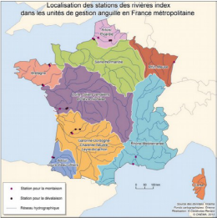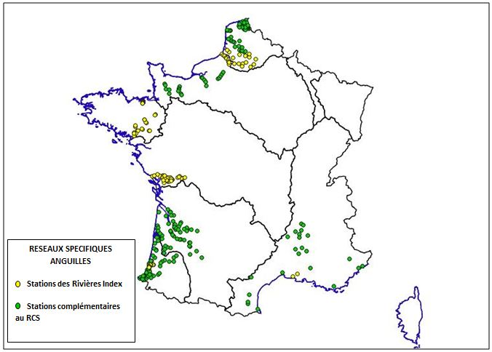
Figure left: location of monitored sites of recruitment and downstream migration; Figure right: location of électrofishing stations - yellow eels
Fishery dependent data collection
In the public river domain, recreational and professional fishermen fishing with gears and nets are monitored under the National monitoring of fishing with gears by monthly declaration of catches. In this case, monthly reporting is mandatory. As of November 1, 2019, a new tool (CESMIA) allows telereporting. This tool covers all species caught, including salmon and eel. This new tool reduces the time between capture and banking.
In additional biological measurements (length, weight, age and sex when possible) will be performed on fish purchased from commercial fishermen on management units affected by commercial fishing (glass eel, yellow eel and silver eel).

SALMON
Fishery independent data collection
For salmon, there are four index rivers used by salmon group ICES (WGNAS) for the length of the series. Migration monitoring stations are implementing traps. Bresle on track parr did not begin until autumn 2016 and no monitoring of smolts are on the Nivelle. Electrical fisheries are conducted in addition to the migration controls to calculate an abundance index for salmon.
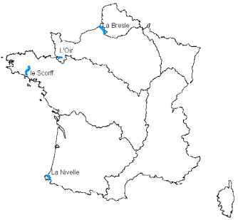

Fishery dependent data collection
Salmon catch reporting is mandatory.
Salmon fishing takes place in 3 regions :
- Normandy
- Brittany
- Adour
When declaring their catches, recreational and professional fishermen provide information on the length, weight, date and place for the individuals they have caught, accompanied by a scale sample.
Interpretation of the scale samples thus provided along with the declarations makes it possible to improve our knowledge of salmon populations by determining the age and life characteristics of each individual.
Eel
Sampling/purchase eel biometry
For the glass eel, the protocol consists of collecting 50 individuals per area (sampling/purchase) three times during the fishing season (so 150 individuals per year per strata). The Rivers were chosen according to the distribution of known catches to be the best representativity of the fishery.
The service provider collects the glass eels from the fishermen the same day as the fishing. They are then euthanized and for each individual the size, weight and pigment stage are recorded according to a defined protocol. The glass eels are then individually banked in a bank of biological samples of the INRAE to allow future analyses. New samplings will be added in the next working plan (Artois-Picardie, Seine-Normandie, Bretagne) because the test phase on the EMUs (Loire, Adour, Garonne) has allowed the validation of the method and the proposal of a sampling plan that now covers the entire fished area.
A problem persists in the sampling plan. In many areas (Loire/glass, Garonne/glass, Adour/glass, Charente/glass, Adour_several_rivers/glass, Loire_several_rivers/glass) the 3 collections could not be made because the quota was reached well before the end of the season. A meeting was held in 2021 to discuss with experts and providers the best solution to have a representative sampling of the whole fishing season. The decision was made to work in collaboration with the National Fisheries Committee to have a weekly update on the progress of the consumption of the quota and to change the collection dates according to this progress.
For the yellow and silver eel, the protocol consists of collecting yellow and silver eels (sampling/purchase) during all the fishing season in all the EMU where there are professional river fishermen.
The service provider collects the eels from the fishermen the same day as the fishing. They are then euthanized and for each individual the size, weight and eye diameter are recorded according to a defined protocol. The individuals are then dissected to remove the otoliths (which will allow ageing) and to determine the sex for the individuals between 30 and 45 cm. The otoliths were send to expert from Ifremer and the age is determined by a protocol made by Ifremer
Non conformity on eel sampling due to the need to change in the next national work plan (NWP) :
Sampling/purchase, n..yellow, Rhin: There was no professional eel fishing on the Rhine in 2021. Fishing is rare on this area which makes sampling complicated every year. It was therefore decided not to do any more this sampling in the following years and to change the NWP.
Electrofishing, Vilaine, station: The sampling scheme was modified from 30 to 20 stations in 2020. The new stations are more representative of the river habitat and will improve the estimate. This new sampling scheme was added in the next NWP.
Somme/Trap/silver/night: the trapping system has been fully automated since the end of 2019 allowing for more monitoring nights. This was modified in the next NWP.
Other reasons for non conformity
Sampling/purchase, n.glass for all EMU: The sampling scheme provides for three samples of 50 glass eels per area spread over the authorized fishing season. The quota was reached before the end of the season and the third sampling could not be done and some times the second sampling also. The sampling plan was changed to accommodate the early end of the fishing season
Sampling/purchase, n.yellow, Garonne and Loire EMU: During the samplings more fish were provided by the fishermen. This had no financial impact.
Somme/Trap/yellow: The pump used to supply water to the fishway and to ensure the attractiveness of the fishway has broken down. It took several months to replace it. This lack of monitoring has had a strong impact on the quality of monitoring, which will be reported to the WGEEL working group.
Fremur/electrofishing/yellow: Some years other stations than those of the usual network are monitored to check the dispersion. This has no impact on the quality of the monitoring and on the financial plan.
Sevre niortaise/silver/trap: There was not enough rain in 2021, which resulted in low flows that did not allow the passage of silver eels. Passage was only possible for 2 weeks. However, despite the significant decrease in the number of days monitored, all the individuals that were able to migrate were counted
Dronne/silver/trap: Monitoring is still ongoing as of the reporting date. The expected number of nights should be achieved (unless there are problems)
For information about protocols and quality, see table and textbox 5A.

Salmon
Index rivers and sampling plans are defined at national or regional level, not at RCG level, but the data collected follows the WGNAS recommendations.
Non conformity due to optimization of the sampling plan change the next national work plan (NWP)
Electrofishing: The work of the last few years (including 2021) consisted of establishing the relationship between the number of fisheries and the density of salmon according to the same protocol as the other rivers. In 2021, additional station was carried out to complete the one that could not be done en 2020 as part of the intercalibration between abundance index and density. The implementation of a monitoring network by electric fishing was finalised at the end of 2021. In 2022-2024 NWP, 10 stations will be sampled per year.
Trap: On the Bresle river, 9 months (10 in the NWP) cover the entire adult migration period on the Bresle. This has been corrected for the 2022-2024 NWP
For information about protocols and quality, see table and textbox 5A.
(max 500 words per Area)

Text box 1F: Incidental by-catch of birds, mammals, reptiles and fish

Region : North Sea and Eastern Arctic
General Comment: This box fulfils paragraph 3 point (a) of Chapter III of the Annex of the Delegated Decision (EU) 2019/910, on the multiannual Union programme; and Article 2 of the Implementing Decision (EU) 2016/1701 on the format of the WP. This box is applicable to the Annual Report. This box is applicable only for those sections where Member States have reported that they have been carrying out regular sampling. Results and deviations for Pilot studies should be reported under Pilot Study 2.
1. Results
Incidental by-catch of birds, mammals, reptiles and fish is collected within the at-sea (ObsMer) programme. The release alive or dead is also collected and for all fishing operations in the sampled trips.
Also, since September 2018, declaration of all incidental by-catch of mammals is mandatory.
Results of bycatch observed are publicly available through annual Obsmer reports.
2019 report : https://archimer.ifremer.fr/doc/00680/79198/81709.pdf – report 2020 in press.

2. Deviations from Work Plan
See table and textbox 4A for at-sea (ObsMer) programme. All stratas of Obsmer program (which consists into observers at sea) are monitored for the bycatch of birds, mammals, reptiles and fish. No deviation in the implementation of the protocol is to report, deviations in the sampling intensity are detailed in table and textbox 4A.

3. Data quality
The observer is instructed to monitor incidental by catches for all fishing operations of the sampled trips.
Obsmer observers are trained to recognize all PETS during an annual dedicated training. In case of doubts, a photo of the individual is taken, and species identification can be confirmed by a specialist later on. Details on the observer protocol are available here : https://archimer.ifremer.fr/doc/00664/77630/88583.pdf
Obsmer programme includes an exhaustive observation of all PETS species (mammals, birds, reptiles, fishes) bycaught during :
o All sampled fishing operations for mammals, birds, reptiles
o All sampled fishing operation for protected fishes
For birds : observer have to report it, indicating species name, geographical position, age (if possible), how animal was released (alive, dead, in which state). For mammals : observer have to report it, indicating species name, geographical position, length, weight, how animal was released (alive, dead), if any mark of fishing gear is present and which type. Observer have to put a caudal bracelet with a unique identification number on all mammals bycaught.
Data are stored into Harmonie database by IFREMER and transmitted on an annual basis to WGBYC.

It must be noted that French onboard observer Programm was not originally designed for the recording of incidental by-catch of PETs, but to monitor and record data of retained catches and discards and to collect samples in order to estimate discards and to calculate biological variables/parameters of commercial species.

(max 900 words)

Region : North Atlantic
General Comment: This box fulfils paragraph 3 point (a) of Chapter III of the Annex of the Delegated Decision (EU) 2019/910, on the multiannual Union programme; and Article 2 of the Implementing Decision (EU) 2016/1701 on the format of the WP. This box is applicable to the Annual Report. This box is applicable only for those sections where Member States have reported that they have been carrying out regular sampling. Results and deviations for Pilot studies should be reported under Pilot Study 2.
1. Results
Incidental by-catch of birds, mammals, reptiles and fish is collected within the at-sea (ObsMer) programme. The release alive or dead is also collected and for all fishing operations in the sampled trips.
Also, since September 2018, declaration of all incidental by-catch of mammals is mandatory.
Results of bycatch observed are publicly available through annual Obsmer reports.
2019 report : https://archimer.ifremer.fr/doc/00680/79198/81709.pdf – report 2020 in press.

2. Deviations from Work Plan
See table and textbox 4A for at-sea (ObsMer) programme. All stratas of Obsmer program (which consists into observers at sea) are monitored for the bycatch of birds, mammals, reptiles and fish. No deviation in the implementation of the protocol is to report, deviations in the sampling intensity are detailed in table and textbox 4A.
As in previous years, a reinforced effort into Obsmer sampling plan was performed during December 2020-april 2021 in the Bay of Biscay – see pilot study 2. This reinforcement was also reconducted for December 2021-april 2022 and included into NWP 2022-2024, and thus is not detailed in this annual report.

3. Data quality
The observer is instructed to monitor incidental by catches for all fishing operations of the sampled trips.
Obsmer observers are trained to recognize all PETS during an annual dedicated training. In case of doubts, a photo of the individual is taken, and species identification can be confirmed by a specialist later on. Details on the observer protocol are available here : https://archimer.ifremer.fr/doc/00664/77630/88583.pdf
Obsmer programme includes an exhaustive observation of all PETS species (mammals, birds, reptiles, fishes) bycaught during :
o All sampled fishing operations for mammals, birds, reptiles
o All sampled fishing operation for protected fishes
For birds : observer have to report it, indicating species name, geographical position, age (if possible), how animal was released (alive, dead, in which state). For mammals : observer have to report it, indicating species name, geographical position, length, weight, how animal was released (alive, dead), if any mark of fishing gear is present and which type. Observer have to put a caudal bracelet with a unique identification number on all mammals bycaught.
Data are stored into Harmonie database by IFREMER and transmitted on an annual basis to WGBYC.

It must be noted that French onboard observer Programm was not originally designed for the recording of incidental by-catch of PETs, but to monitor and record data of retained catches and discards and to collect samples in order to estimate discards and to calculate biological variables/parameters of commercial species.

(max 900 words)

Region : Mediterranean Sea and Black sea
General Comment: This box fulfils paragraph 3 point (a) of Chapter III of the Annex of the Delegated Decision (EU) 2019/910, on the multiannual Union programme; and Article 2 of the Implementing Decision (EU) 2016/1701 on the format of the WP. This box is applicable to the Annual Report. This box is applicable only for those sections where Member States have reported that they have been carrying out regular sampling. Results and deviations for Pilot studies should be reported under Pilot Study 2.
1. Results
Incidental by-catch of birds, mammals, reptiles and fish is collected within the at-sea (ObsMer for Gulf of Lion and CFDCF for Corsica) programmes. The release alive or dead is also collected and for all fishing operations in the sampled trips.
Also, since September 2018, declaration of all incidental by-catch of mammals is mandatory.
Results of bycatch observed are publicly available through annual Obsmer reports :
2019 report : https://archimer.ifremer.fr/doc/00680/79198/81709.pdf – report 2020 in press.

2. Deviations from Work Plan
See table and textbox 4A for at-sea (ObsMer for Gulf of Lion and CFDCF for Corsica) programme. All stratas of Obsmer and CFDCF programs (which consists into observers at sea) are monitored for the bycatch of birds, mammals, reptiles and fish. No deviation in the implementation of the protocol is to report, deviations in the sampling intensity are detailed in table and textbox 4A.

3. Data quality
Obsmer programme is conducted in the Gulf of Lion on trawlers and longliners. In Corsica, CFDCF protocol is conducted on small scale fisheries and includes observation at sea. Both programs include reporting and data collection of bycatch of mammals, reptiles, birds and fishes.

Corsica : the sampling campaigns carried out in 2021 were focused on small-scale coastal fishing and does not include trawls. In Corsica (CF-DCF program), all discards (released alive and dead) are measured (or estimated) and categorized by protected species, not marketed, below legal catch size, degraded ... What must be remembered is that small coastal fisheries by-catches have the possibility of being released alive, particularly for undersized individuals, grained crustaceans, protected species.
Data are stored in OEC Data base for Corsica.
For Corsican small costal fishery collected by CF-DCF project (DACOR), all observations at sea or fisherman declarations of mammals and reptiles are transferred to the “Réseau National Echouage” and to the “Réseau tortues marine pour la Méditerranée française”.
Observer protocol is available here : https://www.oec.corsica/attachment/2199485/

Gulf of Lion : the Obsmer observer is instructed to monitor incidental by catches for all fishing operations of the sampled trips.
Obsmer observers are trained to recognize all PETS during an annual dedicated training. In case of doubts, a photo of the individual is taken, and species identification can be confirmed by a specialist later on. Details on the observer protocol are available here : https://archimer.ifremer.fr/doc/00664/77630/88583.pdf
Obsmer programme includes an exhaustive observation of all PETS species (mammals, birds, reptiles, fishes) bycaught during :
o All sampled fishing operations for mammals, birds, reptiles
o All sampled fishing operation for protected fishes
For birds : observer have to report it, indicating species name, geographical position, age (if possible), how animal was released (alive, dead, in which state). For mammals : observer have to report it, indicating species name, geographical position, length, weight, how animal was released (alive, dead), if any mark of fishing gear is present and which type. Observer have to put a caudal bracelet with a unique identification number on all mammals bycaught.
Data are stored into Harmonie database by IFREMER and transmitted on an annual basis to WGBYC.

It must be noted that for both program, onboard observer Programm was not originally designed for the recording of incidental by-catch of PETs, but to monitor and record data of retained catches and discards and to collect samples in order to estimate discards and to calculate biological variables/parameters of commercial species.

(max 900 words)

Region : Other regions
General Comment: This box fulfils paragraph 3 point (a) of Chapter III of the Annex of the Delegated Decision (EU) 2019/910, on the multiannual Union programme; and Article 2 of the Implementing Decision (EU) 2016/1701 on the format of the WP. This box is applicable to the Annual Report. This box is applicable only for those sections where Member States have reported that they have been carrying out regular sampling. Results and deviations for Pilot studies should be reported under Pilot Study 2.
1. Results
For purse seine fisheries in the Atlantic Ocean and Indian Ocean the coverage of observer programs set up is up to the mandatory requests of RFMOs (ICCAT and IOTC). Since 2018, the coverage level for this fishery for France has increased to 20% of the days at sea to increase the accuracy of catch estimates (in number and/or weight) or interaction events for the less occurrent sensitive species (large individuals of silky shark, oceanic whitetip shark, mobulids, ...). For the 2020-2021 work plan, the decision to reduce the level to 15% was taken in order to maintain the accuracy of catch estimates and to rationalise costs.
For purse seine fisheries, observers collect the fate of individuals at release as well as the fulfilment of best practices in place to enhance the post release survival of individuals discarded.
In 2021, a total of 205 482 individuals in the Indian Ocean and 85 853 in the Atlantic Ocean were recorded as incidental catch for the purse seine fisheries. It must be noticed that for sensitive species like whale shark and sea turtles, individuals were released alive. Sharks represent less than 2% of these catches.
Purse seine | Atlantic |  | Indian
Species group | N | % | N | %
Billfishes | 65 | 0,08% | 122 | 0,06%
Cephalopods | 0 | 0,00% | 0 | 0,00%
Cetaceans | 5 | 0,01% | 5 | 0,00%
Other bony fishes | 78054 | 90,92% | 74194 | 36,11%
Rays | 9 | 0,01% | 24 | 0,01%
Seabirds | 0 | 0,00% | 0 | 0,00%
Sharks | 862 | 1,00% | 3091 | 1,50%
Tunas nei | 6812 | 7,93% | 128020 | 62,30%
Turtles | 45 | 0,05% | 12 | 0,01%
Whale shark | 1 | 0,00% | 14 | 0,01%
Total | 85853 | 100,00% | 205482 | 100,00%
For the pelagic longline fishery based in La Réunion due to potential difficulties to embark observers on board, there is two observers’ programmes: a scientific and a self-reporting. The programs observers collect the fate of individuals at release as well as the fulfilment of best practices in place to enhance the post release survival of individuals discarded. The main difference between two programs is that the self-reporting doesn’t catch the length measurements.
In 2021, scientific observers reported 14 253 individuals caught as incidental catches retained or discarded. It must be noted no bycatch of seabirds and cetaceans while sharks which are all discarded represented 15% of bycatch in number.
Longline | Indian
Species group | N | %
Billfishes | 4729 | 33,18%
Cephalopods | 2 | 0,01%
Cetaceans | 2 | 0,01%
Other bony fishes | 2855 | 20,03%
Rays | 1214 | 8,52%
Seabirds | 0 | 0,00%
Sharks | 2130 | 14,94%
To precise | 1 | 0,01%
Tunas nei | 3298 | 23,14%
Turtles | 22 | 0,15%
Whale shark | 0 | 0,00%
Total | 14253 | 100,00%

Mayotte : For the pelagic mini-longline fishery based Mayotte, no observers embarked in 2021 due to a change in the float (a single vessel the first three quarters and arrival of a new smaller vessel not allowing to embark an observer) and a lack of qualified personnel.
2. Deviations from Work Plan
No deviations.
COVID-19 pandemic: no impact

3. Data quality
See table 5A
For both purse seine (PS) and longline (LL) fisheries, observers are equipped with the species identification cards developed by tRFMOs and have for instruction in their sampling protocol to produce an exhaustive list of species caught per fishing operation at the best specific resolution possible. All are equipped with a digital camera for rare specimens for identification purposes at the end of the trip. All pictures have a code to reaffect the individual to its fishing operation. During the training course the observer is trained on sampling methods allowing to estimate the total amount of bycatch and discards at the level of the fishing operation. Methods are explained in the observer manual given during the training course.
The sampling design set up for PS and LL fisheries follows the recommendations developed in the regional observer scheme of tRFMOs. This sampling design is documented in the observer manual updated every year.
Data quality is taken into account for purse seine and longline fisheries in the other regions. After each observer trip a debriefing of the cruise is organized between the observer and two scientists involved in the coordination of the observer program. This debriefing will permit to attribute a score to the quality of data collected.
PS and LL observer data are stored in the Observe database shared between France and Spain for the PS fishery. The development of the software achieved by IRD is discussed every year during the Observer meeting organized between Spain, France and some partner institutes from coastal countries. Currently the quality of data stored in the Observe database is controlled for the position of fishing operation deployed (and for the deployment of FADs for the PS fishery) by cross-checking latitude and longitude data in the database with VMS data. The development of a tool aiming to enlarge the number of variables controlled is ongoing. We have developed controls to cross-check the data from observer program, VMS sources and logbook data to improve the data quality. The next step is to integrate these controls in package available online.

(max 900 words)

Pilot Study 2: Level of fishing and impact of fisheries on biological resources and marine ecosystem: By-catch of PETS in the North Atlantic - Supra region: North Atlantic region: ICES
General comment: This Box fulfills paragraph 3 point (c) of Chapter III of the Annex of the Delegated Decision (EU) 2019/910 on the multiannual Union programme; and Article 2 and Article 4 paragraph (3) point (b) of the Implementing Decision (EU) 2016/1701 on the format of the WP.
General comment: This box is applicable to the Annual Report. This box is intended to provide information on the results obtained from the implementation of the pilot study.
- Aim of pilot study
Numerous stranded common dolphins and harbour porpoise were reported on the French Atlantic coast during the winter periods of the last three years. According to scientific studies issued by Pelagis observatory, for 80% of the stranded marine mammals there was evidence of an interaction with fishing activities. A national working group was created in April 2017 in order to mitigate those by catch events. This pilot study is one of the outcomes of the national working group and aims to improve knowledge of the interactions between marine mammals and fishing activities. The at-sea sampling plan for the French fishing fleet of mid water trawlers in pairs and for fixed nets will be reinforced to have more vessel*trip observed and collect data about by catch events (number of by catch, species, length, location, etc.). This study also aims to mark marine mammals captured with rings in order to evaluate the proportion of individuals stranded and those sunk. This study is the prolongation of a first pilot study of at-sea sampling during the winter period from December 2018 to April 2019 for mid-water trawlers in pairs.
2. Duration of pilot study
The first phase of this pilot study will begin in 1st December of 2019 and will finish on April 30th, 2020. A second phase will begin in 15th December 2020 and will finish on April 30th 2021.
3. Methodology and expected outcomes of pilot study
The French fishing fleets of mid water trawlers in pairs and the fleet of fixed nets have been identified as potentially responsible for mammal by-catch by studies of Pelagis observatory, as well as by the risk assessment produced by fishpi2 and by ICES in its latest advice of May 26th 2020. PELAGIS studies showed evidence of spatial correlation between mammal populations and vessels of these fleets. Therefore, the target populations are the French fleet operating mid water trawlers in pairs and operating fixed nets in the Bay of Biscay. The sampling frame is a list of vessels, which has been built by crossing information from the community fleet register, the active vessels during winters between 2015 and 2019 and expert knowledge provided by the producer organisations concerned by these fleets.
The primary sampling unit of this pilot study is vessel*trip. There is no secondary sampling unit since we assume that observers will observe all marine mammal by-catch.
As the fixed nets French fleet is composed of an average of 500 vessels, the goal is to observe and collect data for 5% of the vessel*trip of this fleet during the period of winter 2020-2021. The vessel*trip are chosen by the contractors according to the list of vessels. The contractor has instruction to contact all vessels and board as many as possible.
These contacts are registered and if the observer cannot go onboard the motive of the impossibility is registered.
Brief description of the results obtained (including deviations from planned and justifications as to why if this was not the case).

1. Achievement of the original expected outcomes of pilot study and justification if this was not the case
During winter 2020-2021, a total of 644 days at sea were observed in the Bay of Biscay representing 3.3% of fishing effort for targeted gears. For this pilot study, the protocol used is the Obsmer protocol (see https://archimer.ifremer.fr/doc/00664/77630/88583.pdf), but sampling effort is reinforced on targeted gears. 15 events of bycatch of cetaceans were reported by observers on the gear targeted by the pilot study. These observation complete observations conducted since 2018 and reported in previous annual reports.
Gear | Number of days at sea observed by gear (and % of effort observed) | Total number of days at sea during the observed period (12/2020 – 04/2021) | Number of event of bycatch observed
PTM | 75 (6%) | 1256 | 5
GTR | 340 (3,2%) | 10634 | 7
GNS | 229 (3%) | 7639 | 3
Total | 644 (3,3%) | 19529 | 15

Difficulties were encountered during winter 2020-2021 due to COVID. It was also difficult to embark on small vessels, due to security rules and absence of authorizations to embark observers.
Vessels to contact by observers were also drawn randomly from the total list of vessels using the targeted gear in the Bay of Biscay. This novelty introduced in july 2020 induced an increase effort to contact fishermen (finding phone numbers, motivating them to participate,..). Random drawn of vessels was introduced to improve the representativity of Obsmer sampling.

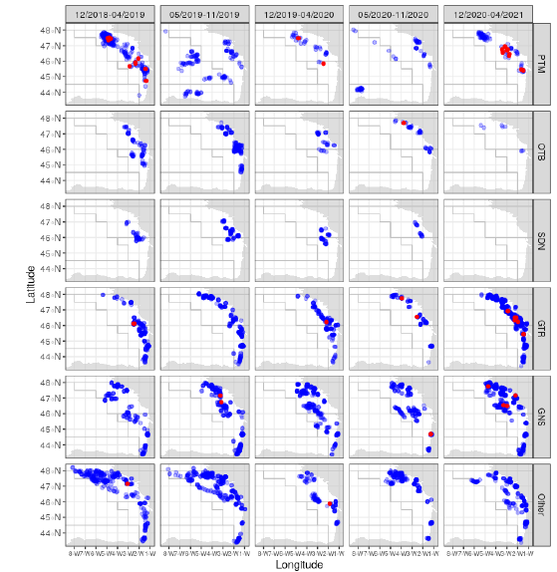

Maps showing number of observed fishing operations by gear observed since winter 2018-2019. Red dots show fishing operations with bycatch of cetaceans, blue dots are without bycatch.

5. Incorporation of results from pilot study into regular sampling by the MS
This pilot study was conducted in the context of increased stranding of common dolphins in the Bay of Biscay. Differents protocols are currently developped to improve knowledge on bycatch of cetaceans, including electronic monitoring, through Obscame program. Reinforced observations by observers at-sea (Obsmer) in the Bay of Biscay during winter are included in the NWP 2022-2024, however the design and sampling strategy may evolve depending on available knowledge and data already collected, in order to provide risk analysis by gear or metier.

(max 900 words)

Pilot Study 2 bis: Level of fishing and impact of fisheries on biological resources and marine ecosystem: assessment of by-catch mortality in the Indian Ocean - Region: Other Region – Indian Ocean (IOTC)
General comment: This Box fulfills paragraph 3 point (c) of Chapter III of the Annex of the Delegated Decision (EU) 2019/910 on the multiannual Union programme; and Article 2 and Article 4 paragraph (3) point (b) of the Implementing Decision (EU) 2016/1701 on the format of the WP.
General comment: This box is applicable to the Annual Report. This box is intended to provide information on the results obtained from the implementation of the pilot study.
1. Aim of pilot study
Fishing methods such as purse seining around drifting FADs and pelagic longlining are non-selective with respect to the species and size captured, resulting in the capture of both juveniles and adults of target and non-target species. Bycatch of non-commercial, unretained species can lead to their injury or death, and may be driving population declines of many species on a global scale. Marine megafauna such as sea turtles, seabirds, sharks and marine mammals appear to be particularly susceptible to bycatch mortality in fishing gear. However bycatch and discarding of less charismatic species is also viewed as a global problem. Despite the global concern regarding the magnitude of the bycatch issues still few studies have been set up to investigate bycatch mortality in the context of ecosystem-based fishery management. Bycatch mortality can be categorized into capture mortality (e.g. immediate or hooking mortality) and post-release (or discard) mortality. Capture mortality is readily quantified, since it can be assessed by observers on board the fishing vessel at the time the fishing gear is pulled aboard. However, the assessment of post-release mortality is more problematic. Unpredictable and potentially large discard mortality rates can result from injuries due to fishing and handling, as well as the stress of capture plus the complicating effects of environmental conditions at the time of release. This pilot study aims to investigate the post-release mortality rate of the oceanic whitetip shark in order to assess the efficiency of the retention ban of this species in the Indian Ocean.
2. Duration of pilot study
Five years: 2017 – 2018 – 2019 – 2020 – 2021
This duration is scheduled as:
2017: Discussions on the material selection (electronic tags) with experts and purchasing of the selected material.
2018 – 2019 – 2020: Deployment of tags and intermediate reporting of results.
2021: Data analysis and publication of results (conference, peer-reviewed paper).

3. Methodology and expected outcomes of pilot study
The behaviour of post-release fish will be assessed by using pop-up satellite archival tags (PSAT) of two types: short term deployment survivorship electronic tags and medium term deployment electronic tags. Those tags will be deployed by well-trained observers on both purse seiners and longliners in 2018, 2019 and 2020. We expect a long duration for the tag deployment particularly for the longline fishery for which the observer coverage of 5% is low.
For each fish released after tagging both condition (injuries, exhauted, well alive) and handling practices will be monitored.
Expected outcomes of this pilot study are:
* to identify how condition and handling practices for post-released fish variables are relevant to quantify the post-release mortality,
* to validate « a guide of best practices for handling released fish » that will be disseminated to stakeholders,
* to infer the implications of discard mortality rates on overall fishing mortality.

(max 900 words)
Brief description of the results obtained (including deviations from planned and justifications as to why if this was not the case).

4. Achievement of the original expected outcomes of pilot study and justification if this was not the case
Appropriate mitigation measures in fisheries must be set up to preserve protected, endangered, threatened and protected (ETP) species to maintain both biodiversity and ecosystem sustainability. In this context, the release of alive sharks has been considered as a relevant conservation measure for threatened and endangered shark species. Specifically for Carcharhinus longimanus (OCS) in fisheries managed by IOTC, IOTC Resolution 13/06 specifies that “CPCs shall prohibit, as an interim pilot measure, all fishing vessels flying their flag and on the IOTC Record of Authorized Vessels, or authorized to fish for tuna or tuna-like species managed by the IOTC on the high seas to retain onboard, trans-ship, land or store any part or whole carcass of oceanic whitetip sharks with the exception of paragraph 7 (dedicated for scientific purposes). The provisions of this measure do not apply to artisanal fisheries operating exclusively in their respective Exclusive Economic Zone (EEZ) for the purpose of local consumption”. While this retention ban alone may be insufficient to halt the decrease of the oceanic whitetip shark population, its effectiveness has not been assessed in the Indian Ocean. So, in the frame of the EU Data Collection Multi-Annual Program (EU DCMAP) project, in 2017 a budget of 100K€ has been allocated for a pilot study focused on post release mortality (PRM) of OCS bycaught by EU fleets operating in the Indian ocean. The budget was used to purchase two type of electronic tags: 1) survivorship PAT (sPAT) designed by Wildlife Computers to assess short term post release mortality (PRM) and programmed to pop-up at a maximum of 60 days after their deployment, and 2) miniPAT also from Wildlife Computers that is normally used for individual tracking purposes, the latter programmed to pop-up 180 days after deployment. A total of 35 electronic tags (20 sPATs and 15 miniPATs) were purchased. Those tags were shared between several EU fleet/countries for deployment in both purse seine (PS) and pelagic longline (LL) fisheries in their respective fishing grounds. Tag deployments were carrie out with the support of observers recruted in the frame of EU observer programs (Spain, Portugal and France) funded by DCF. To date, 24 electronic tags (16 sPATs and 8 miniPATs) have been deployed, representing a deployment rate of 68% (71% for PS and 64% for LL).
For PS, tag deployments were achieved between August 2018 and June 2021. It can be noted that the number of deployments decreased dramatically in 2020 and 2021 due to COVID-19 pandemic. The tagging operations ranged between latitudes -24.6 °S and 6.7 °S and between longitudes 40.2 ° E and 62.2 °E. The fork length of the 15 tagged individuals ranged between 87 cm and 180 cm with an average of 138 cm. Mortality was observed for only one of the 15 tagged individuals. One sPAT deployed in September 2018 did not transmit any message. Therefore, for the 14 individuals released from purse seiners (and for which data were transmitted) the survival rate reached 93 %.
For the longline, tag deployments were achieved between May 2018 and May 2021. As observed for the PS fishery, the number of deployments dropped dramatically in 2020 and 2021 due to COVID-19 pandemic. The tagging operations ranged between latitudes -32.75 °S and -20.5 °S and between longitudes 34.9 ° E and 54 °E. The fork length of the 9 individuals ranged between 100 cm and 200 cm with an average of 153 cm. Among the 9 individuals no post release mortality was observed. Therefore, for the 9 individuals released from longliners (and for which data were transmitted) the survival rate reached 100 %.
Results of this pilot study are encouraging and might be considered as incentives for fishermen to apply best practices when they release alive sensitive species like sharks, rays and/or sea turtles. The post release mortality of the oceanic whitetip shark would be very low for both fisheries, 7% for the purse seine and 0% for the longline. Therefore, an effort must be made to significantly reduce at-vessel mortality, which varies from 15% to 58.9% depending on the fishery, in order to maximize the effectiveness of the retention ban.
This pilot study led to several communications :
- Bach, P., Sabarros, P.S., Coelho, R., Murua, H., Krug, I., Romanov, E.V., 2019. Second progress report on the post release mortality of the oceanic whitetip shark (POREMO project) discarded by EU purse seine and pelagic longline fisheries, in: IOTC–2019–WPEB15–19. Presented at the 15th Session of the IOTC Working Party on Ecosystems and Bycatch, La Réunion, France, p. 13.
- Bach, P., Sabarros, P.S., Coelho, R., Murua, H., Krug, I., Romanov, E.V., 2018. Progress report on the post release mortality of the oceanic white tip shark (POREMO project) discarded by EU purse seine and pelagic longline fisheries, in: IOTC-2018-WPEB14-38. Presented at the 14th Session of the IOTC Working Party on Ecosystems and Bycatch, Cape Town, South Africa, p. 10.
- Bach, P., Sabarros, P.S., Romanov, E.V., Coelho, R., Guillon, N., Massey, Y., Murua, H., 2021. Third progress report on tag deployments to investigate the post-release mortality of oceanic white sharks discarded by EU purse seine and pelagic longline fisheries in the South West Indian Ocean (POREMO project), in: IOTC-2021-WPEB17(AS)-26_Rev1. Presented at the 13th Session of the IOTC Working Party on Ecosystems and Bycatch - Assessment meeting, Online, p. 9.5.

5. Incorporation of results from pilot study into regular sampling by the MS
Such kind of operations into a routine sampling is very specific for being considered into a data collection framework which is more dedicated to collect life history traits information, size structure of landings, bycatch composition of kept and discarded species. However, such kind of research is crucial to validate as fast as possible a conservation measure in order to mitigate the impact of fisheries on sensitive bycatch population. It is why similar pilot studies should be funded through dedicated measures in EMFAF as they provide paramount information to support the ecosystem-based management of fisheries.

(max 900 words)

Text Box 1G: List of research surveys at sea
General comment: This box fulfills Chapter I of the Annex of the Implementing Decision (EU) 2019/909, on the list of mandatory surveys and thresholds, of the multiannual Union programme; and Article 2 and Article 7 paragraph (3) of the Decision (EU) 2016/1701 on the format of the WP. It is intended to specify which reseach surveys at sea set out in the multiannual Union programme will be carried out. Member States shall specify whether the research survey is included in Chapter I of the Annex of the implementing decision of the multiannual Union programme or whether it is an additional survey.
General comment: This box is applicable to the Annual Report. This box should provide complementary information on the performance of the surveys, the results and their main use.

1. International Bottom Trawl Survey - IBTS_Q1 (French survey)
1. Objectives of the survey
The surveys conducted by France every year during the first quarter, as part of the International Bottom Trawl Survey primarily aimed at the annual estimates of abundance indices (total, by age and recruitment) for the main commercial demersal fish species exploited in the North Sea. The collected data are not only used by the international working groups for stock assessment but also provide inputs for numerous research programmes on the biology and distribution of selected species and on trends of North Sea fish populations. The first surveys were organised in the 1960s. France has participated in this ICES-coordinated international programme since 1976 in conjunction together with the six other countries bordering the North Sea.

2. Description of the methods used in the survey. For mandatory surveys, link to the manuals. Include a graphical representation (map)
Assessing fish stocks in the North sea may needs some data collection in the eastern part of English Channel, due to substantial stocks interactions and exchanges between the two sea areas. Therefore, the IBTS working group requested, in consultation with the Herring Assessment Working Group (HAWG), an extension of the sampling area for IBTS surveys to include the Eastern English Channel as far as 0°E; this has been done since 2009.
The main species considered are whiting, cod, haddock, Norway pout, herring, sprat, mackerel and plaice, for which analyses include age-reading and maturity staging. In 2016, the IBTS working group defined a new allocation of the sampling areas between countries in order to reduce time at sea. As a result, 55 hauls were allocated to the french IBTS survey, which samples the Southern North Sea and the Eastern English Channel over a period of 21 days (see table 1G of the annual report). The hauls are being carried out by using the research vessel “Thalassa” according to the IBTS protocols defined at international level under the coordination of the ICES WGIBTS.
Manual for the International bottom trawl surveys:
http://www.ices.dk/sites/pub/Publication%20Reports/ICES%20Survey%20Protocols%20(SISP)/SISP%2010%20-%20Manual%20for%20the%20International%20Bottom%20Trawl%20Surveys%20-%20Revision%20IX.pdf
Age-length keys are built for the main fish species: whiting, cod, haddock, Norway pout, herring, sprat and plaice. Each fishing operation is systematically associated with a hydrological station and acoustic data are recorded for several echosounder frequencies and stored to be processed on shore.
To estimate larval abundance indices (group 0 for herring and sprat), night sampling with a MIK (Methot-Isaac-Kidd) net is carried out following the standard protocol. Since 2006, continuous sampling of plankton (one sample per hour) is performed by means of the Continuous Underwater Fish Eggs Sampler device (CUFES). Sampling plans for monitoring phytoplankton, benthos and marine litter, as well as bird and mammal observations were initiated in 2008 (see table 1H of the annual report), thus demonstrating the multidisciplinary character of the IBTS survey and the efforts to ensure optimum use of the observation platform provided by R/V Thalassa.
The data are cheked and validated on board, where they are recorded in a temporary database. On land, quality checks are applied to the data both internally and by the ICES (Datras system (DATa base of TRAwl Survey) data screening module). Following their final validation on land, the IBTS data are uploaded to the “Scientific surveys” module of Ifremer’s Harmonie database. All data sets are also transmitted in the ICES-stipulated formats.
Datras website: https://datras.ices.dk/
The protocols and scheduled operations lead to the calculation of ecosystem indicators. Raw data and indicators are available.
Website: http://www.ifremer.fr/SIH-indices-campagnes/index

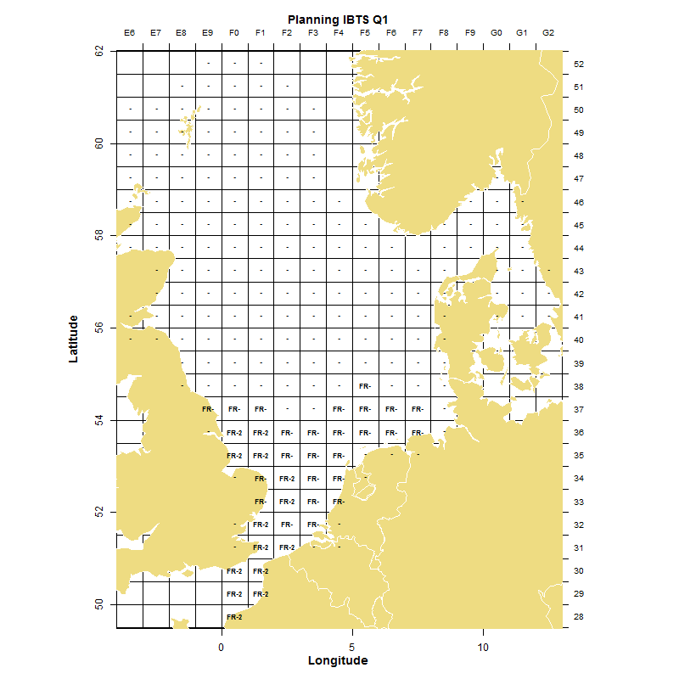
IBTS_Q1 French survey sampling scheme.

3. For internationally coordinated surveys, describe the participating Member States/vessels and the relevant international group in charge of planning the survey
The southern North Sea area is sampled by France and partly by the Netherlands and Denmark.
In addition to reporting at national level (for use by industry, government agencies and Regions), the main assessment groups using IBTS data are: the Herring Assessment Working Group (HAWG) for the area “South of 62°N” (trawl data and larvae net station data), the Working Group on the assessment of demersal stocks in the North Sea and Skagerrak (WGNSSK), and the Working Group on Assessment of New species (WGNEW). The International Bottom Trawl Survey Working Group (WGIBTS) also needs the data.

4. Where applicable, describe the international task sharing (physical and/or financial) and the cost sharing agreement used
Hauls stations are allocated between countries by WGIBTS. There is no survey cost sharing agreement involving France.

5. Explain where thresholds apply
Not relevant

(max. 450 words per survey)
6. Graphical representation (map) showing the positions (locations) of the realized samples.
Member State shall provide maps presenting the spatial distribution of the main sampling types obtained during the survey.
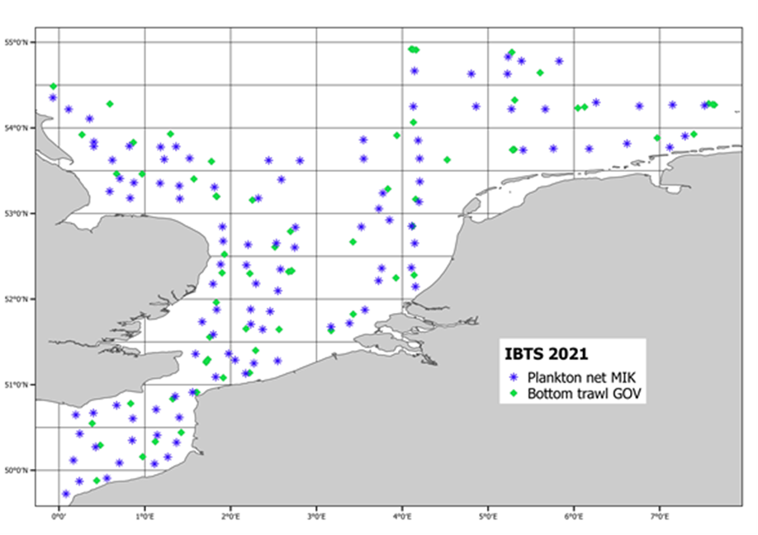

7. For internationally coordinated surveys, provide a link to the latest meeting report of the coordination group.
Member State shall provide a hyperlink to the meeting report from the body coordinating the survey (ICES, MEDITS coordination group, MEDIAS coordination group etc.). For non-international coordinated surveys, Member State shall refer to any status report (e.g. Cruise report).
The latest IBTSWG report is available at the ICES website:
https://backend.orbit.dtu.dk/ws/portalfiles/portal/256262842/IBTSWG_Report_2021.pdf

8. List the main use of the results of the survey (e.g. indices, abundance estimates, environmental indicators).
Member State shall specify in which context the results are used (on routine basis), both on an international as well as on a national context.
The protocols and scheduled operations lead to collect data on individual biological parameters. The data is used to estimate abundance and ecosystemic indicators. Raw data and indicators can be found at the following address:
https://www.ices.dk/data/data-portals/pages/default.aspx

9. Extended comments (Tables 1G and 1H) If the Member State has extended AR Comments, these can be placed under this section. If this is the case, a reference to this text box should be provided in the corresponding tables.
Some samplings are not conducted every year or the sampling plan is adapted according to MSFD objectives and fundings. A reduced number of phytoplankton and floating litter samples were carried out in 2021 during this survey.
(max 450 words per survey)

2. Western IBTS fourth quarter (including Porcupine survey) - IBTS_Q4 (French survey)
1. Objectives of the survey
The EVHOE survey (EValuation des ressources Halieutiques de l'Ouest Européen - Assessment of Fisheries Resources in Western Approaches) contributes to the Western IBTS 4th quarter surveys. The survey covers fish and invertebrate species in the Bay of Biscay and Central Celtic Sea and provides abundance indices for demersal species (total, recruitment and by age for selected species). Further, the collected data makes it possible to estimate the recruitment level of the several species of commercial interest. The data also contribute to numerous research programmes on the biology and distribution of selected species and on trends of fish and shellfish populations in the Bay of Biscay and Celtic Sea. In the Bay of Biscay the first survey took place in 1987. In 1997 the survey area was extended to include the Celtic Sea.

2. Description of the methods used in the survey. For mandatory surveys, link to the manuals. Include a graphical representation (map)
Each year, bottom trawling is carried out from mid-October to early December (45 days, 155 stations, research vessel “Thalassa”) using standard protocols (sampling plan, fishing gear, catch analysis protocol). The survey design was recently revised to become a stratified systematic unaligned design with fixed stations. The new designed was approved by WGIBTS and is implemented from 2016. For each haul, all fish are identified and measured. For several commercial species otolithes are sampled for age reading; species composition of benthos is regularly observed. Biological parameters for commercially exploited species are collected in accordance with the sampling plan designed and coordinated by the ICES IBTS working group. Temperature and salinity profiles are collected for each haul. Sampling plans for monitoring zooplankton, benthos and litter items, as well as bird and mammal observations have been implemented in recent years (table 1H of the 2018 annual report).
The main species relevant for stock assessment are cod, haddock, red gurnard, megrim, black and white anglerfish, hake, greater forkbeard, mackerel, and various rays and skates.
This series is also coordinated internationally by the ICES IBTS Working group, with protocols defined by the DATRAS project.
EVHOE manual: http://datras.ices.dk/Documents/Manuals/Manuals.aspx

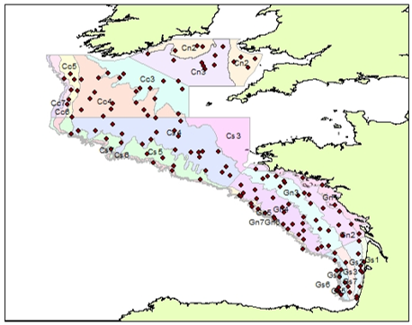
IBTS_Q4 French survey sampling scheme.

Data quality checking and data storage follow the same procedures as for IBTS (see previous section). The validated data are uploaded to the “Scientific surveys” module of Ifremer’s Harmonie database. A data set is also transmitted to ICES in the stipulated formats.
The collected information contributes to the production of survey-derived ecosystem indicators (codes 1 to 4 of Appendix XIII of the technical Decision).

3. For internationally coordinated surveys, describe the participating Member States/vessels and the relevant international group in charge of planning the survey
No other countries participate. The survey is internationally coordinated by WGIBTS.
In addition to national reporting purposes (for use by industry, government agencies and Regions), the main users of EVHOE data are the ICES working groups assessing stocks in the North Eastern Atlantic, the Celtic Sea and the Bay of Biscay: Working Group for the Bay of Biscay and the Iberian Waters Ecoregion (WGBIE), Working Group for the Celtic Seas Ecoregion (WGCSE) and Stocks, Working Group on Elasmobranch Fishes (WGEF), Working Group on Widely Distributed Stocks (WGWIDE) Working Group on Biology and Assessment of Deep-sea Fisheries Resources (WGDEEP), in addition of course to WGIBTS.

4. Where applicable, describe the international task sharing (physical and/or financial) and the cost sharing agreement used
Not applicable.

5. Explain where thresholds apply
Not relevant
(max. 450 words per survey)
6. Graphical representation (map) showing the positions (locations) of the realized samples.
Member State shall provide maps presenting the spatial distribution of the main sampling types obtained during the survey.
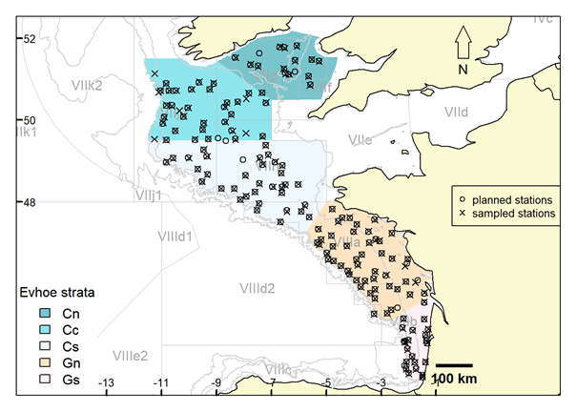

7. For internationally coordinated surveys, provide a link to the latest meeting report of the coordination group.
Member State shall provide a hyperlink to the meeting report from the body coordinating the survey (ICES, MEDITS coordination group, MEDIAS coordination group etc.). For non-international coordinated surveys, Member State shall refer to any status report (e.g. Cruise report).
The latest IBTSWG report is available at the ICES website:
- https://www.ices.dk/community/groups/Pages/IBTSWG.aspx
- 2021 report : https://doi.org/10.17895/ices.pub.8219
8. List the main use of the results of the survey (e.g. indices, abundance estimates, environmental indicators).
Member State shall specify in which context the results are used (on routine basis), both on an international as well as on a national context.
The protocols and scheduled operations lead to the calculation of abundance and biomass indices utilized for stock evaluation and ecosystem indicators. Raw data and indicators can be found at the following address:
https://www.ices.dk/data/data-portals/pages/default.aspx

9. Extended comments (Tables 1G and 1H) If the Member State has extended AR Comments, these can be placed under this section. If this is the case, a reference to this text box should be provided in the corresponding tables.
Not relevant.
(max 450 words per survey)

3. Sardine, Anchovy, Horse Mackerel Acoustic Survey – SAHMAS (French survey)
1. Objectives of the survey
The PELGAS survey is the French contribution to the international Sardine, anchovy, horse mackerel acoustic survey (SAMHAS) in the Bay of Biscay. The PELGAS survey aims at monitoring pelagic ecosystem, in order to provide scientific data for implementing an ecosystem-based management of the Bay of Biscay living resources. The spatial and temporal dynamics of small pelagic fish populations are specifically monitored, with focus on anchovy. The survey takes place in spring, during anchovy spawning, to allow for the assessment of both eggs and adult stages. Anchovy, sardine, horse mackerel, sprat and mackerel biomass estimates and information on population structure (length and age structure…) are derived from the survey data. Anchovy and sardine eggs distribution and abundance, as well as hydrological conditions are also assessed during the PELGAS survey.

2. Description of the methods used in the survey. For mandatory surveys, link to the manuals. Include a graphical representation (map)
The PELGAS survey is internationally coordinated by the ICES WGACEGG working group. Methods have been validated by WGACEGG and are described in details in the survey protocols manual.
The survey is performed in May onboard Research Vessel Thalassa. Data are collected continuously during daytime along 27 parallel transects covering the whole Bay of Biscay. Multibeam and multifrequency (6 frequencies) echosounders provide real time information on the spatial patterns and abundance of small pelagic fish. Simultaneously, a Continuous Fish Eggs Sampler (CUFES) provide complementary information on anchovy and sardine eggs. The presence and abundance of seabirds and marine mammals are also continuously recorded along transects during daytime. The species composition of fish school echoes are identified by midwater trawling, performed in an adaptative manner. CTD stations and zooplankton net casts are performed at night to characterize the small pelagic fish biotic and abiotic environment.
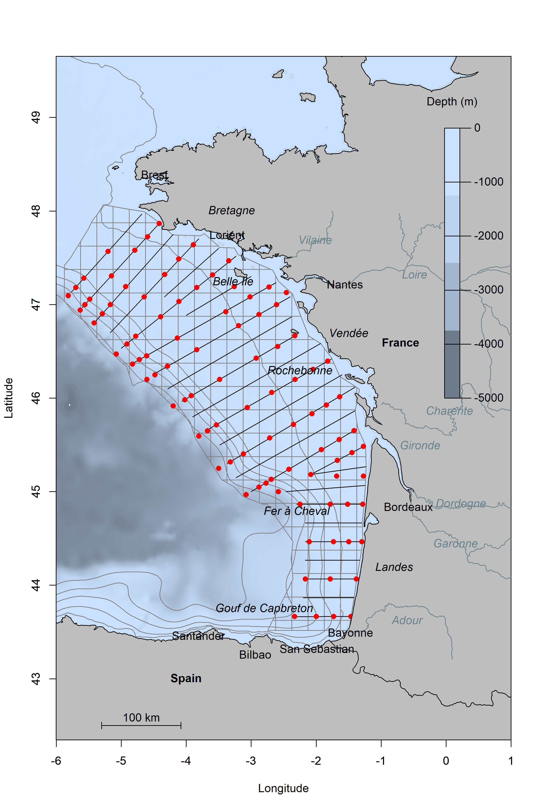
SAHMAS French survey sampling scheme. Acoustic/CUFES transects (black lines) and hydrobiological stations (red dots).

Acoustic data are recorded in real time and processed using the Movies3D software. CUFES samples are processed onboard using the Zoocam egg and mesozooplankton scanner system, which allows for the semi-automatic identification and counting of anchovy and sardine eggs. Fish biological samples are recorded and analysed at sea, including anchovy and sardine age readings. Acoustic and fishing data are combined using the EchoR R package, to derive small pelagic fish biomass estimates and distribution maps.
A commercial pair trawler, sponsored by national fundings, has accompanied Thalassa during Pelgas since 2007 to increase the effort devoted to fish echotraces identification. Catches made on commercial vessels are processed following the same protocol as on Thalassa.
Acoustic and fishing data, as well as biomass assessment results are stored in the EchoBase relational database. Acoustic and fishing data are shared within the ICES ACEGG working group. They will be stored in the ICES dedicated database when it becomes available.
Anchovy, sardine, mackerel, horse mackerel, blue whiting and boarfish biomass estimates derived from data collected during PELGAS are provided to ICES stock assessment groups (WGHANSA and WGWIDE).

3. For internationally coordinated surveys, describe the participating Member States/vessels and the relevant international group in charge of planning the survey
The PELGAS survey is the French contribution to the international Sardine, anchovy, horse mackerel acoustic survey (SAMHAS), covering the Bay of Biscay. The survey is internationally coordinated within the ICES WGACEGG working group, comprising scientists from Spain, Portugal, France, United Kingdom and Ireland.

4. Where applicable, describe the international task sharing (physical and/or financial) and the cost sharing agreement used
Not applicable.

5. Explain where thresholds apply
Not relevant.
(max. 450 words per survey)
6. Graphical representation (map) showing the positions (locations) of the realized samples.
Member State shall provide maps presenting the spatial distribution of the main sampling types obtained during the survey.
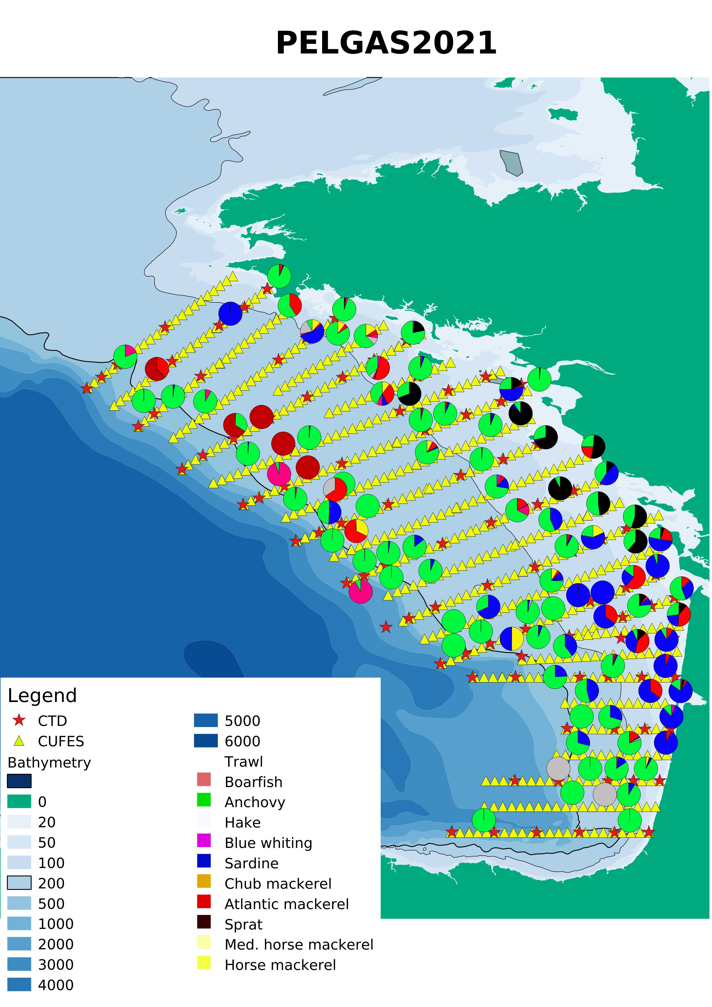

7. For internationally coordinated surveys, provide a link to the latest meeting report of the coordination group.
Member State shall provide a hyperlink to the meeting report from the body coordinating the survey (ICES, MEDITS coordination group, MEDIAS coordination group etc.). For non-international coordinated surveys, Member State shall refer to any status report (e.g. Cruise report).
ICES. 2021. Working Group on Acoustic and Egg Surveys for small pelagic fish in NE Atlantic (WGACEGG; outputs from 2020 meeting) ICES Scientific Reports. 3:76. 706 pp. https://doi.org/10.17895/ices.pub.8234

8. List the main use of the results of the survey (e.g. indices, abundance estimates, environmental indicators).
Member State shall specify in which context the results are used (on routine basis), both on an international as well as on a national context.
Anchovy and sardine 8abd: total biomass, numbers at age, weight and length at age estimates provided to ICES WGHANSA stock assessment group.
Boarfish, horse mackerel, Atlantic mackerel and blue whiting 8abd: numbers at length provided to ICES WGWIDE stock assessment group.
Gelateneous macro-zooplankton, megafauna and marine litter data provided to Marine Strategy Framework Directive national focal point.
Environmental indices provided to national database SISMER.

9. Extended comments (Tables 1G and 1H)
If the Member State has extended AR Comments, these can be placed under this section. If this is the case, a reference to this text box should be provided in the corresponding tables.
According to NWP, organism collection for contaminants and food web was not conducted in 2021.

(max 450 words per survey)

4. Mediterranean international bottom trawl survey - MEDITS (French survey)
1. Objectives of the survey
The aim of the MEDITS-FR survey (French component of MEDITS international bottom trawl programme) is to determine the distribution, abundance and length (age) structure of demersal fish and shellfish species in the trawlable areas between 10m and 800 m on the East coast of Corsica (GSA 8) and in the Gulf of Lions (GSA 7). The MEDiterranean International bottom Trawl Survey (MEDITS) programme was launched in 1994 at the instigation of the European Commission. It involves participants from all Mediterranean and Black Sea Member States, plus some third countries depending on the year.

2. Description of the methods used in the survey. For mandatory surveys, link to the manuals. Include a graphical representation (map)
The international MEDITS series covers a large part of the Mediterranean and Black Sea.
hyperlink: http://www.sibm.it/SITO%20MEDITS/principaleprogramme.htm
Each year, around 90 bottom trawl hauls (respectively 66 in GSA 7 and 24 in GSA 8) are carried out by the research vessel “L'Europe” in late Spring (35 days at sea between May and early July) following a standardised protocol common to all the participant countries. Hauls positions are replicated as far as feasible from year to year, last thirty minutes (one hour >200m) and are coupled with regular measurements of bottom water temperature. All catches of fish, crustaceans and cephalopods are sorted, counted and weighed, according to the MEDITS standardised protocols. According to these protocols, 84 commercially important species are length measured, and sex and maturity stages are determined. Otoliths are collected for age reading for hake, red mullets (2 species), seabass, and gilthead seabream, and also illicia for anglerfish (2 species). Hydrological operations are performed at each trawl station. Litter items in the catch are sorted, counted and weighted and fish samples are collected for research studies (contaminants, diet,..).

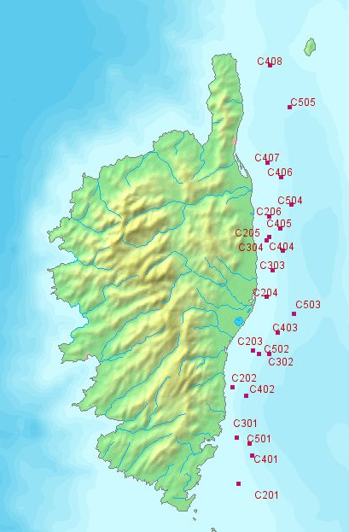
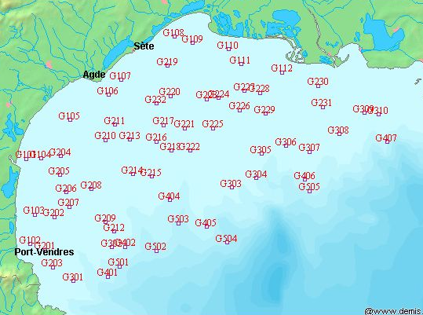
MEDITS French survey sampling scheme (Gulf of Lions on left, eastern Corsica on right).

The data are validated by being reread and checked on board, where they are recorded in a temporary database. On land, consistency checks are applied to the data using automatic protocols. In addition, effort is maintained to improve continuously the quality of the data collected at sea: identification manual for the species caught during MEDITS surveys (2007), photographic atlas of the stages of maturity of the main species (renewed in 2009 and 2010). Finally the yearly validated data set is uploaded to the “Scientific surveys” module of Ifremer’s central database “Harmonie”.
The data are used at international level by the MEDITS group. A common exchange format in three tables was agreed between the data providers but there exist no regional database for raw data. However, the MEDITS group makes data available (accessible to the general public) standardised population indices validated by experts and which reflect the trends observed in populations abundances and catch composition.

3. For internationally coordinated surveys, describe the participating Member States/vessels and the relevant international group in charge of planning the survey
The survey is coordinated by the MEDITS group.
France is the only country covering the gulf of Lions and eastern Corsica.
In addition to national data reporting (for use by industry, government agencies and Regions), MEDITS data are also used by GFCM working groups and sub-groups of STECF, e.g. SGMED.

4. Where applicable, describe the international task sharing (physical and/or financial) and the cost sharing agreement used
There is no survey cost sharing agreement involving France.

5. Explain where thresholds apply
Not relevant.
(max. 450 words per survey)
6. Graphical representation (map) showing the positions (locations) of the realized samples.
Member State shall provide maps presenting the spatial distribution of the main sampling types obtained during the survey.
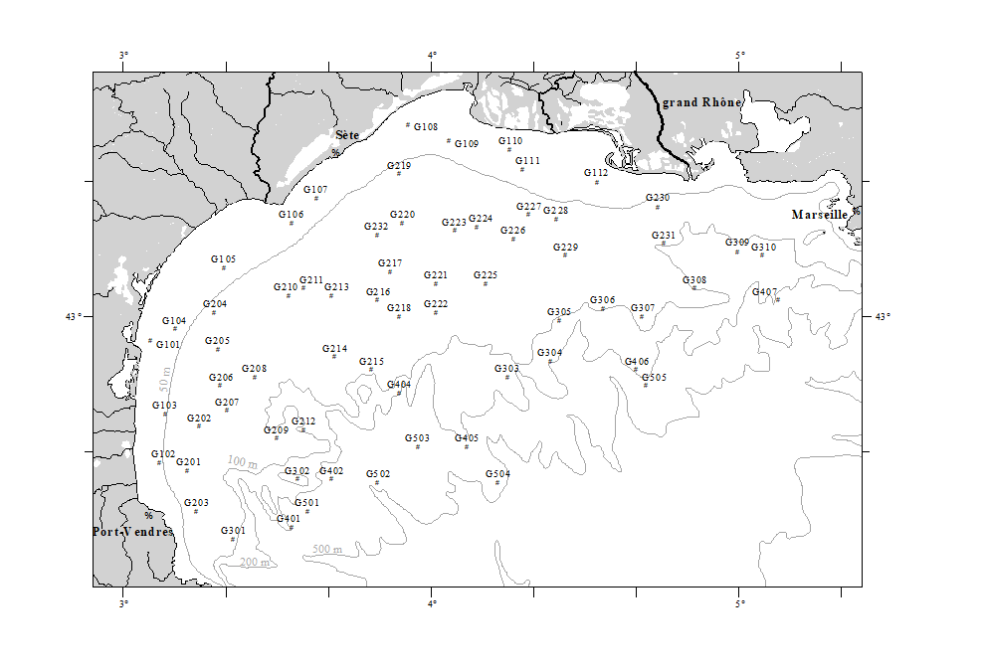
MEDITS – Gulf of Lions – 2021

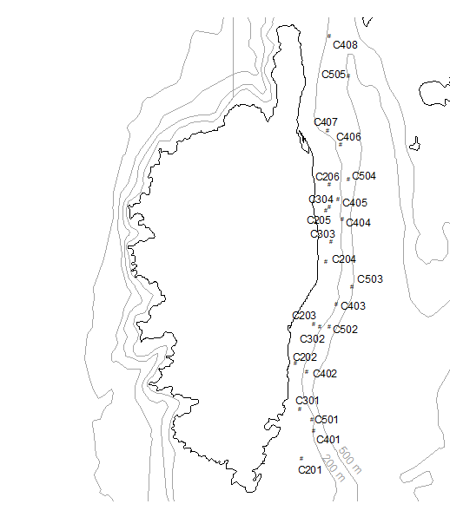
MEDITS – Eastern Corsica – 2021

7. For internationally coordinated surveys, provide a link to the latest meeting report of the coordination group.
Member State shall provide a hyperlink to the meeting report from the body coordinating the survey (ICES, MEDITS coordination group, MEDIAS coordination group etc.). For non-international coordinated surveys, Member State shall refer to any status report (e.g. Cruise report).

https://cloudfs.hcmr.gr/index.php/s/D8fqlmTLYDdnBoI

8. List the main use of the results of the survey (e.g. indices, abundance estimates, environmental indicators).
Member State shall specify in which context the results are used (on routine basis), both on an international as well as on a national context.
MEDITS data are being used routinely to build abundance index for STECF and GFCM stock assessment groups, to document MSFD descriptors 1 and 6, to respond to referrals from the Directorate of Maritime Fisheries and Aquaculture, to document impact assessment for windfarm establishment, to establish spatio-temporal closure areas in the context of the West-Med management plan, to feed various model of fishing fleet management (IAM, ISIS-FISH) within the context of the management plan (STECF), and to support many research initiatives (PhDs, Post-docs).

9. Extended comments (Tables 1G and 1H)If the Member State has extended AR Comments, these can be placed under this section. If this is the case, a reference to this text box should be provided in the corresponding tables.

(max 450 words per survey)

5. Pan-Mediterranean pelagic survey - MEDIAS (French survey)
1. Objectives of the survey
The aim of the French PELMED survey is to increase our understanding of the pelagic ecosystem in the Gulf of Lions using acoustic transects accompanied by pelagic trawl hauls to identify echo-traces detected. In particular it allows us to estimate biomass indices of the main small pelagic species in the Gulf of Lions, as well as their biological characteristics (length- and age-structure, sex ratio, maturity, body condition indices). Those indices constitute the basis of stock assessments for anchovy and sardines (GFCM and STECF). Further, the survey also permits a better characterisation of the spatial distribution of small pelagics both in the water column and geographically. Finally, the monitoring covers the entire ecosystem from physical measurements to seabird and marine mammal observation through to plankton sampling. All protocols are carried out according to the MEDIAS protocol and DCF requirements.

2. Description of the methods used in the survey. For mandatory surveys, link to the manuals. Include a graphical representation (map)
PELMED surveys started in 1993. In the Gulf of Lion, systematic sampling is performed along 9 parallel and regularly spaced transects (inter-transect distance = 12 nautical miles). From 2008 to 2013, an extension in the North Catalan Sea was conducted to better cover the small pelagics distribution. This extension is no longer conducted since 2016 as Spain now covers the area using the MEDIAS protocole. In replacement, the survey has been extended towards the East (see map below RAB -> RKL) to better cover the sardine habitat.
The protocol is similar to the PELGAS survey in the Bay of Biscay. Acoustic data are obtained by means of echosounders (Simrad ER60) and recorded at constant speed of 8 nm.h⁻¹. A 3D-echosounder (Simrad ME70) is also now installed and used discriminate schools. The size of the elementary distance sampling unit (EDSU) is 1 nautical mile. Discrimination between species is done both by echo trace classification and trawl composition. Each time a fish trace is observed for at least 2 nm on the echogram, the boat turns around to conduct a ~30 min-trawl at 4 nm.h⁻¹ to evaluate species composition and length distribution. While all 5 frequencies are visualized during sampling and help deciding when to conduct a trawl, only the energies from the 38kHz echosounder are used to estimate fish biomass.
Adopting an ecosystem approach, observations and counts of cetaceans and birds encountered on the survey transects are also made. Hydrological stations are performed in the middle of each trawl and at the ends of each transect. This comprises plankton nets, CTD casts, and water sampling through Niskin bottles.

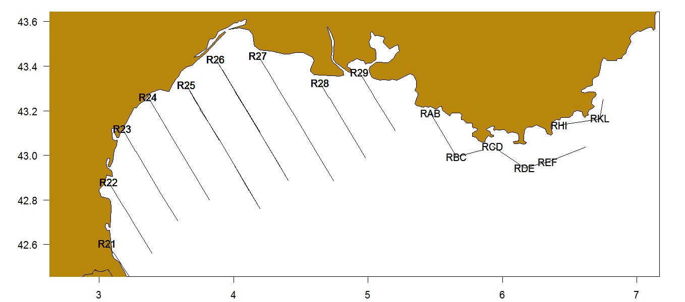
MEDIAS French survey sampling scheme.

The MEDIAS protocol is applied. This guarantees availability of data under the required format, allowing potential use to estimate ecosystem indicators linked to the scientific surveys (codes 1 to 4 of appendix XIII of the technical Decision 93/2010/EU).
Sixteen transects totalling around 325 nautical miles of acoustic acquisition are planned, along witch two or three daily trawl hauls coupled with hydrology parameters collection will be performed on echo- detections not exceeding the 200-metre isobath.

3. For internationally coordinated surveys, describe the participating Member States/vessels and the relevant international group in charge of planning the survey
In addition to national data reporting (for the industry, government agencies and Regions), PELMED data are also used by GFCM working groups and sub-groups of STECF such as SGMED. Further, data are presented and surveys discussed each year at the annual MEDIAS working group.

4. Where applicable, describe the international task sharing (physical and/or financial) and the cost sharing agreement used
Not applicable

5. Explain where thresholds apply
Not relevant.

(max. 450 words per survey)
6. Graphical representation (map) showing the positions (locations) of the realized samples.
Member State shall provide maps presenting the spatial distribution of the main sampling types obtained during the survey.
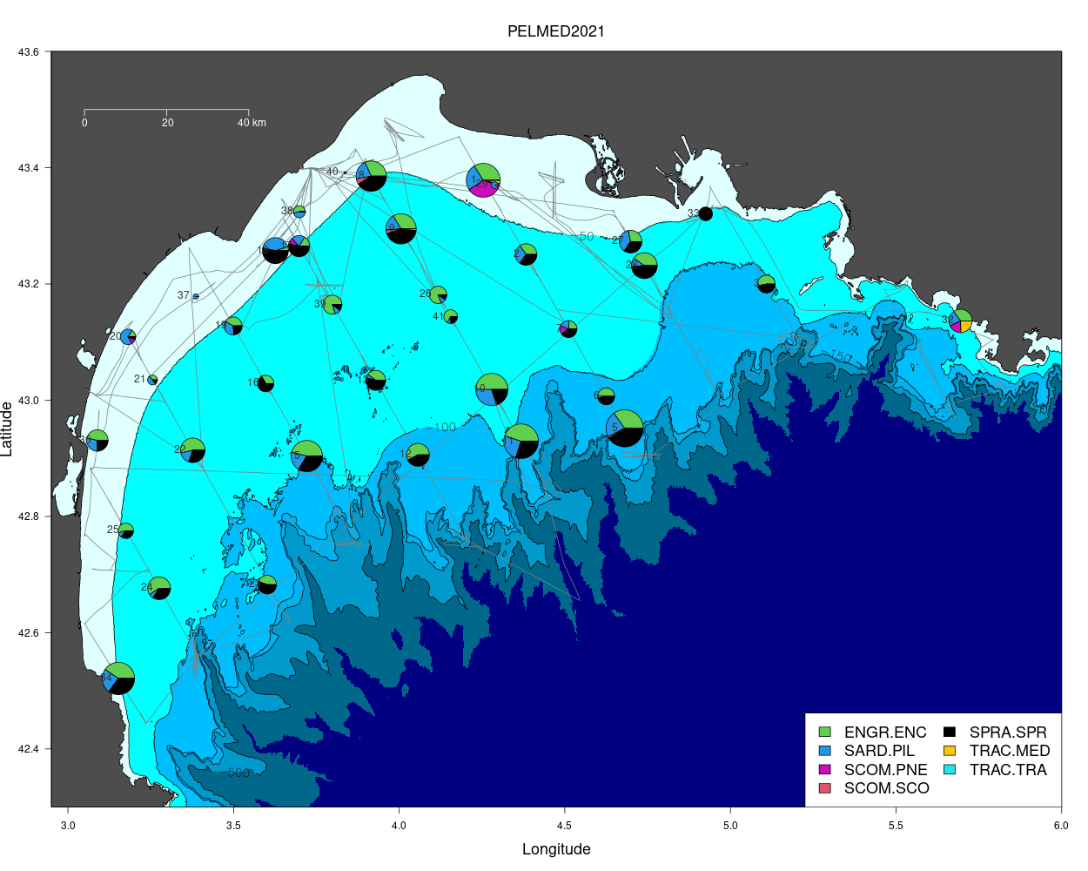
Map trawl positions and species composition in 2021. The gray lines represent the vessel course
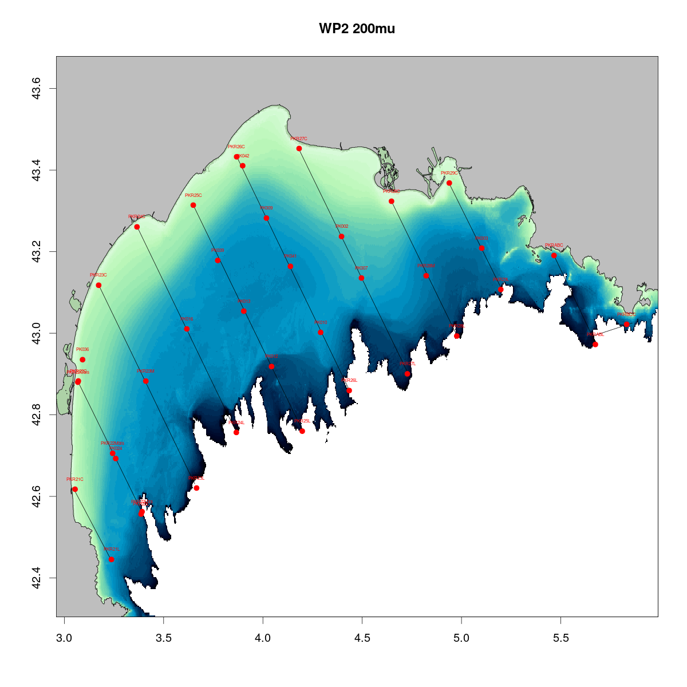
Map of hydrological stations sampled in 2021

7. For internationally coordinated surveys, provide a link to the latest meeting report of the coordination group.
Member State shall provide a hyperlink to the meeting report from the body coordinating the survey (ICES, MEDITS coordination group etc.). For non-international coordinated surveys, Member State shall refer to any status report (e.g. Cruise report).
Latest Medias meeting report is available at the following website:
http://www.medias-project.eu/medias/website/meetingrep.html

8. List the main use of the results of the survey (e.g. indices, abundance estimates, environmental indicators).
Member State shall specify in which context the results are used (on routine basis), both on an international as well as on a national context.
Biological data collected during the Medias survey are mainly used for stock assessment of small pelagic fish (Sardine and Anchovy) realized within GFCM working groups and sub-groups of STECF. For Sardine, biomasses estimates are used to calibrate a 2-stage biomass model. This model requires a series of catch as well as 2 independent tuning series (an index of recruitment and an index of adult biomass). Both tuning indices are obtained from the Medias acoustic survey. In regards to Anchovy, the stock assessment relies on a statistical catch-at-age model (Assessment for All Initiative (a4a)) which is also tuned using the abundance-at-age estimates from Medias survey. Besides, Medias data are also used to calculate biomass reference points (e.g. Blim defined as the lowest biomass from which a recovery has been confirmed) based on empirical analysis of time series of biomass estimates.
Hydrological and biological data collected during Medias survey are used for the purposes of the Marine Strategy Framework Directive (MSFD) French legislation. These data are sent to the national scientific pilot of the different MSFD descriptors (e.g. contaminants, food web, pelagic habitat, commercial species) to derive qualitative descriptors of environmental status. Since 2020 a microplastic monitoring with a MANTA net has been carried out for the purposes of the Marine Strategy Framework Directive (MSFD) French legislation.

9. Extended comments (Tables 1G and 1H)
If the Member State has extended AR Comments, these can be placed under this section. If this is the case, a reference to this text box should be provided in the corresponding tables.

(max 450 words per survey)

6. Chanel Ground Fish Survey – IBTS_Q4 (French survey)
1. Objectives of the survey
The Channel GroundFish Survey (CGFS) aims at estimating the abundance and distribution of demersal fish stocks, independently of commercial fisheries data, in the ICES area 7d (eastern English Channel). This bottom trawl survey, conducted in October every year since 1988 following a standard protocol, provides data for exploited stocks (total abundance; recruitment index; spatial distribution; maturity; age/size structure). This survey also collects data on non-commercial species and other biological compartments (benthic invertebrates, plankton…) as input to an ecosystem approach to fisheries.

2. Description of the methods used in the survey. For mandatory surveys, link to the manuals. Include a graphical representation (map)
Since 1988, the ICES area 7d has been sampled annually during 30 days in October following a fixed sampling design with about 88 trawling stations. At the time of the vessel change in 2014 from R/V Gwen Drez to R/V Thalassa, the sampling scheme was optimized and is now composed of about 70 stations, sampled in 16 days. Both the intercalibration realised between the vessels and the optimized sampling scheme have been validated by WGIBTS. CGFS follows the standard protocol and uses the standard bottom trawl “gear A” (GOV 36/47) to conduct 30min tows during day-light. All individuals from the haul are sorted, identified, weighted, counted and measured, according to IBTS standardised protocols. A subset of species is also subject to sex and maturity determination associated to otolith sampling for age reading, in relation with DCF requirements (plaice, sole, cod, whiting, red mullet, pouting, red gurnard, seabass). In addition to fish and cephalopods, benthic invertebrates and gelatinous organisms are also determined, counted and weighed. Litter in the trawl is sorted, counted and weighed at each station and additional biological sampling may be conducted for different purposes (e.g. MSFD requirements, request from ICES working groups, studies on genetics, food web, etc.). Hydro-biological data are gathered from CTD profiles, water sampling through Niskin bottles and zooplankton nets. Fish egg sampling (mostly sardine and horse mackerel eggs) is realised en route using a pumping device associated to semi-automatic identification software. Finally, onboard observers record birds and mammals encountered.
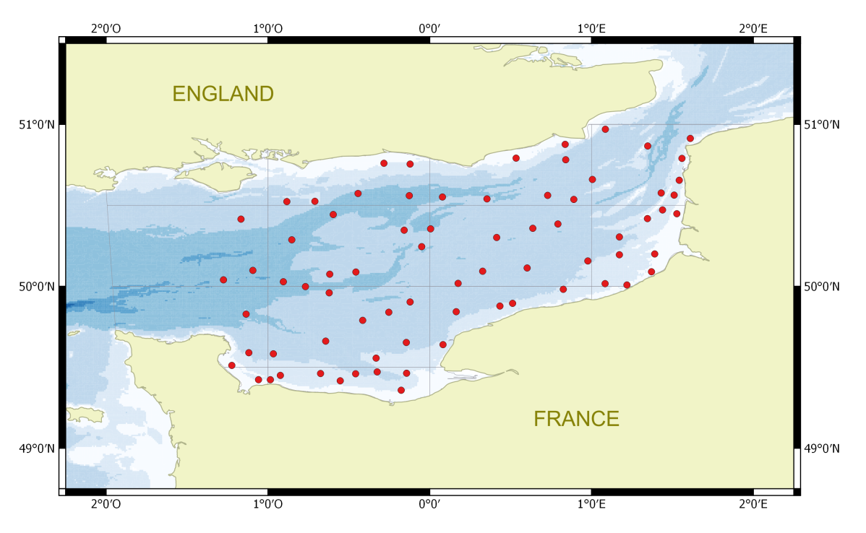
IBTS_Q4 French survey sampling scheme.

3. For internationally coordinated surveys, describe the participating Member States/vessels and the relevant international group in charge of planning the survey
The CGFS survey is coordinated by WGIBTS. As such, the data collected during each survey are validated (on board and at land) and formated before being uploaded to the common database DATRAS. Global abundance or biomass indices are computed as well as abundance-by-age indices for some species, to be used in the stock assessment of plaice, red-mullet, seabass, squids, cuttlefish, horse mackerel and elasmobranchs by the ICES working groups WGNSSK WGCEP, WGWIDE, WGEF, WGCSE.

4. Where applicable, describe the international task sharing (physical and/or financial) and the cost sharing agreement used
Not applicable.

5. Explain where thresholds apply
Not relevant.
(max. 450 words per survey)
6. Graphical representation (map) showing the positions (locations) of the realized samples.
Member State shall provide maps presenting the spatial distribution of the main sampling types obtained during the survey.

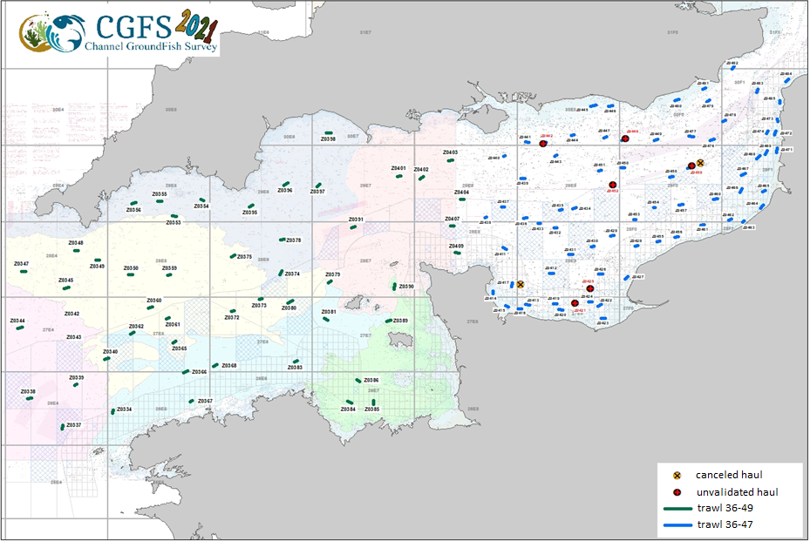
Since 2018, the survey has been extended to the western part of the Channel (ICES area 7e (western Channel), with the same data collection objectives. This series, once validated, aims to be integrated into the DATRAS database.

7. For internationally coordinated surveys, provide a link to the latest meeting report of the coordination group.
Member State shall provide a hyperlink to the meeting report from the body coordinating the survey (ICES, MEDITS coordination group, MEDIAS coordination group etc.). For non-international coordinated surveys, Member State shall refer to any status report (e.g. Cruise report).
The latest IBTSWG report is available at the ICES website:
https://ices-library.figshare.com/articles/report/International_Bottom_Trawl_Survey_Working_Group_IBTSWG_/18618368

8. List the main use of the results of the survey (e.g. indices, abundance estimates, environmental indicators).
Member State shall specify in which context the results are used (on routine basis), both on an international as well as on a national context.
The protocols and scheduled operations lead to the calculation of ecosystem indicators. Raw data and indicators can be found at the following address: http://www.ifremer.fr/SIH-indices-campagnes/index
Abundance-at-age indices for red mullet and plaice, and global indices for seabass, cuttlefish and squids have been provided to the relevant ICES working groups. Hydrological and biological data collected during the survey are used for the purposes of the Marine Strategy Framework Directive (MSFD) French legislation.

9. Extended comments (Tables 1G and 1H)
If the Member State has extended AR Comments, these can be placed under this section. If this is the case, a reference to this text box should be provided in the corresponding tables.
This year's survey took place under normal conditions (33 days) and with the authorization to work in English waters received early enough in the process.
Ifremer was therefore able to carry out the entire program initially planned, validating 50 trawl stations in the Western Channel (out of 48) and 66 in the Eastern Channel (out of 74). In the Eastern Channel, we suffered 4 major incidents, and in the Bay of Seine, we had to seal off 2 stations in brittle stars areas. We also had to cancel 2 stations due to the presence of professional equipment in the area.
Phytoplankton sampling has been largely extended in 2021 (213 hauls instead of 45). 45 hauls were needed for the MSFD. 168 hauls were needed for a specific project called Forsea project. These extra-hauls hadno impact on the DCF sampling plan.

(max 450 words per survey)

7. Bay of Biscay Demersal Resources Survey – ORHAGO_Q4_FRA (French survey)
1. Objectives of the survey
The Bay of Biscay ORHAGO beam trawl survey aims to collect data on composition, distribution and change in relative abundance of benthic fish fauna on the continental shelf (<100m) on a yearly basis (quarter 4). Information are collected on length frequency for all the fish, with biological information (age, maturity) for some species. The main target species is sole, other abundant commercial species include (top 10 by decreasing numbers/hour in 2015): Norway lobster, hake, brown shrimp, cuttlefish, horse mackerel, common whelk, common spider crab, small-spotted catshark, greater weever and common prawn. Since 2013, the benthos is exhaustively sampled for all the hauls (for determination at the laboratory).

2. Description of the methods used in the survey. For mandatory surveys, link to the manuals. Include a graphical representation (map)
The ORHAGO survey was launched in 2007 to fulfil the need of a fishery independent abundance index for the Bay of Biscay sole stock which has been pointed out since many years by successive ICES WG and their review groups and as well as in ICES advice.
In accordance with ICES agreed gear for flatfish abundance surveys , the gear is 4m-beam trawl with chain mat, 50mm mesh in the net et 40 mm mesh in the cod-end.
The sampling plan was designed to ensure full coverage of the sole habitat in the Bay of Biscay during a period (November-December) for which fish behaviour and distribution was suitable for obtaining an unbiased abundance index (young fish move offshore when coastal waters become colder and before the concentrations of the spawning season). The sampling design is systematic sampling with 49 reference stations. The design was validated in 2007 by the ICES WGBEAM working group.
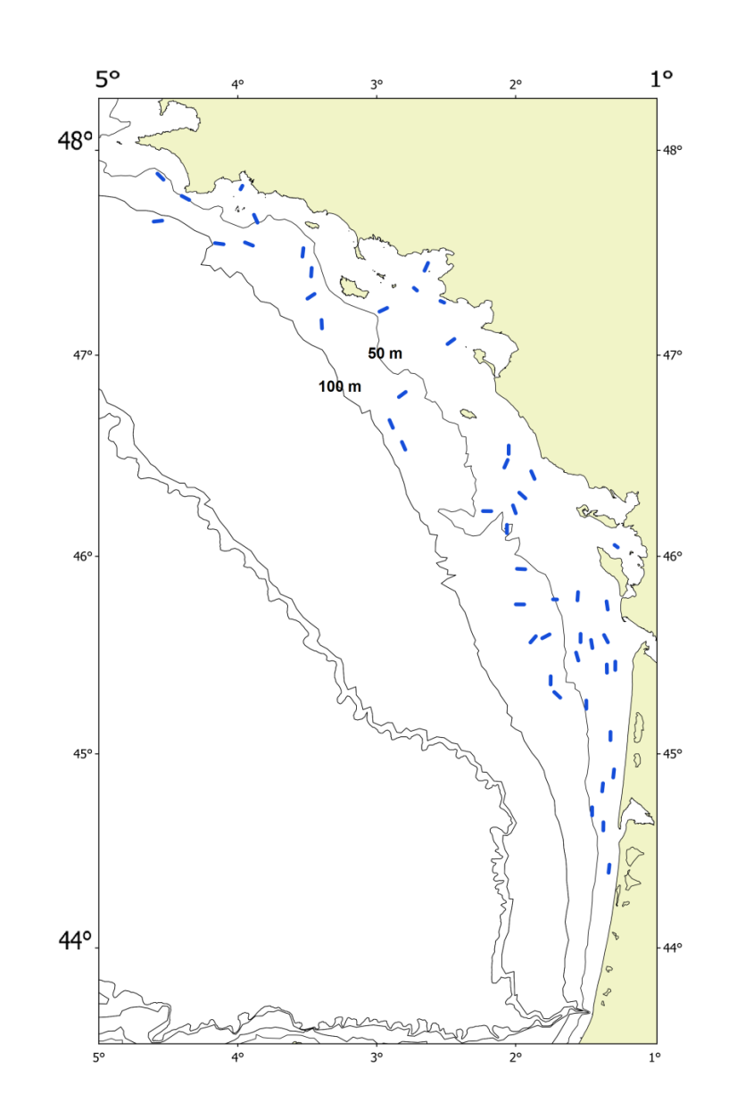
ORHAGO_Q4_FRA French survey sampling scheme.

3. For internationally coordinated surveys, describe the participating Member States/vessels and the relevant international group in charge of planning the survey
The ORHAGO survey is coordinated by the ICES WGBEAM working group.
WGBEAM has approved the calculation method for the Bay of Biscay sole stock abundance index at its 2013 meeting (daylight hauls for a set of reference stations). The same year, an interim benchmark approved the inclusion of the ORHAGO survey in the Bay of Biscay sole stock assessment. Since 2013, the ORHAGO survey has consequently been used to assess the status of this stock (WGMMM in 2013, WGBIE in 2014-2016).

4. Where applicable, describe the international task sharing (physical and/or financial) and the cost sharing agreement used
Not applicable.

5. Explain where thresholds apply
Not relevant.

(max. 450 words per survey)
6. Graphical representation (map) showing the positions (locations) of the realized samples.
Member State shall provide maps presenting the spatial distribution of the main sampling types obtained during the survey.
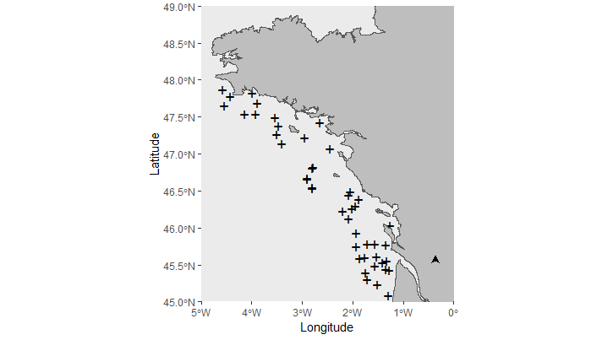
Map of trawl positions in 2021

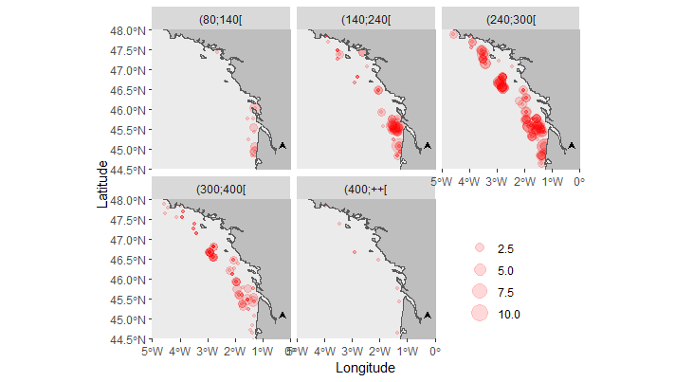
Map of common sole (Solea solea) catches in number per length class in mm in 2021.

7. For internationally coordinated surveys, provide a link to the latest meeting report of the coordination group.
Member State shall provide a hyperlink to the meeting report from the body coordinating the survey (ICES, MEDITS coordination group, MEDIAS coordination group etc.). For non-international coordinated surveys, Member State shall refer to any status report (e.g. Cruise report).
ICES. 2021. Working Group on Beam Trawl Surveys (WGBEAM). ICES Scientific Reports. 3:46. 89pp. https://doi.org/10.17895/ices.pub.8114
8. List the main use of the results of the survey (e.g. indices, abundance estimates, environmental indicators).
Member State shall specify in which context the results are used (on routine basis), both on an international as well as on a national context.
Since 2013, the ORHAGO surveys have been used by ICES WGBIE to assess the state of the Bay of Biscay sole stock. They allow this assessment to be analytical, i.e. carried out with a model to analyse and simulate the dynamics of the stock. The ORHAGO survey is also the only survey to provide abundance indices relevant for four other flatfishes species present on the continental shelf of the Bay of Biscay (Arnoglossus lanterna, Buglossidium luteum, Microchirus variegatus and Dicoglossa cuneate).
Since 2015, all benthos species have been identified and counted.

9. Extended comments (Tables 1G and 1H) If the Member State has extended AR Comments, these can be placed under this section. If this is the case, a reference to this text box should be provided in the corresponding tables.
CTD by haul is not collected during the survey : this is an error in the national Work Plan – CTD by haul is still indicated in NWP 2021, but error will be corrected in the 2022-2024 NWP.

(max 450 words per survey)

Section 2: Fishing Activity Data

Text Box 2A: Fishing activity variables data collection strategy
General comment: This box fulfills paragraph 4 of Chapter III of the Annex of the Delegated Decision (EU) 2019/910 on the multiannual Union programme; and Article 2, Article 4 paragraph (2) point (b) and Article 5 paragraph (2) of the Implementing Decision (EU) 2016/1701 on the format of the WP. It is intended to describe the method used to derive estimates on representative samples where data are not to be recorded under Regulation (EU) No 1224/2009 or where data collected under Regulation (EU) No 1224/2009 are not at the right aggregation level for the intended scientific use.
General comment:
Textboxes hereunder were modified compared to NWP to better reflect differences in data collection planned between regions (eg complementary on-site sampling of trips only perfomed in outermost regions) and allow comments on deviations by regions, thus modifications compared to submitted in NWP are highlighted in red.

Regarding fleet segmentation, when the French authorities submitted the 2020-2021 national work plan for data collection in the fisheries and aquaculture sectors, only an estimation of the fleet segments which will be effectively active in 2021 could be done (vessels could be inactive during the year or change fishing activity and gears between 2020 and 2021). In table 2A, are detailed the few (with very few vessels concerned) new fleet segment which have been observed in 2021 and also the ones which do not exist anymore. A resume of them is given hereunder:
New fleet segment in 2021:
- Supra-region Baltic Sea, North Sea, Eastern Arctic, NAFO, Extended North Western waters (Ices areas V, VI and VII) and Southern Western waters / Beam trawlers VL0010 – Purse seiners VL0010 – Beam trawlers VL1012 – Vessels using Polyvalent ‘passive’ gears only VL1218.
- Supra-region Mediterranean Sea and Black Sea / Dredgers VL0006 – Vessels using Polyvalent ‘passive’ gears only VL1218.
- Supra-region Others regions / Inactive vessels VL1218
Fleet segment with no more vessels attributed in 2021:
- Supra-region Baltic Sea, North Sea, Eastern Arctic, NAFO, Extended North Western waters (Ices areas V, VI and VII) and Southern Western waters Pelagic trawlers VL0010 – Vessels using Polyvalent ‘passive’ gears only VL1440 – Inactive vessels VL2440.
- Supra-region Mediterranean Sea and Black Sea / Vessels using other active gears VL0006 – Vessels using active and passive gears VL0006 – Inactive vessels VL40XX

Supra-region : Baltic Sea; North Sea; Eastern Arctic; NAFO; Extended North-Western waters (Ices areas V, VI and VII) and Southern Western waters
1. Description of methodologies used to cross-validate the different sources of data. 2. Description of methodologies used to estimate the value of landings. 3. Description of methodologies used to estimate the average price (it is recommended to use weighted averages, trip by trip)
The French fishing activity data in the supra-region Atlantic are based on the following sources of information:
- French fleet register (vessel characteristic (length overall, kilowatt, gross tonnage, age of the vessel), geographical indicator, total number of vessels)
- Annual fishing activity calendars survey (active/inactive vessels, typological classification of vessels by fleet/fishing technique, fishing area, metier, gears characteristics)
- Logbooks (over 10m’ vessels) and monthly declarative forms (less 10m’ vessels, declarative forms adapted to the special features of the small-scale coastal fisheries) (total weight of landings by species, fishing effort (number of trips, days at sea, fishing days and hours at sea), fishing area, gear and mesh size)
- Sales note data (total weight and value of landings by species)
- Geolocalisation data (inc. VMS data) (fishing effort (number of trips, days at sea, fishing days and hours at sea), fishing area)
- Complementary on-site sampling of trips (catch assessment survey) (total estimates of weight and value of landings by species and fishing effort (number of trips, days at sea, fishing days and hours at sea), fishing area, metier)
- Scientific observer on-board sampling data (gears characteristics)

The definition of the reference fleet population follows the definition of Commission decision 2016/1251 (any vessel registered on 31st December or which has fished at least one day in the year up to 31st December) in order to have a comprehensive view of the fishing activity applied during the year.

The definition of all the fishing trips of the French fleet with their associated features (dates, fishing area, metier, gear and mesh size, total weight and value of landings by species) is based on a cross-validation tool (SACROIS) of the different available data (fleet register, annual fishing activity calendars, logbooks, monthly declarative forms, sales note data, geolocalisation data), aiming at providing the best possible fishing statistics data.

SACROIS (http://sih.ifremer.fr/Description-des-donnees/Les-donnees-estimees/SACROIS) is a cross-validation tool for the fisheries statistics, aiming at cross-checking data from different declarative sources, as demanded in article 145 of the EU control Regulation (EC Reg. 404/2011). The application is crossing information, at the most disaggregated level, from the fishing fleet register, logbooks, monthly declarative forms, sales notes data, geolocalisation data and the scientific census of annual fishing activity calendars, in order to build a dataset compiling the most accurate and complete information for each individual fishing trip. The application verifies and controls the different sources of data, with the aim of displaying validated and qualified landings per species and effort data series. The application provides also several quality indicators and evaluates the completeness of the data flows.

A specific algorithm is included into SACROIS to estimate the value of landings based on sales note data available (sometimes directly deducted from them) or estimation of an average price. For some fleet segment, estimated price based on expert knowledges is also used. This algorithm allows to estimate value of almost every landings, only very few species/fleets do not have value assigned.

SACROIS include also the allocation of a single metier to a fishing trip, based on the dominant landed specie (or group of species) in value (by a raw ordination), the vessel’ activity calendar survey and eventually the declared gear (see detailed methodology explained in ‘Anonymous, DCF metier workshop report, 2018’).

For French fleets for which the coverage and precision of their available declarative data (basically SACROIS data) is insufficient to meet the end-users data needs (e.g. DCF requirements): 1/ complementary on-site sampling data could be collected (catch assessment survey) and-or 2/ re-evaluation methodology (on the basis on the annual fishing activity calendars survey), could be applied, in order to calculate the reference fishing activity’ estimates. The choice between one of these two methodologies is also based on the coverage and precision of the available declarative data.

For the French fishing fleet operating in the supra-region Atlantic, the coverage and precision of their available declarative data (basically SACROIS data) are considered sufficient to meet the end-user’s data needs (e.g. DCF requirements) and reference fishing activity’ estimates are directly deducted and calculated from SACROIS data.
Based on that, Therefore, fishing capacity and activity’ estimates could be calculated for the whole of the reference population (French fleet register’ vessels operating in the supra-region Atlantic including the small-scale fleets French fleet register including overseas fisheries, long distance fisheries and small-scale fleets, except the Other Regions – more than 24m length vessels, see below) and cover all the areas and fishing practices they are operated. where French vessels are operated.

During the scope of the precedent national program, quality of the available declarative data (logbooks and monthly declarative forms) on passive gears characteristics (Number of nets/Length, Number of hooks, Number of lines, Number of pots/traps) proved to be insufficient to reach DCF requirements and no improvement of the data capture software could be done. It is linked with the implementation of a new IT chain in 2009, which led to a less quality-controlled field to inform these data with the consequence of insufficient sub sample of declarative forms data with reliable gears characteristics information. In order to estimate these data, gears characteristics collected under the complementary survey: 1) Annual fishing activity survey and 2) Scientific observer on-board sampling will be used to calculate estimates. It is programed to follow 5% of the French fleets’ passive gears characteristics in 2019 through the annual fishing activity survey. Furthermore, the implementation of the new on-board sampling scheme in 2020 will probably also improve the coverage of these specific information by the scientific observer on-board sampling.

During the scope of the precedent national program, quality of the available declarative data (logbooks and monthly declarative forms) on passive gears characteristics (Number of nets/Length, Number of hooks, Number of lines, Number of pots/traps) proved to be insufficient to reach DCF requirements. Consequently, and since 2018, in order to be able to estimate these data, gears characteristics are collected under the following complementary surveys: 1) Annual fishing activity survey and 2) Scientific observer on-board sampling. Estimates are then deducted/calculated on this basis. It is programmed to follow at least 5% of the French fleets’ passive gears characteristics through the annual fishing activity survey for the principal fishing fleet operating in the supra-region Atlantic. These data are completed by the scientific observer on-board sampling where gears characteristics are also collected.
4. Description of methodologies used to plan collection of the complementary data (sample plan methodology, type of data collected, frequency of collection etc)
One complementary data set is collected.
Annual fishing activity survey is conducted by fishing observers yearly in France on the basis of preliminary documentation provided by available data (fleet register, logbooks, monthly declarative forms, sales note data, geolocalisation data, on-site samplings data). It covers the whole of the reference population (also vessels not cover by available data), take place every year in the first month of the year on the previous year and aim at characterizing each year the inactivity or activity of all the vessels each month of the year and, in the latter case, the metiers practiced and the main fishing areas (Berthou et al., 2008) . It is to be noticed that this procedure has the benefit to provide the metiers as given by the fisherman himself throughout the year on an exhaustive basis. This survey cover the whole of the French vessels (French fleet register including overseas fisheries, long distance fisheries and small-scale fleets) in all the supra-regions where French vessels operated. Such surveys provide information on the part of fishing activity not included in available declarative data (completeness check of the available declarative data) and also the basis, if necessary, to re-evaluate available fishing activity data estimates (in case of incomplete data for example). They constitute also an input each year for the typological classifications of vessels by fleet and a description of their metiers which in return makes also possible the definition of sampling plans to structure the routine data collection actions in response to the EU-MAP technical decision. They are also used to allocate metiers to each fishing trip. Finally, they are the exhaustive basis for doing estimation based on the on-site sampling data (for the fleets where such data has to be collected).
Complementary on-site sampling of trips (catch assessment survey) is used to estimate fishing activity variables estimates of vessels for which the coverage and precision of their available declarative data are insufficient to meet the end-users needs. The sampling scheme is based on the frame survey (Activity survey) useful to optimise the strategy of the spatio-temporal on-site sampling plan. Fishing trips features, effort and catches and weekly activity calendar (effort) are sampled directly on-site, when the fishers come back to the harbour. The raising method is based on a post-stratification of the fishing trips and weekly calendar sampled. Percentile bootstrap methodology is used to calculate the precision’ estimate. In 2020 and 2021, this will be applied for vessels under 12m in La Réunion, Mayotte, French Antilles and French Guiana (other regions, less than 12 meters).
The coverage and precision of the available declarative data of these fleets will be however analysed regularly during the scope of the present working plan and alternative methodology could be applied, during the period in which the present working plan will be applied, if they are judged sufficient and reliable to estimate the transversal variables. In this case, they could be eventually re-evaluated on the basis of the exhaustive activity calendar survey.
5. Others
Data presentation:
Fishing activity data on year N will be available for all segment and regions at two different stages:
A special data processing for stock assessment purpose, will be carried out in due time before stock assessment working groups, to allow experts to work with the “best” estimates available by the time of the working groups. So, a 1st procedure will provide estimates based on raw data from the different declarative forms, scaled to the known fishing activity of year N-1. They will be available to the scientific community on a quasi-real time basis (N+2 months) bearing the inherent risk of errors and incompleteness of working with unqualified and unvalidated data.
The official, qualified and validated effort data estimates on year N, with precision associated based on all the data available (including the different declarative forms and the data provided by the on-site samplings) scaled to the known fishing activity of year N will be available in June N+1.
(max 900 words per Region)
5. Deviations from Work Plan methodology used to cross-validate the different sources of data
No deviation from the WP in 2021.
The expected coverage of data collected under control regulation (% of fishing trips) was almost reached for all the fleet segment evolving in the supra-region Atlantic. Only the following Fleet segments present issues regarding their available declarative data’ coverage but it should be improved during the following months (regarding the delays observed to input the data in the database, especially for small-scale fleets): Vessels using other Passive gears VL0010 (79 vessels only 1/3 of coverage for 2/3 expected) and VL1218 (no declarative data available for one vessel / seven months).
Regarding the gear characteristics (Number of nets/Length, Number of hooks/lines, Number of pots/traps) ; where declarative are often insufficient to reach DCF requirements ; the complementary surveys (Annual fishing activity survey & scientific observer on-board sampling) have been collected to compensate the poor quality of the declarative data. For the majority of the fleet segments, the objective to follow at least 5% of the French fleets’ passive gears characteristics through the annual fishing activity survey was reached. In few cases, scientific observer on-board sampling should be used to complete the view. Furthermore, scientific observer on-board sampling information do not reach always the coverage percentage targeted (see Text-box 4A) but it generally compensates by the fishing activity survey. Finally, issues remain for only one fleet segment: Vessels using hooks VL2440 (20 vessels concerned) but for these large vessels, declarative data will be investigated to do the estimation as they present better quality than for the other fleet segments.
6. Deviations from Work Plan methodology used to estimate the value of landings.
No deviation from the WP in 2021.
7. Deviations from Work Plan methodology used to estimate the average price.
No deviation from the WP in 2021.
8. Deviations from Work Plan methodology used to plan collection of the complementary data
No deviation from the WP in 2021.
In supra-region Atlantic was reached the exhaustive coverage of the whole reference population for the Annual fishing activity survey (see hereabove).
(max 900 words per Region)

Supra-region: Mediterranean Sea and Black Sea
1. Description of methodologies used to cross-validate the different sources of data. 2. Description of methodologies used to estimate the value of landings. 3. Description of methodologies used to estimate the average price (it is recommended to use weighted averages, trip by trip)
The French fishing activity data in the supra-region Mediterranean are based on the following sources of information:
- French fleet register (vessel characteristic (length overall, kilowatt, gross tonnage, age of the vessel), geographical indicator, total number of vessels)
- Annual fishing activity calendars survey (active/inactive vessels, typological classification of vessels by fleet/fishing technique, fishing area, metier, gears characteristics)
- Logbooks (over 10m’ vessels) and monthly declarative forms (less 10m’ vessels, declarative forms adapted to the special features of the small-scale coastal fisheries) (total weight of landings by species, fishing effort (number of trips, days at sea, fishing days and hours at sea), fishing area, gear and mesh size)
- Sales note data (total weight and value of landings by species)
- Geolocalisation data (inc. VMS data) (fishing effort (number of trips, days at sea, fishing days and hours at sea), fishing area)
- Complementary on-site sampling of trips (catch assessment survey) (total estimates of weight and value of landings by species and fishing effort (number of trips, days at sea, fishing days and hours at sea), fishing area, metier)
- Scientific observer on-board sampling data (gears characteristics)

The definition of the reference fleet population follows the definition of Commission decision 2016/1251 (any vessel registered on 31st December or which has fished at least one day in the year up to 31st December) in order to have a comprehensive view of the fishing activity applied during the year.

The definition of all the fishing trips of the French fleet with their associated features (dates, fishing area, metier, gear and mesh size, total weight and value of landings by species) is based on a cross-validation tool (SACROIS) of the different available data (fleet register, annual fishing activity calendars, logbooks, monthly declarative forms, sales note data, geolocalisation data), aiming at providing the best possible fishing statistics data.

SACROIS (http://sih.ifremer.fr/Description-des-donnees/Les-donnees-estimees/SACROIS) is a cross-validation tool for the fisheries statistics, aiming at cross-checking data from different declarative sources, as demanded in article 145 of the EU control Regulation (EC Reg. 404/2011). The application is crossing information, at the most disaggregated level, from the fishing fleet register, logbooks, monthly declarative forms, sales notes data, geolocalisation data and the scientific census of annual fishing activity calendars, in order to build a dataset compiling the most accurate and complete information for each individual fishing trip. The application verifies and controls the different sources of data, with the aim of displaying validated and qualified landings per species and effort data series. The application provides also several quality indicators and evaluates the completeness of the data flows.

A specific algorithm is included into SACROIS to estimate the value of landings based on sales note data available (sometimes directly deducted from them) or estimation of an average price. For some fleet segment, estimated price based on expert knowledges is also used. This algorithm allows to estimate value of almost every landings, only very few species/fleets do not have value assigned.

SACROIS include also the allocation of a single metier to a fishing trip, based on the dominant landed specie (or group of species) in value (by a raw ordination), the vessel’ activity calendar survey and eventually the declared gear (see detailed methodology explained in ‘Anonymous, DCF metier workshop report, 2018’).

For French fleets for which the coverage and precision of their available declarative data (basically SACROIS data) is insufficient to meet the end-users data needs (e.g. DCF requirements): 1/ complementary on-site sampling data could be collected (catch assessment survey) and-or 2/ re-evaluation methodology (on the basis on the annual fishing activity calendars survey), could be applied, in order to calculate the reference fishing activity’ estimates. The choice between one of these two methodologies is also based on the coverage and precision of the available declarative data.
For the French fishing fleet over 12 meters length operating in the supra-region Mediterranean, the coverage and precision of their available declarative data (basically SACROIS data) are considered sufficient to meet the end-user’s data needs (e.g. DCF requirements) and reference fishing activity’ estimates are directly deducted and calculated from SACROIS data.
For the French fishing fleet less than 12 meters length operating in the supra-region Mediterranean, the coverage and precision of their available declarative data (basically SACROIS data) is evaluated as insufficient/incomplete to meet the end-user’s data needs (e.g. DCF requirements) but are judged sufficient and reliable nevertheless to estimate the fishing activity data. Consequently, a re-evaluation methodology (on the basis on the annual fishing activity calendars survey) is applied to calculate the reference fishing activity’ estimates for this fleet.

Based on that, Therefore, fishing capacity and activity’ estimates could be calculated for the whole of the reference population (French fleet register’ vessels operating in the supra-region Mediterranean including the small-scale fleets French fleet register including overseas fisheries, long distance fisheries and small-scale fleets, except the Other Regions – more than 24m length vessels, see below) and cover all the areas and fishing practices they are operated. where French vessels are operated.

During the scope of the precedent national program, quality of the available declarative data (logbooks and monthly declarative forms) on passive gears characteristics (Number of nets/Length, Number of hooks, Number of lines, Number of pots/traps) proved to be insufficient to reach DCF requirements and no improvement of the data capture software could be done. It is linked with the implementation of a new IT chain in 2009, which led to a less quality-controlled field to inform these data with the consequence of insufficient sub sample of declarative forms data with reliable gears characteristics information. In order to estimate these data, gears characteristics collected under the complementary survey: 1) Annual fishing activity survey and 2) Scientific observer on-board sampling will be used to calculate estimates. It is programed to follow 5% of the French fleets’ passive gears characteristics in 2019 through the annual fishing activity survey. Furthermore, the implementation of the new on-board sampling scheme in 2020 will probably also improve the coverage of these specific information by the scientific observer on-board sampling.

During the scope of the precedent national program, quality of the available declarative data (logbooks and monthly declarative forms) on passive gears characteristics (Number of nets/Length, Number of hooks, Number of lines, Number of pots/traps) proved to be insufficient to reach DCF requirements. Consequently, and since 2018, in order to be able to estimate these data, gears characteristics are collected under the following complementary surveys: 1) Annual fishing activity survey and 2) Scientific observer on-board sampling. Estimates are then deducted/calculated on this basis. It is programmed to follow at least 5% of the French fleets’ passive gears characteristics through the annual fishing activity survey for the principal fishing fleet operating in the supra-region Mediterranean. These data are completed by the scientific observer on-board sampling where gears characteristics are also collected.
4. Description of methodologies used to plan collection of the complementary data (sample plan methodology, type of data collected, frequency of collection etc)
One complementary data set is collected.
Annual fishing activity survey is conducted by fishing observers yearly in France on the basis of preliminary documentation provided by available data (fleet register, logbooks, monthly declarative forms, sales note data, geolocalisation data, on-site samplings data). It covers the whole of the reference population (also vessels not cover by available data), take place every year in the first month of the year on the previous year and aim at characterizing each year the inactivity or activity of all the vessels each month of the year and, in the latter case, the metiers practiced and the main fishing areas (Berthou et al., 2008) . It is to be noticed that this procedure has the benefit to provide the metiers as given by the fisherman himself throughout the year on an exhaustive basis. This survey cover the whole of the French vessels (French fleet register including overseas fisheries, long distance fisheries and small-scale fleets) in all the supra-regions where French vessels operated. Such surveys provide information on the part of fishing activity not included in available declarative data (completeness check of the available declarative data) and also the basis, if necessary, to re-evaluate available fishing activity data estimates (in case of incomplete data for example). They constitute also an input each year for the typological classifications of vessels by fleet and a description of their metiers which in return makes also possible the definition of sampling plans to structure the routine data collection actions in response to the EU-MAP technical decision. They are also used to allocate metiers to each fishing trip. Finally, they are the exhaustive basis for doing estimation based on the on-site sampling data (for the fleets where such data has to be collected).
Complementary on-site sampling of trips (catch assessment survey) is used to estimate fishing activity variables estimates of vessels for which the coverage and precision of their available declarative data are insufficient to meet the end-users needs. The sampling scheme is based on the frame survey (Activity survey) useful to optimise the strategy of the spatio-temporal on-site sampling plan. Fishing trips features, effort and catches and weekly activity calendar (effort) are sampled directly on-site, when the fishers come back to the harbour. The raising method is based on a post-stratification of the fishing trips and weekly calendar sampled. Percentile bootstrap methodology is used to calculate the precision’ estimate. In 2020 and 2021, this will be applied for vessels under 12m in La Réunion, Mayotte, French Antilles and French Guiana (other regions, less than 12 meters).
The coverage and precision of the available declarative data of these fleets will be however analysed regularly during the scope of the present working plan and alternative methodology could be applied, during the period in which the present working plan will be applied, if they are judged sufficient and reliable to estimate the transversal variables. In this case, they could be eventually re-evaluated on the basis of the exhaustive activity calendar survey.
5. Others
Data presentation:
Fishing activity data on year N will be available for all segment and regions at two different stages:
A special data processing for stock assessment purpose, will be carried out in due time before stock assessment working groups, to allow experts to work with the “best” estimates available by the time of the working groups. So, a 1st procedure will provide estimates based on raw data from the different declarative forms, scaled to the known fishing activity of year N-1. They will be available to the scientific community on a quasi-real time basis (N+2 months) bearing the inherent risk of errors and incompleteness of working with unqualified and unvalidated data.
The official, qualified and validated effort data estimates on year N, with precision associated based on all the data available (including the different declarative forms and the data provided by the on-site samplings) scaled to the known fishing activity of year N will be available in June N+1.
(max 900 words per Region)
5. Deviations from Work Plan methodology used to cross-validate the different sources of data
No deviation from the NWP in 2021.
Some specific data collection applied for the Bluefin Tuna Seiners (DCF Fleet segment “Purse seiners VL2440 & VL40XX), they are specified in the Table 2A.
The expected coverage of data collected under control regulation (% of fishing trips) was almost reached for all the fleet segment evolving in the supra-region Mediterranean.
Although it improves globally for the less than 12m ‘vessels, declarative data’ coverage is still insufficient to reach the DCF requirements for these fleets and a re-evaluation methodology (based on the annual fishing activity calendar survey) is applied to calculate their reference fishing activity’ estimates.
For the more than 12m’ vessels, the declarative data’ coverage tend to reduce but remain sufficient to estimate the fishing activity’ data of these fleets and should be improved during the following months (regarding the delays observed to input the data in the database).
Regarding the gear characteristics (Number of nets/Length, Number of hooks/lines, Number of pots/traps) ; where declarative are often insufficient to reach DCF requirements ; the complementary surveys (Annual fishing activity survey & scientific observer on-board sampling) have been collected to compensate the poor quality of the declarative data. For the majority of the fleet segments, the objective to follow at least 5% of the French fleets’ passive gears characteristics through the annual fishing activity survey was reached. In few cases, scientific observer on-board sampling should be used to complete the view. Furthermore, scientific observer on-board sampling information do not reach always the coverage percentage targeted (see Text-box 4A) but it generally compensates by the fishing activity survey. Finally, issues remain for only one fleet segment: Vessels using pots/Traps VL1218 (20 vessels concerned) but for these large vessels, declarative data will be investigated to do the estimation as they present better quality than for the other fleet segments.
6. Deviations from Work Plan methodology used to estimate the value of landings.
No deviation from the WP in 2021.
7. Deviations from Work Plan methodology used to estimate the average price.
No deviation from the WP in 2021.
8. Deviations from Work Plan methodology used to plan collection of the complementary data
No deviation from the WP in 2021.
In supra-region Mediterranean was reached the exhaustive coverage of the whole reference population for the Annual fishing activity survey (see hereabove). This survey is also the basis to re-evaluate available fishing activity data estimates for the less than 12m’ vessels.
(max 900 words per Region)

Supra-region: Other regions
1. Description of methodologies used to cross-validate the different sources of data. 2. Description of methodologies used to estimate the value of landings. 3. Description of methodologies used to estimate the average price (it is recommended to use weighted averages, trip by trip)
The tropical seiners and longliner of more than 24 meters length operating in the supra-region “others region” present some specificities in their data reporting linked with the data requirements of ICCAT and IOTC RFMOs. These specificities are presented in a second section of this box. The following described methodology concerned the less than 24 meters vessel operating in the supra-region “Other regions”.
The French fishing activity data of the less than 24 meters length vessels operating in the supra-region ‘Other regions’ are based on the following sources of information:
- French fleet register (vessel characteristic (length overall, kilowatt, gross tonnage, age of the vessel), geographical indicator, total number of vessels)
- Annual fishing activity calendars survey (active/inactive vessels, typological classification of vessels by fleet/fishing technique, fishing area, metier, gears characteristics)
- Logbooks (over 10m’ vessels) and monthly declarative forms (less 10m’ vessels, declarative forms adapted to the special features of the small-scale coastal fisheries) (total weight of landings by species, fishing effort (number of trips, days at sea, fishing days and hours at sea), fishing area, gear and mesh size)
- Sales note data (total weight and value of landings by species)
- Geolocalisation data (inc. VMS data) (fishing effort (number of trips, days at sea, fishing days and hours at sea), fishing area)
- Complementary on-site sampling of trips (catch assessment survey) (total estimates of weight and value of landings by species and fishing effort (number of trips, days at sea, fishing days and hours at sea), fishing area, metier)
- Scientific observer on-board sampling data (gears characteristics)

The definition of the reference fleet population follows the definition of Commission decision 2016/1251 (any vessel registered on 31st December or which has fished at least one day in the year up to 31st December) in order to have a comprehensive view of the fishing activity applied during the year.

The definition of all the fishing trips of the French fleet with their associated features (dates, fishing area, metier, gear and mesh size, total weight and value of landings by species) is based on a cross-validation tool (SACROIS) of the different available data (fleet register, annual fishing activity calendars, logbooks, monthly declarative forms, sales note data, geolocalisation data), aiming at providing the best possible fishing statistics data.

SACROIS (http://sih.ifremer.fr/Description-des-donnees/Les-donnees-estimees/SACROIS) is a cross-validation tool for the fisheries statistics, aiming at cross-checking data from different declarative sources, as demanded in article 145 of the EU control Regulation (EC Reg. 404/2011). The application is crossing information, at the most disaggregated level, from the fishing fleet register, logbooks, monthly declarative forms, sales notes data, geolocalisation data and the scientific census of annual fishing activity calendars, in order to build a dataset compiling the most accurate and complete information for each individual fishing trip. The application verifies and controls the different sources of data, with the aim of displaying validated and qualified landings per species and effort data series. The application provides also several quality indicators and evaluates the completeness of the data flows.

A specific algorithm is included into SACROIS to estimate the value of landings based on sales note data available (sometimes directly deducted from them) or estimation of an average price. For some fleet segment, estimated price based on expert knowledges is also used. This algorithm allows to estimate value of almost every landings, only few species/fleets do not have value assigned (the principal being the Guiana shrimp trawler; work is on-going to estimate these data).

SACROIS include also the allocation of a single metier to a fishing trip, based on the dominant landed specie (or group of species) in value (by a raw ordination), the vessel’ activity calendar survey and eventually the declared gear (see detailed methodology explained in ‘Anonymous, DCF metier workshop report, 2018’).

For French fleets for which the coverage and precision of their available declarative data (basically SACROIS data) is insufficient to meet the end-users data needs (e.g. DCF requirements): 1/ complementary on-site sampling data could be collected (catch assessment survey) and-or 2/ re-evaluation methodology (on the basis on the annual fishing activity calendars survey), could be applied, in order to calculate the reference fishing activity’ estimates. The choice between one of these two methodologies is also based on the coverage and precision of the available declarative data.
For the French fishing fleet between 12- and 24-meters length operating in the supra-region Other regions, the coverage and precision of their available declarative data (basically SACROIS data) are considered sufficient to meet the end-user’s data needs (e.g. DCF requirements) and reference fishing activity’ estimates are directly deducted and calculated from SACROIS data.
For the French fishing fleet less than 12 meters length operating in the supra-region Other regions, the coverage and precision of their available declarative data (basically SACROIS data) is evaluated as insufficient/incomplete to meet the end-user’s data needs (e.g. DCF requirements) and are judged insufficient and unreliable to estimate the fishing activity data. Consequently, complementary on-site sampling data are collected (catch assessment survey) and calculation of the reference fishing activity’ estimates is estimated on this basis.
Based on that, Therefore, fishing capacity and activity’ estimates could be calculated for the whole of the reference population (French fleet register’ vessels operating in the supra-region Other regions including the small-scale fleets French fleet register including overseas fisheries, long distance fisheries and small-scale fleets, except the Other Regions – more than 24m length vessels, see below) and cover all the areas and fishing practices they are operated. where French vessels are operated.

During the scope of the precedent national program, quality of the available declarative data (logbooks and monthly declarative forms) on passive gears characteristics (Number of nets/Length, Number of hooks, Number of lines, Number of pots/traps) proved to be insufficient to reach DCF requirements and no improvement of the data capture software could be done. It is linked with the implementation of a new IT chain in 2009, which led to a less quality-controlled field to inform these data with the consequence of insufficient sub sample of declarative forms data with reliable gears characteristics information. In order to estimate these data, gears characteristics collected under the complementary survey: 1) Annual fishing activity survey and 2) Scientific observer on-board sampling will be used to calculate estimates. It is programed to follow 5% of the French fleets’ passive gears characteristics in 2019 through the annual fishing activity survey. Furthermore, the implementation of the new on-board sampling scheme in 2020 will probably also improve the coverage of these specific information by the scientific observer on-board sampling.

During the scope of the precedent national program, quality of the available declarative data (logbooks and monthly declarative forms) on passive gears characteristics (Number of nets/Length, Number of hooks, Number of lines, Number of pots/traps) proved to be insufficient to reach DCF requirements. Consequently, and since 2018, in order to be able to estimate these data, gears characteristics are collected under the following complementary survey “Annual fishing activity survey” for the 12 to 24 meters vessels operating in the supra-region “Other regions” (it is programmed to follow at least 5% of these vessels). For the less than 12 meters vessels passive gears characteristics are collected through the complementary on-site sampling survey. Estimates are then deducted/calculated on this basis.
4. Description of methodologies used to plan collection of the complementary data (sample plan methodology, type of data collected, frequency of collection etc)
Two complementary data set are collected.
Annual fishing activity survey is conducted by fishing observers yearly in France on the basis of preliminary documentation provided by available data (fleet register, logbooks, monthly declarative forms, sales note data, geolocalisation data, on-site samplings data). It covers the whole of the reference population (also vessels not cover by available data), take place every year in the first month of the year on the previous year and aim at characterizing each year the inactivity or activity of all the vessels each month of the year and, in the latter case, the metiers practiced and the main fishing areas (Berthou et al., 2008) . It is to be noticed that this procedure has the benefit to provide the metiers as given by the fisherman himself throughout the year on an exhaustive basis. This survey cover the whole of the French vessels (French fleet register including overseas fisheries, long distance fisheries and small-scale fleets) in all the supra-regions where French vessels operated. Such surveys provide information on the part of fishing activity not included in available declarative data (completeness check of the available declarative data) and also the basis, if necessary, to re-evaluate available fishing activity data estimates (in case of incomplete data for example). They constitute also an input each year for the typological classifications of vessels by fleet and a description of their metiers which in return makes also possible the definition of sampling plans to structure the routine data collection actions in response to the EU-MAP technical decision. They are also used to allocate metiers to each fishing trip. Finally, they are the exhaustive basis for doing estimation based on the on-site sampling data (for the fleets where such data has to be collected).
Complementary on-site sampling of trips (catch assessment survey) is used to estimate fishing activity variables estimates of vessels for which the coverage and precision of their available declarative data are insufficient to meet the end-users needs. The sampling scheme is based on the frame survey (Activity survey) useful to optimise the strategy of the spatio-temporal on-site sampling plan. Fishing trips features, effort and catches and weekly activity calendar (effort) are sampled directly on-site, when the fishers come back to the harbour. The raising method is based on a post-stratification of the fishing trips and weekly calendar sampled. Percentile bootstrap methodology is used to calculate the precision’ estimate. In 2020 and 2021, this will be applied for vessels under 12m in La Réunion, Mayotte, French Antilles and French Guiana (other regions, less than 12 meters).
The coverage and precision of the available declarative data of these fleets will be however analysed regularly during the scope of the present working plan and alternative methodology could be applied, during the period in which the present working plan will be applied, if they are judged sufficient and reliable to estimate the transversal variables. In this case, they could be eventually re-evaluated on the basis of the exhaustive activity calendar survey.
5. Others
Data presentation:
Fishing activity data on year N will be available for all segment and regions at two different stages:
A special data processing for stock assessment purpose, will be carried out in due time before stock assessment working groups, to allow experts to work with the “best” estimates available by the time of the working groups. So, a 1st procedure will provide estimates based on raw data from the different declarative forms, scaled to the known fishing activity of year N-1. They will be available to the scientific community on a quasi-real time basis (N+2 months) bearing the inherent risk of errors and incompleteness of working with unqualified and unvalidated data.
The official, qualified and validated effort data estimates on year N, with precision associated based on all the data available (including the different declarative forms and the data provided by the on-site samplings) scaled to the known fishing activity of year N will be available in June N+1.

The tropical seiners and longliner of more than 24 meters length operating in the supra-region “others region” present some specificities in their data reporting linked with the data requirements of ICCAT and IOTC RFMOs. These specificities are presented below in two supplementary boxes.
(max 900 words per Region)
5. Deviations from Work Plan methodology used to cross-validate the different sources of data
No deviation from the WP in 2021.
The expected coverage of data collected under control regulation (% of fishing trips) was almost reached for all the fleet segment evolving in the supra-region Other regions (vessels less than 24m length).
Although it improves globally for the less than 12m ‘vessels, declarative data’ coverage is still insufficient to reach the DCF requirements for these fleets and complementary on-site sampling data are collected (catch assessment survey) to calculate their reference fishing activity’ estimates.
For the more than 12m’ vessels, the declarative data’ coverage tend to improve and fishing activity’ data of these fleets could be estimated on this basis.
Regarding the gear characteristics (Number of nets/Length, Number of hooks/lines, Number of pots/traps) ; where declarative are often insufficient to reach DCF requirements ; the complementary surveys (Annual fishing activity survey (for the more than 12m vessels) & on-site sampling data (for the less than 12m vessels)) have been collected to compensate the poor quality of the declarative data. They cover all the fleet segments involved in the supra-region Other regions. Finally, issues remain for only two fleet segments with only one vessel in each of them: Vessels using pots/Traps VL1218 (1 vessel) and VL1824 (1 vessel) but for these large vessels, declarative data will be investigated to do the estimation as they present better quality.
6. Deviations from Work Plan methodology used to estimate the value of landings.
No deviation from the WP in 2021.
7. Deviations from Work Plan methodology used to estimate the average price.
No deviation from the WP in 2021.
8. Deviations from Work Plan methodology used to plan collection of the complementary data
No deviation from the WP in 2021.
In supra-region Other regions was reached the exhaustive coverage of the whole reference population for the Annual fishing activity survey (see hereabove). This survey is also the basis to re-evaluate available fishing activity data estimates for the less than 12m’ vessels.
The planned coverage of complementary on-site sampling data of 5% was also reached with a final coverage of 9% related to a response rate of 79% (with some differences observed from one region to another). In the end, fishing activity estimates have been calculated for all the fleet segments evolving in the supra-region Other regions in 2021. Furthermore, they have been calculated by geo-indicator (i.e. for French Guiana, Martinique, Guadeloupe, Mayotte and La Réunion).
(max 900 words per Region)

Supra Region: Others Regions, - 24-< 40 m, 40 m or larger Indian Ocean (IOTC)
1. Data sources
The French fishing activity data are based on the following sources of information:
- French fleet register (vessel characteristic (length overall, kilowatt, gross tonnage, age of the vessel), geographical indicator, total number of vessels).
- Logbooks with a coverage of 100% transmitted by the fishing industry aiming to discriminate fishing activity and fishing research for schools.
- Sales note data (total weight and value of landings by species) transmitted by professional organization.
- Geolocalisation data (inc. VMS data) used to organize the sampling stratification and the correction of data entry of logbook data in the dedicated database.

The definition of the reference fleet population follow the definition of Commission decision 2016/1251 (any vessel registered on 31 December or which has fished at least one day in the year up to 31 December) in order to have a comprehensive view of the fishing activity applied during the year.
2. Description of methodologies used to cross-validate the different sources of data.
Selection of metiers to be sampled
IRD is responsible of the whole collection of activity variables for the French tropical purse seine fishery (effort, landings and observer data). In the Indian Ocean, IRD has at least one representative of technical staff based in Victoria, backed by a support team based in Sète (France) which is responsible for overall coordination of activities and the consolidation and processing of the data. The coordination of activities between the various landing ports (Victoria, Antsiranana, Port Louis) is handled remotely and by regular support and inspection missions for that member of technical staff with responsibility for the Indian Ocean. Conventional assessments (length composition of catches by species) are then carried out in accordance with the standards laid down by IOTC applying a processing suite specifically adapted to the sampling procedures described below.
Target population and sampling units
The target population corresponds to all the fishing trips of all the French purse seiners landing in the main harbors, for the entire Indian Ocean. For landed catches, the sampling unit considered is the brine-freezing well (or tank) in which the tunas are stored frozen after having been caught. A typical well contains about 60-70 t of catch and French purse seiners have from 14 to 18 wells, storing a maximum of about 1,250 t. The whole vessel (i.e. all wells combined) have not been used as sampling unit as the data required by IOTC need to be geo-referenced on a grid of squares of 1°. A typical purse seine fishing trip lasts 6-10 weeks spanning about 20-30 squares of 1° during a cruise.
The stratification between sampling units for landed catches is based on the fishing activity mode, i.e. fishing on free school on one part and fishing on Fishing Aggregation Devices (FAD) on the other part. At the end of the trip, before starting the sampling, the sampling plan depending on the fishing period, fishing ground and fishing mode (free school versus FAD) is defined for the technicians on shore. The selection of wells to be sampled is achieved by cross-checking the logbook information and the well plan transmitted by the chief engineer of the crew.
2. Description of methodologies used to estimate the value of landings.
NA
3. Description of methodologies used to estimate the average price (it is recommended to use weighted averages, trip by trip)
NA
4. Description of methodologies used to plan collection of the complementary data (sample plan methodology, type of data collected, frequency of collection etc)
Deployment of FADs by both purse seiners and supply vessels are collected in logbooks and by observers on board (for 20% of fishing trips). The two sources of FAD deployment data are cross-checked if necessary a corrective value is applied to logbook data to estimate the whole population of FAD deployed by the fleet at different time scales.

5. Deviations from Work Plan methodology used to cross-validate the different sources of data
No deviation from the Work Plan methodology of the data collection strategy of fishing activity variables of the French tropical purse seine fishery in the Indian ocean.
6. Deviations from Work Plan methodology used to estimate the value of landings.
No deviation
7. Deviations from Work Plan methodology used to estimate the average price.
No deviation
8. Deviations from Work Plan methodology used to plan collection of the complementary data
No deviation

(max 900 words per Region)

Supra Region: Others Regions, - 24-< 40 m, 40 m or larger RFMO: ICCAT
1. Description of methodologies used to cross-validate the different sources of data.
The French fishing activity data are based on the following sources of information:
- French fleet register (vessel characteristic (length overall, kilowatt, gross tonnage, age of the vessel), geographical indicator, total number of vessels)
- Logbooks with a coverage of 100% transmitted by the fishing industry aiming to discriminate fishing activity and fishing research for schools
- Sales note data (total weight and value of landings by species) transmitted by professional organization
- Geolocalisation data (inc. VMS data) used to organize the sampling stratification and the correction of data entry of logbook data in the dedicated database.

The definition of the reference fleet population follow the definition of Commission decision 2016/1251 (any vessel registered on 31 December or which has fished at least one day in the year up to 31 December) in order to have a comprehensive view of the fishing activity applied during the year.
Selection of metiers to be sampled
IRD is responsible of the whole collection of activity variables for the French tropical purse seine fishery (effort, landings and observer data). In the Atlantic ocean, the IRD has a representative of technical staff based in Abidjan, backed by a support team in France, in Sète, responsible for the overall coordination of activities plus the consolidation and processing of the data. The local survey team is administratively managed by a service provider on field. The coordination of activities between the various ports (Abidjan, Dakar, Tema) is handled by the IRD technician based in Abidjan.
Conventional assessments (catches by species) are then carried out in accordance with the standards laid down by ICCAT applying a processing suite specifically adapted to the sampling procedures described in the Text Box 4A.
Target population and sampling units
Purse seine fishery: The target population corresponds to all the fishing trips of all the French purse seiners landing in the main harbors, for the south eastern part of the Atlantic Ocean. For landed catches, the sampling unit considered is the brine-freezing well (or tank) in which the tunas are stored frozen after having been caught. A typical well contains about 60-70 t of catch and French purse seiners have from 14 to 18 wells, storing a maximum of about 1,250 t. The whole vessel (i.e. all wells combined) have not been used as sampling unit as the data required by IOTC need to be geo-referenced on a grid of squares of 1°. A typical purse seine fishing trip lasts 6-10 weeks spanning about 20-30 squares of 1° during a cruise.
The stratification between sampling units for landed catches is based on the fishing activity mode, i.e. fishing on free school on one part and fishing on Fishing Aggregation Devices (FAD) on the other part. At the end of the trip, before starting the sampling, the sampling plan depending on the fishing period, fishing ground and fishing mode (free school versus FAD) is defined for the technicians on shore. The selection of wells to be sampled is achieved by cross-checking the logbook information and the well plan transmitted by the chief engineer of the crew.
Pole and lines: For this metier, the target population is all the fishing trips of the entire French bait boats landing in Dakar only. All landings are monitored and for the species composition the frame population is a sample of unloading days.
2. Description of methodologies used to estimate the value of landings.
NA
3. Description of methodologies used to estimate the average price (it is recommended to use weighted averages, trip by trip)
NA
4. Description of methodologies used to plan collection of the complementary data (sample plan methodology, type of data collected, frequency of collection etc)
Deployment of FADs by both purse seiners and supply boats are collected in logbooks and by observers on board (for 20% of fishing trips). The two sources of FAD deployment data are cross-checked are if necessary a corrective value is applied to logbook data to estimate the whole population of FAD deployed by the fleet at different time scales.

(max 900 words per Region)
5. Deviations from Work Plan methodology used to cross-validate the different sources of data
No deviation from the Work Plan methodology of the data collection strategy of fishing activity variables of the French tropical purse seine and pole and line fisheries in the Atlantic Ocean.
6. Deviations from Work Plan methodology used to estimate the value of landings.
No deviation from the WP in 2021.
7. Deviations from Work Plan methodology used to estimate the average price.
No deviation
8. Deviations from Work Plan methodology used to plan collection of the complementary data
No deviation
(max 900 words per Region)

Section 3: Economic and Social Data

Text Box 3A: Population segments for collection of economic and social data for fisheries
General comment: This box fulfils paragraph 5 points (a) and (b) of Chapter III of the Annex of the Delegated Decision (EU) 2019/910 on the multiannual Union programme; and Article 2, Article 4 paragraphs (1), (2) and (5) and Article 5 paragraph (2) of the Implementing Decision (EU) 2016/1701 on the format of the WP. It is intended to specify data to be collected under Tables 5(A) and 6 of the delegated decision on the multiannual Union programme.
General comment: This box is applicable to the Annual Report. This box should provide information on the implementation of the fleet socio-economic data collection of Member States.
In relation to the NWP, the improvements are as follow:
In Supra region Other Regions, the estimation procedures have been extended to vessels of less than 12 metres, using hooks, from Mayotte and in Reunion island.
For vessels of less than 12 metres in Martinique, the estimation is calculated from the cost structure of Guadeloupe, for the same segments.

Supra regions Baltic Sea, North Sea and Eastern Arctic, and North Atlantic
1 & 2. Description of methodologies used to choose the different sources of data and the different types of data collection
The procedure that is used to collect economic data for fisheries has recently been certified for its public interest and statistical quality. Data will be produced by SSP, which is the Ministry of Agriculture statistical service. The procedure relies on two partners who carry out different methodologies:
- The Laboratoire d'Economie et de Management de l'Université de Nantes (LEMNA) collects economic data for ships belonging to firms that keep usable accounts (i.e. firms that own several ships and have established an internal bookkeeping procedure). Additional data (i.e. data that is not available in the accounts) is collected by having all partners fill in an input mask.
- The Institut Français pour l'exploitation de la mer (IFREMER) carries out field surveys each year to collect data for ships that do not belong to firms that keep usable accounts. Face-to-face meetings with fishermen make it possible to fill in a questionnaire and collect social and economic data, as well as activity, fishing effort, and production data (see text-box 2)

3. Description of methodologies used to choose sampling frame and allocation scheme
For more-than-40-meter-long Atlantic trawlers, no sampling is performed. Exhaustive aggregated data is supplied by the firm, which keeps accounts on behalf of the ship-owners (PriceWaterhouseCoopers).
Sampling frames are built for Mediterranean ships - including those of Corsica - and for less-than-40-meter-long Atlantic ships. They include all active ships that have not changed owner during the course of the year. Monthly activity data (fishing techniques, target species, fishing ground) make it possible to build fleet segmentation.
A sampling target (number of ships to survey) for each fleet segment is computed in two steps. First, a precision target, correlated to turnover, is set for each fleet segment. Second, Neyman allocations are used to compute optimal sampling targets.
A list of target ships (i.e. ships be surveyed) is then obtained by a random draw within each sampling frame.

4.Description of methodologies used for estimation procedures

We expect some of the target ships to be impossible to survey. We estimate social and economic variables for these ships using logistic regressions. Explanatory variables in these regressions include data collection scheme (field survey or accounting data), place of registration, ship length, number of active months, and main type of fishing gear.
Cost variables and gross value of landing are then extrapolated, using weights adjusted to take into account the number of target ships that could not be surveyed and the total number of ships in each fleet segment.
Economic data about subsidies, investments, financial position, and other income are only available through accounts (and not through surveys). These variables can therefore only be estimated for some fleet segments.
Capital cost and capital value variables are computed using the PIM methodology, which cross-checks data from different data sources.
Employment variables are computed using an exhaustive database based on economic and activity surveys.
Quota or other fishing rights cannot be leased or rented by individual fishermen in France, the associated variables (income, cost, value) are therefore not applicable to France.
Unpaid labour at sea is illegal in France, even the revenue of one owner alone on his boat is considered a salary, and included in variable "personnel cost". Thus both unpaid labour at sea and value of unpaid labour at sea are equal to zero for all segments, and there is not need for sampling.
Social variables (employment by age, by gender and nationality) was collected in 2018. Next data will be collected at the end of the year 2021, for a submission on the JRC in 2022, because social variables are collected every 3 years.

5. Description of methodologies used on data quality
Consistency checks on individual data are routinely carried out by both Ifremer and LEMNA. Summary indicators are computed, and individual ship data is compared to mean values in the fleet segment and to values obtained in former years. Abnormal values are then corrected.

6. Deviations from Work Plan methodology for selection of data source
No deviations, methodology for selection of data source was respected and applied as planned.
7. Deviations from Work Plan methodology to choose type of data collection
No deviations, methodology to choose type of data collection was respected and applied as planned.
8. Deviations from Work Plan methodology regarding sampling frame and allocation scheme
No deviations, methodology regarding sampling frame and allocation scheme was respected and applied as planned. However, for the Probabilistic Sampling Survey cases, not all vessels responded to the survey. The response rate was therefore lower than expected. Thus the calculated mean rate (Achieved Sample/Planned sample) is less than 80%. The mandatory nature from 2022 will make it possible to achieve the objectives set.

It should also be noted that the register of the fleet in year N that is studied is not known at the time of the sample draw. Therefore the segments may be different, depending on the number of vessels in the fleet, which enter and leave each year. There is thus a deviation between the proposed NWP and the final AR.
This is the case for :
Baltic Sea, North Sea and Eastern Arctic, and North Atlantic/ Beam trawlers 10-< 12 m and
Vessels using Polyvalent ‘passive’ gears only 12-< 18 m appeared with 2 and 1 vessel (segment clusterized).
But Vessels using Polyvalent ‘passive’ gears only 24-< 40 m desappeared (crossed out in the table)
9. Deviations from Work Plan methodology used for estimation procedures
No deviations, methodology used for estimation procedures was respected and applied as planned.
10. Quality assurance
10.1 Sound methodology
Detailled methodology is available https://archimer.ifremer.fr/doc/00694/80622/
10.2. Accuracy and reliability
Response rate and Achieved sample rate are provided in Table 3A.
Intermediate rates are calculated to check the raw data inputs and intermediate results. Errors are thus processed and documented in the programmes and by the different numbered versions.
The output data is compared with previous years to identify possible errors and to correct them.

10.3. Accessibility and Clarity
Indicate with Yes or No
Are methodological documents publicly available? YES
Are data stored in databases? YES
Where can methodological and other documentation be found?
The label file obtained in November 2020 contains all the information from this survey. It is available on the CNIS website and here:
https://archimer.ifremer.fr/doc/00694/80622/
https://www.cnis.fr/enquetes/production-de-donnees-economiques-secteur-peches-maritimes-enquete/?producer=475
(max 1000 words)

Supra Region: Mediterranean Sea and Black Sea
1 & 2. Description of methodologies used to choose the different sources of data and the different types of data collection
The procedure that is used to collect economic data for fisheries has recently been certified for its public interest and statistical quality. Data will be produced by SSP, which is the Ministry of Agriculture statistical service. The procedure relies on two partners who carry out different methodologies:
- The Laboratoire d'Economie et de Management de l'Université de Nantes (LEMNA) collects economic data for ships belonging to firms that keep usable accounts (i.e. firms that own several ships and have established an internal bookkeeping procedure). Additional data (i.e. data that is not available in the accounts) is collected by having all partners fill in an input mask.
- The Institut Français pour l'exploitation de la mer (IFREMER) carries out field surveys each year to collect data for ships that do not belong to firms that keep usable accounts. Face-to-face meetings with fishermen make it possible to fill in a questionnaire and collect social and economic data, as well as activity, fishing effort, and production data (see text-box 2)

3. Description of methodologies used to choose sampling frame and allocation scheme
For more-than-40-meter-long Atlantic trawlers, no sampling is performed. Exhaustive aggregated data is supplied by the firm, which keeps accounts on behalf of the ship-owners (PriceWaterhouseCoopers).
Sampling frames are built for Mediterranean ships - including those of Corsica - and for less-than-40-meter-long Atlantic ships. They include all active ships that have not changed owner during the course of the year. Monthly activity data (fishing techniques, target species, fishing ground) make it possible to build fleet segmentation.
A sampling target (number of ships to survey) for each fleet segment is computed in two steps. First, a precision target, correlated to turnover, is set for each fleet segment. Second, Neyman allocations are used to compute optimal sampling targets.
A list of target ships (i.e. ships be surveyed) is then obtained by a random draw within each sampling frame.

4. Description of methodologies used for estimation procedures
We expect some of the target ships to be impossible to survey. We estimate social and economic variables for these ships using logistic regressions. Explanatory variables in these regressions include data collection scheme (field survey or accounting data), place of registration, ship length, number of active months, and main type of fishing gear.
Cost variables and gross value of landing are then extrapolated, using weights adjusted to take into account the number of target ships that could not be surveyed and the total number of ships in each fleet segment.
Economic data about subsidies, investments, financial position, and other income are only available through accounts (and not through surveys). These variables can therefore only be estimated for some fleet segments.
Capital cost and capital value variables are computed using the PIM methodology, which cross-checks data from different data sources.
Employment variables are computed using an exhaustive database based on economic and activity surveys.
Quota or other fishing rights cannot be leased or rented by individual fishermen in France, the associated variables (income, cost, value) are therefore not applicable to France.
Unpaid labour at sea is illegal in France, even the revenue of one owner alone on his boat is considered a salary, and included in variable "personnel cost". Thus both unpaid labour at sea and value of unpaid labour at sea are equal to zero for all segments, and there is not need for sampling.
Social variables (employment by age, by gender and nationality) was collected in 2018. Next data will be collected in 2021, because social variables are collected every 3 years.

5. Description of methodologies used on data quality
Consistency checks on individual data are routinely carried out by both Ifremer and LEMNA. Summary indicators are computed, and individual ship data is compared to mean values in the fleet segment and to values obtained in former years. Abnormal values are then corrected.

6. Deviations from Work Plan methodology for selection of data source
No deviations, methodology for selection of data source was respected and applied as planned.
7. Deviations from Work Plan methodology to choose type of data collection
No deviations, methodology to choose type of data collection was respected and applied as planned.
8. Deviations from Work Plan methodology regarding sampling frame and allocation scheme
No deviations, methodology regarding sampling frame and allocation scheme was respected and applied as planned. However, for the Probabilistic Sampling Survey cases, not all vessels responded to the survey. The response rate was therefore lower than expected. Thus the calculated rate (Achieved Sample/Planned sample) is less than 80%. The mandatory nature from 2022 will make it possible to achieve the objectives set.
It should also be noted that the register of the fleet in year N that is studied is not known at the time of the sample draw. Therefore the segments may be different, depending on the number of vessels in the fleet, which enter and leave each year. There is thus a deviation between the proposed NWP and the final AR.
This is the case for :
Mediterranean Sea and Black Sea / Inactive vessels 40 m or larger and Vessel using other active gears 0-< 6 m (Med) and Vessels using Pots and/or traps 12-< 18 m ; these 3 segments disappeared (crossed out in the table)
But Vessels using Polyvalent 'passive' gears only 12-< 18 m appeared with one vessel (clusterized segment).
9. Deviations from Work Plan methodology used for estimation procedures
No deviations, methodology used for estimation procedures was respected and applied as planned.
10. Quality assurance
10.1 Sound methodology
Detailled methodology is available https://archimer.ifremer.fr/doc/00694/80622/
10.2. Accuracy and reliability
Response rate and Achieved sample rate are provided in Table 3A.
Intermediate rates are calculated to check the raw data inputs and intermediate results. Errors are thus processed and documented in the programmes and by the different numbered versions.
The output data is compared with previous years to identify possible errors and to correct them.

10.3. Accessibility and Clarity
Indicate with Yes or No
Are methodological documents publicly available? YES
Are data stored in databases? YES
Where can methodological and other documentation be found?
The label file obtained in November 2020 contains all the information from this survey. It is available on the CNIS website and here:
https://archimer.ifremer.fr/doc/00694/80622/
https://www.cnis.fr/enquetes/production-de-donnees-economiques-secteur-peches-maritimes-enquete/?producer=475

(max 1000 words)

Supra region Other Regions
1 & 2. Description of methodologies used to choose the different sources of data and the different types of data collection
The Economic data collection in Other Regions is shared between the two partners as follow:
- LEMNA: vessels using hooks more than 12 meters in Reunion island, and Purse seiners more than 40 meters targeting tuna, by using the same collecting methodology as the other fleet segments. The LEMNA will use the same method as for the other supra-regions namely the accounting source and will seek to extend its collect to 10-12m in Reunion island and 18-24m in French Guiana.
- IFREMER: vessels less than 10 meters in the French West indies (Guadeloupe DFN, FPO, HOK, PGP,PS, and PGP 10-12) and vessels in French Guyana using nets (DFN) less than 12 meters

Before 2018, no data were transmitted to any end-users for fleet segments less than 12 meters in French other regions. Ifremer tested a new methodology in 2018. The context of the French outermost regions is characterized by small-scale fleets with one-day trips, direct sales to consumers and no bookkeeping. Previous attempts showed that it was not possible to establish a yearly economic data survey (as it is done on the other supra-regions). It is impossible to collect some variables at annual level with high quality and reliability using a questionnaire. Most fishers do not know for instance income from landings, variable costs and this is reinforced by the fact that they do not have either bookkeeping or personal forms to register this information. Ifremer tested a statistical approach to estimate economic yearly indicators by using the following complementary data sources:

- Fishing Activity survey: annual; census; individual data on monthly fishing activities (days at sea, gears, targeted species, areas…);
- Gear characteristics and dimensions: annual; sample; individual data on gears: type, number, dimensions used for estimation of gear costs;
- Fuel consumption data: annual; census; individual data on vessel fuel consumption used for estimation of fuel consumption and fuel costs;
- On-site samplings: yearly collection at trip level; sample; Data on landings by days at sea, fleet, metier, species), effort (by fleet, metier), other variable costs (by days at sea, fleet, metier), prices by species;
- Socioeconomic survey: every four years; sample; individual data on other fixed costs, repair and maintenance costs, crew share, etc.
- Local economic data: annual; data on landings costs, prices for fuel, oil, bait, vessels-equipement and gears prices collected through shipchandlers.

Those data sources make possible the estimation of socioeconomic variables at fleet-segment level based on a statistical approach. Depending on the availability of data at vessel level, the socioeconomic indicators were estimated at vessel level or directly at fleet-segment level. All those data sources will be collected yearly except for the socioeonomic survey that only need to be implemented the first year in 2020 and then every four years. However, it might be necessary to use data from previous year if no updated data are available.

For instance, income from landings will be estimated based on:
- average landings collected by days at sea by species, by metier and by fleet segment collected
- number of days at sea by metier and by fleet segment
- prices by species and by metier.

For more details, see Guyader et al, 2016. Proposition d'implication de l'Ifremer dans les différents volets de la DCF 2017-2020. Faisabilité et méthodologies de calcul des indicateurs économiques pour les flottilles de pêche dans les Départements d’Outre-Mer, Guadeloupe – Martinique - Guyane – La Réunion, Rapport Ifremer 20 p.
Data regarding fishing rights and unpaid labour: not sampled in France
Unpaid labour at sea is illegal in France, even the revenue of one owner alone on his boat is considered a salary, and included in variable "personnel cost". Thus both unpaid labour at sea and value of unpaid labour at sea are equal to zero for all segments, and there is no need for sampling.
Financial position variables (long/short debt, total assets): not applicable for vessels less than 12 meters in French other regions because of the lack of bookkeeping.
In order to estimate capital costs and value, we tested the PIM method in 2017.

6. Deviations from Work Plan methodology for selection of data source
No deviations, methodology for selection of data source was respected and applied as planned.
The data for new segments was calculated from the cost structure, which was estimated using aid data for grant applications. These are vessels of less than 12 metres, Vessels using hooks from Mayotte and in Reunion island.
7. Deviations from Work Plan methodology to choose type of data collection
No deviations, methodology to choose type of data collection was respected and applied as planned (census or Indirect survey, according to the variables).
8. Deviations from Work Plan methodology regarding sampling frame and allocation scheme
No deviations.
It should also be noted that the register of the fleet in year N that is studied is not known at the time of the sample draw. Therefore the segments may be different, depending on the number of vessels in the fleet, which enter and leave each year. There is thus a deviation between the proposed NWP and the final AR.
This is the case for :
Inactive vessels 12-< 18 m and 40 m or larger appeared with 4 and 1 vessel respectively.
9. Deviations from Work Plan methodology used for estimation procedures
The deviations are positive, because the estimation procedures have been extended to vessels of less than 12 metres, using hooks, from Mayotte and in Reunion island.
For vessels of less than 12 metres in Martinique, the estimation hypothesis used was to apply the cost structure of Guadeloupe, for the same segments.
10. Quality assurance
10.1 Sound methodology
Methodology is described in following documents (see below).
10.2. Accuracy and reliability
Response rate and Achieved sample rate are provided in Table 3A.
The results are checked and verified by Ifremer and Lemna, depending on the segments concerned (Indirect survey).
10.3. Accessibility and Clarity
Indicate with Yes or No
Are methodological documents publicly available? YES
For the survey conducted by LEMNA, the label file obtained in November 2020 contains all the information from this survey. It is available on the CNIS website.
Are data stored in databases? YES
Where can methodological and other documentation be found?
- Le Grand Christelle, Merzereaud Mathieu, Leonardi Sophie, Guyader Olivier (2020). Indicateurs socio-économiques sur la pêche professionnelle. Guyane et Guadeloupe. Guide méthodologique . Rapport Ifremer-RBE-SIH-EM, 24 p. https://archimer.ifremer.fr/doc/00649/76107/
- Leonardi Sophie, Le Grand Christelle, Merzereaud Mathieu, Bettali Tiphaine, Blanchard Fabian, Mansuy Emmanuel, Cisse Abdoul, Guyader Olivier (2020). Méthodologie de collecte des données socio-économiques sur la pêche professionnelle. Guyane et Guadeloupe. Année 2020 . Rapport Ifremer-RBE-SIH-EM-BIODIVHAL. 18p. https://archimer.ifremer.fr/doc/00649/76105/
- IFREMER (2020). Enquête socio-économique annuelle sur le secteur de la pêche en Outre-Mer. Année de référence 2019 . Questionnaire Économique - N°2020-01 . https://archimer.ifremer.fr/doc/00636/74848/
- CNIS website : https://www.cnis.fr/enquetes/production-de-donnees-economiques-secteur-peches-maritimes-enquete/?producer=475

(max 1000 words)

Pilot Study 3: Data on employment by education level and nationality
General comment: This box fulfills paragraph 5 point (b) and paragraph 6 point (b) of Chapter III of the Annex Delegated Decision (EU) 2019/910 on the multiannual Union programme; and Article 2 and Article 4 paragraph (3) point (c) of the Implementing Decision (EU) 2016/1701 on the format of the WP. It is intended to specify data to be collected under Table 6 of the delegated decision on the multiannual Union programme.
General comment: This box is applicable to the Annual Report. This box is intended to provide information on the results obtained from the implementation of the pilot study (including deviations from planned and justifications as to why if this was not the case).
1. Aim of pilot study
Social data on fisheries allow the evaluation of the social performance of the fisheries sector.
Data on employment by level of education and nationality can be collected on the basis of pilot studies in national level.

2. Duration of pilot study
Social data are collected every three years. First social data (2017) were collected in 2018, and submitted on the JRC in 2019. Next data (2020) will be collected at the end of the year 2021 for a submission on JRC in 2022.

- Methodology and expected outcomes of pilot study
About employment by nationality, we collected data from administrative files at the fleet segment level, because it is exhaustive.
Outcomes were given to the social meeting.
About employment by level of education, data will be available in 2021, only population census data, so at national level, not fleet segment level.
In 2018, outcomes have not been reported because sociologists wanted data at a more detailed level. Template proposed at fleet level without possibility to give data in national level. Guidelines asked national level, not fleet segment (“Social variables as indicated in Table 6.” In table 6, there are Variable and Unit, not segmentation). So there was a problem between guidelines without segmentation and template for social data with segmentation.

4. Achievement of the original expected outcomes of pilot study and justification if this was not the case.
Yes, achievement of the original expected outcomes. Data on employment by education level and nationality were collected, exhaustively. Indeed, the data comes directly from the maritime affairs administration. Data on employment are available by gender, by age, by education level, nationality and by employment status for each segment. Thus, all social variables are submitted in JRC, for France.
5. Incorporation of results from pilot study into regular sampling by the Member State.
Results were uploaded and submitted on the JRC, for 2018, 2019 and 2020, as expected by the call for data.
For NWP 2022-2024, an agreement was concluded and social data will available each year.
(max 900 words)

Text Box 3B: Population segments for collection of economic and social data for aquaculture
General comment: This box fulfills paragraph 6 points (a) and (b) of Chapter III of the Annex of the Delegated Decision (EU) 2019/910 on the multiannual Union programme; and Article 2, Article 4 paragraphs (1) and (5) and Article 5 paragraph (2) of the Implementing Decision (EU) 2016/1701 on the format of the WP. It is intended to specify data to be collected under Tables 6 and 7 of the delegated decision on the multiannual Union programme.

General comment: This box is applicable to the Annual Report. This box should provide information on the implementation of the socio-economic data collection for aquaculture of Member States.

1. Description of methodologies used to choose the different sources of data
Data collection will combine two information sources, one of census type and the other by non-probabilistic sampling:
- an exhaustive national annual survey (A-type) will allow to collect data on production (volume and value) and employment.
- accounting and extra-accounting data will be collected from a non-probabilistic sampling of enterprises (C-type). Data will be collected from chartered accountant centers, specialized in the aquaculture sector, on the basis of the enterprise financial accounts and of a supplementary survey.
The population of reference comprises:
- enterprises whose main activity is classified as aquaculture under NACE code 03.21 (marine aquaculture) or 03.22 (freshwater aquaculture);
- enterprises holding concessions for areas in the public maritime domain (Domaine public maritime - DPM) used for the farming of fish and shellfish;
- enterprises with premises holding public health certification for the cleansing or shipment of live shellfish;
- enterprises carrying on fish farming certified with regard to diseases legally designated as infectious or contagious (VHS, IHN, ISA) where such farming is the main activity.

2. Description of methodologies used to choose the different types of data collection
The information sources described below are used to provide the segmentation of the target population of enterprises and to calculate the economic indicators for each selected segment.
Production exhaustive survey
Data on production volumes have been collected since 1997 by means of an exhaustive postal survey of firms. Council Regulation (EC) no. 788/96 on the submission of statistics on aquaculture was replaced in July 2008 by Regulation (EC) no. 762/2008 of the European Parliament and of the Council, applicable from 2009. This regulation increases the number of items of information and segments the activity by species and farming technique in a more detailed manner than before.
In 2009, the production surveys have been revised in order to meet the requirements of the new EC regulation no. 762/2008 and to include the information needed to start the new section on aquaculture activity in the DCF, for which the population segmentation is different.
The aquaculture industry comprises a large number of one-person businesses, which are often difficult to identify in the official records. In order to build a list of such enterprises a range of databases must be examined:
- the SIRENE register of enterprises in sectors 03.21 or 03.22;
- the list of public health certificates issued for the shipment of live shellfish, the list of individual qualifications relating to infectious and contagious diseases maintained by the General Food Directorate at the Ministry of Agriculture and Fisheries;
- data relating to public domain (DPM) concessions and concession-holders maintained by the Directorate of Maritime Affairs (Direction des Affaires Maritimes – DAM).
The list of enterprises is drawn up each year using the previous survey, with input provided by examination of the databases listed above. Given the differences in identifiers in all these various sources, a single identifier is used specifically for this production survey.
A postal mail is sent in order to inform each enterprise about the launch of the survey. The survey is carried out on an exhaustive basis by internet and provides for 6 reminder email, 2 text messages and a partial reminder program by telephone.Different questionnaires are used according to the type of aquaculture: saltwater shellfish farming, saltwater fish farming, freshwater fish farming.
Since 2009, the production survey is providing the following data:
- list of enterprises covered by the DCF, with information on their main farming techniques for each species, this being necessary for the subsequent segmentation of the population of reference in accordance with the category;
- establishment of data for sold production per species (in volume and value) and employment for each representative segment in the population of reference.

The French Ministry of Agriculture and Food launched two surveys in 2019 with integration of the social and environmental variables::
- the annual aquaculture survey update in order to obtain the general interest and statistical quality label for the next 4 years (the previous label being valid until 2018)
- the decennial census of fish and seaweed aquaculture (the previous one took place in 2007-2008)
These two surveys will bring added information in order to evaluate the weight of all aquaculture segments for the year 2018 and in particular the segments where data are missing like “seaweeds” (micro or macro algae), other species reared in ponds and “other aquatic organisms”.
Accounting and extra-accounting data
Accounting and non-accounting data will be collected from a sample of enterprises belonging to the target population. They will be collected by the Nantes University, which will lead a network of partners including chartered accountant or financial management centers. Non-accounting data will be obtained from a supplementary survey, which will be validated annually in order to provide the required indicators. The definition and calculation method will be explained for the new variables such as number of hours by employees and unpaid labour.

3. Description of methodologies used to choose sampling frame and allocation scheme
On the basis of the results of the annual national exhaustive survey of aquaculture enterprises, the target population will be stratified according to the table 3B. The stratification from year N⁻¹ will be used to define the program of collection of economic data.
For shellfish farming and if possible freshwater fish farming, data collection will be made from a sample of enterprises selected from the files of accounting and financial data kept by chartered accountant or financial management centers specialised in these economic sectors. The planned sample rate is from 15 to 20%.
In accordance with the Commission Implementing Decision (EU) 2016/1251 of 12 July 2016 and in particular in the Chapter V concerning the thresholds, no data need to be collected on aquaculture for species accounting for less than 10 % of the Member State's aquaculture production by volume and value. In consequence, no data have been collected for the year 2020 for marine fish farming.
4. Description of methodologies used for estimation procedures
As regards the annual production exhaustive survey, the response rate is over 70%, with a higher rate from companies than from one-person businesses. The activity of non-responding firms is estimated by two means:
- For the important segments in effective terms (shellfish or trout segment), a missing reply is replaced by a random drawing among answers received from the same geographic region belonging to enterprises with the same legal status and the same size;
- For the little segments in effective terms (marine aquaculture), a missing reply for an enterprise is replaced in applying the evolution calculated on the answers in year N-1 and N of the enterprises of the same segment at the N-1 data of this enterprise.
The comparison of these two estimations indicates a good reliability when the difference is low.
Economic data collected from a sample of enterprises can also include data on production, at least the value of sales, possibly employment data. It will therefore be possible to compare data obtained from both sources. The representativeness of samples will be measured by segment by comparing the mean and distribution in the sample with data obtained from the exhaustive survey.
Economic indicators derived from sampling will be calculated for each segment by using « Horvitz-Thompson » estimators.
5. Description of methodologies used on data quality
Production exhaustive survey: returns are sorted by checking the validity of the responses in relation to the primary information (location, activity or known farming capacity) in addition to internal consistency (quantities produced in relation to areas worked and numbers of employees).
Collection of accounting and non-accounting data: quality control will be made during the data collection process and on the results of estimation. Procedures of quality control and data validation include:
- Test of consistency: Cross-validation of information from tax files and sales data.
- Test of homogeneity: There may be atypical values for various reasons in some enterprises. The homogeneity test allows to identify indicators significantly different from the average value in the segment.
- Test of continuity: Each year, gaps between observed values and “theoretical” values based on previous tendencies will also allow to detect anomalies, with reference to a pre-determined threshold. In addition, a check comparing each enterprise data for the previous 3 or 4 years is performed in order to detect atypical evolutions which could be explained in particular by a data entry error.
Special comment:
Due to the lack of definition concerning the allocation of the firms in the different segments (“Tanks and Raceways”, “Recirculation systems”) of “Trout”, France has defined a segmentation criterion. The production of trout in “Tanks and Raceways” is predominant in France but many farms hold “Recirculation systems ». Taking into account the ratio [Volume of "Recirculation systems"> = Volume "Tanks and Raceways"] to classify a firm in the "Recirculation systems" segment, less than 10 were in this segment, hence a very significant risk of not be able to collect data from these companies. It was therefore decided to allocate all French trout firms in the "Tanks and Raceways" segment.(max 1000 words)

6. Deviations from Work Plan methodology for selection of data source
No deviations.
7. Deviations from Work Plan methodology to choose type of data collection
No deviations.
8. Deviations from Work Plan methodology regarding sampling frame and allocation scheme
As regards the census (annual national exhaustive survey of aquaculture enterprises), it is aimed at the whole population. However, despite several reminders, there are still some non-responses, but France considers the achived sample rate to be sufficient at 75%. This is the case for all the segments surveyed and this rate is in line with that of previous years.
For the collection of accounting and financial data from a sample of enterprises, the returns were in line with the sampling plan, but for some segments, in order to have a better representativeness, France accepted response rates slightly higher than 100% (Oyster on-bottom for example).
The segments affected by threshold 2 (Sturgeon and Sea bass & Sea bream) as well as the Mussel Raft segment will be deleted in the next NWP.
Furthermore, for the first time in 2019, in view of the future NWP, after consultation and agreement with the national union of shellfish hatcheries and nurseries, France has started to collect data from 2017 to 2020 from the oyster segments "hatcheries and nurseries". Due to the small number of shellfish farmers in this segment and the concentration of the sector, the data will be collected for several years in order to assess its quality. A consolidation of the data on this segment of oysters "Hatcheries and nurseries" will take place in 2022 as well as meetings to verify the quality and representativeness of the data.
9. Deviations from Work Plan methodology used for estimation procedures
No deviations.

10. Quality assurance
10.1 Sound methodology
Collection of accounting and non-accounting data: The University of Nantes has written internal methodological guides for the "shellfish farming" and "fish farming" expert groups. These guides are for internal use.
Production exhaustive survey: data collection follows methodologies documented in guides (internal use).
10.2. Accuracy and reliability
Response rate and Achieved sample rate are provided in Table 3B.
Control formulas are applied to the input data and intermediate results. Errors are thus processed, corrected and documented in the programmes.
The output data is compared with previous years in order to identify and correct any errors.
10.3. Accessibility and Clarity
Are methodological documents publicly available?
Yes
Are data stored in databases?
Yes
Where can methodological and other documentation be found?
Provide the web link, if documentation is publicly available
https://www.cnis.fr/enquetes/aquaculture-enquete-annuelle-2020a062ag-2/
https://agreste.agriculture.gouv.fr/agreste-web/methodon/%20S-Enquete%20aquaculture%20en%20cours/methodon/

(max 1000 words)

Pilot Study 4: Environmental data on aquaculture
General comment: This box fulfills paragraph 6 point (c) of Chapter III of the Annex of the Delegated Decision (EU) 2019/910 on the multiannual Union programme; and Article 2 and Article 4 paragraph (3) point (d) of the Implementing Decision (EU) 2016/1701 on the format of the WP. It is intended to specify data to be collected under Table 8 of the delegated decision on the multiannual Union programme.
General comment: This box is applicable to the Annual Report. This box is intended to provide information on the results obtained from the implementation of the pilot study (including deviations from planned and justifications as to why if this was not the case).
1. Aim of pilot study
In order to respond to Regulation (EC) No 852/2004 concerning environmental data (mortality and medicines or treatments administrated), an approach with the French ministry for agriculture and food cares (SSP-MAA) has been implemented in 2018 in order to evaluate the feasibility of collecting environmental data on aquaculture.

2. Duration of pilot study
The work on the surveys has begun in 2018 with exchange in working groups. This work resulted in additional questions in decennial census of fish and seaweed aquaculture and in shellfish farming annual survey in order to collect environmental variables for year 2018. The treatment and the data results are available since 2020.

3. Methodology and expected outcomes of pilot study
The results from surveys about the mortalities:
- Concerning mortalities, only the losses in weight of adult sold shellfish or fish (by specie) are available in 2020 for the survey 2019. The mortalities of seeds, juvenile and on-growing shellfish/fish have not been included in the surveys because of a lack of knowledge of the stock level (volume) in the firms.
- The survey 2020 concerning the shellfish sector will include the mortalities by stage of rearing (seeds, juvenile and on-growing shellfish) and by geographical area.
- For the aquaculture fish sector, questions related to mortalities data will be asked every 3 to 5 years. In addition, SSP-MAA will launch in 2021 a study on the statistical database of removal order to rendering companies available at FranceAgriMer.
The results from surveys about the medicines:
- In the census 2018, three categories of medicines or treatments administrated have been identified only for freshwater fish farmers: the chemical treatment products (hydrogen peroxide, copper sulphate, etc.), antibiotic (Oxolinic acid, flumequine, florfenicol, etc.) and vaccine (against Yersiniosis agent, furunculosis, vibriosis, etc.). For each category, fish farmers must indicate the unity (gram, ml, etc.). For each medicines or treatments administered, the number of firms is available but data about quantities of each category are not statistically significant due the difficulties of firms to respond and the difficulties to harmonize and extrapolate data with different units (gram, ml, etc). That’s why, in the survey 2019, information concerning the quantities of medicines or treatments administrated have been removed.
4. Achievement of the original expected outcomes of pilot study and justification if this was not the case.
We followed the detailed plan in the pilot study and met the data collection targets. Questions were inserted in the annual questionnaire to all aquaculture companies. The response rates is 93% in fish farming and 81% in shellfish farming. For "Medicines or treatment administered" we obtained results for the year 2018 and for "Mortalities" we obtained results for the years 2018 and 2019. The details of these results (data table) as well as the conclusions of this pilot study can be found in a 10-page document sent to the Commission last year.
Medicines or treatments administered :
The response rate (93%) is related to the use of medicines or treatment administered product (yes or no) but not on the quantity administered.
There are two basic problems with the collection of data on Medecines or treatments administred : the time required to fill in the data for each medicine is long and no professional was able to answer this question (the doses, units and dilution are different according to the products prescribed, making it difficult to record the quantities administered).

Mortalities :
The feedback from professionals concerning “mortalities” has revealed other facts/issues:
• Do they have to report all losses (including natural mortality) or only exceptional losses?
• Reporting a total loss on the finished product for a product that is reared over several years is not relevant. The loss must be known according to the stage of rearing.
• Indicating an overall loss on all sales of a company is not relevant because the company often rears shellfish in different areas, with very different losses between areas.
• Reporting practices among professionals vary: some report what they think is real. Others report no loss: they think that reporting mortalities on shellfish can give a negative image of shellfish consumption, with the shortcut "mortality" = "disease".

Finally, concerning rendering data, we did not find any quality data available to mobilise.

5. Incorporation of results from pilot study into regular sampling by the Member State.

Medicines or treatments administered: No inclusion into regular sampling
If the quantities could have been collected and compared between medicine types, it would have been interesting to monitor changes in practices on an annual basis. But without this collection and scale for comparison between medicine types, a very regular follow-up loses much of its interest.
We are thinking of relying periodically (every 5 to 10 years) to identify major trends in the use of these products.

Mortalities: Inclusion into regular sampling in future NWP
- Shellfish and algae/cyanobacteria culture: the question on losses is now incorporated in the annual questionnaire;
- Pond pisciculture: the question on losses and predation is incorporated into the annual questionnaire;
- Marine fish farming and freshwater fish farming outside ponds: the experts considered that the data did not fluctuate much from year to year. We planned to ask this question only every 3 years.
(max 900 words)

Text Box 3C: Population segments for collection of economic and social data for the processing industry
General comment: This box fulfils footnote 6 of paragraph 1.1(d) of Chapter III of the Annex of the Delegated Decision (EU) 2019/910 on the multiannual Union programme; and Article 2, Article 4 paragraphs (1) and (5) and Article 5 paragraph (2) of the Implementing Decision (EU) 2016/1701 on the format of the WP. It is intended to specify data to be collected under Table 10 of the delegated decision on the multiannual Union programme.
General comment: This box is applicable to the Annual Report. This box should provide information on the implementation of the socio-economic data collection for aquaculture of Member States.
Since it is only on a voluntary basis, collection of economic and social data for the processing industry will be discontinued in the 2020-2021 workplan.
Feasibility studies will be conducted in 2021, and if successful, data collection of economic and social data for the processing industry will be integrated into 2022-2024 workplan.

No data collection performed in 2021, following NWP.
No complementary data collection integrated into NWP 2022-2024, data regarding processing industry will be transmitted through Eurostat.

Section 4: Sampling Strategy for Biological Data from Commercial Fisheries

Text Box 4A: Sampling plan description for biological data
General comment: This box fulfills Article 3, Article 4 paragraph (4) and Article 8 of the Implementing Decision (EU) 2016/1701 on the format of the WP and forms the basis for the fulfilment of paragraph 2 point (a)(i) of Chapter III of the Annex of the Delegated Decision (EU) 2019/910 on the multiannual Union programme. This Table refers to data to be collected under Tables 1(A), 1(B) and 1(C) of the delegated decision on the multiannual Union programme.

Workplan was resubmitted for 2021 in order to take into account the change in sampling plan for on-shore sampling in mainland (Obsventes), and mirror the new plan implemented from july 2020 (especially new sampling frame ID for auctions).
General comment: This box is applicable to the Annual Report. This box should provide information on the deviations from the planned sampling of Member States.
Reference to real allocation is given in the column Y ‘ AR Comments’ when the actual sampling effort allocation difers significantly from the one planned 2 or 3 years before for the on-shore ObsVentes and at-sea ObsMer programmes. For these sampling programmes the sampling effort allocation is evaluated every 6 months for the next 2 quarters, based on the most recent fisheries information on effort and landings for the relevant quarters. Commenting on the deviations this way conveys two information, (i) the under or over achievement is due to a change in the proportionality of sampling vs population based on the most recent information and (2) the new value for sampling effort which was applied during the considered year without modifying the value in column N, which stems from the NWP.

Region: North Sea and Eastern Arctic
Description of the sampling plan according to Article 5 paragraph (3) of this Decision
The biological data as referred in Chapter 3 (2) of the Commission Implementing Decision (EU) 2016/1251, may be divided into two main sources:
- The fisheries independent data as collected through scientific surveys enables the collection of individual fish biological parameters such as age, weight, sex-ration and maturity in the population. The sampling plan is detailed in section 1.
- The fisheries dependent data are collected through several sources:
  - The at-sea sampling plan (sampling schemes: “ObsMer” ): estimation of volume of catches (all fractions) and their length structures.
  - The on-shore sampling plan (sampling schemes: “ObsVentes” and “Elasmobranches on shore”): estimation of length structures of the fractions landed, and collection of calcified pieces for ageing.
  - Fish buying from the market for collection of individual fish biological parameters such as age, weight, sex-ration and maturity in the catches (cf section 1).
For the purpose of this section, only the points 2.a and 2.b will be detailed here, they represent the vast majority of the collected data.
From 2020 onwards, new sampling designs for at sea (ObsMer) and on-shore (ObsVentes) will be implemented, in order to move effectively towards statistically sound sampling schemes (S4). The sampling frames for ObsMer will be based on fleets with each vessel attributed to one and only fleet, and the sampling frames for ObsVentes will be the French maritime regions (see table 4D) each constituted of one (max 2) auctions and several minor harbours. The sampling allocation will be proportional to the landings of the fleets as defined for at-sea sampling in the administrative regions. The randomness of the sampling on-shore will be done on which harbours to visit within each administrative region and on the choice of species to sample during each of the visits. The complementarity between the two schemes is driven by the following statements:
- Priority to on shore sampling will be given to those fleets known to have no or insignificant discards (same as previous schemes)
- Priority to on shore sampling will be given to the smallest vessels with security issues to embark an observer (same as previous schemes)
- Priority to on shore sampling will be given to species poorly sampled at sea (new)
- Shift between the schemes for ensuring the sampling of related species can be adapted on real time to accommodate refusal to embark or to access a landing site (new)
- Reduction of the number of strata to sample in order to provide more sampling occasions to observers (new)
- Accommodation of specific sampling requirement (e.g. blue fin tuna, deep sea fisheries), as in the previous schemes;
- Less ambiguity for the observer on which trip to sample (fleet based for at-sea, species based for on-shore) (new):
- The sampling allocation for at sea sampling is based on the number and duration of trips (fishing days) in the previous year (new);
- The sampling allocation for on-shore sampling is based on the landings of the species to sample in the previous year (same as previous plan).
- The allocations for both schemes were done based on a fixed combined budget (a variable between 0 and 1 gives the relative value of on-shore sampling vs at-sea, and allows to modify the allocation key on real time, see bullet point #4)
The sampling protocol on board has been modified to explicitly take into account the constraints induced by the French labour legislation The primary sampling units are the vessels*quarter for onboard sampling and the port*day for the on-shore sampling.
For ObsMer scheme, at the start of each quarter, a sample of N_{k} vessels is drawn randomly with replacement for all the sampling frames, N_{k} being the total number of vessels in the k^{th} frame. Each vessel in the frame has a probability of being sampled based on the number of trips in the previous year. For each frame, the n_{k} first vessels drawn are given to the observers, n_{k} being the sampling allocation for the k^{th} frame (as in table 4A). After the observers have taken contact to each of the n_{k} vessels, as many vessels as refusals encountered will be given to the observers from the following part of the drawn vessels. At the end of the process, if there are still observations to be done to meet the allocation, the observer is free to sample any vessel at will.
For ObsVentes scheme, the random draw will be on splitting the quarterly allocation in the different harbours of the administrative region, giving more weight to auction places than in minor ports. Each administrative region receives at the start of each quarter, a sampling allocation based on the volume of landings of the fleets as defined for at-sea frames in the previous year (table 4A). The randomness of the sampling is also ensured by the selection of species to sample. A top 90% of the landing sites for each species of interest has been calculated, and this has enabled to list the species to sample in each administrative regions. For each visit to a sampling site, the observer will access to the priority ordered list to sample based on the needs defined originally and on the importance of the sampling of this species already in the database, be it at-sea or on-shore. There is no prescription on métier or gear type to sample, the selection of the considered species to sample is only based on the availability of the boxes to sampling.
A dedicated web application (WAO) was already in place to ensure the monitoring and handling of the at-sea and on-shore sampling plans. This web application is being totally reviewed to accommodate the shift to S4 sampling. The random drawing will be part of the new features imbedded in the application.
The quality assurance which was developed made use of advanced controls in the data input tool (Allegro, see input protocols on the websites), and multi level validation before being transferred in the database Harmonie. Note that most of the french validation functions were transcripted in the fishPi project (MARE/2014/19).
For data processing and answering the multitude of datacalls, a specific organisation has been put in place in 2013, making use of the COST library, a dedicated supervisor, an engineer and all experts in stock assessment helping on the built-up and validation of the datasets for the expert groups. The first years were considered as learning years, and the full operationality of the process was effective in 2016, following the implementation of an action plan proposed to the EU in 2015 (EMFF ex-ante conditions).
Deviation from the sampling plan according to Article 5 paragraph (3) of the Implementing Decision (EU) 2016/1701:
2. Deviations from the Work Plan
In addition to the deviations explained in the general comments, achievements not in accordance with the plan are detailed as follows:
ObsMer :
- M0001: the two shipping companies refused to take observers back on board from second lockdown (October 2020) to June 2021 for various reasons (mainly COVID-19 but also Brexit). After a meeting at the end of April 2021 with administration and the two companies, situation unblocked and gradually went back to normal from June to October. In October, as UK tightened up sanitary restrictions due to COVID-19, transit of observers was made impossible via the UK, preventing any observations for one company. Nonetheless, observations continued with the other company, allowing full achievement of sampling effort in the fourth quarter.
- For the other strata (M0002 to M0005), very bad weather in January, February, May and August. Observers still had difficulties to adapt to new rules (especially random selection of vessels resulting in higher non response rate and refusal rate – more time had to be dedicated to contacting fishermen compared to previous years) in the first three quarters. Some problems with the sampling frame also (vessels practicing non-eligible metiers like scallop dredge). After a meeting with observers in September, situation got better on this front.
- Unsampled population – The unsampled vessels are those too small to embark an observer or not having the administrative authorisation to embark an observer. On top of these unsampled vessels, some métiers are excluded from the on-board sampling, these are mainly those métiers leading to no discarding or discarding living animals (crustacean potters, hand liners, scallop dredgers,…) which are monitored on-shore.
ObsVentes :
- Big sampling effort in the first quarter to compensate for difficulties in at-sea sampling (M0001 closed, COVID, Brexit, weather). Dedicated deep-sea species sampling were organised in Boulogne auction (V0001).
- Cherbourg auction (V0004) was closed from 27th of January to beginning of second quarter due to COVID-19
- Dunkerque auction (V007) stopped its activities in 2020. Sampling effort was reallocated to Boulogne (V0001), Dieppe (V0003) and Fécamp (V0005), which then overshoot their initial allocation.
- Mutualization of elasmobranch sampling with MNHN’s program EOS. ObsVentes took over from end of January in the Boulogne (V0001), Dieppe (V0003), Fécamp (V0005) and Grandcamp (V0006) auctions. Some difficulties at first to adapt to the new protocol but did not result, as such, to any deviation..
- In short, some difficulties in the first quarter (big effort, new elasmobranch protocol and COVID-19). No deviation to report from the second quarter on.
- Unsampled population – Only auctions are monitored on-shore, which means that all minor harbours are unsampled.
Self-sampling for cod:
- Self_Cod_12: The situation continued to progress during 2021 where the largest French vessel operating in area I and II conducted 5 trips of 37 days on average. At each return to the harbour, Ifremer staff was able to communicate with the company on the protocol to apply, on missing means (balance) and on different areas the vessel was visiting, all resulting in returns without data reported or with missing information making this data unexploitable. After these trial runs, it happened that resulted in the first exploitable data samples were being provided during the first trip of 2022.
3. Action to avoid deviations
ObsMer :
- M0001: meeting with administration and the two shipping companies end of April lead to unblocking the situation in June. While waiting for the unblocking of this situation, specific on-shore sampling trips devoted to deep-sea species were organized in Boulogne (saithe in particular) and Lorient auctions.
- Due to difficulties with the sampling frame and random selection of vessels, meeting was held with observers in September and resulted in adapting both our process of randomly selecting vessels and sampling frame to facilitate work of observers. Boarding rate increased progressively each trimester.
ObsVentes: dedicated deep-sea sampling in Boulogne to compensate for closure of M0001.
Self-sampling for cod: non stop communication with the company and the crew to address all issues reported and the first samples were provided from their first trip in 2022. It is expected that the situation is now resolved and that the data will keep coming during the next trips.

(max. 1000 words per region OR fishing ground)

Region: North Atlantic
Description of the sampling plan according to Article 5 paragraph (3) of this Decision
The biological data as referred in Chapter 3 (2) of the Commission Implementing Decision (EU) 2016/1251, may be divided into two main sources:
- The fisheries independent data as collected through scientific surveys enables the collection of individual fish biological parameters such as age, weight, sex-ration and maturity in the population. The sampling plan is detailed in section 1.
- The fisheries dependent data are collected through several sources:
  - The at-sea sampling plan (sampling schemes: “ObsMer”): estimation of volume of catches (all fractions) and their length structures.
  - The on-shore sampling plan (sampling schemes: “ ObsVentes” and “Elasmobranches on shore”): estimation of length structures of the fractions landed, and collection of calcified pieces for ageing.
  - Fish purchase from the market for collection of individual fish biological parameters such as age, weight, sex-ration and maturity in the catches (cf section 1).
For the purpose of this section, only the points 2.a and 2.b will be detailed here, they represent the vast majority of the collected data.
From 2020 onwards, new sampling designs for at sea (ObsMer) and on-shore (ObsVentes) will be implemented, in order to move effectively towards statistically sound sampling schemes (S4). The sampling frames for ObsMer will be based on fleets with each vessel attributed to one and only fleet, and the sampling frames for ObsVentes will be the major harbours, which will be all visited following a systematic sampling, and sampling allocation will be proportional to the landings. The randomness of the sampling on-shore will be guaranteed by the system developed to choose the species to sample. The complementarity between the two schemes are is driven by the following statements:
- Priority to on shore sampling will be given to those fleets known to have no or insignificant discards (same as previous schemes)
- Priority to on shore sampling will be given to the smallest vessels with security issues to embark an observer (same as previous schemes)
- Priority to on shore sampling will be given to species poorly sampled at sea (new)
- Shift between the schemes for ensuring the sampling of related species can be adapted on real time to accommodate refusal to embark or to access a landing site (new)
- Reduction of the number of strata to sample in order to provide more sampling occasions to observers (new)
- Accommodation of specific sampling requirement (e.g. blue fin tuna, deep sea fisheries), as in the previous schemes;
- Less ambiguity for the observer on which trip to sample (fleet based for at-sea, species based for on-shore) (new):
- The sampling allocation for at sea sampling is based on the number and duration of trips (fishing days) in the previous year (new);
- The sampling allocation for on-shore sampling is based on the landings of the species to sample in the previous year (same as previous plan).
- The allocations for both schemes were done based on a fixed combined budget (a variable between 0 and 1 gives the relative value of on-shore sampling vs at-sea, and allows to modify the allocation key on real time, see bullet point #4)
- The sampling protocol on board has been modified to explicitly take into account the constraints induced by the French labour legislation
The primary sampling units are the vessels*quarter for onboard sampling and the port*day for the on-shore sampling.
For ObsMer scheme, at the start of each quarter, a sample of N_{k} vessels is drawn randomly with replacement for all the sampling frames, N_{k} being the total number of vessels in the k^{th} frame. Each vessel in the frame has a probability of being sampled based on the number of trips in the previous year. For each frame, the n_{k} first vessels drawn are given to the observers, n_{k} being the sampling allocation for the k^{th} frame (as in table 4A). After the observers have taken contact to each of the n_{k} vessels, as many vessels as refusals encountered will be given to the observers from the following part of the drawn vessels. At the end of the process, if there are still observations to be done to meet the allocation, the observer is free to sample any vessel at will.
For ObsVentes scheme, the random draw will be on splitting the quarterly allocation in the different harbours of the administrative region, giving more weight to auction places than in minor ports. Each administrative region receives at the start of each quarter, a sampling allocation based on the volume of landings of the fleets as defined for at-sea frames in the previous year (table 4A). The randomness of the sampling is also ensured by the selection of species to sample. A top 90% of the landing sites for each species of interest has been calculated, and this has enabled to list the species to sample in each administrative regions. For each visit to a sampling site, the observer will access to the priority ordered list to sample based on the needs defined originally and on the importance of the sampling of this species already in the database, be it at-sea or on-shore. There is no prescription on métier or gear type to sample, the selection of the considered species to sample is only based on the availability of the boxes to sampling.
A dedicated web application (WAO) was already in place to ensure the monitoring and handling of the at-sea and on-shore sampling plans. This web application is being totally reviewed to accommodate the shift to S4 sampling. The random drawing will be part of the new features imbedded in the application.
The quality assurance which was developed made use of advanced controls in the data input tool (Allegro, see input protocols on the websites), and multi level validation before being transferred in the database Harmonie. Note that most of the french validation functions were transcripted in the fishPi project (MARE/2014/19).
For data processing and answering the multitude of datacalls, a specific organisation has been put in place in 2013, making use of the COST library, a dedicated supervisor, an engineer and all experts in stock assessment helping on the built-up and validation of the datasets for the expert groups. The first years were considered as learning years, and the full operationality of the process was effective in 2016, following the implementation of an action plan proposed to the EU in 2015 (EMFF ex-ante conditions).
Deviation from the sampling plan according to Article 5 paragraph (3) of the Implementing Decision (EU) 2016/1701:
2. Deviations from the Work Plan
In addition to the deviations explained in the general comments, achievements not in accordance with the plan are detailed as follows:
ObsMer :
- Cetacean bycatch dedicated sampling (funded nationally) took place from December 2020 to April 2021 in the Bay of Biscay (gillnetters and pelagic trawlers only) on top of usual ObsMer sampling allocation. Overall the high sampling effort took a toll on ObsMer sampling (reconstruction of sampling frames to separate vessels eligible to the by-catch sampling vs those not eligible shrinking the observation opportunities in ObsMer), although the data emanating from the two programmes are eventually merged into a single dataset.
- First quarter was very difficult with bycatch dedicated campaign in parallel, COVID-19 closures, sampling frames not perfect (vessels practicing non-eligible metiers (scallop dredgers mainly), no place on board, bad weather and problems adapting to the new random selection of vessels.
- In second and third quarter, situation improved due to decrease in COVID pandemic, but problems related to the sampling frame and random selection of vessels remained.
- Fourth quarter was the best of all quarters. Following a meeting in September (see also North Sea section, a better sampling frame and new rules for the random selection of vessels were implemented, which allowed observers to realise a better achievement rate (60% overall). Still some difficulties in the M0008 and M0016 (small vessels practicing active gears): a lot of vessels unreachable, no administrative authorization to embark observers etc.
- For M0006 - gillnetters <15m, the main difficulties were the adaption to the new programme with a lot of vessels in the sampling frame which were ineligible to embark observers (e.g. too small, no room onboard, no authorisation to embark an observer) and also unexpected competition with large scale research programmes implementing on-board observation (e.g. marine protected areas, PETS dedicated sampling). Moreover, the COVID context was still there hampering the efforts to realize the sampling.
- Unsampled population – The unsampled vessels are those too small to embark an observer or not having the administrative authorisation to embark an observer. On top of these unsampled vessels, some métiers are excluded from the on-board sampling, these are mainly those métiers leading to no discarding or discarding living animals (crustacean potters, hand liners, scallop dredgers,…) which are monitored on-shore.
ObsVentes:
- All auctions were primarily included in the on-shore (ObsVentes) sampling plan, but implementation on the field showed that the smallest auctions (Douarnenez V0020, Lanildut V0021 and Saint-Malo V0022) were difficult to sample due to their low activities. Moreover, a profiling of the species sold in the auctions showed high similarities with other auctions with close locations (Audierne, St-Guénolé and Loctudy for Douarnenez and Lanildut, St-Quay-Portrieux and Erquy for St-Malo) so it was decided to reallocate the small number of visits to those neighbouring auctions.
- no deviation to report, excellent achievement of sampling effort, except for La Côtinière auction (V0024) which remained closed to observers for the whole year and eel dedicated sampling in Vannes (V0039) which was limited due to low landings compared to previous years (3.8t compared to an average of 9t in 2017-2019) and late start in eel fishing season. For most of under achievements, the reason was the specific 2021 allocation, proportional to total landings, which decreased from the plan and, most of the time, the achievements were at or close to 100%.
- Unsampled population – Only auctions are monitored on-shore, which means that all minor harbours are unsampled.
3. Action to avoid deviations
ObsMer: due to difficulties with the sampling frame and random selection of vessels, meeting was held with observers in September and resulted in adapting both our process of randomly selecting vessels (basically higher number of vessels drawn especially when the allocation is small and some reasons for refusals like bad weather or maintenance transformed in delays to embark rather than cancelling the opportunity) and sampling frame (cleaning out vessels which non eligible activities (lining, potting, …) were too high in the given quarter) to facilitate work of observers.
ObsVentes:
- A meeting with La Cotinière auction (V0024) and local producer organisation, administration, Ifremer and observers took place in November 2021 to try to unblock the situation. Following this meeting, the auction reopened in March 2022, 4 years after the last sampling trip took place.
- Dedicated deep-sea sampling in Lorient auction (V0014) to compensate for closure of M0001 (see North Sea and Eastern Arctic textbox).

(max. 1000 words per region OR fishing ground)

Region: Mediterranean Sea and Black Sea
Description of the sampling plan according to Article 5 paragraph (3) of this Decision
The biological data as referred in Chapter 3 (2) of the Commission Implementing Decision (EU) 2016/1251, may be divided into two main sources:
1.The fisheries independent data as collected through scientific surveys enables the collection of individual fish biological parameters such as age, weight, sex-ration and maturity in the population. The sampling plan is detailed in section 1.
2. The fisheries dependent data are collected through several sources:a- The at-sea sampling plan (sampling schemes: “At-sea sampling – ObsMer” and CF-DCF (formerly “DACOR”)):
a- estimation of volume of catches (all fractions) and their length structures. This sampling plan incorporate the activities related to the implementation of the recovery plan on Mediterranean swordfishb-
b - The on-shore sampling plan (sampling scheme: “On-shore sampling - ObsVentes”): estimation of length structures of the fractions landed, and collection of calcified pieces for ageing.
c- Fish buying from the market for collection of individual fish biological parameters such as age, weight, sex-ration and maturity in the catches (cf section 1).
For the purpose of this section, only the points 2.a and 2.b will be detailed here, they represent the vast majority of the collected data.
From 2020 onwards, new sampling designs for at sea (ObsMer) and on-shore (ObsVentes) will be implemented, in order to move effectively towards statistically sound sampling schemes (S4). The sampling frames for ObsMer will be based on fleets with each vessel attributed to one and only fleet, and the sampling frames for ObsVentes will be the major harbours, which will be all visited following a systematic sampling, and sampling allocation will be proportional to the landings. The randomness of the sampling on-shore will be guaranteed by the system developed to choose the species to sample. The complementarity between the two schemes are is driven by the following statements:
- Priority to on shore sampling will be given to those fleets known to have no or insignificant discards (same as previous schemes)
- Priority to on shore sampling will be given to the smallest vessels with security issues to embark an observer (same as previous schemes)
- Priority to on shore sampling will be given to species poorly sampled at sea (new)
- Shift between the schemes for ensuring the sampling of related species can be adapted on real time to accommodate refusal to embark or to access a landing site (new)
- Reduction of the number of strata to sample in order to provide more sampling occasions to observers (new)
- Accommodation of specific sampling requirement (e.g. blue fin tuna, deep sea fisheries), as in the previous schemes;
- Less ambiguity for the observer on which trip to sample (fleet based for at-sea, species based for on-shore) (new):
- The sampling allocation for at sea sampling is based on the number and duration of trips (fishing days) in the previous year (new);
- The sampling allocation for on-shore sampling is based on the landings of the species to sample in the previous year (same as previous plan).
- The allocations for both schemes were done based on a fixed combined budget (a variable between 0 and 1 gives the relative value of on-shore sampling vs at-sea, and allows to modify the allocation key on real time, see bullet point #4)
- Due respect to the labour legislation has been given to the sampling protocol on-board (more constraints than in the previous plan)
The primary sampling units are the vessel*quarter for onboard sampling and the port*day for the on-shore sampling.
For ObsMer scheme, at the start of each quarter, a sample of N_{k} vessels is drawn randomly with replacement for all the sampling frames, N_{k} being the total number of vessels in the k^{th} frame. Each vessel in the frame has a probability of being sampled based on the number of trips in the previous year. For each frame, the n_{k} first vessels drawn are given to the observers, n_{k} being the sampling allocation for the k^{th} frame (as in table 4A). After the observers have taken contact to each of the n_{k} vessels, as many vessels as refusals encountered will be given to the observers from the following part of the drawn vessels. At the end of the process, if there are still observations to be done to meet the allocation, the observer is free to sample any vessel at will.
For ObsVentes scheme, the random draw will be on splitting the quarterly allocation in the different harbours of the administrative region, giving more weight to auction places than in minor ports. Each administrative region receives at the start of each quarter, a sampling allocation based on the volume of landings of the fleets as defined for at-sea frames in the previous year (table 4A). The randomness of the sampling is also ensured by the selection of species to sample. A top 90% of the landing sites for each species of interest has been calculated, and this has enabled to list the species to sample in each administrative regions. For each visit to a sampling site, the observer will access to the priority ordered list to sample based on the needs defined originally and on the importance of the sampling of this species already in the database, be it at-sea or on-shore. There is no prescription on métier or gear type to sample, the selection of the considered species to sample is only based on the availability of the boxes to sampling.
A dedicated web application (WAO) was already in place to ensure the monitoring and handling of the at-sea and on-shore sampling plans. This web application is being totally reviewed to accommodate the shift to S4 sampling. The random drawing will be part of the new features imbedded in the application.
The quality assurance which was developed made use of advanced controls in the data input tool (Allegro, see input protocols on the websites), and multi level validation before being transferred in the database Harmonie. Note that most of the french validation functions were transcripted in the fishPi project (MARE/2014/19).
For data processing and answering the multitude of datacalls, a specific organisation has been put in place in 2013, making use of the COST library, a dedicated supervisor, an engineer and all experts in stock assessment helping on the built-up and validation of the datasets for the expert groups. The first years were considered as learning years, and the full operationality of the process was effective in 2016, following the implementation of an action plan proposed to the EU in 2015 (EMFF ex-ante conditions).
In 2020, for the corsican small-scale fishery, the OEC will continue data collection through the CF-DCF project. This biological data collection will be carried out on the basis of a statistically reliable at-sea sampling plan according to the methodology applied within the framework of the DACOR project between 2017 and 2019 on Corsica: estimation of the volume of the catches (all fractions) and their length structure.
The sampling will be based on 4 spatial strata: the prud'homies of Bastia, Bunifaziu, Aiacciu and Balagna with, respectively, 40, 34, 73 and 19 vessels active in small-scale coastal fishing in 2018 (DACOR project). Each vessel is assigned to one and the same prud'homie. The distribution of the sampling will be proportional to the number of trips carried out on the territory, taking as a reference the estimated fishing effort in 2019 on Corsica. The random character of the sampling will be guaranteed by the system developed within the framework of the DACOR project and adapted by quarter in 2020. Each quarter, a drawing of lots of a sample of vessels shall be carried out on the basis of the list of fishing licenses transmitted by the DIRM for the period concerned.
Each vessel in the sampling frame has a probability of being sampled according to the number of trips during the previous year. For each quarter, a sample of vessels is drawn at random. Once the observers have made contact with each vessel, as many vessels as there are refusals encountered or other technical constraints will be included in the list of vessels to be sampled over the following period. At the end of the process, if there are still observations to be made in order to comply with the sampling plan, the observer is free to sample any vessel as he wishes.
In Corsica, there is a constraint related to the authorization of special personnel on a large part of the fishing fleet (20% in 2018) strongly represented in small scale coastal fisheries by vessels less than 7m LOA. For each fishing season, an update of the vessels holding this authorization must be carried out with the support of the DIRM. Within the framework of the at-sea sampling campaigns, vessels that do not hold an authorization to take on board special personnel must be removed from the listing (basis of random sampling).
This sampling plan is intended to be representative of the fishing activity carried out on the 4 prud'homies of Corsica and will be equitably distributed over the season so as to obtain the expected results for the species listed in the PTN 2020-2021. At-sea observers will be responsible for collecting biological data according to the DACOR sampling protocol.
All the data collected will be entered into the Corsican fisheries database of OEC on the basis of data entry forms adapted to the DACOR sampling protocol. This database is compatible with the IFREMER Harmony database thanks to the implementation of an exchange interface (COST format) set up by IFREMER. This system ensures data backup on a web server hosted at the OEC while facilitating centralized data reporting for data processing and answering the multitude of datacalls.

Deviation from the sampling plan according to Article 5 paragraph (3) of the Implementing Decision (EU) 2016/1701:
2. Deviations from the Work Plan
In addition to the deviations explained in the general comments, achievements not in accordance with the plan are detailed as follows:
For Corsica: for the DEM stratum, 80 PSU achieved out of the 62 planned, the number of PSU has been increased thanks to the good cooperation of the fishermen, and thus increase the data collected for a better representation of the small coastal fishery. the number of PSU planned has been readapted for the next Working Plan. For the PEL stratum, 8 PSUs were carried out of the 11 planned. Few fishermen targeting pelagic species agree to take on board scientific observers. Some fishermen with which OEC cooperates have stopped this activity during the season.
ObsMer: no deviation to report except some refusals in the third quarter due to the general fishing situation in the Mediterranean Sea (reduction of fishing effort) and bad weather in the fourth quarter. Some problems with the probability of inclusion of the trawler fleet, resulting in over-sollicitation of some vessels.
Unsampled population – The unsampled vessels are those too small to embark an observer or not having the administrative authorisation to embark an observer. On top of these unsampled vessels, some métiers are excluded from the on-board sampling, these are mainly those métiers leading to no discarding or discarding living animals (crustacean potters, hand liners, scallop dredgers,…) which are monitored on-shore. The gillnetters are also excluded from the at-sea sampling but work is ongoing to include them in the future.

ObsVentes: no deviation to report except some difficulties to reach 100% realisation in the first quarter due to bad weather and reduced fishing activity. Note that, adjustment on the allocation keys modified quite significantly from the original plan, but overall the real realisation rate is close to 100%.
Unsampled population – Only auctions and major harbours are monitored on-shore, which means that minor harbours are unsampled.

3. Action to avoid deviations
For Corsica : during the monitoring period, the OEC continued́ the process of making contact with fishermen in Corsican ports in order to present the project and facilitate future sampling.
ObsMer and ObsVentes: no deviation to report

Region: Other region – Indian Ocean (IOTC and SWIOFC)
Description of the sampling plan according to Article 5 paragraph (3) of this Decision

Purse seiners
For landings the sampling is conducted in conjunction with France’s partners in the countries where catches are landed and sampled. The partners involved in the Indian Ocean are:
- SFA (Seychelles Fisheries Authority, attached to the Ministry of Agriculture and Fisheries) in the Seychelles,
- USTA (Unité Statistique Thonière d’Antsiranana / Antsiranana tuna statistics unit, attached to Madagascar’s Ministry of Fisheries Resources) if the level of catches in Madagascar justifies this,
- sometimes Albion Fisheries Research Centre in Mauritius (Port Louis).
Those sampling activities are homogeneous at the scale of the UE purse seine in the Indian ocean.
Methodologies applied are as follows:
In the case of tropical tuna fisheries, it is imperative to estimate the species composition of landings insofar as these are weighted according to commercial categories based more on length size than on species, which is a major source of bias. The catch for each species can be estimated by cross-correlation of information from fishing logbooks, VMS data and information about landings provided by the producer organisation, as well as from the sampling of species composition at the landing site. Sampling is carried out concurrently in port and then pooled for estimates of the length and species compositions of landings on the basis of predefined spatial and temporal strata, according to the type of association and the weight category of the individuals. This involves a minimum number of samples for each stratum and a predetermined population of individuals for each sample, which differs according to the fishing mode. Adherence to these procedures results in an important number of sampled and measured individuals, this arises from the fact that in order to achieve a reasonable level of precision for the estimation of the species composition necessary to examine a large number of individuals for each sample (500 individuals). When the number of samples is considered insufficient a substitution procedure follows ocean-based schemes which vary between size and species composition.
Reference: Pianet R., P. Pallares and Ch. Petit, 2000. New sampling and data processing strategy for estimating the composition of catches by species and sizes in the European purse seine tropical tuna fisheries. IOTC-WPDCS/2000/10
For Bycatch and discards: Discards of both target species (tunas) as priority and second bycatch are monitored by at-sea observers. Observations consist in counting, species composition, length measurements (and weighting when possible). The observer handles all the discards, and when not possible, a fraction of it that is raised at the level of the fishing set. In such case, discarded fish are randomly sampled to be counted and measured. When possible the condition (dead or alive) of discarded fish is monitored.

Longliners
At-sea observers monitor the retained catch as well as the discards of both target (swordfish, tunas) and all bycatch species. Quantification (in numbers) of retained and discarded fish is exhaustive, as well as the condition at discard (dead or alive). Length measurements of retained and discarded fish are taken when possible. Depredation by cetaceans and sharks on target species is noted when it occurs. Within the framework of the observer scheme, self-reporting data are collected by fishermen themselves and consist of counting both the retained catch and discards, including the condition at discard and depredation. No measurements are done by fishermen.
Size frequencies of all landed species are sampled twice a month for longliners longer than 12 m in la Réunion (there are no longliners longer than 12m in Mayotte). Since 2017, sampling is conducted for longliners smaller than 12 m (“mini-longliners”) in an opportunistic way, corresponding to a frequency of once every two weeks. All size and weight measurements are taken for a sample of landed swordfish, bigeye, yellowfin and albacore tuna. This includes straight and curved fork length, pectoral fork length, round weight, gutted weight and headed and gutted weight. For these species, sex is identified and the sexual maturity stage is determined only for bigeye and yellowfin tuna.
Handliners
Size frequencies of landed species is conducted routinely both in la Réunion and Mayotte for the small scale fishery as part of the on-shore sampling scheme ‘ObsVentes’. The IOTC gear code used is “Handline” while this fishery can also uses rod and reel, and longlines. 6 % of trips are sampled to assess the quantity of the different species landed and the gear used. Size measurements are taken in a ratio of 1 fish sampled for each metric tons landed as required by IOTC.
Deviation from the sampling plan according to Article 5 paragraph (3) of the Implementing Decision (EU) 2016/1701:
2. Deviations from the Work Plan
On shore: Purse seine fishery (PSF) (OI1, OI3)
Due to the COVID-19 pandemic, data collection has been interrupted during the year:
- (OI1) For large pelagic sizes on foreign shores (in purpose to estimate the species composition of landings) due to the sampling team has the COVID or the sampling team was not allowed on vessel. This impact is reduced by the application of a sample substitution process which includes samples from previous years.
- The deviation observed for large pelagic biological data in foreign tuna canneries (OI3) is due to the method of sampling which is opportunistic and depends of size categories by species available. To achieve our objectives, we have sampled more trips compared to period of references years.

Unsampled population – the main harbour is sampled (Victoria, Seychelles). For now, the sampling is representative of all landing but we continue to follow the representativeness in case we need to sample another harbour.

At-sea: Purse seine fisheries (PSF) (OI2)
No deviation
At-sea: Pelagic longliners in La Réunion (OI4)
The deviations observed were due to the refusal of fishermen to welcome observers on board for most part of the year. Moreover, we have noted that the "average number of PSU during the reference years" value in NWP was false. LDF_LHP and LTL_LHP gears were included and not only LLD_LHP gear as per the sampling plan.
Unsampled population – The unsampled vessels are those too small to embark an observer or not having the administrative authorisation to embark an observer. Moreover, some captains are reluctant to embark an observer.

At-sea in Mayotte: No observation at sea was carried out on the mini-longliners in 2021 because of a restructuring of the fleet (boat too small not allowing the boarding of an observer)

On-shore (ObsVentes) in La Réunion
Like 2020, the realization exceeded the plan because the vessels <12m were added to the initial plan; this new sampling frame comprising all vessels targeting large pelagics will become the norm in the future NWP. Also, for the population data, precise data is impossible to get so we use a proxy "port x day" corresponding to the number of harbours (9) multiplied by the number of days in a year when there is a potential activity in the harbour (300).
Unsampled population – the main harbours are sampled, only very minor harbours are not but these represent a very minor fraction of the total catches

On-shore (ObsVentes) in Mayotte
Nothing to report for the first three quarters. Difficulties to achieve plan in the fourth quarter due to organisation problems and lack of personnel. As for La Réunion, precise population data is impossible to get so we use a proxy "port x day" corresponding to the number of harbours (5) multiplied by the number of days in a year when there is a potential activity in the harbour (300).
Unsampled population – the main harbours are sampled, only very minor harbours are not but these represent a very minor fraction of the total catches

3. Action to avoid deviations
None

(max. 1000 words per region OR fishing ground)

Region: South Eastern Atlantic (ICCAT)
Description of the sampling plan according to Article 5 paragraph (3) of this Decision
Purse seiners
For landings the sampling is conducted in conjunction with France’s partners in the countries where catches are landed and sampled. The partners involved in the Atlantic ocean are:
- the CRO in Côte d’Ivoire (Centre de Recherches Océanologiques in Abidjan, attached to the Ministry of Research),
- the CRODT in Senegal (Centre de Recherches Océanographiques de Dakar-Thiaroye in Dakar, attached to the Senegal’s Institute for Agricultural Research).
- The Scientific Fisheries Survey Division of Tema (Ghana) can be involved in the sampling of landings,
- the AMEXPERT in Côte d’Ivoire as sampling service provider.
Those sampling activities are homogeneous for the whole UE purse seine fishery in the Atlantic Ocean.
Methodologies applied are as follows:
In the case of tropical tuna fisheries, it is imperative to estimate the species composition of landings insofar as these are weighted according to commercial categories based more on length size than on species, which is a major source of bias. The catch for each species can be estimated by cross-correlation of information from fishing logbooks, VMS data and information about landings provided by the producer organisation, as well as from the sampling of species composition at the landing site. Sampling is carried out concurrently in port and then pooled for estimates of the length and species compositions of landings on the basis of predefined spatial and temporal strata, according to the type of association and the weight category of the individuals. This involves a minimum number of samples for each stratum and a predetermined population of individuals for each sample, which differs according to the fishing mode. Adherence to these procedures results in an important number of sampled and measured individuals, this arises from the fact that in order to achieve a reasonable level of precision for the estimation of the species composition necessary to examine a large number of individuals for each sample (500 individuals). When the number of samples is considered insufficient a substitution procedure follows ocean-based schemes which vary between size and species composition.
Reference: Pianet R., P. Pallares and Ch. Petit, 2000. New sampling and data processing strategy for estimating the composition of catches by species and sizes in the European purse seine tropical tuna fisheries. IOTC-WPDCS/2000/10
Bycatch and discards: Discards of both target species (tunas) as priority and second bycatch are monitored by at-sea observers. Observations consist in counting, species composition, length measurements (and weighting when possible). The observer handles all the discards, and when not possible, a fraction of it that is raised at the level of the fishing set. In such case, discarded fish are randomly sampled to be counted and measured. When possible the condition (dead or alive) of discarded fish is monitored.
Pole and lines
For the landings occurring only in Dakar (Senegal) the sampling procedures that are described in the IOTC section for purse seiners also apply for the Atlantic Ocean pole liner fleet. There is no observer data collected for this metier.
Deviation from the sampling plan according to Article 5 paragraph (3) of the Implementing Decision (EU) 2016/1701:
2. Deviations from the Work Plan
On shore: Purse seine (OA1, OA4)
No deviation for Large pelagic sizes on foreign shore (OA1).
The deviation observed (OA4) were due to the increasing of the vessel available for the sampling compared to period of references years.
Unsampled population – the main harbour is sampled (Dakar, Senegal and Abidjan, Ivory Coast). For now, the sampling is representative of all landing but we continue to follow the representativeness in case we need to sample another harbour.

On shore: Pole and line fisheries (OA2)
The deviations observed were due to the reduction in the number of trips. The establishment of the Dakar MPA in 2021 forces the bait boat to make his bait in zones that are more distant and less profitable before going out to sea. He has therefore reduced the number of trips.
At-sea: Purse seine fisheries (PSF) (OA3)
No deviation

3. Action to avoid deviations
None

(max. 1000 words per region OR fishing ground)

Region: Central Western Atlantic (WECAFC and ICCAT)
Description of the sampling plan according to Article 5 paragraph (3) of this Decision
The biological data as referred in Chapter 3 (2) of the Commission Implementing Decision (EU) 2016/1251, is taken from the on-shore sampling plan (sampling schemes: “ ObsVentes”: estimation of length structures of the fractions landed
The primary sampling units are the port*day for the on-shore sampling. For any trip sampled the general rule is the use a restricted list of species related to metiers.
To progress towards statistical sound sampling, several initiatives were taken in recent years. First a website dedicated to presenting and monitoring the sampling plan was put in place. For details see both sampling protocols available on the website (see table 5A).
The quality assurance which was developed made use of advanced controls in the data input tool (Allegro, see input protocols on the websites), and multi level validation before being transferred in the database Harmonie. Note that most of the french validation functions were transcripted in the fishPi project (MARE/2014/19).
For data processing and answering the multitude of datacalls, a specific organisation has been put in place in 2013, making use of the COST library, a dedicated supervisor, an engineer and all experts in stock assessment helping on the built-up and validation of the datasets for the expert groups. The first years were considered as learning years, and the full operationality of the process has been effective since 2016, following the implementation of an action plan proposed to the EU in 2015 (EMFF ex-ante conditions).
Deviation from the sampling plan according to Article 5 paragraph (3) of the Implementing Decision (EU) 2016/1701:
2. Deviations from the Work Plan
ObsVentes in French Guiana: no deviation to report
ObsVentes in Martinique : Real difficulties were encountered impacting the fishing activity and therefore the sampling :
- Period of strong currents offshore and on the coast
- Sanitary context 2021 with the implementation of lockdowns and curfews
- Social crisis linked to the cost of living in the fall of 2021
- Departures of observers and complete renewal of the team
As a result, only 19% of the sampling plan was completed. In addition, we sample observation units, which can gather several harbours, so PSU is more an « observation unit x day » instead of a « harbour x day ». Precise population data is impossible to get so we use a proxy corresponding to the number of observation units (21) multiplied by the number of days in a year when there is a potential activity in the unit (300).
ObsVentes in Guadeloupe: problems in the third quarter due to demonstrations against COVID-19 sanitary pass. Only half of the effort planned was achieved this quarter. Sampling effort that wasn’t achieved in the third quarter was postponed to the fourth quarter. Despite this action, a bit of the effort planned was not achieved (real realisation rate yearly = 92%). As for Martinique, We sample observation units, which can gather several harbours, so PSU is more an « observation unit x day » instead of a « harbour x day ». Precise population data is impossible to get so we use a proxy corresponding to the number of observation units (21) multiplied by the number of days in a year when there is a potential activity in the unit (300). The reason for the move from port to group of ports (Observation Unit) is that, in the Carribean, there are multiple landing locations with small number of vessels. When an observer moves to a place for sampling, he can witness a fishing vessel still at sea but heading ‘somewhere‘ for landing and move quickly to that place to sample before the landings is sold directly at the arrival and repeat that process during the day on close harbours belonging to that Observation Unit.
Unsampled population – Basically every harbours are visited, since the on-shore sampling is a subsample of the full catch assessment survey (see table 2A).

3. Action to avoid deviations
ObsVentes in Guadeloupe: sampling effort that wasn’t achieved in the third quarter was postponed to the fourth quarter.
(max. 1000 words per region OR fishing ground)

Section 5: data quality

Text Box 5A: Quality assurance framework for biological data

General comments
General comment: This box is applicable to the Annual Report. This box fulfills Article 5 paragraph (2) point (a) of the Implementing Decision (EU) 2016/1701 on the format of the WP. This box is intended to specify data to be collected under Tables 1(A), 1(B) and 1(C) of the Annex of the Delegated Decision (EU) 2019/910 on the multiannual Union programme. Use this box to provide additional information on Table 5A of the Annual Report.
1. Evidence of data quality assurance
As part of the work to be carried out within the at-sea and on-shore data collection programmes, all protocols and guidelines were developed and made available on a website (see table 5A). Observer manuals for Obsmer and Obsventes have been updated according to the new sampling protocol put in place in july 2020 :
- Obsventes – on-shore sampling manual : https://archimer.ifremer.fr/doc/00681/79337/88739.pdf
- Obsmer – at-sea sampling manual : https://archimer.ifremer.fr/doc/00664/77630/88583.pdf

Survey protocols are available at the following hyperlink: http://www.ifremer.fr/SIH-indices-campagnes/survey.action

Elasmobranches on shore
In regard with the Elasmobranches on shore sampling scheme, an English version of the 2020-2021 protocol can be downloaded on the dedicated webpage : https://borea.mnhn.fr/fr/programme-recherche/feamp-eos.

At-sea sampling (ObsMer), on-shore sampling (ObsVentes), Biological parameters sampling (ObsBio), self-sampling at sea, Research Surveys at sea
Ifremer is developing a full scale ISO 9001 quality assurance. The ISO 9001 quality process for fisheries data collection is included in the process #7 ‘Monitoring the littoral environment and the biological resources’ (see process scheme figure below). The scheme covers all the topics described in this section of the report
- Definition of the monitoring modalities
- Definition of the sampling design
- Organising and realizing the data collections
- Data storage
- Data processing
- Data provisions and communication
1. Sampling modalities
Depending on the sampling programme, Ifremer enacts either as Project manager (MOA) or as Assistant to Project Manager (AMOA). These acronyms are detailed as foolows:
- MOA = maître d’ouvrage = Project manager. The self-sampling at sea, biological parameters sampling and research survey at sea are all fully managed and designed by Ifremer as project manager. The field work is done by Ifremer staff, linked with the crews of the fishing vessels for the self-sampling schemes.
- AMOA = Assistance à Maîtrise d’ouvrage = Assistant to Project Manager. Ifremer acts as Assistant to project manager for on-shore (ObsVentes) and at-sea (ObsMer) programmes under the management of the fisheries directorate (DGAMPA) who is the project manager. These programmes are implemented in the field by sub-contractors (1 lot considers actions to be carried out in Eastern Channel and North Sea).

Activity variables :
- Annual fishing activity calendar survey covers the whole of the reference population in all the supra-regions where French vessels operated (French fishing fleet register’ vessels (FPC) including overseas fisheries, small-scale coastal fleets also vessels not covered by available control regulation declarative data).
- Obsdeb protocol – in Outermost regions only : The fishing trips landings observation programme is based on a sampling plan adapted to each monitored region (Weiss et al., 2018) and based on the frame survey (Annual fishing activity calendar survey, see above) useful to optimise the strategy of the spatio-temporal on-site sampling plan. This sampling plan sets out for each observer the schedule of landing sites (group of ports) to be visited and the fleets to be surveyed. The principle of the protocol is as follows: each observer is in charge of a portfolio of ports, which are grouped into observation units. The sampling plan is based on a random selection of “days × observation units”, emphasising the sampling effort in the most active and diversified observation units. This is thus a cluster weighted sampling of the fishing trips of the vessels, where each observer monitors all trip returns of the day for the selected observation unit. The ObsDEB protocol elaborated for each monitoring region/fleet define the number of observers and the number of on-site observations per observer and week to apply with the aim to cover at least about 5% of the total fishing activity of the fleets covered (e.g. 4 fishing observers are allocated to monitor the fishing fleet less than 12m operating in Guadeloupe with an objective of 4 on-site observation per observer and week). It aims also to cover at best and regarding the aimed estimates accuracies, the variability of catches and fishing effort between “metiers”, “fishing areas” or “seasonality” by optimising the expendable sampling effort. In order to optimise the accuracy of the ObsDEB estimates, a random stratified (vessels are stratified into fleets) telephone survey is also conducted in parallel (when it is appropriate, i.e. in Martinique and Guadeloupe) aimed at estimating the fishing activity calendar at a finer scale. During these telephone interviews, only the metiers practised and the number of days at sea during the last week are collected. This allows a better allocation of sampling effort and a better allocation of fishing vessels in the strata. In Guadeloupe, exhaustive fuel consumption per vessel is also used to consolidate total fishing effort estimation.
- Tropical tuna fishing activity survey covers the whole reference population for the targeted segments (purse seiners and vessels using hooks) in all the ICCAT and IOTC regions where French vessels operated. This survey is conducted yearly, and all vessels is the specified segments and regions are interviewed. Tropical tuna fishing activity survey is conducted based on documentation provided by available control regulation declarative data (fleet register, logbooks, geolocalisation data) and takes place throughout the year. It aims at characterizing each year the inactivity or activity of all the vessels targeting tropical tuna. They are no interviews of vessel owner, we analyse the data with a cross cheking of logbooks and VMS.
The aim of collecting data about the activity of each vessel is to have the exhaustive information on the vessels, even if they are landing in the harbour which are not in the sampling scheme of the large pelagic sizes on foreign shores (Senegal, Ivory Coast and Seychelles – see Annex 1.1). In addition, fishing activity calendar identified the port of exploitation, the number of days at sea, the number of fishing days and the number of FAD deployed.

2. Sampling design
Sampling design, implementation, data storage and processing are all detailed now within the quality documents available in the new Annexes 1.1 documents in the French NWP 2022-24 – description applies to data collection in 2021. The correspondence between the sampling schemes of Table 5A and the Annexes 1.1 given in the comment cells of Table 5A.

3. Sampling implementation
See section 2. Sampling design

4. Data capture
See section 2. Sampling design

5. Data Storage
See section 2. Sampling design

6. Data processing
See section 2. Sampling design

(max. 900 words per Region/RFMO/RFO/IO OR sampling scheme)

Region: North Sea and Eastern Arctic
1. Evidence of data quality assurance
Sampling schemes operating in the region are as follows;
Commercial fishing trips : At-sea sampling ObsMer, on-shore sampling ObsVentes and EOS, self-sampling for cod, biological parameters,
Scientific surveys: IBTS Q1, IBTS Q4 CGFS
Activity variables : Annual fishing activity calendar survey
For all these programmes, the quality evidence is detailed in the general section above and linkage to the new Annex 1.1 Quality documents are all available as part of the French NWP 2022-24 with linkages between former and new naming of sampling schemes given in Table 5A.

2. Sampling design
See general section
In regard with the Elasmobranches on shore sampling scheme, an English version of the 2020-2021 protocol can be downloaded on the dedicated webpage : https://borea.mnhn.fr/fr/programme-recherche/feamp-eos
This document explains the way data are collected monthly under V0701 stratum (see Table 4A and Table 4B), the sampling procedure for controlling the quality of the data and, in appendix, the attached documents to acquire the biological parameters.
One sub-contractor (https://www.bureauveritas.fr/ ) is implemented in the field to carry out collection in Port-en-Bessin. Sub-contractors’ work is limited to the collection of data under auction by scrupulously complying with MNHN’s protocol. The MNHN carries out the validation and computerizes all biological and commercial data.

3. Sampling implementation
For commercial catch sampling schemes, a web application (WAO) was developed in order to monitor closely the sub-contractors work, register refusals and reasons for cancelling an observation (bad weather, shift in metier activity, lack of room on board, security issues, …). This web application has developed outputs to quantify the work achieved (realised vs planned, number of days between observation and population into the database, …) and is used on a real-time basis to adjust the sampling allocation and as a communication tool between involved parties. This application has been updated in 2020 to allow implementation of the new Obsmer protocol started in july 2020.
A WAO user guide for observers has been developed (in French, restricted access, can be sent on demand) https://sih.ifremer.fr/content/download/23062/159067/file/Guide_WAO_V5.3.3.pdf

4. Data capture
Ifremer has developed a fully-fledged software for capturing the fisheries sampling data, named Allegro. All necessary information can be found on a dedicated web-page (http://www.ifremer.fr/allegro/index.html). This software offers scientists and technicians the complete palette of forms required for the entry of all types of data to be collected as part of EU-MAP and during fieldwork in general. Its core purpose is thus to cover the whole range from economic surveys to biological sampling (at-sea and on-shore) sampling and at sea scientific surveys. In order to ensure high quality for the data prior to their transfer to the Ifremer’s Harmonie central database, the data are pre-validated automatically by applying plausibility criteria consistent with the reference criteria of Ifremer’s Fisheries Information System [System d'informations halieutiques (SIH)] and Harmonie (active vessels, taxonomic references, reference lists of metiers, and so on). In addition, this software provides data collectors with all the preliminary documentation required for their data collection activities. Development is ongoing to replace Allegro software in the next couple of years.
In regard with the Elasmobranches on shore scheme, the data capture proceed in two steps:
- In the first step, the data entry process is done via a form accessible only to the MNHN agent working on the DCF program in a database developed under Microsoft ACCESS called DCF-MNHN-SAISIE. Once entered, the data from the different tables are stored in this same database on the MNHN's secure computers. Once a week the file is updated on a secure server within Dinard's Marine Biology Station, itself synchronized with the Oracle database (PecheKer) on a MNHN server in Paris.
- In the second step, and before the final storage in Ifremer Harmonie database for data processing, a set of automated verification procedures in accordance with Ifremer team is applied to detect, correct or invalidate any outliers.

5. Data Storage
Ifremer has developed a central database (HARMONIE) for all fishery-dependent and fishery-independent data. The central system integrates the main sources of data for the "Fisheries Information System" (SIH):
- Fishery statistics and activity of the fleets managed by the Directorate of Maritime Fisheries and Aquaculture (DPMA) or collected by the SIH Observation Network;
- The information collected in the context of the collection of economic data to assess the economic indicators of the production of fishing vessels;
- Data Observations at sea (on board fishing vessels) and Sampling on shore to obtain the size and / or age structure of catches (retained and discarded) of the main species exploited by French fleets;
- Data provided by the MNHN for the Elasmobranches on shore sampling scheme
- Biological parameters for stock assessment.
- Data from the sea surveys conducted by Ifremer.

The system is designed to meet the following requirements:
- setting up a common reference system for the various sources of SIH information,
- the integration of the data of the different sources of information into a central system by ensuring their safeguard, integrity and durability, the quality control and dissemination,
- the transversal integration of SIH data with additional data from other Ifremer systems (environment, ...),
- the rationalization of the exploitation of data around a dedicated team,
- the export of fishery-dependent and biological parameters to COST format for data processing.

6. Data processing
Two main developments can be considered for data processing of fisheries data in the regional
- SACROIS: application for reporting fisheries statistics and quantify population indicators for raising the sampled data by strata. This application crosses all information issued from the control regulation (logbooks, dales notes, VMS) and also fleet activities (see section 2A) to provide a complete and quality controlled information on the fishing activities and catches.
- COST library: the exploratory analysis and raising procedures for discards, length and age structures and biological parameters are done with the COST library. R scripts have been developed based on the methods embedded in COST to automatize the provisions of data sets to end-users. For each stock, each year, a repository is created on a common drive to store all the supporting information, the R script having been used and a document describing all outputs and exploratory analysis.
A dedicated team has been put in place to process all data demanded through formal data calls (CREDO standing for Cellule de REponse aux appels à Données). The CREDO team prepares the data formatted as demanded by end-users based on the information provided by SACROIS and information from the sampling prepared with the COST library. A monitoring tool is used to track all demands and taking care of the work progress and dedication to the deadlines for submitting the data.

Region: North Atlantic
1. Evidence of data quality assurance
Sampling schemes operating in the region are as follows :
Commercial fishing trips : At-sea sampling ObsMer, on-shore sampling ObsVentes and EOS, self-sampling for blue whiting, biological parameters
Scientific surveys: IBTS Q4 EVHOE, LangolfTV, ORHAGO Q4, SAHMAS
Activity variables : Annual fishing activity calendar survey

For all these programmes, the quality evidence is detailed in the general section above and linkage to the new Annex 1.1 Quality documents are all available as part of the French NWP 2022-24 with linkages between former and new naming of sampling schemes given in Table 5A.

Elasmobranches on shore :
In regard with the Elasmobranches on shore sampling scheme, an English version of the 2020-2021 protocol can be downloaded on the dedicated webpage https://borea.mnhn.fr/fr/programme-recherche/feamp-eos.
This document explain the way data are collected monthly under V0700 and V0702 strata (see Table 4A and Table 4B), the sampling procedure for controlling the quality of the data and, in appendix, the attached documents to acquire the biological parameters
The MNHN is collecting data in the V0700 strata (6 of 7 auctions). Two sub-contractors (https://www.sinay.fr/ and https://www.bureauveritas.fr/ ) are implemented in the field to carry out collection in the V0700 and V0702 strata; auctions of Cherbourg (V0700), La Turballe (V0702) and Les Sables d’Olonne (V0702). Sub-contractors’ works are limited to the collection of data under auction by scrupulously complying with MNHN’s protocol. The MNHN carries out the validation and computerizes all biological and commercial data.
All other sampling schemes
See general section.
In the North Atlantic, the fisheries directorate (DGAMPA) is project manager for on-shore programme (ObsVentes) and at-sea programme (ObsMer). These programmes are implemented in the field by sub-contractors (2 lots consider actions to be carried out in the Bay of Biscay, Celtic Seas, West of Ireland, West of Scotland and Western Channel).
Ifremer acts as Assistant to project manager for on-shore (ObsVentes) and at-sea (ObsMer) programmes.
Ifremer is project manager for scientific surveys.

2. Sampling design
As part of the work to be carried out within the at-sea and on-shore data collection programmes which were fully subcontracted in the region, all guidelines, protocols and guidelines were developed and made available on a website (see table 5A).
Survey protocols are available at the following hyperlink: http://www.ifremer.fr/SIH-indices-campagnes/survey.action
The only scheme for which sampling design is not yet fully documented is self sampling as it is still in development in 2020-2021.

3. Sampling implementation
A web application (WAO) was developed in order to monitor closely the sub-contractors work, register refusals and reasons for cancelling an observation (bad weather, shift in metier activity, lack of room on board, security issues, …). A specific application was developed for at-Sea ObsMer, on-shore ObsVentes and for biological parameters. The web application has also developed outputs to quantify the work achieved (realised vs planed, number of days between observation and population into the database, …) and is used on a real-time basis to adjust the sampling allocation and a communication tool between the project manager (DPMA), the assistant to project manager (Ifremer) and the sub-contractors.
A WAO user guide for observers has been developed (in French, restricted access, can be sent on demand) https://sih.ifremer.fr/content/download/23062/159067/file/Guide_WAO_V5.3.3.pdf
The two Elasmobranches on shore stratum are fully integrated in the WAO application.

4. Data capture
Ifremer has developed a fully-fledged software for capturing the fisheries sampling data, named Allegro. All necessary information can be found on a dedicated web-page (http://www.ifremer.fr/allegro/index.html). This software offers scientists and technicians the complete palette of forms required for the entry of all types of data to be collected as part of EU-MAP and during fieldwork in general. Its core purpose is thus to cover the whole range from economic surveys to biological sampling (at-sea and on-shore) sampling and at sea scientific surveys. In order to ensure high quality for the data prior to their transfer to the Ifremer’s Harmonie central database, the data are pre-validated automatically by applying plausibility criteria consistent with the reference criteria of Ifremer’s Fisheries Information System [System d'informations halieutiques (SIH)] and Harmonie (active vessels, taxonomic references, reference lists of metiers, and so on). In addition, this software provides data collectors with all the preliminary documentation required for their data collection activities.
In regard with the Elasmobranches on shore scheme, the data capture proceed in two steps:
- In the first step, the data entry process is done via a form accessible only to the MNHN agent working on the DCF program in a database developed under Microsoft ACCESS called DCF-MNHN-SAISIE. Once entered, the data from the different tables are stored in this same database on the MNHN's secure computers. Once a week the file is updated on a secure server within Dinard's Marine Biology Station, itself synchronized with the Oracle database (PecheKer) on a MNHN server in Paris.
- In the second step, and before the final storage in Ifremer Harmonie database for data processing, a set of automated verification procedures in accordance with Ifremer team is applied to detect, correct or invalidate any outliers.

5. Data Storage
Ifremer has developed a central database (HARMONIE) for all fishery-dependent and fishery-independent data. The central system integrates the main sources of data for the "Fisheries Information System" (SIH):
- Fishery statistics and activity of the fleets managed by the Directorate of Maritime Fisheries and Aquaculture (DPMA) or collected by the SIH Observation Network,
- The information collected in the context of the collection of economic data to assess the economic indicators of the production of fishing vessels,
- Data Observations at sea (on board fishing vessels) and Sampling on shore to obtain the size and / or age structure of catches (retained and discarded) of the main species exploited by French fleets,
- Data provided by the MNHN for the Elasmobranches on shore sampling scheme,
- Biological parameters for stock assessment,
- Data from the sea surveys conducted by Ifremer.

The system is designed to meet the following requirements:
- setting up a common reference system for the various sources of SIH information,
- the integration of the data of the different sources of information into a central system by ensuring their safeguard, integrity and durability, the quality control and dissemination,
- the transversal integration of SIH data with additional data from other Ifremer systems (environnement, ...),
- the rationalization of the exploitation of data around a dedicated team,
- the export of fishery-dependent and biological parameters to COST format for data processing.

6. Data processing
Two main developments can be considered for data processing of fisheries data in the regional
- SACROIS: application for reporting fisheries statistics and quantify population indicators for raising the sampled data by strata. This application crosses all information issued from the control regulation (logbooks, dales notes, VMS) and also fleet activities (see section 2A) to provide a complete and quality controlled information on the fishing activities and catches.
- COST library: the exploratory analysis and raising procedures for discards, length and age structures and biological parameters are done with the COST library. R scripts have been developed based on the methods embedded in COST to automatize the provisions of data sets to end-users. For each stock, each year, a repository is created on a common drive to store all the supporting information, the R script having been used and a document describing all outputs and exploratory analysis.
A dedicated team has been put in place to process all data demanded through formal data calls (CREDO standing for Cellule de REponse aux appels à Données). The CREDO team prepares the data formatted as demanded by end-users based on the information provided by SACROIS and information from the sampling prepared with the COST library. A monitoring tool is used to track all demands and taking care of the work progress and dedication to the deadlines for submitting the data.

Region: Mediterranean Sea and Black Sea
1. Evidence of data quality assurance
Sampling schemes operating in the region are as follows;
Commercial fishing trips : At-sea sampling ObsMer and CF-DCF, on-shore sampling ObsVentes,, biological parameters,
Scientific surveys: MEDITS, MEDIAS, FRAER
Activity variables : Annual fishing activity calendar survey

For all these programmes, the quality evidence is detailed in the general section above and linkage to the new Annex 1.1 Quality documents are all available as part of the French NWP 2022-24 with linkages between former and new naming of sampling schemes given in Table 5A.

CF-DCF:
Specifically for Corsica (GSA08), the EU-MAP partner OEC (Office de l'Environnement de la Corse) runs the at-sea observation programme named CF-DCF. Protocols are available at the following hyperlink :
https://www.oec.corsica/Un-reseau-d-observateurs-scientifiques-embarques-a-bord-des-navires-de-la-petite-peche-cotiere-de-Corse_a4812.html

All other sampling programmes
In the Mediterranean (no French fisheries in the Black Sea), the fisheries directorate (DGAMPA) is project manager for on-shore (ObsVentes) and at-sea (ObsMer) programmes. These programmes are implemented in the field by sub-contractors (1 lot considers actions to be carried out in the Gulf of Lion GSA07).
Ifremer acts as Assistant to project manager for on-shore (ObsVentes) and at-sea (ObsMer) programmes, and is project manager for catch assessment survey (ObsDeb).
Ifremer runs the scientific surveys (MEDITS, MEDIAS and FRAER) and activity survey.

2. Sampling design
As part of the work to be carried out within the at-sea, on-shore data and catch assessment survey which were fully subcontracted in the region, all guidelines, protocols and guidelines were developed and made available on a website (see table 5A).
Survey protocols are available at the following hyperlink:
http://www.ifremer.fr/SIH-indices-campagnes/survey.action
In Corsica, the CF-DCF sampling protocols have been developed in compatibility with Obsmer protocols. They are deliverables of the DACOR project and have been presented in the final report of the project in September 2020 and published on the websites of the OEC and the project partners in 2021. The CF-DCF project uses the DACOR protocol to collect biological data.

3. Sampling implementation
A web application (WAO) was developed in order to monitor closely the sub-contractors work, register refusals and reasons for cancelling an observation (bad weather, shift in metier activity, lack of room on board, security issues, …). A specific application was developed for at-Sea ObsMer, on-shore ObsVentes and for biological parameters. The web application has also developed outputs to quantify the work achieved (realised vs planed, number of days between observation and population into the database, …) and is used on a real-time basis to adjust the sampling allocation and a communication tool between the project manager (DPMA), the assistant to project manager (Ifremer) and the sub-contractors.
A WAO user guide for observers has been developed (in French, restricted access, can be sent on demand):
https://sih.ifremer.fr/content/download/23062/159067/file/Guide_WAO_V5.3.3.pdf
Work is on going to integrate Corsican sampling data within the WAO application.

4. Data capture
Ifremer has developed a fully-fledged software for capturing the fisheries sampling data, named Allegro. All necessary information can be found on a dedicated web-page (http://www.ifremer.fr/allegro/index.html). This software offers scientists and technicians the complete palette of forms required for the entry of all types of data to be collected as part of EU-MAP and during fieldwork in general. Its core purpose is thus to cover the whole range from economic surveys to biological sampling (at-sea and on-shore) sampling and at sea scientific surveys. In order to ensure high quality for the data prior to their transfer to the Ifremer’s Harmonie central database, the data are pre-validated automatically by applying plausibility criteria consistent with the reference criteria of Ifremer’s Fisheries Information System [System d'informations halieutiques (SIH)] and Harmonie (active vessels, taxonomic references, reference lists of metiers, and so on). In addition, this software provides data collectors with all the preliminary documentation required for their data collection activities.
In Corsica, OEC has developed a fully-fledged software for capturing the fisheries sampling data, named Base de données halieutiques corses within the framework of DACOR project and used in CF-DCF project. This software offers scientists and technicians the forms required for the observations at sea specifically adapted to small scale fisheries and auto-sampling made by fisher men (not included in DCF). Data Observations at sea (on board fishing vessels) and Sampling on shore allows to obtain the size and / or age structure of catches (retained and discarded) of the main species exploited by Corsican fleets. These data observations allow to obtain a categorisation of releases caused by the depredation of sea fleas, Tusiops truncatus,morey, individuals under catch limit size released alive, individuals alive and dead out of quota, individuals alive and dead out of AEP, releases because not marketed… This database also give the forms requiered for biological parameters for stock assessment.

5. Data Storage
Ifremer has developed a central database (HARMONIE) for all fishery-dependent and fishery-independent data. The central system integrates the main sources of data for the "Fisheries Information System" (SIH):
- Fishery statistics and activity of the fleets managed by the Directorate of Maritime Fisheries and Aquaculture (DPMA) or collected by the SIH Observation Network;
- The information collected in the context of the collection of economic data to assess the economic indicators of the production of fishing vessels;
- Data Observations at sea (on board fishing vessels) and Sampling on shore to obtain the size and / or age structure of catches (retained and discarded) of the main species exploited by French fleets;
- Biological parameters for stock assessment.
- Data from the sea surveys conducted by Ifremer.
The system is designed to meet the following requirements:
- setting up a common reference system for the various sources of SIH information,
- the integration of the data of the different sources of information into a central system by ensuring their safeguard, integrity and durability, the quality control and dissemination,
- the transversal integration of SIH data with additional data from other Ifremer systems (environment, ...),
- the rationalization of the exploitation of data around a dedicated team;
- the export of fishery-dependent and biological parameters to COST format for data processing.

In Corsica, the programme CFDCF has developed a database which enables the export of data into the COST format (see section below).

6. Data processing
Three main developments can be considered for data processing of fisheries data in the region :
- SACROIS: application for reporting fisheries statistics and quantify population indicators for raising the sampled data by strata. This application crosses all information issued from the control regulation (logbooks, dales notes, VMS) and also fleet activities (see section 2A) to provide a complete and quality controlled information on the fishing activities and catches.
- COST library: the exploratory analysis and raising procedures for discards, length and age structures and biological parameters are done with the COST library. R scripts have been developed based on the methods embedded in COST to automatize the provisions of data sets to end-users. For each stock, each year, a repository is created on a common drive to store all the supporting information, the R script having been used and a document describing all outputs and exploratory analysis.
- CF-DCF: The data from Corsica is exported in the COST format and processed together with the Gulf of Lion data following the CREDO procedure (see below).
A dedicated team has been put in place to process all data demanded through formal data calls (CREDO standing for Cellule de REponse aux appels à Données). The CREDO team prepares the data formatted as demanded by end-users based on the information provided by SACROIS and information from the sampling prepared with the COST library. A monitoring tool is used to track all demands and taking care of the work progress and dedication to the deadlines for submitting the data.

Region: Other region – Indian Ocean (IOTC and SWIOFC)
General comment: This box is applicable to the Annual Report. This box fulfills Article 5 paragraph (2) point (a) of the Decision (EU) 2016/1701. This box is intended to specify data to be collected under Tables 1(A), 1(B) and 1(C) of the multiannual Union programme. Use this box to provide additional information on Table 5A.
1. Evidence of data quality assurance
Sampling schemes operating in the region are as follows;
Commercial fishing trips : At-sea sampling Large Pelagics, on-shore sampling ObsVentes and Large Pelagics sizes on foreign shores
Scientific surveys: None
Activity variables : Annual fishing activity calendar survey, Obsdeb, Tropical tuna fishing activity survey

For all these programmes, the quality evidence is detailed in the general section above and linkage to the new Annex 1.1 Quality documents are all available as part of the French NWP 2022-24 with linkages between former and new naming of sampling schemes given in Table 5A.

In the Indian ocean, the partners of the data collection are IRD (French National Research Institute for Sustainable Development) taking care of large pelagic sizes on foreign shores and large pelagics at sea. On shore, Ifremer takes care of large pelagics sampling in La Réunion (see region North Sea and Eastern Arctic for the brief summary on Ifremer ObsVentes data quality assurance), and PNMM (Parc National Marin de Mayotte) takes care of sampling in Mayotte.
The data quality assurance developed at Ifremer is followed for on-shore sampling and catch assessment surveys in La Réunion and Mayotte (see section on North Sea and Eastern Arctic region) and developed at IRD for at-sea sampling and on-shore sampling on foreign harbours (see section on South Eastern Atlantic region).

2. Sampling design
As part of the work to be carried out within on-shore data collection programmes all guidelines, protocols and guidelines were developed and made available on a website (see table 5A).
In the Atlantic and Indian Oceans purse seine sampling by scientific observers follows a specific and common methodology edited in a manual used by IRD, AZTI and IEO. Both samplings at market and at sea are analyzed in joint workshops, in the frame of RCG Large Pelagic, with other scientific institutes using the same methodology (e.g., IEO, AZTI, CRODT, etc.). Moreover, the sampling follows the methodology described by IOTC and ICCAT manuals (like in: http://www.iccat.int/es/ICCATManual.asp).

3. Sampling implementation
For on-shore sampling, a web application (WAO) was developed in order to monitor closely the work on the field. The sampling design as planned in the NWP is transcripted in WAO application every year.
For on-shore on foreign shores, the sampling design and protocols follow the RFMOs guidelines of sampling. Outliers and anomalous registrations have been detected using statistical techniques and routinely applications which avoid their input.

4. Data capture
For on-shore data, the ALLEGRO software is used (see section Data capture in North Sea and Eastern Arctic Region).
The data from large pelagics at sea and on foreign on shores are respectively collected in the ObServe and AVDTH softwares (see section Data capture in “Other region – South Eastern Atlantic (ICCAT)”).

5. Data Storage
For on-shore data, the information issued from ALLEGRO software is imported in the HARMONIE database (see section Data storage in North Sea and Eastern Arctic region).
The data from large pelagics at sea and on foreign on shores are respectively stored in the ObServe and T3 databases (see section Data storage in “Other region – South Eastern Atlantic (ICCAT)”).

6. Data processing
Three main developments can be considered for data processing of fisheries data in the region
- OBSDEB: the estimation of catches and effort in La Réunion and Mayotte is done through a dedicated programme.
- COST library: the exploratory analysis and raising procedures for length structures from on-shore sampling are done with the COST library and processed following the CREDO procedure (see section on North Sea and Eastern Arctic region).
- T3: (see section Data processing in “Other region – South Eastern Atlantic (ICCAT)”).

Region: Other region – Western Central Atlantic (ICCAT and WECAFC)
General comment: This box is applicable to the Annual Report. This box fulfills Article 5 paragraph (2) point (a) of the Decision (EU) 2016/1701. This box is intended to specify data to be collected under Tables 1(A), 1(B) and 1(C) of the multiannual Union programme. Use this box to provide additional information on Table 5A.
1. Evidence of data quality assurance
Sampling schemes operating in the region are as follows;
Commercial fishing trips : on-shore sampling ObsVentes
Scientific surveys: None
Activity variables : Annual fishing activity calendar survey, Obsdeb, Tropical tuna fishing activity survey

For all these programmes, the quality evidence is detailed in the general section above and linkage to the new Annex 1.1 Quality documents are all available as part of the French NWP 2022-24 with linkages between former and new naming of sampling schemes given in Table 5A.

In the WECAFC area (French Guyana, Martinique and Guadeloupe) Ifremer is the only contributor to the biological data collection (See text on textbox 5A – Region North Sea and Eastern Arctic for a brief summary of Ifremer quality assurance framework).
More specifically, in French Guyana, Ifremer runs the data collection in the main harbour of Cayenne, and is project manager for the other harbours. In Martinique Ifremer runs the programme and in Guadeloupe Ifremer is project manager. All these programmes are totally included in the same data quality assurance as in the mainland.
2. Sampling design
As part of the work to be carried out within on-shore data collection programmes all guidelines, protocols and guidelines were developed and made available on a website (see table 5A).
3. Sampling implementation
For on-shore sampling, a web application (WAO) was developed in order to monitor closely the work on the field. The sampling design as planned in the NWP is transcripted in WAO application every year
4. Data capture
For on-shore data, the ALLEGRO software is used (see section Data capture in North Sea and Eastern Arctic Region).
5. Data Storage
For on-shore data, the information issued from ALLEGRO software is imported in the HARMONIE database (see section Data storage in North Sea and Eastern Arctic region).

6. Data processing
Two main developments can be considered for data processing of fisheries data in the regional
- OBSDEB: the estimation of catches and effort is done through a dedicated programme.
- COST library: the exploratory analysis and raising procedures for length structures are done with the COST library and processed following the CREDO procedure (see section on North Sea and Eastern Arctic region).

Region: Other region – South Eastern Atlantic (ICCAT)
1. Evidence of data quality assurance
Sampling schemes operating in the region are as follows;
Commercial fishing trips : Large Pelagics sizes on foreign shores
Scientific surveys: None
Activity variables : Tropical tuna fishing activity survey

For this programme, the quality evidence is detailed in the general section above and linkage to the new Annex 1.1 Quality documents are all available as part of the French NWP 2022-24 with linkages between former and new naming of sampling schemes given in Table 5A.
IRD has developed a quality assurance based on quality management system (QMS) and is qualified ISO 9001:2015 since February 2017 (https://www.ob7.ird.fr/pages/quality-policy.html).

2. Sampling design
The sampling design and protocols follow the RFMOs guidelines of sampling. Outliers and anomalous registrations have been detected using statistical techniques and routinely applications which avoid their input.
In the Atlantic and Indian Oceans purse seine sampling by scientific observers follows a specific and common methodology edited in a manual used by IRD, AZTI and IEO. Both samplings at market and at sea are analyzed in joint workshops with other scientific institutes using the same methodology (e.g., IEO, AZTI, CRODT, etc.). Moreover, the sampling follows the methodology described by IOTC and ICCAT manuals (like in http://www.iccat.int/es/ICCATManual.asp).
As part of the work to be carried out within the at-sea and on-shore data collection programmes which were fully subcontracted in the region, all guidelines, protocols and guidelines were developed and made available on a website (see table 5A).

4. Data capture
IRD has developed two fully-fledged softwares: one for capturing the fisheries landings and sampling on-shore data on foreign shores, named AVDTH; another one for capturing the fisheries sampling at-sea data, named ObServe. This softwares offers scientists and technicians the complete palette of forms required for the entry of all types of data to be collected as part of EU-MAP and during fieldwork in general. Its core purpose is thus to cover the whole range from economic surveys to biological sampling (at-sea and on-shore) sampling and at sea scientific surveys. In order to ensure high quality for the data prior to their transfer to the central database, the data are pre-validated automatically by applying plausibility criteria consistent with the reference criteria of IRD's Exploited Tropical Pelagic Ecosystems Observatory (active vessels, taxonomic references, reference lists of metiers, and so on). In addition, this software provides data collectors with all the preliminary documentation required for their data collection activities.
The sampling protocol is available at: https://hal.ird.fr/ird-02132072
The main problems in large pelagic fisheries are the wide range of length distributions and the huge weight range of the individuals. There are trips with landings of kg and trips with landings of tons. The data quality of sampling is considered satisfactory. For most of the species, the number of individuals is difficult to plan in advance. It will depend on the access to the samples. In the case of by-catch species (usually low prevalence), the number of individuals sampled at national level cannot be planned in advance.
In 2020, the user guide for observer has been updated: https://hal.ird.fr/ird-02293012v3
5. Data Storage
IRD has developed three databases to store all fishery data:
- Observe: ObServe is designed to be generic in order to cover the needs of any observation program of purse-seine or longline fisheries. ObServe consists of a central database and multiple instances of the acquisition and management software. The software can be used offline (without connection to the central database) as it uses a built-in instance of the database model that is identical to the central database model. Synchronization functions are used to (i)download/update reference data from the central database to the software instance, and (ii) upload data collected (and saved offline) by the observer into the central database.
- T3: T3 is designed to store the raw data collected from logbook, landings and sampling on–shore on foreign shores, and the data after T3 processing (see Data processing below).
- Tunabio: Biological parameters collected in tuna canneries. Data are available at: DOI: 10.17882/73500
6. Data processing
- Observe: raw data (N in Data processing on Table 5A). A RCG LP subgroup is working on dedicate program to the exploratory analysis and raising procedures for bycatch
- T3 processing: The multi-species nature of tropical tuna surface fisheries gives rise to a series of difficulties when estimating the catch by species and catch at size statistics. The T3 processing is built in order to correct biases of the logbook data on species composition and to provide more accurate catch estimates per species, taking into account data from sampling at port. This methodology is common to IRD and IEO (Spain). A new version of T3 is under development. Initially, the release was planned for 2021, but various bugs were discovered, which delayed the release to April 2022.
- The documentation is available at: https://ob7-ird.github.io/t3/
- Tunabio: raw data (N in Data processing on Table 5A).

Region: All regions – Eel (Anguilla anguilla)
1. Evidence of data quality assurance
Sampling schemes operating in the region are as follows: anguilla anguilla* sampling/purchase, anguilla anguilla* electofishing, anguilla anguilla* declaration
For all these programmes, the quality evidence is detailed in the general section above and linkage to the new Annex 1.1 Quality documents are all available as part of the French NWP 2022-24 with linkages between former and new naming of sampling schemes given in Table 5A.

The eel data sets are collected by different data providers. The OFB works as data coordinator to make data available at the national level and to standardize the procedures and processing to ensure a good quality assurance framework. For that, the construction of the sampling designs was done in collaboration with different actors of the eel sector at the national level (eel management plan). Sampling designs, sampling protocols and data storage are defined for all types of monitoring. Common data verification procedures were developed with the different data providers (meetings have been held in 2019 and 2021) for electrofishing and trap monitoring.
More detailed information can be found in Annex 1.1 of the new NWP 2022-2024 with identifier: eel sampling purchase, eel scientific surveys, eel mandatory report CESMIA
2. Sampling design
Declaration: In the public river domain, recreational and professional fishermen fishing with gears and nets are monitored under the SNPE (Suivi National de la Pêche aux Engins / National monitoring of fishing with gears by monthly declaration of catches). The sampling design can be found on the following website : https://professionnels.ofb.fr/sites/default/files/pdf/snpe_2003-2012_201505.pdf
Sampling/purchase: The purchase of eels is carried out at the EMU level by covering the different sectors where professional fishing takes place. Sampling is carried out over the entire fishing period depending on the stages and on the EMU. The sampling designs (for adults and juveniles) could be found in the text box 1E.
Electrofishing: The sampling design can be found on the following report : https://professionnels.ofb.fr/sites/default/files/pdf/RapportPGA2018.pdf from page 8 to page 13.
Trap/video counting: the sampling scheme anguilla anguilla*trap concerns the different trapping systems (trap, video counter, sonar, ...). It has been defined to follow the fish run on the different index rivers and the choice of the counting system depends on the configuration of the site and the local skills. The sampling design can be found on the following report : https://professionnels.ofb.fr/sites/default/files/pdf/RapportPGA2018.pdf from page 8 to page 13

3. Sampling implementation
Sampling declaration: In november 2019, the deployment of the new SNPE project (CESMIA) was made to facilitate feedback on non-declarations which are now only followed with difficulty by the state services. The project relies on the teledeclaration (teledeclaration started in january 2020).
Electrofishing & trap: the electrofishing sampling sites where and the days when the data could not be collected at fish counting facilities are saved in the databases as well as the reasons for this non-sampling.
4. Data capture
Sampling declaration : the fishermen send their declarations (monthly forms) to the address designated by OFB who saved the data in the SNPE database. In 2021, the fishermen have the possibility to continue to send their declaration to the address designated by OFB but they could also used the teledeclaration
Sampling/purchase : Protocols have been drafted for the biometry of glass eels and yellow and silver eels. They have been sent to the service providers and will be described in the dedicated annex of the NWP.
Electrofishing : Most of the protocols used for electrofishing can be found on the following report https://professionnels.ofb.fr/sites/default/files/pdf/guide_de_peches_a_lelectricite.pdf and the specific Eel
abundance index protocol can be found in the following report : https://professionnels.ofb.fr/sites/default/files/pdf/guide_de_peches_a_lelectricite.pdf
Trap /video counting: Each of the migration control stations have their own protocol depending on the monitoring device, the sampled stages and the constraints. This will be described in the dedicated annex of the NWP.
5. Data Storage
All the data are stored in the appropriate national databases :
Sampling/purchase : base IFREMER + local database
Sampling declaration : SNPE
Electrofishing : WAMA/ASPE/RSA
Trap/video counting : STACOMI

6. Data processing
Fishing declaration: It is the raw data that is delivered. In 2019 a national working group laid the foundations for data quality. The first guidelines are implemented.
Sampling/purchase: raw data
Electrofishing & trap/video counting: the raw data are used in the model EDA to estimate the escapement of silver eels from French rivers (estimates made for the implementation report).

Region: All regions – Salmon (Salmo salar)
1. Evidence of data quality assurance
Sampling schemes operating in the region are as follows: Salmo salar* electofishing, Salmo salar * trap, Salmo sala declaration
For all these programmes, the quality evidence is detailed in the general section above and linkage to the new Annex 1.1 Quality documents are all available as part of the French NWP 2022-24 with linkages between former and new naming of sampling schemes given in Table 5A.

Sampling scheme: salmo salar* electofishing, salmo salar * trap
The quality of the data is steered by the observatory for environmental research on diadromous fish in coastal rivers (ORE DiaPFC) for salmo salar* electrofishing and salmo salar * trap sampling scheme (https://www6.inrae.fr/diapfc/Dispositifs/Observatoires-in-natura).
The different trapping systems are not fully effective. In order to estimate the total number of individuals, capture-mark-recapture operations are carried out all along the migrations. Monitoring by electrofishing is carried out by people trained according to a strict protocol (Prévost 1995*). On the Bresle, the implementation of a monitoring network by electric fishing was finalised at the end of 2021. The work of the last few years (including 2021) consisted of establishing the relationship between the number of fisheries and the density of salmon according to the same protocol as the other rivers. Identification of species and sex is carried out by confirmed operators and most often in pairs. Length and weight are measured and automatically sent by bluethooth to avoid transcription errors. When maturity does not allow sexing the fish, this is done by DNA analysis (protocol) on 100 individuals per stage (parr, smolts and adults). The effectiveness of the method is tested annually by including individuals of known sex in the analyses.
Sampling scheme: salmo salar * declaration
The measurements made by anglers can’t be verified. Only a consistency check is made when the data are inserted into the database for the size and the weight. In case of inconsistency, the information is entered into the database.
Scales validate the species determined by anglers, which is made by recognized experts in scalimetry, usually two.
Sex of all the salmon is analysed using DNA.
For all the schemes, the ageing of the salmon is carried out from the scales. Competence checks are regularly carried out during intercalibration seminars (3 or 4 times a year) within the framework of Colisa Biological Resources Center (https://doi.org/10.15454/D3ODJM).
*Prévost E., Baglinière J.-L., 1995. Présentation et premiers éléments de mise au point d'une méthode simple d'évaluation du recrutement en juvéniles de saumon atlantique (Salmo salar) de l'année en eau courante, p. 39-48. In Gascuel D., Durand J.L., Fonteneau A., (Eds.) Les recherches françaises en évaluation quantitative et modélisation des ressources et des systèmes halieutiques. Colloques et séminaires, ORSTOM éditions, Paris.
2. Sampling design
For sampling scheme “salmo salar* electrofishing” and “salmo salar * trap”, protocols are available at the following hyperlink : https://www6.inrae.fr/diapfc/Dispositifs/Observatoires-in-natura
The Bresle salmon electrofishing sampling scheme has been finalised since the end of 2021, and 10 stations will be sampled per year in the new NWP.
For sampling schemes “Mandatory reports salmo salar” (recreational and professional fisheries), all fishermen whether amateur or professional, operating on the public river domain, must declare their catches. Fishermen transmit their declarations throughout the authorised fishing period (depending on the fishing area). See following hyperlink:
https://partage-fichiers.extranet.inra.fr/Portal/Account/AnonymousAccessForFile?sharedspobjectid=a91c2e1b-e6b2-4192-9a49-39fbc87dde82
3. Sampling implementation
For sampling scheme “salmo salar* electrofishing” and “salmo salar * trap”, a specific application was developed to record information on capture campaigns and to guide users on the operations to be performed. The sampling of the individuals on which samples must be taken is displayed in real time depending on the stage of the fish (parr, smolt or adults), the place of capture ...
For sampling scheme “recreative fisheries: Mandatory reports” anglers have been required to report the catch of a salmon to the National Centre for Interpretation of Migratory Salmonid Catches (CNICS) (Order of October 16, 1996 in force, NOR: ENVE9650377A). This obligation concerns both recreational and professional fishermen in freshwaters. In 2020, only for anglers, a specific application for online declaration of salmon catches was set up on all French rivers.
4. Data capture
In order to prevent others errors, automatic consistency checks were made based on previous results during the sampling session. A warning message is displayed if the measured value is not within [1-99%] interval of the observed previous years values (length, weight, length/weight relation).
All our scales are checked annually and the length measurement tool is calibrated at the beginning of a trap or electrofishing session.

5. Data Storage
Data sets are in national PostgreSQL databases and are thus subject to an integrity check by the database management system. These national databases are not in open access but data can be uploaded on request. Electrofishing data are also stored in the GBIF database in open access. 3/4 of the trapping data are also stored in the GBIF and all will be completed in 2022
6. Data processing
Data processing is made with the Bresle, Scorff, Nivelle and Oir data sets by the observatory for environmental research on diadromous fish in coastal rivers (ORE DiaPFC) for salmo salar* electrofishing. There is no current validation by WGNAS, but discussions are in progress.

Region: North Sea and Eastern Arctic North Atlantic Mediterranean Sea and Black Sea - Recreative fisheries
- Evidence of data quality assurance
Recreative fisheries : Online surveys, fishermen panels
Sampling schemes Online surveys, fishermen panels is conducted in metropolitan France including Corsica.
For this programme, the quality evidence is detailed in the general section above and linkage to the new Annex 1.1 Quality documents are all available as part of the French NWP 2022-24 with linkages between former and new naming of sampling schemes given in Table 5A.
See pilot study 1.

Recreative fisheries : Mandatory reports, bluefin tuna
The regulation that was in force in 2021 can be found here:
https://www.legifrance.gouv.fr/loda/id/JORFTEXT000043268606
and the form that fishermen have to fill in is available here:
https://www.formulaires.service-public.fr/gf/cerfa_14938.do

- Sampling design
Recreative fisheries : Online surveys, fishermen panels
Sampling design and procedures are documented, and available on demand.

Recreative fisheries : Mandatory reports, bluefin tuna
There is no sampling design. Fishermen have to declare all catches.

- Sampling implementation
Recreative fisheries : Online surveys, fishermen panels
Non responses are not reported..

- Data capture
Recreative fisheries : Online surveys, fishermen panels
Quality checks are not documented.

Recreative fisheries : Mandatory reports, bluefin tuna
There are no quality checks.

- Data Storage
Recreative fisheries : Online surveys, fishermen panels
A national data base is not setted up yet.

Recreative fisheries : Mandatory reports, bluefin tuna
Data is stored by the DPMA.

- Data processing
Recreative fisheries : Online surveys, fishermen panels
Data processing is not documented.

Recreative fisheries : Mandatory reports, bluefin tuna
There is no data processing as reporting is mandatory and thus should be exhaustive.

Text Box 5B: Quality assurance framework for socioeconomic data

Fishing fleet
1. Evidence of data quality assurance
Within this section MS shall provide information on the methodology used to assure the quality of the data collected, highlighting those aspects where changes have been made during the sampling year. Information shall be provided by each sector (Fishing fleet, Aquaculture, Fish processing) for which data was collected and by each data collection scheme. In the case where the same quality assurance framework is applied to all sectors or/and all data collection schemes, information can be provided at general level with the indication “all sectors” or “all data collection schemes”.
In those sections of Table 5B where “N” is indicated, Member States shall explain the main constrains and/ or the steps taken to fulfil this obligation. In the cases where a reference documents is requested, Member States shall provide a web link.
In cases where documents are not publicly available, due to institutions internal policy, confidentiality or other reasons, this shall be indicated by the Member State.
Table filled with yes – so no comment in this textbox. For further details on protocols, see Annex 1.2 in FRA NWP 2022-2024 which applied for data collection in 2021 :
- Annual fishing activity calendar census survey
- Complementary on-site sampling of fishing trips (ObsDEB, catch assessment survey)
- Tropical tuna fishing activity survey
- Socio-economic data on fisheries from logbooks, sales notes, VMS and administrative documents
- Socio-economic data on fisheries from economic survey and accounts bookkeeping
- Socio-economic data from field survey and indirect survey in Outermost regions

2. Section P3 Impartiality and objectiveness
Explain main constraints and/ or steps taken, if ‘N’ (no) was indicated in Table 5B

3. Section P4 Confidentiality
Explain main constraints and/ or steps taken, if ‘N’ (no) was indicated in Table 5B
4. Section P5 Sound methodology
Explain main constraints and/ or steps taken, if ‘N’ (no) was indicated in Table 5B
Information on this principle should be briefly explained in Text boxes 3A, 3B and 3C. Description of methodologies used on data quality.

5. Section P6 Appropriate statistical procedures
Explain main constraints and/ or steps taken, if ‘N’ (no) was indicated in Table 5B. Please provide a link if the documented revisions are available and not confidential.

6. Section P7 Non-excessive burden on respondents
Explain main constraints and/ or steps taken, if ‘N’ (no) was indicated in Table 5B

7. Section P8 Cost effectiveness
Explain main constraints and/ or steps taken, if ‘N’ (no) was indicated in Table 5B

8. Section P9 Relevance
Explain main constraints and/ or steps taken, if ‘N’ (no) was indicated in Table 5B

9. Section P10 Accuracy and reliability
Explain main constraints and/ or steps taken, if ‘N’ (no) was indicated in Table 5B. Information on this principle should be briefly explained in Text boxes 3A, 3B and 3C. Description of methodologies used on data quality.

10. Section P11 Timeliness and punctuality
Explain main constraints and/ or steps taken, if ‘N’ (no) was indicated in Table 5B

11. Section P12 coherence and comparability
Explain main constraints and/ or steps taken, if ‘N’ (no) was indicated in Table 5B

12. Section P13 Accessibility and Clarity
Explain main constraints and/ or steps taken, if ‘N’ (no) was indicated in Table 5B. Information and links to documentation on this principle should be briefly explained in Text boxes 3A, 3B and 3C. Description of methodologies used on data quality.

Aquaculture
1. Evidence of data quality assurance
Within this section MS shall provide information on the methodology used to assure the quality of the data collected, highlighting those aspects where changes have been made during the sampling year. Information shall be provided by each sector (Fishing fleet, Aquaculture, Fish processing) for which data was collected and by each data collection scheme. In the case where the same quality assurance framework is applied to all sectors or/and all data collection schemes, information can be provided at general level with the indication “all sectors” or “all data collection schemes”.
In those sections of Table 5B where “N” is indicated, Member States shall explain the main constrains and/ or the steps taken to fulfil this obligation. In the cases where a reference documents is requested, Member States shall provide a web link.
In cases where documents are not publicly available, due to institutions internal policy, confidentiality or other reasons, this shall be indicated by the Member State.
For further details on protocols, see Annex 1.2 in FRA NWP 2022-2024 which applied for data collection in 2021 :
- Annual aquaculture social and production survey
- Annual aquaculture economic survey

2. Section P3 Impartiality and objectiveness
Explain main constraints and/ or steps taken, if ‘N’ (no) was indicated in Table 5B

3. Section P4 Confidentiality
Explain main constraints and/ or steps taken, if ‘N’ (no) was indicated in Table 5B

4. Section P5 Sound methodology
Explain main constraints and/ or steps taken, if ‘N’ (no) was indicated in Table 5B
Information on this principle should be briefly explained in Text boxes 3A, 3B and 3C. Description of methodologies used on data quality.

5. Section P6 Appropriate statistical procedures
Explain main constraints and/ or steps taken, if ‘N’ (no) was indicated in Table 5B. Please provide a link if the documented revisions are available and not confidential.

6. Section P7 Non-excessive burden on respondents
Explain main constraints and/ or steps taken, if ‘N’ (no) was indicated in Table 5B

7. Section P8 Cost effectiveness
Explain main constraints and/ or steps taken, if ‘N’ (no) was indicated in Table 5B

8. Section P9 Relevance
Explain main constraints and/ or steps taken, if ‘N’ (no) was indicated in Table 5B

9. Section P10 Accuracy and reliability
Explain main constraints and/ or steps taken, if ‘N’ (no) was indicated in Table 5B. Information on this principle should be briefly explained in Text boxes 3A, 3B and 3C. Description of methodologies used on data quality.
Documentation concerning errors measured and documented will be written

10. Section P11 Timeliness and punctuality
Explain main constraints and/ or steps taken, if ‘N’ (no) was indicated in Table 5B

11. Section P12 coherence and comparability
Explain main constraints and/ or steps taken, if ‘N’ (no) was indicated in Table 5B

12. Section P13 Accessibility and Clarity
Explain main constraints and/ or steps taken, if ‘N’ (no) was indicated in Table 5B. Information and links to documentation on this principle should be briefly explained in Text boxes 3A, 3B and 3C. Description of methodologies used on data quality.
Technical reports available on demand

Processing industry
1. Evidence of data quality assurance
No data collection performed in 2021. Main constraint is focused on estimation of missing data. As planned in the national programme, the estimation of missing data was optimized by stratifying the reference population to apply the best suited estimates to lacking enterprises, taking into account the disparity of economic performances within the sector.
Stratification was based on the technology and the range of processed products of the enterprises, but also socioeconomic performances of the enterprises: the 217 companies were dispatched in 19 groups as shown in table 2. The figures for missing companies were obtained by applying them the average of the stratum.

2. Section P3 Impartiality and objectiveness
Explain main constraints and/ or steps taken, if ‘N’ (no) was indicated in Table 5B

3. Section P4 Confidentiality
Explain main constraints and/ or steps taken, if ‘N’ (no) was indicated in Table 5B
Confidentiality procedures are insufficiently documented for data collection on processing industry. Since collecting data on processing industry is not compulsory, data collection will be discontinued from 2020 onwards.

4. Section P5 Sound methodology
Explain main constraints and/ or steps taken, if ‘N’ (no) was indicated in Table 5B
Information on this principle should be briefly explained in Text boxes 3A, 3B and 3C. Description of methodologies used on data quality.
Methodology is insufficiently documented for data collection on processing industry. Since collecting data on processing industry is not compulsory, data collection will be discontinued from 2020 onwards.

5. Section P6 Appropriate statistical procedures
Explain main constraints and/ or steps taken, if ‘N’ (no) was indicated in Table 5B. Please provide a link if the documented revisions are available and not confidential.
Revisions are insufficiently documented for data collection on processing industry. Since collecting data on processing industry is not compulsory, data collection will be discontinued from 2020 onwards.
6. Section P7 Non-excessive burden on respondents
Explain main constraints and/ or steps taken, if ‘N’ (no) was indicated in Table 5B

7. Section P8 Cost effectiveness
Explain main constraints and/ or steps taken, if ‘N’ (no) was indicated in Table 5B
No automatic techniques for data capture, data coding and validation exist. Since collecting data on processing industry is not compulsory, data collection will be discontinued from 2020 onwards.
8. Section P9 Relevance
Explain main constraints and/ or steps taken, if ‘N’ (no) was indicated in Table 5B
For data collection on processing industry, end users are not listed. Since collecting data on processing industry is not compulsory, data collection will be discontinued from 2020 onwards.

9. Section P10 Accuracy and reliability
Explain main constraints and/ or steps taken, if ‘N’ (no) was indicated in Table 5B. Information on this principle should be briefly explained in Text boxes 3A, 3B and 3C. Description of methodologies used on data quality.
Information collected through questionnaires are cross-checked with others data sources (for example from financial accounts and INSEE national base) and with key informants like association of processing companies or fish merchants’ association (“Association Des Entreprises de Produits Alimentaires Elaborés”, “Union du Mareyage Français”).
But this cross-checking is insufficiently documented. Since collecting data on processing industry is not compulsory, data collection will be discontinued from 2020 onwards.

10. Section P11 Timeliness and punctuality
Explain main constraints and/ or steps taken, if ‘N’ (no) was indicated in Table 5B
Procedures are correctly in place to ensure technical report in March and to collect data completed 2 years before the current year. Data collection will be discontinued from 2020 onwards.

11. Section P12 coherence and comparability
Explain main constraints and/ or steps taken, if ‘N’ (no) was indicated in Table 5B
Procedures to monitor internal coherence are insufficiently documented to check internal coherence.
12. Section P13 Accessibility and Clarity
Explain main constraints and/ or steps taken, if ‘N’ (no) was indicated in Table 5B. Information and links to documentation on this principle should be briefly explained in Text boxes 3A, 3B and 3C. Description of methodologies used on data quality.
Technical reports are available on demand.

STECF EWG-21-17: https://stecf.jrc.ec.europa.eu/documents/43805/8504348/STECF+21-17+-+Eval+WP+Data+Collection.pdf/aaa7cbfa-5f0b-4ce9-a47e-fca36e517ffc
http://www.ices.dk/community/groups/Pages/WGACEGG.aspx
http://doi.org/10.13155/30259
http://www.ifremer.fr/Medits_indices/ or http://www.sibm.it/SITO%20MEDITS/principaleprogramme.htm
http://www.ices.dk/marine-data/Documents/DATRAS%20Manuals/Addendum_2_Manual_IBTS_Western_and_Southern_Areas_Revision_III.pdf
ICES CM 2008/K:12 "From fleet census to sampling schemes: an original collection of data on fishing activity for the assessment of the French fisheries." - Patrick BERTHOU, Olivier GUYADER, Emilie LEBLOND, Sébastien DEMANECHE, Fabienne DAURES, Claude MERRIEN, Patrick LESPAGNOL - HH.
ICES CM 2008/K:12 "From fleet census to sampling schemes: an original collection of data on fishing activity for the assessment of the French fisheries." - Patrick BERTHOU, Olivier GUYADER, Emilie LEBLOND, Sébastien DEMANECHE, Fabienne DAURES, Claude MERRIEN, Patrick LESPAGNOL - HH.
ICES CM 2008/K:12 "From fleet census to sampling schemes: an original collection of data on fishing activity for the assessment of the French fisheries." - Patrick BERTHOU, Olivier GUYADER, Emilie LEBLOND, Sébastien DEMANECHE, Fabienne DAURES, Claude MERRIEN, Patrick LESPAGNOL - HH.

