Ministry of the Environment, Republic of Estonia

Regulation (EU) 2017/1004 of 17 May 2017of the European Parliament and the Council
on the establishment of a Union framework for the collection, management and use of data in the fisheries sector and support for scientific advice regarding the common fisheries policy and repealing Council Regulation (EC) No 199/2008
Commission Implementing Decision (EU) 2019/909 of 18 February 2019 establishing the list of mandatory research surveys and thresholds for the purposes of the multiannual Union programme for the collection and management of data in the fisheries and aquaculture sectors
Commission Delegated Decision (EU) 2019/910 of 13 March 2019 establishing the multiannual Union programme for the collection and management of biological, environmental, technical and socioeconomic data in the fisheries and aquaculture sectors
Commission Implementing Decision (EU) 2016/1701 of 19 August 2016 laying down rules on the format for the submission of work plans for data collection in the fisheries and aquaculture sectors.
Commission Implementing Decision (EU) 2018/1283 of 24 August 2018 laying down rules on the format and timetables for the submission of annual data collection reports in the fisheries and aquaculture sectors.

ESTONIAN Annual Report for data collection in the fisheries and aquaculture sectors
2021

Version 2
Tallinn, June 2022
CONTENTS
Section 1: Biological Data 3
Text Box 1C: Sampling intensity for biological variables 3
Section 1: Biological Data 4
Text Box 1D - Recreational fisheries 4
Section 1: Biological Data 5
Pilot Study 1: Relative share of catches of recreational fisheries compared to commercial fisheries 5
Section 1: Biological Data 6
Text Box 1E: Anadromous and catadromous species data collection in fresh water 6
Section 1: Biological Data 7
Text box 1F: Incidental by-catch of birds, mammals, reptiles and fish 7
Section 1: Biological Data 8
Pilot Study 2: Level of fishing and impact of fisheries on biological resources and marine ecosystem 8
Section 1: Biological Data 10
Text Box 1G: List of research surveys at sea 10
Section 2: Fishing Activity Data 25
Text Box 2A: Fishing activity variables data collection strategy 25
Section 3: Economic and Social Data 26
Text Box 3A: Population segments for collection of economic and social data for fisheries 26
Section 3: Economic and Social Data 28
Pilot Study 3: Data on employment by education level and nationality 28
Section 3: Economic and Social Data 28
Text Box 3B: Population segments for collection of economic and social data for aquaculture 28
Section 3: Economic and Social Data 29
Pilot Study 4: Environmental data on aquaculture 29
Section 3: Economic and Social Data 29
Text Box 3C: Population segments for collection of economic and social data for the processing industry 29
Section 4: Sampling Strategy for Biological Data from Commercial Fisheries 30
Text Box 4A: Sampling plan description for biological data 30
Section 5: data quality 31
Text Box 5A: Quality assurance framework for biological data 31
Section 5: data quality 32
Text Box 5B: Quality assurance framework for socioeconomic data 32

Section 1: Biological Data

Text Box 1C: Sampling intensity for biological variables

General comment: This box fulfils paragraph 2 point (a)(i)(ii)(iii) of Chapter III, of the Annex of the Delegated Decision (EU) 2019/910 and Chapter I of the Implementing Decision (EU) 2019/909 on the multiannual Union programme; and Article 2, Article 4 paragraph 1 and Article 8 of the Implementing Decision (EU) 2016/1701 on the format of the WP. This box is applicable to the Annual Report.
RFMO: Baltic sea (ICES areas III b-d)
- Evidence of data quality assurance
Sampling protocols for commercial sampling are available in our national DCF homepage (https://envir.ee/elusloodus-looduskaitse/kalandus/kalanduse-riiklik-andmekogumise-programm-akp). Data were recorded, analysed and transferred according to the established protocols.

For international surveys corresponding ICES manuals (Manual for the Baltic International Trawl Surveys (BITS), March 2014, ICES Baltic International Fish Survey Working Group; SISP MANUAL OF INTERNATIONAL BALTIC ACOUSTIC SURVEYS (IBAS) Version 1.02 28-03-2014, ICES 2014) are followed in detail. Methods for coastal fish analyses are accredited nationally by the accreditation certificate No L179 (2017) of the Tartu University, Estonian Marine Institute: Assessment of biodiversity, abundance and biomass of fish assemblages; KJ l/20; based on EVSEN 14757; Helcom, 2015 (Coastal Fish Guidelines) and Assessment of species composition and abundance of salmonids in riverine habitat, KJ l/21; based on Bohlin et al., 1989 and ICES, 2014. Laboratory of the Estonian Marine Institute is accredited against the requirements of standard EVS-EN ISO/IEC 17025:2006 (https://mereinstituut.ut.ee/sites/default/files/mereinstituut/akrediteerimisulatus_2020.pdf).

Sampling from surveys were conducted according to the established protocol.

- Deviations from the Work Plan
Salmon (ICES SD 22-31) was the only undersampled stock and the reason for that was big declain in landings compared to the reference years and very low catches among the self sampling fishermen. Oversampling in small pelagic fishery was due to the concern that planned number of individual measurements could not be met, as there will be no quota left for the second half of the year, so more samples were taken during the first half of the year. Perch sex data was collected additionally. These numbers in WP are smaller compared to length and weight measurements because cutting the fish is not always allowed by fishermen during the fish analyse. In case it is allowed the opportunity is used to provide more precise data. See Table 1C, AR comments.

- Actions to avoid deviations.
We have not considered oversampling as a big problem if initiative comes from the reseachers or self sampling fishermen without any additional costs and provides more precise data. Undersampling remains a problem due to fluctuating stocks and quotas and could be to some extent avoided in the future with more extensive planning and continious monitoring of the sampled numbers and fishery uptakes. We expect to see the immediate effect.

RFMO: Eastern Arctic (ICES areas I and II)
1. Evidence of data quality assurance
Sampling protocols for commercial sampling are available in our national DCF homepage (https://envir.ee/elusloodus-looduskaitse/kalandus/kalanduse-riiklik-andmekogumise-programm-akp#proovivtu-juhendid).
Data were recorded, analysed and transferred according to the established protocol. Data is collected by observers on board following international requirements and protocols elaborated by Estonian Marine Institute (EMI). The sampling design and protocols follow the outcomes of sampling expert groups.
Common standard criteria agreed with other research groups from other countries are used.
2. Deviations from the working plan
In Eastern arctic (ICES area XIV) data about Pandalus borealis stock was additionally collected. This area was initially not included in WP due to low catches in the reference period, but fishing activity has gone up in the area. See Table 1C AR comments for explanations of some undersampling in planned numbers.
3. Actions to avoid deviations.
Yearly catch statistics has been monitored to respond to the increased fishing activities and collect the samples according to DCF rules. Undersampling could be a problem due to fluctuating catches (quotas) and changing fishing pattern. Sample numbers in WP are based on the catches of reference years and are not always reflecting the ongoing year peculiarities in somewhat opportunistic fishing patterns. In case there is no quota or EST fleet is not fishing in the area or is fishing in the area during a very limited time there is no solution to avoid undersampling.

RFMO: NAFO (FAO area 21)
1. Evidence of data quality assurance
Sampling protocols for commercial sampling are available in our national DCF homepage (https://envir.ee/elusloodus-looduskaitse/kalandus/kalanduse-riiklik-andmekogumise-programm-akp).
Data were recorded, analysed and transferred according to the established protocol. For NAFO, data is collected by observers on board following requirements of NAFO Conservation and Enforcement Measures and protocols elaborated by Estonian Marine Institute (EMI). The sampling design and protocols follow the outcomes of sampling expert groups, especially NAFO Scientific Council.
Common standard criteria agreed with other research groups from other countries are used.
2. Deviations from the working plan
Sampling intensity within NAFO area depends on the movements of the fleet between NAFO 3M, 3L, 3 N and 3O and is associated with quotas available. As observers are on board of vessels during the whole trip, they are collecting samples independently by subareas. See Table 1C, AR comments for explanations of some undersampling and exceeding of minimal planned numbers. Age samples for NAFO stocks, which were not included to the National WP, but were sampled during the trips, have been added to Table 1C (extra rows).
3. Actions to avoid deviations.
Over- and undersampling will remain a problem due to fluctuating catches (quotas) and movements of fishing vessels within NAFO area. No good solution. Sample numbers in WP are based on the catches of reference years, that might not always reflect the peculiarities of the ongoing year. In case there is no quota or EST fleet is not fishing in the area or is fishing in the area during very limited time there is no solution to avoid undersampling. Catch statistics has been monitored to respond the increased fishing activities and collect the samples according to the DCF rules (but there will always be a time gap between the increase of fishing activity and reaction to it).

Section 1: Biological Data

Text Box 1D - Recreational fisheries

General comment: This box fulfills paragraph 2 point (a) (iv) of Chapter III of the Annex of the Delegated Decision (EU) 2019/910 on the multiannual Union programme; and Article 2, Article 3 and Article 4 paragraph 1 of the Implementing Decision (EU) 2016/1701 on the format of the WP. This box is applicable to the Annual Report. This box is intended to provide information on the design, implementation and analysis of all components of sampling schemes/ surveys that are listed in Table 1D.
1. Description of the target population
Recreational fishery in Estonia consists of 3 major parts:
1) Recreational fishermen using commercial gear (gill nets, trap nets, longlines) have an obligation to report the catches to the Ministry of the Environment.
2) Recreational fishermen need a licence to fish salmon and sea trout in rivers and are obliged to report the catches to the Ministry of the Environment.
3) Anglers and rod fishermen fishing in sea are not covered with compulsory catch reports. Their catches are estimated during phone survey every second year.
The main target species in the recreational fishery are perch, pike-perch, flounder, whitefish, sea trout and salmon (among species listed in the Data Regulation), comprising 60% of the total recreational catch (50t out of 83 t in 2021) according to catch reports sent to TEHA (Science and Recreational Fisheries database, held by Ministry of Environment).
2. Type of survey
Recreational fishermen that use commercial gear or are fishing on “salmonid”-rivers (part 1 and part 2) are obliged to report the catches (census survey) to the Ministry of the Environment (entered into TEHA database). Amount of catches made by recreational fishermen that do not fall into before mentioned groups (anglers and rod fishermen fishing in the sea, part 3) are based on regular biannual recreational fishery phone survey questionnaire. Phone survey report about catches in 2020 is available at: https://envir.ee/media/5170/download

3. Data Quality
Information about non-responses can be derived from database, as the number of licences and permits purchased with the reports received could be compared. As you cannot buy new fishing license if any report from previous year is undelivered, the response rate is adequate.
Refusals in phone survey questionnaire are documented.
4. Data Analysis and processing
For recreational fishermen groups 1 and 2 (licensed catch), we get the total real catch from the database TEHA (Science and Recreational Fisheries database).
For recreational fishermen group 3, the catch volume and the confidence limits are calculated and documented from phone survey results.

Section 1: Biological Data

Pilot Study 1: Relative share of catches of recreational fisheries compared to commercial fisheries

General comment: This box fulfils paragraph 4 of Chapter II of the Annex of the Implementing Decision (EU) 2019/909 on the multiannual Union programme and Article 2 and Article 4 paragraph (3) point (a) of the Implementing Decision (EU) 2016/1701 on the format of the WP.
General comment: This box is applicable to the Annual Report. This box is intended to provide information on the results obtained from the implementation of the pilot study.
No pilot study, information is collected on regular bases.

Section 1: Biological Data

Text Box 1E: Anadromous and catadromous species data collection in fresh water

General comment: This box fulfills paragraph 2 points (b) and (c) of Chapter III of the Annex of the Delegated Decision (EU) 2019/910 on the multiannual Union programme; and Article 2 of the Implementing Decision (EU) 2016/1701 on the format of the WP.
General comment: This box is applicable to the Annual Report.
Salmon and sea trout.
The principal way of monitoring salmonid populations in rivers is electrofishing. Permanent monitoring sites, located in important parr rearing areas, are fished annually. The sites are fished twice to calculate fishing efficiency and parr densities are presented as individuals per 100 m2. The results of this method are comparable to all neighbouring countries.
Atlantic salmon and sea trout smolt abundancy estimate in river Pirita is done by capture-mark-recapture method. Smolts are caught by trap-net at the river mouth throughout the migration season. Captured smolts are tagged by VIE (visible implant elastomer) and released 2 km upstream from the trap. Some of the tagged smolts will be recaptured during their descent towards the sea. This enables to estimate the overall smolt run size.
Ascending Atlantic salmon and sea trout spawners are counted in river Pirita throughout the migration season. A fish fence (type: resistance board weir) covering the entire width of the river guides fish through an opening that has a fish counter. Vaki Riverwatcher with a camera tunnel is used.
All caught fish will be measured and released after analyses.

Eel
Fyke nets (mouth opening <3m, mesh size >38mm in the cod end) for eel fresh water scientific survey are used. Survey lasts usually from May until October, depending on water temperature. Fyke nets are controlled in every 3 days. Length (TL=mm), weight (g), age (from otolith), silvering stage (length of the pectoral fins and eye diameter) and infestation with parasites are recorded.
List of trusted fishermen are used for collecting information from commercial catches. Total length, weight and silvering stage are recorded for the individuals sampled from commercial catches.
Annual data of eel restocking is collected with average weight (g) and total number of restocked individuals recorded.
2. Were the planned number achieved? Yes/ No
Yes.
Number 30 in Table 1E (cell M15) as a planned nos of rivers, where smolt trapping of sea trout takes place was mistake. The correct number should be 1. The trout smolts are counted parallelly with salmon smolts in river Pirita. The textbox 1E in WP gives correct explanation that smolt trapping takes place only in River Pirita.
There is no commercial fishery for salmon and sea trout in fresh waters.
Commercial fishery for eel exists only in four lakes and is based on stocked eels. Sufficient amount of silver eels were unavailable for sampling due to low number of silver eels in commercial catch.
(max 500 words per Area)

Section 1: Biological Data

Text box 1F: Incidental by-catch of birds, mammals, reptiles and fish

General Comment: This box fulfils paragraph 3 point (a) of Chapter III of the Annex of the Delegated Decision (EU) 2019/910, on the multiannual Union programme; and Article 2 of the Implementing Decision (EU) 2016/1701 on the format of the WP. This box is applicable to the Annual Report. This box is applicable only for those sections where Member States have reported that they have been carrying out regular sampling. Results and deviations for Pilot studies should be reported under Pilot Study 2.
1. Results
Registering by-catch is mandatory by the law and data are included in the Estonian Fisheries Information System. In 2021 by-catch incidents happened in coastal fishery but not in trawl fishery. In the coastal fishery (53948 fishing trips) by-catch was registered in 70 cases: mammals in 29 cases (altogether 31 seals) and birds in 41 cases (in total 126 specimens: unidentified ducks 11, 3 long-tailed ducks (Clangula hyemalis), 106 great cormorants (Phalacrocorax carbo), 2 black-throated loons (Gavia arctica), 1 common (Bucephala clangula), 2 red-breasted mergansers (Mergus serrator) and 1 great crested grebe (Podiceps cristatus)). Seal damage to fishing gear or catch was registered in 365 cases and European otter damage in 2 cases. During recreational fishery with commercial gear 5 bird bycatch incidents were recorded.
Checked PSU numbers for trawls in Table 1F covers trips checked by the staff of the Estonian Marine Institute in ports during the direct questioning the crew. No by-catch was registered.
No by-catch was registered during our trawl surveys. However, by-catch is registered during the coastal survey (see 1G.7).
2. Deviations from Work Plan
No

3. Data quality
- Does the onboard observer protocol contain a check for rare specimens in the catch at opening of the codend? If YES is the observer instructed to indicate if the codend was NOT checked in a haul?
Yes and if the codend was not checked in a haul, observers should indicate it in the report. Observer is instructed to report all bycatch in haul, not only mammals or birds.
- In gill nets - and hook-and-line fisheries: No special instruction as the Estonian fleet uses only small boats (below 12 m) in gill net fishery and hook-and-line fisheries is seldom used nowadays as main species fished by this technique was eel. All alive specimens (seals, sturgeons, etc) in incidental catches should be released.
-Does the onboard observer protocol instruct to report on the use of mitigation (i.e. Escape Devices or Acoustic Deterrent Devices)? Yes
- Does the sampling design and protocol follow the recommendations from relevant expert groups? No, although ICES WGBYC reports are monitored.
- Are data quality issues taken into account? Data of the Estonian Fisheries Information Systems indicate that fishermen are usually not able to identify bycatch species (especially in case of birds); special guide for fishermen to identify bycatch bird and mammal was published and distributed to fishermen free of charge in 2020.
- How are data (and samples) stored: in the Estonian Fisheries Information System.

(max 900 words)

Section 1: Biological Data

Pilot Study 2: Level of fishing and impact of fisheries on biological resources and marine ecosystem

General comment: This Box fulfills paragraph 3 point (c) of Chapter III of the Annex of the Delegated Decision (EU) 2019/910 on the multiannual Union programme; and Article 2 and Article 4 paragraph (3) point (b) of the Implementing Decision (EU) 2016/1701 on the format of the WP.
General comment: This box is applicable to the Annual Report. This box is intended to provide information on the results obtained from the implementation of the pilot study.
As there are no active bottom trawlers now (2016-19), we do not study fishery’s impact to the sea floor. During coastal fish survey we study by-catch, monitor different fish species stock fluctuations and study the diet of predatory fish to understand the food web functioning.
For period 2020-2021 a separate bird and seal by-catch survey is planned
1. Aim of pilot study
To evaluate the number of seal and bird species perishing in passive fishing gears in different coastal areas (subdivisions 28-29 and 32) and assess the impact of incidental by-catch to involved by-catch species.
2. Duration of pilot study
2020-2021
3. Methodology and expected outcomes of pilot study
Fishermen often ignore the duty to register the by-catch species in fisherman log-books and are not able to identfy the birds and seals to species level. For the study a network of motivated fishermen will register, preserve or take the photo of by-catch species together with all relevant catch data. The by-caught bird and seal species are identified to species level using preserved specimens and/or photos. The data from involved fishermen will be extrapolated to the whole coastal area to evaluate the impact of coastal fishery using small boats (< 12 m) and passive gears to the bird and mammal populations. The results of the study will be compared with the results of the 2007-2009 LIFE project (“Baltic MPAs - Marine Protected Areas in the Eastern Baltic Sea” LIFE05 NAT/LV/000100). Selective construction of fishing gears, closed seasons and other solutions how to minimize the unwanted incidental by-catch will be suggested depending on the results of the project.
(max 900 words)
Brief description of the results obtained (including deviations from planned and justifications as to why if this was not the case).
Data on bycatch of seals and birds from passive commercial fishing gear (fykes and gillnets) was collected by contracting commercial coastal fishers to register and report data about all the bycatch occasions during 2020 and 2021. At the same time official data on fishing effort was analysed to calculate catch per unit effort of bycatch and to estimate bycaught individuals over all coastal fishery for 2021. Data were received from 39 commercial fishers from all Estonian coastal areas (Gulf of Finland, Väinameri, Gulf of Riga and Baltic Proper). 248 bycatch cases were registered. Bycatch of four mammal (grey seal, ringed seal, Eurasian beaver and Eurasian otter) and 15 bird species were registered. Grey seal was the most abundant mammal species registered as accidental bycatch in fishing gear was (52 registered in study, estimate of 110±22 individuals caught in 2021). Other mammals were registered as single individuals (one beaver and one otter) and two ringed seals caught allowed for estimated bycatch of this species to 20 (±10) individuals in Estonian coastal areas in 2021. From 59 bycatch cases of mammals 52 individuals were caught with fykes and 7 with gillnets. In case of birds, the most abundant species caught in passive fishing gear was great cormorant (65 registered in study, estimate of 286±48 individuals caught in 2021). From 139 bycatch cases of birds 68 were caught in fykes and 71 in gillnets. In comparison to previous analogous studies from Estonian coastal fishery, this study demonstrated considerably lower bycatch estimates of seals (estimated annual bycatch of 260-370 individuals in Vetemaa 2009 and 780-930 individuals in Vanhatalo et al. 2014). Also, Vetemaa (2009) estimated 2154 birds to be caught in passive fishing gears in Estonian coastal sea annually – a considerably higher estimate than registered in this study. These differences may occur due to methodological differences in estimate calculations but may also reflect changes in fishing practises and gear used (e.g. modification of fykes to avoid bycatch of seals). The results of current study also indicate that species abundance in the area is positively associated with species abundance in bycatch. This is illustrated by replacement of long tailed duck as the most numerous bird caught in fishing gear (Vetemaa 2009) with great cormorant in current study. Current study also revealed that 16,6% of birds that were caught in passive gear were released alive . Therefore, this study indicates that in the case of most species that were registered as bycatch in commercial fishing gear, the mortality due to bycatch has probably very small effect on population level.
4. Achievement of the original expected outcomes of pilot study and justification if this was not the case
Part of the recruited fishermen did not provide photos of caught birds and mammals or dead by-caught specimens. In 2021 we increased the number of motivated fishermen taking part in the study to have bigger sample size and more reliable results.
5. Incorporation of results from pilot study into regular sampling by the MS
The data collection using contracted commercial coastal fishers to register and report data about all the bycatch occasions has been proceeded in 2022.

Section 1: Biological Data

Text Box 1G: List of research surveys at sea
General comment: This box fulfills Chapter I of the Annex of the Implementing Decision (EU) 2019/909, on the list of mandatory surveys and thresholds, of the multiannual Union programme; and Article 2 and Article 7 paragraph (3) of the Decision (EU) 2016/1701 on the format of the WP. It is intended to specify which reseach surveys at sea set out in the multiannual Union programme will be carried out. Member States shall specify whether the research survey is included in Chapter I of the Annex of the implementing decision of the multiannual Union programme or whether it is an additional survey.
General comment: This box is applicable to the Annual Report. This box should provide complementary information on the performance of the surveys, the results and their main use.
1G.1 Baltic International Trawl Survey (BITS Q 4)
1. Objectives of the survey.
The main aim of the BITS ground-trawl survey is monitoring the spatial distribution and abundance of cod and flounder recruiting year-classes, and other fish species spatial distribution in a bottom zone of particular ICES Subdivisions, taking into consideration the principal hydrological parameters vertical and horizontal variations. Moreover, the survey is focused on evaluation of the fishing efficiency and abundance of diferent species (Catch Per Unit of Effort), analysis of the Baltic ichthyofauna biodiversity and collects materials for the main species principal biological parameters. The results are primarily used by the ICES Baltic Fisheries Assessment Working Group (WGBFAS).
2. Description of the methods used in the survey. For mandatory surveys, link to the manuals. Include a graphical representation (map).
Estonia follows the methods agreed for the BITS by the ICES Baltic International Fish Survey Working Group (WGBIFS) described in the Manual for the Baltic International Trawl Surveys (BITS). http://www.ices.dk/sites/pub/Publication%20Reports/ICES%20Survey%20Protocols%20%28SISP%29/SISP%207%20-%20Manual%20for%20the%20Baltic%20International%20Trawl%20Surveys%20%28BITS%29.pdf
Map (Figure 1.) describes the approximate location of sampling sites allocated for Estonia.
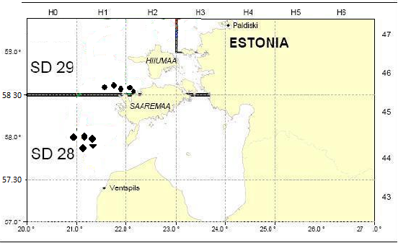
Figure 1. Approximate location of trawl stations in Sub-divisions 28.2. and 29.
3. For internationally coordinated surveys, describe the participating Member States/vessels and the relevant international group in charge of planning the survey
National parts of the international coordinated fish surveys should be carried out in the first quarter between 15 February and 31 March (spring survey) and in the fourth quarter between 1 and 30 November (autumn survey). The total distribution area of cod should be covered by the BITS trawl survey. It was agreed by the responsible ICES WGBIFS that the ICES Subdivisions 22–28 should be covered with fish control-hauls during the trawl surveys. The surveys are coordinated and the results are annually discussed by the ICES WGBIFS.
The participating countries use their research vessel or chartered fishing vessel and the standard gear. Estonia is participating in the 4th quatrer (autumn) survey using the chartered Estonian fishing vessel and TV2-520 trawl.
4. Where applicable, describe the international task sharing (physical and/or financial) and the cost sharing agreement used.
Each MS performs the survey in its EEZ according to the pre-defined sampling stations. These are randomly chosen and assigned internationally from the Clear Tow Database.
5. Explain where thresholds apply
NA
6. Graphical representation (map) showing the positions (locations) of the realized samples.
Member State shall provide maps presenting the spatial distribution of the main sampling types obtained during the survey.
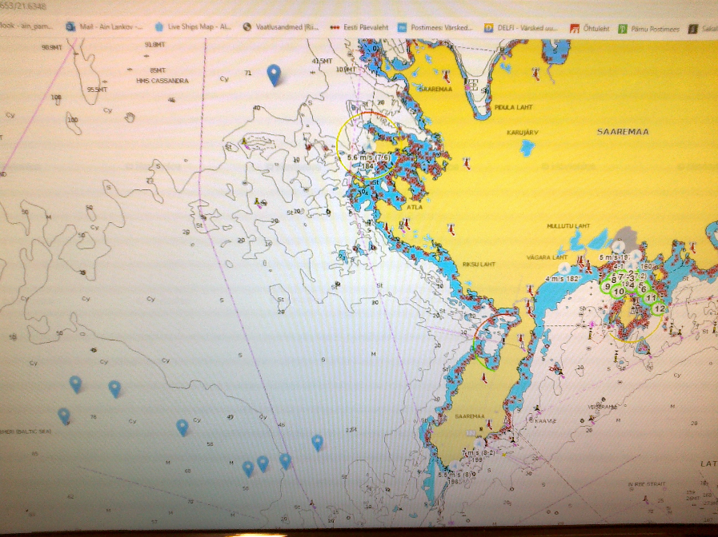
Figure 1G.1. BITS IV QRT survey in November 2021. Blue marks indicate the location of Estonian trawl hauls.

7. For internationally coordinated surveys, provide a link to the latest meeting report of the coordination group.
ICES WGBIFS and the Baltic RCG are in charge in coordinating the survey. (https://www.ices.dk/sites/pub/Publication%20Reports/Forms/DispForm.aspx?ID=37344)
8. List the main use of the results of the survey (e.g. indices, abundance estimates, environmental indicators).
The results are used by the ICES WGBFAS for assessment of the Baltic cod and flounder stocks on routinely basis.
9. Extended comments (Tables 1G and 1H)
Eight countries have been participating in realization of the BITS surveys: Denmark, Germany, Latvia, Poland, Sweden, Estonia, Lithuania and Russia.
Estonia performed its part of the survey on 14-16 of November 2021. 9 trawl hauls were performed in the ICES Sub-division 28.2 (Fig. 1G.1). The number and location of hauls to be executed by the MS is defined by the ICES WGBIFS.
(max 450 words per survey)
General comment: This box fulfills Chapter I of the Annex of the Implementing Decision (EU) 2019/909, on the list of mandatory surveys and thresholds, of the multiannual Union programme; and Article 2 and Article 7 paragraph (3) of the Decision (EU) 2016/1701 on the format of the WP. It is intended to specify which reseach surveys at sea set out in the multiannual Union programme will be carried out. Member States shall specify whether the research survey is included in Chapter I of the Annex of the implementing decision of the multiannual Union programme or whether it is an additional survey.
General comment: This box is applicable to the Annual Report. This box should provide complementary information on the performance of the surveys, the results and their main use.
1G.2 Baltic International Acoustic Survey (BIAS)
1. Objectives of the survey
The objective of the Baltic International Acoustic Survey (BIAS) and Baltic Acoustic Spring Survey (SPARS) programs are to obtain the fisheries-independent information for tuning analytical stock assessment models for Baltic herring and sprat, to standardize survey design, acoustic measurements, fishing method and data analysis throughout all national surveys where data are used as indices for assessment purposes.
2. Description of the methods used in the survey. For mandatory surveys, link to the manuals. Include a graphical representation (map)
The acoustic surveys cover the total area of ICES Division III. Each statistical rectangle of the area under investigation is allocated to one particular country by the Baltic International Fish Survey Working Group (WGBIFS), thus each country has a mandatory responsible area. The area is limited inshore by the 10 m depth line. The standard equipment used for the survey is the Simrad EK/EY-60 echosounder and the standard frequency is 38 kHz. Baltic International Acoustic Survey (BIAS) is carried out in September/October. All surveys are carried out by the agreed Manual of International Baltic Acoustic Surveys (IBAS) (http://www.ices.dk/community/groups/Pages/WGBIFS.aspx). The surveys are coordinated and the results discussed by the ICES WGBIFS annually. Data are stored in BIAS_DB.mdb. In future the data will be transferred to the new ICES acoustic and trawl database which is under construction.
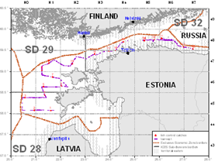
Figure 2. Location of planned track for BIAS in the Sub-divisions 28.2, 29 and 32

3. For internationally coordinated surveys, describe the participating Member States/vessels and the relevant international group in charge of planning the survey.

Each MS performs the survey in its EEZ on its own or shared research vessel. Estonia is using the Polish Research vessel BALTICA for both SPARS and BIAS surveys. The overall coordination of the coming surveys is done by the WGBIFS in order to secure the full coverage of the Baltic Sea.
4. Where applicable, describe the international task sharing (physical and/or financial) and the cost sharing agreement used.

Estonia is sharing the coverage of statistical rectangles of the Gulf of Finland during the BIAS.
5. Explain where thresholds apply
NA
- Graphical representation (map) showing the positions (locations) of the realized samples.

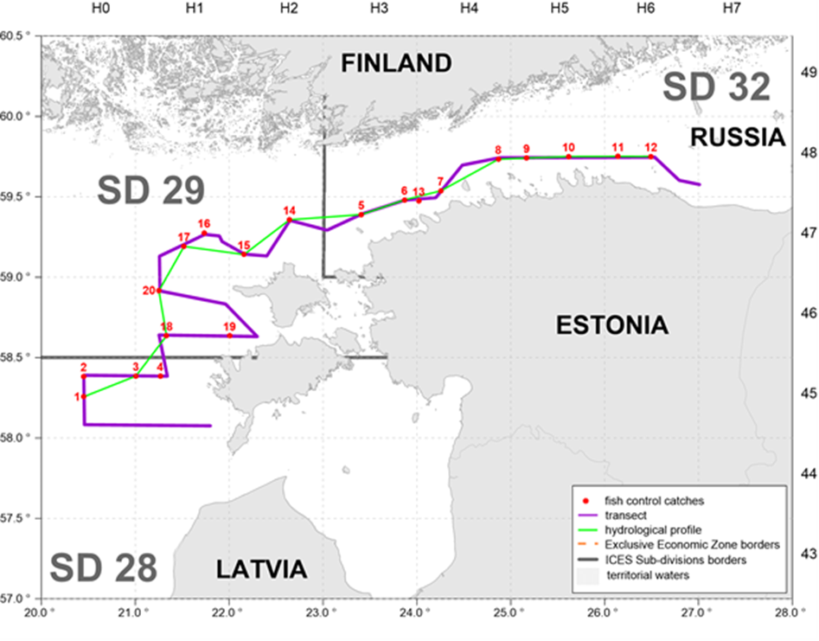
Figure 1G.2. Survey track and locations of the fish pelagic control catches and hydrological stations during of EST-POL BIAS in Sub-divisions 28.2, 29 and 32 in 22 October 2020 to 01 November 2021 (803 NM of acoustic survey and 20 control hauls were realized).
- For internationally coordinated surveys, provide a link to the latest meeting report of the coordination group.
ICES WGBIFS and the Baltic RCG are in charge in coordinating the survey. (https://www.ices.dk/sites/pub/Publication%20Reports/Forms/DispForm.aspx?ID=37344)
- List the main use of the results of the survey (e.g. indices, abundance estimates, environmental indicators).
The results are used by WGBFAS for Baltic sea herring and sprat stocks assessment.
9. Extended comments (Tables 1G and 1H)
Nine countries have been participating in realization of the BIAS surveys: Denmark, Estonia, Finland, Germany, Latvia, Lithuania, Poland, Sweden and Russia. Survey was conducted on board of the chartered Polish research vessel “Baltica”. All collected acoustic information was uploaded ICES Acoustic and Trawl Database. The results are used by the ICES WGBFAS on routinely

General comment: This box fulfills Chapter I of the Annex of the Implementing Decision (EU) 2019/909, on the list of mandatory surveys and thresholds, of the multiannual Union programme; and Article 2 and Article 7 paragraph (3) of the Decision (EU) 2016/1701 on the format of the WP. It is intended to specify which reseach surveys at sea set out in the multiannual Union programme will be carried out. Member States shall specify whether the research survey is included in Chapter I of the Annex of the implementing decision of the multiannual Union programme or whether it is an additional survey.
General comment: This box is applicable to the Annual Report. This box should provide complementary information on the performance of the surveys, the results and their main use.
1G.3 Gulf of Riga Acoustic Herring Survey GRAHS
1. Objectives of the survey.
The aim of the survey is to obtain the fisheries-independent information for tuning analytical stock assessment models for Baltic herring in the Gulf of Riga (Gulf of Riga herring). The information obtained during the survey is used by the Baltic Fisheries Assessment Working Group of the ICES (WGBFAS).
2. Description of the methods used in the survey. For mandatory surveys, link to the manuals. Include a graphical representation (map).
Survey will be carried out following the agreed Manual of International Baltic Acoustic Surveys (IBAS) (http://www.ices.dk/community/groups/Pages/WGBIFS.aspx). The surveys are coordinated and the results are discussed by the ICES WGBIFS annually. The survey is carried out in July-August annually in order to cover the period after main spawning season when most of the stock has left the near-coast spawning grounds. In near futuure data will be stored in ICES Acoustic trawl surveys Database.
The map (Figure 3) describes the acoustic track and approximate position of trawl stations in the Gulf of Riga
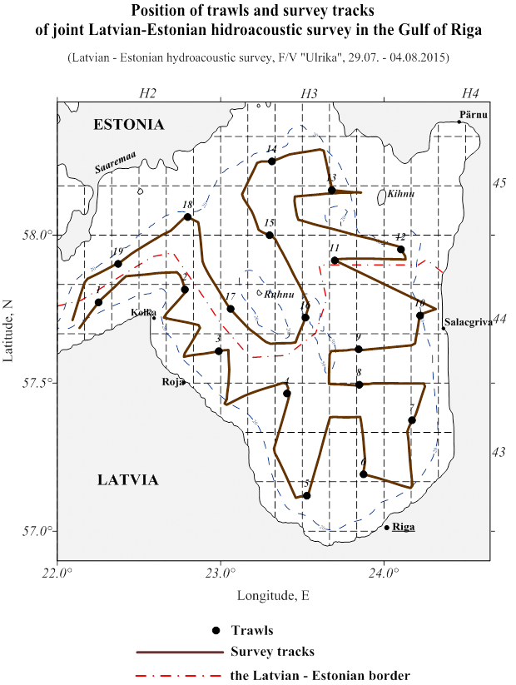
Figure 3. Acoustic track and trawl stations during the Gulf of Riga Acoustic herring survey.
3. For internationally coordinated surveys, describe the participating Member States/vessels and the relevant international group in charge of planning the survey.
The survey is carried out jointly by the Latvian and Estonian scientists on the chartered Latvian fishing vessel. The results are discussed and future surveys planned during the meeting of the ICES WGBIFS annual meetings.
4. Where applicable, describe the international task sharing (physical and/or financial) and the cost sharing agreement used.
Estonia and Latvia share the tasks of work and also the survey costs on this joint survey.
5. Explain where thresholds apply
NA
6. Graphical representation (map) showing the positions (locations) of the realized samples.
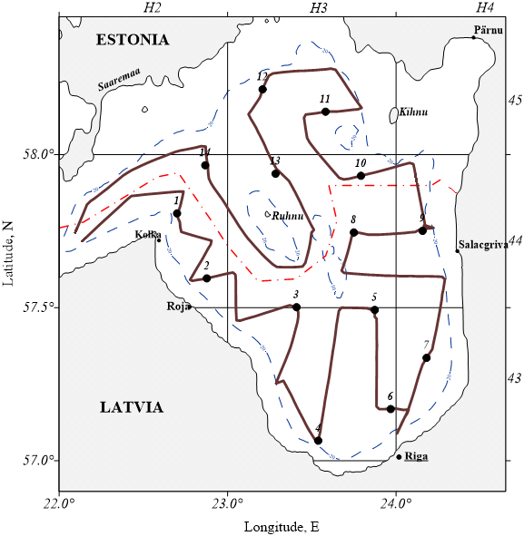
Figure 1G.3. Survey track and location of control hauls during the EST-LAT acoustic survey in the Gulf of Riga in 22 July – 01 August 2021.

7. For internationally coordinated surveys, provide a link to the latest meeting report of the coordination group.
ICES WGBIFS and the Baltic RCG are in charge in coordinating the survey. (https://www.ices.dk/sites/pub/Publication%20Reports/Forms/DispForm.aspx?ID=37344)

8. List the main use of the results of the survey (e.g. indices, abundance estimates, environmental indicators).
The information on abundance, biomass and distribution of the Baltic herring in the Gulf of Riga is used by the relevant ICES working group (WGBFAS) in stock assessment process.

9. Extended comments (Tables 1G and 1H)
Survey was performed in 22.07-01.08.2021, using the same particular chartered fishing vessel as in previous years. Altogether 14 trawl hauls were performed and acoustic track of 445 NM was covered with acoustic measurements in the Estonian and Latvian EEZs (Fig. 1G.3). The number of trawl houls remained below the planned due to the breakdown of vessel´s trawl equipment. (max 450 words per survey)
General comment: This box fulfills Chapter I of the Annex of the Implementing Decision (EU) 2019/909, on the list of mandatory surveys and thresholds, of the multiannual Union programme; and Article 2 and Article 7 paragraph (3) of the Decision (EU) 2016/1701 on the format of the WP. It is intended to specify which reseach surveys at sea set out in the multiannual Union programme will be carried out. Member States shall specify whether the research survey is included in Chapter I of the Annex of the implementing decision of the multiannual Union programme or whether it is an additional survey.
General comment: This box is applicable to the Annual Report. This box should provide complementary information on the performance of the surveys, the results and their main use.
1G.4 Sprat Acoustic Survey (SPARS)
1. Objectives of the survey.
The main objective of the Sprat Acoustic Survey (SPARS) programs are to obtain the fisheries-independent information for tuning analytical stock assessment models for Baltic sprat, to standardize survey design, acoustic measurements, fishing method and data analysis throughout all national surveys where data are used as indices for assessment purposes.
2. Description of the methods used in the survey. For mandatory surveys, link to the manuals. Include a graphical representation (map)
The acoustic survey covers the main area of sprat distribution in the Baltic. Each statistical rectangle of the area under investigation is allocated to one particular country by the Baltic International Fish Survey Working Group (WGBIFS), thus each country has a mandatory responsible area. The area is limited inshore by the 10 m depth line. The standard equipment used for the survey is the Simrad EK/EY-60 echosounder and the standard frequency is 38 kHz. The Baltic Acoustic Spring Survey (SPARS) is carried out annually in May. Survey is carried out by the agreed Manual of International Baltic Acoustic Surveys (IBAS) (http://www.ices.dk/community/groups/Pages/WGBIFS.aspx). The survey is annually coordinated and the results discussed by the ICES WGBIFS. Data is stored in ICES Acoustic trawl surveys Database.
Map (Figure 4) describes the location of sampling sites allocated for Estonia during the SPARS.
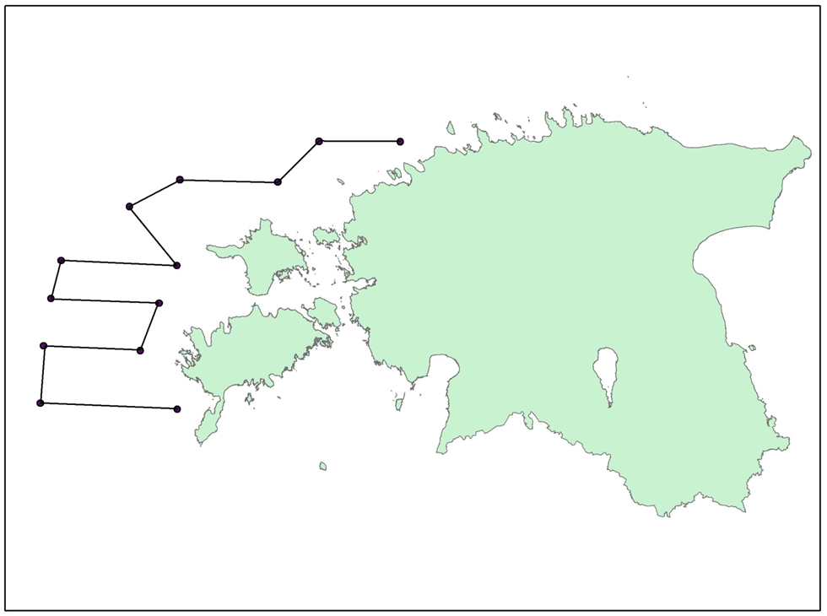
Figure 4. Location of planned acoustic track for Estonian SPARS in the Sub-divisions 28.2, 29 and 32.
3. For internationally coordinated surveys, describe the participating Member States/vessels and the relevant international group in charge of planning the survey
Each MS performs the survey in its EEZ on its own or shared research vessel. Estonia is using the Polish Research vessel BALTICA. The overall coordination of the coming surveys is done by the WGBIFS in order to secure the full coverage of the agreed during the WGBIFS area.
4. Where applicable, describe the international task sharing (physical and/or financial) and the cost sharing agreement used
Each MS performs the survey in its EEZ according to the agreed coverage of the statistical rectangles.
5. Explain where thresholds apply
NA
6. Graphical representation (map) showing the positions (locations) of the realized samples.
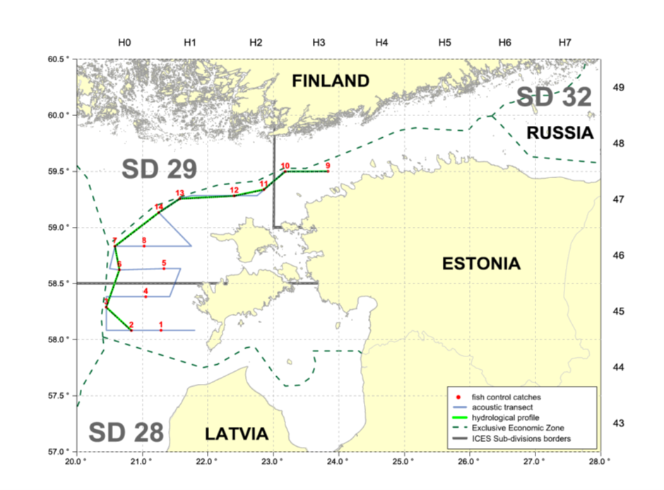
Figure 1G.4. Survey track of EST-POL SPRAS in Sub-divisions 28.2, 29 and 32 in May 2021 (303 NM of acoustic survey and 14 control hauls were realized).

7. For internationally coordinated surveys, provide a link to the latest meeting report of the coordination group.
ICES WGBIFS and the Baltic RCG are in charge in coordinating the survey. (https://www.ices.dk/sites/pub/Publication%20Reports/Forms/DispForm.aspx?ID=37344)

8. List the main use of the results of the survey (e.g. indices, abundance estimates, environmental indicators).
Information on abundance, biomass and distribution of the Baltic herring and sprat obtained during the SPARS are used by the relevant ICES working group (WGBFAS) in stock assessment process (to produce the tuning files) of the Baltic sprat on routinely basis.

9. Extended comments (Tables 1G and 1H)
Five countries have been participating in realization of the SPRAS surveys: Estonia, Germany, Latvia, Lithuania and Poland. SPRAS survey was conducted between 27 May - 01 June 2021, on board of the Polish research vessel “Baltica” (Fig. 1G.4.) All collected acoustic information was uploaded ICES Acoustic and Trawl Database.
(max 450 words per survey)
General comment: This box fulfills Chapter I of the Annex of the Implementing Decision (EU) 2019/909, on the list of mandatory surveys and thresholds, of the multiannual Union programme; and Article 2 and Article 7 paragraph (3) of the Decision (EU) 2016/1701 on the format of the WP. It is intended to specify which reseach surveys at sea set out in the multiannual Union programme will be carried out. Member States shall specify whether the research survey is included in Chapter I of the Annex of the implementing decision of the multiannual Union programme or whether it is an additional survey.
General comment: This box is applicable to the Annual Report. This box should provide complementary information on the performance of the surveys, the results and their main use.
1G.5 Estonian Fish Larvae Survey
1. Objectives of the survey
This national survey has been conducted annually since 1947 to study the distribution and abundance of fish larvae and juveniles with the aim to provide primary information on herring yearclass abundance and to unerstand the affecting environmental backround. Results of the survey is used for early estimation of the spawning success and yearclass potential of herring, but also commercially important percids (perch and pikeperch) and smelt.
2. Description of the methods used in the survey. For mandatory surveys, link to the manuals. Include a graphical representation (map)
Nine fixed stations are visited weekly (May-July). Hensen larval fish net is used for 10 min. hauls in NE of the Gulf of Riga in commercially important fish spawning and nursery grounds.
Larvae and juveniles will be collected using research vessels of the Estonian Marine Institute. Larvae are identified, measured and counted. Plankton samples and environmental data are collected and analysed. The map (Figure 5) describes the location of the stations which are vistited during the survey.
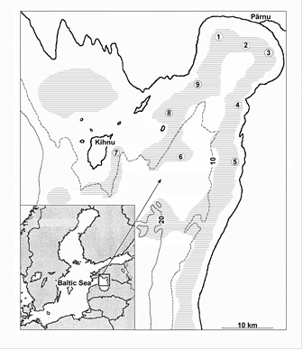
Figure 5. Location of the stations: 1 – Audru, 2 – Poi, 3 – Uulu, 4 – Tahku, 5 – Timmkanal, 6 – Palva, 7 – Kihnu, 8 – Sorgu ja 9 – Liu
6. Graphical representation (map) showing the positions (locations) of the realized samples.
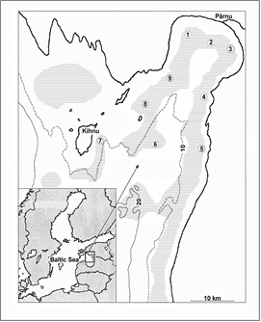
Figure 1G.5 . Location of 9 larval herring sampling stations in the NE of the Gulf of Riga in 2021.

7. For internationally coordinated surveys, provide a link to the latest meeting report of the coordination group.
Not coordinated internationally.
8. List the main use of the results of the survey (e.g. indices, abundance estimates, environmental indicators).
Data on abundance and distribution of the spring spawning herring larvae in the Gulf of Riga is used to calculate larval herring index N2. The rationale for this approach is that (i) the eggs and larvae of a species should be in direct proportion to the biomass of the adults, (ii) estimating the abundance of eggs or larvae is either more accurate or less costly than estimating the abundance of adults, and (iii) ichthyoplankton surveys provide data on a different group of species than trawl surveys for adults. One commonly used analytical approach to developing indices from ichthyoplankton surveys relies on the mean larval abundance across a survey area.

9. Extended comments (Tables 1G and 1H)
Survey was conducted from May until the 14th of July (normally once a week), using EMI RV Fortuuna. Altogether 9 trips were performed, 77 fish hauls performed and 25 vertical CTD profiles measured.

(max 450 words per survey)
General comment: This box fulfills Chapter I of the Annex of the Implementing Decision (EU) 2019/909, on the list of mandatory surveys and thresholds, of the multiannual Union programme; and Article 2 and Article 7 paragraph (3) of the Decision (EU) 2016/1701 on the format of the WP. It is intended to specify which reseach surveys at sea set out in the multiannual Union programme will be carried out. Member States shall specify whether the research survey is included in Chapter I of the Annex of the implementing decision of the multiannual Union programme or whether it is an additional survey.
General comment: This box is applicable to the Annual Report. This box should provide complementary information on the performance of the surveys, the results and their main use.
1G.6 Gulf of Riga Fish survey
1. Objectives of the survey
Objective of this survey is to collect fisheries independent data for tuning the pikeperch and perch VPA assessment and get information about ohter commercially important species (smelt, cyprinids).

Trawl survey in the Pärnu Bay was conducted already in earlier decades (since 1950s), and resumed 2009.
2. Description of the methods used in the survey. For mandatory survey, link to the manuals. Include a graphical representation (map).
Research vessel of the Estonian Marine Institute AURELIE is used for trawling. The trawl (working depth 0.3 m from the bottom) is pulled with the speed of 3 knots for 30 minutes. The trawl mouth is 2 m high and 6 m wide, distance between doors is 20 m and maximum distance between the 8.2 m long trawl wings is 12 m. Mesh size is 60 mm (knot to knot), at the tip of the trawl wings, 45 mm at the trawl mouth and decreases gradually to 10 mm at the codend. Six fixed trawl transects are situated three to eight km from shore (water depth five to nine m) to cover the entire length of the Pärnu Bay. All fixed stations are fished in May, September, October, November and December. The survey is coordinated and the results are discussed by the HELCOM FISH-PRO annually. Survey is carried out following the manual of HELCOM: (https://portal.helcom.fi/meetings/FISH-PRO%20III%201-2019-592/MeetingDocuments/4-1%20Updated%20guidelines%20for%20coastal%20fish%20monitoring.pdf)
Map (Figure 6.) describes the location of sampling sites which are vistited during the survey.
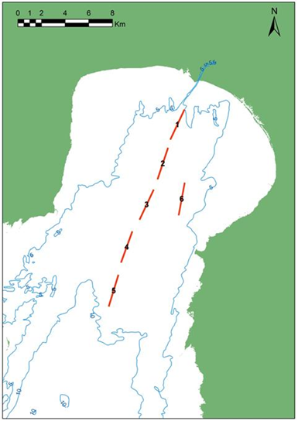
Figure 6. Location of the Gulf of Riga Fish survey transects.
6. Graphical representation (map) showing the positions (locations) of the realized samples.
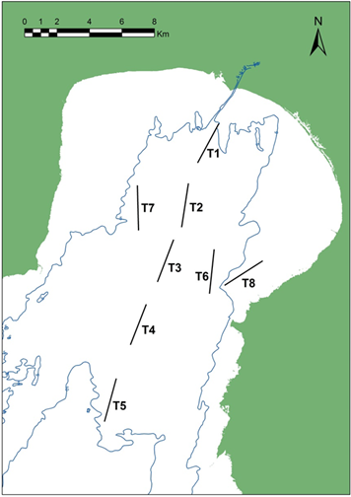
Figure 1G.6 Map of trawl transects fished in 2021

7. For internationally coordinated surveys, provide a link to the latest meeting report of the coordination group.
Not internationally coordinated.
8. List the main use of the results of the survey (e.g. indices, abundance estimates, environmental indicators).
Results are used in national context, primarily to assess the pikeperch and perch stock, but also abundance index for other species.

9. Extended comments (Tables 1G and 1H)
Research vessel AURELIE of the Estonian Marine Institute is used.
In 2021 trawling was conducted in April, June, July, September, October, November and December. 38 fish hauls were made during eight days at sea. Altogether 19 species of fish were caught, and 6054 specimens were measured for length.
General comment: This box fulfills Chapter I of the Annex of the Implementing Decision (EU) 2019/909, on the list of mandatory surveys and thresholds, of the multiannual Union programme; and Article 2 and Article 7 paragraph (3) of the Decision (EU) 2016/1701 on the format of the WP. It is intended to specify which reseach surveys at sea set out in the multiannual Union programme will be carried out. Member States shall specify whether the research survey is included in Chapter I of the Annex of the implementing decision of the multiannual Union programme or whether it is an additional survey.
General comment: This box is applicable to the Annual Report. This box should provide complementary information on the performance of the surveys, the results and their main use.
1G.7 Coastal fish survey
1. Objectives of the survey
National annual survey started in 1992, now in 10 fixed areas. Collected information (CPUE, age and length distribution, age-length keys for commercial species etc) form the basis for advice for commercially important stocks (perch, pikeperch, flounder, eel, cyprinids) and allow following fish assemblage dynamics, including abundance of alien species and their distribution.
2. Description of the methods used in the survey. For mandatory surveys, link to the manuals. Include a graphical representation (map)
Annual gill-net survey in defined areas along the Estonian coast, in fixed (Hiiumaa, Kõiguste and Küdema) or random stations. Each station consists of a series of gill nets of fixed mesh sizes and construction. 24-72 stations are fished in each area (less in Vaindloo). Additionally in six areas (Vilsandi, Kihnu, Kõiguste, Matsalu, Saarnaki and Käsmu) minimum 80 standard fyke net/days are fished for eel CPUE and length distribution.
Methods: Thoresson, 1995, HELCOM 2015 (http://www.helcom.fi/Documents/Action%20areas/Monitoring%20and%20assessment/Manuals%20and%20Guidelines/Guidelines%20for%20Coastal%20fish%20Monitoring%20of%20HELCOM.pdf )
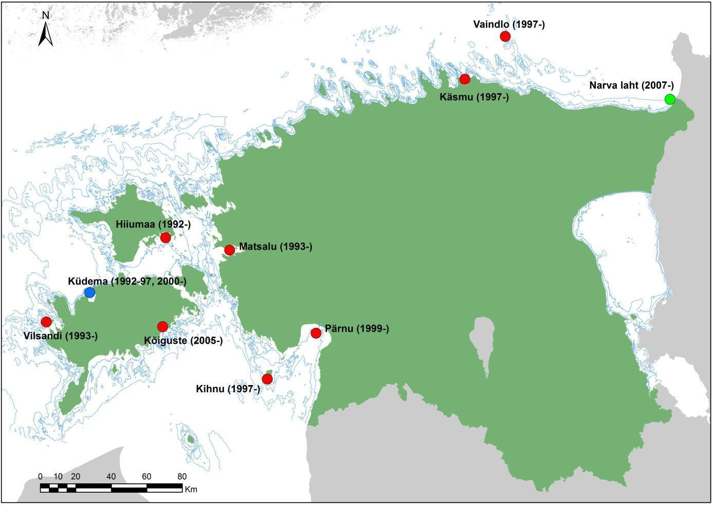
Figure 7. Map of research areas and the data series starting year.
3. For internationally coordinated surveys, describe the participating Member States and the relevant international group in charge of planning the survey.
Similar surveys are conducted in Sweden, Finland, Lithuania, Poland, Germany and Latvia. Data are stored in national database, and delivered to HELCOM.
6. Graphical representation (map) showing the positions (locations) of the realized samples.
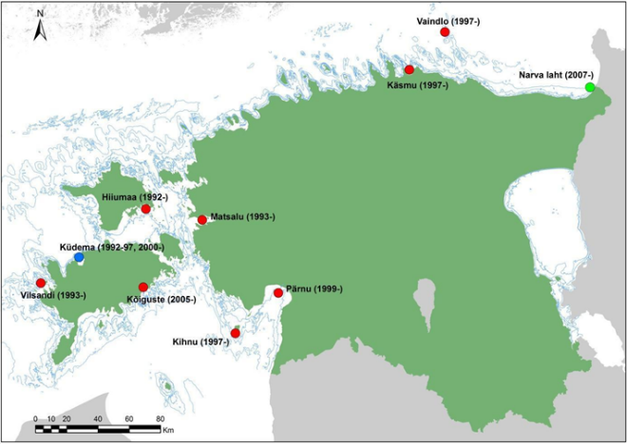
Fig 1G.7. Map of research areas in 2021 with the starting years.

7. For internationally coordinated surveys, provide a link to the latest meeting report of the coordination group.
Not internationally coordinated.

8. List the main use of the results of the survey (e.g. indices, abundance estimates, environmental indicators).
Data on abundance, relative year class strength, size and age distribution, structure of coastal fish assemblages are used in routine basis for giving advice for main commercially important species (also those not namely listed in the National WP). Most of our coastal fish are listed in EU regulation 1251/2016 Table 1D as relevant to HELCOM. Additional data on bycatch (incl. birds), seal damage to catch, distribution and abundance of alien species. Data is also used to calculate Marine Strategy Framework Directive and HELCOM indicators.

9. Extended comments (Tables 1G and 1H)
Test fishing was conducted in all 10 areas. In total 301 stations were fished, and 57028 specimens belonging to 36 species were measured.

Section 2: Fishing Activity Data

Text Box 2A: Fishing activity variables data collection strategy

General comment: This box fulfills paragraph 4 of Chapter III of the Annex of the Delegated Decision (EU) 2019/910 on the multiannual Union programme; and Article 2, Article 4 paragraph (2) point (b) and Article 5 paragraph (2) of the Implementing Decision (EU) 2016/1701 on the format of the WP. It is intended to describe the method used to derive estimates on representative samples where data are not to be recorded under Regulation (EU) No 1224/2009 or where data collected under Regulation (EU) No 1224/2009 are not at the right aggregation level for the intended scientific use.
General comment: This box is applicable to the Annual Report. This box should provide information on the implementation of the data collection of fishing activity variables of Member States.
1. Description of methodologies used to cross-validate the different sources of data
The census data are obtained from an administrative source – Estonian Fisheries Information System (an electronic database - includes logbook and coastal fishing data, fishing vessel register, first-sales data etc.).

2. Description of methodologies used to estimate the value of landings
Value of landings is calculated through the multiplication of the amount of landings per species in kilograms and the average price per kilogram live weight per species.

3. Description of methodologies used to estimate the average price (it is recommended to use weighted averages, trip by trip)
Estimation about the average price per kilogram live weight per species based on first-sales data.

4. Description of methodologies used to plan collection of the complementary data (sample plan methodology, type of data collected, frequency of collection etc)
No additional studies are planned.

5. Deviations from Work Plan methodology used to cross-validate the different sources of data
No deviations
6. Deviations from Work Plan methodology used to estimate the value of landings.
No deviations
7. Deviations from Work Plan methodology used to estimate the average price.
No deviations
8. Deviations from Work Plan methodology used to plan collection of the complementary data
No deviations

Section 3: Economic and Social Data

Text Box 3A: Population segments for collection of economic and social data for fisheries

General comment: This box fulfils paragraph 5 points (a) and (b) of Chapter III of the Annex of the Delegated Decision (EU) 2019/910 on the multiannual Union programme; and Article 2, Article 4 paragraphs (1), (2) and (5) and Article 5 paragraph (2) of the Implementing Decision (EU) 2016/1701 on the format of the WP. It is intended to specify data to be collected under Tables 5(A) and 6 of the delegated decision on the multiannual Union programme.
General comment: This box is applicable to the Annual Report. This box should provide information on the implementation of the fleet socio-economic data collection of Member States.
1. Description of methodologies used to choose the different sources of data
Selection of the data source depends on the variable and its availability. Main sources are:
- Survey (questionnaires - the variables which are not available from administrative sources);
- Estonian Fisheries Information System (an electronic database - includes logbook and coastal fishing data, fishing vessel register and first-sales data);
- Estonian Agricultural Registers and Information Board (information about operating and investment subsidies)
2. Description of methodologies used to choose the different types of data collection
Total population is defined as all vessels that are in the fishing vessel register, sampling is done through owner (management unit).
Logbook and first-sales data, which are obtained from administrative sources, are census data as reporting this info is obligatory by law. To collect other variables survey is conducted. Estonian fishing fleet can be divided into two – open sea trawlers and coastal fishing fleet, that are using mainly passive gears. All trawlers are under survey (census), as well as those boats from coastal fleet that catch at least 100t per year (based on previous year’s catches). Rest of the coastal fleet is handled by stratified probability sample.
3. Description of methodologies used to choose sampling frame and allocation scheme
Coastal fleet (length classes 0-< 10 m and 10-< 12 m), that catch less then 100t per year, are sampled by stratified probability sample. Every sample group will have a weight that is used for extrapolation. The weight is corrected so that non responses would have less influence. The sampling unit is a vessel and a randomly selected sample of vessels is selected for both segment.
For other fleet segments all vessels are covered by census based approach.
Fishermen will be informed by 15th of December if they are chosen to the sampling frame. The list is updated and obligations corrected in the beginning of the sampling year. Raw data are obtained through online questionnaire by 1st of August. Questionnaires and all related information are available in Statistics Estonia homepage https://www.stat.ee/andmete-esitamine.
4. Description of methodologies used for estimation procedures
In the case of missing or unreliable data, estimate imputation based on established regulations will be used. The data of the enterprises that did not submit the questionnaire are replaced by the respective average of responded similar enterprises.
For statistical units weights are calculated, which are used to expand the data of the sample survey to the total population.
Microdata are aggregated to the level necessary for analysis. This includes aggregating the data according to the classification, and calculating various statistical measures, e.g. average, median, dispersion, etc.
The collected data are converted into statistical output. This includes calculating additional indicators.
5. Description of methodologies used on data quality
Validation includes arithmetical and qualitative controls including comparison with other data.
To assure the quality of processes and products, Statistics Estonia applies the EFQM Excellence Model, the European Statistics Code of Practice and the Quality Assurance Framework of the European Statistical System (ESS QAF). Statistics Estonia is also guided by the requirements in § 7. “Principles and quality criteria of producing official statistics” of the Official Statistics Act.
Statistics Estonia performs all statistical activities according to an international model (Generic Statistical Business Process Model – GSBPM). According to the GSBPM, the final phase of statistical activities is overall evaluation using information gathered in each phase or sub-process; this information can take many forms, including feedback from users, process metadata, system metrics and suggestions from employees. This information is used to prepare the evaluation report which outlines all the quality problems related to the specific statistical activity and serves as input for improvement actions.
6. Deviations from Work Plan methodology for selection of data source
No deviations
7. Deviations from Work Plan methodology to choose type of data collection
No deviations.
8. Deviations from Work Plan methodology regarding sampling frame and allocation scheme
No deviations
9. Deviations from Work Plan methodology used for estimation procedures
No deviations
10. Quality assurance
10.1 Sound methodology
Sound methodology is ensured by Estonian Statistics.
10.2. Accuracy and reliability
Response rate and achieved sample rate are provided in Table 3A.
Accuracy and reliability is ensured by Estonian Statistics.
10.3. Accessibility and Clarity
Are methodological documents publicly available? Yes
Are data stored in databases? Yes
Where can methodological and other documentation be found? https://envir.ee/elusloodus-looduskaitse/kalandus/kalanduse-riiklik-andmekogumise-programm-akp

Section 3: Economic and Social Data

Pilot Study 3: Data on employment by education level and nationality

General comment: This box fulfills paragraph 5 point (b) and paragraph 6 point (b) of Chapter III of the Annex Delegated Decision (EU) 2019/910 on the multiannual Union programme; and Article 2 and Article 4 paragraph (3) point (c) of the Implementing Decision (EU) 2016/1701 on the format of the WP. It is intended to specify data to be collected under Table 6 of the delegated decision on the multiannual Union programme.
General comment: This box is applicable to the Annual Report. This box is intended to provide information on the results obtained from the implementation of the pilot study (including deviations from planned and justifications as to why if this was not the case).
Social data collection is now part of the data collection programm.

Section 3: Economic and Social Data

Text Box 3B: Population segments for collection of economic and social data for aquaculture

General comment: This box fulfills paragraph 6 points (a) and (b) of Chapter III of the Annex of the Delegated Decision (EU) 2019/910 on the multiannual Union programme; and Article 2, Article 4 paragraphs (1) and (5) and Article 5 paragraph (2) of the Implementing Decision (EU) 2016/1701 on the format of the WP. It is intended to specify data to be collected under Tables 6 and 7 of the delegated decision on the multiannual Union programme.

General comment: This box is applicable to the Annual Report. This box should provide information on the implementation of the socio-economic data collection for aquaculture of Member States.

According to the multiannual Union programme for the collection, management and use of data in the fisheries and aquaculture sectors the collection of social, economic and environmental data on freshwater aquaculture is optional. Because there is no marine aquaculture and the total production of freshwater aquaculture is very low, Estonia does not collect data on aquaculture under the EU MAP

Section 3: Economic and Social Data

Pilot Study 4: Environmental data on aquaculture

General comment: This box fulfills paragraph 6 point (c) of Chapter III of the Annex of the Delegated Decision (EU) 2019/910 on the multiannual Union programme; and Article 2 and Article 4 paragraph (3) point (d) of the Implementing Decision (EU) 2016/1701 on the format of the WP. It is intended to specify data to be collected under Table 8 of the delegated decision on the multiannual Union programme.
General comment: This box is applicable to the Annual Report. This box is intended to provide information on the results obtained from the implementation of the pilot study (including deviations from planned and justifications as to why if this was not the case).
According to the multiannual Union programme for the collection, management and use of data in the fisheries and aquaculture sectors the collection of social, economic and environmental data on freshwater aquaculture is optional. Because there is no marine aquaculture and the total production of freshwater aquaculture is very low, Estonia does not collect data on aquaculture under the EU MAP.

Section 3: Economic and Social Data

Text Box 3C: Population segments for collection of economic and social data for the processing industry

General comment: This box fulfils footnote 6 of paragraph 1.1(d) of Chapter III of the Annex of the Delegated Decision (EU) 2019/910 on the multiannual Union programme; and Article 2, Article 4 paragraphs (1) and (5) and Article 5 paragraph (2) of the Implementing Decision (EU) 2016/1701 on the format of the WP. It is intended to specify data to be collected under Table 10 of the delegated decision on the multiannual Union programme.
General comment: This box is applicable to the Annual Report. This box should provide information on the implementation of the socio-economic data collection for aquaculture of Member States.
According to the multiannual Union programme for the collection, management and use of data in the fisheries and aquaculture sectors the collection of data on the processing industry is optional. Because similar data is already collected by Statistics Estonia and forwarded to Eurostat, Estonia will not collect data on the processing industry in frames of EU MAP, to avoid the duplication in data collection.

Section 4: Sampling Strategy for Biological Data from Commercial Fisheries

Text Box 4A: Sampling plan description for biological data

General comment: This box fulfills Article 3, Article 4 paragraph (4) and Article 8 of the Implementing Decision (EU) 2016/1701 on the format of the WP and forms the basis for the fulfilment of paragraph 2 point (a)(i) of Chapter III of the Annex of the Delegated Decision (EU) 2019/910 on the multiannual Union programme. This Table refers to data to be collected under Tables 1(A), 1(B) and 1(C) of the delegated decision on the multiannual Union programme.
General comment: This box is applicable to the Annual Report. This box should provide information on the deviations from the planned sampling of Member States.
All fleet segments of commercial fisheries are sampled (strata OSF PEL–29 vessels; GOR PEL–15 vessels; HSF-1 –3 vessels; HSF-2 – 2 and stratum SB – 1585 vessels).
Primary sampling unit (PSU) for OSF PEL and GOR PEL segments is time unit of week and sampling takes place onshore. Sampling scheme for these segments follow the Hierarchy 8 in RDBES. Description of RDBES hierarchy 8: Sampling where time (e.g. days, weeks) is the primary sampling unit (PSU) and vessel is the secondary sampling units (SSU). For the pelagic fisheries (OSF PEL, GOR PEL) our sampling strategy is that in every month when active fishing is ongoing (this depends on the year and subarea) subset of week(s) are sampled (PSU=week).The OSF PEL stratum consists of multiple subareas (SD29, 28.2, 32) and each of this stratum is sampled separately, as the aim is to get detailed description of the fisheries per subarea, even though all these subareas belong under one stock unit (Central Baltic herring stock and Baltic sprat stock unit). Average number of PSU during the reference years was calculated as the sum of subareas. E.g. for OSF PEL the number of weeks in 2018 when fishing was conducted was as follows: SD 28.2 - 31 weeks; SD29 - 40 weeks, SD32 - 49 weeks. The total number of weeks in 2018 when fishing was ongoing is calculated as the sum of weeks in all subareas (31+40+49=110). Same is done for all reference years and then divided by 3 to get the average per reference time period. So in OSF PEL on average 2 weeks per month per area are sampled during the active fishing period. GOR PEL is a separate stratum (and stock unit) consisting only subarea SD28.1 (Gulf of Riga) and there too on average 2 weeks per month, during fishing season, are sampled. OSF PEL segment targets Clupea harengus and Sprattus sprattus in central Baltic (ICES SD 25-29 and 32 excluding 28.1), while GOR PEL targets Clupea harengus in Gulf of Riga (SD28.1).
Stratum SB is sampled onshore or by self-sampling by fishermen according to the Hierarchy 8 in RDBES. PSU is month and sampling is species specific and evenly distributed by catch volumes along the coastal area. Average number of PSU during reference years is calculated with the same logic as for OSF PEL and GOR PEL. In total 6 species are sampled in different sub areas: Platichthys flesus (SD28-29, 32), Perca fluviatilis (SD28.1), Sander lucioperca (SD28.1), Salmo salar (SD28, 32), Salmo trutta (SD32) and Clupea harengus (caught with FPN during spawning season in SD28.1, 29, 32).
Stratums HSF-1 (Eastern Arctic) and HSF-2 (NAFO) are sampled on sea and according to the Hierarchy 3 in RDBES the corresponding PSU is fishing trip. In the Eastern Arctic (ICES areas I and II) the sampled species are Gadus morhua, Pandalus borealis and Reinhardtius hippoglossoides. Sebastes spp. is sampled in NAFO areas (3LN, 3M and 3O), but Gadus morhua only in NAFO 3M area. Limanda ferruginea will be sampled in NAFO areas (3LNO) and Reinhardtius hippoglossoides in areas (3KLMNO).
Samples of biological variables are taken as indicated in Table1B. Sample of 100 fish from catch is taken and analysed or when less than 100 then all the individuals of the catch are sampled. The latter case describes mostly sampling of Salmo salar, Salmo trutta and Sander lucioperca where sample sizes are lower due to the nature of fishery. Selected Eastern Arctic and North Atlantic species are sampled annually by scientific observers on board as indicated in Table1B.
The number of sampled variables from commercial catches for different species is related to the stock and catch size, number of fisheries involved, availability of survey data, end-user needs etc. In certain cases, the quota availability, e.g. in the second half of the year, and/or fishers´ behavior may affects both fishery and thus also the sampling intensity. Sampling effort will be directed to the most important fishing grounds and fishing seasons.
Sampling plan purpose, design, quality assurance procedures, analysis methods, sampling units, sampling frames and sample selection methods and data archiving methods are coordinated (RCGs), and follow the needs of the relevant end-users (e.g. ICES, NAFO) via their respective working groups (ICES WGBFAS, WGBIFS, WGBAST etc.). To ensure the quality of data, observers on board are regularly trained and briefed before every trip. Data of different observers are cross-checked.
Deviation from the sampling plan according to Article 5 paragraph (3) of the Implementing Decision (EU) 2016/1701:
RFMO: Baltic sea (ICES areas III b-d)
2. Deviations from the Work Plan
Oversampling in OSF PEL took place because the share of Clupea harengus in pelagic catches were low compared to Sprattus sprattus, thus more samples were needed to collect planned minimum no of individuals. Due to unexpectedly high presence of sprat in the pelagic catches of Gulf of Riga sprat samples were taken additionally which caused oversampling in stratum GOR PEL.
It should be stressed that commercial sample numbers for herring in Table 1C include both trawl fishery and trapnet (pound net) fishery. In Table 4A, trapnet fishery is included to stratum SB, and thus total number of sampled fish in OSF PEL and GOR PEL is lower than in Table 1C. Table 4A in stratum rows OSF PEL and GOR PEL contain only combined commercial catch of herring and sprat.
3. Action to avoid deviations
Oversampling due to fluctuating stocks could be to some extent avoided in the future with more extensive planning and continuous monitoring of the sampled numbers.

RFMO: Eastern Arctic (ICES areas I and II)
2. Deviations from the Work Plan
75% of planned number of PSUs in Eastern Arctic (ICES areas I and II) were achieved because one of the planned PSUs was transferred to sub-area XIVb due to high fishing activity there, thus additional area missing in WP was sampled and some undersampling took in place in the planned area.
3. Action to avoid deviations
Deviations could be to some extent avoided in the future with more extensive planning.

RFMO: NAFO (FAO area 21)
2. Deviations from the Work Plan
67% of planned number of PSUs in NAFO area were achieved because there were no more trips, all trips to the area were covered.
3. Action to avoid deviations
There is no solution. Sampling without fishing is not possible.

(max. 1000 words per region OR fishing ground)

Section 5: data quality

Text Box 5A: Quality assurance framework for biological data

General comment: This box is applicable to the Annual Report. This box fulfills Article 5 paragraph (2) point (a) of the Implementing Decision (EU) 2016/1701 on the format of the WP. This box is intended to specify data to be collected under Tables 1(A), 1(B) and 1(C) of the Annex of the Delegated Decision (EU) 2019/910 on the multiannual Union programme. Use this box to provide additional information on Table 5A of the Annual Report.
RFMO: Baltic sea (ICES areas III b-d)
1. Evidence of data quality assurance
Quality assurance framework for biological data have been made available (survey manuals, sampling commercial fishery in Baltics, how the data is handled, stored, methodology of phone survey of recreational fishery etc): https://envir.ee/elusloodus-looduskaitse/kalandus/kalanduse-riiklik-andmekogumise-programm-akp#proovivotu-juhendid
2. Sampling design
3. Sampling implementation
4. Data capture
5. Data Storage
A major issue is storage of otoliths and other structures for age determination. Currently, we are attempting to put together historical collection of these structures (to be stored in the database of the Natural Museum of the University of Tartu). We hope to make use of this system also for recent data.

6. Data processing

RFMO: Eastern Arctic (ICES areas I and II)
1. Evidence of data quality assurance
Quality assurance framework for biological data have been made available (sampling manual for our distant fleet, how the data is handled and stored: https://envir.ee/elusloodus-looduskaitse/kalandus/kalanduse-riiklik-andmekogumise-programm-akp#proovivotu-juhendid
2. Sampling design
3. Sampling implementation
4. Data capture
5. Data Storage
A major issue is storage of otoliths and other structures for age determination. Currently, we are attempting to put together historical collection of these structures (to be stored in the database of the Natural Museum of the University of Tartu). We hope to make use of this system also for recent data.

6. Data processing
For areas outside the Baltic Sea sampling depends on available quotas and in the Eastern Arctic (ICES areas I and II) is not predictable due to limited observer coverage; our data can be hardly evaluated nationally.

RFMO: NAFO (FAO area 21)
1. Evidence of data quality assurance
Quality assurance framework for biological data have been made available (sampling manual for our distant fleet, how the data is handled, stored etc): https://envir.ee/elusloodus-looduskaitse/kalandus/kalanduse-riiklik-andmekogumise-programm-akp#proovivotu-juhendid
2. Sampling design
3. Sampling implementation
4. Data capture
5. Data Storage
A major issue is storage of otoliths and other structures for age determination. Currently, we are attempting to put together historical collection of these structures (to be stored in the database of the Natural Museum of the University of Tartu). We hope to make use of this system also for recent data.
6. Data processing
For areas outside the Baltic Sea sampling depends on available quotas; our data can be hardly evaluated nationally.

Section 5: data quality

Text Box 5B: Quality assurance framework for socioeconomic data

General comment: This box fulfills Article 5 paragraph (2) point (b) of the Implementing Decision (EU) 2016/1701 on the format of the WP. This box is intended to specify data to be collected under Tables 5(A), 6 and 7 of the Annex of the Delegated Decision (EU) 2019/910 on the multiannual Union programme. Use this box to provide additional information on Table 5B of the Annual Report.
1. Evidence of data quality assurance
Within this section MS shall provide information on the methodology used to assure the quality of the data collected, highlighting those aspects where changes have been made during the sampling year. Information shall be provided by each sector (Fishing fleet, Aquaculture, Fish processing) for which data was collected and by each data collection scheme. In the case where the same quality assurance framework is applied to all sectors or/and all data collection schemes, information can be provided at general level with the indication “all sectors” or “all data collection schemes”.
In those sections of Table 5B where “N” is indicated, Member States shall explain the main constrains and/ or the steps taken to fulfil this obligation. In the cases where a reference documents is requested, Member States shall provide a web link.
In cases where documents are not publicly available, due to institutions internal policy, confidentiality or other reasons, this shall be indicated by the Member State.

According to the WP, socioeconomic data was collected only for fishing fleet. Census data collection scheme was used, where data collection is mandatory for all fishermen by Technical Measures regulation. To collect other variables probability sample survey was conducted by Statistics Estonia. Due to the low response rates in voluntary based surveys in previous years, Estonia changed the data collector. As the governmental organisation Statistics Estonia has a stronger legal base for obtaining the data. Response rate has improved significantly.

2. Section P3 Impartiality and objectiveness
Explain main constraints and/ or steps taken, if ‘N’ (no) was indicated in Table 5B

3. Section P4 Confidentiality
Explain main constraints and/ or steps taken, if ‘N’ (no) was indicated in Table 5B

4. Section P5 Sound methodology
Explain main constraints and/ or steps taken, if ‘N’ (no) was indicated in Table 5B
Information on this principle should be briefly explained in Text boxes 3A, 3B and 3C. Description of methodologies used on data quality.

5. Section P6 Appropriate statistical procedures
Explain main constraints and/ or steps taken, if ‘N’ (no) was indicated in Table 5B. Please provide a link if the documented revisions are available and not confidential.

6. Section P7 Non-excessive burden on respondents
Explain main constraints and/ or steps taken, if ‘N’ (no) was indicated in Table 5B

7. Section P8 Cost effectiveness
Explain main constraints and/ or steps taken, if ‘N’ (no) was indicated in Table 5B

8. Section P9 Relevance
Explain main constraints and/ or steps taken, if ‘N’ (no) was indicated in Table 5B

9. Section P10 Accuracy and reliability
Explain main constraints and/ or steps taken, if ‘N’ (no) was indicated in Table 5B. Information on this principle should be briefly explained in Text boxes 3A, 3B and 3C. Description of methodologies used on data quality.

10. Section P11 Timeliness and punctuality
Explain main constraints and/ or steps taken, if ‘N’ (no) was indicated in Table 5B

11. Section P12 coherence and comparability
Explain main constraints and/ or steps taken, if ‘N’ (no) was indicated in Table 5B

12. Section P13 Accessibility and Clarity
Explain main constraints and/ or steps taken, if ‘N’ (no) was indicated in Table 5B. Information and links to documentation on this principle should be briefly explained in Text boxes 3A, 3B and 3C. Description of methodologies used on data quality.

(max. 900 words per Region/RFMO/RFO/IO/NSB OR sector)

