Ministry of the Environment, Republic of Estonia

Commission Implementing Decision (EU) 2016/1701
on the establishment of a Union framework for the collection, management and use of data in the fisheries sector and support for scientific advice regarding the common fisheries policy and repealing Council Regulation (EC) No 199/2008 (recast).
Commission Implementing Decision (EU) 2016/1251 of 12 July 2016 adopting a multiannual Union programme for the collection, management and use of data in the fisheries and aquaculture sectors for the period 2017-2019.
Commission Implementing Decision (EU) 2016/1701
laying down rules on the format for the submission of work plans for data collection in the fisheries and aquaculture sectors.
Commission Implementing Decision (EU) 2018/1283
laying down rules on the format and timetables for the submission of annual data collection reports in the fisheries and aquaculture sectors.

ESTONIAN Annual Report for data collection in the fisheries and aquaculture sectors
2018
Version 1 – 2019

Tallinn, 31 May 2019
CONTENTS
SECTION 1: BIOLOGICAL DATA 3
Text Box 1C: Sampling intensity for biological variables 3
Text Box 1D - Recreational fisheries 4
Pilot Study 1: Relative share of catches of recreational fisheries compared to commercial fisheries 5
Text Box 1E: Anadromous and catadromous species data collection in fresh water 6
Text box 1F: Incidental by-catch of birds, mammals, reptiles and fish 6
Pilot Study 2: Level of fishing and impact of fisheries on biological resources and marine ecosystem 7
Text Box 1G: List of research surveys at sea 8
Section 2: Fishing Activity Data 19
Text Box 2A: Fishing activity variables data collection strategy 19
SECTION 3: ECONOMIC AND SOCIAL DATA 20
Text Box 3A: Population segments for collection of economic and social data for fisheries 20
Pilot Study 3: Data on employment by education level and nationality 21
Text Box 3B: Population segments for collection of economic and social data for aquaculture 22
Pilot Study 4: Environmental data on aquaculture 22
Text Box 3C: Population segments for collection of economic and social data for the processing industry 23
Section 4: Sampling Strategy for Biological Data from Commercial Fisheries 23
Text Box 4A: Sampling plan description for biological data 23
Section 5: data quality 25
Text Box 5A: Quality assurance framework for biological data 25
Text Box 5B: Quality assurance framework for socioeconomic data 25
Annex 1 26

SECTION 1: BIOLOGICAL DATA

Text Box 1C: Sampling intensity for biological variables
General comment: This box fulfils paragraph 2 point (a)(i)(ii)(iii) of Chapter III, Chapter IV of the multiannual Union programme and Article 2, Article 4 paragraph 1 and Article 8 of the Decision (EU) 2016/1701. This box is applicable to the Annual Report.
RFMO: ICES
- Evidence of data quality assurance
Sampling protocols for commercial sampling are available in our national DCF homepage (https://www.envir.ee/et/eesmargid-tegevused/kalandus/kalanduse-riiklik-andmekogumise-programm-akp). . Data were recorded, analysed and transferred according to the established protocol.
Corresponding ICES manuals (Manual for the Baltic International Trawl Surveys (BITS), March 2014, ICES Baltic International Fish Survey Working Group; SISP MANUAL OF INTERNATIONAL BALTIC ACOUSTIC SURVEYS (IBAS) Version 1.02 28-03-2014, ICES 2014) are followed in detail. Methods for coastal fish analyses are accredited nationally by the accreditation certificate No L179 (2017) of the Tartu University, Estonian Marine Institute: Assessment of biodiversity, abundance and biomass of fish assemblages; KJ l/20; based on EVSEN 14757; Helcom, 2015 (Coastal Fish Guidelines) and Assessment of species composition and abundance of salmonids in riverine habitat, KJ l/21; based on Bohlin et al., 1989 and ICES, 2014. Laboratory of the Estonian Marine Institute is accredited against the requirements of standard EVS-EN ISO/IEC 17025:2006 (http://www.sea.ee/en/11064/).
Sampling from surveys were conducted according to the established protocol

- Deviations from the working plan
See Table 1C, AR comments.
Two stocks were not analyzed, as in 2018: commercial samples of Gadus morhua form the Baltic Sea (no directed fishery) and Pandalus borealis from ICES XIV area where few, very short and unpredictable fishing trips were done (total catch in 2018 was 84 t). Eel was undersampled in spite of the effort put into it. All sampled eel in the sea came from test fishing.
Additional stocks (Reinhardtius hippoglossoides, Hippoglossoides platessoides, Anarhichas lupus, Sebastes ssp) were sampled from ICES I and II in 2018. Sampling of Reinhardtius hippoglossoides and Hippoglossoides platessoides were done due to increase in catches.

- Actions to avoid deviations.
Undersampling will remain a problem due to fluctuating stocks. Oversampling, if staff is available, is not a big problem and usually comes from sampling protocol. For example, coastal fish survey prescribes to measure length and weight of all caught specimens

RFMO: NAFO
- Evidence of data quality assurance
Quality assurance framework for biological data is under elaboration and will be completed in 2019.
For NAFO, data is collected by observers on board following requirements of NAFO Conservation and Enforcement Measures and protocols elaborated by Estonian Marine Institute (EMI). The sampling design and protocols follow the outcomes of sampling expert groups, especially NAFO Scientific Council.
Common standard criteria agreed with other research groups from other countries are used.

- Deviations from the working plan
Sampling intensity within NAFO area depends on movements of the fleet between NAFO 3M, 3L, 3 N and 3O and is associated with available quotas. As observers are on board of vessels during the whole trip, they will take samples independently of subareas. See Table 1C, AR comments, for explanations of undersampling and significant exceeding of minimal planned numbers.
Sexual maturity values for NAFO stocks, which were not included to the National WP, but were sampled during the trips, have been added to Table 1C (extra rows).

- Actions to avoid deviations.
Over- and undersampling will remain a problem due to fluctuating catches (quotas) and movements of fishing vessels within NAFO area. No good solution. To compensate for undersampling, we perform full biological analysis (including sex ratio and sexual maturity) of samples.

Section 1: Biological Data

Text Box 1D - Recreational fisheries
General comment: This box fulfills paragraph 2 point (a) (iv) of Chapter III of the multiannual Union programme and Article 2, Article 3 and Article 4 paragraph 1 of the Decision (EU) 2016/1701. This box is applicable to the Annual Report. This box is intended to provide information on the design, implementation and analysis of all components of sampling schemes/ surveys that are listed in Table 1D.
1. Description of the target population
Recreational fishery in Estonia consists of 3 major parts:
- Recreational fishermen using commercial gear (gill nets, trap nets, longlines) have an obligation to report the catches to the Ministry of the Environment.
- Recreational fishermen need a licence to fish salmon and sea trout in rivers and are obliged to report the catches to the Ministry of the Environment.
- Anglers and rod fishermen fishing in sea are not covered with compulsory catch reports. Their catches are estimated during separate studies once over several years using questionnaires.
The main species in the recreational fishery are perch, pike-perch, flounder, whitefish, sea trout and salmon (among species listed in the Data Regulation), comprising 65% of the total recreational catch (82t out of 127 t in 2018) according to data in TEHA (Science and Recreational Fisheries database, held by Ministry of Environment).

2. Type of survey
Collecting of data on catch for target groups 1 and 2 (recreational fishermen using commercial gear and fishing on “salmon”-rivers) is mandatory for recreational fishermen (census survey) and entered in the TEHA, details for target group 3 will be elaborated during the pilot study.
Catches by anglers and rod fishermen, especially by anglers in Pärnu Bay, will be registered by on-site observations (number of fishermen, catch composition) and questionnaires.
The release estimates are based on regular recreational fishery phone survey questionnaire.

3. Data Quality
Information about non-responses can be derived from database, as we can compare the number of licences and permits purchased with the reports received.
The release estimates are based on regular recreational fishery phone survey questionnaire.

4. Data Analysis and processing
For target groups 1 and 2 (licensed catch), we get the total real catch from the database TEHA (Science and Recreational Fisheries database).
For recreational fishery, a basic imputation method – computing the overall mean and median will be used. Precision of the estimates will be calculated and documented.
Section 1: Biological Data

Pilot Study 1: Relative share of catches of recreational fisheries compared to commercial fisheries
General comment: This box fulfils paragraph 4 of Chapter V of the multiannual Union programme and Article 2 and Article 4 paragraph (3) point (a) of the Decision (EU) 2016/1701.
General comment: This box is applicable to the Annual Report. This box is intended to provide information on the results obtained from the implementation of the pilot study.
1. Aim of pilot study
Estonia has carried out some relevant studies earlier, and the results have been published. Ministry of the Environment collects data about volume of catches of all species from recreational fishermen using commercial gear (gill nets and trap nets) as well as licenced catches of salmon and trout in rivers. Volume of catches taken by anglers and rod fishermen remains unknown, but is substantial (in addition to inland waters) in eg Pärnu Bay, especially in winter (under-ice fishery). These catches in the sea consist mostly of Perca fluviatilis and Sander lucioperca. Also, length distribution of catches remains largely unknown, but previous available data indicate substantial catch of undersized fish. Pilot study will be directed to get better estimate of total catch taken by recreational fishermen in the sea and in sea trout and salmon rivers, and on length distribution of catches.
2. Duration of pilot study
2017-2018
3. Methodology and expected outcomes of pilot study
Questionnaires and on-site evaluation of catch composition and size distribution. This study will show the impact recreational fishery has on stocks compared with commercial fisheries.
(max 900 words)
4. Brief description of the results obtained (including deviations from planned and justifications as to why if this was not the case)
The two years project to study the impact of ice fishing with rod on perch population in Pärnu bay was initialised in 2019. Fishermen were counted during the icecover period using the multifunctional optronic device Vector 21. Fishermen were interviewed at the site and their catch was measured for length (and age) distribution. The maximum daily number of counted fishermen was over 600 and the average daily catch was about 5 kg perch per day.
According to regular phone survey (conducted in February 2019) of recreational fishermen, in 2018 estimated recreational outtake of perch from sea was 335,5t (+/- 30% of confidence interval), that is approximately 23% of perch total outtake (recreational + commercial catches). But we have to remember the limitations of a phone survey, eg. the memory bias, so the results might not go well together with more accurate contact survey, where catches are actually weighted.

5. Achievement of the original expected outcomes of pilot study and justification if this was not the case.
Will be available for after completion of the pilot study

6. Incorporation of results from pilot study into regular sampling by the Member State.
Will be decided after the completion of the pilot study

Section 1: Biological Data

Text Box 1E: Anadromous and catadromous species data collection in fresh water
General comment: This box fulfills paragraph 2 points (b) and (c) of Chapter III of the multiannual Union programme and Article 2 of the Decision (EU) 2016/1701.
General comment: This box is applicable to the Annual Report.
1. Method selected for collecting data.
Salmon and sea trout.
The principal way of monitoring salmonid populations in rivers remains electrofishing. Permanent monitoring sites, located in important parr rearing areas, are fished annually. The sites are fished twice to calculate fishing efficiency and parr densities are presented as individuals per 100 m². The results of this method are comparable to all neighbouring countries.
Atlantic salmon and sea trout smolt abundance estimate in river Pirita is done by capture-mark-recapture method. Smolts are caught by trap-net at the river mouth throughout the migration season. Captured smolts are tagged by VIE (visible implant elastomer) and released 2 km upstream from the trap. Some of the tagged smolts will be recaptured during their descent towards the sea. This enables to estimate the overall smolt run size.
Ascending Atlantic salmon and sea trout spawners are counted in river Pirita throughout the migration season. A fish fence (type: resistance board weir) covering the entire with of the river guides fish through an opening that has a fish counter. Vaki Riverwatcher with a camera tunnel is used.
All caught fish will be measured and released after analyses.
Eel
Eel samples (N_{min}=200 specimens) from fresh waters are collected using fyke nets (mouth opening <3m, mesh size >38mm in the cod end), 1 ha enclosure fyke net system or sampled in the catch of commercial fishermen. Length (TL=mm), weight (g), age (from otolith), silvering stage (length of the pectoral fins and eye diameter) and infestation with parasites are recorded for the specimens. Annual data of eel restocking is collected with average weight (g) and total number of restocked individuals recorded.
(max 250 words per Area)
2. Were the planned number achieved?
Yes.
There is no commercial fishery for salmon and sea trout in fresh waters. Commercial fishery for eel exists only in four lakes and is based on stocked eels. Sufficient amount of silver eels were unavailable for sampling due to low number of silver eels in commercial catch.

Section 1: Biological Data

Text box 1F: Incidental by-catch of birds, mammals, reptiles and fish
General Comment: This box fulfils paragraph 3 point (a) of Chapter III of the multiannual Union programme and Article 2 of the Decision (EU) 2016/1701. This box is applicable to the Annual Report. This box is applicable only for those sections where Member States have reported that they have been carrying out regular sampling. Results and deviations for Pilot studies should be reported under Pilot Study 2.
1. Results
Registering bycatch is mandatory by the law and data are included in the Estonian Fisheries Information System. This means that, in principle, all PSU in Estonia are covered. In 2018 bycatch was registered in coastal fishery but not in trawl fishery. In the coastal fishery (79359 PSUs), bycatch was registered in 15 cases: mammals in 7 cases - altogether 9 seals, in 8 cases - bird (10 specimens: mostly ducks plus 1 cormorant). Seal damage to fishing gear or catch was registered in 320 cases. During recreational fishery with commercial gear two bird bycatch incidents were recorded.
Checked PSU numbers for trawls in Table 1F covers trips checked by the staff of the Estonian Marine Institute, on vessels or in ports during the direct questioning the crew. No bycatch was registered.
No bycatch was registered during our trawl surveys. However, bycatch was registered during the coastal survey (see 1G.7).

2. Deviations from Work Plan
No

3. Data quality
-Does the onboard observer protocol contain a check for rare specimens in the catch at opening of the codend? Yes and if the codend was not checked in a haul, observers should indicate it in the report. Observer is instructed to report all bycatch in haul, not only mammals or birds.
-In gill nets - and hook-and-line fisheries: No special instruction as the Estonian fleet uses only small boats (below 12 m) in gill net fishery and hook-and-line fisheries is seldom used as main species fished by this technique is eel. As for large incidental catch, alive specimens (seals, sturgeons, etc) should be released.
-Does the onboard observer protocol instruct to report on the use of mitigation (i.e. Escape Devices or Acoustic Deterrent Devices)? Yes
- Does the sampling design and protocol follow the recommendations from relevant expert groups? No, although ICES WGBYC reports are monitored
- Are data quality issues taken into account? Data of the Estonian Fisheries Information Systems indicate that fishermen are usually not able to identify bycatch species (especially in case of birds); training is needed.
- How are data (and samples) stored: in the Estonian Fisheries Information System.
Section 1: Biological Data

Pilot Study 2: Level of fishing and impact of fisheries on biological resources and marine ecosystem
General comment: This Box fulfills paragraph 3 point (c) of Chapter III of the multiannual Union programme and Article 2 and Article 4 paragraph (3) point (b) of the Decision (EU) 2016/1701.
General comment: This box is applicable to the Annual Report. This box is intended to provide information on the results obtained from the implementation of the pilot study.
As there are no active bottom trawlers at the moment (2016-18) we do not study fishery’s impact to the sea floor. During costal fish survey we study by-catch, monitor different fish species stock fluctuations and study the diet of predatory fish to understand the predator-prey relationships.
Brief description of the results obtained (including deviations from planned and justifications as to why if this was not the case).
During coastal fish survey covering different areas along the Estonian coast (see 1G.7, Coastal fish survey), 305 stations (each consisting of gill nets of different mesh size) were fished. 36 species of fish were captured, bycatch of 2 specimens of birds (Somateria mollissima and Podiceps cristatus) and protected fish Cottus gobio and Gobio gobio were registered. No grey seals were recorded in bycatch, but damage of catch by seas was registered in several cases.
4. Achievement of the original expected outcomes of pilot study and justification if this was not the case
Fishery independent survey allows full registration of bycatch and long-term data series (data available since 1991 in some areas) showing dynamics of coastal fish assemblages, including rare species. As data is analysed by net, bycatch of gillnets with different mesh size can be followed (including mesh sizes used by commercial and recreational fishermen). This is valuable additional contribution to state information system collecting catch and bycatch data from fishermen.
5. Incorporation of results from pilot study into regular sampling by the MS
As coastal survey is conducted every year, data is already incorporated into regular sampling.
Section 1: Biological Data

Text Box 1G: List of research surveys at sea
General comment: This box fulfills Chapter IV of the multiannual Union programme and Article 2 and Article 7 paragraph (3) of the Decision (EU) 2016/1701. It is intended to specify which reseach surveys at sea set out in Table 10 of the multiannual Union programme will be carried out. Member States shall specify whether the research survey is included in Table 10 of the multiannual Union programme or whether it is an additional survey.
General comment: This box is applicable to the Annual Report. This box should provide complementary information on the performance of the surveys, the results and their main use.
1G.1 Baltic International Trawl Survey (BITS Q 4)
1. Objectives of the survey
The main aim of the BITS ground-trawl survey, conducted twice per year in February-March and November-December is monitoring of the spatial distribution and abundance of cod, flounder, sprat and herring recruiting year-classes, and other fish species spatial distribution in a bottom zone of particular the ICES Subdivisions, taking into consideration the principal hydrological parameters vertical and horizontal variations. Moreover, the survey is focused on evaluation of the fishing efficiency (catch per unit of effort), and analysis of the Baltic ichthyofauna biodiversity as well as on sampling materials for the main species principal biological parameters of main fish species. The results are primarily used by the ICES Baltic Fisheries Assessment Working Group (WGBFAS) annually.

2. Description of the methods used in the survey. For mandatory surveys, link to the manuals. Include a graphical representation (map)
Estonia follows the methods agreed for the BITS by the ICES Baltic International Fish Survey Working Group (WGBIFS) described in the Manual for the Baltic International Trawl Surveys (BITS). http://www.ices.dk/sites/pub/Publication%20Reports/ICES%20Survey%20Protocols%20%28SISP%29/SISP%207%20-%20Manual%20for%20the%20Baltic%20International%20Trawl%20Surveys%20%28BITS%29.pdf
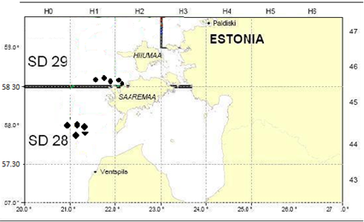
Figure 1. Approximate location of trawl stations in Sub-divisions 28.2. and 29.

3. For internationally coordinated surveys, describe the participating Member States/vessels and the relevant international group in charge of planning the survey
National parts of the international coordinated fish surveys should be carried out in the first quarter between 15 February and 31 March (spring survey) and in the fourth quarter between 1 and 30 November (autumn survey). The total distribution area of cod should be covered by the BITS trawl survey. It was agreed by the responsible ICES WGBIFS that the ICES Subdivisions 22–28 should be covered with fish control-hauls during the trawl surveys. All Baltic countries are participating in the BITS survey. The surveys are coordinated and the results are discussed by the ICES WGBIFS annually.
The participating countries use their research vessel or chartered fishing vessel and the standard gear. Estonia is participating in the 4th quarter (autumn) survey using the chartered Estonian fishing vessel and TV3-520 trawl.
4. Where applicable, describe the international task sharing (physical and/or financial) and the cost sharing agreement used
Each MS performs the survey in its EEZ according to the pre-defined sampling stations. These are randomly chosen and assigned internationally from the Clear Tow Database.
5. Explain where thresholds apply
NA
- Graphical representation (map) showing the positions (locations) of the realized samples
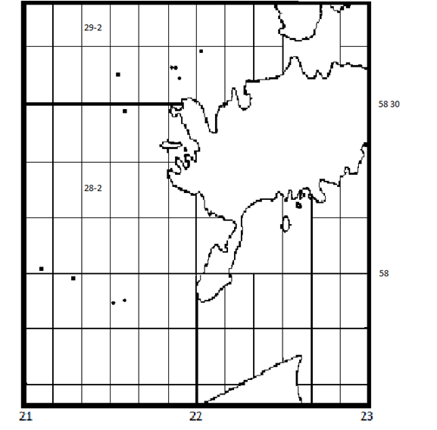
Figure 1G.1. BITS IV QRT survey in November 2018. Black dots indicate the location of Estonian trawl hauls.
- For internationally coordinated surveys, provide a link to the latest meeting report of the coordination group.
ICES WGBIFS and the Baltic RCG are in charge in coordinating the survey. (http://ices.dk/sites/pub/Publication%20Reports/Expert%20Group%20Report/SSGIEOM/2017/WGBIFS/WGBIFS%202017.pdf)

- List the main use of the results of the survey (e.g. indices, abundance estimates, environmental indicators).

The results are used by the ICES WGBFAS for assessment of the Baltic cod and flounder stocks on routinely basis.
9. Extended comments (Tables 1G and 1H)

Eight countries have been participating in realization of the BITS surveys: Denmark, Germany, Latvia, Poland, Sweden, Estonia, Lithuania and Russia.
Estonia performed its part of the survey in 19-20 of November 2018. 10 planned trawl hauls were performed in the ICES Sub-divisions 28.2 and 29 (Fig. 1G.1).
1G.2 Baltic International Acoustic Survey (BIAS)
1. Objectives of the survey
The objective of the Baltic International Acoustic Survey (BIAS) and Baltic Acoustic Spring Survey (SPARS) programs are to obtain the fisheries-independent information for tuning analytical stock assessment models for Baltic herring and sprat, to standardize survey design, acoustic measurements, fishing method and data analysis throughout all national surveys where data are used as indices for assessment purposes.
2. Description of the methods used in the survey. For mandatory surveys, link to the manuals. Include a graphical representation (map)
The acoustic surveys cover the total area of ICES Division III. Each statistical rectangle of the area under investigation is allocated to one particular country by the Baltic International Fish Survey Working Group (WGBIFS), thus each country has a mandatory responsible area. The area is limited inshore by the 10 m depth line. The standard equipment used for the survey is the Simrad EK/EY-60 echosounder and the standard frequency is 38 kHz. Baltic International Acoustic Survey (BIAS) is carried out in September/October. All surveys are carried out by the agreed Manual of International Baltic Acoustic Surveys (IBAS) (http://www.ices.dk/community/groups/Pages/WGBIFS.aspx). The surveys are coordinated and the results discussed by the ICES WGBIFS annually. Data are stored in BIAS_DB.mdb. In future the data will be transferred to the new ICES acoustic and trawl database which is under construction.
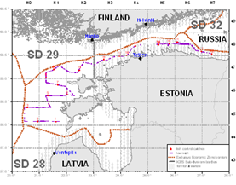
Figure 2. Location of planned track for BIAS in the Sub-divisions 28.2, 29 and 32

3. For internationally coordinated surveys, describe the participating Member States/vessels and the relevant international group in charge of planning the survey.

Each MS performs the survey in its EEZ on its own or shared research vessel. Estonia is using the Polish Research vessel BALTICA for both SPARS and BIAS surveys. The overall coordination of the coming surveys is done by the WGBIFS in order to secure the full coverage of the Baltic Sea.
4. Where applicable, describe the international task sharing (physical and/or financial) and the cost sharing agreement used.

Estonia is sharing the coverage of statistical rectangles of the Gulf of Finland during the BIAS.
5. Explain where thresholds apply
NA
- Graphical representation (map) showing the positions (locations) of the realized samples.

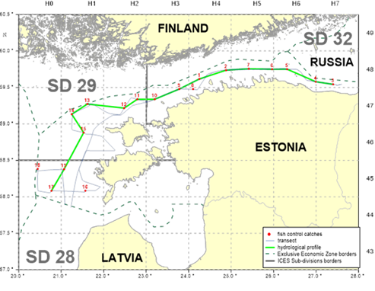
Figure 1G.2. Survey track of EST-POL BIAS in Sub-divisions 28.2, 29 and 32 in October 2018 (486 NM of acoustic survey and 19 control hauls were realized).
- For internationally coordinated surveys, provide a link to the latest meeting report of the coordination group.
ICES WGBIFS and the Baltic RCG are in charge in coordinating the survey. (http://ices.dk/sites/pub/Publication%20Reports/Expert%20Group%20Report/SSGIEOM/2017/WGBIFS/WGBIFS%202017.pdf)

- List the main use of the results of the survey (e.g. indices, abundance estimates, environmental indicators).
The results are used by WGBIFS for Baltic sea herring and sprat stocks assessment.
9. Extended comments (Tables 1G and 1H)

Nine countries have been participating in realization of the BIAS surveys: Denmark, Estonia, Finland, Germany, Latvia, Lithuania, Poland, Sweden and Russia. Survey was conducted between 21 and 31 of October 2018, on board of the chartered Polish research vessel “Baltica”. All collected acoustic information was uploaded ICES Acoustic and Trawl Database. The results are used by the ICES WGBFAS on routinely

1G.3 Gulf of Riga Acoustic Herring Survey GRAHS
1. Objectives of the survey.
The aim of the survey is to obtain the fisheries-independent information for tuning analytical stock assessment models for Baltic herring in the Gulf of Riga (Gulf of Riga herring). The information obtained during the survey is used by the Baltic Fisheries Assessment Working Group of the ICES.
2. Description of the methods used in the survey. For mandatory surveys, link to the manuals. Include a graphical representation (map).
Survey will be carried out following the agreed Manual of International Baltic Acoustic Surveys (IBAS) (http://www.ices.dk/community/groups/Pages/WGBIFS.aspx). The surveys are coordinated and the results are discussed by the ICES WGBIFS annually. The survey is carried out in July-August annually in order to cover the period after main spawning season when most of the stock has left the near-coast spawning grounds. Data are stored in BIAS_DB.mdb. In future the data will be transferred to the new ICES acoustic database which is under construction.
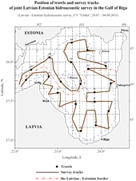
Figure 3. Acoustic track and trawl stations during the Gulf of Riga Acoustic herring survey.

3. For internationally coordinated surveys, describe the participating Member States/vessels and the relevant international group in charge of planning the survey.
The survey is carried out jointly by the Latvian and Estonian scientists on the chartered Latvian fishing vessel. The results are discussed and future surveys planned during the meeting of the ICES WGBIFS annual meetings.
4. Where applicable, describe the international task sharing (physical and/or financial) and the cost sharing agreement used.
Estonia and Latvia share the tasks of work and also the survey costs on this joint survey.
5. Explain where thresholds apply
NA
- Graphical representation (map) showing the positions (locations) of the realized samples.
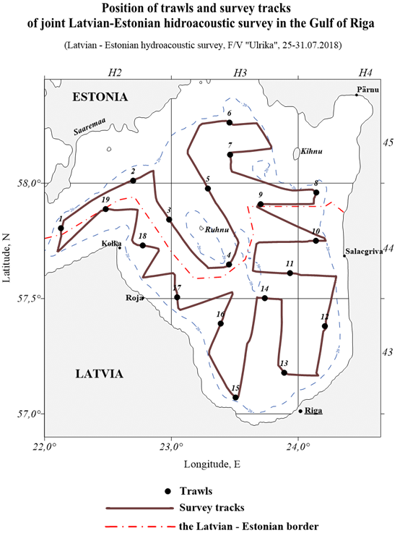
Figure 1G.3. Survey track and location of control hauls during the EST-LAT acoustic survey in the Gulf of Riga in July-August 2018. Length of acoustic track 448 NM, 19 hauls.

- For internationally coordinated surveys, provide a link to the latest meeting report of the coordination group.
ICES WGBIFS and the Baltic RCG are in charge in coordinating the survey. (http://ices.dk/sites/pub/Publication%20Reports/Expert%20Group%20Report/SSGIEOM/2017/WGBIFS/WGBIFS%202017.pdf)

- List the main use of the results of the survey (e.g. indices, abundance estimates, environmental indicators).
The information on abundance, biomass and distribution of the Baltic herring in the Gulf of Riga is used by the relevant ICES working group (WGBFAS) in stock assessment process.

- Extended comments (Tables 1G and 1H)

Estonia and Latvia are participating in this survey. Survey was performed in 25- 31.08.2018 (7 days at sea), using the same particular chartered fishing vessel as in previous years.

1G.4. Baltic Acoustic Spring Survey (SPARS)
1. Objectives of the survey.
The main objective of the Baltic Acoustic Spring Survey (SPARS) programs are to obtain the fisheries-independent information for tuning analytical stock assessment models for Baltic sprat, to standardize survey design, acoustic measurements, fishing method and data analysis throughout all national surveys where data are used as indices for assessment purposes.
2. Description of the methods used in the survey. For mandatory surveys, link to the manuals. Include a graphical representation (map)
The acoustic survey covers the main area of sprat distribution in the Baltic. Each statistical rectangle of the area under investigation is allocated to one particular country by the Baltic International Fish Survey Working Group (WGBIFS), thus each country has a mandatory responsible area. The area is limited inshore by the 10 m depth line. The standard equipment used for the survey is the Simrad EK/EY-60 echosounder and the standard frequency is 38 kHz. The Baltic Acoustic Spring Survey (SPARS) is carried out annually in May. All surveys are carried out by the agreed Manual of International Baltic Acoustic Surveys (IBAS) (http://www.ices.dk/community/groups/Pages/WGBIFS.aspx). The surveys are coordinated and the results are discussed by the ICES WGBIFS annually. Data are stored in BASS_DB.mdb. In future the data will be transferred to the new ICES acoustic database which is under construction.
Map (Figure 1G.4) describes the location of sampling sites allocated for Estonia during the SPARS.
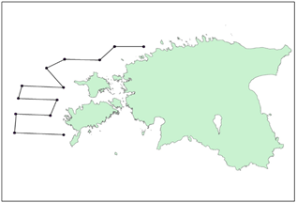
Figure 1G.4. Location of planned acoustic track for Estonian SPARS in the Sub-divisions 28.2, 29 and 32

3. For internationally coordinated surveys, describe the participating Member States/vessels and the relevant international group in charge of planning the survey
Each MS performs the survey in its EEZ on its own or shared research vessel. Estonia is using the Polish Research vessel BALTICA for both SPARS and BIAS surveys. The overall coordination of the coming surveys is done by the WGBIFS in order to secure the full coverage of the agreed during the WGBIFS area.
4. Where applicable, describe the international task sharing (physical and/or financial) and the cost sharing agreement used
Each MS performs the survey in its EEZ according to the agreed coverage of the statistical rectangles.
5. Explain where thresholds apply
NA
- Graphical representation (map) showing the positions (locations) of the realized samples.

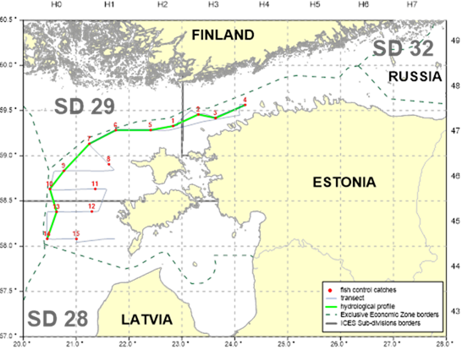
Figure 1G.4. Survey track of EST-POL SPARS in Sub-divisions 28.2, 29 and 32 in May 2018 (392 NM of acoustic survey and 15 control hauls were realized).
- For internationally coordinated surveys, provide a link to the latest meeting report of the coordination group.
ICES WGBIFS( http://ices.dk/sites/pub/Publication%20Reports/Expert%20Group%20Report/SSGIEOM/2017/WGBIFS/WGBIFS%202017.pdf), and the Baltic RCG are in charge in coordinating the survey.
- List the main use of the results of the survey (e.g. indices, abundance estimates, environmental indicators).

Information on abundance, biomass and distribution of the Baltic herring and sprat obtained during the SPARS are used by the relevant ICES working group (WGBFAS) in stock assessment process (to produce the tuning files) of the Baltic sprat on routinely basis.
9. Extended comments (Tables 1G and 1H)
Five countries have been participating in realization of the SPARS surveys: Estonia, Germany, Latvia, Lithuania and Poland. SPRAS survey in Sub-divisions 28.2, 29 and 32 was conducted in May 2018 as planned. A number of additional fish hauls and hydrological stations were performed in order to have better information as a basis for later data analysis, due to complicated distribution pattern of fish stocks. There additional stations did not have any additional cost implications.
1G.5. Estonian Fish Larvae Survey
1. Objectives of the survey
A national survey has been conducted annually since 1947. To study the distribution and abundance of commercially important fish larvae and juveniles with the aim to provide the ICES WGBFAS with primary information on herring year –class abundance. Additionally the information on spawning success of other commercially important species (perch, pikeperch, smelt) will be obtained.
2. Description of the methods used in the survey. For mandatory surveys, link to the manuals. Include a graphical representation (map)
Nine fixed stations will be visited weekly (May-August). Hensen larval fish net is used for 10 min. hauls in NE of the Gulf of Riga in commercially important fish spawning and nursery grounds.
Larvae and juveniles will be collected using research vessels of the Estonian Marine Institute. Larvae are identified, measured and counted. Plankton samples and environmental data are collected and analysed. The map (Figure 5) describes the location of the stations which are sampled during the survey.
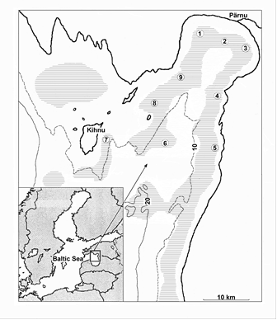
Figure 5. Location of the stations: 1 – Audru, 2 – Poi, 3 – Uulu, 4 – Tahku, 5 – Timmkanal, 6 – Palva, 7 – Kihnu, 8 – Sorgu ja 9 – Liu

- Graphical representation (map) showing the positions (locations) of the realized samples.
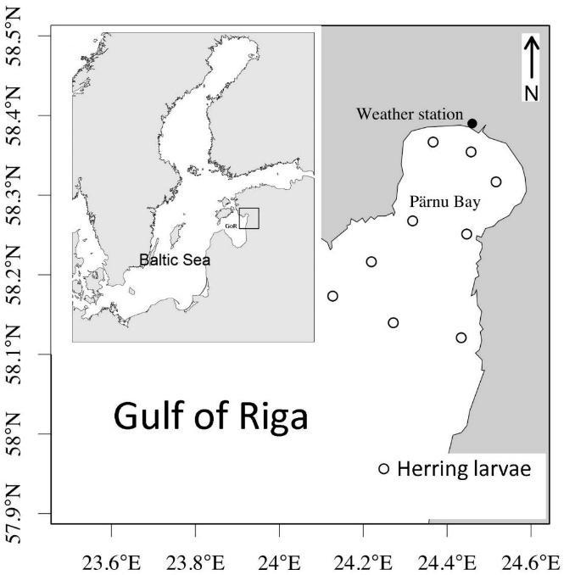
Figure 1G.5
- For internationally coordinated surveys, provide a link to the latest meeting report of the coordination group.
Not coordinated internationally
- List the main use of the results of the survey
Data on abundance and distribution of the spring spawning herring larvae in the Gulf of Riga is used to calculate larval herring index N2. The rationale for this approach is that (i) the eggs and larvae of a species should be in direct proportion to the biomass of the adults, (ii) estimating the abundance of eggs or larvae is either more accurate or less costly than estimating the abundance of adults, and (iii) ichthyoplankton surveys provide data on a different group of species than trawl surveys for adults. One commonly used analytical approach to developing indices from ichthyoplankton surveys relies on the mean larval abundance across a survey area.

9. Extended comments (Tables 1G and 1H)
Survey was conducted from April until the end of July (normally once a week), using EMI RV AURELIE. Altogether 96 trawl hauls were performed and vertical CTD profiles measured.
1G.6. Gulf of Riga Fish survey
      - Objectives of the survey
Objective of this survey is to collect fisheries-independent data for tuning of pikeperch VPA assessment and to get information for other commercially important species (perch, cyprinids).
Bottom trawl survey in the Pärnu Bay which was conducted already in earlier decades (since 1950s), and resumed in a few years ago.
2. Description of the methods used in the survey. For mandatory surveys, link to the manuals. Include a graphical representation (map)
During pilot study (until 2016) survey trawl hauls was performed monthly from spring to autumn. The final design includes trawling in spring and autumn. Research vessel AURELIE of the Estonian Marine Institute is used.
Survey instructions are in preparation.
- Graphical representation (map) showing the positions (locations) of the realized samples.
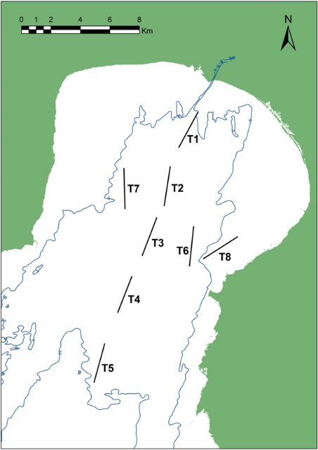
Figure 1G.5
- For internationally coordinated surveys, provide a link to the latest meeting report of the coordination group.
Not internationally coordinated
- List the main use of the results of the survey
Results are used in national context, primarily to assess the pikeperch stock, but also abundance index for perch and other species.
9. Extended comments (Tables 1G and 1H)
During pilot study (until 2016) survey trawl hauls was performed monthly from spring to autumn. The final design includes trawling in spring and autumn (since 2017). Research vessel AURELIE of the Estonian Marine Institute is used.
In 2018, trawling was concentrated to late May – beginning of June and late autumn (October – December). Trawling was performed during 8 days, 42 hauls. Altogether 15156 fish were captured and 6259 measured, predominantly Perca fluviatilis (2227 specimens) and pikeperch (1901 specimens). 18 species of fish were caught.
1G.7. Coastal fish survey
1. Objectives of the survey
National annual survey started in 1992, now in 8 fixed areas. Collected information (CPUE, age and length distribution, age-length keys for commercial species etc) form the basis for advice for commercially important stocks (perch, pikeperch, flounder, cyprinids) and allow following fish assemblage dynamics, including abundance of alien species and their distribution.

2. Description of the methods used in the survey.
Annual gill-net survey in defined areas along the Estonian coast, in fixed (Hiiumaa) or random stations. Each station consists of a series of gill nets of fixed mesh sizes and construction. 30-72 stations are fished in each area (less in Vaindloo).
Methods: Thoresson, 1995, HELCOM 2015 (http://www.helcom.fi/Documents/Action%20areas/Monitoring%20and%20assessment/Manuals%20and%20Guidelines/Guidelines%20for%20Coastal%20fish%20Monitoring%20of%20HELCOM.pdf ), described in appendix of annual research agreement between the Ministry of the Environment and Estonian Marine Institute (unchanged from the beginning of survey).

3. For internationally coordinated surveys, describe the participating Member States and the relevant international group in charge of planning the survey
Similar surveys have been conducted in Sweden, Finland, Lithuania and Latvia. Data are stored in national database, and are delivered to HELCOM.
- Graphical representation (map) showing the positions (locations) of the realized samples.
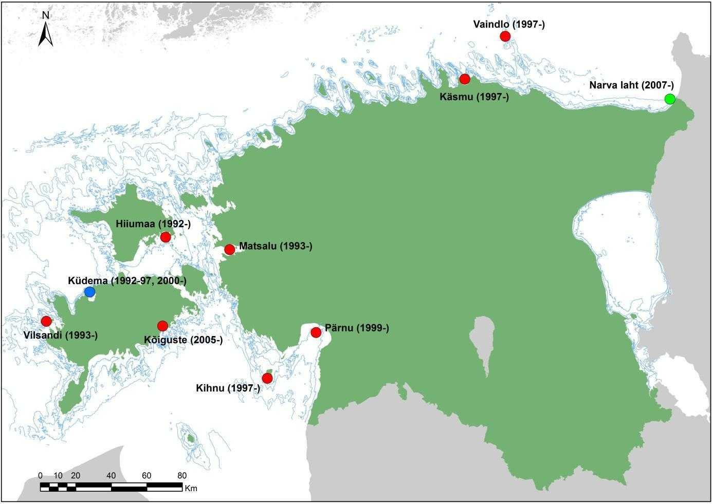
Fig 1G.7. Map of research areas in 2018.
- For internationally coordinated surveys, provide a link to the latest meeting report of the coordination group.
Not internationally coordinated
- List the main use of the results of the survey (e.g. indices, abundance estimates, environmental indicators).
Data on abundance, relative year class strength, size and age distribution, structure of coastal fish assemblages are used in routine basis for giving advice for main commercially important species (also those not namely listed in the National WP). Most of our coastal fish are listed in EU regulation 1251/2016 Table 1D as relevant to HELCOM. Additional data on bycatch (incl marine birds), seal and fish damage of catch, distribution and abundance of alien species, microplastics in fish stomachs is collected.
- Extended comments (Tables 1G and 1H)
Test fishing was conducted in all 9 fixed areas. In total 305 stations were fished, and 48601 specimens belonging to 38 species were measured.

Section 2: Fishing Activity Data

Text Box 2A: Fishing activity variables data collection strategy
General comment: This box fulfills paragraph 4 of Chapter III of the multiannual Union programme and Article 2, Article 4 paragraph (2) point (b) and Article 5 paragraph (2) of the Decision (EU) 2016/1701. It is intended to describe the method used to derive estimates on representative samples where data are not to be recorded under Regulation (EU) No 1224/2009 or where data collected under Regulation (EU) No 1224/2009 are not at the right aggregation level for the intended scientific use.
General comment: This box is applicable to the Annual Report. This box should provide information on the implementation of the data collection of fishing activity variables of Member States.
1. Description of methodologies used to cross-validate the different sources of data
The census data are obtained from an administrative source – Estonian Fisheries Information System (an electronic database - includes logbook and coastal fishing data, fishing vessel register, first-sales data etc.).

2. Description of methodologies used to estimate the value of landings
Value of landings is calculated through the multiplication of the amount of landings per species in kilograms and the average price per kilogram live weight per species.

3. Description of methodologies used to estimate the average price (it is recommended to use weighted averages, trip by trip)
Estimation about the average price per kilogram live weight per species based on first-sales data.

4. Description of methodologies used to plan collection of the complementary data (sample plan methodology, type of data collected, frequency of collection etc)
No additional studies are planned.

5. Deviations from Work Plan methodology used to cross-validate the different sources of data.
No deviations
6. Deviations from Work Plan methodology used to estimate the value of landings.
No deviations
7. Deviations from Work Plan methodology used to estimate the average price.
No deviations
8. Deviations from Work Plan methodology used to plan collection of the complementary data
No deviations

SECTION 3: ECONOMIC AND SOCIAL DATA

Text Box 3A: Population segments for collection of economic and social data for fisheries
General comment: This box fulfils paragraph 5 points (a) and (b) of Chapter III of the multiannual Union programme and Article 2, Article 4 paragraphs (1), (2) and (5) and Article 5 paragraph (2) of the Decision (EU) 2016/1701. It is intended to specify data to be collected under Tables 5(A) and 6 of the multiannual Union programme.
General comment: This box is applicable to the Annual Report. This box should provide information on the implementation of the fleet socio-economic data collection of Member States.
1. Description of methodologies used to choose the different sources of data
Selection of the data source depends on the variable and its availability. Main sources are:
- Survey (questionnaires - the variables which are not available from administrative sources);
- Estonian Fisheries Information System (an electronic database - includes logbook and coastal fishing data, fishing vessel register and first-sales data);
- Estonian Agricultural Registers and Information Board (information about operating and investment subsidies)

2. Description of methodologies used to choose the different types of data collection
Fishing vessel register, logbook and first-sales data which are obtained from administrative sources are census data. To collect other variables surveys are conducted. The Estonian fishing fleet can be divided into two - open sea trawlers and coastal fishing fleet using mainly passive gears. Due to the small number of vessels in trawlers segments census type of data collection survey is used - a questionnaire is sent to each company engaged in trawling. In the case of coastal fishery probability sample survey is used.

3. Description of methodologies used to choose sampling frame and allocation scheme
For the questionnaire survey only fleet segments from coastal fishery (length classes 0-< 10 m and 10-< 12 m) are sampled by simple random sample, The sampling unit is a vessel and a randomly selected sample of vessels is selected for both segment. For other fleet segments all vessels are planned to cover by census based approach.

4. Description of methodologies used for estimation procedures
In the case of simple random sampling the Horvitz-Thompson estimator is used to estimate the total values. In case the variable which is not directly collected but estimated, indirect survey is applied:
Value of unpaid labour – is calculated through the multiplication of the FTE number of unpaid labour and the average wage of person employed (FTE).
Estimation of capital value – the capital value were estimated according to the PIM methodology in the capital valuation report (No FISH/2005/03). Additionally, the final report of the DCF workshop on “calculation of capital value in accordance to PIM methodology and definition of variables not clearly defined in the DCF” is considered as guideline for capital estimation. The calculations of the price per capacity unit (GT) is based on the book values of the vessels from the balance sheets.
Value of landings per species – is calculated through the multiplication of the annual amount of landings per species in kilograms and the average annual price per kilogram live weight per species.
Average price per species – the average annual price per kilogram live weight per species (based on first-sales data from Estonian Fisheries Information System).

5. Description of methodologies used on data quality
For data will be collected by a probability sample survey the bias will be assessed by coverage rate and variability by CV. In case of low response rate (<70%) CV will be calculated also for census based approach.
Consistency and comparability for some economic variables will be ensured by using of official data sources. Results of questionnaires will be checked for consistency and comparability of the numbers. Extreme values which are wrong by evidence will be reviewed.
6. Deviations from Work Plan methodology for selection of data source
No deviations
7. Deviations from Work Plan methodology to choose type of data collection
No deviations
8. Deviations from Work Plan methodology regarding sampling frame and allocation scheme
No deviations
9. Deviations from Work Plan methodology used for estimation procedures
No deviations
10. Quality assurance
Due to the low response rates in voluntary based surveys, Estonia is changing the data collector. Governmental organisation Statistics Estonia has a stronger legal bases for obtaining the data. According to the contract, Statistics Estonia used year 2018 to put together the workflow and verify the methodology and they will take the leading role in economic data collection in 2019 (and social data collection in 2021). First versions of the documentation is available in our DCF web page (https://www.envir.ee/et/eesmargid-tegevused/kalandus/kalanduse-riiklik-andmekogumise-programm-akp)
10.1 Sound methodology
Estonia has set a goal to follow the methodologies and guidelines published on the official DCF web site (https://datacollection.jrc.ec.europa.eu/docs-links/socio-eco-var).
10.2. Accuracy and reliability
Response rate and Achieved sample rate are provided in Table 3A.
Consistency and comparability for some economic variables are ensured by using of official data sources. Results of questionnaires are checked for consistency and comparability of the numbers. Extreme values which are wrong by evidence are reviewed.
10.3. Accessibility and Clarity
Are methodological documents publicly available? Yes
Are data stored in databases? Yes
Where can methodological and other documentation be found? https://www.envir.ee/et/eesmargid-tegevused/kalandus/kalanduse-riiklik-andmekogumise-programm-akp

Section 3: Economic and Social Data

Pilot Study 3: Data on employment by education level and nationality
General comment: This box fulfills paragraph 5 point (b) and paragraph 6 point (b) of Chapter III of the multiannual Union programme and Article 2 and Article 3 paragraph (3) point (c) of the Decision (EU) 2016/1701.It is intended to specify data to be collected under Table 6 of the multiannual Union programme.
General comment: This box is applicable to the Annual Report. This box is intended to provide information on the results obtained from the implementation of the pilot study (including deviations from planned and justifications as to why if this was not the case).
1. Aim of pilot study
The aim of the study is to assess the data availability.
2. Duration of pilot study
From 1 September until 31 October 2017.
3. Methodology and expected outcomes of pilot study
Due to the small number of companies in trawlers segments census type of data collection survey is planned to use - a questionnaire will be sent to each company engaged in trawling. In the case of coastal fishery probability sample survey will be used. The data availability could be evaluated after the analysis of the pilot study results.
4. Achievement of the original expected outcomes of pilot study and justification if this was not the case.
According to the WP Estonia planned to carry out a pilot study, but it was abandoned. The willingness to participate in the surveys has been low among companies in previous years. To solve the problem Estonia is changing the data collector. Statistics Estonia takes that role in 2019. However, the collection of the social indicators was started in regular basis together with economic data in 2018.

5. Incorporation of results from pilot study into regular sampling by the Member State.
Statistics Estonia will take a leading role in collecting social data and will be collecting data first in 2021.

Section 3: Economic and Social Data

Text Box 3B: Population segments for collection of economic and social data for aquaculture
General comment: This box fulfills paragraph 6 points (a) and (b) of Chapter III of the multiannual Union programme and Article 2, Article 4 paragraphs (1) and (5) and Article 5 paragraph (2) of the Decision (EU) 2016/1701.It is intended to specify data to be collected under Tables 6 and 7 of the multiannual Union programme.

General comment: This box is applicable to the Annual Report. This box should provide information on the implementation of the socio-economic data collection for aquaculture of Member States.

According to the multiannual Union programme for the collection, management and use of data in the fisheries and aquaculture sectors for the period 2017-2019, the collection of social, economic and environmental data on freshwater aquaculture is optional. Because there is no marine aquaculture and the total production of freshwater aquaculture is very low, Estonia does not collect data on aquaculture under the EU MAP.

Section 3: Economic and Social Data

Pilot Study 4: Environmental data on aquaculture
General comment: This box fulfills paragraph 6 point (c) of Chapter III of the multiannual Union programme and Article 2 and Article 4 paragraph (3) point (d) of the Decision (EU) 2016/1701. It is intended to specify data to be collected under Table 8 of the multiannual Union programme.
General comment: This box is applicable to the Annual Report. This box is intended to provide information on the results obtained from the implementation of the pilot study (including deviations from planned and justifications as to why if this was not the case).
According to the multiannual Union programme for the collection, management and use of data in the fisheries and aquaculture sectors for the period 2017-2019, the collection of social, economic and environmental data on freshwater aquaculture is optional. Because there is no marine aquaculture and the total production of freshwater aquaculture is very low, Estonia does not collect data on aquaculture under the EU MAP.
Section 3: Economic and Social Data

Text Box 3C: Population segments for collection of economic and social data for the processing industry
General comment: This box fulfils footnote 6 of paragraph 1.1(d) of Chapter III of the multiannual Union programme, Article 2, Article 4 paragraphs (1) and (5) and Article 5 paragraph (2) of Decision (EU) 2016/1701. It is intended to specify data to be collected under Table 11 of the multiannual Union programme.
General comment: This box is applicable to the Annual Report. This box should provide information on the implementation of the socio-economic data collection for aquaculture of Member States.
According to the multiannual Union programme for the collection, management and use of data in the fisheries and aquaculture sectors for the period 2017-2019, the collection of data on the processing industry is optional. Because similar data is already collected by Statistics Estonia and forwarded to Eurostat, Estonia will not collect data on the processing industry in frames of DCF, to avoid the duplication in data collection under the EU MAP.

Section 4: Sampling Strategy for Biological Data from Commercial Fisheries

Text Box 4A: Sampling plan description for biological data
General comment: This box fulfills Article 3, Article 4 paragraph (4) and Article 8 of the Decision (EU) 2016/1701 and forms the basis for the fulfilment of paragraph 2 point (a)(i) of Chapter III of the multiannual Union programme. This Table refers to data to be collected under Tables 1(A), 1(B) and 1(C) of the multiannual Union programme.
General comment: This box is applicable to the Annual Report. This box should provide information on the deviations from the planned sampling of Member States.
1. Description of the sampling plan according to Article 5 paragraph (3) of the Decision (EU) 2016/1701
Both sea and coastal segments of commercial fisheries (strata OSF PEL-1, OSF PEL-2, OSF PEL-3 - altogether 34 vessels; GOR PEL-1, GOR PEL-2 - altogether 15 vessels; OSF DEM - 1 vessel; HSF-1 - 3 vessels; HSF-2 - 5 and stratum SB - 1424 vessels) are sampled. Primary sampling unit for each segment is vessel trip (no exclusions). The vessels for sampling from strata OSF PEL-1, OSF PEL-2, OSF PEL-3 and GOR PEL-1, GOR PEL-2 are selected by random draw from stratum list, all the vessels from strata OSF DEM, HSF-1 and HSF-2 are sampled. Stratum SB is sampled by on board and self-sampling by fishermen evenly distributed by catch volumes along the coastal area. On-board sampling of SB is complicated due to small capacity of vessels. If possible, samples are taken on the sea (using boats of the Estonian Marine Institute). Otherwise, trained fishermen are asked to take all the catch to the port and samples will be taken there.
In the Baltic Sea the selected fish species for biological sampling of commercial catches are Anguilla Anguilla, Clupea harengus, Coregonus lavaretus, Gadus morhua, Perca fluviatilis, Platichthys flesus, Psetta maxima, Salmo salar, Salmo trutta, Sander lucioperca and Sprattus sprattus. Clupea harengus in the Baltic sea is sampled separately in Area/Stock 25-29, 32 and the Gulf of Riga.
In the Eastern Arctic (ICES areas I and II) the sampled species are Gadus morhua and Pandalus borealis. In the North-East Atlantic (ICES Subarea XIV) the only sampled species is Pandalus borealis. Sebastes spp. is sampled in NAFO areas (3LN, 3M and 3O), but Gadus morhua only in NAFO 3M area. Limanda ferruginea will be sampled in NAFO areas (3LNO) and Reinhardtius hippoglossoides in areas (3KLMNO).
All selected Baltic Sea fish species are sampled for following biological variables: length, age, weight, sex ratio and sexual maturity. Subsample of 200-300 fish is taken from catch from what 100 specimens are biologically analysed for all dominant species. Most of the
Baltic fish species are sampled on the monthly basis, except Anguilla anguilla and Psetta maxima, which are sampled yearly and Coregonus lavaretus and Gadus morhua, which are sampled quarterly. Selected Eastern Arctic and North Atlantic species are sampled annually by scientific observers on board for length, age, weight and sex ratio with the only exception for Pandalus borealis, which is sampled for length, sex ratio and sexual maturity.
The number of sampled variables from commercial catches for different species is related to the stock and catch size, number of fisheries involved, availability of survey data, end-user needs etc. In certain cases the quota availability, e.g. in the second half of the year, and/or fishers´ behavior may affects both fishery and thus also the sampling intensity (see table 1C). The biggest problems with data quality will be related to the sampling of very variable métiers, namely fyke nets and gill nets. Sampling effort will be directed to the most important fishing grounds and fishing seasons. As for gill net fishery, test fishing data from different parts of the coastal sea will be used as a reference.
Sampling plan purpose, design, quality assurance procedures, analysis methods, sampling units, sampling frames and sample selection methods and data archiving methods are regionally coordinated (RCMs), and follow the needs of the relevant end-users (eg ICES, NAFO) via their respective working groups (ICES WGBFAS, WGBIFS, WGBAST etc.). To ensure quality of data, observers on board are regularly trained and briefed before every trip. Data of different observers are cross-checked.
Corresponding ICES manuals (Manual for the Baltic International Trawl Surveys (BITS), March 2014, ICES Baltic International Fish Survey Working Group; SISP MANUAL OF INTERNATIONAL BALTIC ACOUSTIC SURVEYS (IBAS) Version 1.02 28-03-2014, ICES 2014) are followed in detail. Methods for coastal fish analyses are accredited nationally by the accreditation certificate No L179 (2017) of the Tartu University, Estonian Marine Instituute: Assessment of biodiversity, abundance and biomass of fish assemblages; KJ l/20; based on EVSEN 14757; Helcom, 2015 (Coastal Fish Guidlines) and Assessment of species composition and abundance of salmonids in riverine habitat, KJ l/21; based on Bohlin et al., 1989 and ICES, 2014. Laboratory of the Estonian Marine Institute is accredited against the requirements of standard EVS-EN ISO/IEC 17025:2006 (http://www.sea.ee/en/11064/).
(max 900 words per region)
Deviation from the sampling plan according to Article 5 paragraph (3) of the Decision (EU) 2016/1701:

2. Deviations from the Work Plan
For OSF PEL and GOR PEL, the total number of samples was exceeded or was close to the planned number, but vessels in different length group were analysed at different level. OSF PEL-1 and GOR PEL-1 were not sampled as few and very short trips were made, majority of catch was landed abroad or in a remote harbours and landed often during night time or very early in the mornings. As those segments contain few ships, then we are planning to merge those segments with larger vessel groups. OSF PEL-2 was slightly undersampled as getting samples was complicated due to similar reasons described for OSF PEL-1 and GOR PEL-1. Slight undersampling of OSF PEL-2 does not effect the overall amount and quality of data as OSF PEL-3 was oversampled (this vessel group is more accessible and are responsible for majority of catches) to get better overview of catch composition changes over time and area. In Gulf of Riga trapnet fishery of herring is also covered under commercial sampling scheme.
For other deviations, see Table 4A.
It should be stressed that commercial sample numbers for herring in Table 1C include both trawl fishery and trapnet (pound net) fishery in the Gulf of Riga and out of the Gulf. In Table 4A, trapnet fishery is included to stratum SB, and thus total number of sampled fish in OSF PEL and GOR PEL is lower than in Table 1C. Tabel 4A in stratum rows OSF PEL and GOR PEL contain only combined commercial catch of herring and sprat.

3. Action to avoid deviations
As there are a few active vessels in OSF PEL-1 and GOR PEL-1, it seems reasonable to join these vessels with vessels of the following length group. This means 2 groups of vessels for OSF PEL (12-24 and 24-40 m) and one for GOR PEL (18-40 m).

Section 5: data quality

Text Box 5A: Quality assurance framework for biological data
General comment: This box is applicable to the Annual Report. This box fulfills Article 5 paragraph (2) point (a) of the Decision (EU) 2016/1701. This box is intended to specify data to be collected under Tables 1(A), 1(B) and 1(C) of the multiannual Union programme. Use this box to provide additional information on Table 5A.
1. Evidence of data quality assurance
Quality assurance framework for biological data is still under elaboration, but first set of documentation is already made available (sampling commercial fishery in Baltics, how the data is handled, methodology of phone survey of recreational fishery). Documentation about sampling our distant fleet is incomplete at the moment, but will be made available next year.

2. Sampling design
Documentation about long distance fleet sampling design will be made available next year.

3. Sampling implementation
Documentation about long distance fleet sampling design will be made available next year.

4. Data capture

5. Data Storage
A major issue is storage of otoliths and other structures for age determination. Currently, we are attempting to put together historical collection of these structures (to be stored in the database of the Natural Museum of the University of Tartu). We hope to make use of this system also for recent data.

6. Data processing
This section will be completed in 2019. For areas outside the Baltic Sea, we have provisionally noted N. Sampling in these areas depends on available quotas and in the Eastern Arctic (ICES areas I and II) is not predictable due to limited observer coverage; our data can be hardly evaluated nationally.

Section 5: data quality

Text Box 5B: Quality assurance framework for socioeconomic data
General comment: This box fulfills Article 5 paragraph (2) point (b) of the Decision (EU) 2016/1701. This box is intended to specify data to be collected under Tables 5(A), 6 and 7 of the multiannual Union programme. Use this box to provide additional information on Table 5B.
1. Evidence of data quality assurance
Quality assurance framework for socioeconomic data is under elaboration as we are changing our data collector to a governmental organisation Statistics Estonia. Statistics Estonia has a stronger legal bases for obtaining the data.
2018 was transitional year when Statistics Estonia did preliminary works to start collecting economic data in 2019. Social data collection will go under Statistics Estonia liability in following years. First review of the documentation about economic data collection is available in our national DCF web page (https://www.envir.ee/et/eesmargid-tegevused/kalandus/kalanduse-riiklik-andmekogumise-programm-akp). This documentation will be reviewed at the end of this year, when first data collection period for Statistics Estonia is over.

Annex 1
