Ministry of the Environment, Republic of Estonia (EST)

Regulation (EU) 2017/1004 of the European Parliament and of the Council
of 17 May 2017
on the establishment of a Union framework for the collection, management and use of data in the fisheries sector and support for scientific advice regarding the common fisheries policy and repealing Council Regulation (EC) No 199/2008

Commission delegated decision (EU) 2019/910 of 13 March 2019
establishing the multiannual Union programme for the collection and management of biological, environmental, technical and socioeconomic data in the fisheries and aquaculture sectors

Commission implementing decision (EU) 2019/909 of 18 February 2019
establishing the list of mandatory research surveys and thresholds for the purposes of the multiannual Union programme for the collection and management of data in the fisheries and aquaculture sectors

ESTONIAN Work Plan for data collection in the fisheries and aquaculture sectors
2020-2021

Tallinn, 31 October 2019

CONTENTS

Section 1: Biological Data 3
Pilot Study 1: Relative share of catches of recreational fisheries compared to commercial fisheries 3
Text Box 1E: Anadromous and catadromous species data collection in fresh water 4
Pilot Study 2: Level of fishing and impact of fisheries on biological resources and marine ecosystem 5
Text Box 1G: List of research surveys at sea 6
Section 2: Fishing Activity Data 14
Text Box 2A: Fishing activity variables data collection strategy 14
Section 3: Economic and Social Data 15
Text Box 3A: Population segments for collection of economic and social data for fisheries 15
Pilot Study 3: Data on employment by education level and nationality 17
Text Box 3B: Population segments for collection of economic and social data for aquaculture 18
Pilot Study 4: Environmental data on aquaculture 19
Text Box 3C: Population segments for collection of economic and social data for the processing industry 20
Section 4: Sampling Strategy for Biological Data from Commercial Fisheries 21
Text Box 4A: Sampling plan description for biological data 21

Section 1: Biological Data

Pilot Study 1: Relative share of catches of recreational fisheries compared to commercial fisheries
General comment: This Box fulfills paragraph 4 of Chapter V of the multi-annual Union programme and Article 2 and Article 4 paragraph (3) point (a) of this Decision.
No pilot study, information is collected on regular bases.

Section 1: Biological Data

Text Box 1E: Anadromous and catadromous species data collection in fresh water
General comment: This Box fulfills paragraph 2 points (b) and (c) of Chapter III of the multi-annual Union programme and Article 2 of this Decision.
Salmon and sea trout.
The principal way of monitoring salmonid populations in rivers is electrofishing. Permanent monitoring sites, located in important parr rearing areas, are fished annually. The sites are fished twice to calculate fishing efficiency and parr densities are presented as individuals per 100 m². The results of this method are comparable to all neighbouring countries.
Atlantic salmon and sea trout smolt abundancy estimate in river Pirita is done by capture-mark-recapture method. Smolts are caught by trap-net at the river mouth throughout the migration season. Captured smolts are tagged by VIE (visible implant elastomer) and released 2 km upstream from the trap. Some of the tagged smolts will be recaptured during their descent towards the sea. This enables to estimate the overall smolt run size.
Ascending Atlantic salmon and sea trout spwners are counted in river Pirita throughout the migration season. A fish fence (type: resistance board weir) covering the entire width of the river guides fish through an opening that has a fish counter. Vaki Riverwatcher with a camera tunnel is used.
All caught fish will be measured and released after analyses.

Eel
Fyke nets (mouth opening <3m, mesh size >38mm in the cod end) for eel fresh water scientific survey are used. Survey lasts usually from May until October, depending on water temperature. Fyke nets are controlled in every 3 days. Length (TL=mm), weight (g), age (from otolith), silvering stage (length of the pectoral fins and eye diameter) and infestation with parasites are recorded.
List of trusted fishermen are used for collecting information from commercial catches. Total length, weight and silvering stage are recorded for the individuals sampled from commercial catches.
Annual data of eel restocking is collected with average weight (g) and total number of restocked individuals recorded.

Section 1: Biological Data

Pilot Study 2: Level of fishing and impact of fisheries on biological resources and marine ecosystem
General comment: This Box fulfills paragraph 3 point (c) of Chapter III of the multi-annual Union programme and Article 2 and Article 4 paragraph (3) point (b) of this Decision.
As there are no active bottom trawlers now (2016-19), we do not study fishery’s impact to the sea floor. During coastal fish survey we study by-catch, monitor different fish species stock fluctuations and study the diet of predatory fish to understand the food web functioning.
For period 2020-2021 a separate bird and seal by-catch survey is planned
- Aim of pilot study
To evaluate the number of seal and bird species perishing in passive fishing gears in different coastal areas (subdivisions 28-29 and 32) and assess the impact of incidental by-catch to involved by-catch species.
- Duration of pilot study
2020-2021
- Methodology and expected outcomes of pilot study
Fishermen often ignore the duty to register the by-catch species in fisherman log-books and are not able to identfy the birds and seals to species level. For the study a network of motivated fishermen will register, preserve or take the photo of by-catch species together with all relevant catch data. The by-caught bird and seal species are identified to species level using preserved specimens and/or photos. The data from involved fishermen will be extrapolated to the whole coastal area to evaluate the impact of coastal fishery using small boats (< 12 m) and passive gears to the bird and mammal populations. The results of the study will be compared with the results of the 2007-2009 LIFE project (“Baltic MPAs - Marine Protected Areas in the Eastern Baltic Sea” LIFE05 NAT/LV/000100). Selective construction of fishing gears, closed seasons and other solutions how to minimize the unwanted incidental by-catch will be suggested depending on the results of the project.

Section 1: Biological Data

Text Box 1G: List of research surveys at sea
Baltic International Trawl Survey (BITS Q 4)
General Comment: This Box fulfills Chapter IV of the multi-annual Union programme and Article 2 and Article 7 paragraph (3) of this Decision. It is intended to specify which reseach surveys at sea set out in Table 10 of the multi-annual Union programme will be carried out. Member States shall specify whether the research survey is included in Table 10 of the multi-annual Union programme or whether it is an additional survey.
1. Objectives of the survey.
The main aim of the BITS ground-trawl survey is monitoring the spatial distribution and abundance of cod and flounder recruiting year-classes, and other fish species spatial distribution in a bottom zone of particular ICES Subdivisions, taking into consideration the principal hydrological parameters vertical and horizontal variations. Moreover, the survey is focused on evaluation of the fishing efficiency and abundance of diferent species (Catch Per Unit of Effort), analysis of the Baltic ichthyofauna biodiversity and collects materials for the main species principal biological parameters. The results are primarily used by the ICES Baltic Fisheries Assessment Working Group (WGBFAS).
2. Description of the methods used in the survey. For mandatory surveys, link to the manuals. Include a graphical representation (map).
Estonia follows the methods agreed for the BITS by the ICES Baltic International Fish Survey Working Group (WGBIFS) described in the Manual for the Baltic International Trawl Surveys (BITS). http://www.ices.dk/sites/pub/Publication%20Reports/ICES%20Survey%20Protocols%20%28SISP%29/SISP%207%20-%20Manual%20for%20the%20Baltic%20International%20Trawl%20Surveys%20%28BITS%29.pdf
Map (Figure 1.) describes the approximate location of sampling sites allocated for Estonia.
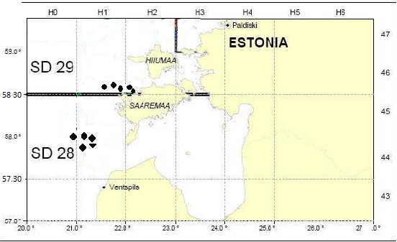
Figure 1. Approximate location of trawl stations in Sub-divisions 28.2. and 29.
3. For internationally coordinated surveys, describe the participating Member States/vessels and the relevant international group in charge of planning the survey
- National parts of the international coordinated fish surveys should be carried out in the first quarter between 15 February and 31 March (spring survey) and in the fourth quarter between 1 and 30 November (autumn survey). The total distribution area of cod should be covered by the BITS trawl survey. It was agreed by the responsible ICES WGBIFS that the ICES Subdivisions 22–28 should be covered with fish control-hauls during the trawl surveys. The surveys are coordinated and the results are annually discussed by the ICES WGBIFS.
The participating countries use their research vessel or chartered fishing vessel and the standard gear. Estonia is participating in the 4th quatrer (autumn) survey using the chartered Estonian fishing vessel and TV2-520 trawl.
4. Where applicable, describe the international task sharing (physical and/or financial) and the cost sharing agreement used.
Each MS performs the survey in its EEZ according to the pre-defined sampling stations. These are randomly chosen and assigned internationally from the Clear Tow Database.
5. Explain where thresholds apply
NA

Baltic International Acoustic Survey (BIAS)
1. Objectives of the survey
The objective of the Baltic International Acoustic Survey (BIAS) is to obtain the fisheries-independent information for tuning analytical stock assessment models for Baltic herring and sprat, to standardize survey design, acoustic measurements, fishing method and data analysis throughout all national surveys where data are used as indices for assessment purposes.
2. Description of the methods used in the survey. For mandatory surveys, link to the manuals. Include a graphical representation (map)
The acoustic surveys cover the total area of ICES Division III. Each statistical rectangle of the area under investigation is allocated to one particular country by the Baltic International Fish Survey Working Group (WGBIFS), thus each country has a mandatory responsible area. The area is limited inshore by the 10 m depth line. The standard equipment used for the survey is the Simrad EK/EY-60 echosounder and the standard frequency is 38 kHz. Baltic International Acoustic Survey (BIAS) is carried out in September/October. Survey is carried out by the agreed Manual of International Baltic Acoustic Surveys (IBAS) (http://www.ices.dk/community/groups/Pages/WGBIFS.aspx). The survey is annually coordinated and the results discussed by the ICES WGBIFS. Data are stored in ICES Acoustic trawl surveys Database.
Map (Figure 2.) describes the location of sampling sites allocated for Estonia during the BIAS.
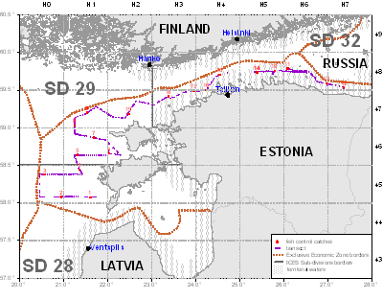
Figure 2. Location of planned track for BIAS in the Sub-divisions 28.2, 29 and 32.
3. For internationally coordinated surveys, describe the participating Member States/vessels and the relevant international group in charge of planning the survey.
Each MS performs the survey in its EEZ on its own or shared research vessel. Estonia is using the Polish Research vessel BALTICA for both SPARS and BIAS surveys. The overall coordination of the coming surveys is done by the WGBIFS in order to secure the full coverage of the Baltic Sea.
4. Where applicable, describe the international task sharing (physical and/or financial) and the cost sharing agreement used.
Each statistical rectangle of the area under investigation is allocated to one particular country by the Baltic International Fish Survey Working Group (WGBIFS), thus each country has a mandatory responsible area.
5. Explain where thresholds apply NA

Gulf of Riga Acoustic Herring Survey GRAHS
1. Objectives of the survey.
The aim of the survey is to obtain the fisheries-independent information for tuning analytical stock assessment models for Baltic herring in the Gulf of Riga (Gulf of Riga herring). The information obtained during the survey is used by the Baltic Fisheries Assessment Working Group of the ICES (WGBFAS).
2. Description of the methods used in the survey. For mandatory surveys, link to the manuals. Include a graphical representation (map).
Survey will be carried out following the agreed Manual of International Baltic Acoustic Surveys (IBAS) (http://www.ices.dk/community/groups/Pages/WGBIFS.aspx). The surveys are coordinated and the results are discussed by the ICES WGBIFS annually. The survey is carried out in July-August annually in order to cover the period after main spawning season when most of the stock has left the near-coast spawning grounds. In near futuure data will be stored in ICES Acoustic trawl surveys Database.
The map (Figure 3) describes the acoustic track and approximate position of trawl stations in the Gulf of Riga
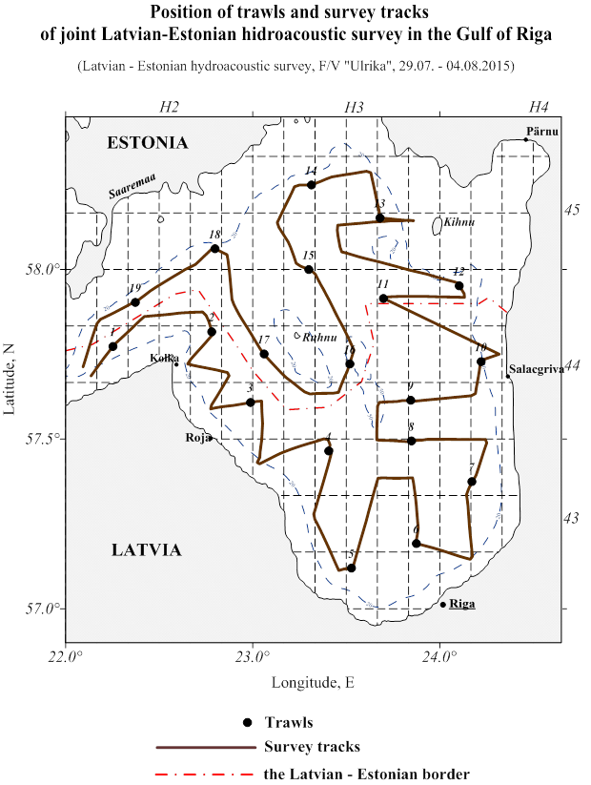
Figure 3. Acoustic track and trawl stations during the Gulf of Riga Acoustic herring survey.
3. For internationally coordinated surveys, describe the participating Member States/vessels and the relevant international group in charge of planning the survey.
The survey is carried out jointly by the Latvian and Estonian scientists on the chartered Latvian fishing vessel. The results are discussed and future surveys planned during the meeting of the ICES WGBIFS annual meetings.
4. Where applicable, describe the international task sharing (physical and/or financial) and the cost sharing agreement used.
Estonia and Latvia share the tasks of work and also the survey costs on this joint survey.
5. Explain where thresholds apply
NA

Sprat Acoustic Survey (SPARS)
1. Objectives of the survey.
The main objective of the Sprat Acoustic Survey (SPARS) programs are to obtain the fisheries-independent information for tuning analytical stock assessment models for Baltic sprat, to standardize survey design, acoustic measurements, fishing method and data analysis throughout all national surveys where data are used as indices for assessment purposes.
2. Description of the methods used in the survey. For mandatory surveys, link to the manuals. Include a graphical representation (map)
The acoustic survey covers the main area of sprat distribution in the Baltic. Each statistical rectangle of the area under investigation is allocated to one particular country by the Baltic International Fish Survey Working Group (WGBIFS), thus each country has a mandatory responsible area. The area is limited inshore by the 10 m depth line. The standard equipment used for the survey is the Simrad EK/EY-60 echosounder and the standard frequency is 38 kHz. The Baltic Acoustic Spring Survey (SPARS) is carried out annually in May. Survey is carried out by the agreed Manual of International Baltic Acoustic Surveys (IBAS) (http://www.ices.dk/community/groups/Pages/WGBIFS.aspx). The survey is annually coordinated and the results discussed by the ICES WGBIFS. Data is stored in ICES Acoustic trawl surveys Database.
Map (Figure 4) describes the location of sampling sites allocated for Estonia during the SPARS.
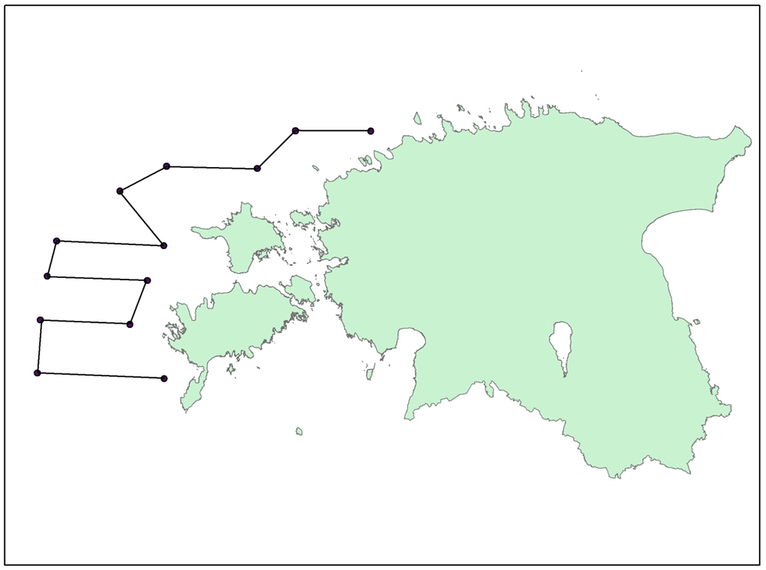
Figure 4. Location of planned acoustic track for Estonian SPARS in the Sub-divisions 28.2, 29 and 32.
3. For internationally coordinated surveys, describe the participating Member States/vessels and the relevant international group in charge of planning the survey
Each MS performs the survey in its EEZ on its own or shared research vessel. Estonia is using the Polish Research vessel BALTICA. The overall coordination of the coming surveys is done by the WGBIFS in order to secure the full coverage of the agreed during the WGBIFS area.
4. Where applicable, describe the international task sharing (physical and/or financial) and the cost sharing agreement used
Each MS performs the survey in its EEZ according to the agreed coverage of the statistical rectangles.
5. Explain where thresholds apply
NA

Estonian Fish Larvae Survey
1. Objectives of the survey
This national survey has been conducted annually since 1947 to study the distribution and abundance of fish larvae and juveniles with the aim to provide primary information on herring yearclass abundance and to unerstand the affecting environmental backround. Results of the survey is used for early estimation of the spawning success and yearclass potential of herring, but also commercially important percids (perch and pikeperch) and smelt.
2. Description of the methods used in the survey. For mandatory surveys, link to the manuals. Include a graphical representation (map)
Nine fixed stations are visited weekly (May-July). Hensen larval fish net is used for 10 min. hauls in NE of the Gulf of Riga in commercially important fish spawning and nursery grounds.
Larvae and juveniles will be collected using research vessels of the Estonian Marine Institute. Larvae are identified, measured and counted. Plankton samples and environmental data are collected and analysed. The map (Figure 5) describes the location of the stations which are vistited during the survey.
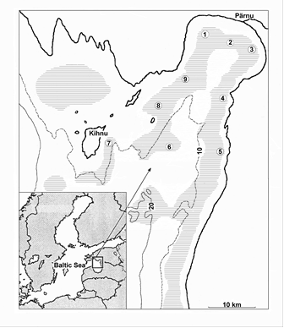
Figure 5. Location of the stations: 1 – Audru, 2 – Poi, 3 – Uulu, 4 – Tahku, 5 – Timmkanal, 6 – Palva, 7 – Kihnu, 8 – Sorgu ja 9 – Liu

Gulf of Riga Fish survey
1. Objectives of the survey
Objective of this survey is to collect fisheries independent data for tuning the pikeperch and perch VPA assessment and get information about ohter commercially important species (smelt, cyprinids).

Trawl survey in the Pärnu Bay was conducted already in earlier decades (since 1950s), and resumed 2009.
2. Description of the methods used in the survey. For mandatory survey, link to the manuals. Include a graphical representation (map).
Research vessel of the Estonian Marine Institute AURELIE is used for trawling. The trawl (working depth 0.3 m from the bottom) is pulled with the speed of 3 knots for 30 minutes. The trawl mouth is 2 m high and 6 m wide, distance between doors is 20 m and maximum distance between the 8.2 m long trawl wings is 12 m. Mesh size is 60 mm (knot to knot), at the tip of the trawl wings, 45 mm at the trawl mouth and decreases gradually to 10 mm at the codend. Six fixed trawl transects are situated three to eight km from shore (water depth five to nine m) to cover the entire length of the Pärnu Bay. All fixed stations are fished in May, September, October, November and December. The survey is coordinated and the results are discussed by the HELCOM FISH-PRO annually. Survey is carried out following the manual of HELCOM: (https://portal.helcom.fi/meetings/FISH-PRO%20III%201-2019-592/MeetingDocuments/4-1%20Updated%20guidelines%20for%20coastal%20fish%20monitoring.pdf)
Map (Figure 6.) describes the location of sampling sites which are vistited during the survey.
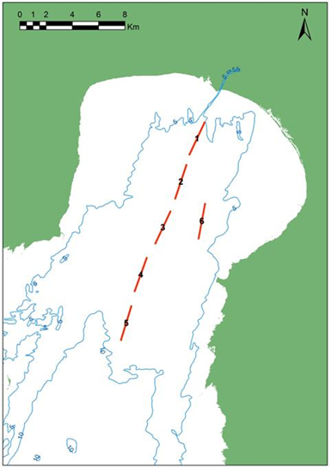
Figure 6. Location of the Gulf of Riga Fish survey transects.

Coastal fish survey
1. Objectives of the survey
National annual survey started in 1992, now in 10 fixed areas. Collected information (CPUE, age and length distribution, age-length keys for commercial species etc) form the basis for advice for commercially important stocks (perch, pikeperch, flounder, eel, cyprinids) and allow following fish assemblage dynamics, including abundance of alien species and their distribution.
2. Description of the methods used in the survey. For mandatory surveys, link to the manuals. Include a graphical representation (map)
Annual gill-net survey in defined areas along the Estonian coast, in fixed (Hiiumaa, Kõiguste and Küdema) or random stations. Each station consists of a series of gill nets of fixed mesh sizes and construction. 24-72 stations are fished in each area (less in Vaindloo). Additionally in six areas (Vilsandi, Kihnu, Kõiguste, Matsalu, Saarnaki and Käsmu) minimum 80 standard fyke net/days are fished for eel CPUE and length distribution.
Methods: Thoresson, 1995, HELCOM 2015 (http://www.helcom.fi/Documents/Action%20areas/Monitoring%20and%20assessment/Manuals%20and%20Guidelines/Guidelines%20for%20Coastal%20fish%20Monitoring%20of%20HELCOM.pdf )
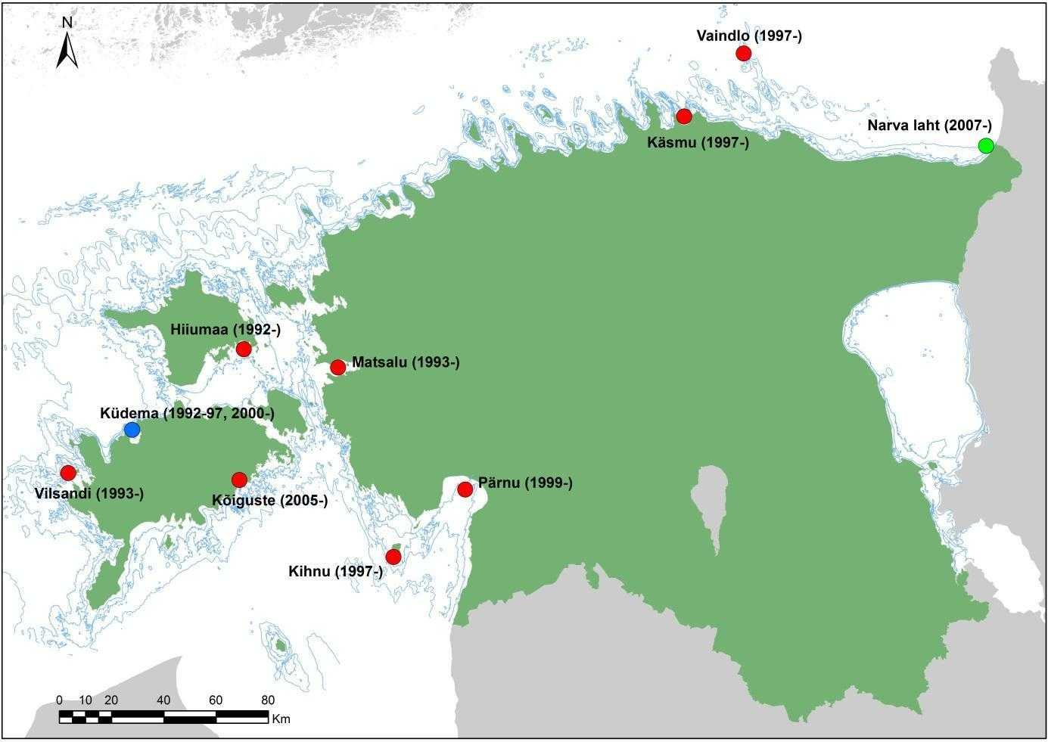
Figure 7. Map of research areas and the data series starting year.
3. For internationally coordinated surveys, describe the participating Member States and the relevant international group in charge of planning the survey.
Similar surveys are conducted in Sweden, Finland, Lithuania, Poland, Germany and Latvia. Data are stored in national database, and delivered to HELCOM.

Section 2: Fishing Activity Data

Text Box 2A: Fishing activity variables data collection strategy
General comment: This Box fulfills paragraph 4 of Chapter III of the multi-annual Union programme and Article 2, Article 4 paragraph (2) point (b) and Article 5 paragraph (2) of this Decision. It is intended to describe the method used to derive estimates on representative samples where data are not to be recorded under Regulation (EU) No 1224/2009 or where data collected under Regulation (EU) No 1224/2009 are not at the right aggregation level for the intended scientific use.
1. Description of methodologies used to cross-validate the different sources of data.
The census data are obtained from an administrative source – Estonian Fisheries Information System (an electronic database that includes logbook and coastal fishing data, fishing vessel register, first-sales data etc.).
2. Description of methodologies used to estimate the value of landings.
Value of landings is calculated through the multiplication of the amount of landings per species in kilograms and the average price per kilogram live weight per species.
3. Description of methodologies used to estimate the average price (it is recommended to use weighted averages, trip by trip)
Estimation about the average price per kilogram live weight per species based on first-sales data.
4. Description of methodologies used to plan collection of the complementary data (sample plan methodology, type of data collected, frequency of collection etc)
No additional studies are planned.

Section 3: Economic and Social Data

Text Box 3A: Population segments for collection of economic and social data for fisheries
General comment: This Box fulfills paragraph 5 points (a) and (b) of Chapter III of the multi-annual Union programme and Article 2, Article 4 paragraphs (1), (2) and (5) and Article 5 paragraph (2) of this Decision. It is intended to specify data to be collected under Tables 5(A) and 6 of the multi-annual Union programme.
1. Description of methodologies used to choose the different sources of data
Selection of the data source depends on the variable and its availability. Main sources are:
- Survey (questionnaires - the variables which are not available from administrative sources);
- Estonian Fisheries Information System (an electronic database - includes logbook and coastal fishing data, fishing vessel register and first-sales data);
- Estonian Agricultural Registers and Information Board (information about operating and investment subsidies)
2. Description of methodologies used to choose the different types of data collection
Total population is defined as all vessels that are in the fishing vessel register, sampling is done through owner (management unit).
Logbook and first-sales data, which are obtained from administrative sources, are census data as reporting this info is obligatory by law. To collect other variables survey is conducted. Estonian fishing fleet can be divided into two – open sea trawlers and coastal fishing fleet, that are using mainly passive gears. All trawlers are under survey (census), as well as those boats from coastal fleet that catch at least 100t per year (based on previous year’s catches). Rest of the coastal fleet is handled by stratified probability sample.
3. Description of methodologies used to choose sampling frame and allocation scheme
Coastal fleet (length classes 0-< 10 m and 10-< 12 m), that catch less then 100t per year, are sampled by stratified probability sample. Every sample group will have a weight that is used for extrapolation. The weight is corrected so that non responses would have less influence. The sampling unit is a vessel and a randomly selected sample of vessels is selected for both segment.
For other fleet segments all vessels are covered by census based approach.
Fishermen will be informed by 15th of December if they are chosen to the sampling frame. The list is updated and obligations corrected in the beginning of the sampling year. Raw data are obtained through online questionnaire by 1st of August. Questionnaires and all related information are available in Statistics Estonia homepage https://www.stat.ee/andmete-esitamine.
4. Description of methodologies used for estimation procedures
In the case of missing or unreliable data, estimate imputation based on established regulations will be used. The data of the enterprises that did not submit the questionnaire are replaced by the respective average of responded similar enterprises.
For statistical units weights are calculated, which are used to expand the data of the sample survey to the total population.
Microdata are aggregated to the level necessary for analysis. This includes aggregating the data according to the classification, and calculating various statistical measures, e.g. average, median, dispersion, etc.
The collected data are converted into statistical output. This includes calculating additional indicators.
5. Description of methodologies used on data quality
Validation includes arithmetical and qualitative controls including comparison with other data.
To assure the quality of processes and products, Statistics Estonia applies the EFQM Excellence Model, the European Statistics Code of Practice and the Quality Assurance Framework of the European Statistical System (ESS QAF). Statistics Estonia is also guided by the requirements in § 7. “Principles and quality criteria of producing official statistics” of the Official Statistics Act.
Statistics Estonia performs all statistical activities according to an international model (Generic Statistical Business Process Model – GSBPM). According to the GSBPM, the final phase of statistical activities is overall evaluation using information gathered in each phase or sub-process; this information can take many forms, including feedback from users, process metadata, system metrics and suggestions from employees. This information is used to prepare the evaluation report which outlines all the quality problems related to the specific statistical activity and serves as input for improvement actions.

Section 3: Economic and Social Data

Pilot Study 3: Data on employment by education level and nationality
General comment: This Box fulfills paragraph 5 point (b) and paragraph 6 point (b) of Chapter III of the multi-annual Union programme and Article 2 and Article 3 paragraph (3) point (c) of this Decision. It is intended to specify data to be collected under Table 6 of the multi-annual Union programme.
Social data collection is now part of the data collection programm.

Section 3: Economic and Social Data

Text Box 3B: Population segments for collection of economic and social data for aquaculture
General comment: This Box fulfills paragraph 6 points (a) and (b) of Chapter III of the multi-annual Union programme and Article 2, Article 4 paragraphs (1) and (5) and Article 5 paragraph (2) of this Decision. It is intended to specify data to be collected under Tables 6 and 7 of the multi-annual Union programme.
According to the multiannual Union programme for the collection, management and use of data in the fisheries and aquaculture sectors the collection of social, economic and environmental data on freshwater aquaculture is optional. Because there is no marine aquaculture and the total production of freshwater aquaculture is very low, Estonia does not collect data on aquaculture under the EU MAP.

Section 3: Economic and Social Data

Pilot Study 4: Environmental data on aquaculture
General comment: This Box fulfills paragraph 6 point (c) of Chapter III of the multi-annual Union programme and Article 2 and Article 4 paragraph (3) point (d) of this Decision. It is intended to specify data to be collected under Table 8 of the multi-annual Union programme.
According to the multiannual Union programme for the collection, management and use of data in the fisheries and aquaculture sectors the collection of social, economic and environmental data on freshwater aquaculture is optional. Because there is no marine aquaculture and the total production of freshwater aquaculture is very low, Estonia does not collect data on aquaculture under the EU MAP.

Section 3: Economic and Social Data

Text Box 3C: Population segments for collection of economic and social data for the processing industry
General comment: This Box fulfills footnote 6 of paragraph 1.1(d) of Chapter III of the multi-annual Union programme, Article 2, Article 4 paragraphs (1) and (5) and Article 5 paragraph (2) of this Decision. It is intended to specify data to be collected under Table 11 of the multi-annual Union programme.
According to the multiannual Union programme for the collection, management and use of data in the fisheries and aquaculture sectors the collection of data on the processing industry is optional. Because similar data is already collected by Statistics Estonia and forwarded to Eurostat, Estonia will not collect data on the processing industry in frames of DCF, to avoid the duplication in data collection.

Section 4: Sampling Strategy for Biological Data from Commercial Fisheries

Text Box 4A: Sampling plan description for biological data
General Comment: This Box fulfills Article 3, Article 4 paragraph (4) and Article 8 of this Decision and forms the basis for the fulfilment of paragraph 2 point (a)(i) of Chapter III of the multi-annual Union programme. This Table refers to data to be collected under Tables 1(A), 1(B) and 1(C) of the multi-annual Union programme.
All fleet segments of commercial fisheries are sampled (strata OSF PEL–29 vessels; GOR PEL–15 vessels; HSF-1 –3 vessels; HSF-2 – 2 and stratum SB – 1585 vessels).
Primary sampling unit (PSU) for OSF PEL and GOR PEL segments is time unit of week and sampling takes place onshore. Sampling scheme for these segments follow the Hierarchy 8 in RDBES. Description of RDBES hierarchy 8: Sampling where time (e.g. days, weeks) is the primary sampling unit (PSU) and vessel is the secondary sampling units (SSU). For the pelagic fisheries (OSF PEL, GOR PEL) our sampling strategy is that in every month when active fishing is ongoing (this depends on the year and subarea) subset of week(s) are sampled (PSU=week).The OSF PEL stratum consists of multiple subareas (SD29, 28.2, 32) and each of this stratum is sampled separately, as the aim is to get detailed description of the fisheries per subarea, even though all these subareas belong under one stock unit (Central Baltic herring stock and Baltic sprat stock unit). Average number of PSU during the reference years was calculated as the sum of subareas. E.g. for OSF PEL the number of weeks in 2018 when fishing was conducted was as follows: SD 28.2 - 31 weeks; SD29 - 40 weeks, SD32 - 49 weeks. The total number of weeks in 2018 when fishing was ongoing is calculated as the sum of weeks in all subareas (31+40+49=110). Same is done for all reference years and then divided by 3 to get the average per reference time period. So in OSF PEL on average 2 weeks per month per area are sampled during the active fishing period. GOR PEL is a separate stratum (and stock unit) consisting only subarea SD28.1 (Gulf of Riga) and there too on average 2 weeks per month, during fishing season, are sampled. OSF PEL segment targets Clupea harengus and Sprattus sprattus in central Baltic (ICES SD 25-29 and 32 excluding 28.1), while GOR PEL targets Clupea harengus in Gulf of Riga (SD28.1).
Stratum SB is sampled onshore or by self-sampling by fishermen according to the Hierarchy 8 in RDBES. PSU is month and sampling is species specific and evenly distributed by catch volumes along the coastal area. Average number of PSU during reference years is calculated with the same logic as for OSF PEL and GOR PEL. In total 6 species are sampled in different sub areas: Platichthys flesus (SD28-29, 32), Perca fluviatilis (SD28.1), Sander lucioperca (SD28.1), Salmo salar (SD28, 32), Salmo trutta (SD32) and Clupea harengus (caught with FPN during spawning season in SD28.1, 29, 32).
Stratums HSF-1 (Eastern Arctic) and HSF-2 (NAFO) are sampled on sea and according to the Hierarchy 3 in RDBES the corresponding PSU is fishing trip. In the Eastern Arctic (ICES areas I and II) the sampled species are Gadus morhua, Pandalus borealis and Reinhardtius hippoglossoides. Sebastes spp. is sampled in NAFO areas (3LN, 3M and 3O), but Gadus morhua only in NAFO 3M area. Limanda ferruginea will be sampled in NAFO areas (3LNO) and Reinhardtius hippoglossoides in areas (3KLMNO).
Samples of biological variables are taken as indicated in Table1B. Sample of 100 fish from catch is taken and analysed or when less than 100 then all the individuals of the catch are sampled. The latter case describes mostly sampling of Salmo salar, Salmo trutta and Sander lucioperca where sample sizes are lower due to the nature of fishery. Selected Eastern Arctic and North Atlantic species are sampled annually by scientific observers on board as indicated in Table1B.
The number of sampled variables from commercial catches for different species is related to the stock and catch size, number of fisheries involved, availability of survey data, end-user needs etc. In certain cases, the quota availability, e.g. in the second half of the year, and/or fishers´ behavior may affects both fishery and thus also the sampling intensity. Sampling effort will be directed to the most important fishing grounds and fishing seasons.
Sampling plan purpose, design, quality assurance procedures, analysis methods, sampling units, sampling frames and sample selection methods and data archiving methods are coordinated (RCGs), and follow the needs of the relevant end-users (e.g. ICES, NAFO) via their respective working groups (ICES WGBFAS, WGBIFS, WGBAST etc.). To ensure the quality of data, observers on board are regularly trained and briefed before every trip. Data of different observers are cross-checked.

