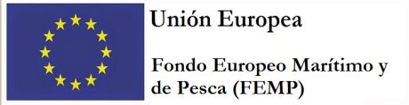
Ministerio de Agricultura, Pesca y Alimentación
Secretaría General de Pesca

REGULATION (EU) 2017/1004 OF THE EUROPEAN PARLIAMENT AND OF THE COUNCIL of 17 May 2017
on the establishment of a Union framework for the collection, management and use of data in the fisheries sector and support for scientific advice regarding the common fisheries policy and repealing Council Regulation (EC) No 199/2008 (recast)

COMMISSION DELEGATED DECISION (EU) 2019/910 of 13 March 2019
establishing the multiannual Union programme for the collection and management of biological, environmental, technical and socioeconomic data in the fisheries and aquaculture sectors

COMMISSION IMPLEMENTING DECISION (EU) 2019/909 of 18 February 2019 establishing the list of mandatory research surveys and thresholds for the purposes of the multiannual Union programme for the collection and management of data in the fisheries and aquaculture sectors

SPAIN Work Plan for data collection in the fisheries and aquaculture sectors
2020-2021
Version 1

Madrid, 30-10-2019

CONTENTS

Section 1: Biological Data 4
Pilot Study 1: Relative share of catches of recreational fisheries compared to commercial fisheries 4
Section 1: Biological Data 6
Text Box 1E: Anadromous and catadromous species data collection in fresh water 6
Section 1: Biological Data 8
Pilot Study 2: Level of fishing and impact of fisheries on biological resources and marine ecosystem 8
Section 1: Biological Data 10
Text Box 1G: List of research surveys at sea 10
FLEMISH CAP GROUNDFISH SURVEY 10
Text Box 1G: List of research surveys at sea 12
3LNO GROUNDFISH SURVEY-1st part (3NO) 12
Text Box 1G: List of research surveys at sea 14
3LNO GROUNDFISH SURVEY-2nd part (3L) 14
Text Box 1G: List of research surveys at sea- 16
IBTS 4th. Quarter 16
Text Box 1G: List of research surveys at sea 18
IBTS 4th. Quarter 18
Text Box 1G: List of research surveys at sea 20
IBTS 4th. Quarter 20
Text Box 1G: List of research surveys at sea 22
MACKEREL / H. MACKEREL EGGS SURVEY 22
Text Box 1G: List of research surveys at sea 24
MACKEREL / H. MACKEREL EGGS SURVEY 24
Text Box 1G: List of research surveys at sea 26
MACKEREL / H. MACKEREL EGGS SURVEY 26
Text Box 1G: List of research surveys at sea 28
SARDINE, ANCHOVY, H. MACKEREL ACOUSTIC SURVEY 28
Text Box 1G: List of research surveys at sea 30
Sardine DEPM 30
Text Box 1G: List of research surveys at sea 32
BIOMAN 32
Text Box 1G: List of research surveys at sea 34
MEDITS 34
Text Box 1G: List of research surveys at sea 36
MEDIAS 36
Text Box 1G: List of research surveys at sea 38
DEPM-BOCADEVA 38
Text Box 1G: List of research surveys at sea 40
ECOCADIZ 40
Text Box 1G: List of research surveys at sea 42
ECOCADIZ-RECLUTAS 42
Text Box 1G: List of research surveys at sea 44
IBTS 1st. Quarter 44
Text Box 1G: List of research surveys at sea 46
JUVENA 46
Text Box 1G: List of research surveys at sea 48
PALPRO 48
Text Box 1G: List of research surveys at sea 50
BFT index 50
Text Box 1G: List of research surveys at sea 52
ISUNEPCA_TV Survey 52
Text Box 1G: List of research surveys at sea 54
BLUE WHITING 54
Text Box 1G: List of research surveys at sea 56
TUNIBAL 56
Section 2: Fishing Activity Data 58
Text Box 2A: Fishing activity variables data collection strategy 58
Section 3: Economic and Social Data 60
Text Box 3A: Population segments for collection of economic and social data for fisheries 60
Section 3: Economic and Social Data 62
Pilot Study 3: Data on employment by education level and nationality 62
Section 3: Economic and Social Data 63
Text Box 3B: Population segments for collection of economic and social data for aquaculture 63
Section 3: Economic and Social Data 65
Pilot Study 4: Environmental data on aquaculture 65
Section 3: Economic and Social Data 66
Text Box 3C: Population segments for collection of economic and social data for the processing industry 66
Section 4: Sampling Strategy for Biological Data from Commercial Fisheries 69
Text Box 4A: Sampling plan description for biological data 69
North Sea (ICES 3a, 4 and 7d areas) and Eastern Arctic (ICES areas 1, 2) 69
Section 4: Sampling Strategy for Biological Data from Commercial Fisheries 71
Text Box 4A: Sampling plan description for biological data 71
North Atlantic 71
Section 4: Sampling Strategy for Biological Data from Commercial Fisheries 73
Text Box 4A: Sampling plan description for biological data 73
Medierranean and Black Sea 73
Section 4: Sampling Strategy for Biological Data from Commercial Fisheries 75
Text Box 4A: Sampling plan description for biological data 75
CECAF 75
Section 4: Sampling Strategy for Biological Data from Commercial Fisheries 77
Text Box 4A: Sampling plan description for biological data 77
ICCAT, IOTC, IATTC, WCPFC 77

Section 1: Biological Data

Pilot Study 1: Relative share of catches of recreational fisheries compared to commercial fisheries
General comment: This Box fulfills paragraph 4 of Chapter V of the multi-annual Union programme and Article 2 and Article 4 paragraph (3) point (a) of this Decision.
1. Aim of pilot study
- To estimate the catch made by recreational fisheries. Priority will be given to the species listed in table 3 of the EU-MAP, excepting diadromous species (eel and salmon) which will be addressed separately. However, impact on other species identified as target by this fishery in Spain (both Atlantic and Mediterranean region) will be analized. This will allow to calculate the relative share of catches of recreational fisheries compared to commercial fisheries.
- To characterize the marine recreational fishing in Spain
- To set up a sampling plan designed to fulfil the requirements of the EUMAP
2. Duration of pilot study
Due to technical and financial reasons this study could not be performed in 2018-2019 as it has been planned. However it is intended to be carried out in 2020-2021.
3. Methodology and expected outcomes of pilot study
In Spain, the management of recreational fishing, and therefore the sampling, is responsibility of the Spanish Autonomous Regions for inshore areas and by the Ministry of Fisheries for offshore areas. A fishing licence is mandatory for recreational fishers and is issued by the administrations of the Autonomous Regions.
There has been studies of recreational fisheries on several regions of the Spanish coast (Zarauz et al.,2015). However, this is the first study with an overall national approach, and with an objective of continuity, in terms of setting up a routinary sampling of these fisheriesThe recreational fisheries in Spain differ considerably between the Atlantic and the Mediterranean, and therefore, the sampling will need to be adapted to the specifities of each of the two regions. The methodological approach will be the following:
- Two regions are defined (Atlantic and the Mediterranean)
- In each region the sampling will be coordinated by a scientific partner (experts in recreational fisheries surveys). The execution of the sampling will be done by the different Autonomous Regions.
- The scientific partner will provide guidance for the sampling design, implementation and analysis according to international best practices guidelines (i.e. WGRFS). All componets of the survey programme will be documeneted to have accurate and complete documentation. Quality assessment tools will be considered to analyse the robustness of the survey. Training will be given to the people in charge for the sampling in the Autonomous Regions
- The scientific partner will also ensure the coordination between the Atlantic and Mediterranean sampling and the consistency of the sampling and estimation methodologies.
- The sampling will include all types of recreational fishing: from boat, from the shore and spear fishing
- The sampling will consist on off-shore surveys.
- When possible, the licence list will be used as a sampling frame and the people to be interviewed will be selected randomply. This design, however, will need to be adapted to the data available in each Autonomous Region.
The sampling of recreational fishing of anadromous and catadromous species (eel and salmon) needs a different approach and will not be covered in this study.
The main expected outcomes are the following:
- Catch estimates for, at least, the marine species listed in table 3. If other species are identified as relevant for this fishery, estimates will be also provived, but this depend on the results obtained.
- Characterization of the recreational fisheries in Spain.
- The development of a routinary sampling plan for recreational fisheries in Spain.
References:
Zarauz, L., Ruiz, J., Urtizberea, A., Andonegi, E., Mugerza, E., & Artetxe, I. (2015). Comparing different survey methods to estimate European sea bass recreational catches in the Basque Country. ICES Journal of Marine Science, 72 (49, pp. 1181-1191).

(max 900 words)

Section 1: Biological Data

Text Box 1E: Anadromous and catadromous species data collection in fresh water
General comment: This Box fulfills paragraph 2 points (b) and (c) of Chapter III of the multi-annual Union programme and Article 2 of this Decision.
Method selected for collecting data.
Anguilla anguilla
In Spain, each autonomous region constitutes an eel management unit. In some of the regions sampling for the determination of the required parameters are already taking place; but not in others. For these EMUs where sampling design needs to be developed it is not possible to give much detail about the sampling design.
ES-Basque Country (ES-Bas)
1)The abundance of recruits will be estimated by:
a.Monthly samplings of the glass eel entrance in the estuary using sieve trawling during the maximum recruitment period (October-March)
b.Using the glass eel fishery catch and effort data compiled in the daily catches report.
c.Sampling daily the eel entrance in a fish trap located in the tidal limit of the Oria River during the migration period (May-October)
2)The abundance of the standing stock (yellow eel); will be determined by electrofishing surveys in 25 sampling points.
3)The number or weight and sex ratio of emigrating silver eels will be determined applying Durif et al. (2003; 2005) to the eels obtained in the electrofishing surveys.
EMU_ES_Asturias (EMU_ES_Astu)
1)The abundance of recruits will be estimated using the glass eel fishery catch and effort data
2)The abundance of the standing stock (yellow eel); will be determined by electrofishing surveys.
3)The number or weight and sex ratio of emigrating silver eels will be determined applying Durif et al. (2003; 2005) to the eels obtained in the electrofishing surveys.
EMU_ES_Galicia (EMU_ES_Gali)
1)The abundance of recruits will be estimated using a fish trap capturing elvers and yellow eel.
2)The abundance of the standing stock (yellow eel); will be determined by electrofishing surveys.
3)The number or weight and sex ratio of emigrating silver eels will be determined using a fish trap applying Durif et al. (2003; 2005) to the eels obtained in the electrofishing surveys.
EMU_ES_Murcía (EMU_ES_Murc)
The abundance of recruits, standing stock (yellow eel); and the number or weight and sex ratio of emigrating silver eels will be determined by sampling the Mar Menor fishery catches.
EMU_ES_Valencia (EMU_ES_Vale)
1)The abundance of recruits will be estimated using the glass eel fishery catch and effort data
2)The abundance of the standing stock (yellow eel); will be determined by electrofishing surveys.
3)The number or weight and sex ratio of emigrating silver eels will be determined applying Durif et al. (2003; 2005) to the eels obtained in the electrofishing surveys.
EMU_ES_Cantabria(EMU_ES_Cant)
1)The abundance of recruits will be estimated using the glass eel fishery catch and effort data and if possible using fishery independent methods once an appropriate sampling design is defined
2)The abundance of the standing stock (yellow eel); will be determined by electrofishing surveys.
3)The number or weight and sex ratio of emigrating silver eels will be determined applying Durif et al. (2003; 2005) to the eels obtained in the electrofishing surveys.
EMU_ES_Cataluña (EMU_ES_Cata)
1)The abundance of recruits will be estimated by:
a.Monthly samplings of the glass eel entrance in the estuary using fyke nets with fine mesh during the maximum recruitment period (October-March)
b.Using the glass eel fishery catch and effort data compiled in the daily catches report.
2)The abundance of the standing stock (yellow eel); will be determined by electrofishing surveys in 25 sampling points.
3)Age and sex will be determined from a sampling of individuals obtained by means of electrofishing surveys. The number or weight and sex ratio of emigrating silver eels will be determined applying Durif et al. (2003; 2005) to the eels obtained in the electrofishing surveys.
EMU_ES_Navarra (EMU_ES_Nava)
Eel has disappeared in most of this EMU; and the population is restricted to the lower part of the Bidasoa River.
1)The abundance of recruits won´t be estimated since Bidasoa River estuary is located below the limits of Navarra territory (between the Basque Country and France)
2)The abundance of the standing stock (yellow eel); will be determined by electrofishing surveys.
3)The number or weight and sex ratio of emigrating silver eels will be determined using a fish trap applying Durif et al. (2003; 2005) to the eels obtained in the electrofishing surveys
EMU_ES_Inner basins (EMU_ES_Inne)
Although historically eel was present in this EMU; nowadays it has disappear from the area. Thus, it is not possible to sample.
Salmo salar
There is no professional fishing targeting Salmo salar (only recreational)

(max 250 words per Area)

Section 1: Biological Data

Pilot Study 2: Level of fishing and impact of fisheries on biological resources and marine ecosystem

General comment: This Box fulfills paragraph 3 point (c) of Chapter III of the multi-annual Union programme and Article 2 and Article 4 paragraph (3) point (b) of this Decision.
Mediterranean Sea
Pilot study 2.1: Incidental Bycatch
Following the 2016 Recommendation of RCM Med&BS-LP on pilot studies for the assessment of incidental bycatches of birds, mammals, reptiles and fish, the RCG Med&BS-LP 2017 has agreed to carry out the following pilot studies:
-2018: Pilot study for assessing incidental bycatches from bottom trawlers
-2019: Pilot study for assessing incidental bycatches from longlines
-2020: Pilot study for assessing incidental bycatches from set nets (trammel nets).
The proposed metiers and year of sampling are in agreement with the GFCM planned bycatch sampling programme which will be performed in the period 2018-2020.
1. Aim of pilot study
Collect accurate information on the species, quantities, sizes, locations and timing of bycatches of vulnerable species.
2. Duration of pilot study
Each pilot study related to each selected métier will have a duration of one year.
3. Methodology and expected outcomes of pilot study
In overall, the methodology that will be followed for collecting data on bycatches includes the collection of data from:
•Observer programmes
•Logbook completion by fishers
•Interviews with fishers.
The Handbook with guidelines for monitoring incidental by catch and processing the collected data, delivered under MARE/2014/19 project Med&BS, will be followed.
Data to be collected will include: identification of species, number and weight of individuals, size measurements, location and timing of bycatches.
Expected outcomes
With the implementation of the planned pilot studies, it is expected that accurate information will be collected on the species incidentally caught, as well as their quantities, sizes, locations and the timing of such bycatches. This information will increase the knowledge on bycatch in the region. Based on the results, systematic bycatch sampling may be proposed for certain metiers/areas.
The knowledge gained under the pilot study and possible future systematic sampling will be very useful for the formulation of possible management measures for minimising bycatch of vulnerable species in the region.
Pilot study 2.2: Stomach contents
The RCGMed&BS 2019 recommends to follow the methodology proposed by the STREAM project to collect data on stomach contents.
1. Aim of pilot study
To increase the knowledge on predator-prey relationships, which are required for multi-species stock assessments which is one of the aspects to be taken into account for the future EU Multiannual Programmes.
2. Duration of pilot study
1 year (between 2020 and 2021)
3. Methodology and expected outcomes of pilot study
- Stocks. The stocks proposed by the STREAM project were Merluccius merluccius and Lophius spp.
- Sources of data. Two sources of data: MEDITS survey and commercial sampling. In the survey, both species will be sampled, but in the sampling based in the fishery only hake will be sampled, since most of the individuals of anglerfish come to market with the stomach regurgitated.
- The methodology proposed here belongs to the group of volumetric methods. It is proposed to measure the volume (cubic centimeters) of total prey groups in the stomach using a trophometer, a calibrated instrument consisting of several different-sized half-cylinders built into a tray, so that they form horizontal cylindrical moulds (Olaso, 1990). Different food items will be determined to the lowest possible taxonomic level under a stereoscopic microscope.
- Sampling plan. The sampling has been planned taking into account the following three criteria:bathymetric depth strata which is known to influence the diet of the investigated species; size class (juveniles, sub-adults and adults); seasonality (quarter). The sample size (number of full stomachs to be sampled) will be a maximum of ten individuals of each target species and size class after each fishing haul in surveys, while a maximum of 100 individuals per size class and quarter will be sampled in laboratory (only M. Merluccius).
- Expected outcomes. The study of the feeding habits of fish based upon analysis of stomach content may provide important insights not only to assess food spectra at species level, but to understand the prey-predator relationships, useful aspects to contribute to multispecies stock assessment (Rindorf et al., 2013; Casini et al., 2008, 2009) or to be included in ecological models as mentioned before. Stomach content data are also useful to evaluate the resource partitioning among the species inhabiting a particular habitat/fishing ground. At species level, the information on predator-prey relationship can also be helpful for a better evaluation of the natural mortality of the key exploited stocks. Finally, the obtained information will be useful in order to develop trophic indicators which will help in the monitoring of the ecosystem studied.
Atlantic
No pilot study will be carried out as the sampling scheme implemented by the pilot study carried out in 2017 has been incorporated under the routinely sampling programme.
(max 900 words)

Section 1: Biological Data

Text Box 1G: List of research surveys at sea

FLEMISH CAP GROUNDFISH SURVEY
General Comment: This Box fulfills Chapter IV of the multi-annual Union programme and Article 2 and Article 7 paragraph (3) of this Decision. It is intended to specify which reseach surveys at sea set out in Table 10 of the multi-annual Union programme will be carried out. Member States shall specify whether the research survey is included in Table 10 of the multi-annual Union programme or whether it is an additional survey.

FLEMISH CAP GROUNDFISH SURVEY
1. Objectives of the survey
The main objectives of the survey are the estimation of abundance and biomass index of the target species, as well as the knowledge of their population demographic structure and the oceanographic conditions on the Flemish Cap Bank (NAFO Division 3M). To this end the following tasks were implemented.
- Detailed length distribution and biological sampling of the catch for each target species, recording length, weight, sex, and the collection of otoliths and gonads. For other species only length and length-weight sampling were performed.
- Observation of the oceanographic conditions on the Bank. The collection of oceanographic data (temperature and salinity) was carried out mainly through the CTD profiling; with a grid-pattern design, placing CTD stations separated 15 nautical miles, both in latitude and longitude, with the aim of covering the whole Bank.
- Feeding analysis of most abundant species, to be done every two years.
- Sampling of invertebrates, with special attention to corals and sponges, to allow identification of potentially vulnerable marine ecosystems.
Target species: Cod, Redfish, Northern shrimp, Greenland halibut, American plaice and Roughhead grenadier.
2. Description of the methods used in the survey. For mandatory surveys, link to the manuals. Include a graphical representation (map)
Manual: http://archive.nafo.int/open/studies/s46/S46.pdf
Bottom trawl fishing hauls that lasting for 30 minutes and are distributed using a stratified random sampling scheme The trawling gear used is the Lofoten (NAFO 1990). Temperature and salinity profiles are taken with a CTD according to a predefined square grid. The survey starts in the second half of June, and needs 35 days at sea.
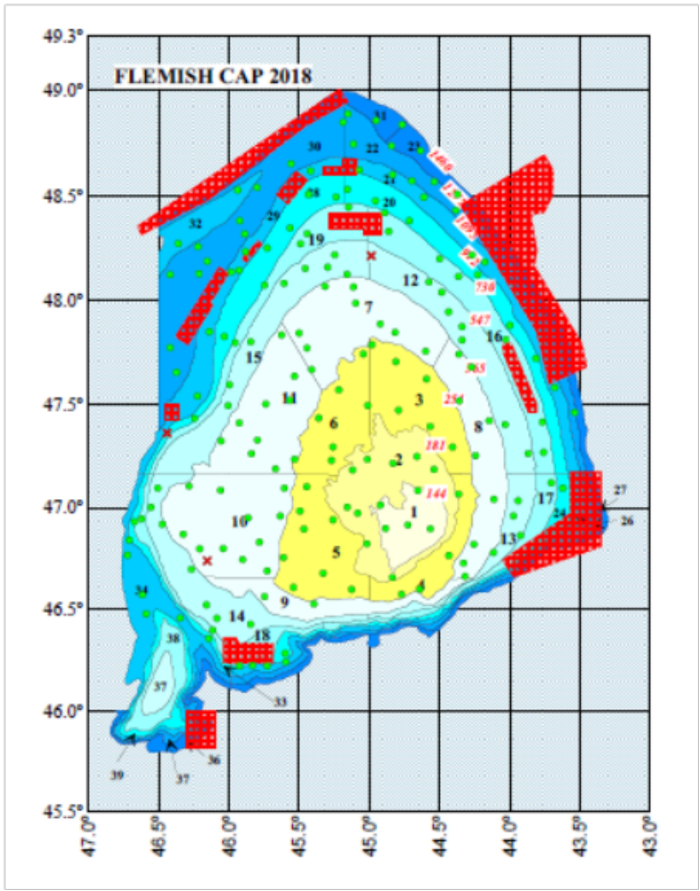Figure 1
3. For internationally coordinated surveys, describe the participating Member States/vessels and the relevant international group in charge of planning the survey
Participants: Spain+ Portugal .RV Vizconde de Eza.
Relevant international planning group: Portuguese-Spanish surveys in Flemish Cap - coordination meeting for the survey
4. Where applicable, describe the international task sharing (physical and/or financial) and the cost sharing agreement used
Spain contributes with vessel, staff and samples analysis in laboratory and Portugal contributes with staff and samples analysis in laboratory.
There is not signed agreement about task sharing.
5. Explain where thresholds apply
Not applicable

Text Box 1G: List of research surveys at sea

3LNO GROUNDFISH SURVEY-1st part (3NO)
General Comment: This Box fulfills Chapter IV of the multi-annual Union programme and Article 2 and Article 7 paragraph (3) of this Decision. It is intended to specify which reseach surveys at sea set out in Table 10 of the multi-annual Union programme will be carried out. Member States shall specify whether the research survey is included in Table 10 of the multi-annual Union programme or whether it is an additional survey.

3LNO GROUNDFISH SURVEY.1st part (3NO)
1. Objectives of the survey
The main objectives of the survey are the estimation of abundance and biomass index of the target species, as well as the knowledge of their population demographic structure and the oceanographic conditions on the Grand Bank (NAFO Division 3NO). To this end the following tasks were implemented.
- Detailed length distribution and biological sampling of the catch for each target species, recording length, weight, sex, and the collection of otoliths and gonads. For other species only length and length-weight sampling were performed.
- Collection of oceanographic data data from the area using a CTD at the end of each fishing-haul.
- Collection of catch data (weight and number) of invertebrates in the most accurate way and continuing in the line of a higher taxonomic identification.
- Sampling of stomach contents of the main species to continue the study of their trophic relationships.
Target species: Cod, Roughhead grenadier, Redfish, Thorny skate, American plaice, Witch flounder, Greenland halibut, Yellow flounder, Black dogfish and Northern shrimp.
2. Description of the methods used in the survey. For mandatory surveys, link to the manuals. Include a graphical representation (map)
Manual:http://www.repositorio.ieo.es/e-ieo/bitstream/handle/10508/632/PROTOCOLO%20CAMPA%C3%91A%203LNO%20GROUNDFISH%20SURVEY_v2-revisi%C3%B3n%20enero%202013%20(2).pdf?sequence=9
Stratified random sampling scheme, diurnal Bottom trawl fishing hauls from 6 am to 9.30 pm with an average hauling time of 30 minutes. The trawling gear used is the ‘Campelen 1800’. Hydrographic profiles by haul are taken with a CTD. In NAFO Division 3NO there are planned 35 days at sea including sailing days. In NAFO division 3L there are planned 26 days at sea including sailing days
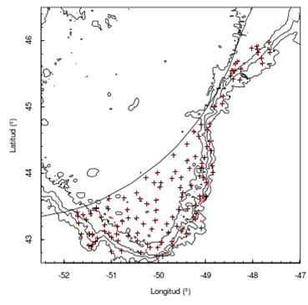Figure 2
3. For internationally coordinated surveys, describe the participating Member States/vessels and the relevant international group in charge of planning the survey
Not applicable. Spain is the only participant. The vessel is Vizconde de Eza.
4. Where applicable, describe the international task sharing (physical and/or financial) and the cost sharing agreement used
Not applicable
5. Explain where thresholds apply
Not applicable

Text Box 1G: List of research surveys at sea

3LNO GROUNDFISH SURVEY-2nd part (3L)
General Comment: This Box fulfills Chapter IV of the multi-annual Union programme and Article 2 and Article 7 paragraph (3) of this Decision. It is intended to specify which reseach surveys at sea set out in Table 10 of the multi-annual Union programme will be carried out. Member States shall specify whether the research survey is included in Table 10 of the multi-annual Union programme or whether it is an additional survey.

3LNO GROUNDFISH SURVEY. 2nd part (3L)
1. Objectives of the survey
The main objectives of the survey are the estimation of abundance and biomass index of the target species, as well as the knowledge of their population demographic structure and the oceanographic conditions on the Grand Bank (NAFO Division 3NO and Division 3L). To this end the following tasks were implemented.
- Detailed length distribution and biological sampling of the catch for each target species, recording length, weight, sex, and the collection of otoliths and gonads. For other species only length and length-weight sampling were performed.
- Collection of oceanographic data data from the area using a CTD at the end of each fishing-haul.
- Collection of catch data (weight and number) of invertebrates in the most accurate way and continuing in the line of a higher taxonomic identification.
- Sampling of stomach contents of the main species to continue the study of their trophic relationships.
Target species: Cod, Roughhead grenadier, Redfish, Thorny skate, American plaice, Witch flounder, Greenland halibut, Yellow flounder, Black dogfish and Northern shrimp.
2. Description of the methods used in the survey. For mandatory surveys, link to the manuals. Include a graphical representation (map)
Manual:http://www.repositorio.ieo.es/e-ieo/bitstream/handle/10508/632/PROTOCOLO%20CAMPA%C3%91A%203LNO%20GROUNDFISH%20SURVEY_v2-revisi%C3%B3n%20enero%202013%20(2).pdf?sequence=9
Stratified random sampling scheme, diurnal Bottom trawl fishing hauls from 6 am to 9.30 pm with an average hauling time of 30 minutes. The trawling gear used is the ‘Campelen 1800’. Hydrographic profiles by haul are taken with a CTD. In NAFO Division 3NO there are planned 35 days at sea including sailing days. In NAFO division 3L there are planned 26 days at sea including sailing days

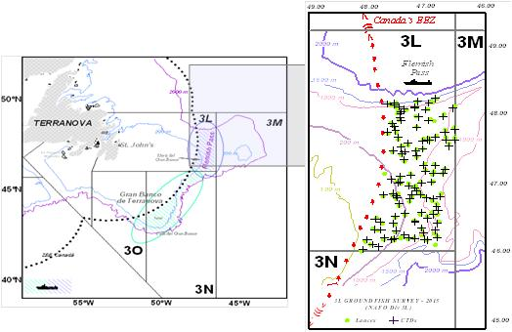Figure 3
3. For internationally coordinated surveys, describe the participating Member States/vessels and the relevant international group in charge of planning the survey
Not applicable. Spain is the only participant. The vessel is Vizconde de Eza.
4. Where applicable, describe the international task sharing (physical and/or financial) and the cost sharing agreement used
Not applicable
5. Explain where thresholds apply
Not applicable

Text Box 1G: List of research surveys at sea-

IBTS 4th. Quarter
General Comment: This Box fulfills Chapter IV of the multi-annual Union programme and Article 2 and Article 7 paragraph (3) of this Decision. It is intended to specify which reseach surveys at sea set out in Table 10 of the multi-annual Union programme will be carried out. Member States shall specify whether the research survey is included in Table 10 of the multi-annual Union programme or whether it is an additional survey.

IBTS 4th. Quarter (8c y 9a north)
1. Objectives of the survey
- Estimation of abundance indices by age of megrim (Lepidorhombus boscii and L. whiffiagonis), blue whiting, horse mackerel and mackerel, as well as indices by size class of hake and monkfish (Lophius budegassa and L. piscatorius),
- Estimation of the recruitment strength of the species mentioned, mainly hake, monkfish and megrims.
- Estimation of abundance indices (number and biomass) of other demersal species of fishing interest (Norway lobster, sparids, etc), as well as the fauna associated to them.
- Determination of geographical and bathymetric distribution of the different species.
- Obtaining the length distributions of all species of fish, Norway lobster and main cephalopods in the catches.
- Collecting biological data of the main commercial species: maturity stages, sex ratio, etc...
- Getting oceanographic data.
2. Description of the methods used in the survey. For mandatory surveys, link to the manuals. Include a graphical representation (map)
Stratified random sampling based on 30 minutes bottom trawl hauls during day light, getting abundance indices stratified by haul. Sampling for abundance indices covers the depths between 70 and 500 m and is stratified random, the hauls are allocated in 15 strata determined by combining 3 depth strata (>70-120m, 121-200 m and 201-500m) and five geographical sectors. Hauls allocation is proportional to the area of each stratum.
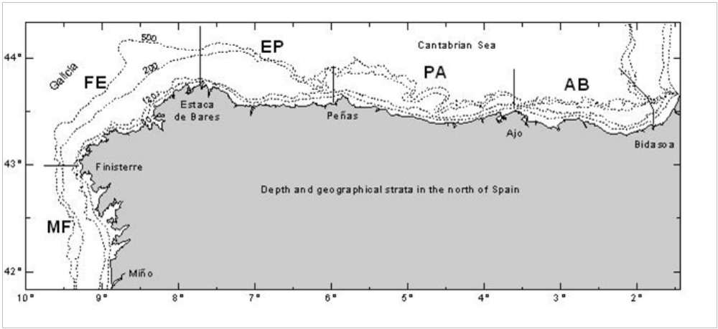Figure 4
3. For internationally coordinated surveys, describe the participating Member States/vessels and the relevant international group in charge of planning the survey
UK-Scotland/Scotia; UK-North Ireland/Corystes; Ireland/Celtic Explorer; France/Thalassa; Spain/Miguel Oliver; Portugal/Noruega
Relevant international planning group: IBTSWG-International Bottom Trawl survey Working Group of ICES
4. Where applicable, describe the international task sharing (physical and/or financial) and the cost sharing agreement used
Individual tasks to the survey participants are allocated by the responsible ICES survey planning group. Each participating country is responsible for the activities conducted on its national part of the international survey. There is no particular cost sharing agreement in place for this survey.
5. Explain where thresholds apply
Not applicable
(max 450 words per survey)

Text Box 1G: List of research surveys at sea

IBTS 4th. Quarter
General Comment: This Box fulfills Chapter IV of the multi-annual Union programme and Article 2 and Article 7 paragraph (3) of this Decision. It is intended to specify which reseach surveys at sea set out in Table 10 of the multi-annual Union programme will be carried out. Member States shall specify whether the research survey is included in Table 10 of the multi-annual Union programme or whether it is an additional survey.

IBTS 4th. Quarter (9a south)
1. Objectives of the survey
- -Estimate distribution and relative abundance the main commercial species and provide recruitment indices.
- -Monitor changes in the stocks of commercial fish species independently of commercial fisheries data.
- -Monitor the distribution and relative abundance of all fish and invertebrates species.
- -Collecting data for the determination of biological parameters for selected species;
- -Collecting hydrographical and environmental information.
2. Description of the methods used in the survey. For mandatory surveys, link to the manuals. Include a graphical representation (map)
The whole area (7224 km2) has been separated into five depth strata (15-30, 31-100, 101-200, 201-500 and 501-800 m). The sampling design is random stratified with proportional allocation with a total of 42 fishing stations and swept-area method.
Length distribution of all fish and main species of crustacean and cephalopods are collected and biological parameters are obtained in the most important commercial species
Temperature and salinity are collected during each tow with a CTD attached to the gear. A CTD by haul will be carried out in the survey area.
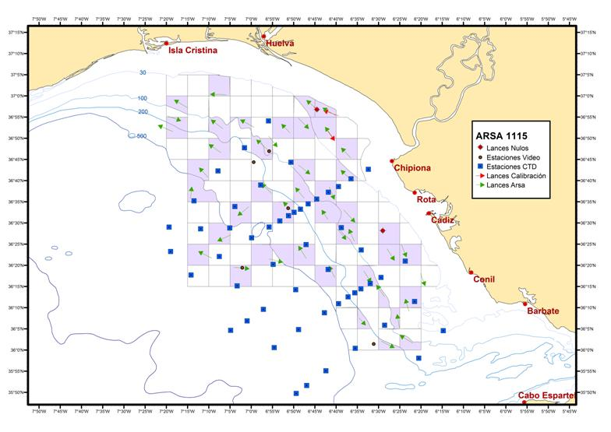Figure 5
3. For internationally coordinated surveys, describe the participating Member States/vessels and the relevant international group in charge of planning the survey
UK-Scotland/Scotia; UK-North Ireland/Corystes; Ireland/Celtic Explorer; France/Thalassa; Spain/Miguel Oliver; Portugal/Noruega
Relevant international planning group: IBTSWG-International Bottom Trawl survey Working Group of ICES
4. Where applicable, describe the international task sharing (physical and/or financial) and the cost sharing agreement used
Individual tasks to the survey participants are allocated by the responsible ICES survey planning group. Each participating country is responsible for the activities conducted on its national part of the international survey. There is no particular cost sharing agreement in place for this survey.
5. Explain where thresholds apply
Not applicable

Text Box 1G: List of research surveys at sea

IBTS 4th. Quarter
General Comment: This Box fulfills Chapter IV of the multi-annual Union programme and Article 2 and Article 7 paragraph (3) of this Decision. It is intended to specify which reseach surveys at sea set out in Table 10 of the multi-annual Union programme will be carried out. Member States shall specify whether the research survey is included in Table 10 of the multi-annual Union programme or whether it is an additional survey.

IBTS 3th. Quarter. Porcupine groundfish survey
1. Objectives of the survey
- To estimate stratified abundances indices by age of megrims (L. whiffiagonis) and by length of hake (Merluccius merluccius), monkfishes (Lophius budegassa and L. piscatorius), four spotted megrim (L. boscii), Norway lobster (Nephrops norvegicus) and other fish species.
- To estimate recruitment indices and spatial trends of younger ages of hake, megrims and monkfishes.
- To estimate stratified abundances indices of commercial fish species (N. norvergicus, Phycis blennoides, Helicolenus dactylopterus, Molva molva, Conger conger)
- To describe the spatial distribution patterns of demersal and benthic species on Porcupine Bank.
- To collect otoliths and biological parameters of the main commercial fish species (hake, megrims, anglerfishes, H. dactilopterus….)
- To collect data for the determination of biological parameters for the demersal species selected by DCF.
- To collect hydrographic data.
2. Description of the methods used in the survey. For mandatory surveys, link to the manuals. Include a graphical representation (map)
The sampling design was random stratified with two geographical sectors (Northern and Southern) and three depth strata (> 300 m, 300 – 450 m and 450 - 800 m). Hauls allocation is proportional to the strata area following a buffered random sampling procedure.
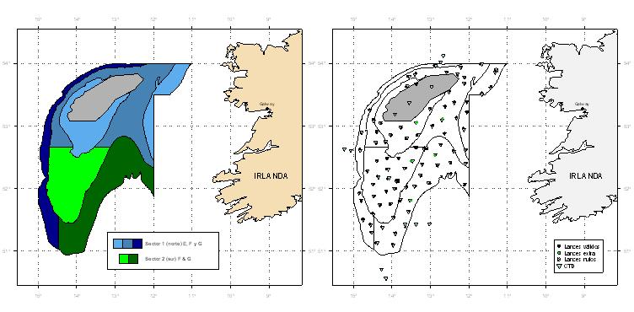Figure 6
3. For internationally coordinated surveys, describe the participating Member States/vessels and the relevant international group in charge of planning the survey
UK-Scotland/Scotia; UK-North Ireland/Corystes; Ireland/Celtic Explorer; France/Thalassa; Spain/Miguel Oliver; Portugal/Noruega
Relevant international planning group: IBTSWG-International Bottom Trawl survey Working Group of ICES
4. Where applicable, describe the international task sharing (physical and/or financial) and the cost sharing agreement used
Individual tasks to the survey participants are allocated by the responsible ICES survey planning group. Each participating country is responsible for the activities conducted on its national part of the international survey. There is no particular cost sharing agreement in place for this survey.
5. Explain where thresholds apply
Not applicable

Text Box 1G: List of research surveys at sea

MACKEREL / H. MACKEREL EGGS SURVEY
General Comment: This Box fulfills Chapter IV of the multi-annual Union programme and Article 2 and Article 7 paragraph (3) of this Decision. It is intended to specify which reseach surveys at sea set out in Table 10 of the multi-annual Union programme will be carried out. Member States shall specify whether the research survey is included in Table 10 of the multi-annual Union programme or whether it is an additional survey.

MACKEREL / H. MACKEREL EGGS SURVEY (trienal)-CAREVA
1. Objectives of the survey
- This survey (CAREVA) provides indices for the strength of the SSB and a relative abundance index of Atlantic mackerel (Scomber scombrus) spawning stock.
- Egg production and spawning area estimation for both mackerel and horse mackerel.
- Fecundity estimation
- Determine the egg distribution area and density of other commercial species (hake, sardine, etc.)
- Characterise the main oceanographic conditions of the surveyed area
2. Description of the methods used in the survey. For mandatory surveys, link to the manuals. Include a graphical representation (map)
WGMEGS Manual for the Mackerel and Horse Mackerel Egg Surveys (ICES, 2016a).
- In most of the western area plankton samplers are deployed at the centre of half standard ICES rectangles, which are 0.5° latitude, by 0.5° longitude. To the north of Spain (Cantabrian Sea) three sampler deployments are undertaken (in an east-west direction) in each 0.25° latitude by 1.0° longitude rectangle because of the proximity of the shelf edge to the coast.
- The standard plankton samplers used in the survey are Bongo 40 (oblique tows). All of these samplers generally have temperature, salinity and depth probes (Seabird 37 CTD) attached to the frames and they are also fitted with either mechanical flowmeters to enable the volume of water filtered on each deployment to be calculated.
- CTD profiles with Seabird 25 are also obtained in each BONGO station.
- Adult fish samples are obtained by pelagic trawls.
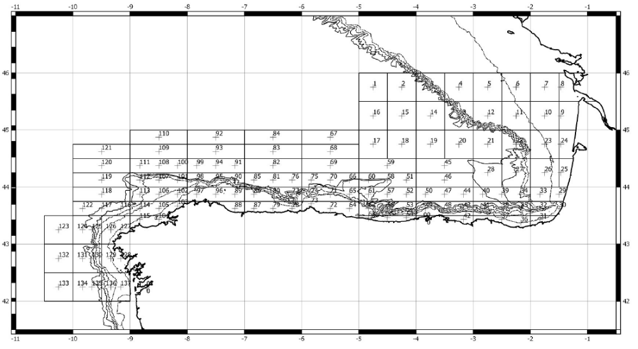Figure 7
3. For internationally coordinated surveys, describe the participating Member States/vessels and the relevant international group in charge of planning the survey
Spain /Vizconde de Eza, Ramon Margalef, Enma Bardan; Portugal/; Denmark/; UK-Scotland/; Ireland/; Germany/; The Netherlands/; Faroe Islands/;
Relevant international planning group: WGMEGS: Working Group on Mackerel and Horse Mackerel Egg Surveys
4. Where applicable, describe the international task sharing (physical and/or financial) and the cost sharing agreement used
Individual tasks to the survey participants (e.g. coverage of certain areas in a certain time frame) are allocated by the responsible ICES survey planning group. Each participating country is responsible for the activities conducted on its national part of the international survey. There is no particular cost sharing agreement in place for this survey.
5. Explain where thresholds apply
Not applicable

Text Box 1G: List of research surveys at sea

MACKEREL / H. MACKEREL EGGS SURVEY
General Comment: This Box fulfills Chapter IV of the multi-annual Union programme and Article 2 and Article 7 paragraph (3) of this Decision. It is intended to specify which reseach surveys at sea set out in Table 10 of the multi-annual Union programme will be carried out. Member States shall specify whether the research survey is included in Table 10 of the multi-annual Union programme or whether it is an additional survey.

MACKEREL / H. MACKEREL EGGS SURVEY (trienal)-JUREVA
1. Objectives of the survey
- This survey (JUREVA) provides indices for the strength of the SSB and a relative abundance index of horse mackerel (Trachurus trachurus) spawning stock.
- Egg production and spawning area estimation for both mackerel and horse mackerel.
- Fecundity estimation
- Determine the egg distribution area and density of other commercial species (hake, sardine, etc.)
- Characterise the main oceanographic conditions of the surveyed area
2. Description of the methods used in the survey. For mandatory surveys, link to the manuals. Include a graphical representation (map)
WGMEGS Manual for the Mackerel and Horse Mackerel Egg Surveys (ICES, 2016a).
- In most of the western area plankton samplers are deployed at the centre of half standard ICES rectangles, which are 0.5° latitude, by 0.5° longitude. To the north of Spain (Cantabrian Sea) three sampler deployments are undertaken (in an east-west direction) in each 0.25° latitude by 1.0° longitude rectangle because of the proximity of the shelf edge to the coast.
- The standard plankton samplers used in the survey are Bongo 40 (oblique tows). All of these samplers generally have temperature, salinity and depth probes (Seabird 37 CTD) attached to the frames and they are also fitted with either mechanical flowmeters to enable the volume of water filtered on each deployment to be calculated.
- CTD profiles with Seabird 25 are also obtained in each BONGO station.
- Adult fish samples are obtained by pelagic trawls.
Figure 8
3. For internationally coordinated surveys, describe the participating Member States/vessels and the relevant international group in charge of planning the survey
Spain /Vizconde de Eza, Ramon Margalef, Enma Bardan; Portugal/; Denmark/; UK-Scotland/; Ireland/; Germany/; The Netherlands/; Faroe Islands/;
Relevant international planning group: WGMEGS: Working Group on Mackerel and Horse Mackerel Egg Surveys
4. Where applicable, describe the international task sharing (physical and/or financial) and the cost sharing agreement used
Individual tasks to the survey participants (e.g. coverage of certain areas in a certain time frame) are allocated by the responsible ICES survey planning group. Each participating country is responsible for the activities conducted on its national part of the international survey. There is no particular cost sharing agreement in place for this survey.
5. Explain where thresholds apply
Not applicable

Text Box 1G: List of research surveys at sea

MACKEREL / H. MACKEREL EGGS SURVEY
General Comment: This Box fulfills Chapter IV of the multi-annual Union programme and Article 2 and Article 7 paragraph (3) of this Decision. It is intended to specify which reseach surveys at sea set out in Table 10 of the multi-annual Union programme will be carried out. Member States shall specify whether the research survey is included in Table 10 of the multi-annual Union programme or whether it is an additional survey.

MACKEREL / H. MACKEREL EGGS SURVEY (trienal)-AZTI
1. Objectives of the survey
The main objective of Mackerel and Horse Mackerel Egg Survey (AZTI) is to relate the number of freshly spawned eggs found in the water column to the number of females having spawned these eggs. With the estimated fecundity of the females, this provides an estimate of the spawning-stock biomass.
AZTI provides data for P3 (19 March to 6 April) and for P5 (4 to 24 May).
2. Description of the methods used in the survey. For mandatory surveys, link to the manuals. Include a graphical representation (map)
Details of methods used during the survey can be consulted at: Manual of the mackerel and horse mackerel egg surveys (MEGS): sampling at sea. Version 1.3. The working group on Mackerel and horse mackerel egg surveys. SISP 6-MEGS V1.3.62 pp.
http://www.ices.dk/sites/pub/Publication%20Reports/ICES%20Survey%20Protocols%20(SISP)/SISP%206%20-%20MEGS%20V1.3.pdf
The standard plankton net used in the ICES triennial egg surveys by AZTI is the Bongo 40. The procedures used in these surveys are described in detail the manual of surveys (see below). On completion of the hauls, plankton was preserved in a 4% buffered formaldehyde solution. At sea, fish eggs from plankton samples are sorted out- Once at lab, eggs are identified (Mackerel and horse mackerel species) and staged.
Adult samples of mackerel are captured using pelagic trawls at those areas where the presence of eggs is positive.

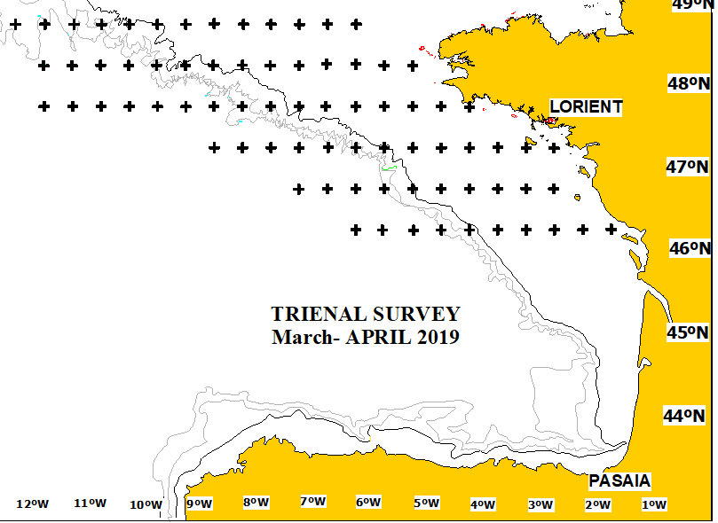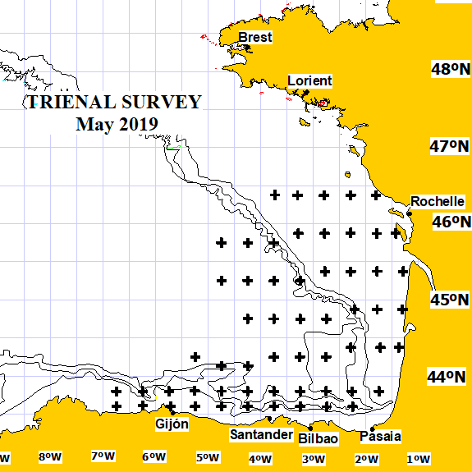Figure 9
3. For internationally coordinated surveys, describe the participating Member States/vessels and the relevant international group in charge of planning the survey
Spain /Ramon Margalef, Enma Bardan; Portugal/ ; Denmark/ ; UK-Scotland/ ; Ireland/; Germany/ ; The Netherlands/ ; Faroe Islands /;
Relevant international planning group: WGMEGS: Working Group on Mackerel and Horse Mackerel Egg Surveys
4. Where applicable, describe the international task sharing (physical and/or financial) and the cost sharing agreement used
Individual tasks to the survey participants (e.g. coverage of certain areas in a certain time frame) are allocated by the responsible ICES survey planning group. Each participating country is responsible for the activities conducted on its national part of the international survey. There is no particular cost sharing agreement in place for this survey.
AZTI participates covering the Cantabrian sea and Bay of Biscay areas in 2 periods, period 3 (March-April) and period 5 (May). During the last years, the surveys were executed on board the B/O Ramon Margalef and B/O Enma Bardan. The coordinator for international survey is Brendan O’ Hea, MI, Galway, Ireland.
5. Explain where thresholds apply
Not applicable

Text Box 1G: List of research surveys at sea

SARDINE, ANCHOVY, H. MACKEREL ACOUSTIC SURVEY
General Comment: This Box fulfills Chapter IV of the multi-annual Union programme and Article 2 and Article 7 paragraph (3) of this Decision. It is intended to specify which reseach surveys at sea set out in Table 10 of the multi-annual Union programme will be carried out. Member States shall specify whether the research survey is included in Table 10 of the multi-annual Union programme or whether it is an additional survey.

SARDINE, ANCHOVY, H. MACKEREL ACOUSTIC SURVEY (PELACUS)
1. Objectives of the survey
- The main objective of this survey was to achieve a biomass’ estimation by echointegration of the main pelagic fish distributed in the Spanish Cantabrian and NW waters (sardine, anchovy, horse mackerel, mackerel, blue whiting, bogue, boar fish, and chub mackerel). Together with this, the following objectives were also foreseen:
- Determine the distribution area and density of the main fish species
- Determine the main biological characteristics (length, sex, maturity stage and age) of the main fish species
- Estimate the relative abundance and distribution area of sardine and anchovy eggs by means of CUFES
- Estimate the adults parameters needed to apply the Daily Egg Production Method to sardine.
- Characterise the main oceanographic conditions of the surveyed area
- Determine the distribution pattern, taxonomic diversity and dry biomass by size classes of the plankton population presented in the surveyed area.
- Determine the natural abundance of N15 in sardine, anchovy and mackerel and their trophic position.
- Determine the distribution area and density of apical predators
- Determine the distribution area and density of marine microplastics litter
2. Description of the methods used in the survey. For mandatory surveys, link to the manuals. Include a graphical representation (map)
Survey design and strategies are described at ICES Cooperative Research Report No. 332. 268 pp. https://doi.org/10.17895/ices.pub.4599. Acoustic, Systematic track with parallel transects evenly distribute each 8 nmi. Backscattering energy attributed to fish species after scrutinisation of the echograms. Biomass estimates using echointegration method. Pelagic fishing stations for echo-trace allocation and biological characterisation. CUFES for mapping egg (anchovy and sardine) distribution area. Trained observers recorded marine mammal, seabird, floating litter and vessel presence and abundance. Data on the hydrography and hydrodynamics of the water masses are collected via the deployment of rosettes and conductivity, temperature and depth sensors. Information on the composition, distribution and biomass of phytoplankton and zooplankton is derived from the analyses of samples taken by plankton nets.
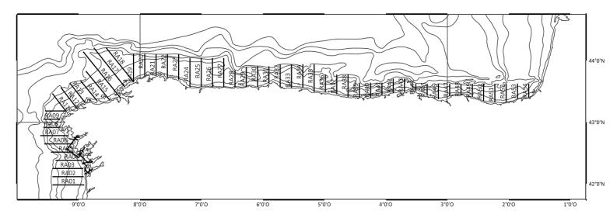Figure 10
3. For internationally coordinated surveys, describe the participating Member States/vessels and the relevant international group in charge of planning the survey
Spain/Miguel Oliver; Portugal/; France/
Relevant international planning group: WGACEGG: Working Group on Acoustic and Egg Surveys for Sardine and Anchovy in ICES Areas 7, 8 and 9
4. Where applicable, describe the international task sharing (physical and/or financial) and the cost sharing agreement used
Individual tasks to the survey participants are allocated by the responsible ICES survey planning group. Each participating country is responsible for the activities conducted on its national part of the international survey. There is no particular cost sharing agreement in place for this survey.
5. Explain where thresholds apply
Not applicable

Text Box 1G: List of research surveys at sea

Sardine DEPM
General Comment: This Box fulfills Chapter IV of the multi-annual Union programme and Article 2 and Article 7 paragraph (3) of this Decision. It is intended to specify which reseach surveys at sea set out in Table 10 of the multi-annual Union programme will be carried out. Member States shall specify whether the research survey is included in Table 10 of the multi-annual Union programme or whether it is an additional survey.

Sardine DEPM (SAREVA)
1. Objectives of the survey
- Estimation of the spawning stock biomass of sardine (Sardina pilchardus) based on the application Method of Daily Egg Production (DEPM).
- Sardine Spawning area estimation.
- Esti Daily egg production estimation and Total egg production of sardine.
- Determine the egg distribution area and density of other commercial species (hake, mackerel, horse mackerel, etc.)
- Characterise the main oceanographic conditions of the surveyed area.
2. Description of the methods used in the survey. For mandatory surveys, link to the manuals. Include a graphical representation (map)
Survey methodology is described in ICES 2011. Report of the Working Group on Acoustic and Egg Surveys for Sardine and Anchovy in ICES Areas VIII and IX (WGACEGG), 22-26 November 2010, . ICES CM 2010/SSGESST:24. 210 pp.
SAREVA survey consisted of ichthyoplankton, hydrographic and adults sampling. Plankton samplers, PairoVET and CUFES (Continuous Underway Fish Egg Sampler, Checkley et al. 1997) are used on a survey grid consisting of fixed transects perpendicular to the coast and spaced 8 nm. The inshore limit of the transects is determined by bottom depth (as close to the shore as possible) while the offshore extension is decided adaptively (based on the presence/absence of eggs) and always covering the extension of the platform to the 200 m isobath.
- PairoVET net (150 µm mesh size) collects eggs through the water column every 3 nm in the inner shelf (up to 200 m depth) and every 3 or 6 nm beyond the inner shelf. The PairoVET sampling covered the water column from 100 m depth to the surface.
- CUFES is used as an auxiliary sampler for adaptive decisions in order to delimit the spawning area and to modify the intensity of the PairoVET sampling. CUFES samples are taken every 3 nm throughout the transects
- CTD profiles are obtained in each PairolVET station. A thermosalinometer and fluorometer sensors continuously register temperature, salinity and fluorescence at 5 m depth on the transects.
- Fishing hauls are undertaken for the estimation of the adult parameters (sex ratio, female weight, batch fecundity and spawning fraction) and are conducted by pelagic trawling following the species schools detection by the echo-sounder. Adults sampling were undertaken from PELACUS acoustic survey which was carried out concurrently with SAREVA.
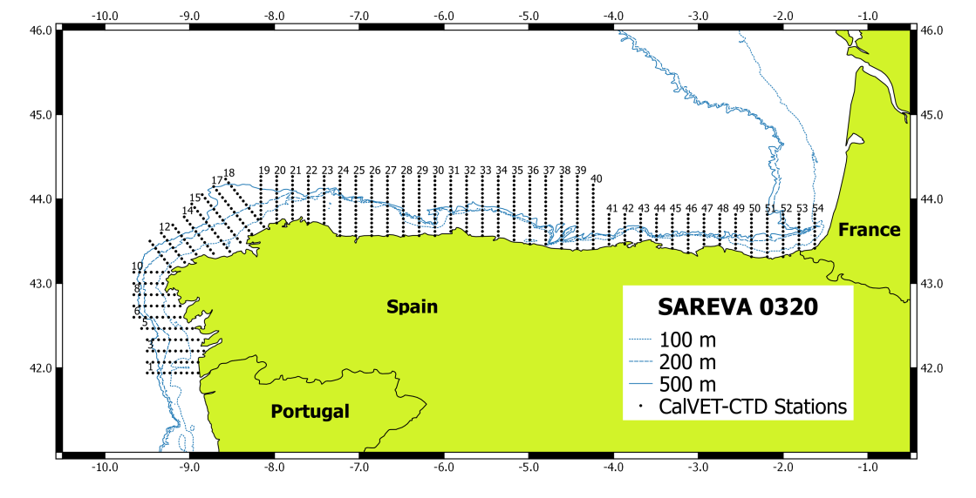Figure 11
3. For internationally coordinated surveys, describe the participating Member States/vessels and the relevant international group in charge of planning the survey
Spain/ RV.Ramon Margalef, RV. Miguel Oliver; Portugal/Noruega
Relevant international planning group: WGACEGG: Working Group on Acoustic and Egg Surveys for Sardine and Anchovy in ICES Areas VII, VIII and IX
4. Where applicable, describe the international task sharing (physical and/or financial) and the cost sharing agreement used
Not applicable
5. Explain where thresholds apply
Not applicable

Text Box 1G: List of research surveys at sea

BIOMAN
General Comment: This Box fulfills Chapter IV of the multi-annual Union programme and Article 2 and Article 7 paragraph (3) of this Decision. It is intended to specify which reseach surveys at sea set out in Table 10 of the multi-annual Union programme will be carried out. Member States shall specify whether the research survey is included in Table 10 of the multi-annual Union programme or whether it is an additional survey.

BIOMAN
1. Objectives of the survey
- To estimate annually the total biomass of anchovy in the Bay of Biscay applying the DEPM, the age structure of the population (numbers, percentage, weight and length by age) and the spatial distribution of the specie. These estimates are used for the assessment and posterior management of this stock.
- To obtain triennially (2020) the sardine spawning stock biomass in 8abd (45ºN to 48ºN) applying the DEPM, to contribute to the triennial estimates.
- To obtain the daily egg production for sardine in 8abd. These estimates are used for the survey trends-based assessment of this stock.
- Biological characterization of the species, spawning area delimitation of anchovy and sardine in the Bay of Biscay.
- Hydrological conditions of the prospected area.
- To obtain the anchovy and sardine egg abundances at 3m depth with CUFES
- To obtain the distribution and abundance of zooplankton in the Bay of Biscay
- To obtain the distribution and abundances of marine mammals, sea birds, marine litters and human activities.
- Collection of water samples for eDNA
2. Description of the methods used in the survey. For mandatory surveys, link to the manuals. Include a graphical representation (map)
The DEPM is applying following the protocol accorded at WGACEGG. In (ICES -Cooperative Research Report 332). http://www.ices.dk/sites/pub/Publication%20Reports/Cooperative%20Research%20Report%20(CRR)/CRR%20332.pdf
Coverage: southeast of the Bay of Biscay (anchovy main spawning area).
Sampling strategy: adaptive. The survey starts from the West, looking for the western limit of the spawning, and continue to the north to find the Northern limit of the spawning. Stations are located at intervals of 3 nmi along 15 nmi apart transects, perpendicular to the coast. At each station a vertical plankton haul is performed using a PairoVET net.
The Continuous Underway Fish Egg Sampler (CUFES, Checkley et al., 1997) is used to delimit the spawning area of the species.
Sample depth, temperature, salinity and fluorescence profiles are obtained at each sampling station using a CTD coupled to the PairoVET.
The adult samples are obtained, coinciding in space and time with the plankton sampling. When areas with anchovy or sardine eggs are encountered, the pelagic trawl is directed to those areas. In each haul, a sample of 2 kg of anchovy and/or sardine is randomly selected. 100 individuals of each species are measured and a biological sampling (60 - 120 individuals) is conducted. Length, weight, sex maturity and extraction of otolith are measured for each individual.
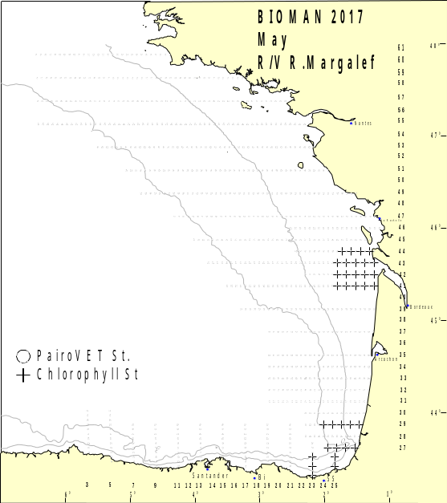Figure 12
3. For internationally coordinated surveys, describe the participating Member States/vessels and the relevant international group in charge of planning the survey
Spain/Viconde de Eza, Ramon Margalef; Portugal/Noruega
WGACEGG: Working Group on Acoustic and Egg Surveys for Sardine and Anchovy in ICES Areas VII, VIII and IX
4. Where applicable, describe the international task sharing (physical and/or financial) and the cost sharing agreement used
Not applicable
5. Explain where thresholds apply
Not applicable

Text Box 1G: List of research surveys at sea

MEDITS
General Comment: This Box fulfills Chapter IV of the multi-annual Union programme and Article 2 and Article 7 paragraph (3) of this Decision. It is intended to specify which reseach surveys at sea set out in Table 10 of the multi-annual Union programme will be carried out. Member States shall specify whether the research survey is included in Table 10 of the multi-annual Union programme or whether it is an additional survey.

MEDITS (Mediterranean International bottom trawl survey)
1. Objectives of the survey
Since the article 12 of the Council Regulation (EC) Nº 199/2008, of 25 February 2008, concerning the establishment of a Community framework for the collection, management and use of data in the fisheries sector and support for scientific advice regarding the Common Fisheries Policy, the main objective of the research surveys at sea is to evaluate the abundance and distribution of stocks, independently of the data provided by commercial fisheries, and to assess the impact of the fishing activity on the environment. The specific objectives of MEDITS surveys are:
- To get standardized indices of abundance and biomass of demersal species distributed in the circalittoral and batial soft bottoms of the Mediterranean
- To know the geographic and bathymetric distribution of these species.
- To describe the demographic structure of their populations.
- To collect biological data of the target species for fisheries.
- To get physical-chemical parameters (e.g. temperature and salinity) of the water masses where communities and demersal resources are distributed.
2. Description of the methods used in the survey. For mandatory surveys, link to the manuals. Include a graphical representation (map)
The MEDITS survey is carried out along the Spanish Mediterranean coast: Geographical sub-areas GSA01 (Northern Alboran Sea), GSA02 (Alboran Island), GSA05 (Balearic Islands) and GSA06 (Northern Spain) of the General Fisheries Commission for the Mediterranean (GFCM). See map below.
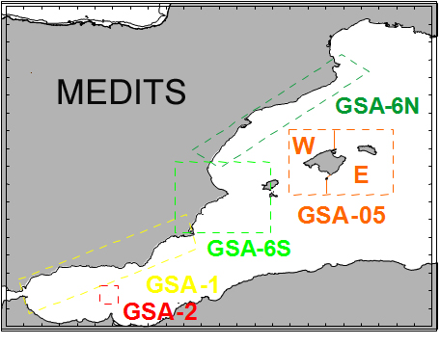Figure 13
According to MEDITS protocol, the hauls are positioned applying a stratified sampling scheme with random drawing of the positions within each stratum. The stratification parameter adopted is the depth with the following bathymetric limits: 10, 50, 100, 200, 500 and 800 m. The duration of the hauls is fixed to 30 minutes on depth less than 200 m and 60 minutes on more than 200 m. The hauls are performed only during daylight.
The survey is carried out in April-June (around 55 days), on board the research vessel "Miguel Oliver" (70 meters long, 14 meters wide, 2495 TRB and 2000 KW). The gear (GOC-73) is a bottom trawl designed for experimental fishing, with a cod-end mesh size of 20 mm. A SCANMAR system is used to monitor the arrival and departure of the net from the seabed and to estimate its horizontal and vertical openings. The bottom water temperature and salinity is recorded with the use of a CTD SBE-37 coupled to the flotsam of the net.
The data are stored in the IEO database SIRENO. Five file types are defined in order to store and exchange the data:
•Type A: Characteristics of haul. This file includes the data on bottom temperature and stratification
•Type B: Catches by haul
•Type C: Length, sex, and maturity at aggregated level
•Type E: Age weight and maturity by length at individual level
•Type L: Collection of marine litter data. According to the current common protocol, the collection of these data is voluntary.
The national coordinator of the MEDITS survey is Enric Massutí (IEO Baleares). The regional coordinators are Cristina García (IEO Málaga) for GSA01 and GSA02, Antonio Esteban (IEO Murcia) for GSA06 and Antoni Quetglas (IEO Baleares) for GSA05.
3. For internationally coordinated surveys, describe the participating Member States/vessels and the relevant international group in charge of planning the survey
Participating Member States: Albania, Cyprus, Spain, France, Greece, Croatia, Italy, Malta, Montenegro and Slovenia. For the list of vessels, see Annex I of the Medits Handbook_v8:
www.sibm.it/MEDITS%202011/principaleprogramme.htm
The international coordination of the survey is carried out during the annual “MEDITS coordination meeting”.
4. Where applicable, describe the international task sharing (physical and/or financial) and the cost sharing agreement used
Each participating country is responsible for the activities conducted on its national part of the international survey. There is no particular cost sharing agreement in place for this survey.
5. Explain where thresholds apply
Not applicable

Text Box 1G: List of research surveys at sea

MEDIAS
General Comment: This Box fulfills Chapter IV of the multi-annual Union programme and Article 2 and Article 7 paragraph (3) of this Decision. It is intended to specify which reseach surveys at sea set out in Table 10 of the multi-annual Union programme will be carried out. Member States shall specify whether the research survey is included in Table 10 of the multi-annual Union programme or whether it is an additional survey.

MEDIAS (Mediterranean International Acoustic Survey)
1. Objectives of the survey
The MEDIAS project started in 2009 within the cooperation of seven research Institutes from six Mediterranean Member States of the European Union. The target was to harmonize and standardize the five ongoing acoustic surveys in the Mediterranean: Gulf of Lions (IFREMER), Iberian Coast (IEO), Sicilian Channel (IAMC/MCFS), Adriatic Sea (ISMAR), and North Aegean Sea (HCMR). The general aim is to produce information on small pelagic species for management decisions and provide input to assessment for stocks which are managed internationally, principally, anchovy (Engraulis encrasicolus) and sardine (Sardina pilchardus). Surveys take place during summer, during the anchovy peak of spawning.
2. Description of the methods used in the survey. For mandatory surveys, link to the manuals. Include a graphical representation (map)
The MEDIAS survey design covers the Spanish Mediterranean continental shelf (20 to 200 m depth) from the French border to Punta Europa (Strait of Gibraltar). Transects run perpendicular to the coastline/bathymetry. The inter-transect is 4 or 8 nautical miles in order to achieve the minimization of the coefficient of variation of the acoustic estimates for the target species taking into account the topography of each area. Survey is performed during the day.
A calibrated EK60 (Simrad) scientific echosounder is used, equiped with five frequencies (18, 38, 70, 120 and 200 kHz), for the collection of acoustic data. The frequency for assessment is 38 kHz, while the 18, 70, 120 and 200 kHz operate as complementary frequencies. The elementary distance sampling unit (EDSU) is 1 nautical mile. The fish density values are obtained as NASC (Nautical Acoustic Scattering Coefficient) (m2/mn2) values.
Opportunistic pelagic hauls are carried out in order to ground truth the fish echotraces detected by the echosounder. Target species of the MEDIAS surveys are anchovy and sardine, for wich abundance (nº individuals), biomass (tons) are estimated by length, sex and age but biological data for all species in the pelagic community regarding length frequency distribution and length-weight relationships are also acquired. Hidrological variables are collected by CTD’s.
National coordinator of the survey is Magdalena Iglesias (IEO-C.O. de Baleares).
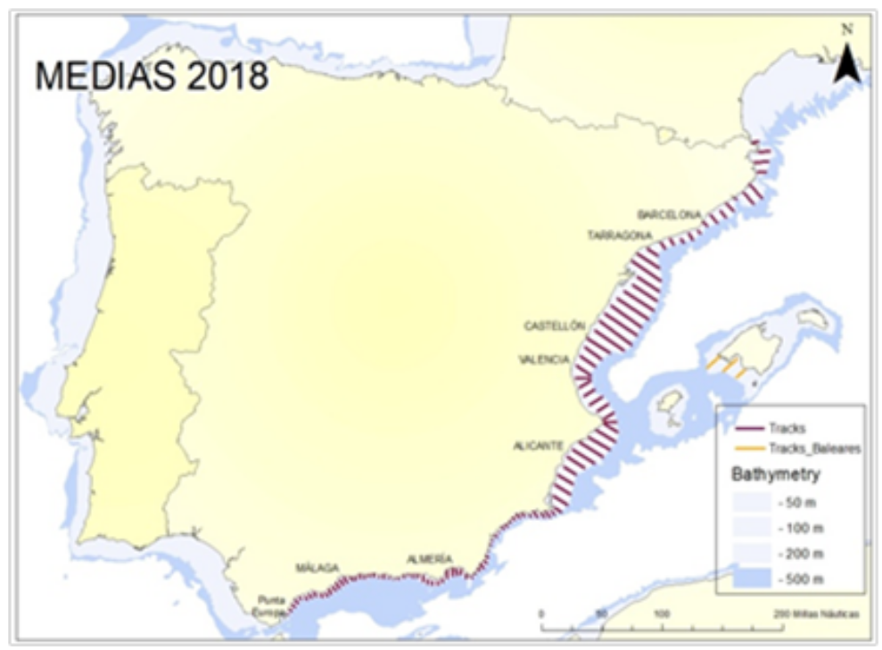Figure 14
3. For internationally coordinated surveys, describe the participating Member States/vessels and the relevant international group in charge of planning the survey
Participating Member States: France, Italy, Greece, Slovenia, Malta, Croatia and Spain/ RV. Miguel Oliver.
The international coordination of the survey is carried out in the “MEDIAS coordination meeting”.
http://www.medias-project.eu/medias/website/
4. Where applicable, describe the international task sharing (physical and/or financial) and the cost sharing agreement used
Each participating country is responsible for the activities conducted on its national part of the international survey. There is no particular cost sharing agreement in place for this survey.
5. Explain where thresholds apply
Not applicable

Text Box 1G: List of research surveys at sea

DEPM-BOCADEVA
General Comment: This Box fulfills Chapter IV of the multi-annual Union programme and Article 2 and Article 7 paragraph (3) of this Decision. It is intended to specify which reseach surveys at sea set out in Table 10 of the multi-annual Union programme will be carried out. Member States shall specify whether the research survey is included in Table 10 of the multi-annual Union programme or whether it is an additional survey.

BOCADEVA
1. Objectives of the survey
The main objective of BOCADEVA series is the estimation of spawning stock biomass (SSB) of Anchovy (Engraulis encrasicolus), based on the application of the Daily Egg Production Method (DEPM)
- To estimate the extension of Anchovy Spawning area in the Gulf of Cadiz.
- To estimate the Daily egg production (Po) and total production (Ptotal) of Anchovy in the Gulf of Cadiz.
- To determine the egg distribution area and density of other commercial species
- To characterize oceanographic and meteorological conditions in the study area during the survey
2. Description of the methods used in the survey. For mandatory surveys, link to the manuals. Include a graphical representation (map)
Vertical sampling (PairoVET)
The sampling grid is established on the continental shelf following a systematic sampling scheme, with the 21 transects being perpendicular to the coast and equally spaced 8 nm. Egg samples are taken every 3 nm in the inner shelf (ICES, 2003). The inshore limit of transects is determined by bottom depth (as close to the shore as possible), while the offshore extension is decided adaptively depending on the results of the CUFES sample.
Vertical hauls are carried out with a PairoVET sampler equipped with nets of 150 μm of mesh size. Hauls are carried out up to a maximum depth of 100 m or of 5 m above the bottom in shallower depths, (speed of about 1 m/s). Flowmeters are used to calculate the volume of filtered water during each haul. Egg samples are analysed onboard. A preliminary identification and counting of anchovy eggs and larvae, as well as other commercial species is carried out. Samples are sorted, counted and preserved in a 4 % buffered formaldehyde solution. Anchovy eggs are classified in 11 developmental stages, according to the key proposed by Moser and Ahlstrom (1985).
Continuous sampling (CUFES)
During the CUFES sampling (Checkley et al., 2000) the volume of filtered water (600 l/min, approximately) is also integrated each 3 nm (at a fixed depth of 5 m). The CUFES collector was arranged with a 335 µm net. Anchovy eggs were classified in three stages: No-Embryo (I-III), Early Embryo (IV-VI) and Late Embryo (VII-XI).
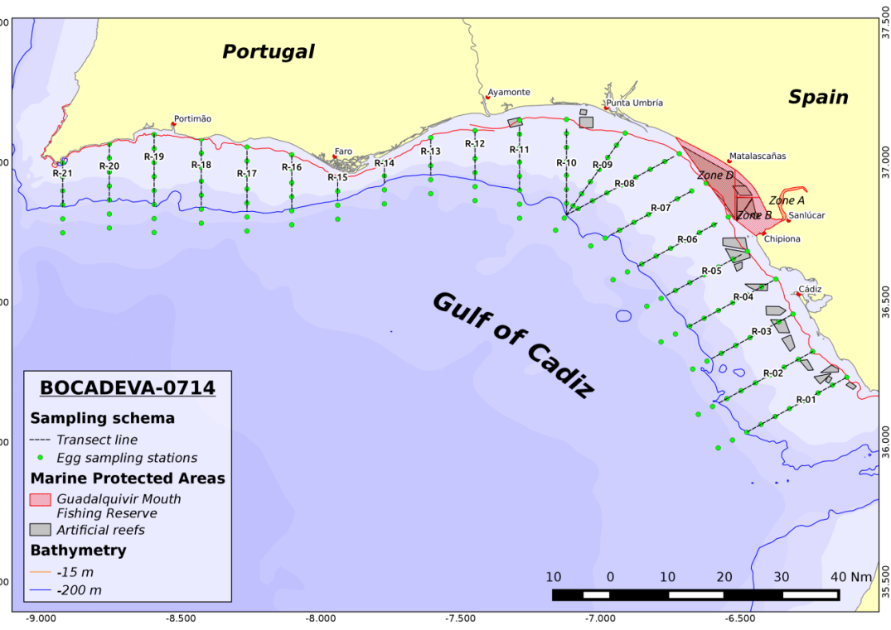Figure 15
3. For internationally coordinated surveys, describe the participating Member States/vessels and the relevant international group in charge of planning the survey
Spain/RV.Ramon Margalef; Portugal/Noruega
WGACEGG: Working Group on Acoustic and Egg Surveys for Sardine and Anchovy in ICES Areas VII, VIII and IX
4. Where applicable, describe the international task sharing (physical and/or financial) and the cost sharing agreement used
Not applicable
5. Explain where thresholds apply
Not applicable

Text Box 1G: List of research surveys at sea

ECOCADIZ
General Comment: This Box fulfills Chapter IV of the multi-annual Union programme and Article 2 and Article 7 paragraph (3) of this Decision. It is intended to specify which reseach surveys at sea set out in Table 10 of the multi-annual Union programme will be carried out. Member States shall specify whether the research survey is included in Table 10 of the multi-annual Union programme or whether it is an additional survey.

ECOCADIZ
1. Objectives of the survey
- To estimate by hydroacoustics (echo-integration) and map the abundance and biomass of the main neritic pelagic species inhabiting the Gulf of Cadiz shelf waters, especially the Gulf of Cadiz anchovy spawning stock.
- To determine the distribution area and density of the main fish species.
- To characterize the biology of the above species in relation to their main habitats, especially according to the size composition and/or age structure, and to the maturity repletion and condition stages.
- To estimate the relative abundance and to map the distribution area of anchovy eggs by means of CUFES.
- To map the distribution and abundance of the apical predators within the surveyed pelagic community and their relation to oceanographic and biological factors.
- To oceanographically characterize the surveyed area
- To map the distribution area and density of floating macro-litter and micro-plastics.
- To collect anchovy “extra” samples for the estimation of the adults’ parameters needed to apply the Daily Egg Production Method to Gulf of Cadiz anchovy
2. Description of the methods used in the survey. For mandatory surveys, link to the manuals. Include a graphical representation (map)
Acoustic estimation of the abundance and biomass of the survey target species during daylight, along to a systematic grid composed by (21) transects, between 20 – 200 m isobaths, 8 nm-equally spaced and normal to the shoreline, with a Simrad™ EK-60 scientific echo-sounder working in a multi-frequency fashion (18, 38, 120 and 200 kHz; ICES CRR 332, Massé et al., 2018). The echo-traces identification, size, age composition and other biological aspects of the assessed species are obtained from the results from opportunistic ground-truthing fishing hauls. Hydrographic characterization of the surveyed area is carried out by night through the sampling of a systematic grid of discrete CTD (with coupled multisensors)-LADCP casts and along-transect sub-superficial continuous sampling with VMADCP and ThermoSal-F. The climatic characterization of the surveyed area is obtained from the analysis of continuous records of weather variables by an Aanderaa weather station. The ichthyoplankton (anchovy eggs) distribution and sub-superficial density is recorded by a Continuous Underway Fish Egg Sampler (CUFES) along transects during the acoustic sampling. Information on the distribution and abundance of apical predators and floating macro-litter is collated by direct observation. Sub-superficial density of micro-plastics is opportunistically sampled with Manta Trawl hauls.
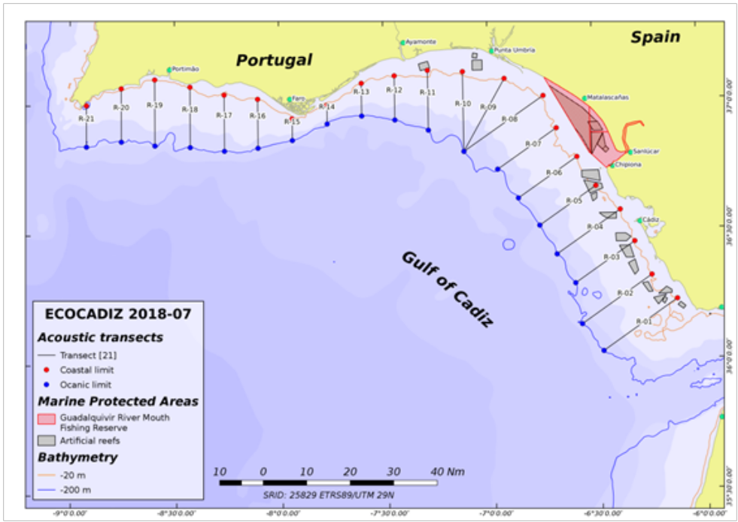Figure 16
3. For internationally coordinated surveys, describe the participating Member States/vessels and the relevant international group in charge of planning the survey
Spain/ RV.Miguel Oliver;
WGACEGG: Working Group on Acoustic and Egg Surveys for Sardine and Anchovy in ICES Areas VII, VIII and IX
4. Where applicable, describe the international task sharing (physical and/or financial) and the cost sharing agreement used
Not applicable
5. Explain where thresholds apply
Not applicable

Text Box 1G: List of research surveys at sea

ECOCADIZ-RECLUTAS
General Comment: This Box fulfills Chapter IV of the multi-annual Union programme and Article 2 and Article 7 paragraph (3) of this Decision. It is intended to specify which reseach surveys at sea set out in Table 10 of the multi-annual Union programme will be carried out. Member States shall specify whether the research survey is included in Table 10 of the multi-annual Union programme or whether it is an additional survey.

ECOCADIZ-RECLUTAS
1. Objectives of the survey
- To estimate by hydroacoustics (echo-integration) and map the abundance and biomass of the main neritic pelagic species inhabiting the Gulf of Cadiz shelf waters, especially in those waters considered according to previous studies as recruitment areas of the Gulf of Cadiz anchovy and sardine.
- To characterize the biology of the above species in relation to their main habitats (especially according to the size composition and/or age structure, and to the maturity, repletion and condition stages.
- To estimate the abundance and biomass of the juvenile fraction (age 0 fish) of anchovy and sardine in the surveyed area.
- To detect, identify and capture those echo-traces corresponding to anchovy (and sardine) recruits in the insonified water column.
- To delimit the extension of anchovy (and sardine) recruitment area in the surveyed area from the spatial distribution of this population fraction.
- To oceanographically characterize the surveyed area.
2. Description of the methods used in the survey. For mandatory surveys, link to the manuals. Include a graphical representation (map)
Acoustic estimation of the abundance and biomass of the survey target species during daylight, along to a systematic grid composed by (21) transects, between 20 – 200 m isobaths, 8 nm-equally spaced and normal to the shoreline, with a Simrad™ EK-60 scientific echo-sounder working in a multi-frequency fashion (18, 38, 70, 120, 200 and 333 kHz; ICES CRR 332, Massé et al., 2018). Since 2018 on, the EK-60 echosounder has been replaced by the EK-80 one. The echo-traces identification, size and age composition and other biological aspects of the assessed species are obtained from the results from opportunistic ground-truthing fishing hauls. Hydrographic characterization of the surveyed is carried out by night through the sampling of a systematic grid of discrete CTD (with coupled multisensors)-LADCP casts and along-transect sub-superficial continuous sampling with VMADCP and TSG-F. The climatic characterization of the surveyed area was obtained from the analysis of continuous records of weather variables by an Aanderaa weather station.
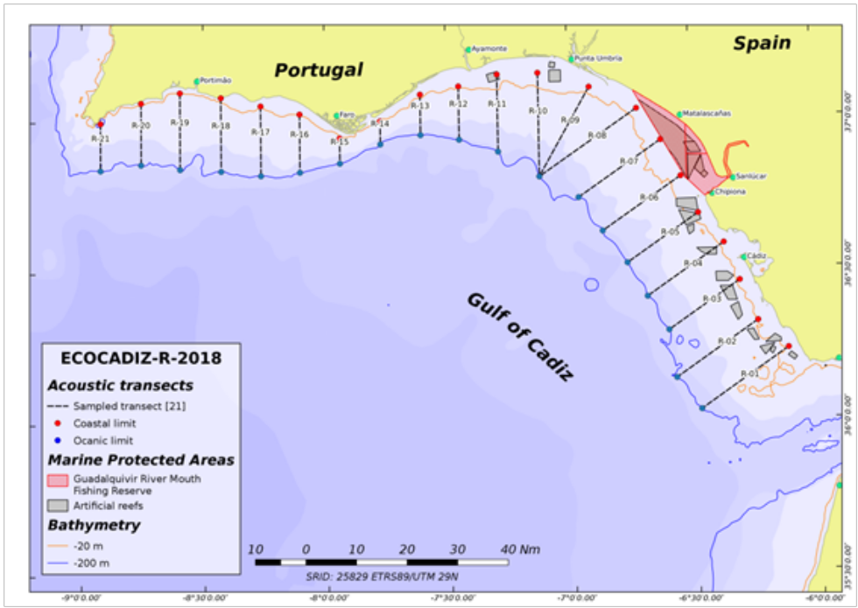Figure 17
3. For internationally coordinated surveys, describe the participating Member States/vessels and the relevant international group in charge of planning the survey
Spain/ RV Ramon Margalef,
WGACEGG: Working Group on Acoustic and Egg Surveys for Sardine and Anchovy in ICES Areas VII, VIII and IX
4. Where applicable, describe the international task sharing (physical and/or financial) and the cost sharing agreement used
Not applicable
5. Explain where thresholds apply
Not applicable

Text Box 1G: List of research surveys at sea

IBTS 1st. Quarter
General Comment: This Box fulfills Chapter IV of the multi-annual Union programme and Article 2 and Article 7 paragraph (3) of this Decision. It is intended to specify which reseach surveys at sea set out in Table 10 of the multi-annual Union programme will be carried out. Member States shall specify whether the research survey is included in Table 10 of the multi-annual Union programme or whether it is an additional survey.

IBTS 1th. Quarter (9a south)
1. Objectives of the survey
- Estimate distribution and relative abundance of the main commercial species and provide recruitment indices
- - Estimate changes in the stocks of commercial fish species independently of commercial fisheries data
- - Monitoring of distribution and relative abundance of all fish and invertebrates species
- - Collect data for the determination of biological parameters for selected species
- - Collect hydrographical and environmental information.
2. Description of the methods used in the survey. For mandatory surveys, link to the manuals. Include a graphical representation (map)
The whole area (7224 km2) has been separated into five depth strata (15-30, 31-100, 101-200, 201-500 and 501-800 m). The sampling design is random stratified with proportional allocation with a total of 45 fishing stations and swept-area method.
Length distribution of all fish and main species of crustacean and cephalopods are collected and biological parameters are obtained in the most important commercial species
Temperature and salinity are collected during each tow with a CTD attached to the gear. A CTD by haul will be carried out in the survey area.
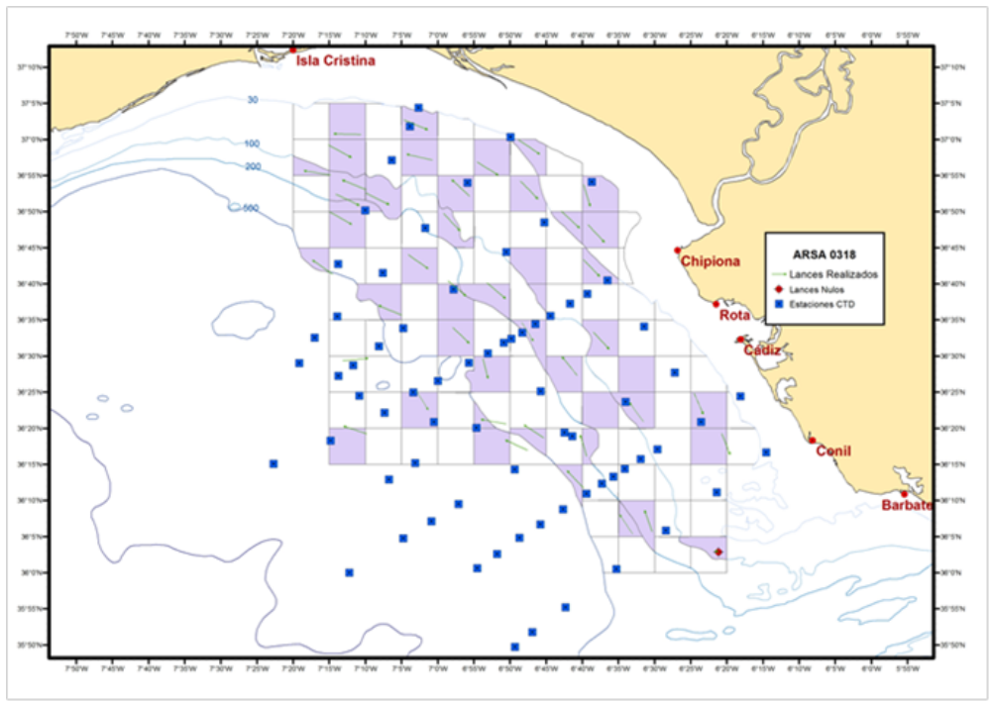Figure 18
3. For internationally coordinated surveys, describe the participating Member States/vessels and the relevant international group in charge of planning the survey
UK-Scotland/Scotia; UK-North Ireland/Corystes; Ireland/Celtic Explorer; France/Thalassa; Spain/Miguel Oliver; Portugal/Noruega.
Relevant international planning group: IBTSWG-International Bottom Trawl survey Working Group of ICES
4. Where applicable, describe the international task sharing (physical and/or financial) and the cost sharing agreement used
Individual tasks to the survey participants are allocated by the responsible ICES survey planning group. Each participating country is responsible for the activities conducted on its national part of the international survey. There is no particular cost sharing agreement in place for this survey.
5. Explain where thresholds apply
Not applicable

Text Box 1G: List of research surveys at sea

JUVENA
General Comment: This Box fulfills Chapter IV of the multi-annual Union programme and Article 2 and Article 7 paragraph (3) of this Decision. It is intended to specify which reseach surveys at sea set out in Table 10 of the multi-annual Union programme will be carried out. Member States shall specify whether the research survey is included in Table 10 of the multi-annual Union programme or whether it is an additional survey.

JUVENA
1. Objectives of the survey
The main objective of the project is estimating the abundance of juvenile anchovy in the Bay of Biscay in Autumn, as a tool for predicting the recruitment of anchovy. Secondary objectives are:
- Studying the biological condition of juvenile anchovy and its influence on the recruitment process.
- Caracterizing the hydrographic conditions and the abundance and distribution of the components of the pelagic ecosystem relevants to understand the dynamics of the recruitment.
- Studying the interactions between top predators and their preys in the Bay of Biscay, as well as inter-specific interactions between marine birds and sub-superficial predators.
- Acoustic identification and vertical distribution of mesopelagic species in the Bay of Biscay.
2. Description of the methods used in the survey. For mandatory surveys, link to the manuals. Include a graphical representation (map)
The methodology used to estimate the abundance of juvenile anchovy is the acoustic-trawl methodology. Acoustic data processing is performed by layer echo-integration. The identification and sizing is obtained by pelagic fishing hauls. The hauls are grouped by strata of homogeneous species and size composition. Inside each of these homogeneous strata, the echo-integrated acoustic backscattering is assigned to species according to the composition of the hauls. Afterwards, the energy corresponding to each specie-size is converted to biomass using their corresponding conversion factor. Details of the methodology of the JUVENA surveys were described in “Boyra, G., Martınez, U., Cotano, U., Santos, M., Irigoien, X., and Uriarte, A. 2013. Acoustic surveys for juvenile anchovy in the Bay of Biscay: abundance estimate as an indicator of the next year’s recruitment and spatial distribution patterns. ICES Journal of Marine Science, 70: 1354–1368."

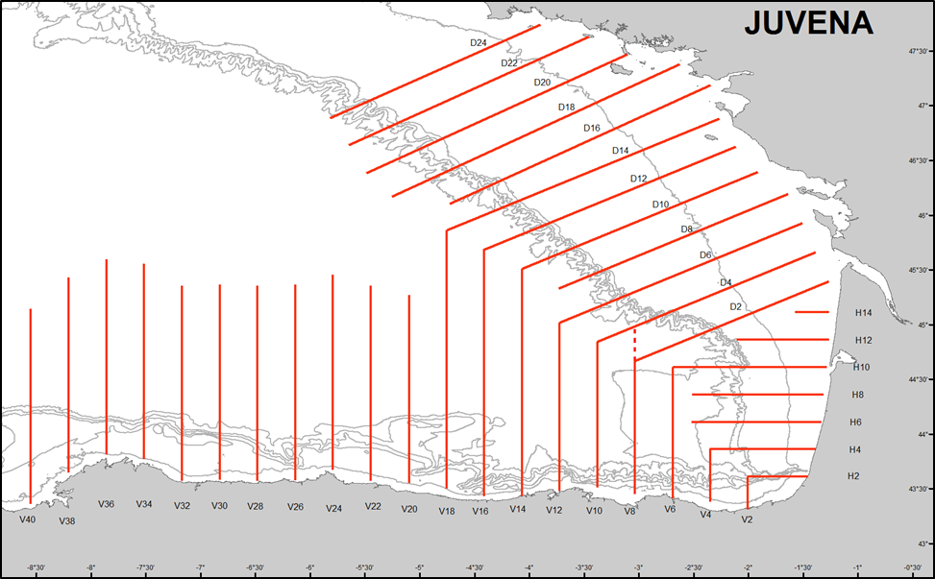 Figure 19
3. For internationally coordinated surveys, describe the participating Member States/vessels and the relevant international group in charge of planning the survey
Spain: RV. Angeles Alvariño, RV. Enma Bardan
WGACEGG: Working Group on Acoustic and Egg Surveys for Sardine and Anchovy in ICES Areas VII, VIII and IX
4. Where applicable, describe the international task sharing (physical and/or financial) and the cost sharing agreement used
Not applicable
5. Explain where thresholds apply
Not applicable

Text Box 1G: List of research surveys at sea

PALPRO
General Comment: This Box fulfills Chapter IV of the multi-annual Union programme and Article 2 and Article 7 paragraph (3) of this Decision. It is intended to specify which reseach surveys at sea set out in Table 10 of the multi-annual Union programme will be carried out. Member States shall specify whether the research survey is included in Table 10 of the multi-annual Union programme or whether it is an additional survey.

PALPRO
1. Objectives of the survey
- To obtain data on biodiversity and biomass estimates.
- To obtain biological samples (tissues) of the most deep-water representative species.
- To test the suitability of the commercial longline fishing gear (for deep-water sharks) modified for scientific surveys.
- To test depth, salinity and temperature sensors adapted to deep for monitoring the fishing gear.
2. Description of the methods used in the survey. For mandatory surveys, link to the manuals. Include a graphical representation (map)
The methodology is published in the report of WGDEEP 2016.
A modified commercial deep-water fishing gear adapted was used for the survey. The fishing gear is a two equal horizontal line sections of 1750 m +1750 m, each with 150 hooks (300 in total). Each hook was baited with 1/3 of mackerel.
The horizontal line was attached to the bottom with 1.5 kg stone each five hooks. To improve the catch efficiency of species that feed above the bottom, the stones of the horizontal line were removed in two “floating” sections of 75 + 75 hooks allowing these sections to get more buoyancy. The fishing gear was linked to the surface by two vertical lines and two buoys placed at the beginning and end of the horizontal line.
For the continuous recording of depth, temperature and salinity the long line was monitored with five small sensors DST centi and DST CTD able to withstand 2500 m depth. The survey areas was 10.5 km north of the Cape Matxitxako (VIIIc east) in a narrow canyon of about 28 km length that decreases progressively in depth from 500 to 2.500 m.
The average duration of the haul was 7:30 hours. For the calculation of the fishing effort several categories of the hook status were recorded.
Null (N) Lost of bait during the hauling
Entire (E) Hook with bait
Eaten (C) with bait partially eaten
Broken (R) Tangled-broken hook
Empty (V) Empty (no catch, no bait)
With catch (P) with catch
The specimens were identified, measured (cm), weighted (g) and sexed on board.
For the analysis of effort and CPUEs hauls’ catches were grouped in four depth strata: 650-1050 m, 1051-1450 m, 1451-1850 m and 1851-2250 m.
The Effort in each stratum (EFFORTst) was estimated as the number of hooks able to fish during the haul (P + E + C) divided by the total of hooks and multiplied by the soak time (minutes):
EFFORTst: ((P + E + C) / total hooks) x min
The Catch per Unit of Effort of each stratum (CPUEs) was calculated as the catch (kg) divided by the EFFORTst:
CPUEst = kg / EFFORTst

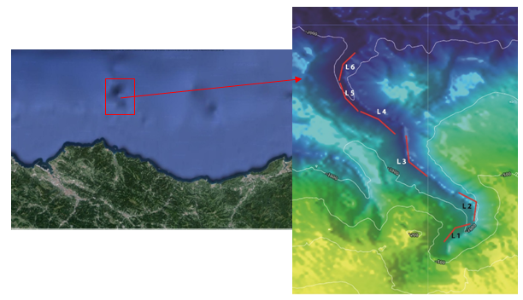 Figure 20
3. For internationally coordinated surveys, describe the participating Member States/vessels and the relevant international group in charge of planning the survey
It is not an International coordinated survey
4. Where applicable, describe the international task sharing (physical and/or financial) and the cost sharing agreement used
Not applicable
5. Explain where thresholds apply
Not applicable

Text Box 1G: List of research surveys at sea

BFT index
General Comment: This Box fulfills Chapter IV of the multi-annual Union programme and Article 2 and Article 7 paragraph (3) of this Decision. It is intended to specify which reseach surveys at sea set out in Table 10 of the multi-annual Union programme will be carried out. Member States shall specify whether the research survey is included in Table 10 of the multi-annual Union programme or whether it is an additional survey.

BFT index
1. Objectives of the survey
Main objective: developing a fishery-independent abundance index for juvenile bluefin tuna in the Bay of Biscay.
- Secondary objectives include:
- Analysing the geographical distribution of bluefin tuna schools in the Bay of Biscay,
- Assessing the size distributions in each tuna school detected in the Bay of Biscay,
- Identifying differential geographical distribution of tunas of different size classes in the Bay of Biscay,
- Studying the interactions between bluefin tunas and their main prey (anchovy) in the Bay of Biscay, as well as inter-specific interactions between marine birds and sub-superficial predators.
- Acoustic identification of bluefin tuna behavior within schools in the Bay of Biscay.
2. Description of the methods used in the survey. For mandatory surveys, link to the manuals. Include a graphical representation (map)
The methodology used to estimate the abundance of juvenile bluefin tuna is an acoustic survey following systematic transects, using long-range omnidirectional sonar as a detection tool and an EK60 echosounder to measure school dimensions and estimate biomass.
The identification and sizing of tunas is obtained by pole-and-line fishing and release and by a stereoscopic camera. Acoustic data processing is performed by both layer echo-integration, for schools observed during sampling fishing events, and school echo-integration for schools observed during transects without stopping the vessel. In the first case, the data are post-processed so as to keep only pings containing acoustic backscattering corresponding to tuna aggregations, by keeping only non-zero echointegration pings. This produces an along-track compacted echogram from which we obtain the mean density of the school calculated as the mean of the volume backscattering coefficient (sv; Maclennan et al 2002) of the non-zero pings. The shape of the schools is assumed to be a revolution ellipsoid with horizontal isotropy, i.e., with circular horizontal cross section. Details of the methodology of the surveys were described in “Goñi N, Onandia I, Lopez J,Arregui I, Uranga J, Melvin G D, Boyra G, Arrizabalaga H, Santiago J, 2016. Acoustic-based fishery-independent abundance index of juvenile bluefin tunas in the bay of biscay: 2015 and 2016 surveys. SCRS/2016/137, 15 p.” and in “MacLennan, D.N., Fernandes, P.G., Dalen, J., 2002. A consistent approach to definitions and symbols in fisheries acoustics, ICES J. Mar. Sci. 59, 365-369.”

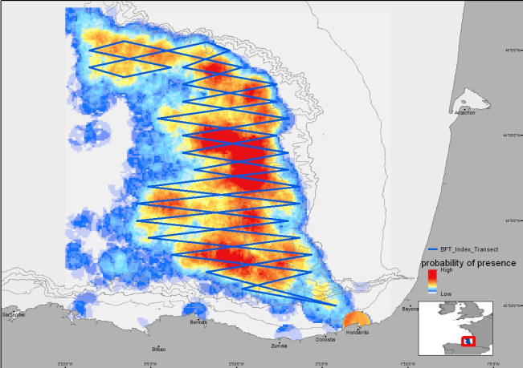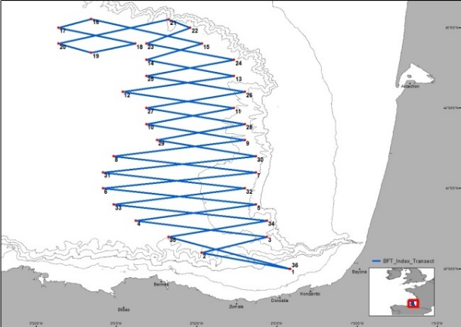 Figure 21
3. For internationally coordinated surveys, describe the participating Member States/vessels and the relevant international group in charge of planning the survey
The survey is coordinated by AZTI. Scientists from DFO Canada took part in the 2016 survey, and scientists from Ifremer, France, will be invited to participate in the survey every year. The possibility of organizing a parallel survey for juvenile bluefin tunas in the Gulf of Lions is being discussed with Ifremer scientists.
4. Where applicable, describe the international task sharing (physical and/or financial) and the cost sharing agreement used
Not applicable
5. Explain where thresholds apply
Not applicable

Text Box 1G: List of research surveys at sea

ISUNEPCA_TV Survey
General Comment: This Box fulfills Chapter IV of the multi-annual Union programme and Article 2 and Article 7 paragraph (3) of this Decision. It is intended to specify which reseach surveys at sea set out in Table 10 of the multi-annual Union programme will be carried out. Member States shall specify whether the research survey is included in Table 10 of the multi-annual Union programme or whether it is an additional survey.

ISUNEPCA_TV Survey (Nephrops FU 30, Gulf of Cadiz, ICES IXa)
1. Objectives of the survey
- To obtain estimates of Nephrops burrows densities in the Gulf of Cádiz from a randomized isometric grid of UWTV stations spacing 4 nautical miles using the underwater images.
- To define the Nephrops distribution in the Gulf of Cadiz
- To obtain density estimates of bentho-demersal macrofauna species and the occurrence of trawl marks on the sea bed
- To calibrate bentho-demersal macrofauna observed in the underwater videos and those obtained in the beam trawl.
- To measure oceanographic variables using a sledge mounted CTD
2. Description of the methods used in the survey. For mandatory surveys, link to the manuals. Include a graphical representation (map)
The UWTV design follows a randomized isometric grid of stations at 4 nm spacing. The stations ranged from 130-650 m depth with an average depth around 410 m. Additionally, stations located on the shallower edge of the study area are considered in order to verify the boundary of the Nephrops distribution. The sledge, once stable on the seabed, is towed at between 0.6-0.7 knots in order to obtain the best possible conditions for counting burrows and 10 good minutes are recorded. This time corresponds to 200 m swept, approximately. HiPAP transponder on the sledge is used to obtain the sledge position. The distance over ground estimate (DOG) is calculated using the sledge position and the field of view of the video footages is 75 cm (FOV), which was confirmed using lasers.
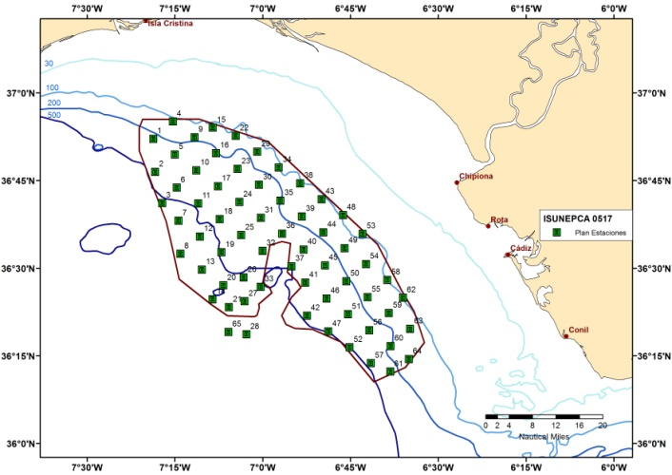 Figure 22
3. For internationally coordinated surveys, describe the participating Member States/vessels and the relevant international group in charge of planning the survey
UK-Scotland/Scotia; UK/Endeavour; AFBI/Corystes; Ireland/Celtic Explorer, Celtic Voyager; France/Celtic Voyager; Denmark/Havfisken; Sweden/Asterix; Spain/Ángeles Alvariño, Ramón Margalef
Relevant international planning group: WGNEPS_ICES Working Group of Nephrops Surveys.
4. Where applicable, describe the international task sharing (physical and/or financial) and the cost sharing agreement used
Individual tasks to the survey participants are allocated by the responsible ICES survey planning group. Each participating country is responsible for the activities conducted on its national part of the international survey. There is no particular cost sharing agreement in place for this survey.
5. Explain where thresholds apply
Not applicable

Text Box 1G: List of research surveys at sea

BLUE WHITING
General Comment: This Box fulfills Chapter IV of the multi-annual Union programme and Article 2 and Article 7 paragraph (3) of this Decision. It is intended to specify which reseach surveys at sea set out in Table 10 of the multi-annual Union programme will be carried out. Member States shall specify whether the research survey is included in Table 10 of the multi-annual Union programme or whether it is an additional survey.

BLUE WHITING
Introduction
For first time Spain (IEO) has joined the International Blue Whiting Spring Survey in 2018. In 2019 at the IBWSS post-meeting cruise held in Galway (April 2019) it was decided that WHB estimates from this survey be included in the final WHB estimates from IBWSS and used for assessment purposes.
For next year (2020) and intercalibration exercise between R/V Tridens and Miguel Oliver was planned.
Survey plan are included at the IPS withing SIPS no 9.
1. Objectives of the survey
Biomass estimation by means of echointegration of the main pelagic fish population present in the surveyed area.
Physical, chemical and biological characterisation of the pelagic ecosystem.
2. Description of the methods used in the survey. For mandatory surveys, link to the manuals. Include a graphical representation (map)
Systematic grid with random start, tracks 30 nmi apart in the southern part, 20 nmi in the northern part, from self-break in the eastern limit to 13°W in the western limit, following the methodology defined in the “ICES Manual for International Pelagic Surveys (IPS) chapter 2.1.1”
Acoustic echosounder EK-60 at 18-38-70-120-200 kHZ. Day/night observation.
Pelagic fishing stations to identify the species composition of the acoustic recordings.
Hydrological characterisation (CTD with plankton nets).
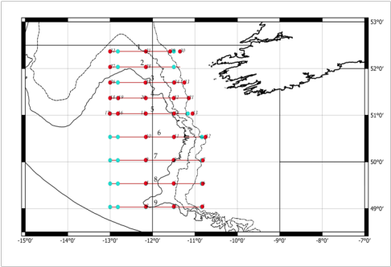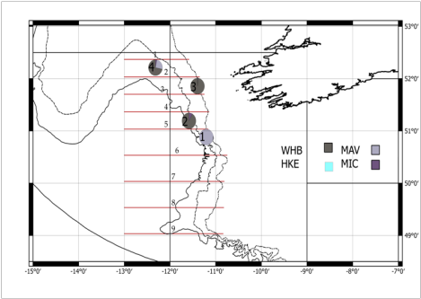 Figure 23
3. For internationally coordinated surveys, describe the participating Member States/vessels and the relevant international group in charge of planning the survey
The survey is coordinated by the ICES Working Group on International Pelagic Surveys (WGIPS) and performed in collaboration with research vessels from Ireland, Faroe Islands, Netherland, and Norway
The blue whiting spawning stock estimate is used as a tuning index by ICES WGWIDE to determine the size of the population. The survey data (hydrographic, biological, & acoustic) are stored in the PGNAPES database and at the ICES acoustic portal.
Results from 2019 survey indicated that the area covered by R/V Miguel Oliver is a potential spawning area for blue whiting. Therefore this should be taken into account for assessment purposes.
4. Where applicable, describe the international task sharing (physical and/or financial) and the cost sharing agreement used
The IBWSS is carried out by three EU MSs (Ireland, Netherland and Spain), and two non EU MSs, each contributing with its own vessel.
Cost sharing: the operational costs of the vessels are shared by EU MSs applying an allocation key proportional to national share of the EU TAC.
5. Explain where thresholds apply
Not applicable

Text Box 1G: List of research surveys at sea

TUNIBAL
General Comment: This Box fulfills Chapter IV of the multi-annual Union programme and Article 2 and Article 7 paragraph (3) of this Decision. It is intended to specify which reseach surveys at sea set out in Table 10 of the multi-annual Union programme will be carried out. Member States shall specify whether the research survey is included in Table 10 of the multi-annual Union programme or whether it is an additional survey.

Tuna index in Balearic Sea (TUNIBAL)
1. Objectives of the survey
Main objective: developing a fishery-independent abundance index for the spawning biomass and the recruitment of Atlantic bluefin tuna and Mediterranean albacore in their major spawning area in the Balearic Sea to be used in assessment models.
Secondary objectives include:
- Determine the influence of hydrographic scenarios on the structure, distribution and abundance of larval populations of large and medium pelagic species with special attention to the targeted species.
- Completing the database for the development of habitat models for the tuna species, models based on data taken in-situ by hydrographic profiles. The models are used to calibrate the fishery-independence abundance indices
- Calculate a fishery-independent abundance index for other tuna species in the Balearic Sea
- Deepening knowledge about growth, trophic ecology (interactions predator prey) and the genetic structure of larval populations of bluefin tuna and related species in the Balearic Sea.
- Determining the processes that determine planktonic productivity and biodiversity in the Balearic Sea
- Improve inter-calibration of quantitative sampling carried out with different plankton samplers
- Compare fishery-independent indices for the bluefin tuna eastern stock and the albacore in the Mediterranean with indices developed for the western and Atlantic stocks
2. Description of the methods used in the survey. For mandatory surveys, link to the manuals. Include a graphical representation (map)
The methodology used to estimate the abundance of tuna larvae includes
In all stations, an oblique plankton fishing between 0 and 30 meters, with Bongo 20 networks equipped with meshes of 55 and 200 microns and mounted above the structure of the Bongo 90 equipped with meshes of 500 microns is conducted. All networks are equipped with flow meters. To know precisely the depth of departure and the relative position of the plankton nets with respect to the vessel we will use an Acoustic Positioning System. Fishing will be carried out using a 4 mm steel cable, maintaining the speed of the ship at 2 knots. Additionally, in positive stations for bluefin tuna larvae are carried using other samplers. Besides, in each station a hydrographic profile with a CTD mounted in the rosette, is conducted between 0 and 350 or 650 meters. In standard stations, Niskin bottles will be sampled at depths of 5, 25, deep chlorophyll maximum, 200, 500, the LIW (maximum salinity). The methods are standardized with NOAA and University of Miami (USA).
The area coverage includes a grid of stations covering the major spawning area of tuna species in the Balearic Sea.
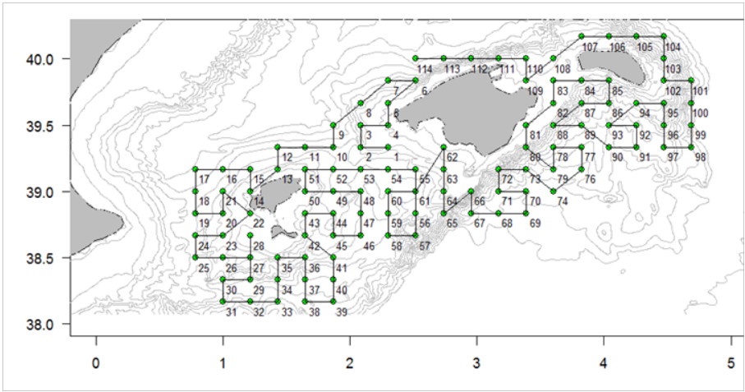 Figure 24
The methodology is detailed in:
Ingram W. Jr., Álvarez-Berastegui D., Reglero P., Balbín R., García A., Alemany F. 2017. Incorporation of habitat information in the development of indices of larval bluefin tuna (Thunnus thynnus) in the Western Mediterranean sea. Deep Sea Research Part II: Topical Studies in Oceanography, 140: 203-211. https://doi.org/10.1016/j.dsr2.2017.03.012
Álvarez-Berastegui D., Saber S., Ingram W.G.Jr, Díaz-Barroso L., Reglero P., Macías D., García-Barcelona S., Ortiz de Urbina J., Tintoré J., Alemany F. 2018. Integrating reproductive ecology, early life dynamics and mesoscale oceanography to improve albacore tuna assessment in the Western Mediterranean. Fisheries Research, 208C (2018) pp. 329-338. https://doi.org/10.1016/j.fishres.2018.08.014
Alemany, F., Quintanilla, L., Velez-Belchí, P., García, A., Cortés, D., Rodríguez, J. M., Fernández de Puelles, M. L., González-Pola, C., López-Jurado, J. L. 2010 Characterization of the spawning habitat of Atlantic bluefin tuna and related species in the Balearic Sea (western Mediterranean). Prog. Oceanogr. 86, 21–38. (doi:10.1016/j.pocean.2010.04.014)

3. For internationally coordinated surveys, describe the participating Member States/vessels and the relevant international group in charge of planning the survey
The survey is coordinated by IEO (Patricia Reglero and Raul Laiz). Scientists from SOCIB (Spain), NOAA (USA) and University of Miami (USA) took part in some of the surveys and will be invited to participate. It is being discuss the possibility of conducting acoustic sampling of spawners in collaboration with ICCAT.
4. Where applicable, describe the international task sharing (physical and/or financial) and the cost sharing agreement used
Not applicable
5. Explain where thresholds apply
Not applicable

Section 2: Fishing Activity Data

Text Box 2A: Fishing activity variables data collection strategy

General comment: This Box fulfills paragraph 4 of Chapter III of the multi-annual Union programme and Article 2, Article 4 paragraph (2) point (b) and Article 5 paragraph (2) of this Decision. It is intended to describe the method used to derive estimates on representative samples where data are not to be recorded under Regulation (EU) No 1224/2009 or where data collected under Regulation (EU) No 1224/2009 are not at the right aggregation level for the intended scientific use.
1. Description of methodologies used to cross-validate the different sources of data.
Fishing activity variables are collected under control regulation. The sources of data are: Fleet register, logboook, sales notes and VMS. All this information is integrated into the centralized database of the SGP and can be found with precision levels settled by the regulation.
Improvements are being made in the centralized database in order to develop consistency filters and query with data matching in order to detect errors or inconsistencies as established by Community law and as approved by the European Commission.
Capacity: The data regarding capacity are obtained from Operating Spanish Fleet Register which is part of Community vessel Register, in which all vessels included.
From a software application, the parameters of the vessels according to the disaggregation level required by the Regulations can be checked. In this sense, regarding gear data, they are obtained from national census where vessels are included or, alternatively, from data of fishing licences issued.
Automatic filters are being implemented in the database to check possible inconsistencies.
These census are updated any time a change occurs, so that the annual update of the data is guaranteed. This gives a total coverage of Spanish fleet vessels, including those less than 10 m.
Effort:
- for vessels of more than 10 meters, data come from Fleet Register, logbooks and positions provided by the VMS data (vessels exceeding 15 m.)
- for vessels of up to 10 and 15m data are obtained from the logbooks.
- For vessels less than 10 meters, the data for fleet segments and fishing gear are obtained from Fleet register and those derived from sale notes given that each note corresponds to a day of fishing in the fishing ground to which the vessel´s been operating.
The fleet census is updated any time a change occurs, so that the yearly update of the data is guaranteed. This gives a total coverage of the Spanish fleet vessels, including those less than 10 m length.
Sales notes are collected daily on all auctions by the autonomous regions authorities that process and integrate them into their databases so that there is a full coverage. Whith established frequency, the sales notes are forwarded to the SGP that incorporate the information into its central database, which guarantee the full coverage in all national territory.
Improvements are being made in the centralized database in order to develop consistency filters and query with data matching in order to detect errors or inconsistencies, as established by Community law and as approved by the European Commission.
Landing: Information on landings by vessels over 10 meters comes from the landing declarations.
In 2012 it began the gradual implementation of the system of "electronic logbook". With this system, incorporating data on catches and landing declarations to the database is immediate, thus speeding up the incorporoation of information. This system has been a major advance over manual recording of data done in ports. This manual recording has been relegated to those vessels that are not required to have this electronic logbook, although a logbook in paper format is mandatory.
These recordings represent just 5% of the total catches of the Spanish fleet.
For vessels less than 10 meters, these data are collected from sales notes.
The latter information, if necessary, can be obtained through the crossings of sales notes against the tables of fleet census where the fishing mode is recorded for each vessel.
The precision and disaggregation levels under the Regulation have been reached, however, the information of disaggregation level required by the regulations concerning the value of species landed obtained from surveys to collect economic data. These surveys are processed in the year following their collection and also the data obtained are not yet integrated into the SGP central database, so it cannot be done automatically with a cross-checking like other parameters required for this module.
2. Description of methodologies used to estimate the value of landings.
As explained above.
3. Description of methodologies used to estimate the average price (it is recommended to use weighted averages, trip by trip)
Sales notes provide this data.
4. Description of methodologies used to plan collection of the complementary data (sample plan methodology, type of data collected, frequency of collection etc)
Not applicable. All variables are covered by the methodology as explained.

(max 900 words per Region)

Section 3: Economic and Social Data

Text Box 3A: Population segments for collection of economic and social data for fisheries

General comment: This Box fulfills paragraph 5 points (a) and (b) of Chapter III of the multi-annual Union programme and Article 2, Article 4 paragraphs (1), (2) and (5) and Article 5 paragraph (2) of this Decision. It is intended to specify data to be collected under Tables 5(A) and 6 of the multi-annual Union programme.
1. Description of methodologies used to choose the different sources of data
The statistic operation Marine Fisheries Economic Survey includes pollsters who gather information directly in questionnaires designed ad hoc.
Due to the considerable population size, performing an annual census would be too expensive and is not considered appropriate. Therefore, stratified random sampling will be performed, using economic profitability of the statistical unit as main variable, and size (measured by GT) as auxiliary variable.
The statistical unit or observation unit is each of the vessels included in the CFP (Operative Fishing Fleet Census, in Spanish), which can perform marine fishing, classified in group 03.11 of the National Activities Classification (CNAE-2009).
The reporting unit is the vessel’s owner.
The sampling unit is each CFP vessel with activity during the referred year.
The analysis unit, or economic activity unit is the vessel, therefore, it coincides with the observation unit.
2. Description of methodologies used to choose the different types of data collection
The data collection method is based on a stratified random sampling through a representative sample of the total population.
Data are collected by personal direct interview to the informers, including:
• daily contact between provincial and general coordinators
• training agents in their province
• preparation of materials
• designing surveying routes
• receiving filled-in questionnaires
• inspection
• submitting weekly to central offices all interviews conducted
The different phases of the work are listed below:
1) Sending covering letter
2) Location of phone numbers to make the first contact
3) First contact with companies
4) Conducting interviews
5) Detection of incidents
The survey questionnaire contains the following:
1) Identification of vessel’s owner - name, address, etc.
2) Detailed information of the vessel’s owner to set the economic and financial situation ashore of companies in the sector.
3) Vessel information.
4) Vessel’s Income Statement Account.
3. Description of methodologies used to choose sampling frame and allocation scheme
Stratified random sampling. The main variable of this survey is the economic profitability of the ship, and the auxiliary variable to be used to stratify is the GT, a variable of which the population distribution is known.
Stratification: Survey population was divided into strata, according to the auxiliary variable GT, with the aim of obtaining groups on vessels as homogeneous as possible within stratum GT and with the greatest possible heterogeneity among the different strata, in relation to the profitability of the vessels.
Strata were defined according to statistic, biological (similarity in the fishing grounds’ characteristics), and technical (type of fishing methods utilised and vessel length).
In addition to the above mentioned criteria, stratification of the population has to meet the levels of disaggregation required by Community rules, resulting from Commission Delegated Decision (EU) 2019/910.
Strata cannot contain less than 10 elements: strata not meeting this condition are grouped with others.
Sample size: with optimum allocation. Total sample size is determined aiming to estimate the median GT of the population with an expected error of 5%, that is, a 95% level of confidence.
Sample selection: In the population database, vessel data will appear together with the vessel’s owner data. By selecting the statistical units, reporting units of the survey are perfectly demarcated.
The various ships in the population are grouped according to the stratum to which they belong, and in each of these groups, membership or not of each of the vessels to the stratum will be randomly allocated. The result is a set of random and mutually independent subsamples.
The size of each of these subsamples will be previously determined by the (previously set) expected error level.
4. Description of methodologies used for estimation procedures
Target variables will be estimated using the stratified random sampling method. From data included in questionnaires, variables with those population values which may be of interest will be built.
5. Description of methodologies used on data quality
Refer to table 5B for a detailed description of these methodologies.
If a survey unit is considered “Impossible to include in the survey”, the reason for not having that information available will be noted in order to improve the design phase of future surveys, and they will affect the frame of this survey in the corresponding percentage.
(max 900 words per Region)

Section 3: Economic and Social Data

Pilot Study 3: Data on employment by education level and nationality
General comment: This Box fulfills paragraph 5 point (b) and paragraph 6 point (b) of Chapter III of the multi-annual Union programme and Article 2 and Article 3 paragraph (3) point (c) of this Decision. It is intended to specify data to be collected under Table 6 of the multi-annual Union programme.
Methodology and results obtained from the study
The information on the social variables has been collected for previous years and no significant problems have been observed in the response of the respondents. In future exercises it is assumed that the same lack of problems will continue.
The data from the pilot study are collected together with the rest of the economic variables following the same sampling methodology. This methodology has been adapted to what was indicated by the different interlocutors, in relation to the intervals of the variables.
The variables included in the pilot study on social information are: employment by age, employment by level of education, employment by nationality and employment by employment status.
• Employment by age: information on the number of jobs by age and sex is collected, considering the following intervals:
1. 16-24
2. 25-39
3. 40-64
4.> = 65
5. Unknown
• Employment by level of education: information on the number of jobs by level of education and sex is collected, considering the following categories:
1. Low (Level 0-2)
2. Medium (Level 3-4)
3. High (Level 5-7)
4. Unknown
• Employment by nationality: information on the number of jobs by nationality and sex is collected, the following categories are considered:
1. NAC. National
2. R.UE Rest of the EU
3. F.UE outside the EU
4.Unknown
• Employment by employment status: information on the number of jobs by employment status and sex is collected, the following intervals are considered:
1. Employees: Includes Employees, Family Aid and Cooperative members.
2. Owners: Includes Employers and Self-Employed Workers.
3. Unknown

(max 900 words)

Section 3: Economic and Social Data

Text Box 3B: Population segments for collection of economic and social data for aquaculture

General comment: This Box fulfills paragraph 6 points (a) and (b) of Chapter III of the multi-annual Union programme and Article 2, Article 4 paragraphs (1) and (5) and Article 5 paragraph (2) of this Decision. It is intended to specify data to be collected under Tables 6 and 7 of the multi-annual Union programme.
1. Description of methodologies used to choose the different sources of data
The statistic operation Aquaculture Economic Survey includes pollers gathering information directly in questionnaires designed ad hoc.
The statistical unit or observation unit is each of the establishments authorised to perform aquaculture activities, as described in group 03.2 of CNAE-2009.
The reporting unit is the person who, owning the company to which the establishment belongs, or having the power and ability to respond, can be asked the questions contained in the corresponding questionnaire, related to the observation unit.
Sample units are the establishments performing aquaculture activities which in the reference year were authorised to do so.
The analysis unit, or economic activity unit is the establishment. It is the part of the company which undertakes its activity in a given geographical situation. Hence, in most cases it coincides with the observation unit.
When a company of the same owner and the same main activity has several establishments of aquaculture and data collected in the questionnaire are not disaggregated by each of the establishment, an proportional estimation of the corresponding fraction for each establishment is made.
2. Description of methodologies used to choose the different types of data collection
The methodology used for data collection is mixed. One part of the population is surveyed exhaustively (with a census) and the other part is surveyed with stratified random sampling.
Data are collected by direct personal interview to informers, by:
• daily contact between provincial and general coordinators
• training agents in their province
• preparation of materials
• designing surveying routes
• receiving filled-in questionnaires
• inspection
• submitting weekly to central offices all interviews conducted
The different phases of the work are listed below:
1) Sending covering letter
2) Location of phone numbers to make the first contact
3) First contact with companies
4) Conducting interviews
5) Detection of incidents
The survey questionnaire contains the following:
1) Identification of the legal form of the establishment’s owner and the number of establishments under his ownership.
2) Description of the establishments
3) Income Statement Account of the establishments
3. Description of methodologies used to choose sampling frame and allocation scheme
Stratified random sampling. The main variable of this survey is the result before taxes. However, the main variable will be determined at the end of the survey. This is why, in order to determine the simple size, it is necessary to have an auxiliary variable that is both previously known and correlated to the main variable. The effectively used capacity of the establishment will be the auxiliary variable, referred to as the size of the existing facilities in the establishment used to accommodate the species during the different phases or processes of aquaculture, which are effectively being used to this end.
The population to be sampled has been divided into strata, aiming to obtain groups of establishments with characteristics as homogeneous as possible within the stratum and with the greatest possible heterogeneity among the different strata.
Another criterion when defining the strata has been to obtain a number of them which can be handled, ensuring that each either includes a significant number of establishments or it represents a given species or zone.
In addition to the above mentioned criteria, stratification of the population has to meet the levels of disaggregation required by Community rules, resulting from Commission Delegated Decision (EU) 2019/910.
Stratification was made based on the establishments’ characteristics: type of aquaculture according to water origin, type of aquaculture facilities (ground, in natural spaces. Horizontal culture, cages), and main species rose.
Strata have been surveyed by census or by sampling according to the following criteria:
- Strata including less than 20 establishments for each main species cultivated: exhaustive survey.
- Strata including 20 or more establishments and homogeneous characteristics: sampled and then extrapolated to obtain data for the population.
In this second group we must consider that sample size is calculated according to the auxiliary variable, the capacity effectively used by the establishment, and that, when variability within the stratum is high, it may be the case that sample size is the same as the population size for a particular stratum.
Sample size: with optimum allocation. Total sample size is determined aiming to estimate the economics results of the population with an expected error of 5%, that is, a 95% level of confidence.
Sample selection: In the population database, data from the aquaculture establishments will appear together with the corresponding owner data, for both the exhaustive survey and sampling. By selecting the statistical units, reporting units of the survey are perfectly demarcated.
In the exhaustive survey, each statistical unit will represent one unit in the population as a whole.
In sampling, the units will represent the corresponding population. Therefore, it will be necessary to select sampling units randomly.
For sampling, the population of different groups will be grouped according to the stratum to which they belong, and in each of these groups sampling will be made randomly obtaining as many random and mutually independent subsamples as there are strata.
The size of each of these subsamples will be previously determined by the (previously set) expected error level.
4. Description of methodologies used for estimation procedures
In the exhaustive survey there is an imputation method for those cases in which mandatory questions do not get a response within partially completed questionnaires.
5. Description of methodologies used on data quality
Refer to table 5B for a detailed description of these methodologies.

(max 1000 words)

Section 3: Economic and Social Data

Pilot Study 4: Environmental data on aquaculture

General comment: This Box fulfills paragraph 6 point (c) of Chapter III of the multi-annual Union programme and Article 2 and Article 4 paragraph (3) point (d) of this Decision. It is intended to specify data to be collected under Table 8 of the multi-annual Union programme.
1. Aim of pilot study
No pilot study planned
The collection of this data is made by the competent authorities in the subject, which in the case of Spain are the Regional Authorities since it deals with Animal and Public Health. Besides, it is considered that no pilot should be carried out. It is mandatory to collect them by the legislation on the matters mentioned, and therefore, since it falls on domains which exceed the competence of the CFP, no specific recommendations from the Fisheries authorities should be made. Also, it is worthy to remind that one the legislative body is a Directive, which entails to the Member States the best possible way to incorporate to its own legislative corp.
2. Duration of pilot study

3. Methodology and expected outcomes of pilot study

(max 900 words)

Section 3: Economic and Social Data

Text Box 3C: Population segments for collection of economic and social data for the processing industry

General comment: This Box fulfills footnote 6 of paragraph 1.1(d) of Chapter III of the multi-annual Union programme, Article 2, Article 4 paragraphs (1) and (5) and Article 5 paragraph (2) of this Decision. It is intended to specify data to be collected under Table 11 of the multi-annual Union programme.
1. Description of methodologies used to choose the different sources of data
Accomodation to EU legislation.
Two main aspects must be highlighted:
- The survey is vertebrated following a multiple units model, in which, and according to EU legislation, the companies assume the main role.
- With the purpose to adapt to European nomenclature of economic activities (NACE rev.2), the “Industrial Companies Survey” is articulated referring to sectorization, stratification and statistical infraestructe on the basis of the “National Clasification of Economic Activities 2009”
Approach to obtain the primary data.
The primary data are oriented to the informing unit, trying to compile the features or variables they may provide, either because they know them or because they are accessible in their documentation.
All of the above aim to:
- Adapt the main variables of the questionnaire to the criteria and guidelines of the new “General Account Plan”.
- Utilisation of the different models of questionnaires depending on the size of the company and the different types of economic-finantial operations… all of them aspects that may hinder the homogeneous treatment of these units from the statistical point of view. To adjust the requested data (and according to its level of especification) to the intrinsic characteristics of each unit, different models of questionnaires have been designed depending on the features of each reporting company.
Units of the survey
The basic survey unit is the industrial company. The company may perform one or more activities in one or more places.
In the scheme of the survey, the company assumes at the same time, the roles of informing unit and observation unit.
However, although the company is the main unit of the survey, given the numerous objectives to be reached with this investigation, there are units that complement the information system, such as the industrial establishment (as observation unit) and the economic activity unit at local level (as analysis unit).
Population scope
The population under sampling is comprised by the companies whose main activity is included in the CNAE-2009 following sections:
- Section B: harvesting industries
- Section C: manufacture industry
- Section D: air conditioning, steam, gas and electric provider
- Section E: water provider, sanitation activities, waste management and decontamination.
2. Description of methodologies used to choose the different types of data collection
Collecting of information
The collection of information is carried out annually by the “Collection Units” of INE, responsible also for answering telephones to clear up doubts of the informers and for recording and filtering questionnaires.
The process of this collection of reference year “t” is carried out from the second trimester of the year “t+1”, with an aproximate duration of 4 months.
It will be assumed that the company has been surveyed if its main activity is one of those included in the population scope of the survey; also, if the questionnaire has been obtained duly fullfilled and the data comply with the consistency and completeness as established.
Besides, during the collection of all the information, some incidences may arise that dont allow to obtain the questionnaire: definite closure of the bussines, temporary closure o inactive company, mistakenly included in the survey, not in the scope, duplicated or impossible to locate, negative or not responding.
Models of questionnaires
Four models of questionnaires have been designed with the purpose of adequating the requested information to the specific features of the companies:
- Companies with less than 10 employees.
- Companies between 10-49 employees.
- Companies with 50 or more employees and whose activity is included in sections B and C of CNAE-2009.
- Companies with 50 or more employees and whose activity is included in sections D and E of CNAE-2009.
3. Description of methodologies used to choose sampling frame and allocation scheme
Sampling and design
Population framework: Companies Central Directory (“DIRCE”) which contains the information on the companies identification, as well as its main economic activity, location and size.
Type of sampling. Estratification
The population under study has been divided in different strata, according to the following variables:
- Company main activity, at 4 digit level (class), according to CNAE-2009.
- Autonomous region
- Company size interval, depending on the number of employees:
- Up to 3 employees
- From 4 to 9
- From 10 to 19
- From 20 to 49
- 50 or more employees
- Characteristics of the subsidiary company ( if it is subsidiary of a foreign company or not)
It has been thoroughly investigated those companies with 50 or more employees, as well as all companies included in the “Foreing subsidiary companies” record in Spain. Also, all companies that, although with a small size in terms of employees, have an important facturation volume, have been exhaustively surveyed.
The rest of the companies have been sampled. Each stratum, which has been determined by the crossing of the above mentioned variables, has conformed an independent population, in terms of the sampling.
Size sampling. Affixation.
Within each stratum, it has been calculated the size sample by optimum affixation or Neyman´s affixation, by fixing in advance the relative sampling error for the variable “number of employees”, at national level of 1%, and at regional level of 5%.
The size sampling has been increased, if necessary, to a minimum of two companies by stratum. On the other hand, and with the purpose of reaching more precise aggregated results, it has been determined by statistical criteria, within each strata, the outlier companies (in terms of facturation volume and employees) with the objective of including them in the thorough part of the sample.
By size intervals, sampling fraction have been as follows:
Strata by size | Sampling fraction
Up to 3 employees | 10%
From 4 to 9 employees | 29%
From 10 to 19 employees | 42%
From 20 to 49 employees | 69%
50 or more | 100%
TOTAL | 21%

Size selection: by means of the assigning aleatory number, which allows the coordination of the sample with other surveys.
The selection process is independent from one year to another: the probability of a company being selected in year “t” is independent from the fact that this company has been selected the previous year (t-1).
4. Description of methodologies used for estimation procedures
Unbiased expansion estimators have been utilised in the stratified sample.
5. Description of methodologies used on data quality
IT processing of the sample file: carried out by IT application that ensures the organization, continuous collection supervision, filtering and efficient control of the process since the beginning of the survery, with the detection of systematic mistakes of fullfillement and interpretation of the questionnaries during the initial phase, making it easier to correct them afterwards.
Information processing Carried out in a paralell to data collection itself; focusing on the continuous update process; refinement of the questionnaire content, integrated in the recording and treatment of the inter provincial management of the company (in particular, for companies located in different provinces).

(max 1000 words)

Section 4: Sampling Strategy for Biological Data from Commercial Fisheries

Text Box 4A: Sampling plan description for biological data

North Sea (ICES 3a, 4 and 7d areas) and Eastern Arctic (ICES areas 1, 2)
General Comment: This Box fulfills Article 3, Article 4 paragraph (4) and Article 8 of this Decision and forms the basis for the fulfilment of paragraph 2 point (a)(i) of Chapter III of the multi-annual Union programme. This Table refers to data to be collected under Tables 1(A), 1(B) and 1(C) of the multi-annual Union programme.
North Sea and Eastern Arctic
Spain has only fisheries in Eastern Acrtic. All the sampling will be performed on commercial unsorted catches at sea by observers on board of fishing vessels that operate in international waters.
1. Sampling design
There are two types of fisheries and the target population is stratified into two fleets:bottom trawlers targeted Cod (OTB_DEF_> = 120_0_0) and midwater trawlers targeted redfish (OTM_DEF_100-119_0_0).
Target population: is the total number of trips in a year carried out by the Spanish fleet targeting the stocks selected for sampling. The trips lasted from few days to 3 months and all vessels are over 40 m.
Sampling frame: is the list of vessels with license to fish in each fishery.
Primary Sampling Units (PSUs): are the individual fishing trip in a fishery. In a single trip one vessel can cover two o more fisheries and even different Areas and/or Regions.
Method of PSU selection: is a systematic non-random sampling (rotation) from a list of vessels ranked by the effort of observation on board in previous years by fishery and updated every year. The selection is made by the fisheries authority which granted the license. The refusal rate in the last years is zero because the license is linked to the acceptance of scientific observer on board.
Sampling effort: is allocated according to the scientific experience gained from the study of fisheries in the area. The number of fishing trips and the number of individuals planned to be sampled were calculated based on data from previous years in order to keep the coverage from previous years and to cpmply the requirements of the end users.
Sampling procedures: the method to collect the length data from commercial fisheries is the concurrent sampling on board carried out by observers at-sea who remain on board throughout the period of the whole fishing trip (1-3 months). Observers on board collect data on unsorted catches and discards by species, efforts and positions The biological parameters (Weight, Age, Maturity) come from a sampling design stratified by length class. The Sex-ratio index is achieved at the same time of sampling of length which are randomly collected and not stratified.
2. Estimation procedures
Estimation of discards and catches structure are carried out from data collected by observers on board. The data consist on length data by sex and length-weight relationship collected by trip sampled. Raisings are done for each species by month and division. Finally, a raising is made to the total catch of the fishery.
The calculation to achieve other biological parameters will be estimated based on bootstrap procedures and fitting models with the tool INBIO 2.0 (“Estimation of biological parameters and their uncertainties through simulation techniques”) developed in R environment by the IEO.
3. Data quality evaluation
Data of each trip, collected and recorded on board, are checked during and after the trip (in the laboratory) in order to detect errors and inconsistencies (outliers, trends, range of variables, dispersion).
After the trip, the observer debugs all data, haul by haul and sampling by sampling. Finally, a random check of about 15% of the data is carried out to validate the quality of the results. Annually all sets of data for each fishery are checked previously to be used for assessment and other scientific tasks.
Quality controls like the following are performed:
- Implementation of sampling protocols for each species where the methodologies of sampling, processing and storage of samples are described.
- Processing, debugging and periodic checking of data.
- Standardization of the common criteria in assigning maturity and age of each species, in order to improve the accuracy.
- Attendance to workshops and/or exchanges between different scientific teams.
Data storage: Sampling data are stored into own and SIRENO database: (Seguimiento Informático de los Recursos Naturales Oceánicos) which is managed by the IEO.
Documentation are currently at the preparation stage.A document compiled, about Sampling Design, Quality Checks and Processes to evaluate Data Accuracy will be ready and published in the period 2020-2021.

Section 4: Sampling Strategy for Biological Data from Commercial Fisheries

Text Box 4A: Sampling plan description for biological data

North Atlantic
General Comment: This Box fulfills Article 3, Article 4 paragraph (4) and Article 8 of this Decision and forms the basis for the fulfilment of paragraph 2 point (a)(i) of Chapter III of the multi-annual Union programme. This Table refers to data to be collected under Tables 1(A), 1(B) and 1(C) of the multi-annual Union programme.
North Atlantic (ICES areas 12, 14 and NAFO areas)
All the sampling will be performed on commercial unsorted catches at sea by observers on board of fishing vessels that operate in international waters.
1. Sampling design
In ICES Subareas XII, XIV there are two types of fisheries and the target population is stratified into two fleets: Bottom trawlers targeting deep-sea species in ICES Division XIIb and VIb-Hatton Bank (OTB_DWS_100-129_0_0) and Midwater trawlers targeting Redfish and Grenadiers in ICES Subareas XII and XIV-Irminger Sea-(OTM_DEF_100-119_0_0). In ICES Subarea VI a new metier (OTM_DEF_32-69_0_0) targeting Blue Whiting has been included in the NWP 2020-2021.
In NAFO Regulatory Area (NRA), Spanish fleet carry out different fisheries characterized by different mesh size, target species, depth and fishing area:
- Botton trawlers targeting Greenland halibut in Div 3LMNO (OTB_MDD_130-219_0_0).
- Botton trawlers targeting Skates in Div 3LNO (OTB_MDD_>=220_0_0).
- Botton trawlers targeting Northern Shrimp in Div 3LMNO (OTB_CRU_40-59). 3LNO fishery is currently closed. 3M fishery will reopened in 2020.
- Midwater trawlers targeting Alfonsino in Div 6G (OTM_DEF_130-219_0_0). Reason for change: see table 4C (column comments).
- Bottom trawlers targeting Cephalopodos in Div 3O (OTB_MOL_60-89_0_0). New métier included in NWP 2020-2021
Target population, Sampling frame, Primary sampling units (PSUs), Method of PSU selection, Sampling effort, Sampling procedures (see NS&EA)
2. Estimation procedures (see NS&EA)
3. Data quality evaluation (see NS&EA)
North Atlantic (ICES areas 6-9)
1. Sampling design, Estimation procedures and Data quality evaluation
Sampling onshore (at market)
Purpose: Estimate landings at length for all stocks
Target population: All fish landed in Spain by the Spanish fleet. This target population is divided in two subpopulation:
- IEO is in charge of all the landings performed in Spain excepting the Basque Country
- AZTI is in charge of all the landings performed in the Basque Country
Stratification: The target population is stratified into 24 strata which are defined by mutually exclusive list of vessels (Table 4B). The temporal strata is the quarter, although equal monthly coverage is aimed.
Sampling frame, Primary sampling units (PSUs), Secondary sampling units (SSU), terciary sampling units (TSU) and protocol for the selection of samplesis explained in table 4A for each strata
Distribution of sampling effort: Sampling effort is allocated according to information on fishing effort and catches in the previous year.
Implementation:
-Refusals are recorded
-Expected difficulties: each strata has its own particularities. In general: refusals, incomplete trips (due to landings sent to a processing industry, where the sampling is not possible), getting in advance information about whether landings will take place in the selected port (for small vessels), randomization of the vessel selection
Sampling onboard
Target population: All fish discarded by Spanish fleet. This target population is divided in two subpopulation:
- IEO is in chagre of all the discards performed by Spanish vessels excepting the Basque Country
- AZTI is in chagre of all the discards performed by Basque vessels
Stratification: The target population is stratified into 11 strata which are defined by mutually exclusive list of vessels (Table 4B). The temporal strata is the quarter, although equal monthly coverage is aimed.
Sampling frame, Primary sampling units (PSUs), Secondary sampling units (SSU), and protocol for the selection of samples: explained in table 4A for each strata
Distribution of sampling effort: Sampling effort is allocated according to information on fishing effort and catches in the previous year.
Implementation:
-Refusals are recorded
-Expected difficulties: Refusal rate in PTB.
General
All data are stored in the IEO data base (SIRENO) and AZTI database.
Quality Assurance: Refusals are recorded. Automatic quality checks are applied when entering the data in the DataBase. Outliers are checked.
Documentation of raising/weighting procedure for national estimates: Sampling data is extrapolated to the whole population in each domain (usually stock*metier*quarter).
- For length distributions of the landings, the landed weight is used as raising factor and empty cells are filled using the nearest neibourgh criteria
- For catch (retained and discarded) estimates , the total effort by metiers is used as raising factor.

Section 4: Sampling Strategy for Biological Data from Commercial Fisheries

Text Box 4A: Sampling plan description for biological data

Medierranean and Black Sea
General Comment: This Box fulfills Article 3, Article 4 paragraph (4) and Article 8 of this Decision and forms the basis for the fulfilment of paragraph 2 point (a)(i) of Chapter III of the multi-annual Union programme. This Table refers to data to be collected under Tables 1(A), 1(B) and 1(C) of the multi-annual Union programme.
Mediterranean and Black Sea
Spain has no fisheries in Black Sea
The length of the coast of the Spanish Mediterranean, including Majorca and Menorca (Balearic Islands) is about 2200 km. There are 2578 vessels distributed in 71 ports. Most of them (60 ports) have regular auctions. Sampling staff are dispersed at several locations around the coast to reduce travelling time. In general the different fisheries (otter trawls, purse seines, artisanal fleet...) are widely distributed along the coast. There is a complete vessel registry and census data for landings, effort, gear, etc. as required by EU logbooks and sales notes.
1. Sampling design, Estimation procedures and Data quality evaluation
The sampling design in the Spanish Mediterranean is done at the métier level (level 5), for those métiers selected by the ranking system, as state in the GFCM-DCRF Regulation. This ranking system is performed for each Geographical Sub-Area. The design has been done taking into account the representativeness of the data to collect with relation to the population (catches from the commercial fleet), considering that these data should be obtained cost-effectively and the information obtained can be used to estimate the population characteristics of interest precisely (low variability) and accurately (unbiased). For the proposed sampling schemes, it is possible to calculate estimates of the precision of the estimators of the population parameters.
Both for at-sea sampling and on-shore sampling, four different strata area considered: GSA, metier, selected ports and time frame. For each GSA, metiers are non-probabilistic selected, based on the rules of the regional RFMO (GFCM). For each combination of GSA-metier, the ports to sample have previously been selected according to previous knowledge which include their importance for each métiers (both in terms of biomass landed and effort as number of vessels) as well as their availability to carry out the sampling (both predisposition and adequate facilities) . Finally, the time frame (quarter or month) is set to force the sampling to cover the entire year.
The new survey design has the following features:
At-sea sampling:
The sampling frame is the list of vessel for each GSA, métier and selected ports, with vessel as primary sampling unit (PSU).
- The sampling effort (number of trips to sample) is distributed across strata (GSA, métier and ports) based on the fishing effort in the previous years (days at sea = trips).
- The list of vessel which operated in each GSA, métier and ports in the previous year would be available.
- The list of vessels will be randomly ordered in each sampling period (month/quarter) and vessels will be contacted in order as they appear in the list. Every unit is equally likely to be in the sample.
- Results of the contact (no answer, refusal and reasons for refusals) will be tracked.
- All catches will be concurrently sampled.
On shore sampling:
a-. GSAs 1, 6 and 7. For these GSAs, the primary sampling unit (PSU) is the combination port*vessel:
- The sampling effort (number of trips to sample) is distributed across strata (GSA, métier and selected ports) based on the fishing effort in the previous years (days at sea = trips).
- For those métiers selected in each GSA to sample, in each selected ports, a list of vessel-port which operated in that métier in the previous year would be available.
- The list of port-vessels will be randomly ordered in each sampling period (month) and vessels will be contacted in order as they appear in the list.
- Results of the contact (no answer, refusal and reasons for refusals) will be tracked.
- All catches landed will be concurrently sampled.
b-.GSA 5. For this GSA, the PSU is vessel:
In Mallorca, catches from all ports are sent to a unique market in the capital (Palma de Mallorca). The sampling frame is the list of vessels from the island which worked in the selected métier during that fishing trip. No refusals are expected in this case. If necessary, samples can be post-stratified.
For the collection of individual information in order to estimate age, maturity, sex ratio and weigth of the main species will be selected a number of individuals by length class every period (month, quarter or year).
The estimation of the biological parameters and their uncertainties will be carried out using the tool INBIO 2.0 (“Estimation of biological parameters and their uncertainties through simulation techniques”), developed in R environment by the IEO. INBIO makes possible to fit the most usual models and to estimate the coefficient of variation for parameters by using the non-parametric bootstrap methodology.
Update of “Sampedro, P., Sainza, M. and Trujillo, V., 2005.A simple tool to calculate biological parameters’uncertainty. Working Document, In: Workshop on Sampling Desing for Fisheries Data (WKSDFD), Pasajes, Spain

Section 4: Sampling Strategy for Biological Data from Commercial Fisheries

Text Box 4A: Sampling plan description for biological data

CECAF
General Comment: This Box fulfills Article 3, Article 4 paragraph (4) and Article 8 of this Decision and forms the basis for the fulfilment of paragraph 2 point (a)(i) of Chapter III of the multi-annual Union programme. This Table refers to data to be collected under Tables 1(A), 1(B) and 1(C) of the multi-annual Union programme.
Fishing ground: Canary (EU waters)
1. Sampling design, Estimation procedures and Data quality evaluation
- PS_SPF_10_0_0: Artisanal purse seiners targeting small pelagics. Daily fishing trips at night. Monthly samplings at markets are carried out in the main landing ports in Tenerife, where landings account for around 30% of the total canary vessels operate. Primary sampling units or PSUs (vessel x trip) are selected ad-hoc from the boats that cooperate (around 60% of the total target population in Tenerife), covering representative boats (see Table 4B): Sampling frame code C6-S for concurrent at sea in Tenerife and C6-ss for stock specific in the Canary Islands carried out at markets for the four small pelagics target species.
- MIS_DES_0_0_0: Artisanal polyvalent and multi-specific fleet targeting demersal species with small gears (traps, hooks, nets). Daily fishing trips. Ports in Tenerife represent 11% of landings but cover around 30% in number of boats and 27% in effort. Samplings are carried out on a monthly basis, at sea (code C7-S), in Tenerife and at markets in the Canaries (code C7-ss) for stock specific samplings of Sparisoma cretense (main target species). PSUs at sea were selected ad-hoc covering representative “type vessels” operating in the island from those that cooperate (around 15% of the total target population in Tenerife). Main difficulties are related to the high number of vessels, landing places, gears and target species of this fleet. Random selection of PSU from the collaborative boats are planned to be considered in the upcoming years.
Fishing ground: "West Africa" (non EU waters in West Africa) (called before "From Morocco to Guinea Bissau". Renamed in RCG_LDF_2018).
1. Sampling design, Estimation procedures and Data quality evaluation
These are EU fisheries carried out under bilateral Sustainable Fishing Partnership Agreements (SFPAs) between the EU and West African coastal states. In addition, there are other fisheries developed in the area, under direct authorizations.
Sampling coverage in these areas highly depends on the varying circumstances of the Protocols of the SFPAs between the EU and coastal States. These can involve changes in the fisheries conditions and accessibility or even the closure of certain fisheries or the introduction of new fisheries to be sampled. As a consequence, some of the planned objectives for 2020-2021 would not be adequately achieved or some new métiers to be sampled could be added in the future.
In all cases, in sampling at sea schemes, difficulties might be expected, related to the collaboration of the fishing sector to have observers onboard. The degree of collaboration has been varying in the past, depending on the type of fleet and their specific circumstances (limited space onboard, uncertainty of the fishing activity in response of changing protocol measures, etc.).
All data (Canarian and NW African fishing grounds), are stored in the IEO data base SIRENO (Table 5A), processed and analyzed by the IEO scientists to be used in the CECAF assessment WGs and/or Joint Scientific Committees of SFPAs, following the requirements of these data by end-users.
Sampling schemes are different from one métier to another and are designed to collect the best data and information need for the assessment purposes required by CECAF:
- PS_SPF_0_0_0: Artisanal purse seiners targeting small pelagics in North Morocco (SFPA UE-Morocco). Mainly daily fishing trips. Samplings are carried out in the only Spanish fishing port where landings take place (Barbate), and thus covering 100% of the landing ports (Table 4B). Sampling frame code C1-M is used for monthly concurrent samplings and code C1-ss for biweekly stock specific sampling of Engraulis encrasicolus, (traditionally the target species). PSUs (vessels per trip) for both types of samplings are selected randomly. Main difficulties are related to the discontinuous activity of this fleet in Morocco that also operates in the Spanish waters of the Gulf of Cadiz. Circumstances related to the Protocol regulations, management measures in the Spanish fishing ground (closed seasons, TACs) or the abundance of the stocks in one fishing ground or another may affect the activity of the fleet in Morocco. The last FPA Morocco-UE expired in July 2018. A new SFPA has been signed EU fisheries have been re-opened last July 2019.
- OTB_CRU_>=40_0_0: Bottom shrimper trawlers operating in NW Africa under SFPAs. Fishing trips of 1-3 months duration. Sampling is carried out at sea (code C-2). An Observer on board’s program has been implemented since 2010, allowing to sample retained catch, discards and incidental by-catch. PSU (vessel per fishing trip) are selected by the ship-owners association, trying to follow a rotation system (one vessel per fishing trip), allowing 100% coverage of the target population. The last protocol of the SFPA EU-Guinea-Bissau expired in November 2017 and the new one was signed in June 2019, this involving the re-opening of the fishery.
- OTB_DEF_>=70_0_0: Mainly Bottom fresh trawlers targeting black hake in NW Africa under SPFAs. Weekly fishing trips landing in ports of the coastal States. All landings are transported by trucks to the Cadiz (Spain) fish market, where they are commercialized. Two sampling schemes are followed: a) samplings at sea (code C3-S), planned on an annual basis and considering commercial and discarded species. PSU (vessel x trip) are selected opportunistically, depending on the fishing sector cooperation and boat habitability; b) market stock specific sampling of the target species (Merluccius spp.) (code C3-ss), conducted on a monthly basis in the Port of Cádiz (100% of sampling coverage). PSU (vessel x trip) are selected randomly, all vessels collaborating. . In the last years, from 2014 to 2019, the Spanish industrial fleet of freezer trawlers (OTB_MCF_>=70_0_0, below) has targeted intermittently black hake in West Africa (OTB_DEF_>=70_0_0), alternating different fishing grounds. A sampling scheme at sea (C3-S) has been followed when possible, since the unpredictable behavior of this fleet when targeting black hake makes difficult to follow a continuous sampling rate.
- OTB_MCF_>=70_0_0: Industrial fleet of freezer trawlers targeting mix cephalopods and finfish in West Africa, under SFPAs (currently Guinea-Bissau), conducting fishing trips of around one month. Sampling is carried out at sea (code C4). The sampled PSU are assigned by the ship-owners association, trying to cover all vessels. Main difficulties are related to the options of random selection of PSU. The last protocol of the SFPA EU-Guinea-Bissau expired in November 2017 and the new one was signed in June 2019, this involving the re-opening of the fishery.
- LLS_DEF_0_0_0: Bottom longliners targeting Atlantic pomfret (Brama brama) in NW Africa under SPFAs. Weekly fishing trips landing in ports of the coastal States. All landings are transported by trucks to the Vigo fish market (Spain), where they are commercialized. The sampling scheme to follow from 2020 will be at market for target species (code C8-M); a total of 1200 individuals will be measured annually, throughout biweekly samplings

Section 4: Sampling Strategy for Biological Data from Commercial Fisheries

Text Box 4A: Sampling plan description for biological data

ICCAT, IOTC, IATTC, WCPFC
General Comment: This Box fulfills Article 3, Article 4 paragraph (4) and Article 8 of this Decision and forms the basis for the fulfilment of paragraph 2 point (a)(i) of Chapter III of the multi-annual Union programme. This Table refers to data to be collected under Tables 1(A), 1(B) and 1(C) of the multi-annual Union programme.
Large pelagic fisheries
1. Sampling design, Estimation procedures and Data quality evaluation
The sampling designs of the different types of large pelagic fisheries are described in the tuna RFMOs manuals. All large pelagic metiers are selected for sampling at level 7 (identifying the target species).
There are two types of sampling scheme:
Sampling on shore.
In this scheme the following fisheries are involved:
- longlines (LLD_LPF_0_0_0 (ALB), LLD_LPF_0_0_0 (BFT), LLD_LPF_0_0_0 (SWO)) purse seine (PS_LPF_14_0_0) and trap (FPN_LPF_0_0_0) fisheries in the Mediterranean Sea.
- baitboats (LHP_LPF_0_0_0 (ALB), LHP_LPF_0_0_0 (BFT), LHP_LPF_0_0_0 (MSP), LHP_LPF_0_0_0 (TROP)), hand lines (LHM_LPF_0_0_0 (BFT)), longline (LLD_LPF_0_0_0 (SWO)), purse seines (PS_LPF_0_0_0 (TROP)), traps (FPN_LPF_0_0_0 (BFT)) and trolling lines LTL_LPF_0_0_0 (ALB)) fisheries in the Atlantic ocean.
- purse seine (PS_LPF_0_0_0 (TROP)) fisheries in the Indian ocean.
Sampling frame: is the list of vessels with license to fish for each fishery on annual basis.
Landing locations: the vessels of the strata T2, T3 and T4 (see table 4B) land in the main Mediterranean ports of Spain; the vessels of the strata T8, T9, T10, T11, T12, T13, T14 and T15 land in the main Spanish Atlantic and Bay of Biscay fishing ports; Port of Dakar (Senegal) for the vessels of the stratum T16; ports of Abidjan (Ivory Coast) and Dakar (Senegal) for the vessels of the stratum T17; and the vessels of the stratum T18 landing in the port of Victoria (Seychelles).
The primary sampling units (PSU) is the fishing trip and the number of trips planned to be sampled at national level are randomly selected according to spatial and temporal strata. In the baitboat metiers (T15 and T16) and on purse seines fisheries (T17 and T18) the data collected suppose nearly a 100% of the total catches landed.
Sampling effort: the number of trips to be sampled by métier, time, area, and port. The number of individuals planned to be measured at national level were calculated based on the fishing effort of the previous years.
The methodology for collecting length data and other biological variables (age, maturity, sex ratio and weight) follows the RFMOs manuals. In the case of strata T16, T17 and T18 the sampling procedure is the selection of wells considering zone, quarter and type of banc. Sampling follows a two-steps (time of landing) simple random scheme focusing on those wells holding less strata variability. In the case of T16 stratum, the whole capture is considered as a unique well.
Execution difficulties:
- Sampling accessibility: in some cases the landing ports are variable and distant from each other, so it would be really difficult to establish sampling staff in each port. In many cases, it was necessary the purchase of specimens to carry out the sampling.
- In the case of baitboat fisheries (LHP_LPF_0_0_0 (TROP)) the tracking of ‘faux-poisson’ weight in the port of Dakar (Senegal) (multiple transport media and absence of control).
The data are stored into specific databases designed according to different strata of fleet and into SIRENO database which is managed by the IEO.
Sampling at sea.
In this scheme the following fisheries are involved:
- longlines (LLD_LPF_0_0_0 (ALB), LLD_LPF_0_0_0 (BFT), LLD_LPF_0_0_0 (SWO)) fisheries in the Mediterranean Sea.
- longline (LLD_LPF_0_0_0 (SWO)), purse seine (PS_LPF_0_0_0 (TROP)) fisheries in the Atlantic, Indian and Pacific oceans.
Sampling frame: is the list of vessels with license to fish for each fishery.
The primary sampling unit (PSU) is the trip and the number of trips planned to be sampled at national level are randomly selected. Purse seine fisheries comprise a coverage of 10% of the total trips for both Atlantic and Indian Oceans uniformly distributed along the year. For the IATTC Area the coverage of purse seine fisheries is 100% of annual primary sampling units (50% by IATTC observers and 50% by national observers).
The observers on board collect data of catches (target and bycatch species) and also biological variables (length, sex, maturity and weight) from commercial fisheries. In the case of tropical purse seines, the observers on board collects the bycatch and the discard data for all fishing set.
Sampling effort: the number of fishing trips and the number of individuals planned to be measured at national level were calculated based on data from previous years in order to keep the coverage from previous experience.
Execution difficulties:
- It is challenging to cover trips in specific areas in specific time periods and selection depends on a combination of factors such as vessel access, and other logistics factors.
- In some cases refusal to embark observers.
- Priortity to ‘good practices’ when releasing bycatch species in Atlantic ocean's purse seine fisheries and Indian ocean's purse seine fisheries.
The observers on board data are stored into specific databases designed according to different strata of fleet and into SIRENO database which is managed by the IEO.
The biological parameters will be estimated based on bootstrap procedures and fitting models with the tool INBIO 2.0 (“Estimation of biological parameters and their uncertainties through simulation techniques”) developed in R environment by the IEO.
Update of “Sampedro, P., Sainza, M. and Trujillo, V., 2005.A simple tool to calculate biological parameters’uncertainty. Working Document, In: Workshop on Sampling Desing for Fisheries Data (WKSDFD), Pasajes, Spain

