National Institute for Aquatic Resources, DTU Aqua

in cooperation with

Institute of Food and Resource Economics, IFRO
and
Statistics Denmark, DST

Regulation (EU) 1004/2017 of the European Parliament and of the Council of 17 May 2017
on the establishment of a Union framework for the collection, management and use of data in the fisheries sector and support for scientific advice regarding the common fisheries policy and repealing Council Regulation (EC) No 199/2008

Denmark - Work Plan for data collection in the fisheries and aquaculture sectors
2020-2021

Lyngby, Denmark 31st October 2019

CONTENTS

Section 1: Biological Data 3
Pilot Study 1: Relative share of catches of recreational fisheries compared to commercial fisheries 3
Section 1: Biological Data 5
Text Box 1E: Anadromous and catadromous species data collection in fresh water 5
Section 1: Biological Data 6
Pilot Study 2: Level of fishing and impact of fisheries on biological resources and marine ecosystem 6
Section 1: Biological Data 7
Text Box 1G: List of research surveys at sea 7
Section 2: Fishing Activity Data 23
Text Box 2A: Fishing activity variables data collection strategy 23
Section 3: Economic and Social Data 24
Text Box 3A: Population segments for collection of economic and social data for fisheries 24
Section 3: Economic and Social Data 26
Study 3: Data on employment by education level and nationality 26
Section 3: Economic and Social Data 27
Text Box 3B: Population segments for collection of economic and social data for aquaculture 27
Section 3: Economic and Social Data 28
Study 4: Environmental data on aquaculture 28
Section 3: Economic and Social Data 29
Text Box 3C: Population segments for collection of economic and social data for the processing industry 29
Section 4: Sampling Strategy for Biological Data from Commercial Fisheries 31
Text Box 4A: Sampling plan description for biological data 31

Section 1: Biological Data

Pilot Study 1: Relative share of catches of recreational fisheries compared to commercial fisheries

General comment: This Box fulfills paragraph 4 of Chapter V of the multi-annual Union programme and Article 2 and Article 4 paragraph (3) point (a) of this Decision.
1. Aim of pilot study
Recreational fisheries are increasingly getting recognized as potential important components of the stock assessment and management, however presently only used in very few stock assessments in the European waters. In the Baltic Sea two stock assessments are implementing recreational fisheries data; the western Baltic cod (Gadus morhua) and the Baltic salmon (Salmo salar)..
In Denmark, marine recreational fishers are subjected to hold a valid license. Anglers - domestic as well as tourists - between 18 and 65 years of age have to purchase a license for a year, week or day. All passive gear fishers have to have an annual license and you are not allowed to fish before the age of 12. The license is personal and non-transferable. However self-reporting and hence information on e.g. gear used, platform or catches (retained and released fish) is not available. Since 2009 Danish recreational catches of cod (Gadus morhua), eel (Anguilla anguilla) and sea trout (Salmo trutta) and since 2015 salmon (Salmo salar) and sharks) have therefore been estimated based on an interview based recall survey which is conducted by DTU Aqua in cooperation with Statistics Denmark.
The aim of the current pilot study is to improve the accuracy of the catch estimates from the interview based recall survey for western Baltic cod. Hereunder verify and potentially tune the estimated reported landings in the recall survey and to include biological parameters (length, weight and age) for cod in the Belt Sea (ICES SD22).
The first pilot study was conducted in the time period from mid 2016 to end of 2018. The results from this study was evaluated in the ICES WGRFS and in the benchmark WKBALTCOD2 in 2019. This pilot study was carried out and funded outside the DCF (EU-MAP)
2. Duration of pilot study
Relevant part of the pilot study (2016 – 2018) was included as part of standard DCF in 2019. This was mainly the biological and catch data from on-site survey on western Baltic cod on ICES SD23 and salmon (Baltic). The new pilot study will run from 2020 – 2021.

3. Methodology and expected outcomes of pilot study
The catch data used for verification and tuning is collected from different types of on-site surveys and sampling methodologies in ICES SD22 for cod. The sampling designs and effort will be evaluated and potentially adjusted throughout the study based on preliminary results. The study will feed directly into the stock assessment work of western Baltic cod and in general contribute to the management for the recreational fisheries of cod..
Specific tasks and methods:
- Sampling design – Cod ICES SD22
  - A combined on-board/access-point survey targeting charter vessels (anglers join by buying a ticket), boat ramps and harbours. The Danish recreational passive gear fishing in the Belt Sea is by the existing recall survey estimated to be negligible regarding cod catches and therefore not included in the pilot study. Charter boats: The sampling design is probability based i.e. sampling is simple random.
    - Sampling frame is a list of Danish fishing charter vessels in the Belt Sea.
    - Stratified sampling effort by quarter. Effort, catches (retained and released), length and age information will be collected during on-board surveys.
  - Private boats: The sampling is designed to increase numbers of interviews. Only the most frequently used boat ramps will be visited..
    - Sampling frame is a list of the most frequently used access-points (boat ramps)
    - Stratified sampling effort by quarter.Effort, catches (retained and released), length and age information will be collected..
Outputs:
The results of the different surveys will be evaluated and methodology and sampling effort adjusted if necessary. The preliminary results will be presented and discussed at WGRFS in 2020 and data from the pilot study will be presented for the ICES assessment working groups WGBFAS in 20219.Off-site recall survey data and on-site data will be used to tune the off-site recall catch data time series.

(max 900 words)

Section 1: Biological Data

Text Box 1E: Anadromous and catadromous species data collection in fresh water

General comment: This Box fulfills paragraph 2 points (b) and (c) of Chapter III of the multi-annual Union programme and Article 2 of this Decision.
Method selected for collecting data.
Salmon spawning-run
The spawning-run of salmon will be assessed in the four rivers in Denmark with indigenous salmon; River Ribe, River Varde, River Skjern and River Storaa. The assessment in each river will be done by the Mark/recapture method during November – December. The fish will be caught by electrofishing and tagged with passive integrated tags (PIT) and Panjet. Each river/population will be assessed bi-annually.
Population density of ½ -yearlings and 1+ salmon
The population density of ½ -yearlings and 1+ salmon will be assessed in the four rivers in Denmark with indigenous salmon; River Ribe, River Varde, River Skjern and River Storaa. The status of each population will be assessed in the river where the spawning-run was assessed during the previous autumn/winter, to provide data on the relationship between number of spawners and juvenile abundance the following year.
Each of the four rivers will be assessed every fourth year. Data on the salmon populations will be collected by electrofishing, both by wading and by fishing from boat, depending on the size of the river. The investigations will take place during late summer and autumn.
Salmon smolt-run
The salmon smolt-run from River Skjern will be assessed once every fourth year. The Mark/recapture method will be used. The smolts will be caught in rotary-screw traps and tagged with Panjet. The investigation will be done during March – June.
Monitoring of elver-run
In Klitmøller,Å, Nors Å and SletteÅ the glass eel run will be monitored using electrofishing and in Hellebækken, at Harte and in River Gudenaa elvers will be caught by traps, providing a relative index of the size of the run.
In Vester Vedsted assessment of the standing stock (all year classes) will be done by electrofishing, providing a relative index of the standing stock.
The monitoring will take place during spring and summer.
Monitoring of Silver eel-run
At two sites the silver eel-run will be monitored. In River Gudenaa a trap will provide the absolute numbers of the run. In River Ribe, the run will be monitored by investigating the efficiency of the commercial fyke-net fishery operating in the lower part of River Ribe. The efficiency of the fyke-net fishery will be monitored by mark/recapture. Knowing the efficiency and the total catch of the fyke-net fishery, the absolute number of the silver eel-run in River Ribe is provided.
The investigation will be done during autumn.
(max 250 words per Area)

Section 1: Biological Data

Pilot Study 2: Level of fishing and impact of fisheries on biological resources and marine ecosystem

General comment: This Box fulfills paragraph 3 point (c) of Chapter III of the multi-annual Union programme and Article 2 and Article 4 paragraph (3) point (b) of this Decision.
1. Aim of pilot study
Ref: 3.b. Impact of fisheries on marine habitats
For assessing the impact of fisheries on marine habitats (ref: 2016/1251Chapter 3, 3 (b)), a routine has been set up using a combination of VMS/AIS and logbook, sales notes and vessel register data (DFAD). For creating the DFAD dataset, the sales notes information is distributed on the logbook data using the logbook ID and species information. In addition the vessel register is added using the vessel-id and landing date. For trips from vessels without logbooks, sales notes are available. For these trips, the métiers are estimated using the species composition of the landings, knowledge about the métiers used in the same area and auxiliary data.
The VMS/AIS data are merged with DFAD data using vessel-id and fishing date to get information on the gear used as well as the DCF métier. Depending on the gear type, a speed filter where fishing activity is assumed is applied to the combined DFAD/VMS/AIS data to estimate the fishing activity on a high spatial resolution that can be compared with the habitat mapping. Using these data fishing effort as well as weights and values of species landed within an area can be estimated by gear or métier.
The VMS data are available for vessels larger than 12 m from 2012 and onwards. For the years 2005-2011 it is available for vessels larger than 15 meters.
The AIS data have been provided by the Danish Maritime Agency, and is mandatory for vessels larger than 15 meters, but smaller vessels can have it on a voluntary basis.
DTU Aqua has worked with methods to assess the benthic impact of fisheries through the EU FP-7 BENTHIS project (Eigaard et al, 2016). These methods have also been applied in ICES WGSFD and ICES WGFBIT for estimating total fishing pressure and impact from ICES member states.
Reference:
Eigaard OR, Bastardie F, Breen M, et al. (2016) Estimating seabed pressure from demersal trawls, seines and dredges based on gear design and dimensions. ICES Journal of Marine Science, 73: i27-i43

Ref: 3.c. Predator-prey relationship
1. Aim of pilot study
The aim is to update the multi species assessment in the Eastern Baltic Sea
2. Duration of pilot study
During the 1st and 4th quarter BITS survey in 2020-2021.
3. Methodology and expected outcomes of pilot study
There has been which for updating the multi spices model in ICES and for this reason stomach sampling has be re-introduced in the Baltic for cod on all cods were otoliths and individual weight are already taken during the BITS survey.
(max 900 words)

Section 1: Biological Data

Text Box 1G: List of research surveys at sea

General Comment: This Box fulfills Chapter IV of the multi-annual Union programme and Article 2 and Article 7 paragraph (3) of this Decision. It is intended to specify which reseach surveys at sea set out in Table 10 of the multi-annual Union programme will be carried out. Member States shall specify whether the research survey is included in Table 10 of the multi-annual Union programme or whether it is an additional survey.
Text Box 1G: List of research surveys at sea
The DTU Aqua command three fisheries research vessels. The R/V DANA is a 2483 GRT stern trawler with a length of 78 meters. The other Danish research vessel is R/V HAVFISKEN, a 105 GRT stern trawler with a length of 17 m. The third research vessel is Egon P. having a length of 9.9 m and 8 GRT, and which working area is restricted to coastal and inner Danish waters.
R/V DANA allows in principal 24 hour operation for almost all types of survey whereas this is not possible with R/V Havfisken for trawl surveys and not for R/V Egon P. at all.
The monitoring surveys with research vessel are supplemented with surveys using commercial vessels whenever appropriate.

Baltic International Trawl Survey (BITS Q1, BITS Q4)
1. Objectives
The main aim of the BITS ground-trawl survey, conducted twice per year, i.e. in February-March and November-December is monitoring of the spatial distribution and abundance of cod, flounder, sprat and herring recruiting year-classes, and other less numerous fish species spatial distribution in a bottom zone of particular the ICES Subdivisions (the Baltic Sea), taking into consideration the principal hydrological parameters vertical and horizontal variations. Moreover, the survey is focused on evaluation of the fishing efficiency (catch per unit of effort; cpue), and analysis of the Baltic ichthyofauna biodiversity as well as on sampling materials for the main species principal biological parameters of main fish species.
2. Methods and survey area
The sampling procedures are described in:
http://www.ices.dk/sites/pub/Publication%20Reports/ICES%20Survey%20Protocols%20(SISP)/2017/SISP7%20BITS%202017.pdf.
The survey area allocated to Denmark is shown in Figs. 1G.1 and Figs. 1G.2. However, station allocation may change between years depending on agreements of the international coordination group.

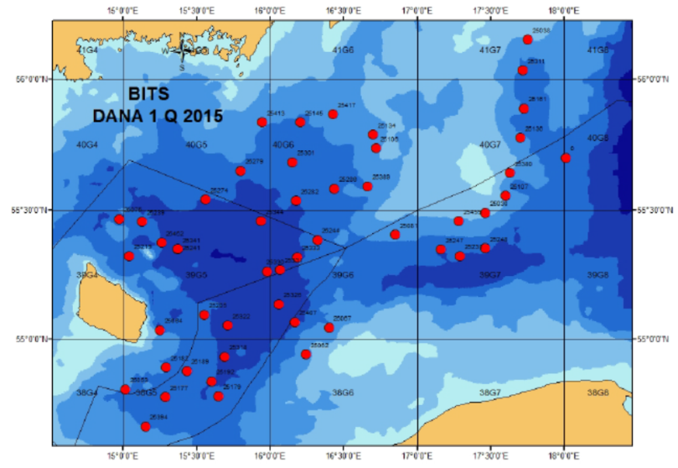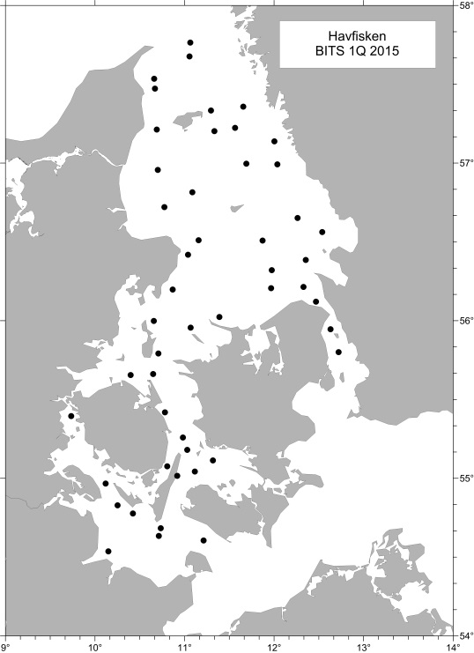
Fig. 1G.1: BITS Q1 Bottom trawl and CTD stations a) RV Dana in ICES area 3d and b) RV Havfisken in areas 3aS, 3b and 3c.
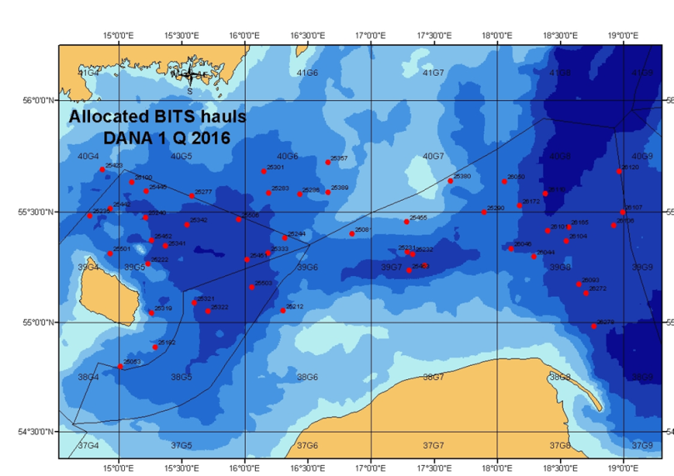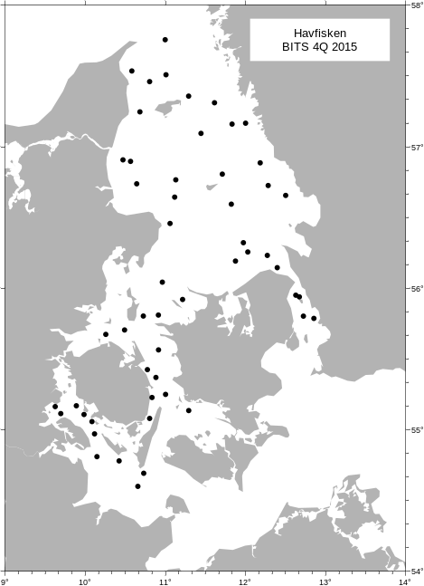
Fig. 1G.2: BITS Q4 Bottom trawl and CTD stations a) RV Dana in ICES area 3d and b) RV Havfisken in areas 3aS, 3b and 3c.

3. Planning
Eight countries are participating in BITS survey: Denmark, Germany, Poland, Sweden, Latvia, Lithuania, Estonia and Russia. The planning and coordination is done by ICES WGBIFS.
4. Where applicable, describe the international task sharing (physical and/or financial) and the cost sharing agreement used
Not applicable.
5. Explain where thresholds apply

International Bottom Trawl Survey (IBTS Q1, IBTS Q3)
1. Objectives
The main objectives of the North Sea IBTS are:
- To determine the distribution and relative abundance of pre‐recruits of the main commercial species with a view of deriving recruitment indices;
- To monitor changes in the stocks of commercial fish species independently of commercial fisheries data;
- To monitor the distribution and relative abundance of all fish species and selected invertebrates;
- To collect data for the determination of biological parameters for selected species;
- To collect hydrographical and environmental information;
- To determine the abundance and distribution of late herring larvae (February North Sea survey).

2. Methods and survey area
The sampling procedures are described in:
http://www.ices.dk/sites/pub/Publication%20Reports/ICES%20Survey%20Protocols%20(SISP)/SISP%2010%20-%20Manual%20for%20the%20International%20Bottom%20Trawl%20Surveys%20-%20Revision%20IX.pdf
for the trawl catches (manual is currently under revision to adopt changes implemented in the most recent years), and:
http://www.ices.dk/sites/pub/Publication%20Reports/ICES%20Survey%20Protocols%20(SISP)/2017/SISP%202%20MIKeyM-net.pdf
for the sampling of herring larvae.
The survey area allocated to Denmark is shown in Fig. 1G.3 and Fig. 1G4. However, area and station allocation may change between years depending on agreements of the international coordination group.
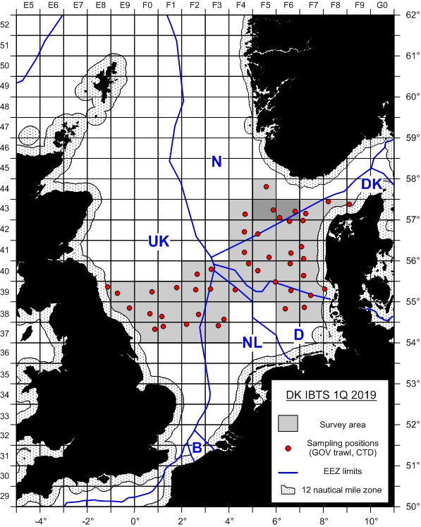
Fig. 1G.3: IBTS Q1 survey area for RV Dana in ICES areas 3a, 4a and 4b (2 MIK stations per rectangle for collecting herring and sprat larvae are not shown on the map).
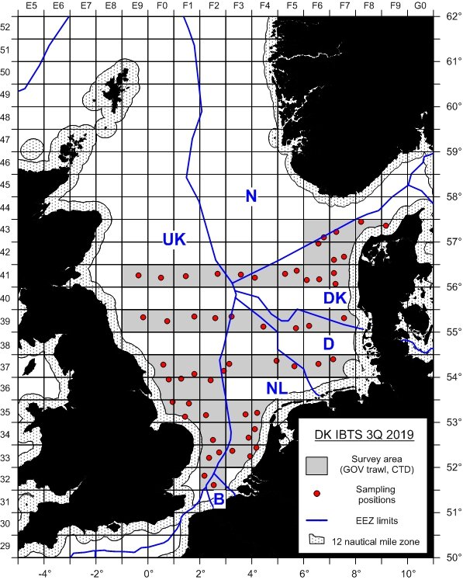
Fig. 1G.4: IBTS Q4 survey area for RV Dana in ICES areas 3a, 4a and 4b.

3. Planning
Seven countries (Denmark, France, Germany, Netherlands, Norway, Scotland and Sweden) are participating in the NS IBTS Q1 and six countries (Denmark, England, Germany, Norway, Scotland and Sweden) are participating in the NS IBTS Q3. The planning and coordination is done by ICES IBTSWG.
4. Where applicable, describe the international task sharing (physical and/or financial) and the cost sharing agreement used
Not applicable.
5. Explain where thresholds apply

North Sea Sandeels Survey (NSSS)
1. Objectives
Improve the scientific advice on sandeel scientific advice ion sandeel and should be the basis for setting a preliminary index for the sandeel fishery for the coming year. Data from the dredge survey is the basis for calculating a 0-group index, which is used in stock assessment. The survey is conducted with a commercial fishing vessel.

2. Methods and survey area
The sampling of sandeels is conducted with a modified scallop dredge and sediment samples are taken with a Van Veen grab. The sampling locations are shown in Fig. 1G.5.
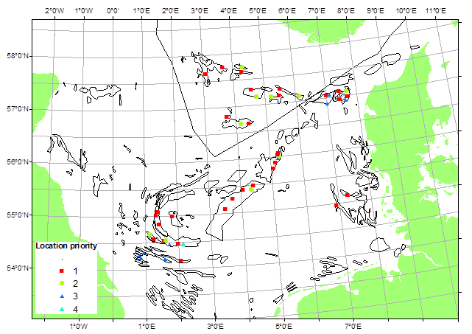
Fig. 1G.5: Danish sandeel survey sampling locations in ICES areas 4a and 4b.

3. Planning
Planning is done on a national level. The survey results are presented to ICES WGNSSK.

International Ecosystem Survey in the Nordic Seas (ASH; alternative abbr. IESSNS)
1. Objectives
This survey is carried out in order to investigate distribution and migrations of the Atlanto-Scandian herring, blue whiting and other pelagic fish and to produce a biomass index for herring and a recruitment index for blue whiting for the ICES Working Group on Widely Distributed stocks (ICES WGWIDE). Furthermore, hydrographic conditions and plankton abundance in the Norwegian Sea and adjacent waters are monitored in order to investigate distribution and migration of herring and other pelagic fishes are influenced by environmental conditions.
2. Methods and survey area
The sampling procedures are described in:
http://www.ices.dk/sites/pub/Publication%20Reports/ICES%20Survey%20Protocols%20(SISP)/SISP%209%20Manual%20for%20International%20Pelagic%20Surveys%20(IPS).pdf

The survey area allocated to Denmark is shown in Fig. 1G.6.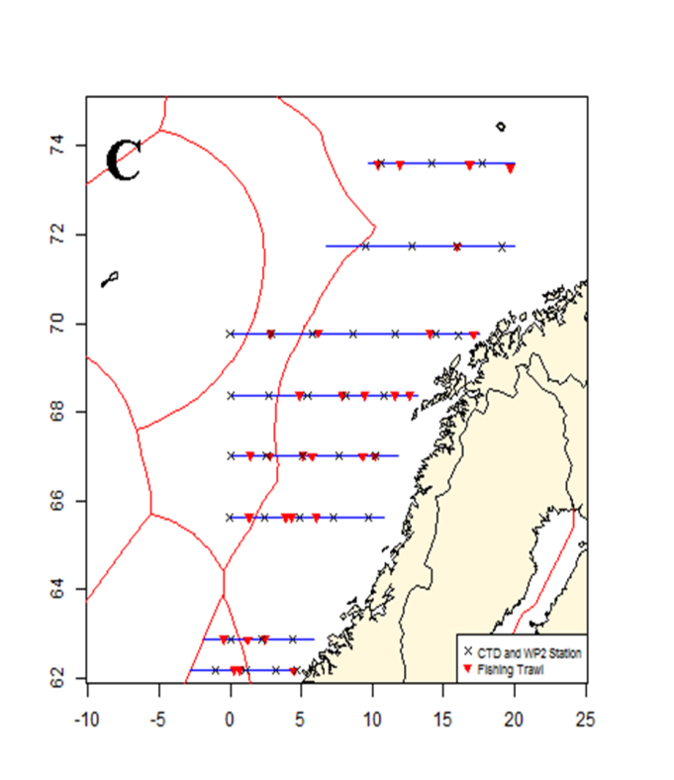
Fig. 1G.6: RV Dana 2015 sailed transects, pelagic trawl, CTD and WP2 stations in ICES area 2a.

3. Planning
The survey is coordinated with Norway as an international survey with participation of Norway, Iceland, Faroe Islands and EU, where the Danish R/V Dana conducted the EU survey part. Planning and coordination is done by ICES WGIPS.
4. Where applicable, describe the international task sharing (physical and/or financial) and the cost sharing agreement used
Not applicable.
5. Explain where thresholds apply

NS Herring Acoustic Survey (NHAS)
1. Objectives
The purpose is to provide acoustic abundance estimates of herring and sprat in the North Sea (eastern part), Skagerrak and Kattegat.

2. Methods and survey area
The sampling procedures are described in:
http://www.ices.dk/sites/pub/Publication%20Reports/ICES%20Survey%20Protocols%20(SISP)/SISP%209%20Manual%20for%20International%20Pelagic%20Surveys%20(IPS).pdf

The survey area allocated to Denmark is shown in Fig. 1G.7.
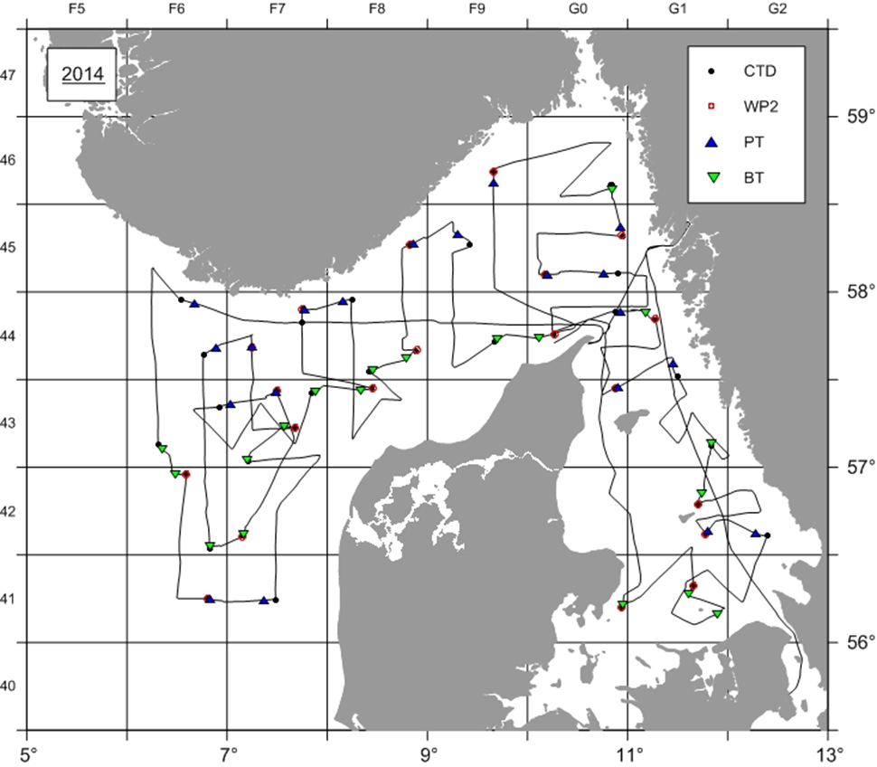
Fig. 1G.7: RV Dana NHAS 2014 survey track, trawl locations (blue triangles: pelagic trawl, green triangles: bottom trawl) and CTD as well as plankton (WP2) sample positions in area 3a, 4a and 4b.

3. Planning
The survey is coordinated by the ICES Working Group for International Pelagic Surveys, WGIPS, and is a part of the international acoustic survey of the North Sea and adjacent areas, which are covered by Germany, Ireland, the Netherlands, Norway and Scotland.
4. Where applicable, describe the international task sharing (physical and/or financial) and the cost sharing agreement used
Not applicable.
5. Explain where thresholds apply

Nephrops TVsurvey in FU 3 & 4 (NTV3&4)
1. Objectives
The purpose of the survey is to estimate the abundance of Nephrops in the Skagerrak and the Kattegat (Functional units 3 and 4).

2. Methods and survey area
An underwater video technique is used and later the video footage is analysed in laboratory to estimate the Nephrops abundance in selected subareas.

The survey area allocated to Denmark is shown in Fig. 1G.8.

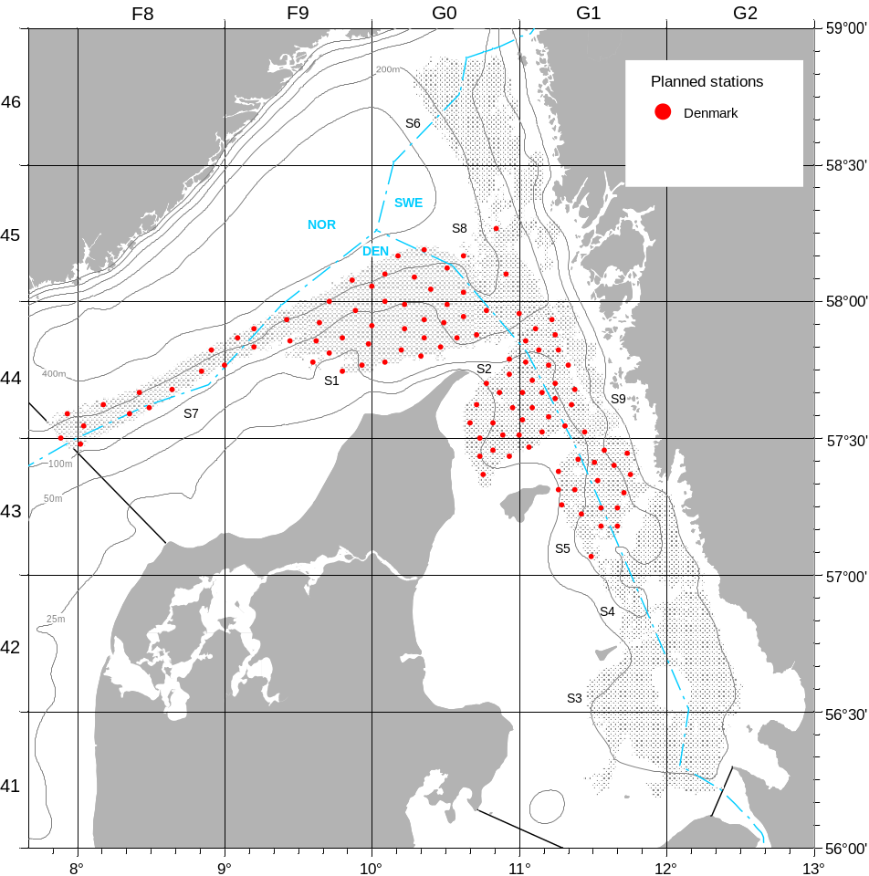
Fig. 1G.8: NTV3&4 sampling locations covered by Denmark with RV Havfisken in area 3a (Strata S3, S4, S6 and S9 are currently allocated to Sweden).

3. Planning
Survey planning and data analysis is conducted in close cooperation with Sweden and coordinated by ICES WGNEPS.
4. Where applicable, describe the international task sharing (physical and/or financial) and the cost sharing agreement used
Not applicable.
5. Explain where thresholds apply

Flatfish survey in the Kattegat and Skagerrak (FFS)
1. Objectives
Establish a time series of catch and effort data independent of the commercial fishery for sole and plaice in the Kattegat and the southern Skagerrak. The survey has been initiated in 2004 and provides currently the main input data set for the 3a sole assessment.

2. Methods and survey area
So far, the survey has been conducting using two commercial fishing vessels in parallel. The survey is now conducted with RV Havfisken using the same commercial flatfish trawl as before. The survey area is indicated in Fig. 1G.9.

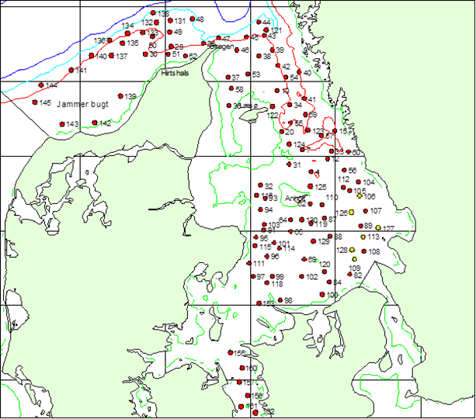
Fig. 1G.9: Survey area and provisional station allocation for the flatfish survey with RV Havfisken in area 3a.

3. Planning
Planning occurs on a national level and the survey results are provided to WGBFAS.
4. Where applicable, describe the international task sharing (physical and/or financial) and the cost sharing agreement used
Not applicable.
5. Explain where thresholds apply

Nephrops TVsurvey in FU 33 (NTV33)
1. Objectives
The purpose of the survey is to estimate the abundance of Nephrops off Horns Rev (Functional unit 33). The survey has been stated in 2017 as no fishery-independent information existed for this area.

2. Methods and survey area
An underwater video technique is used and later the video footage is analysed in laboratory to estimate the Nephrops abundance. The survey area is indicated in Fig. 1G.10.
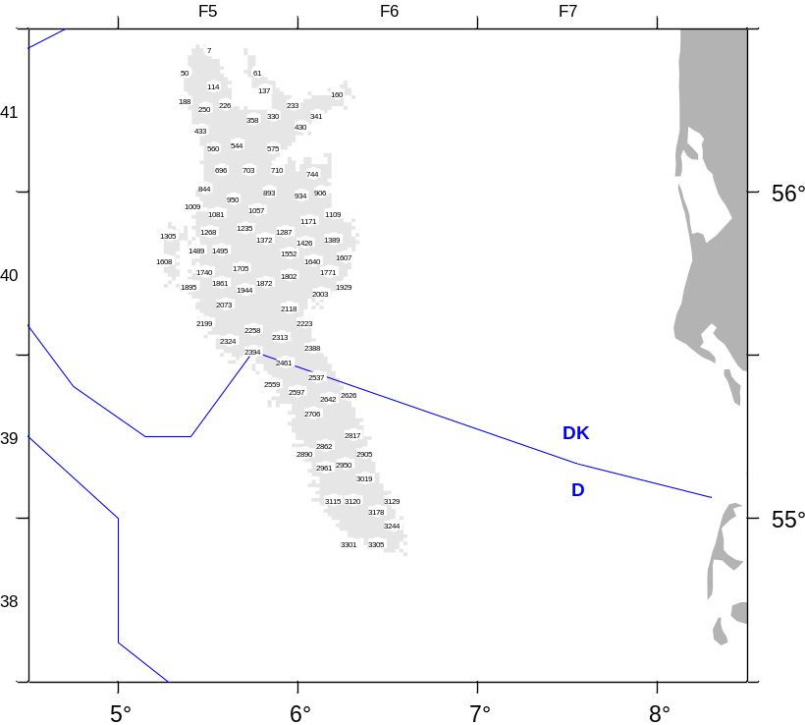
Fig. 1G.10: NTV33 survey area to be covered by Denmark with RV Havfisken in area 4b.

3. Planning
Survey planning and data analysis is coordinated by ICES WGNEPS.
4. Where applicable, describe the international task sharing (physical and/or financial) and the cost sharing agreement used
Not applicable.
5. Explain where thresholds apply

Cod survey in the Kattegat (CODS_Q4)
1. Objectives
The survey is a combined Danish- Swedish fisherman-scientist survey. The goal of the Kattegat cod survey is to estimate the abundance, biomass and distribution of cod and to establish a fisheries independent time series of catch and effort series. Furthermore, a recruitment index is established. The results has for the first time in 2015 been used, together with commercial catch and effort data, to strengthen the scientific advice on the cod stock in Kattegat.
2. Methods and survey area
Initially, 4 commercial trawlers (2 Swedish and 2 Danish vessels) participated in the survey. In 2016, Sweden continued to use commercial vessel whereas Denmark used the new research vessel RV Havfisken but with the same trawl as previously on the commercial vessels. In 2017, the Danish part of the survey was combined with the BITS Q4 survey but in the future it will be kept separate again to allow better overlap in the timing with the Swedish part of the survey. The survey area is shown in Fig. 1G.12.

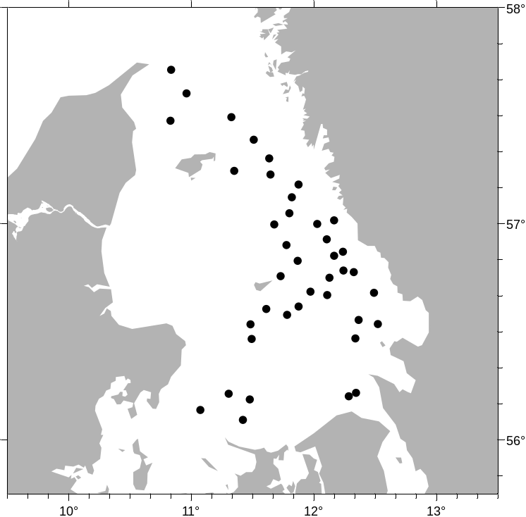

Fig. 1G.11: Survey area for the Danish CodS_Q4 survey with RV Havfisken.

3. Planning
Survey planning and data analysis is conducted in close cooperation with Sweden and the survey results are provided to WGBFAS.
4. Where applicable, describe the international task sharing (physical and/or financial) and the cost sharing agreement used
Not applicable.
5. Explain where thresholds apply

International Ecosystem Summer Survey in the Nordic Seas (IESSNS)
1. Objectives
The survey is carried out in order to provide annual age-segregated abundance index, with an uncertainty estimate, for northeast Atlantic mackerel (Scomber scombrus). The index is used as a tuning series in stock assessment. The area has been extended to the North Sea in 2018 when Denmark joined the survey.

2. Methods and survey area
A standardised pelagic swept area trawl method is used to obtain the abundance index and to study the spatial distribution of mackerel in relation to environmental factors.

The sampling procedures are described in:
http://www.ices.dk/sites/pub/Publication%20Reports/ICES%20Survey%20Protocols%20(SISP)/SISP%209%20Manual%20for%20International%20Pelagic%20Surveys%20(IPS).pdf

Denmark is using a commercial vessel for the survey and the area allocated to Denmark is shown in Fig. 1G12.

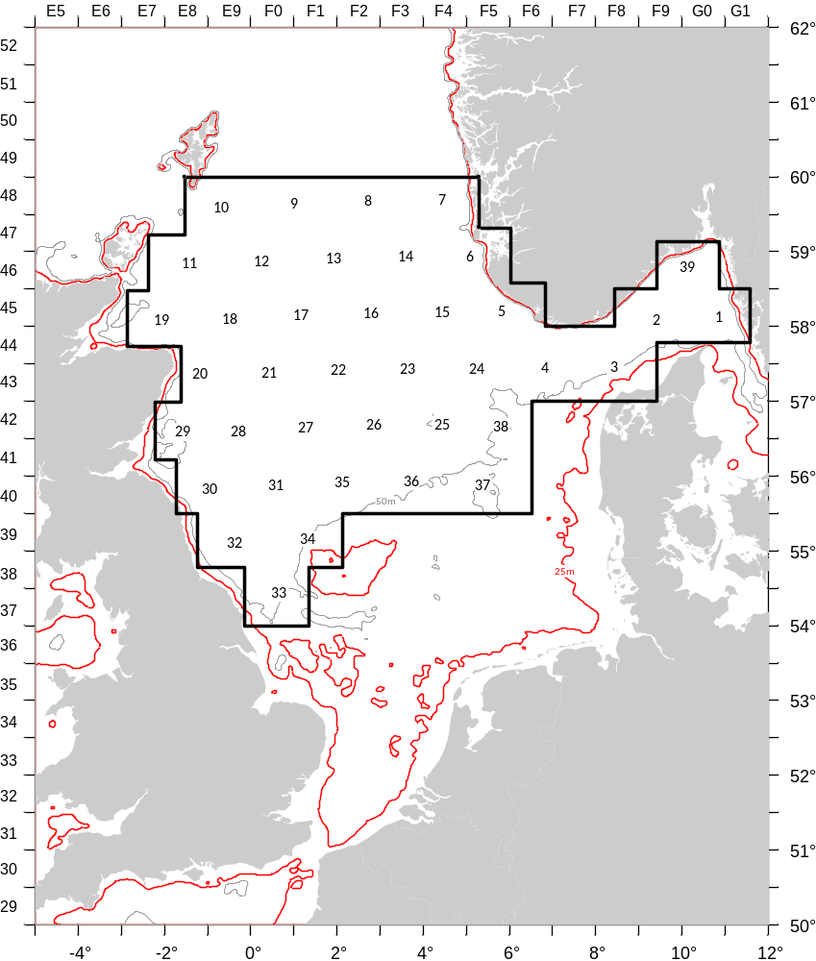
Fig. 1G.12: Survey area for the Danish contribution to the IESSNS.

3. Planning
The survey is coordinated by the ICES Working Group for International Pelagic Surveys, WGIPS.

4. Where applicable, describe the international task sharing (physical and/or financial) and the cost sharing agreement used

5. Explain where thresholds apply

Mackerel egg production survey in the North Sea (NS MEGS)
1. Objectives
The survey aims at to provide an index of the spawning stock biomass of the North Sea component of Northeast Atlantic mackerel stock.

2. Methods and survey area
The sampling procedures are describe in :

http://www.ices.dk/sites/pub/Publication%20Reports/ICES%20Survey%20Protocols%20(SISP)/SISP%206%20-%20MEGS%20V1.3.pdf,

and

http://www.ices.dk/sites/pub/Publication%20Reports/ICES%20Survey%20Protocols%20(SISP)/SISP%205%20-%20WGMEGS%20V11%20Manual%20for%20AEPM%20and%20DEPM%20fecundity.pdf.

Denmark will join the survey for the first time in 2020 and will conduct the sampling in close cooperation with the Netherlands. The area actually allocated to Denmark is shown in Fig. 1G.13.
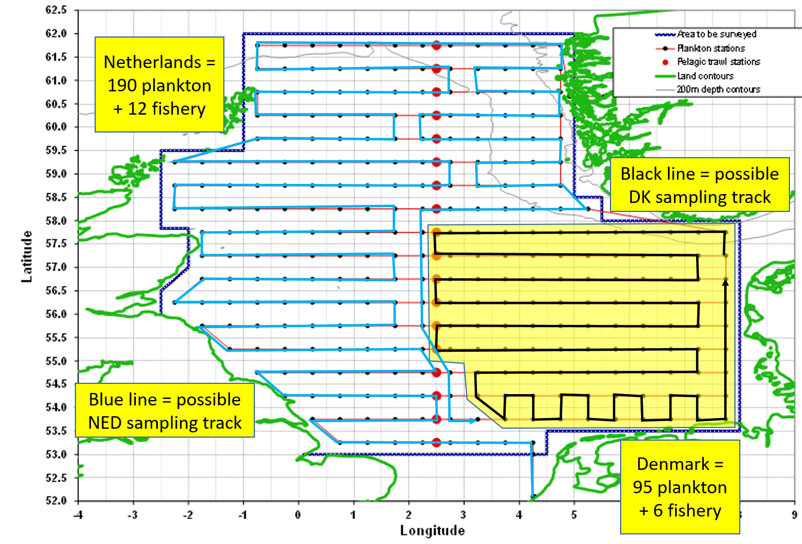
Fig. 1G.13: Proposed sampling area for RV Dana for NS MEGS in 2020.

3. Planning

4. Where applicable, describe the international task sharing (physical and/or financial) and the cost sharing agreement used

5. Explain where thresholds apply

(max 450 words per survey)

Section 2: Fishing Activity Data

Text Box 2A: Fishing activity variables data collection strategy

General comment: This Box fulfills paragraph 4 of Chapter III of the multi-annual Union programme and Article 2, Article 4 paragraph (2) point (b) and Article 5 paragraph (2) of this Decision. It is intended to describe the method used to derive estimates on representative samples where data are not to be recorded under Regulation (EU) No 1224/2009 or where data collected under Regulation (EU) No 1224/2009 are not at the right aggregation level for the intended scientific use.
1. Description of methodologies used to cross-validate the different sources of data.
Every night, Logbook-, Sales notes and VMS data are transferred form the Danish AgriFish Agency to DTU Aqua via a secure FTP connection. Therefore these data are available immediately for data cheking and cross validating with the sampled data.
From at-sea sampling trips, the logbook sheet number is registered. Information from the observer trip can then be cross-validated with the data entered in the logbooks and the sales notes. From at market sampling, the vessel-id and the landing date is registered, and is used for cross-validating with sales notes and logbook data, e.g. if the gear, mesh size and ICES rectangle are correct of if information are missing.
2. Description of methodologies used to estimate the value of landings.
The value of landings are taken from directly from the sales notes data register (census data). The sales notes are merged with the logbook data by trip and vessel register to estimate values of landings by e.g. gear.
3. Description of methodologies used to estimate the average price (it is recommended to use weighted averages, trip by trip)
Average prices can be calculated directly from the sales notes register as the sales notes are sensus..
4. Description of methodologies used to plan collection of the complementary data (sample plan methodology, type of data collected, frequency of collection etc)
As census data are collected, not additional data collection is needed.

(max 900 words per Region)

Section 3: Economic and Social Data

Text Box 3A: Population segments for collection of economic and social data for fisheries

General comment: This Box fulfills paragraph 5 points (a) and (b) of Chapter III of the multi-annual Union programme and Article 2, Article 4 paragraphs (1), (2) and (5) and Article 5 paragraph (2) of this Decision. It is intended to specify data to be collected under Tables 5(A) and 6 of the multi-annual Union programme.
1. Description of methodologies used to choose the different sources of data
Data on landings (sales notes, species, quantity and value), fishing vessels (type, size, etc.) fishing activity (logbook, days, gear and fishing area), and vessel owners (fishermen, fishing firms) are registered contiously during the year. During the first quarter of the year after recording the administrative registers are combined and corrected for mismatch and errors. At the beginning of April the Danish Agrifish Agency produces a final “freezed” version of the registered data, where all data for a vessel version (vessel with same owner) is combined and aggregated. The aggregated data is delivered to Statistics Denmark for statistical use. Thus information on fishing activity and production for the year is available for each vessel version, that is a vessel with the same owner/fisherman from date of purchase until sale/decommission. Statistics Denmark combines the vessel versions to form the production units, which is a “vessel” from january 1st to December 31st. These units constitute the total fishery population for the year.
Data on fishing rights is also registered. All transactions of ITQ’s (Individually Transferable Qouta) and VQS’s (Vessel Qouta Share) are registered by date and vessel identity on the Register on fishing rights. That information is used together with estimated shadow prices for each quota stock to calculate the capital value of fishing rights for each production unit.
Economic data is collected by Statistics Denmark using a harmonized accounting form for fisheries.
2. Description of methodologies used to choose the different types of data collection
The legal entity/person responsible for economic data is the fisherman or fishing firm, who usually use an authorized accountant to produce their yearly account and balance. In order to get the most reliable economic data we confide in the fishermans accountant to complete the harmonized accouting form, and compensate her for the performance.
3. Description of methodologies used to choose sampling frame and allocation scheme
The entire population is segmented according to the DCF requirement (Supra region, Fishing technique, Length class) and each segment stratified into 7 groups on economic size. Group 0 (inactive) and 1 (revenue below threshold) are treated separately, as there are no accounts to be collected for these units.
For the units with yearly revenue below the threshold (=DKK 270,000) we do not have individual accounts. We use register information (vessel characteristics, gear, and species composition) to place the units below threshold into the relevant fleet segment. Then we use the value of landings (all landings are registered on the sales note register) to calculate a multiplier, which is used to adjust the economic variables for the segment that includes units below threshold.
For group 2 to 6, the commercially active vessels (about 550 production units), a sample of 275 accounts are collected on a voluntary basis. The sample is not stocastically drawn from the stratified publication, because most the bigger companies have great variation in economic terms which makes it difficult to represent them by other companies. We get a better sample by using a panel which consists of the 100 biggest production units plus a representativ sample of the rest of the population. About 10 per cent of the sample is renewed each year.
The large sample, about half of the units in the population over the threshold, covers more than 85% of the total revenue, which means that estimation of cost etc. is limited to less than 15% of the production.
4. Description of methodologies used for estimation procedures
Individual accounts are simulated for each unit in the population that is not in the sample. These simulations are done by selection of one to three “donors” from the sampled accounts, that are valuated to be best possible replacement for the simulated unit, and calibrate the average of the one to three selected matching units, to equal the registered revenue of the simulated unit.
The simulations are performed using a BANFF MASSIMPUTATION model in SAS. Donors are matched according to known registered data for catches on selected species, crew size, engine power and days at sea in Ices III and Ices IV. Some accounts for units in the sample that had extraordinary events during the year may be excluded from the basis for simulation.
5. Description of methodologies used on data quality
The most important quality check lies in the scrutinized analysis of the individual accounts for each production unit. All variables have to be right to balance the account correctly. Also the contents of all variables are assessed and evaluated by comparing with related variables and last years account for the same unit.
6. Request for preliminary data
We are aware of the request for capacity data for the year after the year for economic data in the Fleet Economic Report. Therefore we will agree to report perliminary capacity data when the first version of the fishery population for the year has been compiled and segmented acording to EU MAP table 5B.

(max 900 words per Region)

Section 3: Economic and Social Data

Study 3: Data on employment by education level and nationality

General comment: This Box fulfills paragraph 5 point (b) and paragraph 6 point (b) of Chapter III of the multi-annual Union programme and Article 2 and Article 3 paragraph (3) point (c) of this Decision. It is intended to specify data to be collected under Table 6 of the multi-annual Union programme.
1. Pilot study
During 2018 we performed a pilot study on collecting data on employment in fisheries and aquaculture by education level and nationality to fulfill the requirements of the Commission decision (EU) 2016/1701 of 19. August 2016.
2. Description of methodologies used to choose the different sources of data
The information needed to produce data on employment in fisheries and aquaculture are at present collected by Statistics Denmark for the annual labour market statistic. From 2015 the labour market statistic has been strengthened by the creation of the Labour Market Account (LMA) which combine several administrative and statistical registers (eIncome register, business register, educational register, employment classification module, and population register). LMA is now the data foundation for the Register based labour force statistic (RAS). There is no response burden as the data is collected exclusively on the basis of administrative and statistical registers.
3. Description of methodologies for data collection
The data collection is done by separate processing of each source register. After that a transverse data processing is done (also called a treatment of overlaps) where information in the various registers are compared, and corrected where needed. Finally the data are linked to other registers to add background information and form the population. The statistical unit is persons. More information is available in the documention: https://www.dst.dk/en/Statistik/dokumentation/documentationofstatistics/labour-market-account
4. Description of methodologies for selection data for fisheries and aquaculture
Data from the LMA is extracted for all firms/persons in the fishery and aquaculture sector by business register number and matched with the production units from the populations in fishery and aquaculture. The data are checked and corrected for persons working in several fishing firms during the year.
The calculation of FTE will be based on the number of paid hours (wage or salary) for all personell in the LMA.
(max 900 words)

Section 3: Economic and Social Data

Text Box 3B: Population segments for collection of economic and social data for aquaculture

General comment: This Box fulfills paragraph 6 points (a) and (b) of Chapter III of the multi-annual Union programme and Article 2, Article 4 paragraphs (1) and (5) and Article 5 paragraph (2) of this Decision. It is intended to specify data to be collected under Tables 6 and 7 of the multi-annual Union programme.
1. Description of methodologies used to choose the different sources of data
Whenever register data are available for a variable these are preferred as they originate from a census type data collection scheme and contain information on all elements of the population. This is the case for the economic variables Gross sales and Weight of sales. All other economic variables are collected by Statistics Denmark by non probability sample survey using a harmonized accounting form for aquaculture enterprises.
2. Description of methodologies used to choose the different types of data collection
The economic variables Gross sales and Weight of sales are submitted mandatorily as they are also used for other statistical purposes. All other economic variables are collected on a voluntary basis. Theoretically a probability sample survey would be preferable, but as the population is quite small, particularly in some segments, all volunteers are accepted even though that results in a non probability sample survey.
3. Description of methodologies used to choose sampling frame and allocation scheme
The sampling frame consists of all commercially active aquaculture companies in Denmark. The population is allocated into segments by production method and produced species. This forms four internally homogenous segments and one smaller rest segment.
4. Description of methodologies used for estimation procedures
Register data are combined with the data obtained from the sampled accounts to estimate the value of the economic variables for companies that is not included in the sample. The stratified imputation based on linear regression enables us to impute complete accounts for all members of the population.
5. Description of methodologies used on data quality
The register data for Gross sales and Weight of sales and checked for outliers and compared to the data obtained from the sampled account sheets. The data for all other economic variables are submitted in balanced account sheets. This in it self constitutes a quality control, as the account sheets are not easily balanced if one or more values are reported falsely. Even so, the submitted accounts are checked for outliers in important variables. Accounts containing such outliers are then excluded from the basis for imputation of the missing accounts.
(max 1000 words)

Section 3: Economic and Social Data

Study 4: Environmental data on aquaculture

General comment: This Box fulfills paragraph 6 point (c) of Chapter III of the multi-annual Union programme and Article 2 and Article 4 paragraph (3) point (d) of this Decision. It is intended to specify data to be collected under Table 8 of the multi-annual Union programme.
1. Aim of the study
To fulfil the requirements of the COMMISSION DELEGATED DECISION (EU) 2019/910 of 13 March 2019 by collecting environmental data on the aquaculture sector.

2. Duration of the study
Every second year, beginning in 2020.

3. Methodology and expected outcomes of the study
Register data covering all farms on medicines and treatments is aquiered from the Danish Veterinary and Food Administration (part of the Ministry of Environment and Food).
Register data covering all farms on mortality will be aquired from the Danish Fisheries Agency (part of he Ministry of Environment and Food of Denmark).
In both cases data will be processed to accommodate the required segmentation.

(max 900 words)

Section 3: Economic and Social Data

Text Box 3C: Population segments for collection of economic and social data for the processing industry

General comment: This Box fulfills footnote 6 of paragraph 1.1(d) of Chapter III of the multi-annual Union programme, Article 2, Article 4 paragraphs (1) and (5) and Article 5 paragraph (2) of this Decision. It is intended to specify data to be collected under Table 11 of the multi-annual Union programme.
1. Description of methodologies used to choose the different sources of data
The Danish fish processing industry is defined by the Business Register using NACE code 10.20. Enterprises engaging in fish processing in Denmark are highly specialized and cover more than 95% of the value and volume of fish processed in Denmark. The Danish fish processing sector consisted of approximately 100 enterprises employing more than 3700 persons in 2017. The enterprises are divided on 3 segments in terms of size measured on employment, where 45 enterprises has less than 10 employees, 32 has 10-49 employees and 22 has 50-249 employees, respectively.
In order to avoid a duplication of data collection, data collected by Statistic Denmark is used as the primary data source. In collaboration with Statistics Denmark, data from the Industry Commodity Statistics and Account Statistics are combined to deliver and comply with the variables listed in the Commission implementation decision (EU) 2016/1251 (EU-MAP), Table 11. The type of data collection used for collection of the economic data is all based on census. In addition to the economic data, social data on gender, age, education and nationality are collected and integrated with the economic data using data from Statistics Denmark’s “Register-Based Workforce Statistic” and “Labour Market Account Statistic”.
Based on the results from the Danish pilot study, the SECFISH (MARE/2016/22) project and PGECON recommendations, raw material input data for the processing industry by species and origin will not be collected. As an alternative, the output (Commodity Statistics) from the enterprises can be used as a proxy for the raw material input. Furthermore, the output from the industry can be used to divide the industry into species segments depending on the output produced (which also indicate the input used). This type of segmentation can be used to determine the dependency on different fish species.

2. Description of methodologies used to choose the different types of data collection
The already existing data collections by Statistic Denmark are well established and provide reliable and validated time series data. Quality reports are available on the website of Statistics Denmark. To combine the different statistics to form segments on employment categories and species used as raw material input, IFRO’s expertise is used.

3. Description of methodologies used to choose sampling frame and allocation scheme
The Danish fish processing industry is defined by the Business Register using NACE code 10.20. The Danish data collection is based on data from the Account Statistics and the Industry Commodity Statistics collected by Statistics Denmark. In collaboration with Statistics Denmark, data from the Industrial Commodity- and Account Statistics are combined to make sure that all enterprises processing fish are covered by this data collection and to comply with the data variables listed in the Commission implementation decision (EU) 2016/1251 (EU-MAP), Table 11.

The Account Statistic collected by Statistics Denmark are essentially aggregations of items of the annual accounts of business enterprises, notably items of the profit and loss account, the balance sheet and the statement of fixed assets. The accounts statistics are a reliable indicator of the activity level and of the structure of the Danish business sector. The highest data quality is achieved at the enterprise level, primarily because the enterprises prepare their annual accounts at that level. The Statistics are based on questionnaires, the Central Customs and Tax Administration (SLS-E data), and the business register. The population is defined on the basis of Statistics Denmark's Central Business Register covering all businesses in Denmark (ESR). The data collected from all sources are combined in such a way that a complete set of accounting items is obtained for each business enterprise.

For the social parameters, data are collected by Statistics Denmark and available within Statistics Denmark’s “Register-Based Workforce Statistic” and “Labour Market Account Statistic”.

4. Description of methodologies used for estimation procedures
The Account Statistics covers the whole population defined by the Business Register NACE 10.20. Data for the Account Statistics is collected from different sources and combined in such a way that a complete set of accounting items is computed for each business enterprise. No estimation is therefore necessary because data are based on census and a full set of account for all business enterprises are created.

5. Description of methodologies used on data quality
The data collected for the processing industry give a complete coverage of all enterprises covered by NACE 10.20. The accounts statistics are a reliable indicator of the activity level and of the structure of the Danish processing industry sector. The highest data quality is achieved at the enterprise level, primarily because the enterprises prepare their annual accounts at that level. Quality reports are available on the website of Statistics Denmark.

Data for the processing industry concerning the year 2018 will be available in September 2020 (1½ years of time lag). Data for 2019 will be available in September 2021.

Section 4: Sampling Strategy for Biological Data from Commercial Fisheries

Text Box 4A: Sampling plan description for biological data

General Comment: This Box fulfills Article 3, Article 4 paragraph (4) and Article 8 of this Decision and forms the basis for the fulfilment of paragraph 2 point (a)(i) of Chapter III of the multi-annual Union programme. This Table refers to data to be collected under Tables 1(A), 1(B) and 1(C) of the multi-annual Union programme.
The commercial sampling in Denmark is conducted in four large programs sampling different components of the landings and at sea catches. The fou main programs are:
- At sea – Observer programme
- At market – human consumption
- At market – small pelagic
- At sea – self-sampling- small pelagic
Further, the different sampling programs have several list/ strata.
- At sea – Observer programme
Denmark initiated the work to improve the sampling design of the commercial on board sampling following the outcomes of ICES WKACCU, WKPRECISE, WKCATCH, WKPICS and SGPIDS. This outcome has since 2011 led to a gradually change from an ad-hoc sampling programme to a statistically sound sampling (4S) in the observer programme where trips/vessel are the primary sampling unit within some pre-defined fleet lists. The vessel list has been selected according to the home harbour and the main gear type (fleet group) and each lists accounts of unique vessels based on the fishery from the previous year, indicating that the same vessel cannot be present in more than one list. If a vessel is selected by one list and is conducting another fishery however, still part of the observer program, the trip is still conducted. If the vessel is conducting a fishery presently not included in the observer program the trip is not selected. Presently, Denmark has applied sex fleet lists (sampling frames) for the at sea observer programme with a similar selection design however, with different target species and effort. The vessel list are presently covering:
- Lyngby, Trawler/Seiner (OTB-SDN: SD 25-32)
- Lyngby, trawler/Seiner (OTB-SDN: SD 21-24)
- Hirtshals, Trawler/Seiner Skagerrak/ Kattegat (OTB-SDN: SD 20-21)
- Hirtshals, Trawler/Seiner North Sea (OTB-SDN: SD IV)
- Hirtshals, Skagerrak and North Sea – shrimp fishery (OTB_CRU: SD 20- IV)
- Lyngby , Beam trawler, North Sea brown shrimp (TBB: IV)
Effort allocation (observer trips) between the vessel lists are based on the total effort available allocated according to the numbers of trips in each vessel list group. Each stratum has incorporated a minimum number of 2 trips. Each vessel list is stratified by quarter. Each vessel on a given list has equal change of being selected.
As the vessels are randomly selected in a database based on last years fishery, large changes in fishing pattern between years can affect the sampling in a given year. When a vessel is selected for an observer trip the vessel has to be contacted by the observer and asked for participation on the next conducted fishing trip. The fishermen answers are recorded and refusal rates calculated for each vessel list.

Purpose: At-sea Observer Programme for length, age, weight data of landings of and discards of demersal species as well as for brown shrimps and deep water shrimp. All species caught are registered for total weight and length but only selected species for the area are collected for age and individual weight. The main aim of the observer trips is to measure the discarded part and only weight by species is recorded for the landed part.
Temporal Stratification: Quarterly
 | Sampling frame | Sampling unit | Stratification | Selection Method | Sampling effort
1.SU | vessel*time. In principal a list of vessel, where the next trip within a quarter is selected. | Fishing Trip | Quarterly | Random draw from vessel list with equal probability and with replacement (probability proportional to number of vessels within a list) | Between list is effort proportional to the total number of trips in the lists
2.SU | Hypothetical list of hauls in trip | Haul | --- | Ad-hoc decision | Minimum 1haul per day
3.SU | Hypothetical list of individuals caught in haul | Species and Individuals | Species, Catch Fraction, Commercial Size Category  Biology: length stratified sampling: 1cm length classes | Length: Census (random sub -sample if too large)  Biology: length stratified and only for selected species | Length: all individuals  Biology:For selected species discards: 1-3 otoliths and individual weights (per cm size group and trip – depending on the length of the trip) by trip.

- At market – Human Consumption

In 2014 the harbour sampling program was uodated from an ad-hoc quota sampling programme to a statistically sound sampling programme. The harbours were grouped in a list with small and large harbours and only harbours where 80% of the landings, trips and value for every stock, was included in the sampling programme based on last years landing data. If a harbour is not selected for one of these criteria it is not included in the sampling program. Depending on the size of the harbour (small or large) different effort has been allocated to the harbour site. Each harbour on the list has been given a time period where a visit has to be conducted and sampled for the selected species/stocks. Presently, 24 harbours have been selected and each harbour is considered a separate sampling frame. The 6 largest harbour have been allocated 4 sampling event per quarter and the small harbours 1 sampling event per quarter. Do to the quarterly stratification a harbour can change between being one of the 6 largest harbour and the smaller harbours between quarters. At a harbour visit the amount of fish is selected as 1 of each commercial size sorting box per selected species which is measured for length, individual weight and age. For flatfish species only 2 fish per cm is messured for length, weight and age.
- Bagenkop – M DKBAG
- Bønnerup – M DKBNP
- Dragør – M DKDRA
- Fåborg- M DKFAB
- Gilleleje - M DKGLE
- Grenå - M DKGRE
- Hanstholm - M DKHAN
- Hirtshals -M DKHIR
- Hvide Sande -M DKHVS
- Hundested -M DKHUN
- Klintholm – DKKLH
- Korsør – M DKKRR
- København – M DKCPH
- Langø - MDKLNG
- Nexø - M DKNEX
- Rødvig – M DKRQG
- Rønne - M DKRNN
- Skagen - M DKSKA
- Sletten – M DKSLT
- Strandby - M DKSTD
- Tejn - M DKTEJ
- Thorsminde -M DKTMD
- Thyborøn - M DKTHN
- Vedbæk - M DKVBK

Purpose: At-market Human Consumption Programme for length, age, weight data of landings of selected demersal species
Temporal Stratification: Quarterly

 | Sampling frame | Sampling unit | Stratification | Selection Method | Sampling effort
1.SU | Each market site is considered a separate list | Market site* time | Quarterly | Each market site is pree-selected in the beginning of the year | 1 visit for every small market and 4 visits for every large market (per quarter)
2.SU | Total sold fish boxes per sorting group and species on the selected day of visit | Commercial size sorting boxes | --- | ad-hoc | 1 box per selected species per sorting group
3.SU | All fish within a box | individuals | --- | Census | Census  (for flatfish 2 fish per cm group is selected)

- At Market – small pelagic
For the industrial fishery the sampling program is presently not conducted as a statistically sound sampling but is still sampled according to quota samplings were a sampled is collected for every 2000 t landed. For the species an unsorted sample is taken from the landings, often at the factory site. Seven different species are collected in the small pelagic market sampling programme.
- Herring - Clupea harengus
- Blue whitting- Micromesistius poutassou
- Sand eel - Ammodytidae sp.
- Sprat - Sprattus sprattus
- Mackerel- Scomber scombrus
- Boar fish- Capros aper
- Norway Pout - Trisopterus esmarkii
The Danish sampling program for the industrial fishery will change in 2020 as it has been mandatory for the landing sites to conduct sampling from all landings. However, as the sampling program presently has not been approved by the commission the final design is still not known.
- At Sea – self-sampling – small pelagic
The industrial harbour sampling schemes are combined with a self-sampling program conducted on a part of the Danish industrial fleet. Here the fishermen are sampling a random sample from 1. haul per trip that are stored on board and delivered to the landing site with the relevant information attached (a self-sampling scheme has been developed) . The self- sampling program is manly conducted for sand eel and sprat but in a smaller extend also for Norway pout. The vessels participating in the self-sampling for other species than sand eel are not selected randomly but on a voluntary basis. For the sand eel fishery the self-sampling is part of the fishing license. The quality of the samples from the self-sampling program are higher than the quality obtained from the harbour samples as the self samples are frozen just after the fishing event and information on the position are included. However, the combination of the two independent sampling programs (self-sampling of small pelagic and harbour sampling) are assuring quality control on the fisherman collected data.

(max 900 words per Region)

