DTU Aqua in cooperation with DST and IFRO
Regulation (EU) 2017/1004 of 17 May 2017of the European Parliament and the Council
on the establishment of a Union framework for the collection, management and use of data in the fisheries sector and support for scientific advice regarding the common fisheries policy and repealing Council Regulation (EC) No 199/2008

Commission Implementing Decision (EU) 2019/909 of 18 February 2019 establishing the list of mandatory research surveys and thresholds for the purposes of the multiannual Union programme for the collection and management of data in the fisheries and aquaculture sectors

Commission Delegated Decision (EU) 2019/910 of 13 March 2019 establishing the multiannual Union programme for the collection and management of biological, environmental, technical and socioeconomic data in the fisheries and aquaculture sectors

Commission Implementing Decision (EU) 2016/1701 of 19 August 2016laying down rules on the format for the submission of work plans for data collection in the fisheries and aquaculture sectors.

Commission Implementing Decision (EU) 2018/1283 of 24 August 2018 laying down rules on the format and timetables for the submission of annual data collection reports in the fisheries and aquaculture sectors.

Denmark - Annual Report for data collection in the fisheries and aquaculture sectors
2021
Version 1
Kgs. Lyngby, Denmark 31st May 2022

CONTENTS
Commission Implementing Decision (EU) 2018/1283 of 24 August 2018 laying down rules on the format and timetables for the submission of annual data collection reports in the fisheries and aquaculture sectors. 1
Section 1: Biological Data 4
Text Box 1C: Sampling intensity for biological variables 4
Section 1: Biological Data 5
Text Box 1D - Recreational fisheries 5
Section 1: Biological Data 7
Pilot Study 1: Relative share of catches of recreational fisheries compared to commercial fisheries 7
Section 1: Biological Data 10
Text Box 1E: Anadromous and catadromous species data collection in fresh water 10
Section 1: Biological Data 12
Text box 1F: Incidental by-catch of birds, mammals, reptiles and fish 12
Section 1: Biological Data 14
Pilot Study 2: Level of fishing and impact of fisheries on biological resources and marine ecosystem 14
Section 1: Biological Data 17
Text Box 1G: List of research surveys at sea 17
Section 2: Fishing Activity Data 52
Text Box 2A: Fishing activity variables data collection strategy 52
Section 3: Economic and Social Data 54
Text Box 3A: Population segments for collection of economic and social data for fisheries 54
Section 3: Economic and Social Data 56
Pilot Study 3: Data on employment by education level and nationality 56
Section 3: Economic and Social Data 58
Text Box 3B: Population segments for collection of economic and social data for aquaculture 58
Section 3: Economic and Social Data 61
Pilot Study 4: Environmental data on aquaculture 61
Section 3: Economic and Social Data 61
Text Box 3C: Population segments for collection of economic and social data for the processing industry 61
Section 4: Sampling Strategy for Biological Data from Commercial Fisheries 64
Text Box 4A: Sampling plan description for biological data 64
Section 5: data quality 69
Section 5: data quality 70
Text Box 5B: Quality assurance framework for socioeconomic data ……….…………………23

Section 1: Biological Data

Text Box 1C: Sampling intensity for biological variables

General comment: This box fulfils paragraph 2 point (a)(i)(ii)(iii) of Chapter III, of the Annex of the Delegated Decision (EU) 2019/910 and Chapter I of the Implementing Decision (EU) 2019/909 on the multiannual Union programme; and Article 2, Article 4 paragraph 1 and Article 8 of the Implementing Decision (EU) 2016/1701 on the format of the WP. This box is applicable to the Annual Report.
Member State should provide by Region/RFMO/RFO/IO:
- Evidence of data quality assurance
Table 5A has been completed for all regions

- Deviations from the Work Plan
Denmark is no longer conducing quota sampling on numbers of fish, but aims to sample a certain level of PSUs. For this reason the numbers of individual fish per stock in the WP are mainly seen as an average of what have been collected in former time more than a goal for the present sampling program. However, as the data in the final end will be used for stock assessment it is off course important that enough individuals are sampled to conduct an assessment. The aim of the different sampling programs are to deliver the promised numbers of PSU.
In 2021 due to the covid-19 situation the Danish at sea observer program and partly the harbour sampling program was closed down in longer periods. The first close down was from January to March 2021 and the second from November to December. This has off course had an effect on the quality as well as on the amounts of samples.

Baltic Sea
Larger deviations in the sampling program was especially pronounced in the salmon fisheries due to the national Covid close down in the first period where the targeted fishery were conducted, it was however possible to achieve some samples in the fall were the fishery was started up again.
Denmark has since 2019 included samples of landed ells in the sampling program. Samples are however still not used for any assessment purposes.
For Dab in and flounders in the Baltic the stocks are assessed as a category 3 stock were ages from commercial samples are not used only ages from the surveys. After consultation with the end users Denmark has now stopped the aging from the commercial samples from these stocks, but is still collecting and aging from the surveys.

North Sea and Eastern Artic
Denmark has until 2019 had an ad hoc sampling program in the unsorted pelagic fishery. As a Baltic RCG initiative a regional sampling program is under development for this fleet segment in the Baltic mainly for sprat and herring. Denmark decided however, to introduce the same sampling program for all larger pelagic / industrial trawls above 25 meters landing unsorted pelagic species spices and this fleet segment target a wide range of pelagic fish and fish for reduction. In the program the vessels are asked to collect 1 sample per trip. Refusals are registered. The aim for Denmark is to have a single sampling scheme covering all larger pelagic / industrial trawls in all regions. The species targeted in these fisheries are herring, mackerel, blue whiting, horse mackerel and Norway pout. These species has been added as additional samples in the program.
Dab in the North Sea the stocks are assessed as a category 3 stock were ages from commercial samples are not used only ages from the surveys. After consultation with the end users Denmark has now stopped the aging from the commercial samples from these stocks, but is still conducting aging from surveys.

- Actions to avoid deviations.
The largest deviation in 2021 was due to covid-19, and it has been difficult to avoid. We have however managed to keep up a certain level of sampling due to a very large degree of testing of observers before going to sea.
Further, there has been an increased sampling level in the self-sampling program
Baltic Sea
In the Baltic Sea many fish stocks have declined significantly in later years and it has become very difficult to archive enough samples according to the sampling schemes to provide estimates for the stock assessment. This is especially true for sole, Baltic cod and western Baltic herring. For these stocks extra sampling effort has been initiated to ensure individuals for stock assessment.

North Sea and Baltic Sea
It has become more difficult to archive positive responses when calling fishermen for an observer trip in all waters. This is mainly because the general situation in the fishing fleet where many fishermen experience that the quota is decreasing on many of the important stocks and an increased pressure on the sea (Brexit, windmill farms ect). To increase the positive response rates focus is giving to increase the cooperation with the fishing industry by having meeting and writing articles in fishermen newspaper to explain about the importance for more correct data.

North Atlantic
The main part of the Danish landings within the Atlantic is from the unsorted pelagic fishery (blue whiting, Mackerel and Horse mackerel). In some years the landings are very low within Denmark and therefore it can be difficult to obtain fish in the planned numbers. However to improve the sampling level also in years with the main landings abroad we have extended our self-sampling program.

(max. 1000 words per Region/RFMO/RFO/IO)

Section 1: Biological Data

Text Box 1D - Recreational fisheries

General comment: This box fulfills paragraph 2 point (a) (iv) of Chapter III of the Annex of the Delegated Decision (EU) 2019/910 on the multiannual Union programme; and Article 2, Article 3 and Article 4 paragraph 1 of the Implementing Decision (EU) 2016/1701 on the format of the WP. This box is applicable to the Annual Report. This box is intended to provide information on the design, implementation and analysis of all components of sampling schemes/ surveys that are listed in Table 1D.
1. Description of the target population
The target population and the elements of this target population accessibility, need to be defined and described in this section. In the case of Recreational Fisheries, the target population could be whole population of resident anglers, charter boats etc. This will permit to evaluate if all sectors contributing to the total catch, are included in the survey.
Off-site internet based questionnaire survey.
The target population in the is all Danish anglers and passive gear fishers. The sampling frame is a list of anglers and passive gear fishers holding a valid annual license at the time of the survey. It is mandatory to hold a license when fishing in the sea in Denmark when you are between 18 – 65 years of age. The undercoverage of the sampling frame compared to the target population was covered by 4 omnibus surveys in 2009 – 2010 making it possible to estimate the amount of legal and illegal fishing without a license.
On-site charter boat survey
Target population is all anglers on board Danish charter boats in ICES SD23
Access-point survey
Target population is all salmon trolling anglers departing harbours on the Island Bornholm (ICES SD24/25) including foreign boats/tourist fishing

2. Type of survey
In Table 1D, the methodology or type of survey used must be included, but any information about the design is missing.
Table 5A in the Work Plan allows to identify if the sampling design is documented and where it can be found. Are the surveys identified correctly in Table 5A and information about sampling design provided under this table?
If the answer is No: information on the design should be included in this section of the Annual Report (e.g.: stratification, selection of PSU, is sampling probability base etc.).

Yes (for the off-site recall survey and the on-site charter boat survey)
If the answer is No: information on the design should be included in this section of the Annual Report (e.g.: stratification, selection of PSU, is sampling probability base etc.).
Access-point survey
No stratification.
PSU=day/harbor
SSU=boat
TSU=angler
Sampling is not probability based. Total effort estimates are based on AIS data, which gives a conservative estimate, since not all vessels have/use AIS.

In Table 1D, the methodology or type of survey used must be included, but any information about the design is missing.
Table 5A in the Work Plan allows to identify if the sampling design is documented and where it can be found. Are the surveys identified correctly in Table 5A and information about sampling design provided under this table?
If the answer is No: information on the design should be included in this section of the Annual Report (e.g.: stratification, selection of PSU, is sampling probability base etc.).

3. Data Quality
Information about non-responses and refusals is found in the Work Plan, Table 5A. Are non-responses and refusals recorded in Table 5A?
Yes.

If the answer is No: information on recordings of non-responses and refusals should be included in this section of the Annual Report.

4. Data Analysis and processing
Information about data processing is found in the Work Plan, Table 5A. Are the editing and imputation methods documented and identified?
No.
If the answer is No: information on estimation procedures should be included in this section of the Annual Report, following the questions below:
Does the estimation procedure follow the survey design?
Yes
Survey design described in Sparrevohn, C. R., and Storr-Paulsen, M. 2012. Using interview-based recall surveys to estimate cod Gadus morhua and eel Anguilla anguilla harvest in Danish recreational fishing. – ICES Journal of Marine Science, 69: 323–330 and ICES. 2019. Benchmark Workshop on Baltic Cod Stocks (WKBALTCOD2).ICES Scientific Reports. 1:9. 310 pp. http://doi.org/10.17895/ices.pub.4984
Has the precision of the estimates been calculated and documented?
Yes.
All estimates on harvested and released components have relative standard errors. Methods described in Sparrevohn, C. R., and Storr-Paulsen, M. 2012. Using interview-based recall surveys to estimate cod Gadus morhua and eel Anguilla anguilla harvest in Danish recreational fishing. – ICES Journal of Marine Science, 69: 323–330 and ICES. 2019. Benchmark Workshop on Baltic Cod Stocks (WKBALTCOD2).ICES Scientific Reports. 1:9. 310 pp. http://doi.org/10.17895/ices.pub.4984

(max. 900 words per survey)

Section 1: Biological Data

Pilot Study 1: Relative share of catches of recreational fisheries compared to commercial fisheries

General comment: This box fulfils paragraph 4 of Chapter II of the Annex of the Implementing Decision (EU) 2019/909 on the multiannual Union programme and Article 2 and Article 4 paragraph (3) point (a) of the Implementing Decision (EU) 2016/1701 on the format of the WP.
General comment: This box is applicable to the Annual Report. This box is intended to provide information on the results obtained from the implementation of the pilot study.
- Aim of pilot study
Recreational fisheries are increasingly getting recognized as potential important components of the stock assessment and management, however presently only used in very few stock assessments in the European waters. In the Baltic Sea two stock assessments are implementing recreational fisheries data; the western Baltic cod (Gadus morhua) and the Baltic salmon (Salmo salar).
In Denmark, marine recreational fishers are subjected to hold a valid license. Anglers - domestic as well as tourists - between 18 and 65 years of age have to purchase a license for a year, week or day. All passive gear fishers have to have an annual license and you are not allowed to fish before the age of 12. The license is personal and non-transferable. However self-reporting and hence information on e.g. gear used, platform or catches (retained and released fish) is not available. Since 2009 Danish recreational catches of cod (Gadus morhua), eel (Anguilla anguilla) and sea trout (Salmo trutta) and since 2015 salmon (Salmo salar) and sharks) have therefore been estimated based on an interview based recall survey which is conducted by DTU Aqua in cooperation with Statistics Denmark.
The aim of the current pilot study is to improve the accuracy of the catch estimates from the interview based recall survey for western Baltic cod. Hereunder verify and potentially tune the estimated reported landings in the recall survey and to include biological parameters (length, weight and age) for cod in the Belt Sea (ICES SD22).
Pilot study funded outside the DCF
- Duration of pilot study
2020-2021 (Extended to 2023)

- Methodology and expected outcomes of pilot study
The catch data used for verification and tuning is collected from different types of on-site surveys and sampling methodologies in ICES SD22 for cod. The sampling designs and effort will be evaluated and potentially adjusted throughout the study based on preliminary results. The study will feed directly into the stock assessment work of western Baltic cod and in general contribute to the management for the recreational fisheries of cod.
Specific tasks and methods:
- Sampling design – Cod ICES SD22
  - A combined on-board/access-point survey targeting charter vessels (anglers join by buying a ticket), boat ramps and harbours. The Danish recreational passive gear fishing in the Belt Sea is by the existing recall survey estimated to be negligible regarding cod catches and therefore not included in the pilot study. Charter boats: The sampling design is probability based i.e. sampling is simple random.
    - Sampling frame is a list of Danish fishing charter vessels in the Belt Sea.
    - Stratified sampling effort by quarter. Effort, catches (retained and released), length and age information will be collected during on-board surveys.
  - Private boats: The sampling is designed to increase numbers of interviews. Only the most frequently used boat ramps will be visited..
    - Sampling frame is a list of the most frequently used access-points (boat ramps)
    - Stratified sampling effort by quarter.Effort, catches (retained and released), length and age information will be collected..
(max 900 words)
Brief description of the results obtained (including deviations from planned and justifications as to why if this was not the case).

4. Achievement of the original expected outcomes of pilot study and justification if this was not the case.
No sampling has been carried out for the private boats (access-point survey) in 2021 and only a few trips have been conducted on the charterboats. The missing sampling was caused by the COVID-19 situation, which made the on-site surveys impossible to conduct. Observers were not allowed to interview anglers and the charter boats were banned from going to sea in DK.
5. Incorporation of results from pilot study into regular sampling by the Member State.
Results will be used to incorporate the Danish recreaional catches of cod in the ICES SD22 in the stock assessment for western Baltic cod. However, no results are obtained yet due to the missing sampling.

(max 900 words)

Section 1: Biological Data

Text Box 1E: Anadromous and catadromous species data collection in fresh water

General comment: This box fulfills paragraph 2 points (b) and (c) of Chapter III of the Annex of the Delegated Decision (EU) 2019/910 on the multiannual Union programme; and Article 2 of the Implementing Decision (EU) 2016/1701 on the format of the WP.
General comment: This box is applicable to the Annual Report.
1. Method selected for collecting data.
Salmon spawning-run
The spawning-run of salmon will be assessed in the four rivers in Denmark with indigenous salmon; River Ribe, River Varde, River Skjern and River Storaa. The assessment in each river will be done by the Mark/recapture method during November – December. The fish will be caught by electrofishing and tagged with passive integrated tags (PIT) and Panjet. Each river/population will be assessed bi-annually.
Population density of ½ -yearlings and 1+ salmon
The population density of ½ -yearlings and 1+ salmon will be assessed in the four rivers in Denmark with indigenous salmon; River Ribe, River Varde, River Skjern and River Storaa. The status of each population will be assessed in the river where the spawning-run was assessed during the previous autumn/winter, to provide data on the relationship between number of spawners and juvenile abundance the following year.
Each of the four rivers will be assessed every fourth year. Data on the salmon populations will be collected by electrofishing, both by wading and by fishing from boat, depending on the size of the river. The investigations will take place during late summer and autumn.
Salmon smolt-run
The salmon smolt-run from River Skjern will be assessed once every fourth year. The Mark/recapture method will be used. The smolts will be caught in rotary-screw traps and tagged with Panjet. The investigation will be done during March – June.
Monitoring of elver-run
In Klitmøller Å (DNK -ELE -FRW -ELEKTROFISHING-fishery independent), Nors Å (DNK -ELE -FRW -ELEKTROFISHING-fishery independent) and SletteÅ (DNK -ELE -FRW -ELEKTROFISHING-fishery independent) the glass eel run will be monitored using electrofishing and in Hellebækken (DNK -ELE -FRW -FIX-fishery independent), at Harte (DNK -ELE -FRW -FIX-fishery independent) and in River Gudenaa elvers (DNK -ELE -FRW -FIX-fishery independent)will be caught by traps, providing a relative index of the size of the run.
In Vester Vedsted (DNK -ELE -FRW -ELEKTROFISHING-fishery independent) assessment of the standing stock (all year classes) will be done by electrofishing, providing a relative index of the standing stock.
The monitoring will take place during spring and summer.
Monitoring of Silver eel-run
At two sites, the silver eel-run will be monitored. In River Gudenaa a trap (DNK -ELE -FRW -FIX-fishery independent) will provide the absolute numbers of the run. In River Ribe, Ribe (DNK -ELE -FRW -FYK-commercial fishing) the run will be monitored by investigating the efficiency of the commercial fyke-net fishery operating in the lower part of River Ribe. The efficiency of the fyke-net fishery will be monitored by mark/recapture. Knowing the efficiency and the total catch of the fyke-net fishery, the absolute number of the silver eel-run in River Ribe is provided.
The investigation will be done during autumn

(max 250 words per Area)
2. Were the planned number achieved? Yes/ No
Salmon spawning-run: No
If answer is No, Member State shall explain why not, and what measures were taken to avoid non-conformity.
The number of spawners is determined by the Mark/recapture method during the months November – December, where the salmon are caught by electrofishing and tagged with passive integrated tags (PIT-tags). Two weeks later, the recaptures from a second round of e-fishing provides data for calculating total run with good statistical power. Each river/population is planned to be assessed bi-annually. However several logistic and biological factors play a role, and thus it may be 3-4 years between successive surveys in each river. Recently, salmon populations have been established in four additional rivers (not genetically original). It has been important to also include these in the surveys, to provide better data for setting quotas and follow the development. The salmon run has now been surveyed in all these (Sneum, Vidaa, Kongeå, Brede).
In 2021 Brede Å was surveyed alongside with Ribe å, one of the four rivers with genetically original populations. For this reason, the planned number (in terms of number of rivers surveyed) was not achieved. It was important to estimate the salmon run in Brede Å because significant river restoration projects are being carried out now, so to get a “before” run size is crucial to evaluate the effect of the restoration efforts
Monitoring of Silver eel-run: No
In river Gudenå (DNK -ELE -FRW -FIX-fishery independent) the trap monitoring silver eel run was not in operation in 2021 and no data was available from this site. The hydropower is closing down and monitoring at this site will not be possible in the future.
Monitoring of elver-run: In Klitmøller Å(DNK -ELE -FRW -ELEKTROFISHING-fishery independent) and SletteÅ(DNK -ELE -FRW -ELEKTROFISHING-fishery independent) only two stations were possible to use for monitoring. This will be the number of stations to be monitored, in the future, in these two small rivers.

(max 500 words per Area)

Section 1: Biological Data

Text box 1F: Incidental by-catch of birds, mammals, reptiles and fish

General Comment: This box fulfils paragraph 3 point (a) of Chapter III of the Annex of the Delegated Decision (EU) 2019/910, on the multiannual Union programme; and Article 2 of the Implementing Decision (EU) 2016/1701 on the format of the WP. This box is applicable to the Annual Report. This box is applicable only for those sections where Member States have reported that they have been carrying out regular sampling. Results and deviations for Pilot studies should be reported under Pilot Study 2.
1. Results
Member States shall fill in Table 1F and provide additional information, if available, in this text box. For example, species (or family) identification, number of samples, and the state of the animals incidentally by-caught (i.e. were they released alive, dead, or collected for sampling).
Danish at-sea observers are not instructed to record the state of the by-catch. Bycatches are only recorded if the specimen are landed or discarded. In the self-sampling and at-market programmes, bycaught animals are dead at sampling. Furthermore, it is presently not possible to record the state of bycaught animals in the Danish national database. Fish identification is done on board using a species ID manual. If the observers are in doubt, the fish is brought back to shore to be identified by specialists at Copenhagen University. For seabirds and mammals, a guide has been developed Danish observers for the species in the Baltic and North Sea, which gives a good overview of the most common species caught in Danish waters. The manual is available from the Danish DCF homepage.
A targeted sampling programme using electronic monitoring (EM) systems with CCTV cameras on board commercial gillnet vessels and aiming at estimating by-catches of birds and mammals in gillnets started in 2010 and is now part of the Danish standard DCF monitoring. Bycatch data are collected for every haul in each fishing trip. Identification to species level is done internally at the institute by bird and mammal experts. These data allow estimating species-specific bycatch rates at regional level that can be scaled up to fleet level, although some caution towards the data has to be made due to vessels in the sampling program are not randomly selected and the number of vessels are presently 12.

2. Deviations from Work Plan
Member States shall list the deviations (if any) in the achieved data collection compared to what was planned in the WP and explain the reasons for the deviations.
Explain any deviations from the proposed:
- sampling intensity
- methods used for collecting data
In 2020, the observer programme was in periods terminated due to the covid-19 situation, making the coverage patchier at times. The first close down was from March to June and then again in late November and December.
In 2021, as was the case in 2020, the PETS bycatch monitoring programme using EM with CCTV followed the initial plan, with the sampling area expanded compared to the WP and now covering SD 21, 22 and 23 in the Baltic, as well as the 3AN and IV (not including Limfjorden), yet, covid-19 restrictions affected the work of the video analysts, such that less data was analysed for 2021 than planned initially, delaying the results delivery.
In 2020 an additional vessel was included in the CCTV program (CCTV-GNS-27.4), covering the North Sea. It is added in table 1F, 4A, 4B and 5A as an additional sampling.
In 2021 a regional cooperation within the RCG Baltic has been initiated to start to align the sampling protocols between MS on by catch of bird and harbour porpoises.
3. Data quality
Member States shall provide information on sampling protocols and sampling design for incidental by-catch data collection.
Questions to be addressed are listed below:
- Does the onboard observer protocol contain a check for rare specimens in the catch at opening of the codend? If YES is the observer instructed to indicate if the codend was NOT checked in a haul?
No, the observers are not instructed to check for rare specimens at the opening of the cod end only during the sorting process on the covert belt.
The onboard observer protocol has until now not instructed observers to indicate how much of the hauling process is observed for (large) incidental bycatches, which never came on board. Observers are not instructed to indicate the percentage of the sorting or hauling process is checked at haul level.
Member States shall provide information on sampling protocols and sampling design for incidental by-catch data collection.
- In gill nets - and hook-and-line fisheries: does the onboard observer protocol instruct the observer to indicate how much of the hauling process has been observed for (large) incidental bycatches which never came on board (because they fall out of the net)? In large catches: does the protocol instruct to check for rare specimens during sorting of the catch (i.e. at conveyor belt)? Is the observer instructed to indicate what percentage of the sorting or hauling process has been checked at “haul level”?
A protocol for analysing EM with CCTV data to estimate bycatch exists and is available from the Danish DCF homepage. For each participating vessel, every haul in each fishing trip is analysed for bycatch and each rare specimen of bird, mammal and reptile is identified by an expert. Hauls that cannot be analysed, e.g., because of poor video quality, are flagged in the dataset to limit bias.

-Does the onboard observer protocol instruct to report on the use of mitigation (i.e. Escape Devices or Acoustic Deterrent Devices)?
Yes, all observers are instructed to report on relevant Escape Devices or Acoustic Deterrent Devices.
The use of mitigation methods is also systematically reported in the analyses of EM with CCTV data.

- Does the sampling design and protocol follow the recommendations from relevant expert groups? Provide appropriate references. If there are no relevant expert groups, the design and protocol have to be explained in the text.
The sampling design of the commercial on-board sampling following the outcomes of ICES WKACCU, WKPRECISE, WKCATCH, WKPICS and SGPIDS. However, as the aim of this sampling discard of mainly commercial species the program is not designed to account for more rare events as by catch of birds, mammals, reptiles, and rare fish species.
The bycatch monitoring programme using EM with CCTV is on the other hand designed to register all rare bycatch events of seabirds, mammals, and reptiles at a fine spatiotemporal scale. As such, it goes beyond the recommendations of notably WKCATCH and WGBYC.
- Are data quality issues taken into account?
All observer trips are reviewed by the observer and a 2. reviewer. Further, all observer trips are on a quarterly basis evaluated by a larger group including fisherman’s organisations for representativeness and non responses.
EM data are reviewed by trained analysts, who are instructed to rank the video data quality, ranging from excellent to not exploitable. Moreover, a 10% random check is run by one of the supervisors of the sampling programme. If significant deviations are found (e.g., missing bycatch events), up to 100% of the data treated by the audited analyst are being re-analysed. Bycatch ID is done by field experts, independently of the EM data analysis, and animals are identified at the lowest taxon possible, based on all visible anatomical features.

- How are data (and samples) stored
Data are stored in the national database Fishline and submitted to ICES in RDB and IC.
Data collected with EM are treated as confidential and can only be accessed by authorised computers at the institute. Raw EM data, including GPS positions and video data, are stored internally at the Danish Technical University on secured storage servers. These data are only accessible to authorised personnel through a dedicated software interface.

(max 900 words)

Section 1: Biological Data

Pilot Study 2: Level of fishing and impact of fisheries on biological resources and marine ecosystem

General comment: This Box fulfills paragraph 3 point (c) of Chapter III of the Annex of the Delegated Decision (EU) 2019/910 on the multiannual Union programme; and Article 2 and Article 4 paragraph (3) point (b) of the Implementing Decision (EU) 2016/1701 on the format of the WP.
General comment: This box is applicable to the Annual Report. This box is intended to provide information on the results obtained from the implementation of the pilot study.
1. Aim of pilot study
Ref: 3.b. Impact of fisheries on marine habitats
For assessing the impact of fisheries on marine habitats (ref: 2016/1251Chapter 3, 3 (b)), a routine has been set up using a combination of VMS/AIS and logbook, sales notes and vessel register data (DFAD). For creating the DFAD dataset, the sales notes information is distributed on the logbook data using the logbook ID and species information. In addition the vessel register is added using the vessel-id and landing date. For trips from vessels without logbooks, sales notes are available. For these trips, the métiers are estimated using the species composition of the landings, knowledge about the métiers used in the same area and auxiliary data.
The VMS/AIS data are merged with DFAD data using vessel-id and fishing date to get information on the gear used as well as the DCF métier. Depending on the gear type, a speed filter where fishing activity is assumed is applied to the combined DFAD/VMS/AIS data to estimate the fishing activity on a high spatial resolution that can be compared with the habitat mapping. Using these data fishing effort as well as weights and values of species landed within an area can be estimated by gear or métier.
The VMS data are available for vessels larger than 12 m from 2012 and onwards. For the years 2005-2011 it is available for vessels larger than 15 meters.
The AIS data have been provided by the Danish Maritime Agency, and is mandatory for vessels larger than 15 meters, but smaller vessels can have it on a voluntary basis.
DTU Aqua has worked with methods to assess the benthic impact of fisheries through the EU FP-7 BENTHIS project (Eigaard et al, 2016). These methods have also been applied in ICES WGSFD and ICES WGFBIT for estimating total fishing pressure and impact from ICES member states.
Reference:
Eigaard OR, Bastardie F, Breen M, et al. (2016) Estimating seabed pressure from demersal trawls, seines and dredges based on gear design and dimensions. ICES Journal of Marine Science, 73: i27-i43

Ref: 3.c. Predator-prey relationship
There has been which for updating the multi spices model in ICES and for this reason stomach sampling has be re-introduced in the Baltic for cod.

2. Duration of pilot study

3. Methodology and expected outcomes of pilot study

(max 900 words)
Brief description of the results obtained (including deviations from planned and justifications as to why if this was not the case).
3b. Pilot study has now been complited and included as a standard rutine in the data handling. A separate document on the pilot study has been delivred in 2021. The results has been presented and discussed in the ICES WGSFD and WGFBIT.

3c. Stomach sampling for cod in the Baltic has been conducted on an annual basis in the BITS survey (Q1 and Q4).

4. Achievement of the original expected outcomes of pilot study and justification if this was not the case
3c. Although the stomach has been sampled, most of them have not been worked up. The further processing of the samples are waiting for a regional dessision on how this can bee conducted. In 2022 Denmark has started to work up cod stomachs samples from the Baltic.

5. Incorporation of results from pilot study into regular sampling by the MS
3b is now fully implemented in the standard data dandling rutine

4. Achievement of the original expected outcomes of pilot study and justification if this was not the case

5. Incorporation of results from pilot study into regular sampling by the MS

(max 900 words)

Section 1: Biological Data

Text Box 1G: List of research surveys at sea

General comment: This box fulfills Chapter I of the Annex of the Implementing Decision (EU) 2019/909, on the list of mandatory surveys and thresholds, of the multiannual Union programme; and Article 2 and Article 7 paragraph (3) of the Decision (EU) 2016/1701 on the format of the WP. It is intended to specify which reseach surveys at sea set out in the multiannual Union programme will be carried out. Member States shall specify whether the research survey is included in Chapter I of the Annex of the implementing decision of the multiannual Union programme or whether it is an additional survey.
General comment: This box is applicable to the Annual Report. This box should provide complementary information on the performance of the surveys, the results and their main use.
DTU Aqua command three fisheries research vessels. The R/V DANA is a 2483 GRT stern trawler with a length of 78 meters. The other Danish research vessel is R/V HAVFISKEN, a 105 GRT stern trawler with a length of 17 m. The third research vessel is Egon P. having a length of 9.9 m and 8 GRT, and which working area is restricted to coastal and inner Danish waters.
R/V DANA allows in principal 24 hour operation for almost all types of survey whereas this is not possible with R/V Havfisken for trawl surveys and not for R/V Egon P. at all.
The monitoring surveys with research vessel are supplemented with surveys using commercial vessels whenever appropriate.
Baltic International Trawl Survey (BITS Q1, BITS Q4)
- Objectives of the survey
The main aim of the BITS ground-trawl survey, conducted twice per year, i.e. in February-March and November-December is monitoring of the spatial distribution and abundance of cod, flounder, sprat and herring recruiting year-classes, and other less numerous fish species spatial distribution in a bottom zone of particular the ICES Subdivisions (the Baltic Sea), taking into consideration the principal hydrological parameters vertical and horizontal variations. Moreover, the survey is focused on evaluation of the fishing efficiency (catch per unit of effort; cpue), and analysis of the Baltic ichthyofauna biodiversity as well as on sampling materials for the main species principal biological parameters of main fish species.

2. Description of the methods used in the survey. For mandatory surveys, link to the manuals. Include a graphical representation (map)
The sampling procedures are described in:
http://www.ices.dk/sites/pub/Publication%20Reports/ICES%20Survey%20Protocols%20(SISP)/2017/SISP7%20BITS%202017.pdf.
The survey area allocated to Denmark is shown in Figs. 1G.1 and Figs. 1G.2. However, station allocation may change between years depending on agreements of the international coordination group.

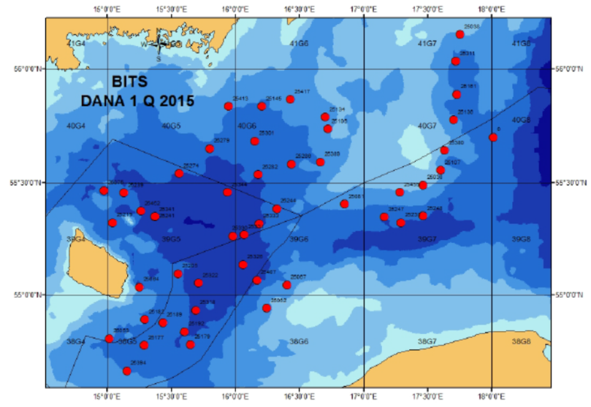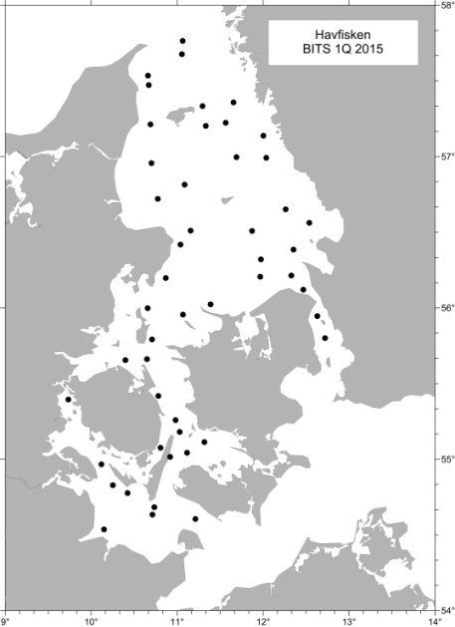
Fig. 1G.1: BITS Q1 Bottom trawl and CTD stations a) RV Dana in ICES area 3d and b) RV Havfisken in areas 3aS, 3b and 3c.
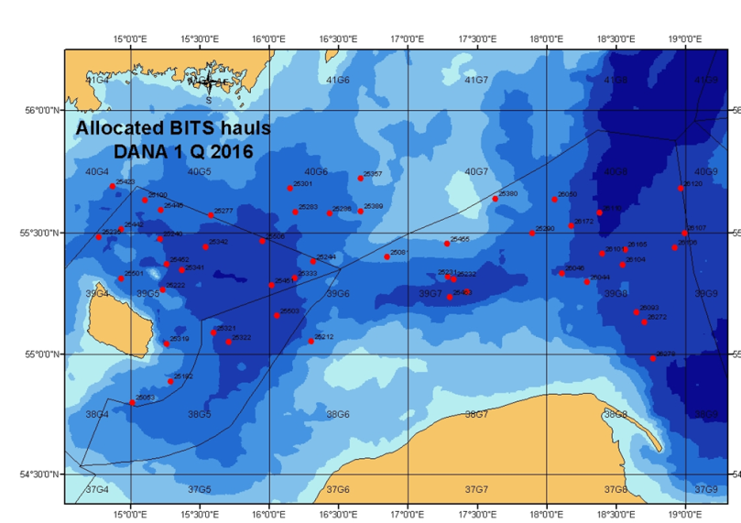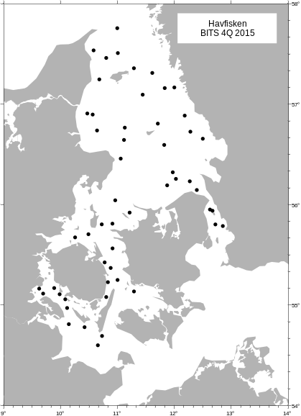
Fig. 1G.2: BITS Q4 Bottom trawl and CTD stations a) RV Dana in ICES area 3d and b) RV Havfisken in areas 3aS, 3b and 3c.

3. For internationally coordinated surveys, describe the participating Member States/ vessels and the relevant international group in charge of planning the survey
Eight countries are participating in BITS survey: Denmark, Germany, Poland, Sweden, Latvia, Lithuania, Estonia and Russia. The planning and coordination is done by ICES WGBIFS.
4. Where applicable, describe the international task-sharing (physical and/or financial) and the cost-sharing agreement used
-
5. Explain where thresholds apply
-
(max. 450 words per survey)
- Graphical representation (map) showing the positions (locations) of the realized samples.
Member State shall provide maps presenting the spatial distribution of the main sampling types obtained during the survey.

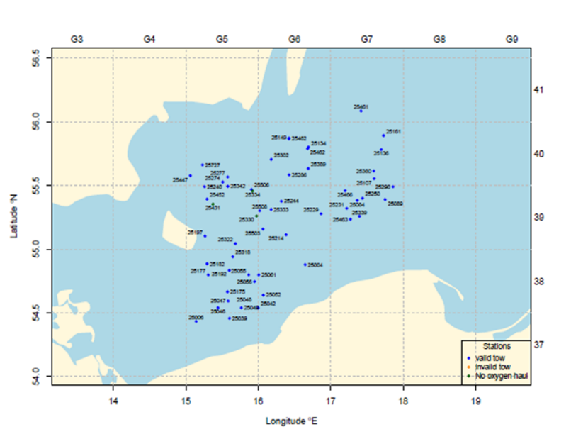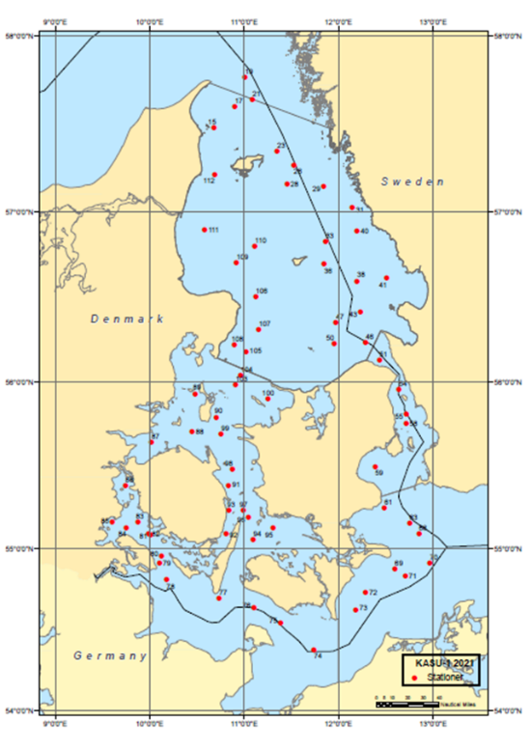
Achieved sampling during BITS Q1 with RV Dana and RV Havfisken in 2021.
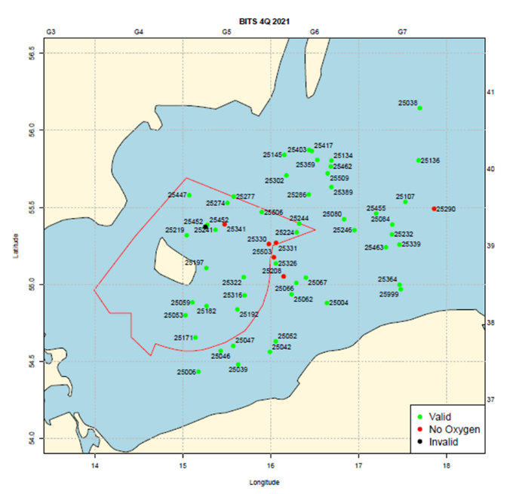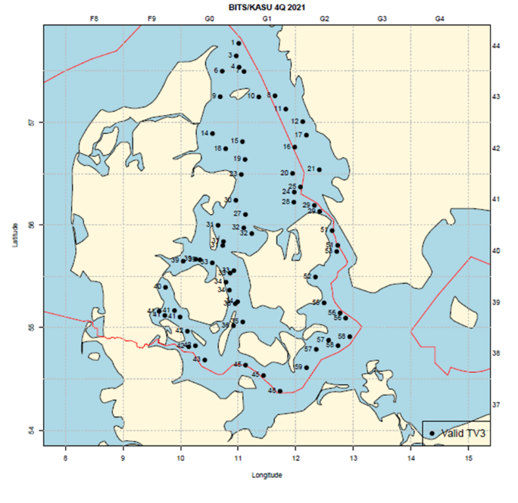
Achieved sampling during BITS Q4 with RV Dana and RV Havfisken in 2021.

- For internationally coordinated surveys, provide a link to the latest meeting report of the coordination group.
Member State shall provide a hyperlink to the meeting report from the body coordinating the survey (ICES, MEDITS coordination group, MEDIAS coordination group etc.). For non-international coordinated surveys, Member State shall refer to any status report (e.g. Cruise report).

The latest report which also describes the main use of the results is found at:

https://ices-library.figshare.com/articles/report/Baltic_International_Fish_Survey_Working_Group_WGBIFS_/18618341

- List the main use of the results of the survey (e.g. indices, abundance estimates, environmental indicators).
Member State shall specify in which context the results are used (on routine basis), both on an international as well as on a national context.

Indices and environmental indicators

9. Extended comments (Tables 1G and 1H)
If the Member State has extended AR Comments, these can be placed under this section. If this is the case, a reference to this text box should be provided in the corresponding tables.

-
(max. 450 words persurvey)

International Bottom Trawl Survey (IBTS Q1, IBTS Q3)
- Objectives of the survey

The main objectives of the North Sea IBTS are:
- To determine the distribution and relative abundance of pre‐recruits of the main commercial species with a view of deriving recruitment indices;
- To monitor changes in the stocks of commercial fish species independently of commercial fisheries data;
- To monitor the distribution and relative abundance of all fish species and selected invertebrates;
- To collect data for the determination of biological parameters for selected species;
- To collect hydrographical and environmental information;
- To determine the abundance and distribution of late herring larvae (February North Sea survey).

2. Methods and survey area
The sampling procedures are described in:
http://doi.org/10.17895/ices.pub.7562
for the trawl catches and:
http://doi.org/10.17895/ices.pub.3434
for the sampling of herring larvae.

The survey area allocated to Denmark is shown in Fig. 1G.3 and Fig. 1G4. However, area and station allocation may change between years depending on agreements of the international coordination group.
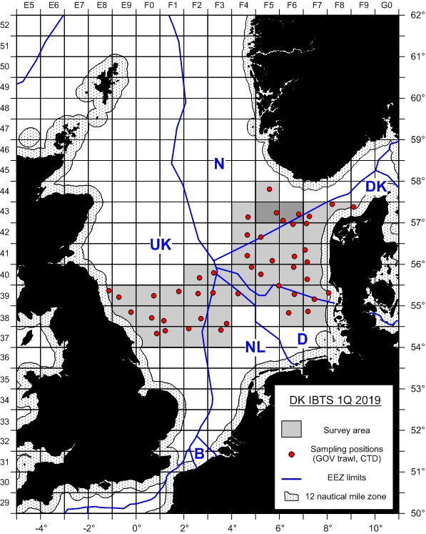
Fig. 1G.3: IBTS Q1 survey area for RV Dana in ICES areas 3a, 4a and 4b (2 MIK stations per rectangle for collecting herring and sprat larvae are not shown on the map).
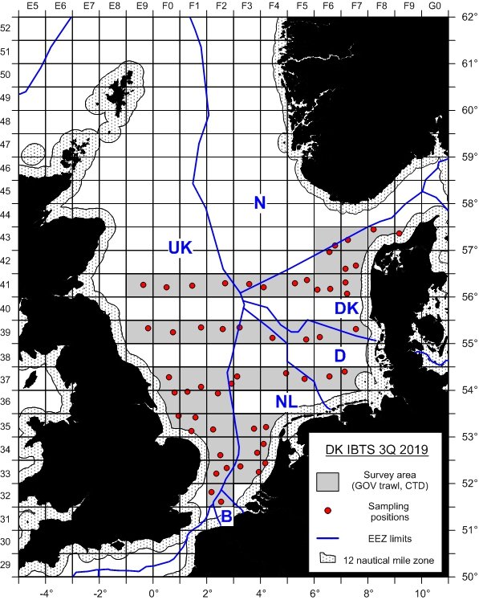
Fig. 1G.4: IBTS Q3 survey area for RV Dana in ICES areas 3a, 4a and 4b.

- For internationally coordinated surveys, describe the participating Member States/ vessels and the relevant international group in charge of planning the survey

Seven countries (Denmark, France, Germany, Netherlands, Norway, Scotland, Sweden) are participating in the North Seas IBTS Q1 and six countries (Denmark, England, Germany, Norway, Scotland, Sweden) are participating in the North Sea IBTS Q3. The planning and coordination is done by ICES IBTSWG.

- Where applicable, describe the international task-sharing (physical and/or financial) and the cost-sharing agreement used

- Where applicable, describe the international task-sharing (physical and/or financial) and the cost-sharing agreement used

- Explain where thresholds apply

(max. 450 words per survey)

- Graphical representation (map) showing the positions (locations) of the realized samples.
Member State shall provide maps presenting the spatial distribution of the main sampling types obtained during the survey.

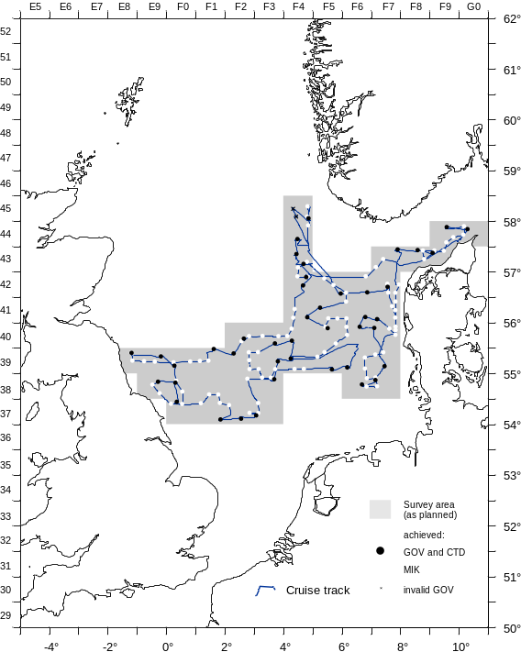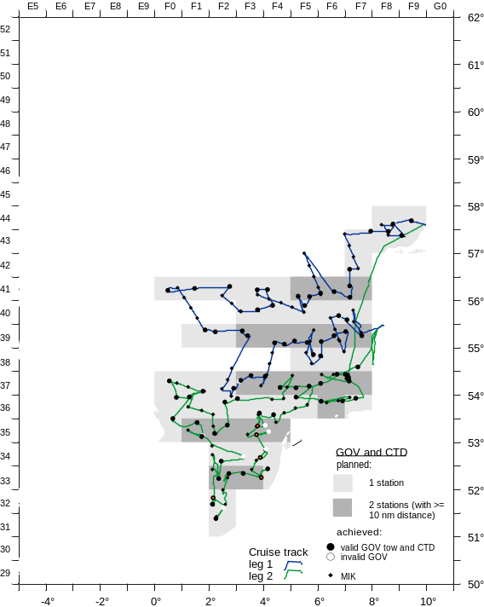

Achieved sampling during IBTS Q1 and Q3 with RV Dana in 2021.

- For internationally coordinated surveys, provide a link to the latest meeting report of the coordination group.
Member State shall provide a hyperlink to the meeting report from the body coordinating the survey (ICES, MEDITS coordination group, MEDIAS coordination group etc.). For non-international coordinated surveys, Member State shall refer to any status report (e.g. Cruise report).
The latest report which also describes the main use of the results is found at:
https://doi.org/10.17895/ices.pub.8219

- List the main use of the results of the survey (e.g. indices, abundance estimates, environmental indicators).
Member State shall specify in which context the results are used (on routine basis), both on an international as well as on a national context.

Indices, environmental indicators

9. Extended comments (Tables 1G and 1H)
If the Member State has extended AR Comments, these can be placed under this section. If this is the case, a reference to this text box should be provided in the corresponding tables.

Q3:Area allocation was changed and extended to help out another country (Germany) due to unavailability of its research vessel.
(max 450 words per survey)

DTU Aqua command three fisheries research vessels. The R/V DANA is a 2483 GRT stern trawler with a length of 78 meters. The other Danish research vessel is R/V HAVFISKEN, a 105 GRT stern trawler with a length of 17 m. The third research vessel is Egon P. having a length of 9.9 m and 8 GRT, and which working area is restricted to coastal and inner Danish waters.
R/V DANA allows in principal 24 hour operation for almost all types of survey whereas this is not possible with R/V Havfisken for trawl surveys and not for R/V Egon P. at all.
The monitoring surveys with research vessel are supplemented with surveys using commercial vessels whenever appropriate.
Baltic International Trawl Survey (BITS Q1, BITS Q4)
- Objectives of the survey
The main aim of the BITS ground-trawl survey, conducted twice per year, i.e. in February-March and November-December is monitoring of the spatial distribution and abundance of cod, flounder, sprat and herring recruiting year-classes, and other less numerous fish species spatial distribution in a bottom zone of particular the ICES Subdivisions (the Baltic Sea), taking into consideration the principal hydrological parameters vertical and horizontal variations. Moreover, the survey is focused on evaluation of the fishing efficiency (catch per unit of effort; cpue), and analysis of the Baltic ichthyofauna biodiversity as well as on sampling materials for the main species principal biological parameters of main fish species.

2. Description of the methods used in the survey. For mandatory surveys, link to the manuals. Include a graphical representation (map)
The sampling procedures are described in:
http://www.ices.dk/sites/pub/Publication%20Reports/ICES%20Survey%20Protocols%20(SISP)/2017/SISP7%20BITS%202017.pdf.
The survey area allocated to Denmark is shown in Figs. 1G.1 and Figs. 1G.2. However, station allocation may change between years depending on agreements of the international coordination group.

Fig. 1G.1: BITS Q1 Bottom trawl and CTD stations a) RV Dana in ICES area 3d and b) RV Havfisken in areas 3aS, 3b and 3c.
Fig. 1G.2: BITS Q4 Bottom trawl and CTD stations a) RV Dana in ICES area 3d and b) RV Havfisken in areas 3aS, 3b and 3c.

3. For internationally coordinated surveys, describe the participating Member States/ vessels and the relevant international group in charge of planning the survey
Eight countries are participating in BITS survey: Denmark, Germany, Poland, Sweden, Latvia, Lithuania, Estonia and Russia. The planning and coordination is done by ICES WGBIFS.
4. Where applicable, describe the international task-sharing (physical and/or financial) and the cost-sharing agreement used
-
5. Explain where thresholds apply
-
(max. 450 words per survey)
- Graphical representation (map) showing the positions (locations) of the realized samples.
Member State shall provide maps presenting the spatial distribution of the main sampling types obtained during the survey.

Achieved sampling during BITS Q1 with RV Dana and RV Havfisken in 2021.
Achieved sampling during BITS Q4 with RV Dana and RV Havfisken in 2021.

- For internationally coordinated surveys, provide a link to the latest meeting report of the coordination group.
Member State shall provide a hyperlink to the meeting report from the body coordinating the survey (ICES, MEDITS coordination group, MEDIAS coordination group etc.). For non-international coordinated surveys, Member State shall refer to any status report (e.g. Cruise report).

The latest report which also describes the main use of the results is found at:

https://ices-library.figshare.com/articles/report/Baltic_International_Fish_Survey_Working_Group_WGBIFS_/18618341

- List the main use of the results of the survey (e.g. indices, abundance estimates, environmental indicators).
Member State shall specify in which context the results are used (on routine basis), both on an international as well as on a national context.

Indices and environmental indicators

9. Extended comments (Tables 1G and 1H)
If the Member State has extended AR Comments, these can be placed under this section. If this is the case, a reference to this text box should be provided in the corresponding tables.

-
(max. 450 words persurvey)

International Bottom Trawl Survey (IBTS Q1, IBTS Q3)
- Objectives of the survey

The main objectives of the North Sea IBTS are:
- To determine the distribution and relative abundance of pre‐recruits of the main commercial species with a view of deriving recruitment indices;
- To monitor changes in the stocks of commercial fish species independently of commercial fisheries data;
- To monitor the distribution and relative abundance of all fish species and selected invertebrates;
- To collect data for the determination of biological parameters for selected species;
- To collect hydrographical and environmental information;
- To determine the abundance and distribution of late herring larvae (February North Sea survey).

2. Methods and survey area
The sampling procedures are described in:
http://doi.org/10.17895/ices.pub.7562
for the trawl catches and:
http://doi.org/10.17895/ices.pub.3434
for the sampling of herring larvae.

The survey area allocated to Denmark is shown in Fig. 1G.3 and Fig. 1G4. However, area and station allocation may change between years depending on agreements of the international coordination group.
Fig. 1G.3: IBTS Q1 survey area for RV Dana in ICES areas 3a, 4a and 4b (2 MIK stations per rectangle for collecting herring and sprat larvae are not shown on the map).
Fig. 1G.4: IBTS Q3 survey area for RV Dana in ICES areas 3a, 4a and 4b.

- For internationally coordinated surveys, describe the participating Member States/ vessels and the relevant international group in charge of planning the survey

Seven countries (Denmark, France, Germany, Netherlands, Norway, Scotland, Sweden) are participating in the North Seas IBTS Q1 and six countries (Denmark, England, Germany, Norway, Scotland, Sweden) are participating in the North Sea IBTS Q3. The planning and coordination is done by ICES IBTSWG.

- Where applicable, describe the international task-sharing (physical and/or financial) and the cost-sharing agreement used

- Where applicable, describe the international task-sharing (physical and/or financial) and the cost-sharing agreement used

- Explain where thresholds apply

(max. 450 words per survey)

- Graphical representation (map) showing the positions (locations) of the realized samples.
Member State shall provide maps presenting the spatial distribution of the main sampling types obtained during the survey.

Achieved sampling during IBTS Q1 and Q3 with RV Dana in 2021.

- For internationally coordinated surveys, provide a link to the latest meeting report of the coordination group.
Member State shall provide a hyperlink to the meeting report from the body coordinating the survey (ICES, MEDITS coordination group, MEDIAS coordination group etc.). For non-international coordinated surveys, Member State shall refer to any status report (e.g. Cruise report).
The latest report which also describes the main use of the results is found at:
https://doi.org/10.17895/ices.pub.8219

- List the main use of the results of the survey (e.g. indices, abundance estimates, environmental indicators).
Member State shall specify in which context the results are used (on routine basis), both on an international as well as on a national context.

Indices, environmental indicators

9. Extended comments (Tables 1G and 1H)
If the Member State has extended AR Comments, these can be placed under this section. If this is the case, a reference to this text box should be provided in the corresponding tables.

Q3:Area allocation was changed and extended to help out another country (Germany) due to unavailability of its research vessel.
(max 450 words per survey)

North Sea Sandeels Survey (NSSS)

- Objectives of the survey

Objective of the survey is to improve the scientific advice on sandeel and it provides the basis for setting a preliminary index for the sandeel fishery for the coming year. Data from the dredge survey is the basis for calculating a 0-group index, which is used in stock assessment. The survey is conducted with a commercial fishing vessel.

- Description of the methods used in the survey. For mandatory surveys, link to the manuals. Include a graphical representation (map)

The sampling of sandeels is conducted with a modified scallop dredge and sediment samples are taken with a Van Veen grab. The sampling locations are shown in Fig. 1G.5.

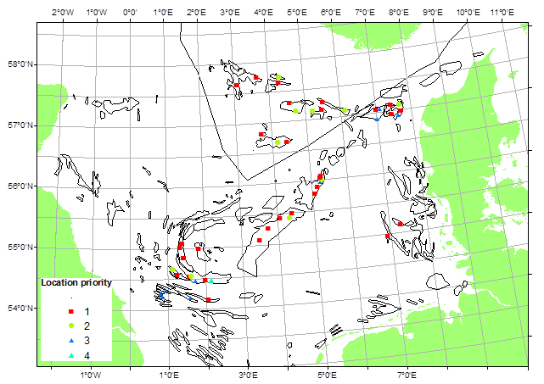
Fig. 1G.6: Danish sandeel survey sampling locations in area 4a and 4b.

Planning is done on a national level.

- For internationally coordinated surveys, describe the participating Member States/ vessels and the relevant international group in charge of planning the survey
-

- Where applicable, describe the international task-sharing (physical and/or financial) and the cost-sharing agreement used
-

- Explain where thresholds apply
-

(max. 450 words per survey)

- Graphical representation (map) showing the positions (locations) of the realized samples.
Member State shall provide maps presenting the spatial distribution of the main sampling types obtained during the survey.

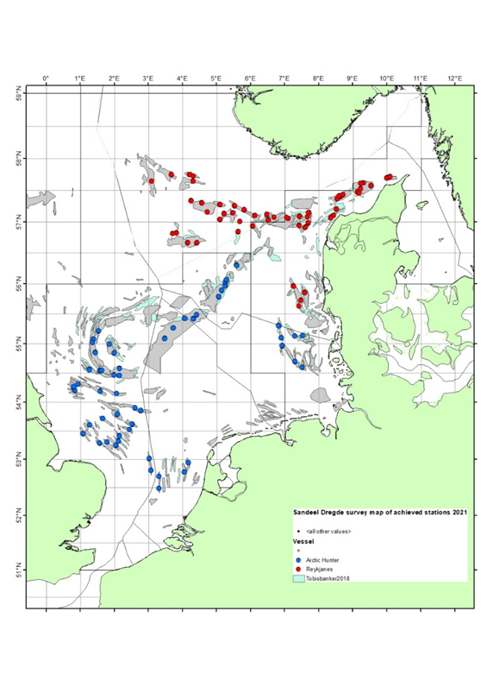
Achieved sampling during the Danish sandeel survey in 2021.

- For internationally coordinated surveys, provide a link to the latest meeting report of the coordination group.
Member State shall provide a hyperlink to the meeting report from the body coordinating the survey (ICES, MEDITS coordination group, MEDIAS coordination group etc.). For non-international coordinated surveys, Member State shall refer to any status report (e.g. Cruise report).

The latest report which also describes the main use of the results is found at:

https://ices-library.figshare.com/articles/report/Herring_Assessment_Working_Group_for_the_area_South_of_62_N_HAWG_2021/18620597

- List the main use of the results of the survey (e.g. indices, abundance estimates, environmental indicators).
Member State shall specify in which context the results are used (on routine basis), both on an international as well as on a national context.

Abundance indices

9. Extended comments (Tables 1G and 1H)
If the Member State has extended AR Comments, these can be placed under this section. If this is the case, a reference to this text box should be provided in the corresponding tables.

No collection of sediment samples due to technical reasons
-
(max 450 words per survey)

International Ecosystem Survey in the Nordic Seas (ASH; alternative abbr. IESNS)

- Objectives of the survey
This survey is carried out in order to investigate distribution and migrations of the Atlanto-Scandian herring, blue whiting and other pelagic fish and to produce a biomass index for herring and a recruitment index for blue whiting for the ICES Working Group on Widely Distributed stocks (ICES WGWIDE). Furthermore, hydrographic conditions and plankton abundance in the Norwegian Sea and adjacent waters are monitored in order to investigate distribution and migration of herring and other pelagic fishes are influenced by environmental conditions.

- Description of the methods used in the survey. For mandatory surveys, link to the manuals. Include a graphical representation (map)

Acoustics, pelagic trawl

http://www.ices.dk/sites/pub/Publication%20Reports/ICES%20Survey%20Protocols%20(SISP)/SISP%209%20Manual%20for%20International%20Pelagic%20Surveys%20(IPS).pdf

The survey area allocated to Denmark is shown in Fig. 1G.6.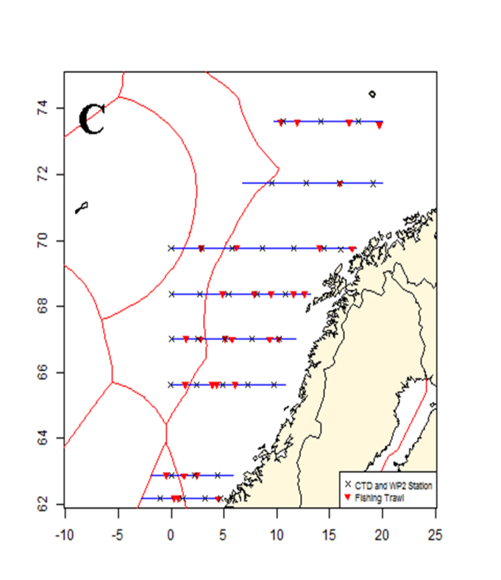
Fig. 1G.6: RV Dana 2015 sailed transects, pelagic trawl, CTD and WP2 stations in ICES area 2a.

- For internationally coordinated surveys, describe the participating Member States/ vessels and the relevant international group in charge of planning the survey

The survey is coordinated with Norway as an international survey with participation of Norway, Iceland, Faroe Islands and EU, where the Danish R/V Dana conducted the EU survey part. Planning and coordination is done by ICES WGIPS.

- Where applicable, describe the international task-sharing (physical and/or financial) and the cost-sharing agreement used

- Explain where thresholds apply

(max. 450 words per survey)
- Graphical representation (map) showing the positions (locations) of the realized samples.
Member State shall provide maps presenting the spatial distribution of the main sampling types obtained during the survey.

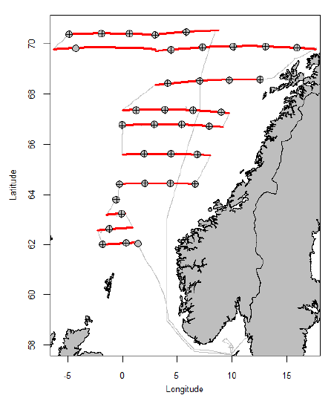

Achieved sampling during the ASH/IESNS with Dana in 2021 (Red lines: acoustic integration, grey circles: CTD, black crosses: WP2 plankton net).

- For internationally coordinated surveys, provide a link to the latest meeting report of the coordination group.
Member State shall provide a hyperlink to the meeting report from the body coordinating the survey (ICES, MEDITS coordination group, MEDIAS coordination group etc.). For non-international coordinated surveys, Member State shall refer to any status report (e.g. Cruise report).
The latest report which also describes the main use of the results is found at:

https://doi.org/10.17895/ices.pub.8055

- List the main use of the results of the survey (e.g. indices, abundance estimates, environmental indicators).
Member State shall specify in which context the results are used (on routine basis), both on an international as well as on a national context.

Abundance estimates, environmental indicators

9. Extended comments (Tables 1G and 1H)
If the Member State has extended AR Comments, these can be placed under this section. If this is the case, a reference to this text box should be provided in the corresponding tables.

The 2021 survey was conducted solely with DTU Aqua staff except for one participant from Germany, and the usual half time crew exchange in Bodø (Norway) was cancelled due to Corona related travel restriction and health safety concerns.
(max 450 words per survey)

NS Herring Acoustic Survey (NHAS)

- Objectives of the survey

The purpose of the survey is to provide acoustic abundance estimates of herring and sprat in the North Sea (eastern part), Skagerrak and Kattegat.

- Description of the methods used in the survey. For mandatory surveys, link to the manuals. Include a graphical representation (map)

Acoustics, pelagic and bottom trawling

The sampling procedures are described in:
http://www.ices.dk/sites/pub/Publication%20Reports/ICES%20Survey%20Protocols%20(SISP)/SISP%209%20Manual%20for%20International%20Pelagic%20Surveys%20(IPS).pdf

The survey area allocated to Denmark is shown in Fig. 1G.10.
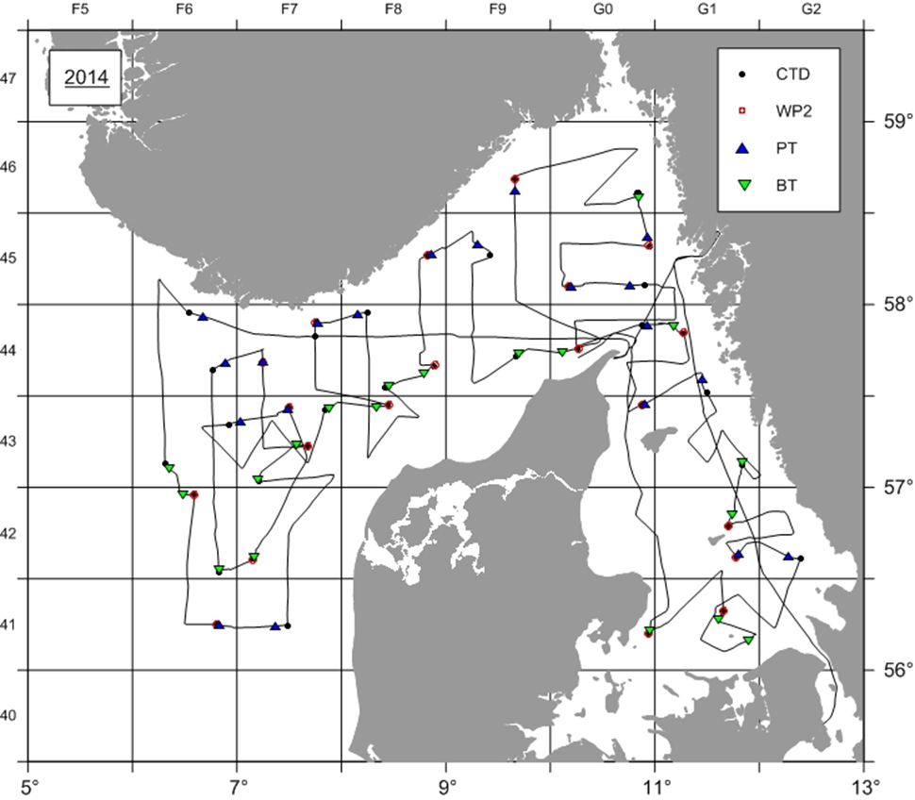
Fig. 1G7: RV Dana NHAS survey area.

- For internationally coordinated surveys, describe the participating Member States/ vessels and the relevant international group in charge of planning the survey

The survey is coordinated by the ICES Working Group for International Pelagic Surveys, WGIPS, and is a part of the international acoustic survey of the North Sea and adjacent areas which are covered by Germany, Ireland, the Netherlands, Norway and Scotland.

- Where applicable, describe the international task-sharing (physical and/or financial) and the cost-sharing agreement used
-

- Explain where thresholds apply
-

(max. 450 words per survey)
- Graphical representation (map) showing the positions (locations) of the realized samples.
Member State shall provide maps presenting the spatial distribution of the main sampling types obtained during the survey.

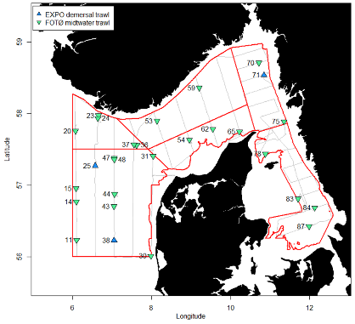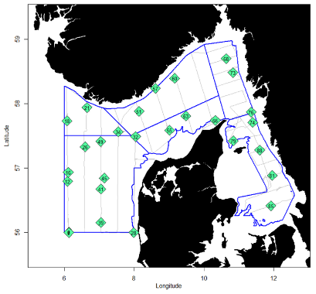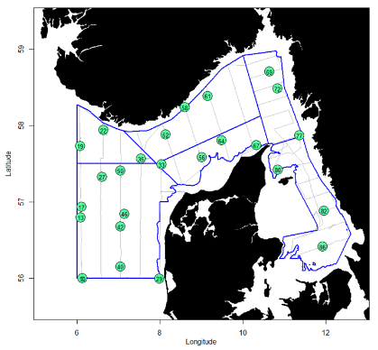

Achieved sampling during the NHAS with Dana in 2021( tiangles: trat, diamonds: CTD, circles: WP2 plankton net).

- For internationally coordinated surveys, provide a link to the latest meeting report of the coordination group.
Member State shall provide a hyperlink to the meeting report from the body coordinating the survey (ICES, MEDITS coordination group, MEDIAS coordination group etc.). For non-international coordinated surveys, Member State shall refer to any status report (e.g. Cruise report).
The latest report which also describes the main use of the results is found at:
https://doi.org/10.17895/ices.pub.8055

- List the main use of the results of the survey (e.g. indices, abundance estimates, environmental indicators).
Member State shall specify in which context the results are used (on routine basis), both on an international as well as on a national context.

Abundance estimates, environmental indicators

9. Extended comments (Tables 1G and 1H)
If the Member State has extended AR Comments, these can be placed under this section. If this is the case, a reference to this text box should be provided in the corresponding tables.

(max 450 words per survey)

Nephrops TVsurvey in FU 3 & 4 (NTV3&4)

- Objectives of the survey

The purpose of the survey is to estimate the abundance of Norway lobster (Nephrops norwegicus) in the Skagerrak and the Kattegat (Functional units 3 and 4).

- Description of the methods used in the survey. For mandatory surveys, link to the manuals. Include a graphical representation (map)

An underwater video technique is used and later the video footage is analysed in laboratory to estimate the Nephrops abundance in selected subareas. The survey area allocated to Denmark is shown in Fig. 1G.8.
The sampling procedures are described in:
https://doi.org/10.17895/ices.pub.8014
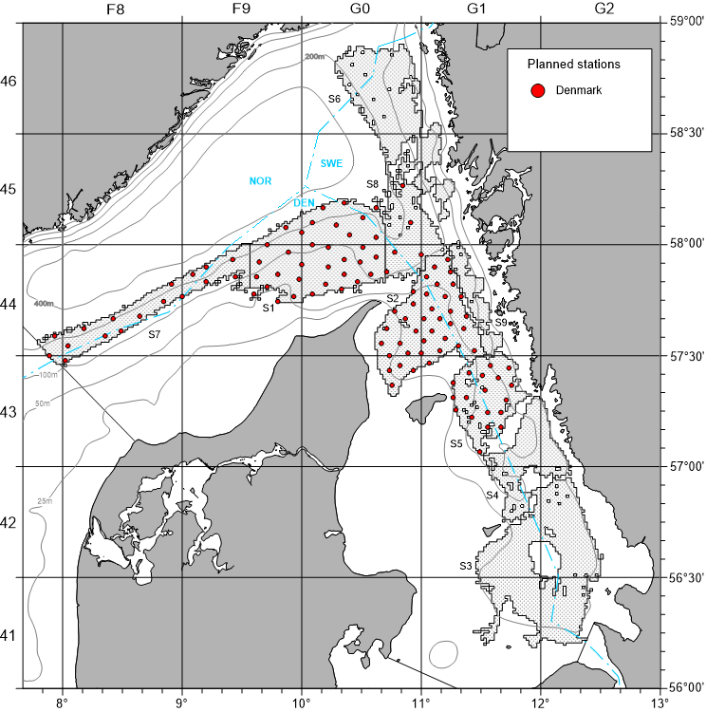

Fig. 1G.8: NTV3&4 sampling locations covered by Denmark with RV Havfisken in area 3a (Strata S3, S4, S6 and S9 are currently allocated to Sweden).

- For internationally coordinated surveys, describe the participating Member States/ vessels and the relevant international group in charge of planning the survey

Survey planning and data analysis is conducted in close cooperation with Sweden and coordinated by ICES WGNEPS.

- Where applicable, describe the international task-sharing (physical and/or financial) and the cost-sharing agreement used

-

- Explain where thresholds apply

-

(max. 450 words per survey)
- Graphical representation (map) showing the positions (locations) of the realized samples.
Member State shall provide maps presenting the spatial distribution of the main sampling types obtained during the survey.

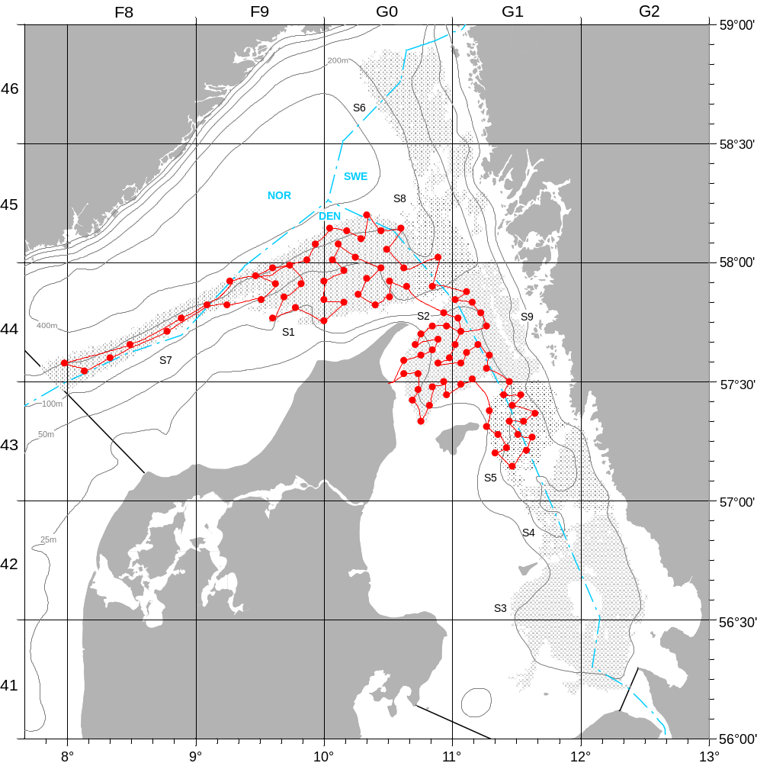
Achieved sampling during the Danish NTV3&4 survey with RV Havfisken in 2021.

- For internationally coordinated surveys, provide a link to the latest meeting report of the coordination group.
Member State shall provide a hyperlink to the meeting report from the body coordinating the survey (ICES, MEDITS coordination group, MEDIAS coordination group etc.). For non-international coordinated surveys, Member State shall refer to any status report (e.g. Cruise report).
The latest report which also describes the main use of the results is found at: http://doi.org/10.17895/ices.pub.19438472
- List the main use of the results of the survey (e.g. indices, abundance estimates, environmental indicators).
Member State shall specify in which context the results are used (on routine basis), both on an international as well as on a national context.

The combined survey abundance estimates from Denmark and Sweden are used for stock assessment by ICES WGNSSK.

9. Extended comments (Tables 1G and 1H)
If the Member State has extended AR Comments, these can be placed under this section. If this is the case, a reference to this text box should be provided in the corresponding tables.

(max 450 words per survey)

Flatfish survey in the Kattegat and Skagerrak (FFS)

- Objectives of the survey

Establish a time series of catch and effort data independent of the commercial fishery for sole and plaice in the Kattegat and the southern Skagerrak. The survey has been initiated in 2004 and provides currently the main input data set for the 3a sole assessment.

- Methods and survey area
So far, the survey has been conducting using two commercial fishing vessels in parallel. The survey is now conducted with RV Havfisken using the same commercial flatfish trawl as before. The survey area is indicated in Fig. 1G.9.

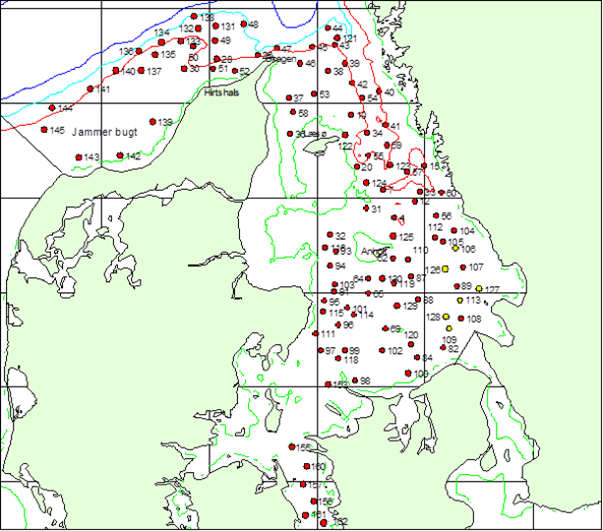
Fig. 1G.9: Survey area and provisional station allocation for the flatfish survey with RV Havfisken in area 3a.

Planning occurs on a national level and the survey results are provided to WGBFAS.

- For internationally coordinated surveys, describe the participating Member States/ vessels and the relevant international group in charge of planning the survey
-

- Where applicable, describe the international task-sharing (physical and/or financial) and the cost-sharing agreement used

- Explain where thresholds apply

-

(max. 450 words per survey)
- Graphical representation (map) showing the positions (locations) of the realized samples.
Member State shall provide maps presenting the spatial distribution of the main sampling types obtained during the survey.

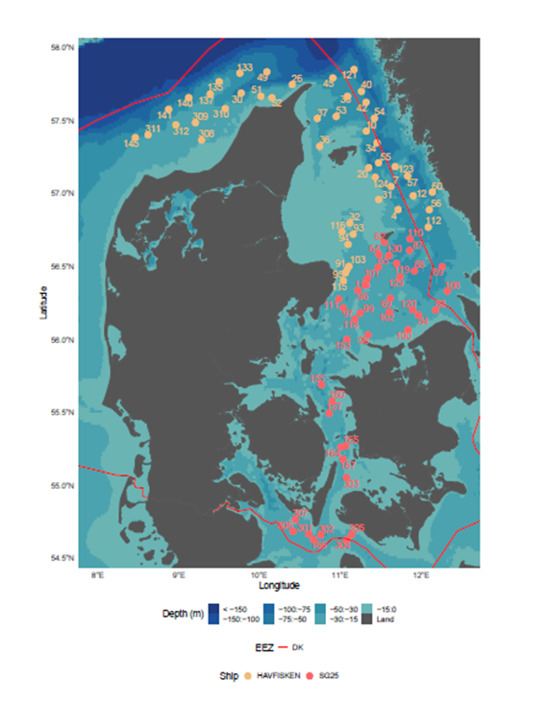
Achieved sampling during the Danish FSS with RV Havfisken (yellow circles) and SG25 Anni Holm (orange circles) in 2021.

- For internationally coordinated surveys, provide a link to the latest meeting report of the coordination group.
Member State shall provide a hyperlink to the meeting report from the body coordinating the survey (ICES, MEDITS coordination group, MEDIAS coordination group etc.). For non-international coordinated surveys, Member State shall refer to any status report (e.g. Cruise report).

https://ices-library.figshare.com/articles/report/Baltic_Fisheries_Assesment_Working_Group_WGBFAS_/18618875

- List the main use of the results of the survey (e.g. indices, abundance estimates, environmental indicators).
Member State shall specify in which context the results are used (on routine basis), both on an international as well as on a national context.

Abundance indices

The survey results are provided to WGBFAS in form of a working document and are used for the assessment of the sole stock in area 3a.

9. Extended comments (Tables 1G and 1H)
If the Member State has extended AR Comments, these can be placed under this section. If this is the case, a reference to this text box should be provided in the corresponding tables.

(max 450 words per survey)

Nephrops TVsurvey in FU 33 (NTV33)

- Objectives of the survey

The purpose of the survey is to estimate the abundance of Nephrops off Horns Rev (Functional unit 33). The survey has been stated in 2017 as no fishery-independent information existed for this area.

- Methods and survey area
An underwater video technique is used and later the video footage is analysed in laboratory to estimate the Nephrops abundance. The survey area is indicated in Fig. 1G.10.
The sampling procedures are described in:
https://doi.org/10.17895/ices.pub.8014
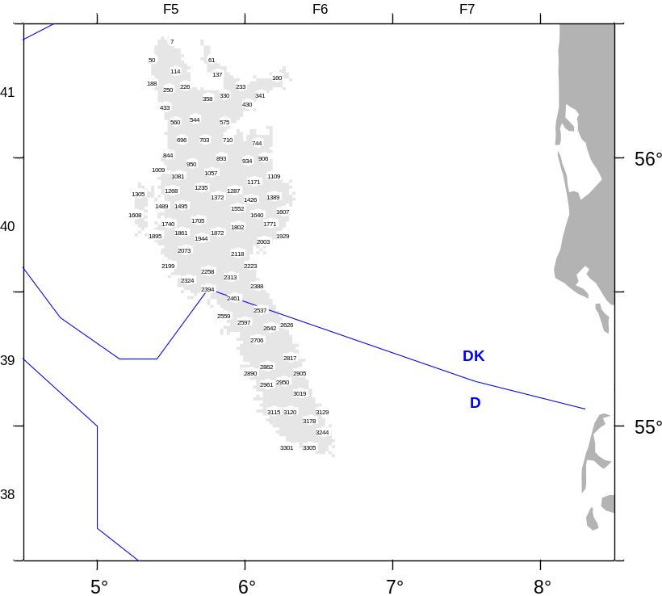
Fig. 1G.10: NTV33 survey area to be covered by Denmark with RV Havfisken in area 4b.

- Planning

Survey planning and data analysis is coordinated by ICES WGNEPS

- Where applicable, describe the international task-sharing (physical and/or financial) and the cost-sharing agreement used

-

- Explain where thresholds apply

-

(max. 450 words per survey)

- Graphical representation (map) showing the positions (locations) of the realized samples.
Member State shall provide maps presenting the spatial distribution of the main sampling types obtained during the survey.

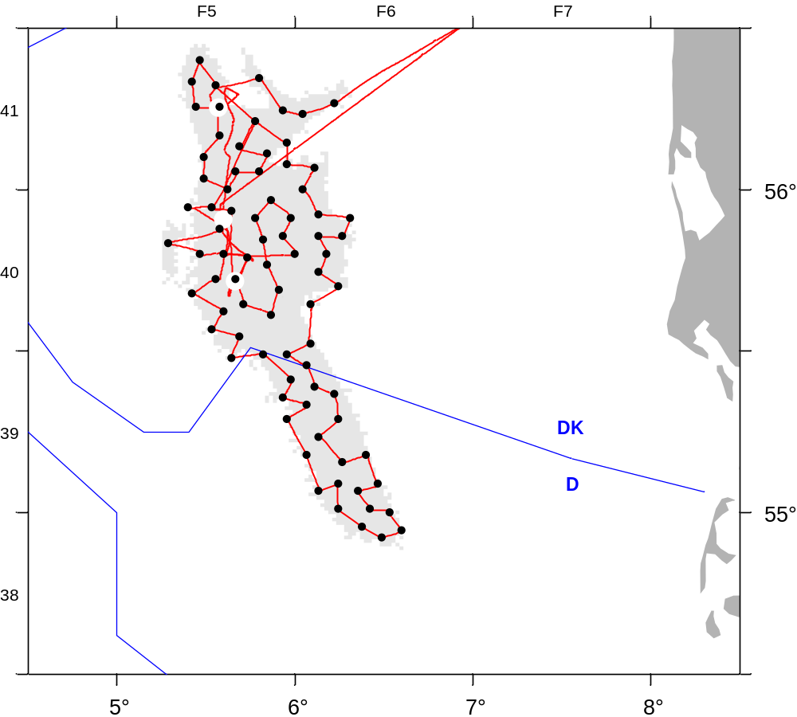

Achieved sampling during the Danish NTV33survey with RV Havfisken in 2021 (black dots: Video sledge, white dots: trawl).

- For internationally coordinated surveys, provide a link to the latest meeting report of the coordination group.
Member State shall provide a hyperlink to the meeting report from the body coordinating the survey (ICES, MEDITS coordination group, MEDIAS coordination group etc.). For non-international coordinated surveys, Member State shall refer to any status report (e.g. Cruise report).
The latest report which also describes the main use of the results is found at:
http://doi.org/10.17895/ices.pub.19438472

- List the main use of the results of the survey (e.g. indices, abundance estimates, environmental indicators).
Member State shall specify in which context the results are used (on routine basis), both on an international as well as on a national context.

Abundance estimates

9. Extended comments (Tables 1G and 1H)
If the Member State has extended AR Comments, these can be placed under this section. If this is the case, a reference to this text box should be provided in the corresponding tables.

(max 450 words per survey)

Cod survey in the Kattegat (CODS_Q4)
- Objectives

The survey is a combined Danish- Swedish fisherman-scientist survey. The goal of the Kattegat cod survey is to estimate the abundance, biomass and distribution of cod and to establish a fisheries independent time series of catch and effort series. Furthermore, a recruitment index is established. The results has for the first time in 2015 been used, together with commercial catch and effort data, to strengthen the scientific advice on the cod stock in Kattegat.

- Methods and survey area

Initially, 4 commercial trawlers (2 Swedish and 2 Danish vessels) participated in the survey. In 2016, Sweden continued to use commercial vessel whereas Denmark used the new research vessel RV Havfisken but with the same trawl as previously on the commercial vessels. In 2017, the Danish part of the survey was combined with the BITS Q4 survey but in the future it will be kept separate again to allow better overlap in the timing with the Swedish part of the survey.

The sampling procedures are described in:
http://www.ices.dk/sites/pub/Publication%20Reports/ICES%20Survey%20Protocols%20(SISP)/SISP%209%20Manual%20for%20International%20Pelagic%20Surveys%20(IPS).pdf

The survey area allocated to Denmark is shown in Fig. 1G12. is shown in Fig. 1G.11.

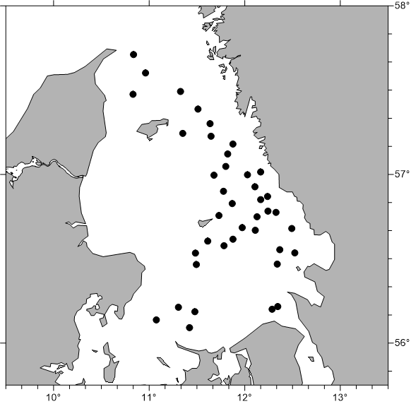

Fig. 1G.11: Survey area for the Danish CodS_Q4 survey with RV Havfisken.

3. Planning

Survey planning and data analysis is conducted in close cooperation with Sweden and the survey results are provided to ICES WGBFAS.

- Where applicable, describe the international task-sharing (physical and/or financial) and the cost-sharing agreement used

-

- Explain where thresholds apply

-

(max. 450 words per survey)

- Graphical representation (map) showing the positions (locations) of the realized samples.
Member State shall provide maps presenting the spatial distribution of the main sampling types obtained during the survey.
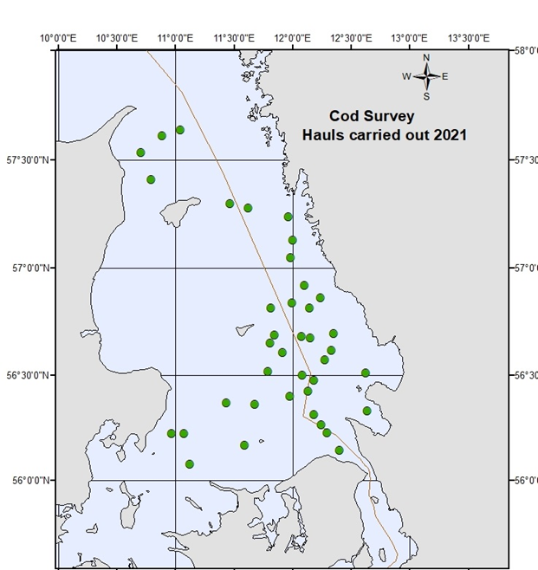

Achieved sampling during the Danish Danish CodS_Q4 survey with RV Havfisken in 2021

- For internationally coordinated surveys, provide a link to the latest meeting report of the coordination group.
Member State shall provide a hyperlink to the meeting report from the body coordinating the survey (ICES, MEDITS coordination group, MEDIAS coordination group etc.). For non-international coordinated surveys, Member State shall refer to any status report (e.g. Cruise report).

https://ices-library.figshare.com/articles/report/Baltic_Fisheries_Assesment_Working_Group_WGBFAS_/18618875

- List the main use of the results of the survey (e.g. indices, abundance estimates, environmental indicators).
Member State shall specify in which context the results are used (on routine basis), both on an international as well as on a national context.

Abundance indices

9. Extended comments (Tables 1G and 1H)
If the Member State has extended AR Comments, these can be placed under this section. If this is the case, a reference to this text box should be provided in the corresponding tables.

(max 450 words per survey)

International Ecosystem Summer Survey in the Nordic Seas (IESSNS)

1. Objectives

The survey is carried out in order to provide annual age-segregated abundance index, with an uncertainty estimate, for northeast Atlantic mackerel (Scomber scombrus). The index is used as a tuning series in stock assessment. The area has been extended to the North Sea in 2018 when Denmark joined the survey.

2. Methods and survey area
A standardised pelagic swept area trawl method is used to obtain the abundance index and to study the spatial distribution of mackerel in relation to environmental factors.

The sampling procedures are described in:
http://www.ices.dk/sites/pub/Publication%20Reports/ICES%20Survey%20Protocols%20(SISP)/SISP%209%20Manual%20for%20International%20Pelagic%20Surveys%20(IPS).pdf

Denmark is using a commercial vessel for the survey and the area allocated to Denmark is shown in Fig. 1G12

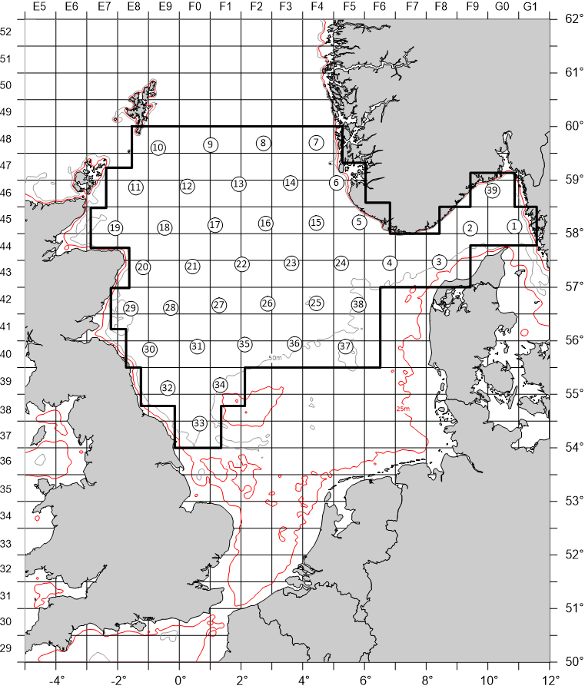

Fig. 1G.12: Survey area for the Danish contribution to the IESSNS.

3. Planning

The survey is coordinated by the ICES Working Group for International Pelagic Surveys, WGIPS.

4. Where applicable, describe the international task-sharing (physical and/or financial) and the cost-sharing agreement used

-

- Explain where thresholds apply

-

(max. 450 words per survey)
- Graphical representation (map) showing the positions (locations) of the realized samples.
Member State shall provide maps presenting the spatial distribution of the main sampling types obtained during the survey.

The 2021 survey was conducted without DCF funding

- For internationally coordinated surveys, provide a link to the latest meeting report of the coordination group.
Member State shall provide a hyperlink to the meeting report from the body coordinating the survey (ICES, MEDITS coordination group, MEDIAS coordination group etc.). For non-international coordinated surveys, Member State shall refer to any status report (e.g. Cruise report).

- List the main use of the results of the survey (e.g. indices, abundance estimates, environmental indicators).
Member State shall specify in which context the results are used (on routine basis), both on an international as well as on a national context.

9. Extended comments (Tables 1G and 1H)
If the Member State has extended AR Comments, these can be placed under this section. If this is the case, a reference to this text box should be provided in the corresponding tables.

(max 450 words per survey)

Mackerel egg production survey in the North Sea (NS MEGS)
1. Objectives
The survey aims at to provide an index of the spawning stock biomass of the North Sea component of Northeast Atlantic mackerel stock.

2. Methods and survey area
The sampling procedures are describe in :

http://www.ices.dk/sites/pub/Publication%20Reports/ICES%20Survey%20Protocols%20(SISP)/SISP%206%20-%20MEGS%20V1.3.pdf,

and

http://www.ices.dk/sites/pub/Publication%20Reports/ICES%20Survey%20Protocols%20(SISP)/SISP%205%20-%20WGMEGS%20V11%20Manual%20for%20AEPM%20and%20DEPM%20fecundity.pdf.

Denmark will join the survey for the first time in 2020 and will conduct the sampling in close cooperation with the Netherlands. The area actually allocated to Denmark is shown in Fig. 1G.13.

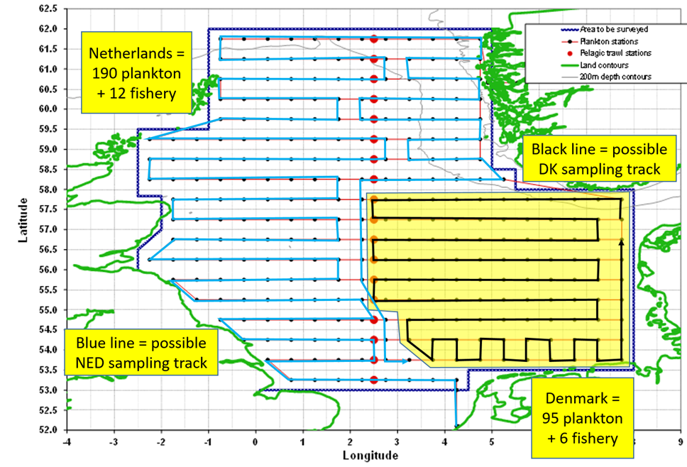

Fig. 1G.13: Proposed sampling area for RV Dana for NS MEGS in 2020.

3. Planning

4. Where applicable, describe the international task sharing (physical and/or financial) and the cost sharing agreement used

5. Explain where thresholds apply

(max 450 words per survey)

- Graphical representation (map) showing the positions (locations) of the realized samples.
Member State shall provide maps presenting the spatial distribution of the main sampling types obtained during the survey.

The 2020 survey was postpone to 2021 due to the Corona pandemic.
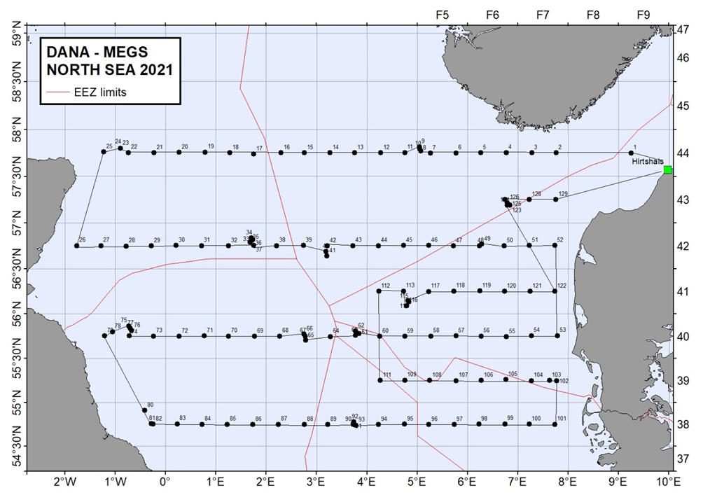
Achieved sampling during the NSMEGS with Dana in 2021.

- For internationally coordinated surveys, provide a link to the latest meeting report of the coordination group.
Member State shall provide a hyperlink to the meeting report from the body coordinating the survey (ICES, MEDITS coordination group, MEDIAS coordination group etc.). For non-international coordinated surveys, Member State shall refer to any status report (e.g. Cruise report).
https://doi.org/10.17895/ices.pub.8249

- List the main use of the results of the survey (e.g. indices, abundance estimates, environmental indicators).
Member State shall specify in which context the results are used (on routine basis), both on an international as well as on a national context.

Mackerel egg abundance indices

9. Extended comments (Tables 1G and 1H)
If the Member State has extended AR Comments, these can be placed under this section. If this is the case, a reference to this text box should be provided in the corresponding tables.

(max 450 words per survey)

Baltic International Acoustic Survey (BIAS)

See AR from other MS

Blue whiting survey (IBWSS)

See AR from other MS

- Objectives of the survey

- Description of the methods used in the survey. For mandatory surveys, link to the manuals. Include a graphical representation (map)

- For internationally coordinated surveys, describe the participating Member States/ vessels and the relevant international group in charge of planning the survey

- Where applicable, describe the international task-sharing (physical and/or financial) and the cost-sharing agreement used

- Explain where thresholds apply

(max. 450 words per survey)
- Graphical representation (map) showing the positions (locations) of the realized samples.
Member State shall provide maps presenting the spatial distribution of the main sampling types obtained during the survey.

- For internationally coordinated surveys, provide a link to the latest meeting report of the coordination group.
Member State shall provide a hyperlink to the meeting report from the body coordinating the survey (ICES, MEDITS coordination group, MEDIAS coordination group etc.). For non-international coordinated surveys, Member State shall refer to any status report (e.g. Cruise report).

- List the main use of the results of the survey (e.g. indices, abundance estimates, and environmental indicators).
Member State shall specify in which context the results are used (on routine basis), both on an international as well as on a national context.

9. Extended comments (Tables 1G and 1H)
If the Member State has extended AR Comments, these can be placed under this section. If this is the case, a reference to this text box should be provided in the corresponding tables.

(max 450 words per survey)

Section 2: Fishing Activity Data

Text Box 2A: Fishing activity variables data collection strategy

General comment: This box fulfills paragraph 4 of Chapter III of the Annex of the Delegated Decision (EU) 2019/910 on the multiannual Union programme; and Article 2, Article 4 paragraph (2) point (b) and Article 5 paragraph (2) of the Implementing Decision (EU) 2016/1701 on the format of the WP. It is intended to describe the method used to derive estimates on representative samples where data are not to be recorded under Regulation (EU) No 1224/2009 or where data collected under Regulation (EU) No 1224/2009 are not at the right aggregation level for the intended scientific use.
General comment: This box is applicable to the Annual Report. This box should provide information on the implementation of the data collection of fishing activity variables of Member States.
1. Description of methodologies used to cross-validate the different sources of data

Every night, logbook, sales notes and VMS data are transferred form the Danish Fisheries Agency to DTU Aqua via a secure FTP connection. Therefore these data are available immediately for data cheking and cross validating with the sampled data.
Sales notes are reported for all fishing trips (census data) and combined with logbooks using a logbook sheet number and with the fleet register to create the “DFAD” database. This combined data is then merged with VMS data by vessel and date to get a finer spatial information of the fishery, the VMS data are filtered to positions where fishing activity is assumed. If there is a mis-match between the area and ICES rectangle reported in the DFAD data, the position is validated and corrected using the VMS data.

For small vessels where logbooks are not mandatory (under 10 m / 8 m in the Baltic), sales notes and fleet register information are available. Based on the catch composition, area and fleet register gear, a method has been implemented for estimating the métier code. For effort estimates for vessels without logbooks, it is assumed that one landing date equals one fishing day and one day at sea.

2. Description of methodologies used to estimate the value of landings

The value of landings are informed directly from the sales notes data register (census data). When the sales notes are merged with the logbook data, the values of landings can be reported by e.g. gear, métier and ICES rectangle. When estimates of value of landings are needed on a high spatial resolution, the value of landings are distributed out on the VMS positions where fishing activity is assumed by vessel and date.

3. Description of methodologies used to estimate the average price (it is recommended to use weighted averages, trip by trip)

Average prices can be calculated directly from the sales notes register as the sales notes are sensus

4. Description of methodologies used to plan collection of the complementary data (sample plan methodology, type of data collected, frequency of collection etc)
As census data are collected, not additional data collection is needed.

(max 900 words per Region)
5. Deviations from Work Plan methodology used to cross-validate the different sources of data
No deviation from Work Plan methodology used to cross-validate the different sources of data

6. Deviations from Work Plan methodology used to estimate the value of landings.
No deviation from Work Plan methodology used to estimate the value of landings

7. Deviations from Work Plan methodology used to estimate the average price.
No deviation from Work Plan methodology used to estimate the average price

8. Deviations from Work Plan methodology used to plan collection of the complementary data
The telephone interviews started after the WP was submitted, as we became aware of the big gaps in logbook data in relation to effort for passive gears (net length, soaking time, number of pots/traps), which are important when estimating bycatches of PETS. The telephone interviews could be a way to collect information to give better effort estimates for passive gears mentioned in the EU-MAP table 6 (previous table 4), and as mentioned in section 3.1 (previous section 4) that if the data required by end users are not recorded under regulation 1224/2009, the data shall be collected by using sampling methods.

Section 3: Economic and Social Data

Text Box 3A: Population segments for collection of economic and social data for fisheries

General comment: This box fulfils paragraph 5 points (a) and (b) of Chapter III of the Annex of the Delegated Decision (EU) 2019/910 on the multiannual Union programme; and Article 2, Article 4 paragraphs (1), (2) and (5) and Article 5 paragraph (2) of the Implementing Decision (EU) 2016/1701 on the format of the WP. It is intended to specify data to be collected under Tables 5(A) and 6 of the delegated decision on the multiannual Union programme.
General comment: This box is applicable to the Annual Report. This box should provide information on the implementation of the fleet socio-economic data collection of Member States.
1. Description of methodologies used to choose the different sources of data
Whenever register data are available for a variable these are preferred as they originate from a census type data collection scheme and contain information on all elements of the population. Data on landings (sales notes, species, quantity and value), fishing vessels (type, size, etc.) fishing activity (logbook, days, gear and fishing area), and vessel owners (fishermen, fishing firms) are examples of register data collected by the Danish Fishery Agency.
Data on fishing rights is also registered by the Danish Fishery Agency. All transactions of ITQ’s (Individually Transferable Qouta) and VQS’s (Vessel Qouta Share) are registered by date and vessel identity on the Register on fishing rights. That information is used together with estimated shadow prices for each qouta stock to calculate the capital value of fishing rights for each production unit.
Economic data is collected by Statistics Denmark by non probability sample survey using a harmonized accounting form for fisheries.

2. Description of methodologies used to choose the different types of data collection
All register data from the Danish Fishery Agency are submittet mandatorily, as they are used for other statistics and control purposes. All other economic variables are collected on a voluntary basis. Theoretically a probability sample survey would be preferable, but as the population is quite small, particularly in some segments, all volunteers are accepted even though that results in a non probability sample survey.

3. Description of methodologies used to choose sampling frame and allocation scheme
The entire population is segmented according to the DCMAP requirement (Supra region, Fishing technique, Length class) and each segment stratified into 7 groups on economic size. Group 0 (inactive) and 1 (revenue below threshold) are treated separately, as there are no accounts to be collected for these units.
For the units with yearly revenue below the threshold (=DKK 270,000) we do not have individual accounts. We use register information (vessel characteristics, gear, and species composition) to place the units below threshold into the relevant fleet segment. Then we use the value of landings (all landings are registered on the sales note register) to calculate a multiplier, which is used to adjust the economic variables for the segment that includes units below threshold.
For group 2 to 6, the commercially active vessels (about 550 production units), a sample of 275 accounts are collected on a voluntary basis. The sample is not stocastically drawn from the stratified publication, because most the bigger companies have great variation in economic terms which makes it difficult to represent them by other companies. We get a better sample by using a panel which consists of the 100 biggest production units plus a representativ sample of the rest of the population. About 10 per cent of the sample is renewed each year.
4. Description of methodologies used for estimation procedures
Individual accounts are simulated for each unit in the population that is not in the sample. These simulations are done by selection of one to three “donors” from the sampled accounts, that are valuated to be best possible replacement for the simulated unit, and calibrate the average of the one to three selected matching units, to equal the registered revenue of the simulated unit.
The simulations are performed using a BANFF MASSIMPUTATION model. Donors are matched according to known registered data for catches on selected species, crew size, engine power and days at sea in Ices III and Ices IV. Some accounts for units in the sample that had extraordinary events during the year may be excluded from the basis for simulation.

5. Description of methodologies used on data quality
The most important quality check lies in the scrutinized analysis of the individual accounts for each production unit. All variables have to be right to balance the account correctly. Also the contents of all variables are assessed and evaluated by comparing with related variables and last years account for the same unit.

(max 900 words per Region)
6. Deviations from Work Plan methodology for selection of data source
No deviations from the Work Plan

7. Deviations from Work Plan methodology to choose type of data collection
No deviations from the Work Plan

8. Deviations from Work Plan methodology regarding sampling frame and allocation scheme
The AR include segment Dredgers VL 10-12, that are not included in NWP. At the time the NWP was submittet, there were no vessels in this segment. When data was collected 3 vessels where active in this segment, and therefor they were colelcted and reported in AR.

9. Deviations from Work Plan methodology used for estimation procedures
No deviations from the Work Plan

10. Quality assurance
10.1 Sound methodology
The Danish data collection follow methodologies, guidelines and best practices agreed in expert groups.

10.2. Accuracy and reliability
Data collection method and validation etc. can be found at:
https://www.dst.dk/en/Statistik/dokumentation/documentationofstatistics/account-statistics-for-fishery
Response rate and Achieved sample rate are provided in Table 3A.

10.3. Accessibility and Clarity
Indicate with Yes or No
Are methodological documents publicly available? Yes
Are data stored in databases? Yes
Where can methodological and other documentation be found? Yes
Provide the web link, if documentation is publicly available
https://www.dst.dk/en/Statistik/dokumentation/documentationofstatistics/account-statistics-for-fishery
(max 1000 words)

Section 3: Economic and Social Data

Pilot Study 3: Data on employment by education level and nationality

General comment: This box fulfills paragraph 5 point (b) and paragraph 6 point (b) of Chapter III of the Annex Delegated Decision (EU) 2019/910 on the multiannual Union programme; and Article 2 and Article 4 paragraph (3) point (c) of the Implementing Decision (EU) 2016/1701 on the format of the WP. It is intended to specify data to be collected under Table 6 of the delegated decision on the multiannual Union programme.
General comment: This box is applicable to the Annual Report. This box is intended to provide information on the results obtained from the implementation of the pilot study (including deviations from planned and justifications as to why if this was not the case).
1. Aim of pilot study
The study was conducted in 2019. Report is available in the AR for 2019.
2. Duration of pilot study
3. Methodology and expected outcomes of pilot study
(max 900 words)
4. Achievement of the original expected outcomes of pilot study and justification if this was not the case.

5. Incorporation of results from pilot study into regular sampling by the Member State.

(max 900 words)

Section 3: Economic and Social Data

Text Box 3B: Population segments for collection of economic and social data for aquaculture

General comment: This box fulfills paragraph 6 points (a) and (b) of Chapter III of the Annex of the Delegated Decision (EU) 2019/910 on the multiannual Union programme; and Article 2, Article 4 paragraphs (1) and (5) and Article 5 paragraph (2) of the Implementing Decision (EU) 2016/1701 on the format of the WP. It is intended to specify data to be collected under Tables 6 and 7 of the delegated decision on the multiannual Union programme.

General comment: This box is applicable to the Annual Report. This box should provide information on the implementation of the socio-economic data collection for aquaculture of Member States.

1. Description of methodologies used to choose the different sources of data
Whenever register data are available for a variable these are preferred as they originate from a census type data collection scheme and contain information on all elements of the population. This is the case for the economic variables Gross sales and Weight of sales. All other economic variables are collected by Statistics Denmark by non probability sample survey using a harmonized accounting form for aquaculture enterprises.

2. Description of methodologies used to choose the different types of data collection
The economic variables Gross sales and Weight of sales are submitted mandatorily as they are also used for other statistical purposes. All other economic variables are collected on a voluntary basis. Theoretically a probability sample survey would be preferable, but as the population is quite small, particularly in some segments, all volunteers are accepted even though that results in a non probability sample survey.

3. Description of methodologies used to choose sampling frame and allocation scheme
The sampling frame consists of all commercially active aquaculture companies in Denmark. The population is allocated into segments by production method and produced species. This forms six internally homogenous segments.

4. Description of methodologies used for estimation procedures
Register data are combined with the data obtained from the sampled accounts to estimate the value of the economic variables for companies that are not included in the sample. The stratified imputation based on linear regression enables imputation of complete accounts for all members of the population.

5. Description of methodologies used on data quality
The register data for Gross sales and Weight of sales and checked for outliers and compared to the data obtained from the sampled account sheets. The data for all other economic variables are submitted in balanced account sheets. This in it self constitutes a quality control, as the account sheets are not easily balanced if one or more values are reported falsely. Even so, the submitted accounts are checked for outliers in important variables. Accounts containing such outliers are then excluded from the basis for imputation of the missing accounts.

(max 1000 words)
6. Deviations from Work Plan methodology for selection of data source
No deviations from the Work Plan.

7. Deviations from Work Plan methodology to choose type of data collection
No deviations from the Work Plan.

8. Deviations from Work Plan methodology regarding sampling frame and allocation scheme
No deviations from the Work Plan.
Response rate is correctly 100 % for all variables. Response rate is calculated as: Achieved sample no. / planned sample no. We do achieve a greater sample no. than planned, but that does not alter the fact, that all contacted respondents have responded and send in data. Hence the response rate is 100 %.

9. Deviations from Work Plan methodology used for estimation procedures
No deviations from the Work Plan.

10. Quality assurance
10.1 Sound methodology
The Danish data collection follow methodologies, guidelines and best practices agreed in expert groups.

10.2. Accuracy and reliability
Response rate and Achieved sample rate are provided in Table 3C.
Data collection method and validation etc. can be found at:
https://www.dst.dk/en/Statistik/dokumentation/documentationofstatistics/accounts-statistics-for-aquaculture

10.3. Accessibility and Clarity
Indicate with Yes or No:
Are methodological documents publicly available? Yes
Are data stored in databases? Yes
Where can methodological and other documentation be found?
Provide the web link, if documentation is publicly available.
https://www.dst.dk/en/Statistik/dokumentation/documentationofstatistics/accounts-statistics-for-aquaculture
(max 1000 words)

Section 3: Economic and Social Data

Pilot Study 4: Environmental data on aquaculture

General comment: This box fulfills paragraph 6 point (c) of Chapter III of the Annex of the Delegated Decision (EU) 2019/910 on the multiannual Union programme; and Article 2 and Article 4 paragraph (3) point (d) of the Implementing Decision (EU) 2016/1701 on the format of the WP. It is intended to specify data to be collected under Table 8 of the delegated decision on the multiannual Union programme.
General comment: This box is applicable to the Annual Report. This box is intended to provide information on the results obtained from the implementation of the pilot study (including deviations from planned and justifications as to why if this was not the case).
1. Aim of pilot study
The study was conducted in 2019. Report is available in the AR for 2019.
2. Duration of pilot study
3. Methodology and expected outcomes of pilot study
(max 900 words)
4. Achievement of the original expected outcomes of pilot study and justification if this was not the case.

5. Incorporation of results from pilot study into regular sampling by the Member State.

(max 900 words)

Section 3: Economic and Social Data

Text Box 3C: Population segments for collection of economic and social data for the processing industry

General comment: This box fulfils footnote 6 of paragraph 1.1(d) of Chapter III of the Annex of the Delegated Decision (EU) 2019/910 on the multiannual Union programme; and Article 2, Article 4 paragraphs (1) and (5) and Article 5 paragraph (2) of the Implementing Decision (EU) 2016/1701 on the format of the WP. It is intended to specify data to be collected under Table 10 of the delegated decision on the multiannual Union programme.
General comment: This box is applicable to the Annual Report. This box should provide information on the implementation of the socio-economic data collection for aquaculture of Member States.
1. Description of methodologies used to choose the different sources of data
The Danish fish processing sector consisted of just under 100 enterprises employing approximately 3000 full time workers in 2019. The enterprises are placed within 3 segments in terms of size measured on employment, where 46% has less than 10 employees, 34% between 10-50 employees and 20% between 50-250 employees, respectively. The Danish fish processing industry is defined by the Business Register using NACE code 10.20. Enterprises engaging in fish processing in Denmark are highly specialized and cover more than 95% of the value and volume of fish processed in Denmark.
In order to avoid a duplication of data collection, data collected by Statistic Denmark is used as primary data. In collaboration with Statistics Denmark, data from the Industry Commodity Statistics, Account Statistics and Labour Marked Account are combined to comply with the variables listed in Table 11 in European Commission (2016) EC 2016/1251 of 12 July 2016. The type of data collection used for collection of the economic data is all based on census.

2. Description of methodologies used to choose the different types of data collection
The already existing data collections by Statistic Denmark are well established and provide reliable and validated time series. Quality reports are available on the website of Statistics Denmark. To combine the different statistics to form groups of enterprises relying on different species for raw input, IFRO’s expertise from former work on this issue is used. The collection of the volume of raw material is not part of the national program and is therefor not being collected.

3. Description of methodologies used to choose sampling frame and allocation scheme
The Danish data collection covering the processing industry is based on data from the Account Statistics and the Industry Commodity Statistics collected by Statistics Denmark. In collaboration with Statistics Denmark, data from the Industrial Commodity Statistics, the Account Statistics and Labour Marked Account Statisrics are combined to make sure that all enterprises processing fish are covered by this data collection and to comply with the data variables listed in Table 11 in European Commission (2016) EC 2016/1251 of 12 July 2016.
The Account Statistic collected by Statistics Denmark are essentially aggregations of items of the annual accounts of business enterprises, notably items of the profit and loss account, the balance sheet and the statement of fixed assets. The accounts statistics are a reliable indicator of the activity level and of the structure of the Danish business sector. The highest data quality is achieved at the enterprise level, primarily because the enterprises prepare their annual accounts at that level. The Statistics are based on questionnaires, the Central Customs and Tax Administration (SLS-E data), and the business register. The population is defined on the basis of Statistics Denmark's Central Business Register covering all businesses in Denmark (ESR). The data collected from all sources are combined in such a way that a complete set of accounting items is obtained for each business enterprise.

4. Description of methodologies used for estimation procedures
The Account Statistics covers the whole population defined by the Business Register NACE 10.20. Data for the Account Statistics is collected from different sources and combined in such a way that a complete set of accounting items is computed for each business enterprise. No estimation is therefore necessary because data are based on census and a full set of account for all business enterprises are created.

5. Description of methodologies used on data quality
The accounts statistics are a reliable indicator of the activity level and of the structure of the Danish processing industry sector. The highest data quality are achieved at the enterprise level, primarily because the enterprises prepare their annual accounts at that level.
(max 1000 words)
6. Deviations from Work Plan methodology for selection of data source
No deviations from the Work Plan.
7. Deviations from Work Plan methodology to choose type of data collection
No deviations from the Work Plan.
8. Deviations from Work Plan methodology regarding sampling frame and allocation scheme
No deviations from the Work Plan.
9. Deviations from Work Plan methodology used for estimation procedures
No deviations from the Work Plan.
10. Quality assurance
10.1 Sound methodology
The Danish data collection follow methodologies, guidelines and best practices agreed in expert groups.
10.2. Accuracy and reliability
Data are collected by Statistics Denmark. Data collection method and validation etc. can be found at:
https://www.dst.dk/da/Statistik/dokumentation
10.3. Accessibility and Clarity
Are methodological documents publicly available? YES
Are data stored in databases? YES
Where can methodological and other documentation be found?
Statistics Denmark: Account and Industrial Commodity Statistics – Data collection and validation.
Department of Food and Resource Economics – Segmentation and analysis of the industry.
Statistics Denmark, Industrial Commodity statistics:
https://www.dst.dk/da/Statistik/dokumentation/statistikdokumentation/industriens-salg-af-varer--kvt--
Statistics Denmark, Account Statistics:
https://www.dst.dk/da/Statistik/dokumentation/statistikdokumentation/regnskabsstatistik-for-private-byerhverv
Statistics Denmark: Labour Market Account (register data)
https://www.dst.dk/en/Statistik/dokumentation/documentationofstatistics/labour-market-account
Department of Food and Resource Economics (IFRO):
http://ifro.ku.dk/publikationer/ifro_serier/fiskeriets_okonomi/
For a presentation of the basic data collection and analysis of the processing industry - Economic Situation of the Danish Fishery 2005
The last available analysis - Economic Situation of the Danish Fishery 2021: The processing industry
(max 1000 words)

Section 4: Sampling Strategy for Biological Data from Commercial Fisheries

Text Box 4A: Sampling plan description for biological data

General comment: This box fulfills Article 3, Article 4 paragraph (4) and Article 8 of the Implementing Decision (EU) 2016/1701 on the format of the WP and forms the basis for the fulfilment of paragraph 2 point (a)(i) of Chapter III of the Annex of the Delegated Decision (EU) 2019/910 on the multiannual Union programme. This Table refers to data to be collected under Tables 1(A), 1(B) and 1(C) of the delegated decision on the multiannual Union programme.
General comment: This box is applicable to the Annual Report. This box should provide information on the deviations from the planned sampling of Member States.
The commercial sampling in Denmark is conducted in four large programs sampling different components of the landings and at sea catches. The four main programs are:
- At sea – Observer programme
- At market – human consumption
- At market – small pelagic
- At sea – self-sampling- small pelagic
Further, the different sampling programs have several list/ strata.
- At sea – Observer programme
Denmark initiated the work to improve the sampling design of the commercial on board sampling following the outcomes of ICES WKACCU, WKPRECISE, WKCATCH, WKPICS and SGPIDS. This outcome has since 2011 led to a gradually change from an ad-hoc sampling programme to a statistically sound sampling (4S) in the observer programme where trips/vessel are the primary sampling unit within some pre-defined fleet lists. The vessel list has been selected according to the home harbour and the main gear type (fleet group) and each lists accounts of unique vessels based on the fishery from the previous year, indicating that the same vessel cannot be present in more than one list. If a vessel is selected by one list and is conducting another fishery however, still part of the observer program, the trip is still conducted. If the vessel is conducting a fishery presently not included in the observer program the trip is not selected. Presently, Denmark has applied sex fleet lists (sampling frames) for the at sea observer programme with a similar selection design however, with different target species and effort. The vessel list are presently covering:
- Lyngby, Trawler/Seiner (OTB-SDN: SD 25-32)
- Lyngby, trawler/Seiner (OTB-SDN: SD 21-24)
- Hirtshals, Trawler/Seiner Skagerrak/ Kattegat (OTB-SDN: SD 20-21)
- Hirtshals, Trawler/Seiner North Sea (OTB-SDN: SD IV)
- Hirtshals, Skagerrak and North Sea – shrimp fishery (OTB_CRU: SD 20- IV)
- Lyngby , Beam trawler, North Sea brown shrimp (TBB: IV)
Effort allocation (observer trips) between the vessel lists are based on the total effort available allocated according to the numbers of trips in each vessel list group. Each stratum has incorporated a minimum number of 2 trips. Each vessel list is stratified by quarter. Each vessel on a given list has equal change of being selected.
As the vessels are randomly selected in a database based on last years fishery, large changes in fishing pattern between years can affect the sampling in a given year. When a vessel is selected for an observer trip the vessel has to be contacted by the observer and asked for participation on the next conducted fishing trip. The fishermen answers are recorded and refusal rates calculated for each vessel list.

Purpose: At-sea Observer Programme for length, age, weight data of landings of and discards of demersal species as well as for brown shrimps and deep water shrimp. All species caught are registered for total weight and length but only selected species for the area are collected for age and individual weight. The main aim of the observer trips is to measure the discarded part and only weight by species is recorded for the landed part.
Temporal Stratification: Quarterly
 | Sampling frame | Sampling unit | Stratification | Selection Method | Sampling effort
1.SU | vessel*time. In principal a list of vessel, where the next trip within a quarter is selected. | Fishing Trip | Quarterly | Random draw from vessel list with equal probability and with replacement (probability proportional to number of vessels within a list) | Between list is effort proportional to the total number of trips in the lists
2.SU | Hypothetical list of hauls in trip | Haul | --- | Ad-hoc decision | Minimum 1haul per day
3.SU | Hypothetical list of individuals caught in haul | Species and Individuals | Species, Catch Fraction, Commercial Size Category  Biology: length stratified sampling: 1cm length classes | Length: Census (random sub -sample if too large)  Biology: length stratified and only for selected species | Length: all individuals  Biology:For selected species discards: 1-3 otoliths and individual weights (per cm size group and trip – depending on the length of the trip) by trip.

- At market – Human Consumption

In 2014 the harbour sampling program was updated from an ad-hoc quota sampling programme to a statistically sound sampling programme. The harbours were grouped in a list with small and large harbours and only harbours where 80% of the landings, trips and value for every stock, was included in the sampling programme based on last years landing data. If a harbour is not selected for one of these criteria it is not included in the sampling program. Depending on the size of the harbour (small or large) different effort has been allocated to the harbour site. Each harbour on the list has been given a time period where a visit has to be conducted and sampled for the selected species/stocks. Presently, 24 harbours have been selected and each harbour is considered a separate sampling frame. The 6 largest harbour have been allocated 4 sampling event per quarter and the small harbours 1 sampling event per quarter. Do to the quarterly stratification a harbour can change between being one of the 6 largest harbour and the smaller harbours between quarters. At a harbour visit the amount of fish is selected as 1 of each commercial size sorting box per selected species which is measured for length, individual weight and age. For flatfish species only 2 fish per cm is measured for length, weight and age.
- Bagenkop – M DKBAG
- Bønnerup – M DKBNP
- Dragør – M DKDRA
- Fåborg- M DKFAB
- Gilleleje - M DKGLE
- Grenå - M DKGRE
- Hanstholm - M DKHAN
- Hirtshals -M DKHIR
- Hvide Sande -M DKHVS
- Hundested -M DKHUN
- Klintholm – DKKLH
- Korsør – M DKKRR
- København – M DKCPH
- Langø - MDKLNG
- Nexø - M DKNEX
- Rødvig – M DKRQG
- Rønne - M DKRNN
- Skagen - M DKSKA
- Sletten – M DKSLT
- Strandby - M DKSTD
- Tejn - M DKTEJ
- Thorsminde -M DKTMD
- Thyborøn - M DKTHN
- Vedbæk - M DKVBK

Purpose: At-market Human Consumption Programme for length, age, weight data of landings of selected demersal species
Temporal Stratification: Quarterly

 | Sampling frame | Sampling unit | Stratification | Selection Method | Sampling effort
1.SU | Each market site is considered a separate list | Market site* time | Quarterly | Each market site is pree-selected in the beginning of the year | 1 visit for every small market and 4 visits for every large market (per quarter)
2.SU | Total sold fish boxes per sorting group and species on the selected day of visit | Commercial size sorting boxes | --- | ad-hoc | 1 box per selected species per sorting group
3.SU | All fish within a box | Individuals | --- | Census | Census  (for flatfish 2 fish per cm group is selected)

- At Market – small pelagic
For the industrial fishery the sampling program is presently not conducted as a statistically sound sampling but is still sampled according to quota samplings were a sampled is collected for every 2000 t landed. For the species an unsorted sample is taken from the landings, often at the factory site. Seven different species are collected in the small pelagic market sampling programme.
- Herring - Clupea harengus
- Blue whitting- Micromesistius poutassou
- Sand eel - Ammodytidae sp.
- Sprat - Sprattus sprattus
- Mackerel- Scomber scombrus
- Boar fish- Capros aper
- Norway Pout - Trisopterus esmarkii
The Danish sampling program for the industrial fishery will change in 2020 as it has been mandatory for the landing sites to conduct sampling from all landings. However, as the sampling program presently has not been approved by the commission the final design is still not known.
- At Sea – self-sampling – small pelagic
The industrial harbour sampling schemes are combined with a self-sampling program conducted on a part of the Danish industrial fleet. Here the fishermen are sampling a random sample from 1. haul per trip that are stored on board and delivered to the landing site with the relevant information attached (a self-sampling scheme has been developed) . The self- sampling program is manly conducted for sand eel and sprat but in a smaller extend also for Norway pout. The vessels participating in the self-sampling for other species than sand eel are not selected randomly but on a voluntary basis. For the sand eel fishery the self-sampling is part of the fishing license. The quality of the samples from the self-sampling program are higher than the quality obtained from the harbour samples as the self samples are frozen just after the fishing event and information on the position are included. However, the combination of the two independent sampling programs (self-sampling of small pelagic and harbour sampling) are assuring quality control on the fisherman collected data.

(max 900 words per Region)
Deviation from the sampling plan according to Article 5 paragraph (3) of the Implementing Decision (EU) 2016/1701:
2. Deviations from the Work Plan
Member State shall list the deviations (if any) in the achieved data collection, compared to what was planned in the Work Plan and explain the reasons for the deviations.

Due to covid-19 there has been large deviations in the achieved sampling program compared to the planned.
Denmark was closed down in 2 larger periods from January to March and again from mid November to end of December 2021. In these periods it was not possible to have any observers at sea and the human consumption harbour sampling were sampled at a lower rate. Further, in the periods where it was possible to conduct observer trips, the program was changed towards a more restricted draw list (and not the full list of all possible vessels) to decrease the number of new contact persons for each observer. This indicates that the system was not fully a random selection of the vessel fleet as it would normally be. Extra sampling was conducted in the time periods were the country was open to compensate for the long period the country closed down however, this has off course effected the effort distribution over time, making the sampling more patchy.
The at-marked small pelagic programs has changed in 2020. Before April 2020 the samples were collected by the Danish control agency based on an ad hoc sampling method. This changed to a much more comprehensive sampling program based on census sampling from all industrial landings. In 2021 this new system has been up and running and has increased the numbers of samples from most of the industrial fish.

The Self-sampling program on the small pelagic was continued throughout without any break due to covid-19 and was in 2021 intensified in especially the Baltic sea due to the RCG small pelagic case study on regional sampling. The self-sampling program is now aiming at all pelagic and industrial fishery on vessels above 25 meters. The program is still in the initial face for many of the stocks.

The bycatch monitoring programme using EM with CCTV with the main focus on PETS is now part of the standard monitoring program but has been reported in section 1F, however is also included in table 4A and 4B. The coverage area has increased from only covering SD22 to now covering SD 21, 22 and 23. Further, the program has been expanded to cover area 4. This has been added to table 4a, 4b and 5a

3. Action to avoid deviations
Member State shall describe the actions that will be considered / have been taken to avoid the deviations in the future and when these actions are expected to produce effect. If there are no deviations, then this section is not applicable.

The main reasons for not archiving the planned sampling level was due to covid. An increased self-sampling program can maintain a high sampling level even with a situation as covid, however this will not be an optimal solution for all sampling programs.

(max. 1000 words per region OR fishing ground)

Section 5: data quality

Text Box 5A: Quality assurance framework for biological data

General comment: This box is applicable to the Annual Report. This box fulfills Article 5 paragraph (2) point (a) of the Implementing Decision (EU) 2016/1701 on the format of the WP. This box is intended to specify data to be collected under Tables 1(A), 1(B) and 1(C) of the Annex of the Delegated Decision (EU) 2019/910 on the multiannual Union programme. Use this box to provide additional information on Table 5A of the Annual Report.
1. Evidence of data quality assurance
Within this section Member State shall provide information on the methodology used to assure the quality of the data collected, highlighting those aspects where changes have been made during the sampling year. Information shall be provided by each sampling scheme for which data was collected. In the case where the same quality assurance framework is applied to all data collection schemes, information can be provided at general level with the indication “all sampling schemes”.
In those sections of Table 5A where “N” is indicated, Member States shall explain the main constrains and/ or the steps taken to fulfil this obligation. In the cases where a reference documents is requested, Member States shall provide a web link.
In cases where documents are not publicly available, due to institutions internal policy, confidentiality or other reasons, this shall be indicated by the Member State.

2. Sampling design
Explain main constraints and/ or steps taken, if ‘N’ (no) was indicated in Table 5A.
All sampling designs are described. In April 2020 the ad hoc based sampling of small pelagic sampled at marked was changed towards a random sampling design based on 3rd companies taken samples from all industrial landings in Denmark. The new sampling has been conducted for 1.5 year but is still under development and some 3rd companies are refusing to deliver samples. Presently this is a minor part of the total landings in tons, but is covering some areas of Denmark not were well covered by other company’s.

3. Sampling implementation
Explain main constraints and/or steps taken, if ‘N’ (no) was indicated in Table 5A.
At the harbour sampling program we have never experienced non cooperative responses and the need for documenting non responses have therefor been low.
The CCTV sampling is conducted with a reference fleet and therefore there are no refusals
The trap and electrofishing on salmon and eels are conducted by scientific observers and therefore there are no refusals

Explain main constraints and/ or steps taken, if ‘N’ (no) was indicated in Table 5A.

5. Data Storage
Explain main constraints and/ or steps taken, if ‘N’ (no) was indicated in Table 5A. Please provide a link if the documented revisions are available and not confidential.

6. Data processing
Explain main constraints and/ or steps taken, if ‘N’ (no) was indicated in Table 5A.

(max. 900 words per Region/RFMO/RFO/IO OR sampling scheme)

Section 5: data quality

Text Box 5B: Quality assurance framework for socioeconomic data

General comment: This box fulfills Article 5 paragraph (2) point (b) of the Implementing Decision (EU) 2016/1701 on the format of the WP. This box is intended to specify data to be collected under Tables 5(A), 6 and 7 of the Annex of the Delegated Decision (EU) 2019/910 on the multiannual Union programme. Use this box to provide additional information on Table 5B of the Annual Report.
“NO” has not been indicated in Table 5B. Hence, no additional comments.

