DTU Aqua in cooperation with DST and IFRO

Regulation (EU) 2017/1004 of the European Parliament and of the Council of 17 May 2017
on the establishment of a Union framework for the collection, management and use of data in the fisheries sector and support for scientific advice regarding the common fisheries policy and repealing Council Regulation (EC) No 199/2008 (recast).
Commission Implementing Decision (EU) 2016/1251 of 12 July 2016 adopting a multiannual Union programme for the collection, management and use of data in the fisheries and aquaculture sectors for the period 2017-2019.
Commission Implementing Decision (EU) 2016/1701
laying down rules on the format for the submission of work plans for data collection in the fisheries and aquaculture sectors.
Commission Implementing Decision (EU) 2018/1283
laying down rules on the format and timetables for the submission of annual data collection reports in the fisheries and aquaculture sectors.

DENMARK Annual Report for data collection in the fisheries and aquaculture sectors
2018

Lyngby, Denmark, 30th May 2019

CONTENTS
Section 1: Biological Data 4
Text Box 1C: Sampling intensity for biological variables 4
Section 1: Biological Data 5
Text Box 1D - Recreational fisheries 5
Section 1: Biological Data 7
Pilot Study 1: Relative share of catches of recreational fisheries compared to commercial fisheries 7
Section 1: Biological Data 10
Text Box 1E: Anadromous and catadromous species data collection in fresh water 10
Section 1: Biological Data 12
Text box 1F: Incidental by-catch of birds, mammals, reptiles and fish 12
Section 1: Biological Data 13
Pilot Study 2: Level of fishing and impact of fisheries on biological resources and marine ecosystem 13
Section 1: Biological Data 15
Text Box 1G: List of research surveys at sea 15
Section 2: Fishing Activity Data 42
Text Box 2A: Fishing activity variables data collection strategy 42
Section 3: Economic and Social Data 43
Text Box 3A: Population segments for collection of economic and social data for fisheries 43
Section 3: Economic and Social Data 46
Pilot Study 3: Data on employment by education level and nationality 46
Section 3: Economic and Social Data 48
Text Box 3B: Population segments for collection of economic and social data for aquaculture 48
Section 3: Economic and Social Data 50
Pilot Study 4: Environmental data on aquaculture 50
Section 3: Economic and Social Data 51
Text Box 3C: Population segments for collection of economic and social data for the processing industry 51
Section 4: Sampling Strategy for Biological Data from Commercial Fisheries 53
Text Box 4A: Sampling plan description for biological data 53
Section 5: data quality 59
Text Box 5A: Quality assurance framework for biological data 59
Section 5: data quality 60
Text Box 5B: Quality assurance framework for socioeconomic data 60

Section 1: Biological Data

Text Box 1C: Sampling intensity for biological variables

General comment: This box fulfils paragraph 2 point (a)(i)(ii)(iii) of Chapter III, Chapter IV of the multiannual Union programme and Article 2, Article 4 paragraph 1 and Article 8 of the Decision (EU) 2016/1701. This box is applicable to the Annual Report.
Member State should provide by Region/RFMO/RFO/IO:
- Evidence of data quality assurance
Table 5A has been completed

- Deviations from the Work Plan
Denmark is no longer conducing quota sampling on numbers of fish, but aims to sample a certain level of PSUs. For this reason the numbers of individual fish per stock in the WP are mainly seen as an average of what have been collected in former time more than a goal for the present sampling program. However, as the data in the final end will be used for stock assessment it is off course important that enough individuals are sampled to conduct an assessment. The aim of the different sampling programs are to deliver the promised numbers of PSU, and any deviations from the PSU will be explained in the following text.

Larger deviations in the sampling program was conducted on salmon were the landings has decreased by more than 85%. Due to the decreased the change of encounter a salmon at the marked was very low and the sampling scheme was changed to by conducted on board on the observer program.

The sole self-sampling program was terminated in 2017 due to lack of participants. Sole was hereafter included in the regular harbour and observer sampling program. This indicates that the amount of sole collected in the self-sampling program is 0 in 2018.

Sprat and herring was until 2017 collected for individual measures (maturity, individual weight) at the BITS survey conducted in the Baltic Sea. This has been ongoing for more than 15 years. However, after end-users consultant is was high-lighted that this data could not be used for stock assessment and this part of the program have hereafter been terminated.

Boar fish has only been fished by Danish vessels in very limited amount in later years (below 2% of the Danish quota). The reason is the restricted quota combined with the fishing ground, relatively far away from the main Danish fishing area and alternative fishing opportunities. For this reason no boar fish has been collected.

For more detailed description please see in the table 1C

- Actions to avoid deviations.
The conducted PSU for harbour visits and observer trips has been much close to the applied. However, for the small pelagic a better sampling scheme has to be implemented as it is presently not conducted in a statistical sound way but as a quota sampling. Effort is in place in Denmark to improve this sampling program and have it implemented on a regional level.

(max. 1000 words per Region/RFMO/RFO/IO)

Section 1: Biological Data

Text Box 1D - Recreational fisheries

General comment: This box fulfills paragraph 2 point (a) (iv) of Chapter III of the multiannual Union programme and Article 2, Article 3 and Article 4 paragraph 1 of the Decision (EU) 2016/1701. This box is applicable to the Annual Report. This box is intended to provide information on the design, implementation and analysis of all components of sampling schemes/ surveys that are listed in Table 1D.
1. Description of the target population
The target population in the off-site internet based questionnaire survey is all Danish anglers and passive gear fishers. The sampling frame is a list of anglers and passive gear fishers holding a valid license at the time of the survey. It is mandatory to hold a license when fishing in the sea in Denmark when you are between 18 – 65 years of age. The undercoverage of the sampling frame compared to the target population was covered by 4 omnibus surveys in 2009 – 2010 making it possible to estimate the amount of legal and illegal fishing without a license. The target population in the pilot study REKREA is anglers in the Sound (ICES SD 23) fishing from charter boats or private boats, Anglers fishing from land on Funen, passive gear fishers in the Great Belt (ICES SD 22) and trolling fishers in the Baltic Sea (ICES SD 24/25).

2. Type of survey
The biannually survey is a web based recall questionnaire survey.
The pilot study is testing different survey types: Aerial survey, questionnaire self reporting survey, list based on-board charter vessel survey, access-point survey, video survey and roving creel survey.
List based and access point survey sampling units etc. described in the table.
Multi stage PPS sampling
PSU | Vessel/access-point*day | PPS sampling with replacement based on number of anglers/quarter/vessel.  Accesspoint survey is PPS based on number of trips per quarter for the boat ramps/harbours
SSU | Angler | Simple random sampling (if possible census)
Strata 1 | Time (Quarter)
Strata 2 | Type of day (workday/weekend or holiday)
sampling frame | List of Danish charter-boats in the Sound/  list of access-points (boat ramps) in the Sound
target population | Charter-boat and private boat anglers in the Sound

3. Data Quality
Information about non-responses and refusals is found in the Work Plan, Table 5A. Are non-responses and refusals recorded in table 5A?
Yes

4. Data Analysis and processing
Information about data processing is found in the Work Plan, Table 5A. Are the editing and imputation methods documented and identified?
No
If the answer is No: information on estimation procedures should be included in this section of the Annual Report, following the questions below:
Does the estimation procedure follow the survey design?
Yes. Estimation of total catches are calculated as mean catch/trip/angler or passive gear fisher and raised with the total number of fishing trips/quarter.
Has the precision of the estimates been calculated and documented?
Yes The preciosion of the recall survey is calculated as RSE for each catch quarterly estimate per ICES SD. The precision for the on-site survey for western Baltic cod (ICES SD 23) has been calculated and was presented during western Baltic cod benchmark assessmnet in ICES (ICES WKBALTCOD2 report). The precision of the estiamtes for the surveys in ICES SD22 and 24/25 has been presented at ICES WGEEL and WGBAST. Results expected to be publised in 2019.
(max. 900 words per survey)

Section 1: Biological Data

Pilot Study 1: Relative share of catches of recreational fisheries compared to commercial fisheries
General comment: This box fulfils paragraph 4 of Chapter V of the multiannual Union programme and Article 2 and Article 4 paragraph (3) point (a) of the Decision (EU) 2016/1701.
General comment: This box is applicable to the Annual Report. This box is intended to provide information on the results obtained from the implementation of the pilot study.
1. Aim of pilot study
Recreational fisheries are increasingly getting recognized as potential important components of the stock assessment and management, however presently only used in very few stock assessments in the European waters. In the Baltic Sea the only stock assessment implementing recreational fisheries data is the one for western Baltic cod (Gadus morhua) which at present, only includes German recreational fisheries data. The probability that Danish and partly the Swedish recreational fisheries contribute significantly to the fishing mortality severely impairs both assessment and management.
In Denmark, marine recreational fishers are subjected to hold a valid license. Anglers - domestic as well as tourists - between 18 and 65 years of age have to purchase a license for a year, week or day. All passive gear fishers have to have an annual license and you are not allowed to fish before the age of 12. The license is personal and non-transferable. However self-reporting and hence information on e.g. gear used, platform or catches (retained and released fish) is not available. Since 2009 Danish recreational catches of cod (Gadus morhua), eel (Anguilla anguilla) and sea trout (Salmo trutta) and since 2015 salmon (Salmo salar) and sharks ) have therefore been estimated based on an interview based recall survey which is conducted by DTU Aqua in cooperation with Statistics Denmark.
The aim of the current pilot study is to improve the accuracy of the catch estimates for western Baltic cod and Baltic salmon. Hereunder verify and potentially tune the estimated reported landings in the recall survey and to include biological parameters (length, weight and age) for cod in the Sound (ICES SD23) and Salmon in the Baltic (ICES SD24-25) to be able to include the data in the respective stock assessments.
2. Duration of pilot study
The pilot study runs from 1/1-2017 to 31/12- 2018. Another project which aims to improve the foundation for management of stocks in the recreational fisheries runs from 15/7 - 2016 to 31/12 – 2018. This project also includes the western Baltic cod and the Baltic Salmon in area SD23 and SD24-25 respectively.
3. Methodology and expected outcomes of pilot study
The catch data used for verification and tuning is collected from different types of on-site surveys and sampling methodologies in 3 different ICES Subdivisions for the 2 target species; cod and salmon. The sampling designs and effort will be evaluated and potentially adjusted throughout the study based on preliminary results. The study is assumed to feed directly into the stock assessment work of western Baltic cod and Baltic salmon and in general contribute to the management for the recreational fisheries of cod and salmon.
Specific tasks and methods:
- Identification of stake-holders and development and implementation of an outreach and communication plan to obtain and keep their collaboration.
- Sampling design – Cod ICES SD23
  - A combined on-board/access-point survey targeting charter vessels (boats taking up to 70 persons where anglers join by buying a ticket), boat ramps and harbours. The Danish recreational passive gear fishing in the Sound is by the existing recall survey estimated to be negligible regarding cod catches and therefore not included in the pilot study. The same is assumed to be the case with land-based angling. This assumption will be tested in the 2016 off-site recall survey and in 4 roving creel surveys targeting shore fishing anglers.
  - Charter boats: The sampling design is probability based i.e. sampling is proportional to the number of anglers on the charter vessels.
    - Sampling frame is a list of Danish fishing charter vessels in the Sound.
    - Stratified sampling effort by quarter, type of day (weekday, weekend/holidays)
    - Effort, catches (retained and released), length and age information will be collected during on-board surveys.
  - Private boats: The sampling design is probability based i.e. the sampling effort is done proportional to the number of launches from the boat ramps and private boats afloat in the harbours.
    - Local authorities (ports bailiffs) will be questioned with regards to data they make have on seasonal launches from the boat ramps and occupation rates of smaller vessels in the harbours.
    - Sampling frame is a list of access-points in terms of boat ramps and harbours having smaller private boats afloat
    - Stratified sampling effort by quarter, type of day (weekday, weekend/holidays)
    - Effort, catches (retained and released), length and age information will be collected on the access-point surveys.
- Sampling design – Salmon ICES SD24 – 25
  - An access-point survey targeting private boats (trolling fishing) boat ramps and harbours. The Danish recreational fishing for salmon in the Baltic is dominated by angling (trolling fishing) The passive gear fishing for salmon in ICES SD24 - 25 is assumed to be negligible and therefore not included in the pilot study. The same is assumed to be the case with land-based angling for salmon.
  - Private boats: The sampling design is probability based i.e. the sampling effort is done proportional to the number of launches from the boat ramps and private boats afloat in the harbours.
    - Local authorities (ports bailiffs) will be questioned with regards to data they make have on seasonal launches from the boat ramps and occupation rates of smaller vessels in the harbours.
    - Sampling frame is a list of access-points in terms of boat ramps and harbours having smaller private boats afloat
    - Stratified sampling effort by quarter, type of day (weekday, weekend/holidays)
    - Effort, catches (retained and released), length and age information will be collected on the access-point surveys
Outputs:
The results of the different surveys will be evaluated and methodology and sampling effort adjusted if necessary. The preliminary results will be presented and discussed at WGRFS in 2017 and data from the pilot study will be presented for the ICES assessment working groups WGBFAS and WGBAST in 2018.Off-site recall survey data and on-sitedata will be compared to try and establish a tuning to the off-site recall catch data time series.

Brief description of the results obtained (including deviations from planned and justifications as to why if this was not the case).
4. Achievement of the original expected outcomes of pilot study and justification if this was not the case.
The results for all on-site sueveys have been presented at ICES WKBALTCOD2, WGEEL and WGBAST. The results for ICES SD 23 was evaluated at the benchmark for western Baltic cod (WKBALTCOD2) and included in the stock assessment. Results from the survey on Baltic Salmon (ICESSD24/25) has been included in the stock assessment work (ICES WGBAST 2018 and 2019) for Baltic Salmon. Results from ICES SD 22 has been presented at the ICES WGEEL.
5. Incorporation of results from pilot study into regular sampling by the Member State.
The on-site surveys in ICES SD23 (cod) and SD24/25 (Salmon) is now adopted in the national regular sampling scheme.
(max 900 words)

Section 1: Biological Data

Text Box 1E: Anadromous and catadromous species data collection in fresh water
General comment: This box fulfills paragraph 2 points (b) and (c) of Chapter III of the multiannual Union programme and Article 2 of the Decision (EU) 2016/1701.
General comment: This box is applicable to the Annual Report.
1. Method selected for collecting data.
Salmon spawning-run
The spawning-run of salmon will be assessed in the four rivers in Denmark with indigenous salmon; River Ribe, River Varde, River Skjern and River Storaa. The assessment in each river will be done by the Mark/recapture method during November – December. The fish will be caught by electrofishing and tagged with passive integrated tags (PIT) and Panjet. Each river/population will be assessed bi-annually.
Population density of ½ -yearlings and 1+ salmon
The population density of ½ -yearlings and 1+ salmon will be assessed in the four rivers in Denmark with indigenous salmon; River Ribe, River Varde, River Skjern and River Storaa. In the smaller parts of the rivers the assessment will be done by the removal method. In the larger parts of the rivers where this method is not feasible the Mark/recapture method will be used. The fish will be caught by electrofishing and tagged with Panjet. The investigations will be done during August – September and each river/population will be assessed every fourth year.
Salmon smolt-run
The salmon smolt-run from River Skjern will be assessed once every fourth year. The Mark/recapture method will be used. The smolts will be caught in rotary-screw traps and and tagged with Panjet. The investigation will be done during March – June.

Elver-run
The elver-run was monitored in three sites. In Hellebækken and River Gudenaa elvers were caught by traps, providing a relative index of the size of the run.
In Vester Vedsted assessment was done by electrofishing, providing a relative index.
Silver eel-run
The silver eel-run was monitored in three sites. In two rivers silver eel was caught in traps; River Gudenaa (partial trap ~ 40 %) and River Klitmøller (100 %), providing absolute numbers of the runs in these two river systems.
In River Ribe, silver eels was caught by fyke-nets. The efficiency of the fyke-net is known form previous studies, thus this provide an absolute number of the silver eel-run in River Ribe.

(max 250 words per Area)
2. Were the planned number achieved? Yes/ No
Salmon spawning run: YES
The spawning run was assessed in River Storå and River Skjern
Population density of ½ -yearlings and 1+ salmon: NO
The scheduled assessment of population densities in River Ribe was postponed to 2019. The assessment will be conducted together with the assessment of River Storå.
The salmon smolt-run from River Skjern: not planned until 2021
Monitoring of elver run and silver eel run: YES

(max 500 words per Area)

Section 1: Biological Data

Text box 1F: Incidental by-catch of birds, mammals, reptiles and fish

General Comment: This box fulfils paragraph 3 point (a) of Chapter III of the multiannual Union programme and Article 2 of the Decision (EU) 2016/1701. This box is applicable to the Annual Report. This box is applicable only for those sections where Member States have reported that they have been carrying out regular sampling. Results and deviations for Pilot studies should be reported under Pilot Study 2.
1. Results
In the Danish observer program at-sea the observers are not instructed to record the state of the by-catch, it is only recorded if the specimen is landed or discarded. In the self-sampling and at-market programs the by-catch is dead when sampling. Further it is not possible to record the state of the by-catch in the Danish national database. Animal identification is for fish done by a Species ID manual and if the observer are in doubt the fish is brought back home to a more detailed ID by Copenhagen University. For sea birds and mammals a guide has been developed for the species in the Baltic and North Sea, that gives a good overview. The manual is available on the Danish DCF homepage.
The Table 1F column H from the National Work Plan in combination with columns P, Q, R, S and T creates uncertainty on how to be filled in. An example; if column H is filled in with “Mammals” it does not make sense to fill in column P. Therefore, as the WP information may not be changed filling in the columns P, Q, R, S and T may not be correct.

2. Deviations from Work Plan
No deviations from the work plan

3. Data quality
The on board observer protocol has not instructed the observer to indicate how much of the hauling process has been observed for (large) incidental bycatches which never came on board and the observer has further not been instructed to indicate what percentage of the sorting or hauling process has been checked at “haul level. It has now been made possible (and also possible to be entered in the database) for the observers to indicate if they were present when the trawl was hauled, and also to indicate how much of the sorting process they have been observing.
Data are stored in the national database

(max 900 words)

Section 1: Biological Data

Pilot Study 2: Level of fishing and impact of fisheries on biological resources and marine ecosystem
General comment: This Box fulfills paragraph 3 point (c) of Chapter III of the multiannual Union programme and Article 2 and Article 4 paragraph (3) point (b) of the Decision (EU) 2016/1701.
General comment: This box is applicable to the Annual Report. This box is intended to provide information on the results obtained from the implementation of the pilot study.
- Aim of pilot study
- To estimate incidental bycatches of marine mammals and sea bird.
- To be able to calculate impact of fisheries on marine habitats
2. Duration of pilot study
- Is also conducted in 2018 and 2019
- Is now running on routine basis-

3. Methodology and expected outcomes of pilot study
Incidental by-catches of sea bird and marine mammals
In addition to the registration of incidental by-catch of sea birds and marine mammals during the standard observer programme for estimation total catches Denmark is running a pilot project outside the DCF with the aim of estimating incidental by-catches of sea birds and marine mammals. During the pilot project a number of smaller commercial fishing vessels are equipped with CCTV cameras and GPS sensors, documenting their fishery with respect to time, fishing locations, net lengths, soak times and number of bycatches. These data will be used to calculate total bycatches of marine mammals and sea birds in Danish waters.
Impact of fisheries on marine habitats
For assessing the impact of fisheries on marine habitats, a routine has been set up using a combination of VMS and logbook, sales notes and vessel register data (DFAD). For creating the DFAD dataset, the sales notes information is distributed on the logbook data using the logbook ID and species information. In addition the vessel register is added using the vessel-id and landing date. The VMS data are merged with DFAD data using vessel-id and fishing date to get information on the gear used as well as the DCF métier. Depending on the gear type, a speed filter where fishing activity is assumed is applied to the combined DFAD/VMS data to estimate the fishing activity on a high spatial resolution that can be compared with the habitat mapping. Using these data fishing effort as well as weights and values of species landed within an area can be estimated by gear or métier.
The VMS data are available for vessels larger than 12 m from 2012 and onwards. For the years 2005-2011 it is available for vessels larger than 15 meters.
DTU Aqua has worked with methods to assess the benthic impact of fisheries through the EU FP-7 BENTHIS project. These methods have also been applied in ICES WGSFD for estimating total fishing impact (Surface and Subsurface swept area ratio’s) from ICES member states.
(max 900 words)
4. Achievement of the original expected outcomes of pilot study and justification if this was not the case
Incidental by-catches of sea bird and marine mammals
The data collected on incidental by-catches have been reported to the ICES WGBYC and to the Commission on accordance with the obligation in Reg. 812/2004.
Impact of fisheries on marine habitats
Data on impact of fisheries on marine habitats have been reported to the various ICES expert groups dealing with this topic. In addition the data have been used when ICES is giving advice to the HELCOM and OSPAR and development of indicators in accordance with the MSFD.

5. Incorporation of results from pilot study into regular sampling by the MS
Collection on data on incidental bycatches of marine mammals and sea bird has over time developed and for 2018 and 2019 CCTV cameres are used on a number of vessels in addition the collection of data on the at-sea observer programme.
Data on impact of fisheries on marine habitats is collected/recorded on rutine basis.

(max 900 words)

Section 1: Biological Data

Text Box 1G: List of research surveys at sea
General comment: This box fulfills Chapter IV of the multiannual Union programme and Article 2 and Article 7 paragraph (3) of the Decision (EU) 2016/1701. It is intended to specify which reseach surveys at sea set out in Table 10 of the multiannual Union programme will be carried out. Member States shall specify whether the research survey is included in Table 10 of the multiannual Union programme or whether it is an additional survey.
General comment: This box is applicable to the Annual Report. This box should provide complementary information on the performance of the surveys, the results and their main use.

Baltic International Trawl Survey (BITS Q1, BITS Q4)
- Objectives of the survey

The main objective of the Baltic International Trawl Survey (BITS), conducted twice per year, i.e. in February-March and November-December is monitoring of the spatial distribution and abundance of cod, flounder, sprat and herring recruiting year-classes, and other less numerous fish species spatial distribution in a bottom zone of particular the ICES Subdivisions (the Baltic Sea), taking into consideration the principal hydrological parameters vertical and horizontal variations. Moreover, the survey is focused on evaluation of the fishing efficiency (catch per unit of effort; CPUE), and analysis of the Baltic ichthyofauna biodiversity as well as on sampling materials for the main species principal biological parameters of main fish species.

2. Description of the methods used in the survey. For mandatory surveys, link to the manuals. Include a graphical representation (map)
The sampling procedures are described in:
http://www.ices.dk/sites/pub/Publication%20Reports/ICES%20Survey%20Protocols%20%28SISP%29/SISP%207%20-%20Manual%20for%20the%20Baltic%20International%20Trawl%20Surveys%20%28BITS%29.pdf.
The survey area allocated to Denmark shown in Figure 1G.1 is the same in both quarters. However, station allocation may change between years depending on agreements of the international coordination group.

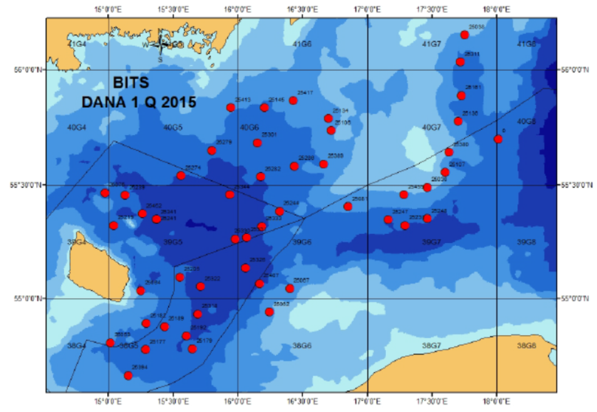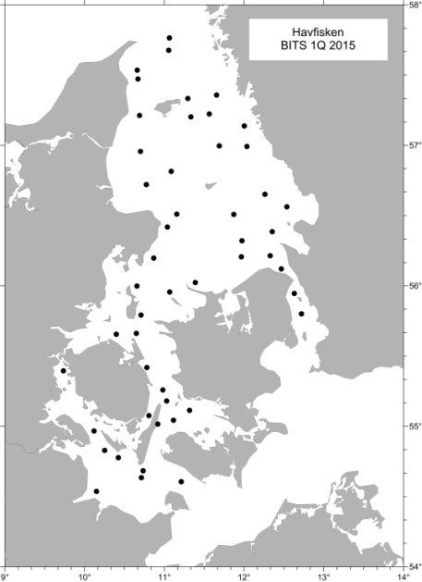
Fig. 1G.1: BITS Q1 Bottom trawl and CTD stations a) RV Dana in ICES area 3d and b) RV Havfisken in areas 3aS, 3b and 3c.
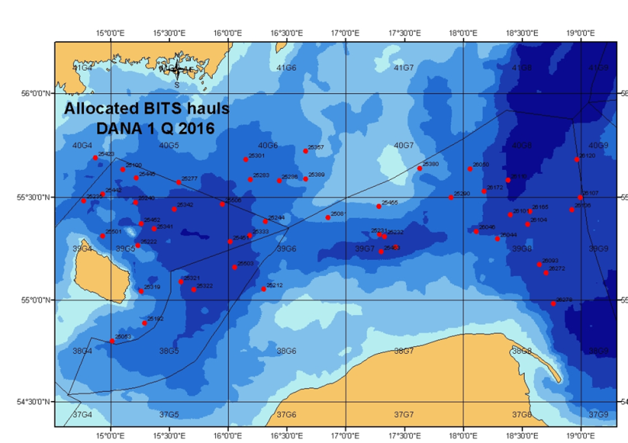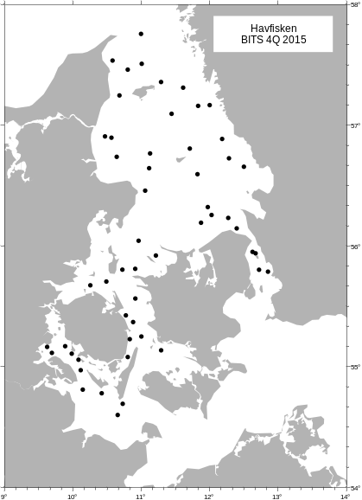
Fig. 1G.2: BITS Q4 Bottom trawl and CTD stations a) RV Dana in ICES area 3d and b) RV Havfisken in areas 3aS, 3b and 3c.

3. For internationally coordinated surveys, describe the participating Member States/ vessels and the relevant international group in charge of planning the survey
Eight countries are participating in BITS survey: Denmark, Germany, Poland, Sweden, Latvia, Lithuania, Estonia and Russia. The planning and coordination is done by ICES WGBIFS.
4. Where applicable, describe the international task-sharing (physical and/or financial) and the cost-sharing agreement used
-
5. Explain where thresholds apply
-
(max. 450 words per survey)
- Graphical representation (map) showing the positions (locations) of the realized samples.
Member State shall provide maps presenting the spatial distribution of the main sampling types obtained during the survey.

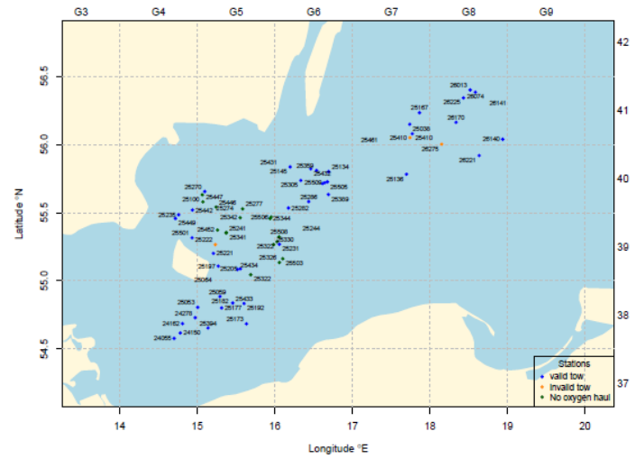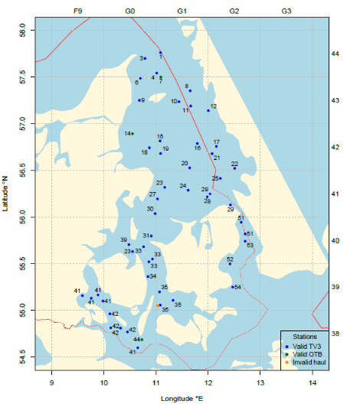

Achieved sampling during BITS Q1 with RV Dana and RV Havfisken in 2018.
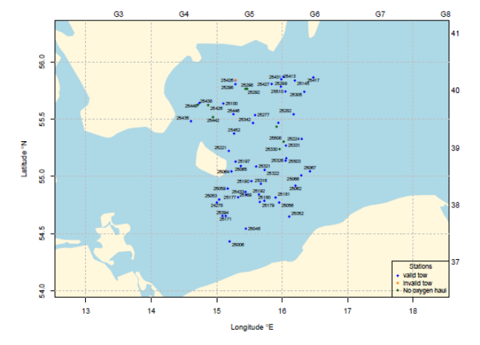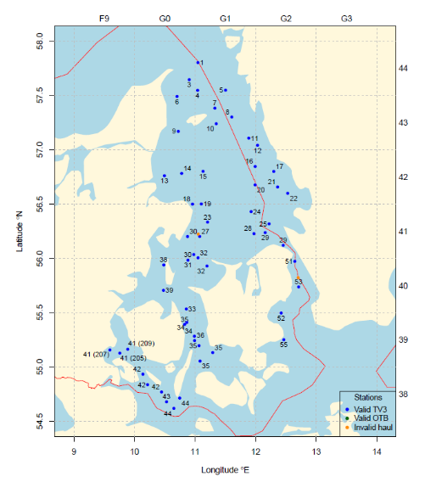
Achieved sampling during BITS Q4 with RV Dana and RV Havfisken in 2018.

- For internationally coordinated surveys, provide a link to the latest meeting report of the coordination group.
Member State shall provide a hyperlink to the meeting report from the body coordinating the survey (ICES, MEDITS coordination group, MEDIAS coordination group etc.). For non-international coordinated surveys, Member State shall refer to any status report (e.g. Cruise report).

The latest report which also describes the main use of the results is found at: http://ices.dk/sites/pub/Publication%20Reports/Expert%20Group%20Report/EOSG/2019/WGBIFS/WGBIFS%20report%202019.pdf

- List the main use of the results of the survey (e.g. indices, abundance estimates, environmental indicators).
Member State shall specify in which context the results are used (on routine basis), both on an international as well as on a national context.

Indices and environmental indicators

9. Extended comments (Tables 1G and 1H)
If the Member State has extended AR Comments, these can be placed under this section. If this is the case, a reference to this text box should be provided in the corresponding tables.

-
(max. 450 words persurvey)

International Bottom Trawl Survey (IBTS Q1, IBTS Q3)
- Objectives of the survey

The main objectives of the North Sea IBTS are:
- To determine the distribution and relative abundance of pre‐recruits of the main commercial species with a view of deriving recruitment indices;
- To monitor changes in the stocks of commercial fish species independently of commercial fisheries data;
- To monitor the distribution and relative abundance of all fish species and selected invertebrates;
- To collect data for the determination of biological parameters for selected species;
- To collect hydrographical and environmental information;
- To determine the abundance and distribution of late herring larvae (February North Sea survey).

- Description of the methods used in the survey. For mandatory surveys, link to the manuals. Include a graphical representation (map)

The sampling procedures are described in:
http://www.ices.dk/sites/pub/Publication%20Reports/ICES%20Survey%20Protocols%20(SISP)/SISP%2010%20-%20Manual%20for%20the%20International%20Bottom%20Trawl%20Surveys%20-%20Revision%20IX.pdf.
for the trawl catches, and:
http://www.ices.dk/sites/pub/Publication%20Reports/ICES%20Survey%20Protocols%20(SISP)/SISP%202%20MIK2.pdf.
for the sampling of herring larvae. However, both manuals are currently under revision to adopt changes implemented in the most recent years.

The survey area allocated to Denmark is shown in Fig. 1G.3 and Fig. 1G4. However, area and station allocation may change between years depending on agreements of the international coordination group.
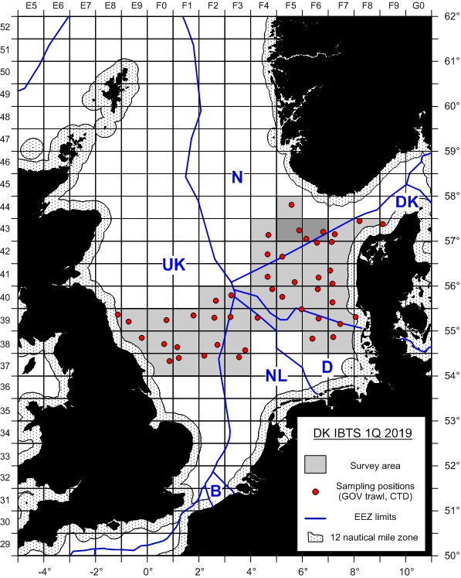
Fig. 1G.3: IBTS Q1 survey area for RV Dana in ICES areas 3a, 4a and 4b (2 MIK stations per rectangle for collecting herring and sprat larvae are not shown on the map).
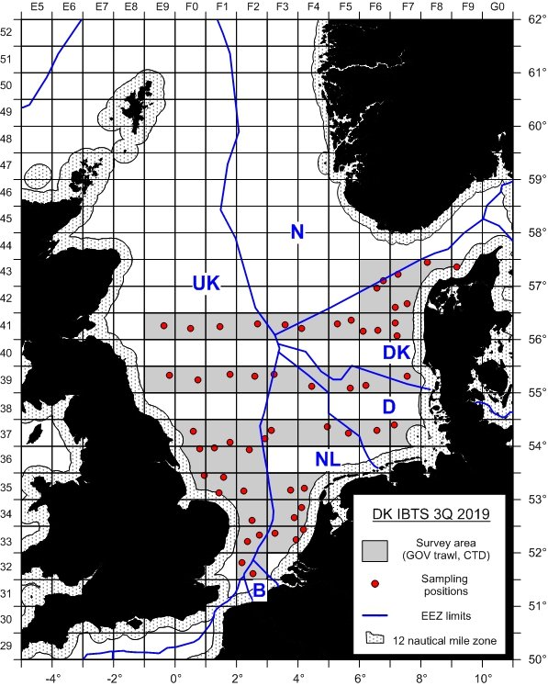
Fig. 1G.4: IBTS Q4 survey area for RV Dana in ICES areas 3a, 4a and 4b.

- For internationally coordinated surveys, describe the participating Member States/ vessels and the relevant international group in charge of planning the survey

Seven countries (Denmark, France, Germany, Netherlands, Norway, Scotland, Sweden) are participating in the North Seas IBTS Q1 and six countries (Denmark, England, Germany, Norway, Scotland, Sweden) are participating in the North Sea IBTS Q3. The planning and coordination is done by ICES IBTSWG.

- Where applicable, describe the international task-sharing (physical and/or financial) and the cost-sharing agreement used

- Explain where thresholds apply
-

(max. 450 words per survey)

- Graphical representation (map) showing the positions (locations) of the realized samples.
Member State shall provide maps presenting the spatial distribution of the main sampling types obtained during the survey.

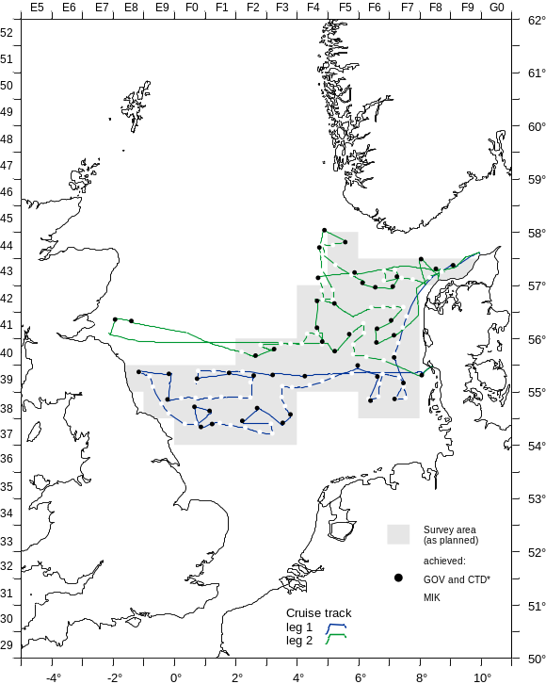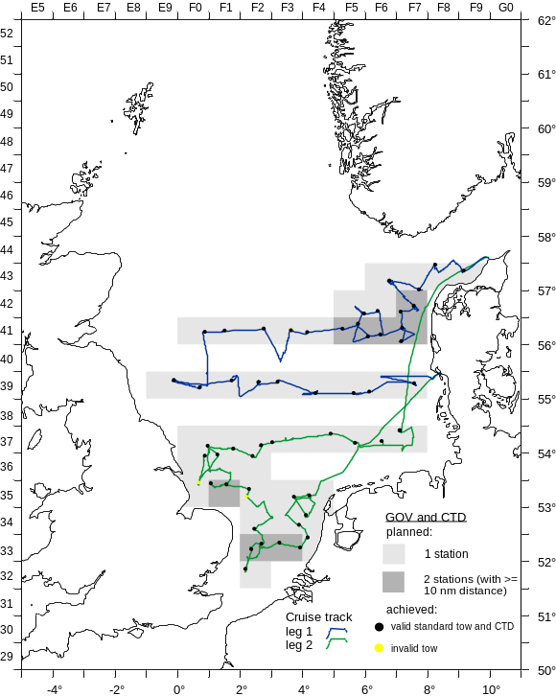

Achieved sampling during IBTS Q1 and Q3 with RV Dana in 2018.

- For internationally coordinated surveys, provide a link to the latest meeting report of the coordination group.
Member State shall provide a hyperlink to the meeting report from the body coordinating the survey (ICES, MEDITS coordination group, MEDIAS coordination group etc.). For non-international coordinated surveys, Member State shall refer to any status report (e.g. Cruise report).
The latest report which also describes the main use of the results is found at:
http://ices.dk/sites/pub/Publication%20Reports/Expert%20Group%20Report/EOSG/2018/IBTSWG/IBTSWG%20Report%202018.pdf for Q1 2018 and
http://ices.dk/sites/pub/Publication%20Reports/Expert%20Group%20Report/EOSG/2019/IBTSWG/IBTSWG%20Report%202019.pdf for Q3 2018.

- List the main use of the results of the survey (e.g. indices, abundance estimates, environmental indicators).
Member State shall specify in which context the results are used (on routine basis), both on an international as well as on a national context.

Indices, environmental indicators

9. Extended comments (Tables 1G and 1H)
If the Member State has extended AR Comments, these can be placed under this section. If this is the case, a reference to this text box should be provided in the corresponding tables.
-
(max 450 words per survey)

North Sea Sandeels Survey (NSSS)

- Objectives of the survey

Objective of the survey is to Improve the scientific advice on sandeel and it provides the basis for setting a preliminary index for the sandeel fishery for the coming year. Data from the dredge survey is the basis for calculating a 0-group index, which is used in stock assessment. The survey is conducted with a commercial fishing vessel.

- Description of the methods used in the survey. For mandatory surveys, link to the manuals. Include a graphical representation (map)

The sampling of sandeels is conducted with a modified scallop dredge and sediment samples are taken with a Van Veen grab. The sampling locations are shown in Fig. 1G.5.

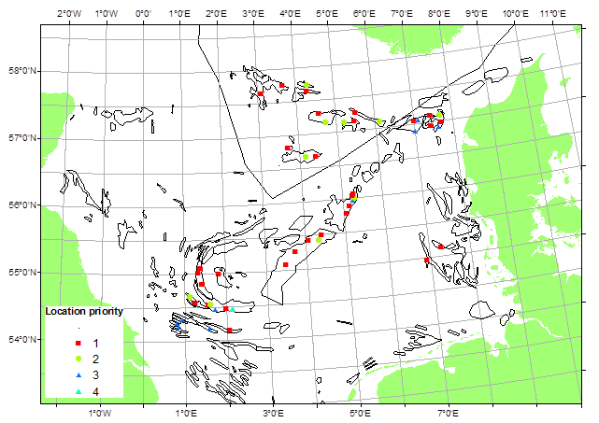
Fig. 1G.6: Danish sandeel survey sampling locations in area 4a and 4b.

Planning is done on a national level.

- For internationally coordinated surveys, describe the participating Member States/ vessels and the relevant international group in charge of planning the survey
-

- Where applicable, describe the international task-sharing (physical and/or financial) and the cost-sharing agreement used
-

- Explain where thresholds apply
-

(max. 450 words per survey)

- Graphical representation (map) showing the positions (locations) of the realized samples.
Member State shall provide maps presenting the spatial distribution of the main sampling types obtained during the survey.

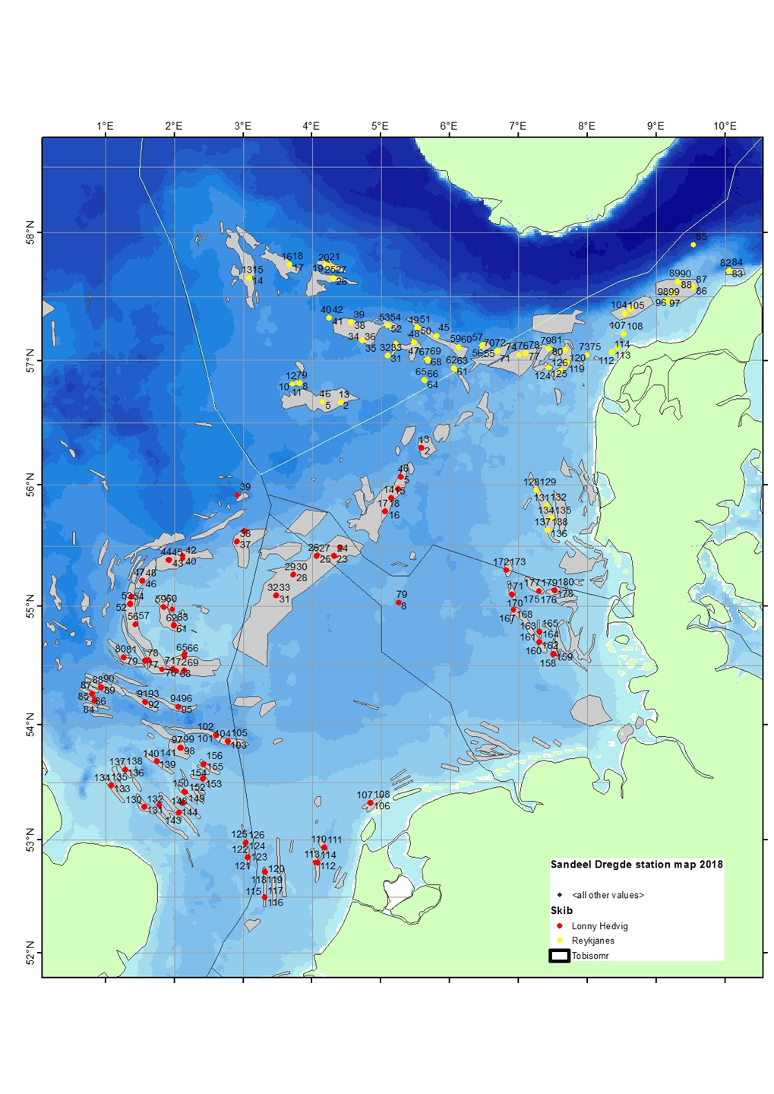
Achieved sampling during the Danish sandeel survey in 2018.

- For internationally coordinated surveys, provide a link to the latest meeting report of the coordination group.
Member State shall provide a hyperlink to the meeting report from the body coordinating the survey (ICES, MEDITS coordination group, MEDIAS coordination group etc.). For non-international coordinated surveys, Member State shall refer to any status report (e.g. Cruise report).
-
- List the main use of the results of the survey (e.g. indices, abundance estimates, environmental indicators).
Member State shall specify in which context the results are used (on routine basis), both on an international as well as on a national context.

The survey results are presented to ICES WGNSSK.

9. Extended comments (Tables 1G and 1H)
If the Member State has extended AR Comments, these can be placed under this section. If this is the case, a reference to this text box should be provided in the corresponding tables.
-
(max 450 words per survey)

International Ecosystem Survey in the Nordic Seas (ASH; alternative abbr. IESNS)

- Objectives of the survey
This survey is carried out in order to investigate distribution and migrations of the Atlanto-Scandian herring, blue whiting and other pelagic fish and to produce a biomass index for herring and a recruitment index for blue whiting for the ICES Working Group on Widely Distributed stocks (ICES WGWIDE). Furthermore, hydrographic conditions and plankton abundance in the Norwegian Sea and adjacent waters are monitored in order to investigate distribution and migration of herring and other pelagic fishes are influenced by environmental conditions.

- Description of the methods used in the survey. For mandatory surveys, link to the manuals. Include a graphical representation (map)

Acoustics, pelagic trawl

The sampling procedures are described in:
http://www.ices.dk/sites/pub/Publication%20Reports/ICES%20Survey%20Protocols%20(SISP)/SISP%209%20Manual%20for%20International%20Pelagic%20Surveys%20(IPS).pdf
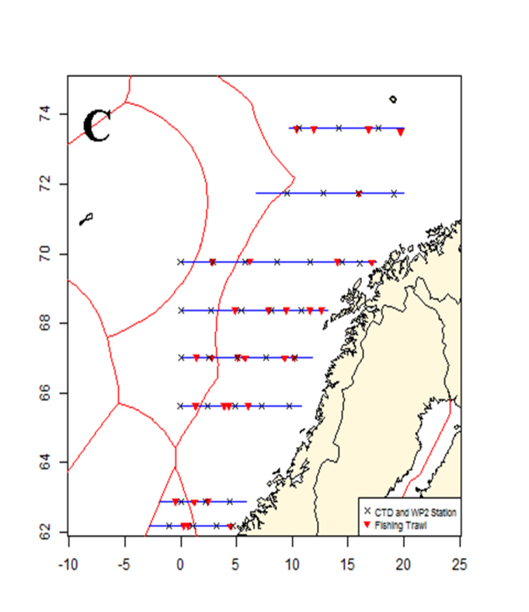

Fig. 1G.6: Survey area allocated to Denmark

- For internationally coordinated surveys, describe the participating Member States/ vessels and the relevant international group in charge of planning the survey

The survey is coordinated with Norway as an international survey with participation of Norway, Iceland, Faroe Islands and EU, where the Danish R/V Dana conducted the EU survey part. Planning and coordination is done by ICES WGIPS.

- Where applicable, describe the international task-sharing (physical and/or financial) and the cost-sharing agreement used

The task sharing is in accordance with agreements made at the RCM NS&EA 2014 where MS having a quota share of NSSH more than 5% of the EU quota are cost sharing the vessel cost and are supporting by scientific crew in accordance to this cost sharing model.

- Explain where thresholds apply

-

(max. 450 words per survey)
- Graphical representation (map) showing the positions (locations) of the realized samples.
Member State shall provide maps presenting the spatial distribution of the main sampling types obtained during the survey.

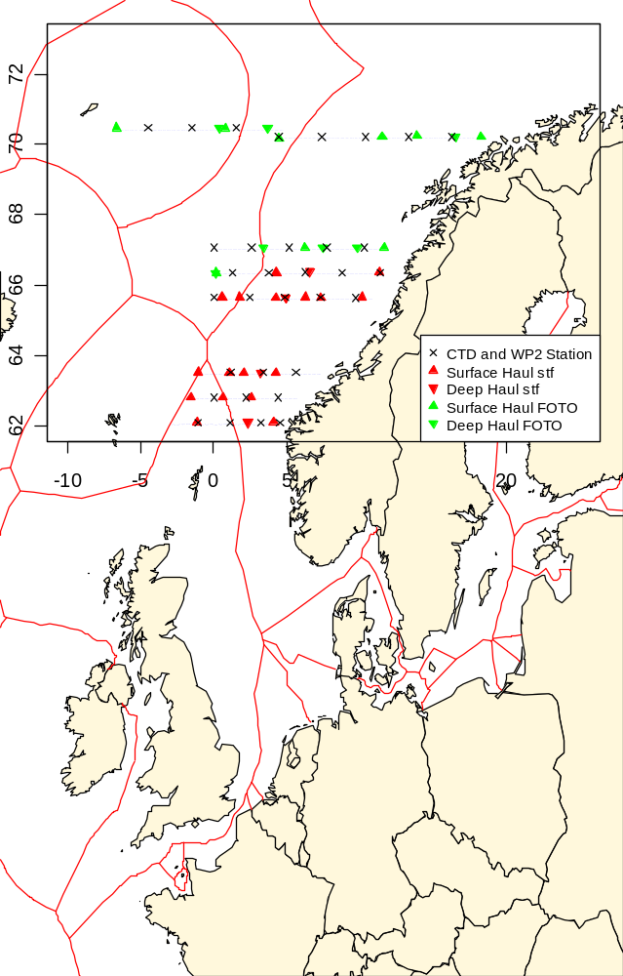

Achieved sampling during the ASH/IESNS with Dana in 2018.

- For internationally coordinated surveys, provide a link to the latest meeting report of the coordination group.
Member State shall provide a hyperlink to the meeting report from the body coordinating the survey (ICES, MEDITS coordination group, MEDIAS coordination group etc.). For non-international coordinated surveys, Member State shall refer to any status report (e.g. Cruise report).
The latest report which also describes the main use of the results is found at:
http://ices.dk/sites/pub/Publication%20Reports/Expert%20Group%20Report/EOSG/2019/WGIPS%20report%202019.pdf

- List the main use of the results of the survey (e.g. indices, abundance estimates, environmental indicators).
Member State shall specify in which context the results are used (on routine basis), both on an international as well as on a national context.

Indices, environmental indicators

9. Extended comments (Tables 1G and 1H)
If the Member State has extended AR Comments, these can be placed under this section. If this is the case, a reference to this text box should be provided in the corresponding tables.
-
(max 450 words per survey)

NS Herring Acoustic Survey (NHAS)

- Objectives of the survey

The purpose of the survey is to provide acoustic abundance estimates of herring and sprat in the North Sea (eastern part), Skagerrak and Kattegat.

- Description of the methods used in the survey. For mandatory surveys, link to the manuals. Include a graphical representation (map)

Acoustics, pelagic and bottom trawling

The sampling procedures are described in:
http://www.ices.dk/sites/pub/Publication%20Reports/ICES%20Survey%20Protocols%20(SISP)/SISP%209%20Manual%20for%20International%20Pelagic%20Surveys%20(IPS).pdf.

The survey area allocated to Denmark is shown in Fig. 1G.10.
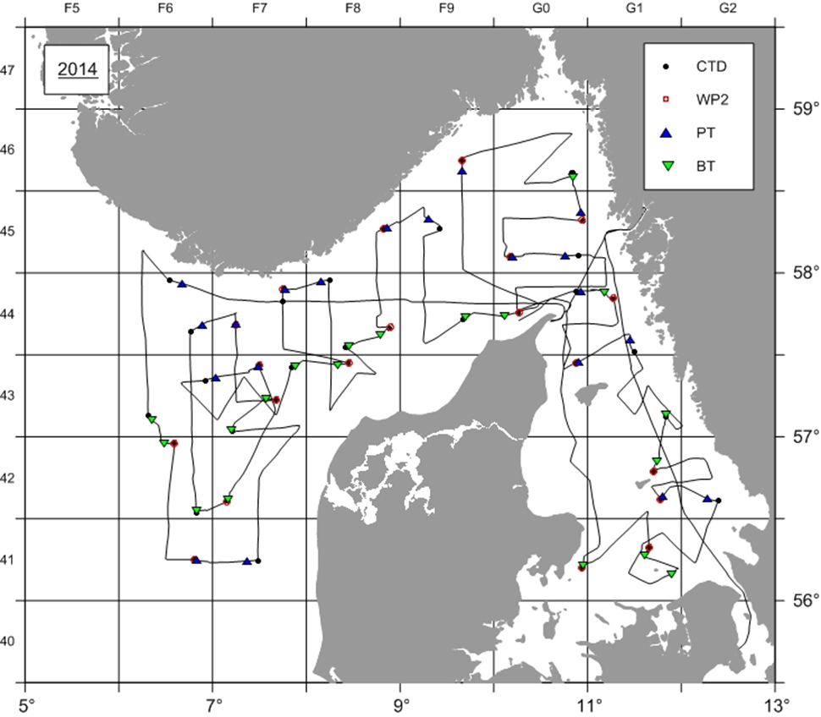
Fig. 1G7: RV Dana NHAS survey area.

- For internationally coordinated surveys, describe the participating Member States/ vessels and the relevant international group in charge of planning the survey

The survey is coordinated by the ICES Working Group for International Pelagic Surveys, WGIPS, and is a part of the international acoustic survey of the North Sea and adjacent areas which are covered by Germany, Ireland, the Netherlands, Norway and Scotland.

- Where applicable, describe the international task-sharing (physical and/or financial) and the cost-sharing agreement used
-

- Explain where thresholds apply
-

(max. 450 words per survey)
- Graphical representation (map) showing the positions (locations) of the realized samples.
Member State shall provide maps presenting the spatial distribution of the main sampling types obtained during the survey.

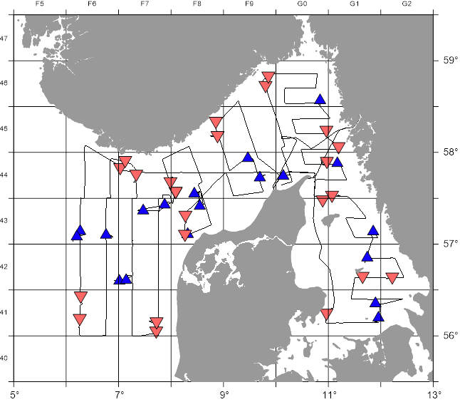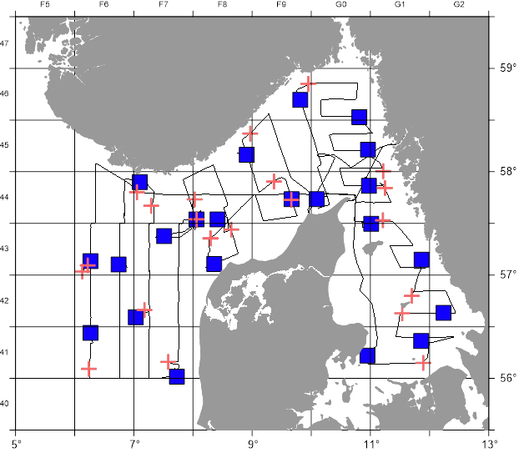

Achieved sampling during the NHAS with Dana in 2018 (red: pelagic trawl, blue: bottom trawl, black squares CTD and WP2, X: CTD).

- For internationally coordinated surveys, provide a link to the latest meeting report of the coordination group.
Member State shall provide a hyperlink to the meeting report from the body coordinating the survey (ICES, MEDITS coordination group, MEDIAS coordination group etc.). For non-international coordinated surveys, Member State shall refer to any status report (e.g. Cruise report).
The latest report which also describes the main use of the results is found at: http://ices.dk/sites/pub/Publication%20Reports/Expert%20Group%20Report/EOSG/2019/WGIPS%20report%202019.pdf

- List the main use of the results of the survey (e.g. indices, abundance estimates, environmental indicators).
Member State shall specify in which context the results are used (on routine basis), both on an international as well as on a national context.

Indices, environmental indicators

9. Extended comments (Tables 1G and 1H)
If the Member State has extended AR Comments, these can be placed under this section. If this is the case, a reference to this text box should be provided in the corresponding tables.

The realized sailed distance with echo integration is as allocated to Denmark. The value is considerably lower than given in the NP. This has always been the case in the present period and the NP for 2019 has been corrected.
(max 450 words per survey)

Nephrops TVsurvey in FU 3 & 4 (NTV3&4)

- Objectives of the survey

The purpose of the survey is to estimate the abundance of Norway lobster (Nephrops norwegicus) in the Skagerrak and the Kattegat (Functional units 3 and 4).

- Description of the methods used in the survey. For mandatory surveys, link to the manuals. Include a graphical representation (map)

An underwater video technique is used and later the video footage is analysed in laboratory to estimate the Nephrops abundance in selected subareas. The survey area allocated to Denmark is shown in Fig. 1G.8.

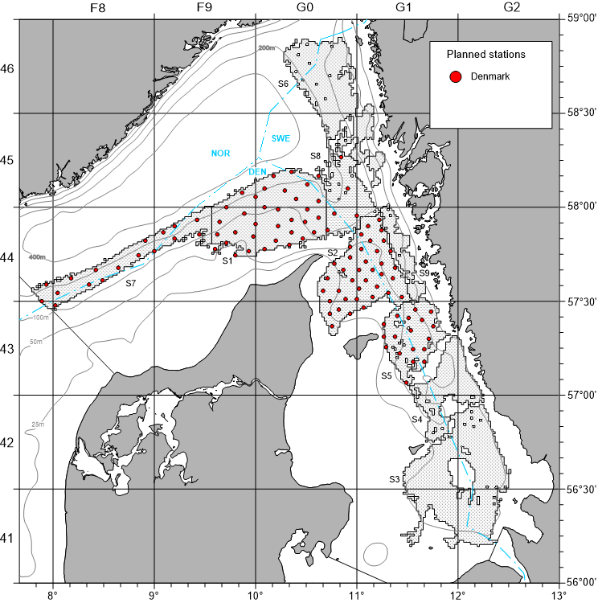

Fig. 1G.8: NTV3&4 sampling locations covered by Denmark with RV Havfisken in area 3a (Strata S3, S4, S6 and S9 are currently allocated to Sweden).

- For internationally coordinated surveys, describe the participating Member States/ vessels and the relevant international group in charge of planning the survey

Survey planning and data analysis is conducted in close cooperation with Sweden and coordinated by ICES WGNEPS.

- Where applicable, describe the international task-sharing (physical and/or financial) and the cost-sharing agreement used

-

- Explain where thresholds apply

-

(max. 450 words per survey)
- Graphical representation (map) showing the positions (locations) of the realized samples.
Member State shall provide maps presenting the spatial distribution of the main sampling types obtained during the survey.

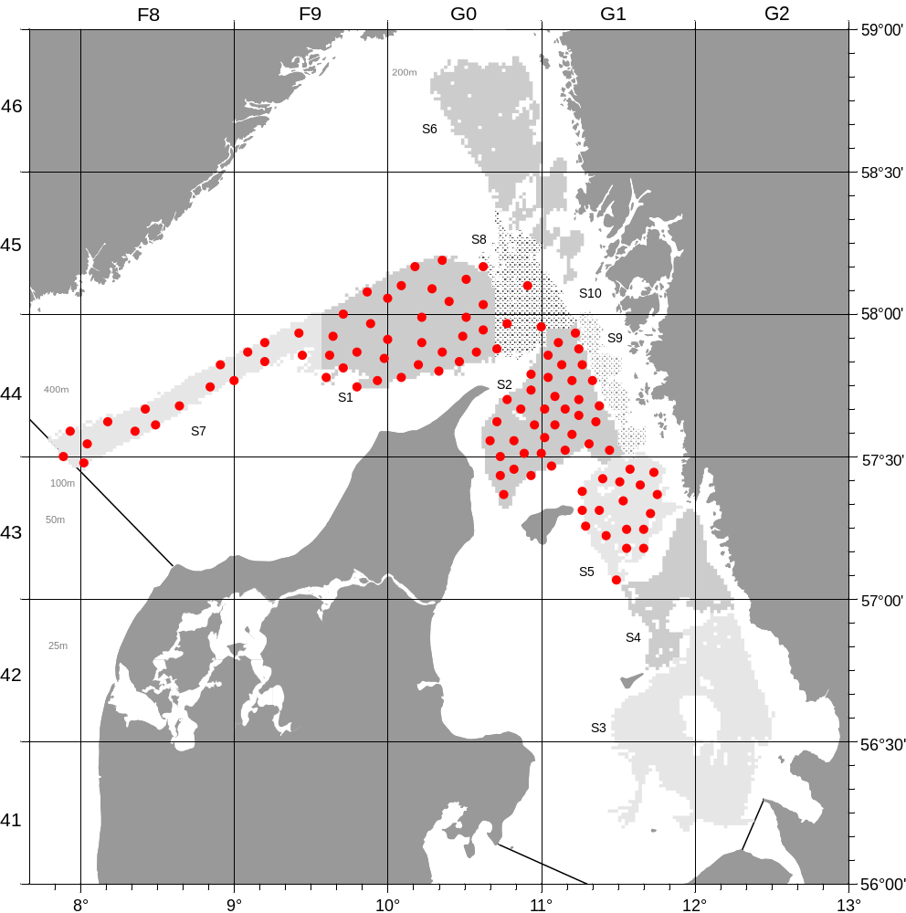

Achieved sampling during the Danish NTV3&4 survey with RV Havfisken in 2018.

- For internationally coordinated surveys, provide a link to the latest meeting report of the coordination group.
Member State shall provide a hyperlink to the meeting report from the body coordinating the survey (ICES, MEDITS coordination group, MEDIAS coordination group etc.). For non-international coordinated surveys, Member State shall refer to any status report (e.g. Cruise report).
The latest report which also describes the main use of the results is found at:
http://www.ices.dk/sites/pub/Publication%20Reports/Expert%20Group%20Report/EOSG/2018/WGNEPS/WGNEPS%20report%202018.pdf
- List the main use of the results of the survey (e.g. indices, abundance estimates, environmental indicators).
Member State shall specify in which context the results are used (on routine basis), both on an international as well as on a national context.

The combined survey results from Denmark and Sweden are used for stock assessment by ICES WGNSSK.

9. Extended comments (Tables 1G and 1H)
If the Member State has extended AR Comments, these can be placed under this section. If this is the case, a reference to this text box should be provided in the corresponding tables.

(max 450 words per survey)

Flatfish survey in the Kattegat and Skagerrak (FFS)

- Objectives of the survey

Objective of the survey is to establish a time series of catch and effort data independent of the commercial fishery for sole and plaice in the Kattegat and Skagerrak. The survey has been initiated in 2004 and provides currently the main input data set for the 3a sole assessment.

- Description of the methods used in the survey. For mandatory surveys, link to the manuals. Include a graphical representation (map)

Bottom trawling

The survey area is indicated in Fig. 1G.9.
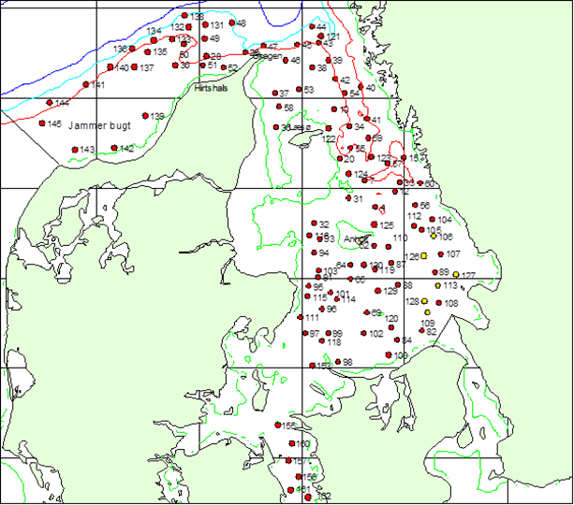
Fig. 1G.9: Survey area and provisional station allocation for the flatfish survey with RV Havfisken in area 3a.

Planning occurs on a national level.

- For internationally coordinated surveys, describe the participating Member States/ vessels and the relevant international group in charge of planning the survey
-

- Where applicable, describe the international task-sharing (physical and/or financial) and the cost-sharing agreement used
-

- Explain where thresholds apply

-

(max. 450 words per survey)
- Graphical representation (map) showing the positions (locations) of the realized samples.
Member State shall provide maps presenting the spatial distribution of the main sampling types obtained during the survey.

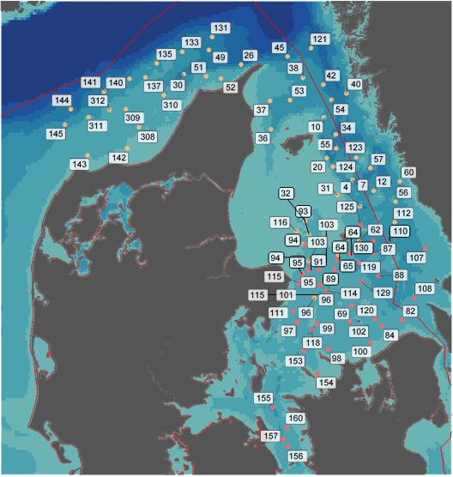
Achieved sampling during the Danish FSS with RV Havfisken and SG50 in 2018.

- For internationally coordinated surveys, provide a link to the latest meeting report of the coordination group.
Member State shall provide a hyperlink to the meeting report from the body coordinating the survey (ICES, MEDITS coordination group, MEDIAS coordination group etc.). For non-international coordinated surveys, Member State shall refer to any status report (e.g. Cruise report).
-

- List the main use of the results of the survey (e.g. indices, abundance estimates, environmental indicators).
Member State shall specify in which context the results are used (on routine basis), both on an international as well as on a national context.

Indices

The survey results are provided to WGBFAS in form of a working document and are used for the assessment of the sole stock in area 3a.

9. Extended comments (Tables 1G and 1H)
If the Member State has extended AR Comments, these can be placed under this section. If this is the case, a reference to this text box should be provided in the corresponding tables.

(max 450 words per survey)

Nephrops TVsurvey in FU 33 (NTV33)

- Objectives of the survey

The purpose of the survey is to estimate the abundance of Nephrops off Horns Rev (Functional unit 33). The survey is new and so far no fishery-independent information exists for this area.

- Description of the methods used in the survey. For mandatory surveys, link to the manuals. Include a graphical representation (map)

An underwater video technique is used and later the video footage is analysed in laboratory to estimate the Nephrops abundance. The survey area is indicated in Fig. 1G.10.
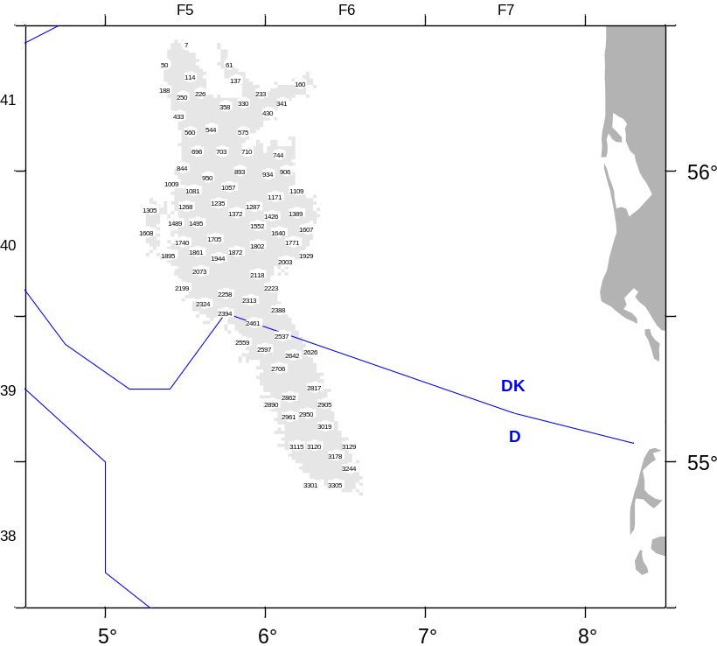
Fig. 1G.10: NTV33 survey area to be covered by Denmark with RV Havfisken in area 4b.

Planning occurs on a national level. Survey designed, data analysis and quality of the abundance estimates of Nephrops are checked and reported by ICES WGNEPS.

- For internationally coordinated surveys, describe the participating Member States/ vessels and the relevant international group in charge of planning the survey

-

- Where applicable, describe the international task-sharing (physical and/or financial) and the cost-sharing agreement used

-

- Explain where thresholds apply

-

(max. 450 words per survey)
- Graphical representation (map) showing the positions (locations) of the realized samples.
Member State shall provide maps presenting the spatial distribution of the main sampling types obtained during the survey.

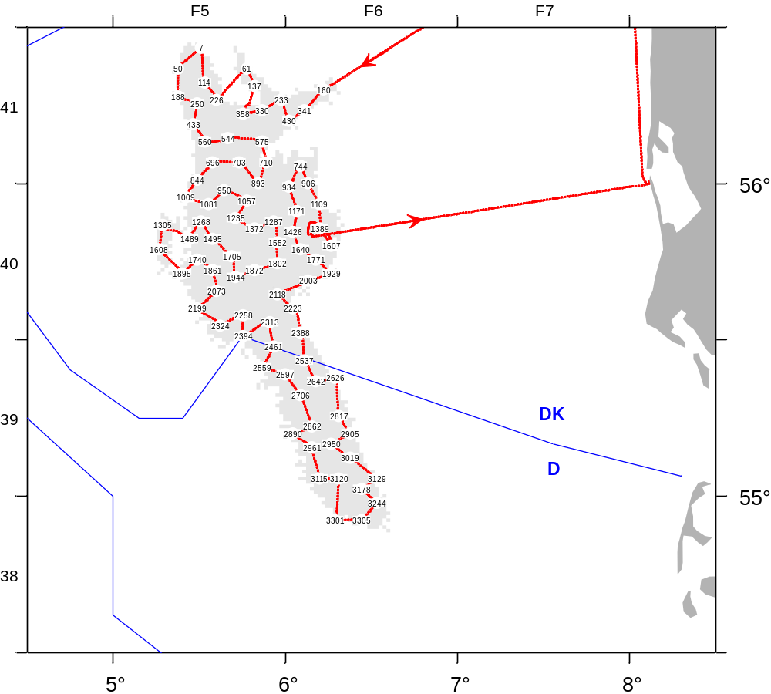

Achieved sampling during the Danish NTV33 survey with RV Havfisken in 2018 (Red line: cruise track).

- For internationally coordinated surveys, provide a link to the latest meeting report of the coordination group.
Member State shall provide a hyperlink to the meeting report from the body coordinating the survey (ICES, MEDITS coordination group, MEDIAS coordination group etc.). For non-international coordinated surveys, Member State shall refer to any status report (e.g. Cruise report).
-

- List the main use of the results of the survey (e.g. indices, abundance estimates, environmental indicators).
Member State shall specify in which context the results are used (on routine basis), both on an international as well as on a national context.

The latest report which also describes the main use of the results is found at:
http://www.ices.dk/sites/pub/Publication%20Reports/Expert%20Group%20Report/EOSG/2018/WGNEPS/WGNEPS%20report%202018.pdf

The survey results have recently been considered for stock assessment by ICES WGNSSK.

9. Extended comments (Tables 1G and 1H)
If the Member State has extended AR Comments, these can be placed under this section. If this is the case, a reference to this text box should be provided in the corresponding tables.

Reduced coverage due to poor weather and technical problems in 2017

(max 450 words per survey)

Cod survey in 3aS (CODS_Q4

1. Objectives

The survey is a combined Danish- Swedish fisherman-scientist survey. The goal of the Kattegat cod survey is to estimate the abundance, biomass and distribution of cod and to establish a fisheries independent time series of catch and effort series. Furthermore, a recruitment index is established. The results has for the first time in 2015 been used, together with commercial catch and effort data, to strengthen the scientific advice on the cod stock in Kattegat.

2. Methods and survey area

Initially, 4 commercial trawlers (2 Swedish and 2 Danish vessels) participated in the survey. In 2016, Sweden continued to use commercial vessel whereas Denmark used the new research vessel RV Havfisken but with the same trawl as previously on the commercial vessels.

In 2017, the Danish part of the survey was combined with the BITS Q4 survey but in the future it will be kept separate again to allow better overlap in the timing with the Swedish part of the survey. The survey area is shown in Fig. 1G.12.

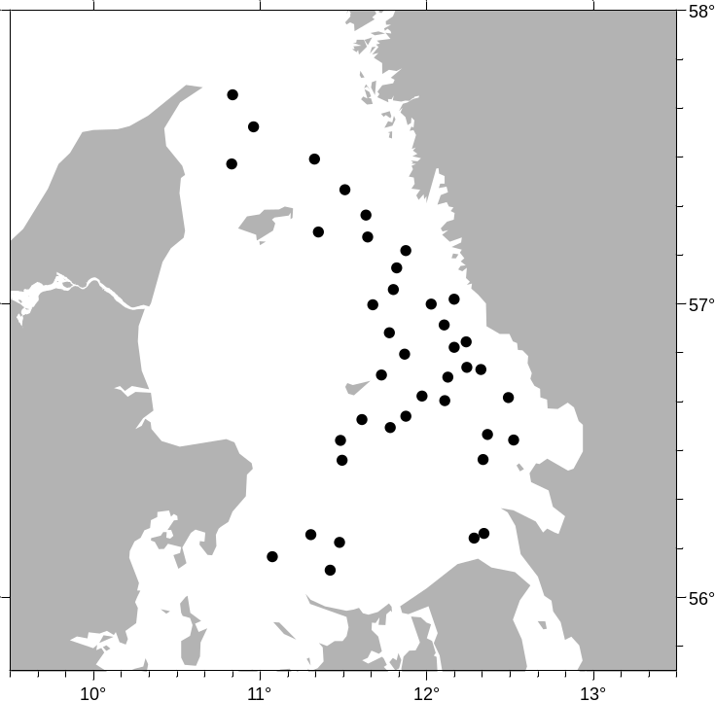

Fig. 1G.12: Area for the Danish CodS_Q4 survey with RV Havfisken.

3. Planning

Survey planning and data analysis is conducted in close cooperation with Sweden and the survey results are provided to WGBFAS.

4. Where applicable, describe the international task-sharing (physical and/or financial) and the cost-sharing agreement used

-

- Explain where thresholds apply

-

(max. 450 words per survey)
- Graphical representation (map) showing the positions (locations) of the realized samples.
Member State shall provide maps presenting the spatial distribution of the main sampling types obtained during the survey.

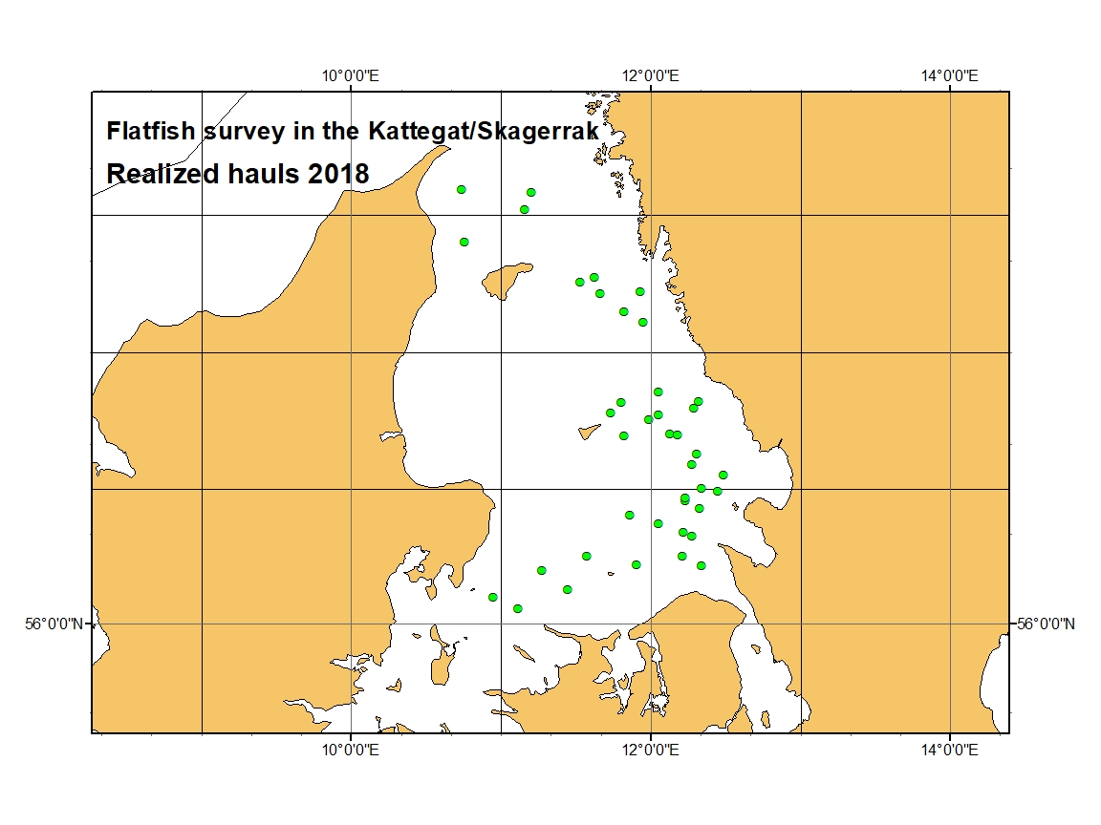

Achieved sampling during the Danish Danish CodS_Q4 survey with RV Havfisken in 2018.

- For internationally coordinated surveys, provide a link to the latest meeting report of the coordination group.
Member State shall provide a hyperlink to the meeting report from the body coordinating the survey (ICES, MEDITS coordination group, MEDIAS coordination group etc.). For non-international coordinated surveys, Member State shall refer to any status report (e.g. Cruise report).

- List the main use of the results of the survey (e.g. indices, abundance estimates, environmental indicators).
Member State shall specify in which context the results are used (on routine basis), both on an international as well as on a national context.

9. Extended comments (Tables 1G and 1H)
If the Member State has extended AR Comments, these can be placed under this section. If this is the case, a reference to this text box should be provided in the corresponding tables.

(max 450 words per survey)

Section 2: Fishing Activity Data

Text Box 2A: Fishing activity variables data collection strategy
General comment: This box fulfills paragraph 4 of Chapter III of the multiannual Union programme and Article 2, Article 4 paragraph (2) point (b) and Article 5 paragraph (2) of the Decision (EU) 2016/1701. It is intended to describe the method used to derive estimates on representative samples where data are not to be recorded under Regulation (EU) No 1224/2009 or where data collected under Regulation (EU) No 1224/2009 are not at the right aggregation level for the intended scientific use.
General comment: This box is applicable to the Annual Report. This box should provide information on the implementation of the data collection of fishing activity variables of Member States.
1. Description of methodologies used to cross-validate the different sources of data
Every night, logbooks, sales notes, fleet register and VMS data are transferred form the Danish Fisheries Agency to DTU Aqua via a secure FTP connection. Therefore these data are available immediately for data cheking and cross validating with the sampled data.
From at-sea sampling trips, the logbook sheet number is registered. Information from the observer trip can then be cross-validated with the data entered in the logbooks and the sales notes. From at market sampling, the vessel-id and the landing date is registered, and is used for cross-validating with sales notes and logbook data, e.g. if the gear, mesh size and ICES rectangle are correct of if information are missing.
2. Description of methodologies used to estimate the value of landings
The value of landings are taken from directly from the sales notes data register (census data). The sales notes are merged with the logbook data by trip and vessel register to estimate values of landings by e.g. gear.
3. Description of methodologies used to estimate the average price (it is recommended to use weighted averages, trip by trip)
Average prices can be calculated directly from the sales notes register as the sales notes are sensus..
4. Description of methodologies used to plan collection of the complementary data (sample plan methodology, type of data collected, frequency of collection etc)
As census data are collected, no additional data collection is needed.

5. Deviations from Work Plan methodology used to cross-validate the different sources of data
No deviations from work plan on methods to cross-validate different sources of data
6. Deviations from Work Plan methodology used to estimate the value of landings.
No deviations from work plan on methods to estimate the value of landings
7. Deviations from Work Plan methodology used to estimate the average price.
No deviations from work plan on methods to estimated the average price
8. Deviations from Work Plan methodology used to plan collection of the complementary data
No deviations from work plan on collection of complementary data.

Section 3: Economic and Social Data

Text Box 3A: Population segments for collection of economic and social data for fisheries
General comment: This box fulfils paragraph 5 points (a) and (b) of Chapter III of the multiannual Union programme and Article 2, Article 4 paragraphs (1), (2) and (5) and Article 5 paragraph (2) of the Decision (EU) 2016/1701. It is intended to specify data to be collected under Tables 5(A) and 6 of the multiannual Union programme.
General comment: This box is applicable to the Annual Report. This box should provide information on the implementation of the fleet socio-economic data collection of Member States.
1. Description of methodologies used to choose the different sources of data
Data on landings (sales notes, species, quantity and value), fishing vessels (type, size, etc.) fishing activity (logbook, days, gear and fishing area), and vessel owners (fishermen, fishing firms) are registered contiously during the year. During the first quarter of the year after recording the administrative registers are combined and corrected for mismatch and errors. At the beginning of April the Danish Agrifish Agency produces a final “freezed” version of the registered data, where all data for a vessel version (vessel with same owner) is combined and aggregated. The aggregated data is delivered to Statistics Denmark for statistical use. Thus information on fishing activity and production for the year is available for each vessel version, that is a vessel with the same owner/fisherman from date of purchase until sale/decommission. Statistics Denmark combines the vessel versions to form the production units, which is a “vessel” from january 1st to December 31st. These units constitute the total fishery population for the year.
Data on fishing rights is also registered. All transactions of ITQ’s (Individually Transferable Qouta) and VQS’s (Vessel Qouta Share) are registered by date and vessel identity on the Register on fishing rights. That information is used together with estimated shadow prices for each qouta stock to calculate the capital value of fishing rights for each production unit.
Economic data is collected by Statistics Denmark using a harmonized accounting form for fisheries.

2. Description of methodologies used to choose the different types of data collection
The legal entity/person responsible for economic data is the fisherman or fishing firm, who usually use an authorized accountant to produce their yearly account and balance. In order to get the most reliable economic data we confide in the fishermans accountant to complete the harmonized accouting form, and compensate her for the performance.

3. Description of methodologies used to choose sampling frame and allocation scheme
The entire population is segmented according to the DCMAP requirement (Supra region, Fishing technique, Length class) and each segment stratified into 7 groups on economic size. Group 0 (inactive) and 1 (revenue below threshold) are treated separately, as there are no accounts to be collected for these units.
For the units with yearly revenue below the threshold (=DKK 270,000) we do not have individual accounts. We use register information (vessel characteristics, gear, and species composition) to place the units below threshold into the relevant fleet segment. Then we use the value of landings (all landings are registered on the sales note register) to calculate a multiplier, which is used to adjust the economic variables for the segment that includes units below threshold.
For group 2 to 6, the commercially active vessels (about 550 production units), a sample of 275 accounts are collected on a voluntary basis. The sample is not stocastically drawn from the stratified publication, because most the bigger companies have great variation in economic terms which makes it difficult to represent them by other companies. We get a better sample by using a panel which consists of the 100 biggest production units plus a representativ sample of the rest of the population. About 10 per cent of the sample is renewed each year.
The large sample, about half of the units in the population over the threshold, covers more than 80% of the total revenue, which means that estimation of cost etc. is limited to less than 20% of the production. For the year 2017 the 272 accounts in the sample had a total revenue of 383 Mio Euro, which was 87 per cent of the total value of landings for Danish fishery in 2017.

4. Description of methodologies used for estimation procedures
Individual accounts are simulated for each unit in the population that is not in the sample. These simulations are done by selection of one to three “donors” from the sampled accounts, that are valuated to be best possible replacement for the simulated unit, and calibrate the average of the one to three selected matching units, to equal the registered revenue of the simulated unit.
The simulations are performed using a BANFF MASSIMPUTATION model in SAS. Donors are matched according to known registered data for catches on selected species, crew size, engine power and days at sea in Ices III and Ices IV. Some accounts for units in the sample that had extraordinary events during the year may be excluded from the basis for simulation.

5. Description of methodologies used on data quality
The most important quality check lies in the scrutinized analysis of the individual accounts for each production unit. All variables have to be right to balance the account correctly. Also the contents of all variables are assessed and evaluated by comparing with related variables and last years account for the same unit.

(max 900 words per Region)
6. Deviations from Work Plan methodology for selection of data source
No deviations from the Work Plan.
7. Deviations from Work Plan methodology to choose type of data collection
No deviations from the Work Plan.
8. Deviations from Work Plan methodology regarding sampling frame and allocation scheme
No deviations from the Work Plan.
9. Deviations from Work Plan methodology used for estimation procedures
No deviations from the Work Plan.
10. Quality assurance
10.1 Sound methodology
The Danish data collection follow methodologies, guidelines and best practices agreed in expert groups.
10.2. Accuracy and reliability
Data collection method and validation etc. can be found at:
https://www.dst.dk/en/Statistik/dokumentation/documentationofstatistics/account-statistics-for-fishery
Response rate and Achieved sample rate are provided in Table 3A.
10.3. Accessibility and Clarity
Are methodological documents publicly available? Yes
Are data stored in databases? Yes
Where can methodological and other documentation be found?
Provide the web link, if documentation is publicly available
https://www.dst.dk/en/Statistik/dokumentation/documentationofstatistics/account-statistics-for-fishery

(max 1000 words)

Section 3: Economic and Social Data

Pilot Study 3: Data on employment by education level and nationality
General comment: This box fulfills paragraph 5 point (b) and paragraph 6 point (b) of Chapter III of the multiannual Union programme and Article 2 and Article 3 paragraph (3) point (c) of the Decision (EU) 2016/1701.It is intended to specify data to be collected under Table 6 of the multiannual Union programme.
General comment: This box is applicable to the Annual Report. This box is intended to provide information on the results obtained from the implementation of the pilot study (including deviations from planned and justifications as to why if this was not the case).
1. Aim of pilot study
To fulfil the requirements of the Commission decision (EU) 2016/1701 of 19. August 2016 by collecting data on employment in fisheries by education level and nationality.
2. Duration of pilot study
About 200 working hours during 2018.
3. Methodology and outcomes of pilot study
The first step in the pilot study was to analyse to what extent the existing social data collected by education and labour market surveys could fulfil the requirements for DCMAP social variables for the people working in fishery and aquaculture. We could establish that the specifications for all DCMAP social variables was in agreement with the already used specifications for education level, employment status, nationality, gender and age in the existing programme for data collecting to the registers on Educational attainment and Employed persons. Thus we realized that Statistics Denmark could not initiate a sampling on data which already has been collected for labour force statistics and educational statistics.
The data collected on employment, education and Socio-economic status is compiled annually into a comprehensive register, the Labour Market Account (LMA), which contains information on the entire population’s labour market status. The LMA register is ready for analysis 14 months after the end of the year. Therefore the DCMAP social data pilot study was performed using data for 2016, as the 2017 data would not be accessible before the end of February 2019.
Step two was to extract the relevant data for the fishery, aquaculture and the fish processing sectors from the LMA and match each unit in these branches with the enterprises in the DCMAP population. In Denmark we have an official register on all enterprises, which means all firms and commercially active persons has a CVR-number (Central Virksomheds/company Register). As many “firms” have more than one CVR-number, it was a labour-intensive task to match all units correctly, but when the work was done for the first year (2016) it was much easier to perform for the next year, when we prepared the 2017 data for the Fleet Economic Report in March 2019.
Third step was to filter the data extracted from the LMA. The unit on the LMA is individual persons identified by CPR-numbers (Central Persons Register) and connected to firms CVR-numbers (and even work places by SE-numbers). Some of the firms in fishery or aquaculture may also be involved in work in other branches, so the persons engaged in other line of work was excluded from the DCMAP statistics. Also the data is checked for persons working in several fishing firms during the year to avoid double counting.
The final step to prepare the data for DCMAP was to compile the variables according to the categories and grouping in the DCMAP. All variables on education level, employment status, nationality, gender and age are recoded straightforward, as the standard code on the LMA is more detailed than the DCMAP level.
The grouping on small and large scale fleet (SSF/LSF) is also straightforward as there are no firms with vessels both in SSF and LSF. It would be more challenging to categorize by fleet segmentation (vessel length and fishing technique), as some fishing firms have vessels in different fleet segments, and their employees can work on several vessels during the year.
(max 900 words)
4. Achievement of the original expected outcomes of pilot study and justification if this was not the case.
The pilot study showed that the use of the LMA register in combination with the statistical units in the DCMAP statistics is rational way to enhance the outcome of the Fleet economic and aquaculture statistic for DCMAP.

5. Incorporation of results from pilot study into regular sampling by the Member State.
The existing data collection on Education and Employment status should be used when aquaculture and fleet economic data should be combined with data on socio economic status for the labour force.

(max 900 words)

Section 3: Economic and Social Data

Text Box 3B: Population segments for collection of economic and social data for aquaculture
General comment: This box fulfills paragraph 6 points (a) and (b) of Chapter III of the multiannual Union programme and Article 2, Article 4 paragraphs (1) and (5) and Article 5 paragraph (2) of the Decision (EU) 2016/1701.It is intended to specify data to be collected under Tables 6 and 7 of the multiannual Union programme.

General comment: This box is applicable to the Annual Report. This box should provide information on the implementation of the socio-economic data collection for aquaculture of Member States.

1. Description of methodologies used to choose the different sources of data

Whenever register data are available for a variable these are preferred as they originate from a census type data collection scheme and contain information on all elements of the population. This is the case for the economic variables Gross sales and Weight of sales. All other economic variables are collected by Statistics Denmark by non probability sample survey using a harmonized accounting form for aquaculture enterprises.

2. Description of methodologies used to choose the different types of data collection
The economic variables Gross sales and Weight of sales are submitted mandatorily as they are also used for other statistical purposes. All other economic variables are collected on a voluntary basis. Theoretically a probability sample survey would be preferable, but as the population is quite small, particularly in some segments, all volunteers are accepted even though that results in a non probability sample survey.

3. Description of methodologies used to choose sampling frame and allocation scheme
The sampling frame consists of all commercially active aquaculture companies in Denmark. The population is allocated into segments by production method and produced species. This forms four internally homogenous segments and one smaller rest segment.

4. Description of methodologies used for estimation procedures
Register data are combined with the data obtained from the sampled accounts to estimate the value of the economic variables for companies that are not included in the sample. The stratified imputation based on linear regression enables us to impute complete accounts for all members of the population.

5. Description of methodologies used on data quality
The register data for Gross sales and Weight of sales and checked for outliers and compared to the data obtained from the sampled account sheets. The data for all other economic variables are submitted in balanced account sheets. This in it self constitutes a quality control, as the account sheets are not easily balanced if one or more values are reported falsely. Even so, the submitted accounts are checked for outliers in important variables. Accounts containing such outliers are then excluded from the basis for imputation of the missing accounts.

(max 1000 words)
6. Deviations from Work Plan methodology for selection of data source
No deviations from the Work Plan.
7. Deviations from Work Plan methodology to choose type of data collection
No deviations from the Work Plan.
8. Deviations from Work Plan methodology regarding sampling frame and allocation scheme
No deviations from the Work Plan.
9. Deviations from Work Plan methodology used for estimation procedures
No deviations from the Work Plan.
10. Quality assurance
10.1 Sound methodology
The Danish data collection follow methodologies, guidelines and best practices agreed in expert groups.
10.2. Accuracy and reliability
Response rate and Achieved sample rate are provided in Table 3B.
Data collection method and validation etc. can be found at:
https://www.dst.dk/en/Statistik/dokumentation/documentationofstatistics/accounts-statistics-for-aquaculture
10.3. Accessibility and Clarity
Are methodological documents publicly available? Yes
Are data stored in databases? Yes
Where can methodological and other documentation be found?
Provide the web link, if documentation is publicly available
https://www.dst.dk/en/Statistik/dokumentation/documentationofstatistics/accounts-statistics-for-aquaculture

(max 1000 words)

Section 3: Economic and Social Data

Pilot Study 4: Environmental data on aquaculture
General comment: This box fulfills paragraph 6 point (c) of Chapter III of the multiannual Union programme and Article 2 and Article 4 paragraph (3) point (d) of the Decision (EU) 2016/1701. It is intended to specify data to be collected under Table 8 of the multiannual Union programme.
General comment: This box is applicable to the Annual Report. This box is intended to provide information on the results obtained from the implementation of the pilot study (including deviations from planned and justifications as to why if this was not the case).
1. Aim of pilot study
To fulfil the requirements of the Commission decision (EU) 2016/1701 of 19. August 2016 by collecting environmental data on the aquaculture sector.

2. Duration of pilot study
Year 2018

3. Methodology and expected outcomes of pilot study
It was confirmed that the requested variables are available in administrative registers in the Danish Veterinary and Food Administration and the Danish Environmental Protection Agency.

(max 900 words)
4. Achievement of the original expected outcomes of pilot study and justification if this was not the case.

5. Incorporation of results from pilot study into regular sampling by the Member State.

(max 900 words)

Section 3: Economic and Social Data

Text Box 3C: Population segments for collection of economic and social data for the processing industry
General comment: This box fulfils footnote 6 of paragraph 1.1(d) of Chapter III of the multiannual Union programme, Article 2, Article 4 paragraphs (1) and (5) and Article 5 paragraph (2) of Decision (EU) 2016/1701. It is intended to specify data to be collected under Table 11 of the multiannual Union programme.
General comment: This box is applicable to the Annual Report. This box should provide information on the implementation of the socio-economic data collection for aquaculture of Member States.
1. Description of methodologies used to choose the different sources of data
The Danish fish processing sector consisted of approximately 100 enterprises employing 3000 workers in 2016. The enterprises are segmented on 3 segments in terms of size measured on employment, where 50% has less than 10 employees, and the last 50% is equally distributed on the segments with between 10-50 employees and 50-250 employees, respectively. The Danish fish processing industry is defined by the Business Register using NACE code 10.20. Enterprises engaging in fish processing in Denmark are highly specialized and cover more than 95% of the value and volume of fish processed in Denmark.
In order to avoid a duplication of data collection, data collected by Statistic Denmark is used as primary data. In collaboration with Statistics Denmark, data from the Industry Commodity Statistics and Account Statistics are combined to comply with the variables listed in Table 11 in European Commission (2016) EC 2016/1251 of 12 July 2016. The type of data collection used for collection of the economic data is all based on census.

2. Description of methodologies used to choose the different types of data collection
The already existing data collections by Statistic Denmark are well established and provide reliable and validated time series. Quality reports are available on the website of Statistics Denmark. To combine the different statistics to form groups of enterprises relying on different species for raw input, IFRO’s expertise from former work on this issue is used. The volume of raw material is not collected. The pilot study revealed that the industry is very reluctant to participate and that the expenses for the industry delivering these data would be very high, compared to the benefit of collecting these data. The data will only be collected if it becomes mandatory.

3. Description of methodologies used to choose sampling frame and allocation scheme
The Danish data collection covering the processing industry is based on data from the Account Statistics and the Industry Commodity Statistics collected by Statistics Denmark. In collaboration with Statistics Denmark, data from the Industrial Commodity- and Account Statistics are combined to make sure that all enterprises processing fish are covered by this data collection and to comply with the data variables listed in Table 11 in European Commission (2016) EC 2016/1251 of 12 July 2016.
The Account Statistic collected by Statistics Denmark are essentially aggregations of items of the annual accounts of business enterprises, notably items of the profit and loss account, the balance sheet and the statement of fixed assets. The accounts statistics are a reliable indicator of the activity level and of the structure of the Danish business sector. The highest data quality is achieved at the enterprise level, primarily because the enterprises prepare their annual accounts at that level. The Statistics are based on questionnaires, the Central Customs and Tax Administration (SLS-E data), and the business register. The population is defined on the basis of Statistics Denmark's Central Business Register covering all businesses in Denmark (ESR). The data collected from all sources are combined in such a way that a complete set of accounting items is obtained for each business enterprise.

4. Description of methodologies used for estimation procedures
The Account Statistics covers the whole population defined by the Business Register NACE 10.20. Data for the Account Statistics is collected from different sources and combined in such a way that a complete set of accounting items is computed for each business enterprise. No estimation is therefore necessary because data are based on census and a full set of account for all business enterprises are created.

5. Description of methodologies used on data quality
The accounts statistics are a reliable indicator of the activity level and of the structure of the Danish processing industry sector. The highest data quality is achieved at the enterprise level, primarily because the enterprises prepare their annual accounts at that level.

Pilot Study on the Danish Processing Industry: Collection of raw material volume by species and origin
The aim of the pilot study is to evaluate the possibility and constraints of a regular collection of data on raw material volume by species and origin.
- Duration of pilot study
The pilot study started in 2018 and final results were obtained in the beginning of 2019.
- Outcome of pilot study
The work has included which parameters and on which aggregation level data could be collected to allow for national as well as international analysis of the raw materials entering the fish processing industry. Interviews with national as well as international sector representatives and data collection experts has been conducted. Furthermore, the industries perception of a future data collection and if the industry voluntarily would participate has examined.
The main conclusion of the study is that detailed data are available at the enterprise level, species, product form, production method, gear type used, area of catch etc.; however, they are not organized in a way that allows for national as well as international comparison of the data using the EU commodity number coding at an 8-digit level. Thus, it would be very time consuming (expensive) for the respondent (the industry) to deliver data in an organized and international comparable way. Furthermore, the industry can see no benefit of sharing these data and especially price data are considered as confidential. Thus the industry will not voluntarily participate in a data collection of raw material.
6. Deviations from Work Plan methodology for selection of data source
No deviations from the Work Plan.
7. Deviations from Work Plan methodology to choose type of data collection
No deviations from the Work Plan.
8. Deviations from Work Plan methodology regarding sampling frame and allocation scheme
No deviations from the Work Plan.
9. Deviations from Work Plan methodology used for estimation procedures
No deviations from the Work Plan.
10. Quality assurance
10.1 Sound methodology
The Danish data collection follow methodologies, guidelines and best practices agreed in expert groups.
10.2. Accuracy and reliability
Data are collected by Statistics Denmark. Data collection method and validation etc. can be found at:
https://www.dst.dk/da/Statistik/dokumentation
10.3. Accessibility and Clarity
Are methodological documents publicly available? YES
Are data stored in databases? YES
Where can methodological and other documentation be found?
Statistics Denmark: Account and Commodity Statistics – Data collection and validation.
Depertment of Food and Recource Economics – Segmentation and analysis of the industry.
Statistics Denmark, Commodity statistics:
https://www.dst.dk/da/Statistik/dokumentation/statistikdokumentation/industriens-salg-af-varer
Statistics Denmark, Account Statistics:
https://www.dst.dk/da/Statistik/dokumentation/statistikdokumentation/regnskabsstatistik-for-private-byerhverv
Department of Food and Resource Economics (IFRO):
http://ifro.ku.dk/publikationer/ifro_serier/fiskeriets_okonomi/
For a presentation of the basic data collection and analysis of the prcessing industry - Economic Situation of the Danish Fishery 2005
The last available anaysis - Economic Situation of the Danish Fishery 2018: The processing industry

Section 4: Sampling Strategy for Biological Data from Commercial Fisheries

Text Box 4A: Sampling plan description for biological data
General comment: This box fulfills Article 3, Article 4 paragraph (4) and Article 8 of the Decision (EU) 2016/1701 and forms the basis for the fulfilment of paragraph 2 point (a)(i) of Chapter III of the multiannual Union programme. This Table refers to data to be collected under Tables 1(A), 1(B) and 1(C) of the multiannual Union programme.
General comment: This box is applicable to the Annual Report. This box should provide information on the deviations from the planned sampling of Member States.
1. Description of the sampling plan according to Article 5 paragraph (3) of the Decision (EU) 2016/1701

The commercial sampling in Denmark is conducted by 4 large programs sampling different components of the landings and at sea catches. The 5 main programs are:
- At sea – Observer programme
- At market – human consumption
- At market – small pelagic
- At sea – self-sampling- small pelagic
The different programs can then again have several different list/ strata. A fifth sampling program on self-sampling on sole was terminated in 2017 as all involved vessel participants stopped the sampling. The commercial sole in now sampled during the At-sea observer program.

- At sea – Observer programme
Denmark has initiated work to improve the sampling design of the commercial sampling following the outcomes of ICES WKACCU, WKPRECISE, WKCATCH, WKPICS and SGPIDS. This outcome has since 2011 led to a gradually change from an ad-hoc sampling programme to a statistically sound sampling (4S) in the observer programme where trips/vessel are the primary sampling unit within some pre-defined fleet lists. The vessel list has been selected according to the main gear type (fleet group) and the home harbour and the lists account of unique vessels based on the fishery from the previous year, indicating that the same vessel cannot be present in more than one list.

Not all vessel within the Danish fishing fleet is part of the sampling frame. Vessels below 9.5 meters, as well as less active vessels (bellow 50 days at sea a year) or with a low annual income (less than 200 000 d Kr / year), are not part of any vessels list were observers are participating in a trip. Further, Denmark do presently not conduct observer programs on industrial or pelagic fleets but samples these fisheries in land. Denmark has applied six fleet lists (sampling frames) for the at sea observer programme with a similar selection design however, with different target species. The vessel list are presently covering:
- Bornholm, Trawler/Seiner (OTB-SDN: SD 25-32)
- Charlottenlund, trawler/Seiner (OTB-SDN: SD 21-24)
- Hirtshals, Trawler/Seiner Skagerrak/ Kattegat(OTB-SDN: SD 20-21)
- Hirtshals, Trawler/Seiner North Sea (OTB-SDN: SD IV)
- Hirtshals, Skagerrak and North Sea – shrimp fishery (OTB_CRU: SD 20- IV)
- North Sea, brown shrimp (TBB: IV)
- Hirtshals, Skagerrak – North Sea, demersal fishery with CCTV (OTB: SD 20- IV) - terminated

The last vessel list has in later years been terminated as presently no demersal fleet is using CCTV cameras.
Effort allocation (observer trips) between the vessel lists are based on the total effort available allocated corresponding to the numbers of vessels in each vessel list group. A minimum number of 2 trips have been incorporated by each stratum. Each vessel list is stratified by quarter.
As the vessels are randomly selected in a database based on last years fishery, large changes in fishing pattern between years can affect the sampling in a given year. When a given vessel is selected for an observer trip the vessel has to be contacted by the observer and asked for participation on the next conducted fishing trip. The fishermen answers are recorded and refusal rates calculated for each vessel list.

Purpose: At-sea Observer Programme for length, age and weight data of landings and discards of demersal species. All species caught are registered for total weight and length but only selected species for the area are collected for age and individual weight.
Temporal Stratification: Quarterly
 | Sampling frame | Sampling unit | Stratification | Selection Method | Sampling effort
1SU | vessel*time. In principal a list of vessel, where the next trip within a quarter is selected. | Fishing Trip | Quarterly | random draw from vessel list with equal probability and with replacement (probability proportional to number of vessels within a list) | Between list is propertional to number of vessels in the list
2SU | Hypothetical list of hauls in trip | Haul | --- | Ad-hoc decision | Minimum 1haul per day
3SU | Hypothetical list of individuals caught in haul | Species and Individuals | Species, Catch Fraction, Commercial Size Category  Biology length stratified sampling: 1cm length classes | Length: Census (random sub -sample if too large)  Biology: length stratified and only for selected species | Length: all individuals  Biology:  For selected species discards: 1-3 otoliths and individual weights (per size class and trip – depending on the length of the trip)

- At market – Human Consumption
In 2014 the harbour sampling program was changed from an ad-hoc quota sampling programme to a statistically sound sampling programme. The harbours were grouped in a list with small and large harbours and harbours where minimum 80% of the landings, trips and value for every stock selected for sampling, was included in the sampling programme. If a harbour is not selected for one of these criteria it is not included in the sampling program. Further, the harbours were divided between 3 locations for practical logistic reasons. Depending on the size of the harbour (small or large) different effort has been allocated to the harbour site. Each harbour on the list has been given a time period where a visit has to be conducted and sampled for the selected species/stocks. Presently, 18 harbours have been selected and each harbour is considered a separate sampling frame. The six largest harbours within a quarter have been allocated 4 sampling event per quarter and the small harbours 1 sampling event per quarter. The harbours are stratified per quarter.
- Fåborg- M DKFAB
- Gilleleje - M DKGLE
- Grenå - M DKGRE
- Hanstholm - M DKHAN
- Hirtshals -M DKHIR
- Hvide Sande -M DKHVS
- Hundested -M DKHUN
- Klintholm – M DKKLH
- København – M CHP
- Nexø - M DKNEX
- Rønne - M DKRNN
- Sletten - MDKSLT
- Skagen - M DKSKA
- Strandby - M DKSTD
- Tejn - M DKTEJ
- Thorsminde -M DKTMD
- Thyborøn - M DKTHN
- Vedbæk - M DKVBK

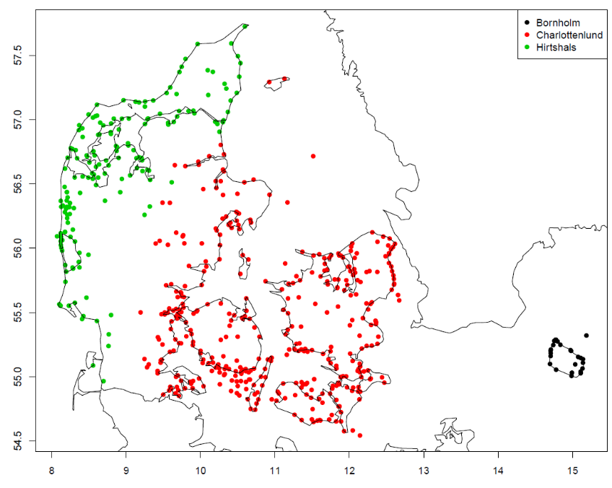
Number of harbours in Demark depending on sampling place.
In the harbours one commercial size sorting box per selected species is sampled. For all fish within a box length is measured, weighted and otoliths are taken. As this system is not taken into account how important a given stock is, all stocks are sampled at equal level if present at the harbour at the selected visit day, this gave a rather large sampling effort for all flatfish species (more fish per box) and a lower number of round fish. It was therefore introduced that only 2 flatfish per cm needed to be aged and weighted per box per visit.
Purpose: At-market Human Consumption Programme for length, age, weight data of landings of selected demersal species
Temporal Stratification: Quarterly

 | Sampling frame | Sampling unit | Stratification | Selection Method | Sampling effort
1SU | Each market site is considered a separate list | Market site* time | Quarterly | Each market site is pree selected in the beginning of the year | 1 visit for every small market and 3 visits for every large market (per quarter)
2SU | Total sold fish boxes per sorting group and species on the selected day of visit | Fish boxes | --- | ad-hoc | 1 box per selected species per sorting group
3aSU | All fish within a box | individuals | --- | Census (execpt flatfishes). | census
3bSU |  |  |  | Lenght stratified  2 fish / cm/ box

- At Market – small pelagic
For the industrial fishery the sampling program is presently not conducted as a statistically sound sampling but is still sampled according to quota samplings were a sampled is collected for every 2000 t landed. An unsorted sample is taken from the landings, often at the factory site. Seven different species are collected in the small pelagic market sampling programme.
- Herring - Clupea harengus
- Blue whitting- Micromesistius poutassou
- Sand eel - Ammodytidae sp.
- Sprat - Sprattus sprattus
- Mackerel- Scomber scombrus
- Boar fish- Capros aper
- Norway Pout - Trisopterus esmarkii

For some of these species the stocks (and quotas) can be very fluctuating between years. Boar fish is an example on a stock which has decreased a lot in later years and in 2018 no Danish commercial fishery for this species was conducted.

- At Sea – self-sampling – small pelagic
The industrial harbour sampling schemes are combined with a self-sampling program conducted on a part of the Danish industrial fleet. Here the fishermen are sampling one haul per trip which are stored on board and delivered to the landing site with the relevant information attached (vessel ID, sampling site and logbook number). The self- sampling program is manly conducted for sand eel and sprat but in a smaller extend also for Norway pout, mackerel and blue whiting. The vessels participating in the self-sampling are not selected randomly but on a voluntary basis except for the sand eel self-sampling. For this fishery it has been incorporated as part of the fishery license to conduct self-sampling. The quality of the samples from the self-sampling program are higher than the quality obtained from the harbour samples as the samples obtained from this program are frozen just after the fishing event and information on the position are included. The combination of the two independent sampling programs (self-sampling of small pelagic and harbour sampling) are assuring quality control on the fisherman collected data, and also ensuring that even if fishermen are terminating the sampling program alternative samples are available.
- At sea – self-sampling- sole
A self-sampling programme for sole in Skagerrak, Kattegat and western Baltic was initiated in 2016. The reason was the very low and scattered landing pattern of this stock. Therefore a self-sampling program was initiated for a selected part of the fleet. In each of the main fishing area (Skagerrak, Kattegat and western Baltic) a few vessels were participating. In the main sole fishing period, 4th and 1st quarter the participating vessels were conducting a length based sample from the first trip conducted in the week. From the length sample 1 individual / cm is collected and brought to land for individual weight and age measurements.

(max 900 words per region)
Deviation from the sampling plan according to Article 5 paragraph (3) of the Decision (EU) 2016/1701:
2. Deviations from the Work Plan
The at-sea self-sampling program for sole conducted in Kattegat and Skagerrak has only been partly working due to communication challenges with the fishermen participating. This led to all participating fishermen terminated the program during 2017 and an extra effort was conducted to sample the sole in the harbour sampling program and in the observer program. Due to this extra effort the total number of sampled fish used for stock assessment has increased compared to the former years. This program is therefore not included anymore in the updated program for 2020.

A self-sampling program for sprat in the North Sea has been conducted in several years were sampling was mandatory for the fishery in the area. However, in 2018 this changed to a voluntary sampling scheme and the sampling level has decreased accordingly.

The CCTV observer program was terminated in 2016 due to lack of vessels with CCTV on board. This program is therefore not included anymore in the updated program for 2020.

In the At market – Human Consumption program, the numbers and actual harbours to conduct sampling is depended on the landed amount of fish, numbers of landing events and value of the landing on the selected species covering a minimum of 80% of each category. For this reason, some of the selected harbours in the program due not match with the harbours selected based on the 2017 data.

In the COM comments from last year’s evaluation, Denmark was asked to provide information on unsampled strata. This information has been included in table 4A as “at-market – not sampled” and gives the information on how many harbours, landing events and vessels that have landed in the harbours in 2018. Although this analysis indicate that many vessels and harbour days are not sampled, the current sampling program is covering 87% of all the landed species within the selection of table 1A, 1B and 1C and the many vessels and harbour landing days presently not sampled is an indication for the many small harbours, with small vessels having many trips.

Many ICES assessment working groups has in later years demanded more data from the sampling programs to achieve a higher certainty in there stock assessment. For this reason the effort in the harbour sampling program was increased during 2018 and in the updated program in 2019 the new updated effort in part of the program. It has been the PSU for harbour visits that has been increased.

In 2018 no proper system was introduced to account for harbour visits when no fish was landed. This is the case in some of the smaller harbours were due to weather or other circumstances no fish is landed the selected harbour day. For this reason 0 visits have been notated for a few small harbours although in principal the notation should have been 1, but with no landed fish.

3. Action to avoid deviations
Self-sampling programs always bare the conflict that if fishermen become unhappy with the scientist, also for reasons not linked directly to the cooperation or sampling program this will likely effect the sampling effort. In programs were self-sampling is considered one of the main input to the data source alternative data possibility should be considered as well to avoid lack of data if the self-sampling stops. This is not the case for the self-sampling for sand eel were the sampling is linked to the license to fish the sand eel and this could be a solution if self- sampling should continue to be a major part of the sampling system in Denmark.
For the small pelagic a more statistical sound sampling system is under development to improve the sampling quality and level. This will be part of a regional sampling program, as a very large part of the industrial landings from both the Baltic and the North Sea is landed in Denmark.

(max. 1000 words per region OR fishing ground)

Section 5: data quality

Text Box 5A: Quality assurance framework for biological data
General comment: This box is applicable to the Annual Report. This box fulfills Article 5 paragraph (2) point (a) of the Decision (EU) 2016/1701. This box is intended to specify data to be collected under Tables 1(A), 1(B) and 1(C) of the multiannual Union programme.Use this box to provide additional information on Table 5A.
1. Evidence of data quality assurance
Within this section Member State shall provide information on the methodology used to assure the quality of the data collected, highlighting those aspects where changes have been made during the sampling year. Information shall be provided by each sampling scheme for which data was collected. In the case where the same quality assurance framework is applied to all data collection schemes, information can be provided at general level with the indication “all sampling schemes”.
In those sections of Table 5A where “N” is indicated, Member States shall explain the main constrains and/ or the steps taken to fulfil this obligation. In the cases where a reference documents is requested, Member States shall provide a web link.
In cases where documents are not publicly available, due to institutions internal policy, confidentiality or other reasons, this shall be indicated by the Member State.

2. Sampling design
Explain main constraints and/ or steps taken, if ‘N’ (no) was indicated in Table 5A.
In the at- market small pelagic sampling, the Danish control agency is conducting the sampling when an inspection is conducted at the landing event. This sampling program is conducted as quota sampling (roughly 1 sample by every 2000 t landed) and no statistically sampling design has been applied.
It is however, a program under further development and the small scale pelagic fishery has for the same reason been appointed for a Baltic regional case study. Development of an adequate sampling design is still ongoing in cooperation with Sweden and the RCG Baltic.

3. Sampling implementation
Explain main constraints and/or steps taken, if ‘N’ (no) was indicated in Table 5A.
Non responses have not been recorded in the Danish harbor sampling programs as access has never been denied. This could be changing if Denmark would target trips or vessel as the SSU, instead of commercial size sorting groups bought by boxes. Refusal could however be implemented in future programmes.

4. Data capture
Explain main constraints and/ or steps taken, if ‘N’ (no) was indicated in Table 5A.
Presently all commercial data stored in the Danish and international data base several check programs. In later years this programs have been further developed to an add-on program some with the aim to run after every observer trip conducted and some to run every quarter for quality checks. However for the recreational programs and the fresh water programs check programs are still not finalized.

5. Data Storage
Explain main constraints and/ or steps taken, if ‘N’ (no) was indicated in Table 5A. Please provide a link if the documented revisions are available and not confidential.
All data sampled in the programs indicated in Table 5A are stored in a national database. For all data linked to the RDB this data is uploaded. For the recreational fishery no international database is presently available, and Denmark is presently finalizing a national database for storing recreational data. Denmark will upload data to the international database when this is finalized.

6. Data processing
Explain main constraints and/ or steps taken, if ‘N’ (no) was indicated in Table 5A.
Data processing for accuracy (bias and precision) is work still in progress and presently it is not possible by default to have these estimates for all programs. Some biases have been documented in the observer programs by plotting the vessels refusing to bring observers compared to vessels accepting observers and to compare landing categories and commercial size sorting groups between the refusal and non-refusals.

(max. 900 words per Region/RFMO/RFO/IO OR sampling scheme)

Section 5: data quality

Text Box 5B: Quality assurance framework for socioeconomic data
General comment: This box fulfills Article 5 paragraph (2) point (b) of the Decision (EU) 2016/1701. This box is intended to specify data to be collected under Tables 5(A), 6 and 7 of the multiannual Union programme. Use this box to provide additional information on Table 5B.
1. Evidence of data quality assurance
Within this section MS shall provide information on the methodology used to assure the quality of the data collected, highlighting those aspects where changes have been made during the sampling year. Information shall be provided by each sector (Fishing fleet, Aquaculture, Fish processing) for which data was collected and by each data collection scheme. In the case where the same quality assurance framework is applied to all sectors or/and all data collection schemes, information can be provided at general level with the indication “all sectors” or “all data collection schemes”.
In those sections of Table 5B where “N” is indicated, Member States shall explain the main constrains and/ or the steps taken to fulfil this obligation. In the cases where a reference documents is requested, Member States shall provide a web link.
In cases where documents are not publicly available, due to institutions internal policy, confidentiality or other reasons, this shall be indicated by the Member State.

2. Section P3 Impartiality and objectiveness
Explain main constraints and/ or steps taken, if ‘N’ (no) was indicated in Table 5B

3. Section P4 Confidentiality
Explain main constraints and/ or steps taken, if ‘N’ (no) was indicated in Table 5B

4. Section P5 Sound methodology
Explain main constraints and/ or steps taken, if ‘N’ (no) was indicated in Table 5B
Information on this principle should be briefly explained in Text boxes 3A, 3B and 3C. Description of methodologies used on data quality.

5. Section P6 Appropriate statistical procedures
Explain main constraints and/ or steps taken, if ‘N’ (no) was indicated in Table 5B. Please provide a link if the documented revisions are available and not confidential.

6. Section P7 Non-excessive burden on respondents
Explain main constraints and/ or steps taken, if ‘N’ (no) was indicated in Table 5B

7. Section P8 Cost effectiveness
Explain main constraints and/ or steps taken, if ‘N’ (no) was indicated in Table 5B

8. Section P9 Relevance
Explain main constraints and/ or steps taken, if ‘N’ (no) was indicated in Table 5B

9. Section P10 Accuracy and reliability
Explain main constraints and/ or steps taken, if ‘N’ (no) was indicated in Table 5B. Information on this principle should be briefly explained in Text boxes 3A, 3B and 3C. Description of methodologies used on data quality.

10. Section P11 Timeliness and punctuality
Explain main constraints and/ or steps taken, if ‘N’ (no) was indicated in Table 5B

11. Section P12 coherence and comparability
Explain main constraints and/ or steps taken, if ‘N’ (no) was indicated in Table 5B

12. Section P13 Accessibility and Clarity
Explain main constraints and/ or steps taken, if ‘N’ (no) was indicated in Table 5B. Information and links to documentation on this principle should be briefly explained in Text boxes 3A, 3B and 3C. Description of methodologies used on data quality.
(max. 900 words per Region/RFMO/RFO/IO/NSB OR sector)

