MINISTRY OF AGRICULTURE

INSTITUTE OF OCEANOGRAPHY AND FISHERIES

Regulation (EU) 2017/1004 of 17 May 2017of the European Parliament and the Council
on the establishment of a Union framework for the collection, management and use of data in the fisheries sector and support for scientific advice regarding the common fisheries policy and repealing Council Regulation (EC) No 199/2008

Commission Implementing Decision (EU) 2019/909 of 18 February 2019
establishing the list of mandatory research surveys and thresholds for the purposes of the multiannual Union programme for the collection and management of data in the fisheries and aquaculture sectors

Commission Delegated Decision (EU) 2019/910 of 13 March 2019
establishing the multiannual Union programme for the collection and management of biological, environmental, technical and socioeconomic data in the fisheries and aquaculture sectors

Commission Implementing Decision (EU) 2016/1701 of 19 August 2016
laying down rules on the format for the submission of work plans for data collection in the fisheries and aquaculture sectors.

Commission Implementing Decision (EU) 2018/1283 of 24 August 2018
laying down rules on the format and timetables for the submission of annual data collection reports in the fisheries and aquaculture sectors.

Croatia - Annual Report for data collection in the fisheries and aquaculture sectors
2021
Version 1
Zagreb, 31st May 2022

CONTENTS

Section 1: Biological Data 3
Text Box 1C: Sampling intensity for biological variables 3
Section 1: Biological Data 6
Text Box 1D - Recreational fisheries 6
Section 1: Biological Data 8
Pilot Study 1: Relative share of catches of recreational fisheries compared to commercial fisheries 8
Section 1: Biological Data 10
Text Box 1E: Anadromous and catadromous species data collection in fresh water 10
Section 1: Biological Data 12
Text box 1F: Incidental by-catch of birds, mammals, reptiles and fish 12
Section 1: Biological Data 14
Pilot Study 2: Level of fishing and impact of fisheries on biological resources and marine ecosystem 14
Section 1: Biological Data 16
Text Box 1G: List of research surveys at sea 16
Section 2: Fishing Activity Data 26
Text Box 2A: Fishing activity variables data collection strategy 26
Section 3: Economic and Social Data 28
Text Box 3A: Population segments for collection of economic and social data for fisheries 28
Section 3: Economic and Social Data 33
Pilot Study 3: Data on employment by education level and nationality 33
Section 3: Economic and Social Data 34
Text Box 3B: Population segments for collection of economic and social data for aquaculture 34
Section 3: Economic and Social Data 37
Pilot Study 4: Environmental data on aquaculture 37
Section 3: Economic and Social Data 38
Text Box 3C: Population segments for collection of economic and social data for the processing industry 38
Section 4: Sampling Strategy for Biological Data from Commercial Fisheries 41
Text Box 4A: Sampling plan description for biological data 41
Section 5: data quality 46
Text Box 5A: Quality assurance framework for biological data…………………………..22
Section 5: data quality 49
Text Box 5B: Quality assurance framework for socioeconomic data ……….…………………49

Section 1: Biological Data

Text Box 1C: Sampling intensity for biological variables

General comment: This box fulfils paragraph 2 point (a)(i)(ii)(iii) of Chapter III, of the Annex of the Delegated Decision (EU) 2019/910 and Chapter I of the Implementing Decision (EU) 2019/909 on the multiannual Union programme; and Article 2, Article 4 paragraph 1 and Article 8 of the Implementing Decision (EU) 2016/1701 on the format of the WP. This box is applicable to the Annual Report.
Member State should provide by Region/RFMO/RFO/IO
REGION: Mediterranean Sea / GFCM
1. Evidence of data quality assurance
Quality evaluation can only be carried out if the information coming from Table 5A in the Work Plan is available. If this is not the case, Member State shall provide an overview by giving information on the methodology used to assure the quality of the data collected.
e.g.:
The sampling design and protocols follow the outcomes of sampling expert groups.
Use of common standard criteria agreed with other countries/groups.
Use of special packages or tools (e.g. COST …) for calculations.
Use of sampling protocol for storage of data.
Use of sampling protocol for processing of data.
Use appropriate exploratory statistical techniques to detect outliers and anomalous registers.
Scientific monitoring of commercial fishery is in line with the national methodological guidelines available on the Croatian DCF website (https://podaci.ribarstvo.hr/metodologija/bioloski/). Furthermore, the results of the working groups, workshops and projects attended by Croatian scientists and researchers with expertise in the specific fields related to the different tasks are taken into account.
Information on the methodology used to assure the quality of the data collected is reported in Table 5A. In 2021 considerable effort was dedicated to the improvement of data quality procedures and upgrading of IOF database including data checking procedures as well as module for processing of data for reporting purposes.
IOF report on monitoring programme in 2021 (only in Croatian language) is available on national DCF web page:
https://podaci.ribarstvo.hr/2022/02/15/zavrsno-izvjesce-o-provedbi-pracenja-bioloskih-podataka-u-2021-godini/
During the implementation of the project activities within monitoring of biological variables, the sampling design and protocols of the activities followed the outcomes of sampling expert groups (RCG MED & BS; RCG LP, GFCM WGs; FAO AdriaMed WGs) and existing common standard criteria were used (MEDITS and MEDIAS scientific surveys sampling protocols; Age determination protocols, etc.). Samples and measurements for large pelagic species are collected and the data are processed and stored following up the recommendations from expert groups – ICCAT SCRS and RCG LP. Techniques and procedures used for obtaining and reading the biological samples are derived from scientific papers and protocols recommended by ICCAT, GFCM (DCRF) and FAO.
Documentation on sampling methodologies and sampling design (only in Croatian language) is available of the following link: https://podaci.ribarstvo.hr/metodologija/bioloski/ (Metodologija za znanstveni monitoring gospodarskog i rekreativnog ribolova_verzija 1_HR).
2. Deviations from the Work Plan
MS to list the deviations (if any) in the achieved data collection compared to what was planned in the Work Plan and explain the reasons for the deviations. The threshold for deviation follow those set in the former AR: <90 % and >150 %.
Explain any deviation from the proposed:
- sampling intensity,
- methods used for collecting data.
- methods used for estimating the parameters.
General reasons for deviations from the Work Plan in terms of planned vs. achieved should be summarised in this section, while detailed comments on deviations on particular species/stocks should be included in the AR Comments column in Table 1C.
In case of Member State adding new species not included in the WP, this should be clearly explained and justified.
Fishing area under jurisdiction of the Republic of Croatia is divided into several fishing zones. Each zone has its own specific oceanographic and geomorphological characteristics and environmental conditions differ from one zone to another. Selected species for monitoring are not equally distributed across the Adriatic Sea due to its biological and ecological characteristics. For some species there is strong variation in distribution between seasons due to migrations patterns, recruitment, spawning etc. Sampling scheme is designed to cover quarterly all fishing zones in RC in order to achieve representative length frequency distribution and to cover different life stages as well.
During the implementation of the project activities within monitoring of biological variables minor deviations have occurred.
For species Eledone moschata, Engraulis encrasicolus, Merluccius merluccius, Mullus barbatus, sardina pilchardus, Scomber colias, Parapeneous longirostris, Trachurus mediterraneus, Trachurus trachurus, Pecten jacobaeus, Pectinidae and Octopus vulgaris there was a slight increase regarding the measurements of biological parameters, but oversampling did not affect the financial plan. Regarding the Nephrops norvegicus there was a slight decrease of 12% from the planned number regarding measurements of biological parameters, due to an unrealised number of onboard sampling. For Auxis rochei and Euthynnus alletteratus, number of lengths were slightly oversampled for Auxis and right as planned for Euthynnus, however weights and sex were not sampled in all specimens due to the fisherman not interested to sell and therefore just allowed lengths to be measured.
For species Anguilla anguilla, 69 individuals were measured for all biological parameters with exception for sexual maturity and sex ratio. Although it was planned to sample 100 specimens in the pilot study (Text Box 1E), during the four fishing trips which were sampled, the entire catch was collected sampled for length, weight and age. Reason for not collecting data on sexual maturity and sex ratio is that it was not possible to macroscopically determine sex of specimens.
For most of the Elasmobranchs species (GFCM G3 and Vulnerable species group) there was one registered landings at species level during the 2021. Some information is available from the MEDITS survey.
Compared to average landings in the reference period, landings of European flat oyster Ostrea edulis continued to significantly decrease during 2021 (only 2,1 tonnes in 2021). The decrease in catch and landings had a negative impact on biological sampling. During sampling on board, this species was extremely rare and the planned sampled rate could not be achieved (biological parameters), therefore - significant under sampling occurred during the 2021 monitoring program. Oversampling shown in table IC refers to individuals measured only by length (because of conditions onboard, scientific observers could not measure all of the biological parameters).
Atherina spp, were not sampled in 2021 due to the legal restrictions on the fishing gears that target this species and which influenced the possibility to sample. Mugilidae and Sarpa salpa as targeted species of purse seine ‘ciplara’ were not sampled and Oblada melanura sampled very scarcely in the 2021 due to lack of cooperation with fishermen. Namely, since those species are not profitable and there are other more valuable target species, there was a lack of them in the landings reported to IOF for scientific staff to collect.
For the listed species below, there is no registered landings at the species level and biological information can be provided only through scientific surveys MEDITS and MEDIAS if there is any record:
- Alopias vulpinus
- Dalatias licha
- Dipturus oxyrinchus
- Etmopterus spinax
- Galeus melastomus
- Hexanchus griseus
- Mustelus asterias
- Mustelus mustelus
- Mustelus punctulatus
- Myliobatis aquila
- Prionace glauca
- Pteroplatytrygon violacea
- Raja clavata, Raja asterias, Raja miraletus
- Scyliorhinus canicula, Scyliorhinus stellaris
- Squalus acanthias
- Squalus blainvillei
- Torpedo marmorata
- Torpedo torpedo
- Isurus oxyrinchus
3. Actions to avoid deviations.
Member State to describe the actions that will be considered / have been taken to avoid the deviations in the future and when these actions are expected to produce effect. If there are no deviations, then this section is not applicable.
Coordination between IOF and MA DoF was established in 2020 regarding providing information to IOF on vessels under temporary cessation of fishing activities, e.g. purse seiners for small pelagic fish and demersal trawlers (vessels not available for sampling). This coordination was continued in 2021.
For some gears sampling in previous years was planned as conditional sampling following the approval of derogations for these gears. After the approval of management plans for specific gears (specific types of shore seines and purse seines) their target species, including Seriola dumerili, Atherina spp. and Auxis rochei, were included in Table 1A and planned for sampling in the period 2020-2021. Although the sampling methodology was developed in 2019, during which time IOF conducted consultation with authorized fishermen in order to develop sampling methodology and intensity, the monitoring programme is still not fully developed in terms of determining population of fishermen and establishing contact for on-board sampling. Therefore, in the second half of 2020 IOF organized a coordination meeting with MA DoF regarding the problem of access to vessels for on-board sampling. It was agreed that more focus shall be given to coordination between IOF, MA DoF and fishermen in order to achieve the planned sampling rate in the future and provide good quality data to effectively measure the effects of management plans.
Since coordination between the sector, MA DoF and IOF did not result in increased achieved sampled rate for certain gears even in 2021, MA DoF has undertaken to develop legal instruments which should facilitate in achieving the desired effect in the future. Ordinance on the conditions and manner of work of authorized observers should be adopted in the second quarter of 2022, and the Ordinance introduces an obligation to make public the list of vessels that should be available for scientific monitoring. This achieves transparency in the selection of vessels for sampling, and easier monitoring of the obligations of fishermen and their cooperation with scientists.
REGION: Mediterranean Sea / ICCAT
1. Evidence of data quality assurance
Quality evaluation can only be carried out if the information coming from Table 5A in the Work Plan is available. If this is not the case, Member State shall provide an overview by giving information on the methodology used to assure the quality of the data collected.
e.g.:
The sampling design and protocols follow the outcomes of sampling expert groups.
Use of common standard criteria agreed with other countries/groups.
Use of special packages or tools (e.g. COST …) for calculations.
Use of sampling protocol for storage of data.
Use of sampling protocol for processing of data.
Use appropriate exploratory statistical techniques to detect outliers and anomalous registers.

Same as information provided for region Mediterranean Sea / GFCM.
2. Deviations from the Work Plan
MS to list the deviations (if any) in the achieved data collection compared to what was planned in the Work Plan and explain the reasons for the deviations. The threshold for deviation follow those set in the former AR: <90 % and >150 %.
Explain any deviation from the proposed:
- sampling intensity,
- methods used for collecting data.
- methods used for estimating the parameters.
General reasons for deviations from the Work Plan in terms of planned vs. achieved should be summarised in this section, while detailed comments on deviations on particular species/stocks should be included in the AR Comments column in Table 1C.
In case of Member State adding new species not included in the WP, this should be clearly explained and justified.
Sampling of Thunnus thynnus and Xiphias gladius for sex ratio and maturity was lower than planned due to the fact that the fish caught by either the hand line or the long line is gutted on the sea, immediately after it is landed on the boat which prevents this type of sampling at landing. At the same time sampling at sea was minimised due to COVID-19 pandemic restrictions and the size of the fishing boats (<15m) which limit the boarding possibility.
Catch of Thunnus alalunga is rare and unpredictable since it is a seasonal fish in the Adriatic Sea that is not primarily targeted by the fishermen. Samples are taken if Thunnus alalunga is encountered during the sampling trips for Thunnus thynnus and Xiphias gladius or if there is reported catch from the fishermen that can be timely sampled.
3. Actions to avoid deviations.
Member State to describe the actions that will be considered / have been taken to avoid the deviations in the future and when these actions are expected to produce effect. If there are no deviations, then this section is not applicable.
It is expected that the results from the dialogue with the fishermen will be noticeable in the 2022 sampling. Fishermen will preserve the innards of the caught Thunnus thynnus and Xiphias gladius to be sampled along with the caught fish during the landing, which will increase the number of samples for sex ratio and maturity. With the easing of Covid restrictions, compromise has been made with long line fishermen targeting Xiphias gladius to increase the number of on board sampling, despite the small size of the fishing boats.

Section 1: Biological Data

Text Box 1D - Recreational fisheries
General comment: This box fulfills paragraph 2 point (a) (iv) of Chapter III of the Annex of the Delegated Decision (EU) 2019/910 on the multiannual Union programme; and Article 2, Article 3 and Article 4 paragraph 1 of the Implementing Decision (EU) 2016/1701 on the format of the WP. This box is applicable to the Annual Report. This box is intended to provide information on the design, implementation and analysis of all components of sampling schemes/ surveys that are listed in Table 1D.
1. Description of the target population
The target population and the elements of this target population accessibility, need to be defined and described in this section. In the case of Recreational Fisheries, the target population could be whole population of resident anglers, charter boats etc. This will permit to evaluate if all sectors contributing to the total catch, are included in the survey.
For large pelagic species - Thunnus thynnus and Xiphias gladius, the target population includes all fishing boats that are registered to participate in every Big Game Fishing (BGF) Competitions that are held during the whole year. For the year 2021 there were 15 competitions registered that had 5t of bluefin tuna fishing quota that was allocated to recreational and sports fishing. Each competition with the allocated recreational and sports fishing catch quota was planned to be sampled. The dates were announced in advance which meant that they are dependent on the weather conditions. However, due to the Covid-19 pandemic and the very nature of these competitions as a gathering of larger numbers of both fishermen and guests, the vast majority of planned competitions were postponed and only five out of 15 were held in 2021.
At national level there is no registered catch of European eel Anguilla anguilla and Elasmobranch species in this type of fishery in 2021. As regards data collection for Anguilla anguilla and Elasmobranchs, Pilot study 1 performed in 2019 included information also for these species. During the Pilot study a questionnaire was designed and distributed in 2019 among recreational fishermen via online survey through the recreational fisheries associations and social networks. Target population were sport and recreational licence holders in 2018 registered in The Ministry of Agriculture recreational fisheries licence register, so as non-registered recreational fishers that carried out activities on shore (e.g. angling, spearing and fish caught using harpoons) and on-board vessels. No further activities were planned nor conducted in 2021, regular data collection is foreseen according to WP 2022-2024.
2. Type of survey
In Table 1D, the methodology or type of survey used must be included, but any information about the design is missing.
Table 5A in the Work Plan allows to identify if the sampling design is documented and where it can be found. Are the surveys identified correctly in Table 5A and information about sampling design provided under this table?
Yes.
Documentation on pilot survey design and results:
https://podaci.ribarstvo.hr/2021/05/25/izvjesce-pilot-studije-u-rekreativnom-ribolovu/
Documentation on BGF monitoring programme in 2021:
https://podaci.ribarstvo.hr/2022/02/15/zavrsno-izvjesce-o-provedbi-pracenja-bioloskih-podataka-u-2021-godini/
Documentation on methodologies and sampling design in commercial and recreational fisheries:
https://podaci.ribarstvo.hr/metodologija/bioloski/ (document: Metodologija za znanstveni monitoring gospodarskog i rekreativnog ribolova_verzija 1_HR)
If the answer is No: information on the design should be included in this section of the Annual Report (e.g.: stratification, selection of PSU, is sampling probability base etc.).
NA
3. Data Quality
Information about non-responses and refusals is found in the Work Plan, Table 5A. Are non-responses and refusals recorded in Table 5A?
Yes
If the answer is No: information on recordings of non-responses and refusals should be included in this section of the Annual Report.
NA. There were no non-responses and refusals recorded during 2021 monitoring of Big Game Fishing recreational fisheries.
4. Data Analysis and processing
Information about data processing is found in the Work Plan, Table 5A. Are the editing and imputation methods documented and identified?
Yes
If the answer is No: information on estimation procedures should be included in this section of the Annual Report, following the questions below:
Does the estimation procedure follow the survey design?
Yes
Has the precision of the estimates been calculated and documented?
Sampling and data processing follows the same protocol as in other biological samplings regarding large pelagic fish and monitoring of commercial fisheries.

Section 1: Biological Data

Pilot Study 1: Relative share of catches of recreational fisheries compared to commercial fisheries
General comment: This box fulfils paragraph 4 of Chapter II of the Annex of the Implementing Decision (EU) 2019/909 on the multiannual Union programme and Article 2 and Article 4 paragraph (3) point (a) of the Implementing Decision (EU) 2016/1701 on the format of the WP.
General comment: This box is applicable to the Annual Report. This box is intended to provide information on the results obtained from the implementation of the pilot study.
1. Aim of pilot study
The study is a continuation of the pilot study implemented according to the Work plan 2017-2019, encompassing the activities which were not realized in the estimated timeframe, as well as the additional activities on recreational fisheries. The aim of this pilot study is to assess the share of catches from recreational fisheries in relation to commercial catches and to obtain indicative data on fishing effort and the qualitative and quantitative composition of the catch particularly in relation to the species listed in Table 3 EUMAP (eel and elasmobranchs, while highly migratory ICCAT species are already included in on site sampling). In order to achieve this goal the annual catches by species in both weight and number shall be obtained. Also, the study will take into account the national activities planned in the reference year, regarding the regulation and additional projects on data collection in recreational fisheries.
2. Duration of pilot study
The anticipated duration of the project is one year, and will be performed by early 2020.
The results of the pilot study will be included in the Annual Report for 2019 by the end of May 2020.
3. Methodology and expected outcomes of pilot study
Considering the large number of participants in sport and recreational fisheries (in recent years, over 70,000 permits is being issued), and the problem of direct (on-board) data collection, the necessary data collection for recreational fisheries is planned through a simple questionnaire that will be distributed to fishermen when purchasing the fishing permit. Data would partly be collected by a prepaid post card survey (for those anglers who purchase their permit in the offices of the Directorate of Fisheries (in further text: DoF) and sports associations), and the other by an e-survey for those who buy an online permit. During the survey information on the types of fishing gears used will be gathered, as well as data on fishing effort, and qualitative and quantitative composition of the catch, with special reference to species listed in Table 3 of the EUMAP (eel and elasmobranchs).
The target population shall consist of all recreational fishing and shall include fishing activities carried out on shore (e.g. angling, spearing and fish caught using harpoons) and on board vessels.
Brief description of the results obtained (including deviations from planned and justifications as to why if this was not the case).
4. Achievement of the original expected outcomes of pilot study and justification if this was not the case.
The aim of the pilot study of recreational fisheries was to provide preliminary data on this type of fisheries in Croatia. In order to acquire such data, an online survey, featuring comprehensive structured questionnaire was designed. Data collection commenced in April 2019 and lasted until the end of June 2019. A questionnaire was disseminated through relevant institutions and through public and social media. Through the survey, data on fishing type, effort and total biomass of catches was extracted from participants. Also, more detailed information was extracted for the priority species listed in Table 3 EUMAP (eel and elasmobranchs, while highly migratory ICCAT species are already included in on site sampling).
In 2020 an additional analysis of data in the register of licences maintained by DoF was carried out (number of licences by specific fishing gear, spatial distribution of fishermen and fishing effort etc.) for 2018 and 2019 reference years to support the analysis of data obtained from the pilot study.
Since the survey was non-probabilistic and with an unknown bias, no approximations on the relative share of catches were calculated. Still, outcomes of the pilot study will greatly help in the design of monitoring programme which should commence in 2022.
Results of Pilots study 1 were submitted to DG MARE in March 2021 and are available on the national DCF web page: https://podaci.ribarstvo.hr/2021/05/25/izvjesce-pilot-studije-u-rekreativnom-ribolovu/.
No further activities were carried out in 2021, other than regional coordination and on a national level preparation of system for regular data collection according to WP 2022-2024.
5. Incorporation of results from pilot study into regular sampling by the Member State.
Regular sampling will commence in 2022 according to WP 2022-2024. Data from the pilot study as well as comprehensive licensing system in Croatia will be used to establish metiers and to design a stratified monitoring programme.
Results of pilot study revealed weak points in the current licencing system. Therefore in 2021 the licencing system was adapted to allow probabilistic sampling scheme in regular data collection starting from 2022, in coordination between IOF, MA DoF and the Croatian Association for Sport Fisheries at Sea.
Results of pilot study were presented during the RCG Med&BS Workshop on Recreational Fisheries in March 2021.
Determination of species for data collection will be done in accordance with relevant RCG Med&BS recommendations in 2021, and in line with end-user needs.
Croatian scientists participated in the STREAMLINE & RCG Med&BS Joint Workshop on Recreational Fisheries in April 2022, pending agreement in the RCG Med&BS annual meeting in September 2022 regarding regional work plan, Croatia will adapt the WP 2023-2024 accordingly.

Section 1: Biological Data

Text Box 1E: Anadromous and catadromous species data collection in fresh water
General comment: This box fulfills paragraph 2 points (b) and (c) of Chapter III of the Annex of the Delegated Decision (EU) 2019/910 on the multiannual Union programme; and Article 2 of the Implementing Decision (EU) 2016/1701 on the format of the WP.
General comment: This box is applicable to the Annual Report.
1. Method selected for collecting data.
The only species from the group of anadromous and catadromous species that has a commercial importance in Croatia is Anguilla anguilla, European eel. The annual catch of this species is very small (an average of about 400 kg) and is performed by commercial and sport and recreational fishing. This type of fisheries is primarily performed using two types of gears - a special type of pot to catch eel and fyke for eel. Fishing takes place throughout the year with different intensity, while the major area of ​​fishing is the mouth of the river Neretva.
Monitoring of eel in Croatia for the period 2017-2019 was planned as a pilot study. During the monitoring program there was no information about registered catch due to scarcity of catch of this species. The prolonged implementation of the pilot study is due to the consultation of the fisheries sector and administration. Therefore the pilot study shall be continued in the period 2020-2021.
Within the pilot study sampling is planned to be carried out annually, as on-board sampling and sampling on the landing place. During sampling, data on the characteristics of the fishing gear will be collected (number and size of fish pots, mesh size), as well as data on fishing effort and the information on the qualitative and quantitative composition of catches (target species, by-catch and discard). For the target species eel data on length frequencies and biological data (length, individual weight, sex, maturity and age over otolith) will be collected.
All stages of eel (recruits – glass eel, standing stock – yellow eel and emigrating silver eel) will be subject to the pilot study as is planned in Table 1E and sampled for the determination of the required parameters (abundance of glass and yellow eel, and the number or weight and sex ratio of emigrating silver eels). The abundance will be estimated using the eel fishery catch and effort data if possible and using fishery independent methods once an appropriate sampling design is defined. By the end of 2019 the national management plan for eel is still not adopted, however according to scientific and fisheries data, River Neretva is determined as the sampling area for the pilot study.
The methodology for the monitoring, and the protocol will be designed for the purpose of reporting and evaluation referred to in Article 9 of Council Regulation (EC) No 1100/2007 of 18 September 2007 establishing measures for the recovery of the stock of European eel. Coordination of both administrative and methodological activities is needed in order to establish a monitoring programme for eel by the end of the period. In this regard, national coordination is planned for the beginning of 2020. The sampling methodology shall also be discussed within the Regional Coordination Group for the Mediterranean and Black sea in 2020.
2. Were the planned number achieved? Yes/ No
If answer is No, Member State shall explain why not, and what measures were taken to avoid non-conformity.
Eel pilot study 2021 - River Neretva
In Croatia fishery using fyke nets for catching eel is regulated and it is possible to use this gear only in winter months. In 2020 this coincided with lockdowns due to COVID and the Pilot Study was carried out in 2021.
In 2021, four samplings on the landing places have been undertaken in the area of Neretva River Delta as planned. Samples originated from fyke nets for eel and in all, 69 specimens of Anguilla anguilla, European eel, have been sampled and subsequently analysed in the laboratory (Table 1C). For 44 specimens life stage could be determined (as is specified in Table 1E), while for the remaining 25 specimens life stage is undetermined.
Data will be provided according to the Mediterranean and Black Sea Data Call in 2022, as well as according to relevant GFCM-DCRF and ICES data calls.
Based on pilot study results the methodology for the monitoring, and the protocol will be designed for the purpose of reporting and evaluation referred to in Article 9 of Council Regulation (EC) No 1100/2007 of 18 September 2007 establishing measures for the recovery of the stock of European eel.

Section 1: Biological Data

Text box 1F: Incidental by-catch of birds, mammals, reptiles and fish
General Comment: This box fulfils paragraph 3 point (a) of Chapter III of the Annex of the Delegated Decision (EU) 2019/910, on the multiannual Union programme; and Article 2 of the Implementing Decision (EU) 2016/1701 on the format of the WP. This box is applicable to the Annual Report. This box is applicable only for those sections where Member States have reported that they have been carrying out regular sampling. Results and deviations for Pilot studies should be reported under Pilot Study 2.
1. Results
Member States shall fill in Table 1F and provide additional information, if available, in this text box. For example, species (or family) identification, number of samples, and the state of the animals incidentally by-caught (i.e. were they released alive, dead, or collected for sampling).
Table 1F provides information on activities performed in 2021 during monitoring of commercial fisheries.
Scientific observers are instructed to monitor incidental bycatch of vulnerable species of Elasmobranchs and marine birds, mammals and turtles during on-board sampling for all metiers for which on-board sampling is carried out (as listed Table 1F). Information provided Table 1F is on occurrence of incidental bycatch during monitoring of each of metiers sampled.
For métieres OTB_DEF_>=40_0_0, FPO_DEF_0_0_0 and DRB_MOL_0_0_0 during on board sampling in 2021, observers did not record any specimens of vulnerable species of birds, mammals, reptiles or Elasmobranchs.
In GTR_DEF_>=16_0_0 (GTR) bycatch a single specimen of strictly protected seabird (Phalacrocorax aristotelis) was incidentally caught and recorded during onboard sampling by scientific observer. The specimen unfortunately showed no signs of life when brought on board. No other vulnerable species were recorded in this metier.
In PS_LPF_>=40_0_0 (BFT) bycatch of sea turtles (Caretta caretta) numbering 14 individuals and Elasmobranchs (Prionace glauca - 1 individual , Myliobatidae with 16 individuals, Pteroplatytrygon violacea – 1 individual) was observed. Since the caught tuna is transferred alive from the net to a floating cage, all of the bycatch is removed from the nets and released alive into the sea directly by the divers operating the transfers of live BFT.
In LHP_LPF_0_0_0 (BFT) bycatch of Elasmobranch was recorded, more precisely 3 individuals of Prionace glauca. This bycatch is released alive without landing by cutting the fishing line immediately once the fishermen determine the type of the catch.
For LLD_LPF_0_0_0 (SWO) bycatch of sea turtles (Caretta caretta – 1 individual) , Elasmobranchs (Prionace glauca with 28 individuals and Myliobatidae with 38) and seabirds (Laridae – 1 individual) was recorded. Bycatch was released alive and without landing on the fishing boat when possible, mostly depending on the species of bycatch and the time when it was caught e.g. seabirds were released immediately as they get caught when the long line is deploying and Prionace glauca is released in the sea by cutting the fishing line.
2. Deviations from Work Plan
Member States shall list the deviations (if any) in the achieved data collection compared to what was planned in the WP and explain the reasons for the deviations.
Explain any deviations from the proposed:
- sampling intensity
- methods used for collecting data
During the activities in 2021, there were no significant deviations in comparison to the Work plan. With reference to the Work Plan, all the planned activities have been implemented.
3. Data quality
Member States shall provide information on sampling protocols and sampling design for incidental by-catch data collection.
Questions to be addressed are listed below:
- Does the onboard observer protocol contain a check for rare specimens in the catch at opening of the codend? If YES is the observer instructed to indicate if the codend was NOT checked in a haul?
Yes.
- In gill nets - and hook-and-line fisheries: does the onboard observer protocol instruct the observer to indicate how much of the hauling process has been observed for (large) incidental bycatches which never came on board (because they fall out of the net)? In large catches: does the protocol instruct to check for rare specimens during sorting of the catch (i.e. at conveyor belt)? Is the observer instructed to indicate what percentage of the sorting or hauling process has been checked at “haul level”?
Not applicable.
- Does the onboard observer protocol instruct to report on the use of mitigation (i.e. Escape Devices or Acoustic Deterrent Devices)?
No, currently there are no deterrent devices in use in Croatia.
- Does the sampling design and protocol follow the recommendations from relevant expert groups? Provide appropriate references. If there are no relevant expert groups, the design and protocol have to be explained in the text.
Yes. Methodology is in line with GFCM methodology (FAO. 2019. Monitoring the incidental catch of vulnerable species in Mediterranean and Black Sea fisheries: Methodology for data collection) adopted by GFCM SAC in 2019.
Documentation on sampling methodologies and sampling design (only in Croatian language) is available of the following link: https://podaci.ribarstvo.hr/metodologija/bioloski/ (Metodologija za znanstveni monitoring gospodarskog i rekreativnog ribolova_verzija 1_HR).
- Are data quality issues taken into account?
Yes.
- How are data (and samples) stored?
All collected data are stored in the relevant database of the Institute of Oceanography and Fisheries database (IOF) in Split. Collected data will be processed and transmitted to the end users (ICES WGBYC and GFCM) as it was requested and according to relevant recommendations (GFCM DCRF).

Section 1: Biological Data

Pilot Study 2: Level of fishing and impact of fisheries on biological resources and marine ecosystem
General comment: This Box fulfills paragraph 3 point (c) of Chapter III of the Annex of the Delegated Decision (EU) 2019/910 on the multiannual Union programme; and Article 2 and Article 4 paragraph (3) point (b) of the Implementing Decision (EU) 2016/1701 on the format of the WP.
General comment: This box is applicable to the Annual Report. This box is intended to provide information on the results obtained from the implementation of the pilot study.
1. Aim of pilot study
The aim of this study is to collect the data to assess the impact of Union fisheries on marine ecosystems in Union waters and outside Union waters. Data for estimating the level of fishing and the impact of fishing activities on marine biological resources and on marine ecosystems shall be collected based on end-user needs.
2. Duration of pilot study
From 2017 observers on-board are being used also to monitor incidental by-catch. Pilot study will be conducted in the period from 2018 to 2020.
3. Methodology and expected outcomes of pilot study
Incidental by-catch of all birds, mammals and reptiles and fish protected under Union legislation and international agreements, including the species listed in Table 1D, including absence in the catch, will be monitored during scientific observer trips on fishing vessels and by the fisherman themselves through logbooks.
Pilot study 2 shall be carried out according to RCG MED&BS 2017 Recommendation 5: Pilot studies on incidental catch of vulnerable species.
Following the 2016 Recommendation of the RCG Med&BS-LP on pilot studies for the assessment of incidental catches of birds, mammals, reptiles and fish, the planned monitoring programme of the GFCM on the incidental catch of vulnerable species, shall be followed carrying out the following pilot studies:
- 2018: Pilot study for assessing incidental catches of vulnerable species from bottom trawlers
- 2019: Pilot study for assessing incidental catches of vulnerable species from longlines
- 2020: Pilot study for assessing incidental catches of vulnerable species from set nets (gillnets).
The guidelines for monitoring incidental catch of vulnerable species and processing the collected data, will be based both on the outputs of the EU MARE/2014/19 project for the Med&BS, and the GFCM guidelines on incidental catch (under preparation). Data to be collected will include: identification of species, number and weight (when possible) of individuals, gear specifications, location and timing of catches.
Brief description of the results obtained (including deviations from planned and justifications as to why if this was not the case).
4. Achievement of the original expected outcomes of pilot study and justification if this was not the case
As was planned in the WP the Pilot study for assessing incidental catches of vulnerable species from set nets (gillnets) was carried out in 2020.
Pilot study for assessing incidental catches of vulnerable species from set nets (gillnets) has been conducted throughout 2020 on 37 trips by scientific observers during monitoring of commercial fishery. No additional activities were carried out in 2021.
Monitoring of incidental catch of vulnerable species was based both on the outputs of the EU MARE/2014/19 project for the Med&BS, and the GFCM guidelines on incidental catch (FAO, 2019). Data collected included the following: identification of species, number and weight (when possible) of individuals, gear specifications, location and timing of catches. Furthermore, in 2020 sampling program for assessing incidental catches of vulnerable species was extended to cover all metiers selected by the ranking system (as indicated in Table 1F).
All collected data and metadata are stored in the IOF database. Collected data were processed and will be transmitted to end users (ICES WGBYC and GFCM) in 2021.
Results of Pilots study 1 were submitted to DG MARE in March 2021 and are available on the national DCF web page: https://podaci.ribarstvo.hr/2021/05/25/izvjesce-pilot-studije-o-slucajnom-ulovu-osjetljivih-vrsta-u-gospodarskom-ribolovu/
5. Incorporation of results from pilot study into regular sampling by the MS
Education of fisherman and cooperation
The problem of cooperation with fishermen is present in all metiers. There is a need to educate fishermen about the purpose of recording incidental catches and additional motivation to ensure good and continuous cooperation for scientific monitoring. During 2022 MA-DoF, IOF, with the cooperation of Institute for Environmental Protection and Nature, relevant NGOs and Faculty of Veterinary Medicine (University of Zagreb), has undertaken to develop a guide to species identification and a protocol intended for fisherman. In the first half of 2022 the protocol is being developed and in the second half of 2022 the Advisory Service of MA-DoF will incorporate into obligatory training od fisherman the guide and protocol on incidental catch of vulnerable species. With the cooperation of NGOs and all included stakeholders, a workshop will be organized for fisherman in Zadar.
Training of scientific observers
Training of scientific observers on handling and identification of vulnerable species and benthic organisms was organized on a national level during January-February 2022. All Croatian scientific observers we required to participate in the RCG Med&BS-GFCM regional training course on vulnerable species for the Mediterranean and Black Sea in February 2022. Also, IOF employed additional scientific observers, as there is a significant increase of onboard observations from 2022.
Legal framework
National legal framework is being adapted to incorporate conditions and code of conduct for scientific observers in regards to monitoring of vulnerable species and relevant national, GFCM and ICCAT provisions. Ordinance on scientific observers is under preparation (planned for adoption in second quarter 2022) and will include provisions on data collection and handling of PET species, according to GFCM forms and protocols.
Sampling plan
The results of monitoring of commercial fisheries in 2018 - 2020 were compared to MEDITS sampling results in order to improve the sampling methodology for commercial fisheries and on-board monitoring of incidental catch of PET species determined in accordance to the new EUMAP 2022-2027. For the preparation on the Annual Work Plan 2022-2024, an evaluation of sampling effort in correlation to fishing effort was carried out. Sampling effort was increased on all high risk metiers in order to increase coverage of fishing effort through observers on board. Similarly, sampling areas will be adapted to ensure adequate sampling of vulnerable species, according to sampling in 2022.
Finally, incorporation of the results into regular sampling will be in accordance with the recommendations of the GFCM SAC and RCG Med&BS, and other relevant working groups if relevant.

Section 1: Biological Data

Text Box 1G: List of research surveys at sea
General comment: This box fulfills Chapter I of the Annex of the Implementing Decision (EU) 2019/909, on the list of mandatory surveys and thresholds, of the multiannual Union programme; and Article 2 and Article 7 paragraph (3) of the Decision (EU) 2016/1701 on the format of the WP. It is intended to specify which reseach surveys at sea set out in the multiannual Union programme will be carried out. Member States shall specify whether the research survey is included in Chapter I of the Annex of the implementing decision of the multiannual Union programme or whether it is an additional survey.
General comment: This box is applicable to the Annual Report. This box should provide complementary information on the performance of the surveys, the results and their main use.
Pan-Mediterranean Acoustic Survey (MEDIAS)
1. Objectives of the survey
Evaluate the abundance and spatial distribution of small pelagic fish resources by direct methods (acoustics), independently of the data provided by commercial fisheries; Target species are anchovy and sardine.
2. Description of the methods used in the survey.
Acoustic data for fish abundance estimation are collected by calibrated scientific echo sounder at 38kHz; Fish samples are collected by use of pelagic trawl net, with aim to provide information needed for echograms scrutinization, as well as for collection of fish biological data; Abiotic environmental data (measurements of temperature and salinity) collections are made by CTD vertical profiles, while additional biotic data in pelagic ecosystem are obtained by plankton sampling (acoustic at 120kHz and/or vertical hauls). Collection of navigational data ensures that all other collected data are geo-referenced (suitable for spatial analyses). Manual of the survey is available at http://www.medias-project.eu/medias/website/handbooks-menu.html, and it contains a graphical map of the surveys.
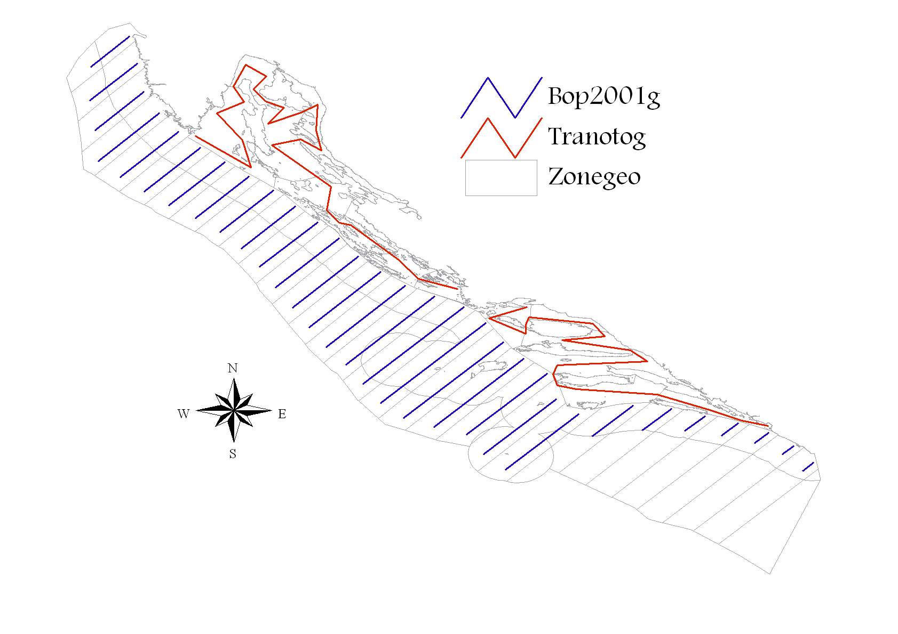
Figure 1. Map of acoustic survey in eastern part of GSA 17 during MEDIAS-DCF survey. Blue transects in open sea and red transects in inner sea.
Figure 2. Example of spatial position of the CTD stations at which the measurements were made during the echo-monitoring DCF MEDIAS. The number and positions of stations can vary from year to year. Source: http://jadran.izor.hr/roscop/.
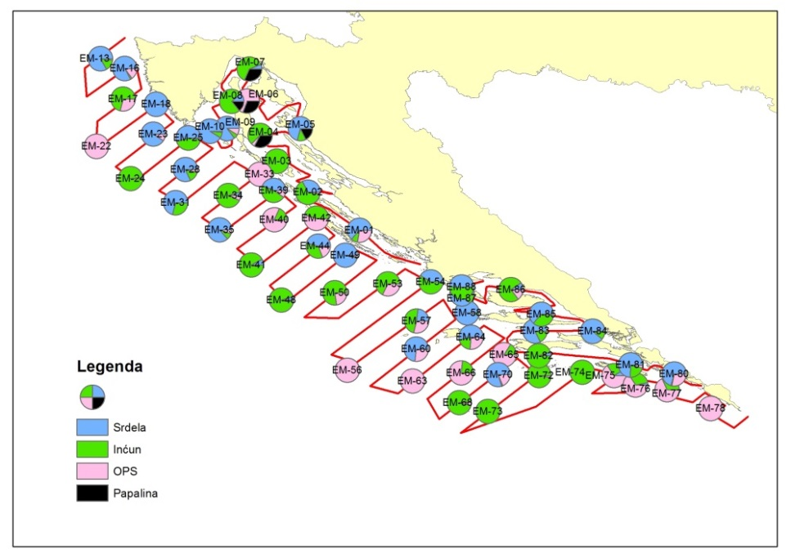

Figure 3. Example of spatial distribution of sampling and composition of catches achieved with the pelagic trawl along acoustic transects (green - anchovy, blue - sardine, black - sprat, and red - OPS). The number and positions of stations can vary from year to year.
3. Participating Member States/vessels and the relevant international group in charge of planning the survey
Croatia is participating in MEDIAS by conducting an acoustic survey in the eastern part of GSA 17 area (Adriatic Sea), covering an area of 13,578 Nm². International MEDIAS Steering Committee is in charge of surveys planning.
4. Where applicable, describe the international task sharing (physical and/or financial) and the cost sharing agreement used
Not applicable.
5. Explain where thresholds apply
Thresholds are applied only in acoustic data elaborations, as described in MEDIAS Handbook (see at http://www.medias-project.eu/medias/website/handbooks-menu.html).
6. Graphical representation (map) showing the positions (locations) of the realized samples.
Member State shall provide maps presenting the spatial distribution of the main sampling types obtained during the survey.
Sampling was carried out according to the MEDIAS manual:
https://podaci.ribarstvo.hr/files/MEDIASHandbookApril2021.pdf
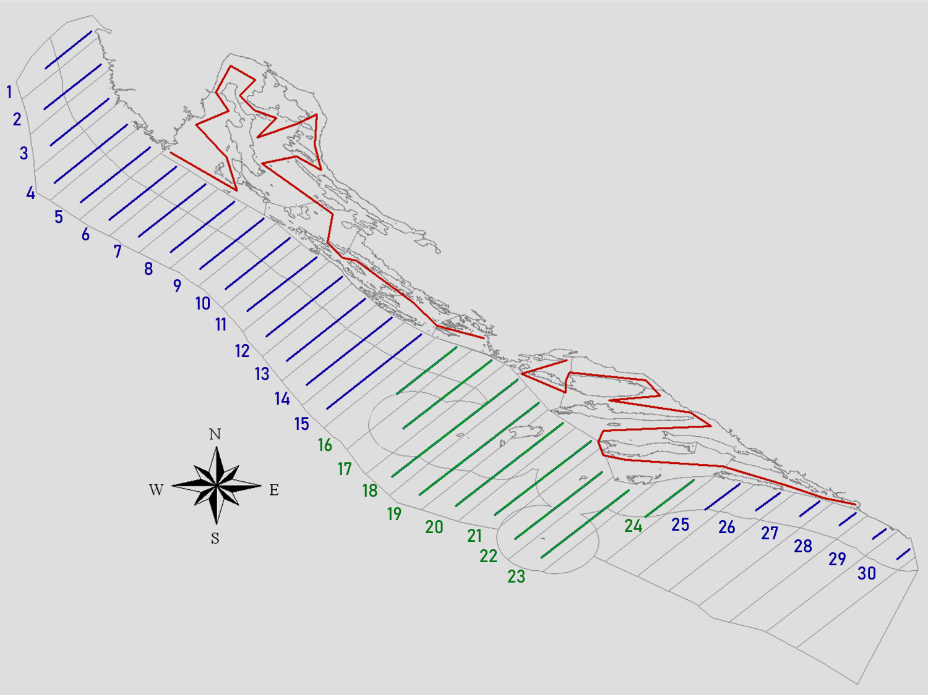
Figure 7. Map of acoustic transects in eastern part of GSA 17 as sampled in DCF-MEDIAS 2021 survey. Blue and green transects in open sea and red transects in inner sea.
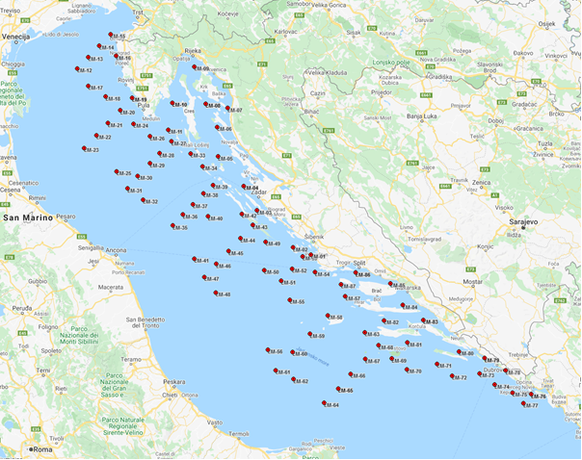
Figure 8. The spatial position of the CTD stations at which the measurements were made during the echo-monitoring DCF MEDIAS (September, 2021). Source: http://faust.izor.hr/roscop
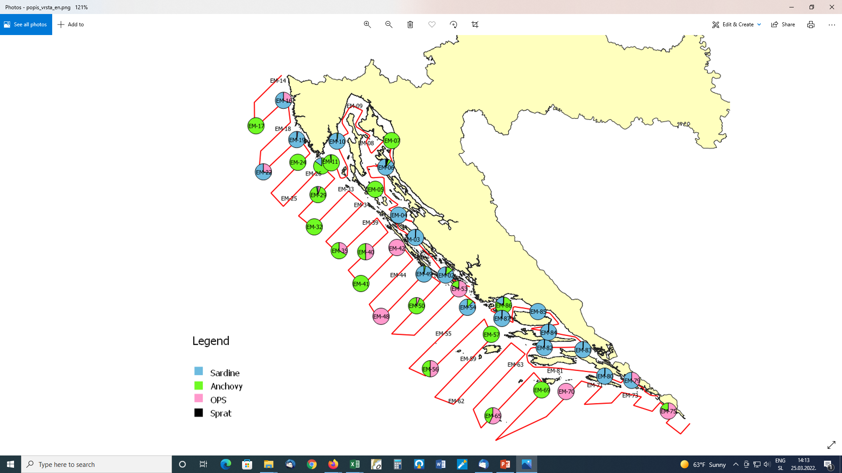
Figure 9. The spatial distribution of sampling with the pelagic trawl along acoustic transects during September 2021, and composition of catches obtained.

7. For internationally coordinated surveys, provide a link to the latest meeting report of the coordination group.
Member State shall provide a hyperlink to the meeting report from the body coordinating the survey (ICES, MEDITS coordination group, MEDIAS coordination group etc.). For non-international coordinated surveys, Member State shall refer to any status report (e.g. Cruise report).
Due to difficulties caused by COVID-19 that prevented organization of physical MEDIAS annual meeting in 2021 from being organized in Ljubljana, Slovenia, in April 2021, the MEDIAS (MEDiterranean International Acoustic Surveys) Steering Committee decided to have a virtual meeting. The meeting was held from 20 to 22 April 2021 and chaired by Vjekoslav Tičina (IOF). Meeting report is available at http://www.medias-project.eu/medias/website/meetingrep.html
8. List the main use of the results of the survey (e.g. indices, abundance estimates, environmental indicators).
Member State shall specify in which context the results are used (on routine basis), both on an international as well as on a national context.
Results of the survey are used in international context (GFCM and STECF) as contribution to analytical stock assessments of anchovy and sardine in the Adriatic Sea. Results are used for assessment tuning purposes. In addition, survey’s results were used for collaboration with MEDIAS experts from other EU MS in scientific papers publishing within Special Issue of Mediterranean Marine Science journal:
https://ejournals.epublishing.ekt.gr/index.php/hcmr-med-mar-sc/issue/view/1696

9. Extended comments (Tables 1G and 1H)
If the Member State has extended AR Comments, these can be placed under this section. If this is the case, a reference to this text box should be provided in the corresponding tables.
Table 1H: Survey results are not directly used for the formulation of management advice, but as a contribution to analytical assessment (e.g. for tuning purposes), with very low weight given to these survey results so far (i.e. have no influence on analytical assessment outputs). Oceanographic data (CTD) currently are not used for advices, but are potentially useful if could be related to recruitment index. These data are currently used to calculate sound speed as an input parameter for the echo sounder and to describe oceanography of the area surveyed.
International bottom trawl survey in the Mediterranean (MEDITS)
1. Objectives of the survey
The MEDITS survey programme intends to produce basic information on benthic and demersal species in terms of population distribution as well as demographic structure, on the continental shelves and along the upper slopes at a global scale in the Mediterranean Sea, through systematic bottom trawl surveys.
2. Description of the methods used in the survey
The MEDITS is conducted in spring - summer period from Max to July based on MEDITS protocol using specially designed bottom trawl net GOC 73. Sampling stations are randomly distributed according to the depth strata (10-50; 50-100; 100-200; 200-500; 500-800 m) and the number of stations is proportional to the surface of each stratum (Figure 1). The duration of tow in the area shallower than 200 m is 30 min, while in the area deeper than 200 m is 60 min. On board the vessel, the catches are split into the categories and sub-categories as reported in Annex V and XV of the manual. For each species the total weight and number of individuals should be collected, excluding the taxonomic category V, G, H for which only the total weight should be collected. For taxonomic categories D and E the number of individuals is not mandatory. When the catch of a given species or a fraction of a given species (e.g. juveniles) is too abundant to be measured in extenso it is reasonable to take a representative sub-sample of the catch. This sub-sample should be not less than 100 individuals.
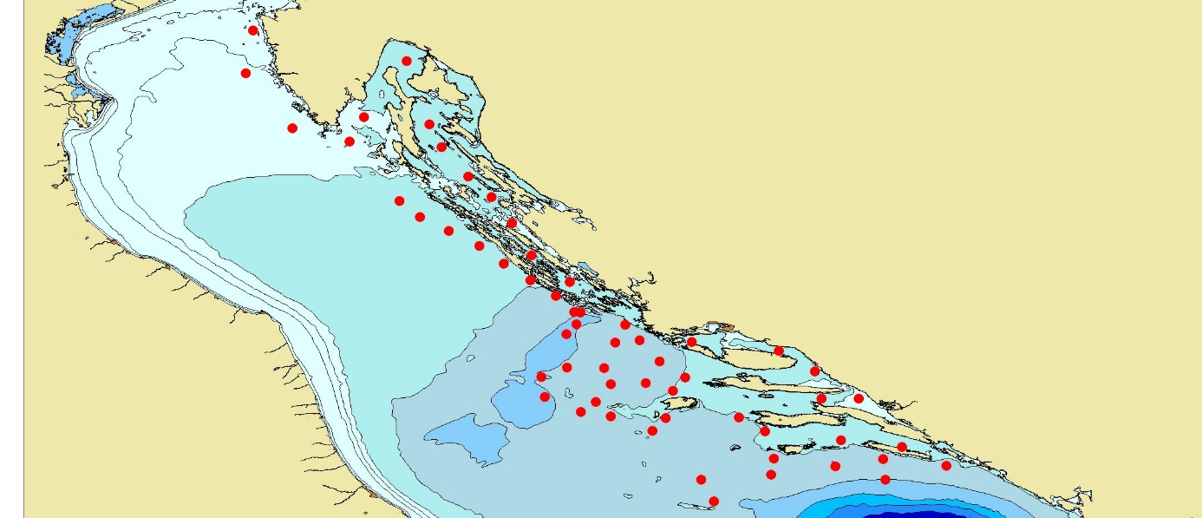
Figure 4. Map of sampling positions during the MEDITS survey in GSA 17 (Croatian territorial waters).
3. Participating Member States/vessels and the relevant international group in charge of planning the survey
Croatia is participating in MEDITS Surveys by conducting a bottom trawl survey in the eastern part of GSA17 area (Adriatic Sea), covering an area of 32000 Km2. MEDITS Working Group is in charge of survey planning.
4. Where applicable, describe the international task sharing (physical and/or financial) and the cost sharing agreement used
Not applicable.
5. Explain where thresholds apply
Not applicable.
6. Graphical representation (map) showing the positions (locations) of the realized samples.
Member State shall provide maps presenting the spatial distribution of the main sampling types obtained during the survey.
Sampling was carried out according to the MEDITS manual:
https://podaci.ribarstvo.hr/files/Medits_Handbook_2017_version_9.pdf

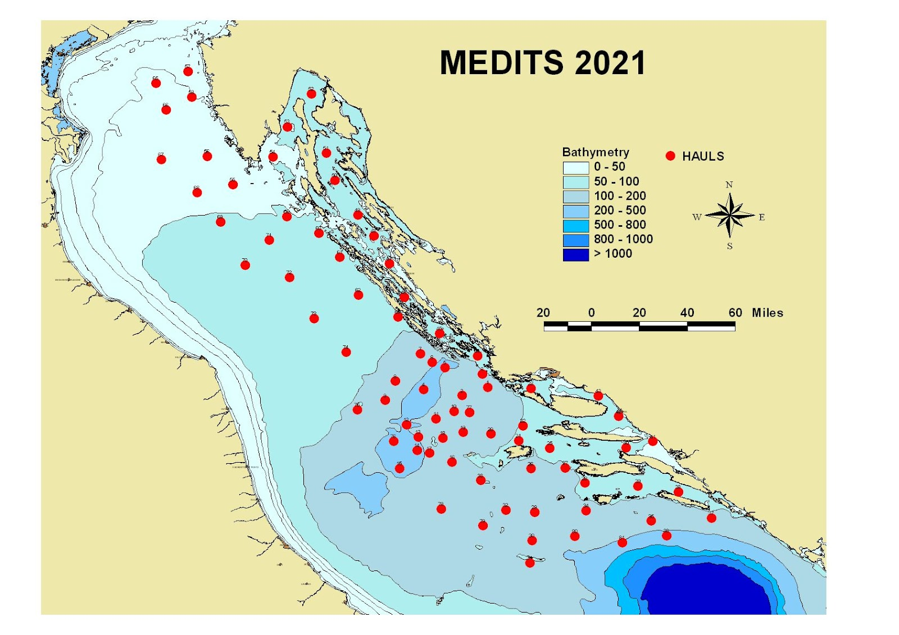
Figure 10. Map of sampling positions performed during the MEDITS 2021 survey in GSA 17 (Croatian territorial waters and exclusive economic zone).

7. For internationally coordinated surveys, provide a link to the latest meeting report of the coordination group.
Member State shall provide a hyperlink to the meeting report from the body coordinating the survey (ICES, MEDITS coordination group, MEDIAS coordination group etc.). For non-international coordinated surveys, Member State shall refer to any status report (e.g. Cruise report).
Due to COVID pandemic situation no meeting were held during 2021.
8. List the main use of the results of the survey (e.g. indices, abundance estimates, environmental indicators).
Member State shall specify in which context the results are used (on routine basis), both on an international as well as on a national context.
Results of the survey are used in international context (GFCM and STECF) as contribution to analytical stock assessments of demersal species in the Adriatic Sea, for assessment tuning purposes.

9. Extended comments (Tables 1G and 1H)
If the Member State has extended AR Comments, these can be placed under this section. If this is the case, a reference to this text box should be provided in the corresponding tables.
Both core and additional sampling such as marine litter and macro zoobenthos samples. Survey was conducted and data collected according to the MEDITS Instructional Manual Version 9 (2017) and sampling of temperature was conducted by STAR CODI probes.
During 2021 there was an increase in sampling intensity, 20 stations situated in the area of the Croatian exclusive zone were performed by the Croatian side. The total number of stations in GSA 17 remains the same.
Adriatic Rapido Trawl Survey (SoleMon)
1. Objectives of the survey
Solea solea is an important resource in the GFCM area. About 22% of the GFCM landings of soles come from the Adriatic Sea. In the GSA17 soles are targeted by “rapido” trawl and set nets by around 500 vessels, for a total of 1,600 fishermen and an annual value of landings of around 40 million Euros.
The main survey objectives are:
a) Assessing abundance, distribution in GSA17 of sole and other important demersal resources by surveys with “rapido” gears suitable to seize flatfish and other benthic animals.
b) Pursuing the studies on the ecosystem impact of the “rapido” trawl fishery.
c) Contribution to the setting of the GES and targets for the Adriatic Sea in the framework of an ecosystem approach, thus matching to the requirement of the implementation of the MSFD [DIRECTIVE 2008/56/EC].
2. Description of the methods used in the survey
The survey will cover sole presence within the GSA 17 that, according to the genetic information pertains as a single stock (Figure 5). All this holds also for benthic fish and shellfish of commercial interest, including rays and other selachians, since the EU greatly focuses on such vulnerable resources. Since 2005 the same gear and protocol has been used. The gear was a modified beam trawl named as “rapido” trawl. The gear was appositely planned to be fished on different types of bottom. The survey vessel utilizes two gears simultaneously; taking the characteristics of the gear and the rigging into account the warps should have a diameter of 14-16 mm. The length of warps to be shot is determined by the depth. The gear positioned in the right side of the vessel has 15 m of warp more than the other, in order to avoid possible interference between the two gears during the haul.
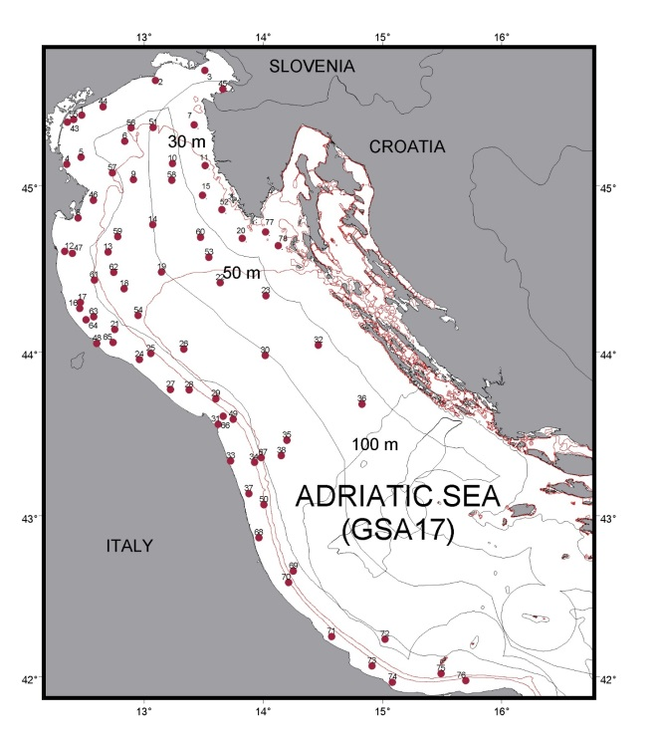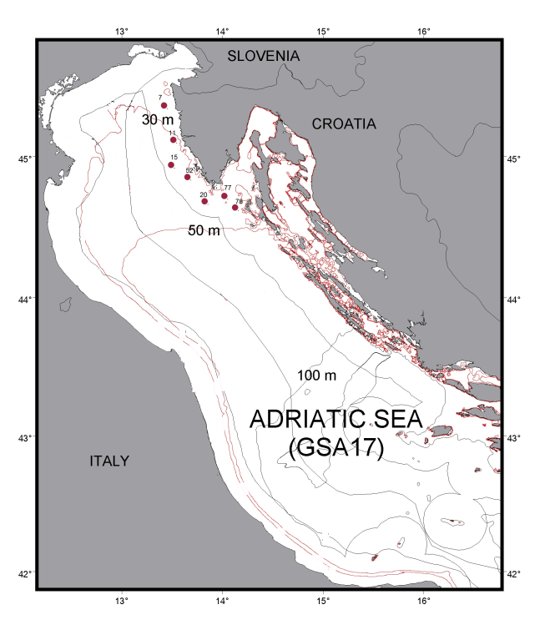
Figure 5. (left) Map of Solemon hauls in the Adriatic, GSA 17 (74 hauls). Borders between MS are indicative and without prejudice to territorial boundaries.
Figure 6. (right) Croatian hauls in the Adriatic Sea, GSA 17 (7 hauls).
3. Participating Member States/vessels and the relevant international group in charge of planning the survey
Data will be shared in working groups both at EU (STECF and ICES) and Mediterranean level (FAO-GFCM), and with all Member States of AdriaMed through common database AtrIS.
4. Where applicable, describe the international task sharing (physical and/or financial) and the cost sharing agreement used
Not applicable. The survey is performed by the Italian research vessel with no additional cost for Croatia while DSA for the Croatian scientists are financed through the AdriaMed project. Coordination is provided under the framework of FAO AdriaMed project. Biological sampling is carried out on board scientific vessel "G. Dallaporta" in GSA 17 area by scientists from CNR, IOF and FRI. Sampling is based according to the Handbook on Solemon survey. CNR, IOF and FRI are responsible for data collection, quality control and delivery to the FAO AdriaMed working group for all data collected.
5. Explain where thresholds apply
Not applicable.

6. Graphical representation (map) showing the positions (locations) of the realized samples.
Member State shall provide maps presenting the spatial distribution of the main sampling types obtained during the survey.
Sampling was carried out according to the Solemon manual:
https://podaci.ribarstvo.hr/files/SOLEMON-Handbook_2019_Ver_4.pdf

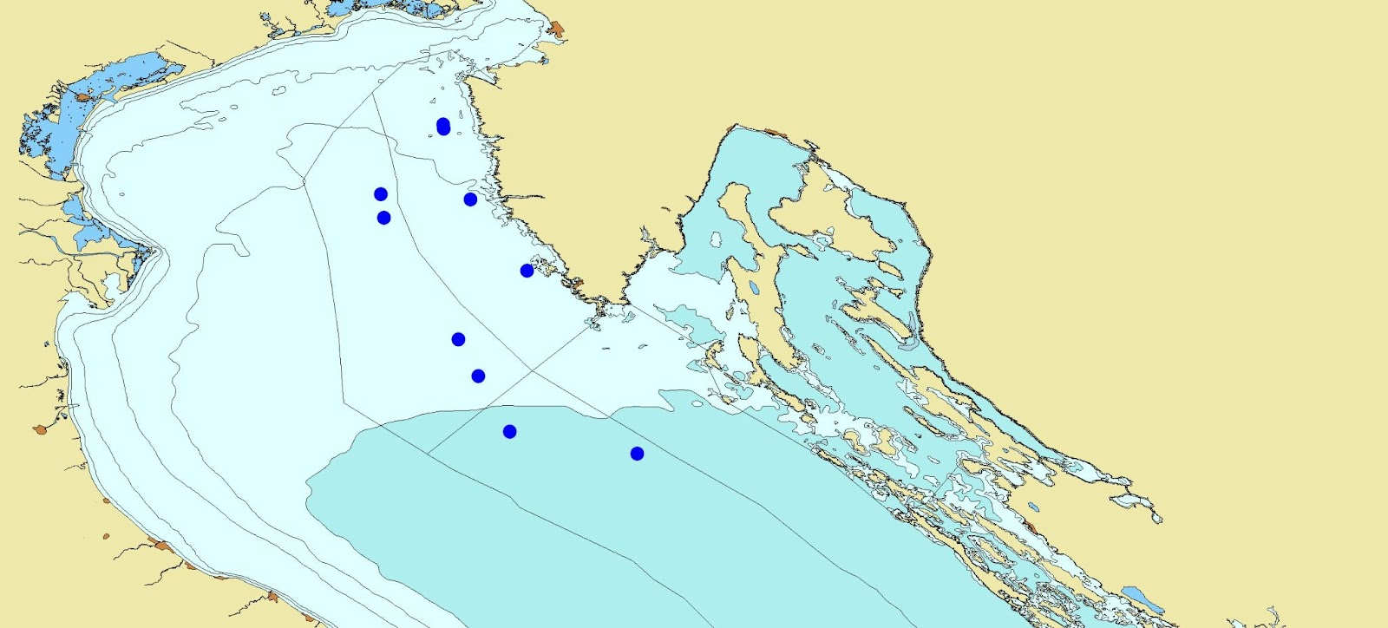
Figure 11. Map of sampling positions performed during the SOLEMON 2021 survey in GSA 17 (Croatian territorial waters and exclusive economic zone).

7. For internationally coordinated surveys, provide a link to the latest meeting report of the coordination group.
Member State shall provide a hyperlink to the meeting report from the body coordinating the survey (ICES, MEDITS coordination group, MEDIAS coordination group etc.). For non-international coordinated surveys, Member State shall refer to any status report (e.g. Cruise report).
Due to COVID 19 restriction coordination meeting was not held during 2021.
8. List the main use of the results of the survey (e.g. indices, abundance estimates, environmental indicators).
Member State shall specify in which context the results are used (on routine basis), both on an international as well as on a national context.
Results of the survey are used in international context (GFCM and STECF) as contribution to analytical stock assessments of demersal species in the Adriatic Sea, for assessment tuning purposes.

9. Extended comments (Tables 1G and 1H)
If the Member State has extended AR Comments, these can be placed under this section. If this is the case, a reference to this text box should be provided in the corresponding tables.
Not applicable.

Section 2: Fishing Activity Data

Text Box 2A: Fishing activity variables data collection strategy
General comment: This box fulfills paragraph 4 of Chapter III of the Annex of the Delegated Decision (EU) 2019/910 on the multiannual Union programme; and Article 2, Article 4 paragraph (2) point (b) and Article 5 paragraph (2) of the Implementing Decision (EU) 2016/1701 on the format of the WP. It is intended to describe the method used to derive estimates on representative samples where data are not to be recorded under Regulation (EU) No 1224/2009 or where data collected under Regulation (EU) No 1224/2009 are not at the right aggregation level for the intended scientific use.
General comment: This box is applicable to the Annual Report. This box should provide information on the implementation of the data collection of fishing activity variables of Member States.
Region: MEDITERRANEAN SEA
1. Description of methodologies used to cross-validate the different sources of data.
As part of the data collection preparation process, before retrieval of data, quality control procedures are performed to ensure the quality of collected data before its use. Such procedures include validation and verification of primary data from logbooks, fishing reports, sales notes, economic questionnaires etc. During 2015 Croatia started implementing the national validation and verification system under the National Plan for the Implementation of the Validation and Verification System in Republic of Croatia, approved by the European Commission. The so called “Valid” system includes automatic cross-checking procedures of Control data with the aim to validate and verify data coming from fishing declarations (including logbooks and fishing reports) and sales notes. Data on fishing activities is cross-checked with VMS data and relevant inspection procedures are applied when needed.
Although Control data is continuously validated during the year, separate quality reports are used to accomplish this task after data has been collected and stored in the data base. This process lasts around two months and is accomplished prior to the data-call announcement.
2. Description of methodologies used to estimate the value of landings.
Value of landings represents landings weight average prices. Amounts of first sales from sales notes and questionnaires are used to cross-check the resulting estimates. Total value for each species is the result of total weight landed multiplied by the average price.
3. Description of methodologies used to estimate the average price.
Average price is estimated using the recommended method, using weighted averages, trip by trip, obtained from sales notes, logbooks and fishing reports data. Average price is estimated using weighted mean of average price by the landing weight obtained by specie and trip.
4. Description of methodologies used to plan collection of the complementary data (sample plan methodology, type of data collected, frequency of collection etc.).
Capacity, effort and landing information is fully covered by DoF and will be collected on the census basis. Complementary data collection is not applied as catch reporting requirements in Croatia are required for all vessels less than 10 m LoA by national legislation in force. The reporting is based on monthly catch reports that are particularly suited for passive gears. Additionally, small scale vessels for personal needs that were transferred to the commercial fleet in 2015 were included in the DCF population for 2015 and fall under the national requirement of catch reporting.
5. Deviations from Work Plan methodology used to cross-validate the different sources of data
List the deviations (if any) and explain the reasons for the deviations.
- No deviations.
Actions to avoid deviations.
Briefly describe the actions that will be considered / have been taken to avoid the deviations in the future and when these actions are expected to produce effect. If there are no deviations, then this section can be skipped.
- Not applicable.
6. Deviations from Work Plan methodology used to estimate the value of landings.
List the deviations (if any) and explain the reasons for the deviations.
- No deviations.
Actions to avoid deviations
Briefly describe the actions that will be considered / have been taken to avoid the deviations in the future and when these actions are expected to produce effect. If there are no deviations, then this section can be skipped.
- Not applicable.
7. Deviations from Work Plan methodology used to estimate the average price.
List the deviations (if any) and explain the reasons for the deviations.
- No deviations.
Actions to avoid deviations.
Briefly describe the actions that will be considered / have been taken to avoid the deviations in the future and when these actions are expected to produce effect. If there are no deviations, then this section can be skipped.
- Not applicable.
8. Deviations from Work Plan methodology used to plan collection of the complementary data
List the deviations (if any) and explain the reasons for the deviations.
- No deviations.
Actions to avoid deviations
Briefly describe the actions that will be considered / have been taken to avoid the deviations in the future and when these actions are expected to produce effect. If there are no deviations, then this section can be skipped.
- Not applicable.

Section 3: Economic and Social Data

Text Box 3A: Population segments for collection of economic and social data for fisheries
General comment: This box fulfils paragraph 5 points (a) and (b) of Chapter III of the Annex of the Delegated Decision (EU) 2019/910 on the multiannual Union programme; and Article 2, Article 4 paragraphs (1), (2) and (5) and Article 5 paragraph (2) of the Implementing Decision (EU) 2016/1701 on the format of the WP. It is intended to specify data to be collected under Tables 5(A) and 6 of the delegated decision on the multiannual Union programme.
General comment: This box is applicable to the Annual Report. This box should provide information on the implementation of the fleet socio-economic data collection of Member States.
Region: MEDITERRANEAN SEA
1. Description of methodologies used to choose the different sources of data.
Collection of the economic variables of the fleet is based on two major data sources:
a) Fishery Information System administered by DoF (fishing activity variables, volume and value of blue diesel consumed per vessel; information on subsidies etc.); and
b) Questionnaires for economic data collection.
The consistency of information coming from questionnaires and administrative sources is assured by cross-checking information from the different data sources.
2. Description of methodologies used to choose the different types of data collection.
Economic variables will be collected by questionnaires; the type of data collection scheme is probability sample survey by stratified random sampling and in some cases a census survey. For the variables Consumption of fixed capital and Value of physical capital Indirect survey shall be applied.
All demersal trawl and purse seine segments regardless of the length class shall be sampled on a census basis, due to the importance of a higher response rate (these segments are under heavy management measures).
3. Description of methodologies used to choose sampling frame and allocation scheme.
Based on the basic data on the population and data on the use of fishing gears retrieved and stored, after data has been validated and verified, a segmentation of the fishing fleet is performed. In some cases fleet segments are clustered for sampling purposes or reporting purposes for confidentiality reasons. As clustering depends entirely on the activity of vessels, in cases where clustering is needed, vessel activity is reviewed on a vessel to vessel case. In cases where a vessel changes its activity from one year to another inconsistently, it is directly reflected in the clustering.
On the basis of determined fleet segments, the procedure for determining sample sizes is carried out.
In order to estimate the sample size for the collection of economic variables, the variability of GT and kW is calculated. Coefficient of GT variation is used as a basis to define the sample size of the total fleet.
The sample is distributed among the relevant strata with the principal objective of minimizing the sampling error to be obtained for the stratification variable. The optimum Neyman allocation, which guarantees a minimum variance for the variable used in the stratification, is used for this purpose.
The sample size for each stratum is adjusted in accordance with several minimum rules: not less than 10% of each stratum, not less than 5 observations per segment with <50 active vessels assuming the response rate of 50%. According to the distribution of the GT few segments need to be sampled on census basis.
Stratification on the basis of representative sub-sample per coastal county will be made which should result in a somewhat higher sample rate overall. This has to be done in order to try to reach a representative sample size for each coastal county for two reasons: 1) efficiently organize sampling among data collectors in seven DoF field units and 2) enable economic analysis at the level of smaller units for the purposes of evaluating FLAG strategies, different development plans at municipal level etc.
4. Description of methodologies used for estimation procedures
Estimation procedures are performed according to agreed methodologies published on the official DCF web site (https://datacollection.jrc.ec.europa.eu/docs-links/socio-eco-var).
National procedures and methodological documents will be made available by the end of 2019 on the new national web site (https://podaci.ribarstvo.hr).
In cases where response rate is inadequate to reach a statistically sound estimation, a simple regression is used to cross-check results or estimate totals. Low response rate is typically a problem of data collection for the small-scale fleet, for which questionnaire return rate is low, data in questionnaires inconsistent, unreliable and sometimes unreadable as in most cases there is no professional accounting. To tackle these issues, considerably more effort is placed into data collection for the fisherman involved in small scale fisheries, including direct contact, reviewing questionnaires, cross checking data to ensure a more complete data sets, higher quality and more reliable results.
The calculation of variables Consumption of fixed capital and Value of physical capital is based on data from questionnaires and financial accounts in accordance with the PIM methodology, proposed in the report of study No FISH/2005/03. The age data is available per each vessel in the Fleet register. The data on the value of physical capital (replacement, insurance and purchase is collected through the questionnaire by DoF). The proposed DCF Excel template for the calculation of the capital costs will be used.
Estimation of direct subsidies: DoF records on direct subsidies are used as well as questionnaires. In cases where enterprises have more than one vessel, the amount of subsidies is allocated to vessels based on GT, as subsidies are collected on an enterprise level. The estimations are cross-checked by allocating the total amount of subsidies paid to respective fleet segments using the share of landings value of the fleet segment. In the end, three sets of estimations are compared to reach a sound conclusion.
Estimation of energy consumption and energy costs: For the estimation of energy consumption and energy cost blue diesel records are used. The register of blue diesel is updated annually on the amount of fuel consumed per vessel. No estimation to determine totals is used, as data is collected on a census basis. Energy consumption and information on subsidies (as a second data source) was excluded from DoF questionnaires to avoid duplication of data collection. According to several years of cross-check, FINA and DoF records are proven to be sufficient and there is no need to keep two data sources. PGECON was consulted on the change of methodology in 2019.
Estimation of FTE: The number of hours worked during the year, collected from the enterprises through the economic questionnaire, is divided by national annual full-time working hours (based on the CBS methodology 2084 hours).
5. Description of methodologies used on data quality
To ensure the quality of data collected accuracy of the data that will be calculated. The data quality evaluation depends on the data collection scheme. In all cases (census and probability sampling) unit response rate (number of enterprises responded/total sample) and item response rate (response rate per each variable) is calculated as follows:
- Response rate (per item j);
N – Total number of vessels in the sample;
n – Number of vessels which provided the data (questionnaire/per each variable).
Coverage rate (number of responses/total population) is calculated in case of probability sampling survey.
It is planned that random samples be used and the sample size adjusted in accordance with the response rate during the implementation.
6. Deviations from Work Plan methodology for selection of data source
List the deviations (if any) from the methodology used to select data source compared to what was planned in the Work Plan, and explain the reasons for the deviations.
Several data sources for the collection of data on energy consumption and information on subsidies (as a second data source).
Actions to avoid deviations
Briefly describe the actions that will be considered / have been taken to avoid the deviations in the future and when these actions are expected to produce effect. If there are no deviations, then this section can be skipped.
Energy consumption and information on subsidies (as a second data source) was excluded from DoF questionnaires to avoid duplication of data collection. According to several years of cross-check, FINA and DoF records are proven to be sufficient and there is no need to keep two data sources. PGECON was consulted on the change of methodology in 2019, while the proposed changes were incorporated in the AWP 2020-2021.
7. Deviations from Work Plan methodology to choose type of data collection
List the deviations (if any) from the methodologies to choose type of data collection scheme compared to what was planned in the Work Plan, and explain the reasons for the deviations.
All demersal trawl and purse seine segments regardless of the length class were sampled on a census basis, due to the importance of a higher response rate (these segments are under heavy management measures).
Actions to avoid deviations
Briefly describe the actions that will be considered / have been taken to avoid the deviations in the future and when these actions are expected to produce effect. If there are no deviations, then this section can be skipped.
These changes are considered to be positive deviations. However, the sample rate was adjusted in the AWP revision for 2020-2021, in order to reflect the increased planned sample rate.
8. Deviations from Work Plan methodology regarding sampling frame and allocation scheme
List the deviations (if any) from the methodologies used regarding sampling frame and allocation scheme compared to what was planned in the Work Plan, and explain the reasons for the deviations.
Stratification on the basis of representative sub-sample per coastal county was made which resulted in a somewhat higher sample rate overall.
Actions to avoid deviations
Briefly describe the actions that will be considered / have been taken to avoid the deviations in the future and when these actions are expected to produce effect. If there are no deviations, then this section can be skipped.
The change to include substratification is considered as an improvement. This was done in order to try to reach a representative sample size for each coastal county for two reasons: 1) efficiently organize sampling among data collectors in seven DoF field units and 2) enable economic analysis at the level of smaller units for the purposes of evaluating FLAG strategies, different development plans at municipal level etc.
9. Deviations from Work Plan methodology used for estimation procedures
List the deviations (if any) from the methodologies used for estimation procedures compared to what was planned in the Work Plan, and explain the reasons for the deviations.
- No deviations.
Actions to avoid deviations
Briefly describe the actions that will be considered / have been taken to avoid the deviations in the future and when these actions are expected to produce effect. If there are no deviations, then this section can be skipped.
- Not applicable.
10. Quality assurance
10.1 Sound methodology
Briefly describe if the data collection follow methodologies, guidelines and best practices agreed in expert groups and whether methodologies are documented and are made publicly available.
The data collection follows methodologies, guidelines and best practices agreed in expert groups, available at the link below.
- https://datacollection.jrc.ec.europa.eu/guidelines/socioeco/fleet and
- National DCF web page: https://podaci.ribarstvo.hr/prikupljanje-podataka/socioekonomski/.
10.2. Accuracy and reliability
Response rate and Achieved sample rate are provided in Table 3A.
For additional information, briefly describe how raw data inputs, intermediate results and outputs are regularly assessed and validated and how errors are identified, documented and dealt with.
All questionnaires were checked by DoF employees and all strange or unknown data reviewed and compared to balance sheets. An analysis of the entire time series of economic data for individual CFRs was made during the course of data-check, to reveal nonconformities, as well as an analysis of outliers and missing data at the fleet segment level. In some cases, respondents were asked to clarify information they submitted. Intermediate results and output are regularly compared to previous years results.
10.3. Accessibility and Clarity
Indicate with Yes or No
Are methodological documents publicly available?
- Yes.
Are data stored in databases?
- Yes.
Where can methodological and other documentation be found?
Provide the web link, if documentation is publicly available
- https://datacollection.jrc.ec.europa.eu/guidelines/socioeco/fleet and
- National DCF web page https://podaci.ribarstvo.hr/prikupljanje-podataka/socioekonomski/.

Section 3: Economic and Social Data

Pilot Study 3: Data on employment by education level and nationality
General comment: This box fulfills paragraph 5 point (b) and paragraph 6 point (b) of Chapter III of the Annex Delegated Decision (EU) 2019/910 on the multiannual Union programme; and Article 2 and Article 4 paragraph (3) point (c) of the Implementing Decision (EU) 2016/1701 on the format of the WP. It is intended to specify data to be collected under Table 6 of the delegated decision on the multiannual Union programme.
General comment: This box is applicable to the Annual Report. This box is intended to provide information on the results obtained from the implementation of the pilot study (including deviations from planned and justifications as to why if this was not the case).
The pilot study on employment by education level and nationality has been carried out in 2018 and the data on employment by education level and nationality shall be collected through the annual economic questionnaire. The questionnaire has been amended to include the additional information on employment by nationality, employment status and information on unpaid labour in 2019.
4. Achievement of the original expected outcomes of pilot study and justification if this was not the case.
Social data collection has been carried out together with the economic survey, separately for fisheries and aquaculture, based on recommended classes, which does not significantly affect the quality of collected data. Individual data shall be collected every three years, starting from 2018.
5. Incorporation of results from pilot study into regular sampling by the Member State.
The methodologies and results of the pilot study on social data were presented to the relevant expert groups (PGECON 2018, EAFE Conference 2019, STECF EWG 19-03) to be taken into account when defining the obligation of data collection in the future EUMAP and the Annual work plan. The results of the pilot study are available on the national DCF web page:
https://podaci.ribarstvo.hr/2019/06/28/social-data-collection/
No additional activities regarding the pilot study were carried out in 2021. Data collection on social variables was carried out for referent year 2021 according to WP 2021.

Section 3: Economic and Social Data

Text Box 3B: Population segments for collection of economic and social data for aquaculture
General comment: This box fulfills paragraph 6 points (a) and (b) of Chapter III of the Annex of the Delegated Decision (EU) 2019/910 on the multiannual Union programme; and Article 2, Article 4 paragraphs (1) and (5) and Article 5 paragraph (2) of the Implementing Decision (EU) 2016/1701 on the format of the WP. It is intended to specify data to be collected under Tables 6 and 7 of the delegated decision on the multiannual Union programme.

General comment: This box is applicable to the Annual Report. This box should provide information on the implementation of the socio-economic data collection for aquaculture of Member States.

1. Description of methodologies used to choose the different sources of data
There are two main sources of data - some variables will be collected from DoF database and subsidies register while some will be taken from questionnaires. For cross-checking, data from the Croatian Financial Agency (FINA) will be used, which is mostly connected with the balance sheet, but only for companies who have to deliver their data due to their size category or net profit.
2. Description of methodologies used to choose the different types of data collection
Data collection for all techniques and species groups shall be carried out on the basis of a census, except for Long line-Mussel which shall be sampled on the basis of a Probability Sample Survey.
Data collection will be conducted by phone contact with subjects, introducing them with the data collection, and sending questionnaires together with guidelines by post or email. To ensure data consistency for all segments, together with each variable defined in guidelines it will be given the link to accounting code in balance sheets. The subject will have time two weeks to prepare documentation for data collection and after that a data collector will arrange a visit to farm office or accounting office to check and collect the requested data. For some cases where it is not possible to ensure direct contact, the subjects answer the questionnaires with telephone consultation and send it to DoF by e-mail.
3. Description of methodologies used to choose sampling frame and allocation scheme
Segmentation will be based on species and technique. Since a large number of enterprises are producing more than one species, additional segmentation is based on the value of production attributed to one species. Collecting data shall be for all segments by a census, except shellfish farm, where collecting is based on probability sampling.
4. Description of methodologies used for estimation procedures
One of the main problems is low response and cooperation so estimation needs to be used. Missing variables can be estimated from the FINA database and from Croatian national statistics bureau. Also, additional attention will be made on collecting data, especially on small-scale companies in marine aquaculture, so as in freshwater aquaculture. Since in Croatia there are different levels of enterprises legal registration with different accounting methods, it came clear during data collecting that is necessary to adjust guidelines for each of them. Two different questionnaires with different approach shall be devised. The first one, for small-scale companies, tailored to their business activities and the way of leading accounting records. Other for larger companies where it is easier to respond to inquiries and requests submitted to them.
Since a large number of shellfish enterprises are producing more than one species with significantly different market value (with an increasing volume and value of oysters and decreasing quantities of mussels), in order to make the segmentation more precise, to the additional segmentation, based on the value of production attributed to one species, the third criteria shall be applied - the total area of production per species.
5. Description of methodologies used on data quality
Data collection will be performed through questioners created for this purpose. To ensure data consistency for all segments, together with definition of each variable in guidelines, link is made to accounting code in balance sheets. Some of variables also will be collected from the DoF subsidies register, since it is mandatory for all aquaculture producers in Croatia to report the production in volume and value each year at the farm level. Some of the variables will be taken from questionnaires. Some other variables, e.g. subsidies, will be collected through DoF register and questionnaires. For some segments with small-scale companies it will be necessary to put additional effort in future data collection since they have difficulties in recording financial documents.
6. Deviations from Work Plan methodology for selection of data source
List the deviations (if any) from the methodology used to select data source compared to what was planned in the Work Plan, and explain the reasons for the deviations.
- No deviations.
Briefly describe the actions that will be considered / have been taken to avoid the deviations in the future and when these actions are expected to produce effect. If there are no deviations, then this section can be skipped.
- Not applicable.
7. Deviations from Work Plan methodology to choose type of data collection
List the deviations (if any) from the methodologies to choose type of data collection scheme compared to what was planned in the Work Plan, and explain the reasons for the deviations.
Simplified social data collection has been conducted in 2020 in parallel with the annual economic survey, based on recommended age, nationality and education classes. This deviation does not significantly affect the quality of collected data.
Actions to avoid deviations
Briefly describe the actions that will be considered / have been taken to avoid the deviations in the future and when these actions are expected to produce effect. If there are no deviations, then this section can be skipped.
- Not applicable.
8. Deviations from Work Plan methodology regarding sampling frame and allocation scheme
List the deviations (if any) from the methodologies used regarding sampling frame and allocation scheme compared to what was planned in the Work Plan, and explain the reasons for the deviations.
Actions to avoid deviations
Briefly describe the actions that will be considered / have been taken to avoid the deviations in the future and when these actions are expected to produce effect. If there are no deviations, then this section can be skipped.
- No deviations.
9. Deviations from Work Plan methodology used for estimation procedures
List the deviations (if any) from the methodologies used for estimation procedures compared to what was planned in the Work Plan, and explain the reasons for the deviations.
Since a large number of shellfish enterprises are producing more than one species with significantly different market value, in order to make the segmentation more precise, to the additional segmentation, based on the value of production attributed to one species, the third criteria was applied - the total area of production per species. Actions to avoid deviations
Briefly describe the actions that will be considered / have been taken to avoid the deviations in the future and when these actions are expected to produce effect. If there are no deviations, then this section can be skipped.
This approach to the segmentation adapted to ongoing trends in aquaculture production represents progress in the methodology and can be considered a positive deviation.
10. Quality assurance
10.1 Sound methodology
Briefly describe if the data collection follow methodologies, guidelines and best practices agreed in expert groups and whether methodologies are documented and are made publicly available.
The data collection follows methodologies, guidelines and best practices agreed in expert groups, available at the link below.
- https://datacollection.jrc.ec.europa.eu/guidelines/socioeco/aqua and
- National DCF web page https://podaci.ribarstvo.hr/prikupljanje-podataka/socioekonomski/
10.2. Accuracy and reliability
Response rate and Achieved sample rate are provided in Table 3B.
For additional information, briefly describe how raw data inputs, intermediate results and outputs are regularly assessed and validated and how errors are identified, documented and dealt with.
All questionnaires were checked by DoF employees and all strange or unknown data reviewed and compared to balance sheets. In most cases, respondents were asked to clarify some numbers or information they sent. Intermediate results and output are regularly compared to previous year’s results and aggregated data from data EUROSTAT database and aggregated data from SBS.
10.3. Accessibility and Clarity
Indicate with Yes or No
Are methodological documents publicly available?
- Yes
Are data stored in databases?
- Yes
Where can methodological and other documentation be found?
Provide the web link, if documentation is publicly available
- https://datacollection.jrc.ec.europa.eu/guidelines/socioeco/aqua and
- National DCF web page https://podaci.ribarstvo.hr/prikupljanje-podataka/socioekonomski/

Section 3: Economic and Social Data

Pilot Study 4: Environmental data on aquaculture
General comment: This box fulfills paragraph 6 point (c) of Chapter III of the Annex of the Delegated Decision (EU) 2019/910 on the multiannual Union programme; and Article 2 and Article 4 paragraph (3) point (d) of the Implementing Decision (EU) 2016/1701 on the format of the WP. It is intended to specify data to be collected under Table 8 of the delegated decision on the multiannual Union programme.
General comment: This box is applicable to the Annual Report. This box is intended to provide information on the results obtained from the implementation of the pilot study (including deviations from planned and justifications as to why if this was not the case).
According to available Eurostat aquaculture production data, Croatian aquaculture production, with 17,1 thousand tonnes in 2017 represents a share of 1,3% of the total EU-28 production. Taking into account the defined thresholds of the EU MAP (Implementing Decision 2016/1251, chapter V 6.), environmental data on aquaculture will not be collected.
4. Achievement of the original expected outcomes of pilot study and justification if this was not the case.
- Not applicable.
5. Incorporation of results from pilot study into regular sampling by the Member State.
- Not applicable.

Section 3: Economic and Social Data

Text Box 3C: Population segments for collection of economic and social data for the processing industry
General comment: This box fulfils footnote 6 of paragraph 1.1(d) of Chapter III of the Annex of the Delegated Decision (EU) 2019/910 on the multiannual Union programme; and Article 2, Article 4 paragraphs (1) and (5) and Article 5 paragraph (2) of the Implementing Decision (EU) 2016/1701 on the format of the WP. It is intended to specify data to be collected under Table 10 of the delegated decision on the multiannual Union programme.
General comment: This box is applicable to the Annual Report. This box should provide information on the implementation of the socio-economic data collection for aquaculture of Member States.
1. Description of methodologies used to choose the different sources of data
Most of the data and additional information will collected through DCF collection and some from FINA (Croatian Financial Agency). Balance sheets will be used for cross-checking of data from questionnaires. DCF data will be collected through the questionnaires sent to the companies’ accountants.
Balance sheets, coming from CBS (Central Business Statistics), will be complemented by the DoF questionnaire. In order to ensure the consistency of data coming from different data sources cross checking indicators will be used, e.g. volume and value of production collected by DoF and CBS. For enterprises with less than 10 employees, which are not covered by the CBS survey, all the data need to be collected through the DoF questionnaire.
2. Description of methodologies used to choose the different types of data collection
Data collection will be conducted by phone contact with subjects, introducing them with the data collection, and sending questionnaires (forms) together with guidelines by post or email. In the case of processing industry, it is not necessary to visit subjects since most companies have an accounting service and have much better data than some aquaculture segments or the small-scale fishing fleet. The exact size of the active population will be determined only after data collection (in 2015), since all companies that have fish processing as main or as part of their activities were contacted.
3. Description of methodologies used to choose sampling frame and allocation scheme
As data from the Business Register is not necessarily updated, data from the Register of approved establishments, maintained by Ministry of Agriculture, the Veterinary Directorate, will be taken into account when defining the population for reference years 2017-2019.
4. Description of methodologies used for estimation procedures
All questionnaires will be checked by DoF employees and all strange or unknown data reviewed. In some cases, respondents need to be asked to clarify some numbers or information they sent. In cases when data collection is not possible directly from a visit, questionnaires will be filled with telephone consultation and send to DoF by e-mail. Also, some data collection can be made through balance sheet and profit and loss accounts. Those financial reports are available for public at FINA.
5. Description of methodologies used on data quality
A new type of questionnaire should provide data that maximum correspond to the actual operation of enterprises in the fish processing industry. Many companies whose main activity is processing, have also many other activities, as well as aquaculture and fishing activities. In this manner, data placed in questionnaires are actually balanced. Data coming from CBS can however only be used in cross-checking procedures since DCF data call deadlines are usually well before the CBS data availability.
6. Deviations from Work Plan methodology for selection of data source
List the deviations (if any) from the methodology used to select data source compared to what was planned in the Work Plan, and explain the reasons for the deviations.
- No deviations.
Actions to avoid deviations
Briefly describe the actions that will be considered / have been taken to avoid the deviations in the future and when these actions are expected to produce effect. If there are no deviations, then this section can be skipped.
- Not applicable.
7. Deviations from Work Plan methodology to choose type of data collection
List the deviations (if any) from the methodologies to choose type of data collection scheme compared to what was planned in the Work Plan, and explain the reasons for the deviations.
- Simplified social data collection has been conducted in 2021 in parallel with the annual economic survey, based on recommended age, nationality and education classes. This deviation does not significantly affect the quality of collected data.
Actions to avoid deviations
Briefly describe the actions that will be considered / have been taken to avoid the deviations in the future and when these actions are expected to produce effect. If there are no deviations, then this section can be skipped.
- Not applicable.
8. Deviations from Work Plan methodology regarding sampling frame and allocation scheme
List the deviations (if any) from the methodologies used regarding sampling frame and allocation scheme compared to what was planned in the Work Plan, and explain the reasons for the deviations.
- No deviations.
Actions to avoid deviations
Briefly describe the actions that will be considered / have been taken to avoid the deviations in the future and when these actions are expected to produce effect. If there are no deviations, then this section can be skipped.
- Not applicable.
9. Deviations from Work Plan methodology used for estimation procedures
List the deviations (if any) from the methodologies used for estimation procedures compared to what was planned in the Work Plan, and explain the reasons for the deviations.
- No deviations.
Actions to avoid deviations
Briefly describe the actions that will be considered / have been taken to avoid the deviations in the future and when these actions are expected to produce effect. If there are no deviations, then this section can be skipped.
- Not applicable.
10. Quality assurance
10.1 Sound methodology
Briefly describe if the data collection follow methodologies, guidelines and best practices agreed in expert groups and whether methodologies are documented and are made publicly available.
The data collection follows methodologies, guidelines and best practices agreed in expert groups, available at the link below.
- RCG ECON Guidance document for the fish processing:
https://datacollection.jrc.ec.europa.eu/guidelines/socioeco/proind
- National DCF web page:
https://podaci.ribarstvo.hr/prikupljanje-podataka/socioekonomski/
10.2. Accuracy and reliability
Response rate and Achieved sample rate are provided in Table 3C.
For additional information, briefly describe how raw data inputs, intermediate results and outputs are regularly assessed and validated and how errors are identified, documented and dealt with.
All questionnaires were checked by DoF employees and all strange or unknown data reviewed and compared to balance sheets. In some cases, respondents were asked to clarify some numbers or information they sent. Intermediate results and output are regularly compared to previous year’s results and aggregated data from data EUROSTAT database and aggregate SBS data from CBS.
10.3. Accessibility and Clarity
Indicate with Yes or No:
Are methodological documents publicly available?
- Yes
Are data stored in databases?
- Yes
Where can methodological and other documentation be found?
Provide the web link, if documentation is publicly available.
- RCG ECON Guidance document for the fish processing:
https://datacollection.jrc.ec.europa.eu/guidelines/socioeco/proind
- National DCF web page:
https://podaci.ribarstvo.hr/prikupljanje-podataka/socioekonomski/

Section 4: Sampling Strategy for Biological Data from Commercial Fisheries

Text Box 4A: Sampling plan description for biological data
General comment: This box fulfills Article 3, Article 4 paragraph (4) and Article 8 of the Implementing Decision (EU) 2016/1701 on the format of the WP and forms the basis for the fulfilment of paragraph 2 point (a)(i) of Chapter III of the Annex of the Delegated Decision (EU) 2019/910 on the multiannual Union programme. This Table refers to data to be collected under Tables 1(A), 1(B) and 1(C) of the delegated decision on the multiannual Union programme.
General comment: This box is applicable to the Annual Report. This box should provide information on the deviations from the planned sampling of Member States.
1. Description of the sampling plan according to Article 5 paragraph (3) of the Implementing Decision (EU) 2016/1701 on the format of the WP.

REGION: Mediterranean Sea and Black Sea
In order to ensure compatibility along the time series, Croatia will report data by metiers as recommended by RCM Med&BS-LP 2016 and 2017, and as defined by EU Decision 1251/2016 under Chapter III (data requirements), paragraph 2(a) requesting catch data at the aggregation level 6 (corresponding to mesh size). All the collection and analysis of data will be performed and reported at GSA level. Sampling will be performed in order to evaluate the quarterly (in some cases monthly) length distribution of species in the catches, and the quarterly volume of discards.
Only the major metiers will be considered for sampling purposes (following metiers sampled in the previous programming period for comparability purposes and time series). Official statistics (catch, discards, landings, effort and value data) have been used to apply the ranking system. Sampling strategy for each metiere is designed partly as concurrency-at-sea (sampling directly on board by observers and scientists) and concurrency-at-landing site (sampling directly on landing site, at market etc.), taking also into account the Croatian fishing zones and their specificities. The target population for the reference year will be the number of fishing trips (fishing days) by metier of the previous years. The frame population is a subsample of the target population: it will be a selection of fishing trips, mainly on spatial (Croatian fishing zones and subzones) and time stratification basis (monthly or quarterly) with measurements of the composition of the catch in order to detect seasonal differences in the demographic structure and composition of the landings for different metiers. The sampling will be accomplished as stratified random sampling: the sampling unit belonging to the metier (primary unit) will be the fishing trip (secondary unit). The number of fishing days to be sampled has been defined proportionally to the effort (number of days at sea for each metier) and the landings.
Considering the results given through the STREAM project (Strengthening regional cooperation in the area of fisheries data collection) in 2019, there are several modifications included in Sampling plan for 2021.
Demersal trawls
Sampling by individual fishing zones is planned for the demersal trawl metier; in total 6 zones per year will be covered 28 times on-board and 72 times at landing places. Sampling plan for on-shore sampling in 2021 is intensified since almost 30% of the trawl catches in Croatia comes from fishing zone C. This area includes GFCM FRA Jabuka/Pomo Pit where catches have increased due to management measures applied in recent years. Sampling plan for landings in 2021 is intensified according to stratification by Croatian Fishing Zones – sampling trips are planned for every Croatian Fishing Zone on a monthly basis.
Dredges
Sampling is planned for the dredges metier in total 4 times on-board and 6 times at landing places per year. In 2021 sampling of landing is increased to 6 PSU (sampling every two months). Due to decrease in catch of Ostrea edulis and problem of collecting samples, number of PSU was increased to 6.
Sampling of demersal trawl and dredges will be conducted seasonally in order to achieve optimum quarterly distribution of data.
Purse seine net “srdelara”
Sampling of purse seine net “srdelara” will be carried out by individual fishing zones seasonally 36 times on-board and 24 times on landing places.
Purse seine nets “male plivarice”
Sampling for purse seines “oližnica”, “igličara”, “palamidara”, “ciplara” and “lokardara” will be carried out annually in total 6 times on board and 26 times on landing places.
Purse seine net “oližnica” will be sampled 6 times on landing. Sampling plan in 2021 for purse seine net “oližnica” is amended taking into account that vessels which are authorized to use this gear (in 2019 there were 13 such authorized vessels) are typically below 12 m LoA and are active in a very limited area in GSA 17. Due to the small size of the vessels scientific observers often cannot board the vessels to conduct on-shore sampling. In addition discard has been proven negligible according to previous years’ sampling on-board, therefore only sampling on landing is planned in 2021.
Purse seine net “igličara” will be sampled 4 times overall; all on landing. In 2019, only 5 vessels, all below 12 m LoA were authorized to use this gear. Due to the fact that these fishing vessels operate in a limited area fishing area/islands and on small fishing vessels it is difficult to organize sampling on board. In 2021, more effort will be dedicated to ensure planned sample is achieved.
Purse seine net “palamidara” will be sampled 6 times overall; all on landing. For “palamidara” number of sampling was increased for 2021 due to the number of species needed to sample (Auxis rochei, Euthynnus alleteratus, Seriola dumerili, Sarda sarda) and the fact that catches are usually one species catches. In 2019, 31 vessels were authorized to use “palamidara”.
Purse seine net “ciplara” will be sampled 8 times overall; 2 on-board and 6 on landing. In 2019, 36 vessels were authorized to use “ciplara”.
Purse seine net “lokardara” will be sampled 8 times overall; 4 on-board and 4 on landing. “Lokardara” is fishing gear restricted to small area/island and used mostly with small vessels below 12 m LoA (39 vessels were authorized to use this gear in 2019). Fishermen tend to activate it when restricted to work with other fishing gears. Due to that, communication and planning of sampling are difficult to achieve so the planned 4 on board and 4 on landing place is not achieved in any of previous years. In 2021, more effort will be dedicated to ensure planned sample is achieved.
Metier GTR
Trammel nets will be sampled depending on the season when the gear is allowed to be used. Sampling will be carried out 6 times on board and 18 times at landing places.
Metier GNS
Gillnets will be sampled during the entire year 35 times at landing places and 2 times on-board.
Metier FPO
Pots for crustaceans will be sampled in the summer season 12 times at landing places targeting catches of Norway lobster, Hommarus gammarus and Palinurus elephas. Sampling plan in 2021 is optimized following a by-monthly sampling scheme.
Metier SB-SV
Seine nets will be sampled 18 times at landing places and 10 times on-board during the entire year.
Metier LLS
Set longlines will be sampled during the entire year 12 times on landing places.
PS_LPF_>=14_0_0: Large purse seiners targeting Bluefin tuna using individual quotas. The fishing season is restricted to one month per year. This BFT fishery is based on farming activities which means that BFT is not landed but transferred live into cages. Metier shall be covered by all relevant monitoring and data collection activities as per ICCAT Recommendation. Given that only a small percentage (less than 1%) of the fish is landed, a part of the measurement shall be based on stereoscopic camera to evaluate the length compositions of the fish. This metiere was selected due to the international obligations and not as per any of the predetermined parameters, and to follow ICCAT recommendation (ref. RCM Med&BS 2009 and 2010 agreement) in order to ensure regional coordination in the sampling of BFT PS.
Change in the amount of PSU’s is adjustment to available days for sampling during the fishing season. The new figure is based on the average of achieved number of PSU’s in the previous years. Since the quantity of sampling is restricted by the duration of the fishing season (approximately 40 days) and the sampling depends on other factors such as possibility of departing to the sea due to weather and number of transfers to the farm cage, realistically it is not possible to achieve previously set PSU figures.
LLD_LPF_0_0_0: Drifting longlines for large pelagic. Although this metier was not selected by the ranking system and it accounts for only 0,04 % of effort and 0,006 % of landings, it is selected for sampling following ICCAT recommendation in order to ensure regional coordination in the sampling of drifting longlines. The metier is thereafter disaggregated into two metiers:
- LLD_LPF_0_0_0 BFT: Drifting longlines for large pelagic targeting Bluefin tuna; and
- LLD_LPF_0_0_0 SWO: Drifting longlines for large pelagic targeting swordfish.
As of present the catch of BFT is minimal in this metier because of fishermen preference of fishing with other tools. For last two years catch quota of SWO has increased from 29t to 50t and in accordance with this the number of PSUs and samples taken has been increased.
LHP_LPF_0_0_0 (BFT): Sampling programme will encompass commercial catch that is part of the TAC used by a number of vessels that catch BFT by hand lines.
For all the above mentioned metiers minimal number of 700 length samples and 120 total samples (length, weight, age, sex, maturity) of BFT and minimum of 50 total samples of swordfish will be collected.
This is increase in number of samples taken in comparison to previous years to fit in with the yearly increase of the fishing quota. The aforementioned change increases the number of planned PSUs as well.
Recreational fishery and big game fishing competitions of large pelagic fish (BGF REC): Allocated TAC for recreational fishery and BGF will be covered for every held competition and all of the landed fish will be sampled.
Deviation from the sampling plan according to Article 5 paragraph (3) of the Implementing Decision (EU) 2016/1701:
Region: Mediterranean Sea
2. Deviations from the Work Plan
Member State shall list the deviations (if any) in the achieved data collection, compared to what was planned in the Work Plan and explain the reasons for the deviations.
Considering the results given through the STREAM project (Strengthening regional cooperation in the area of fisheries data collection) in 2019, there are several modifications included in Sampling plan for 2020-2021.
Demersal trawls
Sampling intensity for metier OTB was conducted according to the National Plan. For onboard sampling, 25 trips were conducted out of the planned 28.
Dredges
Sampling intensity for metier DRB was conducted according to the National Plan.
Pots and traps
Sampling intensity for metier FPO was conducted according to the National Plan.
Purse seine net ‘srdelara’
Sampling intensity for metier PS SPF was conducted according to the National Plan. For onboard sampling, 42 trips were conducted out of the planned 36, and on the landing place 27 out of planned 24 trips. These deviations were due to the fact that IOF staff went to fishing vessel, however, no fishing activities were done due to the bad weather, gathering of the mammals, no fish on the sonar etc. additionally, in few cases, member of the fishing crew was found to be COVID 19 positive and regardless of the IOF staff arriving on the fishing boat, it didn’t leave the port.
Small purse seine nets
Sampling had some deviations for all fishing gears in this metier. Namely, purse seine ‘palamidara’ was oversampled - 7 out of 6 planned trips were conducted due to the fact that it has different target species and in order to achieve enough specimens of each species, need for oversampling occurred. Purse seine net ‘ciplara’ was planned to be sampled 2 times on board and sampling was successful once, and on landing place out of 6 planned, one was achieved. On purse seine ‘igličara’ planned 4 landings were not achieved - only one landing was done. Namely, this gear is very limited both in the number of vessels that own the licence as well as the area in which they operate. Purse seine ‘oližnica’ and ‘lokardara’ were not sampled in the 2021 due to the legislation restrictions for ‘oližnica’ and a very small number of active vessels with licences.
GTR metier was oversampled. Namely, 26 trips were sampled on landing site (planned 18) and 7 times on board (planned 6), with the aim to achieve enough specimens of each species.
LLD_LPF_0_0_0 (BFT):
This type of fishing falls in the same category of economic catch as hand line tuna fishing and fishermen prefer to catch the tuna with hand line due to better quality of tuna and consequently better market price and placement. This resulted in only two active ships for this type of fishing with a very low number of total PSUs which severely limited the possible number of samplings in tuna long line fishing.
LLD_LPF_0_0_0 (SWO):
Majority of Xiphias gladius long line fishing is done in the fishing port of Komiža in the island of Vis. Island Vis is a somewhat remote location with a low number of ferry connections. This means that in order to make it to the catch sampling, the observer needs to spend the night on the island. At the same time, because of the Covid situation, this remoteness appealed to the tourists and all of the island's sleeping facilities were booked during the peak of the season (July-August). This made it impossible for the observers to spend the night on the island and do the sampling during the height of the fishing season, resulting in lower number of PSU’s than planned.
Recreational fishery and big game fishing competitions of large pelagic fish (BGF REC):
Since these competitions include a large number of crews and are connected with tourism they are usually public and highly populated gatherings. This, coupled with the Covid restrictions resulted in cancellation of the majority of the competitions. Situation will return to normal once the Covid situation is resolved.
3. Action to avoid deviations
Member State shall describe the actions that will be considered / have been taken to avoid the deviations in the future and when these actions are expected to produce effect. If there are no deviations, then this section is not applicable.
Sampling is underway in 2022 according to the annual work plan 2022.
It is expected that regional activities and implementation of the results of the STREAMLINE project (WP1 on regional sampling plan) will improve the sampling plan for biological data.
In 2022 sampling effort was increased according to the GFCM methodology on vulnerable species in order to cover 0,5% fishing effort whenever possible, and significantly for high risk metiers.

Section 5: data quality

Text Box 5A: Quality assurance framework for biological data
General comment: This box is applicable to the Annual Report. This box fulfills Article 5 paragraph (2) point (a) of the Implementing Decision (EU) 2016/1701 on the format of the WP. This box is intended to specify data to be collected under Tables 1(A), 1(B) and 1(C) of the Annex of the Delegated Decision (EU) 2019/910 on the multiannual Union programme. Use this box to provide additional information on Table 5A of the Annual Report.
1. Evidence of data quality assurance
Within this section Member State shall provide information on the methodology used to assure the quality of the data collected, highlighting those aspects where changes have been made during the sampling year. Information shall be provided by each sampling scheme for which data was collected. In the case where the same quality assurance framework is applied to all data collection schemes, information can be provided at general level with the indication “all sampling schemes”.
In those sections of Table 5A where “N” is indicated, Member States shall explain the main constrains and/ or the steps taken to fulfil this obligation. In the cases where a reference documents is requested, Member States shall provide a web link.
In cases where documents are not publicly available, due to institutions internal policy, confidentiality or other reasons, this shall be indicated by the Member State.
Region: Mediterranean Sea/GFCM/ICCAT/ All sampling schemes
Information on the QAF for the biological sampling is reported in table 5A, where the web links to the reference documents are also provided.
Access to IOF database and QAF documentation is not publicly available as it is limited to partners involved in project implementation.
Documentation on sampling methodologies is publicly available on the main national DCF web site (https://podaci.ribarstvo.hr/prikupljanje-podataka/bioloski/).
The biological data collected during the sampling activities of the commercial catches and the discards was archived and validated using different data entry and processing programs which are constantly being updated and are suited for each métier and stock. Data with limited values are inserted using drop down list with predefined values (métier, type of sampling, species, etc.). Times and dates data are inserted using time picker insuring the same format. Numeric data are checked for value range if such is specified (coordinates, weight, etc.). In cases of errors in data entries, data will not be committed and will be marked with red notice and cannot be uploaded until the error is corrected. Visual check of graphic data representation is also available during data entry.
Automatic checks are in line with possible missing data and/or eventual errors regarding calculations. Operator managing database applications, before the final validation, can use graphic representation of data sets for easier notice of out of range data.
Improvements in sampling procedures and data analysis were implemented starting from 2020 according to the results of the European project MARE / 2016/22 STREAM “Strengthening Regional cooperation in the area of fisheries biological data collection in the Mediterranean and Black Sea”.
2. Sampling design
Explain main constraints and/ or steps taken, if ‘N’ (no) was indicated in Table 5A.
Parallel to the development of DC database and documentation, a common sampling plan is currently being updated for all metiers sampled. Time constraints and availability of data managers are the main issues. Documentation is published on the main national DCF web site (https://podaci.ribarstvo.hr/prikupljanje-podataka/bioloski/).
The Vulnerable species module was developed and implemented in 2021 and is since operational part of the IOF database.
3. Sampling implementation
Explain main constraints and/or steps taken, if ‘N’ (no) was indicated in Table 5A.
Information on the sampling implementation for the biological sampling is reported in table 5A, where the web links to the reference documents are also provided.
Recording of non-responses and refusals is under development and testing in IOF database and is expected to be operational during 2022.
4. Data capture
Explain main constraints and/ or steps taken, if ‘N’ (no) was indicated in Table 5A.
The complete sampling scheme, data evaluation quality check are based according to the previous knowledge. Comprehensive and updated documentation is available since the end of 2019 on the IOF database (access with authorized credentials).
5. Data Storage
Explain main constraints and/ or steps taken, if ‘N’ (no) was indicated in Table 5A. Please provide a link if the documented revisions are available and not confidential.
All collected biological data are stored in IOF (Institute of Oceanography and Fisheries) database in Split at: https://vrtlac.izor.hr/ords/riba/DCF_TERENI
For accessing documentation authorisation is required.
Comprehensive and updated database documentation is available since the end of 2019 on the IOF database (access with authorized credentials).
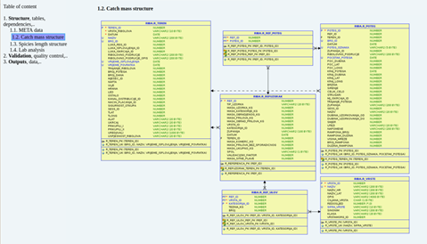
Figure 12. IOF DCF database structure.
6. Data processing
Explain main constraints and/ or steps taken, if ‘N’ (no) was indicated in Table 5A.
The complete sampling scheme, data evaluation quality check are based according to the previous knowledge. Comprehensive and updated database documentation is available since the end of 2019 on the IOF database (access with authorized credentials). The documentation is constantly being updated on all DC procedures related to quality (database documentation, quality control procedures, sampling methodologies, data processing methods etc.).
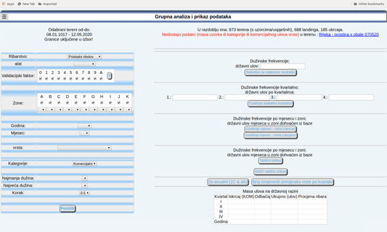
Figure 13. IOF database – data validation.
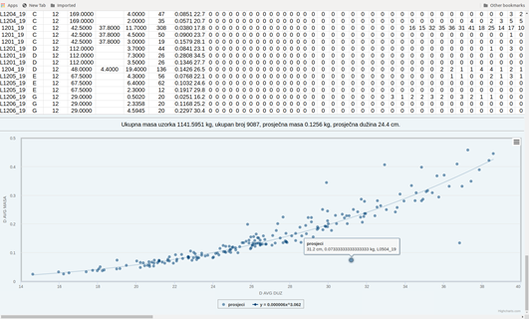
Figure 14. IOF database – data processing.

Section 5: data quality

Text Box 5B: Quality assurance framework for socioeconomic data
General comment: This box fulfills Article 5 paragraph (2) point (b) of the Implementing Decision (EU) 2016/1701 on the format of the WP. This box is intended to specify data to be collected under Tables 5(A), 6 and 7 of the Annex of the Delegated Decision (EU) 2019/910 on the multiannual Union programme. Use this box to provide additional information on Table 5B of the Annual Report.
1. Evidence of data quality assurance
Within this section MS shall provide information on the methodology used to assure the quality of the data collected, highlighting those aspects where changes have been made during the sampling year. Information shall be provided by each sector (Fishing fleet, Aquaculture, Fish processing) for which data was collected and by each data collection scheme. In the case where the same quality assurance framework is applied to all sectors or/and all data collection schemes, information can be provided at general level with the indication “all sectors” or “all data collection schemes”.
In those sections of Table 5B where “N” is indicated, Member States shall explain the main constrains and/ or the steps taken to fulfil this obligation. In the cases where a reference documents is requested, Member States shall provide a web link.
In cases where documents are not publicly available, due to institutions internal policy, confidentiality or other reasons, this shall be indicated by the Member State.
Fisheries
Documentation is available on the DCF web page (https://podaci.ribarstvo.hr).
Croatia has a national plan for the validation systems as per Article 109 (8) of the Control Regulation. The National Plan for the Implementation of the Validation and Verification System in Republic of Croatia was approved by Commission Implementing Decision (EU) 2015/2277 of 2 December 2015. During 2015 Croatia started implementing the VALID system which is continuously being developed further and is used to control data quality. VALID automatic cross-check procedures operate in addition to local validations on data-entry and are based on several validation rules packages (EC core rules, national VMS rules, fleet registrations/licensing, catch report/qualitative statistical analysis etc.).
Statistical cross-check procedures are performed prior to reporting according to data collection on-demand validation reports and internal procedures for statistical and reporting purposes for data end users (EC, ICCAT, GFCM, EUROSTAT, FAO etc.) under DCF and include specific rules developed for each report in order to verify and validate data.
In 2016 the upgrading of the national FIS (Fisheries Information System) in regard to the fleet register and the new FIS module used for license issuing has been finalized. Both registers, fleet register and register of licences, are directly linked which enables efficient data verification of data. Catch reporting requirements in Croatia for all vessels less than 10 m LoA are based on monthly catch reports that are particularly suited for passive gears. Small-scale vessels for personal needs, that were transferred to the commercial fleet in 2015 also fall under the national requirement. As the current calculation of fishing days previously slightly exaggerated fishing days for passive gears, the methodology was harmonized with results of the DCF Workshops on transversal variables in 2017. Starting from 2017 and 2018 a full traceability system of fisheries products up until first sale was planned to be established in 2019 and 2020. This process started in 2016 by implementing an electronic transport document and linking first sale with logbooks and catch reports. The aim is to enhance the estimation of economic indicators and monitor fish prices in domestic market as well as import and export more efficiently.
In addition to obligations pursuant to Article 9 of the Basic Regulation, the following vessels are equipped with a VMS device and e-logbook: every authorized active demersal trawler (OTB), purse seiner (PS) and vessel with dredges (DRB) regardless of LoA, HL and LL vessels with BFT/SWO quota, vessels with quota for recreational fisheries of BFT. The e-logbook has greatly improved catch reporting and timely availability of catch and effort data in recent years. In addition to elements as required by the Basic regulation, the information on fish size of sardine and anchovy was added to the e-logbook for purse seiners. As fisheries in Croatia are managed through national fishing zones, fish size is an important element in terms of indirectly monitoring the stocks. As this data is linked with VMS data, the indication of the movement of fish of a certain size in certain periods and fishing zones is obtained.
Croatia is currently developing mobile applications (mTransportDocument, mSalesNote, mCatchReport and mLogbook) to facilitate reporting by the sector. This should lessen the administrative burden of data entry into FIS and enable the DoF to focus more resources on data validation and verification.
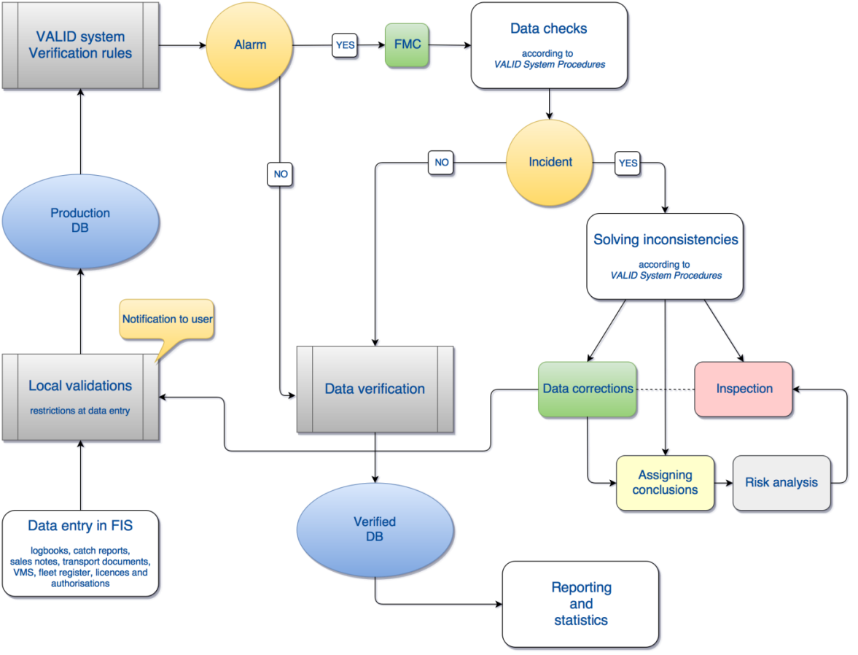
Chart 1. Flow chart of the data validation and verification system for fisheries

Aquaculture and processing industry
Data on processing industry and aquaculture sector are regularly checked with data from the Financial agency and starting from 2017 with Structural Business Statistics Data (SBS) from Croatian Bureau of Statistics aggregated by company size (number of employees). SBS data related to population is also checked by detailed insight into companies' activities during the reference year. Therefore, the number of companies and indicators included in DCF population could be slightly different than those included in EUROSTAT population. Further plan is to improve data on raw material by comparing the data from recently developed traceability system. The main constraints were still lower response for some small segments which is expected to be improved following the changes in the new Marine Fisheries Act and subsequent Ordinance on Data Collection and further development in data collection organization.
2. Section P3 Impartiality and objectiveness
Explain main constraints and/ or steps taken, if ‘N’ (no) was indicated in Table 5B
- Not applicable.
3. Section P4 Confidentiality
Explain main constraints and/ or steps taken, if ‘N’ (no) was indicated in Table 5B
- Not applicable.
4. Section P5 Sound methodology
Explain main constraints and/ or steps taken, if ‘N’ (no) was indicated in Table 5B
Information on this principle should be briefly explained in Text boxes 3A, 3B and 3C. Description of methodologies used on data quality.
- Not applicable.
5. Section P6 Appropriate statistical procedures
Explain main constraints and/ or steps taken, if ‘N’ (no) was indicated in Table 5B. Please provide a link if the documented revisions are available and not confidential.
- Not applicable.
6. Section P7 Non-excessive burden on respondents
Explain main constraints and/ or steps taken, if ‘N’ (no) was indicated in Table 5B
- Not applicable.
7. Section P8 Cost effectiveness
Explain main constraints and/ or steps taken, if ‘N’ (no) was indicated in Table 5B
- Not applicable.
8. Section P9 Relevance
Explain main constraints and/ or steps taken, if ‘N’ (no) was indicated in Table 5B
- Not applicable.
9. Section P10 Accuracy and reliability
Explain main constraints and/ or steps taken, if ‘N’ (no) was indicated in Table 5B. Information on this principle should be briefly explained in Text boxes 3A, 3B and 3C. Description of methodologies used on data quality.
- Not applicable.
10. Section P11 Timeliness and punctuality
Explain main constraints and/ or steps taken, if ‘N’ (no) was indicated in Table 5B
- Not applicable.
11. Section P12 coherence and comparability
Explain main constraints and/ or steps taken, if ‘N’ (no) was indicated in Table 5B
- Not applicable.
12. Section P13 Accessibility and Clarity
Explain main constraints and/ or steps taken, if ‘N’ (no) was indicated in Table 5B. Information and links to documentation on this principle should be briefly explained in Text boxes 3A, 3B and 3C. Description of methodologies used on data quality.
The process of updating documentation on all DC procedures related to quality (database documentation, quality control procedures, sampling methodologies, data processing methods etc.) is ongoing. Database documentation is stored on DoF server which is available with authenticated access to project partners. Methodological documents are publicly available on the national DCF website. New national website indicated in section P13 has been released early June 2019.
Methodological documentation is available on the following links:
https://podaci.ribarstvo.hr/prikupljanje-podataka/transverzalni/ and https://podaci.ribarstvo.hr/prikupljanje-podataka/socioekonomski/

