MINISTRY OF AGRICULTURE
Directorate of Fisheries



Commission Implementing Decision (EU) 2016/1701
on the establishment of a Union framework for the collection, management and use of data in the fisheries sector and support for scientific advice regarding the common fisheries policy and repealing Council Regulation (EC) No 199/2008 (recast).
Commission Implementing Decision (EU) 2016/1251 of 12 July 2016 adopting a multiannual Union programme for the collection, management and use of data in the fisheries and aquaculture sectors for the period 2017-2019.
Commission Implementing Decision (EU) 2016/1701
laying down rules on the format for the submission of work plans for data collection in the fisheries and aquaculture sectors.

Commission Implementing Decision (EU) ****/*****

Croatian Annual Report for data collection in the fisheries and aquaculture sectors
2017-2019
Version 2 – 2017

EUROPEAN UNION
Zagreb, December 17, 2018
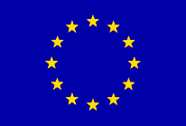

EUROPEAN UNION

EUROPEAN UNION

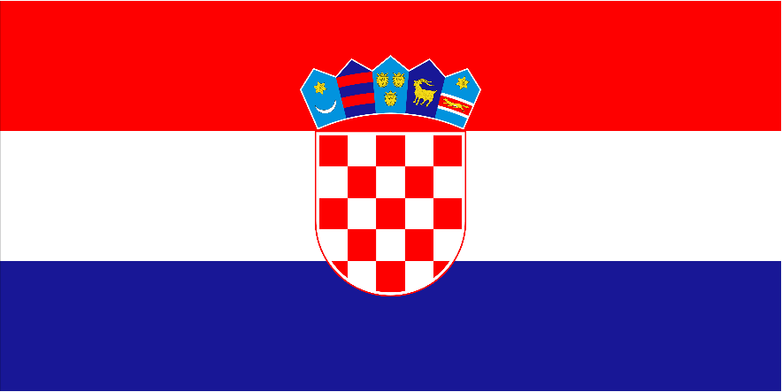
CONTENTS

Section 1: Biological Data 2
Text Box 1C: Sampling intensity for biological variables 2
Section 1: Biological Data 4
Text Box 1D - Recreational fisheries 4
Section 1: Biological Data 6
Pilot Study 1: Relative share of catches of recreational fisheries compared to commercial fisheries 6
Section 1: Biological Data 7
Text Box 1E: Anadromous and catadromous species data collection in fresh water 7
Section 1: Biological Data 8
Text box 1F: Incidental by-catch of birds, mammals, reptiles and fish 8
Section 1: Biological Data 10
Pilot Study 2: Level of fishing and impact of fisheries on biological resources and marine ecosystem 10
Section 1: Biological Data 12
Text Box 1G: List of research surveys at sea 12
Section 2: Fishing Activity Data 20
Text Box 2A: Fishing activity variables data collection strategy 20
Section 3: Economic and Social Data 22
Text Box 3A: Population segments for collection of economic and social data for fisheries 22
Section 3: Economic and Social Data 26
Pilot Study 3: Data on employment by education level and nationality 26
Section 3: Economic and Social Data 27
Text Box 3B: Population segments for collection of economic and social data for aquaculture 27
Section 3: Economic and Social Data 30
Pilot Study 4: Environmental data on aquaculture 30
Section 3: Economic and Social Data 31
Text Box 3C: Population segments for collection of economic and social data for the processing industry 31
Section 4: Sampling Strategy for Biological Data from Commercial Fisheries 34
Text Box 4A: Sampling plan description for biological data 34
Section 5: data quality 38
Text Box 5A: Quality assurance framework for biological data…………………………..38
Section 5: data quality 39
Text Box 5B: Quality assurance framework for socioeconomic data ……….…………………39

Section 1: Biological Data

Text Box 1C: Sampling intensity for biological variables

General comment: This box fulfils paragraph 2 point (a)(i)(ii)(iii) of Chapter III, Chapter IV of the multiannual Union programme and Article 2, Article 4 paragraph 1 and Article 8 of the Decision (EU) 2016/1701. This box is applicable to the Annual Report.
Member State should provide by Region/RFMO/RFO/IO:
Mediterranean Sea/GFCM/ICCAT/ICES
- Evidence of data quality assurance
Quality evaluation can only be carried out if the information coming from Table 5A is available. If this is not the case, Member State shall provide an overview by giving information on the methodology used to assure the quality of the data collected.
e.g.:
The sampling design and protocols follow the outcomes of sampling expert groups.
Use of common standard criteria agreed with other countries/groups.
Use of special packages or tools (e.g. COST …) for calculations.
Use of sampling protocol for storage of data.
Use of sampling protocol for processing of data.
Use appropriate exploratory statistical techniques to detect outliers and anomalous registers.
During the implementation of the project activities within monitoring of biological variables, the sampling design and protocols of the activities followed the outcomes of sampling expert groups (RCG LP MED & BS; GFCM WGs; FAO AdriaMed WGs) and existing common standard criteria were used (MEDITS and MEIDAS scientific surveys sampling protocols; Age determination protocols, etc.).
Samples and measurements for large pelagic species are collected and the data are processed and stored following up the recommendations from expert groups – ICCAT SCRS and RCG and LP MED&BS. Techniques and procedures used for obtaining and reading the biological samples are derived from scientific papers and protocols recommended by ICCAT and FAO.
- Deviations from the Work Plan
MS to list the deviations (if any) in the achieved data collection compared to what was planned in the Work Plan and explain the reasons for the deviations. The threshold for deviation follow those set in the former AR: <90 % and >150 %.
Explain any deviation from the proposed:
- sampling intensity,
- methods used for collecting data.
- methods used for estimating the parameters.
General reasons for deviations from the Work Plan in terms of planned vs. achieved should be summarised in this section, while detailed comments on deviations on particular species/stocks should be included in the AR Comments column in Table 1C.
In case of Member State adding new species not included in the WP, this should be clearly explained and justified.
During the implementation of the project activities within monitoring of biological variables minor deviations have occurred. For large pelagic species there were some problems in cooperation with fishermen and because of that lower number of sampling trips and consequently less samples were collected.

Species Sardina pilchardus, Atherina spp., Mugilidae and Sarda sarda were oversampled over 150% but oversampling did not affect the financial cost.
Solea vulgaris was sampled on landing places. In all, we measured lengths of 587 specimens of S. vulgaris out of 120 planned. Out of these, 120 specimens were taken for laboratory analysis. There was no additional cost although we achieved 490% of planned length measurements.
Spicara smaris was sampled on board and on landing places. In all, 3000 specimens were measured (758 length and weight), among which 300 were taken for laboratory analysis. There was no additional cost although we achieved 253% of planned length and weight measurements.
Boops boops as sampled on landing places and on board. In all 172 specimens were measured and 100 of those were taken for laboratory analysis. All went according to plan.
Ostrea edulis was sampled on board and on landing places and out of the 1000 planned specimens; length was measured on 588 specimens. There is a 59 % of achievement due to significantly lower catches of the Ostrea edulis in 2017. Lower quantities in the catches caused price increase at the markets, which prevent the purchase of the samples because it required more financial cost than was predicted by the National Plan.
Species Pecten jacobaeus, Pectinidae and Trachurus trachurus were over sampled more than 150% than it was planned. Oversampling did not affect financial plan.
For some species (Auxis rochei, Euthynnus alleteratus, Seriola dumerili and Scomber scombrus) were undersampled due to the fact that during sampling procedures there was no catch of that species; fisherman sold the fish before contacting scientists, and/or specimens were out of price range prepared for sampling.
For the listed species below, there is no registered landings at the species level and biological information can be provide only through scientific surveys:
- Dipturus oxyrinchus
- Etmopterus spinax
- Galeus melastomus
- Hexanchus griseus
- Mustelus asterias
- Mustelus punctulatus
- Prionace glauca
- Pteroplatytrygon violacea
- Squalus blainvillei
- Torpedo marmorata
- Torpedo torpedo
- Dalatias licha
- Selachii
- Scyliorhinus spp.
- Raja spp.
- Mustelus mustelus
- Myliobatis Aquila
- Squalus acanthias
A. rochei, E. alleteratus, S. dumerili and S. scombrus were planned for conditional sampling depending on approval of relevant management plan and derogation as they are mostly targeted by specific gears that are designated at national level as PS_DEF_>=14_0_0 (MISC) "OLIŽNICA", PS_LPF_>=50_0_0 "PALAMIDARA", PS_SPF_>=14_0_0 "LOKARDARA", PS_DEF_>=14_0_0 (MISC) "CIPLARA" and PS_SPF_>=14_0_0 "IGLIČARA". For most of these gears technical characteristics, fishing methodology or main fishing grounds were not in accordance with EU legislative. For this reason, the use of these gears was limited if not totally suspended during negotiation process between Republic of Croatia and EC that has been finalized in October 2018. This situation significantly affected the sampling scheme and possibility of observes to acquire planned numbers of individuals that comes from effective number of samples. During 2019, it will be possible to conduct the predicted sampling scheme due to exemption rules that were granted for the use of those gears by EC (COMMISSION IMPLEMENTING REGULATION (EU) 2018/1585 of 22 October 2018 establishing a derogation from Council Regulation (EC) No 1967/2006 as regards the minimum distance from coast and the minimum sea depth for purse seines fishing in territorial waters of Croatia).
Regarding sampling of eel, in Croatia fishing on eel represents minor if not a symbolic type of fisheries which is conducted by very few fishermen on several fishing locations (mostly at estuaries of rivers Neretva and Zrmanja). Eel fishing has seasonal characteristics and usually it is conducted as supplement to other passive fishing gears. In addition, majority of eel catch is achieved in recreational and sport fishery. This situation creates the significant logistic problem that significantly affects the implementation of sampling scheme predicted by Pilot study.
- Actions to avoid deviations.
Member State to describe the actions that will be considered / have been taken to avoid the deviations in the future and when these actions are expected to produce effect. If there are no deviations, then this section is not applicable.
Regarding the deviations listed in table 1C section 2, in relation for métier DRB and species Ostrea edulis – in 2018 we provided better cooperation with fishermen at landing sites in order to achieve planned number of individual without raising financial cost.
To avoid deviations regarding the sampling of large pelagic species, detected problem was taken fast into account and immediate actions were taken. Since handline fishing of tuna is new metier and sampling started in 2016, with large increase in fishing quota this could be looked as a transitional period where the scientist and fishermen are coming to agreement on how to cooperate better since the sampling is done based on a good will of fishermen. Meetings were adjourned between fishermen, scientist and the ministry to come to a better understanding with immediate effect being noticeable already in 2018.
As regards to undersampling of species due to sampling protocol (Auxis rochei, Euthynnus alleteratus, Seriola dumerili and Scomber scombrus) and/or problem with contacting fisherman, we will try to adjust the sampling protocol to avoid undersampling in the future.
Since derogation has been set for the aforementioned purse seine gears it is expected that sampling will be carried according to National plan during 2019.
RC is aware of under sampling and difficulties in implementation of Pilot study for eel fisheries.
In order to legally strengthen the role and importance of scientific observers in the first half of 2019, it is envisaged to adopt an Ordinance on scientific observers in accordance with the provisions that have been set in the Marine Fisheries Act (OJ No 62/2017) and Article 12 of Regulation (EU) 2017/1004. This act will regulate on a national level the terms and conditions of authorized scientific observers in order to conduct sampling and achieve planned number of individuals for biological analysis. In addition, in 2019 the Directorate of Fisheries is implementing a strategy for information and promotion of data collection activities that will focus on improvement of collaboration of fishermen with the Institute of Oceanography and Fisheries which conducts the sampling. Several coordination meetings were held during the 2018 and are planned for 2019 between representatives of Directorate of Fisheries, scientists, stakeholders and members of fisheries associations in order to improve cooperation.
External advisors and experts have created the existing sampling scheme during the pre-accession negotiations of RC with EC during the 2012 under framework of IPA project. The advisors conducted the complete screening of Croatian marine fisheries and set a foundation of National sampling scheme taking in consideration specifics of Croatian fishery and the biological and ecological characteristics of the main species that have been selected for monitoring.
In order to revise the achieved number of individuals which come from an effective number of samples, RC is conducting screening the national sampling scheme through the activities of STREAM project. The project STREAM MARE/2016/22 “Strengthening Regional cooperation in the area of fisheries biological data collection in the Mediterranean and Black Sea” aims at providing support to the Commission and MSs to build up experience in new areas of regional cooperation in the Mediterranean and Black Sea for the realization of the Regional Sampling Plans (RSP). Under the framework of the Project several Training Workshop on Sampling Optimization were held during the 2018 in order to revise existing sampling schemes by use of the SD tool developed by MARE/2016/22. The results of the sampling optimization conducted in 2018 will be incorporated in the AWP revision after the finalization of the projet and pending approval at the RCG Med&BS and RCG-LP level.
(max. 1000 words per Region/RFMO/RFO/IO)

Section 1: Biological Data

Text Box 1D - Recreational fisheries

General comment: This box fulfills paragraph 2 point (a) (iv) of Chapter III of the multiannual Union programme and Article 2, Article 3 and Article 4 paragraph 1 of the Decision (EU) 2016/1701. This box is applicable to the Annual Report. This box is intended to provide information on the design, implementation and analysis of all components of sampling schemes/ surveys that are listed in Table 1D.
1. Description of the target population
The target population and the elements of this target population accessibility, need to be defined and described in this section. In the case of Recreational Fisheries, the target population could be whole population of resident anglers, charter boats etc. This will permit to evaluate if all sectors contributing to the total catch, are included in the survey.
For large pelagic species the target population includes all fishing boats that are registered to participate in every Big Game Fishing Competition that is held during the whole year.
At national level there is no registered catch of Anguilla anguilla and elasmobranch species in this type of fishery in 2017. During the Pilot study a questionnaires was designed and will be distributed among recreational fishermen or fisheries associations during 2018.
2. Type of survey
In Table 1D, the methodology or type of survey used must be included, but any information about the design is missing.
Table 5A in the Work Plan allows to identify if the sampling design is documented and where it can be found. Are the surveys identified correctly in table 5A and information about sampling design provided under this table?
If the answer is No: information on the design should be included in this section of the Annual Report (e.g.: stratification, selection of PSU, is sampling probability base etc.).
Target population for large pelagic species includes all fishing boats that register to participate in every Big Game Fishing Competition that is held during the whole year.
The complete sampling scheme regarding the recreational fishery, data evaluation quality check are based according to the previous knowledge. Comprehensive and updated documentation will be available at the end of 2018.
3. Data Quality
Information about non-responses and refusals is found in the Work Plan, Table 5A. Are non-responses and refusals recorded in table 5A?
The non-responses and refusals were not recorded during 2017.
If the answer is No: information on recordings of non-responses and refusals should be included in this section of the Annual Report.
The non-responses and refusals will be recorded during the 2018.
4. Data Analysis and processing
Information about data processing is found in the Work Plan, Table 5A. Are the editing and imputation methods documented and identified?
If the answer is No: information on estimation procedures should be included in this section of the Annual Report, following the questions below:
Does the estimation procedure follow the survey design?
Has the precision of the estimates been calculated and documented?
Sampling and data processing is done as in other biological samplings regarding large pelagic fish, or more precisely Bluefin tuna.

Section 1: Biological Data

Pilot Study 1: Relative share of catches of recreational fisheries compared to commercial fisheries

General comment: This box fulfils paragraph 4 of Chapter V of the multiannual Union programme and Article 2 and Article 4 paragraph (3) point (a) of the Decision (EU) 2016/1701.
General comment: This box is applicable to the Annual Report. This box is intended to provide information on the results obtained from the implementation of the pilot study.
1. Aim of pilot study
The aim of this pilot study is to assess the share of catches from recreational fisheries in relation to commercial catches and to obtain indicative data on fishing effort and the qualitative and quantitative composition of the catch particularly in relation to the species listed in Table 3 EUMAP (eel and elasmobranchs). In order to achieve this goal the annual catches by species in both weight and number shall be obtained.
2. Duration of pilot study
The anticipated duration of the project is one year, and will be performed by the end of December 2018.
Data will be available by end of May 2019.
3. Methodology and expected outcomes of pilot study
Considering the large number of participants in sport and recreational fisheries (in recent years, over 70,000 permits is being issued), and the problem of direct (on-board) data collection, the necessary data collection for recreational fisheries is planned through a simple questionnaire that will be distributed to fishermen when purchasing the fishing permit. Data would partly be collected by a prepaid post card survey (for those anglers who purchase their permit in the offices of the Directorate of Fisheries (in further text: DoF) and sports associations), and the other by an e-survey for those who buy an online permit. During the survey information on the types of fishing gears used will be gathered, as well as data on fishing effort, and qualitative and quantitative composition of the catch, with special reference to species listed in Table 3 of the EUMAP (eel and elasmobranchs).
The target population shall consist of all recreational fishing and shall include activities carried out on shore (eg. angling, spearing and fish caught using harpoons) and onboard vessels.
Brief description of the results obtained (including deviations from planned and justifications as to why if this was not the case).
4. Achievement of the original expected outcomes of pilot study and justification if this was not the case.
During the monitoring activities in 2017 there was problem to collect the data since there was no registerd catch in recreational fishery for the selected species. The member state will put greater effort in raising the awerness of data importance to recreational fishermen i order to achive planned activities.
5. Incorporation of results from pilot study into regular sampling by the Member State.
Incorporation of the results into regular sampling by the MS will be in accordance with recommendation of relevant expert group under RCG Med & BS and GFCM.
(max 900 words)

Section 1: Biological Data

Text Box 1E: Anadromous and catadromous species data collection in fresh water

General comment: This box fulfills paragraph 2 points (b) and (c) of Chapter III of the multiannual Union programme and Article 2 of the Decision (EU) 2016/1701.
General comment: This box is applicable to the Annual Report.
1. Method selected for collecting data
The only species from the group of anadromous and catadromous species that has a commercial importance in Croatia is Anguilla anguilla, European eel. The annual catch of this species is very small (an average of about 400 kg) and is performed by commercial and sport and recreational fishing. This type of fisheries is primarily performed using two types of gears - a special type of pot to catch eel and fyke for eel. Fishing takes place throughout the year with different intensity, while the major area of ​​fishing is the mouth of the river Neretva.
Monitoring of eel in Croatia for the period 2017-2019 is planned as a pilot study and the sampling scheme will be designed by the end of 2017. Within the pilot study sampling is planned to be carried out annually, as on-board sampling and sampling on the landing place. During sampling, data on the characteristics of the fishing gear will be collected (number and size of fish pots, mesh size), as well as data on fishing effort and the information on the qualitative and quantitative composition of catches (target species, by-catch and discard). For the target species eel data on length frequencies and biological data (length, individual weight, sex, maturity and age over otolith) will be collected.
All stages of eel (recruits – glass eel, standing stock – yellow eel and emigrating silver eel) will be subject to the pilot study as is planned in Table 1E and sampled for the determination of the required parameters (abundance of glass and yellow eel, and the number or weight and sex ratio of emigrating silver eels). The abundance will be estimated using the eel fishery catch and effort data if possible and using fishery independent methods once an appropriate sampling design is defined. By the end of 2017 the national management plan for eel is still not adopted, however according to scientific and fisheries data, River Neretva is determined as the sampling area for the pilot study.
The methodology for the monitoring, and the protocol will be designed for the purpose of reporting and evaluation refered to in Article 9 of Council Regulation (EC) No 1100/2007 of 18 September 2007 establishing measures for the recovery of the stock of European eel. Coordination of both administrative and methodological activities is needed in order to establish a monitoring programme for eel by the end of the period. In this regard, national coordination is planned for the beginning of 2018. The sampling methodology shall also be discussed within the Regional Coordination Group for the Mediterranean and Black sea.
2. Were the planned number achieved? Yes/ No
No
If answer is No, Member State shall explain why not, and what measures were taken to avoid non-conformity.
The recorded annual catch of this species during the 2017 was very small (less than 500 kg). During the observing period no information about this species were collected due to scarcity of catch.

Section 1: Biological Data

Text box 1F: Incidental by-catch of birds, mammals, reptiles and fish

General Comment: This box fulfils paragraph 3 point (a) of Chapter III of the multiannual Union programme and Article 2 of the Decision (EU) 2016/1701. This box is applicable to the Annual Report. This box is applicable only for those sections where Member States have reported that they have been carrying out regular sampling. Results and deviations for Pilot studies should be reported under Pilot Study 2.
1. Results
Member States shall fill in Table 1F and provide additional information, if available, in this text box. For example, species (or family) identification, number of samples, and the state of the animals incidentally by-caught (i.e. were they released alive, dead, or collected for sampling).
For métier OTB (demersal trawl) during 2017, our observers recorded during on board sampling one specimen of vulnerable species of Elasmobranchs: Dipturus oxyrinchus and that one specimen was released alive. Total length, weight and sex was taken.
2. Deviations from Work Plan
Member States shall list the deviations (if any) in the achieved data collection compared to what was planned in the WP and explain the reasons for the deviations.
Explain any deviations from the proposed:
- sampling intensity
- methods used for collecting data
During the activities in 2017 there were no significant deviations in comparison to the Work plan.
3. Data quality
Member States shall provide information on sampling protocols and sampling design for incidental by-catch data collection.
Questions to be addressed are listed below:
- Does the onboard observer protocol contain a check for rare specimens in the catch at opening of the codend? If YES is the observer instructed to indicate if the codend was NOT checked in a haul?
Yes.
- In gill nets - and hook-and-line fisheries: does the onboard observer protocol instruct the observer to indicate how much of the hauling process has been observed for (large) incidental bycatches which never came on board (because they fall out of the net)? In large catches: does the protocol instruct to check for rare specimens during sorting of the catch (i.e. at conveyor belt)? Is the observer instructed to indicate what percentage of the sorting or hauling process has been checked at “haul level”?
- Does the onboard observer protocol instruct to report on the use of mitigation (i.e. Escape Devices or Acoustic Deterrent Devices)?
- Does the sampling design and protocol follow the recommendations from relevant expert groups? Provide appropriate references. If there are no relevant expert groups, the design and protocol have to be explained in the text.
During the on board monitoring of commercial fisheries observers are instructed to register any kind of catch and design of fishery gear following the relevant protocol described in GFCM DCRF manual and following the recommendation in the outputs of the MARE/2014/19 Project.
- Are data quality issues taken into account?
Yes.
- How are data (and samples) stored
Data is stored in the Institute of Oceanography and Fisheries database (IOF) in Split. No samples were taken because the caught specimens were released alive and unharmed.

Section 1: Biological Data

Pilot Study 2: Level of fishing and impact of fisheries on biological resources and marine ecosystem

General comment: This Box fulfills paragraph 3 point (c) of Chapter III of the multiannual Union programme and Article 2 and Article 4 paragraph (3) point (b) of the Decision (EU) 2016/1701.
General comment: This box is applicable to the Annual Report. This box is intended to provide information on the results obtained from the implementation of the pilot study.
1. Aim of pilot study
The aim of this study is to collect the data to assess the impact of Union fisheries on marine ecosystems in Union waters and outside Union waters. Data for estimating the level of fishing and the impact of fishing activities on marine biological resources and on marine ecosystems shall be collected based on end-user needs.
2. Duration of pilot study
In 2017 observers on-board are being used also to monitor incidental by-catch. Pilot study will be conducted in the period from 2018 to 2019.
3. Methodology and expected outcomes of pilot study
Incidental by-catch of all birds, mammals and reptiles and fish protected under Union legislation and international agreements, including the species listed in Table 1D, including absence in the catch, will be monitored during scientific observer trips on fishing vessels and by the fisherman themselves through logbooks.
Pilot study 2 shall be carried out according to RCG MED&BS 2017 Recommendation 5: Pilot studies on incidental catch of vulnerable species.
Following the 2016 Recommendation of the RCG Med&BS-LP on pilot studies for the assessment of incidental catches of birds, mammals, reptiles and fish, the planned monitoring programme of the GFCM on the incidental catch of vulnerable species, shall be followed carrying out the following pilot studies:
- 2018: Pilot study for assessing incidental catches of vulnerable species from bottom trawlers
- 2019: Pilot study for assessing incidental catches of vulnerable species from longlines
- 2020: Pilot study for assessing incidental catches of vulnerable species from set nets (gillnets).
The guidelines for monitoring incidental catch of vulnerable species and processing the collected data, will be based both on the outputs of the EU MARE/2014/19 project for the Med&BS, and the GFCM guidelines on incidental catch (under preparation). Data to be collected will include: identification of species, number and weight (when possible) of individuals, gear specifications, location and timing of catches.
Brief description of the results obtained (including deviations from planned and justifications as to why if this was not the case).
Level of fishing and impact of fisheries on biological resources and marine ecosystem was observed during on board sampling and scientific survey (MEDITS). During the scientific survey and monitoring of commercial fisheries, incidental by catch of vulnerable species (present or absence) were recorded according to the Plan. All collected data are stored in relevant database. Collected data were procesed and uploaded to the end user (ICES WGBYC) as it was requested.
4. Achievement of the original expected outcomes of pilot study and justification if this was not the case
The workshop on sampling, processing and analysing the stomach contents (WKSTCON) was held in Palma de Mallorca, from 24-27 April 2018 following the proposal from the MARE/2014/19 Med&BS project (Strengthening regional cooperation in the area of fisheries data collection in the Mediterranean and Black Sea). The responsible researcher for collection of the data was participating this workshop in order to harmonize the sampling and data processing at regional level. According to outcome of workshop, common protocol will be used for sampling, processing and analysing the stomach contents.
5. Incorporation of results from pilot study into regular sampling by the MS
Incorporation of the results into regular sampling by the MS will be in accordance with recommendation of relevant expert group under RCG Med & BS and GFCM.

Section 1: Biological Data

Text Box 1G: List of research surveys at sea

General comment: This box fulfills Chapter IV of the multiannual Union programme and Article 2 and Article 7 paragraph (3) of the Decision (EU) 2016/1701. It is intended to specify which reseach surveys at sea set out in Table 10 of the multiannual Union programme will be carried out. Member States shall specify whether the research survey is included in Table 10 of the multiannual Union programme or whether it is an additional survey.
General comment: This box is applicable to the Annual Report. This box should provide complementary information on the performance of the surveys, the results and their main use.
Pan-Mediterranean Acoustic Survey (MEDIAS)
1. Objectives of the survey
Evaluate the abundance and spatial distribution of small pelagic fish resources by direct methods (acoustics), independently of the data provided by commercial fisheries; Target species are anchovy and sardine.
2. Description of the methods used in the survey.
Acoustic data for fish abundance estimation are collected by calibrated scientific echo sounder at 38kHz; Fish samples are collected by use of pelagic trawl net, with aim to provide information needed for echograms scrutinization, as well as for collection of fish biological data; Abiotic environmental data (measurements of temperature and salinity) collections are made by CTD vertical profiles, while additional biotic data in pelagic ecosystem are obtained by plankton sampling (acoustic at 120kHz and/or vertical hauls). Collection of navigational data ensures that all other collected data are geo-referenced (suitable for spatial analyses). Manual of the survey is available at http://www.medias-project.eu/medias/website/handbooks-menu.html, and it contains a graphical map of the surveys.
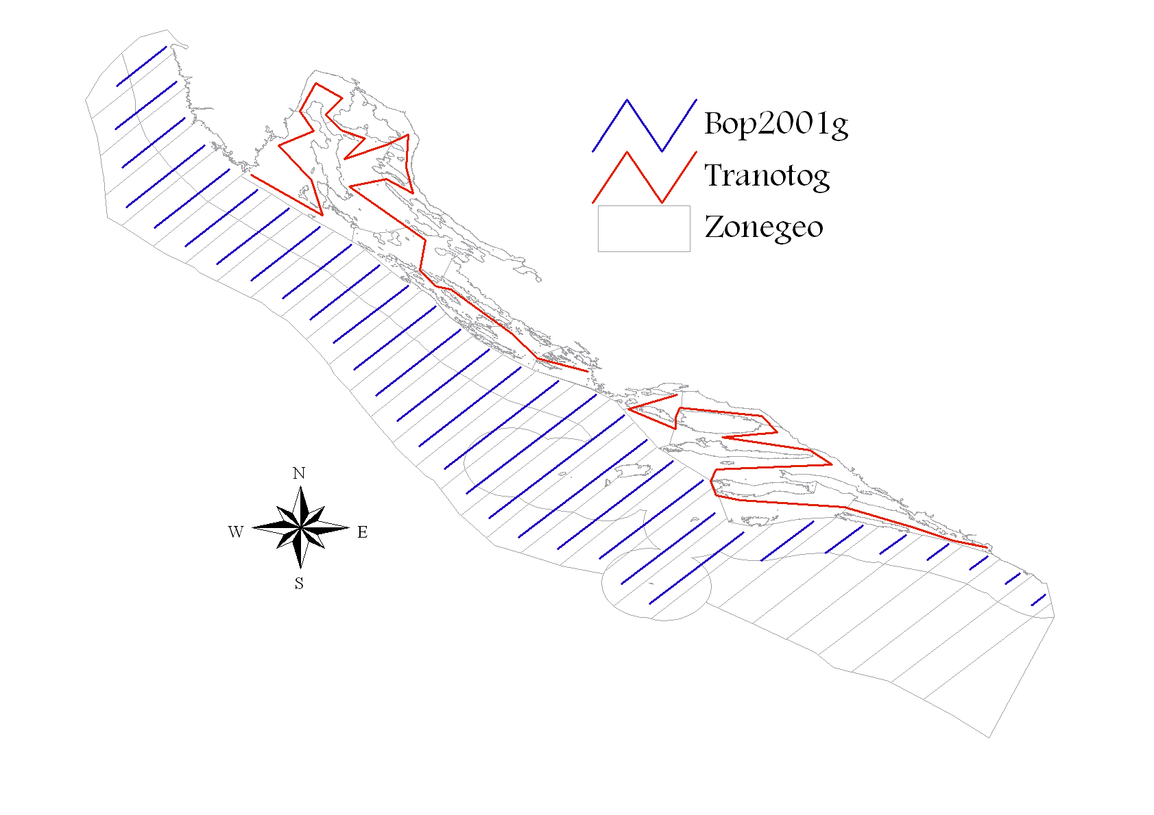
Figure 1. Map of acoustic survey in eastern part of GSA 17 during MEDIAS-DCF 2015 survey. Blue transects in open sea and red transects in inner sea.

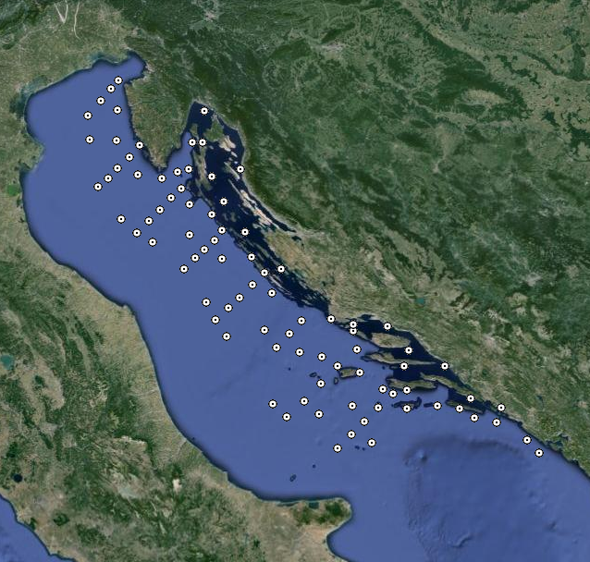
Figure 2. The spatial position of the CTD stations at which the measurements were made during the echo-monitoring DCF MEDIAS (September-October, 2015). Source: http://jadran.izor.hr/roscop/.
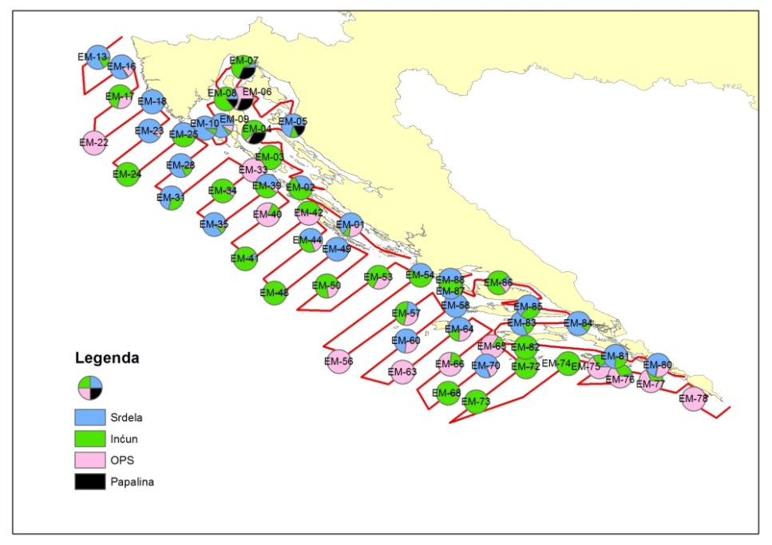
Figure 3. The spatial distribution of sampling and composition of catches achieved with the pelagic trawl along acoustic transects (green - anchovy, blue - sardine, black - sprat, and red - OPS) in September and October 2015.
3. Participating Member States/vessels and the relevant international group in charge of planning the survey
Croatia is participating in MEDIAS by conducting an acoustic survey in the eastern part of GSA17 area (Adriatic Sea), covering an area of 13,578 Nm². International MEDIAS Steering Committee is in charge of surveys planning.
4. Where applicable, describe the international task sharing (physical and/or financial) and the cost sharing agreement used
Not applicable.
5. Explain where thresholds apply
Thresholds are applied only in acoustic data elaborations, as described in MEDIAS Handbook (see at http://www.medias-project.eu/medias/website/handbooks-menu.html).

International bottom trawl survey in the Mediterranean (MEDITS)
1. Objectives of the survey
The MEDITS survey programme intends to produce basic information on benthic and demersal species in term of population distribution as well as demographic structure, on the continental shelves and along the upper slopes at a global scale in the Mediterranean Sea, through systematic bottom trawl surveys.
2. Description of the methods used in the survey
The MEDITS is conducted in spring - summer period from Max to July based on MEDITS protocol using specially designed bottom trawl net GOC 73. Sampling stations are randomly distributed according to the depth strata (10-50; 50-100; 100-200; 200-500; 500-800 m) and the number of stations is proportional to the surface of each stratum (Figure 1). The duration of tow in the area shallower than 200 m is 30 min, while in the area deeper than 200 m is 60 min. On board the vessel, the catches are split into the categories and sub-categories as reported in Annex V and XV of the manual. For each species the total weight and number of individuals should be collected, excluding the taxonomic category V, G, H for which only the total weight should be collected. For taxonomic categories D and E the number of individuals is not mandatory. When the catch of a given species or a fraction of a given species (e.g. juveniles) is too abundant to be measured in extenso it is reasonable to take a representative sub-sample of the catch. This sub-sample should be not less than 100 individuals.
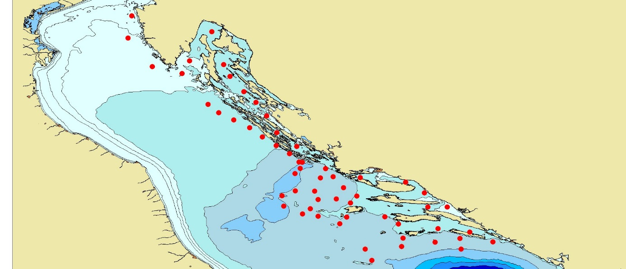
Figure 4. Map of sampling positions during the MEDITS survey in GSA 17 (Croatian territorial waters).
3. Participating Member States/vessels and the relevant international group in charge of planning the survey
Croatia is participating in MEDITS Surveys by conducting a bottom trawl survey in the eastern part of GSA17 area (Adriatic Sea), covering an area of 32000 Km2. MEDITS Working Group is in charge of survey planning.
4. Where applicable, describe the international task sharing (physical and/or financial) and the cost sharing agreement used
Not applicable.
5. Explain where thresholds apply
Not applicable.

Adriatic Rapido Trawl Survey (SoleMon)
1. Objectives of the survey
Solea solea is an important resource in the GFCM area. About 22% of the GFCM landings of soles come from the Adriatic Sea. In the GSA17 soles are targeted by “rapido” trawl and set nets by around 500 vessels, for a total of 1,600 fishermen and an annual value of landings of around 40 million Euros.
The main survey objectives are:
a) Assessing abundance, distribution in GSA17 of sole and other important demersal resources by surveys with “rapido” gears suitable to seize flatfish and other benthic animals.
b) Pursuing the studies on the ecosystem impact of the “rapido” trawl fishery.
c) Contribution to the setting of the GES and targets for the Adriatic Sea in the framework of an ecosystem approach, thus matching to the requirement of the implementation of the MSFD [DIRECTIVE 2008/56/EC].
2. Description of the methods used in the survey
The survey will cover sole presence within the GSA 17 that, according to the genetic information pertains as a single stock (Figure 5). All this holds also for benthic fish and shellfish of commercial interest, including rays and other selachians, since EU greatly focuses on such vulnerable resources. Since 2005 the same gear and protocol was used. The gear was a modified beam trawl named as “rapido” trawl. The gear was appositely planned to be fished on different types of bottom. The survey vessel utilizes two gears simultaneously; taking the characteristics of the gear and the rigging into account the warps should have a diameter of 14-16 mm. The length of warps to be shot is determined by the depth. The gear positioned in the right side of the vessel has 15 m of warp more than the other, in order to avoid possible interference between the two gears during the haul.
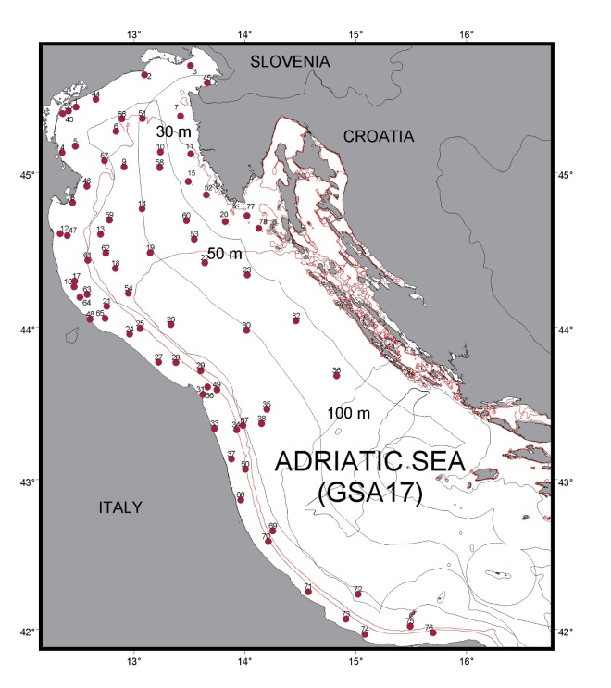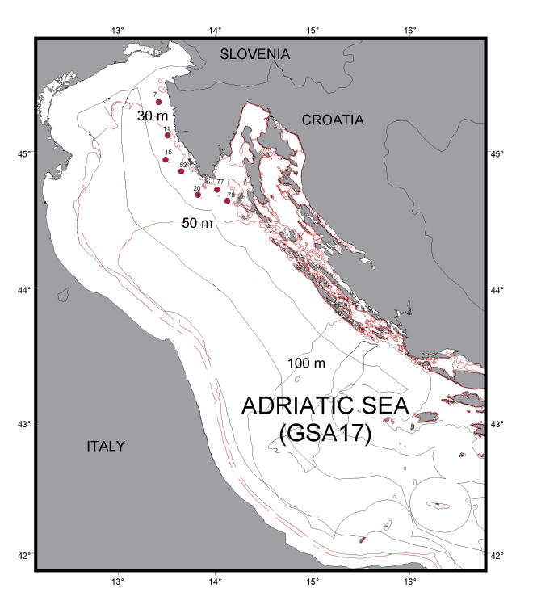
Figure 5. (left) Map of Solemon hauls in the Adriatic, GSA 17 (74 hauls). Borders between MS are indicative and without prejudice to territorial boundaries.
Figure 6. (right) Croatian hauls in the Adriatic Sea, GSA 17 (7 hauls).
3. Participating Member States/vessels and the relevant international group in charge of planning the survey
Data will be shared in working groups both at EU (STECF and ICES) and Mediterranean level (FAO-GFCM), and with all Member States of AdriaMed through common database AtrIS.
4. Where applicable, describe the international task sharing (physical and/or financial) and the cost sharing agreement used
Not applicable. The survey is performed by the Italian research vessel with no additional cost for Croatia while DSA for the Croatian scientists are financed through the AdriaMed project.
5. Explain where thresholds apply
Not applicable.

Pan-Mediterranean Acoustic Survey (MEDIAS)
6. Graphical representation (map) showing the positions (locations) of the realized samples.
Member State shall provide maps presenting the spatial distribution of the main sampling types obtained during the survey.
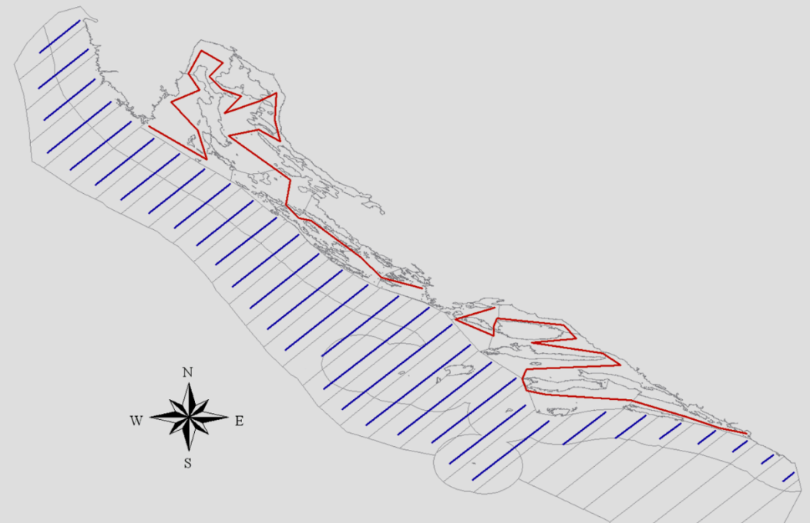
Figure 6. Map of acoustic transects in eastern part of GSA 17 as planned in DCF-MEDIAS 2017 survey. Blue transects in open sea and red transects in inner sea.

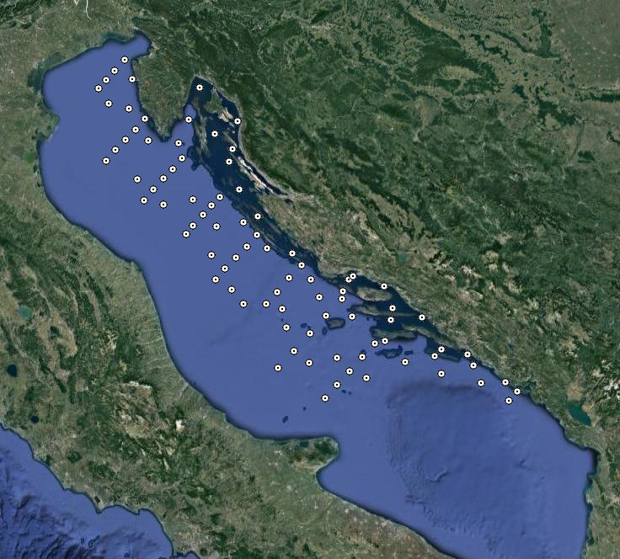
Figure 7. The spatial position of the CTD stations at which the measurements were made during the echo-monitoring DCF MEDIAS (August-September, 2017). Source: http://jadran.izor.hr/roscop/.

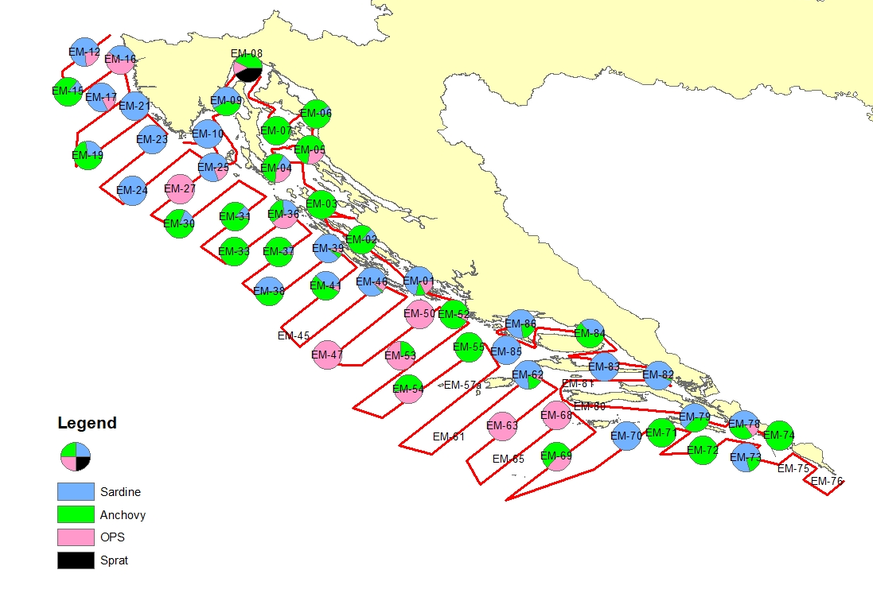
Figure 8. The spatial distribution of sampling and composition of catches achieved with the pelagic trawl along acoustic transects in late August and September 2017.
7. For internationally coordinated surveys, provide a link to the latest meeting report of the coordination group.
Member State shall provide a hyperlink to the meeting report from the body coordinating the survey (ICES, MEDITS coordination group, MEDIAS coordination group etc.). For non-international coordinated surveys, Member State shall refer to any status report (e.g. Cruise report).
http://www.medias-project.eu/medias/website/meetingrep.html
8. List the main use of the results of the survey (e.g. indices, abundance estimates, environmental indicators).
Member State shall specify in which context the results are used (on routine basis), both on an international as well as on a national context.
Results of the survey are used in international context (GFCM and STECF) as contribution to analytical stock assessments of anchovy and sardine in the Adriatic Sea, for assessment tuning purposes.
9. Extended comments (Tables 1G and 1H)
If the Member State has extended AR Comments, these can be placed under this section. If this is the case, a reference to this text box should be provided in the corresponding tables.
Table 1H: Survey results are not directly used for the advice, but just as a contribution for analytical assessment tuning purposes, with very low weight given to these survey results (i.e. have no influence on analytical assessment outputs). Oceanographic data (CTD) currently are not used for advices, but are potentially useful if could be related to recruitment index. These data are currently used to calculate sound speed as an input parameter for the echo sounder and to describe oceanography of the area surveyed.

International bottom trawl survey in the Mediterranean (MEDITS)
6. Graphical representation (map) showing the positions (locations) of the realized samples.
Member State shall provide maps presenting the spatial distribution of the main sampling types obtained during the survey.
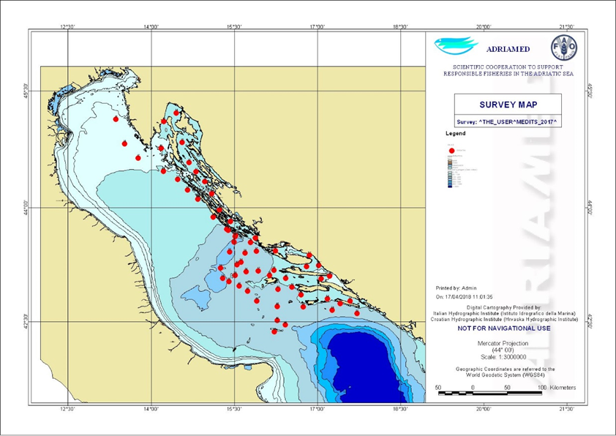
Figure 9. Map of sampling positions during the MEDITS survey in GSA 17 (Croatian territorial waters).
7. For internationally coordinated surveys, provide a link to the latest meeting report of the coordination group.
Member State shall provide a hyperlink to the meeting report from the body coordinating the survey (ICES, MEDITS coordination group, MEDIAS coordination group etc.). For non-international coordinated surveys, Member State shall refer to any status report (e.g. Cruise report).
N/A
8. List the main use of the results of the survey (e.g. indices, abundance estimates, environmental indicators).
Member State shall specify in which context the results are used (on routine basis), both on an international as well as on a national context.
Results of the survey are used in international context (GFCM and STECF) as contribution to analytical stock assessments of demersal species in the Adriatic Sea, for assessment tuning purposes.
9. Extended comments (Tables 1G and 1H)
If the Member State has extended AR Comments, these can be placed under this section. If this is the case, a reference to this text box should be provided in the corresponding tables.
Both core and additional sampling such as temperature, marine litter, macro zoobenthos samples, etc. was conducted and data collected according to the MEDITS Instructional Manual Version 9 (2017).

Adriatic Rapido Trawl Survey (SoleMon)
6. Graphical representation (map) showing the positions (locations) of the realized samples.
Member State shall provide maps presenting the spatial distribution of the main sampling types obtained during the survey.
Same as Figures. 5. and 6.
7. For internationally coordinated surveys, provide a link to the latest meeting report of the coordination group.
Member State shall provide a hyperlink to the meeting report from the body coordinating the survey (ICES, MEDITS coordination group, MEDIAS coordination group etc.). For non-international coordinated surveys, Member State shall refer to any status report (e.g. Cruise report).
N/A
8. List the main use of the results of the survey (e.g. indices, abundance estimates, environmental indicators).
Member State shall specify in which context the results are used (on routine basis), both on an international as well as on a national context.
Assessment of the current population status of common sole with regard to the degree of threat to exploitation. Based on the research conducted, measures for future management and protection are recommended.
9. Extended comments (Tables 1G and 1H)
If the Member State has extended AR Comments, these can be placed under this section. If this is the case, a reference to this text box should be provided in the corresponding tables.
N/A

Section 2: Fishing Activity Data

Text Box 2A: Fishing activity variables data collection strategy

General comment: This box fulfills paragraph 4 of Chapter III of the multiannual Union programme and Article 2, Article 4 paragraph (2) point (b) and Article 5 paragraph (2) of the Decision (EU) 2016/1701. It is intended to describe the method used to derive estimates on representative samples where data are not to be recorded under Regulation (EU) No 1224/2009 or where data collected under Regulation (EU) No 1224/2009 are not at the right aggregation level for the intended scientific use.
General comment: This box is applicable to the Annual Report. This box should provide information on the implementation of the data collection of fishing activity variables of Member States.
1. Description of methodologies used to cross-validate the different sources of data.
As part of the data collection preparation process, before retrieval of data, quality control procedures are performed to ensure the quality of collected data before its use. Such procedures include validation and verification of primary data from logbooks, fishing reports, sales notes, economic questionnaires etc. During 2015 Croatia started implementing the national validation and verification system under the National Plan for the Implementation of the Validation and Verification System in Republic of Croatia, approved by the European Commission. The so called “Valid” system includes automatic cross-checking procedures of Control data with the aim to validate and verify data comming from fishing declarations (including logbooks and fishing reports) and sales notes. Data on fishing activities is cross-checked with VMS data and relevant inspection procedures are applied when needed.
Although Control data is continuously validated during the year, separate quality reports are used to accomplish this task after data has been collected and stored in the data base. This process lasts around two months and is accomplished prior to the data-call announcement.
2. Description of methodologies used to estimate the value of landings.
Value of landings represents landings weight average prices. Amounts of first sales from sales notes and questionnaires are used to cross-check the resulting estimates. Total value for each species is the result of total weight landed multiplied by the average price.
3. Description of methodologies used to estimate the average price.
Average price is estimated using the recommended method, using weighted averages, trip by trip, obtained from sales notes, logbooks and fishing reports data. Average price is estimated using weighted mean of average price by the landing weight obtained by specie and trip.
4. Description of methodologies used to plan collection of the complementary data (sample plan methodology, type of data collected, frequency of collection etc).
Capacity, effort and landing information is fully covered by DoF and will be collected on the census basis. Complementary data collection is not applied as catch reporting requirements in Croatia are required for all vessels less than 10 m LoA by national legislation in force. The reporting is based on monthly catch reports that are particularly suited for passive gears. Additionally, small scale vessels for personal needs that were transferred to the commercial fleet in 2015 were included in the DCF population for 2015 and fall under the national requirement of catch reporting. As the current calculation of fishing days slightly exaggerates fishing days for passive gears, the methodology will be harmonized with results of the DCF Workshops on transversal variables I and II in early 2017.
5. Deviations from Work Plan methodology used to cross-validate the different sources of data
List the deviations (if any) and explain the reasons for the deviations.
No deviations.
Actions to avoid deviations.
Briefly describe the actions that will be considered / have been taken to avoid the deviations in the future and when these actions are expected to produce effect. If there are no deviations, then this section can be skipped.
Not applicable.
6. Deviations from Work Plan methodology used to estimate the value of landings.
List the deviations (if any) and explain the reasons for the deviations.
No deviations.
Actions to avoid deviations
Briefly describe the actions that will be considered / have been taken to avoid the deviations in the future and when these actions are expected to produce effect. If there are no deviations, then this section can be skipped.
Not applicable.
7. Deviations from Work Plan methodology used to estimate the average price.
List the deviations (if any) and explain the reasons for the deviations.
No deviations.
Actions to avoid deviations.
Briefly describe the actions that will be considered / have been taken to avoid the deviations in the future and when these actions are expected to produce effect. If there are no deviations, then this section can be skipped.
Not applicable.
8. Deviations from Work Plan methodology used to plan collection of the complementary data
List the deviations (if any) and explain the reasons for the deviations.
No deviations.
Actions to avoid deviations
Briefly describe the actions that will be considered / have been taken to avoid the deviations in the future and when these actions are expected to produce effect. If there are no deviations, then this section can be skipped.
Not applicable.

Section 3: Economic and Social Data

Text Box 3A: Population segments for collection of economic and social data for fisheries

General comment: This box fulfils paragraph 5 points (a) and (b) of Chapter III of the multiannual Union programme and Article 2, Article 4 paragraphs (1), (2) and (5) and Article 5 paragraph (2) of the Decision (EU) 2016/1701. It is intended to specify data to be collected under Tables 5(A) and 6 of the multiannual Union programme.
General comment: This box is applicable to the Annual Report. This box should provide information on the implementation of the fleet socio-economic data collection of Member States.
1. Description of methodologies used to choose the different sources of data.
Collection of the economic variables of the fleet is based on two major data sources:
a) Fishery Information System administered by DoF (fishing activity variables, volume and value of blue diesel consumed per vessel; information on subsidies etc.); and
b) Questionnaires for economic data collection.
The consistency of information coming from questionnaires and administrative sources is assured by cross-checking information from the different data sources.
2. Description of methodologies used to choose the different types of data collection.
Economic variables will be collected by questionnaires; the type of data collection scheme is probability sample survey by stratified random sampling and in some cases a census survey. For the variables Consumption of fixed capital and Value of physical capital Indirect survey shall be applied.
3. Description of methodologies used to choose sampling frame and allocation scheme.
Based on the basic data on the population and data on the use of fishing gears retrieved and stored, after data has been validated and verified, a segmentation of the fishing fleet is performed. In some cases fleet segments are clusered for sampling purposes or reporting purposes for confidentiality reasons. As clustering depends entirely on the activity of vessels, in cases where clustering is needed, vessel activity is reviewed on a vessel to vessel case. In cases where a vessel changes its activity from one year to another inconsistently, it is directly reflected in the clustering.
On the basis of determined fleet segments, the procedure for determining sample sizes is carried out.
In order to estimate the sample size for the collection of economic variables, the variability of GT and kW is calculated. Coefficient of GT variation is used as a basis to define the sample size of the total fleet.
The sample is distributed among the relevant strata with the principal objective of minimizing the sampling error to be obtained for the stratification variable. The optimum Neyman allocation, which guarantees a minimum variance for the variable used in the stratification, is used for this purpose.
The sample size for each stratum is adjusted in accordance with several minimum rules: not less than 10% of each stratum, not less than 5 observations per segment with <50 active vessels assuming the response rate of 50%. According to the distribution of the GT few segments need to be sampled on census basis.
4. Description of methodologies used for estimation procedures
Estimation procedures are performed according to agreed methodologies published on the official DCF web site (https://datacollection.jrc.ec.europa.eu/docs-links/socio-eco-var).
In cases where response rate is inadequate to reach a statistically sound estimation, a simple regression is used to cross-check results or estimate totals. Low response rate is typically a problem of data collection for the small-scale fleet, for which questionnaire return rate is low, data in questionnaires inconsistent, unreliable and sometimes unreadable as in most cases there is no professional accounting. To tackle these issues, considerably more effort is placed into data collection for the fisherman involved in small scale fisheries, including direct contact, reviewing questionnaires, cross checking data to ensure a more complete data sets, higher quality and more reliable results.
The calculation of variables Consumption of fixed capital and Value of physical capital is based on data from questionnaires and financial accounts in accordance with the PIM methodology, proposed in the report of study No FISH/2005/03. The age data is available per each vessel in the Fleet register. The data on the value of physical capital (replacement, insurance and purchase is collected through the questionnaire by DoF). The proposed DCF Excel template for the calculation of the capital costs will be used.
Estimation of direct subsidies: DoF records on direct subsidies are used as well as questionnaires. In cases where enterprises have more than one vessel, the amount of subsidies is allocated to vessels based on GT, as subsidies are collected on an enterprise level. The estimations are cross-checked by allocating the total amount of subsidies paid to respective fleet segments using the share of landings value of the fleet segment. In the end, three sets of estimations are compared to reach a sound conclusion.
Estimation of energy consumption and energy costs: For the estimation of energy consumption and energy cost blue diesel records are used. The register of blue diesel is updated annually on the amount of fuel consumed per vessel. No estimation to determine totals is used, as data is collected on a census basis. In order to estimate energy costs, data is collected both via questionnaires and by using average fuel prices.
Estimation of FTE: The number of hours worked during the year, collected from the enterprises through the economic questionnaire, is divided by national annual full-time working hours (based on the CBS methodology 2084 hours).
5. Description of methodologies used on data quality
To ensure the quality of data collected accuracy of the data that will be calculated. The data quality evaluation depends on the data collection scheme. In all cases (census and probability sampling) unit response rate (number of enterprises responded/total sample) and item response rate (response rate per each variable) is calculated as follows:
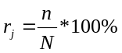
- Response rate (per item j);
N – Total number of vessels in the sample;
n – Number of vessels which provided the data (questionnaire/per each variable).
Coverage rate (number of responses/total population) is calculated in case of probability sampling survey.
It is planned that random samples be used and the sample size adjusted in accordance with the response rate during the implementation.
6. Deviations from Work Plan methodology for selection of data source
List the deviations (if any) from the methodology used to select data source compared to what was planned in the Work Plan, and explain the reasons for the deviations.
Several data sources for the collection of data on energy consumption and information on subsidies (as a second data source).
Actions to avoid deviations
Briefly describe the actions that will be considered / have been taken to avoid the deviations in the future and when these actions are expected to produce effect. If there are no deviations, then this section can be skipped.
Energy consumption and information on subsidies (as a second data source) was excluded from DoF questionnaires to avoid duplication of data collection. According to several years of cross-check, FINA and DoF records are proven to be sufficient and there is no need to keep two data sources.
7. Deviations from Work Plan methodology to choose type of data collection
List the deviations (if any) from the methodologies to choose type of data collecton scheme compared to what was planned in the Work Plan, and explain the reasons for the deviations.
All demersal trawl and purse seine segments regardless of the length class were sampled on a census basis, due to the importance of a higher response rate (these segments are under heavy management measures).
Actions to avoid deviations
Briefly describe the actions that will be considered / have been taken to avoid the deviations in the future and when these actions are expected to produce effect. If there are no deviations, then this section can be skipped.
These changes are considered to be positive deviations. However, the sample rate shall be adjusted in the AWP revision for 2019, in order to reflect the increased planned sample rate.
8. Deviations from Work Plan methodology regarding sampling frame and allocation scheme
List the deviations (if any) from the methodologies used regarding sampling frame and allocation scheme compared to what was planned in the Work Plan, and explain the reasons for the deviations.
Stratification on the basis of representative sub-sample per coastal county was made which resulted in a somewhat higher sample rate overall.
Actions to avoid deviations
Briefly describe the actions that will be considered / have been taken to avoid the deviations in the future and when these actions are expected to produce effect. If there are no deviations, then this section can be skipped.
The change to include substratification is considered as an improvement. This was done in order to try to reach a representative sample size for each coastal county for two reasons: 1) efficiently organize sampling among data collectors in seven DoF field units and 2) enable economic analysis at the level of smaller units for the purposes of evaluating FLAG strategies, different development plans at municipal level etc.
9. Deviations from Work Plan methodology used for estimation procedures
List the deviations (if any) from the methodologies used for estimation procedures compared to what was planned in the Work Plan, and explain the reasons for the deviations.
No deviations.
Actions to avoid deviations
Briefly describe the actions that will be considered / have been taken to avoid the deviations in the future and when these actions are expected to produce effect. If there are no deviations, then this section can be skipped.
Not applicable.
10. Quality assurance
10.1 Sound methodology
Briefly describe if the data collection follow methodologies, guidelines and best practices agreed in expert groups and whether methodologies are documented and are made publicly available.
The data collection follows methodologies, guidelines and best practices agreed in expert groups, available at the link below.
https://datacollection.jrc.ec.europa.eu/docs-links/socio-eco-var
10.2. Accuracy and reliability
Response rate and Achieved sample rate are provided in Table 3A.
For additional information, briefly describe how raw data inputs, intermediate results and outputs are regularly assessed and validated and how errors are identified, documented and dealt with.
All questionnaires were checked by DoF employees and all strange or unknown data reviewed and compared to balance sheets. An analysis of the entire time series of economic data for individual CFRs was made during the course of data-check, to reveal nonconformities, as well as an analysis of outliers and missing data at the fleet segment level. In some cases, respondents were asked to clarify information they submitted. Intermediate results and output are regulary compared to previous years results.
10.3. Accessibility and Clarity
Indicate with Yes or No
Are methodological documents publicly available?
Yes.
Are data stored in databases?
Yes.
Where can methodological and other documentation be found?
Provide the web link, if documentation is publicly available
https://datacollection.jrc.ec.europa.eu/docs-links/socio-eco-var

Section 3: Economic and Social Data

Pilot Study 3: Data on employment by education level and nationality

General comment: This box fulfills paragraph 5 point (b) and paragraph 6 point (b) of Chapter III of the multiannual Union programme and Article 2 and Article 3 paragraph (3) point (c) of the Decision (EU) 2016/1701.It is intended to specify data to be collected under Table 6 of the multiannual Union programme.
General comment: This box is applicable to the Annual Report. This box is intended to provide information on the results obtained from the implementation of the pilot study (including deviations from planned and justifications as to why if this was not the case).
1. Aim of pilot study
The aim of the pilot study is to analyse the feasibility of collecting social variables as indicated in Table 6 of the EU-MAP Regulation, separately for the fisheries and aquaculture sectors on a triannual basis starting in 2018.
2. Duration of pilot study
Pilot study shall be carried out in 2018.
3. Methodology and expected outcomes of pilot study
Data shall be collected via economic survey questionnaires and following PGECON guidelines after they are made available.
4. Achievement of the original expected outcomes of pilot study and justification if this was not the case.
Pilot study shall be carried out in 2018.

5. Incorporation of results from pilot study into regular sampling by the Member State.
Pilot study shall be carried out in 2018.

Section 3: Economic and Social Data

Text Box 3B: Population segments for collection of economic and social data for aquaculture

General comment: This box fulfills paragraph 6 points (a) and (b) of Chapter III of the multiannual Union programme and Article 2, Article 4 paragraphs (1) and (5) and Article 5 paragraph (2) of the Decision (EU) 2016/1701.It is intended to specify data to be collected under Tables 6 and 7 of the multiannual Union programme.

General comment: This box is applicable to the Annual Report. This box should provide information on the implementation of the socio-economic data collection for aquaculture of Member States.

1. Description of methodologies used to choose the different sources of data
There are two main sources of data - some variables will be collected from DoF database and subsidies register while some will be taken from questionnaires. For cross-checking, data from the Croatian Financial Agency (FINA) will be used, which is mostly connected with the balance sheet, but only for companies who have to deliver their data due to their size category or net profit.
2. Description of methodologies used to choose the different types of data collection
Data collection for all techniquest and species groups shall be carried out on the basis of a census, except for Long line-Mussel which shall be sampled on the basis of a Probability Sample Survey.
Data collection will be conducted by phone contact with subjects, introducing them with the data collection, and sending questionnaires together with guidelines by post or email. To ensure data consistency for all segments, together with each variable defined in guidelines it will be given the link to accounting code in balance sheets. The subject will have time two weeks to prepare documentation for data collection and after that a data collector will arrange a visit to farm office or accounting office to check and collect the requested data. For some cases where it is not possible to ensure direct contact, the subjects answer the questionnaires with telephone consultation and send it to DoF by e-mail.
3. Description of methodologies used to choose sampling frame and allocation scheme
Segmentation will be based on species and technique. Since a large number of enterprises are producing more than one species, additional segmentation is based on the value of production attributed to one species. Collecting data shall be for all segments by a census, except shellfish farm, where collecting is based on probability sampling.
4. Description of methodologies used for estimation procedures
One of the main problems is low response and cooperation so estimation needs to be used. Missing variables can be estimated from the Croatian Financial Agency (FINA) database and from Croatian national statistics bureau. Also, additional attention will be made on collecting data, especially on small-scale companies in marine aquaculture, so as in freshwater aquaculture. Since in Croatia there are different levels of enterprises legal registration with different accounting methods, it came clear during data collecting that is necessary to adjust guidelines for each of them. Two different questionnaires with different approach shall be devised. The first one, for small-scale companies, tailored to their business activities and the way of leading accounting records. Other for larger companies where it is easier to respond to inquiries and requests submitted to them.
5. Description of methodologies used on data quality
Data collection will be performed through questioners created for this purpose. To ensure data consistency for all segments, together with definition of each variable in guidelines, link is made to accounting code in balance sheets. Some of variables also will be collected from the DoF subsidies register, since it is mandatory for all aquaculture producers in Croatia to report the production in volume and value each year at the farm level. Some of the variables will be taken from questionnaires. Some other variables, e.g. subsidies, will be collected through DoF register and questionnaires. For some segments with small-scale companies it will be necessary to put additional effort in future data collection since they have difficulties in recording financial documents.

6. Deviations from Work Plan methodology for selection of data source
List the deviations (if any) from the methodology used to select data source compared to what was planned in the Work Plan, and explain the reasons for the deviations.
No deviations.
Briefly describe the actions that will be considered / have been taken to avoid the deviations in the future and when these actions are expected to produce effect. If there are no deviations, then this section can be skipped.
Not applicable.
7. Deviations from Work Plan methodology to choose type of data collection
List the deviations (if any) from the methodologies to choose type of data collecton scheme compared to what was planned in the Work Plan, and explain the reasons for the deviations.
Some segments were excluded from the Annual report and the Long line-Oyster segment was added after the additional analysis of the economic data.
Actions to avoid deviations
Briefly describe the actions that will be considered / have been taken to avoid the deviations in the future and when these actions are expected to produce effect. If there are no deviations, then this section can be skipped.
Additional analysis of available economic data in aquaculture sector before the data collection.
8. Deviations from Work Plan methodology regarding sampling frame and allocation scheme
List the deviations (if any) from the methodologies used regarding sampling frame and allocation scheme compared to what was planned in the Work Plan, and explain the reasons for the deviations.
Actions to avoid deviations
Briefly describe the actions that will be considered / have been taken to avoid the deviations in the future and when these actions are expected to produce effect. If there are no deviations, then this section can be skipped.
No deviations.
9. Deviations from Work Plan methodology used for estimation procedures
List the deviations (if any) from the methodologies used for estimation procedures compared to what was planned in the Work Plan, and explain the reasons for the deviations.
No deviations.
Actions to avoid deviations
Briefly describe the actions that will be considered / have been taken to avoid the deviations in the future and when these actions are expected to produce effect. If there are no deviations, then this section can be skipped.
Not applicable.
10. Quality assurance
10.1 Sound methodology
Briefly describe if the data collection follow methodologies, guidelines and best practices agreed in expert groups and whether methodologies are documented and are made publicly available.
The data collection follows methodologies, guidelines and best practices agreed in expert groups, available at the link below.
https://datacollection.jrc.ec.europa.eu/docs-links/socio-eco-var
10.2. Accuracy and reliability
Response rate and Achieved sample rate are provided in Table 3B.
For additional information, briefly describe how raw data inputs, intermediate results and outputs are regularly assessed and validated and how errors are identified, documented and dealt with.
All questionnaires were checked by DoF employees and all strange or unknown data reviewed and compared to balance sheets. In some cases, respondents were asked to clarify some numbers or information they sent. Intermediate results and output are regulary compared to previous years results and agregated data from data EUROSTAT data base and agregated data from SBS.
10.3. Accessibility and Clarity
Indicate with Yes or No
Are methodological documents publicly available?
Yes
Are data stored in databases?
Yes
Where can methodological and other documentation be found?
Provide the web link, if documentation is publicly available
https://datacollection.jrc.ec.europa.eu/docs-links/socio-eco-var

Section 3: Economic and Social Data

Pilot Study 4: Environmental data on aquaculture

General comment: This box fulfills paragraph 6 point (c) of Chapter III of the multiannual Union programme and Article 2 and Article 4 paragraph (3) point (d) of the Decision (EU) 2016/1701. It is intended to specify data to be collected under Table 8 of the multiannual Union programme.
General comment: This box is applicable to the Annual Report. This box is intended to provide information on the results obtained from the implementation of the pilot study (including deviations from planned and justifications as to why if this was not the case).
1. Aim of pilot study
To assess the feasibility of collecting the environmental data indicated in Table 8 of the EU-MAP Regulation through sub-sampling and extrapolating it to the whole population.
2. Duration of pilot study
Environmental data shall be collected every two years starting in 2018.
3. Methodology and expected outcomes of pilot study
Environmental data on aquaculture will be collected through the questionnaires with additional fields:
a) Medicines or treatments administered; and
b) Mortalities.
Also, for comparation will be used cross checking method with DoF data base in which are data about mortalities, hatcheries and nurseries, home production of fish feed in killos and pieces for mariculture sector. For freshwater aquaculture the reports on medicaments and mortalities will be used (estimated value of the enterprises employees).
It is expected that there should be no problems during collecting this data as all companies already maintain internal records.
4. Achievement of the original expected outcomes of pilot study and justification if this was not the case.
Environmental data shall be collected every two years starting in 2018.
5. Incorporation of results from pilot study into regular sampling by the Member State.
Environmental data shall be collected every two years starting in 2018.

Section 3: Economic and Social Data

Text Box 3C: Population segments for collection of economic and social data for the processing industry

General comment: This box fulfils footnote 6 of paragraph 1.1(d) of Chapter III of the multiannual Union programme, Article 2, Article 4 paragraphs (1) and (5) and Article 5 paragraph (2) of Decision (EU) 2016/1701. It is intended to specify data to be collected under Table 11 of the multiannual Union programme.
General comment: This box is applicable to the Annual Report. This box should provide information on the implementation of the socio-economic data collection for aquaculture of Member States.
1. Description of methodologies used to choose the different sources of data
Most of the data and additional information will collected through DCF collection and some from FINA (Croatian Financial Agency). Balance sheets will be used for cross-checking of data from questionnaires. DCF data will be collected through the questionnaires sent to the companies accountants.
Balance sheets, coming from CBS (Central Business Statisics), will be complemented by the DoF questionnaire. In order to ensure the consistency of data coming from different data sources cross checking indicators will be used, e.g. volume and value of production collected by DoF and CBS. For enterprises with less than 10 employees, which are not covered by the CBS survey, all the data need to be collected through the DoF questionnaire.
2. Description of methodologies used to choose the different types of data collection
Data collection will be conducted by phone contact with subjects, introducing them with the data collection, and sending questionnaires (forms) together with guidelines by post or email. In the case of processing industry, it is not necessary to visit subjects since most companies have an accounting service and have much better data than some aquaculture segments or the small-scale fishing fleet. The exact size of the active population will be determined only after data collection (in 2015), since all companies that have fish processing as main or as part of their activities were contacted.
3. Description of methodologies used to choose sampling frame and allocation scheme
As data from the Business Register is not necessarily updated, data from the Register of approved establishments, maintained by Ministry of Agriculture, the Veterinary Directorate, will be taken into account when defining the population for reference years 2017-2019.
4. Description of methodologies used for estimation procedures
All questionnaires will be checked by DoF employees and all strange or unknown data reviewed. In some cases, respondents need to be asked to clarify some numbers or information they sent. In cases when data collection is not possible directly from a visit, questionnaires will be filled with telephone consultation and send to DoF by e-mail. Also, some data collection can be made through balance sheet and profit and loss accounts. Those financial reports are available for public at FINA.
5. Description of methodologies used on data quality
A new type of questionnaire should provide data that maximum correspond to the actual operation of enterprises in the fish processing industry. Many companies whose main activity is processing, have also many other activities, as well as aquaculture and fishing activties. In this manner, data placed in questionnaires are actually balanced. Data coming from CBS can however only be used in cross-checking procedures since DCF data call deadlines are usually well before the SBS data availability.
6. Deviations from Work Plan methodology for selection of data source
List the deviations (if any) from the methodology used to select data source compared to what was planned in the Work Plan, and explain the reasons for the deviations.
No deviations.
Actions to avoid deviations
Briefly describe the actions that will be considered / have been taken to avoid the deviations in the future and when these actions are expected to produce effect. If there are no deviations, then this section can be skipped.
Not applicable.
7. Deviations from Work Plan methodology to choose type of data collection
List the deviations (if any) from the methodologies to choose type of data collecton scheme compared to what was planned in the Work Plan, and explain the reasons for the deviations.
No deviations.
Actions to avoid deviations
Briefly describe the actions that will be considered / have been taken to avoid the deviations in the future and when these actions are expected to produce effect. If there are no deviations, then this section can be skipped.
Not applicable.
8. Deviations from Work Plan methodology regarding sampling frame and allocation scheme
List the deviations (if any) from the methodologies used regarding sampling frame and allocation scheme compared to what was planned in the Work Plan, and explain the reasons for the deviations.
No deviations.
Actions to avoid deviations
Briefly describe the actions that will be considered / have been taken to avoid the deviations in the future and when these actions are expected to produce effect. If there are no deviations, then this section can be skipped.
Not applicable.
9. Deviations from Work Plan methodology used for estimation procedures
List the deviations (if any) from the methodologies used for estimation procedures compared to what was planned in the Work Plan, and explain the reasons for the deviations.
No deviations.
Actions to avoid deviations
Briefly describe the actions that will be considered / have been taken to avoid the deviations in the future and when these actions are expected to produce effect. If there are no deviations, then this section can be skipped.
Not applicable.
10. Quality assurance
10.1 Sound methodology
Briefly describe if the data collection follow methodologies, guidelines and best practices agreed in expert groups and whether methodologies are documented and are made publicly available.
The data collection follows methodologies, guidelines and best practices agreed in expert groups, available at the link below.
https://datacollection.jrc.ec.europa.eu/docs-links/socio-eco-var
10.2. Accuracy and reliability
Response rate and Achieved sample rate are provided in Table 3C.
For additional information, briefly describe how raw data inputs, intermediate results and outputs are regularly assessed and validated and how errors are identified, documented and dealt with.
All questionnaires were checked by DoF employees and all strange or unknown data reviewed and compared to balance sheets. In some cases, respondents were asked to clarify some numbers or information they sent. Intermediate results and output are reguraly compared to previous years results and agregated data from data EUROSTAT data base and agregated SBS data from CBS.
10.3. Accessibility and Clarity
Indicate with Yes or No:
Are methodological documents publicly available?
Yes
Are data stored in databases?
Yes
Where can methodological and other documentation be found?
Provide the web link, if documentation is publicly available.
https://datacollection.jrc.ec.europa.eu/docs-links/socio-eco-var

Section 4: Sampling Strategy for Biological Data from Commercial Fisheries

Text Box 4A: Sampling plan description for biological data

General comment: This box fulfills Article 3, Article 4 paragraph (4) and Article 8 of the Decision (EU) 2016/1701 and forms the basis for the fulfilment of paragraph 2 point (a)(i) of Chapter III of the multiannual Union programme. This Table refers to data to be collected under Tables 1(A), 1(B) and 1(C) of the multiannual Union programme.
General comment: This box is applicable to the Annual Report. This box should provide information on the deviations from the planned sampling of Member States.
1. Description of the sampling plan according to Article 5 paragraph (3) of this Decision
REGION: Mediterranean Sea and Black Sea
In order to ensure compatibility along the time series, Croatia will report data by metiers as recommended by RCMMed&BS-LP 2016 and 2017, and as defined by EU Decision 1251/2016 under Chapter III (data requirements), paragraph 2(a) requesting catch data at the aggregation level 6 (corresponding to mesh size). All the collection and analysis of data will be performed and reported at GSA level. Sampling will be performed in order to evaluate the quarterly (in some cases monthly) length distribution of species in the catches, and the quarterly volume of discards.
Only the major metiers will be considered for sampling purposes (following metiers sampled in the previous programming period for comparability purposes and time series). Official statistics (catch, discards, landings, effort and value data) have been used to apply the ranking system. Sampling strategy for each metiere is designed partly as concurrency-at-sea (sampling directly on board by observers and scientists) and concurrency-at-landing site (sampling directly on landing site, at market etc.), taking also into accoount the croatian fishing zones and their specificities. The target population for the reference year will be the number of fishing trips (fishing days) by metier of the previous years. The frame population is a subsample of the target population: it will be a selection of fishing trips, mainly on spatial (Croatian fishing zones and subzones) and time stratification basis (monthly or quarterly) with measurements of the composition of the catch in order to detect seasonal differences in the demographic structure and composition of the landings for different metiers. The sampling will be accomplished as stratified random sampling: the sampling unit belonging to the metier (primary unit) will be the fishing trip (secondary unit). The number of fishing days to be sampled has been defined proportionally to the effort (number of days at sea for each metier) and the landings.
Demersal trawls
Sampling by individual fishing zones is planned for the demersal trawl metier; in total 6 zones per year will be covered 25 times on-board and 60 times at landing places.
Dredges
Sampling is planned for the dredges metier in total 4 times on-board and 4 times at landing places per year. Sampling of demersal trawl and dredges will be conducted seasonally in order to achieve optimum quarterly distribution of data.
Purse seine net “srdelara”
Sampling of purse seine net “srdelara” will be carried out by individual fishing zones seasonally 36 times on-board and 24 times on landing places.
Purse seine nets
Sampling for purse seines “oližnica”, “igličara”, “palamidara”, “ciplara” and “lokardara” will be carried out annually in total 6 times on board and 24 times on landing places. Namely, purse seines “oližnica” will be sampled 8 times overall; 2 on-board and 6 on landing, purse seines “igličara” will be sampled 4 times overall; all on landing, purse seines “palamidara” will be sampled 4 times overall; all on landing, purse seines “ciplara” will be sampled 8 times overall; 2 on-board and 6 on landing, and purse seines “lokardara” will be sampled 8 times overall; 4 on-board and 4 on landing.
Metier GTR
Trammel nets will be sampled depending on the season when the gear is allowed to be used. Sampling will be carried out 6 times on board and 18 times at landing places.
Metier GNS
Gillnets will be sampled during the entire year 35 times at landing places and 2 times on-board.
Metier FPO
Pots for crustaceans will be sampled in the summer season 15 times at landing places targeting catches of Norway lobster.
Metier SB-SV
Seine nets will be sampled 18 times at landing places and 10 times on-board during the entire year.
Metier LLS
Set longlines will be sampled during the entire year 12 times on landing places.
PS_LPF_>=14_0_0: Large purse seiners targeting bluefin tuna using individual quotas. The fishing season is restricted to one month per year. This BFT fishery is based on farming activities which means that BFT is not landed but transferred live into cages. Metier shall be covered by all relevant monitoring and data collection activities as per ICCAT Recommendation. Given that only a small percentage (less than 1%) of the fish is landed, a part of the measurement shall be based on stereoscopical camera to evaluate the length compositions of the fish. This metiere was selected due to the international obligations and not as per any of the predetermined parameters, and to follow ICCAT recommendation (ref. RCMMed&BS 2009 and 2010 agreement) in order to ensure regional coordination in the sampling of BFT PS.
LLD_LPF_0_0_0: Drifting longlines for large pelagic. Although this metier was not selected by the ranking system and it accounts for only 0,04 % of effort and 0,006 % of landings, it is selected for sampling following ICCAT recommendation in order to ensure regional coordination in the sampling of drifting longlines. The metier is thereafter disaggregated into two metiers:
- LLD_LPF_0_0_0 BFT: Drifting longlines for large pelagic targeting bluefin tuna; and
- LLD_LPF_0_0_0 SWO: Drifting longlines for large pelagic targeting swordfish.
LHP_LPF_0_0_0 (BFT): Sampling programme will encompass commercial catch that is part of the TAC used by a number of vessels that catch BFT by hand lines.
For all the above mentioned metiers minimal number of 600 length samples and 92 total samples (length, weight, age, sex, maturity) of BFT and minimum of 10 total samples of swordfish will be collected.
Recreational fishery and big game fishing competitions of large pelagic fish (BGF REC): Allocated TAC for recreational fishery and BGF will be covered for every held competition and all of the landed fish will be sampled.
Deviation from the sampling plan according to Article 5 paragraph (3) of the Decision (EU) 2016/1701:
2. Deviations from the Work Plan
Member State shall list the deviations (if any) in the achieved data collection, compared to what was planned in the Work Plan and explain the reasons for the deviations.
Demersal trawls
Sampling intensity for bottom trawler metier was slightly increased due to changes in spatio – temporal regulations in 2017. For onboard sampling, 27 trips were conducted out of the planned 25 and for landing places there was 65 trips, out of the planned 60. Deviations in work plan are less than 10 % from the planned sampling. Additional sampling increased the cost less than 1% in total Financial plan.
Dredges
Sampling intensity for bottom trawler metier was slightly increased due to changes in spatio – temporal regulations in 2017. For onboard sampling, 6 trips were conducted out of the planned 4 and for landing places there was 4 rips, out of the planned 4. Deviations in work plan are less than 10 % from the planned sampling. Additional sampling increased the cost less than 1% in total Financial plan.
Purse seine net “srdelara”
Sampling intensity for purse seine net “srdelara” was altered due to the spatio temporal closures of the fishing zones in 2017. Namely, for on-board sampling out of 36 planned, 32 samplings were conducted- 88,9%. Sampling on the landing place has been 100% as planned, 24 planned -24 sampled.
Purse seine nets
Sampling intensity for purse seine nets was slightly changed due to the fishermans’ activities which were not carried out and/or changed. Nevertheless, sampling for “oližnica” was increased on on-board sampling- 4 trips were undertaken (200% increase), but landing sampling were decreased- from 6 planned only 2 were sampled (33,3%). Sampling intensity for “palamidara” were slightly increased- 5 trips instead of planned 4 (125%). Sampling for “lokardara” on-board was 100% successful, but on landng place, only one sample was taken (out of planned 4- 25%). Purse seine Lokardara was not sampled as planned 4 times as this fishing gear used by limited number of fisherman which are using it depending on the season and weather replacing other nets with it if needed so it required better notifying system from fisherman to scientist. Sampling for “ciplara” was 100% in accordance with planned. Sampling for “igličara” has been slighly decreased- out of planned 4 trips 3 were undertaken (75%). Changes in sampling increased the cost less than 1% in total Financial plan.
Metier GNS
Sampling for this metier went as planned except for 2 unaccomplished trips in the period when this metier is rarely used. Level of accomplishment reached 94%.
Metier FPO
Pots for crustaceans were sampled bimonthly 12 times at landing places targeting catches of Norway lobster. Due to unpredicted rough weather conditions, 3 trips were cancelled.
Metier SB_SV
Sampling for this metier went as planned except for 2 unaccomplished trips which were supposed to cover rarely used bach seines targeting Atherina sp. Level of accomplishment reached 94%.
Drifting longliners and handlines for large pelagics (bluefin tuna and swordfish)
Due to problems in cooperation with the fishermen there were less sampling trips than was planned in large pelagic fish longline metier and handline metier. This resulted in lower number of collected samples since the number of the fish caught per fishing trip is small and there is no possibility to increase the number of sampled fish. This makes sampling dependent on the number of trips rather than on the amount of the caught fish.
All of the Big Game Fishing competitions were observed and sampled. However, organizers had to cancel some of the competitions which resulted in lower number of PSU’s.
3. Action to avoid deviations
Member State shall describe the actions that will be considered / have been taken to avoid the deviations in the future and when these actions are expected to produce effect. If there are no deviations, then this section is not applicable.
The aforementioned problem regarding the sampling of large pelagic species was taken fast into account and immediate actions were taken. Since handline fishing of tuna is new metier and sampling started in 2016, with large increase in fishing quota this could be looked as a transitional period where the scientist and fishermen are coming to agreement on how to cooperate better since the sampling is done based on a good will of fishermen. Meetings were adjourned between fishermen, scientist and the ministry to come to a better understanding with immediate effect being noticeable already in 2018.

Section 5: data quality

Text Box 5A: Quality assurance framework for biological data

General comment: This box is applicable to the Annual Report. This box fulfills Article 5 paragraph (2) point (a) of the Decision (EU) 2016/1701. This box is intended to specify data to be collected under Tables 1(A), 1(B) and 1(C) of the multiannual Union programme.Use this box to provide additional information on Table 5A.
1. Evidence of data quality assurance
Within this section Member State shall provide information on the methodology used to assure the quality of the data collected, highlighting those aspects where changes have been made during the sampling year. Information shall be provided by each sampling scheme for which data was collected. In the case where the same quality assurance framework is applied to all data collection schemes, information can be provided at general level with the indication “all sampling schemes”.
In those sections of Table 5A where “N” is indicated, Member States shall explain the main constrains and/ or the steps taken to fulfil this obligation. In the cases where a reference documents is requested, Member States shall provide a web link.
In cases where documents are not publicly available, due to institutions internal policy, confidentiality or other reasons, this shall be indicated by the Member State.
The complete sampling scheme, data evaluation quality check are based according to the previous knowledge. Comprehensive and updated documentation will be available at the end of 2018.
2. Sampling design
Explain main constraints and/ or steps taken, if ‘N’ (no) was indicated in Table 5A.
Parallel to the development of DC database and documentation, a common sampling plan is currently being developed for all metiers sampled. Time constraints and availability of data managers are the main issues.
3. Sampling implementation
Explain main constraints and/or steps taken, if ‘N’ (no) was indicated in Table 5A.
Organizational issues and time constraints.
4. Data capture
Explain main constraints and/ or steps taken, if ‘N’ (no) was indicated in Table 5A.
The complete sampling scheme, data evaluation quality check are based according to the previous knowledge. Comprehensive and updated documentation will be available at the end of 2018.
5. Data Storage
Explain main constraints and/ or steps taken, if ‘N’ (no) was indicated in Table 5A. Please provide a link if the documented revisions are available and not confidential.
All collected biological data are stored in IOF (Institute of Oceanography and Fisheries) database in Split. We are currently in the process of connecting the central DC database in Zagreb and IOF database.
6. Data processing
Explain main constraints and/ or steps taken, if ‘N’ (no) was indicated in Table 5A.
The complete sampling scheme, data evaluation quality check are based according to the previous knowledge. We are currently in the process of updating documentation on all DC procedures related to quality (data base documentation, quality control procedures, sampling methodologies, data processing methods etc.).

Section 5: data quality

Text Box 5B: Quality assurance framework for socioeconomic data

General comment: This box fulfills Article 5 paragraph (2) point (b) of the Decision (EU) 2016/1701. This box is intended to specify data to be collected under Tables 5(A), 6 and 7 of the multiannual Union programme. Use this box to provide additional information on Table 5B.
1. Evidence of data quality assurance
Within this section MS shall provide information on the methodology used to assure the quality of the data collected, highlighting those aspects where changes have been made during the sampling year. Information shall be provided by each sector (Fishing fleet, Aquaculture, Fish processing) for which data was collected and by each data collection scheme. In the case where the same quality assurance framework is applied to all sectors or/and all data collection schemes, information can be provided at general level with the indication “all sectors” or “all data collection schemes”.
In those sections of Table 5B where “N” is indicated, Member States shall explain the main constrains and/ or the steps taken to fulfil this obligation. In the cases where a reference documents is requested, Member States shall provide a web link.
In cases where documents are not publicly available, due to institutions internal policy, confidentiality or other reasons, this shall be indicated by the Member State.
Fisheries
We are currently in the process of updating documentation on all DC procedures related to quality (data base documentation, quality control procedures, sampling methodologies, data processing methods etc.). Documentation will be publicly finalized in the course of 2018 and beginning of 2019.
Croatia has a national plan for the validation systems as per Article 109 (8) of the Control Regulation. The National Plan for the Implementation of the Validation and Verification System in Republic of Croatia was approved by Commission Implementing Decision (EU) 2015/2277 of 2 December 2015. During 2015 Croatia started implementing the VALID system which is continuously being developed further and is used to control data quality. VALID automatic cross-check procedures operate in addition to local validations on data-entry and are based on several validation rules packages (EC core rules, national VMS rules, fleet registrations/licensing, catch report/qualitative statistical analysis etc.).
Statistical cross-check procedures are performed prior to reporting according to data collection on-demand validation reports and internal procedures for statistical and reporting purposes for data end users (EC, ICCAT, GFCM, EUROSTAT, FAO etc.) under DCF and include specific rules developed for each report in order to verify and validate data.
In 2016 the upgrading of the national FIS (Fisheries Information System) in regard to the fleet register and the new FIS module used for license issuing has been finalized. Both registers, fleet register and register of licences, are directly linked which enables efficient data verification of data. Catch reporting requirements in Croatia for all vessels less than 10 m LoA are based on monthly catch reports that are particularly suited for passive gears. Small-scale vessels for personal needs, that were transferred to the commercial fleet in 2015 also fall under the national requirement. As the current calculation of fishing days previously slightly exaggerated fishing days for passive gears, the methodology was harmonized with results of the DCF Workshops on transversal variables in 2017. Starting from 2017 and 2018 a full traceability system of fisheries products up until first sale is planned be established. This process started in 2016 by implementing an electronic transport document and linking first sale with logbooks and catch reports. The aim is to enhance the estimation of economic indicators and monitor fish prices in domestic market as well as import and export more efficiently.
In addition to obligations pursuant to Article 9 of the Basic Regulation, the following vessels are equipped with a VMS device and e-logbook: every authorized active demersal trawler (OTB), purse seiner (PS) and vessel with dredges (DRB) regardless of LoA, HL and LL vessels with BFT/SWO quota, vessels with quota for recreational fisheries of BFT. The e-logbook has greatly improved catch reporting and timely availability of catch and effort data in recent years. In addition to elements as required by the Basic regulation, the information on fish size of sardine and anchovy was added to the e-logbook for purse seiners. As fisheries in Croatia are managed through national fishing zones, fish size is an important element in terms of indirectly monitoring the stocks. As this data is linked with VMS data, the indication of the movement of fish of a certain size in certain periods and fishing zones is obtained.
Croatia is currently developing mobile applications (mTransportDocument, mSalesNote, mCatchReport and mLogbook) to facilitate reporting by the sector. This should lessen the administrative burden of data entry into FIS and enable the DoF to focus more resources on data validation and verification.
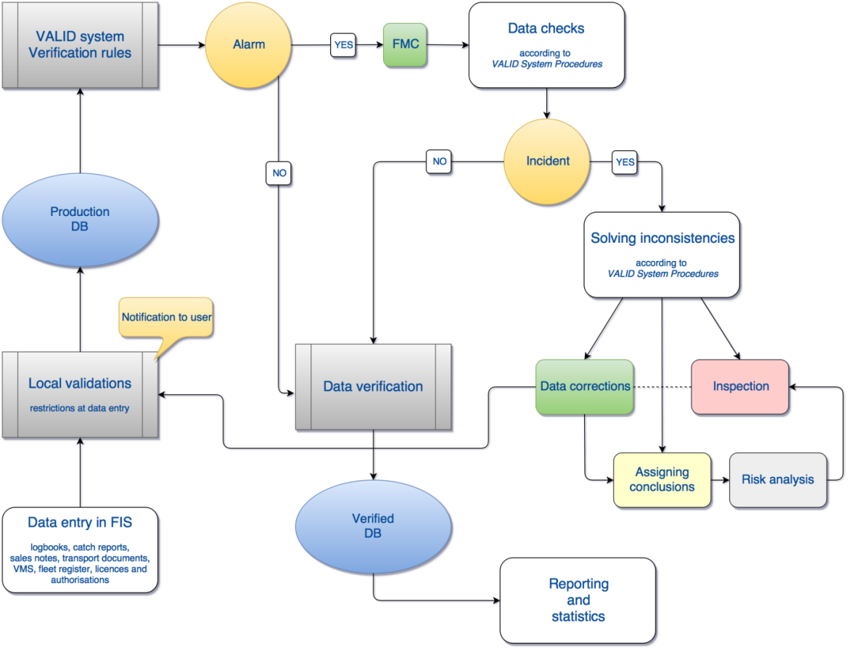
Chart 1. Flow chart of the data validation and verification system for fisheries

Aquaculture and processing industry
Data on processing industry and aquaculture sector are regularly checked with data from the Financial agency and starting from 2017 with Structural Business Statistics Data (SBS) from Croatian Bureau of Statistics aggregated by company size (number of employees). SBS data related to population is also checked by detailed insight into companies' activities during the reference year. Therefore, the number of companies and indicators included in DCF population could be slightly different than those included in EUROSTAT population. Further plan is to improve data on raw material by comparing the data from recently developed traceability system. The main constraints were still lower response for some small segments which is expected to be improved following the changes in the new Marine Fisheries Act and subsequent Ordinance on Data Collection and further development in data collection organization.

2. Section P3 Impartiality and objectiveness
Explain main constraints and/ or steps taken, if ‘N’ (no) was indicated in Table 5B
Not applicable.
3. Section P4 Confidentiality
Explain main constraints and/ or steps taken, if ‘N’ (no) was indicated in Table 5B
Not applicable.
4. Section P5 Sound methodology
Explain main constraints and/ or steps taken, if ‘N’ (no) was indicated in Table 5B
Information on this principle should be briefly explained in Text boxes 3A, 3B and 3C. Description of methodologies used on data quality.
Not applicable.
5. Section P6 Appropriate statistical procedures
Explain main constraints and/ or steps taken, if ‘N’ (no) was indicated in Table 5B. Please provide a link if the documented revisions are available and not confidential.
Not applicable.
6. Section P7 Non-excessive burden on respondents
Explain main constraints and/ or steps taken, if ‘N’ (no) was indicated in Table 5B
Not applicable.
7. Section P8 Cost effectiveness
Explain main constraints and/ or steps taken, if ‘N’ (no) was indicated in Table 5B
Not applicable.
8. Section P9 Relevance
Explain main constraints and/ or steps taken, if ‘N’ (no) was indicated in Table 5B
Not applicable.
9. Section P10 Accuracy and reliability
Explain main constraints and/ or steps taken, if ‘N’ (no) was indicated in Table 5B. Information on this principle should be briefly explained in Text boxes 3A, 3B and 3C. Description of methodologies used on data quality.
Not applicable.
10. Section P11 Timeliness and punctuality
Explain main constraints and/ or steps taken, if ‘N’ (no) was indicated in Table 5B
Not applicable.
11. Section P12 coherence and comparability
Explain main constraints and/ or steps taken, if ‘N’ (no) was indicated in Table 5B
Not applicable.
12. Section P13 Accessibility and Clarity
Explain main constraints and/ or steps taken, if ‘N’ (no) was indicated in Table 5B. Information and links to documentation on this principle should be briefly explained in Text boxes 3A, 3B and 3C. Description of methodologies used on data quality.
We are currently in the process of updating documentation on all DC procedures related to quality (data base documentation, quality control procedures, sampling methodologies, data processing methods etc.). The main constraint is limited time, constant demand for data with overlaping deadlines, as well as heavy administrative burden on data managers with numerous data requirements and administrative procedures.

