MINISTRY OF AGRICULTURE
EXECUTIVE AGENCY FOR FISHERIES AND AQUACULTURE

Regulation (EU) 2017/1004 of 17 May 2017 of the European Parliament and the Council
on the establishment of a Union framework for the collection, management and use of data in the fisheries sector and support for scientific advice regarding the common fisheries policy and repealing Council Regulation (EC) No 199/2008

Commission Implementing Decision (EU) 2019/909 of 18 February 2019 establishing the list of mandatory research surveys and thresholds for the purposes of the multiannual Union programme for the collection and management of data in the fisheries and aquaculture sectors

Commission Delegated Decision (EU) 2019/910 of 13 March 2019 establishing the multiannual Union programme for the collection and management of biological, environmental, technical and socioeconomic data in the fisheries and aquaculture sectors

Commission Implementing Decision (EU) 2016/1701 of 19 August 2016laying down rules on the format for the submission of work plans for data collection in the fisheries and aquaculture sectors.

Commission Implementing Decision (EU) 2018/1283 of 24 August 2018 laying down rules on the format and timetables for the submission of annual data collection reports in the fisheries and aquaculture sectors.

Bulgaria Annual Report for data collection in the fisheries and aquaculture sectors
2021
Version 1
Burgas, 31.05.2022
CONTENTS

Section 1: Biological Data 3
Text Box 1C: Sampling intensity for biological variables 3
Section 1: Biological Data 4
Text Box 1D - Recreational fisheries 4
Section 1: Biological Data 5
Pilot Study 1: Relative share of catches of recreational fisheries compared to commercial fisheries 5
Section 1: Biological Data 7
Text Box 1E: Anadromous and catadromous species data collection in fresh water 7
Section 1: Biological Data 8
Text box 1F: Incidental by-catch of birds, mammals, reptiles and fish 8
Section 1: Biological Data 11
Pilot Study 2: Level of fishing and impact of fisheries on biological resources and marine ecosystem 11
Section 1: Biological Data 12
Text Box 1G: List of research surveys at sea 12
Section 2: Fishing Activity Data 19
Text Box 2A: Fishing activity variables data collection strategy 19
Section 3: Economic and Social Data 21
Text Box 3A: Population segments for collection of economic and social data for fisheries 21
Section 3: Economic and Social Data 24
Pilot Study 3: Data on employment by education level and nationality 24
Section 3: Economic and Social Data 25
Text Box 3B: Population segments for collection of economic and social data for aquaculture 25
Section 3: Economic and Social Data 28
Pilot Study 4: Environmental data on aquaculture 28
Section 3: Economic and Social Data 29
Text Box 3C: Population segments for collection of economic and social data for the processing industry 29
Section 4: Sampling Strategy for Biological Data from Commercial Fisheries 32
Text Box 4A: Sampling plan description for biological data 32
Section 5: data quality 35
Text Box 5A: Quality assurance framework for biological data 35
Section 5: data quality 36
Text Box 5B: Quality assurance framework for socioeconomic data 36
Annex 1. 38

Section 1: Biological Data

Text Box 1C: Sampling intensity for biological variables

General comment: This box fulfils paragraph 2 point (a)(i)(ii)(iii) of Chapter III, of the Annex of the Delegated Decision (EU) 2019/910 and Chapter I of the Implementing Decision (EU) 2019/909 on the multiannual Union programme; and Article 2, Article 4 paragraph 1 and Article 8 of the Implementing Decision (EU) 2016/1701 on the format of the WP. This box is applicable to the Annual Report.
Member State should provide by Region/RFMO/RFO/IO:
- Evidence of data quality assurance
Information on the methodology used to assure the quality of the data collected:
1. http://dcf-bulgaria.bg/documents/ - under Materials and Methods section.
2. Biometric measurements, data checks & analysis
3. Descriptive statistics
4. ODV
5. Outliers Check values
6. L-W relationships
7. RoME software, developed with R language, RoME represents a common tool to perform data checks
8. BioIndex
9. Usage of appropriate exploratory statistical techniques to detect outliers and anomalous registers.
Bulgarian institutes use common standard protocols for processing of data agreed with Romanian institute.

- Deviations from the Work Plan
The number of the measured individuals is more than 150% higher than the planned minimum because the Bulgarian scientists decided to investigate more fish in order to obtain a higher level of significance of the biological parameters of species. The oversampling did not lead to any financial burdens.

- Actions to avoid deviations.
According to the scientists from the research institutes in Bulgaria, the collection of more samples and the measurement of biological parameters of more individuals than the minimum planned in the work plan (when this is possible and does not cost additional funds) contribute to more reliable and detailed results to be used for stock assessments.

(max. 1000 words per Region/RFMO/RFO/IO)

Section 1: Biological Data

Text Box 1D - Recreational fisheries

General comment: This box fulfills paragraph 2 point (a) (iv) of Chapter III of the Annex of the Delegated Decision (EU) 2019/910 on the multiannual Union programme; and Article 2, Article 3 and Article 4 paragraph 1 of the Implementing Decision (EU) 2016/1701 on the format of the WP. This box is applicable to the Annual Report. This box is intended to provide information on the design, implementation and analysis of all components of sampling schemes/ surveys that are listed in Table 1D.
1. Description of the target population
Not applicable.

2. Type of survey
Since in Bulgaria there is neither commercial catch nor recreational fisheries of the species that should be collected for recreational fisheries described in Table 3 of the multi-annual Union programme, we do not plan to conduct a pilot study. If in future there is registered catch of any of the species, we will update the work plan and include a pilot study.
Statements from our research institutes are available at Bulgarian DCF web page – http://dcf-bulgaria.bg/documents/ - under Materials and Methods section.

3. Data Quality
Not applicable.

4. Data Analysis and processing
Not applicable.

(max. 900 words per survey)

Section 1: Biological Data

Pilot Study 1: Relative share of catches of recreational fisheries compared to commercial fisheries

General comment: This box fulfils paragraph 4 of Chapter II of the Annex of the Implementing Decision (EU) 2019/909 on the multiannual Union programme and Article 2 and Article 4 paragraph (3) point (a) of the Implementing Decision (EU) 2016/1701 on the format of the WP.
General comment: This box is applicable to the Annual Report. This box is intended to provide information on the results obtained from the implementation of the pilot study.
- Aim of pilot study
Since in Bulgaria there is neither commercial catch nor recreational fisheries of the species that should be collected for recreational fisheries described in Table 3 of the multi-annual Union programme, we do not plan to conduct a pilot study for the listed species (Eels, elasmobranchs and highly migratory ICCAT species). Following the recommendation by RCG MED & BS and the requirements under multi-annual Union programme, Bulgaria will establish a pilot study in order to allow assessment of the share of catches from recreational fisheries in relation to commercial catches by Bulgarian fleet in the Black sea. The aim of the pilot study will be to estimate the number of recreational fishermen in the marine waters in the country, to record their fishing practices, and to collect data for the species and quantitative data of their catches.
Due to the lack of a licensing system for recreational fisheries in the Bulgarian marine waters after results from the pilot study will be developed an application for registration of catch by recreational fishermen in both - marine and fresh waters.

- Duration of pilot study
The duration of the pilot study will be one or two years depending on administrative burdens in the country and the number of responses and collected data. The pilot study will be conducted by phone and/or online survey.
The pilot study is planned to start in 2020 but in case of administrative and funding problems, it may be postponed for 2021.

- Methodology and expected outcomes of pilot study
The screening survey will be performed through a telephone and/or online survey by a commercial company, which used an ad hoc questionnaire addressed to the households from its database. The questionnaire will be short and simple. The data from the survey will be used for the estimation of the average number of fishermen in each household for one year. These estimates will be used in combination with the available data of national census in order to assess the total number of inhabitants of the country engaged in recreational fishing. The expected outcome of the pilot project is to understand better the current situation of the recreational fishery in Bulgaria by getting answers to questions like where people have gone fishing during the last year and what equipment was used, how many trips/days/hours were performed, so to determine the level of fishing activity, 4 how many individuals by species were caught and their weight.
For the development of the mobile application, EAFA will engage a company. The aim of the app will be to provide information directly from the recreational fishermen.

(max 900 words)
Brief description of the results obtained (including deviations from planned and justifications as to why if this was not the case).
Bulgarian pilot study on recreational fisheries which was expected to start in 2020 or 2021 was postponed for 2022 due to Covid-19 restrictions and administrative burdens. Оnce finalized the report will be uploaded to http://dcf-bulgaria.bg/documents/.

4. Achievement of the original expected outcomes of pilot study and justification if this was not the case.
Not applicable.

5. Incorporation of results from pilot study into regular sampling by the Member State.
After the results from pilot study are finalized the WP for 2023 will be amended accordingly.

(max 900 words)

Section 1: Biological Data

Text Box 1E: Anadromous and catadromous species data collection in fresh water

General comment: This box fulfills paragraph 2 points (b) and (c) of Chapter III of the Annex of the Delegated Decision (EU) 2019/910 on the multiannual Union programme; and Article 2 of the Implementing Decision (EU) 2016/1701 on the format of the WP.
General comment: This box is applicable to the Annual Report.
1. Method selected for collecting data.
None of the species from Table 1E of the multi-annual Union programme regarding the freshwater anadromous and catadromous species is presented in our region. If in future there is registered catch of any of the species, we will update the work plan and include a pilot study.

(max 250 words per Area)
2. Were the planned number achieved? Yes/ No
Not applicable.

(max 500 words per Area)

Section 1: Biological Data

Text box 1F: Incidental by-catch of birds, mammals, reptiles and fish

General Comment: This box fulfils paragraph 3 point (a) of Chapter III of the Annex of the Delegated Decision (EU) 2019/910, on the multiannual Union programme; and Article 2 of the Implementing Decision (EU) 2016/1701 on the format of the WP. This box is applicable to the Annual Report. This box is applicable only for those sections where Member States have reported that they have been carrying out regular sampling. Results and deviations for Pilot studies should be reported under Pilot Study 2.
1. Results
In 2021, the scientific observations of vessels of the Bulgarian fishing fleet covered 66 fishing days - 23 days on vessels with gillnets, 10 days on vessels with pelagic trawls, 21 days on vessels with beam trawls and 12 days - on polyvalent vessels. Expeditions with observers onboard on fishing vessels were carried out as follows:

 | GNS | OTM | TBB | PMP | Number days per month
III.2021 | 2 | 7 |  |  | 9
IV.2021 | 13 |  |  |  | 13
V.2021 |  |  | 3 |  | 3
VI.2021 | 2 |  | 3 |  | 5
VII.2021 | 5 |  | 5 |  | 10
VIII.2021 | 1 | 3 |  | 2 | 6
IX.2021 |  |  |  | 10 | 10
X.2021 |  |  | 5 |  | 5
XI.2021 |  |  | 5 |  | 5
Total | 23 | 10 | 21 | 12 | 66

- The main catch from anchored gillnets is formed by turbot (Scophthalmus maximus), and bycatches are composed mainly of common stingray (Dasyatis pastinaca), thornback ray (Raja clavata), piked dogfish (Squalus acanthias), black mussel (Mytilus galloprovincialis) and rapana (R. venosa). During the studied period, the average catch of S. maximus reached 51.40 kg / day ± 6.07 SE (Standard Error), with an average bycatch of 17.62 kg / day ± 3.23 SE, total catch weight of 69.03 kg / day ± 6.34 SE and average percentage bycatch of total catches - 27.55% ± 4.52 SE. By-catch weight data show a high coefficient of variation (CV = 87.98) during the study period. The average catches of turbot are the highest (69.50 kg / day) in March. In general, in the spring (III-IV), the average catch of turbot is of the order of 64.19 kg / day, and in the summer (VI-VIII) it decreases to 43.02 kg / day. At the same time, the by-catch, expressed as a percentage of the total catch (TC, catch + by-catch), showed a maximum (43.61% TA) in July-August. The average monthly percentage of by-catches is highest in July - 55.49% TC, with a significant presence of Dasyatis pastinaca in bycatches. For the study period in 2021, bycatches in gillnets are formed mainly by black mussels - 51.24%, common stingray - 40.53%, thornback ray - 6.25% and Black Sea shark - 1.43%.

- Between March and August 2021, pelagic trawl research focused on the target species of sprat (Sprattus sprattus), with daily catches reaching 1553.80 kg / day ± 270.56 SE. The quantities of bycatches range between 0.31 - 1.73 kg/day. In the pelagic trawls, as bycatches by sprat fishery, there were between 1 - 11 different species, but the percentage of bycatches from marine organisms is insignificant and reaches 0.09% TC ± 0.02 SE. In sprat fishery, by-catches in 2021 are formed mainly by whiting (Merlangius merlangus) and gobies with an average share - 49.3% of the total bycatch, and in smaller quantities - from horse mackerel, mullet, scorpion fish, black mussel, crustaceans, etc.

- During the interval V - X.2021, the catches of rapana with beam-trawl range between 2112 - 3800 kg / day, and the quantities of by-catches of marine organisms fluctuate between 0 - 1.46 kg / day; the total catch (TC1) is 3045.06 kg / day ± 153.27 SE, and the average by-catch percentage of this catch is 0.03% ± 0.01 SE. The species composition of by catches of rapana was varied and includes 26 species - mainly fish, arthropods and molluscs, and up to 16 different species of marine organisms are found in beam trawls per day. The most common by catches of rapana during the study period were gobies (66% of catches per day), stargazer (Uranoscopus scaber, 58% of catches per day), anada sand mussel (50% of catches per day) and turbot (Scophthalmus maximus, 50% of catches per day). Molluscs (Mollusca - mainly Anadara kagoshimensis, Mytilus galloprovincialis), and decapods crabs (Decapoda) were found in the bycatches. For the study period, the dominant species by weight in the by-catches were the gobies, stargazer, Anadara and turbot which form 72% of the weight of the bycatch, followed by the swimming crab, scorpionfish and whiting.

- The target species for fishing with polyvalent vessels in VIII - IX.2021 were horse mackerel (Trachurus mediterraneus) and mullet (Mullus barbatus). The average daily catches of the two target species were 854.33 kg/day ± 145.08 S, the average by-catch weight was 21.87 kg/day ± 14.55 SE, with a total catch weight of 876.18 kg/day ± 145.45 SE. The average percentage bycatch shall be 2.31% ± 1.52 SE of the total catch. During the study, a total of 14 species of marine organisms, mainly fish and crustaceans, were identified as bycatches, and a maximum of 6 different species were identified per day. The most frequent in the daily catches were gobies (50%), stargazer (33%) and swimming crab (33%). The average weight of bycatches is in the range of 0-114.51 kg/day, and the percentage of by-catches reaches a maximum of 13.58% TC in August 2021.

2. Deviations from Work Plan
No deviations.

3. Data quality
Questions to be addressed are listed below:
- Does the onboard observer protocol contain a check for rare specimens in the catch at opening of the codend? If YES is the observer instructed to indicate if the codend was NOT checked in a haul? - Yes
- In gill nets - and hook-and-line fisheries: does the onboard observer protocol instruct the observer to indicate how much of the hauling process has been observed for (large) incidental bycatches which never came on board (because they fall out of the net)? In large catches: does the protocol instruct to check for rare specimens during sorting of the catch (i.e. at conveyor belt)? Is the observer instructed to indicate what percentage of the sorting or hauling process has been checked at “haul level”? - Yes
-Does the onboard observer protocol instruct to report on the use of mitigation (i.e. Escape Devices or Acoustic Deterrent Devices)? - Yes
- Does the sampling design and protocol follow the recommendations from relevant expert groups? Provide appropriate references. If there are no relevant expert groups, the design and protocol have to be explained in the text.
The sampling follows the recommendations of:
FAO. 2019a. Monitoring discards in Mediterranean and Black Sea fisheries: Methodology for data collection. FAO Fisheries and Aquaculture Technical Paper No. 639. Rome. http://www.fao.org/3/ca4914en/ca4914en.pdf
FAO. 2019b. Monitoring the incidental catch of vulnerable species in Mediterranean and Black Sea fisheries: Methodology for data collection. FAO Fisheries and Aquaculture Technical Paper No. 640. Rome, FAO http://www.fao.org/3/ca4991en/CA4991EN.pdf
FAO, 2020, Technical guidelines for scientific surveys in the Mediterranean and the Black Sea Carpentieri, P.; Bonanno, A.; Scarcella, G. http://www.fao.org/3/ca8870en/CA8870EN.pdf
GFCM, Edited draft, VI. (2018): Monitoring discards in Mediterranean and Black Sea fisheries: a methodology for data collection, 76 pp.

- Are data quality issues taken into account?
Yes, based on: Borges, L., Zuur, A.F. Rogan, E. & Officer, R. 2005. Choosing the best sampling unit and auxiliary variable for discards estimations. Fisheries Research 75. p. 29–39.; Rochet, M.J. & Trenkel, V.M. 2005. Factors for the variability of discards: assumptions and field evidence. Canadian Journal of Fisheries and Aquatic Sciences, 62, pp. 224–235.; Stratoudakis, Y., Fryer, R.J. & Cook, R.M. 1998. Discarding practices for commercial gadoids in the North Sea. Canadian Journal of Fisheries and Aquatic Sciences, 55: 1632–1644.

- How are data (and samples) stored
In xls files and protocols.

(max 900 words)

Section 1: Biological Data

Pilot Study 2: Level of fishing and impact of fisheries on biological resources and marine ecosystem

General comment: This Box fulfills paragraph 3 point (c) of Chapter III of the Annex of the Delegated Decision (EU) 2019/910 on the multiannual Union programme; and Article 2 and Article 4 paragraph (3) point (b) of the Implementing Decision (EU) 2016/1701 on the format of the WP.
General comment: This box is applicable to the Annual Report. This box is intended to provide information on the results obtained from the implementation of the pilot study.
1. Aim of pilot study
Not applicable. The pilot study was conducted in 2017 and from 2018 Bulgaria started a regular programme
with observers on board which will continue in 2020-2021.
2. Duration of pilot study
Not applicable.
3. Methodology and expected outcomes of pilot study
Not applicable.
(max 900 words)
Brief description of the results obtained (including deviations from planned and justifications as to why if this was not the case).
Not applicable. The pilot study was conducted in 2017 and from 2018 Bulgaria started a regular programme with observers on board which continues in 2021. Details are provided in Text box 1F: Incidental by-catch of birds, mammals, reptiles and fish.

4. Achievement of the original expected outcomes of pilot study and justification if this was not the case
Not applicable.

5. Incorporation of results from pilot study into regular sampling by the MS
Not applicable.

(max 900 words)

Section 1: Biological Data

Text Box 1G: List of research surveys at sea

General comment: This box fulfills Chapter I of the Annex of the Implementing Decision (EU) 2019/909, on the list of mandatory surveys and thresholds, of the multiannual Union programme; and Article 2 and Article 7 paragraph (3) of the Decision (EU) 2016/1701 on the format of the WP. It is intended to specify which reseach surveys at sea set out in the multiannual Union programme will be carried out. Member States shall specify whether the research survey is included in Chapter I of the Annex of the implementing decision of the multiannual Union programme or whether it is an additional survey.
General comment: This box is applicable to the Annual Report. This box should provide complementary information on the performance of the surveys, the results and their main use.
Pelagic trawl survey in the Black sea
- Objectives of the survey

The aim of the pelagic trawl survey in the Black sea is the assessment of the stock biomass of sprat (Sprattus sprattus). Furthermore, an analysis of the distribution and abundance of the other species caught as by-catch will be presented.

- Description of the methods used in the survey. For mandatory surveys, link to the manuals. Include a graphical representation (map)

Pelagic Trawl survey will be accomplished in spring and autumn quarters each year. The study will be held in the area enclosed between Durankulak and Ahtopol (Bulgaria) with a total length of the coastline of 370 km. Study area encloses waters between 42o 05’ and 43o 45’ N and 27o 55 and 29o 55 E. Bulgarian waters will be partitioned into 128 equal in size, not overlying fields and during each survey 36 random mid-water hauls will be carried out in the Bulgarian area (72 trawls per year). The survey undergoes during the day and the following types of data were collected:
• Coordinates and duration of each trawl
• Sprat total catch weight
• Separation of the by-catch by species
• Composition of by-catch
• Conservation of the samples
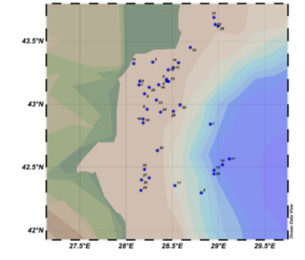
Fig. 1. Research area and plan of the sampling fields for pelagic trawl surveys.
To establish the abundance of the reference species in front of the Bulgarian coast a standard methodology for stratified sampling was employed (Gulland, 1966;). To address the research objectives the region was divided into four strata according to depth – Stratum 1 (15-35 m) Stratum 2 (35–50 m), Stratum 3 (50–75 m) and Stratum 4 (75–100 m). Each field is a rectangle with sides 5' Lat × 5' Long and area around 62.58 km2 (measured by application of GIS), large enough for a standard lug extent in a meridian direction to fit within the field boundaries. At each of the fields, only one haul with a duration between 30-40 min at speed 2.7-2.9 knots will be carried out. The research survey is included in Table 10 of the multi-annual Union programme.

- For internationally coordinated surveys, describe the participating Member States/ vessels and the relevant international group in charge of planning the survey

Bulgaria and Romania will undertake annually research surveys in their territorial waters and EEZ under their jurisdiction, following common methodology, harmonization of biological data sampling and analysis and harmonization of stock assessment methods. Both countries will follow the methodology already adopted by other EU countries (MEDIAS and MEDITS). The agreement between Bulgaria and Romania is available on the following link: http://dcf-bulgaria.bg/documents for cooperation and partnership.

- Where applicable, describe the international task-sharing (physical and/or financial) and the cost-sharing agreement used

Not applicable.
- Explain where thresholds apply

No thresholds are applicable.

(max. 450 words per survey)
- Graphical representation (map) showing the positions (locations) of the realized samples.

a. 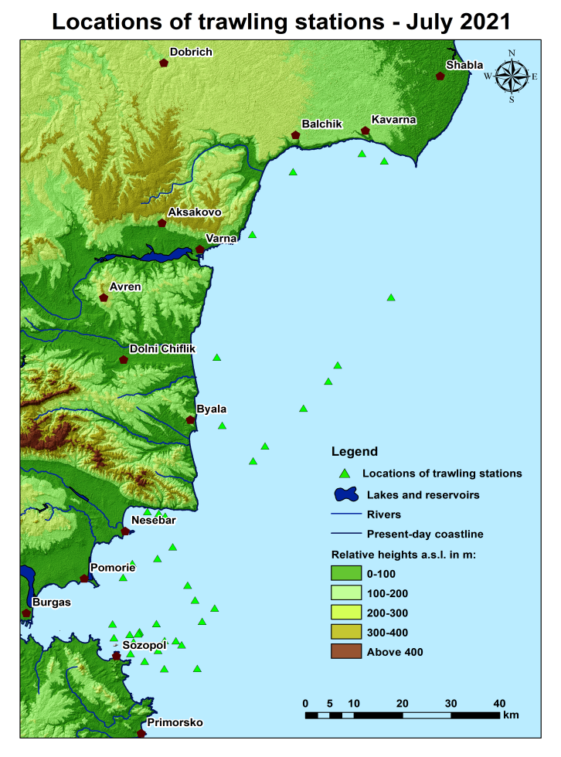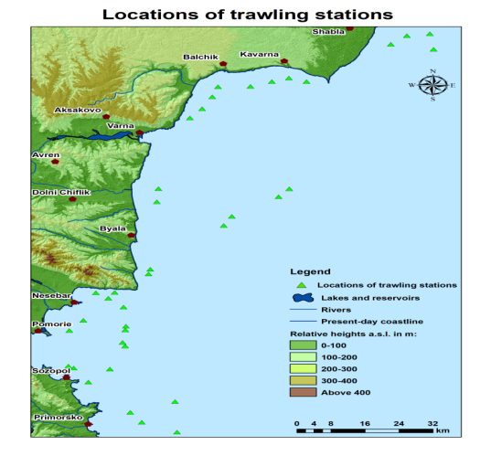 b.
Fig.1.1 a) July b) November 2021

- For internationally coordinated surveys, provide a link to the latest meeting report of the coordination group.
Bulgarian pelagic trawl surveys are coordinated with Romania.
https://datacollection.jrc.ec.europa.eu/docs/rcg?p_p_id=110_INSTANCE_FMxyil88Aos3&p_p_lifecycle=0&p_p_state=normal&p_p_mode=view&p_p_col_id=column-2&p_p_col_count=1&_110_INSTANCE_FMxyil88Aos3_struts_action=%2Fdocument_library_display%2Fview_file_entry&_110_INSTANCE_FMxyil88Aos3_redirect=https%3A%2F%2Fdatacollection.jrc.ec.europa.eu%2Fdocs%2Frcg%3Fp_p_id%3D110_INSTANCE_FMxyil88Aos3%26p_p_lifecycle%3D0%26p_p_state%3Dnormal%26p_p_mode%3Dview%26p_p_col_id%3Dcolumn-2%26p_p_col_count%3D1&_110_INSTANCE_FMxyil88Aos3_fileEntryId=1342583
https://www.fao.org/gfcm/data/safs/en/
https://www.fao.org/gfcm/technical-meetings/detail/en/c/1439089/
https://www.fao.org/gfcm/technical-meetings/detail/en/c/1442355/
https://www.fao.org/gfcm/technical-meetings/detail/en/c/1440228/

Information on the methodology of the pelagic trawl survey is available at the following link: http://dcf-bulgaria.bg/documents/ - under Data Collection Methodologies.
If possible, Romanian scientists are participating in the pelagic research surveys in Bulgaria and Bulgarian scientists are participating in the Romanian pelagic surveys. Due to COVID-19 restrictions this exchange was not possible in 2021.

- List the main use of the results of the survey (e.g. indices, abundance estimates, environmental indicators).
The survey indices of relative abundance (in numbs) were derived in order to calculate the biomass indices in the respective area (EEZ of Bulgaria). The abundance indices were used in further calculations for the tuning files for stock assessment purposes (historical reconstructions of biomass).

9. Extended comments (Tables 1G and 1H)
The stomach sampling was not planned in the 2021 WP, but the Institute of oceanology decided to conduct stomach sampling. Detailed information for the results are available in the pelagic trawl survey reports -http://dcf-bulgaria.bg/documents/.
(max 450 words per survey)

Bottom trawl survey in the Black sea
- Objectives of the survey

The main goal is the assessment of the stock biomass of turbot (Scophthalmus maximus) along the Bulgarian Black Sea coast, estimation of the biomass and abundance of the reference species by depth strata and study of size/age and sex structure, food composition, by-catch, distribution of the stock.

- Description of the methods used in the survey. For mandatory surveys, link to the manuals. Include a graphical representation (map)

The bottom trawl survey for turbot stock assessment will be conducted in April-May and October-November each year. To establish abundance and biomass of turbot, a standard methodology for stratified sampling (Gulland, 1966; Sparre, Venema, 1998;) will be applied. The indicative zones, where trawling will be performed, are presented in Figure 2.
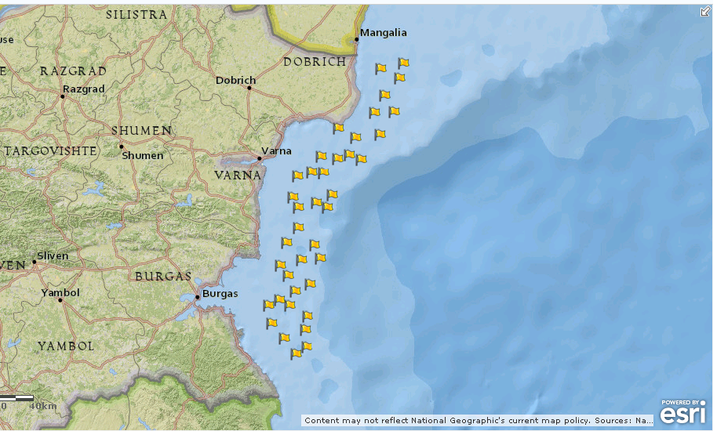
Fig.2 Indicative map of the surveyed sectors.
The surveyed region of the Bulgarian coast is divided into four strata, depending on the depth – Stratum 1 (15 - 35 m), Stratum 2 (35 - 50 m), Stratum 3 (50 - 75 m) and Stratum 4 (75 - 100 m). For the purpose of turbot abundance and biomass assessment, the surveyed territory is divided into 143 squares, each of them with sides 5 x 5 Nm, area 25 Nm² (or 85.8569 m² ) (Fig.3).
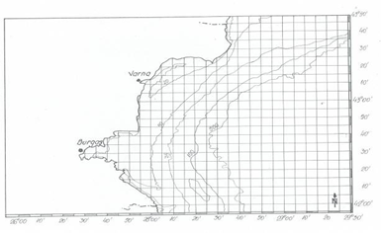

Fig.3. Grid lines used for calculations of the area.
The sampling is carried out at randomly chosen fields (rectangles), situated at a depth of 15-100 m. Each rectangle is with sides 5’Lat × 5’Long, while the total area is 62.58 km² (measured by GIS). Each field is marked with letters and digits for better distinction (Fig.4).

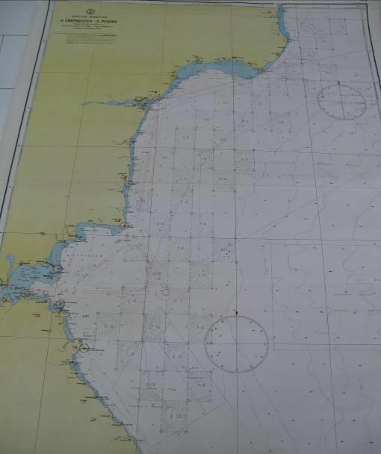
Fig.4 Map and scheme of the fields used in the sampling design.

The seabed area covered during a single haul represents a basic measurement unit, considered representative, as turbots do not aggregate in dense assemblages. The duration of each haul is 60 min. at the trawling speed of 2.2-2.6 knots.

- For internationally coordinated surveys, describe the participating Member States/ vessels and the relevant international group in charge of planning the survey

Bulgaria and Romania will undertake annually research surveys in their territorial waters and EEZ under their jurisdiction, following common methodology, harmonization of biological data sampling and analysis and harmonization of stock assessment methods. Both countries will follow the methodology already adopted by other EU countries (MEDIAS and MEDITS). The agreement between Bulgaria and Romania is available on the following link: http://dcf-bulgaria.bg/documents for cooperation and partnership.

- Where applicable, describe the international task-sharing (physical and/or financial) and the cost-sharing agreement used

Not applicable.
- Explain where thresholds apply

No thresholds are applicable.

(max. 450 words per survey)
- Graphical representation (map) showing the positions (locations) of the realized samples.
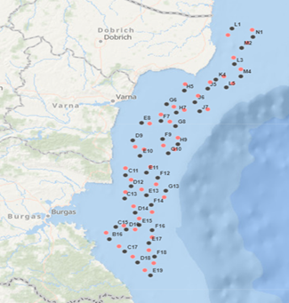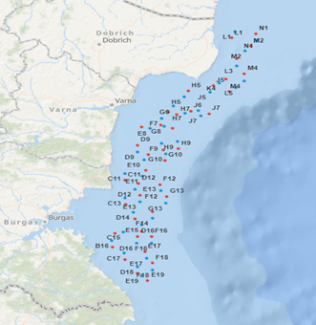
Fig. 4.1 Map of the surveyed sectors, May 2021 Map of the surveyed sectors, December 2021.

- For internationally coordinated surveys, provide a link to the latest meeting report of the coordination group.
Bulgarian bottom trawl surveys are coordinated with Romania.
https://datacollection.jrc.ec.europa.eu/docs/rcg?p_p_id=110_INSTANCE_FMxyil88Aos3&p_p_lifecycle=0&p_p_state=normal&p_p_mode=view&p_p_col_id=column-2&p_p_col_count=1&_110_INSTANCE_FMxyil88Aos3_struts_action=%2Fdocument_library_display%2Fview_file_entry&_110_INSTANCE_FMxyil88Aos3_redirect=https%3A%2F%2Fdatacollection.jrc.ec.europa.eu%2Fdocs%2Frcg%3Fp_p_id%3D110_INSTANCE_FMxyil88Aos3%26p_p_lifecycle%3D0%26p_p_state%3Dnormal%26p_p_mode%3Dview%26p_p_col_id%3Dcolumn-2%26p_p_col_count%3D1&_110_INSTANCE_FMxyil88Aos3_fileEntryId=1342583

Information on the methodology of the bottom trawl survey is available at the following link: http://dcf-bulgaria.bg/documents/ - under Data Collection Methodologies.
https://www.fao.org/gfcm/data/safs/en/
If possible, Romanian scientists are participating in the bottom trawl research surveys in Bulgaria and Bulgarian scientists are participating in the Romanian bottom surveys. Due to COVID-19 restrictions this exchange was not possible in 2021.

- List the main use of the results of the survey (e.g. indices, abundance estimates, environmental indicators).
IFR Varna conducted two seasonal bottom trawl surveys (in spring and autumn 2021) to obtain data about the turbot biomass and abundance in Bulgarian Black Sea waters. The turbot biomass was estimated at 1466 tonnes in May and 2140 tonnes in December, and the turbot abundance in the surveyed area was estimated at 803 460 individuals in May and 1 267 936 individuals in December. The recommended MSY (maximum sustainable yield) for Bulgaria should not exceed 214 t, using the "ad hoc" method, it is assumed that the TAC of turbot can reach 107 tons in the Bulgarian Black Sea, calculated on the basis of data from the autumn season of 2021, but it should be noted that the percentage distribution of sexually mature specimens (L > 45 cm) was 44.7% for the autumn season of 2021 and after recalculations based on this percentage, the total allowable catch should not exceed 65 tonnes.
9. Extended comments (Tables 1G and 1H)
The stomach sampling was not planned in the 2021 WP, but the Institute for fish resources decided to conduct stomach sampling in regards to the RCG Med&BS recommendation. Detailed information for the results are available in the bottom trawl survey reports -http://dcf-bulgaria.bg/documents/.
(max 450 words per survey)

Section 2: Fishing Activity Data

Text Box 2A: Fishing activity variables data collection strategy

General comment: This box fulfills paragraph 4 of Chapter III of the Annex of the Delegated Decision (EU) 2019/910 on the multiannual Union programme; and Article 2, Article 4 paragraph (2) point (b) and Article 5 paragraph (2) of the Implementing Decision (EU) 2016/1701 on the format of the WP. It is intended to describe the method used to derive estimates on representative samples where data are not to be recorded under Regulation (EU) No 1224/2009 or where data collected under Regulation (EU) No 1224/2009 are not at the right aggregation level for the intended scientific use.
General comment: This box is applicable to the Annual Report. This box should provide information on the implementation of the data collection of fishing activity variables of Member States.
- Description of methodologies used to cross-validate the different sources of data

Bulgaria stores the data as primary, aggregated and metadata. The distant access to the database is available for the data received from logbooks, sales notes and fleet vessel register and aquaculture production. Different modules in the Information Statistical System of EAFA perform different crosschecks of the data mainly to ensure the data quality from the logbooks, first sale notes, take over declaration and transport declaration. It is carried out to trace the fish quantity from the fishermen or aquaculture producer (both obliged to fill a logbook) to the market passing through processing industry.

- Description of methodologies used to estimate the value of landings

The information contained in the fishing logbooks of fishing vessels is verified at the time of landing. All fishermen involved in the landing and marketing of fish and fishery products are required to declare the quantities landed, transhipped, offered for sale or purchased. All fishing vessels have an obligation to keep a fishing logbook and the fishermen shall complete a landing declaration, indicating specifically all quantities of each species landed.

- Description of methodologies used to estimate the average price (it is recommended to use weighted averages, trip by trip)

Every sale of fish and fish products is accompanied by a mandatory filing of sales notes. The sales notes contain information about the price per kilogram. All the information from the sales notes is introduced into the information system of EAFA and is connected with the landing declarations. In calculating the average price are excluded the values that are tremendously low or extremely high if any.

- Description of methodologies used to plan collection of the complementary data (sample plan methodology, type of data collected, frequency of collection etc)

If any complementary data is needed, it can incorporate into the sales notes or in the annual questionnaire for economic statistics, which is mandatory for each vessel.

(max 900 words per Region)
5. Deviations from Work Plan methodology used to cross-validate the different sources of data
There are no deviations from the planned methodology in the WP and no actions to avoid deviations are needed.

6. Deviations from Work Plan methodology used to estimate the value of landings.
There are no deviations from the planned methodology used to estimate the value of landings in the WP and no actions to avoid deviations are needed.

7. Deviations from Work Plan methodology used to estimate the average price.
There are no deviations from the planned methodology used to estimate the average price in the WP and no actions to avoid deviations are needed.

8. Deviations from Work Plan methodology used to plan collection of the complementary data
There are no deviations from the planned methodology in the WP and no actions to avoid deviations are needed.

(max 900 words per Region)

Section 3: Economic and Social Data

Text Box 3A: Population segments for collection of economic and social data for fisheries

General comment: This box fulfils paragraph 5 points (a) and (b) of Chapter III of the Annex of the Delegated Decision (EU) 2019/910 on the multiannual Union programme; and Article 2, Article 4 paragraphs (1), (2) and (5) and Article 5 paragraph (2) of the Implementing Decision (EU) 2016/1701 on the format of the WP. It is intended to specify data to be collected under Tables 5(A) and 6 of the delegated decision on the multiannual Union programme.
General comment: This box is applicable to the Annual Report. This box should provide information on the implementation of the fleet socio-economic data collection of Member States.
- Description of methodologies used to choose the different sources of data

All of the economic variables indicated in Table 5A according to the sector segmentation of Table 5B and according to the supraregions as defined in Table 5C and all of the social variables as indicated in Table 6 will be collected by annual questionnaires. The annual questionnaire for economic variables is mandatory for each vessel. The social data on employment by education level and employment by nationality were included in the questionnaire, which is the only source of information regarding all the economic and social variables.

2. Description of methodologies used to choose the different types of data collection
The only type of data collection of economic and social data that EAFA uses is directly from survey via questionnaire.

3. Description of methodologies used to choose sampling frame and allocation scheme
EAFA uses census survey type and since the questionnaire is mandatory all segments are covered.

4. Description of methodologies used for estimation procedures
If some part of the economic variables is missing in the replies to the survey, they are estimated from the sample to active vessels in the fleet segment to provide comparable estimates of the fleet segment level.

5. Description of methodologies used on data quality
According to the Bulgarian legislation at the beginning of each year (before March 31), the owners of fishing vessels or their representatives are required to complete a questionnaire and to ensure accuracy and quality of data by their signatures.

(max 900 words per Region)
6. Deviations from Work Plan methodology for selection of data source
There are no deviations from the planned methodology for selection of data source in the WP and no actions to avoid deviations are needed.
7. Deviations from Work Plan methodology to choose type of data collection
There are no deviations from the planned methodology in the WP and no actions to avoid deviations are needed.

8. Deviations from Work Plan methodology regarding sampling frame and allocation scheme
There are no deviations from the planned methodology in the WP and no actions to avoid deviations are needed.

9. Deviations from Work Plan methodology used for estimation procedures
There are no deviations from the planned methodology in the WP and no actions to avoid deviations are needed.

10. Quality assurance
10.1 Sound methodology
EAFA continues to follow census survey type and since the questionnaire is obligatory all segments are covered. The type of data collection of the variables was also A – census.
10.2. Accuracy and reliability
Response rate and Achieved sample rate are 100% because the questionnaire is obligatory for all vessels.
10.3. Accessibility and Clarity
Indicate with Yes or No
Are methodological documents publicly available? – Yes.
Are data stored in databases? – Yes.
Where can methodological and other documentation be found? - All the recommendations related to the collection and processing of economic and social data adequate to census data collection scheme agreed by PGECON /RCG ECON/ and other relevant experts groups or workshops are being followed. - https://datacollection.jrc.ec.europa.eu/docs/rcg; https://datacollection.jrc.ec.europa.eu/docs/other-meetings and http://dcf-bulgaria.bg/documents/
Provide the web link, if documentation is publicly available - The methodology for data collection of transversal and socio-economic variables for the fleet is available at the following link: http://dcf-bulgaria.bg/documents/ - under Data Collection Methodologies section in the file called ‘Methodological report for transversal and socio-economic data collection for the fleet’. Also, we are following the GUIDANCE DOCUMENT FOR THE FISHING FLEET /Living document/.

(max 1000 words)

Section 3: Economic and Social Data

Pilot Study 3: Data on employment by education level and nationality

General comment: This box fulfills paragraph 5 point (b) and paragraph 6 point (b) of Chapter III of the Annex Delegated Decision (EU) 2019/910 on the multiannual Union programme; and Article 2 and Article 4 paragraph (3) point (c) of the Implementing Decision (EU) 2016/1701 on the format of the WP. It is intended to specify data to be collected under Table 6 of the delegated decision on the multiannual Union programme.
General comment: This box is applicable to the Annual Report. This box is intended to provide information on the results obtained from the implementation of the pilot study (including deviations from planned and justifications as to why if this was not the case).
1. Aim of pilot study
Not applicable. The social data on employment by education level and employment by nationality started in 2018. The variables were included in the questionnaire for economic data.

2. Duration of pilot study
Not applicable.

3. Methodology and expected outcomes of pilot study
Not applicable.

(max 900 words)
4. Achievement of the original expected outcomes of pilot study and justification if this was not the case.
Not applicable. We have 100% data collection of the social variables because were included in the mandatory questionnaires for fleet, aquaculture and fish processing. Response rate and Achieved sample rate are 100% for the 3 sectors - fleet, aquaculture and fish processing.

5. Incorporation of results from pilot study into regular sampling by the Member State.
For Bulgaria it was not a pilot project, but regular data collection. Our sampling scheme was Census – we collect social data from every vessel, aquaculture farm and processing enterprise. This was possible because we are amending our questionnaire every year in order to ensure the collection of the most relevant data.

(max 900 words)

Section 3: Economic and Social Data

Text Box 3B: Population segments for collection of economic and social data for aquaculture

General comment: This box fulfills paragraph 6 points (a) and (b) of Chapter III of the Annex of the Delegated Decision (EU) 2019/910 on the multiannual Union programme; and Article 2, Article 4 paragraphs (1) and (5) and Article 5 paragraph (2) of the Implementing Decision (EU) 2016/1701 on the format of the WP. It is intended to specify data to be collected under Tables 6 and 7 of the delegated decision on the multiannual Union programme.

General comment: This box is applicable to the Annual Report. This box should provide information on the implementation of the socio-economic data collection for aquaculture of Member States.

1. Description of methodologies used to choose the different sources of data
All of the economic variables indicated in Table 7 of the Delegated Decision on the multi-annual Union programme and all of the social variables in Table 6 will be collected by annual questionnaires. The annual questionnaire for economic variables is mandatory for each aquaculture enterprise. The social data on employment by education level and employment by nationality were included in the survey in 2018. The only source of information regarding all of the variables is the questionnaire.

2. Description of methodologies used to choose the different types of data collection
The only type of data collection of economic and social data that EAFA uses is via questionnaire.

3. Description of methodologies used to choose sampling frame and allocation scheme
EAFA uses census survey type and since the questionnaire is obligatory all registered aquaculture enterprises are covered.

4. Description of methodologies used for estimation procedures
If some economic variables are missing in the replies to the survey, they are estimated from the sample to active aquaculture farms, which are registered in the agency

5. Description of methodologies used on data quality
One of the main objectives of Bulgaria was to increase the collection and quality of the statistical data about the aquaculture farms. The questionnaire for the aquaculture sector is updated when needed, according to the needs of the end-users. Measures were taken on raising the awareness of the owners or managers of farms about their obligation to submit the questionnaire and in 2014 we achieved 100% answers from respondents.
Аccording to the Bulgarian legislation at the beginning of each year (before January 31), the owners of farms or their representatives are required to complete a questionnaire and to ensure accuracy and quality of data by their signatures.

(max 1000 words)
6. Deviations from Work Plan methodology for selection of data source
There are no deviations from the planned methodology for selection of data source in the WP and no actions to avoid deviations are needed.Actions to avoid deviations
Actions to avoid deviations
There are no deviations and no actions to avoid deviations are needed.

7. Deviations from Work Plan methodology to choose type of data collection
There are no deviations from the planned methodology to choose type of data collection in the WP and no actions to avoid deviations are needed.
Actions to avoid deviations
There are no deviations and no actions to avoid deviations are needed.

8. Deviations from Work Plan methodology regarding sampling frame and allocation scheme
There are no deviations from the planned methodology regarding sampling frame and allocation scheme in the WP and no actions to avoid deviations are needed.
Actions to avoid deviations
There are no deviations and no actions to avoid deviations are needed.

9. Deviations from Work Plan methodology used for estimation procedures
There are no deviations from the planned methodology used for estimation procedures in the WP and no actions to avoid deviations are needed..
Actions to avoid deviations
There are no deviations and no actions to avoid deviations are needed.

10. Quality assurance
10.1 Sound methodology
EAFA continues to follow census survey type and since the questionnaire is obligatory all aquaculture enterprises are covered. The type of data collection of the variables was also A – census.
10.2. Accuracy and reliability
Response rate and Achieved sample rate for economic and social variables are 100% because the questionnaire is obligatory for all aquaculture farms.
10.3. Accessibility and Clarity
Are methodological documents publicly available? – Yes.
Are data stored in databases? – Yes.
Where can methodological and other documentation be found? - All the recommendations related to the collection and processing of economic and social data adequate to census data collection scheme agreed by PGECON /RCG ECON/ and other relevant experts groups or workshops are being followed. - https://datacollection.jrc.ec.europa.eu/docs/rcg; https://datacollection.jrc.ec.europa.eu/docs/other-meetings and http://dcf-bulgaria.bg/documents/
Provide the web link, if documentation is publicly available - The methodology for data collection of socio-economic variables for the aquaculture is available at the following link: http://dcf-bulgaria.bg/documents/ - under Data Collection Methodologies in the file called ‘Methodological report for socio-economic data collection for the aquaculture sector’. Also, we are following the GUIDANCE DOCUMENT FOR THE AQUACULTURE /Living document/ and the Requirements for EU Map data submission: table 1, table 2 and table 3 - https://datacollection.jrc.ec.europa.eu/dc/aqua/templates

(max 1000 words)

Section 3: Economic and Social Data

Pilot Study 4: Environmental data on aquaculture

General comment: This box fulfills paragraph 6 point (c) of Chapter III of the Annex of the Delegated Decision (EU) 2019/910 on the multiannual Union programme; and Article 2 and Article 4 paragraph (3) point (d) of the Implementing Decision (EU) 2016/1701 on the format of the WP. It is intended to specify data to be collected under Table 8 of the delegated decision on the multiannual Union programme.
General comment: This box is applicable to the Annual Report. This box is intended to provide information on the results obtained from the implementation of the pilot study (including deviations from planned and justifications as to why if this was not the case).
1. Aim of pilot study
The data regarding the Environmental variables for the aquaculture sector is collected via questionnaire, like the other variables. Each producer should keep records about the medicines or treatments administered and mortalities. There is no need for a special pilot study since the data is included in the annual questionnaire.

2. Duration of pilot study
Not applicable.

3. Methodology and expected outcomes of pilot study
Not applicable.

(max 900 words)
4. Achievement of the original expected outcomes of pilot study and justification if this was not the case.
Not applicable. The questions about the environmental data were included in the mandatory questionnaire - Achieved Sample Rate and Response Rate are 100%.

5. Incorporation of results from pilot study into regular sampling by the Member State.
Not applicable. The questions about the environmental data were included in the mandatory questionnaire - Achieved Sample Rate and Response Rate are 100%.

(max 900 words)

Section 3: Economic and Social Data

Text Box 3C: Population segments for collection of economic and social data for the processing industry

General comment: This box fulfils footnote 6 of paragraph 1.1(d) of Chapter III of the Annex of the Delegated Decision (EU) 2019/910 on the multiannual Union programme; and Article 2, Article 4 paragraphs (1) and (5) and Article 5 paragraph (2) of the Implementing Decision (EU) 2016/1701 on the format of the WP. It is intended to specify data to be collected under Table 10 of the delegated decision on the multiannual Union programme.
General comment: This box is applicable to the Annual Report. This box should provide information on the implementation of the socio-economic data collection for aquaculture of Member States.
1. Description of methodologies used to choose the different sources of data
All of the economic and social variables indicated in Table 10 of the Delegated Decision on the multi-annual Union programme according to the sector segmentation of Table 3C of the Bulgarian work plan will be collected by annual questionnaire, which is mandatory. The social data on employment by education level and employment by nationality were be included in the survey in 2018. The only source of information regarding all of the variables is the questionnaire.

2. Description of methodologies used to choose the different types of data collection
The annual questionnaire for economic variables is mandatory for all registered processing enterprises. The social data on employment by education level and employment by nationality were included in the survey in 2018. The only source of information regarding all of the variables is the questionnaire.

3. Description of methodologies used to choose sampling frame and allocation scheme
EAFA uses census survey type and required questionnaires by all registered fish processing enterprises.

4. Description of methodologies used for estimation procedures
If some economic variables are missing in the replies to the survey, they are estimated from the sample to active processing farms in the segment.

5. Description of methodologies used on data quality
One of the main objectives of Bulgaria was to increase the collection and quality of the statistical data about the processing industry. The questionnaire for the processing sector is updated when needed, according to the needs of the end-users. Measures were taken on raising the awareness of the owners or managers of enterprises about the need to receive the questionnaires.
Аt the beginning of each year, the owners of enterprises or their representatives are asked to complete a questionnaire and to ensure accuracy and quality of data by their signatures.

(max 1000 words)
6. Deviations from Work Plan methodology for selection of data source
There are no deviations from the planned methodology for selection of data source in the WP and no actions to avoid deviations are needed.Actions to avoid deviations
Actions to avoid deviations
There are no deviations and no actions to avoid deviations are needed.

7. Deviations from Work Plan methodology to choose type of data collection
There are no deviations from the planned methodology to choose type of data collection in the WP and no actions to avoid deviations are needed.
Actions to avoid deviations
There are no deviations and no actions to avoid deviations are needed.

8. Deviations from Work Plan methodology regarding sampling frame and allocation scheme
There are no deviations from the planned methodology regarding sampling frame and allocation scheme in the WP and no actions to avoid deviations are needed.
Actions to avoid deviations
There are no deviations and no actions to avoid deviations are needed.

9. Deviations from Work Plan methodology used for estimation procedures
There are no deviations from the planned methodology used for estimation procedures in the WP and no actions to avoid deviations are needed.
Actions to avoid deviations
There are no deviations and no actions to avoid deviations are needed.

10. Quality assurance
10.1 Sound methodology
EAFA is following census survey type for economic and social variables, since the questionnaire is obligatory all processing enterprises are covered.
10.2. Accuracy and reliability
Response rate and Achieved sample rate are provided in Table 3C.
Response rate and Achieved sample rate for economic and social variables are 100% because the questionnaire is obligatory for all processing enterprices.
10.3. Accessibility and Clarity
Are methodological documents publicly available? – Yes.
Are data stored in databases? – Yes.
Where can methodological and other documentation be found? - All the recommendations related to the collection and processing of economic and social data adequate to census data collection scheme agreed by PGECON /RCG ECON/ and other relevant experts groups or workshops are being followed. - https://datacollection.jrc.ec.europa.eu/docs/rcg; https://datacollection.jrc.ec.europa.eu/docs/other-meetings and http://dcf-bulgaria.bg/documents/

Provide the web link, if documentation is publicly available. - The methodology for data collection of socio-economic variables for the processing sector is available at the following link: http://dcf-bulgaria.bg/documents/ - under Data Collection Methodologies in the file called ‘Methodological report for socio-economic data collection for the fish processing sector’. Also, we are following the GUIDANCE DOCUMENT FOR THE FISH PROCESSING /Living document/ and the Requirements for EU Map data submission: table 1, table 2 and table 3 - https://datacollection.jrc.ec.europa.eu/dc/proind/eum/templates.

(max 1000 words)

Section 4: Sampling Strategy for Biological Data from Commercial Fisheries

Text Box 4A: Sampling plan description for biological data

General comment: This box fulfills Article 3, Article 4 paragraph (4) and Article 8 of the Implementing Decision (EU) 2016/1701 on the format of the WP and forms the basis for the fulfilment of paragraph 2 point (a)(i) of Chapter III of the Annex of the Delegated Decision (EU) 2019/910 on the multiannual Union programme. This Table refers to data to be collected under Tables 1(A), 1(B) and 1(C) of the delegated decision on the multiannual Union programme.
General comment: This box is applicable to the Annual Report. This box should provide information on the deviations from the planned sampling of Member States.
1. Description of the sampling plan according to Article 5 paragraph (3) of the Implementing Decision (EU) 2016/1701 on the format of the WP.

Target species for sampling are Sprat (Sprattus sprattus), Turbot (Scophthalmus maximus), Anchovy
(Engraulis encrasicholus), Piked dogfish (Squalus acanthias), Horse mackerel (Trachurus mediterraneus), from Group 1 species in GFCM-DCRF Annex A.1; Whiting (Merlangius merlangus) and Rapa whelk (Rapana venosa) from Group 2 species in GFCM-DCRF Annex A.2; (Raja clavata) from Group 3 species in GFCMDCRF Annex A.3; Red mullet (Mullus barbatus) is chosen because the average landings for the reference period are 617 tonnes. Data collection method will be from landings and by observers on board. Métiers selected through the ranking procedure for the Black Sea were GNS_DEF_360-400_0_0, OTM_MPD_>=13_19_0_0 and FPO_DEF_0_0_0. Instead of vessels using pots and/or traps, we plan to sample vessels using active and passive gears and vessels using beam trawls, because their presence in the Bulgarian fishing fleet is much more significant in terms of landings weight and value.
In each métier, some vessels will be randomly selected. Table 4C lists all fleet segments operating in Bulgarian EEZ, 3 of them have average landings > 200t. The sampling frames for biological data are described in Table 4B. The approach is an opportunistic randomized PSU selection and not fully probability-based due to the low number of vessels within one segment. The sampling frame is designed to fulfil the sampling obligations according to Table 1A and to understand the catch compositions of the important fisheries in this region qualitatively and quantitatively.
Random draw from the vessel at the landing port which landed at the day in which the samples will be collected. Samples from sprat, red mullet, whiting, anchovy, picked dogfish, horse mackerel, will be collected from main landing ports directly from the landings of fishing vessels. For aging the otoliths will be extracted.
In the case with red mullet scales will be used where is necessary. No aging for piked dogfish will be performed. Means and standard deviation of total length and weight will be estimated. The samples collection for the pelagic species will be carried out in order to cover the biggest landing ports (Varna, Burgas, Balchik, Sozopol, Nessebar) in the northern and southern part of the coast. Each sample will consist of a specific number of individuals. Length-weight relationships will be presented. The distribution of targeted species numbers, length and weight characteristics among ports and fishing vessels will be reported. Precision will be evaluated, based on the coefficient of variation, CV = 0.20.
Stock-related biological variables will be collected from both onboard(during landings) and market sampling.
Age: Age compositions are generally estimated from two-stage sampling where random length samples are taken and length-stratified age samples are used to construct an age-length-key.
Length: Length distributions are obtained from random samples.
Weight: Individual weights are recorded for all fish that are aged. A length-weight relationship is fitted to estimate weight-at-length and weight-at-age is estimated from this using an age-length-key
Sex: Sex-at-age is estimated using a sex-age-length-key
Maturity: Maturity-at-age is estimated using a maturity-age-length-key or, if appropriate, a sex-maturity-agelength-key.
Landings of turbot occur from July to March. From April until June there is a catch ban during the reproduction season. The regional turbot landing distribution is about 75% for the northern part of the Black sea coast, and around 25 % for the southern part of the coast, which determines that the samples will be collected more intensively in the northern part of the Black sea. The total length and weight data collection will be performed in 3 or 4 of the quarters depending on the ban and cover at least 4 ports.
The total length and weight sampling will be based on the spring-summer collection on at least 100 individuals and in the autumn-winter collection on at least 300 individuals.
The length and weight structure distribution and the weight-length relationship will be calculated separately for male and female individuals.
Market sampling is an essential source of data for age-based finfish stock assessment. The age sampling data will be based on fish purchase twice a year – a total of 100 individuals will be investigated - 50 in the first half of the year and 50 in the second half.
Age distribution at total length and weight will be estimated for male and female separately as well as sex ratio at age and sex ratio at length. Additionally, other biological parameters such as fecundity at length and fecundity at age and GSI, % will be presented for females (at least 20 individuals) sampled close or during the breeding season (February-May) too.
The data collection method for Rapa whelk (Rapana venosa) will be from landings. The samples will be collected from fishing boats, that use beam trawls for Molluscs fishing. The fishing season takes place from late April until the end of September/early October. Random samples of Rapana venosa will be collected from the main ports for Rapa landings, according to the requirements for representativeness of the results and aims to characterize the species development during the active season. To establish the rapa whelk size-weight composition, between 20 – 60 samples (x 100 individuals each) will be collected; additionally, 10 samples x 100 individuals will be analyzed for estimation of the meat/shell ratio. The main sampling ports will include – Varna, Kavarna, and Nessebar (or another one), depending on the landings dynamics throughout the fishing season. We will aim to collect samples from the northern and southern regions, in order to assess the differences in rapa whelk population parameters among the main fishing zones. To determine the specific biological parameters, the following metric characteristics will be used: length (L, cm), medium length (Ml, cm), weight (W, gr); The collection of the samples will be carried out every two months during the active fishing season (6 days per every two months’ period); the data collection programme will involve minimum three ports with the largest recent landings - encompassing northern and southern coastal regions. The length and weight measurements will include all collected individuals (minimum 2000 individuals), and the ratio between meet/shell will be established for randomly chosen 10 samples (X100 individuals each). The length-weight relationship will be presented. The distribution of rapa whelk numbers, length and weight characteristics among ports and fishing vessels will be reported. Precision will be evaluated, based on the coefficient of variation, CV = 0.20.
The precision of sampling program will be based on the requirements of following reports: “Sampling Calculation and Methodology for Fisheries Data” (WKSCMFD) (ICES 2004); SGPIDS report (ICES, 2011a),
Report of the Study Group on Practical Implementation of Discard Sampling Plans (SGPIDS).
The sampling design documentation is available in the reports for biological sampling on the following link:
http://dcf-bulgaria.bg/documents/.

(max 900 words per region)
Deviation from the sampling plan according to Article 5 paragraph (3) of the Implementing Decision (EU) 2016/1701:
2. Deviations from the Work Plan
The deviations from the planned activities are related to the oversampling of commercial catches due to random collection from significant amount of catches in terms of numbers, as the data collection did not implies additional costs and efforts of the technical team performed the sampling.
Instead of the planned 60 expeditions with observers onboard 66 were performed without any additional costs - the detailed description is available in Text box 1F of this report.

3. Action to avoid deviations
To avoid deviations the sampling design and protocol were followed. ICES, 2004/ACFM:12: Advisory Committee on Fishery Management Report of the Workshop on Sampling and Calculation Methodology for Fisheries Data (WKSCMFD), 26–30 January 2004 Nantes, France, 242 pp
ICES, 2011. Report of the Study Group on Practical Implementation of Discard Sampling Plans (SGPIDS), 27 June - 1 July 2011, ICES Headquarters, Denmark. ICES CM 2011/ACOM: 50. 116 pp
ICES. 2013. Report of the Study Group on Practical Implementation of Discard Sampling Plans (SGPIDS), 24 June – 28 June 2013, Lysekil, Sweden. ICES CM 2013/ACOM:56. 142pp
http://dcf-bulgaria.bg/documents/

(max. 1000 words per region OR fishing ground)

Section 5: data quality

Text Box 5A: Quality assurance framework for biological data
General comment: This box is applicable to the Annual Report. This box fulfills Article 5 paragraph (2) point (a) of the Implementing Decision (EU) 2016/1701 on the format of the WP. This box is intended to specify data to be collected under Tables 1(A), 1(B) and 1(C) of the Annex of the Delegated Decision (EU) 2019/910 on the multiannual Union programme. Use this box to provide additional information on Table 5A of the Annual Report.
1. Evidence of data quality assurance
The sampling design is documented in protocols, available in the responsible research institutes and in the annual report for the implementation of the Work Plan and in the reports for each survey. The reports from the research surveys and information about the methodologies are available at http://dcf-bulgaria.bg/documents/.
There are rules for Data Quality Control (DQC) and Data Quality Assurance (DQA), including all steps of marine data collection and analysis - from sea expedition to final reporting. For example, all data, collected in the sea, are included in protocols and checked by two different persons for mistakes (scientist and expedition leader) and all samples are numbered and identified by given rules. If any corrections are needed, they are presented in separate protocols, controlled by two scientists. Scientific data are kept in databases and in xls files. Specific technical reports are prepared every six months and on yearly basis, regarding evolution of the main parameters of the stock, biomass assessments, catch projections, size, age composition, maturity, physical condition etc. and are kept on two different computers, with copies on CD and flash memories.
All the surveys were performed in line with the relevant recommendations from international meetings and reports:
http://www.fao.org/gfcm/technical-meetings/detail/en/c/1244960/
http://www.fao.org/gfcm/technical-meetings/detail/en/c/1196000/
http://www.fao.org/gfcm/technical-meetings/detail/en/c/1234784/
The above mentioned reports are also available at national DCF webpage - http://dcf-bulgaria.bg/gfcm-reports/

2. Sampling design
Not applicable.

3. Sampling implementation
Not applicable.

4. Data capture
Not applicable.

5. Data Storage
Not applicable.

6. Data processing
Not applicable.
(max. 900 words per Region/RFMO/RFO/IO OR sampling scheme)

Section 5: data quality

Text Box 5B: Quality assurance framework for socioeconomic data

General comment: This box fulfills Article 5 paragraph (2) point (b) of the Implementing Decision (EU) 2016/1701 on the format of the WP. This box is intended to specify data to be collected under Tables 5(A), 6 and 7 of the Annex of the Delegated Decision (EU) 2019/910 on the multiannual Union programme. Use this box to provide additional information on Table 5B of the Annual Report.
1. Evidence of data quality assurance
There were no changes in the type of data collection scheme or the data sources in the sampling year. The same quality assurance framework is applied to all sectors and all data collection schemes, since each sector (Fishing fleet, Aquaculture, Fish processing) are with A-census data collection scheme. The methodology for data collection of transversal and socio-economic variables for the fleet, aquaculture and processing is available at the following link: http://dcf-bulgaria.bg/documents/ - under ‘Data Collection Methodologies’ national and international documents are available:
National:
- Methodological report for transversal and socio-economic data collection for the fleet
- Methodological report for socio-economic data collection for the aquaculture sector
- Methodological report for socio-economic data collection for the fish processing sector

International:
- Guidance Document for the Fishing Fleet
- Guidance Document for the Aquaculture
- Guidance Document for the Fish Processing
- Guidance Document for the Social Variables

NA was provided were for the sections related to the protocols to enforce confidentiality between DCF partners and the agreements for access and the quality of administrative data between partners, because the Agency is the only institution which is collecting the data for DCF and we don't have partners now. If in future we have some contracts with any partners for collecting data we will revise the table and the text of Annual report.

2. Section P3 Impartiality and objectiveness
Not applicable.

3. Section P4 Confidentiality
Not applicable.

4. Section P5 Sound methodology
Not applicable.

5. Section P6 Appropriate statistical procedures
Not applicable.

6. Section P7 Non-excessive burden on respondents
Not applicable.

7. Section P8 Cost effectiveness
Not applicable.

8. Section P9 Relevance
Not applicable.

9. Section P10 Accuracy and reliability
Not applicable.

10. Section P11 Timeliness and punctuality
Not applicable.

11. Section P12 coherence and comparability
Not applicable.

12. Section P13 Accessibility and Clarity
Not applicable.

(max. 900 words per Region/RFMO/RFO/IO/NSB OR sector)

Annex 1.

Minutes from the national coordination meeting
