Ministry of the Flemish Community – Policy Domain Agriculture and Fisheries
Flanders Research Institute for Agricultural, Fisheries and Food (ILVO), Oostende, Belgium

Commission Implementing Decision (EU) 2016/1701
on the establishment of a Union framework for the collection, management and use of data in the fisheries sector and support for scientific advice regarding the common fisheries policy and repealing Council Regulation (EC) No 199/2008 (recast).
Commission Implementing Decision (EU) 2016/1251 of 12 July 2016 adopting a multiannual Union programme for the collection, management and use of data in the fisheries and aquaculture sectors for the period 2017-2019.
Commission Implementing Decision (EU) 2016/1701
laying down rules on the format for the submission of work plans for data collection in the fisheries and aquaculture sectors.

Commission Implementing Decision (EU) 2018/1283
laying down rules on the format and timetables for the submission of annual data collection reports in the fisheries and aquaculture sectors.

Belgian Annual Report for data collection in the fisheries and aquaculture sectors
2018
Version 01

[Ostend, 31st May 2019]

Contents

Section 1: Biological Data 3
Text Box 1C: Sampling intensity for biological variables 3
Section 1: Biological Data 5
Text Box 1D - Recreational fisheries 5
Section 1: Biological Data 8
Pilot Study 1: Relative share of catches of recreational fisheries compared to commercial fisheries 8
Section 1: Biological Data 10
Text Box 1E: Anadromous and catadromous species data collection in fresh water 10
Section 1: Biological Data 11
Text box 1F: Incidental by-catch of birds, mammals, reptiles and fish 11
Section 1: Biological Data 13
Pilot Study 2: Level of fishing and impact of fisheries on biological resources and marine ecosystem 13
Section 1: Biological Data 15
Text Box 1G: List of research surveys at sea 15
Section 2: Fishing Activity Data 22
Text Box 2A: Fishing activity variables data collection strategy 22
Section 3: Economic and Social Data 25
Text Box 3A: Population segments for collection of economic and social data for fisheries 25
Section 3: Economic and Social Data 30
Pilot Study 3: Data on employment by education level and nationality 30
Section 3: Economic and Social Data 33
Text Box 3B: Population segments for collection of economic and social data for aquaculture 33
Section 3: Economic and Social Data 37
Pilot Study 4: Environmental data on aquaculture 37
Section 3: Economic and Social Data 38
Text Box 3C: Population segments for collection of economic and social data for the processing industry 38
Section 4: Sampling Strategy for Biological Data from Commercial Fisheries 43
Text Box 4A: Sampling plan description for biological data 43
Section 5: data quality 47
Text Box 5A: Quality assurance framework for biological data 47
Section 5: data quality 51
Text Box 5B: Quality assurance framework for socioeconomic data 51

Section 1: Biological Data

Text Box 1C: Sampling intensity for biological variables

General comment: This box fulfils paragraph 2 point (a)(i)(ii)(iii) of Chapter III, Chapter IV of the multiannual Union programme and Article 2, Article 4 paragraph 1 and Article 8 of the Decision (EU) 2016/1701. This box is applicable to the Annual Report.
Member State should provide by Region/RFMO/RFO/IO:
- Evidence of data quality assurance

*The sampling design and protocols follow the outcomes of sampling expert groups:
Yes. Recommendations from expert working groups such as WKACCU, WKPRECISE, WGCATCH, WKBIOPTIM, WKCOSTBEN, RCGs etc. were taken into account to design the sampling protocols.
*Use of common standard criteria agreed with other countries/groups.
Yes. Recommendations from expert working groups such as WKACCU, WKPRECISE, WGCATCH, WKBIOPTIM, WKCOSTBEN, RCGs etc. were taken into account to design the sampling protocols.
*Use of special packages or tools (e.g. COST …) for calculations.
Yes. The standardized procedures incorporated in the COST packages are used for raising of the sampled data to fleet level.
*Use of special tools for data collection.
Yes.
- Electronic measuring board: since December 2016, all at sea and lab data collection is done by an (in-house) developed electronic measuring board (presented at WKSEATEC2017)
- SmartDots application tool for age reading and quality control of age reading (endorsed by WGBIOP and used by the ICES community for exchanges and workshops on age reading)
- SmartLab application tool to follow up the processing of the samples in the lab for collection of biological parameters.
- Plan-It application tool for project and time management (see below under 'Use of sampling protocol for storage/processing of data.')
*Use of sampling protocol for storage/processing of data.
Belgium uses a well-documented protocol to ensure high quality data of sampled trips (documentation is stored at the ILVO-ICT intranet web portal). When seagoing observers return from sampling a commercial fishing trip (a similar protocol is used for survey trips), collected data are immediately transferred from their ruggedized tablet to the SmartFish database (Sync Trip). Other data of the trip are registered in the database and all data are checked by a second observer present. Before the trip can be validated, an internal quality control is run by the database. In the next step, a markdown script is run by a scientist and a vessel report is produced which is sent to the vessel owner. This vessel report is checked by the seagoing observer of that specific trip. Next, scientists run an intensive quality control in which the raw data is checked in a set of consecutive steps (among which outlier detection). When no quality issues arise, the trip is given a status 'consolidated'. If any quality issues arise, the observer is requested to check the raw data and to correct where needed.
Finally, the trip receives status done, and data can be used for analysis and raising.
To track the data flow for each trip, the in-house developed tool 'Plan-it' is used. In the figure below, the status of each trip is visible and provides an efficient overview for both observers and scientists.
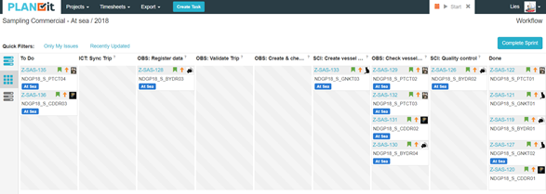
- Deviations from the Work Plan
MS to list the deviations (if any) in the achieved data collection compared to what was planned in the Work Plan and explain the reasons for the deviations. The threshold for deviation follow those set in the former AR: <90 % and >150 %.
Explain any deviation from the proposed:
- sampling intensity,
- methods used for collecting data.
- methods used for estimating the parameters.
General reasons for deviations from the Work Plan in terms of planned vs. achieved should be summarized in this section, while detailed comments on deviations on particular species/stocks should be included in the AR Comments column in Table 1C.
In case of Member State adding new species not included in the WP, this should be clearly explained and justified.
General reasons for deviations from the WP in the areas North Sea, Eastern Channel and North East Atlantic, Western Channel are listed below.
For a lot of the fish stocks, the number of individuals measurement for length, age, weight, sex and maturity well-exceeded the planned minimum number.
For species that are primarily sampled during observer trips, it is difficult to define the number of measurements in advance. All fish of a once randomly chosen subsample must be measured to calculate the retained and discarded fraction of the whole catch. Moreover, the seagoing observers measure length every other haul during the trip, irrespective of the sampling levels already achieved. This does not result in extra costs, since the observers are on board anyhow. Only at the home laboratory, some extra staff time is needed for sample processing. In this regard, additional length measurements were done for haddock (IV, VIIa and VIIb-k) and whiting (IV+VIId, VIIa and VIIb-ce-k). Those samples are not mentioned in table 1C as the layout of this table and the consistency with the other tables do not allow this.
For only a few fish stocks the planned number of individuals was not achieved. This is due to a reduced TAC and/or because of low catches of this species during the observer trip.
The survey protocol prescribes that all individuals in a haul are measured. The enhanced or reduced occurrence of certain species in a haul can result in a higher or lower number of individuals sampled compared to the average number. Occasionally, other species are caught than the ones that were recorded in the reference years. Those additionally sampled species are not mentioned in table 1C as the layout of this table and the consistency with the other tables do not allow this.
*Note on the future data collection for rays and skates
Future data collection and sampling for different species of rays and skates will be continued through two projects: namely the INTERREG 2-Seas SUMARiS project (2017-2020) and a recently submitted EFMZV-project called “RAYWATCH”:
- SUMARiS: The SUMARiS (Sustainable Management of Rays and Skates) project, is a cross-border INTERREG 2-Seas project which aims for an evidence-based, sustainable management strategy of rays and skates in the North Sea and English Channel (ICES-areas 4c,7d). During ±30 commercial sea trips, sea-going observers collect various types of data and through longer-term monitoring of sampled skates reliable and robust survival estimates are calculated.
- Raywatch: The recently submitted national RAYWATCH project - a collaboration between science (ILVO) and industry (fishermen) - aims for a more efficient data collection for commercially important ray species using state-of-the art techniques in the framework of the 3-year “Roadmap for rays and skates” and the Data Collection Framework (DCF). In this project, rays and skates data will be collected onboard of commercial vessels during ± 10 sea trips using toughbooks coupled to electronic measuring boards and via camera-scanners in order to limit the amount of catch manipulation by observers. By doing so, more details on the catch composition (e.g. numbers of discards) will be collected and data gaps defined in the “Roadmap for rays and skates” will be addressed. This newly collected data will be made available for stock assessments to improve advice and management of rays and skate stocks in the future.
- Actions to avoid deviations.
Member State to describe the actions that will be considered / have been taken to avoid the deviations in the future and when these actions are expected to produce effect. If there are no deviations, then this section is not applicable.
Oversampling did not have an impact on the sampling of mandatory variables. Moreover, this entailed no extra financial costs in sampling or data analysis.
Undersampling had no implications on the assessments of stocks for which Belgium needed to collect data on (no negative feedback from stock assessments groups).

(max. 1000 words per Region/RFMO/RFO/IO)

Section 1: Biological Data

Text Box 1D - Recreational fisheries

General comment: This box fulfills paragraph 2 point (a) (iv) of Chapter III of the multiannual Union programme and Article 2, Article 3 and Article 4 paragraph 1 of the Decision (EU) 2016/1701. This box is applicable to the Annual Report. This box is intended to provide information on the design, implementation and analysis of all components of sampling schemes/ surveys that are listed in Table 1D.
1. Description of the target population
The target population and the elements of this target population accessibility, need to be defined and described in this section. In the case of Recreational Fisheries, the target population could be whole population of resident anglers, charter boats etc. This will permit to evaluate if all sectors contributing to the total catch, are included in the survey.

The target population is the entire population of recreational fishermen fishing in the Belgian part of the North Sea. All gear types and platforms are included in the current survey, except for nightfishing
2. Type of survey
In Table 1D, the methodology or type of survey used must be included, but any information about the design is missing.
Table 5A in the Work Plan allows to identify if the sampling design is documented and where it can be found. Are the surveys identified correctly in table 5A and information about sampling design provided under this table?
If the answer is No: information on the design should be included in this section of the Annual Report (e.g.: stratification, selection of PSU, is sampling probability base etc.).
The survey consists of two parts: 1) On site survey methods are used to estimate effort and 2) catch diaries are used to estimate CPUE. On site surveys include harbour observations, beach observations and aerial surveys. Observation days are chosen at random and stratification is used to distinguish between weekdays and weekends / holidays and on and off-season. The catch diary volunteers are not chosen at random, but post-stratification regarding avidity and gear type applied.

3. Data Quality
Information about non-responses and refusals is found in the Work Plan, Table 5A. Are non-responses and refusals recorded in table 5A?
If the answer is No: information on recordings of non-responses and refusals should be included in this section of the Annual Report.

No, non-responses and refusals were not recorded in table 5A.
For effort estimation non-respondent and refusal biasses are not applicable as we observe the activity on-site. Interviews can be refused, but only serve the purpose for estimating the different avidity classes and as a check on the reported catches in the diaries.

The catch diaries volunteers were recuited using snow ball sampling, i.e. initial fishermen were recruited on-site and contacted via fishing clubs, these initial volunteers were than asked to recruit there friends and collegues. This design does not provide a random sample. As such, refusals were not taken into account.

Diary participants that did not report any fishing trip during one month were contacted in order to minimalize recall bias.

4. Data Analysis and processing
Information about data processing is found in the Work Plan, Table 5A. Are the editing and imputation methods documented and identified? Yes
If the answer is No: information on estimation procedures should be included in this section of the Annual Report, following the questions below:
Does the estimation procedure follow the survey design?
The estimation procedure was designed together with the survey design and follows it as such.

Has the precision of the estimates been calculated and documented?
Precision estimates are available since the end of 2018. The full report and results conatining precision results can be found on htpps://www.recreatievezeevisserij.be

(max. 900 words per survey)

Section 1: Biological Data

Pilot Study 1: Relative share of catches of recreational fisheries compared to commercial fisheries

General comment: This box fulfils paragraph 4 of Chapter V of the multiannual Union programme and Article 2 and Article 4 paragraph (3) point (a) of the Decision (EU) 2016/1701.
General comment: This box is applicable to the Annual Report. This box is intended to provide information on the results obtained from the implementation of the pilot study.
- Aim of pilot study
Check the relative contribution of the Belgian recreational catches of European sea bass (Dicentrarchus labrax), cod (Gadus morhua) and pollack (Pollachius virens) in the total national catches (recreational and commercial) of these species with regards to possible tresholds.

- Duration of pilot study
1 year, the national recreational catch survey for Belgium will be yearly conducted from 2017 onwards
- Methodology and expected outcomes of pilot study

The survey consists of two parts: 1) the estimation of the total population of recreational sea fishermen or recreational fishing effort and 2) the estimation of catches for a sample of recreational fishermen. An online omnibus survey will be sent to a representative sample of 200.000 Belgian inhabitants, inquiring about their recreational fishing activity in the Belgian part of the North Sea in the past 12 months. Follow-up questions, when a positive response was received, allow to estimate the total population of Belgian fishermen in function of the used fishing technique and avidity classes. Logbook participants are recruited in the omnibus survey and are added to a pool of purposefully selected logbook participants. On-site surveys, among which an aerial survey, are planned in 2017 to estimate total fishing effort. Logbook surveys are used to estimate the recreational catches of a stratified sample of recreational fishermen. Interviews in the 4 major Belgian marinas and at the coast act as a control on the reported catches. Extrapolation to total catches take into account fishing technique and avidity. The exact protocol is being developed at the time of writing and will most likely be published in the beginning of 2017.
Although no prior studies regarding the total Belgian recreational catch (including all species) have been performed, it can be expected that only for sea bass a significant share of the total Belgian catch can be attributed to recreational fishermen. Although cod is a target species for recerational fisheries, it is expected that the volume of recreational catch is rather low compared to the commercial landings. The recreational catch of pollack is expected to be insignificant

(max 900 words)
Brief description of the results obtained (including deviations from planned and justifications as to why if this was not the case).

4. Achievement of the original expected outcomes of pilot study and justification if this was not the case.
The aim of the study to estimate the relative contribution of the Belgian recreational catches of the mentioned species on the total national catches was achieved. The first results show that the recreational catch of European sea bass (Dicentrarchus labrax) and cod (Gadus morhua) take up 6.2% (recreational catch is estimated to be 11.7 ton) and 3.7% (recreational catch is estimated to be 27.6 ton) of the total national catches (recreational and commercial) respectively.

5. Incorporation of results from pilot study into regular sampling by the Member State.
The recreational catch survey is continued in 2018 and will be continued to at least 2021 in its current form. Effort estimations will be performed biennially and catch (CPUE) estimations will be performed continuously

(max 900 words)

Section 1: Biological Data

Text Box 1E: Anadromous and catadromous species data collection in fresh water

General comment: This box fulfills paragraph 2 points (b) and (c) of Chapter III of the multiannual Union programme and Article 2 of the Decision (EU) 2016/1701.
General comment: This box is applicable to the Annual Report.
1. Method selected for collecting data.
Data collection in fresh water is carried out by INBO in the framework of their Fish Monitoring Network. Fish stock assessments are performed using electrofishing and fykefishing techniques.
For the assessment of glass eel recruitment dipnet fishing procedures in the sluices at Nieuwpoort are followed.

(max 250 words per Area)
2. Were the planned number achieved? Yes/ No
If answer is No, Member State shall explain why not, and what measures were taken to avoid non-conformity.
Yes. In general, planned numbers were achieved. However, the balance in assessed sites between Eel Management Unit (EMU) of Scheldt and Meuse is not fully in line with the reported planning.
Reason for this is the limited availability of staff.

(max 500 words per Area)

Section 1: Biological Data

Text box 1F: Incidental by-catch of birds, mammals, reptiles and fish

General Comment: This box fulfils paragraph 3 point (a) of Chapter III of the multiannual Union programme and Article 2 of the Decision (EU) 2016/1701. This box is applicable to the Annual Report. This box is applicable only for those sections where Member States have reported that they have been carrying out regular sampling. Results and deviations for Pilot studies should be reported under Pilot Study 2.
1. Results
Member States shall fill in Table 1F and provide additional information, if available, in this text box. For example, species (or family) identification, number of samples, and the state of the animals incidentally by-caught (i.e. were they released alive, dead, or collected for sampling).
Observers were instructed to look for incidental bycatch of vulnerable species of fish, mammals, reptiles and birds in commercial fishing trips, both TBB_DEF_>221kW and TBB_DEF_<=221kW and on the national BTS & DYFS surveys. For the BTS survey all fish species were recorded in the national database of SmartFish and were uploaded to the international survey database of ICES (DATRAS).
Incidental bycatch found in the catch was handled with care and released as fast as possible after recording.

2. Deviations from Work Plan
Member States shall list the deviations (if any) in the achieved data collection compared to what was planned in the WP and explain the reasons for the deviations.
Explain any deviations from the proposed:
- sampling intensity
- methods used for collecting data
Incidental by-catch registration during the national DYFS was started in 2018 (see Table 1H).

3. Data quality
Member States shall provide information on sampling protocols and sampling design for incidental by-catch data collection.
Questions to be addressed are listed below:
- Does the onboard observer protocol contain a check for rare specimens in the catch at opening of the codend?
YES
If YES is the observer instructed to indicate if the codend was NOT checked in a haul?
YES

- In gill nets - and hook-and-line fisheries: does the onboard observer protocol instruct the observer to indicate how much of the hauling process has been observed for (large) incidental bycatches which never came on board (because they fall out of the net)? In large catches: does the protocol instruct to check for rare specimens during sorting of the catch (i.e. at conveyor belt)? Is the observer instructed to indicate what percentage of the sorting or hauling process has been checked at “haul level”?
Not applicable

-Does the onboard observer protocol instruct to report on the use of mitigation (i.e. Escape Devices or Acoustic Deterrent Devices)?
YES
- Does the sampling design and protocol follow the recommendations from relevant expert groups? Provide appropriate references. If there are no relevant expert groups, the design and protocol have to be explained in the text.
The ICES Working group on bycatch of protected species (WGBYC) issued a data call in March 2019 to which Belgium responded on time by delivering its data (data was requested from 2017). This working group collates and assesses information on bycatch monitoring and assessment for protected species, including mammals, birds, turtles, and rare fish. Recommendations from WGBYC about technical improvements to monitoring and mitigation methodology are followed up by Belgium where relevant.

- Are data quality issues taken into account?
YES, seagoing observers are trained in identifying different species of incidental by-catch. If they are unsure about the identification, a picture is taken before the specimen is released. Data on incidental by-catch is recorded on the haul level.

- How are data (and samples) stored
Currently the observations of incidental bycatch on commercial fishing trips are still registered in Excel sheets, but ILVO is optimizing the sampling method in order to have this information stored in the national database SmartFish in the near future. The data collected on the surveys (BTS & DYFS) are already recorded in SmartFish and have been uploaded to the international survey database of ICES (DATRAS).

(max 900 words)

Section 1: Biological Data

Pilot Study 2: Level of fishing and impact of fisheries on biological resources and marine ecosystem

General comment: This Box fulfills paragraph 3 point (c) of Chapter III of the multiannual Union programme and Article 2 and Article 4 paragraph (3) point (b) of the Decision (EU) 2016/1701.
General comment: This box is applicable to the Annual Report. This box is intended to provide information on the results obtained from the implementation of the pilot study.
1. Aim of pilot study
To be coordinated at marine regional level and based on end-user needs. Regional studies are yet to be determined.
2. Duration of pilot study
To be coordinated at marine regional level and based on end-user needs. Regional studies are yet to be determined.
3. Methodology and expected outcomes of pilot study
To be coordinated at marine regional level and based on end-user needs. Regional studies are yet to be determined.

(max 900 words)
Brief description of the results obtained (including deviations from planned and justifications as to why if this was not the case).

4. Achievement of the original expected outcomes of pilot study and justification if this was not the case
To be coordinated at marine regional level and based on end-user needs. Regional studies are yet to be determined. Belgium follows-up the RCG NSEA&NA sub-group on establishing of regional plans and the results from FishPi²
WP3 of the FihP² concerns the regional sampling programmes for fisheries and ecosystem impact data not currently collected. There will be looked at developing a sampling plan for the collection of new data from commercial fishing vessels monitored under the at-sea sampling designs (PETS) and for the collection of new data coming from fisheries independent surveys (stomach sampling), both operating in the region NSEA. Additionally, there is a revision and identification of future areas of coordination in other data collection schemes (small-scale fisheries, recreational fisheries, potential new variables related to MSFD).
During the whole process, consultation with the end-users and with involved MS is used to review current sampling and estimation methodologies in small-scale fisheries and recreational fisheries and to identify future areas of corporation. An important added value of the project is that it will also move forward to regional sampling of new variables needed to understand the fisheries impacts on the ecosystem and to align EU MAP obligations under other existing EU legislative instruments.
ILVO (Belgium) is one of the partners in this project.

5. Incorporation of results from pilot study into regular sampling by the MS
Not applicable as project is not finalised in 2018.

(max 900 words)

Section 1: Biological Data

Text Box 1G: List of research surveys at sea

General comment: This box fulfills Chapter IV of the multiannual Union programme and Article 2 and Article 7 paragraph (3) of the Decision (EU) 2016/1701. It is intended to specify which reseach surveys at sea set out in Table 10 of the multiannual Union programme will be carried out. Member States shall specify whether the research survey is included in Table 10 of the multiannual Union programme or whether it is an additional survey.
General comment: This box is applicable to the Annual Report. This box should provide complementary information on the performance of the surveys, the results and their main use.
- Objectives of the survey

North Sea Beam Trawl Survey (BTS, listed in Table 1G.1)
History:
The Belgian offshore beam trawl survey, collecting fisheries-independent data primarily for plaice and sole in the North Sea (area IVb,c), started in 1992. The continuous time-series using a 4 m-beam trawl as standard gear, started in 1993. 62 fixed stations are fished for 30 min at 4 knots. Although the target species are plaice and sole, all fish species are measured since 2010 (before 2010, only numbers were recorded for some fish species) and ages of several flatfish (such as sole, plaice, brill, turbot, dab and lemon sole) and cod are determined. All epibenthic species are recorded (numbers) since 2009. Litter is recorded since 2011.

Objectives:
- Create a fisheries-independent stock estimate for plaice and sole for the sampled area
- Collection of data on all fish species for ecosystem purposes
- Collection of data on epibenthos species for ecosystem purposes
The indices are supplied to the relevant ICES stock assessment working groups.

Demersal Young Fish Survey (DYFS , listed in Table 10)
History:
As part of the international Demersal Young Fish and Brown Shrimp Survey, an annual autumn (quarter 3) DYFS survey is carried out in the Belgian coastal waters to collect data on the abundance of juvenile flatfish (primarily plaice and sole) and brown shrimp (Crangon crangon).
Since 1973, 33 fixed sampling stations are fished. The location of the sampling area matches the main flatfish nursery grounds along the Belgian coast. Until 1982, the research vessel ‘Hinders’ was used. From 1983 onwards, the survey was carried out using the training and research vessel O.29 ‘Broodwinner’. From 2013 onwards, the new research vessel ‘Simon Stevin’ was used for the Belgian DYFS.

Objective:
- Collect data on the abundance and distribution of juvenile flatfish (primarily plaice and sole) and brown shrimp.

- Description of the methods used in the survey. For mandatory surveys, link to the manuals. Include a graphical representation (map)

North Sea Beam Trawl Survey (BTS)
The methods for the mandatory North Sea Beam Trawl survey (BTS) are described in the Manual for the Offshore Beam Trawl Surveys (WGBEAM, 2009; http://www.ices.dk/marine-data/Documents/DATRAS%20Manuals/WGBEAM_Manual.pdf). The ICES Working Group on Beam Trawl Surveys (WGBEAM) has prepared an update of the manual, which is under review by the SSGIEOM chair and will be published by ICES after approval. For the period 2017-2019, Belgium guarantees to continue with previous survey designs as coordinated by ICES WGBEAM.

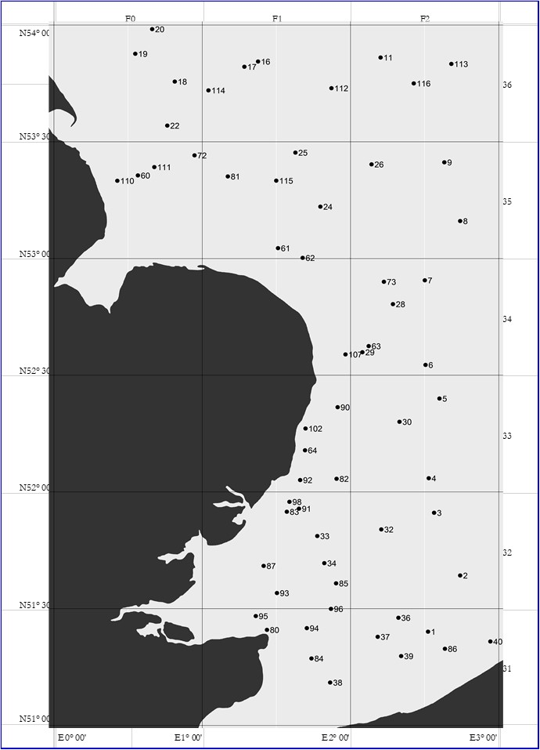
Map 1G.1: Belgian BTS sampling stations in the North Sea

Demersal Young Fish Survey (DYFS)
The methods for the mandatory Demersal Young Fish Survey (DYFS) are described below as a manual is not yet available. During the WGBEAM meeting in 2015, a draft manual of this inshore survey was initiated and discussed. The working group aims to finalise the manual during WGBEAM meetings in the period 2020-2022.
All DYFS sampling stations are fished for approximately 30 min, with a standard shrimp beam trawl (beam length 6 m; cod-end mesh size 22 mm, no tickler chains), at an average 3.5 knots against tide.
Several fish species (cod, whiting, plaice, flounder, dab, sole, brill and turbot) are hand-picked from the catches, sorted by species, weighed and measured in mm (the in-house developed SmartFish measuring board allows measuring length in mm). From 2009 onwards, the species list was extended to cover a larger range of commercial fish species (e.g. including lesser spotted dogfish, gurnards, lemon sole, horse mackerel, etc.). In this way, a total of 18 species are documented (Table 1G.1).
The brown shrimp (Crangon crangon) from the catches are first sorted into a ‘small’ and ‘large’ fraction by means of a rotating shrimp riddle (same type used on commercial shrimp trawlers). From each of these two fractions, 1-2 liter samples are taken (depending on the amount of shrimp and other organisms in the fractions). Samples are further sub-sampled in the lab to approximately 250 shrimps, which are then measured in mm using an in-house developed system for automated length measurements. Since 2018 also incidental by-catch of elasmobranch species and litter were recorded.

Table 1G.1: Commercial fish species sampled during DYFS
Species
Sole (Solea solea)
Plaice (Pleuronectes platessa)
Turbot (Scophthalmus maximus)
Brill (Scophthalmus rhombus)
Cod (Gadus morhua)
Whiting (Merlangius merlangus)
Dab (Limanda limanda)
Flounder (Platichthys flesus)
Lemon Sole (Microstomus kitt)
Tub Gurnard (Chelidonichthys lucerna)
Grey Gurnard (Eutrigla gurnardus)
Red Gurnard (Chelidonichthys cuculus)
Horse Mackerel (Trachurus trachurus)
Mackerel (Scomber scombrus)
Striped Red Mullet (Mullus surmuletus)
Thornback Ray (Raja clavata)
Lesser Spotted Dogfish (Scyliorhinus canicula)
European Seabass (Dicentrarchus labrax)

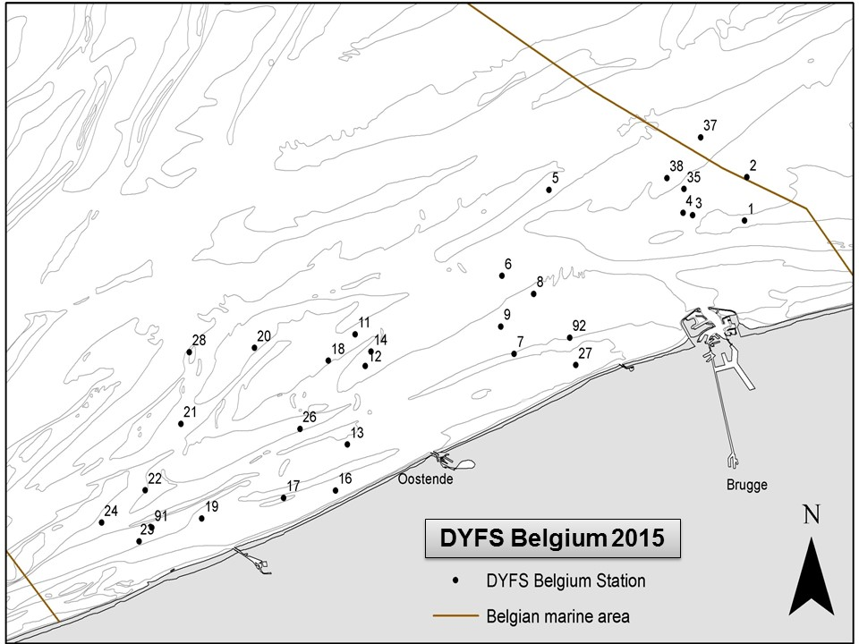
DYFS Belgium
Map 1G.2: DYFS sampling stations in the Belgian coastal waters

- For internationally coordinated surveys, describe the participating Member States/ vessels and the relevant international group in charge of planning the survey

International agreements for both surveys (BTS and DYFS) are coordinated at the ICES WGBEAM working group, where Belgium is represented. Other Member States carrying out beam trawl surveys in the region are The Netherlands, Germany and the UK.

- Where applicable, describe the international task-sharing (physical and/or financial) and the cost-sharing agreement used

Not applicable

- Explain where thresholds apply

For all target species (i.e. sole, plaice and brown shrimp) of the selected mandatory surveys (BTS and DYFS in area IV), the threshold is attained (>3% of the TAC or when no TAC is available >3% of the share in average EU landings.
Belgian average landings of Sole in area IV are 869 tonnes, representing 8% of the TAC.
Belgian average landings of Plaice in area IV are 6470 tonnes, representing 6% of the TAC.
Belgian average landings of Brown Shrimp in area IV are 1011 tonnes, representing 3% of the share in average EU landings.

(max. 450 words per survey)
- Graphical representation (map) showing the positions (locations) of the realized samples.
Member State shall provide maps presenting the spatial distribution of the main sampling types obtained during the survey.

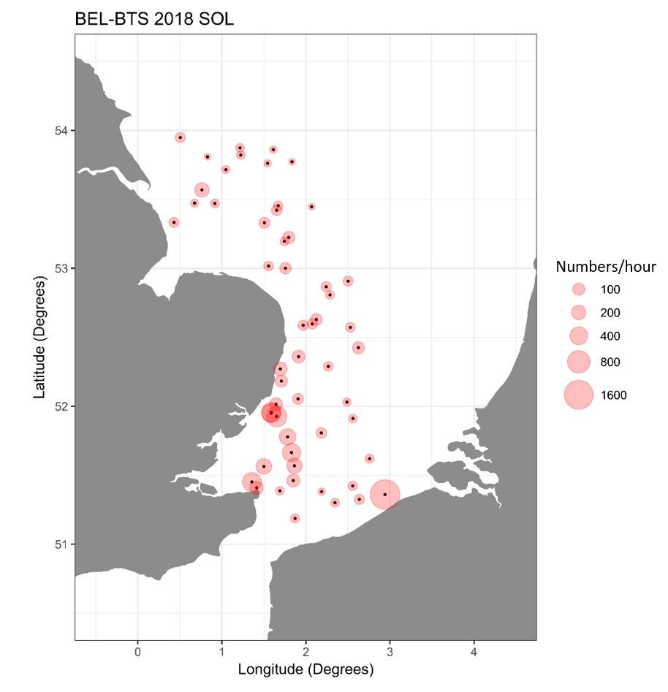
Map 1: CPUE (Numbers per hour) of focus species sole (SOL) in the realized BTS stations in 2018.

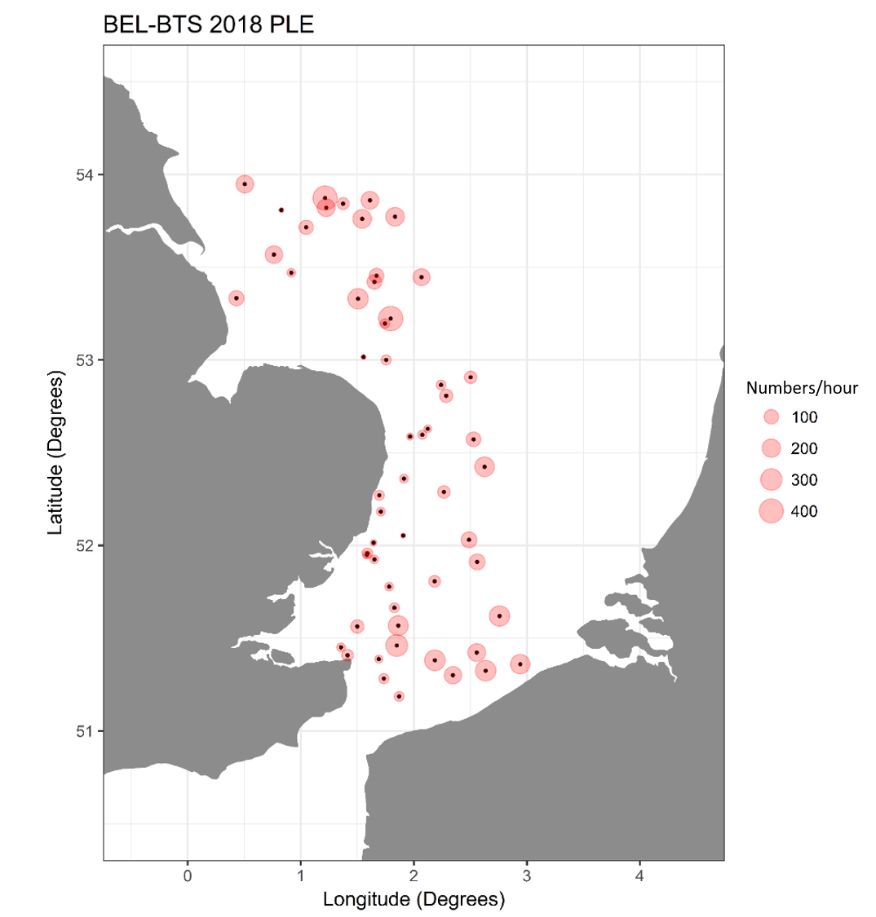
Map 2: CPUE (Numbers per hour) of focus species plaice (PLE) in the realized BTS stations 2018.

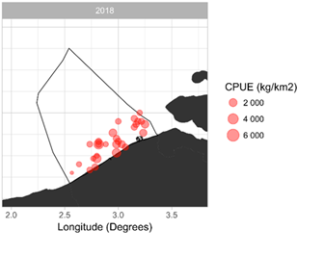
Map 3: CPUE (kilograms per square kilometer) of focus species brown shrimp in the realized DYFS stations 2018.

- For internationally coordinated surveys, provide a link to the latest meeting report of the coordination group.
Member State shall provide a hyperlink to the meeting report from the body coordinating the survey (ICES, MEDITS coordination group, MEDIAS coordination group etc.). For non-international coordinated surveys, Member State shall refer to any status report (e.g. Cruise report).
http://www.ices.dk/sites/pub/Publication%20Reports/Expert%20Group%20Report/EOSG/2018/WGBEAM/WGBEAM%20report%202018.pdf

- List the main use of the results of the survey (e.g. indices, abundance estimates, environmental indicators).
Member State shall specify in which context the results are used (on routine basis), both on an international as well as on a national context.
- The Belgian BTS data on plaice is included in the international combined beam trawl survey index which is used in the assessment of the North Sea plaice stock (ple.27.420) during WGNSSK.
- The Belgian BTS survey index for sole was calculated and explored during the WGNSSK 2018 & 2019 with the intention to include it in the assessment of the North Sea sole stock (sol.27.4).
- The Belgian BTS and DYFS data on sole and plaice also feed into the MSFD assessments for Descriptor 3, which are based on the ICES fish stock assessments for the North Sea.
- The Belgian BTS data on Thornback rays (Raja clavata) is used in the MSFD assessment for Descriptor 1 .
- The Belgian DYFS data on plaice and sole is used in the international combined inshore indices for age groups 0 and 1 which are used in the assessments of the North Sea plaice (ple.27.420) and North Sea sole (sol.27.4) stocks during the WGNSSK.

9. Extended comments (Tables 1G and 1H)
If the Member State has extended AR Comments, these can be placed under this section. If this is the case, a reference to this text box should be provided in the corresponding tables.

(max 450 words per survey)

Section 2: Fishing Activity Data

Text Box 2A: Fishing activity variables data collection strategy

General comment: This box fulfills paragraph 4 of Chapter III of the multiannual Union programme and Article 2, Article 4 paragraph (2) point (b) and Article 5 paragraph (2) of the Decision (EU) 2016/1701. It is intended to describe the method used to derive estimates on representative samples where data are not to be recorded under Regulation (EU) No 1224/2009 or where data collected under Regulation (EU) No 1224/2009 are not at the right aggregation level for the intended scientific use.
General comment: This box is applicable to the Annual Report. This box should provide information on the implementation of the data collection of fishing activity variables of Member States.
1. Description of methodologies used to cross-validate the different sources of data.
Capacity:
Data are 100% covered by the Fleet register and the logbooks.

Effort:
The logbooks provide information on the hours spent fishing per day and per ICES Statistical Rectangle. Those data are used to derive the hours at sea and based thereon, the days at sea. The hours at sea per trip and per ICES Statistical Rectangle (or Division) are summed, divided by 24 and rounded up to calculate the days at sea.
Effort variables available in the fishing logbooks are cross-validated with effort estimates derived from VMS data. The estimated quantities of each species in kilograms live-weight in the fishing logbooks are compared with the sales notes.

Landings:
The estimated weight for all species caught, grouped by ICES Statistical Rectangle and by day is obtained from the logbooks. While information on the quantities auctioned by market category for all species landed is obtained from the sales notes. These two data sources are merged to obtain the landings by area and market category. As the retained catches from the logbooks are estimated weights, the landed weights are derived from the quantities recorded in the sales notes. The two systems are equally important to the Belgian data collection system and complementary. The combination of the two data sources has clear advantages.
(1) The two approaches yield independent estimates of the retained and landed portions of the catches, and can thus be used for quality control and validation purposes. This helps improving the reliability of the landings figures.
(2) In the Logbook Regulation, it is stipulated that ‘only catches of an amount greater than 50 kg of live-weight equivalent of any species retained on board must be recorded in the logbook’ (Article 2.4.2. of Annex V of Commission Regulation (EEC) No. 2807/83). Consequently, small bycatches of fish and shellfish often remain unrecorded in the logbooks. However, these quantities are picked up in the sales notes, which help to improve the species coverage and hence the comprehensiveness of the landings statistics.
(3) Roughly one fifth of all fish and shellfish landed by Belgian vessels in the southern and central North Sea are auctioned abroad, mostly in the Netherlands. Furthermore, vessels making consecutive fishing trips in distant waters before returning to their homeport in Belgium, may sell part of their catches during their stop-overs in a foreign port. Sales data from abroad are collected by local authorities from sales notes and submitted to the Sea Fisheries Service (Dienst Zeevisserij) for incorporation in the Belgian national fishstats database. These data require additional quality checks and codification, to ensure that the imported data are compatible with the recipient database.
(4) Lastly, the landings data by market category are of critical importance to the biological data collection programme on the landings. This heavily relies on stratified sampling by market category.
2. Description of methodologies used to estimate the value of landings.
The actual value of each landing is available in the sales notes, therefore no estimation is needed.
The sales notes contain information on the quantities auctioned and the price by market category for all species landed. Information on the exact origin of the landings (from the logbooks) is added to allocate the price and the corresponding quantities auctioned to a ICES Statistical Rectangle. Multiplication of the latter two will result in the value on a specific level.
3. Description of methodologies used to estimate the average price (it is recommended to use weighted averages, trip by trip)
The actual value of each landing is available in the sales notes, therefore no estimation of average price is needed.

4. Description of methodologies used to plan collection of the complementary data (sample plan methodology, type of data collected, frequency of collection etc)
In 2015, Belgium had one demersal trawler in LOA 10-<12m, however this vessel was inactive. All active vessels are >12m, therefore all data needed are collected under Regulation (EU) No 1224/2009 and no additional data collection will be done.

(max 900 words per Region)
5. Deviations from Work Plan methodology used to cross-validate the different sources of data
List the deviations (if any) and explain the reasons for the deviations. There are no deviations.
Actions to avoid deviations. Not applicable.
Briefly describe the actions that will be considered / have been taken to avoid the deviations in the future and when these actions are expected to produce effect. If there are no deviations, then this section can be skipped.
Not applicable.

6. Deviations from Work Plan methodology used to estimate the value of landings.
List the deviations (if any) and explain the reasons for the deviations. There are no deviations.
Actions to avoid deviations. Not applicable.
Briefly describe the actions that will be considered / have been taken to avoid the deviations in the future and when these actions are expected to produce effect. If there are no deviations, then this section can be skipped.
Not applicable.

7. Deviations from Work Plan methodology used to estimate the average price.
List the deviations (if any) and explain the reasons for the deviations. There are no deviations.
Actions to avoid deviations. Not applicable.
Briefly describe the actions that will be considered / have been taken to avoid the deviations in the future and when these actions are expected to produce effect. If there are no deviations, then this section can be skipped.
Not applicable.
8. Deviations from Work Plan methodology used to plan collection of the complementary data
List the deviations (if any) and explain the reasons for the deviations. There are no deviations.
Actions to avoid deviations Not applicable.
Briefly describe the actions that will be considered / have been taken to avoid the deviations in the future and when these actions are expected to produce effect. If there are no deviations, then this section can be skipped.
Not applicable.
(max 900 words per Region)

Section 3: Economic and Social Data

Text Box 3A: Population segments for collection of economic and social data for fisheries

General comment: This box fulfils paragraph 5 points (a) and (b) of Chapter III of the multiannual Union programme and Article 2, Article 4 paragraphs (1), (2) and (5) and Article 5 paragraph (2) of the Decision (EU) 2016/1701. It is intended to specify data to be collected under Tables 5(A) and 6 of the multiannual Union programme.
General comment: This box is applicable to the Annual Report. This box should provide information on the implementation of the fleet socio-economic data collection of Member States.
1. Description of methodologies used to choose the different sources of data
The Belgian fleet encompasses mainly beam and demersal trawlers and has no registered fishing vessels of < 10m LOA. Fleet overview in 2015:
Type of fishing technique |  | Length classes (LOA) | N° of vessels
Active gears | Beam trawlers | 10-<12 m | 0
Active gears | Beam trawlers | 12-<18 m | 3
Active gears | Beam trawlers | 18-<24 m | 25
Active gears | Beam trawlers | 24-<40 m | 29
Active gears | Demersal trawlers and/or demersal seiners | 10-<12 m | 0
Active gears | Demersal trawlers and/or demersal seiners | 12-<18 m | 1
Active gears | Demersal trawlers and/or demersal seiners | 18-<24 m | 7
Active gears | Demersal trawlers and/or demersal seiners | 24-<40 m | 5
Active gears | Dredges¹ | 18-<40 m | 1
Passive gears | Drift and/or fixed netter² | 12-<24 m | 2
Total active vessels |  |  | 73
Inactive vessels |  |  | 6
Total |  |  | 79
¹ dredges (18-<24 m and 24-<40 m)
² Passive gears - drift and/or fixed netter (12-<18 m and 18-< 24m)

An annual survey is conducted by Dienst Zeevisserij, Department of Agriculture and Fisheries (Flemish government) to collect fleet socio-economic data. Information is collected by vessel. Wherever possible, data on the balance accounts of the company are also consulted.

Employment data are obtained through the employers social-accounting secretariat, who gather data regarding the social costs. The Belgian fishery sector has a unique system of social security. These data are delivered directly to Dienst Zeevisserij via the accredited accountancy office Morbee & Ballegeer.
Landings and effort data are obtained from official logbooks. The official Belgian vessel register (the Fleet register) is used to obtain data with regards to vessel characteristics. Value of landings (sales notes) is available from all Belgian fish auctions. Sales notes are also provided for vessels that do not sell their catches through the auction (i.e. coastal vessels). Logbook, Sales and Fleet data are provided by the controlling bodies under Regulation (EU) no. 1224/2009. “Fishstats Database DZV” is the official database of Dienst Zeevisserij containing this information.

2. Description of methodologies used to choose the different types of data collection
A census is carried out for socio-economic data collection. All vessels are surveyed (questionnaire). Since the 1st of September 2010, a Decision was agreed upon by the Flemish Government, regarding the obligation to supply economic data. Thus, national legislation was introduced to impose the obligation to provide data requested under Appendix VI of the DCF. As a consequence, response rates increased.

Methodologies are in accordance with ad hoc contract Commitment No. SI2 725 694 - Methodologies for the socio-economic data described in EU MAP.
3. Description of methodologies used to choose sampling frame and allocation scheme
The target and the frame population are identical. Following the national legislation, the coverage of the population is close to 100%. The sampling frame of the economic data covers the complete Belgian marine fishing fleet as registered in the EU vessel register. Inland and aquaculture fishing vessels are excluded from data collection.

Fleet segments are determined as described in European legislation. However, this raises the issue of clustering. Many segments consist of less than 10 fishing vessels (see table under point 1). Economic data are sensitive data and therefore confidentiality must be guaranteed. There are 2 possibilities to tackle this issue:

- Data by fleet segment for segments where the number of vessels is too low shall not be reported separately.
- Data for these fleet segments can be clustered. The clustering procedures are based on technical data and catch composition. Important fleet segments shall not be clustered or shall be clustered in accordance with the similarity principle. Therefore, beam trawlers 12-18m would be clustered with beam trawlers 18-24m. The latter is an important segment, however both segments use the same fishing gear and exhibit similar behaviour in terms of target species. Following the same logic, demersal trawlers or seiners of all length categories would be clustered in order to be consistent over time.
Option 2 is preferred. However, a problem remains for dredges and passive gear. In last data reporting years (Data call 2016; Annual Report 2015), these fleet segments were clustered together as they do not resemble any of the other fleet segments within the Belgian fleet. These segments were clustered following the ‘Non-important segments with distinct characteristics’ principle in order to provide a full dataset. As there is no real dominant segment in this cluster and in an attempt to avoid misleading the end-user, these vessels were clustered as ‘Vessels using active and passive gears’ (PMP). A category ‘Other’ is non-existent. This also allowed for constant clustering over the time series 2008-2014. However, with only 3 vessels remaining in the cluster, Belgium chooses option 1 for these fleet segments.
4. Description of methodologies used for estimation procedures
Costs and earnings from the active vessels are surveyed through a questionnaire. As the response within the important fleet segments is high, missing data will be estimated by calculating the mean per fleet segment in the sample. This is then raised to the population level of each segment. The sum of the totals of the different categories estimate the total value for the entire fleet.
Information on technical characteristics, effort and landings from all vessels in the population are available from the logbooks and the vessel register (collected under Regulation (EU) no. 1224/2009).
5. Description of methodologies used on data quality
Wherever possible, data from different sources will be cross-checked. During 2017-2019, Belgium would like to further develop and improve routine data quality check-ups (e.g. summary statistics, analyse outliers, correlations between variables, …).

(max 900 words per Region)
6. Deviations from Work Plan methodology for selection of data source
List the deviations (if any) from the methodology used to select data source compared to what was planned in the Work Plan, and explain the reasons for the deviations. There are no deviations.
Actions to avoid deviations. Not applicable.
Briefly describe the actions that will be considered / have been taken to avoid the deviations in the future and when these actions are expected to produce effect. If there are no deviations, then this section can be skipped.
Not applicable.

7. Deviations from Work Plan methodology to choose type of data collection
List the deviations (if any) from the methodologies to choose type of data collecton scheme compared to what was planned in the Work Plan, and explain the reasons for the deviations. There are no deviations.
Actions to avoid deviations. Not applicable.
Briefly describe the actions that will be considered / have been taken to avoid the deviations in the future and when these actions are expected to produce effect. If there are no deviations, then this section can be skipped.
Not applicable.

8. Deviations from Work Plan methodology regarding sampling frame and allocation scheme
List the deviations (if any) from the methodologies used regarding sampling frame and allocation scheme compared to what was planned in the Work Plan, and explain the reasons for the deviations. There are no deviations.
Actions to avoid deviations Not applicable.
Briefly describe the actions that will be considered / have been taken to avoid the deviations in the future and when these actions are expected to produce effect. If there are no deviations, then this section can be skipped. Not applicable.

9. Deviations from Work Plan methodology used for estimation procedures
List the deviations (if any) from the methodologies used for estimation procedures compared to what was planned in the Work Plan, and explain the reasons for the deviations. There are no deviations.
Actions to avoid deviations Not applicable.
Briefly describe the actions that will be considered / have been taken to avoid the deviations in the future and when these actions are expected to produce effect. If there are no deviations, then this section can be skipped. Not applicable.

10. Quality assurance
10.1 Sound methodology
Briefly describe if the data collection follow methodologies, guidelines and best practices agreed in expert groups and whether methodologies are documented and are made publicly available.
Belgium has clarified and adjusted its survey to be in line with the suggestions made by the PGECON expert group. This specifically as a result of recommendations made in the Statistical issues and methodologies (SIM) workshop in Rome in December 2016 and the 6th annual PGECON meeting in Vilnius in May 2017.
10.2. Accuracy and reliability
Response rate and Achieved sample rate are provided in Table 3A.
For additional information, briefly describe how raw data inputs, intermediate results and outputs are regularly assessed and validated and how errors are identified, documented and dealt with.
The PGECON group has made many efforts to clarify definitions and interpretations of economic variables for the fleet in order to improve comparibilty across Member States. Furthermore, the commision implemented a new decision in 2016 (EU 2016/1251), updating its requested variables and also including new variables.
Belgium aims to follow these changes and adapted its 2017 surveys accordingly. Further fine-tuning was done in the 2018 survey. Consequently, anomalies in the time-series may occur as a result of these changes (respondents interpreted some questions differently).
Belgium has made efforts to develop a number of automated checks of intermediate results and outputs in the framework of the Data Call for the Annual Economic Report (AER). These checks are carried out using markdown documents generated in the R-software environment. Similar quality checks were developed on the raw data inputs. However, there is still room for improvement and Belgium plans to further improve these checks and corresponding documents.
Due to structural changes in the organisation of the workforce involved with the data collection, there were some challenges to maintain the usual workflow. As such there were some gaps with regards to data cleaning and some data checks were not fully conducted. This may have a slight influence on the estimations. Belgium aims to reestablish a balanced workflow.
10.3. Accessibility and Clarity
Indicate with Yes or No
Are methodological documents publicly available? Yes
Are data stored in databases? Yes
Where can methodological and other documentation be found? Online and on request
Provide the web link, if documentation is publicly available
http://www.smartfisheries.be/
https://lv.vlaanderen.be/nl/visserij/cijfers-marktoverzichten/publicaties-zeevisserij -> see publications called "Bedrijfsresultaten 2016" and "Aanvoer en besomming 2016".
The version 2017 is to be published within the coming weeks (will be availbale on https://lv.vlaanderen.be/nl/visserij/cijfers-marktoverzichten/publicaties-zeevisserij)

(max 1000 words)

Section 3: Economic and Social Data

Pilot Study 3: Data on employment by education level and nationality

General comment: This box fulfills paragraph 5 point (b) and paragraph 6 point (b) of Chapter III of the multiannual Union programme and Article 2 and Article 3 paragraph (3) point (c) of the Decision (EU) 2016/1701.It is intended to specify data to be collected under Table 6 of the multiannual Union programme.
General comment: This box is applicable to the Annual Report. This box is intended to provide information on the results obtained from the implementation of the pilot study (including deviations from planned and justifications as to why if this was not the case).
1. Aim of pilot study
The Belgian fishery sector has a unique system of social security. Fishermen receive relatively high incomes. Since 2003, a law on employment ended the ‘No catch, no pay’ principle, assuring income security for each sea trip (Royal Decree, Belgian State Journal, 07/03/2005). The crew receives a fixed percentage of the value of landings. If the value of landings is lower than a certain minimum wage, the employer has to pay a minimum wage. This is a system that favours employees over employer, bearing in mind that being a fisherman remains a dangerous profession. The fact that this has been set legally for all vessels is unique in Europe and might contribute to the fight against illegal fishing.
However, finding appropriate staff for fisheries remains a challenge. Young people graduating from the Maritime Institute prefer to work for dredging companies or in the tourism industry. Therefore, it is possible that crew members from elsewhere (from other sectors and/or abroad) are attracted. Wages are relatively high, but minimum educational requirements in the Belgian fishery sector are strict and costly.
To acquire more insights in this matter, this pilot study aims to collect information on the age, nationality and education level of crew members on Belgian fishing vessels. Initially, the focus lies on the beam trawler fleet. Beam trawlers with a vessel length of 24-40 m provide about half of employment opportunities (STECF, 2016). Ultimately, this will be expanded to the entire fleet.
2. Duration of pilot study
This pilot study will start in 2017 and data collection will be carried out throughout the year for engaged crew members. Data analyses will be performed in 2018.
3. Methodology and expected outcomes of pilot study
Close collaboration with the employers social-accounting secretariat will be necessary to collect social data on employment by education level and nationality. The employers social-accounting secretariat should have part of this information available on a trip and vessel level. Data gaps will be filled by surveying vessel owners and/or fishermen.

4. Achievement of the original expected outcomes of pilot study and justification if this was not the case.
The aim of this pilot study was to collect information on age, nationality and education level of crew members on Belgian fishing vessels. To avoid collecting data twice, an inventory was made on which data were already collected and by whom. This was complemented with a literature review on the Belgian Social Security system for ‘sea fisheries’ (including its legal basis).
This research showed that there is a ‘Paritair Comité’ in place for sea fisheries. A Paritair Comité groups companies with similar activities and acts as a council linking employers and employees. For example, negotiations concerning collective labour agreements (CAO) are done at this level. Agreements from this Paritair Comité are binding for the whole sector. An example of such a binding agreement is the issue that all sea fishing enterprises must make their employment declarations through the Social Secretariat of the Coast, which is recognised by the Federal Government (Belgian Public Service). Information is collected through an employment declaration (so called Dimona and Multifunctional declarations) for the entire Belgian fleet for every trip separately.
The social secretariat calculates monthly wages and pays the crew and social security contribution. It collects information on age, gender, nationality (at the level of national vs. non-national), resident, number of days at sea and job function of the crew. This information is used to calculate FTE and number of engaged crew. However, no information is available on education or number of unpaid labour. The intermediary findings of this investigatory work were presented at the PGECON Workshop on Social variables in Vilnius in May 2017. During this workshop some recommendations were made with regards to the groups that should be used for the social variables. With the information collected by the Social Secretariat of the Coast it should be possible to meet most of these recommendations.
Information on the education level was found in a dedicated database of the Department of Education of the Flemish Government. This database contains information on qualification levels (diplomas, certificates, proof of experience,…), on higher education since 2000 and secondary education since 2001 in Flanders. Citizens can consult their personal information and so can governmental bodies that have been granted permission by the Oversight Committee for specific tasks.

5. Incorporation of results from pilot study into regular sampling by the Member State.
Most of the social data requested under the DCMAP is already collected by the Social Secretariat of the Coast and by the Department of Education of the Flemish Government as described above. Consequently, it is more a matter of accessing this information in a legally correct manner. Agreements need to be made with these different institutions to obtain anonymised/aggregated social information of the crew members to full-fill DCMAP requirements. However, it is imperative to guard the privacy of these crew members. Therefore, such agreements need to happen on an administrative level, but this is sometimes a lengthy process.
Belgium made agreements in 2019 with the Social Secretariat of the Coast to receive most social data required under DCMAP. However, the implementation of this agreement was not in time to be used for the 2019 Social Data Call. Therefore data provided under this call will be improved in the next data call.
In theory, to obtain some information on education level (i.e. after 2001), it should be possible to link the personal information on education with the personal crew information that is collected by the Social Secretariat of the Coast. This would give information on education for all crew members that graduated secondary school after 2001. However, an important matter that needs a great deal of consideration regards privacy issues. It was not easy to find a party that is authorised to link this sensitive information. Therefore, it was esteemed that the procedure to do this was too lengthy and too labour intensive relative to the gained information. Getting this information will require a large amount of effort (and be costly), while the added value is questionable. For the same reasons, Belgium decided not to conduct additional surveys to gather this information.
The number of unpaid labour was included in the questionnaire sent out to collect the economic data of the fleet (Text Box 3A). However, response rate was too low to make any sensible estimations and therefore Belgium decided not to report this variable in the social data call. Due to structural changes in the organisation of the workforce involved with the data collection, there were some challenges to maintain the usual workflow. As such there were some gaps with regards to data cleaning. For e.g. we were not able to check missing answers for the number of unpaid labour. Belgium is aiming to reestablishing a balanced workflow.

(max 900 words)

Section 3: Economic and Social Data

Text Box 3B: Population segments for collection of economic and social data for aquaculture

General comment: This box fulfills paragraph 6 points (a) and (b) of Chapter III of the multiannual Union programme and Article 2, Article 4 paragraphs (1) and (5) and Article 5 paragraph (2) of the Decision (EU) 2016/1701.It is intended to specify data to be collected under Tables 6 and 7 of the multiannual Union programme.

General comment: This box is applicable to the Annual Report. This box should provide information on the implementation of the socio-economic data collection for aquaculture of Member States.

According to Eurostat, the total Belgian annual production in marine aquaculture was 128 tonnes in 2007 (last data year). As this production did still not increase since 2007, the Belgian Federal Department of Economics, which is still monitoring the volume and value of this sector, did not publish actualised data in Eurostat.
Until the end of 2016, Belgium has a derogation for collecting data on aquaculture. For this new WP 2017-2019, a pilot study will be executed to investigate whether Belgium complies with the thresholds as described in Chapter V of Commission Implementing Decision 2016/1251. To ensure efficient use of resources, the pilot study will include collecting economic, social as well as environmental data on the aquaculture sector.

1. Description of methodologies used to choose the different sources of data

To be determined through pilot study 2017-2019

2. Description of methodologies used to choose the different types of data collection
To be determined through pilot study 2017-2019

3. Description of methodologies used to choose sampling frame and allocation scheme
To be determined through pilot study 2017-2019

4. Description of methodologies used for estimation procedures

To be determined through pilot study 2017-2019

5. Description of methodologies used on data quality
To be determined through pilot study 2017-2019

(max 1000 words)
6. Deviations from Work Plan methodology for selection of data source
List the deviations (if any) from the methodology used to select data source compared to what was planned in the Work Plan, and explain the reasons for the deviations.
Actions to avoid deviations
Briefly describe the actions that will be considered / have been taken to avoid the deviations in the future and when these actions are expected to produce effect. If there are no deviations, then this section can be skipped.
In general, the Belgian fresh water aquaculture sector is characterized by small-scale, extensive production units, with low employment rate. Only a limited number of farms form an exception to this rule of thumb. In the northern part of Belgium (Flanders) the companies can be identified, in the southern part of Belgium (Wallonia) the situation is more complicated.
The biggest production is situated in Wallonia, where mostly rainbow trout (Oncorhynchus mykiss) and to a lesser extent brown trout (Salmo trutta fario) and brook trout (Salvelinus fontinalis) are kept. Most of the aquaculture farms are family-based operations that often have no further personnel on the pay-role and subsequently, do not have significant alternative employment opportunities. As a result, farmers are prepared to accept incomes, which would not be acceptable to publically limited liability companies and keep producing trout under non-profitable conditions. Furthermore, leaving and getting back into business is fairly easy, because the infrastructure is not expensive to maintain. Nowadays, big producers of trout, import large size of trout (from Italy, Greece and Turkey) and keep them in outdoor ponds until there is a demand for trout. To our knowledge is no full cycle production (from broodstock via eggs to market sized product) of trout in Belgium.
Tilapia farming in Belgium started in 1980, with a pilot-farm at Thiange. The farm used warm water from the nearby nuclear power plant to heat the water in the outdoor fish tanks. The farm was operated for two years, but was then incorporated in a larger commercial fish farm (Piscimeuse) in 1982, designed and built by Gabriel N.V. to produce 150 tons of tilapia. In 1994 Gabriel N.V. was producing about 250 tons of tilapia in its farm at Thiange. In 2006 a consortium of investors constructed Europe’s largest indoor tilapia farm (on recirculation) and processing plant at Dottignies, with the aim of producing 3 000 tonnes of fresh product per year for major European retail markets. The farm had to empty its tanks and start again after disease problems in 2007. In 2008, the farm experienced low selling prices due to declining fish prices, in particular the low cost of cod from the Barents Sea and increased Icelandic and Norwegian quotas. In 2010, the farm went bankrupt and was bought by Aqua Bio to farm sturgeons and maybe other cold water species. In 2019 no tilapia farms were active.
Shortly after the establishment of Aqua Bio (fish feed mill) in 1990, the sturgeon farm in Turnhout was built. In several indoor units and outdoor ponds, about 20 000 sturgeons are farmed until maturation, after which they are slaughtered to extract the caviar. The company has mastered the entire culture and reproduction cycle of 7 sturgeon species, e.g. Acipenser gueldenstaedti, A. persicus, A. stellatus, A. baeri, A. ruthenus and Huso huso. Apart from these five Eurasian sturgeons, Aqua Bio also houses two American species, the paddlefish (Polyodon spatula) and the shovelnose sturgeon (Scaphirhynchus platorynchus). These species produce different kinds of caviar, which are sold under the name “Royal Belgian Caviar”. Sturgeon fillets are sold to Germany as fresh or smoked product.
In Kruishoutem (near Ghent), Aqua4C is farming “Omegabaars®” or jade perch (Scortum barcoo). Pruduction is about 150 tons (in 2018) and sells mainly to retail stores e.g. Spar, Albert Heijn and Carrefour. This company receives warm water from combined heat and power (CHP) station from a neighbouring company Tomato Masters, specialized in the production tomatoes. The warm water is used to heat up the water in the fish tanks. The superfluous water is rich in nutrients (nitrogen and phosphor) is returned to the tomato farm and used to fertilize the tomato plants. Mariculture is very rare in Belgium and is limited to the production of oyster, blue mussel and tropical shrimps. Farming of oysters takes place in the “Spuikom” in Ostend. The “Spuikom” is an 86 ha inland saltwater reservoir in connection with the port of Ostend. The production consists of Ostrea edulis and Crassostrea gigas. The oysters are imported from abroad and kept in big basins that contains filtered seawater from the “Spuikom” for adjustment of the oyster's flavor. Next to oyster farming, two farmers were active in the period 2007-2011 in the production of blue mussels. Both were located in the same shellfish production area: D1 – Noordpas, offshore in front of Nieuwpoort. But the mussel production ended in 2011 because of technical and legal problems. Crevetec is zero-exchange shrimp farm with a maximum capacity of 20 tons, located in Ternat and producing 9 tons tropical whiteleg shrimp (Litopenaeus vannamei).
In total, ILVO has collected 108 addresses of fish farmers, but it is uncertain that all of these are still in business. A questionnaire was sent to all 108 farmers, in order to select a number of farmers to be representative for the total Belgian aquaculture production. By the end of 2018, 3 replies were received: 2 replies indicating the business was not active anymore, one with data. As this is only one set of data avilable, due to privacy reasons, the data cannot be used.
7. Deviations from Work Plan methodology to choose type of data collection
List the deviations (if any) from the methodologies to choose type of data collecton scheme compared to what was planned in the Work Plan, and explain the reasons for the deviations.
Not applicable.

Actions to avoid deviations
Briefly describe the actions that will be considered / have been taken to avoid the deviations in the future and when these actions are expected to produce effect. If there are no deviations, then this section can be skipped.
Not applicable.

8. Deviations from Work Plan methodology regarding sampling frame and allocation scheme
List the deviations (if any) from the methodologies used regarding sampling frame and allocation scheme compared to what was planned in the Work Plan, and explain the reasons for the deviations.
Actions to avoid deviations
Briefly describe the actions that will be considered / have been taken to avoid the deviations in the future and when these actions are expected to produce effect. If there are no deviations, then this section can be skipped.
Not applicable.

9. Deviations from Work Plan methodology used for estimation procedures
List the deviations (if any) from the methodologies used for estimation procedures compared to what was planned in the Work Plan, and explain the reasons for the deviations.
Actions to avoid deviations
Briefly describe the actions that will be considered / have been taken to avoid the deviations in the future and when these actions are expected to produce effect. If there are no deviations, then this section can be skipped.
Not applicable.

10. Quality assurance
10.1 Sound methodology
Briefly describe if the data collection follow methodologies, guidelines and best practices agreed in expert groups and whether methodologies are documented and are made publicly available.
Not applicable.

10.2. Accuracy and reliability
Response rate and Achieved sample rate are provided in Table 3B.
For additional information, briefly describe how raw data inputs, intermediate results and outputs are regularly assessed and validated and how errors are identified, documented and dealt with.
Not applicable.

10.3. Accessibility and Clarity
Indicate with Yes or No
Are methodological documents publicly available? No
Are data stored in databases? No
Where can methodological and other documentation be found?
On the ILVO server
Provide the web link, if documentation is publicly available
Not applicable.
(max 1000 words)

Section 3: Economic and Social Data

Pilot Study 4: Environmental data on aquaculture

General comment: This box fulfills paragraph 6 point (c) of Chapter III of the multiannual Union programme and Article 2 and Article 4 paragraph (3) point (d) of the Decision (EU) 2016/1701. It is intended to specify data to be collected under Table 8 of the multiannual Union programme.
General comment: This box is applicable to the Annual Report. This box is intended to provide information on the results obtained from the implementation of the pilot study (including deviations from planned and justifications as to why if this was not the case).
To investigate whether Belgium complies with the thresholds as described in Chapter V of Commission Implementing Decision 2016/1251, a pilot study will be executed to collect economic, social as well as environmental data on the aquaculture sector.
1. Aim of pilot study
Investigate whether Belgium complies with the thresholds as described in Chapter V of Commission Implementing Decision 2016/1251.
2. Duration of pilot study
Period 2017-2018.
3. Methodology and expected outcomes of pilot study
Due to the very fragmented situation of the aquaculture sector in Belgium, it will take time to develop a proper strategy for setting up a proper methodology. Initially, Belgium will start with making an inventory of the aquaculture production sector with the respective data on production, systems used, value, etc

(max 900 words)
4. Achievement of the original expected outcomes of pilot study and justification if this was not the case.

In total, ILVO has collected 108 addresses of fish farmers, but it is uncertain that all of these are still in business. A questionnaire was sent to all 108 farmers, in order to select a number of farmers to be representative for the total Belgian aquaculture production. By the end of 2018, 3 replies were received: 2 replies indicating the business was not active anymore, one with data. As this is only one set of data avilable, due to privacy reasons, the data cannot be used.
5. Incorporation of results from pilot study into regular sampling by the Member State.

Not applicable
(max 900 words)

Section 3: Economic and Social Data

Text Box 3C: Population segments for collection of economic and social data for the processing industry

General comment: This box fulfils footnote 6 of paragraph 1.1(d) of Chapter III of the multiannual Union programme, Article 2, Article 4 paragraphs (1) and (5) and Article 5 paragraph (2) of Decision (EU) 2016/1701. It is intended to specify data to be collected under Table 11 of the multiannual Union programme.
General comment: This box is applicable to the Annual Report. This box should provide information on the implementation of the socio-economic data collection for aquaculture of Member States.
In the previous Belgian National Programme, the absence of a reference list with ‘fish processing companies’ sensu stricto was mentioned. In order to address this issue, ILVO contacted the top-255 (ranking based on company turnover and number of employees) of Belgian companies that were identified as being involved in ‘fish processing’ in a national survey of private company performance indicators. However, the identification of true fish processing companies remained a major issue to set up a meaningful collection scheme. Over the past two years efforts have been made in this regard.
1. Description of methodologies used to choose the different sources of data
The list of fish processing companies has been rigorously updated by cross-checking different sources with information on companies involved in fish-based activities. The effort invested in the improvement of this list, resulted in a better population identification and thus data quality. ILVO collaborated with the Federal Agency for the Safety of the Food Chain (FASFC) who strictly monitor processing activities of these companies from a health safety angle. Their list was further cross-checked with other lists, such as the initial ‘top-255’ list, the database of FPS Economy, S.M.E.s, Self-employed and Energy (Federal Government) and a list of the Belgian representative of AIPCE-CEP (European Fish Processors Association - European Federation of National Organisations of Importers and Exporters of Fish).
This led to a population of approximately 250 companies. Not all companies process fish as their main activity. Based on answers obtained through a questionnaire, consulting public balance accounts, direct contact with some companies as well as web-research, it was estimated that in 2013 there were 68 companies that processed fish as a main activity, with an estimated turnover of 650 million euro and 1500 FTE’s.
On an annual basis this list is updated through consultation of the following sources:
- Federal Agency for the Safety of the Food Chain (FASFC)
- FPS Economy, S.M.E.s, Self-employed and Energy (Federal Government)
- Balance accounts, National Bank of Belgium
- Questionnaire
If resources are available, Belgium will invest in further refining the information by contacting the enterprises directly.
2. Description of methodologies used to choose the different types of data collection
Data can be acquired from different sources:
- Balance sheets: The balance sheets for some companies can publically be consulted. Especially from larger companies a lot of information is available in these sheets. A limitation is that not all variables requested under EU Decision 2016/1251, Table 11, are available in the company accounts. For example energy costs are not separately available, but aggregated within other operational costs.
- Questionnaires: Information which is not available through balance sheets, or in general not publically available will be obtained via questionnaires. Online surveys are preferred, whenever possible (i.e. when an e-mail-address is available), in other cases paper surveys are sent out.
Efforts related to determine the main activity of the company will continue. Total weight and weight of seafood and fish for the most important processed species will be surveyed. However, collecting data by origin is not feasible.
The data requested under Decision 2016/1251 is considered to be sensitive data. In the past, some companies have responded that they did not have the time or they simply refused to provide the requested economic data. Especially small and medium enterprises do not see the purpose of requesting economic data and therefore their response rate is limited. Regular and direct contact with enterprises improves trust, and hence the needed understanding and willingness of companies to cooperate and provide the requested data will increase. On the other hand, direct contact with enterprises, given the size of the population, is labour intensive and Belgium cannot yet guarantee that the necessary resources will be available to effectively adopt this approach.
3. Description of methodologies used to choose sampling frame and allocation scheme
Enterprises for which fish processing is an important activity are targeted first. As it is not possible to directly determine the importance of the activity from the population list, the questionnaire aims to identify the enterprises using questions to determine the proportional importance of the fish processing activity based on turnover and employment. In the online questionnaire, a shortened version is foreseen in case fish processing is not an important activity. Under the current circumstances, economic and social variables are not collected from these enterprises.
4. Description of methodologies used for estimation procedures
The enterprises are classified in categories according to the number of employees (≤ 10; 11-49; 50-249; ≥ 250 employees). When the number of companies per category are low, several categories are grouped. Variables for missing data are estimated by calculating the mean per category in the sample. This is then raised to the population level of each category. The sum of the totals of the different categories estimate the total value for the entire population. More information will be included on larger companies (less abundant) than on smaller ones (more abundant). This leads to a stratified sample in which larger companies are oversampled. However, the total estimation is likely to be more precise, given that larger companies contribute more.
Should the variance between observations in a given category be large, an alternative method could be applied. This concerns mostly the 11-49 employee group. Companies in this group could be further subdivided based on their balance account type. Above certain thresholds, companies must lay down a ‘full’ balance account. Estimations could then be done for the ‘full’ and the ‘short’ balance account separately.
5. Description of methodologies used on data quality
In the period 2014-2016, data in the balance accounts were compared to answers in the questionnaire (whenever possible). This was done to determine whether both sources could be combined and to test the effectiveness of the questionnaire. As they were comparable, redundant questions were omitted. This enabled the use of balance accounts for companies that did not respond to the questionnaire.

(max 1000 words)
6. Deviations from Work Plan methodology for selection of data source
Since 2018, Belgium has been seeking to hire a data collector who will be able to ensure a regular and improved data collection for the fish processing industry. For administrative reasons, there have been some delays. Currently, the vacancy has been published and it is expected that the position will be filled by the summer of 2019.
There were some complications with the survey for 2015 and 2016 data (N-2) due to a turnover in the available workforce. As a result no questionnaire was sent out in 2017 nor 2018. For 2015 data, the used data source were the balance accounts.
Additionally, Belgium finds it challenging to collect information on some of the new variables introduced in the new WP (e.g. raw material, employment by nationality, etc…). It involves large adjustments in the sampling methodologies. The best approach for this needs to be well-thought-out and therefore Belgium is hoping that results from the SECFISH project will provide some insight.
Actions to avoid deviations
Belgium intends to work out a plan to gather information on the new variables and to adjust the questionnaire accordingly with the help of staff reinforcement.
With regards to raw material, Belgium awaits the results from the SECFISH project.

7. Deviations from Work Plan methodology to choose type of data collection
There were no deviations from the Work Plan methodlogy to choose the type of data collection.
Actions to avoid deviations
Not applicable.
8. Deviations from Work Plan methodology regarding sampling frame and allocation scheme.
There were no deviations from the Work Plan methodology regarding sampling frame and allocation scheme.
Actions to avoid deviations
Not applicable.
9. Deviations from Work Plan methodology used for estimation procedures.
There were no deviations from the Work Plan methodlogy used for estimation procedures.
Actions to avoid deviations
Not applicable.

10. Quality assurance
10.1 Sound methodology
Briefly describe if the data collection follow methodologies, guidelines and best practices agreed in expert groups and whether methodologies are documented and are made publicly available.

In general, as described in the WP, the Federal Agency for the Safety of the Food Chain (FASFC) is used as a starting point for the identification of the population of companies involved in fish processing.
Next, the frame population of companies with fish processing as a main activity need to be determined. This is usually done by consulting the NACE code in de 'Kruispunt Bank voor Ondernemingen' (KBO), the company website, literature, research on the web as well as by consulting previous answers to the questionnaires, previous contact by phone or previous interviews. When unclear, it was assumed that companies with a main fish processing activity in 2014 still had fish processing as a main activity in 2015. Data from the national balance accounts was retrieved for this frame population.
As described in the WP, the enterprises can be classified by category according to the number of employees (≤ 10; 11-49; 50-249; ≥ 250 employees) and balance sheet type. When data is missing, the mean per category can be calculated in the sample and imputed to estimate totals. Data for the smaller enterprises is generally more limited and therefore a survey is needed.
There are no plans to change this method as a way of determining the population and using information from the national balance accounts as an additional source of information.
A survey is needed to obtain sufficient background knowledge on the industry in order to raise the data within groups of comparable companies. Failing to do so will lead to faulty estimations with high levels of uncertainty. Implementing data collection according to the new WP, given certain new variables, requires some careful thinking in order to set-up a sound methodology to obtain this information on a long term basis.
Currently, Belgium is looking to find a data collector to set-up this survey and ensure a long term and robust data collection. Without this staff reinforcement, it has been proven not feasible to meet requirements and expectations.
As in 2018, no staff reinforcement was found yet, Belgium will from 2019 start with a 2-year questionnaire, instead of a yearly based.

10.2. Accuracy and reliability
Response rate and Achieved sample rate are provided in Table 3C.
For additional information, briefly describe how raw data inputs, intermediate results and outputs are regularly assessed and validated and how errors are identified, documented and dealt with.
Raw data inputs are assessed by checking the different data sources used for collection of the data. The big challenge is in identifying the difference between the companies which have fish processing as main activity and which companies have the fish processing as a side actvity (non-main actvity). The identification of these companies is done based on the register of the FASFC, the NACE code in de 'Kruispunt Bank voor Ondernemingen' (KBO), the company website, literature, research on the web, answers to previous questionnaires, previous phone contact and previous interviews.
Another challenge is related to variables that are not always available separatly in the national balance. For example, energy costs for 2015 were underestimated for seg.1 and part of seg.2 as these costs are partly included in raw material. On the otherhand, purchase of raw material was overestimated for seg.1 and part of seg.2 as energy costs were partly included. However, total operational costs should still add up.
R scripts are used to raise the data and to have quality scripts run on the data. The R-scripts are available on the SVN server of ILVO.
Staff reinforcement – expected soon - is necessary to conduct these analyses for 2016 and 2017 data.
10.3. Accessibility and Clarity
Indicate with Yes or No:
Are methodological documents publicly available?
No. The methodological documents are in the finalization stage and are available on request. Currently, they are available in Dutch, the English version has yet to be finalized. Recommendations of PGECON 2019 and the results of the project SECFISH will be taken into account. Expected publication date for the english version is 2020. The documents are planned to be publicaly avaible on the website http://www.smartfisheries.be/
Are data stored in databases?
No. In 2017 the data were not in a database yet. A new database for the fish processing industry data is under construction.

Where can methodological and other documentation be found?
The documents are currently safely stored on the ILVO server.
Provide the web link, if documentation is publicly available.

(max 1000 words)

Section 4: Sampling Strategy for Biological Data from Commercial Fisheries

Text Box 4A: Sampling plan description for biological data

General comment: This box fulfills Article 3, Article 4 paragraph (4) and Article 8 of the Decision (EU) 2016/1701 and forms the basis for the fulfilment of paragraph 2 point (a)(i) of Chapter III of the multiannual Union programme. This Table refers to data to be collected under Tables 1(A), 1(B) and 1(C) of the multiannual Union programme.
General comment: This box is applicable to the Annual Report. This box should provide information on the deviations from the planned sampling of Member States.
1. Description of the sampling plan according to Article 5 paragraph (3) of the Decision (EU) 2016/1701

Belgian fisheries:
The beam trawl fishery is by far the most important fishery for Belgium (in 2015 TBB covered 84% of the total Belgian fishing hours) and comprises of a beam trawl fleet targeting crustaceans (TBB_CRU covers 10% of the total Belgian fishing hours) and a beam trawl fleet targeting demersal species (TBB_DEF covers 74% of the total Belgian fishing hours). The TBB_DEF fleet comprises of 2 fleet segments: the TBB_DEF_>221 kW fleet segment and the TBB_DEF_<=221 kW fleet segment.
The TBB_DEF_>221 kW fleet segment comprises vessels with a capacity of more than 221 kW, operating in ICES divisions IV, VIId, VIIe-h, VIIa, VIIIab (referred to as ‘all regions’ in Table 4A). The TBB_DEF_>221 kW trip duration is on average 8-10 days and one trip can cover several areas.
The TBB_DEF_<=221 kW fleet segment comprises vessels with a maximum power of 221 kW (coastal vessels and euro cutters), operating in ICES divisions IV and VIId. In contrast to TBB_DEF_>221 kW, TBB_DEF_<=221 kW also has access to the 12 mile zone. A coastal vessel has a trip duration of less than 48 hours and a euro cutter of approximately 4 days.
Sampling design:
In accordance with the recommendations from STECF-EWGs and RCMs following the preparation of the new DCF, Belgium started from 2011 onwards to redesign the catch sampling schemes to move from a ‘métier-based’ to a ‘statistically sound’ sampling scheme in order to apply at random sampling of the trips. Considering the importance of the Belgian beam trawl fleet targeting demersal species, Belgium focusses on the collection of fishery-dependent data for this fleet (both fleet segments). The two fleet segments (TBB_DEF_>221 kW and TBB_DEF_<=221 kW) are treated as two separate strata in the Belgian at sea sampling programme. Catch information (all catch fractions are covered) is obtained through on-board observation or ‘at sea sampling’. Four ILVO observers assure a sampling coverage of on average 1% of all fishing hours (i.e. approximately 40 trips). The sampling effort targets for one year are set at 8 trips for the TBB_DEF_<=221 kW fleet segment and 32 trips for the TBB_DEF_>221 kW fleet segment.
The primary sampling unit (PSU) in the Belgian at sea sampling programme is vessel x trip (as a proxy for trip) so the sampling design class is defined as ‘type A’¹. A haul (within a trip) is defined as the secondary sampling unit (SSU).
A vessel x trip (PSU) for the TBB_DEF_>221 kW fleet segment is selected by means of a random draw from a vessel list (with replacement; as described in the Belgian AR 2015²). Only the vessels that are willing to take observers onboard and those that are suited, from a logistic point of view, to have an observer onboard are included in the vessel list (sampling frame): 19 vessels out of 28 vessels in total. Non–responses and refusals are documented.
A vessel x trip (PSU) for the TBB_DEF_<=221 kW fleet segment is selected ad hoc. The vessel list (sampling frame) has been steadily decreasing and proved too small to ensure random PSU selection. This was the result of vessels being taken out of service, but also logistic issues onboard facilitated this decrease. Therefore, ad hoc sampling of 2 euro cutters and 4 coastal vessels is carried out. There are 36 TBB vessels with a capacity <=221 kW. However, 21 of those are regularly fishing for shrimp (TBB_CRU). Until the end of 2016, Belgium has a derogation for sampling the TBB_CRU métier. In the process of optimizing the Belgian sampling strategy (see further), sampling these shrimp vessels will be investigated. During 2017, the sampling strategy as performed in 2016 will be continued awaiting an optimized sampling strategy (see further).
For the TBB_DEF_>221 kW fleet segment, every other haul (systematic sampling of SSU) is sampled by an observer. Sampling takes place around the clock to reflect typical working conditions on board. For the TBB_DEF_<=221 kW fleet segment, the goal is to sample all hauls during the short trips of the coastal vessels. During euro cutter trips, every other haul is sampled, similar to the TBB_DEF_>221 kW fleet segment. The crew is sorting the marketable fish from the conveyor belt and stores it per species for the observer to sample later on. In the meantime, the observer is sampling the discarded fraction of the catch by sorting all commercially important species, i.e. selected set of species as indicated in Table 1A & 1B. The total weight per species in each haul is determined and lengths are measured. When a species is extremely abundant, a smaller representative subsample (TSU) is measured. The marketable part of the catch (landings) is sampled in the same way as the discarded part of the catch.
During each trip, otoliths from minimum 3 fish per cm-size class per species per area, are collected (except for cod 1 fish per cm-size class) for age estimations. Otoliths are collected throughout the whole trip (several hauls) until the quota of otoliths is achieved. For the discarded part of the catch, otoliths are being removed on board. For the retained part (landings) of the catch, the fish are purchased for individual length, weight, sex, maturity and age determination. In the Belgian AR2015² and in previous years, this fish purchased directly from a ‘sampled-at-sea-vessel’, was referred to as ‘on shore sampling’.
All the at sea sampling data (metadata and all biological data) are stored in a national database called ‘SmartFish’. For quality assurance and analyses (e.g. raising) of the catch data, R packages (incl. COST) and excel applications are being used.
Sampling strategy optimization:
In the coming years, Belgium will invest in the further optimization of the at sea sampling design. The ultimate goal is to make the most efficient use of sampling resources and collect unbiased and precise catch data. This step-wise optimization process will be executed during the period 2017-2019 and involves running a series of statistical analyses (a.o. a random effects analysis using the at sea sampling data from the last decade), investigating self-sampling options in the Belgian fleet, etc.
¹: ICES. 2013. Report of the second Workshop on Practical Implementation of Statistical Sound Catch Sampling Programmes, 6 - 9 November 2012, ICES Copenhagen. ICES CM 2012 / ACOM:52 71 pp.
²: Belgian Annual Report 2015 as accepted by DG MARE dd 21 september 2016. Ares(2016)5475305 - BE – Acceptance of Annual Report for 2015 - Data Collection Framework

(max 900 words per region)
Deviation from the sampling plan according to Article 5 paragraph (3) of the Decision (EU) 2016/1701:
2. Deviations from the Work Plan

The sampling plan was executed as described in the WP except for the deviations described below:
Within the framework of the ongoing optimization of the at sea sampling design, at the end of 2017, ILVO decided to distance itself from the original workplan idea to select a vessel x trip (PSU) for the TBB_DEF_>221 kW fleet segment by means of a random draw from a vessel list (with replacement). There were several reasons to justify this decision:
  - One of the main goals of the at sea sampling programme is to gather information that will be used as input for stock assessments. Using a non-stratified (spatial/temporal) random design resulted in an insufficiency of data in terms of numbers of sampled trips for certain areas/quarters (eg. data based on only 1 sampled trip for 27.7.a had to be used as input for the Irish Sea sole stock, although Belgium is one of the main players in the landings of that stock). Adding a spatial stratification in the random based design was considered as a possible solution at first but after discussion with two experts in this field, we realized this wouldn’t be statistically justifiable because the overlap between strata (vessel lists) would be significant.
  - Furthermore a lot of logistic issues were linked to the random based design:
    - As we have a relative small number of vessels in our sampling frame, some vessels were repeatedly selected for sampling, while others were never selected, which led to frustration within the industry.
    - The overall procedure to select a vessel for sampling got more complicated over time and a lot of logistic issues were associated with this random based design, e.g. sometimes selected vessels were put ‘on hold’ because on the first planned trip there was no place to sleep for an observer (because a trainee was onboard), sometimes a vessel that was selected for sampling, left from a foreign harbour and there was not enough time to get the observer on board, etc.

Therefore, we introduced a non-probability-based sampling programme (ad hoc / standard quota sampling) for the TBB_DEF_kW>221 fleet on the first of January 2018. At that time, the sampling frame only covered 10 vessels from that fleet. We planned to spread our sampling as much as possible over all these 10 vessels. We introduced 2 types of sampling:
  - Ad hoc sampling: for those strata with a lower sampling coverage (based on previous years):
    - TBB_DEF_70-99 kW>221 fleet area 7a
    - TBB_DEF_70-99 kW>221 fleet area 8ab
    - TBB_DEF_120 kW>221 fleet area 4b
  - Quota sampling: sampling effort is proportionally to the fleet effort (based on previous year)
The table below represents an overview of the planned sampling-effort in terms of number of trips per quarter/area/gear:
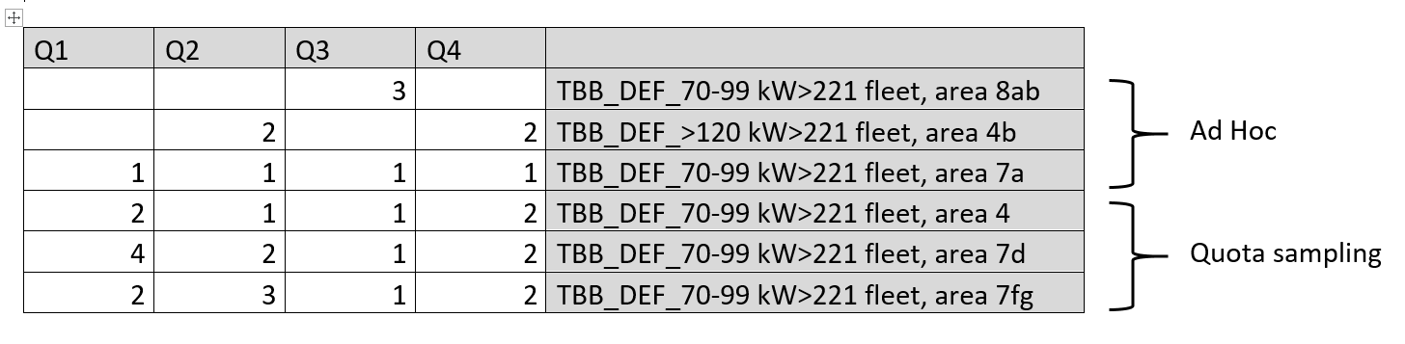
Regarding the planned number of trips versus what has been realized in 2018, a deviation is observed:
For the TBB_DEF_<=221kW stratum, 8 trips were planned but 4 trips were sampled. The main reasons are:
- Lack of space onboard the vessel to perform the sampling
- Lack of place to sleep for the observer
- Refusal by the vessel owner or crew to have an observer onboard
- Some vessels use two different métiers during the year: TBB_DEF and TBB_CRU. In 2018, most of these vessels decided to target shrimp (TBB_CRU) for the main part of the year, which meant they were not available for sampling (TBB_DEF).
For the TBB_DEF_>221kW stratum, 32 trips were planned (according to the WP) and 20 were sampled. The main reasons are:
- 1 of the 4 ILVO observers was on sick leave for several months. This temporal lack of manpower didn’t only result in a lower number of trips being sampled but also caused problems in the general workflow onshore. The observers are not only responsible for the work onboard a vessel, but are also involved in the processing of the samples in the lab. Sometimes one of the 3 remaining observers had to cancel a planned trip in order to help the observer coordinator in the lab.
- In the past, when an observer was assigned to a trip for sampling, it was possible for the observer to take the “crew bus” to go to the departure harbour. Since 2018, this is no longer an option. The observer coordinator is now forced to take the obervers to the departure harbours himself. Sometimes one observer should depart from a French harbour whereas another observer is supposed to depart from a UK harbour on the same or the next day. This logistic issue makes the trip planning more complicated than in the past.
- A trainee on board resulting in no available place to sleep for the observer or no space in the life raft (refusal due to safety reasons)
- Refusal of the vessel crew or owner to have an observer onboard

3. Action to avoid deviations
ILVO, as developer and executer of the sampling plan, aims on a daily basis to keep relations with the fishermen in a good condition in order to acquire or maintain access to the vessels for sampling. Nevertheless, having a rather small fleet fishing in 5 different fishing grounds hampers the development of a simple sampling design. Continuous effort is done to optimise the current sampling plan in order to match statistically sound sampling with practical feasibility. In the upcoming years, ILVO will investigate the potential added value of electronic monitoring in the commercial sampling programme. ILVO will also set up a back-up plan for potential unavailability of staff, to avoid the problems mentioned above, in the future.

(max. 1000 words per region OR fishing ground)

Section 5: data quality

Text Box 5A: Quality assurance framework for biological data

General comment: This box is applicable to the Annual Report. This box fulfills Article 5 paragraph (2) point (a)
of the Decision (EU) 2016/1701. This box is intended to specify data to be collected under Tables 1(A), 1(B)
and 1(C) of the multiannual Union programme.Use this box to provide additional information on Table 5A.
1. Evidence of data quality assurance
Within this section Member State shall provide information on the methodology used to assure the quality of the data collected, highlighting those aspects where changes have been made during the sampling year. Information shall be provided by each sampling scheme for which data was collected. In the case where the same quality assurance framework is applied to all data collection schemes, information can be provided at general level with the indication “all sampling schemes”.
In those sections of Table 5A where “N” is indicated, Member States shall explain the main constrains and/ or the steps taken to fulfil this obligation. In the cases where a reference documents is requested, Member States shall provide a web link.
In cases where documents are not publicly available, due to institutions internal policy, confidentiality or other reasons, this shall be indicated by the Member State.

At sea - commercial:
For the commercial fisheries sampling schemes, the following methodology is used to assure data quality:
Belgium uses a well-documented protocol to ensure high quality data of sampled trips (see text box 1C). When seagoing observers return from sampling a commercial fishing trip (a similar protocol is used for survey trips), collected data are immediately transferred from their ruggedized tablet to the Smartfish database (Sync Trip). Other data of the trip are registered in the database and all data are checked with a second observer present. Before the trip can be validated, an internal quality control is run by the database. Then, a markdown script is run by a scientist and a vessel report is produced to give to the shipowner. This vessel report is checked by the seagoing observer of that trip. Next, scientists run an intensive quality control in which the raw data is checked in a set of consecutive steps (among which outlier detection). When no quality issues arise, the trip is given a status 'consolidated'. Finally, the trip receives status done, which means data can be used for analysis and raising.
To track the data flow for each trip, the in-house developed tool 'Plan-it' is used (see text box 1C).
Finally, good communication between technical staff (including seagoing observers) and scientists is constantly worked on.

RecVis
All information is provided in Table 5A and the references therein.

INBO (eel)
All information is provided in Table 5A and the references therein.

2. Sampling design
Explain main constraints and/ or steps taken, if ‘N’ (no) was indicated in Table 5A.

At sea - commercial
Not applicable to commercial fisheries sampling schemes.

RecVis
Not applicable to the RecVis sampling scheme.

INBO (eel)
Not applicable to the INBO sampling scheme.

3. Sampling implementation
Explain main constraints and/or steps taken, if ‘N’ (no) was indicated in Table 5A.
At sea – commercial
The commercial sampling programme at ILVO is defined as ad hoc/quota sampling (see Text Box 4A - 2. Deviations from the Work Plan). Therefore, ILVO considers collecting non-responses and refusals on PSU (trip) level not relevant. However, the observer coordinator keeps track of the vessels within the sampling frame.

RecVis
Given that effort estimation relies fully on on-site surveys (creel survey, aerial survey and harbour observations), non-response is not applicable. Although interviews can be refused, total effort in fishing hours can always be estimated. For the selection of the diary volunteers we used snowball sampling methods. The sample is non-random but post-stratification for gear type and avidity is applied. Given this selection procedure, non-response is not applicable.

INBO (eel)
Not applicable to INBO sampling schemes.

4. Data capture
Explain main constraints and/ or steps taken, if ‘N’ (no) was indicated in Table 5A.

At sea - commercial
Not applicable to commercial fisheries sampling schemes.

RecVis
The full protocol can be found online (in Dutch): Verleye, T., van Winsen, F., 2016. Protocol recreatieve zeevisserij monitoring. ILVO-VLIZ publicatie 001. 43 pp.
https://www.recreatievezeevisserij.be/Portals/0/Bestanden/PROTOCOL%20Recreatieve%20zeevisserijmonitoring_FINAL_incl%20annex.pdf

A newly updated protocol is expected to be drafted in 2019, considering improved effort data collection and investigating the possibility of acquiring a random sample of dairy volunteers.

INBO (eel)
Not applicable to INBO sampling schemes.

5. Data Storage
Explain main constraints and/ or steps taken, if ‘N’ (no) was indicated in Table 5A. Please provide a link if the documented revisions are available and not confidential.

At sea - commercial
Not applicable to commercial fisheries sampling schemes. The SmartFish database is hosted on the ILVO servers. The RDB is hosted at ICES.

RecVis
Not applicable to the RecVis sampling scheme.

INBO (eel)
The data are stored in the eel database on the servers of INBO (nationally) and on the international ICES database EQD (Eel Quality Database).

6. Data processing
Explain main constraints and/ or steps taken, if ‘N’ (no) was indicated in Table 5A.
At sea - commercial
Not applicable to commercial fisheries sampling schemes.

RecVis
Due to the low participation rate and lack of information of the total population of recreational fishermen (no license system is in place for recreational marine fishing), it was not possible to obtain a random sample of catch diary volunteers. Post-stratification on gear type and avidity is applied to somewhat overcome possible biases caused by the non-random sample design. It is currently investigated if there are other possibilities to obtain a random sample of volunteers from 2019 onwards.
Documentation on biases, precision and uncertainty around the data and results will be made available in 2019.

INBO (eel)
Not applicable to INBO sampling schemes.

(max. 900 words per Region/RFMO/RFO/IO OR sampling scheme)

Section 5: data quality

Text Box 5B: Quality assurance framework for socioeconomic data

General comment: This box fulfills Article 5 paragraph (2) point (b) of the Decision (EU) 2016/1701. This box is intended to specify data to be collected under Tables 5(A), 6 and 7 of the multiannual Union programme. Use this box to provide additional information on Table 5B.
1. Evidence of data quality assurance
Within this section MS shall provide information on the methodology used to assure the quality of the data collected, highlighting those aspects where changes have been made during the sampling year. Information shall be provided by each sector (Fishing fleet, Aquaculture, Fish processing) for which data was collected and by each data collection scheme. In the case where the same quality assurance framework is applied to all sectors or/and all data collection schemes, information can be provided at general level with the indication “all sectors” or “all data collection schemes”.
In those sections of Table 5B where “N” is indicated, Member States shall explain the main constrains and/ or the steps taken to fulfil this obligation. In the cases where a reference documents is requested, Member States shall provide a web link.
In cases where documents are not publicly available, due to institutions internal policy, confidentiality or other reasons, this shall be indicated by the Member State.
For the fishing fleet, see text box 3A.
For the aquaculture sector, see text box 3B.
For the fish processing industry, see text box 3C.

2. Section P3 Impartiality and objectiveness
Fishing fleet:
An annual survey is conducted by Dienst Zeevisserij, Department of Agriculture and Fisheries (Flemish government) to collect fleet socio-economic data. As given in Table 3A, the questionnaire to collect data on the balance sheet of the fishing companies, is sent to all vessel owners. Information is collected by vessel. Wherever possible, data on the balance accounts of the company are also consulted.
Employment data are obtained through the employers social-accounting secretariat, who gather data regarding the social costs. The Belgian fishery sector has a unique system of social security. These data are delivered directly to Dienst Zeevisserij via the accredited Social Secretariat of the Coast.
Aquaculture: Not applicable (see text box 3B)
Fish processing industry:
No error checking on National balance accounts: information from the national balance accounts is considered correct, as the source of these data is the National Bank of Belgium (https://www.nbb.be/nl/balanscentrale). The 'Balanscentrale' is the legal entity collecting all financial statements of companies.

3. Section P4 Confidentiality
Explain main constraints and/ or steps taken, if ‘N’ (no) was indicated in Table 5B
Fishing fleet:
Not applicable
Aquaculture:
Not applicable – pilot study (see text box 3B)
Fish processing industry:
External end-users are currently limited.
As described in Text box 3C, a new database for the fish processing industry data is under construction. With the construction of the database, protocols on confidentiality issues when sharing with external users will be developed.

4. Section P5 Sound methodology
Explain main constraints and/ or steps taken, if ‘N’ (no) was indicated in Table 5B
Information on this principle should be briefly explained in Text boxes 3A, 3B and 3C. Description of methodologies used on data quality.
Fishing Fleet:
Methodologies are in accordance with ad hoc contract Commitment No. SI2 725 694 - Methodologies for the socio-economic data described in EU MAP.
Costs and earnings from the active vessels are surveyed through a questionnaire. As the response within the important fleet segments is high, missing data will be estimated by calculating the mean per fleet segment in the sample. This is then raised to the population level of each segment. The sum of the totals of the different categories estimate the total value for the entire fleet.
Information on technical characteristics, effort and landings from all vessels in the population are available from the logbooks and the vessel register (collected under Regulation (EU) no. 1224/2009).
For further elaboration on this, see Table and Text 3A.
Aquaculture:
Not applicable – pilot study (see text box 3B)
Fish processing industry:
Not applicable

5. Section P6 Appropriate statistical procedures
Explain main constraints and/ or steps taken, if ‘N’ (no) was indicated in Table 5B. Please provide a link if the documented revisions are available and not confidential.
Fishing fleet:
Column P - Logbook data and sales data: cross checks of totals are possible, as part of the sales originate from direct sales at the 'Vistrap' (Ostend) or from the vessels and all data are checked because of re-organisation of the databases at Dienst Zeevisserij.
Column T - questionnaire balance sheet, employers social-accounting secretariat: methodologies are available (see column S), however, it is not written down in a structured way. During 2018-2019, an effort was done to document used editing and imputation methodologies. ILVO supported the 'Dienst Zeevisserij' (DZ) in achieving this, as DZ has limited staff available.
Aquaculture:
Not applicable – pilot study (see text box 3B)
Fish processing industry:
Not applicable.

6. Section P7 Non-excessive burden on respondents
Explain main constraints and/ or steps taken, if ‘N’ (no) was indicated in Table 5B
Fishing fleet:
Not applicable.
Aquaculture:
Not applicable – pilot study (see text box 3B)
Fish processing industry:
Not applicable.

7. Section P8 Cost effectiveness
Explain main constraints and/ or steps taken, if ‘N’ (no) was indicated in Table 5B
Fishing fleet:
Not applicable.
Aquaculture:
Not applicable – pilot study (see text box 3B)
Fish processing industry:
Not applicable.

8. Section P9 Relevance
Explain main constraints and/ or steps taken, if ‘N’ (no) was indicated in Table 5B

Fishing fleet:
Not applicable.
Aquaculture:
Not applicable – pilot study (see text box 3B)
Fish processing industry:
External end-users are currently limited.
As described in Text box 3C, a new database for the fish processing industry data is under construction. With the construction of the database, a full list of end-users will be compiled and regularly updated.

9. Section P10 Accuracy and reliability
Explain main constraints and/ or steps taken, if ‘N’ (no) was indicated in Table 5B. Information on this principle should be briefly explained in Text boxes 3A, 3B and 3C. Description of methodologies used on data quality.
Fishing fleet:
The PGECON group has made many efforts to clarify definitions and interpretations of economic variables for the fleet in order to improve comparability across Member States. Furthermore, the commission implemented a new decision in 2016 (EU 2016/1251), updating its requested variables and also including new variables.
Belgium aims to follow these changes and adapted its 2017 survey accordingly. Consequently, anomalies in the time-series may occur as a result of these changes (respondents interpreted some questions differently). Further fine-tuning is done during the data collection in 2018.
Belgium has made efforts to develop a number of automated checks of intermediate results and outputs in the framework of the Data Call for the Annual Economic Report (AER). These checks are carried out using markdown documents generated in the R-software environment. Belgium plans to further improve these checks and corresponding documents. Similar quality checks were developed on the raw data inputs and are now being elaborated.
Aquaculture:
Not applicable – pilot study (see text box 3B)
Fish processing industry:
Raw data inputs are assessed by checking the different data sources used for collection of the data. The big challenge lies in identifying the difference between the companies which have fish processing as main activity and those that have fish processing as a side actvity (non-main actvity). The identification of these companies is done based on the register of the FASFC, the NACE code in de 'Kruispunt Bank voor Ondernemingen' (KBO), the company website, literature, research on the web, answers to previous questionnaires, previous phone contact and previous interviews.
Another challenge is related to variables that are not always available seperately in the national balance. For example, energy costs for 2015 were underestimated for segment 1 and part of segment 2 as these costs are partly included in raw material. On the other hand, purchase of raw material was overestimated for segment 1 and part of segment 2 as energy costs were partly included. However, total operational costs should still add up.
R scripts are used to raise the data and to check the quality of the data. The R-scripts are available on the SVN server of ILVO (subversion control).
On a yearly basis, the different variables are compared with the time series generated in the previous years. A time series is built up since 2008.
Error checking happens as new data are added to the time series. However, when feedback is received from JRC (based on the Data call fish processing industry) immediate action is undertaken by the MS.

10. Section P11 Timeliness and punctuality
Explain main constraints and/ or steps taken, if ‘N’ (no) was indicated in Table 5B
Fishing fleet:
On a monthly basis, reports are made to be sent to the EU.
Snapshots are made 4/year of the reports made and are send to the EU to prove that timeliness is respected.
Aquaculture:
Not applicable – pilot study (see text box 3B)
Fish processing industry:
Not applicable.

11. Section P12 coherence and comparability
Explain main constraints and/ or steps taken, if ‘N’ (no) was indicated in Table 5B
Fishing fleet:
Logbook and sales data - Internal coherence is partly checked: logbook data and sales data: both sources are cross checked, however this is partly possible for the total of sales. Part of the sales originate from direct sales at the 'Vistrap' (Ostend) or from the vessels. This part of the sale is estimated and monthly this estimate is checked with the actual sales.
Aquaculture:
Not applicable – pilot study (see text box 3B)
Fish processing industry:
Not applicable

12. Section P13 Accessibility and Clarity
Explain main constraints and/ or steps taken, if ‘N’ (no) was indicated in Table 5B. Information and links to documentation on this principle should be briefly explained in Text boxes 3A, 3B and 3C. Description of methodologies used on data quality.

Fishing fleet:
Methodologies are available (see column S), however, it is not written down in a structured way. During 2018-2019, an effort will be done to document used editing and imputation methodologies. ILVO is supporting the 'Dienst Zeevisserij' (DZ) in achieving this, as DZ has limited staff available.
Aquaculture:
Not applicable – pilot study (see text box 3B)
Fish processing industry:
Documents are stored on the ILVO server (see text box 3C).

(max. 900 words per Region/RFMO/RFO/IO/NSB OR sector)

