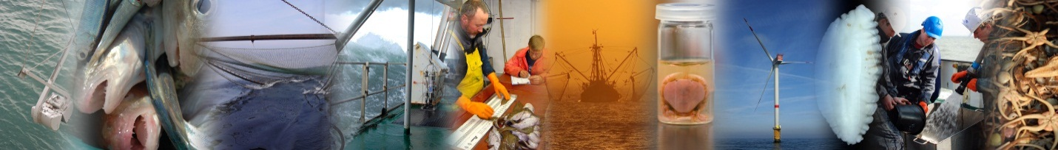
National Data Gathering Program
under EC Regulation 199/2008

Belgium
AR2012
ILVO - Fisheries (Oostende, Belgium) Sea Fisheries Service (Oostende, Belgium) ILVO- Social Sciences Unit (Merelbeke, Belgium) BMM-MUMM- Research Institute (Brussels, Belgium)
5/31/2013

Version control
Version 1:
Belgium_Annual_report_2012_Text_version01_30-may-2013
Version 2:
Belgium_Annual_report_2012_Text_version02_4-June-2013

The corresponding standard tables are submitted in an Excel file:
Belgium_Annual_report_2012_Tables_4-June-2013

The corresponding cost statement is submitted separately in an Excel file:
Belgium_Annual_report_2012_FinForms_v1.xlsx

Table of Contents

I General Framework
Belgian fishing industry – small and complex 7
II. National Data Collection Organisation ……………………………………12
II.A.2 National organisation and co-ordination 13
II.B Regional and International co-ordination 14
II B 1 Attendance of International meetings 14
II B 2 Follow-up of regional and international recommendations 14
III. Module of evaluation of the fishing sector 16
III A General description of the fishing sector 16
III B Economic Variables 16
III F Transversal Variables 41
General: 41
III.F.1 Capacity 41
III.F.2 Effort 41
III.F.3 Landings 43
III G Research surveys at sea 44
M 49
IV Module of the evaluation of the economic situation of the aquaculture and processing industry 50
IV A Collection of data concerning aquaculture 50
IV B Collection of data concerning the processing industry 52
❖ What data are being collected? 52
❖ What are the data collected from and how are the data collected? 52
V Module of evaluation of the effects of the fishing sector on the marine ecosystem 54
V 1 Achievements: results and deviation from NP proposal 54
V 2 Actions to avoid shortfalls 54
VI 1 Achievements: results and deviation from NP proposal 55
VI 2 Actions to avoid shortfalls 55
VII Follow up of STECF recommendations 59
VIII List of acronyms and abbreviations 61
IX Comments, suggestions and reflections 63
XI Annexes 65

I General Framework
This document presents the Annual Report (AR) on the work carried according to the Belgium National Programme (NP) for data collection in the fisheries sector for the year 2012. The programme has been carried out in accordance with the rules laid down in the “Commission Regulation (665/2008) and Commission Decision (2010/93/EC) adopting a multi annual Community programme pursuant to Council Regulation (EC) No 199/2008 establishing a Community framework for the collection, management and use of data in the fisheries sector and support for scientific advice regarding the Common Fisheries Policy”, hereafter referred to as “DCF” in this AR.
The format of this report is structured following the most recent guidelines from the Commission. The AR is structured in a number of modules. In the following chapters a description is given of the activities related to the DCF that have been carried out by Belgium.
Furthermore, the EC has established provisions to facilitate the cooperation between MS with the regard to the collection of data. These are Regional Coordination Meetings (RCM), formal (bilateral) agreements with other MS and in the future regional databases. As far as the conclusions and agreements of the meetings are relevant for the regional data collection and for Belgium they have been taken into account in this AR2012.
In addition to this AR a financial report for the 2012 programme has been made. The financial report of the costs is presented in separate spreadsheets in the FinForms formats as provided by the Commission.
The following derogations are valid for Belgium
Short title of derogation | NP proposal section | Type of data - Variables | Region | Derogation  approved or rejected | Year of approval  or rejection | Reason / Justification for derogation
OTB_MCD_70-99_0_0, VIIfg |  | Métier based sampling: discards and landings | North Atlantic | approved | 2007 | The cost for setting up discard sampling programs this fisheries is disproportionate compared to the added value to the international data collection  system
TBB_CRU_16-3_0_0 in IVc | P27 of Belgium proposal 2011-2013 | Discard sampling in Crangon fisheries | North Sea (IVc) | Rejected for 2009-2010 | No approval or rejection officially received | See Text under III.C.1
Collection of economic variables for Aquaculture | AR2011 | All | All | No reply | No Reply | See Text under Section IV.A.1
Lophidae | 2006, AR, page 34. Section MP proposal Module H, | Age sampling | All | Approved | 2006 | See text page 34 NP proposal Module H

Belgian fishing industry – small and complex

In previous years, the idea of having a 'restricted' list of species for which landings data are recorded, has repeatedly been labelled as a 'non-conformity' by the External Evaluators. However, as already explained on several occasions in the NP proposals, there is a rationale behind the idea of the restricted list. Species that do not figure in the restricted list are not deliberately omitted from the data recording system – they are simply not landed by the Belgian fleet in quantities of any importance. As such, the list should not be seen as an attempt 'to get away with the minimum', but rather as a reflection of the actual composition of the Belgian fish and shellfish landings. In its evaluation of the 2004 and 2005 NP proposals (the issue was not raised by the External Evaluators in relation to the 2006 NP Proposal), SGRN stated that it saw no contradiction between the requirements of the DCF and the use of a restricted list, "as long as the 'restricted list' is a correct reflection of the species composition of the landings". Belgium has repeatedly confirmed that this is the case (see e.g. SEC (2004) 179, page 16, and SEC (2005) 255, page 26.
No data are reported for the variables for which no data are collected within the framework of the above described data collection scheme or for the variables which are not associated with the fishing techniques used by the Belgian fleet.
In Belgium, effort and landings data are collected in two ways: from logbooks and from sales notes. The logbooks contain extensive information on the retained catches and their species composition by haul (albeit with certain restrictions – see bullet point 2 underneath), but they do not contain information on the size composition (in terms of market categories) of the retained catches. The sales notes on the other hand, contain information on the quantities auctioned by market category for all species landed (and not just for the species recorded in the logbooks – again see bullet point 2), but they do not provide information on the exact origin (in terms of statistical rectangles) of the landings. The two systems are equally important to the Belgian data collection system, they are complementary, and the combination of the two has clear advantages:
- The two approaches yield independent estimates of the retained and landed portions of the catches, and can thus be used for quality control and validation purposes. This helps improving the reliability of the landings figures.
- In the Logbook Regulation, it is stipulated that "only catches of an amount greater than 50 kg of live-weight equivalent of any species retained on board must be recorded in the logbook" (Article 2.4.2. of Annex V of Commission Regulation (EEC) No. 2807/83), the consequence being that small by-catches of fish and shellfish often remain unrecorded in the logbooks. These quantities however, are picked up in the sales notes, which helps improving the species coverage and hence the comprehensiveness of the landings statistics.
- As already mentioned in, roughly one fifth of all fish and shellfish taken by Belgian vessels in the southern and central North Sea are auctioned abroad, mostly in the Netherlands. Also, vessels making consecutive fishing trips in distant waters before returning to their homeport in Belgium, may sell part of their catches during their stop-overs in a foreign harbour. Data on the sales abroad are collected by local authorities from sales notes and submitted to the Sea Fisheries Service for incorporation in the Belgian national fishstats database. This requires additional quality checks and codification, to ensure that the imported data are compatible with the recipient database.
- Last but not least, the landings data by market category are of critical importance to the biological data collection programme on the landings, which heavily relies on stratified sampling by market category.
The dual approach (logbooks and sales notes) is advocated by the ICES Planning Group on Commercial Catch, Discards and Biological Sampling (PGCCDBS) as a means to validate the different sources of information on catches and landings. In its 2007 report (), the PGCCDBS states that "In order to establish quality indicators that can be used to evaluate / estimate the accuracy of the fishery statistics and biological information about the catches, it is necessary to make use of different sources of information and analyse the consistency between them with regards to the relevant parameters. Such a quality control thus needs to check different sources for the same information, e.g. logbooks compared with sale slips from the same vessel and/or trip". This is exactly what has been done for several years now in Belgium.
  - The problem of the 'restricted' list
In the past, the idea of having a 'restricted' list of species for which landings data are recorded, has been labelled as a 'non-conformity' by the External Evaluators. There is, however, a rationale behind the idea of the restricted list. Species that do not figure in the restricted list are not deliberately omitted from the data recording system – they are simply not landed by the Belgian fleet in quantities of any importance. As such, the list should not be seen as an attempt 'to get away with the minimum', but rather as a reflection of the actual composition of the Belgian fish and shellfish landings. There is a historical background to the restricted list, which is based on the peculiarities of the Belgian sea fisheries:
- The geographical distribution of Belgian fishing effort is limited to the North Sea, the English Channel, the Irish Sea, the Celtic Sea, South of Ireland and the inner part of the Bay of Biscay. The consequence being, that all typically boreal and Lusitanian species are absent from the landings.
- Belgium has no industrial, no distant and no deep-water fisheries. Again, this implies that all species which are typical to such fisheries are absent from the landings.
In its evaluation of the 2004 and 2005 NP proposals (the issue was not raised by the External Evaluators in relation to the 2006 and 2007 NP proposals), SGRN stated that it saw no contradiction between the requirements of the DCR and the use of a restricted list, "as long as the 'restricted list' is a correct reflection of the species composition of the landings". Belgium has repeatedly confirmed that this is the case (see e.g. SEC (2004) 179, page 16, and SEC (2005) 255, page 26).
  - The problem of 'mixed' landings
Belgium has taken notice of SGRN's recommendation that "pilot studies shall be implemented, where relevant, to obtain a better understanding of the composition of mixed species categories" (SEC (2003) 101, page 11).
In the Belgian fish and shellfish landings, a distinction must be made between two categories of mixed landings:
- Mixed landings of (relatively) large quantities of fish pertaining to the same group of species, such as Lepidorhombus spp., Lophius spp. and Raja spp.
For Lophius and the Rajidae, partitioning of the landings by species is done as part of the routine length and age sampling programmas (for details, see Section 8.1).
The landings of Lepidorhombus spp. are too small (≈ 160 t live weight annually for all areas combined) to justify dedicated sampling for species segregation purposes.
- Mixed landings and sales of fish and shellfish in quantities that are too small to be auctioned separately.
These mixed sales are of an extremely variegated and variable nature, and they never represent more than a few kilograms per voyage. The cost for setting up a system to disaggregate such mixed landings would be disproportionate compared to the increase in precision that might be achieved.
In the current data system collection, this category of mixed landings is recorded as 'Other demersals', 'Other pelagics', etc., together with the landings of species that are not in the restricted list. It is worth noticing that the 'Other' categories represent less than 2 % of the total Belgian landings (see table on page 10). In view of this, the omission of the quantities that end up in the 'Other' categories from the species-wise totals, hardly affects the reliability of the latter, and the final figures remain well within the margins of the precision levels required by the DCR. As the data collection was exhaustive, it is not meaningful to apply any data quality issues in the context of the DCF.
For completeness of the reply by MS, the problem of the 'restricted' list is situated as described in the AR2009, AR2010 and AR2011 as well.
In the past, the idea of having a 'restricted' list of species for which landings data are recorded, has been labelled as a 'non-conformity' by the External Evaluators. There is, however, a rationale behind the idea of the restricted list. Species that do not figure in the restricted list are not deliberately omitted from the data recording system – they are simply not landed by the Belgian fleet in quantities of any importance. As such, the list should not be seen as an attempt 'to get away with the minimum', but rather as a reflection of the actual composition of the Belgian fish and shellfish landings. There is a historical background to the restricted list, which is based on the peculiarities of the Belgian sea fisheries:
- The geographical distribution of Belgian fishing effort is limited to the North Sea, the English Channel, the Irish Sea, the Celtic Sea, South of Ireland and the inner part of the Bay of Biscay. The consequence being, that all typically boreal and Lusitanian species are absent from the landings.
- Belgium has no industrial, no distant and no deep-water fisheries. Again, this implies that all species which are typical to such fisheries are absent from the landings.

In its evaluation of the previous NP proposals (the issue was not raised by the External Evaluators in relation to the 2006, 2007 and 2008 NP proposals), SGRN stated that it saw no contradiction between the requirements of the DCR and the use of a restricted list, "as long as the 'restricted list' is a correct reflection of the species composition of the landings". Belgium has repeatedly confirmed that this is the case (see e.g. SEC (2004) 179, page 16, and SEC (2005) 255, page 26).
Belgium has taken notice of SGRN's recommendation that "pilot studies shall be implemented, where relevant, to obtain a better understanding of the composition of mixed species categories" (SEC (2003) 101, page 11).
In the Belgian fish and shellfish landings, a distinction must be made between two categories of mixed landings:
- Mixed landings of (relatively) large quantities of fish pertaining to the same group of species, such as Lepidorhombus spp., Lophius spp. and Raja spp.
For Lophius and the Rajidae, partitioning of the landings by species is done as part of the routine length and age sampling programmes.
The landings of Lepidorhombus spp. are too small (≈ 160 t live weight annually for all areas combined) to justify dedicated sampling for species segregation purposes.
- Mixed landings and sales of fish and shellfish in quantities that are too small to be auctioned separately.
These mixed sales are of an extremely variegated and variable nature, and they never represent more than a few kilograms per voyage. The cost for setting up a system to disaggregate such mixed landings would be disproportionate compared to the increase in precision that might be achieved.
In the current data system collection, this category of mixed landings is recorded as 'Other demersals', 'Other pelagics', etc., together with the landings of species that are not in the restricted list. It is worth noticing that the 'Other' categories represent less than 2 % of the total Belgian landings. In view of this, the omission of the quantities that end up in the 'Other' categories from the species-wise totals, hardly affects the reliability of the latter, and the final figures remain well within the margins of the precision levels required by the DCF. Specific fishing effort is derived from the landings and effort data, and again, can be reported by fleet segment, gear type and ICES Sub-area as requested by the DCF, or by any other type of spatial or temporal aggregation. Species-specific effort is available for all species in Appendix VI of the DCF (in as much as they are caught and landed in sensible quantities by the Belgian fleet).
In Belgium, effort and landings data are collected in two ways:
- from logbooks and
- from sales notes.

The logbooks contain extensive information on the retained catches and their species composition by haul (albeit with certain restrictions), but they do not contain information on the size composition (in terms of market categories) of the retained catches. The sales notes on the other hand, contain information on the quantities auctioned by market category for all species landed (and not just for the species recorded in the logbooks), but they do not provide information on the exact origin (in terms of statistical rectangles) of the landings. The two systems are equally important to the Belgian data collection system, they are complementary, and the combination of the two has clear advantages with regards to species coverage and data quality.

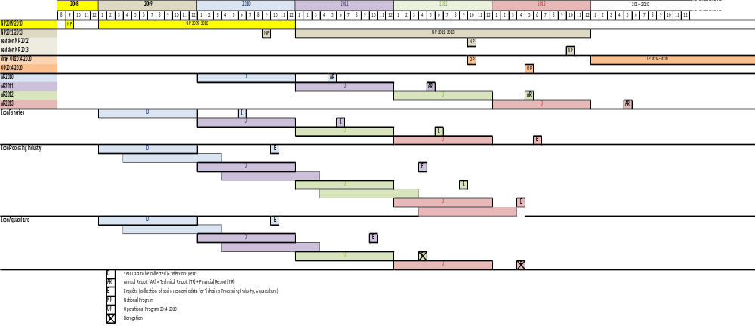

II. National Data Collection Organisation
II.A. National correspondent and participating institutes

National correspondent
The Belgian National Correspondent in 2011 was Dr. Kris COOREMAN. He is employed as the scientific director at ILVO Fisheries, Ostend, Belgium.
Dr. Kris Cooreman
Scientific Director
Instituut voor Landbouw en Visserij Onderzoek (ILVO) - Visserij
Ankerstraat 1, B-8400 Oostende, Belgium
Phone: + 32 (0)59 56.98.20 (direct) or + 32 (0)59 34.22.50 (operator)
Fax: + 32 (0)59 33.06.29
E-mail: kris.cooreman@ilvo.vlaanderen.be

Since April 2012, the Belgian national Correspondent is MSc ir. Els TORREELE, Head of Reaserch Group Fisheries Biology, ILVO-Fisheries, Ostend, Belgium

MSc. Ir. Els Torreele
Head of Research Group Fisheries Biology,
Instituut voor Landbouw en Visserij Onderzoek (ILVO) - Visserij
Ankerstraat 1, B-8400 Oostende, Belgium
Phone: + 32 (0)59 56.98.33 (direct) or + 32 (0)59 34.22.50 (operator)
Fax: + 32 (0)59 33.06.29
E-mail: els.torreele@ilvo.vlaanderen.be

Participating institutes
In Belgium, the Ministry of Agriculture and Fisheries, Department Fisheries, is the administrative authority responsible for fisheries and fisheries issues.
The work regarding the Belgium National Data Gathering program is carried out by the following partners:
- Ministry of the Flemish Community - Policy Domain Agriculture & Fisheries

The collection of information on fishing capacity, fishing effort, landing statistics and economics of the fisheries sector, the aquaculture and the processing industry, is done by the Sea Fisheries Department (DVZ) and VISEO (ILVO)

Dienst Zeevisserij - Sea Fisheries Departement
Administratief Centrum
Vrijhavenstraat 5, B-8400 Oostende, Belgium
Phone: + 32 (0)59 43.19.20
Fax: + 32 (0)59 80.76.93
URL: www2.vlaanderen.be/ned/sites/landbouw/visserij/index.html

Instituut voor Landbouw en Visserij Onderzoek (ILVO) - Institute for Agriculture and Fisheries Research
ILVO-Social Science Unit
Burg. van Gansberghelaan 115 box 2, 9820 Merelbeke, Belgium
Phone: +32 (0)9 272 23 40,
Fax: +32 (0)9 272 23 41
URL:www.ilvo.vlaanderen.be/Social_sciences

The biological data are gathered by the Institute of Agriculture and Fisheries (ILVO) – Research group Fisheries biology (ILVO-FB)
Instituut voor Landbouw en Visserij Onderzoek (ILVO) - Institute for Agriculture and Fisheries Research
ILVO-Fisheries
Ankerstraat 1, B-8400 Oostende, Belgium
Phone: + 32 (0)59 34 22 50
Fax: + 32 (0)59 33 06 29
URL: www.ilvo.vlaanderen.be/Animal/Fisheries.htm

- Federal Research Institute
Management Unit of the North Sea Mathematical Models and the Scheldt Estuary
Since January 2008 onwards, the Management Unit of the North Sea Mathematical Models and the Scheldt Estuary (acronym MUMM) joins the Belgian National Data Gathering Programme (NDGP). MUMM is a federal research institute with extensive responsibilities in the fields of marine modelling, monitoring and management. MUMM also runs the 'Belgica', the research vessel that is used in the North Sea Beam Trawl Survey. It is in this capacity that MUMM is joining the NDGP. MUMM's contact details are:
BMM-MUMM
Gulledelle 100, B-1200 Brussel (St Lambrechts-Woluwe)
Head: Dr. Georges Pichot
Phone: + 32 (0)2 773 21 22
Fax: + 32 (0)2 770 69 72
URL: www.mumm.ac.be/EN/index.php

II.A.2 National organisation and co-ordination

National co-ordination of the Belgian AR2012 is organizedas followed:
- Informal contacts between the section heads of the participating institutes, one after the final completion of the NP (including modifications after RCMs, expert evaluations and Communications with the EC) and one after the final completion of the AR (like NP). Furthermore quarterly contacts are maintained to ensure that the targets defined are being met.

II.B Regional and International co-ordination

II B 1 Attendance of International meetings
Table II.B.1 list the meeting which have been attended by the MS in 2012.
The following meetings were not attended by Belgium
Expert group | MS Participation | Eligible under DCF | Attendance | Reason not attended
Economists workshop - 1 (details TBD after STECF-EWG11-18 (ex-SGECA) on economic data meeting of 17-21/10/2011) | yes | yes | no | No economist temporary available in BE
Economists workshop - 2 (details TBD after STECF-EWG11-18 (ex-SGECA) on economic data meeting of 17-21/10/2011) | yes | yes | no | No economist temporary available in BE. The economic topics are unfortunately currently taken up by 2-3 people, which makes it not suitable for one of them to attend the meeting
Regional database training workshop - North Sea & Eastern Arctic (November, Copenhagen) | yes | yes | no | Belgium has attended previous training workshops and it was not relevant anymore to attend this specific training (similar to one of the previous)
Workshop on sexual maturity staging of turbot and brill [WKMSTB] (Ijmuiden, 5-9 March) | yes | yes | no | During this week, the scientist and laborant who should have attended were unexpectedly not available. One was ill, the other had another
Workshop on sexual maturity staging of cod, whiting, haddock, saithe and hake [WKMSGAD] San Sebastian, 12-16 November) | yes | yes | no | Due to budget cost, this became less of a priority
Workshop on sexual maturity staging on elasmobranches [WKMSEL-2] (dates and venue tbd) | yes | yes | no | Due to budget cost, this became less of a priority
Working Group on Improving use of Survey Data for Assessment and Advice (WGISDAA), (ICES HQ, Copenhagen, 10-13 January) | yes | Yes | no | When re-screening the ToRs and the agenda of this meeting, it was for Belgium not relevant to attend this meeting.
Working Group on Recreational Fisheries Surveys [WGRFS] (former PGRFS) (7-11 May, Mallorca) | yes | Yes | no | This meeting was interfering with the preparartion of the stock assesments. As such, it became lower in priority. From 2014 these WG will be attented as a new person will take up the recreational fisheries in all its aspects.
Working Group on the Ecosystem Effects of Fishing Activities [WGECO] (Copenhagen, 11-18 April) | yes | yes | no | When setting up the workplan for 2012, it was initially not sure if there would be a scientist availble to attend this meeting. During 2012 it became clear this was not possible.

II B 2 Follow-up of regional and international recommendations
Belgium attends the relevant RCM being NS&EA and NEA. In RCMNs&EA a representation of the Belgian National Correspondent attended the meeting.
For Belgium, over the past years, the RCMs have resulted, next to the more general decisions, in:
- Bilateral agreements with the UK and The Netherlands for sampling of their foreign flag vessels,
- Bilateral agreements with Danmark for sampling and reading turbot and brill due to common interests in the fisheries in Skagerrak, the North Sea and the Baltic.

- Co-ordination towards the use of the regional database for the North Sea and upload of the data in the Regional Data Base.
Relevant recommendations Which are not dealt with under a specific section of the AR2012.

RCMNS&EA_QA_01: Quality issues: use of FishFrame as regional database
RCM NS&EA 2011 Recommendations | The RCM NS&EA recommends that that all MS respond to the data call in 2012 from the chair of RCM NS&EA and load their data to FishFrame or make it available in the FishFrame format. This data call will include Commercial Landings(CL), Commercail Effort (CE) and Commerical Samples (CS) records for 2010 and 2011.
Follow-up actions needed | MS to have responded to the data call. If issues persist then ICES to inform the chair of RCM NS&EA
Responsible persons for follow-up actions | All MS and chair of RCM NS&EA
Time frame (Deadline) | Data call in February 2012 and then deadline 4 months later
Reply by MS | Belgium has responded to the data call and has submitted all requested data available.

RCMNS&EA_QA_02: Quality issues: sampling summary information
RCM NS&EA 2011 Recommendations | RCM NS&EA recommends ICES to use the list of NC contacts available to all WGs. The list is on the DCF website https://datacollection.jrc.ec.europa.eu/documents?p_p_id=20&p_p_lifecycle=0&p_p_state=maximized&p_p_mode=view&p_p_col_id=column-1&p_p_col_count=1&_20_struts_action=%2Fdocument_library%2Fview&_20_folderId=20944..
Follow-up actions needed | None
Responsible persons for follow-up actions | ICES
Time frame (Deadline) | Immediately
Reply by MS | Belgium checked the details of the NC and these are listed in the NC list

RCMNS&EA_QA_03: Quality issues: data raising methods
RCM NS&EA 2011 Recommendations | RCM NS&EA recommends that each MS should send a representative to WKPICS to discuss data collection and the methods used to raise this data for assessment use and that WKPICS adds this to its ToR.
Follow-up actions needed | MS participates in WKPICS
Responsible persons for follow-up actions | All MS
Time frame (Deadline) | End of WKPICS 2011
Reply by MS | In 2012, a Belgian scientist has attended the WKPICS see table II.B.

III. Module of evaluation of the fishing sector

III A General description of the fishing sector

There are no specific or major changes in the Belgian fisheries sector which had an impact on the implementation of the National Programme 2012.

III B Economic Variables

Supra region: Baltic Sea, North Sea and Eastern Arctic, and North Atlantic
III B 1 Achievements: results and deviations from NP proposal

Data collection was exhaustive and comprised all fishing vessels in the EU Fleet Register that were active in 2011. The programme was executed as planned. Fleet segmentation for gathering fishing capacity data took into account the amendments imposed by Council Regulation EC no 199/2008 and Commission Decision 2010/93/EU, and is given in table 1. The Belgian fleet has no vessels under 10 m or above 40 m. The target population for collecting economic data for the reference year 2011 consisted of 86 vessels.

Table 1: Overview fleet segmentation

Type of fishing technique |  | Length classes (LOA) | N° of vessels
Active gears | Beam trawlers | 12-<18 m | 5
Active gears | Beam trawlers | 18-<24 m | 34
Active gears | Beam trawlers | 24-<40 m | 30
Active gears | Demersal trawlers and/or demersal seiners | 10-<24 m | 4+1
Active gears | Demersal trawlers and/or demersal seiners | 24-<40 m | 5
Active gears | Dredges¹ | 18-<40 m | 2
Passive gears | Drift and/or fixed netter² | 12-<24 m | 5
Total active vessels |  |  | 86
Inactive vessels |  |  | 6
Total |  |  | 92
¹ dredges (18-<24 m and 24-<40 m)
² Passive gears - drift and/or fixed netter (12-<18 m and 18-< 24m)

The data that are currently collected on the Belgian vessels include gross tonnage, maximum continuous power (kW) of the main engine (as registered by the Federal Ministry of Transport and Infrastructure) and vessel age based on the hull (years).
The commercially active vessels are concentrated in the following segments:
- Beam trawl: 12-18 m
- Beam trawl: 18-24 m
- Beam trawl: 24-40 m
- Beam trawl : 40- m
- Demersal trawls and seiners : 18-24 m
- Demersal trawls and seiners : 24-40 m

Standard Table III.B.2 reports the segments that have been clustered. Clusters have been named after the biggest segment in terms of number of vessels.
DRB1840: contains dregdes of 18-24m and dredges of 24-40.
GNS1018: conatins the passive gears length class 10-12m, 12-18m and 18-24m
OTB1024: contains the demersal trawlers 10-18m and 18-24m.
The reason for this clustering is to protect the identities of individual vessels in small samples,
and to ensure adequate coverage of all identified fleet segments, where compliance is not mandatory.
In accordance with the National Programme guidelines, clustered segments take the same name as the
segment contributing the greatest number of vessels.
  - What data are being collected?
Table III.B.3 summarizes the economic data by group of vessels that were collected under the NP. These parameters correspond to the list in Appendix XVII of the DCF Regulation no. 199/2008. How the parameters are defined and calculated is set out in table 2 (with the exception of parameters with straightforward definitions).
Table 2: Definition and calculation of some economic variables

Variables | Definition / comment
Depreciation | Calculated as depreciation rate (4 %) * book value.
Interest | Interest rate (% of 10-year govt bond) * book value. This is not requested anymore by the JRC data call.
Employment | There are 2 types of employment estimates : (1) totJob is based on the maximum number of crew members per vessel, totalled over all vessels; and (2) totNatFTE and totHarmFTE are based on employment figures from the Social Secretariat for Fisheries, and allow estimates per fleet segment.

In 2011 and 2012 Belgian fishing companies could not lease out quota or other fishing rights; hence the variables related to this type of income do not exist (indicated in table III.B.3 with N.A.). Data related to FTE National and FTE harmonised were not requested from the ship owners.
For details on information requested from the companies and parameter definitions, see Annex 1 and Annex 2 respectively.
  - What are the data collected from and how are the data collected?
Information on economic data is obtained through questionnaires. Since 2010, i.e. data for reference year 2009, it is in principal mandatory for ship owners to return the completed questionnaires to DZV. In practice, this is done mainly by accounting firms. The information should be returned to DZV before end September of the year following the reference year. There is a one-year time lag in the data collecting system. Data are thus available for the reference year 2011 for 79 vessels out of 86, i.e. 91,9% of the fleet. For individual fleet segments the achieved sample rate varies between 40 and 100%.
Revenues per fishing voyage and per species, and average auction prices per species are routinely collected throughout the year, as part of the existing effort, landings and revenue data recording system. See table III.B.3.
Tables III.B.1-3 is completed in compliance with the guidelines for reporting information. There are no deviations from the NP proposal.
  - Estimation of capital value and capital costs
For the capital value of the vessel, engine and all on board equipment two options (replacement value or historical value) are offered to the respondents, they can only select one option (see questionnaire annex 2).
- Replacement value: the cost estimated for replacing the current vessel and its equipment, the insured value may be used.
- Historical value: calculated using the price actually paid and apply an annual depreciation scheme. In principle the depreciation rate used is the one commonly used in tax related matters.
Currently the reported value is included in the database as ‘book value ‘ (without indication which option was used to derive the value).
The enterprises are prompted to provide the capital value of the vessel, the engine and the full equipment
aboard and fill these in into one of the two estimates approaches In case of replacement, the cost estimated of the insured value above should be as such that the current vessel can be replaced, and its equipment.
When the historical value is used, than one needs to depart from the price actually paid, and links
this to an annual depreciation . This depreciation is basically one that is fiscally prevalent..
Estimation of capital value and capital costs
In accordance with Appendix VI of Commission Decision (2008/199/EC), the Perpetual Inventory
Method (PIM) is applied to estimate capital value and costs for each of the fleet segments in
Table III.B.1. The following input parameters (required by the STECF model) will be estimated;
- Selected capacity unit,
- Price per capacity unit,
- Share in total investment ,
- Government bonds,
- Market rate for loans.
Capacity indicators and capital value are estimated for all vessels on the register, regardless of
their activity. The following sources are used to estimate the input parameters to the PIM model:
- Questions on fixed assets, investments, and depreciation from the annual economic survey,
- EU fleet register,
- EU log-book data
- Sentinel vessel programme,
- Central Bureau for Statistics,
III B 2 Data quality: results and deviations from NP proposal
There were no deviations from the objective identified.
III B 3 Follow-up of Regional and international recommendations
The relevant regional recommendations have been taken into account when implementing the NP.2012.
III B 4 Actions to avoid shortfall
EWG 11-18 “Review of economic data collected in relation to the DCF and harmonisation of sampling strategies” (October 17-21, 2011, Salerno, Italy) and PGECON “Planning Group on Economic Issues 16-19 April 2012, Salerno, Italy) were attended by scientist from ILVO-VISEO to obtain better insights in the collection and calculation methods related to economic variables and to discuss with colleagues from other member states. From 2012, these insights are used to alter the questionnaires which are sent out to the ship owners in June year n+1 to collect the economic data for year n.

III.C Métier-related variables
Tables III.C.3, III.C.4, III.C.5 and III.C.6 provide the sampling plan for the métier related variables and the realised results in 2011.
In these tables, i;e. III.C.5 the coding agreed by the RCMs has been used. These tables were recommended to be used and have been compiled by the RCMNA initially and completed by the RCMNS&EA.
Table III.C.6: Belgium has no shark species fished in their fisheries; therefore these species are not taken into the list.
CVs have been added in the respective tables and the CVs have been calculated by using COST.
Every year the COST is used where possible. However, the use of the COST tool is intensive and still not yet fully applicable. Further development and information on the use of the COST tool is more than ever and continuously needed to use this tool in an optimal way.
For 2011, values and corresponding CVs are provided for 4 stocks.
For 2012, values and corresponding CVs are provided for 6 stocks.
For cod (Gadus morhua) stocks, sampled weights were raised to fleet level (TBB-DEF-70-99) by haul, using the COST tools in R.
For plaice (Pleuronectes platessa) stocks, sampled weights were raised to fleet level (TBB-DEF-70-99) by ratio estimator (auxiliary variable plaice landings), using the COST tools in R.

North Atlantic

- III.C.1 Achievements: Results and deviation from NP proposal

The abbreviations used in Table II_C_3, being the BEL-codes, are corresponding with the métier Lvl6 and if the sampling takes place on shore or at sea, in the respective regions
The used abbreviations are explained in table hereunder:

BEL01 | Onshore sampling of TBB_DEF_70-99_0_0 in area VIIfg
BEL02 | at sea sampling of TBB_DEF_70-99_0_0 in area VIIfg
BEL03 | Onshore sampling of TBB_DEF_70-99_0_0 in area VIIa
BEL04 | at sea sampling of TBB_DEF_70-99_0_0 in area VIIa
BEL05 | Onshore sampling of TBB_DEF_70-99_0_0 in area VIIIa,b
BEL06 | at sea sampling TBB_DEF_70-99_0_0 in area VIIIa,b
BEL07 | Onshore sampling of TBB_DEF_70-99_0_0 in area VIIe
BEL08 | at sea sampling of TBB_DEF_70-99_0_0 in VIIe
BEL09 | Onshore sampling of OTB_MCD_70-99_in area VIIfg
BEL10 | at sea sampling of OTB_MCD_70-99_0_0 in area VIIfg

TBB_DEF_70-99_0_0, VIIfg
Sampling effort: 10 trips were planned to sample at the market but only 6 trips were conducted. To compensate for the 40% below the planned sampling level in the on shore sampling program, an extra effort was inserted to increase the sampling level at sea for this métier – In the at sea sampling 7 observer trips were conducted instead of 5. This indicates that the métier is very well covered in the sampling program in 2012.
The reason why the number of trips was lower than planned, is related to:
the accessibility of the auction and
the problem of the “mixed landings”.
Because of increasing qualitative and hygienic standards, landed fish is immediately transferred from the vessel to the auction in a continuous flow. Within this flow, it has become uttermost difficult to sample the landed fish. The problem of “mixed landings” is described under the section “General Framework”

TBB_DEF_70-99_0_0, VIIa
This métier was not well covered in the at-sea neither in the on-shore sampling program. For collecting harbour samples only 5 trips were conducted compared to 8 trips planned in the NP and for the at sea sampling only 3 trips were conducted compared to 6 trips planned in the NP. As the Belgian fisheries are targeting mainly sole in this region, and as because of this stock being under very high pressure, not many Belgian vessels are available for sampling.
However, at the end of 2012 additional quota regulations were imposed by the Flemish government for the Belgian sole fishery in the Irish Sea. Because of the decrease in fishing opportunities in 2013, the allocation of sole in VIIa is subject to scientific monitoring. This will almost certainly lead to a higher sampling level next year.

TBB_DEF_70-99_0_0, VIIIa,b
Sampling effort: 5 trips were planned to sample at the market but only 3 trips were conducted. Peak season: Belgian vessels only fish in this area in June, July and August, therefore a target of 3 trips is more realistic. This métier was well covered in the at sea sampling program as all the planned observer trips were conducted.

TBB_DEF_70-99_0_0, VIIe
This métier was over-sampled by 100% or with 2 trips compared to 1 planned in the NP. One reason for this excess sampling is caused by fishermen deciding rather late on the trips if they want to fish in area VIIe or area VIId, this can happen while the observer is already on board: fishing start in VIId, but after 1 day, the fisherman decides to change to VIIe (according to the circumstances in VIId and VIIe). The observer trips in area VIId are for the same reason oversampled by 100%. The planned market sampling was not conducted as no opportunity arose (problem of the “mixed landings – see section General Framework)

OTB_MCD_70-99_0_0, VIIfg
The sampling of this métier was not planned in the NP.
Derogation for sampling this métier is granted since 2007 (see table of derogations in section General Framework)

- III.C.2 Data quality: Results and deviation from NP proposal

- Calculation of CVs
The implementation of the calculation of the CV’s is a slow and step by step process for Belgium.
Belgium has done an effort to insert more CVs. However, as mentioned using the COST methodology is intensive in time use. Besides, to ensure the quality of the data, an intensive set of quality checks is done before using the data. As such, it is not yet possible to have all CVs calculated. Based on a study of DevStat (study ordered by the EC), Belgium has invested a lot in the setup of a new database system and will be able to automatize much more regarding quality checks than previously. As such more time can be spent in using the cost methodology for the CVs.

- Sample size
In several cases, the planned sample sizes have exceeded the planned minimum number. A reason for that is that once an observer is onboard, the entire trip is being sampled. However, the main cost associated with the sea sampling programme is getting the observer on board , thereafter any sampling in excess of the planned targets is effectively cost neutral. As such, the oversampling or extra sampling was done at no extra financial implications for Belgium.

- Number of trips
Belgium will try to get the participation of as many vessels as possible in the observer programme in order to have a broad spectrum of possible variance among the vessels. However, there are always vessels that don't have enough space to take an observer on board or that are not willing to cooperate. Therefore, only a rather limited selection of the fleet takes part in the sampling programme and thus random sampling of the fleet is not feasible. Besides the opportunistic sampling strategy also the fact that fishermen often switch between different fishing grounds on short notice, hampers the sampling plans.
In order to correspond with the more recent fishing activities, the sampling intensities for 2013 will be reviewed and updated using the experience from 2011-2012. The update of the sampling intensities has no financial implications for the year 2013. It will even result in a more efficient en better quality of sampling

- III.C.3 Follow-up of Regional and international recommendations

RCMNS&EA_M_01: Métier related variables: Routines for establishing bilateral agreements
RCM NA 2011 Recommendation | - MS should make sure that their landings abroad are included in their FishFrame upload allowing the RCM to analyse the possible needs for bilateral agreements.  - The RCMs should perform an annual analysis on landings in foreign countries and conclude where bilateral agreements need to be made. MS should set up agreements, fixing the details of sampling, compilation and submission of data in each case when it is indicated by the RCM that a bilateral agreement is needed. Standard output algorithms to enable analysis of compiled data should be included in FishFrame.  - MS should set up agreements, fixing the details of sampling, compilation and submission of data in each case it is concluded by the RCM that a bilateral agreement is needed.
Follow-up actions | MS to make sure landings abroad data are included into FishFrame
Responsible persons for follow-up actions | MS
Time frame | Annually. Deadline 1st of July 2012.
Reply by MS | Ongoing-Bilateral agreements are in place (see programme 2011-2013)

LM 23 - Métier variables : Métier descriptions
RCM NA 2011  Recommendation | MS to update métier descriptions already compiled by RCM NA 2010 and using the standard template complete descriptions for any new regionally ranked métiers identified. Updated and new files to be uploaded by Fishing Ground co-ordinators.
Follow-up actions  needed | MS to complete métier descriptions
Responsible persons  for follow- up actions | All MS
Time frame  (Deadline) | RCM NA 2012
Reply by MS | Ongoing-Updates are available

LM 26 - Métier variables : Availability of 2011-2013 National Programmes
RCM NA 2011  Recommendation | RCM NA recommends DG MARE to place all final versions of the 2011-2013 NPs on the DCF website.
Follow-up actions  needed | DG MARE and JRC to arrange uploading of the documents on the DCF public website
Responsible persons  for follow- up actions | DG MARE
Time frame  (Deadline) | As soon as possible
Reply by MS | MS agrees with this recommendation

LM 27 - Métier related variables: Routines for establishing bilateral agreements
RCM NA 2011  Recommendation | ▪ MS should make sure that their landings abroad are  included in the Regional Database upload allowing the RCM  to analyse the possible needs for bilateral agreements.  ▪ The RCMs should perform an annual analysis on landings in foreign countries and conclude where bilateral agreements need to be made. MS should set up agreements, fixing the details of sampling, compilation and submission of data in each case when it is indicated by the RCM that a bilateral agreement is needed. Standard output algorithms to enable analysis of compiled data should be included in the RDB.
Follow-up actions  needed | MS to make sure landings abroad data are included into the RDB
Responsible persons  for follow- up actions | MS
Time frame  (Deadline) | Annually. Deadline 1st of July 2012.
Reply by MS | Landings abroad data are included into the RDB

LM 28 - Métier related variables: Routines for establishing bilateral agreements
RCM NA 2011  Recommendation | In order to identify were bilateral agreements on sampling of foreign landings have to be set up, the RCM NA proposes a common  understanding of thresholds for sampling.  ▪ where less than 5% of a Member State’s total landings, sampling of landings abroad are excluded (corresponding to the application of 1639/2001), given that the other 95% of the landings are sufficiently sampled by the landing  countries for the relevant métier(s)  ▪ the analysis on when bilateral agreements are needed, should be done annually by the RCM using landing data from the previous year
Follow-up actions  needed | DG MARE and STECF to reflect on this
Responsible persons  for follow- up actions | DG MARE and STECF
Time frame  (Deadline) | 2012
Reply by MS | MS agrees with the routines for establishing bilateral agreements

LM 42 - Métier variables : Regional ranking / RDB
RCM NA 2011  Recommendation | RCM NA recommends that all MS investigate data loaded to RDB under métier 'No_logbook' and replace with the agreed code given in section 3.1 and request the RDB steering group to endorse these as the only permitted entries within the fields defined.
Follow-up actions  needed | Resubmit data into the regional database after correction
Responsible persons  for follow- up actions | All MS
Time frame  (Deadline) | July 2012
Reply by MS | Belgium has done accordingly, all data were correct uploaded.

- III.C.4 Actions to avoid shortfalls

Belgium will try to get the participation of as many vessels as possible in the observer programme in order to have a broad spectrum of possible variance among the vessels. However, there are always vessels that don't have enough space to take an observer on board or that are not willing to cooperate. Therefore, only a rather limited selection of the fleet takes part in the sampling programme and thus random sampling of the fleet is not feasible. Besides the opportunistic sampling strategy also the fact that fishermen often switch between different fishing grounds on short notice, hampers the sampling plans.
In order to correspond with the more recent fishing activities, the sampling intensities for 2013 will be reviewed and updated using the experience from 2011-2012. The update of the sampling intensities has no financial implications for the year 2013. It will even result in a more efficient en better quality of sampling.

North Sea & Eastern Arctic

III.C.1 Achievements: Results and deviation from NP proposal

The abbreviations used in Table II_C_3, being the BEL-codes, are corresponding with the métier Lvl6 and if the sampling takes place on shore or at sea, in the respective regions
The used abbreviations are explained in table hereunder:

BEL11 | Onshore sampling of TBB_DEF_70-99_0_0 in area VIId
BEL12 | Concurrent at sea sampling of TBB_DEF_70-99_0_0 in area VIId
BEL13 | Onshore sampling of TBB_DEF_70-99_0_0 in area VIIb,c
BEL14 | Concurrent at sea sampling of TBB_DEF_70-99_0_0 in area VIIb,c
BEL15 | Concurrent at sea sampling of TBB_DEF_16-31_0_0 in area IVc
BEL16 | Onshore sampling of TBB_DEF_>=120_0_0 in area IVb
BEL17 | Concurrent at sea sampling of TBB_DEF_>=120_0_0 in area IVb

TBB_DEF_70-99_0_0, VIId
This métier was very well covered in the at-sea and the on-shore sampling program as nearly all the market sampling trips were conducted (90%) and the planned observer trips exceeded by 100%. Vessels fishing in IV often switch between VIId and IV, which makes sampling of this area not easy to conduct.

TBB_DEF_70-99_0_0, IVb,c
This métier was almost entirely covered in the market sampling program (80%) however under sampled in at sea samples with 6 trips compared to 10 trips planned in the NP. Vessels fishing in IV often switch between VIId and IV, which makes sampling of this area not easy to conduct.

TBB_CRU_16-31_0_0, IVc
This métier was not set up in the sampling programme.
Altough there is no formal derogation granted, a detailed motivation is given below, why sampling the métier TBB_CRU_16-31_0_0 in IVc, is not performed.

Brown shrimp fisheries - ICES Sub-area IVc
For the time being, Belgium has set up no discard sampling programme forits brown shrimp (Crangon crangon) fishery. In the past, this fishery used to be concentrated in the Belgian and the southernmost part of the Dutch coastal waters, but in recent years, it has spread into more northern waters, such as the German Bight and off theDanish North Sea coast. First sale landings from the latter are mostly made into The Netherlands.
Extensive studies on the discards in the European brown shrimp fisheries, carried out in the
mid-1990s as part of the EU projects RESCUE and ECODISC, have shown that:
- Discards levels vary widely between areas, seasons, voyages and hauls.
- The finfish discards in the Belgian shrimp fishery primarily consist of 0 and 1 year old whiting, plaice, dab and sole. The discards of 2 year old fish and of juvenile cod (all ages) are marginal.
- Overall, the discards by the Belgian shrimper fleet represent less than 1.0 % of the total discards of 0 year old fish and less than 2.5 % of the total discards of 1 year old fish by the European brown shrimp fisheries (i.e. for all relevant North Sea countries combined).

In view of the above, it can be argued that setting up a discard sampling programme for the
Belgian brown shrimp fishery would:
- Be very laborious, cost and time-consuming, since it would require very large numbers of observer trips in order to adequately cope with the different sources of variability.
- Add little to the improvement of the stock assessments of the fish species concerned
(primarily plaice and sole), since most fish discarded by the shrimp trawlers belong to age classes that are below the age at first recruitment.
- Give a highly incomplete picture of the impact of the shrimp fisheries on the round and flatfish stocks in the North Sea, unless the Belgian data are complemented by similar data sets on the discards in the Danish, Dutch, German and UK shrimp fisheries.

In light of the above, and stressing the fact that a discard sampling programme on the Belgian brown shrimp fishery would have very little added value when performed in isolation, Belgium still requests derogation for discard sampling on its brown shrimp fishery.

TBB_DEF_>=120_0_0, IVb
This is a difficult métier to sample as it comprises of few vessel. In 2012 only 15 vessels reported landings from IVb with only 5 vessels accounting for 51% of the landings. The main vessel (accounting for ~13% of the landings) was sampled as much as possible within a year.

III.C.2 Data quality: Results and deviation from NP proposal

- Calculation of CVs
The implementation of the calculation of the CV’s is a slow and step by step process for Belgium.
Belgium has done an effort to insert more CVs. However, as mentioned using the COST methodology is intensive in time use. Besides, to ensure the quality of the data, an intensive set of quality checks is done before using the data. As such, it is not yet possible to have all CVs calculated. Based on a study of DevStat (study ordered by the EC), Belgium has invested a lot in the setup of a new database system and will be able to automatize much more regarding quality checks than previously. As such more time can be spent in using the cost methodology for the CVs.

- Sample size
In several cases, the planned sample sizes have exceeded the planned minimum number. A reason for that is that once an observer is onboard, the entire trip is being sampled. However, the main cost associated with the sea sampling programme is getting the observer on board , thereafter any sampling in excess of the planned targets is effectively cost neutral. As such, the oversampling or extra sampling was done at no extra financial implications for Belgium.

- Number of trips
Belgium will try to get the participation of as many vessels as possible in the observer programme in order to have a broad spectrum of possible variance among the vessels. However, there are always vessels that don't have enough space to take an observer on board or that are not willing to cooperate. Therefore, only a rather limited selection of the fleet takes part in the sampling programme and thus random sampling of the fleet is not feasible. Besides the opportunistic sampling strategy also the fact that fishermen often switch between different fishing grounds on short notice, hampers the sampling plans.
In order to correspond with the more recent fishing activities, the sampling intensities for 2013 will be reviewed and updated using the experience from 2011-2012. The update of the sampling intensities has no financial implications for the year 2013. It will even result in a more efficient en better quality of sampling

III.C.3 Follow-up of Regional and international recommendations

RCMNS&EA_M_02: Métier and stock variables : Métier descriptions
RCM NS&EA 2011 Recommendation | MS to fill update métier descriptions already compiled by RCM NS&EA 2010 and using the standard template complete descriptions for any new métiers identified. Updated and new files to be uploaded by Fishing Ground co-ordinators.
Follow-up actions needed
Responsible persons for follow-up actions | All MS
Time frame  (Deadline) | RCM NS & EA 2012
Reply by MS | Ongoing-Updates are available

RCMNS&EA_M_03: Métier related variables: Regional agreements on framework for the analysis of landings abroad
RCM NS&EA 2011 Recommendation | In order to identify were bilateral agreements on sampling of foreign landings have to be set up, the RCM NS&EA agreed on a common understanding of thresholds for sampling. It was agreed  - should MS landings be less than 200 tonnes (incl. landings in MS) there should be no sampling requirement, this should not be applied to stocks where there is a low TAC  - RCM should analyse the landings of MS and, were suitable, resolve sampling of landings abroad and obtain agreements at the RCM If this is not possible a bilateral agreement should be implemented between the MS concerned  - that the analysis on sampling agreements are needed, should be done annually by the RCM using landing data from the previous year.  - the agreement has to include descriptions on how the data should be collected and who is responsible to process the data
Followed actions needed | Commission should be contacted for acceptance of this proposal
Responsible persons for follow-up actions | The Chair of the RCM NS&EA
Reply by MS | Ongoing-Bilateral agreements are in place (see programme 2011-2013)

Métier variables: Review of RCM Derogations
RCM NS&EA 2012 Recommendation | RCM NS&EA 2012 recommends to review the summaries on the derogations reached during RCM NS&EA 2011,to provide a final list of current derogations. From these lists the Liaison Meeting could review the derogations and where appropriate put forward a list of derogations that could be approved to cover métiers across all RCM’s
Follow-up actions needed | RCM Chair to provide updated lists of the derogation to the Liaison Meeting for consideration
Responsible persons for follow-up actions | Liaison Meeting 2012
Time frame (Deadline) | September 2012
Reply by MS | MS agrees with this recommendation

III.C.4 Actions to avoid shortfalls
Belgium will try to get the participation of as many vessels as possible in the observer programme in order to have a broad spectrum of possible variance among the vessels. However, there are always vessels that don't have enough space to take an observer on board or that are not willing to cooperate. Therefore, only a rather limited selection of the fleet takes part in the sampling programme and thus random sampling of the fleet is not feasible. Besides the opportunistic sampling strategy also the fact that fishermen often switch between different fishing grounds on short notice, hampers the sampling plans.
In order to correspond with the more recent fishing activities, the sampling intensities for 2013 will be reviewed and updated using the experience from 2011-2012. The update of the sampling intensities has no financial implications for the year 2013. It will even result in a more efficient en better quality of sampling

III D Recreational Fisheries
III D 1 Achievements: results and deviations from NP proposal
During 2009-2010, a qualitative study regarding recreational fisheries in Belgium was undertaken. Based on the results of these study, a quantitative study on the recreational fisheries has been initiated, in cooperation with the Belgian Angler Association. The study is continued during 2012.
Results of qualitative questionnaire 2012
 | % participants questionnaire
Average kg’s  By trip | cod | dab | whiting | sole | plaice | seabass
A. 0-5 | 37 | 62 | 54 | 68 | 62 | 45
B. 5-10 | 38 | 10 | 18 | 87 | 69 | 32
C. 10-15 | 10 | 4 | 3 | 2 | 0 | 2
D. >15 | 6 | 0 | 0 | 0 | 0 | 2
No information given | 7 | 9 | 9 | 8 | 10 | 9
Not targetting these species | 0 | 3 | 2 | 12 | 28 | 28
Total fishing on these species | 96 | 89 | 95 | 88 | 79 | 88

 | kabeljauw | schar | wijting | tong | schol | zeebaars
 | 1 | 2 | 3 | 4 | 5 | 6
geen info | 7 | 9 | 9 | 8 | 10 | 9
D.>15 | 6 | 0 | 0 | 0 | 0 | 2
C.10-15 | 10 | 4 | 3 | 2 | 0 | 2
B. 5-10 | 38 | 10 | 18 | 87 | 69 | 32
A. 0-5 | 37 | 62 | 54 | 68 | 62 | 45

Figuur Partcipants targeting the species cod, dab, whiting, sole, plaice and seabass

Recreational fisheries for cod, Gadus morhua
In 2006, a pilot study was performed on the recreational fisheries for cod in the Belgian coastal waters. The pilot study report (Resultaten van een pilootstudie over de recreatieve visserij op kabeljauw in de Belgische wateren - Results of a pilot study on the recreational cod fisheries in the waters under Belgian jurisdiction) was transmitted to the Commission in February 2007.
No quantitative sampling activities on the recreational fisheries for cod were performed for the year 2010. However, as seen from the qualitative study on recreational fisheries, cod is still a main target species in recreational fisheries. Gradually, a quantitative inventarization of the recreational fisheries is undertaken in 2011, 2012 & 2013.
Recreational fisheries for eel, Anguilla anguilla
No sampling activities on the recreational fisheries for eel were planned for the year 2012
Salmon, and bluefin tuna
Belgium has no recreational fisheries for salmon and bluefin tuna, and is therefore not sampling these species in the recreational fisheries.
III D 2 Data quality: results and deviations from NP proposal
A new database is in development in which the results for the recreational fisheries can be stored, retrieved and used for reporting.
There need to be noted that the results from the Belgian recreational fisheries in 2012, are preliminary and may not be published without consultation of ILVO Fisheries. The methodology is developed by ‘trial and error’ and need to be further refined and improved as there is no public information available in Belgium regarding recreational fisheries.

III D 3 Follow-up of Regional and international recommendations
No relevant recommendation for Belgium
III D 4 Actions to avoid shortfall
Based on the results of the qualitative study in 2009-2010, the quantitative study is continued. To set up a quantitative study is very labour intensive and almost not achievable as there is no license system in Belgium for recreational fisheries.
However, from 2014 Belgium will set up a multi annual sampling program covering all angler fisheries in fresh and marine waters. The surveys will be directed to cod and sea bass, but may as well provide information on other species. As there is no license system from which recreational fishermen can be identified, the program will consist of screening survey covering an (to be determined) number of randomly selected households. The screening will be done during December 2013 and January 2014. These households will be screened if they are involved in recreational fisheries. If yes, a specific recreational survey will be addressed to these household. At the same time, the existing co-corporation with the Vlaamse Vereniging van Verbonden (http://www.vvhv.be/). This organisation is currently already involved in the qualitative data collection of recreative fisheries.

Belgium is gradually improving a full sampling program for recreational fisheries, but because of financial restrictions in the national research budget, Belgium cannot implement all relevant international recommendations at once, e.g. the estimation of fishing trips abroad, estimations of methodological bias in the sampling.

III.E Stock-related variables
By bilateral agreement, the age-reading lab at ILVO estimates ages of otolith-samples collected by Denmark and the UK. These numbers have not been included in the III.E.3-table as these were sampled by Denmark and the UK.
Commission Decision 2010/93 EU paragraph III.B2.1.1 lists the variables that need to be collected for the stocks specified in its Appendix VII. Only for a small number of stocks, individual information on weight, sex and maturity are sampled by Belgium. Sampling these parameters for the other stocks is met with so many practical difficulties and high costs, that sampling these variables for these stocks is currently not possible. Individual information on fecundity is never sampled.
North Sea and Eastern Channel — ICES areas IV, VIId
III.E.1 Achievements: results and deviations from NP proposal
Estimates of the total weight of the discards of all Appendix VII species, together with some particularly abundant Appendix VII species, were collected for the flatfish directed beam trawl fisheries in ICES Sub-areas IV (North Sea), VIIa (Irish Sea), VIId (Eastern Channel), VIIe (Western Channel), VIIfg (Celtic Sea). The sampling programmes were also used to estimate the length and age composition of the discards. Planned and achieved sampling levels are summarised in Table III.E.1 and III.E.3
Estimates of the total weight of the discards of all Appendix VII species, together with some particularly abundant Appendix VII species, were collected for the flatfish directed beam trawl fisheries in ICES Sub-areas IV (North Sea), VIIa (Irish Sea), VIId (Eastern Channel), VIIe (Western Channel), VIIfg (Celtic Sea). The sampling programmes were also used to estimate the length and age composition of the discards (mandatory under the DCF). Planned and achieved sampling levels are summarised in Table III.E.3.
A summary of the planned and achieved discard sampling (numbers of sea-going observer trips in the case of the beam trawl fisheries) is given in Table III.C.3. The achieved length and age measurements on the retained and discarded catch fractions are shown in Table III.E.3.
Belgium provides age determination for all turbot (Psetta maxima) and brill (Scophthalmus rhombus) otoliths collected by the UK as part of the UK National Programme. In return UK will carry out the age determination of VIIa cod otoliths collected as part of the Belgian National programme.

Since 2006, Lophidae are sampled for length, not for age. This is referred to in the Belgium Program Proposal Text 2006, p34. Section MP proposal, Module H. This has been accepted by the Commission and has not been changed since then. Below are two main tables from this NP whith the reference to only length measurements for landings and discards of Lophius spp.
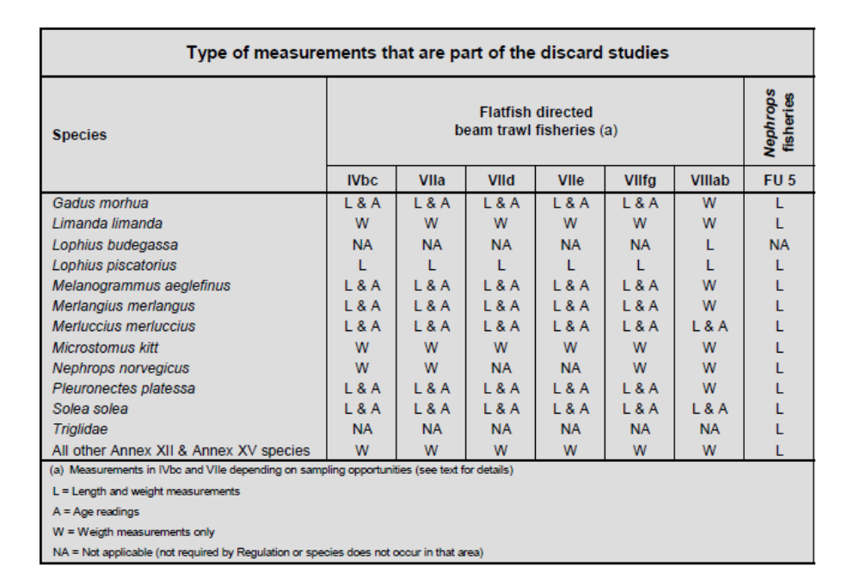
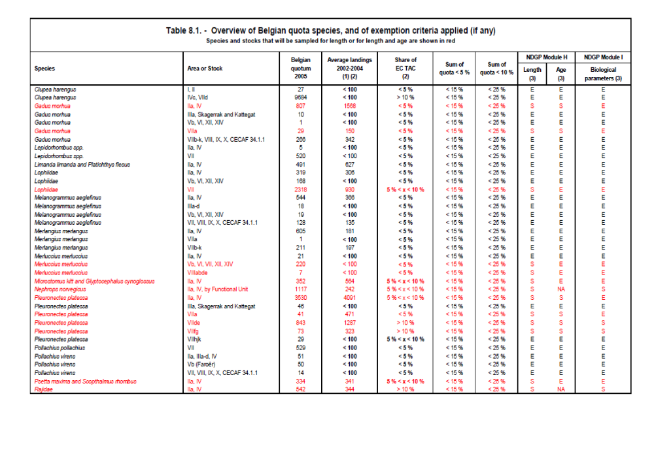

III.E.2 Data quality: results and deviations from NP proposal
According to the Guidelines, the achieved numbers for length and age should be compared to what was planned by the MS for the stocks that :
- were sampled so as to reach particular precision levels,
- are under an EC Recovery Plan, and/or
- for which the data series are used for tuning purposes; and to what is required by the DCF for all other stocks. The numbers and percentages achieved are presented in Table III.E.3.

Following the recommendations of STECF-SGRN, achieved sampling was considered as 'deviating from the objective' when it was > 10% below or > 50% above the target.
For species and stocks that are primarily sampled during discard trips, it is difficult to define the number of measurements in advance, and the achieved numbers for length and age often exceed the numbers required or planned. In principle, the sea-going observers take length measurements every other haul of all the retained and discarded fish, and collect otoliths of 5 fish (at the most) per cm class, irrespective of the total number of length and age measurements already made. This explains the apparent and sometimes considerable 'over-shooting' of the targets (particularly for length) for several stocks such as Gadus morhua, Pleuronectes platessa and Solea solea.
Scopthalmus rhombus and Psetta maxima in VIIa, VIIe, VIIfg and VIIIab were not mentioned in the planning 2011-2013. The length measurements and age samples were derived from by-catches in other fisheries.

Solea solea and Pleuronestes platessa in VIIe were not mentioned in the planning 2011-2013. It is not possible to plan a minimum number of targets as the sampling is done as opportunities arise.

Melanogrammus aeglefinus in VIIa, VIIe and VIIfg were not mentioned in the planning planning 2011-2013, but were sampled as it is mandatory regarding the discard rule.

Merlangius merlangus in VIIa, VIIe, VIIfg and VIIIa,b were not mentioned in the planning 2011-2013, but were sampled as it is mandatory regarding the discard rule.

Pleuronestes platessa in VIIIab was not mentioned in the planning planning 2011-2013. The few length measurements were derived from by-catches in other fisheries.

Raja naevus in all areas (North Atlantic) highly exceeded the target of zero. This is mainly due to a large catch of this species in VIIa (94%). It would be advisable to include this species in the new programme.

Length sampling – deviations from aim
Most fish stocks turned out to have been sampled well in excess of what was planned or required, but this is mostly because the length samples taken during observer trips were also included in the figures, on top of the numbers sampled at the auction and surveys. As mentioned before, the sea-going observers take length measurements every other haul, irrespective of the sampling levels already achieved. This causes no extra costs, since the observers are on board anyhow. In addition, the extra measurements are essential to make comparisons between the discarded and retained catch fractions, and to calculate how many fish are being discarded for each retained fish.
Lemon sole (Microstomus kitt): from 2010 onwards, is not sampled anymore on commercial vessel. From surveys 603 individuals were measured and variable Weight@Lenght available..
Since a few years, starting from 2009, sampling in excess of the DCF was a deliberate choice, as the required sampling levels were considered to be too low to yield reliable length composition data.
Age sampling – deviation from aim
The number of age samples taken met the national targets of the NP proposal for all stocks, except for North Sea turbot and brill (see next paragraph for details on the reasons why). Excess age sampling at no extra cost occurred for cod and hake in all Sub-areas sampled (extra samples taken during observer trips), and for plaice and sole in Sub-area IV (extra samples taken during the North Sea Beam Trawl Survey).
Psetta maxima and Scophthalmus rhombus in ICES Sub-area IV (North Sea)
Turbot and brill are pricey fish, and a sampling programme based on buying these species to measure lengths and collect otoliths (as is done for, e.g., plaice and sole) would be far too expensive. This can be circumvented by measuring length and 'drilling' otoliths at the market. Drilling otoliths under the operculum limits the external physical damage, but nonetheless, fishermen get a compensation for the internal damage that is caused to the fish. Despite this compensation, there is increased reluctance to allow these species to be sampled.
Effort restrictions in the North Sea in recent years, have led to an increase in the number of vessels that fish in different areas during the same trip (e.g. North Sea and eastern English Channel, where there are no effort restrictions for the beam trawler fleet). Such fishing trips however, are not suited for market sampling, since the exact origin of the fish in the landings cannot be retrieved(problems of the “mixed landings” as described in the general introduction part. Because of the difficulties to find vessels with 'pure North Sea catches', it was decided to focus sampling on the species for which the data needs are highest, i.e. plaice and sole. Unfortunately, this has been to the detriment of turbot and brill, which were left unsampled.
Rajidae - ICES Sub-areas IV and VII (except VIId)- deviation from aim
The estimation of growth requires either direct ageing or tagging experiments, to establish the relationship between length and age. So far however, there is no generally approved method for age determination in rays, while tagging is expensive (and not eligible under the DCF). Therefore, no growth studies on rays have been included in the Belgian NDGP. Since the
start of 2010, Belgium has started research in development of a methodology for determination of age in Rajidae. Prelimary results are available at present and have been presented on the ICES-ASC 2012 in Bergen.
Sex ratios for the ray stocks in ICES Sub-areas IV and VII (except VIId) are collected as part of the routine market sampling programmes.
Sexual maturity there were no maturity studies undertaken for Rajidae in this area.
For the sampling programmes on the flatfish directed beam trawl fisheries in IV, VIIa, VIId, VIIe and VIIfg the minimum targets were reached or exceeded (Table III.E.3).

III.E.3 Follow-up of Regional and international recommendations

Métier variables: Bilateral agreement on age reading of turbot and brill between UK-SCO and BEL.
RCM NA 2010 Recommendation | RCM NA 2010 recommends Scotland to liaise with Belgium to (investigate whether it is possible to) set up a regional coordination allowing for turbot and brill otoliths that were collected by Scotland to be transferred to Belgium for age reading.
Follow-up actions needed | Document availability of turbot and brill otoliths collected by Scotland. When relevant, sign agreement on regional coordination.
Responsible persons for follow-up actions | RCM NA participants from UK-SCO and BEL.
Time frame (Deadline) | Before end of 2010
Reply by MS | See text below, is ongoing since 2011.

Belgium provides age determination for all turbot (Psetta maxima) and brill (Scophthalmus rhombus) otoliths collected by the UK as part of the UK National Programme. In return UK will carry out the age determination of VIIa cod otoliths collected (406) as part of the Belgian National programme.

2012 | Psetta maxima | IV,VIId | 37
2012 | Psetta maxima | VIIa,VIIe,VIIfg,VIIh | 128
2012 | Scophthalmus rhombus | IV,VIId | 24
2012 | Scophthalmus rhombus | VIIa,VIIe,VIIfg,VIIh | 161
 |  |  | 350

Furthermore there is a bilateral agreement with Denmark for sampling and age reading of turbot and brill in the Skagerrak (IIIa North) and North Sea (II) from the IBTS survey and the commercial harbour and at sea sampling. In return, Denmark will provide genetic samples of brill and turbot from the IBTS and their commercial sampling.

2012 | Psetta maxima | IIIa | 156
2012 | Psetta maxima | IIIb,IIIc,IIId | 352
2012 | Psetta maxima | IV | 30
2012 | Psetta maxima | VIIe,VIIh | 91
2012 | Scophthalmus rhombus | IIIa | 622
2012 | Scophthalmus rhombus | IIIb,IIIc,IIId | 297
2012 | Scophthalmus rhombus | VIIe,VIIh | 85
 |  |  | 1633

Stock related variables: Potential bilateral agreements on sampling of landings abroad
RCM NS&EA 2012  Recommendation | Where it was identified that bilateral agreement is required, according to the rules agreed upon at the RCM NS&EA 2011 and endorsed by the LM8 and STECF 11-19, MS are requested to establish or update a bilateral agreement on sampling of landings abroad
Follow-up actions | MS to evaluate the need for such an agreement based on the overview provided by the RCM NS&EA
Responsible persons for follow-up actions | MS
Time frame | Annually. Before deadline for compilation/amendment of NP
Reply by MS | Ongoing, MS identifies on an annual basis if a new bilateral is relevant.

Since 2006, Lophidae are sampled for length, not for age. This is referred to in the Belgium Program Proposal Text 2006, p34. Section MP proposal, Module H. This has been accepted by the Commission and has not been changed since then. Below are two main tables from this NP whith the reference to only length measurements for landings and discards of Lophius spp.
Lemon sole (Microstomus kitt): from 2010 onwards, this is not sampled anymore.
In the past (2009), sampling in excess of the DCF was a deliberate choice, as the required sampling levels were considered to be too low to yield reliable length composition data.
This was done in agreement with the stock coordinator. Belgium will present the request for an official derogation on the RCM2014. The motivation of not sampling Microstomis kitt as the required sampling levels were considered too low to yield relaible lenght composition is based on the use of resources in an efficient way and based on the principle of delivering good quality data.

III.E.4 Actions to avoid shortfall
General:
Belgium is look at how to replace the oversampling during at sea sampling, by alternative activities that at-sea going observers could do in order to improve the implementation of the Belgian NP. During 2012, some trials were set up. However, the over sampling has always been done at no extra financial cost of the sampling, neither on the data analysis.
For the stocks which were undersampled, there were no implications on the stock assessments (feedback from stock assessments did not indicate negative impact)
Age sampling for Psetta maxima and Scophthalmus rhombus in ICES Sub-area IV (North Sea)
There are no other possibilities for collecting otoliths of turbot and brill than by means of the method that is currently applied. Therefore, otoliths should be drilled at the market, and ILVO-Fisheries is trying to expand the list of fishermen who, in return for a financial compensation, are willing to co-operate on this issue. However, no fishermen have agreed during 2012 for drilling otoliths. Furthermore, Belgium is also using surveys undertaken by other ILVO-research groups to collect more otoliths from turbot and brill. This is at no extra cost to Belgium.

North East Atlantic and Western Channel — ICES areas V, VI, VII (excluding d), VIII, IX, X, XII, XIV
III.E.1 Achievements: results and deviations from NP proposal
Due to the derogation for age sampling of Lophiidae and not sampling other parameters (weight, sex ratio, maturity, etc) this was left out of table III.E.3.
Since 2006, Lophidae are sampled for length, not for age. This is referred to in the Belgium Program Proposal Text 2006, p34. Section MP proposal, Module H. This has been accepted by the Commission and has not been changed since then. Below are two main tables from this NP whith the reference to only length measurements for landings and discards of Lophius spp.

Estimates of the total weight of the discards of all Appendix VII species, together with some particularly abundant Appendix VII species, were collected for the flatfish directed beam trawl fisheries in ICES Sub-areas IV (North Sea), VIIa (Irish Sea), VIId (Eastern Channel), VIIe (Western Channel), VIIfg (Celtic Sea). The sampling programmes were also used to estimate the length and age composition of the discards. Planned and achieved sampling levels are summarised in Table III.E.1 and III.E.3
Estimates of the total weight of the discards of all Appendix XII species, together with some particularly abundant Appendix XIII species, were collected for the flatfish directed beam trawl fisheries in ICES Sub-areas IV (North Sea), VIIa (Irish Sea), VIId (Eastern Channel), VIIe (Western Channel), VIIfg (Celtic Sea). The sampling programmes were also used to estimate the length and age composition of the discards (mandatory under the DCF). Planned and achieved sampling levels are summarised in Table III.E.3.
A summary of the planned and achieved discard sampling (numbers of sea-going observer trips in the case of the beam trawl fisheries) is given in Table III.C.3. The achieved length and age measurements on the retained and discarded catch fractions are shown in Table III.E.3.
III.E.2 Data quality: results and deviations from NP proposal
According to the Guidelines, the achieved numbers for length and age should be compared to what was planned by the MS for the stocks that
- were sampled so as to reach particular precision levels,
- are under an EC Recovery Plan, and/or
- for which the data series are used for tuning purposes; and to what is required by the DCF for all other stocks. The numbers and percentages achieved are presented in Table III.E.3.
Following the recommendations of SGRN, achieved sampling was considered as 'deviating from the objective' when it was > 10% below or > 50% above the target.
For species and stocks that are primarily sampled during discard trips, it is difficult to define the number of measurements in advance, and the achieved numbers for length and age often exceed the numbers required or planned. In principle, the sea-going observers take length measurements every other haul of all the retained and discarded fish, and collect otoliths of 5 fish (at the most) per cm class, irrespective of the total number of length and age measurements already made. This explains the apparent and sometimes considerable 'over-shooting' of the targets (particularly for length) for several stocks such as Gadus morhua, Pleuronectes platessa and Solea solea.
For the stocks which were undersampled, there were no implications on the stock assessments (feed back from stock assessments did not indicate negative impact)
Length sampling – deviations from aim
Most fish stocks turned out to have been sampled well in excess of what was planned or required, but this is mostly because the length samples taken during observer trips were also included in the figures, on top of the numbers sampled at the auction and surveys. As mentioned before, the sea-going observers take length measurements every other haul, irrespective of the sampling levels already achieved. This causes no extra costs, since the observers are on board anyhow. In addition, the extra measurements are essential to make comparisons between the discarded and retained catch fractions, and to calculate how many fish are being discarded for each retained fish.
Lemon sole (Microstomus kitt): from 2010 onwards, is not sampled anymore on commercial vessel. From surveys 603 individuals were measured and variable Weight@Lenght available..
Since a few years, strating from 2009, sampling in excess of the DCF was a deliberate choice, as the required sampling levels were considered to be too low to yield reliable length composition data.
Melanogrammus aeglefinus in IV was not mentioned in the planning 2011-2013, but were sampled as it became mandatory regarding the discard rule.
Merlangius merlangus in IV and VIId were not mentioned in the planning 2011-2013, but were sampled as it becames mandatory regarding the discard rule.
Lophiidae in IV and VIId were not mentioned in the planning 2011-2013, but were sampled as it became mandatory.

These additional sampling had no implications on the financial aspects of the Belgium data collection program 2012.

Age sampling – deviation from aim
The number of age samples taken met the national targets of the NP proposal for all stocks, except for turbot and brill (see next paragraph for details on the reasons why). Excess age sampling at no extra cost occurred for cod and hake in all Sub-areas sampled (extra samples taken during observer trips), and for plaice and sole in
For the stocks which were undersampled, there were no implications on the stock assessments. The working groups in need and using this data did not report a negative impact and did use the data transmitted.
Rajidae - V, VI, VII (excluding d), VIII, IX, X, XII, XIV deviation from aim
The estimation of growth requires either direct ageing or tagging experiments, to establish the relationship between length and age. So far however, there is no generally approved method for age determination in rays, while tagging is expensive (and not eligible under the DCF). Therefore, no growth studies on rays have been included in the Belgian NDGP. Since the start of 2010, Belgium has started research in development of a methodology for determination of age in Rajidae. Prelimary results are available at present
Sex ratios for the ray stocks in ICES Sub-areas V, VI, VII (excluding d), VIII, IX, X, XII, XIV are collected as part of the routine market sampling programmes.
Sexual maturity there were no maturity studies undertaken for Rajidae in this area.
For the sampling programmes on the flatfish directed beam trawl fisheries in IV, VIIa, VIId, VIIe and VIIfg the minimum targets were reached or exceeded (Table III.E.3).
III.E.3 Follow-up of Regional and international recommendations

Stock related variables: Potential bilateral agreements on sampling of landings abroad
RCM NS&EA 2012  Recommendation | Where it was identified that bilateral agreement is required, according to the rules agreed upon at the RCM NS&EA 2011 and endorsed by the LM8 and STECF 11-19, MS are requested to establish or update a bilateral agreement on sampling of landings abroad
Follow-up actions | MS to evaluate the need for such an agreement based on the overview provided by the RCM NS&EA
Responsible persons for follow-up actions | MS
Time frame | Annually. Before deadline for compilation/amendment of NP
Reply by MS | Ongoing, MS identifies on an annual basis if a new bilateral is relevant.

Stock related variables: Setting up of Pilot programmes for sampling of Boar fish (Capros aper)
RCM NA 2012 Recommendation (RCMNA 5) | RCM NA recommends MS involved and that have obligations in the Boar fish fishery to set up a pilot program for sampling.
Follow-up actions needed | Include pilot study in the revised NP proposals
Responsible persons for follow-up actions | MS fishing Boar fish
Time frame (Deadline) | 31 Oct 2012
Reply by MS | Belgium has no boar fish fisheries

Since 2006, Lophidae are sampled for length, not for age. This is referred to in the Belgium Program Proposal Text 2006, p34. Section MP proposal, Module H. This has been accepted by the Commission and has not been changed since then. Below are two main tables from this NP whith the reference to only length measurements for landings and discards of Lophius spp.
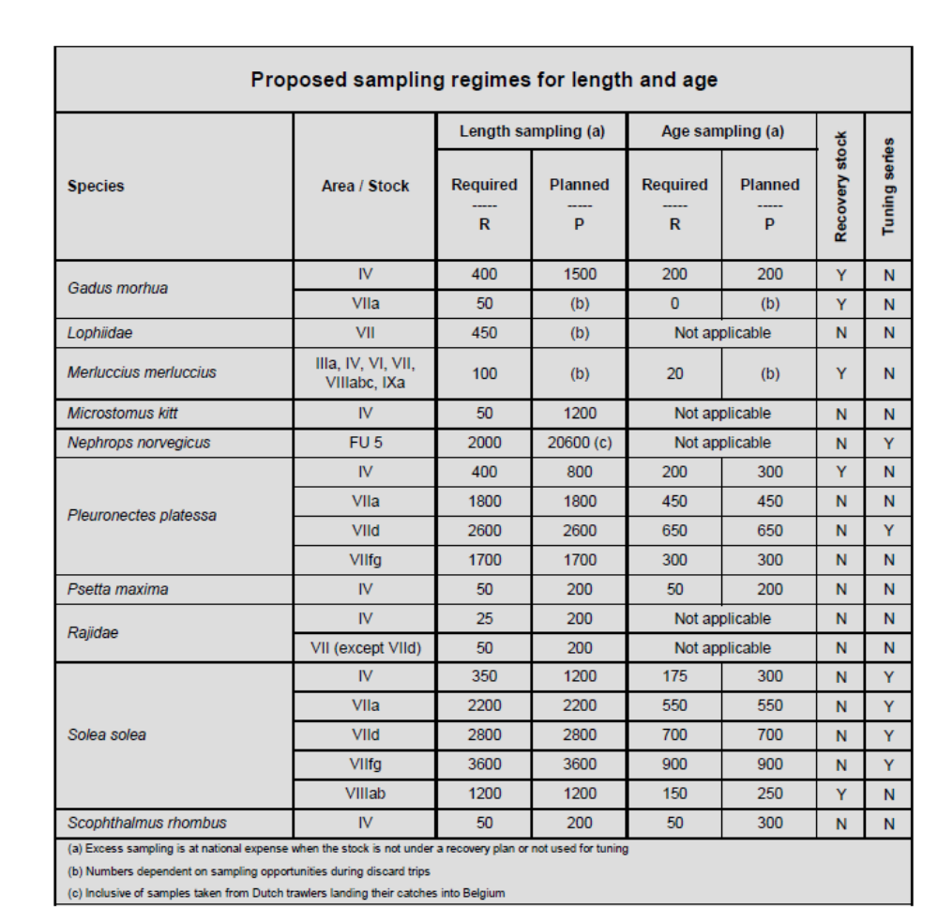

Lemon sole (Microstomus kitt): from 2010 onwards, this is not sampled anymore.
In the past (2009), sampling in excess of the DCF was a deliberate choice, as the required sampling levels were considered to be too low to yield reliable length composition data.
This was done in agreement with the stock coordinator. Belgium will present the request for an official derogation on the RCM2014. The motivation of not sampling Microstomis kitt as the required sampling levels were considered too low to yield relaible lenght composition is based on the use of resources in an efficient way and based on the principle of delivering good quality data.

III.E.4 Actions to avoid shortfall
General:
Belgium is looking at how to replace the oversampling during at sea sampling, by alternative activities that at-sea going observers could do in order to improve the implementation of the Belgian NP. During 2012, some trials were set up. However, the over sampling has always been done at no extra financial cost of the sampling, neither on the data analysis.
For the stocks which were undersampled, there were no implications on the stock assessments (feedback from stock assessments did not indicate negative impact)

III F Transversal Variables

General:

Some effort data such as hours dredged, length of nest or prices are not available.

These fishing gears have not handed in this information.

In general the passive gears are not prominently present in the Belgian fisheries.

III.F.1 Capacity
III F 1 1 Achievements: results and deviations from NP proposal

Data collection was exhaustive and comprised all fishing vessels in the EU Fleet Register that were active in 2012, so no estimation was required. The programme was executed as planned. Fleet segmentation for gathering fishing capacity data took into account the amendments imposed by Council Regulation EC no 199/2008 and Commission Decision 2010/93/EU (see table 1). The data that are currently collected on the Belgian vessels include gross tonnage, maximum continuous power (kW) of the main engine (as registered by the Federal Ministry of Transport and Infrastructure) and vessel age based on the hull (years).

III F 1 2 Data quality: results and deviations from NP proposal

As the data collection was exhaustive, it is not meaningful to apply any data quality issues in the context of the DCF. No deviations from the aim have been identified.
III F 1 3 Actions to avoid shortfall

No shortfalls identified.

III.F.2 Effort
III F 2 1 Achievements: results and deviations from NP proposal
Data collection was exhaustive and comprised all fishing vessels in the EU Fleet Register that were active in 2012. No deviations from the aim have been identified. No shortfalls were identified.
  - Fishing effort
Fishing effort data are collected by fishing voyage as part of the routine effort, landings and revenue data collection system and can be reported by fleet segment, gear type and ICES Sub-area as requested by the DCF, or by any other type of spatial or temporal aggregation.

  - Species specific effort
Landings (and revenues) by species were recorded as foreseen in the NP proposal, for all species listed in the text table below.
Species for which species-wise landings (and revenue) data were collected in 2012

Species for which species-wise landings (and revenue) data were collected in 2012
Scientific name | Code | Scientific name | Code
Amblyraja radiata | RJR | Mullus surmuletus | MUR
Anarhichas lupus | CAA | Nephrops norvegicus | NEP
Aspitrigla cuculus | GUR | Nephrops norvegicus | NEP
Bivalvia | CLX | Octopus spp. | OCZ
Brosme brosme | USK | Pecten maximus | SCE
Buccinum undatum | WHE | Perciformes | DPX
Cancer pangurus | CRE | Perciformes | PPX
Cancer pangurus | CRE | Plathichthys flesus | FLE
Chelidonichthys lucerna | GUU | Pleuronectes platessa | PLE
Clupea harengus | HER | Pollachius pollachius | POL
Conger conger | COE | Pollachius virens | POK
Crangon spp. | CSH | Psetta maxima | TUR
Crustacea | CRU | Raja brachyura | RJH
Dicentrarchus labrax | BSS | Raja circularis | RJI
Dipturus batis | RJB | Raja clavata | RJC
Eutrigla gurnardus | GUG | Raja fullonica | RJF
Gadus morhua | COD | Raja microocellata | RJE
Hippoglossus hippoglossus | HAL | Raja montagui | RJM
Homarus gammarus | LBE | Raja spp. | SKA
Lepidorhombus spp. | LEZ | Scomber scrombus | MAC
Leucoraja naevus | RJN | Scophthalmus rhombus | BLL
Limanda limanda | DAB | Scyliorhinus spp. | SCL
Loligo spp. | SQC | Sebastes spp. | RED
Lophiidae | ANF | Selachimorpha | SKH
Melanogrammus aeglefinus | HAD | Sepia officinalis | CTC
Merlangius merlangus | WHG | Solea solea | SOL
Merluccius merluccius | HKE | Sprattus sprattus | SPR
Microstomus kitt | LEM | Squalus acanthias | DGS
Mollusca | MOL | Trachurus spp. | JAX
Molva molva | LIN | Trisopterus luscus | BIB

II F 2 2 Data quality: results and deviations from NP proposal

As the data collection was exhaustive, it is not meaningful to apply any data quality issues for the reported variables in the context of the DCF. No deviations from the aim have been identified.
III F 2 3 Follow-up of Regional and international recommendations
There were no specific recommendations relevant for Belgium.
III F 2 4 Actions to avoid shortfall

No shortfalls were identified.

III.F.3 Landings
III F 3 1 Achievements: results and deviations from NP proposal

Data collection was exhaustive and comprised all fishing vessels in the EU Fleet Register that were active in 2012.
  - Conversion factors
The conversion factors used to convert landed weights to live weights are conform the Commission implementing regulation (EU) No 404/2011 of 8 April 2011, Annex XIII – European Union conversion factors for fresh fish.
III F 3 2 Data quality: results and deviations from NP proposal
As indicated in section General Framework of this report Belgium has to take in to account the problem of the restricted’ list and ‘mixed’ landings. However, no deviation of the national proposal was identified. As the data collection was exhaustive, it is not meaningful to apply any data quality issues in the context of the DCF.
III F 3 3 Follow-up of Regional and international recommendations
There were no specific recommendations relevant for Belgium.
III F 3 4 Actions to avoid shortfall
No shortfalls identified.

III G Research surveys at sea
III G 1 Achievements: results and deviations from NP proposal
Belgium was expected to take part in two Priority 1 surveys, viz. the Demersal Young Fish Survey (DYFS) and the North Sea Beam Trawl Survey (BTS). Both surveys were carried out as planned in the NP proposal.
- Demersal Young Fish Survey (DYFS)
As part of the international Demersal Young Fish (and Brown Shrimp) Survey, an annual autumn sampling survey was carried out in the Belgian coastal waters, to collect data on the abundance of juvenile flatfish (primarily plaice, Pleuronectes platessa, dab, Limanda limanda, and sole, Solea solea) and brown shrimp (Crangon crangon). The vessel used was the training and research vessel O.29 'Broodwinner' (LOA 27.2 m; engine power 221 kW). The location of the sampling area matches the main flatfish nursery grounds along the Belgian coast. The planned and achieved numbers of days at sea, and the planned and achieved sampling stations are summarized in Table III.G.1. 31 sampling stations were fished of the 33 planned (Map 2), and this was realised in only seven days. Already in 2010, five stations had become dredging points and could not be sampled. Three of these could be relocated to suitable alternative locations in 2011, but such locations still need to be identified for the remaining two stations (see further under ‘Actions to avoid shortfalls).
Although the weather interfered with the sea-going operations in 2012 on several days of the survey, the ten days of ship time still allowed 32 of the 33 sampling stations to be fished successfully. None of the fished stations were declared invalid
Methodology
All DYFS sampling stations are fished for approx. 15 min, with a standard shrimp beam trawl (beam length 6 m; codend mesh size 22 mm). Commercial fish are hand-picked from the catches, sorted by species and measured to the cm below.
Brown shrimp are first graded into 'small' and 'large' by means of a rotating shrimp riddle (of the type that is also used on commercial shrimpers). From these two fractions, samples are taken of 1-2 litre each (depending on the proportions of shrimp and other organisms in the catch fractions). Samples are further sub-sampled in the lab (by weight) to an equivalent of approx. 250 shrimps, which are then measured in 5 mm size classes. All data of the shrimps analyses are done in 2010 as well. These data will be transmitted to WGCRAN 2012 and incorporated in the report of the WGCRAN2012.
The DYFS focusses on measuring the most important commercial fish species (value and/or volume) to the cm below being cod, whiting, plaice, flounder, dab, sole, brill and turbot. From 2009 on, the species list was extended to cover all commercial fish species caught (e.g. including lesser spotted dogfish, gurnards, lemon sole, …). In this way, 11 species were documented in 2012.

Ordered by number, these are:
Species | Total number
Dab (Limanda limanda) | 6109
Plaice (Pleuronectes platessa) | 2944
Whiting (Merlangius merlangus) | 2176
Sole (Solea solea) | 891
Flounder (Platichthys flesus) | 97
Horse Mackerel (Trachurus trachurus) | 26
Lemon Sole (Microstomus kitt) | 19
Turbot (Psetta maxima) | 17
Cod (Gadus morhua) | 15
Tub Gurnard (Chelidonichthys lucerna) | 8
Grey Gurnard (Eutrigla gurnardus) | 3

All data are stored in Excel spreadsheets at ILVO-Fisheries, and are presented to WGBEAM and uploaded in DATRAS.
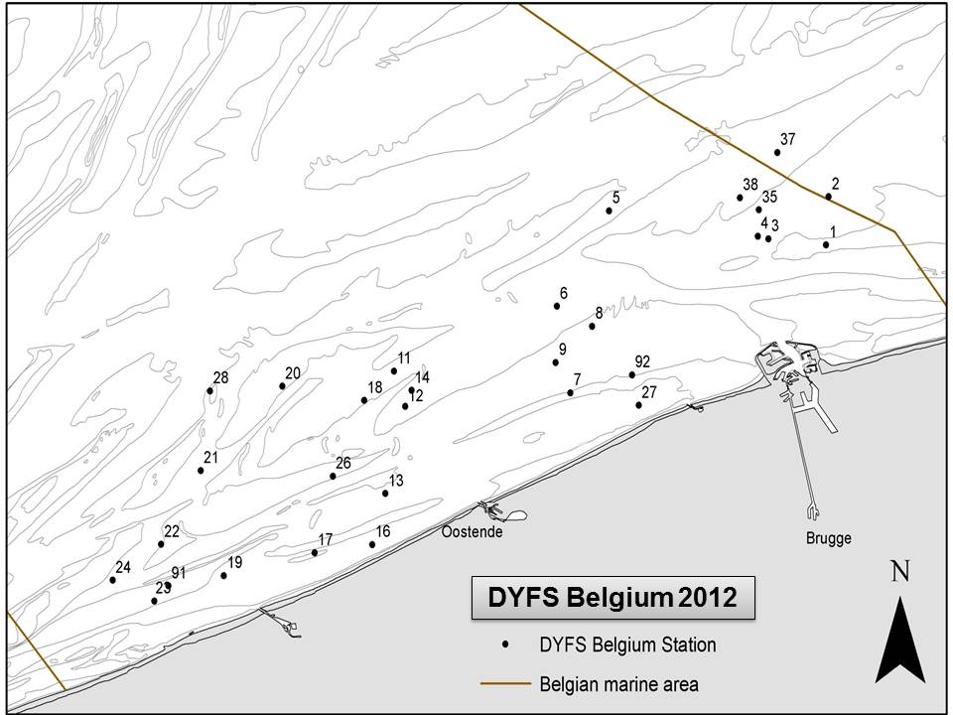

- Beam Trawl Survey (BTS)

with the RV 'Belgica' (LOA 50 m, engine power 1154 kW), as part of the annual international North Sea Beam Trawl Survey.
An annual North Sea Beam Trawl Survey is carried out in the south-western part of the North Sea (IVb and IVc West) to sample the adult flatfish stocks, primarily targeting plaice Pleuronectes platessa and sole Solea solea. Starting in 1992, the RV “Belgica” samples 62 fixed sampling stations in BTS Areas 2, 3 and 4.
In 2012, the weather did not interfere with the fishing activities. However, only 57 of the 62 planned survey stations were fished succesfully. Two stations in the north-western part (60 and 111) were fished but declared invalid as the catch sizes were too different from the time series of these stations to be considered reliable. The other three stations (81, 96 and 96b) were missed because of delays caused by technical issues that affected the cruise plan and/or scientific operations (hydraulic, engine and electricity problems). These were geographically well spread so the spatial resolution in the results was not compromised. Problems with the depth meter forced us to fish two stations a second time, creating additional delay.
Number of otoliths: 4 ind per cm size class per ICES Statistical Rectangle for cod, brill, turbot, plaice and sole. This was the second time that the collection of biological samples was geographically organised based on the rectangles instead of the formerly used ALK-areas.
Indices for plaice and sole are the numbers per hour, averaged by ICES rectangle and averaged over all sampled ICES rectangles.
Methodology
All BTS stations are fished for 20-30 min (depending on quantities to be expected and the likely presence of potentially damaging obstructions such as rocks, boulders, etc.) with a 4 m beam trawl.
The NS BTS measures all commercial fish species to the 5 mm below (no subsampling), and also records all other fish species by length (mostly all individuals, but sometimes based on subsamples). 53 different species of fish were caught. 4 otoliths per cm size class are collected per ICES Statistical Rectangle for cod, brill, turbot, plaice and sole, and the fish these came from are also sexed.
No maturity information is recorded (inappropriate period of the year)..

The top 10 of the species caught, by number are:
Species | Total number
Dab (Limanda limanda) | 4938
Lesser Weever (Echiichthys vipera) | 2981
Plaice (Pleuronectes platessa) | 2972
Sole (Solea solea) | 2432
Common Dragonet (Callionymus lyra) | 1732
Pogge (Agonus cataphractus) | 1555
Solenette (Buglossidium luteum) | 919
Whiting (Merlangius merlangus) | 913
Scaldfish (Arnoglossus laterna) | 625
Lemon Sole (Microstomus kitt) | 603

In addition, semi-quantitative data are collected on the abundance of the most important by-catch species (both invertebrates and fish), and on the size composition of the Cancer pagurus by-catches. Also the presence of marine litter in all catches was documented.
All data are stored in Excel spreadsheets at ILVO-Fisheries, and are given through to WGBEAM and uploaded in DATRAS.
There were no major deviations from the objective.

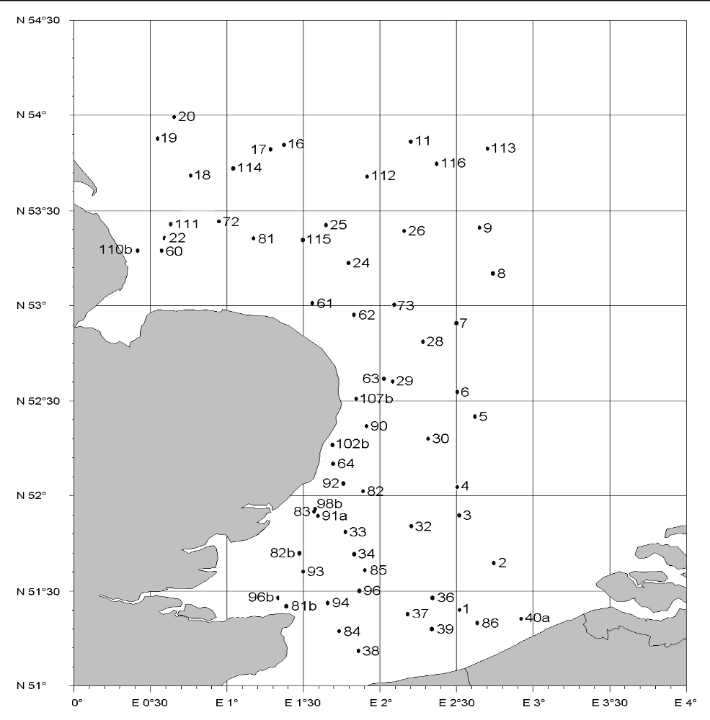
Map 1 - Sampling stations fished by the RV 'Belgica' in the SW North Sea in August-September 2011, as part of the annual late summer BTS survey.

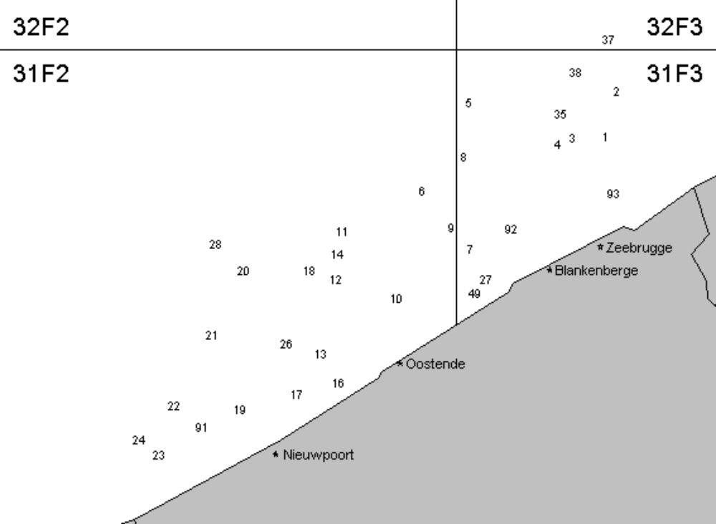

Map 2 - Sampling stations fished in the Belgian coastal waters in September 2011, as part of the annual autumn DYFS survey.

III G 2 Data quality: results and deviations from NP proposal
No changes to any kind of settings were done that could have impaired the quality of the indices, thus no shortfalls were present.

III G 3 Follow up of regional and international recommendations
Belgium changed the geographical resolution of the age information that is collected on the BTS from the coarser ALK-areas (three in the survey area) to the ICES-statistical rectangles (14 in the survey area), as was suggested by WGBEAM. This way belgium collect age data in the exact same way as the other member States conducting similar surveys, and obtain a geographically more detailed view on the age compositions of the exploited commercial fish populations.
III G 4 Actions to avoid shortfalls
Since there were no major shortfalls under the Module Surveys, the surveys will largely remain unchanged in the years to come. Regarding the DYFS, three out of five stations that have become dredging points were shifted to new positions with similar depths and substrates in the vicinity of the old positions, and were fished again from 2011 onwards.

IV Module of the evaluation of the economic situation of the aquaculture and processing industry

IV A Collection of data concerning aquaculture
IV A 1 Achievements: results and deviations from NP proposal
A new regulation on aquaculture (EC) No 762/2008 of the European Parliament and of the Council came into force, since 9th of July 2008. In respect of this regulation, the Federal Department of Economics has carried out research that demonstrates that the aquaculture sector is in a difficult position in Belgium.
The sector never really gained in importance and many enterprises have ceased their activities for financial reasons over the last years. Strong dependency on environment, disease sensitivity and important competition from imported products rapidly discourage starting enterprises. Experts expect this downward trend to continue in the coming years. A more detailed survey as prescribed by the new regulation doesn’t seem to commensurate with the small scale of aquaculture in Belgium. In 2007, the total annual production amounted to 128 tons .
The 128 ton mentioned above, reflects only oyster and mussel production in the Belgian waters, no fresh water aquaculture is included in this production data, thus the given number of tons production does not reflect the total aquaculture situation in Belgium
However, compared to the total European production of aquaculture products, Belgium is still relatively small,

The aquaculture sector in Belgium is very fragmented for example the trout production in Wallonia, the French part of Belgium, used to be organized by one large feeding mill; since a few years, the scenario has changed completely: most of the trout production is owned by small family business, which in good economic situations stay on the market, but during less positive economic situations, get out of the market. However, these business re-start very easily as well when the market situation improves again
A questionnaire was sent out by the end of 2011 to collect data for the aquaculture industry for year 2010. As the response rate for the questionnaire sent out to collect data on year 2009 was very low, companies who did not provide data for 2009 were requested to send back the filled out questionnaires for 2009 and 2010. In total, ILVO has collected 107 addresses of fish farmers. These addresses were screened but it is uncertain that all of these companies meet the definition of an aquaculture company or are still in business. The questionnaire was sent to all farmers, however the return rate was very low, only 8 companies replied, of which only six are still active. Of these only a few companies filled in the questionnaire in full, the others only partly and these are considered as “invalid”. None of the valid ones are dealing with marine species. As the response is so low and problems with confidentiality issues arises, data are not provided.
Also, there is the incompatibility between the year of reporting and the account year that company keeps. Most of the companies have their accountant year from 1st of April 2010 until 31 March 2011, some of them from 1st of June until 31 of May of the year n+1. Not one of the companies that sent back data uses calendar years for accountancy.
Mariculture is very rare in Belgium and is limited to the production of oyster and blue mussel. In the DCF, the collection of fresh water species is not mandatory. FAO FishStat Plus classifies all Belgian aquaculture as freshwater; Eurostat data confirms that Belgian aquaculture is “inland”. And ‘FPS Economy, SMEs, Self-Employed and Energy’ has requested and obtained a derogation and did not collect economic data for aquaculture sector during the reported period. As the aquaculture production in Belgium is already very small and only 3 companies are producing marine species, confidentiality issues arise.
Considering all of the above Belgium decided not to report aquaculture data for the 2010 annual report, which was accepted by the commission. The arguments used in AR2010 still stand and were confirmed by STECF report “Economic Performance of the EU Aquaculture Sector (STECF-OWP-12-03)”. The low response rate for the 2010 & 2011 data provides an additional argument. Hence, Belgium decided not to report aquaculture data for the 2012 annual report. Belgium does not expect any major changes in the aquaculture sector during 2012 and 2013 and therefore requested a derogation for AR2012 and AR2013 as well. However our aquaculture experts will closely monitor the sector and recommence data collection and reporting when appropriate.
¹ Section A of the Chapter IV of the Commission Decision 2010/93/<EU of the 18th of December 2009, on Adopting a multiannual Community programme pursuant to Council Regulation (EC) No 199/2008 establishing a Community framework for the collection, management and use of data in the fisheries sector and support for scientific advice regarding the common fisheries policy.

IV A 2 Data quality: results and deviations from NP proposal
As explained in IV A 1 no data were reported, hence not applicable
IV A 3 Follow up of regional and international recommendations
No regional and international recommendations are set up.
IV A 4 Actions to avoid shortfalls
Considering all of the above Belgium decided not to report aquaculture data for the 2010 annual report, which was accepted by the commission. The arguments used in AR2010 still stand and were confirmed by STECF report “Economic Performance of the EU Aquaculture Sector (STECF-OWP-12-03)”. The low response rate for the 2010 data provides an additional argument. Hence, Belgium decided not to report aquaculture data for the 2012 annual report. Belgium does not expect any major changes in the aquaculture sector during 2013 and therefore request a derogation for AR2013 as well. However our aquaculture experts will closely monitor the sector and recommence data collection and reporting when appropriate.
.

IV B Collection of data concerning the processing industry
IV B 1 Achievements: results and deviations from NP proposal

All data collection is done in accordance with the NP proposal. On the date of drafting the AR2011 the most recent economic data available were the data for the account year 2011-2012, which considered as reference year 2011-2012 (see figure under section General Framework). This one-year time lag in the data collecting system is caused by the incompatibility between the year of reporting and the account year that company keeps. Most of the companies have their accountant year from 1st of April 2011 until 31st of March 2012, some of them from 1st of June 2011 until 31st of May of the year 2012. The collection of economic data for 2011-2012 is done in accordance with the NP proposal. An overview of the collected data is reported in the Excel tables IV.B.1 and IV.B.2. The questionnaire was sent to 240 companies.
  - What data are being collected?
The economic data/variables for the Belgian processing industry that were collected under the NP correspond to the list in Appendix XII of the EU Decision 2010/93. For details on information requested from the companies and parameter definitions, see Annex 3 and Annex 4 respectively.
  - What are the data collected from and how are the data collected?
In Belgium, there is no reference list of fish processing companies in the strict sense of the word. Therefore in the previous years, ILVO-Fisheries addressed the top-255 (ranking based on company turnover and number of employees) of the Belgian companies that were identified as being involved in 'fish processing' in a national survey of private company performance indicators. A priori, most of these companies could be expected to have different types of food processing activities, of which fish and shellfish could be one, but not necessarily the most important one. In order to up-date and fine-tune the list of fish processing companies a list with postal addresses of companies involved in fish processing was obtained from the ‘Belgische groepering van de visindustrie’, the Belgian representative of AIPCE-CEP (European Fish Processors Association - European Federation of National Organisations of Importers and Exporters of Fish). Based on the already available information and an Internet search the e-mail addresses for these companies were included where possible.
In 2012, similar to 2011, 240 companies received a questionnaire (see Annex 3) and the explanatory note with variables definitions (see Annex 4) by e-mail (when a correct e-mail address was available) or by post. Several companies informed ILVO via a phone call, an E-mail message or the comment box on the questionnaire that processing fish was only a very minor part of their activities, that they did not have the time or that they were not willing to provide the requested economic data. In order to fine-tune the list of fish processing companies, companies were requested to fill-out the contact details of the person best placed within the company to fill out the questionnaire. This feed-back is used for further fine tuning the sampling scheme and the list of companies active in the processing industry. Additionally, the questionnaire is based on gathering data inclusive VAT. However, this is rather difficult to extract from the accountancy of the respective companies.
In total 35 replies were received, including 9 non-valid responses as the respondent indicated that the company only used very low quantities of fish or shellfish for the preparation of meals or that they did not have the time to fill-out the questionnaire. In total y 26 useful questionnaires were received, hence a response rate of 11% was achieved.
IV B 2 Data quality: results and deviations from NP proposal
There were no deviations from the objective
IV B 3 Follow-up of regional and international recommendations
There were no specific recommendations relevant for Belgium.
IV B 4 Actions to avoid shortfall
Belgium will continue its effort to improve the data collection concerning the processing industry. The list of fish processing companies will be further up-dated and fine-tuned. To ensure that only active fish processing companies receive a questionnaire, the companies on the (draft) list will be contacted by phone prior to the mailing. It is also the intention to collect the contact details of the person best placed within the company to fill out the questionnaire. Belgium aims at sending out as many questionnaires as possible electronically, e.g. by E-mail, to facilitate the follow-up of each contact and the input of the returned data into the data base. The questionnaire was update based on the recommendations of the STECF WS “Review of economic data collected in relation to the DCF and harmonisation of sampling strategies (EWG-11-18)” (October 17 – 21, 2011 in Salerno) and PGECON “Planning Group on Economic Issues 16-19 April 2012, Salerno, Italy) which was attended by a scientist from ILVO.
From 2013 and 2014 onwards (for AR2013), Belgium investigates first what companies are in the different segments, being segment 1 with companies employing less than 10 employees, and the segment 2 with companies employing more than 10 employees. The different segments will be sent the same questionnaire, but the results for the achieved sample rate and the achieved sample rate/planned sample rate will be more accurate. Currently, there is only one frame population and one planned sample no. Table IV.B.2 will then also be subdivided into the two segments with more realistic achieved sample rate, response rate and CVs for the variables of both segments. There will be looked if for both segments the type of data collection scheme will be the same or different. i.e. there will be looked if a probability based sampling schemes would be more correct.
Because of the combination of both segments, the achieved sample rate and the response rate are for 2012 the same (11%). When the segmentation is used, these response rate will be different and more accurate. For both segment the response rate is now < 70% (being 11%), but as stated, this is not representative for the two segments individually. The CVs calculated are consequently, as well for the whole frame population, and not for the individual segments.
Belgium assumes that these actions will improve the response rate and quality of the data collected.

V Module of evaluation of the effects of the fishing sector on the marine ecosystem

V 1 Achievements: results and deviation from NP proposal
Indicators 1-3 are calculated from fisheries survey results. As Belgium only organises such surveys in the North Sea, indicators 1-3 can be delivered for the North Sea and Eastern Arctic region, but not for the North Atlantic region.
Source data for indicator 4 can be collected on research surveys or though market sampling programmes. However, due to the lack of internationally standardised maturity scales, Belgium did not collect maturity data so far.
The Fuel efficiency indicator is calculated based on the value of landings calculated as the product of landings by species and the cost of fuel. The indicator would be calculated for each métier according to level 6 métiers.
Data on the fuel cost are be collected from the relevant company accounts, on which the actual cost paid for fuel is registered and available.
The source of data for collecting the value of landings and the price of the species are the Fishstats, which is the official database of DvZ and contains the information from sales notes and log books.
In the section and Table III.B.3, a detailed overview is given of data sources and methodologies used for collecting economic data.
  - Fuel consumption
Currently, the estimates of fuel consumption are based on annual fuel costs, as reported by vessel owners on a voluntary basis (also see Section III.B.3). The most recent data available relate to 2009 and are applicable to the beam trawlers only. For the other fleet segments (with < 10 vessels in total), no data to calculate fuel consumption were provided by the vessel owners.
  - VMS data
Indicator 5,6 and 7 are calculated based on the VMS data. Since begin of 2010, Belgium has access to the Belgian VMS data and received the first data by the end of March 2010. Time lag between two registrations is two hours.

V 2 Actions to avoid shortfalls

Maturity data, needed for the calculation of indicator 4 but currently lacking, and were collected from 2012 onwards on research surveys by Belgium. However, these data are not relevant as the time in the year that survey takes place is not the correct timing for determining maturity stages. See section G– Surveys.

VI Module for management and use of the data

VI 1 Achievements: results and deviation from NP proposal

Sea Fisheries Service
The Sea Fisheries Service has extensive databases with landings, effort and economic data on the Belgian sea-going fishing fleet that is be complemented with the information gathered during the past and is update every year.

Survey data
Both results from the North Sea Beam Trawl Survey and the Demaersal Young Fishe Survey are supplied to WGBEAM database, held by IMARES on behalf of ICES. The data from the BTS survey are uploaded to the DATRAS database in ICES.

ILVO-Fisheries
In April 2003, ILVO-Fisheries started with the development of a central depository for NDGP-data (the so-called Belsamp database), in co-operation with a sub-contracted software developer. The Belsamp database has a modular structure, with (i) separate modules for the quality control, storage, partial treatment and retrieval of fisheries statistics, data from market and discard samplings, survey data, etc., and (ii) peripheral modules with vessel registers, taxonomic information on the most important fish and shellfish species, area and stock descriptions (in terms of statistical rectangles), etc.
So far, the general framework of the Belsamp database has been elaborated (in close co-operation between data collectors and software developer) But the belsamp has it clear limitations. Therefore, a new design is developed (see figure 1 & 2)

Data transmitted
In 2012, all data collected under the DCF were transmitted to the relevant assessment working groups, study groups, advisory committees, ad hoc expert groups, etc., when and as requested
In 2012, there were several calls from the Joint Research Centre (JRC) and they are included in Table VI.1.

VI 2 Actions to avoid shortfalls
In 2012, all data collected under the DCF were transmitted to the relevant assessment working groups, study groups, advisory committees, ad hoc expert groups, etc., when and as requested.
In October 2011, Devstat visited Belgium and analysed the storage and transfer of data. Following extract from the conclusions:
“’The human resources allocated to DCF-related tasks are enthusiastic, but young scientists suffer from lack of expertise in the preparation of DCF reports (tables) and especially in database design and management, which is undertaken on a learning-by-doing way. It is important to strengthen this aspect by updating and improving the current BELSAMP and biological (so-called “Discard”) databases, and ensure the correct transfer of know-how from the most experienced staff in SFS and ILVO. To this aim, it is of the utmost importance to document the procedures and practice in place and to secure funding for the re-design of databases and transfer of information. Practices in dissemination of DCF data have also to be urgently improved (website, management of users’ requests).”
During 2012, a new dataperson (development and managing of new databank) will be appointed in order to improve all shortcomings as listed by the Report. By the 31st of May, the vacancy was published and people interested in the vacancy listed. From September 2012 onwards, the vacancy has been filled in and the requirements for a new database is being revised. Figure 1 and Figure 2 give the schematic overview of the database flow and the database modules to be. In the new design, there has been taken into account the development regarding the Regional Database and enough flexibility regarding developments towards DC-MAP.

Figure 1: Modules data base for DCF/DC-Map to be
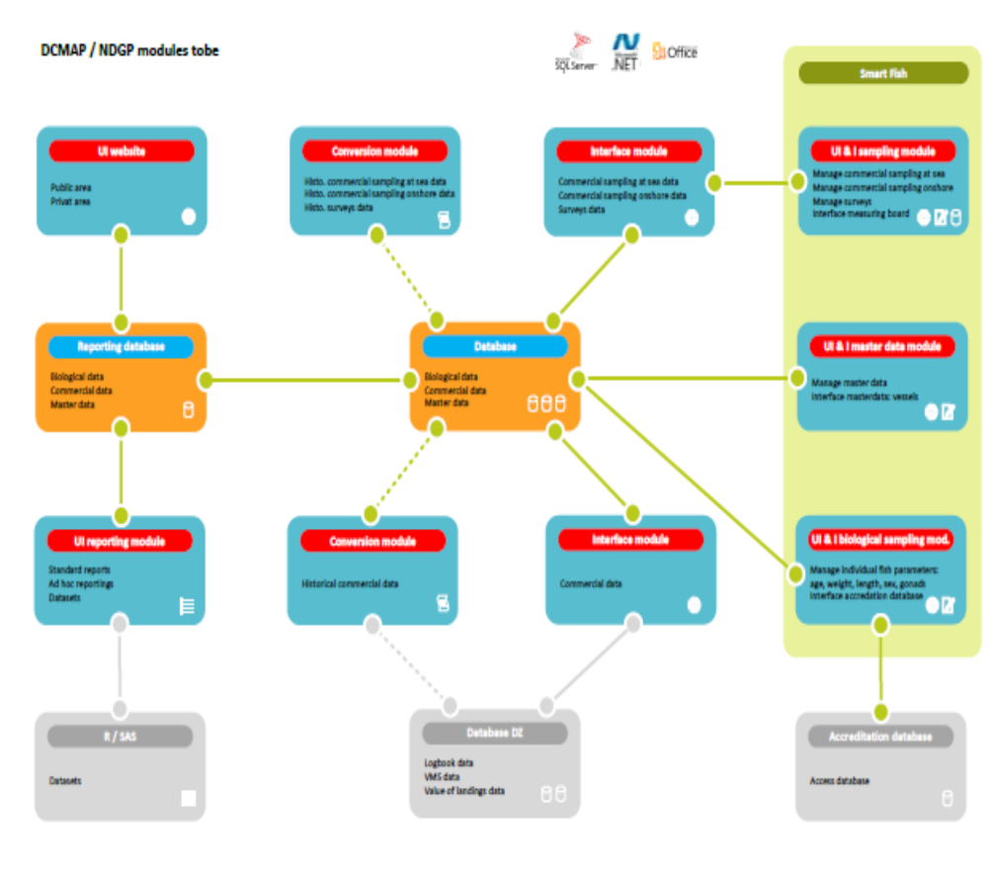

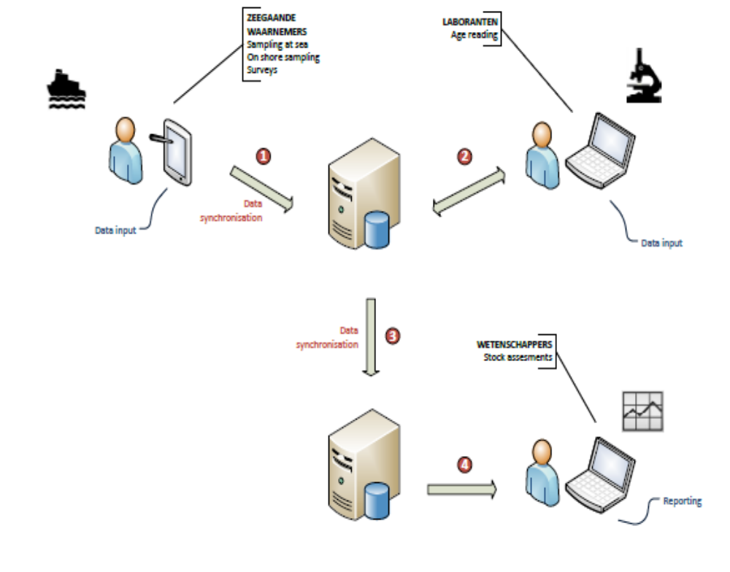

Figure2: General flow of data input

VII Follow up of STECF recommendations

The recommendations, dealt with in this section, are addressed to the MS by the STECF EWG in 2010 and 2011. The recommendations for 2012 originate from the STECF reviews (in the STECF plenary reports) of the EWG held in 2012.

STECF EWG in 2010
The following recommendations were selected from the SGRN 10-02 and SGRN 10-03. The selection contains the recommendation which are considered relevant to Belgium or the MS in general.
No final SGRN 10-01 report is available (also not on the JRC website). In a draft report, provided by a participant of the meeting, no recommendations are highlighted.
The numbering of recommendations of SGRN 10-02 is applied by the MS. In the report of SGRN 10-03, no recommendations addressed to the MS were found.

2 Topic: Reporting of landings vs. retained catches
STECF SGRN 10-02  Recommendation | SGRN recommends using the term 'retained catches' instead of 'landings' throughout.
Follow-up actions needed | European Commission, MS, SGRN.
Responsible persons for follow-up actions
Time frame (Deadline)
MS response | MS considers this recommendation redundant

3 Topic: Data calls |  | VI-1
STECF SGRN 10-02  Recommendation | SGRN recommends MS to report technical problems with the upload of data in detail to JRC and DG MARE. The consistency of data with the DCF and Data Call lies in the responsibility of the Member States.
Follow-up actions needed | Member States to report technical uploading problems to JRC and DGMARE.  Member States to ensure consistency of the data with the DCF and Data Calls
Responsible persons for follow-up actions
Time frame (Deadline)
MS response | BE reports possible problems to JRC when applicable. MS strives for consistency of the data throughout all data calls.

4 Topic: Data calls |  | VI-1
STECF SGRN 10-02  Recommendation | SGRN recommends that all MS to thoroughly check the data quality before submitting them and to use the electronic upload procedure and eventual built-in automatic quality checks.  SGRN strongly recommends that all MS to submit data in the given time frame.
Follow-up actions needed | Member States to respect these recommendations
Responsible persons for follow-up actions
Time frame (Deadline)
MS response | BE respects these recommendations.

5 Topic: Data calls |  | VI-1
STECF SGRN 10-02  Recommendation | SGRN recommends MS to report problems with the upload of data in detail to JRC and DG MARE
Follow-up actions needed | Member States to report uploading problems to JRC and DG MARE.
Responsible persons for follow-up actions
Time frame (Deadline)
MS response | see topic 3

6 Topic: Transversal variables |  | VI-1
STECF SGRN 10-02  Recommendation | SGRN recommends that all MS to thoroughly check the data quality before submitting them and to use the electronic upload procedure and eventual built-in automatic quality checks.
Follow-up actions needed | Member States to respect these recommendations.
Responsible persons for follow-up actions
Time frame (Deadline)
MS response | MS agrees with this recommendation and has implemented internal quality checks of the data.

7 Topic: Fish processing industry |  | VI-1  IV-B3
STECF SGRN 10-02  Recommendation | SGRN recommends that MS should consult with the national statistical offices in order to improve efficiency and guarantee consistency in the data collection process. Efficiency can be improved because national statistical offices could already have information required to be collected under the DCF. Data consistency will be met if the same definitions are applied.  SGRN recommends that MS to follow the specification stated in the DCF and fully comply with future data calls on economic data related to the fish processing sector.
Follow-up actions needed | Member States to respect these recommendations.
Responsible persons for follow-up actions
Time frame (Deadline)
MS response | Member State started consulation with national statistical office about the data collection of the processing industry

STECF EWG in 2011
The following recommendations were selected from STECF EWG 11-02, EWG 11-08 and EWG 11-19. The selection contains the recommendation which are considered relevant to Belgium or the MS in general. The numbering of recommendations of EWG11-02 is applied by the MS. The numbering of the recommendations of the other EWG corresponds with those in their reports.

1 Topic: STECF, RCM and LM recommendations
STECF EWG 11-02  Recommendation | EWG 11-02 recommended that all relevant recommendations issued by RCMs, LM, STECF and its sub-groups should be compiled,
Follow-up actions needed | Compile the Information – Circulate to NC
Responsible persons for follow-up actions | Frans van Beek volunteered to do a list of STECF 2009 recommendations (see Annex 4) Recommendations are compiled in RCM report.
Time frame (Deadline) | By end April 2011
MS response | Frans van Beek has produced and distributed the list, Belgium has received this list

2 Topic: Co-operation between Control Authorities and the NP of the DCF
STECF EWG 11-02  Recommendation | EWG 11-02 recommends including in the new DCF, commitments for Member States to set up at national or regional level, a system to encourage cooperation between control authorities and the National Programmes of the DCF. The cooperation system should address all issues of relevance for the collection and processing of data to be collected under the CR and the DCF Follow Up Action Needed : Scope out requirements for such
Follow-up actions needed | Scope out requirements for such a co-operation
Responsible persons for follow-up actions | MS  DG MARE
Time frame (Deadline) | 2011 et seq.
MS response | MS agrees with this recommendation and will strive to implement such a system when needed.

3 Topic: Control Regulation and Sampling Plans for Vessels not Subject to Logbooks
STECF EWG 11-02  Recommendation | The CR includes commitments for MS to develop and implement sampling plans for vessels not subject to logbook requirements and landing declarations. EWG 11-02 recommends that when MS develop the sampling plans due notice is taken to the data requirements under the DCF. This could be done by actively involving at national level the DCF experts in the development of the sampling plans.
Follow-up actions needed | MS to Identify Sampling Plans under CR
Responsible persons for follow-up actions | MS Control Authority and DCF Personnel  DG MARES
Time frame (Deadline) | 2011 et seq.
MS response | This recommendation is not relevant for Belgium

3 Topic: Calculation of CV |  | III-B3
STECF EWG 11-08  Recommendation | EWG 11-08 recommends that information and description on the method/software used for calculation of CV’s should be included (or referred to) in the AR if not provided in NP.
Follow-up actions needed | Await review by STECF Plenary in July
Responsible persons for follow-up actions | DG MARE  MEMBER STATES
Time frame (Deadline) | After STECF July Plenary  Address in 2012
MS response | In the reply of the MS to the commenst of the evaluation of the AR2012, of this report contains a short description on the method/software used for calculation of CV’s including references. A paper with a description of the methods is in preparation  For Economic variables, MS has followed the suggested calculation of CV as provided in the definitions on the JRC website.

4 Topic: List of Meetings Attended |  | II-B2
STECF EWG 11-08  Recommendation | EWG 11-08 recommends for the AR tables, Table II.B.1 (list of eligible meetings) that is provided by the Commission should be used and all meetings and not only the meetings attended should be provided.
Follow-up actions needed | Await review by STECF Plenary in July
Responsible persons for follow-up actions | DG MARE, Member States
Time frame (Deadline) | After STECF July Plenary. Action in 2012
MS response | MS has followed this approach in the AR

5 Topic: Recommendations from LM, STECF
STECF EWG 11-08  Recommendation | EWG 11-08 recommends that STECF compiles the filtered LIST of recommendations by region (from the previous year) for use by Member States in compiling AR and NP. This list should be available on the DCF website.  MS put in a filtered list of Recommendations and show what actions that have been taken to follow up recs.  Amend the current guidelines to say only previous year recs. should be followed. (EWG 11-08 would point out that a recurring recommendation should be a guideline).
Follow-up actions needed | Await review by STECF Plenary in July
Responsible persons for follow-up actions | DG MARE, STECF, Member States
Time frame (Deadline) | After STECF July Plenary, Address in 2012
MS response | STECF has not taken this action. The approach of BE with dealing of regulation is explained in this report.

6 Topic: Derogations Table
STECF EWG 11-08  Recommendation | EWG 11-08 recommends that a table including derogations asked for and if granted or rejected to be included in the AR tables. Adjust Guidelines for AR to include this.
Follow-up actions needed | Await review by STECF Plenary in July
Responsible persons for follow-up actions | DG MARE, Member States
Time frame (Deadline) | After STECF July Plenary, Address in 2012
MS response | The guidelines to the 2012 AR have not been adjusted to this request. BE has provided a table with derogations in its NP.

7 Topic: Tables from NP included in AR
STECF EWG 11-08  Recommendation | EWG 11-08 recommends that. Table III.C.1 and III.C.2 III E 1 should not to be deleted from the AR. Maintaining the tables is what is expected. This should be included in the revision of the AR guidelines.
Follow-up actions needed | Await review by STECF Plenary in July
Responsible persons for follow-up actions | DG MARE, Member States
Time frame (Deadline) | After STECF July Plenary, Address in 2012
MS response | MS has not deleted any table from the AR

10 Topic: MS Website |  | VI-1
STECF EWG 11-08  Recommendation | EWG 11-08 recommends that MS set-up a website on their data collection. They are obliged (by DCF regulation) to do so. No MS mentioned or referenced in the AR to such websites.
Follow-up actions needed | Await review by STECF Plenary in July
Responsible persons for follow-up actions | DG MARE, Member States
Time frame (Deadline) | After STECF July Plenary. Address in 2012
MS response | MS has set up a DCF section in the ILVO website

11 Topic: MS unable to conduct a Survey |  | III-G3
STECF EWG 11-08  Recommendation | EWG 11-08 recommends that in cases that a research vessels is not available for carrying out a contribution to a DCF survey, that MS in question should demonstrate that it made all necessary efforts to carry out the survey. MS must make provisions so that such problems do not happen e.g. seek assistance from other MS or charter a vessel.
Follow-up actions needed | Await review by STECF Plenary in July
Responsible persons for follow-up actions | DG MARE, Member States
Time frame (Deadline) | After STECF July Plenary, Address in 2012
MS response | MS agrees with the recommendation. In the past, in such situation MS has managed to find replacing vessel capacity.

14 Topic: Capital Value Calculation |  | III-B3
STECF EWG 11-08  Recommendation | EWG 11-08 recommends that for the calculation of Capital value, all MS shall use PIM (Perpetual Inventory Method) in the future. A Workshop has already explained the method (DCF Workshop on Capital Valuation, Naples June 2011). MS should use this report in next AR. Also explore the need for a Training Workshop. This Report should be made available on the on DCF WEB site.
Follow-up actions needed | Await review by STECF Plenary in July
Responsible persons for follow-up actions | DG MARE, Member States
Time frame (Deadline) | After STECF July Plenary  Address in 2012
MS response | MS was not able yet to full fill this recommendation, in progress

16 Topic: AR TEMPLATE
STECF EWG 11-08  Recommendation | EWG 11-08 recommends that files with filters, hidden cells, track changes, coloured cells etc. should not be submitted in AR
Follow-up actions needed | Await review by STECF Plenary in July
Responsible persons for follow-up actions | DG MARE, Member States
Time frame (Deadline) | After STECF July Plenary, Address in 2012
MS response | Yes, MS agrees and applies

17 Topic: Guide Line Review |  | III-C3
STECF EWG 11-08  Recommendation | EWG 11-08 recommends that non conformities in the tables of the AR needs to be explained in the text.
Follow-up actions needed | Await review by STECF Plenary in July
Responsible persons for follow-up actions | DG MARE, Member States
Time frame (Deadline) | After STECF July Plenary, Address in 2012
MS response | Yes, MS will do so.

1 Topic: Annual Reports 2013 – Reporting of Adjustments to NP
STECF EWG 11-19  Recommendation | EWG 11-19 recommends that for Annual Report 2013, all the adjustments carried out by MSs must be clearly reported to illustrate the activities implemented in the reference year. This rule has to be applied to all kind of adjustments (minor, major, substantial etc etc) even in case MS have submitted or not a revised version of the National Program. All these “adjustments” should then appear in the relevant tables of the Annual Report Changes in AR tables with respect to the NP tables should be tracked in red.
Follow-up actions needed | Await review by STECF Plenary in April 2012
Responsible persons for follow-up actions | DG MARE , STECF, Member States, Data End Users
Time frame (Deadline) | During early 2012 after STECF Plenary April 2012
MS response | This recommendation is unclear. Also, if this is relevant, it should be dealt with in the guidelines.

2 Topic: Metier Ranking System
STECF EWG 11-19  Recommendation | According to Commission Decision 93/2010, all MS performing the ranking system should use the average values of the 2 previous years. EWG 11-19 recommends that MS (even if they submitted or not a revised version of the National Program) use the most update set of values (i.e. landing values, tons, fishing days) in order to select the metiers to be sampled.
Follow-up actions needed | Await review by STECF Plenary in April 2012
Responsible persons for follow-up actions | DG MARE , STECF, Member States, Data End Users
Time frame (Deadline) | During early 2012 after STECF Plenary April 2012
MS response | BE does partly agree with this recommendation. The programme is made for a period of three years and if a rec alculation of petiers is used, the harmonistaion of the data collection could be hampered; On the other hand, it is of importance that the correct data are sampled, in order to follow up the actual situations.

5 Topic: On the revision of the National Programmes within a Programme Period
STECF EWG 11-19  Recommendation | EWG 11-19 recommends that revisions in the text of the NP proposals within the programme period should be done in a way allowing the reader to follow the development in the MS. This means that all information valid for the first years of the triennial programme should be kept and not deleted. For example, if a pilot study was carried out in 2011 and the NP for 2012 was revised in accordance with the result from the pilot study, information about the pilot study should be kept in the text of the NP, specifying that this was the situation in 2011, and description of the related modifications should be added, specifying that this was the revised situation for 2012.
Follow-up actions needed | Await review by STECF Plenary in April 2012
Responsible persons for follow-up actions | DG MARE , STECF, Member States
Time frame (Deadline) | During early 2012 after STECF Plenary April 2012
MS response | MS does not agree with the recommendation. The NP for a specific year should contain the intended actions and not the history of the actions done in the past. These can be found in NP’s of previous years.

14 Topic: Issues identified from a Brainstorm of the DCF
STECF EWG 11-19  Recommendation | EWG 11-19 recommends that the issues raised during the DCF brainstorm session (list of 46) should be used to inform the debate on the new DCF. The focus should be on addressing these issues rather than identifying new issues.
Follow-up actions needed | Await review by STECF Plenary in April 2012
Responsible persons for follow-up actions | DG MARE , STECF, Member States, Data End Users
Time frame (Deadline) | During early 2012 after STECF Plenary April 2012
MS response | This recommendation is incorrectly addressed to the MS

15 Topic: Updated SWOT on DCF
STECF EWG 11-19  Recommendation | EWG 11-19 recommends that the updated SWOT analyses (Table 3.2) should be used to inform the debate on the new DCF. The focus should be on addressing the issues in the SWOT rather than identifying new issues.
Follow-up actions needed | Await review by STECF Plenary in April 2012
Responsible persons for follow-up actions | DG MARE , STECF, Member States, Data End Users
Time frame (Deadline) | During early 2012 after STECF Plenary April 2012
MS response | This recommendation is incorrectly addressed to MS

16 Topic: STECF Comments and Recommendations on new DCF
STECF EWG 11-19  Recommendation | EWG 11-19 recommends that the 18 issues outlined in the Table 4.1 of this report are included in the discussion on a new DCF during the early part of 2012.
Follow-up actions needed | Await review by STECF Plenary in April 2012
Responsible persons for follow-up actions | DG MARE , STECF, Member States, Data End Users
Time frame (Deadline) | During early 2012 after STECF Plenary April 2012
MS response | This recommendation is incorrectly addressed to MS

17 Topic: Concurrent Sampling
STECF EWG 11-19  Recommendation | EWG 11-19 recommends that for on-shore sampling, MS should continue to sample the metiers and make sure to cover all the species/stocks where a demand is formulated by an end-user (or listed in Appendix VII of the Comm. Dec.), but the methodology used to achieve the goals remains at the discretion of the MS, provided that it is fully documented and approved within their NP proposal.
Follow-up actions needed | Await review by STECF Plenary in April 2012
Responsible persons for follow-up actions | DG MARE , STECF, Member States, Data End Users
Time frame (Deadline) | During early 2012 After STECF Plenary April 2012
MS response | MS agrees with the recommendation and proposes to apply the concept in the revision of the DCF.

STECF EWG in 2012
The following recommendations were selected from STECF PLEN-01, PLEN 12-02 and PLEN 12-03. In its second meeting in 2012 STECF stated that conclusions and recommendations from EWG reports are NOT the opinion of the STECF before review and adoption by the committee. Therefore, recommendations were collected not from the EWG reports but from STECF. This section presents a selection of recommendation which apply to data collection and which are considered relevant to Belgium or the MS in general. The numbering of the selected recommendations is applied by the MS.

1 Topic: National Progamme and Annual Report
STECF PLEN 12-01  Recommendation | In order to facilitate enhancements in the NPs, STECF recommends that the Commission should:  - include in the guidelines definitions of minor, major, or substantial changes (e.g. methodological issues, sampling design, changing in the surveys, derogations etc etc).  - request all MS to include a summary page giving a brief overview of the main revision made to the NP.  - publish the list of all relevant recommendations from STECF, RCM, Liaison meetings in the data collection web site.  STECF recommends that the Commission provide to the NP review group, the original text and the proposed NP revisions for ease of comparison. The final version of the approved NP is what should appear on the DCF website. This website is currently not up to date.
Follow-up actions needed
Responsible persons for follow-up actions | Commission
Time frame (Deadline)
MS response | MS endorses the recommendation and regrets that no list of relevant recommendations of STECF has been provided so far.

2 Topic: Overview of selectivity of gears used in EU fisheries
STECF PLEN 12-01  Recommendation | STECF recommends that a more detailed analysis of discard data gathered under the Data Collection Framework should be undertaken to provide a quantitative rather than a qualitative assessment and this analysis be used to identify the level of discards for the aggregated fleets.
Follow-up actions needed
Responsible persons for follow-up actions
Time frame (Deadline)
MS response | MS strongly supports this recommendation. Belgium has started a quantitative analyses in 2013 and urges other MS also to do so. The information is relevant to for the implementation of the landing obligation under the new CFP. The Netherlands also would support an initiative to coordinate this internationally.

3 Topic: International dimension
STECF PLEN 12-02  Recommendation | STECF recommends that FPAs be based on management plans, which should include management objectives, harvest control rules, TAC or effort allocation keys and should be supported by data collection programs, scientific advice and monitoring.
Follow-up actions needed
Responsible persons for follow-up actions
Time frame (Deadline)
MS response | MS supports this recommendation. Future legislation on data collection should accommodate for this.

4 Topic: fishing effort data call
STECF PLEN 12-02  Recommendation | STECF would like to reiterate its recommendation from STECF PLEN-11-03 that data collected under different EU programs and DCF have to be compatible if bioeconomic modeling should be further developed and improved. In particular, there is an urgent need to harmonize gear and area descriptors between economic and biological data calls, as well as to improve the consistency of transversal data such as effort and landings by fleet and métier across these data calls. At present, economic data are only available for aggregated groups of vessels assigned to a single majority activity (to preserve confidentiality) without detailed information on their actual fishing activities, while biological data are collected at the scale of fishing activities =(or métiers) without insights of how individuals select different combinations of activities, making the two data sets largely irreconcilable as they are currently requested under Data Calls. In practice, it might be possible to link the two through allocation to fleets and métiers of logbooks data crossed with fleet register. STECF emphasizes that the DCF needs to explicitly improve this link.
Follow-up actions needed
Responsible persons for follow-up actions
Time frame (Deadline)
MS response | MS agrees, but it is unclear what kind of action has to be taken by who and when.

5 Topic: STECF advice from July 2012 on tuna fisheries where sharks are associated species
STECF PLEN 12-03  Recommendation | To facilitate data collection and accurate documentation and reporting of catches, STECF recommends that any sharks caught in FPA fisheries should be retained and landed whole (with fins wholly or partly attached to their respective carcass).
Follow-up actions needed
Responsible persons for follow-up actions
Time frame (Deadline)
MS response | The recommendation does not apply to Belgium

.

VIII List of acronyms and abbreviations
ACOM ICES Advisory Committee
ALK Age-length-key
AMAWGC ICES Annual Meeting of Advisory-related Working Group Chairs
AR Annual Report
BTS Beam Trawl Survey
CEFAS Centre for Environment, Fisheries and Aquaculture Science (England)
CL Carapace length (standard measure for whole Nephrops)
CPUE Catch per unit effort
DCF Data Collection Framework
DYFS Demersal Young Fish (and Brown Shrimp) Survey
DZV Dienst Zee Visserij
EC European Commission
EP Extended Programme under the requirements of the DCF
EWG 11-18 Review of economic data collected in relation to the DCF and harmonisation of sampling strategies
FTE Full Time Equivalent
FU Functional Unit (geographical definition of Nephrops stocks)
GT Gross tonnage
ICES International Council for the Exploration of the Sea (Denmark)
ICES BRG ICES Baltic Review Group
ICES CSRG ICES Celtic Sea Review Group
ILVO Institute for Agriculture and Fisheries Research (Belgium) (successor of Centre for Agricultural Research, CLO)
IMARES Institute for Marine Resources & Ecosystem Studies (Netherlands)
JRC Joint Research Centre (Italy)
LOA Length over all
LPUE Landings per unit effort
MoU Memorandum of Understanding
MP Minimum Programme under the requirements of the DCF
MS EU Member State(s)
NP National Proposal
NDGP (Belgian) National Data Gathering Programme
PCU Price Per Capacity
PGCCDBS ICES Planning Group on Commercial Catch, Discards and Biological Sampling
PGECON ICES Planning Group on Economic Issues
RAC Regional Advisory Council
RCM Regional Co-ordination Meeting
RCM NEA Regional Co-ordination Meeting for the North-East Atlantic
RCM NS&EA Regional Co-ordination Meeting for the North Sea & the East Arctic
RDB Regional Database
RFO Regional Fisheries Organisation
SGMix STECF Sub-group on Mixed Fisheries
SGRN STECF Sub-group on Research Needs
SGRST STECF Sub-group on Review of Stock Status
STECF Scientific, Technical and Economic Committee on Fisheries
TAC Total Allowable Catch
WKACCU Workshop on Methods to Evaluate and Estimate the Accuracy of Fisheries Data used for Assessment
WGBEAM ICES Working Group on Beam Trawl Surveys
WGCRAN ICES Working Group on the Life History, Population Biology and Assessment of Crangon Stocks
WGEF ICES Working Group on Elasmobranch Fishes
WGHMM ICES Working Group on the Assessment of Southern Shelf Stocks of Hake, Megrim and Monk
WGMIXMAN ICES Workshop on Simple Mixed Fisheries Management Models
WKMOG Workshop on Maturity Ogive Estimation for Stock Assessment
WGNEPH ICES Working Group on the Assessment of Nephrops Stocks
WGNEW ICES Working Group on New MoU Species
WGNSDS ICES Working Group on the Assessment of Northern Shelf Demersal Stocks
WGNSSK ICES Working Group on the Assessment of Demersal Stocks in the North Sea and Skagerrak
WGQAF ICES Working Group on Quantifying All Fishing Mortality
WGSSDS ICES Working Group on the Assessment of Southern Shelf Demersal Stocks
WKDRP ICES Workshop on Discard Raising Procedures
WKMAT ICES Workshop on Maturity
WKMSCHWS ICES Workshop on Maturity staging of Cod, Haddock, Whiting and Saithe
WKNEPH ICES Workshop on Nephrops Stocks (successor of WGNEPH)
WKSCMFD ICES Workshop on Sampling and Calculation Methodology for Fisheries Data

IX Comments, suggestions and reflections
The use of drop down lists in the excel tables would limit the possibilities for recording data in certain columns. For example, the list of variables in the III.E.3 table could easily be put in a hidden spreadsheet and used as a drop down list in table III.E.3. This would greatly reduce the confusion encountered when completing the Tables.

X References

- Council Regulation (EC) No 199/2008 of 25 February 2008 concerning the establishment of a Community framework for the collection, management and use of data in the fisheries sector and support for scientific advice regarding the Common Fisheries Policy

- 2010/93/EU Commission Decision of 18th December 2009 adopting a multiannual Community programme pursuant to Council Regulation (EC) No 199/2008 establishing a Community framework for the collection, management and use of data in the fisheries sector and support for scientific advice regarding the common fisheries policy

- 9th Liaison Meeting – Final Report 2012_10_30, 97pgs.

- RCMNS&EA _ 2012 Report: https://groupnet.ices.dk/rcm2012/nsea/default.aspx

- RCMNEA _ 2012 Report : https://groupnet.ices.dk/rcm2012/na/default.aspx?PageView=Shared

- Study N° FISH/2005/03 on the evaluation of the capital value, investments and capital costs in the fisheries sector
- • Study FISH/2005/14 and amendments made by SGECA 07-01 report (15-19 January 2007, Salerno).

XI Annexes

Annex 1

Collection of economic data of the fisheries sector
Questionnaire

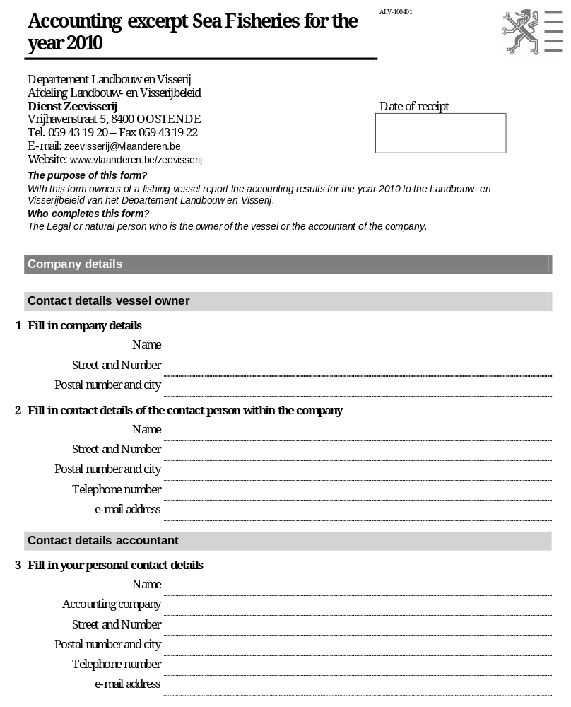

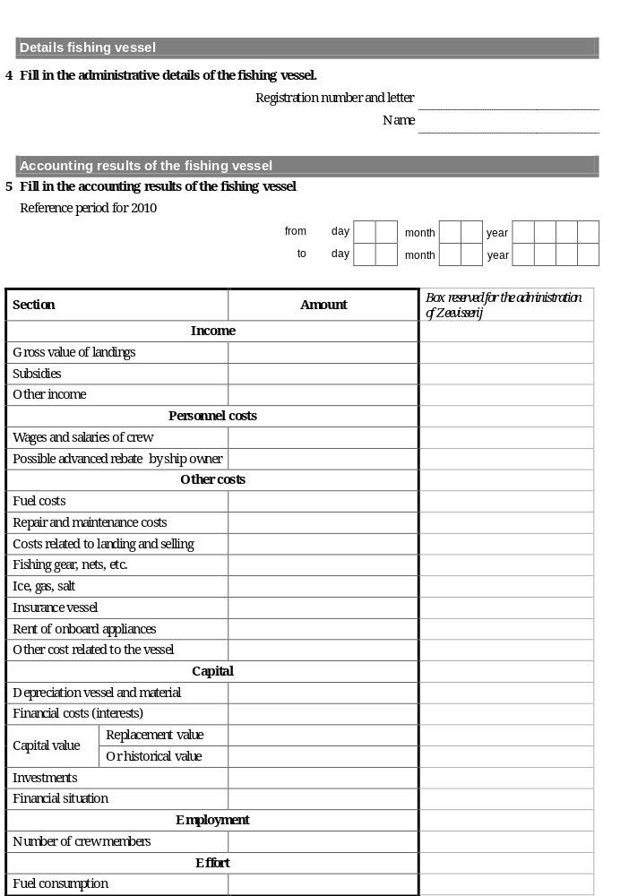

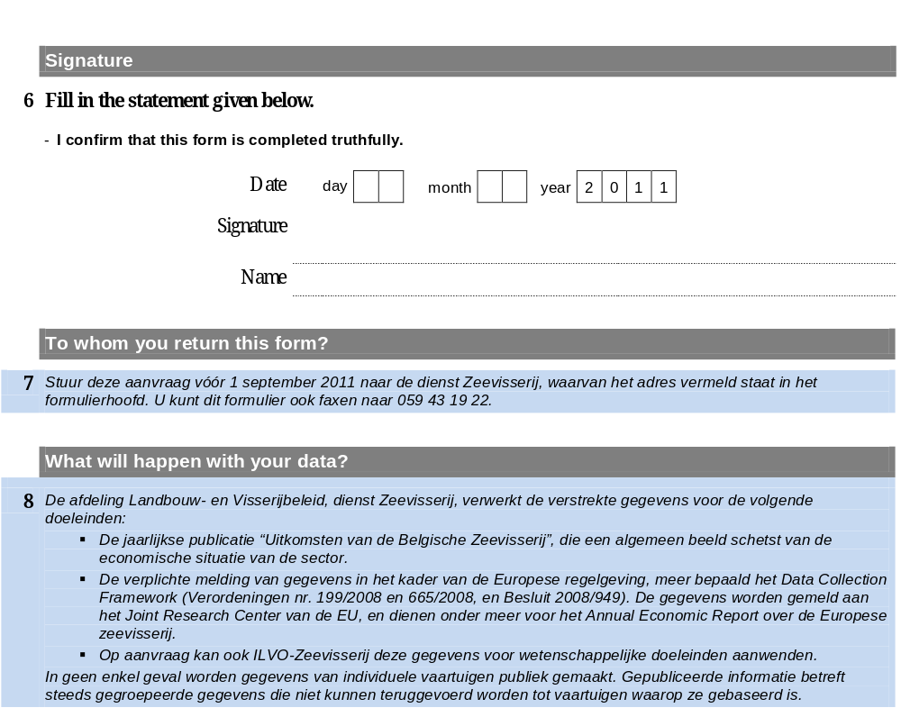

Annex 2

Collection of economic data of the fisheries sector
Variables definitions

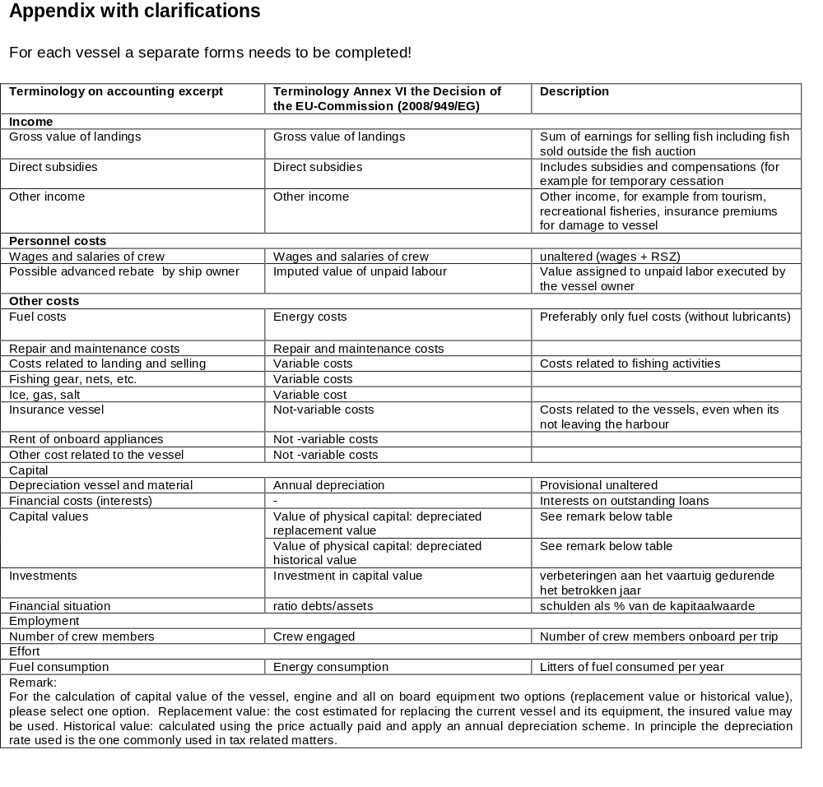

Annex 3

2012 Survey of the fish processing industry
Questionnaire
Bedrijf
Addres
Tel. (algemeen)
E-mail (algemeen)
Website
Contactpersoon
Functie
Tel.
E-mail
Gelieve de definities te hanteren zoals vermeld in bijgevoegd document
Opbrengsten uit goederen en diensten
Euro
Subsidies
2
Euro
Andere opbrengsten
Euro
Loonkosten
3
Euro
Toegerekende waarde onbetaalde arbeid
Euro
Euro
Euro
Euro
Kapitaalafschrijvingen
Euro
Financiële kosten, netto
Euro
Euro
Euro
Euro
Euro
Mannelijke werknemers
Number
Vrouwelijke werknemers
Number
FTE
Number
Hartelijk dank voor uw medewerking.

Enquête Visverwerkende Nijverheid - 2013
Contact gegevens

Kapitaalkosten

Referentie jaar
1

Bedrijfsopbrengsten
Personeelskosten
Energiekosten
Aankoopgrondstoffen
Andere productiekosten
4

Gelieve het ingevulde en opgeslagen (!) formulier terug te bezorgen aan
Els Torreele, ILVO-Visserij, Ankerstraat 1, 8400 Oostende
E-mail: fish.forms@ilvo.vlaanderen.be
Uitzonderlijke kosten, netto
Kapitaalwaarde
5
- Totale waarde van de activa
Investeringen, netto
6
Schulden
7
Tewerkstelling
Opmerkingen
Annex 4

Survey of the fish processing industry
Variables definitions

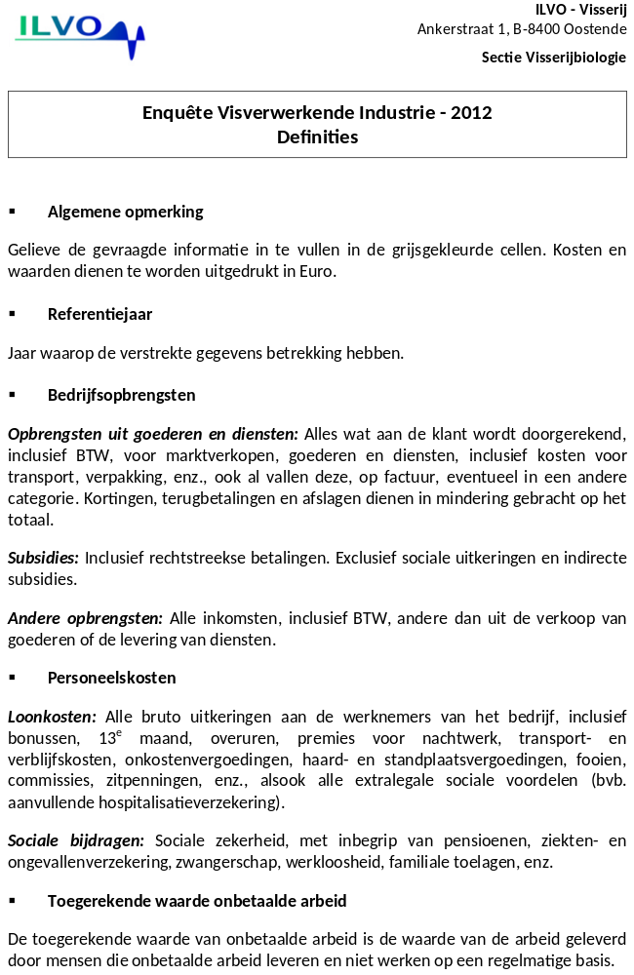
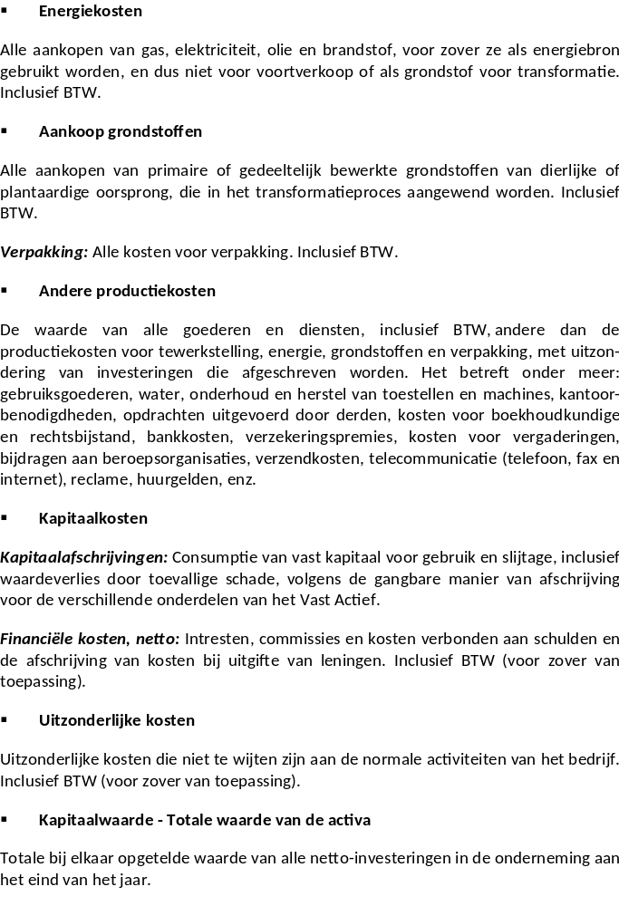

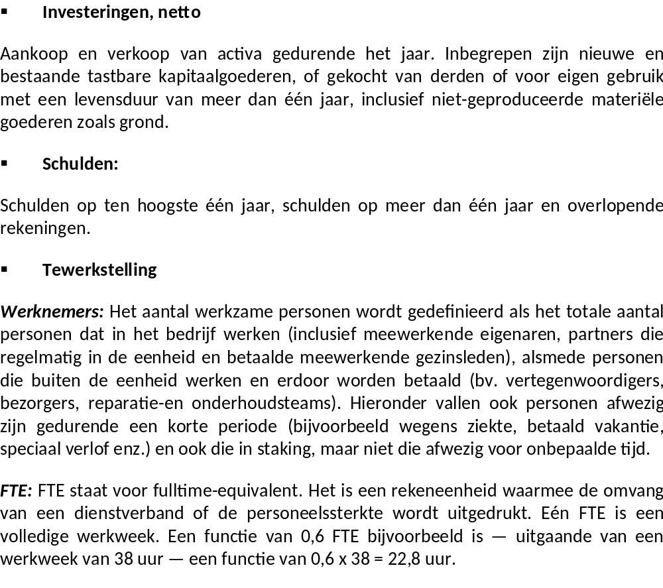

() ICES (2007): Report of the Planning Group on Commercial Catch, Discards and Biological Sampling, ICES Advisory Committee on Fisheries Management, ICES CM 2007/ACFM:09, page 68.

