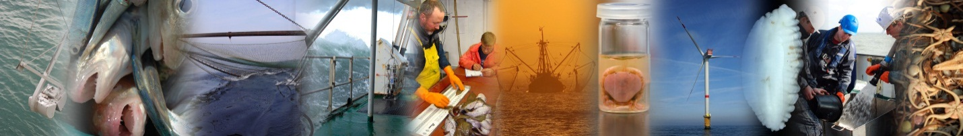
National Data Gathering Program
under EC Regulation 199/2008

Belgium
AR2011
ILVO - Fisheries (Oostende, Belgium) Sea Fisheries Service (Oostende, Belgium) ILVO- Social Sciences Unit (Merelbeke, Belgium) BMM-MUMM- Research Institute (Brussels, Belgium)
5/31/2012

Version control
Version 3:
Annual_Report_2011_BE_v1.docx is the original version of the report submitted at May 31, 2011.

Annual_Report_2011_Text_version3.docx is the original version of the report submitted at May 31, 2011with editorial changes

The corresponding standard tables are submitted in an Excel file:
Annual_Report_2011_BE_Standard_Tables_v1.xlsx

The corresponding cost statement is submitted in an Excel file:
Annual_Report_2011_BE_FinForms_v1.xlsx

Contents
I General framework 6
II. National Data Collection Organisation 12
II.A.2 National organisation and co-ordination 13
II.B Regional and International co-ordination 14
II B 1 Attendance of International meetings 14
II B 2 Follow-up of regional and international recommendations 14
III. Module of evaluation of the fishing sector 23
III A General description of the fishing sector 23
III B Economic Variables 23
III.CBiological - Métier-related variables 26
III.E Stock-related variables 39
North Sea and Eastern Channel — ICES areas IV, VIId 39
North East Atlantic and Western Channel — ICES areas V, VI, VII (excluding d), VIII, IX, X, XII, XIV 41
III F Transversal Variables 45
III.F.1 Capacity 45
III.F.2 Effort 45
III.F.3 Landings 48
III G Research surveys at sea 49
IV Module of the evaluation of the economic situation of the aquaculture and processing industry 53
IV A Collection of data concerning aquaculture 53
IV B Collection of data concerning the processing industry 55
V Module of evaluation of the effects of the fishing sector on the marine ecosystem 57
V 1 Achievements: results and deviation from NP proposal 57
V 2 Actions to avoid shortfalls 57
VI 1 Achievements: results and deviation from NP proposal 58
VI 2 Actions to avoid shortfalls 59
VII Follow up of STECF recommendations 60
VIII List of acronyms and abbreviations 62
IX Comments, suggestions and reflections 64
XI Annexes 65

I General Framework
This document presents the Annual Report (AR) on the work carried according to the Belgium National Programme (NP) for data collection in the fisheries sector for the year 2011. The programme has been carried out in accordance with the rules laid down in the “Commission Regulation (665/2008) and Commission Decision (2010/93/EC) adopting a multi annual Community programme pursuant to Council Regulation (EC) No 199/2008 establishing a Community framework for the collection, management and use of data in the fisheries sector and support for scientific advice regarding the Common Fisheries Policy”, hereafter referred to as “DCF” in this AR.
The format of this report is structured following the most recent guidelines from the Commission. The AR is structured in a number of modules. In the following chapters a description is given of the activities related to the DCF that have been carried out by Belgium.
Furthermore, the EC has established provisions to facilitate the cooperation between MS with the regard to the collection of data. These are Regional Coordination Meetings (RCM), formal (bilateral) agreements with other MS and in the future regional databases. As far as the conclusions and agreements of the meetings are relevant for the regional data collection and for Belgium they have been taken into account in this AR.
In addition to this AR a financial report for the 2011 programme has been made. The financial report of the costs is presented in separate spreadsheets in the FinForms formats as provided by the Commission.

Belgian fishing industry – small and complex

In previous years, the idea of having a 'restricted' list of species for which landings data are recorded, has repeatedly been labelled as a 'non-conformity' by the External Evaluators. However, as already explained on several occasions in the NP proposals, there is a rationale behind the idea of the restricted list. Species that do not figure in the restricted list are not deliberately omitted from the data recording system – they are simply not landed by the Belgian fleet in quantities of any importance. As such, the list should not be seen as an attempt 'to get away with the minimum', but rather as a reflection of the actual composition of the Belgian fish and shellfish landings. In its evaluation of the 2004 and 2005 NP proposals (the issue was not raised by the External Evaluators in relation to the 2006 NP Proposal), SGRN stated that it saw no contradiction between the requirements of the DCF and the use of a restricted list, "as long as the 'restricted list' is a correct reflection of the species composition of the landings". Belgium has repeatedly confirmed that this is the case (see e.g. SEC (2004) 179, page 16, and SEC (2005) 255, page 26.
No data are reported for the variables for which no data are collected within the framework of the above described data collection scheme or for the variables which are not associated with the fishing techniques used by the Belgian fleet.
In Belgium, effort and landings data are collected in two ways: from logbooks and from sales notes. The logbooks contain extensive information on the retained catches and their species composition by haul (albeit with certain restrictions – see bullet point 2 underneath), but they do not contain information on the size composition (in terms of market categories) of the retained catches. The sales notes on the other hand, contain information on the quantities auctioned by market category for all species landed (and not just for the species recorded in the logbooks – again see bullet point 2), but they do not provide information on the exact origin (in terms of statistical rectangles) of the landings. The two systems are equally important to the Belgian data collection system, they are complementary, and the combination of the two has clear advantages:
- The two approaches yield independent estimates of the retained and landed portions of the catches, and can thus be used for quality control and validation purposes. This helps improving the reliability of the landings figures.
- In the Logbook Regulation, it is stipulated that "only catches of an amount greater than 50 kg of live-weight equivalent of any species retained on board must be recorded in the logbook" (Article 2.4.2. of Annex V of Commission Regulation (EEC) No. 2807/83), the consequence being that small by-catches of fish and shellfish often remain unrecorded in the logbooks. These quantities however, are picked up in the sales notes, which helps improving the species coverage and hence the comprehensiveness of the landings statistics.
- As already mentioned in, roughly one fifth of all fish and shellfish taken by Belgian vessels in the southern and central North Sea are auctioned abroad, mostly in the Netherlands. Also, vessels making consecutive fishing trips in distant waters before returning to their homeport in Belgium, may sell part of their catches during their stop-overs in a foreign harbour. Data on the sales abroad are collected by local authorities from sales notes and submitted to the Sea Fisheries Service for incorporation in the Belgian national fishstats database. This requires additional quality checks and codification, to ensure that the imported data are compatible with the recipient database.
- Last but not least, the landings data by market category are of critical importance to the biological data collection programme on the landings, which heavily relies on stratified sampling by market category.
The dual approach (logbooks and sales notes) is advocated by the ICES Planning Group on Commercial Catch, Discards and Biological Sampling (PGCCDBS) as a means to validate the different sources of information on catches and landings. In its 2007 report (), the PGCCDBS states that "In order to establish quality indicators that can be used to evaluate / estimate the accuracy of the fishery statistics and biological information about the catches, it is necessary to make use of different sources of information and analyse the consistency between them with regards to the relevant parameters. Such a quality control thus needs to check different sources for the same information, e.g. logbooks compared with sale slips from the same vessel and/or trip". This is exactly what has been done for several years now in Belgium.
  - The problem of the 'restricted' list
In the past, the idea of having a 'restricted' list of species for which landings data are recorded, has been labelled as a 'non-conformity' by the External Evaluators. There is, however, a rationale behind the idea of the restricted list. Species that do not figure in the restricted list are not deliberately omitted from the data recording system – they are simply not landed by the Belgian fleet in quantities of any importance. As such, the list should not be seen as an attempt 'to get away with the minimum', but rather as a reflection of the actual composition of the Belgian fish and shellfish landings. There is a historical background to the restricted list, which is based on the peculiarities of the Belgian sea fisheries:
- The geographical distribution of Belgian fishing effort is limited to the North Sea, the English Channel, the Irish Sea, the Celtic Sea, South of Ireland and the inner part of the Bay of Biscay. The consequence being, that all typically boreal and Lusitanian species are absent from the landings.
- Belgium has no industrial, no distant and no deep-water fisheries. Again, this implies that all species which are typical to such fisheries are absent from the landings.
In its evaluation of the 2004 and 2005 NP proposals (the issue was not raised by the External Evaluators in relation to the 2006 and 2007 NP proposals), SGRN stated that it saw no contradiction between the requirements of the DCR and the use of a restricted list, "as long as the 'restricted list' is a correct reflection of the species composition of the landings". Belgium has repeatedly confirmed that this is the case (see e.g. SEC (2004) 179, page 16, and SEC (2005) 255, page 26).
  - The problem of 'mixed' landings
Belgium has taken notice of SGRN's recommendation that "pilot studies shall be implemented, where relevant, to obtain a better understanding of the composition of mixed species categories" (SEC (2003) 101, page 11).
In the Belgian fish and shellfish landings, a distinction must be made between two categories of mixed landings:
- Mixed landings of (relatively) large quantities of fish pertaining to the same group of species, such as Lepidorhombus spp., Lophius spp. and Raja spp.
For Lophius and the Rajidae, partitioning of the landings by species is done as part of the routine length and age sampling programmas (for details, see Section 8.1).
The landings of Lepidorhombus spp. are too small (≈ 160 t live weight annually for all areas combined) to justify dedicated sampling for species segregation purposes.
- Mixed landings and sales of fish and shellfish in quantities that are too small to be auctioned separately.
These mixed sales are of an extremely variegated and variable nature, and they never represent more than a few kilograms per voyage. The cost for setting up a system to disaggregate such mixed landings would be disproportionate compared to the increase in precision that might be achieved.
In the current data system collection, this category of mixed landings is recorded as 'Other demersals', 'Other pelagics', etc., together with the landings of species that are not in the restricted list. It is worth noticing that the 'Other' categories represent less than 2 % of the total Belgian landings (see table on page 10). In view of this, the omission of the quantities that end up in the 'Other' categories from the species-wise totals, hardly affects the reliability of the latter, and the final figures remain well within the margins of the precision levels required by the DCR. As the data collection was exhaustive, it is not meaningful to apply any data quality issues in the context of the DCF.
For completeness of the reply by MS, the problem of the 'restricted' list is situated as described in the AR2009 and AR2010 as well.
In the past, the idea of having a 'restricted' list of species for which landings data are recorded, has been labelled as a 'non-conformity' by the External Evaluators. There is, however, a rationale behind the idea of the restricted list. Species that do not figure in the restricted list are not deliberately omitted from the data recording system – they are simply not landed by the Belgian fleet in quantities of any importance. As such, the list should not be seen as an attempt 'to get away with the minimum', but rather as a reflection of the actual composition of the Belgian fish and shellfish landings. There is a historical background to the restricted list, which is based on the peculiarities of the Belgian sea fisheries:
- The geographical distribution of Belgian fishing effort is limited to the North Sea, the English Channel, the Irish Sea, the Celtic Sea, South of Ireland and the inner part of the Bay of Biscay. The consequence being, that all typically boreal and Lusitanian species are absent from the landings.
- Belgium has no industrial, no distant and no deep-water fisheries. Again, this implies that all species which are typical to such fisheries are absent from the landings.

In its evaluation of the previous NP proposals (the issue was not raised by the External Evaluators in relation to the 2006, 2007 and 2008 NP proposals), SGRN stated that it saw no contradiction between the requirements of the DCR and the use of a restricted list, "as long as the 'restricted list' is a correct reflection of the species composition of the landings". Belgium has repeatedly confirmed that this is the case (see e.g. SEC (2004) 179, page 16, and SEC (2005) 255, page 26).
Belgium has taken notice of SGRN's recommendation that "pilot studies shall be implemented, where relevant, to obtain a better understanding of the composition of mixed species categories" (SEC (2003) 101, page 11).
In the Belgian fish and shellfish landings, a distinction must be made between two categories of mixed landings:
- Mixed landings of (relatively) large quantities of fish pertaining to the same group of species, such as Lepidorhombus spp., Lophius spp. and Raja spp.
For Lophius and the Rajidae, partitioning of the landings by species is done as part of the routine length and age sampling programmes.
The landings of Lepidorhombus spp. are too small (≈ 160 t live weight annually for all areas combined) to justify dedicated sampling for species segregation purposes.
- Mixed landings and sales of fish and shellfish in quantities that are too small to be auctioned separately.
These mixed sales are of an extremely variegated and variable nature, and they never represent more than a few kilograms per voyage. The cost for setting up a system to disaggregate such mixed landings would be disproportionate compared to the increase in precision that might be achieved.
In the current data system collection, this category of mixed landings is recorded as 'Other demersals', 'Other pelagics', etc., together with the landings of species that are not in the restricted list. It is worth noticing that the 'Other' categories represent less than 2 % of the total Belgian landings. In view of this, the omission of the quantities that end up in the 'Other' categories from the species-wise totals, hardly affects the reliability of the latter, and the final figures remain well within the margins of the precision levels required by the DCF. Specific fishing effort is derived from the landings and effort data, and again, can be reported by fleet segment, gear type and ICES Sub-area as requested by the DCF, or by any other type of spatial or temporal aggregation. Species-specific effort is available for all species in Appendix VI of the DCF (in as much as they are caught and landed in sensible quantities by the Belgian fleet).
In Belgium, effort and landings data are collected in two ways:
- from logbooks and
- from sales notes.

The logbooks contain extensive information on the retained catches and their species composition by haul (albeit with certain restrictions), but they do not contain information on the size composition (in terms of market categories) of the retained catches. The sales notes on the other hand, contain information on the quantities auctioned by market category for all species landed (and not just for the species recorded in the logbooks), but they do not provide information on the exact origin (in terms of statistical rectangles) of the landings. The two systems are equally important to the Belgian data collection system, they are complementary, and the combination of the two has clear advantages with regards to species coverage and data quality.

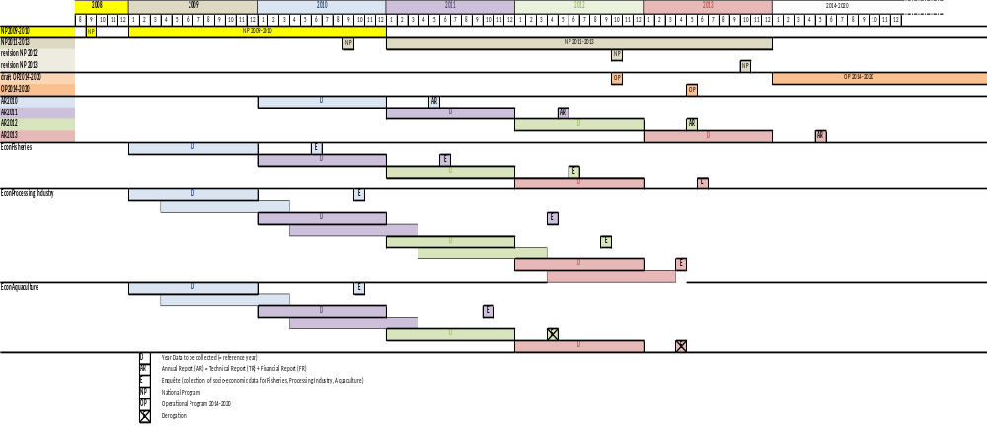

II. National Data Collection Organisation
II.A. National correspondent and participating institutes

National correspondent
The Belgian National Correspondent in 2011 was Dr. Kris COOREMAN. He is employed as the scientific director at ILVO Fisheries, Ostend, Belgium.
Dr. Kris Cooreman
Scientific Director
Instituut voor Landbouw en Visserij Onderzoek (ILVO) - Visserij
Ankerstraat 1, B-8400 Oostende, Belgium
Phone: + 32 (0)59 56.98.20 (direct) or + 32 (0)59 34.22.50 (operator)
Fax: + 32 (0)59 33.06.29
E-mail: kris.cooreman@ilvo.vlaanderen.be

Since April 2012, the Belgian national Correspondent is MSc ir. Els TORREELE, Head of Reaserch Group Fisheries Biology, ILVO-Fisheries, Ostend, Belgium

MSc. Ir. Els Torreele
Head of Research Group Fisheries Biology,
Instituut voor Landbouw en Visserij Onderzoek (ILVO) - Visserij
Ankerstraat 1, B-8400 Oostende, Belgium
Phone: + 32 (0)59 56.98.33 (direct) or + 32 (0)59 34.22.50 (operator)
Fax: + 32 (0)59 33.06.29
E-mail: els.torreele@ilvo.vlaanderen.be

Participating institutes
In Belgium, the Ministry of Agriculture and Fisheries, Department Fisheries, is the administrative authority responsible for fisheries and fisheries issues.
The work regarding the Belgium National Data Gathering program is carried out by the following partners:
- Ministry of the Flemish Community - Policy Domain Agriculture & Fisheries
The collection of information on fishing capacity, fishing effort, landing statistics and economics of the fisheries sector, the aquaculture and the processing industry, is done by the Sea Fisheries Department (DVZ) and VISEO (ILVO)

Dienst Zeevisserij - Sea Fisheries Departement
Administratief Centrum
Vrijhavenstraat 5, B-8400 Oostende, Belgium
Phone: + 32 (0)59 43.19.20
Fax: + 32 (0)59 80.76.93
URL: www2.vlaanderen.be/ned/sites/landbouw/visserij/index.html

Instituut voor Landbouw en Visserij Onderzoek (ILVO) - Institute for Agriculture and Fisheries Research
ILVO-Social Science Unit
Burg. van Gansberghelaan 115 box 2, 9820 Merelbeke, Belgium
Phone: +32 (0)9 272 23 40,
Fax: +32 (0)9 272 23 41
URL:www.ilvo.vlaanderen.be/Social_sciences

The biological data are gathered by the Institute of Agriculture and Fisheries (ILVO) – Research group Fisheries biology (ILVO-FB)
Instituut voor Landbouw en Visserij Onderzoek (ILVO) - Institute for Agriculture and Fisheries Research
ILVO-Fisheries
Ankerstraat 1, B-8400 Oostende, Belgium
Phone: + 32 (0)59 34 22 50
Fax: + 32 (0)59 33 06 29
URL: www.ilvo.vlaanderen.be/Animal/Fisheries.htm

- Federal Research Institute
Management Unit of the North Sea Mathematical Models and the Scheldt Estuary
Since January 2008 onwards, the Management Unit of the North Sea Mathematical Models and the Scheldt Estuary (acronym MUMM) joins the Belgian National Data Gathering Programme (NDGP). MUMM is a federal research institute with extensive responsibilities in the fields of marine modelling, monitoring and management. MUMM also runs the 'Belgica', the research vessel that is used in the North Sea Beam Trawl Survey. It is in this capacity that MUMM is joining the NDGP. MUMM's contact details are:
BMM-MUMM
Gulledelle 100, B-1200 Brussel (St Lambrechts-Woluwe)
Head: Dr. Georges Pichot
Phone: + 32 (0)2 773 21 22
Fax: + 32 (0)2 770 69 72
URL: www.mumm.ac.be/EN/index.php

II.A.2 National organisation and co-ordination

National co-ordination of the Belgian AR2011 is organized twofold, being:
- In 2011, a one day coordination meeting was organized in order to organize and coordinate the work carried out in Belgium. The first meeting (full day) took place on the 3rd of March 2011 and was attended by a representation of DGMare. In Annex 1, a short summary of the meeting is attached.
- Informal contacts between the section heads of the participating institutes, one after the final completion of the NP (including modifications after RCMs, expert evaluations and Communications with the EC) and one after the final completion of the AR (like NP). Furthermore quarterly contacts will be maintained to ensure that the targets defined are being met.

II.B Regional and International co-ordination

II B 1 Attendance of International meetings
Table II.B.1 list the meeting which have been attended by the MS in 2010. MS participated in all meetings which were planned in the NP.

II B 2 Follow-up of regional and international recommendations
Belgium attends the relevant RCM being NS&EA and NEA. In both RCMs a representation of the Belgian National Correspondent attended the meeting.
For Belgium, over the past years, the RCMs have resulted, next to the more general decisions, in:
- Bilateral agreements with the UK and The Netherlands for sampling of their foreign flag vessels,
- Bilateral agreements with Danmark for sampling and reading turbot and brill due to common interests in the fisheries in Skagerrak, the North Sea and the Baltic.
- Co-ordination towards the use of the regional database for the North Sea.
Relevant recommendations from RCMNS&EA2010 for Belgium

Métier variables: Tasks prior to the LM 2010
RCM NS&EA 2010 Recommendation | Based on the outcomes of RCM NA 2010 (first part), reference tables were provided to MS to inform on standardization of naming conventions. To extend these reference tables, RCM NS&EA recommends adding the métier level 6 by fishing ground.
Follow-up actions needed | Add information to the reference table and provide this table to participants and other RCMs for consideration.
Responsible persons for follow-up actions | Katja Ringdahl
Time frame (Deadline) | 31 May 2010
Action taken by MS | Belgium has where relevant, completed the information and has used the tables as agreed.

Métier variables: RCM Role and revision of the DCF
RCM NS&EA 2010 Recommendation | RCM NS&EA strongly advices STECF and the Commission to consider the present situation with respect to  1. defining a practical approach to the MS which deals with the present situation where most NP are not complying with the DCF;  2. preparing interim guidelines to MS and RCM with regard to national and regional sampling priorities taking into account available resources;  3. prepare timely for a revision of the Commission Decision while  a. ensuring the availability of statistically sound estimates to the scientific expert groups;  b. taking into account that the ambitions of the Decision meet the limited resources of the Commission and MS;  c. defining regional and national sampling priorities and the coordination role of the RCM;  d. revising precision requirements based on scientific analyses of data;
Follow-up actions needed | Include a term of reference on quality issues (quantity vs. quality) and coordination tasks by RCM in the forthcoming SGRN meeting, including a roadmap for the revision of the Commission Decision
Responsible persons for follow-up actions | SGRN, DG-MARE
Time frame (Deadline) | June/July 2010
Follow up by Belgium | Is still ongoing as there is no official road map yet available. Will be taken further in 2012

Métier variables: Workshop on discard estimates
RCM NS&EA 2010 Recommendation | RCM NS&EA considers that, in a situation where sampling resources are limited, priority should be given to the sampling of discards in those métiers with high discarding. In order to be able to allocate and prioritize sampling effort to observer programmes at sea or self sampling programmes for estimating discards, preliminary information is required on discarding by métier where it is available. The information required is an estimate of the level of discarding (volume and percentage) and the main species contributing to the discard fraction of the catch.
Follow-up actions needed | MS to prepare information on level of discarding in national métiers collected in recent years to be presented at a dedicated workshop to be defined
Responsible persons for follow-up actions | SGRN to plan a workshop  MS to be prepared to provide information for the workshop
Time frame (Deadline) | results to reported to RCM NS&EA in 2011
Action taken by MS | Belgium can provide the requested information when needed.

Métier variables: Relation between data collectors and end users
RCM NS&EA 2010 Recommendation | WGCHAIRS to allocate sufficient time (half a day) during their next meeting in order to address the exact needs in terms of data collection and metiers requirements.
Follow-up actions needed | Develop a term of reference for the ICES WGCHAIRS
Responsible persons for follow-up actions | ICES ACOM, DG-MARE
Time frame (Deadline) | September 1, 2010
Action taken by MS | No individual action by a MS needed

Stock related variables: Inconsistencies in NP proposal tables
RCM NS&EA 2010 Recommendations | In order to have correct reference list of species and stocks in Appendix VII 2010/93 and to avoid inconsistencies and errors in the tables filled in by MS in their NP proposals, the following is recommended:  1: Appendix VII 2010/93:  - All MS should look for inconsistencies and errors and suggest on corrections this refers to naming of stock/area, species included and errors in sampling level  2: Table III.E.1 NP:  - Species list following reference list based on a corrected Appendix VII 2010/93  - Area/Stock definition following reference list based on a corrected Appendix VII 2010/93  Table III.E.3:  - Species list following reference list based on a corrected Appendix VII 2010/93  - Area/Stock definition following reference list based on a corrected Appendix VII 2010/93  3: Establish a reference list of available data sources (survey, sea sampling, market sampling etc).
Follow-up actions needed | 1. MS to suggest on corrections and put on RCM share point  2. Revision of the Guidelines and templates for future NP proposal  3. Establish a reference list
Responsible persons for follow-up actions | 1. Maria Hansson Sweden to collate the updates and comments received from MS and to pass these to the Chair of SGRN.  2 & 3 To be considered by STECF-SGRN while updating the guidelines
Time frame (Deadline) | 1. Prior to September 30, 2010  2 & 3 To be considered in the next update of the guidelines
Action taken by MS | Belgium has given input to the lreference list. There is no revision yet of the future Guidelines or templates.

Stock variables: sampling for stocks where the sum of MS having a share of quotas/landings less than 10%, altogether exceeds 25%
RCM NS&EA 2010 Recommendations | The RCM NS&EA recommends that relevant countries investigate the distribution of their landings from the named stocks in Error! Reference source not found. in relation to the overall distribution across the stock area. Where they have no sampling plans for catches, they should consider if their component of the stock is adequately sampled, spatially and temporally by other MS.
Follow-up actions needed | Check if MS has catches in this RCM area and if MS has no sampling plans for catches, ensure that its component of the catch is adequately covered elsewhere. MS to report back to RCM NS&EA 2011.
Responsible persons for follow-up actions | Belgium, Denmark, Germany, France, The Netherlands, Sweden, Portugal and Spain.
Time frame (Deadline) | 10 June 2010 for NP Revision
Action taken by MS | Belgium has checked with the relevant MS in the regions and is looking for a bilateral regarding sampling discards in Crangon fisheries

Métier variables: COST 2
RCM NS&EA 2010 Recommendation | RCM NS&EA considers that given the fact that most likely, almost all Member States involved in the DCF will use COST for computing their precision levels for 2009 and prepare assessment working groups, resulting in a positive attitude of the EC towards the implementation of COST, a follow up of the COST project – COST 2- is required.  The framework for the continuation of the project has several objectives:  - avoiding the development of national versions of the tool  - creating a functional help mailing list and expanding/enhancing the examples (taking into account the simulation outcomes).  - correcting the possible bugs, improving the code, adapting to new versions of exporting (InterCatch)  - Progressing on benchmarking the methods and simulating different sampling schemes and levels with COSTsim  - Make the tool user friendly
Follow-up actions needed | MS to start to implement COST
Responsible persons for follow-up actions | MS to be prepared to use COST
Time frame (Deadline) | results to reported to EC and RCM NS&EA in 2011
Action taken by MS | Belgium has sent 2 participants to the Cost Workshop which was held in Nantes in April 2010. It appeared that for a number of countries the COST software is of limited use. Operating the software requires people which are expert in several expertise fields. Also within the MS, many sampling systems are in use which cannot be dealt with by the present COST application. Belgium is at present applying COST successfully for 6 stocks.

Studies: Study Group on Discard Sampling
RCM NS&EA 2010 Recommendation | RCM NS&EA recommends establishing a Study Group on Discard Sampling. The main objective of the Study Group is to exchange expertise and experience in sampling techniques and cooperation with the industry.
Follow-up actions needed | ICES to establish Study Group (probably under ACOM)
Responsible persons for follow-up actions | LM meeting to approve, ICES for follow up.
Time frame (Deadline) | 2011
Action taken by MS | Belgium has attended these SG

AOB - WKEID Data needs and identification of key fisheries
RCM NS&EA 2010 Recommendation | The RCM NS &EA recommends that OTB_DEF_>=120_0_0 and TBB_DEF_70-99_0_0 are used as case studies for North Sea region in the ICES WKEID. The RCM NS &EA further recommend MS submit data to the ICES WKEID.
Follow-up actions needed | WKEID to use the suggested metiers as case studies. Chairs to provide MS with the data format definition. MS to submit data
Responsible persons for follow-up actions | Chairs WKEID, MS
Time frame (Deadline) | early September 2010
Action taken by MS | Belgium has participated this meeting and has provided data.

Relevant recommendations from RCMNA2010 for Belgium

DCF requirements : Reference landings by country
RCM NA 20109 Recommendation | RCM NA recommends MS to upload the landings in EUROSTAT by ICES division and by gender and species, and avoid as much as possible the use of the generic code “spp”. It is reminded that STECF (2007) recommended the use of EUROSTAT as the reference for landings by country and area, and that all effort should be done to secure the quality of information provided to EUROSTAT.  RCM NA recommends EUROSTAT to promulgate its transmission procedure for this kind of data, to all MS.
Follow-up actions needed | All MS  EUROSTAT for promulgation of transmission procedure.
Responsible persons for follow-up actions | National Correspondents
Time frame  (Deadline) | No time frame
Action taken by MS | No action taken specifically by Belgium

Feedback from assessment working groups : Online database
RCM NA 2010 Recommendation | RCM NA recommends ICES to reflect on the setting of an online ‘recommendation database’, with AWG, PGCCDBS, RCM chairs, National correspondents and other relevant people having access and being able to comment and update the status of each of the recommendations.
Follow-up actions needed | Setting of a public online database.
Responsible persons for follow-up actions | ICES, DG-MARE
Time frame  (Deadline) | Before March 2011 (for PGCCDBS first use)
Action taken by MS | Belgium has given input to the recommendationdatabase

Metier and stock variables : descriptions of nationally ranked métiers.
RCM NA 2010 Recommendation | RCM 2010 recommends that MS use the template provided by RCM NA 2009 to update old métier descriptions (when needed) and describe new ranking métiers identified at this RCM, and strictly respect the agreed naming conventions of fishing ground and métiers as well as the deadline for submission of the information. Appointed persons are responsible for requesting the data and compiling it on a regional level.
Follow-up actions needed | Preparation of métier descriptions/exchange data for task-sharing.
Responsible persons for follow-up actions | All MS.
Time frame (Deadline) | Every year before RCM meetings.
Action taken by MS | MS has included in its NP for 2011-2013 comprehensive descriptions of all metiers which qualified in the ranking procedure

Métier variables: concurrent sampling.
RCM NA 2010 Recommendation |  | RCM 2010 provides a template for summarizing national information on the actions undertaken by MS to include concurrent sampling in their sampling programmes, and recommends that MS use this template to document their activities regarding this topic.
Follow-up actions needed |  | Preparation of national descriptions on concurrent sampling.
Responsible persons for follow-up actions |  | RCM participants and MS without delegates in RCM NA 2010.
Time frame (Deadline) |  | Before RCM 2011
Action taken by MS |  | Belgium has submitted the national description of the sampling prograame for concurrent sampling, based on the template sent by the Chair of the RCMNA2010
Métier variables: concurrent sampling.
RCM NA 2010 Recommendation |  | RCM 2010 recommends SGRN to review the actions undertaken by MS regarding concurrent sampling, and give feedback to RCM for the 2011 meeting.
Follow-up actions needed |  | Preparation and collection of national descriptions on concurrent sampling .
Responsible persons for follow-up actions |  | RCM participants and MS without delegates in RCM NA 2010.
Time frame (Deadline) |  | Before RCM 2011
Action taken by MS |  | Belgium has submitted the national description of the sampling prograame for concurrent sampling, based on the template sent by the Chair of the RCMNA2010
 | Metier variables : Sampling coordination.
 | RCM NA 2010 Recommendation |  | RCM NA 2010 recommends MS to review precisely all statements made by RCM NA in the section describing the fishing and sampling activities per fishing grounds, and propose actions.  RCM NA recommends SGRN to use the tables proposed by RCM NA in its evaluation of NP proposals 2011-2013 in June 2010.
 | Follow-up actions needed |  | Propose actions in line with RCM NA recommendations.
 | Responsible persons for follow-up actions |  | All MS, SGRN.
 | Time frame  (Deadline) |  | June 2010,  Revision of the NP proposals after SGRN evaluation.
 | Action taken by MS |  | There has been no feed back by the SGRN regarding this, as such Belgium could not follow up further this recommendation.

Métier variables: Inclusion of bilateral and RCM agreements in NP.
RCM NA 2010 Recommendation | Revised National Programmes to include appropriate reference to RCM NA report in relation to sampling agreement at metier level. National Programmes to include in annex formal bilateral agreements, using the template in annex 9.
Follow-up actions needed | National Correspondents to ensure that National Programme includes appropriate reference to RCM and bilateral agreements in relation to sampling activities as referred to in the RCM NA report.
Responsible persons for follow-up actions | National Correspondents
Time frame | March 2011
RCM NA 2010 Recommendation | RCM NA 2010 recommends Scotland to liaise with Belgium to (investigate whether it is possible to) set up a regional coordination allowing for turbot and brill otoliths that were collected by Scotland to be transferred to Belgium for age reading.
Follow-up actions needed | Document availability of turbot and brill otoliths collected by Scotland. When relevant, sign agreement on regional coordination.
Responsible persons for follow-up actions | RCM NA participants from UK-SCO and BEL.
Time frame (Deadline) | Before end of 2010
Action taken by MS | A bilateral agreement is already signed and available with the Programme. The turbot and brill otoliths are sent to Belgium, cod VIIa is sent to the UK.

Recreational fisheries: Best practice.
RCM NA 2010 Recommendation | RCM NA recommends MS not to wait for the outcomes of the PGRFS to revise current (when relevant) and prepare future NP Proposal on recreational fisheries, but base their planning on the DCF requirements and their own knowledge of the fisheries. RCM NA also recommends to consider the recommendations of WKSMRF, WGEEL, and the future recommendations of PGRFS.
Follow-up actions needed | Revising MS NP proposals 2011-2013 and drafting new NP’s.
Responsible persons for follow-up actions | All MS.
Time frame (Deadline) | October 2011
Action taken by MS | As the reacrive fisheries on salomon and eel in marine waters in not relevant for Belgium, Belgium has done no specific changes yet to the recreational fisheries.

Recreational fisheries: Review of actions proposed in National Programmes regarding recreational fisheries.
RCM NA 2010 Recommendation | RCM NA recommends that a first review of the actions concerning recreational sampling that were proposed by MS in their NP’s 2011-2013 should be taken care of by PGRFS. At a later stage, RCM NA will identify whether there is scope for regional coordination in this field.
Follow-up actions needed | Review at PGRFS.
Responsible persons for follow-up actions | RCM NA participants that also join PGRFS.
Time frame (Deadline) | Before PGRFS
Action taken by MS | As the reacrive fisheries on salomon and eel in marine waters in not relevant for Belgium, Belgium has done no specific changes yet to the recreational fisheries

Stock related variables: Inconsistencies in NP proposal tables
RCM NA 2010 Recommendation | In order to have correct reference list of species and stocks in Appendix VII 2010/93 and to avoid inconsistencies and errors in the tables filled in by MS in their NP proposals, the following is recommended: All MS should look for inconsistencies and errors and suggest on corrections this refers to naming of stock/area, species included and errors in sampling level.
Follow-up actions needed | MS to provide their comments to the RCM NA chair.
Responsible persons for follow-up actions | Chair of RCM NA to collate the comments received from MS and pass these to the Chair of SGRN.
Time frame (Deadline) | End of June 2010
Action taken by MS | Inconsistencies were checked and reported.

Quality issue : COST 2
RCM NA 2010 Recommendation | RCM NA considers that given the fact that most likely, almost all Member States involved in the DCF will use COST for computing their precision levels for 2009 and prepare assessment working groups, resulting in a positive attitude of the EC towards the implementation of COST, a follow up of the COST project – COST 2- is required.  The framework for the continuation of the project has several objectives:  - avoiding the development of national versions of the tool  - creating a functional help mailing list and expanding/enhancing the examples (taking into account the simulation outcomes).  - correcting the possible bugs, improving the code, adapting to new versions of exporting (InterCatch)  - Progressing on benchmarking the methods and simulating different sampling schemes and levels with COSTsim  - Make the tool user friendly
Follow-up actions needed | MS to start to implement COST
Responsible persons for follow-up actions | All MS
Time frame (Deadline) | Results to be reported to EC and RCM NA in 2011
Action taken by MS | Belgium has strated to introduce COST stepwise. A follow up and further training is relevant but there need to be looked at how the RDB (FF) will further develop in qualitytools as well.

AOB - WKEID Data needs and identification of key fisheries
RCM NA 2010 Recommendation | The RCM NA recommends that GNS_DEF_120-219_0_0 in the Celtic Sea and West of Ireland and OTM_SPF_32-69_0_0 all fishing grounds are used as case studies for North Atlantic in the ICES WKEID. The RCM NA further recommend MS submit data to the ICES WKEID.
Follow-up actions needed | WKEID to use the suggested metiers as case studies. Chairs to provide MS with the data format definition. MS to submit data
Responsible persons for follow-up actions | Chairs WKEID, MS
Time frame (Deadline) | Early September 2010
Action taken by MS | No action need to be taken by Belgium: Belgium is not active in these métiers

III. Module of evaluation of the fishing sector

III A General description of the fishing sector

There are no specific or major changes in the Belgian fisheries sector which had an impact on the implementation of the National Programme 2011.

III B Economic Variables

Supra region: Baltic Sea, North Sea and Eastern Arctic, and North Atlantic
III B 1 Achievements: results and deviations from NP proposal

Data collection was exhaustive and comprised all fishing vessels in the EU Fleet Register that were active in 2010. The programme was executed as planned. Fleet segmentation for gathering fishing capacity data took into account the amendments imposed by Council Regulation EC no 199/2008 and Commission Decision 2010/93/EU, and is given in table 1. The Belgian fleet has no vessels under 10 m or above 40 m. The target population for collecting economic data for the reference year 2010 consisted out of 84 vessels.

Table 1: Overview fleet segmentation

Type of fishing technique |  | Length classes (LOA) | N° of vessels
Active gears | Beam trawlers | 12-<18 m | 5
Active gears | Beam trawlers | 18-<24 m | 34
Active gears | Beam trawlers | 24-<40 m | 32
Active gears | Demersal trawlers and/or demersal seiners | 18-<24 m | 2
Active gears | Demersal trawlers and/or demersal seiners | 24-<40 m | 4
Active gears | Dredges¹ | 18-<40 m | 2
Passive gears | Drift and/or fixed netter² | 10-<24 m | 5
Total active vessels |  |  | 84
Inactive vessels |  |  | 5
Total |  |  | 89
¹ dredges (18-<24 m and 24-<40 m)
² Passive gears - drift and/or fixed netter (10-<12 m, 12-<18 m and 18-< 24m)

The data that are currently collected on the Belgian vessels include gross tonnage, maximum continuous power (kW) of the main engine (as registered by the Federal Ministry of Transport and Infrastructure) and vessel age based on the hull (years).
  - What data are being collected?
Table III.B.3 summarizes the economic data by group of vessels that were collected under the NP. These parameters correspond to the list in Appendix XVII of the DCF Regulation no. 199/2008. How the parameters are defined and calculated is set out in table 2 (with the exception of parameters with straightforward definitions).

Table 2: Definition and calculation of some economic variables

Variables | Definition / comment
Depreciation | Calculated as depreciation rate (4 %) * book value.
Interest | Interest rate (% of 10-year govt bond) * book value. In 2010, the 10-year govt bond rate was estimated to be 3.6 %.
Employment | Based on actual crew size per vessel. For the estimates of employment (in FTEs or other), there are different sources of information. Firstly, there is the Federal Bureau for Transport and Shipping, which has figures on the number of fishers employed, either full-time or part-time. Since 2006 however, only figures for full-time fishers are available. Secondly, there is the National Office for Social Security. The Office has employment figures by labourer's category, but the conversion of their figures from part-time to full-time equivalents is complicated and not always reliable. In neither of the cases is it possible to make a distinction between fleet segments.  The employment estimates in the 2011 AR are based on the number of person-days at sea, regardless whether these are being realised by full-time or part-time crew members. If, e.g., for 100 vessels, the average number of crew is five, then the estimate of total employment comes to 500 FTE, and this estimate is no better or worse than the estimates derived from the above mentioned "official" sources.

In 2010 Belgian fishing companies could not lease out quota or other fishing rights; hence the variables related to this type of income do not exist (indicated in table III.B.3 with N.A.). Data related to FTE National and FTE harmonised were not requested from the ship owners.
For details on information requested from the companies and parameter definitions, see Annex 2 and Annex 3 respectively.
  - Who are the data collected from and how are the data collected?
Information on economic data is obtained through questionnaires. Since 2010, e.g. data for reference year 2009, it is in principal mandatory for ship owners to return the completed questionnaires to DZV. In practice, this is done mainly by accounting firms. The information should be returned to DZV before end September of the year following the reference year. There is a one-year time lag in the data collecting system. Data are thus available for the reference year 2010 for 76 vessels out of 84, i.e. 90,5% of the fleet. For individual fleet segments the achieved sample rate varies between 40 and 100%.
Revenues per fishing voyage and per species, and average auction prices per species are routinely collected throughout the year, as part of the existing effort, landings and revenue data recording system. See table III.B.3.
Tables III.B.1-3 is completed in compliance with the guidelines for reporting information. There are no deviations from the NP proposal.
  - Estimation of capital value and capital costs
For the capital value of the vessel, engine and all on board equipment two options (replacement value or historical value) are offered to the respondents, they can only select one option (see questionnaire annex 4).
- Replacement value: the cost estimated for replacing the current vessel and its equipment, the insured value may be used.
- Historical value: calculated using the price actually paid and apply an annual depreciation scheme. In principle the depreciation rate used is the one commonly used in tax related matters.
Currently the reported value is included in the database as ‘book value ‘ (without indication which option was used to derive the value).
III B 2 Data quality: results and deviations from NP proposal
There were no deviations from the objective identified.
III B 3 Follow-up of Regional and international recommendations
The relevant regional recommendations have been taken into account when implementing the NP 2011.
III B 4 Actions to avoid shortfall
EWG 11-18 “Review of economic data collected in relation to the DCF and harmonisation of sampling strategies” (October 17-21, 2011, Salerno, Italy) and PGECON “Planning Group on Economic Issues 16-19 April 2012, Salerno, Italy) were attended by scientist from ILVO-VISEO to obtain better insights in the collection and calculation methods related to economic variables and to discuss with colleagues from other member states. These insights will be used to alter the questionnaires which will be sent out to the ship owners in June 2012 to collect the economic data for year 2011. The most efficient way to collect and estimate the Price Per Capacity Unit (PCU) is currently being evaluated and will be implemented in future data collection, estimation and reporting schemes.

III.C Biological - Métier-related variables
Tables III.C.3, III.C.4, III.C.5 and III.C.6 provide the sampling plan for the métier related variables and the realised results in 2011.
In these tables, I;e. III.C.5 the coding of the RCM tables has been used. These tables were recommended to be used and have been compiled by the RCMNA initially and completed by the RCMNS&EA.
Table III.C.6: Belgium has no shark species fished in their fisheries; therefore these species are not taken into the list.
CVs have been added in the respective tables and the CVs have been calculated by using COST.
Every year the COSt is used where possible. However, the use of the COST tool is intensive and not yet fully applicable. Further development and information on the use of the COST tool is needed to use this tool optimal.

North Atlantic
III.C.1 Achievements: Results and deviation from NP proposal
The abbreviations used in Table II_C_3, being the BEL-codes, are corresponding with the métier Lvl6 and if the sampling takes place on shore or at sea, in the respective regions
The used abbreviations are explained in table hereunder:

BEL01 | Onshore sampling of TBB_DEF_70-99_0_0 in area VIIfg
BEL02 | Concurrent at sea sampling of TBB_DEF_70-99_0_0 in area VIIfg
BEL03 | Onshore sampling of TBB_DEF_70-99_0_0 in area VIIa
BEL04 | Concurrent at sea sampling of TBB_DEF_70-99_0_0 in area VIIa
BEL05 | Onshore sampling of TBB_DEF_70-99_0_0 in area VIIIa,b
BEL06 | Concurrent at sea sampling TBB_DEF_70-99_0_0 in area VIIIa,b
BEL07 | Onshore sampling of TBB_DEF_70-99_0_0 in area VIIe
BEL08 | Concurrent at sea sampling of TBB_DEF_70-99_0_0 in VIIe
BEL09 | Onshore sampling of OTB_MCD_70-99_in area VIIfg
BEL10 | Concurrent at sea sampling of OTB_MCD_70-99_0_0 in area VIIfg

TBB_DEF_70-99_0_0, VIIfg
Sampling effort: 10 trips were planned to sample at the market but only 7 trips were conducted. To compensate for the 30% below the planned sampling level in the on shore sampling program an extra effort was inserted to increase the sampling level at sea for this métier – In the sea sampling 8 observer trips were conducted instead of 5. This indicates that the métier is very well covered in the sampling program in 2011.

TBB_DEF_70-99_0_0, VIIa
This metier was well covered in the at-sea and the on-shore sampling program as all the planned trips were conducted.

TBB_DEF_70-99_0_0, VIIIa,b
Sampling effort: 5 trips were planned to sample at the market but only 2 trips were conducted. Peak season: Belgian vessels only fish in this area in June, July and August. The planned number of market sampling trips required to reach the target sample numbers were overestimated and will be adjusted in 2012 and beyond.The vessels going to the VIIIa, b are limited. During 2011 less vessels went to this fishing grounds. The vessels which were going did not always have the place on board to have a sea going observers; The landings from VIIIa,b 2011 were less than estimated based on the past landings used to select the metier for sampling.

TBB_DEF_70-99_0_0, VIIe
This metier was over-sampled by 400% or with 4 trips compared to 1 planned in the NP. One reason for this excess sampling is caused by fishermen deciding rather late on the trips if they want to fish in area VIIe or area VIId. The observer trips in area VIId are for the same reason oversampled by 80%. The planned market sampling was not conducted as no opportunity arose.

OTB_MCD_70-99_0_0, VIIfg
The sampling of this metier was not planned in the NP.
Derogation
Derogation was granted in 2007, 2007, 2009 and 2010.

III.C.2 Data quality: Results and deviation from NP proposal

The implementation of the calculation of the CV’s is a slow and step by step process for Belgium.

In several cases, the planned sample sizes have exceeded the planned minimum number. A reason for that is that once an observer is onboard, the entire trip is being sampled. However, the main cost associated with the sea sampling programme is getting the observer on board , thereafter any sampling in excess of the planned targets is effectively cost neutral.

Scopthalmus rhombus and Psetta maxima in VIIa, VIIe, VIIfg and VIIIab were not mentioned in the planning 2011. The length measurements and age samples were derived from by-catches in other fisheries.
Solea solea and Pleuronestes platessa in VIIe were not mentioned in the planning 2011. It is not possible to plan a minimum number of targets as the sampling is done as opportunities arise.
Melanogrammus aeglefinus in VIIa, VIIe and VIIfg were not mentioned in the planning 2011, but were sampled as it is mandatory regarding the discard rule.
Merlangius merlangus in VIIa, VIIe, VIIfg and VIIIa,b were not mentioned in the planning 2011, but were sampled as it is mandatory regarding the discard rule.
Pleuronestes platessa in VIIIab was not mentioned in the planning 2011. The few length measurements were derived from by-catches in other fisheries.
Raja naevus in all areas (North Atlantic) highly exceeded the target of zero. This is mainly due to a large catch of this species in VIIa (93%). It would be advisable to include this species in the planning of 2012 and beyond.

III.C.3 Follow-up of Regional and international recommendations

Métier variables: Inclusion of bilateral and RCM agreements in NP.
RCM NA 2010 Recommendation | Revised National Programmes to include appropriate reference to RCM NA report in relation to sampling agreement at metier level. National Programmes to include in annex formal bilateral agreements, using the template in annex 9.
Follow-up actions needed | National Correspondents to ensure that National Programme includes appropriate reference to RCM and bilateral agreements in relation to sampling activities as referred to in the RCM NA report.
Responsible persons for follow-up actions | National Correspondents
Time frame | March 2011

Metier variables : Merging metier
RCM NA 2011 Recommendation | RCM NA recommends RCM participants to contact relevant staff within their institute to attend the ICES WKPICS1 meeting on practical implementation of statistical sound catch sampling programmes
Follow-up actions needed | Identify experts for attending WKPICS1
Responsible persons for follow-up actions | RCM NA participants
Time frame  (Deadline) | November 2011

III.C.4 Actions to avoid shortfalls
Belgium tries to get the participation of as many vessels as possible in the observer programme in order to have a broad spectrum of possible variance among the vessels. However, there are always vessels that don't have enough space to take an observer on board or that are not willing to cooperate. Therefore, only a rather limited selection of the fleet takes part in the sampling programme and thus random sampling of the fleet is not feasible. Besides the opportunistic sampling strategy also the fact that fishermen often switch between different fishing grounds on short notice, hampers the sampling plans.
Belgium has sent 2 people to attend the WKPICS (Workshop on practical implementation of statistical sound catch sampling programmes) in Bilbao from 6-10 November 2011. This Workshop is an essential follow-on to WKMERGE to establish a methodological support system to facilitate the design and practical implementation of fishery catch sampling schemes, such as are required under the EU Data Collection Framework. The workshop was based on a small number of representative case studies allowing for a more thorough discussion on the details of design and implementation of catch sampling schemes. The case studies were from a methodological point of view be of general interest, covering three different types of sampling schemes common in European fisheries.
In order to correspond with the more recent fishing activities, the sampling intensities for 2012 will be reviewed and updated using the experience from 2010-2011.

North Sea & Eastern Arctic
III.C.1 Achievements: Results and deviation from NP proposal

The abbreviations used in Table II_C_3, being the BEL-codes, are corresponding with the métier Lvl6 and if the sampling takes place on shore or at sea, in the respective regions
The used abbreviations are explained in table hereunder:

BEL11 | Onshore sampling of TBB_DEF_70-99_0_0 in area VIId
BEL12 | Concurrent at sea sampling of TBB_DEF_70-99_0_0 in area VIId
BEL13 | Onshore sampling of TBB_DEF_70-99_0_0 in area VIIb,c
BEL14 | Concurrent at sea sampling of TBB_DEF_70-99_0_0 in area VIIb,c
BEL15 | Concurrent at sea sampling of TBB_DEF_16-31_0_0 in area IVc
BEL16 | Onshore sampling of TBB_DEF_>=120_0_0 in area IVb
BEL17 | Concurrent at sea sampling of TBB_DEF_>=120_0_0 in area IVb

TBB_DEF_70-99_0_0, VIId
This metier was covered in the at-sea sampling program however under sampled in harbour samples with 4 trips compared to 10 trips planned in the NP. Vessels fishing in IV often switch between VIId and IV, which makes market sampling of this area not easy to conduct.
As a result of this, it is not to foresee if the planned numbers of trips will be possible to achieve. This is the reason why there has been an undersampling of these metier.

TBB_DEF_70-99_0_0, IVb,c
This metier was well covered in the at-sea and the on-shore sampling program as nearly all the planned observer trips were conducted (90%) and the market sampling exceeded within the acceptable margin (40%).

TBB_CRU_16-31_0_0, IVc
This metier was not set up in the sampling programme.
Derogation
Métier TBB_CRU_16-31_0_0: The contribution of the discards in the Belgian Crangon Fishery in IV is only minor (TR2008, TR2009, TR2010) compared to the total of Crangon Fisheries in IV. Therefore, Belgium has been awaiting initiative of larger contributors before incorporating a co-ordinated discard sampling for its crangon fishery into its NP. This comment was not reflected yet in the ToR’s of the RCM NS&EA, but must be taken up in the upcoming RCM NS&EA.

TBB_DEF_>=120_0_0, IVb
This is a difficult metier to sample as it comprises of few vessel. In 2011 only 14 vessels reported landings from IVb with only 4 vessels accounting for 55% of the landings. The main vessel (accounting for ~18% of the landings) was sampled as much as possible within a year.
III.C.2 Data quality: Results and deviation from NP proposal

See section III.C.2 for the North Atlantic.

Melanogrammus aeglefinus in IV was not mentioned in the planning 2011, but were sampled as it is mandatory regarding the discard rule.
Merlangius merlangus in IV and VIId were not mentioned in the planning 2011, but were sampled as it is mandatory regarding the discard rule.
Lophiidae in IV and VIId were not mentioned in the planning 2011, but were sampled as it is mandatory.

III.C.3 Follow-up of Regional and international recommendations

Métier variables: Tasks prior to the LM 2010
RCM NS&EA 2010 Recommendation | Based on the outcomes of RCM NA 2010 (first part), reference tables were provided to MS to inform on standardization of naming conventions. To extend these reference tables, RCM NS&EA recommends adding the métier level 6 by fishing ground.
Follow-up actions needed | Add information to the reference table and provide this table to participants and other RCMs for consideration.
Responsible persons for follow-up actions | Katja Ringdahl
Time frame (Deadline) | 31 May 2010
MS Response

Métier variables: RCM Role and revision of the DCF
RCM NS&EA 2010 Recommendation | RCM NS&EA strongly advices STECF and the Commission to consider the present situation with respect to  1. defining a practical approach to the MS which deals with the present situation where most NP are not complying with the DCF;  2. preparing interim guidelines to MS and RCM with regard to national and regional sampling priorities taking into account available resources;  3. prepare timely for a revision of the Commission Decision while  a. ensuring the availability of statistically sound estimates to the scientific expert groups;  b. taking into account that the ambitions of the Decision meet the limited resources of the Commission and MS;  c. defining regional and national sampling priorities and the coordination role of the RCM;  d. revising precision requirements based on scientific analyses of data;
Follow-up actions needed | Include a term of reference on quality issues (quantity vs. quality) and coordination tasks by RCM in the forthcoming SGRN meeting, including a roadmap for the revision of the Commission Decision
Responsible persons for follow-up actions | SGRN, DG-MARE
Time frame (Deadline) | June/July 2010

Métier variables: Workshop on discard estimates
RCM NS&EA 2010 Recommendation | RCM NS&EA considers that, in a situation where sampling resources are limited, priority should be given to the sampling of discards in those métiers with high discarding. In order to be able to allocate and prioritize sampling effort to observer programmes at sea or self sampling programmes for estimating discards, preliminary information is required on discarding by métier where it is available. The information required is an estimate of the level of discarding (volume and percentage) and the main species contributing to the discard fraction of the catch.
Follow-up actions needed | MS to prepare information on level of discarding in national métiers collected in recent years to be presented at a dedicated workshop to be defined
Responsible persons for follow-up actions | SGRN to plan a workshop  MS to be prepared to provide information for the workshop
Time frame (Deadline) | results to reported to RCM NS&EA in 2011

Métier variables: Relation between data collectors and end users
RCM NS&EA 2010 Recommendation | WGCHAIRS to allocate sufficient time (half a day) during their next meeting in order to address the exact needs in terms of data collection and metiers requirements.
Follow-up actions needed | Develop a term of reference for the ICES WGCHAIRS
Responsible persons for follow-up actions | ICES ACOM, DG-MARE
Time frame (Deadline) | September 1, 2010

III.C.4 Actions to avoid shortfalls
see section North Atlantic III.C.4

III D Recreational Fisheries
III D 1 Achievements: results and deviations from NP proposal
During 2009-2010, a qualitative study regarding recreational fisheries in Belgium was undertaken. Based on the results of these study, a quantitative study on the recreational fisheries has been initiated, in cooperation with the Belgian Angler Association.
Results of qualitative questionnaire 2010 & 2011
 | % participants questionnaire
Average kg’s  By trip | cod | dab | whiting | sole | plaice | seabass
A. 0-5 | 39 | 69 | 57 | 65 | 59 | 37
B. 5-10 | 33 | 13 | 24 | 7 | 9 | 19
C. 10-15 | 13 | 7 | 6 | 4 | 0 | 2
D. >15 | 6 | 0 | 0 | 0 | 0 | 2
No information given | 9 | 9 | 9 | 9 | 6 | 7
Not targetting these species | 0 | 2 | 4 | 15 | 26 | 33
Total fishing on these species | 100 | 98 | 96 | 85 | 74 | 67

Figuur 1: % of partcipants targeting the species cod, dab, whiting, sole, plaice and seabass

Recreational fisheries for cod, Gadus morhua
In 2006, a pilot study was performed on the recreational fisheries for cod in the Belgian coastal waters. The pilot study report (Resultaten van een pilootstudie over de recreatieve visserij op kabeljauw in de Belgische wateren - Results of a pilot study on the recreational cod fisheries in the waters under Belgian jurisdiction) was transmitted to the Commission in February 2007. No quantitative sampling activities on the recreational fisheries for cod were performed for the year 2010. However, as seen from the qualitative study on recreational fisheries, cod is still a main target species in recreational fisheries. Gradually, a quantitative inventarisation of the recreationa fisheries is undertaken in 2011, 2012 & 2013.
Recreational fisheries for eel, Anguilla anguilla
No sampling activities on the recreational fisheries for eel were planned for the year 2010
Salmon, and bluefin tuna
Belgium has no recreational fisheries for salmon and bluefin tuna, and therefore obtained derogation for this part of the DCF.
III D 2 Data quality: results and deviations from NP proposal
A new database need to developed in which the results for the recreational fisheries can be stored, retrieved and used for reporting. The recommendations given by the DevStat group during their visit to Belgium, will be taken into account. The Report of DevStat is available to the Commission. The summary of the report is available in Annex.
By the end of the third quarter 2012, a first trial of the database will be fully developed.
III D 3 Follow-up of Regional and international recommendations

Recreational fisheries: Best practice.
RCM NA 2010 Recommendation | RCM NA recommends MS not to wait for the outcomes of the PGRFS to revise current (when relevant) and prepare future NP Proposal on recreational fisheries, but base their planning on the DCF requirements and their own knowledge of the fisheries. RCM NA also recommends to consider the recommendations of WKSMRF, WGEEL, and the future recommendations of PGRFS.
Follow-up actions needed | Revising MS NP proposals 2011-2013 and drafting new NP’s.
Responsible persons for follow-up actions | All MS.
Time frame (Deadline) | October 2011
Follow up by MS | The outcome of the PGRFS will be taken into account in the new questionnaire and reviewed approach for inventorying the recreational fisheries in Belgium. Before the 31st October, a review of the NP2013 will be handed in.

Recreational fisheries: Review of actions proposed in National Programmes regarding recreational fisheries.
RCM NA 2010 Recommendation | RCM NA recommends that a first review of the actions concerning recreational sampling that were proposed by MS in their NP’s 2011-2013 should be taken care of by PGRFS. At a later stage, RCM NA will identify whether there is scope for regional coordination in this field.
Follow-up actions needed | Review at PGRFS.
Responsible persons for follow-up actions | RCM NA participants that also join PGRFS.
Time frame (Deadline) | Before PGRFS
Follow up by MS | ongoing

III D 4 Actions to avoid shortfall
Based on the results of the qualitative study in 2009-2010, the gradual implementation of a full quantitative study on recreational fisheries is undertaken in 2011, 2012 & 2013.

By the 31st of May 2012, the results of the questionnaire and sampled data in 2011 was not finalized yet. Results can be given during the year.

III.E Stock-related variables
By billateral agreement, the age-reading lab at ILVO estimates ages of otolith-samples collected by Denmark and the UK. These numbers have not been included in the III.E.3-table as these were sampled by Denmark and the UK.
Commission decision 2010/93 EU paragraph III.B2.1.1 lists the variables that need to be collected for the stocks specified in its Appendix VII. Only for a small number of stocks, individual information on weight, sex and maturity are sampled by Belgium. Sampling these parameters for the other stocks is met with so many practical dificulties that sampling these variables for these stocks is currently not possible. Individual information on fecundity is never sampled.

North Sea and Eastern Channel — ICES areas IV, VIId
III.E.1 Achievements: results and deviations from NP proposal
Estimates of the total weight of the discards of all Appendix VII species, together with some particularly abundant Appendix VII species, were collected for the flatfish directed beam trawl fisheries in ICES Sub-areas IV (North Sea), VIIa (Irish Sea), VIId (Eastern Channel), VIIe (Western Channel), VIIfg (Celtic Sea). The sampling programmes were also used to estimate the length and age composition of the discards. Planned and achieved sampling levels are summarised in Table III.E.1 and III.E.3
Estimates of the total weight of the discards of all Appendix VII species, together with some particularly abundant Appendix VII species, were collected for the flatfish directed beam trawl fisheries in ICES Sub-areas IV (North Sea), VIIa (Irish Sea), VIId (Eastern Channel), VIIe (Western Channel), VIIfg (Celtic Sea). The sampling programmes were also used to estimate the length and age composition of the discards (mandatory under the DCF). Planned and achieved sampling levels are summarised in Table III.E.3.
A summary of the planned and achieved discard sampling (numbers of sea-going observer trips in the case of the beam trawl fisheries) is given in Table III.C.3. The achieved length and age measurements on the retained and discarded catch fractions are shown in Table III.E.3.
III.E.2 Data quality: results and deviations from NP proposal
According to the Guidelines, the achieved numbers for length and age should be compared to what was planned by the MS for the stocks that
- were sampled so as to reach particular precision levels,
- are under an EC Recovery Plan, and/or
- for which the data series are used for tuning purposes; and to what is required by the DCF for all other stocks. The numbers and percentages achieved are presented in Table III.E.3.
Following the recommendations of SGRN, achieved sampling was considered as 'deviating from the objective' when it was > 10% below or > 50% above the target.
For species and stocks that are primarily sampled during discard trips, it is difficult to define the number of measurements in advance, and the achieved numbers for length and age often exceed the numbers required or planned. In principle, the sea-going observers take length measurements every other haul of all the retained and discarded fish, and collect otoliths of 5 fish (at the most) per cm class, irrespective of the total number of length and age measurements already made. This explains the apparent and sometimes considerable 'over-shooting' of the targets (particularly for length) for several stocks such as Gadus morhua, Pleuronectes platessa and Solea solea.
Length sampling – deviations from aim
Most fish stocks turned out to have been sampled well in excess of what was planned or required, but this is mostly because the length samples taken during observer trips were also included in the figures, on top of the numbers sampled at the auction and surveys. As mentioned before, the sea-going observers take length measurements every other haul, irrespective of the sampling levels already achieved. This causes no extra costs, since the observers are on board anyhow. In addition, the extra measurements are essential to make comparisons between the discarded and retained catch fractions, and to calculate how many fish are being discarded for each retained fish.
Lemon sole (Microstomus kitt): from 2010 onwards, this is not sampled anymore.
In the past (2009), sampling in excess of the DCF was a deliberate choice, as the required sampling levels were considered to be too low to yield reliable length composition data.
Age sampling – deviation from aim
The number of age samples taken met the national targets of the NP proposal for all stocks, except for North Sea turbot and brill (see next paragraph for details on the reasons why). Excess age sampling at no extra cost occurred for cod and hake in all Sub-areas sampled (extra samples taken during observer trips), and for plaice and sole in Sub-area IV (extra samples taken during the North Sea Beam Trawl Survey).
Psetta maxima and Scophthalmus rhombus in ICES Sub-area IV (North Sea)
Turbot and brill are pricey fish, and a sampling programme based on buying these species to measure lengths and collect otoliths (as is done for, e.g., plaice and sole) would be far too expensive. This can be circumvented by measuring length and 'drilling' otoliths at the market. Drilling otoliths under the operculum limits the external physical damage, but nonetheless, fishermen get a compensation for the internal damage that is caused to the fish. Despite this compensation, there is increased reluctance to allow these species to be sampled.
Effort restrictions in the North Sea in recent years, have led to an increase in the number of vessels that fish in different areas during the same trip (e.g. North Sea and eastern English Channel, where there are no effort restrictions for the beam trawler fleet). Such fishing trips however, are not suited for market sampling, since the exact origin of the fish in the landings cannot be retrieved. Because of the difficulties to find vessels with 'pure North Sea catches', it was decided to focus sampling on the species for which the data needs are highest, i.e. plaice and sole. Unfortunately, this has been to the detriment of turbot and brill, which were left unsampled.
Rajidae - ICES Sub-areas IV and VII (except VIId)- deviation from aim
The estimation of growth requires either direct ageing or tagging experiments, to establish the relationship between length and age. So far however, there is no generally approved method for age determination in rays, while tagging is expensive (and not eligible under the DCF). Therefore, no growth studies on rays have been included in the Belgian NDGP. Since the begining of 2010, Belgium has started research in development of a methodology for determination of age in Rajidae.
Sex ratios for the ray stocks in ICES Sub-areas IV and VII (except VIId) are collected as part of the routine market sampling programmes.
Sexual maturity there were no maturity studies undertaken for Rajidae in this area.
For the sampling programmes on the flatfish directed beam trawl fisheries in IV, VIIa, VIId, VIIe and VIIfg the minimum targets were reached or exceeded (Table III.E.3).
III.E.3 Follow-up of Regional and international recommendations
There were no specific recommendations relevant for Belgium.
III.E.4 Actions to avoid shortfall
Age sampling for Psetta maxima and Scophthalmus rhombus in ICES Sub-area IV (North Sea)
There are no other possibilities for collecting otoliths of turbot and brill than by means of the method that is currently applied. Therefore, otoliths should be drilled at the market, and ILVO-Fisheries is trying to expand the list of fishermen who, in return for a financial compensation, are willing to co-operate on this issue. However, no fishermen have agreed during 2010 for drilling otoliths. Furthermore, Belgium is also using surveys undertaken by other ILVO-research groups to collect more otoliths from turbot and brill. This is at no extra cost to Belgium.
General:
In several cases, the planned sample sizes have exceeded the planned minimum number. A reason for that is that once an observer is onboard, the entire trip is being sampled. However, the main cost associated with the sea sampling programme is getting the observer on board , thereafter any sampling in excess of the planned targets is effectively cost neutral.
Belgium will look at how to replace the oversampling during at sea sampling, by alternative activities that at-sea going observers could do in order to improve the implementation of the Belgian NP. During 2012, some trials will be set up.
Métier variables: Bilateral agreement on age reading of turbot and brill between UK-SCO and BEL.
RCM NA 2010 Recommendation | RCM NA 2010 recommends Scotland to liaise with Belgium to (investigate whether it is possible to) set up a regional coordination allowing for turbot and brill otoliths that were collected by Scotland to be transferred to Belgium for age reading.
Follow-up actions needed | Document availability of turbot and brill otoliths collected by Scotland. When relevant, sign agreement on regional coordination.
Responsible persons for follow-up actions | RCM NA participants from UK-SCO and BEL.
Time frame (Deadline) | Before end of 2010

Belgium provides age determination for all turbot (Psetta maxima) and brill (Scophthalmus rhombus) otoliths collected by the UK as part of the UK National Programme. In return UK will carry out the age determination of VIIa cod otoliths collected as part of the Belgian National programme.

2011 | Psetta maxima | IV,VIId | 40
2011 | Psetta maxima | VIIa,VIIe,VIIfg,VIIh | 104
2011 | Scophthalmus rhombus | IV,VIId | 38
2011 | Scophthalmus rhombus | VIIa,VIIe,VIIfg,VIIh | 128
 |  |  | 310

Furthermore there is a bilateral agreement with Denmark for sampling and age reading of turbot and brill in the Skagerrak (IIIa North) and North Sea (II) from the IBTS survey and the commercial harbour and at sea sampling. In return, Denmark will sample 50-70 genetic samples of brill and turbot from the IBTS and commercial sampling.

2011 | Psetta maxima | IIIa | 156
2011 | Psetta maxima | IIIb,IIIc,IIId | 351
2011 | Scophthalmus rhombus | IIIa | 622
2011 | Scophthalmus rhombus | IIIb,IIIc,IIId | 279
 |  |  | 1408

North East Atlantic and Western Channel — ICES areas V, VI, VII (excluding d), VIII, IX, X, XII, XIV
III.E.1 Achievements: results and deviations from NP proposal
Due to the derogation for age sampling of Lophiidae and not sampling other parameters (weight, sex ratio, maturity, etc) this was left out of table III.E.3.
Estimates of the total weight of the discards of all Appendix VII species, together with some particularly abundant Appendix VII species, were collected for the flatfish directed beam trawl fisheries in ICES Sub-areas IV (North Sea), VIIa (Irish Sea), VIId (Eastern Channel), VIIe (Western Channel), VIIfg (Celtic Sea). The sampling programmes were also used to estimate the length and age composition of the discards. Planned and achieved sampling levels are summarised in Table III.E.1 and III.E.3
Estimates of the total weight of the discards of all Appendix XII species, together with some particularly abundant Appendix XIII species, were collected for the flatfish directed beam trawl fisheries in ICES Sub-areas IV (North Sea), VIIa (Irish Sea), VIId (Eastern Channel), VIIe (Western Channel), VIIfg (Celtic Sea). The sampling programmes were also used to estimate the length and age composition of the discards (mandatory under the DCF). Planned and achieved sampling levels are summarised in Table III.E.3.
A summary of the planned and achieved discard sampling (numbers of sea-going observer trips in the case of the beam trawl fisheries) is given in Table III.C.3. The achieved length and age measurements on the retained and discarded catch fractions are shown in Table III.E.3.
III.E.2 Data quality: results and deviations from NP proposal
According to the Guidelines, the achieved numbers for length and age should be compared to what was planned by the MS for the stocks that
- were sampled so as to reach particular precision levels,
- are under an EC Recovery Plan, and/or
- for which the data series are used for tuning purposes; and to what is required by the DCF for all other stocks. The numbers and percentages achieved are presented in Table III.E.3.
Following the recommendations of SGRN, achieved sampling was considered as 'deviating from the objective' when it was > 10% below or > 50% above the target.
For species and stocks that are primarily sampled during discard trips, it is difficult to define the number of measurements in advance, and the achieved numbers for length and age often exceed the numbers required or planned. In principle, the sea-going observers take length measurements every other haul of all the retained and discarded fish, and collect otoliths of 5 fish (at the most) per cm class, irrespective of the total number of length and age measurements already made. This explains the apparent and sometimes considerable 'over-shooting' of the targets (particularly for length) for several stocks such as Gadus morhua, Pleuronectes platessa and Solea solea.
For the stocks which were undersmapled, there were no implications on the stock assessments (feed back from stock assessments did not indicate negative impact)
Length sampling – deviations from aim
Most fish stocks turned out to have been sampled well in excess of what was planned or required, but this is mostly because the length samples taken during observer trips were also included in the figures, on top of the numbers sampled at the auction and surveys. As mentioned before, the sea-going observers take length measurements every other haul, irrespective of the sampling levels already achieved. This causes no extra costs, since the observers are on board anyhow. In addition, the extra measurements are essential to make comparisons between the discarded and retained catch fractions, and to calculate how many fish are being discarded for each retained fish.
Lemon sole (Microstomus kitt): from 2010 onwards, this is not sampled anymore.
In the past (2009), sampling in excess of the DCF was a deliberate choice, as the required sampling levels were considered to be too low to yield reliable length composition data.
Age sampling – deviation from aim
The number of age samples taken met the national targets of the NP proposal for all stocks, except for North Sea turbot and brill (see next paragraph for details on the reasons why). Excess age sampling at no extra cost occurred for cod and hake in all Sub-areas sampled (extra samples taken during observer trips), and for plaice and sole in Sub-area IV (extra samples taken during the North Sea Beam Trawl Survey).
For the stocks which were undersmapled, there were no implications on the stock assessments (feed back from stock assessments did not indicate negative impact)
Rajidae - ICES Sub-areas IV and VII (except VIId)- deviation from aim
The estimation of growth requires either direct ageing or tagging experiments, to establish the relationship between length and age. So far however, there is no generally approved method for age determination in rays, while tagging is expensive (and not eligible under the DCF). Therefore, no growth studies on rays have been included in the Belgian NDGP. Since the begining of 2010, Belgium has started research in development of a methodology for determination of age in Rajidae.
Sex ratios for the ray stocks in ICES Sub-areas IV and VII (except VIId) are collected as part of the routine market sampling programmes.
Sexual maturity there were no maturity studies undertaken for Rajidae in this area.
For the sampling programmes on the flatfish directed beam trawl fisheries in IV, VIIa, VIId, VIIe and VIIfg the minimum targets were reached or exceeded (Table III.E.3).
III.E.3 Follow-up of Regional and international recommendations
There were no specific recommendations relevant for Belgium.
III.E.4 Actions to avoid shortfall
General:
Belgium will look at how to replace the oversampling during at sea sampling, by alternative activities that at-sea going observers could do in order to improve the implementation of the Belgian NP. During 2012, some trials will be set up.
For the stocks which were undersmapled, there were no implications on the stock assessments (feed back from stock assessments did not indicate negative impact)

III F Transversal Variables

General:

Some effort data such as hours dredged, length of nest or prices are not available. These fishing gears

have not handed in tehis information; In general are tha passive gears not prominent present in the

Belgian fisheries

III.F.1 Capacity
III F 1 1 Achievements: results and deviations from NP proposal

Data collection was exhaustive and comprised all fishing vessels in the EU Fleet Register that were active in 2011, so no estimation was required. The programme was executed as planned. Fleet segmentation for gathering fishing capacity data took into account the amendments imposed by Council Regulation EC no 199/2008 and Commission Decision 2010/93/EU (see table 1). The data that are currently collected on the Belgian vessels include gross tonnage, maximum continuous power (kW) of the main engine (as registered by the Federal Ministry of Transport and Infrastructure) and vessel age based on the hull (years).

III F 1 2 Data quality: results and deviations from NP proposal

As the data collection was exhaustive, it is not meaningful to apply any data quality issues in the context of the DCF. No deviations from the aim have been identified.
III F 1 3 Actions to avoid shortfall

No shortfalls identified.

III.F.2 Effort
III F 2 1 Achievements: results and deviations from NP proposal
Data collection was exhaustive and comprised all fishing vessels in the EU Fleet Register that were active in 2011. No deviations from the aim have been identified. No shortfalls were identified.
  - Fishing effort
Fishing effort data are collected by fishing voyage as part of the routine effort, landings and revenue data collection system and can be reported by fleet segment, gear type and ICES Sub-area as requested by the DCF, or by any other type of spatial or temporal aggregation.
  - Species specific effort
Landings (and revenues) by species were recorded as foreseen in the NP proposal, for all species listed in the text table below.

Species for which species-wise landings (and revenue) data were collected in 2011

Species for which species-wise landings (and revenue) data were collected in 2011
Scientific name | Code | Scientific name | Code
Amblyraja radiata | RJR | Mullus surmuletus | MUR
Anarhichas lupus | CAA | Nephrops norvegicus | NEP
Aspitrigla cuculus | GUR | Nephrops norvegicus | NEP
Bivalvia | CLX | Octopus spp. | OCZ
Brosme brosme | USK | Pecten maximus | SCE
Buccinum undatum | WHE | Perciformes | DPX
Cancer pangurus | CRE | Perciformes | PPX
Cancer pangurus | CRE | Plathichthys flesus | FLE
Chelidonichthys lucerna | GUU | Pleuronectes platessa | PLE
Clupea harengus | HER | Pollachius pollachius | POL
Conger conger | COE | Pollachius virens | POK
Crangon spp. | CSH | Psetta maxima | TUR
Crustacea | CRU | Raja brachyura | RJH
Dicentrarchus labrax | BSS | Raja circularis | RJI
Dipturus batis | RJB | Raja clavata | RJC
Eutrigla gurnardus | GUG | Raja fullonica | RJF
Gadus morhua | COD | Raja microocellata | RJE
Hippoglossus hippoglossus | HAL | Raja montagui | RJM
Homarus gammarus | LBE | Raja spp. | SKA
Lepidorhombus spp. | LEZ | Scomber scrombus | MAC
Leucoraja naevus | RJN | Scophthalmus rhombus | BLL
Limanda limanda | DAB | Scyliorhinus spp. | SCL
Loligo spp. | SQC | Sebastes spp. | RED
Lophiidae | ANF | Selachimorpha | SKH
Melanogrammus aeglefinus | HAD | Sepia officinalis | CTC
Merlangius merlangus | WHG | Solea solea | SOL
Merluccius merluccius | HKE | Sprattus sprattus | SPR
Microstomus kitt | LEM | Squalus acanthias | DGS
Mollusca | MOL | Trachurus spp. | JAX
Molva molva | LIN | Trisopterus luscus | BIB

III F 2 2 Data quality: results and deviations from NP proposal

As the data collection was exhaustive, it is not meaningful to apply any data quality issues for the reported variables in the context of the DCF. No deviations from the aim have been identified.
III F 2 3 Follow-up of Regional and international recommendations
There were no specific recommendations relevant for Belgium.
III F 2 4 Actions to avoid shortfall

No shortfalls were identified.

III.F.3 Landings
III F 3 1 Achievements: results and deviations from NP proposal

Data collection was exhaustive and comprised all fishing vessels in the EU Fleet Register that were active in 2011.
  - Conversion factors
The conversion factors used to convert landed weights to live weights are conform the Commission implementing regulation (EU) No 404/2011 of 8 April 2011, Annex XIII – European Union conversion factors for fresh fish.
III F 3 2 Data quality: results and deviations from NP proposal
As indicated in section X of this report Belgium has to take in to account the problem of the restricted’ list and ‘mixed’ landings. However, no deviation of the national proposal was identified. As the data collection was exhaustive, it is not meaningful to apply any data quality issues in the context of the DCF.
III F 3 3 Follow-up of Regional and international recommendations
There were no specific recommendations relevant for Belgium.
III F 3 4 Actions to avoid shortfall
No shortfalls identified.

III G Research surveys at sea
III G 1 Achievements: results and deviations from NP proposal
Belgium was expected to take part in two Priority 1 surveys, viz. the Demersal Young Fish Survey (DYFS) and the North Sea Beam Trawl Survey (BTS). Both surveys were carried out as planned in the NP proposal.
- Demersal Young Fish Survey (DYFS)
As part of the international Demersal Young Fish (and Brown Shrimp) Survey, an annual autumn sampling survey was carried out in the Belgian coastal waters, to collect data on the abundance of juvenile flatfish (primarily plaice, Pleuronectes platessa, dab, Limanda limanda, and sole, Solea solea) and brown shrimp (Crangon crangon). The vessel used was the training and research vessel O.29 'Broodwinner' (LOA 27.2 m; engine power 221 kW). The location of the sampling area matches the main flatfish nursery grounds along the Belgian coast. The planned and achieved numbers of days at sea, and the planned and achieved sampling stations are summarized in Table III.G.1. 31 sampling stations were fished of the 33 planned (Map 2), and this was realised in only seven days. Already in 2010, five stations had become dredging points and could not be sampled. Three of these could be relocated to suitable alternative locations in 2011, but such locations still need to be identified for the remaining two stations (see further under ‘Actions to avoid shortfalls).
Methodology
All DYFS sampling stations are fished for approx. 15 min, with a standard shrimp beam trawl (beam length 6 m; codend mesh size 22 mm). Commercial fish are hand-picked from the catches, sorted by species and measured to the cm below.
Brown shrimp are first graded into 'small' and 'large' by means of a rotating shrimp riddle (of the type that is also used on commercial shrimpers). From these two fractions, samples are taken of 1-2 litre each (depending on the proportions of shrimp and other organisms in the catch fractions). Samples are further sub-sampled in the lab (by weight) to an equivalent of approx. 250 shrimps, which are then measured in 5 mm size classes. All data of the shrimps analyses are done in 2010 as well. These data will be transmitted to WGCRAN 2012 and incorporated in the report of the WGCRAN2012.
All data are stored in Excel spreadsheets at ILVO-Fisheries, and are presented to WGBEAM and uploaded in DATRAS.
- Beam Trawl Survey (BTS)

In August 2011, the adult flatfish stocks (primarily plaice and sole) in the south-western part of the North Sea were sampled with the RV 'Belgica' (LOA 50 m, engine power 1154 kW), as part of the annual international North Sea Beam Trawl Survey. 58 out of the 62 planned survey stations were successfully fished (Table III.G.1 and Map 1). Two stations in the north-eastern part of the survey area could not be fished as there were active crab fisheries going on, and one station (40a) has to be moved to a different location (or a shorter haul duration) as the catch was so big here (predominantly consisting of starfish) that it could not be transferred to the deck. The fourth station was missed because of time constraints as a consequence of technical problems with the vessel (hydraulics & winches; we lost an entire day due to these problems but were able to make up for most of the loss).
Methodology
All BTS stations are fished for 20-30 min (depending on quantities to be expected and the likely presence of potentially damaging obstructions such as rocks, boulders, etc.) with a 4 m beam trawl. All commercial fish are hand-picked from the catches, sorted by species and measured to the cm below. For plaice, sole, brill, turbot and cod, otoliths are taken from 3 fish per cm class per ICES statistical rectangle, to establish species- and area-specific age-length keys (ALKs).
In addition, semi-quantitative data are collected on the abundance of the most important by-catch species (both invertebrates and fish), and on the size composition of the Cancer pagurus by-catches. Also the presence of marine litter in all catches was documented.
All data are stored in Excel spreadsheets at ILVO-Fisheries, and are given through to WGBEAM and uploaded in DATRAS.
Glass eel recruitment survey (GERS)
The GERS has been removed from the NP after communications with the EC in the past. The GERS can be re-introduced into future NP if needed.
Yellow eel monitoring survey (YEMS)
The YEMS has been removed from the NP after communications with the EC. The YEMS can be re-introduced into future NP if needed.
There were no major deviations from the objective.
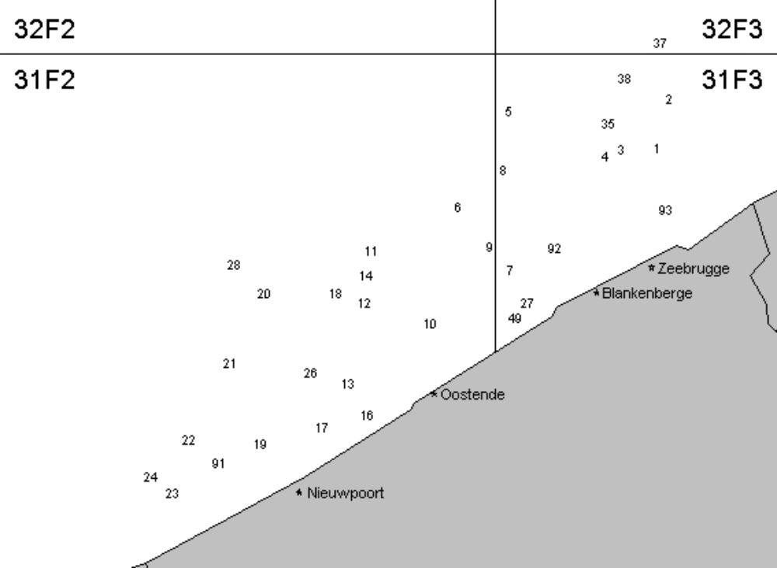

Map 2 - Sampling stations fished in the Belgian coastal waters in September 2011, as part of the annual autumn DYFS survey.

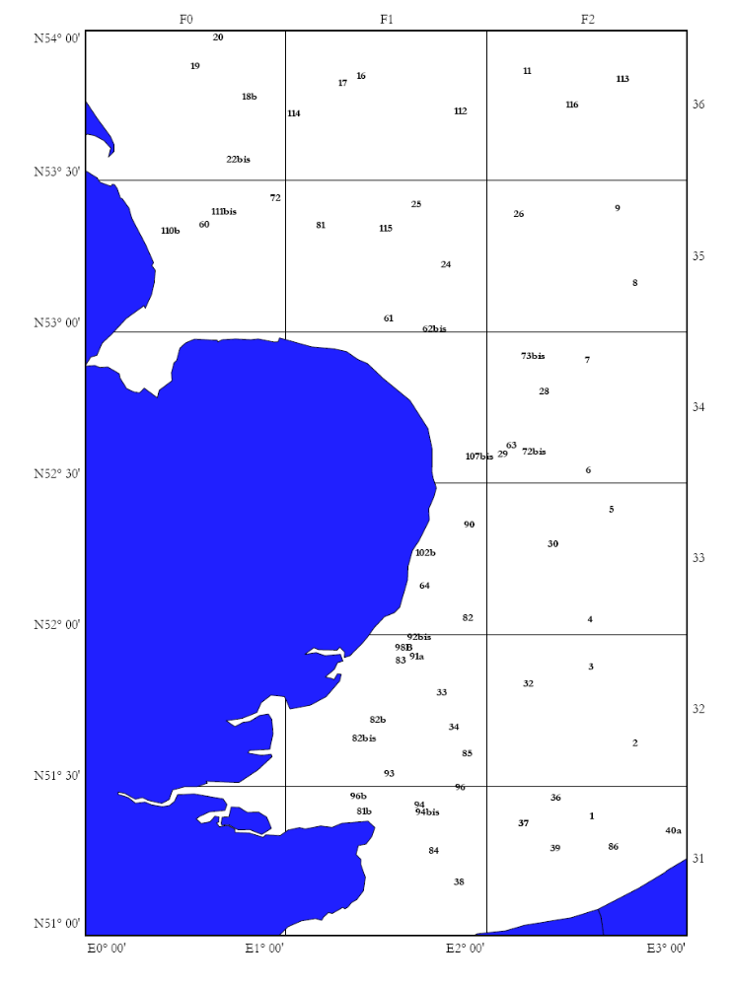
Map 1 - Sampling stations fished by the RV 'Belgica' in the SW North Sea in August-September 2011, as part of the annual late summer BTS survey.

III G 2 Data quality: results and deviations from NP proposal
No changes to any kind of settings were done that could have impaired the quality of the indices, thus no shortfalls were present.

III G 3 Follow up of regional and international recommendations
Belgium changed the geographical resolution of the age information that is collected on the BTS from the coarser ALK-areas (three in the survey area) to the ICES-statistical rectangles (14 in the survey area), as was suggested by WGBEAM. This way we collect age data in the exact same way as the other countries conducting similar surveys, and obtain a geographically more detailed view on the age compositions of the exploited commercial fish populations.
III G 4 Actions to avoid shortfalls
Since there were no major shortfalls under the Module Surveys, the surveys will largely remain unchanged in the years to come. Regarding the DYFS, three out of five stations that have become dredging points were shifted to new positions with similar depths and substrates in the vicinity of the old positions, and were fished again from 2011 onwards.

IV Module of the evaluation of the economic situation of the aquaculture and processing industry

IV A Collection of data concerning aquaculture
IV A 1 Achievements: results and deviations from NP proposal
A questionnaire was sent out by the end of 2011 to collect data for the aquaculture industry for year 2010. As the response rate for the questionnaire sent out to collect data on year 2009 was very low, companies who did not provide data for 2009 were requested to send back the filled out questionnaires for 2009 and 2010. In total, ILVO has collected 107 addresses of fish farmers. These addresses were screened but it is uncertain that all of these companies meet the definition of an aquaculture company or are still in business. The questionnaire was sent to all farmers, however the return rate was very low, only 8 companies replied, of which only six are still active. Of these only a few companies filled in the questionnaire in full, the others only partly and these are considered as “invalid”. None of the valid ones are dealing with marine species. As the response is so low and problems with confidentiality issues arises, data are not provided.
Also, there is the incompatibility between the year of reporting and the account year that company keeps. Most of the companies have their accountant year from 1st of April 2010 until 31 March 2011, some of them from 1st of June until 31 of May of the year n+1. Not one of the companies that sent back data uses calendar years for accountancy.
Mariculture is very rare in Belgium and is limited to the production of oyster and blue mussel. In the DCF1 the collection of fresh water species is not mandatory. FAO FishStat Plus classifies all Belgian aquaculture as freshwater; Eurostat data confirms that Belgian aquaculture is “inland”. And ‘FPS Economy, SMEs, Self-Employed and Energy’ has requested and obtained a derogation and did not collect economic data for aquaculture sector during the reported period. As the aquaculture production in Belgium is already very small and only 3 companies are producing marine species, confidentiality issues arise.
Considering all of the above Belgium decided not to report aquaculture data for the 2010 annual report, which was accepted by the commission. The arguments used in AR2010 still stand and were confirmed by STECF report “Economic Performance of the EU Aquaculture Sector (STECF-OWP-12-03)”. The low response rate for the 2010 data provides an additional argument. Hence, Belgium decided not to report aquaculture data for the 2011 annual report. Belgium does not expect any major changes in the aquaculture sector during 2012 and 2013 and therefore request a derogation for AR2012 and AR2013 as well. However our aquaculture experts will closely monitor the sector and recommence data collection and reporting when appropriate.
¹ Section A of the Chapter IV of the Commission Decision 2010/93/<EU of the 18th of December 2009, on Adopting a multiannual Community programme pursuant to Council Regulation (EC) No 199/2008 establishing a Community framework for the collection, management and use of data in the fisheries sector and support for scientific advice regarding the common fisheries policy.

IV A 2 Data quality: results and deviations from NP proposal
As explained in IV A 1 no data were reported, hence not applicable
IV A 3 Follow up of regional and international recommendations
No regional and international recommendations are set up.
IV A 4 Actions to avoid shortfalls
Considering all of the above Belgium decided not to report aquaculture data for the 2010 annual report, which was accepted by the commission. The arguments used in AR2010 still stand and were confirmed by STECF report “Economic Performance of the EU Aquaculture Sector (STECF-OWP-12-03)”. The low response rate for the 2010 data provides an additional argument. Hence, Belgium decided not to report aquaculture data for the 2011 annual report. Belgium does not expect any major changes in the aquaculture sector during 2012 and 2013 and therefore request a derogation for AR2012 and AR2013 as well. However our aquaculture experts will closely monitor the sector and recommence data collection and reporting when appropriate.
.

IV B Collection of data concerning the processing industry
IV B 1 Achievements: results and deviations from NP proposal
All data collection is done in accordance with the NP proposal. On the date of drafting the AR2011 the most recent economic data available were the data for the account year 2010-2011, which considered as reference year 2010-2011 (see figure x). This one-year time lag in the data collecting system is caused by the incompatibility between the year of reporting and the account year that company keeps. Most of the companies have their accountant year from 1st of April 2010 until 31st of March 2011, some of them from 1st of June 2010 until 31st of May of the year 2011. The collection of economic data for 2010-2011 is done in accordance with the NP proposal. An overview of the collected data is reported in the Excel tables IV.B.1 and IV.B.2. The questionnaire was sent to 236 companies.
  - What data are being collected?
The economic data/variables for the Belgian processing industry that were collected under the NP correspond to the list in Appendix XII of the DCF Regulation no. 199/2008. For details on information requested from the companies and parameter definitions, see Annex 3 and Annex 4 respectively.
  - Who are the data collected from and how are the data collected?
In Belgium, there is no reference list of fish processing companies in the strict sense of the word. Therefore in the previous years, ILVO-Fisheries addressed the top-255 (ranking based on company turnover and number of employees) of the Belgian companies that were identified as being involved in 'fish processing' in a national survey of private company performance indicators. A priori, most of these companies could be expected to have different types of food processing activities, of which fish and shellfish could be one, but not necessarily the most important one. In order to up-date and fine-tune the list of fish processing companies a list with postal addresses of companies involved in fish processing was obtained from the ‘Belgische groepering van de visindustrie’, the Belgian representative of AIPCE-CEP (European Fish Processors Association - European Federation of National Organisations of Importers and Exporters of Fish). Based on the already available information and an Internet search the e-mail addresses for these companies were included where possible.
In 2011, 236 companies received a questionnaire (see Annex 3) and the explanatory note with variables definitions (see Annex 4) by e-mail (when a correct e-mail address was available) or by post. Several companies informed ILVO via a phone call, an E-mail message or the comment box on the questionnaire that processing fish was only a very minor part of their activities, that they did not have the time or that they were not willing to provide the requested economic data. In order to fine-tune the list of fish processing companies, companies were requested to fill-out the contact details of the person best placed within the company to fill out the questionnaire. This feed-back is used for further fine tuning the sampling scheme and the list of companies active in the processing industry. Additionally, the questionnaire is based on gathering data inclusive VAT. However, this is rather difficult to extract from the accountancy of the respective companies.
In total only 12 useful questionnaires were received, hence a response rate of 5% was achieved.
IV B 2 Data quality: results and deviations from NP proposal
There were no deviations from the objective
IV B 3 Follow-up of regional and international recommendations
There were no specific recommendations relevant for Belgium.
IV B 4 Actions to avoid shortfall
Belgium will continue its effort to improve the data collection concerning the processing industry. The list of fish processing companies will be further up-dated and fine-tuned. To ensure that only active fish processing companies receive a questionnaire, the companies on the (draft) list will be contacted by phone prior to the mailing. It is also the intention to collect the contact details of the person best placed within the company to fill out the questionnaire. Belgium aims at sending out as many questionnaires as possible electronically, e.g. by E-mail, to facilitate the follow-up of each contact and the input of the returned data into the data base. The questionnaire was update based on the recommendations of the STECF WS “Review of economic data collected in relation to the DCF and harmonisation of sampling strategies (EWG-11-18)” (October 17 – 21, 2011 in Salerno) and PGECON “Planning Group on Economic Issues 16-19 April 2012, Salerno, Italy) which was attended by a scientist from ILVO. Belgium assumes that these actions will improve the response rate and quality of the data collected.

V Module of evaluation of the effects of the fishing sector on the marine ecosystem

V 1 Achievements: results and deviation from NP proposal
Indicators 1-3 are calculated from fisheries survey results. As Belgium only organises such surveys in the North Sea, indicators 1-3 can be delivered for the North Sea and Eastern Arctic region, but not for the North Atlantic region.
Source data for indicator 4 can be collected on research surveys or though market sampling programmes. However, due to the lack of internationally standardised maturity scales, Belgium did not collect maturity data so far but will start doing so in 2012, using the outcome of relevant maturity staging workshops organised in 2010–2012 (e.g., WKMSSPDF 1 & 2, WKMSTB).
The Fuel efficiency indicator is calculated based on the value of landings calculated as the product of landings by species and the cost of fuel. The indicator would be calculated for each métier according to level 6 métiers.
Data on the fuel cost will be collected from the relevant company accounts, on which the actual cost paid for fuel is registered and available.
The source of data for collecting the value of landings and the price of the species are the Fishstats, which is the official database of DvZ and contains the information from sales notes and log books.
In the section and Table III.B.3, a detailed overview is given of data sources and methodologies used for collecting economic data.
  - Fuel consumption
Currently, the estimates of fuel consumption are based on annual fuel costs, as reported by vessel owners on a voluntary basis (also see Section III.B.3). The most recent data available relate to 2009 and are applicable to the beam trawlers only. For the other fleet segments (with < 10 vessels in total), no data to calculate fuel consumption were provided by the vessel owners.
  - VMS data
Indicator 5,6 and 7 are calculated based on the VMS data. Since begin of 2010, Belgium has access to the Belgian VMS data and received the first data by the end of March 2010. Time lag between two registrations is two hours.

V 2 Actions to avoid shortfalls

Maturity data, needed for the calculation of indicator 4 but currently lacking, will be collected from 2012 onwards on research surveys by Belgium.

VI Module for management and use of the data

VI 1 Achievements: results and deviation from NP proposal

Sea Fisheries Service
The Sea Fisheries Service has extensive databases with landings, effort and economic data on the Belgian sea-going fishing fleet that is be complemented with the information gathered during the past and is update every year.

Survey data
The results from the North Sea Beam Trawl Survey are currently stored in a central WGBEAM database, held by IMARES on behalf of ICES.

ILVO-Fisheries
In April 2003, ILVO-Fisheries started with the development of a central depository for NDGP-data (the so-called Belsamp database), in co-operation with a sub-contracted software developer. The Belsamp database has a modular structure, with (i) separate modules for the quality control, storage, partial treatment and retrieval of fisheries statistics, data from market and discard samplings, survey data, etc., and (ii) peripheral modules with vessel registers, taxonomic information on the most important fish and shellfish species, area and stock descriptions (in terms of statistical rectangles), etc.
So far, the general framework of the Belsamp database has been elaborated (in close co-operation between data collectors and software developer) and several modules have been completed or are close to completion.

Regional database
In 2006, the North Sea countries have started exploring the potential of a regional database for the North Sea, with a view to its future use as a regional depository for fisheries statistics (primarily landings and effort data) and biological data.
Such a move implies that large amounts of data will need to be uploaded from Belsamp to this regional database. This can best be done by means of automated exchange protocols, to make sure that data transmission is flawless and in the proper format. In the budget proposals for 2007 , 2008 and 2009-2010, a pro memore cost was/is foreseen for the development of such protocols.
In 2009, special attention was paid to adjusting the Belsamp database to the exchange format that is required for transmitting data to FishFrame. As FishFrame is likely to become the central depository for fisheries statistics and biological sampling data for the North Sea area (as recommended by RCM NS&EA 2005 and 2006), it is essential that flawless communication between the national (Belsamp) and the regional (FishFrame) database can be assured. For this to be the case, a number of adjustments need to be made to the Belsamp database (extra species codes, translation of Belsamp gear and métier codes to the corresponding FishFrame codes, etc.). This process was tested by setting up a tri-lateral project with Belgium, The Netherlands and Denmark where trials have been done in uploading data and realizing different output reports.

Data transmitted
In 2011, all data collected under the DCF were transmitted to the relevant assessment working groups, study groups, advisory committees, ad hoc expert groups, etc., when and as requested
In 2011, there were several calls from the Joint Research Centre (JRC) and they are included in Table VI.1.

VI 2 Actions to avoid shortfalls
In 2011, all data collected under the DCF were transmitted to the relevant assessment working groups, study groups, advisory committees, ad hoc expert groups, etc., when and as requested.
In October 2011, Devstat visited Belgium and analysed the storage and transfer of data. A summary of the conclusions and recommendations is given in Annex 5
Following extract from the conclusions:
“’The human resources allocated to DCF-related tasks are enthusiastic, but young scientists suffer from lack of expertise in the preparation of DCF reports (tables) and especially in database design and management, which is undertaken on a learning-by-doing way. It is important to strengthen this aspect by updating and improving the current BELSAMP and biological (so-called “Discard”) databases, and ensure the correct transfer of know-how from the most experienced staff in SFS and ILVO. To this aim, it is of the utmost importance to document the procedures and practice in place and to secure funding for the re-design of databases and transfer of information. Practices in dissemination of DCF data have also to be urgently improved (website, management of users’ requests).”
During 2012, a new dataperson (development and managing of new databank) will be appointed in order to improve all shortcomings as listed by the Report. By the 31st of May, the vacancy was published and people interested in the vacancy listed.

VII Follow up of STECF recommendations

STECF SGRN 09-04 Meeting
RECOMMENDATION 7 – Concerning the New Guidelines and Procedures
SGRN stress that the revised guidelines which will be circulated to National Correspondents must be used by Member States in their 2011-2013 National Programme Submissions. Furthermore, SGRN stresses that Member States must fill in new forms in the submission of their 2009-2010 Technical Reports, transposing the informational contained in their 2009-2010 National Programmes from the old forms

Belgium has implemented this recommendation and transposed the information from the old template to the new template.

09-02_SG-ECA/RN 09-01 - Evaluation of DCF Programs: no “general comment”. There is referred to “STECF endorses the recommendations of SGRN/SGECA 09-01. Unfortunately, Belgium could not trace back this report on the STECF website.
09-05_SG-ECA 09-02 - Economic Data:
- STECF recommends that MS indicate the data collection category that is to be applied for each fleet segment
and for each economic variable as listed in Appendix VI of Council Decision 949/08.
SGECA 09-02 identified three different categories of data collection scheme that covers all the possible
typologies of data collection:
A. Census, which attempts to collect data from all members of a population.
B. Probability Sample Survey, in which data are collected from a sample of a population members randomly
selected
C. Non-Probability Sample Survey, in which data are collected from a sample of population members not
randomly selected.
- STECF notes that this classification will facilitate the comparison of survey methodologies among
Member States (MS).
- STECF also recommends that MS include in their NPs for the period 2011-2013, a methodological report to
describe the sampling strategies. STECF also recommends that MS adhere to the guidelines for the
preparation of the methodological report given in Table 4.1.1 below (adapted from the report of the STECF-
SGECA 09-02 – Table in report

- STECF also recommends that MS include in their annual Technical Reports, the data quality indicator given.
- Belgium has taken into the account these recommendations as well in the AR2010 as in the NP2011-2013.

09-06_SG-ECA /RN 09-02 - Review of Guidlines and Procedures: no specific recommendations for Belgium.
09-10_SG-ECA/RN 09-03 - Guidelines for NPs-TRs: this report is referring exclusively to the Guidelines for NP and AR. Belgium has tried to implement these Guidelines.
09-12_SG-ECA/RN 09-04 - NPs & Roadmap Surveys: no specific recommendations for MS.

VIII List of acronyms and abbreviations
ACOM ICES Advisory Committee
ALK Age-length-key
AMAWGC ICES Annual Meeting of Advisory-related Working Group Chairs
AR Annual Report
BTS Beam Trawl Survey
CEFAS Centre for Environment, Fisheries and Aquaculture Science (England)
CL Carapace length (standard measure for whole Nephrops)
CPUE Catch per unit effort
DCF Data Collection Framework
DYFS Demersal Young Fish (and Brown Shrimp) Survey
DZV Dienst Zee Visserij
EC European Commission
EP Extended Programme under the requirements of the DCF
EWG 11-18 Review of economic data collected in relation to the DCF and harmonisation of sampling strategies
FU Functional Unit (geographical definition of Nephrops stocks)
GT Gross tonnage
ICES International Council for the Exploration of the Sea (Denmark)
ICES BRG ICES Baltic Review Group
ICES CSRG ICES Celtic Sea Review Group
ILVO Institute for Agriculture and Fisheries Research (Belgium) (successor of Centre for Agricultural Research, CLO)
IMARES Institute for Marine Resources & Ecosystem Studies (Netherlands)
JRC Joint Research Centre (Italy)
LOA Length over all
LPUE Landings per unit effort
MoU Memorandum of Understanding
MP Minimum Programme under the requirements of the DCF
MS EU Member State(s)
NP National Proposal
NDGP (Belgian) National Data Gathering Programme
PCU Price Per Capacity
PGCCDBS ICES Planning Group on Commercial Catch, Discards and Biological Sampling
PGECON ICES Planning Group on Economic Issues
RAC Regional Advisory Council
RCM Regional Co-ordination Meeting
RCM NEA Regional Co-ordination Meeting for the North-East Atlantic
RCM NS&EA Regional Co-ordination Meeting for the North Sea & the East Arctic
RFO Regional Fisheries Organisation
SGMix STECF Sub-group on Mixed Fisheries
SGRN STECF Sub-group on Research Needs
SGRST STECF Sub-group on Review of Stock Status
STECF Scientific, Technical and Economic Committee on Fisheries
TAC Total Allowable Catch
WKACCU Workshop on Methods to Evaluate and Estimate the Accuracy of Fisheries Data used for Assessment
WGBEAM ICES Working Group on Beam Trawl Surveys
WGCRAN ICES Working Group on the Life History, Population Biology and Assessment of Crangon Stocks
WGEF ICES Working Group on Elasmobranch Fishes
WGHMM ICES Working Group on the Assessment of Southern Shelf Stocks of Hake, Megrim and Monk
WGMIXMAN ICES Workshop on Simple Mixed Fisheries Management Models
WKMOG Workshop on Maturity Ogive Estimation for Stock Assessment
WGNEPH ICES Working Group on the Assessment of Nephrops Stocks
WGNEW ICES Working Group on New MoU Species
WGNSDS ICES Working Group on the Assessment of Northern Shelf Demersal Stocks
WGNSSK ICES Working Group on the Assessment of Demersal Stocks in the North Sea and Skagerrak
WGQAF ICES Working Group on Quantifying All Fishing Mortality
WGSSDS ICES Working Group on the Assessment of Southern Shelf Demersal Stocks
WKDRP ICES Workshop on Discard Raising Procedures
WKMAT ICES Workshop on Maturity
WKMSCHWS ICES Workshop on Maturity staging of Cod, Haddock, Whiting and Saithe
WKNEPH ICES Workshop on Nephrops Stocks (successor of WGNEPH)
WKSCMFD ICES Workshop on Sampling and Calculation Methodology for Fisheries Data

IX Comments, suggestions and reflections
The use of drop down lists in the excel tables would limit the possibilities for recording data in certain columns. For example, the list of variables in the III.E.3 table could easily be put in a hidden spreadsheet and used as a drop down list in table III.E.3. This would greatly reduce the confusion encountered when completing the Tables.
X References
- Commission Staff Working Paper, Plenary Meeting Report of the Scientific, Technical and Economic Committee for fisheries, STECF SGRN 09-04 Meeting

- Council Regulation (EC) No 199/2008 of 25 February 2008 concerning the establishment of a Community framework for the collection, management and use of data in the fisheries sector and support for scientific advice regarding the Common Fisheries Policy

- 2010/93/EU Commission Decision of 18th December 2009 adopting a multiannual Community programme pursuant to Council Regulation (EC) No 199/2008 establishing a Community framework for the collection, management and use of data in the fisheries sector and support for scientific advice regarding the common fisheries policy

XI Annexes

Annex 1

Collection of economic data of the fisheries sector
Questionnaire

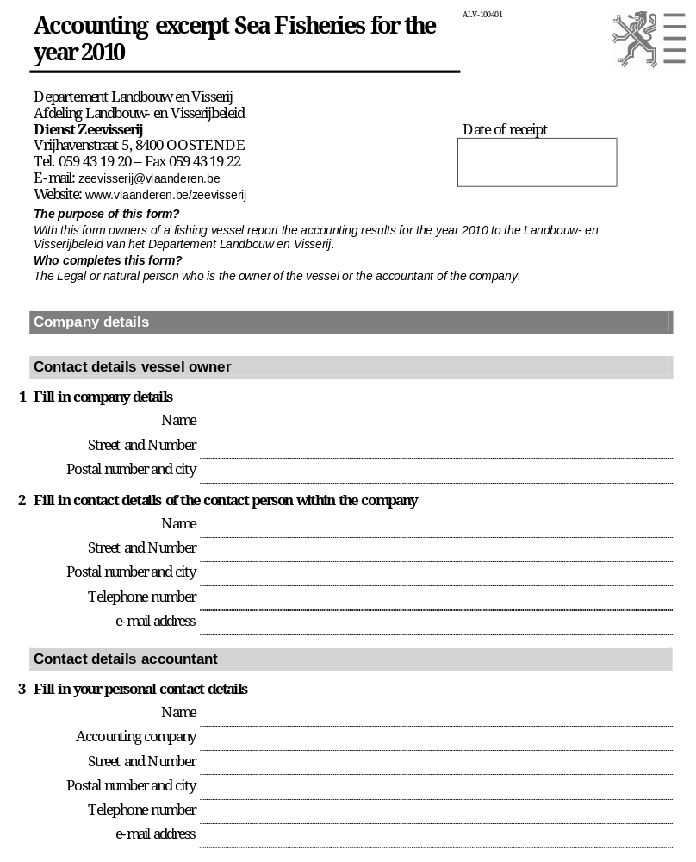

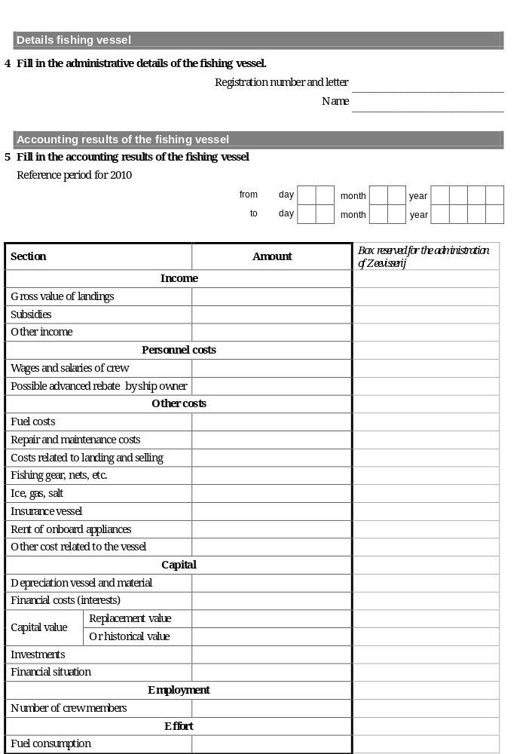

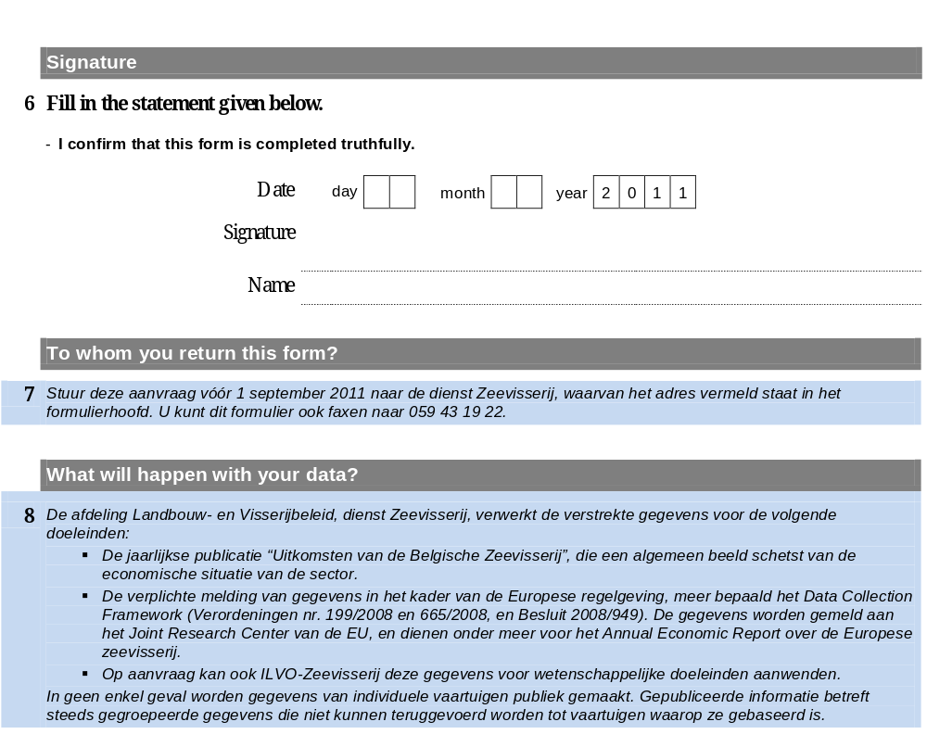

Annex 2

Collection of economic data of the fisheries sector
Variables definitions

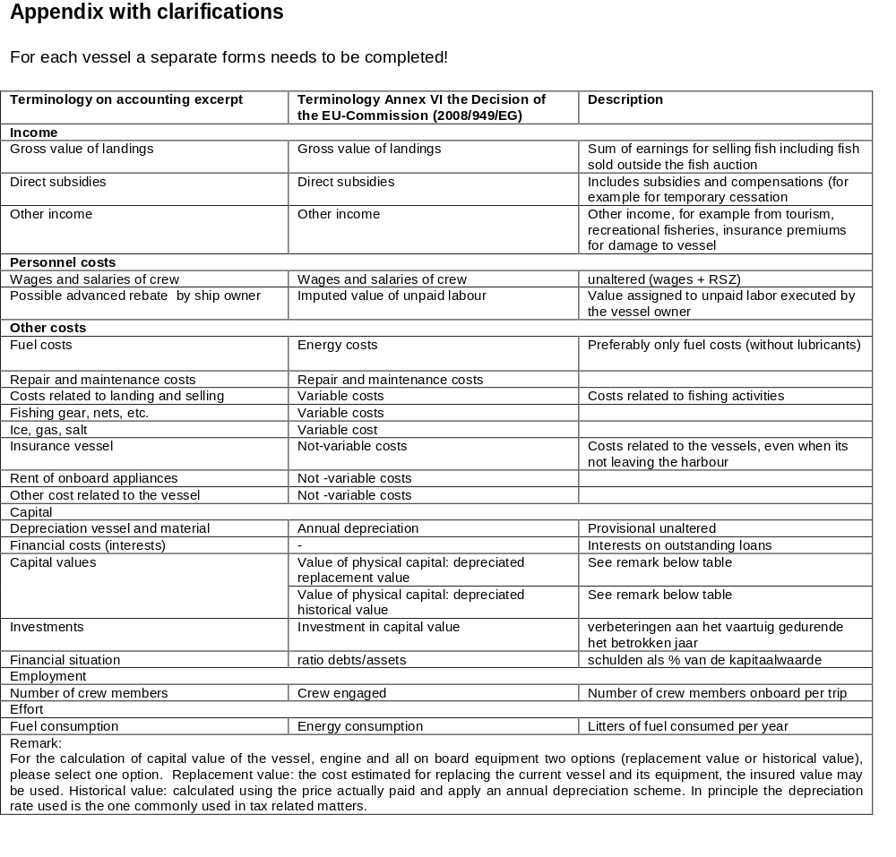

Annex 3

2010 Survey of the fish processing industry
Questionnaire
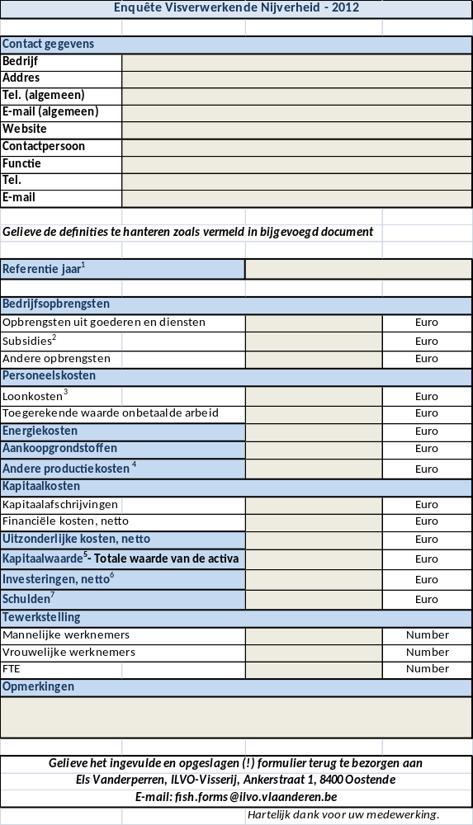
Annex 4

Survey of the fish processing industry
Variables definitions

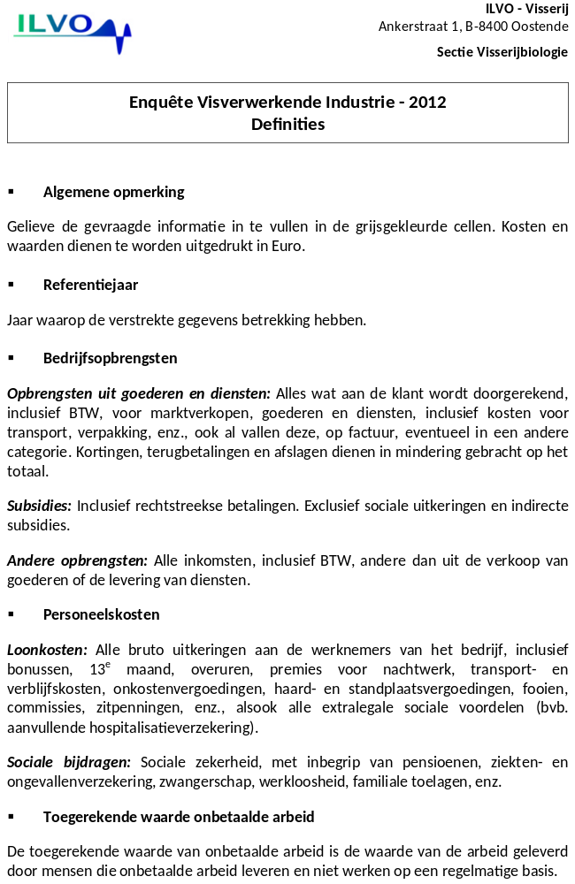

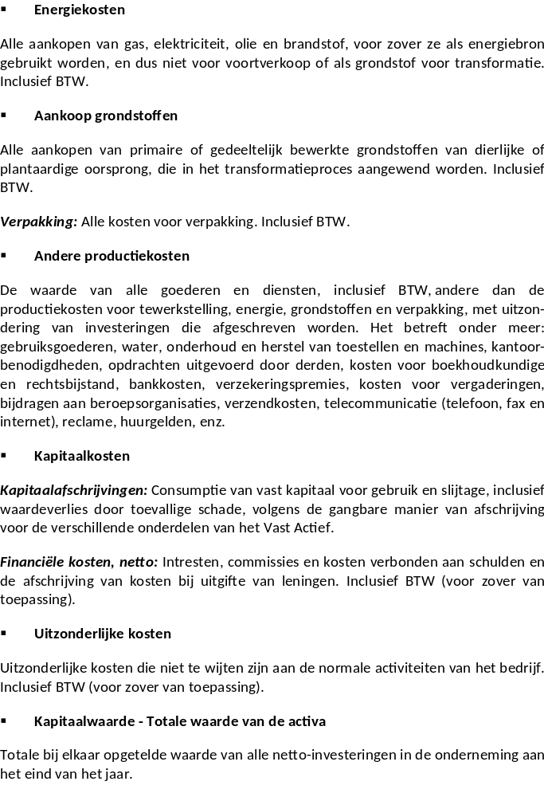

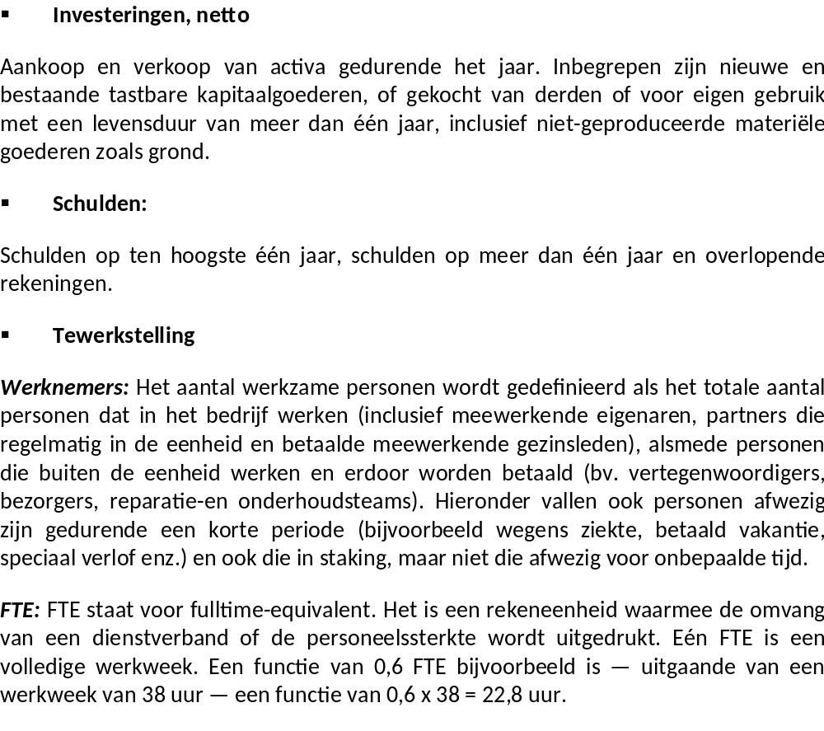

ANNEX 5
SPECIFIC CONTRACT No 3
“Field Work Contract to Belgium”
Implementing framework contract MARE/2009/2008 “Assistance for the monitoring of the implementation of national programmes for the collection, management and use of data in the fisheries sector”.
COUNTRY REPORT
October 2011

Framework Contract No. | MARE/2009/08
Specific Contract No. | SI2.598750
Activity | Activity 3. Reporting
Date of submission: | 25 October 2011
Author(s): | Jose CERVERA, Pavel SALZ, Christine ALBERTI, Rafael ROBLES, Ester AZORIN
Version: | V.1.0

- EXECUTIVE SUMMARY
This report presents the results of the second field work mission within the framework contract “Assistance for the monitoring of the implementation of national programmes for the collection, management and use of data in the fisheries sector”, which took place in Oostende, Belgium.
The main organizations intervening in the DCF in Belgium are the research institute ILVO and the Sea Fisheries Service of the Ministry of the Flemish Community. The National Correspondent for DCF has delegated many functions to the ILVO-Fisheries unit Director. There are frequent exchanges of data and good (informal) coordination between the two organizations. In addition, the team considers that the National Statistical Institute of Belgium could play a role in the improvement of surveys to the aquaculture and fish processing sector (in particular for defining the relevant populations of firms and receive technical advice for statistical issues). International cooperation could also improve the implementation of DCF through the adoption in Belgium of survey tools and databases available in other Member States.
The human resources allocated to DCF-related tasks are enthusiastic, but young scientists suffer from lack of expertise in the preparation of DCF reports (tables) and especially in database design and management, which is undertaken on a learning-by-doing way. It is important to strengthen this aspect by updating and improving the current BELSAMP and biological (so-called “Discard”) databases, and ensure the correct transfer of know-how from the most experienced staff in SFS and ILVO. To this aim, it is of the utmost importance to document the procedures and practice in place and to secure funding for the re-design of databases and transfer of information. Practices in dissemination of DCF data have also to be urgently improved (website, management of users’ requests).
Biological data- métier-related variables: Data are collected exhaustively from all Belgian vessels. Data corresponding to landings abroad (which currently amount to one-fifth of all landings) are received later from foreign harbours. The transmission of data from SFS to ILVO is frequent. Market sampling data are collected in separate Excel spreadsheets and only include sole and plaice. The presence of observers at sea is limited (due to the small number of observers and the level of collaboration of skippers). No calculation of precision parameters is done by ILVO. Further training (on COST and other methods) is necessary. Due to the lack of expertise and the fact that the databases are not well designed to produce the necessary information in an efficient manner, the National Programme and Annual Report don’t fully reflect the reality and inconsistencies appear between the reported figures for métier-related sampling and the actual ones (checked in the databases). There is a need for improving the reporting related to DCF.
Biological data- stock-related variables: achieved sample sizes do not show relationship with targets. In some cases, the achieved number of length measurements is extremely larger than the target, while for some cases (turbot and brill) the achievements are minimal. No statistical precision measures (standard deviation or coefficient of variation) are calculated at all. It is recommended to better organize the work at sea of observers. For the age measurements, the current practice of merging samples from different quarters is not based on sound statistical analysis. The biological database (so-called “Discard” database) is not well designed and urgently needs an improvement. Procedures for its use are not documented. In addition, a large amount of information is stored in separate spreadsheets and not fully integrated in the database, thus making the completion of AR tables a very complex, error-prone and burdensome task. The quality of age readings may be compromised by the practice of merging samples from different quarters to obtain artificially larger sample sizes. Sound statistical analyses should be carried out to justify this practice.
Recreational fisheries are not well covered, but there are some pilot experiences which deserve, such as a small survey on cod catches, being mentioned in the NP and AR. The amount of cod caught as recreational fishery is significant with respect to the national total, and therefore further research is needed.
Transversal variables are obtained with the collaboration of SFS. The current practice of monitoring all the Belgian fleet complies with the relevant procedures.
Data from research surveys at sea (namely DYFS and BTS), collected by ILVO, are stored in separate spreadsheets and transmitted to ICES. The latest data have not been already uploaded into the DATRAS database. The team checked the correspondence between AR and the database contents, and the difference with the plans has been explained. It seems that there are misunderstanding between the Belgian authorities and the EC regarding the sampling for eel fisheries.
Regarding economic data on the catching sector, the SFS collects exhaustively the data from the Belgian fleet, mainly through accountants. The SFS carries out some simple grossing-up of figures to account for non-response. There are no statistical measures of spread (coefficient of variation or standard deviation) of economic variables. Data are stored in the QUOVIS database.
A planned survey on aquaculture, for which the questionnaire has been prepared, needs to be planned more carefully, and in collaboration with the National Statistical Institute to establish the population of firms/establishments. As suggested by the team, the survey has been held in stand-by until a better survey frame is prepared. No data are therefore available. There is no database prepared yet to store the data that will be collected.
Regarding the fish processing industry, the situation is similar. There is a need for improving the population frame. Any data collected may suffer from the quality of the survey directory. The currently used directory (a commercial one) may be improved in collaboration with the National Statistical Institute. A database is under construction.
With respect to the variables on the effects of fisheries on the marine ecosystem, the reporting tables are confusing in some cases. Better design of the relevant databases could enhance answering the requests of this module.
As main conclusion, it can be said that the implementation of the DCF in Belgium needs urgent improvement in the reporting procedures, and this can be done through the re-design of the information system, in parallel with coaching of the ILVO-Fisheries young staff regarding the DCF requirements.

() ICES (2007): Report of the Planning Group on Commercial Catch, Discards and Biological Sampling, ICES Advisory Committee on Fisheries Management, ICES CM 2007/ACFM:09, page 68.

