Ministry of the Flemish Community – Policy Domain Agriculture and Fisheries
Dienst Zeevisserij, Oostende, Belgium
Flanders Research Institute for Agricultural, Fisheries and Food (ILVO), Oostende, Belgium

Council Regulation (EC) No 2017/1004 of 17 May 2017
establishment of a Union framework for the collection, management and use of data in the fisheries sector and support for scientific advice regarding the common fisheries policy and repealing Council Regulation (EC) No 199/2008 (Recast).

Commission Delegated Decision (EU) 2019/910 of 13 March 2019 establishing the multiannual Union programme for the collection and management of biological, environmental, technical and socioeconomic data in the fisheries and aquaculture sectors.

Commission Implementing Decision (EU) 2019/909 of 18 February 2019
establishing the list of mandatory research surveys and thresholds for the purposes of the multiannual union programme for the collection and management of data in the fisheries and aquaculture sectors.

Belgian Work Plan for data collection in the fisheries and aquaculture sectors
2020-2021
Version 1.0

Oostende (Belgium)
October 31, 2019
CONTENTS

Section 1: Biological Data 3
Pilot Study 1: Relative share of catches of recreational fisheries compared to commercial fisheries 3
Section 1: Biological Data 4
Text Box 1E: Anadromous and catadromous species data collection in fresh water 4
Section 1: Biological Data 5
Pilot Study 2: Level of fishing and impact of fisheries on biological resources and marine ecosystem 5
Section 1: Biological Data 6
Text Box 1G: List of research surveys at sea 6
Section 2: Fishing Activity Data 10
Text Box 2A: Fishing activity variables data collection strategy 10
Section 3: Economic and Social Data 12
Text Box 3A: Population segments for collection of economic and social data for fisheries 12
Section 3: Economic and Social Data 14
Pilot Study 3: Data on employment by education level and nationality 14
Section 3: Economic and Social Data 15
Text Box 3B: Population segments for collection of economic and social data for aquaculture 15
Section 3: Economic and Social Data 16
Pilot Study 4: Environmental data on aquaculture 16
Section 3: Economic and Social Data 17
Text Box 3C: Population segments for collection of economic and social data for the processing industry 17
Section 4: Sampling Strategy for Biological Data from Commercial Fisheries 19
Text Box 4A: Sampling plan description for biological data 19

Section 1: Biological Data

Pilot Study 1: Relative share of catches of recreational fisheries compared to commercial fisheries

General comment: This Box fulfills paragraph 4 of Chapter V of the Delegated Decision on the multi-annual Union programme and Article 2 and Article 4 paragraph (3) point (a) of this Decision.
1. Aim of pilot study
In the WP2017-2019, a pilot study was established to check the relative contribution of the Belgian recreational catches of European sea bass (Dicentrarchus labrax), cod (Gadus morhua) and pollack (Pollachius virens) in the total national catches (recreational and commercial) of these species with regards to possible tresholds.
From 2017 onwards, the inventarization of the recreational fisheries in Belgium, is part of the ongoing Data Collection, on a yearly basis.
2. Duration of pilot study
Not applicable
3. Methodology and expected outcomes of pilot study
The exact protocol is developed, published and reported in the AR 2017-2019.

Section 1: Biological Data

Text Box 1E: Anadromous and catadromous species data collection in fresh water

General comment: This Box fulfills paragraph 2 points (b) and (c) of Chapter III of the Delegated decision on multi-annual Union programme and Article 2 of this Decision.
Method selected for collecting data.
Data on anadromous and catadromous species are collected by the Research Institute for Nature and Forest (INBO) under the Belgian Eel Management Plan (Commission Decision C (2009)10510).
Following the Delegated Decision, no duplication of data collection may occur. Therefore, no data on anadromous and catadromous species is collected under this workplan2020-2021. Table 1E is filled in accordingly.
The full description of the Belgian Eel Management Plan can be found on
https://www.natuurenbos.be/sites/default/files/inserted-files/soortbeschermingsplan_voor_de_paling.pdf

Section 1: Biological Data

Pilot Study 2: Level of fishing and impact of fisheries on biological resources and marine ecosystem

General comment: This Box fulfills paragraph 3 point (c) of Chapter III of the Delegated Decision on the multi-annual Union programme and Article 2 and Article 4 paragraph (3) point (b) of this Decision.
Accoridng to the Annex to the Delegated Decision refers to defining data collection is according to end-user needs, all of which relate to biological data collection, ecosystem impacts and thresholds for data collection (Chapter 3: articles 2 and 3, and Chapter 5: Article 2). These are areas of data collection where the RCGs have a particular mandate to ensure coordination of data collection at a regional level. During the period 2017-2019, regional case studies are started within Inter sessional subgroups studies. The approach with ISSG is continued for the period 2020-2021.
1. Aim of pilot study
To be coordinated at marine regional level and based on end-user needs. Regional studies are ongoing within the RCG ISSG
2. Duration of pilot study
To be coordinated at marine regional level and based on end-user needs. Regional studies are ongoing within the RCG ISSG
3. Methodology and expected outcomes of pilot study
To be coordinated at marine regional level and based on end-user needs. Regional studies are ongoing within the RCG ISSG

Section 1: Biological Data

Text Box 1G: List of research surveys at sea

General Comment: This Box fulfills Chapter IV of the Delegated Decision on the multi-annual Union programme and Article 2 and Article 7 paragraph (3) of this Decision. It is intended to specify which reseach surveys at sea set out in Table 10 of the multi-annual Union programme will be carried out. Member States shall specify whether the research survey is included in Table 10 of the Delegated Decision on the multi-annual Union programme or whether it is an additional survey.
1. Objectives of the survey
North Sea Beam Trawl Survey (BTS, listed in Table 1G.1)
History:
The Belgian offshore beam trawl survey, collecting fisheries-independent data primarily for plaice and sole in the North Sea (area IVb,c), started in 1992. The continuous time-series using a 4 m-beam trawl as standard gear, started in 1993. 62 fixed stations are fished for 30 min at 4 knots. Although the target species are plaice and sole, all fish species are measured since 2010 (before 2010, only numbers were recorded for some fish species). All epibenthic species are recorded (numbers).
Objectives:
- Create a fisheries-independent stock estimate for plaice and sole for the sampled area
- Collection of data on all fish species for ecosystem purposes
- Collection of data on epibenthos species for ecosystem purposes
The indices are supplied to the relevant ICES stock assessment working groups.

Demersal Young Fish Survey (DYFS , listed in Table 10)
History:
As part of the international Demersal Young Fish and Brown Shrimp Survey, an annual autumn (quarter 3) DYFS survey is carried out in the Belgian coastal waters to collect data on the abundance of juvenile flatfish (primarily plaice and sole) and brown shrimp (Crangon crangon).
Since 1973, 33 fixed sampling stations are fished. The location of the sampling area matches the main flatfish nursery grounds along the Belgian coast.
Until 1982, the research vessel ‘Hinders’ was used. From 1983 onwards, the survey was carried out using the training and research vessel O.29 ‘Broodwinner’. From 2013 onwards, the new research vessel ‘Simon Stevin’ was used for the Belgian DYFS.
Objective:
- Collect data on the abundance and distribution of juvenile flatfish (primarily plaice and sole) and brown shrimp.

2. Description of the methods used in the survey. For mandatory surveys, link to the manuals. Include a graphical representation (map).

North Sea Beam Trawl Survey (BTS)
The methods for the mandatory North Sea Beam Trawl survey (BTS) are described in the Manual for the Offshore Beam Trawl Surveys (WGBEAM, 2009; http://www.ices.dk/marine-data/Documents/DATRAS%20Manuals/WGBEAM_Manual.pdf). The ICES Working Group on Beam Trawl Surveys (WGBEAM) has prepared an update of the manual, which is under review by the SSGIEOM chair and will be published by ICES after approval. For the period 2017-2019, Belgium guarantees to continue with previous survey designs as coordinated by ICES WGBEAM.

Map 1G.1: BTS sampling stations in the south-western part of the North Sea

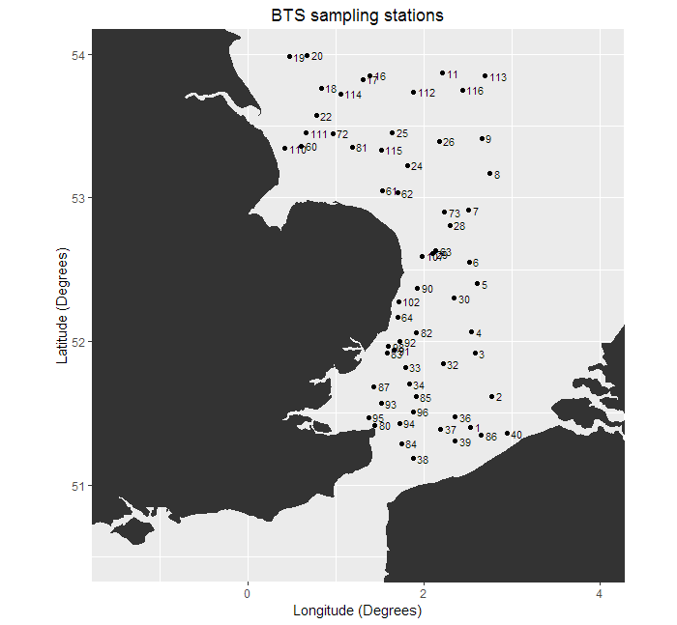
Demersal Young Fish Survey (DYFS)
The methods for the mandatory Demersal Young Fish Survey (DYFS) are described below as a manual is not yet available. During the WGBEAM meeting in 2015, a draft manual of this inshore survey was initiated and discussed. The working group aims to finalise the manual during WGBEAM meetings in the period 2017-2019.
All DYFS sampling stations are fished for approximately 30 min, with a standard shrimp beam trawl (beam length 6 m; cod-end mesh size 22 mm, no tickler chains), at 3 knots against tide.
Several fish species (cod, whiting, plaice, flounder, dab, sole, brill and turbot) are hand-picked from the catches, sorted by species, weighed and measured in mm (the in-house developed SmartFish measuring board allows measuring length in mm). From 2009 onwards, the species list was extended to cover a larger range of commercial fish species (e.g. including lesser spotted dogfish, gurnards, lemon sole, horse mackerel, etc.). In this way, a total of 18 species are documented (Table 1G.1).
The brown shrimp (Crangon crangon) from the catches are first sorted into a ‘small’ and ‘large’ fraction by means of a rotating shrimp riddle (same type used on commercial shrimp trawlers). From each of these two fractions, 1-2 liter samples are taken (depending on the amount of shrimp and other organisms in the fractions). Samples are further sub-sampled in the lab to approximately 250 shrimps, which are then measured in mm using an in-house developed system for automated length measurements.

Table 1G.1: Commercial fish species sampled during DYFS
Species
Sole (Solea solea)
Plaice (Pleuronectes platessa)
Turbot (Scophthalmus maximus)
Brill (Scophthalmus rhombus)
Cod (Gadus morhua)
Whiting (Merlangius merlangus)
Dab (Limanda limanda)
Flounder (Platichthys flesus)
Lemon Sole (Microstomus kitt)
Tub Gurnard (Chelidonichthys lucerna)
Grey Gurnard (Eutrigla gurnardus)
Red Gurnard (Chelidonichthys cuculus)
Horse Mackerel (Trachurus trachurus)
Mackerel (Scomber scombrus)
Striped Red Mullet (Mullus surmuletus)
Thornback Ray (Raja clavata)
Lesser Spotted Dogfish (Scyliorhinus canicula)
European Seabass (Dicentrarchus labrax)

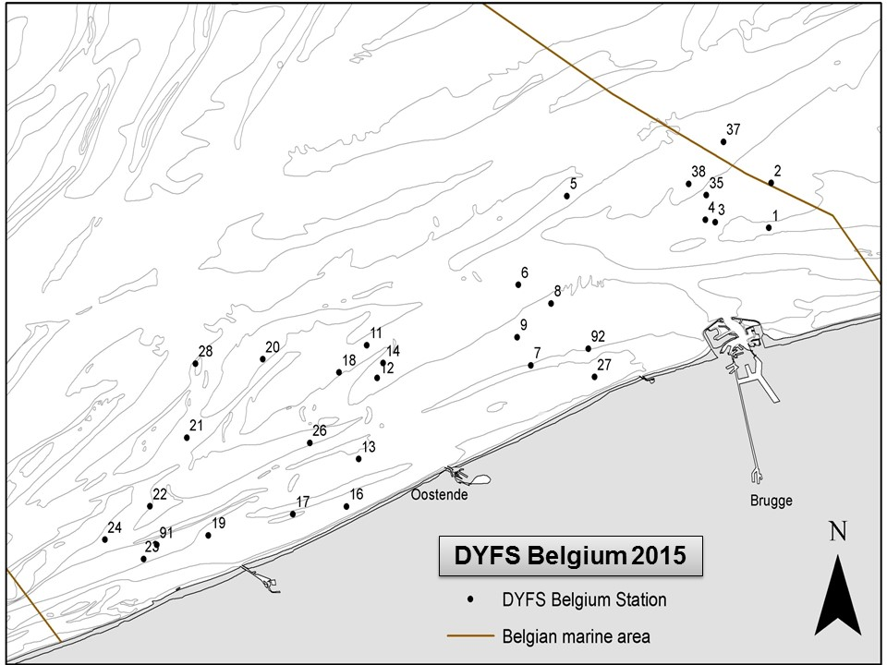
DYFS Belgium
Map 1G.2: DYFS sampling stations in the Belgian coastal waters

3. For internationally coordinated surveys, describe the participating Member States/vessels and the relevant international group in charge of planning the survey
International agreements for both surveys (BTS and DYFS) are coordinated at the ICES WGBEAM working group, where Belgium is represented. Other MSs carrying out beam trawl surveys in the region are The Netherlands, Germany and the UK.
4. Where applicable, describe the international task sharing (physical and/or financial) and the cost sharing agreement used
Not applicable

5. Explain where thresholds apply
For all target species (i.e. Sole, Plaice and Brown shrimp) of the selected mandatory surveys (BTS and DYFS in area IV), the threshold is attained (>3% of the TAC or when no TAC is available >3% of the share in average EU landings.
Belgian average landings 2016-2018 of Sole in area IV are 716 tonnes, representing 27% of the TAC.
Belgian average landings 2016-2018 of Plaice in area IV are 2103 tonnes, representing 16% of the TAC.
Belgian average landings of Brown Shrimp in area IV are 1074 tonnes, representing 3% of the share in average EU landings.

Section 2: Fishing Activity Data

Text Box 2A: Fishing activity variables data collection strategy

General comment: This Box fulfills paragraph 4 of Chapter III of the Delegated decision on the multi-annual Union programme and Article 2, Article 4 paragraph (2) point (b) and Article 5 paragraph (2) of this Decision. It is intended to describe the method used to derive estimates on representative samples where data are not to be recorded under Regulation (EU) No 1224/2009 or where data collected under Regulation (EU) No 1224/2009 are not at the right aggregation level for the intended scientific use.
1. Description of methodologies used to cross-validate the different sources of data.
Capacity:
Data are 100% covered by the Fleet register and the logbooks.

Effort:
The logbooks provide information on the hours spent fishing per day and per ICES Statistical Rectangle. Those data are used to derive the hours at sea and based thereon, the days at sea. The hours at sea per trip and per ICES Statistical Rectangle (or Division) are summed, divided by 24 and rounded up to calculate the days at sea.
Effort variables available in the fishing logbooks are cross-validated with effort estimates derived from VMS data. The estimated quantities of each species in kilograms live-weight in the fishing logbooks are compared with the sales notes.

Landings:
The estimated weight for all species caught, grouped by ICES Statistical Rectangle and by day is obtained from the logbooks. While information on the quantities auctioned by market category for all species landed is obtained from the sales notes. These two data sources are merged to obtain the landings by area and market category. As the retained catches from the logbooks are estimated weights, the landed weights are derived from the quantities recorded in the sales notes. The two systems are equally important to the Belgian data collection system and complementary. The combination of the two data sources has clear advantages.
(1) The two approaches yield independent estimates of the retained and landed portions of the catches, and can thus be used for quality control and validation purposes. This helps improving the reliability of the landings figures.
(2) In the Logbook Regulation, it is stipulated that ‘only catches of an amount greater than 50 kg of live-weight equivalent of any species retained on board must be recorded in the logbook’ (Article 2.4.2. of Annex V of Commission Regulation (EEC) No. 2807/83). Consequently, small bycatches of fish and shellfish often remain unrecorded in the logbooks. However, these quantities are picked up in the sales notes, which help to improve the species coverage and hence the comprehensiveness of the landings statistics.
(3) Roughly one fifth of all fish and shellfish landed by Belgian vessels in the southern and central North Sea are auctioned abroad, mostly in the Netherlands. Furthermore, vessels making consecutive fishing trips in distant waters before returning to their homeport in Belgium, may sell part of their catches during their stop-overs in a foreign port. Sales data from abroad are collected by local authorities from sales notes and submitted to the Sea Fisheries Service (Dienst Zeevisserij) for incorporation in the Belgian national fishstats database. These data require additional quality checks and codification, to ensure that the imported data are compatible with the recipient database.
(4) Lastly, the landings data by market category are of critical importance to the biological data collection programme on the landings. This heavily relies on stratified sampling by market category.
2. Description of methodologies used to estimate the value of landings.
The actual value of each landing is available in the sales notes, therefore no estimation is needed.
The sales notes contain information on the quantities auctioned and the price by market category for all species landed. Information on the exact origin of the landings (from the logbooks) is added to allocate the price and the corresponding quantities auctioned to a ICES Statistical Rectangle. Multiplication of the latter two will result in the value on a specific level.
3. Description of methodologies used to estimate the average price (it is recommended to use weighted averages, trip by trip)
The actual value of each landing is available in the sales notes, therefore no estimation of average price is needed.

4. Description of methodologies used to plan collection of the complementary data (sample plan methodology, type of data collected, frequency of collection etc)
In 2018, Belgium had one demersal trawler in LOA 10-<12m, however this vessel was inactive. All active vessels are >12m, therefore all data needed are collected under Regulation (EU) No 1224/2009 and no additional data collection will be done.

Section 3: Economic and Social Data

Text Box 3A: Population segments for collection of economic and social data for fisheries

General comment: This Box fulfills paragraph 5 points (a) and (b) of Chapter III of the Delegated Decision on the multi-annual Union programme and Article 2, Article 4 paragraphs (1), (2) and (5) and Article 5 paragraph (2) of this Decision. It is intended to specify data to be collected under Tables 5(A) and 6 of the Delegated Decision on the multi-annual Union programme.
1. Description of methodologies used to choose the different sources of data
The Belgian fleet encompasses mainly beam and demersal trawlers and has no registered fishing vessels of < 10m LOA. Fleet overview in 2018:
Type of fishing technique |  |  |  | Length classes (LOA) | N° of vessels
Active gears | Beam trawlers |  |  | 10-<12 m | 0
Active gears |  |  |  | 12-<18 m | 2
Active gears |  |  |  | 18-<24 m | 18
Active gears |  |  |  | 24-<40 m | 27
Active gears | Demersal trawlers and/or demersal seiners |  |  | 10-<12 m | 0
Active gears |  |  |  | 12-<18 m | 1
Active gears |  |  |  | 18-<24 m | 8
Active gears |  |  |  | 24-<40 m | 6
Active gears | Dredges¹ |  |  | 18-<40 m | 1
Passive gears | Drift and/or fixed netter² |  |  | 12-<24 m | 1
Total active vessels |  |  |  |  | 64
 |  |  | 12-<18 m |  | 1
Inactive vessel |  |  | 18-<24 m |  | 2
 |  |  | 24-<40 m |  | 1
Inactive vessels |  |  |  |  | 4
Total |  |  |  |  | 68
¹ dredges (18-<24 m and 24-<40 m)
² Passive gears - drift and/or fixed netter (12-<18 m and 18-< 24m)

An annual survey is conducted by Dienst Zeevisserij, Department of Agriculture and Fisheries (Flemish government) to collect fleet socio-economic data. Information is collected by vessel. Wherever possible, data on the balance accounts of the company are also consulted.

Employment data are obtained through the employers social-accounting secretariat, who gather data regarding the social costs. The Belgian fishery sector has a unique system of social security. These data are delivered directly to Dienst Zeevisserij via the accredited accountancy office Morbee & Ballegeer.
Landings and effort data are obtained from official logbooks. The official Belgian vessel register (the Fleet register) is used to obtain data with regards to vessel characteristics. Value of landings (sales notes) is available from all Belgian fish auctions. Sales notes are also provided for vessels that do not sell their catches through the auction (i.e. coastal vessels). Logbook, Sales and Fleet data are provided by the controlling bodies under Regulation (EU) no. 1224/2009. “Fishstats Database DZV” is the official database of Dienst Zeevisserij containing this information.

2. Description of methodologies used to choose the different types of data collection
A census is carried out for socio-economic data collection. All vessels are surveyed (questionnaire). Since the 1st of September 2010, a Decision was agreed upon by the Flemish Government, regarding the obligation to supply economic data. Thus, national legislation was introduced to impose the obligation to provide data requested under Appendix VI of the DCF. As a consequence, response rates increased.

Methodologies are in accordance with ad hoc contract Commitment No. SI2 725 694 - Methodologies for the socio-economic data described in EU MAP.
3. Description of methodologies used to choose sampling frame and allocation scheme
The target and the frame population are identical. Following the national legislation, the coverage of the population is close to 100%. The sampling frame of the economic data covers the complete Belgian marine fishing fleet as registered in the EU vessel register. Inland and aquaculture fishing vessels are excluded from data collection.

Fleet segments are determined as described in European legislation. However, this raises the issue of clustering. Many segments consist of less than 10 fishing vessels (see table under point 1). Economic data are sensitive data and therefore confidentiality must be guaranteed. There are 2 possibilities to tackle this issue:

- Data by fleet segment for segments where the number of vessels is too low shall not be reported separately.
- Data for these fleet segments can be clustered. The clustering procedures are based on technical data and catch composition. Important fleet segments shall not be clustered or shall be clustered in accordance with the similarity principle. Therefore, beam trawlers 12-18m would be clustered with beam trawlers 18-24m. The latter is an important segment, however both segments use the same fishing gear and exhibit similar behaviour in terms of target species. Following the same logic, demersal trawlers or seiners of all length categories would be clustered in order to be consistent over time.
Option 2 is preferred. However, a problem remains for dredges and passive gear. In last data reporting years (Data call 2019; Annual Report 2018), these fleet segments were clustered together as they do not resemble any of the other fleet segments within the Belgian fleet. These segments were clustered following the ‘Non-important segments with distinct characteristics’ principle in order to provide a full dataset. As there is no real dominant segment in this cluster and in an attempt to avoid misleading the end-user, these vessels were clustered as ‘Vessels using active and passive gears’ (PMP). A category ‘Other’ is non-existent. This also allowed for constant clustering over the time series 2008-2018. However, with only 3 vessels remaining in the cluster, Belgium chooses option 1 for these fleet segments.
4. Description of methodologies used for estimation procedures
Costs and earnings from the active vessels are surveyed through a questionnaire. As the response within the important fleet segments is high, missing data will be estimated by calculating the mean per fleet segment in the sample. This is then raised to the population level of each segment. The sum of the totals of the different categories estimate the total value for the entire fleet.
Information on technical characteristics, effort and landings from all vessels in the population are available from the logbooks and the vessel register (collected under Regulation (EU) no. 1224/2009).
5. Description of methodologies used on data quality
Wherever possible, data from different sources will be cross-checked. During 2020-2021, Belgium would like to further develop and improve routine data quality check-ups (e.g. summary statistics, analyse outliers, correlations between variables, …).

Section 3: Economic and Social Data

Pilot Study 3: Data on employment by education level and nationality

General comment: This Box fulfills paragraph 5 point (b) and paragraph 6 point (b) of Chapter III of the Delegated Decision on the multi-annual Union programme and Article 2 and Article 3 paragraph (3) point (c) of this Decision. It is intended to specify data to be collected under Table 6 of Delegated Decision on the multi-annual Union programme.
1. Aim of pilot study
The Belgian fishery sector has a unique system of social security. Fishermen receive relatively high incomes. Since 2003, a law on employment ended the ‘No catch, no pay’ principle, assuring income security for each sea trip (Royal Decree, Belgian State Journal, 07/03/2005). The crew receive a fixed percentage of the value of landings. If the value of landings is lower than a certain minimum wage, the employer has to pay a minimum wage. This is a system that favours employees over employer, bearing in mind that being fisherman remains a dangerous profession. The fact that this has been set legally for all vessels is unique in Europe and might contribute to the fight against illegal fishing.
However, finding appropriate staff for fisheries remains a challenge. Young people graduating from the Maritime Institute prefer to work for dredging companies or in the tourism industry. Therefore, it is possible that crew members from elsewhere (from other sectors and/or abroad) are attracted. Wages are relatively high, but minimum educational requirements in the Belgian fishery sector are strict and costly.
To acquire more insights in this matter, this pilot study aims to collect information on the age, nationality and education level of crew members on Belgian fishing vessels. Initially, the focus lies on the beam trawler fleet. Beam trawlers with a vessel length of 24-40 m provide about half of employment opportunities (STECF, 2016). Ultimately, this will be expanded to the entire fleet.
2. Duration of pilot study
This pilot study has started in 2019 and data collection will be carried out throughout the period 2020-2021 for engaged crew members.
3. Methodology and expected outcomes of pilot study
Close collaboration with the employers social-accounting secretariat BESOX is necessary (and achieved in 2019) to collect social data on employment by education level and nationality. The employers social-accounting secretariat should have part of this information available on a trip and vessel level. Data gaps will be filled by surveying vessel owners and/or fishermen.

Section 3: Economic and Social Data

Text Box 3B: Population segments for collection of economic and social data for aquaculture

General comment: This Box fulfills paragraph 6 points (a) and (b) of Chapter III of the Delegated Decision on the multi-annual Union programme and Article 2, Article 4 paragraphs (1) and (5) and Article 5 paragraph (2) of this Decision. It is intended to specify data to be collected under Tables 6 and 7 of the Delegated Decision on the multi-annual Union programme.
According to Eurostat, the total Belgian annual production in aquaculture was 32 tonnes in 2015(last data year). As this production did not increase since 20157, the Belgian Federal Department of Economics, which is still monitoring the volume and value of this sector, did not publish actualised data in Eurostat.
Belgium complies with the thresholds as described in Commission Implementing Decision (EU) 2019/909 and as such does not have to collect data for the aquaculture sector
- Description of methodologies used to choose the different sources of data
. Not applicable
- Description of methodologies used to choose the different types of data collection
. Not applicable
- Description of methodologies used to choose sampling frame and allocation scheme
. Not applicable
- Description of methodologies used for estimation procedures
. Not applicable
5. Description of methodologies used on data quality
. Not applicable

Section 3: Economic and Social Data

Pilot Study 4: Environmental data on aquaculture

General comment: This Box fulfills paragraph 6 point (c) of Chapter III of Delegated Decision on the multi-annual Union Programme and Article 2 and Article 4 paragraph (3) point (d) of this Decision. It is intended to specify data to be collected under Table 8 of the Delegated Decision on the multi-annual Union Programme.
. See text Box 3B. . Belgium complies with the thresholds as described in Commission Implementing Decision (EU) 2019/909 and as such does not have to collect data for the aquaculture sector.
1. Aim of pilot study
Not applicable.
2. Duration of pilot study
Not applicable.
3. Methodology and expected outcomes of pilot study
Not applicable

Section 3: Economic and Social Data

Text Box 3C: Population segments for collection of economic and social data for the processing industry

General comment: This Box fulfills footnote 6 of paragraph 1.1(d) of Chapter III of the Delegated Decision on the multi-annual Union Programme., Article 2, Article 4 paragraphs (1) and (5) and Article 5 paragraph (2) of this Decision. It is intended to specify data to be collected under Table 11 of the Delegated Decision on the multi-annual Union Programme..
In the previous Belgian National Programme, the absence of a reference list with ‘fish processing companies’ sensu stricto was mentioned. In order to address this issue, ILVO contacted the top-255 (ranking based on company turnover and number of employees) of Belgian companies that were identified as being involved in ‘fish processing’ in a national survey of private company performance indicators. However, the identification of true fish processing companies remained a major issue to set up a meaningful collection scheme. Over the past two years efforts have been made in this regard.
1. Description of methodologies used to choose the different sources of data
The list of fish processing companies has been rigorously updated by cross-checking different sources with information on companies involved in fish-based activities. The effort invested in the improvement of this list, resulted in a better population identification and thus data quality. ILVO collaborated with the Federal Agency for the Safety of the Food Chain (FASFC) who strictly monitor processing activities of these companies from a health safety angle. Their list was further cross-checked with other lists, such as the initial ‘top-255’ list, the database of FPS Economy, S.M.E.s, Self-employed and Energy (Federal Government) and a list of the Belgian representative of AIPCE-CEP (European Fish Processors Association - European Federation of National Organisations of Importers and Exporters of Fish).
This led to a population of approximately 250 companies. Not all companies process fish as their main activity. Based on answers obtained through a questionnaire, consulting public balance accounts, direct contact with some companies as well as web-research, it was estimated that in 2013 there were 68 companies that processed fish as a main activity, with an estimated turnover of 650 million euro and 1500 FTE’s.
On an annual basis this list is updated through consultation of the following sources:
- Federal Agency for the Safety of the Food Chain (FASFC)
- FPS Economy, S.M.E.s, Self-employed and Energy (Federal Government)
- Balance accounts, National Bank of Belgium
- Questionnaire
If resources are available, Belgium will invest in further refining the information by contacting the enterprises directly.
2. Description of methodologies used to choose the different types of data collection
Data can be acquired from different sources:
- Balance sheets: The balance sheets for some companies can publically be consulted. Especially from larger companies a lot of information is available in these sheets. A limitation is that not all variables requested under the Delegated Decision, Table 11, are available in the company accounts. For example energy costs are not separately available, but aggregated within other operational costs.
- Questionnaires: Information which is not available through balance sheets, or in general not publically available will be obtained via questionnaires. Online surveys are preferred, whenever possible (i.e. when an e-mail-address is available), in other cases paper surveys are sent out.
Efforts related to determine the main activity of the company will continue. Total weight and weight of seafood and fish for the most important processed species will be surveyed. However, collecting data by origin is not feasible.
The data requested under Delegated Decision is considered to be sensitive data. In the past, some companies have responded that they did not have the time or they simply refused to provide the requested economic data. Especially small and medium enterprises do not see the purpose of requesting economic data and therefore their response rate is limited. Regular and direct contact with enterprises improves trust, and hence the needed understanding and willingness of companies to cooperate and provide the requested data will increase. On the other hand, direct contact with enterprises, given the size of the population, is labour intensive and Belgium cannot yet guarantee that the necessary resources will be available to effectively adopt this approach.
3. Description of methodologies used to choose sampling frame and allocation scheme
Enterprises for which fish processing is an important activity are targeted first. As it is not possible to directly determine the importance of the activity from the population list, the questionnaire aims to identify the enterprises using questions to determine the proportional importance of the fish processing activity based on turnover and employment. In the online questionnaire, a shortened version is foreseen in case fish processing is not an important activity. Under the current circumstances, economic and social variables are not collected from these enterprises.
4. Description of methodologies used for estimation procedures
The enterprises are classified in categories according to the number of employees (≤ 10; 11-49; 50-249; ≥ 250 employees). When the number of companies per category are low, several categories are grouped. Variables for missing data are estimated by calculating the mean per category in the sample. This is then raised to the population level of each category. The sum of the totals of the different categories estimate the total value for the entire population. More information will be included on larger companies (less abundant) than on smaller ones (more abundant). This leads to a stratified sample in which larger companies are oversampled. However, the total estimation is likely to be more precise, given that larger companies contribute more.
Should the variance between observations in a given category be large, an alternative method could be applied. This concerns mostly the 11-49 employee group. Companies in this group could be further subdivided based on their balance account type. Above certain thresholds, companies must lay down a ‘full’ balance account. Estimations could then be done for the ‘full’ and the ‘short’ balance account separately.
5. Description of methodologies used on data quality
In the period 2017-2019, where possible, data in the balance accounts were compared to answers in the questionnaire (whenever possible). This was done to determine whether both sources could be combined and to test the effectiveness of the questionnaire. As they were comparable, redundant questions were omitted. This enabled the use of balance accounts for companies that did not respond to the questionnaire.

Section 4: Sampling Strategy for Biological Data from Commercial Fisheries

Text Box 4A: Sampling plan description for biological data

General Comment: This Box fulfills Article 3, Article 4 paragraph (4) and Article 8 of this Delegated Decision on the multi-annual Union Programme. and forms the basis for the fulfilment of paragraph 2 point (a)(i) of Chapter III of the Delegated Decision. This Table refers to data to be collected under Tables 1(A), 1(B) and 1(C) of the Delegated Decision on the multi-annual Union Programme.
Description of the sampling plan according to Article 5 paragraph (3) of this Decision
Belgian fisheries:
The beam trawl fishery is by far the most important fishery for Belgium (in 2018 TBB covered 80% of the total Belgian fishing hours) and comprises of a beam trawl fleet targeting crustaceans (TBB_CRU covers 12% of the total Belgian fishing hours) and a beam trawl fleet targeting demersal species (TBB_DEF covers 68% of the total Belgian fishing hours). The TBB_DEF fleet comprises of 2 fleet segments: the TBB_DEF_>221 kW fleet segment and the TBB_DEF_<=221 kW fleet segment.
The TBB_DEF_>221 kW fleet segment comprises vessels with a capacity of more than 221 kW, operating in ICES divisions IV, VIId, VIIe-h, VIIa, VIIIab (referred to as ‘all regions’ in Table 4A). The TBB_DEF_>221 kW trip duration is on average 8-10 days and one trip can cover several areas.
The TBB_DEF_<=221 kW fleet segment comprises vessels with a maximum power of 221 kW (coastal vessels and euro cutters), operating in ICES divisions IV and VIId. In contrast to TBB_DEF_>221 kW, TBB_DEF_<=221 kW also has access to the 12 mile zone. A coastal vessel has a trip duration of less than 48 hours and a euro cutter of approximately 4 days.
Sampling design:
Belgium does not have an onshore sampling programme (market sampling) in place because the origin of the fish that are sold in the market is unknown. The landings of the trips very often cover several areas and it is not traceable from what area the fish is landed.
In accordance with the recommendations from STECF-EWGs and RCMs following the preparation of the new DCF, Belgium started from 2011 onwards to redesign the catch sampling schemes to move from a ‘métier-based’ to a ‘statistically sound’ sampling. Considering the importance of the Belgian beam trawl fleet targeting demersal species, Belgium focusses on the collection of fishery-dependent data for this fleet (both fleet segments). The two fleet segments (TBB_DEF_>221 kW and TBB_DEF_<=221 kW) are treated as two separate strata in the Belgian at sea sampling programme. Catch information (all catch fractions are covered) is obtained through on-board observation or ‘at sea sampling’. Four ILVO observers assure a sampling coverage of on average 1% of all fishing hours (i.e. approximately 40 trips). The sampling effort targets for one year are set at 8 trips for the TBB_DEF_<=221 kW fleet segment and 34 trips for the TBB_DEF_>221 kW fleet segment.
The primary sampling unit (PSU) in the Belgian at sea sampling programme is vessel x trip (as a proxy for trip) so the sampling design class is defined as ‘type A’¹. A haul (within a trip) is defined as the secondary sampling unit (SSU).
A vessel x trip (PSU) for the TBB_DEF_>221 kW fleet segment is selected ad hoc or standard quota sampling is conducted (non-probability-based sampling). In 2018, there were 27 TBB_DEF vessels with a capacity >221 kW flying the Belgian flag. The vessels that are willing to take observers onboard and those that are suited, from a logistic point of view, to have an observer onboard are included in the vessel list (sampling frame): currently the sampling frame covers ± 15 vessels. The observer coordinator keeps track of the vessels within the sampling frame but ILVO considers collecting non-responses and refusals on PSU (trip) level not relevant. The sampling will be spread as much as possible over all these 15 vessels. We introduced 2 types of sampling:
  - Ad hoc sampling: for those strata with a lower sampling coverage (based on previous years):
    - TBB_DEF_70-99 kW>221 fleet area 7a
    - TBB_DEF_70-99 kW>221 fleet area 8ab
    - TBB_DEF_120 kW>221 fleet area 4b
  - Quota sampling: sampling effort is proportionally to the fleet effort (based on previous year)
The table below represents an overview of the planned sampling-effort in terms of number of trips per quarter/area/gear:
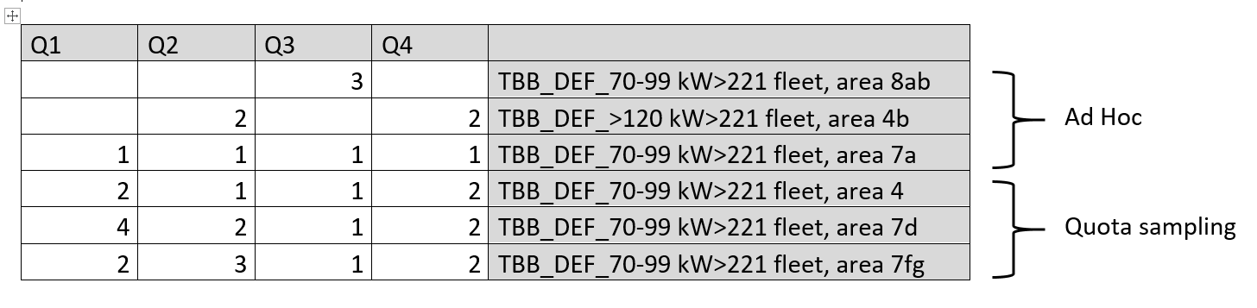
A vessel x trip (PSU) for the TBB_DEF_<=221 kW fleet segment is selected ad hoc. In 2018, there were 21 TBB_DEF vessels with a capacity <=221 kW flying the Belgian flag. However, 12 of those are regularly fishing for shrimp (TBB_CRU). Until the end of 2021, Belgium has a derogation for sampling the TBB_CRU métier. The TBB_DEF_<=221 kW vessel list (sampling frame) has been steadily decreasing and proved too small to ensure random PSU selection. This was the result of vessels being taken out of service, but also logistic issues onboard facilitated this decrease. Therefore, ad hoc sampling of 2 euro cutters and 2 coastal vessels is carried out. The observer coordinator keeps track of the vessels within the sampling frame but ILVO considers collecting non-responses and refusals on PSU (trip) level not relevant.
For the TBB_DEF_>221 kW fleet segment, every other haul (systematic sampling of SSU) is sampled by an observer. Sampling takes place around the clock to reflect typical working conditions on board. For the TBB_DEF_<=221 kW fleet segment, the goal is to sample all hauls during the short trips of the coastal vessels. During euro cutter trips, every other haul is sampled, similar to the TBB_DEF_>221 kW fleet segment. The crew is sorting the marketable fish from the conveyor belt and stores it per species for the observer to sample later on. In the meantime, the observer is sampling the discarded fraction of the catch by sorting all commercially important species, i.e. selected set of species as indicated in Table 1A & 1B. The total weight per species in each haul is determined and lengths are measured. When a species is extremely abundant, a smaller representative subsample (TSU) is measured. The marketable part of the catch (landings) is sampled in the same way as the discarded part of the catch.
During each trip, otoliths from minimum 3 fish per cm-size class per species per area, are collected (except for cod 1 fish per cm-size class) for age estimations. Otoliths are collected throughout the whole trip (several hauls) until the quota of otoliths is achieved. For the discarded part of the catch, otoliths are being removed on board. For the retained part (landings) of the catch, the fish are purchased for individual length, weight, sex, maturity and age determination.
All the at sea sampling data (metadata and all biological data) are stored in a national database called ‘SmartFish’. For quality assurance and analyses (e.g. raising) of the catch data, powerBI desktop and several R scripts (o.a. COST packages) are being used.
Sampling strategy optimization:
ILVO, as developer and executer of the sampling plan, will invest in the further optimization of the at sea sampling design. Continuous effort is done to optimise the current sampling plan in order to match statistically sound sampling with practical feasibility. In the upcoming years (2020-2021), ILVO will investigate alternative sampling techniques such as self-sampling and will test the potential added value of electronic monitoring in the commercial sampling programme. In this way, ILVO will try to increase the numbers of vessels in both sampling frames (TBB_DEF_>221 kW and TBB_DEF_<=221 kW) and the number of sampled PSUs in the medium to long term.
¹: ICES. 2013. Report of the second Workshop on Practical Implementation of Statistical Sound Catch Sampling Programmes, 6 - 9 November 2012, ICES Copenhagen. ICES CM 2012 / ACOM:52 71 pp.
(max 900 words per region)

