Template for requests of data under the EU Data Collection Framework

- Data requested
Please specify what data you need:
- which data specifications are needed based on the EU MAP (Commission Delegated Decision (EU) 2021/1167 and Commission Implementing Decision (EU) 2021/1168)
- which years
- which Member States have collected the data

- Purpose of the data request
Please include a clear description of the purpose(s) for which the data are requested. Consult the categories listed in the DCF legal framework explained below (i.e. fisheries management, any other purpose, for scientific publication). If the data are needed for a study or a project, provide a short description (max 300 words) with objectives.

According to the Regulation 2017/1004, there is a clear obligation for an EU member state (MS) to submit data to end users of scientific data or other interested parties upon their request (with different deadlines):
- if data are requested for fisheries management purposes by relevant end users, the MS has to comply with such a request within the deadline set in the request, which may however not be shorter than 1 month (Article 17(3));
- data requested for any other purpose than specified in Article 17(3) has to be sent by the MS to relevant end users or other interested parties within a reasonable time, which should be proportional to the request (Article 17(4)).

The following exceptions apply (differing in the provision of the data series):
- if the data are requested for scientific publication purposes, the MS may require that the publication of data be delayed by 3 years from the date to which the data refer (sampling date), to protect the professional interests of their national scientists involved in the collection of these data (Article 17(7)). In case of MS refusal to transmit data on this account, the end user can ask the European Commission to launch an official procedure of review (Article 19);
- the MS may also limit or refuse access to (all requested) data (regardless of the purpose it was requested for) if an end user is not respecting the obligations set in Article 20 (see Annex) – mainly related to misuse of data. However, such a refusal would be conditional upon European Commission approval;
- in the interest of protection of personal data, the MS may also refuse the transmission of (all requested) data if there is a risk that a natural person or legal entity might be identified in line with Article 17(2). However, in such case, the MS has to provide alternative means to meet the needs of the requesting party while ensuring anonymity.

- Deadline for receipt of data
Please specify by when you would need the data. Kindly note and respect in your request the deadlines that apply to different categories (point 2 above).

Address the data request to the MARE DATACOLLECTIONFRAMEWORK: MARE-DATACOLLECTIONFRAMEWORK@ec.europa.eu

ANNEX

Obligations of end users regarding DCF data (Regulation 2017/1004)

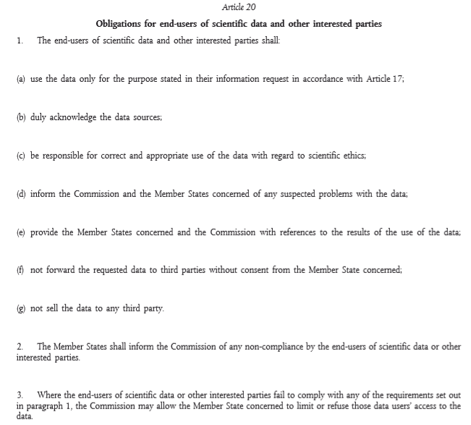

A list of DG MARE data calls can be found in the DCF website hosted by JRC: https://datacollection.jrc.ec.europa.eu/data-calls
All legislation (past, current and in preparation) can be found in the DCF website hosted by JRC: https://datacollection.jrc.ec.europa.eu/legislation
Note the starting year of DCF collection in the different MS. You can check this in the DCF website hosted by JRC: https://datacollection.jrc.ec.europa.eu/wp-np-ar.
MARE-DATACOLLECTIONFRAMEWORK@ec.europa.eu

